**HOLY MOTHER CHURCH**

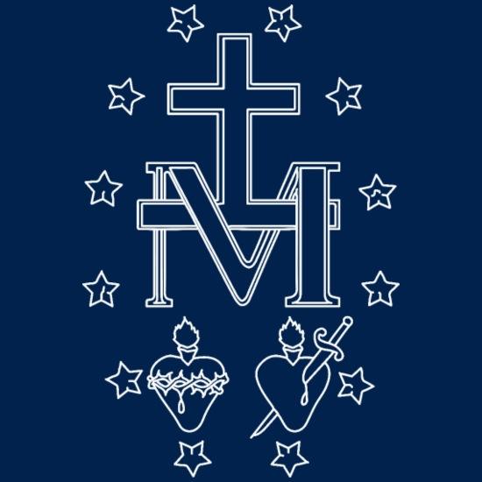

The Church, which God gave us to hand down the faith, has always understood Blessed Virgin Mary to be the fulfillment of the ark of the covenant and the sign of Holy Mother Church (Rev 12:17).

*The spouse of Christ cannot be defiled, she is inviolate and chaste; she knows one home alone, in all modesty she keeps faithfully to one only couch. It is she who rescues us for God, she who seals for the kingdom the sons whom she has borne. Whoever breaks with the Church and enters on an adulterous union, cuts himself off from the promises made to the Church; and he who has turned his back on the Church of Christ shall not come to the rewards of Christ: he is an alien, a worldling, an enemy. You cannot have God for your Father if you have not the Church for your mother. If there was escape for anyone who was outside the ark of Noe, there is escape too for one who is found to be outside the Church. Our Lord warns us when He says: ‘He that is not with me is against me, and he that gathereth not with me, scattereth.’ Whoever breaks the peace and harmony of Christ acts against Christ; whoever gathers elsewhere than in the Church, scatters the Church of Christ.* (St. Cyprian of Carthage, *The Unity of the Church*, Chapter 6, **251 A.D.**)

*Now I do not deny of course, that under the image of the Woman, the Church is signified; but what I would maintain is this, that the Holy Apostle would not have spoken of the Church under this particular image, unless there had existed a blessed Virgin Mary, who was exalted on high, and the object of veneration to all the faithful. No one doubts that the “man-child” spoken of is an allusion to our Lord: why then is not “the Woman” an allusion to His Mother? This surely is the obvious sense of the words; of course they have a further sense also, which is the scope of the image; doubtless the Child represents the children of the Church, and doubtless the Woman represents the Church; this, I grant, is the real or direct sense, but what is the sense of the symbol under which that real sense is conveyed? who are the Woman and the Child? I answer, they are not personifications but Persons. This is true of the Child, therefore it is true of the Woman. But again: not only Mother and Child, but a serpent is introduced into the vision. Such a meeting of man, woman, and serpent has not been found in Scripture, since the beginning of Scripture, and now it is found in its end.*

(St. John Henry Newman, *Letter to Rev. Pusey*, **1900 A.D.**)

**VIRGIN MOTHER**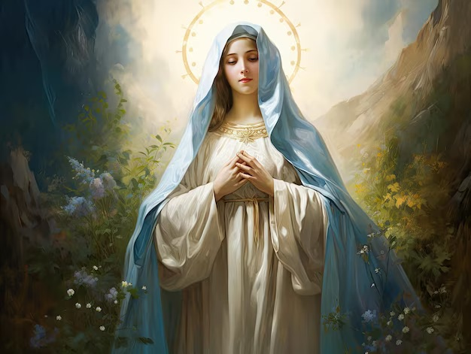

**BLESSED QUEEN**

**VIRGIN MOTHER**

**ARK OF THE COVENANT**

**HOLY MOTHER CHURCH**

Blessed Mother Mary

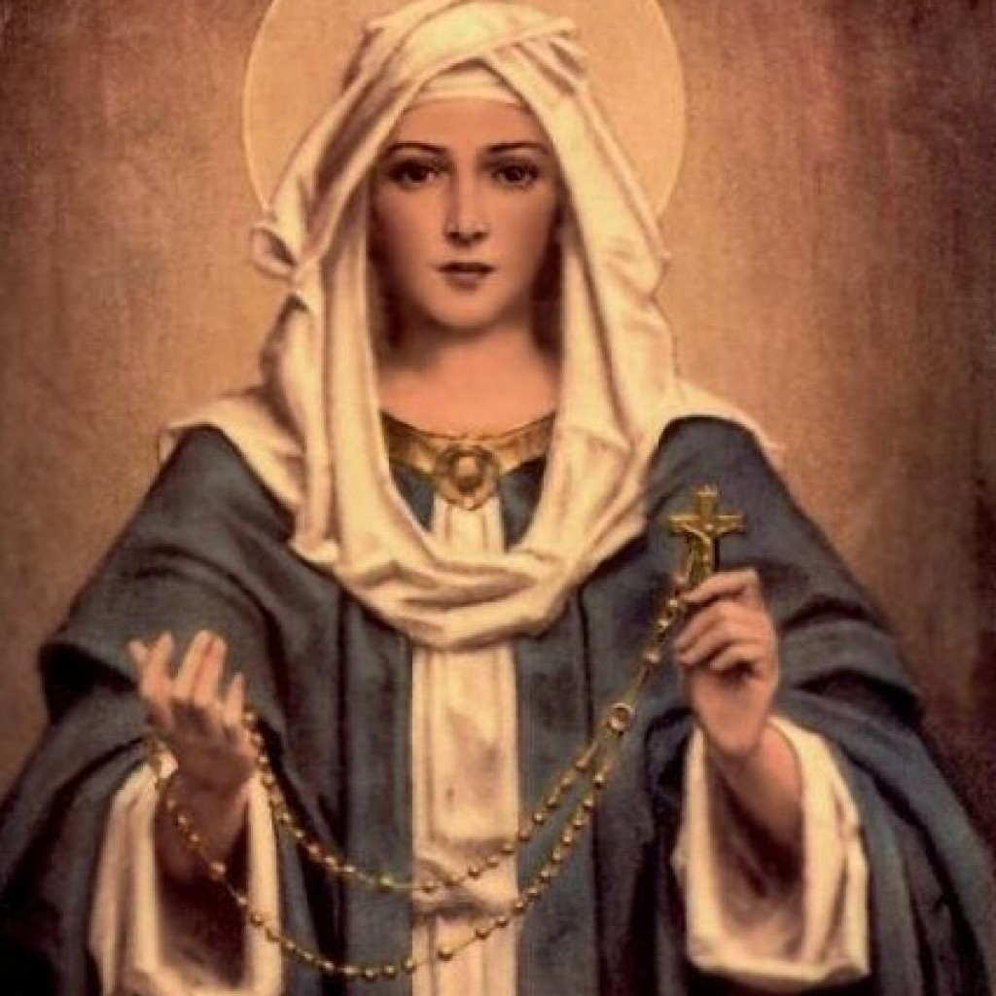

*To a virgin espoused to a man whose name was Joseph, of the house of David: and the virgin's name was Mary…. Behold thou shalt conceive in thy womb and shalt bring forth a son: and thou shalt call his name Jesus…. And Mary said to the angel: How shall this be done, because I know not man. (Luke 1:27,31,34)*

Standing beneath the cross: *Among whom was Mary Magdalen and Mary the mother of James and Joseph and the mother of the sons of Zebedee.* (Mt 27:56).

*…among whom was Mary Magdalen and Mary the mother of James the Less and of Joseph and Salome,* (Mk 15:40).

*Now there stood by the cross of Jesus, his mother and his mother's sister, Mary of Cleophas, and Mary Magdalen.* (Jn 19:25)

The terms *brother/sister* had a wider meaning in Sacred Scripture. Lot is described as Abraham’s *brother* in Gen 14:14, but Lot was the son of Aran, Abraham’s deceased brother (Gen 11:26- 28). Lot was Abraham’s nephew. Jacob is called the brother of his uncle, Laban (Gen 29:15). Examples are numerous. The words could even refer to people apparently unrelated such as a friend (2 Sam 1:26, 1 Kings 9:13) or just an ally (Amos 1:9). Mary, the wife of Cleophas, is described as Mary’s *sister*. It is unlikely that the parents of Mary gave their children the same name.

According to Hegesippus, a **2nd century** historian, Cleophas was the brother of Joseph, the foster father of Jesus. James and Simon (Mt 13:55), Bishops and martyrs of the early Church, are Joseph’s nephews and are cousins of Jesus. (Eusebius, *Church History*, 3.11.1-2;4.22, **315 A.D.**)

*And the temple of God was opened in heaven: and the ark of his testament was seen in his temple. And there were lightnings and voices and an earthquake and great hail. And a great sign appeared in heaven: A woman clothed with the sun, and the moon under her feet, and on her head a crown of twelve stars…. And she brought forth a man child, who was to rule all nations with an iron rod. And her son was taken up to God and to his throne.* (Rev 11:19-12:1,5)

*Christ became man by the Virgin, in order that the disobedience that proceeded from the serpent might receive its destruction in the same manner in which it derived its origin. For Eve, who was a virgin and undefiled, having conceived the word of the serpent, brought forth disobedience and death. But the Virgin Mary received faith and joy when Gabriel announced the good tidings to her that the Spirit of the Lord would come upon her, and the power of the Highest would overshadow her: wherefore also the Holy Thing begotten of her is the Son of God; and she replied, “Be it unto me according to Thy word” (Lk 1:38). And by her has He been born, to Whom we have proved so many Scriptures refer, and by Whom God destroys both the serpent and those angels and men who are like him.*

(St. Justin Martyr, *Dialogue with Trypho*, 100, **150 A.D.**)

…Mary, though she had a man destined for her beforehand, yet nevertheless a virgin, was obedient and was made the cause of salvation for herself and the entire human race…. the knot of Eve’s disobedience was untied by Mary’s obedience. For what the virgin Eve tied by her unbelief, this Mary untied by her belief. (St. Irenaeus, *Against the Heresies*, 3.22.4, **180 A.D.**)

*The Lord was made without sin, made in His human nature of incorruptible wood, that is to say, of the Virgin and the Holy Spirit, overlaid within and without, as it were, by purest gold of the word of God…*

(St. Hippolytus, *Discourse on Psalm 23*, **2nd–3rd century A.D.)**

*O noble Virgin, truly you are greater than any other greatness. For who is your equal in greatness, O dwelling place of God the Word? O [Ark of the New] Covenant, clothed with purity instead of gold! You are the Ark in which is found the golden vessel containing the true manna, that is, the flesh in which divinity resides…You carry within you the feet, the head, and the entire body of the perfect God…you are God’s place of repose.* (St. Athanasius, *Homily from the Papyrus of Turin*, **4th century A.D.)**

**ARK OF THE COVENANT**

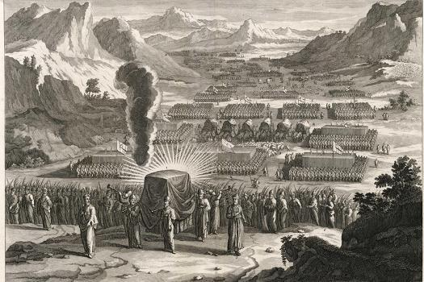

Cloud of glory covered the ark (Ex 40:34-35; Num 9:15). *And the angel answering, said to her: The Holy Ghost shall come upon thee and the power of the Most High shall overshadow thee…* (Lk 1:35)

*And David arose and went, with all the people that were with him of the men of Juda to fetch the ark of God…* (2 Sam 6:2)

*And Mary rising up in those days, went into the hill country with haste into a city of Juda.* (Lk 1:39)

*And David was afraid of the Lord that day, saying: How shall the ark of the Lord come to me?* (2 Sam 6:9)

*And whence is this to me that the mother of my Lord should come to me?* (Lk 1:43

*And he would not have the ark of the Lord brought into himself in to the city of David: but he caused it to be carried into the house of Obededom the Gethite.* (2 Sam 6:10)

*And she entered into the house of Zachary and saluted Elizabeth.* (Lk 1:40)

*And the ark of the Lord abode in the house of Obededom the Gethite three months: and the Lord blessed Obededom, and all his household.* (2 Sam 6:11)

*And Mary abode with her about three months. And she returned to her own house.* (Luke 1:56)

**BLESSED QUEEN**

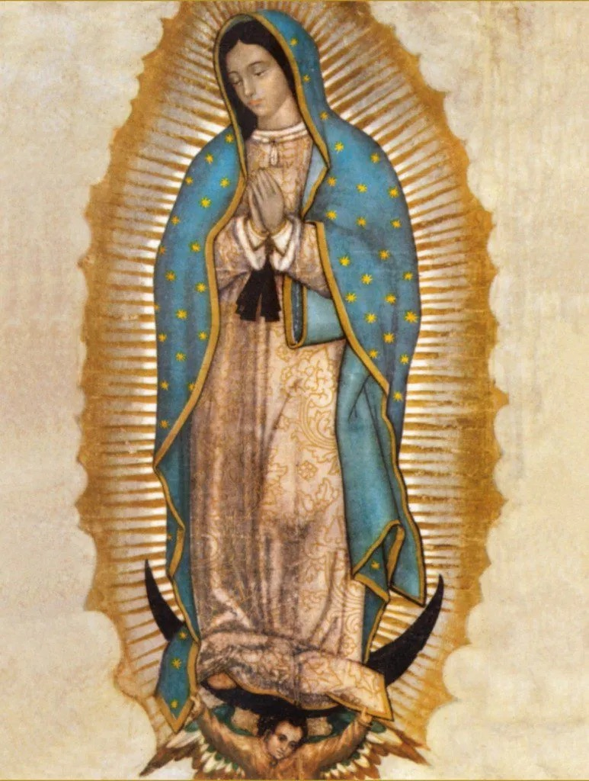

*And in the sixth month, the angel Gabriel was sent from God into a city of Galilee, called Nazareth, To a virgin espoused to a man whose name was Joseph, of the house of David: and the virgin's name was Mary. And the angel being come in, said unto her: Hail, full of grace, the Lord is with thee: blessed art thou among women.* (Lk 1:26-28)

*…And Elizabeth was filled with the Holy Ghost. And she cried out with a loud voice and said: Blessed art thou among women and blessed is the fruit of thy womb…. And Mary said: My soul doth magnify the Lord. And my spirit hath rejoiced in God my Saviour. Because he hath regarded the humility of his handmaid: for behold from henceforth all generations shall call me blessed.*

(Lk 1:41-42,46-48)

The *throne* of David’s *kingdom* was established *forever*

(2 Sam 7:13).

*…Jesus came in Galilee, preaching the gospel of the kingdom of God, And saying: The time is accomplished and the kingdom of God is at hand. Repent and believe the gospel:* (Mk 1:14-15)

*Queen Mother* (Hebrew *gebirah*) is the feminine form of *master*. It has also been translated as *great lady* or *mistress* (1 Kg 15:13; 2 Ch 15:16; Jer 29:2). In the genealogical introduction of each new king, it is the king’s mother, not his wife, who is recorded (1 Kg 15:1-2).

*So Bathsheba went to King Solomon, to speak to him on behalf of Adonijah. And the king rose to meet her, and bowed down to her; then he sat on his throne, and had a throne brought for the king’s mother; and she sat on his right.* (1 Kings 2:19–20)

*Must there not therefore be a Mother of God who bore God incarnate? Assuredly she who played the part of the Creator’s servant and mother is in all strictness and truth in reality God’s Mother and Lady and Queen over all created things.* (St. John Damascene, *On the Orthodox Faith*, 4.14, **8th century A.D.**)