

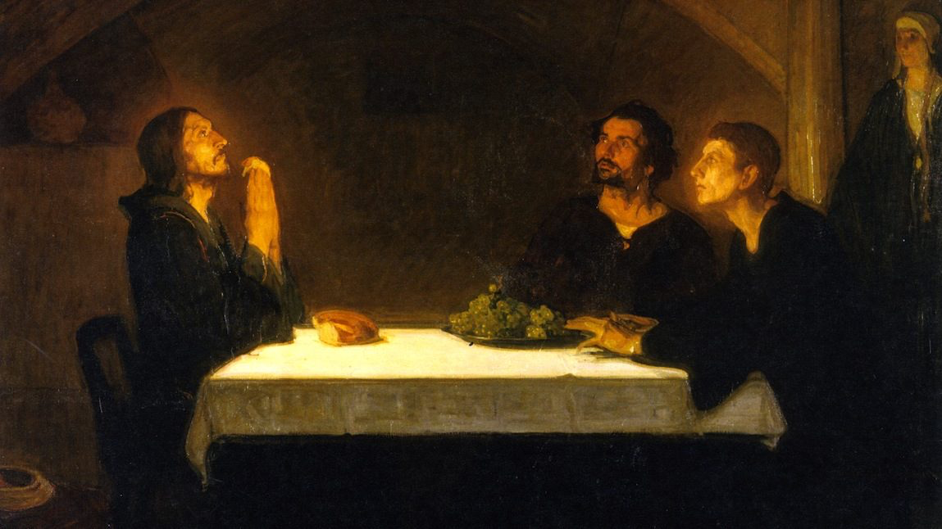

What then shall we say to this? If God is for us, who is against us? He who did not spare his own Son but gave him up for us all, will he not also give us all things with him? Who shall bring any charge against God’s elect? It is God who justifies; who is to condemn? Is it Christ Jesus, who died, yes, who was raised from the dead, who is at the right hand of God, who indeed intercedes for us? Who shall separate us from the love of Christ? Shall tribulation, or distress, or persecution, or famine, or nakedness, or peril, or sword? As it is written, “For your sake we are being killed all the day long; we are regarded as sheep to be slaughtered.” No, in all these things we are more than conquerors through him who loved us. For I am sure that neither death, nor life, nor angels, nor principalities, nor things present, nor things to come, nor powers, nor height, nor depth, nor anything else in all creation, will be able to separate us from the love of God in Christ Jesus our Lord.

(Romans 8:31-39)

When we cry, “Abba! Father!” it is the Spirit himself bearing witness with our spirit that we are children of God, and if children, then heirs, heirs of God and fellow heirs with Christ, provided we suffer with him in order that we may also be glorified with him.

(Romans 8:15-17)

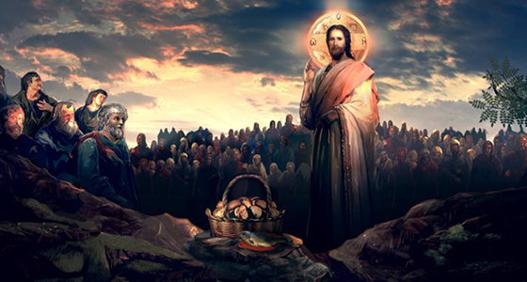

“So if you are offering your gift at the altar, and there remember that your brother has something against you, leave your gift there before the altar and go; first be reconciled to your brother, and then come and offer your gift. Make friends quickly with your accuser, while you are going with him to court, lest your accuser hand you over to the judge, and the judge to the guard, and you be put in prison; truly, I say to you, you will never get out till you have paid the last penny.”

(Matthew 5:23-26)

“Then the King will say to those at his right hand, ‘Come, O blessed of my Father, inherit the kingdom prepared for you from the foundation of the world; for I was hungry and you gave me food, I was thirsty and you gave me drink, I was a stranger and you welcomed me, I was naked and you clothed me, I was sick and you visited me, I was in prison and you came to me.’ Then the righteous will answer him, ‘Lord, when did we see you hungry and feed you, or thirsty and give you drink? And when did we see you a stranger and welcome you, or naked and clothe you? And when did we see you sick or in prison and visit you?’ And the King will answer them, ‘Truly, I say to you, as you did it to one of the least of these my brethren, you did it to me.’” (Matthew 25:34-40)

"

God, infinitely perfect and blessed in himself, in a plan of sheer goodness freely created man to make him share in his own blessed life. For this reason, at every time and in every place, God draws close to man. He calls man to seek him, to know him, to love him with all his strength. He calls together all men, scattered and divided by sin, into the unity of his family, the Church. To accomplish this, when the fullness of time had come, God sent his Son as Redeemer and Savior. In his Son and through him, he invites men to become, in the Holy Spirit, his adopted children and thus heirs of his blessed life.

(Catechism of the Catholic Church, 1.)

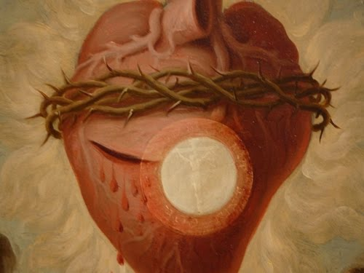

“Abide in me, and I in you. As the branch cannot bear fruit by itself, unless it abides in the vine, neither can you, unless you abide in me. I am the vine, you are the branches. He who abides in me, and I in him, he it is that bears much fruit, for apart from me you can do nothing. If a man does not abide in me, he is cast forth as a branch and withers; and the branches are gathered, thrown into the fire and burned. If you abide in me, and my words abide in you, ask whatever you will, and it shall be done for you. By this my Father is glorified, that you bear much fruit, and so prove to be my disciples. As the Father has loved me, so have I loved you; abide in my love. If you keep my commandments, you will abide in my love, just as I have kept my Father’s commandments and abide in his love. These things I have spoken to you, that my joy may be in you, and that your joy may be full. “This is my commandment, that you love one another as I have loved you. Greater love has no man than this, that a man lay down his life for his friends. You are my friends if you do what I command you. No longer do I call you servants, for the servant does not know what his master is doing; but I have called you friends, for all that I have heard from my Father I have made known to you. You did not choose me, but I chose you and appointed you that you should go and bear fruit and that your fruit should abide; so that whatever you ask the Father in my name, he may give it to you. This I command you, to love one another.”

(John 15:4-17)

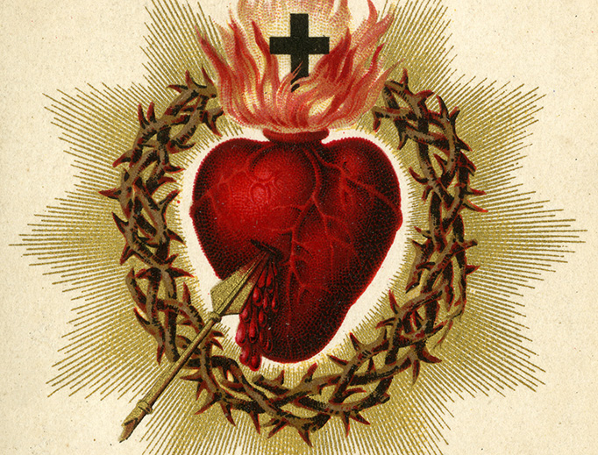

Beloved, let us love one another; for love is of God, and he who loves is born of God and knows God. He who does not love does not know God; for God is love. In this the love of God was made manifest among us, that God sent his only-begotten Son into the world, so that we might live through him. In this is love, not that we loved God but that he loved us and sent his Son to be the expiation for our sins. Beloved, if God so loved us, we also ought to love one another. No man has ever seen God; if we love one another, God abides in us and his love is perfected in us. By this we know that we abide in him and he in us, because he has given us of his own Spirit. And we have seen and testify that the Father has sent his Son as the Savior of the world. Whoever confesses that Jesus is the Son of God, God abides in him, and he in God. So we know and believe the love God has for us. God is love, and he who abides in love abides in God, and God abides in him. In this is love perfected with us, that we may have confidence for the day of judgment, because as he is so are we in this world. There is no fear in love, but perfect love casts out fear. For fear has to do with punishment, and he who fears is not perfected in love. We love, because he first loved us. If any one says, “I love God,” and hates his brother, he is a liar; for he who does not love his brother whom he has seen, cannot love God whom he has not seen. And this commandment we have from him, that he who loves God should love his brother also.

(1 John 4:7-21)



And you he made alive, when you were dead through the trespasses and sins in which you once walked, following the course of this world, following the prince of the power of the air, the spirit that is now at work in the sons of disobedience. Among these we all once lived in the passions of our flesh, following the desires of body and mind, and so we were by nature children of wrath, like the rest of mankind. But God, who is rich in mercy, out of the great love with which he loved us, even when we were dead through our trespasses, made us alive together with Christ (by grace you have been saved), and raised us up with him, and made us sit with him in the heavenly places in Christ Jesus, that in the coming ages he might show the immeasurable riches of his grace in kindness toward us in Christ Jesus. For by grace you have been saved through faith; and this is not your own doing, it is the gift of God—not because of works, lest any man should boast. For we are his workmanship, created in Christ Jesus for good works, which God prepared beforehand, that we should walk in them.

(Ephesians 2:2-10)