HOLY

Mother CHURCH

**HOLY COMMUNION**

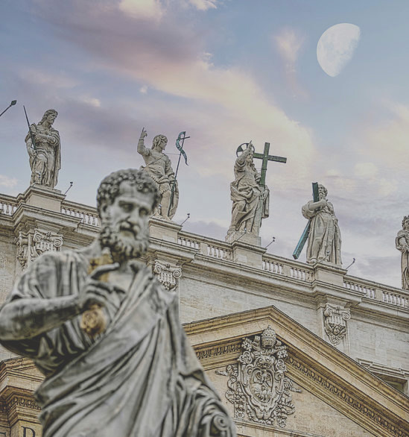

And this food is called among us [Εὐχαριστία] [the Eucharist], of which no one is allowed to partake but the man who believes that the things which we teach are true, and who has been washed with the washing that is for the remission of sins, and unto regeneration, and who is so living as Christ has enjoined. For not as common bread and common drink do we receive these; but in like manner as Jesus Christ our Saviour, having been made flesh by the Word of God, had both flesh and blood for our salvation, so likewise have we been taught that the food which is blessed by the prayer of His word, and from which our blood and flesh by transmutation are nourished, is the flesh and blood of that Jesus who was made flesh.…  
….And we afterwards continually remind each other of these things. And the wealthy among us help the needy; and we always keep together; and for all things wherewith we are supplied, we bless the Maker of all through His Son Jesus Christ, and through the Holy Ghost. And on the day called Sunday, all who live in cities or in the country gather together to one place, and the memoirs of the apostles or the writings of the prophets are read, as long as time permits; then, when the reader has ceased, the president verbally instructs, and exhorts to the imitation of these good things. Then we all rise together and pray, and, as we before said, when our prayer is ended, bread and wine and water are brought, and the president in like manner offers prayers and thanksgivings, according to his ability, and the people assent, saying Amen; and there is a distribution to each, and a participation of that over which thanks have been given, and to those who are absent a portion is sent by the deacons. And they who are well to do, and willing, give what each thinks fit; and what is collected is deposited with the president, who succours the orphans and widows and those who, through sickness or any other cause, are in want, and those who are in bonds and the strangers sojourning among us, and in a word takes care of all who are in need. But Sunday is the day on which we all hold our common assembly, because it is the first day on which God, having wrought a change in the darkness and matter, made the world; and Jesus Christ our Saviour on the same day rose from the dead….

(Justin Martyr, *First Apology*, Chapter 66-67, **151 A.D., friend of Saint Irenaeus, martyred by beheading**)

**HEAR ME**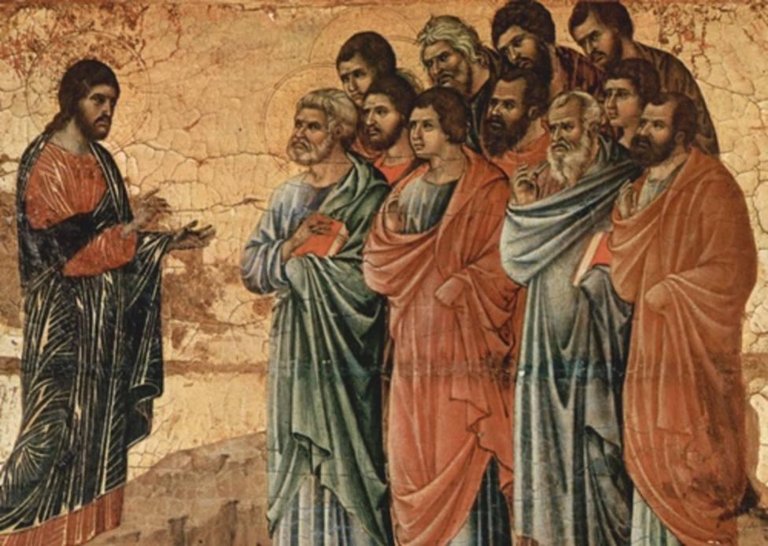

*But if thy brother shall offend against thee, go, and rebuke him between thee and him alone. If he shall hear thee, thou shalt gain thy brother. And if he will not hear thee, take with thee one or two more: that in the mouth of two or three witnesses every word may stand. And if he will not hear them: tell the church. And if he will not hear the church, let him be to thee as the heathen and publican. Amen I say to you, whatsoever you shall bind upon earth, shall be bound also in heaven: and whatsoever you shall loose upon earth, shall be loosed also in heaven.* (Matthew 18:15-18)

*And the eleven disciples went into Galilee, unto the mountain where Jesus had appointed them. And seeing him they adored: but some doubted. And Jesus coming, spoke to them, saying: All power is given to me in heaven and in earth. Going therefore, teach ye all nations, baptizing them in the name of the Father, and of the Son, and of the Holy Ghost. Teaching them to observe all things whatsoever I have commanded you: and behold I am with you all days, even to the consummation of the world.* (Matthew 28:16-20)

*He said therefore to them again: Peace be to you. As the Father hath sent me, I also send you. When he had said this, he breathed on them; and he said to them: Receive ye the Holy Ghost. Whose sins you shall forgive, they are forgiven them; and whose sins you shall retain, they are retained.* (John 16:21-23)

*In those days Peter rising up in the midst of the brethren, said (now the number of persons together was about an hundred and twenty): Men, brethren, the scripture must needs be fulfilled, which the Holy Ghost spoke before by the mouth of David concerning Judas, who was the leader of them that apprehended Jesus: Who was numbered with us, and had obtained part of this ministry….For it is written in the book of Psalms: Let their habitation become desolate, and let there be none to dwell therein. And his bishopric let another take…. And praying, they said: Thou, Lord, who knowest the heart of all men, shew whether of these two thou hast chosen, To take the place of this ministry and apostleship, from which Judas hath by transgression fallen, that he might go to his own place. And they gave them lot, and the lot fell upon Matthias, and he was numbered with the eleven apostles.* (Acts 1:15-26)

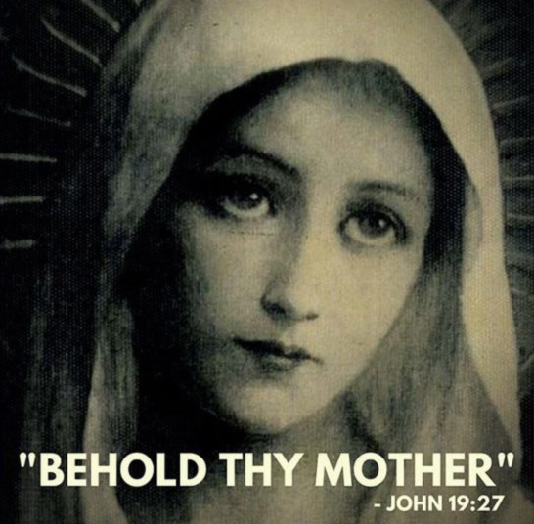

**UPON CEPHAS**

**HEAR ME**

**APOSTOLIC CHRISTIANITY**

**HOLY COMMUNION**

In like manner should the deacons be blameless before the face of His righteousness, as being the servants of God and Christ, and not of men. They must not be slanderers, double-tongued, or lovers of money, but temperate in all things, compassionate, industrious, walking according to the truth of the Lord, who was the servant of all. If we please Him in this present world, we shall receive also the future world, according as He has promised to us that He will raise us again from the dead, and that if we live worthily of Him, we shall also reign together with Him, provided only we believe. In like manner, let the young men also be blameless in all things, being especially careful to preserve purity, and keeping themselves in, as with a bridle, from every kind of evil. For it is well that they should be cut off from the lusts that are in the world, since every lust wars against the spirit; and neither fornicators, nor effeminate, nor abusers of themselves with mankind, shall inherit the kingdom of God, nor those who do things inconsistent and unbecoming. Wherefore, it is needful to abstain from all these things, being subject to the presbyters and deacons, as unto God and Christ. The virgins also must walk in a blameless and pure conscience.

(Saint Polycarp, *Epistle to the Philippians*, Chapter 5, **150 A.D., consecrated by Saint John the Apostle, martyred by burning and spear**)

Suppose there arise a dispute relative to some important question among us, should we not have recourse to the most ancient Churches with which the apostles held constant intercourse, and learn from them what is certain and clear in regard to the present question? For how should it be if the apostles themselves had not left us writings? Would it not be necessary, [in that case,] to follow the course of the tradition which they handed down to those to whom they did commit the Churches?....

….The true gnosis [knowledge] is the doctrine of the Apostles, and the ancient organization of the Church throughout the whole world, and the manifestations of the body of Christ according to the successions of bishops, by which successions the bishops have handed down the Church which is found everywhere; and the very complete tradition of the Scriptures, which have come down to us by being guarded against falsification, and which are received without addition or deletion; and reading without falsification, and a legitimate and diligent exposition according to the Scriptures, without danger and without blasphemy; and the preeminent gift of love, which is more precious than knowledge, more glorious than prophecy, and more honored than all the other charismatic gifts.

(Saint Irenaeus of Lyons, *Against Heresies* Book 3 4:1; Book 4, 33:8, **180 A.D., student of Saint Polycarp**)

**APOSTOLIC CHRISTIANITY**

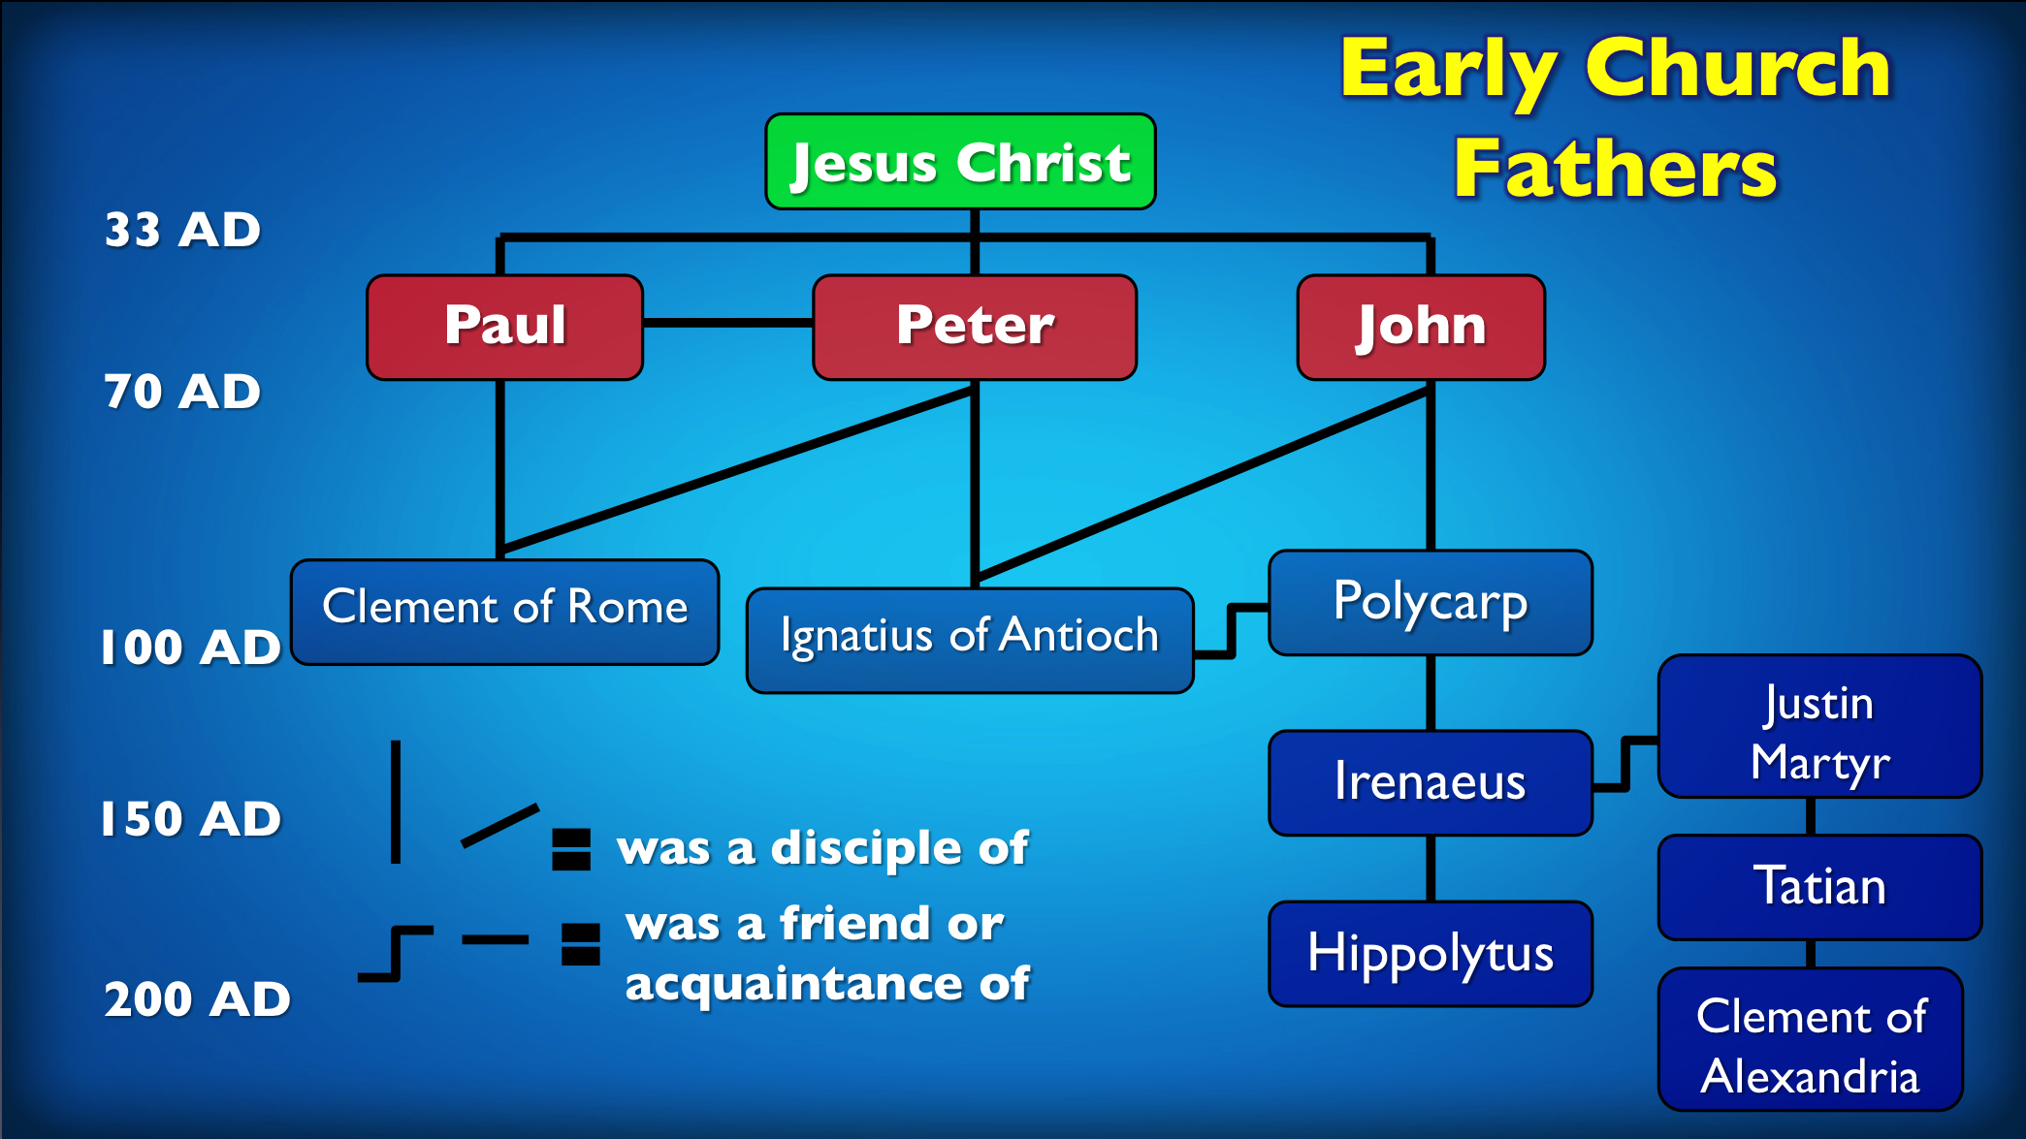

**Christianity is a historical reality. God gives you His One, Apostolic, Catholic, Holy Church, for your salvation. Humble conformity to God’s Traditional Church is true conformity to God’s gift of salvation.**

Our apostles also knew, through our Lord Jesus Christ, that there would be strife on account of the office of the episcopate. For this reason, therefore, inasmuch as they had obtained a perfect foreknowledge of this, they appointed those [ministers] already mentioned, and afterwards gave instructions, that when these should fall asleep, other approved men should succeed them in their ministry.

(Pope Saint Clement of Rome, *Epistle to the Corinthians*, Chapter 44, **95 A.D., consecrated by Saint Paul the Apostle, martyred by drowning**)

You must all follow the lead of the bishop, as Jesus Christ followed that of the Father; follow the presbytery as you would the Apostles; reverence the deacons as you would God’s commandment. Let no one do anything touching the Church, apart from the bishop. Let that celebration of the Eucharist be considered valid which is held under the bishop or anyone to whom he has committed it. Where the bishop appears, there let the people be, just as where Jesus Christ is, there is the Catholic Church. It is not permitted without authorization from the bishop either to baptize or to hold an agape; but whatever he approves is also pleasing to God. Thus everything you do will be proof against danger and valid.

(St. Ignatius of Antioch, *The Epistle to the Smyrnaeans*, Chapter 8, **110 A.D., consecrated by Saint Peter the Apostle/First Pope, student of Saint John, martyred by lions**)

**UPON CEPHAS**

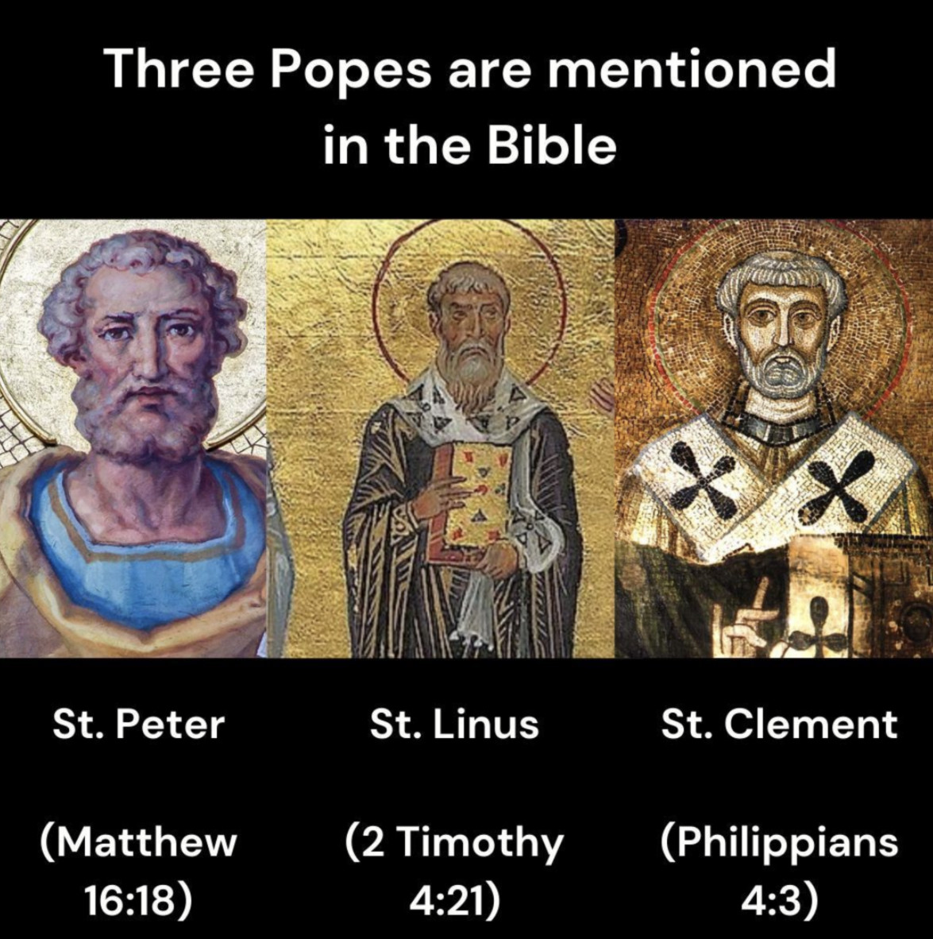

**\**Cephas*/*Kephas* is the Aramaic word for *Rock***

*And he brought him to Jesus. And Jesus looking upon him, said: Thou art Simon the son of Jona. Thou shalt be called Cephas, which is interpreted Peter.*

(John 1:42)

*And he made that twelve should be with him, and that he might send them to preach. And he gave them power to heal sicknesses, and to cast out devils. And to Simon he gave the name Peter.*

(Mark 3:14-16)

*And Jesus answering said to him: Blessed art thou, Simon Bar-Jona: because flesh and blood hath not revealed it to thee, but my Father who is in heaven. And I say to thee: That thou art Peter; and upon this rock I will build my church, and the gates of hell shall not prevail against it. And I will give to thee the keys of the kingdom of heaven. And whatsoever thou shalt bind upon earth, it shall be bound also in heaven: and whatsoever thou shalt loose on earth, it shall be loosed also in heaven.*

(Matthew 16:17-19)

*And I dispose to you, as my Father hath disposed to me, a kingdom; That you may eat and drink at my table, in my kingdom: and may sit upon thrones, judging the twelve tribes of Israel. And the Lord said: Simon, Simon, behold Satan hath desired to have you, that he may sift you as wheat. But I have prayed for thee, that thy faith fail not: and thou, being once converted, confirm thy brethren.*

(Luke 22:29-32)

*He said to him: Feed my sheep.*

(John 21:17)