VILLAGE OF COLUMBUS GROVE
January 11, 2022
The Village of Columbus Grove met in regular session on Monday, January 11, 2022, at 7:30 pm at Columbus Grove Community Center with Mayor Ken Wright presiding. Council members in attendance were Brian Schroeder, Todd Wolfe, Pete Langhals, Skyler Mayberry, Gretchen Staley and Aaron Siefker. Also attended: Village Administrator Jeff Vance, and Police Chief Sean Hiler & Captain Russell Lammers.
Mayor Wright swore in the newly elected Council members. Skyler Mayberry, Brian Schroeder, Pete Langhals, and Todd Wolfe.
Mayor Wright read the Village Address: 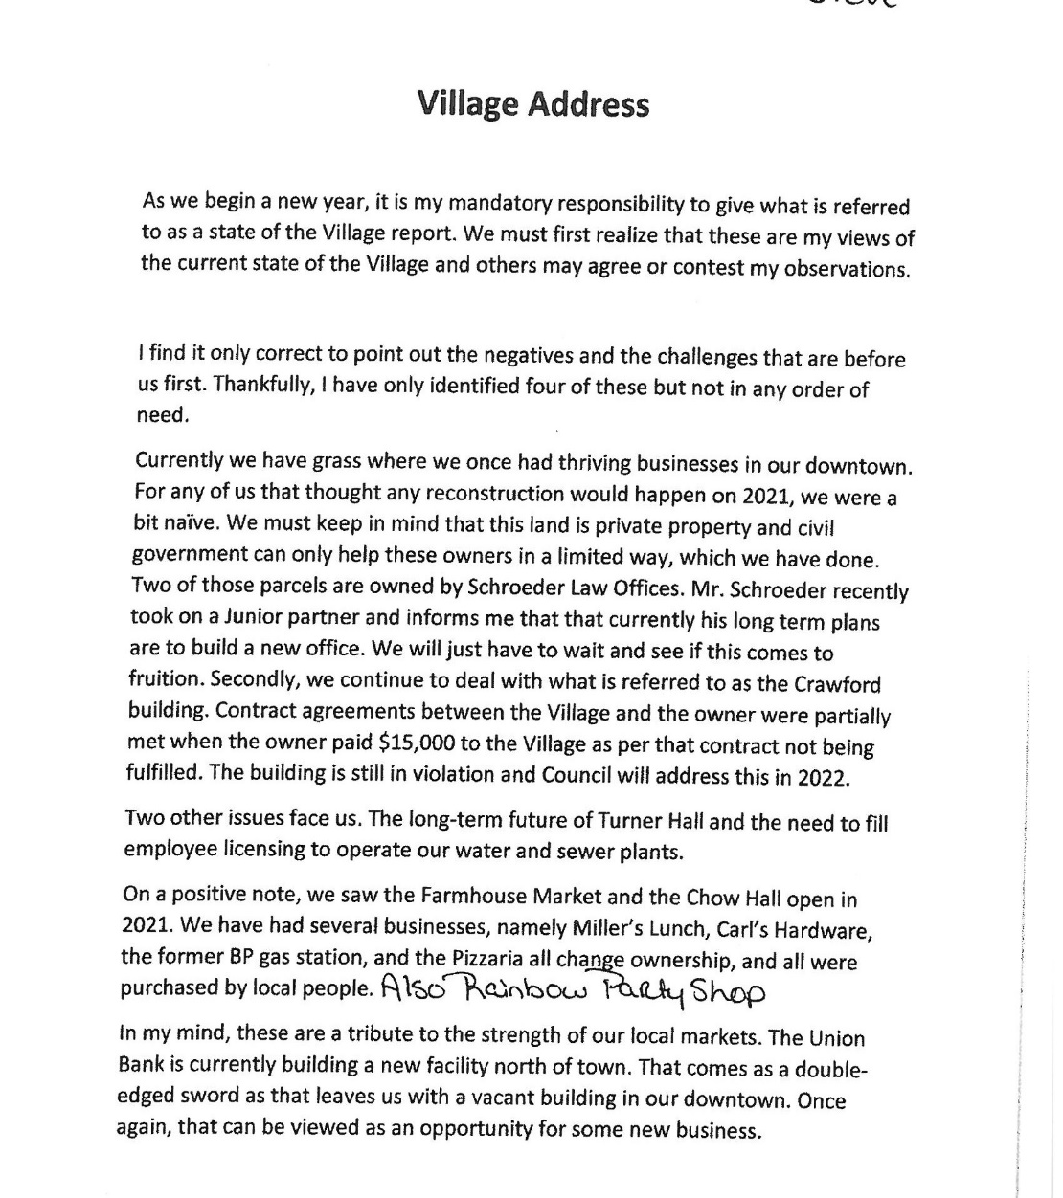
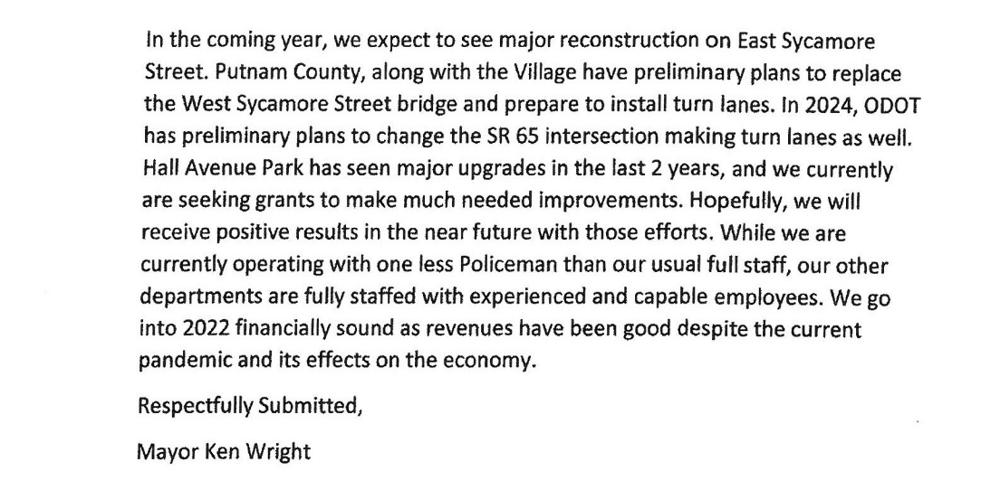
Committees Were assigned to Council members and asked that they keep in mind that replacements are needed for the Tax Commission and also the Board of Zoning Appeals.
Mr. Langhals made motion to approve the minutes from December 13, 2021 meeting. Mr. Mayberry seconded the motion. Motion carried. 6 yeas, 0 nay
Visitors: John Bryan was here to observe the meeting
Mr. Schroeder made a motion to approve the bills from 12-14-21 to 01-10-22. Mr. Siefker seconded the motion. Motion carried. 6 yeas, 0 nay
VILLAGE OF COLUMBUS GROVE
January 11, 2022
All end of the month and end of the quarter reports were given to Council.
Ms. Kerns asked to schedule a Finance Comm Meeting. Committee agreed to Monday January 24, 2022 at 7:00 pm in council chambers.
Chief Hiler asked that at the end of the meeting to go into executive session to discuss personnel.
Chief asked council permission to look into getting a new cruiser. 5-2 is over 80,000 miles and it’s time to replace, at this time it will take over a year to get a new one. Council agreed for Chief to get prices.
There are several junk vehicles that need to be addressed. Chief explained that once he gets back from maternity leave and the new ordinance is passed, they will get to work on getting the issues resolved.
Chief also discussed security cameras, he still waiting on the other company for another quote.
Mr. Vance received an email from the Putnam County YMCA. The Village of Ottawa is looking into offering their residents to enter their pool for free with the support of local businesses. Council all agreed to leave our contract the way it is.
Mr. Vance also discussed the West Sycamore bridge being replaced. The Village will have some cost in it but can be paid through the permissive tax fund. We will have to extend the street, and this will all be worked into one contract/1 project for the whole thing. We will have 2 seasons with that section of Sycamore Street being torn up, and when the bridge goes down, we will have to completely close that section of Sycamore Street off. The bridge will be concrete.
The rest of the concrete has been poured in Hall Ave Park, and we will be ready for baseball season in the Spring.
Some information was given to Council and Mr. Vance asked that Council go through it and he would like to talk about it next time. His thought was to use it for a new ramp/ sign and re-do the front of the City Building.
Water loss report was given to Council, some months were higher than others and Mr. Vance explained that he would like to see each month around 15%. He would like to do another water audit in the spring.
Mr. Vance asked to schedule a Building Committee meeting to discuss the salt shed and where to put it. Committee agreed to meet on Thursday January 20th at 5:00pm.
Mr. Vance also asked to Schedule a Park and Rec Committee meeting. Mr. Siefker will check his schedule and get back to the Committee members.
Chief Hiler asked Mr. Vance if there were any places to put the cruisers down at the shop. Mr. Vance will work on getting spots cleared out for them.
Mr. Mayberry asked about the school’s involvement with the Safe Walks grant and how this was coming along. Mr. Vance will look into this.
Mr. Schroeder asked if the school had gotten back to Mr. Vance regarding the soccer field. Mr. Vance has not heard and will look into this as well.
Mr. Langhals made a motion for the 1st reading of Ordinance 2022-01 Regulating junk & abandoned motor vehicles. Mr. Schroeder seconded the motion. Motion carried 6 yeas, 0 nay
Mayor Wright wanted Council to know that the Turner Hall Committee will be meeting this Thursday the 6th at 7:00 pm at Turner Hall.
The county will be filling in the ditch in front of the Mayors house and will be starting this week.
Ms. Staley made a motion to go into executive session to discuss personnel and contracts. Mr. mayberry seconded the motion. Motion carried 6 yeas, 0 nay @ 8:14 pm
Ms. Staley made a motion to leave executive session. Mr. Mayberry seconded the motion. Motion carried 6 yeas, 0 nay at 8:31 pm
VILLAGE OF COLUMBUS GROVE
January 11, 2022

Mr. Schroeder made a motion to hire Sara Brown-Pucket for a full time Police Officer at $18.10 per hour. Ms. Staley seconded the motion. Motion carried 6 yeas, 0 nay
Mayor Wright announced that it was time to appoint someone to attend a Sunshine Laws meeting. Ms. Kerns will be attending this meeting.
Mr. Mayberry made a motion to adjourn the meeting. Mr. Siefker seconded the motion. Motion carried 6 yeas, o nay at 8:34 pm

_____________________________________ _____________________________________
Clerk Mayor

