1. Fold paper in half to get the full face
2. If covering with colored paper, use this template to
trace and cut colored pieces.
3. Cut places where things overlap or bend to connect
(with the nose)
Note:
Watch the video for full instructions:
https://youtu.be/SvzXKvjYG34

and if you want to color it:
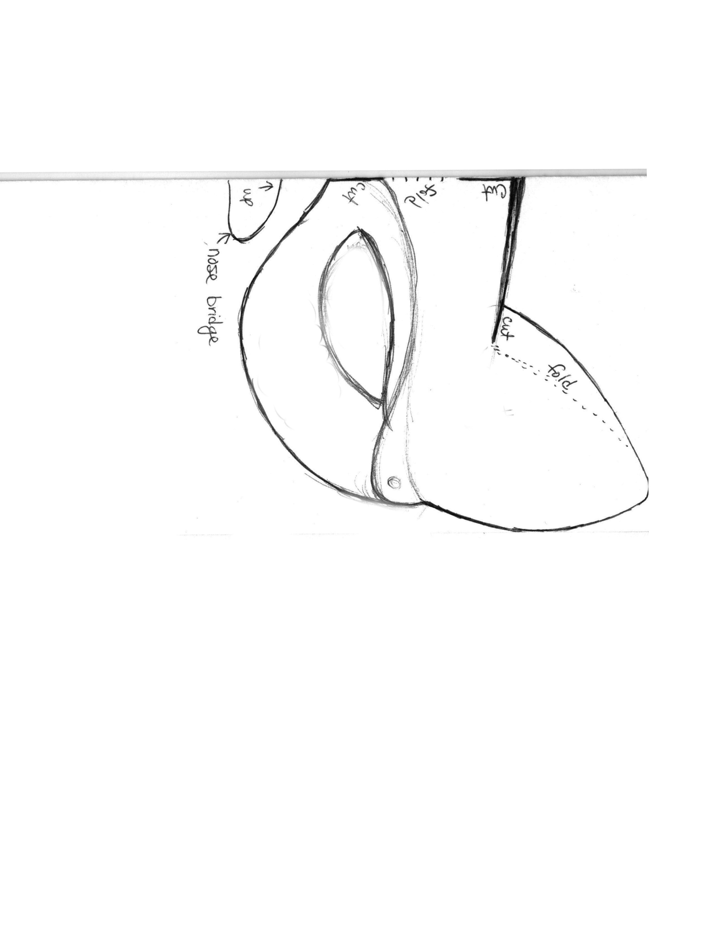
https://youtu.be/lVkIMj3UEmc

