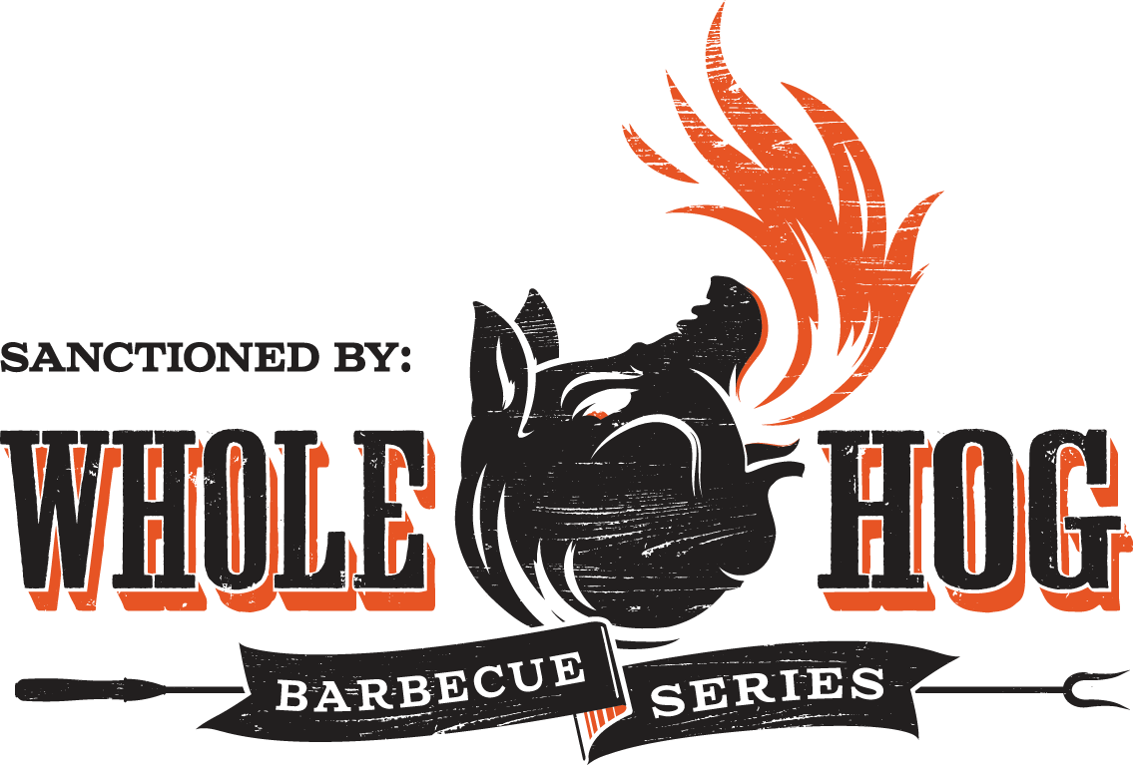

**22nd Annual NC Blueberry Festival Whole Hog Barbecue Cook-Off Friday, June 20, 2025**

**NC Pork Council Rules shall apply to this event** [**info@ncblueberryfestival.com**](mailto:info@ncblueberryfestival.com)

**910.259.2007**

**Team Information:**

Team Name

Chief Cook (All correspondence will be with the Chief Cook)

Address E-mail City State Zip Telephone (Cell) (Home/Office)

**Assistant Cooks:** (minimum of 1, maximum of 3)

1.

2.

3.

**Space Information:**

Each team will be allocated one 12’ x 20’ outside space. Each team must provide their own shelter if desired. Cooks must have documentation or labels on tents saying that tents are fireproof and should also have a fire extinguisher. If you require a larger cooking area, describe in detail your reasons, including sizes of grills, props, and any other items used in cooking set-up. Attach additional sheet if needed.

**Payment Information:**

A **$100.00 non-refundable entry** fee must be received with each entry form no later than **May 15th**. The contest is limited to 16 teams; entries will be accepted on a first-come, first serve basis. The committee reserves the right to reject any entry. If entry is not accepted, your $100 entry fee will be refunded.

In consideration of the acceptance of this entry, I forever release the North Carolina Blueberry Festival and all sponsors and organizers of the festival and the “NC Blueberry Festival Whole-Hog BBQ Cook-off” of all claims, damages, injury, death and rights of action present or future whatsoever for my participation in this event. The NC Blueberry Festival Association reserves the right to rectify the application as needed.

 **I have read and agree to abide by all Rules and Regulations of the NC Blueberry Festival Barbecue Cook-off. (Please check the box.)**

Chief Cook Signature Printed Name

Date

Return with check payable to ***NC Blueberry Festival*** no later than May 15, 2025

For additional information, go to [www.ncblueberryfestival.com.](http://www.ncblueberryfestival.com/)

Mail to:

NC Blueberry Festival Assoc.

Whole Hog Cook Off

P.O. Box 1554

Burgaw, NC 28425

**\*Please review the complete rules for the contest before submitting this application. Rules available at** [**www.ncblueberryfestival.com/whole-hog-bbq-cook-off.**](http://www.ncblueberryfestival.com/whole-hog-bbq-cook-off)