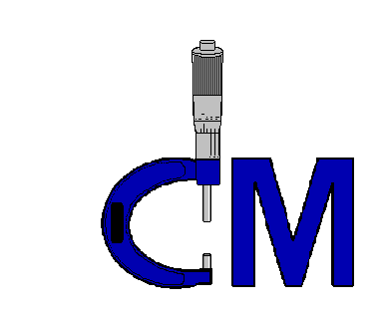

**PRECISION CNC MACHINING  
  
  
Facilities List**

**COMMERCIAL  
MACHINE, INC.**

Commercial Machine, Inc. 2024

## CNC MILLING

## 

## [https://encrypted-tbn2.gstatic.com/images?q=tbn:ANd9GcS9ukC_Lg-iNkKwjMj3h1bvNqeKfuN_KDsFT8SpV8IMMyyS93jK](http://www.google.com/imgres?imgurl=http://www.alkor-s.ru/sites/default/files/imagecache/disassembling_gallery/unimatic/dura_vertical_copy.jpg&imgrefurl=http://www.alkor-s.ru/oborudovanie/seriya-duravertical&h=325&w=525&tbnid=OI7y-uUK0Gn-FM:&zoom=1&docid=Sm8HiHOo9gnJRM&ei=OUl2U9vMG6PE8QHbk4CACQ&tbm=isch&ved=0CF8QMyhXMFc4ZA&iact=rc&uact=3&dur=147&page=5&start=153&ndsp=42)2009 Mori Seiki Dura Vertical 5100, Fanuc 0i Control, Travel; X Axis 40”, Y Axis 20”, Z Axis 24”, 30 Tool ATC, 1,000 PSI Chip Blaster Thru Spindle Coolant.

## 2008 Mori Seiki Dura Vertical 5100, Fanuc 0i Control, Travel; X Axis 40”, Y Axis 20”, Z Axis 24”, 30 Tool ATC, 1,000 PSI Chip Blaster Thru Spindle Coolant, Full 4th axis.

**2015 Mori Seiki Dura Vertical 5100,** Fanuc 0iMD Control, Travel; X Axis 40”,

Y Axis 20”, Z Axis 24”, 30 tool ATC, 1,000 PSI Chip Blaster Thru Spindle Coolant, 12,000 RPM.

**2007 Mori Seiki Dura Vertical 5060,** Fanuc 0i Control, Travel; X axis 23.6, Y axis 21”, Z axis 20”, 30 tools, 10,000 RPM, 1,000 PSI Chip Blaster.

## 2022 Smart SV3, Fanuc 0i MF Plus Control, 30 Tool ATC, Travel; X Axis 43”, Y Axis 23”, Z Axis 23”, 12,000 RPM, HPC.

## 2020 Makino a51nx HMC, Professional 6 Control, 60 Tools, Full 4th Axis, High Pressure Coolant Thru Spindle, 50 HP, 14,00 RPM.

**2000 Mori-Seki MV40-E VMC,** Fanuc 21m Control, 20 Tool ATC, Travel; X axis 22”, Y Axis 16” Z Axis 20”.

**1998 Excel VMC,** Fanuc 21M Control, 18 Tool ATC**,** Travel; X Axis 20”, Y Axis 16”, Z Axis 18” and 8” Tsudakoma Indexer.

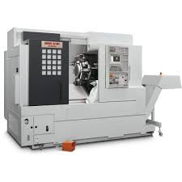

***CNC TURNING***

**2022 Mori Seiki NL-2000SY/500 CNC Lathe,**

Celos control, Live Tooling, Sub Spindle, Y axis, Parts Catcher, 2.5 bar capacity.

**2006 Mori Seiki NL-2000SY/500 CNC Lathe,**

MSX-850BM Control, Live Tooling, Sub Spindle, Y axis, Parts Catcher & Conveyor, LNS III Servo Bar feed, 2.5 bar capacity.

**2014 Mori Seiki NLX-2500SY/700 CNC Lathe,**

M730BM Control, Live Tooling, Sub Spindle, Y axis, Parts Catcher, 3.15 bar capacity.

**2017 Mori Seiki NLX-2500SY/700 CNC Lathe**

Celos Control, Live Tooling, Sub Spindle, Y axis,

Parts Catcher, 3.15 bar capacity.

**Mazak Quick Turn 6G,** Mazatrol EIA Control, 1.25 bar capacity.

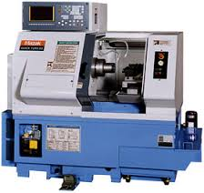

## 

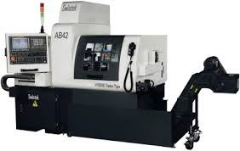

**Swistek AB42**

###### Key Features

42mm bar capacity w/o Guide Bush 38mm w/Guide Bushing Housing

7 Controllable Axis Independent Sub-spindle

FANUC 32i-A Control HYBRID Removable Guide Bushing

Rapid Traverse Rate 1,260ipm Rotary Guide Bushing

Simultaneous 7-Axis Up to 14 Live Tools

Up to 30 Tools Total C-Axis Main and Sub-spindle

10HP Integrated Main/Sub Spindle Rotating Part Conveyor

Chip Conveyor with Cart Temperature Controlled Spindle and coolant

2,000 PSI Thru-Tool Coolant

## MANUAL MILLING / TURNING

[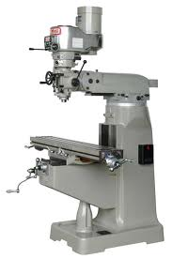](http://www.google.com/imgres?imgurl=http://www.hhrobertsmachinery.com/Milling_machines/Topwell/3VS/Topwell_3VS_milliing_machine.jpg&imgrefurl=http://www.hhrobertsmachinery.com/Milling_machines/milling-machines.html&h=981&w=650&tbnid=fZdf0riVhzsc6M:&zoom=1&docid=hkugjGfitif2AM&ei=Okp2U5vLEOHQ8AHgtoGwDQ&tbm=isch&ved=0CJcBEDMoKDAo&iact=rc&uact=3&dur=2930&page=1&start=0&ndsp=45)

**Bridgeport Series 1**, 2 HP Variable Speed Vertical

Milling Machine, 9” x 42” Table, with a Prototrak MX2

Control.

**Bridgeport Series 1**, 2 HP Variable Speed Vertical

Milling Machine, 9 x 42” Table, Mitutoyo 2 Axis DRO,

Servo 140 Power Feed.

**Bridgeport Series 1**, 2 HP Variable Speed Vertical

Milling Machine, 9” x 42” Table, with a Prototrak MX2

Control.

**Kerry 16” x 40” Gap Bed Engine Lathe**, 5HP,

Equipped with a Travel-Dial.

## GRINDING

## Acer AGS1224AHD Hydraulic Surface Grinder,

2 Axis Power Feed, 12” x 24” Magnetic Chuck.

**DoAll MD 6 Surface Grinder,** Magnetic Chuck.

## SAWING

## [https://encrypted-tbn3.gstatic.com/images?q=tbn:ANd9GcR0bV_0SRemPToEEjTTJj0sWXKr-KCKSowgvL5slnodK3LDD0DsEA](http://www.google.com/imgres?imgurl=http://www.ap-magazine.com/upload/Machinetools/Product/Image1/sawingmachine00340m1564.jpg&imgrefurl=http://www.ap-magazine.com/machinetools-product/Detail_101567_SNC-NC-Series-NC-250H.html&h=356&w=450&tbnid=GJHLV0tjD0qW7M:&zoom=1&docid=nEh8ddqeC-EwQM&itg=1&ei=00p2U5jGJuaR8gHQq4GIDw&tbm=isch&ved=0CCUQMygdMB04ZA&iact=rc&uact=3&dur=227&page=4&start=128&ndsp=51)

## 2005 Cosen Automatic N-250NC Cut-Off Saw,

10”x 12” Cut-Off Capability.

## [https://encrypted-tbn0.gstatic.com/images?q=tbn:ANd9GcQ5o1f-5P4UmAlKyQgfREgCAwAzEAliv7tCDDwKxyN4f2fVEAM6](http://www.google.com/imgres?imgurl=http://tesatools.by/sites/default/files/styles/photo800/public/q-tesa-micro-hite-3d-mod-454-474-remote-control.png&imgrefurl=http://tesatools.by/koordinatno-izmeritelnye-mashiny/tesa-micro-hite-3d-mod-454-474-remote-control&h=784&w=592&tbnid=XeyoygNGfgSJZM:&zoom=1&docid=xIhFfBNUjSoeiM&ei=-kd2U-iCAeq78QHy5oH4BQ&tbm=isch&ved=0CJgBEDMoPjA-&iact=rc&uact=3&dur=123&page=2&start=55&ndsp=53)

## QUALITY CONTROL

## A close up of a device Description automatically generated2008 Tesa Micro-Hite 3D CMM, Nikon CMM Manager

## 2018 Mitutoyo Crysta-Apex S 574



## 

## 

## TESA MICRO-HITE +M 600 Motorized Height Gage - 00730080Fowler-Sylvac Z-Cal 300’S & Tesa Micro Hites

[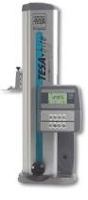](http://www.google.com/imgres?imgurl=http://www.auto-met.com/brown%26shapre/images/Height1.jpg&imgrefurl=http://www.auto-met.com/mitutoyo/Height_Gages.htm&h=520&w=230&tbnid=bKi3uKMABuR_9M:&zoom=1&docid=PLmmvpIBXn9XeM&ei=ykN2U97EB6TD8gHY2YGIDQ&tbm=isch&ved=0CLABEDMoUzBT&iact=rc&uact=3&dur=254&page=2&start=50&ndsp=69) 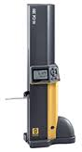

## A close-up of a machine Description automatically generatedStarrett HDV300

## https://d2pbmlo3fglvvr.cloudfront.net/product/large/Z0tJBtmcpEx_.JPG Mitutoyo PH-A14 Optical Comparator

## 

## 

## Mitutoyo Surftest SJ-201 and various handheld gages.

**ENGINEERING / SOFTWARE**

[](http://www.google.com/imgres?imgurl=http://2.imimg.com/data2/BQ/NC/MY-3467805/mastercam-dealer-india-250x250.jpg&imgrefurl=http://trade.indiamart.com/details.mp?offer%3D3719346688&h=250&w=250&tbnid=OCQGskT9R_o8kM:&zoom=1&docid=uku4aI6dM6G-HM&ei=igR2U57LBMWKqgag9YK4Ag&tbm=isch&ved=0CEoQMyhCMEI4yAE&iact=rc&uact=3&dur=188&page=8&start=259&ndsp=36)





COMMERCIAL MACHINE, INC.

305 MOODY STREET, SUITE B

LUDLOW, MA. 01056

PHONE (413) 583-3670

FAX (413) 583-3269

### ESTABLISHED 1990

Commercial Machine, Inc. 2024