Northwest Region of the National Shoot to Retrieve Association (NW NSTRA)

Regional Elimination Championship
12-13 June 2021 Condon, Oregon – Buckhorn Ranch

Newsletter

Members of the NW NSTRA region convened on the second weekend in June at the Buckhorn Ranch, Condon, Oregon. The region trial was drawn with 30 qualified dogs and 14 handlers. Due to unforeseen circumstances a bye-dog/hander was replaced for a handler that was unable to participate in the competition.
Officials: President/Trial Chair Jeremy Lessmann and Field Marshall Meki Porter.
Judges: Jim Wall (Utah Region) and Daniel Seliger (Big Sky Region)
Bird Planter: Leigh Cartwright (Big Sky Region)
Recorder: Laura McMahon
On Saturday, the 30 dogs competed in a 15-brace trial, with placements noted below. Note: One of the qualified handlers had to pull from the competition and a bye-dog was used (non-scoring).
Saturday, 12 June 2021 -First Round:
Call Name Registered Name Breed Handler/Owner
1st 979.5 (5-5) Hali Hali ES M. Smith / Nelson
2nd 733.0 (3-3+Back) Stella Stotts’s Skipping Stella ES M. Stotts
3rd 694.5 (3-3+Back) Buster Blazen Sunrise Rowdy Buster B M. Smith
4th 683.5 (4-3) Harli Arnie’s Lil Harley ES N. Ceccarelli
Highest Scores:
Finds: 93, Kody (GSP, Dan McMahon)
Retrieves: 90 Purdy (ES, Mike Stotts)
Obedience: 71, Indie (B, Ross Brown)
Ground Coverage: 88, Fame (ES, Donaye Smith)
Back: 72, Red (ES, Jerry Youmans)
Dogs advancing to the second round on Sunday (Top 16 Dogs of 30)

1 thru 4 listed above 5) Blaze / Mike Ouchida 6) Purdy / Mike Stotts
7) Fame / Donaye Smith 8) Jack / Jerry Youmans 9) Indie / Ross Brown
10) Kirby / Westbrook / King 11) Sophia / Mike Stotts 12) Annie / Cameron Cole
13) Rio / Paul McCawley 14) Blaze / Fitzgerald 15) Uno / Ed Westbrook
16) Kody / Dan McMahon
After Saturday’s trial was complete, the members convened for the annual meeting of the NW region membership (minutes at the end of this report). Members voted for outgoing office positions of Secretary and Treasurer. Laura McMahon was voted as the new Secretary and Michelle Coons-Gunter remains Treasurer. At the conclusion for dinner, Mike Ouchida and Linda Jenkins provided the delicious standing prime rib! A big shoutout to everyone that provided side-dishes and kitchen support.
Sunday Quarter Final:
Call Name Registered Name Breed Handler/Owner
1st 1012.6 (5-5) Buster Blazen Sunrise Rowdy Buster B Mike Smith
2nd 694.0 (3-3+Back) Indie Brown’s Sublime Indiana Temple of Doom B Ross Brown
3rd 646.0 (3-3) Sophia Stott’s Astrape Sophia ES Mike Stotts
4th 609.5 (3-3) Uno Lucky Rimrock Uno EP Ed Westbrook
5th 609.5 (3-3) Kirby Cascade Kirby GSP Ed Westbrook/King
6th 570.0 (2-2+back) Fame Stonecold to Lamron ES Donaye Smith
Handlers advancing dogs Semi-Finals
Left to right: Mike Stotts (Sophia), Donaye Smith (Fame), Ed Westbrook handling two dogs (Kirby and Uno), Mike Smith (Buster) and Ross Brown (Indie)
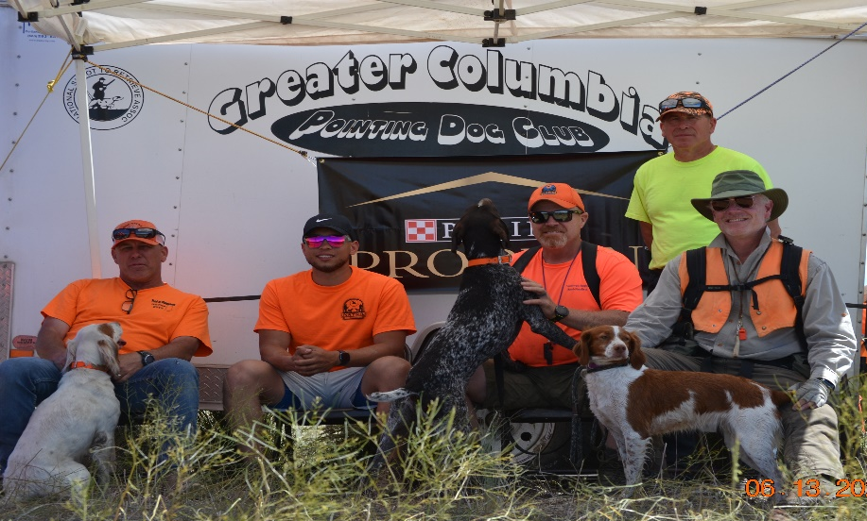

Semi Final Round: Conditions 80’s and dry minimum wind.

Call Name Registered Name Breed Handler/Owner

1st 848.33 (4-4) Buster Blazen Sunrise Rowdy Buster B Mike Smith
2nd 474.5 (2-2) Uno Lucky Rimrock Uno EP Ed Westbrook
3rd 457.0 (2-2) Kirby Cascade Kirby GSP Ed Westbrook/King
4th 453.5 (2-2) Indie Brown’s Sublime Indiana Temple of Doom B Ross Brown
5th 434.0 (2-2) Sophia Stott’s Astrape Sophia ES Mike Stotts
6th 367.0 (1-1+back) Fame Stonecold to Lamron ES Donaye Smith

Championship Round: One-hour Round Conditions 80’s and dry minimum wind. – Congratulations to Ed Westbrook (Uno) and Mike Smith (Buster).
Champion: 933.75 (5-5) Uno Lucky Rimrock Uno EP Ed Westbrook
1st Runner Up Buster Blazen Sunrise Rowdy Buster B Mike Smith
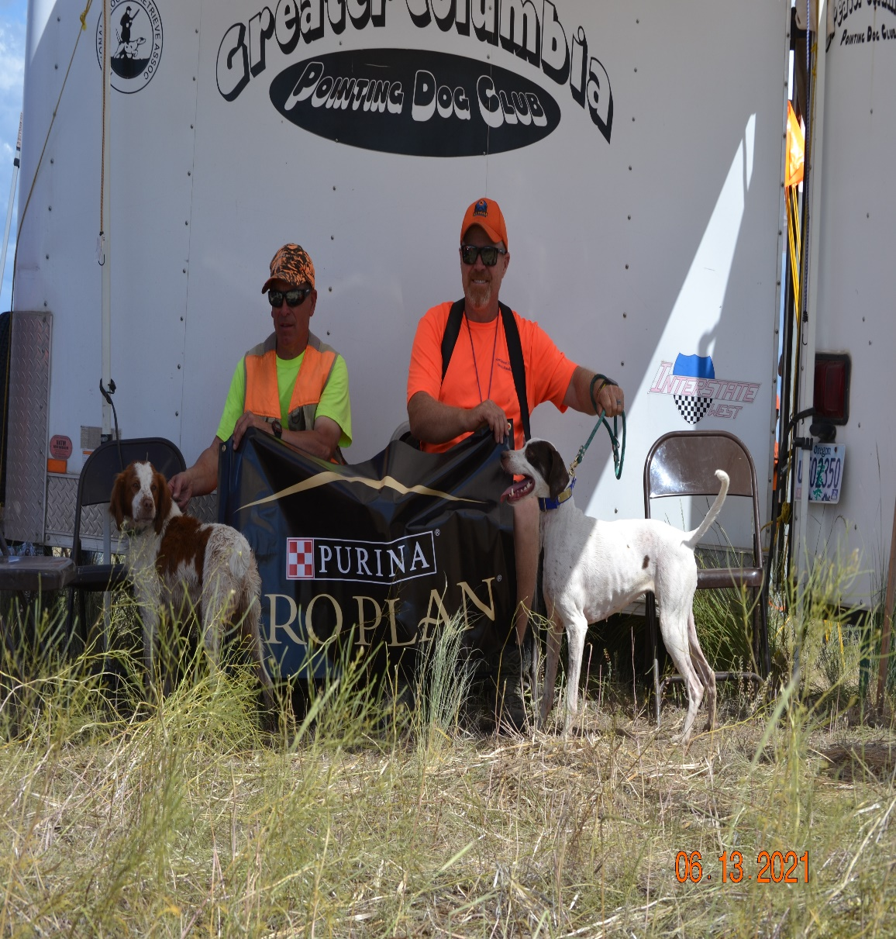
2021 NW NSTRA Regional Champion UNO/Ed Westbrook.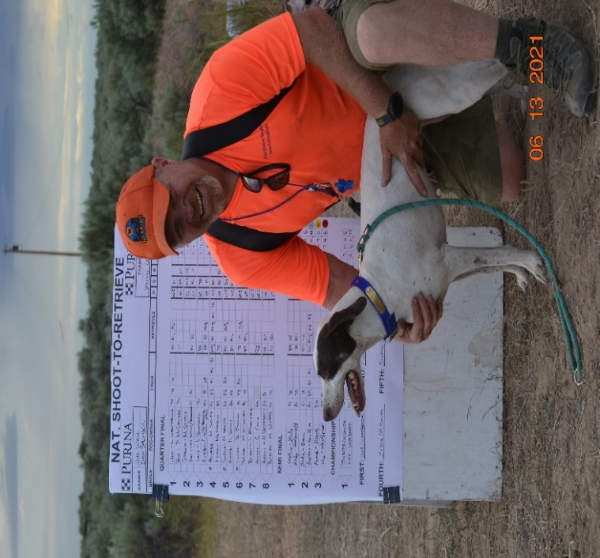
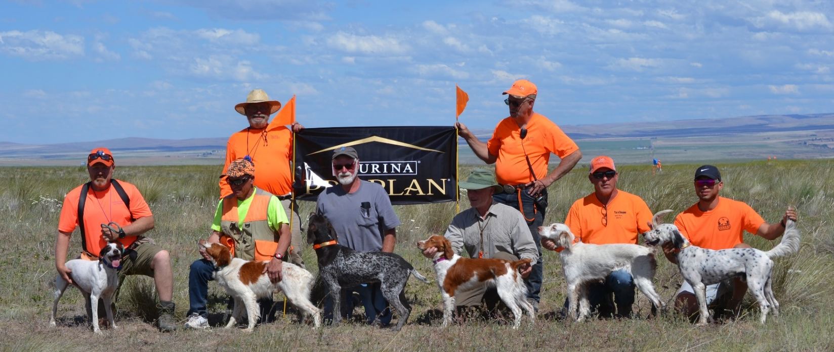
Recognitions:
2021 President’s Sportsman of the Year: Ed Johnson  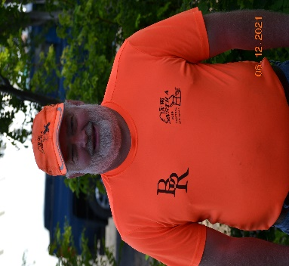  Every year, the NW President recognizes a member of the region for his/her contribution in service and sportsmanship. | 2021 NW NSTRA Open Field Highpoint:  Southwind Rain Bo / Mike Stotts  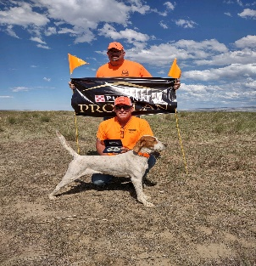  Congratulations Rain! | 2021 NW NSTRA Amateur Highpoint:  Arrow’s Jazzy Molly / Mike Smith  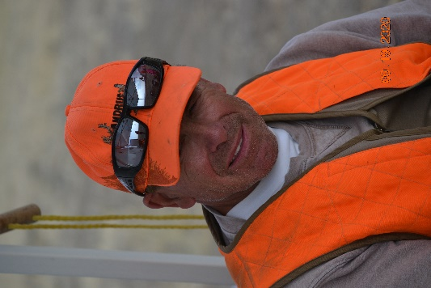  Congratulations Molly!
Special Recognition and Appreciation
Birds: Jerry Youmans – Thank you for picking up birds from Lewistown.
Grounds: Buckhorn Ranch / Kara and Chuck Kundes (Land Owners) - Greater Columbia PDC - Thank you for the coordination and location.
Shirts and silent auction: Michelle Coons-Gunter - Thank you for all your coordination.
Calcutta: Organization from Mike Stotts and everyone that donated. Congratulations to the winner(s).
Purina: Awards and food for each qualifying dog. Your sponsorship is very appreciated!
Garmin: Special thank you for the dog collar donation to the winning dog, and the 20% off Garmin purchase coupons for 2nd through 4th place. Your sponsorship is very appreciated!
Dakota 283: Special thanks for the Dash 3.5-gallon water system for the winning dog. Your sponsorship is very appreciated!
Important Upcoming Events:
2021 Purina Endurance Pre-Trial – Lewistown, Montana September 4-6, 2021. It will be a 96 dog OPEN-LIMITED ENTRIES Triple-triple/Open-combined format. The NW Region Day is September 6th. Region members’ placements that day will count for NW Region High-Point.
Send entries to:
Dean Goodall, MN, Chairman
11680 39th St SW
Dickenson, ND 68601
701-690-6671
Dagfb1@yahoo.com
$50.00 entry
Make checks payable to: Big Sky Region Endurance Pre-Trial
Please send entry fee for only one run per day per dog. Only mailed entries with checks will be accepted. No email or text entries will be accepted.

This uses a regular NSTRA Entry Form

2021 Purina Endurance Trial
Date and Location: September 8 – 11, 2021. King Colony Grounds Lewistown, MT.
Official Entry: Click Here for Official Entry Form
Entry Fee: $150.00 – Entry into tis trial is based on all points earned within a dog’s home region and placement points earned from qualifying rounds of a National Trial during the period of June 1, 2020 through May 31, 2021.
Entry Deadline: Entries must be received or postmarked by 5:00 pm Eastern on July 28, 2021.
Ways to Enter: Online at www.nstra.org/trail-registration; email at office@nstra.org with payment information; Fax at 317-839-4197 or mail entry & fee to NSTRA, 203 N. Mill St. Plainfield, IN 46168.

Fall Trial(s): Note: Both field trials are filling up quickly, get entries soon.
Three Rivers Bird Dog Club (Open/Combined Dbl/Dbl)
Date: September 18-19th, 2021
Location: Kennewick, WA
Please send entries to Meki Porter, Chairman
308 Jessica Road - Pasco, WA 99301 - Tel: 509-379-0205 Mekstar@msn.com
$55, chukar – Please submit your entries; make checks out to Meki Porter
Entry Deadline: September 13, 2021

Greater Columbia PDC - Three Day Double Trial (six runs possible for each dog entered).
Date: September 24th, 25th and 26th, 2021
Location: Condon, OR – Buckhorn Ranch
POC: Chairman: Mike Ouchida
6339 SE Beverly Ln.
Portland, Or. 97222
Email: mgouchida@comcast.net
Cellphone: 503-320-9164
Chukar $55 per brace- Please submit your entries; make checks out to Greater Columbia PDC.
Remember to notate if your dog is in “Open or Amateur”, the number of runs and the day(s) each dog (if multiple) will be running.

Resources
- NSTRA Web Site: http://www.nstra.org/
- NW NSTRA Web Site: NW Region Website
- NW NSTRA Region Facebook Page: NW NSTRA | Facebook
- NW NSTRA Region Twitter Page - NW NSTRA Region Twitter Page
- NW NSTRA Region Instagram: NW NSTRA Region Instagram Page
NSTRA entry forms: Official Trial Entry Form
NW NSTRA Officers as of June 2021
President: Jeremy Lessmann 509-336-9559 jlessman@icloud.com
Vice President: Mike Stotts 509-468-4957 mstotts@nwlbhdd.com
Secretary: Laura McMahon 360-481-2195 dnlmcmahon@msn.com
Treasurer: Michelle Coons-Gunter 509-430-2685 chelle_gunter@hotmail.com
Board of Directors:
Jerry Youmans (Past President) 208-734-7585 rdrjerry2@gmail.com
Mike Ouchida (Past President) 503-320-9164 mgouchida48@gmail.com

Quail Recipe by Hank Shaw

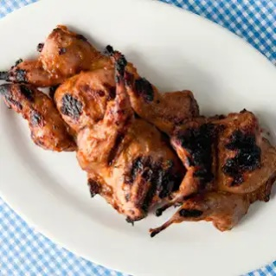
- 16 Quail (backbones removed and flattened)
- 4 Tablespoons vegetable oil
- 4 Tablespoons butter
- ½ onion (grated)
- ½ cup yellow mustard
- ½ cup brown sugar
- ½ cup cider vinegar
- 1 Tablespoon dry Mustard (like Coleman’s)
- 2 Teaspoons Cayenne
- 1 Bay Leaf
- Salt to taste

Instructions: Make sauce first. Heat Butter over medium heat, then add onion, sauté until turns translucent and then add everything else and simmer slowly for 20 minutes more. Place on “Hot” grill and paint the breast side with sauce after 2 minutes turn over and cook another 2-4 minutes. Take off grill and sauce one more time. Yum.

