President’s Message
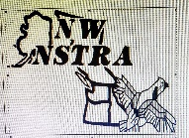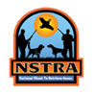

Congratulations to Mike Stotts and his Setter Stella for their win at the 2023 NW NSTRA Regional
held May 20-21 at the Horseshoe bend Ranch near Goldendale, WA. Stella, a four-time NSTRA champion, the 2022 NW Regional winner and 2021 Endurance trial champion won by the closest of margins this year. Challenged by Mike Ouchida's young setter, Cooper. Both dogs harvested five birds, and each had backs in the one-hour final. The final point tally was separated by a one-point margin, 1008.75 to 1007.75. I was delighted just to be in the final round and not get my socks blown off by Stella. What a great brace!
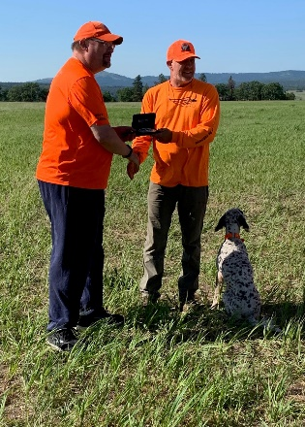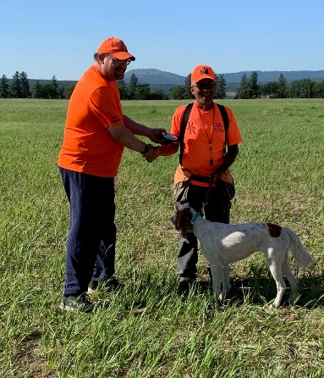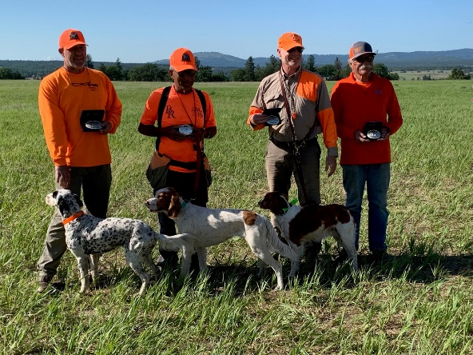
Second runner-up honors go to Indie, owned by Ross Brown
Third runner-up went to Moby, owned by Paul McCawley
Fourth runner-up was won by Jazz, owned by Paul Schneider
Fifth runner-up was won by Molly owned by Mike Smith
At this year’s regional the final six dogs included five setters and one Brit. The amazing note is three of the setters are litter mates and the fourth setter, Jazz is the mother.

This year’s open class High-Point dog is Indie, a Brit, owned and handled by Ross Brown. High-Point Amateur dog honors was won by Ross’s other Brit., Scarlett. What an amazing achievement. I am wondering what Ross is going to do with all those belt buckles.

In all we had thirty dogs entered in this year’s trial. The following dogs advanced from Saturday's round one to Sunday:

    - Purdy/Mike Stotts 803.5
    - Jazz/Paul Schneider 777.5
    - Hali/Nelson Banuelos 702.5
    - Molly/Mike Smith 696.5
    - Moby/Paul McCawley 643.5
    - Kody/Dan McMahon 636.5
    - Junior/Bryon Davis 632
    - Annie/Cameron Cole 619
    - Cooper/Mike Ouchida 615.5
    - Sugar/John Bunn 573.5
    - Gunner/Nelson Banuelos 571
    - Indie/Ross Brown 557.5
    - Stella/Mike Stotts 532.5
    - Scarlett/Ross Brown 495
    - Stubbs/Dan McMahon 495
    - Fritzi/Laura McMahon 476

Sunday round two top six advance to round three.

- Molly/Mike Smith 877
- Moby/Paul McCawley 697.5
- Indie/Ross Brown 690
- Cooper/Mike Ouchida 675.5
- Stella/Mike Stotts 652
- Jazz/Paul Schneider 568.5
- Scarlett/Ross Brown 560
- Purdy/Mike Stotts 448
- Kody/Dan McMahon 432
- Fritzi/Laura McMahon 334
- Junior/Bryon Davis 299.5
- Stubbs/Dan McMahon 296.5
- Annie/Cameron Cole 296
- Hali/Nelson Banuelos 294.5
- Gunner/Nelson Banuelos 278
- Sugar/John Bunn 50

Round three

  - Stella/Mike Stotts 965.8
  - Cooper/Mike Ouchida 881.5
  - Indie/Ross Brown 633.5
  - Moby/Paul McCawley 622.5
  - Jazz/Paul Schneider 286.5
  - Molly/Mike Smith 189.5

Round 4 Final one hour

    - Stella/Mike Stotts 1008.75
    - Cooper/Mike Ouchida 1007.75

Congratulations to the winners and all that entered this year’s regional.

On Sunday, the consolation trial had twelve braces, making it a full three-point trial. Chukar were used and with the cooler weather and wind, nearly every brace cleaned the field.

Open class placers:
- Rosie/Nelson Banuelos 960.5
- Moose/Ryan Fortier 869.5
- Jack/Joe Biggs 771
- Curly/Crozier-Moen (h) 706
Amateur class placers:

- Moose/Ryan Fortier 869.5
- Jack/Joe Biggs 771
- Curly/Crozier-Moen (h) 706
- Pita/Mike Smith 674

Thank you to the Judges April Smith and Laura McMahon. Laura/Fritzi had the first regional brace on Sunday, afterwards Laura judged all day after her run.

The following members provided the Meals:

- Friday night; potluck, potato salad Phyllis Clark, smoked ribs Mike Ouchida
- Saturday-Sunday breakfast and lunch; breakfast burritos, Philly cheese sandwiches by Angie Banuelos
- Saturday night; Steak and chicken barbecue, Mike Stotts, macaroni, and potato salads by Loraine Stotts.

Many thanks to everyone that donated food and brought dishes to share. Special thanks to Angie for donating all proceeds from her meals to our region. So many members made this year’s regional possible. Thank you to outgoing President Mike Stotts. The coordination of hosting a regional are huge. Mike and Mike senior and Loraine Stotts, thank you so very much.

Our young bird planters Brodie and Braydon Davis deserve gold stars for the great job they have done at each and every trial. They made us check every square yard of the field for birds in this regional trial. Judges Richard Hughes from the Big Sky region and Ray Ellis from the NW were outstanding. Field marshalling the trial was our own Jeremy Lessmann, a great job, guys.

This year’s auction and calcutta brought in a record amount for the region due to generous and outlandish bidding. Thank you to Linda Johnson and Paul Schneider for running the auction and most important keeping track of donated items, bidders and amounts paid.

Finally, we are so grateful to Angie and Nelson Banuelos for being NW members as they live in S. California. This year they donated the cost of the cool sweatshirts given out to all entrants. The cool embroidered regional hats that were also handed out were donated by Mike Stotts. Also, this year’s belt buckles will be donated again by a wonderful person who wishes to be anonymous. So many people to thank and so few recognized in this letter. Thank you everyone.

Mike Ouchida NW Region President

