***Laura Ann McMahon***

Laura spends the fall/winter hunting upland birds and hunting deer. As a child, I appreciated and respected the benefits of game/bird hunting from my father’s need to feed his 18 children (I am #17). I really became passionate about the sport when my husband Dan and I started hunting together with our first pointing puppy Kody. Spending quality time together in the great outdoors with hunting dogs there is nothing better than a good solid point. We have started taking our grandchildren out hunting and enjoying time as a family.

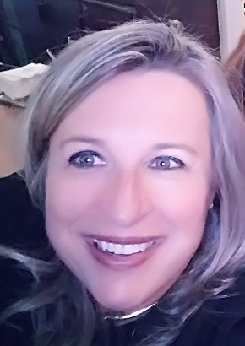Laura been a NSTRA Associate/spouse member for 3 years and currently a full member. My interest in NSTRA is the people and talent(s) from trialing in real life scenarios, while working your dog(s). My goal(s) for the Secretary position is to continue and, enhance the experience for all members by increased communication and organization.

Laura is a Health System Specialist / Program Manager with the Veterans Health Administration and has dedicated her entire career of 34 years proudly serving American Hero(s).

Laura works virtually from Olympia, Washington. In her personal time, she enjoys gardening, outdoors, spending quality time with family and friends.

Laura Ann is married with 3 children and 2 grandchildren and 5 dogs.

***Michael Ouchida***, retired farmer and marine electrician.

NSTRA life member. Active member for almost 40 years. President and co-founder of the Greater Columbia PDC. Past NW regional president and secretary.  Active NSTRA judge and judging instructor.

I'm passionate about Shoot to Retrieve and want to promote the sport within our region and encourage members from other regions to compete in the NW by supporting them.

**\*\*\*\*\*\*\*\*\*\*\*\*\*\*\*\*\*\*\*\*\*\*\*\*\*\*\*\*\*\*\*\*\*\*\*\*\*\*\*\*\*\*\*\*\*\*\*\*\*\*\*\*\*\*\*\*\*\*\*\*\*\*\*\*\*\*\*\*\*\*\*\*\*\*\***

***Jerry Youmans***

• Retired

• NSTRA member for 36 years

• past Region VP 4 years

• past Region President 10+ years

• attended first national judging seminar held in Amo, Indiana (about 1988)

• active judging instructor since 1988

• actively judging weekend, regional, national trials

• actively competing my dogs in several (8) different region’s weekend trials, as well as national trials

• been on NSTRA’s National committees: Rules, Hall of Fame, Board of Directors

• member in SRSGDA, founding member of Clearwater PDC, founding member of Mike-Jerry BDC

• will continue to stay active in NSTRA at all levels

Respectfully submitted,

Jerry Youmans

***Michelle Coons-Gunter***

*Biography:*

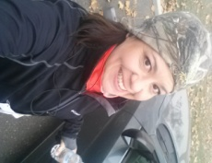Michelle was born and raised in South Eastern Washington State where she spent the majority of the time outdoors with her parents and family. This began the journey, a love for the outdoors. She went camping, fishing, hunting, boating and skiing ~ always with a bird dog beside her. As she grew older her father began taking her on hunting trips for birds and big game, which was quality Dad and Daughter time.

Residing now in the Tri-Cities, with Meki and their 5 dogs (3 English Pointers, 1 Lab and the Chihuahua) she is an active member for 7 years and a board member of the Three Rivers Dog Club for the past 6 years, and a full NSTRA member for 5 years. The Three Rivers Bird Dog Club, particularly, Charlie Hingston introduced them to the NSTRA Community. From the very beginning they knew they would be committed to pointing dog competitions for many years to come! Charlie took them in and made them feel welcome in a sport that was intimidating and foreign to them as the new kids. He always told her “It’s about you and your dog, enjoy”, something she will always remember. Trialing became a way of life, fulfillment and enjoyment from the people, a dog slamming that point, coordinating and hosting trials, and learning (always learning) the intricacies of what it takes to train, the hunt, inner workings of the organization and of course how the game is played. With Meki, Michelle has made many friendships in the bird dog community over the years, and shared with these important friends the joy of new puppies, successes in the field, and also the sorrow of loss of the people and dogs that have become more than family. In her spare time, she enjoys spending time with her family/friends and dogs, hiking and kayaking.

Michelle has a background in Government Contracts specializing in analysis, interpreting financial results and distribution of Native American Funds for The Bureau of Indian Affairs.

*Vision Statement:*

During the past 4 years serving as the Treasurer for the NW Region, I have been able to work alongside other officers as we continue to expand our membership and participate/co-host a National Trial. Within this group is where most of the work is done. Serving has been an effective way to learn about what is going on at the National and Regional level and to contribute in a meaningful way to the betterment of the local, regional and national NSTRA environment. To be effective, it is important to understand the focus of what needs to be achieved and identify the challenges. I believe NW NSTRA is a wonderful organization with tons of potential *i.e* membership growth and identification of trial grounds that would increase the amount of events each year. There are few things that allow you be one with nature and provide you with the ability to compete with your dogs in an atmosphere like that provided by our NSTRA community! I want to help make this community even better through communication, organization and the promotion/introduction of NSTRA to potential new members.