The Preston & Wilma Williams Foundation For Social Change, Inc. (the “Foundation”) was created by Dr. Preston W. Williams II and, Dr. Wilma Delores Webb Williams, to tackle critical social problems by making financial gifts directly to individuals, communities or organizations irrespective of the race, color, sex, or national origin of the recipients. The Foundation will identify individuals with critical needs that may have problems that would not ordinarily be addressed by governmental agencies and/or organizations that require formal grant application.

There are many families who find themselves in destitute situations due to the death or serious illness of the major wage earner in the households. As these situations are brought to the attention of the Foundation’s board, immediate and no restrictions financial gifts are made. An example of this is a gift of $10,000 to a family after the death of the father left the family destitute with immediate housing issues. The gift was given to the family to secure housing.

One of the major initiatives of the foundation aided the water crises in Flint, Michigan. The Foundation directly purchased 12 semi-trucks full of bottled water for distribution by the Food Bank of Eastern Michigan to residents of Flint most affected by water contamination. By coordinating directly with the American Red Cross in Flint and a Michigan water supplier, the Foundation delivered water to the Food Bank warehouses. As Flint’s population is presently numbered at approximately 102,434, this contribution was viewed as significant.

The Foundation seeks to address the lack of clean water and indoor plumbing, including toilets, to thousands of citizens of the United States in rural areas. In 2019, the Washington Post reported that 2.0 million Americans were living without indoor plumbing – which means no running drinking water, no

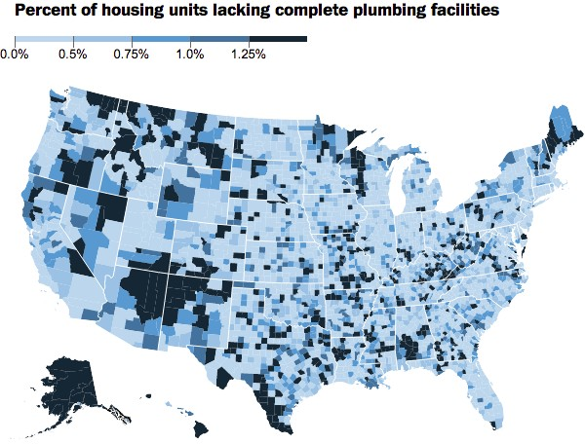toilets, no tubs or showers.

As the map above indicates, there are still areas of Georgia, Alabama and Mississippi where there are households still lacking the indoor plumbing needed to meet normal quality of life existence. This data comes from the American Community Survey, a function of the U.S. Census Bureau.

The Foundation is committing funding to facilitate indoor plumbing for individual households in the three rural states identified above. The Foundation will directly fund the cost of plumbing to individuals and households who are mostly elderly, poor and living in rural areas. We will provide financial support for costs such as digging wells for clean and sanitary water; and installing indoor plumbing and building portable toilet facilities.

2

The Foundation will continue to address quality of life issues, by providing the necessary assistance and support to enable people to improve their lives. The directors and volunteers of the Foundation actively seek opportunities to do so.