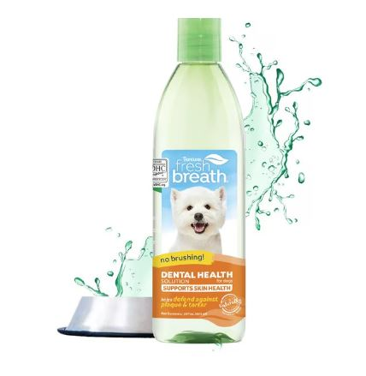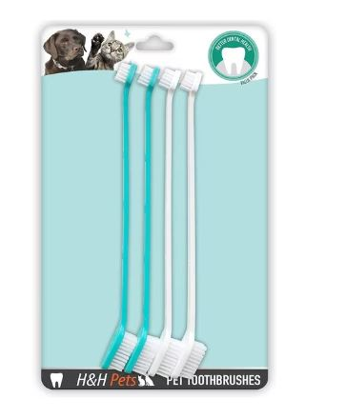[TROPICLEAN Fresh Breath + Skin Health Support Dog Dental Water Additive, 16-oz bottle - Chewy.com](https://www.chewy.com/tropiclean-fresh-breath-dental-health/dp/48438)

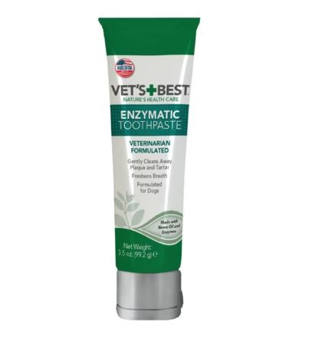[H&H PETS Dual Headed Dog & Cat Toothbrush, 4 count - Chewy.com](https://www.chewy.com/hh-pets-dual-headed-dog-cat/dp/183898?adId=c4bb7b77-b9fa-4f63-814c-c42b929eee03)

[VET'S BEST Enzymatic Dog Toothpaste, 3.5-oz bottle - Chewy.com](https://www.chewy.com/vets-best-enzymatic-dog-toothpaste/dp/56140)