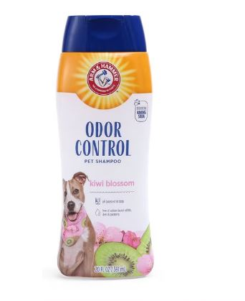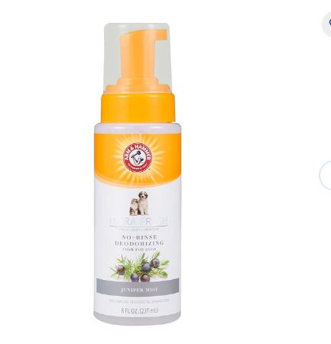

[arm and hammer shampoo - Free shipping | Chewy](https://www.chewy.com/s?query=arm%20and%20hammer%20shampoo&nav-submit-button=)