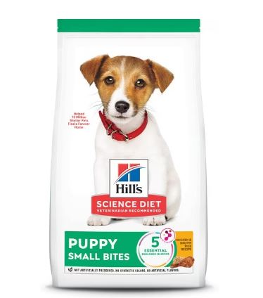

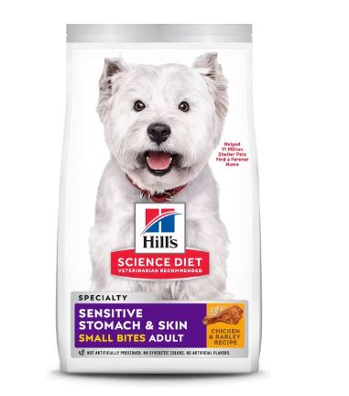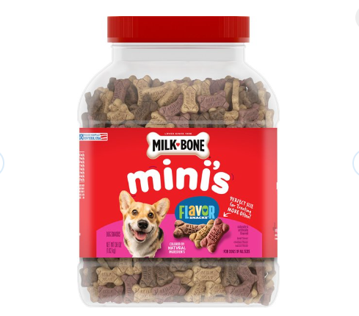[HILL'S SCIENCE DIET Puppy Small Bites Chicken & Brown Rice Recipe Dry Dog Food, 12.5-lb bag - Chewy.com](https://www.chewy.com/hills-science-diet-puppy-small-bites/dp/779118)

[MILK-BONE Mini's Flavor Snacks Beef, Chicken & Bacon Flavored Biscuit Dog Treats, 36-oz tub - Chewy.com](https://www.chewy.com/milk-bone-minis-flavor-snacks-beef/dp/127408?adId=fcefbe73-e6f6-45d0-a5b4-7383a146577b)

[HILL'S SCIENCE DIET Adult Sensitive Stomach & Sensitive Skin Small Bites Dry Dog Food, Chicken Recipe, 30-lb bag - Chewy.com](https://www.chewy.com/hills-science-diet-adult-sensitive/dp/241831?adId=add2a397-58a7-4ec7-aa28-8feb35f3af28)