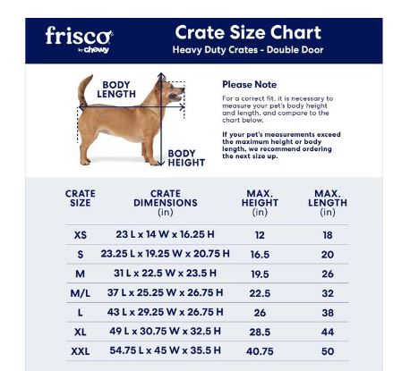

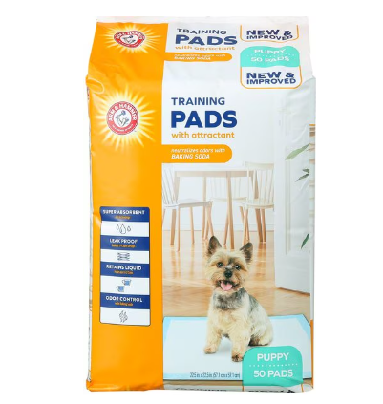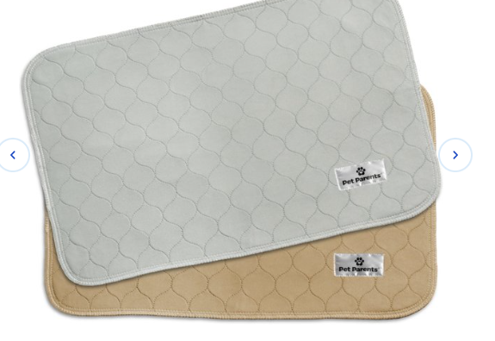

[FRISCO Heavy Duty Fold & Carry Single Door Collapsible Wire Dog Crate, 30 inch & Frisco Quilted Dog Crate Mat, Ivory, 30-in - Chewy.com](https://www.chewy.com/frisco-heavy-duty-fold-carry-single/dp/282012)

[Dog Potty Pads: Unscented & Scented Toilet Pads (Free Shipping) | Chewy](https://www.chewy.com/b/pee-pads-1445?ref-query=puppy%20pads&ref=searchRedirect)

[PET PARENTS Pawtect Pads Washable Training Puppy, Dog & Cat Pee Pads, 2 count, 18x24-in, Grey & Beige - Chewy.com](https://www.chewy.com/pet-parents-pawtect-pads-washable-dog/dp/177641?adId=0cc17475-aaa5-4c5e-8374-796e9423a4cc)