How to Create an appFile
- Open appFiles – There are two ways you can start a new appFile. You can select New appFile from the top of the screen or Create New appFile from the left-hand side of the screen.
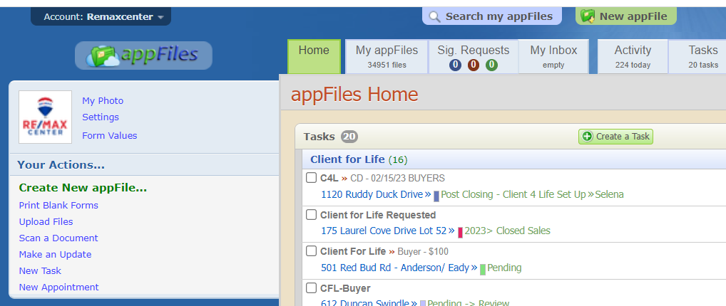

- A new tab will open to start creating your new appFile.
- You will need to give your file name. This should be the address of the property you are selling for your client(s).
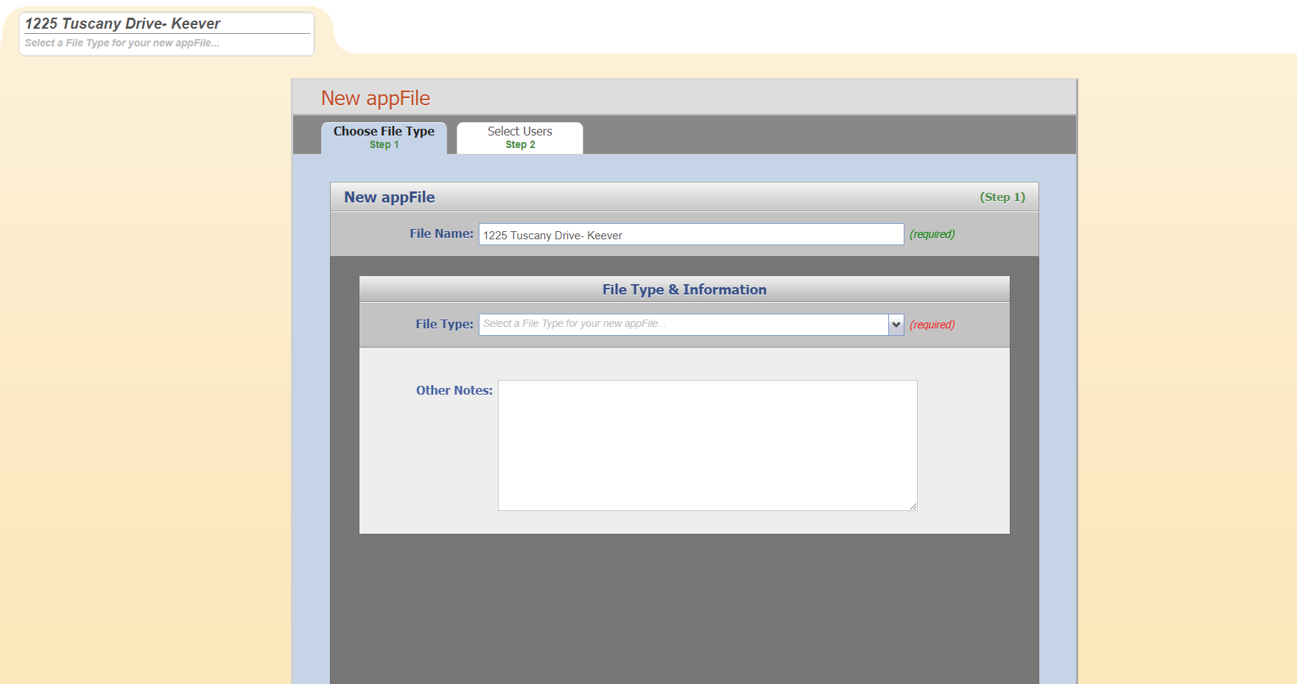

- If you are representing the buyer, then you can enter the clients’ names.
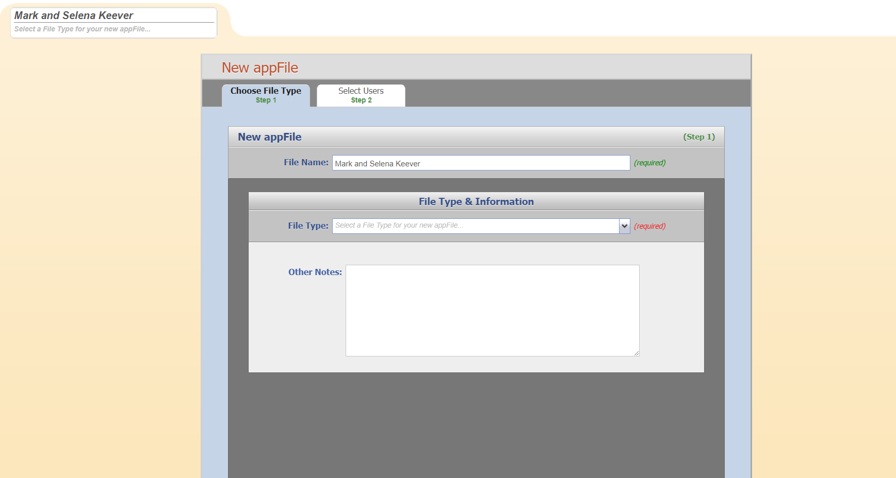

- After you give your file a name, you need to choose the File Type.
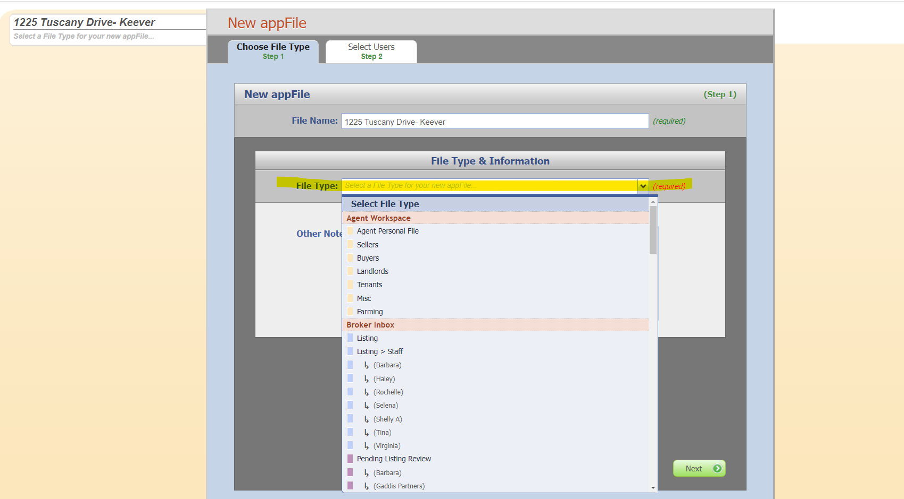

- For this example, we will choose Sellers. Please fill out as much of the information as you can in this section. Click next.
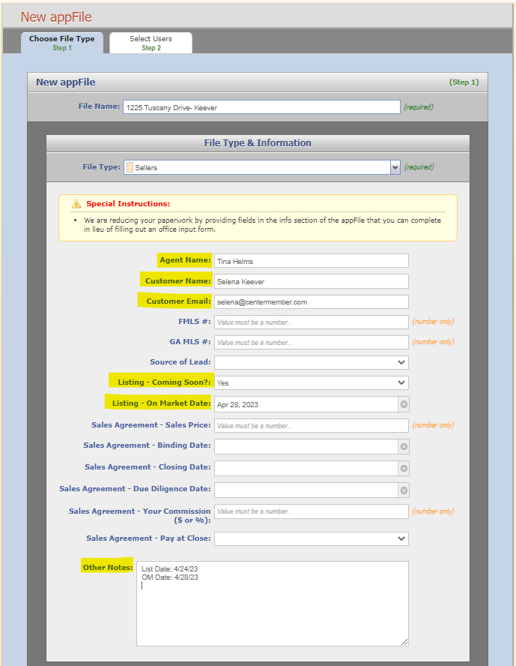

- For this example, we will choose Buyers. Please fill out as much of the information as you can in this section. Click Next.
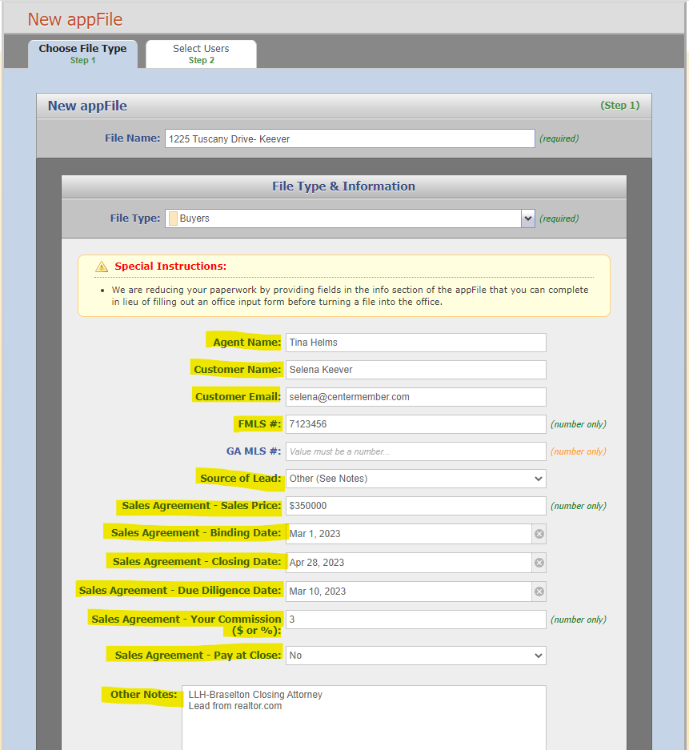
**Please note that you may not have all this information when you first start a file for a buyer.**

- If you are representing the Landlord, Tenant or if the file is for a Miscellaneous use (like a referral), then you would choose one of those as the file type.
- Remember to fill out as much of the information as you can in this section. Click Next.
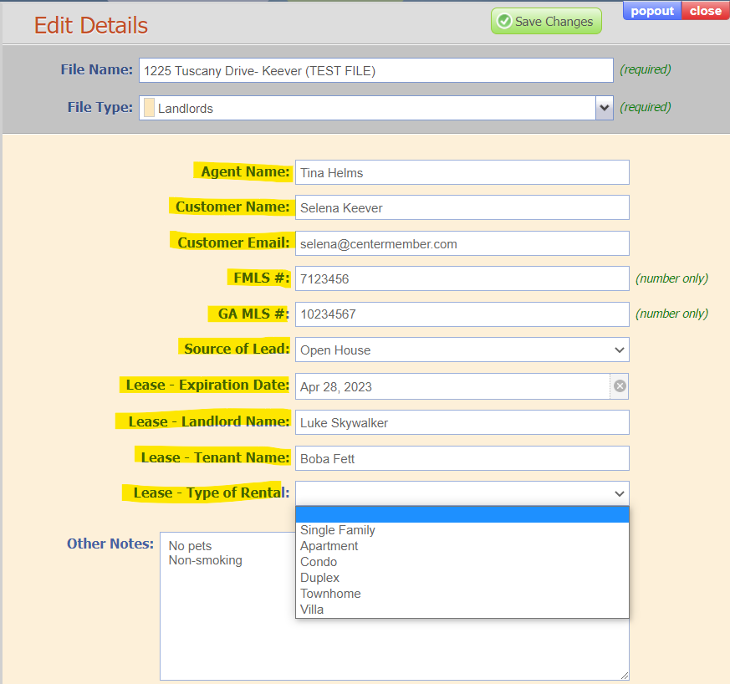
- Next you will choose who will have access to the file.
- The right side of the screen will populate automatically with your name and the RE/MAX Staff. Choose from the left side if you would like someone else to have access to the file.
- Click the green button on the right Create appFile.
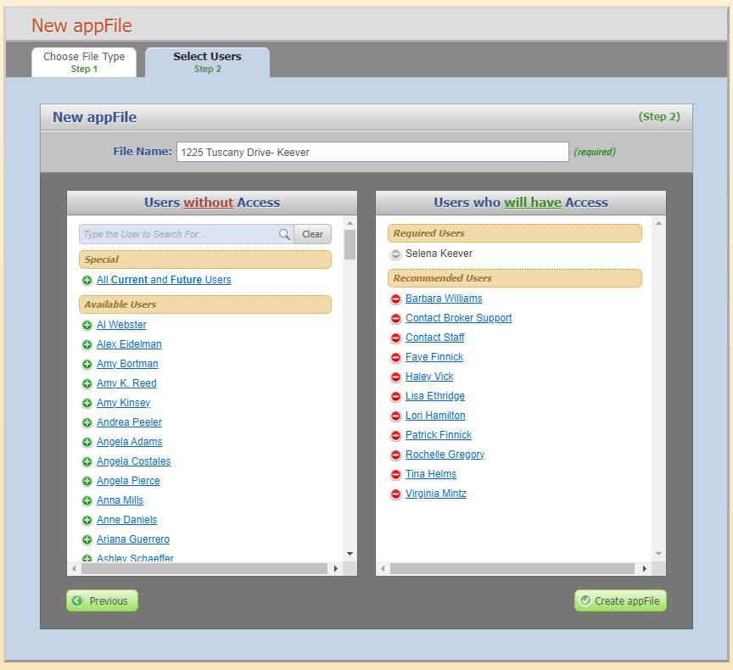
a.
b.

How to Maintain an appFile (Selling Side)
Now that you’ve created your appFile, we will go over how you maintain your appFile by adding documents and information.
- For example, if you are representing the seller, you will begin by adding forms from the listing package.
- First, click the add forms button on the left-hand side of your appFile.
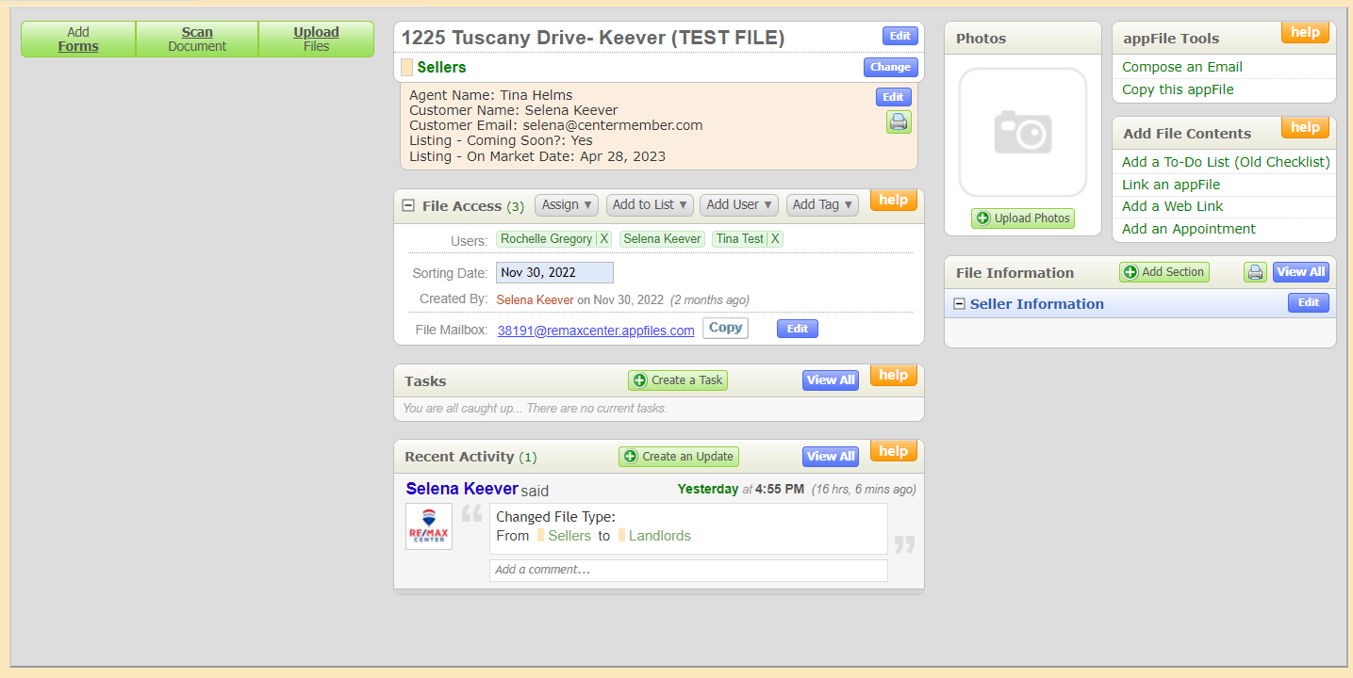
- Then, you’ll select the listing package from Available Forms on the left-hand side by clicking select all. This will move them to Selected Forms on the right-hand side. (Repeat, as necessary, for all forms you would like to include.)
- Click Add Selected Forms.
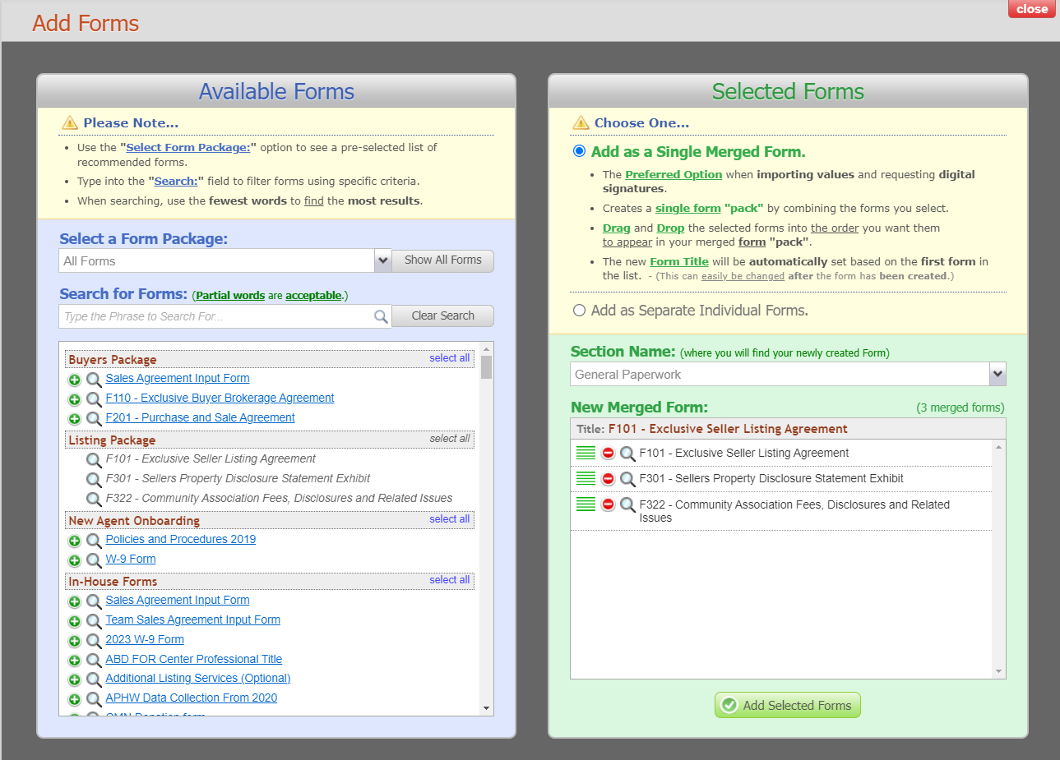
c.
b.
- The listing package will default to “Add as a Single Merged Form.” This is useful for sending to your clients for signatures if you prefer to send everything at once, but you can also add them individually.
- Select Add as Separate Individual Forms.
- Click Add Selected Forms.
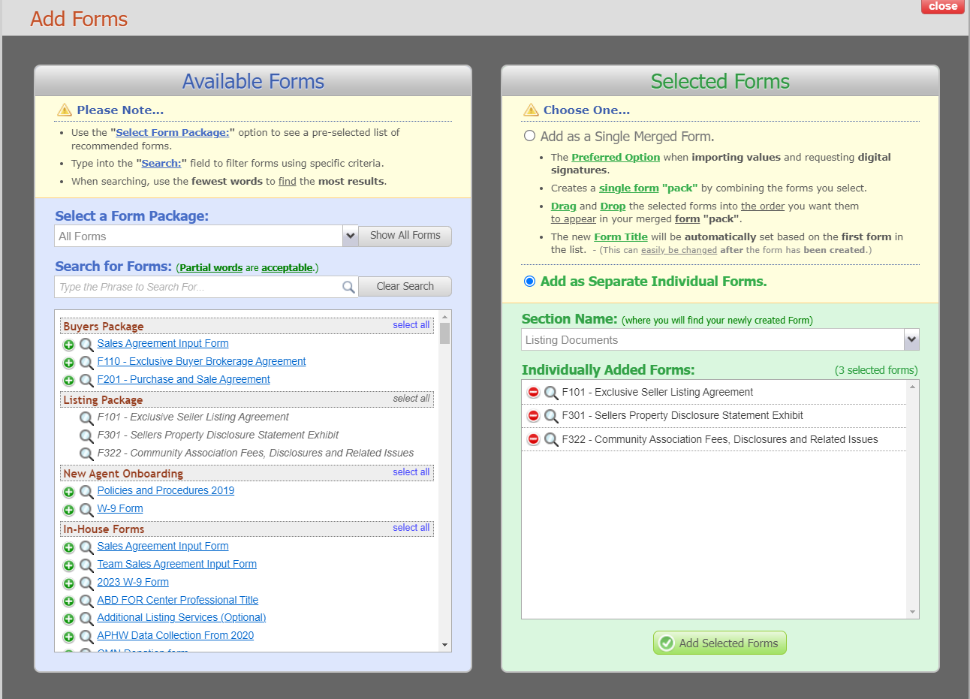
b.
a.
- At this point, you will need to fill in any necessary information on your forms, such as address, sale price, etc. (See How to Set User Default Values to pre-fill forms with your information.)

- Once your forms have been filled in, it is time to send them to your client for signature. This can be done in 3 ways.
- Click on the blue Request Signature button.
- Click on the Green Send Via Email button and select Send a Signature Request.
- If you have a client that prefers to print and fill in their forms by hand, you can select the send via email (PDF) button.
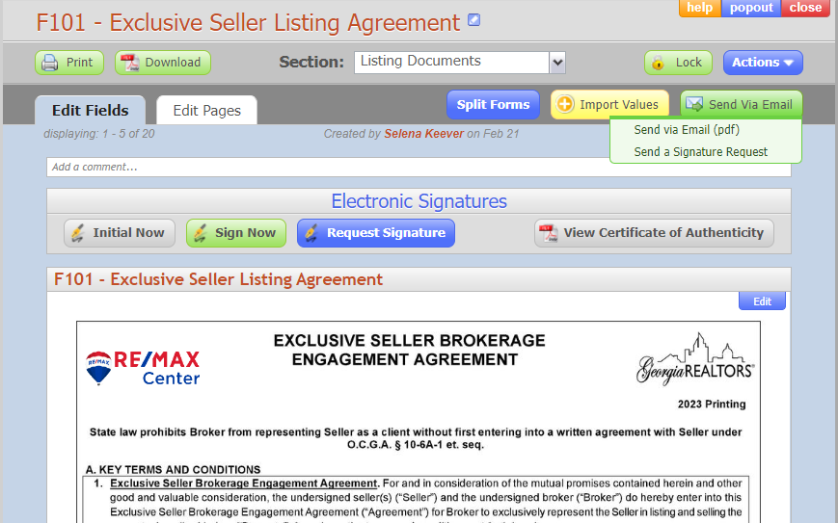
b or c
a.
- If your seller chooses to fill out these forms by hand, you will need to scan and upload these forms to the appFile.
- Click on Upload Files.

- A new window will pop up. Click on the drop-down menu under Section Name and select Listing Documents.
- Click on Browse at the bottom left of the pop-up screen.

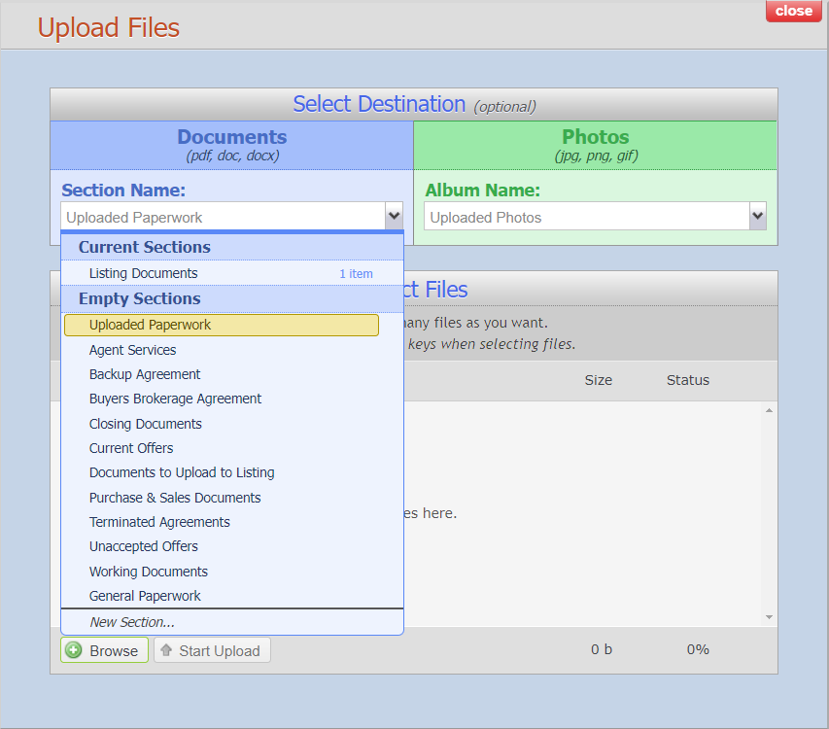
c.
b.

- A dialogue window will open.
- Choose your file and click open.
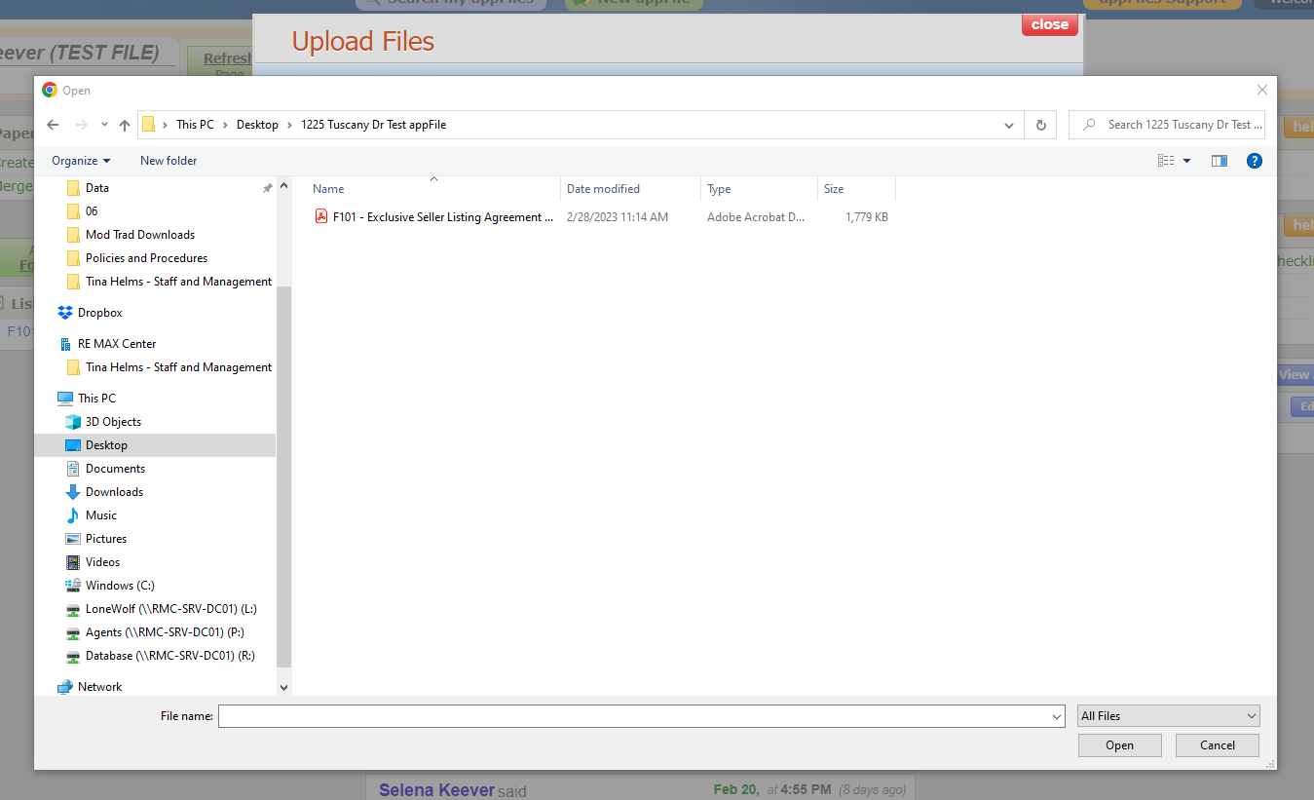
e.
e.
- Then, click Start Upload.
