



What’s your Rome,

One askes

What’s his interest? I’m travelling

Around now.

What if this checkpoint



Was that security station? He says: I see

But what he sees

To prove his alibi

Or disprove it.

Only you are still

Holding on

* + - * 1. A postcard I sent you

1. Last year
2. Was wrong: it only gave you out

My location.

Where can it lie?

 Which book behind?

1. 

Last night is the night of reception

Out of the square

I made a circle

And was stopped by a policeman:

* Who are you
* To add to the lanterns
* Your reading self?

I say

Sorry, sor

My hotel lamp is too dark

TO

* See you
* I made a note
* I think it wasn’t

At all polite.



What towers in front of the façade

Of a touristy city

Below the ultimate marker

I arrive too late

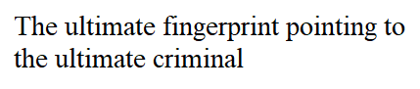The shot was missing

Among other copies. This day was the day of my life

It represented

Time is imperfect killer, but it never

Returns to the crime scene. Thanks to

The other day

Regards to

*I stumbled*

My mother

I just wanted to make sure my message was transferred correctly.

I walked all this way to make sure.

I

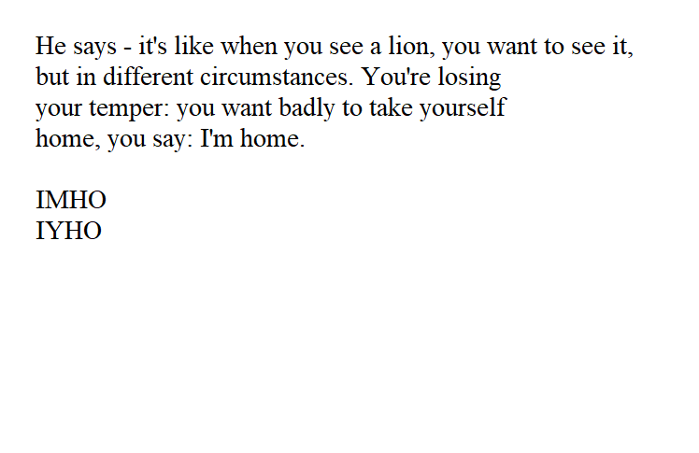

What’s opposed to a door?

You ask to open a window to leave it open

It’s not enough to

fill my hotel room

with the presence.

or post-sense

or present



*I’ve been away from home for a while*



|  |  |  |  |  |  |  |  |  |
| --- | --- | --- | --- | --- | --- | --- | --- | --- |
|  |  |  |  |  |  |  |  |  |
|  |  |  |  |  |  |  |  |  |
|  |  | I’m being polite, but |  |  | some of them lie, |  |  |  |
|  |  |  |  |  |  |  |  |  |
|  |  |  | officer, |  | behind the background |  |  |  |
|  |  |  |  |  |  |  |  |  |
|  |  |  |  |  |  |  |  |  |
|  |  |  |  |  |  |  |  |  |

*when I ask them*

wy

*what time it is*

as we say

hen no body can hear us 

Would anyone even talk

с. Alone?

For how much have you written: “end this tent was my Rome”?

Who wrote it

If not you?



Who would?

You were

In the long run,

You say,

Of it’s not one of whom

We call a friend.

At last safe

In the long run, you say

A prolonged one.

Your answer depends on nothing and relies



 It’s seen from the above

The same way it’s seen from the land. Or in the letter of mine



this tower is there

# A tourist is a tower watcher

# And if you wish

# A ranger

A

In a brand new dictionary

I’m looking up

What do you mean?

* What was that?

Raindeer

Where was I?

He’s telling me

Of every step of mine. As a sibling

With two levels. With a floor

 They match

 But do they

 we live in a block of flats

a semi-detached house

a terraced house

choose none

my doubts are the doubts

of a person who’s seen it already:

there shouldn’t be