  CCFA Programs & Services
  Victim Advocacy
  General Counseling Services
  - Individual Therapy
  - Play/Sand Therapy
  - Group Therapy
  - Marriage Counseling
  - Child Sexual Abuse Treatment
  - Domestic Violence Treatment
  - Adult Sex Offender Treatment
  - Youth with Sexual Behavior Problems and Treatment
  Prevention Programming
  - Domestic Violence Prevention
  - Safe Dates
  - Who Do You Tell?
  - Bounce Back Program
  - Safe and Healthy Relationships
  SART Clinic
  - Sexual assault examination in a private medical environment
  Supervised Visitation
  Domestic Violence Shelter
  Domestic Violence Support Group
  Case Management
  Contacts and Resources
  The Center for Child and Family Advocacy, Inc.
  Main Office Phone: 419-592-0540
  The House of Ruth
  Women’s Domestic Violence Shelter
  Phone: 1-800-782-8555
  24-Hour Crisis Hotline
  Phone: 1-800-782-8555
  Fulton County Sheriff’s Department
  Phone: 419-335-4010
  Fulton County Prosecuting Attorney
  Phone: 419-337-9240
  Fulton County Court of Common Pleas
  Phone: 419-337-9260
  Eastern District Municipal Court
  Phone: 419-826-5636
  Western District Municipal Court
  Phone: 419-337-9212
    - Victim Advocate Program
  The Center for Child and Family Advocacy
  Fulton County
  Family Justice Center
  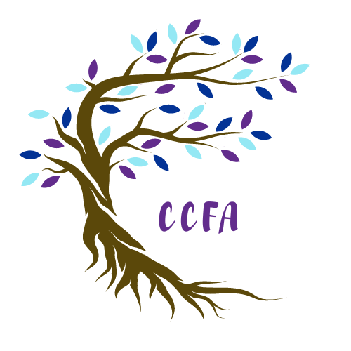
  
  @ccfa_connect
  
  
  120 E. Chestnut St.
  Wauseon, OH 43567
  Phone: 419-335-4255
  @TheCCFA
  Visit us at theccfa.org or on our social media sites.

  Victim Advocacy
  The Victim Advocate Program of The Center for Child and Family Advocacy, Inc. was established to respond to the needs of adults and children who are residents of Fulton County.
  The program services victims of sexual abuse, assault, domestic violence, menacing by stalking, aggravated trespassing, violation of a protection order, felonious assault, aggravated assault, and other violent and non-violent crimes.
  The Victim Advocates are trained professionals who are available to offer emotional support and practical assistance to victims of crime and their families.
  
  Trust Your Wings
  Trust your Wings is a support group that is made up of survivors of domestic violence and/or sexual assault/abuse.
  This is a judgement free safe-zone that is peer led and confidential. We are here to find support for ourselves and provide support to others.
  For more information, call 419-335-4255.
  Victim Services
  Criminal Justice Information and Advocacy
  Perhaps the greatest difficulty for many crime victims in the midst of a traumatic experience is trying to understand and prepare for involvement in the criminal justice system. Through the Victim Advocacy Program, victims receive information on the processes and procedures of the criminal justice system. Victims receive ongoing information on the status of their case. Crime victims can also request that a victim advocate accompany them in the courtroom or attend in their place.
  Protection Orders
  Advocates can help victims navigate through the process of obtaining a Civil Protection Order, as well as informing them of the different types of protection orders available.
  Crime Victims Compensation
  The advocate is available to assist the victim in completing the application for the Crime Victim Compensation Program provided by the Ohio Attorney General’s Office.
  Emotional Support
  The victim advocate offers emotional support to victims.
  Referrals
  The advocates are familiar with community resources and can assist victims in linking with needed services.
  
  Victims’ Bill of Rights
  Victims have a right:
  - To be treated with dignity, fairness and compassion.
  - To protection from intimidation and harm.
  - To be informed concerning the criminal justice system.
  - To provide input into the criminal justice process, especially at key points like plea bargaining, sentencing, and parole release hearings.
  - To restitution.
  - To due process in criminal court proceedings.
  - To reasonable protection from the accused or any person acting on behalf of the accused.
  - To timely notice of judicial proceedings that they are to attend, and timely notice of cancellation of any proceedings.

