2005 Atlas, Pompano 21ft
$30,000 OBRO
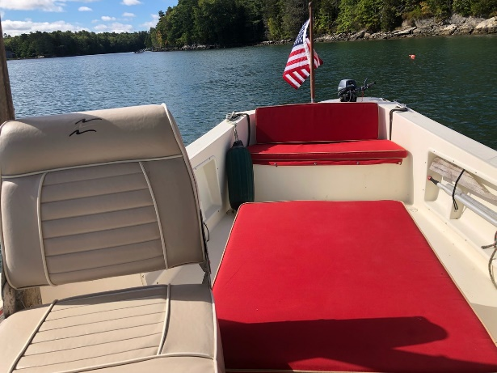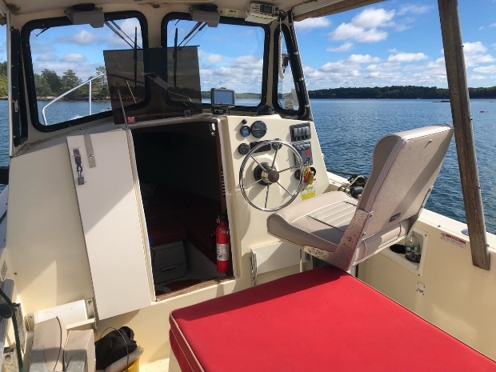
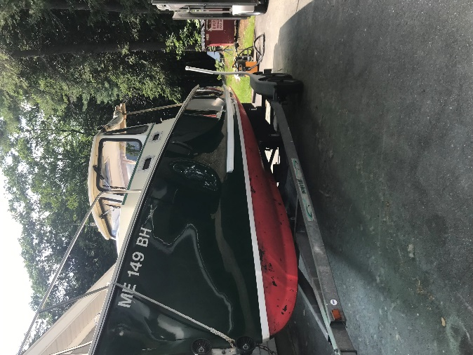
-1 owner boat. Wonderfully maintained and care for
- Yanmar, 75 HP Diesel Motor with 260 hours
-Trailer is included, which is a 2005 Magic Tilt Model TSBV1

