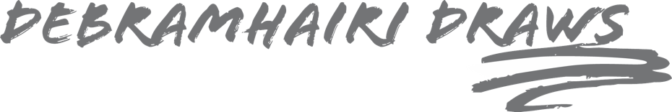

Photography Tips

The most important tip is that the photograph must show the character of your dog(s)

Ideally, the photograph should be in a jpeg format and sent to my email address.

I find the best photographs are of the dog sat down – facing front onto the camera or a side profile. Avoid taking photographs from above, looking down – try and kneel to their level.

If the portrait is of more than one dog, they don’t necessarily need to be photographed together as I can put separate images onto Photoshop and combine them into a suitable composition.

I would prefer them to have their mouth closed with no tongue hanging out and without wearing a harness especially one that covers the chest.

If using an iPhone please don’t use portrait mode as it blurs out some of the detail needed.

Please make sure the photograph is taken in daylight and is in focus. Please don’t play around with filters.

Below are some examples from previous commissions that have worked well.

You can send me as many photographs as you like, the more the better. Before I start the drawing, we can discuss which one will work best and I will ensure that you agree before I begin the drawing.
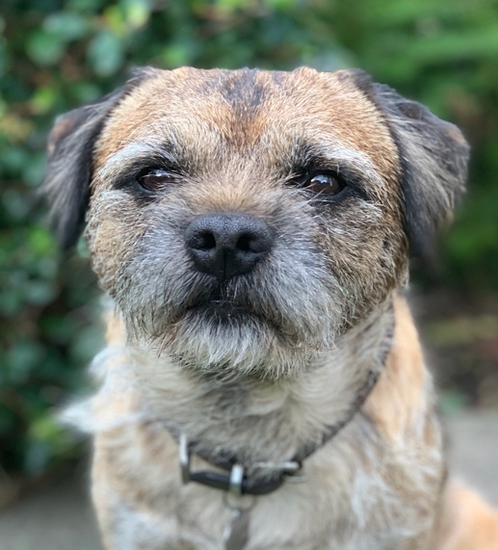
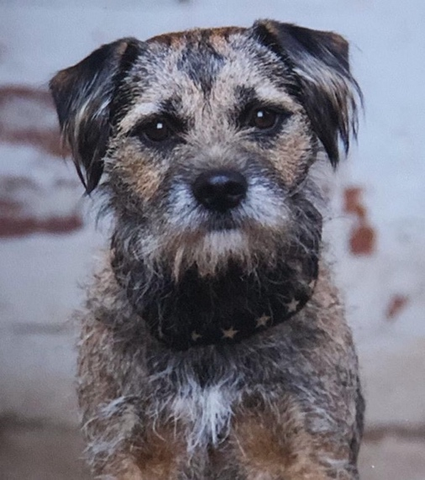
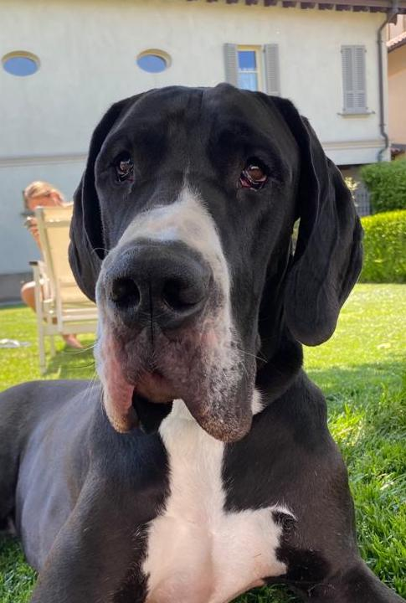

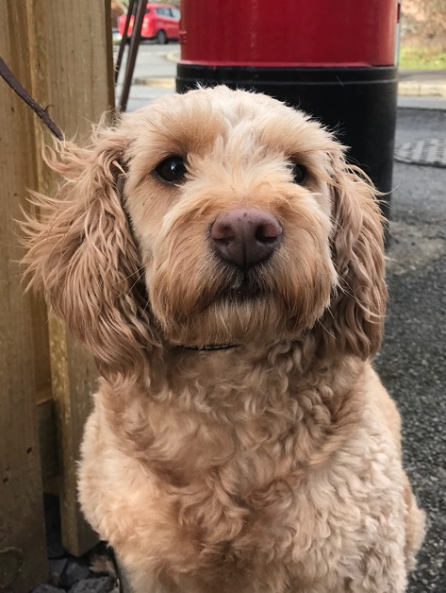
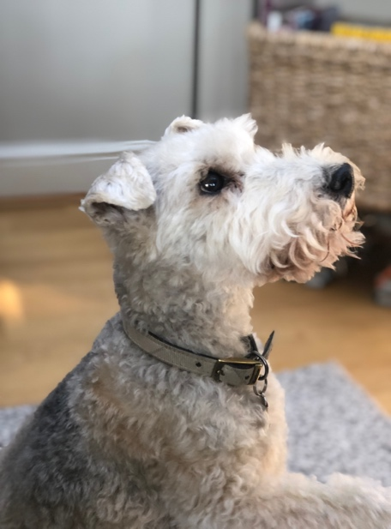
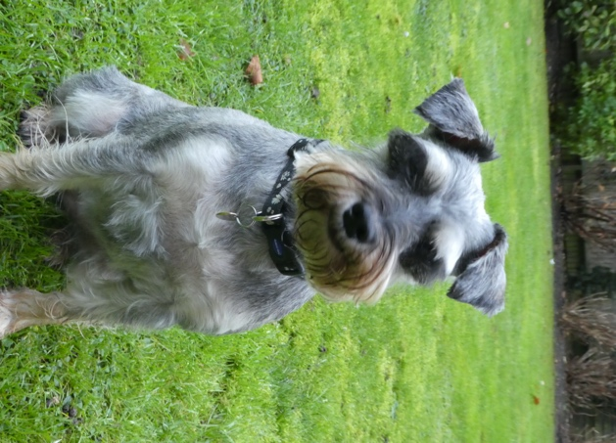
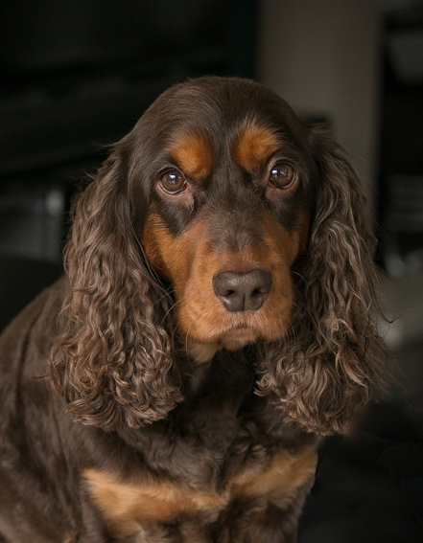
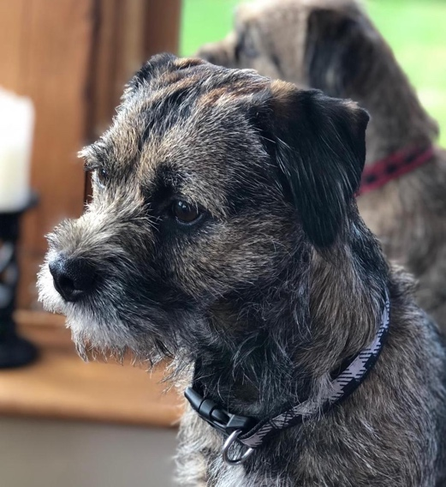

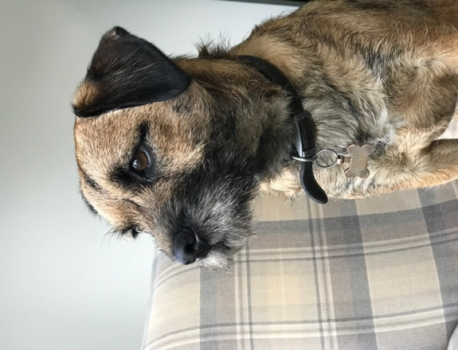
I hope that this helps and look forward to seeing your photographs.

Debra

