

June 18 - 23, 2024

TUESDAY – ferial
1 Kings 21.17-29 Matthew 5.43-48
12 noon | For the Intentions of Stephanie Walker
12:30 pm | Eucharistic Adoration until 1:00 pm
WEDNESDAY – ferial
2 Kings 2.1, 6-14 Matthew 6.1-6,16-18
12 noon | †Tojeen Xavier
12:30 pm | Rosary
THURSDAY – ferial
Sirach 48.1-14 Matthew 6.7-15
11:30 am | Confessions until 11:50 am
12 noon | For the Intentions of Mike O’Reilly
FRIDAY – St. Aloysius Gonzaga
2 Kings 11.1-4, 9-18, 20 Matthew 6.19-23
12 noon | ††Murray & Deloris Rittinger
TWELFTH SUNDAY IN ORDINARY TIME
Job 38.1-4, 8-11++ 2 Corinthians 5.14-17 Mark 4.35-41

SATURDAY
4:00 pm | Confession until 4:30 pm
5:00 pm | †Inocencio Salcedo, †Victoria Grey, †Francisco Dimalaluan, †Fr. Harry Smithuis, For the Intentions of Roger & Rita Boudreau, Alison Lett
SUNDAY
8:30 am | For Our Parishioners
11:00 am | For the Intentions of Laurie Lowe

BULLETINS
This is the last bulletin of the season. Mass times, intentions and any announcements will be posted on the bulletin boards and on our website. Please check regularly for new postings.

HAPPY FATHER’S DAY TO OUR FATHERS!!
May God continue to bless you with the strength and grace needed to provide and care for the members of your family!
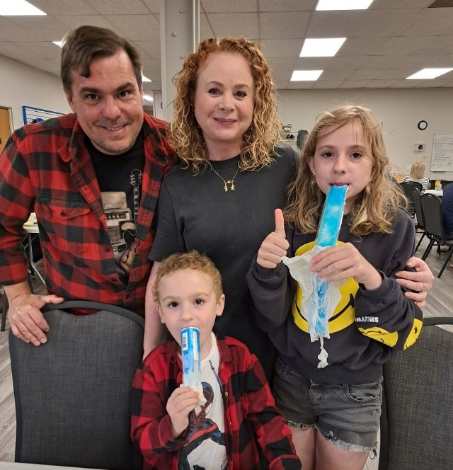

PICTURE OF THE WEEK
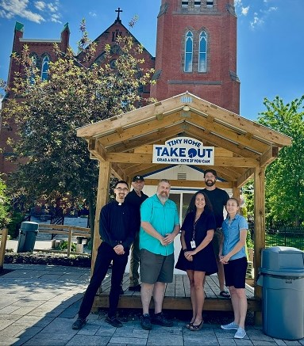
The Tiny Home Takeout Class Trip Experience Team wants to send a huge thank-you to all of the staff, students, and parent-volunteers who made this school-year a huge success through fundraising, spreading awareness, and coming to visit us at Tiny Home Takeout and St. Mary’s Church. We wish you all a fun and safe summer and can't wait to welcome you back in October!

ITEMS NEEDED
Tiny Home Takeout is in need of:
men's underwear, men's socks, men's pants size 28, 29, 30, 31, and gently used men's and women's running shoes for our unsheltered friends. Please drop them off in the bin at the back of the church by the bulletin board. Thank you for your support!

ST. MARY’S CATHOLIC WOMEN’S LEAGUE

Join us this Sunday, June 16th following 11 am Mass for our last meeting before summer holidays! Our prayers and Liturgy will be in honour of the "Most Sacred Heart of Jesus” and the "Immaculate Heart of the Blessed Virgin Mary”. Please join us for this special time of prayer, fellowship, friendship, and reflection.

MARILLAC PLACE BABY BOTTLE CAMPAIGN

Father’s Day is here! Please return your baby bottles to the hampers at the back of the church. Marillac Place relies heavily on these donations from our community to keep their doors open and support their programs. Please support the young mothers within our community, by returning your baby bottles filled with your donation(s) next weekend. The staff and mothers of Marillac Place appreciate your continued generosity.

DINNER & DISCERNMENT

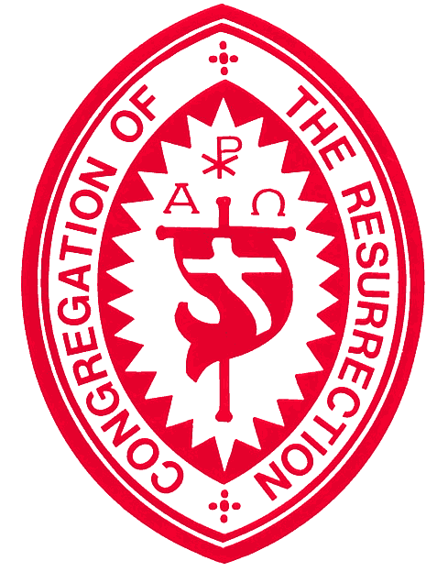
Wondering about religious life or priesthood? Looking to deepen your faith and understand your vocation? Join us at St. Mary’s every last Saturday of the month for Dinner & Discernment. Enjoy a meal, prayer, and conversations with fellow young men and Resurrectionists. Register using the QR code.

IMPORTANT NOTICE
Please note: from July 9th – 12th there will be no 12 noon weekday Mass. Our Priests and all the members of the Congregation of the Resurrection will be on retreat. Please keep the Resurrectionists and all priests and religious in your prayers.

RESURRECTIONIST VOCATION MINUTE
At the beginning, it is not easy to notice the small seed of a vocation that God has planted in our hearts. Even if we are unaware of its presence, God patiently nurtures it, allowing it to sprout and grow. Gradually, He invites us to take care of it, ensuring it is firmly grounded in faith and His love. Are you aware of this seed that God has planted in your heart? Are you guarding and cultivating God's seed of your vocation? Fr. Pawel Szymanowski CR; Vocation Team; resurrectionistvocation@gmail.com

To Inform, Encourage and Heal
June is Indigenous History Month in Canada. We invite you take time in this season to learn more about the Catholic Church’s commitment to ongoing reconciliation efforts with Indigenous communities through a four-week learning opportunity through the VLCFF (Virtual Learning Community for Adult Faith Formation). To learn more about this study, please visit us at www.hamiltondioceselearns.com.

St. Agnes Church
75 Bluevale Street North, Waterloo
EDUCATION CAFÉ
Sometimes we may struggle to listen to God. What is He calling me to do? Or perhaps it is a challenge speaking with, and listening patiently to one another? Yet, God promises rich blessings to all who listen to him… and follow His Son Jesus in all circumstances. Join us for “The Art of Listening: to God and the Church, to Others and to Self”, with Fr. Paul Voisin C.R. Sunday, June 23rd at 2 pm. For details visit: www.saintagnescatholicchurch.org/Events

