# Live Laugh Grow Nursery Office- 757-755-3023 [www.livelaughgrownursery.co](http://www.livelaughgrownursery.co)m [livelaughgrownursery@gmail.com](mailto:livelaughgrownursery@gmail.com)

### ***** Packages Must Be Returned 24 Hrs In Advance Of Child Starting Date******

**\*\*\*\*\*\*Office Use Only\*\*\*\*\*\***

**Orientation Date Enrollment/ Update Date Start Date Teacher NURSERY Termination Date Program Full Time (6-6)**

Child’s Name , , Nickname_______

(Last) (First) (MI) Gender: Male Female (Circle one)

Birthday:

/ /

Age yrs mos.

Custodial Parent: Mom Dad Both (circle one) Other

Any Medical Condition(s): Allergies:

Is this child on any Long-term Medications: Frequency: Are there any special actions needed in case of emergency?

Current/ Previous School Experience: (Yes No) How Long? Reason for Leaving Previous Daycare Facility:

# Parent Information – Please complete all fields of information COMPLETELY

Mother’s Name ,

(Last) (First) Authorized to P/U Yes No Home Address:

City State Zip

Phone No. 1 ( ) -

CELL or HOME

Work Number: ( ) -

EXT.

Employer Name: Active Duty Military? Yes No

**If Active Duty please give full Command Name, Full Mailing Address. Incl. Full PPO or City, State & ZIp

Address:

City State Zip

Email Address-

****************************************************************************************** Father’s Name ,

(Last) (First) Authorized to P/U Yes No

Home Address:

City State Zip

Phone No. 1 ( ) -

CELL or HOME

Work Number: ( ) -

EXT.

Employer Name: Active Duty Military? Yes No Address:

**If Active Duty please give full Command Name, Full Mailing Address. Incl. Full PPO or City, State & ZIp

City State Zip Email Address-

**Emergency Contacts: (You Must List 2- other than parents; parents are always contacted first- at least one contact must be local)**

|  |  |  |
| --- | --- | --- |
| **CONTACT #1: ,** |  |  |
| **(Last Name) (First Name)** | **`(Phone)** | **( Other Phone)** |

**Authorized to Pick Up (Complete Address – - Please Include city, state, & zip) (Relationship)**

**CONTACT #2: ,**

**(Last Name) (First Name) `(Phone) ( Other Phone)**

**Authorized to Pick Up (Complete Address – - Please Include city, state, & zip) (Relationship)**

# Other Authorized To Pick Up (If applicable, not required)



### (Full Name—ID will be required before picking up) (Relationship)



**(Full Name—ID will be required before picking up) (Relationship)**

# UNAUTHORIZED PICK UP

If there is ANYONE who is not allowed to pick-up your child, please give their name below:

**\*\*\* Please not, if this is a parent and their name is listed on the Birth Certificate, you must provide documentation to support your wishes for them to be UNAUTHORIZED**.

Not Authorized to Pick Up:

# A logo for a nursery Description automatically generatedIllness Policy

## PARENTS AGREE TO KEEP THEIR CHILD/CHILDREN AT HOME OR SEEK ALTERNATE CARE ARRANGEMENTS FOR THE FOLLOWING CONDITIONS:

* Pain - any complaints of unexplained or undiagnosed pain
* Fever (100°F/38.3°C or higher)
* Sore throat or trouble swallowing
* Headache or stiff neck
* Unexplained diarrhea or loose stool combined with nausea, vomiting or abdominal cramps. The child will be kept at home until all symptoms have stopped.
* Nausea or vomiting
* Sever itching of body and scalp
* Known or suspected communicable diseases.

## IT IS REQUIRED TO KEEP (OR TAKE) A CHILD HOME WHEN THE CHILD:

* Is suffering from one or more of the above symptoms
* Is not well enough to take part in the activities at the daycare

## ULTIMATELY THE CARE OF THE CHILD IS THE PARENT'S RESPONSIBILITY

Parents will inform the daycare within 24 hours of a diagnosis of a serious illness or contagious disease of a communicable nature in the family. This is to protect my family and the other families who attend the daycare. Failure to do so is grounds for immediate termination of care. Parents agree that a child will be symptom free, without the aid of symptom reducing medications such as Tylenol, for a full 24 hours prior to returning to daycare. We reserve the right to ask for a note from your family doctor, depending on the illness/disease.

## MEDICATIONS:

Prescription medications will only be given to a child in care with the following conditions:

* Parent gives written permission to the caregiver, with full instructions as to dosage, and times to administer medication. (forms are available from the daycare for this purpose)
* All prescribed medications must have the child's name on the prescription bottle.
* Non-prescription medications will be administered as per recommended dosages on medicine bottle.

## CARE OF A SICK CHILD AND NOTIFICATION OF PARENTS

When a child becomes ill, I will make the child comfortable in a quiet place where he/she can rest and will be closely supervised.

Parents will be notified immediately and agree to begin to making alternate work arrangements or arrangements for alternate care. If your child is seriously ill, you or an alternate must come for the child IMMEDIATELY. If I cannot reach a parent, I will call an emergency contact listed on the registration form or the child's doctor may be contacted depending on the seriousness of the illness.

### Parent Signatures:

**Live Laugh Grow Nursery**

# EMERGENCY CONSENT FORM: Permission to seek Emergent Medication/ Attention

I, parent/ guardian of do hereby authorize Live Laugh Grow Nursery LLC to seek emergency medical care for my child in the event that such an emergency does occur and cannot be reached immediately. I understand that I will be responsible for all medical costs & will not hold Live Laugh Grow Nursery liable for any cost that incur as a result of the care they receive in your facility.

Insurance Information

Medical treatment costs are covered by:

**Name of Insurance Company Policy Number**

Child’s Physician: Physician Phone

Medical Conditions: Current Medications:

Chronic or Physical Conditions Pre Existing: Physical/ Developmental Issues: Special Accommodations Needed:

Allergies (List any Medication/food your child may be allergic to and the reactions

Allergic to What happens if Taken? Additional Information:

### Please note that ALL medication Must be brought to the office before it can be administered to your child by our trained staff. No medication can be given without proper paperwork on file.

**Parent Signature Date**

# Sunscreen Authorization/ Diaper Ointment

Live Laugh Grow Nursery requires written consent to apply any chemical to your child. Sunscreen and Diaper Ointment is considered a chemical lotion. Please fill out the consent form below giving your consent for LLGN to apply sunscreen. Please understand that LLGN will NOT provide sunscreen for your child and will NOT be responsible for lost sunscreen or sunscreen that is not applied. Diaper rash ointment needs to be in its original container and clearly labeled with your child names. All nonprescription drugs and over-the-counter skin products shall be used in accordance with the manufacture’s recommendations. Nonprescription drugs & over-the-counter skin products shall not be kept or used beyond the expiration date of the product. You will be notified of any adverse reactions.

I, do hereby authorize Live Laugh Grow Nursery to use the sunscreen/ Diaper Ointment (if applicable) that I have provided for my child

during the summer as needed.

Parent Signature Date

# Media Release

During the course of the year, we here at LLGN take many pictures &/or videos of you children showing the various activities we do throughout the day. At times, we will be updating our LLGN Web Site and other advertisement. This release allows us to have your child photographed either by a professional or ourselves. With your permission, we would like to be free to publish these memorable moments. In the event your child is selected to be photographed for publication, you will be notified in your absence and will still reserve the right to refuse.

I, hereby Release / Do Not Release my son or daughter,

to be photographers or published for advertisement of LLGN. I also GIVE / Do NOT Give my permission to videotape my child for any in house training and or orientation.

Parent’s Signature Date

### Field Trip Information/Permission

The setting outside the classroom provides varied opportunities for children to explore things they might otherwise experience in books, pictures, or film. In order to reduce paperwork & waste, we have a permission slip below that authorizes LLGN to take your child on walks around the campus. We do this rather than having a separate permission slip to go home for every outing thus risking confusion, loss, and possibility that we would not take your child for lack of permission.

I, do hereby agree that my child, is permitted to leave the building for short walks accompanied by trained staff members.

**Live Laugh Grow Nursery Breastfeeding Policy**

### Live Laugh Grow Nursery LLC is committed to providing a breastfeeding friendly environment for our enrolled children and staff. LLGN subscribes to the following policy:

**Breastfeeding mothers shall be provided a place to breastfeed or express their milk**. Breastfeeding mothers, including employees, shall be provided a private and sanitary place (other than a bathroom) to breastfeed their babies or express milk. This area has an electric outlet, comfortable chair, and nearby access to running water. Mothers are also welcome to breastfeed in front of others if they wish.

**A refrigerator will be made available for storage of expressed breast milk.** Breastfeeding mothers and employees may store their expressed breast milk in the center refrigerator. Mothers should provide their own containers, clearly labeled with name and date.

**Sensitivity will be shown to breastfeeding mothers and their babies.** The center is committed to providing ongoing support to breastfeeding mothers, including providing an opportunity to breastfeed their baby in the morning and evening, and holding off giving a bottle, if possible, when mom is due to arrive. Infant formula and solid foods will not be provided unless requested by the mother. Babies will be held closely when feeding.

**Staff shall be trained in handling breast milk**. All center staff will be trained in the proper storage and handling of breast milk, as well as ways to support breastfeeding mothers. The center will follow human milk storage guidelines from the American Academy of Pediatrics and Centers for Disease Control and Prevention to avoid waste and prevent food borne illness.

**Breastfeeding employees shall be provided flexible breaks to accommodate breastfeeding or milk expression.** Breastfeeding employees shall be provided a flexible schedule for breastfeeding or pumping to provide breast milk for their children. The time allowed would not exceed the normal time allowed to other employees for lunch and breaks. For time above and beyond normal lunch and breaks, sick/annual leave may be used, or the employee can come in earlier or leave later to make up the time.

**Breastfeeding promotion information will be displayed**. The center will provide information on breastfeeding, including the names of area resources should questions or problems arise. In addition, positive promotion of breastfeeding will be on display in the center.

**Live Laugh Grow Nursery**

**Bottle Guidelines:**

Bottles must be clean inside and out, including nipples and caps.

Bottles and caps must be labeled with the child's first and last name and the current date.

Only bottles containing formula, milk, or water are acceptable. Please do not add cereal, medication, juice, or any other products.

If bottles appear to have unknown additives, we will refuse to serve them for the safety of all children.

Please sign in acknowledgement of our Bottle Policy:

Parent Signature ___________________________________________ Date _____________________________

**Live Laugh Grow Nursery Schedule**

**Hour of Operation: 7:00 am- 5:30 pm**

PROVIDER will provide child care services for CHILD beginning on ____________________________

according to the following schedule

|  |  |  |
| --- | --- | --- |
| Day of the Week | ARRIVAL TIME | DEPARTURE TIME |
| **Monday** | Circle: AM PM | Circle: AM PM |
| **Tuesday** | Circle: AM PM | Circle: AM PM |
| **Wednesday** | Circle: AM PM | Circle: AM PM |
| **Thursday** | Circle: AM PM | Circle: AM PM |
| **Friday** | Circle: AM PM | Circle: AM PM |

**Live Laugh Grow Nursery Tuition Fee Schedule**

# Hours of Operation: 7:00 am- 5:30 pm

**Annual Registration Fee is $150 per Family (Non-Refundable)**

(Registration must be submitted with application)

# Payment Options

You may choose freely the billing option that best suits your financial situation. We ask that you please honor your choice and pay your tuition accordingly. Please indicate your choice by initialing ONE option below.

**Weekly Payment Option $325** - Tuition is billed every Friday payments are due no later than close of the business Monday to avoid a $25.00 Late fee. If tuition is not paid within two weeks, you may be asked not to return your child to class until the past due balance and current week are paid up front.

**Semi-Monthly Payment Option $650**- Tuition is billed on the 1st and 15th of every month; payments are due no later than close of business on the 3rd and 18th of every month. If your tuition is not paid within that time frame, you may be asked not to return your child to class until the past due balance and the upcoming bill is paid up front.

**Monthly Payment Option $1300**- Tuition is billed on the 1st of every month; payments are due not later than the close of business on the 3rd. if tuition is not paid by the 3rd, you may be asked not to return your child to class until the past due balance and the upcoming bill is paid up front.

Please initial the following as well;

I understand that if I decide to change my billing options or schedule of attendance, I must void this contract and re-sign a new one.

Late fees- paying after your tuition is due- $25.00 will be applied to your account if you carry a balance into the next billing cycle.

Registration Fees Billed/Paid are Non-refundable- if you dis-enroll, you will be subjected to paying registration again. Registration fees are due annually and must be paid in full to reserve my child’s space.

I understand that I pay for enrollment not attendance. My tuition is due weather my child attends or not unless a two-week disenrollment notice is given.

Late Pick-up fees- $1 per minute your child is in our care after 5:30 p.m. closing. You must pay in CASH the total amount due to the staff person caring for your child.

Parent Signature Date

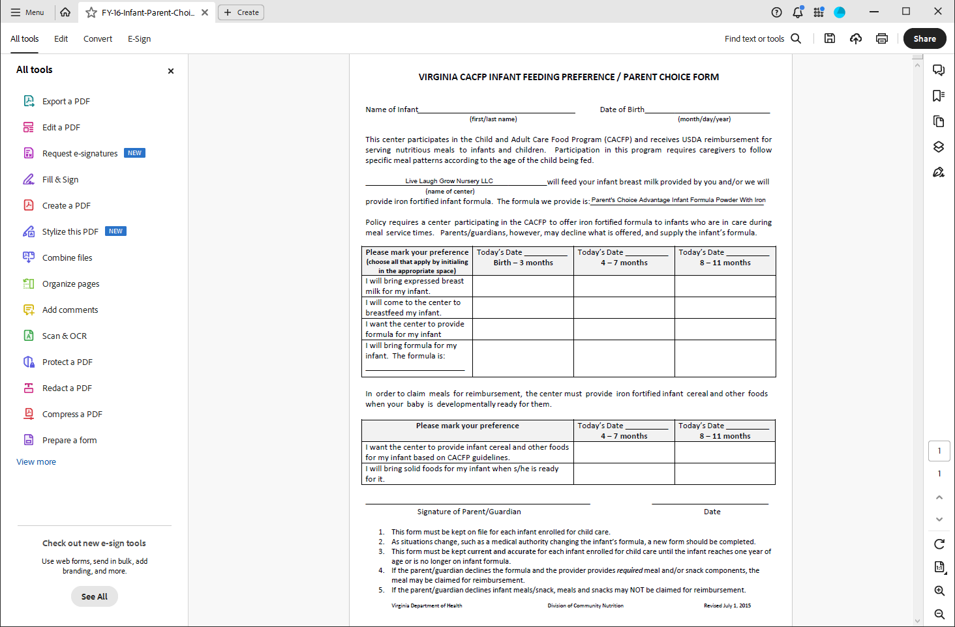

# Live Laugh Grow Nursery Contract / Services Agreement

Please review & initial all items below. These are often parents overlook or take for granted. Please make sure you understand each of the following. Failure to initial does not

exempt you from the following. Failure to read them does not exempt you. All of the following are important to the care of your child.

I, , (Parent’s Name) , (SSN) acknowledge that;

LLGN WILL NOT BE RESPONSIBLE FOR LOST, STOLEN, DAMAGED, &/ OR FORGOTTON ITEMS- SUCH AS BUT NOT LIMITED TO: COATS, HATS, TOYS, SUPPLIES, NAP ITEMS, VIDEOS,

FOOD CONTAINERS, BACKPACKS, LUNCH BOXES, ETC. Please label all items coming into the center. We will always try our best to locate lost items.

Failure to provide a two week notice either in writing or verbal will result in 2 weeks’ worth of tuition charged to your account. If your account is not paid in full within 2 weeks after leaving our center, your account will be forwarded to a private collection agency & collection fees will incur. Please see the office for a copy of our official withdraw form.

Lunch - This is not applicable for children on Infant formula.

Shot Records must be current and turned into the office at the time of enrollment. Your child cannot be permitted in class without a shot record. Shot records must be updated whenever your child receives new shots.

A physical & Birth Certificate must be turned into the office within 21 days of enrollment. Failure to submit these documents will dis-enroll your child.

Parents are required to bring in diapers, wipes, and tissues for their child.

1-2 sets of weather appropriate clothing

You must walk your child to his/her classroom and over to the staff person in the room. Upon arrival always allow your child’s teacher to do a brief daily health check. (During health crisis such as Covid-19, teachers will conduct health check at the door and walk the students to class.)

LLGN does offer one week of vacation per year and no sick days. All vacation must be given with a two-week written notice. Your tuition is expected whether your child is here or not. If you take a leave of absence and decide to dis-enroll your child, you must pay the registration fee again and any fees left on your account. We can only re-enroll on space availability.

CHECK YOUR CHILD IN & OUT DAILY on the computer. If you are unsure how to do this properly, please see the office and someone will be happy to help you. Failure to check your child in and out

could result in extra fees.

LLGN has a strict drop off policy. No children will be allowed to be dropped off during the hours of 9:30am-2:30pm.

LLGN reserve the right to close for all major holidays as listed in you parent information packet was well as 3 additional days providing notice is given. These days do not include days for man-made or natural disasters.

LLGN has a maximum care time of 10 hours for our day program and 6 hours for our evening program. Any additional hours can be subjected to additional cost.

I have read and agree to all the terms and conditions of this agreement. Parent Signature:

Date

Daycare Provider:

Date

**INFANT FEEDING PLAN**

Child's Full Name Date Date of Birth

|  |  |  |  |  |
| --- | --- | --- | --- | --- |
| Does the child take a bottle? Is the bottle warmed?  Does the child hold own bottle? Can the child feed self? | Yes [ Yes [ Yes [ Yes [ | ]  ]  ]  ] | No [  No [  No [  No [ | ]  ]  ]  ] |
| Does the child eat: (check all that apply) Strained Foods [ ] Whole Milk | [ ] |  |  |  |
| Baby Foods [ ] Table Food  Formula [ ] Other | [ ]  [ ] |  |  |  |

What type formula used, if applicable? Amount and time of formula/breast milk to be given? Date

|  |  |  |  |
| --- | --- | --- | --- |
| **UPDATED AMOUNTS OF FORMULA/BREAST MILK TO BE GIVEN** | | | |
| DATE | TIME | AMOUNT | TYPE |
|  |  |  |  |
|  |  |  |  |
|  |  |  |  |
|  |  |  |  |

Does the child take a pacifier? Yes [ ] No [ ] If yes, when?

**INTRODUCTION OF SOLID FOODS**

The introduction of age-appropriate solid foods should preferably occur at six months of age, but no sooner than four months. Has the parent discussed with the child’s primary caregiver that the child has met appropriate developmental skills for the introduction of solid foods? Yes [ ] No [ ] Parent Initials:

|  |  |  |  |  |
| --- | --- | --- | --- | --- |
| The child has reached the following developmental skills: |  | | | |
| Can hold his/her head steady? | Yes [ | ] | No [ | ] |
| Opens mouth/leans forward in anticipation of food offered? | Yes [ | ] | No [ | ] |
| Closes lips around a spoon? | Yes [ | ] | No [ | ] |
| Transfers food from front of the tongue to the back and swallows? | Yes [ | ] | No [ | ] |

Instructions for the introduction of solid foods

Food likes Food dislikes Allergies? (including any premixed formula)

|  |  |  |
| --- | --- | --- |
| **UPDATED AMOUNTS/TYPE OF FOOD TO BE GIVEN** | | |
| TIME | AMOUNT | TYPE |
|  |  |  |
|  |  |  |
|  |  |  |
|  |  |  |

Any updated instructions regarding adding new foods or other dietary changes, please list as needed.

**PARENT’S SIGNATURE:** Date:

INFANT/TODDLER (BIRTH TO 16 MONTHS) DEVELOPMENT & ROUTINE

We want to provide your child with the best care possible. Please help us to get to know your child by filling out this questionnaire. Thank you!

Child’s Name Date of Birth Facility Room

DAILY ROUTINES SLEEPING

Please describe your child’s usual bedtime routine (including what time and where he/she usually sleeps).

How do you know that your child is sleepy/tired?

Does your child have any difficulties falling asleep? If yes, what is helpful?

About how many hours of uninterrupted sleep does your child get each night? How many times per day does your child nap? How many hours on average? Does your child sleep with a pacifier, or need a special song? (Please refer back to the Safe Sleep Policy for allowable items children can sleep with)

Do you have any concerns about your child’s sleep habits? If yes, please explain:

Parent Signature Date

Administration Signature Date