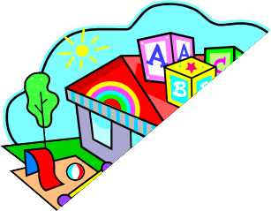November 2023

**MONDAY** 11/6, 11/13, 11/20, 11/27

A.M. Snack: Muffins (WG) & Milk

Lunch: Rice with Ground Turkey & Gravy, Broccoli, Pears, & Milk

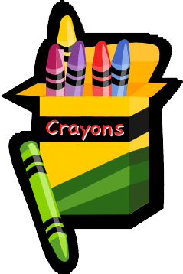P.M. Snack: Goldfish (WG) & Water

**TUESDAY** 11/7, 11/14, 11/21, 11/28

A.M. Snack: Cereal (WG) & Milk

Lunch: Chicken Nuggets, Mixed Vegetables, Applesauce, & Milk

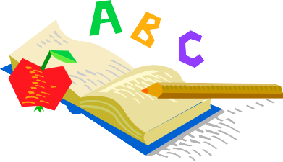 P.M. Snack: Munchies (WG) & 100% Juice

**WEDNESDAY** 11/1, 11/8, 11/15, 11/22, 11/29

A.M. Snack: Fruit Pastry (WG), Milk

Lunch: Turkey Sandwich with Cheese, Corn, Mixed Fruit, & Milk

P.M. Snack: Motts Fruit Snacks, & Water

Children under 2 served whole milk. Above 2 are served skim or 2% milk. This center is an equal opportunity employer and provider.

WG: Whole Grain

**THURSDAY** 11/2, 11/9, 11/16, 11/23, 11/30

A.M. Snack: French Toast Sticks (WG) & Milk

Lunch: Mac & Cheese, Green Beans, & Milk

P.M. Snack: Animal Cookies & Water

**FRIDAY** 11/3, 11/10, 11/17, 11/24

A.M. Snack: Fruit Bars (WG)& Milk

Lunch: Pack-A-Lunch **(PICNIC STYLE LUNCHES ARE PREFERRED)**

P.M. Snack: Pretzels & 100% Juice

**There is a $6.00 Charge for Forgotten Lunch on Pack-A-Lunch Friday**