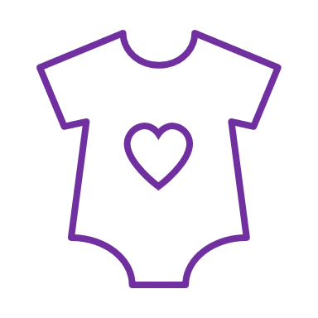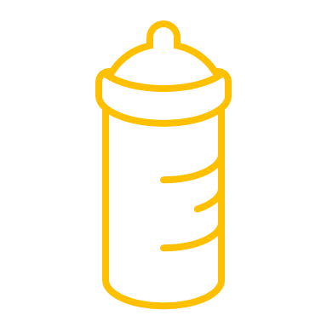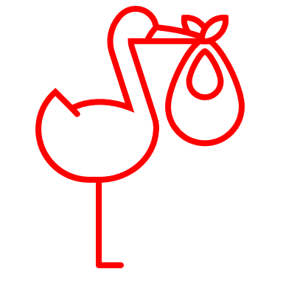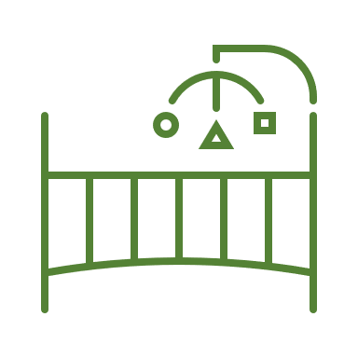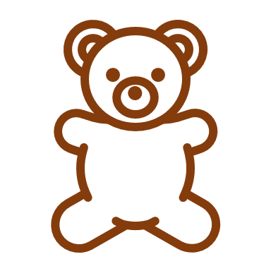

**Bottle Guidelines:**

* Bottles must be clean inside and out, including nipples and caps.
* Bottles and caps must be labeled with the child's first and last name and the current date.
* Only bottles containing formula, milk, or water are acceptable. Please do not add cereal, medication, juice, or any other products.
* If bottles appear to have unknown additives, we will refuse to serve them for the safety of all children.