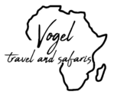

# Kenya Safari

*Nairobi - Tsavo West National Park - Samburu National Reserve - Masai Mara National Reserve*  
*10 Days / 9 Nights*  
  
*Date of Issue: 01 May 2024*  
**16 March 2025 - 25 March 2025**

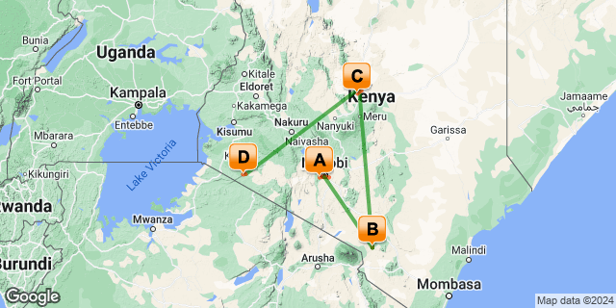

# [Click here to view your Digital Itinerary](https://travel.tourdafrique.co.za/Itinerary/Landing/4880f722-2195-4645-9430-a0f70b371b51)

## Introduction

|  |  |  |  |  |  |
| --- | --- | --- | --- | --- | --- |
| **Accommodation** | **Destination** | **Start** | **End** | **Basis** | **Duration** |
| [Hemingways Nairobi](https://travel.tourdafrique.co.za/iBrochure/10189_122457_27816) | Nairobi | 16 Mar | 18 Mar | B&B | **2 Nights** |
| [Finch Hattons Luxury Tented Camp](https://travel.tourdafrique.co.za/iBrochure/10189_122457_20400) | Tsavo West National Park | 18 Mar | 20 Mar | FB+ | **2 Nights** |
| [Soroi Larsens Camp](https://travel.tourdafrique.co.za/iBrochure/10189_122457_20387) | Samburu National Reserve | 20 Mar | 22 Mar | FB+ | **2 Nights** |
| [Angama Mara](https://travel.tourdafrique.co.za/iBrochure/10189_122457_47351) | Masai Mara National Reserve | 22 Mar | 25 Mar | FI | **3 Nights** |

**Key**  
B&B: Bed and Breakfast  
FB+: Full Board Plus - Dinner, Bed, Breakfast, Lunch and Activities  
FI: Fully Inclusive - Bed, All Meals, Fees and Activities

## Price

USD 13,635.00 per person sharing

## Included

•                 All accommodation as per attached quote

•                 All activities / game drives / park fees / excursions as per attached itinerary

•                 All meals as per quote

•                 Game drives on shared basis where applicable

•                 Private charters with Tropic Air

## Excluded

•                 All activities / game drives / park fees / excursions not mentioned in the attached itinerary

•                 International Flights

•                 Visas

•                 Travel Insurance

•                 Drinks at Hemingways Nairobi

•                 Gratuities

•                 Items of personal nature

## Day 1: Sunday, 16 March Hemingways Nairobi, Nairobi

### Day Itinerary

Arrive Jomo Kenya International Airport where you will be met by a Tradewinds representative who will assist you with customs and immigrations  before escorting you to your awaiting transfer vehicle. Transfer to Hemingways Nairobi for overnight.

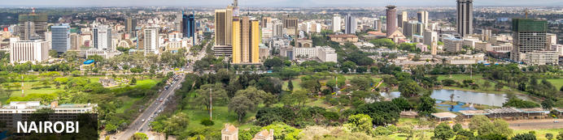

Nairobi is Africa’s 4th largest city and is a vibrant and exciting place and although it has developed a reputation which keeps tourist visits brief there are some fascinating attractions: its café culture, unbridled nightlife, the National Museum, the Karen Blixen Museum and most notably just 20 minutes from the city centre wild lions and buffalo roam in the world’s only urban game reserve.

### Overnight: Hemingways Nairobi [View iBrochure](https://travel.tourdafrique.co.za/iBrochure/10189_122457_27816)

Hemingways Nairobi, a member of the Small Luxury Hotels of the world, is an elegant boutique hotel situated in Nairobi's Karen residential area with magnificent views of the nearby Ngong hills. Sensitively designed for the discerning business and leisure traveller, Hemingways Nairobi offers the full facilities expected in a modern day luxury boutique hotel. Hemingways offers forty-five luxury suites which include the Hemingways suite, The Blixen suite, 19 Executive rooms and 24 deluxe rooms. The Hemingways Nairobi Brasserie serves classic dishes and the very best of local and international cuisine and is open everyday for breakfast, lunch afternoon tea and dinner.

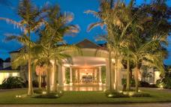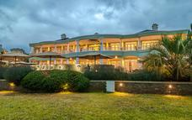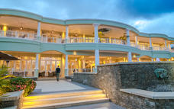

### Basis

Bed and Breakfast

### Included

Breakfast, express check-in and check-out, Wi-Fi, satellite television, government taxes, , mineral water in the room, complimentary use of the gym, sauna, steam room, and outdoor pool.

### Excluded

Lunch, dinner, drinks, any items of a personal nature, gratuities

## Day 2: Monday, 17 March Hemingways Nairobi, Nairobi

### Day Itinerary

Today embark on a full day visiting the Daphne Sheldrick Elephant Orphanage followed by a visit to the Karen Blixen Museum.  Lunch en route (clients own account) and do some shopping.

Optional (not included) Giraffe Centre at $15 per person (subject to change for 2025).

Note: The Daphne Sheldrick Elephant Sanctuary public tour is between 11h00 - 12h00 and can only be prebooked 3 months prior to arrival.

### Activities

|  |
| --- |
| Sheldrick Orphanage Entrance Fee |
| Karen Blixen Museum |

#### The Sheldrick Wildlife Trust

Founded in 1977 by Dr Dame Daphne Sheldrick D.B.E, in honour of the memory of her late husband, famous naturalist and founding Warden of Tsavo East National Park, David Leslie William Sheldrick MBE, the DSWT claims a rich and deeply rooted family history in wildlife and conservation. Born from one family’s passion for Kenya and it's wilderness, the Sheldrick Wildlife Trust is today the most successful orphan-elephant rescue and rehabilitation program in the world and one of the pioneering conservation organisations for wildlife and habitat protection in East Africa.

To date the Sheldrick Wildlife Trust has successfully hand-raised over 244 infant elephants and has accomplished its long-term conservation priority by effectively reintegrating orphans back into the wild herds of Tsavo, claiming many healthy wild-born calves from former-orphaned elephants raised in care.

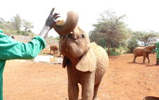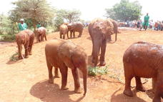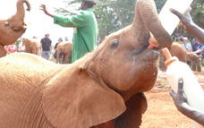

#### Karen Blixen Museum

The Karen Blixen Museum was once the home of the Danish author Karen Blixen. The renowned author made famous by the release of the Oscar winning movie ‘Out of Africa’, based on Karen’s autobiography of the same title. The museum displays many pieces of the author's furniture and has a splendid view of the Ngong Hills, immortalized in Karen Blixen's opening line, "I had a farm in Africa at the foot of the Ngong Hills."

The Karen Blixen Museum is open to the public every day, with guided tours on offer. The museum shop features handicrafts, posters, postcards, the movie ‘Out of Africa’, as well as books and other Kenyan souvenirs.

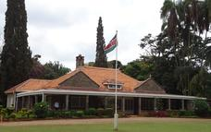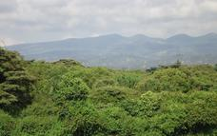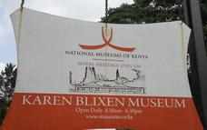

### Basis

Bed and Breakfast

### Included

Breakfast, express check-in and check-out, Wi-Fi, satellite television, government taxes, , mineral water in the room, complimentary use of the gym, sauna, steam room, and outdoor pool.

### Excluded

Lunch, dinner, drinks, any items of a personal nature, gratuities

## Day 3: Tuesday, 18 March Finch Hattons Luxury Tented Camp, Tsavo West National Park

### Day Itinerary

After breakfast and check out, transfer to Wilson Airport for your Tropic Air private charter flight to Tsavo West National Park.

Tropic Air private charter flight Wilson - Finch Hattons Airstrip (2 x private charters: 1 x C208B Grand 10 pax  & 1 x C208 Baby 6 pax).

On arrival at Finch Hattons Airstrip you will be met by a local Finch Hattons driver/guide and transferred to the camp. Explore the camp as it has a variety of activities on offer.

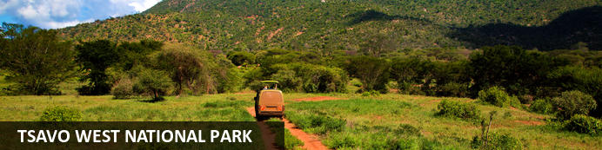

Tsavo West is covered in fairly thick bush but has spectacular natural scenery which includes volcanic cones, rocky outcrops and lava flows, mountains, river forest, plains, lakes and wooded grassland. Although the game is not as easy to spot as in Tsavo East it’s all here. Natural attractions include the Mzima Springs (the main source of water for the Tsavo River), the Chaimu Crater and Roaring Rocks, with their panoramic view.

### Overnight: Finch Hattons Luxury Tented Camp [View iBrochure](https://travel.tourdafrique.co.za/iBrochure/10189_122457_20400)

Situated in Tsavo West National Park, Finch Hattons is an eco, luxury safari camp rich in history and committed to conservation.

After an extensive refurbishment completed in 2015, the camp features 17 luxury tented suites including 2 two-bedroom suites, and a presidential suite equipped with a private plunge pool, a separate room for a nanny/body guard and a kitchen/pantry.

Further facilities available to guests are a wellness centre, a spa, 2 infinity pools, a fully equipped gym, a yoga pavilion, business centre and a kids activity room.

Relax and watch the resident hippo pods wallow in the natural spring-pools flowing through camp, tingle your tastebuds with delights on our fine-dining and a la-carte menus or be adventurous and discover the untouched surrounding bush on game drives or walking safaris.

Finch Hattons has something to offer every one of your senses.

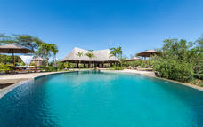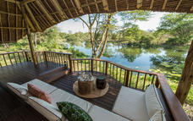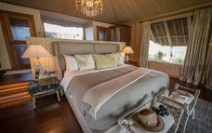

### Basis

Full Board Plus - Dinner, Bed, Breakfast, Lunch and Activities   
All Local Brands (Spirits, Wine and Beers) Included

### Included

All meals, return Finch Hattons airstrip transfers, scheduled activities (including game drives, excursion to Shetani lava flow, Oldonyo Larami volcano hike, yoga,  nature walk, bush breakfast & sundowners), use of spa (excluding treatments), laundry (excluding dry cleaning), all drinks (excluding premium wines & spirits), complimentary wireless internet throughout camp, exclusive use of vehicle, butler service and a private chef for in-suite dining (when booking Finch Hattons Suite).

### Excluded

Air transfer, spa treatments, travel insurance, gratuities, tips & personal expenses, and optional activities.

## Day 4: Wednesday, 19 March Finch Hattons Luxury Tented Camp, Tsavo West National Park

### Day Itinerary

Schedule activities like game drives, excursion to the Shetani lava flow, embark on a hike to the Oldonyo Larami volcano,  nature walks, bush breakfast and sundowners on offer.

### Activities

|  |
| --- |
| Game Drives |
| Night Game Drives |
| Chyulu Sundowners |
| Guided Bush Walks & Hikes |
| Bush Breakfast |
| Bird Watching |
| Cultural Visits |

#### Chyulu Spa and Wellness Centre

Who says going on safari means you can't indulge your mind, body and spirit all at once? The Chyulu Spa and Wellness Centre offers a wide range of treatments and therapies using the finest Africology products. The spa also features a secondary swimming pool, a hamam, a small gym and an elevated yoga deck from which you can continue to spot game during your practice.

#### Game Drives

Most people tend to forget about Tsavo and why it is amongst the top pick of many experienced safari guides. Being Kenya's largest game park and with so few lodges in the area, you will soon understand why. The park is amongst the most iconic in Kenya with its diverse landscapes and is rich history.

While the best game viewing is generally in the coolness of the early mornings or late afternoons, you are free to decide how long and when you would like to set out for your game drive. Using only open-sided vehicles, you can experience the quintessential African landscape and the wide range of birds and flora & fauna that thrive in the surrounding area.

#### Night Game Drives

Head into the park after sunset for a chance to discover some of the more nocturnal species of Tsavo. Setting off after dark offers another adventure as you explore the vastness of the park by moonlight and experience the night sounds of the bush.

#### Chyulu Sundowners

Settle down at the foot of the Chyulu Hills in time for cocktails and canapés as the sun sets over Tsavo with Mt Kilimanjaro in the backdrop. This is truly one of the best ways to end the day before heading back to camp.

#### Guided Bush Walks & Hikes

Get a little more up-close and personal with the park's flora and fauna on a guided nature walk. You will be accompanied by an experienced guide and armed ranger who will be happy to share their vast knowledge of how nature lives and thrives in Tsavo.

Among our favourite hiking locations is the Chyulu Hills Forest. The gentle gradient of the forest is more comfortable to the novice hiker and provides a haven from which to explore the several species of bids, plants and wildlife that inhabit the area. Our guides can easily point out animal tracks as well as the medicinal uses for various plants during these hikes.

There are several other hiking options available in the area and each offers a unique experience.

#### Bush Breakfast

Though there are several different dining areas at camp, why not enjoy a gourmet breakfast served in the heart of the bush. After your morning game drive, rather than heading back to camp, we will set up a full breakfast somewhere along the way for a real al-fresco experience.

#### Bird Watching

Home to over 500 species of birds, Tsavo is a real birders paradise. A lot of these species can easily be spotted without leaving the luxury of your private viewing deck as many of them reside around the hippo pools however our guides can easily spot these out to you during game drives or bush walks.

#### Cultural Visits

Iltilal is the closest village to Finch Hattons and home to a large Maasai community. We have developed a close relationship with the village and can easily organise cultural visits here for a chance to gain some insight into their daily way of life. The Maasai are a very welcoming tribe and are always happy to invite you into their homes for a closer glimpse into their lifestyle.

### Basis

Full Board Plus - Dinner, Bed, Breakfast, Lunch and Activities   
All Local Brands (Spirits, Wine and Beers) Included

### Included

All meals, return Finch Hattons airstrip transfers, scheduled activities (including game drives, excursion to Shetani lava flow, Oldonyo Larami volcano hike, yoga,  nature walk, bush breakfast & sundowners), use of spa (excluding treatments), laundry (excluding dry cleaning), all drinks (excluding premium wines & spirits), complimentary wireless internet throughout camp, exclusive use of vehicle, butler service and a private chef for in-suite dining (when booking Finch Hattons Suite).

### Excluded

Air transfer, spa treatments, travel insurance, gratuities, tips & personal expenses, and optional activities.

## Day 5: Thursday, 20 March Soroi Larsens Camp, Samburu National Reserve

### Day Itinerary

Depart with Tropic Air private charter to Kalama Airstrip in Samburu.

Tropic Air private charter flight Finch Hattons Airstrip - Kalama Airstrip  (2 x private charters: 1 x C208B Grand 10 pax  & 1 x C208 Baby 6 pax).

On arrival at Kalama Airstrip you will be met by a local Larsens Camp driver/guide and transferred to the camp.  Rest of the day at leisure to enjoy the facilities the camp has to offer.

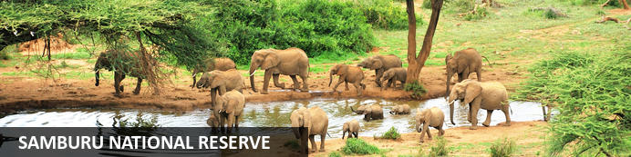

Samburu is remote, hot and arid with rugged hills and undulating plains. And like most wildlife areas in such environments Samburu’s life blood is the Ewaso Ngiro River, and its riverine forests, which forms its boundary with the Buffalo Springs National Park. This is one of the few areas in Kenya where you can spot southern and northern dwelling species together with highlights being reticulated giraffe, the long necked gerenuk, Somali ostrich and Grevy's Zebra. Samburu was one of the homes of Elsa the Lioness, star of the bestselling book and award winning movie Born Free.

### Overnight: Soroi Larsens Camp [View iBrochure](https://travel.tourdafrique.co.za/iBrochure/10189_122457_20387)

Welcome to Soroi Larsens Camp, an exquisite boutique luxury retreat nestled in the untamed heart of the Samburu Game Reserve. Embrace the spirit of adventure that once inspired renowned explorer Eric Larsen as you step into a world of unbridled wilderness and indulgent comfort. Our eco-conscious camp expertly blends sustainability and local community support, providing an unparalleled experience for the discerning traveller seeking luxury and a deeper connection with nature.

Perched serenely on the banks of the Ewaso Nyiro River, Soroi Larsens Camp boasts an intimate selection of ten opulent tents, two family units, and two deluxe luxury tented suites, each offering private terraces with exclusive river frontage. Relish the breathtaking vistas while nestled in our lavish accommodations, designed to immerse you in the untouched beauty of Samburu.

Our “pièce de résistance”, the deluxe luxury tented suites, elevate your stay to extraordinary heights with generous living spaces, private 24/7 butlers, outdoor showers, and mesmerizing sleepout decks with star beds. Recline under the celestial canopy as you fall asleep to the soothing lullaby of the river and the whispers of the African night.

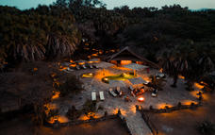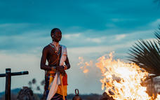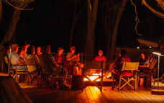

### Basis

Full Board Plus - Dinner, Bed, Breakfast, Lunch and Activities   
All Local Brands (Spirits, Wine and Beers) Included

### Included

Full board accommodation inclusive of all meals, twice daily shared & scheduled game drives in custom built 4x4 safari vehicles with accredited English-speaking safari guide, local airstrip transfers, filtered water, coffees and teas, local branded beverages inclusive of soft drinks, local beers, selected spirits and house wines activities for children under 12, laundry, guided naturalist walk around camp.

### Excluded

All extra meals, premium drinks, spirits, whiskies, private cellar wines and champagne, additional activities, gratuities & tips and items of a personal nature.

## Day 6: Friday, 21 March Soroi Larsens Camp, Samburu National Reserve

### Day Itinerary

Today enjoy two daily shared & scheduled game drives in custom built 4x4 safari vehicles with accredited English-speaking safari guide.

### Activities

|  |
| --- |
| The Game Drive Experience |
| Wilderness Breakfast |
| Evening Euphoria (AKA Sundowner) |
| Dinner in the Bush |
| Starlit Learning (AKA Stargazing) |
| Birdwatching in Camp |
| Umoja Women's Village |
| Soroi Professional Photography Hide |
| Exclusive Sunset Dinner & Star Bed Sleepout |
| Goat Feast in Samburu Village |
| Singing Well |
| Day Excursion to Reteti Elephant Sanctuary |

#### The Game Drive Experience

Samburu National Reserve is renowned for its unique "Samburu Special 5" species, endemic to Northern Kenya. These include the rare Grevy's Zebra, Somali Ostrich, Beisa Oryx, Gerenuk, and the beautiful reticulated giraffes. Opt for an AM or PM game drive to experience the difference.

#### Wilderness Breakfast

Nothing compares to the exclusive tranquility of breakfast in the African wild, serenaded by the harmonious birdsong that greets the new day. The morning sunlight provides a rich supply of vitamin D.

#### Evening Euphoria (AKA Sundowner)

Following an exhilarating evening safari, you will be guided to an elevated viewing platform near Larsen'scamp. Here you can savor the sunset behind Koitogo Hills, complemented by a cocktail of choice and nutritious canapés.

#### Dinner in the Bush

Indulge in the evening's finest meal, served in the bush under the star-studded Samburu sky.

#### Starlit Learning (AKA Stargazing)

Post dinner, you will be led to a special location where our knowledgeable naturalist will teach you about the constellations adorning the breathtaking Samburu night sky. This is an opportunity not to be missed.

#### Birdwatching in Camp

Samburu, home to over 400 native bird species, is a birdwatcher's paradise. Our experienced local bird guide will take you along the Ewaso Nyiroriver forest line to observe the unique northern bird species, including the Somali bee-eater and Somali ostrich, amongst others. This is your chance to expand your birding list.

#### Umoja Women's Village

Visit this matriarchal village searchers post of Samburu County. Established in 1990, the village is a haven for women fleeing abusive relationships. They advocate for women's rights, including anti-FGM campaigns, and offer refuge to vulnerable girls. Handcraft-making serves as their livelihood.

#### Soroi Professional Photography Hide

As a professional photographer and an avid safari traveler, the quest for the perfect shot is never-ending. Our Photographic Hide offers an optimal photographic experience through meticulous design. Elevated slightly above ground level, the Hide provides a unique vantage point, putting photographers at eye level with their subjects. This perspective creates intimate and powerful images that immerse the viewer in the animals' world. The viewing slots allow a 180-degree panoramic view of the watering hole and the surrounding landscape. In addition, the Hide is equipped with comfortable seating and ample space for tripods and other equipment, ensuring photographers can focus on capturing the perfect shot.

#### Exclusive Sunset Dinner & Star Bed Sleepout

Surrender to the enchantment of the Samburu night sky with our signature Sunset Dinner & Star Bed Sleepout experience at Soroi Larsens Camp. As twilight drapes the landscape, the evening unfolds with a sumptuous three or four-course gourmet feast served beneath the twinkling tapestry of stars. Your senses awaken with each morsel, marrying the taste of exquisite cuisine with the intoxicating allure of the wild. Post-dinner, we invite you to recline on our luxurious star beds, cradled within the ambient glow of a candlelit tented terrace. Framed by the rhythmic serenade of the Ewaso Nyiro River, this is your exclusive gateway to sleeping under the boundless African sky. Throughout the evening, your personal butler remains at your service, ensuring every detail of this unique adventure is woven with impeccable care. Allow the tranquil majesty of Samburu National Reserve to lull you into a peaceful slumber and awaken to a sunrise that imprints an indelible memory on your soul. With the Soroi Larsens Sleepout, you don't just experience Samburu; you become a part of it.

#### Goat Feast in Samburu Village

Experience the Samburu tradition of slaughtering, roasting, and sharing goat meat by a campfire. Watch the warriors drink raw blood and eat raw kidneys, and if you wish, participate in the process.

#### Singing Well

Immerse yourself in a unique Samburu tradition. Warriors form a human chain to descend into wells dug deep in dry riverbeds to fetch the precious resource - water. They water their animals and sing beautiful songs to strengthen their bond. The singing provides rhythm and motivation for the warriors not to tire.

#### Day Excursion to Reteti Elephant Sanctuary

Visit this community-run elephant sanctuary in Samburu County, established in 2016, to care for orphaned and abandoned baby elephants. Your visit supports the conservation efforts of these vulnerable creatures.

### Basis

Full Board Plus - Dinner, Bed, Breakfast, Lunch and Activities   
All Local Brands (Spirits, Wine and Beers) Included

### Included

Full board accommodation inclusive of all meals, twice daily shared & scheduled game drives in custom built 4x4 safari vehicles with accredited English-speaking safari guide, local airstrip transfers, filtered water, coffees and teas, local branded beverages inclusive of soft drinks, local beers, selected spirits and house wines activities for children under 12, laundry, guided naturalist walk around camp.

### Excluded

All extra meals, premium drinks, spirits, whiskies, private cellar wines and champagne, additional activities, gratuities & tips and items of a personal nature.

## Day 7: Saturday, 22 March Angama Mara, Masai Mara National Reserve

### Day Itinerary

This morning depart with Tropic Air private charter to Angama Mara in the Masai Mara.

Tropic Air private charter Kalama Airstrip - Kichwa Tembo Airstrip (2 x private charters: 1 x C208B Grand 10 pax  & 1 x C208 Baby 6 pax).

On arrival at Kichwa Tembo Airstrip you will be met by a local Angama Mara driver/guide and transferred to the camp.  Rest of the day at leisure to enjoy the facilities the camp has to offer.

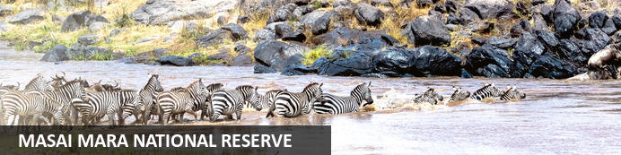

One of Kenya’s undisputed natural highlights is the Masai Mara National Reserve, which sprawls across more than 1500 square kilometres of the country’s southwest. The park protects a phenomenal array of game, including elephant, lion, leopard and buffalo, as well as crocodile and hippopotamus in the Mara River. The birdlife is no less impressive, with over 450 resident bird species. However, the true highlight here is the Great Migration, recognised as one of the Seven New Wonders of the World. To survive the dry months of July to September, some 1.7 million wildebeest, migrate from the parched plains of the Serengeti National Park in Tanzania. Along with much smaller numbers of antelope, buffalo and zebra, they move to the more forgiving grasslands of the Masai Mara. In their wake come predators such as lion, hyena and cheetah, for whom these giant herds are an easy source of prey.

### Overnight: Angama Mara [View iBrochure](https://travel.tourdafrique.co.za/iBrochure/10189_122457_47351)

Angama Mara is a remarkable new owner-run safari lodge. Located high above the floor of Africa’s Great Rift Valley, Angama Mara overlooks Kenya’s Maasai Mara, considered by many as the loveliest game reserve on the continent. Guests will find two intimate camps of just fifteen tented suites each, a private airfield and access to the Mara below, tailor-made safari days and a famously warm Kenyan welcome. Days are as action-packed or as gentle as guests choose them to be. The Mara Triangle is home to Africa’s great mammals, a mere 10 minute drive from the lodge, and guests can experience hot air ballooning, walking safaris, cultural visits to neighbouring Maasai villages – or simply do nothing at all.

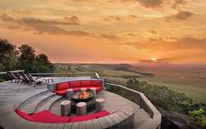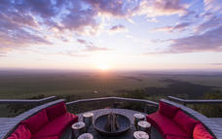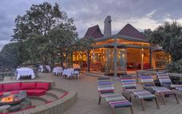

### Basis

Fully Inclusive - Bed, All Meals, Fees and Activities   
All Local Brands (Spirits, Wine and Beers) Included

### Included

Full Board Accommodation, meals and drinks (excluding French Champagne & reserve wines), all guided safaris into the Mara Triangle, walking safaris on the escarpment, laundry service, Wi-Fi, on property guest experiences, transfers to/from Angama Mara Airfield or Kichwa Tembo Airstrip, emergency medical evacuation insurance, childminding (from 18h00 to 22h00), VAT and all levies.

### Excluded

All additional guest experiences as otherwise listed, safari shop purchases & in-tent massages, air and road transfers from elsewhere within the Maasai Mara, gratuities, and hot air balloon safaris

## Day 8: Sunday, 23 March Angama Mara, Masai Mara National Reserve

### Day Itinerary

Gently wake before dawn with freshly-brewed tea or coffee delivered to your tented suite. Enjoy the fresh, early morning air on a drive through the Mara to the launch site. Watch the awe-inspiring sight of the enormous balloons filling with fired air. A quick pre-flight briefing, and before you know it, you’re in the basket, floating effortlessly above the Mara. Once you’ve settled back to earth, toast with a celebratory champagne breakfast under a tree, somewhere in the middle of nowhere.

Rest of the day at leisure and embark on the activities the camp has to offer.

### Activities

|  |
| --- |
| Governors Balloon Safari |
| Safari |
| Walking Safaris |
| Out of Africa Picnics |
| Sundowners in the Boma |
| Forest BBQ |
| Visit the Beading Studio |
| Run with a Kenyan |
| Visit a Maasai Manyatta |
| Mara Conservancy Canine Patrol Training |

#### Photography

Visit Angama Mara’s Photographic Studio for a private tutorial with our on-site photographers who will help you come to grips with your camera. Hire photographic equipment or learn more about the editing process on our large-screen Apple desktops. Explore the Mara on a private photographic safari with one of our specialist guides. Those who prefer to put down their cameras, the in-house photographer can capture these special moments in a professional photoshoot.

#### The Shamba

Explore Angama Mara’s one-acre lovely kitchen garden followed by a soil-to-fork lunch under towering moth trees. Crusty bread, local cheese, chilled rosé and the freshest of salads served with the Mara as a backdrop – what could be better?

#### Governors' Balloon Safaris

Hot air balloon safaris operator since 1978. We offer the best flight path over the winding course of the river, forests and plains of the Masai Mara.

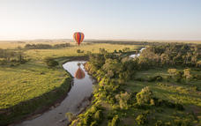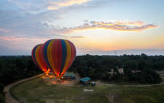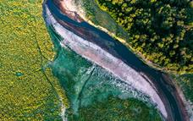

#### Safari

Game drives at Angama Mara are planned according to what the guests would like to do as there is no set programme. Descending down Angama Mara’s private road, 10-minutes later guests enter the Reserve. Even though there is game a-plenty around the lodge, the heart of the action takes place in one of Africa’s most iconic year-round Big Five destinations – the Mara Triangle.

#### Walking Safaris

Guests have access to over a huge tract of wilderness along the Oloololo Escarpment. Escorted by a Maasai naturalist guide, walks can be as long or short as guests prefer. Discover the smaller details – fascinating plants, birds, insects and animals and the role they play in traditional Maasai beliefs and customs.

#### Out of Africa Picnics

Intimate private picnics for two (maximum four) on the Out of Africa kopje featured on the movie’s iconic poster. Checked blankets, comfy cushions, canvas safari chairs, a picnic and sparkling wine on ice – everything you could need for elegant romance.

#### Sundowners in the Boma

As the day ends, it’s time to sit back, sip a cocktail and watch the sun descend behind the Rift Valley from the spectacular vantage point of the Sundowner Boma — perfect for this, with its circular shape encapsulating the dramatic views overlooking the Maasai Mara.

Traditionally as the sun set, livestock was gathered into this space to protect the animals from predators. Today, it is also a space in which people gather, and where the African night is welcomed with song, dance and celebration.

#### Forest BBQ

Gather in a lantern-lit forest for dinner cooked over the coals. Guests dine family-style at long, wooden tables, off enamel plates with dishcloths for napkins. It’s fun, it’s relaxed and most of all, it’s delicious.

#### Visit the Beading Studio

Leading off the Safari Shop is a sunny studio for Maasai ladies who come daily to bead bespoke items. Guests can try their hand at beading or perhaps have the ladies bead a name bracelet or an item of their clothing.

#### Run with a Kenyan

Join the Angama Running Club and see how you fare against this nation of great athletes as you jog along the Escarpment with the possibility of encountering plains game such as giraffe and zebra along the way.

#### Visit a Maasai Manyatta

Guests enjoy a rare opportunity of gaining a deeper understanding into every day lives of the Maasai, their ways and their fascinating culture, and maybe a few keepsakes to take home.

#### Mara Conservancy Canine Patrol Training

A hands-on opportunity to learn about the invaluable work of the Mara Conservancy’s canine unit. Observe and participate in training exercises and see if you can outsmart these determined canines.

### Basis

Fully Inclusive - Bed, All Meals, Fees and Activities   
All Local Brands (Spirits, Wine and Beers) Included

### Included

Full Board Accommodation, meals and drinks (excluding French Champagne & reserve wines), all guided safaris into the Mara Triangle, walking safaris on the escarpment, laundry service, Wi-Fi, on property guest experiences, transfers to/from Angama Mara Airfield or Kichwa Tembo Airstrip, emergency medical evacuation insurance, childminding (from 18h00 to 22h00), VAT and all levies

### Excluded

All additional guest experiences as otherwise listed, safari shop purchases & in-tent massages, air and road transfers from elsewhere within the Maasai Mara, gratuities, and hot air balloon safaris

## Day 9: Monday, 24 March Angama Mara, Masai Mara National Reserve

### Day Itinerary

Today enjoy two daily shared & scheduled game drives in custom built 4x4 safari vehicles with accredited English-speaking safari guide.

### Basis

Fully Inclusive - Bed, All Meals, Fees and Activities   
All Local Brands (Spirits, Wine and Beers) Included

### Included

Full Board Accommodation, meals and drinks (excluding French Champagne & reserve wines), all guided safaris into the Mara Triangle, walking safaris on the escarpment, laundry service, Wi-Fi, on property guest experiences, transfers to/from Angama Mara Airfield or Kichwa Tembo Airstrip, emergency medical evacuation insurance, childminding (from 18h00 to 22h00), VAT and all levies

### Excluded

All additional guest experiences as otherwise listed, safari shop purchases & in-tent massages, air and road transfers from elsewhere within the Maasai Mara, gratuities, and hot air balloon safaris

## Day 10: Tuesday, 25 March End of Itinerary

### Day Itinerary

Enjoy your last breakfast in the bush before being transferred to Kichwa Tembo Airstrip. Fly with Tropic Air private charters to Wilson Airport.

Tropic Air private charter Kichwa Tembo Airstrip - Wilson Airstrip (2 x private charters: 1 x C208B Grand 10 pax  & 1 x C208 Baby 6 pax).

Arrive at Wilson Airport where you will be met by a local African Safari Excellence driver/guide who will take you to a local restaurant for lunch followed by some last minute shopping.  A half day vehicle is included this afternoon (max 5 hours).  Transfer to Jomo Kenyatta International Airport where you will be met by a Tradewinds representative who will assist you in checking in for your international flight.

End of services.

### Included

Breakfast

# Transport

## Flight Information

|  |  |  |  |  |  |  |  |  |
| --- | --- | --- | --- | --- | --- | --- | --- | --- |
| **Date** | **Flight** | **Airline** | **Departure Airport** | **Time** | **Arrival Airport** | **Time** | **Class** | **Ref** |
| 18 Mar | Charter Flight | Tropic Air | Wilson Airport [WIL] |  | Finch Hatton's Airstrip |  |  |  |
| 20 Mar | Charter Flight | Tropic Air | Finch Hatton's Airstrip |  | Kalama Airstrip |  |  |  |
| 22 Mar | Charter Flight | Tropic Air | Kalama Airstrip |  | Kichwa Tembo Airstrip |  |  |  |
| 25 Mar | Charter Flight | Tropic Air | Kichwa Tembo Airstrip |  | Wilson Airport [WIL] |  |  |  |

## Transfers

|  |  |  |  |  |  |
| --- | --- | --- | --- | --- | --- |
| **Date** | **Company** | **Pick Up** | **Drop Off** | **Time** | **Vehicle** |
| 16 Mar | African Safari Excellence | Jomo Kenyatta International Airport | Hemingways Nairobi |  | Transfer |
| 18 Mar | African Safari Excellence | Hemingways Nairobi | Wilson Airport |  | Transfer |
| 18 Mar | Finch Hattons Luxury Tented Camp | Finch Hattons Airstrip | Finch Hattons Luxury Tented Camp |  | Transfer |
| 20 Mar | Finch Hattons Luxury Tented Camp | Finch Hattons Luxury Tented Camp | Finch Hattons Airstrip |  | Transfer |
| 20 Mar | Soroi Larsens Camp | Kalama Airstrip | Larsens Camp |  | Transfer |
| 22 Mar | Soroi Larsens Camp | Soroi Larsens Camp | Kalama Airstrip |  | Transfer |
| 22 Mar | Angama Mara | Kichwa Tembo Airstrip | Angama Mara |  | Transfer |
| 25 Mar | Angama Mara | Angama Mara | Kichwa Tembo Airstrip |  | Transfer |
| 25 Mar | African Safari Excellence | Wilson Airport | Jomo Kenyatta International Airport |  | Transfer |

### Urgent Contact Numbers

|  |  |  |  |
| --- | --- | --- | --- |
| **Company Name** | **Telephone** | **Email Address** | **Contact Person** |
| Vogel Travel and Safaris | +1 602-214-6654 | Leon.Vogel@globaltravelcollection.com |  |

### Service Provider Directory

|  |  |  |  |
| --- | --- | --- | --- |
| **Service Provider** | **Ref. Number** | **Telephone** | **Address** |
| Angama Mara |  | +27 10 020 0699 | Mara Triangle  Narok County  Kenya |
| Finch Hattons Luxury Tented Camp |  | +254 720 444419 |  |
| Hemingways Nairobi |  | +254 20 2295011 | Mbagathi Ridge,  Karen  Nairobi  Kenya |
| Soroi Larsens Camp |  | +254 700 141736 |  |

## Call us for pricing

## Terms and Conditions

### Itinerary Terms and Conditions

**25% non-refundable deposit is due within 7 days of confirmation.**

**Balance of payment is due 60 days prior to travel.**