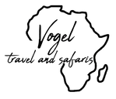

# Gorillas and Kenya potential trip for 2027

*Kigali - Nyungwe Forest National Park - Nairobi - Mara North Conservancy*  
*9 Days / 8 Nights*  
*8 Persons*  
*Date of Issue: 02 July 2025*  
**01 June 2026 - 09 June 2026**

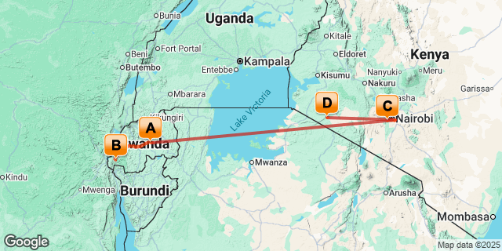

# [Click here to view your Digital Itinerary](https://travel.tourdafrique.co.za/Itinerary/Landing/C406453C-C0A6-4161-ADAB-3EC22EAC43EE)

## Introduction

|  |  |  |  |  |  |
| --- | --- | --- | --- | --- | --- |
| **Accommodation** | **Destination** | **Start** | **End** | **Basis** | **Duration** |
| [The Retreat by Heaven](https://travel.tourdafrique.co.za/iBrochure/10189_122457_130674) | Kigali | 1 Jun | 2 Jun | B&B | **1 Night** |
| One & Only Nyungwe House | Nyungwe Forest National Park | 2 Jun | 4 Jun | FB+ | **2 Nights** |
| [Hemingways Nairobi](https://travel.tourdafrique.co.za/iBrochure/10189_122457_27816) | Nairobi | 4 Jun | 6 Jun | B&B | **2 Nights** |
| [andBeyond Kichwa Tembo Tented Camp](https://travel.tourdafrique.co.za/iBrochure/10189_122457_15485) | Mara North Conservancy | 6 Jun | 9 Jun | FI | **3 Nights** |

**Key**  
B&B: Bed and Breakfast  
FB+: Full Board Plus - Dinner, Bed, Breakfast, Lunch and Activities  
FI: Fully Inclusive - Bed, All Meals, Fees and Activities

## Day 1: Monday, 1 June The Retreat by Heaven, Kigali

### Day Itinerary

WELCOME TO AFRICA!!!

On arrival into Kigali International Airport, you will be met off the plane by a representative and will clear customs. Once you have collected your luggage, you will be transferred to The Retreat by Heaven, your home for the evening.

Evening at leisure.

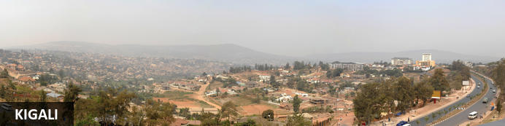

Perched at an elevation of approximately 1,850 metres, Rwanda's capital city sprawls across a series of verdant hills and valleys and is the country’s financial, commercial and cultural hub, . This undulating terrain provides panoramic vistas, with Mount Kigali offering well-marked trails for hikers to explore its lush vegetation and unique wildlife. The city's history is deeply etched in sites like the Kigali Genocide Memorial, a poignant tribute to the nation's past. Today, Kigali thrives with a vibrant arts scene, exemplified by venues such as the Inema Arts Center, where contemporary Rwandan art flourishes. Culinary enthusiasts can indulge in the city's burgeoning food scene, including traditional milk bars that serve fresh dairy-based beverages. The Kimironko Market presents a sensory feast of fresh produce, textiles, and crafts. The Uganda National Mosque, commissioned by Libya’s former leader Muammar Gaddafi, was built to strengthen diplomatic and religious ties between Libya and Rwanda. Nearby, Nyamirambo brims with colourful streets, local boutiques, and a lively nightlife.

### Overnight: The Retreat by Heaven [View iBrochure](https://travel.tourdafrique.co.za/iBrochure/10189_122457_130674)

Town & Country and The New York Times describe The Retreat in Kigali as one of the top boutique hotels of the world. The American owners of Heaven Restaurant created The Retreat, a 20-room luxury boutique hotel located on a tree-lined residential street steps from Kigali City Center and 20 minutes from the airport. 8 new luxury pool villas are now open where King Charles III stayed in June 2022! The Retreat is Kigali’s first eco-friendly resort and features solar electricity, organic toiletries, locally-crafted furniture from a Tanzanian sustainable teak farm, outdoor showers, private terraces, a yoga and meditation deck, spa, large heated saltwater swimming pool with hot tub and diving rocks, and an open-air fitness center. Fusion Restaurant and its Swahili-inspired bar, located at The Retreat, offers delicious farm-to-table international cuisine, while Heaven Restaurant (reached through The Retreat’s “Stairway to Heaven”) offers an innovative modern African menu. The Retreat is the perfect choice to host guests for first 2 nights or several days as visitors enjoy innovative, curated cultural experiences and exciting activities onsite and around Kigali. From public health to hospitality, co-owners Alissa & Josh Ruxin created Heaven Restaurant in 2008 to provide jobs and vocational training in hospitality, to date, Heaven and The Retreat have trained over 3,000 Rwandans.

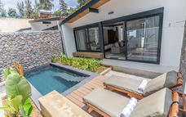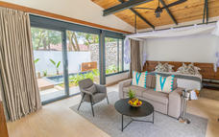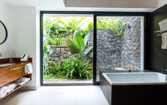

### Basis

Bed and Breakfast

## Day 2: Tuesday, 2 June One & Only Nyungwe House, Nyungwe Forest National Park

### Day Itinerary

After breakfast you will be transferred by road (+/-3hrs) to the Volcanoes National Park, and check-in at One & Only Nyungwe House, for the following 2 nights.

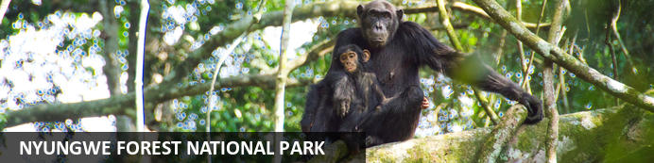

Situated in southwestern Rwanda, the Nyungwe Forest National Park is known for its exceptional biodiversity and its wide range of endemic species. The park is composed of lush tracts of rainforest set high up on fertile mountain slopes. It is one of Africa’s most ancient forests and the home of Rwanda’s sole remaining chimpanzee population, as well as 85 additional mammal species, 43 reptile species, nearly 300 bird species and over 1000 plant species. Visitors can enjoy spotting colobus monkeys and chimpanzees hiding in the trees, hiking on a well-maintained network of trails passing through lush equatorial rainforest and catching a glimpse of a beautiful array of colourful birdlife. Don’t miss the thrilling Canopy Walk; it is one of its kind in Africa and offers impressive views of the forest.

### Activities

|  |
| --- |
| The Ellen DeGeneres Campus of the Dian Fossey Gorilla Fund |

#### The Ellen DeGeneres Campus of the Dian Fossey Gorilla Fund

The Ellen DeGeneres Campus of the Dian Fossey Gorilla Fund is an expansive, 12-acre property that rests adjacent to the Volcanoes National Park in northern Rwanda. The campus showcases the best in sustainable architecture, local resourcing, and environmentally responsible practices and will offer state-of-the-art laboratories, a scientific conservation library, and meeting space for large groups. The goal of the campus is to inspire everyone who visits, to cherish gorillas and encourage a lifetime of conservation.

### Overnight: One & Only Nyungwe House

Nestled on the edge of the vast and ancient Nyungwe rainforest, within the lush green expanse of a working tea plantation, One&Only Nyungwe House in Rwanda offers guests the opportunity to go where few have gone before, with once-in-a-lifetime experiences in one of the world’s most exceptional natural locations. Immersed in wild beauty surrounded by awe-inspiring jungle views, every element of the resort has been carefully considered, with inspired farm-to-table dining, spa and wellness offerings that embrace nature and local traditions, and curated, authentic experiences to discover.

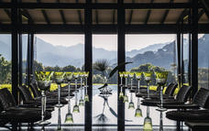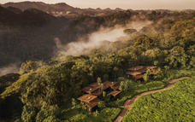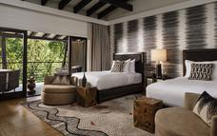

### Basis

Full Board Plus - Dinner, Bed, Breakfast, Lunch and Activities   
All Local Brands (Spirits, Wine and Beers) Included

### Included

All meals, laundry (within reason), access to Fitness Centre, alcoholic and non-alcoholic beverages (house wines and beers), two activities per day and 3% Government Tourism Levy.

### Excluded

Any additional activities, park permits, spa treatments, additional beverages and transportation.

## Day 3: Wednesday, 3 June One & Only Nyungwe House, Nyungwe Forest National Park

### Activities

|  |
| --- |
| Gorilla Trekking Volcanoes National Park |

#### Gorilla Trekking Volcanoes National Park

Gorilla Trekking in the Volcanoes National Park offers visitors the unique opportunity of discovering the 10 families of gorillas that live within the national park. Visitors can enjoy a cup of coffee before the trek starts and will be separated into groups of 8 depending on their physical abilities. Each group is guided by a guide and two scouts who are well trained in emergency situations. The amount of time set aside per trek is different depending on where the gorilla family is situated. Some trips may take as little as half an hour and some taking the better part of the day.

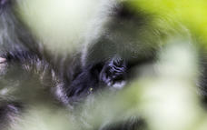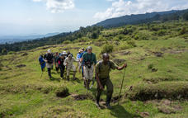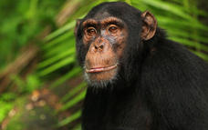

### Basis

Full Board Plus - Dinner, Bed, Breakfast, Lunch and Activities   
All Local Brands (Spirits, Wine and Beers) Included

## Day 4: Thursday, 4 June Hemingways Nairobi, Nairobi

### Day Itinerary

After check-out, you will be transferred by road back to Kigali Airport and board your flight to Jomo Kenyatta Airport, where you will be met by a private driver and transferred to Hemingways Nairobi, your home for the following 2 nights.

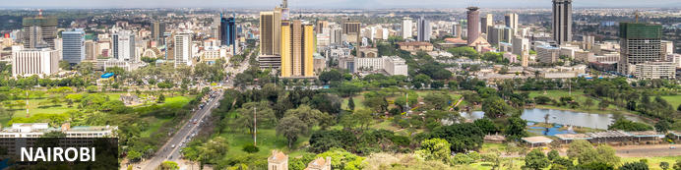

Nairobi is Africa’s 4th largest city and is a vibrant and exciting place and although it has developed a reputation which keeps tourist visits brief there are some fascinating attractions: its café culture, unbridled nightlife, the National Museum, the Karen Blixen Museum and most notably just 20 minutes from the city centre wild lions and buffalo roam in the world’s only urban game reserve.

### Overnight: Hemingways Nairobi [View iBrochure](https://travel.tourdafrique.co.za/iBrochure/10189_122457_27816)

Hemingways Nairobi, a member of the Small Luxury Hotels of the world, is an elegant boutique hotel situated in Nairobi's Karen residential area with magnificent views of the nearby Ngong hills. Sensitively designed for the discerning business and leisure traveller, Hemingways Nairobi offers the full facilities expected in a modern day luxury boutique hotel. Hemingways offers forty-five luxury suites which include the Hemingways suite, The Blixen suite, 19 Executive rooms and 24 deluxe rooms. The Hemingways Nairobi Brasserie serves classic dishes and the very best of local and international cuisine and is open everyday for breakfast, lunch afternoon tea and dinner.

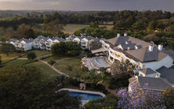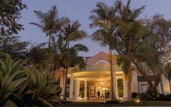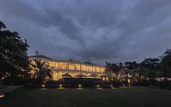

### Basis

Bed and Breakfast

## Day 5: Friday, 5 June Hemingways Nairobi, Nairobi

### Day Itinerary

Today you have a private driver and vehicle at disposal to visit the Giraffe Centre and Karen Blixen Museum.

### Activities

|  |
| --- |
| Giraffe Centre |
| Karen Blixen Museum |

#### Giraffe Centre

The African Fund for Endangered Wildlife Kenya (A.F.E.W. Kenya) also known as the Giraffe Centre is a non-governmental, non-profit making organization, which was founded by Betty and Jock Leslie-Melville in 1979. This was in a bid to save the endangered Rothschild Giraffe, which had lost its natural habitat in Western Kenya to agriculture and there were only 130 left in the wild. Funds were raised and 4 herds of the Rothschild giraffes were moved to 4 parks namely Lake Nakuru National Park, Mwea Game Reserve, Ruma National Park and Nasalot Game Reserve.

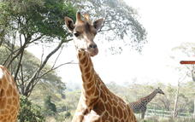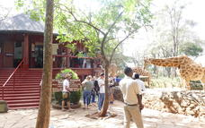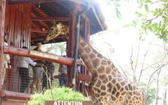

#### Karen Blixen Museum

The Karen Blixen Museum was once the home of the Danish author Karen Blixen. The renowned author made famous by the release of the Oscar winning movie ‘Out of Africa’, based on Karen’s autobiography of the same title. The museum displays many pieces of the author's furniture and has a splendid view of the Ngong Hills, immortalized in Karen Blixen's opening line, "I had a farm in Africa at the foot of the Ngong Hills."

The Karen Blixen Museum is open to the public every day, with guided tours on offer. The museum shop features handicrafts, posters, postcards, the movie ‘Out of Africa’, as well as books and other Kenyan souvenirs.

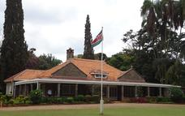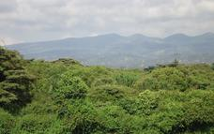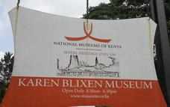

### Basis

Bed and Breakfast

## Day 6: Saturday, 6 June andBeyond Kichwa Tembo Tented Camp, Mara North Conservancy

### Day Itinerary

Today your magical Safari adventure continues. After an early breakfast and check out you will be met by a private representative and will be transferred to Wilson Airport for your onward flight to Kichwa Tembo Airstrip.

On arrival into Kichwa Tembo, you will be met by a lodge representative and will be transferred to the magnificent &Beyond Kichwa Tembo Tented Camp, your home  for the next 3 nights.

After arriving at the lodge, you will have time to freshen up before departing on the afternoon safari.

Typical afternoon schedule:

15:30 Gather for a decadent high tea

16:00 Depart

19:00 Arrive back at the lodge with time to freshen up before dinner

19:30 Dinner is served

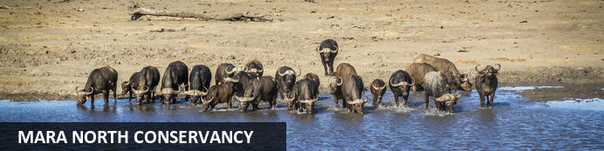

Situated in southwest Kenya, the Mara North Conservancy is a beautiful private wilderness area spanning more than 30 000 hectares. It is home to a spectacular array of plants, reptiles, birds and mammals; including elephant, rhino, buffalo, lion, leopard, cheetah and large concentrations of wildebeest, zebra, gazelle and other migratory wildlife. Leopard Gorge, in the heart of the conservancy, is famous as the setting of countless BBC Big Cat Diaries and National Geographic documentaries. Neighbouring the well-known Maasai Mara National Reserve, this conservancy is vital for sustaining the famous Serengeti wildebeest migrations as well as the highly threatened African wild dog and black rhino.

### Overnight: andBeyond Kichwa Tembo Tented Camp [View iBrochure](https://travel.tourdafrique.co.za/iBrochure/10189_122457_15485)

andBeyond Kichwa Tembo Tented Camp is situated in the Kichwa Tembo private concession, which neighbours the Masai Mara National Reserve. In addition to the excellent year-round concentration of wildlife, Kichwa Tembo lies directly in the path of Africa’s spectacular Great Migration. The camp boasts 12 classic tents, 20 superior tents and eight superior view tents. While all the tents look out onto the open grasslands or the shady forest surrounding the Sabaringo River, the superior view tents boast exceptionally beautiful, uninterrupted views of the Masai Mara.The generously sized swimming pool is set among the trees and surrounded by lush lawns and spectacular views. Opening up onto incredible Masai Mara views, the guest areas feature a double-storey bar and lounge area with oversized windows offering spectacular panoramas. The dining area surrounds an interactive kitchen and vegetable garden, making food an integral part of the safari experience.

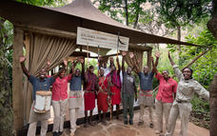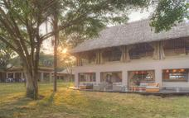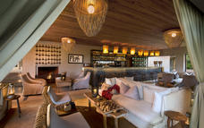

### Basis

Fully Inclusive - Bed, All Meals, Fees and Activities   
All Local Brands (Spirits, Wine and Beers) Included

### Included

Three meals daily, soft drinks, alcoholic beverages including house wines and local brand spirits and beers (excluding champagne, cognac, fine wines, and premium brand spirits), tea and coffee, refreshments on game drives, safari activities, laundry, emergency medical evacuation cover, transfers to and from the lodge airstrip, one complimentary pair of SWAROVSKI OPTIK Companion 8x32 binoculars per room to share during your stay, and a Guides' Journal that includes an illustrated wildlife and vegetation checklist, as well as an area map with an illustrated Star Birds checklist.

### Excluded

Telephone calls, &Beyond Safari Shop purchases, gratuities, all items of a personal nature, cigars, all Healing Earth wellness treatments, and park fees

## Day 7-8: Sunday, 7 June to Monday, 8 June andBeyond Kichwa Tembo Tented Camp, Mara North Conservancy

### Day Itinerary

Typical day on safari at **&Beyond Kichwa Tembo Tented Camp**  
*Please note that timings and activities may differ from lodge to lodge, depending on what is available*  
05:30 - Wakeup call  
06:00 - Morning game activity  
09:00 - Return from game activity and enjoy breakfast   
11:00 - Possible mid-morning game activity closer to the lodge or spa treatment (if available)   
13:00 - Lunch   
16:00 - Afternoon tea on camp deck followed by afternoon game activity and sundowners in the bush   
19:00 - Return from the afternoon activity and either freshen up first or head straight to dinner

### Activities

|  |
| --- |
| Game drives (Included) |

#### Night Game Drives (Additional cost)

The andBeyond Kichwa Tembo concession is the only place where guests can experience night game drives in the Masai Mara. As the sun sinks over the vast horizon, the African bush comes to life with predators and other nocturnal creatures. Guests may have the opportunity to observe fascinating species not normally encountered in daylight.  
  
Min 4 guests. Duration 2 hours.

#### Guided Walks (Additional cost)

Make the most the incredible scenery and views at andBeyond Kichwa Thembo by enjoying a guided walk. There are three walking routes to choose from, each exploring different areas and lasting approximately two hours. The Kichwa Nature Trail winds through riverine forest and follows the perimeter of Sabaringo Creek, home to fantastic birdlife. The Mara Hippo Trail offers an exciting opportunity to explore the wilderness on foot, through the plains, riverine forest, savannah grasslands and bush land surrounding the camp and on to the Mara River. The Oloololo Escarpment Trail leads from the camp to the top of the escarpment and boasts breathtaking views of the Mara reserve, the Mara river and riverine forest.

#### Sundowner Cocktails (Additional Cost)

Enjoy sundowner cocktails at a breathtaking location on the famous Oloololo Escarpment. Watch as the sun sinks over a spectacular classical safari landscape from a vantage point that commands views over the entire Masai Mara.  
  
Maximum 100 guests; minimum 6 guests. Time 18:00 – 18:45 (45 Minutes to an Hour at Sundown).

#### Morning Balloon Safari (Additional Cost)

Be a part of the Masai Mara by air. Enjoy breathtakingly beautiful views of the morning's sunrise. Marvel at the diverse habitats of the Masai Mara Reserve, the great Mara River, swamps, forests, wildlife and the African Savanna. Enjoy a delicious champagne breakfast served in the open plains of the Masai Mara upon landing.

#### Maasai Village Visit (Additional Cost)

Guests will be guided through the village by an English-speaking Maasai, who lives in the village. He will introduce your guests to the authentic, daily hustle and bustle of Maasai living. Guests will also have the opportunity to browse through the Maasai Craft Centre and purchase artefacts and souvenirs, which are made in the village — all proceeds are given back to the community.  
  
Duration approx. 30 minutes

#### Game drives (Included)

Set out in an open 4x4 safari vehicle in the company of your guide in search of the incredible wildlife in the Masai Mara. &Beyond’s professionally trained guides will ask you about your favorite wildlife and will do their best to ensure that your preferences are met, whether it is tracking a particular species or spending more time enjoying each sighting, getting to know the habits of the animals. They will also tell you about the vegetation of the region and will explain the behavior of the animals that you come across. In some cases, the guides will be able to identify individual animals and let you know about their history and habits. If the Great Migration is passing through the area, your guide will attempt to catch up with it and spend some time in the midst of the massed herds.

### Basis

Fully Inclusive - Bed, All Meals, Fees and Activities   
All Local Brands (Spirits, Wine and Beers) Included

## Day 9: Tuesday, 9 June End of Itinerary

### Day Itinerary

Today you must leave this magical paradise of the African continent, and return home. You will surely be leaving with ever-lasting memories that you will one day toast to with your loved ones.

After last morning activities and breakfast, you will be transferred back to Kichwa Tembo Airstrip, board your flight to Wilson Airport. You will then be transferred by road t Jomo Kenyatta Airport and board your flight home.

END OF SERVICES

SEE YOU AGAIN SOON!!

# Transport

## Flight Information

|  |  |  |  |  |  |  |  |  |
| --- | --- | --- | --- | --- | --- | --- | --- | --- |
| **Date** | **Flight** | **Airline** | **Departure Airport** | **Time** | **Arrival Airport** | **Time** | **Class** | **Ref** |
| 4 Jun | Scheduled |  | Kigali International Airport [KGL] |  | Jomo Kenyatta International Airport [NBO] |  |  |  |
| 6 Jun | Scheduled |  | Wilson Airport [WIL] |  | Kichwa Tembo Airstrip |  |  |  |
| 9 Jun | Scheduled |  | Kichwa Tembo Airstrip |  | Wilson Airport [WIL] |  |  |  |

## Transfers

|  |  |  |  |  |  |
| --- | --- | --- | --- | --- | --- |
| **Date** | **Company** | **Pick Up** | **Drop Off** | **Time** | **Vehicle** |
| 1 Jun |  | Kigali International Airport [KGL] | The Retreat by Heaven |  | Transfer |
| 2 Jun |  | The Retreat by Heaven | One & Only Nyungwe House |  | Transfer |
| 4 Jun |  | One & Only Nyungwe House | Kigali International Airport [KGL] |  | Transfer |
| 4 Jun |  | Jomo Kenyatta International Airport [NBO] | Hemingways Nairobi |  | Transfer |
| 6 Jun |  | Hemingways Nairobi | Wilson Airport [WIL] |  | Transfer |
| 6 Jun |  | Kichwa Tembo Airstrip | andBeyond Kichwa Tembo Tented Camp |  | Transfer |
| 9 Jun |  | andBeyond Kichwa Tembo Tented Camp | Kichwa Tembo Airstrip |  | Transfer |
| 9 Jun |  | Wilson Airport [WIL] | Jomo Kenyatta International Airport [NBO] |  | Transfer |

### Urgent Contact Numbers

|  |  |  |  |
| --- | --- | --- | --- |
| **Company Name** | **Telephone** | **Email Address** | **Contact Person** |
| Vogel Travel and Safaris | +1 602-214-6654 | Leon.Vogel@globaltravelcollection.com |  |
| Tour d'Afrique - Cape Town | +27 (0)21 526 9000 | chanelle@tourdafrique.co.za | Chanelle Diergaardt |
| Tour d'Afrique - Cape Town - Emergency Contact | +27 (0)76 981 9129 |  |  |

### Service Provider Directory

|  |  |  |  |
| --- | --- | --- | --- |
| **Service Provider** | **Ref. Number** | **Telephone** | **Address** |
| andBeyond Kichwa Tembo Tented Camp |  | +27 11 809 4300 |  |
| Hemingways Nairobi |  | +254 20 2295011 | Mbagathi Ridge,  Karen  Nairobi  Kenya |
| One & Only Nyungwe House |  | +250 787 352 279 | Gisakura  Nyamasheke  Western Province  Rwanda |
| The Retreat by Heaven |  | +250 782 000 001 | No. 5, KN 29 Street  Kigali  Rwanda |

## Terms and Conditions

### Itinerary Terms and Conditions

*Terms and conditions*

* *30% non-refundable deposit on confirmation*
* *Balance 60-45 days prior to arrival*
* *Cancellation requests must be submitted in writing to Tour d’Afrique.*
* *Tour d’Afrique reserves the right to charge cancellation fees, which may be imposed by hotels, lodges, and service providers.*
* *Cancellation charges vary among service providers. The cancellation conditions stated here are Tour d’Afrique's General Cancellation Conditions. If a service provider has more stringent cancellation policies than Tour d’Afrique, their policies will apply.*
* *The following cancellation charges apply, irrespective of service provider, and should be used as the basis for determining the holding deposit by the Travel Partner:*
  + *30% cancellation is applicable on confirmation until 60 days prior*
  + *46 - 59 days prior:                 50% cancellation*
  + *1 - 45 days prior:                    100% cancellation*