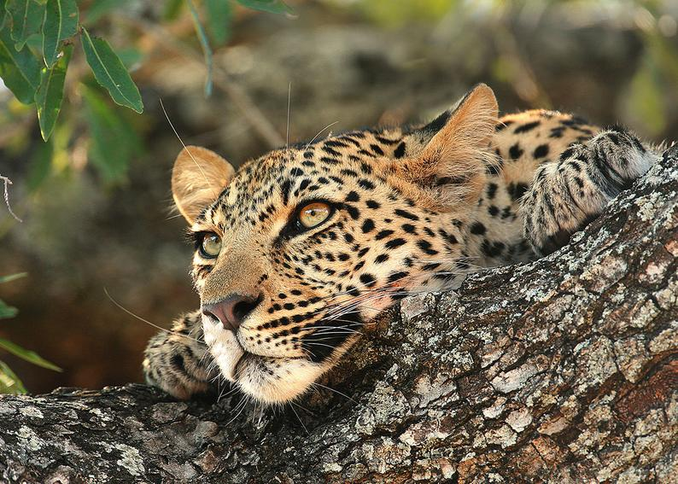

Itinerary for Zimbabwe and South Africa

Let your imagination soar

Journey overview

With Table Mountain, one of the most spiritual places on earth, at its heart and two oceans at its feet; the city of Cape Town, strategically situated at the south-western tip of Africa, has been famed for centuries as the Tavern of the Seas. Vibrant, cosmopolitan and an eclectic mix of old and new, this laid-back city is as much at home with its 17th century castle – whose cannons have never been fired in anger – as it is with its sleek skyscrapers and trendy malls. Home to South Africa’s first mosque, oldest wine farm, a 350-yearold garden, award-winning eateries and timelessly beautiful beaches, it’s no surprise the legendary spectral ship, the Flying Dutchman, has spent eternity sailing the city’s shores.

Meander through the famed Cape Winelands where a harmonious blend of art, nature and decadent food, paired with the finest wines in the world, await you. The region is the source of many legendary Cape wines, the result of the area’s row upon row of grapevines, many of which were first planted hundreds of years ago. Its classic Cape-Dutch homesteads,

mountainous surrounds, grand heritage and award-winning restaurants have earned the Cape Winelands the right to call itself South Africa’s culinary capital. Apart from a wide

choice of wine estate cellars, visitors can also indulge on a variety of locally produced cheeses, olives, export-quality fruit and organic produce.

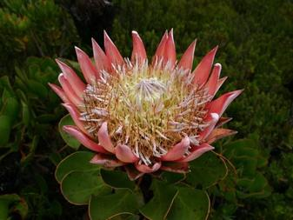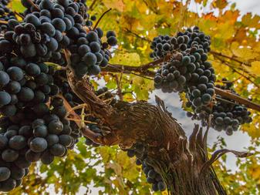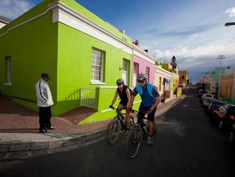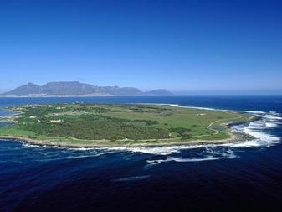

At a glance

|  |  |
| --- | --- |
|  | 12 nights / 13 Days |

‍

|  |  |
| --- | --- |
| Day | Programme |
| Day 1 | * Arrive into OR Tambo JNB, South Africa |
| Day 2 | * Overnight at Ilala Lodge Hotel |
| Day 3 | * Overnight at Ilala Lodge Hotel |
| Day 4 | * Overnight at Ilala Lodge Hotel |
| Day 5 | * Overnight at Victoria & Alfred Hotel |
| Day 6 | * Overnight at Victoria & Alfred Hotel |
| Day 7 | * Overnight at Victoria & Alfred Hotel |
| Day 8 | * Overnight at Kapama River Lodge |
| Day 9 | * Overnight at Kapama River Lodge |
| Day 10 | * Overnight at Kapama Buffalo Camp |
| Day 11 | * Overnight at Kapama Buffalo Camp |
| Day 12 | * Departure |

Starting at $6,500 per person, excluding international air and other exclusions mentioned here.

# Expect the extraordinary

Day 1

Airport Hotel at O.R. Tambo

Johannesburg, South Africa

Walk across the street to two on-site hotels or take a courtesy shuttle to a nearby airport hotel. Dinner on own arrangement

Day 2

Ilala Lodge Hotel

Victoria Falls (Zimbabwe), Zimbabwe

Upon arrival at your hotel you will be met by a representative and be driven to your hotel.

Explore the sights of Victoria Falls during your 3-night stay at Ilala Lodge in a Deluxe Room with ensuite bathroom. Your stay includes breakfast.

Tonight enjoy a boma dinner at The Boma Restaurant - This is a unique cultural experience with excellent cuisine including a variety of game meats and traditional Zimbabwean dishes, served on a buffet. The dinner is accompanied by entertainment throughout your meal from traditional dancers, the Sangoma (storyteller) and a local witchdoctor who is available for fortune telling (including transfers).

Included activities:

* Boma Dinner (excluding drinks)

Day 3:

This morning you will be met by your guide for your walking Tour of The Falls (guide & entrance fees only).

Zambezi Royal - Sundowner Luxury Cruise - At the end of the day, sail upstream to celebrate the setting African sun. Share in the end-of-day ritual which sees wild herds streaming to the riverbanks for their last drink. Flocks of birds skim the waterline as the sun sets behind the African skyline. Enjoy our range of beverages served with an accompaniment of delectable hors d oeuvres. Bring a camera and create your own golden memories.

Enjoy dinner at Lookout Café, which is an iconic restaurant in Victoria Falls where casual dining is a decadent affair. Menus range from cocktails and canapes to diverse meal options for seater dinners. Imported wine from South African vineyards and flavours foraged from nature make the “place on a plate” sentiment a reality. Delicious food, staggering views and exceptional service make Lookout Café a must-try place to eat out in Victoria Falls (including transfers).

Included activities:

* Walking Tour of The Falls
* Sundowner Cruise - Zambezi Royal
* Dinner at Lookout Café (excluding drinks)

# Expect the extraordinary

Day 4:

This morning depart to the Chobe National Park in Botswana. Clients will be transferred to the Kazungula border where their Botswana Guide will meet them. The half day consists of either a game drive or a boat cruise (including lunch) in the Chobe National Park and return transfers to Victoria Falls.

This evening enjoy dinner at Dusty Road Township - including transfers

Included activities:

* Chobe Day Trip - Half day ex Zimbabwe
* Dinner – Dusty Road Township (excluding drinks)

# Expect the extraordinary

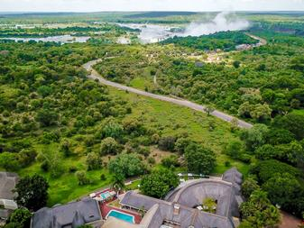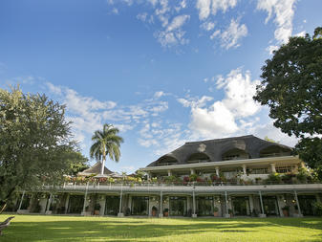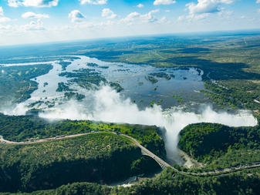

Ilala Lodge Hotel

Victoria Falls (Zimbabwe), Zimbabwe

A warm Zimbabwean welcome awaits guests at Ilala Lodge, which is built on the closest site to the majestic Victoria Falls. Spacious rooms boast breathtaking views of the falls, ensuite bathrooms, air conditioning, overhead fans and satellite television.

Relax and savour superb meals in the gracious surrounds of the outstanding Palm Restaurant. For a different experience, try the Kubika Restaurant – serving delicacies such as venison, ostrich and crocodile tails! Dining under the African sky amidst the rushing sounds of the mighty waterfall makes for a romantic evening, while a swimming pool and pool bar (overlooking the pristine Victoria Falls National Park) are perfect areas for lazy afternoons. Guests can embark on a cruise on the Ra-Ikane (the lodge’s small cruise boat) and visit the crocodile farm and nature sanctuary. Other adventures include exhilarating water sports, trips to Victoria Falls and cultural village tours.

WHAT WE LOVE ABOUT ILALA LODGE

Spend the afternoon lounging around the lush lawns of the lodge with your favourite sundowner in hand. Wildlife can often be seen grazing on the grass.

Spoil yourself with an exhilarating and memorable helicopter flight around the falls.

Ask your hosts to arrange a traditional village excursion.

# Expect the extraordinary

Victoria & Alfred Hotel

Cape Town, South Africa

Day 5

This morning you will be driven to Victoria Falls Airport for your onward arrangements to Cape Town.

Upon arrival at Cape Town International Airport, you will be met by a member from our team who will drive you to your hotel. As you drive toward the city, your view from afar will be Table Mountain, one of the most spiritual places on earth, with its heart, two oceans and the beautiful city of Cape Town at its feet.

Relax during your 3-night stay at Victoria & Alfred Hotel in a Piazza Facing Room with ensuite bathroom. Your stay includes breakfast.

Dinner under own arrangements.

Day 6:

Indulge in a full day in the spectacular Cape Winelands. The estates visited will vary according to your preferences, but the tour includes the region’s major wine producing areas and visits some beautiful wine estates for tastings of high-quality vintages. Nestled in a valley where the French Huguenots settled in 1688, Franschhoek is a delight for antique lovers and gastronomes (the town boasts some world-famous eateries). South Africa's second-oldest town, Stellenbosch provides another glimpse of classic 17th and 18th century Cape style, with a chance to browse quaint Dorp Street, visit the museum or explore the many galleries and shops of this university town. Wine tastings are tailored to the estates opening hours and the guests wine preferences. Enjoy lunch at Lanzerac Wine Estate, Taphuis Restaurant.

Included activities:

* Private Tour - Full Day Winelands Tour
* Tastings at De Grendel & Durbanville Hills
* Lunch (excluding drinks)
* Dinner under own arrangements

# Expect the extraordinary

Day 7

This full-day tour takes in the scenic highlights of the Cape Peninsula, beginning at the spectacular coastal suburb of Hout Bay, a former fishing village with a long, sandy beach facing a bay framed by the mountains. Explore the restaurants, shops and markets of Mariner's Wharf, a harbour-front emporium with a distinct maritime ambiance. Depending on whether the road is open, the tour will continue along the breath-taking Chapman's Peak Drive before heading to the Cape of Good Hope to explore the nature reserve, see the Diaz Cross and perhaps even indulge in lunch at a Seaforth Restaurant. From here you will travel to Simon's Town, famous for its naval military base, and then visit the charming penguin colony at Boulders Beach.

Enjoy lunch at Seaforth Restaurant (drinks excluded)

Included activities:

* Private Tour - Full Day Cape Point Tour
* Dinner under own arrangements

# Expect the extraordinary

Victoria & Alfred Hotel

Cape Town, South Africa

The landmark Victoria & Alfred Hotel is perched on the edge of the harbour in the midst of the Victoria & Alfred Waterfront. Originally built as a warehouse in 1904, it was converted into a luxury hotel in 1990. It is named after the Queen and her son Alfred, who graced the Cape with a visit in 1870 to open the Breakwater Basin — today’s V&A Waterfront. Guests will feel like royalty themselves with luxurious rooms, spacious ensuite bathrooms, air-conditioning, satellite television, internet access, in-room robes and personal bars. At the end of a day’s sightseeing, guests can unwind and soak up the views with a cocktail or two at the *OYO* Restaurant & Cocktail Bar, followed by a sumptuous seafood feast.

WHAT WE LOVE ABOUT VICTORIA & ALFRED HOTEL

Located within the Victoria & Alfred Waterfront, the bustling shops and surrounding first-class restaurants are all within walking distance of the hotel.

# Expect the extraordinary

Day 8

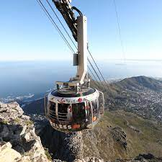Begin this scenic tour of Cape Town at iconic Table Mountain or, if the weather is not favourable, at the flat-topped mound known as Signal Hill. Browse vibrant Greenmarket Square, one of the city's oldest markets, and take a walk-through Company Gardens, established by Dutch settlers in 1652. Drive past the Houses of Parliament and the historical Castle of Good Hope, as well as the Slave Lodge, which used to house thousands of slaves belonging to the Dutch East India Company. Next you will visit the traditional Malay Quarter in the predominantly Muslim Bo-Kaap, with its brightly coloured houses dating back as far as the 17th century. Pause to listen to the firing of the noonday gun from Signal Hill. Table Mountain Closed 22 July - 8 August annually (subject to change).

Included activities:

* Private Tour - Half Day City & Table Mountain Tour

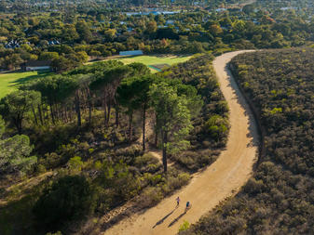

# Expect the extraordinary

Kapama River Lodge

Kapama Private Game Reserve, South Africa

Day 9

A member from our team will collect you at your hotel and drive you to Cape Town International Airport in time for your onward arrangements.

*\*\* Scheduled flight Cape Town to Hoedspruit \*\**

You will be collected from Hoedspruit airport and driven to the lodge.

Delight in your 4 night stay at Kapama Buffalo Camp or River Lodge in a Luxury Tent or Luxury Room with ensuite bathroom. Your stay includes all meals, teas & snacks, all local drinks selection of wines and premium drinks, two daily safari activities in open game drives vehicles, guided bush walks and return transfers to/from Eastgate Airport (HDS) for scheduled flights only.

Included activities:

* Game Drive
* Bush Walks

Kapama Buffalo Camp

Kapama Private Game Reserve, South Africa

A traditional African safari camp, Kapama Buffalo Camp combines true tented style with the ultimate in comfort. Ten luxury canvas tents are set on wooden decks built on stilts over a steep riverbank. Wooden walkways connect the rooms, nestled among the shady leaves of riverine trees. Leather and dark wood finishes gives the tents traditional African flair.

A thatched bar, dining room and pool terrace are tucked among succulent aloe and euphorbia. The cosy lounge, set on the edge of the riverbank, invites guests to while the afternoon away in deeply upholstered sofas and chairs. A large rim flow pool, surrounded by cosy sun loungers, sparkles in the African sun. Lanterns, rather than electric lights, glow at night under the trees as mouthwatering meals are served around an open fire in the traditional outdoor boma.

WHAT WE LOVE ABOUT KAPAMA BUFFALO LODGE

Spoil yourself with the truly decadent marula miracle moments treatment at the spa – it includes a body wrap, Rasul treatment, African calabash massage, facial and Kapama marble hand or footprint treatment.

Enjoy a night beneath a lover’s moon on a romantic sleepout on a double story platform in the middle of the bush, complete with luxury bathroom and gourmet five-course dinner.

Relax on the shaded balcony of your tent, among the bush willow and leadwood tree branches, and keep an eye out for the vervet monkeys in the trees or antelope in the riverbed below.

# Expect the extraordinary

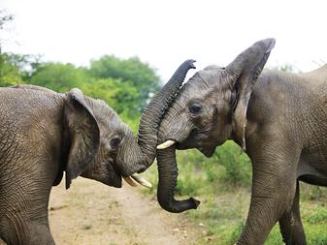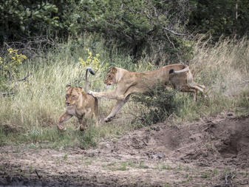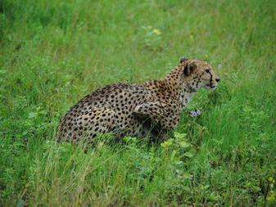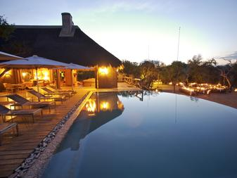

Departure

Kapama Private Game Reserve, South Africa

You will be collected from your lodge after breakfast and driven to Hoedspruit Airport for your onward arrangements.

Most international flights leave after 18h00 from both Johannesburg or Cape Town International Airports.

# Journey overview

What’s included:

Accommodation as specified in the itinerary

Meals, drinks and laundry as specified

Scheduled flights as specified in the itinerary

Private/Scheduled transfers as specified in the itinerary

Private/Scheduled sightseeing and excursions as specified in the itinerary

Private/Scheduled game viewing activities as specified in the itinerary

National parks, concession and landing fees where applicable

Emergency medical evacuation insurance

Domestic/international departure tax, fuel and safety levies from airports and airstrips unless otherwise stipulated

What’s not included:

Meals, drinks and laundry not specified in the itinerary or as outlined in the Includes

Premium brand drinks, champagne, cognacs, cellar wines, cigars and cigarettes

Gratuities and any items of a personal nature

Sightseeing and excursions not specified in the itinerary

Flights and transfers not specified in the itinerary

National parks and concession fees not specified in the itinerary

Travel Insurance

Visa fees (please be sure to check if visas are required) US Citizens need a Visa for Zimbabwe