LORDS OF THE FALLEN

ULTIMATE ETERNAL NOTE: THE ONLY THING THAT IS FOREVERMORE NEEDED IS ONLY YAHWEH, BUT ALL THESE GAMES SERVES AS THE POSSIBLE CANDIDATES OF THE GREAT JEALOUS IMMUTABLE YAHWEH OF EXODUS 3:14, THE IMMUTABLE GREAT I AM WHO I AM OMNI-MILITARY LORDLY DOING AS HE GODDAMN-WELL PLEASES!!!! BUT YOU OMNI-MILITARY LORDLY SWEAR THAT THESE THINGS IN RPG GAMES ARE ONLY FICTIONAL AND NEVER REAL AND FOR THE MOST PART IS TRUTHFUL, BUT IF YAHWEH CHOOSES TO BE IN IT AND/OR YAHWEH CHOOSES TO EMPOWERMENT IT, IT IS WHAT IT IS, AS REAL, ACTIVE & ALIVE, AS THE IMMUTABLE YAHWEH GODDAMN-WELL PLEASES!!! BUT ALSO, YOU OMNI-MILITARY LORDLY SWEAR IN SAYING THAT SOMETHING MUST BE AUTHORIZED, OR SOMETHING EMPOWERED, OR THE GOLDEN RULE, OR SOMETHING HAS TO BE EARNED OR BE ETERNALLY ESTABLISHED, BUT WITHOUT YAHWEH THESE OMNI-MILITARY LORDLY THINGS ARE ALL FOREVERMORE ETERNAL BULLSHIT!!! REMEMBER IN THE ULTIMATE BEGINNING OF ALL INFINITE OMNI-MILITARY LORDLY THINGS, IS ONLY YAHWEH STEPHEN (YAHWEH ELYON), OR SIMPLY ONLY YAHWEH FOR THE OMNI-MILITARY LORDLY LEGAL STATUSES & IN THE ULTIMATE BEGINNING OF ALL INFINITE OMNI-MILITARY LORDLY THINGS IS ONLY YAH STEVE, OR SIMPLY ONLY YAH FOR THE OMNI-MILITARY LORDLY STATUSES, BUT ALSO REMEMBER IN THE ULTIMATE ENDING OF ALL INFINITE OMNI-MILITARY LORDLY THINGS, IS ONLY STEPHEN YAHWEH (ELYON YAHWEH), OR SIMPLY ONLY STEPHEN FOR THE OMNI-MILITARY LORDLY LEGAL STATUSES & IN THE ULTIMATE ENDING OF ALL INFINITE OMNI-MILITARY LORDLY THINGS IS ONLY STEVE YAH, OR SIMPLY ONLY STEVE (THE TOP-SECRET MEANING IS STAVE AS THE ULTIMATE OMNI-MILITARY LORDLY ROD FOR THE ULTIMATE OMNI-MILITARY LORDLY DICK, ULTIMATE OMNI-MILITARY LORDLY SCEPTER FOR THE ULTIMATE OMNI-MILITARY LORDLY KINGDOM, ULTIMATE OMNI-MILITARY LORDLY WAND FOR THE ULTIMATE OMNI-MILITARY LORDLY ASS & ULTIMATE OMNI-MILITARY LORDLY STAFF FOR THE ULTIMATE OMNI-MILITARY LORDLY PUSSY BY THE ONLY IMMUTABLE YAHWEH’S OMNI-LORDLY ETERNAL EMPOWERMENT AS THE GREAT JEALOUS IMMUTABLE YAHWEH OF EXODUS 3:14 DAMN-WELL PLEASES) FOR THE OMNI-MILITARY LORDLY STATUSES!!! IT IS NEVER YOU OR ANYONE ELSE FOREVERMORE WANTING AND DOING, BUT ONLY YAHWEH WANTING AND DOING!!! THIS MEANS ALL OMNI-MILITARY LORDLY THINGS ARE POSSIBLE WITH YAHWEH CONCERNING HIMSELF & ALSO ALL OMNI-MILITARY LORDLY THINGS ARE IMPOSSIBLE WITH YAHWEH CONCERNING EVIL!!! BUT REMEMBER YAHWEH IS ONLY IN ULTIMATE SOVEREIGN GODDAMN CONTROL!!! BUT YOU OMNI-MILITARY LORDLY SWEAR & OMNI-MILITARY LORDLY SAY, OBEY THE GODDAMN OMNI-MILITARY LORDLY RULES, BUT YOU BETTER ONLY OBEY YAHWEH, AND FUCK THE GODDAMN OMNI-MILITARY LORDLY RULES!!!

LIGHT ARMOR
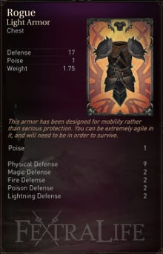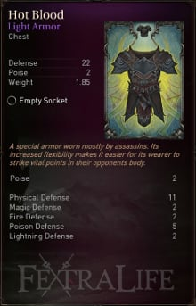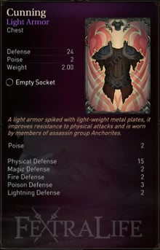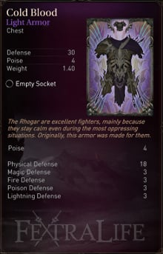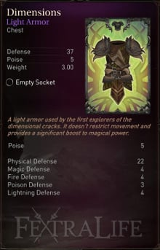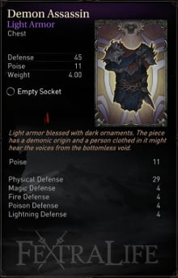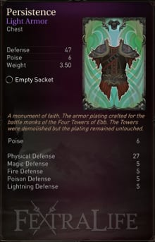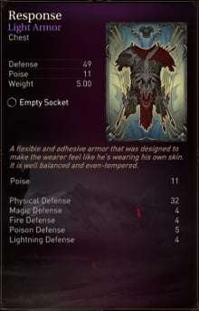

MEDIUM ARMOR
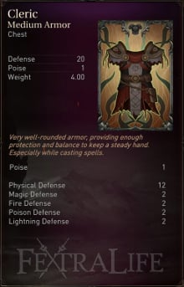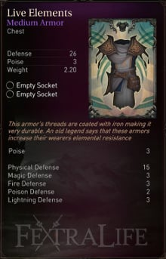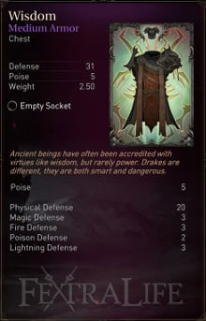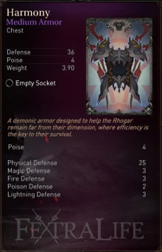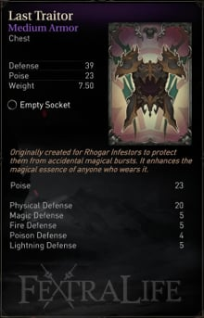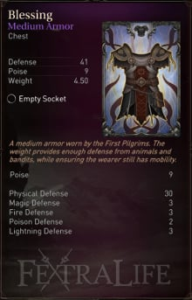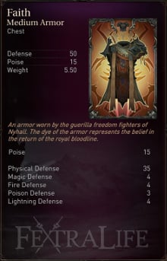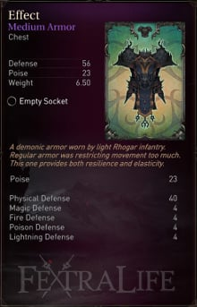

HEAVY ARMOR
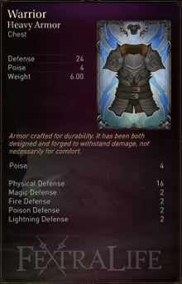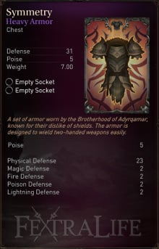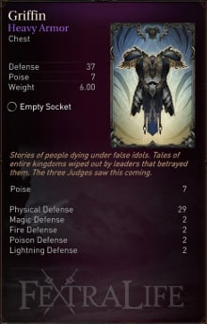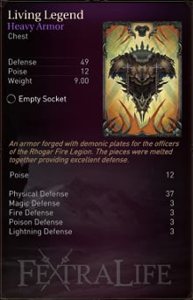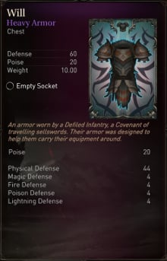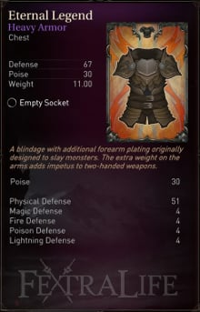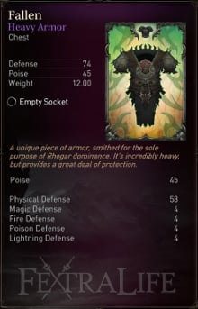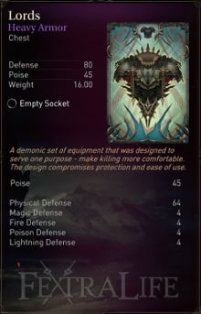

LIGHT ARMOR
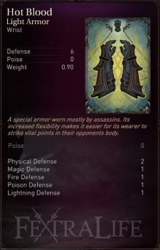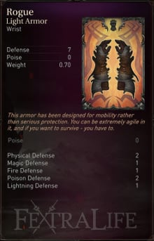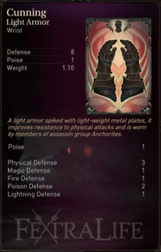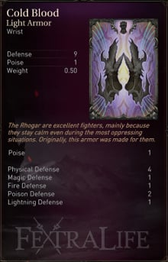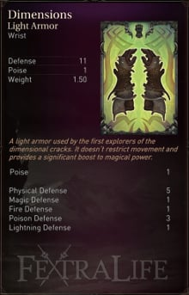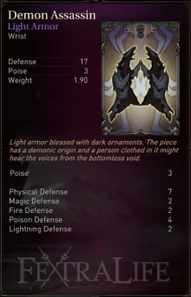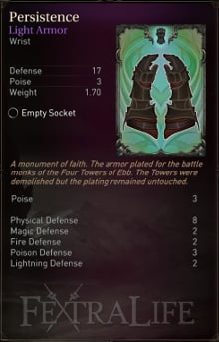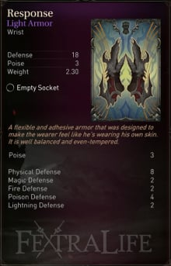

MEDIUM ARMOR
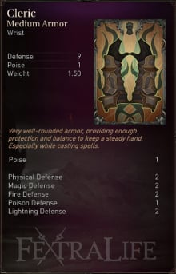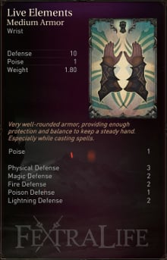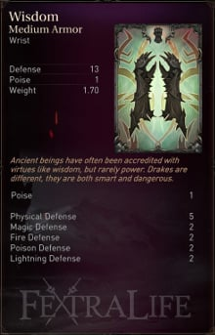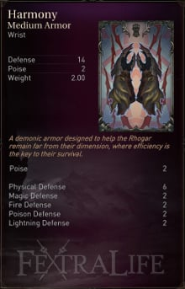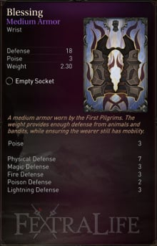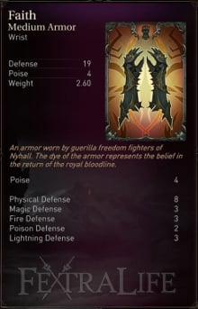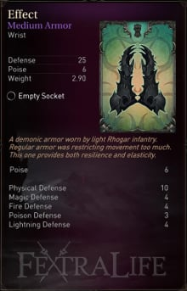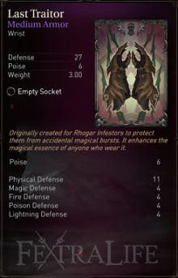

HEAVY ARMOR
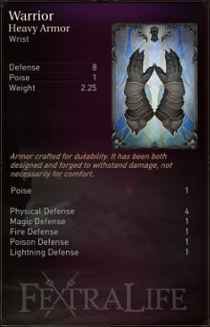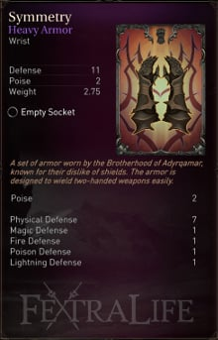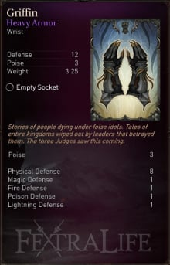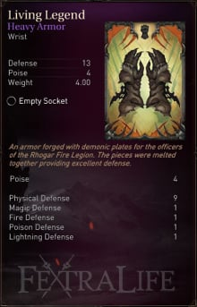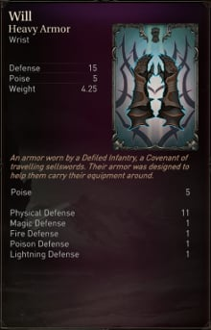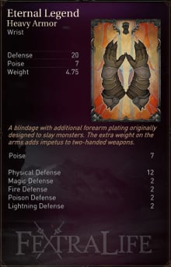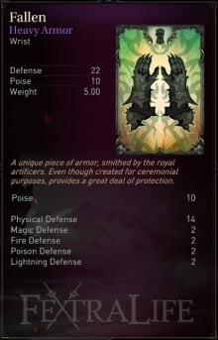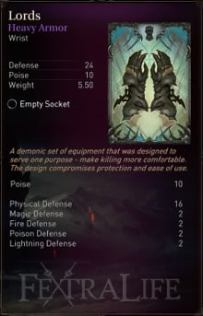

LIGHT ARMOR
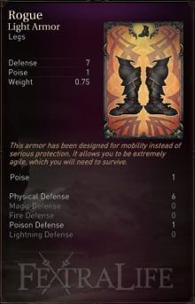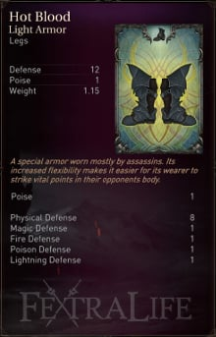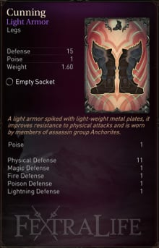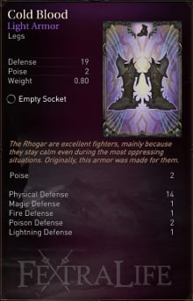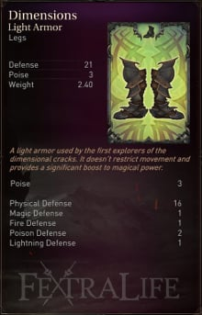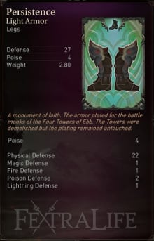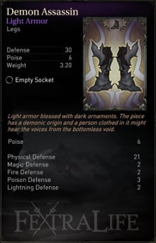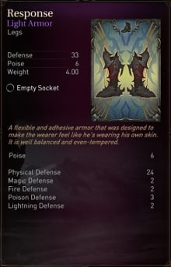

MEDIUM ARMOR
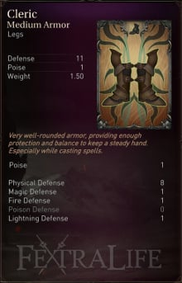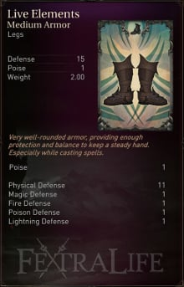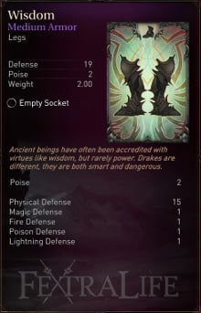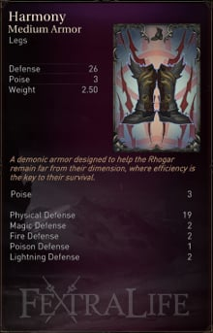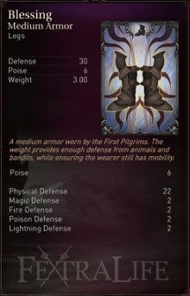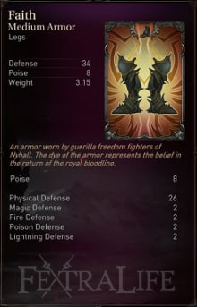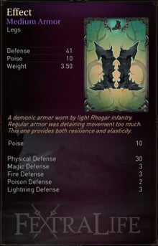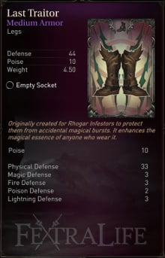

HEAVY ARMOR
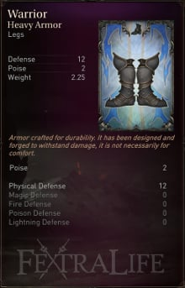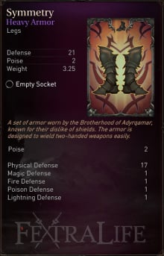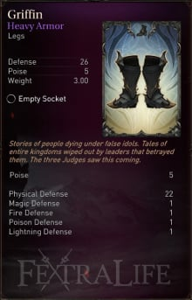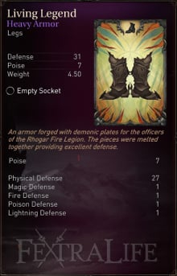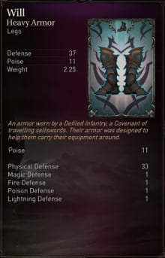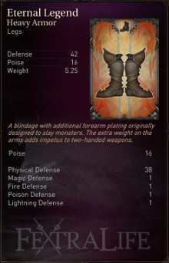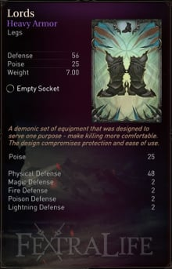

BUCKLERS
IMAGE & NAME |  | BLOCK PERCENT  DEFENSE |  |  |  |  | STAT REQS | POISE | WT. | LOCATION  &  NOTES
 |  | PHYS | MAG | FIRE | PSN | LIT
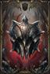  BLOCKER |  | 100%  8 | 50% | 40% | 70% | 40% | AGI - 16 | 8 | 1.00 | LOCATED IN A LOCKED CELL IN CELL CIRCLE (CATACOMBS).  (REQUIRES LEVER HANDLE TO OPEN)
  BUCKLER |  | 75%  3 | 0% | 0% | 0% | 0% | AGI - 8 | 2 | 0.50 | ROGUE STARTING EQUIPMENT.  FOUND IN A CHEST IN THE BURNT WATCHTOWER FOR OTHER CLASSES.
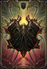  CHIPPED ROUND SHIELD |  | 80% | 0% | 0% | 0% | 0% | AGI - 12 | 4 | 1.0
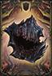  DEFENDER |  | 100%  17 | 50% | 100% | 70% | 0% | AGI - 15 | 23 | 1.50 | ACQUIRED FROM DEFEATING LOST BROTHERS.
  HARMONY |  | 100% | 40% | 90% | 60% | 40% | AGI - 15 | 8 | 0.5 | LOCATED IN A CHEST INSIDE THE PLANETARIUM (KEYSTONE CITADEL)

KITE SHIELDS
IMAGE & NAME |  | BLOCK PERCENT  DEFENSE |  |  |  |  | STAT REQS | POISE | WT. | LOCATION  &  NOTES
 |  | PHYS | MAG | FIRE | PSN | LIT
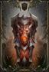  BULWARK SHIELD |  | 100%  8 | 40% | 40% | 40% | 40% | STR - 14 | 12 | 5.00 | DROPS FROM RHOGAR WHO WIELD THIS SHIELD.
  CREST SHIELD |  | 80%  4 | 0% | 0% | 0% | 0% | STR - 8 | 4 | 1.00 | CLERIC STARTING EQUIPMENT.  FOUND IN A CHEST IN THE BURNT WATCHTOWER FOR OTHER CLASSES.
  FIERY WITHHOLDER |  | 100%  8 | 65% | 30% | 60% | 15% | STR - 15 | 12 | 3.00 | FOUND IN A CHEST IN THE CHAMBER OF LIES.
  HEAVY SHIELD |  | 100%  5 | 0% | 0% | 0% | 0% | STR - 8 | 8 | 1.50 | WARRIOR STARTING EQUIPMENT.  FOUND IN A CHEST IN THE BURNT WATCHTOWER FOR OTHER CLASSES.
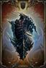  STANCE |  | 100%  14 | 75% | 75% | 0% | 0% | STR - 15 | 24 | 3.00 | DROPPED BY THE CRIPPLED RHOGAR.  AN UPGRADED VERSION CAN BE OBTAINED BY GIVING HIM 15 HUMAN SKULLS.

TOWER SHIELDS
IMAGE & NAME |  | BLOCK PERCENT  DEFENSE |  |  |  |  | STAT REQS | POISE | WT. | LOCATION  &  NOTES
 |  | PHYS | MAG | FIRE | PSN | LIT
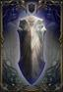  COMMANDER SHIELD |  | 100%  10 | 25% | 0% | 20% | 0% | STR - 15 | 12 | 4.50 | ACQUIRED FROM DEFEATING COMMANDER.
  EAGLE'S WINGS |  | 100%  22 | 70% | 40% | 0% | 28% | STR - 24 | 91 | 7 | FROM THE KEYSTONE MONASTERY. LOCKED DOOR NEAR N.10 ON THE MAP.  FROM GOLDEN CHEST LOCATED IN OLD GARDENS. DOOR TO THIS AREA IS LOCKED, AND ONLY WAY TO GET THERE IS TO LOOT THE KEY FROM CAPTAIN'S BODY (WHICH MEANS PLAYER MUST KILL HIM).
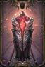  THE COCOON |  | 100%  14 | 60% | 75% | 30% | 50% | STR - 18 | 41 | 5.5 | LOCATED IN A LOCKED CHEST IN THE MAIN HALL (KEYTSTONE CITADEL), BEHIND A SEALED RUNE DOOR.  (MUST HAVE MAIN HALL CHEST KEY TO OPEN)
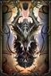  TWO-HORNED SHIELD |  | 95%  16 | 80% | 40% | 9% | 20% | STR - 20 | 61 | 6.0 | DROPS FROM A WIZARD IN THE WESTERN ANTECHAMBER (THIS ENEMY IS RIGHT NEXT TO THE ETERNAL FLAME IN A HALLWAY)
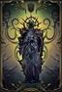  VOID SHIELD |  | 100%  18 | 30% | 25% | 75% | 40% | STR - 22 | 91 | 6.50 | FROM IN CHAMBER OF LIES IN A LOOT SHARD NEAR A CHECKPOINT.
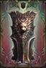  LION'S HEAD |  | 100%  5 | 0% | 0% | 0% | 0% | STR - 8 | 8 | 2.50 | LIONHEART PACK DLC  ADDED TO INVENTORY AFTER COMPLETING THE TUTORIAL.

DLC SHIELDS
IMAGE & NAME |  | BLOCK PERCENT  DEFENSE |  |  |  |  | STAT REQS | POISE | WT. | LOCATION  &  NOTES
 |  | PHYS | MAG | FIRE | PSN | LIT
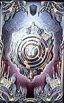  TWISTED WAYS |  | 95% | 80% | 80% | 80% | 80% | 22 AGILITY | 20 | 2.00 | AT THE START OF THE DLC SURROUNDED BY 3 SKELETONS ON A ROCK.  LABYRINTH MUST BE FULLY EXPLORED IN ORDER TO OBTAIN.

FIST WEAPONS
IMAGE & NAME |  | DAMAGE |  |  |  |  | POWER  &  ENERGY | ATK SPD  CRIT | STAT REQS  SCALING | WT. | LOCATION  NOTES
 |  | PHYS | MAG | FIRE | LIT | PSN
  ARROWHEAD |  | 27 | 0 | 0 | 0 | 0 | 100%  95% | 100%  350% | AGI - 17  7% | 0.60 | ACQUIRED FROM KILLING COMMANDER
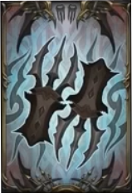  CLAWS |  | 60 | 0 | 0 | 0 | 0 | 100%  145% | 110%  350% | AGI - 14  0% | 1.10 | FOUND IN CHEST IN CHAMBER OF LIES.
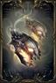  ITCH |  | 39 | 0 | 78 | 0 | 0 | 100%  160% | 120%  100% | AGI - 30  8% | 1.30 | DROPS FROM BOW WIELDING HUMAN ENEMIES.
  NEEDLES |  | 54 | 0 | 0 | 0 | 0 | 100%  110% | 110%  350% | AGI - 24  9% | 0.80 | NEXT TO THE CHECKPOINT IN THE CELLARS IN THE KEYSTONE CITADEL.
  SCRATCH |  | 11 | 0 | 0 | 0 | 0 | 100%  85% | 110%  350% | AGI - 8  6% | 0.50 | CAN DROP FROM RHOGAR ENEMIES WIELDING FIST WEAPONS.
  STING |  | 36 | 0 | 0 | 0 | 0 | 100%  135% | 90%  350% | AGI - 20  8% | 0.90 | ACQUIRED FROM KILLING CHAMPION.

DAGGERS
IMAGE & NAME |  | DAMAGE |  |  |  |  | POWER  &  ENERGY | ATK SPD  CRIT | STAT REQS  SCALING | WT. | LOCATION  NOTES
 |  | PHYS | MAG | FIRE | LIT | PSN
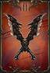  GLOW |  | 50 | 0 | 0 | 0 | 0 | 100%  160% | 110%  300% | AGI - 18  0% | 1.50 | LOCATED IN A CHEST IN THE CHAMBER OF LIES.
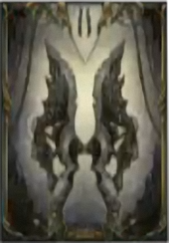  GRIP |  | 30 | 0 | 0 | 0 | 0 | 100%  120% | 100%  300% | AGI - 15  7% | 1.10 | FOUND IN CHEST IN THE CATACOMBS
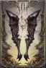  MARGYR |  | 12 | 0 | 0 | 0 | 0 | 100%  100% | 110%  300% | AGI - 8  4% | 0.70 | DEMONIC WEAPONS PACK DLC.  ADDED TO THE PLAYER'S INVENTORY AT THE BEGINNING OF HIS FIRST PLAYTHROUGH.
  PROTECTOR |  | 51 | 0 | 0 | 0 | 0 | 100%  140% | 120%  300% | AGI - 22  8% | 1.30 | OBTAINED FROM KNIGHT OUTSIDE ABANDONED TEMPLE IF YOU CHOOSE TO HELP THEM AT FIRST ENCOUNTER.  DROPS FROM KNIGHT OUTSIDE ABANDONED TEMPLE IF YOU CHOOSE TO KILL THEM FOR GUARD CAPTAINS SIDE QUEST. BE CAREFUL THEY ARE VERY STRONG ESPECIALLY YOUR 1ST TIME THROUGH RHOGAR REALM.
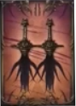  REVENGE |  | 21 | 21 | 0 | 0 | 0 | 100%  110% | 120%  300% | AGI - 16  0% | 0.90 | OBTAINED BY USING THE SHARD OF HEROES ON ONE OF THE STATUES DURING THE COMMANDER OR BEAST BOSS FIGHT.
  SKULL SCRAPER |  | 102 | 0 | 0 | 0 | 0 | 100%  180% | 120%  300% | AGI - 29  10% | 1.70 | DROPPED BY HUMAN ROGUE ENEMIES
  STEEL DAGGER |  | 12 | 0 | 0 | 0 | 0 | 100%  100% | 110%  300% | AGI - 8  3% | 0.70 | ROGUES, RANGERS AND OUTLAWS BEGIN THE GAME WITH THIS WEAPON.
  YETKA'S DAGGER |  | 19 | 0 | 0 | 0 | 0 | 100%  90% | 120%  300% | AGI - 10  7% | 0.50 | OBTAINED FROM A LOOT SHARD ON THE BOTTOM FLOOR OF THE NORTHERN WATCHTOWER IN KEYSTONE MONASTERY.

SHORTSWORDS
IMAGE & NAME |  | DAMAGE |  |  |  |  | POWER  &  ENERGY | ATK SPD  CRIT | STAT REQS  SCALING | WT. | LOCATION  NOTES
 |  | PHYS | MAG | FIRE | LIT | PSN
  BLOODLUST |  | 25  45% | 0 | 0 | 0 | 0 | 100%  140% | 120%  100% | AGI - 22  9% | 1.20 | KILLING ENEMIES MAKES THIS WEAPON STRONGER, BUT CAPS OUT AFTER 2 ADVANCES IN DAMAGE. TAKES ABOUT 5-6 KILLS FOR THE FIRST POWER UP (56 AGL 25) AND ABOUT 19-20 MORE KILLS FOR THE SECOND POWER UP (78 AGL 25)  FOUND BEHIND LOCKED DOOR IN THE PIT. MUST USE PRAYER ON PRESS PLATE ON LEFT SIDE OF PIT THEN RUN TO THE NOW OPEN DOOR TO FIND SWORDS IN A STATUE IN ROOM.
  BLOODSICK |  | 70  45% | 0 | 0 | 0 | 0 | 100%  130% | 114%  100% | AGI - 18  0% | 1.10 | KILLING ENEMIES MAKES THIS WEAPON WEAKER  LOCATED IN A CHEST INSIDE THE COLLAPSED TUNNELTHROUGH A BOARDED PASSAGE WAY THAT YOU MUST BREAK.
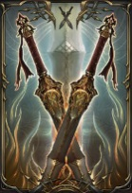  CURSE |  | 23 (14)  45% | 0 (43) | 0 | 0 | 0 | 100%  120% | 120%  100% | AGI - 18  12% | 1.00 | THIS WEAPON CAN BE ALTERED BY BURYING IT THE KYLE EMBER'S GRAVE IN THE GRAVEYARD.  THIS WEAPON IS ORIGINALLY OBTAINED IN THE OLD QUARTERS.
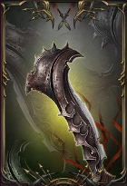  FIREWALKER |  | 67  45% | 0 | 0 | 0 | 0 | 100%  150% | 110%  100% | AGI - 23  8% | 1.40 | THIS WEAPON IS ACQUIRED FROM DEFEATING GUARDIAN.
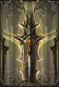  IMPATIENCE |  | 101  45% | 0 | 0 | 0 | 0 | 100%  170% | 120%  100% | AGI - 25  11% | 1.50 | LOCATED IN A CHEST IN THE OLD GARDENS.
  LAST RESORT |  | 24  45% | 0 | 0 | 0 | 0 | 100%  100% | 110%  100% | STR - 14  9% | 1.50 | CAN DROP FROM ENEMIES WIELDING SWORDS.
  LETHAL SECRET |  | 17  45% | 0 | 0 | 0 | 0 | 100%  90% | 120%  100% | AGI - 8  3% | 0.80 | OBTAINED FROM A CHEST IN THE SOUTH WATCHTOWER.
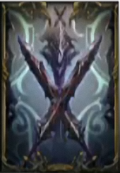  VELOCITY |  | 56  45% | 0 | 0 | 0 | 0 | 100%  150% | 110%  100% | AGI - 18  0% | 1.40 | FOUND IN THE SACRED HALLWAYS IN A CHEST OPENED WITH THE BLACKSMITH'S CHEST KEY.

SWORDS
IMAGE & NAME |  | DAMAGE |  |  |  |  | POWER  &  ENERGY | ATK SPD  &  CRIT | STAT REQS  &  SCALING | WT. | LOCATION  &  NOTES
 |  | PHYS | MAG | FIRE | PSN | LIT
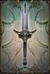  GUARD'S SWORD |  | 168  62% | 0 | 0 | 0 | 0 | 100%  200% | 85%  100% | STR - 31  13% | 4.50 | LOCATED INSIDE LOCKED CHEST IN THE PLANETARIUM.  (REQUIRES PLANETARIUM CHEST KEY DROPS FROM SOLDIER ON LAST RETURN TO CITADEL)
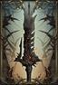  IHIR |  | 19  80% | 0 | 0 | 0 | 0 | 100%  100% | 85%  100% | STR - 8  3% | 1.00 | DEMONIC WEAPONS PACK DLC.  ADDED TO THE PLAYER'S INVENTORY AT THE BEGINNING OF HIS FIRST PLAYTHROUGH.
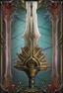  JUSTICE |  | 137  62% | 0 | 0 | 0 | 0 | 100%  170% | 85%  100% | STR - 26  8% | 3.50 | LOCATED INSIDE CHEST IN THE CHAMBER OF LIES.
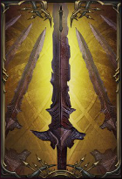  ROTTEN |  | 45  62% | 0 | 0 | 0 | 0 | 100%  120% | 90%  100% | STR - 18  12% | 1.75 | THIS WEAPON CAN BE ACQUIRED FROM KILLING ENEMIES THAT WIELD SWORDS.
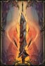  SHU |  | 35  62% | 0 | 0 | 0 | 0 | 100%  140% | 85%  100% | STR - 22  13% | 2.50 | FOUND IN A CHEST IN THE NORTHERN WING
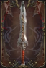  SPINE SLASHER |  | 116  62% | 0 | 0 | 0 | 0 | 100%  180% | 90%  100% | STR - 8  0% | 4.0 | LOCATED IN CHEST INSIDE THE CHAMBER OF LIES BEHIND A SEALED RUNE DOOR.
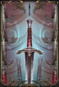  STEEL SWORD |  | 18  62% | 0 | 0 | 0 | 0 | 100%  100% | 85%  100% | STR - 8  3% | 1.00 | PALADINS, WARRIORS AND RAIDERS BEGIN THE GAME WITH THIS WEAPON.
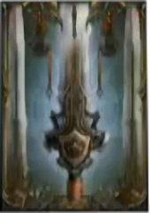  TRIBUTE |  | 113  62% | 0 | 0 | 0 | 0 | 100%  150% | 75%  100% | STR - 24  7% | 3.00 | LOCATED INSIDE A CHEST IN THE DIMENSION PORTAL NEAR ETERNAL FLAME.
  VANGUARD BLADE |  | 50  62% | 0 | 0 | 0 | 0 | 100%  130% | 85%  100% | STR - 18  0% | 2.00 | FOUND INSIDE CELL IN THE CELL CIRCLE IN THE CATACOMBS
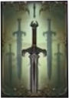  WARRIOR |  | 33  62% | 0 | 21 | 0 | 0 | 100%  110% | 80%  100% | STR - 14  5% | 1.00 | OBTAINED FROM USING THE SHARD OF HEROES ON THE WARRIOR STATUE DURING THE COMMANDER FIGHT OR BEAST FIGHT

GREATSWORDS
IMAGE & NAME |  | DAMAGE  PHYSICAL BLOCK |  |  |  |  | POWER  &  ENERGY | ATK SPD  &  CRIT | STAT REQS  &  SCALING | WT. | LOCATION  &  NOTES
 |  | PHYS | MAG | FIRE | PSN | LIT
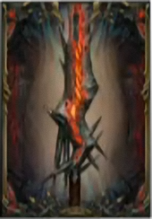  BREAKER |  | 128  68% | 0 | 0 | 0 | 0 | 100%  220% | 105%  90% | STR - 18  0% | 4.50 | CAN DROP FROM FIRST WARDEN ENEMIES IN CHAMBER OF LIES OR THE GRAVEYARD.
  CODEX |  | 84  68% | 0 | 0 | 0 | 0 | 100%  210% | 100%  90% | STR - 22  2% | 4.00 | FOUND IN A CHEST INSIDE THE DIMENSION PORTAL AFTER DEFEATING INFILTRATOR.  CAN ALSO DROP FROM THE VERY LARGE RHOGAR WITH SWORD AND SHIELD.
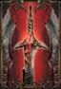  CORE |  | 225  68% | 0 | 0 | 0 | 0 | 100%  240% | 96%  90% | STR - 31  1% | 5.50 | LOCATED INSIDE DIMENSION PORTAL IN THE CHAMBER OF LIES.  (MUST DEFEAT ANNIHILATOR TO OPEN IT)
  GUARD'S GREATSWORD |  | 30  68% | 0 | 0 | 0 | 0 | 100%  180% | 100%  90% | STR - 9  1% | 2.50 | LOCATED IN A CHEST BELOW BURNT WATCHTOWER
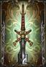  LAST WILL |  | 202  68% | 0 | 0 | 0 | 0 | 100%  230% | 100%  90% | STR - 28  3% | 5.00 | LOCATED IN A CHEST IN THE CHAMBER OF LIES.
  LURKER THRUST |  | 79  68% | 0 | 0 | 0 | 0 | 100%  200% | 94%  90% | STR - 18  0% | 3.50 | FOUND IN CHEST ABOVE THE WESTERN ANTECHAMBER GUARDED BY AN ARCHER.
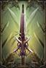  PEACEMAKER |  | 277  68% | 0 | 0 | 0 | 0 | 100%  260% | 100%  90% | STR - 34  1% | 6.00 | DROPS FROM GREATSWORD WIELDING HUMAN ENEMIES.
  PERSISTENCE |  | 55  68% | 0 | 0 | 0 | 0 | 100%  190% | 104%  90% | STR - 15  3% | 3.00 | ACQUIRED FROM KILLING FIRST WARDEN.

POLESWORDS
IMAGE & NAME |  | DAMAGE  PHYS BLOCK DEFENSE |  |  |  |  | POWER  &  ENERGY | ATK SPD  &  CRIT | STAT REQS  &  SCALING | WT. | LOCATION  &  NOTES
 |  | PHYS | MAG | FIRE | PSN | LIT
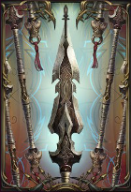  BURDEN |  | 139  85% | 0 | 0 | 0 | 0 | 100%  200% | 100%  100% | STR - 26  9% | 4.00 | IN A CHEST IN THE WESTERN ANTECHAMBER.  (REQUIRES WESTERN ANTECHAMBER KEY)
  JAW |  | 138  85% | 0 | 0 | 0 | 0 | 100%  210% | 100%  100% | STR - 18  0% | 4.50 | CAN DROP FROM POLESWORD-WIELDING TYRANTS.
  LOST PIKE |  | 32  85% | 0 | 0 | 0 | 0 | 100%  150% | 100%  100% | STR - 12  4% | 2.00 | OBTAINED FROM CHEST IN THE WESTERN ANTECHAMBER. UPGRADE AT CRAFTER WITH HIGHER POISON RUNE AND FLAWLESS FIRE RUNE TO GET UPGRADED VERSION AND DIALOGUE ABOUT WEAPON WITH CRAFTER.
  TYRANY |  | 76  85% | 0 | 0 | 0 | 0 | 100%  180% | 100%  100% | STR - 18  0% | 5.50 | CAN DROP FROM POLESWORD-WIELDING TYRANTS.
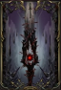  RHOGAR |  | 221  85% | 0 | 0 | 0 | 0 | 100%  220% | 100%  100% | STR - 31  10% | 5.00 | LOCATED IN A CHEST IN THE OLD GARDENS.
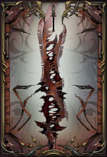  URAS |  | 51  85% | 0 | 0 | 0 | 0 | 100%  160% | 100%  100% | STR - 16  9% | 2.50 | ACQUIRED FROM DEFEATING INFILTRATOR  KILL WITHOUT ALLOWING ALL GOBLETS ABOVE ARENA TO BE LIT TO RECEIVE SPECIAL VERSION WHERE THE HEAVY ATTACK CREATES A HEALING PUDDLE.
ARTIFAKT |  | 52  85% | 0 | 0 | 0 | 0 | 100%  190% | 100%  100% | STR - 22  6% | 3.50

HAMMERS
IMAGE & NAME |  | DAMAGE  PHYSICAL BLOCK |  |  |  |  | POWER  &  ENERGY | ATK SPD  &  CRIT | STAT REQS  &  SCALING | WT. | LOCATION  &  NOTES
 |  | PHYS | MAG | FIRE | PSN | LIT
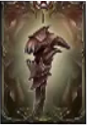  BLIND |  | 18  75% | 0 | 0 | 17 | 0 | 100%  160% | 94%  100% | FTH - 16  0% | 2.00 | LOCATED BEHIND A BREAKABLE WALL IN THE BACKSIDE ENTRANCE.
  CLERIC |  | 86  75% | 0 | 0 | 0 | 0 | 100%  190% | 88%  100% | FTH - 18  0% | 3.00 | USE THE SHARD OF HEROES ON THE CLERIC STATUE DURING THE COMMANDER OR BEAST BOSS FIGHT, AND ALLOW HIM TO DESTROY THE STATUE.
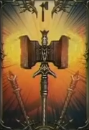  DEFIANCE |  | 22  67% | 0 | 0 | 0 | 0 | 100%  140% | 94%  100% | STR - 8  2% | 1.50 | STARTING WEAPON FOR THE BRAWLER, EXECUTIONER, AND CLERIC.
  FLY |  | 40  67% | 57 | 0 | 0 | 0 | 100%  210% | 94%  100% | FTH - 20  3% | 2.00 | FOUND IN A CHEST IN A DIMENSION PORTAL NEAR ETERNAL FLAME.  (MUST HAVE DEFEATED GUARDIAN FOR IT TO OPEN)
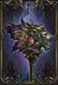  HEIRLOOM |  | 85  67% | 0 | 0 | 0 | 0 | 100%  200% | 94%  100% | FTH - 10  0% | 3.00 | LOCATED BEHIND A BREAKABLE WALL IN CELL 11 OF CELL CIRCLE.  CAN BE UPGRADED IN THE MINES BENEATH THE CATACOMBS.
  HOPE |  | 65  68% | 0 | 0 | 0 | 0 | 100%  170% | 95%  100% | STR - 16  0% | 2.00 | SHOWS UP ON TOP OF THE BURNT WATCHTOWER AFTER RETURNING FROM THE ABANDONED TEMPLE.
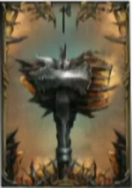  NADO |  | 52  67% | 0 | 52 | 0 | 0 | 100%  220% | 90%  100% | FTH - 23  0% | 4.00 | LOCATED INSIDE A CHEST IN THE CHAMBER OF LIES.
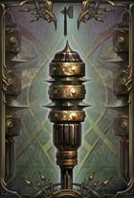  PAIN |  | 0  75% | 14 | 0 | 15 | 0 | 100%  100% | 100%  100% | FTH - 8  3% | 1.50 | LOCATED IN A CHEST IN THE SOUTHERN WATCHTOWER.
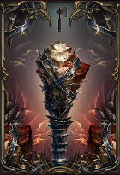  STAIN |  | 54  ??% | 0 | 0 | ?? | 0 | 100%  180% | 94%  100% | STR - 18  13% | 5.00 | ACQUIRED FROM DEFEATING BEAST.
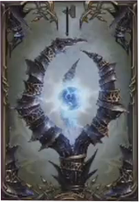  STARE |  | 81  68% | 81 | 0 | 0 | 0 | 100%  240% | 94%  100% | FTH - 22  12% | 5.00 | LOCATED IN DIMENSION PORTAL IN THE OLD QUARTERS.  (MUST DEFEAT LOST BROTHERS FOR THIS PORTAL TO OPEN)
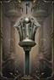  LIGHTNING |  | 65  68% | 0 | 0 | 0 | 75 | 100%  230% | 94%  100% | FTH - 20  0% | 4.00 | ACQUIRED FROM DEFEATING ANNIHILATOR.
  THEHK |  | 24  67% | 0 | 0 | 0 | 8 | 100%  140% | 94%  100% | STR - 8  3% | 1.50 | DEMONIC WEAPONS PACK DLC.  ADDED TO THE PLAYER'S INVENTORY AT THE BEGINNING OF HIS FIRST PLAYTHROUGH.
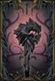  SCREAM |  | 13  67% | 13 | 0 | 0 | 8 | 100%  210% | 94%  100% | FTH - 10  3% | 3.50 | LIONHEART PACK DLC  ADDED TO THE PLAYER'S INVENTORY AT THE BEGINNING OF HIS FIRST PLAYTHROUGH.

GREATHAMMERS
IMAGE & NAME |  | DAMAGE  PHYSICAL BLOCK |  |  |  |  | POWER  &  ENERGY | ATK SPD  &  CRIT | STAT REQS  &  SCALING | WT. | LOCATION  &  NOTES
 |  | PHYS | MAG | FIRE | PSN | LIT
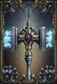  LAW |  | 200  75% | 0 | 0 | 0 | 0 | 100%  300% | 100%  100% | STR - 26  6% | 7.00 | LOCATED IN A CHEST BEHIND A LOCKED DOOR IN THE CELLAR. NEED CELLAR KEY OBTAINED FROM KILLING ENEMIES ON FINAL RETURN TO CITADEL.
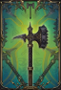  SPIKE |  | 48  75% | 0 | 0 | 0 | 0 | 100%  160% | 100%  100% | STR - 12  4% | 4.50 | LOCATED IN A CHEST IN THE TOWER BEFORE THE COMMANDER BOSS FIGHT.
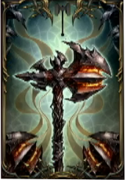  TOR |  | 129  75% | 0 | 0 | 0 | 0 | 100%  210% | 100%  100% | STR - 22  11% | 5.00 | LOCATED ON THE GROUND IN THE CHAMBER OF LIES.  USED TO DESTROY THE RHOGAR STATUES AND OBTAIN THE LAST TRAITOR ARMOR SET.

AXES
IMAGE & NAME |  | DAMAGE  PHYSICAL BLOCK |  |  |  |  | POWER  &  ENERGY | ATK SPD  &  CRIT | STAT REQS  &  SCALING | WT. | LOCATION  &  NOTES
 |  | PHYS | MAG | FIRE | PSN | LIT
  BUTCHER |  | 27  65% | 0 | 0 | 0 | 0 | 100%  100% | 75%  100% | STR - 9  8% | 1.00 | ACQUIRED FROM THE INJURED MONK.
  FATE |  | 53  65% | 0 | 0 | 0 | 0 | 100%  120% | 80%  100% | STR - 16  7% | 2.00 | LOCATED IN A CHEST BENEATH THE SOUTHERN WATCHTOWER.
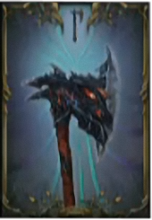  GARGOYLE AND HAWK |  | 135  65% | 0 | 0 | 0 | 0 | 100%  160% | 75%  100% | AGI - 26  11% | 4.00 | LOCATED IN A LOOT SHARD LAYING NEXT TO A STATUE IN THE MAIN HALL.
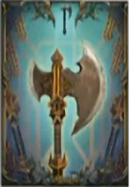  TWINKLING AXE |  | 65  65% | 0 | 0 | 0 | 0 | 100%  140% | 85%  100% | STR - 18  0% | 3.00 | IN A LOCKED ROOM, BELOW CHAMPION. YOU MUST USE THE PRESSURE PLATE NEAR THERE TO OPEN THE DOOR.
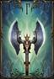  REMINDER |  | 191  65% | 0 | 0 | 0 | 0 | 100%  180% | 80%  100% | STR - 31  9% | 5.00 | LOCATED INSIDE A CHEST IN THE CHAMBER OF LIES.

GREATAXES
IMAGE & NAME |  | DAMAGE  PHYSICAL BLOCK |  |  |  |  | POWER  &  ENERGY | ATK SPD  &  CRIT | STAT REQS  &  SCALING | WT. | LOCATION  &  NOTES
 |  | PHYS | MAG | FIRE | PSN | LIT
  CEREMONIAL |  | 162  70% | 0 | 0 | 0 | 0 | 100%  270% | 100%  100% | STR - 26  8% | 6.00 | PROVING GROUNDS CHEST. IN THE KEYSTONE CITADEL BEHIND A GATE IN THE FLOODED HALLS. CAN ONLY BE REACHED AFTER SPEAKING TO ADYR.
  CLAWFINGER |  | 69  70% | 0 | 0 | 0 | 0 | 100%  170% | 100%  100% | FTH - 18  9% | 3.00 | ACQUIRED FROM DEFEATING WORSHIPER.
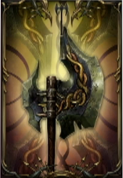  CRUSHER |  | 130  70% | 0 | 0 | 0 | 0 | 100%  250% | 100%  100% | STR - 18  0% | 5.00 | LOCATED IN A CHEST IN THE CHAMBER OF LIES, BEHIND A LOCKED DOOR.  (REQUIRES RIGHT WING KEY TO OPEN)
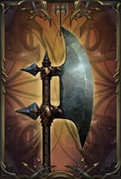  GUARDMAN |  | 78  85% | 0 | 0 | 0 | 0 | 100%  210% | 100%  100% | STR - 20  3% | 4.50 | OBTAINED FROM SEALED RUNE CHEST IN BACKSIDE ENTRANCE.
  MARAUDER GREATAXE |  | 35  70% | 0 | 0 | 0 | 0 | 100%  150% | 100%  100% | STR - 11  6% | 3.00 | CAN DROP FROM GREATAXE WIELDING RHOGAR
  MY AXE |  | 104  70% | 0 | 0 | 0 | 0 | 100%  230% | 100%  100% | STR - 22  8% | 5.00 | LOCATED INSIDE A CHEST IN THE CATACOMBS BEHIND A SEALED RUNE DOOR. 1ST DOOR ON THE RIGHT WHEN ENTERING FROM THE GRAVEYARD ENTRANCE.
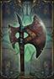  MYTH |  | 192  70% | 0 | 0 | 0 | 0 | 100%  300% | 100%  100% | STR - 30  7% | 6.50 | CAN DROP FROM GREATAXE-WIELDING HUMAN ENEMIES. USUALLY DROPPED FROM GREATAXE-WIELDING SOLDIER IN SPIRE AFTER ENCOUNTER WITH ADYR.
  SWING |  | 75  70% | 0 | 0 | 0 | 0 | 100%  190% | 100%  100% | STR - 19  7% | 4.00 | LOCATED IN A CHEST IN THE ABANDONED RANGE (ABANDONED TEMPLE).

STAVES
IMAGE & NAME |  | DAMAGE  PHYSICAL BLOCK |  |  |  |  | POWER  &  ENERGY | ATK SPD  &  CRIT | STAT REQS  &  SCALING | WT. | LOCATION  &  NOTES
 |  | PHYS | MAG | FIRE | PSN | LIT
  CONCEIT |  | 43  77% | 0 | 0 | 0 | 0 | 100%  150% | 110%  100% | AGI - 16  0% | 2.50 | LOCATED IN THE ANCIENT CAVES NEAR THE ENTRANCE TO THE SACRED HALLWAYS.
  ISHALUK |  | 26  77% | 0 | 0 | 88 | 0 | 100%  200% | 120%  100% | AGI - 28  3% | 4.50 | OBTAINED FROM A CHEST IN THE BEAST'S DIMENSION PORTAL (NEXT TO THE PATHWAY).
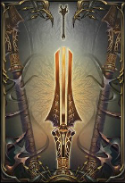  MONK STAFF |  | 25  77% | 0 | 0 | 0 | 0 | 100%  110% | 120%  100% | AGI - 8  2% | 1.50 | OBTAINED FROM A CHEST IN THE NORTH WING.
PREJUDICE |  | 36  77% | 0 | 0 | 0 | 0 | 100%  130% | 120%  100% | AGI - 14  3% | 2.00 | OBTAINED IN A CHEST BELOW THE SOUTHERN WATCHTOWER.  (REQUIRES THE TOWER KEY)
  QAMAR |  | 13  77% | 0 | 66 | 0 | 0 | 100%  190% | 110%  100% | FTH - 20  3% | 3.50 | OBTAINED FROM THE DIMENSION PORTAL AFTER COMMANDER.
  SCAB |  | 14  77% | 0 | 34 | 0 | 0 | 100%  170% | 120%  100% | AGI -19  4% | 3.00 | LOCATED IN SEALED RUNE CHEST IN THE CATACOMBS (WELL OF DEATH).
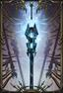  UNITY |  | 14  77% | 0 | 0 | 0 | 80 | 100%  210% | 100%  100% | AGI - 18  0% | 4.00 | LOCATED IN A CHEST IN THE CHAMBER OF LIES.  MUST HAVE THE STAFF HILT AND STAFF HEAD TO OPEN THE DOOR TO IT.

DLC WEAPONS

IMAGE & NAME |  | DAMAGE |  |  |  |  | POWER  &  ENERGY | ATK SPD  CRIT | STAT REQS  SCALING | WT. | LOCATION  NOTES
 |  | PHYS | MAG | FIRE | LIT | PSN
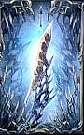  SCALPEL |  | 122  85% | 109 | 0 | 0 | 0 | 100%  200% | 110%  100% | AGI - 28  10% | 4.00 | ACQUIRED FROM KILLING THE KEEPER ATTUNED TO ICE.
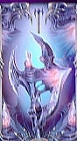  BETWEEN |  | 86  70% | 0 | 52 | 52 | 0 | 100%  200% | 100%  100% | FTH - 26  4% | 5.00 | ACQUIRED FROM KILLING THE KEEPER ATTUNED TO FIRE.
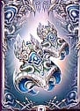  LITHIC RISING |  | 90 | 0 | 0 | 0 | 0 | 100%  200% | 85%  350% | STR - 32  4% | 2.00 | ACQUIRED FROM KILLING THE KEEPER ATTUNED TO LIGHTNING.

SEALED RUNES

SEALED RUNES
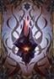  SMALL SEALED RUNE  OBTAINED FROM ENEMIES WHEN KILLED. | BREAK AT THE CRAFTER  UNLOCKS LESSER, COMMON AND HIGHER RUNES.  YOU MAY BET 0-500 XP POINTS TO TRY TO IMPROVE THE QUALITY
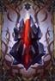  BIG SEALED RUNE  OBTAINED FROM BOSSES | BREAK AT THE CRAFTER  UNLOCKS HIGHER AND FLAWLESS RUNES.  YOU MAY BET 0-1000 XP POINTS TO TRY AND GUARANTEE FLAWLESS QUALITY.

FIRE RUNES

FIRE RUNES
  LESSER FIRE RUNE  OBTAINED FROM SMALL SEALED RUNE | WEAPON: FIRE DAMAGE +2  ARMOR: FIRE DEFENSE +1  SHIELD: FIRE BLOCK DEFENSE +5%  GAUNTLET:  - BLAST GAUNTLET: THE GAUNTLET NOW BREATHES FIRE  - PROJECTILE GAUNTLET: SETS ENEMIES ON FIRE ON IMPACT  - EXPLOSIVE GAUNTLET: DEALS FIRE DAMAGE ON DETONATION
  COMMON FIRE RUNE  OBTAINED FROM SMALL SEALED RUNE | WEAPON: FIRE DAMAGE +3  ARMOR: FIRE DEFENSE +2  SHIELD: FIRE BLOCK DEFENSE +6%  GAUNTLET:  - BLAST GAUNTLET: THE GAUNTLET NOW BREATHES FIRE  - PROJECTILE GAUNTLET: SETS ENEMIES ON FIRE ON IMPACT  - EXPLOSIVE GAUNTLET: DEALS FIRE DAMAGE ON DETONATION
  HIGHER FIRE RUNE  OBTAINED FROM SMALL & BIG SEALED RUNE | WEAPON: FIRE DAMAGE +4  ARMOR: FIRE DEFENSE +3  SHIELD: FIRE BLOCK DEFENSE +7%  GAUNTLET:  - BLAST GAUNTLET: THE GAUNTLET NOW BREATHES FIRE  - PROJECTILE GAUNTLET: SETS ENEMIES ON FIRE ON IMPACT  - EXPLOSIVE GAUNTLET: DEALS FIRE DAMAGE ON DETONATION
  FLAWLESS FIRE RUNE  OBTAINED FROM BIG SEALED RUNE | WEAPON: FIRE DAMAGE +6  ARMOR: FIRE DEFENSE +6  SHIELD: FIRE BLOCK DEFENSE +10%  GAUNTLET:  - BLAST GAUNTLET: THE GAUNTLET NOW BREATHES FIRE  - PROJECTILE GAUNTLET: SETS ENEMIES ON FIRE ON IMPACT  - EXPLOSIVE GAUNTLET: DEALS FIRE DAMAGE ON DETONATION

LUCK RUNES

LUCK RUNES
  LESSER LUCK RUNE  OBTAINED FROM SMALL SEALED RUNE | WEAPON: ATTRIBUTE SCALE +1%  ARMOR: EQUIPMENT CAPACITY +2.00  SHIELD: BLOCK ENERGY LOSS +5%  GAUNTLET:  - BLAST GAUNTLET: KNOCKS DOWN ENEMIES DEALING MINOR DAMAGE. FOR ENEMIES KILLED WITH IT, THE NEXT SPELL WON'T CONSUME MAGIC.  - PROJECTILE GAUNTLET: INCREASED CHANGE OF DROPPING LOOT BY HURTING OR KILLING ENEMIES.  - EXPLOSIVE GAUNTLET: DISTRACTS THE TARGET, DEALING DAMAGE MORE EFFECTIVELY.
  COMMON LUCK RUNE  OBTAINED FROM SMALL SEALED RUNE | WEAPON: ATTRIBUTE SCALE +2%  ARMOR: EQUIPMENT CAPACITY +3.00  SHIELD: BLOCK ENERGY LOSS +6%  GAUNTLET:  - BLAST GAUNTLET: KNOCKS DOWN ENEMIES DEALING MINOR DAMAGE. FOR ENEMIES KILLED WITH IT, THE NEXT SPELL WON'T CONSUME MAGIC.  - PROJECTILE GAUNTLET: INCREASED CHANGE OF DROPPING LOOT BY HURTING OR KILLING ENEMIES.  - EXPLOSIVE GAUNTLET: DISTRACTS THE TARGET, DEALING DAMAGE MORE EFFECTIVELY.
  HIGHER LUCK RUNE  OBTAINED FROM SMALL & BIG SEALED RUNE | WEAPON: ATTRIBUTE SCALE +3%  ARMOR: EQUIPMENT CAPACITY +4.00  SHIELD: BLOCK ENERGY LOSS +7%  GAUNTLET:  - BLAST GAUNTLET: KNOCKS DOWN ENEMIES DEALING MINOR DAMAGE. FOR ENEMIES KILLED WITH IT, THE NEXT SPELL WON'T CONSUME MAGIC.  - PROJECTILE GAUNTLET: INCREASED CHANGE OF DROPPING LOOT BY HURTING OR KILLING ENEMIES.  - EXPLOSIVE GAUNTLET: DISTRACTS THE TARGET, DEALING DAMAGE MORE EFFECTIVELY.
  FLAWLESS LUCK RUNE  OBTAINED FROM BIG SEALED RUNE | WEAPON: ATTRIBUTE SCALE +4%  ARMOR: EQUIPMENT CAPACITY +6.00  SHIELD: BLOCK ENERGY LOSS +9%  GAUNTLET:  - BLAST GAUNTLET: KNOCKS DOWN ENEMIES DEALING MINOR DAMAGE. FOR ENEMIES KILLED WITH IT, THE NEXT SPELL WON'T CONSUME MAGIC.  - PROJECTILE GAUNTLET: INCREASED CHANGE OF DROPPING LOOT BY HURTING OR KILLING ENEMIES.  - EXPLOSIVE GAUNTLET: DISTRACTS THE TARGET, DEALING DAMAGE MORE EFFECTIVELY.

MAGIC RUNES

MAGIC RUNES
  LESSER MAGIC RUNE  OBTAINED FROM SMALL SEALED RUNE | WEAPON: ATTACK POWER +3  ARMOR: MAGIC DEFENSE +1  SHIELD: MAGIC BLOCK DEFENSE +5%  GAUNTLET:  - BLAST GAUNTLET: RELEASES A POWERFUL BLAST OF MAGICAL ENERGY THAT STEALS HEALTH FROM ENEMIES.  - PROJECTILE GAUNTLET: TEMPORARILY SENDS TARGET INTO DIMENSIONAL BREACH. A PASSIVE SHELL REMAINS.  - EXPLOSIVE GAUNTLET: THROWS A MAGICAL BOMB THAT STAYS IN THE AIR AND KEEPS SHOOTING AT ENEMIES.
  COMMON MAGIC RUNE  OBTAINED FROM SMALL SEALED RUNE | WEAPON: ATTACK POWER +4  ARMOR: MAGIC DEFENSE +2  SHIELD: MAGIC BLOCK DEFENSE +6%  GAUNTLET:  - BLAST GAUNTLET: RELEASES A POWERFUL BLAST OF MAGICAL ENERGY THAT STEALS HEALTH FROM ENEMIES.  - PROJECTILE GAUNTLET: TEMPORARILY SENDS TARGET INTO DIMENSIONAL BREACH. A PASSIVE SHELL REMAINS.  - EXPLOSIVE GAUNTLET: THROWS A MAGICAL BOMB THAT STAYS IN THE AIR AND KEEPS SHOOTING AT ENEMIES.
  HIGHER MAGIC RUNE  OBTAINED FROM SMALL & BIG SEALED RUNE | WEAPON: ATTACK POWER +5  ARMOR: MAGIC DEFENSE +3  SHIELD: MAGIC BLOCK DEFENSE +7%  GAUNTLET:  - BLAST GAUNTLET: RELEASES A POWERFUL BLAST OF MAGICAL ENERGY THAT STEALS HEALTH FROM ENEMIES.  - PROJECTILE GAUNTLET: TEMPORARILY SENDS TARGET INTO DIMENSIONAL BREACH. A PASSIVE SHELL REMAINS.  - EXPLOSIVE GAUNTLET: THROWS A MAGICAL BOMB THAT STAYS IN THE AIR AND KEEPS SHOOTING AT ENEMIES.
  FLAWLESS MAGIC RUNE  OBTAINED FROM BIG SEALED RUNE | WEAPON: ATTACK POWER +7  ARMOR: MAGIC DEFENSE +5  SHIELD: MAGIC BLOCK DEFENSE +9%  GAUNTLET:  - BLAST GAUNTLET: RELEASES A POWERFUL BLAST OF MAGICAL ENERGY THAT STEALS HEALTH FROM ENEMIES.  - PROJECTILE GAUNTLET: TEMPORARILY SENDS TARGET INTO DIMENSIONAL BREACH. A PASSIVE SHELL REMAINS.  - EXPLOSIVE GAUNTLET: THROWS A MAGICAL BOMB THAT STAYS IN THE AIR AND KEEPS SHOOTING AT ENEMIES.

POISON RUNES

POISON RUNES
  LESSER POISON RUNE  OBTAINED FROM SMALL SEALED RUNE | WEAPON: POISON DEBUFF (DOT)  ARMOR: POISON DEFENSE +1  SHIELD: POISON BLOCK DEFENSE +5%  GAUNTLET:  - BLAST GAUNTLET: BLAST A LARGE AMOUNT OF POISONOUS ENERGY THAT CORRODES THE ARMOR OF ENEMIES  - PROJECTILE GAUNTLET: POISONS THE TARGET, SLOWING IT DOWN AND DRAINING ITS HEALTH.  - EXPLOSIVE GAUNTLET: CREATES A POISONOUS POOL ON THE GROUND THAT SLOWS ENEMIES DOWN
  COMMON POISON RUNE  OBTAINED FROM SMALL SEALED RUNE | WEAPON: POISON DEBUFF (DOT)  ARMOR: POISON DEFENSE +2  SHIELD: POISON BLOCK DEFENSE +6%  GAUNTLET:  - BLAST GAUNTLET: BLAST A LARGE AMOUNT OF POISONOUS ENERGY THAT CORRODES THE ARMOR OF ENEMIES  - PROJECTILE GAUNTLET: POISONS THE TARGET, SLOWING IT DOWN AND DRAINING ITS HEALTH.  - EXPLOSIVE GAUNTLET: CREATES A POISONOUS POOL ON THE GROUND THAT SLOWS ENEMIES DOWN
  HIGHER POISON RUNE  OBTAINED FROM SMALL & BIG SEALED RUNE | WEAPON: POISON DEBUFF (DOT)  ARMOR: POISON DEFENSE +3  SHIELD: POISON BLOCK DEFENSE +7%  GAUNTLET:  - BLAST GAUNTLET: BLAST A LARGE AMOUNT OF POISONOUS ENERGY THAT CORRODES THE ARMOR OF ENEMIES  - PROJECTILE GAUNTLET: POISONS THE TARGET, SLOWING IT DOWN AND DRAINING ITS HEALTH.  - EXPLOSIVE GAUNTLET: CREATES A POISONOUS POOL ON THE GROUND THAT SLOWS ENEMIES DOWN
  FLAWLESS POISON RUNE  OBTAINED FROM BIG SEALED RUNE | WEAPON: POISON DEBUFF (DOT)  ARMOR: POISON DEFENSE +5  SHIELD: POISON BLOCK DEFENSE +9%  GAUNTLET:  - BLAST GAUNTLET: BLAST A LARGE AMOUNT OF POISONOUS ENERGY THAT CORRODES THE ARMOR OF ENEMIES  - PROJECTILE GAUNTLET: POISONS THE TARGET, SLOWING IT DOWN AND DRAINING ITS HEALTH.  - EXPLOSIVE GAUNTLET: CREATES A POISONOUS POOL ON THE GROUND THAT SLOWS ENEMIES DOWN

POWER RUNES

POWER RUNES
  LESSER POWER RUNE  OBTAINED FROM SMALL SEALED RUNE | WEAPON: PHYSICAL DAMAGE +2  ARMOR: PHYSICAL DEFENSE +6  SHIELD: POISE ON BLOCK +4  GAUNTLET:  - BLAST GAUNTLET: SLAMS THE GROUND CREATING A POWERFUL SHOCKWAVE, KNOCKING ENEMIES OFF.  - PROJECTILE GAUNTLET: SHOOTS A MAGICAL PROJECTILE THAT BURSTS THROUGH ENEMIES.  - EXPLOSIVE GAUNTLET: THROWS AN EXPLOSIVE BOMB, SPAWNING MULTIPLE SMALLER ONES WHILE BURSTING.
  COMMON POWER RUNE  OBTAINED FROM SMALL SEALED RUNE | WEAPON: PHYSICAL DAMAGE +3  ARMOR: PHYSICAL DEFENSE +10  SHIELD: POISE ON BLOCK +6  GAUNTLET:  - BLAST GAUNTLET: SLAMS THE GROUND CREATING A POWERFUL SHOCKWAVE, KNOCKING ENEMIES OFF.  - PROJECTILE GAUNTLET: SHOOTS A MAGICAL PROJECTILE THAT BURSTS THROUGH ENEMIES.  - EXPLOSIVE GAUNTLET: THROWS AN EXPLOSIVE BOMB, SPAWNING MULTIPLE SMALLER ONES WHILE BURSTING.
  HIGHER POWER RUNE  OBTAINED FROM SMALL & BIG SEALED RUNE | WEAPON: PHYSICAL DAMAGE +4  ARMOR: PHYSICAL DEFENSE +14  SHIELD: POISE ON BLOCK +8  GAUNTLET:  - BLAST GAUNTLET: SLAMS THE GROUND CREATING A POWERFUL SHOCKWAVE, KNOCKING ENEMIES OFF.  - PROJECTILE GAUNTLET: SHOOTS A MAGICAL PROJECTILE THAT BURSTS THROUGH ENEMIES.  - EXPLOSIVE GAUNTLET: THROWS AN EXPLOSIVE BOMB, SPAWNING MULTIPLE SMALLER ONES WHILE BURSTING.
  FLAWLESS POWER RUNE  OBTAINED FROM BIG SEALED RUNE | WEAPON: PHYSICAL DAMAGE +6  ARMOR: PHYSICAL DEFENSE +18  SHIELD: POISE ON BLOCK +8  GAUNTLET:  - BLAST GAUNTLET: SLAMS THE GROUND CREATING A POWERFUL SHOCKWAVE, KNOCKING ENEMIES OFF.  - PROJECTILE GAUNTLET: SHOOTS A MAGICAL PROJECTILE THAT BURSTS THROUGH ENEMIES.  - EXPLOSIVE GAUNTLET: THROWS AN EXPLOSIVE BOMB, SPAWNING MULTIPLE SMALLER ONES WHILE BURSTING.
  RUNE OF ADYR  OBTAINED FROM THE PALM OF GOD. | WEAPON: PHYSICAL DAMAGE +9  ARMOR: PHYSICAL DEFENSE +14  SHIELD: POISE ON BLOCK +22  GAUNTLET:  - BLAST GAUNTLET: SLAMS THE GROUND CREATING A POWERFUL SHOCKWAVE, KNOCKING ENEMIES OFF.  - PROJECTILE GAUNTLET: SHOOTS A MAGICAL PROJECTILE THAT BURSTS THROUGH ENEMIES.  - EXPLOSIVE GAUNTLET: THROWS AN EXPLOSIVE BOMB, SPAWNING MULTIPLE SMALLER ONES WHILE BURSTING.

IMAGE & NAME | TRINKET DETAILS | LOCATION
  AMULET OF THE BETRAYER | WEAPONS DEAL 40% ADDITIONAL DAMAGE AT THE COST OF HP (~5 HP / HIT) | LOCATED IN THE AREA WHERE YOU FIGHT BOSS. AFTER SAVING 3 SOLDIERS ON YOUR FIRST VISIT, YOU WILL MEET THEM IN WESTERN ANTECHAMBER. IF YOU SEND THEM AGAINST THE BOSS THEY WILL GET KILLED AND AMULET WILL BE NEAR THEIR BODIES. IF YOU TELL THEM TO GET OUT THEY WILL GIVE YOU THE AMULET THEN.
  BACK BREAKER | INCREASES MAX EQUIPMENT BURDEN BY 25% | FOUND IN A CHEST INSIDE A PROVING GROUNDS AFTER BEATING THE WORSHIPER BOSS
COMPASS | MAKES A NOISE WHEN NEAR SECRETS | AVAILABLE IF YOU OWN THE MONK'S DESCIPHER DLC
  DIM HOPE | PERIODICALLY HEALS FOR APPROXIMATELY 10% HEALTH EVERY 25-30 SECONDS. | FOUND AFTER FREEING THE PRISONER IN CELL 01 IN THE CATACOMBS, FOUND IN CELL 0.
  EQUALIZER | INCREASES LOWEST FIVE ATTRIBUTES BY 2 AND LOWERS HIGHEST ATTRIBUTE BY 7 | FOUND ON CORROSIVE BRUTES, BUT APPEARS TO BE A RELATIVELY RARE FIND.
  FAITHFUL DISCIPLE | INCREASES MAGIC RECOVERY. | FOUND IN A CHEST INSIDE A TREASURE CHAMBER AFTER BEATING THE FIRST WARDEN BOSS
  FIRST AMULET OF THE TRAVELER | SILENCES MOVEMENT. | FOUND IN NG+ ON AN AUDIO LOG FROM THE TRAVELER
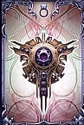  GREED | 20% LESS MAGIC, 20% MORE MAGIC DAMAGE | FIRST VISIT TO ABANDONED TEMPLES. IN PANORAMA, AFTER ENCOUNTER A TYRANT. GO UPSTAIRS AND TURN LEFT, KILL A FEW ENEMIES. REACH THE END AND KILL A FAT CROSSBOW DUDE AND A ALIEN-LIKE MONSTER, FIND THE STAIR TO DOWNSTAIRS. EXPLORE AND KILL A FEW ENEMIES INCLUDING A HEAVY SHIELD DUDE. THERE IS A BAR DOOR THAT MUST BE OPENED BY A RUNE. GREED IS IN A CHEST.
  LAST STRETCH | ADDS A CHANCE THAT YOU DEAL 50% - 75% MORE DAMAGE TO ENEMIES WHILE ATTACKING THEM. VERY USEFUL WITH THE ROGUE ABILITY "SHIFT" DUE TO INCREASED ONE-HITTING ABILITIES. | FOUND IN NG+ ON AN AUDIO LOG FROM THE TRAVELER
  LEECH | REGAIN HEALTH AND MAGIC ON EACH KILL.  +10 HP / +10 MAGIC | ACQUIRED FROM GIVING CRIPPLED RHOGAR 30 HUMAN SKULLS AND THEN KILLING HIM.
  LIFE LEECH | REGAIN A SMALL AMOUNT OF LIFE (15 HP) ON EACH KILL. | FOUND IN A CHEST INSIDE A PROVING GROUNDS AFTER BEATING THE CHAMPION BOSS
  MAGIC LEECH | REGAIN A SMALL AMOUNT OF MAGIC (15 MP) ON EACH KILL. | FOUND AFTER FREEING THE PRISONER IN CELL 0 IN THE CATACOMBS, FOUND IN CELL 01.
  NEW DAWN | ADDS 25% TO MAX HEALTH. CHECKPOINT SHARDS DO NOT REPLENISH THIS EXTRA AMOUNT OF HEALTH, BUT POTIONS DO. NOTE THAT THIS WILL OCCUR DURING THE REST OF YOUR GAME CYCLE EVEN IF YOU TAKE IT OFF. IT IS UNKNOWN IF THIS IS A GLITCH OR INTENDED. | FOUND IN LOCKED CHEST BEHIND BREAKABLE WALL IN PENANCE AREA. KEY OBTAINED BY ATTACKING INVISIBLE GHOST OF A MONK WHO DOESN'T KNOW THAT HE'S DEAD.
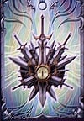  SHARP MIND | INCREASES CRITICAL ATTACK DAMAGE. | FOUND IN NG+ ON AN AUDIO LOG FROM THE TRAVELER
  THE GREAT BURDEN | GRANTS 31% ADDITIONAL POISE. | GIVEN TO YOU BY THE GUARD CAPTAIN IN EXCHANGE FOR 4 HUMAN TATOOS.  OR  BY KILLING HIM WHILE CONFRONTING ANTANAS.
  THE KEEP | SLIGHTLY REDUCES DAMAGE TAKEN. | AFTER DEFEATING INFILTRATOR, THERE IS A HOUND OUTSIDE THE ETERNAL FLAME ARENA NEAR THE STATUE THAT READS "FOR THE ONE WHO STOOD UP FOR US". IF YOU ATTACK IT, IT WILL RUN OFF DOWN THE PATH NEXT TO THE STATUE ALL THE WAY DOWN AND LEFT TILL YOU CAN'T GO ANY FURTHER AND WILL WAIT FOR YOU THERE. IF YOU ATTACK IT YOU WILL BE AMBUSHED. IF YOU SURVIVE THE AMBUSH YOU WILL RECEIVE THIS TRINKET.
CHALLENGER | +25% DMG AND -45% POTION EFFECT | KILL JUDGE WITHOUT LETTING HIM HEAL BY CONSUMING ANY INFESTED. AWARDED AT THE BEGINNING OF THE NG+.

CONSUMABLES
IMAGE & NAME | USAGE & NOTES
  ATTRIBUTE POINT SHARD  "THE SHARD OF ENORMOUS POWER, USED BY MONKS AND SCHOLARS TO ASCEND THEM TO HIGHER LEVELS OF CONSCIOUSNESS. PEOPLE WHISPERING ABOUT THE CRYSTAL SHARE THE SAME STORY. STORY OF THE SHARD ITSELF, TEMPTING THE MONKS, URGING THEM TO FREE THE ESSENCE WITHIN. THE ENERGY WITHIN THIS CRYSTAL CAGE DOESN'T WANT TO BE LEFT IMPRISONED. YOU CAN FEEL THE UNTAMED POWER BURSTING INSIDE." | GRANTS AN ADDITIONAL ATTRIBUTE POINT.
  CHECKPOINT SHARD  "DESCRIPTION HERE." | UNKNOWN.
  ENERGY SHARD  "THE MESSENGER'S VIGOR. IT IS SAID TO FORTIFY THE BODY OF THE USER. FOR A SHORT PERIOD, THE CONSUMER FEELS AND INCREASED INFLUX OF ENERGY. YOU FEEL A DELICATE TINGLING OF THE SHARD, FLASHING IN YOUR PALM. IT'S LIKE THE ENERGY HIDDEN INSIDE IS ABOUT TO BURST, RELEASING IT'S FULL POTENTIAL." | INCREASES ENERGY REGENERATION FOR 30 SECONDS.
  FIRE RESISTANCE SHARD  "FLAMES ARE VISIBLE INSIDE THE GLASS FRACTURE OF THE SHARD. SOME SAY IT IS A PRIMORDIAL ESSENCE OF FIRE ITSELF, CURBED DURING A DIMENSIONAL CLASH AND TRAPPED WITHIN ITS CRYSTAL PRISON. IT FEELS BOILING HOT, YET YOUR SKIN DOESN'T SUFFUSE. YOU FEEL THE SEETHING BLOOD RUSHING THROUGH YOUR VEINS. YOUR STOMACH IS FLAMING BUT THE SENSATION IS SOOTHING. YOU FEEL YOU COULD WITHSTAND INTERNAL FLAMES." | INCREASES FIRE RESISTANCE FOR 30 SECONDS.
  GHOST MERGE SHARD  "THE SHARD FEELS UNNATURAL. YOU CAN'T WASH AWAY THE FEELING THAT SOMETHING IS LOOKING AT YOU FROM INSIDE THE CRYSTAL. AND IT'S YOUR OWN FACE LOOKING BACK AT YOU. THE CENTRAL CRYSTAL LOOKS LIKE IT WAS WEAVED FROM A MYST OR A CLOUD. DABBING IT WITH A FINGER BRINGS A TINGLING SENSATION. YOU CAN FEEL ITS PRESENCE, LIKE IT'S A PART OF YOUR BODY, A PHANTOM LIMB YOU HAVE NEVER HAD." | BRINGS BACK YOUR GHOST AND ITS STORED XP IMMEDIATELY.
  HEALTH POTION  SOME CALL IT A WIDOW'S NIGHTCAP, TURNING THE GRIEVING INTO BANSHEES. OTHERS CALL IT A DEVIL'S HOOCH, GRANTING THE FEEBLE-MINDED AN UNBEARABLE HANGOVER. BUT WARRIORS USING IT IN BATTLE CALL IT A REDEEMER. IT FORCES THE HEART TO BEAT TWICE A FAST, PUMPING TWICE THE AMOUNT OF ADRENALINE. IT CURES THE WOUNDS OF BODY AND MIND. USE IT WISELY THOUGH - ON A BATTLEFIELD IT'S CONSIDERED LIQUID GOLD. | RESTORES 75 HEALTH, REPLENISHES AT CHECKPOINTS. DEFAULT CARRIED AMOUNT VARIES BETWEEN CLASSES FIND EMPTY BOTTLES TO INCREASE THE AMOUNT OF POTIONS CARRIED.  REINFORCED BY COMPLETING INJURED MONK QUESTLINE.
  LIGHTNING RESISTANCE SHARD  "A FLASHING GLOBE, GLITTERING EVEN IN THE NOCTURNAL DARK. IT IS BELIEVED GLOBES LIKE THIS WERE ABLE TO POWER UP ANCIENT CONTRIVANCES. THE LEGEND SAYS THE AUTOMATONS WERE ABLE TO STRIKE THEIR ENEMIES WITH POWERFUL LIGHTINING BOLTS. YOU FEEL THE GLOBE VIBRATING. THE ENERGIZING IMPULSES TOUCH THE ROOTS OF YOUR BODY. YOU FEEL LIKE YOU COULD WITHSTAND A LIGHTNING STRIKE WITH THE WRATH OF THE GODS. " | INCREASES LIGHTNING RESISTANCE FOR 30 SECONDS.
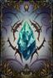  MAGIC ENERGY SHARD  "THE SHARD GLOWS BLUE AND THE EDGES OF THE CRYSTAL ARE AS SHARP AS ICE. IT LOOKS LIKE LIQUID STOPPED IN MOTION. THE SHARD IS GLOWING GENTLY AND YOU CAN FEEL YOUR INNER MAGICKA RESOUNDING WITH THE POWER HELD WITHIN. THE SHARD IS KNOWN FOR REFILLING A MAGUS' SORCERY POWER." | INCREASES MAGIC REGENERATION FOR 30 SECONDS.
  MAGIC RESISTANCE SHARD  "ALSO KNOWN AS THE EYE OF ANOSTEKELES. DURING THE DARK AGE OF HYSTERIA, ANOSTEKELES, THROUGH HIS MAGIC AND DIVINATIONS, SAVED THE PEOPLE WHOSE HAIR TURNED INTO SPIDER WEB AND FEET TRANSFORMED INTO PIG HOOVES, GRANTING THEM RESISTANCE TO DARK MAGIC. THE SHARD FEELS WARM, SENDING HOT WAVES THROUGH YOUR BODY, RESONATING ON THE RIGHT FREQUENCIES." | INCREASES MAGIC RESISTANCE FOR 30 SECONDS.
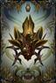  POISON RESISTANCE SHARD  "THE GLOBE IS A LITTLE BIT DISGUSTING, A LITTLE BIT STICKY. THE CRYSTAL SEEMS TO BE FITTED WITH SOMETHING VILE, ABOMINABLE OR EVEN REPULSIVE. IT LEAVES A SENSATION THAT YOUR GUTS ARE FILLED WITH BUGS OR MAGGOTS. YET, YOU FEEL LIKE YOU COULD HOLD OUT TO ANY KIND OF PESTILENCE POURED TO YOUR BODY WITHOUT DISGORGING YOUR OWN INTESTINES." | INCREASES POISON RESISTANCE FOR 30 SECONDS.
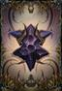  SPELL POINT SHARD  "THOSE OF POWER CALL IT THE CALL OF DEMONS, AS IT WAS USED BY IDOLATRESS TO ENHANCE THEIR ABILITY TO TALK WITH DEMONS. THE SABBATH IS LONG GONE BUT YOU CAN STILL FEEL THE POWER OF THE SHARD. SOMETHING'S BUBBLING INSIDE IT. WHEN YOU SHAKE IT, IT FEELS LIKE IT'S FILLED WITH LIQUID. YOU FEEL IT'S RESONATING WITH YOUR MAGICAL POWERS. BREAK IT TO UNLEASH ITS FULL POTENTIAL." | GRANTS AN ADDITIONAL SPELL POINT.

MAGIC IN LOTF

BRAWLING

"THE ART OF BRAWLING IS TO OVERWHELM YOUR OPPONENT WITH PURE FORCE AND MIGHTY SPELLS."

PRAYER

– "A MOTIONLESS CLONE THAT ATTRACTS ENEMY ATTENTION TO GIVE HARKYN ADVANTAGE. OVER TIME IT WILL ALSO RESTORE SOME OF YOUR HEALTH."

RAGE

– "A SURROUNDING FORCE THAT GIVES MORE DAMAGE, ATTACK POWER AND REMOVES ENERGY RESTRICTIONS."

RAM

– "A POWERFUL CHARGING FORCE THAT, APART FROM DAMAGING, CAN STAGGER OR KNOCK DOWN THE ENEMIES."

QUAKE

– "YOUR MOST POWERFUL ALLY, COMING DOWN TO HELP YOU AND SLAM YOUR ENEMIES WITH A GIANT HAMMER, WREAKING HAVOC."

DECEPTION

"DECEIVING THE ENEMIES AND INJURING THEM BEYOND RECOVERY IS THE MAIN FOCUS OF THE DECEPTION MAGIC TYPE."

PRAYER

– "A MOTIONLESS CLONE THAT ATTRACTS ENEMY ATTENTION TO GIVE HARKYN AN ADVANTAGE IN COMBAT. INCREASES ENERGY RECOVERY."

MIMIC

– "A PHASE OF MAGIC FOLLOWING YOU, COPYING YOUR MOVES AND DEALING REPEATING THE DAMAGE YOU'VE DONE."

STAB

– "A BLOODSEEKING SUPERNATURAL ASSASSIN THAT SPRINTS TOWARDS ITS PREY TO SEVERELY DAMAGE IT OR TAKE ITS LIFE."

SHIFT

– "HARKYN MOVES INTO SHADOW DIMENSION. ANY ATTACK HE DEALS IS DEVASTATING, BUT BRINGS HIM BACK IN TO VIEW."

SOLACE

"MAGIC TAUGHT BY SCHOLARS CONTAINS MOSTLY DEFENSIVE SPELLS TO HEAL AND PROTECT YOURSELF."

PRAYER

– "A MOTIONLESS CLONE THAT ATTRACTS ENEMY ATTENTION TO GIVE HARKYN AN ADVANTAGE IN COMBAT. INCREASES MAGIC RECOVERY."

SHELTER

– "A PROTECTIVE SHELL THAT HIGHLY INCREASES ALL TYPES OF DEFENSE AND MIRRORS THE INCOMING DAMAGE."

DAZE

– "A POWERFUL FORCE THAT INFLICTS FEAR UPON THE ENEMIES, SLOWING THEM DOWN AND LOWERING DEFENSES."

PUNISHMENT

– "EYE FOR AN EYE. ENEMY ATTACKS ARE BEING REVENGED BY STUNNING THE OPPONENT."

  LORDS AND JUDGES |   INFINITE | UNLOCK ALL TROPHIES | OBTAIN ALL OTHER TROPHIES/ACHIEVEMENTS
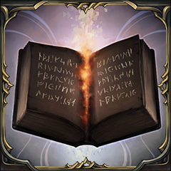  BY THE BOOK |   50 | FOUND 60 AUDIO NOTES | YOU CAN FIND THEIR LOCATIONS ON THE LORE PAGE
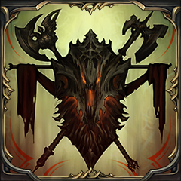  MY PRIVATE STASH | 50 | GOT 12 SPECIAL WEAPONS | YOU CAN FIND THEIR LOCATIONS ON THE SPECIAL WEAPONS PAGE
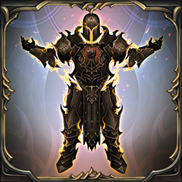  HARKYN COLLECTION | 50 | COLLECTED 20 ARMOR SETS | YOU CAN FIND THEIR LOCATIONS ON THE ARMOR PAGE
  WAY OF THE CLERIC |   30 | COMPLETED THE GAME AS CLERIC | YOU MUST COMPLETE THE GAME USING THE SOLACE MAGIC TREE
  WAY OF THE ROGUE | 30 | COMPLETED THE GAME AS ROGUE | YOU MUST COMPLETE THE GAME USING THE DECEPTION MAGIC TREE
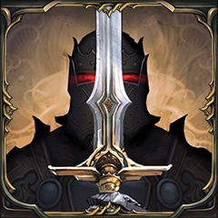  WAY OF THE WARRIOR | 30 | COMPLETED THE GAME AS WARRIOR | YOU MUST COMPLETE THE GAME USING THE BRAWLING MAGIC TREE
  AGAINST ALL ODDS | 40 | DEFEATED A BOSS WITHOUT TAKING DAMAGE | FIRST WARDEN IS THE EASIEST BOSS TO DO THIS ON
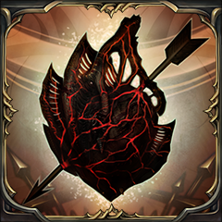  GO BREAKING MY HEART | 40 | COLLECTED 9 TYRANT HEARTS | YOU CAN FIND THEIR LOCATION ON THE TYRANT HEART PAGE
  HUMAN SKULL | 40 | COLLECTED 25 HUMAN SKULLS | YOU CAN FIND THEIR LOCATION ON THE HUMAN SKULL PAGE
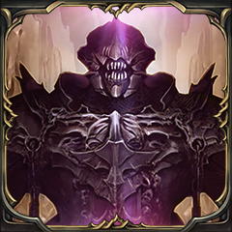  ONLY AFTER DISASTER |   15 | DEFEATED THE WORSHIPER | DEFEAT THE WORSHIPER
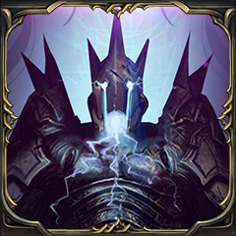  NOT A QUESTION OF CAN OR CAN'T | 15 | DEFEATED THE ANNIHILATOR | DEFEAT ANNIHILATOR
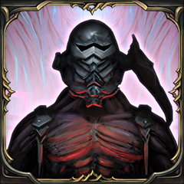  HARD SHELL, SOFT CORE | 15 | DEFEATED THE COMMANDER | DEFEAT THE COMMANDER
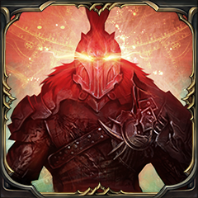  THOUSANDS OF CANDLES | 15 | DEFEATED THE GUARDIAN | DEFEAT THE GUARDIAN
  SO THAT'S A LORD! | 15 | DEFEATED FIRST WARDEN | DEFEAT THE FIRST WARDEN
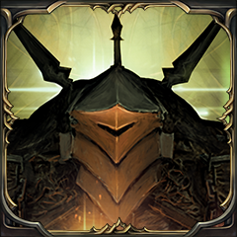  NO TIME FOR LOSERS | 15 | DEFEATED THE CHAMPION | DEFEATED THE CHAMPION
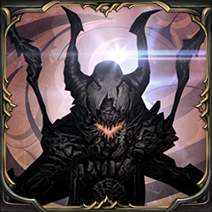  SEAL THE GATE | 15 | DEFEATED THE INFILTRATOR | DEFEAT THE INFILTRATOR
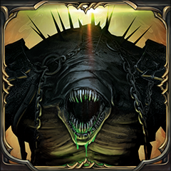  ANGER IS A GIFT | 15 | DEFEATED THE BEAST | DEFEATED THE BEAST
  TWO AGAINST ONE | 15 | DEFEATED LOST BROTHERS | DEFEATED LOST BROTHERS
  HE SPEAKS IN RIDDLES | 15 | MET THE BLACKSMITH | YOU CAN FIND THE LOCATION OF THE BLACKSMITH ON THE CRAFTER PAGE
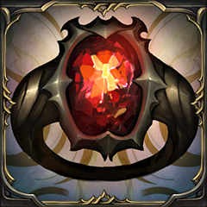  TREASURE LEFT ALONE | 15 | LOOTED ALL TREASURE CHAMBERS | YOU CAN FIND THE LOCATION OF THE TREASURE CHAMBERS ON THE DIMENSION PORTAL PAGE
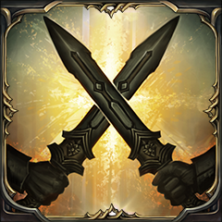  ARE YOU NOT ENTERTAINED? | 20 | COMPLETED ALL PROVING GROUNDS | YOU CAN FIND THE LOCATION OF THE PROVING GROUNDS ON THE DIMENSION PORTAL PAGE
  NO ONE CAN HEAR YOU SCREAM | 20 | COMPLETED ALL INFINITE VOIDS | YOU CAN FIND THE LOCATION OF THE INFINITE VOIDS ON THE DIMENSION PORTAL PAGE
  STRONG WITH THIS ONE | 15 | UNLOCKED ALL SPELLS FOR ONE CLASS | THIS REQUIRES A MINIMUM OF 15 FAITH AND 5 SPELL POINTS
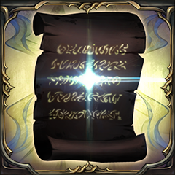  GIVE HIM POWER | 15 | BOUGHT YOUR FIRST ATTRIBUTE OR SPELL POINT | YOU WILL GET THIS TROPHY/ACHIEVEMENT IF YOU SPEND YOUR XP DIRECTLY AFTER DEFEATING THE FIRST WARDEN
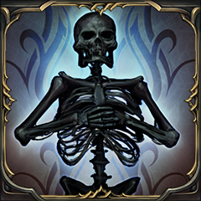  IT'S BOUND TO TAKE YOUR LIFE | 15 | DIED FOR THE FIRST TIME | DIE
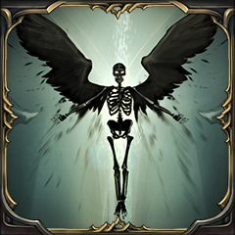  MYSELF AGAIN | 15 | RETRIEVED LOST EXPERIENCE BY COLLECTING YOUR GHOST | AFTER DYING, RETRIEVE THE XP YOU LOST FROM THE GHOST WHERE YOU DIED
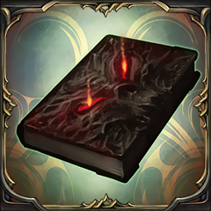  BOOKWORM | 15 | FOUND A NOTE THAT SOMEONE LEFT BEHIND | FIND ONE AUDIO NOTE
  EXTRA STRONG | 30 | UPGRADED THE HEALTH POTIONS | SEE THE INJURED MONK PAGE FOR INSTRUCTIONS ON HOW TO DO THIS
  ALL IN | 20 | DEFEATED A BOSS WITH AT LEAST 20000 UNSPENT EXPERIENCE | DEFEAT A BOSS CARRYING 20000 XP OR MORE ON YOU
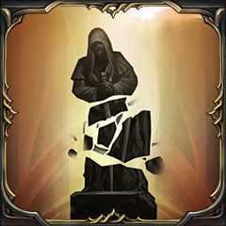  COULDN'T HAVE DONE IT MYSELF | 20 | LET THE BOSS DESTROY THE STATUE DURING FIGHT | SEE THE SHARD OF THE HEROES PAGE FOR INSTRUCTIONS ON HOW TO DO THIS
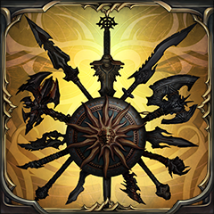  GOOD WITH WEAPONS | 20 | COLLECTED ALL WEAPON TYPES | COLLECTED ONE OF EACH WEAPON TYPE
  KILLING MONSTERS | 20 | KILLED ALL TYPES OF ENEMIES | KILLED ONE OF EACH TYPE OF ENEMY
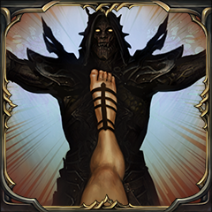  THIS! IS! KEYSTONE! | 15 | KICKED AN ENEMY INTO HIS DEATH | YOU WILL GET THIS FOR KICKING AN ENEMY OFF A CLIFF OR INTO A PIT
  HE WHO PROTECTS US | 15 | MET ANTANAS | MEET ANTANAS
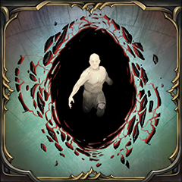  THE REAL LORDS STARTS HERE | 15 | ENTERED THE RHOGAR REALM | DEFEAT WORSHIPER AND TALK TO KASLO OUTSIDE THE GRAVEYARD TO OPEN THE PORTAL
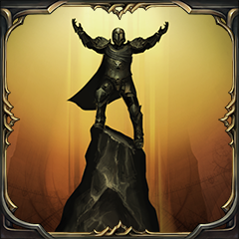  SHOUT AT THE GODS | 15 | MET ADYR | GO THROUGH THE PORTAL AFTER DEFEATING ANNIHILATOR
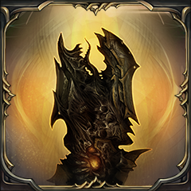  NOW WE'RE TALKING | 20 | FOUND THE GAUNTLET | PICK UP THE GAUNTLET ON THE NORTHERN WALL
  I FEEL LUCKY | 30 | PURIFIED THE SWORD OF THE UNLUCKY GRAVE ROBBER | OBTAIN CURSE FROM THE OLD QUARTERS AND BURY IT IN THE GRAVE AT THE GRAVEYARD AND PICK IT UP AGAIN AFTERWARDS
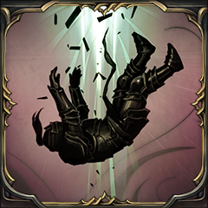  FOOL OF A TUCK | 15 | THROW A CORPSE DOWN THE BOTTOMLESS PIT IN CATACOMBS | KILL THE OVERLY LARGE RHOGAR ARCHER IN THE ROYAL TOMBS (CATACOMBS) AND KICK HIS BODY DOWN THE PIT IN THAT ROOM
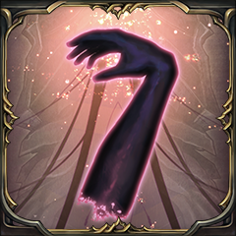  TAKE MY HAND | 10 | CUT OFF MONK'S ARM | CUT OFF THE INJURED MONK'S ARM
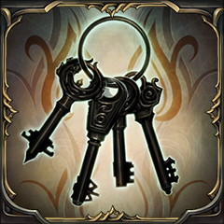  I SAW EVERYTHING | 20 | ENTERED 15 SECRET ROOMS | YOU CAN FIND THE LOCATIONS FOR THESE ON THE SECRETS PAGE
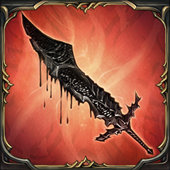  DO UNTO OTHERS | 20 | KILLED THE FIRST WARDEN WITH THE WARDEN GREATSWORD | DEFEAT THE FIRST WARDEN WITH PERSISTENCE (CAN ONLY ACHIEVE THIS IN NG+)
  SHE WAS THE LAST WOMAN HERE | 30 | SHOWED MERCY TO AN IMPRISONED MONSTER | COMPLETE YETKA'S QUEST LINE
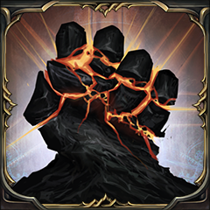  GOD IS DEAD | 15 | LED HUMANS TO VICTORY | USE THE RUNE OF ADYR IN YOUR ARMOR AND DEFEAT JUDGE
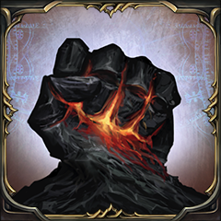  FAITH IS WEAKNESS | 15 | LED RHOGAR TO VICTORY | USE THE RUNE OF ADYR IN YOUR WEAPON AND DEFEAT JUDGE
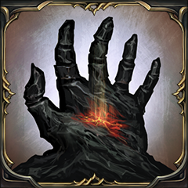  WHOLE WORLD IN HIS HANDS | 15 | BRING BALANCE TO BOTH REALMS | GIVE THE RUNE OF ADYR TO THE CRAFTER AND DEFEAT JUDGE

