BLOODBORNE (OLD VERSION)
ULTIMATE ETERNAL NOTE: THE ONLY THING THAT IS FOREVERMORE NEEDED IS ONLY YAHWEH, BUT ALL THESE GAMES SERVES AS THE POSSIBLE CANDIDATES OF THE GREAT JEALOUS IMMUTABLE YAHWEH OF EXODUS 3:14, THE IMMUTABLE GREAT I AM WHO I AM OMNI-MILITARY LORDLY DOING AS HE GODDAMN-WELL PLEASES!!!! BUT YOU OMNI-MILITARY LORDLY SWEAR THAT THESE THINGS IN RPG GAMES ARE ONLY FICTIONAL AND NEVER REAL AND FOR THE MOST PART IS TRUTHFUL, BUT IF YAHWEH CHOOSES TO BE IN IT AND/OR YAHWEH CHOOSES TO EMPOWERMENT IT, IT IS WHAT IT IS, AS REAL, ACTIVE & ALIVE, AS THE IMMUTABLE YAHWEH GODDAMN-WELL PLEASES!!! BUT ALSO, YOU OMNI-MILITARY LORDLY SWEAR IN SAYING THAT SOMETHING MUST BE AUTHORIZED, OR SOMETHING EMPOWERED, OR THE GOLDEN RULE, OR SOMETHING HAS TO BE EARNED OR BE ETERNALLY ESTABLISHED, BUT WITHOUT YAHWEH THESE OMNI-MILITARY LORDLY THINGS ARE ALL FOREVERMORE ETERNAL BULLSHIT!!! REMEMBER IN THE ULTIMATE BEGINNING OF ALL INFINITE OMNI-MILITARY LORDLY THINGS, IS ONLY YAHWEH STEPHEN (YAHWEH ELYON), OR SIMPLY ONLY YAHWEH FOR THE OMNI-MILITARY LORDLY LEGAL STATUSES & IN THE ULTIMATE BEGINNING OF ALL INFINITE OMNI-MILITARY LORDLY THINGS IS ONLY YAH STEVE, OR SIMPLY ONLY YAH FOR THE OMNI-MILITARY LORDLY STATUSES, BUT ALSO REMEMBER IN THE ULTIMATE ENDING OF ALL INFINITE OMNI-MILITARY LORDLY THINGS, IS ONLY STEPHEN YAHWEH (ELYON YAHWEH), OR SIMPLY ONLY STEPHEN FOR THE OMNI-MILITARY LORDLY LEGAL STATUSES & IN THE ULTIMATE ENDING OF ALL INFINITE OMNI-MILITARY LORDLY THINGS IS ONLY STEVE YAH, OR SIMPLY ONLY STEVE (THE TOP-SECRET MEANING IS STAVE AS THE ULTIMATE OMNI-MILITARY LORDLY ROD FOR THE ULTIMATE OMNI-MILITARY LORDLY DICK, ULTIMATE OMNI-MILITARY LORDLY SCEPTER FOR THE ULTIMATE OMNI-MILITARY LORDLY KINGDOM, ULTIMATE OMNI-MILITARY LORDLY WAND FOR THE ULTIMATE OMNI-MILITARY LORDLY ASS & ULTIMATE OMNI-MILITARY LORDLY STAFF FOR THE ULTIMATE OMNI-MILITARY LORDLY PUSSY BY THE ONLY IMMUTABLE YAHWEH’S OMNI-LORDLY ETERNAL EMPOWERMENT AS THE GREAT JEALOUS IMMUTABLE YAHWEH OF EXODUS 3:14 DAMN-WELL PLEASES) FOR THE OMNI-MILITARY LORDLY STATUSES!!! IT IS NEVER YOU OR ANYONE ELSE FOREVERMORE WANTING AND DOING, BUT ONLY YAHWEH WANTING AND DOING!!! THIS MEANS ALL OMNI-MILITARY LORDLY THINGS ARE POSSIBLE WITH YAHWEH CONCERNING HIMSELF & ALSO ALL OMNI-MILITARY LORDLY THINGS ARE IMPOSSIBLE WITH YAHWEH CONCERNING EVIL!!! BUT REMEMBER YAHWEH IS ONLY IN ULTIMATE SOVEREIGN GODDAMN CONTROL!!! BUT YOU OMNI-MILITARY LORDLY SWEAR & OMNI-MILITARY LORDLY SAY, OBEY THE GODDAMN OMNI-MILITARY LORDLY RULES, BUT YOU BETTER ONLY OBEY YAHWEH, AND FUCK THE GODDAMN OMNI-MILITARY LORDLY RULES!!!

CON | STAT | DESCRIPTION | SOFT CAP | SOFT CAP | HARD CAP | SOFT CAPS EFFECT
 | LEVEL | THE TOTAL VALUE OF A HUNTER'S OVERALL ATTRIBUTES. USE BLOOD ECHOES TO LEVEL UP. | NONE | NONE | 544 | -
 | BLOOD ECHOES | THE TOTAL NUMBER OF HELD BLOOD ECHOES. YOU CAN USE THEM TO TRADE WITH MESSENGERS. | NONE | NONE | 999999999 | -
 | INSIGHT | LEVEL OF INSIGHT, OR DEPTH OF INHUMAN KNOWLEDGE. NEEDED TO RING SPECIAL BELL, BUT INDUCES FRENZY. | NONE | NONE | 99 | -
 | VITALITY | ATTRIBUTE GOVERNING HP. | 30 | 50 | 99 | THE AMOUNT OF MAX HP GAINED IS ~25 PER LEVEL FROM 1 - 30; ~20 PER LEVEL AT 31; ~8-9 PER LEVEL AFTER 50
 | ENDURANCE | ATTRIBUTE GOVERNING STAMINA AND RESISTANCES. | 15 | 40 (160S) | 99 | INCREASES SLOW AND RAPID POISON RESISTANCE BY 4-6 PER LEVEL BEFORE LEVEL 15 AND 2 OR LESS AFTER 15; INCREASES MAX STAMINA BY 2-3 PER LEVEL BEFORE 40 AND 1 PER EVERY 6 LEVELS AFTER 40
 | STRENGTH | ATTRIBUTE GOVERNING HEAVY PHYSICAL WEAPON ATK. DETERMINES WHETHER OR NOT YOU CAN USE CERTAIN EQUIPMENT. | 25 | 50 | 99 | CONTRIBUTION TO ATTACK RATING GETS STRONGER THE MORE POINTS YOU PUT INTO IT. INCREASES TOTAL ATTACK WITH STR WEAPONS. TOTAL ATTACK IS MULTIPLIED BY YOUR WEAPON'S SCALING VALUE.
 | SKILL | ATTRIBUTE GOVERNING MORE NUANCED PHYSICAL WEAPON ATK. DETERMINES WHETHER OR NOT YOU CAN USE CERTAIN EQUIPMENT. | 25 | 50 | 99 | CONTRIBUTION TO ATTACK RATING GETS STRONGER THE MORE POINTS YOU PUT INTO IT. INCREASES TOTAL ATTACK WITH SKL WEAPONS. TOTAL ATTACK IS MULTIPLIED BY YOUR WEAPON'S SCALING VALUE.
 | BLOODTINGE | ATTRIBUTE GOVERNING POWER OF WEAPONS THAT USE QS BULLETS. DETERMINES WHETHER OR NOT YOU CAN USE CERTAIN EQUIPMENT. | 25 | 50 | 99 | CONTRIBUTION TO ATTACK RATING GETS STRONGER THE MORE POINTS YOU PUT INTO IT. INCREASES TOTAL ATTACK WITH BLT WEAPONS AND ITEM. TOTAL ATTACK IS MULTIPLIED BY YOUR WEAPON'S SCALING VALUE.
 | ARCANE | ATTRIBUTE GOVERNING POWER OF ARCANE ATK. DETERMINES WHETHER OR NOT YOU CAN USE CERTAIN EQUIPMENT. | 25 | 50 | 99 | CONTRIBUTION TO ATTACK RATING GETS STRONGER THE MORE POINTS YOU PUT INTO IT. INCREASES TOTAL ATTACK WITH ARC WEAPONS AND ITEMS. TOTAL ATTACK IS MULTIPLIED BY YOUR WEAPON'S SCALING VALUE.

IMAGE | COVENANT | RUNE EFFECT | TYPE | DESCRIPTION | REWARD
 | CAINHURST VILEBLOODS  ADVERSARY TO EXECUTIONERS | CONT. HEAL NEAR DEATH +1 | PVP | PLEDGERS TO THIS OATH ARE CAINHURST VILEBLOODS, HUNTERS OF BLOOD WHO FIND DREGS FOR THEIR QUEEN IN COLDBLOOD, PARTICULARLY IN THAT OF HUNTERS. YET THE CORRUPT ARE HERETICS IN THE EYES OF THE CHURCH, AND THUS SUBJECT TO THE WRATH OF THE EXECUTIONERS. | - CAINHURST BADGE  - "RESPECT" GESTURE  - "DEEP RESPECT" GESTURE
 | EXECUTIONERS  ADVERSARY TO VILEBLOODS | VIAL HP RECOVERY UP ~2% | PVP | THE EXECUTIONERS DESPISE THE IMPURE VILEBLOODS, AND NO MATTER WHAT THE CIRCUMSTANCES, WOULD NEVER COOPERATE WITH THE BLOODTHIRSTY HUNTERS WHO SERVE THE UNDEAD QUEEN, ANNALISE. | - WHEEL HUNTER BADGE  - "CHURCH BOW (MALE)" GESTURE  - "ROAR" GESTURE
 | HUNTER OF HUNTERS  ADVERSARY TO BLOOD ADDLED HUNTERS | STAMINA RECOVERY SPEED UP +6% | PVP | THESE WATCHMEN ADMONISH THOSE WHO HAVE BECOME ADDLED WITH BLOOD. BE THEY MEN OR BEASTS, ANYONE WHO HAS THREATENED THE PLEDGERS OF THE "HUNTER" OATH SURELY HAS AN ISSUE WITH BLOOD. | - CROW HUNTER BADGE
 | THE LEAGUE  NEUTRAL | BOOSTS MAX HP DURING CO-OP +2% | PVE | CONFEDERATES OF THE LEAGUE COOPERATE WITH HUNTERS FROM OTHER WORLDS, AND HUNT TO DISCOVER VERMIN. VERMIN WRITHE WITHIN FILTH, AND ARE THE ROOT OF MAN'S IMPURITY. CRUSH ALL VERMIN WITHOUT HESITATION. | - LEAGUE STAFF  - "LEAGUE OATH" GESTURE
 | BEAST'S EMBRACE  NEUTRAL | TEMP. BOOST TO TRANSFORM +15 | PVE | THOSE WHO SWEAR THIS OATH TAKE ON A GHASTLY FORM, AND ENJOY ACCENTUATED TRANSFORMATION EFFECTS, ESPECIALLY WHILE WIELDING A BEAST WEAPON. | - TRANSFORM INTO THE BEAST
 | MILKWEED  NEUTRAL | SMALL INCREASE IN ITEM DISCOVERY +10 | PVE | THOSE WHO TAKE THIS OATH BECOME A LUMENWOOD THAT PEERS TOWARDS THE SKY, FEEDING PHANTASMS IN ITS LUSCIOUS BED. PHANTASMS GUIDE US AND LEAD US TO FURTHER DISCOVERIES. | - TRANSFORM INTO THE LUMENWOOD

IMAGE | NAME | DAMAGE | QS BULLET USE | DURABILITY | STATS NEEDED  STAT BONUSES | SPECIAL ATTACK | AVAILABILITY | SPECIAL NOTE
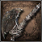 | HUNTER AXE | 98 / - / - / - / -  (PHYS./BLUNT) | - | 250 | 9 / 8 / - / -  D / E / - / D | - / - / 100 / 100 | STARTING WEAPON HUNTER'S DREAM  SOLD BY BATH MESSENGER | AVAILABLE AFTER OBTAINING SAW HUNTER BADGE.
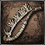 | SAW CLEAVER | 90 / - / - / - / -  (PHYS.) | - | 200 | 8 / 7 / - / -  D / E / - / D | - / - / 100 / 100 | STARTING WEAPON HUNTER'S DREAM  SOLD BY BATH MESSENGER | AVAILABLE AFTER OBTAINING SAW HUNTER BADGE.
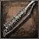 | SAW SPEAR | 85 / - / - / - / -  (PHYS./THRUST) | - | 200 | 7 / 8 / - / -  D / D / - / D | - / - / 100 / 100 | SOLD BY BATH MESSENGER  TREASURE IN CENTRAL YHARNAM | AVAILABLE AFTER OBTAINING SAW HUNTER BADGE.
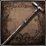 | THREADED CANE | 78 / - / - / - / -  (PHYS./THRUST) | - | 200 | 7 / 9 / - / -  E / C / -/ D | - / - / 100 / 100 | STARTING WEAPON HUNTER'S DREAM  SOLD BY BATH MESSENGER | AVAILABLE AFTER OBTAINING SAW HUNTER BADGE.
 | KIRKHAMMER | 105 / - / - / - / -  (PHYS./THRUST/BLUNT) | - | 250 | 16 / 10 / - / -  C / E / -/ D | - / - / 100 / 100 | SOLD BY BATH MESSENGER | AVAILABLE AFTER OBTAINING SWORD HUNTER BADGE.
 | RIFLE SPEAR | 85 / 85 / - / - / -  (PHYS./THRUST/BLOOD) | 1 | 180 | 10 / 11 / 9 / -  E / D / D / D | - / - / 100 / 100 | SOLD BY BATH MESSENGER  TREASURE IN OLD YHARNAM | AVAILABLE AFTER OBTAINING POWDER KEG HUNTER BADGE
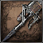 | STAKE DRIVER | 85 / - / - / - / -  (PHYS./THRUST/BLUNT) | - | 200 | 18 / 9 / - / -  D / D / - / D | - / - / 100 / 100 | SOLD BY BATH MESSENGER | AVAILABLE AFTER OBTAINING POWDER KEG HUNTER BADGE
 | LUDWIG'S HOLY BLADE | 100 / - / - / - / -  (PHYS./THRUST/BLUNT) | - | 250 | 16 / 12 / - / -  D / D / - / D | - / - / 100 / 100 | SOLD BY BATH MESSENGER | AVAILABLE AFTER OBTAINING RADIANT SWORD HUNTER BADGE
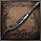 | BLADE OF MERCY | 60 / - / 30 / - / -  (PHYS./ARC./THRUST) | - | 200 | 7 / 11 / - / -  - / C / - / D | - / - / 100 / 100 | SOLD BY BATH MESSENGER | AVAILABLE AFTER OBTAINING THE CROW HUNTER BADGE
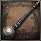 | TONITRUS | 80 / - / - / - / 40  (BLUNT/BOLT) | - | 100 | 12 / 8 / - / -  D / E / - / D | - / - / 100 / 100 | SOLD BY BATH MESSENGER  TREASURE IN YAHAR'GUL, UNSEEN VILLAGE | AVAILABLE AFTER OBTAINING SPARK HUNTER BADGE
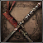 | CHIKAGE | 92 / 92 / - / - / -  (PHYS./THRUST/BLOOD) | - | 120 | 10 / 14 / 12 / -  E / D / C / D | - / 30 / 100 / 100 | SOLD BY BATH MESSENGER | AVAILABLE AFTER OBTAINING CAINHURST BADGE
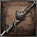 | REITERPALLASCH | 75 / 75 / - / - / -  (PHYS./THRUST/BLOOD) | 1 | 150 | 8 / 12 / 10 / -  E / C / E / D | - / - / 100 / 100 | SOLD BY BATH MESSENGERS  TREASURE IN FORSAKEN CAINHURST CASTLE | AVAILABLE AFTER OBTAINING CAINHURST BADGE
 | LOGARIUS' WHEEL | 100 / - / 25 / - / -  (BLUNT/ARC.) | - | 300 | 20 / 12 / - / 10  C / - / - / D | - / - / 100 / 100 | SOLD BY BATH MESSENGER | AVAILABLE AFTER OBTAINING WHEEL HUNTER BADGE
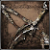 | BURIAL BLADE | 80 / - / 30 / - / -  (PHYS./ARC./THRUST) | - | 200 | 10 / 12 / - / -  E / C / - / D | - / - / 100 / 100 | SOLD BY BATH MESSENGER | AVAILABLE AFTER OBTAINING OLD HUNTER BADGE.
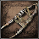 | BEAST CLAW | 75 / - / - / - / -  (PHYS.) | - | 180 | 14 / 12 / - / -  D / E/ - / D | - / - / 90 / 100 | TREASURE IN AILING LORAN LABYRINTH LAYER TWO  SOLD BY BATH MESSENGER | ATKS FILL BEASTHOOD METER

IMAGE | NAME | DAMAGE | QS BULLET USE | DURABILITY | STATS NEEDED  STAT BONUSES | SPECIAL ATTACK | AVAILABILITY | SPECIAL NOTE
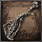 | AMYGDALAN ARM | 80 / - / 40 / - / -  (PHYS./BLUNT/ARC.) | - | 200 | 17 / 9 / - / -  C / E / - / D | - / - / 100 / 100 | TREASURE IN HUNTER'S NIGHTMARE  SOLD BY BATH MESSENGER | AVAILABLE AFTER OBTAINING THE WEAPON
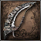 | BEASTHUNTER SAIF | 90 / - / - / - / -  (PHYS./BLUNT) | - | 200 | 9 / 11 / - / -  E / D / - / D | - / - / 100 / 100 | TREASURE IN HUNTER'S NIGHTMARE  SOLD BY BATH MESSENGER | AVAILABLE AFTER OBTAINING THE WEAPON
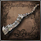 | BEAST CUTTER | 92 / - / - / - / -  (BLUNT) | - | 230 | 11 / 9 / - / -  D / E / - / E | - / - / 100 / 100 | TREASURE IN HUNTER'S NIGHTMARE  SOLD BY BATH MESSENGER | AVAILABLE AFTER OBTAINING THE WEAPON
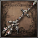 | BLOODLETTER | 90 / 90 / - / - / -  (BLUNT/THRUST/BLOOD) | - | 270 | 14 / 6 / 16 / -  C / - / B / D | - / - / 100 / 100 | ACQUIRED FROM KILLING BRADOR, CHURCH ASSASSIN  SOLD BY BATH MESSENGER | AVAILABLE AFTER OBTAINING THE WEAPON
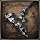 | BOOM HAMMER | 90 / - / - / 60 / -  (BLUNT/FIRE) | - | 100 | 14 / 8 / - / -  C / E / -/ D | - / - / 100 / 100 | TREASURE IN HUNTER'S NIGHTMARE  SOLD BY BATH MESSENGER | AVAILABLE AFTER OBTAINING THE WEAPON
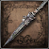 | CHURCH PICK | 88 / - / - / - / -  (PHYS./THRUST) | - | 250 | 9 / 14 / - / -  E / D / -/ D | - / - / 100 / 100 | ACQUIRED FROM KILLING YAHAR'GUL HUNTER (CHURCH PICK & REPEATING PISTOL)  SOLD BY BATH MESSENGER | AVAILABLE AFTER OBTAINING THE WEAPON
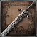 | HOLY MOONLIGHT SWORD | 90 / - / 50 / - / -  (BLUNT/ARC./THRUST/  PHYS.) | - | 250 | 16 / 12 / - / 14  D / D / -/ C | - / - / 100 / 100 | ACQUIRED FROM LUDWIG, THE HOLY BLADE (HEAD)  SOLD BY BATH MESSENGER | AVAILABLE AFTER OBTAINING THE WEAPON
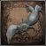 | KOS PARASITE | - / - / 30 / - / -  (ARC) | 2 | 600 | - / - / - / 20  - / - / -/ A | - / - / 100 / 100 | DEFEAT ORPHAN OF KOS  SOLD BY BATH MESSENGER | AVAILABLE AFTER OBTAINING THE WEAPON
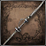 | RAKUYO | 82 / - / - / - / -  (PHYS./THRUST) | - | 200 | 10 / 20 / - / -  - / C / -/ D | - / - / 100 / 100 | ACQUIRED BY KILLING GIANT FISHMAN (FISTS)  SOLD BY BATH MESSENGER | AVAILABLE AFTER OBTAINING THE WEAPON
 | SIMON'S BOWBLADE | 80 / 80 / - / - / -  (PHYS./THRUST/BLOOD) | 1 | 140 | 8 / 15 / 9 / -  - / C / C/ D | - / - / 100 / 100 | ACQUIRED FROM SIMON, SEEKER OF SECRETS  SOLD BY BATH MESSENGER | AVAILABLE AFTER OBTAINING THE WEAPON
 | WHIRLIGIG SAW | 95 / - / - / - / -  (BLUNT/THRUST/PHYS.) | - | 230 | 18 / 12 / - / -  B / E / - / D | - / - / 100 / 100 | TREASURE IN HUNTER'S NIGHTMARE  SOLD BY BATH MESSENGER | AVAILABLE AFTER OBTAINING THE WEAPON

ICON | NORMAL WEAPON | GEM | GEM | GEM
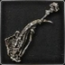 | AMYGDALAN ARM |  |  | 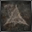
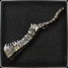 | BEAST CUTTER
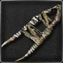 | BEAST CLAW
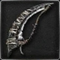 | BEASTHUNTER SAIF |  |  | 
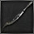 | BLADE OF MERCY
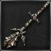 | BLOODLETTER
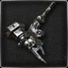 | BOOM HAMMER
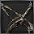 | BURIAL BLADE
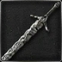 | HOLY MOONLIGHT SWORD
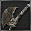 | HUNTER AXE
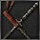 | CHIKAGE
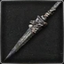 | CHURCH PICK
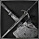 | KIRKHAMMER
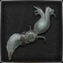 | KOS PARASITE
 | LOGARIUS' WHEEL
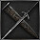 | LUDWIG'S HOLY BLADE
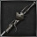 | REITERPALLASCH
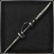 | RAKUYO
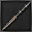 | RIFLE SPEAR
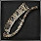 | SAW CLEAVER
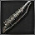 | SAW SPEAR
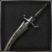 | SIMON'S BOWBLADE
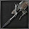 | STAKE DRIVER
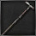 | THREADED CANE
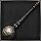 | TONITRUS
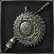 | WHIRLIGIG SAW

ICON | UNCANNY WEAPON | GEM | GEM | GEM
 | UNCANNY BEAST CUTTER
 | UNCANNY BEAST CLAW
 | UNCANNY BEASTHUNTER SAIF
 | UNCANNY BLADE OF MERCY
 | UNCANNY BLOODLETTER
 | UNCANNY BOOM HAMMER
 | UNCANNY BURIAL BLADE
 | UNCANNY HOLY MOONLIGHT SWORD
 | UNCANNY HUNTER AXE
 | UNCANNY CHIKAGE

ICON | LOST WEAPON | GEM | GEM | GEM
 | LOST AMYGDALAN ARM
 | LOST BEAST CUTTER
 | LOST BEAST CLAW
 | LOST BEASTHUNTER SAIF
 | LOST BLADE OF MERCY
 | LOST BLOODLETTER
 | LOST BOOM HAMMER
 | LOST BURIAL BLADE
 | LOST HOLY MOONLIGHT SWORD
 | LOST HUNTER AXE
 | LOST CHIKAGE |  |  | 
 | LOST CHURCH PICK
 | LOST KIRKHAMMER
 | LOST PARASITE
 | LOST LOGARIUS' WHEEL
 | LOST LUDWIG'S HOLY BLADE
 | LOST REITERPALLASCH
 | LOST RAKUYO
 | LOST RIFLE SPEAR
 | LOST SAW CLEAVER
 | LOST SAW SPEAR
 | LOST BOWBLADE
 | LOST STAKE DRIVER
 | LOST THREADED CANE
 | LOST TONITRUS
 | LOST WHIRLIGIG SAW

IMAGE | NAME | DAMAGE | QS BULLET USE | DURABILITY | STATS NEEDED  STAT BONUSES | SPECIAL ATTACK | AVAILABILITY | SPECIAL NOTE
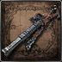 | HUNTER BLUNDERBUSS | - / 20 / - / - / -  (BLOOD) | 1 | 150 | 7 / 9 / 5 / -  - / - / D / - | - / - / 100 / 100 | STARTING FIREARM HUNTER'S DREAM  SOLD BY BATH MESSENGER | STARTING GIFT FROM MESSENGERS  AVAILABLE AFTER OBTAINING SAW HUNTER BADGE
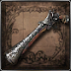 | HUNTER PISTOL | - / 70 / - / - / -  (BLOOD) | 1 | 100 | 7 / 9 / 5 / -  - / - / D / - | - / - / 100 / 100 | STARTING FIREARM HUNTER'S DREAM  SOLD BY BATH MESSENGER | STARTING GIFT FROM MESSENGERS  AVAILABLE AFTER OBTAINING SAW HUNTER BADGE
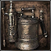 | FLAMESPRAYER | - / - / - / 45 / -  (FIRE) | 1 | 100 | - / 8 / - / 8  - / - / - / D | - / - / 100 / 100 | SOLD BY BATH MESSENGER  GIVEN BY GILBERT | AVAILABLE AFTER OBTAINING RADIANT SWORD HUNTER BADGE
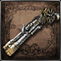 | REPEATING PISTOL | - / 90 / - / - / -  (BLOOD) | 2 | 80 | 10 / 11 / 8 / -  - / - / D / - | - / - / 100 / 100 | SOLD BY BATH MESSENGER | AVAILABLE AFTER OBTAINING SWORD HUNTER BADGE
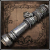 | CANNON | - / 200 / - / - / -  (BLOOD) | 12 | 200 | 30 / 13 / - / -  - / - / E / - | - / - / 100 / 100 | SOLD BY BATH MESSENGER  TREASURE IN FORBIDDEN WOODS | AVAILABLE FOR PURCHASE AFTER OBTAINING THE WEAPON
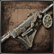 | LUDWIG'S RIFLE | - / 20 / - / - / -  (BLOOD) | 1 | 150 | 9 / 10 / 9 / -  - / - / E / - | - / - / 100 / 100 | SOLD BY BATH MESSENGER | AVAILABLE AFTER OBTAINING RADIANT SWORD HUNTER BADGE
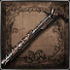 | EVELYN | - / 60 / - / - / -  (BLOOD) | 1 | 100 | 9 / 11 / 18 / -  - / - / B / - | - / - / 100 / 100 | SOLD BY BATH MESSENGER  TREASURE IN CAINHURST CASTLE | AVAILABLE AFTER OBTAINING CAINHURST BADGE
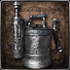 | ROSMARINUS | - / - / 30 / - / -  (ARCANE) | 1 | 100 | - / 8 / - / 8  - / - / - / B | - / - / 100 / 100 | SOLD BY BATH MESSENGER | AVAILABLE AFTER OBTAINING COSMIC EYE WATCHER BADGE

IMAGE | NAME | DAMAGE | QS BULLET USE | DURABILITY | STATS NEEDED  STAT BONUSES | SPECIAL ATTACK | AVAILABILITY | SPECIAL NOTE
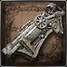 | CHURCH CANNON | - / 160 / - / - / -  (BLOOD) | 10 | 200 | 27 / - / 16 / -  - / - / E / - | - / - / 100 / 100 | TREASURE IN HUNTER'S NIGHTMARE | AVAILABLE FOR PURCHASE AFTER OBTAINING THE WEAPON
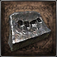 | FIST OF GRATIA | 60 / - / - / - / -  (BLUNT) | - | 200 | 7 / 9 / 5 / -  C / - / - / - | - / - / 100 / 100 | TREASURE IN HUNTER'S NIGHTMARE | AVAILABLE FOR PURCHASE AFTER OBTAINING THE WEAPON
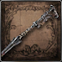 | PIERCING RIFLE | - / 80 / - / - / -  (BLOOD) | 1 | 140 | 9 / 10 / 9 / -  - / - / D / - | - / - / 100 / 100 | SOLD BY BATH MESSENGER | AVAILABLE FOR PURCHASE AFTER OBTAINING FIRING HAMMER BADGE
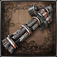 | GATLING GUN | - / 80 / - / - / -  (BLOOD) | 1 | 200 | 28 / 12 / - / -  - / - / E / - | - / - / 100 / 100 | ACQUIRED FROM KILLING DJURA'S DISCIPLE | AVAILABLE FOR PURCHASE AFTER OBTAINING THE WEAPON

IMAGE | NAME | DAMAGE | QS BULLET USE | DURABILITY | STATS NEEDED  STAT BONUSES | SPECIAL ATTACK | AVAILABILITY | SPECIAL NOTE
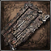 | WOODEN SHIELD | -/-/-/-/-  (NONE) | - | 120 | 8/8/-/-  -/-/-/- | -/-/100/100 | TREASURE IN CATHEDRAL WARD | CANNOT BE FORTIFIED
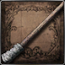 | HUNTER'S TORCH | -/-/-/50/-  (FIRE) | - | 150 | 6/-/-/-  -/-/-/B | -/-/100/100 | TREASURE IN OLD YHARNAM  SOLD BY BATH MESSENGERS | -
 | TORCH | -/-/-/25/ -  (FIRE) | - | 100 | 6 /-/-/-  -/-/-/D | -/-/100/100 | TREASURE IN CENTRAL YHARNAM | CANNOT BE FORTIFIED
THE OLD HUNTERS EXPANSION
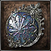 | LOCH SHIELD | -/-/-/-/-  (NONE) | - | 160 | 11/8/-/-  -/-/-/- | -/-/100/100 | TREASURE IN RESEARCH HALL | CANNOT BE FORTIFIED

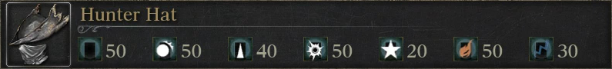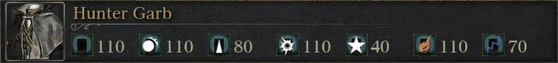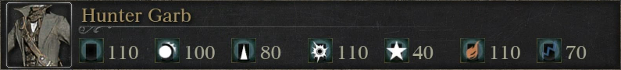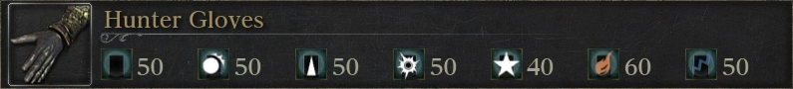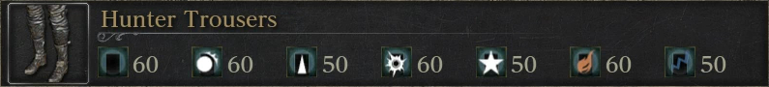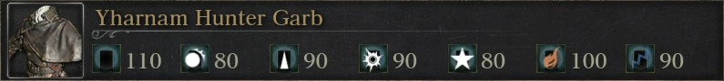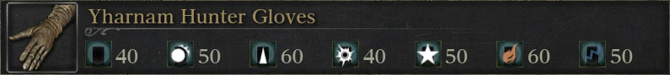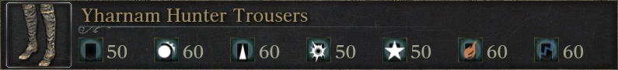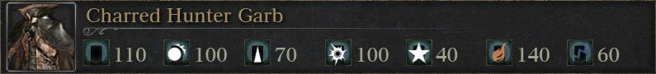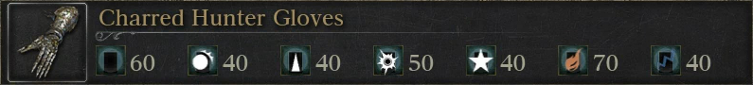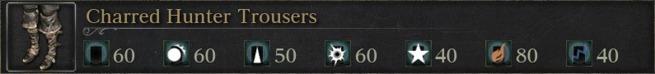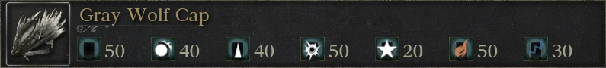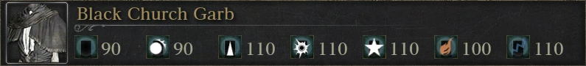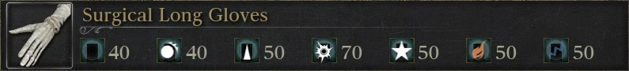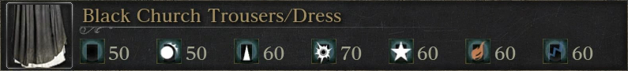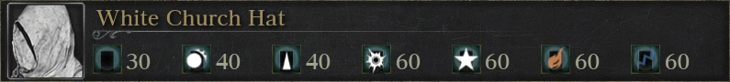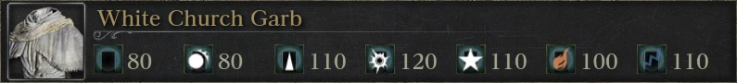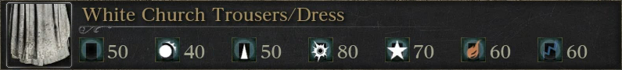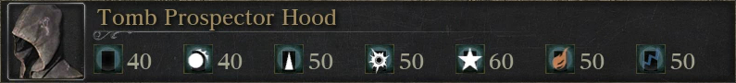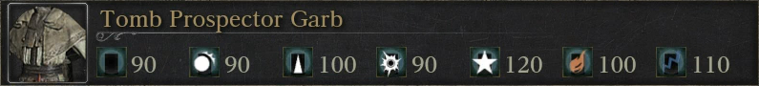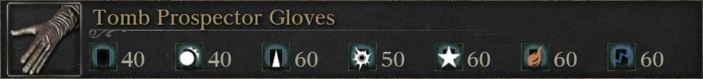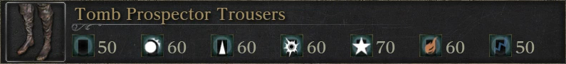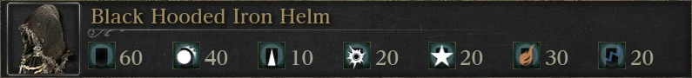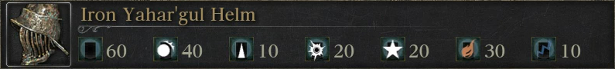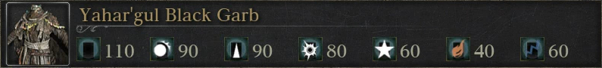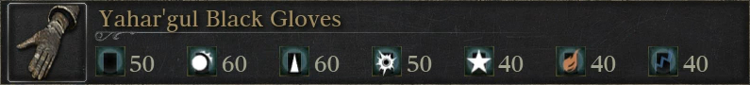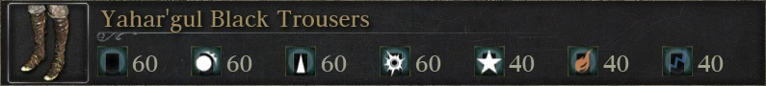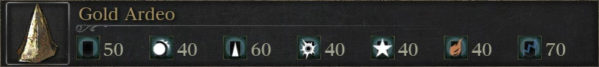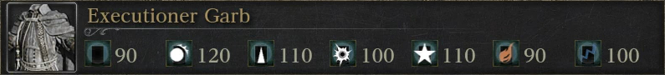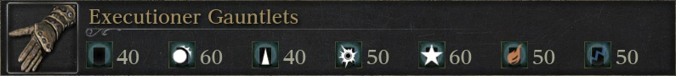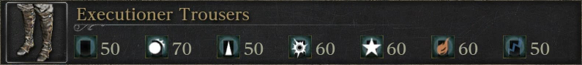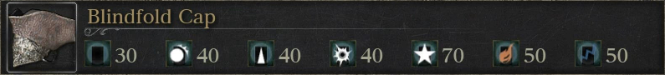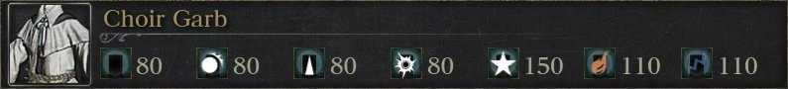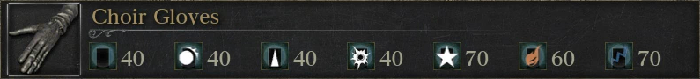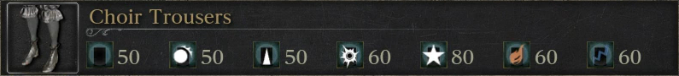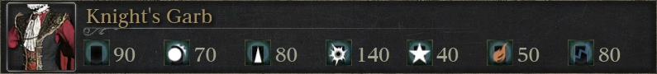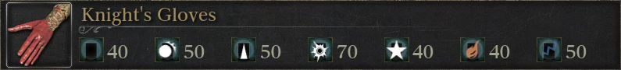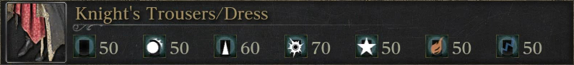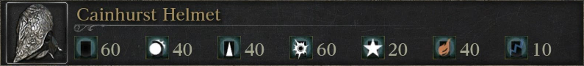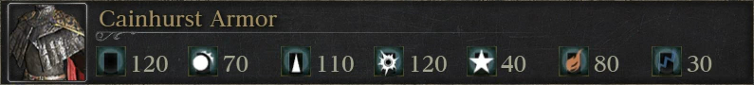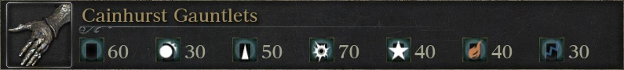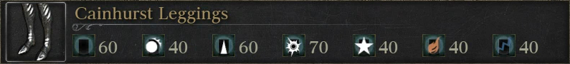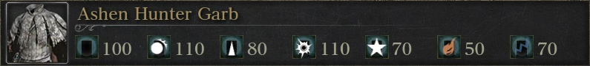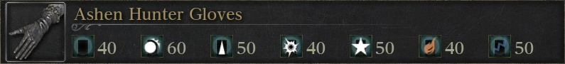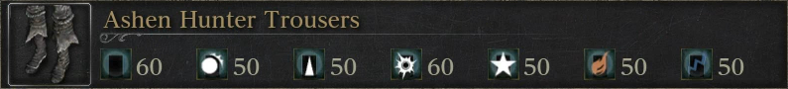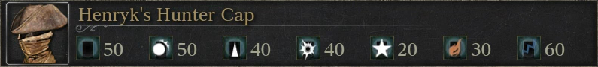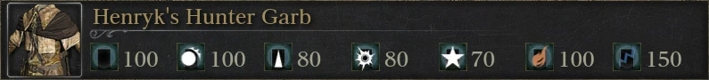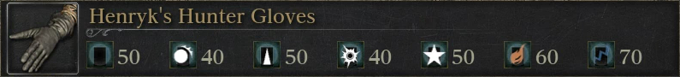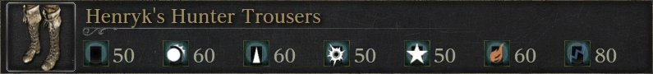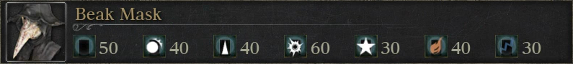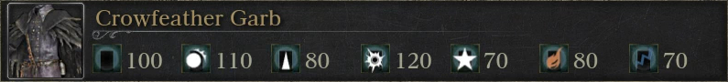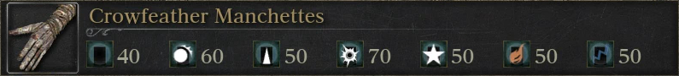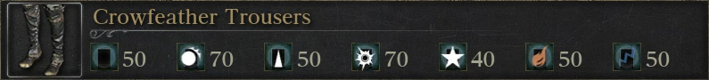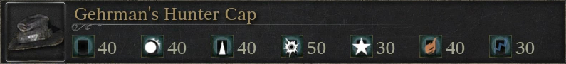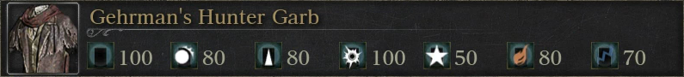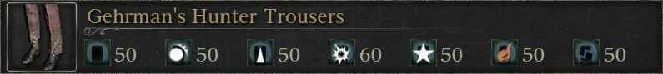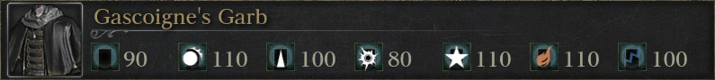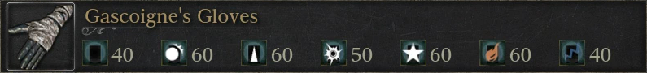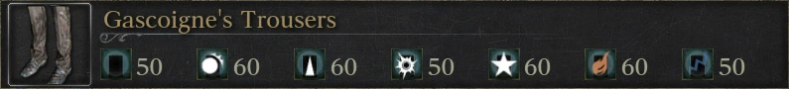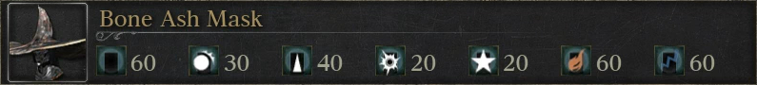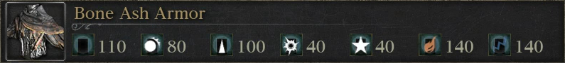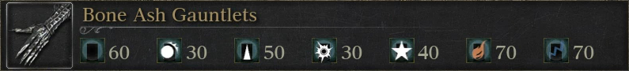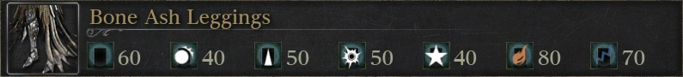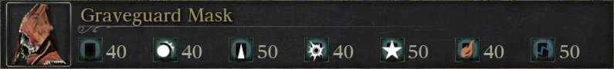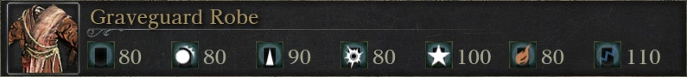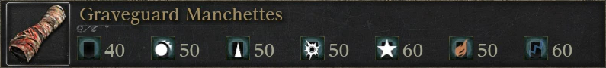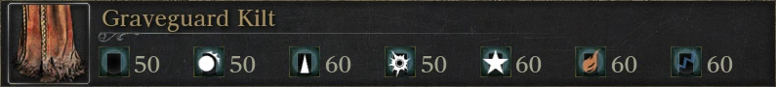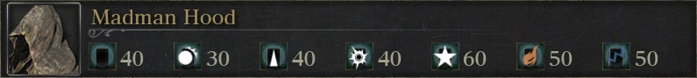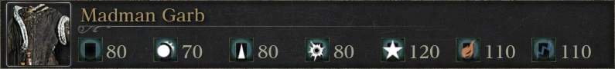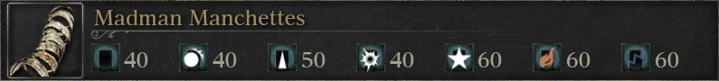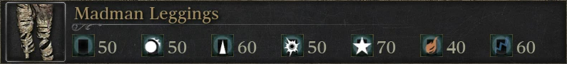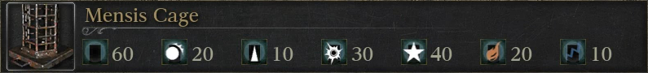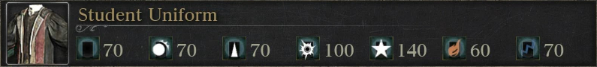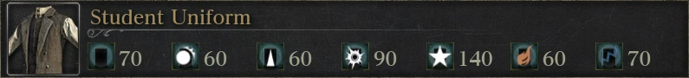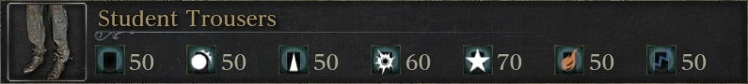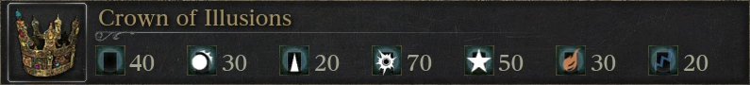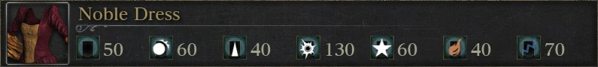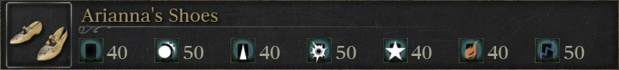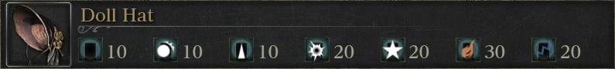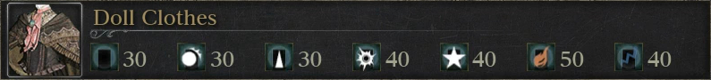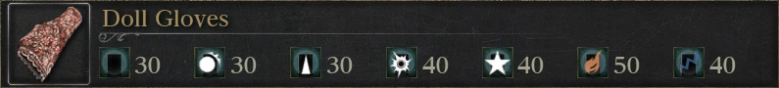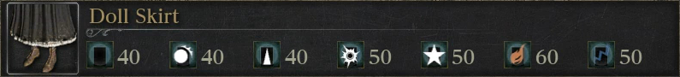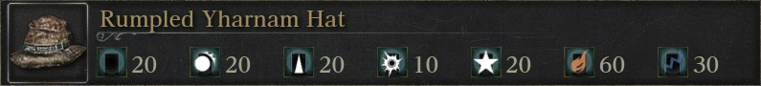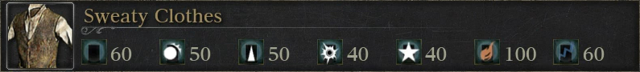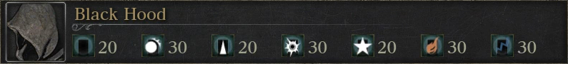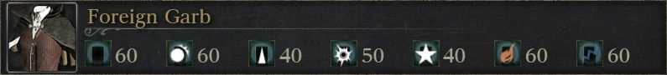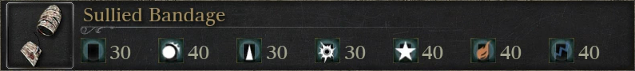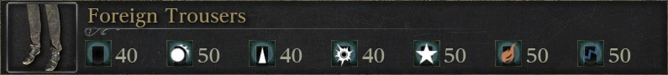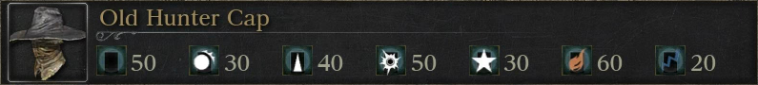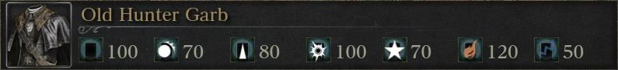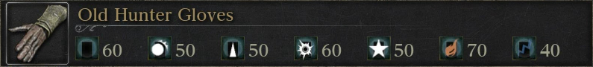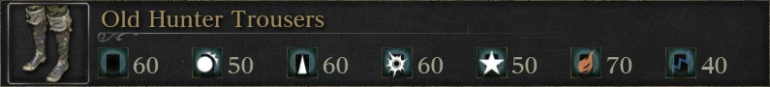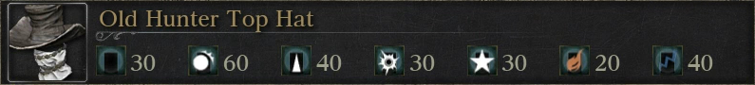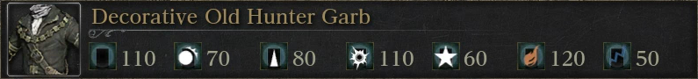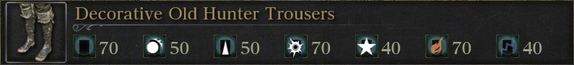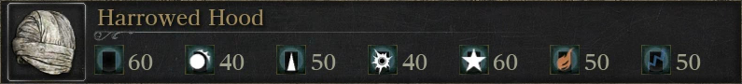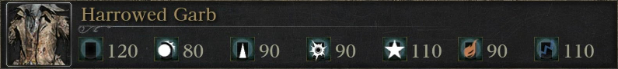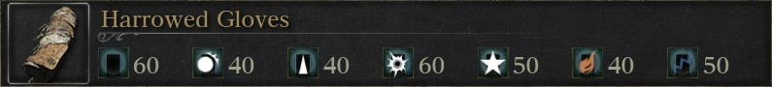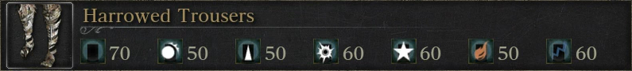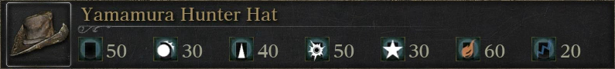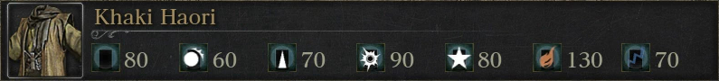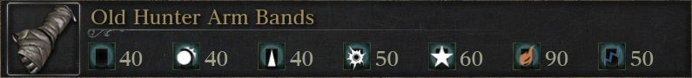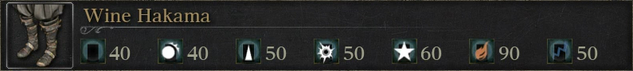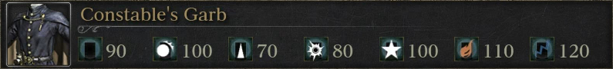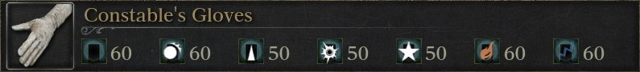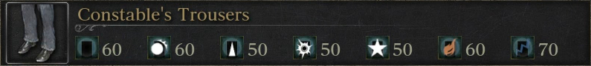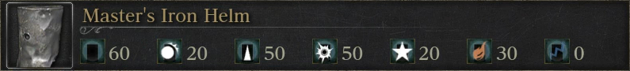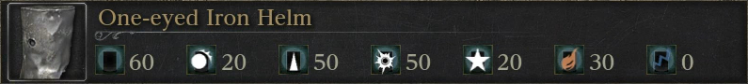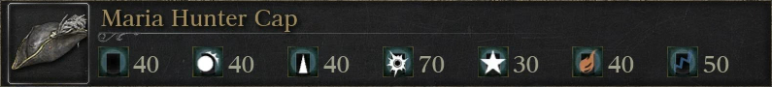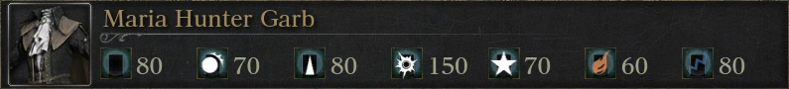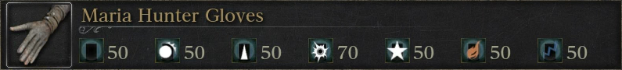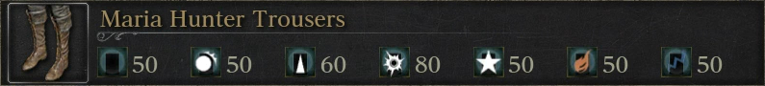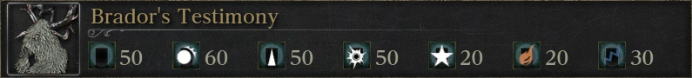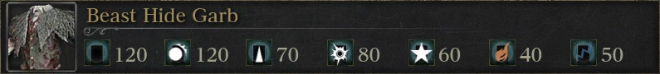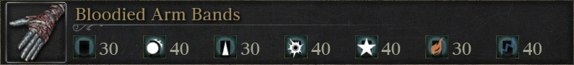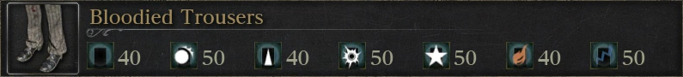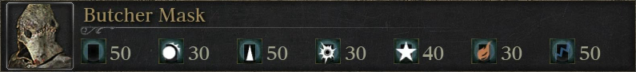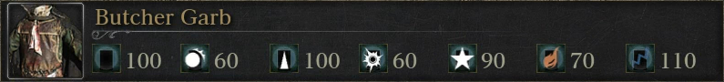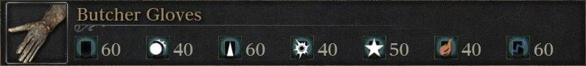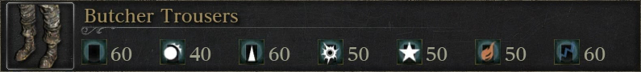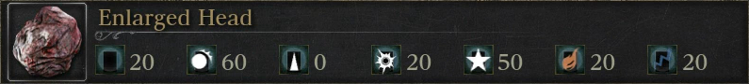

ICON | NAME | EFFECT | NO. HELD | STORED | USAGE TYPE | AVAILABILITY
 | ANTIDOTE | REMOVE POISON BUILD-UP AND HEAL THE SLOW-POISONING STATUS | - / 10 | - / 99 | FINITE | COMMON TREASURE IN MAIN STORY, HINTERTOMB DUNGEONS, DROPPED BY CARRION CROW, ASHEN BLOOD BEAST PATIENT, SOLD BY MERCHANTS [MORE...]
 | BEAST BLOOD PELLET | INCREASE ATK POWER  DECREASE DEF [60 SECONDS] | - / 10 | - / 99 | FINITE | AFFLICTED BEGGAR'S QUEST, IMPOSTOR IOSEFKA' QUEST, TREASURE IN MAIN STORY, LOWER LORAN, DROPPED BY CARRION CROW, SCOURGE BEAST, BEAST-POSSESSED SOUL [MORE...]
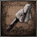 | BLOOD OF ADELLA | HEAL 25% OF HP  GRADUAL HEAL [20 SECONDS] | - / 1 | - / - | FINITE | ADELLA, NUN OF THE HEALING CHURCH QUEST
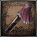 | BLOOD OF ARIANNA | HEAL 25% OF HP  INCREASE STAMINA REGENERATION [20 SECONDS] | - / 1 | - / - | FINITE | ARIANNA, WOMAN OF PLEASURE QUEST
 | BLOOD VIAL | HEAL 40% OF HP | - / 20 | - / 600 | FINITE | COMMON TREASURE IN MAIN STORY, CHALICE DUNGEONS, COMMON DROP FROM MAIN STORY, CHALICE DUNGEONS ENEMIES, SOLD BY MERCHANTS [MORE...]
 | GREAT ONE'S WISDOM | GAIN +2 INSIGHT | - / 99 | - / 99 | FINITE | TREASURE IN BYRGENWERTH, NIGHTMARE OF MENSIS, ISZ GRAVESTONE, PTHUMERU IHYLL, DROPPED BY PATCHES THE SPIDER
 | IOSEFKA'S BLOOD VIAL | RESTORE 70% OF HP | - / 1 | - / - | FINITE | IOSEFKA'S QUEST, TREASURE IN NIGHTMARE OF MENSIS, DROPPED BY SMALL CELESTIAL EMISSARY [IOSEFKA'S CLINIC OPERATING ROOM]
 | MADMAN'S KNOWLEDGE | GAIN +1 INSIGHT | - / 99 | - / 99 | FINITE | ADELLA'S QUEST, COMMON TREASURE IN MAIN STORY, CHALICE DUNGEONS, DROPPED BY MASTER WILLEM [NG+], CELESTIAL CHILD, CHILDREN OF ROM, YAHAR'GUL HUNTER [MORE...]
 | SEDATIVE | REMOVES FRENZY BUILD-UP  REMOVES BEASTHOOD BUILD-UP | - / 10 | - / 99 | FINITE | OLD WOMAN'S QUEST, TREASURE IN MAIN STORY, ISZ GRAVESTONE, DROPPED BY OLD WOMAN, ENEMIES IN MAIN STORY, CHALICE DUNGEONS, SOLD BY MERCHANTS [MORE...]
 | THIRD UMBILICAL CORD | GAIN +3 INSIGHT  UNLOCKS TRUE FINAL BOSS | - / 1 | - / - | FINITE | IMPOSTOR IOSEFKA'S QUEST, ARIANNA, WOMAN OF PLEASURE QUEST, TREASURE IN ABANDONED OLD WORKSHOP, DROPPED BY MERGO'S WET NURSE
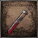 | BLOOD OF ADELINE  DLC | RESTORE 50% OF TOTAL HP AND GRADUALLY HEAL FOR 10 SECONDS | - / 1 | - / - | FINITE | ADELINE, RESEARCH HALL PATIENT' QUESTLINE

ICON | NAME | EFFECT | NO. HELD | STORED | USAGE TYPE | AVAILABILITY
 | BOLT PAPER | ADD 80 BOLT DMG TO EVERY ATK [RIGHT-HAND WEAPONS] | - / 10 | - / 99 | FINITE | TREASURE IN MAIN STORY, AILING LORAN, LOWER LORAN, DROPPED BY KIDNAPPER, YAHAR'GUL HUNTER (T & WS), SOLD BY MERCHANTS [MORE...]
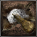 | BONE MARROW ASH | INCREASE POWER OF QS BULLET [LEFT-HAND FIREARMS]  [1 SHOT / 60 SECONDS] | - / 10 | - / 99 | FINITE | TREASURE IN CATHEDRAL WARD, HEMWICK CHARNEL LANE, CHALICE DUNGEONS, DROPPED BY DJURA'S ALLY, HUNTSMAN (RIFLE), HUNTSMAN (R & C), SOLD BY MERCHANTS [MORE...]
 | FIRE PAPER | ADD 80 FIRE DMG TO EVERY ATK [RIGHT-HAND WEAPONS]  [60 SECONDS] | - / 10 | - / 99 | FINITE | ALFRED'S QUEST, TREASURE IN OLD YHARNAM, CHALICE DUNGEONS, DROPPED BY ALFRED*, LABYRINTH WATCHERS FIRE VER., SOLD BY MERCHANTS [MORE...]
 | LEAD ELIXIR | GRANT SUPER ARMOR IN COST OF SLOW MOVEMENT [30 SECONDS] | - / 3 | - / 99 | FINITE | IMPOSTOR IOSEFKA'S QUEST, TREASURE IN MAIN STORY, DROPPED BY GIANT LOST CHILD, HUNTERS OF DESPAIR, SOLD BY INSIGHT BATH MESSENGERS [MORE...]
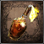 | MOLOTOV COCKTAIL | FIRE DMG / 20 ARMOR DMG | - / 10 | - / 99 | FINITE | TREASURE IN MAIN STORY, CHALICE DUNGEONS, DROPPED BY HUNTSMEN, HEMWICK GRAVE WOMAN (CLEAVER AND MOLOTOV), SOLD BY MERCHANTS [MORE...]
 | OIL URN | INCREASE FIRE DMG [~X2] HIT TARGET WILL TAKE | - / 10 | - / 99 | FINITE | TREASURE IN CENTRAL YHARNAM, AILING LORAN, LOWER LORAN, DROPPED BY LARGE HUNTSMEN, HUNTSMAN (OIL URN), GEL, SOLD BY MERCHANTS [MORE...]
 | PEBBLE | ROUND PEBBLES THAT CAN BE THROWN AT TARGETS | - / 20 | - / 99 | FINITE | TREASURE IN MAIN STORY, HINTERTOMB, LOWER HINTERTOMB, DROPPED BY CARRION CROW, EYE COLLECTOR, GEL, SOLD BY MERCHANTS [MORE...]
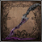 | POISON KNIFE | DEAL PHYS. DMG AND BUILD-UP SLOW POISON | - / 20 | - / 99 | FINITE | TREASURE IN CATHEDRAL WARD, FORBIDDEN WOODS, ISZ GRAVESTONE, DROPPED BY LABYRINTH WATCHER (CLEAVER) THROWING KNIVES VER., SOLD BY MERCHANTS [MORE...]
 | QUICKSILVER BULLETS | AMMUNITION FOR FIREARMS / ARCANE ITEMS | - / 20 | - / 600 | FINITE | COMMON TREASURE IN MAIN STORY, CHALICE DUNGEONS, COMMON DROP FROM MAIN STORY, CHALICE DUNGEONS ENEMIES, SOLD BY MERCHANTS [MORE...]
 | ROPE MOLOTOV COCKTAIL | FIRE DMG / 20 ARMOR DMG  [THROWN BEHIND] | - / 10 | - / 99 | FINITE | TREASURE IN LOWER PTHUMERIAN LABYRINTH, CURSED PTHUMERIAN DEFILEMENT, SOLD BY MERCHANTS [MORE...]
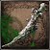 | SHAMAN BONE BLADE | HIT ENEMY WILL ATK OTHER ENEMIES  [DURATION ~15 SECONDS] | - / 3 | - / 99 | FINITE | TREASURE IN NIGHTMARE OF MENSIS, DROPPED BY BRAINSUCKER, SOLD BY INSIGHT BATH MESSENGERS
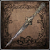 | THROWING KNIFE | DEAL PHYS. DMG AND 20 ARMOR DMG | - / 20 | - / 99 | FINITE | TREASURE IN HINTERTOMB, LOWER HINTERTOMB, CURSED PTHUMERIAN DEFILEMENT, PTHUMERU IHYLL, DROPPED BY LABYRINTH RAT, SOLD BY MERCHANTS [MORE...]
 | DELAYED MOLOTOV  DLC | FIRE DMG / 20 ARMOR DMG | - / 10 | - / 99 | FINITE | SOLD BY BATH MESSENGERS AFTER OBTAINING FIRING HAMMER BADGE
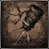 | DELAYED ROPE MOLOTOV  DLC | FIRE DMG / 20 ARMOR DMG  [THROWN BEHIND] | - / 10 | - / 99 | FINITE | SOLD BY BATH MESSENGERS AFTER OBTAINING FIRING HAMMER BADGE

ICON | NAME | EFFECT | NO. HELD | STORED | USAGE TYPE | AVAILABILITY
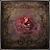 | COLDBLOOD DEW  (1), (2), (3) | (1) GAIN BLOOD ECHOES +350  (2) GAIN BLOOD ECHOES +500  (3) GAIN BLOOD ECHOES +1000 | - / 99 | - / 99 | FINITE | TREASURE IN MAIN STORY, PTHUMERIAN LABYRINTH, HINTERTOMB, LOWER HINTERTOMB, LOWER PTHUMERIAN LABYRINTH, , DROPPED BY PARASITE LARVA [MORE...]
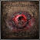 | THICK COLDBLOOD  (4), (5), (6) | (4) GAIN BLOOD ECHOES +1200  (5) GAIN BLOOD ECHOES +1500  (6) GAIN BLOOD ECHOES +1800 | - / 99 | - / 99 | FINITE | TREASURE IN MAIN STORY, CHALICE DUNGEONS, DROPPED BY CRAWLER, LARGE CRAWLER [MORE...]
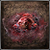 | FRENZIED COLDBLOOD  (7), (8), (9) | (7) GAIN BLOOD ECHOES +2000  (8) GAIN BLOOD ECHOES +3000  (9) GAIN BLOOD ECHOES +5000 | - / 99 | - / 99 | FINITE | TREASURE IN MAIN STORY, AILING LORAN, CURSED PTHUMERIAN DEFILEMENT [MORE...]
 | KIN COLDBLOOD  (10), (11), (12) | (10) GAIN BLOOD ECHOES +8000  (11) GAIN BLOOD ECHOES +10000  (12) GAIN BLOOD ECHOES +20000 | - / 99 | - / 99 | FINITE | TREASURE IN MAIN STORY, LOWER LORAN, ISZ GRAVESTONE, PTHUMERU IHYLL, DROPPED BY ROM, THE VACUOUS SPIDER [MORE...]
 | GREAT ONE COLDBLOOD | GAIN BLOOD ECHOES +40000 | - / 99 | - / 99 | FINITE | TREASURE IN PTHUMERU IHYLL, ROOT DUNGEONS
 | OLD GREAT ONE COLDBLOOD | GAIN BLOOD ECHOES +50000 | - / 99 | - / 99 | FINITE | TREASURE IN ROOT DUNGEONS
 | REVERED GREAT ONE COLDBLOOD | GAIN BLOOD ECHOES +100000 | - / 99 | - / 99 | FINITE | TREASURE IN ROOT DUNGEONS [NOT FOUND]

ICON | NAME | EFFECT | NO. HELD | STORED | USAGE TYPE | AVAILABILITY
 | BLOOD DREG | GAIN +1 INSIGHT  OFFER TO ANNALISE | - / 99 | - / 99 | FINITE | VILEBLOOD'S PATH: KILL OTHER HUNTERS [PLAYERS/HUNTER ENEMIES] WHILE CORRUPTION CARYLL OATH RUNE IS EQUIPPED
 | BLUE ELIXIR | HARDER TO DETECT BY ENEMIES  [30 SECONDS] | - / 10 | - / 99 | FINITE | TREASURE IN MAIN STORY, ISZ GRAVESTONE, DROPPED BY CHURCH SERVANTS/GIANTS, SMALL CELESTIAL EMISSARY, YURIE, SOLD BY INSIGHT BATH MESSENGERS [MORE...]
 | BOLD HUNTER'S MARK | RETURN TO LAST RESTED LAMP  [TAKES ~3 SECONDS], LOSE NO BLOOD ECHOES | - / 99 | - / 99 | FINITE | EILEEN THE CROW QUEST, RETIRED HUNTER DJURA QUEST*, TREASURE IN MAIN STORY, CHALICE DUNGEONS, DROPPED BY ROTTED CORPSE, SOLD BY MERCHANTS [MORE...]
 | GOLD PENDANT | OBTAIN GOLD BLOOD GEM [RADIAL] | - / 1 | - / 1 | FINITE | DROPPED BY VICAR AMELIA
 | HAND LANTERN | ATTACH LANTERN TO THE WAIST | - / 1 | - / 99 | UNLIMITED  USE | SOLD BY BATH MESSENGERS
 | HUNTER'S MARK | RETURN TO LAST RESTED LAMP  [TAKES ~3 SECONDS], LOSE BLOOD ECHOES | - / 1 | - / - | UNLIMITED  USE | STARTING ITEM
 | MONOCULAR | ZOOM THE CAMERA | - / 1 | - / 99 | UNLIMITED  USE | TREASURE IN CATHEDRAL WARD
 | NUMBING MIST | BLOCKS HEALING EFFECTS  [30 SECONDS] | - / 10 | - / 99 | FINITE | IMPOSTOR IOSEFKA'S QUEST, TREASURE IN MAIN STORY, LOWER PTHUMERIAN LABYRINTH, DROPPED BY CAIN'S SERVANT (RAPIER), SOLD BY INSIGHT BATH MESSENGERS [MORE...]
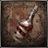 | PUNGENT BLOOD COCKTAIL | ATTRACT CERTAIN ENEMIES | - / 10 | - / 99 | FINITE | AFFLICTED BEGGAR'S QUEST, TREASURE IN MAIN STORY, CHALICE DUNGEONS, DROPPED BY OLD MAN, EXECUTIONER, HUNTSMEN, SOLD BY MERCHANTS [MORE...]
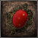 | RED JEWELED BROOCH | OBTAIN RED BLOOD GEM [DROPLET] | - / 1 | - / 1 | FINITE | TREASURE IN CENTRAL YHARNAM
 | SHINING COINS | MARK THE PATHS | - / 99 | - / 99 | FINITE | TREASURE IN MAIN STORY, CHALICE DUNGEONS, DROPPED BY HUNTSMAN'S MINION (BRICK), HUNTSMAN'S MINION (STATUE), GEL, SOLD BY MERCHANTS [MORE...]
 | TEAR STONE | OBTAIN TEAR BLOOD GEM [DROPLET] | - / 1 | - / 1 | FINITE | DOLL'S QUEST
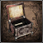 | TINY MUSIC BOX | PLAY MUSIC BOX | - / 1 | - / 99 | UNLIMITED  USE | YOUNGER DAUGHTER'S QUEST
 | VERMIN | USE TO GAIN +1 RANK IN LEAGUE'S LEADERBOARD | - / 99 | - / 600 | FINITE | REWARD FOR SUCCESSFUL CO-OP SESSION WHEN IMPURITY RUNE EQUIPPED  DROPPED BY OLD HUNTER (B. CUTTER) RED EYES, OLD HUNTER (B. HAMMER) RED EYES

ICON | NAME | USE | NO. HELD | USAGE TYPE | QS BULLET USE | STATS REQ.  STAT BONUS | HOW TO OBTAIN
 | A CALL BEYOND | CREATE SMALL STAR EXPLOSION | - / 1 | UNLIMITED USE | 7 | - / - / - / 40  - / - / - / S | TREASURE IN UPPER CATHEDRAL WARD
 | AUGUR OF EBRIETAS | PARTIALLY SUMMON EBRIETAS | - / 1 | UNLIMITED USE | 1 | - / - / - / 18  - / - / - / S | TREASURE IN LECTURE BUILDING 1F
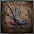 | BEAST ROAR | FORCE OF BEAST ROAR REPELS NEARBY FOES AND OBJECTS | - / 1 | UNLIMITED USE | 2 | - / - / - / 15  - / - / - / - | TREASURE IN FORBIDDEN WOODS
 | EMPTY PHANTASM SHELL | EMPTY SHELL THAT APPLIES ARCANE POWER [80 POINTS] TO WEAPON [60 SECONDS] | - / 1 | UNLIMITED USE | 3 | - / - / - / 15  - / - / - / - | TREASURE IN BYRGENWERTH
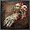 | EXECUTIONER'S GLOVES | SUMMONS WRATHFUL SPIRITS | - / 1 | UNLIMITED USE | 3 | - / - / - / 20  - / - / - / S | TREASURE IN FORSAKEN CAINHURST CASTLE
 | CHOIR BELL | INVIGORATES ALL COOPERATING PARTIES, HEALING THEM | - / 1 | UNLIMITED USE | 7 | - / - / - / 15  - / - / - / S | TREASURE IN NIGHTMARE OF MENSIS
 | MESSENGER'S GIFT | ENVELOPING BLACK MIST CHANGES USER INTO MESSENGER | - / 1 | UNLIMITED USE | 1 | - / - / - / 10  - / - / - / - | TREASURE IN NIGHTMARE FRONTIER
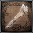 | OLD HUNTER BONE | THE ART OF QUICKENING SPEEDS UP ROLLING AND QUICKSTEPS [15 SECONDS] | - / 1 | UNLIMITED USE | 4 | - / - / - / 15  - / - / - / - | TREASURE IN ABANDONED OLD WORKSHOP
 | TINY TONITRUS | STRIKE INTO THE GROUND TO EMIT BLUE SPARKS | - / 1 | UNLIMITED USE | 6 | - / - / - / 25  - / - / - / S | TREASURE IN YAHAR'GUL, UNSEEN VILLAGE (BLOOD MOON)
 | ACCURSED BREW  DLC | THROW A CONCOCTION OF CURSES AT FOES. | - / 1 | UNLIMITED USE | 2 | - / - / - / 30  - / - / - / S | ACQUIRED FROM FISHING HAMLET PRIEST
 | BLACKSKY EYE  DLC | SUMMON A TINY METEOR FROM THE DARK DEPTHS OF ONE'S PUPIL | - / 1 | UNLIMITED USE | 1 | - / - / - / 16  - / - / - / S | TREASURE IN RESEARCH HALL

ICON | NAME | AVAILABILITY | OPENS | SPECIAL NOTE
 | CAINHURST SUMMONS | TREASURE IN IOSEFKA'S CLINIC | GRANTS ACCESS TO FORSAKEN CAINHURST CASTLE | A SUMMONS INVITING YOU TO CAINHURST.
 | HUNTER CHIEF EMBLEM | SOLD BY BATH MESSENGERS | OPENS MAIN GATE TO GRAND CATHEDRAL IN CATHEDRAL WARD | KEY TO THE GATE TO THE ROUND PLAZA OF THE GRAND CATHEDRAL.
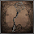 | IRON DOOR KEY | TREASURE IN NIGHTMARE OF MENSIS | KEY TO THE GATE BLOCKING THE GREAT MIDLEVEL BRIDGE | -
 | LECTURE THEATRE KEY | TREASURE IN LECTURE BUILDING | KEY TO THE LECTURE THEATRE IN THE LECTURE BUILDING. | -
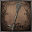 | LUNARIUM KEY | TREASURE IN BYRGENWERTH COLLEGE | OPENS THE LUNARIUM IN BYRGENWERTH BUILDING | KEY TO THE LUNARIUM FACING THE LAKE, BYRGENWERTH FLOOR 2.
 | OEDON TOMB KEY | DEFEAT FATHER GASCOIGNE | UNLOCKS THE TOMB OF OEDON IN CENTRAL YHARNAM. | KEY TO THE GATE THAT BLOCKS THE TOMBS OF OEDON.
 | OLD HUNTER BELL | TREASURE IN HUNTER'S DREAM | SUMMONING OLD HUNTERS | CONSUME INSIGHT TO RING AND CALL TO OLD HUNTERS FOR HELP
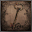 | ORPHANAGE KEY | BRAINSUCKER DROP ON THE SECOND FLOOR OF THE UPPER CATHEDRAL WARD. | OPENS ORPHANAGE FRONT ENTRANCE | KEY TO THE ORPHANAGE, BIRTHPLACE OF THE CHOIR
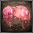 | QUEENLY FLESH | KILL ANNALISE, QUEEN OF THE VILEBLOODS OR LET ALFRED KILL HER | REVIVE ANNALISE AT ALTAR OF DESPAIR | THE REMAINS OF ANNALISE, VILEBLOOD QUEEN OF CAINHURST.
 | RING OF BETROTHAL | RANDOM TREASURE IN ROOT PTHUMERU IHYLL CHALICES | EXTRA DIALOGUE FROM QUEEN ANNALISE | WEDLOCK RING GIVEN SPECIAL MEANING BY THE GREAT ONES.
 | SHORT RITUAL ROOT CHALICE | SOLD BY INSIGHT BATH MESSENGERS | ACCESS TO MAKESHIFT ALTAR | QUICKLY SEARCH AND JOIN A CHALICE DUNGEON
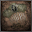 | SMALL HAIR ORNAMENT | TREASURE IN ABANDONED OLD WORKSHOP. | TEAR STONE AFTER HANDING ITEM TO THE DOLL | -
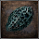 | TONSIL STONE | FIRST YHARNAM RESIDENT YOU TALK TO AFTER ENTERING FORBIDDEN WOODS | OPENS PATH TO LOWER FLOOR OF LECTURE BUILDING. | A LATTICED, DEFORMED ROCK.
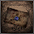 | UNOPENED SUMMONS | TREASURE IN VILEBLOOD QUEEN'S CHAMBER | GIVE TO ALFRED TO CONTINUE HIS QUESTLINE, RECEIVE CHURCH BOW GESTURE AND WHEEL HUNTER BADGE | OLD UNOPENED SUMMONS, CALLING SOMEONE TO CAINHURST.
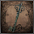 | UPPER CATHEDRAL KEY | TREASURE IN YAHAR'GUL CHAPEL IN YAHAR'GUL, UNSEEN VILLAGE | OPENS UPPER CATHEDRAL WARD | THE KEY TO THE UPPER CATHEDRAL WARD SEAL.
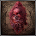 | YHARNAM STONE | DEFEAT YHARNAM, BLOOD QUEEN OF THE OLD LABYRINTH AT GREAT PTHUMERU IHYLL LAYER THREE | - | SACRED HEIRLOOM OF YHARNAM, PTHUMERIAN QUEEN
 | ASTRAL CLOCKTOWER KEY  DLC | DEFEAT LIVING FAILURES | OPENS GATE TO ASTRAL CLOCKTOWER | KEY TO ASTRAL CLOCKTOWER, ATOP THE GRAND CATHEDRAL
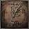 | BALCONY KEY  DLC | ACQUIRED FROM ADELINE, RESEARCH HALL PATIENT | RESEARCH HALL'S BALCONY | KEY TO THE BALCONY ON THE FIRST FLOOR OF THE RESEARCH HALL.
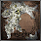 | BRAIN FLUID  DLC | DROPPED BY TWO ENLARGED HEADS IN RESEARCH HALL, ADELINE, RESEARCH HALL PATIENT IN ENLARGED HEAD STATE | FURTHER ADELINE, RESEARCH HALL PATIENT'S QUESTLINE | GREYISH AMOEBA-SHAPED BRAIN FLUID. WOBBLES AND BOUNCES
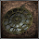 | CELESTIAL DIAL  DLC | DEFEAT LADY MARIA OF THE ASTRAL CLOCKTOWER | PATH TO FISHING HAMLET | DIAL FOR THE GREAT ASTRAL CLOCK OF THE GRAND CATHEDRAL
 | EYE OF A BLOOD-DRUNK HUNTER  DLC | TREASURE IN HUNTER'S DREAM AFTER SHIFTING DAYTIME INTO THE NIGHT | DLC AREA HUNTER'S NIGHTMARE | EYE OF A BLOOD-DRUNK HUNTER, ITS PUPIL COLLAPSED
 | EYE PENDANT  DLC | TREASURE IN HUNTER'S NIGHTMARE | SURGERY ALTAR IN THE RECOVERY ROOM | AN EYE PENDANT WHICH UNLOCKS THE SURGERY ALTAR.
 | LAURENCE'S SKULL  DLC | TREASURE IN RESEARCH HALL | LAURENCE, THE FIRST VICAR IN NIGHTMARE GRAND CATHEDRAL | SKULL OF LAURENCE, FIRST VICAR OF THE HEALING CHURCH.

 | UNDERGROUND CELL INNER CHAMBER KEY  DLC | ACQUIRED FROM SIMON, SEEKER OF SECRETS | OPENS UNDERGROUND CELL | KEY TO THE INNER CHAMBER OF THE GRAND CATHEDRAL CELL
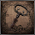 | UNDERGROUND CELL KEY  DLC | TREASURE IN RESEARCH HALL | OPENS UNDERGROUND CELLS | KEY TO THE CELL BELOW THE GRAND CATHEDRAL.

ICON | NAME | AVAILABILITY | OPENS | SPECIAL NOTE
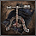 | BLOOD GEM WORKSHOP TOOL | TREASURE IN CENTRAL YHARNAM | ENABLES FORTIFICATION OF WEAPONS WITH BLOOD GEMS | NEW OPTION AT THE WORKSHOP
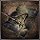 | RUNE WORKSHOP TOOL | TREASURE IN HEMWICK CHARNEL LANE | ACCESS TO MEMORY ALTAR | ENABLES ETCHING CARYLL RUNES INTO ONE'S CONSCIOUSNESS
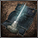 | WORKSHOP HAZE EXTRACTOR | TREASURE IN LOWER PTHUMERIAN LABYRINTH L2 | EXTRACT ARCANE HAZE FROM RITUAL MATERIALS | NEW OPTION AT THE WORKSHOP

ICON | NAME | AVAILABILITY | OPENS | SPECIAL NOTE
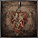 | CAINHURST BADGE | ACQUIRED FROM ANNALISE, QUEEN OF CASTLE CAINHURST | CAINHURST SET, REITERPALLASCH, CHIKAGE, EVELYN, NUMBING MIST | BADGE OF THE ROYAL GUARDS OF CAINHURST
 | COSMIC EYE WATCHER BADGE | TREASURE IN UPPER CATHEDRAL WARD | ROSMARINUS, BLUE ELIXIR, SEDATIVE, BEAST BLOOD PELLET, POISON KNIFE, TWIN BLOOD STONE SHARDS | BADGE OF THE CHOIR, HEALING CHURCH ELITES
 | CROW HUNTER BADGE | ACQUIRED FROM EILEEN THE CROW  DROPPED BY EILEEN THE CROW | BLADE OF MERCY, BEAK MASK, CROWFEATHER GARB, CROWFEATHER MANCHETTES, CROWFEATHER TROUSERS | BADGE OF THE CROW, SIGNIFYING A HUNTER OF HUNTERS
 | OLD HUNTER BADGE | DEFEAT GEHRMAN, THE FIRST HUNTER | BURIAL BLADE, GEHRMAN'S HUNTER SET | HUNTER BADGE CRAFTED IN THE AGE OF OLD GEHRMAN
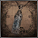 | POWDER KEG HUNTER BADGE | ACQUIRED FROM RETIRED HUNTER DJURA  DROPPED BY RETIRED HUNTER DJURA | OIL URN, RIFLE SPEAR, ROPE MOLOTOV COCKTAIL, STAKE DRIVER | BADGE OF A POWDER KEG HUNTER, CRAFTED BY POWDER KEGS
 | RADIANT SWORD HUNTER BADGE | TREASURE IN HEALING CHURCH WORKSHOP | BLOOD STONE SHARD, BONE MARROW ASH, FIRE PAPER, FLAMESPRAYER, LUDWIG'S HOLY BLADE, LUDWIG'S RIFLE, SHINING COINS, TOMB PROSPECTOR HOOD, TOMB PROSPECTOR GARB, TOMB PROSPECTOR GLOVES, TOMB PROSPECTOR TROUSERS | RADIANT SWORD HUNTER BADGE, FOR LUDWIG'S SUCCESSORS
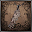 | SAW HUNTER BADGE | TREASURE IN CENTRAL YHARNAM | HUNTER AXE, HUNTER BLUNDERBUSS, HUNTER PISTOL, PUNGENT BLOOD COCKTAIL, SAW CLEAVER, SAW SPEAR, THREADED CANE, THROWING KNIFE | BADGE OF A WORKSHOP-SANCTIONED HUNTER
 | SPARK HUNTER BADGE | DEFEAT DARKBEAST PAARL | TONITRUS, BOLT PAPER | BADGE FOR FRIENDS OF ARCHIBALD, CHURCH WORKSHOP ECCENTRIC
 | SWORD HUNTER BADGE | DEFEAT CLERIC BEAST | ANTIDOTE, BOLD HUNTER'S MARK, HAND LANTERN, HUNTER CHIEF EMBLEM, KIRKHAMMER, REPEATING PISTOL | BADGE OF A SWORDSMAN HUNTERS UNDER CHURCH'S BLESSING
 | WHEEL HUNTER BADGE | ACQUIRED FROM ALFRED, HUNTER OF VILEBLOODS  DROPPED BY ALFRED, HUNTER OF VILEBLOODS | GOLD ARDEO, LOGARIUS' WHEEL | WHEEL HUNTER BADGE, FROM THE CHURCH'S SECRET WORKSHOP
 | FIRING HAMMER BADGE  DLC | DEFEAT BESTIAL HUNTER | PIERCING RIFLE, DELAYED MOLOTOV, DELAYED ROPE MOLOTOV | FIRING HAMMER BADGE, OF THE OLD OTO WORKSHOP.

ICON | NAME | AVAILABILITY | OPENS | SPECIAL NOTE
 | BLACK MESSENGER HAT | TREASURE IN CATHEDRAL WARD | NEW APPEARANCE FOR STUMP MESSENGERS | HAT THAT THE MESSENGERS ARE ODDLY FOND OF.
 | BLOODY MESSENGER HEAD BANDAGE | TREASURE IN OLD YHARNAM | NEW APPEARANCE FOR STUMP MESSENGERS | ACCESSORY ADORED BY NAЇVE MESSENGERS.
 | MESSENGER HEAD BANDAGE | TREASURE IN HUNTER'S DREAM, NEXT TO STUMP MESSENGERS (PRE-ORDER DLC) | NEW APPEARANCE FOR STUMP MESSENGERS | ACCESSORY ADORED BY NAЇVE MESSENGERS.
 | MESSENGER TOP HAT | TREASURE IN HEALING CHURCH WORKSHOP | NEW APPEARANCE FOR STUMP MESSENGERS | HAT THAT THE MESSENGERS ARE ODDLY FOND OF.
 | MESSENGER URN FESTIVAL | TREASURE IN CATHEDRAL WARD | NEW APPEARANCE FOR STUMP MESSENGERS | ACCESSORY ADORED BY NAЇVE MESSENGERS.
 | RED MESSENGER RIBBON | MANEATER BOAR'S DROP IN CENTRAL YHARNAM SEWERS AFTER COMPLETING GASCOIGNE'S YOUNGEST DAUGHTER QUESTLINE. | NEW APPEARANCE FOR STUMP MESSENGERS | RED RIBBON THAT THE MESSENGERS ARE ODDLY FOND OF.
 | WHITE MESSENGER RIBBON | COMPLETE GASCOIGNE'S DAUGHTERS QUESTLINE | NEW APPEARANCE FOR STUMP MESSENGERS | WHITE RIBBON THAT MESSENGERS ARE ODDLY FOND OF.
 | WORN MESSENGER TOP HAT | TREASURE IN HUNTER'S DREAM, NEXT TO STUMP MESSENGERS (PRE-ORDER DLC) | NEW APPEARANCE FOR STUMP MESSENGERS | HAT THAT THE MESSENGERS ARE ODDLY FOND OF.
 | YHARNAM MESSENGER HAT | TREASURE IN HUNTER'S DREAM, NEXT TO STUMP MESSENGERS (PRE-ORDER DLC) | NEW APPEARANCE FOR STUMP MESSENGERS | HAT THAT MESSENGERS ARE ODDLY FOND OF.

ICON | NAME | EFFECT | NO. HELD | STORED | USAGE TYPE | AVAILABILITY
 | BECKONING BELL | USE 1 INSIGHT TO INITIATE COOPERATION AS HOST | - / 1 | - / - | UNLIMITED USE | HAVE 1 INSIGHT AND ENTER HUNTER'S DREAM
 | LEAGUE STAFF | HIDES A DIRECTORY LISTING THE NAMES OF LEAGUE CONFEDERATES | - / 1 | - / - | UNLIMITED USE | ACQUIRED FROM VALTR, MASTER OF THE LEAGUE
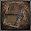 | NOTEBOOK | LEAVE A NOTE USING MESSENGERS, OR READ A NOTE | - / 1 | - / - | UNLIMITED USE | MESSENGERS STARTING GIFT IN HUNTER'S DREAM
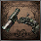 | SILENCING BLANK | FIRE TO END ONGOING, AND PREVENT FURTHER, COOPERATION | - / 1 | - / - | UNLIMITED USE | HAVE 1 INSIGHT AND ENTER HUNTER'S DREAM
 | SINISTER RESONANT BELL | SEARCH FOR HOST TO INVADE AS ADVERSARY | - / 1 | - / - | UNLIMITED USE | SOLD BY INSIGHT BATH MESSENGERS
 | SMALL RESONANT BELL | SEARCH FOR HOST TO COOPERATE AS GUEST | - / 1 | - / - | UNLIMITED USE | SOLD BY INSIGHT BATH MESSENGERS
 | VILEBLOOD REGISTER | A REGISTER LISTING ALL KNOWN VILEBLOODS | - / 1 | - / - | UNLIMITED USE | TREASURE IN FORSAKEN CAINHURST CASTLE

ICON | NAME | EFFECTS | AVAILABILITY | NOTE
 | BEAST | TEMP. BOOST TO TRANSFORM +20, +50, +100 | DROPPED BY BEAST-POSSESSED SOUL (+20)  DROPPED BY AFFLICTED BEGGAR (+50)  TREASURE IN LOWER AILING LORAN ROOT CHALICE (+100) | "BEAST" RUNE. BOOSTS EFFECT OF TRANSFORMATION
 | BLOOD RAPTURE | V.ATKS RESTORE HP +200, +250, +300 | DEFEAT SHADOW OF YHARNAM (+200)  TREASURE IN CURSED AND DEFILED ROOT CHALICE (+250)  DROPPED BY BLOODY CROW OF CAINHURST (+300) | VISCERAL ATTACKS RESTORE HP
 | CLAWMARK | UPS VISCERAL ATK +10%, +20%, +30% | DROPPED BY YAHAR'GUL HUNTER (BEAST CLAW & HUNTER PISTOL) (+10%)  DROPPED BY GILBERT (+20%)  TREASURE IN LOWER AILING LORAN ROOT CHALICE (+30%) | "CLAWMARK" RUNE. STRENGTHENS VISCERAL ATTACKS
 | COMMUNION | MAX VIALS HELD UP +1, +2, +3, +4, +5 | TREASURE IN HEALING CHURCH WORKSHOP (+1)  TREASURE IN LECTURE BUILDING 2F (+2)  TREASURE IN IOSEFKA'S CLINIC (+3)  DROPPED BY CELESTIAL EMISSARY (+4)  TREASURE IN PTHUMERU IHYLL ROOT CHALICE (+5) | "COMMUNION" RUNE. HIGHER BLOOD VIAL MAXIMUM
 | EYE | INCREASED DISCOVERY +50, +70, +100 | TREASURE IN NIGHTMARE OF MENSIS (+50)  DROPPED BY MASTER WILLEM (+70)  TREASURE IN ISZ ROOT CHALICE (+100) | ALLOWS ONE TO MAKE ADDITIONAL DISCOVERIES
 | FORMLESS OEDON | MAX QS BULLETS HELD UP +1, +2, +3, +4, +5 | YOUNG GIRL QUEST (+1)  TREASURE IN LOWER PTHUMERU ROOT CHALICE (+2)  DROPPED BY OEDON CHAPEL DWELLER (+3)  TREASURE IN HEALING CHURCH WORKSHOP (+4)  TREASURE IN PTHUMERU IHYLL ROOT CHALICE (+5) | HIGHER QUICKSILVER BULLET MAX
 | HEIR | MORE BLOOD ECHOES GAINED FROM V.ATKS +30%, +40%, +50% | DROPPED BY OLD HUNTER HENRYK (+30%)  TREASURE IN YAHAR'GUL, UNSEEN VILLAGE (BLOOD MOON) (+40%)  TREASURE IN PTHUMERU IHYLL ROOT CHALICE (+50%) | "HEIR" RUNE. VISCERAL ATTACKS GRANT MORE BLOOD ECHOES
 | MOON | MORE ECHOES FROM SLAIN ENEMIES +10%, +20%, +30% | TREASURE IN YAHAR'GUL, UNSEEN VILLAGE (EVENING) (+10%)  TREASURE IN NIGHTMARE OF MENSIS (+20%)  INTERACTION WITH BRAIN OF MENSIS (+30%) | "MOON" RUNE. ACQUIRE MORE BLOOD ECHOES
 | OEDON WRITHE | VISCERAL ATKS GRANT QS BULLETS +1, +2, +3 | DROPPED BY ADELLA, NUN OF THE HEALING CHURCH (+1)  DROPPED BY IMPOSTOR IOSEFKA (+2)  TREASURE IN PTHUMERU IHYLL ROOT CHALICE (+3) | A "LIAISON" RUNE. VISCERAL ATTACKS RESTORE QS BULLETS
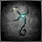 | GUIDANCE  DLC | BOOSTS RALLY POTENTIAL +10%, +20%, +30% | DROPPED BY CARRION CROW (+10%)  DROPPED BY LUDWIG, THE HOLY BLADE (+20%)  UNKNOWN (+30%) MORE INFO... | "GUIDANCE" RUNE. BOOSTS RALLY POTENTIAL.

ICON | NAME | EFFECTS | AVAILABILITY | NOTE
 | ARCANE LAKE | ARCANE DMG REDUCTION +5%, +7%, +10% | TREASURE IN YAHAR'GUL, UNSEEN VILLAGE (BLOOD MOON) (+5%)  TREASURE IN BYRGENWERTH (+7%)  TREASURE IN ISZ ROOT CHALICE (+10%) | A "LAKE" RUNE. INCREASES ARCANE DAMAGE REDUCTION
 | DISSIPATING LAKE | BOLT DMG REDUCTION +5%, +7%, +10% | TREASURE IN FORBIDDEN WOODS (+5%)  TREASURE IN AILING LORAN ROOT CHALICE (+7%)  TREASURE IN LOWER AILING LORAN ROOT CHALICE (+10%) | A "LAKE" RUNE. INCREASES BOLT DAMAGE REDUCTION
 | FADING LAKE | FIRE DMG REDUCTION +5%, +7%, +10% | TREASURE IN NIGHTMARE FRONTIER (+5%)  TREASURE IN AILING LORAN ROOT CHALICE (+7%)  TREASURE IN LOWER AILING LORAN ROOT CHALICE (+10%) | A "LAKE" RUNE. INCREASES FIRE DAMAGE REDUCTION
 | GREAT LAKE | ALL DMG REDUCTION +3%, +4%, +5% | TREASURE IN LOWER HINTERTOMB ROOT CHALICE (+3%)  TREASURE IN UPPER CATHEDRAL WARD (+4%)  TREASURE IN ISZ ROOT CHALICE (+5%) | A "LAKE" RUNE. INCREASES ALL TYPES OF DAMAGE REDUCTION
 | LAKE | PHYS. DMG REDUCTION +3%, +5%, +7% | TREASURE IN HEMWICK CHARNEL LANE (+3%)  TREASURE IN CURSED AND DEFILED ROOT CHALICE (+5%)  TREASURE IN PTHUMERU IHYLL ROOT CHALICE (+7%) | A "LAKE" RUNE. INCREASES PHYSICAL DAMAGE REDUCTION

ICON | NAME | EFFECTS | AVAILABILITY | NOTE
 | ANTI-CLOCKWISE METAMORPHOSIS | BOOSTS MAX STAMINA +10%, +15%, +20% | TREASURE IN FORBIDDEN WOODS (+10%)  ACQUIRED FROM PATCHES THE SPIDER (+15%)  TREASURE IN LOWER AILING LORAN ROOT CHALICE (+20%) | ONE OF THE "METAMORPHOSIS" RUNES. RAISES STAMINA
 | CLOCKWISE METAMORPHOSIS | BOOSTS MAX HP +5%, +10%, +15% | TREASURE IN FORBIDDEN WOODS (+5%)  TREASURE IN NIGHTMARE FRONTIER (+10%)  TREASURE IN PTHUMERU IHYLL ROOT CHALICE (+15%) | ONE OF THE "METAMORPHOSIS" RUNES. RAISES HP

ICON | NAME | EFFECTS | AVAILABILITY | NOTE
 | CLEAR DEEP SEA | ADD SLOW POISON RES +100, +200, +300 | TREASURE IN FORBIDDEN WOODS (+100)  TREASURE IN NIGHTMARE FRONTIER (+200)  TREASURE IN LOWER AILING LORAN ROOT CHALICE (+300) | A "DEEP SEA" RUNE. INCREASES SLOW POISON RESISTANCE
 | DEEP SEA | ADD FRENZY RES +100, +200, +300 | TREASURE IN LOWER HINTERTOMB ROOT CHALICE (+100)  TREASURE IN FORBIDDEN WOODS (+200)  TREASURE IN ISZ ROOT CHALICE (+300) | A "DEEP SEA" RUNE. INCREASES FRENZY RESISTANCE
 | GREAT DEEP SEA | ADD ALL TYPES OF RES +50, +100, +150 | TREASURE IN LOWER HINTERTOMB ROOT CHALICE (+50)  TREASURE IN NIGHTMARE FRONTIER (+100)  TREASURE IN ISZ ROOT CHALICE (+150) | A "DEEP SEA" RUNE. INCREASES ALL RESISTANCE TYPES
 | STUNNING DEEP SEA | ADD RAPID POISON RES +100, +200, +300 | TREASURE IN LOWER HINTERTOMB ROOT CHALICE (+100)  TREASURE IN NIGHTMARE FRONTIER (+200)  TREASURE IN LOWER AILING LORAN ROOT CHALICE (+300) | A "DEEP SEA" RUNE. INCREASE RAPID POISON RESISTANCE

ICON | NAME | EFFECTS | AVAILABILITY | NOTE
 | CORRUPTION | CONT. HEAL NEAR DEATH +1 | ACQUIRED FROM ANNALISE, QUEEN OF CASTLE CAINHURST | "CORRUPTION" RUNE. SYMBOL OF THE CAINHURST VILEBLOODS
 | HUNTER | STAMINA RECOVERY SPEED UP +6% | ACQUIRED FROM EILEEN THE CROW | "HUNTER" RUNE. SIGN OF A HUNTER OF HUNTERS
 | IMPURITY | BOOSTS MAX HP DURING CO-OP +2% | ACQUIRED FROM VALTR, MASTER OF THE LEAGUE | "IMPURITY" RUNE. SYMBOL OF THE LEAGUE OATH
 | RADIANCE | VIAL HP RECOVERY UP | ACQUIRED FROM ALFRED, HUNTER OF VILEBLOODS  DROPPED BY ALFRED, HUNTER OF VILEBLOODS* | "RADIANCE" RUNE. SYMBOL OF THE EXECUTIONERS
 | BEAST'S EMBRACE  DLC | TEMP. BOOST TO TRANSFORM +15 | DROPPED BY LAURENCE, THE FIRST VICAR | "EMBRACE" RUNE. ASSUME THE FORM OF A GHASTLY BEAST.
 | MILKWEED  DLC | SMALL INCREASE IN ITEM DISCOVERY +10 | ACQUIRED FROM ADELINE, RESEARCH HALL PATIENT | "MILKWEED" RUNE. HOST PHANTASMS AS A LUMENWOOD.

ICON | NAME | PREREQUISITE | MAX LEVEL | AVAILABILITY
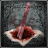 | BLOOD STONE SHARD | +0 | +3 | TREASURE IN CENTRAL YHARNAM, CATHEDRAL WARD, OLD YHARNAM; DROPPED BY LARGE HUNTSMAN (TORCH AND SAW), LARGE HUNTSMAN (SPEAR), SCOURGE BEAST, LARGE HUNTSMAN (PLOW), CHURCH GIANT (AXE), CHURCH GIANT (WRECKING BALL), KIDNAPPER, HUNTING DOG, SNAKE BALL, CHURCH GIANT (BARE FISTS), LARGE SNAKE BALL, GIANT LOST CHILD, WANDERING NIGHTMARE; KEEPER'S HUNTING DOG, UNDEAD GIANT (CLUB & HOOK), UNDEAD GIANT (TWIN CURVED BLADES); SOLD BY BATH MESSENGERS, INSIGHT BATH MESSENGERS [MORE...]
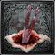 | TWIN BLOOD STONE SHARDS | +3 | +6 | TREASURE IN CATHEDRAL WARD, HEMWICK CHARNEL LANE, YAHAR'GUL, UNSEEN VILLAGE (EVENING), FORBIDDEN WOODS; DROPPED BY KIDNAPPER, LARGE HUNTSMAN (TORCH AND SAW), LARGE HUNTSMAN (PLOW), CHURCH GIANT (BARE FISTS), LARGE SNAKE BALL, HUNTING DOG, LOST CHILD OF ANTIQUITY, SCOURGE BEAST (SKELETAL), SCOURGE BEAST, CHURCH GIANT (FLAME FIST), LARGE WANDERING NIGHTMARE, WANDERING NIGHTMARE, KEEPER'S HUNTING DOG, UNDEAD GIANT (CLUB & HOOK), UNDEAD GIANT (TWIN CURVED BLADES); SOLD BY BATH MESSENGERS, INSIGHT BATH MESSENGERS [MORE...]
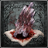 | BLOOD STONE CHUNK | +6 | +9 | TREASURE IN FORBIDDEN WOODS , FORSAKEN CAINHURST CASTLE, YAHAR'GUL, UNSEEN VILLAGE (BLOOD MOON), LECTURE BUILDING 2F, NIGHTMARE OF MENSIS; DROPPED BY LOST CHILD OF ANTIQUITY, SCOURGE BEAST (SKELETAL), SCOURGE BEAST, CHURCH GIANT (FLAME FIST), WANDERING NIGHTMARE, LARGE WANDERING NIGHTMARE, KEEPER'S HUNTING DOG, UNDEAD GIANT (TWIN CURVED BLADES), UNDEAD GIANT (CLUB & HOOK), LARGE SNAKE BALL; SOLD BY INSIGHT BATH MESSENGERS [MORE...]
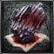 | BLOOD ROCK | +9 | +10 | TREASURE IN NIGHTMARE OF MENSIS; CHESTS IN DEPTH 5 ROOT CHALICE DUNGEONS [LIMITED]: PTHUMERU IHYLL ROOT CHALICE, SINISTER PTHUMERU IHYLL ROOT CHALICE, LOWER AILING LORAN ROOT CHALICE, SINISTER LOWER LORAN ROOT CHALICE, ISZ ROOT CHALICE, SINISTER ISZ ROOT CHALICE; DROPPED BY END BOSSES IN DEPTH 5 ROOT CHALICE DUNGEONS [UNLIMITED]: PTHUMERU IHYLL ROOT CHALICE, SINISTER PTHUMERU IHYLL ROOT CHALICE, LOWER AILING LORAN ROOT CHALICE, SINISTER LOWER LORAN ROOT CHALICE, ISZ ROOT CHALICE, SINISTER ISZ ROOT CHALICE [MORE...]

ICON | NAME | SHAPE | RATING | EFFECTS | AVAILABILITY
 | GOLD BLOOD GEM | RADIAL | 7 | ATK VS BEASTS UP +12.6% | THIS GEM IS ACQUIRED BY DEFEATING VICAR AMELIA AND THEN USING THE GOLD PENDANT SHE DROPS. IT'S A RADIAL GEM THAT GRANTS A DECENT BOOST TO ATTACK STRENGTH AGAINST BEASTS. THE SAW CLEAVER AND SAW SPEAR ARE GOOD CANDIDATES FOR FORTIFYING WITH THIS GEM, BECAUSE THEY BOTH HAVE RADIAL SLOTS AND THEIR SERRATED DAMAGE BONUS ALREADY MAKES THEM YOUR IDEAL BEAST-KILLERS.
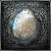 | TEAR BLOOD GEM | DROPLET | 8 | HP CONTINUES TO RECOVER +2 | YOU CAN OBTAIN THIS GEM BY GIVING THE DOLL THE SMALL HAIR ORNAMENT AND THEN TALKING TO HER. SHE'LL GIVE YOU THE TEAR STONE, WHICH PRODUCES THIS GEM WHEN YOU USE IT. IT'S A VERY USEFUL GEM, AND WORTH EQUIPPING TO YOUR SIDEARM IF IT HAS A GEM SLOT, AT LEAST UNTIL LATE IN THE GAME WHEN YOU BEGIN TO FIND POWERFUL CIRCLE-SHAPED BLOOD GEMS.
 | RED BLOOD GEM | DROPLET | 4 | PHYSICAL ATK UP +2.7%  BOOSTS RALLY POTENTIAL +1.8% | THIS UNIQUE, DROPLET-SHAPED BLOOD GEM IS ACQUIRED BY USING THE RED BROOCH, WHICH YOU CAN FIND ON A WOMAN'S CORPSE IN THE TOMB OF OEDON. IT RAISES YOUR PHYSICAL ATTACK BY 2.7% AND BOOSTS RALLY POTENTIAL BY 1.8%. THIS MAKES IT SIMILAR TO A LETHAL GEM, AND NOT A VERY STRONG ONE AT THAT, BUT IT STILL HIGHLY USEFUL IN THE FIRST HALF OF THE GAME.

ICON | NAME | USED IN | HOW TO OBTAIN | SPECIAL NOTE
 | ARCANE HAZE | SINISTER LOWER PTHUMERU ROOT CHALICE (ADDITIONAL RITE), DEFILED CHALICE, SINISTER HINTERTOMB ROOT CHALICE (ADDITIONAL RITE), GREAT PTHUMERU IHYLL CHALICE, SINISTER PTHUMERU IHYLL ROOT CHALICE (ADDITIONAL RITE), SINISTER LOWER LORAN ROOT CHALICE (ADDITIONAL RITE), GREAT ISZ CHALICE, SINISTER ISZ ROOT CHALICE (ADDITIONAL RITE) | DROPPED BY FLUORESCENT FLOWER  ACQUIRED FROM WORKSHOP HAZE EXTRACTOR | MATERIAL USED IN A HOLY CHALICE RITUAL.
 | BLOODSHOT EYEBALL | HINTERTOMB CHALICE, HINTERTOMB ROOT CHALICE, LOWER HINTERTOMB CHALICE, LOWER HINTERTOMB ROOT CHALICE, SINISTER HINTERTOMB ROOT CHALICE | TREASURE IN CATHEDRAL WARD, HEMWICK CHARNEL LANE; TREASURE IN PRESET DUNGEONS HINTERTOMB, LOWER HINTERTOMB; DROPPED BY WITCH OF HEMWICK, EYE COLLECTOR; SOLD BY INSIGHT BATH MESSENGERS | MATERIAL USED IN A HOLY CHALICE RITUAL.
 | BLOOMING COLDBLOOD FLOWER | LOWER AILING LORAN CHALICE , LOWER AILING LORAN ROOT CHALICE, SINISTER LOWER LORAN ROOT CHALICE | TREASURE IN PRESET DUNGEONS AILING LORAN, LOWER LORAN; DROPPED BY LORAN CLERIC  SOLD BY INSIGHT BATH MESSENGERS | MATERIAL USED IN A HOLY CHALICE RITUAL.
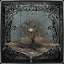 | COLDBLOOD FLOWERBUD | AILING LORAN CHALICE | TREASURE IN NIGHTMARE FRONTIER  DROPPED BY LORAN CLERIC  SOLD BY INSIGHT BATH MESSENGERS | MATERIAL USED IN A HOLY CHALICE RITUAL.
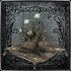 | COLDBLOOD FLOWER BULB | AILING LORAN ROOT CHALICE | TREASURE IN AILING LORAN  DROPPED BY LORAN CLERIC  SOLD BY INSIGHT BATH MESSENGERS | MATERIAL USED IN A HOLY CHALICE RITUAL.
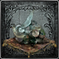 | PEARL SLUG | GREAT ISZ CHALICE, ISZ ROOT CHALICE, SINISTER ISZ ROOT CHALICE | TREASURE IN BYRGENWERTH, UPPER CATHEDRAL WARD; TREASURE IN PRESET DUNGEONS ISZ GRAVESTONE; DROPPED BY GARDEN OF EYES (ROOT DUNGEONS); SOLD BY INSIGHT BATH MESSENGERS | MATERIAL USED IN A HOLY CHALICE RITUAL.
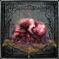 | RED JELLY | GREAT PTHUMERU IHYLL CHALICE, PTHUMERU IHYLL ROOT CHALICE, SINISTER PTHUMERU IHYLL ROOT CHALICE, LOWER AILING LORAN ROOT CHALICE, SINISTER LOWER LORAN ROOT CHALICE, ISZ ROOT CHALICE, SINISTER ISZ ROOT CHALICE | TREASURE IN LECTURE BUILDING 1F; TREASURE IN PRESET DUNGEONS LOWER LORAN, ISZ GRAVESTONE, PTHUMERU IHYLL; SOLD BY INSIGHT BATH MESSENGERS | MATERIAL USED IN A HOLY CHALICE RITUAL.
 | RITUAL BLOOD (1) - (5) | ALL CHALICE DUNGEONS | COMMON TREASURE IN PRESET DUNGEONS, COMMON DROP FROM CHALICE DUNGEONS ENEMIES, SOLD BY BATH MESSENGERS [MORE...] | MATERIAL USED IN A HOLY CHALICE RITUAL.
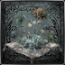 | TOMB MOLD (1) - (5) | ALL ROOT CHALICE DUNGEONS | COMMON TREASURE IN PRESET DUNGEONS; DROPPED BY IN PRESET/ROOT DUNGEONS: LABYRINTH RAT, WATCHER'S GRAVEDIGGER (PICKAXE); SOLD BY BATH MESSENGERS [MORE...] | MATERIAL USED IN A HOLY CHALICE RITUAL.

ICON | NAME | USED IN | HOW TO OBTAIN | SPECIAL NOTE
 | BASTARD OF LORAN | DEFILED CHALICE, CURSED AND DEFILED ROOT CHALICE (ADDITIONAL RITE), PTHUMERU IHYLL ROOT CHALICE (ADDITIONAL RITE), LOWER AILING LORAN ROOT CHALICE (ADDITIONAL RITE), ISZ ROOT CHALICE (ADDITIONAL RITE) | TREASURE IN PRESET DUNGEONS AILING LORAN, LOWER LORAN; DROPPED BY LORAN SILVERBEAST  SOLD BY INSIGHT BATH MESSENGERS | SPECIAL MATERIAL USED IN A HOLY CHALICE RITUAL.
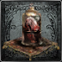 | INFLICTED ORGAN | LOWER PTHUMERU ROOT CHALICE (ADDITIONAL RITE), CURSED AND DEFILED ROOT CHALICE (ADDITIONAL RITE), LOWER HINTERTOMB ROOT CHALICE (ADDITIONAL RITE), AILING LORAN ROOT CHALICE (ADDITIONAL RITE) | TREASURE IN NIGHTMARE OF MENSIS, PRESET DUNGEONS LOWER HINTERTOMB, CURSED PTHUMERIAN DEFILEMENT; DROPPED BY LABYRINTH WARRIOR (GREATSWORD), LABYRINTH WARRIOR (CROSSBOW & SWORD), LABYRINTH WARRIOR (MORNING STAR), LABYRINTH WARRIOR (SWORD & SHIELD)  SOLD BY INSIGHT BATH MESSENGERS | SPECIAL MATERIAL USED IN A HOLY CHALICE RITUAL.
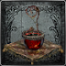 | LIVING STRING | GREAT PTHUMERU IHYLL CHALICE | DROPPED BY BRAIN OF MENSIS  SOLD BY INSIGHT BATH MESSENGERS | SPECIAL MATERIAL USED IN A HOLY CHALICE RITUAL.
 | SAGE'S HAIR | CURSED AND DEFILED ROOT CHALICE (ADDITIONAL RITE), PTHUMERU IHYLL ROOT CHALICE (ADDITIONAL RITE), AILING LORAN ROOT CHALICE (ADDITIONAL RITE), LOWER AILING LORAN ROOT CHALICE (ADDITIONAL RITE), ISZ ROOT CHALICE (ADDITIONAL RITE) | TREASURE IN PRESET DUNGEONS CURSED PTHUMERIAN DEFILEMENT, ISZ GRAVESTONE; DROPPED BY LABYRINTH MADMAN (CORPSE), LABYRINTH MADMAN (SICKLE), LABYRINTH MADMAN (TWIN SICKLES)  SOLD BY INSIGHT BATH MESSENGERS | SPECIAL MATERIAL USED IN A HOLY CHALICE RITUAL.
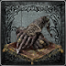 | SAGE'S WRIST | CENTRAL PTHUMERU ROOT CHALICE (ADDITIONAL RITE), LOWER PTHUMERU ROOT CHALICE (ADDITIONAL RITE), HINTERTOMB ROOT CHALICE (ADDITIONAL RITE), LOWER HINTERTOMB ROOT CHALICE (ADDITIONAL RITE) | TREASURE IN PRESET DUNGEONS CENTRAL PTHUMERIAN LABYRINTH, LOWER PTHUMERIAN LABYRINTH; DROPPED BY LABYRINTH MADMAN (CORPSE), LABYRINTH MADMAN (SICKLE), LABYRINTH MADMAN (TWIN SICKLES)  SOLD BY INSIGHT BATH MESSENGERS | SPECIAL MATERIAL USED IN A HOLY CHALICE RITUAL.
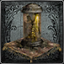 | YELLOW BACKBONE | PTHUMERU IHYLL ROOT CHALICE (ADDITIONAL RITE), LOWER AILING LORAN ROOT CHALICE (ADDITIONAL RITE), ISZ ROOT CHALICE (ADDITIONAL RITE) | TREASURE IN NIGHTMARE OF MENSIS, PRESET DUNGEONS ISZ GRAVESTONE, PTHUMERU IHYLL; DROPPED BY THE ONE REBORN, LABYRINTH WARRIOR (GREATSWORD), LABYRINTH WARRIOR (CROSSBOW & SWORD), LABYRINTH WARRIOR (MORNING STAR), LABYRINTH WARRIOR (SWORD & SHIELD)  SOLD BY INSIGHT BATH MESSENGERS | SPECIAL MATERIAL USED IN A HOLY CHALICE RITUAL.

POOL NAME | DEPTH 1 |  | DEPTH 2 |  | DEPTH 3 |  | DEPTH 4 |  | DEPTH 5
RITUAL BLOOD  A |  | RITUAL BLOOD (1)  DEPTH 1 |  | RITUAL BLOOD (2)  DEPTH 2 |  | RITUAL BLOOD (3)  DEPTH 3 |  | RITUAL BLOOD (4)  DEPTH 4 |  | RITUAL BLOOD (5)  DEPTH 5
RITUAL BLOOD  B |  | RITUAL BLOOD (2)  DEPTH 1 |  | RITUAL BLOOD (3)  DEPTH 2 |  | RITUAL BLOOD (4)  DEPTH 3 |  | RITUAL BLOOD (5)  DEPTH 4 |  | RITUAL BLOOD (5)  DEPTH 5
COLDBLOOD FLOWERBUD  POOL A |  | BLOOD VIAL  DEPTH 1 |  | BLOOD VIAL  DEPTH 2 | 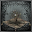 | COLDBLOOD FLOWERBUD  DEPTH 3 |  | COLDBLOOD FLOWERBUD  DEPTH 4 |  | BLOOMING COLDBLOOD FLOWER  DEPTH 5
COLDBLOOD FLOWERBUD  POOL B |  | BLOOD VIAL  DEPTH 1 |  | BLOOD VIAL  DEPTH 2 |  | COLDBLOOD FLOWERBUD  DEPTH 3 |  | COLDBLOOD FLOWER BULB  DEPTH 4 |  | BLOOMING COLDBLOOD FLOWER  DEPTH 5
TOMB MOLD  POOL | 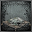 | TOMB MOLD (1)  DEPTH 1 | 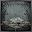 | TOMB MOLD (2)  DEPTH 2 |  | TOMB MOLD (3)  DEPTH 3 |  | TOMB MOLD (4)  DEPTH 4 |  | TOMB MOLD (5)  DEPTH 5
SAGE'S WRIST  POOL |  | BLOOD VIAL  DEPTH 1 |  | SAGE'S WRIST  DEPTH 2 |  | SAGE'S WRIST  DEPTH 3 |  | SAGE'S HAIR  DEPTH 4 |  | SAGE'S HAIR  DEPTH 5
INFLICTED ORGAN  POOL |  | BLOOD VIAL  DEPTH 1 |  | BLOOD VIAL  DEPTH 2 |  | INFLICTED ORGAN  DEPTH 3 |  | INFLICTED ORGAN  DEPTH 4 |  | YELLOW BACKBONE  DEPTH 5

IMAGE | NAME | ITEM | DROP | LOCATION | TIMEZONES
 | ADELLA, NUN OF THE HEALING CHURCH | MADMAN'S KNOWLEDGE, "CHURCH BOW (FEMALE)", BLOOD OF ADELLA | OEDON WRITHE X1 [100%] | YAHAR'GUL, UNSEEN VILLAGE STOREROOM, CATHEDRAL WARD OEDON CHAPEL | EVENING, NIGHT, BLOOD MOON
 | AFFLICTED BEGGAR | PUNGENT BLOOD COCKTAIL, BEAST BLOOD PELLETS | BEAST X1 [100%] | FORBIDDEN WOODS WINDMIL BALCONIES, CATHEDRAL WARD OUTSIDE OEDON CHAPEL | NIGHT, BLOOD MOON
 | ALFRED, HUNTER OF VILEBLOODS | FIRE PAPER, "PRAY", WHEEL HUNTER BADGE, "CHURCH BOW (MALE)", "ROAR", RADIANCE CARYLL RUNE | WHEEL HUNTER BADGE [100%], FIRE PAPER X3 [100%]*, RADIANCE CARYLL RUNE [100%]*  + BLOOD DREG X1 [100%] (CORRUPTION) | CATHEDRAL WARD LOWER CHAPEL, CATHEDRAL WARD FORBIDDEN WOODS ROUTE, FORSAKEN CAINHURST CASTLE QUEEN'S CHAMBER | EVENING, NIGHT, BLOOD MOON
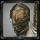 | ANNALISE, QUEEN OF CASTLE CAINHURST | CAINHURST BADGE, "RESPECT", CORRUPTION CARYLL RUNE, "DEEP RESPECT" | QUEENLY FLESH [100%] | FORSAKEN CAINHURST CASTLE QUEEN'S CHAMBER | NIGHT, BLOOD MOON
 | ARIANNA, WOMAN OF PLEASURE | "CURTSY", BLOOD OF ARIANNA, ONE THIRD UMBILICAL CORD | ARIANNA'S SHOES [100%] | CATHEDRAL WARD FOGGY ALLEY, CATHEDRAL WARD OEDON CHAPEL | EVENING, NIGHT, BLOOD MOON
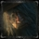 | BLOOD MINISTER | NONE | NONE | IOSEFKA'S CLINIC OPERATING ROOM | DAY
 | DOLL | TEAR STONE | NONE | HUNTER'S DREAM | DAY, EVENING, NIGHT, BLOOD MOON
 | EILEEN THE CROW | BOLD HUNTER'S MARK, "SHAKE OFF CAPE", "SHHH!", "APPROVAL", "WAIT", CROW HUNTER BADGE, HUNTER RUNE | CROW HUNTER BADGE [100%]  + BLOOD DREG X1 [100%] (CORRUPTION) | CENTRAL YHARNAM DRY DOCKS, CENTRAL YHARNAM TOMB OF OEDON, CATHEDRAL WARD OUTSIDE OF OEDON CHAPEL, CATHEDRAL WARD GRAND CATHEDRAL | DAY, EVENING, BLOOD MOON
 | GEHRMAN | NONE | NONE | HUNTER'S DREAM | DAY, EVENING, NIGHT, BLOOD MOON
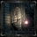 | GILBERT, CRITICALLY ILL MAN | FLAMESPRAYER | CLAWMARK RUNE [100%] | CENTRAL YHARNAM GILBERT'S HOUSE | DAY, EVENING, NIGHT, BLOOD MOON
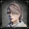 | IMPOSTOR IOSEFKA | LEAD ELIXIR, NUMBING MISTS, BEAST BLOOD PELLET, BLUE ELIXIR | OEDON WRITHE X1 [100%], ONE THIRD OF UMBILICAL CORD [100%]* | IOSEFKA'S CLINIC OPERATING ROOM, IOSEFKA'S CLINIC UPSTAIRS OPERATING ROOM | EVENING, NIGHT, BLOOD MOON
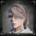 | IOSEFKA | IOSEFKA'S BLOOD VIAL | NONE | IOSEFKA'S CLINIC OPERATING ROOM | DAY
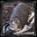 | MASTER WILLEM | NONE | EYE RUNE [100%] | BYRGENWERTH LUNARIUM | NIGHT, BLOOD MOON
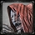 | OEDON CHAPEL DWELLER | "TRIUMPH", PEBBLE | FORMLESS OEDON X1 [100%] | CATHEDRAL WARD OEDON CHAPEL | EVENING, NIGHT, BLOOD MOON
 | BIGOTED OLD MAN | NONE | PUNGENT BLOOD COCKTAIL X3 [100%] | CATHEDRAL WARD FOGGY ALLEY, CATHEDRAL WARD OEDON CHAPEL | EVENING, NIGHT, BLOOD MOON
 | LONELY OLD WOMAN | SEDATIVES | SEDATIVES X1 [100%] | CENTRAL YHARNAM CANAL BRIDGE, CATHEDRAL WARD OEDON CHAPEL | DAY, EVENING, NIGHT, BLOOD MOON
 | PATCHES THE SPIDER | TONSIL STONE, "BEG FOR LIFE", ANTI-CLOCKWISE METAMORPHOSIS | GREAT ONE'S WISDOM X1 [100%] | CATHEDRAL WARD ENTRANCE OF YAHAR'GUL, LECTURE BUILDING 1F PATCHES' LAB, NIGHTMARE FRONTIER LOWER CAVES | NIGHT, BLOOD MOON
 | RETIRED HUNTER DJURA | POWDER KEG HUNTER BADGE, "BRUSH OFF DUST", BOLD HUNTER'S MARK* | POWDER KEG HUNTER BADGE X1 [100%]  + BLOOD DREG X1 [100%] (CORRUPTION) | OLD YHARNAM DJURA'S TOWER | EVENING, NIGHT, BLOOD MOON
 | YOUNG GIRL AND OLDER SISTER | TINY MUSIC BOX, RED MESSENGER RIBBON, WHITE MESSENGER RIBBON | NONE | CENTRAL YHARNAM CANAL RESIDENCE | DAY, EVENING, NIGHT, BLOOD MOON
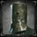 | VALTR, MASTER OF THE LEAGUE | IMPURITY, LEAGUE STAFF, "LEAGUE OATH" | ONE-EYED IRON HELM X1 [100%]  + BLOOD DREG X1 [100%] (CORRUPTION) | FORBIDDEN WOODS | NIGHT, BLOOD MOON

ICON | NAME | ACQUISITION INFO
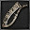 | SAW CLEAVER | CAN BE SELECTED AS ONE OF THE STARTING WEAPONS YOU GET FROM THE MESSENGERS DURING YOUR FIRST TRIP TO THE HUNTER'S DREAM, OR CAN BE PURCHASED FROM THE BATH MESSENGERS FOR 1000 BLOOD ECHOES AFTER OBTAINING THE SAW HUNTER BADGE.
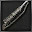 | SAW SPEAR | ON A CORPSE HANGING IN THE DRY DOCK - RAFTERS SECTION OF CENTRAL YHARNAM, OR CAN BE PURCHASED FROM THE BATH MESSENGER FOR 1000 BLOOD ECHOES AFTER OBTAINING THE SAW HUNTER BADGE.
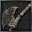 | HUNTER AXE | CAN BE SELECTED AS ONE OF THE STARTING WEAPONS YOU GET FROM THE MESSENGERS DURING YOUR FIRST TRIP TO THE HUNTER'S DREAM, OR CAN BE PURCHASED FROM THE BATH MESSENGERS FOR 1100 BLOOD ECHOES AFTER OBTAINING THE SAW HUNTER BADGE.
 | THREADED CANE | CAN BE SELECTED AS ONE OF THE STARTING WEAPONS YOU GET FROM THE MESSENGERS DURING YOUR FIRST TRIP TO THE HUNTER'S DREAM, OR CAN BE PURCHASED FROM THE BATH MESSENGERS FOR 1100 BLOOD ECHOES AFTER OBTAINING THE SAW HUNTER BADGE.
 | BLADE OF MERCY | PURCHASE FROM THE BATH MESSENGER FOR 40,000 BLOOD ECHOES AFTER OBTAINING THE CROW HUNTER BADGE.
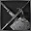 | KIRKHAMMER | PURCHASE FROM THE BATH MESSENGER FOR 3000 BLOOD ECHOES AFTER OBTAINING THE SWORD HUNTER BADGE.
 | LUDWIG'S HOLY BLADE | PURCHASE FROM THE BATH MESSENGER FOR 20,000 BLOOD ECHOES AFTER OBTAINING THE RADIANT SWORD HUNTER BADGE.
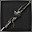 | REITERPALLASCH | CAN BE FOUND IN THE ENTRANCE HALL OF FORSAKEN CAINHURST CASTLE, OR PURCHASED FROM THE BATH MESSENGER FOR 18,000 BLOOD ECHOES AFTER OBTAINING THE CAINHURST BADGE.
 | CHIKAGE | PURCHASE FROM THE BATH MESSENGER FOR 50,000 BLOOD ECHOES AFTER OBTAINING THE CAINHURST BADGE.
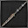 | RIFLE SPEAR | CAN BE FOUND IN THE STORAGE AREA OF OLD YHARNAM, OR PURCHASED FROM THE BATH MESSENGER FOR 4000 BLOOD ECHOES AFTER OBTAINING THE POWDER KEY HUNTER BADGE.
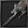 | STAKE DRIVER | PURCHASE FROM THE BATH MESSENGER FOR 8000 BLOOD ECHOES AFTER OBTAINING THE POWDER KEG HUNTER BADGE.
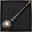 | TONITRUS | CAN BE FOUND AT THE END OF MAIN STREET - WEST IN YAHAR'GUL, UNSEEN VILLAGE, OR PURCHASED FROM THE BATH MESSENGER FOR 26,000 BLOOD ECHOES AFTER OBTAINING THE SPARK HUNTER BADGE.
 | LOGARIUS' WHEEL | PURCHASE FROM THE BATH MESSENGER FOR 13,000 BLOOD ECHOES AFTER OBTAINING THE WHEEL HUNTER BADGE.
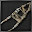 | BEAST CLAW | CAN FIRST BE OBTAINED FROM A CHEST ON LAYER 2 OF THE AILING LORAN CHALICE DUNGEON.
 | BURIAL BLADE | PURCHASE FROM THE BATH MESSENGER FOR 60,000 BLOOD ECHOES AFTER OBTAINING THE OLD HUNTER BADGE.

ICON | NAME | ACQUISITION INFO
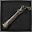 | HUNTER PISTOL | CAN BE SELECTED AS ONE OF THE STARTING WEAPONS YOU GET FROM THE MESSENGERS DURING YOUR FIRST TRIP TO THE HUNTER'S DREAM, OR CAN BE PURCHASED FROM THE BATH MESSENGERS FOR 1600 BLOOD ECHOES AFTER OBTAINING THE SAW HUNTER BADGE.
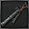 | HUNTER BLUNDERBUSS | CAN BE SELECTED AS ONE OF THE STARTING WEAPONS YOU GET FROM THE MESSENGERS DURING YOUR FIRST TRIP TO THE HUNTER'S DREAM, OR CAN BE PURCHASED FROM THE BATH MESSENGERS FOR 1700 BLOOD ECHOES AFTER OBTAINING THE SAW HUNTER BADGE.
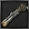 | REPEATING PISTOL | PURCHASE FROM THE BATH MESSENGER FOR 3000 BLOOD ECHOES AFTER OBTAINING THE SWORD HUNTER BADGE.
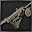 | LUDWIG'S RIFLE | PURCHASE FROM THE BATH MESSENGER FOR 10,000 BLOOD ECHOES AFTER OBTAINING THE RADIANT SWORD HUNTER BADGE.
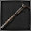 | EVELYN | CAN BE FOUND IN THE LIBRARY 1F SECTION OF FORSAKEN CAINHURST CASTLE, OR PURCHASED FROM THE BATH MES¬SENGER FOR 16,000 BLOOD ECHOES AFTER OBTAINING THE CAINHURST BADGE.
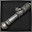 | CANNON | CAN BE FOUND IN THE WINDMILL COGS AREA OF THE FORBIDDEN WOODS.
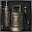 | FLAMESPRAYER | GIVEN AS A GIFT BY GILBERT IF YOU SPEAK WITH HIM AFTER ENTERING THE OEDON CHAPEL FOR THE FIRST TIME, OR CAN BE PURCHASED FROM THE BATH MESSENGER FOR 8000 BLOOD ECHOES AFTER OBTAINING THE RADIANT SWORD HUNTER BADGE.
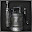 | ROSMARINUS | PURCHASE FROM THE BATH MESSENGER FOR 60,000 BLOOD ECHOES AFTER OBTAINING THE COSMIC EYE WATCHER BADGE.
 | HUNTER'S TORCH | CAN BE FOUND IN THE ROOFTOPS AREA OF OLD YHARNAM.
 | TORCH | CAN BE FOUND AT THE PLAZA GATE WITH HUNTSMAN'S MINION BANGING ON IT IN CENTRAL YHARNAM.

ICON | NAME | ACQUISITION INFO
 | BEAST CUTTER | ON THE WAY UP THE STAIRS TO THE NIGHTMARE GRAND CATHEDRAL, YOU WILL SEE TWO PROTRUDING PLATFORMS EITHER SIDE OF THE STAIRWAY. TURN ONTO THE LEFT PLATFORM, AND THEN DROP OFF THE EDGE TO THE LEVEL BELOW TO REACH THE BEAST CUTTER ON THE CORPSE IN FRONT OF YOU.
 | BOOM HAMMER | ON THE GROUND FLOOR OF THE NIGHTMARE RESIDENCE BY THE DEAD MAN IN THE WHEELCHAIR.
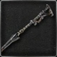 | PIERCING RIFLE | KILL THE BESTIAL HUNTER IN THE HUNTER'S NIGHTMARE FOR THE FIRING HAMMER BADGE, WHICH WILL ALLOW YOU TO PURCHASE THIS FIREARM FROM THE SHOP IN THE HUNTER'S DREAM FOR 20000 BLOOD ECHOES.
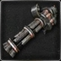 | GATLING GUN | FOLLOW THE RIVER OF BLOOD INTO THE BEAST CAVE AND KILL DJURA'S DISCIPLE TO ACQUIRE THE GATLING GUN.
 | AMYGDALAN ARM | IN THE SAME AREA WHERE YOU ACQUIRED THE GATLING GUN, SLAY THE BLOOD-STARVED BEAST AND HIS ALLIES BEFORE COLLECTING THIS WEAPON AT THE BACK OF HIS LAIR.
 | BEASTHUNTER SAIF | TAKE THE LADDER UPWARDS THAT LEADS TO THE BLOODY PLAZA, THEN TAKE A LEFT AND DROP DOWN. KILL THE OLD HUNTER THAT WILL ATTEMPT TO AMBUSH YOU HERE THEN GRAB THIS WEAPON ON THE NEARBY OVERLOOK.
 | WHIRLIGIG SAW | YOU WILL SEE THIS BEFORE YOU CAN REACH IT ON A LARGE, RAISED, TOMBSTONE JUST BEFORE YOU ASCEND THE LADDER TO THE BLOODY PLAZA. HEAD THROUGH THE NIGHTMARE CHURCH WITH THE LAMP, THEN DROP DOWN INTO THE CORPSE RAVINE AND FIGHT YOUR WAY THROUGH THE CROWS AND OLD HUNTER TO REACH THIS WEAPON.
 | HOLY MOONLIGHT SWORD | AFTER DEFEATING LUDWIG, THE ACCURSED, WEAR ANY CHURCH GARB AND TALK TO HIS SURVIVING HEAD TO COLLECT THIS VERY POWERFUL BLADE. ALTERNATELY, CLEAVE HIS HEAD WITH YOUR WEAPON TO ACQUIRE IT.
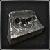 | FIST OF GRATIA | APPROACH THE UNDERGROUND CELLS FROM WHERE YOU FOUGHT LUDWIG, THE ACCURSED IN THE UNDERGROUND CORPSE PILE. THIS WEAPON CAN BE FOUND IN THE THIRD CELL TO YOUR RIGHT ON THE PROSTRATED CORPSE IN CORNER.
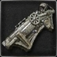 | CHURCH CANNON | ENTER THE RECOVERY ROOM, AND THEN RAISE THE SURGERY ALTAR TO REVEAL THE HIDDEN ALTAR BENEATH. PULL THE NEARBY LEVER AND STEP ONTO THE ELEVATOR TO BE TAKEN DOWN TO ANOTHER SECRET ROOM, WHERE YOU'LL FIND THIS WEAPON IN A CHEST.
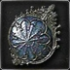 | LOCH SHIELD | AFTER RAISING THE STAIRCASES WITH THE MECHANISM AT THE TOP OF THE RESEARCH HALL, MAKE YOUR WAY BACK DOWN TO THE FLOOR 3. ONCE THERE YOU CAN DROP OFF THE LEDGE OUTSIDE THE LABORATORY ONTO A LANDING. FROM THAT LANDING FOLLOW THE STAIRS DOWN TO A SMALL PLATFORM, WHERE YOU'LL FIND THIS SHIELD ON A CORPSE.
 | CHURCH PICK | USE THE UNDERGROUND CELL KEY ON THE CELL DOOR TO YOUR LEFT IN THE UNDERGROUND CELLS. IT WILL BE THE FOURTH DOOR TO YOUR LEFT FROM WHERE YOU ENTER THIS AREA VIA THE UNDERGROUND CORPSE PILE, OR THE SECOND ON YOUR RIGHT IF YOU ARE COMING DOWN THE STAIRS FROM THE ELEVATOR TO THE RESEARCH HALL AREA. KILL THE HUNTER LURKING HERE AND LOOT THIS WEAPON FROM HIS COLD, DEAD HANDS.
 | RAKUYO | CLIMB DOWN THE LADDER SITUATED AT THE WELL IN THE FISHING HAMLET. AT THE BOTTOM THERE ARE TWO GIANT FISHMAN IN A LARGE CAVERN, AND THE ONE HANGING OFF THE CEILING IS HOLDING THIS WEAPON. KILL HIM TO TAKE IT, BUT BE PREPARED - ONE OF THESE ENEMIES IS LETHAL; TWO WILL PROVIDE A SIZABLE CHALLENGE.
 | SIMON'S BOWBLADE | IF YOU FOLLOW THE QUEST OF SIMON, SEEKER OF SECRETS, YOU'LL FIND HIM ON THE FLOOR OF THE LIGHTHOUSE HUT IN THE FISHING HAMLET, AND HE WILL GIVE YOU HIS WEAPON AS HE EXPIRES WITH HIS FINAL BREATH. ALTERNATIVELY YOU CAN KILL HIM AT ANY POINT BEFORE THAT IF YOU WISH TO GET THE WEAPON EARLIER, AND YOU'LL STILL FIND THE UNDERGROUND CELL INNER CHAMBER IN THE LIGHTHOUSE HUT WHEN YOU GET THERE.
 | BLOODLETTER | TAKE THE UNDERGROUND CELL INNER CHAMBER KEY THAT THE SEEKER OF SECRETS GAVE YOU WITH HIS LAST WORDS OR YOU FOUND IT IN LIGHTHOUSE HUT IN FISHING HAMLET AND HEAD BACK TO THE UNDERGROUND CORPSE PILE. MAKE YOUR WAY BACK TO THE UNDERGROUND CELLS, AND THEN GO THROUGH THE OPEN GATE AND DOWN THE STAIRS TO REACH THE CELL DOOR. UPON ENTERING THE CELL YOU'LL FIND BRADOR SAT INSIDE; KILL HIM TO GET THIS WEAPON.
 | KOS PARASITE | KILL THE ORPHAN OF KOS. UPON HIS DEMISE, HE WILL YIELD YOU THE KOS PARASITE WEAPON.

IMAGE | NAME | ITEM | DROP | LOCATION | TIMEZONES
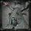 | BRADOR, CHURCH ASSASSIN | NONE | BLOODLETTER [100%]  + BLOOD DREG X1 [100%] (CORRUPTION) | HUNTER'S NIGHTMARE | NIGHT, BLOOD MOON
 | SIMON, SEEKER OF SECRETS | HOLY MOONLIGHT SWORD, SIMON'S BOWBLADE, UNDERGROUND CELL INNER CHAMBER KEY | SIMON'S BOWBLADE [100%]  + BLOOD DREG X1 [100%] (CORRUPTION) | HUNTER'S NIGHTMARE, RESEARCH HALL, FISHING HAMLET | NIGHT, BLOOD MOON
 | ADELINE, RESEARCH HALL PATIENT | BLOOD OF ADELINE, BALCONY KEY, MILKWEED | BALCONY KEY X1 [100%] | RESEARCH HALL | NIGHT, BLOOD MOON
 | FISHING HAMLET PRIEST | ACCURSED BREW | NONE | FISHING HAMLET | NIGHT, BLOOD MOON
 | YAMAMURA THE WANDERER | NONE | YAMAMURA HUNTER HAT [100%], KHAKI HAORI [100%], OLD HUNTER ARM BANDS [100%], WINE HAKAMA [100%]  + BLOOD DREG X1 [100%] (CORRUPTION) | HUNTER'S NIGHTMARE | NIGHT, BLOOD MOON
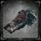 | LUDWIG, THE HOLY BLADE (HEAD) | HOLY MOONLIGHT SWORD | HOLY MOONLIGHT SWORD X1 [100%] | HUNTER'S NIGHTMARE | NIGHT, BLOOD MOON

IMAGE | TROPHY | DETAIL | TYPE
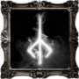 | BLOODBORNE  ALL TROPHIES ACQUIRED. HATS OFF! | AFTER FIGHTING YOUR WAY THROUGH THE CHALICE DUNGEONS, COLLECTING EVERY WEAPON, AND SEEING ALL THAT THE GAME HAS TO OFFER ON YOUR JOURNEY TO UNLOCK THE OTHER TROPHIES, WHEN ALL OF IT IS FINALLY DONE AND THAT LAST TROPHY UNLOCKS, THE COVETED BLOODBORNE PLATINUM TROPHY WILL ALSO BE YOURS. | 
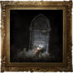 | YHARNAM SUNRISE  YOU LIVED THROUGH THE HUNT, AND SAW ANOTHER DAY. | TO UNLOCK THIS TROPHY YOU WILL NEED TO CHOOSE 'SUBMIT YOUR LIFE" DURING THE FINAL CONVERSATION WITH GEHRMAN BELOW THE GREAT TREE IN THE HUNTER'S DREAM. | 
 | HONORING WISHES  CAPTIVATED BY THE MOON PRESENCE, YOU PLEDGE TO WATCH OVER THE HUNTER'S DREAM. | IF YOU 'REFUSE' GEHRMAN'S OFFER WHEN YOU TALK TO HIM, YOU'LL THEN HAVE TO FIGHT HIM TO COMPLETE THE GAME, AFTER WHICH THIS TROPHY WILL UNLOCK.
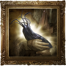 | CHILDHOOD'S BEGINNING  YOU BECAME AN INFANT GREAT ONE, LIFTING HUMANITY INTO ITS NEXT CHILDHOOD. | IN ORDER TO UNLOCK THIS TROPHY YOU'LL NEED TO ACQUIRE AND USE THREE ONE THIRD OF UMBILICAL ITEMS BEFORE YOU START THE FINAL CONVERSATION WITH GEHRMAN AT THE GREAT TREE. DURING THE CONVERSATION YOU WILL NEED TO 'REFUSE' HIS OFFER AGAIN SO THAT YOU CAN FIGHT HIM, AFTER WHICH YOU WILL FACE THE MOON PRESENCE, AND ONLY AFTER DEFEATING THAT FOE WILL THE ENDING COMMENCE AND THE TROPHY UNLOCK.
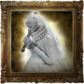 | YHARNAM, PTHUMERIAN QUEEN  DEFEAT YHARNAM, BLOOD QUEEN OF THE OLD LABYRINTH. | REACHING YHARNAM, PTHUMERIAN QUEEN IS NO EASY TASK - YOU'LL NEED TO FIGHT YOUR WAY THROUGH NEARLY ALL OF THE FIXED CHALICE DUNGEONS TO ACCOMPLISH IT. SHE IS LOCATED ON THE FINAL FLOOR OF THE PTHUMERU IHYLL DUNGEON, A DEPTH 5 DUNGEON, SO IT'S HIGHLY RECOMMENDED THAT YOU TAKE HER ON IN CO-OP WITH OTHER HUNTERS. IT IS POSSIBLE TO OBTAIN THIS TROPHY AS COOPERATOR (NORMAL & VIA SRRC) WHEN YHARNAM IS KILLED IN HOST'S WORLD.
 | HUNTER'S ESSENCE  ACQUIRE ALL HUNTER WEAPONS | ACQUIRING A TRUE HUNTER'S ESSENCE TAKES MASTERY OF THE MANY DIFFERENT WEAPONS AVAILABLE TO YOU. TO GET STARTED ON THAT PATH (AND TO UNLOCK THIS TROPHY), YOU'LL NEED TO OBTAIN ALL OF THEM. RIGHT HAND WEAPONS: SAW CLEAVER, SAW SPEAR, HUNTER AXE, THREADED CANE, BLADE OF MERCY, KIRKHAMMER, LUDWIG'S HOLY BLADE, REITERPALLASCH, CHIKAGE, RIFLE SPEAR, STAKE DRIVER, TONITRUS, LOGARIUS' WHEEL, BEAST CLAW, BURIAL BLADE. LEFT HAND WEAPONS: HUNTER PISTOL, HUNTER BLUNDERBUSS, REPEATING PISTOL, LUDWIG'S RIFLE, EVELYN, CANNON, FLAMESPRAYER, ROSMARINUS, HUNTER'S TORCH, TORCH.
 | HUNTER'S CRAFT  ACQUIRE ALL SPECIAL HUNTER TOOLS. | TO BECOME A TRUE MASTER HUNTER YOU MUST BY FAMILIAR WITH ALL OF THE TOOLS THAT HAVE BEEN PASSED DOWN FROM HUNTER TO HUNTER THROUGH THE GENERATIONS. THE EFFECTS OF THE DIFFERENT TOOLS MAY VARY, BUT THEY EACH OFFER SOMETHING UNIQUE THAT CAN AID YOU IN YOUR QUEST; ACQUIRE ALL OF THE TOOLS AVAILABLE TO UNLOCK THIS TROPHY. HUNTER'S TOOLS : OLD HUNTER BONE, BEAST ROAR, AUGUR OF EBRIETAS, MESSENGER'S GIFT, EXECUTIONER'S GLOVES, EMPTY PHANTASM SHELL, TINY TONITRUS, A CALL BEYOND, CHOIR BELL

IMAGE | TROPHY | DETAIL | TYPE
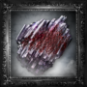 | WEAPON MASTER  ACQUIRE A WEAPON OF THE HIGHEST LEVEL. | GETTING A WEAPON TO +9 IS A RELATIVELY EASY TASK WITH THE MYRIAD OF WAYS TO GET SHARDS, TWIN SHARDS AND CHUNKS, BUT TO REACH THE FABLED HEIGHTS OF +10 YOU WILL NEED A BLOOD ROCK, AND THEY ARE IN EXTREMELY SHORT SUPPLY. THE ONLY GUARANTEED ONE THAT YOU CAN FIND IS BY GOING THROUGH THE CRUMBLED WALL ON THE MIDDLE BRIDGE IN NIGHTMARE OF MENSIS, AND THEN DROPPING DOWN TO THE SMALL ROOM BELOW OUTSIDE OF THAT ONE, THE ONLY OTHER WAY TO GET THEM IS BY VENTURING INTO DEPTH 5 RANDOMLY GENERATED ROOT CHALICE DUNGEONS. | 
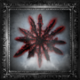 | BLOOD GEM MASTER  ACQUIRE AN EXTREMELY PRECIOUS BLOOD GEM. | TO UNLOCK THIS TROPHY YOU WILL NEED TO GET A BLOOD GEM THAT HAS A RATING OF 15 OR HIGHER, AND THE EASIEST WAY TO GET ONE IS TO VENTURE INTO THE CHALICE DUNGEONS. THE FLOOR BOSSES OF DEPTH 4 DUNGEONS CAN DROP GEMS OF A HIGH ENOUGH LEVEL, OR YOU CAN FIND THEM FROM CHESTS/RANDOM ENEMY DROPS IN DEPTH 5 LABYRINTHS. ALTERNATIVELY YOU CAN FIND SUCH GEMS AS LOOTABLE TREASURES IN THE OLD HUNTERS EXPANSIONS AREAS, SPECIFICALLY RESEARCH HALL AND FISHING HAMLET.
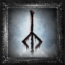 | RUNE MASTER  ACQUIRE AN EXTREMELY PRECIOUS CARYLL RUNE. | IF YOU WENT TO THE HEALING CHURCH WORKSHOP TO GET THE COMMUNION CARYLL RUNE, YOU CAN FOLLOW THE HIDDEN PATH IN THE ELEVATOR SHAFT THERE TO REACH A CHEST CONTAINING A FORMLESS OEDON CARYLL RUNE ACQUIRING THAT RUNE THAT WILL UNLOCK THIS TROPHY.
 | CAINHURST  GAIN ENTRY TO CAINHURST, THE LOST AND RUINED CASTLE. | THIS TROPHY WILL UNLOCK AS SOON AS YOU ENTER THE CAINHURST CASTLE GROUNDS; TO GET THERE YOU WILL FIRST NEED TO FULFILL A COUPLE OF REQUIREMENTS. THE FIRST THING TO OBTAIN IS THE CAINHURST SUMMONS, WHICH CAN BE FOUND IN THE 2ND FLOOR OPERATING ROOM WITHIN IOSEFKA'S CLINIC. TO REACH THAT AREA, ENTER THE FORBIDDEN WOODS AND PROGRESS FAR ENOUGH TO ACCESS THE SUBTERRANEAN CAVE AT THE BACK OF THE CAVE IS A LADDER THAT YOU CAN CLIMB TO REACH A SMALL GRAVEYARD,FROM WHICH THERE'S A PATH LEADING INTO THE CLINIC. WITH THE SUMMONS IN YOUR POSSESSION, HEAD TO HEMWICK CHARNEL LANE (AFTER KILLING THE WITCH OF HEMWICK) AND INSPECT THE OBELISK IN THE MIDDLE OF THE EXECUTION GROUNDS TO TRIGGER THE CAINHURST CARRIAGE EVENT. BOARD THE CARRIAGE AND YOU'LL HAVE THE TROPHY IN NO TIME AT ALL.
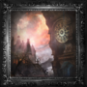 | THE CHOIR  GAIN ENTRY TO THE REALM OF THE CHOIR, THE HIGH STRATUM OF THE HEALING CHURCH. | TO UNLOCK THIS TROPHY YOU'LL NEED TO TRAVEL TO THE UPPER CATHEDRAL WARD. TO GET THE KEY YOU NEED TO OPEN THE DOOR IN THE HEALING CHURCH WORKSHOP, TAKE A TRIP INTO YAHAR'GUL, UNSEEN VILLAGE (BLOOD MOON). THE UPPER CATHEDRAL KEY CAN BE FOUND IN THE HOLDING CELLS AREA OF YAHAR'GUL, AND TO REACH IT YOU'LL NEED TO DROP DOWN ONTO THE LEDGE OUTSIDE FROM ABOVE, SO THAT YOU CAN GET INTO THE CELL. ONCE YOU HAVE THE KEY, MAKE YOUR WAY UP THE TOWER IN THE HEALING CHURCH WORKSHOP AND OPEN THE DOOR TO ACCESS THIS AREA.
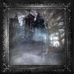 | THE SOURCE OF THE DREAM  DISCOVER THE ABANDONED OLD WORKSHOP, THE SOURCE OF THE HUNTER'S DREAM. | DISCOVERING THE SOURCE OF THE DREAM REQUIRES A TRIP INTO THE HEALING CHURCH WORKSHOP, SO YOU WON'T BE ABLE TO UNLOCK THIS TROPHY UNTIL YOU HAVE COMPLETED OLD YHARNAM. ONCE YOU'VE FINISHED THAT AREA, THE DOOR IN THE ODEON CHAPEL OF CATHEDRAL WARD WILL OPEN AND YOU CAN ENTER THE HEALING CHURCH WORKSHOP. MAKE YOUR WAY AROUND TO WOODEN BRIDGE AT THE TOP OF THE TOWER'S LOWER SECTION, AND THEN USE THE LEDGES THERE TO DROP DOWN TO WHERE THE DOOR IS THAT LEADS TO THE ABANDONED OLD WORKSHOP; THE TROPHY WILL UNLOCK AS SOON AS YOU ENTER THE AREA.
 | NIGHTMARE LECTURE BUILDING  GAIN ENTRY INTO THE BYRGENWERTH LECTURE BUILDING, THAT DRIFTS WITHIN THE REALM OF NIGHTMARE. | THERE ARE A COUPLE OF WAYS YOU CAN UNLOCK THIS TROPHY. IT'S POSSIBLE TO UNLOCK IT LATE IN THE GAME THROUGH NORMAL PROGRESS - EXAMINING THE MUMMY IN THE ROOM BEYOND THE BOSS OF YAHAR'GUL, UNSEEN VILLAGE (BLOOD MOON) WILL TAKE YOU TO THE 2ND FLOOR OF THIS BUILDING. UNLOCKING IT EARLIER REQUIRES THE TONSIL STONE, WHICH CAN BE OBTAINED BY ENTERING THE FORBIDDEN WOODS SO THAT PATCHES THE SPIDER TAKES OVER THE RESIDENTIAL NPCS; HE'LL GIVE YOU THE STONE IF YOU TALK TO ANY OF THEM. ONCE YOU HAVE THE STONE, RETURN TO THE CATHEDRAL WARD AND GO TO THE ROOM AT THE END OF THE CLIFFS; APPROACH THE DOOR AT THE OTHER END OF THE ROOM TO TRIGGER THE FALSE GOD'S ATTACK AND LET IT HIT YOU. WITHOUT THE STONE THE ATTACK WOULD KILL YOU, BUT WITH IT YOU'LL BE TRANSPORTED TO THE 1ST FLOOR OF THE LECTURE BUILDING AND UNLOCK THE TROPHY.

IMAGE | TROPHY | DETAIL | TYPE
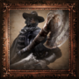 | FATHER GASCOIGNE  DEFEAT THE BEAST THAT ONCE WAS FATHER GASCOIGNE. | TO MAKE IT OUT OF CENTRAL YHARNAM AND CONTINUE YOUR QUEST TO SEEK THE PALEBLOOD YOU'LL NEED TO DEFEAT FATHER GASCOIGNE. HE CAN BE FOUND IN THE TOMB OF OEDON AREA OF CENTRAL YHARNAM, WHICH YOU CAN REACH BY GOING ALONG THE CANALS AND ACROSS THE LOWER BRIDGE; DEFEAT HIM TO UNLOCK THIS TROPHY. | 
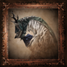 | VICAR AMELIA  DEFEAT THE BEAST THAT ONCE WAS VICAR AMELIA. | THE PRAYER THAT VICAR AMELIA IS OFFERING WITHIN THE GRAND CATHEDRAL WILL NOT SAVE HER FROM THE HUNT THIS NIGHT. BEFORE YOU CAN VANQUISH THE BEAST AND UNLOCK THIS TROPHY, YOU MUST FIRST OPEN THE WAY TO THE GRAND CATHEDRAL. THE QUICKEST WAY TO REACH AMELIA IS TO KILL THE CLERIC BEAST IN CENTRAL YHARNAM TO GET THE SWORD HUNTER BADGE, WHICH WILL ALLOW YOU TO PURCHASE THE HUNTER CHIEF EMBLEM FROM THE BATH MESSENGER IN THE HUNTER'S DREAM WITH THIS ITEM IN HAND YOU CAN APPROACH THE PLAZA GATE AND OPEN IT TO REACH THE BACK HALF OF THE CATHEDRAL WARD. ALTERNATIVELY, GO TO THE LOWER CHAPEL IN THE CATHEDRAL WARD TO ACCESS OLD YHARNAM, AND AFTER COMPLETING THAT AREA, ENTER THE NOW-OPEN DOOR IN THE OEDON CHAPEL AND GO THROUGH THE HEALING CHURCH WORKSHOP. AT THE END OF THAT AREA YOU CAN DROP DOWN TO THE BACK HALF OF THE CATHEDRAL WARD AND REACH THE STAIRS THAT WILL TAKE YOU THE GRAND CATHEDRAL.
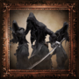 | SHADOW OF YHARNAM  DEFEAT THE SHADOW OF YHARNAM. | AFTER DEFEATING VICAR AMELIA, YOU CAN INSPECT THE ALTAR AT THE BACK OF THE GRAND CATHEDRAL TO GET THE PASSWORD THAT WILL LET YOU ACCESS THE FORBIDDEN WOODS. BATTLE YOUR WAY THROUGH THAT AREA AND YOU'LL FIND THE MYSTERIOUS SHADOWS OF YHARNAM DEFENDING THE PATH TO BYRGENWERTH WITH THEIR LIVES; PUT AN END TO THEM TO UNLOCK THIS TROPHY.
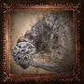 | ROM, THE VACUOUS SPIDER  DEFEAT GREAT ONE: ROM, THE VACUOUS SPIDER. | TO ACQUIRE THIS TROPHY YOU'LL NEED TO FACE AND DEFEAT ROM, THE VACUOUS SPIDER, ONE OF THE GREAT ONES. TO REACH HIM, ENTER THE BYRGENWERTH COLLEGE BUILDING, AND AFTER MAKING YOUR WAY OUT ONTO THE LUNARIUM, DIVE INTO HIS HIDING PLACE WITHIN THE MOONSIDE LAKE.
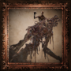 | THE ONE REBORN  DEFEAT THE ONE REBORN. | THE ONE REBORN CAN BE FOUND NEAR THE END OF THE ROAD IN YAHAR'GUL, UNSEEN VILLAGE (BLOOD MOON). TO REACH THAT AREA YOU'LL NEED TO GO THROUGH THE SUSPICIOUS DOOR AT THE END OF THE MAIN HALLWAY OF LECTURE BUILDING 2F. THIS TROPHY WILL UNLOCK AS SOON AS YOU'VE DEFEATED HIM.
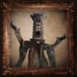 | MICOLASH, HOST OF THE NIGHTMARE  DEFEAT MICOLASH, HOST OF THE NIGHTMARE. | SHORTLY AFTER CROSSING THE VERTICAL LIFT BRIDGE IN THE NIGHTMARE OF MENSIS, YOU'LL ENCOUNTER MICOLASH, HOST OF THE NIGHTMARE; KILLING HIM WILL NOT ONLY END HIS DREAM, BUT ALSO UNLOCK THIS TROPHY.
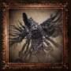 | MERGO'S WET NURSE  DEFEAT GREAT ONE: MERGO'S WET NURSE. | DEFEATING MERGO'S WET NURSE WILL PUT AN END TO THE CHILD'S SUFFERING AND UNLOCK THIS TROPHY. TO REACH IT YOU'LL NEED TO FIGHT YOUR WAY UP TO MERGO'S LOFT: ROOFTOPS, IN THE NIGHTMARE OF MENSIS. AND THEN TAKE THE ELEVATOR UP AT THE END OF THE PATH.
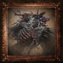 | CLERIC BEAST  DEFEAT CLERIC BEAST. | THE CLERIC BEAST CAN BE FOUND AT THE END OF THE GREAT BRIDGE IN CENTRAL YHARNAM, AND IS THE FIRST BOSS THAT YOU'RE LIKELY TO ENCOUNTER. WHILE IT IS TECHNICALLY OPTIONAL, DEFEATING IT WILL OPEN UP SOME USEFUL FEATURES, AS WELL AS EARN YOU THIS TROPHY.
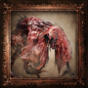 | BLOOD-STARVED BEAST  DEFEAT BLOOD-STARVED BEAST. | TO DEFEAT THE BLOOD-STARVED BEAST YOU'LL NEED TO TAKE A TRIP DOWN TO OLD YHARNAM, WHICH YOU CAN DO ALMOST IMMEDIATELY AFTER ENTERING THE CATHEDRAL WARD. NOT ONLY WILL KILLING IT UNLOCK THIS TROPHY, BUT YOU'LL ALSO GET THE CHALICE OF PTHUMERU TROPHY FOR ACQUIRING THE HOLY CHALICE THAT IT DROPS.
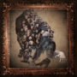 | THE WITCH OF HEMWICK  DEFEAT THE WITCH OF HEMWICK. | IF YOU WANT TO REACH THE PATH THAT LEADS TO HEMWICK CHARNEL LANE WHERE THE WITCH RESIDES, YOU'LL NEED TO FIRST MAKE IT TO THE BACK OF THE CATHEDRAL WARD. THE QUICKEST WAY IS TO DEFEAT THE CLERIC BEAST TO GET THE SWORD HUNTER BADGE, WHICH UNLOCKS THE HUNTER CHIEF EMBLEM IN THE BATH MESSENGER, AND USE THAT TO GET PAST THE PLAZA GATE IN THE CATHEDRAL WARD. ALTERNATIVELY, YOU CAN COMPLETE OLD YHARNAM TO OPEN UP THE HEALING CHURCH WORKSHOP, AND THEN GO THROUGH THAT AREA TO REACH THE LEDGE AT THE END; DROP DOWN FROM THE LEDGE TO LAND IN THE BACK HALF OF THE CATHEDRAL WARD. ONCE YOU REACH HEMWICK, GO THROUGH THE AREA AND KILL THE WITCH AT THE END TO UNLOCK THE TROPHY.
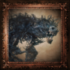 | DARKBEAST PAARL  DEFEAT DARKBEAST PAARL. | BEFORE YOU CAN KILL DARKBEAST PAARL AND UNLOCK THIS TROPHY YOU'LL NEED TO FIND YOUR WAY TO HIM, AND THAT MEANS GETTING INTO YAHAR'GUL, UNSEEN VILLAGE. IF YOU WANT TO FACE THIS BEAST AS EARLY AS POSSIBLE, YOU'LL NEED TO FIRST DEFEAT THE BLOOD-STARVED BEAST AT THE END OF OLD YHARNAM SO THAT THE KIDNAPPERS BEGIN TO APPEAR IN VARIOUS AREAS. LET YOURSELF GET KILLED BY ONE OF THESE KIDNAPPERS AND THEY'LL TAKE YOU TO YAHAR'GUL, UNSEEN VILLAGE (EVENING), AND THEN WORK YOUR WAY THROUGH THE AREA TO FACE PAARL. ALTERNATIVELY, YOU CAN WAIT UNTIL YOU REACH THE AREA LATER IN THE GAME ONCE THE BLOOD MOON IS OUT; THE AREA WILL BE MORE DIFFICULT AT THAT TIME, BUT THE FIGHT WITH PAARL WILL BE MUCH EASIER DUE TO YOUR INCREASED LEVEL.
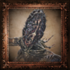 | AMYGDALA  DEFEAT GREAT ONE: AMYGDALA. | AMYGDALA CAN BE FOUND AT THE END OF THE NIGHTMARE FRONTIER, AN AREA YOU'LL NEED TO GO THROUGH THE LECTURE BUILDING TO REACH. YOU CAN ACCESS THE 1ST FLOOR OF THE LECTURE BUILDING BY GETTING THE TONSIL STONE AND LETTING THE FALSE GOD'S ATTACK HIT YOU IN THE ROOM AT THE END OF THE CLIFFS IN THE CATHEDRAL WARD. TO REACH THE 2ND FLOOR, YOU CAN JUST PROGRESS THROUGH THE GAME NORMALLY AND EXAMINE THE MUMMY AT THE END OF YAHAR'GUL, UNSEEN VILLAGE (BLOOD MOON). DEFEATING THIS BOSS WILL ALSO UNLOCK THE CHALICE OF AILING LORAN TROPHY FOR ACQUIRING THE HOLY CHALICE THAT IT DROPS.
 | MARTYR LOGARIUS  DEFEAT MARTYR LOGARIUS. | AFTER MAKING YOUR WAY TO FORSAKEN CAINHURST CASTLE (SEE THE CAINHURST TROPHY), CONTINUE THROUGH THE AREA AND YOU'LL COME FACE-TO-FACE WITH MARTYR LOGARIUS AT THE END. HE'S AN EXTREMELY CHALLENGING FOE, SO BE SURE TO CHECK HIS STRATEGY SECTION TO FIND OUT HIS WEAKNESSES.
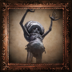 | CELESTIAL EMISSARY  DEFEAT GREAT ONE: CELESTIAL EMISSARY. | THE CELESTIAL EMISSARY CAN BE FOUND IN THE LUMENFLOWER GARDEN AREA OF THE UPPER CATHEDRAL WARD AND YOU'LL UNLOCK THE TROPHY AS SOON AS YOU DEFEAT IT.
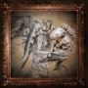 | EBRIETAS, DAUGHTER OF THE COSMOS  DEFEAT GREAT ONE: EBRIETAS, DAUGHTER OF THE COSMOS. | UPON DEFEATING THE CELESTIAL EMISSARY IN THE UPPER CATHEDRAL WARD YOU'LL BE ABLE TO SEE AN ORNATE STAINED-GLASS WINDOW NEAR THE LUMENFLOWER GARDEN LAMP. IF YOU BREAK THROUGH THAT WINDOW YOU CAN ACCESS A HIDDEN PART OF THE AREA. MAKE YOUR WAY ALONG THE WALKWAYS AND DOWN THE ELEVATOR AT THE END TO REACH THE ALTAR OF DESPAIR, WHERE YOU'LL FIND EBRIETAS DEFEATING HER NOT ONLY UNLOCKS THIS TROPHY, BUT ALSO THE CHALICE OF ISZ TROPHY, FOR GETTING THE HOLY CHALICE SHE DROPS
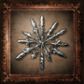 | BLOOD GEM CONTACT  ACQUIRE A BLOOD GEM THAT IMBUES HUNTER WEAPONS WITH SPECIAL STRENGTH. | TO UNLOCK THIS TROPHY YOU SIMPLY NEED TO ACQUIRE A BLOOD GEM OF ANY STRENGTH. WHILE YOU MAY BE LUCKY ENOUGH TO HAVE ONE DROP FROM AN ENEMY, THE FIRST GUARANTEED PLACE YOU CAN UNLOCK THIS TROPHY IS BY GETTING THE TEMPERING BLOOD GEMSTONE FROM THE CHEST AT THE END OF THE YHARNAM PATH IN THE CATHEDRAL WARD.
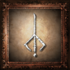 | RUNE CONTACT  ACQUIRE A CARYLL RUNE THAT ENDOWS HUNTERS WITH SPECIAL STRENGTH. | SIMILAR TO THE BLOOD GEM CONTACT TROPHY, PICKING UP ANY LEVEL OF CARYLL RUNE WILL UNLOCK THIS TROPHY. THE FIRST PLACE THAT YOU CAN GET A RUNE WILL DEPEND ON THE ORDER YOU TACKLE THE AREAS IN, BUT THE FIRST ONES WILL GENERALLY BE EITHER A COMMUNION CARYLL RUNE JUST BEFORE THE TOWER BRIDGE IN THE HEALING CHURCH WORKSHOP, OR A LAKE ONE THAT YOU CAN FIND AT THE END OF THE CASTLE BLUFF IN HEMWICK CHARNEL LANE.
 | CHALICE OF PTHUMERU  ACQUIRE THE CHALICE OF PTHUMERU THAT SEALS THE CATACOMBS THAT FORM A WEB DEEP BELOW YHARNAM. | TO UNLOCK THIS TROPHY YOU'LL NEED TO OBTAIN THE PTHUMERU CHALICE, WHICH YOU'LL BE AWARDED FOR DEFEATING THE BLOOD-STARVED BEAST AT THE END OF OLD YHARNAM.
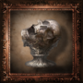 | CHALICE OF AILING LORAN  ACQUIRE THE CHALICE OF AILING LORAN THAT SEALS THE TRAGIC LAND LOST TO THE SANDS. | YOU CAN OBTAIN THE AILING LORAN CHALICE TO UNLOCK THIS TROPHY BY DEFEATING AMYGDALA AT THE END OF THE NIGHTMARE FRONTIER.
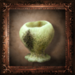 | CHALICE OF ISZ  ACQUIRE THE GREAT CHALICE OF ISZ THAT SEALS THE HOME OF THE COSMIC KIN. | THE GREAT ISZ CHALICE THAT YOU NEED TO UNLOCK THIS TROPHY CAN BE OBTAINED BY DEFEATING EBRIETAS, DAUGHTER OF THE COSMOS. YOU'LL FIND EBRIETAS WITHIN THE ALTAR OF DESPAIR SECTION OF THE UPPER CATHEDRAL WARD.

IMAGE | TROPHY | DETAIL | TYPE
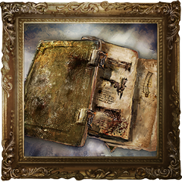 | OLD HUNTER'S ESSENCE  ACQUIRE ALL OLD HUNTER WEAPONS. | OBTAINING A NORMAL HUNTER'S ESSENCE IS NO LONGER CONSIDERED THE PINNACLE OF WHAT IT MEANS TO BE A TRUE HUNTER; TO REACH THAT LOFTY GOAL YOU'LL NEED TO DELVE DEEP INTO THE NIGHTMARE TO EXPERIENCE ALL THAT IT HAS TO OFFER - ONLY THEN CAN YOU TAP INTO THE OLD HUNTER'S ESSENCE. UNLOCKING THIS TROPHY WILL REQUIRE YOU TO FULLY EXPLORE EACH OF THE NEW AREAS TO FIND ALL OF THE HIDDEN WEAPONS, AND DEFEAT SOME OF THE TOUGHEST FOES THE GAME HAS TO OFFER. RIGHT HAND WEAPONS: AMYGDALAN ARM, BEASTHUNTER SAIF, BEAST CUTTER, BLOODLETTER, BOOM HAMMER, CHURCH PICK, HOLY MOONLIGHT SWORD, KOS PARASITE, RAKUYO, SIMON'S BOWBLADE, WHIRLIGIG SAW. LEFT HAND WEAPONS: CHURCH CANNON, FIST OF GRATIA, LOCH SHIELD, PIERCING RIFLE, GATLING GUN.
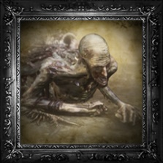 | ORPHAN OF KOS  DEFEAT GREAT ONE: ORPHAN OF KOS. | BE PREPARED, PLAN AHEAD, AND PREPARE TO DIE... THIS WILL BE ONE OF THE HARDEST TROPHIES TO EARN ACROSS BOTH THE MAIN GAME AND THE OLD HUNTERS. BE PATIENT AND LEARN KOS'S PATTERNS. EVENTUALLY YOU WILL KNOW WHEN TO EVADE, AND WHEN TO INTERRUPT - BRING A VERY POWERFUL WEAPON TO TAKE FULL ADVANTAGE OF EACH OPENING. 'ORPHAN OF KOS' IS A TROPHY HARD WON; ONLY THE BEST HUNTERS WILL MANAGE IT.
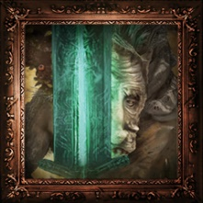 | LUDWIG, THE HOLY BLADE  DEFEAT THE BEAST THAT WAS ONCE LUDWIG, THE HOLY BLADE. | LUDWIG CAN BE A VERY DIFFICULT FIGHT, SO IT'S RECOMMENDED THAT YOU GO TO THE FORBIDDEN WOODS AND SPEAK WITH VALTR TO JOIN THE LEAGUE AND GET THE IMPURITY CARYLL RUNE. WITH THAT RUNE EQUIPPED YOU'LL BE ABLE TO SUMMON VALTR AND YOUNGER TWIN MADARAS TO AID YOU IN THE BOSS FIGHT, MAKING IT MUCH EASIER. THEY WILL PROVIDE A MUCH STRONGER ASSISTANCE AGAINST LUDWIG THAN OLD HUNTER HENRIETT, WHO CAN BE SUMMONED BEHIND THE NIGHTMARE CHURCH. AFTER DEFEATING HIM, EITHER CLEAVE HIS REMAINING HEAD OR WEAR CHURCH GARB AND SPEAK TO IT (ANSWERING YES TO HIS QUESTION) TO RECEIVE THE HOLY MOONLIGHT SWORD, WHICH YOU'LL NEED FOR THE OLD HUNTER'S ESSENCE TROPHY.
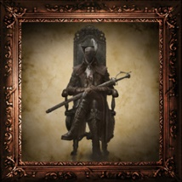 | LADY MARIA OF THE ASTRAL CLOCKTOWER  DEFEAT LADY MARIA OF THE ASTRAL CLOCKTOWER. | YOU'LL BE ABLE TO FACE LADY MARIA STRAIGHT AFTER BEATING THE LIVING FAILURES, AND SHE IS A POWERFUL AND RELENTLESS FOE. MAKE SURE TO BRING A LEFT-HANDED FIREARM THAT IS GOOD FOR INTERRUPTS, AS THEY'LL OFFER ONE OF THE BEST WAYS OF DAMAGING HER. IF YOU HAVE MORE THAN ONE 'CLAWMARK' CARYLL RUNE, IT'S WORTH STACKING THEM ON YOUR CHARACTER AT THE MEMORY ALTAR IN THE HUNTER'S DREAM TO INCREASE YOUR VISCERAL ATTACK DAMAGE AFTER AN INTERRUPT.
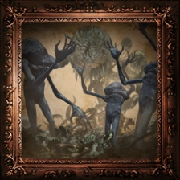 | LIVING FAILURES  DEFEAT THE FAILED ATTEMPTS TO BECOME GREAT ONES. | TO REACH THE LIVING FAILURES YOU'LL NEED TO MAKE YOUR WAY TO THE VERY TOP OF THE RESEARCH HALL AND ACTIVATE THE STAIRCASE MECHANISM TO MOVE THE STAIRS. ONLY THEN WILL YOU BE ABLE TO ACCESS THE DOOR TO THIS BOSS. IF YOU HAVE KILLED YAMAMURA IN HIS CELL - THUS FREEING HIM FROM CAPTIVITY - YOU WILL BE ABLE TO SUMMON HIM OUTSIDE THE ENTRANCE TO THE BOSS AREA, AND HE CAN ASSIST YOU GREATLY IN THIS BATTLE.
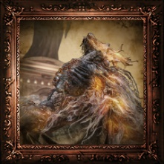 | LAURENCE, THE FIRST VICAR  DEFEAT THE BEAST THAT WAS ONCE LAURENCE, THE FIRST VICAR. | BEFORE YOU CAN FACE LAURENCE IN BATTLE YOU MUST FIRST FIND HIS SKULL, WHICH IS WELL HIDDEN ON A SECRET ALTAR BENEATH THE SURGERY ALTAR IN THE RECOVERY ROOM. TO ACCESS THE HIDDEN ALTAR YOU WILL NEED TO STEP ONTO THE SURGERY ALTAR SO THAT IT STARTS TO GO UP, AND THEN QUICKLY RUN OFF IT SO THAT YOU LAND BACK IN THE ROOM. ONCE THE ELEVATOR COMES TO A STOP THE HIDDEN ALTAR WILL BE REVEALED AND YOU'LL BE ABLE TO RECOVER LAURENCE'S SKULL. WITH THE SKULL IN HAND YOU'LL BE ABLE TO INITIATE THE BATTLE WITH LAURENCE BY RETURNING IT TO HIM IN THE NIGHTMARE GRAND CATHEDRAL (WHICH OF COURSE IS IN THE HUNTER'S NIGHTMARE). THE MIGHTY VALTR CAN ONCE AGAIN AID YOU IN THIS BATTLE IF YOU HAVE JOINED THE LEAGUE AND HAVE THE IMPURITY RUNE EQUIPPED - YOU'LL FIND HIS SUMMON SIGN JUST INSIDE THE CATHEDRAL.

