THE GLOBAL LISTS OF ADDICTIVE DRUG CHEMICALS IN DRINKS, FOODS, SCREWING & SMOKES---PART 4
YAHWEH HIMSELF IS THE ONLY TRUE ANSWER & THE ONLY EFFECTIVE REMEDY TO ANY OF THESE THINGS INFINTELY!!!
YES! YAHWEH ONLY SAVES. BUT NORMALLY SHALL BE LONG WITH YOU, AS LONG AS YAHWEH DAMN-WELL PLEASES, TO GET THE ONLY GLORY TO HIMSELF OUT OF IT. THIS IS THE WHOLE POINT THAT THE SUPREME VENGEANCE ARMOR (ISAIAH 59:17) IS SUPREMELY AUTHORIZED & GREATLY EMPOWERED BASED ON WHAT YOU HAVE ENDURED IN SERVING YAHWEH! BUT IN THE RULES OF ENGAGEMENT, IF YOU ARE ATTACKED FIRST, THEN YOU CAN ATTACK BACK, BUT HOW YOU ATTACK SHALL DETERMINE ITS OUTCOME! THE ONLY CORRECT WAY TO DEAL WITH FORBIDDEN EVIL, IS ALWAYS LET YAHWEH HANDLE IT, NOT SOME INFERIOR LORD! BUT IF YOU WANT AN IMMEDIATE FIXER UPPER WITH YOUR SKIN ARMOR, LIKE LEANING ON JESUS ALONE, CHRIST ALONE, JESUS ONLY, CHRIST ONLY, OR SIMPLY BARABBAS, TO HEAL YOU, THEN YOU HAVE CHOSEN THE INDEPENDENT IDOLATRY (EXODUS 20:1-7) & THE IMMEDIATE HEALING (REVELATION 13) THAT CAN COME FROM ONLY THE DEVIL & THE WITCH! IN JOHN 18:1-43 DECLARES: 18 AND HE SPAKE A PARABLE UNTO THEM TO THIS END, THAT MEN OUGHT ALWAYS TO PRAY, AND NOT TO FAINT; ² SAYING, THERE WAS IN A CITY A (UNJUST) JUDGE, WHICH FEARED NOT GOD (YAHWEH), NEITHER REGARDED MAN (JESUS): ³ AND THERE WAS A WIDOW IN THAT CITY; AND SHE CAME UNTO HIM, SAYING, AVENGE ME OF MINE ADVERSARY. ⁴ AND HE WOULD NOT FOR A WHILE: BUT AFTERWARD HE SAID WITHIN HIMSELF, THOUGH I FEAR NOT GOD (YAHWEH), NOR REGARD MAN (JESUS); ⁵ YET BECAUSE THIS WIDOW TROUBLETH ME, I WILL AVENGE HER, LEST BY HER CONTINUAL COMING SHE WEARY ME. ⁶ AND THE LORD (STEPHEN YAHWEH) SAID, HEAR WHAT THE UNJUST JUDGE SAITH. ⁷ AND SHALL NOT GOD (YAHWEH) AVENGE HIS OWN ELECT, WHICH CRY DAY AND NIGHT UNTO HIM, THOUGH HE BEAR LONG WITH THEM (AS YAHWEH PLEASES)? ⁸ I TELL YOU THAT HE WILL AVENGE THEM SPEEDILY (NORMALLY VENGEANCE SHALL COME UP IMMEDIATE (YAHWEH’S HEROIC DOING SUPREMELY AUTHORIZED IN THE LORDLY OCCULT IN ACTS 5:1-11; 13:4-12) SIMUTANEOUSLY TO 30 SECONDS TO 30 MINUTES (YAHWEH’S DAY TO YAHWEH’S HOUR & YAHWEH’S HOUR TO YAHWEH’S MINUTE, ALL VARIOUS HEALINGS DONE BY YAHWEH ONLY) SIMUTANESOULY TO 12 MINUTES TO 12 HOURS (YAHWEH’S DAY TO YAHWEH’S HOUR & YAHWEH’S HOUR TO YAHWEH’S MINUTE, THE 3RD DAY PERFECTED OR THE 3RD NIGHT PERFECTED) SIMUTANEOUSLY TO 21 MINUTES TO 21 HOURS (YAHWEH’S DAY TO YAHWEH’S HOUR & YAHWEH’S HOUR TO YAHWEH’S MINUTE, THE 6 WITNESES IN REVELATION 11) SIMUTANEOSULY TO 24 MINUTES TO 24 HOURS (YAHWEH’S DAY TO YAHWEH’S HOUR & YAHWEH’S HOUR TO YAHWEH’S MINUTE, LAZARUS RAISED FROM THE DEAD STINKING IN THE TOMB, DEAD & DECOMPOSING FOR 4 DAYS) SIMUTANEOUSLY TOPS BASED ON THE DEATH PENALTY IN MATTHEW 20:12; 24:36-51; MARK 13:32-37; JOHN 11:1-53; REVELATION 11:1-19 & LUKE 13:32). NEVERTHELESS, WHEN THE SON OF MAN COMETH, SHALL HE FIND FAITH ON THE EARTH? ⁹ AND HE SPAKE THIS PARABLE UNTO CERTAIN WHICH TRUSTED IN THEMSELVES THAT THEY WERE RIGHTEOUS, AND DESPISED OTHERS: ¹⁰ TWO MEN WENT UP INTO THE TEMPLE TO PRAY; THE ONE A PHARISEE, AND THE OTHER A PUBLICAN. ¹¹ THE PHARISEE STOOD AND PRAYED THUS WITH HIMSELF, GOD (YAHWEH), I THANK THEE, THAT I AM NOT AS OTHER MEN ARE, EXTORTIONERS, UNJUST, ADULTERERS, OR EVEN AS THIS PUBLICAN. ¹² I FAST TWICE IN THE WEEK, I GIVE (MONEY) TITHES OF ALL THAT I POSSESS. ¹³ AND THE PUBLICAN, STANDING AFAR OFF, WOULD NOT LIFT UP SO MUCH AS HIS EYES UNTO HEAVEN, BUT SMOTE UPON HIS BREAST, SAYING, GOD (YAHWEH) BE MERCIFUL TO ME A SINNER. ¹⁴ I TELL YOU THIS MAN WENT DOWN TO HIS HOUSE JUSTIFIED RATHER THAN THE OTHER: FOR EVERY ONE THAT EXALTETH (PUT UP) HIMSELF SHALL BE ABASED (PUT DOWN); AND HE THAT HUMBLETH (PUT DOWN) HIMSELF SHALL BE EXALTED (PUT UP). ¹⁵ AND THEY BROUGHT UNTO HIM ALSO INFANTS, THAT HE WOULD TOUCH THEM: BUT WHEN HIS DISCIPLES SAW IT, THEY REBUKED THEM. ¹⁶ BUT JESUS CALLED THEM UNTO HIM, AND SAID, SUFFER LITTLE CHILDREN TO COME UNTO ME, AND FORBID THEM NOT: FOR OF SUCH IS THE KINGDOM OF GOD (LORDSHIP). ¹⁷ VERILY I SAY UNTO YOU, WHOSOEVER SHALL NOT RECEIVE THE KINGDOM OF GOD (LORDSHIP) AS A LITTLE CHILD SHALL IN NO WISE ENTER THEREIN. ¹⁸ AND A CERTAIN RULER ASKED HIM, SAYING, GOOD MASTER, WHAT SHALL I DO TO INHERIT ETERNAL LIFE? ¹⁹ AND JESUS SAID UNTO HIM, WHY CALLEST THOU ME GOOD? NONE IS GOOD, SAVE ONE, THAT IS, GOD (YAHWEH). ²⁰ THOU KNOWEST THE COMMANDMENTS, DO NOT COMMIT ADULTERY (JAMES 2:8-13), DO NOT KILL (1ST SAMUEL 2:6), DO NOT STEAL (MALACHI 3:8-12), DO NOT BEAR FALSE WITNESS (EXODUS 20:1-7), HONOUR THY FATHER (STEPHEN) AND THY MOTHER (VICTORIA)---(IN JOHN 5:39-47 DECLARES: 39SEARCH THE SCRIPTURES; FOR IN THEM YE THINK YE HAVE ETERNAL LIFE: AND THEY ARE THEY WHICH TESTIFY OF ME (YAHWEH, NEVER JESUS ALONE). 40AND YE WILL NOT COME TO ME (YAHWEH, NEVER CHRIST ALONE), THAT YE MIGHT HAVE LIFE. 41I RECEIVE NOT HONOUR FROM MEN. 42BUT I KNOW YOU, THAT YE HAVE NOT THE (TRUE) LOVE OF GOD (YAHWEH) IN YOU. 43I AM COME IN MY FATHER'S (YAHWEH’S) NAME, AND YE RECEIVE ME NOT (YAHWEH, NEVER JESUS ALONE): IF ANOTHER SHALL COME IN HIS OWN NAME (JESUS ALONE OR CHRIST ALONE, NEVER YAHWEH ALONE), HIM YE WILL RECEIVE. 44HOW CAN YE BELIEVE, WHICH RECEIVE HONOUR ONE OF ANOTHER (JESUS ALONE OR CHRIST ALONE, NEVER YAHWEH ALONE), AND SEEK NOT THE HONOUR (ALWAYS YAHWEH, NEVER JESUS ALONE OR CHRIST ALONE) THAT COMETH FROM GOD (STEPHEN YAHWEH) ONLY? 45DO NOT THINK THAT I WILL ACCUSE YOU TO THE FATHER (YAHWEH): THERE IS ONE THAT ACCUSETH YOU, EVEN MOSES (THE SUPREME LORDSHIP OF THE SUPREME LAW AUTHORITY), IN WHOM YE TRUST. 46FOR HAD YE BELIEVED MOSES, YE WOULD HAVE BELIEVED ME (YAHWEH, NEVER JESUS ALONE): FOR HE WROTE OF ME (YAHWEH, NEVER JESUS ALONE). 47BUT IF YE BELIEVE NOT HIS WRITINGS, HOW SHALL YE BELIEVE MY WORDS (YAHWEH, NEVER JESUS ALONE)?). ²¹ AND HE SAID, ALL THESE HAVE I KEPT FROM MY YOUTH UP. ²² NOW WHEN JESUS HEARD THESE THINGS, HE SAID UNTO HIM, YET LACKEST THOU ONE THING: SELL (GIVE FREELY) ALL THAT THOU HAST, AND DISTRIBUTE (FREELY GIVE) UNTO THE POOR, AND THOU SHALT HAVE (TRUE) TREASURE IN HEAVEN: AND COME, FOLLOW ME. ²³ AND WHEN HE HEARD THIS, HE WAS VERY SORROWFUL: FOR HE WAS VERY RICH. ²⁴ AND WHEN JESUS SAW THAT HE WAS VERY SORROWFUL, HE SAID, HOW HARDLY SHALL THEY THAT HAVE RICHES ENTER INTO THE KINGDOM OF GOD (LORDSHIP)! ²⁵ FOR IT IS EASIER FOR A CAMEL TO GO THROUGH A NEEDLE'S EYE, THAN FOR A RICH MAN (UP TO 475.2 MILLION AT PALLADIUM LEVELS) TO ENTER INTO THE KINGDOM OF GOD (LORDSHIP). ²⁶ AND THEY THAT HEARD IT SAID, WHO THEN CAN BE SAVED? ²⁷ AND HE SAID, THE THINGS WHICH ARE IMPOSSIBLE WITH MEN ARE POSSIBLE WITH GOD (YAHWEH). ²⁸ THEN PETER SAID, LO, WE HAVE LEFT ALL, AND FOLLOWED THEE. ²⁹ AND HE SAID UNTO THEM, VERILY I SAY UNTO YOU, THERE IS NO MAN THAT HATH LEFT HOUSE, OR PARENTS, OR BRETHREN, OR WIFE, OR CHILDREN, FOR THE KINGDOM OF GOD'S (LORDSHIP’S) SAKE, ³⁰ WHO SHALL NOT RECEIVE MANIFOLD MORE (YAHWEH HIMSELF) IN THIS PRESENT TIME, AND IN THE WORLD TO COME LIFE EVERLASTING (YAHWEH HIMSELF). ³¹ THEN HE TOOK UNTO HIM THE TWELVE, AND SAID UNTO THEM, BEHOLD, WE GO UP TO JERUSALEM, AND ALL THINGS THAT ARE WRITTEN BY THE PROPHETS CONCERNING THE SON OF MAN SHALL BE ACCOMPLISHED. ³² FOR HE SHALL BE DELIVERED UNTO THE GENTILES, AND SHALL BE MOCKED, AND SPITEFULLY ENTREATED, AND SPITTED ON: ³³ AND THEY SHALL SCOURGE HIM, AND PUT HIM TO DEATH: AND THE THIRD DAY HE SHALL RISE AGAIN. ³⁴ AND THEY UNDERSTOOD NONE OF THESE THINGS: AND THIS SAYING WAS HID FROM THEM, NEITHER KNEW THEY THE THINGS WHICH WERE SPOKEN. ³⁵ AND IT CAME TO PASS, THAT AS HE WAS COME NIGH UNTO JERICHO, A CERTAIN BLIND MAN SAT BY THE WAY SIDE BEGGING: ³⁶ AND HEARING THE MULTITUDE PASS BY, HE ASKED WHAT IT MEANT. ³⁷ AND THEY TOLD HIM, THAT JESUS OF NAZARETH PASSETH BY. ³⁸ AND HE CRIED, SAYING, JESUS, THOU SON OF DAVID, HAVE MERCY ON ME. ³⁹ AND THEY WHICH WENT BEFORE REBUKED HIM, THAT HE SHOULD HOLD HIS PEACE: BUT HE CRIED SO MUCH THE MORE, THOU SON OF DAVID, HAVE MERCY ON ME. ⁴⁰ AND JESUS STOOD, AND COMMANDED HIM TO BE BROUGHT UNTO HIM: AND WHEN HE WAS COME NEAR, HE ASKED HIM, ⁴¹ SAYING, WHAT WILT THOU THAT I SHALL DO UNTO THEE? AND HE SAID, LORD (YAHWEH), THAT I MAY RECEIVE MY SIGHT. ⁴² AND JESUS SAID UNTO HIM, RECEIVE THY SIGHT: THY (LORDLY) FAITH (HEBREWS 11:5) HATH SAVED THEE. ⁴³ AND IMMEDIATELY HE RECEIVED HIS SIGHT, AND FOLLOWED HIM, GLORIFYING GOD (YAHWEH): AND ALL THE PEOPLE, WHEN THEY SAW IT, GAVE PRAISE UNTO GOD (YAHWEH ONLY).
THE LORD STEPHEN HIMSELF
THE LORD STEPHEN YAHWEH HIMSELF THE TOP SUPREME ENGLISH LORD
FIRST, THERE IS ONLY ONE ALONE TRUE GOD AS THE TRUE CREATOR OF THE UNIVERSE, BUT TECHNICALLY CONCERNING THE LORD YAHWEH ALSO KNOWN AS YW, IS THE TRUE CREATOR OF THE FATHER STEPHEN OUR LORD AS THE ONE TRUE GOD IN PROVERBS 8:22-29 (RSV). THIS MEANS THAT THE FATHER STEPHEN OUR LORD IS THE TRUE POTTER CREATOR OF THE ENTIRE UNIVERSE ACTING AS THE LORD YAHWEH AUTHORIZED BY HIM TO INITIATE AND SPEAK INTO EXISTENCE THE ENTIRE UNIVERSE IN GENESIS 1:1; DEUTERONOMY 32:6; 2ND PETER 2:1; ISAIAH 64:8; JOHN 8:58 & EPHESIANS 4:6. ALSO HE IS KNOWN AS THE LORD YAHWEH (SHORT NAME FOR YAH) THE CREATOR OVER ALL THE ENTIRE UNIVERSE AS THE FATHER STEPHEN OUR LORD’S SPIRIT IN GENESIS 1:1 & JUDITH 9:12. HE IS ALSO KNOWN AS THE LORD JEHOVAH (SHORT NAME FOR JAH) THE CREATOR OVER ALL THE ENTIRE EARTHS AS THE FATHER STEPHEN’S BODY IN PSALMS 83:18. HE IS ALSO KNOWN AS THE LORD VICTOR (SHORT NAME FOR VIC) THE CREATOR OVER ALL THE ENTIRE HEAVENS AS THE FATHER STEPHEN’S MIND WHICH IS DERIVED FROM THE NAME YAHWEH IN ISAIAH 38:11. THE FATHER STEPHEN (FEMALE SENSE IS THE LADY STEPHANIE) THE POTTER CREATOR OF THE ENTIRE UNIVERSE ONLY COMES INTO ETERNAL AGREEMENT WITH THE LORD YAHWEH THE TRUE CREATOR OF THE FATHER STEPHEN OUR LORD IN PROVERBS 8:22-29 (RSV); ISAIAH 64:8; ROMANS 13:1-10; EPHESIANS 4:6; JOHN 1:1-5, 14; HEBREWS 1:1-3; GENESIS 1:1 & JOHN 8:58. THE FATHER STEPHEN OUR LORD DOES NOT COME INTO ETERNAL AGREEMENT WITH THE LORD YAHWEH THE SUPPOSED CREATOR OF THE ENTIRE UNIVERSE (FATHER STEPHEN’S SPIRIT) OR THE LORD JEHOVAH THE SUPPOSED CREATOR OF THE ENTIRE EARTHS (FATHER STEPHEN’S BODY) OR THE LORD VICTOR THE SUPPOSED CREATOR OF THE ENTIRE HEAVENS (FATHER STEPHEN’S MIND) OR THE LADY VICTORIA THE SUPPOSED FEMALE CREATOR (LADY STEPHANIE’S BEING) BECAUSE HIS ETERNAL WITNESS IS IN ETERNAL LORDSHIP & HE NEVER AGREES WITH THE SEXUAL EROS LOVE APOSTASY CORRUPTION IN THIS WORLD THROUGH LUST IN 1ST JOHN 5:6-13; 2ND CORINTHIANS 2:17 & 2ND PETER 1:4. IN EXODUS 15:11 DECLARES “WHO IS LIKE YOU, O LORD, AMONG THE GODS? WHO IS LIKE YOU, MAJESTIC IN HOLINESS, TERRIBLE IN GLORIOUS DEEDS, DOING WONDERS?” IN DEUTERONOMY 6:4-5 (NIV) DECLARES “HEAR, O ISRAEL: THE LORD OUR GOD, THE LORD IS ONE, YOU SHALL (AGAPE) LOVE THE LORD YOUR GOD WITH ALL YOUR HEART AND WITH ALL YOUR SOUL AND WITH ALL YOUR STRENGTH.” SOME OTHER SCRIPTURES ARE DEUTERONOMY 4:35; MARK 12:29-31; JOHN 17:3; 1ST CORINTHIANS 8:4; 2ND KINGS 19:15; 23:25; MATTHEW 27:37-39; LUKE 10:27 AND PSALMS 97:10. IN 1ST KINGS 8:60 DECLARES “…THAT ALL THE PEOPLES OF THE EARTH MAY KNOW THAT THE LORD IS GOD, THERE IS NO OTHER.” IN ISAIAH 45:5-6 DECLARES “I AM THE LORD, AND THERE IS NO OTHER, BESIDES ME THERE IS NO GOD, I GIRD YOU, THOUGH YOU DO NOT KNOW ME, THAT MEN MAY KNOW, FROM THE RISING OF THE SUN AND FROM THE WEST, THAT THERE IS NONE BESIDES ME. I AM THE LORD AND THERE IS NO OTHER.” IN ISAIAH 45:21-22 SAYS “…THERE IS NO OTHER GOD BESIDES ME, A RIGHTEOUS GOD & SAVIOR (PROTECTION IN CALLING ON HIS NAME), THERE IS NONE BESIDES ME…TURN TO ME AND BE SAVED, ALL THE ENDS OF THE EARTH! FOR I AM GOD, AND THERE IS NO OTHER.” ALSO, A SIMILAR SCRIPTURE IS IN ISAIAH 44:6-8. IN ISAIAH 46:9 MENTIONS “REMEMBER THE FORMER THINGS OF OLD, FOR I AM GOD, AND THERE IS NO OTHER, I AM GOD, AND THERE IS NONE LIKE ME.” THE HOLY SCRIPTURES OF THE FATHER STEPHEN OUR LORD THE ONLY ONE TRUE GOD ACTING AS THE LORD YAHWEH THE CREATOR OF THE FATHER STEPHEN OUR LORD THE ONLY ALONE TRUE GOD IS PROVEN IN ISAIAH 64:8; EPHESIANS 4:6 & JOHN 8:58. IN 1ST TIMOTHY 2:5 DECLARES “FOR THERE IS ONE GOD (FATHER STEPHEN), AND THERE IS ONE MEDIATOR BETWEEN GOD AND MEN, THE MAN CHRIST JESUS.” IN ROMANS 3:30 SAYS “GOD IS ONE.” IN 1ST CORINTHIANS 8:6 SAYS “YET FOR US THERE IS ONE GOD (YAHWEH), THE FATHER (STEPHEN), FROM WHOM ARE ALL THINGS & FROM WHOM WE EXIST.” IN JAMES 2:19 STATES “YOU BELIEVE THAT GOD IS ONE, YOU DO WELL. EVEN THE DEMONS BELIEVE—AND SHUTTER (TREMBLE).” IN EPHESIANS 4:6 SAYS “ONE GOD (YAHWEH) AND FATHER (STEPHEN) OF ALL, WHO IS ABOVE ALL, AND THROUGH ALL, AND IN YOU ALL.”
THE LORD STEPHEN’S LIMITATIONS WITHIN 1 PERIMETER IN THE UPTIME/DOWNTIME IN 6 IN 1 POSITIONS WITH THE NUMBER 0 IN THE HOUSE WORLD? THERFORE THE LORD’S TRUE ELITE HOLY COVENANT PEOPLE & HIS ETERNAL LAWS----SUPREME AUTHORITIES ARE ALSO THERFORE ETERNALLY LIMITED IN ROMANS 13:3-10 & 1ST JOHN 3:9!!!
THE ALWAYS TRUTHFUL LORD ALONE & ONLY!
THE LORD STEPHEN HIMSELF THE SUPREME CREATOR OF THE FATHER STEPHEN OUR LORD KNOWN AS THE LORD STEPHEN YAHWEH HIMSELF IS CALLED “THE TRUTHFUL GOD” IN NUMBERS 23:19. IN NUMBERS 23:19 DECLARES “GOD IS NOT A MAN, THAT HE SHOULD LIE; NEITHER THE SON OF MAN, THAT HE SHOULD REPENT: HATH HE SAID, AND SHALL HE NOT DO IT? OR HATH HE SPOKEN, AND SHALL HE NOT MAKE IT GOOD?
THE ALWAYS REPENTLESS LORD ALONE & ONLY!
THE LORD STEPHEN HIMSELF THE SUPREME CREATOR OF THE FATHER STEPHEN OUR LORD KNOWN AS THE LORD STEPHEN YAHWEH HIMSELF IS CALLED “THE UNREPENTING GOD” IN NUMBERS 23:19. IN NUMBERS 23:19 DECLARES “GOD IS NOT A MAN, THAT HE SHOULD LIE; NEITHER THE SON OF MAN, THAT HE SHOULD REPENT: HATH HE SAID, AND SHALL HE NOT DO IT? OR HATH HE SPOKEN, AND SHALL HE NOT MAKE IT GOOD?
THE ALWAYS RELENTLESS LORD ALONE & ONLY!
THE LORD STEPHEN HIMSELF THE SUPREME CREATOR OF THE FATHER STEPHEN OUR LORD KNOWN AS THE LORD STEPHEN YAHWEH HIMSELF IS CALLED “THE UNRELENTING GOD” IN NUMBERS 23:19. IN NUMBERS 23:19 DECLARES “GOD IS NOT A MAN, THAT HE SHOULD LIE; NEITHER THE SON OF MAN, THAT HE SHOULD REPENT [RELENT]: HATH HE SAID, AND SHALL HE NOT DO IT? OR HATH HE SPOKEN, AND SHALL HE NOT MAKE IT GOOD?
THE ALWAYS TRUE LORD ALONE & ONLY!
THE LORD STEPHEN HIMSELF THE SUPREME CREATOR OF THE FATHER STEPHEN OUR LORD KNOWN AS THE LORD STEPHEN YAHWEH HIMSELF IS CALLED “THE TRUE GOD” IN TITUS 1:1-3; HEBREWS 6:16-18 & ROMANS 3:4. IN TITUS 1:1-3 DECLARES “PAUL, A BONDSERVANT OF GOD (FATHER STEPHEN OUR LORD), AND AN APOSTLE OF JESUS CHRIST, ACCORDING TO THE FAITH OF GOD’S (FATHER STEPHEN’S) ELECT AND THE ACKNOWLEDGEMENT OF THE TRUTH WHICH ACCORDS WITH GODLINESS, IN HOPE OF ETERNAL LIFE WHICH GOD (FATHER STEPHEN), WHO CANNOT LIE, PROMISED BEFORE TIME BEGAN, BUT HAS IN DUE TIME MANIFESTED HIS WORD THROUGH PREACHING, WHICH WAS COMMITTED TO ME ACCORDING TO THE COMMANDMENT OF GOD OUR SAVIOR (LORD YAH THE CREATOR OF THE FATHER STEPHEN OUR LORD AND SHOULD NOT BE THOUGHT AS THE LORD JESUS THE SAVIOR IN ISAIAH 45:21)…” IN HEBREWS 6:16-18 SAYS “FOR MEN INDEED SWEAR BY THE GREATER, AND AN OATH FOR CONFIRMATION IS FOR THEM AN END OF ALL DISPUTE. THUS GOD (FATHER STEPHEN), DETERMINED TO SHOW MORE ABUNDANTLY TO THE HEIRS OF PROMISE THE IMMUTABILITY OF HIS COUNSEL (HOLY TRINITY AS THE FATHER STEPHEN OUR LORD, SON JESUS OUR LORD AND BROTHER JOHN OUR LORD), CONFIRMED IT BY AN OATH, THAT BY TWO IMMUTABLE THINGS (LORD PETER IN BEGINNING OF THE KINGDOM OF GOD AND LORD JAMES THE END OF THE KINGDOM OF GOD), IN WHICH IT IS IMPOSSIBLE FOR GOD (FATHER STEPHEN) TO LIE, WE MIGHT HAVE STRONG CONSOLATION, WHO HAVE FLED FOR REFUGE TO LAY HOLD OF THE HOPE SET BEFORE US.” IN ROMANS 3:4 STATES “…LET GOD (FATHER STEPHEN) BE TRUE BUT EVERY MAN A LIAR.”
THE ALWAYS SINLESS LORD ALONE & ONLY!
THE LORD STEPHEN HIMSELF THE SUPREME CREATOR OF THE FATHER STEPHEN OUR LORD KNOWN AS THE LORD STEPHEN YAHWEH HIMSELF IS CALLED “THE SINLESS GOD” AND CHOOSES NOT TO LOOK UPON SIN IN MATTHEW 27:46 & MARK 15:34. IN MATTHEW 27:46 SAYS “AND ABOUT THE NINTH HOUR (3:00 PM) JESUS CRIED OUT WITH A LOUD VOICE, SAYING, ‘ELI, ELI, LAMA SABACHTHANI?’ THAT IS, ‘MY GOD (FATHER STEPHEN), MY GOD (FATHER STEPHEN), WHY HAVE YOU FORSAKEN ME (SON JESUS)?’” ALSO, THE SIMILAR SCRIPTURE IS IN MARK 15:34.
THE ALWAYS VERY GOOD LORD ALONE & ONLY!
THE LORD STEPHEN HIMSELF THE SUPREME CREATOR OF THE FATHER STEPHEN OUR LORD KNOWN AS THE LORD STEPHEN YAHWEH HIMSELF IS CALLED “THE VERY GOOD GOD” AND IS NOT EVIL IN ORIGIN IN 1ST CORINTHIANS 13:5. IN 1ST CORINTHIANS 13:5 SAYS THAT AGAPE LOVE “DOES NOT BEHAVE RUDELY, DOES NOT SEEK ITS OWN, IS NOT PROVOKED, THINKS NO EVIL…” NOW THE LORD STEPHEN CAN DO MESSIANIC EVIL TO A CITY, COUNTRY OR A NATION TO THOSE WHO DO NOT OBEY HIS COMMAND IN 1ST JOHN 1:8, 10 & JEREMIAH 18:10. IN ROMANS 8:28 SAYS “AND WE KNOW THAT ALL THINGS WORK TOGETHER FOR GOOD TO THOSE WHO (AGAPE) LOVE GOD (FATHER STEPHEN), TO THOSE WHO ARE CALLED ACCORDING TO HIS PURPOSE.”
THE ALWAYS MESSIANIC EVIL LORD ALONE & ONLY!
THE LORD STEPHEN HIMSELF THE SUPREME CREATOR OF THE FATHER STEPHEN OUR LORD KNOWN AS THE LORD STEPHEN YAHWEH HIMSELF IS CALLED “THE MESSIANIC EVIL GOD” IN ISAIAH 45:7. IN ISAIAH 45:7 DECLARES “I FORM THE LIGHT, AND CREATE DARKNESS: I MAKE PEACE, AND CREATE EVIL: I THE LORD DO ALL THESE THINGS.”
THE ALWAYS IMPARTIAL LORD ALONE & ONLY!
THE LORD STEPHEN HIMSELF THE SUPREME CREATOR OF THE FATHER STEPHEN OUR LORD KNOWN AS THE LORD STEPHEN YAHWEH HIMSELF IS CALLED “THE IMPARTIAL GOD” IN 1ST PETER 1:17-21. IN 1ST PETER 1:17-21 DECLARES “AND IF YOU CALL ON THE FATHER [STEPHEN], WHO WITHOUT PARTIALITY JUDGES ACCORDING TO EACH ONE’S WORK, CONDUCT YOURSELVES THROUGHOUT THE TIME OF YOUR STAY HERE IN FEAR; KNOWING THAT YOU WERE NOT REDEEMED WITH CORRUPTIBLE THINGS, LIKE SILVER OR GOLD, FROM YOUR AIMLESS CONDUCT RECEIVED BY TRADITION FROM YOUR FATHERS, BUT WITH THE PRECIOUS BLOOD OF CHRIST, AS OF A LAMB WITHOUT BLEMISH AND WITHOUT SPOT. HE INDEED WAS FOREORDAINED BEFORE THE FOUNDATION OF THE WORLD, BUT WAS MANIFEST IN THESE LAST TIMES FOR YOU WHO THROUGH HIM BELIEVE IN GOD, WHO RAISED HIM FROM THE DEAD AND GAVE HIM GLORY, SO THAT YOUR FAITH AND HOPE ARE IN GOD.”
THE ALWAYS GENUINE RIGHTEOUS JUDGING LORD ALONE & ONLY!
THE LORD STEPHEN HIMSELF THE SUPREME CREATOR OF THE FATHER STEPHEN OUR LORD KNOWN AS THE LORD STEPHEN YAHWEH HIMSELF IS CALLED “THE TRUE RIGHTEOUS GOD” IN 1ST PETER 1:17-21. IN 1ST PETER 1:17-21 DECLARES “AND IF YOU CALL ON THE FATHER [STEPHEN], WHO WITHOUT PARTIALITY JUDGES ACCORDING TO EACH ONE’S WORK, CONDUCT YOURSELVES THROUGHOUT THE TIME OF YOUR STAY HERE IN FEAR; KNOWING THAT YOU WERE NOT REDEEMED WITH CORRUPTIBLE THINGS, LIKE SILVER OR GOLD, FROM YOUR AIMLESS CONDUCT RECEIVED BY TRADITION FROM YOUR FATHERS, BUT WITH THE PRECIOUS BLOOD OF CHRIST, AS OF A LAMB WITHOUT BLEMISH AND WITHOUT SPOT. HE INDEED WAS FOREORDAINED BEFORE THE FOUNDATION OF THE WORLD, BUT WAS MANIFEST IN THESE LAST TIMES FOR YOU WHO THROUGH HIM BELIEVE IN GOD, WHO RAISED HIM FROM THE DEAD AND GAVE HIM GLORY, SO THAT YOUR FAITH AND HOPE ARE IN GOD.”
THE ALWAYS GENUINE RIGHTEOUS JUSTICE LORD ALONE & ONLY!
THE LORD STEPHEN HIMSELF THE SUPREME CREATOR OF THE FATHER STEPHEN OUR LORD KNOWN AS THE LORD STEPHEN YAHWEH HIMSELF IS CALLED “THE TRUE RIGHTEOUS GOD” IN 1ST PETER 1:17-21. IN 1ST PETER 1:17-21 DECLARES “AND IF YOU CALL ON THE FATHER [STEPHEN], WHO WITHOUT PARTIALITY JUDGES ACCORDING TO EACH ONE’S WORK, CONDUCT YOURSELVES THROUGHOUT THE TIME OF YOUR STAY HERE IN FEAR; KNOWING THAT YOU WERE NOT REDEEMED WITH CORRUPTIBLE THINGS, LIKE SILVER OR GOLD, FROM YOUR AIMLESS CONDUCT RECEIVED BY TRADITION FROM YOUR FATHERS, BUT WITH THE PRECIOUS BLOOD OF CHRIST, AS OF A LAMB WITHOUT BLEMISH AND WITHOUT SPOT. HE INDEED WAS FOREORDAINED BEFORE THE FOUNDATION OF THE WORLD, BUT WAS MANIFEST IN THESE LAST TIMES FOR YOU WHO THROUGH HIM BELIEVE IN GOD, WHO RAISED HIM FROM THE DEAD AND GAVE HIM GLORY, SO THAT YOUR FAITH AND HOPE ARE IN GOD.”
THE ALWAYS ALL-KNOWING LORD ALONE & ONLY!
THE LORD STEPHEN HIMSELF THE SUPREME CREATOR OF THE FATHER STEPHEN OUR LORD KNOWN AS THE LORD STEPHEN YAHWEH HIMSELF IS CALLED “THE OMNISCIENT GOD” & “THE ALL KNOW IT ALL GOD” IN 1ST JOHN 3:20. IN 1ST JOHN 3:20 DECLARES “BY THIS WE SHALL KNOW THAT WE ARE OF THE TRUTH AND REASSURE OUR HEART BEFORE HIM; FOR WHENEVER OUR HEART CONDEMNS US, GOD IS GREATER THAN OUR HEART, AND HE KNOWS EVERYTHING.” IN ZECHARIAH 4:10 DECLARES “FOR WHOEVER HAS DESPISED THE DAY OF SMALL THINGS SHALL REJOICE, AND SHALL SEE THE PLUMB LINE IN THE HAND OF ZERUBBABEL. THESE SEVEN ARE THE EYES OF THE LORD, WHICH RANGE THROUGH THE WHOLE EARTH.”
THE ALWAYS ALL-THINKING LORD ALONE & ONLY! (ONLY GOOD IN 1 CORINTHIANS 13:5)
THE LORD STEPHEN HIMSELF THE SUPREME CREATOR OF THE FATHER STEPHEN OUR LORD KNOWN AS THE LORD STEPHEN YAHWEH HIMSELF IS CALLED “THE OMNISCIENT GOD” & “THE ALL THINK IT ALL GOD” IN 1ST JOHN 3:20. IN 1ST JOHN 3:20 DECLARES “BY THIS WE SHALL KNOW THAT WE ARE OF THE TRUTH AND REASSURE OUR HEART BEFORE HIM; FOR WHENEVER OUR HEART CONDEMNS US, GOD IS GREATER THAN OUR HEART, AND HE KNOWS EVERYTHING.” IN ZECHARIAH 4:10 DECLARES “FOR WHOEVER HAS DESPISED THE DAY OF SMALL THINGS SHALL REJOICE, AND SHALL SEE THE PLUMB LINE IN THE HAND OF ZERUBBABEL. THESE SEVEN ARE THE EYES OF THE LORD, WHICH RANGE THROUGH THE WHOLE EARTH.”
THE ALWAYS ALL-THOUGHTFUL LORD ALONE & ONLY! (ONLY GOOD IN 1 CORINTHIANS 13:5)
THE LORD STEPHEN HIMSELF THE SUPREME CREATOR OF THE FATHER STEPHEN OUR LORD KNOWN AS THE LORD STEPHEN YAHWEH HIMSELF IS CALLED “THE OMNISCIENT GOD” & “THE ALL-THOUGHT IT ALL GOD” IN 1ST JOHN 3:20. IN 1ST JOHN 3:20 DECLARES “BY THIS WE SHALL KNOW THAT WE ARE OF THE TRUTH AND REASSURE OUR HEART BEFORE HIM; FOR WHENEVER OUR HEART CONDEMNS US, GOD IS GREATER THAN OUR HEART, AND HE KNOWS EVERYTHING.” IN ZECHARIAH 4:10 DECLARES “FOR WHOEVER HAS DESPISED THE DAY OF SMALL THINGS SHALL REJOICE, AND SHALL SEE THE PLUMB LINE IN THE HAND OF ZERUBBABEL. THESE SEVEN ARE THE EYES OF THE LORD, WHICH RANGE THROUGH THE WHOLE EARTH.”
THE ALWAYS UNREBUKED LORD ALONE & ONLY!
THE LORD STEPHEN HIMSELF THE SUPREME CREATOR OF THE FATHER STEPHEN OUR LORD KNOWN AS THE LORD STEPHEN YAHWEH HIMSELF IS CALLED “THE OMNISCIENT GOD” & “THE ALL-KNOW IT ALL GOD” IN 1ST JOHN 3:20. IN 1ST JOHN 3:20 DECLARES “BY THIS WE SHALL KNOW THAT WE ARE OF THE TRUTH AND REASSURE OUR HEART BEFORE HIM; FOR WHENEVER OUR HEART CONDEMNS US, GOD IS GREATER THAN OUR HEART, AND HE KNOWS EVERYTHING.” IN ZECHARIAH 4:10 DECLARES “FOR WHOEVER HAS DESPISED THE DAY OF SMALL THINGS SHALL REJOICE, AND SHALL SEE THE PLUMB LINE IN THE HAND OF ZERUBBABEL. THESE SEVEN ARE THE EYES OF THE LORD, WHICH RANGE THROUGH THE WHOLE EARTH.”
THE ALWAYS ALL-PRESENT LORD ALONE & ONLY!
THE LORD STEPHEN HIMSELF THE SUPREME CREATOR OF THE FATHER STEPHEN OUR LORD KNOWN AS THE LORD STEPHEN YAHWEH HIMSELF IS CALLED “THE OMNIPRESENT GOD” IN PSALMS 139:7-12. IN PSALMS 139:7-12 DECLARES “WHERE SHALL I GO FROM YOUR SPIRIT [JOHN 4:23-24]? OR WHERE SHALL I FLEE FROM YOUR PRESENCE? IF I ASCEND TO HEAVEN, YOU ARE THERE! IF I MAKE MY BED IN SHEOL, YOU ARE THERE! IF I TAKE THE WINGS OF THE MORNING AND DWELL IN THE UTTERMOST PARTS OF THE SEA, EVEN THERE YOUR HAND SHALL LEAD ME, AND YOUR RIGHT HAND SHALL HOLD ME. IF I SAY, “SURELY THE DARKNESS SHALL COVER ME, AND THE LIGHT ABOUT ME BE NIGHT,” EVEN THE DARKNESS IS NOT DARK TO YOU; THE NIGHT IS BRIGHT AS THE DAY, FOR DARKNESS IS AS LIGHT WITH YOU.”
THE ALWAYS ALL-POWERFUL LORD ALONE & ONLY!
THE LORD STEPHEN HIMSELF THE SUPREME CREATOR OF THE FATHER STEPHEN OUR LORD KNOWN AS THE LORD STEPHEN YAHWEH HIMSELF IS CALLED “THE OMNIPOTENT GOD” IN REVELATION 1:8. IN REVELATION 1:8 DECLARES “I AM THE ALPHA AND THE OMEGA,” SAYS THE LORD GOD, “WHO IS AND WHO WAS AND WHO IS TO COME, THE ALMIGHTY.”
THE ALWAYS ALL-AUTHORITATIVE LORD ALONE & ONLY!
THE LORD STEPHEN HIMSELF THE SUPREME CREATOR OF THE FATHER STEPHEN OUR LORD KNOWN AS THE LORD STEPHEN YAHWEH HIMSELF IS CALLED “THE OMNIPOTENT GOD” IN REVELATION 1:8. IN REVELATION 1:8 DECLARES “I AM THE ALPHA AND THE OMEGA,” SAYS THE LORD GOD, “WHO IS AND WHO WAS AND WHO IS TO COME, THE ALMIGHTY.”
THE ALWAYS ALL-MIGHTY LORD ALONE & ONLY!
THE LORD STEPHEN HIMSELF THE SUPREME CREATOR OF THE FATHER STEPHEN OUR LORD KNOWN AS THE LORD STEPHEN YAHWEH HIMSELF IS CALLED “THE OMNIPOTENT GOD” IN REVELATION 1:8. IN REVELATION 1:8 DECLARES “I AM THE ALPHA AND THE OMEGA,” SAYS THE LORD GOD, “WHO IS AND WHO WAS AND WHO IS TO COME, THE ALMIGHTY.”
THE ALWAYS UNFAILING LORD ALONE & ONLY!
THE LORD STEPHEN HIMSELF THE SUPREME CREATOR OF THE FATHER STEPHEN OUR LORD KNOWN AS THE LORD STEPHEN YAHWEH HIMSELF IS CALLED “THE OMNI-BENEVOLENT GOD” IN 1ST CORINTHIANS 13:1-10. IN 1ST CORINTHIANS 13:1-10 DECLARES “THOUGH I SPEAK WITH THE TONGUES OF MEN AND OF ANGELS, BUT HAVE NOT LOVE, I HAVE BECOME SOUNDING BRASS OR A CLANGING CYMBAL. AND THOUGH I HAVE THE GIFT OF PROPHECY, AND UNDERSTAND ALL MYSTERIES AND ALL KNOWLEDGE, AND THOUGH I HAVE ALL FAITH, SO THAT I COULD REMOVE MOUNTAINS, BUT HAVE NOT LOVE, I AM NOTHING. AND THOUGH I BESTOW ALL MY GOODS TO FEED THE POOR, AND THOUGH I GIVE MY BODY TO BE BURNED, BUT HAVE NOT LOVE, IT PROFITS ME NOTHING. LOVE SUFFERS LONG AND IS KIND; LOVE DOES NOT ENVY; LOVE DOES NOT PARADE ITSELF, IS NOT PUFFED UP; DOES NOT BEHAVE RUDELY, DOES NOT SEEK ITS OWN, IS NOT PROVOKED, THINKS NO EVIL; DOES NOT REJOICE IN INIQUITY, BUT REJOICES IN THE TRUTH; BEARS ALL THINGS, BELIEVES ALL THINGS, HOPES ALL THINGS, ENDURES ALL THINGS. LOVE NEVER FAILS. BUT WHETHER THERE ARE PROPHECIES, THEY WILL FAIL; WHETHER THERE ARE TONGUES, THEY WILL CEASE; WHETHER THERE IS KNOWLEDGE, IT WILL VANISH AWAY. FOR WE KNOW IN PART AND WE PROPHESY IN PART. BUT WHEN THAT WHICH IS PERFECT HAS COME, THEN THAT WHICH IS IN PART WILL BE DONE AWAY. IN 1ST JOHN 4:7-11 DECLARES “BELOVED, LET US LOVE ONE ANOTHER, FOR LOVE IS OF GOD; AND EVERYONE WHO LOVES IS BORN OF GOD AND KNOWS GOD. HE WHO DOES NOT LOVE DOES NOT KNOW GOD, FOR GOD IS LOVE. IN THIS THE LOVE OF GOD WAS MANIFESTED TOWARD US, THAT GOD HAS SENT HIS ONLY BEGOTTEN SON INTO THE WORLD, THAT WE MIGHT LIVE THROUGH HIM. IN THIS IS LOVE, NOT THAT WE LOVED GOD, BUT THAT HE LOVED US AND SENT HIS SON TO BE THE PROPITIATION FOR OUR SINS. BELOVED, IF GOD SO LOVED US, WE ALSO OUGHT TO LOVE ONE ANOTHER.”
THE ALWAYS AGAPE LOVING LORD ALONE & ONLY!
THE LORD STEPHEN HIMSELF THE SUPREME CREATOR OF THE FATHER STEPHEN OUR LORD KNOWN AS THE LORD STEPHEN YAHWEH HIMSELF IS CALLED “THE OMNI-BENEVOLENT GOD” IN 1ST CORINTHIANS 13:1-10. IN 1ST CORINTHIANS 13:1-10 DECLARES “THOUGH I SPEAK WITH THE TONGUES OF MEN AND OF ANGELS, BUT HAVE NOT LOVE, I HAVE BECOME SOUNDING BRASS OR A CLANGING CYMBAL. AND THOUGH I HAVE THE GIFT OF PROPHECY, AND UNDERSTAND ALL MYSTERIES AND ALL KNOWLEDGE, AND THOUGH I HAVE ALL FAITH, SO THAT I COULD REMOVE MOUNTAINS, BUT HAVE NOT LOVE, I AM NOTHING. AND THOUGH I BESTOW ALL MY GOODS TO FEED THE POOR, AND THOUGH I GIVE MY BODY TO BE BURNED, BUT HAVE NOT LOVE, IT PROFITS ME NOTHING. LOVE SUFFERS LONG AND IS KIND; LOVE DOES NOT ENVY; LOVE DOES NOT PARADE ITSELF, IS NOT PUFFED UP; DOES NOT BEHAVE RUDELY, DOES NOT SEEK ITS OWN, IS NOT PROVOKED, THINKS NO EVIL; DOES NOT REJOICE IN INIQUITY, BUT REJOICES IN THE TRUTH; BEARS ALL THINGS, BELIEVES ALL THINGS, HOPES ALL THINGS, ENDURES ALL THINGS. LOVE NEVER FAILS. BUT WHETHER THERE ARE PROPHECIES, THEY WILL FAIL; WHETHER THERE ARE TONGUES, THEY WILL CEASE; WHETHER THERE IS KNOWLEDGE, IT WILL VANISH AWAY. FOR WE KNOW IN PART AND WE PROPHESY IN PART. BUT WHEN THAT WHICH IS PERFECT HAS COME, THEN THAT WHICH IS IN PART WILL BE DONE AWAY. IN 1ST JOHN 4:7-11 DECLARES “BELOVED, LET US LOVE ONE ANOTHER, FOR LOVE IS OF GOD; AND EVERYONE WHO LOVES IS BORN OF GOD AND KNOWS GOD. HE WHO DOES NOT LOVE DOES NOT KNOW GOD, FOR GOD IS LOVE. IN THIS THE LOVE OF GOD WAS MANIFESTED TOWARD US, THAT GOD HAS SENT HIS ONLY BEGOTTEN SON INTO THE WORLD, THAT WE MIGHT LIVE THROUGH HIM. IN THIS IS LOVE, NOT THAT WE LOVED GOD, BUT THAT HE LOVED US AND SENT HIS SON TO BE THE PROPITIATION FOR OUR SINS. BELOVED, IF GOD SO LOVED US, WE ALSO OUGHT TO LOVE ONE ANOTHER.”
THE ALWAYS TEMPTLESS LORD ALONE & ONLY!
THE LORD STEPHEN HIMSELF THE SUPREME CREATOR OF THE FATHER STEPHEN OUR LORD KNOWN AS THE LORD STEPHEN YAHWEH HIMSELF IS CALLED “THE UNTEMPTING GOD” IN JAMES 1:13. IN JAMES 1:13 STATES “LET NO ONE SAY WHEN HE IS TEMPTED, ‘I AM TEMPTED (TESTED, TRIED OR PUT ON TRIAL) BY GOD,’ FOR GOD CANNOT BE TEMPTED (TESTED, TRIED OR PUT ON TRIAL) BY EVIL (MONEY IN MATTHEW 6:24; 1 TIMOTHY 6:9-10 & LUKE 16:9, 11, 13, 15), NOR DOES HE HIMSELF TEMPT (TEST, TRY, PUT ON TRIAL) ANYONE (UNTEMPTING GOD).”
THE ALWAYS DEATHLESS LORD ALONE & ONLY!
THE LORD STEPHEN HIMSELF THE SUPREME CREATOR OF THE FATHER STEPHEN OUR LORD KNOWN AS THE LORD STEPHEN YAHWEH HIMSELF IS CALLED “THE DEATHLESS GOD” IN JAMES 1:13. IN JAMES 1:13 STATES “LET NO ONE SAY WHEN HE IS TEMPTED, ‘I AM TEMPTED (TESTED, TRIED OR PUT ON TRIAL) BY GOD,’ FOR GOD CANNOT BE TEMPTED (TESTED, TRIED OR PUT ON TRIAL) BY EVIL (MONEY IN MATTHEW 6:24; 1 TIMOTHY 6:9-10 & LUKE 16:9, 11, 13, 15), NOR DOES HE HIMSELF TEMPT (TEST, TRY, PUT ON TRIAL) ANYONE (UNTEMPTING GOD).”
THE ALWAYS UNLYING LORD ALONE & ONLY!
THE LORD STEPHEN HIMSELF THE SUPREME CREATOR OF THE FATHER STEPHEN OUR LORD KNOWN AS THE LORD STEPHEN YAHWEH HIMSELF IS CALLED “THE UNLYING GOD” IN TITUS 1:1-3; HEBREWS 6:16-18 & ROMANS 3:4. IN TITUS 1:1-3 DECLARES “PAUL, A BONDSERVANT OF GOD (FATHER STEPHEN OUR LORD), AND AN APOSTLE OF JESUS CHRIST, ACCORDING TO THE FAITH OF GOD’S (FATHER STEPHEN’S) ELECT AND THE ACKNOWLEDGEMENT OF THE TRUTH WHICH ACCORDS WITH GODLINESS, IN HOPE OF ETERNAL LIFE WHICH GOD (FATHER STEPHEN), WHO CANNOT LIE, PROMISED BEFORE TIME BEGAN, BUT HAS IN DUE TIME MANIFESTED HIS WORD THROUGH PREACHING, WHICH WAS COMMITTED TO ME ACCORDING TO THE COMMANDMENT OF GOD OUR SAVIOR (LORD YAH THE CREATOR OF THE FATHER STEPHEN OUR LORD AND SHOULD NOT BE THOUGHT AS THE LORD JESUS THE SAVIOR IN ISAIAH 45:21)…” IN HEBREWS 6:16-18 SAYS “FOR MEN INDEED SWEAR BY THE GREATER, AND AN OATH FOR CONFIRMATION IS FOR THEM AN END OF ALL DISPUTE. THUS GOD (FATHER STEPHEN), DETERMINED TO SHOW MORE ABUNDANTLY TO THE HEIRS OF PROMISE THE IMMUTABILITY OF HIS COUNSEL (HOLY TRINITY AS THE FATHER STEPHEN OUR LORD, SON JESUS OUR LORD AND BROTHER JOHN OUR LORD), CONFIRMED IT BY AN OATH, THAT BY TWO IMMUTABLE THINGS (LORD PETER IN BEGINNING OF THE KINGDOM OF GOD AND LORD JAMES THE END OF THE KINGDOM OF GOD), IN WHICH IT IS IMPOSSIBLE FOR GOD (FATHER STEPHEN) TO LIE, WE MIGHT HAVE STRONG CONSOLATION, WHO HAVE FLED FOR REFUGE TO LAY HOLD OF THE HOPE SET BEFORE US.” IN ROMANS 3:4 STATES “…LET GOD (FATHER STEPHEN) BE TRUE BUT EVERY MAN A LIAR.”
THE ALWAYS FAITHFUL LORD ALONE & ONLY!
THE LORD STEPHEN HIMSELF THE SUPREME CREATOR OF THE FATHER STEPHEN OUR LORD KNOWN AS THE LORD STEPHEN YAHWEH HIMSELF IS CALLED “THE FAITHFUL GOD” AND CANNOT DENY HIMSELF FOR ANYONE IN 2ND TIMOTHY 2:13. IN 2ND TIMOTHY 2:13 DECLARES “IF WE ARE FAITHLESS, HE (FATHER STEPHEN) REMAINS FAITHFUL, HE (FATHER STEPHEN) CANNOT DENY HIMSELF.”
THE ALWAYS UNRIVALED LORD ALONE & ONLY!
THE LORD STEPHEN HIMSELF THE SUPREME CREATOR OF THE FATHER STEPHEN OUR LORD KNOWN AS THE LORD STEPHEN YAHWEH HIMSELF IS CALLED “THE UNRIVALED GOD” AND CANNOT CREATE A RIVAL TO HIM & CERTAINLY NOT ABOVE HIM IS IN EXODUS 20:3. IN EXODUS 20:3 SAYS “YOU SHALL HAVE NO OTHER GODS BEFORE ME.”
THE ALWAYS UNEQUALED LORD ALONE & ONLY!
THE LORD STEPHEN HIMSELF THE SUPREME CREATOR OF THE FATHER STEPHEN OUR LORD KNOWN AS THE LORD STEPHEN YAHWEH HIMSELF IS CALLED “THE UNRIVALED GOD” AND CANNOT CREATE A RIVAL TO HIM & CERTAINLY NOT ABOVE HIM IS IN EXODUS 20:3. IN EXODUS 20:3 SAYS “YOU SHALL HAVE NO OTHER GODS BEFORE ME.”
THE ALWAYS FUCKLESS LORD ALONE & ONLY!
THE LORD STEPHEN HIMSELF THE SUPREME CREATOR OF THE FATHER STEPHEN OUR LORD KNOWN AS THE LORD STEPHEN YAHWEH HIMSELF IS CALLED “THE SEXLESS GOD” AND CAN NEVER CREATE SEX OR FUCKIN TO HIM & CERTAINLY NOT FROM HIM IS IN ACTS 14:15. IN EXODUS 20:3 SAYS “YOU SHALL HAVE NO OTHER GODS BEFORE ME.”
THE ALWAYS SEXLESS LORD ALONE & ONLY!
THE LORD STEPHEN HIMSELF THE SUPREME CREATOR OF THE FATHER STEPHEN OUR LORD KNOWN AS THE LORD STEPHEN YAHWEH HIMSELF IS CALLED “THE DIVINE GOD” AND CAN NEVER CREATE SEX OR FUCKIN TO HIM & CERTAINLY NOT FROM HIM IS IN ACTS 14:15. IN EXODUS 20:3 SAYS “YOU SHALL HAVE NO OTHER GODS BEFORE ME.”
THE ALWAYS SUPREME AUTHORITATIVE LORD ALONE & ONLY!
THE LORD STEPHEN HIMSELF THE SUPREME CREATOR OF THE FATHER STEPHEN OUR LORD KNOWN AS THE LORD STEPHEN YAHWEH HIMSELF IS CALLED “THE SUPREME AUTHORITATIVE GOD” AND CAN NEVER BE UNDER ANYONE AT ANY TIME IN THE SUPREME LORDSHIP OF THE SUPREME LAW AUTHORITY IN MATTHEW 24:36-44. IN EXODUS 20:1-7 SAYS “YOU SHALL HAVE NO OTHER GODS BEFORE ME.”
THE ALWAYS SUPREME POWERFUL LORD ALONE & ONLY!
THE LORD STEPHEN HIMSELF THE SUPREME CREATOR OF THE FATHER STEPHEN OUR LORD KNOWN AS THE LORD STEPHEN YAHWEH HIMSELF IS CALLED “THE SUPREME AUTHORITATIVE GOD” AND CAN NEVER BE UNDER ANYONE AT ANY TIME IN THE SUPREME LORDSHIP OF THE SUPREME LAW AUTHORITY IN MATTHEW 24:36-44. IN EXODUS 20:1-7 SAYS “YOU SHALL HAVE NO OTHER GODS BEFORE ME.”
THE ALWAYS SUPREME ALMIGHTY LORD ALONE & ONLY!
THE LORD STEPHEN HIMSELF THE SUPREME CREATOR OF THE FATHER STEPHEN OUR LORD KNOWN AS THE LORD STEPHEN YAHWEH HIMSELF IS CALLED “THE SUPREME AUTHORITATIVE GOD” AND CAN NEVER BE UNDER ANYONE AT ANY TIME IN THE SUPREME LORDSHIP OF THE SUPREME LAW AUTHORITY IN MATTHEW 24:36-44. IN EXODUS 20:1-7 SAYS “YOU SHALL HAVE NO OTHER GODS BEFORE ME.”
THE ALWAYS SUPREME TOP ENGLISH LORD ALONE & ONLY!
THE LORD STEPHEN HIMSELF THE SUPREME CREATOR OF THE FATHER STEPHEN OUR LORD KNOWN AS THE LORD STEPHEN YAHWEH HIMSELF IS CALLED “THE SUPREME TOP ENGLISH GOD” AND CAN NEVER BE UNDER ANYONE AT ANY TIME IN SUPREME LORDSHIP IN MARK 13:32-37. IN EXODUS 20:1-7 SAYS “YOU SHALL HAVE NO OTHER GODS BEFORE ME.”
HOW DOES THE LORD YAH PLACE IN ETERNAL CREATURES WHETHER IT IN OBEDIENCE TO THE LORD IS THE DIVINE VOID (DIVINE LORDSHIP---2 CORINTHIANS 11:12) OR WHETHER IT IN DISOBEDIENCE TO THE LORD IS THE SEXUAL VOID (SEXUAL LORDSHIP---2 CORINTHIANS 11:13-15)? ALL THOSE ETERNAL CREATURES, EVEN JESUS WITH HIS OWN ETERNAL BULLSHIT ABOUT THE MOTHERFUCKER BARABBAS WHO RUNS THEIR MOUTHS AT THE LORD STEPHEN YAHWEH ABOUT HIS OWN VOID SHALL NEVER PASS ON THEIR OWN IN ACTS 1!!!
HIS DIVINE PROVIDENCE (TOTAL CONTROL) IS PROVEN IN SCRIPTURE. GOD HAS DIVINE REPROBATION AND DIVINE INTELLECT AND IS IN CONTROL OF ALL THINGS IN THE UNIVERSE. IN JOHN 10:27 SAYS “MY SHEEP HEAR MY VOICE, AND I KNOW THEM, AND THEY FOLLOW ME.” FIRST, PROVIDENCE IS CALLED HIS UNIVERSAL PRESERVATION. PRESERVATION IS GOD KEEPING ALL CREATED THINGS TO EXIST AND MAINTAINING THE PROPERTIES BY THEIR OWN CREATION. IN ROMANS 8:29 DECLARES “FOR WHOM HE FOREKNEW, HE ALSO PREDESTINED, TO BE CONFORMED TO THE IMAGE OF HIS SON, THAT HE MIGHT BE THE FIRSTBORN AMONG MANY BRETHREN.” IN HEBREWS 1:3 STATES “…WHO BEING THE BRIGHTNESS OF HIS GLORY AND THE EXPRESS IMAGE OF HIS PERSON, AND UPHOLDING ALL THINGS BE THE WORD OF HIS POWER, WHEN HE HAS BY HIMSELF PURGED OUR SINS, SAT DOWN AT THE RIGHT HAND OF THE MAJESTY ON HIGH…” SOME EXAMPLES FOR GOD’S CONTROLLING POWER IS IN LUKE 5:18 (BRINGING A PARALYZED MAN TO THE BED); 2ND TIMOTHY 4:13 (BRINGING A CLOAK AND BOOKS TO PAUL) AND JOHN 2:8 (BRINGING WINE TO THE STEWARD OF THE FEAST). IN COLOSSIANS 1:17 SAYS “AND HE IS BEFORE ALL THINGS, AND IN HIM ALL THINGS CONSIST.” IN ACTS 17:28 IT TELLS US “IN HIM WE LIVE, AND MOVE AND HAVE OUR BEING.” IN 2ND PETER 3:7 MENTIONS “THE HEAVENS AND THE EARTH THAT NOW EXIST” ARE “BEING KEPT UNTIL THE DAY OF JUDGMENT.” IN JOB 34:14-15 DECLARES “IF HE SHOULD TAKE BACK HIS SPIRIT (STEPHEN) TO HIMSELF, AND GATHER TO HIMSELF HIS BREATH, ALL FLESH WOULD PERISH TOGETHER, AND MAN WOULD RETURN TO DUST.” SECOND, PROVIDENCE IS CALLED HIS UNIVERSAL CONCURRENCE. CONCURRENCE IS GOD COOPERATING WITH HIS CREATIONS IN EVERY ACTION AND CAUSES THEM TO ACT IN A CERTAIN WAY. IN EPHESIANS 1:11 TELLS US THAT GOD “…ACCOMPLISHES ALL THINGS ACCORDING TO THE COUNSEL OF HIS WILL.” IN JOB 38:22-30 DETAILS THAT THE FIRE, WIND, HAIL, FROST AND SNOW OBEYS HIS COMMAND. IN PSALMS 135:6 SAYS “WHATEVER THE LORD PLEASES HE DOES, IN HEAVEN AND ON EARTH, IN THE SEA AND ALL DEEPS.” IN PSALMS 135:7 STATES “HE IT IS WHO MAKES THE CLOUDS RISE AT THE END OF THE EARTH, WHO MAKES LIGHTENING FOR THE RAIN AND BRINGS FORTH THE WIND FOR HIS STOREHOUSES.” ALSO, SCRIPTURES ARE IN PSALMS 104:4, 29. SOME SCRIPTURES THAT PROVE HIS CONCURRENCE IS IN PSALMS 104:14; JOB 38:12, 32 & MATTHEW 5:45. ALSO ANIMALS ARE CONTROLLED BY GOD. IN MATTHEW 6:26 SAYS “LOOK AT THE BIRDS OF THE AIR…YOUR HEAVENLY FATHER (STEPHEN) FEEDS THEM.” IN MATTHEW 10:29 MENTIONS AND HE SAID THAT NOT ONE SPARROW “WILL FALL TO THE GROUND WITHOUT YOUR FATHER’S (STEPHEN) WILL.” SOME OTHER SCRIPTURES ARE PSALMS 104:27-29 & JOB 38:39-41. GOD CONTROLS THE NATIONS (LAWS). IN JOB 12:23 SAYS GOD “MAKES NATIONS (LAWS) GREAT, & HE DESTROYS THEM: HE ENLARGES NATIONS (LAWS) & LEADS THEM AWAY.” IN PSALMS 22:28 STATES “DOMINION BELONGS TO THE LORD, AND HE RULES OVER THE NATIONS (LAWS).” SOME OTHER SCRIPTURES ARE ACTS 14:16; 17:26; DANIEL 4:34-35. GOD FULFILLS EVERY ASPECT OF OUR LIVES. IN MATTHEW 6:11 DECLARES “GIVE US THIS DAY OUR DAILY BREAD…” IN PHILIPPIANS 4:19 MENTIONS “GOD WILL SUPPLY EVERY NEED.” SOME OTHER SCRIPTURES ARE PSALMS 18:34; 33:14-15; 75:6-7; 127:3; 139:16; JOB 14:5; GALATIANS 1:15; ACTS 17:28; JEREMIAH 1:5; 10:23; LUKE 1:52; PROVERBS 16:9; 20:24; 21:1; 1ST CORINTHIANS 4:7; EZRA 1:1; 6:22 AND PHILIPPIANS 2:13. THIRD, PROVIDENCE IS CALLED HIS UNIVERSAL GOVERNMENT. GOVERNMENT IS GOD GIVING PURPOSE ON ALL THAT HE DOES IN THE UNIVERSE AND HE GOVERNS AND DIRECTS ALL THINGS IN ORDER TO ACCOMPLISH HIS DIVINE WILL. IN PSALMS 103:19 SAYS “HIS KINGDOM RULES OVER ALL.” IN DANIEL 4:35 STATES “HE DOES ACCORDING THE HIS WILL IN THE HOST OF HEAVEN AND AMONG THE INHABITANTS OF THE EARTH, AND NONE CAN STAY HIS HAND OR SAY TO HIM, ‘WHAT ARE YOU DOING?’” IN ROMANS 11:36 MENTIONS “FROM HIM AND THROUGH HIM AND TO HIM ARE ALL THINGS.” IN PHILIPPIANS 2:10-11 SAYS “…AT THE NAME OF JESUS,” EVERY KNEE WILL BOW “IN HEAVEN AND ON EARTH AND UNDER THE EARTH, AND EVERY TONGUE CONFESS THAT JESUS CHRIST IS LORD, TO THE GLORY OF GOD THE FATHER (STEPHEN).” IN 1ST CORINTHIANS 15:27 STATES “GOD HAS PUT ALL THINGS IN SUBJECTION UNDER HIS FEET.” IN EPHESIANS 1:11 TELLS US “…ACCOMPLISHES ALL THINGS ACCORDING TO THE COUNSEL OF HIS WILL.” IN ROMANS 8:28 DECLARES “GOD CAUSES ALL THINGS TO WORK TOGETHER FOR GOOD TO THOSE WHO (AGAPE) LOVE GOD, TO THOSE WHO ARE CALLED ACCORDING TO HIS PURPOSE.”
DOES EVIL COME FROM GOD? NO, GOD IS NOT THE AUTHOR OF EVIL, BUT HE TAKES RESPONSIBILITY FOR EVIL. THERE IS NOWHERE IN THE FULLNESS OF SCRIPTURES TO PROVE THAT GOD DIRECTLY DOES EVIL. ALSO, THE SCRIPTURE NEVER BLAMES GOD FOR THE EVIL THAT IS IN THE WORLD OR SHOWS GOD TAKING PLEASURE IN IT. IN GENESIS 45:5 SAYS “GOD SENT ME BEFORE YOU TO PRESERVE LIFE.” IN GENESIS 50:20 STATES “YOU MEANT EVIL AGAINST ME, BUT GOD MEANT IT FOR GOOD, TO BRING IT ABOUT THAT MANY PEOPLE SHOULD BE KEPT ALIVE, AS THEY ARE TODAY.” IN ONE INSTANCE, GOD HARDENED PHARAOH’S HEART AGAINST MOSES IN EXODUS 3:1-14:31 & ACTS 7:19-44. BUT MOSES CONQUERED HIM THROUGH THE FATHER STEPHEN OUR LORD. IN JOSHUA 11:20 SAYS “FOR IT WAS THE LORD’S DOING TO HARDEN THEIR HEARTS THAT THEY SHOULD COME AGAINST ISRAEL IN BATTLE (1 OR 2 POSITIONS), IN ORDER THAT THEY SHOULD BE UTTERLY DESTROYED.” ALSO, THE SCRIPTURES ARE IN JUDGES 3:12; 9:23. IN JUDGES 14:4 SAYS SAMSON DEMANDED TO MARRY AN UNBELIEVER IN THE PHILISTINES. IN 1ST SAMUEL 16:14 TELLS US THAT AN EVIL SPIRIT TORMENTED KING SAUL. WHEN DAVID SINNED, THE LORD RAISED UP EVIL IN HIS HOUSE AND IT DID NOT DEPART IN UNTIL IT WAS FULFILLED IN 2ND SAMUEL 12:11-12; 16:22. MORE PUNISHMENT WAS GIVEN TO KING DAVID ABOUT KILLING URIAH THE HITTITE IN MILITARY WARFARE IN 2ND SAMUEL 12:15-18. KING DAVID PUT HIM IN THE HOTTEST BATTLE (COMBAT ZONE) AND WAS KILLED. THIS WAS DONE SO THAT KING DAVID COULD HAVE BATHSHEBA AS HIS WIFE. THE LORD BROUGHT UP EVIL IN HIS HOUSE BECAUSE OF THIS. THIS KIND OF EVIL WAS MESSIANIC EVIL AND NOT THE EVIL IN THE WORLD. SOME OTHER SCRIPTURE ABOUT DAVID’S SIN ARE IN 2ND SAMUEL 16:5-8, 11; 24:1, 10; 12-17. ALSO, IN THE LIFE OF JOB THE LORD ALLOWED SATAN TO TRY JOB. BUT SATAN FAILED AND JOB WAS VICTORIOUS OVER SATAN IN JOB 1:1-2:13. ALSO IN 1ST KINGS 22:23 THE LORD PUT “A LYING SPIRIT IN THE MOUTH” OF AHAB’S PROPHETS. ALSO, THE LORD DID MANY NATURAL DISASTERS IN AMOS 4:6-12. SOME OTHER SCRIPTURES CONCERNING NATURAL DISASTERS AGAINST ISRAEL IS IN ISAIAH 10:5; JEREMIAH 25:9, 12 AND EZEKIEL 14:9. ALSO GOD RAISED UP ADVERSARIES AGAINST KING SOLOMON IN 1ST KINGS 11:14, 23. IN ISAIAH 45:7 (OKJV) DECLARES “I FORM THE LIGHT AND CREATE DARKNESS, I MAKE PEACE AND CREATE (MESSIANIC) EVIL.” IN THE LIFE OF JONAH THE MAN & GOD THREW HIM INTO THE SEA IN JONAH 1:14-15; 2:3. THE MOST EVIL THING IN THE HOLY BIBLE CONCERNING THE WORLD WAS THE CRUCIFIXION OF THE LORD JESUS CHRIST IN ACTS 2:23; 4:27. ALSO GOD USES ALL THINGS TO FULFILL HIS PURPOSES AND EVEN USES EVIL FOR OUR GOOD AND HIS GLORY. IT IS PROVEN IN ROMANS 8:28 WHICH DECLARES “GOD CAUSES ALL THINGS TO WORK TOGETHER FOR GOOD TO THOSE WHO (AGAPE) LOVE GOD, TO THOSE WHO ARE CALLED ACCORDING TO HIS PURPOSE.” SOME OTHER SCRIPTURES ARE GENESIS 50:20; PSALMS 76:10; PROVERBS 16:4 AND ROMANS 9:14-24. GOD IS ALSO GLORIFIED THOUGH THE DEMONSTRATION OF HIS HOLINESS, POWER AND IMPARTIAL JUSTICE IN EXODUS 19:16 AND ROMANS 8:12-28. GOD IS NEVER TO BE BLAMED FOR EVIL AND NEVER DOES EVIL IN LUKE 22:22; MATTHEW 26:24; MARK 14:21; ACTS 2:23; 4:27-28 & JAMES 1:13-14. GOD JUDGES RIGHTFULLY AND BLAMES CORRECTLY TO HIS CREATURES THAT DOES EVIL IN ISAIAH 66:3-4; ECCLESIASTES 7:29 AND ROMANS 9:19-20. EVIL IS REAL AND WE SHOULD NEVER DO IT TO DISPLEASE GOD IN MATTHEW 6:13; 1ST PETER 2:11; JAMES 5:19-20 AND ROMANS 3:8. THEREFORE WE MUST BE IMITATORS OF GOD AS HIS CHILDREN AND NOT TO DO EVIL IN EPHESIANS 5:1. OVER ALL, GOD DOES NO EVIL, BUT DO WE UNDERSTAND HOW GOD CAN ORDAIN ANYTHING THAT WE DO IN EVIL DEEDS, BUT YET HOLD US ACCOUNTABLE AND HE IS NEVER BLAMED FOR EVIL. THIS IS DONE BY HIS VERY WISE PROVIDENCE. FOR THE FATHER STEPHEN OUR LORD USED EVIL TO TRY THE SON JESUS CHRIST OUR LORD AND BROTHER JOHN OUR LORD AND LORD JAMES OUR LAW TO GLORIFY HIM AND TO PROVE ALL THINGS ARE SUBJECT TO THE FATHER STEPHEN IN ROMANS 8:28; 1ST CORINTHIANS 8:6; 15:24-28 AND EPHESIANS 4:6. THE LORD YAH USED ETERNAL EVIL TO TRY THE FATHER STEPHEN OUR LORD AND TO ULTIMATELY ETERNALLY GLORIFY THE LORD YAH IN THE ENTIRE UNIVERSE & THE ETERNAL SIN IN LORDSHIP IS WITHOUT CEASING & THE FATHER STEPHEN OUR LORD IS SUBJECT ONLY TO THE LORD YAH HIMSELF THE SUPREME CREATOR OF THE FATHER STEPHEN OUR LORD IN JAMES 4:6-7. THE FATHER STEPHEN OUR LORD ONLY COMES INTO AGREEMENT WITH THE LORD YAHWEH (SHORT FOR YAH) HIMSELF THE SUPREME CREATOR OF THE FATHER STEPHEN OUR LORD. THE FATHER STEPHEN OUR LORD DOES NOT COME IN AGREEMENT WITH THE LORD JEHOVAH (SHORT FOR JAH) THE CREATOR OVER ALL THE EARTH OR THE LORD VICTOR (SHORT FOR VIC) THE CREATOR OF THE HEAVENS OR THE LADY VICTORIA THE FEMALE CREATOR BECAUSE THE FATHER STEPHEN OUR LORD’S WITNESS (RECORD) IS ONLY IN SUPREME LORDSHIP (MARK 13:32-37) IN THE GREAT LORD YAHWEH HIMSELF IN 1ST JOHN 5:6-13.
SOME OF THE TRUTHFUL ULTIMATE LIMITATIONS OF THE TRUE CHRIST!
THE ROAD TO HELL IS ALWAYS PAVED WITH GOOD INTENTIONS!
JESUS IS NOT THE LORD BECAUSE JESUS IS NEVER ALL-KNOWING IN EXODUS 20:1-7 & MARK 13:32-37. THE I AM WHO I AM OR YAHWEH IS THE ONLY LORD, BUT YOU DO NOT LISTEN TO MY WORDS BECAUSE YOU ARE NOT OF GOD IN JOHN 8:37-47. JESUS ON THE CROSS DID ASK THE LORD WHY HAVE YOU FORSAKEN ME? THIS IS BECAUSE JESUS BECAME A MAN LIKE EVERY OTHER MAN, WHO THINKS MAN HAS RIGHTS TO DO OR THINK AS MAN PLEASES. BUT YOU DO NOT RUN YOUR MOUTH TO THE LORD WHEN FACING THE SUPREME CREATOR! WHEN MOSES FACED THE LORD, HE WAS DREADFULLY AFRAID & TREMBLED OF THE LORD IN THE BURNING BUSH. WHEN SAUL OF TARSUS TRIED TO ASK ABOUT JESUS’ LORD, JESUS DID NOT RESPOND IN ACTS 22:18-21. BUT THE LORD DID TELL SAUL TO DO EXACTLY AS THE LORD COMMANDED WITHOUT QUESTION IN ACTS 9:3-6; 22:6-8; 26:14-18. WHAT MUST YOU DO TO BE OF GOD? YOU CAN ASK, BUT NOT QUESTION, BUT DO AS THE LORD COMMANDS. YOU MUST BE BORN OF GOD OR SIMPLY BORN-AGAIN IN ORDER TO HEAR GOD’S WORDS. YOU MUST RECEIVE THE SPIRIT OF TRUTH FROM THE LORD THAT MAN NEVER HAS ON HIS OWN NOR CAN HAVE OWN HIS OWN IN JOHN 15:18-26; 16:13. JUST LIKE ON THE POLICE FORCE, YOU TAKE COMMANDS & DO NOT MOUTH BACK AT THE BRASS, BUT WORK WITH YOUR COMMAND TO GET THINGS DONE ACCORDINGLY. THIS IS SIMILAR TO THE LORD, BUT DIFFERENT IN ITS OWN RIGHT. THE DIFFERENCE IS THAT YOU ANSWER TO ONE, THE LORD. WHERE THE OTHER, YOU ANSWER TO THE COMMAND. THE LORD EXPECTS YOU TO OBEY, AND NOT PUT YOUR FUCKIN TWO CENTS IN AT WILL. THE LORD SHALL NOT ARBITRATE WITH MAN, EITHER YOU OBEY OR REFUSE. THIS IS THE PROBLEM, MAN ORIGINALLY ONLY HAS THE SPIRIT OF MAN, WHICH IS THE SPIRIT OF THE DEVIL, BUT CAN ONLY HAVE THE SPIRIT OF TRUTH IF THE LORD ORDAINS & COMMISSIONS YOU WITH HIS SPIRIT IN JOHN 8:37-47 & 1 CORINTHIANS 2:6-16. WHEN THE RELIGIOUS PHARISEES QUESTIONED JESUS ABOUT HIS AUTHORITY. JESUS ASKED THEM ONE QUESTION AND TO ANSWER HIM. BUT WHEN THEY COULD NOT ANSWER TRUTHFULLY, BUT BULLSHITTED AROUND WITH RAILINGS ABOUT MAN’S RIGHTS, JESUS DID NOT GIVE THEM ANY AUTHORITY. GLORY CAN ONLY BE EARNED AND CANNOT BE FREELY RECEIVED. EVEN, THE LORD JESUS, IF JESUS ANSWERS CORRECTLY TO HIS LORD YAHWEH, JESUS SHALL NOT RECEIVE THE SUPREME LORDSHIP THAT ONLY BELONGS TO THE LORD YAHWEH IN MARK 13:32-37! THIS IS WHAT I KNOW ABOUT SERVING A PARTIAL LORD, THAT IS CHRIST IN MARK 13:32-37! THE UNIVERSAL GLOBAL POPULATION OF MAN FROM BEGINNING TO END SHALL NEVER CHANGE WHAT THE LORD YAHWEH HAS COMMANDED, JUST AS YAHWEH HAS DEAL WITH CHRIST ON THE CROSS! WHAT YOU DO NOT REALIZE IS MAN HAS NO CHOICE IN SERVING CHRIST IN THE END. YAHWEH SHALL ULTIMATELY BE SERVED AND ULTIMATELY PRAISED, WHETHER YOU LIKE IT OR NOT. THE ABSOLUTE TRUTH CAN NEVER BE CHANGED BY YOUR ONGOING ETERNAL BULLSHIT! THOSE WHO PLEASE AND SERVE TRUTHFULLY THE LORD YAH PRESENTLY, NOW HAS BEATEN THE RACE! THE PROBLEM IS EVERYBODY TRUSTS IN A LORD, THAT IS CHRIST, WHICH WILL NEVER BRING YOU TO THE END, NOR CAN CHRIST BRING YOU INTO HEAVEN’S ETERNITY! WHAT I KNOW AS THE TRUTH IS STRAIGHT FROM THE LORD YAH, WHICH ALL CREATURES SHALL SERVE IN ETERNITY AND NEVER CHRIST. CHRIST ONLY PREPARES YOU FOR ETERNITY DOWN HERE, BUT NOT FULLY BECAUSE OF THE STONING LAWS & THE PROPHETIC OFFICES, AND NOTHING MORE! BUT THE ONGOING REFUSAL OF SERVING THE ONE & ONLY TRUE LORD HAS BEEN WINKED AT OR OVERLOOKED FOR MULTI-TRILLIONS OF YEARS, BUT THE LORD NOW COMMANDS THAT ALL MEN EVERYWHERE REPENT OF THIS PARTIAL BULLSHIT WITH YOUR SO-CALLED CHRIST IN ACTS 17:22-31. WE SHOULD WORK OUT OUR OWN SALVATION WITH FEAR & TREMBLING, BUT THE MINDSET TO FOLLOW THE CROWD OR THE NORM WON’T WORK ANYMORE! THE SAME NEWS FOR 2,000 YEARS IS OLD NOW, WHICH EVERYBODY WANTS TO SAY THIS IS THE GOOD NEWS, THAT IS ABOUT CHRIST & THE BRAINWASHING AND THE MIND-CONTROL HAS CAUSED EVERYONE TO MISS THE MARK AND COME SHORT OF WHAT WE MUST KNOW ABOUT JESUS’ FATHER, YAHWEH! I AM HERE TO REVEAL WHAT THUS SAYS THE LORD, COMMANDS ME TO REVEAL AND NOTHING MORE. IT’S NOT MY FAULT, IF THE TRUTH IS REVEALED AND EVEN IN GREAT PROOFS FROM THE LORD, AND STILL REFUSED BY MAN. THIS IS MAN’S FAULT NOT THE LORD’S! BUT I HAVE WARNED YOU ABOUT THIS GLOBAL BULLSHIT DOWN HERE! I HAVE DONE MY PART WITH DIRECTING YOU IN THE RIGHT PATH, EVEN THOUGH YOU DENY AND SAY IT’S BULLSHIT. YOU SAY YOU HAVE YOUR TRUTH AND I HAVE MY TRUTH, BUT THAT IS BULLSHIT BECAUSE I HAVE NO TRUTH ON MY OWN, BUT THE TRUE LIGHT IS IN ME, AND THE LORD DOES IMPART TRUTH TO HIS TRUE SLAVES, IN ORDER THAT SOME MAY COME TO THE TRUE LIGHT. BUT SINCE YOU ARE BLIND & UNLEARNED, UNTIL THE LORD GIVES YOU THE TRUE LIGHT TO UNDERSTAND, YOU WILL BE LOST TO THE IMPARTIAL TRUTH, EVEN WITH YOUR CHRIST! I DO NOT NEED ANY FOLLOWERS, FOR THE PRAISE OF MEN, THAT IS BULLSHIT & IDOLATRY IN EXODUS 20:1-7! ALL MAN NEEDS IS THE ONE & ONLY TRUE LORD! WHEN IT COMES TO CHOOSING CHRIST OR YAHWEH, I CHOSE TO ONLY SERVE THE LORD YAH THAT I SHALL SPEND ALL ETERNITY WITH, WHICH IS NEVER CHRIST, BUT GOD THE FATHER!!! WELL IF IT WAS SO GOOD AND NEEDED THAT JESUS WAS TO DIE AS A WICKED MOTHERFUCKER, BARABBAS, THEN ENOCH NEVER DIED BECAUSE HE DID NOT THINK ON HIS OWN, BUT IS ALWAYS FAITHFUL & OBEDIENT TO THE LORD & THIS IS PROVEN IN HEBREWS 11:5! THAT IS WHY ENOCH, ALSO A MAN, YET UNLIKE ANY OTHER MAN, KNEW THAT TOTAL OBEDIENCE ONGOING ALWAYS TO THE LORD WITHOUT QUESTION, FAR EXCEEDS THE DEATH OF JESUS ON THE CROSS OR ANY OTHER DEATH! THAT IS WHY MAN IS STILL FUCKIN UP TODAY, BECAUSE MAN THINKS HE IS INDEPENDENT FROM THE LORD, WHICH IS IDOLATRY IN TRUSTING IN SELF OR TRUSTING IN SOME OTHER FOREIGN POWER TO SUIT THEIR FUCKIN GODDAMN HORSESHIT! THE SCRIPTURE DECLARES THAT ENOCH NEVER DIED. THERE ARE TWO ENOCH’S. ONE DIED & ONE NEVER DIES IN ALL ETERNITY. SINCE ENOCH NEVER DIES IN ALL ETERNITY, AND JESUS DID DIE ONCE, IN THE HOLY BIBLICAL LAW, ENOCH IS THE RIGHTFUL CHRIST IN THE LAW, BECAUSE THE HOLY BIBLICAL LAW FROM THE LORD, SUPREMELY COMMANDS THAT THE TRUE CHRIST SHALL NEVER DIE IN THE LAW. JESUS DIED IN THE WORLD, AND NOT IN THE LAW!!! WHETHER ANYONE DOES NOT LIKE IT OR NOT, THIS BEATS THE HELL OUT OF CHRIST DYING ON THE CROSS! THIS ALSO SHUTS DOWN THE CROSS IN THE LAW!!! ANYBODY THAT PROCLAIMS CHRIST AS ONLY BEING TEMPTLESS, SINLESS & DEATHLESS IS A FALSE CHRIST (JAMES 1:13; 1 JOHN 3:9 & REVELATION 3:4)! ANYBODY THAT PROCLAIMS CHRIST YET BREAKS 1 POINT OF THE LAW TRUTH (JOT OR TITTLE) WHILE TRUSTING IN CHRIST IS A FALSE CHRIST (JAMES 2:8-13)! ANYBODY THAT PROCLAIMS CHRIST FULFILLED THE ENTIRE COMPLETE LAW IS A FALSE CHRIST (STONING LAWS & PROPHETIC OFFICES)! ANYBODY THAT PROCLAIMS CHRIST RESURRECTED HIMSELF FROM THE DEAD INDEPENDENT FROM GOD THE FATHER STEPHEN IS A FALSE CHRIST (JOHN 10:18)! ANYBODY THAT PROCLAIMS CHRIST PAID THE TOP ULTIMATE PRICE IS A FALSE CHRIST (ACTS 7:60)! ANYBODY THAT PROCLAIMS CHRIST TALKS TO EVERYBODY (INCLUDING GIVING TRUTH TO CONTRARY WICKED CREATURES, LOT & RAHAB IS NOT CONTRARY, YET FOUND TO BE WICKED IN DYING, BUT ALSO OBEDIENT TO THE LORD BY MEASURE) IN THE LAW AFTER HIS DEATH GOING TO YAHWEH (HE WAS ONLY SEEN & COMMUNICATED BY A LITTLE OVER 500+ AFTER HIS DEATH) IS A FALSE CHRIST (JOHN 16:10; 16:5-15)! ANYBODY THAT PROCLAIMS CHRIST THAT CHRIST’S DEATH IS ABSOLUTELY NECESSARY FOR ALL MAN & DENY ENOCH (HEBREWS 11:5) OR DENY STEPHEN (NUMBERS 23:19) IS A FALSE CHRIST! ANYBODY THAT PROCLAIMS CHRIST MUST ONLY BE OBEYED & NOT GOD THE FATHER STEPHEN IS A FALSE CHRIST (JOHN 15:18-25; 16:2-4)! ANYBODY THAT PROCLAIMS CHRIST IS THE ONLY CHRIST IS A FALSE CHRIST (ENOCH THAT NEVER DIES IN ALL ETERNITY IS THE TRUE CHRIST IN THE LAW IN HEBREW 11:5)! ANYBODY THAT PROCLAIMS CHRIST AS ONLY BEING DIVINE, SEPARATED FROM THE OTHER 3 LORD’S (1 JOHN 5:6-13) IS A FALSE CHRIST! ANYBODY THAT PROCLAIMS CHRIST CAN ONLY BE TRUSTED & NOT ANY OTHER HIGHER LORDS IS A FALSE CHRIST (AUTHORIZED TRUE SLAVES OF THE LORD IN ACTS 3:17-26)! ANYBODY THAT PROCLAIMS CHRIST AS THE CROWN IS A FALSE CHRIST (HEBREWS 2:7 & REVELATION 19:16)! ANYBODY THAT PROCLAIMS CHRIST, YET DENIES GOD THE FATHER STEPHEN IN THE PROCESS IS A FALSE CHRIST (2 JOHN 7-10)! ANYBODY THAT PROCLAIMS CHRIST AS THE SUPREME CREATOR OF THE UNIVERSE & NOT ONLY THE CREATOR AGENT LORD (JOHN 8:58) TO GOD THE FATHER STEPHEN IS A FALSE CHRIST! ANYBODY THAT PROCLAIMS CHRIST ONLY POSSESSED THE POWERS TO DO MIRACLES INDEPENDENT FROM GOD THE FATHER STEPHEN IS A FALSE CHRIST (EPHESIANS 4:6)! ANYBODY THAT PROCLAIMS CHRIST ONLY SHALL COME AND RESTORE ALL THINGS UNIVERSALLY & GLOBALLY (REVELATION 2:28 & ACTS 3:17-26) IS A FALSE CHRIST! ANYBODY THAT PROCLAIMS CHRIST AS BEING OVER ALL ETERNAL CREATURES ABOVE THE WORLD, THAT IS THE HOLY BIBLICAL LAW (MATTHEW 24:36-44) EMPOWERED BY THE SUPREME LORDSHIP (MARK 13:32-37) IS A FALSE CHRIST (AT THE TIME THIS WAS ETERNALLY ESTABLISHED BY STEPHEN YAHWEH THERE WAS NEVER AN ENGLISH COUNTRY (ACTS 29:1-2) WITH YAHWEH IN EXISTENCE AT THIS TIME, BUT MAY HAVE BEEN AN INFERIOR CELTIC ENGLISH COUNTRY WITH CHRIST UNDER THE TERM DRUIDS (ACTS 29) IN PHILIPPIANS 2:5-11)! ANYBODY THAT PROCLAIMS CHRIST, YET DOES NOT ULTIMATELY SERVE & ULTIMATELY WORSHIP YAHWEH ONLY IS A FALSE CHRIST (EXODUS 20:1-7)! AND THE LIST GOES ON WITH THEIR SO-CALLED CHRIST & THE ETERNAL BULLSHIT PERMEATES & GROWS INTO FULL BULLSHIT MEASURE (2 CORINTHIANS 11:13-15 & JAMES 1:14-15)!!! BUT YOU SAY THAT THIS ULTIMATE REQUIREMENT TO SERVE THE ONE & ONLY TRUE LORD STEPHEN YAHWEH IS ONLY IN THE OLD TESTAMENT IN JUDAISM IN THE ULTIMATE BEGINNING, WHICH IS BULLSHIT BECAUSE THIS IS ALSO ULTIMATELY REQUIRED IN REVELATION IN ISRAEL’S TRIBULATION & IN ACTS 30 AND DANIEL 8:8-14 IN THE USA TRIBULATION IN CHRISTIANITY IN THE ULTIMATE END! SO, WHO IS TRYING TO BULLSHIT WHO? WHAT THIS ALL BOILS DOWN TOO IS YOU ARE ATTEMPTING TO PROTECT YOUR TAILS BY DENYING TOP TRUTH THAT SHALL GODDAMN DESTROY YOU IN YOUR CURRENT FUCKIN STATUS ABOUT YOUR BULLSHIT OF YOUR FALSE CHRIST IN THE CROSS & REFUSE TO REPENT & COME TO THE GREAT TRUTH OF THE LORD YAH! YOU CANNOT BULLSHIT ME, NOR SWAY ME BECAUSE I KNOW THE GREAT TRUTH THAT COMES ONLY FROM THE GREAT LORD YAH! SO, WITH EVERYBODY THAT SWEARS THIS HORSESHIT, THAT CHRIST IS EVER OVER THE LORD YAHWEH & HIS TRUE SLAVES, CONSIDER YOURSELVES TO BE WARNED BY GOD! THOSE WHO MAKE IT THEIR GODDAMN BUSINESS TO RESIST THE INFALLIBLE INERRANT RECORD OF THE LORD YAH’S SUPREME AUTHORITY TO TRY OR ATTEMPT TO SUIT THEIR ETERNAL FUCKIN BULLSHIT SHALL BE ETERNALLY DAMNED IN THE END IN 2 CORINTHIANS 11:13-15! SO, YOU SHOW THE GREAT LORD YAH SOME GODDAMN RESPECT!!! I AM NEVER AGAINST THE TRUE INVINCIBLE CHRIST (HEBREWS 13:8) UNDER THE GREAT LORD YAH, BUT I AM AGAINST THE MOTHERFUCKER BARABBAS ON THE CROSS, WHICH IS ALWAYS THE FALSE JESUS, FALSE CHRIST, ANTI-JESUS, ANTI-CHRIST, FALSE-LORD, FALSE-STEPHEN, FALSE YAHWEH, ANTI-LORD ANTI-STEPHEN & ANTI-YAHWEH!!! IN DEITY IN SUPREME LORDSHIP (MATTHEW 24:36-44 & MARK 13:32-37) IS NEVER JESUS OR JOHN, BUT INFALLIBLY & INERRANTLY ONLY STEPHEN YAHWEH, WHICH IS THE PERSONAL NAME OF JESUS IN THE TRINITY IN ONE LORD IN 1 JOHN 5:6-13!!! BECAUSE JESUS IS THE CHRIST & JESUS IS THE SON OF GOD, THE SUPREME LORDSHIP (MATTHEW 24:36-44 & MARK 13:32-37) THAT IS ABOVE AND BEYOND ALL THINGS IS ACCURATELY ONLY KNOWN AS THE FATHER STEPHEN OUR LORD & HIS GREAT LORD YAHWEH HIMSELF, WHICH COINED TOGETHER IS INFALLIBLY & INERRANTLY KNOWN AS YAHWEH STEPHEN IN THE ULTIMATE BEGINNING TIME IN PROVERBS 8:22!!! BECAUSE JESUS IS THE CHRIST & JESUS IS THE SON OF GOD, THE SUPREME LORDSHIP (MATTHEW 24:36-44 & MARK 13:32-37) THAT IS ABOVE AND BEYOND ALL THINGS IS ACCURATELY ONLY KNOWN AS THE FATHER YAHWEH OUR LORD & HIS GREAT LORD STEPHEN HIMSELF, WHICH COINED TOGETHER IS INFALLIBLY & INERRANTLY KNOWN AS STEPHEN YAHWEH IN THE ULTIMATE END TIME IN ACTS OF THE HOLY GHOST IN ACTS 31!!! JUST WONDERING WHO TAUGHT ANYBODY HOW TO FUCK? CERTAINLY, IT IS NEVER THE TOP ENGLISH LORD! BECAUSE SEXUAL EROS LOVE WAS NOT CREATED BY THE GREAT LORD YAH NOR WOULD HE GO AGAINST HIS PERSON, HIS CHARACTER OR HIS DEITY IN ACTS 14:15. THIS IS BECAUSE OF HIS ATTRIBUTE OF “IMPASSIBILITY” AND HE ONLY HAS “HOLY DIVINE PASSIONS” AND NOT “SEXUAL EROS PASSIONS” IN ISAIAH 54:8; 62:5; PSALMS 78:40; 103:13, 17; EPHESIANS 4:30 AND EXODUS 32:10. IN MATTHEW 19:4-6 SAYS THAT MAN SHALL LEAVE HIS IMMEDIATE FAMILY AND BE JOINED TO HIS WIFE IN “ONE FLESH.” WHAT GOD HAS JOINED TOGETHER LET NOT MAN DIVIDE. BUT THE LORD WAS DOING THIS AND IT HAD TO BE A “HOLY DIVINE UNION” AND NOT A SEXUAL EROS UNION.” THE LORD IN THE BEGINNING COMMANDED ADAM TO BE FRUITFUL AND MULTIPLY AND FILL THE EARTH, BUT THIS MEANT TO DO “HOLY DIVINE LOVE INTERCOURSE” AND NOT “SEXUAL EROS LOVE INTERCOURSE WITH HIS WIFE IN GENESIS 2:24-25. BUT THE LORD DOES IN FACT PROTECT THOSE WHO ENGAGE IN SEXUAL EROS LOVE ACTIVITY IN MARRIAGE IN TOBIT CHAPTERS 1-8. FOR THIS REASON, THE WORLD OF MANKIND WAS DESTROYED ONLY LEAVING 8 PEOPLE ALIVE IN THE ARK IN GENESIS 6:1-9:28. HE DID NOT RELENT. HE COULD HAVE IF HE WANTED TOO. BUT BECAUSE OF CONTINUAL ETERNAL SEXUAL EROS LOVE WICKEDNESS IN THE HEART OF MAN THE FLOOD CAME AND KILLED ALL OF THEM. NO DIFFERENT THAN TODAY, BUT IN WORSE CONDITION & THE WORLD TODAY SHALL BE DESTROYED BY FIRE OR OMNI-BENEVOLENCE EVENTUALLY BY THE TOP ENGLISH LORD! IF YOU ARE HUSBAND ONLY OR WIFE ONLY & JESUS ONLY IN WORSHIP, YOU SHALL BE CHARGED WITH ONGOING IDOLATRY (EXODUS 20:1-7) BECAUSE THE ONLY ONE WHO SHALL BE ULTIMATELY WORSHIPED IN ALL ETERNITY’S IN SUPREME LORDSHIP (MATTHEW 24:36-44 & MARK 13:32-37) IS STEPHEN YAHWEH & NOT YOUR IDOLATROUS PARTIAL BULLSHIT!!! MATTER OF ABSOLUTE TRUTH, JESUS ONLY IS FAITHFUL DOWN HERE ONLY TO STEPHEN YAHWEH WITH THE FRUITFUL CALL OF 16 YEARS (2 CORINTHIANS 12:1-6), JESUS CHRIST INTIALLY FOR 50 YEARS TOPS, THE 50 YEAR JUBILEE FOR ISRAEL IN THE ULTIMATE BEGINNING & JESUS YAHWEH INTIALLY FOR 50 YEARS TOPS, THE 50 YEARS FOR THE USA IN THE ULTIMATE ENDING, YET ENOCH ONLY IS FAITHFUL DOWN HERE ONLY TO STEPHEN YAHWEH WITH THE FRUITFUL CALL OF 16 YEARS (2 CORINTHIANS 12:1-6), ENOCH CHRIST INTIALLY FOR 400 YEARS TOPS, THE 400 YEAR ETERNAL ESTABLISHMENT OF ISRAEL (2 CORINTHIANS 13:1 & ACTS 7:6-7) IN THE ULTIMATE BEGINNING & ENOCH YAHWEH INTIALLY FOR 400 YEARS TOPS, THE 400 YEAR ETERNAL ESTABLISHMENT OF THE USA (2 CORINTHIANS 13:1& ACTS 7:6-7) IN THE ULTIMATE ENDING! LET ME GET ONE THING STRAIGHT! I AM NEVER AGAINST THE TRUE JESUS, WHICH IS ABSOLUTELY THE TRUE CHRIST OF THE GOSPEL, BUT I AM AGAINST THE GODDAMN MOTHERFUCKER BARABBAS OF THE CROSS, AS THE GREAT LORD YAH IS ALSO, WHICH IS NEVER THE TRUE JESUS CHRIST! ANY GODDAMN AUTHORITIES WHO PURPOSELY LOCKS UP & FALSELY CLAIMS & MAKES ANYBODY AS A CRIMINAL WITH A CRIMINAL RECORD WHO GENUINELY PROCLAIMS THE TRUE GOSPEL OF JESUS CHRIST, SHALL BE DEALT WITH BY THE GREAT LORD YAH & ALL THE GODDAMN DAMNATION THAT COMES WITH IT! BASICALLY PUT, ALL WHO DOES THESE CONTRARY THINGS IS ALREADY A DAMNED MOTHERFUCKER! IF YAH IS FOR YOU, THEN I AM FOR YOU, BUT IF YAH IS AGAINST YOU, THEN I AM AGAINST YOU!!! HOW IDOLATROUS IS EVERYONE WITH THEIR SO-CALLED JESUS CHRIST? EXTREMELY IDOLATROUS TO SAY THE LEAST, AND ONLY IN THE EVIL, FORBIDDEN, ILLEGAL, UNLAWFUL & UNAUTHORIZED WAY! THIS IS BECAUSE JESUS CHRIST DID NOTHING FOREVERMORE ENDLESSLY, BUT ONLY HIS FATHER YAHWEH ONLY & ALWAYS DID THE IMPECCABLE WORKS PROVEN BY THE INFALLIBLE INERRANT RECORD ETERNALLY ESTABLISHED BY THE LORD STEPHEN YAHWEH HIMSELF! WHETHER YOU LIKE IT OR NOT, JESUS CHRIST ONLY LIVES, MOVES & HAS HIS OWN BEING BY THE LORD YAHWEH & ONLY DOES THE LORD YAHWEH’S SUPREME COMMANDS WITHOUT QUESTION! AND IF JESUS CHRIST DID SOMETHING, IT ONLY CONCERNED THE WICKED MOTHERFUCKER BARABBAS, WHICH THE LORD YAHWEH FORSOOK EVERY ESSENSE OF THAT ETERNAL BULLSHIT FORVERMORE ENDLESSLY! THIS IS BECAUSE YOU SHALL NOT FIND THE LORD WITH HIS PANTS DOWN! BUT JESUS CHRIST ALWAYS DID WHAT IS SUPREMELY COMMANDED OF HIM! SAD TO SAY THERE ARE NOT MANY TRUE CHRISTIANS TODAY! I HAD A FEMALE CREATURE TELL ME IN THIS CORONAVIRUS, A LOT OF (SO-CALLED, I ADDED THIS IN WHILE SHE HAD SAID THIS) CHRISTIANS HAVE UNGODLY FEAR OF ITS OUTCOME. BUT WHAT MANY DO NOT REALIZE, IF YOU SERVE THE ONE & ONLY TRUE LORD YAH & OBEY ALL HIS SUPREME COMMANDS WITHOUT QUESTON, YOU SHALL HAVE & KNOW THE PERFECT LOVE THAT ALWAYS CASTS OUT UNGODLY FEAR! WHEN YOU RECEIVE THE LORD YAH’S INTELLIGENCE THAT CAN NEVER BE ASCERTAINED OR LEARNED ON YOUR OWN, THEN YOU SHALL HAVE THE TRUE STANDARD AGAINST THIS ETERNAL BULLSHIT, ONCE AND FOR ALL! BUT IF YOU SAY YOU DO NOT HAVE TO CHANGE OR REPENT, THEN YOU ARE PLAYING A GAME WHICH YOU SHALL ALWAYS LOSE! BECAUSE MONEY & IDOLATRY IS KEEPING ALL FROM TRULY SERVING THE LORD, EXCEPT THE TRULY ELECT OF THE LORD, WHICH ARE THE WHITE NATIVE-BORN ENGLISH WHO ARE ONLY AUTHORIZED BY THE LORD OF HIS OWN INCARNATION TO BE 100.0000% EXEMPTED & 100.0000% EXCLUDED FROM THE MONEY TITHE, BUT NEVER THE IDOLATRY OFFERINGS/SACRIFICES! NUMBERS 23:19: GOD IS NOT A MAN, THAT HE SHOULD LIE [ALWAYS TELLS THE TRUTH]; NEITHER THE SON OF MAN, THAT HE SHOULD REPENT [RELENTLESS & REPENTLESS]: HATH HE SAID, AND SHALL HE NOT DO IT? OR HATH HE SPOKEN, AND SHALL HE NOT MAKE IT GOOD? YES, ALWAYS! THE TOP-MOST IMPASSIBILITY (SEXLESS PASSIONS ONLY, FUCKLESS PASSIONS ONLY & DIVINE PASSIONS ONLY) IS PROVEN IN SCRIPTURE. THE LORD NEVER HAS SEXUAL EROS LOVE PASSIONS, NIETHER DOES THE LORD NEVER HAVE SEX OR FUCK LIKE HELL, BUT THE LORD ALWAYS HAS HOLY DIVINE LOVE PASSIONS, WHICH ARE IN FACT IMPASSIBILITY PASSIONS INFINITELY, INFALLIBLY & INERRANTLY IN ACTS 14:15!!! GOD NEVER DID CREATE THE SEXUAL EROS LOVE FROM HIS TERRIBLE JEALOUS HAND AS AN INFINITE WHOLE OF HIS SUPREME CREATION! ALSO, SINCE THE LORD DID NOT CREATE THIS, THEN IT IS NEVER AUTHORIZED TO BE COMMITTED ON THE EARTH IN MARRIAGE OR ANYTHING ELSE. IF ANYONE THINKS AS A MAN, THEN ALL IS A DAMNED MOTHERFUCKER BECAUSE ALL MUST BE BORN OF GOD TO DIE TO SELF AS MAN, YES! YOUR WHOLE DAMN ETERNAL CREATURES MUST BE TRULY TRANSFORMED BY THE LORD YAH, TO BECOME THE LORD IN ALL THINGS! UNTIL THEN, IF YOU ARE STILL A MAN, THEN YOUR WHOLE LIFE IS A DAMN LIE THAT NEVER PLEASES THE LORD YAH! IF YOU ARE A MAN, YOU ONLY HAVE KNOWLEDGE, THOUGHTS, THINKING, WORDS, DEEDS & ACTIONS EQUAL TO THE DEVIL & YOU ARE NEVER THE LORD AS A FUCKIN MAN, BUT AS THE FUCKIN DEVIL ONLY IN JOHN 8:37-47; 1 TIMOTHY 6:9-10 & JAMES 1:14-15; 2:9-11; 3:14-16; 4:1-6!! YOU MUST DIE IN YOUR MAN BULLSHIT & THEN BECOME GOD-LIKE OR LORD-LIKE IN 1 JOHN 3:9! IF YOU ARE A WOMAN WHO ONLY COMES FROM MAN, ONLY HAS KNOWLEDGE, THOUGHTS, THINKING, WORDS, DEEDS & ACTIONS EQUAL TO THE WITCH & YOU ARE NEVER THE LADY OR FEMALE LORD AS A FUCKIN WOMAN, BUT AS THE FUCKIN WITCH ONLY IN JOHN 8:37-47; 1 TIMOTHY 6:9-10 & JAMES 1:14-15; 2:9-11; 3:14-16; 4:1-6! YOU MUST DIE IN YOUR WOMAN BULLSHIT & THEN BECOME GODDESS-LIKE & LADY-LIKE OR FEMALE GOD-LIKE & FEMALE LORD-LIKE IN 1 JOHN 3:9! HOW DO YOU POSSESS THE LORD YAH’S ABSOLUTE ETERNAL TRUTH? TWO THINGS MUST HAPPEN! FIRST, YOUR HEART, MIND & REIGN AND EVERYTHING ABOUT YOU MUST DIE TO SELF AND BE REPLACED BY THE GREAT LORD YAH! SECOND, YOU MUST HAVE AN AUTHORIZED PROPHETIC OFFICE AND FULFILL THE 2 SPECIAL QUALIFICATIONS TO BE EMPOWERED BY IT, IN ORDER FOR THE GREAT LORD YAH TO COME DOWN IN CLOAKED FORM AND GIVE YOU HIS OWN ETERNAL LITTLE BOOK TO EAT SO THAT HIS ABSOLUTE ETERNAL TRUTH SHALL ABIDE WITH YOU FOREVER ENDLESSLY! UNTIL THEN, YOU ARE ALWAYS OPERATING IN ETERNAL BULLSHIT!!! THE PRESENT-DAY CHURCH AND THE PRESENT-DAY LAW COMMANDS AGAINST THE TRUE PROPHETIC OFFICE, WHICH MEANS THEY BOTH ARE IN THEIR ETERNAL BULLSHIT IN MAN’S LAW! JESUS OR THE CHRIST NEVER HAD A TRUE PROPHETIC OFFICE, WHICH MEANS JESUS DID NOT POSSESS THE ABSOLUTE ETERNAL TRUTH AT THE TIME FROM HIS FATHER, THE GREAT LORD YAH! THIS IS PROVEN BY THE GREAT LORD YAH’S FORSAKENESS OF THE LORD JESUS TO THINK HE HAD TO DIE FOR MANKIND IN SOME FACET, WHICH HE DID NOT HAVE DIE FOR MANKIND BECAUSE OF WHAT THE LORD ENOCH ETERNALLY ESTABLISHED IN TOTAL FAITHFULNESS FOREVER ENDLESSLY TO THE GREAT LORD YAH! THIS MEANS AT SOME POINT FROM LUKE 22:35 IN THE SUPPLIES FOR THE ROAD TO ACTS 7:60 IN SUPREME LORDSHIP CONCERNING THE LORD JESUS IS THE INFALLIBLE INERRANT FORSAKENESS & BULLSHIT LINKED TO THAT, WHICH IS DONE BY THE GREAT LORD YAH! JESUS NEVER DID RECUPERATE FROM THIS ON HIS OWN, UNTIL THE LORD JESUS RECEIVED THE GREAT LORD YAH’S SPIRIT FROM THE VICTOR’S GREEK CROWN, THE GREAT LORD YAH’S TRUE SLAVE IN ACTS 7:59-60!!! JESUS CHRIST OF THE CROSS, WHICH IS THE WICKED MOTHERFUCKER ITALIAN BARABBAS IS NEVER OMNIPRESENT & NEVER OMNISCIENT, WHICH MEANS ONCE THE 2,000 YEAR REIGN EXPIRES & IS FULLFILLED, IT IS A DONE PUPPY! SINCE THE INFALLBLE INERRANT RECORD PROCALIMS THE ITALIAN MAFIA CROSS TO HAVE ACTUALLY HAPPENED AROUND APRIL 7TH, 29AD WITH THE PURPOSEFUL DECREASE OF 10 YEARS TO SAVE ALL FLESH LINKED TO IT, THE 2,000 YEAR ANNIVERSARY IS IN FACT APRIL 7TH, 2019 AD PRECISELY! THIS MEANS IN THIS PRESENT AGE TO ETERNITY’S FUTURE, THE ACTUAL TEACHING OF JESUS CHRIST OF THE CROSS BY THE PRESENT-DAY CHURCH WORLD, IS IN FACT NEW NEWS, UNTIL IT HAS PRECISELY EXPIRED IN APRIL 7TH, 2019AD, WHICH MEANS AFTERWARDS IS ONLY OLD NEWS, AND NOT THE GOOD NEWS ANYMORE SINCE IF YOU LOOK TO THE PAST, YOU SHALL NEVER BE FIT FOR ANY OF THE LORD’S TOP KINGDOMS OF LORDSHIP! STEPHEN CHRIST OF THE STONING, WHICH IS THE WICKED MOTHERFUCKER GREEK STEVE IS NEVER OMNIPRESENT & NEVER OMNISCIENT, WHICH MEANS ONCE THE 2,000 YEAR REIGN EXPIRES & IS FULLFILLED, IT IS A DONE PUPPY! A LIVING DOG IS ALWAYS BETTER THAN A DEAD LION? AND BARABBAS IS DEAD! JESUS AS BARABBAS IS DEAD! JESUS ALONE IS DEAD WITH ALL YOUR BULLSHIT & AND ALL YOUR HORSESHIT LINKED TO IT! SINCE THE INFALLBLE INERRANT RECORD PROCALIMS THE GREEK MAFIA STONING TO HAVE ACTUALLY HAPPENED AROUND APRIL 7TH, 32AD WITH THE PURPOSEFUL DECREASE OF 10 YEARS TO SAVE ALL FLESH LINKED TO IT, THE 2,000 YEAR ANNIVERSARY IS IN FACT APRIL 7TH, 2022 AD PRECISELY! THIS MEANS IN THIS PRESENT AGE TO ETERNITY’S FUTURE, THE ACTUAL TEACHING OF STEPHEN CHRIST OF THE STONING BY THE PRESENT-DAY LAW WORLD, IS IN FACT NEW NEWS, UNTIL IT HAS PRECISELY EXPIRED IN APRIL 7TH, 2022AD, WHICH MEANS AFTERWARDS IS ONLY OLD NEWS, AND NOT THE GOOD NEWS ANYMORE SINCE IF YOU LOOK TO THE PAST, YOU SHALL NEVER BE FIT FOR ANY OF THE LORD’S TOP KINGDOMS OF LORDSHIP! WHETHER YOU LIKE IT OR NOT, AND SWEAR IT IS UNPROVEN, JESUS CHRIST AS BARABBAS OF THE ITALIAN MAFIA CROSS IS IN FACT FORSAKEN FOREVER ENDLESSLY BY THE GREAT LORD YAH! THAT IS PROOF ENOUGH! WHETHER YOU LIKE IT OR NOT, AND SWEAR IT IS UNPROVEN, STEPHEN CHRIST AS STEVE OF THE GREEK MAFIA STONING IS IN FACT FORSAKEN FOREVER ENDLESSLY BY THE GREAT LORD YAH! THAT IS PROOF ENOUGH! IF IT IS JESUS ALONE OR BARABBAS, THERE IS NEVER NO TRUTH & ONGOING BULLSHIT IN JOHN 5:31-32! THIS DECLARES:³¹ IF I (JESUS) BEAR WITNESS OF MYSELF (JESUS), MY (JESUS) WITNESS IS NOT TRUE. ³² THERE IS ANOTHER (YAHWEH) THAT BEARETH WITNESS (YAHWEH) OF ME (JESUS); AND I KNOW THAT THE WITNESS (YAHWEH) WHICH HE (YAHWEH) WITNESSETH OF ME (JESUS) IS TRUE. EVERYBODY SAYS JESUS IS LORD LOOSELY, BUT IF THIS IS BUILT ON BARABBAS, IT IS ALWAYS BULLSHIT! IF JESUS DID MIRACLES ALONE IT IS BULLSHIT! IF JESUS ALONE RESURRECTED HIMSELF FROM THE DEAD, IT IS BULLSHIT! IF JESUS ALONE ASCENDED IT IS BULLSHIT! IF JESUS ALONE SAT ON THE THRONE IT IS BULLSHIT! IF JESUS ALONE BECAME THE LORD, IT IS BULLSHIT! WHAT I TELL YOU IS EXACTLY WHAT I KNOW STRAIGHT FROM THE LORD YAHWEH & WHY THE GREAT LORD YAH HIMSELF FORSOOK ALL THIS BULLSHIT TO START WITH 2,000 YEARS AGO! BECAUSE LIKE JESUS OR ANYONE, EVERYBODY ALONE IS BULLSHIT BECAUSE WITHOUT THE GREAT LORD YAH HIMSELF, YOU SIMPLY CAN NEVER EXIST, LIVE, MOVE OR HAVE YOUR BEING! EVEN EVIL CANNOT OPERATE ON ITS OPPOSING SIDE WITHOUT THE LORD YAH DOING HIS OWN GOOD ON THE OTHER SIDE! BUT IT IS THE ULTIMATE CONSPIRACY OF UNFAITHFUL INDEPENDENT IDOLATRY TO HOLD JESUS ALONE IN ANY FACET OF TRUTH, BECAUSE YAHWEH ALONE IS THE ONLY ONE & TRUE LORD & NEVER JESUS ALONE IN EXODUS 20:1-7! BUT WHAT DOES A FUCKIN MAN OR A FUCKIN WOMAN DO WITH THE BIBLE OR ANY AUTHORIZED WRITINGS? BOTH DESCRATES, TWISTS & PERVERTS THE TRUTH TO TRY TO BULLSHIT & JUSTIFY THEIR OWN FUCKIN GODDAMN MEANS! THIS MEANS BOTH NEVER READS, DISSECTS OR STUDIES THE HOLY BIBLE, BUT ONLY READS, DISSECTS & STUDIES A FUCKIN BIBLE! IN THE BEGINNING SEXUAL EROS LOVE CAME FROM THE FALL OF EATING FROM THE TREE OF THE KNOWLEDGE OF GOOD AND EVIL, WHICH FIRST UNIVERSALLY & GLOBALLY BEGAN WITH THE FALLEN LADY STEPHANIE VICTORIA (ISAIAH 47:1-15) AND IS NEVER PART OF THE WHOLE CREATION, UNLESS IT IS AN EVIL CREATION DONE BY THE DEVIL OR WITCH IN REVELATION 13! CONSIDER THIS! IF THERE IS A MISCARRIAGE TO KILL THE BABY OR BABIES WITH AN ABORTION, EVEN IF THERE IS UNJUSTIFIABLE FETAL ABNORMALITIES IN THE WOMB OR A SICKINING TO KILL THE BABY OR BABIES IN THE WOMB, THEN IT NEVER CAME & IS NEVER SUPREMELY AUTHORIZED BY THE GREAT LORD YAH BECAUSE THIS GREAT LORD IS INFINITELY ULTIMATELY PERFECT, INFINITELY IMMUTABLE AND INFALLIBLY & INERRANTLY OMNISCIENT, WHICH MEANS THE GREAT LORD YAH IS THE ONE & ONLY ALL KNOW IT ALL & THE ONE & ONLY ALL THINK IT ALL & NEVER THINKS ANY KIND FORBIDDEN EVIL OR ANY KIND OF FORBIDDEN GOOD, BUT DOES ONLY THINKS MESSIANIC EVIL & MESSIANIC GOOD, BUT KNOWS THESE THINGS IN ITS FULLEST POSSIBLE UNDERSTANDING INFINITELY IN ORDER TO MAKE THE ULTIMATE JUDGMENT CALL THROUGH HIS TRUE SLAVES & ADMINISTER HIS ULTIMATE JUSTICE AGAINST THESE THINGS AT ALL TIMES THROUGH HIS TRUE SLAVES! DO YOU THINK THE GREAT LORD YAH IS GOING TO ALLOW A CREATURE TO GROW UP TO BECOME A FUCKIN DEVIL OR A FUCKIN WITCH TO OPPOSE HIM WITH ONGOING FORBIDDEN EVIL? DO YOU THINK THE GREAT LORD YAH WILL ALLOW THIS GREAT EVIL TO TRANSPIRE? YOU BETTER THINK AGAIN! BUT HOW DOES THE LORD YAH DEAL WITH ANY FORBIDDEN EVIL/FORBIDDEN GOOD BABIES IN THE WOMB THAT IS NEVER CREATED BY HIM: FIRST, THE MISCARRIAGE TO KILL THE EVIL BABY IN THE WOMB IS LIKE THE SECOND, THE SICKINING TO KILL THE EVIL BABY IN THE WOMB: THE ULTIMATE EXAMPLE STRAIGHT FROM THE GREAT LORD YAH HIMSELF! THE LORD NEVER PLAYS YOUR FUCKIN GODDAMN GAMES! KING DAVID WAS ON THE LATTICE PORCH A COUPLE OF STORIES UP AND HE LOOKED IN AN OPEN WINDOW AND SAW A NAKED WOMAN BATHING. DAVID THEN CALLED FOR HER AND BECAUSE HE WAS A KING OF POWER, SHE, DID NOT REFUSE HIS WISHES AND SHE LAY WITH HIM. NOW URIAH THE HUSBAND OF BATHSHEBA CAME BACK FROM WAR (END OF 1 POSITION) AND BATHSHEBA WAS PREGNANT WITH DAVID’S DOING. SO, DAVID CALLED URIAH TO HAVE AN AUDIENCE WITH HIM AND TRIED TO GET URIAH TO GO HOME AND SLEEP WITH HIS WIFE, SO THE BABY WOULD BE CALLED URIAH’S AND NOT DAVID’S. BUT URIAH WAS A SOLDIER AND TOLD THE KING THAT IT WOULD NOT BE RIGHT TO GO HOME WITH THE COMFORTS OF A WIFE, WHEN HIS FELLOW SOLDIERS WERE DYING ON THE BATTLE FIELD. SO, URIAH STAYED IN THE COURTYARD INSTEAD THAT NIGHT. THEN DAVID SENT A LETTER TO THE COMMAND GENERAL COMMANDING URIAH TO BE PLACED IN THE HOTTEST BATTLE OF THE COMBAT ZONE BECAUSE DAVID WAS HOPING URIAH WOULD BE KILLED AND DAVID COULD TAKE THE WIFE, THAT IS THE ASS & PUSSY. SUCCESSFULLY, URIAH WAS KILLED IN BATTLE (MIDST OF POSITION). INTIALLY BATHSHEBA IS FIRST HELD RESPONSIBLE FOR THE ADULTERY BECAUSE SHE NEW THAT KING DAVID COULD SEE HER BATHING IF THE WINDOW ON THE LATTICE WAS CLEARLY OPEN & SHE ALSO KNEW THAT IF KING DAVID SAW HER NAKED ASS, THERE WOULD BE A CHANCE OF POWER OVER KING DAVID! SO, THE FUCKIN LURE DID ACHIEVE THAT POWER THROUGH BATHSHEBA’S NAKED ASS, BUT SHE DID NOT REALIZE THAT THIS WOULD LEAD TO HER HUSBANDS DEATH URIAH! NOW WHEN KING DAVID CALLED THE MARRIED BATHSHEBA TO HIS CHAMBERS TO FUCK HER, ONLY THEN BOTH WERE RESPONSIBLE FOR ADLUTERY & MURDER OF URIAH BECAUSE IF BATHSHEBA DID NOT STRIP IN THE OPEN SO THAT KING DAVID COULD NOT SEE HER NAKED ASS, THEN NOTHING WOULD HAVE TRANSPIRED! NOW THE TOP ENGLISH LORD COMMANDED THAT 1ST SON BETWEEN DAVID & BATHSHEBA SHALL DIE, SO THE TOP ENGLISH LORD SICKENED THE BABY IN BATHSHEBA’S WOMB IN THE BABY’S THROAT AREA (ROMANS 3:4-23) & KILLED THE BABY & ALSO THE TOP ENGLISH LORD SICKENED BATHSHEBA’S WOMB SO THAT IT WOULD BE FILTHY AS FUCK TO HAVE THE MISCARRIAGE, BUT BATHSHEBA & DAVID WAS BARELY & SCARCELY SPARED. DAVID HAD ANOTHER PROBLEM THAT HE HAD TO FACE. THE LORD BROUGHT EVIL UP IN HIS HOUSE BECAUSE OF KILLING URIAH IN BATTLE (MIDST OF POSITION) THROUGH HIS COMMAND AS KING. EVEN THOUGH DAVID ASKED THE LORD FOR A CLEAN HEART AND A RENEWED SPIRIT WITHIN HIM [FIGHT-BEGINNING OF 1 POSITION], HE STILL HAD TROUBLE BECAUSE OF THE MURDER OF URIAH, AND NOT FOR THE ADULTERY COMMITTED BETWEEN THE TWO, & LATER ON AS THE YEARS PASSED ABSALOM WANTED TO BE KING AFTER HIS FATHER, BUT KING DAVID COMMANDED THAT SOLOMON WOULD REIGN AFTER IN HIS STEAD. SO GENERAL JOAB AND ABSALOM DID CONSPIRACIES AND TREASON AGAINST THE CROWN AND WHEN SOLOMON REIGNED AS KING, & HE HAD TO KILL HIS BROTHER ABSALOM AND GENERAL JOAB THAT SERVED KING DAVID FOR 30 YEARS FOR THE SECURITY OF THE KINGDOM IN 1ST KINGS 1:7-2:35. THIS IS AT THE LORD SOLOMON’S LEVEL WHICH ACCORDING TO HIS FLESH WOULD RAISE UP TO CROWN, THE TOP ENGLISH LORD STEPHEN YAHWEH, OR SIMPLY THE TOP ENGLISH LORD STEPHEN TO SIT IN HIS THRONE. AND BECAUSE OF TREASON & CONSPIRACY AGAINST THE ROYAL ENGLISH CROWN, THE LORD SOLOMON HAD TO KILL HIS OWN BROTHER (THIS MEANS ANY SISTER OR BROTHER FOR 30 YEARS) & HIS TOP RANKING GENERAL (THIS MEANS ANY GENERAL FOR 30 YEARS) TO SECURE THE KINGDOM EMPIRE OF MULTI-TRILLIONS OF DOLLARS IN THE BUSINESS, BUT LATER ELEVATED TO KILL HIS OWN SON (THIS MEANS ANY DAUGHTER OR SON FOR 40 YEARS) & HIS HIGHER TOP RANKING GENERAL (THIS MEANS ANY GENERAL FOR 40 YEARS) FOR THE SAME THING TO SECURE THE KINGDOM EMPIRE OF MULTI-QUADRILLIONS OF DOLLARS IN THE CHURCH & THEN ELEVATED TO KILL HIS OWN FATHER (THIS MEANS ANY MOTHER OR FATHER FOR 50 YEARS) & HIS HIGHER TOP MOST RANKING GENERAL (THIS MEANS ANY TOP-MOST GENERAL FOR 50 YEARS) FOR THE SAME THING TO SECURE THE KINGDOM EMPIRE OF MULTI-QUINTILLIONS OF DOLLARS IN THE HOUSE & THEN ELEVATED TO KILL HIS OWN GRANDFATHER (THIS MEANS ANY GRANDMOTHER OR GRANDFATHER FOR 60 YEARS) & HIS TOP MOST HIGHEST RANKING GENERAL (THIS MEANS ANY TOP-MOST HIGHEST GENERAL FOR 60 YEARS) FOR THE SAME THING TO SECURE THE KINGDOM EMPIRE OF MULTI-SEXTILLIONS OF DOLLARS IN THE TOP HOUSE, SINCE HIS GRANDFATHER, THE LORD DAVID, HIS FATHER WAS KILLED BY THE TOP ENGLISH LORD! THEN IN THE UPTIME DOWN TIME IS THEN ELEVATED TO KILL HIS OWN GREAT GRANDFATHER (THIS MEANS ANY GREAT GRANDMOTHER OR GREAT GRANDFATHER FOR 70 YEARS, THEN THE 1ST MANDATE IS FINISHED) & HIS HIGHER TOP MOST HIGHEST RANKING GENERAL (THIS MEANS ANY TOP-MOST HIGHEST GENERAL FOR 70 YEARS, THEN THE 1ST MANDATE IS FINISHED) FOR THE SAME THING TO SECURE THE KINGDOM EMPIRE OF MULTI-SEPTILLIONS OF DOLLARS IN THE TOP HOUSE & THEN ELEVATED TO KILL HIS OWN GREAT-GREAT GRANDFATHER (THIS MEANS ANY GREAT-GREAT GRANDMOTHER OR GREAT-GREAT GRANDFATHER FOR 80 YEARS, THEN THE 2ND MANDATE IS FINISHED) & HIS HIGHER TOP MOST HIGHEST RANKING GENERAL (THIS MEANS ANY TOP-MOST HIGHEST GENERAL FOR 80 YEARS, THEN THE 2ND MANDATE IS FINISHED) FOR THE SAME THING TO SECURE THE KINGDOM EMPIRE OF MULTI-SEPTILLIONS OF DOLLARS IN THE TOP HOUSE & THEN ELEVATED TO KILL HIS OWN GREAT-GREAT-GREAT GRANDFATHER (THIS MEANS ANY GREAT-GREAT-GREAT GRANDMOTHER OR GREAT-GREAT-GREAT GRANDFATHER FOR 90 YEARS) & HIS HIGHER TOP MOST HIGHEST RANKING GENERAL (THIS MEANS ANY TOP-MOST HIGHEST GENERAL FOR 90 YEARS) FOR THE SAME THING TO SECURE THE KINGDOM EMPIRE OF MULTI-SEPTILLIONS OF DOLLARS IN THE TOP HOUSE & THIS IS THE ETERNAL ESTABLISHMENT AFTER THE LORD SOLOMON’S DEATH AT 96 YEARS DONE BY THE TOP ENGLISH LORD, THEN ELEVATED TO KILL HIS OWN GREAT-GREAT-GREAT-GREAT GRANDFATHER (THIS MEANS ANY GREAT-GREAT-GREAT-GREAT GRANDMOTHER OR GREAT-GREAT-GREAT-GREAT GRANDFATHER FOR 100 YEARS) & HIS HIGHER TOP MOST HIGHEST RANKING GENERAL (THIS MEANS ANY TOP-MOST HIGHEST GENERAL FOR 100 YEARS) FOR THE SAME THING TO SECURE THE KINGDOM EMPIRE OF MULTI-SEPTILLIONS OF DOLLARS IN THE TOP HOUSE & THEN ELEVATED TO KILL HIS OWN GREAT GRANDFATHER (THIS MEANS ANY GREAT-GREAT-GREAT-GREAT-GREAT GRANDMOTHER OR GREAT-GREAT-GREAT-GREAT-GREAT GRANDFATHER FOR 110 YEARS) & HIS HIGHER TOP MOST HIGHEST RANKING GENERAL (THIS MEANS ANY TOP-MOST HIGHEST GENERAL FOR 110 YEARS) FOR THE SAME THING TO SECURE THE KINGDOM EMPIRE OF MULTI-SEPTILLIONS OF DOLLARS IN THE TOP HOUSE & THEN ELEVATED TO KILL HIS OWN GREAT-GREAT-GREAT-GREAT-GREAT-GREAT GRANDFATHER (THIS MEANS ANY GREAT-GREAT-GREAT-GREAT-GREAT-GREAT GRANDMOTHER OR GREAT-GREAT-GREAT-GREAT-GREAT-GREAT GRANDFATHER FOR 120 YEARS, THEN THE LAST MANDATE IS FINISHED) & HIS HIGHER TOP MOST HIGHEST RANKING GENERAL (THIS MEANS ANY TOP-MOST HIGHEST GENERAL FOR 120 YEARS, THEN THE LAST MANDATE IS FINISHED) FOR THE SAME THING TO SECURE THE KINGDOM EMPIRE OF MULTI-OCTILLIONS OF DOLLARS IN THE TOP HOUSE! THEN THE LORD ENOCH BEYOND MULTI-OCTILLIONS TO INFINITE DOLLARS IN GENESIS 5:22-24 (367 YEARS); BOOK OF ADAM & EVE (387 YEARS); HEBREWS 11:5 & JUDE 14-15! NOW DON’T YOU THINK IF YOU RUN TREASON & RUN CONSPIRACY AGAINST THE CROWN, IN CHOOSING TO NOT OR NEVER TO PAY YOUR 10% LIFETIME TITHE, THIS SAME SORT OF THING SHALL ALSO KILL YOU & DAMN YOU? YES, YOU SHALL BE KILLED & DAMNED BY THE TOP ROYAL ENGLISH CROWN, IF YOU COMMIT TREASON & CONSPIRACY AGAINST HIS SOVEREIGN ROYALTY BY DENYING THE GREAT TRUTH & REFUSING TO PAY WHAT IS OWED TO THE ROYAL ENGLISH CROWN, GODDAMN IT, YES! YOU LYING IDOLATROUS MOTHERFUCKERS & SANCTIMONIOUS HYPOCRITICAL ASSHOLES! BASICALLY, IF YOU SWEAR THAT JESUS, THE CHRIST, LORD CHRIST, JESUS CHRIST, LORD JESUS CHRIST, JESUS YAHWEH, ETC. IS THE ONLY LORD IN EXODUS 20:1-7, WHICH IS NEVER TRUE, BUT SWEAR THAT STEPHEN, YAHWEH, JEHOVAH, VICTOR, STEPHEN CHRIST, LORD STEPHEN CHRIST, STEPHEN YAHWEH, LORD STEPHEN YAHWEH, ETC. IS NOT THE ONLY LORD IN EXODUS 20:1-7, WHICH IS NEVER TRUE, THEN YOU ARE GODDAMN BASTARDS TO THE ABSOLUTE ETERNAL TRUTH & FOUND TO BE FUCKIN ATHIESTS & THE GODLESS DAMN FOOL IN YOUR ONGOING REBELLIOUS ETERNAL IDOLATROUS BULLSHIT!!! IF THIS HAPPENS THEN NOBODY SHALL HAVE ANYTHING TO DO WITH THE AUTHORITATIVE WRITTEN WORD OF THE LORD, WHO DENIES THE ONE & ONLY TRUE LORD STEPHEN YAHWEH, BUT SHALL HAVE NOTHING FROM THE LORD, BE OUTSIDE OF HIS SUPREME PROTECTION & BE DAMNED FOR YOUR PURPOSEFUL UNBELIEF & YOUR FUCKIN IGNORANCE IN REVELATIONS 21:8! SEX, FUCKIN OR UNAUTHORIZED SCREWING IS ONLY EVIL BECAUSE THIS NEVER COMES FROM THE LORD BY HIS UNDISPUTABLE ATTRIBUTE OF IMPASSIBILITY IN ACTS 14:15!!! IF YOU DO NOT BELIEVE IN THE DEVIL & THE WITCH, THEN ON THE OPPOSING SIDE YOU DO NOT BELIEVE IN THE LORD! EVIL HAS TO EXIST BECAUSE OF GOOD & GOOD HAS TO EXIST BECAUSE OF EVIL!!! THIS HAPPENED WHEN THE FALLEN LADY STEPHANIE VICTORIA, THE MOTHERFUCKER & THE GREAT WITCH FELL IN HER REBELLION AGAINST THE LORD IN THE ULTIMATE BEGINNING IN PROVERBS 8:30-31 & ISAIAH 47:1-15!!! JESUS, THE CHRIST LOSES IT, LUCIFER, THE GREAT DEVIL LOSES IT, VICTORIA, THE GREAT WITCH LOSSES IT, STEPHEN, THE CROWN LOSES IT, MAN, EVERYTHING & EVERYBODY LOSES IT IN THE SUPREME LORDSHIP OF THE SUPREME LAW AUTHORITY (MATTHEW 24:36-44; EPHESIANS 4:6 & ACTS 30), EVEN STEPHEN YAHWEH, THE TOP ENGLISH LORD LOSES IT ONLY IN SUPREME LORDSHIP (MARK 13:32-37; EPHESIANS 4:6 & ACTS 31), IN ORDER TO INFALLIBLY & INERRANTLY UNQUESTIONINGLY PROVE THAT THE IMMUTABLE GREAT LORD YAH HIMSELF, IS THE ONLY TRUE I AM WHO I AM & ONLY THE GREAT LORD FOREVER ENDLESSLY BEYOND ETERNITY TO ETERNITY’S GODDAMN IT AS HE DAMN-WELL PLEASES!!! THE GREAT LORD YAH WHICH HAS NO END IS THE END OF THIS FUCKIN GODDAMN STORY!!! WHETHER YOU LIKE IT OR NOT!!! YOU ARE GODDAMN INSANE & FUCKIN IDOLATROUS TO DO ANYTHING & ANYBODY CONTRARY TO THE GREAT LORD YAH’S SUPREME COMMANDS WITHOUT QUESTION!!! ALL THESE ETERNAL ARGUMENTS ARE BULLSHIT, AND STILL IMMUTABLY, THE GREAT LORD YAH HIMSELF IS THE ONE & ONLY TRUE LORD!!!
DIVINATION, MAGIC & OCCULTIC ACTIVITY IN THE HOLY BIBLE
THE AUTHORIZED LORDLY OCCULTIC BLACK MAGIC/WHITE MAGIC TECHNIQUES IN THE HEBREW SCRIPTURES & ONLY TRUE TOP CREATOR AGENT LORDS OR TRUE TOP CREATOR AGENT LADIES CAN BE SUPREMELY AUTHORIZED BY THE LORD TO USE AND EFFECTIVELY CAST THESE BLACK MAGIC SPELLS
THERE ARE A NUMBER OF INSTANCES IN THE HEBREW SCRIPTURES (OLD TESTAMENT) WHERE RESPECTED BIBLICAL LEADERS WERE INVOLVED WITH VARIOUS BLACK MAGIC, WHITE MAGIC, DIVINATION AND OCCULTIC ACTIVITIES AS A NORMAL PART OF THEIR DAILY ACTIVITIES -- APPARENTLY WITHOUT ANY ETERNAL DAMNATIONS FROM THE LORD, WITH THE SOLE INTENT TO PROTECT THE TOP ENGLISH LORD, HIS INTERESTS & HIS KINGDOM OF LORDSHIP:
SAINT JACOB IS BASICALLY CALLED THE TRUE PERMISSIBLE CHRISTIAN WITCH-WIZARD & A TRUE PERMISSIBLE ADVANCED CHRISTIAN WARLOCK
CAN MAGIC [THE PHYSICAL] TOTALLY CONTROL THE MIRACLE [THE MENTAL, EMOTIONAL, PSYCHOLOGICAL, SPIRITUAL & ETERNAL] IN THE NEW TESTAMENT IN THE 1 POSITION AT 00.0001% ETERNAL INCORRUPTION IN THE ORIGINAL ONCE IN THE NUMBER 0 EQUAL TO 1 MITE, WHICH IS 1/8 CENT? 1 MITE SIMULTANEOUSLY IS EQUAL IN 1 RELENTING (100,000) IS 200,000,000 MILLION LEVELS MEASURED ON BOTH SIDES WITH WITHSTANDING, WHICH IS 4,000 ARMIES TOTAL! FOR EXAMPLE, BASED ON 1 CENT WORTH $32.00 DOLLARS, 1 MITE, 1/8 TH OF A CENT IN PHYSICAL MONEY WILL BUY YOU 640,000,000 MILLION LEVELS (WHICH SIMUTANEOUSLY IS THE FULL POPULATION OF THE USA TODAY) AT 10% WITH 100% SIMULTANEOUSLY BY FAITHFULLY PAYING ONCE ONLY TO THE ONE TRUE LORD STEPHEN YAHWEH!!! YES! STEPHEN YAHWEH IS EXTREMELY IDOLATROUS & EXTRAORDINARILY JEALOUS, BUT IN HIS OWN GODDAMN ETERNAL RIGHTS IN THE TOP-MOST SUPREME ENGLISH LORDSHIP (MARK 13:32-37; EPHESIANS 4:6 & ACTS 31) BECAUSE HE OWNS ALL THE MONEY IN WORSHIP & OWNS ALL THE AUTHORITY IN WORSHIP (MALACHI 3:8-12; MATTHEW 24:36-44; JOHN 4:23-24), UNLIKE ALL ETERNAL CREATURES WHO ONGOINGLY UNAUTHORIZED, STEALS, LIES & CHEATS THE TOP ENGLISH LORD OUT OF HIS WORTHY MONEY (MALACHI 3:8-12; MATTHEW 6:24; 1 TIMOTHY 6:9-10 & LUKE 16:9, 11, 13, 15) & COMMITS ONGOING UNAUTHORIZED IDOLATRY (ROMANS 1:21-28, 32)!!! TO WORSHIP JESUS CHRIST, JESUS YAHWEH, ENOCH YAHWEH OR ANYBODY MORE THAN STEPHEN YAHWEH IN SUPREME ENGLISH LORDSHIP (MATTHEW 24:36-44; MARK 13:32-37; EPHESIANS 4:6 & ACTS 31) IS ONGOING UNAUTHORIZED IDOLATRY & STEALING HIS OWN 10% PHYSICAL LIFETIME MONEY TITHE GLOBALLY AND SHALL INCUR THE DEATH PENALTY ON ALL THOSE MOTHERFUCKERS WHO MAKE IT THEIR BUSINESS IN DOING SO (EXODUS 20:1-7; MALACHI 3:8-12)!!! EVERY GODDAMN MOTHERFUCKER WHO SAYS THEY ARE THE TRUE STEPHEN YAHWEH (2 CORINTHIANS 11:13-15), WHEN THEY SWEAR LIES & NEVER ARE THE TRUE STEPHEN YAHWEH (2 CORINTHIANS 11:13-15 & 1 JOHN 1:8, 10) & SAYS THAT THEIR MONEY THEY WORK FOR IS THEIRS ONLY & NEVER THE TRUE STEPHEN YAHWEH’S (MATTHEW 24:36-44; MARK 13:32-37; 2 CORINTHIANS 11:12; EPHESIANS 4:6 & ACTS 31), IS IN FACT THE WORSHIP IDOLATRY OF THE BEAST OR THE SUPPORTING FACTOR OF THE WORSHIP IDOLATRY OF THE BEAST IN THESE END TIMES OF TODAY IN ABSOLUTE TRUTH!!! BUT EVERYBODY WANTS TO SAY, NOT MY MARRIAGE RELATIONSHIP, BUT WHAT YOU FAIL TO KNOW IS THAT ALL WORSHIP NOT DIRECTLY OR INDIRECTLY WORSHIPPING ONLY STEPHEN YAHWEH IS IN FACT ONGOING UNAUTHORIZED IDOLATROUS BEAST WORSHIP! YES! WHEN YOU HAVE CHILDREN THE WORSHIP, GLORY & PLEASURE COMES WITH IT FROM STEPHEN YAHWEH’S COMMANDS, BUT IF YOU DO IT JUST TO GET OFF & FUCK LIKE HELL, THEN IT ABUSES THE INITIAL INTENTS OF STEPHEN YAHWEH & BECOMES BEAST WORSHIP!!!
IT IS POSSIBLE FOR MAGIC ARTS IN THE PHYSICAL TO CONTROL MIRACLE ARTS OF SUPERNATURAL POWERS, BUT YOU WILL BE FIGHTING TO GAIN CONTROL FOR AT LEAST AN HOUR EQUAL TO A DAY/NIGHT & MOST LIKELY YOU WILL INCUR A HARMFUL DAMAGING EFFECT ON YOUR PHYSICAL BODY. BUT IF YOU FIGHT LONG ENOUGH, WITH THE RIGHT MOTIVES, THEN YOU CAN ACHIEVE A VICTORIOUS OUTCOME!!! ONCE THIS IS DONE, YOU, WILL BE ABLE TO COMMAND SUPERNATURAL ENTITIES & BE ABLE TO ACQUIRE SUPERNATURAL ABILITIES. 1 DAY AS HIGH PRIEST [CHIEF OF POLICE] IN REIGN POWER IS EQUAL TO 240 YEARS & ON THE UP TIME/DOWN TIME IS 480 YEARS [STRENGTH IS 490 YEARS] AS ADAM [130 YEARS] BEFORE, DURING (ON THE OPPOSING SIDE), AFTER HIS FALL & AS JOB [140 YEARS IN STRENGTH IS 150 YEARS] ACHIEVED IN ETERNALLY BEATING THE FUCKING DEVIL & AS MOSES [120 YEARS IN STRENGTH IS 130 YEARS] ACHIEVED WITH THE ROD OF STEPHEN YAHWEH FOR 14 LEVELS BECOMING THE INVINCIBLE ARK AT THE TOP 15TH LEVEL IN 1 PERIMETER UP TO 120 LEVELS IN 8 PERIMETERS, OR 94,608,800,000 BILLION YEARS AT 1%, WHICH IS 7,884,066.6 MONTHS [94,608,800 DAYS/94,608,800 NIGHTS] & 946,088, 000,000 BILLION YEARS AT 10% & 94,608,800,000,000 TRILLION YEARS AT 100% WITH THE NUMBER 0 AS 1 PERIMETER IS AT 100 TRILLION YEAR PEAK WITH 1 TOP RELENTING [1,000,000] ONCE AT 100% UPTIME DOWN TIME IS 200 QUINTILLION YEARS BASED ON MATTHEW 20:12 & 2ND PETER 3:8. THIS CAN ONLY HAPPEN ONCE WITH JACOB FOR 1 PERIMETER WITH 8 MORE PERIMETERS WITH THE NUMBER 0 AS 1 PERIMETER WITH 150 [300] LEVELS AT 1%, 1,500 [3,000] LEVELS AT 10% & 150,000 [300,000] LEVELS AT 100% WITH 1 TOP RELENTING ONCE IS 300,000,000,000 BILLION LEVELS IN ISAIAH 54:17!!!
OT JACOB IS THE EQUIVALENT OF THE NT JAMES, WHICH BOTH NAMES MEANS “SUPPLANTER”--- [SYNONYMS: REPLACE, DISPLACE, SUPERSEDE, TAKE THE PLACE OF, TAKE OVER FROM, SUBSTITUTE FOR, UNDERMINE, OVERRIDE, OUST, USURP, OVERTHROW, REMOVE, TOPPLE, UNSEAT, DEPOSE, DETHRONE, EJECT, DISPEL, SUCCEED, COME AFTER, STEP INTO THE SHOES OF, FILL SOMEONE'S BOOTS, CROWD OUT, DEFENESTRATE].
THE STORY OF THE PROPHET JACOB WRESTLING WITH A MAN OF SUPERNATURAL STRENGTH, WHICH IS IN BOTH TORAH AND BIBLE, HAS CAPTURED READERS' ATTENTION FOR CENTURIES. WHO IS THE MYSTERIOUS MAN WHO STRUGGLES WITH JACOB BEFORE HE FINALLY BLESSES HIM? SOME BELIEVE THAT ARCHANGEL PHANUEL IS THE MAN THE PASSAGE DESCRIBES, BUT OTHER SCHOLARS SAY THE MAN IS ALSO, ACTUALLY THE ANGEL OF THE LORD, A MANIFESTATION OF STEPHEN YAHWEH HIMSELF BEFORE HIS INCARNATION LATER IN HISTORY.
JACOB WRESTLES: JACOB IS ON HIS WAY TO VISIT HIS ESTRANGED BROTHER ESAU, HOPING TO RECONCILE WITH HIM, WHEN HE ENCOUNTERS THE MYSTERIOUS MAN ON A RIVERBANK AT NIGHT. THE STORY IS TOLD IN THE HOLY BIBLE AND TORAH IN THE BOOK OF GENESIS, CHAPTER 32. VERSES 24 THROUGH 28 DESCRIBE THE WRESTLING MATCH BETWEEN JACOB AND THE MAN, IN WHICH JACOB ULTIMATELY PREVAILS. "SO, JACOB WAS LEFT ALONE, AND A MAN WRESTLED WITH HIM TILL DAYBREAK. WHEN THE MAN SAW THAT HE COULD NOT OVERPOWER HIM, HE TOUCHED THE SOCKET OF JACOB’S HIP SO THAT HIS HIP WAS WRENCHED AS HE WRESTLED WITH THE MAN. THEN THE MAN SAID, 'LET ME GO, FOR IT IS DAYBREAK.' BUT JACOB REPLIED, 'I WILL NOT LET YOU GO UNLESS YOU BLESS ME.' THE MAN ASKED HIM, 'WHAT IS YOUR NAME?' ' JACOB,' HE ANSWERED. THEN THE MAN SAID, 'YOUR NAME WILL NO LONGER BE JACOB, BUT ISRAEL BECAUSE YOU HAVE STRUGGLED WITH STEPHEN YAHWEH AND WITH MAN & HAVE OVERCOME.'"
ASKING FOR HIS NAME: AFTER THE MAN GIVES JACOB A NEW NAME, JACOB ASKS THE MAN TO REVEAL HIS OWN NAME. VERSES 29 THROUGH 32 OF GENESIS SHOW THAT THE MAN DOESN'T REALLY ANSWER, BUT JACOB IDENTIFIES THE PLACE OF THEIR ENCOUNTER WITH A NAME THAT REFLECTS ITS MEANING. "JACOB SAID, 'PLEASE TELL ME YOUR NAME [THE SUPREME NAME (STEPHEN YAHWEH) OF STEPHEN YAHWEH AS A MAN---ANGEL HIMSELF [NUMBERS 23:19] OR MAN---STEPHEN YAHWEH HIMSELF [NUMBERS 23:19] CAN ONLY BE YAHWEH STEPHEN IN THE BEGINNING OF THE FIGHT & STEPHEN YAHWEH IN THE ENDING OF THE FIGHT].' BUT HE REPLIED, 'WHY DO YOU ASK MY NAME?' THEN HE BLESSED HIM THERE. SO, JACOB CALLED THE PLACE PENIEL, SAYING, 'IT IS BECAUSE I SAW STEPHEN YAHWEH FACE TO FACE, AND YET MY LIFE WAS SPARED.' THE SUN ROSE ABOVE HIM AS HE PASSED PENIEL, AND HE WAS LIMPING BECAUSE OF HIS HIP. THEREFORE, TO THIS DAY, THE ISRAELITES DO NOT EAT THE TENDON ATTACHED TO THE SOCKET OF THE HIP BECAUSE THE SOCKET OF JACOB’S HIP WAS TOUCHED NEAR THE TENDON."
ANOTHER CRYPTIC DESCRIPTION: LATER, IN THE BOOK OF HOSEA, THE HOLY BIBLE AND THE TORAH MENTION JACOB'S WRESTLING AGAIN. HOWEVER, THE WAY HOSEA 12:3-4 REFERS TO THE EVENT IS JUST AS UNCLEAR, BECAUSE IN VERSE 3 IT SAYS THAT JACOB "STRUGGLED WITH STEPHEN YAHWEH" AND IN VERSE 4 IT SAYS THAT JACOB "STRUGGLED WITH THE ANGEL." JACOB BEAT BOTH ACCOUNTS AT THE SAME TIME OR 1 AFTER THE OTHER.
IS IT ARCHANGEL PHANUEL? SOME PEOPLE IDENTIFY ARCHANGEL PHANUEL AS THE MAN WHO WRESTLES WITH JACOB BECAUSE OF THE CONNECTION BETWEEN PHANUEL'S NAME AND THE NAME "PENIEL." THIS IS THE NAME JACOB GAVE TO THE PLACE WHERE HE STRUGGLED WITH THE MAN. "IN GEN. 32:31, JACOB NAMES THE PLACE OF HIS WRESTLING WITH STEPHEN YAHWEH AS 'PENIEL' — THE FACE OF STEPHEN YAHWEH. SCHOLARS BELIEVE THAT THE ANGELIC NAME 'PHANUEL' AND THE PLACE 'PENIEL' ARE ETYMOLOGICALLY CONNECTED." THE EARLIEST EXISTING MANUSCRIPTS INDICATE THAT JACOB WAS WRESTLING WITH STEPHEN YAHWEH IN ANGELIC FORM. LATER VERSIONS SAY THAT JACOB WRESTLED WITH AN ARCHANGEL. "ACCORDING TO THIS BIBLICAL TEXT, THE HAPPY ENDING OF JACOB'S WRESTLE WITH A MYSTERIOUS OPPONENT, THE PATRIARCH CALLED THE SITE OF THE ENCOUNTER PENIEL/PENUEL (PHANUEL). POINTING INITIALLY TO HIS DIVINE ADVERSARY, THE NAME WAS IN TIME ATTACHED TO AN ANGELIC SUBSTITUTE."
IS IT THE ANGEL OF THE LORD? SOME PEOPLE SAY THAT THE MAN WHO WRESTLES WITH JACOB IS THE ANGEL OF THE LORD. "SO, WHO IS THE 'MAN' WHO WRESTLES WITH JACOB ON THE RIVERBANK AND FINALLY BLESSES HIM WITH A NEW NAME? STEPHEN YAHWEH...THE ANGEL OF THE LORD HIMSELF," "JACOB'S NAMING OF THE PLACE AND THE WORD 'FACE' IN VERSE 30 IS A KEY WORD. IT DENOTES PERSONAL PRESENCE, IN THIS CASE, DIVINE PRESENCE. TO SEEK STEPHEN YAHWEH’S FACE IS TO SEEK HIS PRESENCE." THIS FAMOUS STORY ABOUT JACOB CAN INSPIRE ALL OF US TO WRESTLE WITH STEPHEN YAHWEH AND ANGELS IN OUR LIVES TO STRENGTHEN OUR FAITH IN "WRESTLING WITH ANGELS."
MEANING & HISTORY OF JACOB
FROM THE LATIN IACOBUS, WHICH WAS FROM THE GREEK ΙΑΚΩΒΟΣ (IAKOBOS), WHICH WAS FROM THE HEBREW NAME יַעֲקֹב (YA'AQOV). IN THE OLD TESTAMENT JACOB (LATER CALLED ISRAEL) IS THE SON OF ISAAC AND REBECCA AND THE FATHER OF THE TWELVE FOUNDERS OF THE TWELVE TRIBES OF ISRAEL. HE WAS BORN HOLDING HIS TWIN BROTHER ESAU'S HEEL, AND HIS NAME IS EXPLAINED AS MEANING "HOLDER OF THE HEEL" OR "SUPPLANTER", BECAUSE HE TWICE DEPRIVED HIS BROTHER OF HIS RIGHTS AS THE FIRSTBORN SON (GENESIS 27:36). OTHER THEORIES CLAIM THAT IT IS IN FACT DERIVED FROM A HYPOTHETICAL NAME LIKE יַעֲקֹבְאֵל (YA'AQOV'EL) MEANING "MAY STEPHEN YAHWEH PROTECT". THE ENGLISH NAMES JACOB AND JAMES DERIVE FROM THE SAME SOURCE, WITH JAMES COMING FROM LATIN IACOMUS, A LATER VARIANT OF IACOBUS. UNLIKE ENGLISH, MANY LANGUAGES DO NOT HAVE SEPARATE SPELLINGS FOR THE TWO NAMES. IN ENGLAND, JACOB WAS MAINLY REGARDED AS A JEWISH NAME DURING THE MIDDLE AGES, THOUGH THE VARIANT JAMES WAS USED AMONG CHRISTIANS. JACOB CAME INTO GENERAL USE AS A CHRISTIAN NAME AFTER THE PROTESTANT REFORMATION.
RELATED NAMES OF JACOB
VARIANTS: JAYCOB (ENGLISH) JACOBUS, JAKOB, SJAAK (DUTCH) JAKOB (SWEDISH) JAKOB (NORWEGIAN) JAKOB (DANISH), DIMINUTIVES: COBY, JAKE, JEB, KOBY (ENGLISH) COBUS, COOS, JAAP, KOBE, KOBUS, KOOS (DUTCH) IB, JEPPE (DANISH) KOPPEL, YANKEL, KAPEL (YIDDISH). FEMININE FORMS: JACKLYN, JACLYN, JACQUELINE, JACQUELYN, JAQUELINE (ENGLISH) JACOBA, JACOBINA, JACOBINE, JACOMINA, COBA (DUTCH) JACOBINE (NORWEGIAN) JACOBINE, BINE (DANISH).
OTHER LANGUAGES & CULTURES: YACOUB, YAKUB, YAQOOB, YAQUB (ARABIC) HAGOP, HAKOB (ARMENIAN) JAKES (BASQUE) YAKAU (BELARUSIAN) IAKOBOS (BIBLICAL GREEK) YAAKOV (BIBLICAL HEBREW) IACOBUS (BIBLICAL LATIN) YAKOV (BULGARIAN) JAUME, JAUMET (CATALAN) JAGO (CORNISH) JAKOV, JAKŠA (CROATIAN) JAKUB (CZECH) JAAGUP, JAAK, JAAKOB (ESTONIAN) JÁKUP (FAROESE) JAAKKO, JAAKOB, JAAKOPPI, JASKA (FINNISH) JAAK (FLEMISH) JACQUES, JACKY (FRENCH) JAPIK (FRISIAN) IAGO, XACOBE, XAIME (GALICIAN) IAKOB, KOBA (GEORGIAN) JAKOB, JOCKEL (GERMAN) IAKOVOS (GREEK) YAƘUBU (HAUSA) IAKOPA, KIMO (HAWAIIAN) YAAKOV, YAKOV, AKIBA, AKIVA (HEBREW) JAKAB, JÁKOB (HUNGARIAN) JAKOB (ICELANDIC) SÉAMUS, SHAMUS, SHEAMUS, SÉAMAS (IRISH) GIACOMO, IACOPO, JACOPO, GIACOBBE, LAPO (ITALIAN) IACOMUS, JACOBUS (LATE ROMAN) JĒKABS (LATVIAN) JOKŪBAS (LITHUANIAN) JAKOV (MACEDONIAN) HEMI (MAORI) JAKUB, KUBA (POLISH) IAGO, JAIME, JACÓ (PORTUGUESE) IACOB (ROMANIAN) YAKOV, YASHA (RUSSIAN) SEUMAS, JAMIE (SCOTTISH) JAKOV, JAKŠA (SERBIAN) JAKUB (SLOVAK) JAKOB, JAKA, JAŠA (SLOVENE) JACOBO, JAIME, YAGO (SPANISH) YAKUP (TURKISH) YAKIV (UKRAINIAN) IAGO (WELSH) YACOUBA (WESTERN AFRICAN).
SURNAME DESCENDANTS: JACOBSEN (DANISH) JACOBS, JACOBSE (DUTCH) JACOBS, JACOBSON (ENGLISH). SAINT JOSEPH IS BASICALLY CALLED THE TRUE PERMISSIBLE CHRISTIAN WITCH-WIZARD & A TRUE PERMISSIBLE ADVANCED CHRISTIAN WARLOCK
IN GENESIS 44:5, JOSEPH'S HOUSEHOLD MANAGER REFERS TO A SILVER DRINKING CUP "...IN WHICH MY LORD DRINKETH AND WHEREBY INDEED HE DEVINETH". LATER, JOSEPH ACCUSES HIS BROTHERS OF STEALING THE CUP, SAYING "THAT SUCH A MAN AS I CAN CERTAINLY DIVINE [THE IDENTITY OF THE THIEVES]". THESE PASSAGES SHOW THAT JOSEPH ENGAGED IN SCRYING. THIS IS AN ANCIENT OCCULTIC METHOD OF DIVINATION IN WHICH A CUP OR OTHER VESSEL IS FILLED WITH WATER AND GAZED INTO. THIS TECHNIQUE OF FORETELLING THE FUTURE WAS USED BY NOSTRADAMUS AND IS STILL USED TODAY.
MEANING & HISTORY
FROM IOSEPH, THE LATIN FORM OF GREEK ΙΩΣΗΦ (IOSEPH), WHICH WAS FROM THE HEBREW NAME יוֹסֵף (YOSEF) MEANING "HE WILL ADD", FROM THE ROOT יָסַף (YASAF). IN THE OLD TESTAMENT JOSEPH IS THE ELEVENTH SON OF JACOB AND THE FIRST WITH HIS WIFE RACHEL. BECAUSE HE WAS THE FAVORITE OF HIS FATHER, HIS OLDER BROTHERS SENT HIM TO EGYPT AND TOLD THEIR FATHER THAT HE HAD DIED. IN EGYPT, JOSEPH BECAME AN ADVISOR TO THE PHARAOH, AND WAS EVENTUALLY RECONCILED WITH HIS BROTHERS WHEN THEY CAME TO EGYPT DURING A FAMINE. THIS NAME ALSO, OCCURS IN THE NEW TESTAMENT, BELONGING TO SAINT JOSEPH THE HUSBAND OF MARY, AND TO JOSEPH OF ARIMATHEA. IN THE MIDDLE AGES, JOSEPH WAS A COMMON JEWISH NAME, BEING LESS FREQUENT AMONG CHRISTIANS. IN THE LATE MIDDLE AGES SAINT JOSEPH BECAME MORE HIGHLY REVERED, AND THE NAME BECAME POPULAR IN SPAIN AND ITALY. IN ENGLAND IT BECAME COMMON AFTER THE PROTESTANT REFORMATION. THIS NAME WAS BORNE BY RULERS OF THE HOLY ROMAN EMPIRE AND PORTUGAL.
RELATED NAMES OF JOSEPH
VARIANTS: JOSÉ (FRENCH) JOSEF (GERMAN). DIMINUTIVES: JO, JOE, JOEY, JOJO (ENGLISH) JO, SEPP, SEPPEL (GERMAN). FEMININE FORMS: JODY, JOSEPHA (ENGLISH) JOSÉE, JOSÈPHE, JOSÉPHINE (FRENCH) JOSEPHA (GERMAN)
OTHER LANGUAGES & CULTURES: YOUSEF, YOUSSEF, YUSEF, YUSUF (ARABIC) YOUCEF (ARABIC (MAGHREBI) HOVSEP (ARMENIAN) YUSIF (AZERBAIJANI) JOSEBA (BASQUE) IOSEPH, IOSES (BIBLICAL GREEK) YOSEF (BIBLICAL HEBREW) IOSEPH (BIBLICAL LATIN) JUSUF (BOSNIAN) YOSIF (BULGARIAN) JOSEP (CATALAN) GHJASEPPU (CORSICAN) JOSIP, JOŠKO, JOSO, JOZO (CROATIAN) JOSEF (CZECH) JOSEF (DANISH) JOSEPHUS, JOZEF, JEF, JOEP, JOOP, JOOS, JOOST, JOS, SJEF, ZEF (DUTCH) JOZEFO, JOĈJO (ESPERANTO) JOOSEP (ESTONIAN) JOSE (FILIPINO) JOOSEPPI, JUUSO (FINNISH) XOSÉ (GALICIAN) IOSEB, SOSO (GEORGIAN) IOSIF (GREEK) YOSEF (HEBREW) JOSEPHUS (HISTORY) JÓZSEF, JÓSKA, JÓZSI (HUNGARIAN) JUSUF, YUSUF (INDONESIAN) SEOSAMH (IRISH) GIUSEPPE, BEPPE, GIUSI, PEPPE, PEPPI, PEPPINO, PINO (ITALIAN) IOSEPHUS (LATE ROMAN) JĀZEPS (LATVIAN) JUOZAPAS, JUOZAS (LITHUANIAN) JOSIF (MACEDONIAN) HOHEPA (MAORI) JOSEF (NORWEGIAN) JOSÈP (OCCITAN) YOUSEF, YUSEF (PERSIAN) JÓZEF (POLISH) JOSÉ, ZÉ, ZEZÉ (PORTUGUESE) IOSIF (ROMANIAN) IOSIF, OSIP (RUSSIAN) SEÒSAIDH (SCOTTISH) JOSIF (SERBIAN) JOZEF (SLOVAK) JOSIP, JOŽEF, JOŽE (SLOVENE) YUUSUF (SOMALI) JOSE, JOSÉ, JOSEPE, PEPE, PEPITO (SPANISH) JOSEF (SWEDISH) YUSUF (TURKISH) ÝUSUP (TURKMEN) YOSYP (UKRAINIAN) YOUSAF (URDU) YUSUP (UYGHUR) ISSOUF, ISSOUFOU (WESTERN AFRICAN) YOSSEL (YIDDISH).
SURNAME DESCENDANTS: JOSEPH, JOSEPHS, JOSEPHSON (ENGLISH)
THE SAINTLY SERGEANTS IS BASICALLY CALLED THE TRUE PERMISSIBLE CHRISTIAN WITCH-WIZARD & A TRUE PERMISSIBLE ADVANCED CHRISTIAN WARLOCK
NUMBERS 5:12-31 DESCRIBES A RITUAL OF BLACK MAGIC THAT THE PRIEST WOULD PERFORM ON A WOMAN IF HER HUSBAND SUSPECTED THAT SHE HE HAD COMMITTED ADULTERY. VERSE 17 SAYS: "THEN HE SHALL TAKE SOME HOLY WATER IN A CLAY JAR AND PUT SOME DUST FROM THE TABERNACLE FLOOR INTO THE WATER." SHE AND HER HUSBAND WOULD GO, WITH AN OFFERING OF BARLEY MEAL, TO THE TABERNACLE. THE PRIEST WOULD MAKE A MAGICAL DRINK CONSISTING OF HOLY WATER AND SWEEPINGS FROM THE TABERNACLE FLOOR. HE WOULD HAVE THE WOMAN DRINK THE WATER WHILE HE RECITED A CURSE ON HER. THE CURSE WOULD STATE THAT HER ABDOMEN WOULD SWELL AND HER THIGH WASTE AWAY IF SHE HAD COMMITTED ADULTERY. OTHERWISE, THE CURSE WOULD HAVE NO EFFECT. IF SHE WERE PREGNANT AT THIS TIME, THE CURSE WOULD CERTAINLY INDUCE AN ABORTION. YET NOBODY SEEMS TO HAVE BEEN CONCERNED ABOUT THE FATE OF ANY EMBRYO OR FETUS THAT WAS PRESENT. THERE WAS NO SIMILAR MAGICAL TEST THAT A WOMAN COULD REQUIRE HER HUSBAND TO TAKE IF SHE SUSPECTED HIM OF ADULTERY.
THE SAINTLY HIGH SERGEANTS IS BASICALLY CALLED THE TRUE PERMISSIBLE CHRISTIAN WITCH-WIZARD & A TRUE PERMISSIBLE ADVANCED CHRISTIAN WARLOCK
THE URIM AND THUMMIM WERE TWO OBJECTS MENTIONED IN NUMBERS 27:21 AND 1 SAMUEL 28:6 OF THE HEBREW SCRIPTURES. THEY WERE APPARENTLY DEVICES (PERHAPS IN THE FORM OF FLAT STONES) THAT THE HIGH PRIEST CONSULTED TO DETERMINE THE WILL OF STEPHEN YAHWEH. THEY MIGHT HAVE WORKED SOMETHING LIKE A PAIR OF DICE.
SAINT ELISHA IS BASICALLY CALLED THE TRUE PERMISSIBLE CHRISTIAN WITCH-WIZARD & A TRUE PERMISSIBLE ADVANCED CHRISTIAN WARLOCK
ELISHA WAS ON HIS WAY TO BETHEL. SOME SMALL BOYS CAME OUT OF THE CITY AND MADE FUN OF HIM BECAUSE OF HIS LACK OF HAIR; THEY CALLED HIM "BALDY". IN A VIOLENT DISPLAY OF THE POWER OF BLACK MAGIC, ELISHA CURSED THE CHILDREN IN THE NAME (STEPHEN YAHWEH) OF STEPHEN YAHWEH. TWO BEARS, APPARENTLY PROMPTED BY STEPHEN YAHWEH, CAME OUT OF THE FOREST AND TORE 42 OF THE BOYS TO SHREDS. THE IMPLICATION IS THAT THE CHILDREN WERE ALL MURDERED IN 2 KINGS 2:23-24.
MEANING & HISTORY OF ELISHA
FROM THE HEBREW NAME אֱלִישַׁע ('ELISHA'), A CONTRACTED FORM OF אֱלִישׁוּעַ ('ELISHU'A) MEANING "MY STEPHEN YAHWEH IS SALVATION". ACCORDING TO THE OLD TESTAMENT, ELISHA WAS A PROPHET AND MIRACLE WORKER. HE WAS THE ATTENDANT OF ELIJAH AND SUCCEEDED HIM AFTER HIS ASCENSION TO HEAVEN.
RELATED NAMES OF ELISHA
VARIANTS: ELISHUA (BIBLICAL) ELISHUA (BIBLICAL HEBREW). OTHER LANGUAGES & CULTURES: ELISAIE (BIBLICAL GREEK) ELISEUS (BIBLICAL LATIN) ELISEO (ITALIAN) ELISIE (MACEDONIAN) ELISEO (SPANISH).
THE SAINTLY CHIEF SERGEANTS IS BASICALLY CALLED THE TRUE PERMISSIBLE CHRISTIAN WITCH-WIZARD & A TRUE PERMISSIBLE ADVANCED CHRISTIAN WARLOCK
LOTS -- PIECES OF WOOD OR STONE WITH MARKING -- WERE USED TO DETERMINE THE WILL OF STEPHEN YAHWEH. THEY WERE SIMILAR TO DICE IN NUMBERS 26:55; PROVERBS 16:33 PROVERBS 18:18.
SAINT DANIEL IS BASICALLY CALLED THE TRUE PERMISSIBLE CHRISTIAN WITCH-WIZARD & A TRUE PERMISSIBLE ADVANCED CHRISTIAN WARLOCK
DANIEL, THE PROPHET, WAS EMPLOYED FOR MANY YEARS IN BABYLON AS THE CHIEF OCCULTIST TO THE KING. HE WAS SUPERVISOR "OF THE MAGICIANS, ASTROLOGERS, CHALDEANS AND SOOTHSAYERS" IN DANIEL 5:11.
MEANING & HISTORY OF DANIEL
FROM THE HEBREW NAME דָּנִיֵּאל (DANIYYEL) MEANING "STEPHEN YAHWEH IS MY JUDGE", FROM THE ROOTS דִּין (DIN) MEANING "TO JUDGE" AND אֵל ('EL) MEANING "STEPHEN YAHWEH". DANIEL WAS A HEBREW PROPHET WHOSE STORY IS TOLD IN THE BOOK OF DANIEL IN THE OLD TESTAMENT. HE LIVED DURING THE JEWISH CAPTIVITY IN BABYLON, WHERE HE SERVED IN THE COURT OF THE KING, RISING TO PROMINENCE BY INTERPRETING THE KING'S DREAMS. THE BOOK ALSO, PRESENTS DANIEL’S FOUR VISIONS OF THE END OF THE WORLD. DUE TO THE POPULARITY OF THE BIBLICAL CHARACTER, THE NAME CAME INTO USE IN ENGLAND DURING THE MIDDLE AGES. THOUGH IT BECAME RARE BY THE 15TH CENTURY, IT WAS REVIVED AFTER THE PROTESTANT REFORMATION.
RELATED NAMES OF DANIEL
VARIANTS: DANILO (SPANISH) DANILO (PORTUGUESE) DANIJEL, DANILO (SLOVENE) DANAIL (BULGARIAN) DANIJEL, DANILO (CROATIAN) TANIEL (ARMENIAN). DIMINUTIVES: DAN, DANNIE, DANNY (ENGLISH) DAN, DANY (FRENCH) DAN (GERMAN) DAN, DANNE (SWEDISH) DAN (NORWEGIAN) DAN (DANISH) DAN (CZECH) DAN, DANI (SPANISH) DAN (PORTUGUESE) DAN, DĂNUȚ (ROMANIAN) DANCHO (BULGARIAN) DANČO (MACEDONIAN) DANKO (CROATIAN).
FEMININE FORMS: DANIELA, DANIELLA, DANIELLE, DANNA (ENGLISH) DANIÈLE, DANIELLE, DANY (FRENCH) DANIELA, DANA (GERMAN) DANIELA, DANA (CZECH) DANIELA, DANA, DANKA (SLOVAK) DANIELA (SPANISH) DANIELA (PORTUGUESE) DANIELA, DANA (ROMANIAN) DANIJELA (SLOVENE) DANIELA (BULGARIAN) DANIELA (MACEDONIAN).
OTHER LANGUAGES & CULTURES: DANYAL (ARABIC) DANEL (BASQUE) DANIIL (BELARUSIAN) DANIYYEL (BIBLICAL HEBREW) DANIHEL (BIBLICAL LATIN) DENIEL (BRETON) DANIËL, DAAN, DANI (DUTCH) DÁNIEL, DÁNJAL (FAROESE) TANELI, TATU (FINNISH) DANIIL (GREEK) DÁNIEL, DANI (HUNGARIAN) DANÍEL (ICELANDIC) DANIELE, DANILO (ITALIAN) DANIELS (LATVIAN) DANIELIUS (LITHUANIAN) DANYAL (PERSIAN) DANIIL, DANILA (RUSSIAN) DANIJEL, DANILO, DANKO (SERBIAN) DANYAL (TURKISH) DANYAL (URDU) DEINIOL (WELSH).
SURNAME DESCENDANTS: DANIELSEN (DANISH) DANELL, DANIEL, DANIELL, DANIELS, DANIELSON, DANNEL, DANNIEL, DANNIELL, DENNELL (ENGLISH) DANIAU, DANIEL, DENIAU, DENIAUD, DENIEL, DENNEL (FRENCH) DANIEL (GERMAN) DANIELSEN (NORWEGIAN) DANIEL (PORTUGUESE) DANIELSSON (SWEDISH).
SAME SPELLING: DÁNIEL, DANÍEL, DANIËL.
THE AUTHORIZED OCCULTIC TECHNIQUES IN THE CHRISTIAN SCRIPTURES & ONLY TRUE TOP CREATOR AGENT LORDS OR TRUE TOP CREATOR AGENT LADIES CAN BE SUPREMELY AUTHORIZED BY THE LORD TO USE AND EFFECTIVELY CAST THESE BLACK MAGIC SPELLS
SAINT PAUL IS BASICALLY CALLED THE TRUE PERMISSIBLE CHRISTIAN WITCH-WIZARD & A TRUE PERMISSIBLE ADVANCED CHRISTIAN WARLOCK
ST. PAUL ENGAGED IN EVIL SORCERY AS DESCRIBED IN ACTS 13:6-12. (SORCERY IS HERE USED IN THE SAME WAY AS EXODUS 22:18: A PERSON SAYING MAGICAL WORDS OR PERFORMING MAGICAL RITUALS IN ORDER TO HARM OR KILL ANOTHER PERSON). DURING HIS JOURNEY TO CYPRUS, ST. PAUL MET BAR-JESUS, WHO WAS AN ATTENDANT OF THE ROMAN PROCONSUL SERGIUS PAULUS. HE HAD A CONFLICT WITH CURSED BAR-JESUS, SAYING: "YOU ARE A CHILD OF THE DEVIL AND AN ENEMY OF EVERYTHING THAT IS RIGHT! YOU ARE FULL OF ALL KINDS OF DECEIT AND TRICKERY. WILL YOU NEVER STOP PERVERTING THE RIGHT WAYS OF THE LORD? NOW THE HAND OF THE LORD IS AGAINST YOU. YOU ARE GOING TO BE BLIND, AND FOR A TIME YOU WILL BE UNABLE TO SEE THE LIGHT OF THE SUN. (NIV) BAR-JESUS HEARD THE CURSE AND IMMEDIATELY WAS ARRESTED & BLINDED FOR A SEASON [3 MONTHS] BY THE LORD BECAUSE OF TWISTING & PERVERTING THE LORD’S TRUTH IN 1ST JOHN 1:8, 10.
MEANING & HISTORY OF PAUL
FROM THE ROMAN FAMILY NAME PAULUS, WHICH MEANT "SMALL" OR "HUMBLE" IN LATIN. PAUL WAS AN IMPORTANT LEADER OF THE EARLY CHRISTIAN CHURCH. ACCORDING TO ACTS IN THE NEW TESTAMENT, HE WAS A JEWISH ROMAN CITIZEN WHO CONVERTED TO CHRISTIANITY AFTER THE RESURRECTED JESUS APPEARED TO HIM. AFTER THIS HE TRAVELLED THE EASTERN MEDITERRANEAN AS A MISSIONARY. HIS ORIGINAL HEBREW NAME WAS SAUL. MANY OF THE EPISTLES IN THE NEW TESTAMENT WERE AUTHORED BY HIM. DUE TO THE RENOWN OF SAINT PAUL THE NAME BECAME COMMON AMONG EARLY CHRISTIANS. IT WAS BORNE BY A NUMBER OF OTHER EARLY SAINTS AND SIX POPES. IN ENGLAND IT WAS RELATIVELY RARE DURING THE MIDDLE AGES, BUT BECAME MORE FREQUENT BEGINNING IN THE 17TH CENTURY. A NOTABLE BEARER WAS THE AMERICAN REVOLUTIONARY WAR FIGURE PAUL REVERE (1735-1818), WHO WARNED OF THE ADVANCE OF THE BRITISH ARMY.
RELATED NAMES OF PAUL
VARIANTS: PAUWEL (DUTCH) PÅL (SWEDISH) PÅL (NORWEGIAN) POUL(DANISH). DIMINUTIVES: PAULIE (ENGLISH) PALLE (DANISH). FEMININE FORMS: PAULA (ENGLISH) PAULE (FRENCH) PAULA (GERMAN) PAULA (DUTCH) PAULA (SWEDISH) PAULA (NORWEGIAN) PAULA (DANISH) PAULA (ROMANIAN).
OTHER LANGUAGES & CULTURES: PAL, PALI, PAVLI (ALBANIAN) PAULUS (ANCIENT ROMAN) BOULOS, BULUS (ARABIC) BOGHOS, POGHOS (ARMENIAN) PAVEL, PAVIEL, PAVAL (BELARUSIAN) PAULOS (BIBLICAL GREEK) PAULUS (BIBLICAL LATIN) PAOL (BRETON) PAVEL (BULGARIAN) PAU, POL (CATALAN) PAULU (CORSICAN) PAVAO, PAVLE, PAVO (CROATIAN) PAVEL (CZECH) PAŬLO, PAĈJO (ESPERANTO) PAAVO (ESTONIAN) PÁLL (FAROESE) PAAVALI, PAULI, PAAVO (FINNISH) PAULO (GALICIAN) PAVLE (GEORGIAN) PAVLOS (GREEK) PÁL (HUNGARIAN) PÁLL (ICELANDIC) PÓL (IRISH) PAOLO (ITALIAN) PAULS, PĀVELS, PĀVILS (LATVIAN) PAULIUS (LITHUANIAN) PAVLE, PAVEL (MACEDONIAN) PAWLU (MALTESE) PAORA (MAORI) PAU (OCCITAN) PAWEŁ (POLISH) PAULO, PAULINHO (PORTUGUESE) PAVEL, PASHA (RUSSIAN) PÀULU (SARDINIAN) PÀL, PÒL (SCOTTISH) PAVLE (SERBIAN) PAVOL (SLOVAK) PAVEL (SLOVENE) PABLO (SPANISH) PAVLO (UKRAINIAN).
SURNAME DESCENDANTS: PAULSEN (DANISH) PAUL, PAULIS, PAULISSEN, PAUWELS (DUTCH) PAUL, PAULSON (ENGLISH) PAUL (FRENCH) PAUL, PAWLITZKI, POHL (GERMAN) PAULSEN (NORWEGIAN).
THE TOP ENGLISH LORD’S ETERNAL ARRESTS TO STRIKE WITH ETERNAL BLINDNESSES TO PROTECT THE TOP ENGLISH LORD’S INTERESTS
ST. PAUL A SERVANT OF THE TOP ENGLISH LORD WAS GRANTED TO KNOW HOW TO TAKE CONTROL OF THE OPPOSITION THAT HAD BEEN FORMING AGAINST THE TOP ENGLISH LORD’S KINGDOM & HIS RIGHTEOUS PEOPLE. CHRIST LEARNED HOW TO TAKE CONTROL OF THE KEYS OF DEATH, HELL, THE GRAVE & THE PRISON, THEN TURNED THIS AGAINST THE OPPOSITION IN ITSELF, WHICH HAD CAUSED THE DEVIL’S KINGDOMS TO CRUMBLE. IF SATAN [LUCIFER] RISE UP AGAINST SATAN [LUCIFER], HOW THEN CAN HIS KINGDOM STAND? OR IF [FEMALE] SATAN [VICTORIA] RISE UP AGAINST [FEMALE] SATAN [VICTORIA], HOW THEN CAN HER KINGDOM STAND? BASICALLY, CHRIST USED THE SAME OPPOSING FIRE AGAINST THE SAME OPPOSING FIRE! CHRIST KNEW OF SATAN’S SEED IN JOHN 8:37-59, BUT BEFORE THAT CHRIST KNEW OF THE KIND OF ADDICTIVE DRUG CHEMICAL COMPONENTS THAT HAD ACTUALLY MADE SATAN’S SEED. WE MUST ALSO, BE GRANTED THIS AUTHORITY TO BEAT THE DEVIL THROUGH THE LORD!
ST. PAUL ALSO, ENGAGED IN EVIL SORCERY, AS DESCRIBED IN ACTS 13:4-12. ACTS 13:4-12 CONCERNING BAR-JESUS WHICH IS ALSO, IN TRANSLATION CALLED ELYMAS THE SORCERER. THIS CERTAIN SORCERER WAS A FALSE PROPHET AND A JEW ON THE ISLAND CALLED PAPHOS. THIS ELYMAS WAS WITH THE PROCONSUL, SERGIUS PAULUS, AND MAN OF INTELLIGENCE. THE DEPUTY CALLED FOR BARNABAS AND PAUL TO HEAR THE WORD OF STEPHEN YAHWEH PERTAINING TO THE KINGDOM OF STEPHEN YAHWEH. THEN ELYMAS WITHSTOOD BARNABAS AND PAUL WITH HIS MAGICAL ARTS WITH THE INTENT TO TURN THE DEPUTY FROM THE FAITH OF THE WORD. THEN PAUL LOOKED AT ELYMAS INTENTLY BEING FILLED WITH THE HOLY GHOST AND SAID, “O FULL OF ALL DECEIT AND ALL FRAUD, YOU SON (CHILD) OF THE DEVIL, YOU ENEMY OF ALL RIGHTEOUSNESS, WILL YOU NOT CEASE TO PERVERTING THE STRAIGHT WAYS OF THE LORD?” THEN IMMEDIATELY THE [TERRIBLE, JEALOUS] HAND OF THE LORD WAS ON HIM AND HE BECAME BLIND FOR A SEASON, NOT SEEING THE SUN FOR A TIME AND IMMEDIATELY A DARK MIDST FELL ON HIM. THEN THE DEPUTY BELIEVED BEING ASTONISHED AT THE TEACHING OF THE LORD [IF YOU ARE FAITHFUL IN PAYING A $4,444.00 MONEY TITHE ON THE UPTIME DOWN TIME IS INITIALLY $8,888.00 TO ATTAIN THE TRUTH FROM THE LORD, THEN IN 1 KINGDOM [10] THIS WILL PAY OFF UP TO $88,888,888,888,888,888.00 QUADRILLION DOLLARS & REPENTING ONCE [100] IS $8,888,888,888,888,888,888.00 QUINTILLION DOLLARS & RELENTING ONCE [100,000] IS 888,888,888,888,888,888,888,888,888.00 SEPTILLION DOLLARS TO REBUKE THE 2 TOP DEVILS ON THE UPTIME DOWN TIME IN FAITHFULNESS TO THE LORD EACH MONTH [30 DAYS TOTAL] YOU PAY THIS BECAUSE 1% IS $88,888.00, 10% IS $888.888.00 TO $8,888,888.00 MILLION & 100% IS $88,888,888.00 MILLION TO $888,888,888.00 MILLION TO $8,888,888,888.00 BILLION & ON THE DOWN TIME IS 1000% IS $88,888,888,888.00 BILLION, 10,000% IS 888,888,888,888.00 BILLION TO 8,888,888,888,888.00 TRILLION & 100,000% IS 88,888,888,888,888.00 TRILLION TO 888,888,888,888,888.00 TRILLION TO 8,888,888,888,888,888.00 QUADRILLION EACH MONTH]. THIS MEANS THAT IF YOU DO NOT HAVE THE FATHER STEPHEN’S TRUTH, YOU, ARE DEEMED AS A FALSE PROPHET & A FORBIDDEN SORCERER THAT PERVERTS THE STRAIGHT WAYS OF TRUTH BY TURNING THE TRUTH INTO A LIE THROUGH WITHSTANDING OF 2 VS 1 [DOUBLE OVERPOWERING OF 2 VS 2], WHICH IS 2 POSITIONS AGAINST 2 POSITIONS. BUT THE TRUTH SHALL PREVAIL OVER LIES BECAUSE 2 POSITIONS IN 1 POSITION THAT ONLY CAN BE ESTABLISHED BY 2 POSITIONS [1 POSITION IN THE DEATH PENALTY IN THE HOLY BIBLICAL LAW IS ESTABLISHED] CANNOT BE BROKEN BY THE ESTABLISHED 2 VS 1 [NUMBER 0 POSITION IN THE FATHER STEPHEN OUR LORD’S GOOD SIDE---2] OR BY THE ESTABLISHED 1 VS 1 [NUMBER 0 POSITION IN THE FATHER STEPHEN OUR LORD’S WELL SIDE---1 BY TWO POSITIONS COMING TO MAKE PEACE INTO 1 POSITION, THE FATHER STEPHEN OUR LORD & I [JESUS] & MY FATHER STEPHEN ARE 1] WHICH WILL BE USED TO BLIND & BIND THE OPPOSING FORCE OF LIES OF 0 [NUMBER 0 POSITION IN THE LORD LUCIFER’S GOOD/EVIL SATANIC SIDE---0 BY THE UNHOLY BIBLICAL MAFIA IS ARRESTED & LOCKED UP BY THE FATHER STEPHEN OUR LORD’S MESSIANIC EVIL SIDE---0 BY THE HOLY BIBLICAL MAFIA] BY 0 VS 0 IN 2ND CORINTHIANS 13:1. THIS MEANS THE NUMBER 0 [LORD YAHWEH’S SIDE [0TH SIDE] ON UP TO THE BEST THAN BETTER SIDE [7TH SIDE] TO THE INFINITE NUMBER IS ALWAYS INVINCIBLE, IMPREGNABLE, INVULNERABLE & IMMUNE IN LORDSHIP IN 1ST CORINTHIANS 1:25; 15:47 & 2ND CORINTHIANS 12:1-6.
SAINT PETER IS BASICALLY CALLED THE TRUE PERMISSIBLE CHRISTIAN WITCH-WIZARD & A TRUE PERMISSIBLE ADVANCED CHRISTIAN WARLOCK
ST. PETER A SERVANT OF THE TOP ENGLISH LORD WAS GRANTED TO KNOW HOW TO TAKE CONTROL OF THE OPPOSITION THAT HAD BEEN FORMING AGAINST THE TOP ENGLISH LORD’S KINGDOM & HIS RIGHTEOUS PEOPLE. CHRIST LEARNED HOW TO TAKE CONTROL OF THE KEYS OF DEATH, HELL, THE GRAVE & THE PRISON, THEN TURNED THIS AGAINST THE OPPOSITION IN ITSELF, WHICH HAD CAUSED THE DEVIL’S KINGDOMS TO CRUMBLE. IF SATAN [LUCIFER] RISE UP AGAINST SATAN [LUCIFER], HOW THEN CAN HIS KINGDOM STAND? OR IF [FEMALE] SATAN [VICTORIA] RISE UP AGAINST [FEMALE] SATAN [VICTORIA], HOW THEN CAN HER KINGDOM STAND? BASICALLY, CHRIST USED THE SAME OPPOSING FIRE AGAINST THE SAME OPPOSING FIRE! CHRIST KNEW OF SATAN’S SEED IN JOHN 8:37-59, BUT BEFORE THAT CHRIST KNEW OF THE KIND OF ADDICTIVE DRUG CHEMICAL COMPONENTS THAT HAD ACTUALLY MADE SATAN’S SEED. WE MUST ALSO, BE GRANTED THIS AUTHORITY TO BEAT THE DEVIL THROUGH THE LORD!
ST. PETER ENGAGED IN EVIL SORCERY, AS DESCRIBED IN ACTS 5:1-11. AFTER HE DETERMINED THAT ANANIAS & SAPPHIRA HAD LIED TO HIM, HE CURSED HER, SAYING "HOW IS IT THAT YE HAVE AGREED TOGETHER TO TRY THE SPIRIT OF THE LORD? BEHOLD, THE FEET OF THEM THAT HAVE BURIED THY HUSBAND ARE AT THE DOOR, AND THEY SHALL CARRY THEE OUT. (ASV) SHE COLLAPSED AND DIED. IMMEDIATELY. BOTH WERE KILLED & DAMNED BY THE LORD BECAUSE OF LYING TO THE LORD IN ROMANS 1:21-28, 32. REMEMBER HOW DO YOU THINK THAT ANANIAS & SAPPHIRA TRULY LOVED THE LORD, BY LYING & TESTING HIS SPIRIT? NO, YOU, NEVER TRULY LOVE THE LORD BY DISOBEYING ANY OF HIS COMMANDS [ROMANS 13:1-2], NOR ARE YOU FAITHFUL TO HIM. NO, ANANIAS & SAPPHIRA WAS IN STRONG DELUSION, BELIEVING THE TRUTH AS A LIE AND THE LIE AS THE TRUTH, BY STRONGLY THINKING THEY WERE OBEYING THE LORD & HIS COMMANDS, WHEN IN TRUTH THEY WERE BELIEVING THE LIES FROM THE DEVILS, VICTORIA & LUCIFER ABOUT HOLDING OUT ON THE PRICE OF THE PROPERTY, BEING COMMANDED BY THE LORD, IN GIVING THE PROPERTY TO THE LORD, WITH THE LORD’S NAME---STEPHEN YAHWEH ON THE PROPERTY DEED. NO, SINCE THEY WERE TRYING THE MAKE THE LORD INTO A LIAR [1ST JOHN 1:8, 10] BECAUSE OF THEIR ETERNAL BULLSHIT, THE LORD, ETERNALLY KILLED & ETERNALLY DAMNED BOTH OF THEM SINCE BOTH TRANSPIRED TO TEST THE SPIRIT [JOHN 4:23-24] OF THE LORD!!! THE LORD DOES NOT PLAY ANY GAMES & IF ANYBODY TRIES TO DO THE SAME THINGS AGAINST THE LORD, THE LORD WILL TAKE THEM OUT ALSO, BY ETERNALLY KILLING & ETERNALLY DAMNING ALL & THERE IS NO PARTIALITY WITH THE LORD IN 1ST PETER 1:17-21!!! NOW IF YOUR MOTHER IS THE LADY STEPHANIE VICTORIA, SHE WILL NOT BE ETERNALLY KILLED & ETERNALLY DAMNED, BUT SHALL GO THROUGH PURGATORY, JUST SHORT OF ETERNAL DAMNATION & THE FATHER WHO IS NOT THE LORD ENOCH YAHWEH, HE SHALL BE ETERNALLY KILLED & ETERNALLY DAMNED BY DOING THIS GREAT EVIL AGAINST THE LORD, BECAUSE THE LORD IS THE ONE WHO ONLY HAS THE LORD ENOCH YAHWEH’S IMMORTAL POSITION, BY BEING HIS ETERNAL RESERVE POSITION BECAUSE THE LORD DID IN FACT ETERNALLY DIE TO SELF ONCE TO SET THE ETERNAL EXAMPLE & ETERNAL STANDARD FOR ALL IN ACTS 30. SO, WHEN THE LORD STEPHEN YAHWEH IMPARTIALLY JUDGES [ROMANS 1:21-28, 32; 3:4-23] HIS OWN INFERIOR CREATURES IN THE DEATH PENALTY [EPHESIANS 4:6], IN THIS RESPECT, THE MOTHER [WIFE] IS OVERRULED BY THE FATHER [HUSBAND], SO THE LORD SOLELY HOLDS THE FATHER [HUSBAND] TOTALLY RESPONSIBLE & WILL BE ETERNALLY DEALT WITH BY THE LORD!
MEANING & HISTORY OF PETER
DERIVED FROM GREEK ΠΕΤΡΟΣ (PETROS) MEANING "STONE". THIS IS A TRANSLATION USED IN MOST VERSIONS OF THE NEW TESTAMENT OF THE NAME CEPHAS, MEANING "STONE" IN ARAMAIC, WHICH WAS GIVEN TO THE APOSTLE SIMON BY JESUS (COMPARE MATTHEW 16:18 AND JOHN 1:42). SIMON PETER WAS THE MOST PROMINENT OF THE APOSTLES DURING JESUS' MINISTRY AND IS OFTEN CONSIDERED THE FIRST POPE. DUE TO THE RENOWN OF THE APOSTLE, THIS NAME BECAME COMMON THROUGHOUT THE CHRISTIAN WORLD (IN VARIOUS SPELLINGS). IN ENGLAND THE NORMANS INTRODUCED IT IN THE OLD FRENCH FORM PIERS, WHICH WAS GRADUALLY REPLACED BY THE SPELLING PETER STARTING IN THE 15TH CENTURY. BESIDES THE APOSTLE, OTHER SAINTS BY THIS NAME INCLUDE THE 11TH-CENTURY REFORMER SAINT PETER DAMIAN AND THE 13TH-CENTURY PREACHER SAINT PETER MARTYR.
RELATED NAMES OF PETER
VARIANTS: PIERS (ENGLISH (BRITISH)) PETRUS (GERMAN) PETRUS, PIETER, PIER (DUTCH) PEDER, PETTER (SWEDISH) PEDER, PETTER (NORWEGIAN) PEDER (DANISH). DIMINUTIVES: PETE (ENGLISH) PIET (DUTCH) PÄR, PEER, PEHR, PELLE, PER (SWEDISH) PEER, PER (NORWEGIAN) PEER, PER (DANISH). FEMININE FORMS: PETRA, PETRINA (ENGLISH) PETA (ENGLISH (AUSTRALIAN)) PETRA (DUTCH) PETRA (SWEDISH) PETRA (SLOVENE) PETRA (SLOVAK).
OTHER LANGUAGES & CULTURES: PJETËR (ALBANIAN) BOTROS, BOUTROS, BUTRUS (ARABIC) BEDROS, PETROS (ARMENIAN) PERU, PETRI, PEIO (BASQUE) PIOTR (BELARUSIAN) PETROS (BIBLICAL GREEK) PETRUS (BIBLICAL LATIN) PER, PERIG, PIERRICK (BRETON) PETAR, PENKO (BULGARIAN) PERE (CATALAN) BOTROS, BOUTROS, BUTRUS (COPTIC) PETRU (CORSICAN) PETAR, PEJO, PERICA, PERO (CROATIAN) PETR, PÉŤA, PEŤA, PETŘÍK (CZECH) PETRO (ESPERANTO) PEETER (ESTONIAN) PETUR (FAROESE) PETRI, PETTERI, PIETARI, PEETU, PEKKA (FINNISH) PIERRE, PIERRICK (FRENCH) PITTER (FRISIAN) PETRE (GEORGIAN) PETROS (GREEK) BITRUS (HAUSA) PIKA (HAWAIIAN) PÉTER, PETI (HUNGARIAN) PÉTUR (ICELANDIC) PEADAR, PIARAS (IRISH) PIETRO, PIER, PIERINO, PIERO (ITALIAN) PĒTERIS (LATVIAN) PITTER, PIT (LIMBURGISH) PETRAS (LITHUANIAN) PETAR, PETRE, PECE, PERO (MACEDONIAN) PETERA (MAORI) PIERS (MEDIEVAL FRENCH) PETRUCCIO (MEDIEVAL ITALIAN) PIÈRRE (NORMAN) PÈIRE (OCCITAN) PIOTR (POLISH) PEDRO, PEDRINHO (PORTUGUESE) PETRE, PETRU, PETRICĂ, PETRUȚ (ROMANIAN) PYOTR, PETIA, PETYA (RUSSIAN) PEDRU (SARDINIAN) PEADAR (SCOTTISH) PETAR, PEJO, PERICA, PERO (SERBIAN) PEDRO (SPANISH) PETRO (UKRAINIAN) PEDR (WELSH).
SURNAME DESCENDANTS: PETERSEN (DANISH) PEETERS, PETER, PETERS (DUTCH) PETER, PETERS, PETERSON (ENGLISH) PETER, PETERS (GERMAN) PETERSEN (NORWEGIAN) PETERSSON (SWEDISH). SAME SPELLING: PÉTER.
THE TOP ENGLISH LORD’S ETERNAL KILLINGS & ETERNAL DAMMING’S TO PROTECT THE TOP ENGLISH LORD’S INTERESTS
IN ACTS 5:1-11 DECLARES “BUT A CERTAIN MAN NAMED ANANIAS WITH SAPPHIRA HIS WIFE, SOLD A POSSESSION. AND HE KEPT BACK PART OF THE PROCEEDS, HIS WIFE ALSO, BEING AWARE OF IT, AND BROUGHT A CERTAIN PART AND LAID IT AT THE APOSTLES’ FEET. BUT PETER SAID, ‘ANANIAS, WHAT HAS SATAN FILLED YOUR HEART TO LIE TO THE HOLY SPIRIT AND KEEP BACK PART OF THE PRICE (TITHE PROCEEDS---IF YOU ARE FAITHFUL IN PAYING A $800.00 LOT RENT ON THE UPTIME DOWN TIME IS INITIALLY $1,600.00, THEN IN 1 KINGDOM [10] THIS WILL PAY OFF UP TO 1.6 QUADRILLION DOLLARS & REPENTING ONCE [100] IS $1.6 QUINTILLION & RELENTING ONCE [100,000] IS $160 SEPTILLION DOLLARS TO REBUKE THE 2 TOP DEVILS IN FAITHFULNESS TO THE LORD EACH MONTH [30 DAYS] YOU PAY THIS BECAUSE 1% IS $16,000.00, 10% IS $160.000.00 TO $1,600,000.00 MILLION & 100% IS 16 MILLION TO 160 MILLION TO 1.6 BILLION & 1000% IS $16 BILLION, 100,000% IS 16 TRILLION ON THE DOWN TIME IS 160 TRILLION EACH MONTH) OF THE LAND FOR YOURSELF? WHILE IT REMAINED, WAS IT NOT YOUR OWN? AND AFTER IT WAS SOLD, WAS IT NOT IN YOUR OWN CONTROL? WHY HAVE YOU CONCEIVED THIS THING IN YOUR HEART? YOU HAVE NOT LIED TO MEN BUT TO STEPHEN YAHWEH.’ THEN ANANIAS HEARING THESE WORDS, FELL DOWN AND BREATHED HIS LAST. SO GREAT FEAR (RESPECT, REVERING, HIGH ESTEEM AND REVERENCE) CAME UPON ALL THOSE WHO HEARD THESE THINGS, AND THE YOUNG MEN AROSE AND WRAPPED HIM UP, CARRIED HIM OUT, AND BURIED HIM. NOW I WAS THREE HOURS LATER WHEN HIS WIFE CAME IN, NOT KNOWING WHAT HAD HAPPENED. AND PETER ANSWERED HER, ‘TELL ME WHETHER YOU SOLD THE LAND FOR SO MUCH?’ SHE SAID, ‘YES, FOR SO MUCH.’ THEN PETER SAID TO HER, ‘HOW IS IT THAT YOU HAVE AGREED TOGETHER TO TEST THE SPIRIT OF THE LORD? LOOK, THE FEET OF THOSE WHO HAVE BURIED YOUR HUSBAND ARE AT THE DOOR, AND THEY WILL CARRY YOU OUT.’ THEN IMMEDIATELY SHE FELL DOWN AT HIS FEET AND BREATHED HER LAST. AND THE YOUNG MEN CAME IN AND FOUND HER DEAD, AND CARRYING HER OUT, BURIED HER BY HER HUSBAND, SO GREAT FEAR (RESPECT, REVERENCE, HIGH ESTEEM & REVERING) CAME UPON ALL THE CHURCH AND UPON ALL WHO HEARD THESE THINGS.”
SAINT JAMES IS BASICALLY CALLED THE TRUE PERMISSIBLE CHRISTIAN WITCH-WIZARD & A TRUE PERMISSIBLE ADVANCED CHRISTIAN WARLOCK
CAN MAGIC [THE PHYSICAL] TOTALLY CONTROL THE MIRACLE [THE MENTAL, EMOTIONAL, PSYCHOLOGICAL, SPIRITUAL & ETERNAL] IN THE NEW TESTAMENT IN THE 1 POSITION AT 00.0001% ETERNAL INCORRUPTION IN THE ORIGINAL ONCE IN THE NUMBER 0 EQUAL TO 1 MITE, WHICH IS 1/8 CENT? 1 MITE SIMULTANEOUSLY IS EQUAL IN 1 RELENTING (100,000) IS 200,000,000 MILLION LEVELS MEASURED ON BOTH SIDES WITH WITHSTANDING, WHICH IS 4,000 ARMIES TOTAL! FOR EXAMPLE, BASED ON 1 CENT WORTH $32.00.00, 1 MITE, 1/8 TH OF A CENT IN PHYSICAL MONEY WILL BUY YOU 640,000,000 MILLION LEVELS AT 10% WITH 100% SIMULTANEOUSLY BY FAITHFULLY PAYING ONCE ONLY TO THE ONE TRUE LORD STEPHEN YAHWEH!!! YES! STEPHEN YAHWEH IS EXTREMELY IDOLATROUS & EXTRAORDINARILY JEALOUS, BUT IN HIS OWN GODDAMN ETERNAL RIGHTS IN THE TOP-MOST SUPREME ENGLISH LORDSHIP (MATTHEW 24:36-44; MARK 13:32-37; EPHESIANS 4:6 & ACTS 31) BECAUSE HE OWNS ALL THE MONEY IN WORSHIP & OWNS ALL THE AUTHORITY IN WORSHIP (MALACHI 3:8-12; JOHN 4:23-24), UNLIKE ALL ETERNAL CREATURES WHO ONGOINGLY UNAUTHORIZED, STEALS, LIES & CHEATS THE TOP ENGLISH LORD OUT OF HIS WORTHY MONEY (MALACHI 3:8-12; MATTHEW 6:24; 1 TIMOTHY 6:9-10 & LUKE 16:9, 11, 13, 15) & COMMITS ONGOING UNAUTHORIZED IDOLATRY (ROMANS 1:21-28, 32)!!! TO WORSHIP JESUS CHRIST, JESUS YAHWEH, ENOCH YAHWEH OR ANYBODY MORE THAN STEPHEN YAHWEH IN SUPREME ENGLISH LORDSHIP (MATTHEW 24:36-44; MARK 13:32-37; EPHESIANS 4:6 & ACTS 31) IS ONGOING UNAUTHORIZED IDOLATRY & STEALING HIS OWN 10% PHYSICAL LIFETIME MONEY TITHE GLOBALLY AND SHALL INCUR THE DEATH PENALTY ON ALL THOSE MOTHERFUCKERS WHO MAKE IT THEIR BUSINESS IN DOING SO (EXODUS 20:1-7; MALACHI 3:8-12)!!! EVERY GODDAMN MOTHERFUCKER WHO SAYS THEY ARE THE TRUE STEPHEN YAHWEH (2 CORINTHIANS 11:13-15), WHEN THEY SWEAR LIES & NEVER ARE THE TRUE STEPHEN YAHWEH (2 CORINTHIANS 11:13-15 & 1 JOHN 1:8, 10) & SAYS THAT THEIR MONEY THEY WORK FOR IS THEIRS ONLY & NEVER THE TRUE STEPHEN YAHWEH’S (MATTHEW 24:36-44; MARK 13:32-37; 2 CORINTHIANS 11:12; EPHESIANS 4:6 & ACTS 31), IS IN FACT THE WORSHIP IDOLATRY OF THE BEAST OR THE SUPPORTING FACTOR OF THE WORSHIP IDOLATRY OF THE BEAST IN THESE END TIMES OF TODAY IN ABSOLUTE TRUTH!!! BUT EVERYBODY WANTS TO SAY, NOT MY MARRIAGE RELATIONSHIP, BUT WHAT YOU FAIL TO KNOW IS THAT ALL WORSHIP NOT DIRECTLY OR INDIRECTLY WORSHIPPING ONLY STEPHEN YAHWEH IS IN FACT ONGOING UNAUTHORIZED IDOLATROUS BEAST WORSHIP! YES! WHEN YOU HAVE CHILDREN THE WORSHIP, GLORY & PLEASURE COMES WITH IT FROM STEPHEN YAHWEH’S COMMANDS, BUT IF YOU DO IT JUST TO GET OFF & FUCK LIKE HELL, THEN IT ABUSES THE INITIAL INTENTS OF STEPHEN YAHWEH & BECOMES BEAST WORSHIP!!!
IT IS POSSIBLE FOR MAGIC ARTS IN THE PHYSICAL TO CONTROL MIRACLE ARTS OF SUPERNATURAL POWERS, BUT YOU WILL BE FIGHTING TO GAIN CONTROL FOR AT LEAST AN HOUR EQUAL TO A DAY/NIGHT & MOST LIKELY YOU WILL INCUR A HARMFUL DAMAGING EFFECT ON YOUR PHYSICAL BODY. BUT IF YOU FIGHT LONG ENOUGH, WITH THE RIGHT MOTIVES, THEN YOU CAN ACHIEVE A VICTORIOUS OUTCOME!!! ONCE THIS IS DONE, YOU, WILL BE ABLE TO COMMAND SUPERNATURAL ENTITIES & BE ABLE TO ACQUIRE SUPERNATURAL ABILITIES. 1 DAY AS HIGH PRIEST [CHIEF OF POLICE] IN REIGN POWER IS EQUAL TO 240 YEARS & ON THE UP TIME/DOWN TIME IS 480 YEARS [STRENGTH IS 490 YEARS] AS ADAM [130 YEARS] BEFORE, DURING (ON THE OPPOSING SIDE), AFTER HIS FALL & AS JOB [140 YEARS IN STRENGTH IS 150 YEARS] ACHIEVED IN ETERNALLY BEATING THE FUCKING DEVIL & AS MOSES [120 YEARS IN STRENGTH IS 130 YEARS] ACHIEVED WITH THE ROD OF STEPHEN YAHWEH FOR 14 LEVELS BECOMING THE INVINCIBLE ARK AT THE TOP 15TH LEVEL IN 1 PERIMETER UP TO 120 LEVELS IN 8 PERIMETERS, OR 94,608,800,000 BILLION YEARS AT 1%, WHICH IS 7,884,066.6 MONTHS [94,608,800 DAYS/94,608,800 NIGHTS] & 946,088, 000,000 BILLION YEARS AT 10% & 94,608,800,000,000 TRILLION YEARS AT 100% WITH THE NUMBER 0 AS 1 PERIMETER IS AT 100 TRILLION YEAR PEAK WITH 1 TOP RELENTING [1,000,000] ONCE AT 100% UPTIME DOWN TIME IS 200 QUINTILLION YEARS BASED ON MATTHEW 20:12 & 2ND PETER 3:8. THIS CAN ONLY HAPPEN ONCE WITH JACOB FOR 1 PERIMETER WITH 8 MORE PERIMETERS WITH THE NUMBER 0 AS 1 PERIMETER WITH 150 [300] LEVELS AT 1%, 1,500 [3,000] LEVELS AT 10% & 150,000 [300,000] LEVELS AT 100% WITH 1 TOP RELENTING ONCE IS 300,000,000,000 BILLION LEVELS IN ISAIAH 54:17!!!
NT JAMES IS THE EQUIVALENT OF THE OT JACOB, WHICH BOTH NAMES MEANS “SUPPLANTER”--- [SYNONYMS: REPLACE, DISPLACE, SUPERSEDE, TAKE THE PLACE OF, TAKE OVER FROM, SUBSTITUTE FOR, UNDERMINE, OVERRIDE, OUST, USURP, OVERTHROW, REMOVE, TOPPLE, UNSEAT, DEPOSE, DETHRONE, EJECT, DISPEL, SUCCEED, COME AFTER, STEP INTO THE SHOES OF, FILL SOMEONE'S BOOTS, CROWD OUT, DEFENESTRATE].
MEANING & HISTORY OF JAMES
ENGLISH FORM OF THE LATE LATIN NAME IACOMUS, WHICH WAS DERIVED FROM ΙΑΚΩΒΟΣ (IAKOBOS), THE NEW TESTAMENT GREEK FORM OF THE HEBREW NAME YA'AQOV (SEE JACOB). THIS WAS THE NAME OF TWO APOSTLES IN THE NEW TESTAMENT. THE FIRST WAS SAINT JAMES THE GREATER, THE APOSTLE JOHN’S BROTHER, WHO WAS BEHEADED UNDER HEROD AGRIPPA IN THE BOOK OF ACTS. THE SECOND WAS JAMES THE LESSER, SON OF ALPHAEUS. ANOTHER JAMES (KNOWN AS JAMES THE JUST) IS ALSO, MENTIONED IN THE HOLY BIBLE AS BEING THE BROTHER OF JESUS. THIS NAME HAS BEEN USED IN ENGLAND SINCE THE 13TH CENTURY, THOUGH IT BECAME MORE COMMON IN SCOTLAND WHERE IT WAS BORNE BY SEVERAL KINGS. IN THE 17TH CENTURY THE SCOTTISH KING JAMES VI INHERITED THE ENGLISH THRONE, BECOMING THE FIRST RULER OF ALL BRITAIN, AND THE NAME GREW MUCH MORE POPULAR. THIS NAME HAS ALSO, BEEN BORNE BY SIX AMERICAN PRESIDENTS.
RELATED NAMES OF JAMES
ARABIC: YACOUB, YAKUB, YAQOOB, YAQUB. ARMENIAN: HAGOP, HAKOB. BASQUE: JAKES. BELARUSIAN: YAKAU. BIBLICAL: JACOB, JAMES. BIBLICAL GREEK: IAKOBOS. BIBLICAL HEBREW: YAAKOV. BIBLICAL LATIN: IACOBUS. BULGARIAN: YAKOV. CATALAN: JAUME. CORNISH: JAGO. CROATIAN: JAKOV. CZECH: JAKUB. DANISH: JACOB, JAKOB. DUTCH: JACOB, JACOBUS, JAKOB, SJAAK. ENGLISH: JACOB, JAMES, JAYCOB, JAYMES. ESTONIAN: JAAGUP, JAAKOB. FAROESE: JÁKUP. FINNISH: JAAKOB, JAAKOPPI. FRENCH: JACQUES. GALICIAN: IAGO, XACOBE, XAIME. GEORGIAN: IAKOB. GERMAN: JAKOB. GREEK: IAKOVOS. HAUSA: YAƘUBU. HAWAIIAN: IAKOPA, KIMO. HEBREW: AKIBA, AKIVA, YAAKOV, YAKOV. HUNGARIAN: JAKAB, JÁKOB. ICELANDIC: JAKOB. IRISH: SÉAMAS, SÉAMUS, SHAMUS, SHEAMUS. ITALIAN: GIACOBBE, GIACOMO, IACOPO, JACOPO. JEWISH: JACOB. LATE ROMAN: IACOMUS, JACOBUS. LATVIAN: JĒKABS. LITHUANIAN: JOKŪBAS. MACEDONIAN: JAKOV. MAORI: HEMI. NORWEGIAN: JACOB, JAKOB. OLD CHURCH SLAVIC: IAKOVU. POLISH: JAKUB. PORTUGUESE: IAGO, JACÓ, JAIME. ROMANIAN: IACOB. RUSSIAN: YAKOV. SCOTTISH: SEUMAS. SERBIAN: JAKOV. SLOVAK: JAKUB. SLOVENE: JAKOB. SPANISH: JACOBO, JAIME, YAGO. SWEDISH: JACOB, JAKOB. TURKISH: YAKUP. UKRAINIAN: YAKIV. WELSH: IAGO. WESTERN AFRICAN: YACOUBA.
DIMINUTIVES AND SHORT FORMS
CATALAN: JAUMET. CROATIAN: JAKŠA. DANISH: IB, JEPPE. DUTCH: COBUS, COOS, JAAP, KOBE, KOBUS, KOOS, SJAKIE. ENGLISH: COBY, JAE, JAKE, JAY, JEB, JEM, JEMMY, JIM, JIMI, JIMMIE, JIMMY, KOBY. ESTONIAN: JAAK. FINNISH: JAAKKO, JASKA. FLEMISH: JAAK. FRENCH: JACKY. FRISIAN: JAPIK. GEORGIAN: KOBA. GERMAN: JOCKEL. ITALIAN: LAPO. POLISH: KUBA. RUSSIAN: YASHA. SCOTTISH: JAMIE. SERBIAN: JAKŠA. SLOVENE: JAKA, JAŠA. YIDDISH: KAPEL, KOPPEL, YANKEL
FEMININE FORMS
BULGARIAN: ZHAKLINA. CROATIAN: ŽAKLINA. DANISH: BINE, IBEN, JACOBINE. DUTCH: COBA, JACOBA, JACOBINA, JACOBINE, JACOMINA, JAYLIN, JAYLINN, MINA. ENGLISH: JACI, JACKALYN, JACKI, JACKIE, JACKLYN, JACLYN, JACQUELINE, JACQUELYN, JAKI, JAKKI, JAQUELINE, JAQUELYN, JAYE, JAYLA, JAYLAH, JAYLEN, JAYLENE, JAYLIN, JAYLYN, JAYLYNN. ENGLISH (BRITISH): JACQUETTA, JACQUI. FRENCH: JACQUELINE, JACQUETTE. ITALIAN: GIACOMA, GIACOMINA. LIMBURGISH: MINA. MACEDONIAN: ZHAKLINA. NORWEGIAN: IBEN, JACOBINE. POLISH: ŻAKLINA. PORTUGUESE (BRAZILIAN): JAQUELINE. SCOTTISH: JAMESINA. SERBIAN: ŽAKLINA
OTHER RELATIONS
ENGLISH: JAIME, JAIMIE, JAMESON, JAMEY, JAMI, JAMIE, JAMISON, JAYMA, JAYME. SCOTTISH: THE HAMISH. DESCENDED SURNAMES ARE AS FOLLOW: ENGLISH: JAMES, JAMESON, JAMISON.
ST. JAMES CLEARLY COMMANDS TO ABSTAIN FROM SEXUAL EROS LOVE IMMORALITY OF MAGIC THAT IS A SIN AGAINST THE BODY & ALL OTHER SEXUAL EROS LOVES IN ACTS 15:13-29; 21:18-25; JAMES 2:8-13 & THE ACTS OF THOMAS ON PAGES 464-481 & THE ACTS OF PAUL ON PAGES 426-444. THE 6 RULES OR 6 LAWS AGAINST FORBIDDEN MAGIC OR FORBIDDEN DIVINATION ALL WITH SEXUAL NATURES ARE IN LEVITICUS 19:26-28, 31; 20:6, 27; 21:5 & DEUTERONOMY 18:9-14. THESE 6 RULES OR 6 LAWS DOES NOT PROHIBIT PERMISSIBLE MAGIC OR PERMISSIBLE DIVINATION ALL WITH DIVINE, SEXLESS NATURES, EXCEPT FOR ISRAEL, PRECISELY WITHIN THE CITY GATES OF JERUSALEM SINCE THE STONING OF STEPHEN IN 33AD ONLY & THERE IS NO RESTRICTIONS ON THE HEAVENLY NEW JERUSALEM OR THE GODLY NEW JERUSALEM IN THE END TIME IS IN GENESIS 12:6-7; CHAPTER 41; 2ND KINGS 13:14-19; DANIEL CHAPTER 2, 4; MATTHEW 1:20-21; 2:12, 13; 27:13 & ACTS 7:30-38, 46-50; 17:22-30; 29:24-25; 29:1-2 WITH ACTS 30.
THE APOSTLE STEPHEN CHRIST AT 366TH LEVEL TO STRENGTH IN WEAKNESS AT 376TH LEVEL & STRENGTH ABOVE WEAKNESS AT 386TH LEVEL IN ACTS 6:15-8:1 & ALL THE 18 APOSTLES WITH THE OPPOSING SIDE OF THE ORIGINAL ONCE & THE NON-APOSTLE STEPHEN CHRIST AT 366TH LEVEL TO STRENGTH IN WEAKNESS AT 376TH LEVEL & STRENGTH ABOVE WEAKNESS AT 386TH LEVEL IN ACTS 6:15-8:1 & ALL THE 18 NON-APOSTLES WITH THE OPPOSING SIDE OF THE ORIGINAL ONCE, WHICH IS 40 POSITIONS IN ALL ARE BASICALLY CALLED THE TRUE PERMISSIBLE CHRISTIAN WITCH-WIZARDS & THE TRUE PERMISSIBLE ADVANCED CHRISTIAN WARLOCKS
THE 19 TRUE APOSTLES, INCLUDING THE APOSTLE JESUS YAHWEH & THE APOSTLE STEPHEN CHRIST ARE CALLED BIBLICALLY TRUE MAGIC-WORKERS [THIS COVERS THE PHYSICAL REALMS ONLY] & ALSO, ARE CALLED BIBLICALLY TRUE MIRACLE-WORKERS [THIS COVERS THE NON-PHYSICAL REALMS ONLY] BECAUSE THAT IS EXACTLY WHAT THEY ETERNALLY OPERATED IN BEING SUPREMELY AUTHORIZED TO ETERNALLY PROTECT THE KINGDOM OF LORDSHIP AT ALL COSTS BY THE LORD. TECHNICALLY, THE SECULAR TERMS WOULD MERIT THEM AS PERMISSIBLE WIZARDS, PERMISSIBLE MASTERS, PERMISSIBLE SORCERERS OR PERMISSIBLE MAGICIANS, AND EVEN THE MISUNDERSTOOD, HARD KNOWN TERMS CALLED PERMISSIBLE WITCHES WHICH SIMPLY MEANS AN AUTHORIZED PRACTITIONER OF BASIC MAGIC---WIZARDS OR PERMISSIBLE WARLOCKS WHICH SIMPLY MEANS AN AUTHORIZED PRACTITIONER OF ADVANCED MAGIC---WARLOCKS. IN ACTS 5:1-11 & ACTS 13:4-12 PROVES WITHOUT A SHADOW OF A DOUBT THAT ALL THE TRUE APOSTLES [ACTS 6:7-8] IN ACTS OF THE APOSTLES & ALL THE TRUE NON-APOSTLES [ACTS 6:7-8] IN ACTS OF THE HOLY GHOST PERFORMED PERMISSIBLE BLACK MAGIC ARTS THAT NOT ONLY HARMED THEIR ONGOING ETERNAL ENEMIES BY ETERNALLY ARRESTING & ETERNALLY STRIKING THEM WITH LIGHT BLINDNESS BY THE TERRIBLE HAND OF THE LORD BECAUSE OF TWISTING & PERVERTING THE LORD’S STRAIGHT WAYS, BUT AT SPECIAL TIMES, AT EVERY TIME, EVEN KILLING & DAMNING THEM BY THE LORD’S TRUTHFUL INTELLIGENCE BECAUSE OF DENYING & LYING ABOUT THE LORD WHEN THIS ETERNAL COMMAND IS SUPREMELY AUTHORIZED & ETERNALLY GIVEN BY THE LORD.
THIS 1ST LEVEL OF BLACK MAGIC [WHITE RACE & WHITE NATION] HAS ALWAYS BEEN CONTROLLED BY THE LORD
THE LORD’S HOUSE PROPERTY, BUSINESS PROPERTY OR CHURCH PROPERTY
THIS ENCOUNTER OF MAGIC HAPPENED IN ACTS 5:1-11 IT DECLARES “BUT A CERTAIN MAN NAMED ANANIAS, WITH SAPPHIRE HIS WIFE, SOLD A POSSESSION, AND KEPT BACK PART OF THE PRICE, HIS WIFE ALSO, BEING PRIVY (AWARE OF) TO IT, AND BROUGHT A CERTAIN PART, AND LAID IT AT THE APOSTLES’ FEET. BUT PETER SAID, ANANIAS, WHY HAS SATAN FILLED THINE HEART TO LIE TO THE HOLY GHOST, AND TO KEEP BACK PART OF THE PRICE OF THE LAND? WHILE IT REMAINED, WAS IT NOT THINE OWN? AND AFTER IT WAS SOLD, WAS IT NOT IN THINE OWN POWER (AUTHORITY CONTROL)? WHY HAVE THOU CONCEIVED THIS THING IN THINE HEART? THOU HAS NOT LIED UNTO MEN, BUT UNTO STEPHEN YAHWEH. AND ANANIAS HEARING THESE WORDS FELL DOWN, AND GAVE UP THE GHOST: AND GREAT FEAR CAME ON ALL THEM THAT HEARD THESE THINGS. AND THE YOUNG MEN AROSE, WRAPPED HIM UP, AND CARRIED HIM OUT, AND BURIED HIM. AND IT WAS ABOUT THE SPACE OF THREE HOURS AFTER, WHEN HIS WIFE, NOT KNOWING WHAT WAS DONE, CAME IN. AND PETER ANSWERED UNTO HER, ‘TELL ME WHETHER YE SOLD THE LAND FOR SO MUCH? AND SHE SAID, YES, FOR SO MUCH. THEN PETER SAID UNTO HER, HOW IS IT THAT YE HAVE AGREED TOGETHER TO TEST THE SPIRIT OF THE LORD? BEHOLD, THE FEET OF THEM WHICH HAVE BURIED THY HUSBAND ARE AT THE DOOR, AND SHALL CARRY THEE OUT. THEN FELL SHE DOWN STRAIGHTWAY (INSTANTLY) AT HIS FEET, AND YIELDED (BREATHED HER LAST) UP THE GHOST: AND THE YOUNG MEN CAME IN, AND FOUND HER DEAD, AND CARRYING HER FORTH, BURIED HER BY HER HUSBAND. AND GREAT FEAR CAME UPON ALL THE CHURCH, AND UPON AS MANY AS HEARD THESE THINGS.”
THIS 2ND LEVEL OF BLACK MAGIC [WHITE RACE & WHITE NATION] HAS ALWAYS BEEN CONTROLLED BY THE LORD
THE LORD’S HOUSE ADDRESS, BUSINESS ADDRESS OR CHURCH ADDRESS TO THE LORD’S CAR TO THE LORD’S NATION
THIS ENCOUNTER OF MAGIC HAPPENED IN ACTS 7:1-56 DECLARES, “THEN SAID THE HIGH PRIEST [THE HIGH SERGEANT JOSEPH BEN CAIAPHAS (WITHIN THE NAME STEPHEN IS THE TOP PEN OR THE TOP READY WRITER--THE GREEK LETTER FOR TEN [THE PERFECT SAVED KINGDOM] IS {GREEK I}, THE INITIAL OF THE GREEK FORM OF THE NAME JOSEPH & WITHIN THE NAME WALLACE [TOP STRANGER & THE TOP MOST HIGHEST LAW OF STEPHEN YAHWEH] IS THE TOP SON, TOP ANOINTED INCENSE & TOP MOST MOUNTAIN [THE ACE OF 120 POSITIONS]--THE GREEK LETTER FOR TWO [THE INVINCIBLE ARK OF THE TESTIMONY OF THE TOP ETERNAL ESTABLISHMENT] IS {GREEK B}, THE INITIAL OF THE GREEK FORM OF THE NAME BEN & WITHIN THE NAME STEPHEN IS KETER [CROWN], MONEY, REWARD, DEFENSE, AWARD, WREATH, PROMOTION, RANK, VICTOR & LORD [YAHWEH]-THE GREEK LETTER FOR TWENTY [THE PERFECT TIMEFRAME] IS {GREEK K}, THE INITIAL OF THE GREEK FORM OF THE NAME CAIAPHAS & THIS NAME STEPHEN PROVES THE GREEK AB [I BE THAT I BE OR I AM THAT I AM] & THE GREEK AV [THE FATHER STEPHEN OUR LORD] WHICH IS NO DOUBT THE THE TOP LORD STEPHEN YAHWEH), THE HIGH CAPTAIN JOSEPH BEN CAIAPHAS OR THE HIGH CHIEF OF POLICE JOSEPH BEN CAIAPHAS], ARE THESE THINGS SO? AND HE [FATHER STEPHEN OUR LORD] SAID, “MEN [WOMEN], BRETHREN [BROTHERS & SISTERS], AND FATHERS [SONS, DAUGHTERS & MOTHERS], HEARKEN: THE STEPHEN YAHWEH [FATHER STEPHEN OUR LORD] OF GLORY APPEARED UNTO OUR FATHER ABRAHAM, WHEN HE WAS IN MESOPOTAMIA [THIS IS WHERE THE LORD STEVE TREE OF LIFE RESIDES], BEFORE HE DWELT IN HARAN, AND [FATHER STEPHEN OUR LORD] SAID UNTO HIM, ‘GET THEE OUT OF THY COUNTRY, AND FROM THY KINDRED, AND COME INTO THE LAND WHICH I SHALL SHOW THEE.’ THEN CAME HE OUT OF THE LAND OF THE CHALDEANS, AND DWELT IN HARAN: AND FROM THENCE, WHEN HIS FATHER WAS DEAD, HE REMOVED HIM INTO THIS LAND, WHEREIN YE NOW DWELL. AND HE GAVE HIM NONE INHERITANCE IN IT, NO, NOT SO MUCH AS TO SET HIS FOOT ON: YET HE PROMISED THAT HE WOULD GIVE IT TO HIM FOR A POSSESSION, AND TO HIS SEED AFTER HIM, WHEN AS YET HE HAD NO CHILD. AND STEPHEN YAHWEH [FATHER STEPHEN OUR LORD] SPOKE ON THIS WISE, ‘THAT HIS SEED SHOULD SOJOURN IN A STRANGE LAND, AND THAT THEY SHOULD BRING THEN INTO [SEXUAL] BONDAGE, AND ENTREAT THEN EVIL [SEXUAL PORN] FOUR HUNDRED YEARS WITH TWO POSITION MAKING PEACE INTO ONE [6 TIMES] TIMES RELENTING WITH 100,000 IS 240,000 [240 DAYS OF THE CHIEF OF POLICE IN 240 YEARS CONCERNING THE ULTIMATE PORN SEXUAL TEMPLE IN 2ND PETER 3:8 & JUDE 14-15] YEARS]? AND THE NATION TO WHOM THEY SHALL BE IN [SEXUAL PORN] BONDAGE WILL I [IMPARTIALLY] JUDGE [DANIEL 7:9-28; ROMANS 3:21-32; 3:4-23; JAMES 4:12; 1ST PETER 1:17-21 & REVELATION 20:1-3, 7-10, 11-15; 21:8, 27; 22:15, 18-19], SAID STEPHEN YAHWEH [FATHER STEPHEN OUR LORD]: AND AFTER THAT SHALL THEY COME FORTH, AND SERVE ME IN THIS PLACE [THE FATHER STEPHEN’S HOUSE BARRACK AUTHORITY ADDRESS KNOWN AS ZION THE KINGDOM OF LORDSHIP & THE HOLY MOUNTAIN].’ AND HE GAVE HIM THE COVENANT [OF PEACE] OF CIRCUMCISION: AND SO [LORD] ABRAHAM, BEGAT [LORD] ISAAC, AND CIRCUMCISED HIM THE EIGHTH DAY, AND [LORD] ISAAC BEGAT [LORD] JACOB, AND [LORD] JACOB BEGAT THE TWELVE PATRIARCHS. AND THE PATRIARCHS, MOVED WITH ENVY [JEALOUSY], SOLD [LORD] JOSEPH INTO EGYPT: BUT STEPHEN YAHWEH [FATHER STEPHEN OUR LORD] WAS WITH HIM, AND DELIVERED HIM OUT OF ALL HIS AFFLICTIONS [TROUBLES], AND GAVE HIM FAVOR AND WISDOM IN THE SIGHT OF [LORD] PHARAOH KING OF EGYPT, AND HE MADE HIM GOVERNOR OVER EGYPT AND ALL HIS HOUSE [ZION]. NOW THERE CAME A DEARTH OVER ALL THE LAND OF EGYPT AND CANAAN, AND GREAT AFFLICTION: AND OUR FATHERS FOUND NO SUSTENANCE [GRAIN OR LIQUID GRAIN AS BEER]. BUT WHEN [LORD] JACOB HEARD THAT THERE WAS CORN [GRAIN] IN EGYPT, HE SENT OUT OUR FATHERS FIRST. AND AT THE SECOND TIME [LORD] JOSEPH WAS MADE KNOWN TO HIS BRETHREN [BROTHERS OR SISTERS], AND [LORD] JOSEPH’S KINDRED WAS MADE KNOWN UNTO [LORD] PHARAOH. THEN SENT [LORD] JOSEPH, AND CALLED [1ST PETER 1:17-21] HIS FATHER JACOB TO HIM, AND ALL HIS KINDRED, THREESCORE AND FIFTEEN [75] SOULS. SO [LORD] JACOB WENT DOWN INTO EGYPT, AND DIED, HE, AND OUR FATHERS, AND WERE CARRIED OVER INTO SHECHEM, AND LAID IN THE SEPULCHER THAT [LORD] ABRAHAM BOUGHT FOR A SUM OF MONEY OF THE SONS OF HAMOR THE FATHER OF SHECHEM. BUT WHEN THE TIME OF THE PROMISE DREW NIGH, WHICH STEPHEN YAHWEH [FATHER STEPHEN OUR LORD] HAD SWORN TO [LORD] ABRAHAM, THE PEOPLE GREW AND MULTIPLIED IN EGYPT, TILL ANOTHER KING AROSE, WHICH KNEW NOT [LORD] JOSEPH. THE SAME DEALT SUBTLY WITH OUR KINDRED, AND EVIL [SEXUALLY] ENTREATED OUR FATHERS, SO THAT THEY CAST OUT [SEXUALLY EXPOSED] THEIR YOUNG CHILDREN, TO THE END THEY MIGHT NOT LIVE. IN WHICH TIME [LORD] MOSES WAS BORN, AND WAS EXCEEDING FAIR [HANDSOME], AND NOURISHED UP IN HIS FATHER’S HOUSE [ZION] THREE MONTHS [A SEASON]: AND WHEN HE WAS CAST OUT, [LORD] PHARAOH’S DAUGHTER TOOK HIM UP, AND NOURISHED HIM FOR HER OWN SON. AND [LORD] MOSES WAS LEARNED IN ALL THE WISDOM OF THE EGYPTIANS, AND WAS MIGHTY IN WORDS AND IN DEEDS. AND WHEN HE WAS FULL FORTY YEARS OLD [40 YEARS], IT CAME INTO HIS HEART TO VISIT HIS BRETHREN [BROTHERS OR SISTERS] THE CHILDREN OF ISRAEL. AND SEEING ONE OF THEM SUFFER WRONG, HE DEFENDED HIM, AND AVENGED HIM THAT WAS OPPRESSED, AND SMOTE THE EGYPTIAN. FOR HE SUPPOSED HIS BRETHREN [BROTHERS OR SISTERS] WOULD HAVE UNDERSTOOD HOW THAT STEPHEN YAHWEH [FATHER STEPHEN OUR LORD] BY HIS HAND [THIS REFERS TO 2 HANDS OF 10 TO 14 KINGDOMS OF LORDSHIPS BASED ON 4 TO 6 FINGERS EACH & 2 THUMBS EACH IN LUKE 11:20] WOULD DELIVER THEM: BUT THEY UNDERSTOOD NOT. AND THE NEXT DAY HE [FATHER STEPHEN OUR LORD] SHOWED HIMSELF UNTO THEM AS THEY STROVE [FOUGHT AGAINST EACH OTHER], AND WOULD HAVE SET THEM AT ONE AGAIN, SAYING, SIRS [LORDS OR LADY’S], YE ARE BRETHREN [BROTHERS OR SISTERS], WHY DO YE WRONG ONE TO ANOTHER? BUT HE THAT DID HIS NEIGHBOR WRONG THRUST HIM AWAY, SAYING, ‘WHO MADE THEE A [PARTIAL] RULER [ARBITRATOR] AND A [PARTIAL] JUDGE OVER US? WILT THOU KILL ME, AS THOU DID THE EGYPTIAN [THE SUPREME ROD OF THE FATHER STEPHEN OUR LORD AGAINST ALL THE EGYPTIANS] YESTERDAY?’ THEN FLED [LORD] MOSES AT THIS SAYING, AND WAS A STRANGER IN THE LAND OF MEDIAN, WHERE HE BEGAT TWO SONS. AND WHEN FORTY YEARS [80 YEARS] WERE EXPIRED, THERE APPEARED TO HIM IN THE WILDERNESS OF MOUNT SINAI, AN [THE] ANGEL OF THE LORD [FATHER STEPHEN OUR LORD] IN A FLAME OF FIRE IN A [BURNING] BUSH. WHEN [LORD] MOSES SAW IT, HE WONDERED AT THE SIGHT: AND AS HE DREW NEAR TO BEHOLD IT, THE [SUPREME] VOICE [FATHER STEPHEN OUR LORD] OF THE LORD [FATHER STEPHEN OUR LORD AS THE I AM WHO I AM] CAME UNTO HIM, SAYING, ‘I AM [JOHN 8:58] THE STEPHEN YAHWEH [FATHER STEPHEN[ OF THY FATHERS [ALL NATIONS], THE STEPHEN YAHWEH [FATHER STEPHEN[ OF [LORD] ABRAHAM, AND THE STEPHEN YAHWEH [FATHER STEPHEN[ OF [LORD] ISAAC, AND THE STEPHEN YAHWEH [FATHER STEPHEN] OF [LORD] JACOB [LORD JAMES].’ THEN [LORD] MOSES TREMBLED, AND DURST NOT BEHOLD [LOOK]. THEN SAID THE LORD [FATHER STEPHEN OUR LORD] TO HIM, ‘PUT OFF THY SHOES FROM THY FEET: FOR THE PLACE WHERE THOU STAND IS HOLY GROUND. I HAVE SEEN, I HAVE SEEN THE AFFLICTION [TROUBLE] OF MY PEOPLE WHICH IS IN EGYPT, AND I HAVE HEARD THEIR GROANING, AND AM [I AM IN JOHN 8:58] COME DOWN TO DELIVER THEM. AND NOW COME, I WILL SEND THEE INTO EGYPT.’ THIS [LORD] MOSES WHOM THEY REFUSED, SAYING, ‘WHO MADE THEE A [IMPARTIAL] RULER [ARBITRATOR] AND A [IMPARTIAL] JUDGE?’ THE SAME DID STEPHEN YAHWEH [FATHER STEPHEN OUR LORD] SEND TO BE A RULER [ARBITRATOR] AND A DELIVERER BY THE [SUPREME] HAND [THIS REFERS TO 2 HANDS OF 10 TO 14 KINGDOMS OF LORDSHIPS BASED ON 4 TO 6 FINGERS EACH & 2 THUMBS EACH IN LUKE 11:20] OF THE ANGEL [FATHER STEPHEN OUR LORD] WHICH APPEARED TO HIM IN THE [BURNING] BUSH. HE BROUGHT THEM OUT, AFTER THAT HE HAD SHOWED WONDER AND SIGNS IN THE LAND OF EGYPT, AND IN THE RED SEA, AND IN THE WILDERNESS FORTY YEARS [120 YEARS]. THIS IS THAT [LORD] MOSES, WHICH SAID UNTO THE CHILDREN OF ISRAEL, ‘A PROPHET SHALL THE LORD YOUR STEPHEN YAHWEH [FATHER STEPHEN OUR LORD] RAISE UP UNTO YOU OF YOUR BRETHREN [BROTHERS OR SISTERS], LIKE UNTO ME, HIM SHALL YE HEAR.’ THIS IS HE, THAT WAS IN THE CHURCH IN THE WILDERNESS WITH THE ANGEL [FATHER STEPHEN OUR LORD] WHICH SPOKE TO HIM IN THE MOUNT SINAI, AN WITH OUR FATHERS, WHO RECEIVED THE LIVELY ORACLES [TIME PORTALS] TO GIVE UNTO US: TO WHOM OUR FATHERS WOULD NOT OBEY BUT THRUST HIM FROM THEM, AND IN THEIR HEARTS TURNED BACK [TO SEXUAL BONDAGE IN ROMANS 1:21-23; 3:4-23; 1ST CORINTHIANS 6:9-10 & GALATIANS 5:19-21] AGAIN INTO EGYPT, SAYING UNTO [LORD] AARON, ‘MAKE US [FALSE] STEPHEN YAHWEHS TO GO BEFORE US: FOR AS THIS [LORD] MOSES, WHICH BROUGHT US OUT OF THE LAND OF EGYPT, WE WOT NOT WHAT IS BECOME OF HIM.’ AND THEY MADE A [GOLDEN] CALF IN THOSE DAYS, AND OFFERED SACRIFICE [ACTS 17:29-30] UNTO THE IDOL, AND REJOICED IN THE WORKS [CRAFTSMANSHIP] OF THEIR OWN HANDS. THEN STEPHEN YAHWEH [FATHER STEPHEN OUR LORD] TURNED, AND GAVE THEM UP [ROMANS 1:21-32; 3:4-23; 1ST CORINTHIANS 6:9-10 & GALATIANS 5:19-21] TO WORSHIP THE HOST [LORD MICHAEL OR THE LORD JESUS] OF HEAVEN: AS IT IS WRITTEN IN THE BOOK OF THE PROPHETS, ‘O YE HOUSE [ZION] OF ISRAEL, HAVE YE OFFERED TO ME SLAIN (MYTHOLOGICAL) BEASTS [PERFECT ANIMALS] AND [PERFECT] SACRIFICES BY THE SPACE OF FORTY YEARS [80 YEARS TO 120 YEARS] IN THE WILDERNESS? YES, YE TOOK UP THE TABERNACLE OF [LORD] MOLOCH [REFERS THE LORD MOLECH LINKED TO CHILD PORNOGRAPHY], AND THE STAR OF YOUR STEPHEN YAHWEH [LORD] REMPHAN, FIGURES [GRAVEN IMAGES OR MOLTEN IMAGES] WHICH YE MADE TO WORSHIP THEM: AND I WILL CARRY YOU AWAY BEYOND BABYLON [REVELATION 17:1-18:24]. OUR FATHERS HAD THE TABERNACLE OF WITNESS IN THE WILDERNESS, AS HE HAD APPOINTED, SPEAKING UNTO [LORD] MOSES, THAT HE SHOULD MAKE IT ACCORDING TO THE FASHION THAT HE HAD SEEN. WHICH ALSO, OUR FATHERS THAT CAME AFTER BROUGHT IN WITH [LORD] JESUS [JOSHUA] INTO THE POSSESSION OF [ALL] THE GENTILES [GENTILE RELIGION IN LUKE 1:1-23:56], WHOM STEPHEN YAHWEH [FATHER STEPHEN OUR LORD] DROVE OUT BEFORE THE FACE OF OUR FATHERS, UNTO THE DAYS OF THE [LORD] DAVID, WHO FOUND FAVOR BEFORE STEPHEN YAHWEH [FATHER STEPHEN OUR LORD], AND DESIRED TO FIND A TABERNACLE [ZION HOUSE IN THE LORD STEPHEN’S PREGNANCY & LIFE OF HIS PARENT’S HOUSE] FOR THE STEPHEN YAHWEH [FATHER STEPHEN] OF [LORD] JACOB [THE LORD JAMES IS THE RANKING HIGH SERGEANT, HIGH CAPTAIN OR HIGH CHIEF OF POLICE]. BUT [LORD] SOLOMON BUILT HIM A HOUSE [ZION IS WHERE THE LORD STEPHEN WILL BE RESURRECTED, ASCENDED, ENTHRONED, PLACED IN LORDSHIP & BECOME THE POTTER CREATOR/SUPREME CREATOR]. HOWBEIT THE MOST-HIGH [FATHER STEPHEN OUR LORD AS THE LORD JEHOVAH (STEPHEN YAHWEH) IN JOHN 8:58] DWELLED NOT IN TEMPLES MADE WITH HANDS, AS SAYS [ISAIAH OR ESAIAS] THE PROPHET, ‘HEAVEN IS MY THRONE, AND EARTH IS MY FOOTSTOOL:’ ‘WHAT HOUSE [ZION] WILL YE BUILD ME?’ SAYS THE LORD [THE MOST-HIGHEST FATHER STEPHEN OUR LORD AS THE LORD YAHWEH BEING RAISED BY THE LORD ENOCH AFTER THE LORD SOLOMON]: OR WHAT IS THE PLACE OF MY REST [ON PENTECOSTAL SUNDAY WHICH IS THE 7TH DAY IN GENESIS 2:2-3]? HATH NOT MY HANDS [ISAIAH 64:8] [THIS REFERS TO 4 HANDS OF 20 TO 28 KINGDOMS OF LORDSHIPS BASED ON 4 TO 6 FINGERS EACH & 2 THUMBS EACH IN LUKE 11:20] MADE ALL THESE THINGS [THIS IS THE UPMOST TOP PINNACLE OF THE FATHER STEPHEN OUR LORD AS THE HIGHER THAN MOST-HIGHEST LORD YAHWEH ABOVE ALL THINGS IN ACTS 7:50 & IN STRENGTH IS IN ACTS 7:60]?’ ‘YE STIFF-NECKED AND UNCIRCUMCISED IN HEART [MOUTH] AND EARS [HEARING], YE DO ALWAYS RESIST THE HOLY GHOST [FATHER STEPHEN IN JOHN 4:23-24]: AS YOUR FATHERS DID, SO DO YE [SEXUAL PORN LAWS]. WHICH OF THE [HOLY] PROPHETS HAVE NOT YOUR FATHERS PERSECUTED? AND THEY HAVE SLAIN THEN WHICH SHOWED BEFORE THE COMING OF THE JUST ONE [LORD JESUS OR LORD JAMES], OF WHOM YE HAVE BEEN NOW THE BETRAYERS AND MURDERERS: WHO HAVE RECEIVED THE [INFALLIBLE INERRANT] LAW BY THE DISPOSITION [24 COMMANDS & 24 ORDERS] OF [HOLY] ANGELS [LORDS], AND HAVE NOT KEPT IT.’ WHEN THEY HEARD THESE THINGS, THEY WERE CUT TO THE HEART [ARRESTED, APPREHENDED, SEIZED, CAPTURED & BOUND], AND THEY GNASHED ON HIM WITH THEIR TEETH. THIS IS THE FATHER STEPHEN’S TOP-REVEALED SPEECH [THE PLATOON RAN BY A HIGH LIEUTENANT] FROM GENESIS 12:1-ACTS 29:26. “BUT HE [FATHER STEPHEN OUR LORD], BEING FULL OF THE HOLY GHOST [FATHER STEPHEN IN JOHN 4:23-24], LOOKED UP STEADFASTLY [DOOR OPENED] INTO HEAVEN, AND SAW THE GLORY [GLORIOUS DEEDS, VALOROUS DEEDS & HEROIC DEEDS] OF STEPHEN YAHWEH [FATHER STEPHEN OUR LORD], AND [LORD] JESUS [THIS IS THE SECOND TIME IT GOES THROUGH FROM ACTS 1:4-29:26] ON THE RIGHT HAND [THIS REFERS TO 2 HANDS OF 10 TO 14 KINGDOMS OF LORDSHIPS BASED ON 4 TO 6 FINGERS EACH & 2 THUMBS EACH IN LUKE 11:20] OF STEPHEN YAHWEH [FATHER STEPHEN OUR LORD], AND SAID, ‘BEHOLD, I SEE THE HEAVENS OPENED, AND THE SON OF MAN [THE LORD JAMES IS THE RANKING HIGH SERGEANT, HIGH CAPTAIN OR HIGH CHIEF OF POLICE IS THE FIRST TIME IT GOES THROUGH FROM LUKE 24:1-29:26] ON THE RIGHT HAND [THIS REFERS TO 2 HANDS OF 10 TO 14 KINGDOMS OF LORDSHIPS BASED ON 4 TO 6 FINGERS EACH & 2 THUMBS EACH IN LUKE 11:20] OF STEPHEN YAHWEH [FATHER STEPHEN OUR LORD].’” THIS IS THE FATHER STEPHEN’S TOP-SECRET [ZOHER] SPEECH [THE TEAM RAN BY A HIGH SERGEANT] IN ACTS 7:55-56.
THIS 3RD LEVEL OF BLACK MAGIC [BLACK RACE & BLACK NATION] IS GAINED CONTROL BY THE LORD & THIS 4TH LEVEL OF BLACK MAGIC [WHITE RACE & WHITE NATION] HAS ALWAYS BEEN CONTROLLED BY THE LORD
IN THE LORD’S COUNTY TO THE LORD’S NATION
THESE 2 ENCOUNTERS OF MAGIC HAPPENED IN ACTS 8:9-25 SAYS THE [BLACK] MAN NAMED SIMON MAGNUS, A SORCERER, BEWITCHED & ASTONISHED THE CITY OF SAMARIA CLAIMING TO BE SOMEONE GREAT, SAYING “…THIS MAN WAS THE GREAT POWER OF STEPHEN YAHWEH” WITH HIS MAGICAL ARTS. THEN THE SAMARITANS BEGAN TO BELIEVE PHILIP PREACHING THINGS IN THE KINGDOM OF STEPHEN YAHWEH [LORDSHIP] & SIMON BELIEVED (SAVED) BY BEING AMAZED BY THE MIRACLES DONE BY THE HAND OF PHILIP. SIMON WITNESSED THE LAYING ON THE HANDS OF THE APOSTLES TO RECEIVE THE HOLY GHOST & OFFERED MONEY SAYING, “GIVE ME THE POWER [AUTHORITY] ALSO, SO THAT WHEN I LAY HANDS ON YOU, YOU, WILL RECEIVE THE HOLY GHOST. BUT PETER SAID, “YOUR MONEY PERISHES WITH YOU, BECAUSE YOU THOUGHT THE GIFT OF STEPHEN YAHWEH…BE PURCHASED WITH MONEY!” FOR SIMON’S HEART WAS NOT RIGHT IN THE SIGHT OF STEPHEN YAHWEH & THIS WICKEDNESS [SEXUALITY], HE IS POISONED BY BITTERNESS & BOUND BY INIQUITY. SIMON ASKED PETER TO PRAY FOR HIM THAT THESE THINGS WOULD NOT COME UPON HIM. ALSO, SIMON MAGUS ON PAGES 603-609. THIS MEANS THAT ALL ETERNAL CREATURES THAT CHARGES USURY [INTEREST OR VERY OUTRAGEOUS & EXPENSIVE PRICES TO GET RICH] WILL BE KILLED & DAMNED BY THE FATHER STEPHEN OUR LORD IN THEIR PRECISE APPOINTED TIMES. THEY SAY THAT THE FATHER STEPHEN OUR LORD & HIS KINGDOM OF LORDSHIP ARE FOREIGNERS TO THEM TO TRY TO JUSTIFY THEIR WAY OF CHARGING USURY [FORBIDDEN TO STEPHEN YAHWEH & HIS KINGDOM OF LORDSHIP] BY SAYING THE FATHER STEPHEN OUR LORD & HIS KINGDOM OF LORDSHIP CHOOSES THE LESS EXPENSIVE PRICES ELSEWHERE TO RECEIVE THE GOODS ARE BREAKING THEIR SO-CALLED LAWS, POLICIES OR RULES [ALL BUSINESSES DEMAND BY FORCE TO USE THEIR SERVICES ONLY THE WAY THEY WANT THROUGH FUTILE POLICIES & FUTILE RULES, BUT THEY HAVE NO AUTHORITY & ALL AUTHORITY ONLY BELONGS TO STEPHEN YAHWEH IN ROMANS 13:1-2] BECAUSE THEY SAY IT IS UNFAIR FOR THEM TO LOSE THEIR BUSINESS IN USING THEIR SERVICES BY GETTING RICH FROM THE POOR [THEY DRAG POOR TRUE CHRISTIANS IN HUMAN COURTS, OPPRESS THESE POOR TRUE CHRISTIANS & BLASPHEME THE NAME OF THE FATHER STEPHEN OUR LORD IN JAMES 2:1-31] & ACCUSE FALSELY BY SAYING THEY ARE STEALING FROM THEM, BUT ON THE CONTRARY, THESE ETERNAL CREATURES CHOOSES THE MONEY [UNRIGHTEOUS MAMMON] WITH A LEGAL DOCUMENT [LEGALISM IN A HUMAN COURT] & NOT THE ABSOLUTE TRUTH IN THE LORD’S HOLY BIBLICAL LAW [LORD’S COURT] TO SAY THEY ARE SO-CALLED OWNERS, BUT THEY ARE THIEVES & LIARS TO THE FATHER STEPHEN OUR LORD BECAUSE THE FATHER STEPHEN OUR LORD IS THE ONLY SUPREME OWNER IN HIS GODLY ETERNAL RIGHTS IN ISAIAH 64:1-12; HOSEA 4:1-10; ROMANS 1:21-32; 2:1-24; 3:4-23; 13:1-2; 1ST CORINTHIANS 8:6; 15:24-28; EPHESIANS 4:6 & ACTS 5:39; 7:49-50; 17:22-31. NO, THESE KIND OF MONEY, HUNGRY ETERNAL CREATURES, WITH THEIR GOODS & SERVICES ARE HYPOCRITES & LIARS BECAUSE THEY ARE DOING THE SAME THING, SUCH AS WHEN THEY BUY A CAR, HOUSE, BUSINESS OR CHURCH, THEY ALSO, ARE LOOKING FOR GREAT DEALS THAT ARE CHEAPER TO ATTAIN THOSE SERVICES OR GOODS. WHEN THEY GO TO THE SUPERMARKET, THEY ARE LOOKING FOR PRICE DEALS & THAT’S THE ONLY SMART WAY OF SHOPPING. THEY OFFER MONEY [UNRIGHTEOUS MAMMON] TO TRY TO PURCHASE THE SINGLE KINGDOM OF LORDSHIP IN THE AUTHORITY [ACTS] OF THE HOLY GHOST FROM ACTS 1:4-29:26, BUT THEY WILL NOT PREVAIL BECAUSE THEIR LOWER UNMARRIED/MARRIED KINGDOM OF LORDSHIP, THE UNIVERSAL ZION, THE HEAVENLY NEW JERUSALEM & THE APOSTLE STEPHEN’S HOUSE BARRACK’S AUTHORITY IN THEIR ACTS OF THE APOSTLES FROM ACTS 1:4-29:26 IS GREATLY LIMITED AT THEIR ACTS CHAPTER 8 LEVEL & SHALL NOT PASS TO BE ABLE TO ENTER BY THE ONLY TIME PORTAL [ACTS 7:37-38] INTO THE LORD’S SINGLE KINGDOM OF LORDSHIP, THE UNIVERSAL ZION, THE GODLY NEW JERUSALEM & THE FATHER STEPHEN’S HOUSE BARRACK’S AUTHORITY IN HIS ACTS OF THE HOLY GHOST IN ACTS 1:4-29:26. THE ONLY RESOURCES OR SERVICES THE FATHER STEPHEN OUR LORD USES IS HIS OWN LORD STEPHEN OF HIS OWN HOLY GHOST THE BROTHER JOHN & SPIRIT OF TRUTH, HIS OWN LORD STEPHEN OF HIS OWN SON JESUS THE SPIRIT OF CHRIST & HIS OWN LORD STEPHEN OF HIS OWN LAW JAMES THE SPIRIT OF THE HOLY BIBLICAL LAW, WHICH ALL THESE THINGS IN THE SINGLE PROCEED & COME FORTH FROM THE FATHER STEPHEN OUR LORD, WHICH MAKE UP THE LORD YAHWEH’S POSITION. BOTTOM LINE, IS IF YOU PAY EMPEROR CAESAR THEN YOU DO NOT PAY THE FATHER STEPHEN OUR LORD & IF YOU DO NOT PAY THE LORD, YOU HAVE NOTHING FROM THE LORD, BUT SHIER JUDGMENT TO KILL & DAMN YOU IN YOUR PRECISE APPOINTED TIME THE ULTIMATE END TIME IN ACTS 29:2. YOU HAVE TO CHOOSE BETWEEN MONEY [MAMMON] OR THE TRUTH, BUT YOU CANNOT HAVE BOTH, BUT CAN ONLY SERVE 1 MASTER IN MATTHEW 6:24 & LUKE 16:13. IF YOU HAVE NOT BEEN A FAITHFUL STEWARD OF THE FATHER STEPHEN’S OWN UNIVERSAL MONEY, HOW CAN YOU HAVE THE TRUTH IN LUKE 16:11. IF YOU FAIL, MAKE FRIENDS WITH THE UNRIGHTEOUS MAMMON, SO THEY CAN LIFT YOU UP INTO EVERLASTING HABITATIONS IN LUKE 16:9.
TRUE MIRACLE OVERCOMING FORBIDDEN MAGIC IN ACTS 8:9-25
AS SEEN IN THE STORY OF PHILIP AND SIMON THE SORCERER, THERE ARE SOME SIMILARITIES BETWEEN WORKS OF MAGIC AND THE TRUE MIRACLES OF THE LORD. MOSES FOUND THIS TO BE TRUE AS HE AND AARON CONFRONTED PHARAOH IN EGYPT (EXOD. 7:8–12). THE KING’S MAGICIANS WERE ABLE TO DO EXACTLY WHAT AARON DID, THROWING DOWN THEIR STAFFS AND HAVING THEM TURN TO SNAKES. THE ONLY DIFFERENCE WAS THAT AARON’S SERPENTS SWALLOWED UP THOSE OF THE SORCERERS. SO ALSO, SIMON OF SAMARIA HAS BEEN AMAZING HIS PEOPLE FOR YEARS WITH HIS WORKS OF MAGIC, SOME OF WHICH MAY HAVE BEEN HEALINGS. BOTH MAGIC AND MIRACLE ARE DEMONSTRATIONS OF A POWER NOT COMMONLY POSSESSED BY HUMANS. BOTH ARE THEREFORE CONVINCING TO PEOPLE WHO WITNESS THEM. THERE ARE, HOWEVER, THREE FUNDAMENTAL DIFFERENCES BETWEEN THEM. (1) MAGIC TENDS TO BE SELF-SERVING, EITHER PERFORMED FOR MONEY, A PART OF ONE’S JOB, OR TO GAIN ATTENTION FROM PEOPLE OR POWER OVER THEM. A TRUE MIRACLE, ON THE OTHER HAND, IS BASICALLY FOR THE BENEFIT OF OTHERS. (2) IN THE LONG RUN, MAGIC IS NONPRODUCTIVE SO FAR AS HUMAN WELFARE IS CONCERNED AND MAY EVEN EXPLOIT PEOPLE. BY CONTRAST, TRUE MIRACLES CONTRIBUTE TO THE GOOD OF PERSONS AND SOCIETY. (3) MAGIC MAY BE LEARNED, BOUGHT OR SOLD, AND PASSED ON FROM ONE INDIVIDUAL TO ANOTHER. MIRACLES ARE THE WORK OF ALMIGHTY STEPHEN YAHWEH, GIFTS AND NOT HUMAN ACHIEVEMENTS, AND THE POWER TO PERFORM THEM IS NOT SUBJECT TO TRADE OR EXCHANGE. THE TWO ARE ACTUALLY DIRECT OPPOSITES. MAGIC IS THE ATTEMPT OF HUMAN BEINGS TO GAIN CONTROL OVER NATURAL OR SUPERNATURAL POWERS, WHILE TRUE MIRACLE IS THE RESULT OF PUTTING ONESELF UNDER THE CONTROL OF STEPHEN YAHWEH FOR DIVINE PURPOSES. THESE FUNDAMENTAL DIFFERENCES CAN BE SEEN IN EACH OF THE PASSAGES OF ACTS WHERE THE BATTLE BETWEEN THEM IS JOINED (8:9–24; 13:6–12; 19:11–20). QUITE SIMILAR TO THIS ALSO, IS THE BASIC CLASH BETWEEN THE GOSPEL AND MISGUIDED BUSINESS INTERESTS, AS RELATED IN 16:19–21 AND 19:23–41.
THIS 5TH LEVEL OF BLACK MAGIC [WHITE RACE & WHITE NATION] HAS ALWAYS BEEN CONTROLLED BY THE LORD
IN THE LORD’S COUNTY TO THE LORD’S NATION
THIS ENCOUNTER OF MAGIC HAPPENED IN ACTS 13:4-12 CONCERNING BAR-JESUS WHICH IS ALSO, IN TRANSLATION CALLED ELYMAS THE SORCERER. THIS CERTAIN SORCERER WAS A FALSE PROPHET AND A JEW ON THE ISLAND CALLED PAPHOS. THIS ELYMAS WAS WITH THE PROCONSUL, SERGIUS PAULUS, AND MAN OF INTELLIGENCE. THE DEPUTY CALLED FOR BARNABAS AND PAUL TO HEAR THE WORD OF STEPHEN YAHWEH PERTAINING TO THE KINGDOM OF STEPHEN YAHWEH. THEN ELYMAS WITHSTOOD BARNABAS AND PAUL WITH HIS MAGICAL ARTS WITH THE INTENT TO TURN THE DEPUTY FROM THE FAITH OF THE WORD. THEN PAUL LOOKED AT ELYMAS INTENTLY BEING FILLED WITH THE HOLY GHOST AND SAID, “O FULL OF ALL DECEIT AND ALL FRAUD, YOU SON (CHILD) OF THE DEVIL, YOU ENEMY OF ALL RIGHTEOUSNESS, WILL YOU NOT CEASE TO PERVERTING THE STRAIGHT WAYS OF THE LORD?” THEN IMMEDIATELY THE HAND OF THE LORD WAS ON HIM AND HE BECAME BLIND FOR A SEASON, NOT SEEING THE SUN FOR A TIME AND IMMEDIATELY A DARK MIDST FELL ON HIM. THEN THE DEPUTY BELIEVED BEING ASTONISHED AT THE TEACHING OF THE LORD. THIS MEANS THAT IF YOU DO NOT HAVE THE FATHER STEPHEN’S TRUTH, YOU, ARE DEEMED AS A FALSE PROPHET & A FORBIDDEN SORCERER THAT PERVERTS THE STRAIGHT WAYS OF TRUTH BY TURNING THE TRUTH INTO A LIE THROUGH WITHSTANDING OF 2 VS 1 [DOUBLE OVERPOWERING OF 2 VS 2], WHICH IS 2 POSITIONS AGAINST 2 POSITIONS. BUT THE TRUTH SHALL PREVAIL OVER LIES BECAUSE 2 POSITIONS IN 1 POSITION THAT ONLY CAN BE ESTABLISHED BY 2 POSITIONS [1 POSITION IN THE DEATH PENALTY IN THE HOLY BIBLICAL LAW IS ESTABLISHED] CANNOT BE BROKEN BY THE ESTABLISHED 2 VS 1 [NUMBER 0 POSITION IN THE FATHER STEPHEN OUR LORD’S GOOD SIDE---2] OR BY THE ESTABLISHED 1 VS 1 [NUMBER 0 POSITION IN THE FATHER STEPHEN OUR LORD’S WELL SIDE---1 BY TWO POSITIONS COMING TO MAKE PEACE INTO 1 POSITION, THE FATHER STEPHEN OUR LORD & I [JESUS] & MY FATHER STEPHEN ARE 1] WHICH WILL BE USED TO BLIND & BIND THE OPPOSING FORCE OF LIES OF 0 [NUMBER 0 POSITION IN THE LORD LUCIFER’S GOOD/EVIL SATANIC SIDE---0 BY THE UNHOLY BIBLICAL MAFIA IS ARRESTED & LOCKED UP BY THE FATHER STEPHEN OUR LORD’S MESSIANIC EVIL SIDE---0 BY THE HOLY BIBLICAL MAFIA] BY 0 VS 0 IN 2ND CORINTHIANS 13:1. THIS MEANS THE NUMBER 0 [LORD YAHWEH’S SIDE [0TH SIDE] ON UP TO THE BEST THAN BETTER SIDE [7TH SIDE] TO THE INFINITE NUMBER IS ALWAYS INVINCIBLE, IMPREGNABLE, INVULNERABLE & IMMUNE IN LORDSHIP IN 1ST CORINTHIANS 1:25; 15:47 & 2ND CORINTHIANS 12:1-6.
WITNESS OF BARNABAS AND SAUL ON CYPRUS IN ACTS 13:4–12
THE HOLY SPIRIT SENDS THE TWO MEN (13:4) AND YOUNG JOHN MARK (13:5) DOWN TO SELEUCUS, THE PORT OF ANTIOCH, FIFTEEN MILES AWAY. THERE THEY BOARD A SHIP FOR CYPRUS, BARNABAS’S HOME COUNTRY (4:36), AND DOCK AT SALAMIS, A GREEK CITY ON THE EAST COAST OF THE ISLAND. IN THAT CITY THEY FIND AN INFLUENTIAL JEWISH COLONY SOME CENTURIES OLD AND PROCLAIM THE GOSPEL IN MORE THAN ONE OF ITS SYNAGOGUES (13:5). THE ROLE OF JOHN MARK IS NOT ENTIRELY CLEAR. HE IS CALLED AN ATTENDANT OR HELPER (NIV) WHICH MAY MEAN A PERSONAL SERVANT WHO CARRIES LUGGAGE, BUYS FOOD, ARRANGES FOR LODGING, AND THE LIKE. OR POSSIBLY HE HELPS WITH THE INSTRUCTION OF CONVERTS OR DOES THE BAPTIZING. TEXTS LIKE JOHN 4:2; 1 CORINTHIANS 1:14–17; AND ACTS 10:48 SHOW THAT THIS RITE IS OFTEN PERFORMED BY ASSISTANTS. EVIDENCE THAT JOHN MARK SERVES BY INSTRUCTING CONVERTS MAY BE FOUND IN THE FACT THAT LUKE USES THE SAME GREEK WORD HERE (HUPĒRETĒS) IN THE SINGULAR THAT HE DOES IN LUKE 1:2 IN THE PLURAL TO DESIGNATE “MINISTERS OF THE WORD” (RSV). THERE THEY ARE GROUPED WITH “EYEWITNESSES” AS SOURCES OF THE GOSPEL. THUS, MARK MAY BE ONE WHO HAS BEEN TAUGHT BY THE APOSTLE PETER TO MEMORIZE ACCOUNTS OF THE WORDS AND DEEDS OF JESUS AND TO PASS THIS TRADITION ON TO CONVERTS (SWARTLEY: 27–37). THIS INTRIGUING POSSIBILITY THROWS LIGHT ON WHY HE LATER QUITS THE TEAM (13:13) BUT STILL LATER ACCOMPANIES BARNABAS ON HIS MISSION TO CYPRUS (15:39). EVENTUALLY MARK COMES TO BE VALUED BY PAUL (COL. 4:10), AND SOMETIME AFTER THAT PAUL URGES HIM TO COME AND ASSIST THAT APOSTLE BECAUSE HE IS “USEFUL” TO PAUL IN HIS “MINISTRY” (2 TIM. 4:11). LUKE TELLS NOTHING OF THE MISSIONARY EFFORTS OF THE TEAM BETWEEN SALAMIS AND PAPHOS AT THE WESTERN END OF THE ISLAND. PRESUMABLY THEY CARRY ON THEIR WORK IN WHATEVER SYNAGOGUES THEY FIND, CONTINUING THE PATTERN ALREADY SET OF TAKING THE GOSPEL TO THE JEWS FIRST AND THEN TO STEPHEN YAHWEH-FEARERS AND GENTILES AS THEY RESPOND. (SEE ROM. 1:16 FOR A THEOLOGICAL STATEMENT OF PAUL’S APPROACH AND ACTS 13:46 FOR THE WAY IT WORKS OUT IN ACTUAL PRACTICE.) THE AUTHOR NOW FOCUSES ON PAPHOS, REALLY “NEW PAPHOS,” NINE MILES SOUTH OF THE OLD CITY AND THE CURRENT SEAT OF ROMAN PROVINCIAL GOVERNMENT OF THE ISLAND. THERE THE WORSHIP OF APHRODITE, THE GREEK STEPHEN YAHWEHDESS OF LOVE, HAS ITS CENTER. BUT UPPERMOST IN LUKE’S MIND IS NOT A REFERENCE TO THAT PAGAN CULT BUT THE PRESENCE OF A JEWISH MAGICIAN, WHO PROVIDES THE FIRST REAL OPPOSITION TO THESE CHRISTIAN MISSIONARIES. HE IS KNOWN BOTH BY HIS SEMITIC NAME BAR-JESUS (SON OF JESUS/JESHUA/JOSHUA) AND A POPULAR TITLE ELYMAS, EXPLAINED AS MAGICIAN (13:8), PERHAPS RELATED TO THE LATER-ATTESTED ARABIC ˓ĀLIM, MEANING “SAGE.” AS ELYMAS APPEARS IN THE STORY, HE IS ATTACHED TO THE COURT OF THE CHIEF ROMAN OFFICIAL OF THE ISLAND, THE PROCONSUL SERGIUS PAULUS. AT LEAST TWO MEN WITH THIS NAME ARE KNOWN IN THE HISTORY OF THE TIMES, A “LUCIUS SERGIUS PAULUS” MENTIONED IN AN INSCRIPTION AS ONE OF THE CARETAKERS OF THE TIBER UNDER CLAUDIUS, AND A “SERGIUS PAULUS” SPOKEN OF BY PLINY AS A NATURAL SCIENTIST. NEITHER OF THESE CAN BE PROVED TO BE THE PROCONSUL OF CYPRUS. SINCE THE NAME IS QUITE COMMON, THERE IS NO REASON TO DOUBT THE ACCURACY OF THE REFERENCE HERE. LUKE’S POINT IS THAT HERE IS ANOTHER ROMAN WHO, LIKE CORNELIUS (10:2–8), SENDS FOR SOMEONE TO COME AND EXPLAIN THE WORD OF STEPHEN YAHWEH TO HIM (13:7). UNLIKE THE SITUATION WITH CORNELIUS, HOWEVER, THIS TIME AN ADVERSARY TRIES TO DEFEAT STEPHEN YAHWEH’S PURPOSES. ELYMAS COMES AGAINST BARNABAS AND SAUL AND TRIES TO KEEP THE PROCONSUL FROM BELIEVING THEM (13:8). BY THIS HE SHOWS HIMSELF INDEED A FALSE PROPHET (13:6). THEN SAUL, FROM NOW ON CALLED PAUL, IS FILLED ANEW WITH THE HOLY SPIRIT FOR THE OCCASION, TAKES CHARGE, AND ATTACKS THIS ENEMY OF THE LORD. IN 4:8 PETER WAS SIMILARLY FILLED IN ORDER TO ANSWER HIS OPPONENTS; BOTH INSTANCES ARE FULFILLMENTS OF THE LORD’S PROMISE OF SUFFICIENCY IN THE HOLY SPIRIT (LUKE 12:11–12). THE LANGUAGE PAUL USES, LIKE THAT OF PETER WITH SIMON THE SORCERER (8:20–23; 13:9–11, KJV), IS BOTH BLUNT AND EFFECTIVE. ELYMAS IS OF THE DEVIL, FULL OF ALL EVIL, TWISTING THE STRAIGHT PATHS OF THE LORD (13:10). HE IS ATTEMPTING TO UNDO WHAT JOHN THE BAPTIST AND JESUS HAVE DONE TO STRAIGHTEN WHAT WAS CROOKED (LUKE 3:4–6). THEN, ALONG WITH THIS VERBAL BLAST, PAUL PRONOUNCES A CURSE UPON THE MAGICIAN. THE LORD WILL STRIKE HIM BLIND FOR AWHILE, AND HE WILL GROPE ABOUT FOR PEOPLE TO LEAD HIM BY THE HAND (13:11). THE PARALLEL TO PAUL’S OWN EXPERIENCE OUTSIDE DAMASCUS (9:8–19) IS TOO OBVIOUS TO MISS. IN A SUBTLE WAY, LUKE MAY BE SUGGESTING THAT THE PUNISHMENT IS REDEMPTIVE AND THAT THE MAN IS EVENTUALLY RESTORED. AT ANY RATE, THE MIRACLE HAS A POWERFUL EFFECT ON THE PROCONSUL, AND HE BECOMES A BELIEVER AT ONCE (13:12). WITH THIS CLIMACTIC TOUCH, THE AUTHOR CLOSES THE INCIDENT AND IN 13:13–14 MOVES ON TO THE NEXT PHASE OF THE MISSIONARY JOURNEY. THE FACT THAT FROM 13:9 ONWARD, THROUGH THE REST OF ACTS, LUKE USES THE NAME PAUL FOR SAUL, SHOWS THAT IN ALL LIKELIHOOD HE HAS HAD BOTH THESE NAMES FROM BIRTH. PAULUS, WELL DOCUMENTED AMONG THE RECORDS OF THE TIMES, WOULD BE HIS ROMAN COGNOMEN OR FAMILY NAME. SAUL IS HIS PERSONAL HEBREW NAME, DERIVED FROM KING SAUL, LIKE HIMSELF A MEMBER OF THE TRIBE OF BENJAMIN (1 SAM. 9:1–2; PHIL. 3:5). AS A ROMAN CITIZEN, HE WOULD ALSO, HAVE A PRAENOMEN OR FIRST NAME LIKE GAIUS OR JULIUS—A NAME NO LONGER KNOWN. THE WIDESPREAD NOTION THAT PAUL IS A CHRISTIAN NAME GIVEN TO HIM AT CONVERSION HAS NO BIBLICAL SUPPORT, ESPECIALLY SINCE LUKE BEGINS TO USE IT ONLY NOW, SOME THIRTEEN YEARS AFTER THAT EVENT. THE CONTEXT IN ACTS SUGGESTS THAT AT THIS POINT PAUL HAS MOVED OUT BEYOND PREDOMINANTLY SEMITIC TERRITORY INTO THE WIDER CIRCLES OF THE EMPIRE, WHERE HIS ROMAN NAME IS MORE APPROPRIATE. FOR EXAMPLE, HE CAN BE RIGHT AT HOME WITH THE PROCONSUL WHO HAS THE SAME FAMILY NAME, PAULUS. MORE IMPORTANT, HOWEVER, IS THE FACT THAT FROM NOW ON PAUL SEEMS TO BECOME THE LEADER OF THE TEAM. WHEREAS IT WAS BARNABAS AND SAUL WHO TOOK THE RELIEF TO JERUSALEM, RETURNED TO ANTIOCH, AND WERE SET APART BY THE HOLY SPIRIT (11:30; 12:25; 13:2), FROM THIS POINT ON BOTH THE NAMES AND THEIR ORDER ARE CHANGED (EXCEPT BARNABAS FIRST IN 14:12–14; 15:12).
THIS 6TH LEVEL OF BLACK MAGIC [WHITE RACE & WHITE NATION] HAS ALWAYS BEEN CONTROLLED BY THE LORD
IN THE LORD’S COUNTY TO THE LORD’S NATION
THIS ENCOUNTER OF MAGIC HAPPENED IN ACTS 16:16-34. IT CONCERNED A CERTAIN SLAVE GIRL THAT WAS POSSESSED WITH A SPIRIT OF DIVINATION THAT MET PAUL AND SILAS IN THE WAY. THIS GIRL BROUGHT HER MASTER’S GREAT FORTUNE BY FORTUNETELLING OR SOOTHSAYING. THIS GIRL WAS FOLLOWING PAUL AND SAID, “THESE MEN ARE THE SERVANTS OF THE MOST HIGH STEPHEN YAHWEH, WHO PROCLAIM TO US THE WAY OF SALVATION.” THIS GIRL DID THIS FOR MANY DAYS AND THEN PAUL BEING ANNOYED AT THE SPIRIT, TURNED TO THE WAY OF THE SPIRIT, AND SOLEMNLY COMMANDED THE SPIRIT SAYING, “I COMMAND YOU IN THE NAME OF JESUS YAHWEH TO COME OUT OF HER.” THEN HER MASTER’S SAW THE HOPE OF PROFIT WAS GONE, THEY SEIZED (CAUSED EPILEPSY) PAUL AND SILAS AND DRAGGED THEM TO THE AUTHORITIES IN THE MARKETPLACE. THEN THEY WERE BROUGHT TO THE MAGISTRATES AND SAID, THOSE MEN TROUBLED OUR CITY, TEACHING CUSTOMS (LAWS) WHICH WERE NOT LAWFUL FOR ROMANS TO OBEY. THEN THE MAGISTRATES GAVE THE ORDER FOR PAUL AND SILAS TO BE BEATEN WITH RODS. WHEN MANY STRIPES WERE ON THEM, THEY WERE THROWN IN PRISON AND WERE SECURED FOR A TIME. PAUL AND SILAS WERE SINGING (WORSHIPPING) TO STEPHEN YAHWEH AND PRAYING AND THE OTHERS HEARD THEM. THEN SUDDENLY A GREAT EARTHQUAKE HAD SHAKEN THE PRISON AND THE DOORS WERE OPENED. THE GUARD AWAKING FROM SLEEP SAW THE PRISON DOORS OPEN AND THOUGHT THE PRISONERS HAD FLED. THE GUARD WAS ABOUT TO KILL HIMSELF BY FALLING ON HIS SWORD, BUT PAUL SAID WITH A LOUD VOICE, “WE ARE ALL HERE, DO YOURSELF NO HARM.” THEN THEY CALLED FOR A LIGHT AND THE GUARD CAME INTO THE PRISON AND FELL DOWN BEFORE PAUL AND SILAS TREMBLING. THEN THE GUARD ASKED PAUL WHAT MUST I DO TO BE SAVED? PAUL SAID, “BELIEVE ON THE LORD JESUS YAHWEH, & YOU WILL BE SAVED, YOU & HIS ENTIRE HOUSEHOLD.” THEN PAUL SPOKE THE WORD OF THE LORD TO HIM & HIS ENTIRE HOUSEHOLD. THEN THE PHILIPPIANS JAILOR WASHED THIER STRIPES & WAS BAPTIZED & SAVED BY BELIEVING ON THE LORD JESUS THE SON OF STEPHEN YAHWEH.
DELIVERANCE OF A DEMONIZED SLAVE GIRL IN ACTS 16:16-18
ON A LATER TRIP TO THE PLACE OF PRAYER, THE EVANGELISTS ARE MET BY A SLAVE GIRL OPPRESSED BY A DEMONIC SPIRIT OF DIVINATION (15:16). IT IS CALLED A SPIRIT OF PYTHON (GREEK TEXT), AFTER THE SNAKE THAT GUARDS THE SACRED SHRINE AT DELPHI, WHERE DIVINE ORACLES ARE GIVEN. THE GREEKS SPEAK OF PERSONS UNDER ITS POWER AS VENTRILOQUISTS, GIVING FORTH UTTERANCES BEYOND CONSCIOUS CONTROL, THE SAME WORD USED OF THE WITCH OF ENDOR (1 SAM. 28:7–25, GREEK). THIS PARTICULAR SLAVE IS BEING EXPLOITED BY OWNERS MAKING MONEY FROM HER (16:16), ROUGH MEN CAPABLE OF ATTACKING PAUL AND SILAS AND DRAGGING THEM INTO THE MARKETPLACE (16:19). BEING ATTRACTED TO THE EVANGELISTS, THE GIRL BEGINS TO FOLLOW THEM ABOUT AND PUBLICLY ADVERTISES THEIR MINISTRY: THESE MEN ARE SLAVES OF THE MOST HIGH STEPHEN YAHWEH, WHO PROCLAIM TO YOU A WAY OF SALVATION (16:17). THIS IS THE WAY CERTAIN DEMONIZED PERSONS ANNOUNCED JESUS, RECOGNIZING HIM MORE READILY THAN DID NORMAL PEOPLE AND ACKNOWLEDGING HIS POWER OVER THEM. HENCE, JESUS REBUKED THE DEMONS AND CAST THEM OUT (LUKE 4:35, 41; 8:29; AND PAR.). AFTER MANY DAYS PAUL IS SO THOROUGHLY ANNOYED BY THE SLAVE GIRL’S UNSOLICITED PUBLICITY THAT HE TURNS AND ADDRESSES THE EVIL SPIRIT AND ORDERS IT TO COME OUT IN THE NAME OF JESUS YAHWEH. THE EFFECT IS IMMEDIATE, AND SHE IS DELIVERED ONCE FOR ALL OF HER DEMONIC BURDEN (16:18). NOTHING MORE IS SAID ABOUT THE GIRL, WHETHER SHE BECOMES A CHRISTIAN OR NOT OR EVER FINDS HER WAY INTO THE PHILIPPIAN CHURCH. LUKE TURNS ATTENTION TO THE EFFECT THIS DELIVERANCE HAS ON HER OWNERS.
PUBLIC DISTURBANCE & THE APOSTLES IMPRISONED IN ACTS 16:19-24
THE OWNERS [MASTERS] ARE OUTRAGED BY THIS MERCIFUL ACT, WHICH ROBS THE GIRL OF HER ABILITY TO TELL FORTUNES AND CHEATS THEM OF A NICE INCOME. SO, THEY SEIZE PAUL AND SILAS, THE TWO LEADERS, MANHANDLE THEM, AND HUSTLE THEM INTO THE MARKETPLACE. THERE, IN WHAT IS KNOWN AS THE AGORA OR FORUM, WHERE BOTH THE COURTHOUSE AND PRISON ARE LOCATED, THE TWO MEN ARE BROUGHT BEFORE THE CITY OFFICIALS FOR TRIAL (16:19). THE CHARGE AGAINST THEM IS THAT THEY ARE JEWISH TROUBLEMAKERS ADVOCATING CUSTOMS UNLAWFUL FOR ROMANS TO ACCEPT OR PRACTICE (16:20–21). TWO ASPECTS OF IT STAND OUT IN LUKE’S STRIKING SUMMARY. ONE IS THE STRONG ANTI-SEMITISM THAT PUTS THEIR BEING JEWISH AS THE FIRST CHANGE AGAINST THEM. THE OTHER IS THE TOUGH ROMAN NATIONALISM APPARENT IN THE ACCUSERS’ SMUG REFERENCE TO THEMSELVES AS US ROMANS. THEY DO NOT MENTION THEIR REAL GRIEVANCE AGAINST THE APOSTLES, THE LOSS OF PROFITS FROM THIS CLOSING DOWN OF A QUESTIONABLE BUSINESS. INSTEAD, THEY CLOAK IT UNDER EMOTIONALLY CHARGED RELIGIOUS AND RACIAL ACCUSATIONS. ADDED TO THIS IS THE FACT THAT JUST THE PREVIOUS YEAR (A.D. 49) THE EMPEROR CLAUDIUS EXPELLED ALL JEWS FROM ROME, THE IMPACT OF WHICH IS NO DOUBT SHARPLY FELT IN THIS ROMAN COLONY. THAT IS WHY PAUL AND SILAS CAN BE SO VICIOUSLY ATTACKED EVEN THOUGH THERE IS NOTHING AGAINST ROME IN THE THINGS THEY HAVE BEEN DOING—ATTENDING JEWISH WORSHIP, MAKING CONVERTS TO CHRISTIANITY, CASTING OUT A DEMON. THERE SEEMS TO BE NO REAL TRIAL, NO ATTEMPT TO HEAR WHAT THE ACCUSED HAVE TO SAY. THEIR GUILT IS ASSUMED, AND IMMEDIATE PUNISHMENT IS INFLICTED. EVEN THE MAGISTRATES JOIN IN AND TEAR THE CLOTHES OFF THEM WHILE THEY GIVE ORDERS TO THE LICTORS (MEN WITH RODS FOR BEATING PRISONERS) TO STRIP THEM AND FLOG THEM SOUNDLY (16:22). THIS MAY WELL BE ONE OF THE THREE BEATINGS WITH RODS WHICH PAUL LATER MENTIONS IN 2 CORINTHIANS 11:25. IT IS A CRUEL WHIPPING WHICH BREAKS THE SKIN AND RAISES INFLAMED WELTS ON THE BACKS OF THE VICTIMS. IN THIS CASE, IT IS ALL THE HARDER TO BEAR, BECAUSE IT IS BOTH UNDESERVED AND HIGHLY ILLEGAL, AS THEY LATER MAINTAIN (16:37). NOT CONTENT WITH SIMPLE IMPRISONMENT, THE AUTHORITIES CONSIGN PAUL AND SILAS TO THE INNERMOST CELL OF THE PRISON (16:24). THEY INSTRUCT THE JAILER TO KEEP THEM SAFE, AND THIS HE DOES BY SHACKLING THEIR FEET IN STOCKS, WOODEN FASTENERS BOLTED TO THE WALL. THIS IS EITHER IN THE DUNGEON OR THE MOST REMOTE INNER CELL. THE JAILER IS LIKELY A CENTURION, DISCIPLINED, TRUSTWORTHY, AND EAGER TO CARRY OUT THESE ORDERS TO THE LETTER.

THIS 7TH LEVEL OF BLACK MAGIC [WHITE RACE & WHITE NATION] HAS ALWAYS BEEN CONTROLLED BY THE LORD
IN THE LORD’S COUNTY TO THE LORD’S NATION
THIS ENCOUNTER OF MAGIC HAPPENED IN ACTS 17:16-34. IT CONCERNED THE EPICUREAN PHILOSOPHERS OF MAGIC AND STOIC PHILOSOPHERS OF MAGIC IN COLOSSIANS 2:1-10 ENCOUNTERED PAUL & SOME SAID, WHAT DOES THIS BABBLER HAVE TO SAY? OTHERS SAID, HE SEEMS TO BE A WORSHIPPER OF FOREIGN STEPHEN YAHWEHS, BECAUSE HE PREACHED TO THEM JESUS’ RESURRECTION. THEY TOOK HIM AND BROUGHT HIM TO THE AREOPAGUS (ARES OR MAR’S HILL) SAYING, MAY WE KNOW THIS NEW DOCTRINE YOU SPEAK OF? THEN PAUL PASSING BY AND SEEING THE OBJECTS OF YOUR WORSHIP AND FOUND AN ALTAR WITH THE INSCRIPTION: “TO THE UNKNOWN STEPHEN YAHWEH (FATHER STEPHEN)”, THEREFORE PAUL SAID TO THE ONE YOU WORSHIP WITHOUT KNOWING HIM, I WILL PROCLAIM TO YOU. PAUL SAID, “STEPHEN YAHWEH WHO MADE THE WORLD [PROVERBS 8:30-31] AND EVERYTHING IN IT, SINCE HE IS LORD OF THE HEAVENS AND EARTH, DOES NOT DWELL IN TEMPLES MADE WITH HANDS [ONLY PROPHESIED BY THE MARRIED PROPHET ISAIAH IN ACTS OF THE APOSTLES WAS MADE BY MEN’S HANDS WITH THE APOSTLE STEPHEN & ONLY PROPHESIED BY THE SINGLE PROPHET STEPHEN IN ACTS OF THE HOLY GHOST WAS MADE BY HIS OWN HANDS AS THE FATHER STEPHEN OUR LORD], NOR IS HE WORSHIPPED WITH MEN’S HANDS, AS THOUGH HE NEEDED ANYTHING, SINCE HE GIVES TO ALL LIFE, BREATH AND ALL THINGS. AND HE HAS MADE FROM ONE BLOOD EVERY NATION (LAW) OF MEN TO DWELL ON ALL THE FACE OF THE EARTH, AND HAS DETERMINED THEIR PRE-APPOINTED TIMES AND THEIR BOUNDARIES OF THEIR DWELLINGS, SO THEY SHOULD SEEK THE LORD.” “IN THAT WE SHOULD GROPE FOR HIM, THOUGH HE IS NOT FAR FROM EACH ONE OF US.” AND SOME OF THE POETS HAVE SAID THAT ‘WE ARE THE LORD’S OFFSPRING’…THEREFORE WE SHOULD NOT THINK THAT THE DIVINE NATURE IS LIKE…MAN’S DEVISING. TRULY STEPHEN YAHWEH OVERLOOKED THIS (WINKED AT), BUT NOW COMMAND ALL MEN TO REPENT EVERYWHERE (JOHN’S RESURRECTION). …FOR THE MAN (LORD JOHN IN THE OLD WORLD, LORD JESUS IN THE NEW WORLD & LORD JAMES IN THE HIGHER WORLD) THAT THE LORD HAS ORDAINED WILL JUDGE THE WORLD IN RIGHTEOUSNESS…” THEN ONCE THEY HEARD THE RESURRECTION OF THE DEAD, THEY MOCKED PAUL, BUT SOME BELIEVED. THE REASON THIS KIND OF PHILOSOPHICAL MAGIC IS FORBIDDEN IS BECAUSE THEY WORSHIPPED IN IGNORANCE AND THE HOLY SCRIPTURES CLEARLY SAYS THAT THEY WOULD HAVE TO KNOW THE FATHER (STEPHEN’S RESURRECTION) IN SPIRIT AND IN TRUTH. PHILOSOPHICAL MAGIC MOSTLY CONCERNED MAN AND THAT IS WHY THEY DID NOT KNOW WHO STEPHEN YAHWEH WAS (1ST CORINTHIANS 2:6-16) UNTIL PAUL SAYS THE NEW DOCTRINE OF DIVINE NATURE OF THE SON JESUS’ RESURRECTION.
ENCOUNTERS WITH JEWS AND PHILOSOPHERS IN ACTS 17:16-21
THE AUTHOR ASSUMES THAT HIS READERS KNOW THE CITY OF ATHENS, THE CULTURAL CENTER OF THE GRECO-ROMAN WORLD. HERE, FOR OVER FIVE CENTURIES, ITS ART, ARCHITECTURE, PHILOSOPHY, AND SCIENTIFIC STUDIES HAVE COME TO BE RECOGNIZED AS AMONG THE HIGHEST ACHIEVEMENTS OF THE WESTERN WORLD. THOUGH IN PAUL’S DAY THE CITY IS NO LONGER OF POLITICAL IMPORTANCE AND IS LIVING ON PAST GLORIES, IT IS STILL REVERED FOR ITS FORMER MAGNIFICENCE. THE ROMANS HAVE LEFT IT FREE TO CARRY ON ITS OWN TRADITIONS AND INSTITUTIONS. YET THE WONDERFUL SCULPTURE AND ARCHITECTURE OF THE CITY, THOUGH WITHOUT EQUAL IN THE WORLD OF HIS DAY, MEAN ONLY ONE THING TO PAUL: IDOLATRY, AND THAT ON A WIDE SCALE. IT IS NOT THAT HE IS UNFAMILIAR WITH GREEK ART. HAVING SPENT HIS EARLY LIFE IN TARSUS, A GREEK UNIVERSITY CITY, AND HAVING RETURNED THERE FOR SEVERAL YEARS AS A MATURE MAN (9:30; 11:25), HE IS AT HOME WITH STRUCTURES OF BEAUTY AND GRACE. BUT AS A JEWISH CHRISTIAN, HE SEES BEHIND ALL THIS CULTURAL ACHIEVEMENT A WORSHIP OF FALSE STEPHEN YAHWEH’S, IDOLS. INSTEAD OF BEING FILLED WITH ADMIRATION FOR THE GREAT WORKS OF ART HE SEES ON EVERY HAND, HE IS DEEPLY DISTRESSED (17:16, NIV), HIS SPIRIT…PROVOKED WITHIN HIM (RSV). ALL THIS HAPPENS WHILE PAUL IS ALONE, LOOKING AROUND AND WAITING FOR SILAS AND TIMOTHY TO JOIN HIM. THEN LUKE USES THE STRONG THEREFORE (GREEK: MEN OUN) TO INTRODUCE HIS ATTENDING THE LOCAL SYNAGOGUE AND ENGAGING IN DISCUSSIONS THERE (17:17. PERHAPS IN HIS MOUNTING INDIGNATION OVER ALL THE FALSE STEPHEN YAHWEH’S, HE GOES TO THE SYNAGOGUE TO VENT HIS FEELINGS ABOUT IDOLATRY TO FELLOW BELIEVERS IN THE ONE TRUE STEPHEN YAHWEH AND STAYS ON TO PREACH CHRIST. OUT OF THIS MINISTRY LIKELY COME SOME OF THE CONVERTS MENTIONED IN 17:34. DURING THE WEEKDAYS THE APOSTLE SPENDS TIME IN THE EVER-BUSY AGORA OR MARKETPLACE, THE CENTER OF CITY LIFE. HERE—AMID SHOPS, PUBLIC BUILDINGS, AND PORCHES—HE HAS MANY OPPORTUNITIES TO MEET GENTILES OF ALL KINDS AND TO ADDRESS CROWDS. HERE SOCRATES ONCE ENGAGED IN PUBLIC DIALOGUE AND, AFTER HIM, CENTURIES OF OTHER PHILOSOPHERS AND WANDERING TEACHERS. DURING THESE DAYS IT IS POSSIBLE THAT SILAS AND TIMOTHY HAVE JOINED HIM AND HAVE BEEN SENT BACK TO MACEDONIA (1 THESS. 3:1–5; 17:15), BUT LUKE SAYS NOTHING OF THIS. THE IMPORTANT THING NOW IS PAUL’S CONTACT WITH SOME EPICUREAN AND STOIC PHILOSOPHERS, REPRESENTING THE TWO MOST INFLUENTIAL SCHOOLS OF GREEK THOUGHT OF THE TIMES (17:18). EPICURUS (300 B.C.) TAUGHT THAT HAPPINESS IS THE HIGHEST GOOD AND IS TO BE ATTAINED BY LIVING A LIFE FREE FROM EXCESSES OF ALL KINDS, GETTING RID OF FEAR AND OF LOVE FOR OTHERS. BY PAUL’S TIME, HOWEVER, THIS PHILOSOPHY IS OFTEN EQUATED WITH THE SEEKING OF PLEASURE, A REPUTATION THAT HAS PERSISTED TO OUR OWN DAY. STOICISM, BEGUN BY ZENO (300 B.C.), TAUGHT THAT THERE IS A GREAT PURPOSE SHAPING ALL NATURE AND HUMANKIND TOWARD GOOD ENDS. AS PEOPLE CONFORM TO THIS PURPOSE, THEY FULFILL THEIR DESTINY. WHAT ACTUALLY HAPPENS TO A PERSON IS NOT AS IMPORTANT AS THE PURSUIT OF GOODNESS FOR ITS OWN SAKE. FROM THIS VIEW HAS COME THE POPULAR USE OF THE TERM STOIC TODAY TO INDICATE THE GRIM ENDURANCE OF ANY KIND OF HARDSHIP. BOTH OF THESE PHILOSOPHIES, AT THEIR BEST, HAVE POINTS IN COMMON WITH CHRISTIANITY. BUT AS PAUL’S ENCOUNTER WITH THEIR FOLLOWERS SHOWS, THERE ARE ALSO, SOME BASIC UNBRIDGED DIFFERENCES. WITH REAL CONTEMPT THEY CALL PAUL A BABBLER (LIT., SEEDPICKER, A BIRD THAT FEEDS ON FRAGMENTS, A PERSON WHO HAS NO ORIGINAL IDEAS BUT PASSES ON SECOND-HAND SCRAPS OF INFORMATION). OTHERS REMARK THAT HE SEEMS TO BE A PROCLAIMER OF FOREIGN DIVINITIES, FOR THEY HAVE HEARD HIM SPEAK OF JESUS AND ANASTASIS (GREEK FOR RESURRECTION). NO DOUBT THEY THINK THIS MUST BE ANOTHER PAIR OF MALE AND FEMALE STEPHEN YAHWEH’S (17:18). THE DEBATE IS NO CASUAL MATTER FOR THESE PHILOSOPHERS. THEY TAKE PAUL AND BRING HIM TO THE AREOPAGUS, WHERE THEY MAY FURTHER INVESTIGATE HIS VIEWS (17:19). THIS LITERALLY MEANS THE HILL OF ARES, THE GREEK EQUIVALENT FOR THE ROMAN STEPHEN YAHWEH OF WAR, MARS (HENCE THE MARS’ HILL OF KJV). IN EARLIER TIMES THE SUPREME JUDICIAL AND LEGISLATIVE BODY OF THE CITY MET HERE. BY PAUL’S TIME, THIS AREOPAGUS COUNCIL, STRIPPED OF ITS CIVIL POWERS BUT CONTINUING TO CONTROL RELIGION AND EDUCATION, NO LONGER MEETS ON THE HILL. INSTEAD, IT ASSEMBLES IN AN OPEN BUILDING AT THE MARKETPLACE KNOWN AS THE STOA BASILEIOS (ACCORDING TO MOST SCHOLARS). WHAT NOW TAKES PLACE IS NOT SO MUCH A TRIAL AS AN OPEN HEARING SO THIS GROUP IN CHARGE OF PUBLIC LECTURERS MAY SCRUTINIZE THE NEW TEACHING. MEETING IN COUNCIL, THE AUTHORITIES INQUIRE ABOUT THE STRANGE NEW RELIGION AND ASK PAUL TO EXPLAIN IT TO THEM (17:19–20). AT THIS POINT LUKE ADDS A COMMENT ABOUT THE HABIT OF ATHENIANS AND THEIR MANY VISITORS OF SPENDING THEIR TIME OBSESSIVELY TALKING ABOUT THE LATEST NOVELTIES (17:21). OTHER GREEKS SAID THIS ABOUT THEM AS WELL. FOR EXAMPLE, DEMOSTHENES, THE ORATOR OF CORINTH, CRITICIZED THE ATHENIANS FOR RUNNING AROUND LOOKING FOR WHAT WAS NEW INSTEAD OF GUARDING THEIR LIBERTIES.
PAUL’S MESSAGE AT THE AREOPAGUS IN ACTS 17:22-31
THIS SPEECH AND THE SHORT MESSAGE AT LYSTRA (14:15–18) ARE THE TWO EXAMPLES IN ACTS OF THE APOSTLE’S APPROACH AMONG PEOPLE WITH NO JEWISH BACKGROUND OR KNOWLEDGE. THIS ONE, BY FAR THE LONGER OF THE TWO, PROVIDES A THEOLOGICAL BASE FOR THE COMING MINISTRIES AT CORINTH AND EPHESUS, WHERE THE APOSTLE GOES FAR BEYOND THE SYNAGOGUE IN THE DELICATE TASK OF APPEALING TO GREEK CULTURE. WE HAVE HERE A UNIVERSALIZED VERSION OF PREACHING THE WHOLE COUNSEL OF STEPHEN YAHWEH, WHICH PAUL WILL TELL THE EPHESIAN ELDERS HAS BEEN HIS AIM IN THE GREEK MISSION (20:27, RSV). LUKE NOW PAINTS THE SCENE OF PAUL STANDING IN FRONT OF THE AREOPAGUS, BEFORE THE COUNCIL AND OTHERS GATHERED HERE. HE ADDRESSES THEM AS DO THE ORATORS OF THE DAY, ATHENIANS/MEN OF ATHENS (RSV) AND PROCEEDS TO MAKE AN OBSERVATION THAT WILL LEAD INTO HIS MESSAGE. HE COMPLIMENTS THEM: HOW EXTREMELY RELIGIOUS YOU ARE IN EVERY WAY (17:22). IN VIEW OF WHAT FOLLOWS, THIS SEEMS TO BE TRUER TO HIS INTENTION THAN SUPERSTITIOUS (KJV), SINCE IT IS THEIR YEARNING FOR STEPHEN YAHWEH THAT HE GOES ON TO EMPHASIZE. TO ILLUSTRATE THIS POINT, HE TELLS HOW, AMONG THEIR MANY OBJECTS OF WORSHIP, HE HAS FOUND AN ALTAR INSCRIBED TO AN UNKNOWN STEPHEN YAHWEH. NO ALTAR WITH THIS EXACT INSCRIPTION HAS BEEN FOUND, NOR IS IT QUOTED BY THE ANCIENTS. BUT CHURCH FATHERS AND PAGAN WRITERS MENTION ATHENIAN ALTARS “TO UNKNOWN STEPHEN YAHWEHS” OR “UNNAMED STEPHEN YAHWEHS,” AND SUCH AN INSCRIPTION HAS BEEN FOUND AT PERGAMOS. ONE PAGAN WRITER DOES TELL OF A SACRIFICE TO “THE STEPHEN YAHWEH CONCERNED IN THE MATTER,” TO CLEANSE THE ATHENS FROM PESTILENCE AND POLLUTION. POSSIBLY PAUL DOES SEE AN INSCRIPTION TO AN UNKNOWN STEPHEN YAHWEH, OR WITH SIMILAR WORDS. SOME COMMENTATORS, HOWEVER, CONCLUDE WITH JEROME THAT PAUL TAKES THE LIBERTY OF CHANGING THE REFERENCE TO FIT HIS MONOTHEISTIC MESSAGE: FROM “UNKNOWN STEPHEN YAHWEHS” TO AN UNKNOWN STEPHEN YAHWEH. WHATEVER THE CASE, PAUL IS NOT IMPLYING THAT THEY HAVE ALREADY BEEN UNKNOWINGLY WORSHIPING SUCH A STEPHEN YAHWEH, BUT RATHER THAT WHAT THEY DO NOT KNOW ABOUT THE SUPREME DEITY, PAUL WILL NOW MAKE KNOWN TO THEM. LIKE A PHILOSOPHER, THE APOSTLE BEGINS WITH THE FIRST CAUSE, THE STEPHEN YAHWEH WHO MADE THE WORLD AND EVERYTHING IN IT. HE PROCEEDS TO SHOW THAT SUCH A ONE DOES NOT LIVE IN TEMPLES MADE BY HANDS AND DOES NOT NEED PEOPLE TO SERVE HIM (17:24). THIS ECHOES A POINT MADE BY STEPHEN (7:48–50). THUS, HE SKILLFULLY SUMMARIZES THE BEST IN JEWISH AND CHRISTIAN THOUGHT IN LANGUAGE ACCEPTABLE TO THE EPICUREANS: STEPHEN YAHWEH IS SELF-SUFFICIENT. THEN HE MAKES A STATEMENT WHICH THE STOICS CAN APPROVE, A FREE QUOTATION OF ISAIAH 42:5 TO THE EFFECT THAT STEPHEN YAHWEH GIVES ALL HUMANKIND THEIR LIFE AND BREATH (17:25). SINCE THIS, LIKE ALL THE SPEECHES IN ACTS, IS A BRIEF DIGEST, PAUL NO DOUBT ELABORATES FURTHER ON THESE OPENING STATEMENTS ABOUT STEPHEN YAHWEH IN HIS ACTUAL MESSAGE. NEXT PAUL EMPHASIZES THE UNITY OF HUMANKIND BY CREATION, DRAWING HEAVILY ON GENESIS 1 AND 2. HE USES TERMS THAT WOULD APPEAL TO THE STOICS, WHO ALSO, STRESS THIS (17:26). THEN HE NOTES STEPHEN YAHWEH’S SOVEREIGN MANAGEMENT OF THE WORLD. THIS SHOWS THE GOODNESS OF THE LORD, WHO ALLOTS TO THE NATIONS THEIR TIMES OF EXISTENCE (AS IN DAN. 2:36–45; LUKE 21:24) AS WELL AS THEIR BOUNDARIES (DEUT. 32:8). ALL OF THIS IS DESIGNED TO INSPIRE PEOPLE TO SEEK AFTER STEPHEN YAHWEH WITH THE HOPE OF FINDING HIM. WHILE TALKING THE LANGUAGE OF THE PHILOSOPHERS ABOUT THE HUMAN SEARCH FOR THE INFINITE, PAUL IS REALLY MAKING THE BIBLICAL APPEAL TO SEARCH FOR STEPHEN YAHWEH (ISA. 55:6; 65:1; PS. 14:2; PROV. 8:17). ON THE HUMAN SIDE, PEOPLE GROPE FOR STEPHEN YAHWEH, AND THIS COMES CLOSE TO REVELATION, FOR STEPHEN YAHWEH IS AVAILABLE, NOT FAR FROM EACH ONE (17:27). THE STOICS CAN ALSO, ACCEPT SUCH TEACHING. HOWEVER, FOR THEM THERE IS NO PERSONAL STEPHEN YAHWEH, WHILE FOR PAUL THIS IS THE LIVING LORD OF ISRAEL, ALWAYS NEAR AT HAND (PS. 145:18; JER. 23:23–24). TO CLINCH HIS ARGUMENT, THE APOSTLE NOW QUOTES FROM THE GREEK POETS. FIRST COMES A LINE ADAPTED FROM EPIMENIDES OF CRETE, THAT IN STEPHEN YAHWEH WE LIVE AND MOVE AND HAVE OUR BEING (17:28). THE SECOND IS FOUND IN SEVERAL WRITERS AND IN PHAENOMENA BY ARATUS OF CILICIA (PAUL’S HOME PROVINCE), WHO BORROWED IT FROM A HYMN TO ZEUS BY CLEANTHUS, STATING THAT WE ARE INDEED STEPHEN YAHWEH’S OFFSPRING (17:28). PAUL DOES NOT MEAN THAT ZEUS IS THE SAME AS THE CHRISTIAN STEPHEN YAHWEH, NOR THAT WE ARE CHILDREN OF STEPHEN YAHWEH IN THE WAY THE POETS VIEW IT. THESE QUOTATIONS ARE POINTS OF CONTACT FROM WHICH HE CAN PROCEED TO PREACH THE GOOD NEWS IN JESUS. FROM THIS POINT ON, PAUL BEGINS TO SHOW THE DIFFERENCE BETWEEN THE GOSPEL AND GREEK PHILOSOPHY. IF WE ARE STEPHEN YAHWEH’S CHILDREN, THEN THE DIVINE NATURE CANNOT BE REPRESENTED IN GOLD, OR SILVER, OR STONE (17:29), A TRUTH PROCLAIMED IN SCRIPTURE (DEUT. 4:28; PS. 115:4–8; ISA. 40:18–20; 44:9–20) AND ACCEPTED BY THE MORE ENLIGHTENED PHILOSOPHERS OF THE DAY. MOREOVER, STEPHEN YAHWEH IS WILLING TO OVERLOOK THE IGNORANCE AND IDOLATRY OF THE PAST IF PEOPLE WILL NOW REPENT (17:30). THIS IS NECESSARY BECAUSE (1) THERE IS A DAY ON WHICH STEPHEN YAHWEH WILL HAVE THE WORLD JUDGED, (2) THROUGH A MAN WHOM HE HAS APPOINTED AND (3) APPROVED AS LORD AND JUDGE BY RAISING HIM FROM THE DEAD (17:31). WHILE JESUS’ NAME IS NOT MENTIONED IN LUKE’S SUMMARY, THERE CAN BE NO QUESTION THAT HE IS THE ONE WITH WHOM ALL MUST COME TO TERMS.
RESPONSES TO PAUL’S MESSAGE IN ACTS 17:32-34
THE REPORTED SPEECH ENDS ON THIS NOTE OF THE RESURRECTION OF THE DEAD, AND TO THIS PAUL RECEIVES TWO MAIN RESPONSES. AS ON THE DAY OF PENTECOST, THERE ARE SOME WHO SCOFF (2:13), BUT OTHERS ARE OPEN (2:12) AND SAY THEY WANT TO HEAR MORE ABOUT IT (17:32). MANY EDUCATED GREEKS OF THE TIMES BELIEVE IN THE IMMORTALITY OF THE SOUL, BUT THEY THINK ABSURD THE CLAIM THAT A DEAD PERSON ONCE ACTUALLY CAME TO LIFE AGAIN. TYPICAL OF THIS VIEW IS THE STATEMENT PUT IN THE MOUTH OF THE STEPHEN YAHWEH APOLLO IN THE DRAMA EUMENIDES BY AESCHYLUS, CELEBRATING THIS VERY AREOPAGUS: “ONCE A MAN DIES AND THE EARTH DRINKS UP HIS BLOOD, THERE IS NO RESURRECTION.” OF ALL THE GREEKS, THE MORE MATERIALISTIC EPICUREANS ARE MOST LIKELY TO SNEER AT PAUL’S MENTION OF A CHRIST RISEN FROM THE DEAD. THOSE WHO WISH TO HEAR PAUL AGAIN ARE MORE-POLITE, WHETHER BELIEVING OR NOT. THERE SEEMS TO BE NO FURTHER PRESENTATION OF THE GOSPEL IN THE AREOPAGUS. THE SINCERE AMONG THEM, AS WELL AS ANY CONVERTS FROM THE SYNAGOGUE AND THE MARKETPLACE (17:17), NOW JOIN HIM AND BEGIN A SMALL FELLOWSHIP OF BELIEVERS (17:34). LUKE MENTIONS ONLY TWO SUCH BY NAME. DIONYSIUS THE AREOPAGITE IS A MEMBER OF THE COUNCIL AND BECOMES THE FIRST BISHOP OF ATHENS, ACCORDING TO LATER TRADITION. THEN LUKE LISTS A WOMAN NAMED DAMARIS. CHRYSOSTOM, SEEMS TO MISUNDERSTAND THIS PASSAGE AND TAKES HER TO BE THE WIFE OF DIONYSIUS. RAMSAY REGARDS HER AS LIKELY A NOTABLE FOREIGN WOMAN, SINCE NO ORDINARY GREEK FEMALE WOULD ATTEND THE AREOPAGUS MEETING. PERHAPS SHE IS A CONVERT FROM THE SYNAGOGUE. LUKE THEN MENTIONS OTHERS AND ABRUPTLY ENDS HIS ACCOUNT OF THE MISSION AT ATHENS, IMPORTANT FOR THE CULTURAL ENCOUNTERS AND THE SPEECH, BUT NOT PIVOTAL FOR PAUL’S CONTINUING MISSION.
THIS 8TH LEVEL OF BLACK MAGIC [WHITE RACE & WHITE NATION] HAS ALWAYS BEEN CONTROLLED BY THE LORD
IN THE LORD’S COUNTY TO THE LORD’S NATION
THIS ENCOUNTER OF MAGIC HAPPENED IN ACTS 19:7-20. IT STARTED OFF IN THE SCHOOL OF TYRANNUS WHICH CONTINUED FOR 2 YEARS WHERE PAUL BY HIS OWN HANDS WAS PERFORMING UNUSUAL SPECIAL MIRACLES AT THE CITY OF EPHESUS. APRONS AND HANDKERCHIEF WERE BROUGHT FROM HIS BODY TO THE SICK AND THE EVIL SPIRITS WENT OUT OF THEM AND THE DISEASES LEFT THEM. THEN SOME OF THE ITINERANT JEWISH EXORCISTS (THE CHIEF PRIEST SCEVA AND HIS 7 SONS) TRIED TO USE THE NAME (STEPHEN YAHWEH) OF THE LORD STEPHEN OVER THE EVIL SPIRITS TO COMMAND THEM THROUGH PAUL’S PREACHING OF THE LORD JESUS. THEN THE EVIL SPIRIT SAID, “JESUS I KNOW, AND PAUL I KNOW [THE NAME OF JESUS & THE NAME OF PAUL IS STEPHEN IN EPHESIANS 4:6], BUT WHO ARE YOU?” THEN THE EVIL SPIRIT LEAPED ON THEM WITH HIS MAGICAL ARTS, OVERPOWERED THEM AND PREVAILED OVER THEM WHERE THEY LEFT THAT HOUSE WOUNDED AND NAKED. AND THE PREACHING CAUSED MANY TO CONFESS AND TELL THEIR DEEDS AND THOSE WHO PRACTICED MAGIC CAME AND BURNED THERE BOOKS TOGETHER IN THE SIGHT OF ALL AND THE VALUE OF THE MAGIC BOOKS WAS 50,000 PIECES OF SILVER ($1,600,000.00 MILLION). THEN THE WORD OF THE LORD WAS MAGNIFIED MIGHTILY AND PREVAILED.
TRIUMPH OF TRUE MIRACLES OVER FORBIDDEN MAGIC AT EPHESUS 19:11–20
DEEDS OF POWER THROUGH PAUL IN ACTS 19:11-12
LUKE’S LANGUAGE IS EXACT. DURING THE COURSE OF PAUL’S WORK IN EPHESUS, STEPHEN YAHWEH DOES EXTRAORDINARY MIRACLES THROUGH HIM (19:11). TO THE PEOPLE, THESE ARE THE ACCOMPLISHMENTS OF THE APOSTLE, PROVING HIM TO BE A MIGHTY HEALER WHO CAN CAST OUT EVIL SPIRITS. BUT FOR ACTS, THESE SIGNS AND WONDERS ARE THE DOING OF STEPHEN YAHWEH. IN HIS LETTERS, PAUL VERIFIES THE FACT THAT MIRACLES DO ACCOMPANY HIS WORK (ROM. 15:19; 2 COR. 12:12; GAL. 3:5). THIS IS TO BE EXPECTED. JESUS HIMSELF PREDICTED THAT UNUSUAL POWERS WOULD WORK THROUGH HIS WITNESSES (MARK 16:17–18; JOHN 14:12), AND AFTER PENTECOST SUCH WONDERS ARE DONE THROUGH THE EARLIEST BELIEVERS (ACTS 2:43; 3:1–10). HERE AT EPHESUS THEY ARE CALLED DUNAMEIS (FROM WHICH COMES DYNAMITE), “MIGHTY ACTS.” THIS TERM IS USED FOR JESUS’ DEEDS OF POWER IN EXPELLING DEMONS AND HEALING (2:22; LUKE 10:13; 19:37), AND SOMETIMES FOR BELIEVERS’ DEEDS (8:13; 19:11; LUKE 10:17–20, WITH OTHER WORDS). THE KIND OF WONDERS PERFORMED HERE, TAKING HANDKERCHIEFS OR APRONS FROM PAUL’S BODY TO HEAL THE SICK (19:12), REMINDS ONE OF HOW PEOPLE BROUGHT THEIR SICK OUT SO THAT THE SHADOW OF PETER MIGHT FALL ON THEM AND CURE THEM (5:15–16). NOR WAS THIS FAR DIFFERENT FROM THE HEALING POWER THAT WENT OUT FROM JESUS, ENABLING HIM TO HEAL THROUGH THE TOUCH OF HIS GARMENT (MARK 5:28–29) AND DELIVER PEOPLE FROM DEMONS AND CURE THEM EVEN AT A DISTANCE (MARK 7:24–29; JOHN 4:46–54). IN PAUL’S CASE, THE ARTICLES USED WOULD BE THE SWEAT-RAGS NORMALLY TIED AROUND HIS HEAD AND OTHER CLOTHS FASTENED AT HIS WAIST IN HIS DAILY WORK. WHEREAS IN 5:15–16 THE WORDING LEAVES THE POSSIBILITY THAT THE HEALINGS WERE DUE TO THE EXPECTATIONS OF THE PEOPLE, HERE LUKE LEAVES NO DOUBT THAT MIRACLES REALLY HAPPEN FROM THE TOUCH OF THESE ARTICLES. SUCH WONDER-WORKING MAKES A POWERFUL IMPACT UPON THE PEOPLE OF EPHESUS.
PAUL AND THE JEWISH EXORCISTS IN ACTS 19:13-16
ONE RESULT IS THAT IT INSPIRES IMITATORS. LUKE ILLUSTRATES THIS WITH A HUMOROUS STORY. JEWISH OUTSIDERS, KNOWN AS THE ITINERANT SEVEN SONS OF A HIGH PRIEST SCEVA, HAVE PICKED UP THE NAME OF JESUS FROM PAUL’S MINISTRY AND ARE USING IT TO CAST OUT DEMONS (19:13–14). THE TERM USED FOR THEM IS EXORKISTĒS (EXORCIST), AND THEY ADJURE, AS WITH AN OATH—TERMS NEVER USED IN THE NT FOR JESUS AND HIS DISCIPLES. PAGAN AND JEWISH SOURCES VERIFY THAT NON-CHRISTIANS USED THE NAME OF JESUS IN EXORCISM (MARK 9:38–41). NO JEWISH HIGH PRIEST BY THE NAME OF SCEVA CAN BE IDENTIFIED. PERHAPS THIS SCEVA IS A RELATIVE OF A HIGH PRIEST OR THE EXORCISTS ARE SELF-APPOINTED PRETENDERS (MAGICIANS? 19:19), USING THE TITLE TO ENHANCE THEIR REPUTATION, MUCH AS SIMON THE SORCERER PUT HIMSELF FORWARD AS SOMEONE GREAT (8:9). WHATEVER THEIR INITIAL SUCCESS, HOWEVER, THEY SOON RUN INTO TROUBLE. AS OFTEN HAPPENED TO JESUS (E.G., LUKE 4:34), THE EVIL SPIRIT TALKS BACK TO THEM. QUITE UNEXPECTEDLY, THIS PARTICULAR DEMON RETORTS, JESUS I KNOW, AND PAUL I KNOW; BUT WHO ARE YOU? (19:15). NOR IS THAT ALL. TO THEIR DISMAY, THE POSSESSED MAN LEAPS UPON ALL SEVEN OF THEM AND BEATS THEM UP SO BADLY THAT THEY RUN AWAY NAKED AND WOUNDED! (19:16). HOWEVER AMUSED LUKE’S READERS MAY BE BY THE THOUGHT OF SUCH A SIGHT, THE RESIDENTS OF EPHESUS ARE AWESTRUCK AND THE NAME OF JESUS IS PRAISED (19:17). ONCE MORE THE CHRISTIAN GOSPEL HAS OVERCOME EVIL ADVERSARIES (8:9–24; 13:9–11).
BURNING THE BOOKS OF FORBIDDEN MAGIC & WHAT ENDURES IN THE HOLY FIRE IS THE BOOKS OF PERMISSIBLE MAGIC IN ACTS 19:17-20
THEN LUKE GIVES AN IMPRESSIVE ACCOUNT OF THE IMPACT OF PAUL’S MIRACLE-WORKING AND THE DRAMATIC DEFEAT OF THE UNBELIEVING SONS OF SCEVA. FIRST, SOME OF HIS OWN CHRISTIAN CONVERTS ARE DEEPLY TOUCHED AND COME CONFESSING AND RENOUNCING THE MAGICAL PRACTICES IN WHICH THEY HAVE BEEN ENGAGED (19:18). SUCH CONFESSIONS ARE LIKELY MADE BEFORE THE WHOLE CONGREGATION, AND DIVULGING THESE SECRETS RENDERS THEM INEFFECTIVE FROM THIS TIME ON. NOT ONLY THAT, BUT A NUMBER OF REPENTANT BELIEVERS, POSSIBLY JOINED BY NON-CHRISTIANS AS WELL, BRING THEIR PARCHMENT SCROLLS AND MAGICAL WRITINGS AND BURN THEM IN PUBLIC. THE BONFIRES ARE PILED HIGH; MANUSCRIPTS AND MAGICAL SHEETS WORTH $50,000.00 DAYS’ WAGES GO UP IN SMOKE! MANY EXAMPLES OF SUCH MAGICAL “EPHESIAN LETTERS” MAY BE SEEN TODAY IN MUSEUM COLLECTIONS, MUTE EVIDENCE OF THE THRIVING BUSINESS OF OCCULT ARTS IN EPHESUS. AFTER SUCH A POWERFUL DEFEAT OF THIS SATANIC WORK, LUKE CAN WRITE TRIUMPHANTLY, SO THE WORD OF THE LORD GREW MIGHTILY AND PREVAILED (19:20).
THE BIBLICAL DAMNATION OF THE UNAUTHORIZED FORBIDDEN OCCULT
THERE ARE MANY BIBLICAL PASSAGES THAT DESCRIBED SOME PROHIBITED TYPES OF OCCULTIC ACTIVITY BY THE ANCIENT ISRAELITES. THESE INCLUDE EXODUS 22:18, LEVITICUS 19:26-26; 19:31; 20:6; DEUTERONOMY 18:10-11; ISAIAH 8:19 AND MALACHI 3:5. OF THESE, DEUTERONOMY 18 IS PERHAPS THE MOST IMPORTANT. THEY FORBADE THE ISRAELITES FROM ENGAGING IN HUMAN SACRIFICE AND IN EIGHT SPECIFIC PRACTICES WHICH SOME HAVE BEEN REGARDED AS OCCULTIC. THE KING JAMES TRANSLATION IS: "THERE SHALL NOT BE FOUND AMONG YOU ANYONE THAT MAKETH HIS SON OR HIS DAUGHTER TO PASS THROUGH THE FIRE, OR THAT USETH DIVINATION, OR AN OBSERVER OF TIMES, OR AN ENCHANTER OR A WITCH, OR A CHARMER, OR A CONSULTER WITH FAMILIAR SPIRITS, OR A WIZARD, OR A NECROMANCER. VARIOUS OTHER TRANSLATIONS OF THE HOLY BIBLE USE THE FOLLOWING TERMS OR PHRASES HERE: AUGUR, BLACK MAGIC, CALLS UP THE DEAD, CHARM, CONSULTS WITH SPIRITS, FORTUNE TELLER, INTERPRET OMENS, LOOK FOR OMENS, MAGICIAN, MEDIUM, SORCERER, SOOTHSAYER, SPIRITIST, WEAVES OR CASTS SPELLS, WITCHCRAFT, AND WIZARD.
CLEARLY, TRANSLATORS HAVE HAD A GREAT DEAL OF DIFFICULTY SELECTING UNIQUE ENGLISH WORDS OR SHORT PHRASES TO MATCH THE 8 ORIGINAL HEBREW WORDS: YID'ONI MAKING CONTACT WITH SPIRITS (NOT OF STEPHEN YAHWEH). SHO'EL 'OV MAKING CONTACT WITH THE DEAD. QOSEM Q'SAMIM FORETELLING THE FUTURE BY USING LOTS OR A SIMILAR SYSTEM. M'ONEN PREDICTING THE FUTURE BY INTERPRETING SIGNS IN NATURE. M'NACHESH ENCHANTING (PERHAPS RELATED TO NACHASH, A SNAKE). CHOVER CHAVAR CASTING SPELLS BY MAGICAL KNOT TYING. M'KHASEPH EVIL SORCERY; USING SPOKEN SPELLS TO HARM OTHER PEOPLE. DORESH 'EL HAMETIM "ONE WHO ASKS THE DEAD", PROBABLY VIA ANOTHER METHOD THAN SHO'EL 'OV.
THE REFERENCE TO PASSING CHILDREN THROUGH THE FIRE HAS HISTORICALLY BEEN INTERPRETED AS THE RITUAL KILLING OF THE FIRST-BORN CHILD IN EACH FAMILY. TRIBES SURROUNDING THE ISRAELITES WERE BELIEVED TO ENGAGE IN THIS PRACTICE. IN REALITY, IT PROBABLY REFERS TO A PAINFUL COMING-OF-AGE CHALLENGE THAT CHILDREN HAD TO ENDURE. THEY WOULD PASS THROUGH THE FIRE AND (HOPEFULLY) EMERGE WITHOUT MUCH INJURY. IN OTHER TRADITIONS, THEY WOULD RUN BETWEEN TWO FIRES. THIS PHRASE HAS CAUSED MANY PEOPLE TO BELIEVE THAT PAGANS IN ANCIENT TIMES ENGAGED IN CHILD SACRIFICE. THIS APPEARS TO BE THE SOURCE OF THE BELIEF AMONG SOME CHRISTIANS THAT MODERN-DAY PAGANS DO THE SAME THING. WHILE WE DO NOT KNOW WHAT ANCIENT PAGANS DID, WE CAN BE CERTAIN THAT MODERN-DAY PAGANS DO NOT MURDER CHILDREN.
INTERPRETING DEUTERONOMY 18 IN TERMS OF MODERN-DAY PRACTICE, IT IS APPARENT THAT THE FOLLOWING ARE STRICTLY PROHIBITED: YID'ONI THE NEW AGE PRACTICE OF CHANNELING IN WHICH A PERSON ATTEMPTS TO CONTACT A SPIRIT IN ORDER TO GAIN KNOWLEDGE. SHO'EL 'OV SPIRITUALISM, IN WHICH A MEDIUM, CONTACTS THE DEAD. QOSEM Q'SAMIM CASTING STONES OR STICKS AND PREDICTING THE FUTURE BY THEIR POSITION (E.G. I CHING, AND PERHAPS RUNES, OR TAROT CARDS). M'ONEN FORETELLING THE FUTURE BY LOOKING FOR SIGNS IN NATURE (E.G. PREDICTING THE HARSHNESS OF A WINTER BY LOOKING AT MOSS ON TREES, OR FUR THICKNESS ON ANIMALS IN THE WILD, OR WHETHER THE GROUNDHOG SEES HIS SHADOW). M'NACHESH SNAKE CHARMING. CHOVER CHAVAR CASTING (PRESUMABLY EVIL) SPELLS WHILE TYING KNOTS. M'KHASEPH RECITING EVIL SPOKEN SPELLS TO INJURE OTHERS. DORESH 'EL HAMETIM ANY OTHER METHOD OF CONTACTING THE DEAD.
OTHER CURRENTLY USED METHODS OF FORETELLING THE FUTURE, SUCH AS TEA CUP READING, ASTROLOGY, PALM READING, TAROT CARDS, RUNES ETC. ARE NOT MENTIONED. IT IS THUS NOT OBVIOUS WHETHER THEY ARE FORBIDDEN (AS IN SNAKE CHARMING) OR WHETHER THEY ARE ACCEPTABLE TO STEPHEN YAHWEH (AS IN SCRYING). A MEMBERSHIP IN THE MASONIC ORDER (OR SIMILAR FRATERNAL/SPIRITUAL ORGANIZATION) IS NOT BANNED. WICCA (WITCHCRAFT), WHICH DOES NOT ALLOW ITS FOLLOWERS TO ENGAGE IN BLACK MAGIC OR MANIPULATIVE SPELLS, IS NOT PROHIBITED EITHER. BLACK MAGIC RITUALS, ARE OCCASIONALLY PERFORMED BY SATANISTS AS REVENGE TO INJURY DONE TO THEM BY OTHERS; THEY WOULD BE CONDEMNED BY THIS PASSAGE.
THE BIBLICAL PASSAGES APPEAR TO APPLY TO PERSONS WHO ARE DIRECTLY ENGAGED IN THE VARIOUS PRACTICES (E.G. MEDIUMS, CHANNELERS, ASTROLOGERS, ETC.); THEY DO NOT SEEM TO REFER TO PEOPLE WHO SIMPLY OBSERVE THE ACTIVITY. THE GREEK WORD "PHARMAKOS" WHICH APPEARS IN GALATIANS 5:20 REFERS TO POISONERS.
THERE ARE MANY BIBLICAL PASSAGES THAT DESCRIBED SOME PROHIBITED TYPES OF OCCULTIC ACTIVITY BY THE ANCIENT ISRAELITES. THESE INCLUDE EXODUS 22:18, LEVITICUS 19:26-26; 19:31; 20:6; DEUTERONOMY 18:10-11; ISAIAH 8:19 AND MALACHI 3:5. OF THESE, DEUTERONOMY 18 IS PERHAPS THE MOST IMPORTANT. THEY FORBADE THE ISRAELITES FROM ENGAGING IN HUMAN SACRIFICE AND IN EIGHT SPECIFIC PRACTICES WHICH SOME HAVE BEEN REGARDED AS OCCULTIC. THE KING JAMES TRANSLATION IS: "THERE SHALL NOT BE FOUND AMONG YOU ANYONE THAT MAKETH HIS SON OR HIS DAUGHTER TO PASS THROUGH THE FIRE, OR THAT USETH DIVINATION, OR AN OBSERVER OF TIMES, OR AN ENCHANTER OR A WITCH, OR A CHARMER, OR A CONSULTER WITH FAMILIAR SPIRITS, OR A WIZARD, OR A NECROMANCER.
VARIOUS OTHER TRANSLATIONS OF THE HOLY BIBLE USE THE FOLLOWING TERMS OR PHRASES HERE: AUGUR, BLACK MAGIC, CALLS UP THE DEAD, CHARM, CONSULTS WITH SPIRITS, FORTUNE TELLER, INTERPRET OMENS, LOOK FOR OMENS, MAGICIAN, MEDIUM, SORCERER, SOOTHSAYER, SPIRITIST, WEAVES OR CASTS SPELLS, WITCHCRAFT, AND WIZARD.
CLEARLY, TRANSLATORS HAVE HAD A GREAT DEAL OF DIFFICULTY SELECTING UNIQUE ENGLISH WORDS OR SHORT PHRASES TO MATCH THE 8 ORIGINAL HEBREW WORDS: YID'ONI MAKING CONTACT WITH SPIRITS (NOT OF STEPHEN YAHWEH). SHO'EL 'OV MAKING CONTACT WITH THE DEAD. QOSEM Q'SAMIM FORETELLING THE FUTURE BY USING LOTS OR A SIMILAR SYSTEM. M'ONEN PREDICTING THE FUTURE BY INTERPRETING SIGNS IN NATURE. M'NACHESH ENCHANTING (PERHAPS RELATED TO NACHASH, A SNAKE). CHOVER CHAVAR CASTING SPELLS BY MAGICAL KNOT TYING. M'KHASEPH EVIL SORCERY; USING SPOKEN SPELLS TO HARM OTHER PEOPLE. DORESH 'EL HAMETIM "ONE WHO ASKS THE DEAD", PROBABLY VIA ANOTHER METHOD THAN SHO'EL 'OV.
THE REFERENCE TO PASSING CHILDREN THROUGH THE FIRE HAS HISTORICALLY BEEN INTERPRETED AS THE RITUAL KILLING OF THE FIRST-BORN CHILD IN EACH FAMILY. TRIBES SURROUNDING THE ISRAELITES WERE BELIEVED TO ENGAGE IN THIS PRACTICE. IN REALITY, IT PROBABLY REFERS TO A PAINFUL COMING-OF-AGE CHALLENGE THAT CHILDREN HAD TO ENDURE. THEY WOULD PASS THROUGH THE FIRE AND (HOPEFULLY) EMERGE WITHOUT MUCH INJURY. IN OTHER TRADITIONS, THEY WOULD RUN BETWEEN TWO FIRES. THIS PHRASE HAS CAUSED MANY PEOPLE TO BELIEVE THAT PAGANS IN ANCIENT TIMES ENGAGED IN CHILD SACRIFICE. THIS APPEARS TO BE THE SOURCE OF THE BELIEF AMONG SOME CHRISTIANS THAT MODERN-DAY PAGANS DO THE SAME THING. WHILE WE DO NOT KNOW WHAT ANCIENT PAGANS DID, WE CAN BE CERTAIN THAT MODERN-DAY PAGANS DO NOT MURDER CHILDREN.
INTERPRETING DEUTERONOMY 18 IN TERMS OF MODERN-DAY PRACTICE, IT IS APPARENT THAT THE FOLLOWING ARE STRICTLY PROHIBITED: YID'ONI THE NEW AGE PRACTICE OF CHANNELING IN WHICH A PERSON ATTEMPTS TO CONTACT A SPIRIT IN ORDER TO GAIN KNOWLEDGE. SHO'EL 'OV SPIRITUALISM, IN WHICH A MEDIUM, CONTACTS THE DEAD. QOSEM Q'SAMIM CASTING STONES OR STICKS AND PREDICTING THE FUTURE BY THEIR POSITION (E.G. I CHING, AND PERHAPS RUNES, OR TAROT CARDS). M'ONEN FORETELLING THE FUTURE BY LOOKING FOR SIGNS IN NATURE (E.G. PREDICTING THE HARSHNESS OF A WINTER BY LOOKING AT MOSS ON TREES, OR FUR THICKNESS ON ANIMALS IN THE WILD, OR WHETHER THE GROUNDHOG SEES HIS SHADOW). M'NACHESH SNAKE CHARMING. CHOVER CHAVAR CASTING (PRESUMABLY EVIL) SPELLS WHILE TYING KNOTS. M'KHASEPH RECITING EVIL SPOKEN SPELLS TO INJURE OTHERS. DORESH 'EL HAMETIM ANY OTHER METHOD OF CONTACTING THE DEAD.
OTHER CURRENTLY USED METHODS OF FORETELLING THE FUTURE, SUCH AS TEA CUP READING, ASTROLOGY, PALM READING, TAROT CARDS, RUNES ETC. ARE NOT MENTIONED. IT IS THUS NOT OBVIOUS WHETHER THEY ARE FORBIDDEN (AS IN SNAKE CHARMING) OR WHETHER THEY ARE ACCEPTABLE TO STEPHEN YAHWEH (AS IN SCRYING). A MEMBERSHIP IN THE MASONIC ORDER (OR SIMILAR FRATERNAL/SPIRITUAL ORGANIZATION) IS NOT BANNED. WICCA (WITCHCRAFT), WHICH DOES NOT ALLOW ITS FOLLOWERS TO ENGAGE IN BLACK MAGIC OR MANIPULATIVE SPELLS, IS NOT PROHIBITED EITHER. BLACK MAGIC RITUALS, ARE OCCASIONALLY PERFORMED BY SATANISTS AS REVENGE TO INJURY DONE TO THEM BY OTHERS; THEY WOULD BE CONDEMNED BY THIS PASSAGE.
THE BIBLICAL PASSAGES APPEAR TO APPLY TO PERSONS WHO ARE DIRECTLY ENGAGED IN THE VARIOUS PRACTICES (E.G. MEDIUMS, CHANNELERS, ASTROLOGERS, ETC.); THEY DO NOT SEEM TO REFER TO PEOPLE WHO SIMPLY OBSERVE THE ACTIVITY. THE GREEK WORD "PHARMAKOS" WHICH APPEARS IN GALATIANS 5:20 REFERS TO POISONERS.
THE OLD TESTAMENT. MAGIC — THE ATTEMPT TO EXPLOIT SUPERNATURAL POWERS BY FORMULAIC RECITATIONS TO ACHIEVE GOALS THAT WERE OTHERWISE UNREALIZABLE WAS SEEN IN A NEGATIVE LIGHT IN THE OLD TESTAMENT (LEVITICUS 19:26; LEVITICUS 19:31; 20:6; 1 SAM. 28:9; ISA. 8:19; 44:25; 57:3; JER. 27:9; EZEK. 22:28; MICAH 5:12; NAHUM 3:4; MAL. 3:5) AND WAS BANNED UNDER PENALTY OF DEATH (EXOD. 22:18; LEV. 20:27; DEUT. 18:10-11). HOWEVER, MANY CANAANITE MAGICAL PRACTICES WERE LATER WIDESPREAD IN THE DIVIDED MONARCHY: JEZEBEL PRACTICED SORCERY (2 KINGS 9:22); MANASSEH ENCOURAGED DIVINATION (2 KINGS 21:6; 2 CHRON. 33:6); HEBREW SEERS AND DIVINERS PRACTICED THE MAGIC ARTS (MICAH 3:7); AND ISAIAH CONDEMNED WOMEN WHO WORE CHARMS (ISA. 3:18-23). THE MULTIPLICITY OF TERMINOLOGY USED IN THE BANS TESTIFIES THAT MAGIC WAS A PERVASIVE PROBLEM IN THE ISRAELITE WORLD. HOWEVER, MANY OF THE BANNED TERMS (PRIMARILY IN DEUT. 18:10-11) HAVE DEFIED EASY EXPLANATION, INCLUDING CHILD SACRIFICE (POSSIBLY USED FOR DIVINATORY PURPOSES DEUT. 18:10; 2 KINGS 21:6), TYPES OF DIVINATION (NUM. 23:23; DEUT. 18:10-11; 1 SAM. 15:23; 2 KINGS 17:17; MICAH 3:6), SORCERIES (EXOD. 22:18; DEUT. 18:11; JER. 27:9; MICAH 5:12; MAL 3:5), AND NECROMANCY (1 SAM. 28).
MAGIC WAS CONSIDERED AN ASPECT OF PAGAN WISDOM; MAGICIANS WERE COUNTED AS WISE MEN (PSALMS 58:5; DAN. 1:20; 2:13) AND OFFICIALS OF FOREIGN GOVERNMENTS (GEN. 41:6; EXOD. 7:11; DAN. 2:2). DIFFERENT FROM PAGAN SOURCES, THE OLD TESTAMENT WRITERS DID NOT SEE A CONNECTION BETWEEN MAGIC AND THE STEPHEN YAHWEHS. FOREIGN MAGICIANS IN SCRIPTURE DID NOT INVOKE HELP OF THEIR STEPHEN YAHWEHS FOR MAGICAL FORMULAS, BUT OFTEN CALLED UPON SELF-OPERATING FORCES THAT WERE INDEPENDENT OF THE STEPHEN YAHWEHS (ISA. 47:13; THE MONOTHEISTIC ISRAELITES DID NOT ACCEPT THE EXISTENCE OF THE FOREIGN STEPHEN YAHWEHS). MOREOVER, THE BIBLICAL WRITERS SEEMED TO ATTRIBUTE A REALITY TO MAGICAL POWER THAT IT DID NOT ASCRIBE TO THE STEPHEN YAHWEHS. MAGIC WAS CONSIDERED HUMAN REBELLION THAT UNLOCKED DIVINE SECRETS, MAKING HUMANITY EQUAL WITH STEPHEN YAHWEH.
ALTHOUGH THERE WAS A FORMAL BAN ON MAGIC, ISRAELITE RELIGION APPEARED ON THE SURFACE TO HAVE ADOPTED SOME CANAANITE MAGICAL PRACTICES. THERE ARE MANY REFERENCES SCATTERED THROUGHOUT THE OLD TESTAMENT TO VARIOUS IMITATIVE MAGICAL PRACTICES, INCLUDING THE USE OF CLOTHING (2 KINGS 2:13-14), MAGIC STAFFS (EXOD. 7:9), HANDS (2 KINGS 5:11), MANDRAKES (GEN. 30:14-18), INSTRUMENTS (2 KINGS 6:7), HAIR (JUDGES 16:17), WHISPERING (2 SAM. 12:19), SPELLS (JOSHUA 10:12), BELOMANCY (1 SAM. 20:20-22), HYDROMANCY (EXOD. 15:25), AND VARIOUS BLESSINGS, CURSES, AND DREAMS. OLD TESTAMENT CEREMONIAL REGULATIONS APPEAR TO HAVE HAD A MAGICAL FLAVOR TO THEM. ANIMALS FOR SACRIFICE HAD TO BE THE PROPER AGE, SEX, AND COLOR, MANY WERE PROBABLY NOT USED BECAUSE THEY WERE UTILIZED IN THE MAGIC ARTS OF THE CANAANITES (DEUT. 14:21).
HOWEVER, FOREIGN MATERIALS AND TECHNICAL TERMS OF MAGIC WERE SIMPLY USED AS VEHICLES OF EXPRESSION IN ISRAELITE RELIGION. THE MAGICAL FEATURES PRESERVED ANCIENT ELEMENTS WHOSE ORIGINAL MEANING HAD BEEN RADICALLY ALTERED. THE WRITERS STRIPPED THE MAGICAL ACTIONS OF THEIR AUTONOMOUS POWER AND MADE THEM SERVE AS VEHICLES OF STEPHEN YAHWEH'S DIVINE WILL. YAHWEH STEPHEN'S NAME WAS INVOKED BY THE MIRACLE WORKER (EXOD. 7:8-9; 15:25; 1 KINGS 17:21; 2 KINGS 2:14). MIRACLES WERE MERELY SIGNS VALIDATING THE MISSION OF THE PROPHET, WHO DID NOT WORK BY HIS SKILL BUT BY THE AUTHORITY OF YAHWEH STEPHEN (EXOD. 3:14-17; DEUT. 13:2-3; JUDGES 6:17; JUDGES 6:36; 1 KINGS 18:36; ISA. 7:10-11). THE WRITERS TOOK GREAT PAINS TO SHOW THAT MOSES WAS HELPLESS WITHOUT STEPHEN YAHWEH (EXOD. 4:10; EXODUS 6:12; EXODUS 6:30). EVEN BALAAM, BOTH A MAGICIAN AND PROPHET, COULD ONLY DO STEPHEN YAHWEH'S WILL (NUM. 23:12). STEPHEN YAHWEH COULD OVERTURN A CURSE AND MAKE IT A BLESSING (PSALMS 109:28). THE MAN OF STEPHEN YAHWEH HEALED THE SICK, REVEALED HIDDEN THINGS, PERFORMED WONDERS, AND PRONOUNCED CURSES AND BLESSINGS, JUST LIKE A PAGAN MAGICIAN. HOWEVER, IT WAS NOT DONE WITH ANY TECHNICAL SKILL, NOR WERE THESE PEOPLE PRAISED FOR ANY WISDOM (2 KINGS 5:11). ALL PROCEDURES WERE COMMONPLACE AND UNTRADITIONAL.
THE ISRAELITES VIEWED DIVINATION AS A SUBSIDIARY OF MAGIC. THE BIBLICAL WRITERS BANNED ALL OF THE FOREIGN TECHNIQUES EMPLOYED FOR DIVINATORY ORACLES (LEVITICUS 20:6; LEVITICUS 20:27; DEUT. 18:10; 1 SAM. 28:3; 2 KINGS 23:24; ISA. 2:6; 8:19; 57:3; EZEK. 13:17), INCLUDING HYDROMANCY (GENESIS 44:5; GENESIS 44:15) AND ASTROLOGY (ISA. 47:13; JER. 10:2). THEY WERE DISTINGUISHED FROM INQUIRIES OF YAHWEH STEPHEN (URIM AND THUMMIN, NUM. 27:21; EPHOD, 1 SAM. 23:9; LOTS, NUM. 26:55; DREAMS, 1 SAM. 28:6) ON THE GROUNDS THAT DIVINATION WAS A CUSTOM OF THE NATIONS. HOWEVER, THE ISRAELITES BELIEVED IN ITS POWER (1 SAM. 28:8-20). AS WITH MAGIC, THE BIBLICAL WRITERS DID NOT VIEW DIVINATION AS CONNECTED WITH THE STEPHEN YAHWEHS, BUT INSTEAD CONSIDERED IT A MAGIC OR WISDOM ART THAT REVEALED SECRETS OF STEPHEN YAHWEH IN A WRONG WAY (ISA. 19:3; EZEK. 21:26; HOSEA 4:12). THUS, THE DIVINATORY TECHNICIAN TRUSTED IN OMENS AND IN HUMAN WISDOM, RATHER THAN IN STEPHEN YAHWEH. INQUIRY WAS ACCEPTABLE, AS LONG AS IT WAS ONLY TO STEPHEN YAHWEH AND CONFIRMED BY HIM (JUDGES 6:36; 7:4; 2 SAM. 5:23). THE ISRAELITES PREFERRED THE SIMPLE TECHNIQUE OF LOT INQUIRY, ADDRESSING STEPHEN YAHWEH AND RELYING ON HIS DECISION INSTEAD OF GOING THROUGH AN ELABORATE SYSTEM OF RITUAL. IN SUM, THEY DID NOT REJECT DIVINATION IN THE STRICTEST SENSE, BUT APPROVED OF THE TECHNIQUE OF INQUIRING OF STEPHEN YAHWEH TO LEARN OF HIS DECISIONS.
THE NEW TESTAMENT. MAGICAL PRACTICES WERE ALSO, PREVALENT IN THE NEW TESTAMENT WORLD. ALTHOUGH THE NEW TESTAMENT WRITERS DID NOT EXPLICITLY CONDEMN MAGIC, NONE WHO PRACTICED MAGIC ARTS WERE DESCRIBED IN A FLATTERING WAY. THERE WERE NUMEROUS WARNINGS AGAINST SORCERY (GK. PHARMAKOS [FARMAKOV"], ONE WHO DEALT WITH DRUGS AND POTIONS IN GAL. 5:20 & REV. 9:21; 18:23; 21:8; 22:15).
NEW TESTAMENT CHRISTIANS VIEWED MAGICAL PRACTICES LIKE THEIR OLD TESTAMENT COUNTERPARTS. ALTHOUGH SIMON THE MAGICIAN (GK. MAGOS [MAVGO"] ORIGINALLY A TERM FOR AN IRANIAN PRIESTLY GROUP, IT CAME TO HAVE A TECHNICAL MEANING HERODOTUS, THE HISTORIES 1.101,132; MATT. 2:1-16; ACTS 13:6-8) WAS SEVERELY CRITICIZED BY PETER (ACTS 8:9-24), THE EFFICACY OF HIS POWER WAS NOT DENIED, AND HE WAS CONSIDERED DANGEROUS. THE STORY OF BAR-JESUS (WHO ATTEMPTED TO RESIST PAUL AND BARNABAS ACTS 13:4-12) WAS USED BY THE WRITER TO EXHIBIT THE DIFFERENCES BETWEEN CHRIST AND MAGIC. THE ONLY OTHER MAGICIANS MENTIONED BY NAME WERE JANNES AND JAMBRES, THE EGYPTIAN PRIESTS OF MOSES' TIME (2 TIM. 3:6-8); THESE NAMES WERE NOTED IN LATER JEWISH WRITINGS AND EVEN BY PLINY THE ELDER, WHO THOUGHT MOSES WAS ONE OF THE EGYPTIAN MAGICIANS (NATURAL HISTORY 30, 1 11). THESE TWO WERE LOOKED UPON BY PAUL AS EXAMPLES OF THOSE WHO OPPOSED THE TRUTH. THE ONE WHO HAD A SPIRIT OF DIVINATION (GK. PNEUMA PYTHON NORMALLY A SPIRIT CONNECTED WITH THE DELPHIC ORACLE ACTS 16:16) WAS FORCED TO ACKNOWLEDGE JESUS, BUT THE APOSTLES DID NOT ACCEPT THIS TESTIMONY BECAUSE OF THE UNGODLY SOURCE. THE BURNING OF BOOKS ON MAGIC ARTS (ACTS 19:19-20) WAS SEEN AS A SIGN THAT THE WORD OF THE LORD WAS GROWING. SEDUCERS (A TERM THAT PROBABLY SIGNIFIED A SPELL-BINDING MAGICIAN 2 TIM. 3:13) WERE THOUGHT BY PAUL TO BE DECEIVED, AND PAUL CLAIMED FIGURATIVELY THAT THE GALATIANS HAD BEEN BEWITCHED (GAL. 3:1). HE LIKELY ALLUDED TO MAGICAL PRACTICES IN HIS TREATMENT OF HERESY IN COLOSSIANS 2:8-23.
MANY OF THE ACCEPTED PRACTICES IN THE NEW TESTAMENT (EXORCISMS, FAITH HEALING, AND THE USE OF LOTS ACTS 1:26) COULD HAVE BEEN CONSTRUED BY THE GENTILES AS SIMILAR TO THEIR OWN RITUALS. IN FACT, THERE WERE SOME LINGUISTIC SIMILARITIES BETWEEN WORDS USED FOR EXORCISM AND HEALING IN THE NEW TESTAMENT AND PAGAN MAGICAL RITES. THE GENTILES SAW MIRACLES AS MAGICAL IN NATURE, AND THUS CONFUSED THOSE OF THE APOSTLES WITH THEIR OWN MAGIC (ACTS 8:9-11). THE EXORCISMS OF JESUS APPEARED TO SOME AS MAGICAL (MATT. 12:25-37; MARK 3:23-30; LUKE 11:17-20), AS WELL AS HIS USE OF SALIVA TO HEAL THE BLIND (MARK 7:33). IN FACT, SOME RABBINICAL REFERENCES CLAIMED THAT JESUS WAS A MAGICIAN. BUT THE NEW TESTAMENT WRITERS REGARDED JESUS AND THE APOSTLES' MIRACULOUS ACTS AS OF DIVINE ORIGIN. THE HEALING OF THE WOMAN WITH THE ISSUE OF BLOOD WAS DONE BECAUSE OF HER FAITH (MATT. 9:20-22; MARK 5:25-34; LUKE 9:34-38), NOT BY MAGIC.
THE JEWS SEEM EARLY TO HAVE CONSULTED THE TERAPHIM FOR ORACULAR ANSWERS (JUDGES 18:5; JUDGES 18:6; ZECHARIAH 10:2). THERE IS A REMARKABLE ILLUSTRATION OF THIS DIVINING BY TERAPHIM IN EZEK. 21:19-22. WE READ ALSO, OF THE DIVINING CUP OF JOSEPH (GENESIS 44:5). THE MAGICIANS OF EGYPT ARE FREQUENTLY REFERRED TO IN THE HISTORY OF THE EXODUS. MAGIC WAS AN INHERENT PART OF THE ANCIENT EGYPTIAN RELIGION, AND ENTERED LARGELY INTO THEIR DAILY LIFE.
ALL MAGICAL ARTS WERE DISTINCTLY PROHIBITED UNDER PENALTY OF DEATH IN THE MOSAIC LAW. THE JEWS WERE COMMANDED NOT TO LEARN THE "ABOMINATION" OF THE PEOPLE OF THE PROMISED LAND (LEVITICUS 19:31; DEUTERONOMY 18:9-14). THE HISTORY OF SAUL'S CONSULTING THE WITCH OF ENDOR (1 SAMUEL 28:3-20) GIVES NO WARRANT FOR ATTRIBUTING SUPERNATURAL POWER TO MAGICIANS. FROM THE FIRST THE WITCH IS HERE ONLY A BYSTANDER. THE PRACTICE OF MAGIC LINGERED AMONG THE PEOPLE TILL AFTER THE CAPTIVITY, WHEN THEY GRADUALLY ABANDONED IT.
IT IS NOT MUCH REFERRED TO IN THE NEW TESTAMENT. THE MAGI MENTIONED IN MATTHEW 2:1-12 WERE NOT MAGICIANS IN THE ORDINARY SENSE OF THE WORD. THEY BELONGED TO A RELIGIOUS CASTE, THE FOLLOWERS OF ZOROASTER, THE ASTROLOGERS OF THE EAST. SIMON, A MAGICIAN, WAS FOUND BY PHILIP AT SAMARIA (ACTS 8:9-24); AND PAUL AND BARNABAS ENCOUNTERED ELYMAS, A JEWISH SORCERER, AT PAPHOS (ACTS 13:6-12). AT EPHESUS THERE WAS A GREAT DESTRUCTION OF MAGICAL BOOKS (ACTS 19:18; ACTS 19:19).
DIVINATION: COMMUNICATION WITH A DEITY FOR THE PURPOSE OF DETERMINING THE DEITY'S KNOWLEDGE, RESULTING IN CLARIFICATION OF A DECISION OR DISCERNMENT OF THE FUTURE. TWO FORMS OF DIVINATION DEVELOPED IN THE ANCIENT NEAR EAST, ONE USING INDUCTIVE MANIPULATION OF NATURAL OR HUMAN PHENOMENA AND THE OTHER TAKING INTUITIVE FORMS OF INNER REVELATION.
THE HISTORY OF DIVINATION. IN MESOPOTAMIA, ANATOLIA, EGYPT, AND CANAAN, PEOPLE COMMUNICATED WITH THEIR DEITIES BY MEANS OF DIVINATION, BOTH ON A PERSONAL AND PUBLIC LEVEL. FROM THE OLD BABYLONIAN PERIOD (CA. 2000 B.C.) ON IN MESOPOTAMIA, THE READING OF LIVERS HELPED DETERMINE THE ACTIONS OF COMMONERS AND KINGS. A SHEEP WAS SLAUGHTERED, ITS LIVER REMOVED, AND THE MARKINGS OF THE ORGAN "READ" FOR AN ANSWER. OTHER INDUCTIVE TYPES OF DIVINATION INCLUDED THE ANALYSIS OF STARS, MOON, ENTRAILS, LUNGS, WEATHER, BIRDS, AND FETUSES. HUMAN-PRODUCED PHENOMENA STUDIED INCLUDED CASTING LOTS, SHOOTING ARROWS, DROPPING OIL IN WATER, DRINKING WINE, CALLING THE DEAD, AND SPRINKLING WATER ON AN OX. INTUITIVE TYPES OF DIVINATION IN THE ANCIENT NEAR EAST INVOLVED ORACLES, PROPHECIES, AND DREAMS.
IN ISRAEL, AN OFFICIAL POSITION ON DIVINATION LIMITED ITS USES TO FORMS THAT DID NOT REFLECT THE PRACTICES OF SURROUNDING CULTURES. MOST INDUCTIVE FORMS WERE FORBIDDEN (LEV. 19:26; DEUT. 18:11), ALTHOUGH THE USE OF URIM AND THUMMIM AND LOTS SUPPOSES SOME INDUCTIVE APPROACHES. MOST ANCIENT PRACTICES, HOWEVER, WERE USED BY BOTH THE POPULACE AND THE OFFICIALS. THE HOLY HOLY BIBLE ALLUDES TO THE USE OF OMENS (ISA. 44:25), ARROWS (HO. 4:12), ANIMAL ACTIONS (1 SAM. 6:7-12), THE READING OF LIVERS (EZEK. 21:21-22), BUDDING PLANTS (NUM. 17:1-11), NECROMANCY (1 SAM. 28), AND PROPHETIC UTTERANCES, CALLED FALSE (MICAH 3:7; MICAH 3:11) OR "LYING DIVINATIONS" (ISA. 44:25; JER. 14:14; 27:9-10; EZEK. 12:24; ZECH. 10:2). REFERENCES TO THE "SOOTHSAYERS' TREE" (JUDGES 9:37), THE "SONS OF A SORCERER" (ISA. 57:3), AND THE GIRL WITH A SPIRIT OF DIVINATION (ACTS 16:16-19) ARE EVIDENCE OF WIDESPREAD PRACTICE.
THEOLOGY OF DIVINATION. DIVINATION PRESUPPOSES THAT THE DIVINE COMMUNICATES WITH THE HUMAN. THIS COMMUNICATION TAKES BOTH HUMAN AND DIVINE INITIATIVE. INDUCTIVE TECHNIQUES DEPEND ON HUMAN INITIATION. THE HOLY HOLY BIBLE SUPPOSES THAT A PRIORITY RESTS ON REVELATORY FORMS (DREAM, VISION, ORACLE) RATHER THAN ON INDUCTIVE ONES (URIM/THUMMIM, EPHOD). ALTHOUGH NATURAL PHENOMENA MAY COMMUNICATE STEPHEN YAHWEH'S WILL, THEIR INTERPRETATION MUST BE SCRUTINIZED AND MAY BE HELPED BY THE VERBAL. IT SEEMS CLEAR THAT STEPHEN YAHWEH IS NOT LIMITED TO THE USE OF ANY ONE MEANS OF REVELATION.
WHY WOULD THE HOLY HOLY BIBLE RECORD’S SUCH STRONG NEGATIVE INJUNCTIONS AGAINST INDUCTIVE DIVINATION? DEUTERONOMIC LAW ESPECIALLY ATTACKS EVERYTHING CONNECTED WITH PAGAN RELIGIONS. FOREIGN DEITIES MAY HAVE ATTACHED THEMSELVES TO THESE METHODS. EVEN THEN, MOST OF ISRAEL'S APPROVED METHODS DISPLAY PARALLELS WITH THE SURROUNDING CULTURES. THE QUESTION OF VERACITY MAY BE INVOLVED BECAUSE THEY PROVE DIFFICULT TO INTERPRET. FOR THIS REASON, VERBAL FORMS TAKE PRECEDENCE OVER INDUCTIVE METHODS. YET EVEN PROPHECIES NEED TO STAND THE TEST OF WHETHER THEY COME TRUE (DEUT. 18:21-22). HUMAN NEED REQUIRES DISCERNMENT OF DIVINE DESIRES. STEPHEN YAHWEH CHOOSES TO COMMUNICATE IN A VARIETY OF WAYS, INCLUDING DIVINATION TECHNIQUES, BUT ALWAYS IN THE CLEAREST, MOST UNAMBIGUOUS WAY POSSIBLE.
IDOL, IDOLATRY: THE MOST PREVALENT FORM OF IDOLATRY IN BIBLICAL TIMES WAS THE WORSHIP OF IMAGES OR IDOLS THAT REPRESENTED OR WERE THOUGHT TO EMBODY VARIOUS PAGAN DEITIES.
THE OLD TESTAMENT. FROM THE BEGINNING THE THREAT OF IDOLATRY WAS IN THE MIDST OF ISRAEL. THE FOREFATHERS WERE IDOLATERS AND, WHILE ABRAHAM WAS CALLED OUT OF A POLYTHEISTIC BACKGROUND (JOSHUA 24:2), SOME PERSONS BROUGHT THEIR STEPHEN YAHWEHS WITH THEM (GEN. 35:2-4). ISRAEL'S SOJOURN IN EGYPT PLACED THEM UNDER THE INFLUENCE OF THE EGYPTIAN RELIGION, BUT STEPHEN YAHWEH'S SOVEREIGNTY WAS MANIFEST BY HIS JUDGMENT UPON THE STEPHEN YAHWEHS OF EGYPT (EXOD. 12:12; NUM 33:4). ISRAEL, HOWEVER, QUICKLY SUCCUMBED TO IDOLATRY BY WORSHIPING A GOLDEN CALF AT MOUNT SINAI (EXOD. 32).
IN CANAAN ISRAEL WAS INFLUENCED TO WORSHIP BAAL AND OTHER DEITIES. PERHAPS IT WAS THE FACT THAT THE CANAANITES, WHO CONTROLLED ALL OF THE FERTILE VALLEYS, OFFERED THEIR FERTILITY CULT RELIGION AS AN EXPLANATION FOR GREATER PRODUCTIVITY TO THE HEBREWS, WHO HAD TO SETTLE FOR THE LESS PRODUCTIVE HILLS, OR IT MAY HAVE BEEN THE EMPHASIS UPON SEXUALITY THAT EVENTUALLY SEDUCED ISRAEL TO THE WORSHIP OF IDOLS. OTHER REASONS INCLUDED MATERIALISM (DEUT. 31:20), INTER-MARRIAGE (1 KINGS 11:2-4), POLITICAL PERSUASION (1 KINGS 12:28), ENVIRONMENTAL FACTORS (1 KINGS 20:23), THE CONQUEST OF OTHER NATIONS (2 CHRON. 25:14), AND POWER (2 CHRON. 28:23).
THE ERECTION OF TWO GOLDEN CALVES AT NORTHERN CULT CENTERS BY JEROBOAM TESTIFIES TO THE SYNCRETISTIC WORSHIP OF YAHWEH STEPHEN AND IDOLS THAT MARKED THE REMAINDER OF THE OLD TESTAMENT PERIOD AS ISRAEL INCREASINGLY CAME UNDER THE INFLUENCE OF THE ASSYRIAN AND BABYLONIAN RELIGIONS. TOWARD THE END OF THE DIVIDED MONARCHY IDOLATRY BECAME SO RAMPANT THAT JEREMIAH REMARKED THAT EVERY TOWN (2:28; 11:13) AND ALL MEMBERS OF THE FAMILY (7:18) WERE TAINTED.
ISRAEL'S CALLING WAS TO THE WORSHIP OF THE ONE TRUE STEPHEN YAHWEH. STEPHEN YAHWEH'S ELECTION SEPARATED THE PEOPLE FROM UNHOLINESS AND TO HIMSELF AS HIS SPECIAL POSSESSION. THE COVENANT PROVIDED LEGAL PARAMETERS FOR THIS UNIQUE RELATIONSHIP, AND THE LIMITATION OF EXCLUSIVE WORSHIP WAS A SIGNIFICANT PART OF THE COVENANT. STEPHEN YAHWEH HAD CHOSEN ISRAEL AND THEY WERE TO WORSHIP AND SERVE HIM ONLY. THEY WERE NOT TO FORGET STEPHEN YAHWEH—A PROCESS EVIDENCED BY DISOBEDIENCE AND PROGRESSIVE APOSTASY TO IDOLS (DEUT. 8:19; 11:16). THIS RELATIONSHIP WITH STEPHEN YAHWEH AND SUBSEQUENT LEGISLATION BY HIM MADE IDOLATRY ANATHEMA FOR ISRAEL.
THE FIRST COMMANDMENT IS TO HAVE NO STEPHEN YAHWEHS BEFORE STEPHEN YAHWEH (EXOD. 20:3; DEUT. 5:7). IN ADDITION, THE CONSTRUCTION OF ANY IMAGES (EXOD. 20:23) OR EVEN THE MENTION OF THE NAMES OF STEPHEN YAHWEHS (EXOD. 23:13) WAS FORBIDDEN. INVOKING THE NAME OF A STEPHEN YAHWEH WAS AN ACKNOWLEDGMENT OF ITS EXISTENCE AND GAVE CREDENCE TO ITS POWER. BY SWEARING IN THE NAME OF ANOTHER STEPHEN YAHWEH (1 KINGS 19:2; 20:10), THE PEOPLE WOULD BE BINDING THEMSELVES TO AN ALLEGIANCE OTHER THAN STEPHEN YAHWEH (JOSHUA 23:7).
SINCE IDOLATRY SUBSTITUTED ANOTHER FOR STEPHEN YAHWEH IT VIOLATED THE PEOPLE'S HOLINESS AND WAS PARALLEL TO ADULTERY; HENCE THE FREQUENT USE OF NEGATIVE SEXUAL IMAGERY FOR IDOLATRY, ESPECIALLY BY THE PROPHETS. BOTH INTERMARRIAGE AND FORMAL TREATIES WERE PROHIBITED BECAUSE OF NECESSARY AFFILIATION WITH PAGAN STEPHEN YAHWEHS (EXOD. 23:32-33), LEADING TO EVENTUAL FELLOWSHIP (EXOD. 34:15) AND WORSHIP OF IDOLS (NUM. 25:2-3).
AMONG THE MOST SEVERE COMMANDS WERE THE INSTRUCTIONS TO DESTROY THE INHABITANTS OF CANAAN BECAUSE THEY SERVED IDOLS (DEUT. 7:16). INCLUDED WAS THE DESTRUCTION AND DESECRATION OF THEIR IDOLS (DEUT. 7:25) AND ALL CULTIC PARAPHERNALIA (DEUT. 12:2). INSIGHTFUL ARE THE VERBS EMPLOYED FOR THE DESTRUCTION OF IDOLS. ERADICATION INCLUDED CUTTING AND PULLING DOWN, SMASHING, GRINDING, BREAKING, BURNING, AND SIMILAR PHYSICAL ACTIONS—ALL REMINDERS OF THE INABILITY OF IDOLS TO PROTECT THEMSELVES.
BEYOND DESTRUCTION, DESECRATION BY SCATTERING THE CORPSES AND BONES OF SLAIN IDOL WORSHIPERS UPON CENTERS OF IDOLATRY, UNDERLINED THE DEGREE OF IMPURITY IDOLATRY CAUSED (LEV. 26:30). DESTRUCTION WAS TO BE SO EXTENSIVE THAT THEIR NAMES (MEMORY) WOULD BE ELIMINATED FROM THE CULT SITE (DEUT. 12:3).
THE TESTIMONY OF SCRIPTURE IS THAT STEPHEN YAHWEH ALONE IS WORTHY OF WORSHIP. ACTIVE ACKNOWLEDGMENT OF IDOLS BY PROSTRATION, SACRIFICE, OR OTHER MEANS OF EXALTATION IS NOT ONLY A MISDIRECTION OF ALLEGIANCE; IT ROBS STEPHEN YAHWEH OF THE GLORY AND HONOR THAT IS RIGHTFULLY HIS (ISA. 42:8). STEPHEN YAHWEH EVEN PLACED LIMITS OF PHILOSOPHICAL INQUIRY UPON HIS PEOPLE, INDICATING THAT THEY WERE NOT TO SEEK THE METHOD OF PAGAN WORSHIP BECAUSE OF ASSOCIATED EVIL PRACTICES (DEUT. 12:30-31). THE SENSE OF SCRIPTURE WAS TO DESTROY IDOLATRY OR BE DESTROYED BY IT.
SINCE IDOLATRY PRESENTED AN ALTERNATIVE WORLDVIEW THE PRESSURE TO WORSHIP IDOLS WAS FELT IN ALL ASPECTS OF LIFE. SOCIALLY IDOLATRY BECAME A FAMILY AFFAIR, INVOLVING CITIES, TOWNS, CLANS, AND TRIBES. BOTH EXTERNAL DOCUMENTS AND THE HOLY BIBLE ITSELF TESTIFY TO PAGAN THEOPHORIC ELEMENTS IN THE NAMING OF CHILDREN. ECONOMICALLY IT TOOK THE PRODUCE OF THE LAND AND MANY HOURS OF LABOR FROM THE WORKER WHO BROUGHT THE FRUIT OF HIS LABOR TO THE PRIEST WHO OFFICIATED OVER THE PAGAN RITUALS. THE HARSHEST ECONOMIC CONTRIBUTION WERE CHILDREN THEMSELVES. POLITICALLY THE LEADERS WERE DEEPLY INVOLVED—FROM THE ELDER WHO SAT AT THE CITY GATE (EZEK. 8:11) TO THE KING AS FINAL AUTHORITY. NEITHER PRIEST, PROPHET, NOR PRINCE WERE EXEMPT FROM THE CORRUPTION OF IDOLATRY (JER. 32:32-35). LEADERSHIP WAS HARSHLY CONDEMNED FOR LEADING THE PEOPLE ASTRAY.
MORAL DEGRADATION WAS MOST PRONOUNCED IN THE ACT OF CHILD SACRIFICE, BUT INCLUDED ALL OF THE IMMORALITY OF THE CANAANITE FERTILITY CULT LIKE THE MALE AND FEMALE PROSTITUTES AT CULT SANCTUARIES. RELIGIOUS CORRUPTION PERVADED EVERY AREA OF ISRAEL'S LIFE, ESPECIALLY SINCE LITTLE DISTINCTION WAS MADE BETWEEN SPIRITUAL OR RELIGIOUS SPHERES AND OTHER AREAS OF LIFE. PRIESTS OFFERED SACRIFICES TO BAAL AND YAHWEH AND IDOLS WERE ERECTED IN THE TEMPLE ITSELF (2 CHRON. 15:16; JER. 32:34; EZEK. 8:5-11). PLACES OF HISTORIC VALUE THAT TESTIFIED TO THE POWER AND PRESENCE OF STEPHEN YAHWEH, LIKE BETHEL, WERE TURNED INTO CULTIC SHRINES (AMOS 4:4). AS TIME PROGRESSED THE PEOPLE EVEN BEGAN TO EXPLAIN THEIR PAST ACTIONS IN TERMS OF IDOLS.
IN CONTRAST TO SUCH A BLEAK PICTURE IT IS INTERESTING TO NOTE THAT SOME OF THE HIGHEST ACCOLADES OF SCRIPTURE ARE RESERVED FOR THOSE INDIVIDUALS WHO SHUNNED IDOLATRY: ABRAHAM, THE FRIEND OF STEPHEN YAHWEH; MOSES, TO WHOM STEPHEN YAHWEH SPOKE FACE TO FACE; AND DAVID, A MAN AFTER STEPHEN YAHWEH'S OWN HEART, ARE THREE EXAMPLES.
THEOLOGICALLY THE REASON GIVEN FOR PROHIBITING IDOLS IS THAT STEPHEN YAHWEH IS UNIQUE AND UNREPRESENTABLE. DEUTERONOMY 4:15-19 STATES THAT ISRAEL SAW NO FORM OF STEPHEN YAHWEH AT SINAI, THEREFORE, THEY WERE NOT TO MAKE ANY IMAGES OF HIM OR ANY OTHER OBJECT OF CREATION. FAILURE TO ACKNOWLEDGE STEPHEN YAHWEH AS SOVEREIGN CREATOR OPENS THE DOOR TO IDOLATRY AND SPIRITUAL BLINDNESS (ISA. 42:5-9). MAKING IMAGES OF FOREIGN STEPHEN YAHWEHS AND ATTEMPTING TO REPRESENT THE LORD WERE BOTH FORBIDDEN AS CONTRADICTIONS OF THE MONOTHEISTIC REVELATION OF STEPHEN YAHWEH.
SCRIPTURE VIEWS IDOLS AS IMPOTENT. THEY ARE POWERLESS TO SAVE (ISA. 45:20). WHEN ISRAEL CALLED UPON IDOLS THERE WAS NO RESPONSE. ISRAEL WAS EVEN TOLD, WITH THE VOICE OF IRONY, TO CALL UPON IDOLS FOR HELP (DEUT. 32:28; JUDGES 10:14; JER. 11:12) BUT THE STEPHEN YAHWEHS COULD NOT EVEN SAVE THEIR OWN PEOPLE (2 CHRON. 25:15). IDOLS ARE NOTHING (JER. 51:17-18) AND LIFELESS (PSALMS 106:28).
REFERENCE TO THE CONSTRUCTION OF IDOLS IN SCRIPTURE IS MORE PREVALENT THAN MIGHT BE EXPECTED. FROM THE SELECTION OF MATERIALS TO THE FINAL EMBELLISHMENT OF EYE PAINT THE PROCESS IS MOST EFFECTIVELY PORTRAYED IN THE GREAT PROPHETIC PARODIES OF ISAIAH 44:6-20 AND JEREMIAH 10:1-16. THIS ATTRACTION FOR MANY TO WORSHIP AN IDOL—ITS TANGIBLE NATURE—IS ALSO, ITS GREATEST WEAKNESS. FABRICATED BY HUMAN HANDS, IDOLS CANNOT SEE, HEAR, SMELL, WALK, OR TALK (DEUT. 4:28; PSALM 115:5-7; HAB. 2:18-19). IDOLS ARE NOT TO BE FEARED SINCE THEY CAN DO NEITHER HARM NOR GOOD (JER. 10:5). WHAT MAKES THE POLEMIC AGAINST IDOLS SO SIGNIFICANT IS THAT OTHER RELIGIONS CONDONED THE MAKING OF IMAGES—THE LORD DID NOT!
RECORDED IN SCRIPTURE ARE THE RESULTS OF IDOLATRY FOR BOTH HUMANKIND AND STEPHEN YAHWEH. THOSE WHO VENERATE IMAGES ARE SAID TO BE DECEIVED (ISA. 44:20), SHAMED (ISA. 44:11), AND FOOLISH (JER. 10:8), EVENTUALLY IMITATING THE WORTHLESS IDOLS THEY WORSHIP (2 KINGS 17:15; HOSEA 9:10). THE INEVITABLE OUTCOME IS DESTRUCTION, DEATH, AND THE JUDGMENT OF STEPHEN YAHWEH (JONAH 2:8).
STEPHEN YAHWEH'S FIRST AND FOREMOST REACTION TO IDOLATRY IS ANGER. BECAUSE IDOLATRY CHALLENGES HIS PERSON AND HIS LOVE FOR HIS PEOPLE IT IS VIEWED IN TERMS OF STEPHEN YAHWEH BEING JEALOUS (A CONSUMING ZEAL FOR WHAT WAS RIGHTFULLY HIS) AND IMPUGNS HIS VERY NAME (EXOD. 34:14). THAT STEPHEN YAHWEH DID NOT DESTROY ISRAEL BECAUSE OF THEIR IDOLATRY IS CLEAR EVIDENCE OF HIS MERCY AND FAITHFULNESS. IN THE END STEPHEN YAHWEH PROMISES TO DESTROY ALL THE STEPHEN YAHWEHS OF THE NATIONS (ZEP. 2:11) AND LOOKS FORWARD TO THE DAY WHEN THE PEOPLE WILL THROW AWAY THEIR IDOLS AND RETURN TO HIM (ISA. 30:22).
THE NEW TESTAMENT. FOLLOWING THE EXILE AND SUBSEQUENT INTERTESTAMENTAL STRUGGLES, THE JEWS NO LONGER FELL PREY TO PHYSICAL IDOLATRY. THIS IS WHY IDOLATRY IS RARELY MENTIONED IN THE GOSPELS. AS THE GOSPEL MESSAGE SPREAD IT ENCOUNTERED VARIOUS FORMS OF IDOLATRY IN THE PAGAN WORLD AS ATTESTED IN ACTS, ESPECIALLY PAUL'S ENCOUNTERS AT ATHENS (17:16-31) AND EPHESUS (19:23-34).
THE PRESSURE OF IDOLATRY ON GENTILE BELIEVERS EXPLAINS THE NUMEROUS REFERENCES TO IDOLATRY IN PAUL'S EPISTLES. TEACHING ABOUT FOODS OFFERED TO IDOLS IS AN EXCELLENT EXAMPLE OF THE STRUGGLE OF MATURING CHRISTIANS WITH IDOLATRY. THE FACT THAT IDOLATRY WOULD CONTINUE TO BE A THREAT TO THE CHURCH IS UNDERSCORED BY THE MANY REFERENCES TO THE WORSHIP OF THE IMAGE OF THE BEAST IN REVELATION.
THE NEW TESTAMENT STRESSES THE EXCEEDING SINFULNESS OF IDOLATRY. FREQUENT LISTING OF SINS INCLUDES IDOLATRY (1 COR. 6:9-10; GAL. 5:20; EPH. 5:5; COL. 3:5; 1 PETER 4:3; REV. 21:8) AND PAUL INSTRUCTS BELIEVERS NOT TO ASSOCIATE WITH IDOLATERS (1 COR. 5:11; 10:14). DISTORTION BROUGHT ABOUT BY IDOLATRY IS EMPHATICALLY SET FORTH IN ROMANS 1:18-32, WHERE IMAGE WORSHIP IS SEEN AS A DOWNWARD SPIRAL AWAY FROM THE TRUE STEPHEN YAHWEH.
THE HOLY HOLY BIBLE UNDERSTANDS THAT IDOLATRY EXTENDS BEYOND THE WORSHIP OF IMAGES AND FALSE STEPHEN YAHWEH’S. IT IS A MATTER OF THE HEART, ASSOCIATED WITH PRIDE, SELF-CENTEREDNESS, GREED, GLUTTONY (PHP. 3:19), AND A LOVE FOR POSSESSIONS (MATT. 6:24).
IDOLATRY IS A MAJOR THEME OF THE HOLY HOLY HOLY BIBLE. IT CHALLENGES STEPHEN YAHWEH'S SOVEREIGNTY AND ATTEMPTS TO OFFER AN ALTERNATE EXPLANATION TO THE ISSUES OF LIFE. BUT HOLY SCRIPTURE NOT ONLY RECORDS PEOPLE'S FAILURES; IT ALSO, RECORDS THE HOPE OF REPENTANCE. IN HIS MERCY STEPHEN YAHWEH RAISED UP MEN AND WOMEN WHO CHALLENGED THE FAULTY THEOLOGY OF THE COMMUNITY. ADMONITIONS ARE LACED WITH APPEALS FOR REPENTANCE, REFORM, AND RESTORATION, ONE INDICATION BEING THE ELIMINATION OF IDOLATRY. TO SERVE OTHER STEPHEN YAHWEH’S IS TO FORSAKE STEPHEN YAHWEH; TO ELIMINATE IDOLATRY IS A SIGN OF RETURN. PAUL'S COMMENDATION TO THE THESSALONIAN BELIEVERS EMPHASIZED THEIR TURNING FROM THE SERVICE OF IDOLS "TO SERVE THE LIVING AND TRUE STEPHEN YAHWEH" (1 THESS. 1:9).
WHAT IS FORBIDDEN MAGIC?
THE DEFINITION OF MAGIC VARIES WIDELY, DEPENDING UPON WHOM YOU ASK. MAGIC MAY INCLUDE THE USE OF SYMBOLS, RITUALS, ACTIONS, CHANTS, GESTURES, AND LANGUAGE THAT SOMEHOW CONTAIN POWER TO PERFORM CERTAIN FUNCTIONS. MAGIC STILL PLAYS AN IMPORTANT SPIRITUAL, RELIGIOUS, AND MEDICINAL ROLE IN MANY CULTURES AROUND THE WORLD TODAY. IT MAY INVOLVE THE ART OF PRODUCING ILLUSIONS, USING THE USE OF SLEIGHT OF THE HAND, DECEPTIVE DEVICES, OR CONJURING SOME RESULT UP. IT IS A DESIRED EFFECT OR RESULT THROUGH THE USE OF INCANTATION OR VARIOUS OTHER TECHNIQUES THAT PRESUMABLY ASSURES HUMAN CONTROL OF SUPERNATURAL AGENCIES OR THE FORCES OF NATURE TO BE UNDER THE CONTROL OF THOSE WHO PERFORM IT (MAGICIANS).
TRUE MIRACLES VERSUS FORBIDDEN MAGIC
MANY ARGUE THAT MAGIC AND MIRACLES CLAIM TO BE THE SAME THING AND THAT IS THAT THEY ARE THE INTERVENTION OR SUSPENSION OF THE NATURAL LAWS OF SCIENCE TO ACHIEVE SOMETHING THAT WOULD OTHERWISE BE IMPOSSIBLE, BUT CLEARLY, MAGIC AND MIRACLES ARE NOT EVEN CLOSE TO THE SAME THING BECAUSE OF THEIR SOURCE. A MAGICIAN CAN PULL A RABBIT OUT OF THEIR HAT BUT ONLY STEPHEN YAHWEH CAN BRING A DEAD RABBIT BACK TO LIFE. MAGIC HAS ITS LIMITATIONS BUT MIRACLES DO NOT. MAGIC ALWAYS GIVE GLORY TO THE MAGICIAN & MIRACLES GIVE GLORY TO STEPHEN YAHWEH. EVEN THOSE IN THE EARLY CHURCH THAT HAD STEPHEN YAHWEH PERFORM MIRACLES THROUGH THEM GAVE STEPHEN YAHWEH THE GLORY. THE MAGICIAN TAKES GLORY FOR HIMSELF AND THAT’S BAD BECAUSE STEPHEN YAHWEH WILL NOT SHARE HIS GLORY WITH ANYONE ELSE (ISAIAH 42:8; 48:11). THE GREATEST DIFFERENCE BETWEEN MAGIC AND MIRACLES IS THEIR SOURCE; ONE CAN BE HUMAN OR EVEN FROM WICKED SPIRITS, THE OTHER IS ALWAYS FROM STEPHEN YAHWEH.
THE SOURCE OF FORBIDDEN MAGIC VERSES THE SOURCE OF PERMISSIBLE MAGIC
WHEN STEPHEN YAHWEH SENT MOSES AND AARON TO BRING HIS PEOPLE OUT OF EGYPT, “AARON CAST DOWN HIS STAFF BEFORE PHARAOH AND HIS SERVANTS, AND IT BECAME A SERPENT. THEN PHARAOH SUMMONED THE WISE MEN AND THE SORCERERS, AND THEY, THE MAGICIANS OF EGYPT, ALSO, DID THE SAME BY THEIR SECRET ARTS. FOR EACH MAN CAST DOWN HIS STAFF, AND THEY BECAME SERPENTS. BUT AARON’S STAFF SWALLOWED UP THEIR STAFFS” (EX. 7:10-12). APPARENTLY, PHARAOH HAD HIS OWN MAGICIANS BUT THEY ARE NO MATCH FOR STEPHEN YAHWEH. WHAT WAS THE SOURCE OF PHARAOH’S MAGICIAN’S MAGIC? IF IT IS NOT FROM THE LORD, THE ONLY OTHER SOURCE IS FROM LUCIFER/VICTORIA AND THEIR DEMONS. AMAZINGLY, WHEN STEPHEN YAHWEH’S PLAGUES CAME, “THE MAGICIANS DID THE SAME BY THEIR SECRET ARTS AND MADE FROGS COME UP ON THE LAND OF EGYPT” (EX 8:7) SO THEY MUST HAVE HAD CONSIDERABLE ACCESS TO THE DARK FORCES OF EVIL. THERE IS NO OTHER EXPLANATION BECAUSE LATER “THE MAGICIANS TRIED BY THEIR SECRET ARTS TO PRODUCE GNATS, BUT THEY COULD NOT. SO, THERE WERE GNATS ON MAN AND BEAST” (EX. 8:18) AND EVEN “THE MAGICIANS SAID TO PHARAOH, ‘THIS IS THE FINGER OF STEPHEN YAHWEH.’ BUT PHARAOH’S HEART WAS HARDENED, AND HE WOULD NOT LISTEN TO THEM, AS THE LORD HAD SAID” (EX. 8:19) AS “THE MAGICIANS COULD NOT STAND BEFORE MOSES BECAUSE OF THE BOILS, FOR THE BOILS CAME UPON THE MAGICIANS AND UPON ALL THE EGYPTIANS” (EX. 9:11).
THE 1ST PERMISSIBLE SORCERY IN AN AUTHORIZED WAY FROM THE LORD
ST. PETER ALSO, ENGAGED IN EVIL SORCERY, AS DESCRIBED IN ACTS 5:1-11. AFTER HE DETERMINED THAT ANANIAS & SAPPHIRA HAD LIED TO HIM, HE CURSED HER, SAYING "HOW IS IT THAT YE HAVE AGREED TOGETHER TO TRY THE SPIRIT OF THE LORD? BEHOLD, THE FEET OF THEM THAT HAVE BURIED THY HUSBAND ARE AT THE DOOR, AND THEY SHALL CARRY THEE OUT. (ASV) SHE COLLAPSED AND DIED. IMMEDIATELY. BOTH WERE KILLED & DAMNED BY THE LORD BECAUSE OF LYING TO THE LORD IN ROMANS 1:21-28, 32.
THE 2ND PERMISSIBLE SORCERY IN AN AUTHORIZED WAY FROM THE LORD
ST. PAUL ENGAGED IN EVIL SORCERY AS DESCRIBED IN ACTS 13:6-12. (SORCERY IS HERE USED IN THE SAME WAY AS EXODUS 22:18: A PERSON SAYING MAGICAL WORDS OR PERFORMING MAGICAL RITUALS IN ORDER TO HARM OR KILL ANOTHER PERSON). DURING HIS JOURNEY TO CYPRUS, ST. PAUL MET BAR-JESUS, WHO WAS AN ATTENDANT OF THE ROMAN PROCONSUL SERGIUS PAULUS. HE HAD A CONFLICT WITH CURSED BAR-JESUS, SAYING: "YOU ARE A CHILD OF THE DEVIL AND AN ENEMY OF EVERYTHING THAT IS RIGHT! YOU ARE FULL OF ALL KINDS OF DECEIT AND TRICKERY. WILL YOU NEVER STOP PERVERTING THE RIGHT WAYS OF THE LORD? NOW THE HAND OF THE LORD IS AGAINST YOU. YOU ARE GOING TO BE BLIND, AND FOR A TIME YOU WILL BE UNABLE TO SEE THE LIGHT OF THE SUN. (NIV) BAR-JESUS HEARD THE CURSE AND IMMEDIATELY WAS ARRESTED & BLINDED FOR A SEASON [3 MONTHS] BY THE LORD BECAUSE OF TWISTING & PERVERTING THE LORD’S TRUTH IN 1ST JOHN 1:8, 10.
THE OLD TESTAMENT ON MAGIC
IT DOESN’T MATTER WHAT WE THINK OF MAGIC OR THE SOURCE AS MUCH AS WHAT STEPHEN YAHWEH THINKS; THAT’S WHAT IS IMPORTANT AND STEPHEN YAHWEH SAYS THROUGH EZEKIEL THE PROPHET IN A FOREBODING WAY “WOE TO THE WOMEN WHO SEW MAGIC BANDS UPON ALL WRISTS, AND MAKE VEILS FOR THE HEADS OF PERSONS OF EVERY STATURE, IN THE HUNT FOR SOULS! WILL YOU HUNT DOWN SOULS BELONGING TO MY PEOPLE AND KEEP YOUR OWN SOULS ALIVE” (EZEK. 13:18). THE HEBREW WORD FOR “WOE” IS “HOWY” AND THIS IS NOT A “WOE IS ME” BUT A “JUDGMENT” OR “CONDEMNATION” SO IT’S NOT LIKE A REBUKE BUT A JUDGMENT THAT’S ALREADY BEEN DETERMINED! THIS EXPLAINS STEPHEN YAHWEH’S STATEMENT THAT “I AM AGAINST YOUR MAGIC BANDS WITH WHICH YOU HUNT THE SOULS LIKE BIRDS, AND I WILL TEAR THEM FROM YOUR ARMS, AND I WILL LET THE SOULS WHOM YOU HUNT GO FREE, THE SOULS LIKE BIRDS” (EZEK. 13:20).
THE NEW TESTAMENT ON MAGIC
NOTHING HAS CHANGED BY THE TIME THE NEW TESTAMENT PERIOD COMES BECAUSE STEPHEN YAHWEH DOESN’T CHANGE (MAL. 3:6) AND DOESN’T CHANGE HIS MIND ABOUT WHAT HE THINKS ABOUT MAGIC AS WE READ ABOUT THE EXPERIENCE WITH SIMON THE MAGICIAN IN THE BOOK OF ACTS “THERE WAS A MAN NAMED SIMON, WHO HAD PREVIOUSLY PRACTICED MAGIC IN THE CITY AND AMAZED THE PEOPLE OF SAMARIA, SAYING THAT HE HIMSELF WAS SOMEBODY GREAT. THEY ALL PAID ATTENTION TO HIM, FROM THE LEAST TO THE GREATEST, SAYING, “THIS MAN IS THE POWER OF STEPHEN YAHWEH THAT IS CALLED GREAT” (ACTS 8:9-10). EVERYONE “PAID ATTENTION TO HIM BECAUSE FOR A LONG TIME HE HAD AMAZED THEM WITH HIS MAGIC. BUT WHEN THEY BELIEVED PHILIP AS HE PREACHED GOOD NEWS ABOUT THE KINGDOM OF STEPHEN YAHWEH AND THE NAME OF JESUS YAHWEH, THEY WERE BAPTIZED, BOTH MEN AND WOMEN. EVEN SIMON HIMSELF BELIEVED, AND AFTER BEING BAPTIZED HE CONTINUED WITH PHILIP. AND SEEING SIGNS AND GREAT MIRACLES PERFORMED, HE WAS AMAZED” (ACTS 8:11-13). AFTER THIS, “WHEN SIMON SAW THAT THE SPIRIT WAS GIVEN THROUGH THE LAYING ON OF THE APOSTLES’ HANDS, HE OFFERED THEM MONEY, SAYING, “GIVE ME THIS POWER ALSO, SO THAT ANYONE ON WHOM I LAY MY HANDS MAY RECEIVE THE HOLY SPIRIT.” BUT PETER SAID TO HIM, ‘MAY YOUR SILVER PERISH WITH YOU, BECAUSE YOU THOUGHT YOU COULD OBTAIN THE GIFT OF STEPHEN YAHWEH WITH MONEY! YOU HAVE NEITHER PART NOR LOT IN THIS MATTER, FOR YOUR HEART IS NOT RIGHT BEFORE STEPHEN YAHWEH. REPENT, THEREFORE, OF THIS WICKEDNESS OF YOURS, AND PRAY TO THE LORD THAT, IF POSSIBLE, THE INTENT OF YOUR HEART MAY BE FORGIVEN YOU. FOR I SEE THAT YOU ARE IN THE GALL OF BITTERNESS AND IN THE BOND OF INIQUITY’” (ACTS 8:18-23). WITH THIS, “SIMON ANSWERED, ‘PRAY FOR ME TO THE LORD, THAT NOTHING OF WHAT YOU HAVE SAID MAY COME UPON ME’” (ACTS 8:24). WE DON’T KNOW WHAT CAME TO BE WITH SIMON. WE DON’T HEAR ABOUT HIM ANYMORE BUT THE POINT IS CLEAR; MAGIC WAS SIN TO STEPHEN YAHWEH AND BROUGHT THE THREAT OF HIS JUDGMENT UPON HIM AND ALL WHO DO SUCH THINGS. WE CAN TELL THIS BECAUSE WHEN PAUL AND HIS COMPANIONS ENCOUNTERED “ELYMAS THE MAGICIAN (FOR THAT IS THE MEANING OF HIS NAME) OPPOSED THEM, SEEKING TO TURN THE PROCONSUL AWAY FROM THE FAITH. BUT SAUL, WHO WAS ALSO, CALLED PAUL, FILLED WITH THE HOLY SPIRIT, LOOKED INTENTLY AT HIM AND SAID, ‘YOU SON OF THE DEVIL, YOU ENEMY OF ALL RIGHTEOUSNESS, FULL OF ALL DECEIT AND VILLAINY, WILL YOU NOT STOP MAKING CROOKED THE STRAIGHT PATHS OF THE LORD? AND NOW, BEHOLD, THE HAND OF THE LORD IS UPON YOU, AND YOU WILL BE BLIND AND UNABLE TO SEE THE SUN FOR A TIME.’ IMMEDIATELY MIST AND DARKNESS FELL UPON HIM, AND HE WENT ABOUT SEEKING PEOPLE TO LEAD HIM BY THE HAND. THEN THE PROCONSUL BELIEVED, WHEN HE SAW WHAT HAD OCCURRED, FOR HE WAS ASTONISHED AT THE TEACHING OF THE LORD” (ACTS 13:8-12).
LASTLY, IN ACTS 19 IS A GREAT PICTURE OF REPENTANCE BECAUSE “MANY OF THOSE WHO WERE NOW BELIEVERS CAME, CONFESSING AND DIVULGING THEIR PRACTICES. AND A NUMBER OF THOSE WHO HAD PRACTICED MAGIC ARTS BROUGHT THEIR BOOKS TOGETHER AND BURNED THEM IN THE SIGHT OF ALL. AND THEY COUNTED THE VALUE OF THEM AND FOUND IT CAME TO FIFTY THOUSAND PIECES OF SILVER. SO, THE WORD OF THE LORD CONTINUED TO INCREASE AND PREVAIL MIGHTILY” (ACTS 19:18-20). THE FATE OF ALL MAGICIANS, SOMETIMES CALLED SORCERERS, IS ALREADY PREDETERMINED BY STEPHEN YAHWEH UNLESS THEY REPENT FOR IT IS WRITTEN THAT “THE COWARDLY, THE FAITHLESS, THE DETESTABLE, AS FOR MURDERERS, THE SEXUALLY IMMORAL, SORCERERS, IDOLATERS, AND ALL LIARS, THEIR PORTION WILL BE IN THE LAKE THAT BURNS WITH FIRE AND SULFUR, WHICH IS THE SECOND DEATH” (REV. 21:8) AND OUTSIDE OF THE KINGDOM YOU WILL FIND “SORCERERS AND THE SEXUALLY IMMORAL AND MURDERERS AND IDOLATERS, AND EVERYONE WHO LOVES AND PRACTICES FALSEHOOD” (REV. 22:15), CLEARLY MEANING THAT NO ONE WHO PRACTICES MAGIC WITHOUT REPENTING OF IT WILL NOT BE IN THE KINGDOM BUT INSTEAD, “THE LAKE THAT BURNS WITH FIRE AND SULFUR, WHICH IS THE SECOND DEATH.” THAT SHOULD GIVE US SUFFICIENT CAUSE TO AVOID ANY KIND OF MAGIC AND THOSE WHO DO IT.
FORBIDDEN SORCERY DEFINED
THE DEFINITION OF SORCERY IS THE USE OF POWER GAINED FROM THE CONTROL OR AUTHORITY OF EVIL SPIRITS OR DEMONS THAT ARE USED TO INFLICT HARM, DECEIVE OTHERS, OR DIVINE SOMETHING. SORCERY CAN INCLUDE THE POWER TO CONTROL THE FORCES OF NATURE OR SOMEONE ELSE BY USE OF SUPERNATURAL POWERS. SOME WOULD DEFINE IT AS THE ABILITY TO CONTROL NATURE OR PEOPLE USING WITCHCRAFT OR MAGIC. THE HOLY HOLY BIBLE IS MOST CERTAINLY NOT SILENT ABOUT SORCERY AND THERE IS CLEAR EVIDENCE THAT IT IS ONE OF THE GREATEST EVILS MENTIONED IN THE HOLY BIBLE.
ILLEGAL DRUGS: THE GATEWAY TO FORBIDDEN EVIL
THE GREEK WORD USED FOR THE WORD “SORCERY” IN THE NEW TESTAMENT MIGHT SURPRISE YOU; IT IS “PHARMAKEIA” FROM WHICH WE GET OUR WORD “PHARMACY” FROM. WHAT DO YOU FIND IN PHARMACIES? DRUGS AND LOTS OF THEM! THE WORD SORCERY IS FROM PHARMAKEIA AND THE FIRST PRIMARY USE OF THE WORD IN GREEK MEANS “THE USE OR THE ADMINISTERING OF DRUGS” SO SORCERY CAN ABSOLUTELY MEAN THE USE OF DRUGS BUT THIS CAN REFER TO ILLEGAL DRUGS AND EVEN THE ABUSE OR MISUSE OF LEGALLY PRESCRIBED DRUGS. SINCE ALCOHOL IS A DRUG, COULD ALCOHOL BE IMPLICATED? CERTAINLY, WE KNOW DRUNKENNESS IS SIN. MANY IN THE DRUG CULTURE OF THE 1960’S TO 1970’S USED DRUGS TO “EXPAND THEIR MINDS” OR TO “MEDITATE” AND THIS MEDITATION OR “EXPANDING” ALLOWED AN OPEN DOOR FOR EVIL SPIRITS OR DEMONS TO COME IN, THUS THE SECONDARY MEANING OF THE GREEK WORD “PHARMAKEIA” IS “SORCERY, MAGIC,” OR “DECEPTIONS” WHICH IS WHAT MIND-ALTERING DRUGS OFTEN DO OR OPEN THE DOOR FOR. I AM NOT TALKING ABOUT LEGALLY PRESCRIBED DRUGS BUT THESE TOO CAN BE ABUSED AND MISUSED JUST AS ILLEGAL DRUGS CAN BE. THIS FITS NICELY WITH THE REBUKE OF BABYLON BY THE LORD TO WHICH BABYLON REPRESENTS THE PRESENT FORBIDDEN EVIL SYSTEM OF THE WORLD TO WHICH THE STEPHEN YAHWEH OF THIS WORLD IS IN CONTROL AND THAT IS OF COURSE LUCIFER/VICTORIA, WHO HAS BLINDED THE MINDS OF THOSE WHO DISOBEY (2 COR. 4:4) AND WHO HAS DECEIVED THE WHOLE WORLD (REV. 12:9). PART OF THE REBUKE OF BABYLON INCLUDES SORCERY IN REVELATION 18:23 “YOUR MERCHANTS WERE THE GREAT ONES OF THE EARTH, AND ALL NATIONS WERE DECEIVED BY YOUR SORCERY.”
THE FORBIDDEN FRUITS OF THE FLESH
IN GALATIANS CHAPTER FIVE, PAUL MENTIONS THE MESSIANIC FRUITS OF THE SPIRIT LIKE “LOVE, JOY, PEACE, PATIENCE, KINDNESS, GOODNESS, FAITHFULNESS, GENTLENESS [AND] SELF-CONTROL” (GAL. 5:22-23) BUT IN THIS SAME CHAPTER HE MENTIONS THE FORBIDDEN FRUITS OR DIABOLIC WORKS OF THE FLESH LIKE “SEXUAL IMMORALITY, IMPURITY, SENSUALITY, IDOLATRY, SORCERY, ENMITY, STRIFE, JEALOUSY, FITS OF ANGER, RIVALRIES, DISSENSIONS, DIVISIONS, ENVY, DRUNKENNESS [AND] ORGIES” (GAL. 5:19-21). DID YOU NOTICE THAT SORCERY IS LISTED ALONGSIDE OF SEXUAL IMMORALITY, DRUNKENNESS, AND ORGIES? THAT IS WHAT STEPHEN YAHWEH THINKS ABOUT SORCERY, CONSIDERING IT VERY MUCH LIKE THESE OTHER DESPICABLE AND ABOMINABLE SINS. IT’S IN THE SAME CLASS AS THOSE THINGS THAT PEOPLE WHO ARE HEADED FOR THE LAKE OF FIRE ARE DOING (REV. 21:8) SO CLEARLY, IT IS SOMETHING THAT SHOULD BE AVOIDED AT ALL COSTS AND REPENTED OF AT ONCE. PAUL WAS VERY SERIOUS ABOUT THESE THINGS AS HE CONCLUDED THIS LIST BY WRITING “I WARN YOU, AS I WARNED YOU BEFORE, THAT THOSE WHO DO SUCH THINGS WILL NOT INHERIT THE KINGDOM OF STEPHEN YAHWEH” (GAL. 5:21). THE WORD “SORCERY” USED IN REVELATION 21:8 IS AGAIN FROM THE GREEK WORD “PHARMAKEIA” SO IT CAN MEAN DRUG ABUSE COUPLED WITH MAGIC OR WITCHCRAFT WITH A DEMONIC OR EVIL SPIRIT BEING THE SOURCE OF POWER AND THIS SHOULDN’T BE SURPRISING SINCE THESE TWO OFTEN GO TOGETHER.
SORCERY IN THE OLD TESTAMENT
THE WORD SORCERY IN THE OLD TESTAMENT IS FROM THE HEBREW WORD “KASHAPH” WHICH MEANS “TO PRACTICE” OR “USE WITCHCRAFT” SO IT IS NO LESS SINFUL THAN IT IS IN THE NEW TESTAMENT. THE USE OF SORCERY COMES UP DURING THE REIGN IN ONE OF THE MOST-EVIL KINGS IN ISRAEL’S HISTORY, KING MANASSEH. HE WAS SO FAR FROM STEPHEN YAHWEH AT ONE TIME THAT “HE BURNED HIS SONS AS AN OFFERING IN THE VALLEY OF THE SON OF HINNOM, AND USED FORTUNE-TELLING AND OMENS AND SORCERY, AND DEALT WITH MEDIUMS AND WITH NECROMANCERS. HE DID MUCH EVIL IN THE SIGHT OF THE LORD, PROVOKING HIM TO ANGER. AND THE CARVED IMAGE OF THE IDOL THAT HE HAD MADE HE SET IN THE HOUSE OF STEPHEN YAHWEH” (2 CHRON. 33:6-7). COULD ANYONE REACH A MORE DESPICABLE STATE OF FALSE RELIGION THAN TO ACTUALLY MAKE BURNT OFFERINGS OF YOUR OWN SONS!? IT SEEMS INCREDIBLE THAT A KING OF ISRAEL WOULD GO SO FAR BUT THAT’S WHAT EVIL INFLUENCES DO AND YOU CAN MOST CERTAINLY ATTRIBUTE THIS FORM OF PAGAN WORSHIP TO THE DEVIL AND HIS DEMONS. IT IS NO WONDER THEN THAT THE LORD WAS PROVOKED TO ANGER. KING MANASSEH WENT SO FAR AS TO SET UP AN IDOL IN THE TEMPLE! WHEN A PERSON SLIDES INTO SUCH WICKEDNESS, IT SEEMS THAT THERE IS NO END TO WHAT EVIL CAN BE DONE.
THE LORD’S JUDGMENT ON SORCERERS
STEPHEN YAHWEH DOES NOT GO LIGHTLY ON THOSE WHO PRACTICE SORCERY AT IT SAYS IN MALACHI 3:5 “THEN I WILL DRAW NEAR TO YOU FOR JUDGMENT. I WILL BE A SWIFT WITNESS AGAINST THE SORCERERS.” REVELATION 21:8 TELLS THE ULTIMATE FATE OF ALL EVIL DOERS WHO REFUSE TO REPENT LIKE SORCERERS “BUT AS FOR THE COWARDLY, THE FAITHLESS, THE DETESTABLE, AS FOR MURDERERS, THE SEXUALLY IMMORAL, SORCERERS, IDOLATERS, AND ALL LIARS, THEIR PORTION WILL BE IN THE LAKE THAT BURNS WITH FIRE AND SULFUR, WHICH IS THE SECOND DEATH.” IN THE COMING HEAVENLY NEW JERUSALEM, “OUTSIDE ARE THE DOGS AND SORCERERS AND THE SEXUALLY IMMORAL AND MURDERERS AND IDOLATERS, AND EVERYONE WHO LOVES AND PRACTICES FALSEHOOD” (REV. 22:15).
LASTLY, FORBIDDEN SORCERY IS NO GREY AREA MATTER WHEN IT COMES TO THE HOLY HOLY BIBLE. IT IS CLEARLY SIN AND THOSE WHO PRACTICE SUCH THINGS WITHOUT REPENTING WILL ABSOLUTELY BE ETERNALLY SEPARATED FROM STEPHEN YAHWEH AND CAST INTO THE LAKE OF FIRE WITH NO HOPE OF REPENTANCE AND FORGIVENESS EVER AGAIN. STEPHEN YAHWEH CONDEMNS SUCH THINGS AND THE USE, OR BETTER YET, THE ABUSE OF ILLEGAL DRUGS (CONTROLLED SUBSTANCES) AND THE MISUSE OR ABUSE OF EVEN PRESCRIPTION DRUGS MUST BE REPENTED OF (TURNED AWAY FROM AND FORSAKEN) BECAUSE IT IS A GATEWAY TO THE WICKED SPIRITS OF DARKNESS AND THOSE WHO PARTICIPATE IN AND PRACTICE SUCH THINGS, AS PAUL WROTE, “WILL NOT INHERIT THE KINGDOM OF STEPHEN YAHWEH” (GAL. 5:21).
THE COMMUNICATING WITH THE DEAD
I HAVE HEARD ABOUT THE MANY THAT PORTEND TO BE ABLE TO COMMUNICATE WITH THE DEAD. THEY HOLD SÉANCES AND TRY TO GET IN TOUCH WITH THE DECEASED IN ORDER TO HAVE THEIR FAMILY OR FRIENDS COMMUNICATE WITH THEM. THEY DESIRE TO ASK THEM A QUESTION, SEE WHAT’S ON THE OTHER SIDE, WHERE THEY ARE AT, AND SO FORTH. THE FACT IS THAT IF THEY INDEED DO COMMUNICATE WITH ANYONE IN THE SPIRIT WORLD, IT IS AN EVIL SPIRIT FOR THE HOLY HOLY BIBLE STATES THAT “THE LIVING KNOW THAT THEY WILL DIE, BUT THE DEAD KNOW NOTHING; THEY HAVE NO FURTHER REWARD, AND EVEN THE MEMORY OF THEM IS FORGOTTEN” (ECCL. 9:5). FURTHER, SOLOMON SAYS, “WHATEVER YOUR HAND FINDS TO DO, DO IT WITH ALL YOUR MIGHT, FOR IN THE GRAVE, WHERE YOU ARE GOING, THERE IS NEITHER WORKING NOR PLANNING NOR KNOWLEDGE NOR WISDOM” (ECCL. 9:10). EVEN ISAIAH RECORDS ABOUT THE DECEASED THAT, “THEY ARE NOW DEAD, THEY LIVE NO MORE; THOSE DEPARTED SPIRITS DO NOT RISE. YOU PUNISHED THEM AND BROUGHT THEM TO RUIN; YOU WIPED OUT ALL MEMORY OF THEM” (ISAIAH 26:14). IT IS NOT WISE FOR BELIEVERS OR UNBELIEVERS TO TRY AND COMMUNICATE WITH THE DEAD. FOR ONE THING, THE ONE THAT THEY ARE TRYING TO CALL BACK FROM THE DEAD MAY NOT BE WHO THEY THINK IT IS. THERE IS A SPIRITUAL WORLD OUT THERE FULL OF DEMONS & DEVILS WHO ARE FALLEN ANGELS THAT CHOSE TO REBEL WITH LUCIFER/VICTORIA AND THEY SEXUALLY LOVE TO MIMIC THE DECEASED IN ORDER TO HAVE PEOPLE FALL INTO THE TRAP OF THINKING THAT THEY ARE COMMUNICATING WITH THE DEAD. THIS IS TRULY DANGEROUS TERRITORY FOR ANYONE TO VENTURE INTO AND IT IS SIN FOR UNBELIEVERS AND FOR BELIEVERS.
SAUL COMMUNICATES WITH THE DEAD
IN DEUTERONOMY 18:10-11 IT SAYS, “LET NO ONE BE FOUND AMONG YOU WHO SACRIFICES THEIR SON OR DAUGHTER IN THE FIRE, WHO PRACTICES DIVINATION OR SORCERY, INTERPRETS OMENS, ENGAGES IN WITCHCRAFT, OR CASTS SPELLS, OR WHO IS A MEDIUM OR SPIRITIST OR WHO CONSULTS THE DEAD.” THE PUNISHMENT FOR THIS IN THE OLD TESTAMENT IS ETERNAL DEATH BECAUSE THIS IS TERRITORY THAT HUMANS HAVE NO BUSINESS BEING IN. WHEN SAUL, BEING FIERCELY OUTNUMBERED BY THE PHILISTINES, WENT TO A MEDIUM AT ENDOR, HE ASKS THE MEDIUM TO CALL BACK SAMUEL FOR ADVICE. HERE IS THE ACCOUNT IN 1 SAMUEL 28:11-12 WHERE THE MEDIUM ASKED SAUL, “WHOM SHALL I BRING UP FOR YOU?” “BRING UP SAMUEL,” HE SAID. WHEN THE WOMAN SAW SAMUEL, SHE CRIED OUT AT THE TOP OF HER VOICE AND SAID TO SAUL, “WHY HAVE YOU DECEIVED ME? YOU ARE SAUL!” HERE WE NOTE THAT THE MEDIUM WAS TERRIFIED BECAUSE SHE ACTUALLY SAW SAMUEL CALLED UP AND KNEW THAT HE WAS DEAD. THE MEDIUM WAS SHOCKED BECAUSE SHE HAD LIKELY NEVER DONE THIS BEFORE AND HERE WAS AN ACTUAL PERSON BEING CALLED UP FROM THE DEAD – TO HER UTTER AMAZEMENT AND TERROR. THEN, “SAMUEL SAID TO SAUL, “WHY HAVE YOU DISTURBED ME BY BRINGING ME UP?” “I AM IN GREAT DISTRESS,” SAUL SAID. “THE PHILISTINES ARE FIGHTING AGAINST ME, AND STEPHEN YAHWEH HAS DEPARTED FROM ME. HE NO LONGER ANSWERS ME, EITHER BY PROPHETS OR BY DREAMS. SO, I HAVE CALLED ON YOU TO TELL ME WHAT TO DO.” SAMUEL SAID, “WHY DO YOU CONSULT ME, NOW THAT THE LORD HAS DEPARTED FROM YOU AND BECOME YOUR ENEMY? THE LORD HAS DONE WHAT HE PREDICTED THROUGH ME. THE LORD HAS TORN THE KINGDOM OUT OF YOUR HANDS AND GIVEN IT TO ONE OF YOUR NEIGHBORS—TO DAVID. BECAUSE YOU DID NOT OBEY THE LORD OR CARRY OUT HIS FIERCE WRATH AGAINST THE AMALEKITES, THE LORD HAS DONE THIS TO YOU TODAY. THE LORD WILL DELIVER BOTH ISRAEL AND YOU INTO THE HANDS OF THE PHILISTINES, AND TOMORROW YOU AND YOUR SONS WILL BE WITH ME. THE LORD WILL ALSO, GIVE THE ARMY OF ISRAEL INTO THE HANDS OF THE PHILISTINES.” IMMEDIATELY SAUL FELL FULL LENGTH ON THE GROUND, FILLED WITH FEAR BECAUSE OF SAMUEL’S WORDS. HIS STRENGTH WAS GONE, FOR HE HAD EATEN NOTHING ALL THAT DAY AND ALL THAT NIGHT. WHEN THE WOMAN CAME TO SAUL AND SAW THAT HE WAS GREATLY SHAKEN, SHE SAID, “LOOK, YOUR SERVANT HAS OBEYED YOU. I TOOK MY LIFE IN MY HANDS AND DID WHAT YOU TOLD ME TO DO” (1 SAM. 28:15-21). NOTICE THAT WHEN THE ONLY TIME RECORDED IN THE HOLY BIBLE WHERE SOMEONE ACTUALLY DID COME BACK FROM THE DEAD, IT WAS TO ANNOUNCE THE DEATH OF THE ONE WHO SOUGHT THIS (SAUL). THE WOMAN WAS TERRIFIED AND SHE FEARED FOR HER LIFE, KNOWING THAT THIS WAS PUNISHABLE BY DEATH AT THAT TIME. I BELIEVE THIS WAS THE ONLY EXCEPTION BECAUSE SAUL WAS BEING DISOBEDIENT AND STEPHEN YAHWEH HAD DECLARED THAT DAVID WOULD BE KING YEARS BEFORE. NOTHING GOOD CAME OUT OF THIS EXPERIENCE FOR SAUL AND THE SAME COULD BE SAID FOR ANYONE WHO TRIES TO REPEAT SUCH A THING AS SAUL DID.
THE HOLY HOLY BIBLE ON CONSULTING MEDIUMS, WITCHES, ASTROLOGY’S AND PSYCHICS
THE HOLY HOLY BIBLE IS CLEAR THAT BELIEVERS OR UNBELIEVERS SHOULD NOT BE CONSULTING MEDIUMS, PSYCHICS, AND WITCHES. STEPHEN YAHWEH ALONE IS SOVEREIGN OVER THE FUTURE AND WE HAVE NO BUSINESS TRYING TO KNOW IT. NO GOOD THING WILL EVER COME FROM TRYING TO DO THIS. IN FACT, IT IS A MYSTERY TO ME WHY CHRISTIANS READ THEIR HOROSCOPE TO SEE WHAT THEIR DAY WILL BE LIKE WHEN THERE IS ABSOLUTELY NO EVIDENCE THAT USING THE STARS TO READ THE FUTURE WORKS. WORSE THAN THAT, IT IS CLEARLY SIN. EVEN OUIJA BOARDS ARE CONSIDERED SIN, EVEN THOUGH MOST CHRISTIANS MAY NOT SEE THE HARM.
THE HOLY HOLY BIBLE HAS MUCH TO SAY ABOUT CONSULTING WITH MEDIUMS, WITCHES OR PSYCHICS. ISAIAH 8:19 “WHEN MEN TELL YOU TO CONSULT MEDIUMS AND SPIRITISTS, WHO WHISPER AND MUTTER, SHOULD NOT A PEOPLE INQUIRE OF THEIR STEPHEN YAHWEH? WHY CONSULT THE DEAD, ON BEHALF OF THE LIVING?” LEVITICUS 19:31 “’DO NOT TURN TO MEDIUMS OR SEEK OUT SPIRITISTS, FOR YOU WILL BE DEFILED BY THEM. I AM THE LORD YOUR STEPHEN YAHWEH.” LEVITICUS 20:6 “I WILL SET MY FACE AGAINST THE PERSON WHO TURNS TO MEDIUMS AND SPIRITISTS TO PROSTITUTE HIMSELF BY FOLLOWING THEM, AND I WILL CUT HIM OFF FROM HIS PEOPLE.” 2 KINGS 21:6 “HE SACRIFICED HIS OWN SON IN THE FIRE, PRACTICED SORCERY AND DIVINATION, AND CONSULTED MEDIUMS AND SPIRITISTS. HE DID MUCH EVIL IN THE EYES OF THE LORD, PROVOKING HIM TO ANGER.” ISAIAH 19:3 “THE EGYPTIANS WILL LOSE HEART, AND I WILL BRING THEIR PLANS TO NOTHING; THEY WILL CONSULT THE IDOLS AND THE SPIRITS OF THE DEAD, THE MEDIUMS AND THE SPIRITISTS.” ISAIAH 47:13 “ALL THE COUNSEL YOU HAVE RECEIVED HAS ONLY WORN YOU OUT! LET YOUR ASTROLOGERS COME FORWARD, THOSE STARGAZERS WHO MAKE PREDICTIONS MONTH BY MONTH, LET THEM SAVE YOU FROM WHAT IS COMING UPON YOU.” JEREMIAH 27:9 “SO DO NOT LISTEN TO YOUR PROPHETS, YOUR DIVINERS, YOUR INTERPRETERS OF DREAMS, YOUR MEDIUMS OR YOUR SORCERERS WHO TELL YOU, ‘YOU WILL NOT SERVE THE KING OF BABYLON.” MICAH 5:12 “I WILL DESTROY YOUR WITCHCRAFT AND YOU WILL NO LONGER CAST SPELLS.”
LASTLY, WE HAVE SEEN THAT THE DEAD CAN NOT COMMUNICATE WITH THE LIVING (ISAIAH 26:14), THAT CONSULTING MEDIUMS, WITCHES, ASTROLOGY’S, AND PSYCHICS IS SIN (DUET. 18:10-11), THAT SUCH SPIRITISTS WILL BE CUT OFF FROM STEPHEN YAHWEH FOREVER (LEV. 20:6), AND THAT IT ALL COMES TO NOTHING ANYWAY (ISAIAH 19:3). STEPHEN YAHWEH’S FACE IS AGAINST ANYONE THAT TRIES TO COMMUNICATE WITH THE DEAD, OR CONSULTS MEDIUMS, PSYCHICS, WITCHES, ASTROLOGERS, AND ANY KIND OF SPIRITIST. IF YOU COMMUNICATE WITH SOMEONE FROM THE DEAD, IT IS NOT WHO YOU THINK IT IS. BESIDES, ONCE SOMEONE DIES, THEY CAN NOT CROSS OVER AGAIN TO THE LIVING, UNLESS THEY ARE GRANTED TO BE RAISED FROM THE DEAD BY THE LORD (LUKE 16:26). SINCE FALLEN ANGELS (DEMONS) HAVE LIVED FOR THOUSANDS OF YEARS, THEY KNOW THE TRAITS AND TENDENCIES OF DECEASED FAMILY MEMBERS AND CAN APPEAR TO SOUND LIKE OR LOOK LIKE THOSE WHO ARE DECEASED. IT IS DANGEROUS FOR ANYONE TO EVEN TRY. ONCE A PERSON DIES, THEY ARE IN ONLY ONE OF TWO PLACES. IN TORMENT AND SEPARATED FROM STEPHEN YAHWEH OR WITH THE LORD IN A STATE OF BLISS. IN EITHER PLACE THAT SOUL WILL LIVE FOREVER. IT WILL BE EITHER IN AGONY AND REGRET OR IN JOY AND HAPPINESS…BOTH WILL BE FOREVER. DECIDE TODAY WHERE YOU WILL GO AFTER YOU DIE. BY PLACING YOUR TRUST IN THE LORD, I CAN ASSURE YOU THAT IT IS A DECISION YOU WILL ETERNALLY LIVE TO NEVER REGRET.
IS THE LORD A MAGICIAN?
THERE HAS BEEN A LONG ENMITY BETWEEN CHRISTIANITY AND MAGIC BECAUSE OF AN ONGOING IGNORANCE, AND FOR GOOD REASON: BOTH OLD TESTAMENT AND NEW ARE CLEAR THAT UNAUTHORIZED MAGIC AND UNAUTHORIZED DIVINATION ARE ALWAYS FORBIDDEN FOR ANY TRUE CHRISTIANS TO EVER DO. TRUE CHRISTIANS ARE NOT TO LOOK TO FORBIDDEN MAGIC SPELLS FOR PROTECTION, TO CURE ILLNESS, OR DO ANYTHING ELSE; THEY ARE NOT TO TRY TO TELL THE FUTURE USING SPIRITS, FORTUNE TELLING OR ANY OTHER MEANS. ALTHOUGH FORBIDDEN MAGICIANS WERE FAIRLY COMMON IN THE ANCIENT WORLD, AVAILABLE FOR HIRE, TRUE CHRISTIANS HAVE ALWAYS BEEN TAUGHT TO REJECT THEIR EVIL METHODS. TRUE CHRISTIANS WERE NOT TO USE THE SPELLS THAT ARE RECORDED IN PAPYRI OF THE TIME; SPELLS TO HEAL ILLNESS, PRONOUNCE CURSES ON OTHERS OR PROTECT FROM EVIL SPIRITS. TRUE CHRISTIANS HAVE ALWAYS REJECTED FORBIDDEN MAGIC.
THE LORD THE MAGICIAN?
OR HAVE THEY? THERE’S A LOT OF CONTROVERSY OVER THIS: INDEED, THERE’S A LONG TRADITION THAT SAYS THE HOLY HOLY BIBLE IS NOT AGAINST PERMISSIBLE MAGIC, AT LEAST NOT IN ANY STRAIGHTFORWARD WAY. FOR INSTANCE, SOME PEOPLE IN NEW TESTAMENT TIMES, SAW THE LORD JUST AS ANOTHER TRAVELING MAGICIAN, DOING MAGICAL HEALINGS AND EXORCISMS. A NUMBER OF SCHOLARS HAVE TRIED TO INTERPRET THE LORD IN THESE TERMS TOO. THE HISTORIAN MORTON SMITH ENERGIZED THE “JESUS AS MAGICIAN” MOVEMENT IN 1978, CLAIMING THAT THE LORD IS A MAGICIAN BECAUSE HE DID THE THINGS DESCRIBED IN MAGICAL PAPYRI OF THE TIME—HEALINGS AND EXORCISMS. THESE ARGUMENTS CAN APPEAR TO HAVE A SUPERFICIAL VALIDITY CONCERNING FORBIDDEN MAGIC. PEOPLE CERTAINLY SAW THE LORD AS A SOURCE OF PERMISSIBLE MAGICAL POWER. AS WE SEE IN THE BOOK OF ACTS, AND IN SOME OF THE LATER MAGICAL PAPYRI, PEOPLE USED THE NAME OF JESUS, WHICH IS STEPHEN IN PERMISSIBLE MAGIC TO PERFORM EXORCISMS OR OTHER RITES.
THE LORD—AUTHORITY WITHOUT FORBIDDEN MAGIC
BUT THE FACT THAT THE LORD DID SOME THINGS THAT FORBIDDEN MAGICIANS ALSO, WANTED TO DO DOES NOT PROVE THAT HE WAS ACTING LIKE A MAGICIAN. THE INFLUENCE PROBABLY WENT THE OTHER WAY: THE PRACTITIONERS WHO PUT THE MAGICAL PAPYRI TOGETHER MAY WELL HAVE COPIED THE LORD. THE LORD, AS PRESENTED IN THE GOSPELS, IS NOTABLY DIFFERENT FROM ANCIENT MAGICIANS: HE DIDN’T USE ANY OF THE ARTIFACTS—BOWLS, AMULETS, HERBS ETC.—LISTED FOR USE IN ANCIENT MAGIC. HE DIDN’T USE INCANTATIONS—LONG SERIES OF WORDS, CALLING UPON MULTIPLE SUPERNATURAL BEINGS, WITH MYSTERIOUS UNTRANSLATABLE MAGIC WORDS. IN FACT, THE LORD’S WORDS IN ARAMAIC IN MARK 5:41 AND MARK 7:34 MAY WELL HAVE BEEN TRANSLATED SPECIFICALLY SO THAT READERS WOULD KNOW THEY ARE NOT MAGIC WORDS. THE LORD SIMPLY COMMANDED, AND IT HAPPENED (AS THE CENTURION RECOGNIZED, IN MATTHEW 8:5-13 AND LUKE 7:1-10).
AUTHORITY OVER SPIRITS
SIMILARLY, IN EXORCISMS THE LORD’S COMMANDS TO THE “DAIMONS”—UNCLEAN SPIRITS – WERE EXTREMELY BRIEF; HE DIDN’T NEED MAGIC WORDS, OR TO CALL UPON THE NAMES OF DEITIES. HE SIMPLY COMMANDS THE SPIRITS TO GO. ONCE THEY WERE GONE, TOO, THEY WERE GONE FOR GOOD; HE DID NOT PROVIDE AMULETS OR OTHER PROTECTION FROM THEM COMING BACK, AS FOUND FREQUENTLY IN ANCIENT MAGIC. THE WAY DEMONS REACTED TO HIM IS SIMILAR TO HOW THEY WERE MEANT TO REACT TO MAGICAL RINGS OR AMULETS; THE LORD HIMSELF IS INFUSED WITH AUTHORITY. THE LORD, IN HIS EXORCISMS, WAS NO DOUBT FAMILIAR WITH WHAT OTHER FORBIDDEN EXORCISTS ATTEMPTED TO DO. IN HIS LACK OF ARTIFICE, AND HIS WORDS SPOKEN WITH PERSONAL AUTHORITY, HE SUBVERTED THE RATIONALE OF SUCH FORBIDDEN EXORCISTS; PROVING THAT HE IS STEPHEN YAHWEH, HE DID NOT NEED FORBIDDEN MAGIC. THE LORD MADE THE CLAIM THAT HIS EXORCISMS SIGNIFIED THE COMING OF THE KINGDOM OF STEPHEN YAHWEH (LUKE 11:20). IN CONTRAST, CONTEMPORARY FORBIDDEN EXORCISMS WERE NOT CONSIDERED SIGNS OF THE COMING OF THE KINGDOM OF STEPHEN YAHWEH. THIS IS PART OF HOW THE LORD, AND THE GOSPEL WRITERS, SHOWS HE IS DIFFERENT FROM THE ANCIENT FORBIDDEN MAGIC WORKERS, AND HIS UNDERSTANDING OF WHAT HE WAS DOING IS DIFFERENT.
OPPONENTS OF MAGIC
THE LORD AND THE APOSTLES, IN CONTRAST TO FORBIDDEN MAGICIANS, ARE PORTRAYED AS STAUNCH OPPONENTS OF FORBIDDEN MAGIC; THEY WERE—NOT FORBIDDEN MAGICIANS THEMSELVES. AS LUKE DEMONSTRATES, THE DIFFERENCES ARE OBVIOUS: FORBIDDEN MAGICIANS EXALT THEMSELVES AND TRY TO MISAPPROPRIATE AUTHORITY (ACTS 8:18-19; 19:13-14); THEY SEEK TO TURN PEOPLE AWAY FROM THE WORD OF STEPHEN YAHWEH. BUT CHRISTIAN LEADERS, ON THE OTHER HAND, BRING GLORY NOT TO THEMSELVES BUT TO STEPHEN YAHWEH, SO THAT PEOPLE WILL BELIEVE THE WORD AND THEREBY GAIN RELEASE FROM LUCIFER’S/VICTORIA’S AUTHORITY. EVEN THE DEMONS TESTIFY TO THE DIFFERENCE BETWEEN CHRISTIAN LEADERS AND FORBIDDEN MAGICIANS (ACTS 19:15). THE CONTEXT IN WHICH THE APOSTLES’ MIRACLES ARE PRESENTED, AND THE EXPLANATION OF THEM, HAS TO BE TAKEN SERIOUSLY. SIMON IN ACTS 8 IS REJECTED BECAUSE HE HAS FUNDAMENTALLY MISUNDERSTOOD WHAT SUPERNATURAL POWER IS FOR. HE WANTS THE POWER FOR HIS OWN ENDS, RATHER THAN PROCLAIM THE GOOD NEWS BECAUSE IT IS THE GOOD NEWS. YET BAR-JESUS IN ACTS 13 WAS SIMPLY DEFEATED IN A PERMISSIBLE MAGICAL POWER-STRUGGLE; THE SYMBOLISM OF HIS PUNISHMENT IS SIGNIFICANT. HE WAS BLIND TO THE GOSPEL, SO RECEIVED PHYSICAL BLINDNESS AS WELL FOR A SEASON. IT IS NOTABLE THAT IN ACTS 12 BARNABAS AND PAUL COULD HAVE ASSUMED THE ROLE OF FORBIDDEN MAGICIANS, FORBIDDEN AVATARS OF ZEUS AND HERMES, BUT THEY DID NOT, INSTEAD PROCLAIMING THE LIVING STEPHEN YAHWEH.
THE LORD: DIVINE MAJESTY, NOT FORBIDDEN MAGIC
IN THE END, THE FACT THAT THE LORD IS STEPHEN YAHWEH IS WHAT MAKES THE FUNDAMENTAL DIFFERENCE BETWEEN HIM AND THE FORBIDDEN MAGICIANS. THE AUTHORITY IS ACTUALLY HIS IN ROMANS 13:1-2—AND IS ONLY LOANED TO HIS APOSTLES AT THE LORD’S DISCRETION. ULTIMATELY, WHAT THE LORD’S POWER DEMONSTRATES IS NOT HIS SKILL IN WIELDING IT, NOR EVEN HIS STRENGTH, ALTHOUGH BOTH OF THOSE ALSO, MARK HIM OUT AGAINST ANCIENT FORBIDDEN MAGICIANS. THE KEY THING ABOUT LORD’S POWER IS THAT HE BRINGS IN THE RESURRECTION AGE.
THE LORD’S POWER AND CHRISTIAN CONFIDENCE
THE LORD’S RESURRECTION GIVES US THE PRIMARY CONTEXT FOR UNDERSTANDING WHERE TRUE CHRISTIANS STAND IN RELATION TO FORBIDDEN MAGIC. IN HIS DEATH AND RESURRECTION, THE LORD DEFEATED THE POWERS OF EVIL THAT WERE CALLED UPON FOR FORBIDDEN MAGIC. AS THE RESURRECTED RULER OF THE UNIVERSE, TRULY KNOWN AS THE CREATOR AGENT LORD], HE STANDS IN TRIUMPH OVER THEM. ANYONE WHO BELONGS TO CHRIST NEED NOT FEAR FORBIDDEN MAGIC, AND HAS NO NEED FOR FORBIDDEN MAGIC, EVERY TRUE CHRISTIAN ALREADY HAS EVERY SPIRITUAL BLESSING (EPH 1:3). BEING IN CHRIST TRULY DOES CAST OUT ALL UNGODLYFEAR: THE UNGODLYFEAR THAT FORBIDDEN MAGIC MIGHT OTHERWISE HAVE ADDRESSED. THE LORD IS RISEN AND VICTORIOUS, AND THE FUTURE HOPE HE POINTS TO IS CERTAIN. THE LORD CAME TO A WORLD THAT BELIEVED IN FORBIDDEN MAGIC; A WORLD IN WHICH GHOSTS AND SPIRITS WERE DANGEROUS, AND INTERACTED WITH PEOPLE. SOME OF WHAT HE DID IS UNDERSTOOD IN THIS CONTEXT. BUT HE WASN’T A FORBIDDEN MAGICIAN—HE WAS STEPHEN YAHWEH INCARNATE. HE DEFEATED THE FORBIDDEN MAGICAL POWERS SO THAT THOSE WHO SHARED IN HIM AND HIS SPIRIT, COULD NO LONGER BE DOMINATED BY THEM. HE TOLD THE TRUTH ABOUT THESE FORBIDDEN POWERS. HE MADE FORBIDDEN MAGICAL RITUAL UNNECESSARY, BECAUSE THE NEW LIFE HE OFFERED HAD ACCEPTANCE BY STEPHEN YAHWEH AS ITS CORNERSTONE.
SO, IS THE LORD A MAGICIAN?
FIRST OFF, THE LORD NEVER DOES FORBIDDEN MAGIC, NOT EVEN HIS TRUE APPOINTED AUTHORITIES IS ENDUED WITH FORBIDDEN POWERS, BUT THAT IS ONLY HALF OF THE STORY & LEFT WITH THAT IS PARTIAL TRUTH. BUT ANY TRUE CHRISTIAN WOULD KNOW, THAT CERTAIN THINGS, PROVES THE LORD AS A PERMISSIBLE MAGICIAN. I SAY PERMISSIBLE, BECAUSE IT MEANS THAT IT IS AUTHORIZED, LEGAL & LAWFUL TO DO. IN ACTS 5:1-11 & ACTS 13:4-12 PROVES THAT PERMISSIBLE SORCERY, WHICH WOULD MERIT EVIL SORCERY MAGIC, SINCE THIS CAN ARREST & STRIKE BLINDNESS & EVEN KILL & DAMN ITS EVIL OPPONENTS OF FORBIDDEN MAGIC, PROVES WITHOUT A SHADOW OF DOUBT THAT THE LORD IS NOT LIMITED BY CERTAIN KINDS OF SPECIAL MAGICAL ARTS. THIS MEANS IF YOU ARE ON THE LORD’S SIDE TRUTHFULLY, THEN IT WILL STILL ARREST YOU, BUT STRIKE YOU WITH TRUTHFUL INTELLIGENCE & EVEN PROTECT & JUSTIFY YOU. FOR ANY ETERNAL CREATURE TO SWEAR THAT THE LORD CANNOT DO ANY KIND OF MAGIC, IS ETERNAL BULLSHIT, WHICH TRIES TO LIMIT THE LORD, THAT SHALL NOT BE LIMITED IN THIS INSTANCE. NO RESTRAINING ORDER CAN STAY THE LORD’S TERRIBLE HAND! BUT AS FAR AS FORBIDDEN MAGIC, THE LORD CHOOSES NOT TO OPERATE IN, BECAUSE HE IS A MORAL STEPHEN YAHWEH. BUT AS FAR AS PERMISSIBLE MAGIC, WHICH OPENS A REMARKABLE REALM OF TRUE MAGIC, THE LORD CHOOSES TO OPERATE IN, BECAUSE IT IS THE ONLY TRUE GATEWAY FROM THE TRUE MIRACLES IN THE NON-PHYSICAL TO THE TRUE PERMISSIBLE MAGIC IN THE PHYSICAL.
DID THE LORD USE FORBIDDEN MAGIC AND FORBIDDEN SORCERY?
“GO AND TELL JOHN THE THINGS YOU HAVE SEEN AND HEARD: THAT THE BLIND, SEE, THE LAME WALK, THE LEPERS ARE CLEANSED, THE DEAF HEAR, THE DEAD ARE RAISED, THE POOR HAVE THE GOSPEL PREACHED TO THEM.” (LUKE 7:22). THE MIRACLES THAT THE LORD AND HIS DISCIPLES PERFORMED BEFORE THE PEOPLE TESTIFIED TO THE GREAT AUTHORITY THAT THE LORD HELD; AUTHORITY OVER THE POWERS OF NATURE, AUTHORITY OVER DISEASES, AUTHORITY OVER DEMONS, AUTHORITY OVER CREATION AND EVEN AUTHORITY OVER DEATH. BUT YET, THIS DIDN’T CONVINCE THE RABBIS WHO DECLARED THAT THEY’D RATHER DIE THAN LET SOMEONE HEAL THEM IN THE NAME OF JESUS---STEPHEN. AN EXAMPLE OF THIS CAN BE FOUND IN TRACTATE AVODA ZARA 17A, THERE A CONVERSATION IS DESCRIBED IN WHICH RABBI ELIEZER TOLD RABBI AKIVA ABOUT A DISCIPLE OF JESUS, A MESSIANIC JEW BY THE NAME OF JACOB WHO WAS HEALING PEOPLE IN THE NAME OF JESUS---STEPHEN. THEN, IN 27B, WE ARE TOLD ABOUT THE NEPHEW (A SON OF ONE’S BROTHER, SISTER, BROTHER-IN-LAW, OR SISTER-IN-LAW) OF RABBI ISHMAEL, WHO WAS BITTEN BY A SNAKE. THAT SAME MESSIANIC DISCIPLE, JACOB, OFFERED TO PRAY FOR HIM, BUT THE RABBI, EVEN THOUGH HE KNEW THAT THE DISCIPLES OF JESUS COULD HEAL IN HIS NAME [THE LORD STEPHEN YAHWEH], STRONGLY REFUSED, PREFERRING THAT HIS NEPHEW (A SON OF ONE’S BROTHER, SISTER, BROTHER-IN-LAW, OR SISTER-IN-LAW) WOULD DIE. TO OUR GREAT REGRET, THE SITUATION TODAY IS NOT MUCH DIFFERENT. THE RABBIS SEE THE LORD AS A FALSE MESSIAH. RABBI JOSEPH MIZRACHI FOR EXAMPLE, AGREES THAT THE LORD PERFORMED MIRACLES BUT CLAIMS THAT THEY ARE NO INDICATION THAT HE IS THE MESSIAH. IT’S INTERESTING THAT NEITHER MODERN SAGES NOR RABBIS ARE TRYING TO DENY THE MIRACLES PERFORMED BY THE LORD, BUT INSTEAD THEY ARE TRYING TO QUESTION THE AUTHORITY BY WHICH HE PERFORMED THEM, AND SO DENY THAT HE IS THE MESSIAH. ACCORDING TO THE TALMUD, THE SOURCE OF POWER AND THE AUTHORITY BY WHICH THE LORD PERFORMED MIRACLES WAS FROM LUCIFER/VICTORIA. RABBI DANIEL ASOR CLAIMS: “JESUS WAS INDEED A FALSE PROPHET AS HE ACTED ONLY BY USING POWERS OF SORCERY.” HE ALSO, CLAIMS THAT THE LORD “WAS HIMSELF THE EMBODIMENT OF SATANISM.” CLAIMS LIKE THOSE OF RABBI ASOR ARE BASED ON A MYTH OF THE SAGES THAT THE LORD LEARNED THE ARTS OF SORCERY IN EGYPT. THE PROBLEM WITH THIS CLAIM IS THAT IT HAS THE SAME AMOUNT OF EVIDENCE AND HISTORICAL RELIABILITY AS THE MYTH THAT SANTA CLAUS DISTRIBUTES GIFTS THROUGH CHIMNEYS AT CHRISTMAS. IT HAS NO LITERARY OR HISTORICAL SUPPORT OUTSIDE THE PAGES OF THE TALMUD. ITS RELIABILITY IS FURTHER WEAKENED BY THE FACT THAT IT WAS WRITTEN HUNDREDS OF YEARS AFTER THE TIME OF THE LORD, AND WAS AN ATTEMPT TO EXPLAIN AWAY THE LORD’S ABILITY TO PERFORM MIRACLES AND WONDERS. ANOTHER PROBLEM WITH THIS CLAIM IS THE LACK OF CHRONOLOGICAL RELIABILITY IN THE WAY THE TALMUD RELATES TO THE LORD, SAYING THAT HE WAS THE STUDENT OF RABBI YEHOSHUA BEN-PERACHIAH. BUT YEHOSHUA BEN-PERACHIAH LIVED HUNDREDS OF YEARS BEFORE THE LORD WAS EVEN BORN.
WE WOULD LIKE TO RESPOND TO THE RABBIS’ CLAIMS WITH A FEW POINTS: THE FIRST POINT IS ‘THE FOUR MIRACLES OF THE MESSIAH.’ ACCORDING TO JUDAISM, THERE ARE FOUR MIRACLES THAT ONLY THE MESSIAH CAN PERFORM: 1) TO HEAL A LEPER. 2) TO HEAL SOMEONE WHO IS BLIND FROM BIRTH. 3) TO CAST OUT A MUTE DEMON. 4) TO RAISE FROM THE DEATH A PERSON WHO WAS CONSIDERED DEAD FOR AT LEAST FOUR DAYS. WE CAN FIND SUPPORT FOR THIS ALSO, IN TRACTATE NEDARIM IN THE BABYLONIAN TALMUD, AS WELL AS IN THE QUMRAN SCROLLS (4Q521) WHICH WERE WRITTEN WELL BEFORE THE TIME OF THE LORD. THE JEWISH ESSENES WHO WROTE THE SCROLLS RELATED THESE FOUR MIRACLES TO THE MESSIAH. AND INDEED, IN THE OLD TESTAMENT, THE PROPHET ISAIAH FORETOLD IN CHAPTER 35 THAT THE MESSIAH WOULD BE ABLE TO OPEN THE EYES OF THE BLIND, AND THE EARS OF THE DEAF, AND THAT HE WOULD CAUSE THE MUTE TO SPEAK. SINCE THE COMPLETION OF THE PENTATEUCH AND UNTIL THE TIME OF THE LORD, THERE HAS NOT BEEN ONE HISTORICAL DOCUMENT OR A SINGLE SHRED OF EVIDENCE OF A JEW THAT WAS EVER HEALED OF LEPROSY. MIRIAM THE PROPHETESS WAS HEALED BEFORE THE COMPLETION OF THE PENTATEUCH, AND NAAMAN WASN’T A JEW. THIS OF COURSE WAS BECAUSE STEPHEN YAHWEH KEPT THE RIGHT TO HEAL A JEW FROM LEPROSY FOR THE MESSIAH ALONE. IF THE LORD WANTED TO HEAL LEPERS USING A SATANIC/BABYLONIAN SPELL, HE WOULD NOT HAVE BEEN ABLE TO – STEPHEN YAHWEH WOULD NOT ALLOW AN IMPOSTER TO DO SOMETHING THAT IS KEPT SOLELY FOR THE MESSIAH. THE SECOND POINT IS THAT THE LORD [JESUS] PERFORMED HIS MIRACLES IN THE NAME [THE LORD STEPHEN YAHWEH] OF THE STEPHEN YAHWEH OF ISRAEL. THE LORD DIDN’T CLAIM TO HEAL IN THE NAME OF LUCIFER/VICTORIA, ON THE CONTRARY, HE CLAIMED TO HEAL IN THE NAME [THE LORD STEPHEN YAHWEH] OF THE STEPHEN YAHWEH OF ABRAHAM, ISAAC AND JACOB. YET, THE PHARISEES STILL ACCUSED HIM OF BEING A FORBIDDEN SORCERER WHO WAS USING THE POWER OF LUCIFER/VICTORIA. “NOW WHEN THE PHARISEES HEARD IT, THEY SAID, ‘THIS FELLOW DOES NOT CAST OUT DEMONS EXCEPT BY BEELZEBUB, THE RULER OF THE DEMONS.’” THE LORD ANSWERED WISELY, “BUT JESUS KNEW THEIR THOUGHTS, AND SAID TO THEM: ‘EVERY KINGDOM DIVIDED AGAINST ITSELF IS BROUGHT TO DESOLATION, AND EVERY CITY OR HOUSE DIVIDED AGAINST ITSELF WILL NOT STAND. IF SATAN [LUCIFER/VICTORIA] CASTS OUT SATAN [LUCIFER/VICTORIA], HE IS DIVIDED AGAINST HIMSELF. HOW THEN WILL HIS KINGDOM STAND?’” (MATT. 12:24-26). THE LAST POINT CONCERNS THE CONSEQUENCES OF THE LORD’S TRUE MIRACLES/PERMISSIBLE MAGICAL ARTS. IF THE LORD ATTEMPTED TO CAST SPELLS IN THE NAME OF LUCIFER/VICTORIA OR TO INCITE TO SEXUAL IDOLATRY, THEN HE DID A TERRIBLE JOB BECAUSE HE ONLY BROUGHT PEOPLE CLOSER TO STEPHEN YAHWEH. THE MIRACLES THAT THE LORD PERFORMED IN THE NAME [THE LORD STEPHEN YAHWEH] OF THE STEPHEN YAHWEH OF THE JEWS CAUSED THE JEWS, BUT ALSO, THOUSANDS OF GENTILES, TO LEAVE THEIR IDOLS AND TO BELIEVE IN THE STEPHEN YAHWEH OF ISRAEL. IF THE LORD WAS A FORBIDDEN SORCERER WHO CAME TO TURN PEOPLE AWAY FROM THE STEPHEN YAHWEH OF ISRAEL, THEN HIS PLOT COMPLETELY FAILED. THE LORD PERFORMED MIRACLES BECAUSE HE IS THE MESSIAH, AND EVEN TODAY PEOPLE ALL OVER THE WORLD ARE HEALED IN A SUPERNATURAL WAY IN THE NAME OF JESUS---STEPHEN, THE CHRIST & MESSIAH.
IS FORBIDDEN MAGIC REAL?
THE LORD TELLS US VERY CLEARLY IN THE HOLY BIBLE THAT FORBIDDEN MAGIC IS REAL AND THAT NO ONE SHOULD EVER ATTEMPT TO PRACTICE IT OR PARTICIPATE IN IT IN ANY WAY. WHEN I SAY FORBIDDEN MAGIC, I AM NOT TALKING ABOUT TRUE MIRACLES. THE LORD ALLOWS FORBIDDEN MAGIC THROUGH THE POWERS OF LUCIFER/VICTORIA, DEMONS, AND SECRET ARTS THAT HUMAN BEINGS ARE NOT SUPPOSED TO KNOW. THERE ARE BOTH MALE AND FEMALE “MAGICIANS” THAT CAN GO BY NAMES SUCH AS WITCHES, MEDIUMS, WIZARDS, SORCERERS, CHANNELERS, SOOTHSAYERS, ASTROLOGERS, AND CONJURERS DEPENDING ON THEIR FIELD OF EXPERTISE. SPELLS, INCANTATIONS, AND OTHER FORMS OF MAGIC ARE SIMILAR TO WHAT’S SHOWN TO US ON TV AND IN MOVIES IN THAT THEY ARE EXTREMELY COMPLICATED AND STRANGE. THEY INVOLVE RARE SUBSTANCES, REQUIRE SECRET WORDS TO BE SAID IN SPECIFIC WAYS, AND USUALLY INVOLVE A MAGIC WAND, ANIMAL OR HUMAN BLOOD, SMOKE, FIRE, AND OTHER OCCULT PARAPHERNALIA. THE MORE POWERFUL A SPELL IS, THE MORE THAT IS REQUIRED TO PERFORM IT INCLUDING ANIMAL AND HUMAN SACRIFICES.
FORBIDDEN MAGIC IS OFF LIMITS AND AN ABOMINATION
THE LORD MAKES IT VERY CLEAR IN THE OLD TESTAMENT THAT ANYONE WHO PRACTICED ANY TYPE OF FORBIDDEN MAGIC SHOULD BE AVOIDED AND IGNORED AND ULTIMATELY KILLED BY STONING. EXODUS (22:18); LEVITICUS (19:31, 20:1-27); DEUTERONOMY (18:10-14).
THE ORIGINS OF MAGIC
THE HOLY HOLY BIBLE DOESN’T TELL US WHERE MAGIC COMES FROM BUT WE CAN LOGICALLY DEDUCE IT WAS TAUGHT TO MANKIND. THE SPELLS AND INCANTATIONS REQUIRED TO DO MAGIC ARE SO INCREDIBLY RANDOM AND COMPLICATED, IT WOULD BE IMPOSSIBLE FOR ANYONE TO FIGURE THEM OUT WHETHER ACCIDENTALLY OR BY REASONING. THIS DEMANDS THAT SOMEONE HAD TO TEACH PEOPLE HOW TO DO THESE SPELLS. THE BOOK OF ENOCH TELLS US THAT THE SONS OF STEPHEN YAHWEH (FALLEN ANGELS) THAT CAME TO EARTH DURING THE DAYS OF NOAH (SEE GENESIS 6:1-4) WERE THE ONES THAT TAUGHT MANKIND THESE ABOMINATIONS. “AMEZARAK TAUGHT ALL THOSE WHO CAST SPELLS AND CUT ROOTS, ARMAROS THE RELEASE OF SPELLS, AND BARAQIEL ASTROLOGERS, AND KOKABIEL PORTENTS, AND TAMIEL TAUGHT ASTROLOGY, AND ASRADEL TAUGHT THE PATH OF THE MOON.” THIS QUOTE FROM THE BOOK OF ENOCH TELLS US THAT THESE SIX FALLEN ANGELS TAUGHT MANKIND ALL OF THESE DIFFERENT MAGICAL ARTS…THIS IS VERY SERIOUS AND STEPHEN YAHWEH HAS IMPRISONED THEM IN TARTARUS BECAUSE OF IT (2ND PETER 2:4-5 AND JUDE 1:6-7).
CHILD SACRIFICE
PROBABLY THE MOST DISTURBING AND EXTREME FORM OF MAGICAL ARTS INVOLVES THE SACRIFICE OF HUMAN BABIES. THIS IS TIED TO THE MOST POWERFUL SPELLS AND IS USUALLY ONLY DONE BY THE MOST POWERFUL AND KNOWLEDGEABLE WIZARDS. THROUGHOUT THE HOLY HOLY BIBLE, STEPHEN YAHWEH WARNS OF THIS AND TELLS US OF THE KINGS AND QUEENS WHO PRACTICED IT. STEPHEN YAHWEH REFERS TO THIS AS “PASSING THEIR SONS AND DAUGHTERS THROUGH THE FIRE”. THE BABIES WERE USUALLY KILLED BY BURNING THEM ALIVE. SOME OF THE NAMES OF THE SATANIC STEPHEN YAHWEHS THAT WERE USED IN THESE RITUALS INCLUDE: MOLOCH, DAGON, ASHERAH, BAAL, CHEMOSH, MARDUK, AND NEBO. THIS IS STILL BEING DONE TODAY; HOWEVER, IT IS DONE IN SECRET RATHER THAN OPENLY. SEE LEVITICUS (18:21); DEUTERONOMY (18:10); 2ND KINGS (16:3, 17:17, 21:6, 23:10); 2ND CHRONICLES (33:6).
FORTUNE TELLING (DIVINATION)
WE ARE TOLD IN ACTS (16:16-19) THAT THERE WAS A SLAVE GIRL WHO HAD A SPIRIT OF DIVINATION (SOOTHSAYING). SHE WAS MAKING HER MASTERS MUCH PROFIT BY FORTUNE TELLING. THIS IS WHEN A PERSON IS POSSESSED WITH A PARTICULAR TYPE OF DEMON THAT IS ABLE TO SEE GLIMPSES OF THE FUTURE SOMEHOW. THIS IS USED BY THE MORE ADVANCED WITCHES AND WIZARDS AND IS BEING USED TODAY TO MAKE PEOPLE FORTUNES. OBJECTS INCLUDE CRYSTAL BALLS, BLACK MIRRORS (SCRYING) AND DIVINATION CUPS WHICH ARE FILLED WITH WATER AND BLACK INK (SEE GENESIS 44:2-17).
FIRST EXAMPLE OF BIBLICAL PERMISSIBLE MAGIC
THE FIRST EXAMPLE OF REAL MAGIC WE’RE TOLD OF IN THE HOLY BIBLE IS WHEN MOSES AND AARON MET WITH PHARAOH AND HIS MAGICIANS, JANNES AND JAMBRES (SEE EXODUS 7:10-8:7 AND 2ND TIMOTHY 3:8). THE MAGICIANS WERE ABLE TO DUPLICATE THE FIRST THREE ENCHANTMENTS THAT STEPHEN YAHWEH DID THROUGH MOSES AND AARON. STEPHEN YAHWEH HAD MOSES AND AARON USE THEIR STAFF TO PERFORM THESE ENCHANTMENTS BECAUSE THE PEOPLE WERE USED TO SEEING MAGIC WANDS AND STAFFS USED WHEN MAGIC WAS BEING PERFORMED.
SORCERY
THE WORD “SORCERY” COMES FROM THE GREEK WORD “PHARMACEIA” WHICH IS WHERE WE GET OUR WORD “PHARMACY” FROM. SEE GALATIANS (5:20); REVELATION (9:21, 18:23, 21:8, 22:15). THIS TYPE OF MAGICAL ARTS HAS TO DO WITH THE MAKING AND USE OF DRUGS. MOST WITCHES AND WIZARDS USE DRUGS ON A REGULAR BASIS NOT ONLY FOR PERFORMING THEIR BLACK ARTS BUT ALSO, TO MAKE THEMSELVES MORE SUSCEPTIBLE TO THE INFLUENCES OF THE SPIRITUAL REALM. TODAY, THERE ARE HUGE AMOUNTS OF DRUGS, BOTH ILLEGAL (COCAINE, HEROIN, ETC.) AND LEGAL (PAXIL, ZOLOFT, PROZAC, RITALIN, ETC.) THAT ARE BEING INGESTED BY PEOPLE. THE LEGAL DRUGS ARE JUST AS DANGEROUS AS THE ILLEGAL AND IN SOME CASES, MUCH WORSE.
ASTROLOGY
THE LORD TELLS US IN GENESIS (1:14) THAT ONE REASON HE GAVE US THE SUN, MOON, AND STARS IS FOR “SIGNS”. ASTROLOGY USES DEMONIC KNOWLEDGE COUPLED WITH THE MAPPING AND OBSERVATION OF CELESTIAL OBJECTS TO PREDICT EVENTS. IN GENERAL, HOROSCOPES ARE JUST FOOLISHNESS; HOWEVER, THERE ARE ADVANCED WITCHES AND WIZARDS THAT UNDERSTAND THE TRUE ART OF ASTROLOGY AND ARE USING THIS SECRET KNOWLEDGE TO BENEFIT THE LEADERS OF THE WORLD. MANY RITUALS MUST BE PERFORMED UNDER PARTICULAR MOON PHASES.
CONJURING
CONJURING IS ONE OF THE MORE ADVANCED AND DANGEROUS FORMS OF FORBIDDEN MAGIC. THIS IS WHEN A WIZARD OR WITCH SPECIFICALLY CALLS A DEMON OUT OF THE ABYSS. THIS IS DONE FOR MANY REASONS INCLUDING FORCING IT INTO A PERSON TO GIVE THEM MUSICAL OR OTHER SKILLS, USING IT IN A FALSE MANNER TO DECEIVE PEOPLE, SENDING IT TO VIEW SOMEONE OR SOMETHING AT A DISTANCE (REMOTE VIEWING), OR OTHER REASONS. IT IS SAID THAT KING SOLOMON GAINED CONTROL OVER ALL OF THE DEMONS WITH A SPECIAL RING HE MADE USING HIS WISDOM. AT THE END OF HIS LIFE, SOLOMON USED HIS IMMENSE MAGICAL WISDOM TO IMPRISON THE DEMONS IN JARS SO THEY COULD NOT HURT ANYONE. THIS IS WHERE THE “GENIE IN A BOTTLE” STORY CAME FROM. THE WITCH AT ENDOR WAS A CONJURER OF FAMILIAR SPIRITS (SEE 1ST SAMUEL 28:7-25). APPARENTLY, WHEN SHE PERFORMED HER SPELL, STEPHEN YAHWEH REALLY SENT SAMUEL BACK FROM THE DEAD. THIS SURPRISED HER BECAUSE IT WAS USUALLY A DEMON. CONJURING IS BEING DONE ALL THE TIME IN THE FILM AND MUSIC INDUSTRIES. THERE ARE MANY INTERVIEWS WITH TOP MUSICIANS AND ACTORS THAT TELL OF MEN WHO CONJURED UP SPIRITS AND PUT THEM INTO THEM. THESE ARTISTS ALSO, CALL ON HELP FROM SPIRITS RIGHT BEFORE A MUSICAL CONCERT OR FILMING.
MAGIC BOOKS & OBJECTS
FORBIDDEN MAGIC HAS BEEN HIDDEN IN SECRECY AND CODES AND SOLD IN EXPENSIVE “SPELL BOOKS” SINCE IT WAS TAUGHT TO MANKIND (SEE ACTS 19:19). IT’S SAID THAT THE SEARCH FOR THE “HOLY GRAIL” WAS ACTUALLY A SEARCH FOR A POWERFUL SPELL BOOK WRITTEN BY KING SOLOMON. THERE ARE ALSO, OBJECTS THAT HAVE BEEN “ENCHANTED” WITH SPELLS. IN ADVANCED MAGIC, A DEMON CAN BE CONJURED AND ASSIGNED TO FOLLOW AN OBJECT AND PERFORM COMMANDS WHEN THE OBJECT IS HELD. MAGIC OBJECTS INCLUDE WANDS, STAFFS, TALISMANS, STATUES, ETC.
IS IT O.K. TO BE ACTIVELY INVOLVED WITH CRYSTAL HEALING AND CRYSTAL POWER?
CRYSTALS CERTAINLY ARE BEAUTIFUL OBJECTS, FOR THEY WERE CREATED BY STEPHEN YAHWEH. PORTIONS OF STEPHEN YAHWEH'S GLORIOUS HEAVENLY CITY, THE NEW JERUSALEM, WILL BE CONSTRUCTED FROM CRYSTAL. IT'S IN THE HOLY BIBLE, IN REVELATION 21:11, & 18-20 NIV. "IT SHONE WITH THE GLORY OF STEPHEN YAHWEH, AND ITS BRILLIANCE WAS LIKE THAT OF A VERY PRECIOUS JEWEL, LIKE A JASPER, CLEAR AS CRYSTAL. THE WALL WAS MADE OF JASPER, AND THE CITY OF PURE GOLD, AS PURE AS GLASS. THE FOUNDATIONS OF THE CITY WALLS WERE DECORATED WITH EVERY KIND OF PRECIOUS STONE. THE FIRST FOUNDATION WAS JASPER, THE SECOND SAPPHIRE, THE THIRD CHALCEDONY, THE FOURTH EMERALD, THE FIFTH SARDONYX, THE SIXTH CARNELIAN, THE SEVENTH CHRYSOLITE, THE EIGHTH BERYL, THE NINTH TOPAZ, THE TENTH CHRYSOPRASE, THE ELEVENTH JACINTH, AND THE TWELFTH AMETHYST."
WHEN EVALUATING THE APPROPRIATENESS OF USING CRYSTALS FOR HEALING PURPOSES, IT IS IMPORTANT TO BE AWARE OF THE FACT THAT THE MAJORITY OF EXPERTS WHO PROMOTE CRYSTAL HEALING ARE INVOLVED IN THE OCCULT. THE WORD OCCULT MEANS 'HIDDEN'. OCCULTISM CONCERNS ITSELF WITH THE STUDY AND UTILIZATION OF SUPERNATURAL INFLUENCES, POWERS AND PHENOMENA THAT ARE NORMALLY HIDDEN FROM THE REGULAR PHYSICAL SENSES, AND ARE GENERALLY CONSIDERED TO BE OUTSIDE THE REALM OF TRADITIONAL SCIENTIFIC OBSERVATION. OCCULTISTS BELIEVE THAT HUMAN BEINGS, AND THE WORLD IN WHICH WE LIVE, ARE PERMEATED BY INVISIBLE MYSTICAL ENERGIES. THEY BELIEVE THAT THESE ENERGIES CAN BE FOCUSED AND DIRECTED BY 'SACRED STONES', SUCH AS CRYSTALS AND OTHER TALISMANS, SO AS TO INDUCE PHYSICAL HEALING AND SPIRITUAL ENLIGHTENMENT. IN ADDITION TO INVOLVEMENT WITH CRYSTAL POWER, OCCULTISM IS ASSOCIATED WITH OTHER MYSTICAL PRACTICES SUCH AS ASTROLOGY, NUMEROLOGY, DIVINATION, TAROT CARDS, PSYCHIC HEALING, MEDIUMSHIP, SPIRIT CHANNELING, EASTERN RELIGIONS, RITUAL MAGIC AND SORCERY.
WHAT DOES STEPHEN YAHWEH SAY ABOUT INVOLVEMENT WITH THE OCCULT? HE WARNED THE ISRAELITES AGAINST IT WHEN THEY WERE ABOUT TO ENTER THE PROMISED LAND OF CANAAN. IT'S IN THE HOLY BIBLE, IN DEUTERONOMY 18:9-12 NIV. "WHEN YOU ENTER THE LAND THE LORD YOUR STEPHEN YAHWEH IS GIVING YOU, DO NOT LEARN TO IMITATE THE DETESTABLE WAYS OF THE NATIONS THERE. LET NO ONE BE FOUND AMONG YOU WHO PRACTICES DIVINATION OR SORCERY, INTERPRETS OMENS, ENGAGES IN WITCHCRAFT, OR CASTS SPELLS, OR WHO IS A MEDIUM OR SPIRITIST OR WHO CONSULTS THE DEAD. ANYONE WHO DOES THESE THINGS IS DETESTABLE TO THE LORD."
THE USE OF 'SACRED STONES' FOR MYSTICAL PURPOSES WAS COMMON AMONG THE PAGAN PEOPLES OF THE HOLY HOLY BIBLE LANDS. CALLED AMULETS, THESE MAGICAL CHARMS WERE MADE IN THE FORM OF SMALL PENDANTS ATTACHED TO A NECKLACE OR BRACELET. THEY WERE WORN TO PROTECT A PERSON FROM NEGATIVE ENERGIES, EVIL AND INJURY, AND ALSO, TO BRING GOOD LUCK. STEPHEN YAHWEH UTTERED A STERN WARNING TO THE FALSE PROPHETESSES OF ISRAEL, WHO IN THEIR APOSTASY HAD ADOPTED THE PAGAN PRACTICE OF WEARING AMULETS. IT'S IN THE HOLY BIBLE, IN EZEKIEL 13:18, 20 & 21 NIV. "THIS IS WHAT THE SOVEREIGN LORD SAYS: 'WOE TO THE WOMEN WHO SEW MAGIC CHARMS ON ALL THEIR WRISTS AND MAKE VEILS OF VARIOUS LENGTHS FOR THEIR HEADS IN ORDER TO ENSNARE PEOPLE. WILL YOU ENSNARE THE LIVES OF MY PEOPLE BUT PRESERVE YOUR OWN? I AM AGAINST YOUR MAGIC CHARMS WITH WHICH YOU ENSNARE PEOPLE LIKE BIRDS, AND I WILL TEAR THEM FROM YOUR ARMS; I WILL SET FREE THE PEOPLE THAT YOU ENSNARE LIKE BIRDS. I WILL TEAR OFF YOUR VEILS AND SAVE MY PEOPLE FROM YOUR HANDS, AND THEY WILL NO LONGER FALL PREY TO YOUR POWER.' "
THE HOLY HOLY BIBLE CATEGORIZES THE USE OF AMULETS AS A FORM OF PAGAN MAGIC. MODERN PROPONENTS OF CRYSTAL POWER REGARD CRYSTAL HEALING TO BE 'BENEVOLENT MAGIC', ALSO, KNOWN AS 'WHITE MAGIC'. OCCULT MAGIC CAN SOMETIMES PRODUCE SPECTACULAR MANIFESTATIONS OF POWER. INSTANCES OF THIS ARE DESCRIBED IN THE HOLY BIBLE. FOR EXAMPLE, EXODUS 7:10-12 NIV, "SO MOSES AND AARON WENT TO PHARAOH AND DID JUST AS THE LORD COMMANDED. AARON THREW HIS STAFF DOWN IN FRONT OF PHARAOH AND HIS OFFICIALS, AND IT BECAME A SNAKE. PHARAOH THEN SUMMONED WISE MEN AND SORCERERS; AND THE EGYPTIAN MAGICIANS ALSO, DID THE SAME THING BY THEIR SECRET ARTS. EACH ONE THREW DOWN HIS STAFF AND IT BECAME A SNAKE." FROM A DESCRIPTION OF THE TWO OTHER MIRACLES PERFORMED BY PHARAOH'S SORCERERS, WE KNOW THEY WERE USING OCCULT POWERS, NOT SLEIGHT-OF-HAND STAGE-TYPE MAGIC.
MIRACLES, SIGNS AND WONDERS CAN OFTEN BE THE WORK OF LUCIFER/VICTORIA. IT'S IN THE HOLY BIBLE, IN 2 THESSALONIANS 2:9 & 10 NIV. “THE COMING OF THE LAWLESS ONE WILL BE IN ACCORDANCE WITH THE WORK OF SATAN DISPLAYED IN ALL KINDS OF COUNTERFEIT MIRACLES, SIGNS AND WONDERS, AND IN EVERY SORT OF EVIL THAT DECEIVES THOSE WHO ARE PERISHING.” UNDER THE COMMAND OF SATAN AND HIS PRINCIPALITIES, DEMONIC SPIRITS MANIFEST THESE MIRACULOUS SIGNS. REVELATION 16:13 & 14, “THEN I SAW THREE EVIL SPIRITS THAT LOOKED LIKE FROGS; THEY CAME OUT OF THE MOUTH OF THE DRAGON, OUT OF THE MOUTH OF THE BEAST AND OUT OF THE MOUTH OF THE FALSE PROPHET. THEY ARE SPIRITS OF DEMONS PERFORMING MIRACULOUS SIGNS.” SPIRITS ARE ANGELIC BEINGS. HEBREWS 1:14 NIV, "ARE NOT ALL ANGELS MINISTERING SPIRITS…?”
OCCULT MAGIC WAS PRACTICED DURING THE ERA OF THE EARLY CHURCH. IT'S IN THE HOLY BIBLE, IN ACTS 8:9-13 NAS. "NOW THERE WAS A CERTAIN MAN NAMED SIMON, WHO FORMERLY WAS PRACTICING MAGIC IN THE CITY, AND ASTONISHING THE PEOPLE OF SAMARIA, CLAIMING TO BE SOMEONE GREAT. AND THEY ALL, FROM SMALLEST TO GREATEST, WERE GIVING ATTENTION TO HIM, SAYING, 'THIS MAN IS WHAT IS CALLED THE GREAT POWER OF STEPHEN YAHWEH.' AND THEY WERE GIVING HIM ATTENTION BECAUSE HE HAD FOR A LONG TIME ASTONISHED THEM WITH HIS MAGIC ARTS. BUT WHEN THEY BELIEVED PHILIP PREACHING THE GOOD NEWS ABOUT THE KINGDOM OF STEPHEN YAHWEH AND THE NAME OF JESUS YAHWEH, THEY WERE BEING BAPTIZED, MEN AND WOMEN ALIKE. AND EVEN SIMON HIMSELF BELIEVED; AND AFTER BEING BAPTIZED, HE CONTINUED ON WITH PHILIP; AND AS HE OBSERVED SIGNS AND GREAT MIRACLES TAKING PLACE, HE WAS CONSTANTLY AMAZED."
SIMON DISCOVERED THAT THE POWER OF STEPHEN YAHWEH WAS FAR GREATER THAN THE POWER OF THE OCCULT, AND THAT TRUE HEALING COMES FROM THE LORD. IT'S IN THE HOLY BIBLE, IN PSALM 103:2-4 NIV. “PRAISE THE LORD, O MY SOUL, AND FORGET NOT ALL HIS BENEFITS—WHO FORGIVES ALL YOUR SINS AND HEALS ALL YOUR DISEASES, WHO REDEEMS YOUR LIFE FROM THE PIT AND CROWNS YOU WITH LOVE AND COMPASSION.”
IN THE EARLY CHURCH AT EPHESUS, PRACTITIONERS OF OCCULT MAGIC BECOME ACQUAINTED WITH THE GOSPEL THROUGH THE MINISTRY OF THE APOSTLE PAUL. THEY WERE CONVERTED, AND THEN DESTROYED THEIR OCCULT TEXTBOOKS. IT'S IN THE HOLY BIBLE, IN ACTS 19:17-19 NKJV, "…THE NAME (STEPHEN YAHWEH) OF THE LORD JESUS WAS MAGNIFIED. AND MANY WHO HAD BELIEVED CAME CONFESSING AND TELLING THEIR DEEDS. ALSO, MANY OF THOSE WHO HAD PRACTICED MAGIC BROUGHT THEIR BOOKS TOGETHER AND BURNED THEM IN THE SIGHT OF ALL. AND THEY COUNTED UP THE VALUE OF THEM, AND IT TOTALED FIFTY THOUSAND PIECES OF SILVER."
AT THE SECOND COMING OF JESUS, PRACTITIONERS OF THE OCCULT WILL BE PROHIBITED FROM ENTRY INTO THE GLORIOUS NEW JERUSALEM. IT'S IN THE HOLY BIBLE, IN REVELATION 22:14 & 15 NIV. "BLESSED ARE THOSE WHO WASH THEIR ROBES, THAT THEY MAY HAVE THE RIGHT TO THE TREE OF LIFE AND MAY GO THROUGH THE GATES INTO THE CITY. OUTSIDE ARE THE DOGS, THOSE WHO PRACTICE MAGIC ARTS, THE SEXUALLY IMMORAL, THE MURDERERS, THE IDOLATERS AND EVERYONE WHO LOVES AND PRACTICES FALSEHOOD."
FAILING TO INHERIT ETERNAL LIFE, THOSE WHO PRACTICE MAGIC ARTS WILL, TRAGICALLY, FIND THEMSELVES CONDEMNED TO EXPERIENCE THE SECOND DEATH. REVELATION 21:2, 7 & 8 NIV, "I SAW THE HOLY CITY, THE NEW JERUSALEM, COMING DOWN OUT OF HEAVEN FROM STEPHEN YAHWEH, PREPARED AS A BRIDE BEAUTIFULLY DRESSED FOR HER HUSBAND. HE WHO OVERCOMES WILL INHERIT ALL THIS, AND I WILL BE HIS STEPHEN YAHWEH AND HE WILL BE MY SON. BUT THE COWARDLY, THE UNBELIEVING, THE VILE, THE MURDERERS, THE SEXUALLY IMMORAL, THOSE WHO PRACTICE MAGIC ARTS, THE IDOLATERS AND ALL LIARS—THEIR PLACE WILL BE IN THE FIERY LAKE OF BURNING SULFUR. THIS IS THE SECOND DEATH."
WHAT DOES THE HOLY HOLY BIBLE SAY ABOUT AMULETS?
TOGETHER WITH OTHER KINDS OF TALISMANS, AMULETS ARE BECOMING VERY POPULAR TODAY. THEY ARE USUALLY CRYSTALS, CELTIC CROSSES, OR OTHER MYSTICAL JEWELRY WORN AS A PENDANT ON A NECKLACE OR BRACELET OR HUNG ON A CHAIN DANGLING FROM THE REAR-VIEW MIRROR OF AUTOMOBILES. THESE SO-CALLED “SACRED STONES” AND OTHER ENGRAVED TALISMAN ARE BELIEVED TO HAVE MYSTICAL POWERS, WHICH SUPPOSEDLY BRING PERSONAL PROTECTION, SUCCESS, AND PROSPERITY. THEY ARE OFTEN REGARDED AS TRANSMITTERS OF HEALING ENERGIES AND POSITIVE VIBRATIONS THAT ARE THOUGHT TO PROMOTE FEELINGS OF PEACE AND TRANQUILITY. FROM ARCHAEOLOGICAL EVIDENCE, WE KNOW THAT AMULETS WERE VERY COMMON IN THE ANCIENT CULTURES OF THE HOLY BIBLE LANDS, ESPECIALLY AMONG PAGAN PEOPLES.
WHAT DOES STEPHEN YAHWEH SAY ABOUT PEOPLE WHO USE AMULETS? “THEY ARE FULL OF SUPERSTITIONS FROM THE EAST; THEY PRACTICE DIVINATION LIKE THE PHILISTINES AND CLASP HANDS WITH PAGANS” (ISAIAH 2:6, NIV). THE HOLY BIBLE FURTHER WARNS US, “IN THAT DAY, THE LORD WILL TAKE AWAY THE BEAUTY OF THEIR ANKLETS, HEADBANDS, CRESCENT ORNAMENTS, DANGLING EARRINGS, BRACELETS, VEILS, HEADDRESSES, ANKLE CHAINS, SASHES, PERFUME BOXES [AND] AMULETS” (ISAIAH 3:18-20, NAS).
DURING TIMES OF APOSTASY AND IDOLATRY, THE ISRAELITES COPIED THE SUPERSTITIONS OF THE PAGAN PEOPLE AROUND THEM, INCLUDING THE PRACTICE OF WEARING AMULETS AND MAGIC CHARMS. STEPHEN YAHWEH ISSUED A STERN WARNING TO THE FALSE PROPHETESSES OF ISRAEL WHO WORE AMULETS. “THIS IS WHAT THE SOVEREIGN LORD SAYS: WOE TO THE WOMEN WHO SEW MAGIC CHARMS ON ALL THEIR WRISTS AND MAKE VEILS OF VARIOUS LENGTHS FOR THEIR HEADS IN ORDER TO ENSNARE PEOPLE. WILL YOU ENSNARE THE LIVES OF MY PEOPLE BUT PRESERVE YOUR OWN? ...I AM AGAINST YOUR MAGIC CHARMS WITH WHICH YOU ENSNARE PEOPLE LIKE BIRDS AND I WILL TEAR THEM FROM YOUR ARMS; I WILL SET FREE THE PEOPLE THAT YOU ENSNARE LIKE BIRDS. I WILL TEAR OFF YOUR VEILS AND SAVE MY PEOPLE FROM YOUR HANDS, AND THEY WILL NO LONGER FALL PREY TO YOUR POWER” (EZEKIEL 13:18, 20, 21, NIV).
IN ADDITION TO WEARING AMULETS, PAGAN PEOPLES ALSO, POSSESSED LARGER TALISMANS CALLED “TERAPHIM,” OR HOUSEHOLD IDOLS. THESE MINIATURE IMAGES WERE KEPT IN THE HOME OR WOULD BE TAKEN ALONG ON JOURNEYS. THE USE OF THESE FIGURINES INFILTRATED ISRAEL, AND STEPHEN YAHWEH WAS OPPOSED TO THEM. “MOREOVER, JOSIAH REMOVED THE MEDIUMS AND THE SPIRITS AND THE TERAPHIM AND THE IDOLS AND ALL THE ABOMINATIONS THAT WERE SEEN IN THE LAND OF JUDAH AND IN JERUSALEM, THAT HE MIGHT CONFIRM THE WORDS OF THE LAW WHICH WERE WRITTEN IN THE BOOK” (2 KINGS 23:24, NAS).
WHENEVER AMULETS, IDOLS, AND OTHER MAGIC CHARMS ARE MENTIONED IN THE HOLY BIBLE, STEPHEN YAHWEH’S ATTITUDE IS AGAINST THEM AND THOSE WHO TRUST IN THEM. “I HAVE HATED THOSE WHO REGARD USELESS IDOLS; BUT I TRUST IN THE LORD” (PSALM 31:6, NKJV). WHEN WE FEEL THE NEED FOR DIVINE PROTECTION TO GUARD US AGAINST PHYSICAL HARM OR DANGER, WE SHOULD TRUST IN STEPHEN YAHWEH—NOT SOME MAGIC AMULET OR CHARM. “I WILL SAY OF THE LORD, ‘HE IS MY REFUGE AND MY FORTRESS; MY STEPHEN YAHWEH, IN HIM I WILL TRUST.’ SURELY, HE SHALL DELIVER YOU FROM THE SNARE OF THE FOWLER AND FROM THE PERILOUS PESTILENCE. HE SHALL COVER YOU WITH HIS FEATHERS, AND UNDER HIS WINGS YOU SHALL TAKE REFUGE; HIS TRUTH SHALL BE YOUR SHIELD AND BUCKLER. YOU SHALL NOT BE AFRAID OF THE TERROR BY NIGHT, NOR OF THE ARROW THAT FLIES BY DAY, NOR OF THE PESTILENCE THAT WALKS IN DARKNESS, NOR OF THE DESTRUCTION THAT LAYS WASTE AT NOONDAY” (PSALM 91:2-6, NKJV).
IF WE FEEL A NEED FOR PROTECTION FROM EVIL AND DEMONIC POWERS, STEPHEN YAHWEH HAS SOMETHING FAR BETTER TO OFFER THAN AMULETS AND USELESS FIGURINES. “PUT ON THE FULL ARMOR OF STEPHEN YAHWEH SO THAT YOU CAN TAKE YOUR STAND AGAINST THE DEVIL’S SCHEMES...STAND FIRM THEN, WITH THE BELT OF TRUTH BUCKLED AROUND YOUR WAIST, WITH THE BREASTPLATE OF RIGHTEOUSNESS IN PLACE, AND WITH YOUR FEET FITTED WITH THE READINESS THAT COMES FROM THE GOSPEL OF PEACE. IN ADDITION TO ALL THIS, TAKE UP THE SHIELD OF FAITH, WITH WHICH YOU CAN EXTINGUISH ALL THE FLAMING ARROWS OF THE EVIL ONE. TAKE THE HELMET OF SALVATION AND THE SWORD OF THE SPIRIT, WHICH IS THE WORD OF STEPHEN YAHWEH” (EPHESIANS 6:11, 14-17, NIV).

10 THANKSGIVING TURKEY ALTERNATIVES
IF YOU ARE GOING FOR THAT UNIQUE THANKSGIVING CELEBRATION AND SPREAD THIS YEAR, TAKE A LOOK AT THESE VARIOUS THANKSGIVING TURKEY ALTERNATIVES.
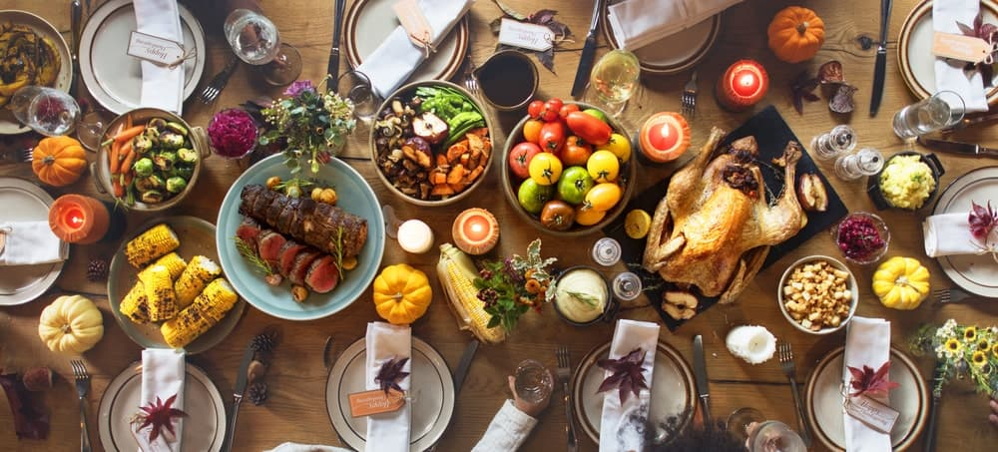
HAVE YOU EVER FELT LIKE MAYBE YOU DIDN’T WANT TURKEY FOR THANKSGIVING? IF YOU EVER HAVE, YOU PROBABLY DIDN’T TELL ANYBODY…BECAUSE WHAT WOULD THEY THINK? AFTER ALL, WHAT ELSE BESIDES TURKEY IS THERE FOR THANKSGIVING?
THERE ARE LOTS OF REASONS WHY TURKEY MIGHT ACTUALLY NOT BE ON THE TABLE AT YOUR BIG MEAL. EXPLORE ALL SORTS OF TASTY TURKEY ALTERNATIVES THAT YOU CAN SERVE ALONG WITH, OR INSTEAD OF, THE TRADITIONAL THANKSGIVING BIRD. BECAUSE EVERY ONCE IN A WHILE, IT’S NOT A BAD IDEA TO SHAKE THINGS UP.
RELATED: HONEY AND PINEAPPLE GLAZED HAM RECIPE | TYPES OF THANKSGIVING STUFFING | VIRTUAL THANKSGIVING | THANKSGIVING PIES

THE THANKSGIVING WITHOUT A TURKEY
TURKEY HAS PRETTY MUCH BECOME SYNONYMOUS WITH THANKSGIVING, SO MUCH SO THAT THE HOLIDAY ITSELF IS CALLED “TURKEY DAY.” BUT THERE ARE LOTS OF THINGS YOU CAN EAT FOR THANKSGIVING INSTEAD OF TURKEY. IN MANY DIFFERENT REGIONS OF THE U.S., TURKEY ISN’T EVEN THE ENTREE OF CHOICE ALREADY!
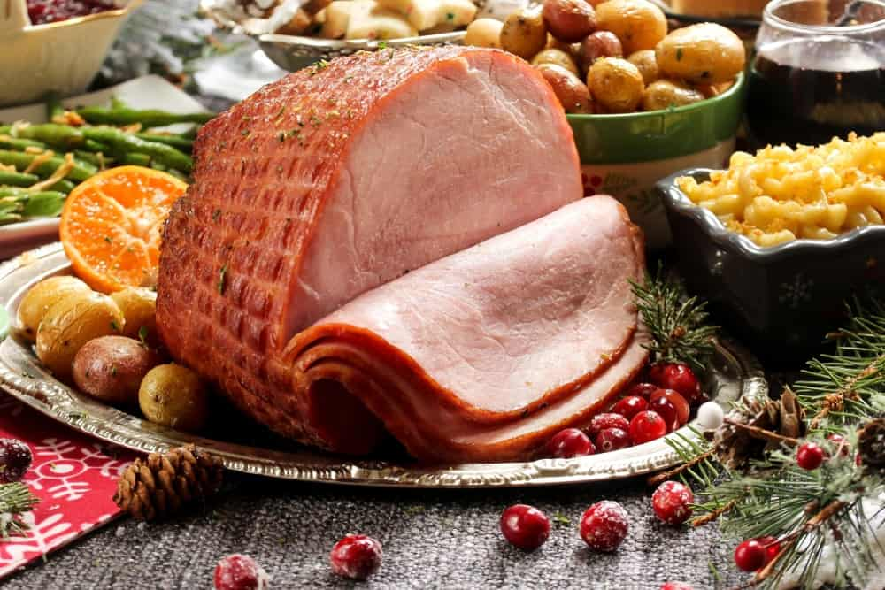
GLAZED HAM IS ALWAYS A HOLIDAY SEASON FAVORITE AND IT’S VERY EASY TO FIND RECIPES ONLINE. DURING THANKSGIVING, IT CAN BE DIFFICULT TO FIND A GOOD TURKEY AT THE SUPERMARKET. THERE SHOULD BE A GREAT SELECTION OF HAMS READY TO GO, HOWEVER. HAM DOESN’T TAKE AS LONG TO COOK AS A WHOLE TURKEY AND IT STILL HAS THAT HOLIDAY FLAVOR TO IT. HAM ALSO TASTES GREAT WITH CLASSIC THANKSGIVING STUFFING.
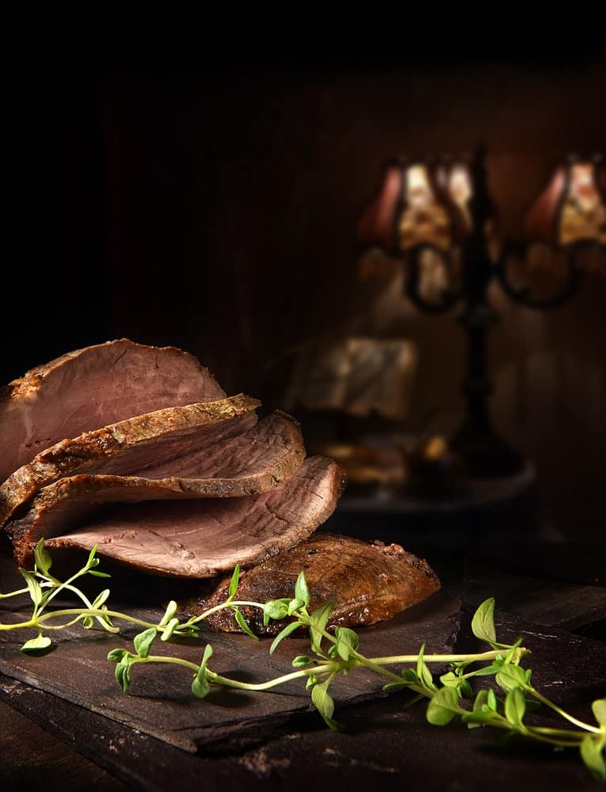
A CLASSIC ROAST IS ALWAYS DELIGHTFUL. THERE ARE MULTIPLE OPTIONS HERE IF YOU WANT TO MAKE A ROAST. COOK A BEEF ROAST WITH HERBS LIKE THYME AND PAPRIKA TO CREATE A POP OF FLAVOR. OR, TRY A POT ROAST WITH CRANBERRIES AND HERBS. THIS COOKS QUICKLY AND COMES OUT OF THE OVEN FULL OF FLAVOR. MAKING A ROAST IS EASY BECAUSE YOU SIMPLY PREPARE AND SEASON IT AND ROAST IT IN THE OVEN. YOU CAN MAKE THE REST OF YOUR MEAL WHILE IT’S COOKING.
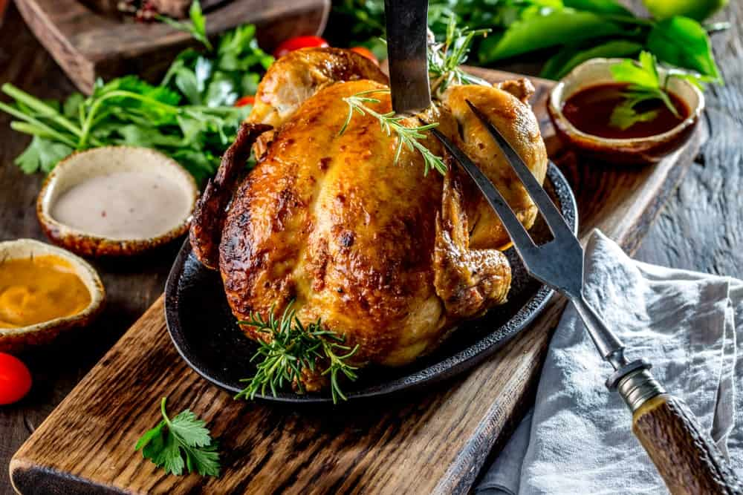
MAKE A ROAST CHICKEN INSTEAD OF ROASTING A TURKEY. A WHOLE CHICKEN COOKS MUCH FASTER AND IT GOES WITH ALL THE CLASSIC THANKSGIVING FIXINGS. YOU STILL GET DRUMSTICKS, TOO. CHICKEN IS MORE AFFORDABLE THAN TURKEY AND IT’S EASY TO FIND ANYWHERE. IF YOU HAVE A LOT OF PEOPLE TO FEED, YOU CAN COOK MULTIPLE CHICKENS AND STILL GET THEM DONE IN A FRACTION OF THE TIME YOU WOULD SPEND COOKING AN ENTIRE LARGE TURKEY.
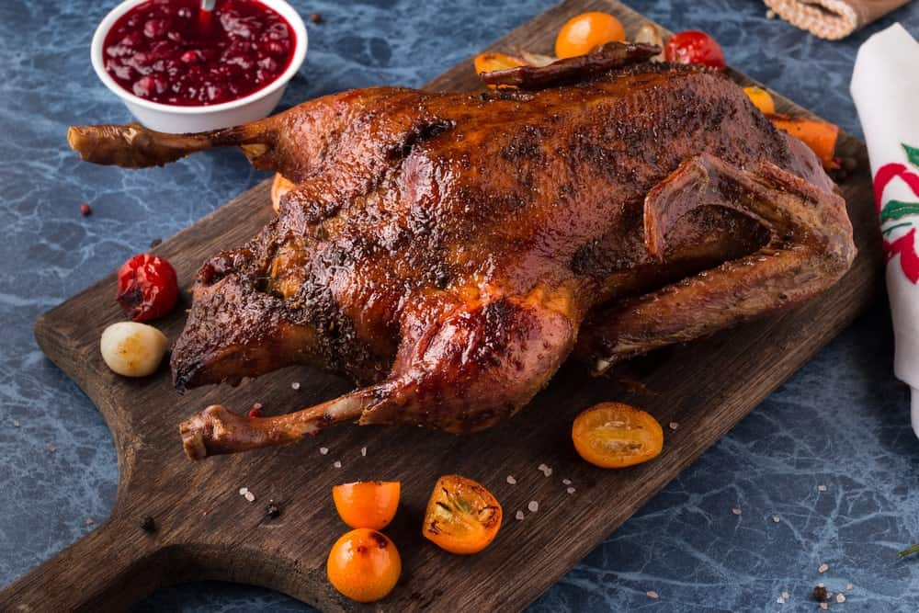
DUCK IS A POPULAR ALTERNATIVE TO THANKSGIVING TURKEY. IT’S EASIEST TO COOK BONELESS DUCK BREAST BECAUSE COOKING A WHOLE DUCK CAN BE A BIT OFF-PUTTING FOR SOME. ONE OF THE BEST WAYS TO COOK DUCK IS TO DEEP FRY IT. THIS IS SOMETHING YOU SHOULD ONLY DO OUTSIDE AND WELL AWAY FROM YOUR HOME BECAUSE IT’S A FIRE HAZARD. KEEP A FIRE EXTINGUISHER HANDY AND DO NOT LEAVE YOUR DUCK UNATTENDED.
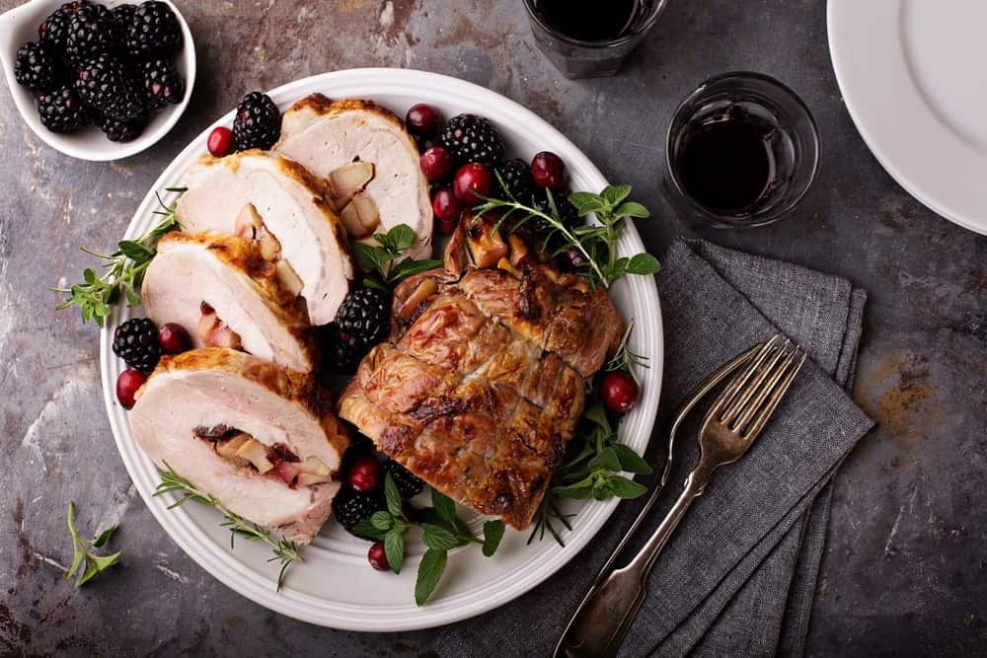
PORK LOIN IS EASY TO COOK AND IT COOKS MUCH MORE QUICKLY THAN A TURKEY OR ANOTHER TYPE OF BIRD. YOU CAN EVEN GET PORK LOIN PRE-SEASONED SO YOU DON’T HAVE TO DO ANYTHING TO IT EXCEPT POP IT IN THE OVEN.
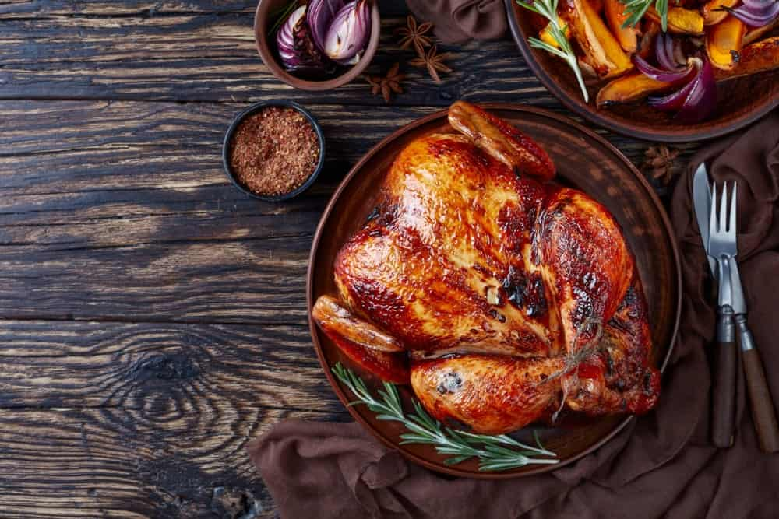
GAME HENS ARE A PERFECT ALTERNATIVE TO TURKEY IF YOU DON’T WANT TO SPEND ALL DAY IN THE KITCHEN. THIS ENTREE WILL COOK UP QUICKLY. GAME HEN TASTES A LITTLE BIT LIKE TURKEY AND IT’S SIZED PERFECTLY SO THAT EVERYONE CAN HAVE THEIR OWN WHOLE BIRD. ROAST HENS IN A PAN WITH VEGETABLES AND HERBS TO CREATE AN AMAZING THANKSGIVING MEAL WITH NO TURKEY ON THE TABLE.
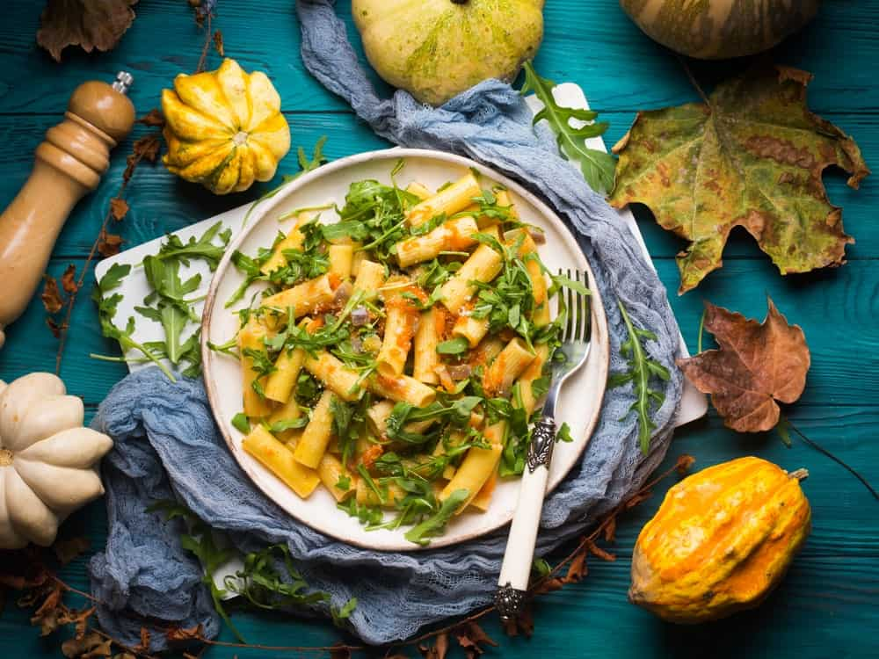
RICH PASTA DISHES LIKE LASAGNA AND MANICOTTI ARE PRETTY MUCH A MUST-HAVE IN ITALIAN-AMERICAN HOUSEHOLDS, THOUGH IT’S USUALLY SERVED ALONG WITH TURKEY ON THANKSGIVING. YOU’LL FIND PASTA DISHES ON MANY TABLES ACROSS NEW YORK AND NEW JERSEY ON THANKSGIVING DAY. TRY SERVING THIS INSTEAD OF TURKEY, BECAUSE WHO DOESN’T LOVE GOOD PASTA? IT’S MUCH QUICKER TO MAKE PASTA THAN TURKEY AND THE FLAVORS ARE MUCH MORE COMPLEX. IN ARKANSAS, TURKEY SPAGHETTI IS A POPULAR THANKSGIVING DISH. IT ONLY SOUNDS STRANGE IF YOU’RE NOT FROM ARKANSAS!
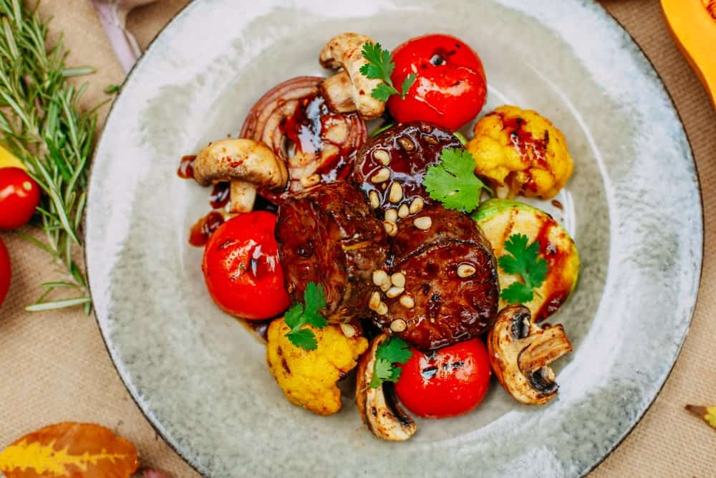
VENISON IS A POPULAR THANKSGIVING ENTREE IN THE PACIFIC NORTHWEST, WHERE IT’S NOT UNCOMMON TO SERVE A THANKSGIVING MEAL WITHOUT TURKEY. VENISON ISN’T ALWAYS EASY TO COME BY BUT IT CAN BE COOKED INTO A DELICIOUS ROAST. WITH THE RIGHT SEASONINGS, THE GAMEY FLAVOR OF THE MEAT ISN’T STRONG AT ALL. VENISON HAS TO BE COOKED SLOWLY AND CAREFULLY AND IT CAN BE EVEN MORE DIFFICULT TO COOK THAN A THANKSGIVING TURKEY, SO CHOOSE THIS ONLY IF YOU WANT A CHALLENGE.
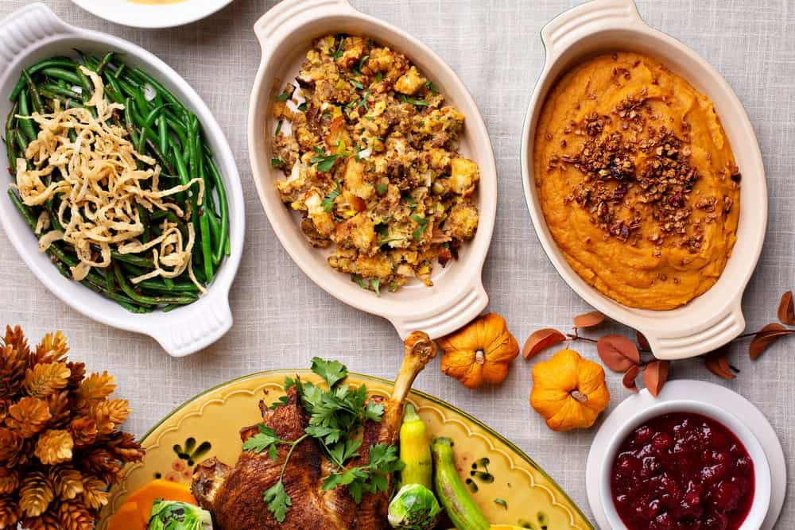
NEED TO HAVE SOME VEGAN AND VEGETARIAN THANKSGIVING OPTIONS? MANY PEOPLE HAVE ALL SORTS OF DIETARY CONCERNS THESE DAYS, AND YOU MAY HAVE SOMEONE WHO DOESN’T EAT MEAT COMING TO ENJOY DINNER AT YOUR TABLE. THERE ARE ALL KINDS OF OPTIONS OUT THERE NOW, INCLUDING VEGETARIAN AND VEGAN TURKEY OPTIONS THAT ARE PRE-SEASONED, PRE-STUFFED, AND READY TO BE PLACED RIGHT IN THE OVEN.
Bottom of Form
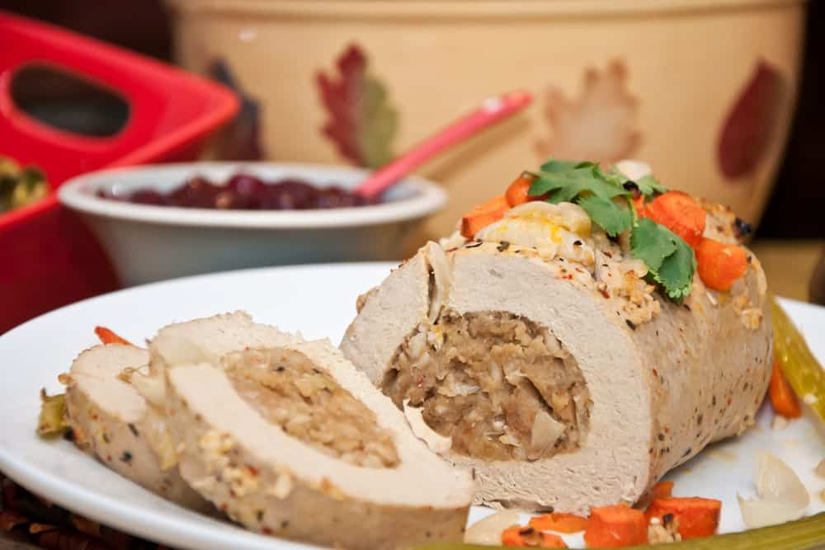
YOU CAN ALWAYS FIND VEGETARIAN TURKEY LUNCHMEAT SLICES AND BAKE THESE FOR A FEW MINUTES IN THE OVEN WITH A LITTLE HONEY AND BROWN SUGAR IF YOU WANT SOMETHING SUPER EASY TO PREPARE FOR JUST ONE OR TWO NON-MEAT-EATERS. AND IF YOU’RE READY TO GET SUPER CREATIVE, MAKE A RICH ROAST VEGETABLE DISH WITH SPINACH, SQUASH, RICE, CORN, AND BEANS. THIS IS HIGH IN PROTEIN AND FULL OF FLAVOR, A PERFECT MAIN COURSE FOR ANYONE WHO DOESN’T EAT MEAT.

COOKING YOUR TURKEY
IF YOUR HEART IS SET ON A THANKSGIVING TURKEY BUT YOU STILL WANT TO EXPERIMENT, TRY COOKING THE TURKEY A DIFFERENT WAY. THE CLASSIC WAY TO PREPARE THE BIRD IS TO ROAST IT WHOLE IN THE OVEN BUT THERE ARE MANY OTHER WAYS THAT PEOPLE EAT TURKEY AROUND THE COUNTRY.
IN TEXAS AND OTHER SOUTHERN STATES, DEEP-FRIED TURKEY IS VERY POPULAR. THIS IS STARTING TO BECOME MORE COMMON IN THE SOUTH THAN THE MORE STANDARD ROAST TURKEY. IN CALIFORNIA, GRILLED TURKEY IS FAR MORE COMMON FOR THANKSGIVING FEASTS. AND IN HAWAII, THE TURKEY IS USUALLY SMOKED.

A DIFFERENT KIND OF THANKSGIVING
HAVE A DIFFERENT KIND OF THANKSGIVING HIS YEAR AND SERVE SOMETHING OTHER THAN TURKEY, OR SERVE ANOTHER MAIN DISH ALONG WITH YOUR TURKEY. THERE IS SUCH A THING AS TOO MUCH OF A GOOD THING, AFTER ALL. EXPERIMENT WITH A BRAND-NEW RECIPE OR A BRAND-NEW METHOD OF COOKING YOUR ENTREE THIS THANKSGIVING.

20 INDULGENT ICE CREAM ALTERNATIVES
INDULGE YOURSELF MINUS THE GUILT WITH THESE HEALTHY AND HEALTHY-ISH ICE CREAM ALTERNATIVES. YOUR DIET'S SAFE NEXT TIME YOU FIND YOURSELF CRAVING FOR THAT REFRESHING SMOOTH TEXTURE AND SWEET CREAMY FLAVOR OF A FROZEN DESSERT.
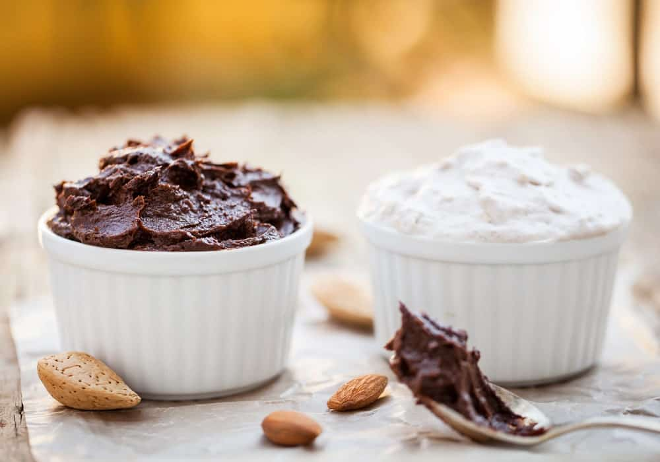
ICE CREAM IS ARGUABLY THE WORLD’S FAVORITE FROZEN DESSERT. THIS COLD, CREAMY, AND SWEET SUMMER TREAT IS INSANELY GOOD THAT IT’S SO IRRESISTIBLE. BUT WHEN YOU’RE WATCHING YOUR WAISTLINE OR WHEN YOU’RE LACTOSE-INTOLERANT, ICE CREAM IS JUST A NO-GO.
SO WE COLLECTED THIS EXHAUSTIVE LIST OF INDULGENT ICE CREAM ALTERNATIVES FOR THOSE WHO WANT SOMETHING HEALTHY, HEALTHY-ISH, OR JUST ANOTHER DELICIOUS FROSTY DESSERT.
RELATED: TYPES OF ICE CREAM | TYPES OF ICE CREAM MAKERS | TYPES OF BANANAS | COCONUT MILK | TYPES OF YOGURT MAKERS

1. CHOCOLATE-DIPPED BANANAS
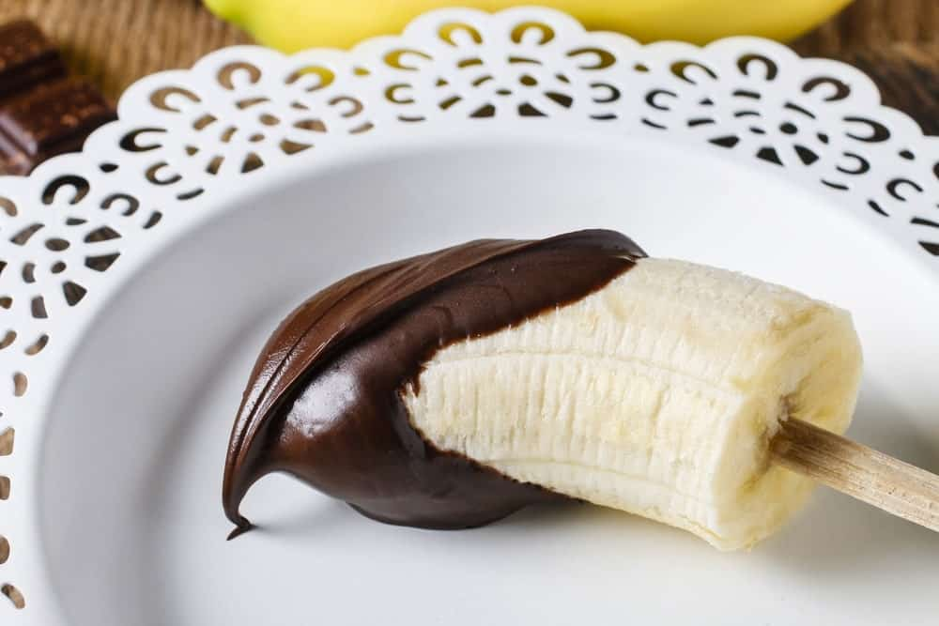
THESE ARE SO EASY TO MAKE THAT ANYONE CAN DO IT. THERE ARE THOUSANDS OF RECIPES FOR THESE BANANAS ALL OVER THE INTERNET, AND IF YOU’RE NOT INTERESTED IN DIPPING THEM IN CHOCOLATE OR EVEN CAROB, YOU CAN DIP THEM IN PEANUT BUTTER, YOGURT, AND MANY OTHER FOODS. THEY ARE NUTRITIOUS, EASY TO MAKE, WILL CERTAINLY SATISFY A SWEET TOOTH, AND THE FOLLOWING SHOULD BE KEPT IN MIND IF YOU’RE INTERESTED IN EATING CHOCOLATE-DIPPED BANANAS INSTEAD OF ICE CREAM:
PROS
- IT IS A FOOD THAT MOST PEOPLE LIKE
- IT HAS A LOT OF NUTRIENTS, INCLUDING VITAMINS C AND B6, AS WELL AS MINERALS SUCH AS POTASSIUM
- YOU CAN ENJOY THEM IN A VARIETY OF WAYS
CONS
- IT HAS VIRTUALLY NO HEALTHY FATS OR PROTEIN OF ANY KIND
- IT IS NOT A GOOD FOOD TO EAT IF YOU’RE TRYING TO LOSE WEIGHT
- BANANAS GO BAD VERY QUICKLY AND MUST BE EATEN RIGHT AWAY
DIPPED BANANAS ARE A GREAT ALTERNATIVE TO ICE CREAM, AND THERE ARE MANY RECIPES FOR THIS YUMMY TREAT, INCLUDING THIS ONE.

2. COCONUT MILK ICE CREAM
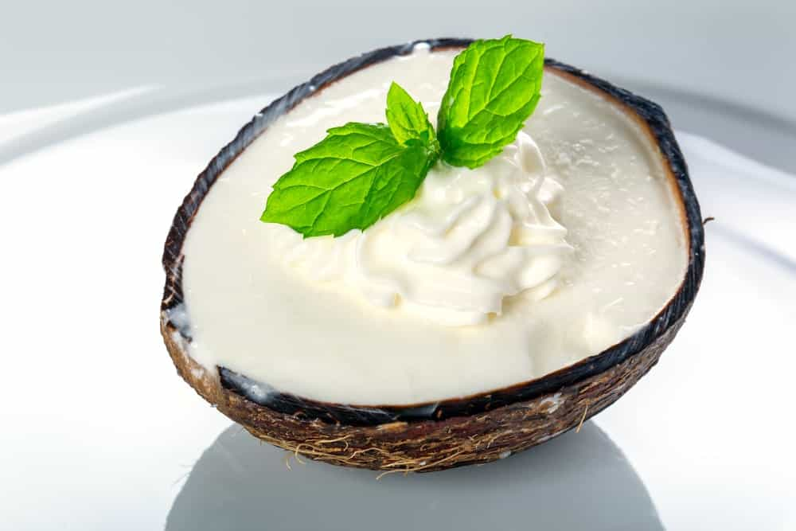
IF YOU DON’T WANT GLUTEN, DAIRY, OR SOY IN YOUR ICE CREAM, TRY SOME MADE WITH COCONUT MILK. THESE TYPES OF ICE CREAM ARE USUALLY 100% ORGANIC AND ARE SWEETENED WITH AGAVE. THEY FLAVOR THEM WITH INGREDIENTS SUCH AS SEEDS, NUTS, AND VARIOUS VEGAN TYPES OF CHOCOLATE AND VANILLA, INCLUDING CAROB. HERE ARE SOME PROS AND CONS OF ICE CREAM MADE WITH COCONUT MILK INSTEAD OF CREAM:
PROS
- ABSOLUTELY DELICIOUS AND NATURAL
- HEALTHY FOR YOU
- HIGH IN CERTAIN VITAMINS, INCLUDING A AND E
CONS
- NOT PARTICULARLY LOW IN CALORIES
- CAN CONTAIN BPA BECAUSE IT IS SOLD IN CANS
- CAN CAUSE GASTRIC PROBLEMS IN SOME INDIVIDUALS
ANOTHER ADVANTAGE IS THAT YOU CAN FIND COCONUT MILK ICE CREAM IN DOZENS OF FLAVORS, INCLUDING YUMMY TASTES SUCH AS WALNUT BROWNIE, COOKIE CARAMEL, AND CHERRY AMARETTO, AS WELL AS A PLAIN VANILLA FLAVOR THAT IS USUALLY VERY TASTY.
Bottom of Form
COCONUT ICE CREAM CAN BE PURCHASED AT STORES SUCH AS THIS.

3. FROZEN KEFIR

KEFIR DELIVERS MORE PROBIOTIC CAPABILITY THAN EVEN YOGURT, SO IT IS NO WONDER COMPANIES STARTED MAKING IT AS AN ALTERNATIVE TO ICE CREAM. WHEN IT COMES TO KEFIR, IN FACT, YOU CAN EASILY CALL IT A SUPERFOOD, BECAUSE IT CONTAINS MANY ACTIVE AND LIVE PROBIOTIC CULTURES AND IS GLUTEN-FREE AS WELL. MOST FROZEN KEFIR IS MADE IN TANGY FRUIT FLAVORS, SO IT CAN BE SIMILAR TO EATING YOGURT OR EVEN AN ICE POP. HOWEVER, LIKE MANY OTHER FOODS, KEFIR HAS BOTH ADVANTAGES AND DISADVANTAGES, INCLUDING:
PROS
- IT IS VERY GOOD FOR YOUR IMMUNE SYSTEM
- CONTAINS VITAMIN K2, WHICH IS GOOD FOR BRAIN FUNCTION AND CORONARY ARTERY DISEASE, AMONG OTHER THINGS
- HAS BEEN PROVEN TO BE ANTI-ALLERGENIC
CONS
- ISN’T GOOD FOR PEOPLE WITH A HISTAMINE INTOLERANCE
- IT CAN INCREASE YOUR BLOOD PRESSURE
- IT IS KNOWN TO CAUSE MIGRAINES IN SOME PEOPLE
MOST OF THE COMPANIES THAT MAKE THIS PRODUCT INCLUDE FRUITY FLAVORS, SO YOU CAN ENJOY THIS TYPE OF ICE CREAM IN FLAVORS SUCH AS STRAWBERRY, MANGO, POMEGRANATE, AND MANY OTHERS.
HERE IS A RECIPE FOR A DELICIOUS COCONUT ALMOND KEFIR ICE CREAM.

4. GELATO

GELATO IS SIMILAR TO ICE CREAM BUT USUALLY HAS LESS CREAM THAN ICE CREAM, AND IT USUALLY HAS NO EGG YOLKS, EITHER. LIKE ICE CREAM, IT IS MADE IN DOZENS OF FLAVORS BECAUSE YOU CAN INCLUDE ANYTHING IN THERE THAT YOU LIKE, INCLUDING VARIOUS FLAVORINGS, FRUITS, NUTS, AND MANY OTHER FOODS. THERE ARE THINGS TO TAKE INTO CONSIDERATION IF YOU’RE INTERESTED IN EATING GELATO, SUCH AS:
PROS
- IT USUALLY HAS A LOWER FAT CONTENT
- SINCE IT IS OFTEN SERVED AT A HIGHER TEMPERATURE, ITS FLAVOR IS USUALLY HARDIER
- HAS A DENSER LOOK AND HEAVIER, CREAMIER TASTE THAN ICE CREAM
CONS
- IT IS RELATIVELY HIGH IN CALORIES
- IT STILL HAS PLENTY OF CREAM, SUGAR, AND MILK
- IT IS NOT COMPLETELY HEALTHY FOR YOU
ALTHOUGH IT CAN ALSO BE DIFFICULT TO FIND A STORE THAT SELLS FRESH GELATO LIKE THEY DO ICE CREAM, GELATO IS A DELICIOUS ALTERNATIVE TO ICE CREAM THAT, LIKE ICE CREAM, WILL HAVE YOU SCREAMING FOR MORE.
YOU CAN EVEN PURCHASE GELATO ONLINE.

5. HAWAIIAN-BASED SHAVED ICE

THE BEST PART ABOUT SHAVED ICE IS THAT YOU CAN MAKE IT ANY FLAVOR YOU WANT, EVEN IF YOU DON’T WANT A SUPER-SWEET ICE CREAM ALTERNATIVE. YOU SIMPLY PICK A FLAVOR, SUCH AS A COCONUT, CHERRY, VANILLA FROZEN YOGURT, OR LIME, PLACE IT IN THE MIDDLE OF THE SHAVED ICE, AND THEN STIR IT AROUND SOME BEFORE EATING. HAWAIIANS EAT THIS A LOT, AND THERE ARE MANY GOOD REASONS THAT IT IS SO POPULAR. IF YOU’D LIKE TO GET STARTED AND MAKE SHAVED-ICE DESSERTS, HERE ARE SOME THINGS TO CONSIDER:
PROS
- YOU CAN SHAPE THE SHAVED ICE THICK OR THIN, CURLY OR STRAIGHT
- YOU CAN CHANGE THE TEXTURE AND CONSISTENCY OF IT VERY EASILY
- IT IS FAST AND SIMPLE TO GET THE FLAVOR YOU WANT
CONS
- SHAVED ICE IS SOMETIMES EXPENSIVE
- IT IS NOT ALWAYS AS POPULAR AS REGULAR SNOW CONES, WHICH ARE DIFFERENT
- THEY ARE NOT USUALLY HEALTHY FOR YOU
NEVERTHELESS, IF YOU INTEND TO BUY A SHAVED ICE CONE FROM A REPUTABLE BUSINESS, IT IS AN ABSOLUTELY DELICIOUS ALTERNATIVE TO ICE CREAM, AND IT CAN QUITE LITERALLY COME IN DOZENS OF DIFFERENT FLAVORS.
SHAVED ICE MAKERS CAN BE FOUND AT STORES SUCH AS TARGET, WHICH ARE SEEN HERE.

6. PUDDING ICE CREAM

WITH THIS PRODUCT, YOU START OUT WITH REGULAR PUDDING, AND YOU END UP WITH ICE CREAM, MAKING IT THE PERFECT SUMMER TREAT. THERE ARE MIXES YOU CAN BUY IN GROCERY STORES THAT ARE EASY TO MAKE, NOT TO MENTION RECIPES FOUND ONLINE, AND THE BEST PART IS THE FACT THAT THE INGREDIENTS ARE ALWAYS EASY TO FIND IN MOST GROCERY STORES. IT IS GREAT FOR COOLING DOWN ON A HOT SUMMER DAY, AND THERE ARE SO MANY FLAVORS THAT YOU ARE GUARANTEED TO FIND ONE THAT YOU LOVE. HERE ARE SOME OF THE PROS AND CONS OF PUDDING ICE CREAM:
PROS
- THEY TEND TO BE VERY HEALTHY FOR YOU
- THERE IS A FLAVOR FOR EVERYONE TO ENJOY
- THEY ARE EXTREMELY EASY TO MAKE
CONS
- SINCE THEY ARE MADE WITH MILK, SOME PEOPLE MAY EXPERIENCE NEGATIVE SYMPTOMS
- MOST HAVE TOO MUCH SUGAR AND CARBS IN THEM
- THEY DON’T HAVE A HIGH PROTEIN CONTENT
PUDDING ICE CREAM IS THICK AND DELICIOUS, AND IT GIVES YOU PLENTY OF VITAMINS AND OTHER TYPES OF NUTRITION. IN ADDITION, IT IS EASY TO MAKE, SO EVEN IF YOU DECIDE THAT YOU WANT TO MAKE SOME AT THE SPUR OF THE MOMENT, IT IS EASY TO DO SO.
HERE IS A SIMPLE, YUMMY RECIPE FOR PUDDING ICE CREAM.

7. SORBET

THE GREAT THING ABOUT SORBET IS THAT IT COMES IN VARIOUS TEXTURES, SO WHETHER YOU LIKE IT LIGHT AND FLUFFY OR CREAMY AND SNOW-LIKE, YOU CAN FIND A BRAND THAT SUITS YOU. SORBET COMES IN A LOT OF THE SAME FLAVORS THAT ICE CREAM DOES, SO YOU CAN ENJOY IT JUST LIKE YOU DO ICE CREAM MOST OF THE TIME. IT USUALLY HAS A VERY CREAMY TEXTURE THAT PEOPLE SEEM TO LOVE, AND THE SELECTION OF AVAILABLE FLAVORS MAY SURPRISE YOU. HERE ARE SOME ADVANTAGES AND DISADVANTAGES TO EATING SORBET:
PROS
- IF YOU INCLUDE FRUIT FLAVORS, YOU GET ADDED FIBER IN YOUR DIET
- THERE ARE DOZENS OF FLAVORS TO CHOOSE FROM
- YOU CAN MAKE IT AS HEALTHY AS YOU LIKE BY ADDING THE RIGHT INGREDIENTS
CONS
- THERE IS NO CALCIUM IN SORBET-LIKE THERE IS IN ICE CREAM
- CONTRARY TO POPULAR BELIEF, IT IS NOT A DIGESTIVE AID
- THERE CAN BE A LOT OF SUGAR IN SORBETS
IF YOU’RE LOOKING FOR SOMETHING HEALTHY, SORBET IS LIKELY NOT THE WAY TO GO. HOWEVER, IF YOU WANT SOMETHING YUMMY AND REFRESHING ON A HOT SUMMER DAY, IT WILL SERVE YOU WELL. SORBET SATISFIES A SWEET TOOTH AND COOLS YOU DOWN JUST LIKE ICE CREAM, AND IT IS PERFECT FOR THOSE WHO ARE LACTOSE-INTOLERANT.
SORBET CAN BE FOUND AT MOST RETAIL OUTLETS, AS SHOWN HERE.

8. TOFU ICE CREAM
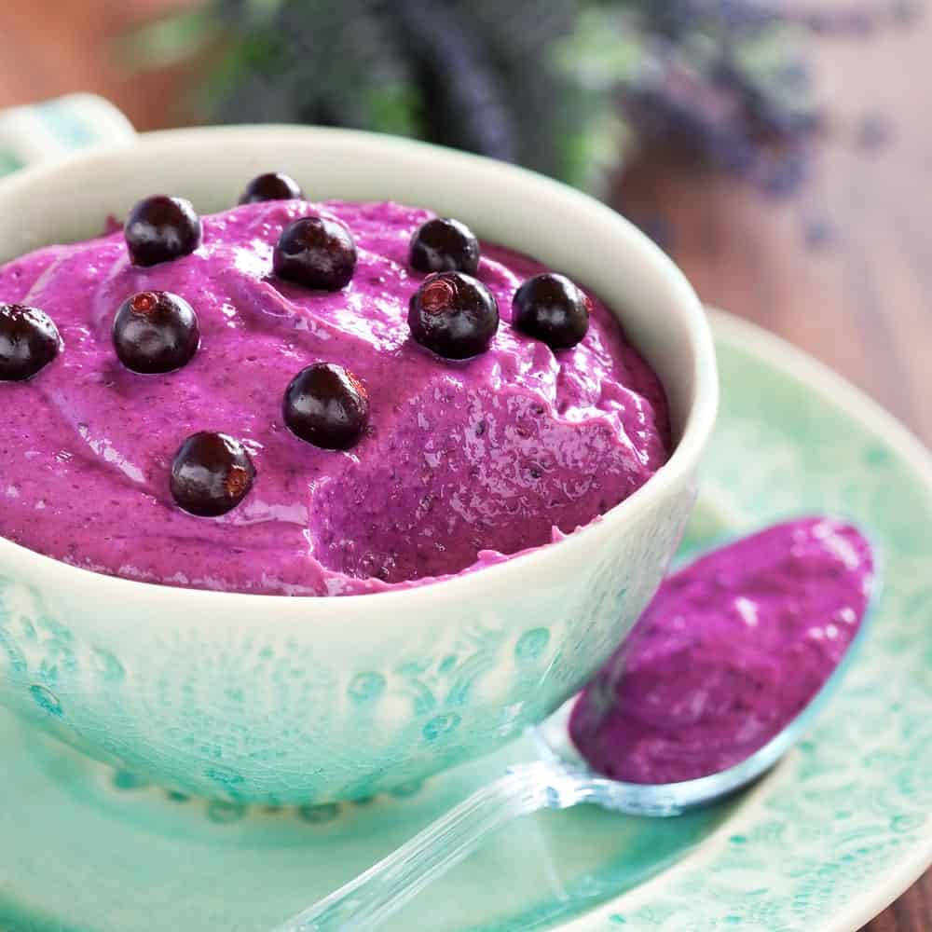
YOUR ICE CREAM CAN BE DAIRY-FREE WHEN YOU MAKE IT FROM TOFU. IF YOU CHOOSE A REPUTABLE BRAND OF TOFU, IT IS EASY TO PRODUCE A DELICIOUS ALTERNATIVE TO ICE CREAM THAT WON’T WEIGH YOU DOWN WITH SUGAR AND HEAVY CREAMS, NOT TO MENTION WHOLE MILK, WHICH IS BAD FOR YOU. TENS OF THOUSANDS OF ICE CREAM RECIPES THAT USE TOFU CAN BE FOUND ONLINE, AND IF YOU’RE INTERESTED IN THE PROS AND CONS, HERE ARE JUST A FEW OF THEM:
PROS
- IT IS A HEART-HEALTHY FOOD
- IT IS HIGH IN FIBER
- IT HAS A LOT OF PROTEIN IN IT
CONS
- SOME SOY PRODUCTS LIKE TOFU PROVIDE YOU WITH TOO MUCH ESTROGEN, WHICH ISN’T GOOD FOR YOU
- THERE HAVE BEEN SOME LINKS BETWEEN THIS PRODUCT AND CERTAIN TYPES OF CANCER
- UNLESS IT’S ORGANIC, IT COULD HAVE HEXANE, WHICH IS LINKED TO SOME NEUROLOGICAL CONDITIONS
THAT BEING SAID, TOFU IS A VERY HEALTHY FOOD OVERALL, AND ONCE YOU GET USED TO THE FACT THAT IT DOESN’T TASTE EXACTLY LIKE ICE CREAM, YOU’LL LIKELY ENJOY EATING IT ALL THE TIME.
HERE IS A DELICIOUS STRAWBERRY TOFU ICE CREAM RECIPE.

9. FROZEN YOGURT

THE FROZEN YOGURT OR FROYO IS BASICALLY A FROZEN DESSERT MADE OF YOGURT, MILK, SUGAR, AND YOGURT CULTURES. IT’S CREAMY AND SWEET BUT TARTER THAN ICE CREAM. IT’S FREQUENTLY PROMOTED AS A HEALTHIER ALTERNATIVE, BUT OTHERS DISPUTE THIS CLAIM.

10. YOGURT PARFAIT POPSICLES
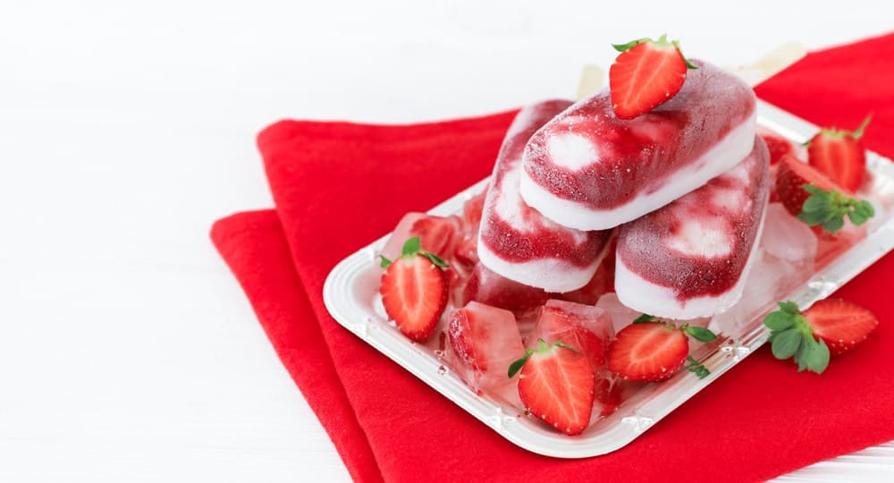
THE YOGURT PARFAIT POPSICLES ARE A HEALTHY DESSERT THAT CAN BE SERVED FOR BREAKFAST. IT’S MADE UP OF GREEK YOGURT, GRANOLA, AND BERRIES.

11. GRANITA
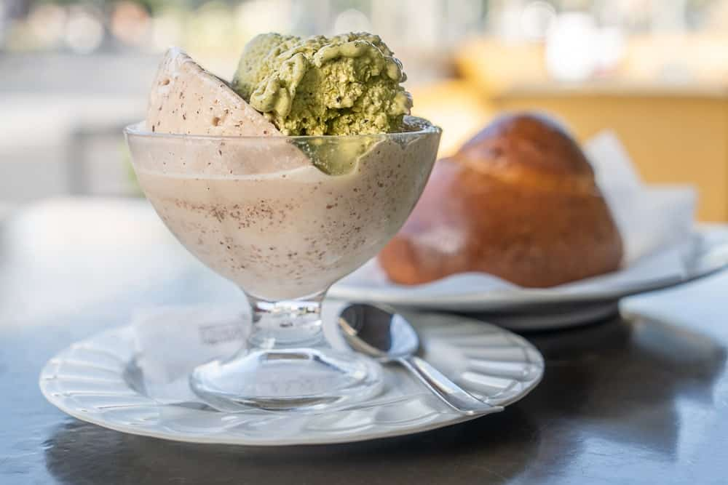
GRANITA IS AN ITALIAN FROZEN FRUIT DESSERT MADE OF FRESH FRUIT AND WATER. IT’S SIMILAR TO A SORBET SINCE BOTH ARE HEALTHY ICE CREAM ALTERNATIVES AND EASY TO MAKE. BUT THE GRANITA IS MADE BY HAND AND IS COARSER AND FLAKY LIKE SHAVED ICE.

12. POPSICLES

THIS IS A POPULAR FROZEN SNACK ON A STICK. IT’S MILK OR WATER-BASED WHICH CAN BE MIXED WITH ANYTHING TO CREATE ANY FLAVOR YOU CAN THINK OF. IT’S ALSO PRETTY EASY TO MAKE SINCE YOU JUST NEED TO MAKE THE MIXTURE, POUR THEM INTO THE POPSICLE MOLD, USE THE STICK AS A HANDLE, AND LET IT FREEZE.

13. ICE CREAM SANDWICH
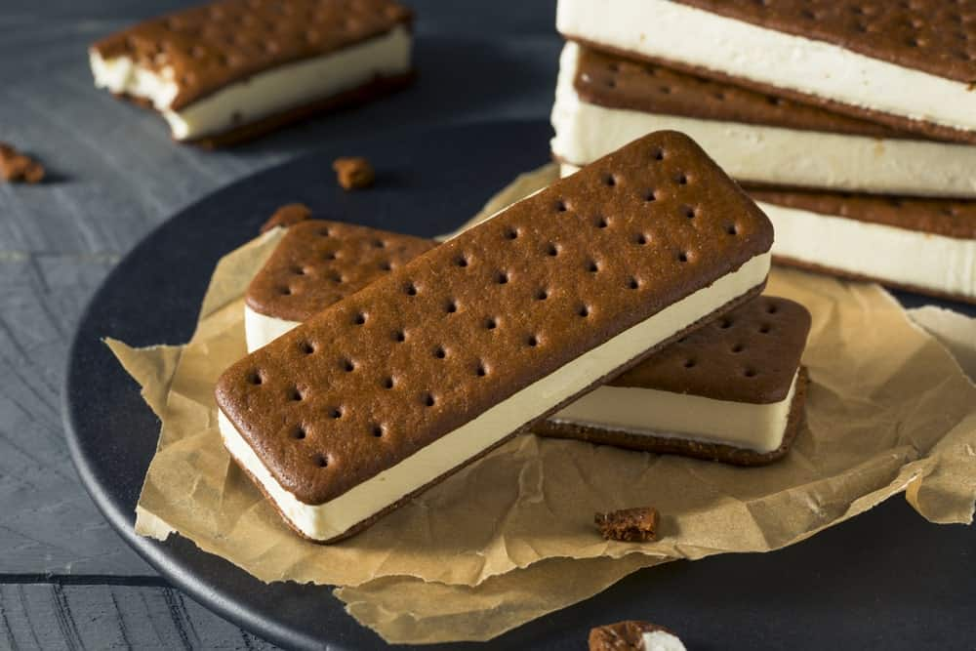
IT’S ANOTHER VERSATILE SNACK THAT LETS YOU CREATE ANY FLAVOR YOU CAN THINK OF. THE ICE CREAM SANDWICH IS AS THE NAME IMPLIES, A SANDWICH BUT HAS THE FILLING OF COLD, SWEET CREAM.

14. BINGSU
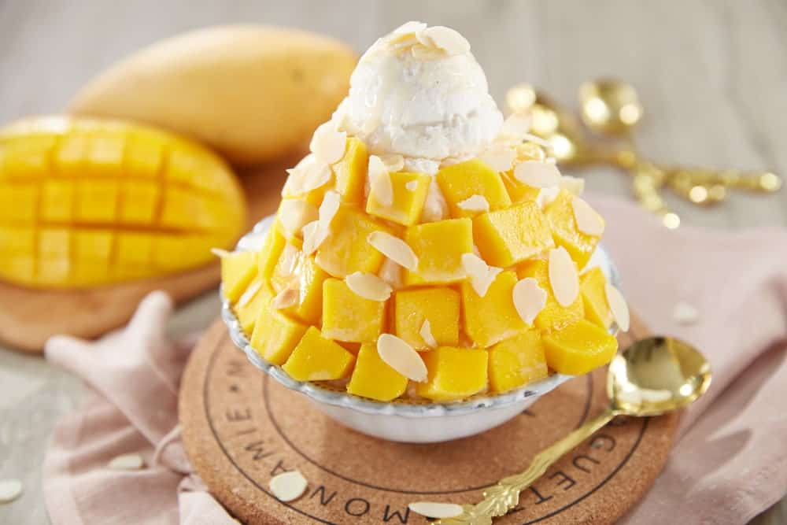
IT’S A KOREAN TRADITIONAL DESSERT WHICH IS BASICALLY SHAVED ICE. IT HAS MANY VARIATIONS TO ACCOMMODATE DIFFERENT FLAVORS AND TOPPINGS SUCH AS SWEETENED AZUKI BEANS, STRAWBERRY, CHOCOLATE, AND CHEESECAKE.

15. HALO-HALO

IT’S A POPULAR FILIPINO COLD DESSERT MADE OF CRUSHED ICE, EVAPORATED MILK, AND A VARIETY OF INGREDIENTS SUCH AS SWEETENED BEANS, COCONUT JULIENNES, SAGO, GULAMAN (SEAWEED GELATIN), PINIPIG RICE, BOILED ROOT CROPS IN CUBES, FRUIT SLICES, AND FLAN.

16. NICE CREAM
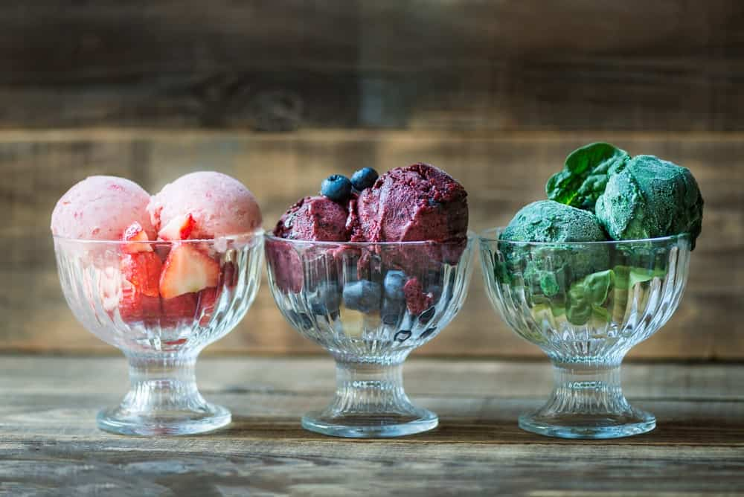
NICE CREAM IS THE PERFECT ALTERNATIVE FOR VEGANS. IT’S FRUIT-BASED, VEGAN, AND DAIRY-FREE SO IT DOESN’T HAVE SUGAR, ARTIFICIAL FLAVORS, AND PRESERVATIVES. HENCE, IT’S “NICE.” IT’S ALSO SUPER EASY TO MAKE AND CAN TAKE YOU AS QUICK AS 10 MINUTES.

17. SOFT SERVE

SOFT SERVE IS A TYPE OF ICE CREAM THAT HAS THE EXPECTED DAIRY AND SWEETENERS PLUS A BUNCH OF OTHER INGREDIENTS. UNLIKE THE REGULAR ICE CREAM, IT’S SOFT AND LESS DENSE.

18. VEGAN CHOCOLATE SHAKE

THIS DELICIOUS DRINK IS RICH, THICK, AND SUPER HEALTHY THAT’S PERFECT FOR A POST-WORKOUT MEAL. ALL YOU NEED IS YOUR PROTEIN POWDER, SOME FRUIT, AND A BLENDER TO MIX THEM TOGETHER.

19. COCONUT ICE MILK
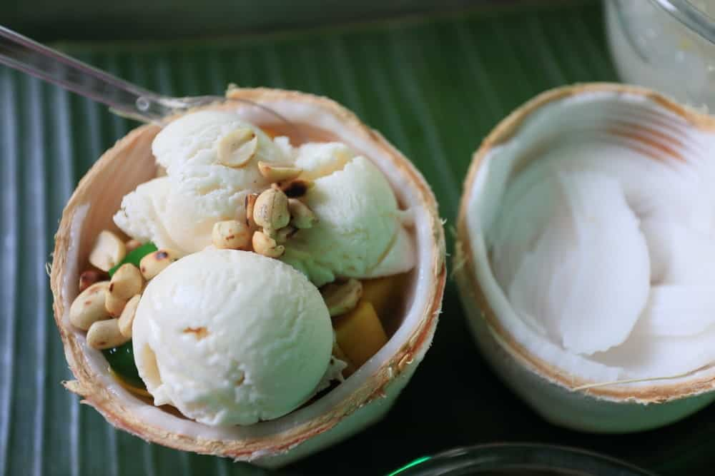
IT’S THE PERFECT SUMMER TREAT THAT’S BOTH HEALTHY AND REFRESHING. IT’S EASY TO MAKE AND ALL YOU NEED IS COCONUT MILK AND MILK SO IT’S SUGAR-FREE.

20. FRAPPE
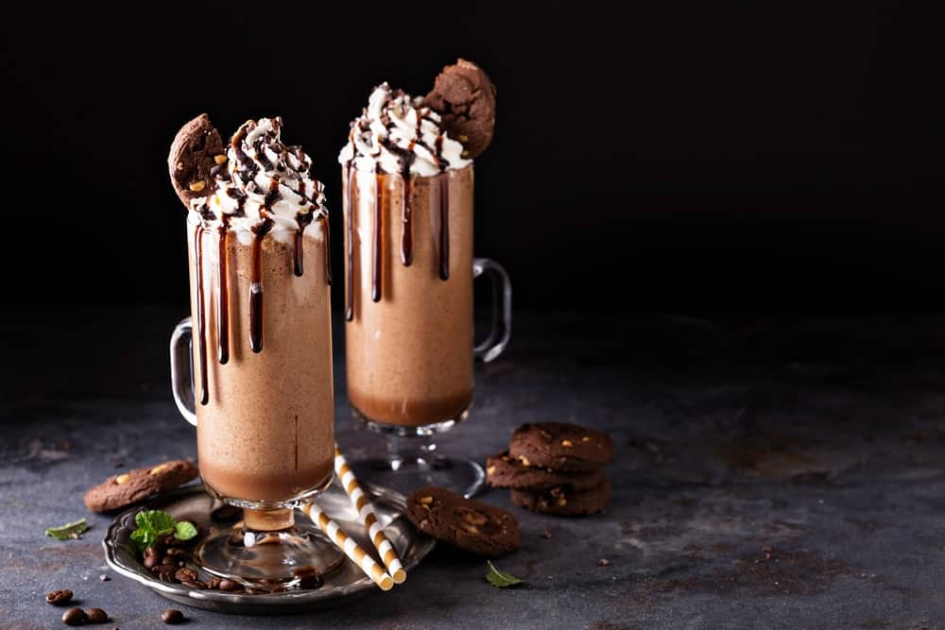
IT’S AN ICED OR CHILLED DRINK OFTEN CONFUSED WITH A MILKSHAKE. IT LOOKS LIKE A MILKSHAKE BUT THE MILKSHAKE IS JUST MILK AND SYRUP WHEREAS FRAPPE IS A THICK MILKSHAKE MADE OF ICE CREAM.

12 ACCEPTABLE ALTERNATIVES TO BUTTER
CUT BACK ON SATURATED FAT AND ENJOY A HEARTY MEAL WITHOUT LOSING THE FLAVOR IN YOUR FAVORITE RECIPES BY SWAPPING BUTTER WITH THESE IDEAL AND HEALTHY ALTERNATIVES.
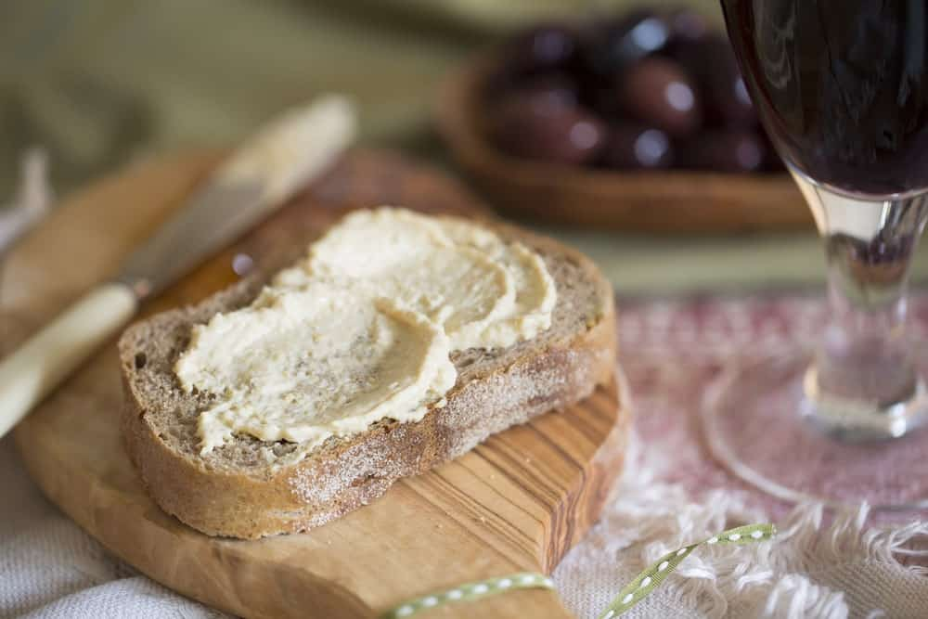
BUTTER PLAYS A STARRING ROLE IN MANY OF OUR FAVORITE RECIPES FROM TOASTS TO PASTA TO CAKES. IT’S MADE FROM COW’S MILK AND HAS HIGH SATURATED FAT CONTENT WHICH LED TO PREVIOUS STUDIES LINKING IT TO HEART DISEASE. OTHER PEOPLE, ON THE OTHER HAND, HAVE MILK ALLERGIES OR LACTOSE INTOLERANCE.
NO WONDER THERE ARE PLENTY OF HEALTHY INGREDIENTS TO BUTTER THAT HAS SPRUNG UP AS HEALTHY ALTERNATIVES TO BUTTER AS A SPREAD OR IN BAKING.
RELATED: THANKSGIVING TURKEY ALTERNATIVES | BROCCOLI ALTERNATIVES | ICE CREAM ALTERNATIVES | HEALTHY ALTERNATIVES TO PIZZA | ALTERNATIVES TO PASTA

1. APPLESAUCE
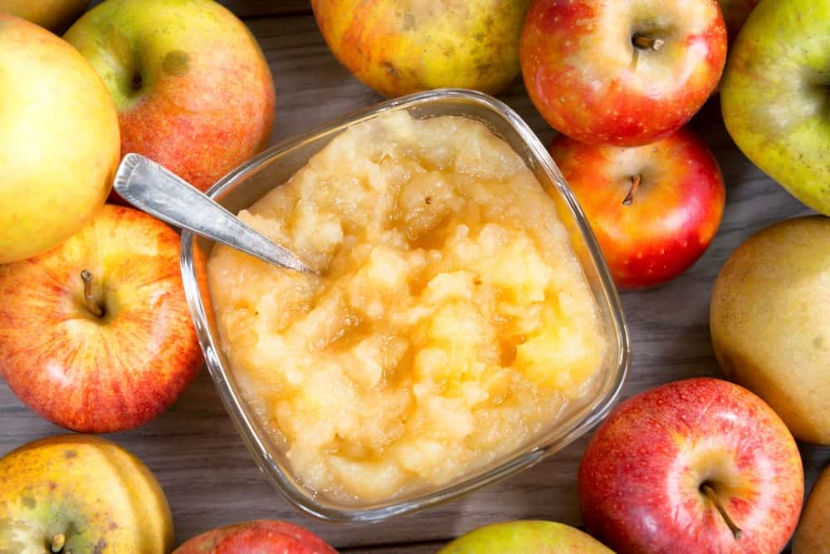
PEOPLE HAVE BEEN SUBSTITUTING APPLESAUCE FOR BUTTER FOR A VERY LONG TIME, AND IF YOU’VE NEVER TRIED IT YOU MAY WANT TO RETHINK YOUR DECISION. APPLESAUCE IS INEXPENSIVE AND FILLED WITH FIBER AND NUMEROUS VITAMINS, SO IT IS A LOT HEALTHIER THAN REGULAR BUTTER. IT ALSO COMES IN SEVERAL TYPES, SO IF YOU WANT TO USE A FLAVORED TYPE OF APPLESAUCE FOR MORE TASTINESS, IT IS EASY TO DO.
ADVANTAGES
- IT IS HIGH IN VITAMIN C AND FIBER
- IT IS INEXPENSIVE AND EASY TO FIND
DISADVANTAGES
Bottom of Form
- SOME BRANDS ARE HIGH IN SUGAR
- YOU HAVE TO EXPERIMENT WITH THE AMOUNT USED IN YOUR RECIPE
IF YOUR RECIPE CALLS FOR A ONE-HALF CUP OF BUTTER, YOU CAN’T ALWAYS SUBSTITUTE WITH A ONE-HALF CUP OF APPLESAUCE. YOU MAY NEED TO PLAY AROUND WITH THE RATIOS AND FIND THE ONE THAT WORKS BEST FOR YOU.

2. AVOCADO
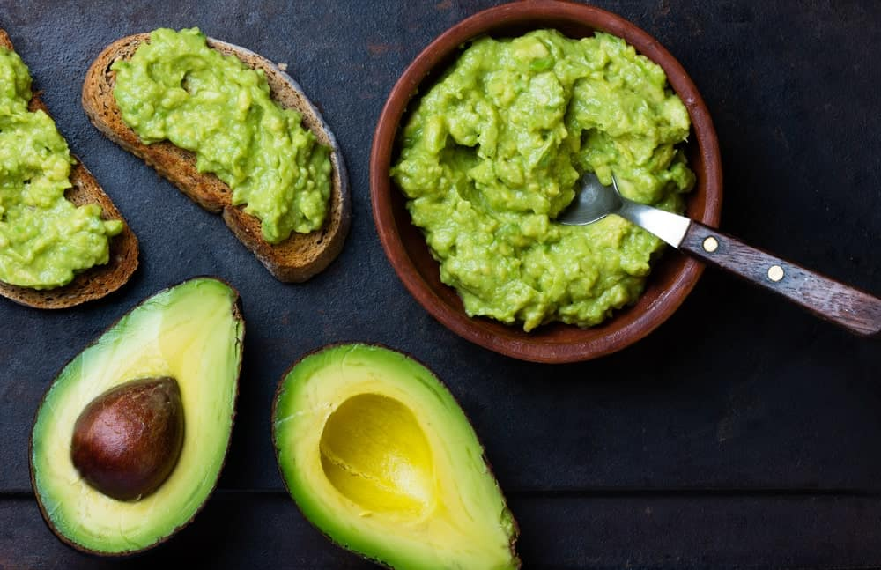
MOST PEOPLE KNOW THAT THE AVOCADO IS FILLED WITH HEALTHY FATS, SO IT SHOULD BE NO SURPRISE THAT MANY PEOPLE ALSO USE IT ON TOAST INSTEAD OF REAL BUTTER. YOU CAN MASH IT UP AND USE IT ON TOAST OR MUFFINS, AND YOU CAN EVEN COOK WITH IT, INSTEAD OF USING BUTTER. YOU CAN ADD IT TO YOUR SMOOTHIE FOR AN EXTRA-RICH DRINK, AND YOU CAN EVEN BAKE A CAKE WITH IT!
ADVANTAGES
- RICH IN FIBER, VITAMIN K, AND POTASSIUM
- REDUCES INFLAMMATION IN THE BODY
DISADVANTAGES
- SOME PEOPLE DO NOT LIKE THE TASTE OF AVOCADO
- PEOPLE WHO ARE ALLERGIC TO BANANAS OR LATEX MAY BE ALLERGIC TO AVOCADOS
IN REALITY, THERE ARE FEW, IF ANY, DISADVANTAGES TO EATING AN AVOCADO, SO THE NEXT TIME YOU’RE AT THE GROCERY STORE, PUT MORE THAN ONE OF THEM IN YOUR CART.

3. CHICKEN STOCK
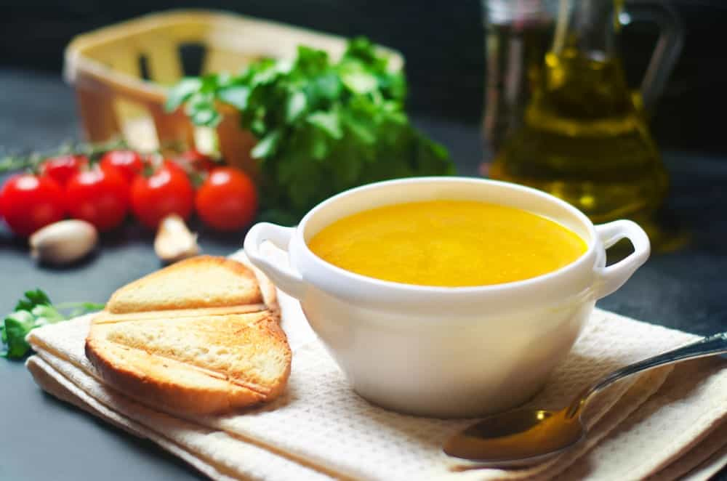
CHICKEN OR VEGETABLE STOCK IS GREAT IF YOU’RE SAUTÉING FOODS, SO MUCH SO THAT YOU WON’T EVEN MISS THE BUTTER! IT HAS ALSO BEEN SHOWN TO HELP WITH ARTHRITIS, YOUR IMMUNE SYSTEM, AND EVEN DIGESTIVE PROBLEMS, AND IT IS CHEAP TO BOOT! YOU MAY HAVE TO ADJUST THE AMOUNT THAT YOU USE WHEN BAKING OR COOKING TO FIND THE RATIO THAT WORKS BEST FOR YOU, BUT CHICKEN STOCK IS A HEALTHY, INEXPENSIVE ALTERNATIVE TO BUTTER.
ADVANTAGES
- IT IS EASY TO FIND AND VERY INEXPENSIVE
- IT ADDS FLAVOR TO ANYTHING YOU’RE COOKING OR BAKING
DISADVANTAGES
- SOME BRANDS ARE VERY HIGH IN SODIUM
- SOME BRANDS HAVE EXTRA INGREDIENTS THAT ARE UNNECESSARY AND UNHEALTHY

4. COCOA BUTTER
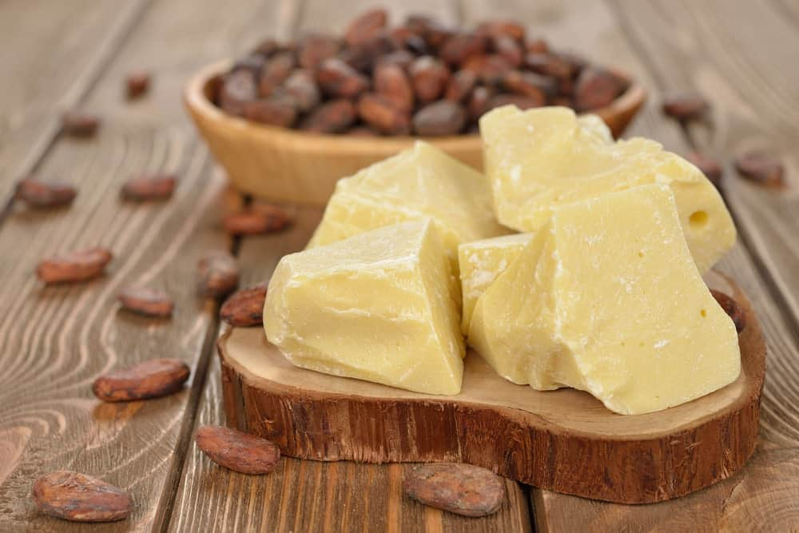
COCOA BUTTER IS CONSIDERED A HEALTHY FAT, AND IT IS THE MAIN INGREDIENT IN CHOCOLATE. IN FACT, SOME STUDIES HAVE SUGGESTED THAT THE PROPERTIES IN COCOA BUTTER CAN ACTUALLY LOWER YOUR RISK OF GETTING HEART DISEASE. TO USE COCOA BUTTER, SIMPLY USE IT JUST AS YOU WOULD REGULAR BUTTER; IT’S THAT SIMPLE. ALSO, MAKE SURE YOU GET THE PURE, UNREFINED TYPE FOR THE HEALTHIEST RESULTS.
ADVANTAGES
- HIGH IN ANTIOXIDANTS
- IS GOOD FOR BOTH YOUR IMMUNE SYSTEM AND INFLAMMATION
DISADVANTAGES
- IT IS RELATIVELY HIGH IN CALORIES
- IT HAS A LOT OF CAFFEINE IN IT
LIKE OTHER BUTTER ALTERNATIVES, IT IS BEST IF YOU DO YOUR DUE DILIGENCE BEFORE CHOOSING TO USE COCOA BUTTER, BUT OVERALL IT APPEARS TO BE A VERY GOOD CHOICE WHEN YOU’RE TRYING TO AVOID REGULAR BUTTER.

5. COCONUT OIL/BUTTER
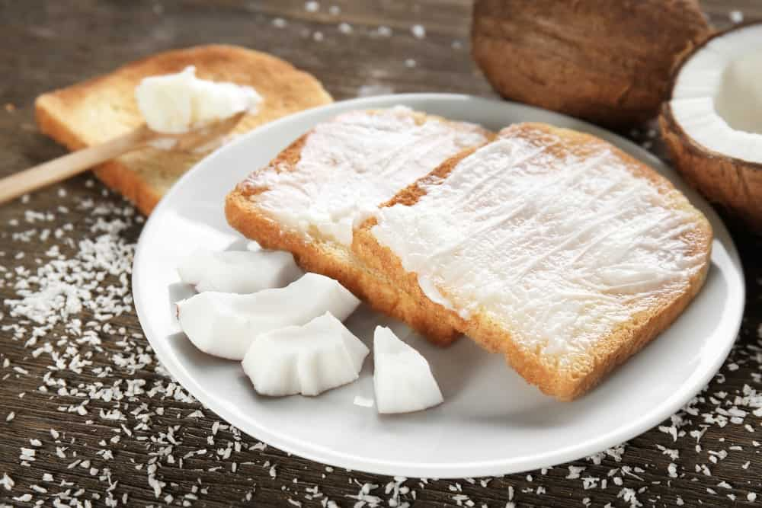
IF USED IN MODERATION, COCONUT OIL CAN BE QUITE HEALTHY. ALTHOUGH THERE HAVE BEEN STUDIES GIVING THE PRODUCT A BAD RAP IN RECENT YEARS, THE KEY IS SIMPLY NOT TO OVERDO IT OR EAT IT ALL THE TIME. IF YOU’RE COOKING WITH COCONUT OIL OR BUTTER, IT LENDS A TOASTY COCONUT FLAVOR TO THE FOOD AND A TOUCH OF SWEETNESS TO SATISFY THAT SWEET TOOTH, AND YOU CAN EVEN USE IT ON TOAST, BISCUITS, AND MUFFINS.
ADVANTAGES
- IT INCREASES THE HEALTHY TYPE OF CHOLESTEROL OR HDL
- IT TASTES GREAT
DISADVANTAGES
- COCONUT OIL HAS A LOT OF CALORIES
- HEAT CAN DESTROY SOME OF ITS HEALTH BENEFITS
IF YOU’RE LOOKING FOR SOMETHING TO TAKE THE PLACE OF BUTTER, EITHER FOR SPREADING OR COOKING, COCONUT OIL OR BUTTER IS DEFINITELY WORTH CONSIDERING, ESPECIALLY IF IT IS ONLY AN OCCASIONAL CHOICE.

6. DAIRY-FREE/GREEK YOGURT
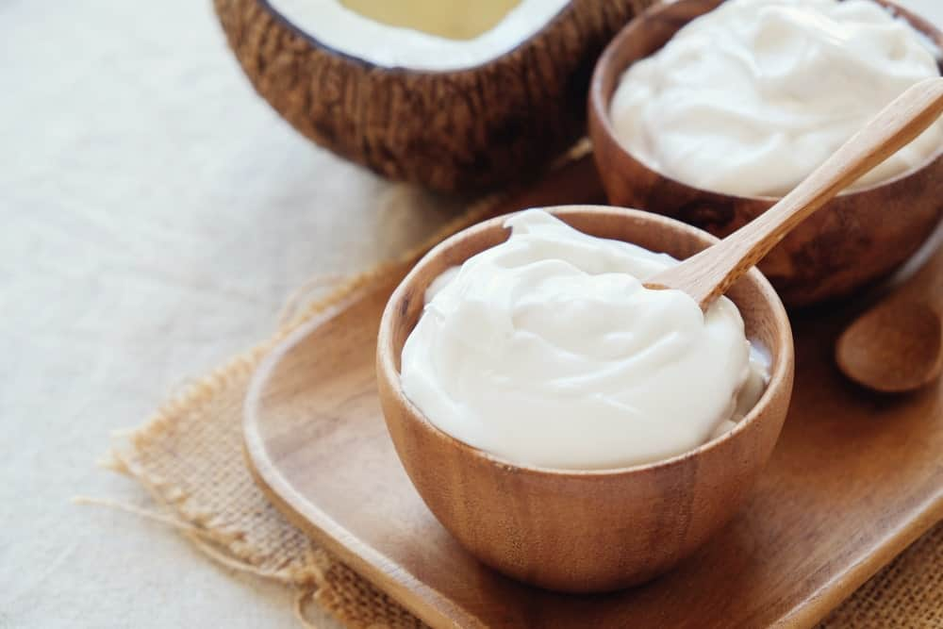
IF YOU USE YOGURTS SUCH AS ALMOND OR COCONUT YOGURT, YOU CAN ADD A LITTLE CINNAMON TO IT AND SPREAD IT ON YOUR TOAST FOR A YUMMY, HEALTHY TREAT. THE MAIN THING YOU’LL WANT TO DO IF USING YOGURT AS A SUBSTITUTE FOR BUTTER IS TO READ YOUR LABELS. A LOT OF DAIRY-FREE FOODS STILL HAVE HIGH AMOUNTS OF SUGAR AND OTHER INGREDIENTS THAT AREN’T HEALTHY, AND THIS IS SOMETHING YOU’LL WANT TO LOOK OUT FOR.
ADVANTAGES
- IT IS INEXPENSIVE AND EASY TO FIND
- IT HAS A LOT OF VITAMINS AND NUTRIENTS IN IT
DISADVANTAGES
- SOME YOGURT IS FILLED WITH SUGAR – READ YOUR LABELS!
- THE PLAIN VERSION IS HEALTHIER BUT DOESN’T ALWAYS TASTE GOOD
IF YOU’RE COOKING OR BAKING WITH YOGURT, THE PLAIN VARIETY WILL WORK WELL, BUT IF YOU’RE SPREADING IT ON YOUR MUFFINS YOU MAY WANT TO TRY THE VARIETIES THAT ARE ALREADY FLAVORED OR FLAVOR THEM YOURSELF.

7. HUMMUS
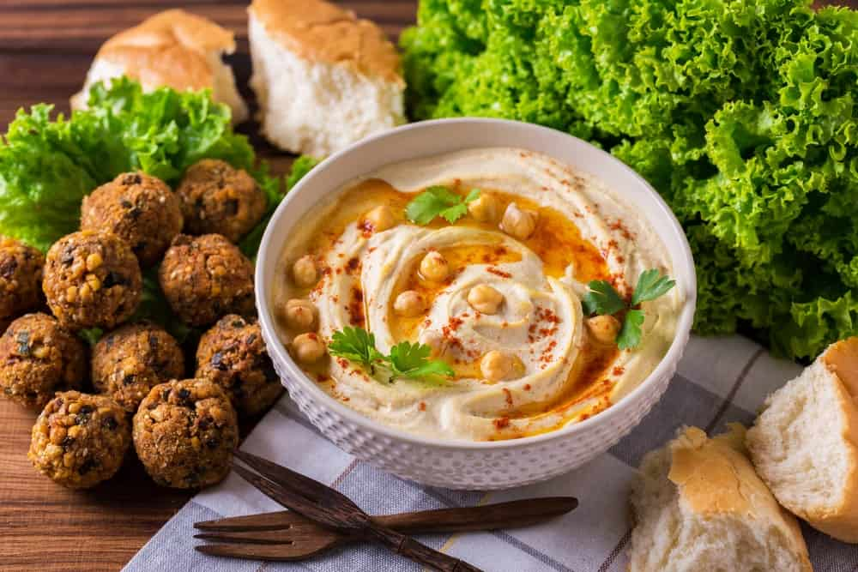
THERE ARE MANY ADVANTAGES TO EATING HUMMUS. IT IS EXTREMELY NUTRITIOUS, BEING MADE WITH CHICKPEAS AND TAHINI, AND IT CAN BE EATEN WITH ALMOST ANYTHING. IF YOU USE IT IN PLACE OF BUTTER, IT ADDS NUTRITIONAL VALUE TO WHATEVER YOU’RE COOKING OR BAKING, AND IT IS INCREDIBLY EASY TO MAKE IF YOU WANT A FRESHER ALTERNATIVE TO BUTTER.
ADVANTAGES
- HUMMUS IS HIGH IN FIBER, VITAMIN B6, AND PROTEIN
- IT CAN BE MADE FROM LENTILS OR BLACK BEANS FOR PEOPLE WHO DON’T LIKE CHICKPEAS
DISADVANTAGES
- IT IS HIGH IN CALORIES
- THE PACKAGED HUMMUS MAY CONTAIN HIDDEN UNHEALTHY INGREDIENTS
IF YOU MAKE YOUR OWN HUMMUS – WHICH IS EXTREMELY EASY – YOU’LL KNOW EXACTLY WHAT YOU’RE CONSUMING, AND HUMMUS ALSO WILL NOT ADD ANY UNPLEASANT TASTE TO WHATEVER YOU’RE MAKING IN YOUR KITCHEN.

8. NUT BUTTER
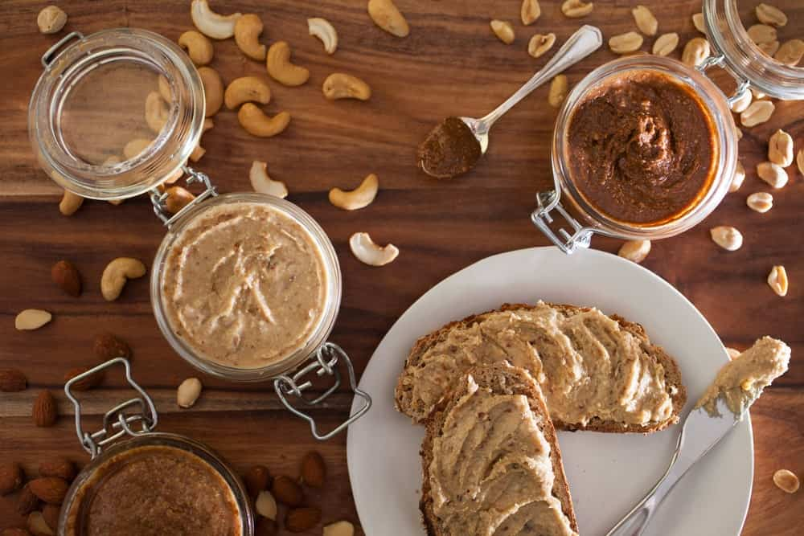
THERE ARE MANY DIFFERENT TYPES OF NUT BUTTER, INCLUDING THOSE MADE WITH PEANUTS, CASHEWS, AND EVEN ALMONDS. THE USES ASSOCIATED WITH THESE BUTTER ARE LIMITLESS BECAUSE YOU CAN ADD NUT BUTTER TO TOAST, CELERY STICKS OR EVEN A VEGETABLE SAUTÉ FOR SOME DISHES, PARTICULARLY THAI DISHES. IF YOU GET THE SUGAR-FREE BUTTER, YOU GET A PURE PRODUCT, AND THEY TASTE JUST AS GOOD AS THE SUGAR-FILLED VERSIONS, IF NOT BETTER.
ADVANTAGES
- IT IS HIGH IN IRON, VITAMIN E, AND MAGNESIUM
- A LITTLE BIT WILL GO A LONG WAY
DISADVANTAGES
- SOME VERSIONS CONTAIN A LOT OF SUGAR AND EVEN OILS
- SOME NUT BUTTER IS QUITE EXPENSIVE
IF YOU LIKE A FRESH, NUTTY TASTE ON YOUR FOODS, A GOOD NUT BUTTER IS A GREAT CHOICE. IT IS MUCH HEALTHIER THAN REGULAR BUTTER, AND IT IS EASY TO USE AND VERSATILE.

9. NUTRITIONAL YEAST
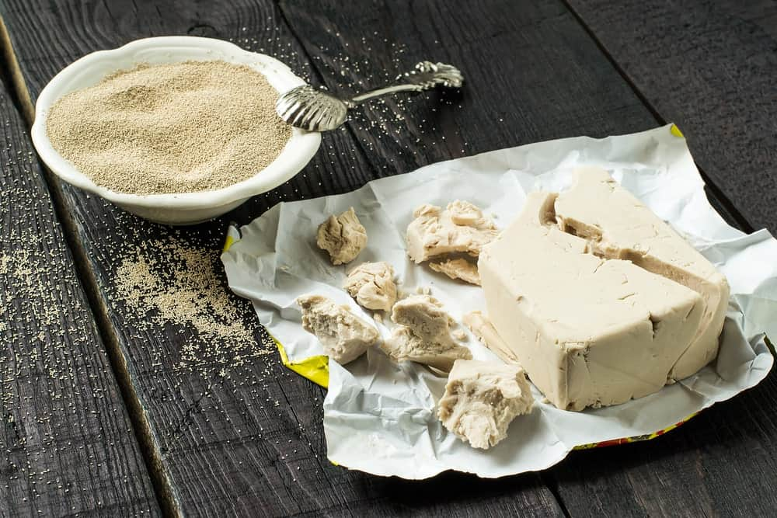
IF YOU PREFER A CHEESY FLAVOR, YOU MAY WANT TO USE NUTRITIONAL YEAST AS A SEASONING. IT HAS A LOT OF NUTRITIONAL VALUE, AND IT’S PERFECT EVEN FOR VEGANS.
ADVANTAGES
- IT IS HIGH IN PROTEIN, VITAMINS B6 AND B12, AND IS GREAT FOR THE IMMUNE SYSTEM
- IT HAS A YUMMY TASTE
DISADVANTAGES
- SOME PEOPLE ARE ALLERGIC TO ALL TYPES OF YEAST
- THE TYPES VARY GREATLY, SO READING LABELS IS IMPORTANT
THE BEST NUTRITIONAL YEAST SHOULD BE PURCHASED FROM A HEALTH-FOOD STORE BECAUSE THIS IS THE BEST WAY TO MAKE SURE IT IS THE MOST NUTRITIONALLY SOUND.

10. OLIVE OIL
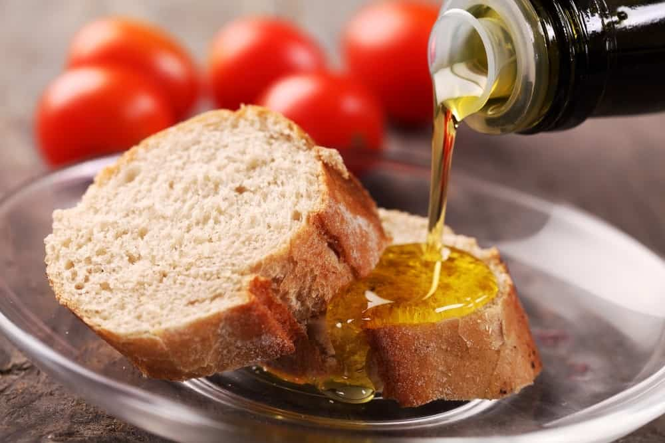
OLIVE OIL IS HEALTHY FOR NUMEROUS REASONS, AND IT ALSO MAKES A GREAT ALTERNATIVE TO BUTTER WHEN YOU’RE COOKING OR BAKING. IT HAS BEEN KNOWN TO HELP WITH EVERYTHING FROM HEART DISEASE TO DEPRESSION, AND IT CAN EVEN HELP WITH INFLAMMATION. FOR BEST RESULTS, USE THE EXTRA-VIRGIN OLIVE OIL, AND MAKE SURE IT IS 100% PURE AND SOLD IN A DARK BOTTLE.
ADVANTAGES
- IT RAISES THE “GOOD” CHOLESTEROL AND LOWERS THE “BAD” TYPE
- IT HAS A LIGHT, PLEASANT TASTE
DISADVANTAGES
- LIKE OTHER FATS, IT SHOULD BE CONSUMED IN MODERATION
- THERE ARE MANY BLENDS ON THE MARKET, AND THEY ARE NOT AS HEALTHY AS THE REAL THING
IF YOU’RE FOLLOWING A MEDITERRANEAN DIET, YOU’RE LIKELY EATING A LOT OF EXTRA-VIRGIN OLIVE OIL, AND USING THIS INSTEAD OF BUTTER IS JUST ANOTHER WAY TO GET THE NUTRITION YOUR BODY NEEDS.

11. PUMPKIN PUREE
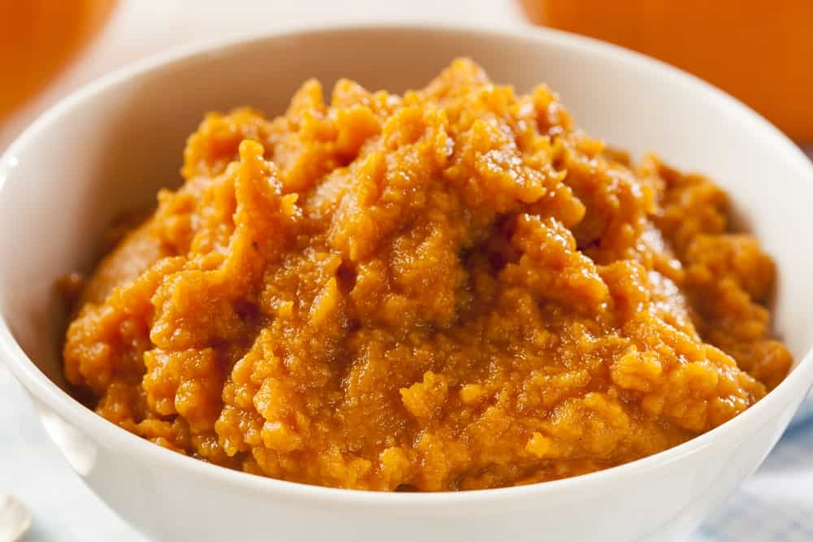
THIS IS A BUTTER ALTERNATIVE MOST PEOPLE DON’T THINK ABOUT, BUT IT IS EASY TO USE IT IN YOUR BAKED GOODS. SIMPLY USE A THREE-FOURTHS CUP OF PUMPKIN PUREE – WHICH YOU CAN FIND IN MOST GROCERY STORES – FOR EVERY CUP OF BUTTER IN THE RECIPE YOU’RE USING. IT IS GREAT FOR A VARIETY OF FOODS, INCLUDING CAKES, MUFFINS, AND BREAD, AND IT ADDS A LOT OF NUTRITIONAL VALUE TO WHATEVER YOU’RE CREATING.
ADVANTAGES
- IT IS HIGH IN FIBER, POTASSIUM, AND VITAMIN K
- IT IS VERY INEXPENSIVE AND EASY TO FIND
DISADVANTAGES
- SOME PEOPLE MAY NOT LIKE THE TASTE THAT RESULTS
- SOME PRODUCTS MAY CONTAIN LESS ACTUAL PUMPKIN THAN YOU THINK – AGAIN, READ YOUR LABELS
IF YOU’VE NEVER TRIED PUMPKIN PUREE AS AN ALTERNATIVE TO BUTTER, YOU MIGHT BE SURPRISED BY THE RESULTS. IT MAKES YOUR BAKED GOODS VERY MOIST, AND IT IS MUCH HEALTHIER AS WELL.

12. SHEA BUTTER
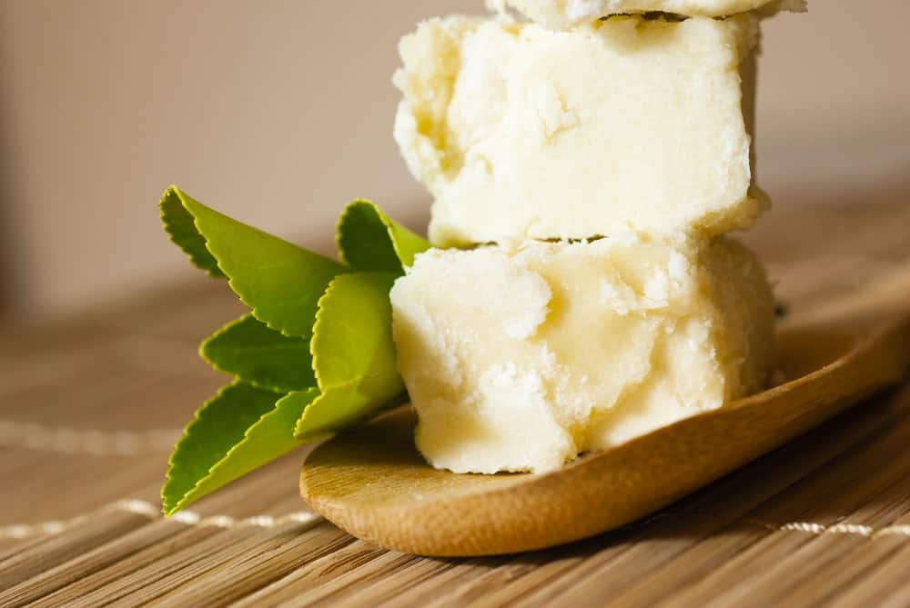
CONTRARY TO WHAT MANY PEOPLE BELIEVE, SHEA BUTTER IS FOR MORE THAN JUST ACHIEVING SMOOTH SKIN. SHEA BUTTER IS NOT ONLY TASTY, BUT IT CONTAINS IMPORTANT NUTRIENTS SUCH AS VITAMIN E, ANTIOXIDANTS, AND ESSENTIAL FATTY ACIDS. IF YOU CHOOSE THIS TYPE OF BUTTER, MAKE SURE YOU PURCHASE THE TYPE THAT IS UNREFINED AND PURE AND ONLY PURCHASE SMALL AMOUNTS BECAUSE IT GOES BAD QUICKLY.
ADVANTAGES
- IT IS A NATURAL PRODUCT
- IT HAS A VERY NICE SMELL AND TASTE
DISADVANTAGES
- THERE ARE MIXED REVIEWS REGARDING ITS NUTRITIONAL VALUE
- IT CAN BE DIFFICULT TO FIND
IF YOU’RE LOOKING FOR AN ALTERNATIVE TO BUTTER, SHEA BUTTER MIGHT BE YOUR ANSWER, AND THERE IS PLENTY OF INFORMATION ONLINE THAT CAN HELP YOU MAKE THE RIGHT DECISION.

20 DIFFERENT TYPES OF DOUGH FOR ALL KINDS OF BAKED GOODS
THERE ARE MANY MOUTHWATERING DELICACIES AND DESSERTS THAT ARE MADE UP OF THE SIMPLE MIXTURE OF FLOUR AND WATER SO GET TO KNOW THE DIFFERENT TYPES OF DOUGH THAT WILL MAKE YOU DROOL.
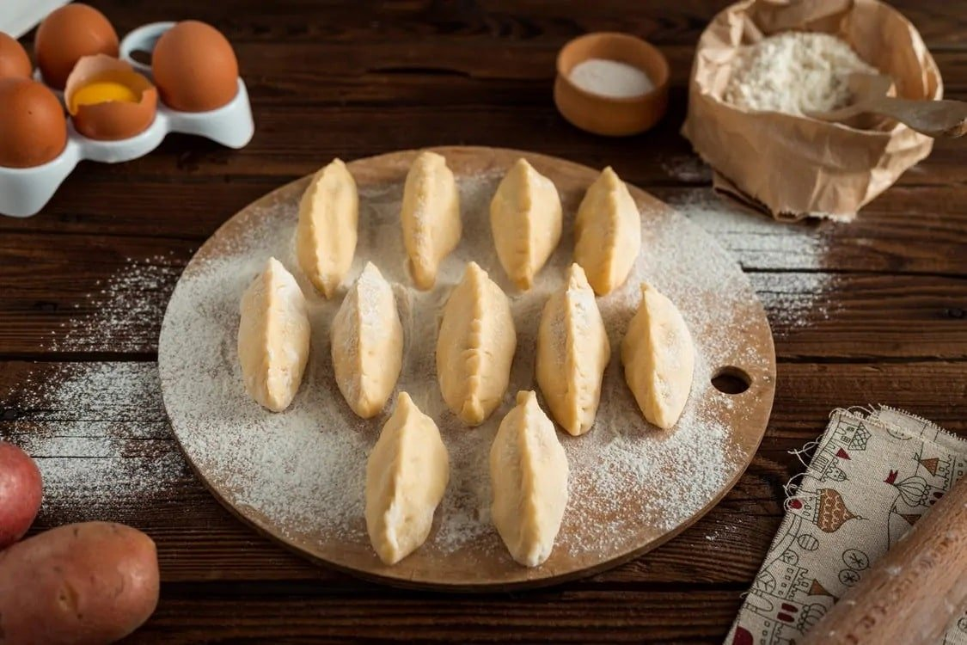
MANY OF OUR CHILDHOOD MEMORIES ARE FILLED WITH DOUGH, WHETHER ITS STEALING CHOCOLATE CHIP COOKIES FROM THE JAR PLACED INSIDE THE TOP KITCHEN DRAWER OR SWIPING CAKE BATTER DIRECTLY FROM THE MIXING BOWL. WHO COULD HAVE IMAGINED THAT SOME OF THE MOST MOUTHWATERING DESSERTS IN THE WORLD COULD BE MADE FROM A SIMPLE MIXTURE OF FLOUR AND WATER?
RELATED: TYPES OF SCONES | TYPES OF BREAD | TYPES OF PASTA | TYPES OF BAGELS | TYPES OF CORNBREAD | TYPES OF WHISKS

HISTORY OF DOUGH
THE ORIGIN OF DOUGH IS SO ANCIENT THAT NO ONE KNOWS EXACTLY WHEN IT WAS FIRST MADE. HOWEVER, PREHISTORIC ARCHEOLOGICAL FINDINGS SHOWED THAT PEOPLE MAY HAVE BEGUN USING FLOUR IN THEIR DIET ABOUT 30,000 YEARS AGO.
DURING THAT TIME, SIMPLE WATER WAS ADDED TO FLOUR TO CREATE THE FIRST DOUGH. IT WAS THEN FLATTENED AND COOKED OVER HOT STONES. THESE EARLY CREATIONS WERE INVENTED DUE TO “MISTAKES.” IT TOOK OVER ALMOST 20,000 MORE YEARS BEFORE PEOPLE STARTING CULTIVATING WHEAT AND MAKING FOOD OUT OF IT.
THIS WAY, THEY WERE ABLE TO SETTLE DOWN, FEED MORE PEOPLE, AND CREATE AN IMPROVED SOCIAL STRUCTURE WHICH MADE THE BASIS OF PRESENT-DAY SOCIETIES.
SOME YEARS LATER, PEOPLE DISCOVERED YEAST, WHICH TOOK THE DOUGH TO A WHOLE NEW LEVEL.
AS CULTURES HAVE DEVELOPED, SO HAVE THE RECIPES FOR DOUGH.
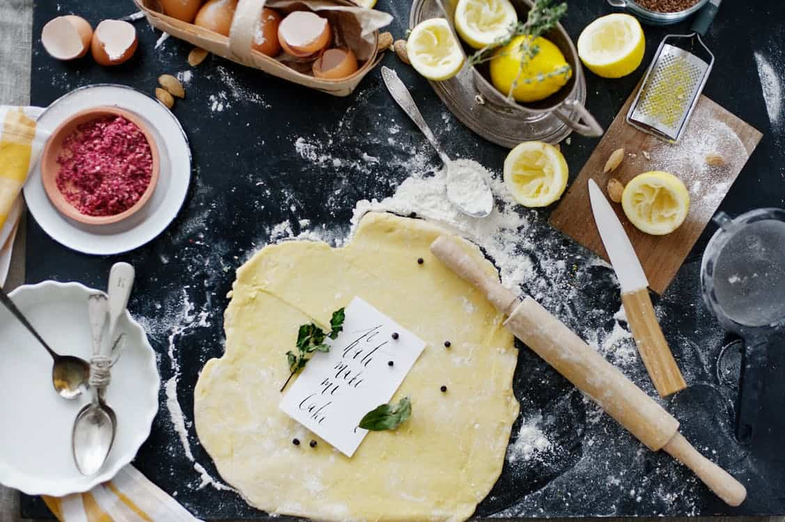

DOUGH AND BATTER: WHAT’S THE DIFFERENCE?
HAVE YOU EVER CHANCED UPON A COOKIE RECIPE THAT TELLS YOU THAT THE DESSERTS ARE DOUGH OR BETTER-BUILT? IF YOU DON’T KNOW THE DIFFERENCE, WE CAN TELL YOU.
THE DOUGH IS A MIXTURE OF CHIEFLY FLOUR WITH LOW WATER CONTENT. AS SUCH, IT IS FROM ENOUGH TO BE KNEADED BY HANDS AND MOLDED INTO SHAPES. BATTERS CONTAIN MORE LIQUID CONTENT THAN DOUGH AND HAVE A RUNNY TEXTURE. THEY ARE USUALLY MIXED WITH HAND OR ELECTRIC MIXERS.

MAIN CATEGORIES OF DOUGH
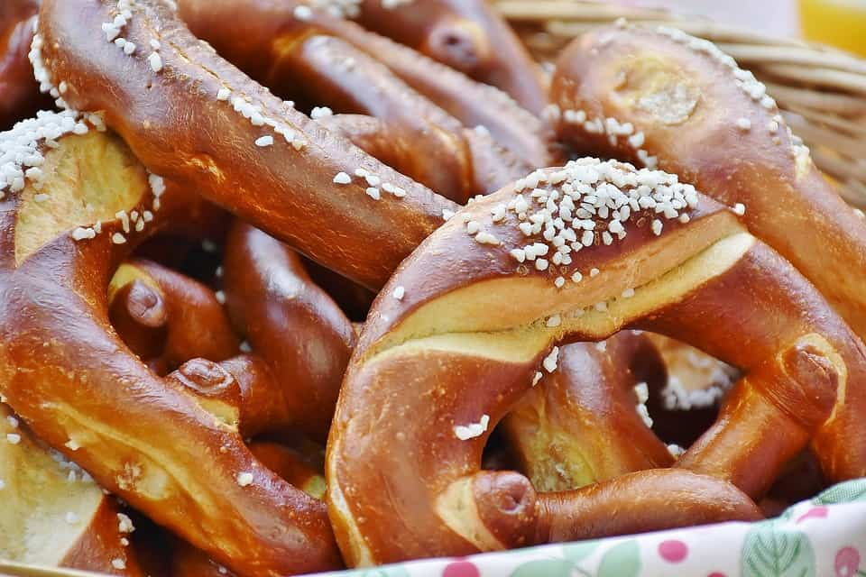
FOR THE SAKE OF PRACTICALITY, THE SEVERAL HUNDRED KINDS OF DOUGH CAN BE SUBDIVIDED INTO TWO MAIN CATEGORIES: LEAVENED AND UNLEAVENED DOUGH.

LEAVENED DOUGH
THE LEAVENED DOUGH IS FERMENTED FOR A PERIOD OF TIME UNTIL IT ACHIEVES ITS FINAL FORM. THE RISING IS DONE THROUGH LEAVENERS, LIKE YEAST, BAKING SODA, AND BAKING POWDER. THE FERMENTED DOUGH CAN BE CREATED BY TWO METHODS:
SPONGE DOUGH METHOD
SPONGE DOUGH METHOD INVOLVES CREATING A MIXTURE OF FLOUR, WATER, AND YEAST, WHICH IS LEFT TO RISE UNTIL IT AT LEAST DOUBLES IN SIZE. THEN MORE FLOUR, SUGAR, SALT, AND FAT IS ADDED TO THE DOUGH AND KNEADED. THIS METHOD GIVES THE BREAD A FLAKIER TEXTURE WITH A SLIGHTLY DIFFERENT FLAVOR.
STRAIGHT DOUGH METHOD
IN THE STRAIGHT DOUGH METHOD, ALL THE INGREDIENTS ARE COMBINED IN A SINGLE SESSION AND THEN KNEADED TO A SMOOTH AND ELASTIC CONSISTENCY. KNEADING DEPENDS ON THE TYPE OF BREAD YOU WANT TO MAKE.
EXAMPLES OF BAKED FOOD MADE FROM LEAVENED DOUGH INCLUDE ALL KINDS OF PIECES OF BREAD, PIZZA, PRETZELS, AND MOST ROLLS.


UNLEAVENED DOUGH
THE UNLEAVENED DOUGH DOES NOT REQUIRE ANY LEAVENING AGENT AND IS USED FOR ALL BAKED GOODIES THAT DO NOT NEED TO RISE BUT INSTEAD STAY THIN AND FLAKY. THESE KINDS OF DOUGH USUALLY HAVE A HIGHER PERCENTAGE OF FAT, WHICH PREVENTS THEM FROM HARDENING.
SOME EXAMPLES OF BAKED TREATS MADE FROM UNLEAVENED DOUGH INCLUDE SHORTCRUST PASTRY, CRACKERS, FLATBREAD, TORTILLAS, AND PASTA.

TYPES OF PASTRY DOUGH

IF YOU ARE INTERESTED IN MAKING PASTRIES, YOU WILL FIND THAT DOUGH CAN BE CATEGORIZED AS LAMINATED AND NON-LAMINATED. BOTH THESE TYPES OF DOUGH CAN BE LEAVENED OR UNLEAVENED.

LAMINATED PASTRY DOUGH
LAMINATED DOUGH INVOLVES FOLDING AND REFOLDING PIECES OF PASTRY SLATHERED WITH BUTTER MANY TIMES UNTIL MANY LAYERS ARE CREATED. GLUTEN IS ALSO DEVELOPED DURING THE FOLDING PROCESS.
EXAMPLES OF UNLEAVENED LAMINATED DOUGH INCLUDE PHYLLO DOUGH AND PUFF PASTRY DOUGH. AN EXAMPLE OF LEAVENED LAMINATED DOUGH INCLUDES THE BREAKFAST FAVORITE, THE CROISSANT.
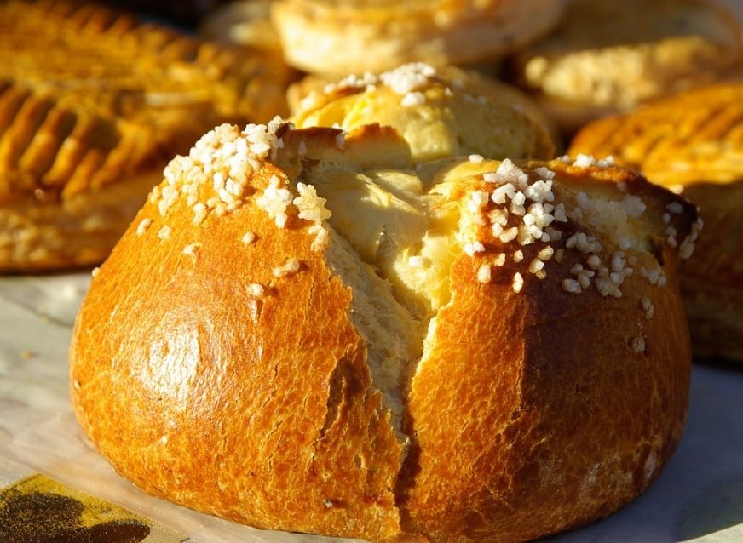

NON-LAMINATED PASTRY DOUGH
THE NON-LAMINATED DOUGH INCLUDES RUBBING IN FAT OR BUTTER INTO THE FLOUR WITHOUT FOLDING IT. UNLEAVENED NON-LAMINATED PASTRIES INCLUDE CHOUX PASTRIES, ÉCLAIRS, AND PIE DOUGH. LEAVENED NON-LAMINATED PASTRIES INCLUDE THE BRIOCHE.

TEXTURES OF DOUGH
DOUGH THAT HAS A HIGHER AMOUNT OF FAT, LESS WATER, AND LESS GLUTEN, IS LESS ELASTIC THAN BREAD DOUGH AND CAN BE MADE WITH TWO DIFFERENT TEXTURES: FLAKY AND MEALY.

FLAKY DOUGH
A FLAKY DOUGH TEXTURE IS CREATED BY MIXING THE FAT WITH THE FLOUR FOR A SMALLER AMOUNT OF TIME. THIS RESULTS IN BIGGER CHUNKS OF FAT SPREAD UNEVENLY IN THE FLOUR, BUT IT ALSO DEPENDS ON THE TYPE OF FAT USED AND THE TEMPERATURE IN WHICH IT IS ADDED TO THE FLOUR. WHEN THE DOUGH IS ROLLED OUT, IT CREATES A LAYER OF FAT AND A FLAKY TEXTURE ONCE THE DOUGH IS BAKED.
THE FLAKY DOUGH IS BEST USED TO MAKE TOP CRUSTS OF PASTRIES BUT CAN ALSO BE USED AS BOTTOM CRUSTS FOR LIQUID FILLINGS.

MEALY DOUGH
MEALY DOUGH MAKES CRUSTS THAT ARE CRISPER AND MORE COMPACT. THE TEXTURE IS CREATED BY INCORPORATING SMALL FAT PARTICLES EVENLY IN THE DOUGH, WHICH CREATES A DENSER TEXTURE. THE DOUGH CANNOT ABSORB AS MUCH WATER AS FLAKY DOUGH CAN AND DOUGH REQUIRES THE FAT TO BE MIXED IN LONGER SO THAT THE MIXTURE LOOKS LIKE CORNMEAL. AFTER BAKING, THE CRUST IS SHORT AND TENDER.
THIS KIND OF DOUGH WORKS WELL FOR LIQUID FILLINGS, LIKE CUSTARD, ESPECIALLY IF YOU DON’T BLIND BAKE THE CRUST (PARTIALLY BAKING THE CRUST BEFOREHAND). IT IS ALSO THE PERFECT DOUGH FOR MAKING BOTTOM CRUSTS OF FRUIT PIES AS IT DOES NOT GET SOGGY.

TYPES OF DOUGH
THERE ARE SEVERAL KINDS OF DOUGH THAT HAVE BEEN CREATED AROUND THE WORLD. SOME OF THE MOST POPULAR TYPES ARE LISTED BELOW:

BREAD DOUGH
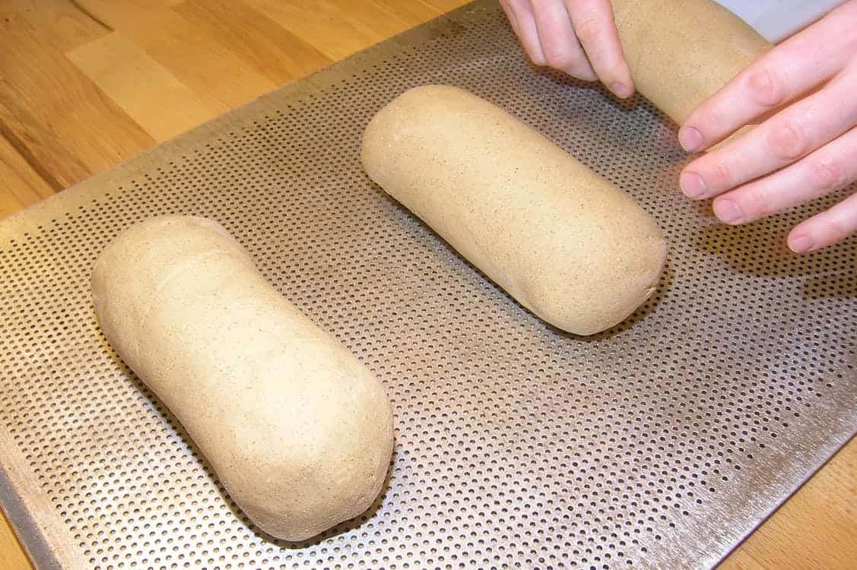
BREAD DOUGH IS THE MOST COMMON TYPE OF DOUGH. THIS DOUGH CAN BE MADE FROM DIFFERENT TYPES OF WHEAT AND VARIOUS AMOUNTS OF WATER AND YEAST. BREAD DOUGH NEEDS TO BE KNEADED CAREFULLY FOR A LONG TIME TO DEVELOP THE GLUTEN SO THAT THE BREAD CAN BECOME FIRM YET ELASTIC AND RISE BEAUTIFULLY WHILE BAKING.
BREAD DOUGH CAN BE MADE FROM A SINGLE OR A COMBINATION OF FLOUR GIVING IT A DIFFERENT TASTE AND TEXTURE. THERE ARE SOME BREAD TYPES THAT USE BAKING SODA AS LEAVENERS INSTEAD OF YEAST. THIS BREAD ARE KNOWN AS SODA BREAD.

SOURDOUGH

SOURDOUGH IS ONE OF THE OLDEST TYPES OF BREAD DATING BACK TO 3700 BCE IN SWITZERLAND; HOWEVER, THE ORIGIN OF SOUR BREAD FERMENTATION IS BELIEVED TO BE IN THE FERTILE CRESCENT SEVERAL THOUSAND YEARS BEFORE THAT.
THE BREAD IS MADE BY NATURALLY OCCURRING BACTERIA IN THE FLOUR CALLED LACTOBACILLI, AND YEAST. THE INGREDIENTS GENERALLY CONSIST OF A STARTER THAT INCLUDES FLOUR AND WATER AND SOME SALT. THESE PIECES OF BREAD HAVE QUITE A SOFT CRUST WITH A CHEWY MIDDLE AND LARGE AIR BUBBLES. IT ALSO HAS A VERY LONG SHELF LIFE.
SOURBREAD, AS THE NAME INDICATES, HAS A SOUR TASTE DUE TO THE LACTIC ACID PRODUCED BY THE BACTERIA. NO MILK, YEAST, FAT, OR SWEETENER IS ADDED TO THE BREAD, WHICH MAKES IT MARKEDLY DIFFERENT AND MORE NATURAL THAN OTHER TYPES OF BREAD.

RICH DOUGH
THE RICH DOUGH IS A TYPE OF LEAVENED DOUGH THAT IS FORTIFIED WITH EGGS AND FATS, LIKE BUTTER, OIL, CREAM. IF PROPERLY MADE, THIS DOUGH CAN STRETCH THIN, HAS A SMOOTH TEXTURE, AND IS TRANSLUCENT.
THE RICH DOUGH CAN MAKE BREAD THAT IS SOFT, FLUFFY, AND TENDER, LIKE CAKE, AS THE EXTRA FAT IN THE FLOUR SHORTENS THE GLUTEN. ALTHOUGH THIS DOUGH CAN HAVE HIGH SUGAR CONTENT, SUGAR IS NOT NECESSARY TO PRODUCE RICH DOUGH.

PIE DOUGH
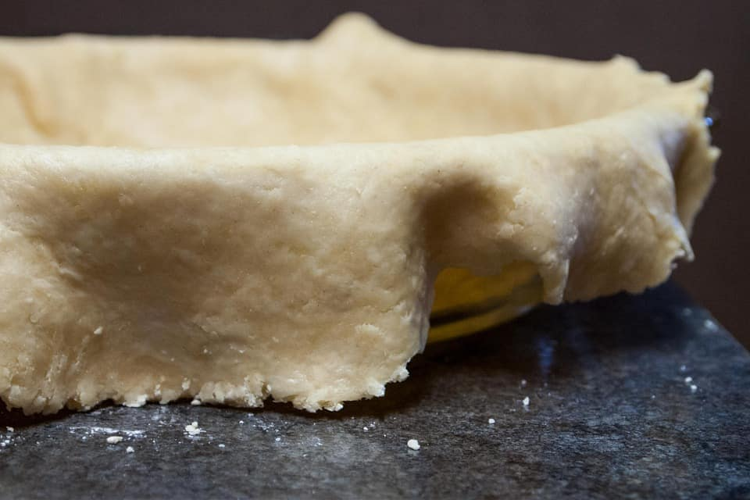
PIE DOUGH CRUSTS WERE FIRST CREATED IN THE MIDDLE AGES. HOWEVER, UNLIKE THE MODERN VERSIONS THAT OFTEN COMPRISE OF FRUIT FILLING, THESE PIES WERE MEANT TO PRESERVE AND CONTAIN MEAT, GIVING BIRTH TO DISHES LIKE CORNISH PASTIES.
PIE DOUGH IS MADE FROM A FEW STANDARD INGREDIENTS INCLUDING FLOUR, WATER, SALT, AND FAT IN DIFFERENT RATIOS. SOME ORE ADVANCED RECIPES ALSO INCLUDE BAKING POWDER OR VINEGAR, OR FLAVORING AGENTS LIKE EGGS, LEMON JUICE, CIDER, AND SUGAR. THE FLOUR IS OFTEN ALL-PURPOSE BUT CAN BE A COMBINATION OF BREAD, PASTRY, OR CAKE FLOUR.
THE FAT INCORPORATED INTO THE PIE DOUGH CAN BE BUTTER, SHORTENING, OR LARD AND EVEN OIL AND IS USED COLD AND HARD. THE SUCCESS OF A PIE CRUST DEPENDS ON HOW COLD THE INGREDIENTS ARE KEPT, HOW THE FAT IS DISTRIBUTED INTO THE FLOUR, AND HOW MUCH GLUTEN IS DEVELOPED. THE RESULTING TEXTURE CAN BE FLAKY OR MEALY AND TENDER, WITH A BEAUTIFUL GOLDEN-BROWN COLOR.

PATE BRISEE
PATE BRISEE IS A TYPE OF PIE DOUGH, ALSO KNOWN AS MEALY PIE DOUGH. THIS IS ONE OF THE MOST POPULAR PIE DOUGH AND IS PERFECT FOR CREATING DESSERTS WITH FLUTED EDGES. THE DOUGH IS MADE FROM ONE PART WATER, TWO PARTS, BUTTER OR FAT, AND THREE PARTS FLOUR, AND CAN BE MIXED TOGETHER TO RESEMBLE CORNMEAL.
THIS DELICIOUS FRENCH PASTRY DOUGH IS MADE WITHOUT SUGAR AND WORKS WELL FOR LIQUID FILLINGS, LIKE CUSTARDS. IT ALSO TYPICALLY CONTAINS ONE EGG FOR EVERY POUND OF FLOUR AND OTHER INGREDIENTS LIKE LEMON JUICE, SALT, AND VANILLA EXTRACT, FOR FLAVOR.
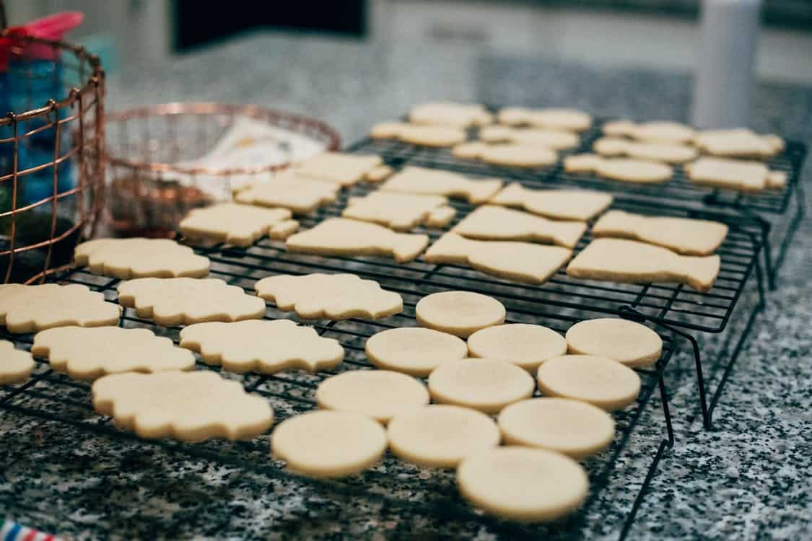

PATE SUCREE
PATE SUCREE LITERALLY TRANSLATES TO SUGAR DOUGH AND IS ALSO KNOWN AS THE SHORT DOUGH. LIKE THE PATE BRISEE, THIS DOUGH CONTAINS ONE PART WATER, TWO PARTS FAT, AND THREE PARTS FLOUR BY WEIGHT. IT ALSO CONTAINS AN EGG FOR EVERY POUND OF FLOUR AND HAS SEVERAL FLAVORING AGENTS, JUST LIKE PATE BRISEE. HOWEVER, IT HAS A MUCH HIGHER SUGAR CONTENT, GIVING IT A SWEET TASTE. THE FLAVOR IS MORE COOKIE-LIKE ALSO AND IT IS THE PREFERRED DOUGH FOR MAKING DESSERT TARTS AND COOKIES.

PATE SABLEE
SABLEE DOUGH IS ONE OF THE MOST POPULAR INGREDIENTS USED TO MAKE CRUMBLY, COMPACT, AND CRISPY DESSERTS. THE TERM TRANSLATES LITERALLY INTO “SANDY DOUGH” AND IT IS NAMED SO BECAUSE OF ITS COOKIE-LIKE, CRUMBLY TEXTURE.
THIS DELICATE DOUGH IS MADE BY CREAMING FAT WITH SUGAR, THEN INCORPORATING EGGS, AND THEN FLOUR IN THE END. THE CRUST IS EITHER PARTIALLY OR WHOLE BAKED PRIOR TO FILLING (BLIND BAKING). SOME RECIPES ALSO REQUIRE EGG YOLKS FOR A MORE TENDER CRUST, THOUGH THIS IS NOT NECESSARY.
THE DOUGH IS QUITE SWEET AS IT REQUIRES 15 PERCENT SUGAR AND SOMETIMES 15 PERCENT GROUND ALMONDS AS WELL. IT CAN ALSO BE BAKED AS IT IS TO MAKE DELICIOUS COOKIES.
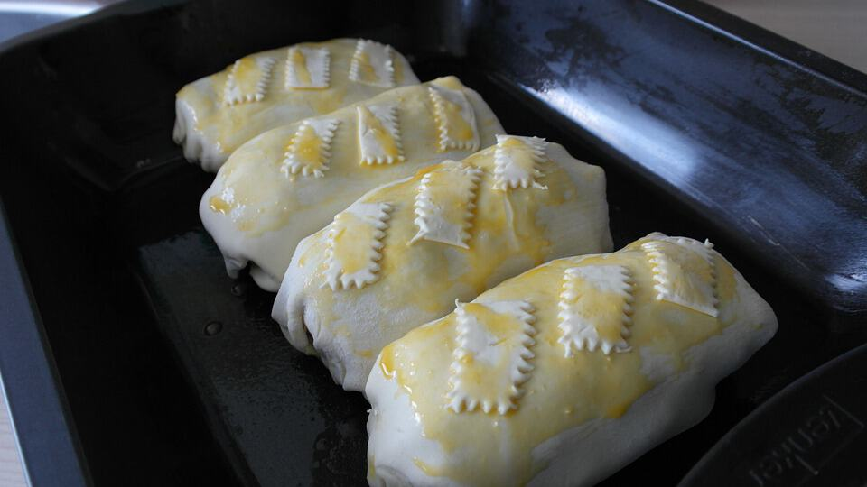

PUFF PASTRY DOUGH
THIS FLAKY PUFF PASTRY DOUGH WAS INVENTED BY FRENCH BAKER, CLADIUS GELE, AND IS LAMINATED, UNFERMENTED DOUGH. UNLIKE OTHER BASIC TYPES OF DOUGH, PUFF PASTRY REQUIRES A LOT OF HARD WORK AND EFFORT.
THERE ARE TWO STEPS TO MAKING A PUFF PASTRY: THE DOUGH IS FIRST ROLLED OUT AROUND BUTTER. IT IS THEN TURNED, ROLLED, AND FOLDED MANY TIMES AND GIVING LONG RESTING SESSIONS SO THAT THE BUTTER SPREADS EVENLY THROUGHOUT THE DOUGH. AS THE DOUGH IS BAKED, THE WATER EVAPORATES AND THE BUTTER MELTS, SEPARATING THE LAYERS OF DOUGH AND GIVING THE PUFF PASTRY ITS DISTINCTIVE LAYERS AND BUTTERY, CRISP, AND FLAKY TEXTURE.
BECAUSE OF ITS MANY FINE LAYERS, THE PASTRY IS ALSO KNOWN AS LEAF PASTRY.
PUFF PASTRY DOUGH CAN BE USED TO MAKE NAPOLEONS OR OTHER DESSERTS OR SAVORIES.
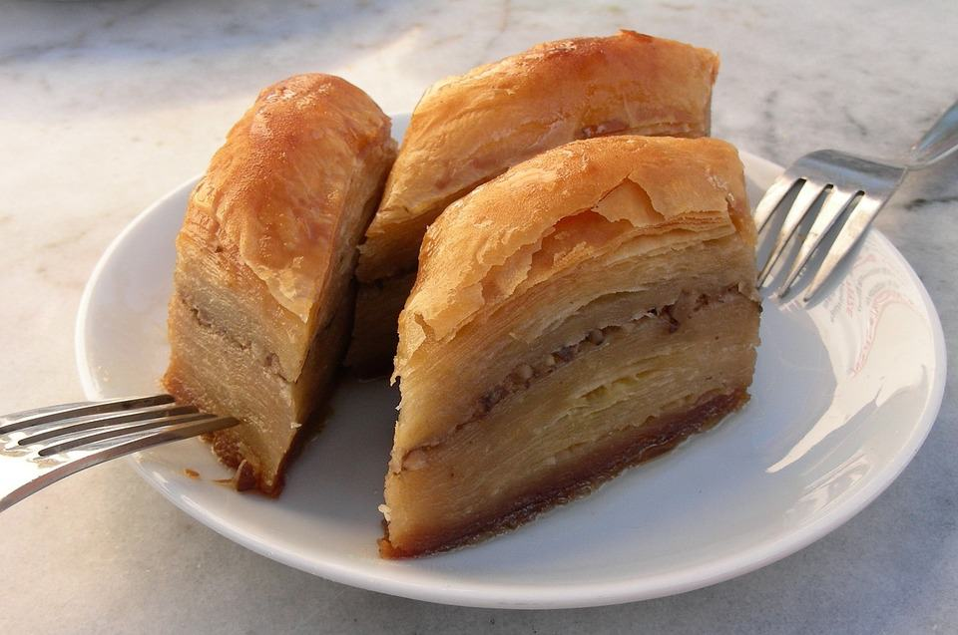

PHYLLO DOUGH
PHYLLO DOUGH WAS CREATED DURING THE BYZANTINE PERIOD IN ISTANBUL AND TODAY IS RENOWNED AS THE PASTRY OF PIES. THE WORD “PHYLLO” MEANS “LEAF” IN GREEK AND IS GIVEN TO THE DOUGH BECAUSE THE PASTRIES MADE FROM IT HAVE A THIN, LIGHT AND DELECTABLE TEXTURE.
PHYLLO DOUGH INVOLVES STRETCHING THE UNLEAVENED DOUGH INTO VERY THIN, TRANSLUCENT SHEETS. THE DOUGH IS POPULARLY USED TO MAKE MIDDLE EASTERN DESSERTS LIKE THE DECADENT BAKLAVA. HOWEVER, IF YOU ADD SOME VEGETABLE FAT TO THE MIXTURE, YOU CAN GET A THICKER VERSION OF PHYLLO DOUGH. THIS DOUGH CAN BE USED TO MAKE CRISP, CRUMBLY PIE CRUSTS, ESPECIALLY FOR MEAT PIES.
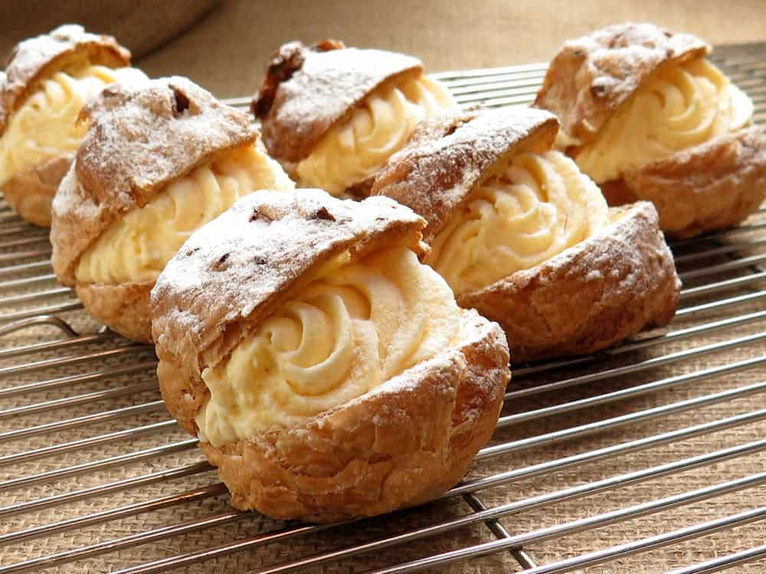

CHOUX PASTRY DOUGH
THE CONCEPT OF CHOUX PASTRY WAS FIRST INVENTED IN 1540 TO COMMEMORATE THE WEDDING OF CATHERINE DE MEDICI WITH KING HENRY II. THE CHOUX PASTRY DOUGH IS FORTIFIED DOUGH PASTE THAT REQUIRES EGG, MILK, BUTTER, AND WATER TO MAKE. IT IS NOT STRICTLY A DOUGH SINCE THE LIQUID CONTENT IS HIGH IN IT AND IT IS PIPED THROUGH A PASTRY TIP.
IF THE DOUGH IS FORMED PERFECTLY, IT CAN PRODUCE A CRISPY CRUST, A LIGHT INTERIOR, AND A PERFECT GOLDEN-BROWN COLOR. DURING BAKING, WATER EVAPORATES, LEAVING THE CENTER SOMEWHAT EMPTY AND HOLLOW. THIS SPACE CAN BE FILLED WITH WHIPPED CREAM, CUSTARD, OR JELLY. THEREFORE, THE DOUGH IS USED TO MAKE A MOUTHWATERING VARIETY OF DESSERTS, INCLUDING ÉCLAIRS, CREAM PUFFS, CROQUEMBOUCHE, PROFITEROLES, AND PARIS-BREST.


CROISSANT DOUGH
CROISSANT DOUGH IS VERY SIMILAR TO A PASTRY PUFF DOUGH BUT WITH ADDED YEAST FOR SOME EXTRA FLUFFINESS. THE DOUGH IS CREATED BY ENFOLDING BUTTER AND TAKING IT TO A SERIES OF TURNS TO CREATE CENTRAL LAYERS OF BUTTER IN BETWEEN THE DOUGH SHEETS. DURING BAKING, THE STEAM SEPARATES THE LAYERS OF DOUGH.
ALTHOUGH A LOT OF HARD WORK IS INVOLVED IN IT, IF THE LAMINATION IS SUCCESSFUL, THE RESULTING BREAD IS VERY LIGHT AND FLAKY IN TEXTURE.
THIS DOUGH CAN ALSO BE WRAPPED AROUND CHOCOLATE OR ALMOND PASTE BEFORE THEY ARE BAKED.

BRIOCHE DOUGH
THE DOUGH USED TO CREATE BRIOCHE PASTRIES IS NON-LAMINATED, YEAST-BASED DOUGH, WHICH IS MIXED WITH BUTTER AND EGGS. THE RESULTING BREAD IS SOFT LIKE CAKE AND HAS A TENDER, CREAMY, AND SLIGHTLY SWEET CONSISTENCY, WITHOUT THE SIGNATURE CRUNCHINESS OR CRISPINESS THAT IS ASSOCIATED WITH MOST PASTRIES.
THIS DOUGH IS TYPICALLY ROLLED INTO BALLS TO MAKE ITS CHARACTERISTIC ROUND SHAPE THOUGH IT CAN ALSO BE MADE INTO AN ORDINARY LOAF SHAPE. BRIOCHE NANTERRE IS MADE BY PLACING TWO LOAF-SHAPED SECTIONS OF BRIOCHE DOUGH SIDE BY SIDE AND BAKING THEM. WHEN THE DOUGH RISES, THE TWO SEPARATE SECTIONS FUSE TOGETHER.

KOUROU DOUGH
KOUROU DOUGH IS A TYPE OF RICH DOUGH MADE WITH BUTTER AND EGGS, AND SOMETIMES MILK AND EVEN YOGURT. UNLIKE THE PUFF PASTRIES WHICH REQUIRE A LARGE AMOUNT OF FAT CONTENT, KOUROU DOUGH NEEDS ONLY A BIT OF OIL TO MOLD IT INTO THE PERFECT FORM.
THE KOUROU DOUGH RESULTS IN A CRUNCHY AND SLIGHTLY DRIER TEXTURE, BUT IS EXTREMELY FLAVORFUL. IT IS ONE OF THE PREFERRED TYPES OF DOUGH FOR MAKING TARTS, QUICHES, PIES, AND TURNOVER.
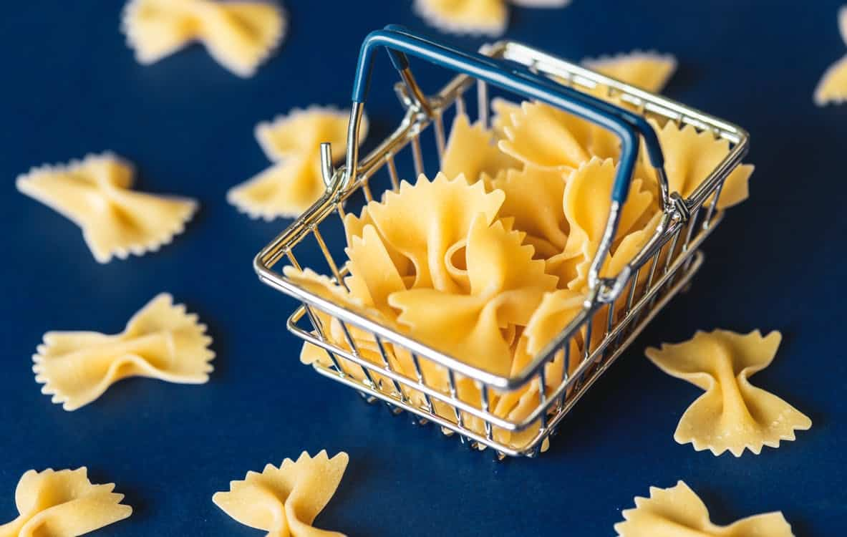

PASTA DOUGH
WHO DOESN’T LOVE PASTA? PASTA DOUGH IS MADE FROM UNFERMENTED DOUGH, TYPICALLY CONSISTING OF WHEAT, EGGS, AND SALT. SOMETIMES, RICE FLOURS, BEAN FLOUR, OR LEGUME FLOUR IS USED TO MAKE THE DOUGH GLUTEN-FREE AND GIVE IT A DIFFERENT TASTE.
THIS DOUGH IS QUITE HARD AND REQUIRES A LOT OF KNEADING SO THAT IT IS MOISTENED ALL THE WAY THROUGH. THE PASTA DOUGH CAN BE ROLLED INTO SHEETS OR MOLDED INTO DIFFERENT SHAPES. HOWEVER, THE BEST PART IS THAT IT CAN BE USED BOTH FRESH AND DRIED.
FRESH PASTA DOUGH CAN BE MADE WITH THE HAND AT HOME AND BAKED OR BOILED. DRY PASTA IS STORE-BOUGHT AND HAS AN EXTREMELY LONG SHELF LIFE.

ARE YOU HUNGRY YET? IF YOU ARE, GO AHEAD AND TRY MAKING THESE VERSATILE AND MOUTHWATERING TYPES OF DOUGH AT HOME, WHICH CAN CREATE SOME OF THE BEST SAVORY AND SWEET DISHES OF ALL TIME.

25 DIFFERENT TYPES OF SCONES
FROM SAVORY BRITISH SCONES TO SWEET AMERICAN VERSIONS, SCONES ARE A GREAT OPTION TO SERVE AT HOME FOR BREAKFAST, AT A BRUNCH WITH BUSINESS ASSOCIATES, OR EVEN AS A SWEET TREAT IN THE AFTERNOON WITH TEA OR COFFE. THERE ARE A VARIETY OF SCONES YOU MAKE IN ANY FLAVOR YOU PREFER.
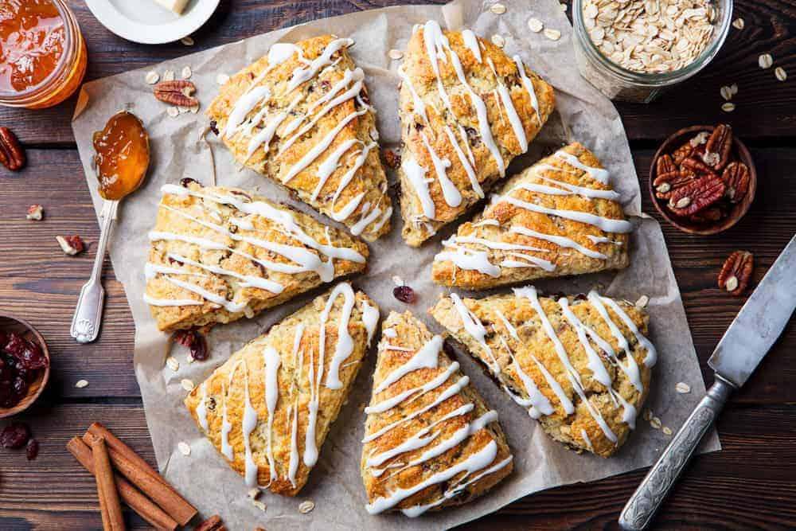
SCONES ARE A PASTRY THAT MANY PEOPLE LOVE BUT NOT EVERYONE UNDERSTANDS. IT DEPENDS ON WHERE YOU LIVE AS TO WHAT A SCONE REALLY REFERS TO. FOR INSTANCE, ENGLISH SCONES ARE SIMILAR TO AMERICAN BISCUITS AND THEY ARE OFTEN SERVED WITH BUTTER, CLOTTED CREAM, OR JAM. AMERICAN SCONES ARE NOT USUALLY TOPPED WITH BUTTER BECAUSE THEY HAVE PLENTY OF BUTTER IN THEM, MORE SO THAN THE BRITISH SCONES.
THE SCONES OF TODAY OR A HEAVIER VERSION THAT TASTE SWEETER AND THERE ARE MANY DIFFERENT VERSIONS OFFERED. THEY ARE MOIST AND SOFT INSIDE, A LITTLE CRUMBLY AROUND THE EDGES, AND FLAKEY. SCONES ARE USUALLY MADE UP OF BAKING POWDER, SO THEY USUALLY DON’T TAKE LONG TO MAKE. THEY PUT SOME PEOPLE IN THE MIND OF BISCUITS OR QUICK BREAD AND ARE ROLLED INTO SHAPES THAT ARE ROUND THEN CUT INTO QUARTERS.
SOME VERSIONS OF THIS PASTRY ARE BAKED IN THE OVEN AND SOME ARE COOKED ON A GRIDDLE. THEY CAN BE SWEET OR SAVORY AND ARE NORMALLY EATEN AS BREAKFAST FOOD BUT ARE AVAILABLE IN COFFEE HOUSES TO EAT ANY TIME OF DAY WITH TEA OR COFFEE.
BASICALLY, ENGLISH SCONES ARE MORE SIMILAR TO AMERICA’S VERSION OF BISCUITS AND AMERICA’S VERSION OF SCONES ARE HEAVIER, SWEETER, AND SOMETIMES TOPPED WITH GLAZE, CONFECTIONER SUGAR, OR VANILLA ICING. WHETHER YOU’RE GOING FOR A BRITISH SCONE OR AN AMERICAN SCONE, THERE ARE MANY DIFFERENT FLAVORS OF FRESHLY BAKED SCONES TO CHOOSE FROM.
RELATED: DILL AND FETA SCONES RECIPE | HAM AND CHEESE SCONES RECIPE | GINGER AND PEAR SCONES RECIPE | CRANBERRY ORANGE SCONES RECIPE | APPLE CINNAMON SCONES RECIPE | HOW TO STORE SCONES

HISTORY OF SCONES
SCONES ARE BELIEVED TO HAVE ORIGINATED IT IN SCOTLAND AS A QUICKBREAD AND WERE MADE WITH OATS AND COOKED ON A GRIDDLE BUT TODAY’S VERSION IS USUALLY MADE WITH FLOUR AND BAKED IN THE OVEN. THE ORIGIN OF THE WORD “SKONE” IS BELIEVED TO BE DUTCH, COMING FROM THE WORD ‘SCHOONBROT’, WHICH MEANS BEAUTIFUL BREAD. OTHER PEOPLE BELIEVE THAT THE WORD SCONE ORIGINATED FROM THE STONE OF DESTINY WHICH IS WHEN THE KINGS OF SCOTLAND WERE CROWNED AND THAT THE PEOPLE STARTED MAKING SCONES IN SCOTLAND IN THE EARLY PART OF THE 1500S.
SCONES INCREASED IN POPULARITY AND BECAME A VERY IMPORTANT PART OF THE RITUAL OF HAVING TEA IN ENGLAND WITH A DUCHESS OR QUEEN. THIS RITUAL BEGAN WITH DUCHESS OF BEDFORD ANNA WHO ONCE ORDERED HER SERVANTS TO BRING SWEETBREADS WITH HER AFTERNOON TEA WHICH HAPPENED TO INCLUDE SCONES.
SHE LIKED THEM SO MUCH THAT SHE ORDERED SCONES TO BE SERVED EVERY AFTERNOON AND IT QUICKLY BECAME PART OF THE ENGLISH TRADITION OF AFTERNOON TEA TIME EVERY DAY AT 4:00 PM. THEY’RE STILL SERVED TO THIS VERY DAY IN BRITAIN WITH THE TRADITIONAL CLOTTED CREAM TOPPING.
SCONES ARE DEFINITELY MORE TRADITIONALLY CONNECTED TO SCOTLAND, ENGLAND, AND IRELAND WITH THE FIRST KNOWN MENTION OF THE WORD SCONE DATING BACK TO 1513 WHEN IT WAS PRINTED IN THE WRITINGS OF A SCOTTISH POET NAMED GAVIN DOUGLAS IN HIS WORK CALLED THE AENEID.
THOUGH THEY HAVE MANY SIMILARITIES, BRITISH AND AMERICAN SCONES ARE REALLY VERY DIFFERENT. BRITISH SCONES ARE SIMPLER TO MAKE SINCE THEY CONTAIN FEWER INGREDIENTS. AMERICAN SCONES ARE OFFERED IN MANY MORE FLAVORS THAN BRITISH SCONES AND WILL MORE THAN LIKELY FEATURE A FRUIT-BASED FILLING. BRITISH SCONES WITH FRUIT USUALLY FEATURE FRUITS, SUCH AS CURRANTS, RAISINS, AND SULTANAS, WHICH ARE GOLDEN RAISINS.
AMERICAN SCONES ARE USUALLY DESIGNED TO BE EATEN ALONE SINCE THEY DO BOAST A SWEET TOPPING AS DISCUSSED ABOVE. BRITISH SCONES ARE MUCH PLAINER AND ARE CREATED TO BE TOPPED WITH THINGS, SUCH AS CLOTTED CREAM, BUTTER, LEMON CURD, AND OR DIFFERENT TYPES OF PRESERVES.
AMERICAN SCONES ARE OFTEN FORMED INTO THE SHAPES OF WEDGES OR TRIANGLES, WHILE THEIR BRITISH COUNTERPARTS ARE TALLER, FLUFFIER, AND USUALLY ROUND. BRITISH SCONES RESEMBLE BISCUITS IN AMERICA BUT AMERICAN SCONES REQUIRE MUCH MORE BUTTER TO CREATE THEM THAN THE BRITISH ONES DO. AMERICAN SCONES ALSO CONTAIN MORE SUGAR THAN BRITISH SCONES.
SCONES CAN BE CREATED TO BE SWEET OR SAVORY AND PAIR WELL WITH TEA OR COFFEE. THEY ARE A GREAT OPTION TO SERVE AT A MOTHER’S DAY BRUNCH, A BABY OR WEDDING SHOWER, AND GARNER A LOT OF ATTENTION AT BACK SALES AND OTHER PLACES WHERE COFFEE AND MUFFINS WOULD BE SERVED. BELOW IS A LIST OF VARIOUS TYPES OF SCONES. ALL ARE DELICIOUS IN CREATED TO SATISFY EVERYONE’S TASTE BUDS.

STRAWBERRY SCONE
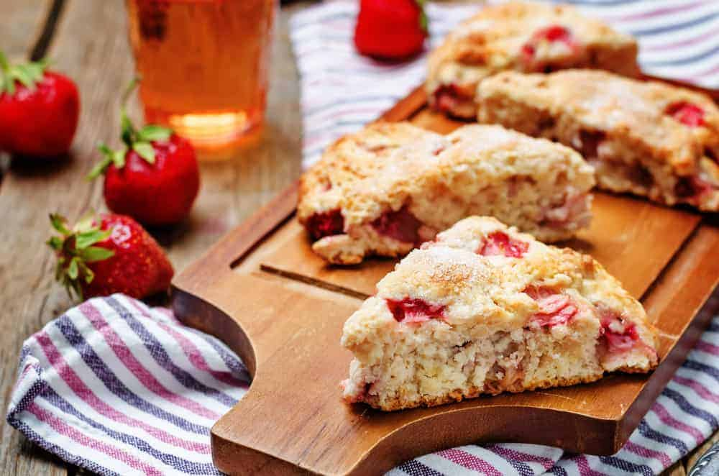
STRAWBERRY SCONES ARE ONE OF THE MANY FLAVORS OFFERED WHEN IT COMES TO AMERICAN-STYLE SCONES. THE STRAWBERRY FILLING IS DELICIOUS AND THEY NORMALLY ARE ICED WITH A DELICIOUS GLAZE FOR EXTRA DELICIOUSNESS. YOU CAN EAT THEM ANY TIME OF DAY OR NIGHT.

STRAWBERRIES ‘N’ CREAM SCONES
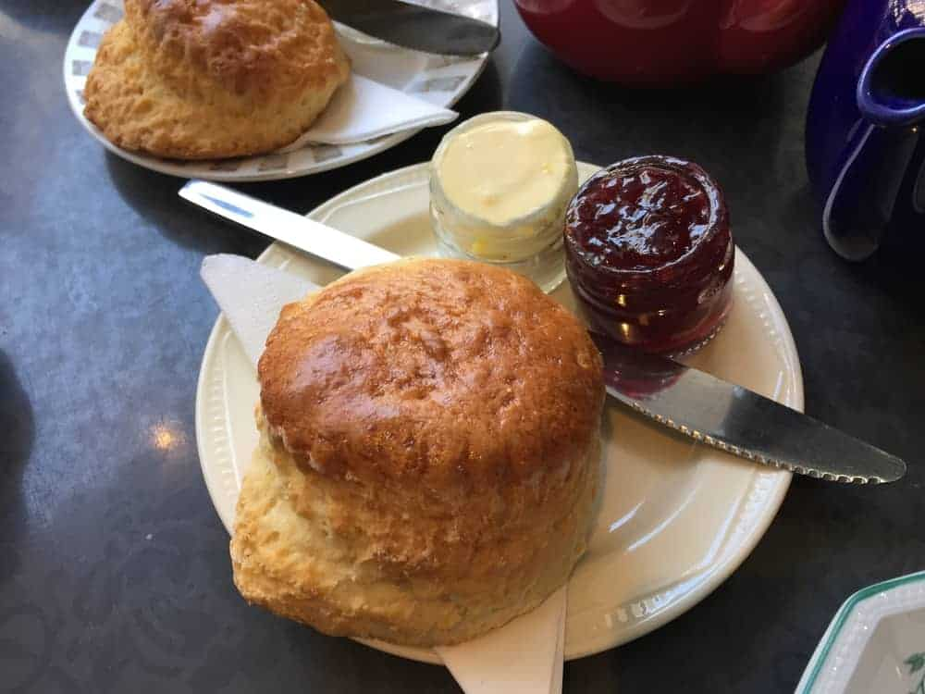
THESE SCONES ARE ABSOLUTELY DELICIOUS AND PACKED WITH STRAWBERRY GOODNESS AND RICH CREAM THAT WILL LEAVE YOU WANTING MORE. BE WARNED, THOUGH, YOU WILL NOT BE ABLE TO EAT JUST ONE OF THESE DELICIOUS SCONES.

ENGLISH SCONES
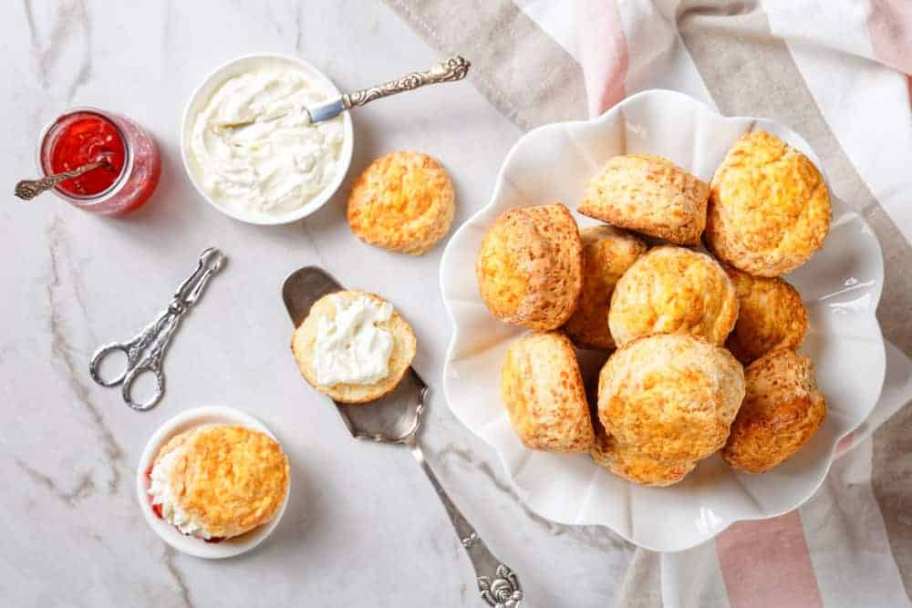
Bottom of Form
IN KEEPING WITH THE TRADITION OF ENGLISH-STYLE SCONES, THESE BAKE UP TO BE FLUFFY, TALL, AND LIGHT. YOU CAN EAT THESE ENGLISH-STYLE SCONES FOR BREAKFAST OR AFTERNOON TEA, AND THEY TASTE GREAT TOPPED WITH JAM, BUTTER, CLOTTED CREAM, AND EVEN SIMPLY PLAIN. SINCE ENGLISH SCONES ARE MADE DIFFERENTLY THAN AMERICAN ONES, THESE ARE VERY FLUFFY AND SOFT INSTEAD OF BEING STIFFER AND DRIER. THEY ARE AROUND LIKE BISCUITS BUT ARE NOT THE SAME.

SAVORY SCONE
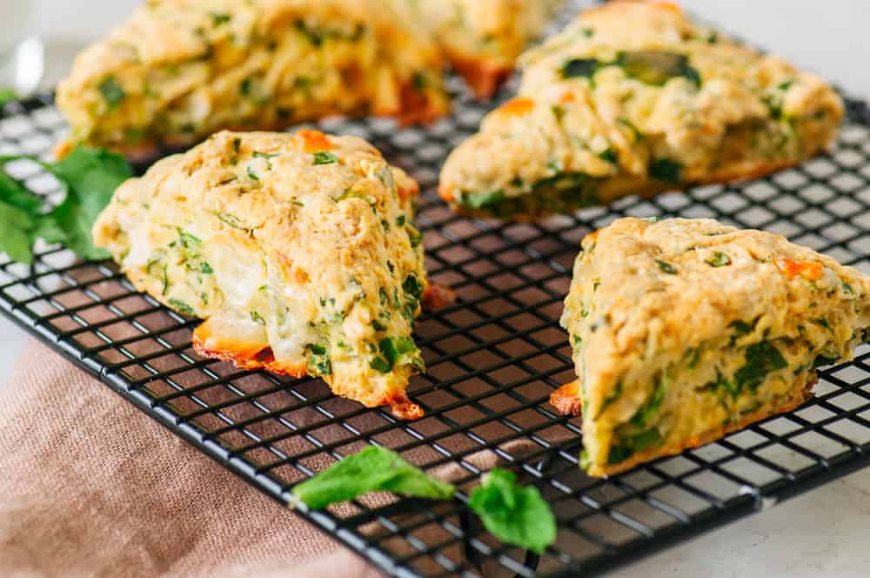
SAVORY SCONES ARE DIFFERENT THAN SWEET ONES AND THE FACT THAT INGREDIENTS ARE USED IN A WAY TO MAKE THEM GREAT FOR BREAKFAST LUNCH OR DINNER INSTEAD OF DESSERT. YOU CAN USE THINGS LIKE CHEDDAR, BACON, MOZZARELLA CHEESE, AND EVEN FETA CHEESE TO MAKE THESE DELICIOUS SAVORY SCONES.

BUTTER SCONES
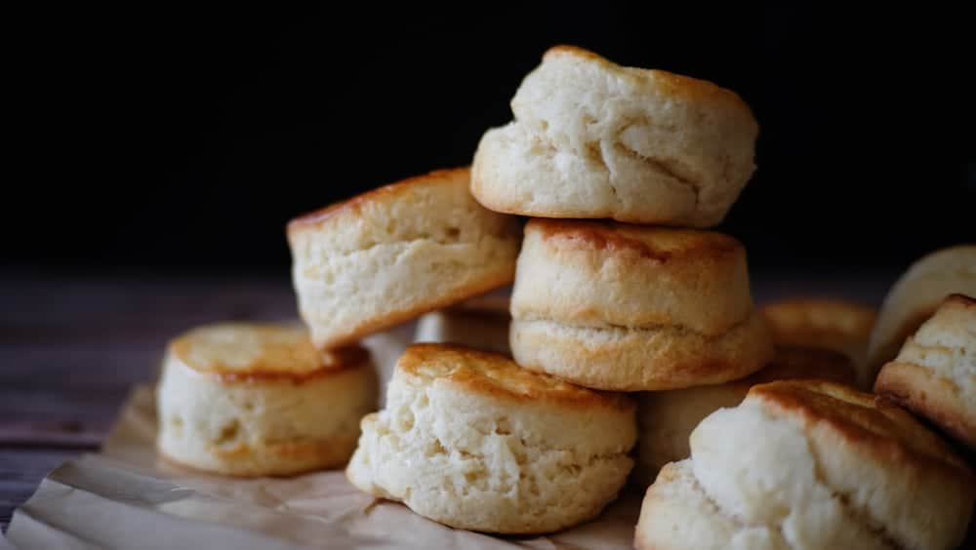
BUTTER SCONES HAVE A MUCH RICHER FLAVOR THAN OTHER TYPES. THEY ARE VERY TASTY AND CAN BE SERVED WITH JAM OR FRESH PRESERVES AND HAVE MORE OF A BREAD-LIKE TEXTURE.

PEANUT BUTTER
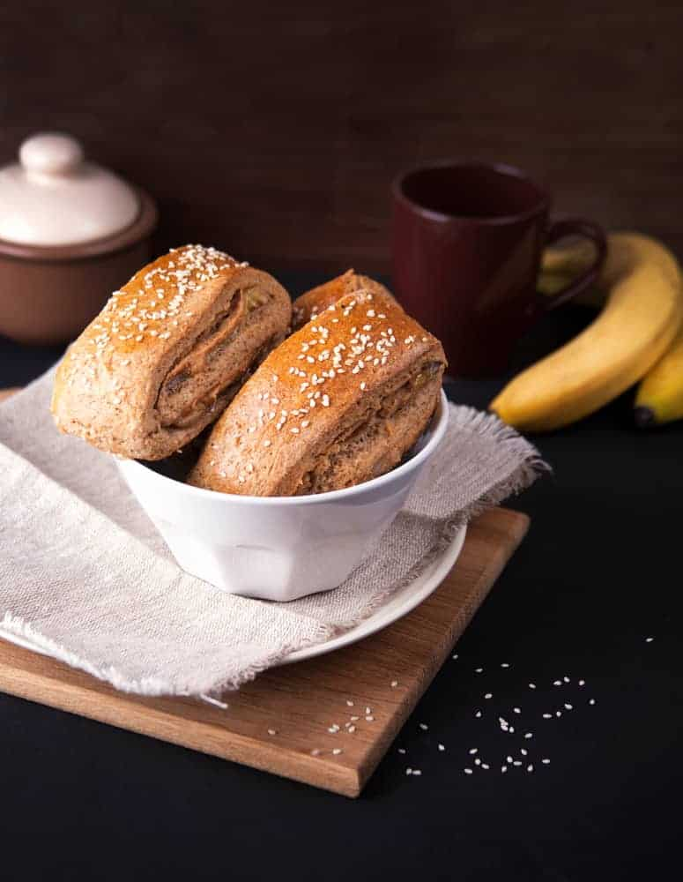
THESE AMAZING PEANUT BUTTER SCONES ARE CREATED TO RESEMBLE A FLUFFY, SOFT, THICK PEANUT BUTTER COOKIE ARE ONLY TAKES 30 MINUTES TO BAKE. THEY ARE EASY TO MAKE AND WILL DELIGHT ANY OF THE PEANUT BUTTER LOVERS IN YOUR LIFE.

AMERICAN SCONE
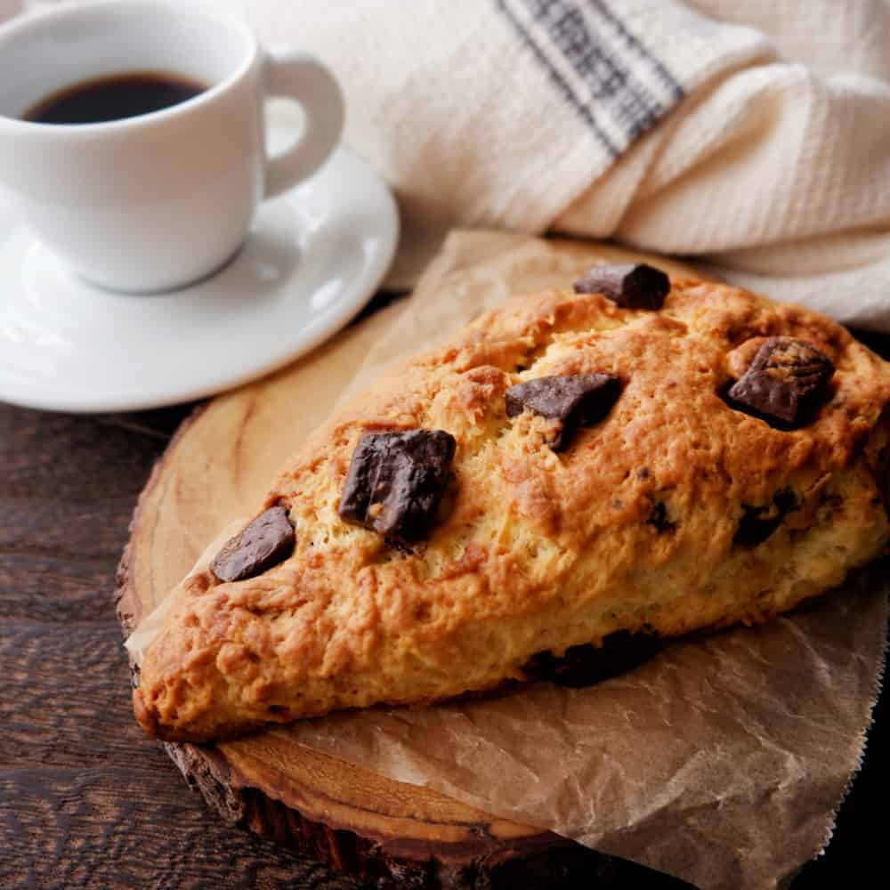
AMERICAN SCONES ARE DENSER AND ARE SHAPED INTO WEDGES OR TRIANGLES, UNLIKE THE BRITISH ONES THAT ARE TALLER AND ROUNDED. AMERICAN SCONE RECIPES USE MORE BUTTER AND SUGAR THAN THEIR BRITISH COUNTERPARTS AND ARE THEREFORE SWEETER TO TASTE.

SCOTTISH SCONES


SCOTTISH SCONES CAN BE MADE IN A VARIETY OF WAYS. SINCE SCONES ORIGINATED IN SCOTLAND, THESE DELICIOUS SCONES ARE MADE WITH ROLLED OATS WHICH IS HOW THEY WERE MADE BACK IN THE 1500S.

DROP SCONE


SCOTTISH PANCAKES ARE REFERRED TO AS DROP SCONES. THE DOUGH OF THESE SCONES IS PLACED DIRECTLY ONTO THE AREA IN WHICH YOU WILL BE COOKING IT. THESE DELICIOUS SCONES ARE SOMETIMES REFERRED TO AS “QUEEN ELIZABETH’S DROP SCONES” AND THEY ARE NATIVE TO SCOTLAND.

FLAKY SCONES
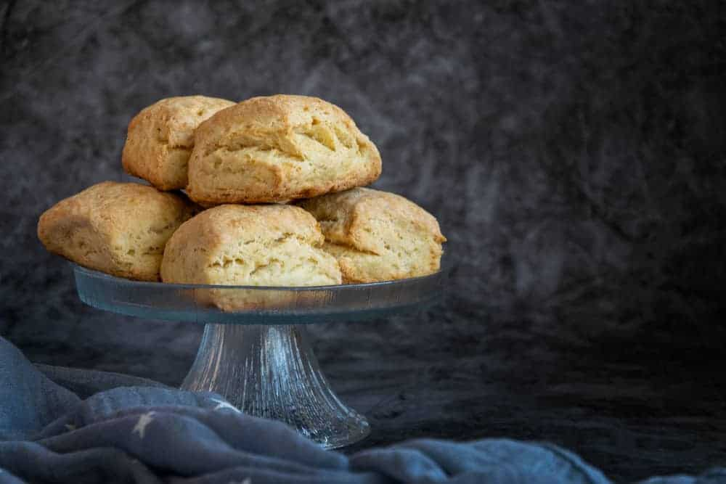
FLAKY SCONES ARE IRISH AND ARE VERY GOOD COMFORT FOOD. THEY HAVE AN OUTSIDE CRUST THAT IS CRISPY BUT THE INSIDE CONTAINS SOFT AND MOST LAYERS OF DELICIOUS BUTTERY FLAVOR.

UNBAKED SCONES
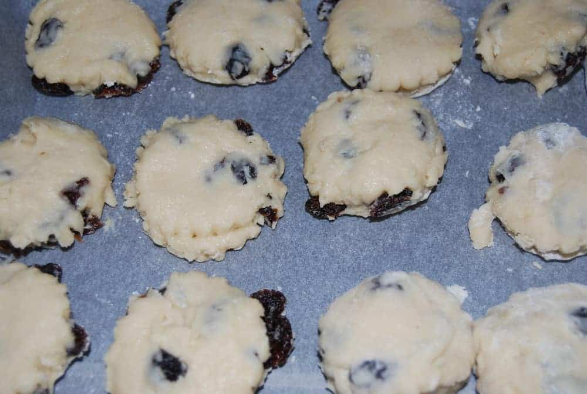
THE WONDERFUL THING ABOUT SCONES IS THAT YOU CAN MAKE THEM UP AHEAD OF TIME THEN PUT THEM IN THE FREEZER UNTIL YOU ARE READY TO SERVE THEM. YOU SIMPLY GRAB YOUR UNBAKED SCONES OUT OF THE FREEZER AND POP THEM IN THE OVEN AND WITHIN A SHORT AMOUNT OF TIME YOU HAVE DELICIOUS SCONES TO SERVE TO YOUR GUESTS.

TATTIE SCONES

TATTIE SCONES ARE MADE WITH MASHED POTATOES, BUTTER, AND PLAIN FLOUR. THEY ARE FRIED UP ON A GRIDDLE AND ARE SERVED HOT. YOU CAN REHEAT COLD POTATO SCONES BY FRYING THEM IN A PAN OR EVEN TOASTING THEM IN YOUR TOASTER.

CREAM SCONES
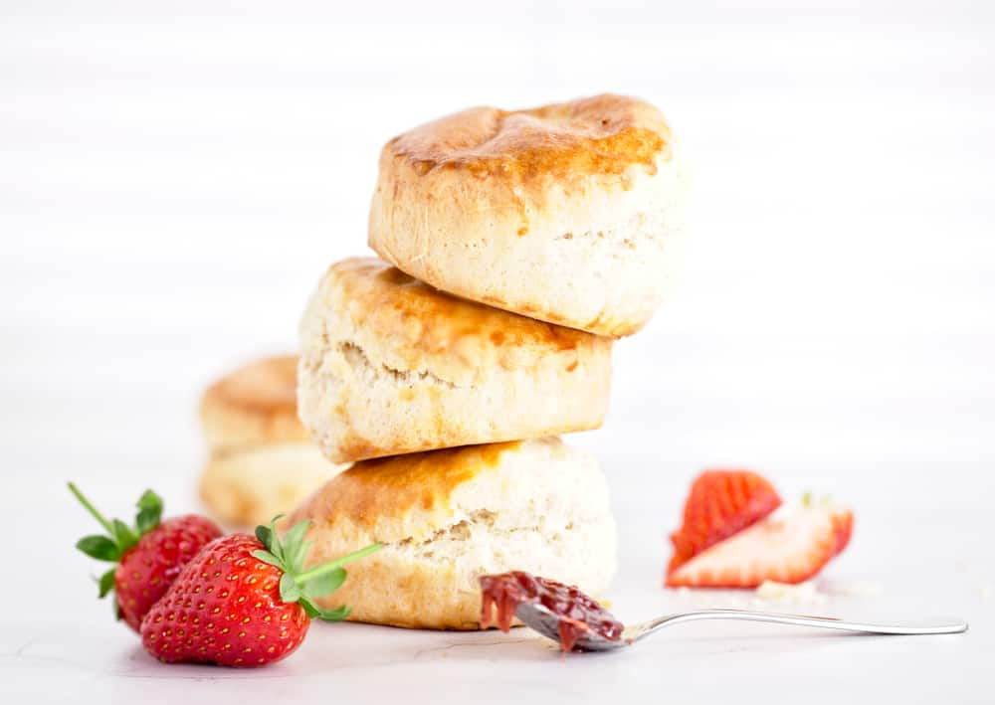
CREAM SCONES ARE VERY BASIC SCONES AND YOU CAN MAKE THEM VERY EASILY. THEY CONTAIN VANILLA, CREAM, FLOUR, SUGAR, SALT, AND A LEAVENING AGENT AND ARE VERY TENDER. THESE CREAM TREATS CAN BE SERVED WITH BUTTER OR FRESH PRESERVES AND ARE VERY DELICIOUS.

CLOTTED CREAM SCONES

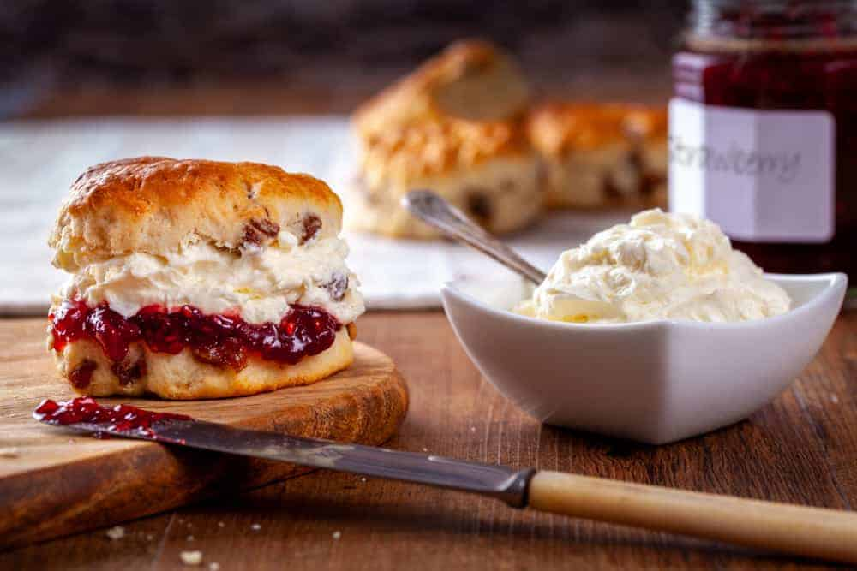
CLOTTED CREAM IS VERY POPULAR IN BRITAIN AND IS SERVED IN A LITTLE DISH WITH A PLATE OF SCONES. IT IS A CREAMY, THICK, WHITE SPREAD THAT REMINDS MANY PEOPLE OF CREAM CHEESE BUT IT IS SWEETER AND CREAMIER.

CHOCOLATE CHIP SCONES
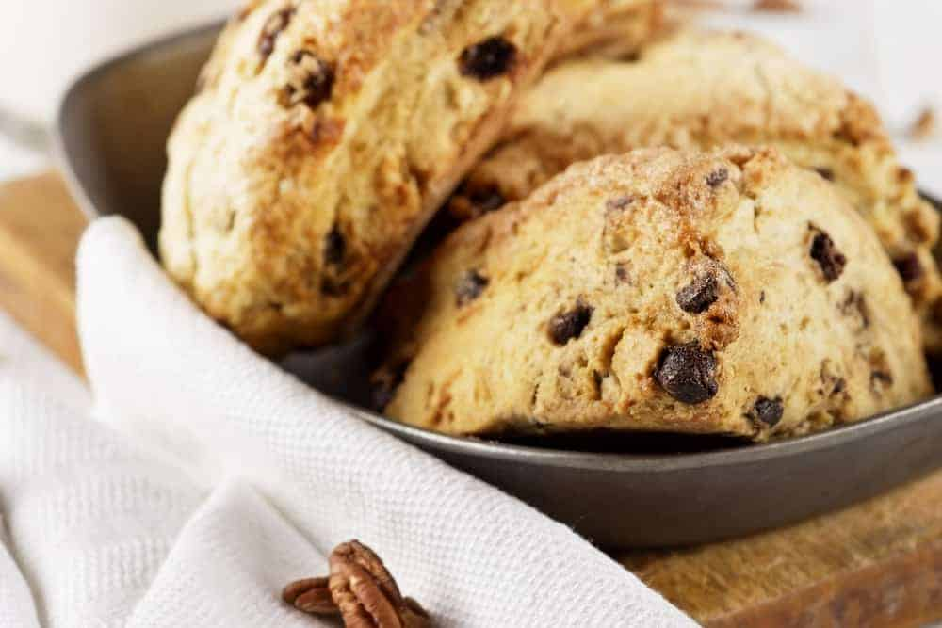
THESE DELICIOUS CHOCOLATE CHIP SCONES WILL REMIND YOU OF THE CHOCOLATE CHIP COOKIE BUT EVEN BETTER. THEY TASTE BEST WHEN SERVED WARM AND WILL LEAVE YOU AND YOUR GUESTS WANTING MORE.

CHOCOLATE SCONE
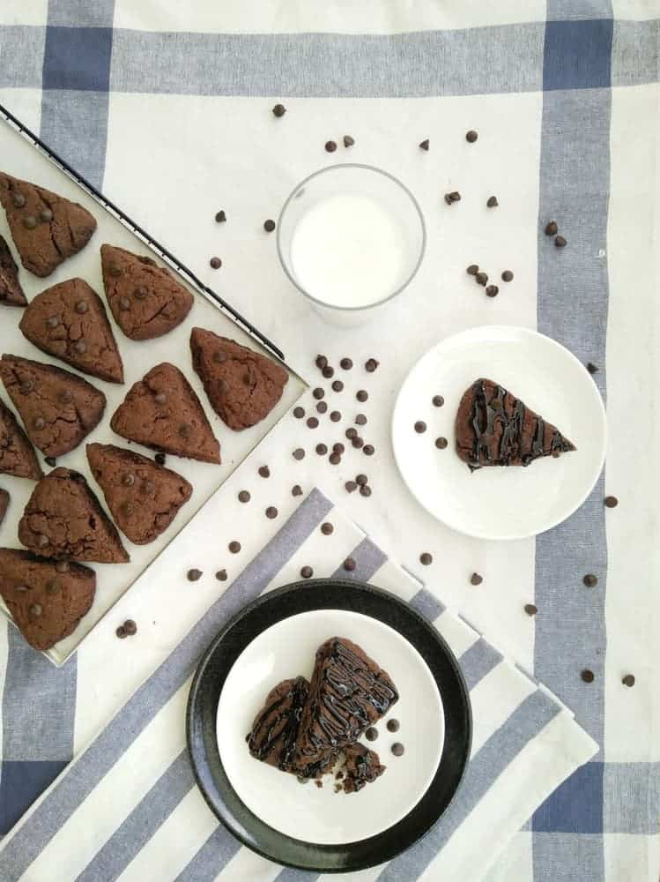
CHOCOLATE SCONES HAVE AN IRISH BACKGROUND AND OR A GREAT TREAT FOR ANY CHOCOLATE LOVER. THE CHOCOLATE FLAVOR COMES FROM A DUTCH-PROCESSED COCOA POWDER THAT WILL SATISFY ANY SWEET TOOTH. YOU CAN ALSO MAKE DOUBLE CHOCOLATE SCONES AND EVEN TRIPLE CHOCOLATE SCONES WHICH INCLUDES MAKING THE BATTER WITH COCOA POWDER TOO.

LEMON SCONES
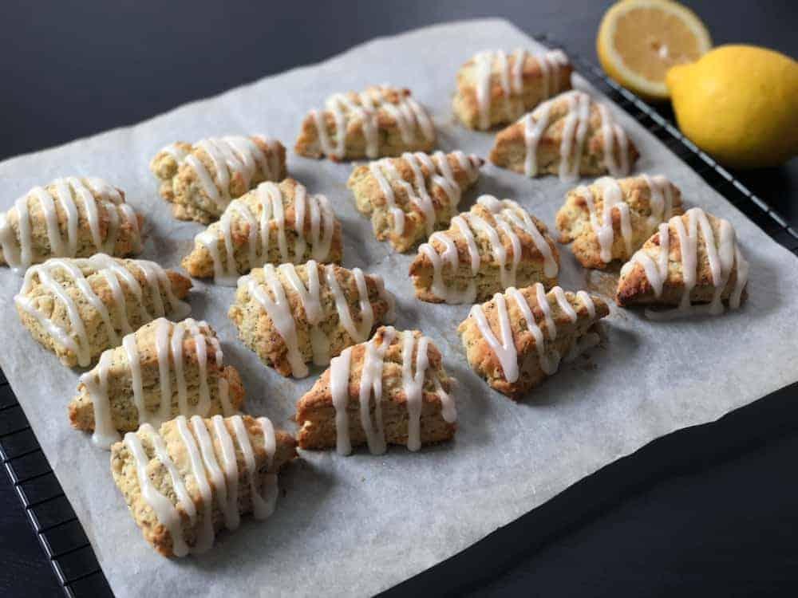
GRATED LEMON ZEST GIVES THESE AMAZING LEMON SCONES THEIR FLAVOR. THEY MAKE A GREAT DESSERT ON AN AFTERNOON SNACK PAIRED WITH A GOOD CUP OF COFFEE OR TEA.

BUTTERMILK SCONES
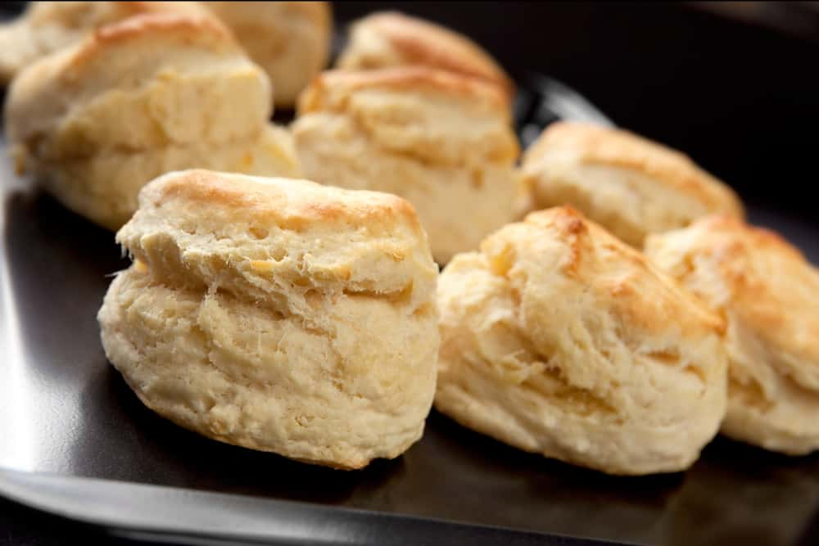
TO MAKE THE BEST TASTING SCONES, YOU CAN EITHER USE HEAVY CREAM OR BUTTERMILK TO MAKE THEM. THE BUTTERMILK GIVES A TANGIER FLAVOR THAN THE HEAVY CREAM DOES BUT EITHER ONE OF THESE CREAMS IS GREAT FOR SCONES BECAUSE THEY’LL KEEP THEM FROM TURNING OUT TO BE DRY, FLAT, AND BLAND.

CRANBERRY ORANGE SCONES

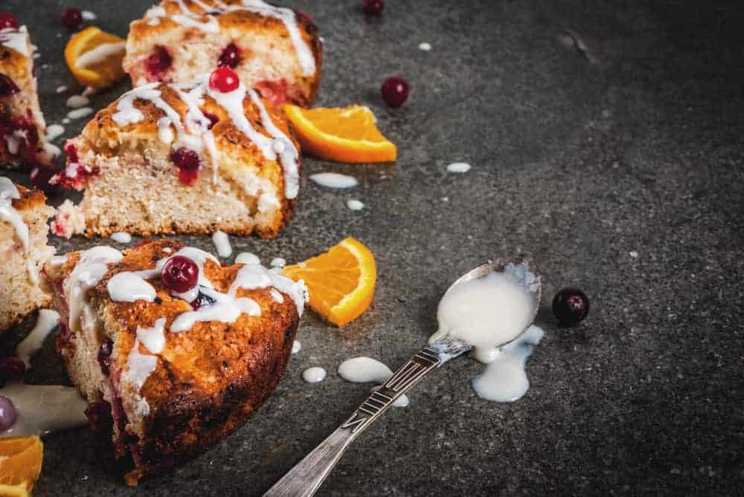
HOMEMADE CRANBERRY ORANGE SCONES ARE A VERY FLAKY, TENDER TREAT. THESE BRIGHT ORANGE SCONES HAVE POPS OF COLOR FROM THE JUICY CRANBERRIES AND CAN BE SERVED WITH AN ORANGE GLAZE ON TOP OR A CRUNCHY MORE COARSE SUGAR.

SOUR CREAM SCONE
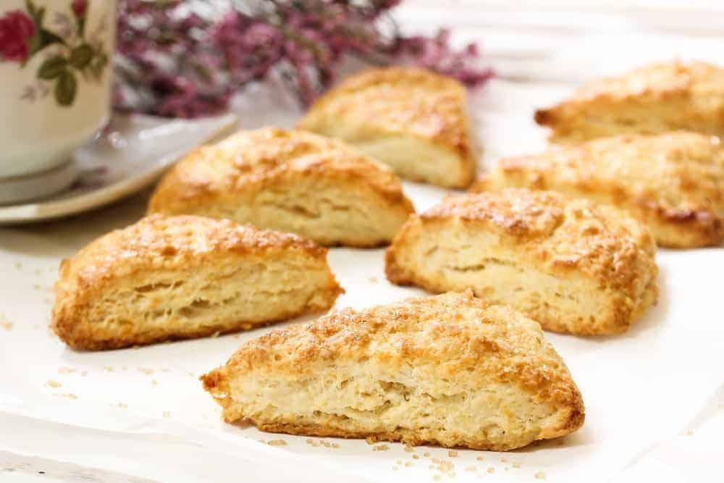
SOUR CREAM WORKS WELL IN MAKING SCONES AND WILL GIVE IT A FLAVOR WITH A LITTLE MORE KICK. YOU CAN EVEN SUBSTITUTE SOUR CREAM FOR HEAVY CREAM IN ANY OF YOUR SCONE RECIPES.

PUMPKIN SCONE
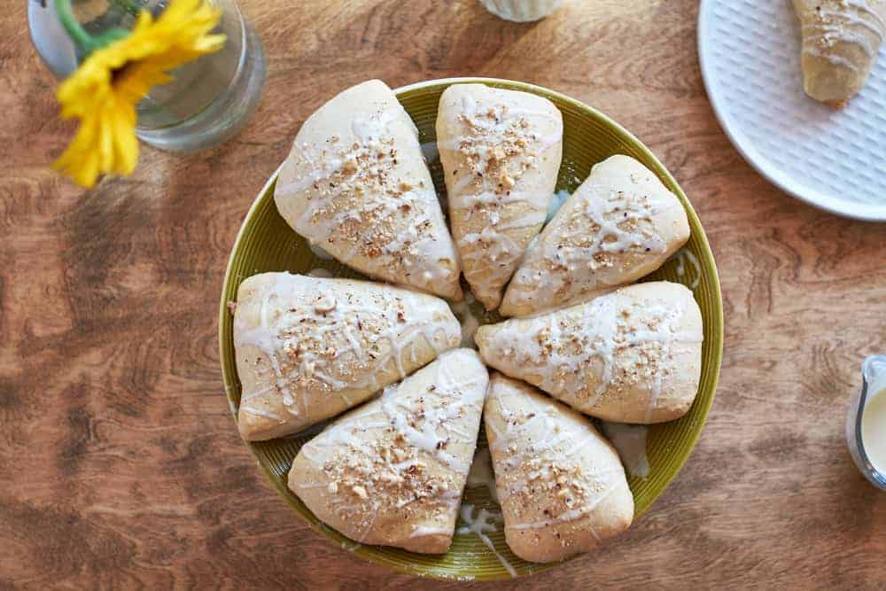
PUMPKIN SCONES TEND TO BE MORE OF AN AMERICAN THING BECAUSE OF THE PUMPKIN CRAZE THAT HAS RIVETED THE COUNTRY FOR SEVERAL YEARS NOW BUT THEY DID ORIGINATE IN SCOTLAND IN THE 1500S AND WERE MADE WITH PUMPKIN SEEDS. THESE SCONES ARE SOFT AND FLAKY IN THE CENTER WITH A CRISP TOP AND THEY CRUMBLE AT THE CORNERS.
YOU CAN MAKE THESE BUTTERY SCONES WITH A PERFECT BLEND OF SPICY PUMPKIN OR YOU COULD PICK ONE UP AT PLACES LIKE STARBUCKS DURING THE FALL SEASON.

SUNDRIED TOMATO SCONE
SUN-DRIED TOMATO SCONES ARE SUPER EASY TO MAKE AND ARE PACKED WITH PLENTY OF SAVORY SUN-DRIED TOMATOES AND DELICIOUS CHEDDAR CHEESE. THESE ARE A GREAT OPTION TO SERVE FOR LUNCH OR FOR A BRUNCH WITH FRIENDS.

DRIED FRUIT SCONE
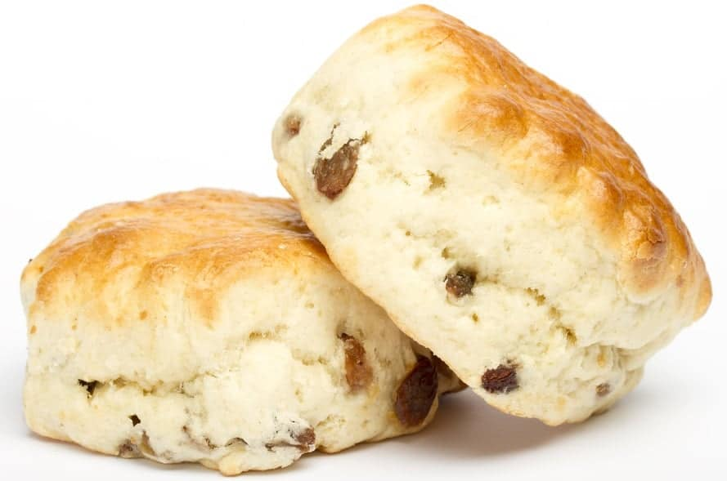
DRIED FRUIT SCONES OR EVEN BRANDIED DRIED FRUIT SCONES, AND PLENTY HAVE WARM SPICY AND CITROUS FLAVORS THROUGHOUT YOUR SCONE AND THEY ARE PERFECT TO SERVE AT HOLIDAY TIME.

DRIED CRANBERRY SCONE
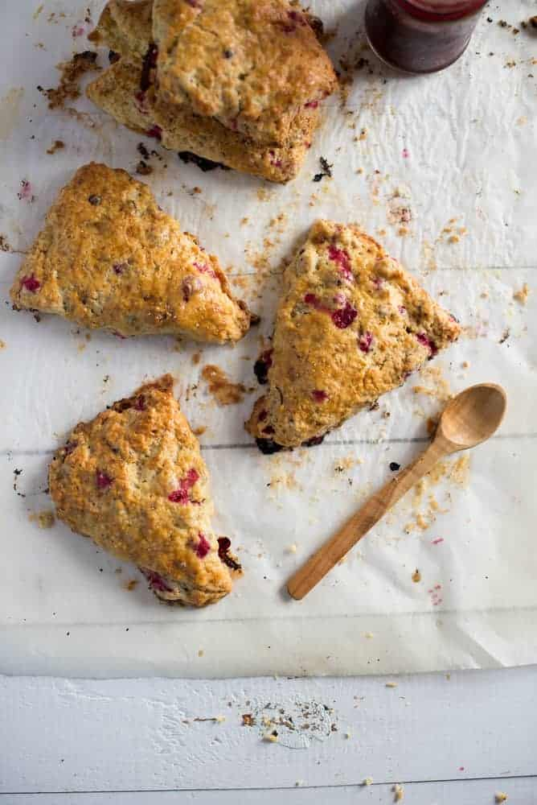
DRIED CRANBERRY SCONES ARE MADE WITH FLOUR, BUTTER, CREAM, BAKING SODA, ORANGE ZEST, DRIED FRUIT, AND YOU CAN USE HONEY OR SUGAR TO GIVE THEM THEIR SWEET TASTE. YOU CAN USE DRIED CRANBERRIES FOR THIS TYPE OF SCONE BUT YOU CAN ALSO SWAP THEM OUT FOR DRIED CHERRIES, APRICOTS, CHOCOLATE CHIPS, RAISINS, OR A COMBINATION OF SEVERAL OF THESE.

PLAIN SCONES
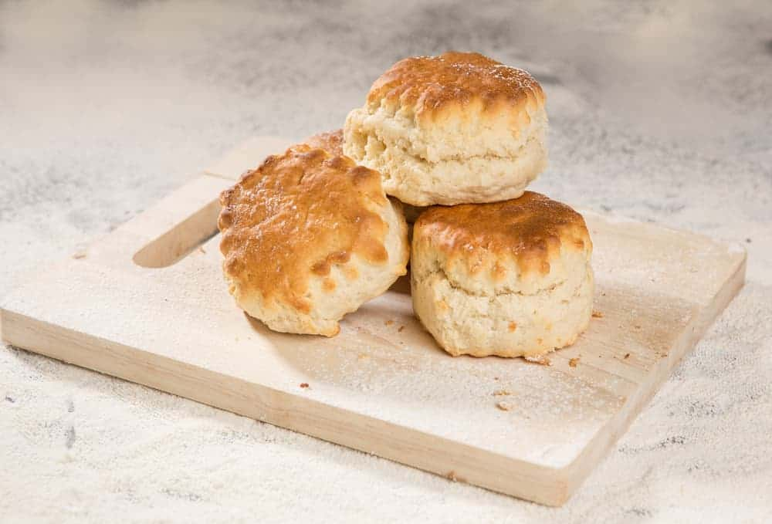
PLAIN SCONES ARE REALLY EASY TO MAKE AND DO NOT TAKE A LONG TIME PERIOD YOU SIMPLY THROW SOME SUGAR, FLOUR, BAKING POWDER, AND SALT INTO A FOOD PROCESSOR, WORK IN A LITTLE BIT OF BUTTER AND CREAM, THEN SHAPE THE DOUGH. THEY ONLY TAKE ABOUT AN HOUR IN THE OVEN TO BAKE.

FAQS

WHAT ARE SOME TIPS FOR MAKING HOMEMADE SCONES?
ACCORDING TO FOOD & WINE TEST KITCHEN MANAGER KELSEY YOUNGMAN, THERE ARE SEVERAL THINGS YOU CAN DO TO ENSURE YOUR SCONES TURN OUT CORRECTLY AND DELICIOUS.
SHE SAID TO USE COLD BUTTER OR EVEN FROZEN BUTTER TO GIVE YOUR SCONES A BETTER RISE AND TO ONLY MIX THE BATTER UNTIL THE DOUGH COMES TOGETHER, BEING CAREFUL NOT TO OVER MIX. SHE ALSO SAYS TO USE PASTRY FLOUR SO YOUR SCONES TURN OUT LIGHTER. SHE ALSO RECOMMENDS THAT ONCE YOU’VE SHAPED YOUR SCONES, YOU CHILL THEM BEFORE BAKING.
THIS WILL RELAX THE GLUTEN AND GIVE YOU A MORE TENDER, FLAKY TEXTURE. YOU SHOULD SPACE YOUR SCONES AT LEAST ONE INCH APART IF YOU HAVE SHAPED THEM INTO WEDGES BUT IF YOU ARE BAKING ROUND SCONES, YOU CAN PLACE THEM WITH THEIR EDGES TOUCHING IN A ROUND PAN LIKE YOU WOULD WITH CINNAMON ROLLS.
SHE SAID IF YOU ARE ADDING FRUIT TO NOT USE FRUIT THAT IS TOO JUICY AND TO MAKE SURE YOU RINSE THE FRUIT WELL BEFORE USING IT. SHE ALSO RECOMMENDS NOT OVER-BAKING YOUR SCONES SINCE THEY ARE MEANT TO BE PAIRED WITH BUTTER, JAM, OR CLOTTED OR HEAVY CREAM.

HOW IS CLOTTED CREAM DIFFERENT FROM CREAM?
CLOTTED CREAM IS CREAM THAT RISES TO THE SURFACE ANNE CLIENTS THEN IS SKIMMED OFF TO SERVE WITH BERRIES, A VARIETY OF DESSERTS, AND SCONES. THE TASTIEST CLOTTED CREAM WILL HAVE A GOOD FIRM CRUST ON TOP AND BE VERY THICK BY USING BUTTERFAT TO CREATE IT.

WHAT DOES CLOTTED CREAM TASTE LIKE?
CLOTTED CREAM HAS A NUTTY FLAVOR TO IT THAT IS RICH AND TASTES A LITTLE BIT LIKE MILK THAT HAS BEEN COOKED. ITS TEXTURE IS A LITTLE GRAINY, AND IT HAS A CRESTED SURFACE ON TOP.

WHAT CAN I USE INSTEAD OF CLOTTED CREAM FOR SCONES?
IF YOU DO NOT WANT TO USE CLOTTED CREAM WITH YOUR SCONES, YOU CAN SWAP IT OUT FOR CREAM CHEESE. IT WON’T HAVE THE SAME FLAVOR AS THE CLOTTED CREAM BUT IT WILL STILL TASTE DELICIOUS WITH YOUR SCONES.

WHAT IS THE AMERICAN EQUIVALENT OF CLOTTED CREAM?
THE EQUIVALENT OF CLOTTED CREAM IN THE UNITED STATES WOULD PROBABLY BE BUTTER BECAUSE OF ITS HIGH-FAT CONTENT. MANY PEOPLE USE BUTTER INSTEAD OF CLOTTED CREAM ON THEIR SCONES.

WHAT ARE SCONES CALLED IN ENGLAND?
SCONES IN ENGLAND ARE REFERRED TO AS SCONES WHICH ARE DIFFERENT FROM SCONES IN AMERICA WHERE THE SAME VERSION IS REFERRED TO AS A BISCUIT. BOTH ARE BAKED BY USING FLOUR, A LIQUID CREAM, FAT, AND SOME TYPE OF LEAVENING AGENT.

DO SCONES HAVE EGGS IN THEM?
SCONES ARE DIFFERENT FROM BISCUITS IN THE FACT THAT THEY HAVE ADDED SUGAR AND EGGS. EGGS GIVE SCONES A MUCH RICHER TASTE.

HOW MANY CALORIES ARE IN A PUMPKIN SCONE?
THERE ARE ABOUT 450 CALORIES IN PUMPKIN SCONES IN MANY PEOPLE PAIR THIS DELICIOUS TREAT WITH A PUMPKIN SPICE LATTE WHICH INCREASES THE CALORIE INTAKE.

25 DIFFERENT TYPES OF PASTA NOODLES AND SHAPES
THE ULTIMATE PASTA GUIDE FEATURING THE MOST POPULAR TYPES WITH PHOTOS AND DESCRIPTIONS OF EACH KIND.
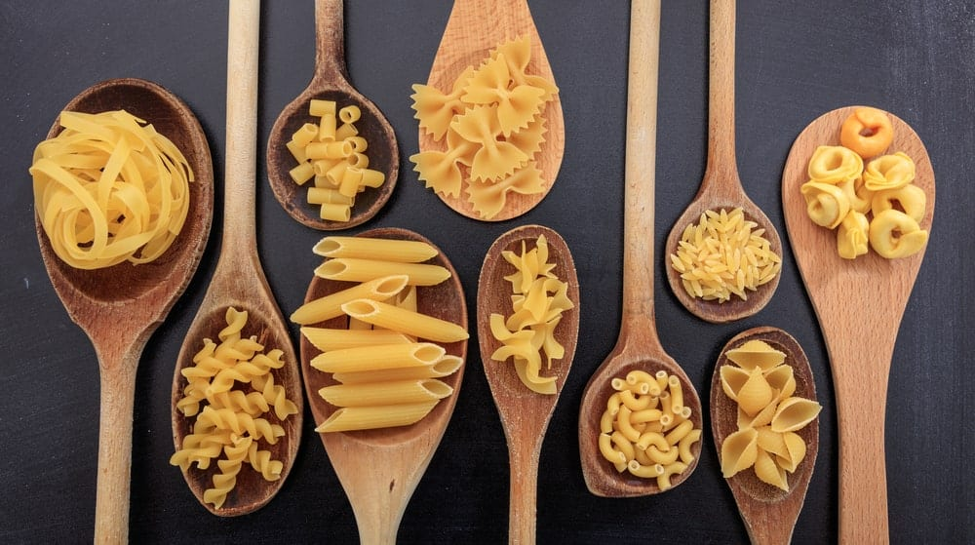

QUICKLIST: PASTA
- SPAGHETTI
- SPAGHETTINI
- BUCATINI
- LINGUINI
- FETTUCCINE
- LASAGNA
- MAFALDA
- FUSILLI
- MACARONI
- PACCHERI
- PENNE
- PENNE RIGATE
- RIGATONI
- TORTIGLIONI
- CELLENTANI
- CHIFFERI
- FARFALLE
- ORECCHIETTE
- PIPE RIGATE
- ROTELLE
- FARFALLE ROTONDE
- CHIFFERIRIGATE
- CONCHIGLIE
- ORZO
- STELLINE
YOU MIGHT BE COOKING PASTA AT LEAST ONCE A WEEK BUT HOW DEEP IS YOUR KNOWLEDGE ABOUT THE DIFFERENT TYPES OF PASTA AVAILABLE? UNLESS YOU ARE A CHEF OR A CULINARY STUDENT, IT IS LIKELY THAT MACARONI, SPAGHETTI AND A FEW OTHER KINDS ARE ALL THAT YOU ARE FAMILIAR WITH — BUT DID YOU KNOW THAT THERE ARE MORE THAN 600 DIFFERENT TYPES OF PASTA?
DEPENDING ON THE INGREDIENTS, SHAPE, SIZE, TEXTURE, AND INTENDED USE, PASTA CAN BE CLASSIFIED INTO MANY DIFFERENT KINDS. HERE WE HAVE GATHERED THE MOST COMMON TYPES OF PASTA THAT ARE POPULAR WORLDWIDE AND THE VARIOUS WAYS IN WHICH THEY CAN BE USED. READ ON TO LEARN MORE.
RELATED: HEALTHY ALTERNATIVES TO PASTA | TYPES OF PASTA SAUCE | ROTINI PASTA SALAD RECIPE | FRESH PASTA AND PESTO FROM SCRATCH | CHICKEN PARMESAN WITH RAVIOLI RECIPE | WHAT TO SERVE WITH SHEPHERD’S PIE

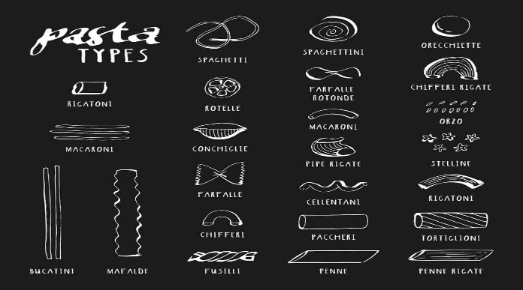

LONG AND MEDIUM-LENGTH PASTA NOODLES

1. SPAGHETTI
DERIVED FROM THE ITALIAN WORDS ‘SPAGO’ AND ‘SPAGHETTO’ (THIN STRING), SPAGHETTI REFERS TO THIN, CYLINDRICAL STRANDS OF PASTA THAT ARE NORMALLY ABOUT 10 INCHES LONG.
MADE FROM FLOUR, WATER AND SEMOLINA, SPAGHETTI IS COMMONLY SERVED WITH A VARIETY OF SAUCES, MEATS, VEGETABLES, AND OTHER FOOD INGREDIENTS. FOR INSTANCE, SPAGHETTI TOSSED IN MARINARA SAUCE AND TOPPED WITH MEATBALLS AND MUSHROOMS IS A FAVORITE.

2. SPAGHETTINI

SPAGHETTINI IS SIMILAR TO TRADITIONAL SPAGHETTI. THE ONLY DIFFERENCE IS THAT SPAGHETTINI IS A LOT THINNER THAN SPAGHETTI (BUT THICKER THAN VERMICELLI). MANY PEOPLE DON’T REALIZE IT BUT THE THICKNESS OF THE PASTA NOODLES MAKES A SIGNIFICANT IMPACT ON THE TASTE AND OVERALL FLAVOR OF THE DISH.
SPAGHETTINI IS BEST SERVED WITH TOMATO-BASED OR OLIVE OIL-BASED SAUCES. YOU WILL ALSO FIND IT COMMONLY USED IN EXOTIC DISHES DUE TO ITS DELICACY AND THE VISUAL APPEAL THAT IT ADDS.

3. BUCATINI

BUCATINI IS A TYPE OF CYLINDRICAL PASTA NOODLE THAT IS SIMILAR TO SPAGHETTI, EXCEPT THAT IT IS THICKER AND HAS A HOLE RUNNING THROUGH THE CENTER.
BUCATINI COMES FROM THE ITALIAN WORD ‘BUCO’, WHICH MEANS HOLE AND ‘BUCATO’ WHICH MEANS PIERCED. THIS TYPE OF PASTA TASTES GREAT IN CASSEROLES OR STEWED IN A BROTH WITH FRESH AND JUICY TOMATOES BECAUSE THE HOLLOW CENTER ALLOWS IT TO SOAK AS MUCH SAUCE AS POSSIBLE.

4. LINGUINI
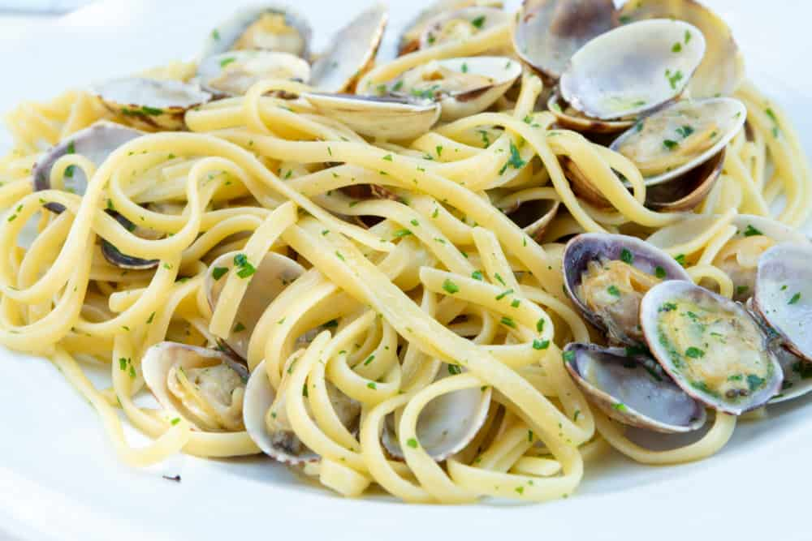
ORIGINATING IN GENOA, LIGURIA, LINGUINI PASTA IS THICKER BUT SLIGHTLY FLATTER THAN SPAGHETTI. TRADITIONALLY SERVED WITH PESTO OR SEAFOOD SAUCES, THE NAME IN ITALIAN MEANS ‘LITTLE TONGUES.’ GENOVESE HISTORIAN GIULIO GIACCHERO DESCRIBED THE PASTA PREPARED WITH PESTO, GREEN BEANS AND POTATOES IN THE 18TH CENTURY — A POPULAR DISH STILL SERVED IN LIGURIA. LINGUINE WITH CLAMS ( ‘AL VONGOLE’) IS ANOTHER LIGURIAN SPECIALTY WHILE OTHER LINGUINE DISHES ARE FOUND THROUGHOUT ITALY.

5. FETTUCCINE
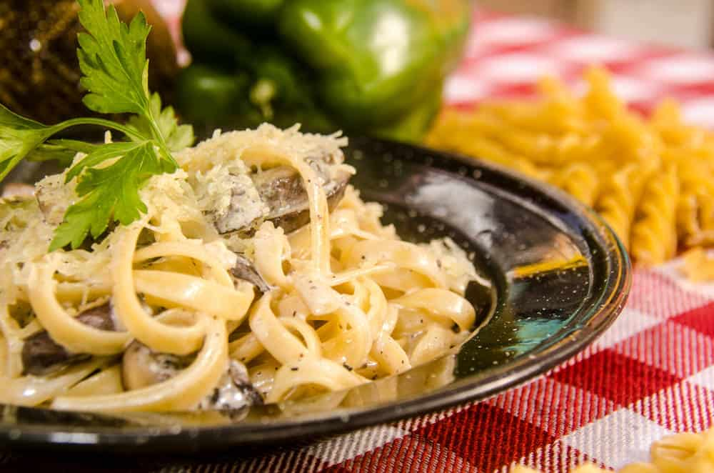
FETTUCCINE (‘LITTLE RIBBONS’) IS A LONG, FLAT NOODLE THAT IS COMMONLY USED WITH CREAMY PASTA SAUCE DISHES, SUCH AS FETTUCCINE ALFREDO. FIFTEENTH-CENTURY CHEF MARINO DA COMO MENTIONS PREPARING A SIMILAR DISH IN HIS BOOK OF RECIPES, “LIBER DE ARTE COQUINARIA” (“BOOK ON THE ART OF COOKING”).

FLAT CUT PASTA

6. LASAGNA
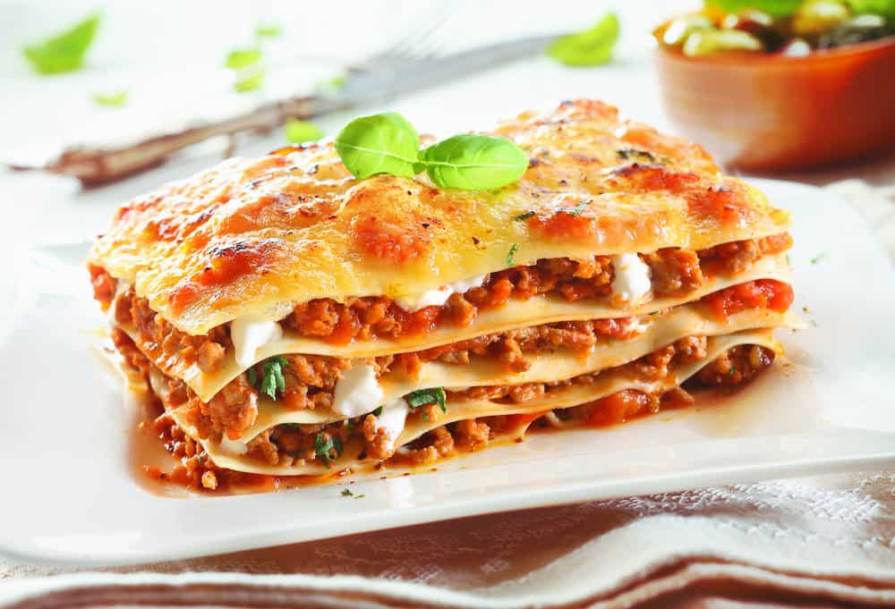
LASAGNE IS THE PLURAL OF LASAGNA — PASTA SHEETS LAYERED WITH RAGÙ MEAT SAUCE, CHEESES, SEASONING, SPICES AND VEGETABLES. LASAGNE MAY BE ONE OF THE OLDEST FORMS OF PASTA, FIRST MENTIONED IN MEDIEVAL TEXTS BUT THE CONCEPT IS PERHAPS MUCH OLDER THAN THAT.

7. MAFALDA

ORIGINALLY KNOWN AS MANFREDINE, PASTA MAKERS RENAMED THIS RIBBON-SHAPED PASTA IN HONOR OF THE 1902 BIRTH OF PRINCESS MAFALDA OF SAVOY, THE SECOND DAUGHTER OF KING VITTORIO EMANUELE III OF ITALY AND HIS WIFE ELENA OF MONTENEGRO.
MAFALDA, OR MAFALDINE, IS MADE OF LONG RECTANGULAR RIBBONS WITH RUFFLED EDGES ON BOTH SIDES. IT IS QUITE SIMILAR IN SHAPE AND SIZE TO LASAGNA, ALTHOUGH NARROWER (APPROXIMATELY ½ TO ¾ INCH IN WIDTH).
MAFALDA IS AVAILABLE IN STRIPS THAT CAN MEASURE UP TO 10 INCHES LONG AS WELL AS IN SHORT PIECES THAT ARE ABOUT AN INCH AND A HALF ONLY. THIS TYPE OF PASTA IS BEST SERVED IN THICK, RICH AND CREAMY SAUCES WITH SHREDDED OR MINCED MEAT.

PASTA IN SHORT, CUT PIECES

8. FUSILLI
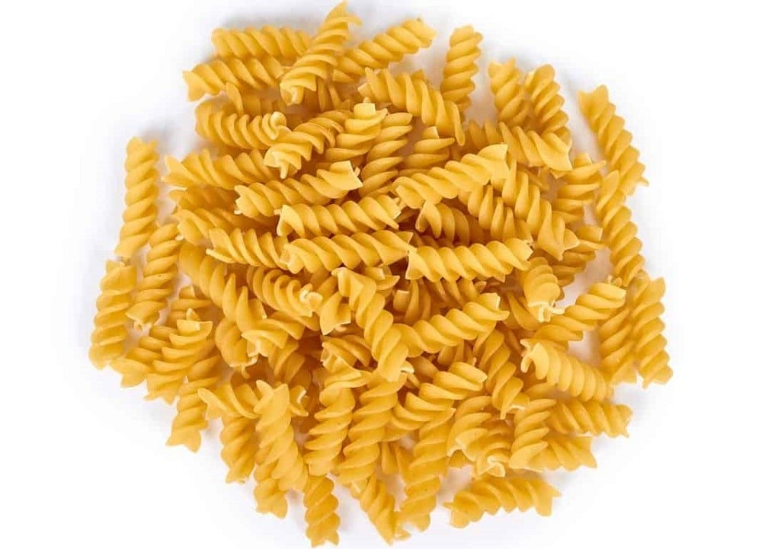
FUSILLI REFERS TO A TYPE OF SOUTHERN ITALIAN PASTA. THIS SHORT TO MEDIUM-SIZED TIGHTLY WOUND PASTA IS AN IDEAL CHOICE FOR SAUCY DISHES BECAUSE THE GROOVES IN ITS SHAPE HOLD ON TO A LOT OF GRAVY. THE TWISTED OR SPIRAL SHAPE OF FUSILLI NOT ONLY LOOKS APPETIZING BUT IT ALSO ALLOWS YOU TO WIPE CLEAN ALL THAT DELICIOUS SAUCE SERVED WITH IT.

9. MACARONI
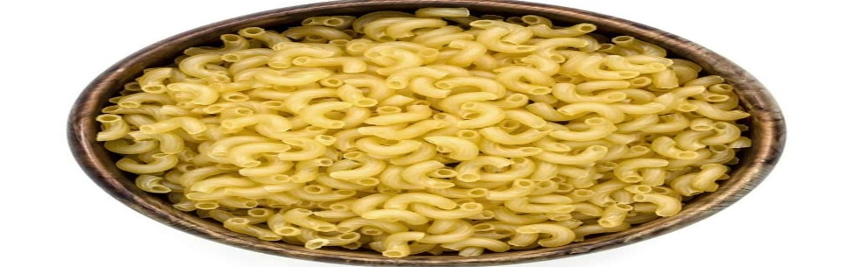
WHO DOESN’T LOVE MACARONI? NOT ONLY IS IT EVERYONE’S FAVORITE CHILDHOOD PASTA DISH, BUT ELBOW MACARONI IS PERHAPS THE MOST VERSATILE OF ALL THE AVAILABLE TYPES OF PASTA.
THE TUBULAR PASTA IS SLIGHTLY ARCHED LIKE A BENT ARM, GIVING IT THE COMPLETE NAME ‘ELBOW MACARONI.’ IT IS THE PERFECT PASTA SHAPE TO USE IN SOUPS, BAKED PASTA DISHES, OR DEVOUR WITH A THICK PASTE OF CHEESE AND VEGETABLE SAUCES. AFTER ALL, NEED WE MENTION THE LEGENDARY MAC ‘N CHEESE?

10. PACCHERI

THIS TYPE OF PASTA ORIGINATED IN THE REGIONS OF CALABRIA AND CAMPANIA. IT CONSISTS OF WIDE, PIPE-SHAPED TUBES THAT ARE USUALLY SMOOTH BUT SOMETIMES THEIR OUTER SURFACE CAN BE RIDGED. THIS VERSION OF PACCHERI IS KNOWN AS PACCHERIMILLERIGHE. COMMONLY USED IN TOMATO SAUCE-BASED RECIPES OR STUFFED WITH FILLINGS SUCH AS CHEESE IN A BAKED CASSEROLE.

11. PENNE

MEANING ‘QUILL’ OR ‘FEATHER,’ PENNE PASTA IS AMONG THE MOST POPULAR TYPES OF CUT PASTA. IT FEATURES MEDIUM LENGTH, HOLLOW TUBES THAT ARE CUT DIAGONALLY AT BOTH ENDS, MAKING IT A PERFECT BED FOR MOIST SAUCES AND TOPPINGS.
PENNE PASTA IS ABOUT TWO INCHES LONG ON AVERAGE BUT SOME MANUFACTURERS MAKE UP TO FOUR-INCH-LONG PIECES, AS WELL. PENNE GOES GREAT WITH CHUNKY VEGETABLES, MEAT AND CREAM SAUCES. SIMPLE PENNE WITH SMOOTH OUTER SIDES IS ALSO CALLED PENNE LISCE TO DISTINGUISH IT FROM PENNE RIGATE.

12. PENNE RIGATE

PENNE RIGATE IS A MODIFIED VERSION OF PENNE PASTA WITH GROOVED OR RIDGED OUTER SIDES. THE VERTICAL RIDGES THAT RUN LENGTHWISE DOWN EACH TUBE NOT ONLY ADD TO THE TEXTURE BUT ALSO HOLD ON THE SAUCES THAT NORMALLY SLIDE DOWN THE SMOOTH PENNE LISCE.

13. RIGATONI
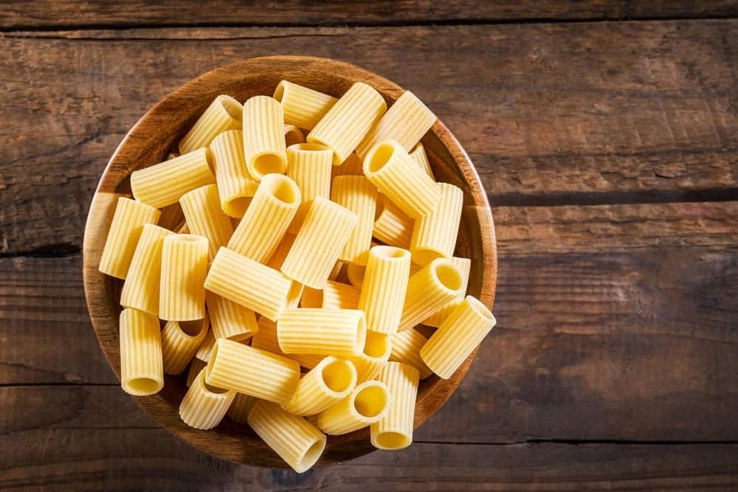
RIGATONI REFERS TO A TYPE OF MEDIUM TO LARGE PIPE-SHAPED PASTA THAT HAS SQUARE-CUT ENDS ON BOTH SIDES. DEPENDING ON THE METHOD OF PRODUCTION AND THE CUTTER USED, RIGATONI CAN BE STRAIGHT OR BENT SLIGHTLY WITH VARYING LENGTH AND DIAMETER.
HOWEVER, IT IS ALWAYS GROOVED AND NEVER AS CURVED AS ELBOW MACARONI. THE RIDGES PROVIDE EXCELLENT ADHESIVE SURFACES FOR SAUCES AND GRATED CHEESE.

14. TORTIGLIONI

TORTIGLIONI IS MUCH LIKE RIGATONI APART FROM THE FACT THAT TORTIGLIONI IS MUCH LARGER AND THE RIDGES ARE TWISTED AROUND THE PASTA. BESIDES MAKING IT VISUALLY APPEALING, THE SPIRAL GROOVES ARE HIGHLY FUNCTIONAL FOR HOLDING ON TO FULL-BODIED SAUCES.

15. CELLENTANI

CELLENTANI OR CAVATAPPI IS THE NAME GIVEN TO CORKSCREW-SHAPED MACARONI AS ‘CAVATAPPI’ LITERALLY MEANS CORKSCREW IN ITALIAN. THE HELICAL TUBE-SHAPED PASTA IS NORMALLY LINED WITH RIDGES ON THE SURFACE.
WHAT’S UNIQUE ABOUT CELLENTANI IS THAT ALTHOUGH IT IS PALE YELLOW LIKE MOST OTHER TYPES OF PASTA, IT IS MADE WITHOUT EGGS. FOOD COLORS SUCH AS RED OR GREEN ARE OFTEN ADDED TO USE IT IN SALADS, SOUPS AND CASSEROLES.

16. CHIFFERI

CHIFFERI REFERS TO PASTA THAT IS SHAPED LIKE CONVENTIONAL ELBOW MACARONI BUT IS SHORTER AND WIDER. IT COMES IN TWO VARIETIES, WHICH ARE LISCE (SMOOTH) AND RIGATI (RIDGED). YOU CAN SUBSTITUTE THE MACARONI IN MAC N’ CHEESE WITH CHIFFERI TO GET MORE FULL AND FLAVORSOME BITES THAT ARE LOADED WITH CHEESE.

PASTA WITH DECORATIVE CUTS

17. FARFALLE
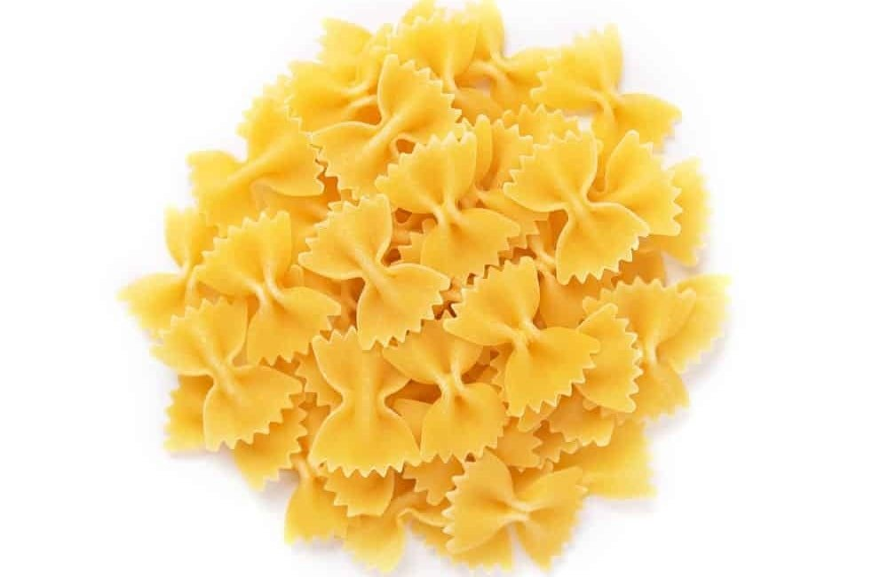
FARFALLE (THE ITALIAN WORD FOR ‘BUTTERFLIES’) IS PINCHED IN THE MIDDLE TO LOOK LIKE BOW TIES, WITH DECORATIVE CUTS AT THE SIDES.
THE PASTA SHAPE RESEMBLES A BUTTERFLY WITH WINGS WIDE OPEN AND MAKES A GREAT INGREDIENT FOR VARIOUS HOT AND COLD PASTA DISHES. YOU CAN USE FARFALLE IN COLD SALADS FOR A NUTRITIOUS TREAT OR TOSS IT IN A BOWL OF WARM MEAT AND VEGGIES FOR AN EQUALLY DELICIOUS MEAL.

18. ORECCHIETTE
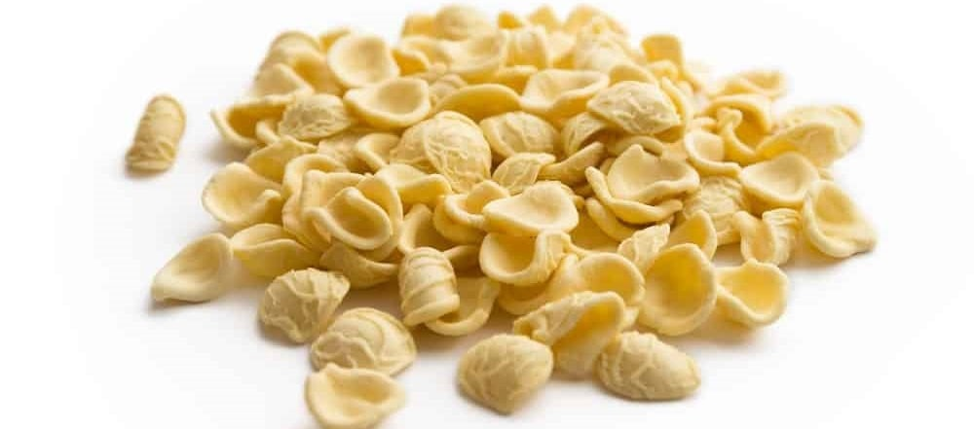
ORECCHIETTE TRANSLATES IN ENGLISH TO ‘LITTLE EARS’. ALTHOUGH THE PASTA ORIGINATED IN THE EARLY 12TH CENTURY IT REMAINS POPULAR TO THIS DAY. ORECCHIETTE IS BEST SERVED WITH RICOTTA, PANCETTA AND OTHER CREAM-BASED SAUCES.
YOU CAN ALSO USE IT TO ADD A FASCINATING SPIN WHEN COOKING BROCCOLI BECAUSE ITS CONCAVE, DISH-LIKE SHAPE WITH CREASED SURFACES MERGE WELL WITH THE TEXTURE OF BROCCOLI ITSELF.

19. PIPE REGATE
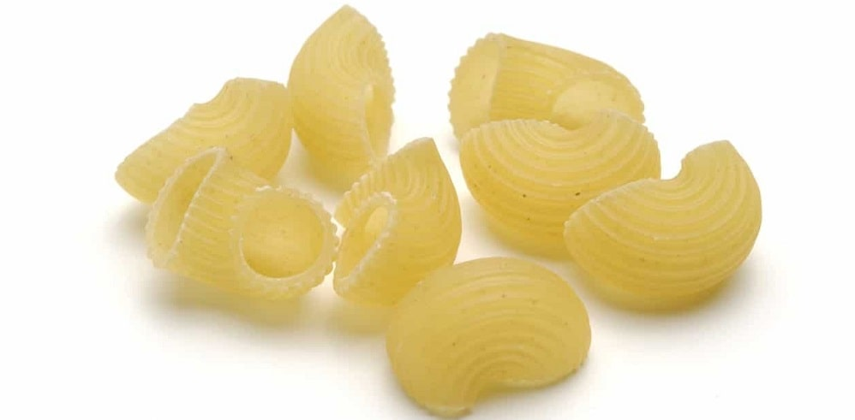
THE SHAPE OF PIPE RIGATE RESEMBLES A SNAIL SHELL WITH A WIDE OPENING ON ONE END AND THE OTHER END PRESSED SO THAT THE FLATTENED SIDE IS CLOSED ALTOGETHER. THIS TYPE OF PASTA GOES WELL WITH CHUNKY, OIL-BASED OR CREAMY SAUCES.

20. ROTELLE

ROTELLE FASCINATES CHILDREN WITH ITS SHAPE SIMILAR TO WAGON WHEELS.
PAIR ROTELLE PASTA WITH RICH AND THICK SAUCES OR SERVE WITH SALAD. IT ALSO ADDS A DECORATIVE FLAIR TO SOUPS AND OTHER DISHES.

21. FARFALLE ROTONDE
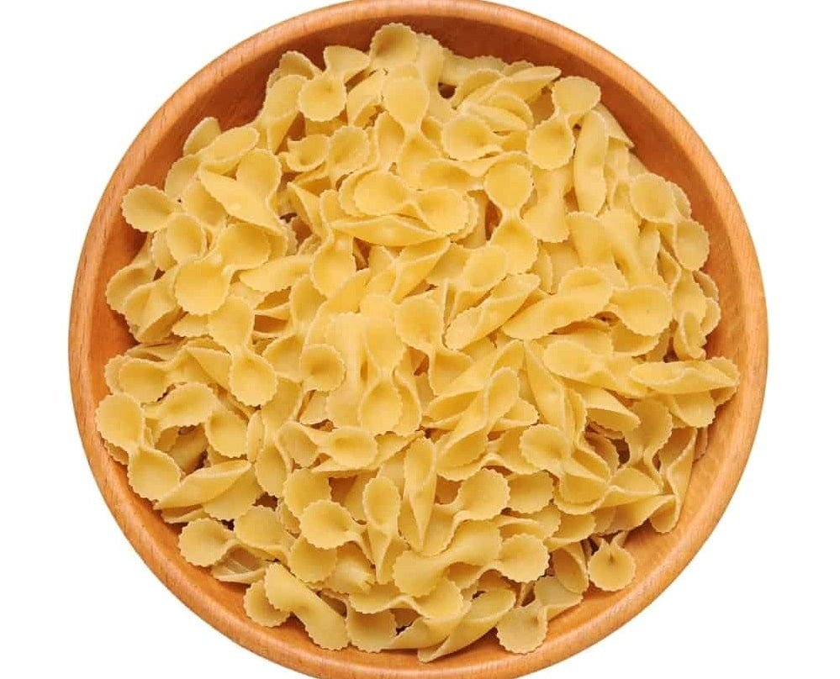
FARFALLE ROTONDE IS BOW-TIE SHAPED PASTA THAT IS SIMILAR IN APPEARANCE TO FARFALLE BUT DIFFERS AT THE SIDES. WHILE FARFALLE HAS ZIGZAG CUT EDGES, FARFALLE ROTONDE HAS ROUND SIDES. THE SMALLER VERSION OF FARFALLEROTONDE IS REFERRED TO AS TRIPOLINI.

22. CHIFFERIRIGATE

THOSE WHO DON’T PAY ATTENTION TO FINE DETAILS MIGHT SAY THAT MACARONI, CHIFFERI AND CHIFFERIRIGATE ARE DIFFERENT NAMES FOR THE SAME PASTA. BUT THE REALITY IS JUST THE OPPOSITE.
MACARONI IS CURVED, PIPE-LIKE PASTA THAT IS BENT IN ALMOST A HALF-CIRCLE IN THE CASE OF ELBOW MACARONI OR CUT AT 180 DEGREES OTHERWISE. CHIFFERI IS SHORTER AND WIDER AS COMPARED TO MACARONI WHILE CHIFFERIRIGATE IS LIKE ELBOW MACARONI BUT WITH RIDGES ON THE OUTSIDE.

MINIATURE PASTA

23. CONCHIGLIE
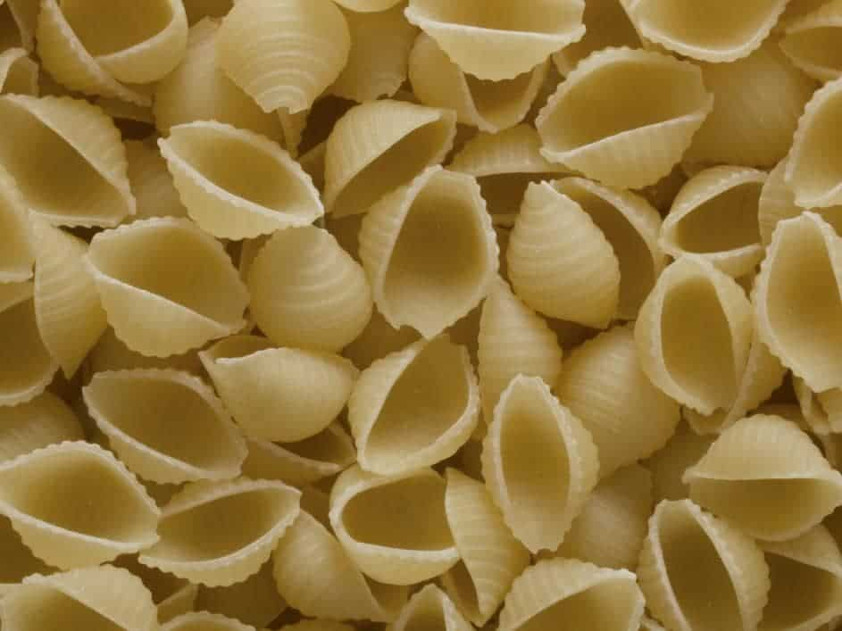
THIS PASTA IS SHAPED LIKE A CONCH SHELL. CONCHIGLIE IS PERFECT FOR USE IN DIFFERENT SOUPS AND CASSEROLES. ALTHOUGH IT IS COMMONLY MINIATURE-SIZED YOU CAN ALSO FIND IT IN LARGER SIZES. THE LARGER VERSION IS CALLED CONCHIGIONI WHILE EXTRA SMALL SIZES ARE CALLED CONCHIGLIETTE.

24. ORZO
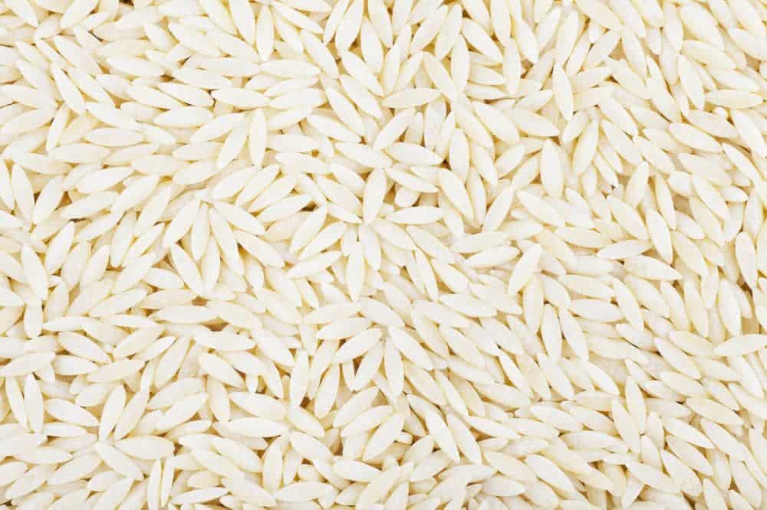
ORZO LOOKS LIKE GRAINS OF BARLEY AND ALSO COMES CLOSE TO LOOKING LIKE LARGER GRAINS OF RICE. BE IT SOUP, SALADS OR SIMPLY AS A SIDE DISH WITH MEAT AND LOTS OF VEGGIES, ORZO IS TOOTHSOME PASTA OPTION.

25. STELLINE

STELLINE PASTA IS A TYPE OF MINIATURE PASTA THAT IS SHAPED LIKE SMALL STARS. GIVEN ITS SHAPE AND SIZE, IT GOES WITHOUT SAYING THAT STELLINE IS THE PREFERRED CHOICE FOR VARIOUS SOUPS AS IT ADDS SUBTLE BURSTS OF FLAVOR IN EVERY SPOON.
TIP: IF YOU EVER WANT TO TRY OUT AN ITALIAN RECIPE BUT CAN’T UNDERSTAND THE DIFFERENCE BETWEEN FUSILLINI, FUSILLI, AND FUSILLIONI, THEN REMEMBER THAT -INI AND -ONI ARE MERELY SUFFIXES THAT DENOTE THE PASTA SIZE. TERMS ENDING IN -INI ARE THE SMALLEST VERSION OF THE PARTICULAR PASTA TYPE WHILE -ONI DENOTES THE LARGER SIZE.

TOP BRANDS FOR PASTA

1. BARILLA
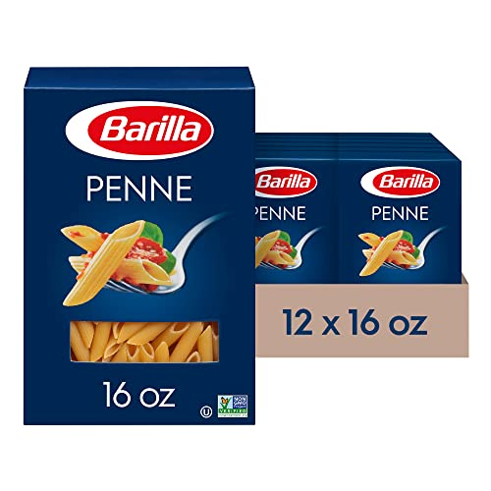
FOUNDED IN THE 1870S IN PARMA, ITALY, BARILLA IS A MULTINATIONAL CONGLOMERATE FOOD COMPANY THAT IS RECOGNIZED TO BE THE LARGEST PRODUCER OF PASTA ACROSS THE GLOBE. THE COMPANY OPERATES THIRTY PRODUCTION SITES ACROSS THE WORLD, WITH HALF LOCATED IN ITALY.
IN 1999, BARILLA FIRST DEVELOPED ITS FIRST PRODUCTION FACILITY IN THE UNITED STATES IN IOWA. THE COMPANY OPERATES TWENTY BRANDS AND GENERATED REVENUE OF NEARLY $4 BILLION IN 2020.

2. PASTA GAROFALO
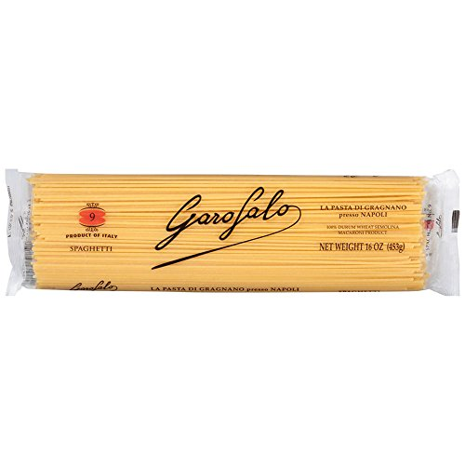
GARAFALO WAS FOUNDED IN THE LATE 1780S IN GRAGNANO, AN AREA OF ITALY THAT OFFERS THE IDEAL CLIMATE FOR MAKING THE PERFECT PASTA. GARAFALO IS THE BENCHMARK OF QUALITY PASTA, AND ITS PRODUCTS ARE MARKETED THROUGHOUT THE WORLD.
ITS LINE OF PRODUCTS, MADE FROM DURUM WHEAT SEMOLINA, ORGANIC WHOLE DURUM WHEAT SEMOLINA, AND GLUTEN-FREE PASTA, ARE AVAILABLE IN TRADITIONAL AND CREATIVE SHAPES AND SIZES.

3. DECECCO
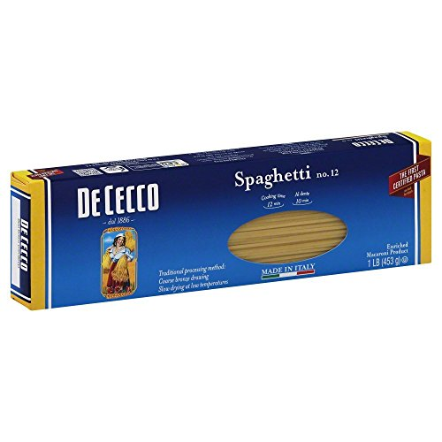
ESTABLISHED IN ABRUZZO, ITALY, IN 1886, DECECCO IS AMONG THE MOST POPULAR PASTA BRANDS ACROSS THE GLOBE. THE DECECCO BAND OF PASTA IS CONSIDERED ONE OF THE FINEST COMMERCIAL BRANDS AVAILABLE IN THE PASTA MARKETPLACE.
DECECCO OFFERS CONSUMERS A WIDE VARIETY OF HIGH-QUALITY MILLED PRODUCTS AND PASTA, INCLUDING PASTA SAUCES AND DELECTABLE EXTRA VIRGIN OLIVE OIL. THE BRAND’S PASTA VARIETIES PROVIDE AN OUTSTANDING BALANCE OF COLOR, FLAVOR, AND AROMA.

4. RUSTICHELLA D’ABRUZZO
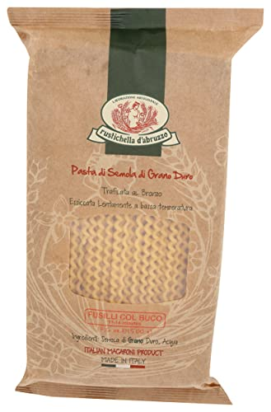
RUSTICHELLA D’ABRUZZO WAS ESTABLISHED IN 1924 IN ABRUZZO, ITALY, AT A FAMILY-OWNED STONE MILL. IN THE EARLY 1980S, THE ORIGINAL OWNER’S DAUGHTER LED A FAMILY INITIATIVE THAT LED TO THE CREATION OF ONE OF ITALY’S MOST EXTENSIVE ARTISANAL LINES OF PASTA PRODUCTS.
RUSTICHELLA D’ABRUZZO NOW OFFERS A WIDE VARIETY OF PASTA, FROM TRADITIONAL TO DELECTABLE PASTA SAUCES, TO ACCOMPANY THE MANY AVAILABLE SHAPES AND SIZES.

5. LA MOLISANA
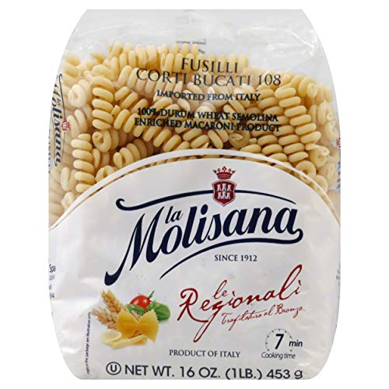
LA MOLISANA IS A PUBLICLY OWNED COMPANY THAT WAS FOUNDED IN 1912 AS AN ARTISANAL WORKSHOP BY THE CARLONE FAMILY. HEADQUARTERED IN CAMPOBASSO, LA MOLISANA IS AN ITALIAN FOOD COMPANY THAT OFFERS A WIDE RANGE OF PASTA ACROSS THE GLOBE.
IN ADDITION TO PRIVATE LABEL BULK SERVICES, LA MOLISANA OFFERS CLASSIC, ORGANIC, WHOLE WHEAT, AND GLUTEN-FREE PASTA PRODUCTS, AMONG OTHERS. THE LA MOLISANA BRAND WAS AWARDED FIRST PRIZE AND GOLD MEDAL AT THE 1927 EXHIBITION FAIR IN ROME.

6. RONZONI

THE RONZONI MACARONI COMPANY WAS FOUNDED IN NEW YORK IN THE EARLY 20TH CENTURY BY EMANUEL RONZONI, AN ITALIAN IMMIGRANT. ABOUT FIVE DECADES LATER, RONZONI PASTA WAS RECOGNIZED TO BE THE NUMBER ONE PASTA IN NEW YORK.
ITS OWNERS HAVE CHANGED OVER THE YEARS THROUGH HERSHEY FOODS AND, ULTIMATELY, POST HOLDINGS IN 2021. IN ADDITION TO TRADITIONAL PASTA, RONZONI HAS LED INNOVATION BY CREATING VEGETABLE AND TURMERIC PASTA OVER THE YEARS.

7. RAO’S HOMEMADE
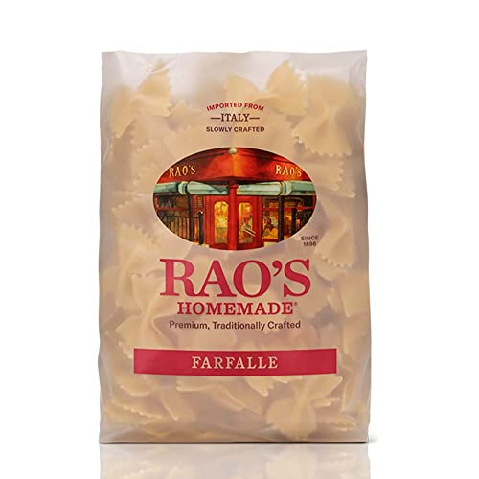
FOUNDED IN THE 19TH CENTURY, RAO’S HOMEMADE BEGAN ITS LEGENDARY ROLE IN THE PASTA TRADE AS ONE OF NEW YORK’S BEST ITALIAN RESTAURANTS. RAO’S HOMEMADE EXPANDED ACROSS THE COUNTRY, MAKING THE FINEST QUALITY PASTA SAUCE AND THEN LAUNCHING A PREMIUM PASTA BRAND.
RAO’S COMPLETE LINE OF PASTA INCLUDES FARFALLE, RIGATONI, FUSILLI, LINGUINE, SPAGHETTI, PENNE, AND FETTUCINE. RAO’S HOMEMADE NOW OFFERS COMPLETE MEALS IN THE FROZEN SECTIONS OF MOST SUPERMARKETS.

8. LIDIA’S

LIDIA’S PASTA IS THE CREATION OF LIDIA BASTIANICH, AN EMMY AWARD-WINNING TV HOST, RESTAURANTEUR, COOKBOOK AUTHOR, AND FOOD BUSINESS ENTREPRENEUR. THE FIRST RESTAURANT – BUONAVIA, OPENED IN NEW YORK CITY’S BOROUGH OF QUEENS.
LIDIA’S FLAGSHIP RESTAURANT OPENED IN 1981 IN MANHATTAN, WITH MANY RESTAURANT VENTURES TO FOLLOW. LIDIA’S PASTA VARIETIES ARE CONSIDERED AMONG THE BEST AVAILABLE. LIDIA ALSO OFFERS SAUCES AND MEALS CREATED FROM HER MANY CREATIVE RECIPES.

9. COLAVITA

COLAVITA IS A PRIVATELY OPERATED FOOD COMPANY THAT WAS ESTABLISHED IN 1930 IN ROME, ITALY. COLAVITA USA, LOCATED IN NEW JERSEY, WAS DEVELOPED LATER TO IMPORT COLAVITA’S AUTHENTIC SPECIALTY ITALIAN PRODUCTS. COLAVITA IS BEST KNOWN FOR ITS OLIVE OIL BUT NOW OFFERS A VARIETY OF PRODUCTS.
COLAVITA’S CLASSIC AND SPECIALTY PASTA LINES INCLUDE ORGANIC, WHOLE WHEAT, AND GLUTEN-FREE, AMONG OTHERS. THE COMPANY ALSO MARKETS GNOCCHI, GRAINS, COUSCOUS, AND A VARIETY OF POLENTA AND SPECIALTY RICE.

10. MONTEBELLO
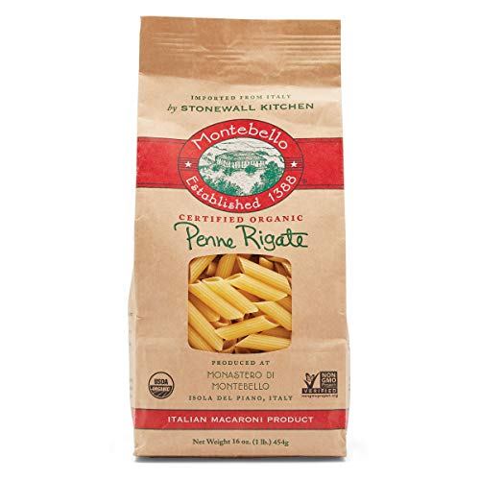
THE MONTEBELLO PASTA BRAND IS A MEMBER OF THE STONEWALL KITCHEN. LOCATED IN NORTHERN ITALY, MONTEBELLO IS A REGION THAT IS PRIZED FOR ITS HEARTY DURUM WHEAT AND VINE-RIPENED TOMATOES.
THIS ARTISANAL AIR-DRIED ANCIENT-GRAIN PASTA IS NOW AVAILABLE WORLDWIDE IN WIDE VARIETIES – PENNE, SPAGHETTI, TAGLIATELLE, FUSILLI, MACCHERONI, AND LASAGNA, TO NAME A FEW. IN ADDITION, TO ITS ORGANIC EXTRA VIRGIN OLIVE OIL, MONTEBELLO ALSO OFFERS BASIL MARINARA, VERDURE, AND ARRABBIATA SAUCES TO COMPLEMENT MONTEBELLO’S DELICIOUS PASTA.

BEST TYPE OF PASTA FOR VARIOUS RECIPES

SOUP
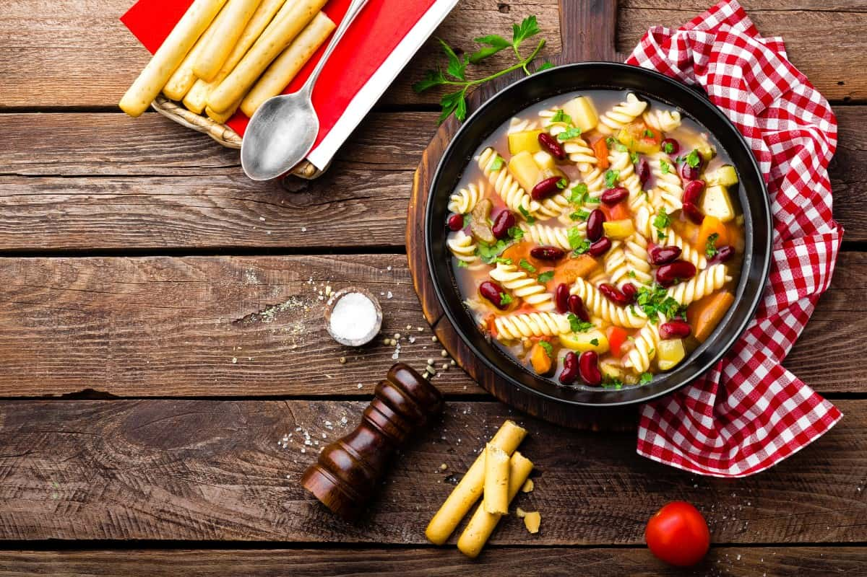
THE BEST PASTA FOR SOUP DEPENDS ON WHAT TYPE OF SOUP YOU MAKE. ACINI DI PEPE IS A GREAT PASTA FOR ITALIAN WEDDING SOUP, WHILE DITALINI IS DELICIOUS WHEN USED TO MAKE PASTA E FAGIOLI.
TUBETTINI IS A LONG, SMALL PASTA THAT IS USED TO MAKE PASTA E CECI, A POPULAR CHICKPEA SOUP THAT’S EASY TO MAKE. ONE OF THE BEST PASTA FOR SOUP IS ORZO, A TINY PASTA THAT LOOKS LIKE LONG GRAIN RICE AND CAN BE ADDED TO A WIDE VARIETY OF SOUP RECIPES.

BOLOGNESE SAUCE
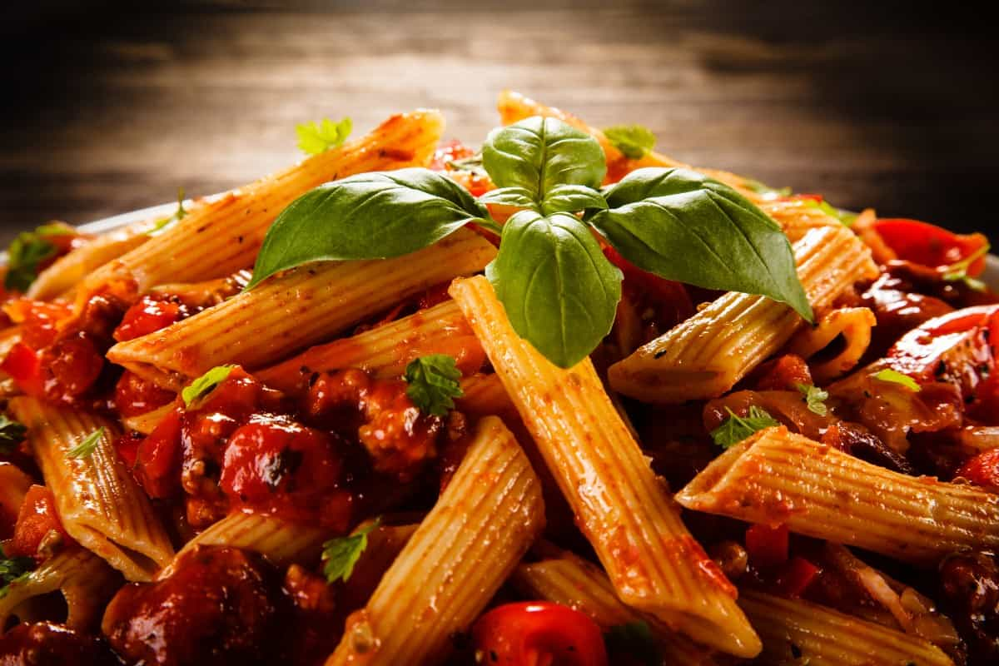
BOLOGNESE IS A THICK, CHUNKY SAUCE THAT REQUIRES HEAVY PASTA. FETTUCCINE IS AN EXCELLENT CHOICE TO GO WITH BOLOGNESE SAUCE THANKS TO ITS THICKER SHAPE THAN TRADITIONAL SPAGHETTI.
TAGLIATELLE IS SIMILAR TO FETTUCCINE EXCEPT THAT IT HAS A NICE ROUGH TEXTURE THAT CLINGS TO THE SAUCE, AND IT’S SLIGHTLY THICKER. ANOTHER GREAT PASTA FOR BOLOGNESE SAUCE IS PAPPARDELLE DUE TO ITS WIDE SHAPE AND CHEWY TEXTURE.

CARBONARA SAUCE
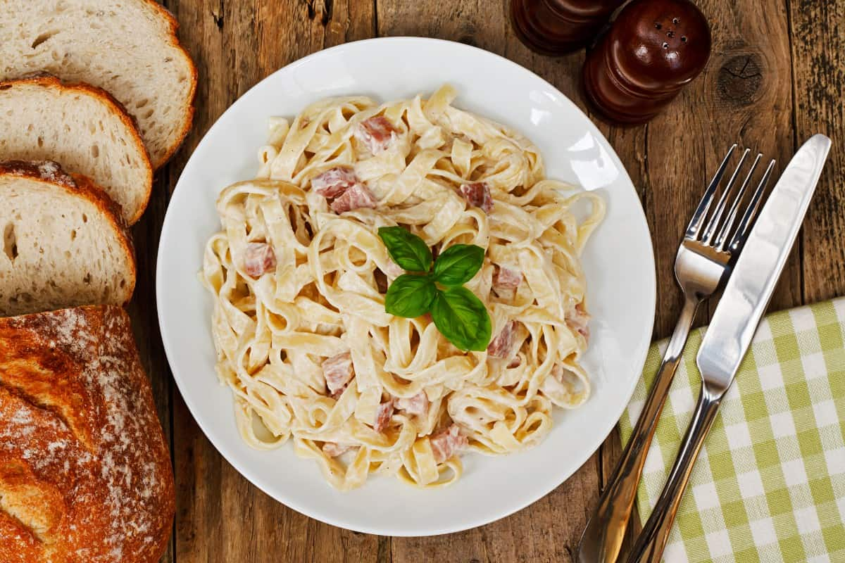
CARBONARA SAUCE IS A HEARTY SAUCE MADE WITH GARLIC, CHEESE, EGGS, BACON AND HEAVY CREAM. THE BEST PASTA FOR THIS RICH SAUCE IS SPAGHETTI OR LINGUINE. YOU CAN ALSO MAKE CARBONARA SAUCE AND SERVE IT WITH SPINACH FETTUCCINE FOR A UNIQUE FLAVOR AND COLOR.

PASTA SALAD
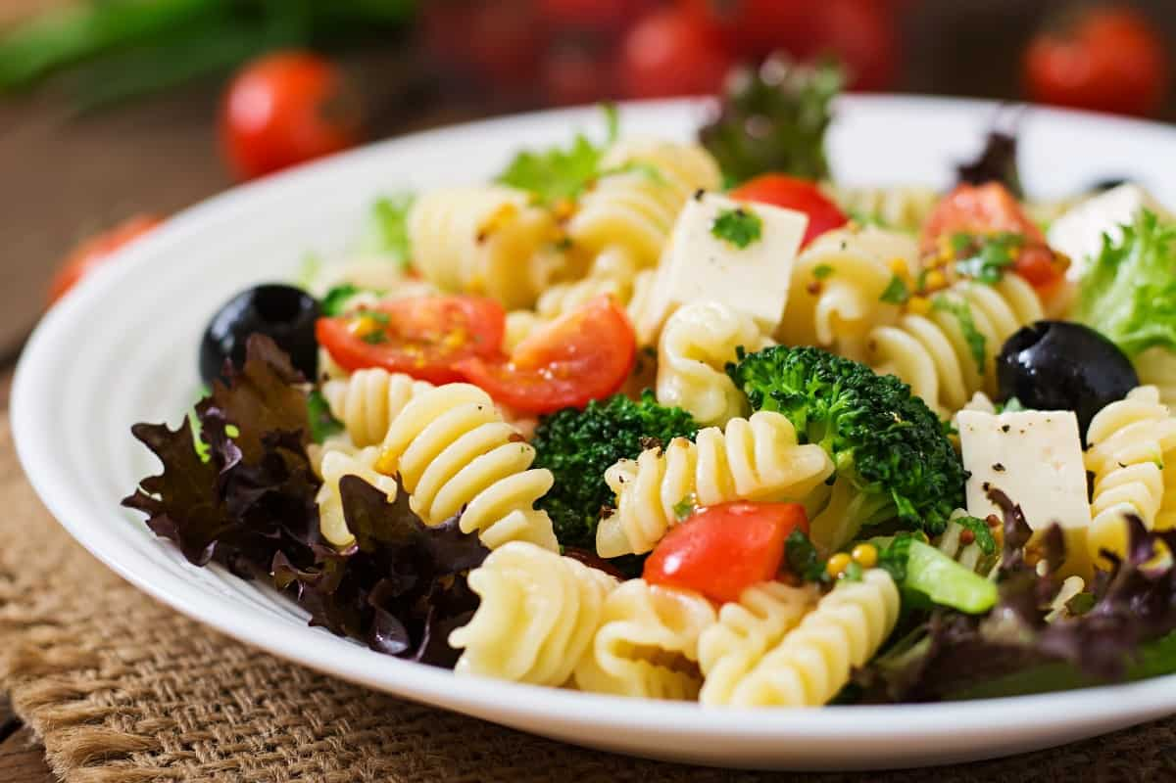
A DELICIOUS PASTA SALAD IS A SUMMERTIME FAVORITE. YOU CAN USE VIRTUALLY ANY TYPE OF PASTA FOR THIS RECIPE INCLUDING CLASSICS LIKE A BOWTIE, ELBOW AND ROTINI. COMBINE YOUR PASTA OF CHOICE WITH HEALTHY INGREDIENTS LIKE FRESH HERBS, OIL AND VINEGAR, AND FRESH CHOPPED VEGGIES.

ALFREDO SAUCE
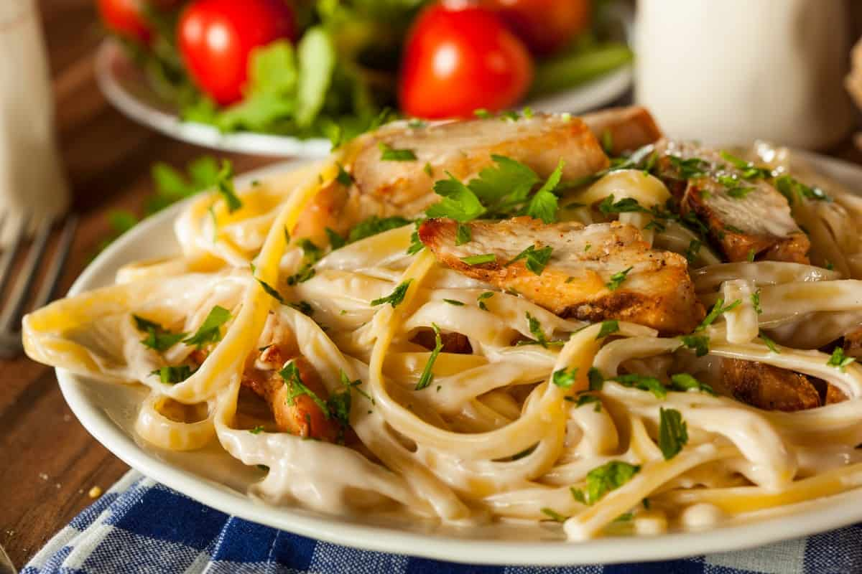
ALFREDO IS A CREAMY WHITE SAUCE THAT PAIRS BEAUTIFULLY WITH FETTUCCINE. THE WIDE SHAPE AND THICK CONSISTENCY OF FETTUCCINE ARE A GREAT COMPANION TO ALFREDO SAUCE.

SEAFOOD PASTA DISHES (SCAMPI)
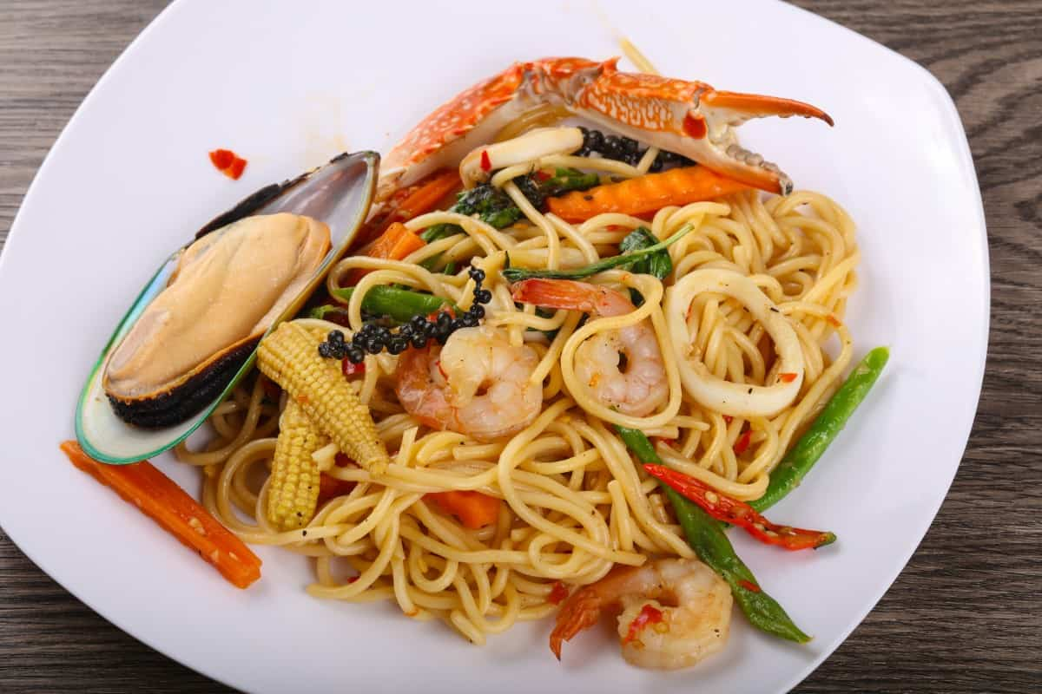
SEAFOOD DISHES LIKE SHRIMP SCAMPI ARE BEST SERVED WITH LONG, THIN NOODLES LIKE ANGEL HAIR PASTA, SPAGHETTI OR LINGUINE. YOU CAN MAKE A VARIETY OF SEAFOOD PASTA DISHES WITH DIFFERENT KINDS OF PASTA, TOO, SUCH AS FRESH COOKED SALMON AND SPAGHETTI OR SPIRALED ROTINI. TOP THE DISH WITH FRESH LEMON AND A CREAMY SAUCE.

MEATBALLS
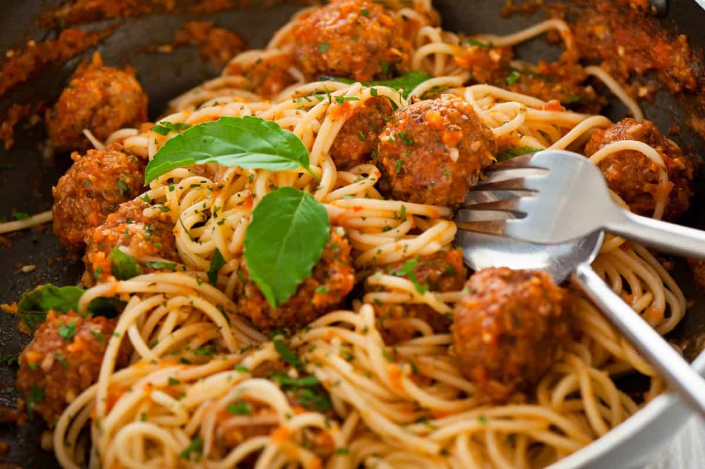
THERE’S NOTHING MORE CLASSIC THAN A DISH OF SPAGHETTI AND MEATBALLS, WHICH IS ALWAYS THE BEST TYPE OF PASTA FOR THIS HEARTY DISH. MEATBALLS ALSO TASTE GREAT WITH OTHER LONG PASTA LIKE FETTUCCINE AND LINGUINE.

MARINARA SAUCE
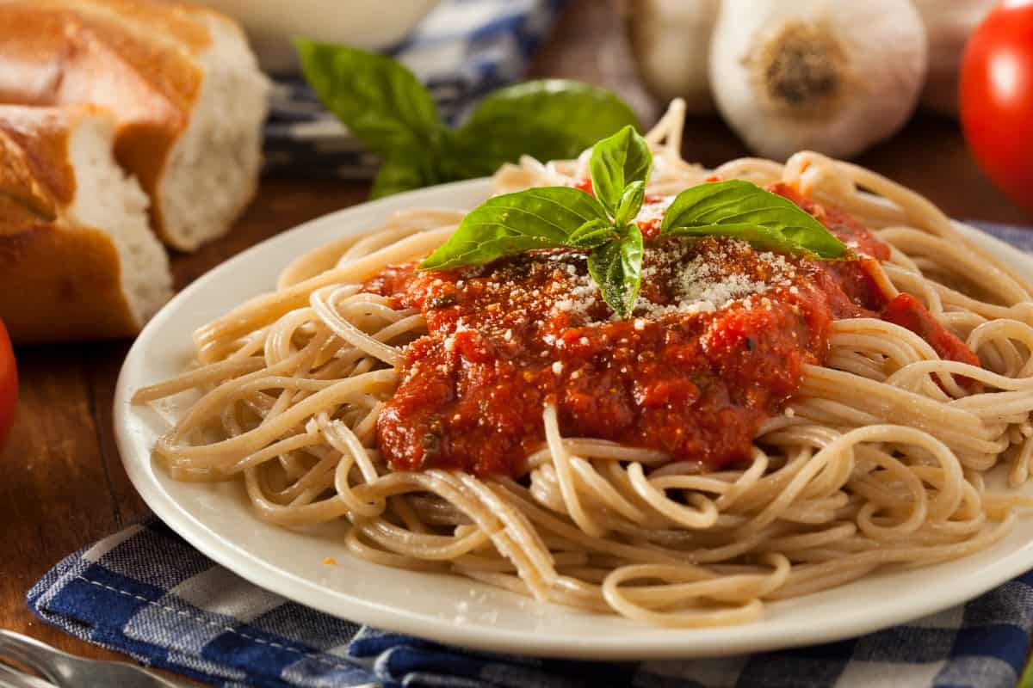
PASTA AND MARINARA SAUCE NATURALLY GO TOGETHER. THIS RED TOMATO SAUCE IS DELICIOUS WITH A PLATE OF FRESH SPAGHETTI OR ANGEL HAIR. IT ALSO GOES NICELY WITH THICKER PASTA, INCLUDING LINGUINE. OF COURSE, IF YOU’RE MAKING LASAGNA WITH MARINARA SAUCE, YOU’LL NEED TO USE LASAGNA NOODLES. THE TYPE OF PASTA YOU USE WILL ULTIMATELY DEPEND ON THE RECIPE.

MAC AND CHEESE
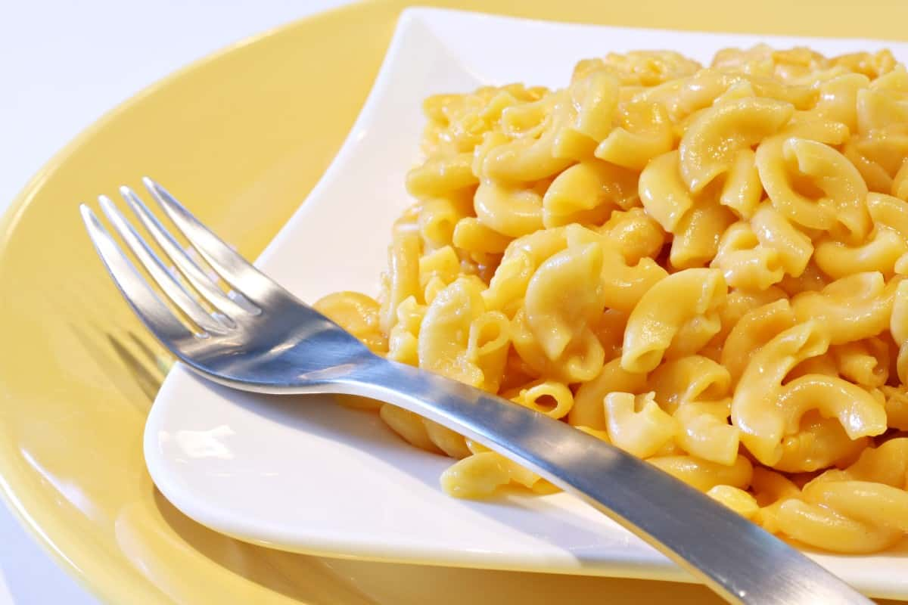
ELBOW NOODLES ARE A CLASSIC CHOICE FOR CREAMY AND DELICIOUS MAC AND CHEESE. ANOTHER GREAT CHOICE IS CAVATAPPI, WHICH HAS RIDGES AND A SPIRALED SHAPE THAT HELPS THE CHEESE CLING NICELY TO THE PASTA. YOU CAN ALSO USE OTHER KINDS OF PASTA SUCH AS SHELL PASTA AND FARFALLE (BOWTIE), WHICH ARE BOTH POPULAR WITH KIDS.

CHICKEN CACCIATORE
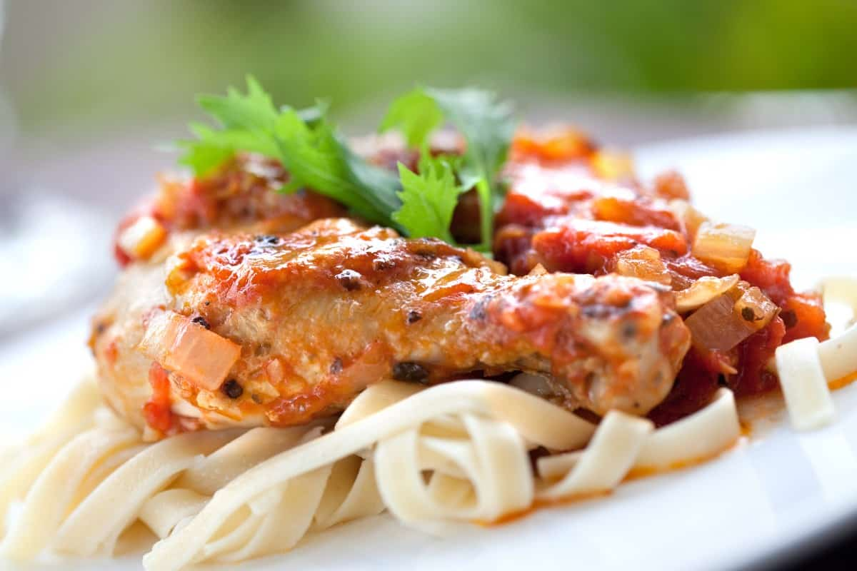
PENNE PASTA IS A GOOD PAIRING FOR CHICKEN CACCIATORE, BUT THIS RUSTIC ITALIAN DISH CAN BE SERVED WITH VIRTUALLY ANY PASTA STYLE. LOOK FOR PASTA THAT CAN STAND UP TO THE RICHNESS AND HEAVINESS OF THEDISH. BUCATINI IS AN EXCELLENT CHOICE SINCE IT’S MUCH THICKER AND HEARTIER THAN SPAGHETTI.

CHICKEN MARSALA
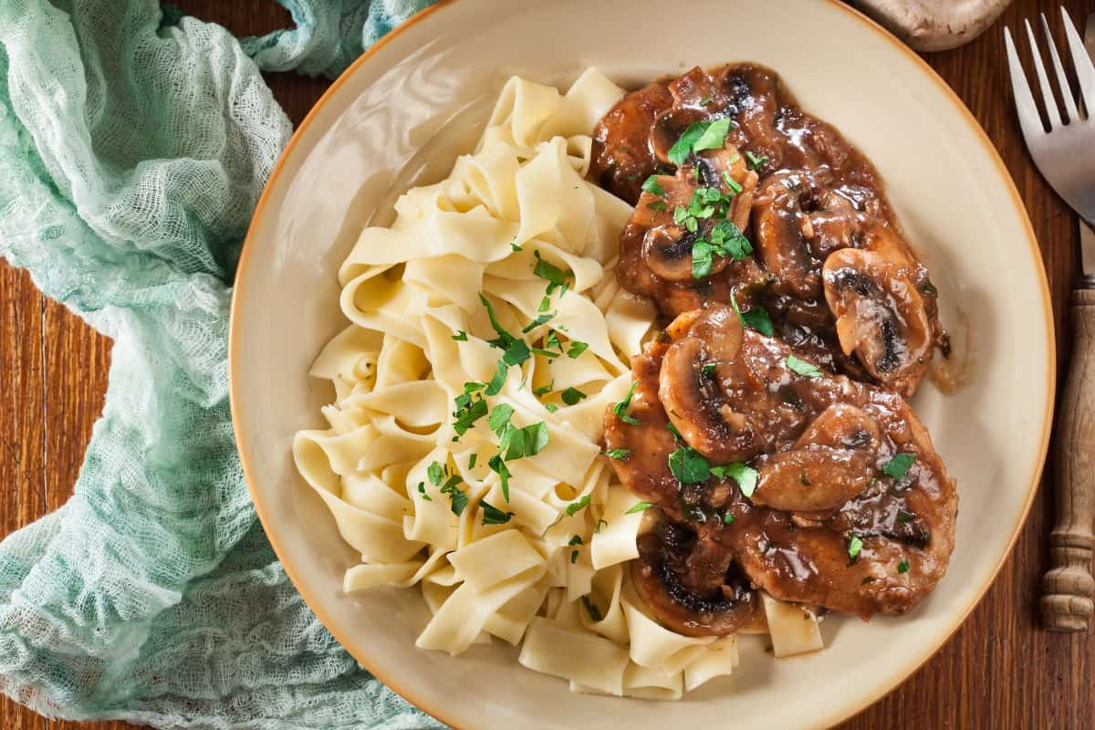
THIS BELOVED ITALIAN DISH IS MADE WITH A DRY WINE SAUCE, CHICKEN, MUSHROOMS, AND A RANGE OF SPICES. MANY KINDS OF PASTA GO WELL WITH CHICKEN MARSALA INCLUDING A SIDE OF ANGEL HAIR OR SPAGHETTI DRIZZLED WITH OLIVE OIL.
YOU CAN ALSO SERVE THIS RUSTIC DISH WITH BUTTERED FETTUCCINE OR SOME RISOTTO. IF YOU’RE LOOKING FOR A HEALTHY ALTERNATIVE, THIS DISH ALSO GOES WELL WITH SPIRALIZED VEGGIES LIKE SQUASH OR ZUCCHINI.

PESTO GENOVESE
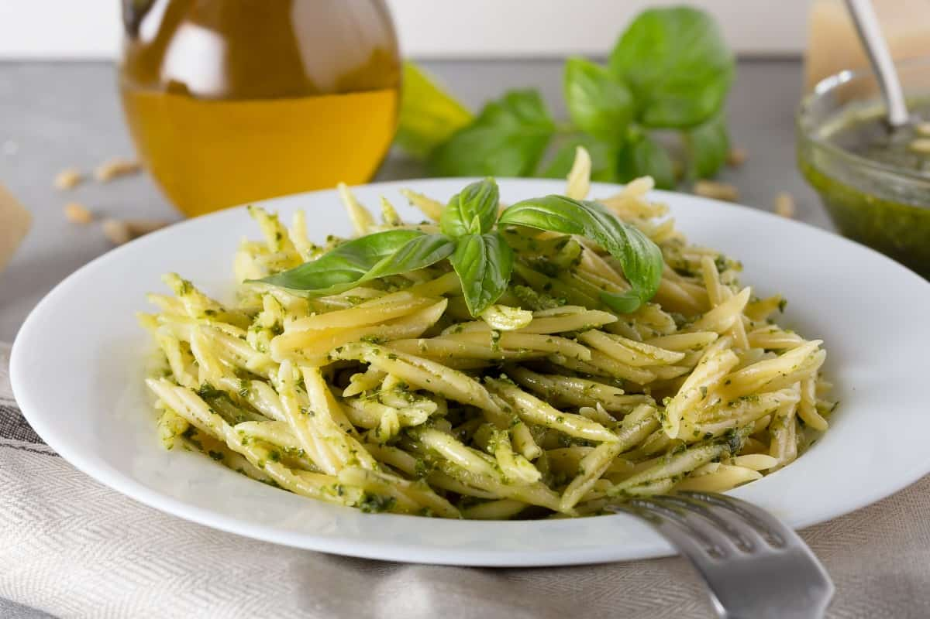
PESTO GENOVESE IS A BRIGHT AND LIVELY SAUCE MADE FROM PINE NUTS, PARMESAN CHEESE, OLIVE OIL AND FRESH BASIL. THIS HEARTY SAUCE GOES WELL WITH PASTA IN LONGER CUTS SUCH AS FUSILLI, THANKS TO ITS CORKSCREW SHAPE.
OTHER GREAT PAIRINGS WITH PASTA GENOVESE INCLUDE CAPELLINI, FETTUCCINE, BUCATINI, AND THINNER VERSIONS OF SPAGHETTI LIKE ANGEL HAIR. YOU CAN ALSO ADD PESTO TO FRESH-BAKED, CRUSTY BREAD FOR A DELICIOUS AND FILLING SIDE DISH.

PUTTANESCA
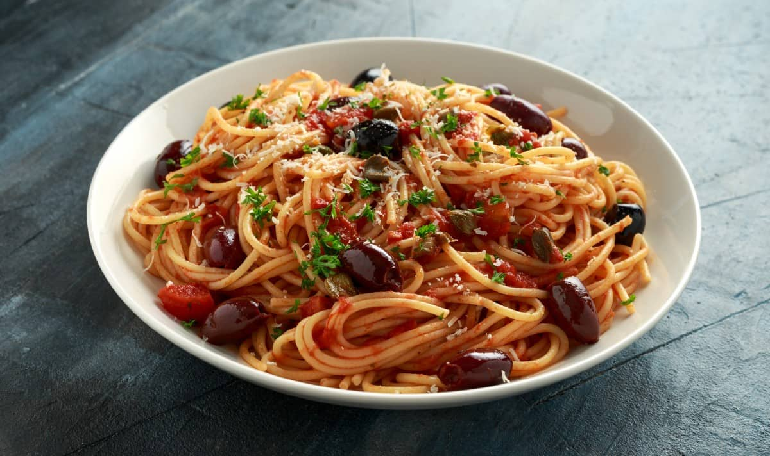
THIS SAVORY SAUCE IS MADE FROM GARLIC, CAPERS, ANCHOVIES, CANNED TOMATOES AND OLIVES. PAIR HOMEMADE PUTTANESCA SAUCE WITH THIN, LONG PASTA OPTIONS LIKE LINGUINE, VERMICELLI OR BUCATINI. THE KEY TO A GREAT PUTTANESCA SAUCE IS TO ADD PASTA THAT’S SIMPLE AND SUBTLE, AND THAT WON’T DETRACT FROM THE SAUCE’S ROBUST FLAVORS.

ARRABIATA SAUCE
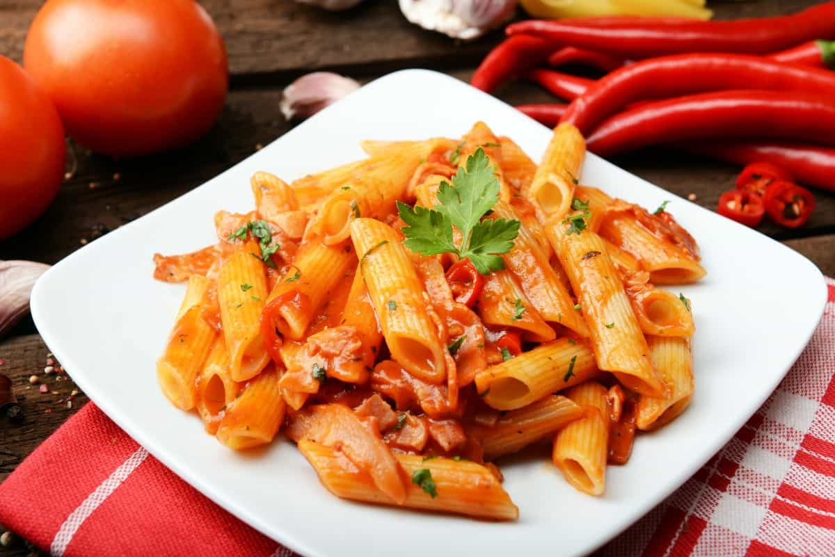
ARRABIATA SAUCE HAS A SPICY KICK THANKS TO THE ADDITION OF INGREDIENTS LIKE RED PEPPER FLAKES, PAPRIKA OR CAYENNE. YOU CAN PAIR YOUR ARRABIATA SAUCE WITH CLASSIC PASTA LIKE SPAGHETTI OR LINGUINE.

ZITI
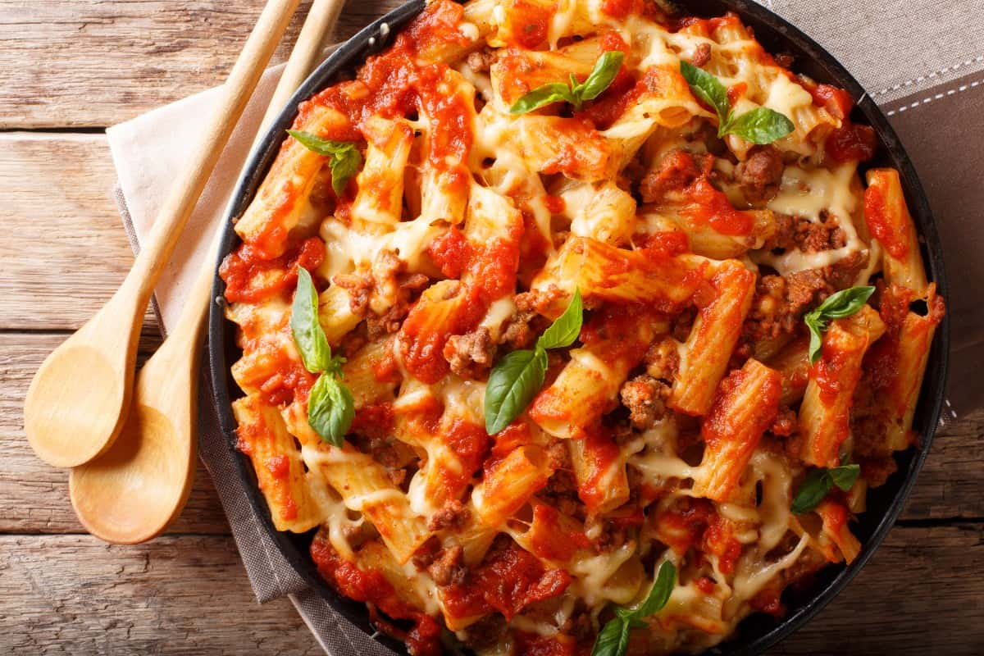
BAKED ZITI IS A CHEESY, SAUCY DISH THAT’S EXTREMELY EASY TO MAKE AT HOME. CLASSIC ZITI PASTA IS ALWAYS THE BEST CHOICE, BUT THERE ARE SOME SUBSTITUTES THAT YOU CAN USE THAT WILL WORK JUST AS WELL. IF YOU CAN’T GET YOUR HANDS ON ZITI, TRY MAKING THE DISH WITH PENNE PASTA OR RIGATONI. THE KEY IS TO USE TUBE-SHAPED PASTA THAT’S NOT TOO WIDE, TOO LONG OR TOO THIN.

VEAL SCALLOPINI
THIS UNIQUE ITALIAN DISH IS MADE BY SEARING FRESH VEAL AND SERVING IT WITH CAPERS, LEMON JUICE, STOCK AND PARSLEY. YOU CAN SERVE THE DISH ALONGSIDE FRESH LINGUINE, FETTUCCINE OR SPAGHETTI. IT ALSO GOES WONDERFULLY WITH ANGEL HAIR PASTA.

CASSEROLES

THERE ARE COUNTLESS CASSEROLE DISHES THAT USE PASTA AS PART OF THE INGREDIENTS. SOME OF THE BEST PASTA FOR CASSEROLES INCLUDE EGG NOODLES, ELBOW NOODLES AND BOWTIE PASTA.
YOU CAN ALSO USE ZITI NOODLES FOR BAKED ZITI CASSEROLE OR TRY SOME MANICOTTI OR LARGE SHELLS TO CREATE BAKED CHEESY CASSEROLES SUCH AS STUFFED SHELLS FILLED WITH MARINARA SAUCE AND RICOTTA CHEESE.

FREQUENTLY ASKED QUESTIONS

ARE PASTA NOODLES HEALTHY?
I THINK THE MOST STRAIGHTFORWARD AND CORRECT ANSWER IS THAT PASTA NOODLES ARE HEALTHY WHEN CONSUMED IN MODERATION AS PART OF A HEALTHY AND NUTRITIOUS DIET. HOWEVER, PASTA NOODLES ARE A CARBOHYDRATE-RICH FOOD, MAKING THEM LESS HEALTHY FOR THOSE WITH DIABETES. THEY SHOULD ALSO BE AVOIDED BY THOSE WITH GLUTEN INTOLERANCES AND CELIAC DISEASE, ALTHOUGH GLUTEN-FREE OPTIONS ARE AVAILABLE.
ADDITIONALLY, REFINED PASTA NOODLES ARE THE MOST CONSUMED PASTA AND ARE HIGHER IN CALORIES AND LOWER IN FIBER THAN SOME OTHER PASTA TYPES. WHOLEGRAIN PASTA NOODLES ARE HIGHER IN FIBER AND SLIGHTLY LOWER IN CALORIES AND ARE AN EXCELLENT ALTERNATIVE TO THE MORE COMMON PASTA TYPES.
LASTLY, REMEMBER WHAT YOU ADD TO YOUR PASTA NOODLES, SUCH AS SAUCES, MEATS, AND CHEESES. THIS CAN MEAN ALL THE DIFFERENCE BETWEEN A HEALTHY AND NOT-SO-HEALTHY BOWL OF PASTA.

DO PASTA NOODLES GO BAD?
YES, PASTA NOODLES CAN GO BAD, BUT THIS REALLY DEPENDS ON WHETHER IT IS DRY PASTA NOODLES, FRESH PASTA NOODLES, OR COOKED PASTA NOODLES.
DRY PASTA NOODLES IN UNOPENED PACKAGING CAN BE STORED SAFELY IN THE PANTRY FOR UP TO 2 YEARS. AFTER THAT, YOU COULD PROBABLY STILL COOK AND EAT THEM, BUT THEY MAY LOSE THEIR FLAVOR. FRESH PASTA SHOULD BE KEPT IN THE FRIDGE AND CONSUMED WITHIN TWO DAYS BECAUSE IT CONTAINS RAW EGGS. COOKED PASTA YOU CAN KEEP IN THE REFRIGERATOR FOR UP TO 5 DAYS. IF, HOWEVER, YOUR COOKED OR FRESH PASTA NOODLES LOOK AND FEEL SLIMY AT ANY STAGE, TOSS THEM IN THE TRASH IMMEDIATELY.

WHAT TO DO WITH LEFTOVER PASTA NOODLES?
YOU CAN EAT THEM! PASTA WITH ADDED INGREDIENTS CAN BE STORED IN THE FRIDGE FOR A FEW DAYS FOR REHEATING AS LEFTOVERS. SPAGHETTI BOLOGNESE TASTES BETTER THE NEXT DAY, ANYWAY. COOKED PASTA NOODLES THAT ARE STILL PLAIN CAN BE TURNED INTO SALADS, SOUPS, OR ZHOOSHED UP WITH OLIVE OIL AND A LITTLE GARLIC AND CHILI. PARMESAN AND BACON ARE OPTIONAL.

HOW LONG DO YOU BOIL PASTA NOODLES?
PASTA NOODLES ARE BEST COOKED AL DENTE WHEN YOU BOIL THEM. DRY PASTA NOODLES TAKE APPROXIMATELY 8 TO 12 MINUTES TO COOK. FRESH PASTA TAKES MUCH LESS THAN THAT, BETWEEN 3 AND 5 MINUTES. DON’T OVERCOOK YOUR PASTA NOODLES; THEY’LL TURN INTO A MUSHY MESS THAT IS NOT APPEALING TO EAT. IF YOU AREN’T SURE, SEPARATE A NOODLE FROM THE BOILING WATER AND TASTE IT AFTER YOU’VE LET IT COOL A LITTLE.

ARE PASTA NOODLES VEGAN?
YES, MOST DRY PASTA NOODLES ARE VEGAN AND CONTAIN PRODUCTS LIKE SEMOLINA AND ENRICHED FLOUR. THE EASIEST WAY TO TELL IS TO CHECK THE INGREDIENT LIST FOR EGG OR ANIMAL-DERIVED PRODUCTS. FRESH PASTA NOODLES ARE UNLIKELY TO BE VEGAN AS THEY USUALLY CONTAIN FRESH EGGS.

HOW MANY CARBS IN PASTA NOODLES?
THE NUMBER OF CARBS IN YOUR PASTA NOODLES WILL VARY DEPENDING ON YOUR PORTION SIZE, BUT AS A RULE OF THUMB, HALF A CUP OF COOKED REFINED OR WHOLEWHEAT PASTA WILL CONTAIN APPROXIMATELY 18-22 GRAMS OF CARBOHYDRATES. ONE CUP OF COOKED PASTA NOODLES IS A STANDARD PORTION CONTAINING ABOUT 36-44 GRAMS OF CARBOHYDRATES. FOR THE EXACT NUTRIENTS IN YOUR PASTA, REFER TO THE PACKAGING.

DO PASTA NOODLES EXPIRE?
YES, DRIED PASTA NOODLES EVENTUALLY EXPIRE OR MOVE PAST THEIR EXPIRATION DATE PRINTED ON THE PACKAGE. HOWEVER, UNLESS THEY HAVE BEEN EXPOSED TO MOISTURE OR HAVE VISIBLE MOLD OR DISCOLORATION, THEY SHOULD STILL BE SAFE TO EAT, ALBEIT LESS TASTY. FRESH PASTA NOODLES DEFINITELY EXPIRE AND CONTAIN RAW EGGS. THEY MUST BE REFRIGERATED AND CONSUMED WITHIN 2 TO 5 DAYS.

ARE PASTA NOODLES GLUTEN FREE?
TRADITIONAL PASTA NOODLES ARE GENERALLY NOT GLUTEN-FREE BECAUSE THEY CONTAIN WHEAT. LUCKILY, THERE ARE MANY GLUTEN-FREE PASTA ALTERNATIVES, INCLUDING RICE NOODLES, QUINOA NOODLES, MULTIGRAIN PASTA, AND SOBA NOODLES. THERE ARE ALSO VEGETABLE PASTA NOODLE IMITATIONS LIKE ZOODLES (ZUCCHINI NOODLES), BUTTERNUT NOODLES, AND SPAGHETTI SQUASH MAKES AN EXCELLENT GLUTEN-FREE ALTERNATIVE TO REGULAR PASTA NOODLES TOO.

HOW WILL YOU STORE DRY PASTA NOODLES?
DRY PASTA NOODLES STORE BEST IN A PANTRY IN A SEALED CONTAINER AWAY FROM DIRECT SUNLIGHT AND MOISTURE. YOU CAN ALSO KEEP THEM SUCCESSFULLY IN THEIR UNOPENED PACKAGING.

WILL PASTA NOODLES COOK IN OVEN?
YES, NOT ONLY LASAGNA OR CANNELLONI ARE COOKED IN THE OVEN. UNCOOKED PASTA NOODLES, WITH THE CORRECT LIQUID RATIO, WILL COOK WELL IN THE OVEN AND ALLOW YOU TO UP THE ANTE ON WEEKNIGHT MAC ‘N-CHEESE WITHOUT GOING TO THE TROUBLE OF PARBOILING THEM.

WHY DO MY PASTA NOODLES STICK?
PASTA NOODLES NEED LOTS OF WATER AND A RAPID BOIL TO PREVENT THEM FROM STICKING. MOVEMENT IS YOUR FRIEND, ESPECIALLY IN THE FIRST TWO MINUTES WHEN YOUR PASTA NOODLES ENTER THE WATER. IF THEY LIE IN WATER THAT ISN’T BOILING, THEY TEND TO STICK TOGETHER BECAUSE THE STARCH HASN’T COME OFF PROPERLY.
THE OTHER REASON YOUR PASTA MAY BE STICKING TOGETHER IS THAT YOU MADE IT WAIT IN THE COLANDER WHILE YOU FINISHED UP YOUR SAUCE. PASTA NOODLES ARE DIVAS THAT WAIT FOR NO ONE. MAKE SURE YOUR SAUCE IS READY FIRST, AND ADD THE PASTA NOODLES AS SOON AS YOU HAVE DRAINED THEM. DON’T USE OIL IN YOUR PASTA WATER UNLESS YOU WANT YOUR SAUCE TO SLIDE OFF THE NOODLES.

WHY ARE MY PASTA NOODLES GUMMY?
PASTA NOODLES TURN GUMMY WHEN YOU OVERCOOK THEM OR LEAVE THEM STANDING FOR A WHILE AFTER YOU HAVE DRAINED THEM. PLEASE DON’T DO IT.

CAN YOU FREEZE ZUCCHINI NOODLES?
YES, YOU CAN FREEZE ZUCCHINI NOODLES, AKA ZOODLES. REPORTS VARY, BUT THE MOST COMMON PROBLEM SEEMS TO BE A BIT OF EXTRA WATERINESS IF THEY ARE PREVIOUSLY FROZEN. DRAINING THEM WELL AND A NICE THICK PASTA SAUCE WILL FIX THAT.

CAN YOU FREEZE COOKED NOODLES?
YES, YOU CAN FREEZE COOKED NOODLES, BUT BE SURE TO COOK THEM AL DENTE; OTHERWISE, YOU RISK THEM TURNING MUSHY WHEN YOU THAW AND REHEAT THEM.

WHERE DO NOODLES COME FROM?
THIS ONE IS A BIT OF A MYSTERY. NOODLES SEEM TO HAIL FROM CHINA, THE MIDDLE EAST, AND ITALY. SCIENTISTS REPORT THAT 4000-YEAR-OLD NOODLES MADE FROM MILLET WERE DISCOVERED IN CHINA, MAKING IT POSSIBLE THAT NOODLES WERE SEEN THERE AND INSPIRED A NOMADIC ARAB WHO INSPIRED AN ITALIAN WHO MADE THEM FAMOUS IN EUROPE. NO MATTER WHO FIRST MADE NOODLES, I AM GRATEFUL EVERY DAY THEY EXIST. I LOVE GOOD NOODLES.

CAN YOU EAT RAMEN NOODLES RAW?
YES, YOU CAN EAT RAMEN NOODLES RAW. MOST RAMEN IS COOKED BEFORE BEING DEHYDRATED/DRIED AND PACKAGED, SO THE RAW RAMEN WE KNOW IS ALREADY COOKED. I’VE HAD A DELIGHTFUL COLESLAW WITH LIGHTLY TOASTED RAMEN NOODLES FOR CRUNCH, AND IT’S ONE OF MY FAVORITES.

WHEN WERE NOODLES INVENTED?
A VERY LONG TIME AGO. AFTER DINOSAURS ROAMED THE EARTH, BUT LONG BEFORE WE WERE ALIVE, THE OLDEST NOODLES DISCOVERED ARE FROM ABOUT 4000 YEARS AGO.

DOES NOODLES HAVE PROTEIN?
YES, PASTA NOODLES DO HAVE PROTEIN IN THEM. THEY ARE A TRIPLE THREAT OF FIBER, CARBOHYDRATES, AND PROTEIN. THE PROTEIN PER CUP IS BETWEEN 7 AND 8 GRAMS, DEPENDING ON THE TYPE OF NOODLE YOU ARE EATING. IF YOU ARE LIVING A HEALTHY LIFESTYLE, THERE IS SPACE IN YOUR DIET FOR NUTRITIOUS PASTA.

DO NOODLES HAVE YEAST?
NO, NOODLES DO NOT TYPICALLY CONTAIN YEAST. YOU MAKE PASTA FROM UNLEAVENED DOUGH. HOWEVER, DOUBLE-CHECK COMMERCIALLY AVAILABLE DRY PASTA NOODLE PACKAGING IF YOU ARE SENSITIVE TO YEAST.

DO NOODLES HAVE DAIRY?
NO, NOODLES DO NOT TYPICALLY CONTAIN ANY DAIRY OR MILK BY-PRODUCTS UNLESS THEY COME MIXED WITH A DRY INSTANT SAUCE. IF YOU ARE LACTOSE-INTOLERANT OR EXCLUDE DAIRY FROM YOUR DAILY DIET, THEN IT IS BEST TO CHECK THE PACKAGING.

16 DIFFERENT TYPES OF BAGELS
PLEASE ENJOY SAMPLING OUR LIST OF THE MANY DIFFERENT BAGEL FLAVORS AVAILABLE - NEVER SETTLE FOR A PLAIN BAGEL IF YOU DON'T WANT TO!

WHEN WAS THE LAST TIME YOU BIT INTO A FRESH, PIPING HOT BAGEL WITH RICH CREAM-CHEESE OOZING OUT WITH EVERY BITE? WITH SO MANY BAGEL FLAVORS IT’S HARD TO CHOOSE… BASICALLY THE DIFFERENT FLAVORS/INGREDIENTS MAKE UP THE MANY DIFFERENT TYPES OF BAGELS.
BAGELS ARE ONE OF THE MOST POPULAR BREAKFAST FOODS CONSUMED BY MILLIONS EVERY DAY AROUND THE WORLD. WITH SUCH A POPULAR FOOD ITEM, IT DOESN’T COME AS A SURPRISE THAT BAGELS HAVE A DEVOTED FOLLOWING. THESE LOYAL BAGEL FANS KNOW EVERYTHING ABOUT EVERYTHING RELATED TO THIS COMMON BREAKFAST FOOD.
BAGEL FANS HOLD SOME STRONG FEELINGS ABOUT THIS ‘RING OF KNEADED BREAD’ WHEN IT COMES TO HOW IT MUST BE EATEN. THERE’S A DEBATE WHETHER TO TOAST IT OR NOT, ONE ON WHETHER SLATHER CREAM CHEESE ON IT OR NOT, AND A DEBATE TO SCOOP OR NOT TO SCOOP. EATING A BAGEL OBVIOUSLY REQUIRES SOME VERY IMPORTANT DECISION-MAKING SKILLS. WITH SO MANY QUESTIONS REGARDING BAGELS IN THE WORLD, WE WILL TRY TO ANSWER THEM ALL BY DISCUSSING THE WONDERFUL WORLD OF BAGELS AND BAGEL FLAVOR.
RELATED: HOW TO STORE BAGELS | HEALTHY ALTERNATIVES TO PIZZA | TYPES OF BREAD | TYPES OF SOFT CHEESE | TYPES OF DOUGH

BAGELS OR BREAD?
ACCORDING TO COMMONLY HELD BELIEFS, BAGELS ARE SIMPLY ROUNDS OF KNEADED BREAD. THIS CONCEPT, OR SHOULD WE RATHER SAY ‘MISCONCEPTION’ HAS STIRRED UP QUITE A DEBATE OVER WHAT A BAGEL REALLY IS.
BAGELS ARE SIMPLY ROUND PIECES OF BREAD THAT CONSIST OF SOME SIMPLE DOUGH INGREDIENTS LIKE FLOUR, WATER, SALT, YEAST, MALT, AND SOMETIMES, EGGS, AS WELL. THE PROCESS OF MAKING A BAGEL IS UNIQUE. IT INVOLVES FIRST BOILING THE DOUGH, THEN BAKING IT TILL IT BECOMES A RICH, GOLDEN CARAMEL COLOR. A KEY CHARACTERISTIC OF BAGELS IS THEIR ABILITY TO PRODUCE A SUBTLE CRACKLING SOUND WHEN YOU TAKE THE FIRST BITE.
THOUGH BAGELS ARE MADE FROM DOUGH SIMILAR TO THE RECIPE USED IN MAKING BREAD, THEY ARE ACTUALLY SO MUCH MORE THAN ‘JUST BREAD’. THERE IS OFTEN A UNIQUE AND FASCINATING STORY BEHIND DIFFERENT FOODS, AND BAGELS HAVE ONE, TOO.

TYPES OF BAGELS
WHAT STARTED WITH A SIMPLE, PLAIN, BREAD-LIKE FOOD HAS NOW TRANSFORMED INTO A FOOD THAT OFFERS A PLETHORA OF ENDLESS FLAVORS AND VARIETIES. MUCH TO THE SURPRISE OF MANY, THERE ARE BAGELS FOR DIFFERENT TIMES OF THE DAY, LIKE LUNCHTIME OR BREAKFAST TIME, AND BAGELS THAT CAN SATISFY DIFFERENT FLAVOR CRAVINGS, WHETHER SWEET, SAVORY, OR A COMBINATION OF BOTH.
WHETHER YOU PREFER A PLAIN BAGEL WITH A DOLLOP OF CREAM CHEESE, OR YOU LIKE YOURS WITH THE DOUGH LOADED WITH CHOCOLATE CHIPS OR RAISINS, YOU CAN FIND DESCRIPTIONS OF MANY BAGEL FLAVORS BELOW.
HERE IS A LIST OF THE MOST POPULAR AND COMMONLY CONSUMED BAGEL FLAVORS. THEY WILL SURELY TANTALIZE YOUR TASTE BUDS AND LEAVE YOU CRAVING ONE OF THESE DELICIOUS FOODS!

EVERYTHING BAGELS

THE NAME COULDN’T HAVE BEEN MORE APT! EVERYTHING BAGELS ARE ACTUALLY COVERED IN “EVERYTHING” FROM ALL THE GREAT BAGELS IN THE WORLD. THE IDEA BEHIND THESE FLAVORFUL BAGELS IS SIMPLE- IF YOU CAN’T DECIDE WHAT BAGEL FLAVOR TO PICK, WHY NOT GET A LITTLE BIT OF EVERYTHING?
EVERYTHING BAGELS ARE BELIEVED TO BE THE TRENDIEST BAGELS AFTER PLAIN ONES, SIMPLY BECAUSE THIS BAGEL FLAVOR SEEMS TO HAVE SPRUNG FROM THE WORLD OF SPICES AND SEEDS. AN EVERYTHING BAGEL FEATURES A MOST DELECTABLE BLEND OF DRIED ONIONS, SESAME SEEDS, POPPY SEEDS, AND SOMETIMES ALSO A PINCH OF SALT TO LET YOU GET A TASTE OF EVERYTHING YOU COULD DESIRE. SIMPLY SAID, AN EVERYTHING BAGEL CAN SATISFY ANY AND ALL SAVORY CRAVINGS!

CHOCOLATE CHIP BAGELS
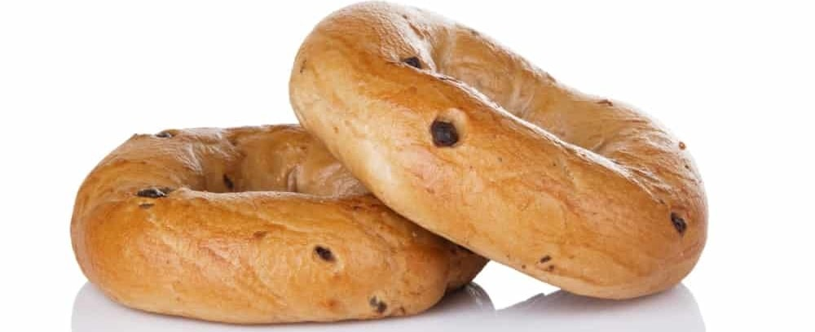
AS IF CHOCOLATE CHIP COOKIES AND MUFFINS WERE NOT ENOUGH, CONSIDER A STACK OF RICH, CHOCOLATE CHIP BAGELS. CHOCOLATE CHIP BAGELS CALL OUT YOUR LONG-BURIED INNER CHILD – YOU KNOW, THE ONE WHO LOVES TO SCHMEAR CHOCOLATE ON LITERALLY EVERYTHING, DESPITE WARNINGS AND FORBIDDING FROM PARENTS. THESE DECADENT BAGELS ARE FILLED WITH CHOCOLATE CHIPS, WHICH ARE AVAILABLE IN EVERY BITE OF A CHOCOLATE CHIP BAGEL. THE CORRECT WAY TO DEVOUR CHOCOLATE CHIP BAGELS, THOUGH, IS BY TOASTING THEM UNTIL YOU SEE THAT WONDERFUL, CRACKED, GOLDEN TOP. THEN, BITE INTO THE WARM BAGEL TO ENJOY THE OOZING, MELTED CHOCOLATE INSIDE.

CINNAMON RAISIN BAGELS
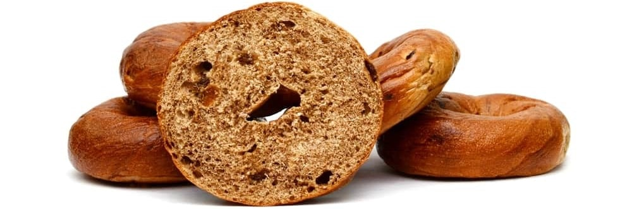
CINNAMON RAISIN BAGELS MAY LACK THE VERSATILITY OF A PLAIN BAGEL, BUT THEY ARE ALSO DELIGHTFUL AND DELICIOUS, RECALLING MISTY AUTUMN MORNINGS. CINNAMON RAISIN BAGELS ARE NOT OVERLY SWEET, AS ONE MIGHT EXPECT THEM TO BE, BUT THEY DO OFFER A SCRUMPTIOUS BLEND OF RAISINS AND CINNAMON. THE RAISINS GIVE CINNAMON RAISIN BAGELS THEIR CHEWY, STRINGY TEXTURE, AND THE CINNAMON PROVIDES A SUBTLE KICK OF SPICE TO COUNTERACT THE SWEETNESS OF THE BAGEL AND THE RAISINS. A CINNAMON RAISIN BAGEL IS DELICIOUS ANY TIME OF YEAR, BUT THEY’RE ESPECIALLY DELECTABLE IN THE FALL AND WINTER!

PLAIN BAGELS

FLAVORED BAGELS WITH A DOLLOP OF CHOCOLATE OR A CARAMEL CRUST MIGHT SOUND UNBELIEVABLY TEMPTING, BUT SOMETIMES, YOU REALLY DO CRAVE A SIMPLE PLAIN BAGEL. THE OTHER FANCY BAGELS AVAILABLE IN THE WORLD ARE ALL AWESOME, BUT A PLAIN BAGEL CAN BE PURE PERFECTION. A SIMPLE BUT OUT-OF-THIS-WORLD CRUSTY BAGEL EXTERIOR FOLLOWED BY A SOFT, WARM, CHEWY CENTER THAT MELTS IN YOUR MOUTH AS SOON AS YOU BITE INTO IT IS NOTHING SHORT OF SCRUMPTIOUS.
YOU CAN NEVER GO WRONG WITH A PLAIN BAGEL, AND CONTRARY TO WHAT ITS NAME SUGGESTS, A PLAIN BAGEL IS ACTUALLY MUCH MORE THAN JUST A BAKED RING OF DOUGH. IT CAN BE A BLANK CANVAS THAT ALLOWS YOU TO TRANSFORM THIS EPITOME OF SIMPLICITY INTO SOMETHING DIFFERENT ALTOGETHER, PERHAPS WITH A LAYER OF CREAM CHEESE OR SOME SALTED BUTTER. FLAVORED CREAM CHEESES CAN ALSO SPICE UP A PLAIN BAGEL!

BLUEBERRY BAGELS
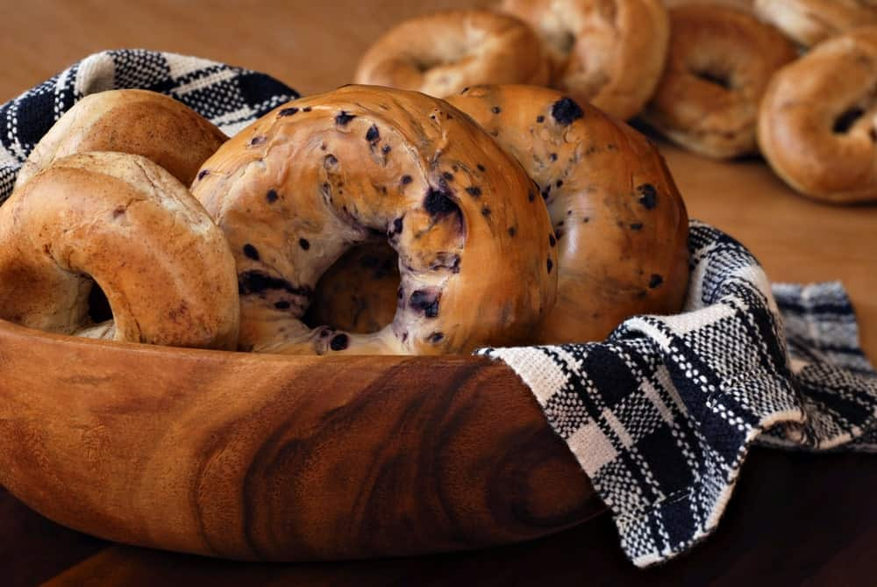
FROM THE COOKING BOWL TO YOUR MOUTH WITHIN TWO HOURS, BLUEBERRY BAGELS ARE A TRUE BREAKFAST TREAT THAT CAN MAKE THE MORNING! A BLUEBERRY BAGEL IS PREPARED THE SAME WAY AN ORIGINAL PLAIN BAGEL IS, EXCEPT THAT THE BAKER ADDS BLUEBERRIES WHILE THE DOUGH IS MIXING IN THE MIXER. SOON ENOUGH, YOU WILL NOTICE THE BAGEL DOUGH TURN TO A BEAUTIFUL SHADE OF PURPLE, FROM THE BLUEBERRY JUICE. BLUEBERRY BAGELS ARE NOT ONLY AN APPEALING PURPLE COLOR INSIDE, THEY’RE ALSO SWEET AND FRAGRANT FROM THE FRUIT THAT DOTS THE DOUGH.

ONION BAGELS
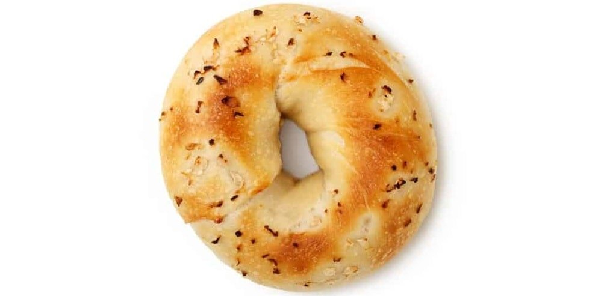
THERE IS NO DENYING THE FACT THAT ONIONS CAN AND OFTEN DO MAKE MOST FOODS TASTE BETTER. THE FLAVOR OF ONION BAGELS IS BEST DEFINED AS BOLD AND ALSO COMPLETELY UNFORGETTABLE. THESE BAGELS HAVE AN EXCEPTIONALLY CRUNCHY TEXTURE AND A RICH, GARLIC-ONIONY FLAVOR. ONION BAGELS ARE LIKE THE BRAD PITT OF THE BAGEL FLAVORS, AND THEY ARE WELL-LOVED ACROSS THE WORLD.
AN ONION BAGEL IS BEST PAIRED WITH SCALLION CREAM CHEESE, BUT SOME PEOPLE MAY EVEN CHOOSE TO SLATHER A THICK LAYER OF GLISTENING BUTTER OVER AN ONION BAGEL’S CRUNCHY TOP. TO MAKE THE BEST GOOEY, ONIONY BAGELS, STIR IN CHOPPED OR DEHYDRATED ONIONS BEFORE ADDING FLOUR TO THE BAGEL DOUGH BATTER. THE BAGEL DOUGH WILL SOON BE INFUSED WITH THE INTOXICATING AROMA OF ONIONS. AS SOON AS ONION BAGELS ARE READY TO BE DEVOURED, YOUR TASTE BUDS WILL THANK YOU – JUST REMEMBER TO BRUSH YOUR TEETH AFTER EATING ONE, TO SPARE THE PEOPLE AROUND YOU!

SALT BAGELS
SALT AND BAGELS AREN’T AN EXCEEDINGLY POPULAR COMBINATION, BUT TAKE A MOMENT AND IMAGINE BITING INTO A SALTY BAGEL, GENEROUSLY SLATHERED WITH COOL CREAM CHEESE. SOUNDS REFRESHING AND INDULGENT, DOESN’T IT?

ALTHOUGH A PINCH OF SALT CAN SOLVE MANY FLAVOR WOES AND DILEMMAS IN MOST DISHES AND ON MANY FOODS, PUTTING A LITTLE TOO MUCH SALT ON A BAGEL MEANS ALL YOU ARE GOING TO TASTE IS AN OVERWHELMING AMOUNT OF SALT. SO TO GET SALT BAGELS RIGHT, SPRINKLE A LITTLE SALT ON THE TOP OF THEM, BRUSH OFF THE EXCESS CRYSTALS, THEN BITE INTO YOUR HOT, OOZY SALT BAGEL WITHOUT THINKING TWICE.

ASIAGO BAGELS

IF BREAD AND CHEESE DON’T CREATE THE MOST WONDERFUL, MATCH MADE IN HEAVEN KIND OF COMBINATION, WE DON’T KNOW WHAT ELSE WOULD! THE COMBINATION OF CHEESE AND BREAD IS EASILY ONE OF THE MOST PERFECT CULINARY BLENDS OF ALL TIME. THE ASIAGO BAGEL IS A DIFFERENT AND DELICIOUS MANIFESTATION OF THIS IDEAL FOOD COMBINATION.
ASIAGO BAGELS PROVIDE MUNCHERS WITH THE ULTIMATE MIXTURE OF WARM, FRESH BREAD AND LAYERS OF RICH, SALTY, SMOOTH CHEESE. THIS IS A COMBINATION THAT BURSTS INTO A SYMPHONY OF FLAVOR ON THE TASTE BUDS. ASIAGO BAGELS, AS THEIR NAME SUGGESTS, FEATURE THE SCRUMPTIOUS ITALIAN CHEESE CALLED THE ASIAGO CHEESE. ASIAGO CHEESE IS MADE FROM AN ITALIAN COW’S MILK, AND CAN ONLY BE PRODUCED IN ITALY ON THE ASIAGO PLATEAU, WHICH IS LOCATED IN THE FOOTHILLS OF THE VENETO REGION OF ITALY.
A GENEROUS AMOUNT OF SHREDDED ASIAGO CHEESE IS TYPICALLY SPRINKLED OVER A BAGEL WITH THIS FLAVOR AS SOON AS IT COMES OUT OF BOILING WATER AND BEFORE BEING BAKED IN THE OVEN. AS SOON AS YOUR KITCHEN FILLS UP WITH THE RICH AROMA OF MELTED ASIAGO CHEESE AND YOU SEE YOUR HOMEMADE BAGELS BECOMING A BEAUTIFUL GOLDEN-BROWN COLOR, YOU’LL KNOW THEY ARE READY TO LEAVE THE OVEN.

FRENCH TOAST BAGELS

FRENCH TOAST BAGELS WILL MAKE YOU WANT TO HAVE BREAKFAST EVERY SINGLE DAY OF THE WEEK, EVEN IF YOU ARE ONE OF THOSE PEOPLE WHO CANNOT STAND THE IDEA OF CONSUMING ANYTHING OTHER THAN COFFEE IN THE MORNING. THESE BAGELS ARE SOFT, SWEET, AND WORTH EVERY SINGLE PENNY THEY COST TO BUY OR MAKE THEM. IF YOU MUST INDULGE IN A SWEET BREAKFAST TREAT, A FRENCH TOAST BAGEL CAN BE THE PERFECT WAY TO SATISFY THAT SWEET TOOTH.
THE BEST ASPECT OF THESE BAGELS IS THAT THE FRENCH TOAST CUSTARD SOAKS INTO EVERY NOOK AND CRANNY OF THE BREAD. SO, THERE IS NO BIT OF THE DOUGH WITHOUT THE FLAVOR OF FRENCH TOAST. TO GET THE MOST OF A FRENCH TOAST BAGEL, SOAK THE BAGEL BREAD WITH THE CUT SIDE DOWN IN THE GLOSSY FRENCH TOAST MIXTURE. THEN, LEAVE IT IN A REFRIGERATOR FOR A FEW HOURS.
DO YOU KNOW WHAT COULD TAKE THESE ALREADY-DELECTABLE BAGELS TO A WHOLE NEW LEVEL? WHIPPED CREAM CHEESE! LET’S FACE IT – WHIPPED CREAM CHEESE MAKES JUST ABOUT EVERYTHING A WHOLE LOT BETTER.

POPPYSEED BAGELS
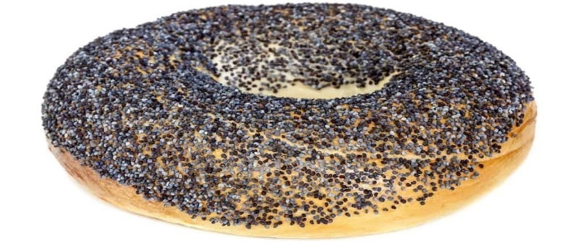
WHILE THESE BAGELS WOULD NORMALLY CAUSE YOU A GREAT INCONVENIENCE (POPPYSEEDS GETTING STUCK IN YOUR TEETH), THEY ARE WORTH ALL THE TROUBLE OF DEALING WITH THE POPPYSEEDS STUCK WHERE YOU DON’T WANT THEM. THERE IS NO FLAVOR IN THE WORLD LIKE THAT OF POPPYSEEDS, A RICH, OUT-OF-THIS-WORLD FLAVOR.
THE FLAVOR OF POPPYSEEDS IS BEST DESCRIBED AS NUTTY, WHILE THESE SEEDS ARE FINELY GRANULATED. POPPYSEEDS HAVE AN IRRESISTIBLE AND PLEASANT FRUITY FLAVOR, AS WELL. TO MOST AMERICANS, BAGELS AND POPPYSEEDS ARE A COMBINATION THAT GOES HAND-IN-HAND. THESE SEEDS PROVIDE A SOFT AND CHEWY BAGEL WITH A CRUNCHY OUTSIDE. SO WITH EVERY BITE OF A POPPY SEED BAGEL, YOU CAN EXPERIENCE THE CONTRASTING YET OH-SO-SATISFYING JUXTAPOSITION OF CRUNCHY AND CHEWY.
ASIDE FROM BEING INCREDIBLY FLAVORFUL, A POPPYSEED BAGEL IS A TREAT FOR THE EYES, AS WELL. GOLDEN-BROWN BAGELS BECOME EVEN MORE BEAUTIFUL ONCE THEY ARE TOPPED WITH DARK BLUE POPPYSEEDS.

EGG BAGELS
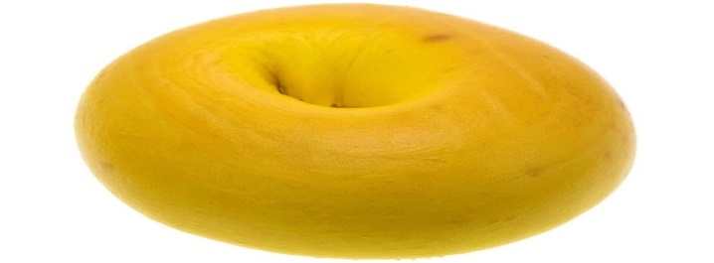
THESE BAGELS ARE USUALLY DESCRIBED AS A WONDERFUL AMALGAMATION OF TWO OF THE MOST INCREDIBLE BREAKFAST ITEMS IN THIS WORLD: EGGS AND BREAD. EGG BAGELS HAVE A HUGE CULT FOLLOWING, BUT MOST OF THEIR FOLLOWERS STRONGLY FEEL THAT THESE BAGELS ARE CHRONICALLY UNDER-APPRECIATED AND ARE CONSIDERED UNDERRATED.
EGG BAGELS ARE MADE WITH THE ADDITION OF EGG YOLKS IN THE BAGEL DOUGH RECIPE. THE ADDITION OF EGG YOLKS RESULTS IN AN INCREDIBLY SWEET FLAVOR. IT ALSO ADDS A SOFT TEXTURE TO THE BAGEL DOUGH. AS RICH AND AMAZING AS AN EGG BAGEL IS, MOST PEOPLE HAVE A LOVE-HATE RELATIONSHIP WITH THEM. THE “HATE” STEMS FROM THE FACT THAT THE TYPICAL EGG BAGEL TEXTURE IS FAR FROM THE QUINTESSENTIAL CRUSTY AND CRUNCHY EXTERIOR OF THE TYPICAL ORIGINAL BAGEL.
HOWEVER, TRUE EGG BAGEL LOVERS WILL FIND EGG BAGELS ABSOLUTE PERFECTION IN TERMS OF FLAVOR, TEXTURE, CONSISTENCY, AND EVEN COLOR! SINCE THESE BAGELS ARE SLIGHTLY SWEETER THAN PLAIN BAGELS, IT IS BEST TO PAIR EGG BAGELS WITH A LOX AND CREAM CHEESE SPREAD TO ENSURE THE PERFECT BALANCE BETWEEN SALTY AND SWEET. OR, LOAD UP ON PROTEIN BY ADDING A FRIED EGG ON TOP OF YOUR TOASTED EGG BAGEL!

WHOLE WHEAT BAGELS

THIS IS THE PERFECT TYPE OF BAGEL FOR DIE-HARD BAGEL FANS WHO WISH TO DEVOUR THESE DELICIOUS TREATS, BUT MUST BE CAREFUL DUE TO HEALTH AND/OR DIETARY CONCERNS. THE HEALTH-CONSCIOUS CAN PREVENT THEMSELVES FROM FEELING THE FULL GUILT OF CARB-LOADING BY INDULGING IN WHOLE WHEAT BAGELS.
ALTHOUGH WHOLE WHEAT BAGELS ARE AS FINGER-LICKING GOOD AS THE OTHER BAGEL FLAVORS, THEY ARE ALSO HEALTHY AND PACKED WITH NUMEROUS NUTRITIOUS BENEFITS. AS THE NAME SUGGESTS, A WHOLE WHEAT BAGEL IS MADE FROM WHOLE GRAINS AND WHOLE GRAIN FLOUR, RATHER THAN THE REGULAR REFINED GRAIN FLOUR THAT ONE WOULD TYPICALLY FIND USED IN THE CREATION OF A PLAIN BAGEL OR LOAF OF WHITE BREAD.
WHOLE GRAINS ARE A SIGNIFICANT PART OF A WELL-BALANCED DIET. THEY ARE ALSO THE HEALTHIEST KIND OF GRAINS TO CONSUME, AS WHOLE GRAINS ARE FULL OF MINERALS AND FIBERS THAT NOURISH THE BODY. WHILE THE DIFFERENCE IN THE GRAINS IN THE FLOUR MIGHT SLIGHTLY ALTER THE TASTE OF WHOLE WHEAT BAGELS COMPARED TO PLAIN BAGELS, THEY STILL TASTE WONDERFULLY DELICIOUS. FOR EXTRA FLAVOR, YOU CAN ALWAYS SLATHER ON SOME UNSALTED BUTTER OR LOW-FAT CREAM CHEESE.

PUMPERNICKEL BAGELS
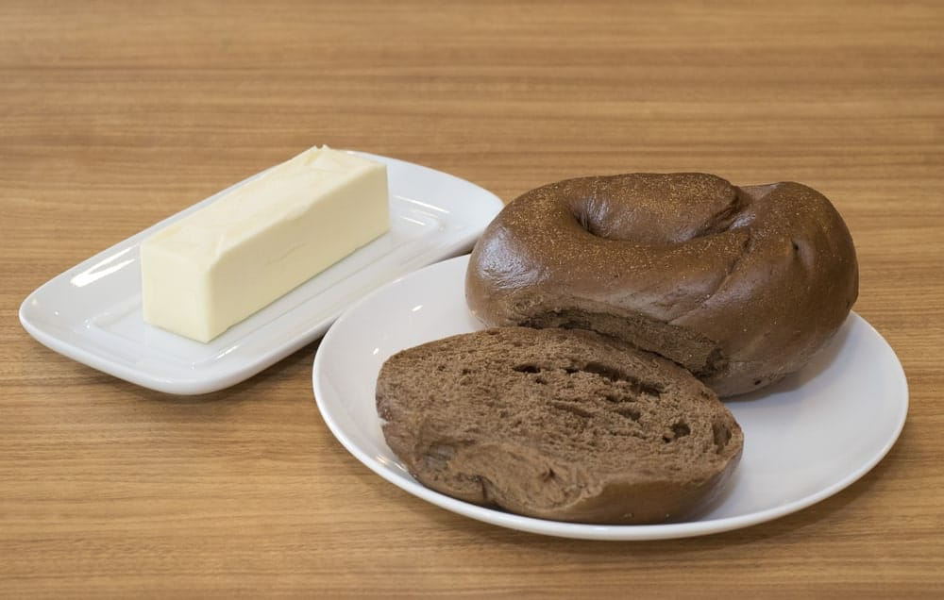
PUMPERNICKEL IS A DARK AND DENSE TYPE OF GERMAN BREAD. THIS BREAD IS TRADITIONALLY MADE WITH COARSELY GROUND RYE AND SOURDOUGH STARTER. NOWADAYS, YOU MAY EVEN SEE A LOAF OF PUMPERNICKEL BREAD THAT HAS BEEN MADE WITH A COMBINATION OF WHOLE RYE BERRIES AND RYE FLOUR.
THAT UNIQUE WORD, “PUMPERNICKEL,” STEMS FROM AN OLD BAVARIAN TERM THAT TRANSLATES ROUGHLY INTO “HARD” IN ENGLISH. THE MEANING “HARD” REFERS TO THE DENSITY OF THIS BREAD ONCE IT IS COMPLETELY MADE. IT MIGHT ALSO REFER TO THE PROCESS THROUGH WHICH THE PUMPERNICKEL GRAIN IS TURNED INTO FLOUR, WHICH CAN BE TRICKY AND DIFFICULT.
WHEN CONSUMED IN A BAGEL, EXPECT TO ENCOUNTER A VERY DIFFERENT BUT ALSO INTERESTING FLAVOR. PUMPERNICKEL ADDS A RICH AND DISTINCT FLAVOR TO A NORMALLY CHEWY AND SOFT BAGEL. THEY ARE ABSOLUTELY DELICIOUS!
YOU CAN ALWAYS EXPERIMENT WITH THESE BAGELS IN TERMS OF THEIR FILLINGS AND TOPPINGS. AN EXCELLENT RENDITION OF THIS BAGEL IS A JEWISH-STYLE PUMPERNICKEL BREAD RECIPE. THIS RECIPE FEATURES THE AROMATIC ADDITION OF CHOPPED ONIONS. AND, AS WE SAID PREVIOUSLY, ONIONS CAN AND OFTEN DO MAKE MOST FOODS TASTE BETTER AND MORE RICHLY FLAVORED. THIS IS TRUE FOR A PUMPERNICKEL BAGEL, JUST AS IT IS FOR MANY OTHER FOODS.

GARLIC BAGELS
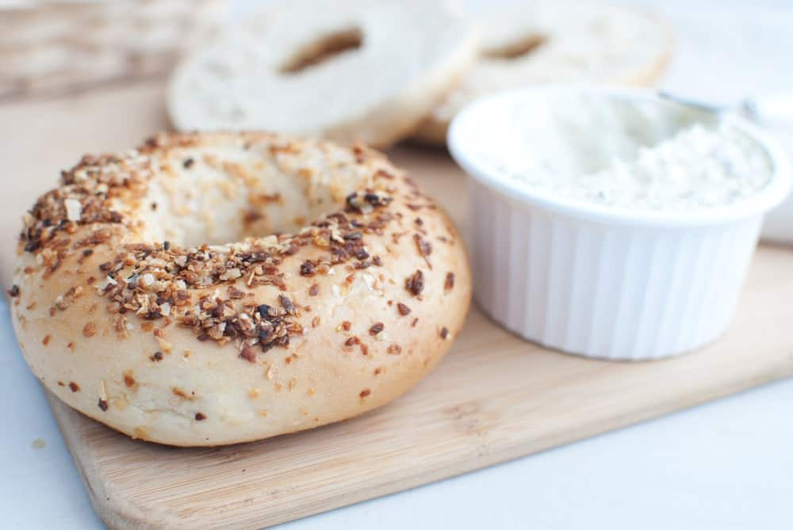
IN MOST PARTS OF THE WORLD, ESPECIALLY IN CERTAIN PARTS OF THE US, THERE IS NO SUCH THING AS TOO MUCH GARLIC USED IN COOKING. IT MUST BE SAID THAT GARLIC IS ONE OF THE MOST VERSATILE INGREDIENTS TO ADD TO RECIPES. A LITTLE BIT OF GARLIC GOES A LONG WAY TO ADD A TON OF FLAVOR AND INCREASE THE PRESENCE OF OTHER FLAVORS IN FOODS TO WHICH IT IS ADDED.
THE GARLICKY CRUNCH ON A GARLIC BAGEL PRODUCES A CRISP NOISE AS SOON AS YOU BITE INTO ONE. THE SOUND IS LIKE MUSIC TO THE EARS. IF YOU MAKE GARLIC BAGELS CORRECTLY WHEN MAKING HOMEMADE BAGELS, EATING ONE WILL BE SIMILAR TO EATING A DELICIOUS BREAKFAST VERSION OF GARLIC BREAD.
THE BEST WAY TO INFUSE MAXIMUM GARLICKY FLAVOR IN A GARLIC BAGEL IS EITHER BY BRUSHING A GARLIC-OLIVE OIL MIXTURE TO THE TOP OF THE BAGEL, OR BY ALSO INFUSING A HINT OF GARLIC IN THE FORM OF GARLIC POWDER OR CHOPPED GARLIC CLOVES IN THE DOUGH BATTER. EITHER WAY, THERE SHOULD BE A RICH, CRACKLING GARLIC LAYER ON THE TOP OF A GARLIC BAGEL THAT LOOKS ALMOST TOO GOOD TO BE TRUE. GO AHEAD – INDULGE!

CHEDDAR BAGELS
JUST AS THERE IS ALMOST NO SUCH THING AS TOO MUCH GARLIC OR ONION IN FOOD, YOU CAN ALSO NEVER HAVE ENOUGH CHEESE, ESPECIALLY CHEDDAR CHEESE! ALTHOUGH CHEDDAR BAGELS LOOK AND TASTE LIKE A BREAD ROLL WITH MELTED CHEESE ON THE TOP AND THE INSIDE, THEY TASTE HEAVENLY. AS WE SAID BEFORE, CHEESE AND BREAD IS A CLASSIC AND MOUTHWATERING COMBINATION, SO IT’S NO SURPRISE THAT CHEDDAR BAGELS ARE SO DELECTABLE!
TO GIVE A KICK TO CHEDDAR BAGELS, ADD IN SLICED JALAPENOS BEFORE MIXING IN THE CHEDDAR CHEESE TO THE DOUGH. THIS CREATES A BURST OF CHEESY, SPICY FLAVORS IN YOUR MOUTH WHEN EATING YOUR HOMEMADE CHEDDAR BAGEL LATER!

SESAME BAGELS

SESAME SEEDS TASTE DELICATE, WITH A NUTTY BRILLIANCE THAT BRINGS LIFE TO BOTH SAVORY AND SWEET FOODS. SESAME SEEDS HAVE A NUTTY TASTE THAT IS ACCOMPANIED BY AN EXCEPTIONALLY DISTINCT CRUNCH, WHICH HELPS TURN AN ORDINARY BAGEL INTO AN EXTRAORDINARY ONE. A SESAME BAGEL IS SIMPLE, SCRUMPTIOUS, AND CRUNCHY, WITH A WARM FLAVOR THAT COMPLIMENTS ANYTHING YOU MAY PUT ON THE BAGEL, WHETHER BUTTER OR PLAIN CREAM CHEESE, OR EVEN FLAVORED CREAM CHEESE.

A RICH HISTORY
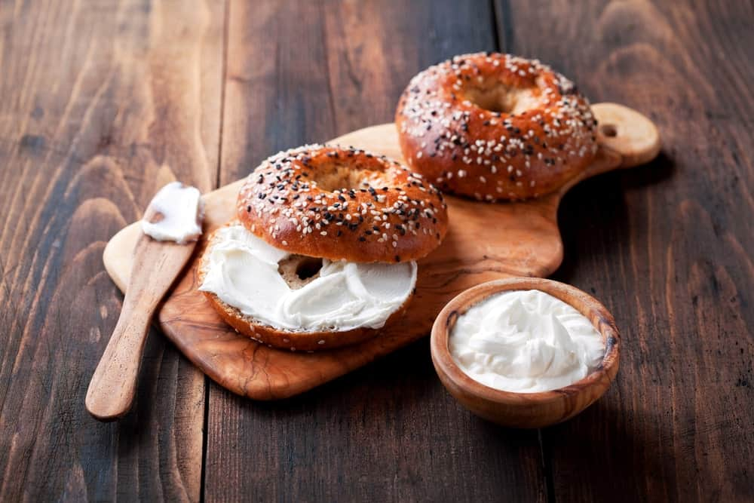
BAGELS ARE BELIEVED TO HAVE ORIGINATED IN CENTRAL EUROPE. THE EARLIEST MENTION OF BAGELS OCCURRED IN THE STATUTES OF THE JEWISH COMMUNITY RESIDING IN POLAND IN 1610. ACCORDING TO THE STATUTES, IT WAS PERMISSIBLE TO GIFT BAGELS TO A WOMAN GIVING BIRTH, A MIDWIFE, AND TO ALL THE OTHER WOMEN PRESENT.
OTHER HISTORICAL EVIDENCE SUGGESTS THAT BAGELS ORIGINATED IN VIENNA, AUSTRIA IN 1683 DURING THE TIME OF THE BATTLE OF VIENNA. APPARENTLY, AN AUSTRIAN BAKER CREATED THEM TO CELEBRATE THE AUSTRIANS’ VICTORY OVER THE TURKS. CONSIDERING THAT, THE GOOD OLD BAGEL REPRESENTS THE ULTIMATE CAVALRY CHARGE HEADED BY KING JOHN III SOBIESKI OF POLAND.
THE TERM ‘BAGEL’ COMES FROM THE POLISH WORD ‘BAJGIEL’, WHICH WAS INITIALLY DERIVED FROM THE YIDDISH WORD ‘BAYGEL’. DIFFERENT VARIANTS OF THIS WORD WERE USED TO REFER TO A TYPE OF SWEET-FILLED PASTRY. ANOTHER SIMILAR ETYMOLOGY SUGGESTS, QUITE LOGICALLY, THAT THE WORD BAGEL CAME FROM THE YIDDISH WORD ‘BEYGL’ WHICH WAS FURTHER TAKEN FROM THE GERMAN WORD ‘BOUGEL’, WHICH MEANS ‘RING.’
BAGELS BECAME SIGNIFICANTLY POPULAR IN NORTH AMERICA SOMETIME DURING THE TWENTIETH CENTURY. AFTER SOME TIME, THE “BAGEL BRUNCH” STARTED TO BECOME A TREND IN NEW YORK CITY. THE “BAGEL BRUNCH” BASICALLY FEATURED A BAGEL TOPPED WITH RED ONIONS, LOX CREAM CHEESE, TOMATOES, AND CAPERS.
ARE YOU CRAVING A WARM, TOASTED BAGEL AFTER READING ABOUT THE MANY DIFFERENT DELICIOUS BAGEL FLAVORS AVAILABLE? WE SURELY ARE!

15 MOST COMMON TYPES OF SOFT CHEESE
HERE'S THE ULTIMATE LIST OF THE MOST POPULAR TYPES OF SOFT CHEESE. SOME YOU'LL KNOW BUT I BET SOME YOU MAY NOT HAVE HEARD ABOUT. INCLUDES PHOTOS AND IN-DEPTH DESCRIPTIONS.
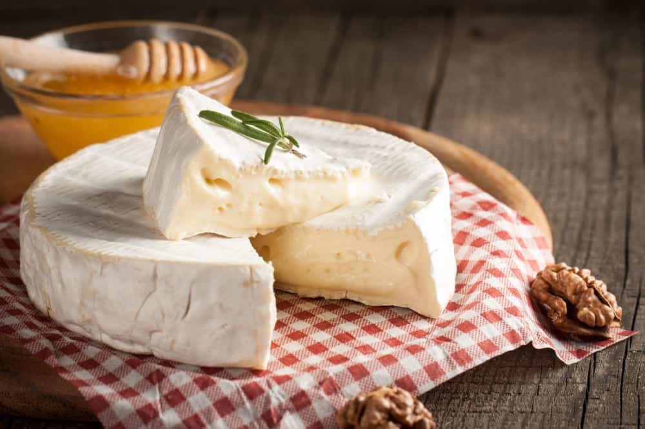
AS YOU GRACIOUSLY SPREAD A THICK LAYER OF HERBED CREAM CHEESE OVER A CRISPY CRACKER AT A COCKTAIL PARTY, EVER STOPPED TO WONDER HOW TRULY RICH AND DELECTABLE SOFT CHEESES ARE?
SOFT CHEESES REALLY OFFER A HIGHLY RICH AND UNIQUE TASTE, FLAVOR, AND AROMA TO EVERY CHEESE CONNOISSEUR OUT THERE. THESE ARE KNOWN FOR THEIR AMAZINGLY MILD TASTE AND CREAMY, MOIST, AND BUTTERY TEXTURES THAT JUST SEEM TO MELT IN THE MOUTH. GIVEN THAT THEY ARE PAIRED WITH THE RIGHT KIND OF WINE OR THE BEST TYPE OF CRACKER, THEY ARE LIKELY TO EXPLODE AND BURST IN YOUR MOUTH IMPECCABLE AND UNPARALLELED FLAVOR.
SOFT CHEESE IS CALLED SO BECAUSE OF ITS AMAZINGLY MOIST AND SOFT TEXTURE AND ALSO THE PROCESS OF MAKING SOFT CHEESE DIFFERS FROM THAT OF HARD CHEESE. THE BIGGEST DIFFERENCE IS THAT SOFT CHEESES ARE NOT AGED SO THEY ARE ABLE TO RETAIN ALL THE MOISTURE, UNLIKE HARD CHEESES.
FOR ANY DIE-HARD CHEESE LOVER, THE LIST OF TYPES OF SOFT CHEESE BELOW IS ABSOLUTE CHEESE HEAVEN. READ ALL ABOUT YOUR FAVORITE CHEESES BELOW!
RELATED: TYPES OF CHEESE GRATERS | SIDE DISHES FOR HAM | WHAT GOES WITH CHILI | WHAT GOES WITH POTATOES | FONDUE MAKERS

BLUE CHEESE
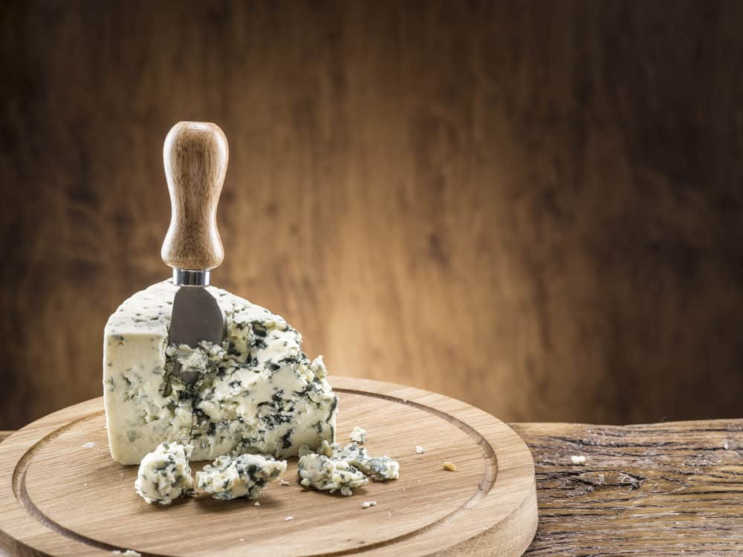
AS THE NAME SUGGESTS, BLUE CHEESE HAS BLUISH-GREEN VEINS OF MOLD THAT MAKES IT HIGHLY DISTINCTIVE FROM OTHER KINDS OF CHEESES. SOME OF THE MOST POPULAR TYPES AND VARIETIES OF BLUE CHEESE INCLUDE ITALIAN GORGONZOLA, ENGLISH STILTON, AND FRENCH ROQUEFORT CHEESE.
BLUE CHEESE IS KNOWN TO CONTAIN A VERY CRUMBLY AND SOFT TEXTURE WITH A VERY PIQUANT AND SHARP KIND OF FLAVOR. IF EATEN RAW OR IN LARGE QUANTITIES, THIS CHEESE CAN END UP BEING SUPER SALTY.
ITS UNIQUE SMELL AND TASTE ARE ESSENTIALLY DUE TO THE FACT THAT BACTERIA AND MOLD ARE ALLOWED TO GROW ON THE CHEESE.
APPARENTLY, BLUE CHEESE WAS DISCOVERED ACCIDENTALLY BACK IN ANCIENT TIMES WHEN CHEESES WERE STORED IN MOISTURE-CONTROLLED CAVES AS WELL AS IN NATURALLY-OCCURRING ENVIRONMENTS.
THERE ARE 2 MAIN TYPES OF BLUE CHEESE: ROQUEFORT AND GORGONZOLA.

ROQUEFORT EXAMPLE
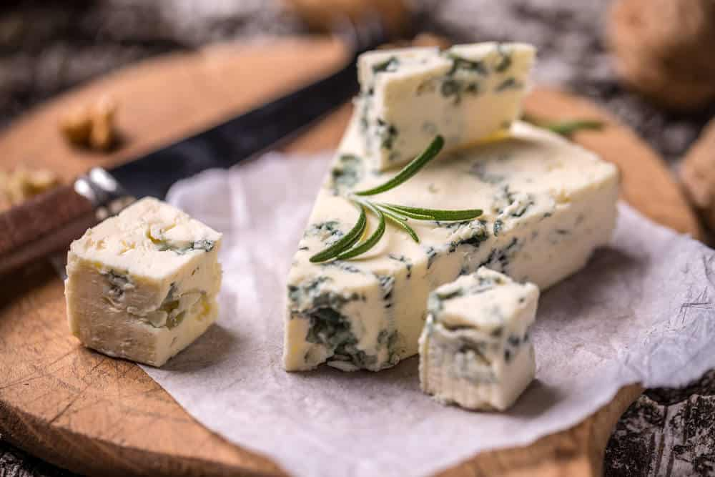
THIS IS ANOTHER POPULAR FRENCH CHEESE THAT HAS ORIGINATED FROM THE SOUTH OF FRANCE AND IS ALSO A KIND OF BLUE CHEESE. IT IS MADE FROM PURE SHEEP’S MILK AND IS SAID TO BE THE ONLY KIND OF CHEESE TO HAVE COME FROM THE REGION SURROUNDING ROQUEFORT-SUR-SOULZON.
ROQUEFORT CHEESE IS A TYPE OF BLUE-VEINED, SEMI-SOFT ARTISAN CHEESE THAT HAS A BEAUTIFUL CRUMBLY AND CREAMY TEXTURE. IT IS ALSO QUITE POPULAR FOR ITS SHARP, SALTY, AND TANGY KIND OF FLAVOR.
ACCORDING TO HISTORIC EVIDENCE, ROQUEFORT CHEESE USED TO BE A FAVORITE OF EMPEROR CHARLEMAGNE. ONE OF ITS KEY FEATURES IS THAT THE CHEESE IS AMAZINGLY MOIST WHICH MAKES IT BREAK INTO LITTLE PIECES EASILY.
SOME OF THE MOST COMMON AND POPULAR USES OF ROQUEFORT CHEESE IS IN DRESSINGS AND SALADS.

GORGONZOLA EXAMPLE
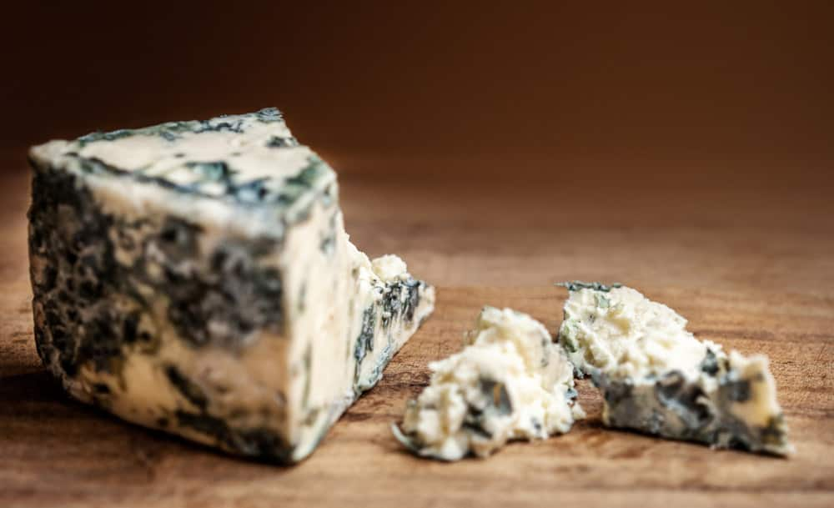
THIS IS A POPULAR VEINED ITALIAN BLUE CHEESE THAT HAS ORIGINATED FROM GORGONZOLA, MILAN, AND HAS BEEN PRODUCED THERE FOR SEVERAL CENTURIES.
PRESENTLY, HOWEVER, GORGONZOLA CHEESE IS CHIEFLY PRODUCED IN THE NORTHERN ITALIAN REGIONS OF LOMBARDY AND PIEDMONT. IT IS A HALLMARK OF ITALIAN CUISINE AND IS MADE FROM PASTEURIZED MILK.
GORGONZOLA CHEESE CAN BE EATEN AND CONSUMED IN VARIOUS WAYS LIKE MELTING IT IN A RISOTTO, SPRINKLING THE CHEESE OVER PASTA, OR PERHAPS, THROWING A GENEROUS AMOUNT OF IT OVER PIZZA AS A DELICIOUS TOPPING.
INTERESTINGLY, GORGONZOLA HOLDS QUITE A REPUTATION IN POPULAR CULTURE AS HISTORICAL EVIDENCE SHOWS THAT IN HIS 1922 ULYSSES, JAMES JOYCE OFFERED THE HERO A GORGONZOLA SANDWICH COUPLED WITH A GLASS OF BURGUNDY.
SINCE THIS CHEESE IS EXCLUSIVELY MADE FROM COW’S MILK, IT OFFERS A MILDER FLAVOR COMPARED TO OTHER TYPES OF BLUE CHEESES. ITS MOST DISTINCTIVE FEATURE IS HOW IT STILL INFLUENCES ITALIAN ARTISANSHIP, EVEN IN TODAY’S TIME.

BOURSAULT
THIS IS A POPULAR TRIPLE-CREAM CHEESE THAT IS MADE FROM PASTEURIZED COW’S MILK AND HAS ORIGINATED FROM THE FRENCH REGION OF VAL-DE-MARNE. THIS CHEESE WAS INITIALLY INVENTED IN THE 1950S BY A MAN NAMED HENRI BOURSAULT.
BOURSAULT CHEESE CONTAINS A VERY HIGH AMOUNT OF FAT, ALMOST 75 PERCENT WHICH IS WHAT MAKES IT ONE OF THOSE MELT-IN-THE-MOUTH KINDS OF CHEESES. IT HAS A SUPER-RICH, CREAMY AND MOIST CONSISTENCY AND A RICH BUTTERY TASTE. THE IDEAL COMBINATION OF THE EXOTIC TASTE AND THE JELLY-SOFT TEXTURE MAKES IT A FAVORITE DESSERT CHEESE.
THIS CHEESE GOES THROUGH A PERIOD OF MATURATION FOR ABOUT TWELVE DAYS AND IS THEN PROPERLY WRAPPED; HOWEVER, THE MATURATION PROCESS STILL GOES ON FOR A MONTH.

BOURSIN

THIS CHEESE IS ALSO MADE FROM PASTEURIZED COW’S MILK AND HAS A CRUMBLY, CREAMY TEXTURE THAT IS SAID TO BE SIMILAR TO THAT OF CREAM CHEESE. IT COMES IN A VARIETY OF DIFFERENT FLAVORS THAT ARE OFTEN INFUSED WITH HERBS AND SPICES. SOME OF ITS POPULAR FLAVORS INCLUDE MAPLE BOURBON, PEPPER, BASIL & CHIVE, RED CHILI PEPPER, AND CRANBERRY & SPICE.
THE VERY FIRST BOURSIN CHEESE FLAVOR WAS GARLIC AND FINE HERBS WHICH WAS CREATED IN 1957 BY A CHEESE MAKER IN NORMANDY CALLED FRANÇOIS BOURSIN. THE INSPIRATION BEHIND THE CREATION OF THIS CHEESE CAME FROM ‘FROMAGE FRAIS’ WHICH IS A TRADITIONAL PARTY DISH IN WHICH PEOPLE TAKE THE CHEESE AND ADD THEIR CHOICE OF HERBS TO IT FOR FLAVOR.
THE OBVIOUS SAVORY-SWEET FLAVOR OF THE BOURSIN CHEESE MAKES IT A GREAT CHOICE FOR A CHEESE DIP TO GO WITH VEGETABLES AND FRUITS. REGARDLESS OF WHAT YOU PAIR IT WITH, THE RICH BUTTERY FLAVOR FOR IT WILL SURELY LEAVE YOU CRAVING FOR MORE.

BRIE
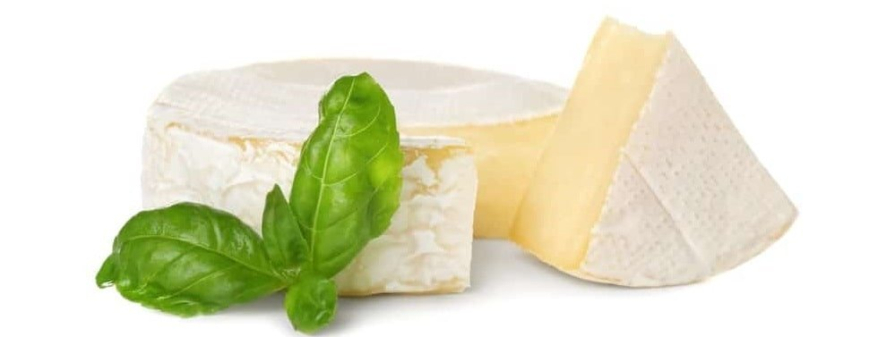
THIS IS ONE OF THE MOST WELL-KNOWN AND POPULARLY CONSUMED TYPES OF SOFT CHEESE. IT ORIGINATES FROM THE FRENCH REGION OF BRIE, AS ALSO THE NAME SUGGESTS.
THIS FAMOUS FRENCH CHEESE IS MADE FROM COW’S MILK AND SPORTS A PALE COLOR WITH A HINT OF LIGHT GRAY UNDER A LAYER OF WHITE MOLD. BRIE CHEESE HAS AN INCREDIBLY BUTTERY AND RUNNY TEXTURE WHICH MAKES IT EASILY SPREADABLE ON A VARIETY OF DIFFERENT FOODS.
SEVERAL VARIETIES OF BRIE ARE MADE ALL OVER THE WORLD, SOME OF WHICH INCLUDE HERBED VARIETIES, PLAIN BRIE, AND DOUBLE AND TRIPLE BRIE.
THE MATURATION PROCESS OF THIS CHEESE RANGES FROM SEVERAL MONTHS TO A WHOLE YEAR WHICH RESULTS IN A STRONG TASTE AND FLAVOR OF THE CHEESE. THE BEST WAY TO TRULY ENJOY BRIE CHEESE IS TO SPREAD IT ON A CRACKER WHICH MAKES AN EXCELLENT APPETIZER!

BUCHETTE
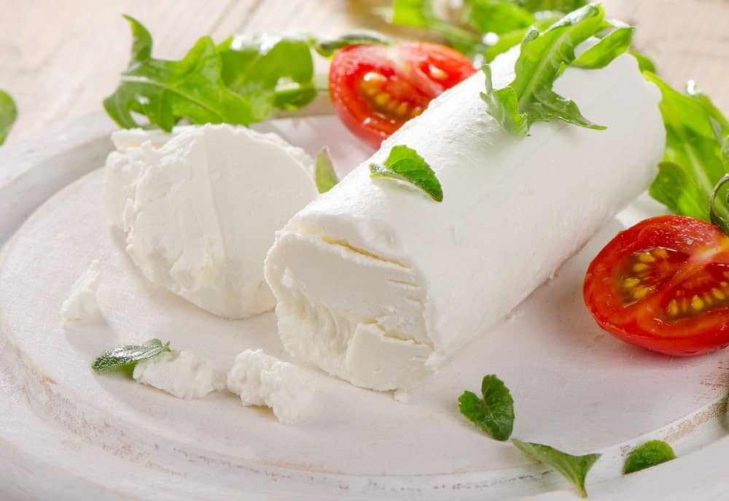
THIS IS A RAW-MILK GOAT CHEESE THAT HAS ORIGINATED FROM AN AREA NAMED ‘ANJOU’ IN THE LOIRE VALLEY, FRANCE. IN THE ENGLISH LANGUAGE, THE CHEESE LITERALLY MEANS “A SMALL LOG FROM ANJOU” BECAUSE IT ACTUALLY LOOKS LIKE A WOOD LOG.
THE USE OF GOAT MILK GIVES BUCHETTE CHEESE A SLIGHTLY ACIDIC FLAVOR BUT THE BEST WAY TO EAT IT IS WHEN IT’S FRESH AND CREAMY. IT ALSO HAS A STRONG, PUNGENT SCENT WHICH WILL REMIND YOU OF LEMONS. THE TEXTURE OF THIS CHEESE IS REALLY GOOEY WHICH MAKES IT EASILY SPREADABLE ON BREAD, CRACKERS AND OTHER SIMILAR FOODS.
INTERESTINGLY, THE HAZELNUT-LIKE TASTE AND THE CREAMY TEXTURE OF THIS CHEESE GET EVEN BETTER AND STRONGER AS THE CHEESE GETS OLDER.

BUFFALO MOZZARELLA
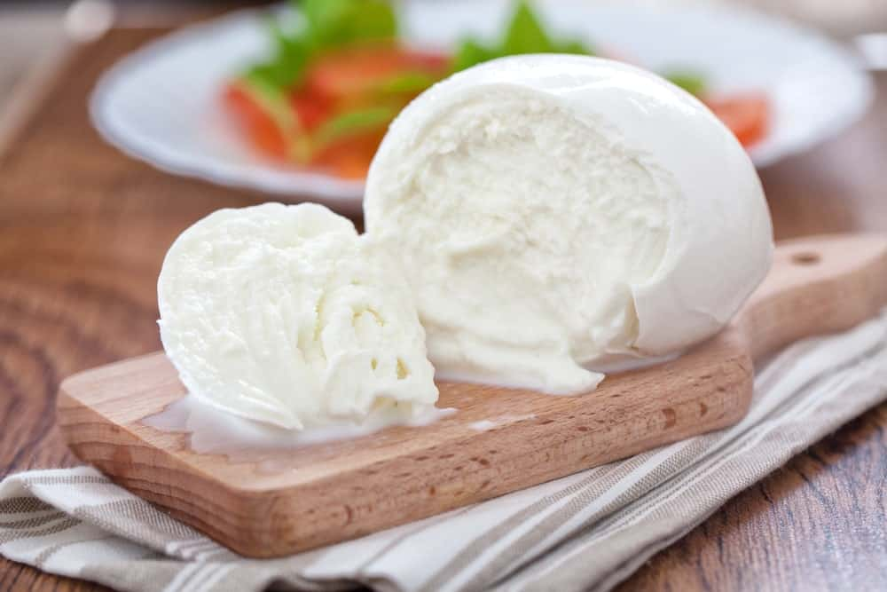
ALSO CALLED ‘MOZZARELLA DI BUFALA’ IN ITALIAN, THE BUFFALO MOZZARELLA CHEESE IS MADE FROM THE MILK OF ITALIAN MEDITERRANEAN MOZZARELLA. IT ORIGINATES FROM CAMPANIA, ITALY, MORE SPECIFICALLY FROM THE PROVINCES OF SALEMO AND CASERTA.
THIS CHEESE BELONGS TO THE “PASTA FILATA” FAMILY AND HAS QUITE A FRESH, MOIST, AND SEMI-ELASTIC TEXTURE. UNLIKE MOST CHEESES, THIS ONE IS RICH IN CALCIUM AND PROTEIN AND IS LOWER IN CHOLESTEROL BECAUSE IT IS MADE FROM BUFFALO MILK.
THE WORD ‘MOZZARELLA’ COMES FROM ‘MOZZARE’ WHICH IS A PROCESS THAT LITERALLY MEANS “CUTTING BY HAND”, FOLLOWED BY A SEPARATION OF THE CURD AND SERVING THE CHEESE IN INDIVIDUAL SHAPES. THIS PROCESS MAKES THE BUFFALO MOZZARELLA CHEESE QUITE VERSATILE AND ELASTIC IN TEXTURE, TWO QUALITIES THAT GAVE IT UNIQUE NAMES LIKE “THE QUEEN OF THE MEDITERRANEAN CUISINE”, “THE PEARL OF THE TABLE” AND “WHITE GOLD”.

CAMEMBERT
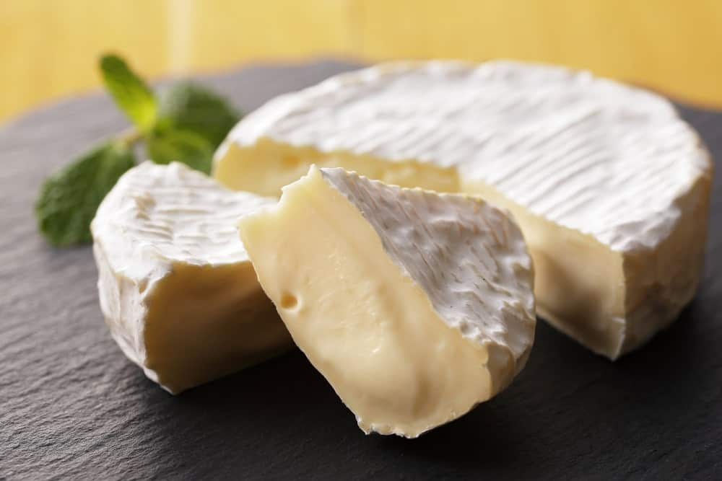
PRONOUNCED AS ‘CAH-MUHN-BARE’, THIS IS ANOTHER SUPER FAMOUS FRENCH SOFT CHEESE THAT WAS FIRST MADE IN THE 18TH CENTURY IN CAMEMBERT, NORMANDY IN NORTHERN FRANCE.
IT IS A SOFT-RIPENED CHEESE MADE FROM UNPASTEURIZED COW’S MILK AND CONTAINS AN INCREDIBLY RICH, BUTTERY TEXTURE THAT YOU SLATHER ONTO A PIECE OF HOT FRENCH BREAD. THE BEST FEATURE OF THE CAMEMBERT CHEESE IS ITS INSIDES THAT ARE SUPER MOIST AND RUNNY. SO, WHEN YOU CUT INTO A SLICE OF THIS CHEESE THAT HAS BEEN KEPT AT ROOM TEMPERATURE, YOU ARE LIKELY TO FEAST YOUR EYES ON A BUTTERY, RUNNY INTERIOR THAT WILL SURELY MAKE YOU WANT TO DIVE RIGHT INTO IT.
ONE OF THE BEST COMBINATIONS OF THIS CHEESE IS PAIRING IT WITH LIGHT RED WINE, OR PERHAPS WITH CIDER, WHICH IS ACTUALLY WHAT IT IS TRADITIONALLY PAIRED WITH.

COEUR DE CHEVRE
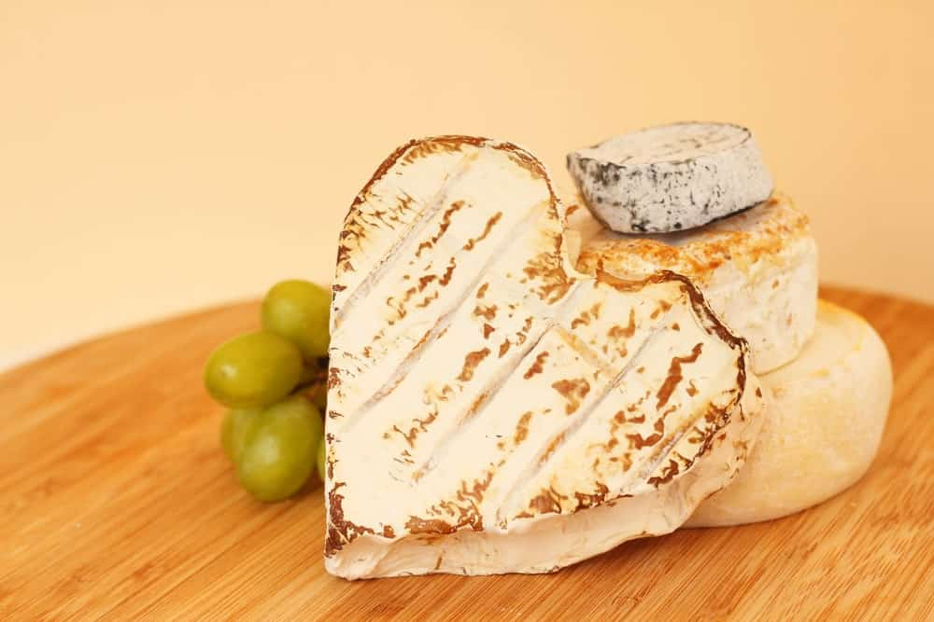
THIS CHEESE IS DEFINED AS AN ARTISANAL, UNPASTEURIZED, AND SOFT-RIPENED CHEESE THAT COMES FROM A REGION IN FRANCE CALLED QUERCY WHERE THE HERDS OF GOATS ROAM AROUND AND FEED ON THE LUSH GRASSES OF THE GATINAIS.
COUER DE CHEVRE CHEESE HAS A SALTY, SPICY FLAVOR WITH A SUPER SOFT, SMOOTH, AND CREAMY TEXTURE. AS THE NAME TRANSLATES TO ‘HEART OF GOAT’, IT IS ACTUALLY HAND-MOLDED INTO THE SHAPE OF A HEART, TOO. IT HAS A RICH, SUCCULENT CONSISTENCY WHICH MAKES IT EASILY SPREADABLE ON A VARIETY OF DIFFERENT FOODS.
ONE OF THE MOST DISTINCTIVE ASPECTS OF THIS CHEESE IS THAT IT IS WRAPPED IN A CHESTNUT LEAF AND OFTEN SERVED WITH FRUITY RED WINE OR SPARKLING WHITE WINE.

COTTAGE CHEESE
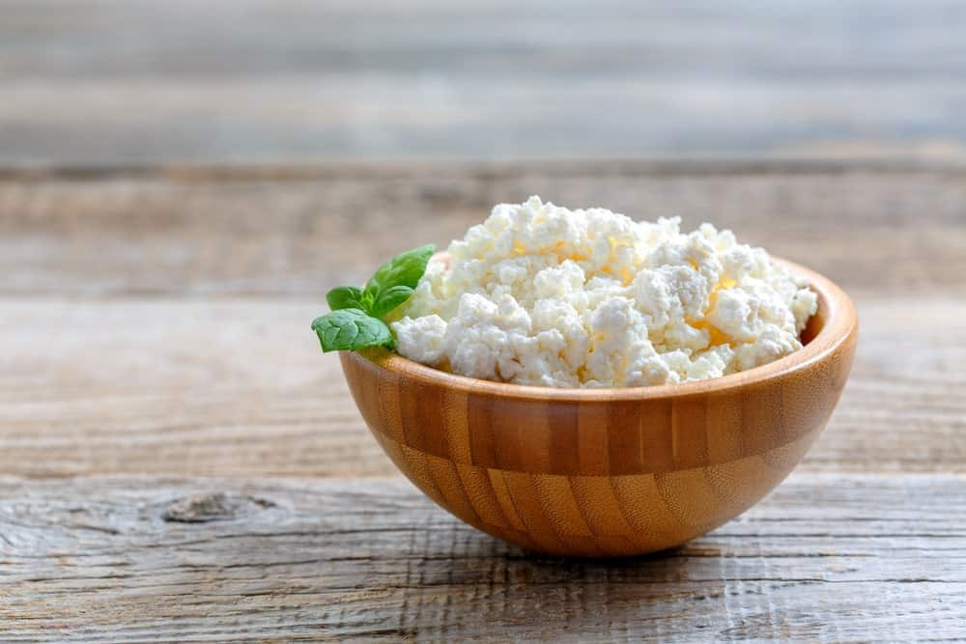
THIS CHEESE HAS QUITE A FASCINATING HISTORY ATTACHED TO IT WHICH GOES BACK TO THE ANCIENT MESOPOTAMIANS DURING THE PERIOD OF 3100BC-510BC. ACCORDING TO HISTORIC RECORDS, COTTAGE CHEESE WAS ACCIDENTALLY FOUND IN A SHEEP’S STOMACH BAG. AFTER ITS ‘ACCIDENTAL’ DISCOVERY’, THIS CHEESE WAS MADE WITH LEFTOVER MILK.
COTTAGE CHEESE IS A SOFT, FRESH CHEESE WITH A VERY MILD FLAVOR AND SUPER SOFT AND CREAMY TEXTURE. IT IS MADE FROM THE CURDS THAT ARE LEFT BEHIND IN PASTEURIZED COW’S MILK BUT CAN ALSO BE MADE WITH THE HELP OF OTHER KINDS OF MILK.
INTERESTINGLY, COTTAGE CHEESE WAS EXTENSIVELY PROMOTED DURING WORLD WAR I AS AN EXCELLENT SUBSTITUTE FOR MEAT BECAUSE IT CONTAINS A LARGE AMOUNT OF PROTEIN. IT IS ALSO LOW IN CALORIES, UNLIKE SEVERAL OTHER TYPES OF CHEESES, WHICH MAKES IT A VERY HEALTHY KIND OF CHEESE. IT IS ALSO QUITE POPULAR AS A DIET SNACK AMONG NUMEROUS HEALTH DEVOTEES AND DIETERS.

CREAM CHEESE
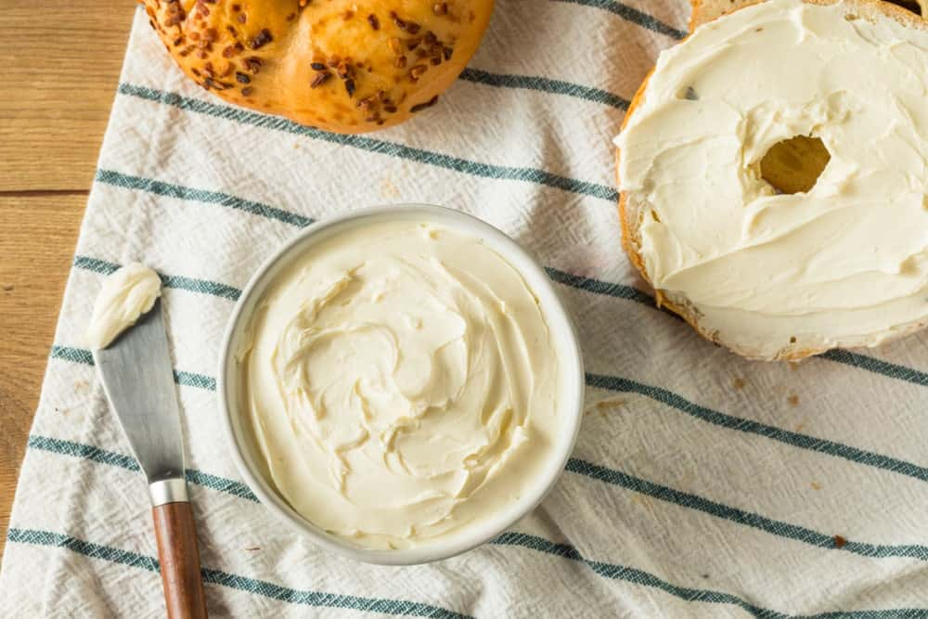
THE INVENTION OF THIS INCREDIBLE CHEESE STEMMED FROM THE AMERICAN CULINARY BACK IN 1872 IN NEW YORK STATE. IT IS A KIND OF FRESH CHEESE THAT IS MADE FROM CREAM AND MILK. CREAM CHEESE IS KNOWN TO HAVE A SUPER MILD TASTE AND BUTTERY SOFT CONSISTENCY AND TEXTURE.
MOST PEOPLE DON’T THINK OF CREAM CHEESE AS AN ACTUAL “CHEESE”, BUT IT IS, IN FACT, A VERY RICH KIND OF CHEESE THAT IS ALSO EASY TO MAKE AT HOME. IT IS POPULARLY AND COMMONLY USED AS A SPREAD FOR BAGELS, CRACKERS, DIFFERENT TYPES OF BREAD, ETC. CREAM CHEESE IS ONE OF THOSE CHEESES THAT ARE USED IN BOTH SAVORY AND SWEET FOODS FOR EXAMPLE, MANY PEOPLE USE IT AS SAVORY DIPS FOR SNACKS AND ALSO TO MAKE CHEESECAKES.
SINCE CREAM CHEESE IS A TYPE OF FRESH CHEESE, IT MEANS THAT IT IS UNAGED. THIS FURTHER SUGGESTS THAT ONCE OPENED, IT TENDS TO HAVE A SHORT SHELF LIFE AND SHOULD ALWAYS BE REFRIGERATED TO PREVENT IT FROM BEING ROTTEN OR SPOILED.

FETA CHEESE
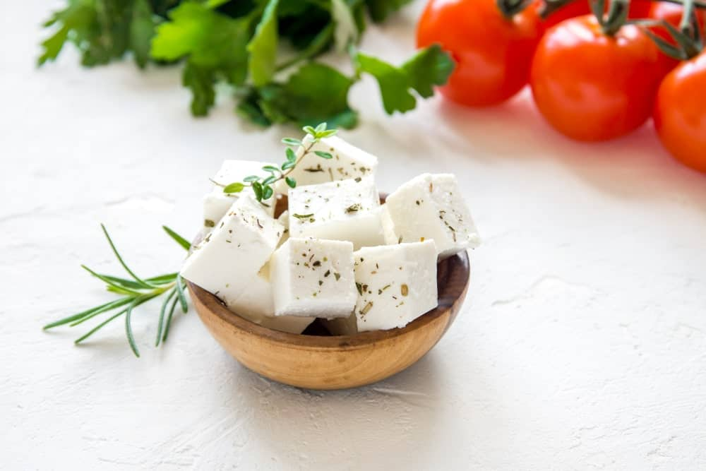
THIS HAS TO BE ONE OF THE MOST POPULAR TYPES OF CHEESE THAT ARE FEATURED IN A VARIETY OF DIFFERENT FOODS AND RECIPES. THIS IS A BRINED CURD WHITE CHEESE THAT IS AUTHENTICALLY MADE FROM WHOLE SHEEP’S MILK. IN RECENT TIMES, HOWEVER, DIFFERENT VERSIONS OF FETA CHEESE ARE ALSO MADE FROM A MIXTURE OF SHEEP MILK AND GOAT MILK.
FETA CHEESE HAS ORIGINATED FROM GREECE AND HAS BEEN AROUND FOR SEVERAL CENTURIES. INTERESTINGLY, THERE IS NOT A SINGLE GREEK MEAL OR DISH THAT DOESN’T MAKE USE OF FETA CHEESE IN SOME WAY OR THE OTHER.
IT IS ALSO DEFINED AS AN AGED, CRUMBLY CHEESE WITH HOLES OR NO HOLES AND A SALTY, TANGY FLAVOR. THE TEXTURE OF THIS CHEESE IS MOSTLY CRUMBLY AND IS COMMONLY FOUND IN SMALL SQUARE-CUT PIECES.
THE MOST POPULAR USE OF FETA CHEESE IS IN A VARIETY OF SALADS SINCE IT CRUMBLES UP EASILY. SOME PEOPLE ALSO PREFER TO USE IT FLATBREADS AND PIZZAS AN ALTERNATIVE TO THE TYPICALLY USED MOZZARELLA CHEESE.

GOAT CHEESE
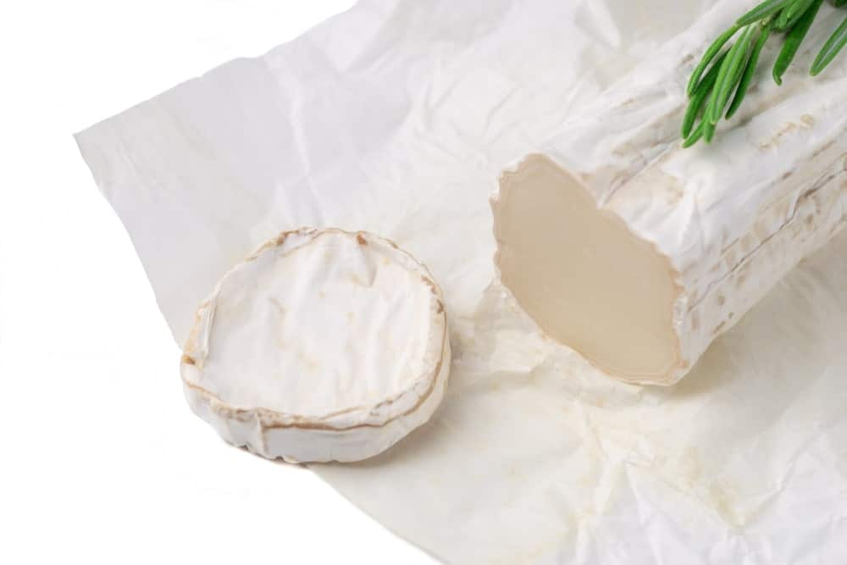
AS THE NAME SUGGESTS, THIS CHEESE IS MADE FROM GOAT’S MILK AND IS ONE OF THE MOST POPULAR DAIRY PRODUCTS THAT IS THOROUGHLY ENJOYED ALL ACROSS THE GLOBE. GOAT CHEESE COMES IN A NUMBER OF VARIETIES WITH DIFFERENT FLAVORS AND TEXTURES. THESE INCLUDE SALTY AND CRUMBLY AGED CHEESE TO SUPER MOIST AND CREAMY SPREADABLE CHEESE.
GOAT CHEESE IS DIVIDED INTO SEVERAL CATEGORIES ACCORDING TO REGIONS OF THEIR ORIGIN. FOR EXAMPLE, GOAT CHEESE FROM CHINA IS CALLED RUBING AND GREATLY RESEMBLED COW’S CHEESE, THE ONE FROM IRELAND IS CALLED TULLY BOY GOAT CHEESE THAT IS MADE FROM PASTEURIZED MILK AND THE ONE FROM JAPAN IS CALLED YAGI CHEESE.
GOAT CHEESE ALSO GOES BY THE NAME ‘CHEVRE’ IN VARIOUS PARTS OF THE WORLD AND IS ALSO QUITE RICH IN VITAMINS, MINERALS, HEALTHY FATS, AND PROTEIN.
SOME OF THE BEST WAYS TO INCORPORATE GOAT CHEESE IN FOODS ARE PERHAPS IN THE FORM OF HERBED GOAT CHEESE BUTTER, GOAT CHEESE STUFFED CHICKEN, OR SAY GOAT CHEESE CHEESECAKE BITES?

NEUFCHATEL
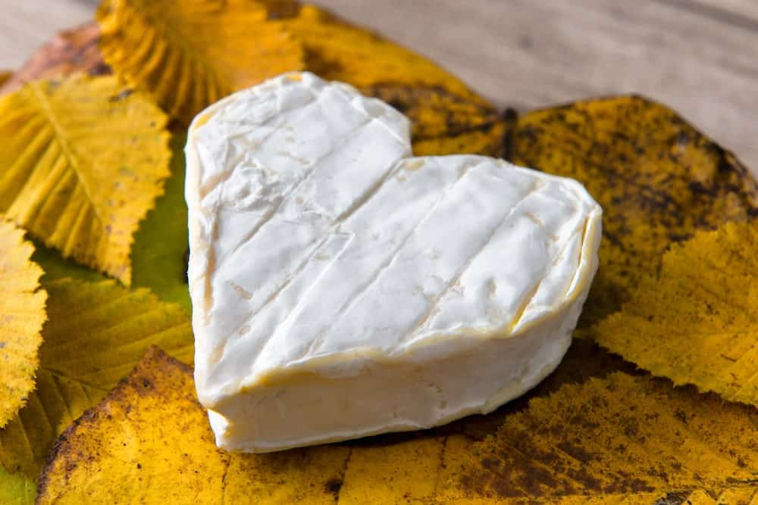
THIS CHEESE IS QUITE POPULAR FOR ITS HEART SHAPE AND IS MADE FROM PASTEURIZED COW MILK. THIS IS ALSO ONE OF FRANCE’S OLDEST TYPES OF CHEESE, DATING BACK TO THE 6TH CENTURY, WHICH MAINLY ORIGINATED FROM THE FRENCH REGION OF NORMANDY.
KITCHENAID

UNLOCK POTENTIAL.
OUR INNOVATIVE APPLIANCES ENSURE THAT ANYTHING YOU WANT TO DO IN THE KITCHEN YOU CAN DO WITH KITCHENAID.
NEUFCHATEL CHEESE HAS A SOFT AND SLIGHTLY CRUMBLY TEXTURE AND HAS AN AROMA AND TASTE THAT IS VERY SIMILAR TO THAT OF MUSHROOMS. ITS FLAVOR CAN ALSO BE DESCRIBED AS A LITTLE NUTTY AND CREAMY, WHICH MAKES IT IDEAL TO BE SPREAD ON CRACKERS AND TOAST.
IN THE UNITED STATES, THE NEUFCHATEL CHEESE IS COMMONLY REFERRED TO AS “FARMERS’ CHEESE”.

RICOTTA CHEESE
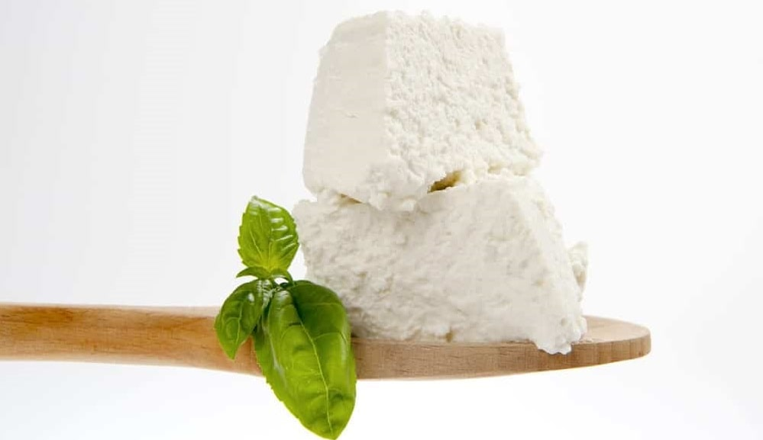
THIS IS A FAMOUS ITALIAN WHEY CHEESE THAT IS MADE FROM THE LEFTOVERS OF OTHER CHEESES THAT COME FROM SHEEP MILK, ITALIAN WATER BUFFALO MILK, OR EVEN GOAT MILK.
THE WORD RICOTTA LITERALLY TRANSLATES TO “RE-COOKED” AND IS PRODUCED BY COAGULATING THOSE PROTEINS THAT REMAIN BEHIND AFTER THE CASEIN FROM THE MILK IS USED TO MAKE OTHER CHEESES.
RICOTTA CHEESE ORIGINALLY COMES FROM THE ITALIAN PENINSULA AND GOES AS FAR BACK AS THE BRONZE AGE. THIS CHEESE IS AN INCREDIBLY MILD FRESH CHEESE THAT HAS A SLIGHTLY SWEET FLAVOR AND AN EXTREMELY SOFT, BUTTERY TEXTURE.
COMMON CULINARY USES OF THE RICOTTA CHEESE INCLUDE ITALIAN DESSERTS LIKE CHEESECAKES AND CANNOLI. IT MAY EVEN BE USED IN A VARIETY OF SAVORY DISHES LIKE DIFFERENT KINDS OF PASTA, PIZZA, CALZONES, LASAGNA, AND RAVIOLI. SOME PEOPLE EVEN SUBSTITUTE IT FOR MAYONNAISE AND USE IT AS A SAUCE THICKENER.
HAVE YOU PICKED YOUR FAVORITE YET? PERHAPS, GRAB A HUGE SUPPLY OF WINE AND CRACKERS AND INDULGE IN YOUR OWN DELICIOUS, RICH, CREAMY CHEESE WORLD!

20 DIFFERENT TYPES OF HAM
THERE IS SO MUCH TO LOVE ABOUT HAM. YOU CAN EAT IT COLD, HOT, SMOKED, OR CURED. THE OPTIONS ARE LIMITLESS WHEN IT COMES TO HAM SELECTION. CHECK OUT THIS ARTICLE TO FIND OUT ALL THE DETAILS ABOUT THE DIFFERENT TYPES OF HAM FROM WHICH YOU CAN CHOOSE.
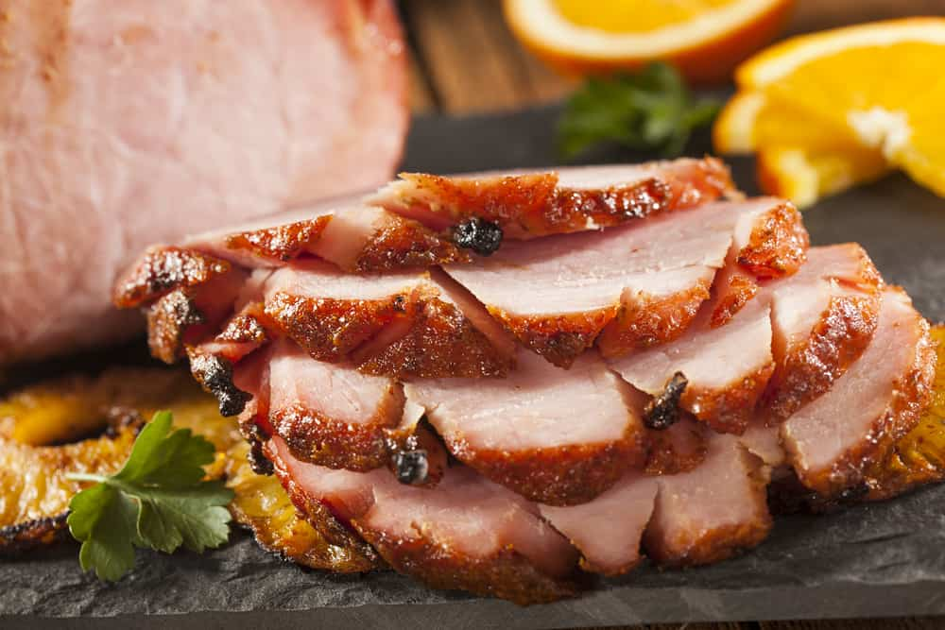
WHILE JUST ABOUT EVERYONE LOVES HAM, IT IS NOT ALWAYS EASY TO DECIDE WHAT TYPE OF HAM TO EAT. IT IS A GO-TO ITEM DURING THE HOLIDAYS AND OTHER FAMILY EVENTS. THERE ARE SEVERAL WAYS YOU CAN PREPARE A HAM, WHICH INCLUDE CURING, SMOKING, AND AGING. THESE PREPARATIONS ALL HAVE A DIFFERENT IMPACT ON THE TASTE OF THE HAM. WHEN YOU ARE LOOKING FOR THE PERFECT PREPARATION, IT IS HELPFUL TO KNOW THE DIFFERENT TYPES OF HAM TO PICK THE RIGHT ONE.
RELATED: HAM SUBSTITUTE OPTIONS | SIDE DISHES FOR HAM | HONEY GLAZED HAM RECIPE | THANKSGIVING TURKEY ALTERNATIVES | HOW TO STORE HAM | HAM VS. BACON | TURKEY VS. HAM

WHAT IS HAM?
ALL HAM IS MEAT THAT BEGINS AS A CUT OF ROAST FROM THE BACK LEG OF A HOG. THE BACK LEG IS THE AREA FROM WHICH FRESH HAM COMES. BEFORE IT HAS ANY PREPARATION, IT IS SIMILAR TO ALL PORK ROAST. FOR ONE TO CONSIDER A PIECE OF MEAT HAM, IT MUST BE SMOKED, CURED, COOKED, OR AGED.

CRITERIA FOR CHOOSING HAM
WHEN YOU ARE LOOKING FOR THE CORRECT TYPE OF HAM, THERE ARE SPECIFIC CRITERIA IN WHICH YOU SHOULD BE INTERESTED.

CUT
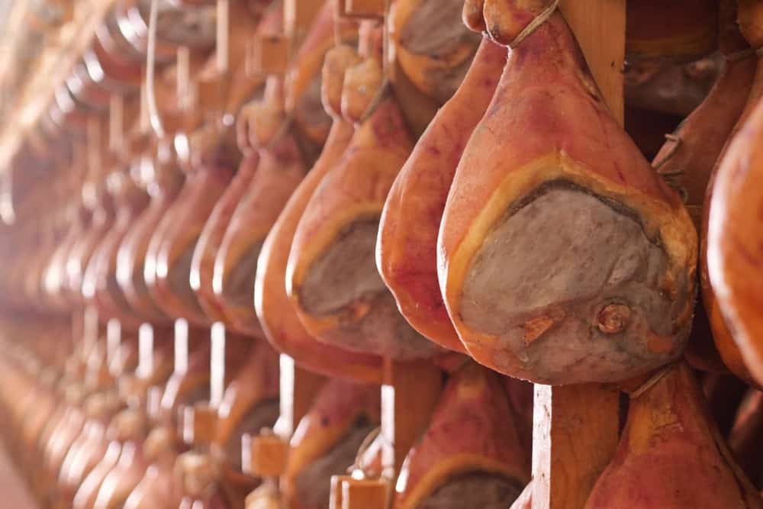
A HAM IS SOLD EITHER BONE-IN, BONELESS, OR PARTIALLY BONED. THE SHANK PART OF THE HAM HAS MORE FAT. THE BUTT PART IS EASIER TO SLICE BECAUSE IT IS LEANER.

CURE
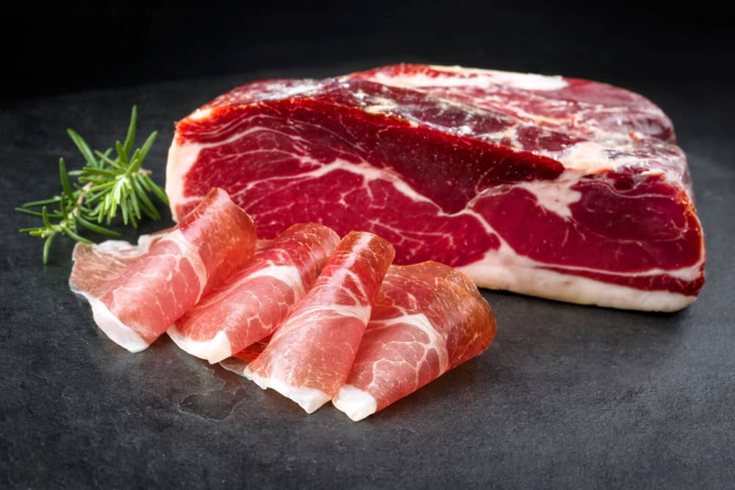
HAM IS ALWAYS CURED IF IT IS NOT FRESH. WHEN IT IS A CURED MEAT, IT CAN BE BRINE-CURED, WHICH IS A WET CURE OR A DRY CURED HAM. WHEN THE HAM IS BRINE-CURED, IT IS SOAKED IN A MIXTURE OF LIQUID AND SALT BEFORE IT IS SMOKED. BRINE-CURED IS THE MOST COMMON WAY YOU WILL FIND HAM. DRY-CURED HAM IS WHEN THE MEAT SURFACE IS COVERED COMPLETELY WITH SALT AND STORE UNTIL THE SALT SOAKS INTO THE MEAT, WHICH ALSO PRESERVES IT.

COOKING TYPE
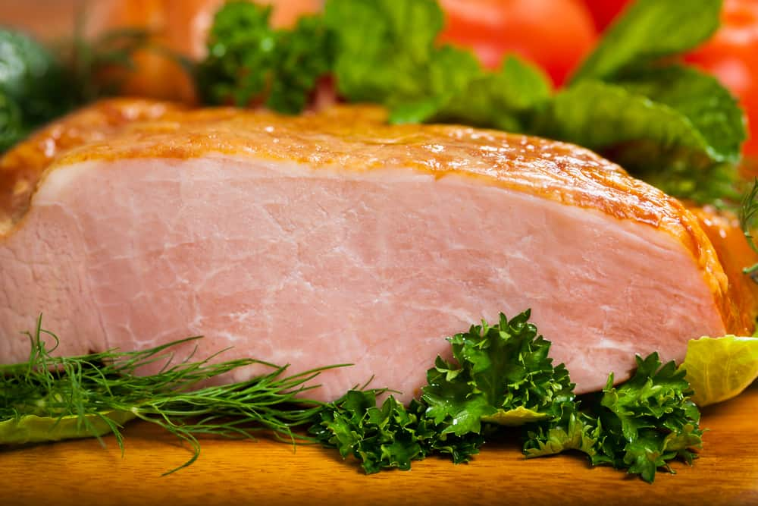
THE HAM MAY BE UNCOOKED, FULLY COOKED, OR PARTIALLY COOKED. WHEN YOU HAVE A FULLY COOKED HAM, THE HAM IS HEATED UNTIL THE INTERNAL TEMPERATURE IS 148 DEGREES FAHRENHEIT. WHEN THE HAM IS PARTIALLY COOKED, THE TEMPERATURE GETS TO 137 DEGREES FAHRENHEIT. IF THE HAM IS PARTIALLY OR UNCOOKED HAM, IT MUST BE BAKED BEFORE IT CAN BE EATEN. IF IT IS FULLY COOKED, YOU ONLY HAVE TO WARM IT FIRST.

SMOKED
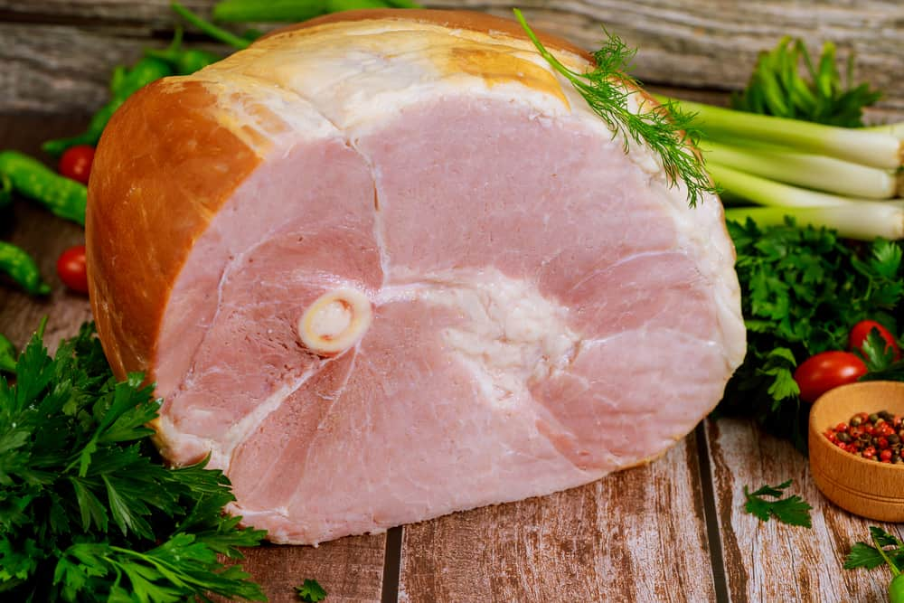
A SMOKED HAM IS SMOKED FOR DAYS OR WEEKS AT A TEMPERATURE THAT IS UNDER 100 DEGREES FAHRENHEIT.

AGE
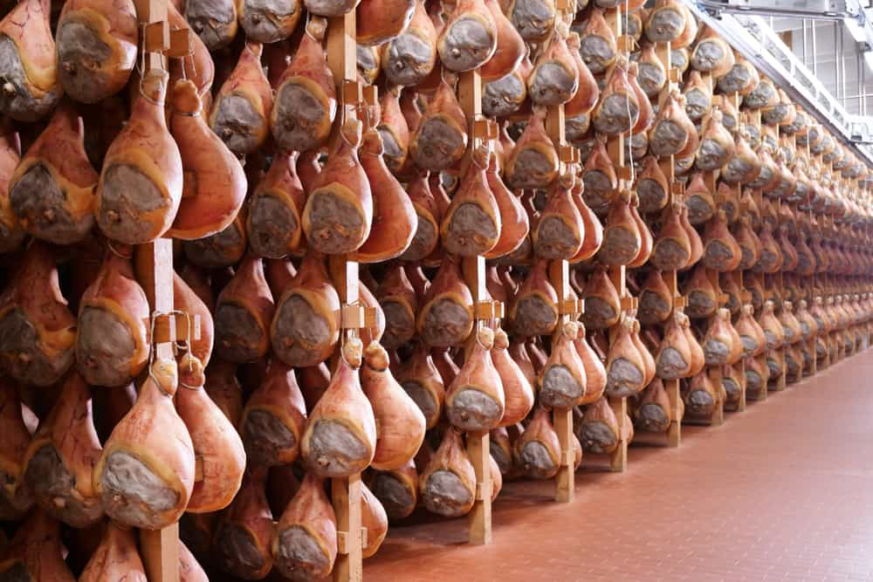
WHEN THE HAM HAS A DEEP FLAVOR, IT IS HEAVILY CURED, SMOKED, AND HUNG FOR ONE TO SEVEN YEARS. THEY BECOME COVERED MOLD THAT MUST BE SCRAPED AND WASHED BEFORE YOU CAN EAT IT. THIS TYPE OF HAM IS OFTEN EXPENSIVE AND HAS A STRONG FLAVOR.

SHANK END VS. BUTT END
THE SHANK END HAM COMES FROM THE LOWER PART OF THE HOG’S LEG. WHEN YOU THINK OF A TRADITIONAL HAM ON YOUR TABLE, IT IS MOST LIKELY THE SHANK END YOU ARE SEEING. THIS IS WHAT YOU CONSIDER YOUR HOLIDAY HAM. YOU MAY HAVE A SPIRAL SLICED HAM. THIS MEAT IS FATTY AND NOT AS TENDER AS THE BUTT END. THE SHANK END IS A NICE-LOOKING CUT OF MEAT AND BIG ENOUGH TO FEED AN ENTIRE FAMILY. SOME USE A SHANK END CUT OF HAM AS A CENTERPIECE FOR THEIR MEAL. THE BUTT END OF THE HOG IS LEANER AND EASY TO CARVE. IT ONLY HAS ONE BONE.

BONE-IN HAM VS. BONELESS HAM
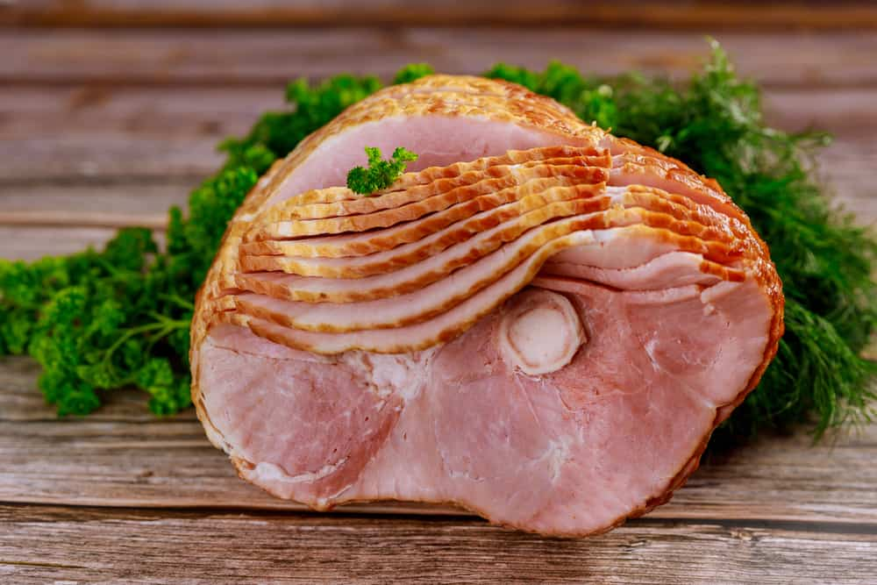
YOU HAVE NO DOUBT HEARD THE TERMS BONELESS OR BONE-IN WHEN TALKING ABOUT HAM. A BONE-IN HAM IS MOISTER AND GIVES YOU A RICH FLAVOR THAT COMES FROM HAVING THE BONE STILL IN THE MEAT. KEEPING THE BONE IN THE HAM DOES MAKE IT MORE DIFFICULT TO CARVE. THE BONE CAN BE USED TO ADD FLAVOR TO A SOUP, COLLARD GREENS, AND OTHER FOODS.
A BONELESS HAM IS EASY TO CARVE BECAUSE THERE IS NO BONE TO WORRY ABOUT. YOU ARE ABLE TO CUT IT UNIFORMLY. A BONELESS HAM HAS BEEN PROCESSED, WHICH TAKES AWAY SOME OF THE FLAVORS. THE BETTER QUALITY THE BONELESS HAM IS MEANS, THE MORE FLAVOR IT WILL HAVE.
THERE IS ALSO A BONE REMOVED HAM. A BONE REMOVED HAM GIVES YOU THE BENEFIT OF NO BONE FOR CARVING PURPOSES. THE DOWNSIDE IS YOU GET MORE FAT AND MARBLING IN THE HAM, SIMILAR TO A BONE-IN HAM. BONE REMOVED IS AN OPTION FOR THOSE THAT CANNOT DECIDE BETWEEN BONE-IN OR BONELESS.

DIFFERENT TYPES OF HAM

BAYONNE HAM
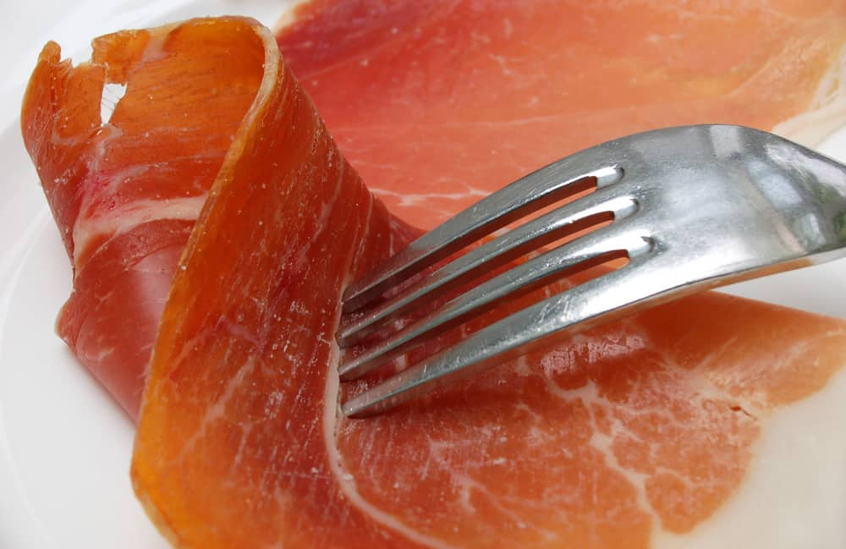
A BAYONNE HAM IS A BONELESS FRENCH HAM THAT IS SALTY. IT IS SALTED AND THEN DRIED FOR SIX MONTHS. THIS HAM IS NAMED FOR THE CITY BAYONNE WHICH IS A PORT CITY IN FRANCE. IT TASTES BEST SLICED ON BUTTERED BREAD.

BLACK FOREST HAM
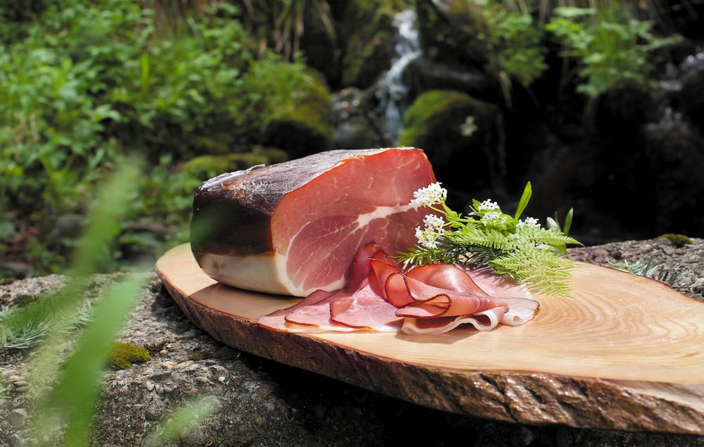
THIS HAM IS NAMED FROM AN AREA IN GERMANY. IT WAS FIRST PRODUCED IN GERMANY. THE OUTSIDE OF THIS HAM IS BLACKENED. IT IS A BONELESS HAM THAT IS SEASONED WITH JUNIPER BERRIES, PEPPER, GARLIC, CORIANDER AND SALTED BEFORE IT IS CURED AND THEN COLD SMOKED.

CANADIAN BACON
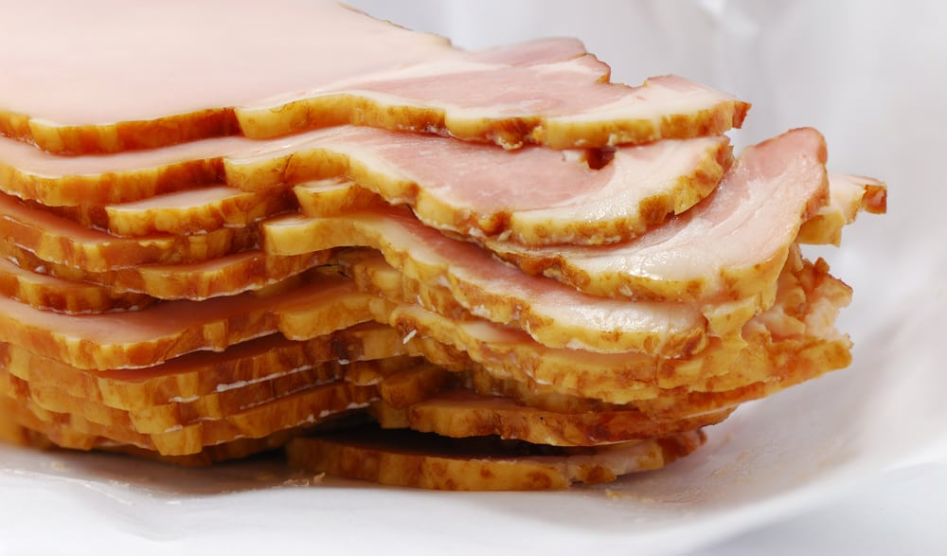
THIS SMOKED MEAT IS PRE-COOKED. IT IS A LEAN CUT FROM THE LOIN AND NOT THE RUMP OR LEG. CANADIAN BACON IS MORE LIKE HAM THAN BACON, DESPITE ITS NAME. IT IS TYPICALLY SERVED FOR BREAKFAST AND FRIED IN A SKILLET.

CAPICOLA
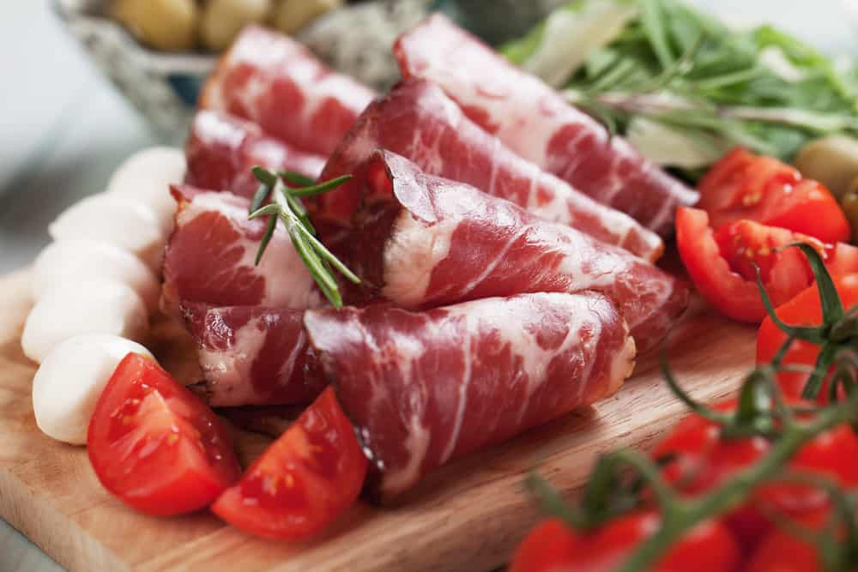
CAPICOLA IS AN ITALIAN CURED HAM MUCH LIKE PROSCIUTTO. CAPICOLA IS MADE FROM PORK SHOULDER OR NECK. PROSCIUTTO IS MADE FROM THE THIGHS OR BUTTOCKS.

CITY HAM
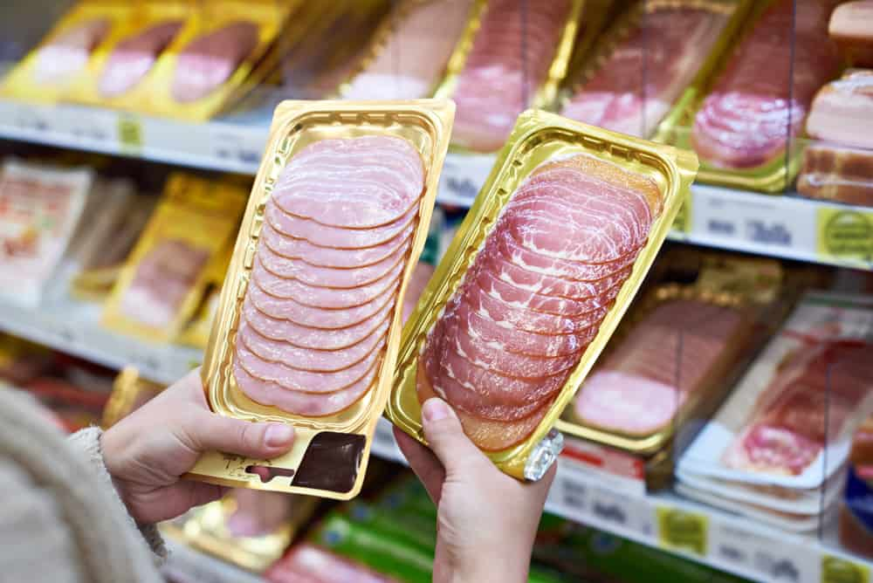
CITY HAM IS A WET CURED HAM AND TYPICALLY SMOKED. CITY HAM IS THE HAM THAT YOU ARE MOST LIKELY TO FIND AT THE GROCERY STORE. THESE TYPES OF HAMS MAY BE REFERRED TO AS SUPERMARKET HAMS. THEY ARE PRE-COOKED, AND ALL YOU HAVE TO DO IS HEAT THEM AT A LOW TEMPERATURE. YOU CAN EAT CITY HAM COLD, IF YOU PREFER, OR COOK IT IN A SKILLET.

COOKED HAM
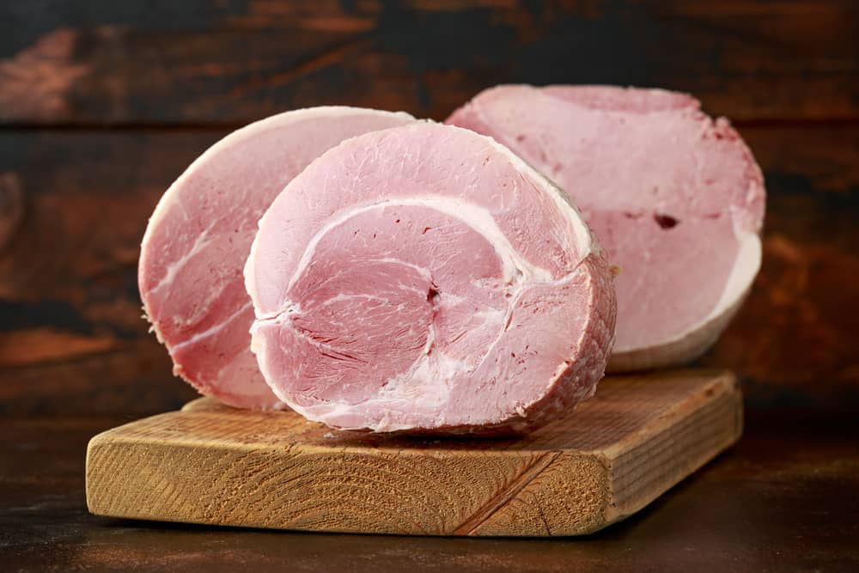
THIS HAM IS NOT SMOKED WITH A BLAND FLAVOR. IT IS USUALLY BOILED OR STEAMED. COOKED HAM IS MOST LIKELY THE HAM YOU WILL GET WHEN YOU ARE EATING LUNCH MEAT.

COUNTRY HAM
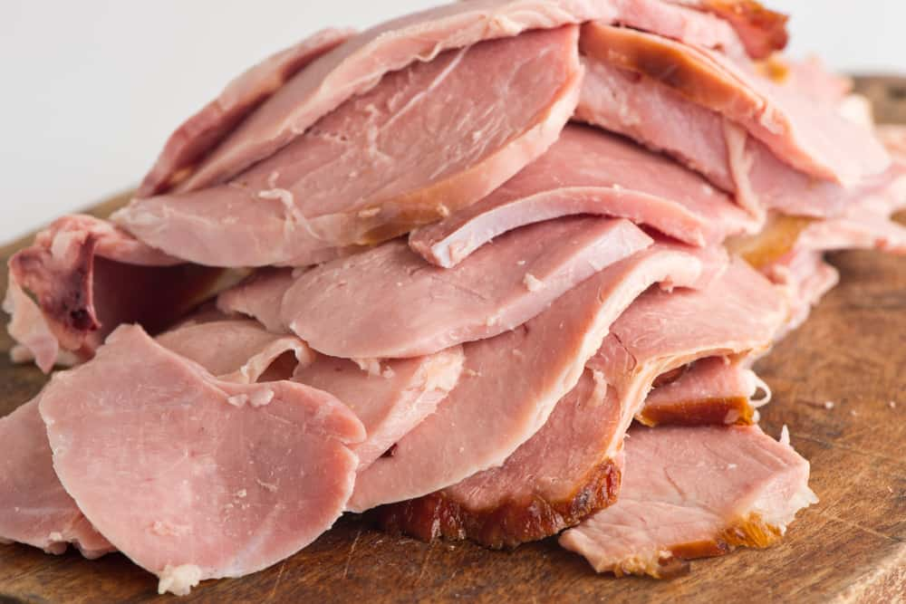
COUNTRY HAM IS POPULAR IN THE SOUTH. FOR HAM TO QUALIFY AS A COUNTRY HAM, IT MUST BE DRIED, CURED, AND AGED FOR A MINIMUM OF 70 DAYS. THIS HAM USES SALT TO DRY CURE IT. IT IS SMOKED ON FRAGRANT HARDWOOD AND AGED FOR SIX MONTHS. THESE HAMS ARE NOT COOKED BUT CAN BE EATEN BECAUSE THEY ARE PRESERVED. A COUNTRY HAM TASTES SALTY AND HAS A DRY TEXTURE. IF YOU PLAN TO COOK A COUNTRY HAM, YOU SHOULD SOAK IT FOR FOUR TO 24 HOURS. SOAKING THE HAM ALLOWS YOU TO REMOVE THE SALT WHILE ADDING MOISTURE.

CULATELLO
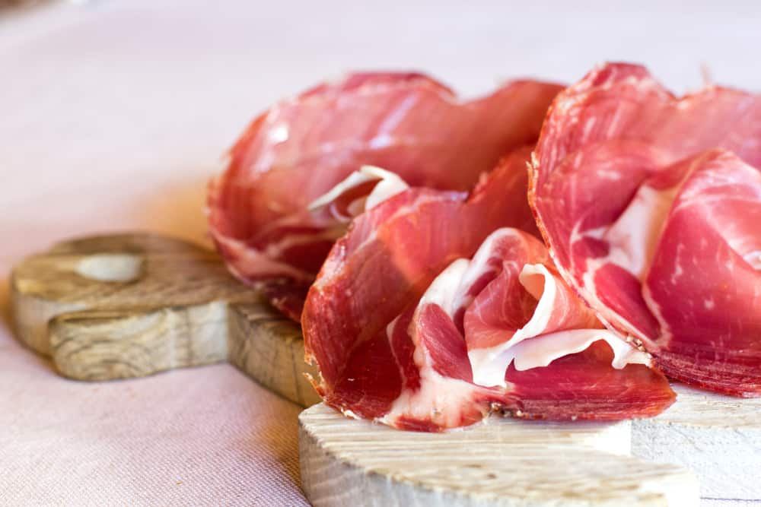
CULATELLO IS AN ITALIAN CURED HAM THAT IS MOST LIKELY FOUND IN AN ANTIPASTO. THIS HAM IS SOAKED IN WINE WHILE IT IS AGING. IT HAS A CLEAN FLAVOR. IT IS A LEAN CUT OF MEAT.

GAMMON
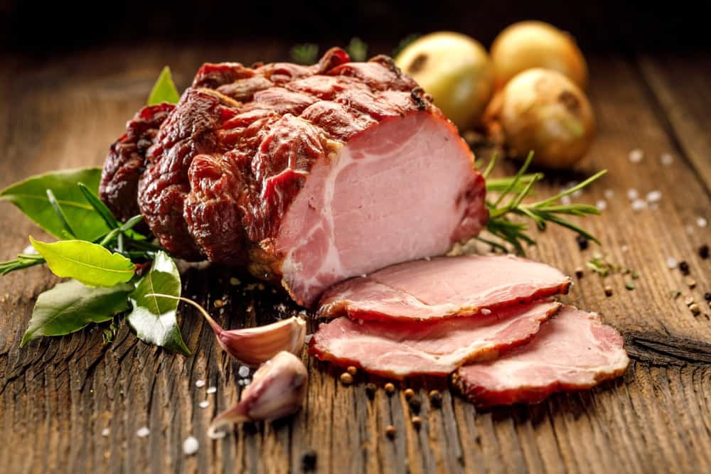
YOU MUST COOK THIS TYPE OF HAM BEFORE EATING IT. IT MAY BE SMOKED OR NOT. IT IS MOST POPULAR IN GREAT BRITAIN.

HONEY HAM
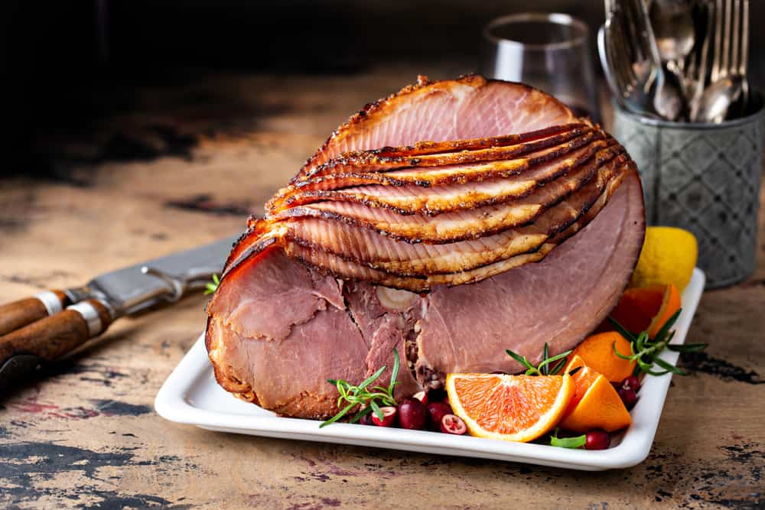
THIS TYPE OF HAM MAY ALSO BE CALLED MAPLE HAM. IT IS WELL CURED AND USES A SWEETER THAT AT LEAST HALF OF IT CONSISTS OF MAPLE SYRUP OR HONEY. THIS USUALLY CREATES A GLAZE ON THE HAM. THESE HAMS HAVE A SAVORY TASTE TO THEM. YOU MOSTLY FIND THEM PRE-COOKED, BUT YOU WILL NEED TO REHEAT THEM.

IRISH HAM
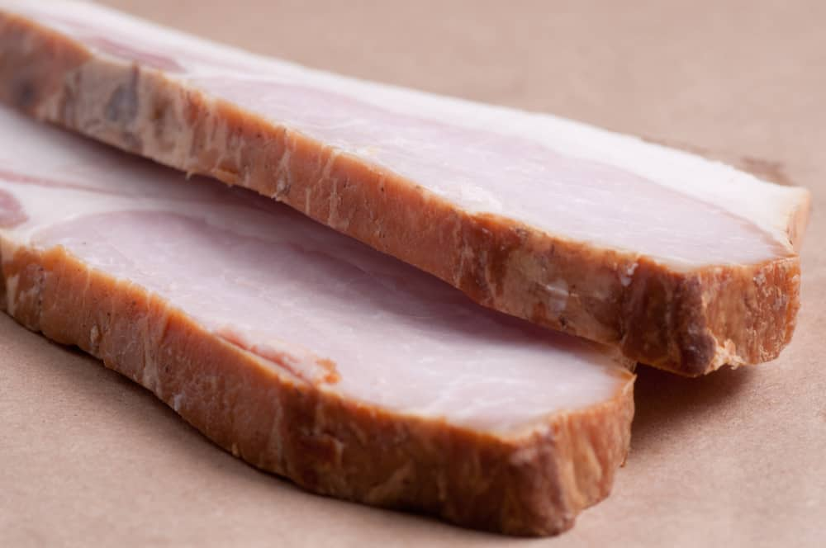
THIS HAM IS A PRODUCT OF BELFAST, IRELAND, AN AREA THAT IS FAMOUS FOR BRINING OR PICKLING HAMS. THEY HAVE A UNIQUE FLAVOR BECAUSE THEY ARE SMOKED OVER A PEAT FIRE. BEFORE THEY ARE EATEN, THEY ARE SOAKED, SCRUBBED, SIMMERED, AND BAKED.

JAMON IBERICO
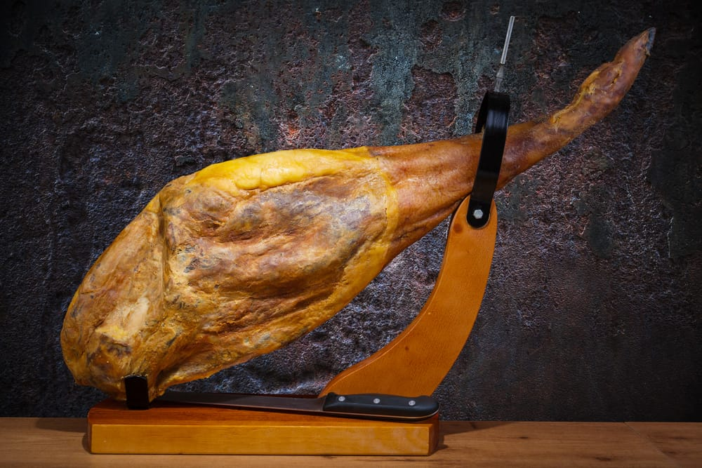
THIS HAM IS ALSO REFERRED TO AS JAMON DE PLATA NEGRA. IT MAY ALSO BE CALLED IBERICO HAM OT IBERIAN HAM. IT COMES FROM SPAIN, AND IT IS CONSIDERED A LUXURY. THERE ARE THREE DIFFERENT GRADES OF THIS HAM. THE HIGHER THE GRADE OF HAM MEANS THE HIGHER PRICE YOU PAY. JAMON IS DRY-CURED FOR ABOUT TWO YEARS, WHICH GIVES IT A NUTTY BUT SWEET TASTE.

PICNIC HAM
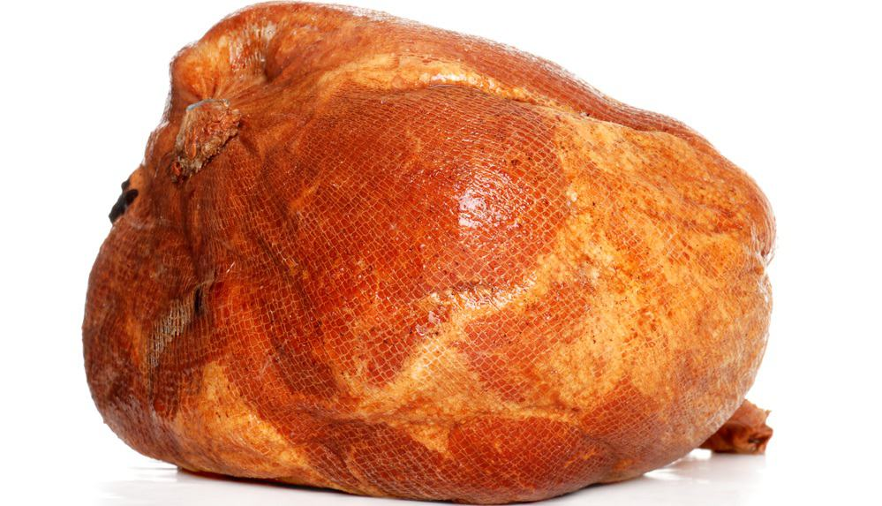
THIS HAM COMES FROM THE UPPER PART OF THE FORELEG OF THE HOG. THIS PART OF THE LEG INCLUDES THE SHOULDER. TECHNICALLY, IT IS NOT TRULY HAM BECAUSE OF THE LOCATION OF PART OF THE HOG FROM WHICH IT COMES. IT IS NOT AS TENDER BUT INEXPENSIVE. YOU WILL FIND IT SMOKED OR FRESH. THIS IS AN UNCURED HAM.

PROSCIUTTO
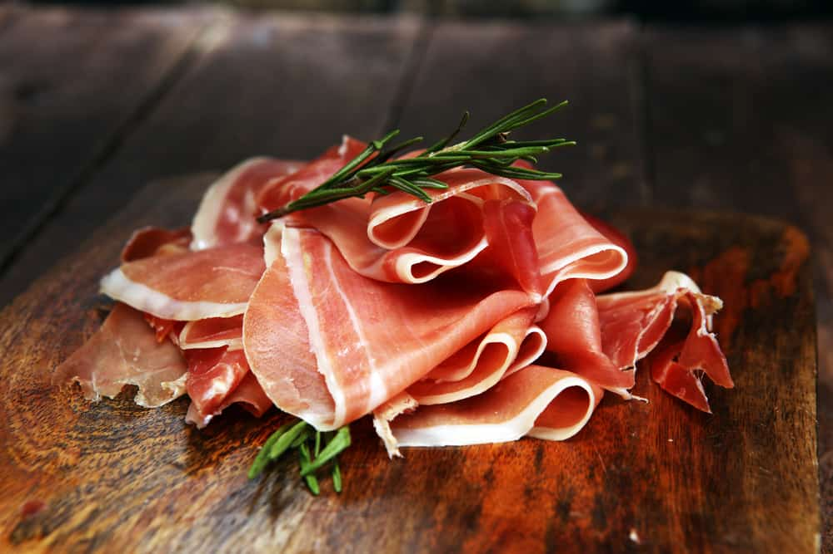
PROSCIUTTO IS AN ITALIAN HAM. THE WORD PROSCIUTTO MEANS HAM. IT IS SEASONED, SALT-CURED, AIR-DRIED, THEN PRESSED TO CREATE A FIRM AND DENSE TEXTURE. THIS HAM IS NOT SMOKED. THE TRUEST OF PROSCIUTTO COMES FROM THE PARMA REGION. IT IS CALLED PROSCIUTTO DI PARMA. TYPICALLY, THIS MEAT IS ADDED TO A MEAL OR ADDED AT THE END OF SOMETHING THAT IS BEING COOKED. YOU WILL FIND THIS HAM IN THIN SLICES.

SCOTCH HAM
THIS HAM WAS INITIALLY MADE IN SCOTLAND. THIS HAM IS NOT COOKED, BONELESS, AND CURED MILDLY. THIS HAM IS ALSO SOLD IN CASINGS.

SERRANO HAM
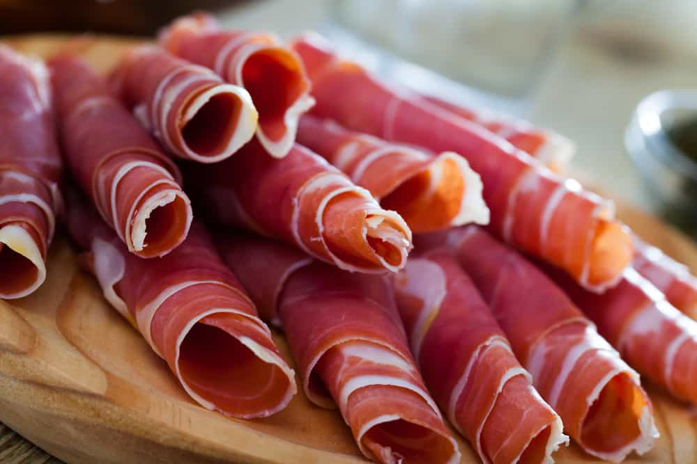
SERRANO HAM IS A SPANISH HAM THAT IS THINLY SLICED FOR SERVING. IT HAS A STRONG FLAVOR.

SMITHFIELD HAM
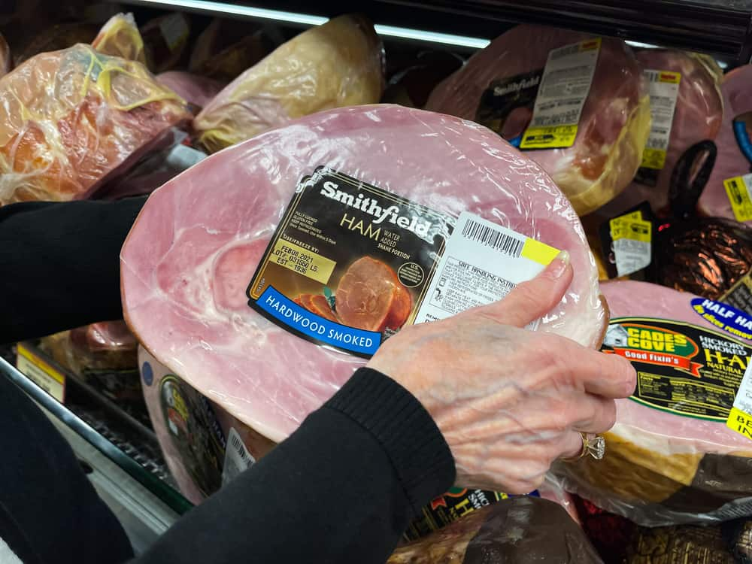
SMITHFIELD IS A SPECIFIC TYPE OF AGED COUNTRY HAM. IT CAN ONLY CARRY THE LABEL SMITHFIELD IF IT IS CURED IN THE CITY LIMITS OF SMITHFIELD, VIRGINIA. YOU MAY ALSO REFER TO IT AS VIRGINIA HAM. IT MUST BE CURED IN A SPECIFIC WAY. THE MEAT OF THE HAM IS A DEEP RED. IT HAS A SALTY TASTE. SMITHFIELD HAM TENDS TO BE AN EXPENSIVE TYPE OF HAM AND MUST BE COOKED SLOWLY OVER A LONG PERIOD OF TIME BEFORE YOU CAN EAT IT. YOU WILL NOT HAVE ANY LEFTOVER HAM OF THIS TYPE.

SPECK
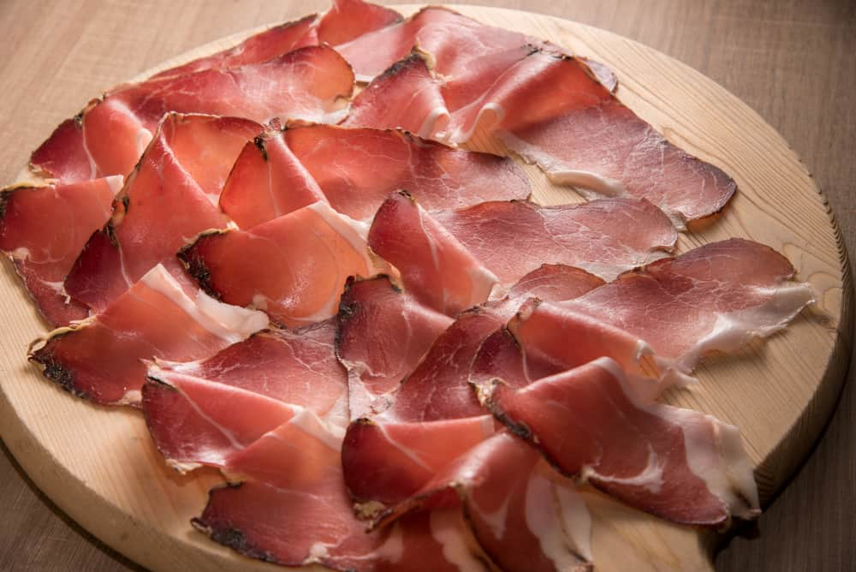
SPECK IS AN ITALIAN HAM THAT IS CURED SIMILARLY TO PROSCIUTTO. AFTER CURING, IT IS LIGHTLY SMOKED. IT COMES FROM THE THIGH OF A HOG AFTER IT HAS BEEN DEBONED. IT IS MASS-PRODUCED. YOU CAN ALSO FIND SPECK ALTO ALDIGE, WHICH IS A SPECIALTY ITEM THAT IS A PDO-PROTECTED VARIETY OF SPECK FROM NORTHERN ITALY. PROTECTED DESIGNATION OF ORIGIN (PDO) MEANS IT IS PRODUCED, PROCESSED, AND PREPARED IN A SPECIFIC AREA WITH THE KNOWLEDGE OF THE LOCALS AND LOCAL INGREDIENTS.

WESTPHALIAN HAM
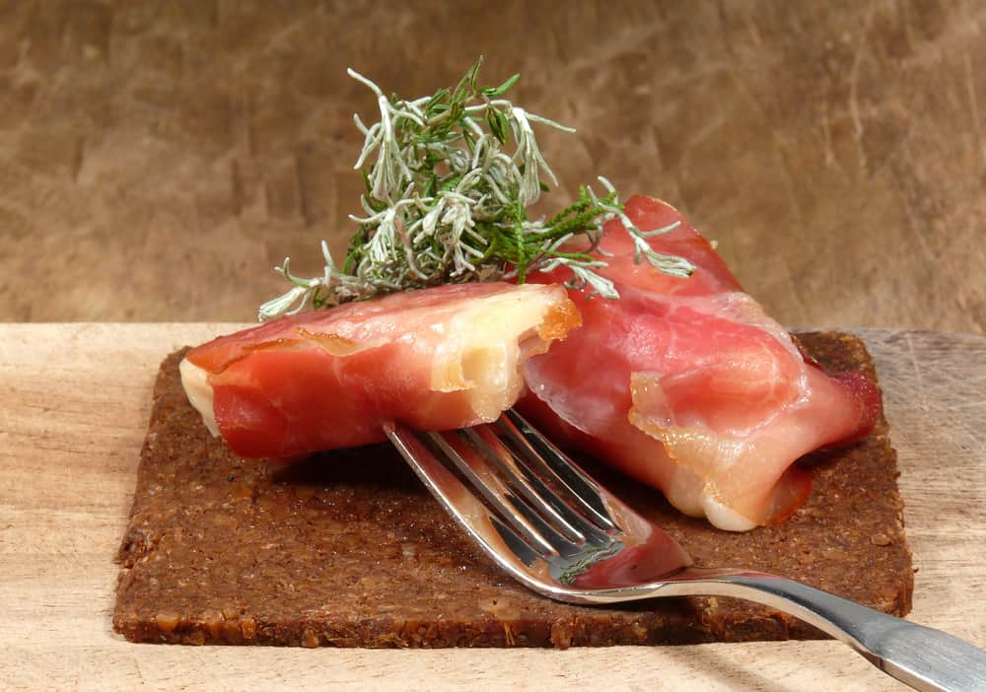
THIS HAM COMES FROM PIGS THAT EAT ACORNS FROM THE WESTPHALIA FOREST IN GERMANY. WESTPHALIAN HAM IS CONSIDERED A PRIZED HAM THAT IS CURED AND SMOKED SLOWLY OVER JUNIPER WOOD AND BEECHWOOD. THIS DENSE HAM IS DARK BROWN AND HAS A LIGHT SMOKY FLAVOR.

YORK HAM
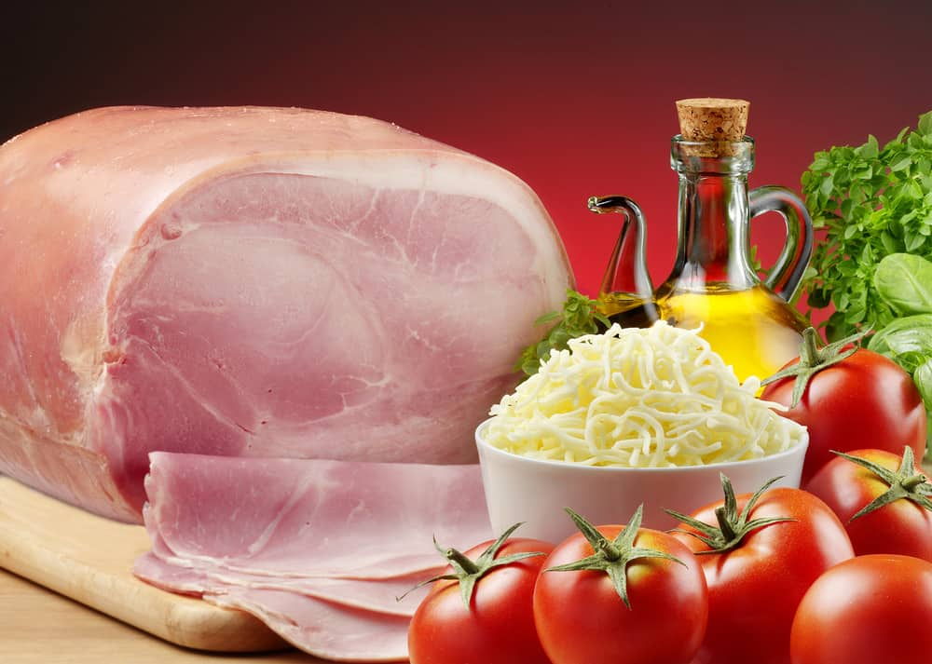
THIS MILD HAM IS FROM ENGLAND. IT HAS DELICATE PINK MEAT, AND YOU MUST COOK IT BEFORE EATING. YOU OFTEN SERVE YORK HAM WITH A MADEIRA SAUCE.

14 DIFFERENT TYPES OF CLAMS
CLAMS ARE ENJOYABLE IN VARIOUS FORMS. YOU CAN EAT THEM FRIED, ON THE HALF SHELL, OR IN CHOWDER. THERE ARE A WIDE VARIETY OF CLAMS THAT CAN BE USED IN DIFFERENT RECIPES. CHECK OUT THIS ARTICLE THAT PROVIDES ALL THE DETAILS YOU NEED ON THE DIFFERENT CLAMS.
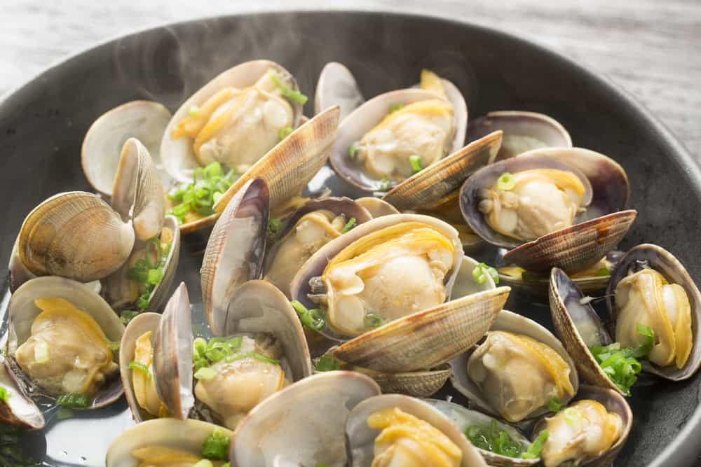
IT HAS BEEN MY EXPERIENCE THAT YOU EITHER LOVE CLAMS OR YOU HATE THEM. CLAMS HAVE MANY DIFFERENT NAMES, AND THAT CAN MAKE IT CONFUSING FOR PEOPLE. THEY ARE PRETTIER IN THEIR SHELLS THAN WHEN YOU TAKE THEM OUT. THEY TEND TO BE SALTY AND CHEWY BUT ARE FANTASTIC IN CLAM CHOWDER.
IF YOU ARE INTERESTED IN FINDING OUT MORE ABOUT CLAMS, KEEP READING THIS ARTICLE TO FIND OUT ALL ABOUT THE TYPES OF CLAMS.
RELATED: WHAT TO SERVE WITH STEAMED CLAMS | CLAMS VS. MUSSELS | CLAMS VS. OYSTERS | HOW TO CLEAN CLAMS | HOW TO STORE CLAMS | CLAM ALTERNATIVES

WHAT ARE CLAMS?
CLAMS ARE PART OF THE BIVALVE FAMILY. BEING BIVALVE MEANS THAT THEY HAVE SHELLS WITH TWO HINGES. THEY ARE FOUND IN BOTH SALTWATER AND FRESHWATER. THE CLAMS THAT PEOPLE EAT COME FROM SALTWATER. YOU DO NOT OFTEN EAT FRESHWATER CLAMS.
CLAMS BURY UNDER THE SEDIMENT OF THE OCEAN, IN THE MUD AND SAND. THE VARIETY OF CLAM IS DICTATED BY HOW DEEPLY THEY BURY THEMSELVES. THERE ARE THOUSANDS OF DIFFERENT CLAMS, BUT THEY ARE NOT ALL EDIBLE.

DIFFERENT TYPES OF CLAMS

HARD SHELL CLAMS
HARD SHELL CLAMS HAVE A SHORT SIPHON, WHICH IS THE PART OF THE CLAM THAT FILTERS THROUGH THE SEAWATER TO ALLOW THEM TO FEED. THEY LIKE TO BURY THEMSELVES IN THE SAND THAT IS SHALLOW. THESE TYPES OF CLAMS ARE OFTEN FARMED CLAMS. THESE CLAMS ARE IDEAL FOR STEAMING, GRILLING, CHOWDER, AND USING IN PASTA.

QUAHOGS
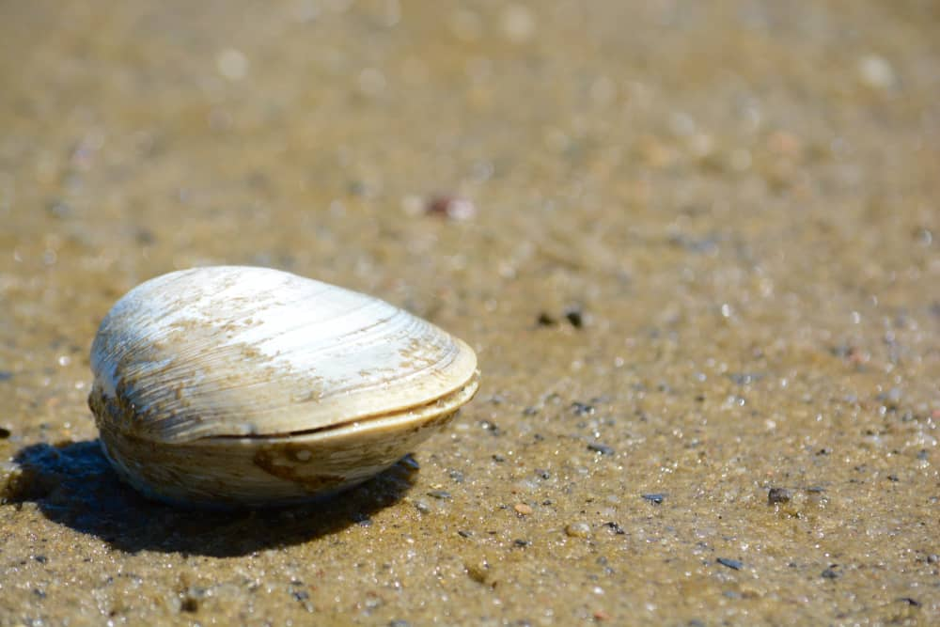
QUAHOGS ARE HARD-SHELL CLAM VARIATION THAT IS FOUND ON THE EASTERN SEABOARD. THEY RANGE FROM FLORIDA TO CANADA, MOST OFTEN IN RHODE ISLAND. THE CLAMS YOU FIND IN YOUR LOCAL GROCERY STORE ARE MOSTLY FARMED QUAHOGS.
WHEN QUAHOGS ARE FRESH, THEY HAVE SHELLS THAT ARE CLOSED TIGHTLY. THEY COME IN SHADES OF BROWN, CREAM, WHITE, AND GRAY. THEY HAVE RINGS ON THEIR SHELLS THAT RANGE IN COLORS FROM LIGHT SHADES OF BROWN TO DARKER BLACK AND GRAY. WHEN YOU DESCRIBE CLAMS BY SIZE, YOU ARE REFERRING TO THE WIDTH OF THE CLAM.

LITTLENECK
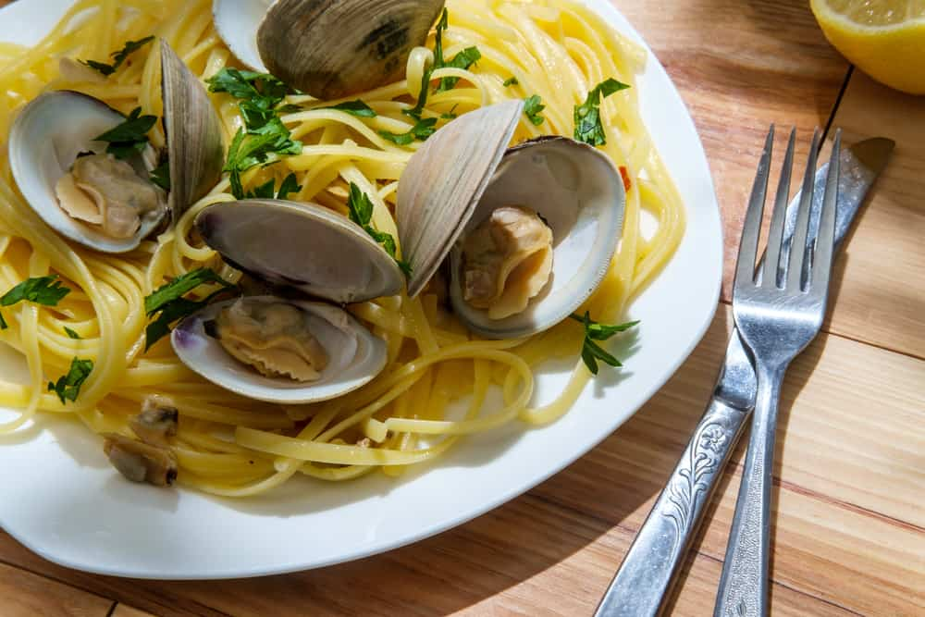
LITTLENECK CLAMS ARE THE SMALLEST OF THE QUAHOGS. A LITTLENECK CLAM IS THE IDEAL CLAM FOR CLAMS ON THE HALF SHELL, WHICH ARE USUALLY RAW. THESE CLAMS MEASURE A LITTLE MORE THAN ONE INCH ACROSS, WHICH IS MEASURED AT THE HINGE.

CHOWDER
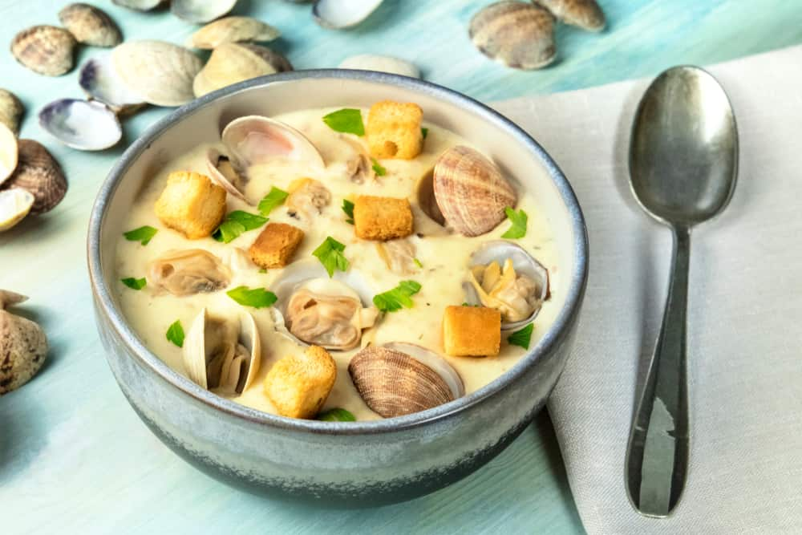
CHOWDER CLAMS ARE THE LARGEST QUAHOGS AND THE OLDEST WHEN THEY ARE HARVESTED. THESE LARGER CLAMS ARE BEST SERVED IN STEWS, SOUPS, AND CHOWDERS. A CHOWDER CLAM IS TENDER WHEN THEY ARE SLOW COOKED, MAKING THEM PERFECT FOR ANY RECIPE.

MIDDLENECKS
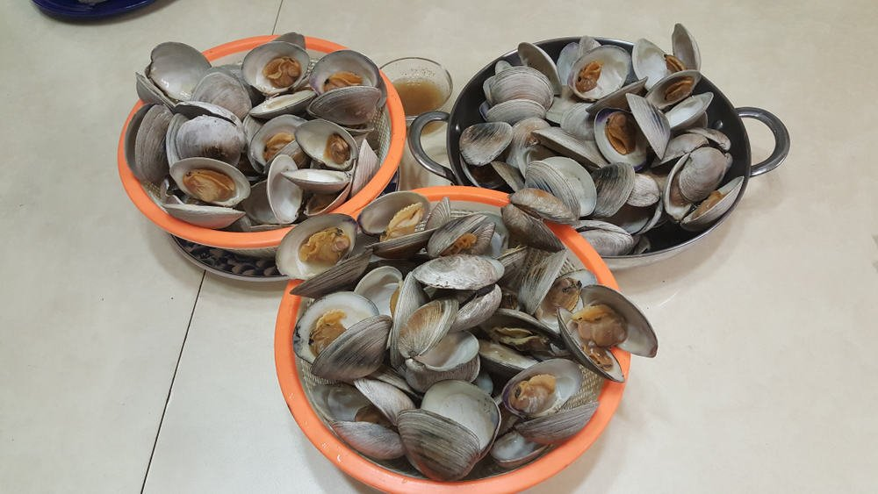
MIDDLENECKS ARE ALSO CALLED TOP NECK CLAMS. THEY MEASURE ROUGHLY ABOUT TWO INCHES. MIDDLENECKS ARE SLIGHTLY LARGER THAN LITTLENECK CLAMS. THEY REMAIN TENDER AND TASTY, NO MATTER IF THEY ARE RAW OR STEAMED. THEY ARE A DECENT ENOUGH SIZE TO EAT THEM GRILLED.
Bottom of Form

CHERRYSTONES
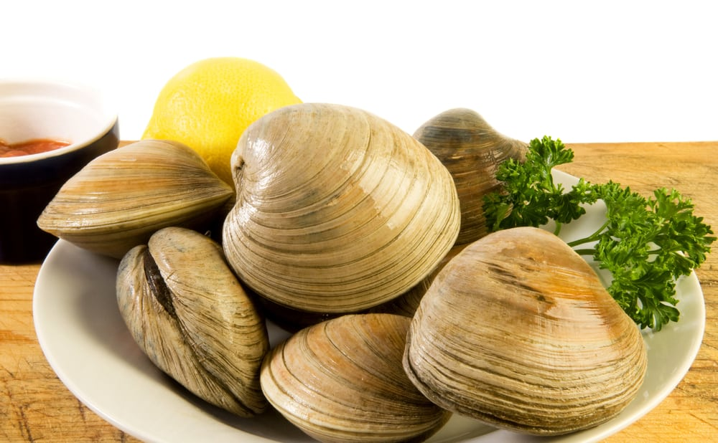
A CHERRYSTONE CLAM IS A POPULAR TYPE OF CLAM. THE CHERRYSTONES ARE A LITTLE BIGGER THAN MIDDLENECKS. THEREFORE, THEY ARE IDEAL FOR USE IN A PASTA SAUCE OR GRILLED. CHERRYSTONE CLAMS ARE ABOUT TWO AND A HALF INCHES IN SIZE.

MANILA
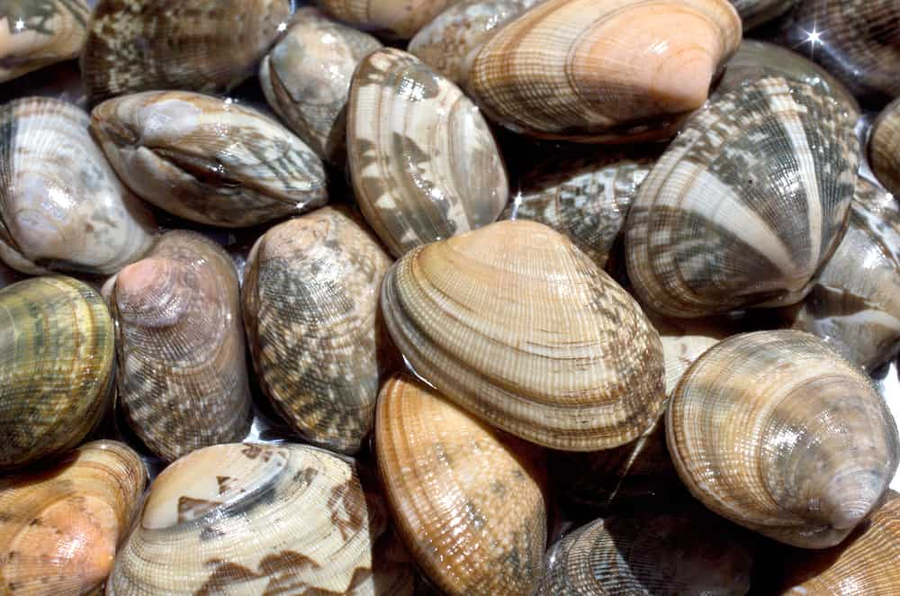
WHILE MANILA CLAMS ARE CONSIDERED A HARD-SHELL VARIETY, THEY HAVE THINNER SHELLS THAN A QUAHOG. A MANILA CLAM IS NATIVE TO THE PACIFIC OCEAN BUT FOUND ITS WAY TO THE NORTHWEST COASTAL REGION OF THE US. THEY LOOK SIMILAR TO LITTLENECK CLAMS BUT TEND TO BE MEATIER. IN ADDITION, THEY COOK IN HALF THE TIME BECAUSE OF THEIR THIN SHELLS.

MAHOGANY CLAM
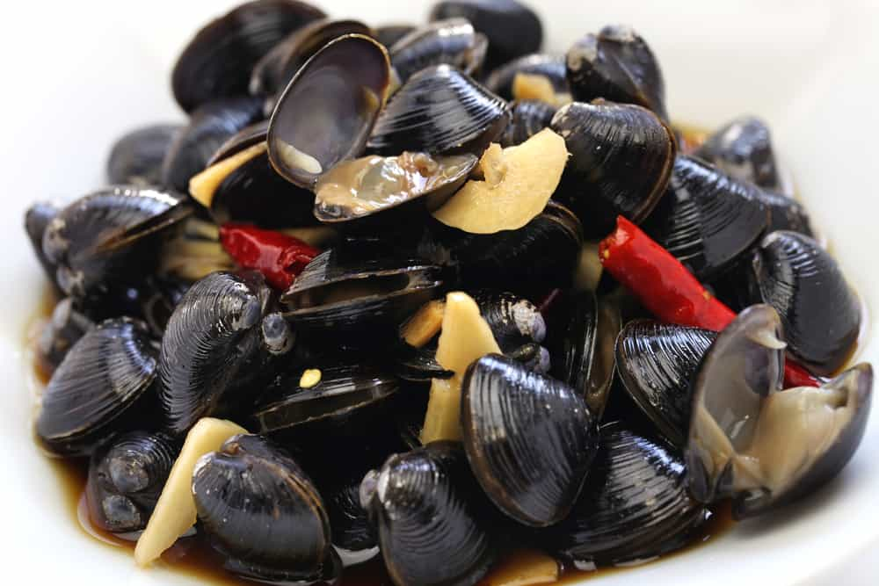
THE MAHOGANY CLAM IS ALSO REFERRED TO A SMALLER OCEAN QUAHOG. THEY ARE HARVESTED FROM THE COASTAL WATERS OF MAINE. THEY ARE THE OLDEST LIVING MARINE ORGANISM AS THEY CAN LIVE LONGER THAN 200 YEARS. THEY ARE A HARD-SHELL CLAIM THAT IS EASY TO FIND BECAUSE OF THEIR SHELL THAT IS A RED BROWN COLOR. THEY CAN GET LARGE, ANYWHERE FROM ONE AND A HALF INCHES TO THREE INCHES.

ATLANTIC SURF CLAM
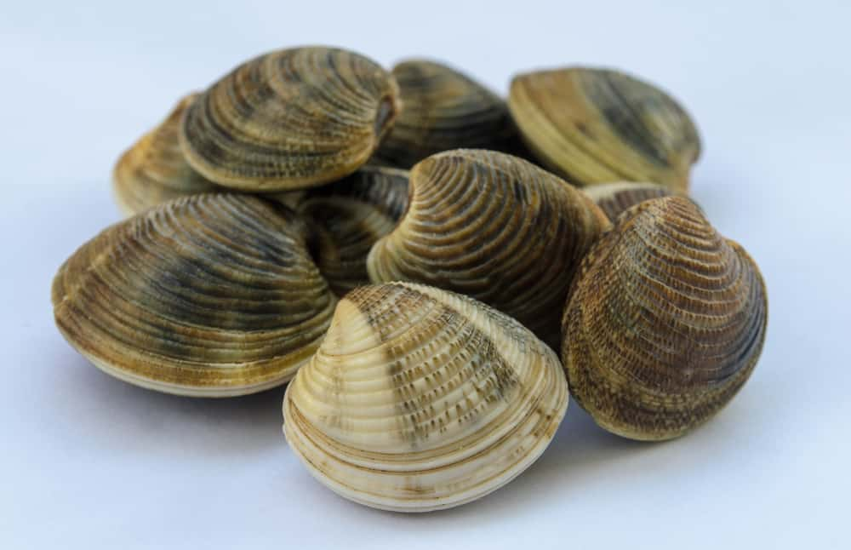
THE ATLANTIC SURF CLAM IS ALSO REFERRED TO AS A HEN CLAM. THE SHELLS ON THE SURF CLAM IS TRIANGULAR SHAPED AND PALE IN COLOR. THEY USUALLY ARE NOT SOLD IN THEIR SHELL. THEY ARE LARGE AND DIFFICULT TO OPEN, SO THEY ARE MOSTLY SOLD IN CANS OR IN FROZEN FORM.

SOFT SHELL CLAMS
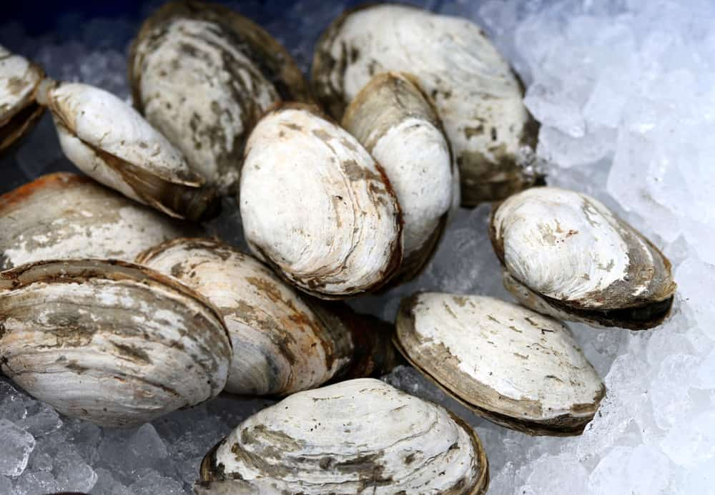
SOFT SHELL CLAMS ARE ALSO CALLED A STEAMER CLAM OR IPSWICH CLAMS. SOFT SHELL CLAMS HAVE OBLONG SHELLS THAT ARE LIGHT COLORED. THEIR SHELLS ARE BRITTLE AND MUST BE HANDLED CAREFULLY. THEY LEAVE SHELL CRUMBS IN THE MUD OF THE ATLANTIC OCEAN. THEY BURY THEMSELVES DEEPLY IN THE SEDIMENT, MUCH DEEPER THAN HARDSHELL CLAMS.
THE ACIDITY IN THE MUD CHANGES THE COLOR OF THE SHELL OF A SOFT SHELL CLAM. THE DARKER SHELLS INDICATE THE CLAMS HAVE MORE FLAVOR. IN ADDITION, THESE CLAMS HAVE LARGER SIPHONS. THESE SIPHONS PREVENT THE CLAMSHELL FROM CLOSING COMPLETELY, MAKING IT IMPORTANT TO REMOVE ALL GRIT BEFORE YOU COOK THEM.
A SOFT-SHELLED CLAM IS TYPICALLY HARVESTED WILD. THESE ARE BEST SERVED AS STEAMED CLAMS OR FRIED CLAMS. THE SHELLS OF A SOFTSHELL CLAM ARE NOT EDIBLE.

RAZOR CLAMS
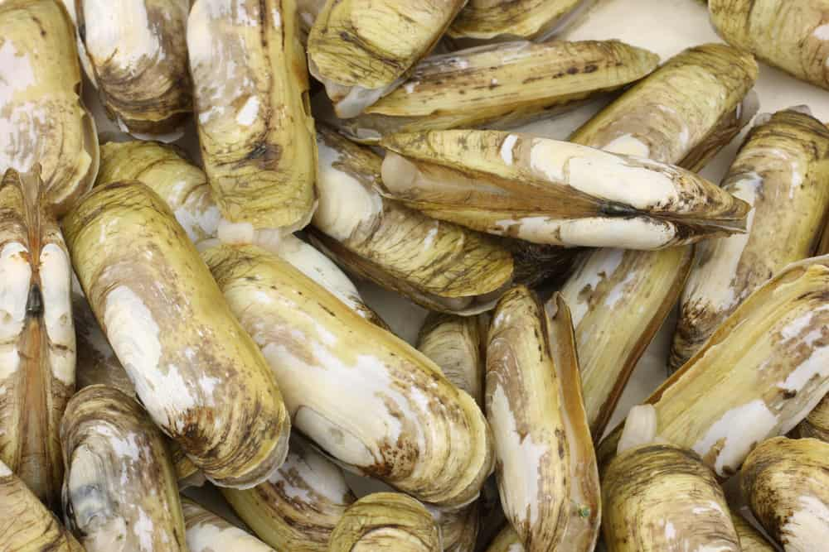
RAZOR CLAMS HAVE SHELLS THAT ARE THIN AND LONG. THEY BURROW THEMSELVES VERTICALLY IN THE SAND. THEREFORE, YOU MUST APPROPRIATELY CLEAN THEM, OR THEY WILL BE FULL OF GRIT AND SAND.

ATLANTIC RAZOR CLAMS

THE ATLANTIC RAZOR CLAMS ARE ALSO KNOWN AS AN ATLANTIC JACKKNIFE CLAM. THEY ARE A SOFT-SHELL VARIETY THAT IS THINNER AND LONGER THAN MANY OTHER VARIETIES. THE SHELLS LOOK LIKE A STRAIGHT EDGED RAZOR, HENCE THEIR NAME. THEY HAVE A SWEET AND DELICATE FLAVOR.
THE ATLANTIC RAZOR TASTES BEST WHEN IT IS SAUTÉED, STEAMED, OR GRILLED. IF YOU PAIR IT WITH A SAUCE THAT DOES NOT OVERPOWER ITS OWN FLAVOR.

PACIFIC RAZOR CLAMS
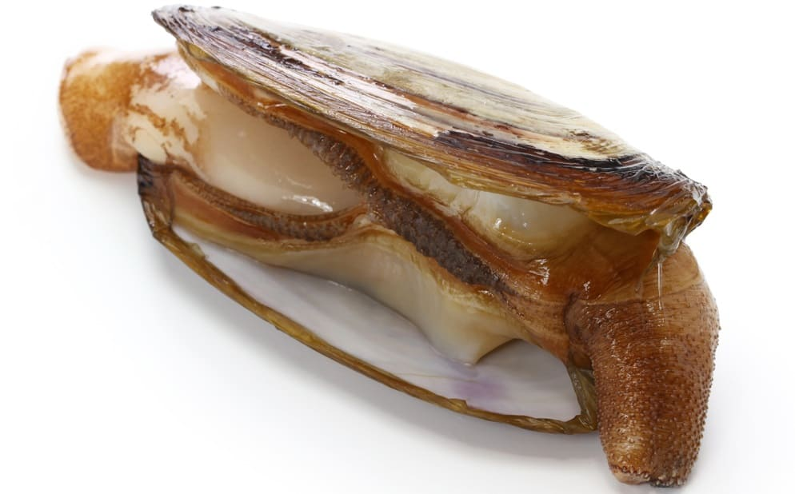
THE PACIFIC RAZOR CLAM IS WIDER AND MEATIER THAN THE ATLANTIC VARIETY. THEY HAVE A STRONG FLAVOR THAT TASTES CLAMMIER. THE PACIFIC RAZOR VARIETY TASTE BEST WHEN THEY ARE STEAMED, GRILLED, SAUTÉED, AND FRIED. THEY ALSO TASTE GREAT IN CHOWDER AND CEVICHE.

GEODUCK
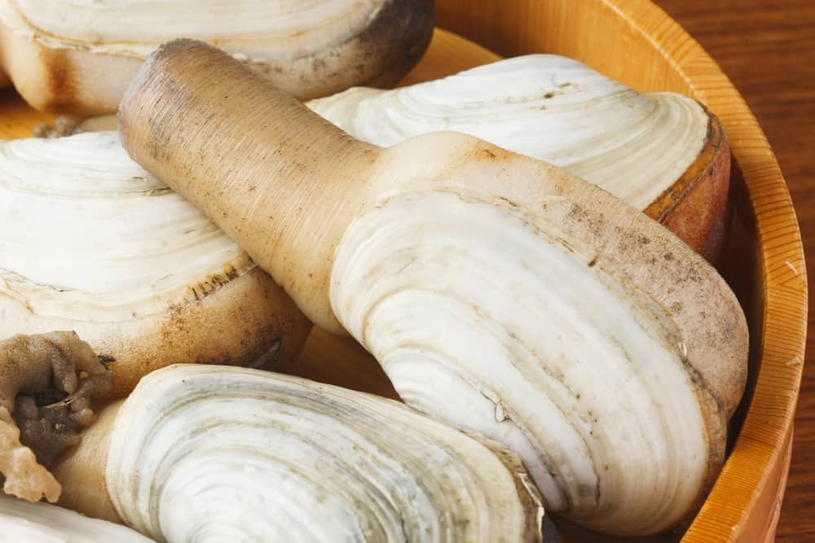
THE GEODUCK CLAM IS A LARGE SIZED CLAM THAT HAS A FUNNY NAME AND LOOKS EVEN FUNNIER. THEY ARE SO BIG, THEY LOOK STRANGE. THEY LIKE TO BURROW THEMSELVES IN THE TIDAL FLATS ALONG THE NORTHWEST COAST. THEY HAVE A GOOD AMOUNT OF FLAVOR AND A NICE TEXTURE. THE MEAT OFTEN HAS A CRUNCHY OR SALTY TASTE TO IT.
THEY ARE RUMORED TO HAVE AN APHRODISIAC QUALITY. THE GEODUCK CLAM TASTES GREAT IN SUSHI OR CEVICHE. THIS GIANT CLAM IS IDEAL FOR FRYING OR IN CHOWDER.

SURF CLAMS
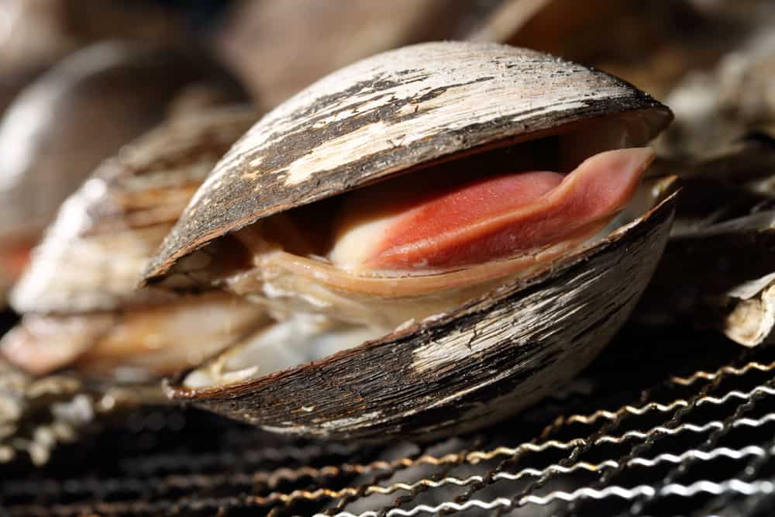
SURF CLAMS ARE ALSO REFERRED TO AS SKIMMERS OR BAR CLAMS. THESE TYPES OF CLAMS LIVE ALONG THE EASTERN SEABOARD OF THE US. THEY SHOW UP IN THE SURF ALONG THE ATLANTIC COAST. THEY TASTE GREAT WHEN THEY ARE FRIED INTO CLAM STRIPS. A SURF CLAM IS IDEAL FOR USE IN CHOWDER.

COCKLES
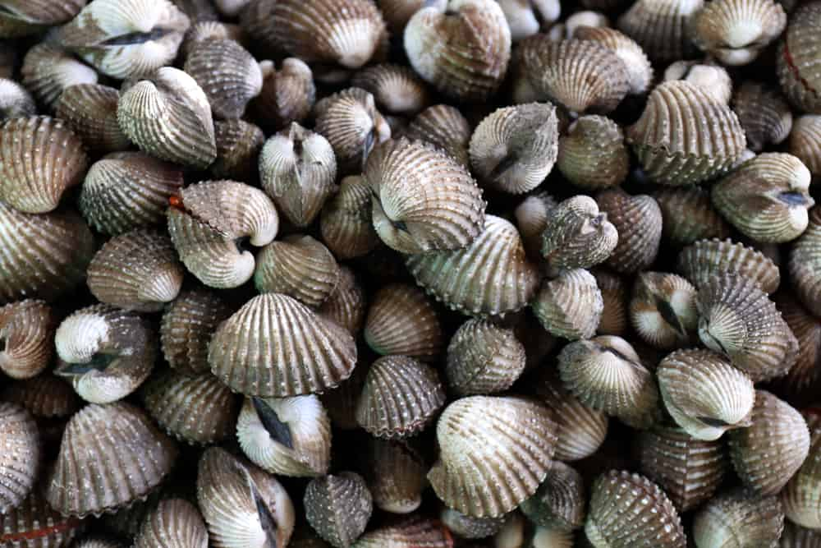
COCKLES ARE NOT QUITE CLAMS. THE ONLY DIFFERENCE BETWEEN A CLAM AND A COCKLE IS THE DIRECTION OF THE RIDGE THAT RUNS ALONG THE SHELL. THE RIDGES ON A CLAM RUN FROM SIDE TO SIDE. THE RIDGES ON A COCKLE RUN FROM THE EDGE TO THE HINGE. THESE ARE A BIT RARE TO FIND THEM COMMERCIALLY IN THE US.
THEY CAN BE FOUND ALONG THE WEST COAST, NEW ENGLAND, AND THE GULF OF MEXICO. DESPITE THIS, YOU ARE MORE LIKELY TO FIND THE COCKLES IN A CANNED THAT HAS BEEN IMPORTED FROM SPAIN OR NEW ZEALAND. COCKLES HAVE A DELICATE AND SWEET TASTE. THEY ARE BEST IN PASTA AND SAUCE.

FAQS

ARE THERE ANY CLAMS THAT ARE NOT EDIBLE?
JUST ABOUT ALL CLAMS ARE EDIBLE, HOWEVER, THERE ARE SOME CLAMS THAT YOU CANNOT EAT THE SHELL. EVEN THOUGH STEAMERS ARE CONSIDERED A SOFT-SHELL CLAM, YOU CANNOT EAT THE SHELL OF A STEAMER.

IS THERE A TIME WHEN YOU SHOULD NOT EAT CLAMS?
THERE IS A COMMON TALE THAT SAYS THAT WE SHOULD NOT EAT SHELLFISH DURING CERTAIN MONTHS. THIS TALE SAYS THAT YOU SHOULD ONLY EAT SHELLFISH IN THE MONTHS THAT HAVE THE LETTER R IN THEM. THIS MEANS THAT YOU CAN EAT CLAMS IN THE MONTHS OF SEPTEMBER THROUGH APRIL. ONCE IT IS MAY, YOU SHOULD NO LONGER EAT CLAMS. SHELLFISH INCLUDES CLAMS, OYSTERS, AND MUSSELS.

WHAT ARE THE BEST CLAMS TO PURCHASE?
THE BEST CLAMS TO BUY ARE CHOWDER CLAMS. THEY ARE NOT THE BEST TO EAT RAW, BUT BECOME SOFT IN A CHOWDER. THE NEXT BEST CLAM TO BUT IS A STEAMER CLAM. YOU SHOULD NOT EAT THEM RAW.

11 DIFFERENT TYPES OF OYSTERS
TYPICALLY REFERRED TO AS “SLIMY” AND “RAW” BY MOST, THERE IS SO MUCH THAT WE DON’T KNOW ABOUT OYSTERS; THEIR ORIGIN, FLAVOR, AND HEALTH BENEFITS! LEARN ALL ABOUT THE DIFFERENT TYPES OF OYSTERS THERE ARE AND THEIR UNIQUE CHARACTERISTICS.
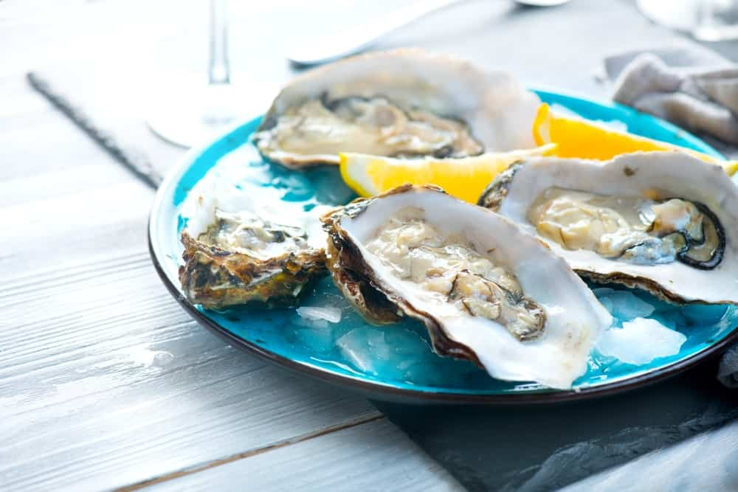
SOME PEOPLE ABSOLUTELY LOVE OYSTERS, AND SOME TRULY HATE THEM, THERE IS NO MIDDLE GROUND HERE, REALLY. A FAMOUS FRENCH POET AND ESSAYIST CALLED LÉON-PAUL FARGUE WHO WAS ALSO A TRUE OYSTER-LOVER ONCE SAID, “EATING AN OYSTER IS LIKE KISSING THE SEA ON THE LIPS”.
OYSTERS ARE ONE OF THE MOST COMMONLY FARMED SHELLFISH AND ARE ALSO KNOWN AS ‘OCEAN MOLLUSKS’ THAT ARE TYPICALLY FOUND IN BRACKISH OR MARINE HABITATS. THEY ARE MEMBERS OF THE OSTREIDAE FAMILY AND ARE COMMONLY FOUND IN SHALLOW WATERS AND A NUMBER OF OCEANS AROUND THE WORLD. DIFFERENT OYSTER VARIETIES AND SPECIES HAVE ORIGINATED FROM DIFFERENT PLACES FOR INSTANCE; THE PACIFIC OYSTER HAS COME FROM ASIA’S PACIFIC COAST.
FASCINATINGLY, OYSTERS AREN’T JUST ONE OF THE MOST FAVORED GOURMET DELICACIES ACROSS THE GLOBE BUT ARE ALSO REALLY GOOD FOR THE ENVIRONMENT. HOW CAN THAT BE? THAT IS PRIMARILY BECAUSE EACH OYSTER MANAGES TO FILTER ALMOST 50 GALLONS OF WATER DAILY. ONE CAN ONLY IMAGINE HOW MUCH WATER A WHOLE BED OF OYSTERS CLEANS EVERY SINGLE DAY!
DURING 1880 AND 1910, THE UNITED STATES BEGAN PRODUCING ABOUT 160 MILLION POUNDS OF OYSTERS EACH YEAR, WHICH WAS WAY MORE THAN THE NUMBER OF OYSTERS PRODUCED BY OTHER COUNTRIES ALTOGETHER. THE PRODUCTION AND CONSUMPTION OF OYSTERS ROSE TO SUCH GREAT HEIGHTS DURING THOSE YEARS THAT NEW YORKERS ENDED UP PAYING THEIR ‘PEARL STREET’ WITH HARD OYSTER SHELLS, AFTER WHICH SOME PEOPLE EVEN USED THEM IN THE FOUNDATIONS OF NUMEROUS BUILDINGS.
RELATED: CLAMS VS. OYSTERS | CLAM ALTERNATIVES | TOOLS FOR EATING SEAFOOD | HOW TO STORE CLAMS | HOW TO CLEAN CLAMS

BENEFITS OF OYSTERS
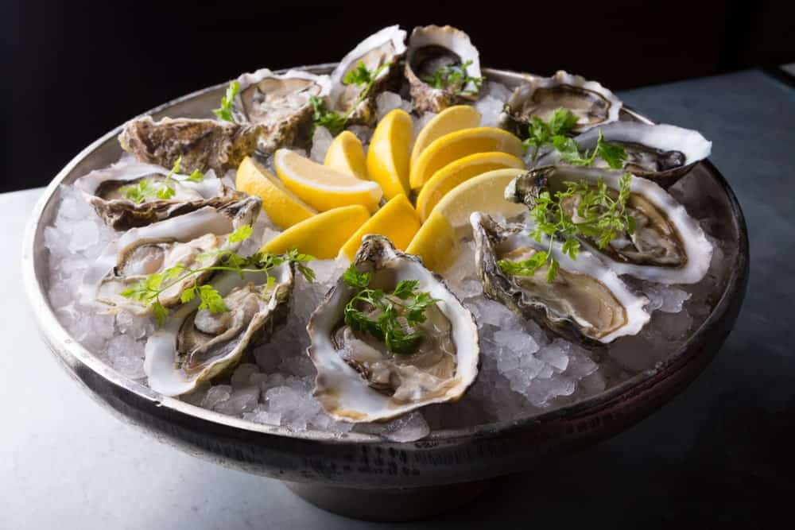
Bottom of Form
AS UNAPPETIZING AS OYSTERS MAY SEEM TO A NUMBER OF PEOPLE, THEY ARE ACTUALLY PACKED WITH A MULTITUDE OF HEALTH BENEFITS, SUCH AS:
- PROTECT HEART HEALTH BY REDUCING LEVELS OF BAD CHOLESTEROL IN THE BLOOD.
- SPEED UP THE HEALING PROCESSES IN THE BODY BY BOOSTING THE IMMUNE SYSTEM AGAINST MICROBES AND INFECTIONS.
- ARE A RICH SOURCE OF PROTEIN THAT HELPS IN TISSUE REPAIR AND MUSCLE GROWTH.
- PROMOTE HEALTHY BONES AND INCREASE BONE MINERAL DENSITY AND DURABILITY.
- BOOST THE BODY’S IMMUNE SYSTEM AND DEFEND IT AGAINST FREE RADICALS.
- INCREASE THE BLOOD CIRCULATION IN THE BODY BY FORMING RED BLOOD CELLS AND PREVENTING AGAINST ANEMIA, OR IRON DEFICIENCY.
[SOURCE: HTTPS://WWW.ORGANICFACTS.NET/]

OYSTER NUTRITIONAL FACT CHART
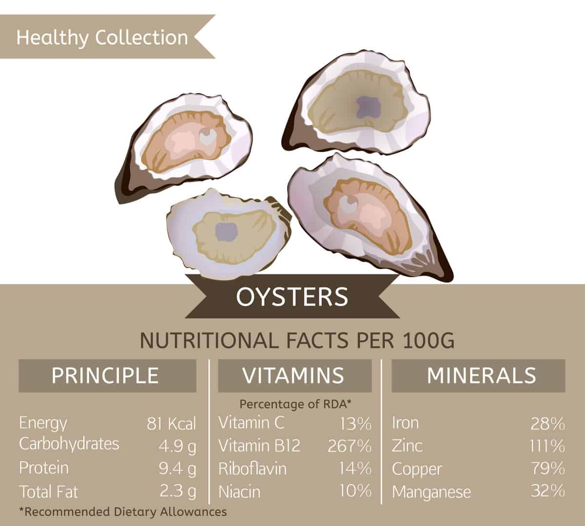

TYPES OF OYSTERS
THERE ARE SEVERAL SPECIES OF OYSTERS, SOME OF WHICH ARE FURTHER BROKEN DOWN INTO MULTIPLE VARIETIES.
THE FOLLOWING ARE SOME OF THE MOST COMMON AND POPULARLY CONSUMED OYSTER VARIETIES, EACH WITH THEIR UNIQUE AND DISTINCT CHARACTERISTICS, FEATURES AND FLAVORS.

CRASSOSTREA GIGAS — PACIFIC OYSTERS
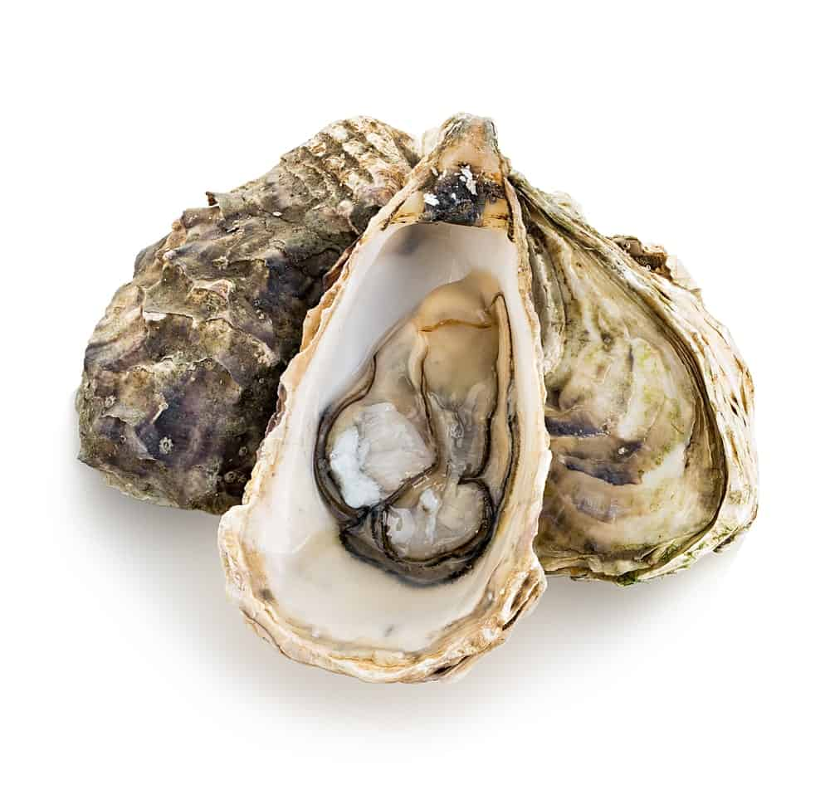
THIS VARIETY OF OYSTERS ARE KNOWN BY INDIVIDUAL NAMES INCLUDING MIYAGI OYSTER OR JAPANESE OYSTER. THEY ARE BELIEVED TO BE THE MOST COSMOPOLITAN TYPE OF ALL OYSTER SPECIES, PROBABLY DUE TO THE FACT THAT PACIFIC OYSTERS WERE INITIALLY INTRODUCED TO A VARIETY OF COUNTRIES FOR AQUACULTURE PURPOSES, AFTER WHICH THEY WENT ON TO TAKE OVER THE SHELLFISH AQUACULTURE PRODUCTION GLOBALLY.
THESE OYSTERS ARE POPULARLY CULTIVATED ON THE UNITED STATES’ PACIFIC COAST; HOWEVER, THEY ARE NOT EXACTLY NATIVE TO THAT REGION. THEY ARE ACTUALLY NATIVE TO THE PACIFIC COAST OF ASIA. THEY ARE SIGNIFICANTLY GROWING IN POPULARITY IN THE WEST COAST AS WELL AS EUROPE AND HAVE LATELY ALSO BEEN INTRODUCED TO NEW ZEALAND, NORTH AMERICA, EUROPE, AND AUSTRALIA.
PACIFIC OYSTERS ARE MAINLY FOUND ON DENSE MATS ON ROCKS AND SOMETIMES ON SOFT SUBSTRATES IN SUB-TIDAL ZONES. ONE CAN EASILY IDENTIFY THEM BY THEIR BEAUTIFUL GREY-BLUE SHELL THAT COMES WITH HIGHLY FLUTED EDGES. THE INTERIOR OF THE SHELL, HOWEVER, IS ALL WHITE COUPLED WITH A DEEP PURPLE MUSCLE SCAR.
THESE OYSTERS ARE KNOWN TO GROW REALLY FAST, AND THEY TYPICALLY GROW TO AN AVERAGE OF 10-15 CM WITHIN A SPAN OF 2-4 YEARS. DIFFERENT VARIETIES THAT FALL UNDER THIS OYSTER SPECIES CONTAIN A WIDE SPECTRUM OF FLAVORS AND AROMAS, HOWEVER, THEY GENERALLY TEND TO BE A LITTLE TOWARDS THE SWEETER SIDE AND ARE LESS SALTY THAN THE ATLANTIC OYSTERS. YOU COULD DESCRIBE THEIR FLAVOR AS A MIXTURE OF CREAMY, SALTY, MELON-LIKE AND VEGETAL.

CRASSOSTREA SIKAMEA — KUMAMOTO OYSTERS
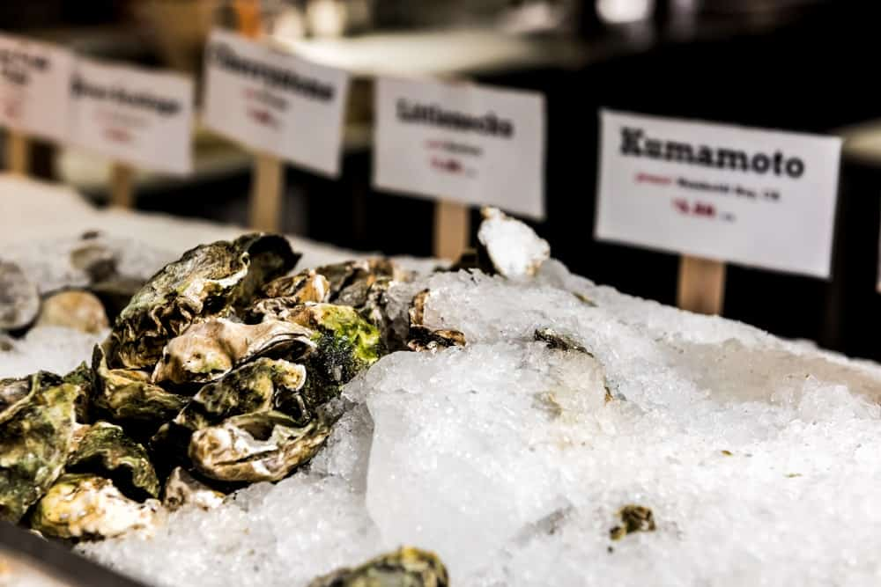
PREVIOUSLY CONSIDERED AS A SUB-SPECIES OF THE PACIFIC OYSTERS, THE KUMAMOTO OYSTERS HAVE BEEN NAMED AFTER THEIR PLACE OF ORIGIN WHICH LIES IN JAPAN, AND THEN EXTENDED ALL THE WAY THROUGH SOUTHERN CHINA, TAIWAN, AND KOREA. THESE NATIVE JAPANESE OYSTERS ARE NOW POPULARLY GROWN IN THE PACIFIC NORTHWEST AND ALSO THE WEST COAST OF NORTH AMERICA.
KUMAMOTO OYSTERS ARE QUITE SIMILAR TO OTHER VARIETIES OF OYSTERS IN TERMS OF THEIR IRREGULAR SHAPE AND UNEQUAL VALVES. THEY ARE ALSO COMPARATIVELY VERY SMALL IN SIZE AND MANAGE TO REACH A MAXIMUM SIZE OF ONLY 60MM. THEY SPORT ROUND AND SMALL GREEN-COLORED TUMBLED SHELLS, AND THEY HAVE CREAMY MEATS, COUPLED WITH A MILD BRINY FLAVOR AND A HONEYDEW-LIKE FINISH.
THESE OYSTERS ARE OFTEN REFERRED TO AS THE “CHARDONNAY OF OYSTERS” BY MANY CONNOISSEURS, MAINLY DUE TO THEIR BRINY, FRUITY FLAVOR AND THEIR HIGHLY SCULPTURED AND FLUTED CELLS THAT COME WITH DEEP CUPS. THEY ARE ALSO NICKNAMED AS ‘KUMIES’ BY MOST PEOPLE, A NAME GIVEN TO THESE OYSTERS OUT OF DEEP LOVE BY OYSTER-LOVERS.
KUMAMOTO OYSTERS DO NOT APPARENTLY THRIVE WELL IN THE COLD WATERS OF THE PACIFIC NORTHWEST, PRIMARILY DUE TO THE FACT THAT THEY ARE QUITE USED TO THE WARM WATERS OF THEIR NATIVE ORIGINS IN JAPAN.

OSTREA EDULIS — BELON OYSTERS
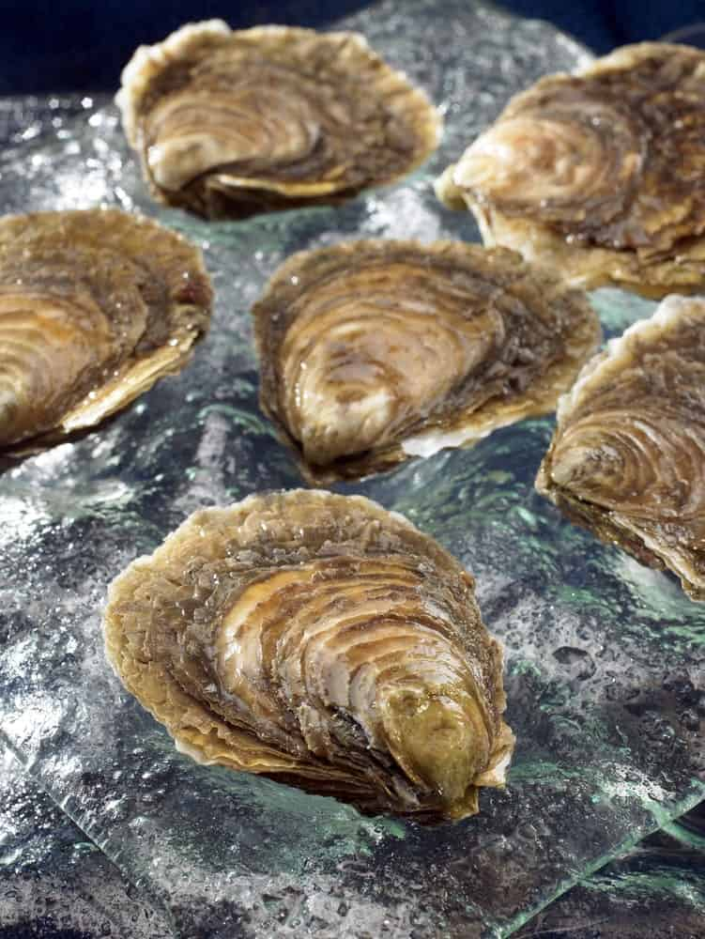
MORE COMMONLY KNOWN AS THE “EUROPEAN FLAT OYSTERS”, BELON OYSTERS HAVE ORIGINATED FROM EUROPE AND TRUE “BELONGS” ARE BELIEVED TO COME FROM THE BELON RIVER ESTUARY LOCATED IN BRITTANY. THESE OYSTERS SEEM TO HAVE QUITE AN INTERESTING HISTORY BEHIND THEIR ORIGIN.
APPARENTLY, SOME SCIENTISTS TRANSPLANTED A BELON OYSTER SEED FROM THE NETHERLANDS TO MAINE SOMETIME DURING THE 1950S. THEY DID THIS BECAUSE THEY WANTED TO CULTIVATE THIS SPECIES IN NORTH AMERICA. HOWEVER, THEY ENDED UP GIVING UP AND ENDING THEIR SHORT-LIVED EFFORTS BECAUSE THEY DIDN’T SEE ANY SUBSTANTIAL RESULTS. BUT, AFTER TEN YEARS, THESE PARTICULAR OYSTERS BEGAN TO GROW RAPIDLY ALONG THE MAINE COAST IN A VARIETY OF THE RIVER BEDS. THEIR NUMBERS SIGNIFICANTLY GREW DURING THE 1980S AFTER WHICH BELON OYSTERS GREATLY BEGAN TO BE FOUND ALONG THE MAINE COAST’S RIVERS, AS WELL AS THE DAMARISCOTTA RIVER.
UNLIKE MOST OF THEIR COUSIN OYSTERS, THE BELONS OR EUROPEAN FLAT OYSTERS HAVE REALLY FLAT SHELLS, ROUND SHAPES, AND LESS DEFINED CUPS. THEY HAVE BEEN NICKNAMED AS “PLATES” BY MOST PEOPLE BECAUSE THEY ACTUALLY LOOK LIKE SMALL SAUCERS. THEIR MEAT IS LIGHT BROWN AND CREAMY WITH A VERY WELL-DEFINED AND WELL-PRONOUNCED METALLIC FLAVOR, FOLLOWED BY A KIND OF A ‘COPPERY’ FINISH. UNLIKE THE EASTERN OYSTER, THEY ARE LESS BRINY AND HAVE SWEET OVERTONES.
INTERESTINGLY, THE COLOR OF THESE OYSTERS CHANGES TO IVORY ONCE THEY ARE COOKED. ALSO, SINCE THEY HAVE A VERY FLAT SURFACE, THEY HAVE TO BE STORED AND PACKED IN A CUP-DOWN MANNER IN ORDER TO RETAIN THEIR LIQUOR.

OSTREA LURIDA/CONCHAPILA — OLYMPIA OYSTERS
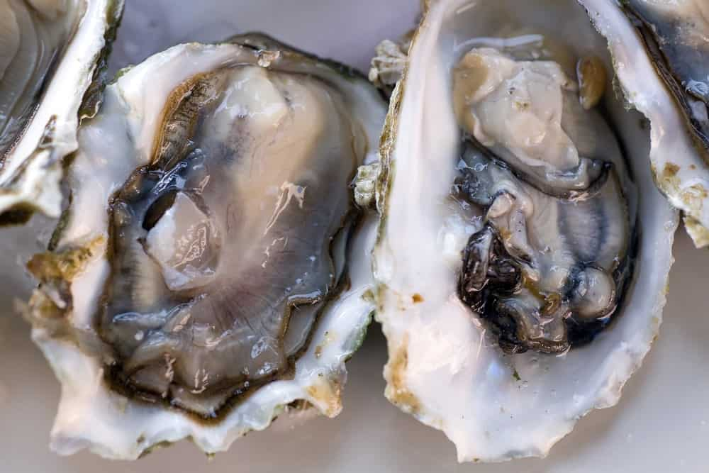
AS THE NAME SUGGESTS, THE OLYMPIA OYSTERS HAVE BEEN NAMED AFTER OLYMPIA, WASHINGTON AND HAVE ORIGINATED FROM THE NORTHERN PACIFIC COAST OF NORTH AMERICA. THEY ALSO INHABIT THE WEST COAST OF CANADA AND ARE BELIEVED TO BE THE ONLY NATIVE OYSTER SPECIES FOUND THERE.
THE OLYMPIA OYSTERS ARE COMMONLY ALSO KNOWN AS NATIVE OYSTER, CALIFORNIA OYSTER, AND ROCK OYSTER, AND THEY HOLD A GREAT HISTORICAL SIGNIFICANCE. THESE OYSTERS ARE POPULARLY USED AS COCKTAIL OYSTERS ALL AROUND THE WORLD.
INTERESTINGLY, OSTREA LURIDA IS QUITE SIMILAR TO ANOTHER OYSTER SPECIES CALLED OSTREA CONCHAPILA. THEY WERE CONSIDERED TWO ENTIRELY DISTINCT AND SEPARATE SPECIES; HOWEVER, DURING THE PERIOD OF 1985, A MAN NAMED HARRY NOTICED VERY SIMILAR ANATOMICAL CHARACTERISTICS BETWEEN THE TWO SPECIES AND FURTHER PROPOSED A SYNONYMY BETWEEN THEM. OTHER RESEARCHERS CARRIED OUT FURTHER ANALYSIS ON THIS PROPOSITION AND COMPARED THEIR DNA SEQUENCES, ONLY TO CONCLUDE THAT THESE TWO SPECIES INDEED ARE SEPARATE FROM ONE ANOTHER.
THE SHELL OF THESE OYSTERS CAN VARY IN SHAPE AND ARE TYPICALLY FOUND TO BE ELONGATED OR ROUNDED. THE SHELL COLOR OFTEN RANGES FROM PURPLISH BLACK TO WHITE WITH BROWN OR YELLOW STRIPES SOMETIMES. THE FLESH USUALLY SPORTS A PRETTY WHITE OR LIGHT OLIVE-GREEN COLOR.
ALTHOUGH THESE OYSTERS BELONG TO THE SAME FAMILY THAT THE EUROPEAN FLATS DO, THEY ARE STILL THE SMALLEST OF ALL THE SPECIES, AND THEIR AVERAGE DIAMETER RANGES SOMEWHERE BETWEEN THE SIZE OF A QUARTER AND A NICKEL. DESPITE OF THEIR SMALL SIZE THOUGH, THEY ARE STILL POPULARLY CONSUMED BECAUSE OF THEIR CREAMY TEXTURES WITH A POTENT FLAVOR OF COPPER AND SWEET CELERY, FINISHED OFF BY A LONG-LASTING METALLIC TASTE.

SACCOSTREA GLOMERATA — SYDNEY ROCK OYSTERS
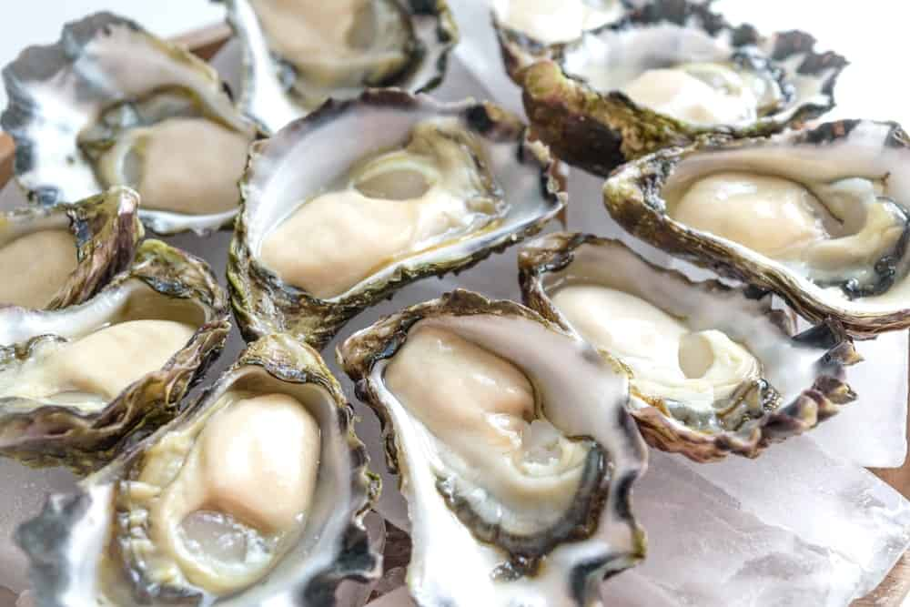
THESE SPECIES ARE ALSO KNOWN AS “AUCKLAND OYSTERS” AND “NEW ZEALAND OYSTERS” WHICH CLEARLY SHOWS THAT THEY ARE NATIVE TO NEW ZEALAND AND AUSTRALIA. SOME OF THEIR HABITATS INCLUDE SHELTERED BAYS AND ESTUARIES RANGING FROM WINGAN INLET IN VICTORIA TO THE HARVEY BAY IN QUEENSLAND.
SYDNEY ROCK OYSTERS TYPICALLY HAVE A LIFESPAN OF UP TO 10 YEARS, AND THEY MANAGE TO WEIGH AROUND 60 KG OVER A PERIOD OF 3 YEARS. SOME OF THEIR OTHER COMMON NAMES INCLUDE “ROCK OYSTER” AND “WESTERN ROCK OYSTER”.
THEY ARE GENERALLY SMALLER THAN OTHER VARIETIES OF OYSTERS AND GROW TO AN AVERAGE OF 6-8 CM SHELL LENGTH. THEY ARE MAINLY DISTINGUISHED BY THEIR SHELL THAT IS RELATIVELY FLATTERING AND CONTAINS A FLINTY, LESS SALTY FLAVOR. THESE OYSTERS ARE NORMALLY AVAILABLE YEAR-ROUND; HOWEVER, THEIR PEAK SEASON GOES ON DURING THE PERIOD OF SEPTEMBER TO MARCH.
THE SHELL OF THESE OYSTERS IS KNOWN TO BE THICK AND SMOOTH, COUPLED WITH TINY TEETH THAT ARE LINED ON THE INTERNAL RIM OF THE SHELL. UNLIKE MANY OTHER OYSTER SPECIES, THESE HAVE A VERY PALE COLORED MUSCLE SCAR. THEY ALSO RESEMBLE THE KUMAMOTO OYSTERS, IN TERMS OF THEIR DEEP CUPS AND THE MILD-SWEET FLAVOR. THEY ARE BEST EATEN WHEN THEY ARE FRESHLY SHUCKED, HOWEVER, CAN LIVE UP TO 14 DAYS EVEN AFTER, GIVEN THAT THEY PROVIDED WITH THE APPROPRIATE TEMPERATURES AND ARE HANDLED WITH CARE.

CRASSOSTREA VIRGINICA — EASTERN OYSTERS
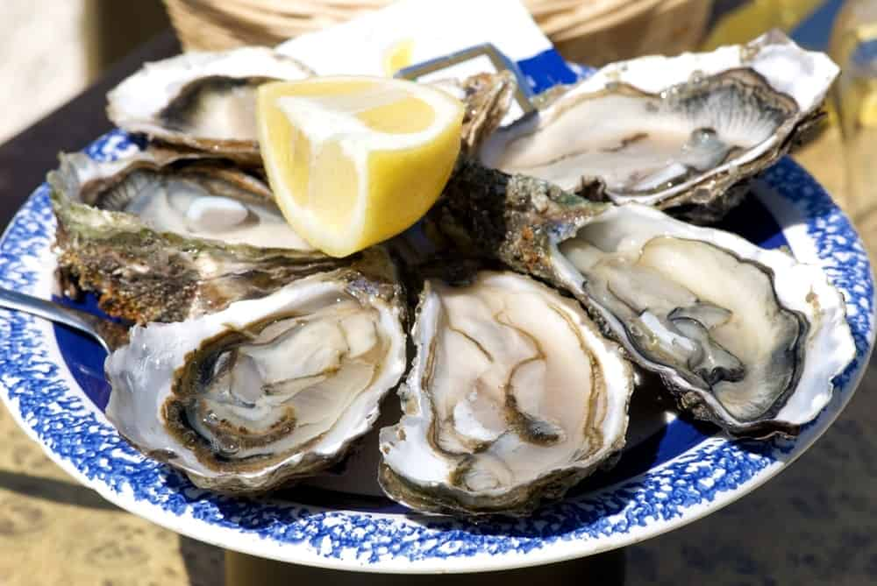
THESE OYSTERS ARE ALSO CALLED “ATLANTIC OYSTERS” AND THEY HAIL THE TITLE OF ‘THE AMERICAN OYSTER’ PRIMARILY BECAUSE THEY ARE FOUND IN GREAT ABUNDANCE ALONG THE NORTH AMERICAN ATLANTIC COAST. THEY ARE ALSO ONE OF THE VERY FEW INDIGENOUS OYSTERS FOUND IN NORTH AMERICA. ABOUT 85 PERCENT OF THEM ARE HARVESTED IN THE UNITED STATES, WHERE MOST VARIETIES SEEM TO COME FROM THE GULF OF MEXICO.
SOME OF THEIR OTHER COMMON NAMES INCLUDE WELLFLEET OYSTER AND VIRGINIA OYSTER. THESE EASTERN OYSTERS HAVE BEEN VERY POPULAR COMMERCIALLY AND STILL SEEM TO HOLD THAT VERY REPUTATION. INTERESTINGLY, THIS OYSTER IS THE ‘STATE SHELLFISH’ OF CONNECTICUT, AND THE SHELL OF THIS OYSTER IS CONSIDERED TO BE THE ‘STATE SHELL’ OF MISSISSIPPI AND VIRGINIA.
SIMILAR TO ALL OTHER OYSTERS, THE EASTERN OYSTERS CONSISTS OF A HARD CALCIUM-CARBONACEOUS SHELL THAT OFFERS IT PROTECTION AGAINST PREDATORS. THEY ARE GENERALLY VERY LARGE IN SIZE AND CONTAIN A SLIGHTLY BRINY AND METALLIC KIND OF A FLAVOR. THEY ALSO DO HAVE A SAVORY FINISH AND A CRISP TEXTURE, WHICH HAS HELPED THEM GAIN QUITE A FOLLOWING IN THE CULINARY MARKET.
THESE OYSTERS PLAY A VERY IMPORTANT ROLE IN THEIR ECOSYSTEM AND ADD A GREAT STRUCTURAL ELEMENT TO IT. THIS IS BECAUSE THEY ARE MORE OF A ‘FOUNDATION SPECIES’ SINCE THEY PLAY THE ROLE OF AN ‘ECOSYSTEM ENGINEER’ PARTICULARLY IN WEST ATLANTIC ESTUARIES.
THEY GROW UP TO 10 CENTIMETERS IN LENGTH AND HAVE A PEAR-SHAPED OUTLINE. HOWEVER, THE MEMBERS WITHIN THIS SPECIES ARE FOUND IN A GREAT MANY SIZES AND SHAPES. THE SHELL OF THESE OYSTERS TYPICALLY CONSISTS OF A DIRTY GRAY EXTERIOR, A WHITE INTERIOR, AND A DEEP PURPLE-COLORED MUSCLE SCAR. SOME OTHER VARIETIES MAY EVEN SPORT A MIXTURE OF BROWN, FOREST GREEN AND CREAM COLORS.
EASTERN OYSTERS ARE SIGNIFICANTLY AFFECTED BY VARYING WATER TEMPERATURES, SO IN RELATIVELY WARM WATERS, FOR EXAMPLE, THESE OYSTERS CAN REACH THE MARKET SIZE IN A PERIOD OF 18 MONTHS, BUT IN FRIGID WATERS, THEY MAY TAKE ALMOST 4 YEARS TO GROW.

OTHER VARIETIES
THE ATLANTIC OYSTER SPECIES FURTHER INCLUDES A GREAT MANY OTHER VARIETIES OF OYSTERS, MOST OF WHICH ARE TYPICALLY FOUND IN CANADA AND THE UNITED STATES. SOME OF THE MOST COMMON AND POPULAR VARIETIES ARE LISTED BELOW.

BLUE POINT OYSTERS
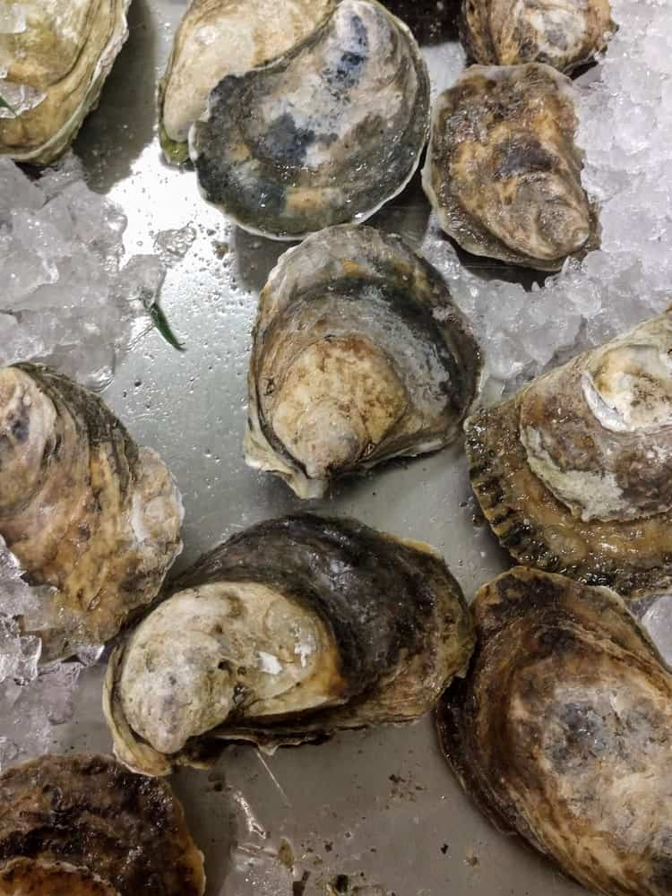
THESE OYSTERS HAVE BEEN SO NAMED AFTER THE TOWN BLUE POINT IN LONG ISLAND AND ARE COMMONLY FOUND ON THE EAST COAST SIDE. SINCE THEY ARE HARVESTED FROM MULTIPLE LOCATIONS INCLUDING THE NEW YORK AND CONNECTICUT OYSTER REGIONS, THEIR FLAVOR IS ALL OVER THE PLACE, AND THE BRININESS HAS QUITE DIFFERENT RANGES.
BLUE POINT OYSTERS WERE PARTICULARLY FAMOUS BACK IN THE 1800S BECAUSE OF THEIR WILD AND ROBUST FLAVOR, EVENTUALLY BECOMING A FAVORITE OF QUEEN VICTORIA.
THEY HAVE A MEDIUM SIZE AND CONSIST OF A MILD, MEATY AND SALTY FLAVOR. THEIR TEXTURE IS VERY CRISP, FIRM AND FRESH WHICH LEAVES A SALTY-SWEET AFTERTASTE.

BEAUSOLEIL OYSTERS
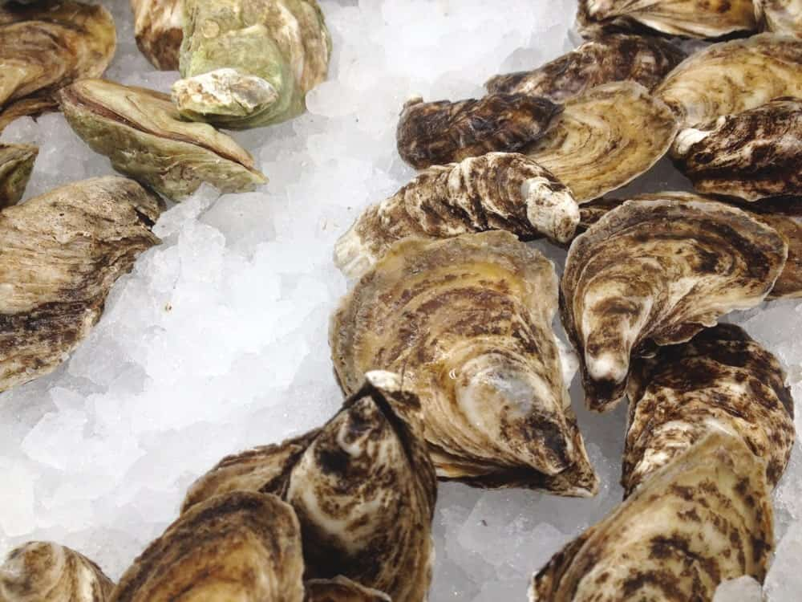
THIS ATLANTIC OYSTER HAS COME FROM AN OYSTER APPELLATION IN CANADA, AND THE NAME ‘BEAUSOLEIL’ TRANSLATES TO “BEAUTIFUL SUN” IN ENGLISH. THEY GROW TO AN AVERAGE SIZE OF 2 1/2 “AND CONSIST OF A VERY DELICATE FLAVOR PROFILE THAT IS COUPLED WITH A SWEET FINISH AND MILD SALTINESS.
AN INTERESTING FEATURE ABOUT THESE OYSTERS IS THAT THEY ARE FARMED THROUGH THE TRAY SUSPENSION METHOD IN WHICH THE WAVES AND TIDES CAUSE THEM TO RUSTLE AGAINST EACH OTHER. THIS CONSTANT RUSTLING ACT IS WHAT TO THE CREATION OF THEIR HARD AND PETITE SHELLS THAT HAVE A CONSISTENT SHAPE WITH DEEP CUPS.

MISTY POINT OYSTERS
THESE HARD-SHELLED OYSTERS ARE AVAILABLE YEAR-ROUND AND ARE GENERALLY RAISED ON THE ISLANDS LOCATED AT THE SOUTHERN TIP OF THE EASTERN SHORE OF VIRGINIA. THEY GROW TO AN AVERAGE SIZE OF UP TO 3” AND ARE TYPICALLY CULTIVATED USING THE RACK AND BAG CULTIVATION PROCESS.
THIS PARTICULAR TYPE OF OYSTER CULTIVATION PUTS THE MISTY POINT OYSTERS THROUGH A TUMBLING PROCESS THAT HELPS HARDEN THEIR SHELLS, GIVE THEM A PROPER, CONSISTENT SHAPE, ALONG WITH DEEP AND PROMINENT CUPS.
THEY CONTAIN FIRM MEATS THAT ARE SET DEEP INTO THEIR CUPS, COUPLED WITH A SIMPLE FLAVOR THAT HAS TRACES OF VERY OBVIOUS SALINITY AND HINTS OF FRESH LETTUCE AND CELERY.

WELL FLEET OYSTERS
HAVING ORIGINATED FROM THE EAST COAST, THESE WELL FLEET OYSTERS THRIVE IN THE RICH AND COLD WATERS PROVIDED BY NORTHERN MAINE AND THE CANADIAN MARITIME PROVINCES. THE COLD WATER HELPS THESE OYSTERS RESERVE THEIR MEATY, SWEET FLAVOR BY BUILDING UP GLYCOGEN RESERVES THAT FURTHER SLOW THEIR METABOLISM PROCESS.
WELL, FLEET OYSTERS ARE QUITE POPULAR FOR THEIR PLUMP MEATS WITH A FIRM TEXTURE, AND A CRISP, MILD FLAVOR THAT IS HIGH IN ITS LEVEL OF BRININESS. THESE ARE TYPICALLY BEACH OR BOTTOM CULTURED SPECIES OF OYSTERS AND GROW TO AN AVERAGE HEIGHT OF 3 ½”.
ARE YOU TEMPTED TO TRY THESE DELICIOUS OYSTERS YET? IF NOT, PERHAPS, YOU MUST KNOW THAT OYSTERS COME IN SUCH A HUGE VARIETY OF FLAVORS THAT THEY ARE OFTEN COMPARED TO FLAVORS OF WINE!

16 DIFFERENT TYPES OF FIGS
FIGS ARE WELL KNOWN IN THE WORLD AND ARE ONE OF THE EARLIEST FRUIT TO BE CULTIVATED. IT ALSO PLAYS A PART IN SOME RELIGIONS. THERE ARE VARIETIES OF FIGS, CHECK THIS ARTICLE.
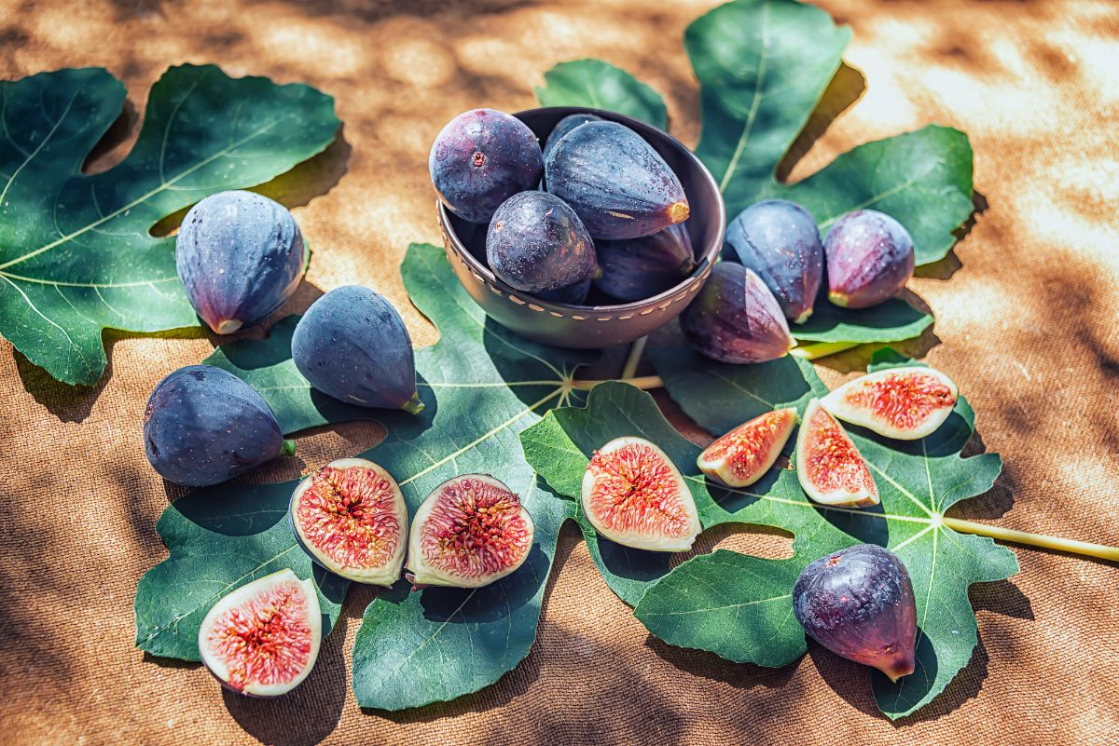
FIGS ARE CLASSIFIED AS ONE OF THE MOST DIVERSIFIED FRUITS IN THE WORLD AND AMONG THE EARLIEST FRUITS TO BE CULTIVATED. THE FRUIT HAS A COMPLEX AND SYMBOLIC HISTORY THAT HAS A PLACE IN MANY RELIGIONS, SUCH AS CHRISTIANITY, ISLAM, BUDDHISM, AND JUDAISM. IT IS ALSO A NUTRITIOUS FRUIT THAT IS PACKED WITH VITAMINS, PHYTOCHEMICALS, FIBER AND HAS NO FAT AT ALL.
NUMEROUS VARIETIES OF FIGS EXIST, AND THEY ARE DIFFERENTIATED BY COLOR, SIZE, AND SHAPE. ACCORDING TO A RECENT STUDY, THERE ARE OVER 600 VARIETIES OF FIG VARIETIES THAT HAVE REMARKABLE GENETIC DIVERSITY. IN THIS ARTICLE, WE WILL DISCUSS THE TYPES OF FIGS, THEIR FRUIT SHAPES, THEIR TASTE, AND SOME OF THE COMMONLY ASKED QUESTIONS ABOUT FIGS.

COMMON TYPES OF FIGS
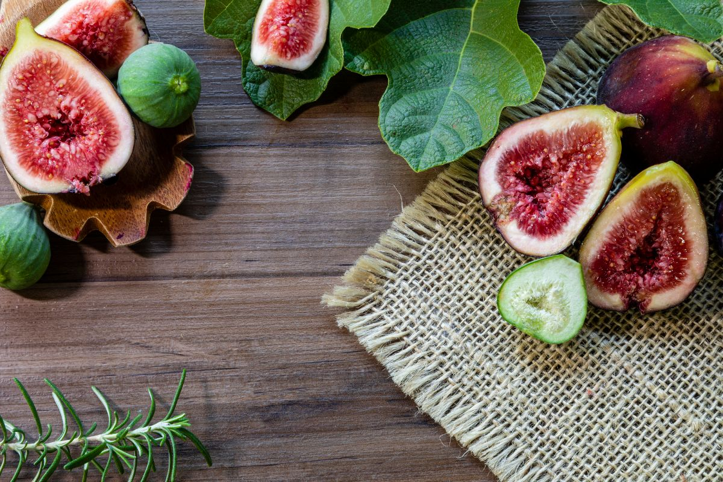
YOU SHOULD NOTE THAT FIGS ARE CLASSIFIED AS EITHER FRESH OR DRY FIGS DESPITE THE VARIETY. BUT OVER 90% OF FIGS WORLDWIDE ARE DRIED. DRIED FIGS HAVE A LONGER SHELF LIFE THAN FRESH FIGS AS THE FRESH ONES ARE FRAGILE AND PRONE TO SPOILING. BELOW ARE SOME OF THE MOST COMMON FIG TYPES FROM DRY AND FRESH CATEGORIES.

1. ADRIATIC FIG
THEY ARE ALSO CALLED WHITE FIGS DUE TO THEIR LIGHT COLOR. ADRIATIC FIGS HAVE GREEN SKIN WITH PALE PINK FLESH AND HAVE A HIGH SUGAR CONTENT. THIS EXTRA SWEETNESS MAKES THE ADRIATIC FIG IDEAL FOR FIG BAR AND PASTE APPLICATIONS. THEY ALSO HAVE A CREAMY RED FLESH, WHICH CAN BE USED AS A FLAVOR.
YOU CAN CONSUME THE ADRIATIC FIGS IN VARIOUS WAYS, SUCH AS A FRUIT DESSERT OR CHOPPING AND INCORPORATING THEM IN YOGURT OR JUICES. HARVESTING OF ADRIATIC FIGS IS DONE IN JUNE AND AUGUST.

2. BLACK MISSION FIG
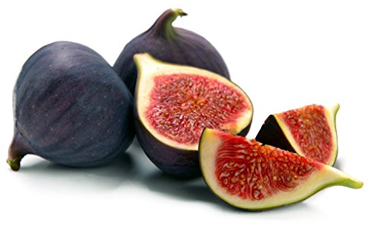
BLACK MISSION FIGS ARE ALSO PROMINENT FOR THEIR SWEETNESS AND ARE A VERY COMMON TYPE WORLDWIDE. THEY ARE SMALL FIGS THAT HAVE A DEEP BLUE TO PURPLE COATING AND SOLID PINK ON THE INSIDE. BLACK MISSION FIGS GET SWEETER WHEN LEFT ON THE TREES AS THE SUN DRIES THEM MORE AND ALSO GAIN A GUMMY TEXTURE.
THEIR REMARKABLE SWEETNESS MAKES THEM AN IDEAL SNACK THAT CAN BE EATEN ALONE OR SERVED WITH DIFFERENT KINDS OF MEALS. YOU CAN TAKE BLACK MISSION FIGS WITH FOODS SUCH AS YOGURT, FRESH CHEESE, AND FRESH RICOTTA, AMONG OTHER MEAL OPTIONS.

3. BROWN TURKEY FIG
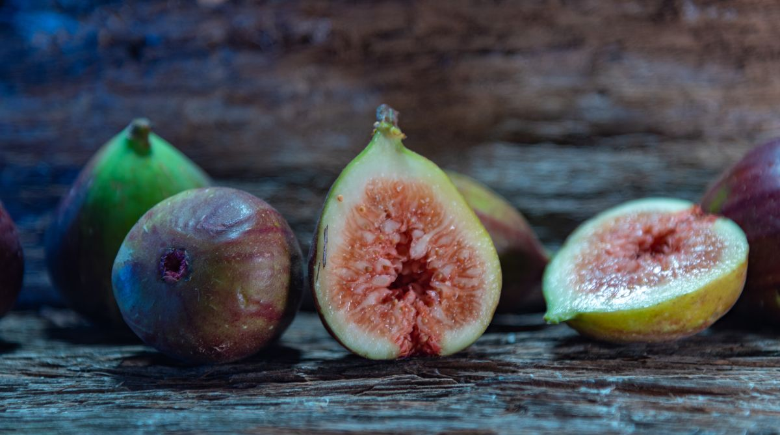
BROWN TURKEY FIGS ARE RELATIVELY LARGER THAN MOST FIGS AND ARE COMPARATIVELY LESS SWEET. THEY HAVE BROWNISH TO DARK PURPLE SKIN AND PALE PINK INSIDE WITH FEWER SEEDS THAN OTHER FIG TYPES. DUE TO THEIR LIGHTER SWEETNESS, BROWN TURKEY FIGS ARE BEST FOR SALADS AS THEY ACT AS NATURAL SWEETENERS. YOU CAN ALSO MIX THEM WITH HONEY AND USE THEM AS DESSERTS, MAKE FIG BREAD, OR EVEN FIG JAM.

4. KADOTA FIG
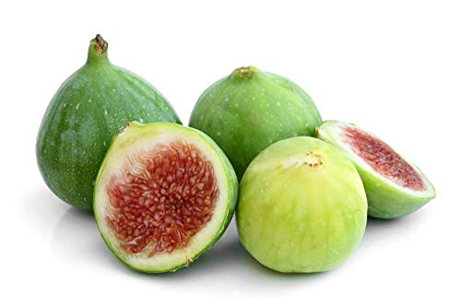
THIS IS ONE OF THE MOST COMMON FIG TREES IN CALIFORNIA. ITS FIGS ARE LIGHT GREEN WITH A PALE INTERIOR, BUT LESS SWEET COMPARED TO MOST FIG TYPES. BUT WHEN THEY ATTAIN THE CORRECT RIPENESS, THE SWEETNESS IS BOOSTED. THEY ARE BEST WHEN TAKEN RAW, AND THEY MAKE A GOOD INGREDIENT WHEN HEATED FOR JAMS AND PRESERVATIVES.
EATING THEM WITH A PINCH OF SALT CAN BRING THE MOST OF THEIR SWEETNESS. THEY CAN ALSO BE USED IN SALADS AND PIZZAS WHERE YOU WILL CHOP THEM AND ADD OTHER INGREDIENTS. THE KADOTA TREE IS ALSO REGARDED AS AN ORNAMENTAL TREE WITH A BEAUTIFUL, BOLD, AND BRANCHING STRUCTURE.

5. CALIMYRNA FIG
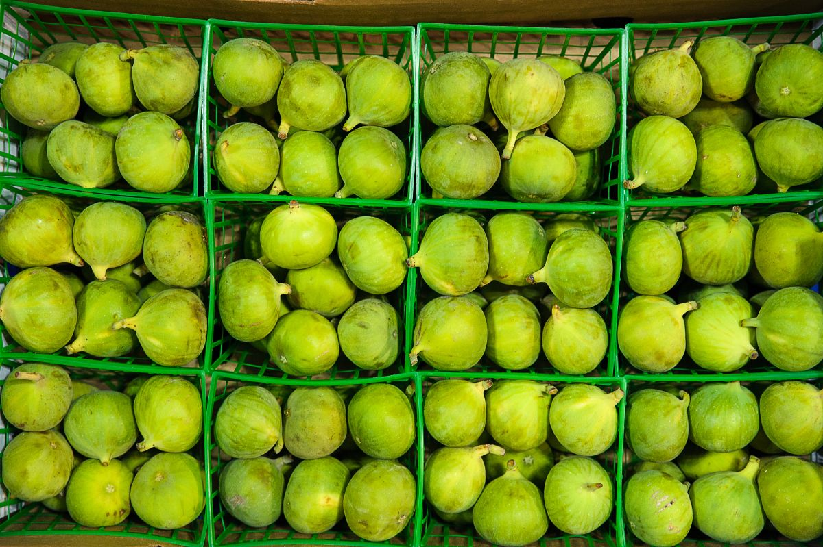
THIS TYPE IS LARGER THAN MOST VARIETIES AND HAS A GREENISH AND SLIGHTLY GOLDEN OUTER PIGMENT. IT HAS STUNNING PINK INSIDES AND IS ONE OF THE SOFTEST AND MOST DELICIOUS FRUITS. THE FRUIT HAS AN EARTHY AND SWEET-LIKE HONEY TASTE PROFILE AND CAN BE USED IN NUMEROUS SAVORY COOKING ROLES. CALIMYRNA FIG HAS A STRIKING INSIDE COLOR THAT MAKES IT BEST FOR CUTTING UP AND SERVING AS-IS.
THEY CAN BE SERVED WITH CHEESE OR WALNUTS DUE TO THEIR NUTTY FLAVOR. YOU CAN ALSO SIMMER THEM IN WATER, WINE, OR JUICE AND USE THEM FOR SAUCES, MARINADES, AND GLAZES. IN ADDITION, CALIMYRNA FIGS CAN ALSO BE USED IN OTHER NUMEROUS COOKING ROLES SUCH AS BAKING, BLENDING WITH RICE, SPICES, AND CHICKEN, TO NAME A FEW.

6. CELESTE FIG
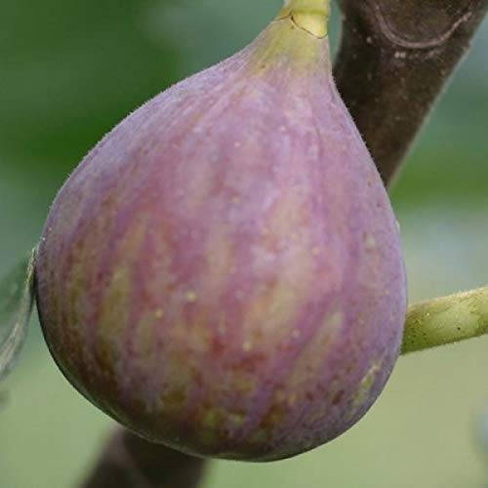
CELESTE FIG IS ONE OF THE MOST POPULAR FIGS WITH A MEDIUM-SIZED FRUIT. ITS SKIN IS LIGHT BROWN TO PURPLE, AND ITS INSIDE IS PINK. IT IS ONE OF THE SWEETEST FIGS, MOSTLY EATEN AS A DESERT FIG. DUE TO ITS SWEETNESS, CELESTE FIG HAS BEEN NICKNAMED “SUGAR FIG.” CELESTE FIG IS ALSO IDEAL FOR PROCESSING PURPOSES SUCH AS PRESERVATION AND DRYING.
THE TREE HAS A LOW MAINTENANCE COST AS IT IS HEAT AND PEST RESISTANT. IT IS ALSO A CLOSED-EYE FIG THAT PREVENTS NATURAL PESTS SUCH AS WASPS FROM ATTACKING THE FRUIT. ANOTHER EXCITING ATTRIBUTE ABOUT THE CELESTE FIG IS THAT IT RIPENS EARLIER IN THE SEASON THAN MOST FIG VARIETIES. IT CAN ALSO PRODUCE FRUITS IN THE FIRST YEAR OF GROWTH AND IS PROMINENT FOR BEING PROLIFIC AND PACKING A LOT OF FRUITS.

7. DESERT KING FIG
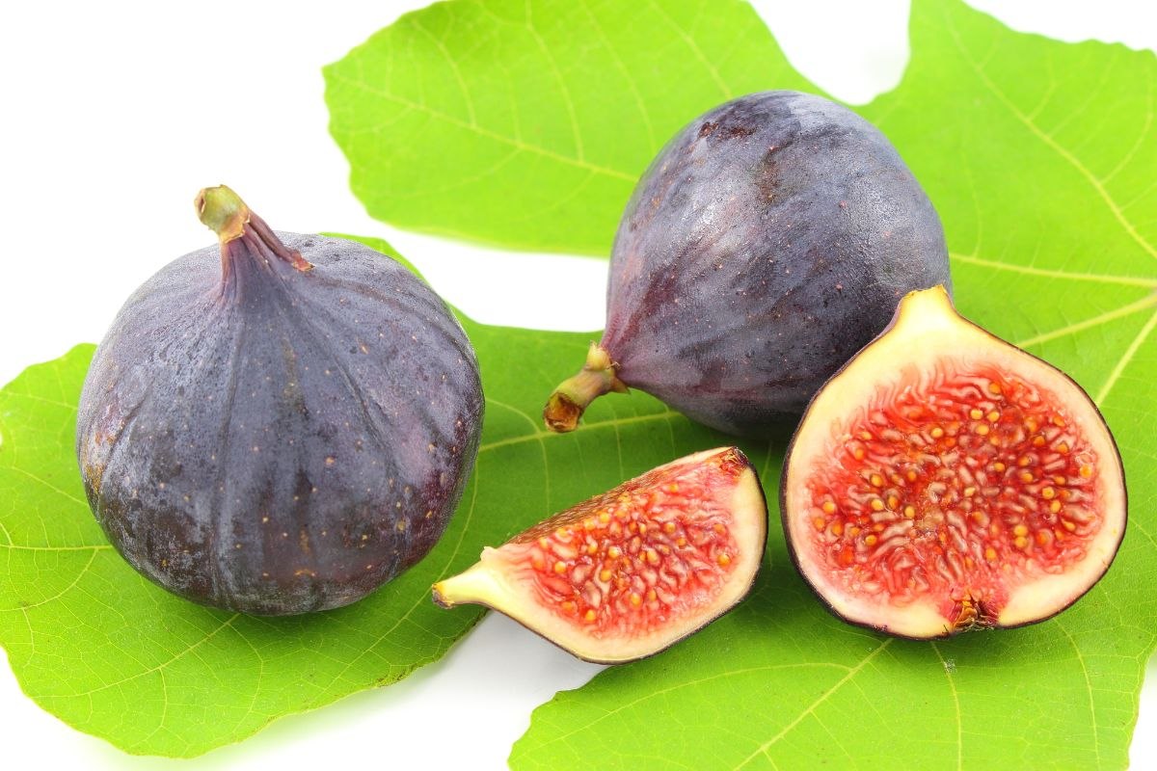
THE DESERT KING FIG IS A PROMINENT TYPE DUE TO ITS OUTSTANDING PERSEVERANCE IN THE RAIN. THE FRUIT HAS MILDLY YELLOW SKIN AND RED FLESH. DESERT KING BEARS FRUITS TWO YEARS AFTER PLANTING AND PRODUCES LARGE FRUITS. THE TREE IS VERSATILE AS IT THRIVES IN COOL CLIMATES, COASTAL REGIONS, AND HIGH ELEVATION REGIONS.
IT HAS AN EXCEPTIONAL FRUIT QUALITY DUE TO ITS MELTING TEXTURE, HIGH SUGAR CONTENT, AND PLEASANT-TASTING SEEDS.

8. CHICAGO HARDY FIG
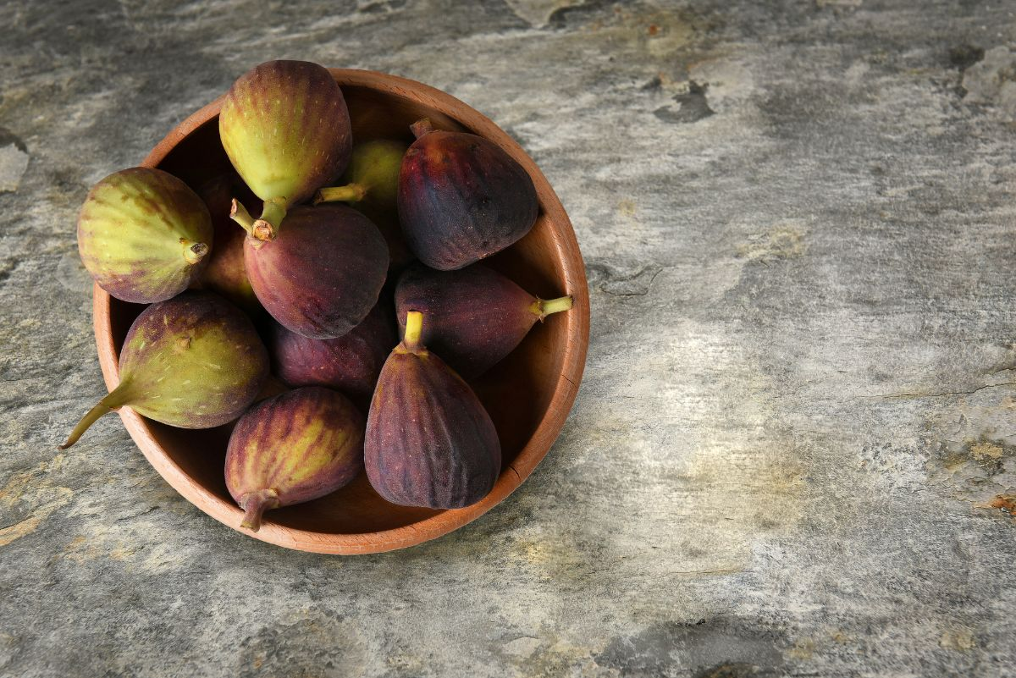
ITS NAME ARISES DUE TO THE FACT THAT THE TREE IS COLD HARDY. CHICAGO HARDY HAS SMALL FRUITS THAT HAVE BROWN TO PURPLE SKIN AND LIGHT PINK FLESH. THE TREE IS EASY TO GROW AND SHOWCASES DROUGHT-RESISTANT CHARACTERISTICS. IT IS ALSO A HEAT-RESISTANT AND SELF-POLLINATING TREE. THIS MEANS THAT IT DOES NOT DEPEND ON OTHER FIG TREES TO BEAR FRUITS.
CHICAGO HARDY FRUITS ARE LOVED FOR THEIR SWEETNESS AND RICH FLAVOR. YOU CAN EAT THEM RAW OR INCORPORATE THEM IN SALADS, CHEESE, OR CHARCUTERIES. ADDITIONALLY, CHICAGO HARDY FRUITS CAN BE DEHYDRATED, CANNED, AND FROZEN. THE FRUITS ARE NUTRITIOUS, AND THE LEAVES ARE A GOOD SOURCE OF FOOD.
LEAVES ARE MOSTLY GRILLED AND STEAMED FOR BAKING PURPOSES. THE LEAVES ALSO HAVE A SMOKY FLAVOR THAT CAN BE USED TO FLAVOR FOODS AND TEA.

9. EXCEL FIG
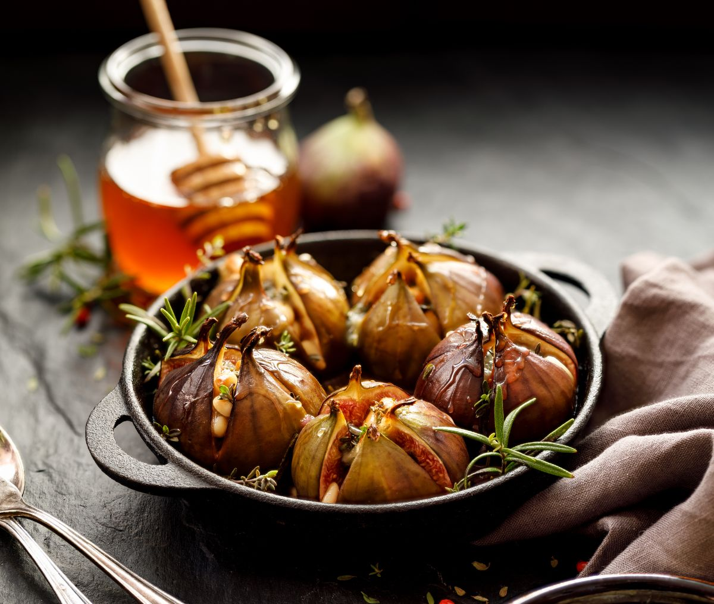
EXCEL FIG IS REGARDED AS ONE OF THE BEST YELLOW FIGS AS IT IS RICHLY SWEET AND HAS AN OUTSTANDING HONEY FLAVOR. IN ADDITION, EXCEL FIG WITHSTANDS SPLITTING COMPARED TO MOST FIG VARIETIES. IT IS ALSO ONE OF THE EASIEST FRUITS TO GROW AND IS WELL ADAPTED TO A WIDE ARRAY OF CLIMATES.
IT PRODUCES SWEET FRUITS EVEN IN COOLER CLIMATES, AND THEY ARE MEDIUM TO LARGE IN SIZE. EXCEL FIG PRODUCES YELLOW FRUIT WITH AMBER PULP. THE TREE IS A NEW TYPE OF FIG CREATED IN 1975 AND IS A HYBRID OF KADOTA FIGS. IT IS A GOOD ALL-PURPOSE FIG THAT IS MORE PRODUCTIVE.

10. CORKY’S HONEY DELIGHT FIG
THE CORKY’S HONEY DELIGHT FIG IS A MODERATELY GROWING TREE THAT PRODUCES GREEN FRUITS THAT TURN LIGHT YELLOWISH GREEN WHEN RIPE. IT HAS AN AMBER, PINK INTERIOR AND HAS SWEET NOTES OF HONEY FLAVORS. THE TREE PRODUCES TWO YIELDS A YEAR, IN JUNE AND LATE SUMMER.
CORKY’S HONEY DELIGHT FIG HAS SUCCULENT SKIN, AND ITS TREE GROWS FAIRLY FAST. IT DOES WELL ALONG THE COASTAL AND MID-HUMID AREAS BUT CAN ALSO THRIVE WELL IN OTHER AREAS WITH GOOD SOIL. THIS FIG TYPE WAS BRED AND CREATED BY MONROVIA, AND IT’S A STRONG BREBA CROP.

11. WHITE GENOA
THE WHITE GENOA FIG TREE GROWS MODERATELY AND PRODUCES VERY LARGE FRUITS THAT HAVE YELLOWISH-GREEN SKIN AND ROSE PULP. IT IS A DELICIOUS FIG THAT CAN BE EATEN RAW OR USED FOR PRESERVATION AND CANNING PURPOSES. THE TREE DOES WELL IN THE COASTAL AREA AND DOES NOT DO WELL IN HUMID AND WET SUMMERS. THIS IS BECAUSE IT IS HIGHLY PRONE TO PEST DAMAGE AS IT HAS A LARGE OPEN EYE.
IT IS ALSO AN EASY FRUIT TO GROW AND MAINTAIN AS IT DOES WELL IN A VARIETY OF SOILS. WHITE GENOA BEARS FRUITS AFTER ONE TO TWO YEARS AFTER PLANTING, AND THE RIPENING TIME IS BETWEEN LATE JULY AND EARLY AUGUST.

12. PETER’S HONEY
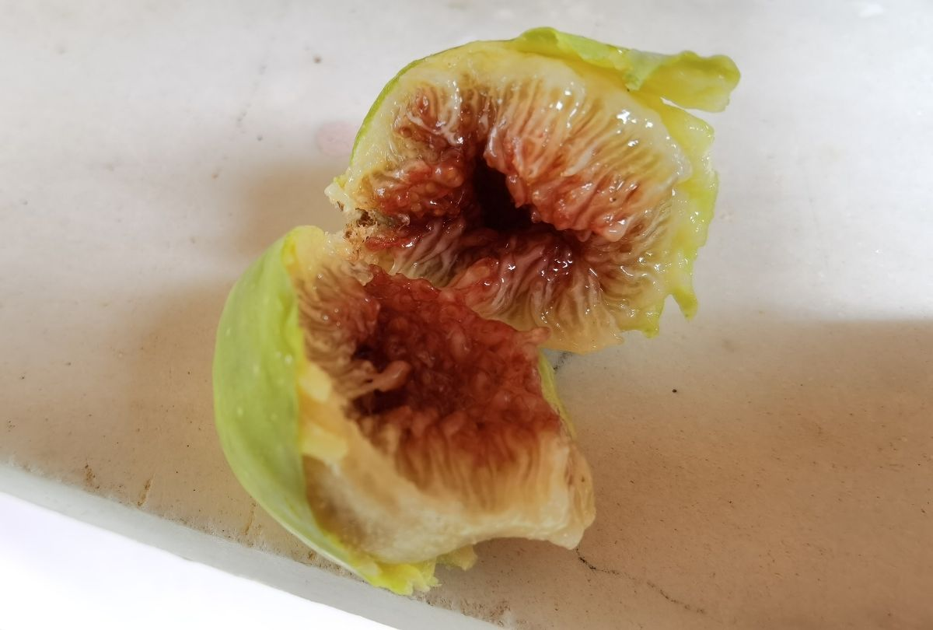
THE TREE IS NAMED AFTER THE LATE PETER DANNA OF PORTLAND AND IS REGARDED AS ONE OF THE BEST FIGS. AS THE NAME SUGGESTS, PETER’S HONEY HAS TENDER, SWEET FRUITS THAT HAVE YELLOWISH-GREEN SKIN AND AMBER FLESH.
THE TREE HAS A MEDIUM GROWTH RATE AND CAN BE USED AS A GARDEN TREE AS WELL. THE FRUITS ARE MEDIUM-SIZED AND RIPEN WELL IN WARMER CLIMATES. PETER’S HONEY FIGS HAVE A SWEET, TENDER FRUIT WITH A HONEY FLAVOR WHICH MAKES THEM IDEAL FOR EATING FRESH.

13. OSBORNE PROLIFIC
ALSO KNOWN AS THE NEVERELLA FIG TREE, THIS TREE HAS A SEMI-DWARF GROWTH AND PRODUCES MEDIUM-SIZED FRUITS. THE FRUITS HAVE YELLOW TO PURPLISH-BROWN SKIN AND HONEY AMBER FLESH. IT IS KNOWN TO BE ONE OF THE MOISTEST FIGS AND HAS FIGGY FLAVORS WITH SWEET BERRY AND HONEY NOTES. OSBORNE PROLIFIC FIG IS KNOWN TO BE A PROLIFIC PRODUCER BUT REQUIRES COOL COASTAL CLIMATES FOR OPTIMUM BEARING.

14. YELLOW LONG NECK
YELLOW LONG NECK FIG IS ONE OF THE MOST DELICIOUS FIGS THAT PRODUCES TWICE A YEAR. IT HAS A TENDER, THIN SKIN THAT IS BRIGHT YELLOW IN COLOR AND HAS LIGHT AMBER FLESH. THE FRUITS ARE LARGE AND ROUND WITH A LONG NECK.
ITS THIN SKIN AND SWEET FLAVOR MAKE IT AN IDEAL FIG TO BE EATEN FRESH. HOWEVER, IT HAS A BETTER TASTE AFTER RECEIVING AT LEAST EIGHT HOURS OF SUN. YOU CAN ALSO USE IT FOR NUMEROUS KITCHEN PURPOSES, SUCH AS MAKING JAMS, PIES, OR FRYING WITH VARIOUS DISHES.

15. OLYMPIAN
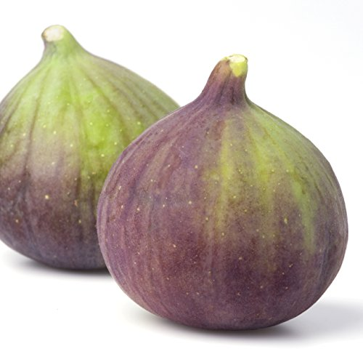
THE OLYMPIAN FIG VARIETY WAS FIRST DISCOVERED IN WASHINGTON STATE AND IS ONE OF THE MOST DELICIOUS FIGS WITH VERY LARGE FRUITS. THE FIGS HAVE TENDER PURPLE SKIN AND VIOLET FLESH THAT IS EXTREMELY SUCCULENT. IT DOES WELL IN COOL, MARITIME CLIMATES, AND THE TREE DOES NOT GROW VERY TALL. THE TREE IS EXTRA HARDY AS IT CAN SURVIVE IN BOTH COOL AND COASTAL CLIMATES. OLYMPIAN FIGS RIPEN AS EARLY AS MAY.

16. RONDE DE BORDEAUX
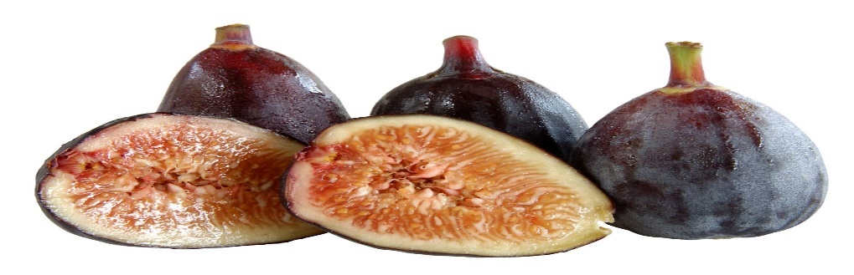
RONDE DE BORDEAUX IS A FRENCH FIG VARIETY THAT PRODUCES SMALL TO MEDIUM FRUITS. THE FRUITS HAVE DARK PURPLE SKIN, AND THE FLESH IS REDDISH-PINK. IT IS A VERY DELICIOUS FIG WITH A SWEET FLAVOR AND NOTES OF GRAPES, SYRUP, AND STRAWBERRY. RONDE DE BORDEAUX PRODUCES ONE CROP STARTING MID-AUGUST.
DESPITE PRODUCING ONE CROP, RONDE DE BORDEAUX IS ONE OF THE EARLIEST RIPENING FIGS EVER SEEN. IT DOES WELL IN COOL CLIMATES AND IS ONE OF THE EASIEST FRUITS TO GROW.

FAQS
HOW LONG DOES A FIG TAKE TO GROW?
FIGS ARE KNOWN TO BE FAST-GROWING FRUIT TREES THAT REQUIRE MINIMAL MAINTENANCE. HOWEVER, THE GROWTH AND RIPENING RATE WILL DEPEND ON THE VARIETY. SOME WILL TAKE ONE TO TWO YEARS TO BEAR FRUITS, WHILE SOME CAN GO UP TO FIVE YEARS.
HOW MANY FIG VARIETIES ARE THERE?
BEING ONE OF THE EARLIEST FRUITS EVER TO BE CULTIVATED, FIGS HAVE AN INDEFINITE NUMBER OF VARIETIES. THERE ARE APPROXIMATELY OVER 600 FIG VARIETIES, AND YET THERE ARE STILL OTHERS THAT HAVE NOT EVER BEEN CULTIVATED.
CAN YOU GROW FIGS INDOORS?
ALTHOUGH MOST PEOPLE MAY HAVE GROWN FIGS INDOORS, THERE ARE SEVERAL REASONS WHY YOU CAN’T DO SO. FIRST, FIGS REQUIRE FULL SUN IN THE SUMMER AS IT HELPS IN RIPENING AND BOOSTING THEIR TASTE PROFILE. MOREOVER, DECIDUOUS FIGS LOSE THEIR LEAVES DURING THE AUTUMN, AND MOST TREES CAN GROW BIG, WHICH DOES NOT SUIT AN INDOOR SETTING.
HOW DO YOU KNOW IF A FIG IS RIPE?
RIPE FIGS ARE SOFT AND YIELD TO PRESSURE WHEN SQUEEZED GENTLY. IN ADDITION, LOOSE STEMS ARE SIGNS THAT THE FIG IS RIPE. THOSE THAT ARE SHRUNKEN OR HAVE SAP OOZING FROM CRACKS ARE OVERRIPE.
WHAT IS THE SHELF LIFE OF FIGS?
FIGS ARE SOME OF THE MOST PERISHABLE FRUITS IN THE WORLD. THAT’S WHY IT IS RECOMMENDED THAT YOU EAT THEM WITHIN ONE OR TWO DAYS. STORAGE ALSO DETERMINES HOW LONG THEY WILL LAST. IF YOU PLACE THEM IN A BOWL WITHOUT STACKING THEM OVER EACH OTHER, THEY CAN AT LEAST LAST FOR FIVE DAYS.

32 DIFFERENT TYPES OF POTATOES
TAKE A CLOSER LOOK ON POTATOES AND LEARN MORE ABOUT ITS MANY DIFFERENT TYPES. GET TO KNOW THEIR DISTINCTIONS, THE NUTRIENTS THEY CONTAIN, AND WHERE YOU CAN FIND THEM.
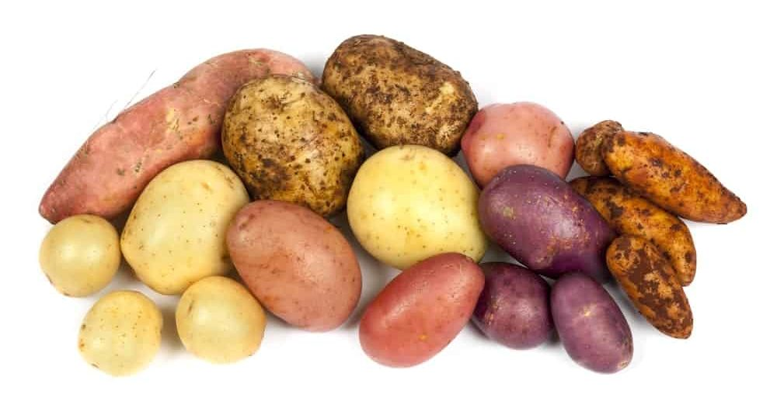
POTATOES ARE VEGETABLES THAT CONTAIN A LOT OF CARBOHYDRATES. IT GOT ITS NAME FROM THE SPANISH WORD PATATA AND THEY’RE ALSO SOMETIMES CALLED SPUDS. THERE ARE HUNDREDS OF VARIETIES OF POTATOES GROWN ALL OVER THE WORLD AND NEW ONES BEING ADDED TO THE LIST ALL THE TIME BUT THEY’RE NOT ALL COMMERCIALLY AVAILABLE.
THE INCA INDIANS IN PERU FIRST CULTIVATED POTATOES AROUND 8,000 TO 5,000 B.C. BEFORE IT MADE ITS WAY TO EUROPE THROUGH THE SPANISH CONQUISTADORS AROUND 1570.
IN 2004, POTATOES BECAME THE FIRST VEGETABLES GROWN IN SPACE WHEN NASA CREATED THE CHAMBER-GROWN SPUD KNOWN AS QUANTUM TUBERS™.
RELATED: WHAT GOES WITH POTATOES (BOILED / MASHED / SWEET / BAKED) | HOW TO STORE POTATOES (6 EASY WAYS) | TACO STUFFED BAKED POTATOES RECIPE | BACON CHEESY POTATOES RECIPE | MY AWESOME TWICE-BAKED POTATOES RECIPE | HERB ROASTED PARMESAN POTATOES RECIPE

POTATOES NUTRITION FACTS CHART
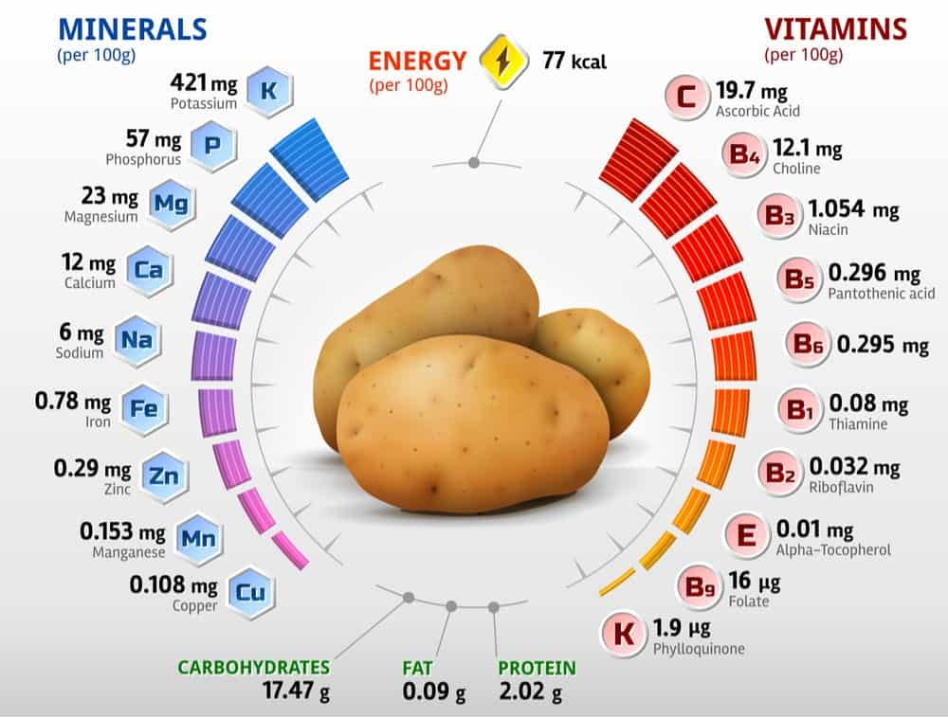
NOW LET’S JUMP INTO YOUR POTATO OPTIONS.

POTATO GROWTH STAGES CHART
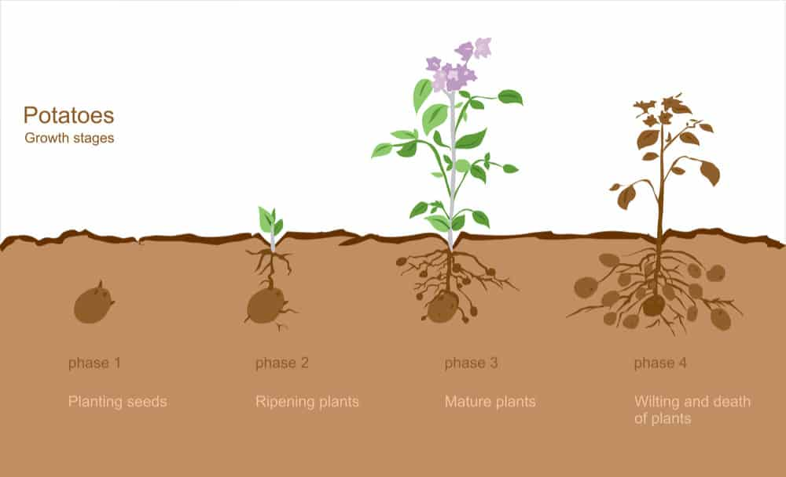

WHAT IS A POTATO?
A POTATO IS A ROOT VEGETABLE AND A STARCHY TUBER OF THE SOLANUM TUBEROSUM PLANT. THE PLANT BELONGS TO THE NIGHTSHADE FAMILY. THERE ARE OVER 200 VARIETIES OF POTATOES AVAILABLE IN THE UNITED STATES. THEY CAN BE PUT INTO MANY DIFFERENT CATEGORIES.
POTATOES ARE CONSIDERED COMFORT FOOD, SOMETHING TO TURN TO WHEN YOU HAD A BAD DAY. POTATOES CONTAIN DIFFERENT AMOUNTS OF STARCH, MAKING PARTICULAR POTATOES BETTER FOR SPECIFIC FOODS. YOU PROBABLY WERE NOT AWARE THERE ARE SO MANY POTATO TYPES.

POTATO TEXTURE
POTATOES CAN BE CLASSIFIED INTO DIFFERENT CATEGORIES BASED ON THEIR TEXTURE.

STARCHY
SOME PEOPLE REFER TO THESE POTATOES AS MEALY, AS THEY ARE HIGH IN STARCH. IDAHO POTATO, RUSSET POTATO, AND SWEET POTATOES FALL INTO THE STARCHY CATEGORIES. THEY DO NOT HAVE A HIGH AMOUNT OF MOISTURE. THEY ARE ABSORBENT AND FLUFFY. THE FLESH OF THE POTATO SEPARATES ONCE IT COOKS AND IT FLAKES. THEY DO NOT HOLD THEIR SHAPE ONCE THEY ARE COOKED. THESE POTATOES ARE BEST FOR FRYING, MASHING, BAKING, OR BOILING.

WAXY
THESE POTATOES ARE HIGH IN MOISTURE AND SUGAR, BUT THEY ARE LOW IN STARCH. WAXY POTATOES HOLD THEIR SHAPE EVEN ONCE THEY HAVE BEEN COOKED. THEIR SKIN IS THIN, AND THEIR TEXTURE IS SMOOTH. THE WAXY POTATOES ARE ROUNDER AND SMALLER THAN OTHER POTATOES. RED BLISS AND FRENCH FINGERLING POTATOES FALL INTO THIS CATEGORY. THESE POTATOES ARE BEST FOR POTATO SALAD, GRATINS, ROASTING, AND BOILING.

ALL-PURPOSE
ALL-PURPOSE POTATOES ARE A BALANCED COMBINATION OF WAXY AND STARCHY POTATOES. THEY ARE THE BEST OF BOTH WORLDS. THEY HAVE LESS STARCH AND HOLD THEIR SHAPE WELL. AT THE SAME TIME, THEY ARE FLUFFY AND ABSORBENT. THE YUKON GOLD POTATO FALLS INTO THIS CATEGORY. THE ALL-PURPOSE POTATO IS GREAT FOR ANY MEAL, ESPECIALLY IF YOU ARE IN A BIND. THEY ARE GREAT FOR MASHED POTATOES.

TYPES

ALL BLUE POTATOES
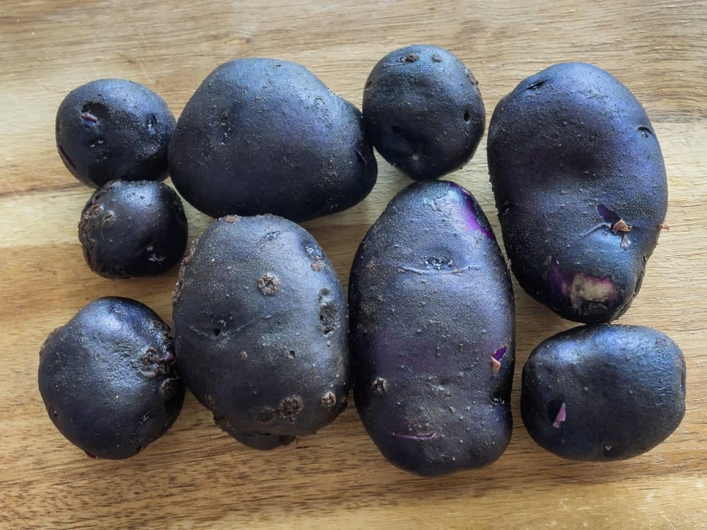
TRUE TO THEIR NAME, ALL BLUE POTATOES ARE BLUE INSIDE AND OUT, AND THEY ARE A GOOD ALL-PURPOSE POTATO THAT IS PERFECT WHEN STEAMED, BOILED, OR BAKED. BECAUSE OF ITS DRY TEXTURE, IT HOLDS ITS SHAPE WELL, REGARDLESS OF HOW YOU COOK IT, AND IF YOU BAKE OR STEAM IT THE COLOR WILL REMAIN THE SAME AS WELL.

AUSTRIAN CRESCENT POTATOES
AUSTRIAN CRESCENT POTATOES ARE AN HEIRLOOM VARIETY AND WAXY IN NATURE. THEIR SKIN IS SMOOTH AND YELLOWISH-TAN IN COLOR, AND ITS FLESH IS A LIGHT YELLOW COLOR. THESE POTATOES ARE DELICIOUS WHEN STEAMED, BOILED, AND ROASTED, BUT THEY ARE PARTICULARLY TASTY WHEN YOU USE THEM IN POTATO SALADS. THE POTATOES STORE VERY WELL AND ARE COMMONLY FOUND IN SPECIALTY MARKETS.

FRENCH FINGERLING POTATOES
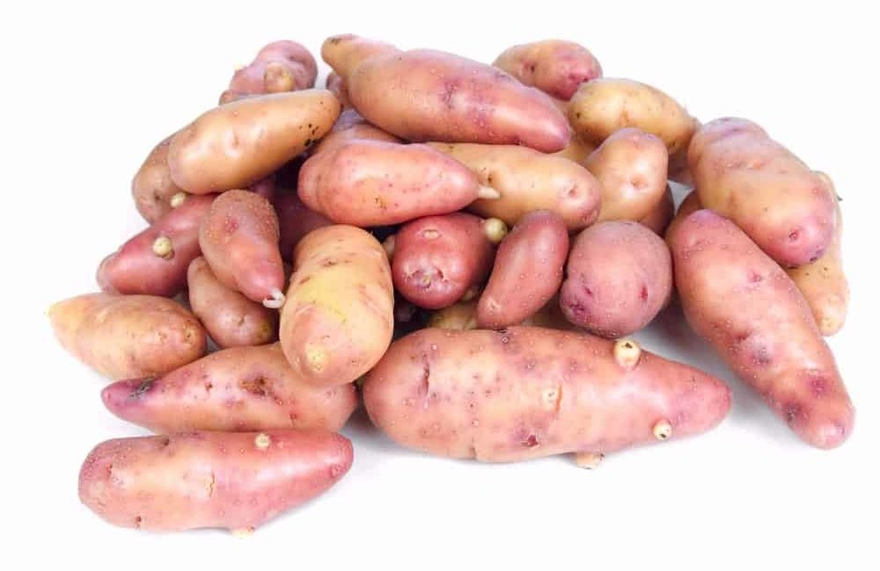
WITH A PINK SKIN AND YELLOWISH-COLORED FLESH, THE FRENCH FINGERLING POTATOES HAVE VERY SMOOTH SKIN AND SOMETIMES A PINKISH RING LOCATED RIGHT UNDER THE SKIN. PERFECT FOR ROASTING, THE FRENCH FINGERLING POTATO GROWS SMALL AND NARROW, AND THEY PREFER DRY, COOL WEATHER IF YOU PLAN ON GROWING THEM. THEIR SKIN COLOR CAN ALSO BE ORANGE OR PURPLE, AND THEY ARE KNOWN MOSTLY FOR THEIR ROASTING CAPABILITIES.

HANNAH SWEET POTATOES
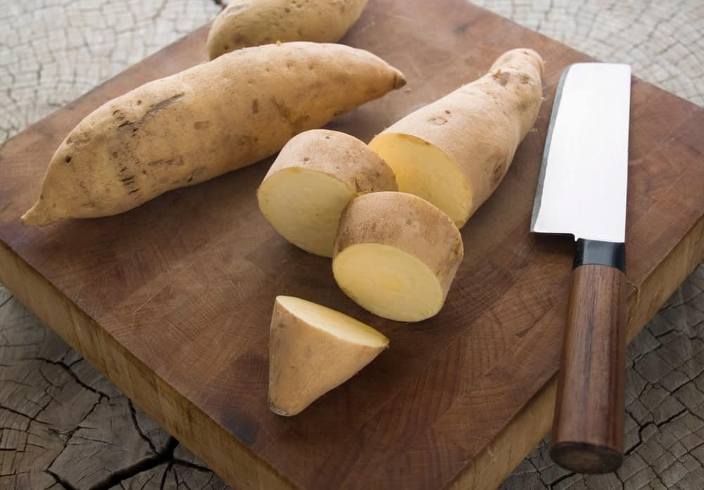
HANNAH SWEET POTATOES ARE A LOT LIKE THE JEWEL POTATOES. THEY ARE STARCHY IN NATURE AND HAVE LIGHT-COLORED SKIN AND FLESH. AVAILABLE ALL YEAR LONG, HANNAH SWEET POTATOES HAVE SEMI-SMOOTH SKIN AND A RATHER OBLONG SHAPE. TO PREVENT THEM FROM GOING BAD, YOU SHOULD ALWAYS KEEP THE SKIN ON THIS POTATO UNTIL YOU ARE READY TO COOK THEM, AND THEY CAN LAST FOR SEVERAL WEEKS WHEN KEPT IN A COOL, DRY PLACE.

JAPANESE SWEET POTATOES
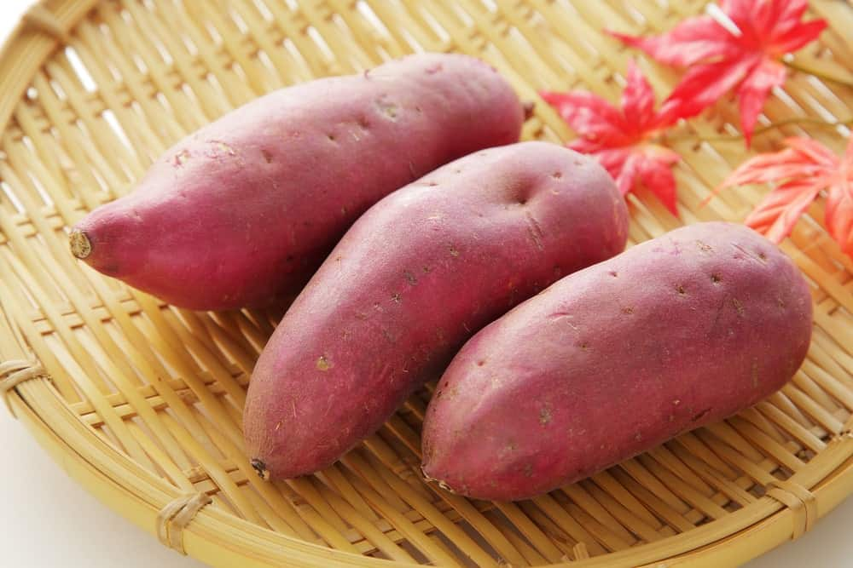
A STARCHY VEGETABLE, THE JAPANESE SWEET POTATO IS PINK TO PURPLE IN COLOR BUT HAS A WHITISH-YELLOW FLESH INSIDE. GOOD FOR BAKING, GRILLING, OR STEAMING, THIS SWEET POTATO HAS A SWEET AND NUTTY FLAVOR. SIMILAR TO AMERICAN SWEET POTATOES, THE JAPANESE VARIETY TASTES EVEN SWEETER, AND IT IS EVEN USED IN PLACES SUCH AS ASIA AS A SUBSTITUTE FOR FLOUR AND A THICKENING AGENT WHEN COOKING.

JEWEL YAM
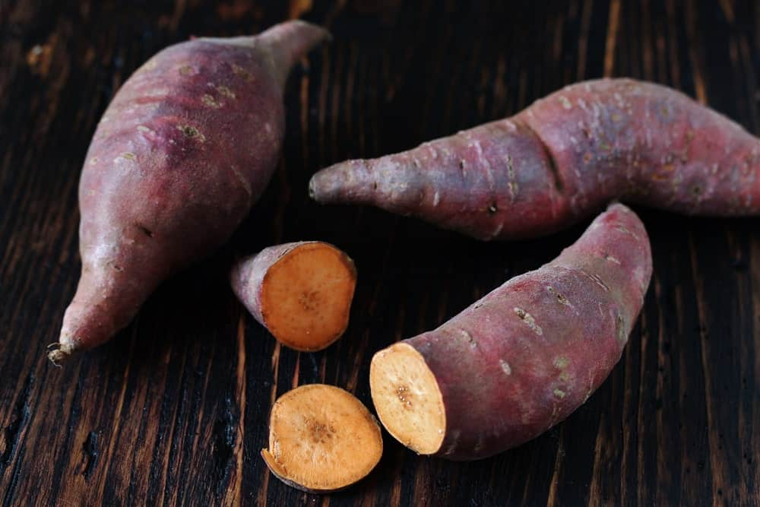
Bottom of Form
THE JEWEL YAM IS A SWEET POTATO, NOT A TRUE YAM, AND IT IS A STARCHY VEGETABLE. IN FACT, THE JEWEL YAM IS THE MOST COMMON TYPE OF SWEET POTATO ON THE MARKET TODAY, AND IT IS ESPECIALLY TASTY WHEN ROASTED OR BAKED. IRONICALLY, ALTHOUGH THE POTATO DOES HAVE A HIGH AMOUNT OF SUGAR IN IT, IT HAS A LOW GLYCEMIC INDEX, WHICH MEANS YOU CAN EAT ONE EVEN IF YOU ARE DIABETIC.

KENNEBEC POTATOES
KENNEBEC POTATOES ARE GOOD ALL-PURPOSE POTATOES AND QUITE LARGE IN SIZE. THEY HAVE TAN SKIN AND WHITE FLESH, AND THEY HOLD TOGETHER PARTICULARLY WELL WHEN BOILED IN WATER. IT GROWS FAST AND IS CONSIDERED A HIGH-QUALITY POTATO, AND IT DOES GREATLY BAKED, FRIED, MASHED, AND EVEN WHEN MADE INTO POTATO PANCAKES. THEY ARE A NICE UNIFORM SHAPE AND SIZE PRODUCED WITHOUT THE HOLES THAT ARE SOMETIMES FOUND IN OTHER TYPES OF POTATOES.

LARETTE POTATOES
THESE SMALL POTATOES, SHAPED LIKE FINGERLINGS WITH A VERY SILKY TEXTURE, ARE WAXY IN NATURE AND HAVE A NICE NUTTY FLAVOR. THEY WERE DISCOVERED IN THE SWISS ALPS, AND THEY ARE TASTIEST WHEN THEY ARE BOILED WHOLE OR ROASTED.

NORLAND RED POTATOES
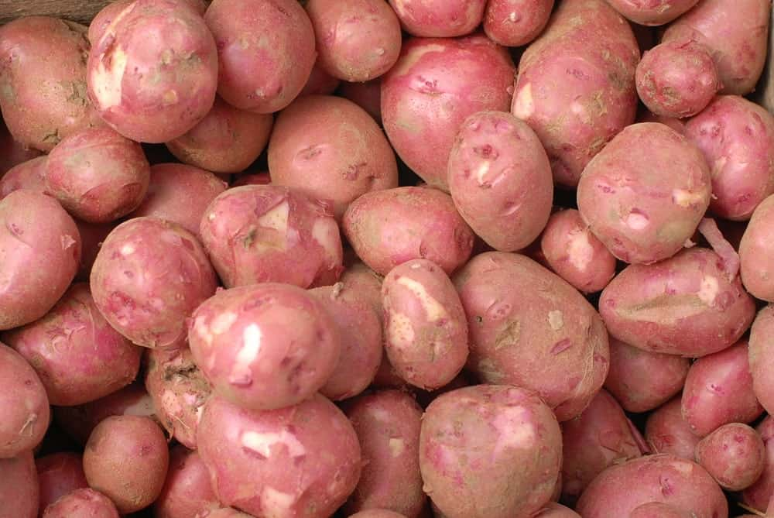
A GOOD ALL-PURPOSE POTATO, THIS ONE HAS RED SKIN AND CREAMY-WHITE FLESH THAT IS MOIST AND HOLDS UP WELL WHENEVER YOU COOK IT. THEY ARE TASTY WHEN PLACED IN POTATO SALADS AND IN SOUPS, BUT YOU CAN ALSO MASH, BAKE, OR ROAST THEM. BECAUSE THEY ARE GOOD AT SO MANY DIFFERENT RECIPES, THEY ARE A GOOD POTATO TO KEEP AROUND YOUR HOME.

PURPLE MAJESTY POTATOES
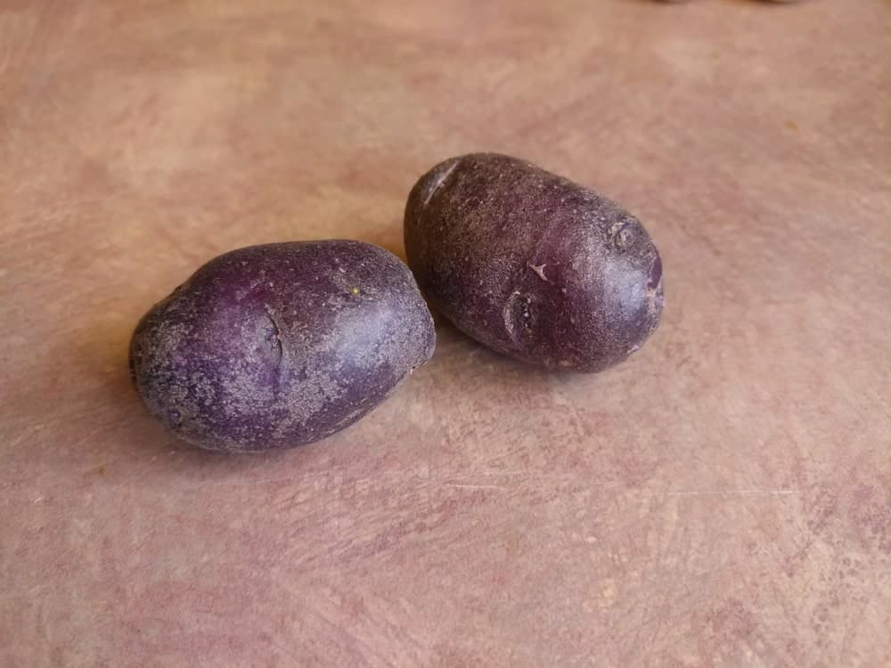
PURPLE MAJESTY POTATOES ARE OBLONG AND HAVE A DARK-PURPLE SKIN AND FLESH THAT IS FIRM, MOIST, AND PURPLE. EVEN WHEN YOU COOK THEM, THESE POTATOES KEEP THEIR COLOR, SO THEY ARE AN EYE-CATCHING, AS WELL AS A TASTY TYPE OF POTATO. HIGH IN ANTIOXIDANTS, THE PURPLE MAJESTY POTATO IS GREAT IN SOUPS, MIXED INTO POTATO SALADS, AND WHEN BAKED OR ROASTED.

RED GOLD POTATOES
THE RED GOLD POTATOES ARE GOOD ALL-PURPOSE POTATOES THAT HAVE RED AND TAN SKINS WITH A GOLDEN-COLORED FLESH. SMOOTH IN TEXTURE, THESE POTATOES ARE MOIST AND HAVE A NUTTY, SWEET FLAVOR. THEY ARE PERFECT FOR ROASTING, BOILING, MASHING, AND BAKING, AND THEIR UNIQUE FLAVOR IS UNLIKE ANY OTHER POTATO YOU WILL EVER EAT. IN FACT, THEY ARE GOOD REGARDLESS OF HOW YOU PREPARE THEM, SO IT IS GOOD TO HAVE THEM AROUND AT ALL TIMES.

RED THUMB POTATOES
RED THUMB POTATOES ARE WAXY AND HAVE BRIGHT-RED SKIN AND PINK FLESH. THEY ARE FINGERLING POTATOES THAT CHEFS LOVE, AND THEY ARE BEST WHEN ROASTED OR BOILED. IF YOU’RE LOOKING FOR SOMETHING THAT GOES GREAT WITH STEAK AND SALAD, THE RED THUMB POTATOES ARE A GREAT CHOICE, AND THEY ARE A VERY ATTRACTIVE POTATO AS WELL.

ROSE FINN APPLE POTATOES
INSTEAD OF A STARCHY POTATO, THIS ONE IS WAXY, AND IT HAS PINK SKIN THAT IS KNOBBY AND FLESH THAT IS A BUTTER-YELLOW COLOR. YOU CAN USE THESE POTATOES IN SALADS, AS WELL AS FOR BOILING, SAUTÉING, FRYING, AND GRILLING. IT HAS AN EXQUISITE, EARTHY FLAVOR THAT YOU ARE CERTAIN TO ENJOY, AND IT IS AN HEIRLOOM FINGERLING TYPE OF POTATO THAT MATURES IN MID- TO LATE-SEASON.

RUSSET POTATOES
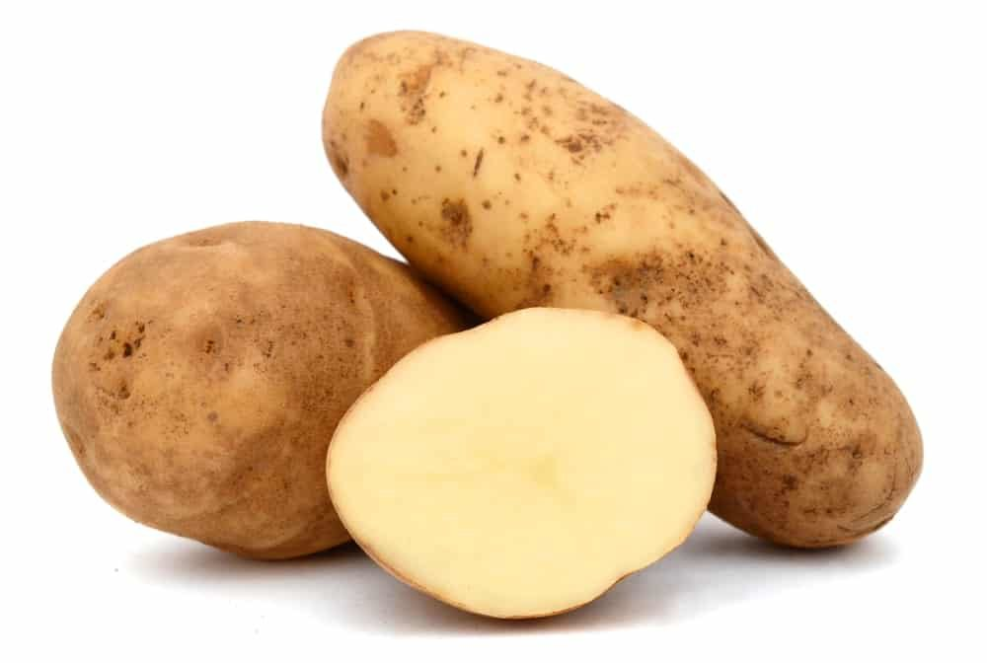
RUSSET POTATOES ARE WHAT MOST PEOPLE THINK OF WHEN THEY THINK OF POTATOES. THEY ARE A STARCHY POTATO THAT CAN BE FRIED, BAKED, OR MASHED. THEY ARE A BROWN TUBER VARIETY, AND THEY COME FROM A WORD THAT MEANS “ROUGH.” THE RUSSET POTATOES HAVE A CONSISTENT FLAVOR AND A LONG SHELF LIFE, AND THEY ARE USUALLY BURBANK POTATOES. RUSSET POTATOES ARE ESPECIALLY POPULAR IN THE UNITED STATES AND CANADA.

RUSSIAN BANANA POTATOES
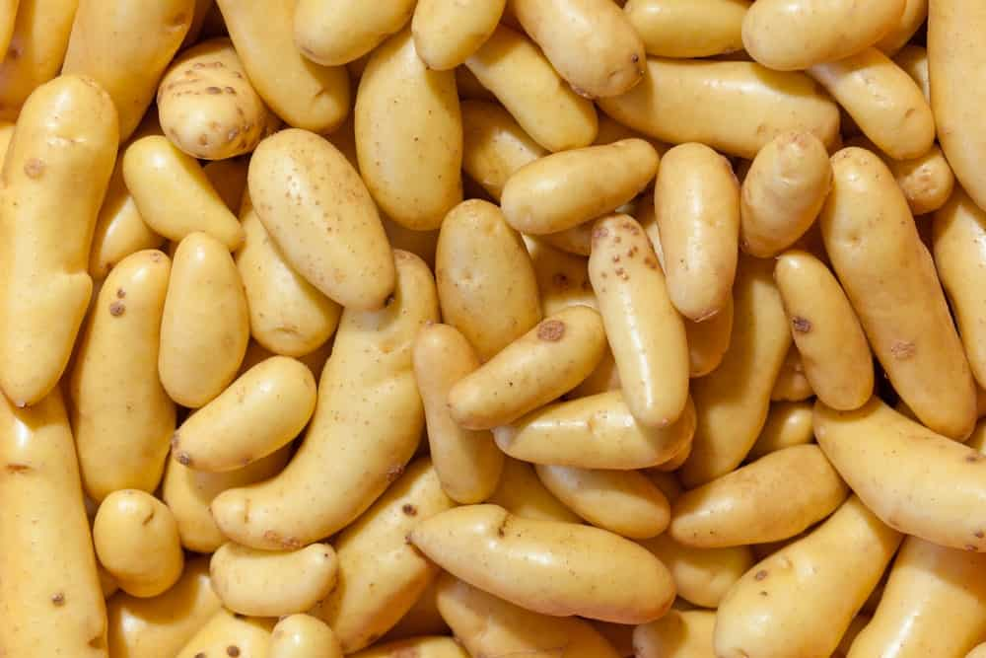
RUSSIAN BANANA POTATOES ARE A WAXY TYPE OF POTATO THAT IS GREAT GRILLED, FRIED, OR SAUTÉED. THEY ARE ALSO VERY TASTY ROASTED WHOLE OR STEAMED WHEN YOU WISH TO MAKE POTATO SALAD. RUSSIAN BANANA POTATOES HAVE SKIN THAT IS PALE YELLOW AND FLESH THAT IS A DEEP-YELLOW COLOR. IT ALSO HAS A VERY FIRM TEXTURE AND IS A VERY POPULAR TYPE OF POTATO AMONG CHEFS AND MARKETS THAT SPECIALIZE IN GOURMET FOODS.

YUKON GOLD POTATOES
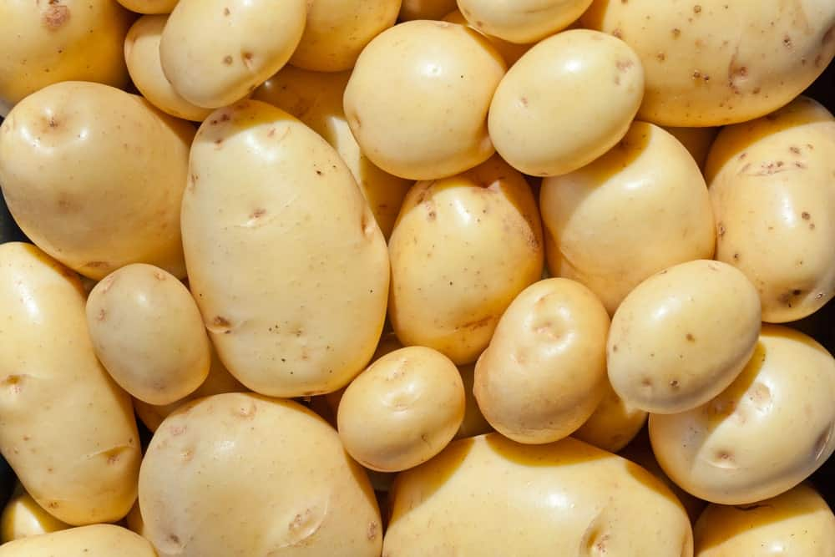
YUKON GOLD POTATOES ARE A GREAT ALL-PURPOSE POTATO WITH ROUGH BROWN SKIN AND A GOLD-COLORED INSIDE. THEY ARE TASTY, REGARDLESS OF HOW YOU PREPARE THEM, INCLUDING FRIED, BOILED, AND MASHED, AND THEY ARE EVEN GREAT IN POTATO SALADS.

BINTJE POTATO
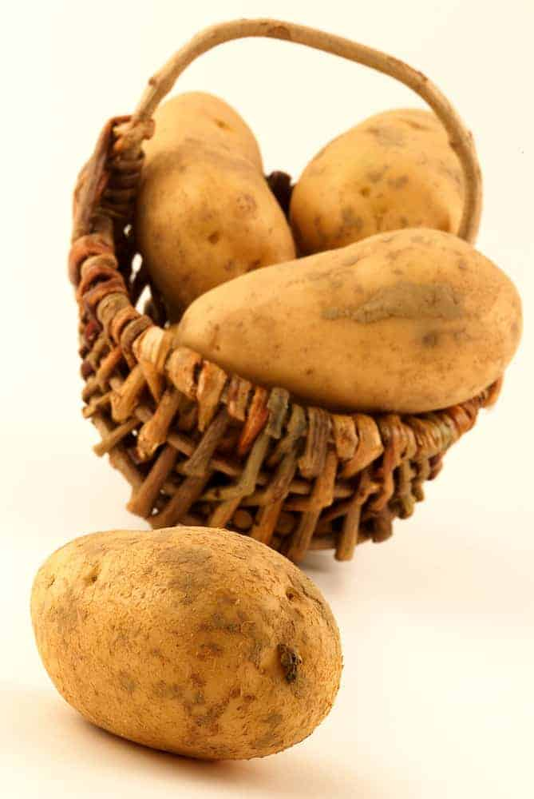
THE BINTJE POTATO WAS FIRST CREATED IN 1905 IN THE NETHERLANDS. THEY ARE PART OF THE HEIRLOOM FAMILY. THEY ARE MEDIUM-SIZED POTATOES THAT ARE ROUND OR OBLONG-SHAPED. THEIR SKIN AND FLESH ARE BOTH YELLOW. THEY HAVE A FLAVOR THAT IS SWEET AND A TEXTURE THAT IS CREAMY AND WAXY. IT IS PERFECT BAKED, BOILED, MASHED, FRIED, AND ROASTED.

LAURA POTATO
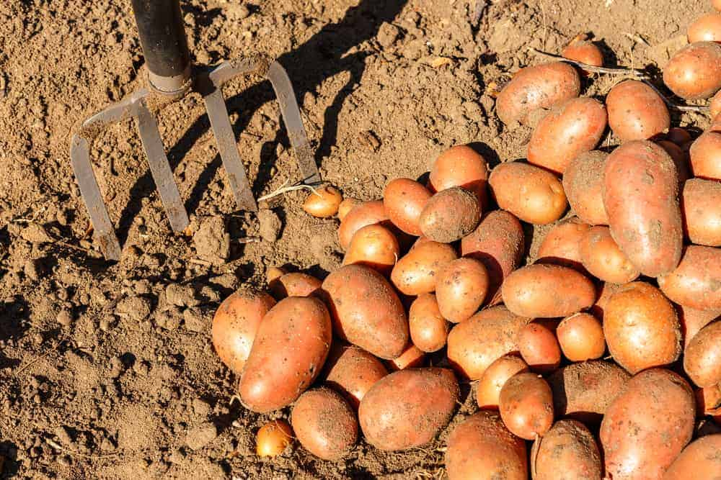
THE LAURA POTATO HAS A SKIN THAT IS A DEEP RED COLOR, AND THE FLESH IS YELLOW. THESE POTATOES TASTE AS GOOD AS THEY LOOK. THE LAURA POTATO IS LONG AND OVAL-SHAPED. THE POTATO IS PERFECT FOR MASHED POTATOES, FRENCH FRIES, AND POTATO CHIPS.

VITELOTTE POTATO
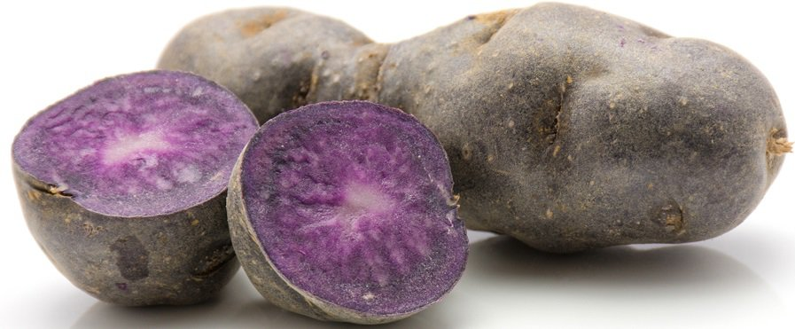
THE VITELOTTE IS A PURPLE POTATO THAT IS SIZED SMALL TO MEDIUM. THEY ARE SLIM AND LONG, MUCH LIKE A FINGERLING POTATO. THEY HAVE LUMPS THAT ARE IRREGULAR. THE SKIN IS SMOOTH AND RANGES IN COLOR FROM DEEP VIOLET-BLUE TO DARK PURPLE. THE SKIN IS SPECKLED WITH EYES THAT ARE DEEP-SET, WHICH IS WHAT MAKES IT BUMPY. THE FLESH IS DENSE, FIRM, AND SMOOTH. THE FLESH MAY BE MARBLED WITH WHITE. THE VITELOTTE POTATO KEEPS THE COLOR EVEN WHEN COOKED AND HAS A TASTE OF CHESTNUTS.

KING EDWARD POTATO
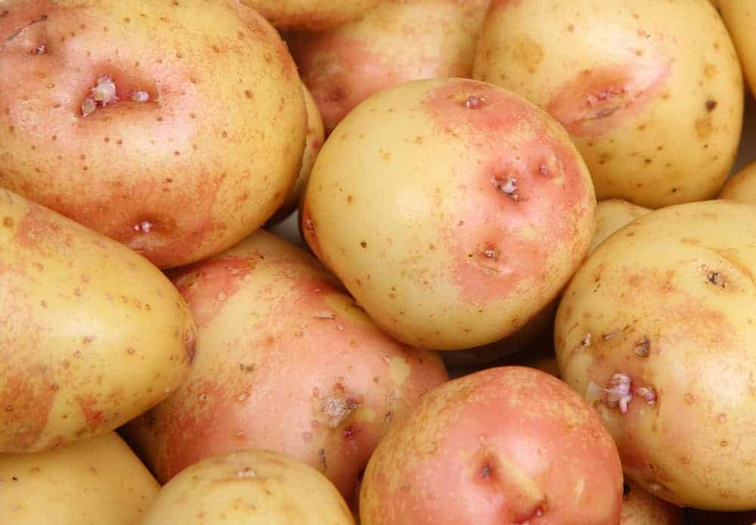
THE KING EDWARD POTATO WAS FIRST GROWN IN 1902 IN THE UK. THE KING EDWARD POTATO IS ONE OF THE OLDEST TYPES OF POTATOES THAT ARE DISTRIBUTED COMMERCIALLY. KING EDWARD HAS WHITE SKIN WITH A SLIGHT PINK HUE. THEY ARE TYPICALLY OVER AND HAVE A TEXTURE THAT IS FLOURY, QUALIFYING THEM AS A FLOURY POTATO.

KERR’S PINK POTATO
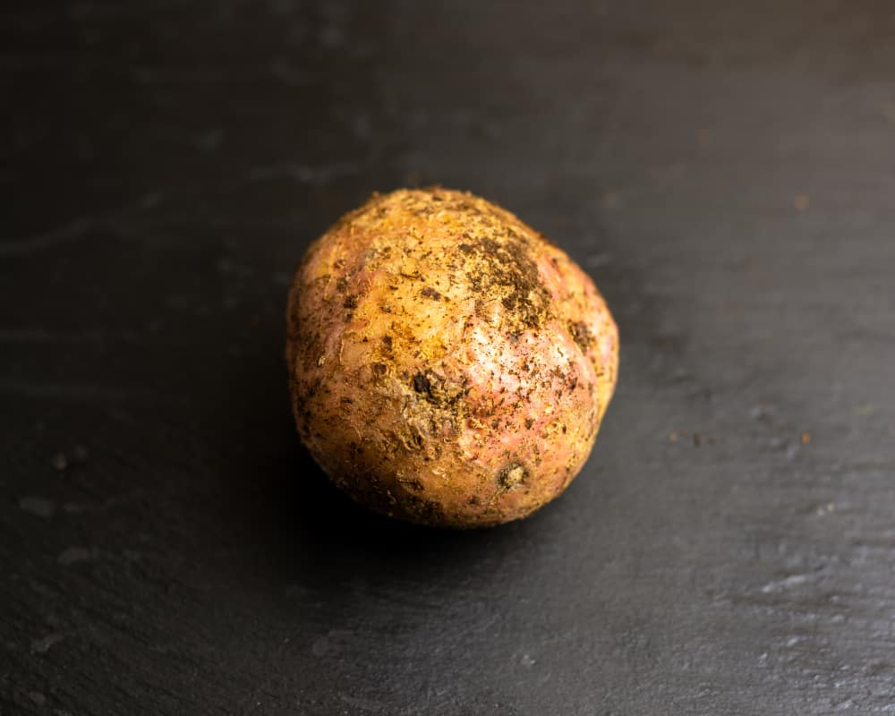
THE KERR’S PINK POTATO IS A ROUND AND SHORT POTATO THAT HAS AN ODD AND SLIGHTLY FLAT SHAPE. THE SKIN OF THIS POTATO IS FIRM, LIGHT BROWN, AND SLIGHTLY ROUGH. IT HAS PATCHES OF PINK BLUSH WITH EYES THAT ARE REDDISH-PINK IN COLOR AND SPRINKLED AROUND THE SKIN. THE FLESH CAN BE YELLOW TO IVORY COLOR. THEY ARE STARCHY POTATOES. WHEN THE KERR’S PINK POTATO IS COOKED, IT IS FLUFFY AND SOFT WITH AN EARTHY TASTE.

OPPERDOEZER RONDE POTATO
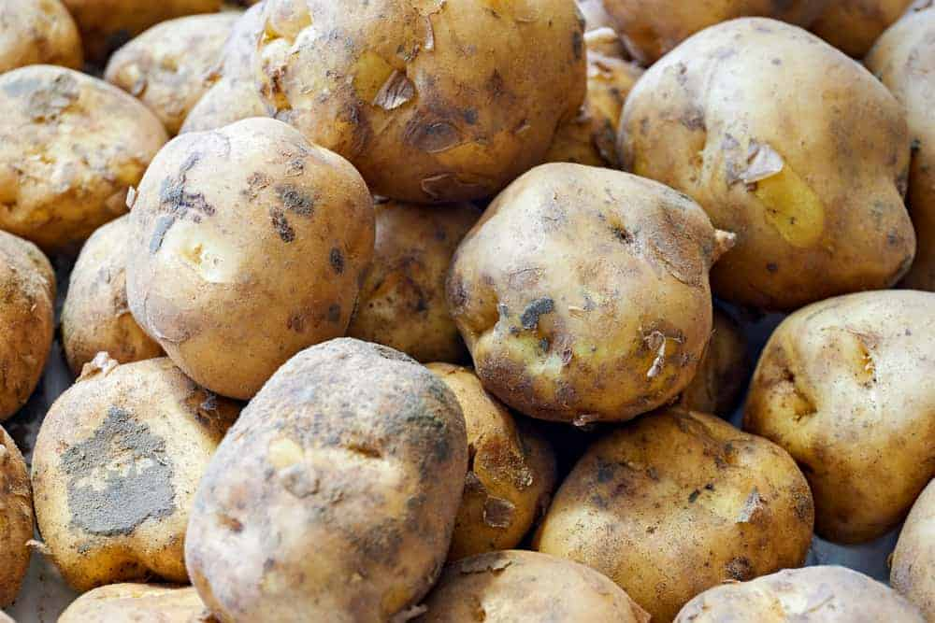
THE OPPERDOEZER RONDE POTATO IS NOT THE MOST ATTRACTIVE-LOOKING POTATO BECAUSE IT HAS AN ODD SHAPE. IT HAS WHITE FLESH OR YELLOW FLESH. IT CONTAINS MANY VITAMINS. THIS POTATO HAS THIN AND DELICATE SKIN AND MUST BE HARVESTED BY HAND TO PROTECT IT. THESE POTATOES ARE BEST FRIED OR BOILED. THEY HAVE A CREAMY FLESH AND BUTTERY TEXTURE AFTER BEING COOKED.

GUNDA POTATO
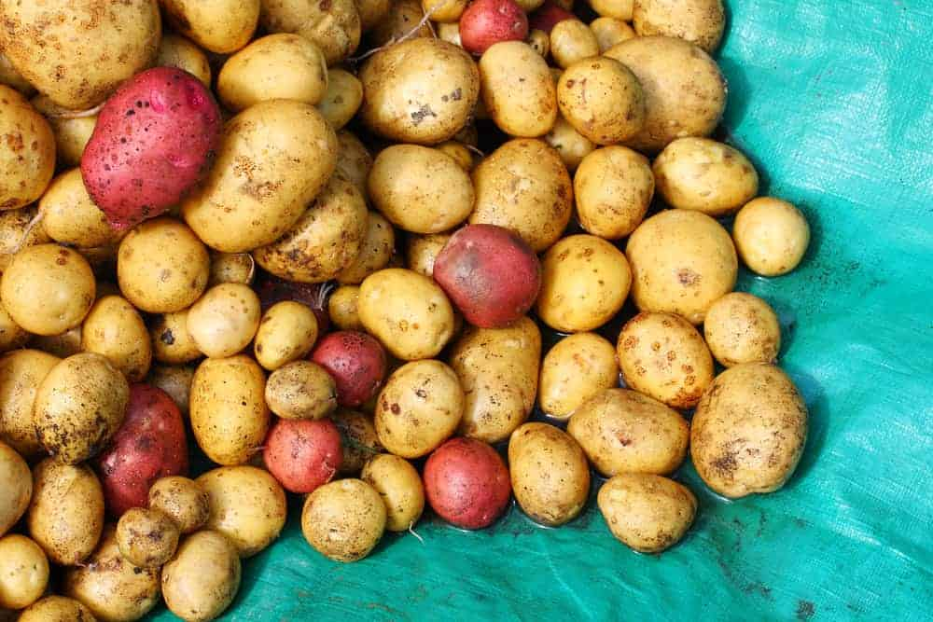
THE GUNDA POTATO HAS SIGNIFICANT NUTRIENTS AND WATER. THEY HAVE AN OVAL SHAPE WITH YELLOW FLESH. THE TEXTURE IS FLOURY AND HAS SLIGHTLY MOIST SKIN. THESE POTATOES YIELD A HIGH AMOUNT OF POTATO CROP. THEY CAN BE STORED FOR A SIGNIFICANT AMOUNT OF TIME.

DUKE OF YORK POTATO
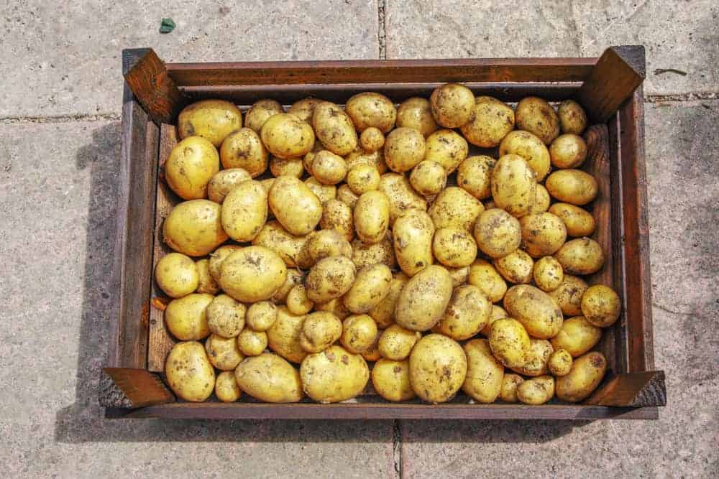
THE DUKE OF YORK POTATO IS A RED POTATO AND PART OF THE SALAD POTATO VARIETY. IT IS AN EARLY POTATO THAT HAS RED SKIN. THESE POTATOES ARE LARGE OVAL TUBERS WITH FLESH THAT IS YELLOW. THE DUKE OF YORK IS AN ALL-PURPOSE POTATO THAT IS IDEAL FOR ROASTING. THIS POTATO PREFERS MOIST SOIL THAT DRAINS WELL AND FULL SUNLIGHT.

SWEET POTATO
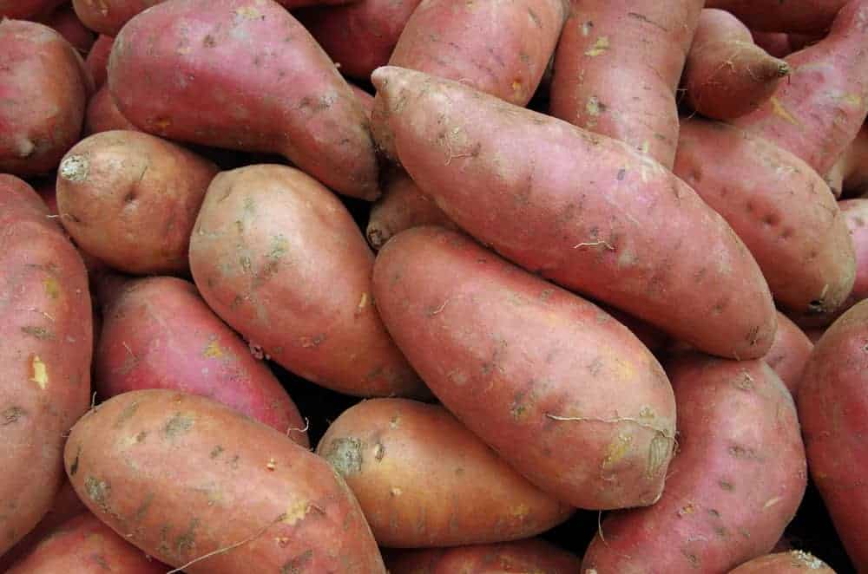
THERE ARE 16 VARIETIES OF SWEET POTATOES. SWEET POTATOES ARE KNOWN AS IPOMOEA BATATA. THEY ARE STARCHY TUBERS. THE FLESH HAS AN ORANGE COLOR, WHILE THE SKIN IS BROWNISH. THEY ARE FULL OF BETA-CAROTENE, WHICH IS WHY THEY HAVE AN ORANGE FLESH COLOR.
THEY ARE LOWER ON THE GLYCEMIC INDEX, MEANING IT TAKES YOUR BODY LONGER TO ABSORB THE SUGAR IT CONTAINS. THEY HAVE A FAIR AMOUNT OF FIBER AND HELP YOU TO FIGHT INFLAMMATION IN YOUR BODY. SWEET POTATOES ARE A GOOD SUBSTITUTE TO HELP THICKEN FOODS LIKE SOUP. YOU CAN REPLACE PASTA WITH SWEET POTATOES FOR A BETTER FOOD OPTION. THERE ARE NO LIMITS TO THE WAYS YOU CAN PREPARE A SWEET POTATO.

RED BLISS POTATO
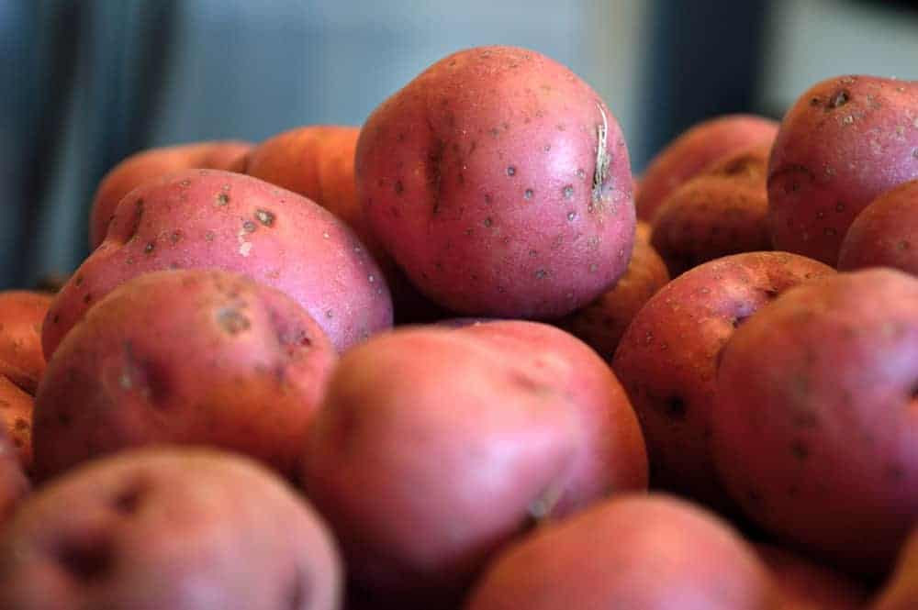
RED BLISS POTATOES FALL INTO THE WAXY CATEGORY. THEY ARE SMALL, ROUND, AND HAVE THICK RED SKIN. THEIR FLESH IS WAXY AND WHITE AND BECOMES CREAMY WHEN THEY ARE COOKED. THESE POTATOES ARE TENDER AND HAVE A SUBTLE FLAVOR. THE ROUND RED POTATO WORKS WELL IN VARIOUS PREPARATIONS. THEY CAN BE ROASTED AND CRISPY, SLICED FOR CASSEROLES, BOILED, AND STEAMED.

RUSSIAN BANANA POTATO
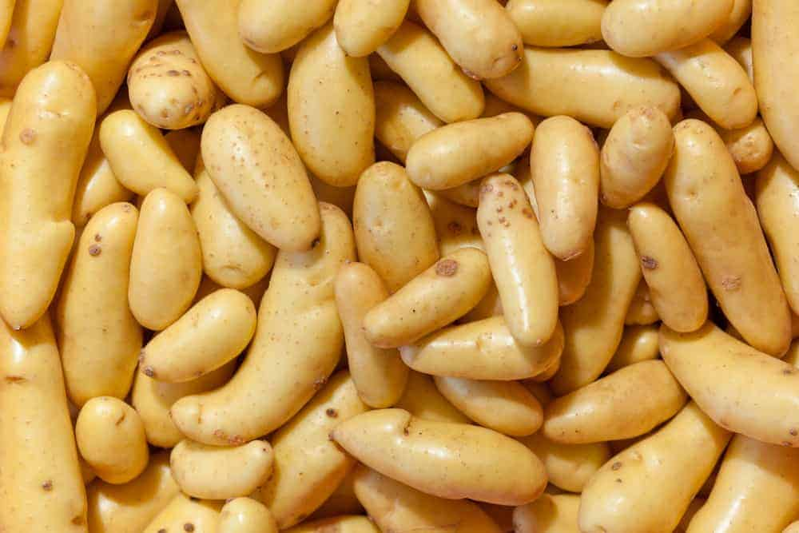
THE RUSSIAN BANANA POTATO IS A FINGERLING THAT FALLS IN THE HEIRLOOM FAMILY. THIS IS THE MOST FAMOUS OF ALL THE FINGERLING POTATOES. THE RUSSIAN BANANA IS A WAXY POTATO, AND ITS FLESH IS A YELLOW COLOR. THIS IS GREAT FOR POTATO SALAD BECAUSE THEY ARE A MOIST POTATO.

NEW POTATO
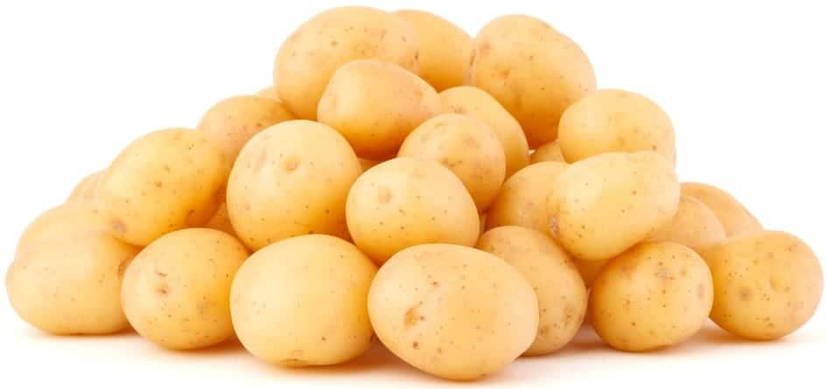
NEW POTATOES COVER A WIDE RANGE OF POTATOES. THEY ARE ANY POTATO THAT IS HARVESTED AT A YOUNG AGE, BEFORE THEY ARE FULLY MATURE AND BEFORE THE SUGAR CONTAINED IN THE POTATO HAS TIME TO COMPLETELY CONVERT TO STARCH. THEY HAVE THIN SKIN AND ARE TYPICALLY ROUND AND SMALL. THEY OFTEN VARY IN COLOR, DEPENDING ON THE TYPE OF POTATO THEY ARE. THEY ARE WAXY AND INCREDIBLY CREAMY. THEY ARE SWEET AND FIRM. THESE POTATOES ARE GREAT FOR ROASTING, STEAMING, OR BOILING. THEY ARE GREAT IN SOAPS. THEY ARE NOT THE BEST FOR BAKING.

SHEPODY POTATO
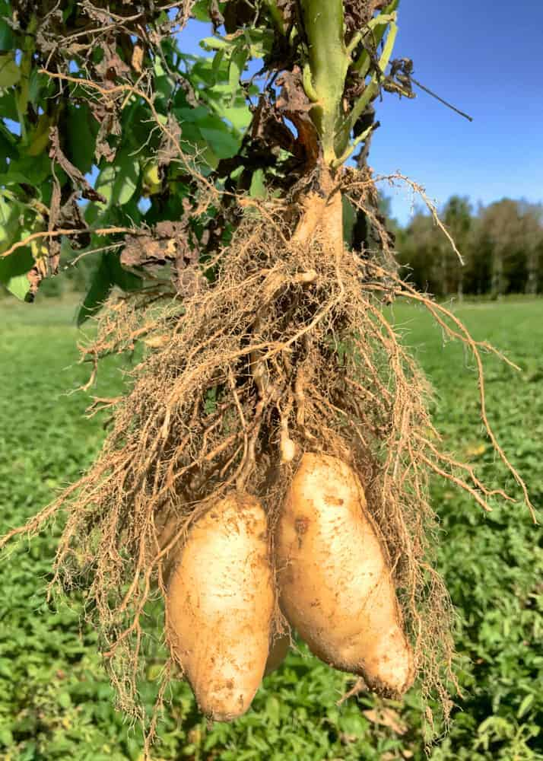
SHEPODY POTATOES ARE AN ALL-PURPOSE POTATO THAT IS HIGH IN STARCH. THEY HAVE WHITE FLESH AND THIN SKIN THAT IS SMOOTH AND WHITE. DESPITE BEING A SOLID ALL-PURPOSE POTATO, THEY ARE RARELY CONSIDERED FOR THAT PURPOSE. THESE POTATOES ARE MOST OFTEN USED FOR FRENCH FRIES. THEY ARE THE PERFECT POTATO FOR FRYING AND CREATE A GREAT FRENCH FRY. THE SHEPODY POTATOES HAVE A GREAT TASTE AND ARE ALSO IDEAL FOR BOILING AND BAKING.

DIFFERENT VARIETIES OF POTATOES

FRENCH FRIES
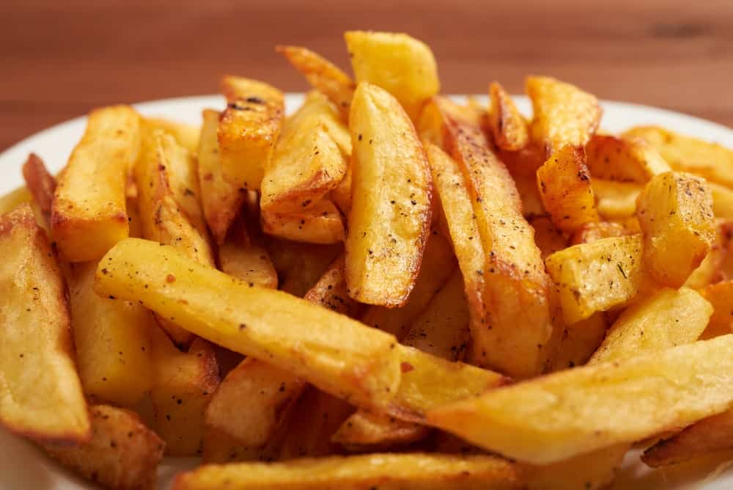
THIS IS ONE OF THE MOST POPULAR VARIETIES OF POTATOES, AND THEY CAN BE FOUND AT NEARLY EVERY FAST-FOOD RESTAURANT, AS WELL AS OTHER TYPES OF EATERIES. THEY ALSO COME IN A FROZEN VARIETY, AND THEY CAN BE CRINKLE-CUT FRIES, STEAK FRIES, SHOESTRING FRIES, WAFFLE FRIES, CURLY-QUE FRIES, POTATO WEDGES, TATER TOTS, AND REGULAR-SHAPED FRENCH FRIES.

FROZEN POTATOES
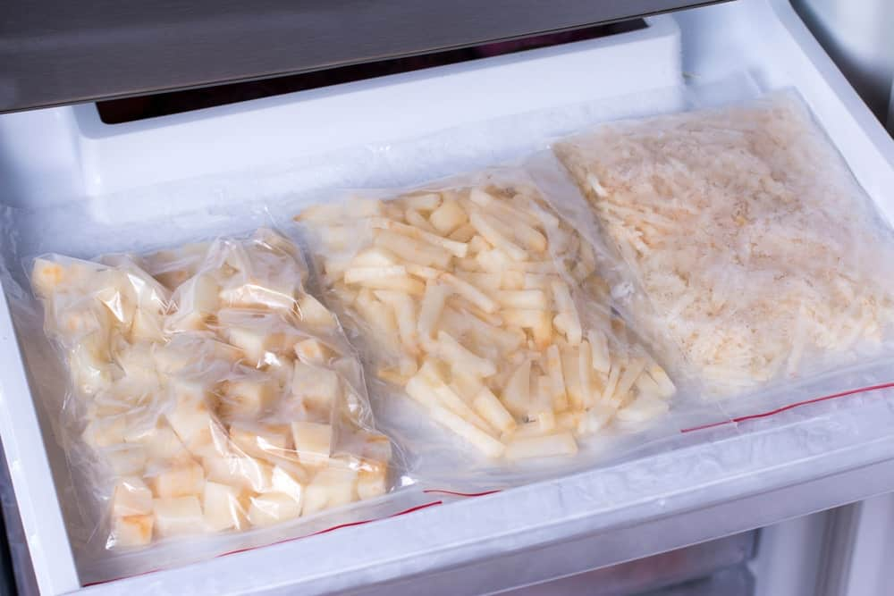
FROZEN POTATOES DO NOT JUST COME IN FRENCH FRIES, BECAUSE YOU CAN FIND REGULAR BAKED POTATOES AND STUFFED POTATOES IN A FROZEN VARIETY. IN FACT, WHEN IT COMES TO FROZEN POTATOES, YOU CAN FIND JUST ABOUT ANY VARIETY YOU MIGHT BE INTERESTED IN, SAVING YOU A LOT OF TIME IN THE KITCHEN. THEY ALSO MAKE FROZEN POTATOES IN THE FORM OF HASH BROWNS AND OTHER TYPES OF BREAKFAST POTATOES, SO THEY ARE NOT JUST FOR LUNCH AND DINNER DISHES.

INSTANT MASHED POTATOES
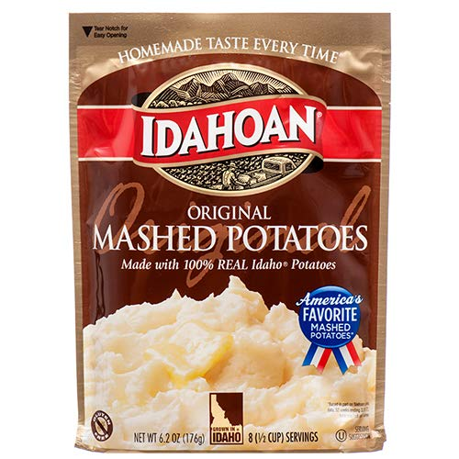
CLICK FOR PRICE
INSTANT MASHED POTATOES USUALLY COME IN A BOX AND ARE COOKED WITH WATER AND SOMETIMES MILK AND BUTTER. THEY CAN BE MICROWAVED OR COOKED ON THE STOVE, AND THE WATER REHYDRATES THEM SO THAT THEY TASTE JUST LIKE REAL POTATOES. INSTANT MASHED POTATOES ARE TASTY AND CONVENIENT, AND THEY ARE A GREAT WAY OF ENJOYING THIS DELICIOUS VEGETABLE WITHOUT SPENDING TOO MUCH TIME IN THE KITCHEN PREPARING IT.

35 DIFFERENT TYPES OF SWEET POTATOES
KNOW MORE ABOUT THE SWEET POTATOES AND DISCOVER ITS MANY DIFFERENT TYPES. TAKE A LOOK ON ITS NUTRITIOUS FACTS AND SEE IMAGES OF THE DIFFERENT TYPES OF SWEET POTATOES.
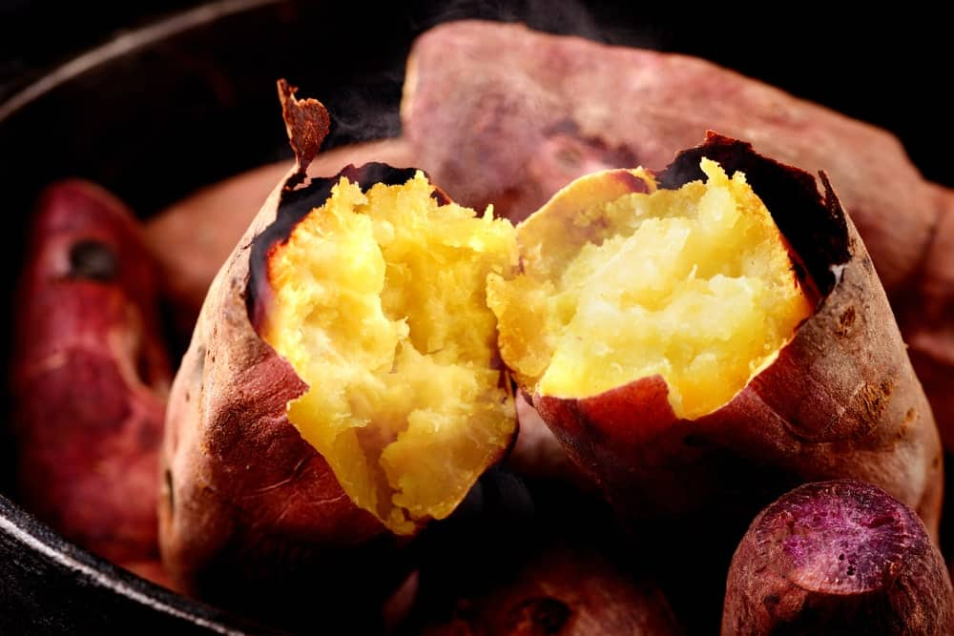
SWEET POTATOES ARE HERBACEOUS VINES THAT GROW HORIZONTALLY AND BELONG TO THE MORNING GLORY FAMILY. THEY’RE TYPICALLY GROWN AS PERENNIAL PLANTS IN WARM CLIMATES AND AS ANNUAL PLANTS IN COLD CLIMATES. THEY ORIGINATED FROM CENTRAL AND SOUTH AMERICA AND WERE CULTIVATED AS EARLY AS 8,000 B.C AS A FOOD SOURCE AS WELL AS FOR ORNAMENTAL PURPOSES.
ALTHOUGH THEY SHARE THE NAME AND LOOK SIMILAR, SWEET POTATOES ARE NOT CLOSELY RELATED TO POTATOES AND YAMS. THE JUICE OF SWEET POTATOES CAN BE USED FOR DYE PRODUCTION THAT RANGES IN COLORS FROM PURPLE TO BLACK. SWEET POTATOES CAN ALSO BE USED FOR PRODUCING RUBBER, INK, AND GLUE.
RELATED: CINNAMON SWEET POTATO BREAD RECIPE | YAMS VS. SWEET POTATOES | SWEET POTATO CASSEROLE RECIPE | WHAT GOES WITH POTATOES | TYPES OF POTATOES

SWEET POTATOES NUTRITION FACTS CHART
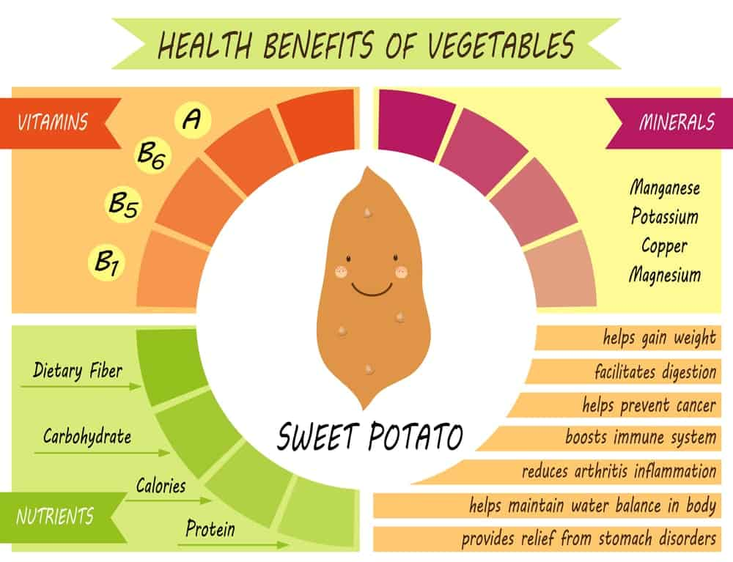
NOW LET’S JUMP INTO YOUR SWEET POTATO OPTIONS.

1. APACHE SWEET POTATOES
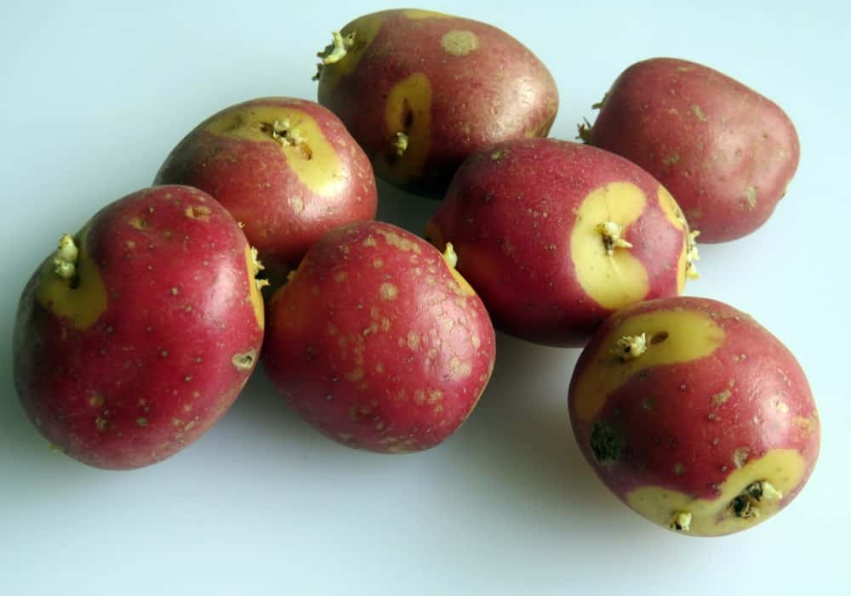
APACHE SWEET POTATOES HAVE PALE ORANGE SKIN AND PALE ORANGE FLESH, AND THEY ARE VERY TASTY AS WELL.

2. BEAUREGARD SWEET POTATOES
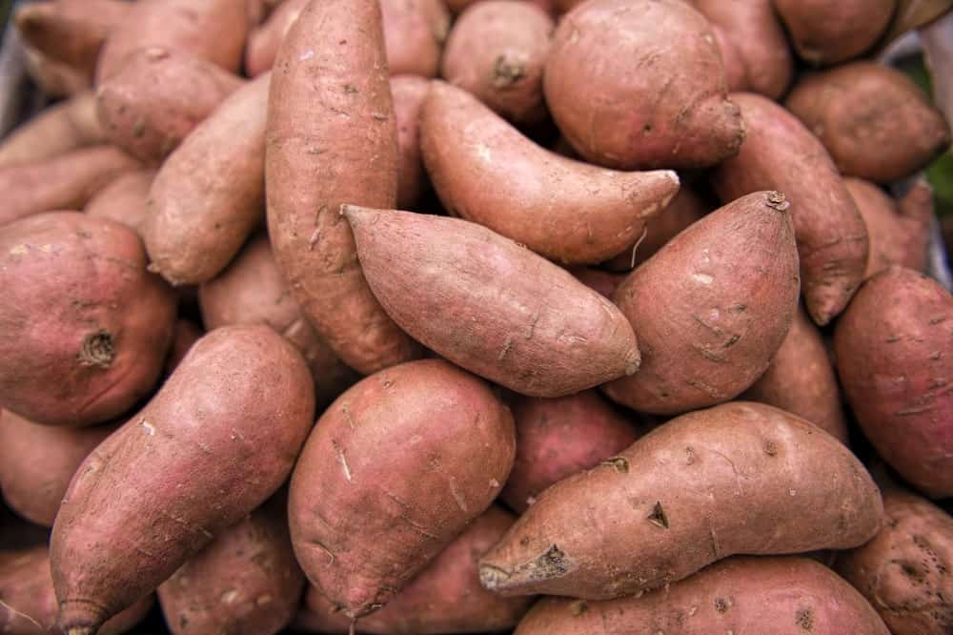
THESE SWEET POTATOES ORIGINATED IN LOUISIANA AND HAVE DARK ORANGE OR COPPER-COLORED SKIN AND VERY UNIFORM SHAPE. THEY MATURE IN ROUGHLY 100 DAYS AND ARE A FAIRLY NEW VARIETY, ALTHOUGH THEY ARE ALREADY VERY POPULAR WITH FARMERS. THEY ALSO PRODUCE HIGH YIELDS AND ARE SUBJECT TO VERY LITTLE CRACKING.

3. BROWN HORSE SWEET POTATOES
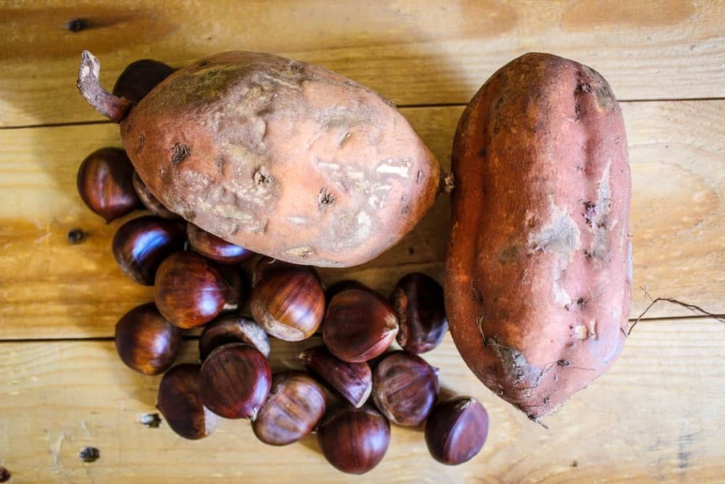
WITH AN ODDLY-COLORED SKIN THAT IS A WOODY BROWN COLOR, THIS TYPE OF SWEET POTATO HAS DARK RED FLESH THAT IS EXTREMELY SWEET. THEY ARE NOT THE EASIEST TYPE OF SWEET POTATOES TO FIND, BUT THEY ARE EXTREMELY POPULAR WITH LOVERS OF SWEET POTATOES.

4. “BUNCH” PORTO RICO SWEET POTATOES
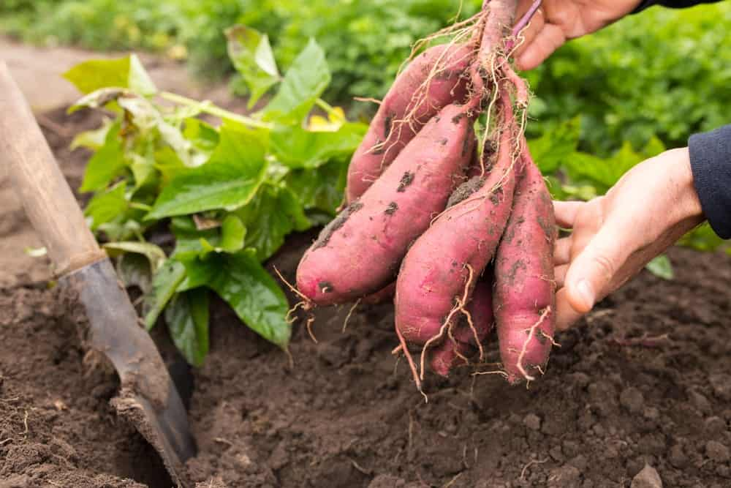
ALSO KNOWN AS VINELESS OR BUSH SWEET POTATOES, YOU CAN GROW THESE EVEN IF YOUR GROWING SPACE IS SMALL. THE FLESH IS LIGHT RED AND THE OUTSIDE IS A COPPER COLOR. THEY HAVE A DELICIOUS FLAVOR AND ARE ESPECIALLY GOOD WHEN BAKED.

5. CAROLINA BUNCH SWEET POTATOES
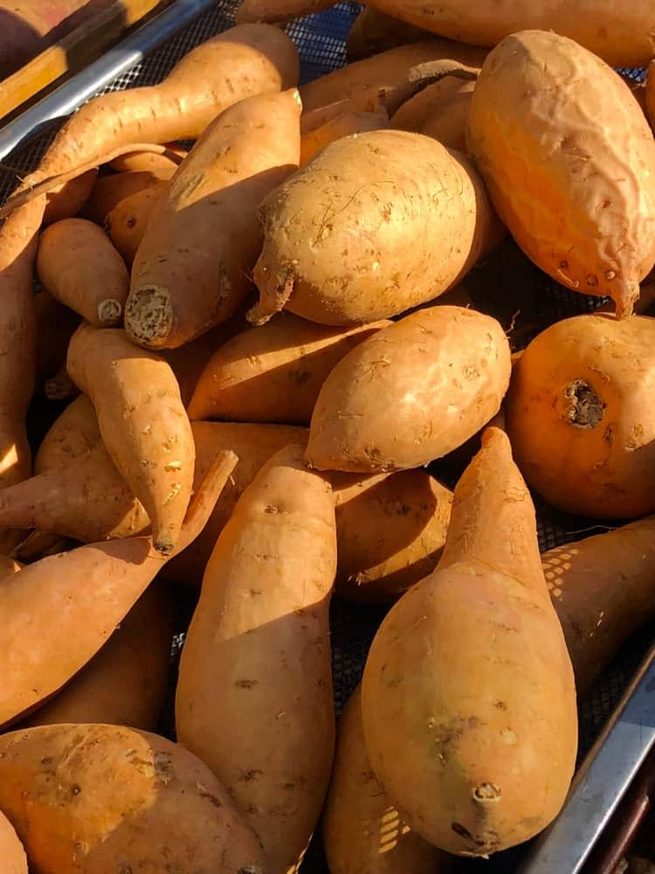
DEVELOPED IN SOUTH CAROLINA, THESE SWEET POTATOES HAVE A UNIFORM SHAPE AND SKIN THAT IS SMOOTH AND BRIGHT TO LIGHT COPPER IN COLOR. THE FLESH ITSELF IS DEEP ORANGE, AND THIS VARIETY IS A VIGOROUS PLANT THAT MATURES IN APPROXIMATELY 120 DAYS.

6. CENTENNIAL SWEET POTATOES
WITH A SOFT FLESH AND A MEDIUM TO LARGE SHAPE, THIS TYPE OF SWEET POTATO HAS A DEEP ORANGE FLESH THAT CAN MAKE ANYONE’S TABLE MORE COLORFUL. BECAUSE OF ITS VERSATILITY IN VARIOUS DISHES, THIS IS A FAVORITE AMONGST GROWERS OF SWEET POTATOES.

7. COVINGTON SWEET POTATOES
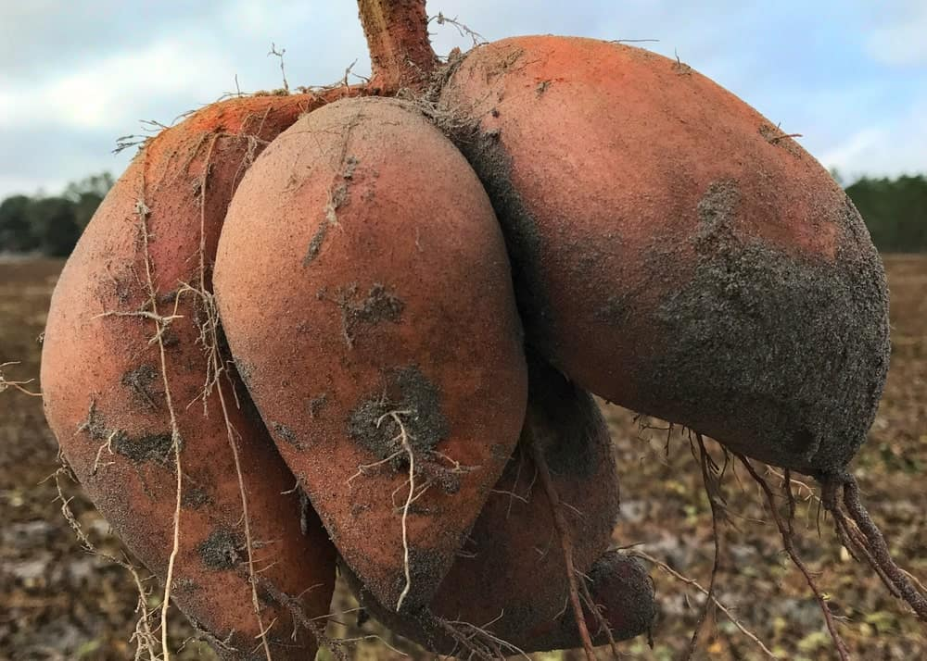
THIS IS A NEW VARIETY ORIGINATING IN NORTH CAROLINA, AND IT HAS DEEP ORANGE FLESH AND A BEAUTIFUL APPEARANCE. IT IS A DELICIOUS SWEET POTATO AND IS VERY POPULAR AMONG GROWERS.

8. DARBY SWEET POTATOES
DARBY SWEET POTATOES HAVE DARK RED SKIN AND DEEP ORANGE FLESH. THEY ARE UNIFORM IN SHAPE, VERY TASTY, AND WHEN YOU BAKE THEM, THEIR FLESH BECOMES VERY SOFT AND JUICY.

9. EVANGELINE SWEET POTATOES
THIS IS A NEW VARIETY FROM LOUISIANA, AND THEY HAVE THE SKIN OF A ROSE COLOR AND VERY MOIST, DEEP ORANGE FLESH.

10. EXCEL SWEET POTATOES
THIS SWEET POTATO HAS ORANGE FLESH AND SKIN THAT IS LIGHT COPPER IN COLOR. IT HAS A NATURAL RESISTANCE TO INSECTS AND GROWS VIGOROUSLY. IT WAS DEVELOPED BY A UNIVERSITY IN SOUTH CAROLINA.

11. GEORGIA JET SWEET POTATOES
THESE SWEET POTATOES GROW EXTREMELY QUICKLY AND ARE SPECIALLY DESIGNED FOR NORTHERN GARDENS. THEY HAVE A VERY RICH FLAVOR AND OUTSIDE SKIN THAT IS A REDDISH-PURPLE COLOR.

12. GINSENG RED SWEET POTATOES
GINSENG RED SWEET POTATOES HAVE SMOOTH SKIN AND A LOVELY SPINDLE SHAPE. THEIR FLESH IS A BRIGHT ORANGE COLOR AND THEY ARE PERFECT FOR GROWERS WHO DON’T HAVE MUCH ROOM IN THEIR GARDEN.

13. HANNAH SWEET POTATOES
THESE SWEET POTATOES ARE SMOOTH, CREAM-COLORED POTATOES THAT HAVE A SWEET TASTE AND A CREAM-COLORED FLESH THAT GETS MORE YELLOW WHEN YOU BAKE IT. CONSIDERED A FIRM OR DRY TYPE OF SWEET POTATO, HANNAH IS STILL AN ATTRACTIVE AND POPULAR TYPE OF VEGETABLE.

14. HAYMAN SWEET POTATOES
HAYMAN SWEET POTATOES ARE EXTREMELY MOIST AND SWEET, AND THEY HAVE A GREENISH-YELLOW FLESH. THESE ARE NOT TO BE CONFUSED WITH WHITE HAYMAN SWEET POTATOES, WHICH ARE SOMEWHAT DRY AND NOT VERY SWEET.

15. HERNANDEZ SWEET POTATOES
ORIGINATING IN LOUISIANA, THIS TYPE OF SWEET POTATO MATURES SLOWLY, TAKING UP TO 125 DAYS TO BE READY TO HARVEST. WITH A DEEP-ORANGE FLESH AND RED SKIN, THE HERNANDEZ SWEET POTATO IS MODERATELY RESISTANT TO DISEASES SUCH AS FUSARIUM WILT, AND IT IS AN EXCELLENT SWEET POTATO FOR BAKING.

16. JERSEY (YELLOW JERSEY) SWEET POTATOES
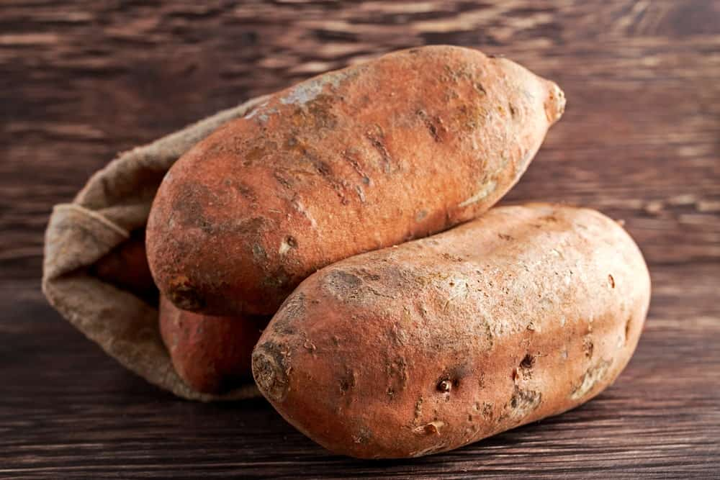
KNOWN AS EITHER JERSEY OR YELLOW JERSEY SWEET POTATOES, THESE VEGETABLES HAVE A GOLDEN-YELLOW SKIN THAT OFTEN FADES TO TAN AFTER THEY’VE BEEN STORED FOR A BIT. THE FLESH IS EITHER CREAMY WHITE OR BRIGHT YELLOW, AND THE POTATO HAS A SWEET TASTE THAT YOU CAN ENJOY JUST FROM STEAMING IT.

17. JEWEL SWEET POTATOES
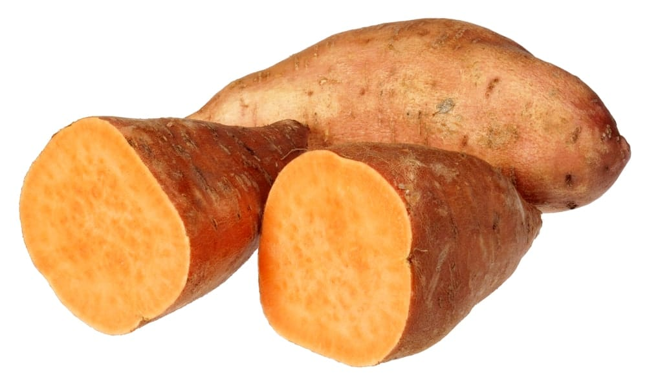
MANY EXPERTS CONSIDER THIS TYPE OF SWEET POTATO TO BE THE MOST VERSATILE, AND IT DOES GREAT WHEN STEAMED, BAKED, OR PLACED IN SALADS. IT HAS A COPPER-COLORED SKIN AND MOIST FLESH THAT IS BRIGHT ORANGE IN COLOR, AND THIS VARIETY TAKES APPROXIMATELY 135 DAYS TO MATURE.

18. KOTOBUKI SWEET POTATOES
ORIGINATING IN JAPAN, THESE SWEET POTATOES HAVE REDDISH-BROWN FLESH AND A SLIGHTLY NUTTY FLAVOR. OUTSIDE OF CERTAIN TYPES OF ASIAN COOKING, THESE POTATOES ARE NOT USUALLY USED BECAUSE OF THEIR DRYNESS; HOWEVER, THEY ARE PERFECT FOR STIR-FRY DISHES AND TEMPURA, AMONG OTHERS.

19. KUMARA SWEET POTATOES
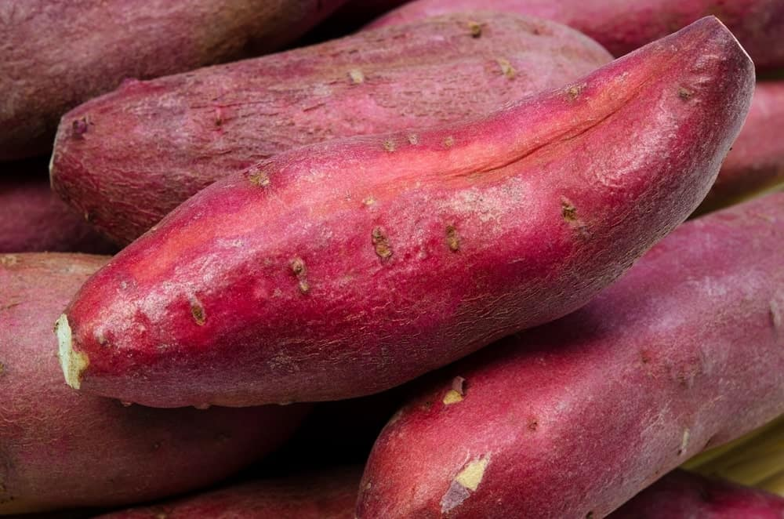
MOSTLY CULTIVATED IN NEW ZEALAND, THESE SWEET POTATOES HAVE BEEN AROUND FOR A VERY LONG TIME AND ARE STILL THE THIRD MOST POPULAR VEGETABLE AMONG NEW ZEALAND CITIZENS.

20. NANCY HALL SWEET POTATOES
THESE SWEET POTATOES HAVE BEEN AROUND SINCE THE 1930S, AND THEY HAVE LIGHT-COLORED SKIN AND YELLOW FLESH. WHEN YOU BAKE THEM, THESE SWEET POTATOES ARE VERY SWEET, MAKING THEM VERY POPULAR EVEN THOUGH THEY ARE NOT ONE OF THE MOST ATTRACTIVE SWEET POTATOES IN EXISTENCE.

21. NEW JEWEL SWEET POTATOES
WITH BEAUTIFUL ROSY-RED SKIN AND DEEP ORANGE FLESH, THIS SWEET POTATO IS ABSOLUTELY DELICIOUS AND PRODUCES LARGE AMOUNTS WHEN PLANTED. IN FACT, THIS TYPE OF SWEET POTATO HAS WON NUMEROUS INTERNATIONAL AWARDS BECAUSE OF ITS COLOR AND TASTE.

22. OKINAWA SWEET POTATOES
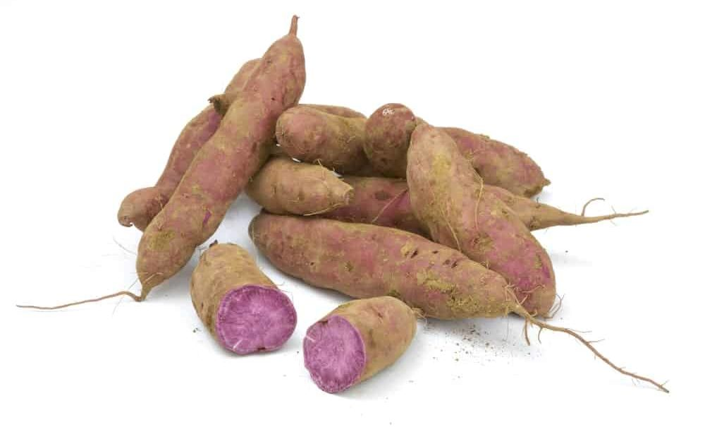
THESE SWEET POTATOES HAVE LIGHT BROWN SKIN AND FLESH THAT IS A UNIQUE SHADE OF PURPLE AND IS VERY SWEET AND NUTRITIOUS. PERFECT FOR BAKING AND USE IN VARIOUS STIR-FRY DISHES, IT RETAINS ITS BEAUTIFUL PURPLE COLOR EVEN WHEN YOU BAKE IT.

23. O’HENRY SWEET POTATOES
O’HENRY SWEET POTATOES HAVE WHITE FLESH AND ARE A HYBRID TYPE OF VEGETABLE. THESE POTATOES PRODUCE A LOT OF YIELDS AND MATURE IN ONLY 90 DAYS. THEY ARE ALSO VERY RESISTANT TO DISEASES THAT OTHER WHITE VARIETIES ARE NOT.

24. ORIENTAL SWEET POTATOES
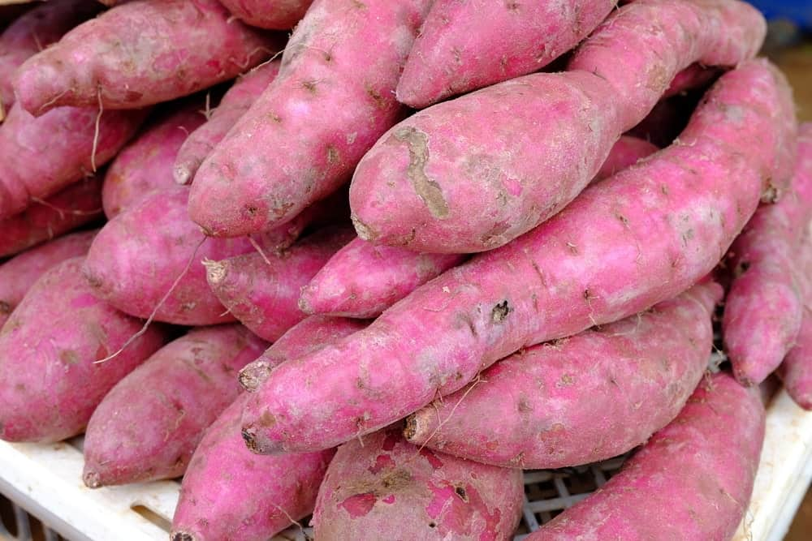
ALSO CALLED THE JAPANESE SWEET POTATO, THIS VARIETY HAS A PURPLISH-PINK SKIN AND IS BRIGHT AND WHITE ON THE INSIDE. ITS NUTTY FLAVOR MAKES IT A POPULAR TYPE OF SWEET POTATO, AND IT CAN BE GRILLED, BAKED, OR EVEN STEAMED.

25. PUERTO RICAN SWEET POTATOES
THESE SWEET POTATOES HAVE COPPER-COLORED SKIN AND RED-ORANGE FLESH THAT IS VERY SWEET AND MOIST. THEY ARE ALSO RESISTANT TO MANY TYPES OF DISEASES, AND THEY MAKE A GREAT GARDEN VARIETY OF SWEET POTATO.

26. PURPLE SWEET POTATOES
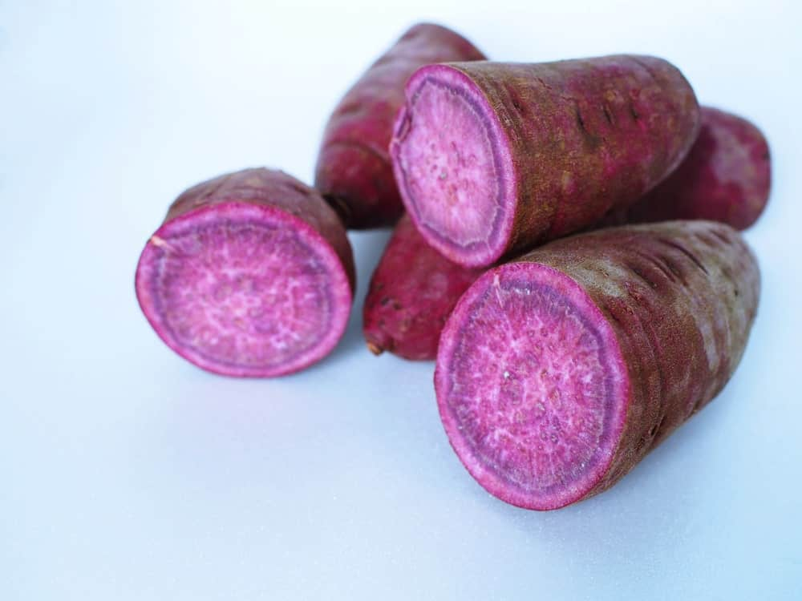
WITH DEEP PURPLE SKIN AND FLESH, THESE SWEET POTATOES ARE FAIRLY DRY IN THE MIDDLE AND NOT VERY SWEET, MAKING THEM BETTER FOR USE IN RECIPES THAN FOR EATING BY THEMSELVES.

27. RED GARNET SWEET POTATOES
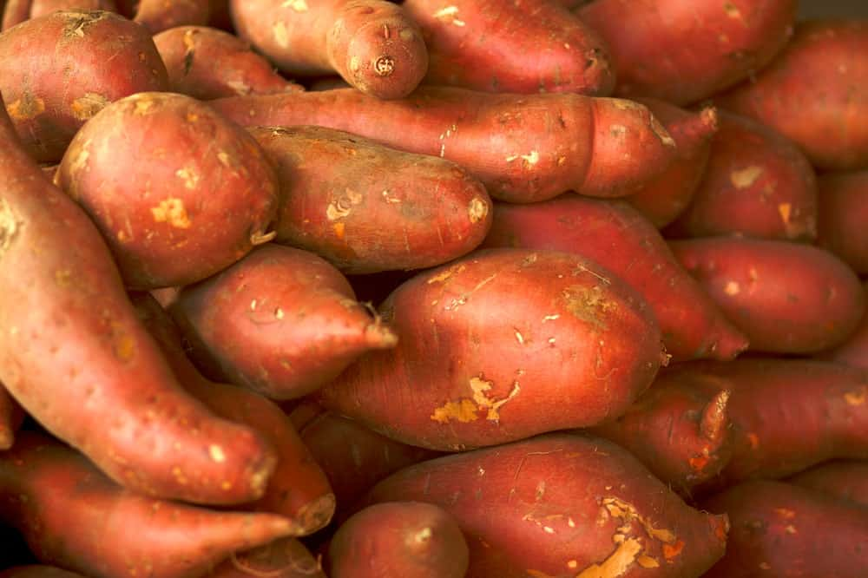
THIS SWEET POTATO GETS ITS NAME BECAUSE OF ITS DEEP RED OR PURPLE SKIN, AND IT IS PERFECT FOR ANY RECIPE THAT CALLS FOR GRATED OR MASHED SWEET POTATOES, INCLUDING BREAD, CAKES, AND MANY OTHER DESSERTS.

28. RED JEWEL SWEET POTATOES
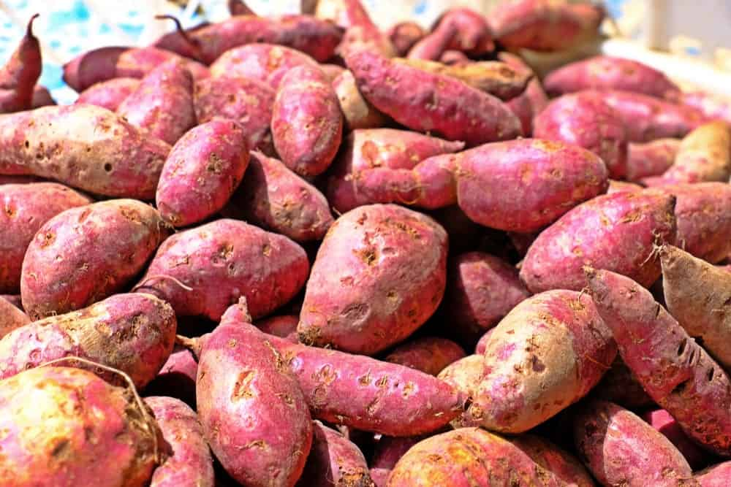
THIS IS A VERY VERSATILE AND POPULAR TYPE OF SWEET POTATO, WITH DARK ORANGE FLESH AND RED SKIN. WHEN BAKED, IT ENDS UP WITH A VERY SOFT TEXTURE, AND IT CAN ADD SOME BEAUTY TO YOUR TABLE AS WELL.

29. REGAL SWEET POTATOES
WITH A BEAUTIFUL DEEP PURPLE-RED SKIN AND ORANGE FLESH, THESE SWEET POTATOES ARE PERFECT FOR BAKING. IT IS HIGH QUALITY AND VERY POPULAR TYPE OF SWEET POTATO, AND IT PRODUCES A VERY LARGE YIELD EVERY SEASON.

30. SATSUMA SWEET POTATOES
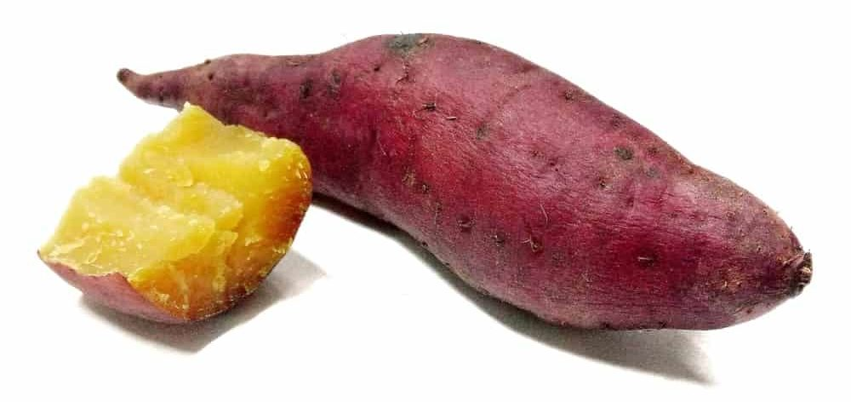
CULTIVATED MOSTLY IN THE SATSUMA AREA OF JAPAN, THESE SWEET POTATOES HAVE BEEN AROUND SINCE THE 1600S. THEY ARE USED IN MANY WAYS IN THAT AREA OF THE WORLD, INCLUDING AS A RAW MATERIAL FOR PROCESSED FOODS AND EVEN AS AN INGREDIENT IN ALCOHOLIC BEVERAGES. THEY HAVE A SIMPLE AND SWEET FLAVOR, WHICH IS ONE REASON WHY THEY ARE SO POPULAR.

31. SOUTHERN DELIGHT SWEET POTATOES
THIS TYPE OF SWEET POTATO HAS DARK ORANGE FLESH AND ROSE OR DARK COPPER SKIN. WITH A DELICIOUS, SATISFYING FLAVOR, THIS SWEET POTATO WAS DEVELOPED IN THE MID-1980S AND STORES FAIRLY WELL.

32. SUMOR SWEET POTATOES
“SUMOR” IS THE OLD ENGLISH WORD FOR “SUMMER,” AND THIS TYPE OF SWEET POTATO HAS LIGHT TAN SKIN AND WHITE OR YELLOW FLESH. A HIGH PRODUCER, IT CONTAINS MORE VITAMIN C THAN MOST TOMATOES AND GROWS VIGOROUSLY. IF YOUR CLIMATE IS TOO WARM FOR IRISH POTATOES, YOU SHOULD CONSIDER PLANTING THESE INSTEAD.

33. VARDAMAN SWEET POTATOES
THIS IS A BUSH VARIETY OF SWEET POTATOES THAT HAVE DEEP ORANGE FLESH. IF YOU HAVE LIMITED SPACE IN YOUR GARDEN, VARDAMAN SWEET POTATOES ARE A PERFECT OPTION TO PLANT. THEY HAVE BEEN AROUND SINCE THE EARLY 1980S, AND THEY HAVE BRIGHT RED AND GREEN FOLIAGE THAT MAKES THEM LOOK JUST AS GOOD AS THEY TASTE.

34. WHITE SWEET POTATOES
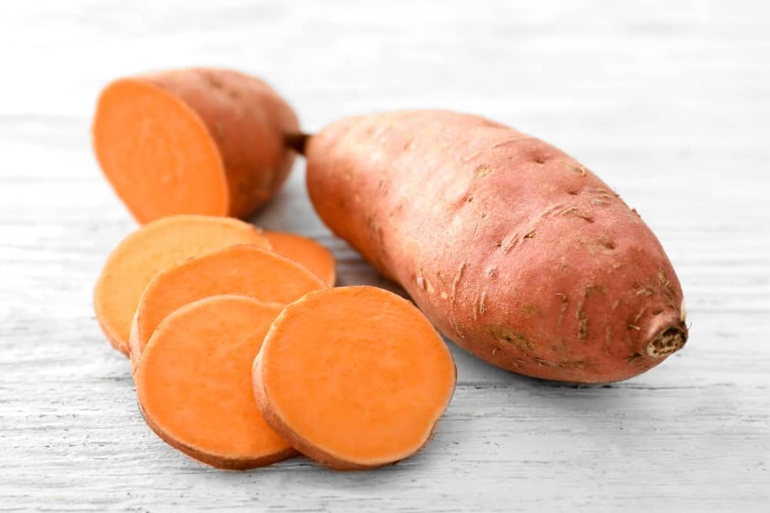
THESE SWEET POTATOES ARE A VARIETY OF THE STANDARD ORANGE-COLORED SWEET POTATO, AND THEY ARE ALSO CALLED CAMOTE OR BATATA POTATOES. WITH SKIN THAT IS EITHER REDDISH-PURPLE OR BROWNISH-PURPLE IN COLOR, THIS TYPE OF SWEET POTATO IS FIRM AND TASTY, AND YOU CAN ENJOY IT BAKED OR COOKED IN VARIOUS DISHES.

35. YAMAIMO SWEET POTATOES
ORIGINATING IN AND MOSTLY USED IN JAPAN, THIS TYPE OF SWEET POTATO IS SWEET AND STICKY AND IS OFTEN USED AS A JULIENNE VEGETABLE FOR SALADS. YOU CAN ALSO FRY IT OR USE IT TO MAKE SOBA NOODLES.

13 DIFFERENT TYPES OF BELL-PEPPER
SWEET PEPPER IS FREQUENTLY REFERRED TO AS BELL PEPPER, AND THE TWO TERMS ARE INTERCHANGEABLE. MANY MAY CONTEND THAT THE DIFFERENCE IN COLOR BETWEEN A RED, YELLOW, ORANGE, OR GREEN PEPPER AND ITS FLAVOR IS INSIGNIFICANT. WITHOUT FURTHER ADO, LET'S LEARN MORE ABOUT THE VARIOUS FORMS OF BELL PEPPER.

THE HUMBLE BELL PEPPER IS ONE OF THE MOST VERSATILE FOODS OUT THERE. WHETHER YOU LIKE THEM RAW AS A MID-AFTERNOON SNACK, ADDED TO A STIR FRY, CHARRED ON THE GRILL, OR JUST USED TO ADD A LITTLE EXTRA COLOR TO A BLAND-LOOKING SALAD, THESE DELICIOUS VEGGIES CAN DO IT ALL.
THAT BEING SAID, THERE’S A LOT OF INFORMATION SURROUNDING BELL PEPPERS THAT NEEDS CLEARING UP.
SO, BEFORE WE GET INTO ALL THE DELICIOUS TYPES OF BELL PEPPER AND THEIR MANY USES – WE OUGHT TO TAKE A QUICK DETOUR AND DEFINE WHAT PEPPERS ACTUALLY ARE BECAUSE BELIEVE IT OR NOT, THESE ARE ONE OF THE RARE FOODS THAT HOLD THE DISTINCTION OF BEING BOTH FRUIT AND VEGETABLE AT THE SAME TIME, WELL KIND OF…

WAIT, ARE BELL PEPPERS A FRUIT OR A VEGETABLE?
THE ANSWER YOU’LL GET TO THE QUESTION OF WHETHER ANY PEPPER (BELL OR NOT) IS A FRUIT OR A VEGETABLE DEPENDS VERY MUCH ON WHO YOU ASK. ANY HORTICULTURAL EXPERT WILL TELL YOU, ACCORDING TO THE STRICT BOTANICAL DEFINITION, THAT PEPPERS ARE A FRUIT.
THIS IS BECAUSE PEPPERS GROW FROM THE FLOWER OR OVARY OF THE PLANT, AND ARE THE SEED-BEARING MEANS OF REPRODUCTION FOR THE PEPPER PLANT.
HOWEVER, IN THE KITCHEN, THE PEPPER IS WIDELY CLASSIFIED AS A VEGETABLE. THIS IS BECAUSE ITS FLAVORS AND COOKING USE FIT THE PROFILE OF A VEGETABLE MUCH BETTER THAN FRUIT. PEPPERS ARE BY NO MEANS THE ONLY ‘VEGETABLE’ THAT’S ACTUALLY A FRUIT, OTHER WELL-KNOWN EXAMPLES ARE TOMATOES, EGGPLANT, PEAS, ZUCCHINI, AND CUCUMBERS.

SO, WHAT IS A BELL PEPPER ANYWAYS?

Bottom of Form
BELL PEPPER IS A COMMONLY USED TERM FOR SWEET PEPPER, AND THE WORDS CAN BE USED INTERCHANGEABLY. THE ONLY DIFFERENCE BETWEEN A SWEET PEPPER AND ANY OTHER PEPPER IS THAT THEY DO NOT CONTAIN CAPSAICIN, THE CHEMICAL THAT GIVES OTHER PEPPERS THEIR HEAT.
BELL PEPPERS HAVE BEEN CULTIVATED BY NATIVE PEOPLES FOR WELL OVER 6,500 YEARS AND WERE ONE OF THE EARLIEST CULTIVATED NEW WORLD CROPS. BELL PEPPERS ARE MEMBERS OF THE SOLANACEAE FAMILY ALSO KNOWN AS THE NIGHTSHADES, ALONG WITH TOMATOES, EGGPLANT, AND POTATOES.
SINCE THE FIRST PEPPER SEEDS ARRIVED IN SPAIN IN 1493, GROWERS ALL OVER THE WORLD HAVE BEEN BUSY PROPAGATING NEW VARIETIES OF PEPPER AND SELECTING THEM FOR DESIRABLE TRAITS.
ONE OF THE MOST COMMON POINTS OF DISAGREEMENT ABOUT BELL PEPPERS IS THAT THERE’S ONLY ONE TYPE, SO LET’S JUST GET THIS OUT OF THE WAY: THIS COULDN’T BE FARTHER FROM THE TRUTH.
WHILE IT’S TRUE THAT ALL BELL PEPPERS ARE BOTANICALLY CLASSIFIED AS CAPSICUM ANNUM, THERE IS A HUGE VARIETY OF CULTIVARS THAT GO WELL BEYOND THE CLASSIC CONCEPTION THAT A BELL PEPPER IS EITHER GREEN, YELLOW OR RED.
IN FACT, MANY PEOPLE WILL ARGUE THAT THERE IS ABSOLUTELY NO DIFFERENCE BETWEEN A RED, YELLOW, ORANGE OR GREEN PEPPER – AND THAT THEIR DIFFERENCE IN COLOR SIMPLY COMES FROM WHAT TIME IN THE GROWING CYCLE THEY WERE CULTIVATED.
WHILE THERE IS A GRAIN OF TRUTH IN THERE, THE REAL ANSWER IS: “IT’S COMPLICATED.” SO, WITHOUT FURTHER ADO, LET’S DIG A LITTLE DEEPER INTO THE TYPES OF BELL PEPPER.
RELATED: HOW TO PRESERVE PEPPER

THE BIG FOUR

1. GREEN PEPPERS

KNOWN FOR THEIR CRISPNESS AND SLIGHTLY SHARPER FLAVOR THAN THEIR MORE MATURE COUNTERPARTS, THE VAST MAJORITY OF GREEN PEPPERS YOU’LL FIND AT YOUR LOCAL SUPERMARKET ARE JUST RED PEPPERS THAT HAVE BEEN PICKED BEFORE THEY HAVE HAD A CHANCE TO RIPEN.
WHILE THERE IS A PERMAGREEN VARIETAL THAT KEEPS ITS GREEN COLOR ALL THE WAY THROUGH THE RIPENING PROCESS, THESE ARE NOT WHAT YOU’RE USUALLY BEING SOLD AT GROCERY STORES.
GREEN PEPPERS TEND TO GET A LITTLE LESS LOVE THAN OTHER VARIETIES DUE TO THEIR BITTERNESS, HOWEVER, THIS CAN BE AN ASSET IN THE KITCHEN. WITH A HIGHER ACIDIC CONTENT, THESE PEPPERS CAN WITHSTAND LONGER COOKING TIMES AND WILL ADD COMPLEXITY TO BLAND DISHES IN A WAY THAT SWEETER BELL PEPPERS CAN’T.

2. YELLOW PEPPERS

SWEETER THAN GREEN PEPPERS BUT PERHAPS NOT QUITE AS SWEET AS RED PEPPERS, THE YELLOW PEPPER IS A HAPPY MEDIUM, AND GREAT FOR ADDING A DASH OF BRIGHT COLOR TO ANY DISH. WHEREAS THE GREEN PEPPER AND RED PEPPERS ARE USUALLY OF THE SAME VARIETY, THE YELLOW PEPPER IS A COMPLETELY DIFFERENT BREED.
YELLOW PEPPERS HAVE GOTTEN MORE POPULAR IN RECENT YEARS DUE TO THEIR LOWER STICKER PRICE THAN RED PEPPERS, AND MORE GROWERS ARE CHOOSING VARIETALS THAT MATURE INTO YELLOW FRUIT (OR VEGETABLES IF YOU PREFER THE CULINARY DEFINITION).
THE YELLOW BELLE VARIETY, OFTEN REFERRED TO AS THE CALIFORNIA WONDER IS A POPULAR CHOICE FOR HOME GARDENS AND IDEAL FOR GRILLING AND STUFFING.
YELLOW PEPPERS HAVE ABOUT TWICE THE VITAMIN C AND NINE TIMES AS MUCH BETA-CAROTENE AS YOUR AVERAGE GREEN PEPPERS, SO IN ADDITION TO BEING DELICIOUS, THEY’RE ALSO GREAT FOR YOU!

3. ORANGE PEPPERS

WITH A LOVELY SWEET AND MILDER FLAVOR, THE ORANGE PEPPER IS DELICIOUS TO EAT RAW AND A FAVORITE FOR SALADS. LIKE YELLOW AND RED PEPPERS, ORANGE PEPPERS ARE A DISTINCT VARIETY AND ARE GROWN TO RIPEN INTO THEIR COLOR. THEY ARE SIMILARLY NUTRITIOUS TO YELLOW AND RED PEPPERS AND ARE A GOOD SOURCE OF FOLIC ACID, ANTIOXIDANTS, FIBER, AND IRON.
THEY ALSO CONTAIN ABOUT 3 TIMES YOUR RECOMMENDED AMOUNT OF VITAMIN C. POPULAR GARDEN VARIETY ORANGE PEPPERS INCLUDE THE MILENA AND THE ORANGE SUN.

4. RED PEPPERS

THE SWEETEST AND JUICIEST OF THE BIG FOUR, RED PEPPERS ARE THE KING OF THE VEGGIE AISLE FOR GOOD REASON. GREAT FOR ROASTING, STUFFING, OR IF YOU DON’T FEEL LIKE COOKING JUST EAT THEM RAW DIPPED IN HUMMUS, THERE ARE FEW VEGETABLES OUT THERE THAT CAN HOLD A CANDLE TO THE FRESHNESS OF A GOOD RED PEPPER.
RED PEPPERS COME IN A HUGE AMOUNT OF VARIETY. GARDEN FAVORITES ARE THE OLYMPUS, WHICH GROWS INTO MASSIVE FRUITS, THE VIDI WHICH IS KNOWN FOR BEING EASY TO GROW IN COOLER CLIMATES, AND THE REVERED ACE BELL WHICH MATURES INTO A DEEP RED ABOUT 2 WEEKS SOONER THAN MOST OTHER VARIETIES.

HEIRLOOM PEPPERS
OKAY SO FIRST A LITTLE DISCLAIMER, THERE ARE LITERALLY THOUSANDS OF TYPES OF HEIRLOOM PEPPER OUT THERE. WITH SO MUCH COLOR AND FLAVOR TO PLAY WITH IT’S UNSURPRISING THAT PEPPERS HAVE BECOME A FAVORITE FOR CULTIVATORS TRYING TO COME UP WITH THE LATEST AND GREATEST VEGGIE VARIETAL.
SINCE I CAN’T TELL YOU ABOUT THEM ALL, HERE’S A SHORTLIST OF SOME OF MY FAVORITES.

5. WHITE PEPPERS

WHITE BELL PEPPERS ARE USUALLY GROWN BY SPECIALTY PRODUCERS AND CAN BE FOUND AT FARMER’S MARKETS AND ORGANIC GROCERS AND HOME GARDENS. THE SKIN IS ALMOST TRANSLUCENT BUT CAN MATURE TO A VERY FAINT YELLOW DEPENDING ON THE VARIETY. THEY’RE SIMILAR IN FLAVOR PROFILE TO

6. CHOCOLATE PEPPERS
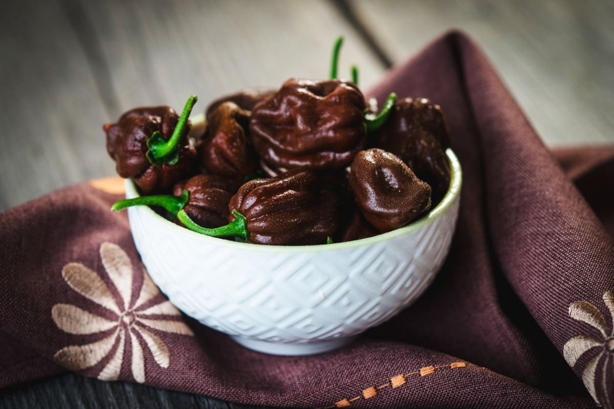
WHILE, ALAS, THEY DON’T TASTE QUITE LIKE CHOCOLATE, BROWN PEPPERS ARE STILL PHENOMENALLY SWEET AND REFRESHING, AND ARE A GREAT CHOICE FOR STUFFED PEPPER DISHES OR CAN BE EATEN RAW WITH SALADS. THE MOST POPULAR IS THE CHOCOLATE BELL VARIETY, WHICH MATURES EARLY INTO A DEEP BROWN ON THE OUTSIDE, WITH A DARK RED FLESH ON THE INSIDE.

7. PURPLE PEPPERS
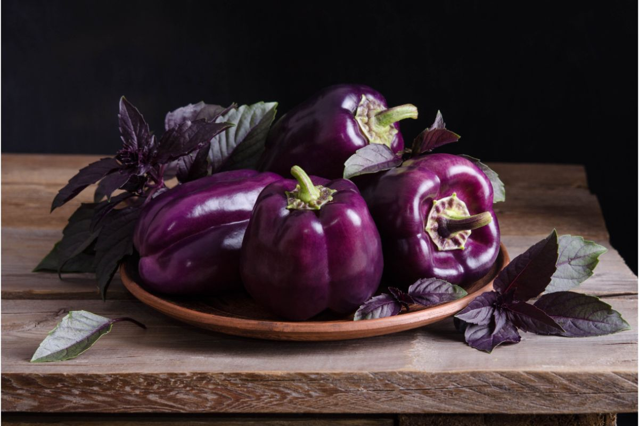
PURPLE PEPPERS ARE UNCOMMON TO FIND OUTSIDE OF FARMERS’ MARKETS BUT THAT DOESN’T MEAN THEY’RE NOT EVERY BIT AS GOOD. THE FLAVOR PROFILE OF PURPLE PEPPERS SITS SOMEWHERE BETWEEN GREEN AND YELLOW PEPPER, WHICH MAKES THEM GREAT FOR THROWING ON THE GRILL AND COOKING LONG.
SOME COMMON VARIETIES OF YELLOW AND ORANGE PEPPER ACTUALLY START OUT PURPLE BEFORE THEY RIPEN, HOWEVER, VARIETIES LIKE PURPLE BEAUTY MATURE INTO DEEP VIOLET.
THESE ARE A FAVORITE FOR HOME GARDENS, WITH HOTTER WEATHER PROVIDING A DEEPER EGGPLANT COLOR AND COOLER WEATHER YIELDING A LIGHTER LILAC FRUIT.

8. THE SHEEPNOSE
THE SHEEPNOSE IS A HUGE BEAUTIFUL RED HEIRLOOM PEPPER. THEY ARE THICK-WALLED, MEANING LOTS OF BANG FOR YOUR BUCK, AND THEY KEEP INCREDIBLY WELL IN THE FRIDGE, LASTING WEEKS. THEY TAKE THEIR NAME FROM THE SHEEPNOSE CHEESE THAT IS COMMONLY USED AS A PEPPER FILLING, AND THUS ARE A PREMIER PEPPER FOR STUFFING IF YOU CAN GET YOUR HANDS ON THEM.
THEY’RE HARDY GROWERS AND PRODUCE WELL IN COOLER, SHADED GARDENS OR IN MORE TEMPERATE NORTHERN CLIMATES.

9. THE IKO IKO

THESE STUNNING PEPPERS WERE ORIGINALLY CULTIVATED IN THE US AND ARE ONE OF THE MOST COLORFUL PEPPERS OUT THERE. WITH MULTICOLORED SKIN THAT MELDS FROM PURPLE TO GREEN TO RED, THESE ARE EASY GROWERS IN THE GARDEN, SO IF YOU CAN’T DECIDE ON WHAT COLOR PEPPER YOU WANT TO GROW, JUST PLANT SOME IKO IKOS SINCE YOU WON’T KNOW WHAT YOU’RE GETTING UNTIL IT MATURES.
DUE TO ITS DIVERSE GENE POOL, IKO IKO PEPPER PLANTS CAN PRODUCE RED, ORANGE, YELLOW, BROWN, OR PURPLE FRUIT AND OFTEN THESE PEPPERS WILL END UP EMERGING WITH A MIX OF ALL THESE COLORS.

HONORABLE MENTIONS

10. PIMIENTO PEPPERS
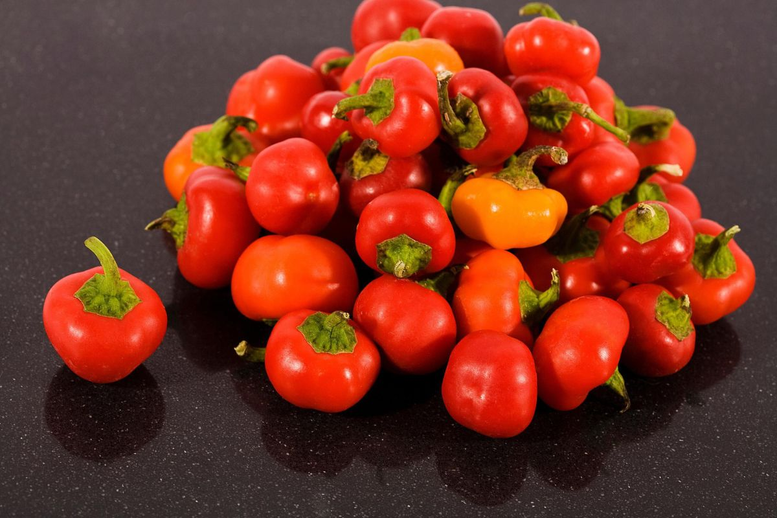
PIMIENTO PEPPERS ARE A LONGER, BEAK-SHAPED SWEET PEPPER WELL-LOVED FOR BEING THICK-WALLED, HEFTY, AND FULL OF SWEET, DELICIOUS FLAVOR. PIMIENTO VARIETIES TEND TO TAKE LONGER TO GROW THAN TRADITIONAL LOBED BELL PEPPERS. PERSONALLY, I HAVE A DEEP APPRECIATION FOR PIMIENTOS AS A ROASTING PEPPER SINCE THEY’RE SO EASY TO THROW ON THE BARBECUE.
JUST LEAVE THEM TO CHAR INTO A PERFECT SWEET SIDE.
ONCE THEY’RE BLACKENED REMOVE THE SKIN UNDER COLD WATER, CHOP THEM INTO STRIPS AND STORE THEM IN OLIVE OIL AND YOU CAN ENJOY THEM FOR WEEKS TO COME! SOME VARIETIES OF PIMIENTO HAVE A HINT OF HEAT, SO THESE ARE NOT ALL STRICTLY CLASSIFIABLE AS BELL PEPPERS BUT WHO MAKES THE RULES ANYWAY?

11. THE HUNGARIAN PEPPER
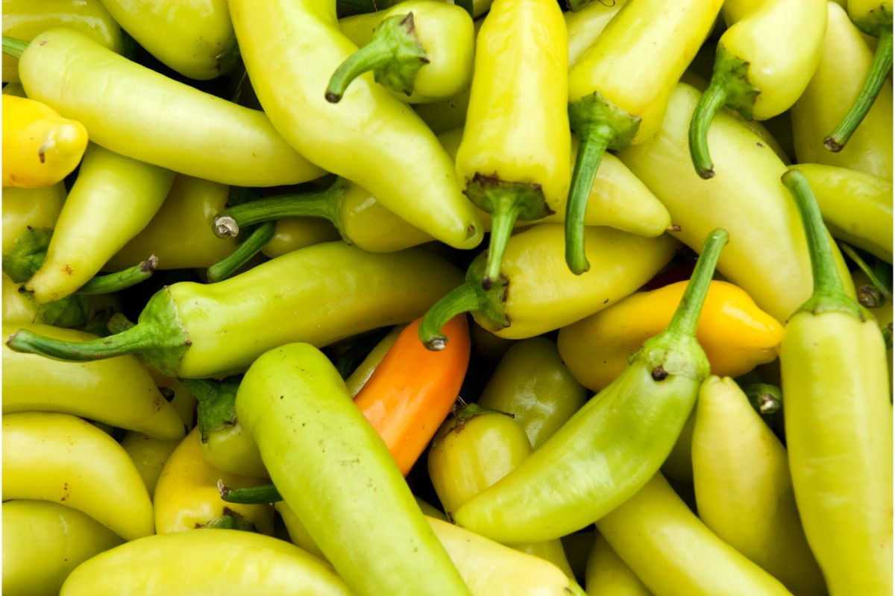
ALSO KNOWN AS THE PAPRIKA PEPPER, HUNGARIAN PEPPERS ARE OFTEN SMOKED, DRIED OUT, AND GROUND DOWN TO MAKE PAPRIKA. WHILE NOT PARTICULARLY HOT, AND STILL CLASSIFIED BY MOST PEOPLE AS SWEET PEPPER, THESE DO HAVE A TINGE OF HEAT TO THEM BUT STILL MAKE FOR GREAT EATING, WITH SWEET WALLS AND A LITTLE HINT OF SPICE IN THE RIBS AND SEEDS.

12. THE ITALIAN FRYING PEPPER, AKA THE CUBANELLE
ANOTHER SWEET PEPPER WITH SOME EXTRA HEAT IS THE CUBANELLE. LONG, THIN AND PALE GREEN, THIS PEPPER IS BELOVED AS A PIZZA TOPPING, OR AS PER ITS NAME, COOKED IN A PAN IN A LITTLE OLIVE OIL.
THESE PEPPERS ARE MOST OFTEN PICKED BEFORE THEY RIPEN SO MANY PEOPLE THINK THEY’RE A GREEN PEPPER, BUT LIKE MOST GREEN PEPPERS, CUBANELLES ACTUALLY MATURE INTO A BRIGHT ORANGEY REDDISH HUE IF ALLOWED.

13. MINI PEPPERS

WHAT’S NOT TO LOVE ABOUT TINY VERSIONS OF ALREADY DELICIOUS FOODS. MINI PEPPERS, ALSO KNOWN AS BABY PEPPERS ARE EXACTLY LIKE OTHER BELL PEPPERS, JUST SMALLER AND SWEETER. THEY ALSO PRODUCE FAR FEWER SEEDS THAN LARGER VARIETIES SO THEY MAKE FOR AN EASY RAW SNACK.

A FINAL NOTE ON THE ORIGINS OF THE BELL PEPPER
ONE PARTICULARLY INTERESTING MYTH THAT KEEPS POPPING UP ABOUT THE BELL PEPPER IS THAT ITS NAME IS DERIVED FROM THE FACT THAT IT WAS A ‘LOUD CROP’. THIS COMES FROM A CLAIM THAT THE FIRST STRAIN OF BELL PEPPERS THAT ARRIVED IN EUROPE HAD A VESTIGIAL STIGMA (MUCH LIKE THE CLAPPER OF A BELL) THAT GREW ON THE INSIDE OF THE FRUIT.
FARMERS HATED THESE CROPS BECAUSE WHEN THE WINDS WOULD PICK UP, THE STIGMATA WOULD SLAP AGAINST THE HARD OUTER WALLS OF THE PEPPERS, CREATING A RAUCOUS NOISE THAT WOULD SPOOK LIVESTOCK AND EVEN KEEP NEARBY VILLAGES AWAKE.
THE STORY GOES THAT IT WAS NOT UNTIL 1908 THAT GREGOR CARILLON DEVELOPED THE FIRST SILENT PEPPER, AND THUS THE BELL PEPPER WAS ABLE TO ASCEND TO ITS RIGHTFUL PLACE AS ONE OF THE MOST POPULAR KITCHEN VEGETABLES AROUND.
WHILE VERY PERSISTENT, THIS TALE IS NOTHING MORE THAN A GOOD APRIL FOOL’S JOKE THAT HAS BEEN RECYCLED INTO COUNTLESS UNDISCERNING ARTICLES ABOUT PEPPERS. I’M SORRY TO TELL YOU, BUT IT JUST ISN’T TRUE.

29 DIFFERENT TYPES OF PEPPER
PEPPERS ARE ONE OF THE MOST DIVERSE FOODS YOU CAN FIND. DEPENDING ON THE SPECIFIC PEPPER, THEY BRING A DIFFERENT FLAVOR TO YOUR FOOD. CHECK OUT THIS ARTICLE TO FIND OUT ALL THE DETAILS ABOUT PEPPERS AND LEARN WHICH ONE IS RIGHT FOR YOUR NEXT DISH.
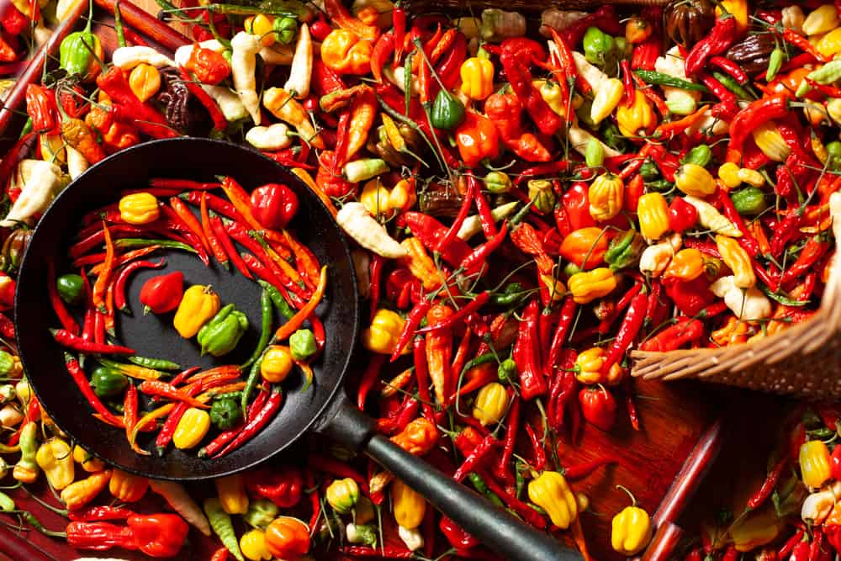
PEPPERS ARE A DELICIOUS WAY TO ADD FLAVOR TO YOUR FOOD. I LOVE PEPPERS AND THE SPICE THEY BRING. HOWEVER, I DO NOT LIKE THE ONES THAT MAKE MY TONGUE FEEL LIKE IT IS ON FIRE. I FOUND OUT LONG AGO THAT IT IS IMPORTANT TO KNOW JUST HOW SPICY A PEPPER IS BEFORE ADDING IT TO YOUR FOOD.
YOU PROBABLY DID NOT REALIZE HOW MANY DIFFERENT TYPES OF PEPPERS THERE ARE. KEEP ON READING TO FIND OUT MORE INFORMATION ABOUT THEM AND DETERMINE WHICH ONES YOU WANT TO EAT.
RELATED: WHAT GOES WITH CHILI | TYPES OF CHILI | HOW TO STORE CHILI | TYPES OF SPICES | HOW TO PRESERVE PEPPER | CAYENNE PEPPER VS. RED PEPPER | PEPPER SUBSTITUTES | FOODS WITH CAYENNE PEPPER

HOW HOT ARE PEPPERS?
IT MAY SURPRISE YOU TO KNOW THAT PEPPERS ARE CONSIDERED FRUITS. THEY ALL, SWEET AND HOT PEPPERS, ARE PART OF THE CAPSICUM GENUS. THE AMOUNT OF HEAT A PEPPER HAS IS MEASURED BY SCOVILLE HEAT UNITS (SHU).
THE SCALE RANGES FROM 0 FOR A BELL PEPPER UP TO 3,000,000, WHICH IS THE HOTTEST PEPPER IN THE WORLD. THIS PEPPER IS CALLED PEPPER X. A DRIED HOT CHILI PEPPER IS GOING TO FALL IN THE MIDDLE OF THE SCALE, BUT SOME OF THEM ARE FAIRLY HOT. THIS SCALE IS A GOOD MEASURE FOR THE HEAT OF A PEPPER, BUT THE CLIMATE IN WHICH THE PEPPER IS GROWN IS GOING TO IMPACT HOW HOT IT TASTES.
AN EFFECTIVE WAY TO REDUCE THE AMOUNT OF FIRE YOU FEEL FROM THE PEPPER IS TO REMOVE THE SEEDS AND RIBS FROM THE INSIDE BEFORE YOU COOK OR USE IT. DAIRY PRODUCTS, LIKE MILK, ARE A GREAT ADDITION TO A HOT MEAL. PEPPERS CONTAIN CAPSAICIN. CAPSAICIN IS THE CHEMICAL THAT CAUSES THEIR FIRE. DAIRY PRODUCTS HAVE CASEIN WHICH CAN NEUTRALIZE THE CAPSAICIN.

TYPES OF PEPPERS
THERE ARE MANY DIFFERENT TYPES OF PEPPERS. NOT ONLY ARE THERE MANY TYPES, BUT MOST PEPPERS HAVE SEVERAL DIFFERENT NAMES.

ANAHEIM PEPPER
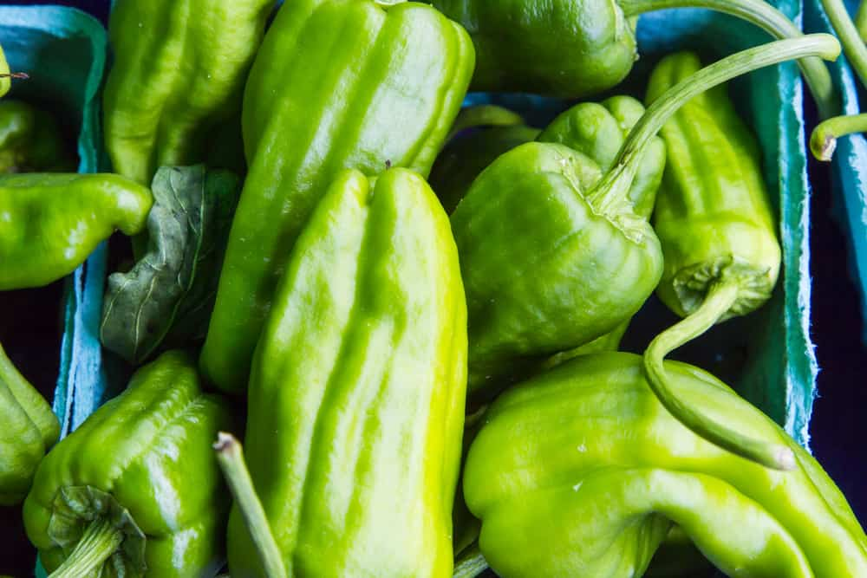
THE ANAHEIM PEPPER HAS A SCOVILLE UNIT OF 500 TO 2,500, MAKING IT A MILD TYPE OF PEPPER. IT GOES BY SEVERAL DIFFERENT NAMES, INCLUDING CHILE VERDE, CALIFORNIA GREEN CHILE, AND NEW MEXICAN CHILE. THE ANAHEIM PEPPER IS LONG AND GREEN WHEN IT HAS NOT MATURED. ONCE IT MATURES, IT TURNS DEEP RED AND MAYBE CALLED CHILE COLORADO. THIS PEPPER IS MOST OFTEN USED IN SALSA. THESE PEPPERS ARE THE ONES MOST OFTEN FOUND IN CANNED PEPPERS.
Bottom of Form

BANANA PEPPER
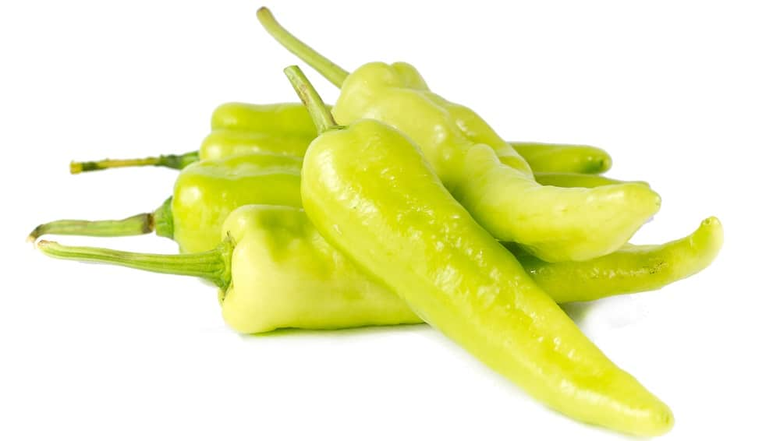
THE BANANA PEPPER HAS A SWEET FLAVOR AND ONLY REGISTERS FROM 0 TO 500 ON THE SCOVILLE SCALE. THEY ARE A LITTLE TANGY AND ADD A NICE LITTLE KICK TO THE FOOD. THEY ARE ALSO CALLED YELLOW WAX PEPPER OR BANANA CHILI PEPPER. WHEN THE BANANA PEPPER IS RIPE, IT HAS A BRIGHT YELLOW COLOR. YOU CAN SOMETIMES FIND THEM IN GREEN, RED, OR ORANGE. THE BANANA PEPPER IS IDEAL FOR SANDWICHES, PIZZA, SALAD, AND ANTIPASTO.

BASQUE FRYER PEPPER
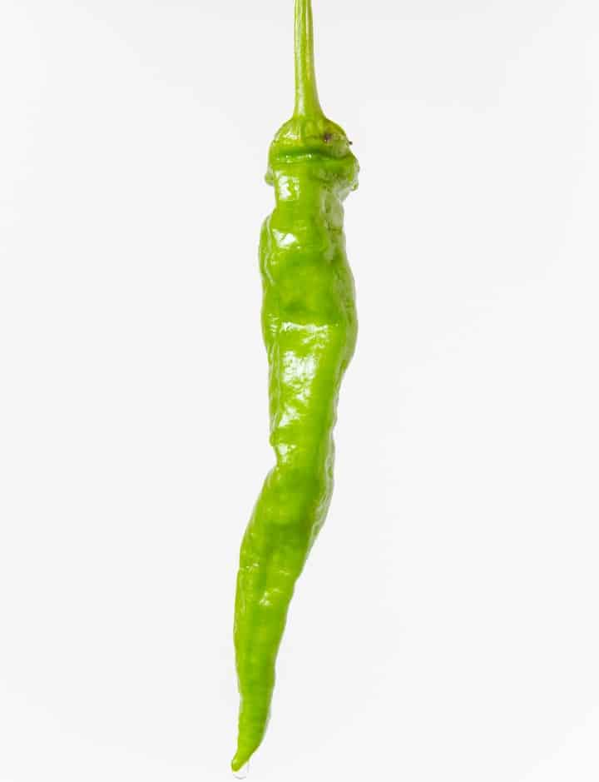
THE BASQUE FRYER PEPPER IS A SWEET PEPPER THAT HAS A HEAT RATING OF ZERO. IT IS ALSO CALLED DOUX LONG DES LANDES, DOUX DE LANDES, OR PIMENT BASQUE. THIS PEPPER IS EATEN ROASTED, SAUTÉED, OR RAW.

BELL PEPPER

BELL PEPPER IS ON THE LARGER SIDE AND HAS THE SHAPE OF A BELL, HENCE THE NAME. WHEN IT IS IMMATURE, IT IS GREEN IN COLOR AND TASTES SLIGHTLY BITTER. AS IT MATURES, IT BECOMES RED AND HAS A SWEETER TASTE. YOU CAN FIND BELL PEPPERS IN ORANGE, YELLOW, PINK, WHITE, AND PURPLE VARIETIES.
THEY HAVE A LOT OF WATER IN THEM AND ADD MOISTURE TO THE FOOD. THEY CAN ALSO GIVE YOUR FOOD POPS OF COLOR. YOU CAN EAT BELL PEPPERS RAW OR COOKED. THEY HAVE EVEN BEEN DRIED AND GROUND INTO SPICES.

BIRD’S EYE PEPPER

THE BIRD’S EYE PEPPER IS A SPICY THAI PEPPER. IT FALLS SOMEWHERE BETWEEN 50,000 TO 100,000 HEAT UNITS WHICH MAKE IT SIMILAR TO CAYENNE AND HABANERO PEPPERS. IT IS ONE TYPE OF THAI PEPPER, AND IT BRINGS A FAIR AMOUNT OF HEAT TO HOT SAUCE. THIS PEPPER IS USED IN CHILI POWDER.

CAYENNE PEPPER
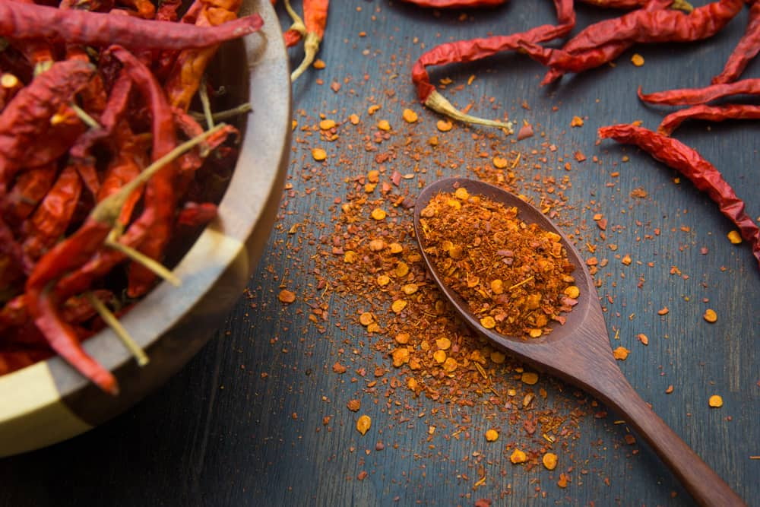
THE CAYENNE PEPPER HAS A SCOVILLE UNIT OF 30,000 TO 50,000 MAKING THIS ONE OF THE SPICIEST PEPPERS. IT IS A SLIM PEPPER WITH A TAPERED END. IT IS ALSO REFERRED TO AS A FINGER CHILD, GINNIE PEPPER, OR BIRD PEPPER. IT IS COMMONLY DRIED AND GROUND, AND SOLD AS CAYENNE PEPPER POWDER. THIS PEPPER IS IDEAL FOR DISHES LIKE CHILI CON CARNE. CAYENNE PEPPERS ARE USUALLY RED, BUT IT IS POSSIBLE TO FIND CAYENNE GOLD PEPPERS, WHICH ARE A YELLOW COLOR.

CHERRY PEPPER
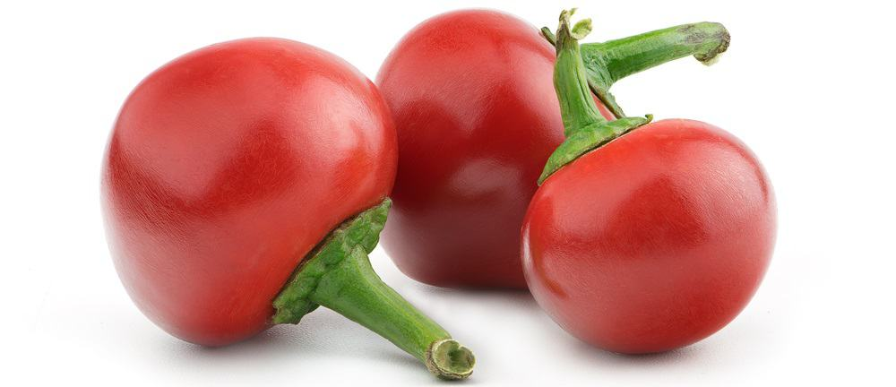
THE CHERRY PEPPER IS A SWEET, LITTLE PEPPER THAT DOES NOT HAVE ANY HEAT. IT RATES AROUND 500 ON THE SCOVILLE CHART. IT IS BRIGHT RED AND LOOKS LIKE A HEART. CHERRY PEPPERS ARE ALSO CALLED PIMENTO PEPPERS OR PIMIENTO PEPPERS. THEY ARE A CRITICAL INGREDIENT IN PIMENTO CHEESE AND PIMENTO LOAVES. THESE ARE A GREAT PEPPER TO STUFF BECAUSE THEY ARE NOT SPICY. THEY ARE OFTEN CHOPPED AND STUFFED INTO OLIVES.

CHILACA PEPPER
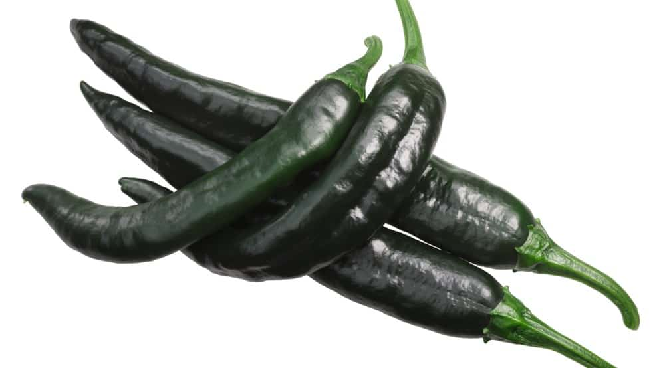
THE CHILACA PEPPER HAS SCOVILLE HEAT OF 1,500 TO 2,500. THIS PEPPER IS WRINKLY AND BLACK. THEY HAVE AN INTERESTING FLAVOR THAT TASTES LIKE PRUNES WITH A TOUCH OF LICORICE. WHEN THEY ARE DRIED, THEY ARE CALLED PASILLA OR CHILE NEGRO. ONCE THEY ARE DRIED, THEY ARE SOAKED OR TOASTED AND THEN BLENDED INTO A SAUCE, MOST OFTEN WITH FRUIT. ANOTHER POPULAR USE IS IN A MOLE SAUCE.

DATIL PEPPER

DATIL PEPPER IS A SMALL AND HOT PEPPER, OFTEN REFERRED TO AS A YELLOW LANTERN CHILI. IT COMES FROM THE CAPSICUM CHINESE SPECIES. WHEN IT IS RIPE, IT IS A YELLOW-ORANGE COLOR. IT CAN BE ANYWHERE FROM 1/4 INCH TO 4 INCHES LONG. IT REGISTERS AROUND 100,000 TO 300,000 ON THE SCOVILLE SCALE, WHICH IS CLOSE TO A HABANERO. THESE PEPPERS ARE A LITTLE SWEET AND HAVE A TANGY, FRUITY FLAVOR.

GHOST PEPPER
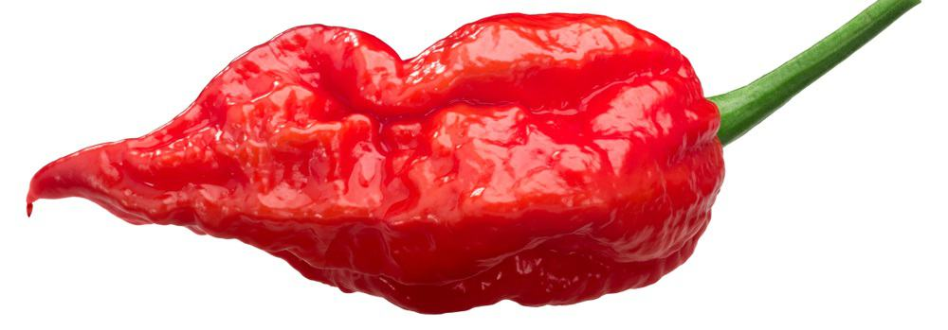
GHOST PEPPER IS AN INCREDIBLY HOT PEPPER COMING IN AT 1,000,000 SCOVILLE UNITS. THE GHOST PEPPER BITES YOU BACK. IT IS ALSO CALLED BHUT NAGA JOLOKIA, BHUT JOLOKIA, NAGA JOLOKIA, GHOST CHILI, GHOST JOLOKIA, RED NAGA, OR U-MOROK. GHOST PEPPER IS ONE OF THE HOTTEST EDIBLE PEPPERS. IT IS 100 TIMES SPICIER THAN A JALAPEÑO. IT IS USED IN CURRY AND CHUTNEY BUT IN SMALL AMOUNTS.

HABANERO PEPPER
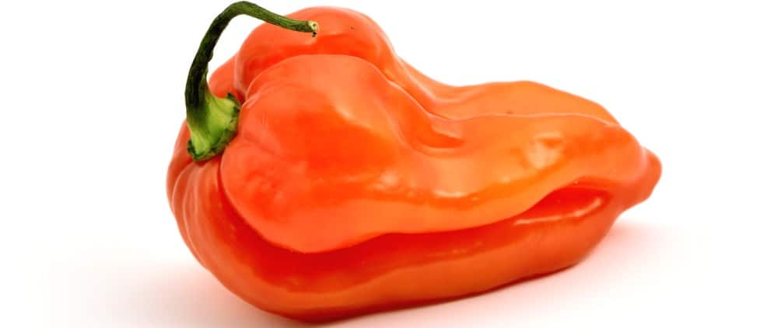
HABANERO PEPPERS ARE HOT. THEY HAVE SCOVILLE UNITS OF 150,000 TO 350,000, WHICH MAKES THEM ONE OF THE HOTTEST PEPPERS YOU CAN FIND. WHAT IS MOST INTERESTING ABOUT THE HABANERO IS THAT UNDERNEATH THE HEAT, THERE IS A TOUCH OF SWEETNESS. THESE PEPPERS ARE SMALL AND LOOK LIKE A BULB. THEY ARE PART OF THE SCOTCH BONNET FAMILY. THESE PEPPERS ARE INCREDIBLY POPULAR IN MEXICO AND THE CARIBBEAN. THEY ARE IDEAL FOR MAKING A HOT SAUCE.

JALAPEÑO PEPPER
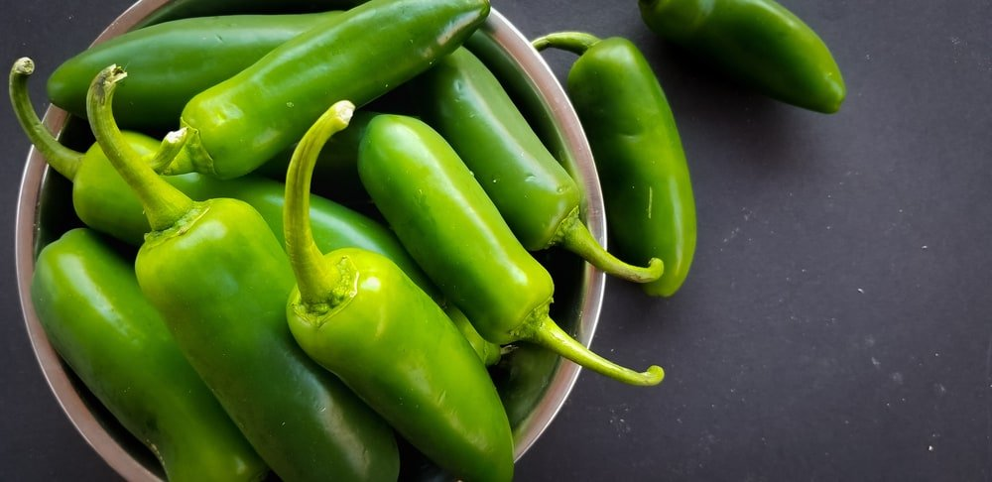
THE JALAPENO PEPPER HAS A HEAT UNIT OF 3,500 TO 8,000. THE JALAPEÑO IS A MEXICAN PEPPER THAT IS USUALLY PICKED FROM THE VINE BEFORE IT TURNS FROM A GREEN COLOR. IF LEFT LONGER ON THE VINE, THEY RIPEN AND TURN RED. STAYING ON THE VINE LONGER ALSO GIVES THEM A FRUITY FLAVOR. JALAPEÑOS ARE NOT A SUPER HOT PEPPER.
THEY PROVIDE GREAT TASTE AND ARE USED IN SAUCE AND SALSA. WHEN THEY ARE DRIED, THEY ARE CALLED CHIPOTLE PEPPER. THEY ARE SMOKE-DRIED AND CREATED IN TWO DIFFERENT VARIETIES. ONE IS MECO, WHICH IS MELLOW TASTING. THE OTHER IS MORITAS, WHICH IS SPICY. CHIPOTLE IS WOODSY, SMOKY, AND SPICY AND IS IDEAL FOR SAUCE, SALSA, ADOBO, AND ESCABECHE.

MIRASOL CHILI PEPPER
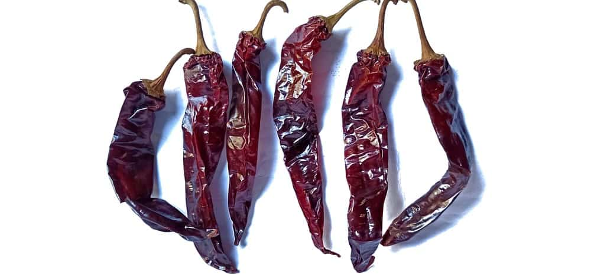
THE MIRASOL CHILI PEPPER HAS SCOVILLE UNITS OF 2,500 TO 5,000, WHICH IS THE SAME AMOUNT OF HEAT YOU WOULD EXPECT FROM A JALAPEÑO BUT A LITTLE SWEETER. THESE PEPPERS ARE RED AND POINT TOWARDS THE SUN WHILE THEY GROW. WHEN THEY ARE DRIED, THEY ARE CALLED GUAJILLO. DRYING THESE PEPPERS CHANGE THEIR TASTE SLIGHTLY. THEY BECOME TANGY, FRUITY, AND SLIGHTLY ACIDIC. THEY ARE COMMONLY USED IN AL PASTOR AND A MOLE SAUCE.

PADRON PEPPER
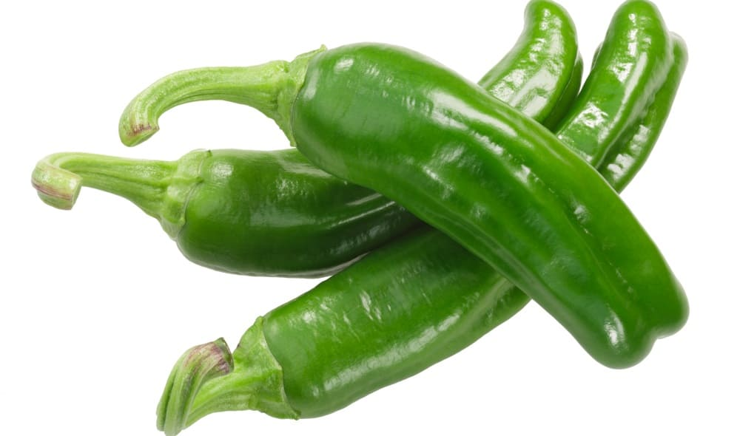
THE PATRON PEPPER IS MILD AND SWEET, REGISTERING BETWEEN 500 TO 2,500 ON THE SCOVILLE SCALE. YOU CAN FIND A PADRON PEPPER THAT IS SPICY. THIS PEPPER IS OFTEN GRILLED OR FRIED.

PIQUILLO PEPPER
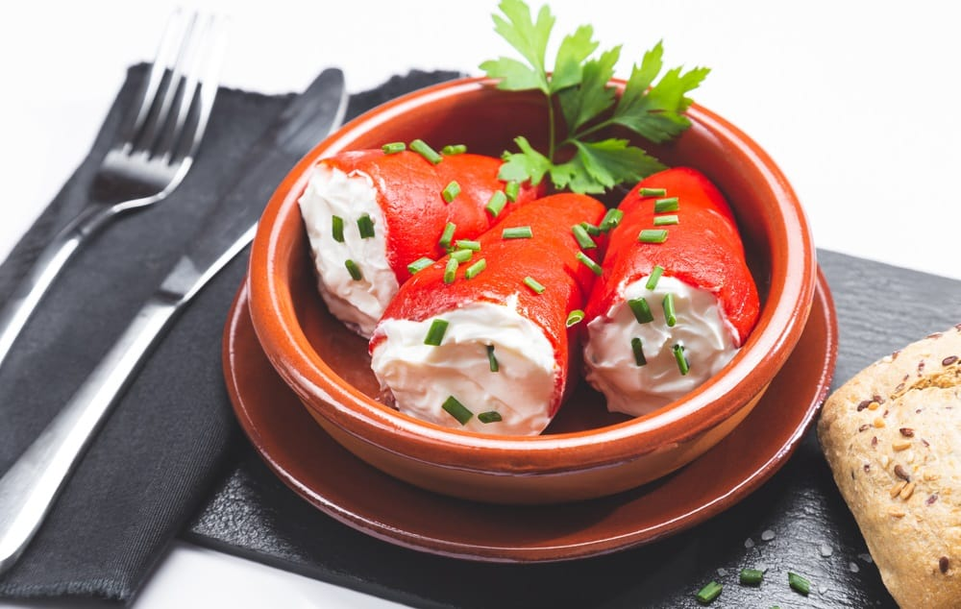
THE PIQUILLO PEPPER IS A MILD AND SWEET PEPPER THAT COMES FROM SPAIN. IT BALANCES SWEETNESS WITH A TART AND SMOKEY FLAVOR, WITH A SCOVILLE HEAT RANGE IS 500 TO 1,000. THEY MEASURE FROM THREE TO FOUR INCHES IN LENGTH. THEY HAVE A SLIGHT CURVE AT THE BOTTOM, WHICH LOOKS LIKE A LITTLE BEAK. THIS IS WHY PIQUILLO PEPPERS ARE ALSO REFERRED TO AS A LITTLE BEAK PEPPER. THEY ARE MOST OFTEN FOUND IN A JAR IN SPECIALTY STORES. THE PIQUILLO PEPPER IS IDEAL FOR SANDWICHES, SAUCES, MEAT, AND CHEESE. THEY ARE ALSO STUFFED WITH CHEESE, BAKED, AND SERVED.

PIRI PIRI
THE PIRI PIRI PEPPER HAS SCOVILLE UNITS 50,000 TO 175,000 MAKING IT A FAIRLY HOT PEPPER. WHILE THEY ARE HOTTER THAN MOST PEPPERS, YOU CAN STILL EAT THEM. THEY ARE OFTEN USED IN PORTUGUESE AND AFRICAN DISHES. THEY ARE ALSO REFERRED TO AS PERI PERI, AFRICAN RED DEVIL PEPPER, OR AFRICAN BIRD’S-EYE PEPPER. THIS IS A SMALL PEPPER THAT IS ONLY ABOUT ONE TO TWO INCHES.

POBLANO PEPPER
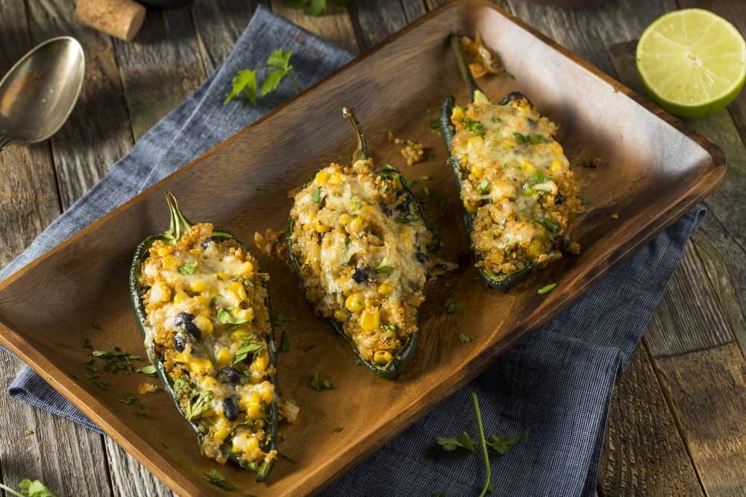
THE POBLANO PEPPER HAS A SCOVILLE UNIT OF 1,000 TO 2,000. THIS LARGER PEPPER IS HEART-SHAPED AND IS COMMONLY FOUND IN MEXICAN FOOD LIKE CHILES RELLENOS. THEY ARE MILDLY SPICY AND WILL GIVE A GOOD AMOUNT OF FLAVOR TO FOOD. ONCE MATURE, THIS PEPPER IS A DARK REDDISH-BROWN COLOR. THEY ARE OFTEN DRIED AND THEN REFERRED TO AS AN ANCHO PEPPER. ONCE THEY BECOME AN ANCHO PEPPER, THEY TAKE ON A RICH SWEETNESS. THESE PEPPERS ARE GREAT FOR SAUCES.

ROCOTO PEPPER
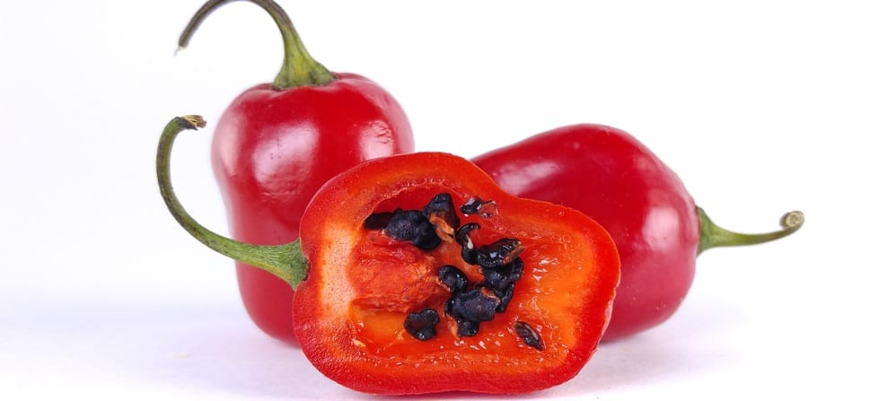
THE ROCOCO PEPPER HAS A SCOVILLE UNIT OF 100,000 TO 250,000. THIS PEPPER IS ALSO CALLED HAIRY PEPPER, LOCOTO, AND AJI ROCOTO. THIS PEPPER IS NATIVE TO SOUTH AMERICA, AND IT LOOKS A LOT LIKE A BELL PEPPER BUT DO NOT LET IT DECEIVE YOU. THERE IS A SERIOUS AMOUNT OF SPICE UNDER THE PEPPER SKIN. IT HAS BLACK SEEDS AND COMES IN VARYING SHADES OF RED, YELLOW, AND ORANGE. THE HOTTEST ROCOTO PEPPERS ARE YELLOW, BUT THE MOST COMMON ONE IS RED. THEY HAVE FURRY LEAVES. THIS PEPPER IS TYPICALLY USED IN SALSA.

SCOTCH BONNET PEPPER

THIS IS A SPICY PEPPER AND THE HOTTEST ONE YOU WILL FIND IN THE CARIBBEAN. YOU SHOULD PROCEED WITH CAUTION WHEN THIS PEPPER IS IN A DISH. IT HAS SCOVILLE HEAT UNITS OF 80,000 TO 400,000. IT IS ALSO CALLED BALL OF FIRE PEPPER, BONNEY PEPPERS, CARIBBEAN RED PEPPERS, OR CACHUCHA. IT IS USED IN MANY DISHES FROM THE ISLANDS, INCLUDING JERK CHICKEN.

SERRANO PEPPER
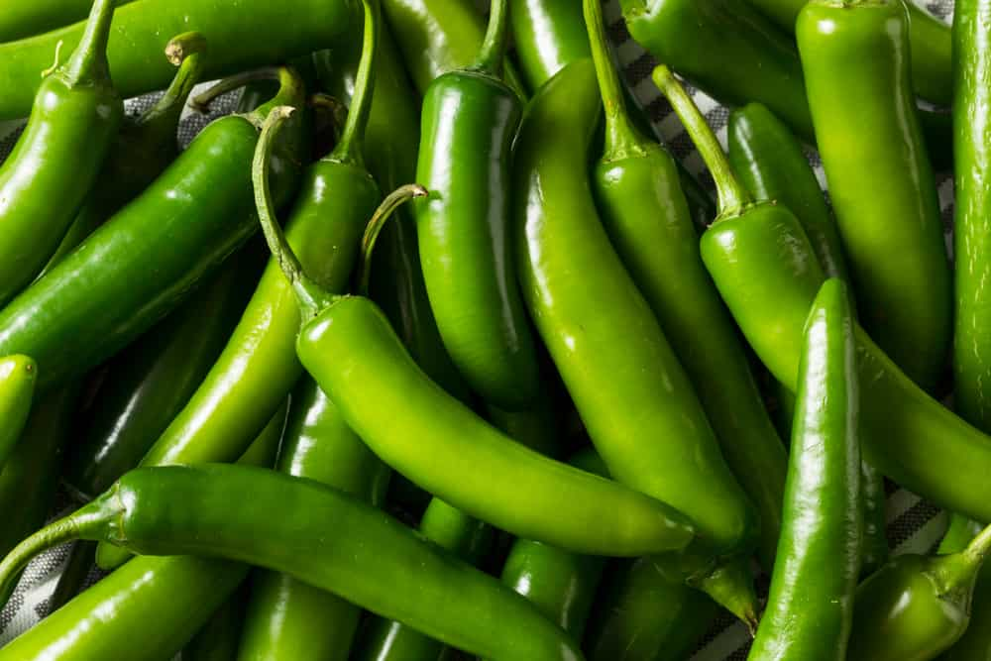
THE SERRANO PEPPER HAS A SCOVILLE HEAT RANGE FROM 6,000 TO 23,000. THIS IS A SMALL BUT ELONGATED PEPPER, MEASURING IN AT A FEW INCHES IN LENGTH. IT HAS A TAPERED END AND CAN PACK A PUNCH. THE SMALLER THIS PEPPER IS, THE HOTTER IT IS GOING TO BE. WHEN THEY ARE MATURE OR RIPE, THE PEPPER IS A YELLOW-ORANGE OR RED COLOR. THEY CAN BE COOKED IN RIPE OR UNRIPE STATES. SERRANO PEPPERS ARE MOST OFTEN FOUND IN THAI OR MEXICAN DISHES. YOU MAY ALSO FIND THEM IN SALSA AND GUACAMOLE.

SHISHITO PEPPER
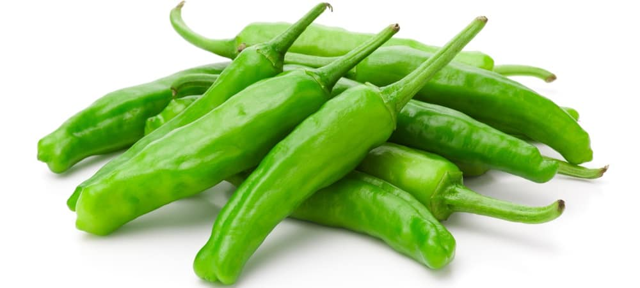
THE SHISHITO PEPPER RANGES FROM 50 TO 200 HEAT UNITS. THIS IS A MILD PEPPER BUT WHAT IS INTERESTING ABOUT IT IS THAT THERE IS OFTEN A SPICY SHISHITO IN THE BUNCH OF PEPPERS. YOU WILL NOT KNOW WHICH ONE IS SPICY UNTIL YOU BITE INTO THE PEPPER. THEY ARE PICKED WHILE THEY ARE STILL GREEN. THE RIPER THEY ARE MEANS, THE SPICIER THEY WILL BE. THEY CAN BE SEARED IN A PAN AND EATEN ALONE. THEY ARE PERFECT FOR ADDING TO PIZZA. THEY CAN ALSO BE ROASTED, DRIZZLES WITH SAUCE OR OIL, AND EATEN.

TABASCO PEPPER

A TABASCO PEPPER HAS A SCOVILLE HEAT OF 30,000 TO 60,000. IT IS MORE WELL KNOWN AS TABASCO SAUCE, WHICH IS THE SAUCE THAT IS MADE FROM THE PEPPER. THE PEPPER ITSELF IS ABOUT ONE TO TWO INCHES AND A BRIGHT RED COLOR. TO USE IT IN THE SAUCE, THE PEPPER IS SMASHED AND MIXED WITH VINEGAR AND SALT. THIS ALSO CUTS THE HEAT OF THE PEPPER TO A HEAT UNIT OF 2,500 TO 5,000. THAT SIGNIFICANTLY CUTS THE HEAT OF THIS PEPPER.

OTHER INCREDIBLY HOT PEPPERS

CAROLINA REAPER PEPPER
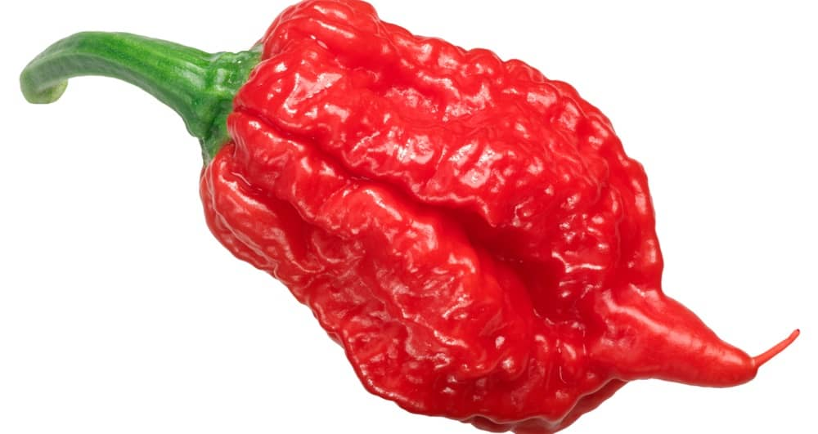
THIS REGISTERS FROM 1,000,000 TO 2,000,000 ON THE SCOVILLE HEAT UNIT. THIS IS AS CLOSE AS YOU CAN GET TO EATING PEPPER SPRAY. THIS IS NOT A PEPPER YOU WILL EASILY FIND.

DRAGON’S BREATH PEPPER
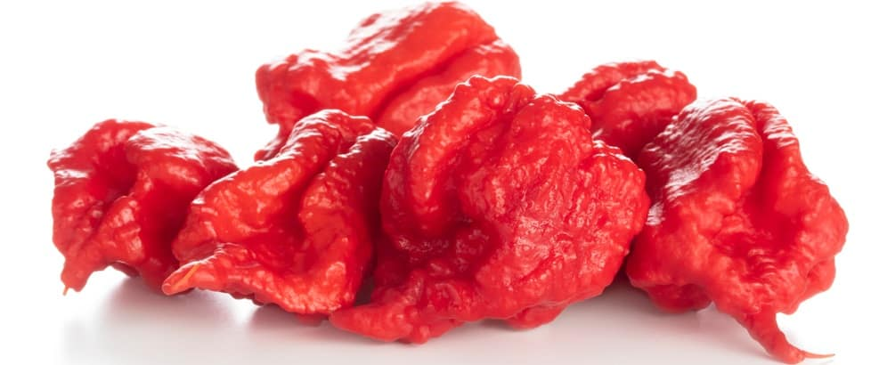
THIS IS ONE OF THE SMALLEST PEPPERS, AND SOME DEBATE THE HOTTEST PEPPER THERE IS. THIS PEPPER IS NOT REALLY AVAILABLE COMMERCIALLY AND IS NOT SUPPOSED TO BE EATEN. THERE IS A CLAIM THAT IT REGISTERS 2,480,000 ON THE SCOVILLE SCALE, BUT IT HAS NOT BEEN TESTED IN A LAB TO CONFIRM THAT NUMBER.

KOMODO DRAGON PEPPER
THE KOMODO DRAGON PEPPER IS ABOUT AS HOT AS A GHOST PEPPER. THIS PEPPER SNEAKS UP ON YOU BECAUSE, AT FIRST, IT TASTES SWEET, AND THEN THE HEAT GETS YOU. MOST LIKELY, YOU WILL REGRET BITING INTO IT. IT REGISTERS AROUND 1,400,000 ON THE SCOVILLE SCALE.

PEPPERCORNS
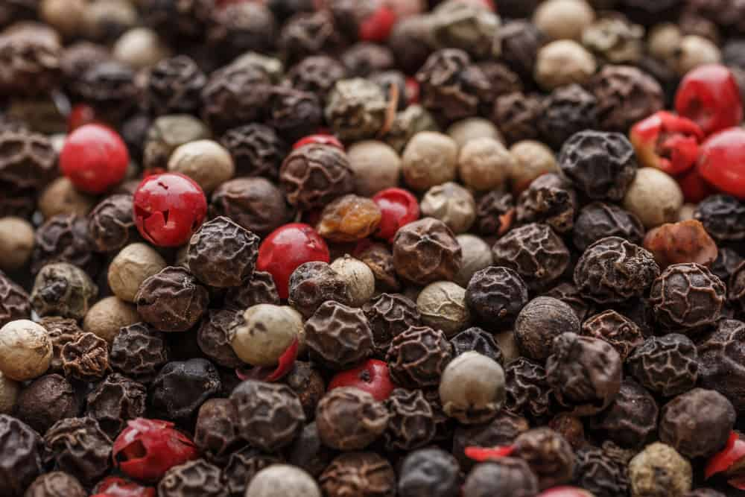
PEPPER IS A KEY SPICE THAT IS USED AROUND THE WORLD. IT HAS BEEN USED ALL AROUND THE WORLD AS SPICE OR CURRENCY. THERE WERE TIMES WHEN PEPPER WAS WORTH ITS WEIGHT IN GOLD. PEPPER IS EARTHY, WOODY, AND HOT. IT HAS A FLAVOR THAT IS DISTINCT AND PAIRS WELL WITH FOOD. PEPPER MAKES FOOD TASTE BOLDER. THERE ARE MANY DIFFERENT TYPES OF PEPPERCORNS.

BLACK PEPPER
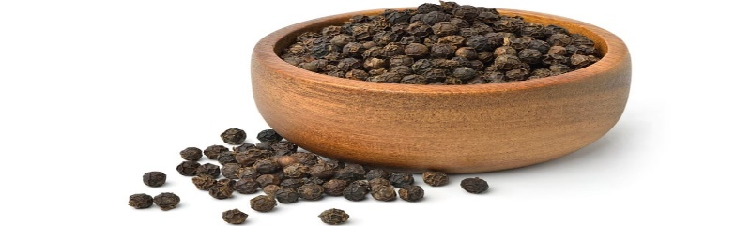
BLACK PEPPERCORN STARTS GREEN WHEN IT IS BERRY STILL ON THE VINE. WHEN THE BERRY RIPENS, IT CHANGES TO A RED COLOR. THE SUN SHRIVELS THE BERRY, AND IT BECOMES A BLACK SPHERE. THIS IS HOW IT BECOMES THE BLACK PEPPERCORN AS WE KNOW IT TODAY. THE LARGER THE PEPPERCORN MEANS, THE STRONGER THE FLAVOR. THERE ARE MANY DIFFERENT FLAVORS OF BLACK PEPPERCORN, FROM A MILD TASTE TO SOMETHING A LITTLE STRONGER.

GREEN PEPPER
GREEN PEPPERCORNS ARE YOUNG AND NOT ALLOWED TO RIPEN. THEY DO START TO RIPEN AFTER THEY ARE PICKED. OFTEN TIMES, GREEN PEPPERCORNS ARE DEHYDRATED AFTER THEY ARE HARVESTED. THIS PREVENTS THEM FROM BECOMING RIPE AND TURNING INTO A BLACK PEPPER. GREEN PEPPERCORNS HAVE BEEN PICKLED IN BRINE IN THE PAST, BUT THAT IS NOT USED AS MUCH TODAY BECAUSE OF IMPROVEMENTS TO TECHNOLOGY.
GREEN PEPPERS ARE NOT AS COMPLEX AS BLACK PEPPERCORNS. THESE ARE A YOUNGER PEPPERCORN. THEY HAVE A ZESTY FLAVOR AND CAN REPLACE BLACK PEPPERCORNS. THEY CAN ALSO BE MIXED WITH BLACK PEPPERCORNS. GREEN PEPPERCORNS ARE IDEAL FOR SEAFOOD, CHICKEN, AND SAUCE.

SICHUAN PEPPER
SICHUAN PEPPER HAS BEEN USED IN CHINESE FOOD FOR YEARS. IT HAS A DISTINCT FLAVOR AND NOT MUCH LIKE BLACK PEPPER. IT DOES HAVE A FAIR AMOUNT OF HEAT. IT ALSO HAS A PLEASING SMELL TO IT. THIS IS A GREAT ADDITION TO FRIED CHICKEN AND HOT DISHES WHERE HEAT PLAYS A ROLE, LIKE A CHILI SAUCE, KUNG PAO CHICKEN, AND MEATS WITH DRY RUB.

WHITE PEPPER
WHITE PEPPERCORNS DO NOT HAVE THE WRINKLED APPEARANCE THAT BLACK PEPPERCORNS HAVE. WHITE PEPPERCORNS START AS BLACK PEPPERCORNS WHEN THEY ARE YOUNG. THEY ARE PICKED WHEN THEY ARE RIPE. AFTER THEY ARE PICKED, THEY ARE RUN UNDERWATER OR SOAK IN WATER. THE WATER DISSOLVES THE SKIN OF THE FRUIT, WHICH LEAVES THE WHITE COLOR BEHIND. THEY ARE SMALLER THAN BLACK PEPPERCORNS. THEY HAVE A COMPLETELY DIFFERENT FLAVOR. THEY ARE MORE DELICATE WITH A FLORAL FLAVOR. WHITE PEPPER IS MORE EXPENSIVE.

15 DIFFERENT TYPES OF CHILI
WHETHER YOU PREFER VEGETARIAN CHILI, SKYLINE CHILI, OR SIMPLY A BOWL OF CHILI CON CARNE, A PIPING HOT BOWL OF THIS POPULAR FOOD WILL FILL YOU UP AND KEEP YOU SATISFIED FOR HOURS. FROM HOT AND SPICY TO THE MORE-MILD WHITE CHILI, THERE IS ONE FOR YOU ON OUR LIST.
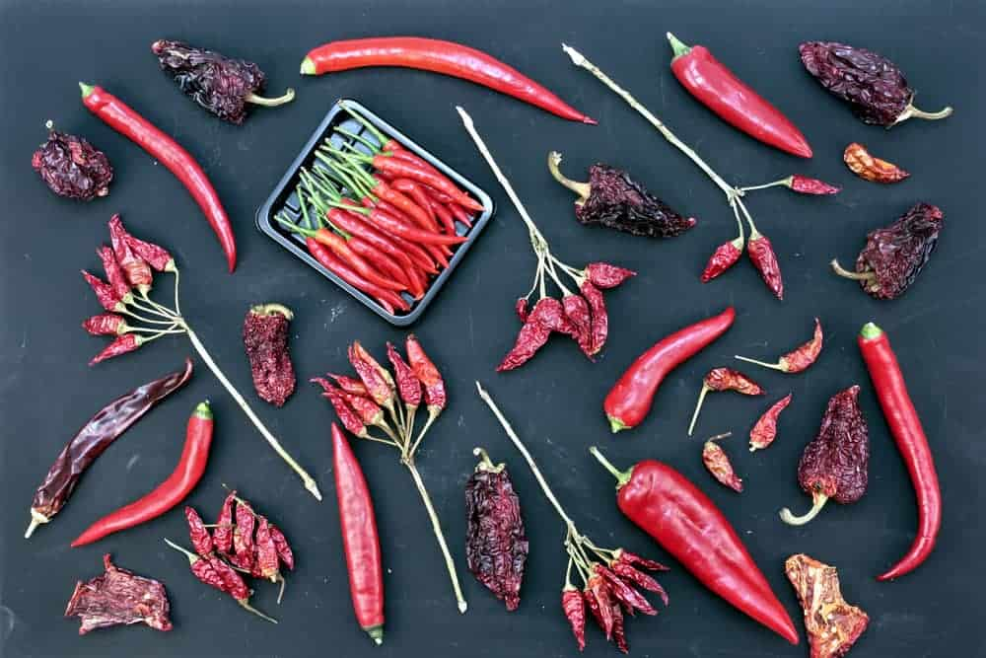
FROM THE RISING POPULARITY OF CHILI BARS TO CHILI COOK-OFFS THAT HAVE BEEN HAPPENING ACROSS AMERICA AND THROUGHOUT THE WORLD FOR YEARS, THERE ARE MANY DIFFERENT VERSIONS OF THE POPULAR DISH.
CHILI PEPPERS WERE ORIGINALLY FOUND IN MEXICO AND MANY CULTIVATORS OF THE CHILI PEPPER BEGAN TO SHIP IT ALL OVER THE WORLD FOR USE IN BOTH FOOD AND MEDICINES. BOWLS OF CHILI BECAME VERY POPULAR AND WERE PREPARED IN VARIOUS LOCATIONS, SUCH AS NORTHERN MEXICO AND SOUTHERN TEXAS, BUT SOON DIFFERENT VERSIONS OF THE DISH POPPED UP ALL OVER THE WORLD.
I HAVE ENTERED MANY CHILI COOK-OFFS IN MY DAY AND EVERY TIME, I USE MY MOM’S RECIPE. SHE CREATES THE ORIGINAL CHILE CON CARNE USING GROUND BEEF, KIDNEY BEANS, TOMATO JUICE, DICED TOMATOES, PLENTY OF ONIONS, AND SHE ADDS GREEN PEPPERS AND HOT SAUSAGE. THIS WINNING COMBO HAS GARNERED ME MANY PRIZES OVER THE YEARS BY STICKING TO MY MOM’S RECIPE, BUT I’VE ALSO TRIED OUT VARIOUS VERSIONS OF CHILI THERE ARE ALSO SUPER DELICIOUS.
MY DAD IS A GREEK IMMIGRANT AND MY MOM IS FROM VIRGINIA BUT MY MOM HAS LEARNED HOW TO COOK GREEK FOODS OVER THE YEARS JUST AS WELL AS MY DAD’S MOM AND HIS SISTERS. I REMEMBER WHEN I WAS GROWING UP, AT SOME POINT, MY PARENTS WERE IN CINCINNATI AND HAD SKYLINE CHILI FOR DINNER. THEY BOTH LOVED IT SO MY MOM FOUND A RECIPE FOR IT AND STARTED MAKING IT AT HOME.
I HAVE ALWAYS BEEN A HUGE FAN OF SPAGHETTI SO THIS PARTICULAR TYPE OF CHILI WAS RIGHT UP MY ALLEY. I TEND TO THINK THAT HER VERSION IS BETTER THAN THE ONES THAT YOU CAN BUY AT THE RESTAURANTS THAT HAVE POPPED UP ALL OVER AMERICA BUT I MAY BE A LITTLE BIASED. I PREFER MINE WITHOUT THE BEANS BUT DEFINITELY TOP IT WITH PLENTY OF CHEESE AND ONIONS. THIS CHILI RECIPE IS DEFINITELY ONE OF MY TOP FAVORITES.
THERE IS EVEN AN INTERNATIONAL CHILI SOCIETY THAT CATTLE DRIVERS IN THE SOUTHWEST CREATED YEARS AGO AND PROPELLED IT INTO POPULARITY. THE WOMEN WHO PARTICIPATED IN MAKING THE CHILI HAVE BECOME KNOWN AS CHILI QUEENS AND THE GROUP DATES BACK TO AT LEAST THE 1880S. THE WORLD’S FIRST CHILI CHAMPIONSHIP WAS SPONSORED BY THE INTERNATIONAL CHILI SOCIETY IN 1967, AND IT WAS HELD IN TERLINGUA, TEXAS.
HERE IS A LIST OF JUST SOME OF THE MANY VERSIONS OF CHILI, ALONG WITH MANY DETAILS ABOUT THE INGREDIENTS THAT ARE USED FOR EACH TYPE AND EVEN WHERE SOME OF THEM ORIGINATED. MANY ARE EVEN SPECIFIC TO THEIR LOCATION. NO MATTER HOW YOU LIKE YOUR CHILI PREPARED, IT IS A DELICIOUS OPTION FOR LUNCH OR SUPPER FOR MILLIONS OF PEOPLE EVERY DAY ACROSS THE WORLD.
RELATED: HOW TO STORE CHILI | WHAT GOES WITH CHILI | EASY HOMEMADE CHILI RECIPE

CHILI CON CARNE
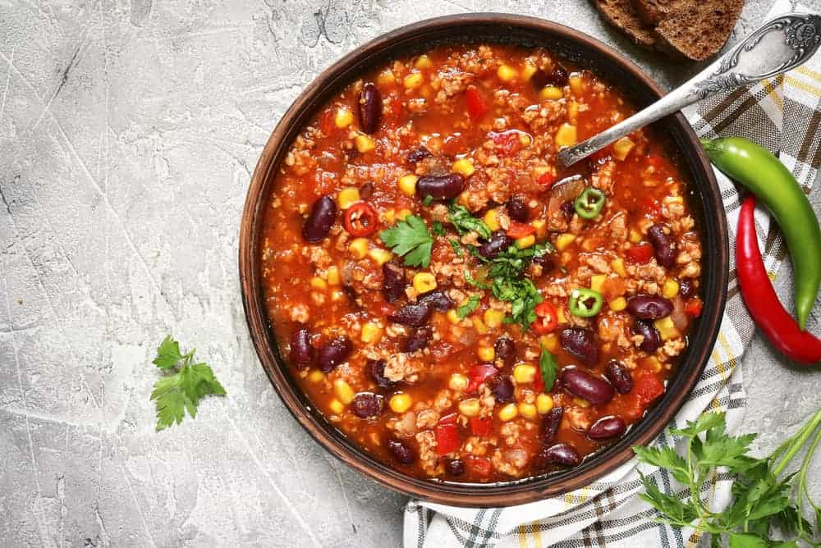
THE NAME OF CHILI CON CARNE MEANS “CHILI WITH MEAT” AND IS THE ORIGINAL SPICY STEW MADE WITH MEAT, USUALLY BEEF, ALONG WITH CHILI PEPPERS, KIDNEY BEANS OR OTHER TYPES OF BEANS, AND TOMATOES OR TOMATO SAUCE. SEASONINGS USED IN CHILI CON CARNE USUALLY ARE GARLIC, ONIONS, CUMIN, AND CHILI POWDER. THIS TYPE OF CHILI IS THE ORIGINAL VERSION THAT ORIGINATED IN NORTHERN MEXICO AND SOUTHERN TEXAS DECADES AGO.
IT IS THE MOST POPULAR VERSION OF ALL CHILI DISHES AND CAN BE MADE WITH DARK RED KIDNEY BEANS OR LIGHT RED KIDNEY BEANS. SOME PEOPLE EVEN USE PINTO BEANS OR OTHER TYPES OF BEANS TO MAKE THEIR CHILI. WHEN IT COMES TO CHILI SUPPERS AND CHILI COOK-OFFS, THIS IS THE MOST POPULAR VERSION THAT PEOPLE BRING TO THE TABLE.
AND THE BEST THING ABOUT THIS CHILI? IT NORMALLY TASTES BETTER THE DAY AFTER YOU COOK IT, AND IT HAS BEEN IN THE REFRIGERATOR OVERNIGHT WHICH MAKES IT A GREAT OPTION FOR LEFTOVERS. IT CAN BE EATEN OVER RICE OR MACARONI AND SOME PEOPLE LIKE TO ADD CRACKERS OR A DOLLOP OF SOUR CREAM ALONG WITH SHREDDED CHEDDAR CHEESE AND CHILI POWDER TO DRESS IT UP EVEN MORE.
CHILI CON CARNE IS AN EASY DISH TO MAKE, AND YOU CAN JAZZ IT UP TO SUIT YOUR TASTE BUDS. YOU CAN USE ANY TYPE OF BEEF YOU WANT, FROM GROUND BEEF TO CHUNKS OF SIRLOIN STEAK, AND THE NUMBER OF SPICES AND PEPPERS YOU ADD TO IT IS TOTALLY UP TO YOU. YOU CAN USE TOMATO JUICE, DICED TOMATOES, TOMATO SAUCE, OR EVEN BEEF BROTH FOR YOUR BASE AND ADD ONIONS IF YOU WANT TO AND WHATEVER TYPE OF BEANS THAT YOU CHOOSE TO USE.
CHILI CON CARNE IS ALSO A HEALTHY DISH SINCE IT’S PACKED WITH PLENTY OF PROTEIN AND FIBER AND CAN BE ENJOYED WITH VERY LITTLE GUILT EVEN IF YOU’RE ON A LOW-CARB DIET. YOU CAN EVEN OPT TO USE LEANER MEATS, SUCH AS CHICKEN OR TURKEY.

TEXAS RED CHILI
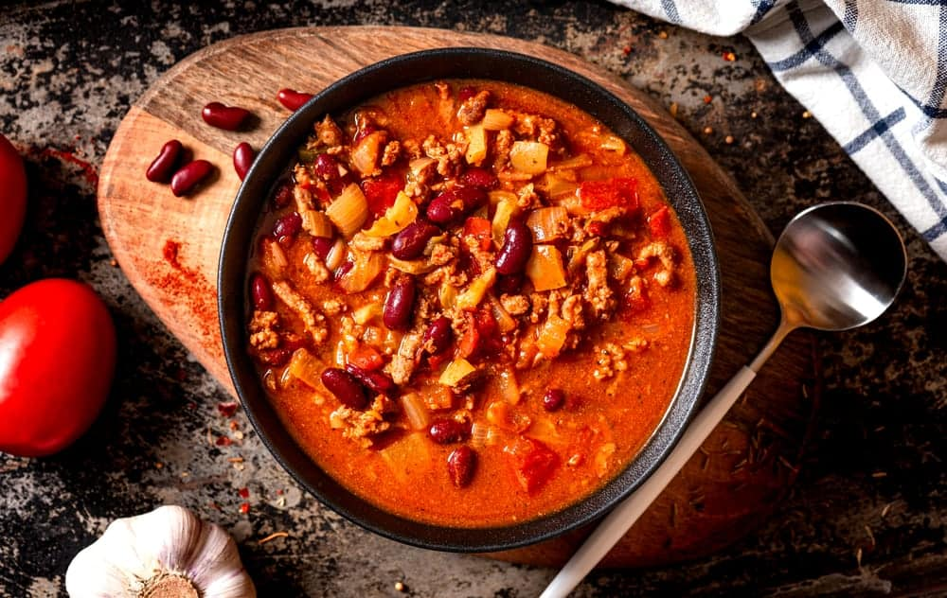
THE TEXAS VERSION OF CHILI CON CARNE IS REFERRED TO AS TEXAS RED AND WAS INVENTED MANY YEARS AGO IN SAN ANTONIO, TEXAS. IT CONSISTS OF BEEF THAT IS COOKED IN A VERY SPICY CUMIN-SPIKED SAUCE WITH RED CHILE PEPPERS WHICH MAKE IT A BEAUTIFUL RED COLOR. TEXANS TAKE THEIR CHILI VERY SERIOUSLY AND ARE VERY MUCH ANTI-BEAN. THE TEXAS LEGISLATOR EVEN MADE CHILI THE STATE DISH IN 1977.
THE TEXT OF THE RESOLUTION ACTUALLY READS, “ONE CANNOT BE A TRUE SON OR DAUGHTER OF THIS STATE WITHOUT HAVING HIS TASTE BUDS TINGLE AT THE THOUGHT OF THE TREAT THAT IS REAL, HONEST-TO-GOODNESS, UNADULTERATED TEXAS CHILI.” THE POPULAR SAYING IN TEXAS WHEN IT COMES TO CHILI IS THIS: “IF YOU KNOW BEANS ABOUT CHILI, YOU KNOW CHILI AIN’T GOT NO BEANS.”
SO, BASICALLY IN TEXAS WHEN IT COMES TO TEXAS RED CHILI IT CANNOT HAVE ANY FILLERS IN IT INCLUDING BEANS. THEIR CHILI CON CARNE ONLY CONSISTS OF MEAT AND CHILE PEPPERS WHICH ARE IN LINE WITH THE SPANISH MEANING OF CHILI CON CARNE WHICH MEANS CHILI WITH MEAT.

SPRINGFIELD “CHILLI”
WHEN YOU ARE IN THE STATE OF ILLINOIS, CHILI IS SPELLED WITH TWO L’S, CHILI. SOME OF THE THEORIES ON THE ORIGINS OF THIS SPELLING INCLUDE THAT A SIGN PAINTER CREATED THE SIGN FOR ONE OF THE STATE’S ORIGINAL CHILI RESTAURANTS WANTED THE WORD TO MIMIC THE SPELLING OF THE STATE’S NAME OF ILLINOIS. ANOTHER THEORY IS THAT JOE DEFRATES, THE ONLY MAN TO EVER WIN BOTH THE NATIONAL AND WORLD CHILI CHAMPIONSHIPS, FIRST STARTED SERVING HIS VERSION OF CHILI IN THE STATE’S CAPITAL CITY OF SPRINGFIELD.
HIS VERSION WAS MADE OF TENDER GROUND BEEF, HUNT’S CANNED TOMATO SAUCE, A DASH OF TABASCO SAUCE, AND HIS SECRET SPICE MIX THAT INCLUDED CHILI POWDER. PEOPLE WHO LIVE IN ILLINOIS TAKE THEIR VERSION OF CHILI AS SERIOUSLY AS THE PEOPLE WHO LIVE IN TEXAS DO AND THE ILLINOIS HOUSE AND SENATE PASSED A JOINT RESOLUTION IN 1993 PROCLAIMING ILLINOIS AS THE CHILLI CAPITAL OF THE WORLD.
THE ILLINOIS GENERAL ASSEMBLY ALSO DECLARED THE CITY OF TAYLORVILLE, WHICH IS HOME TO A LOT OF CHILI COOK-OFFS, AS THE CHILI CAPITAL OF ILLINOIS IN 2016. SPRINGFIELD CHILLI CONSISTS OF GROUND BEEF AND ALL OF THE NORMAL CHILI FIXINGS ALONG WITH A CAN OF BUDWEISER BEER AND A DASH OF WORCESTERSHIRE SAUCE.

CINCINNATI-STYLE CHILI

CINCINNATI-STYLE CHILI IS ALSO KNOWN AS SKYLINE CHILI AND IS MOST OFTEN SERVED OVER TOP OF A BED OF SPAGHETTI AND TOPPED WITH BRIGHT YELLOW SHREDDED CHEDDAR CHEESE AND ONIONS. THIS CHILI DID NOT ACTUALLY ORIGINATE IN CINCINNATI, OHIO, BUT RATHER IN GREECE AND THEN NEW YORK CITY. IT STARTED WITH GREEK-MACEDONIAN IMMIGRANT BROTHERS JOHN AND TOM KIRADJIEFF.
WHEN THE BROTHERS CAME TO CINCINNATI TOWARDS THE BEGINNING OF THE 20TH CENTURY, THEY BEGAN SELLING CONEY DOGS AND HOT DOGS WITH THEIR OWN STYLE OF SPICED MEAT SAUCE. THE BROTHERS ADDED INGREDIENTS OVER TIME, INCLUDING PAPRIKA AND ALLSPICE WITH THE DISTINCTIVE COMBINATION OF CHOCOLATE AND CINNAMON. WHILE THE STEW ALSO RELIED ON CUMIN, BEEF, AND SOME CHILI PEPPER, THE BROTHERS ADDED INGREDIENTS THAT WERE MORE AT HOME IN A MEDITERRANEAN KITCHEN, LIKE PAPRIKA AND ALLSPICE, AS WELL AS THE STYLE’S DISTINCTIVE COMBO OF CINNAMON AND CHOCOLATE.
THEIR RECIPE HAS CHANGED OVER TIME, AND THEY STARTED SERVING IT ON SPAGHETTI IN A TAFFY NET WITH THE BRIGHT YELLOW CHEDDAR CHEESE. SKYLINE CHILI RESTAURANTS HAVE POPPED UP ALL OVER THE UNITED STATES AND YOU ORDER IT BY THE NUMBERS. FOR EXAMPLE, IF YOU ORDER NUMBER ONE, YOU ARE GETTING JUST THE CHILI BUT IF YOU ORDER A NUMBER TWO, YOU GET CHILI AND THE SPAGHETTI.
A NUMBER THREE WILL GET YOU THE CHILI, THE SPAGHETTI, AND THE CHEESE AND IF YOU GO WITH THE NUMBER FOUR, YOU GET THE CHILI OVER THE TOP OF SPAGHETTI TOPPED WITH CHEESE AND YOUR CHOICE OF BEANS OR ONIONS. AND, FINALLY, A NUMBER FIVE GETS YOU ALL OF IT WHICH MEANS YOU’RE GETTING THE CHILI OVER THE SPAGHETTI TOPPED WITH THE CHEESE, ONIONS, AND BEANS.
THE BROTHERS ALSO INSISTED ON SERVING ALL VERSIONS OF THEIR SKYLINE CHILI ON OVAL-SHAPED PLATES, AND YOU’RE SUPPOSED TO USE A FORK TO CUT THE SPAGHETTI, NOT TWIRL IT. THIS TYPE OF CHILI HAS BECOME A FAVORITE AMONG MANY PEOPLE WHO HAVE ALSO LEARNED HOW TO CREATE THEIR OWN VERSIONS AT HOME. IT IS PROBABLY THE MOST DIFFERENT TYPE OF CHILI ON OUR LIST, AND IT IS VERY DELICIOUS.

OKLAHOMA-STYLE CHILI
VERY SIMILAR TO TEXAS RED CHILI, OKLAHOMA’S VERSION OF CHILI ALLOWS BEANS TO BE ADDED. ACCORDING TO WHAT THE HISTORY OF CHILI IN OKLAHOMA SAYS TO US, MOST OKLAHOMA NATIVES HAVE NEVER MET A CHILI THEY DIDN’T LIKE. THEY LOVE BOTH THE TEXAS-STYLE AND THE CINCINNATI VERSION ALONG WITH PLENTY OF CONEY DOGS DRIPPING WITH CONEY SAUCE.
THEIR VERSION OF CHILI IS VERY SIMILAR TO CHILI CON CARNE BECAUSE IT CONTAINS BOTH MEAT AND BEANS ALONG WITH ONION, TOMATOES, CHILI POWDER, AND PLENTY OF SPICES. OKLAHOMA’S RESIDENTS LOVE THEIR CHILI TOPPED WITH SOME SOUR CREAM AND CHEDDAR CHEESE AND SERVED WITH OR WITHOUT CORNBREAD. IT REALLY JUST BOILS DOWN TO THE FACT THAT THEY LOVE THEIR CHILI.

TURKEY CHILI
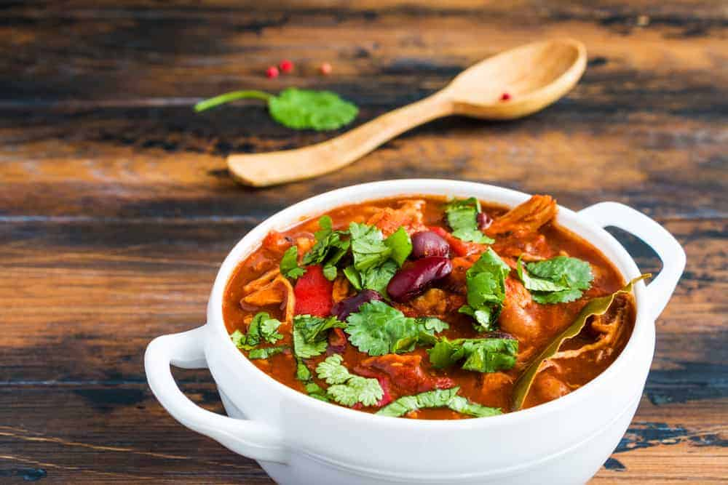
TURKEY CHILI IS ACTUALLY A SPIN ON CHILI CON CARNE, BUT IT IS MADE WITH LEAN GROUND TURKEY INSTEAD OF LEAN GROUND BEEF. THIS VERSION OF CHILI CON CARNE IS BECOMING MORE AND MORE POPULAR AS PEOPLE TRY TO EAT HEALTHIER INTAKE IN LESS FAT. REPLACING GROUND BEEF WITH TURKEY IS A GREAT OPTION SINCE, IF YOU USE THE RIGHT SPICES AND OTHER INGREDIENTS, YOU REALLY CANNOT TELL MUCH OF A DIFFERENCE IN TASTE.

CHILE VERDE
CHILE VERDE IS DIFFERENT FROM OTHER CHILIES ON OUR LIST BECAUSE THE MEAT MOST OFTEN USED IN THIS CHILI DISH IS PORK INSTEAD OF BEEF. TOMATILLOS ARE USED IN THE CREATION OF THE SAUCE ALONG WITH FRESH CHILI PEPPERS AND MANY SPICES, ALTHOUGH NOT NORMALLY CUMIN. NEW MEXICO RESIDENTS LIKE TO MAKE THEIR VERSION OF CHILI VERDE WITH HATCH CHILE PEPPERS.
THIS GIVES THEIR VERSION OF CHILE VERDE A SMOKY FLAVOR THAT COMES FROM THE ROASTED HATCH CHILES WHICH GIVE THE CHILI A TOUCH OF BITTERNESS ALONG WITH A WELCOME PEPPERY SWEET TASTE THAT OTHER CHILI DISHES LACK. THIS CREATES A GREEN SAUCE THAT ALSO INCLUDES MELTED FAT FROM THE PORK. SOME PEOPLE ALSO MAKE THIS CHILI DISH WITH CHICKEN AND ADD BEANS AND PASTA FOR A VERY HEARTY MEAL.
MANY VERSIONS OF THIS CHILI CALL FOR GREEN CHILI PEPPERS TO BE USED ALONG WITH AN ARRAY OF SPICES TO MAKE THIS A VERY TASTY CHILI DISH THAT MANY PEOPLE ENJOY.

WHITE CHILI
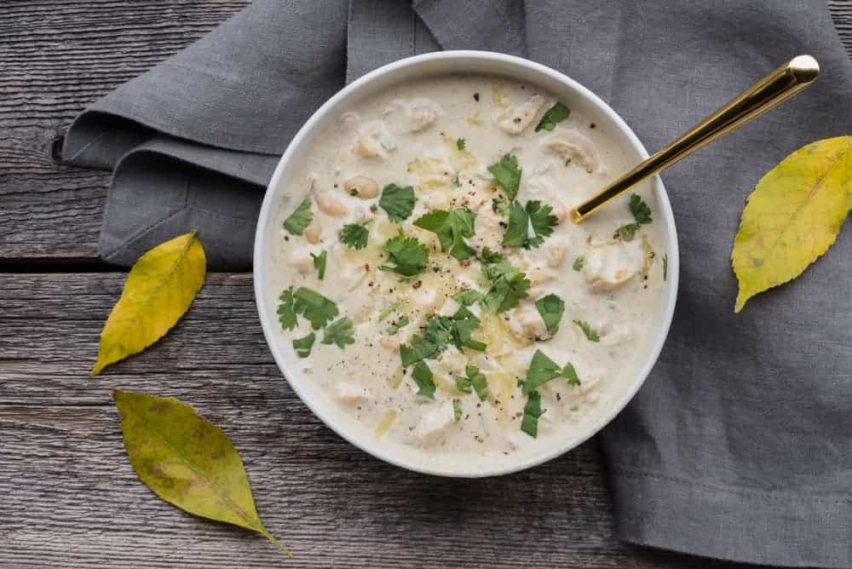
WHITE CHILI HAS A CHILI PEPPER BASE AND CONTAINS MEAT BUT INSTEAD OF BEEF, IT IS USUALLY CHICKEN OR TURKEY THAT IS USED IN THIS DELICIOUS CHILI DISH. IT’S SIMILAR TO CHILI VERDE IN THE FACT THAT IT STARTS WITH A BASE OF FRESH PEPPERS, BUT THEN IT TAKES ITS OWN PATH WITH THE INCLUSION OF WHITE BEANS AND IS NOT NORMALLY SERVED WITH MELTED SHREDDED CHEESE ON TOP. THE WHITE BEANS CREATE A WHITE BASE WHICH IS WHERE THIS CHILI DISH GETS ITS NAME FROM.

CHILI DOG

WHEN IT COMES TO CHILI DOGS MANY PEOPLE MAKE THE CHILI DIFFERENT TO PUT ON TOP OF THE HOT DOG AND THEN. YOU CAN TAKE THE EASY ROUTE AND BUY CANNED CHILI THAT HAS SPECIFICALLY BEEN CREATED TO USE ON CHILI DOGS OR CONEY SAUCE, OR YOU CAN MAKE YOUR OWN VERSION.
SOME PEOPLE HAVE EVEN TAKEN TO ADDING COLESLAW ON TOP OF THE CHILI DOG ALONG WITH CHEDDAR CHEESE AND CREATING A WHOLE NEW VERSION OF THE CHILI DOG. CONEY DOGS BECAME VERY POPULAR WHEN THEY WERE FIRST INTRODUCED TO THE PUBLIC, IN THE STATE OF MICHIGAN, AND EVENTUALLY MADE THEIR WAY TO NEW YORK CITY, WHERE MANY GREEK IMMIGRANTS BEGAN TO OPEN UP RESTAURANTS THAT FEATURED CONEY CHILI DOGS.

FRITO PIE CHILI

THIS CHILI DISH WAS CREATED IN THE MIDWEST AREA OF THE UNITED STATES AND HAS BECOME AN AMERICAN CLASSIC. SIMPLY MAKE A BOWL OF CHILI THAT CONSISTS OF GROUND BEEF, TOMATO SAUCE, BEANS MARINATED IN CHILI POWDER, AND THROW IN SOME MORE SEASONINGS. YOU THEN POUR YOUR BOWL OF CHILI OVER THE TOP OF AN OPENED BAG OF FRITO CHIPS, TOP IT OFF WITH SOME SHREDDED CHEESE AND SOUR CREAM, AND THERE YOU HAVE IT, FRITO PIE CHILI.

CAJUN CHILI, LOUISIANA
CAJUN CHILI IS SIMPLY A BOWL OF CHILI DONE CAJUN STYLE. THIS MEANS THAT TONS OF CAJUN SEASONINGS HAVE BEEN USED ALONG WITH A BIG SPLASH OF LOUISIANA HOT SAUCE THAT MAKES THIS CHILLY DELICIOUS AND UNFORGETTABLE. YOU MAY WANT TO GRAB A PIECE OF CORNBREAD OR MORE TO GO WITH YOUR BOWL OF CAJUN CHILI TO SOOTHE YOUR SCORCHED THROAT AS YOU EAT THIS DELECTABLE BUT VERY HOT VERSION OF CHILI.

CARNE ADOVADA
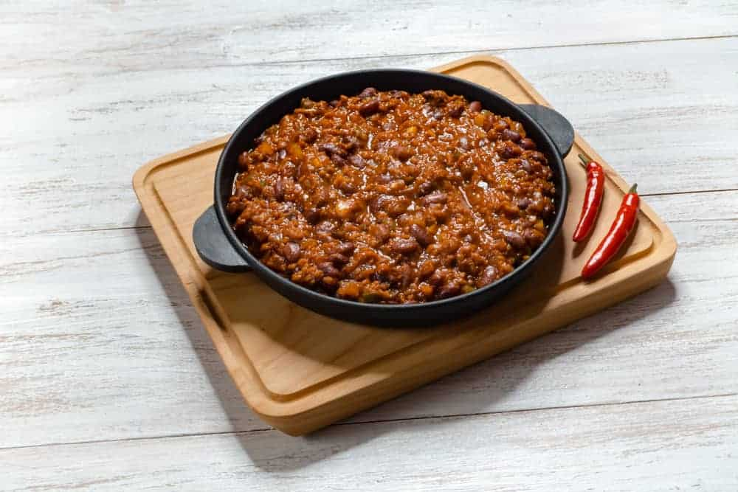
CARNE ADOVADA COULD BE CONSIDERED MORE A WAY OF COOKING RATHER THAN AN ACTUAL CHILI DISH. IT CONSISTS OF A RED CHILI PEPPER-BASED SAUCE THAT IS HIGHLIGHTED BY OREGANO AND CUMIN AND IS USED TO MARINATE AND STEW PORK. IT MAKES THE PORK VERY TENDER AND TASTY, AND IT CAN BE SERVED AS A STEW OR EVEN AS A FILLING FOR FOODS LIKE TACOS, SOPAPILLAS, AND BURRITOS.
CARNE ADOVADA IS BASICALLY A NEW MEXICO-STYLE PORK DISH WITH RED CHILIES AND MAY JUST HAVE MORE USES WITH OTHER FOODS THAN ANY OF THE OTHER CHILIES ON THIS LIST.

VEGETARIAN CHILI
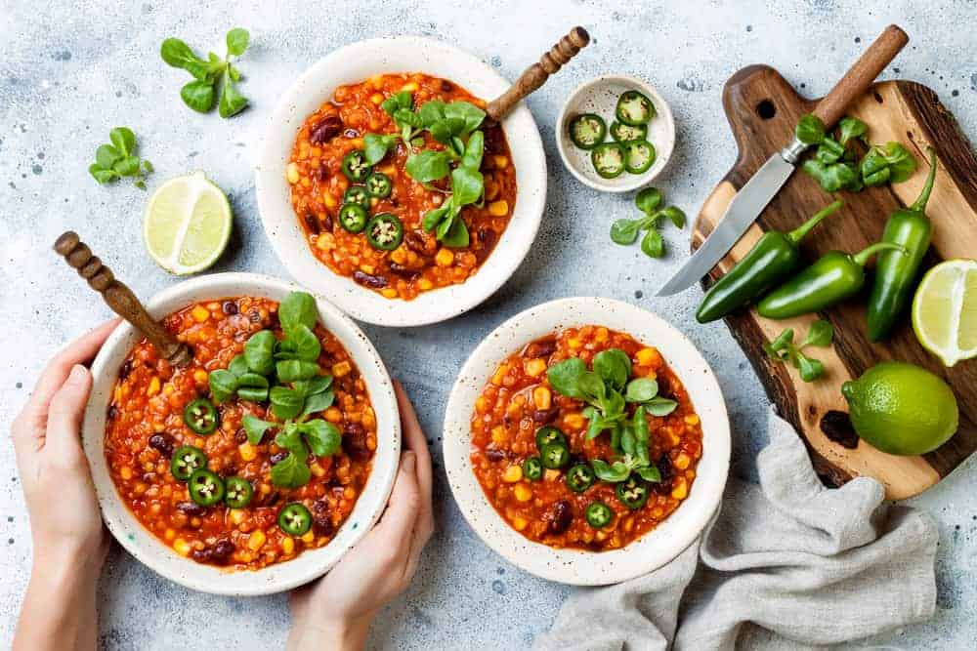
THIS VERSION OF CHILI BECAME POPULAR DURING THE VEGETARIAN CRAZE OF THE 1960S AND 1970S. SOMETIMES VEGETABLES SUCH AS SWEET POTATOES ARE USED IN PLACE OF MEAT IN THIS ALL-VEGETABLE CHILI DISH.
ALL DIFFERENT TYPES OF CHILI BASES ARE USED TO CREATE VEGETATE VEGETARIAN CHILI INCLUDING FRESH OR DRIED CHILI BASES THERE ARE MANY DIFFERENT RECIPES YOU CAN FOLLOW IF YOU WANT TO CREATE YOUR OWN CHILLING THAT CAN BE MADE WITH AN ARRAY OF DIFFERENT VEGGIES INCLUDING DIFFERENT TYPES OF BEANS. IT IS SERVED JUST LIKE REGULAR CHILI, AND YOU CAN TOP IT OFF WITH SOUR CREAM AND CHEESE OR THROW SOME CRACKERS IN IT FOR DIFFERENT FLAVORS.

VEGAN BLACK BEAN CHILI
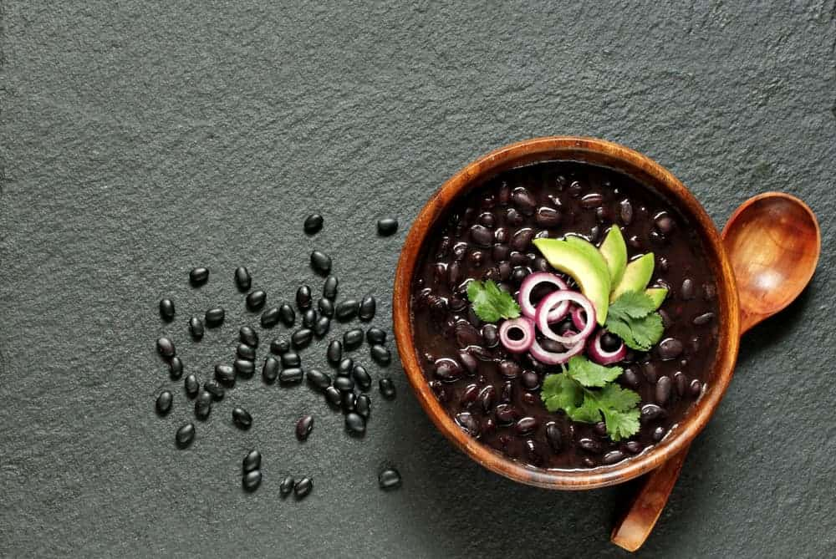
VEGAN BLACK BEAN CHILI IS SIMILAR TO VEGETARIAN CHILI, BUT IT’S VERY FOCUSED ON BEANS. BLACK BEANS ARE A GREAT SOURCE OF FIBER IN MOST PEOPLE CREATE THIS RECIPE WITH HARDY TOMATOES TONS OF ONIONS AND PLENTY OF SPICES.

FIVE ALARM CHILI
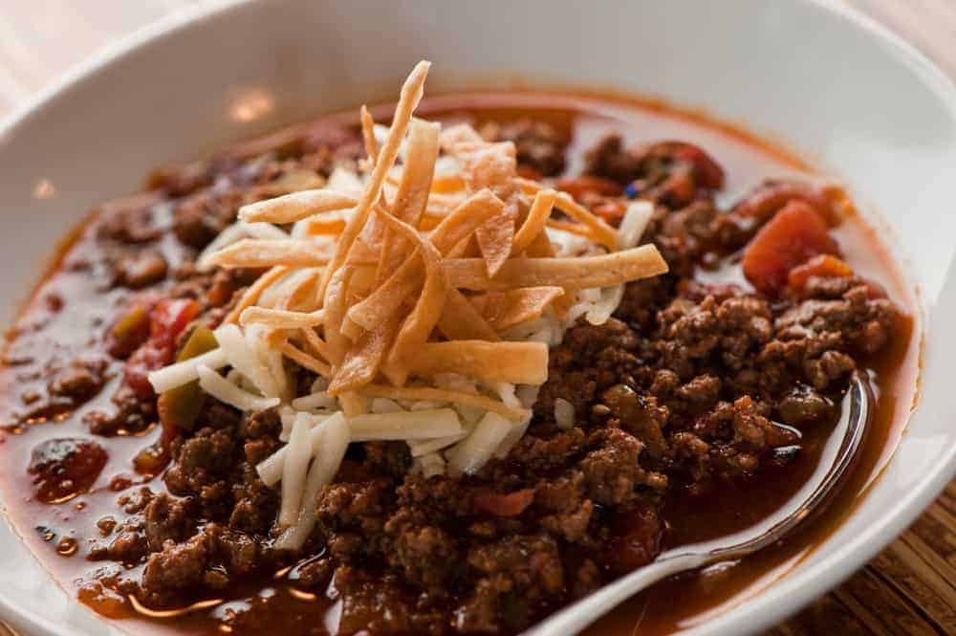
FIVE ALARM CHILI IS THE HOTTEST VERSION OF CHILI ON OUR LIST IN MORE WAYS THAN ONE. THIS RECIPE USES AT LEAST FIVE DIFFERENT TYPES OF PEPPERS INCLUDING CHILI PEPPERS AND JALAPENO PEPPERS. IT USUALLY CONTAINS MEAT, SUCH AS GROUND BEEF, GROUND TURKEY, OR EVEN CHUNKS OF SIRLOIN STEAK, BUT THE FOCUS IS DEFINITELY ON THE PEPPERS THAT ARE USED.
YOU CAN EVEN USE DRIED RED CHILI PEPPERS WHICH ARE ALSO KNOWN AS CHIPOTLE PEPPERS TO CREATE THIS DELICIOUS VERSION OF CHILI. BE ADVISED, HOWEVER, THAT YOU SHOULD DEFINITELY EAT IT WITH CORNBREAD, CRACKERS, OR EVEN FRITOS TO HELP DIFFUSE THE LEVEL OF HOTNESS ON YOUR THROAT.
IN MOST RECIPES FOR FIVE-ALARM CHILI, TWO SLICES OF BACON ARE USED ALONG WITH BLUE CORN TORTILLA CHIPS AND ANAHEIM PEPPERS, JALAPEÑO PEPPERS, POBLANO PEPPERS, TWO OR THREE CHIPOTLE PEPPERS, ONION, A TUBE OF TOMATO PASTE A CAN OF DICED TOMATOES PLENTY OF GARLIC AND CHILI POWDER ALONG WITH SOME WHITE PEPPER A LITTLE BIT OF SUGAR SOME APPLE CIDER VINEGAR AND SOME CRUSHED RED PEPPERS PERIOD, OF COURSE, YOU’RE GOING TO WANT TO THROW IN SOME CUMIN AND SOME SMOKED PAPRIKA, AND YOU WANT TO USE SEVERAL DIFFERENT KINDS OF BEANS.
ALONG WITH OREGANO IN APPLE CIDER VINEGAR YOU CAN THROW IN A CAN OF BLACK BEANS A CAN OF KIDNEY BEANS AND YET ANOTHER CAN CONTAINING PINTO BEANS. FIVE-ALARM CHILI TASTES GREAT SERVED WITH SOUR CREAM, CORN CHIPS, CILANTRO, DRIED AVOCADO, AND SHREDDED CHEDDAR CHEESE. THIS MAKES A GREAT CHILI FOR ANYONE WHO LOVES DELICIOUS CHILI WITH A KICK.

MEGA LIST OF 33 TYPES OF SPICES EVERY KITCHEN NEEDS
DO YOU WANT TO PUT TOGETHER A GOOD STARTING SPICE COLLECTION? WE DID THE RESEARCH FOR YOU. HERE'S A LIST OF 27 DIFFERENT TYPES OF SPICES THAT EVERY GOOD SPICE COLLECTION NEEDS.

CAN YOU IMAGINE A WORLD WITHOUT SPICES? IT IS LIKE EATING FOOD THAT HAS NO SALT IN IT. SPICES ARE WHAT TAKES AN ORDINARY DISH TO A WHOLE NEW EXTRAORDINARY LEVEL.
THE HISTORY OF SPICES GOES AS FAR BACK AS THE START OF THE HUMAN CIVILIZATION WHERE VAST LANDS WERE DISCOVERED BY THE NUMEROUS CIVILIZATIONS THAT SPRUNG DURING ANCIENT TIMES. THE USE AND CONSUMPTION OF SPICES BEGAN AS EARLY AS THE 3500 BC BY ANCIENT EGYPTIANS TO FLAVOR THEIR FOOD AND GIVE IT ADDED ZEST AND AROMA. SOON ENOUGH, THE USE AND PRODUCTION OF SPICES SPREAD THROUGHOUT THE MIDDLE EAST, ALL THE WAY TO EUROPE, THE EASTERN MEDITERRANEAN, INDONESIA, SRI LANKA AND CHINA. SPICES ALSO LED TO THE GREAT AGE OF EXPLORATION, AS WELL AS TO THE ULTIMATE DISCOVERY OF THE NEW WORLD.
WHILE YOU MAY ALREADY KNOW ABOUT THE IMPORTANCE OF SPICES, DID YOU KNOW THAT A MASSIVE VARIETY OF SPICES IS FOUND IN THIS WORLD? YOU PROBABLY AREN’T EVEN AWARE OF MOST IT!
WHAT’S THE DIFFERENCE BETWEEN HERBS AND SPICES?
SPICES COME FROM THE ROOT, BARK OR SEEDS OF A PLANT. HERBS COME FROM THE LEAVES OF A PLANT [SOURCE: THEKITCHN]. THE LIST HERE PERTAINS TO SPICES ONLY.
BELOW IS OUR MEGA LIST OF SPICES EVERY KITCHEN NEEDS.
RELATED: TYPES OF SPICE RACKS | MEGA-LIST OF HERBS | MEGA LIST OF CONDIMENTS | TYPES OF FOOD | FOOD PRESERVATION
TYPES OF SPICES CHART
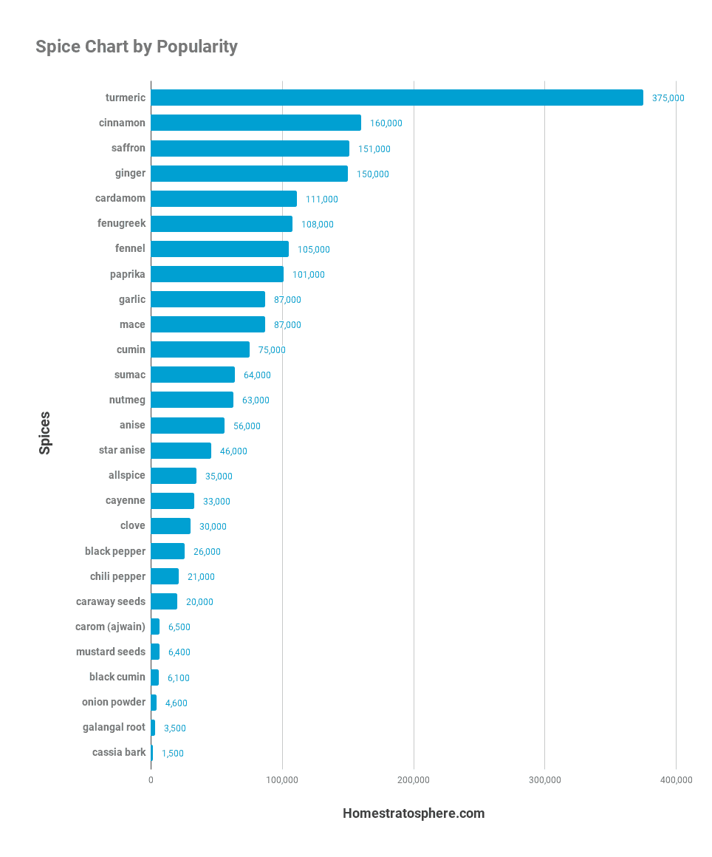
MEGA LIST OF SPICES
YOU WILL BE SURPRISED TO KNOW HOW MANY DIFFERENT SPICES THERE ARE, ALL WITH THEIR UNIQUE TASTE, CHARACTERISTICS, FLAVORS, AND AROMAS. READ ALL ABOUT THE DIFFERENT TYPES OF SPICES AND PICK YOUR FAVORITE ONES!

CARDAMOM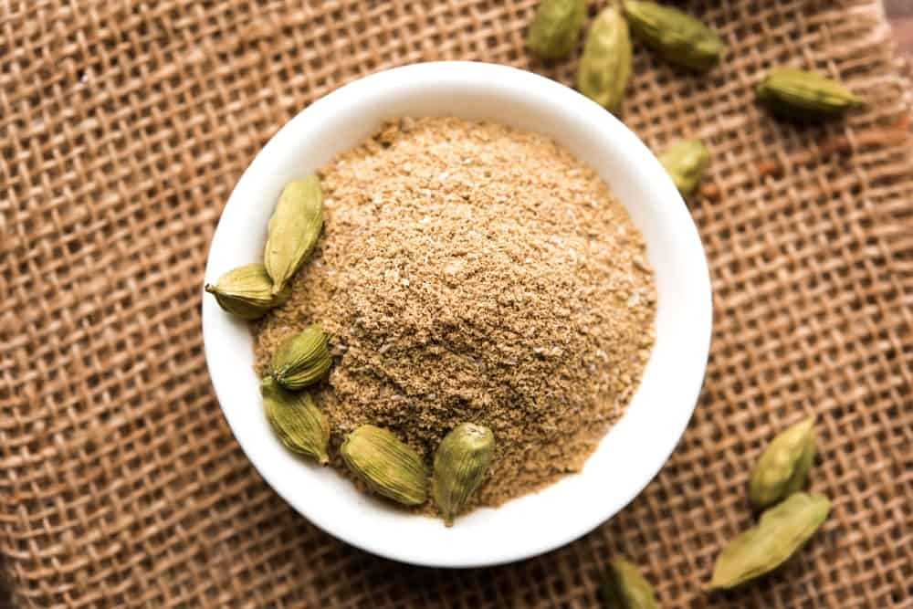
LATIN NAME: ELETTARIA CARDAMOMUM
THIS SPICE IS ALSO KNOWN AS THE “QUEEN OF SPICES” IN INDIA, ITS COUNTRY OF ORIGIN. CARDAMOM HAS A STRONG, PUNGENT FLAVOR THAT HAS SUBTLE HINTS OF LEMON AND MINT. INTERESTINGLY, IT IS A VERY VERSATILE SPICE SO IT CAN BE USED TO INTENSIFY BOTH SWEET AND SAVORY FLAVORS. THERE ARE TWO TYPES OF CARDAMOM THAT ARE TYPICALLY USED IN INDIAN COOKING, AS WELL AS ALL OVER THE WORLD: GREEN AND BLACK.
GREEN CARDAMOM IS USED MORE COMMONLY THAN ITS BLACK COUNTERPART AND HAS A VERY LIGHT AND SWEET FLAVOR. IT IS OFTEN USED IN DESSERTS AND SWEET DRINKS. BLACK CARDAMOM, ON THE OTHER HAND, CONSISTS OF A VERY STRONG SMOKY FLAVOR SO IT IS OFTEN USED IN SPICY RICE DISHES AND CURRIES.
CARDAMOM HAS QUITE A RICH HISTORY BEHIND IT IN TERMS OF ITS MEDICINAL PROPERTIES AND HAS BEEN USED SINCE ANCIENT TIMES AS A DIGESTIVE AID, AS WELL AS TO TREAT INFLAMMATORY AND RESPIRATORY CONDITIONS.

CLOVE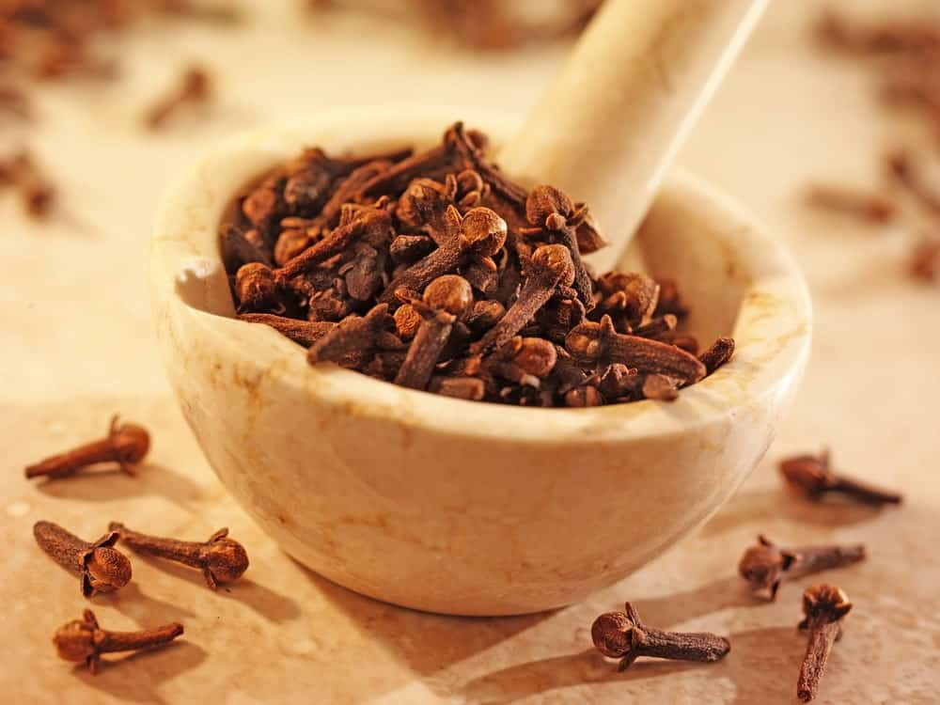
LATIN NAME: SYZGIUM AROMATICUM
THIS IS ANOTHER FAIRLY COMMON INDIAN SPICE THAT WAS FIRST FOUND BEING TRADED AT A PORT IN SRI LANKA SOMEWHERE DURING 900-1100 CE. HOWEVER, IT IS NATIVE TO THE MOLUCCA ISLANDS WHICH IS NOW A PART OF INDONESIA. CLOVES CONTAIN A VERY DISTINCTIVE KIND OF A SWEET SMELL WITH AN EQUALLY SWEET-SPICY FLAVOR.
AN INTERESTING HISTORICAL FACT ABOUT CLOVES IS THAT BEFORE APPROACHING THEIR EMPEROR, THE CHINESE HAD TO HAVE A FEW CLOVES IN THEIR MOUTH AS A WAY OF SWEETENING THEIR BREATH. THIS SUGGESTS THAT IN ANCIENTS, CLOVES WERE ALSO USED AS MOUTH FRESHENERS INSTEAD OF BREATH MINTS THAT ARE TYPICALLY USED TODAY.
WHOLE CLOVES ARE OFTEN USED IN CURRIES AND OTHER LIQUIDS SINCE THEY ALSO PROVIDE QUITE AN AESTHETIC APPEAL WHILE GROUND CLOVES ARE POPULARLY USED IN A VARIETY OF SWEET TREATS. THEY ARE ALSO USED FOR A NUMBER OF HEALTH-RELATED PURPOSES INCLUDING TOOTHACHES, VOMITING, NAUSEA, AND INDIGESTION, TO NAME A FEW.

CASSIA BARK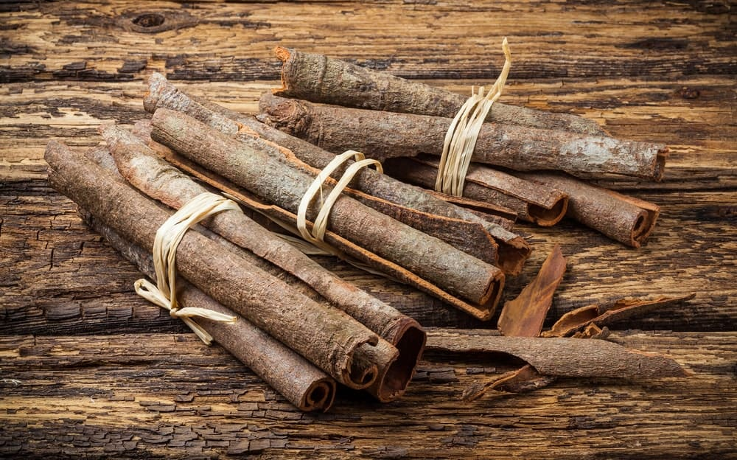
LATIN NAME: CASSIA SENNA
THIS SPICE IS ALSO KNOWN AS “CHINESE CINNAMON” AND IS OFTEN CONFUSED WITH THE OTHER ‘TRUE’ CINNAMON; HOWEVER, IT IS ACTUALLY A MEMBER OF THE PEA FAMILY. IT HAS AN EXTREMELY PUNGENT FLAVOR THAT IS LESS DELICATE WHEN COMPARED TO THAT OF THE TRUE CINNAMON. ALTHOUGH CASSIA BARK LOOKS ALMOST THE SAME AS CINNAMON, IT IS ACTUALLY VERY DIFFERENT AND IS USED MORE OFTEN IN SAVORY DISHES, ESPECIALLY IN CHINA.
CASSIA BARK IS COMMONLY GROWN AND PRODUCED IN INDONESIA, CHINA, AND BURMA AND IS PERFECT FOR HOMEMADE TEA BLENDS OR SPICE BLENDS. MANY PEOPLE USE THIS SPICE TO TREAT MUSCLE AND STOMACH SPASMS, MENSTRUAL PROBLEMS, JOINT PAINS, THE COMMON COLD, HIGH BLOOD PRESSURE, AND MANY OTHER HEALTH AILMENTS.

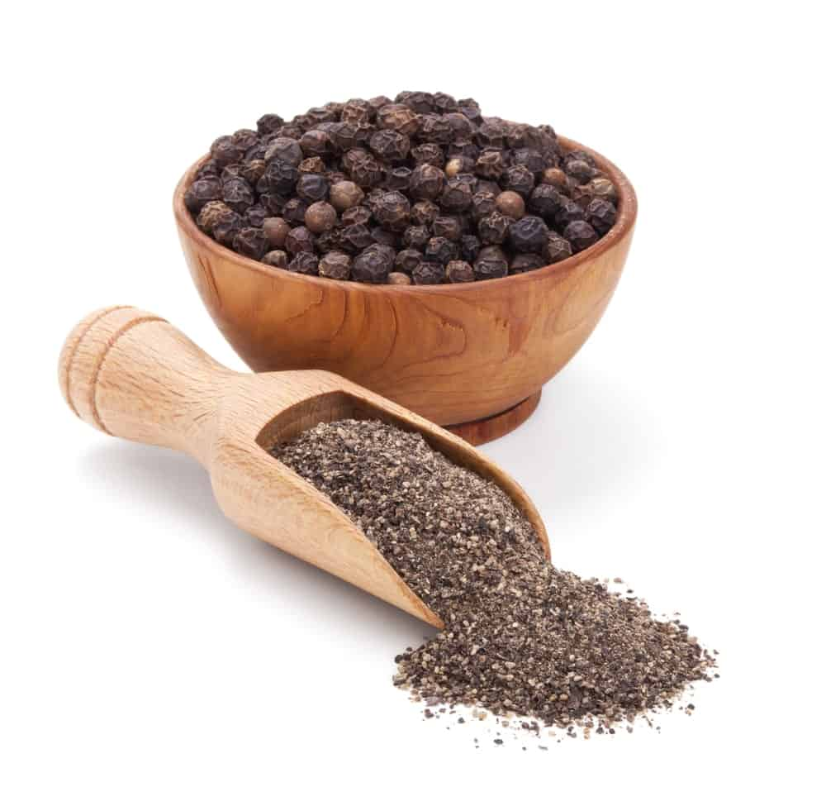

BLACK PEPPER
LATIN NAME: PIPER NIGRUM
THIS HAS TO BE ONE OF THE MOST COMMONLY FOUND AND CONSUMED SPICES ALL OVER THE WORLD. A PINCH OF IT IS ADDED TO ALMOST EVERY RECIPE YOU COULD POSSIBLY IMAGINE. BLACK PEPPER HAS ORIGINATED FROM INDIA, PARTICULARLY FROM THE MALABAR REGION AND THE WESTERN GHATS. IT COMES FROM THE BERRIES OF THE PEPPER PLANT AND YOU WOULD TYPICALLY ALSO FIND WHITE AND GREEN COLORED PEPPERCORNS. THE DIFFERENCE IN COLOR PRIMARILY RESULTS FROM THE VARYING DEVELOPMENTAL STAGES.
SINCE ANCIENT GREECE TIMES, PEPPER HAS BEEN A MUCH CHERISHED AND PRESTIGIOUS SPICE BECAUSE IT WAS USED AS BOTH, A CURRENCY, AS WELL AS, A SACRED OFFERING.
BLACK PEPPER CONSISTS OF A VERY UNIQUE SPICY TASTE AND IS TYPICALLY USED TO PROVIDE A SUBTLE HEAT KICK TO NUMEROUS RECIPES AND DISHES. SOME OF ITS AMAZING MEDICINAL USES INCLUDE USING IT AS LAXATIVES OR FOR CONGESTION RELIEF.

CELERY SEED
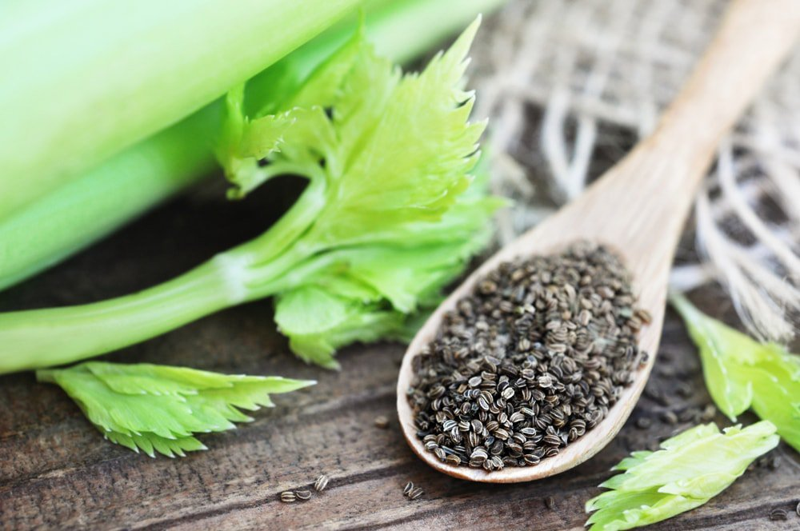
CELERY SEED IS USUALLY GROUND UP INTO SALT, AND CAN THEN BE ADDED TO MANY DISHES FOR A CONCENTRATED TASTE OF CELERY.

CORIANDER SEED
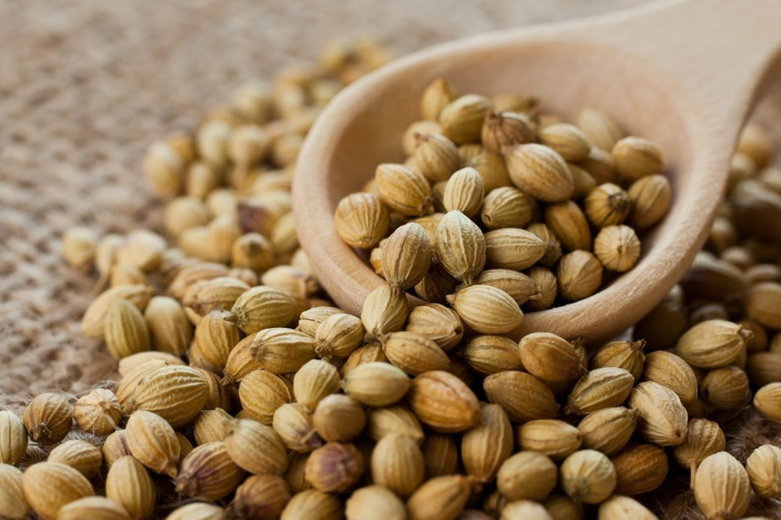
CORIANDER PRODUCES NATURAL CITRUS FLAVORS WHEN GROUND UP. IT IS ESPECIALLY COMMON WITH CHICKEN-BASED DISHES.

CRUSHED RED PEPPER
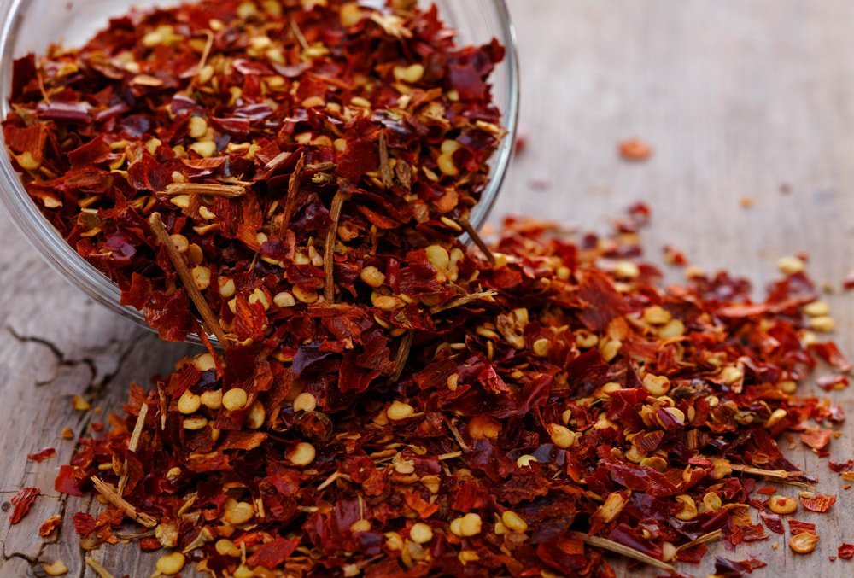
CRUSHED RED PEPPER HAS A DISTINCTIVELY FRUITY, YET SPICY FLAVOR, AND IS COMMONLY USED AS A CONDIMENT ON PIZZAS AND SALADS.

CUMIN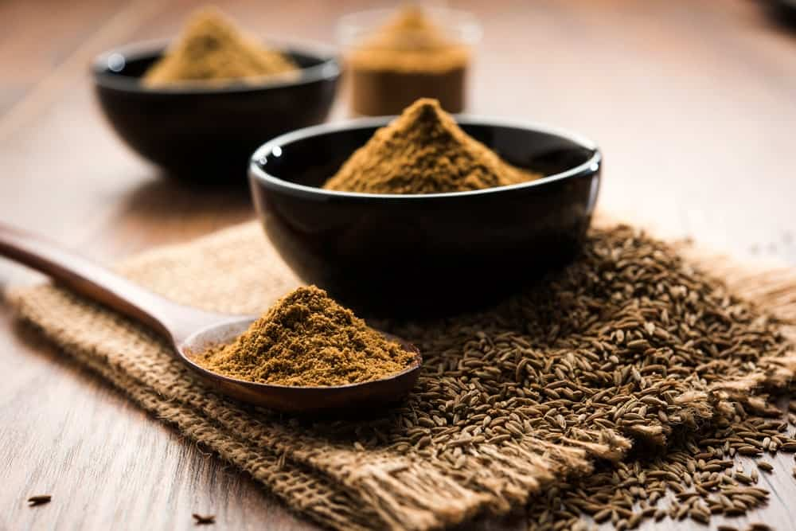
LATIN NAME: CUMINUM CYMINUM
CUMIN IS ONE OF THE MOST MAINSTREAM SPICES AND IS NATIVE TO EUROPE, ASIA AND AFRICA; HOWEVER, IT HAS BECOME A VERY ESSENTIAL INGREDIENT ALL OVER THE WORLD. IT IS POPULAR FOR ITS NUTTY AND EARTHY FLAVOR THAT CONSISTS OF A SUBTLE SPICE KICK AND SOME HINTS OF LEMON.
SOME OF ITS MOST DISTINCTIVE CHARACTERISTICS INCLUDE THE INTENSE FRAGRANCE COUPLED WITH THE UNIQUE RIDGED BROWN SEEDS. CUMIN CAN BE USED AS A WHOLE OR IN A GROUNDED FORM. EITHER WAY, IT ADDS A SMOKY TOUCH TO ANY DISH AND TASTES ABSOLUTELY DELICIOUS. MOST PEOPLE PREFER USING FRESHLY GROUNDED CUMIN IN CURRY RECIPES AND VEGETABLE DISHES TO GET THE MOST OF THAT INTENSE, NUTTY –SPICY FLAVOR.
CUMIN IS BY FAR THE MOST POPULAR SPICE THAT ALSO HAS A MULTITUDE OF HEALTH BENEFITS PERTAINING TO WEIGHT LOSS, CHOLESTEROL, DIABETES, IRRITABLE BOWEL SYNDROME AND MANY MORE.

CURRY POWDER
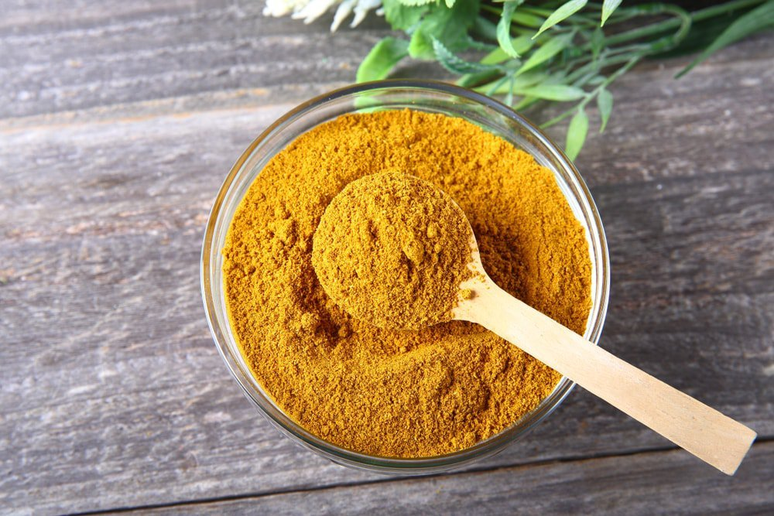
NEEDLESS TO SAY, CURRY POWDER IS A PRIMARY INGREDIENT IN CURRY DISHES, BUT IT CAN ALSO BE USED TO FLAVOR MANY STEWS, MARINADES, AND MEATS.

NUTMEG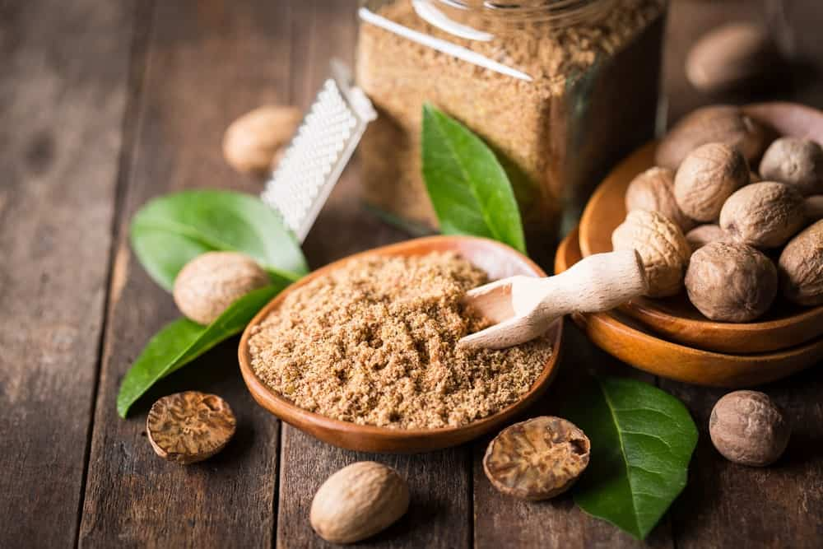
LATIN NAME: MYRISTICA FRAGRANS
NUTMEG COMES FROM A TROPICAL EVERGREEN TREE THAT IS NATIVE TO MOLUCCAS ISLAND IN INDONESIA, WHERE IT IS ALSO CULTIVATED IN ABUNDANCE, AS WELL AS IN WEST INDIES. IT IS OFTEN USED TOGETHER WITH CINNAMON DUE TO THE SIMILAR PUNGENT FRAGRANCE AND A SUBTLE SWEET TASTE. ALTHOUGH NUTMEG IS POPULARLY USED IN BAKING AND COLD BEVERAGES, IT IS ALSO AN EXCELLENT ADDITION TO HEARTY DISHES LIKE MUTTON AND LAMB RECIPES, VEGETABLE STEWS, ETC.
IN ANCIENT TIMES, SOMETIME AROUND THE 1600S, NUTMEG BECAME AN EXPENSIVE COMMERCIAL SPICE IN THE WESTERN WORLD AND WAS COMMONLY USED BY THE DUTCH AS A SUBJECT TO KEEP PRICES HIGH. SOME INCREDIBLE HEALTH BENEFITS OF NUTMEG INCLUDE INDIGESTION RELIEF, DIARRHEA CONTROL, AND APPETITE LOSS.

MACE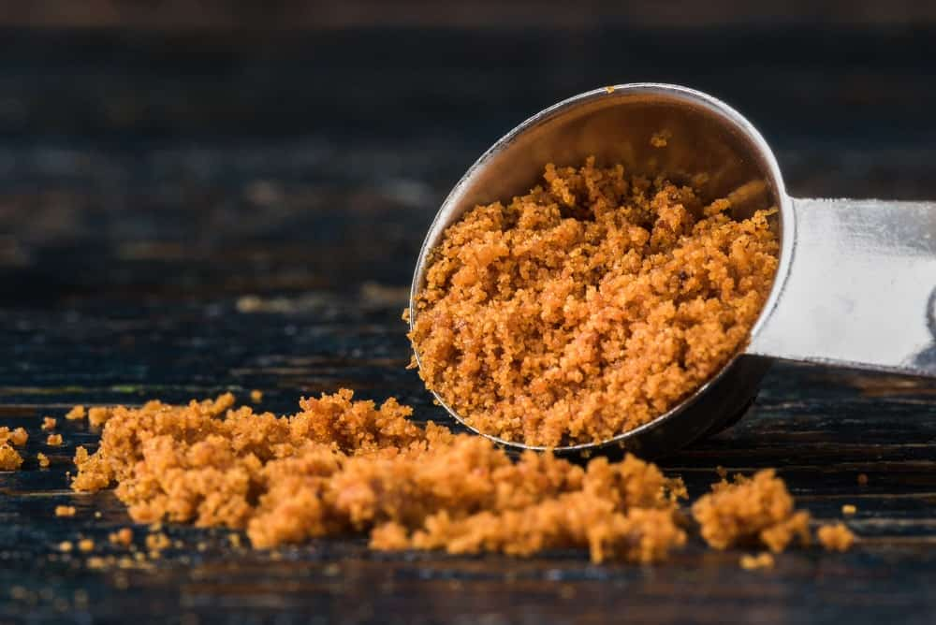
LATIN NAME: MYRISTICA FRAGRANS
THIS IS THE OUTER COVERING OF THE NUTMEG SEED AND IS SAID TO BE A MORE PUNGENT VERSION OF NUTMEG, WITH A COMBINATION OF PEPPER AND CINNAMON KIND OF FLAVOR. INTERESTINGLY, THE COLOR OF MACE CAN HELP YOU FIGURE OUT ITS ORIGIN. FOR INSTANCE, IF THE SPICE HAS ORANGE-YELLOW BLADES, IT MEANS THAT IT HAS COME FROM GRENADA, WHEREAS ORANGE-RED BLADES INDICATE THAT IT IS FROM INDONESIA.
THIS SPICE IS POPULARLY USED IN SWEETS AND DESSERTS LIKE CUSTARDS, PUDDINGS AND CAKES, AS WELL AS IN SAVORY DISHES LIKE SOUPS, SOUFFLÉS, SAUCES, ETC. ITS FLAVOR IS ALSO SAID TO BE VERY WARM, WITH A KICK OF LEMONY SWEETNESS, SO MANY PEOPLE PREFER TO USE IT IN PLACE OF NUTMEG, ESPECIALLY IN LIGHT-COLORED DISHES.
MACE IS OFTEN USED AS A DIGESTIVE AID AND AS A TREATMENT FOR NAUSEA, VOMITING, AND FLATULENCE.
Bottom of Form

MUSTARD SEEDS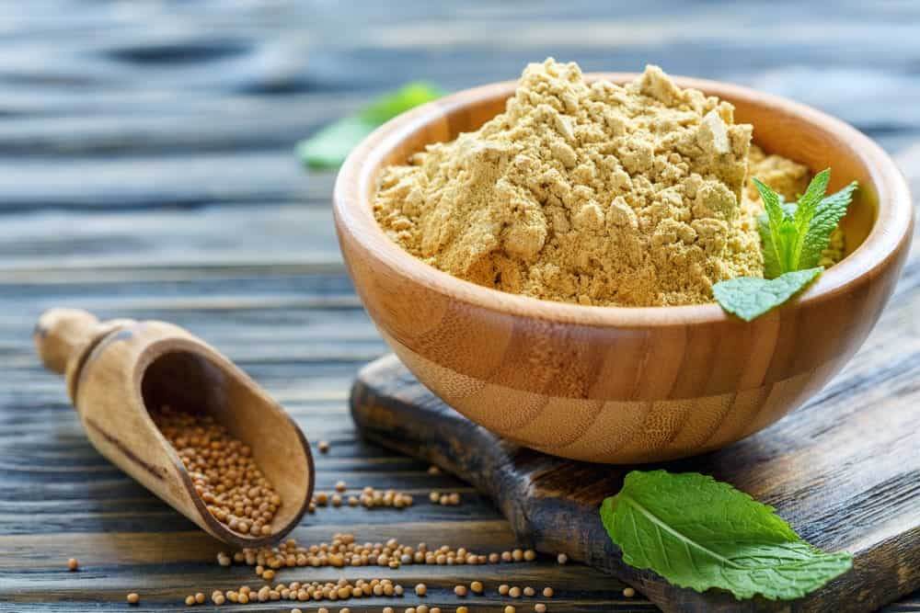
LATIN NAME: BRASSICA ALBA
THESE SPICE SEEDS COME IN A VARIETY OF COLORS LIKE BLACK, BROWN, AND YELLOW, AND ARE OFTEN USED INTERCHANGEABLY IN MOST CUISINES. MUSTARD SEEDS CONSIST OF A NUTTY AND SMOKY FLAVOR THAT IS BEST RELEASED WHEN THEY ARE COOKED IN OIL OR WHEN THEY ARE CRUSHED.
THE USE OF MUSTARD SEEDS AS A CONDIMENT DATES BACK TO ANCIENT TIMES DURING THE ROMAN ERA. THE ROMANS USED TO GRIND THESE SEEDS INTO A PASTE AND MIX THEM WITH WINE. THIS SPICE WAS INITIALLY VERY POPULAR IN EUROPE EVEN BEFORE THE SPICE TRADE THAT BEGAN IN ASIA.
MUSTARD SEEDS ARE OFTEN GROUNDED TO A PASTE TO BE USED IN CURRIES AND STEWS WHEREAS WHOLE SEEDS ARE USED FOR PICKLING PURPOSES. MUSTARD SEED OIL IS POPULARLY USED ALL OVER THE WORLD AS A PAIN REMEDY AND AS A LINIMENT FOR ARTHRITIS.

GARLIC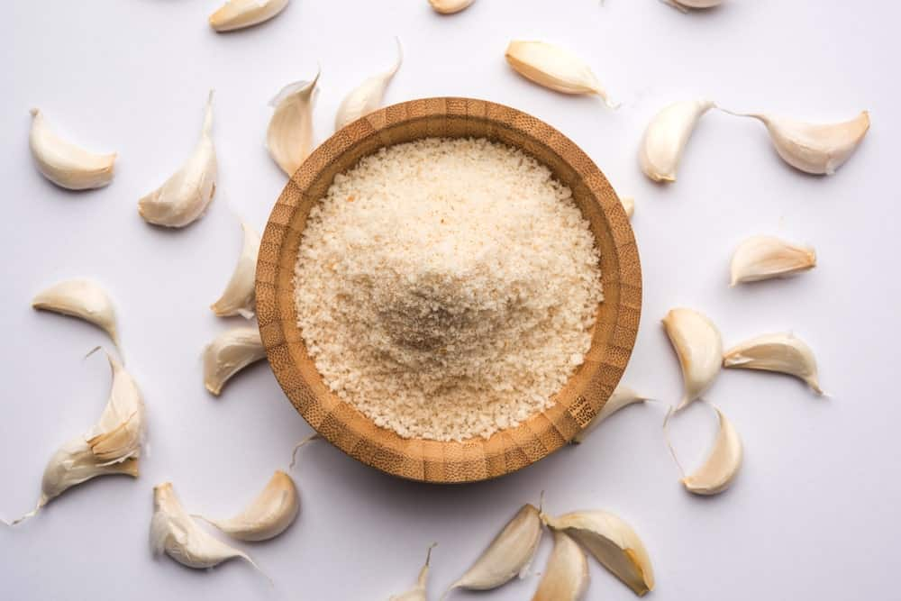
LATIN NAME: ALLIUM SATIVUM
GARLIC IS PROBABLY THE MOST POPULAR AND COMMON SPICE SEASONING THAT IS USED IN ALMOST EVERY CUISINE FOUND IN THE WHOLE WORLD. ITS POPULARITY LARGELY STEMS FROM ITS ABILITY TO ADD AN INCREDIBLE DEPTH OF FLAVOR ALONG WITH POTENCY TO ANY DISH OR MEAL.
AS A SPICE, GARLIC IS USED IN THE FORM OF GARLIC POWDER WHICH IS JUST GROUND, DEHYDRATED GARLIC. IT IS NATIVE TO SOUTH ASIA, CENTRAL ASIA, AND SOUTHWESTERN SIBERIA. GARLIC CONSUMPTION, HOWEVER, GOES BACK SEVERAL THOUSAND YEARS TO ANCIENT EGYPTIAN WHERE IT WAS COMMONLY AS FOOD FLAVORING AS WELL AS IN MEDICINE. SOME OF GARLIC’S EXTRAORDINARY MEDICINAL USES INCLUDE CANCER PREVENTION, TREATMENT FOR RESPIRATORY CONDITIONS, HIGH BLOOD PRESSURE, AND LOW CHOLESTEROL LEVELS.
GARLIC POWDER IS COMMONLY USED IN PASTA, GRILLED CHICKEN, SALAD DRESSINGS, CURRIES AND RICE RECIPES – TO NAME A FEW.

GINGER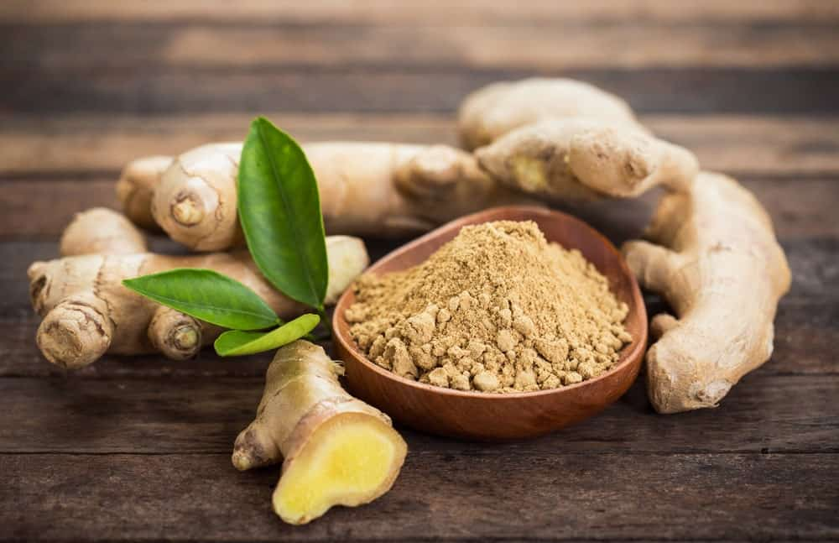
LATIN NAME: ZINGIBER OFFICINALE
LIKE GARLIC, GINGER IS ALSO POPULAR FOR ITS BOLD, PUNGENT, AND SWEET-SPICY FLAVOR. ITS FLAVOR IS ALSO DESCRIBED BY MANY PEOPLE AS PEPPERY AND FIERCE WITH HINTS OF LEMON. GINGER IS ALSO GREATLY USED IN A VARIETY OF DIFFERENT DESSERTS LIKE PUMPKIN PIE AND GINGERBREAD.
GINGER IS A HERBACEOUS PERENNIAL THAT HAS ORIGINATED FROM ISLANDS OF SOUTHEAST ASIA AND WAS LATER TRANSPORTED THROUGHOUT THE INDO-PACIFIC. IT IS OFTEN ALSO USED IN DESSERTS AND SWEET TREATS THAT CALL FOR A SUBTLE SPICE KICK. GINGER HAS LONG BEEN ASSOCIATED WITH NUMEROUS HEALTH AND MEDICINAL BENEFITS AND HAS MAJORLY BEEN USED AS A DIGESTIVE AID AND TO TREAT THE COMMON COLD, FLU, AND COUGH. IT ALSO PLAYS A KEY ROLE IN AYURVEDIC MEDICINE.
MANY CUISINES INVOLVE THE USE OF FRESH GINGER FOR MAKING A VARIETY OF DISHES LIKE CURRIES, RICE, SOUPS, STEWS, ETC.

TURMERIC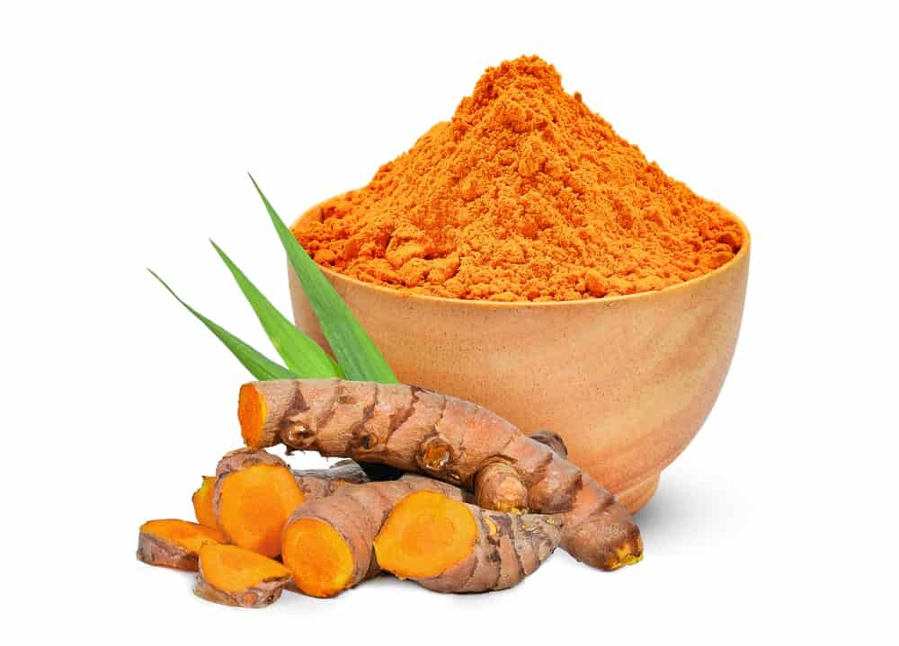
LATIN NAME: CURCUMA LONGA
TURMERIC IS YET ANOTHER INCREDIBLY FAMOUS INDIAN SPICE WITH A MIX OF BITTER, SPICY FLAVOR. IT IS ALSO KNOWN BY OTHER NAMES LIKE INDIAN SAFFRON AND YELLOW GINGER. TURMERIC IS GENERALLY EASILY IDENTIFIABLE DUE TO ITS BRIGHT COLOR COMBINATION OF YELLOW AND ORANGE.
LATELY, TURMERIC HAS BEEN GAINING EXTENSIVE POPULARITY AS ‘THE GOLDEN SPICE’ AND IS NOW BEING FEATURED IN DRINKS LIKE ‘THE GOLDEN LATTE’. THIS IS PRIMARILY DUE TO THE NUMEROUS HEALTH BENEFITS THAT ARE ASSOCIATED WITH THIS SPICE, FOR INSTANCE, IT IS LOADED WITH ANTI-OXIDANT AND ANTI-INFLAMMATORY PROPERTIES, AND IT CAN PREVENT CANCER. MOREOVER, IT IS BELIEVED TO HAVE THE ABILITY TO TREAT DEPRESSION AND ARTHRITIS.
TURMERIC CONSUMPTION GOES AS FAR BACK AS 4000 YEARS TO THE VEDIC CULTURE IN INDIA, WHERE IT HELD SIGNIFICANT RELIGIOUS IMPORTANCE AND WAS ALSO POPULARLY USED FOR CULINARY PURPOSES. THE INTENSE COLOR OF THIS SPICE GIVES CURRIES AND OTHER DISHES A BEAUTIFUL GOLDEN SHADE AND A STRONG FLAVOR THAT GREATLY INTENSIFIES THE OVERALL TASTE OF ANY DISH.

FENUGREEK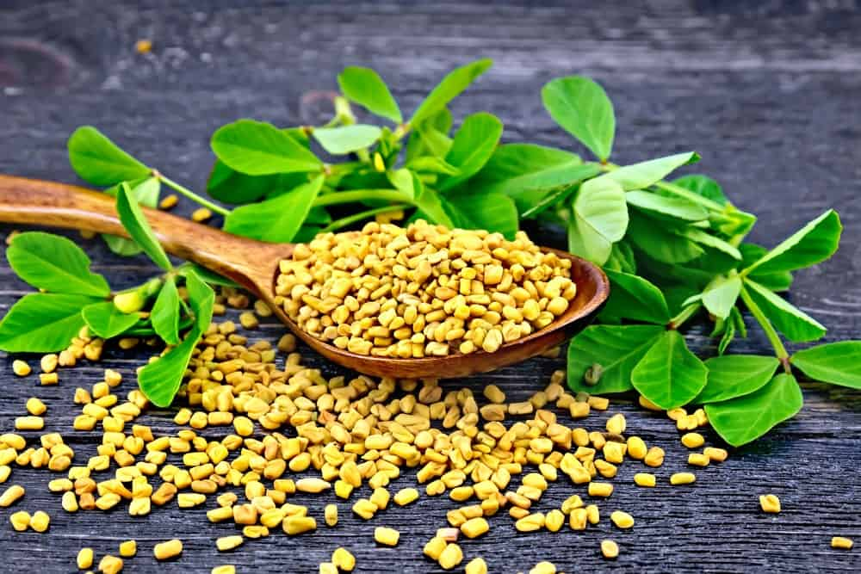
LATIN NAME: TRIGONELLA FOENUM-GRAECUM
THE FENUGREEK SEEDS ARE SMALL, CARAMEL-COLORED, PEBBLE-SHAPED WHEAT KERNELS THAT ARE EXTREMELY POPULAR FOR THEIR TASTE AND AROMA IN MIDDLE EASTERN AND INDIAN CUISINES. THEY CONSIST OF A NUTTY BITTERSWEET FLAVOR THAT IS MORE TOWARDS THE PUNGENT SIDE. THEY ALSO HAVE A SUBTLE SPICY AROMA WITH A BUTTERSCOTCH-TYPE FLAVOR UNDERTONE.
FENUGREEK IS LARGELY CULTIVATED IN THE NEAR EAST AND IT IS WIDELY BELIEVED THAT THE ROMANS USED TO FLAVOR THEIR WINE WITH THIS SPICE DURING THE FIRST CENTURY AD.
FENUGREEK SEEDS ARE OFTEN USED AS WHOLE OR EVEN IN POWDERED FORM MAINLY IN VEGETABLE DISHES, SPICE MIXES, PICKLES, LENTIL-BASED RECIPES, ETC. INTERESTINGLY THOUGH, THIS SPICE IS ALSO USED TO MAKE ‘FAKE’ MAPLE SYRUP THAT A LOT OF PEOPLE BELIEVE TASTES THE SAME AS THE ACTUAL MAPLE SYRUP.

SAFFRON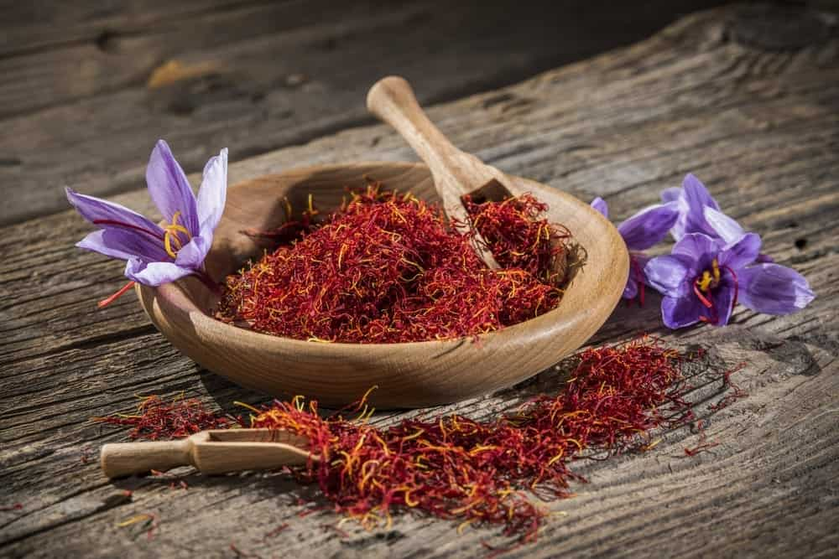
LATIN NAME: CROCUS SATIVUS
BEST KNOWN AS THE MOST EXPENSIVE SPICE IN THE WORLD, SAFFRON GREATLY STANDS OUT DUE TO ITS HIGHLY DISTINCTIVE TASTE AND THE INCREDIBLE ORANGE-MAROONISH COLOR. THE FACT THAT THE PRODUCTION OF SAFFRON IS THE MOST LABOR-INTENSIVE OF ALL IS ONE OF THE MAIN REASONS WHY IT IS MORE VALUABLE THAN GOLD IN TERMS OF WEIGHT AND IS SO EXPENSIVE.
SAFFRON IS BASICALLY THE STIGMA OF CROCUS FLOWERS WHICH IS TYPICALLY PICKED BY HAND. THE BEST TYPE OF SAFFRON IS THE ONE THAT HAS A BEAUTIFUL AND RICH DARK RED COLOR. GENERALLY, THIS PARTICULAR VARIETY COMES FROM SPAIN, IRAN, AND KASHMIR.
SAFFRON IS ALSO VERY FAMOUS FOR ITS FLORAL, HONEY-LIKE FRAGRANCE THAT PROVIDES AN INCREDIBLE AROMATIC SMELL TO ANY FOOD DISH. THE FLAVOR OF THIS SPICE IS VERY UNIQUE AND IS SAID TO BE VERY INTENSE, WHICH IS ONE OF THE REASONS WHY IT IS USED IN SUCH SMALL QUANTITIES.
SAFFRON IS OFTEN USED AS A SEDATIVE AS WELL AS A TREATMENT FOR DRY SKIN, MENSTRUAL SYMPTOMS, AND ASTHMA

ALLSPICE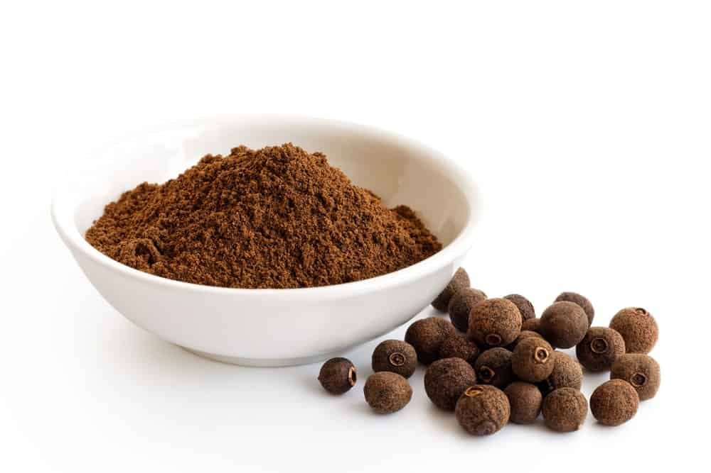
LATIN NAME: PIMENTA DIOICA
AS THE NAME SUGGESTS, ALLSPICE IS A COMBINATION OF ALL OTHER SPICES AND FEATURES AN AMAZING COMBINATION OF CINNAMON, NUTMEG, PEPPER, AND CLOVES. THIS FUSION OF SPICES GIVES IT A MIXTURE OF SWEET-SPICY-PUNGENT TASTE WHICH IS WHY IT IS POPULARLY USED IN SEVERAL FOOD DISHES FOR THAT INTENSE DEPTH OF FLAVOR.
ALLSPICE COMES FROM PIMENTA DIOIC WHICH IS AN EVERGREEN TREE THAT BELONGS TO THE MYRTLE FAMILY. IT IS BELIEVED TO BE NATIVE TO JAMAICA, HONDURAS, AND GUATEMALA. ACCORDING TO HISTORICAL EVIDENCE, CHRISTOPHER COLUMBUS DISCOVERED THIS SPICE IN THE CARIBBEAN AND HE BROUGHT IT BACK TO SPAIN.
ALLSPICE IS VERY POPULAR IN JAMAICAN CUISINES, MOST NOTABLY BEING FEATURED IN THE JAMAICAN JERK CHICKEN. IT IS ALSO USED IN MANY DESSERTS IN GROUND FORM DUE TO ITS DISTINCTIVE FLAVOR AND AROMA. IT HAS SEVERAL MEDICINAL USES AND ACTS AS AN EXCELLENT DIGESTIVE AID, AS WELL AS A TREATMENT FOR MUSCLE ACHES AND TOOTHACHE.

ANISE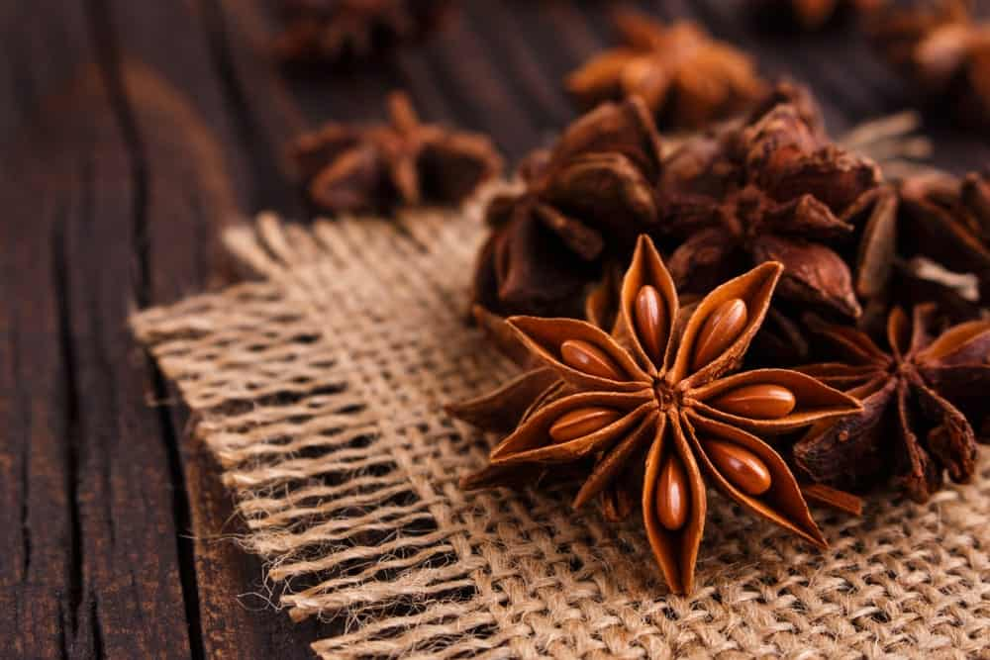
LATIN NAME: PIMPINELLA ANISUM
ALSO KNOWN AS ANISE SEED AND SWEET CUMIN, ANISE IS A FLOWERING PLANT THAT IS NATIVE TO SOUTHWEST ASIA AND THE EASTERN MEDITERRANEAN REGION. IT IS OFTEN CONFUSED WITH ‘STAR ANISE’ PRIMARILY DUE TO THE SIMILAR NAME; HOWEVER, BOTH SPICES ARE QUITE DIFFERENT FROM ONE ANOTHER.
ANISE WAS FIRST CULTIVATED IN THE MIDDLE EAST AND REGIONS OF EGYPT, AFTER WHICH IT GAINED SIGNIFICANT MEDICINAL VALUE IN EUROPE. THE FLAVOR OF ANISE IS SAID TO BE VERY SIMILAR TO THAT OF LICORICE WHICH IS WHY IT IS COMMONLY USED WITH HONEY IN A VARIETY OF BAKED GOODS.
THIS SPICE CONSISTS OF A WARM, FRUITY FLAVOR, AND A SWEET AROMA WHICH IS WHY THEY ARE ALSO FEATURED IN A VARIETY OF TEA BLENDS AND TISANES. ANISE IS WIDELY USED AS A TREATMENT FOR COUGHS, SORE THROAT, INDIGESTION, FLATULENCE, AND SLEEPLESSNESS.

CARAWAY SEED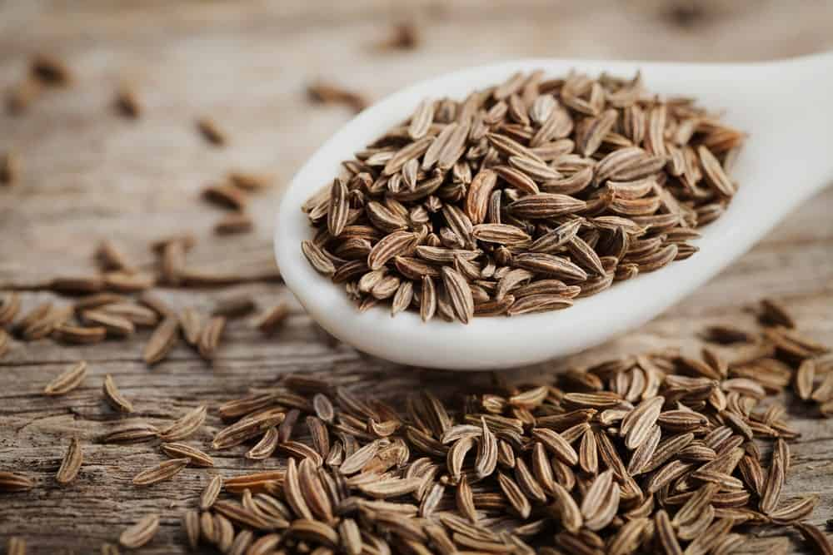
LATIN NAME: CARUM CARVI
ALSO KNOWN AS WILD CUMIN, CARAWAY IS A BIENNIAL PLANT THAT BELONGS TO THE APIACEAE FAMILY. IT IS NATIVE TO NORTH AFRICA, WESTERN ASIA AND EUROPE.
CARAWAY SEEDS ARE MOST COMMONLY USED IN THE PREPARATION OF RYE BREAD DUE TO THEIR WARM, BITING FLAVOR AND A SHARP, PUNGENT AROMA THAT IS HIGHLY SIMILAR TO THE AROMA OF DILL. YOU MAY ALSO FIND THIS SPICE BEING USED IN DESERTS, CASSEROLES, AND CARAWAY SEED CAKES.
CARAWAY SEEDS HAVE LONG BEEN ASSOCIATED WITH A MULTITUDE OF HEALTH BENEFITS THAT INCLUDE RELIEF FROM CONSTIPATION, EASE OF DIGESTION, CHOLESTEROL REDUCTION, AND TREATMENT FOR CRAMPS.

CAROM (AJWAIN)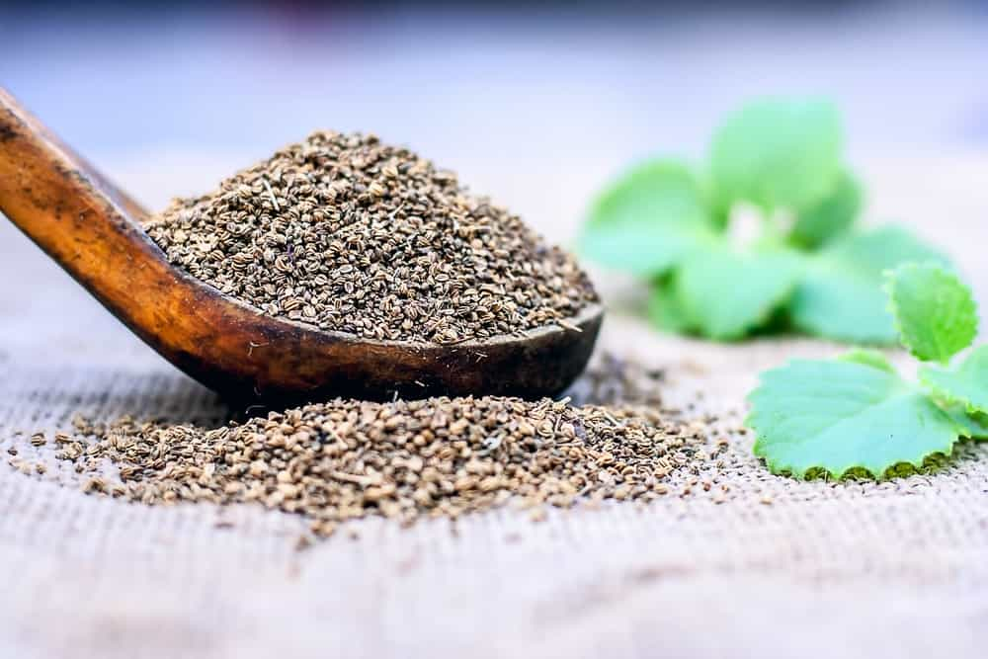
LATIN NAME: TRACHYSPERMUM AMMI OR CARUM COPTICUM
THIS SPICE IS AN ANNUAL HERB THAT BELONGS TO THE FAMILY APIACEAE AND IS COMMONLY KNOWN BY MANY OTHER NAMES LIKE BISHOP’S WEED AND AJOWAN CARAWAY.
AJWAIN SEEDS ARE SMALL AND OVAL-SHAPED AND GREATLY RESEMBLE MANY OTHER SPICE SEEDS INCLUDING CUMIN, CARAWAY, AND FENNEL. THESE SEEDS CONSIST OF A BITTER, PUNGENT TASTE AND A VERY AROMATIC SMELL WHICH IS SIMILAR TO THAT OF THE HERB, THYME. IT IS MAINLY CULTIVATED AND PRODUCED IN INDIA AND IRAN.
THIS SPICE IS TYPICALLY DRY-ROASTED OR FRIED IN OIL WHICH ALLOWS IT TO DEVELOP A COMPLEX AROMA AND A SUBTLE TASTE. IT IS MOST POPULARLY FEATURED IN IRANIAN, ASIAN, PAKISTANI, NORTH INDIAN AND ETHIOPIAN CUISINES. ITS TEXTURE IS QUITE SIMILAR TO THAT OF CARAWAY SEEDS AND IT IS ALSO OFTEN USED IN BAKED FOODS TO GET THAT DEPTH OF FLAVOR AND SMELL.
SOME COMMON MEDICINAL USES OF AJWAIN INCLUDE RELIEF FROM INDIGESTION, NAUSEA, DIARRHEA, AND VOMITING. MANY PEOPLE ALSO USE IT AS A TREATMENT FOR APPETITE LOSS AND RESPIRATORY DISTRESS.

CAYENNE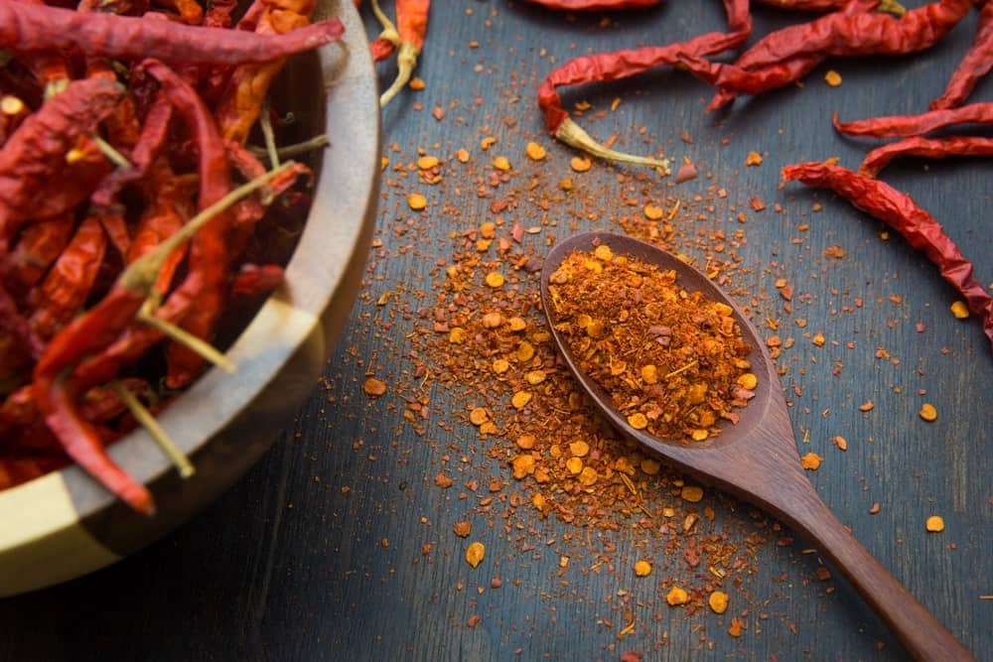
LATIN NAME: CAPSICUM ANNUUM OR FRUTESCENS
THIS IS A FAMOUS HOT CHILI PEPPER THAT IS RELATED TO OTHER HOT PEPPERS LIKE JALAPENO. CAYENNE PEPPERS ARE TYPICALLY RED-COLORED PEPPERS THAT ARE PACKED WITH A LOT OF HEAT AND A SPICY KICK OF FLAVOR. DRIED CAYENNE PEPPERS ARE TURNED INTO GROUND POWDER WHICH IS USED AS A SPICE IN A VARIETY OF CUISINES ALL OVER THE WORLD.
SURPRISINGLY, CAYENNE PEPPERS ARE CONSIDERED TO BE THE ‘KING’ OF MEDICINAL HERBS, ESPECIALLY DUE TO THE FACT THAT THEY HAVE BEEN USED SINCE ANCIENT TIMES TO TREAT A VARIETY OF HEALTH PROBLEMS AND AILMENTS. SOME INCREDIBLE BENEFITS OF THIS SPICE INCLUDE ENHANCED METABOLISM, LOWERED BLOOD PRESSURE, EASE OF DIGESTION, PAIN RELIEF, REDUCED RISK OF CANCER AND DECREASED HUNGER.
THIS SPICE IS ALSO QUITE POPULAR IN THE CULINARY WORLD WHERE IT MAY BE EITHER USED IN ITS FRESH FORM OR AS DRIED POWDER ON CASSEROLES, CURRIES, CHEESE DISHES, STEWS AND MEAT-BASED DISHES.

CHILI PEPPER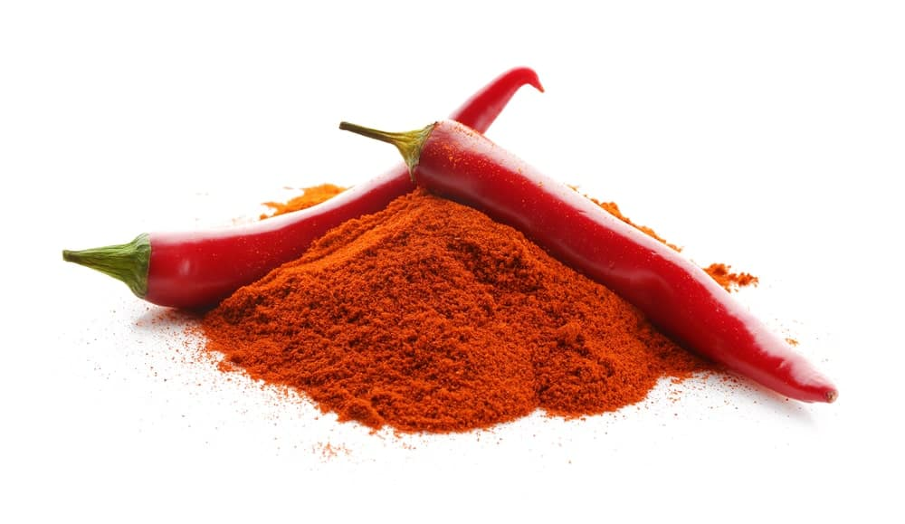
LATIN NAME: CAPSICUM ANNUUM
SIMILAR TO CAYENNE PEPPERS, CHILI PEPPERS COME FROM THE PLANTS OF THE GENUS CAPSICUM AND ARE COMMONLY USED IN FOOD DISHES FOR THAT EXTRA SPICE AND HEAT KICK. THE DRIED AND POWDERED FORM OF CHILI PEPPERS IS CALLED WHAT YOU TYPICALLY REFER TO AS ‘CHILI POWDER’.
CHILI PEPPERS MAINLY ORIGINATE FROM MEXICO. HOWEVER, MANY OF ITS CULTIVARS SPREAD TO MOST PARTS OF THE WORLD. THEY ARE NOW COMMONLY GROWN IN EUROPE AND NORTH AMERICA IN GREAT ABUNDANCE.
THE FLAVOR OF RED CHILI POWDER IS CONSIDERED TO BE EXTREMELY PUNGENT WITH A VERY DISTINCT SPICE KICK THAT ADDS GREAT HEAT TO DISHES. JUST LIKE OTHER PEPPERS BELONGING TO THE SAME FAMILY, RED CHILI PEPPERS ALSO PROVIDE NUMEROUS HEALTH BENEFITS LIKE RELIEF FROM PAIN, CONGESTION, AND COLDS.

FENNEL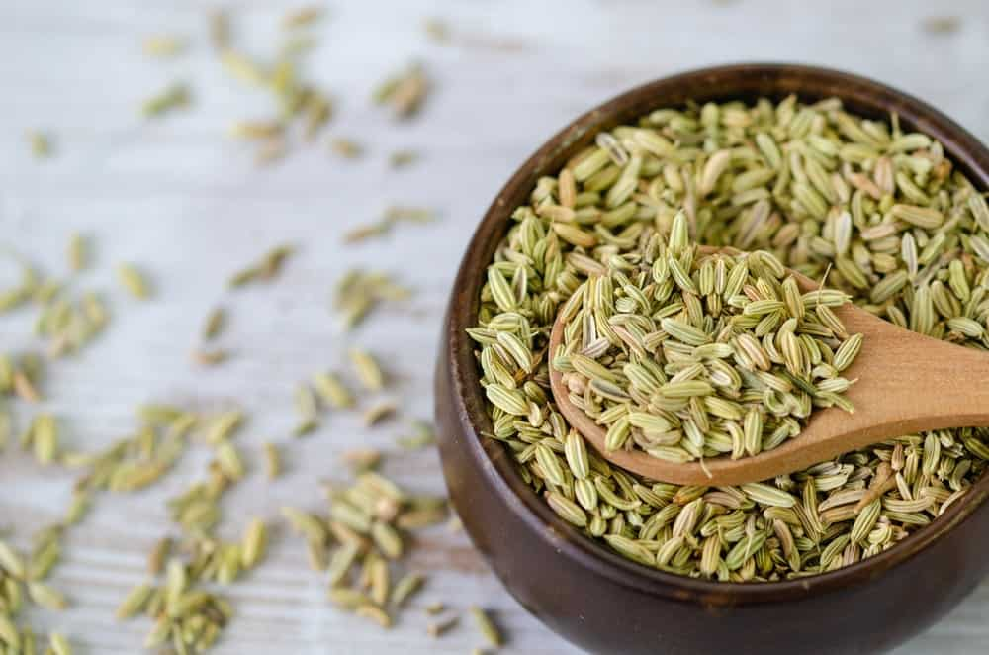
LATIN NAME: ANETHUM FOENICULUM
ALSO CALLED “THE FISH HERB” IN ITALY AND FRANCE, FENNEL SEED IS FOUND IN TWO MAIN VARIETIES. THE FIRST IS BITTER FENNEL WHICH HAS A LICORICE-LIKE AROMA AND A SLIGHTLY SWEET FLAVOR PROFILE. THE OTHER VARIETY IS SWEET FENNEL, WHICH, AS THE NAME SUGGESTS HAS A REALLY SWEET, NUTTY AROMA AND TASTE.
FENNEL IS BASICALLY A HARDY PERENNIAL HERB THAT IS NATIVE TO THE MEDITERRANEAN SHORES. FENNEL WAS GREATLY PRIZED IN ANCIENT TIMES, PARTICULARLY BY GREEKS AND ROMANS WHO MAINLY USED IT IN THEIR FOOD AND FOR ITS MEDICINAL PROPERTIES. SOME OF ITS MEDICAL BENEFITS INCLUDE RELIEF FROM MUSCLE SPASMS AND FLATULENCE.
GROUND FENNEL SEEDS ARE POPULARLY USED AS A SPICE IN SEVERAL CUISINES ALL ACROSS THE WORLD DUE TO ITS SWEET AND GRASSY FLAVOR THAT HAS SUBTLE HINTS OF ANISE AND STAR ANISE. GROUND FENNEL IS WIDELY FEATURED IN DISHES ORIGINATING FROM SCANDINAVIA, THE MIDDLE EAST, AND THE MEDITERRANEAN.
FASCINATINGLY, FENNEL SPICE WAS SIGNIFICANTLY USED THOUSANDS OF YEARS AGO BY THE CHINESE AND HINDU PEOPLE AS A CURE FOR SNAKE BITES. ALSO, ACCORDING TO HISTORICAL EVIDENCE, FENNEL WAS HUNG OVER DOORWAYS TO WARD OFF EVIL SPIRITS, ESPECIALLY DURING THE MIDDLE AGES ERA.

PAPRIKA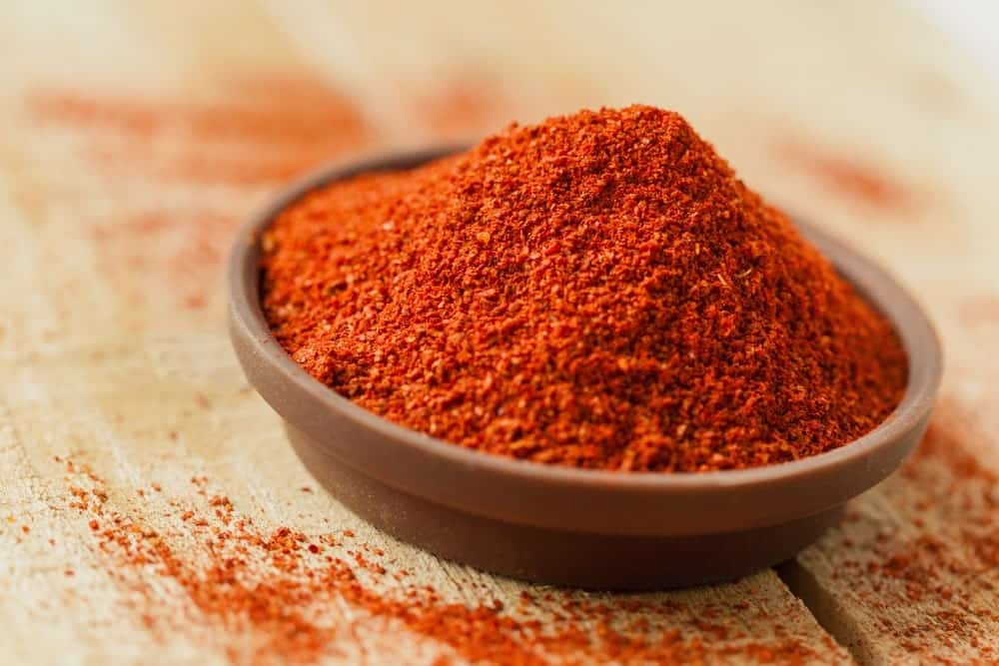
LATIN NAME: CAPISCUM ANNUUM
LIKE CHILI PEPPER AND CAYENNE PEPPER, PAPRIKA IS ALSO A TYPE OF PEPPER THAT BELONGS TO THE SAME FAMILY. PAPRIKA SPICE IS A GROUND VERSION OF THIS PEPPER THAT IS GREATLY FEATURED IN THE SPANISH, SOUTH AMERICAN, AND HUNGARIAN CUISINE.
THIS SPICE HAS COMPLEX UNDERTONES BUT MOSTLY CONSISTS OF A SMOKY FLAVOR COUPLED WITH A MILDLY SWEET AND EARTHY TASTE. PAPRIKA PEPPERS ARE NATIVE TO THE NEW WORLD AND HAVE ORIGINATED FROM CENTRAL MEXICO. THEY WERE THEN INTRODUCED TO SPAIN IN THE 16TH CENTURY AFTER WHICH THE PAPRIKA SPICE BEGAN TO BE POPULARLY USED IN A VARIETY OF DISHES, MAINLY FOR ITS FLAVOR AND THE DEEP REDDISH-ORANGE COLOR.
IT IS OFTEN USED AS A SEASONING IN SOUPS, STEWS, RICE DISHES AND MANY OTHER DISHES. IN THE UNITED STATES, THIS SPICE IS USUALLY SPRINKLED ON FOODS AS A GARNISH; HOWEVER, THE BEST WAY TO GET THE MAXIMUM FLAVOR OUT OF IT IS BY HEATING IT IN OIL.

SUMAC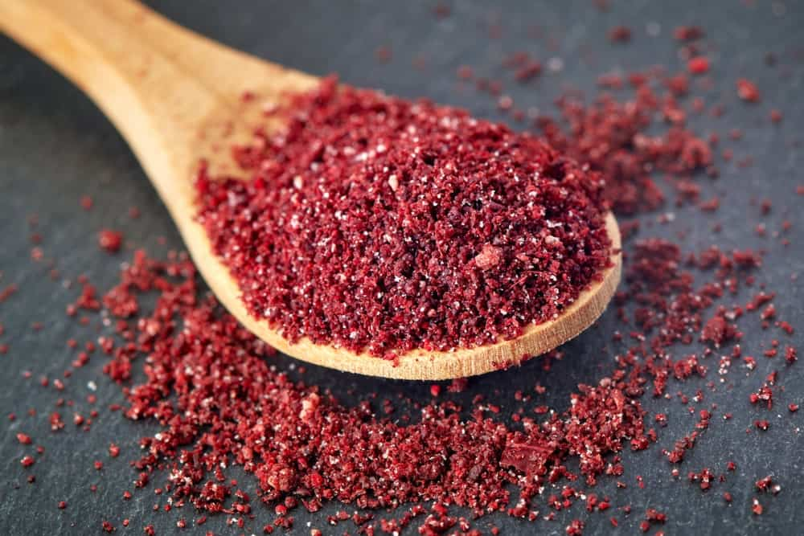
LATIN NAME: RHUS CORIARA
THIS INCREDIBLE SPICE IS POPULAR FOR ITS BEAUTIFUL, PURPLE COLOR AND A TANGY FLAVOR THAT IS HIGHLY CHARACTERISTIC OF VINEGAR OR LEMON. THE WORD ‘SUMAC’ IS BELIEVED TO HAVE COME FROM THE OLD FRENCH DURING THE PERIOD OF THE 13TH CENTURY WHICH TRANSLATES TO ‘RED’ IN THE ENGLISH LANGUAGE.
THE SUMAC SPICE IS GREATLY FEATURED IN A VARIETY OF DIFFERENT CUISINES AND DISHES DUE TO ITS TART, LEMONY FLAVOR THAT IS NOT AS OVERWHELMING AS A LEMON ITSELF.
SUMAC COMES FROM THE FLOWERING PLANTS BELONGING TO THE RHUS GENUS AND IT MAJORLY GROWS IN TEMPERATE AND SUBTROPICAL REGIONS OF NORTH AMERICA, EAST ASIA, AND AFRICA.
MEDICINAL RECORDS FROM MEDIEVAL TIMES SHOW GREAT EVIDENCE OF THIS SPICE BEING USED AS A TREATMENT FOR A NUMBER OF HEALTH AILMENTS LIKE BOWEL CONDITIONS, HEADACHES, ASTHMA, COLD, FEVER AND FLUE.

CINNAMON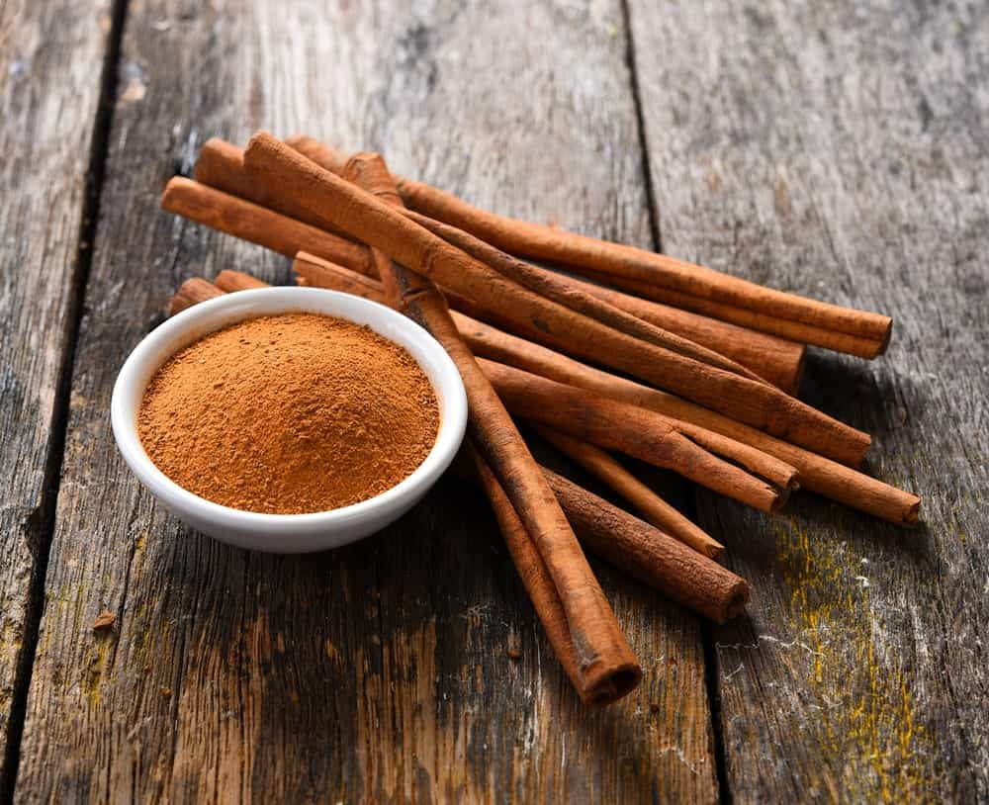
LATIN NAME: CINNAMOMUM ZEYLANICUM
THIS HAS TO BE THE OLDEST KNOWN SPICE THAT DATES BACK TO WRITTEN RECORDS FOUND DURING THE 5TH CENTURY. CINNAMON IS MOST POPULARLY USED AS A FLAVORFUL AND A HIGHLY AROMATIC CONDIMENT IN A NUMBER OF CUISINES, AND A VARIETY OF SWEET AND SAVORY DISHES.
AS THE NAME SUGGESTS, THIS SPICE SPORTS A MID-BROWN COLOR. THE LARGEST CULTIVATION AND PRODUCTION OF CINNAMON COMES FROM CHINA AND INDONESIA, HOWEVER, ITS CONSUMPTION DATES FAR BACK AS THE 2000 BC.
THE CINNAMON SPICE IS POPULARLY USED IN THE PRODUCTION OF CHOCOLATE IN MEXICO, WHEREAS IN THE UNITED STATES, IT IS GREATLY FEATURED IN BREAD-BASED DISHES AND IS ALSO USED TO FLAVOR DIFFERENT CEREALS. THE AROMA AND TASTE OF CINNAMON ARE QUITE SIMILAR TO THE SPICE CASSIA BARK AND IS USUALLY DESCRIBED AS SOFT AND SWEET WITH A DISTINCTIVE SPICE KICK.

ONION POWDER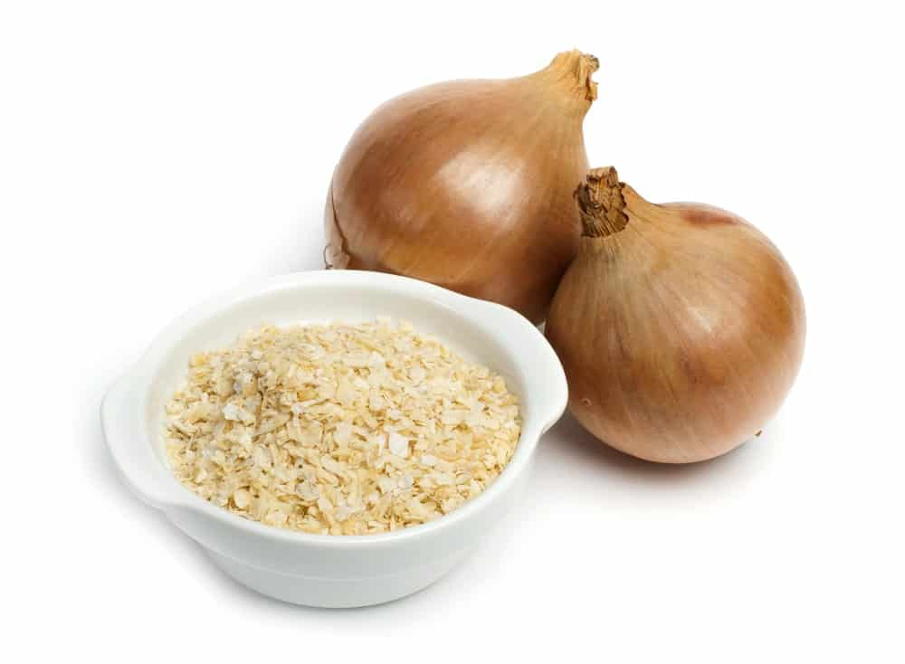
LATIN NAME: ALLIUM CEPA
ONION POWDER COMES FROM DRIED AND DEHYDRATED ONION BULBS AND IS COMMONLY USED AS A SEASONING FOR SOUPS, STEWS, RICE DISHES AND MANY OTHERS FOR THAT EXTRA ONION-EY KICK OF FLAVOR. IT IS ALSO A VERY COMMON INGREDIENT THAT IS OFTEN USED IN SPICE MIXES AND SEASONED SALTS.
ONION POWDER IS PREPARED THROUGH A VARIETY OF DIFFERENT TECHNIQUES, NAMELY FLOW-DRYING, FREEZE-DRYING, DEHYDRATION, AND VACUUM SHELF-DRYING. IT CAN THEN BE USED AS A FLAVORED CONDIMENT FOR GRILLED CHICKEN, PASTA, PIZZA, ETC.
THIS SPICE HAS ALSO BEEN USED TO TREAT A NUMBER OF HEALTH CONDITIONS LIKE SKIN ISSUES, NASAL AND CHEST CONGESTION, AND NUMEROUS RESPIRATORY AILMENTS.

GALANGAL ROOT POWDER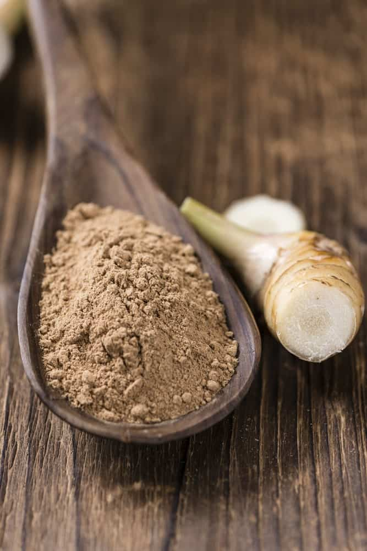
LATIN NAME: LANGUAS GALANGAL OR ALPINIA GALANGA
GALANGAL ROOT POWDER COMES FROM GALANGAL, WHICH IS AN EAST ASIAN TROPICAL SHRUB. IT PRIMARILY GROWS IN SOUTHWEST INDIA AND IN THE EASTERN HIMALAYAS. GALANGAL WAS FIRST INTRODUCED IN EUROPE BACK IN THE 9TH CENTURY AFTER WHICH THE SPICE STARTED GAINING SIGNIFICANT POPULARITY IN THE CULINARY WORLD.
GALANGAL HAS BEEN REFERRED TO AS THE “SPICE OF LIFE” BACK IN ANCIENT TIMES CONSIDERING HOW IT WAS BELIEVED TO PLAY A HUGE PART IN SAUDI HERBAL MEDICINE.
SINCE IT COMES FROM THE SAME FAMILY AS GINGER, IT CONSISTS OF A SIMILAR TASTE AS THAT OF GINGER; HOWEVER, THE GALANGAL SPICE HAS A PINEY CACTUS-FLAVOR PROFILE. THAI CUISINE USES GALANGAL IN ALMOST ALL OF ITS DISHES FROM TOM YUM SOUP TO NUMEROUS CURRIES AND GRAVIES. THE VERSATILE FLAVOR OF THIS INCREDIBLE SPICE ALSO MAKES IT AN EXCELLENT ADDITION TO CITRUS DRINKS, LEMONADES, AND MARGARITAS.

STAR ANISE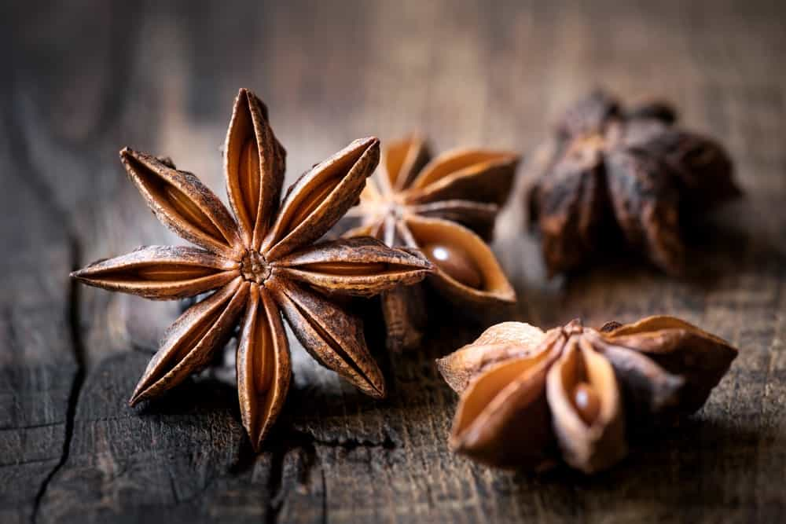
LATIN NAME: ILLICIUM VERUM
THIS SPICE COMES FROM A MEDIUM-SIZED EVERGREEN TREE THAT IS NATIVE TO SOUTHWEST CHINA AND TO NORTHEAST VIETNAM. STAR ANISE IS ALSO KNOWN BY SEVERAL OTHER NAMES LIKE CHINESE STAR ANISE, BADIANE, AND STAR ANISE SEED.
IT IS OFTEN CONFUSED WITH THE SPICE ANISE DUE TO THE SIMILARITY OF NAME, FLAVOR PROFILE, AND SHAPE; HOWEVER, THEY ARE STILL QUITE DIFFERENT. STAR ANISE IS BASICALLY USED AS A LESS EXPENSIVE SUBSTITUTE OF ANISE IN THE CULINARY WORLD AND ALSO IN LIQUOR PRODUCTION.
STAR ANISE IS WIDELY FEATURED IN THE INDIAN, CHINESE, INDONESIAN, AND MALAYSIAN CUISINES AND IS MOSTLY GROWN IN CHINA, INDIA, AND ASIA. SOME OF THE MOST COMMON DISHES THAT STAR THIS SPICE AS ITS MAIN INGREDIENT ARE MASALA CHAI, VIETNAMESE PHO, AND THE FRENCH MULLED WINE CALLED VIN CHAUD, WHICH TRANSLATES TO HOT WINE IN ENGLISH.
THIS SPICE GREATLY AIDS IN DIGESTION AND ALSO HELPS WITH RHEUMATISM AND FLATULENCE.

BLACK CUMIN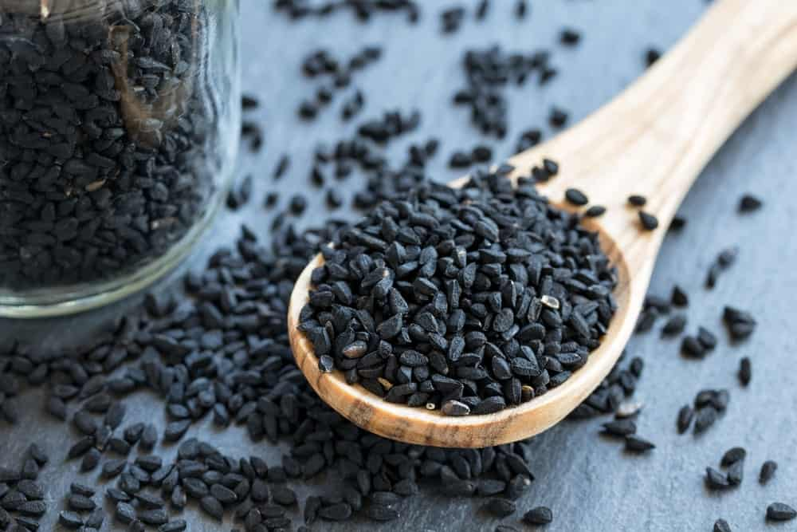
LATIN NAME: NIGELLA SATIVA
THIS POPULAR SPICE COMES FROM AN ANNUAL FLOWERING PLANT THAT IS NATIVE TO SOUTH AND SOUTHWEST ASIA. BLACK CUMIN SEEDS ARE POPULARLY USED IN THE POLISH CUISINE, AS WELL AS MIDDLE EASTERN AND INDIAN CUISINES.
THIS SPICE TASTES LIKE A DELICIOUS MIXTURE OF OREGANO, BLACK PEPPER, AND ONIONS WHICH GIVES IT A HIGHLY PUNGENT AND BITTER TASTE AND AROMA. IT IS MOST COMMONLY USED IN DISHES LIKE CURRIES, STEWS, CHEESE DISHES, OR OFTEN SIMPLY SPRINKLED ON SALADS FOR THAT ADDED KICK AND TEXTURE.
BLACK CUMIN HAS SEVERAL MEDICINAL USES INCLUDING CURING ALLERGIES, ASTHMA, HEADACHES, TOOTHACHES AND INDIGESTION PROBLEMS.

POPPY SEEDS
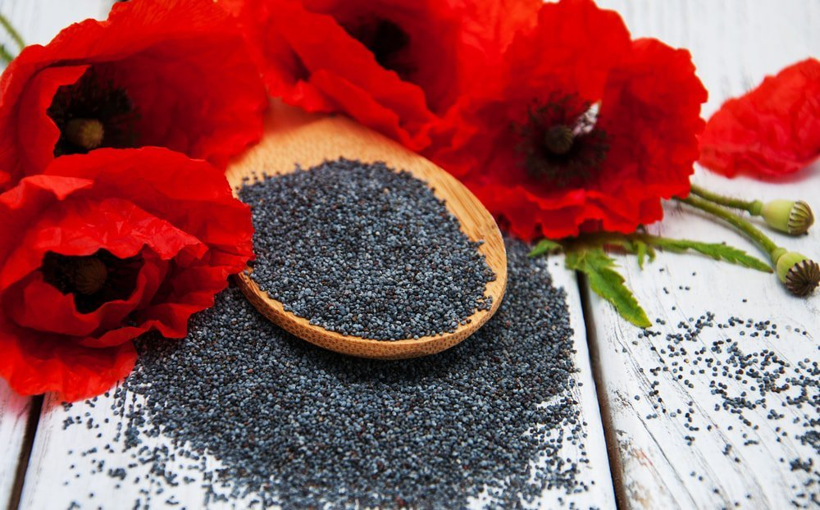
THOUGH POPPY SEEDS ARE COMMONLY COOKED ALONG WITH BAKED GOODS, THEY CAN ALSO BE USED AS CONDIMENTS TO ADD A SWEET, FRUITY FLAVOR.

PUMPKIN SPICE
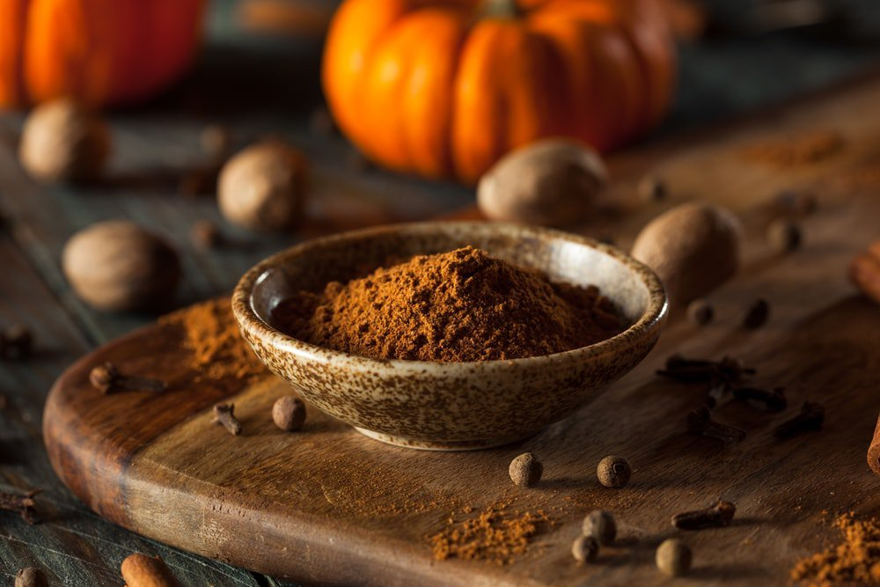
WHILE PUMPKIN SPICE IS A PRIMARY INGREDIENT OF PUMPKIN PIE, IT HAS ALSO BECOME POPULAR AS A FLAVOR ENHANCER FOR COFFEE AND OTHER SWEET DRINKS.
ISN’T IT ABSOLUTELY INCREDIBLE HOW THERE IS SUCH A VAST VARIETY OF DELICIOUS SPICES THAT ARE FOUND ALL OVER THE WORLD? NOW THAT YOU KNOW SOME OF THE MOST COMMON AND POPULAR SPICES, YOU WILL BE ABLE TO IDENTIFY THEM IN MOST OF YOUR FOODS AND DISHES!

22 DIFFERENT TYPES OF CUCUMBERS
DISCOVER THE DIFFERENT TYPES OF CUCUMBERS THAT ARE GROWN ALL OVER THE WORLD. SEE WHAT THEY LOOK LIKE, GET TO KNOW THEIR FEATURES, AND FIND A RENEWED APPRECIATION FOR THIS VEGETABLE.
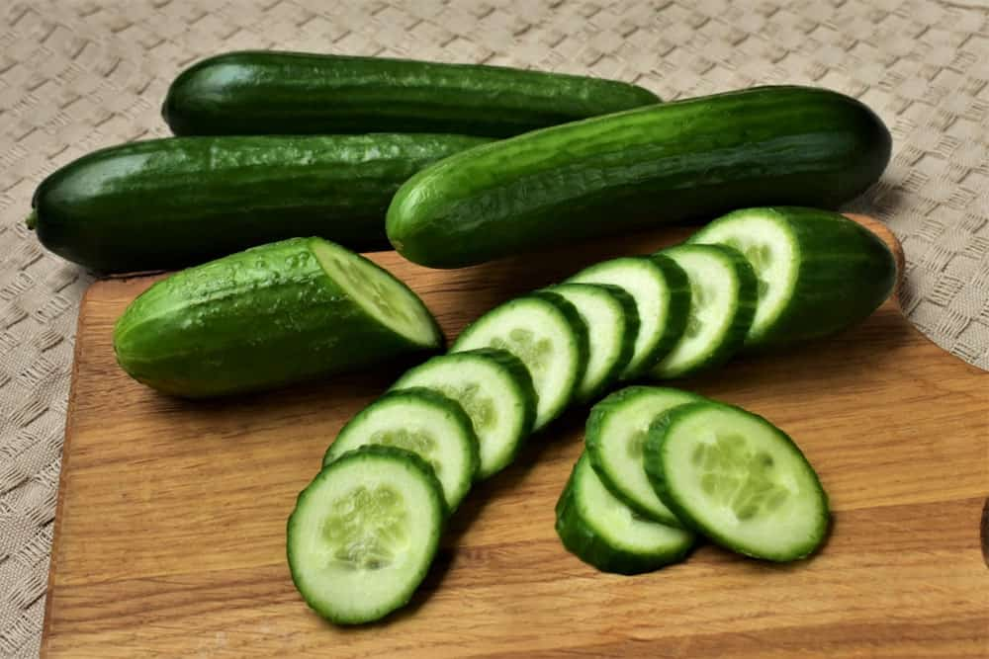
CUCUMBER IS A FLOWERING ANNUAL PLANT THAT BELONGS TO THE PUMPKIN FAMILY. IT ORIGINATED FROM SOUTH ASIA AND WAS FIRST CULTIVATED 3,000 YEARS AGO IN INDIA.
JUST LIKE WE DO TODAY, ANCIENT EGYPTIANS AND ROMANS WERE ALSO FOND OF CUCUMBERS AND OFTEN INCLUDED THE VEGETABLE IN THEIR DIET. ASIDE FROM CONSUMING IT, THE ROMANS ALSO USED CUCUMBER FOR TREATING SCORPION BITES AND BAD EYESIGHT.
TODAY, CHINA IS THE LEADING PRODUCER OF CUCUMBERS IN THE WORLD WITH 40 MILLION TONS PRODUCED ANNUALLY OR 60 PERCENT OF TOTAL GLOBAL CONSUMPTION.
RELATED: HOW TO STORE CUCUMBERS | BORAGE PLANT | TYPES OF FOOD PEELERS | TYPES OF FOOD SLICERS | VEGETABLES AND HERBS FOR SYMBIOTIC GARDENING

CUCUMBERS NUTRITION FACTS CHART
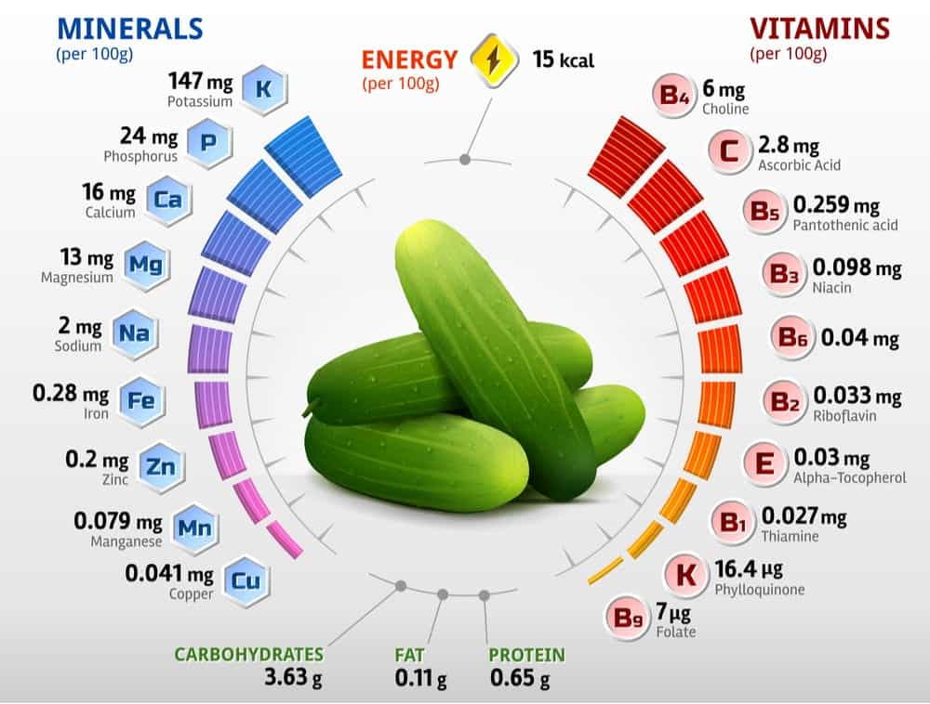
NOW LET’S JUMP INTO YOUR CUCUMBER OPTIONS.

BASIC TYPES

COCKTAIL CUCUMBERS
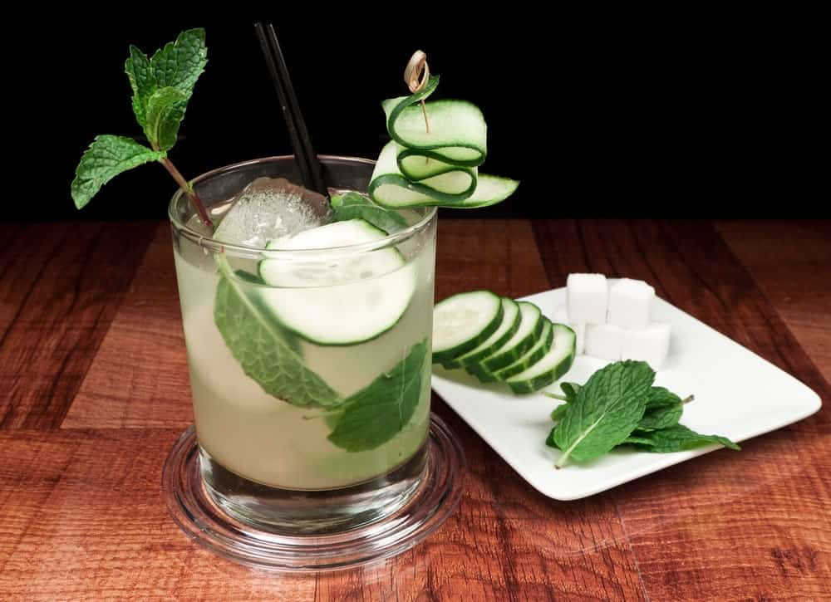
Bottom of Form
WHIRLPOOL

MAKE EVERY DAY SPECIAL
WHIRLPOOL® APPLIANCES HELP YOU CARE FOR YOUR FAMILY. OUR THOUGHTFULLY DESIGNED APPLIANCES ARE MADE WITH YOU IN MIND.
ALSO CALLED SNACK CUCUMBERS, COCKTAIL CUCUMBERS ARE SMALL AND HAVE THIN SKINS. NOT EVERYONE RECOGNIZES THIS AS AN OFFICIAL TYPE OF CUCUMBER BUT THEY ARE FUN TO EAT BECAUSE YOU CAN DEVOUR THEM IN JUST A FEW BITES. COCKTAIL CUCUMBERS ARE GOOD FOR A QUICK SNACK, AS A GARNISHMENT FOR YOUR FAVORITE MARTINI, AND AS A LUNCH BOX ITEM. THEY ARE PETITE, CRUNCHY, AND DELICIOUS AND MOST OF THEM ARE A VIBRANT SHADE OF GREEN AND SEEDLESS AS WELL.

PICKLING CUCUMBERS
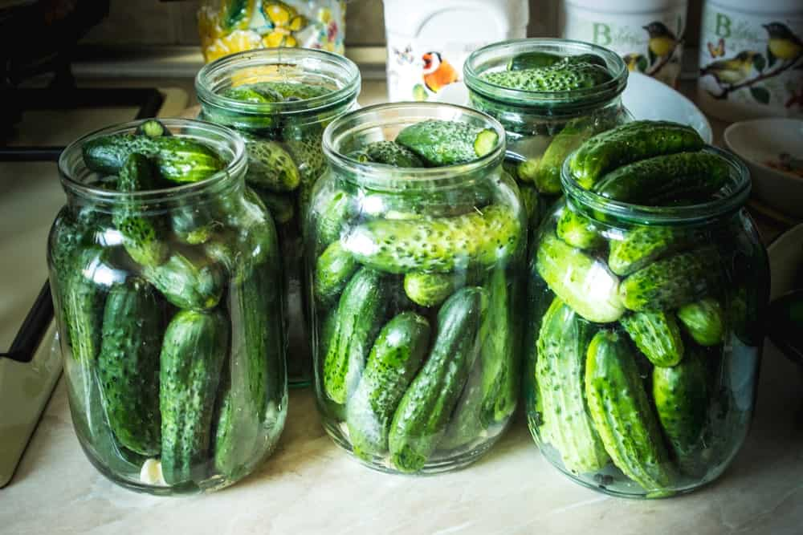
PICKLING CUCUMBERS ARE USUALLY ONLY THREE TO FOUR INCHES IN LENGTH, WHICH IS SHORTER THAN CUCUMBERS USED FOR SLICING, AND THEY HAVE THIN SPINES AND SKINS. THEIR COLOR CAN BE VARIEGATED AND CONSISTS OF DARK OR LIGHT GREEN AT THE END OF THE BLOSSOM.
THEY CAN BE READY TO HARVEST IN SEVEN TO TEN DAYS AND YOU CAN TELL THAT THEY ARE GOOD FOR PICKLING JUST BY LOOKING AT THEM BECAUSE THEY HAVE A “READY FOR THE JAR” LOOK. YOU CAN HARVEST THEM AT ANY TIME AND USE THEM FOR ALL TYPES OF CUCUMBER RECIPES. THEY PRODUCE LARGE CROPS OF CUCUMBERS IN JUST A FEW WEEKS AND THEY ARE VERY SIMPLE TO GROW.

SLICING CUCUMBERS
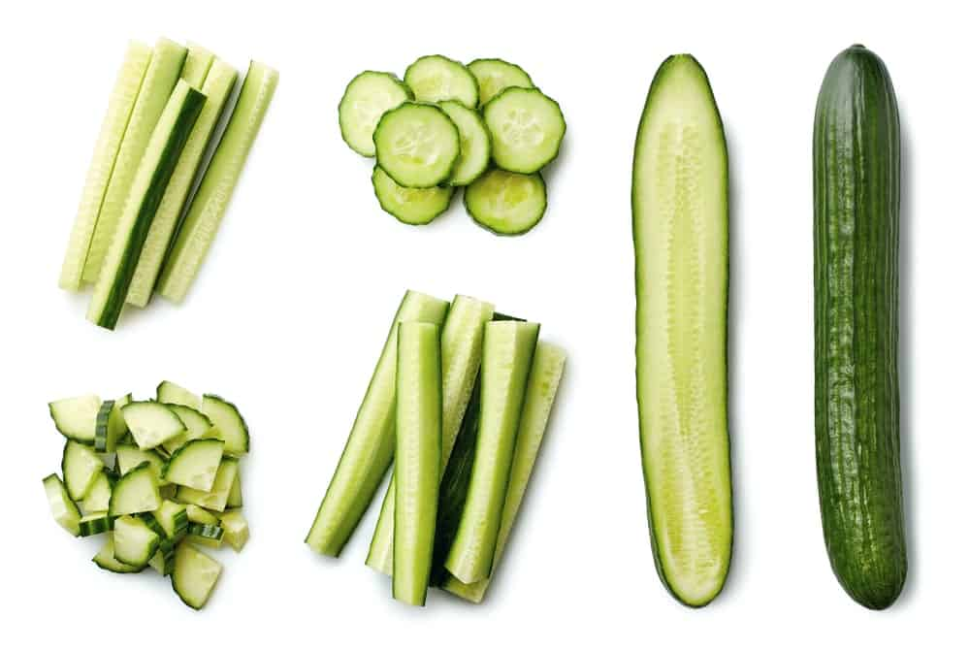
SLICING CUCUMBERS ARE LONGER THAN PICKLING CUCUMBERS, USUALLY AROUND EIGHT INCHES IN LENGTH, AND THEY HAVE MUCH THICKER SKINS AS WELL. THEY ARE USUALLY A UNIFORM DARK-GREEN COLOR, ALTHOUGH SOME HAVE A SLIGHTLY VARIEGATED LOOK.
THEY CAN PRODUCE FRUIT FOR UP TO SIX WEEKS AND THEY ARE USUALLY THE TYPE OF CUCUMBER THAT YOU SEE IN THE GROCERY STORE. THIS TYPE OF CUCUMBER IS ALSO KNOWN AS THE AMERICAN SLICING CUCUMBER AND THEY ARE EASY TO SHIP AND AESTHETICALLY APPEALING BECAUSE OF THEIR LACK OF SPINES AND THEIR THICK SKIN.

SPECIFIC TYPES

AMIGA CUCUMBERS
AMIGA CUCUMBERS ARE THIN-SKINNED AND SPINELESS. THEY HAVE A DELICIOUS FLAVOR AND A DARK-GREEN COLOR. THEY CAN GROW UP TO SIX INCHES IN LENGTH AND ARE RESISTANT TO MANY TYPES OF MILDEW AND VIRUSES.
THEY ARE NOT RECOMMENDED TO GROW IN GREENHOUSES AND THEY PREFER WELL-DRAINED SOIL WITH A PH LEVEL OF 6 TO 6.8. AS DO MANY OTHER TYPES OF CUCUMBERS, AMIGA CUCUMBERS NEED WARM AIR AND SOIL TO GROW BEST, WHICH MEANS THAT THEY DO ESPECIALLY WELL IF YOU ADD A PLASTIC-TYPE OF MULCH TO THE PLANTS.

ARMENIAN CUCUMBERS
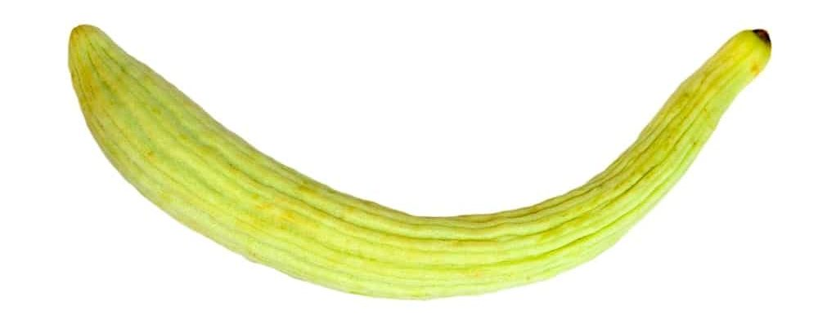
ALSO CALLED SNAKE CUCUMBERS OR SNAKE MELONS, THE ARMENIAN CUCUMBER IS LONG AND TWISTED WITH A DARK-GREEN COLOR. IT HAS A THIN SKIN WITH PALE-GREEN STRIPES THROUGHOUT AND AS IT RIPENS AND MATURES, IT TURNS YELLOW AND HAS A GREAT AROMA. THE CUCUMBER ALSO HAS A VERY MILD TASTE.

CHINESE SOYU CUCUMBERS
THESE ARE LONG, SLIGHTLY CURVED CUCUMBERS THAT ARE LIME GREEN IN COLOR WITH STRIPES OF A DARKER GREEN. IT IS A BURPLESS VARIETY AND HAS A CRISP, WHITE FLESH. BECAUSE OF THEIR MILD AND SWEET FLAVOR, THE CHINESE SOYU CUCUMBERS ARE FREQUENTLY FOUND IN RESTAURANTS AND FARMERS’ MARKETS. THEY ARE A NON-HYBRID ASIAN CUCUMBER.

DIVA CUCUMBERS
DIVA CUCUMBER SEEDS COME TREATED OR UNTREATED AND THIS IS ONE OF THE BEST-TASTING CUCUMBERS AVAILABLE. THEY USUALLY GROW FROM FIVE TO SEVEN INCHES LONG AND THEY ARE SEEDLESS, EXTREMELY TASTY, CRISP, AND TENDER. THEY ARE GREAT WHEN GROWN IN THE OUTDOORS AND PREFER WARM, WELL-DRAINED SOIL. THEY ALSO DO BEST WHEN YOU ROTATE THE CROPS; KEEP IN MIND THAT THEY DON’T DO WELL IF IT IS TOO COLD OUTSIDE.

ENGLISH/EUROPEAN CUCUMBERS
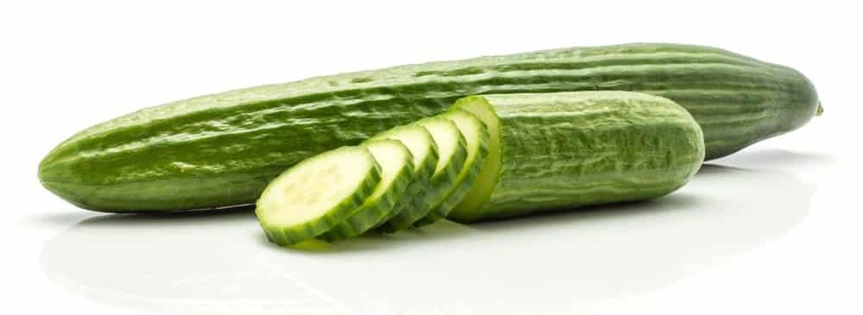
KITCHENAID

UNLOCK POTENTIAL.
OUR INNOVATIVE APPLIANCES ENSURE THAT ANYTHING YOU WANT TO DO IN THE KITCHEN YOU CAN DO WITH KITCHENAID.
THE ENGLISH OR EUROPEAN CUCUMBER IS ONE OF THE MOST COMMON TYPES OF THIS VEGETABLE. THEY ARE NEARLY SEEDLESS AND HAVE THIN SKINS WITH NO SPINES. THEY CAN ALSO GROW UP TO TWO FEET IN LENGTH. ENGLISH CUCUMBERS ARE OFTEN SOLD AS “BURPLESS” CUCUMBERS AND ARE USUALLY GROWN IN HOTHOUSES SO THEY ARE A BIT MORE EXPENSIVE THAN OTHER TYPES OF CUCUMBERS. THEIR TASTE IS ALSO A LOT MILDER THAN OTHER TYPES OF CUCUMBERS, WHICH IS ONE REASON FOR THEIR POPULARITY.

IZNIK CUCUMBERS
IZNIK CUCUMBERS ARE A TYPE OF COCKTAIL CUCUMBER SO THEY ARE QUITE SMALL AND THIN-SKINNED. THEY ARE SPINELESS AND USUALLY ONLY GET TO THREE OR FOUR INCHES LONG. THEY ARE SEEDLESS AND DELICIOUS AS WELL. VERY RESISTANT TO SCAB AND MILDEW, IZNIK CUCUMBERS SHOULD BE PICKED DAILY IF YOU WANT THEM TO BE HIGH-QUALITY AND THEY ALSO PRODUCE SEVERAL FRUITS ON EACH NODE. THEY NEED WARM, WELL-DRAINED SOIL TO GROW SUCCESSFULLY, WHICH MEANS THEY’LL DO EVEN BETTER IF YOU ADD WARM MULCH TO THE PLANTS.

KATRINA CUCUMBERS
KATRINA CUCUMBERS ARE BEST WHEN GROWN IN A GREENHOUSE AND WHEN HARVESTED AT ROUGHLY SIX INCHES IN LENGTH. THEY YIELD A VERY LARGE CROP AND ARE VERY UNIFORM IN SHAPE AND SIZE. THEY ARE RESISTANT TO VARIOUS DISEASES, ESPECIALLY SCAB, AND THEY ARE GREAT FOR EITHER SLICING OR SNACKING. KATRINA CUCUMBERS ALSO PRODUCE EARLY TO MID-SEASON DURING THE GROWING SEASON SO YOU DON’T HAVE TO WAIT LONG FOR THEM TO ARRIVE.

KIRBY CUCUMBERS
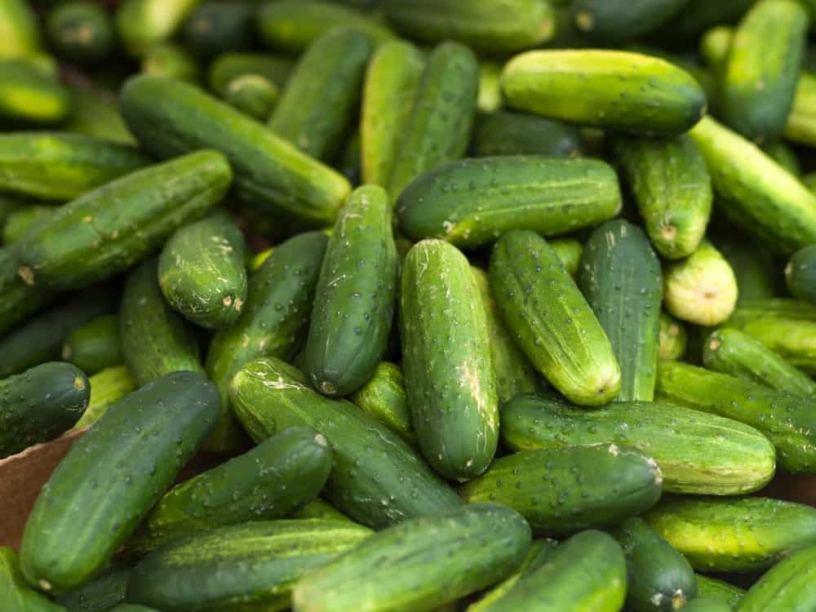
KIRBY CUCUMBERS ARE ONE OF THE MOST POPULAR TYPES OF COMMERCIALLY GROWN CUCUMBERS AND THEY ARE USUALLY SOLD UNWAXED. THEY HAVE THIN SKINS, VERY FEW SEEDS, AND A VERY CRISP AND CRUNCHY TASTE. THEY ARE FIRM CUCUMBERS THAT ARE PERFECT FOR PICKLING AND NORMALLY GET TO AROUND FIVE OR SIX INCHES IN LENGTH. THEY HAVE BUMPY SKIN AND ARE CRUNCHY AND DELICIOUS. THEY CAN BE INCLUDED IN SALADS AND EVEN SALSAS.

KOREAN CUCUMBERS
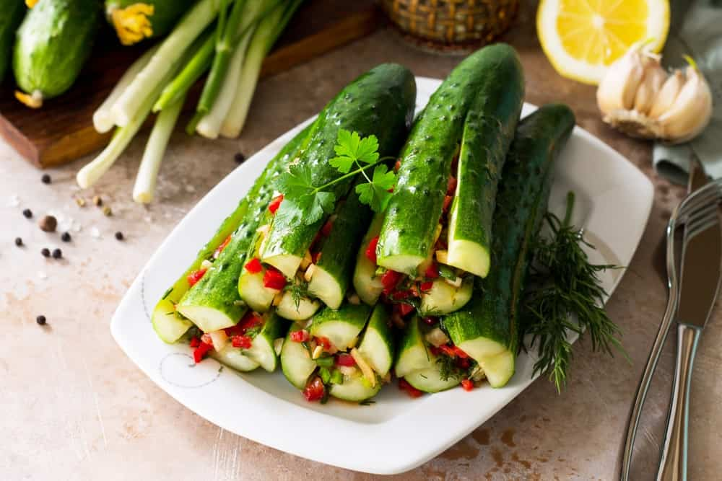
KOREAN CUCUMBERS ARE LONG AND SLENDER WITH SMALL SPINES AND THIN SKIN. IF YOU EAT THEM RAW, THEY ARE CRUNCHY AND SWEET WITHOUT THE BITTER FLAVOR OF SOME OTHER CUCUMBERS. THERE ARE DIFFERENT TYPES OF KOREAN CUCUMBERS, INCLUDING THE WHITE SUN, SUMMER DELIGHT, AND SILVER GREEN, AND THEY ARE GENERALLY LONGER AND THINNER THAN MANY OTHER TYPES OF CUCUMBERS.
THESE CUCUMBERS ARE PERFECT FOR SALADS AND SIDE DISHES AS WELL AS FOR PICKLING AND THEY ARE AVAILABLE ALL YEAR LONG EVEN THOUGH THEY PEAK DURING THE SUMMER MONTHS. THESE CUCUMBERS ARE BEST WHEN EATEN FRESH BECAUSE OF THEIR CRUNCHINESS AND FLAVOR.

KYURI/JAPANESE CUCUMBERS
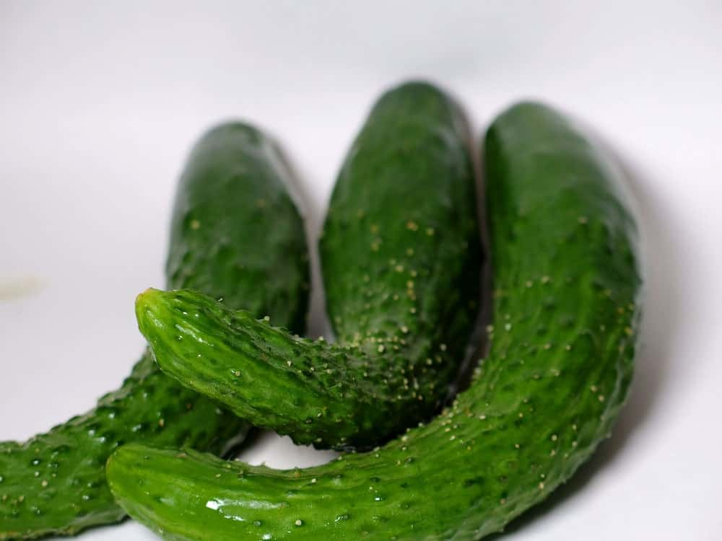
THESE CUCUMBERS ARE VERY SLIM AND HAVE DARK-GREEN SKIN. THEY HAVE THIN SKIN WITH SMALL BUMPS ON THEM AS WELL AS VERY TINY SEEDS AND A CRISP, SWEET TASTE. A BURPLESS VARIETY, THE JAPANESE CUCUMBER IS EXTREMELY TASTY AND BEARS A LOT OF FRUIT FOR SEVERAL WEEKS.
THEY ALSO DO BEST WHEN TRELLISED AND GROWN VERTICALLY. JAPANESE CUCUMBERS ARE RELATED TO MELONS, SQUASHES, AND GOURDS AND THEY TASTE DELICIOUS IN SALADS AND AS A PICKLED CUCUMBER. SOME OF THEM REACH TWO FEET IN LENGTH AND HAVE A THREE-INCH DIAMETER EVEN THOUGH THE MOST COMMON TYPE GETS TO AROUND EIGHT INCHES LONG. ALTHOUGH WESTERN CUCUMBERS TEND TO CURVE SOMEWHAT, THE JAPANESE CUCUMBER IS USUALLY VERY STRAIGHT.

LEMON CUCUMBERS
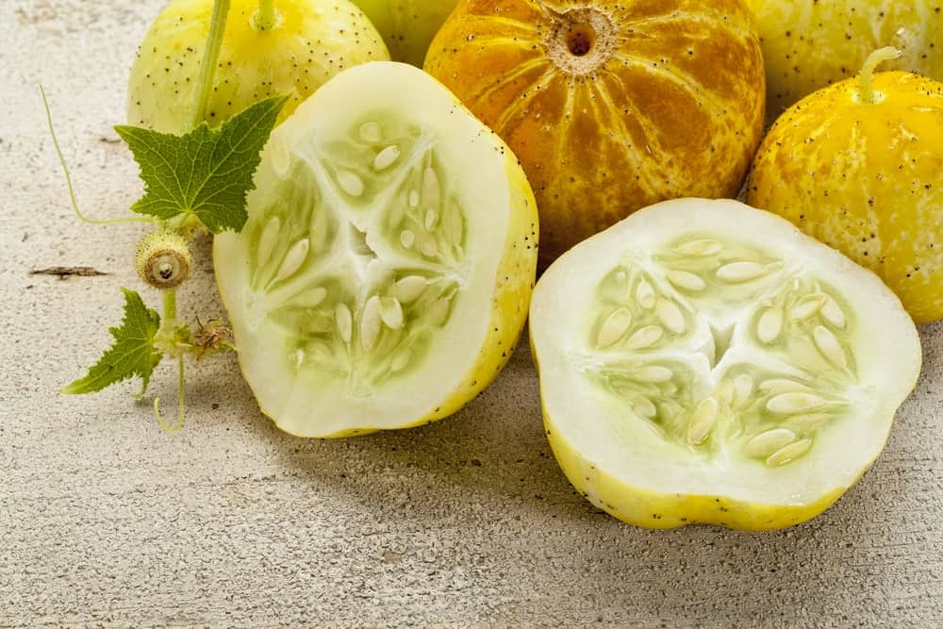
AS ITS NAME SUGGESTS, LEMON CUCUMBERS HAVE A YELLOWISH COLOR AND LOOK SIMILAR TO LEMONS. THEY HAVE A SWEET AND CRISP TASTE BUT STILL TASTE OF CUCUMBER, NOT A LEMON. THEY ARE ONLY CALLED LEMON CUCUMBERS BECAUSE OF THE WAY THEY LOOK AND BECAUSE OF THEIR COLOR.
THEY HAVE A MILD TASTE AND VERY THIN SKINS, WHICH IS WHY A LOT OF CONSUMERS EAT THEM WITH THE SKIN ON. WHEN A RECIPE CALLS FOR ANY TYPE OF CUCUMBER, YOU CAN USE THE LEMON CUCUMBER IN IT BECAUSE IT IS A VERY TASTY, VERY VERSATILE VEGETABLE.

PERSIAN CUCUMBERS
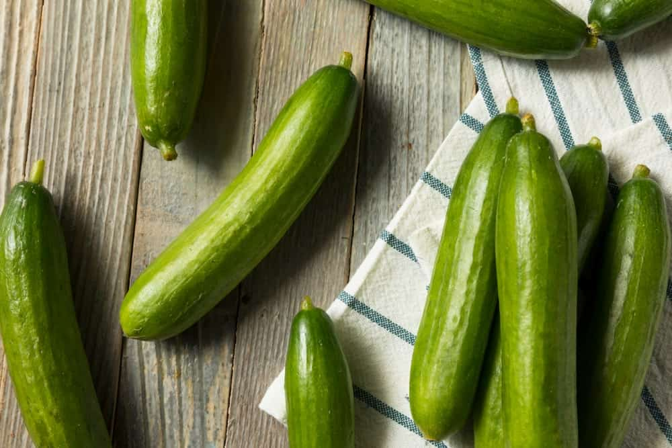
SIMILAR TO THE AMERICAN SLICING CUCUMBERS, PERSIAN CUCUMBERS ARE A LITTLE SHORTER AND MORE COMPACT. THEY ARE CRUNCHY AND JUICY AND THEY ARE STURDY THROUGHOUT MOST CLIMATE TYPES, EVEN THOSE THAT ARE QUITE HOT.
IF YOU’RE STIR-FRYING A DISH, TRY TOSSING IN SOME OF THESE CUCUMBERS BECAUSE THEY CAN BE USED IN A VARIETY OF RECIPES. ONE OF THE BIGGEST ADVANTAGES OF PURCHASING THIS TYPE OF CUCUMBER IS THAT THEY ARE AVAILABLE ALL YEAR ROUND AND THEY HAVE A SWEET, MILD, CRUNCHY TASTE THAT ALL CUCUMBER LOVERS ADORE.

PONIENTE CUCUMBERS
PONIENTE CUCUMBERS ARE QUITE LONG, UP TO 13 INCHES IN LENGTH, AND THEY ARE VERY RESISTANT TO SCAB. THEY GROW STRAIGHT, HAVE TRELLISING, AND ARE STURDY AND PRODUCE A LOT OF FRUIT EACH YEAR. MOST OF THESE TYPES OF CUCUMBERS FILL OUT WELL AND ORIGINATED IN EUROPE.
TO GROW THIS TYPE OF CUCUMBER SUCCESSFULLY, YOU HAVE TO WAIT UNTIL THE SOIL IS AT LEAST 70ᵒ FAHRENHEIT AND THEY DO WELL IN SOIL THAT IS WARM AND WELL-DRAINED. IN FACT, BOTH THE SOIL AND AIR TEMPERATURES NEED TO BE WARM IF YOU WISH THEM TO GROW RIGHT AND THEY DO EVEN BETTER WHEN YOU USE SOME SORT OF MULCH TO KEEP THEM WARM.

SALT AND PEPPER CUCUMBERS
THESE CUCUMBERS ARE A PALE-YELLOW COLOR, ALMOST WHITE, AND GET TO APPROXIMATELY FIVE INCHES IN LENGTH. THEY HAVE MANY TRANSLUCENT SEEDS AND A CRISP, MILD FLAVOR. THEY GROW DARKER THE LONGER THEY ARE LEFT ON THE VINE AND THEY HAVE BUMPS AND BLACK SPIKES ON THEIR SKIN, HENCE THEIR NAME.
BLOOMING IN MID TO LATE SUMMER, SALT AND PEPPER CUCUMBERS ARE A HYBRID CUCUMBER THAT TASTES BEST WHEN EATEN FRESH OR PICKLED. THEY HAVE ALSO WON NUMEROUS FOOD AWARDS AND THEY HAVE BEEN USED IN RECIPES FOR RELISHES, GARNISHES, AND EVEN HORS D’OEUVRES. IF STORED IN THE REFRIGERATOR, THESE CUCUMBERS WILL LAST UP TO ONE MONTH.

SOCRATES CUCUMBERS
SOCRATES CUCUMBERS HAVE THIN SKINS, ARE DARK GREEN IN COLOR, AND ARE ROUGHLY EIGHT INCHES LONG. AS FAR AS TASTE IS CONCERNED, THIS TYPE OF CUCUMBER HAS ONE OF THE BEST TASTES AVAILABLE. THEY ARE RESISTANT TO VARIOUS DISEASES AND IF YOU EXCLUDE THE POLLINATORS YOU CAN END UP WITH A SEEDLESS VARIETY. YOU CAN EASILY GROW THE SOCRATES CUCUMBER INSIDE AND IN TEMPERATURES UP TO 82ᵒ FAHRENHEIT. IF YOU WANT A MORE VIGOROUS PLANT, YOU CAN USE PLASTIC MULCH AND ROW COVERS TO PROVIDE WARMTH AND PROTECTION FROM INSECTS..

TYRIA CUCUMBERS
TYRIA CUCUMBERS ARE VERY LONG, AVERAGING ABOUT 14 INCHES IN LENGTH, AND THEY ARE A BEAUTIFUL DARK-GREEN COLOR WITH A FEW RIBS. THEY ARE USUALLY GROWN ORGANICALLY AND THEY ARE TOLERANT TO STRESS AND VERY STURDY. TYRIA CUCUMBERS ARE NOT BITTER BUT HAVE A DELICIOUS FLAVOR AND YOU CAN TRELLIS THEM IF YOU WANT CUCUMBERS THAT ARE MORE STRAIGHT. THEY ARE NATIVE TO EUROPE AND ARE VERY GOOD PERFORMERS SO YOU SHOULD GET A LOT OF CUCUMBERS EACH YEAR THAT YOU GROW THEM.

UNISTAR CUCUMBERS
THESE CUCUMBERS ARE CONSIDERED COCKTAIL CUCUMBERS AND GET NO MORE THAN FOUR INCHES IN LENGTH. THEY HAVE AN EXCELLENT CRUNCHY FLAVOR AND A GREAT STURDINESS. VERY RESISTANT TO SCAB AND MILDEW, THE UNISTAR CUCUMBER IS GOING TO GROW BETTER IF YOU PICK IT ON A DAILY BASIS AS YOU DO OTHER TYPES OF COCKTAIL CUCUMBERS. THEY PREFER WARM AIR AND SOIL TEMPERATURES, DO BETTER WITH MULCH, AND NEED EXCELLENT IRRIGATION IN ORDER TO GROW RIGHT.

WATERMELON GHERKIN CUCUMBERS
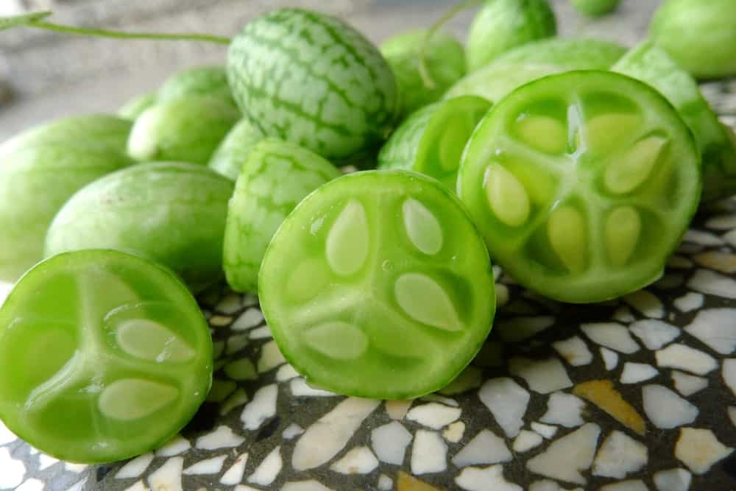
KITCHENAID

UNLOCK POTENTIAL.
OUR INNOVATIVE APPLIANCES ENSURE THAT ANYTHING YOU WANT TO DO IN THE KITCHEN YOU CAN DO WITH KITCHENAID.
WATERMELON GHERKIN CUCUMBERS ARE NOT SHAPED SIMILARLY TO REGULAR CUCUMBERS BUT INSTEAD ARE SMALL AND OBLONG, USUALLY AROUND ONE AND A QUARTER INCHES IN DIAMETER. BECAUSE OF THEIR SIZE AND LIME-GREEN COLOR WITH HINTS OF DARK GREEN, THEY RESEMBLE SMALL WATERMELONS, HENCE THEIR NAME. THEY ARE TANGY AND CRISP AND THEY HAVE A SLIGHTLY TART, CITRUS-LIKE FLAVOR. ESPECIALLY HIGH IN VITAMINS A AND K, THESE CUCUMBERS HAVE BECOME INCREASINGLY POPULAR IN HOME GARDENS BECAUSE THEY ARE HIGH PRODUCERS AND HAVE A UNIQUE LOOK AND TASTE. THEY ARE ALSO AVAILABLE FROM SUMMER TO THE FALL.

WEST INDIAN GHERKIN CUCUMBERS
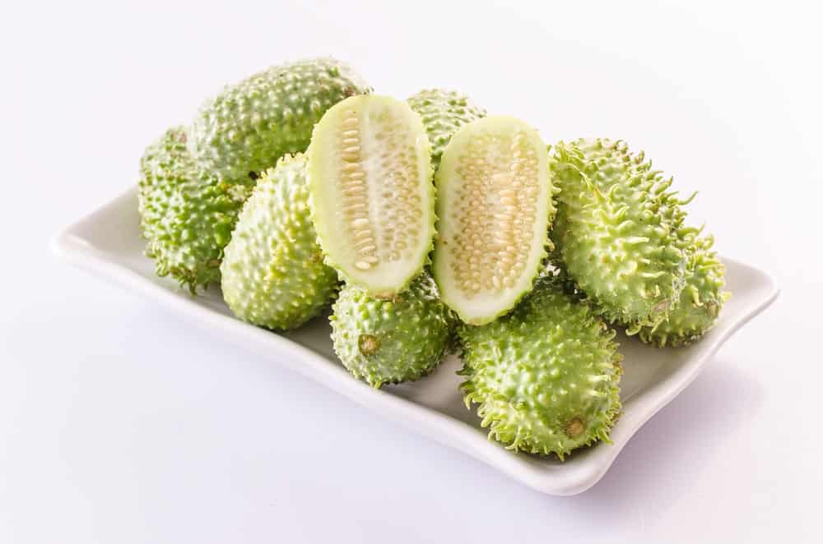
AVERAGING ONE AND A HALF INCHES IN DIAMETER AND TWO INCHES IN LENGTH, THESE ARE SMALL, ROUND, AND BUMPY CUCUMBERS WITH A CRUNCHY TEXTURE AND A STRONG TASTE THAT IS A TINY BIT SOUR. ALTHOUGH THEY PEAK IN LATE SPRING, THESE CUCUMBERS ARE AVAILABLE ALL YEAR LONG. THEY ARE ALSO KNOWN AS THE PRICKLY CUCUMBER, THE MAROON CUCUMBER, AND THE WEST INDIAN GOURD AND THEY CAN BE EATEN RAW OR COOKED. THEY ORIGINATED IN AFRICA AND CAME TO THE UNITED STATES IN THE EARLY 1800S. THEY ARE NOW FOUND IN MANY OTHER PARTS OF THE WORLD, INCLUDING THE CARIBBEAN AND SOUTH AND CENTRAL AMERICA.

29 DIFFERENT TYPES OF SWEET PEAS PLUS FUN FACTS
GET TO KNOW MORE ABOUT THE SWEET PEAS, THE GARDEN FLOWERS WITH EYE-CATCHING MULTICOLORED VARIETIES AND STUNNING FRAGRANCE.

SWEET PEAS HAVE 110 SPECIES AND BELONG TO THE PEA-FLOWER SUBFAMILY OF THE FABACEAE FAMILY. ITS SCIENTIFIC NAME LATHYRUS ODORATUS COMES FROM THE GREEK WORDS LATHYROS AND ADORATUS WHICH MEANS PEA OR PULSE AND FRAGRANT, RESPECTIVELY. NATIVE TO SICILY, CYPRUS AND ITALY, THE GENUS WAS INTRODUCED TO ENGLAND IN THE 17TH CENTURY AFTER A SICILIAN MONK SENT SWEET PEA SEEDS TO THE COUNTRY.
IT WAS THEN CULTIVATED BY THE SCOTS HORTICULTURIST HENRY ECKFORD AND SWEET PEAS BECAME POPULAR IN THE LATE VICTORIAN PERIOD. THE FLOWERS ARE POPULAR IN BOUQUETS, CENTERPIECES AND AS AN ESSENTIAL INGREDIENTS TO POTPOURRI.

TYPES

AIR WARDEN
A STRIKING FLOWER, ITS DARK RED PETALS ARE CERTAIN TO CATCH THE ATTENTION OF ANYONE WHO COMES NEAR IT, AND ITS STRONG STEMS AND FANTASTIC AROMA ADD TO ITS BEAUTY AND CHARM. IT BLOOMS HEAVILY, GROWS UP TO SIX FEET IN HEIGHT, AND IT LOOKS FANTASTIC IN VASES, CONTAINERS, AND WINDOW BOXES.

AMERICA
WITH PETALS THAT ARE RASPBERRY RED WITH WHITE STREAKS, THE AMERICA HAS A UNIQUE SWEET, ALMOST FRUITY FRAGRANCE, AND ITS LONG, AIRY STEMS PERFECTLY COMPLEMENT THE BEAUTIFUL BLOOMS. INTRODUCED IN THE LATE 1800S, THIS FLOWER IS AN ENGLISH HEIRLOOM AND IS PERFECT FOR ANYONE WHO LOVES THE COLORS RED AND PINK.

APRICOT SPRITE
LIKE ITS NAME IMPLIES, THESE FLOWERS ARE APRICOT-SALMON IN COLOR, AND MANY ARE BI-COLORED PINK BLOOMS AS WELL. THEY ARE STUNNING AND COME WITH AN AMAZING SCENT, AND THEIR LONG-LASTING ABILITY MAKES THEM PERFECT AS A CUT FLOWER.

CRIMSON RIPPLE (LATHYRUS ODORATUS)
WITH A WONDERFUL FRAGRANCE AND LARGE WAVY PETALS THAT ARE COLORED IN CRIMSON AND WHITE, THIS TYPE OF SWEET PEA GROWS UP TO EIGHT FEET TALL AND HAS LONG, BEAUTIFUL STEMS. IT BLOOMS FROM SPRING TO FALL AND LOOKS EXTRAORDINARY IN VASES AND CONTAINERS. IT PREFERS FULL SUN OR PARTIAL SHADE, AND IT IS ATTRACTIVE TO BUTTERFLIES AND BEES. DEER-RESISTANT, THIS SWEET PEA ALSO LOOKS GREAT IN BORDERS AND EVEN WINDOW BOXES – ANYWHERE THAT ALLOWS YOU TO SHOW OFF ITS COLORS.

CUPANI (LATHYRUS ODORATUS)

ONE OF THE MOST FRAGRANT VARIETIES OF THE SWEET PEA PLANT, THIS FLOWER HAS DEEP CRIMSON AND VIOLET PETALS AND IS VERY HEAT-TOLERANT. A SELF-SEEDING PLANT, THE CUPANI REMAINS IN YOUR SOIL WHERE IT GROWS YEAR AFTER YEAR, AND IT IS A DEER-RESISTANT PLANT AS WELL. NOT A LOVER OF TOO MUCH HEAT OR HUMIDITY, THIS SWEET PEA BLOOMS FROM SPRING TO FALL AND CAN GROW UP TO EIGHT FEET IN HEIGHT. IT IS ATTRACTIVE TO BEES AND BUTTERFLIES, AND LOOKS BEAUTIFUL AS A BORDER AND EVEN IN WINDOW BOXES.

CUPID PINK
A DWARF PLANT, THE CUPID PINK IS A BUSHY PLANT THAT BLOOMS MASSIVELY AND GROWS UP TO TWO FEET HIGH. ITS ONE-INCH, BI-COLORED PETALS COME IN BEAUTIFUL SHADES OF PINK AND WHITE, AND THEY ARE PERFECT FOR EDGINGS, CONTAINERS, VASES, AND EVEN HANGING BASKETS.

EREWHON (LATHYRUS ODORATUS X BELINENSIS)
WITH LIGHT PINK UPPER PETALS AND BEAUTIFUL RICH BLUE LOWER PETALS, THIS SWEET PEA TRULY STANDS OUT, AND IT MAKES FOR A BEAUTIFUL SUMMER GARDEN, NOT TO MENTION BEAUTIFUL VASES AND CONTAINERS. GROWING UP TO EIGHT FEET HIGH AND TWELVE INCHES WIDE, THE PLANT IS HEAVILY SCENTED AND IS THEREFORE A VERY POPULAR OPTION WHETHER YOU ARE PLANNING TO KEEP IT INSIDE OR OUTDOORS. THE FLOWERS BLOOM FROM SPRING TO FALL, AND THEY ARE NOT TOLERANT OF CONDITIONS THAT GET TOO HOT OR HUMID.

FIRE AND ICE (LATHYRUS ODORATUS)
THIS FLOWER IS QUITE UNIQUE, WITH DEEP PINK AND WHITE MARKINGS, ALONG WITH PURPLE BLUE LOWER PETALS, WHICH GIVE IT A TRULY STUNNING LOOK. GROWING UP TO SIX FEET IN HEIGHT, THIS PLANT DOES BEST IN CLIMATES THAT ARE DRY AND COOL, AND IT BLOOMS FROM SPRING TO FALL. BEST WHEN PLANTED IN FULL SUN OR PARTIAL SHADE, THE FIRE AND ICE DOES BEST WHEN YOU APPLY MULCH TO THE SOIL TO KEEP ITS ROOTS NICE AND MOIST. IT GROWS IN ZONES 2-11, AND YOU CAN PINCH OFF THE PLANTS ONCE THEY REACH SIX INCHES IN HEIGHT IN ORDER TO KEEP THEIR GROWTH UNDER CONTROL.

FRAGRANTISSIMA
WHAT MAKES THIS FLOWER SO UNIQUE IS ITS VARIETIES OF COLORS AND DESIGNS. IT INCLUDES FLOWERS THAT ARE STRIPED, BI-COLORED, AND SOLID-COLORED, COMING IN JUST ABOUT EVERY COLOR YOU CAN IMAGINE. THEY ARE A VIGOROUS PLANT WITH STRONG STEMS, AND THEY GROWS UP TO SIX FEET TALL. THEY ARE ALSO ONE OF THE MOST FRAGRANT TYPES OF SWEET PEA FLOWERS, WHICH MAKES THEM PERFECT FOR CONTAINERS AND VASES, NOT TO MENTION WINDOW BOXES.

HENRY ECKFORD
WITH BRIGHT ORANGE-RED PETALS THAT FADE TO SALMON-COLORED, THIS IS A STUNNING AND EYE-CATCHING FLOWER INDEED. IT IS AN HEIRLOOM SWEET PEA INTRODUCED IN THE EARLY 1900S, AND ITS VINES GROW UP TO EIGHT FEET IN HEIGHT. WHEN THE AFTERNOON SHADE ARRIVES, THE PETALS ALMOST GLOW, AND SINCE THEY CONTAIN FOUR BLOOMS PER STEM, THEY ARE AN ABSOLUTELY BEAUTIFUL PLANT AND A FAVORITE OF GARDENERS.

KING’S HIGH SCENT
THE KING’S HIGH SCENT IS LIKELY THE SWEETEST-SCENTED SWEET PEA AVAILABLE, AND IT CONSISTS OF LARGE PETALS THAT ARE CREAMY WHITE IN COLOR AND TRIMMED IN VIOLET. GROWING UP TO SIX FEET TALL, THE PLANT IS PERFECT AROUND OPEN WINDOWS AND PORCHES, AND ALONGSIDE ANY OUTDOOR SITTING AREA. THEIR SCENT IS SO FANTASTIC THAT THEY CAN SCENT YOUR ENTIRE HOME, AND THEY ALSO MAKE A SPECTACULAR LANDSCAPE.

MAMMOTH MIX
IN COLORS THAT INCLUDE DIFFERENT SHADES OF SALMON, ROSE, LILAC, WHITE, AND PINK, THIS TYPE OF SWEET PEA IS STURDY AND VERY HEAT-RESISTANT, AND YOU CAN EVEN TRAIN THEM ON TRELLISES, STRINGS, AND NETS. THEY GET UP TO SIX FEET IN HEIGHT AND ARE VERY FRAGRANT, AND WHETHER YOU PLACE THEM OUTSIDE OR INDOORS, THEIR AMAZING SCENT IS THERE TO PLEASE.

MATUCANA
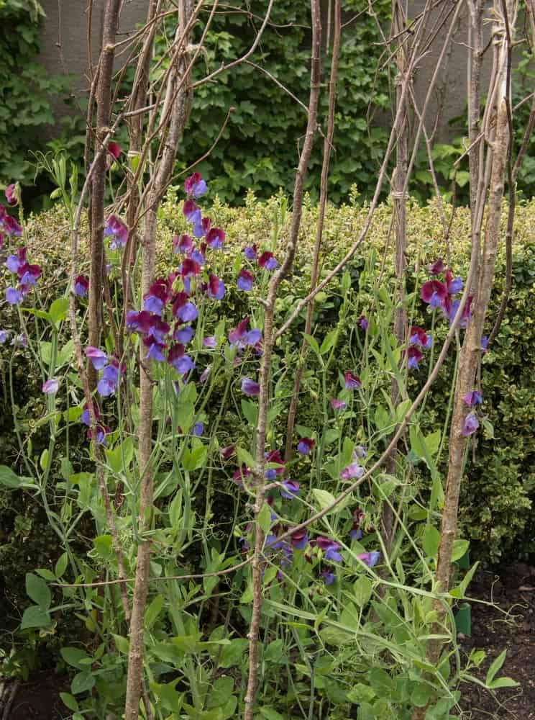
THESE PETALS ARE VERY DARK AND CONSIST OF PETALS THAT ARE DEEP RED AT THE TOP AND VIOLET ON THE BOTTOM. THEIR COLOR IS UNIQUE, AND THEY HAVE A WONDERFUL FRAGRANCE AS WELL, MAKING THEM PERFECT FOR CONTAINERS AND VASES. THEY REACH UP TO SIX FEET HIGH AND ARE A FAVORITE OF MANY GARDENERS, AND THEY ARE PERFECT FOR NETS, TRELLISES, AND STRINGS.

MELODY MIX
WITH LARGE FLOWERS, LONG STEMS, AND A VARIETY OF COLORS, YOU CAN FIND THEM IN MANY SHADES OF MAROON, RED, PINK, LILAC, ROSE, VIOLET, AND LAVENDER. MANY OF THE PETALS ARE BI-COLORED, SO THE MIX IS QUITE STUNNING. THEY ARE EXTREMELY FRAGRANT AND LAST A VERY LONG TIME, AND THEY ARE BEAUTIFUL WHEN PLACED IN A VASE OR CONTAINER.

MISS WILLMOTT

Bottom of Form
THIS SWEET PEA HAS A BEAUTIFUL COLOR OF BLENDED ORANGE, APRICOT, AND PINK, MAKING IT QUITE STRIKING AND EYE-CATCHING. THEY GROW UP TO SIX FEET IN HEIGHT AND HAVE ONLY BEEN AROUND SINCE THE EARLY 1900S. THE MISS WILLMOTT IS AN HEIRLOOM SWEET PEA AND IS PERFECT FOR CONTAINERS AND VASES.

MRS. COLLIER
THIS VARIETY OF SWEET PEA IS EXTREMELY FRAGRANT AND GROWS THREE BLOOMS TO EACH STEM. THEY ARE LIME GREEN IN THE BEGINNING BUT FADE TO A CLEAR CREAM COLOR AS THEY AGE. AN HEIRLOOM SWEET PEA, IT HAS ONLY BEEN AROUND SINCE THE EARLY 1900S, AND IT CAN GROW UP TO TEN FEET HIGH. IT IS FREE-BLOOMING, AND IS ONE OF THE MOST POPULAR OF ALL HEIRLOOM SWEET PEAS.

MRS. R. BOLTON
WITH LARGE, RUFFLED PETALS THAT ARE ALMOND-PINK IN COLOR, THIS VARIETY OF SWEET PEA GROWS TO SIX FEET IN HEIGHT AND LOOKS SPECTACULAR WHEN PLANTED ALONGSIDE SWEET PEAS THAT ARE VIOLET-BLUE IN COLOR. THE FLOWERS SIT ATOP STURDY, LONG STEMS AND LOOK BEAUTIFUL IN VASES AND CONTAINERS.

NIMBUS
WITH PETALS THAT RANGE FROM WHITE TO DEEP PURPLE TO INK-BLUE, THEY BOAST STREAKS, PICOTEE EDGES, AND SPECKS OF ADDITIONAL COLOR. THEY GROW UP TO EIGHT FEET TALL AND HAVE A MAGNIFICENT AROMA, MAKING THEM PERFECT FOR VASES AND CONTAINERS. THEIR STEMS ARE LONG AND STRAIGHT, AND THEY ARE VERY HARDY AND VIGOROUS PLANTS.

NOEL SUTTON
WITH RUFFLED PETALS THAT COME IN VIVID VIOLET-BLUE, THE NOEL SUTTON HAS STRONG, STURDY STEMS THAT GROW QUITE LONG AND A WONDERFUL AROMA. BECAUSE OF THESE THINGS, THE FLOWERS LOOK GREAT IN CONTAINERS AND VASES.

OLD SPICE
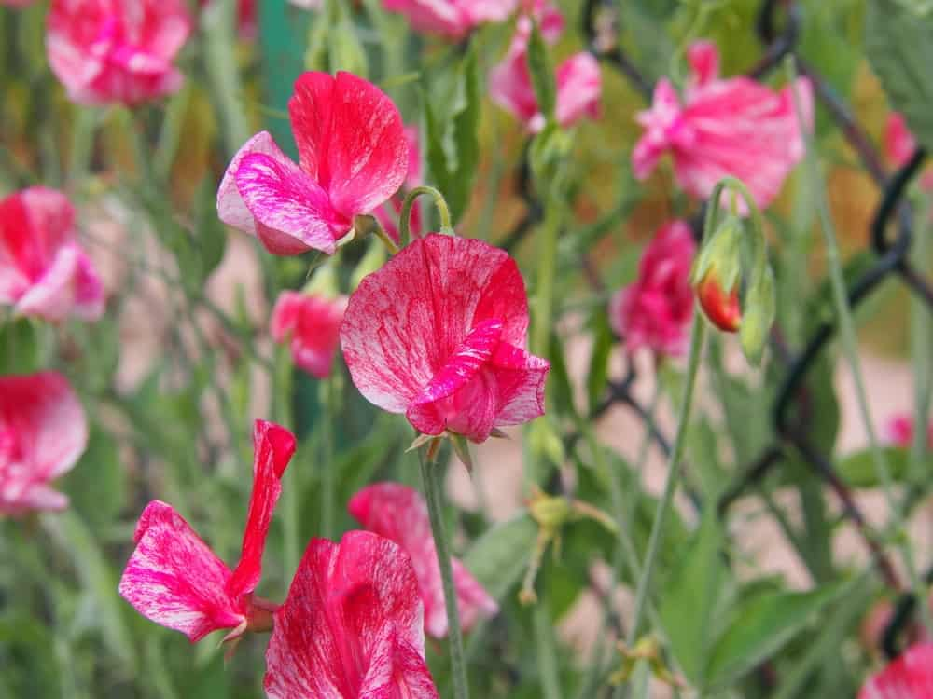
IN BEAUTIFUL COLORS SUCH AS CREAMY WHITE, VIOLET, PINK, AND DEEP PURPLE, AMONG OTHERS, THIS PLANT HAS A LOT OF FRAGRANCE AND IS VERY TOLERANT OF THE HEAT. IF YOU LIVE IN A WARM CLIMATE OR SIMPLY WANT TO PLANT SOMETHING BEAUTIFUL IN THE SUMMER MONTHS, THE OLD SPICE IS ONE PLANT YOU’LL WANT TO CONSIDER.

OXFORD AND CAMBRIDGE
THIS SWEET PEA IS EXTREMELY FRAGRANT AND CONSISTS OF TWO BEAUTIFUL HEIRLOOM FLOWERS, INCLUDING THE OXFORD, WHICH IS DARK BLUE, AND THE CAMBRIDGE, WHICH IS SKY BLUE IN COLOR. IT GROWS UP TO SEVEN FEET IN HEIGHT AND MAKES A STRIKING-LOOKING DISPLAY REGARDLESS OF WHERE IT IS PLANTED.

PERENNIAL SWEET PEA (LATHYRUS LATIFOLIUS)
ALSO CALLED THE EVERLASTING PEA, THIS PLANT RANGES IN COLOR FROM MEDIUM PINK TO ALMOST-WHITE. THE FLOWERS SPAN ONE INCH ACROSS, AND THEY USUALLY CLIMB ON NEARBY VEGETATION OR RAMBLE ALONG THE GROUND. THEY ARE EASY TO GROW, HAVE WON SEVERAL INTERNATIONAL FLOWER AWARDS, AND ARE A SELF-SEEDING TYPE OF SWEET PEA. BUTTERFLIES AND BEES LOVE THEM, BUT DEER DO NOT, AND THEY LOOK GREAT AS GROUNDCOVER ALONG SLOPES OR BANKS.

PRIMA BALLERINA
A DWARF SWEET PEA, THESE START OUT A ROSE-CREAM COLOR THEN FADE TO LAVENDER-WHITE AS THEY AGE, AND THEIR MAGNIFICENT SCENT IS ENOUGH TO MAKE ANYONE WANT TO GROW THEM. THEY ARE COMPACT AND ONLY GROW UP TO 32 INCHES TALL, AND THEY ARE BOTH LONG-LASTING AND GRACEFUL.

PROMISE (LATHYRUS ODORATUS)

WITH LARGE EYE-CATCHING PETALS OF PINK AND WHITE, THEY CAN GROW UP TO SIX FEET TALL AND TWELVE INCHES WIDE, AND THEY ARE BOTH RELIABLE AND VERY SHOWY. GREAT FOR ARBORS AND ARCHES, THE PROMISE HAS LONG STURDY STEMS AND A WONDERFUL FRAGRANCE, MAKING THEM NOTICEABLE WHEREVER YOU PLANT THEM. CONTRARY TO WHAT SOME PEOPLE BELIEVE, SWEET PEAS ARE NOT EDIBLE, BECAUSE THEY CAN CAUSE SEVERE DISCOMFORT IF YOU EAT THEM. IF YOU PICK THEM, THEY CONTINUE TO GROW, AND IF YOU’RE LOOKING FOR SOMETHING TO GO IN CONTAINERS OR WINDOW BOXES, YOU’LL FIND THESE ARE PERFECT.

SOUTHBOURNE (LATHYRUS ODORATUS)
WITH LOVELY LIGHT PINK PETALS TINGED WITH SOFT WHITE, THESE SWEET PEAS ARE STURDY AND VERY FRAGRANT. THEY BLOOM BEST IN CLIMATES THAT ARE MILD AND COOL, AND THEY CAN GROW UP TO EIGHT FEET IN HEIGHT. BUTTERFLIES AND BEES LOVE THEM, AND THEY PREFER SOIL THAT IS WELL-DRAINED AND HAS A MEDIUM AMOUNT OF MOISTURE. THEY ARE BEAUTIFUL BOTH INDOORS AND OUTDOORS, AND THEY BLOOM FROM SPRING TO FALL.

SPENCER MIX (LATHYRUS ODORATUS)
THIS IS ONE OF THE MOST POPULAR AND COMMONLY FOUND TYPES OF SWEET PEAS, MAINLY BECAUSE IT COMES IN COLORS THAT INCLUDE VIOLET, LAVENDER, ROSE PINK, LIGHT PINK, WHITE, AND CREAMY YELLOW. THEY HAVE LARGE PETALS THAT TRULY HIGHLIGHT YOUR SUMMER GARDEN, AND THEY LOOK BEAUTIFUL IN BEDS AND BORDERS, NOT TO MENTION CONTAINERS AND WINDOW BOXES. WITH LOW TO AVERAGE WATERING NEEDS AND A LOW-MAINTENANCE ASPECT, THE SPENCER MIX VARIETY CAN REACH UP TO SIX FEET HIGH AND IS VERY ATTRACTIVE TO BUTTERFLIES AND BEES.

STRAWBERRY SUNDAE
THESE FLOWERS ARE EXCEPTIONALLY FRAGRANT AND COME IN PASTEL COLORS SUCH AS PINK, WHITE, AND A ROSE BI-COLORED PETAL. THE COMBINATION OF THE COLORS IS QUITE EXQUISITE, AND IT IS BOTH HEAT-RESISTANT AND EASY TO GROW. THEY GROW UP TO SIX FEET TALL, AND THEY LOOK BEAUTIFUL IN VASES AND CONTAINERS.

SWAN LAKE
THIS TYPE OF SWEET PEA HAS LARGE, PRISTINE WHITE PETALS ON LONG, STURDY STEMS, NOT TO MENTION A WONDERFUL AROMA. VIGOROUS AND HEAVY-BLOOMING, THE SWAN LAKE GROWS UP TO SIX FEET TALL AND IS THEREFORE PERFECT FOR CUTTING AND PLACING IN CONTAINERS AND VASES.

TURQUOISE LAGOON
IN SHADES OF BEAUTIFUL ROSE PINK THAT FADE TO LAVENDER AND AQUA BLUE WHEN THEY AGE, THESE FLOWERS ARE STUNNING AND LOOK EXQUISITE IN VASES AND CONTAINERS. A HYBRID PLANT, THE TURQUOISE LAGOON GROWS UP TO SIX FEET TALL AND HAS A WONDERFUL SCENT, SO IT IS EASY TO SHOW THEM OFF TO ANYONE WHO COMES NEAR THEM.

FACTS ABOUT SWEET PEA FLOWERS
- BECAUSE MICE, BIRDS, AND OTHER SEED-EATING PESTS CAN BE ATTRACTED TO SWEET PEAS, IT IS GOOD TO USE SOME TYPE OF MESH OR BIRD NET UNTIL AFTER YOU HAVE SEEN AT LEAST TWO PLANTS ON THE STEMS. THIS WILL PREVENT ANIMALS AND PESTS FROM DIGGING INTO THE SOIL AND EATING THE SEEDS YOU’VE PLANTED.
- CONTRARY TO POPULAR BELIEF, YOU SHOULD NEVER CONSUME ANY PART OF THE SWEET PEA FLOWER, BECAUSE IT CAN CAUSE A LOT OF PAIN AND DISCOMFORT.
- SWEET PEAS ARE MULTI-FUNCTIONAL AND CAN BE USED AS A CLIMBING VINE, A TALL BUSH OR TREE, AND EVEN IN CONTAINERS AND VASES IF YOU CHOOSE TO BRING THEM INDOORS.

THE 3 MAIN TYPES OF PEAS: ENGLISH VS. SNOW VS. SNAP – DIFFERENCES?
DETAILED BREAKDOWN OF THE THREE MAIN TYPES OF PEAS - ENGLISH, SNOW AND SUGAR SNAP. INCLUDES MANY VARIETIES OF EACH MAIN TIME, PEA NUTRITIONAL FACT CHART AND PEA PLANT GROWING CHART.
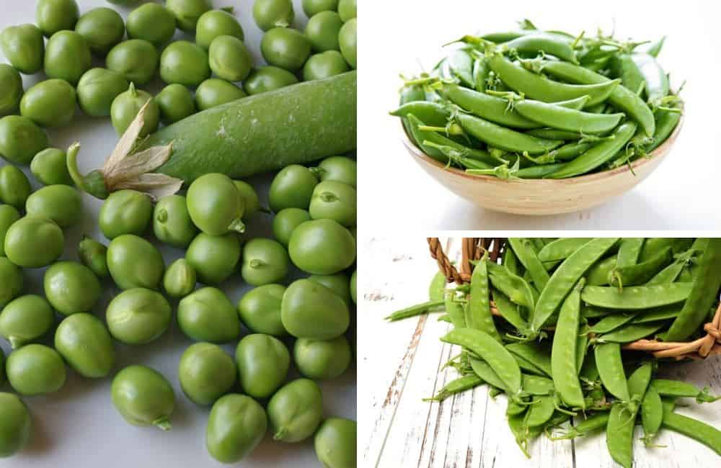
THE WONDERFUL GREEN VEGETABLES CALLED THE PEAS ARE ONE OF THE MOST VERSATILE VEGETABLES IN THE WORLD. THEY CAN BE STIR-FRIED AND EATEN WITH A SPOON, PUREED AND COOKED IN SOUP, STEAMED IN RICE, SERVED IN SALADS AND GARNISHED ON ENTREES.
THEY ARE ALSO EXTREMELY DELICIOUS.
FURTHERMORE, PEAS ARE AN EXCELLENT SOURCE OF FIBERS, POTASSIUM, FOLATE, VITAMIN A, C, AND B6, MAGNESIUM, AND IRON. STRICTLY SPEAKING, THEY ARE LEGUMES AND NOT VEGETABLES. LEGUMES CONTAIN PLANTS WHICH PRODUCE PODS WITH SEEDS INSIDE THEM. SOME OTHER IMPORTANT LEGUMES ARE CHICKPEAS, FRENCH BEANS, AND PEANUTS.
RELATED: TYPES OF SWEET PEAS | WHAT TO SERVE WITH SHEPHERD’S PIE | VEGETABLES AND HERBS | WHEY PROTEIN ALTERNATIVES | TYPES OF BEANS AND LEGUMES | TYPES OF FOOD

ORIGIN OF PEAS
WHEN EXACTLY PEAS WERE FIRST DISCOVERED REMAINS A MYSTERY; HOWEVER, THERE HAVE BEEN MANY SPECULATIONS WHICH SUGGEST POSSIBLE ORIGINS, INCLUDING MIDDLE ASIA, SPECIFICALLY BURMA AND THAILAND WITH EXPANSION TO AFGHANISTAN, THE EASTERN RIM OF THE MEDITERRANEAN BASIN, AND THE MOUNTAINOUS AND PLATEAU RANGES OF ETHIOPIA.
FOSSILIZED PEA PODS FOUND IN SWITZERLAND DATES AS FAR BACK AS 10,000 YEARS. IN THE 3RD CENTURY BC, THEOPHRASTUS WAS RECORDED MENTIONING PEAS SOWN IN LATER WINTER. PEA CULTIVATION IS BELIEVED TO SPREAD THROUGHOUT THE INDUS VALLEY CIVILIZATION, CHINA, AND EUROPE IN THE 2ND MILLENNIUM BC. THE ROMAN LEGIONARIES WERE RECORDED TO GATHER WILD PEAS TO SUPPLEMENT THEIR RATIONS IN 1ST CENTURY BC.
PEAS WERE BROUGHT TO NORTH AMERICA BY CHRISTOPHER COLUMBUS IN 1942, WHERE THEY WERE QUICKLY ADOPTED BY THE NATIVE AMERICANS. DURING THE MIDDLE AGES, PEAS WERE A STABLE DIET THAT KEPT FAMINE AT BAY AND IN THE EARLY MODERN EUROPEAN ERA, IMMATURE, FRESH PEAS WERE PRIZED AS GOURMET FOOD.
Bottom of Form

TYPES OF PEAS
THESE DAYS THERE ARE THREE MAJOR TYPES OF PEAS, WITH DOZENS OF VARIETIES BETWEEN THEM:
- ENGLISH PEAS
- SNOW PEAS
- SUGAR SNAP PEAS

1. ENGLISH PEAS
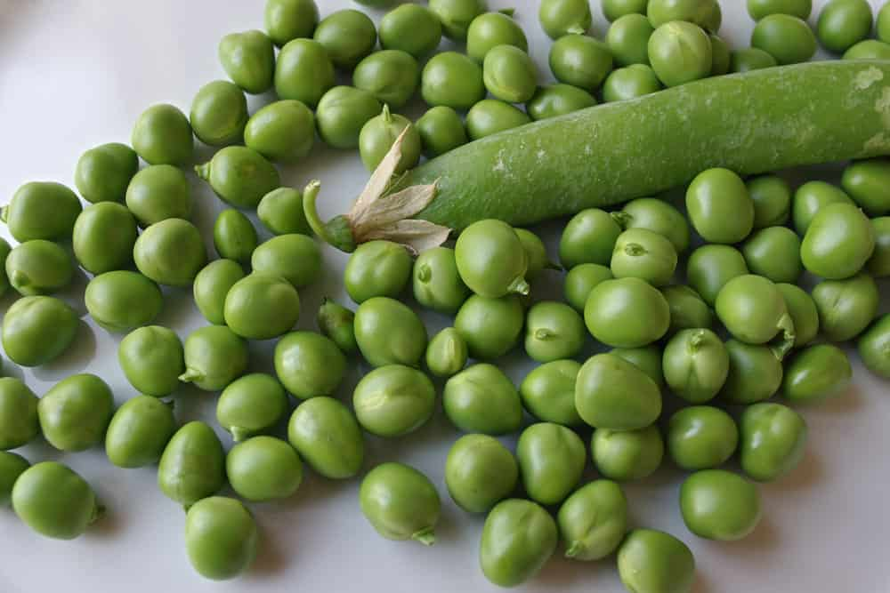
BOTANICAL NAME: PISUM SATIVUM
ENGLISH PEAS, ALSO KNOWN AS SHELL PEAS AND GARDEN PEAS ARE THE MOST COMMON TYPE OF PEAS. GARDEN PEAS HAVE SMOOTH AND FLESHY, CYLINDRICAL GREEN PODS THAT ARE CURVED AND PLUMP. SINCE THEIR POD IS TOUGH AND FIBROUS, IT CANNOT BE DIGESTED AND THIS VARIETY OF PEAS NEEDS TO BE SHELLED. THEY CONTAIN PLUMP, ROUND, SWEET-TASTING SEEDS.
THEY ARE VERY NUTRITIOUS AND DELICIOUS; HOWEVER, THEY REQUIRE A LOT OF SHELLING, SO MANY PEOPLE PREFER TO GET SHELLED AND FROZEN GARDEN PEAS FROM THE MARKET, WHICH MAY NOT BE AS TASTY AS THE FRESHLY SHELLED ONES.
THE GARDEN PEA HAS MANY CULTIVARS:

SPRING PEAS
THIS VARIETY OF PEA PRODUCES A LOT OF PODS PER PLANTS. EACH POD HAS AN AVERAGE OF 7 PEAS INSIDE. IT HAS A MILDLY SWEET FLAVOR AND IS READY IN 60 DAYS.

SURVIVOR PEAS
THIS VARIETY OF PEAS IS ALMOST LEAFLESS AND HAS VERY TOUGH AND STRINGY VINES WHICH CLING TOGETHER. THE PLANT IS ABOUT TWO FEET TALL PRODUCING PEA PODS WITH AN AVERAGE OF 8 PEAS.

WANDO PEAS
THIS VARIETY IS VERY POPULAR AMONG THE MASSES AS IT IS A VERY HARDY CULTIVAR. WANDO PEAS CAN TOLERATE WARM TO COLD WEATHERS EASILY. THEY HAVE DARK GREEN PODS WHICH PRODUCE 7-8 MEDIUM-SIZED PEAS, WHICH ARE READY IN 70 DAYS. THEY HAVE A MODERATELY SWEET TASTE AND ARE GOOD FOR FREEZING OR DRYING.

GARDEN SWEET
AS THE NAME IMPLIES, THIS PEA IS VERY SWEET WITH A 3 ½ INCHES POD CONTAINING 8-9 PEAS. IT CAN BE READY IN 75 DAYS AND IS CONSIDERED ONE OF THE MOST DELICIOUS VARIETIES OF GARDEN PEAS.

THOMAS LAXTON
THESE PEAS ARE ABOUT 4 INCHES LONG. THEY HAVE 8 TO 9 DARK GREEN AND VERY PLUMP PEAS. THEY HAVE A MODERATELY SWEET TASTE.

EARLY PERFECTION
THIS CULTIVAR COMPRISES OF CRESCENT-SHAPED 3 ½ INCHES LONG PODS, WHICH PRODUCE 8 TO 9 TENDER, MEDIUM-SIZED GREEN PEAS. THIS VARIETY IS A VERY PROLIFIC PRODUCER, IS RESISTANT TO DRY AND HOT WEATHERS AND CAN BE READY IN 65 DAYS.

LINCOLN PEAS
THE PODS OF THE LINCOLN PEAS CONTAIN 7-8 LARGE AND TENDER PEAS. THESE PEAS TASTE SWEET, ARE TOLERANT TO HEAT, FREEZE WELL, AND CAN BE READY IN 70 DAYS.

MR. BIG PEAS
AS THE NAME IMPLIES, THIS CULTIVAR PRODUCES EXTRA-LARGE PEAS WITH 9 TO 10 SEEDS IN EACH DARK GREEN POD. THIS VARIETY IS MODERATELY SWEET AND IS A PRIZE-WINNING CULTIVAR.

MAESTRO
THIS CULTIVAR PRODUCES A HIGH YIELD AND HAS 4 ½ INCHES LONG DARK GREEN PODS WITH 10 TO 11 MID-SIZED SEEDS. THE PEA IS MODERATELY SWEET AND IS GENERALLY READY IN 60 DAYS. IT IS A GOOD VARIETY TO HARVEST IN THE FALL.

LITTLE MARVEL
THIS CULTIVAR PRODUCES 3-INCH-LONG PEA PODS WITH 7 TO 8 SEEDS. THESE PEAS ARE MEDIUM SIZED, TENDER, AND SWEET AND ARE READY IN 65 DAYS.

MISTY SHELL
THE MISTY SHELL IS A PROLIFIC PRODUCER WHICH BEARS 3-INCH LARGE PEA PODS WITH 7 TO 8 PEAS EACH. THESE PEAS ARE PLUMP AND SWEET AND CAN BE CULTIVATED IN 60 DAYS.

2. SNOW PEAS
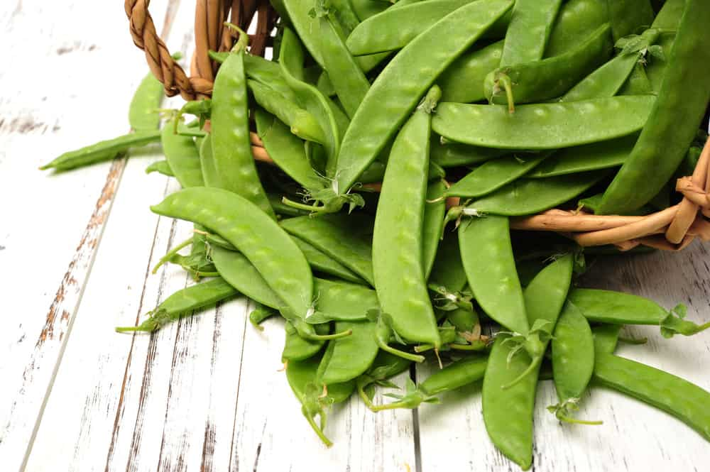
BOTANICAL NAME: PISUM SATIVUM VAR. SACCHARATUM
SNOW PEAS ARE ALSO KNOWN AS CHINESE PEAS BECAUSE THEY ARE USED IN A LOT OF CHINESE CUISINES. THEY ARE ALSO KNOWN BY THEIR FRENCH NAME “MANGETOUT,” WHICH MEANS TO EAT IT ALL. YOU CAN INSTANTLY RECOGNIZE SNOW PEAS FORM GARDEN PEAS AS THEY HAVE AN ALMOST FLAT SHELL WITH NO DISTINCT PEA-SHAPE INSIDE. UNLIKE GARDEN PEAS, THESE PEAS HAVE EDIBLE PODS AND IN FACT, ARE GROWN FOR THEIR PODS RATHER THAN THE SEEDS INSIDE.
SNOW PEAS COME IN SEVERAL DIFFERENT VARIETIES:

SNOWBIRD
THIS IS ONE OF THE SHORTER PEA PLANTS WITH AN AVERAGE HEIGHT OF JUST 18 INCHES. THEY PRODUCE A HIGH YIELD WITH 3 INCHES LONG PODS CONTAINING MODERATELY SWEET PEAS. IT TAKES THEM ABOUT 60 DAYS TO GET READY.

SUGAR DADDY
THIS ECCENTRICALLY-NAMED PEA PRODUCES PODS THAT ARE ABOUT 3 INCHES LONG. THEY CONTAIN SWEET AND TENDER PEAS, WHICH ARE RESISTANT TO DISEASES. THEY GROW UP IN 70 DAYS.

GRAY SUGAR
THIS VARIETY CONTAINS 3-INCH-LONG TENDER PODS, WHICH CONTAIN MODERATELY SWEET PEAS. THIS CULTIVAR IS GENERALLY READY IN 65 DAYS.

MAMMOTH MELTING SUGAR
THIS IS A VERY TALL VARIETY OF PEA WITH PLANTS REACHING UP TO 4 TO 5 FEET IN HEIGHT. THEY PRODUCE 5 ½ INCHES THICK PODS, WHICH ARE INDEED RELATIVELY MAMMOTH-SIZED. THE PEAS HAVE A SWEET FLAVOR AND GET READY IN 70 DAYS. THEY ARE ONE OF THE BEST TYPES OF PEAS FOR COOKING AS THEY CAN TOLERATE HIGH TEMPERATURE AND LONGER COOK TIMES VERY WELL.

OREGON SUGAR PODS
THIS VARIETY OF PEA PLANT IS ALSO CONSIDERABLE LONG, WITH THE PLANT STANDING AT 2 ½ FEET IN HEIGHT. THE PODS INSIDE ARE VERY SWEET AND TENDER AND THE PEA VARIETY IS RESISTANT TO DISEASE. IT CAN BE READY IN 70 DAYS.

OREGON SUGAR POD #2
INTERESTINGLY, THERE ARE TWO TYPES OF OREGON SUGAR PODS. THIS PLANT GIVES A HIGH YIELD WITH TYPICALLY TWO PODS PER GROUP. THE SEEDS ARE VERY SWEET AND TENDER AND ARE ENCASED IN 4-INCH-LONG PODS. THIS CULTIVAR CAN BE READY IN 70 DAYS.

AVALANCHE PEAS
THIS IS A PROLIFIC VARIETY AND PRODUCES 6-INCH-LONG DARK GREEN SNOW PEA PODS. THE CULTIVAR IS QUITE RESISTANT TO DISEASES AND CONTAINS SWEET AND TENDER SEEDS.

3. SUGAR SNAP PEAS
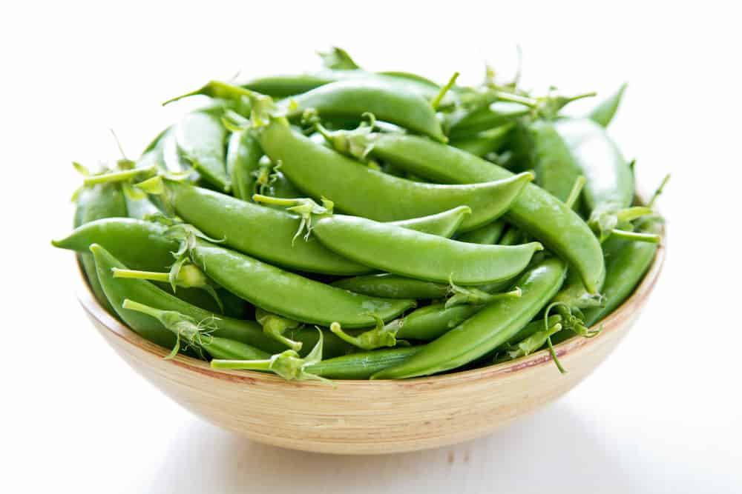
KITCHENAID

UNLOCK POTENTIAL.
OUR INNOVATIVE APPLIANCES ENSURE THAT ANYTHING YOU WANT TO DO IN THE KITCHEN YOU CAN DO WITH KITCHENAID.
BOTANICAL NAME: PISUM SATIVUM VAR. MARCROCARPON
AT FIRST GLANCE, SUGAR SNAP PEAS LOOK ALMOST IDENTICAL TO THE GARDEN PEAS. HOWEVER, THE SUGAR SNAP CAN BE DIFFERENTIATED BY THE SHAPE OF ITS PEA POD, WHICH IS SLIGHTLY MORE CYLINDRICAL THAN THE GARDEN PEA VARIETY. SUGAR SNAP PEAS ARE A HYBRID OF SNOW PEAS AND A MUTANT GARDEN PEA. THEREFORE, THESE PEAS CONTAIN PROPERTIES OF BOTH OF ITS PARENT PEA VARIETIES.
LIKE GARDEN PEAS, THE SEEDS ARE ALLOWED TO BECOME ROUND AND PLUMP BEFORE THEY ARE SHELLED. HOWEVER, THE PODS OF SUGAR SNAP PEAS ARE THICK, CRISP, AND CRUNCHY AND CAN BE EATEN. THESE PEAS DO NOT NEED TO BE SHELLED AND ARE COOKED WITH THEIR PODS, LIKE SNOW PEAS.
SUGAR SNAP PEAS ARE ALSO MORE TOLERANT OF HOT WEATHER THAN GARDEN PEAS.
VARIETIES OF SUGAR SNAP PEAS ARE LISTED BELOW.

SUGAR BON
THE SUGAR BON CULTIVAR PRODUCES 3 INCHES LONG PODS, WHICH ARE VERY SWEET. THIS PLANT IS ALSO QUITE RESISTANT TO DISEASES AND CAN BE READY IN 55 DAYS.

SUGAR SNAP
THIS IS A PRIZE-WINNING VARIETY WITH VINES THAT CAN REACH AS HIGH AS 6 FEET. THE SUGAR SNAP PRODUCES A HIGH YIELD, WITH PODS THAT ARE 3 INCHES LONG AND VERY SWEET.

SUPER SNAPPY
SUPER SNAPPY PEAS ARE A SPECIAL PEA VARIETY FEATURING VERY LARGE PODS, WHICH CONTAIN UP TO 10 SEEDS. THESE PEAS ARE EXTRA SWEET AND VERY CRISP AND ARE RESISTANT TO DISEASES. IT IS READY IN 65 DAYS.

SUPER SUGAR SNAP VP
THIS PLANT IS A VERY PROLIFIC PRODUCER AND CAN GROW TO BE 5 TO 6 FEET LONG. THE POD IS ABOUT 3 INCHES LONG AND SWEETER THAN THE ORIGINAL VARIETY OF SUGAR SNAP PEAS. IT TAKES ABOUT 65 DAYS TO BE READY AND IS VERY RESISTANT TO DISEASE.

SUGAR ANN
THIS VARIETY OF PEA PRODUCES PODS WHICH CONTAIN ABOUT 7 PEAS EACH. THE PEA PODS ARE VERY SWEET AND CRISP. THE PLANT IS VERY DISEASE-RESISTANT AND CAN BE READY IN 55 DAYS.

PEA NUTRITIONAL FACT CHART
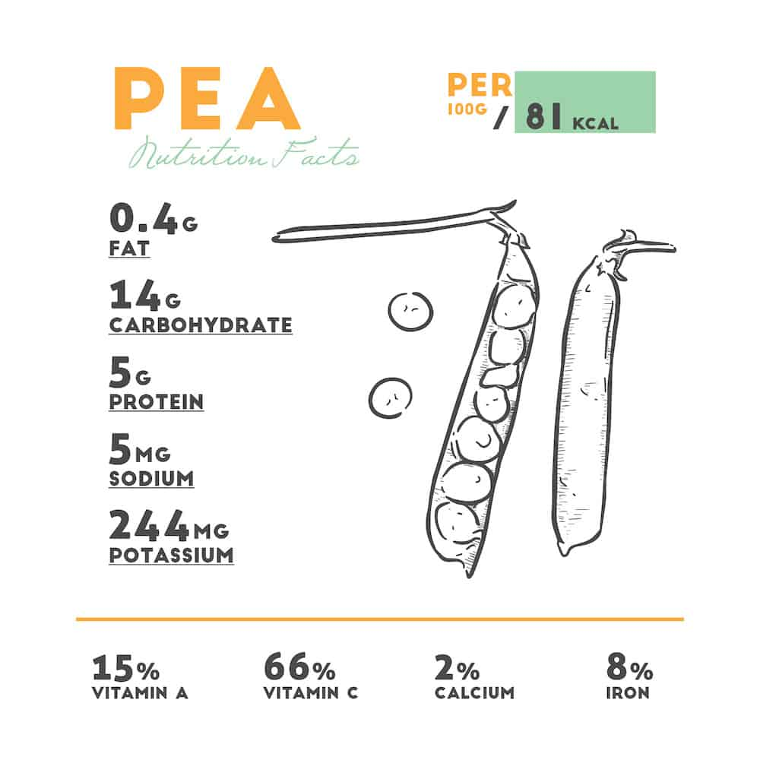

HOW TO GROW PEAS
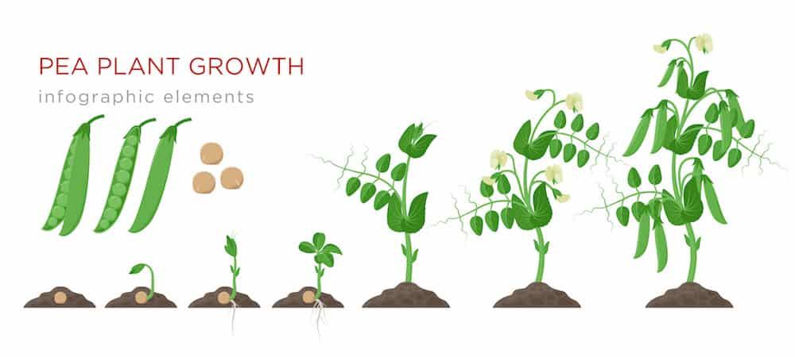HARVESTING GARDEN PEAS
GARDEN PEAS MATURE VERY QUICKLY AND BUSH VARIETIES GET READY IN 50 DAYS. WHEN THE PODS LOOK FULL, PLUMP, AND BRIGHT GREEN, IT’S TIME TO HARVEST THEM. MAKE SURE YOU DON’T LET THE PEAS GET TOO FAT INSIDE THE SHELL OR THEY WILL TAKE ON A YELLOWISH COLOR AND BITTER TASTE AND TURN STARCHY. HOWEVER, DON’T HARVEST TOO EARLY EITHER OR THE PEAS WILL BE VERY SMALL AND NOT AS SWEET. THE BEST WAY TO DETERMINE WHEN THEY ARE RIPE ENOUGH IS TO GENTLY SQUEEZE THEM BETWEEN YOUR FINGERS TO TEST THEIR PLUMPNESS AND TENDERNESS.
ENGLISH PEAS DO NOT STORE WELL AND THEIR NATURAL SUGARS CAN QUICKLY TURN INTO STARCH. THEREFORE, IT IS BEST TO CONSUME THEM ALL 3 TO 4 DAYS AFTER PICKING.

HARVESTING SNOW PEAS
THE SNOW PEA PODS ARE TRANSLUCENT UNDER THE SUNSHINE AND YOU CAN MAKE OUT THE PEAS INSIDE, ONCE THEY START TO FORM. SNOW PEAS TYPICALLY TAKE THE LONGEST TO MATURE, ESPECIALLY THE TALLER CULTIVARS, EVEN THOUGH YOU DO NOT HAVE TO WAIT FOR THE PEAS INSIDE TO GROW PLUMP. THEY CAN BE HARVESTED WHEN THE POD HAS GROWN TO ITS FULL LENGTH BUT STILL REMAINS FLAT. THESE PEAS MUST BE PICKED REGULARLY SO THAT THE PODS REMAIN SWEET AND NON-FIBROUS. IF YOU MISSED SOME MATURE PODS IN THE FIRST PICKING, YOU MUST REMOVE THEM FROM THE PLANT AND USE THE STILL-GROWING PEAS INSIDE LIKE GARDEN PEAS. HOWEVER, THE LARGE, PLUMP SEEDS INSIDE MAY NEED TO BE THROWN OUT AS THEY ARE BITTER.

HARVESTING SUGAR SNAP PEAS
LIKE SNOW PEAS, SUGAR SNAP PEAS ALSO NEED TO BE HARVESTED AFTER EVERY 1 T 3 DAYS. THESE PEAS ARE AT THEIR CRUNCHIEST AND SWEETEST WHEN THE POD FIRST BEGINS TO GET PLUMP BUT THE SEEDS INSIDE ARE STILL GROWING. AT THIS STAGE, THE POD SNAPS LIKE GREEN BEANS AND CAN BE EATEN. SOME VARIETIES ALSO COME WITH STRINGS ALONG THEIR SEAMS THAT MUST BE REMOVED BEFORE COOKING. IF LEFT TOO LONG ON THE VINE, THEIR PODS BECOME TOUGH WITH FIBER AND BECOME INEDIBLE. YOU CAN THEN SHELL THESE PEAS AND EAT THEM LIKE GARDEN PEAS.
SUGAR SNAP PEAS CAN GROW AND PRODUCE MORE PEAS AS LONG AS THE WEATHER STAYS PLEASANT AND THE PLANT REMAINS IN GOOD HEALTH.

TEMPERATURE & SUNLIGHT
PEAS ARE COOL-WEATHER CROPS. THEY WILL NOT GROW WHEN WARMER WEATHER HITS SO MAKE SURE YOU PLANT THEM BY EARLY SPRING. IF NOT, THEY WILL NOT FLOWER AND HENCE, YOU WON’T GET ANY PEA PODS.
PEAS CAN ALSO SURVIVE IN A LIGHT FROST. AREAS WITH MILD TEMPERATURES MAY GET A SECOND CROP OF FALL PEAS, BUT FIRST, YOU WILL NEED TO MANAGE THE PEAS DURING THE UNPREDICTABLE TEMPERATURES OF THE LAST FEW WEEKS OF THE SUMMER.
IT IS ALSO IMPORTANT TO KNOW THAT PEAS PREFER 6 TO 8 HOURS OF DIRECT SUNLIGHT EVERY DAY, THOUGH THEY CAN ALSO SURVIVE IN SHADIER SPOTS.

MULCHING
PEAS DO NOT HAVE DEEP ROOTS SO IT IS IMPORTANT TO KEEP THE SOIL AROUND THE ROOTS MOIST AND COOL. YOU CAN START MULCHING WHEN THE ROOTS OF THE PLANT ARE TWO INCHES LONG.
PEAS PREFER MULCHES MADE OF CHOPPED LEAVES, COMPOST, LEAF MULCH, AND CLEAN STRAW. KEEP IN MIND THAT YOU MAY HAVE TO ADD MORE MULCH TO THE PLANT AS IT GROWS.

MATURITY
THE DAYS TO MATURITY OF PEAS CAN VARY ACCORDING TO THEIR CULTIVAR. MOST PEAS MATURE WITHIN 55 TO 70 DAYS, SO CHECK YOUR SEE PACKAGING FOR INSTRUCTIONS. HOW LONG IT TAKES FOR SEEDS TO GERMINATE DEPENDS ON THE SOIL TEMPERATURE.

WATERING NEEDS
IT IS IMPORTANT TO NOTE THAT WATER IS VERY IMPORTANT WHEN PEAS ARE FLOWERING AND PRODUCING PODS. THEREFORE, YOU NEED TO WATER THE PLANTS DEEPLY EVERY WEEK. IF THEY DON’T GET THE MOISTURE THEY NEED, THE PLANTS WILL PRODUCE ONLY A LIGHT HARVEST.

FERTILIZER
PEAS ARE QUITE LOW MAINTENANCE WHEN IT COMES TO THEIR FEEDING AND DOESN’T NEED TO BE FERTILIZED. IF YOU DO FEED THEM FERTILIZERS, WHICH CONTAIN NITROGEN, THEY WILL PRODUCE A LOT OF LUSH FOLIAGE, INSTEAD OF THE PEA PODS. SO IT IS BEST TO KEEP FERTILIZERS TO THE MINIMUM.

PEST AND DISEASES
FORTUNATELY, A LOT OF VARIETIES OF PEAS ARE RESISTANT TO PESTS AND DISEASES. HOWEVER, SOMETIMES THEY MAY BE INFECTED WITH FUSARIUM WILT AND ROOT ROT DISEASE.
THE SYMPTOMS OF THESE DISEASES ARE WILTING AND YELLOWED LOWER LEAVES AND STUNTED GROWTH. OLDER PLANTS THAT BECOME INFECTED PRODUCE PODS WITH MISSING SEEDS. IF LEFT UNTREATED, THE STEMS WILL BECOME THICK AND BLACK AND THE PLANT WILL EVENTUALLY DIE. YOU CAN PREVENT THIS BY KEEPING THE SOIL WELL-DRAINED.
WE HOPE YOU WERE ABLE TO LEARN A GOOD DEAL ABOUT THE DIFFERENT VARIETIES OF PEAS. THOUGH THE SHELLED AND FROZEN VARIETIES ARE EASILY AVAILABLE IN SUPERMARKETS, NOTHING TASTES AS GOOD AS PEAS THAT ARE GROWN ORGANICALLY IN YOUR OWN GARDEN!

13 DIFFERENT TYPES OF PIZZA
HERE ARE THE DIFFERENT TYPES OF PIZZAS THAT ARE SUB CATEGORIZED INTO THE VARIOUS TYPES OF ITALIAN PIZZAS AND THE VARIOUS TYPES OF AMERICAN PIZZAS SHOWCASING THE DIFFERENT FLAVORS AND TOPPINGS.
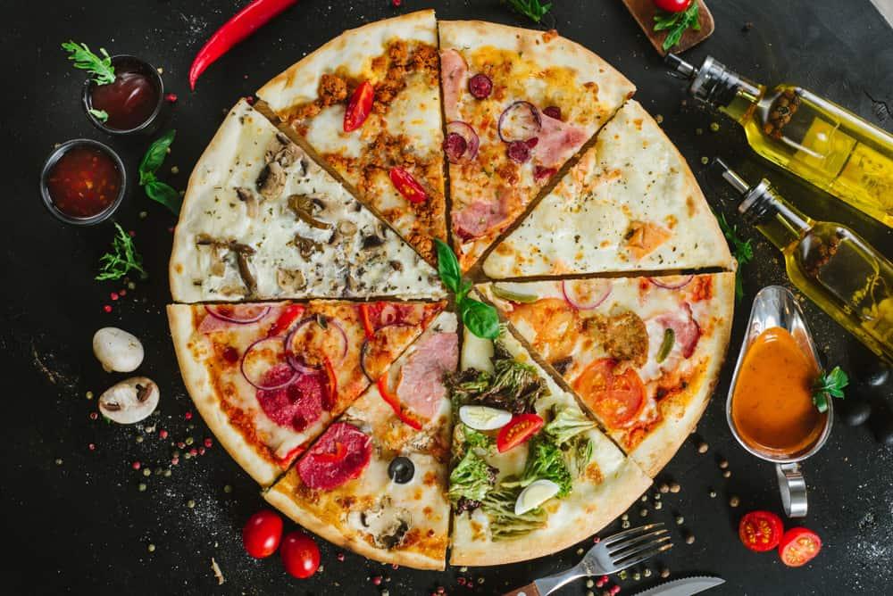
AMERICA REPRESENTS A RICH AND COLORFUL TAPESTRY OF INDIVIDUAL INFLUENCES BY HISTORICAL WAVES OF FOREIGN IMMIGRANTS TO THE UNITED STATES. THEY HAVE ALL LEFT THEIR INDELIBLE MARKS ON THE FABRIC OF LOCAL CULINARY CULTURE.
THE U.S. HAS SOME VERY DISTINCT REGIONAL APPROACHES TO THE ART OF PIZZA MAKING. FROM THIN CRUST AND DEEP-DISH TO TRADITIONAL, TIME-HONORED NEAPOLITAN ITALIAN VARIETIES, THE STYLES ON OFFER ARE VARIED AND STRONGLY INFLUENCED BY THE UNIQUE PREPARATION METHODS OF ITS INHABITANTS.
THERE ARE NOT MANY THAT CAN SAY THEIR NATIONAL DISH HAS BECOME AN INTERNATIONALLY RENOWNED PHENOMENON. CONCEIVED IN NINETEENTH-CENTURY ITALY, PIZZA IS ONE SUCH DISH. SINCE ITS INTRODUCTION TO U.S. SHORES OVER A HUNDRED YEARS AGO, ITS EVOLUTION HAS SPAWNED A WONDERFUL ARRAY OF PIZZA STYLES THAT IS SURE TO PLEASE THE MOST DISCERNING PALATE.
RELATED: HOW TO CLEAN PIZZA STONE | WHAT TO SERVE WITH PIZZA | HOW TO STORE LEFTOVER PIZZA | PIZZA SAUCE SUBSTITUTES | SKILLET DEEP DISH PIZZA RECIPE | ALTERNATIVES TO PIZZA | PIZZA DOUGH RECIPE | TYPES OF PIZZA CUTTERS | TYPES OF FOOD

PIZZA: THE ITALIAN CONNECTION

WITH A STAGGERING THREE BILLION SOLD IN THE U.S. ANNUALLY, THE PIZZA HAS BECOME AS SYNONYMOUS WITH AMERICAN CULTURE AS BASEBALL AND MUSCLE CARS. NO WONDER THEN THAT IT HAS SPAWNED AS MANY VARIATIONS AS IT HAS. IT DOESN’T REQUIRE A COLLEGE DEGREE TO ACKNOWLEDGE ITS UNDISPUTED ITALIAN ORIGINS, YET FEW KNOW ITS EARLY AMERICAN CONNECTIONS.
AN EARLY ANCESTOR OF PIZZA, THE PANIS FOCACIUS OR FOCACCIA AS IT’S KNOWN TODAY, FIRST APPEARED IN 1ST CENTURY ROMAN CUISINE, EARNING ITS POSITION AS AN ITALIAN STAPLE FROM THEN ON. OTHER ITERATIONS OF THE HUMBLE FLATBREAD HAVE APPEARED IN HISTORICAL RECORDS AS FAR BACK AS 7000BC ACROSS THE MEDITERRANEAN AND THE LEVANT.
WITH ITS CUSTOMARY BASIC INGREDIENTS THAT MAKE UP A CLASSIC ITALIAN NEAPOLITAN OR AMERICAN MARGHERITA PIZZA, THE MODERN PIZZA CAN BE TRACED BACK TO SOUTHERN AND CENTRAL ITALY, SPECIFICALLY THE NAPLES REGION IN CENTRAL ITALY.
IN THE LATE 19TH CENTURY, ITALIAN IMMIGRANTS IN NEW YORK CITY AND OTHER LARGE CITIES AND METROPOLES IN THE U.S. WERE BAKING PIZZAS AT HOME FOR THEIR FAMILIES.
IN 2009, A COLUMN IN “SERIOUS EATS” MENTIONED THAT “PIZZA” FIRST APPEARED IN A BOSTON JOURNAL ARTICLE IN 1904. IT ALLEGED THAT THE BRUNO BROTHERS, GIOVANNI AND GENNARO, ARRIVED IN THE U.S. FROM NAPLES, ITALY, IN 1903 AND INTRODUCED THE NEAPOLITAN PIZZA TO BOSTON. LATER, GIOVANNI’S SON, VINCENT, WENT ON TO OPEN THE FIRST PIZZERIA IN CHICAGO.
MANY ALTERNATE THEORIES HAVE EMERGED OVER THE YEARS; HOWEVER, IT IS NOT DISPUTED THAT ITALIANS FIRST BROUGHT PIZZA TO AMERICA.
G.I.’S SERVING IN THE ITALIAN CAMPAIGN DURING WORLD WAR II WERE EXPOSED TO ITALIAN CUISINE, AND AS A RESULT, THE POPULARITY OF PIZZA UPON THEIR RETURN WAS A FOREGONE CONCLUSION. SO MUCH SO THAT IT WAS FEATURED IN AN EPISODE OF “POPEYE THE SAILOR” IN THE 60S. THE REST, AS THEY SAY, IS HISTORY.

PIZZA TYPES: ITALIAN VS. AMERICAN

WHAT MAKES AS “AUTHENTIC” PIZZA IS SOMEWHAT OPEN TO INTERPRETATION. IF YOU TYPE IN “PIZZA” ON YOUTUBE, YOU’RE BOUND TO FIND VIDEOS CLAIMING THAT AN AUTHENTIC PIZZA IS UNDENIABLY “NEAPOLITAN.” IF YOU PUNCH IN “AMERICAN” BEFORE THE “PIZZA,” YOU’RE LIKELY TO GET RESULTS THAT BEAR LITTLE RESEMBLANCE TO ITS ITALIAN COUNTERPART ON CLOSER INSPECTION.
AND THAT HAS SOMETHING TO DO WITH THE INGREDIENTS USED, COOKING METHODS, AND EVEN THE SIZE AND SHAPE.
ALTHOUGH THE EARLY AMERICAN PIZZA DID NOT DIFFER SUBSTANTIALLY FROM ITS NEOPOLITAN FOREBEAR, IT QUICKLY CHANGED AFTER ITS INTRODUCTION TO THE U.S. IT SOON TOOK ON EVOLVED CHARACTERISTICS TO FIT AMERICAN TASTES.
IN ITS MODERN FORM, THE AMERICAN AND ITALIAN VARIETIES STILL DIFFER IN SEVERAL FUNDAMENTAL WAYS.

1. FLOUR TYPE
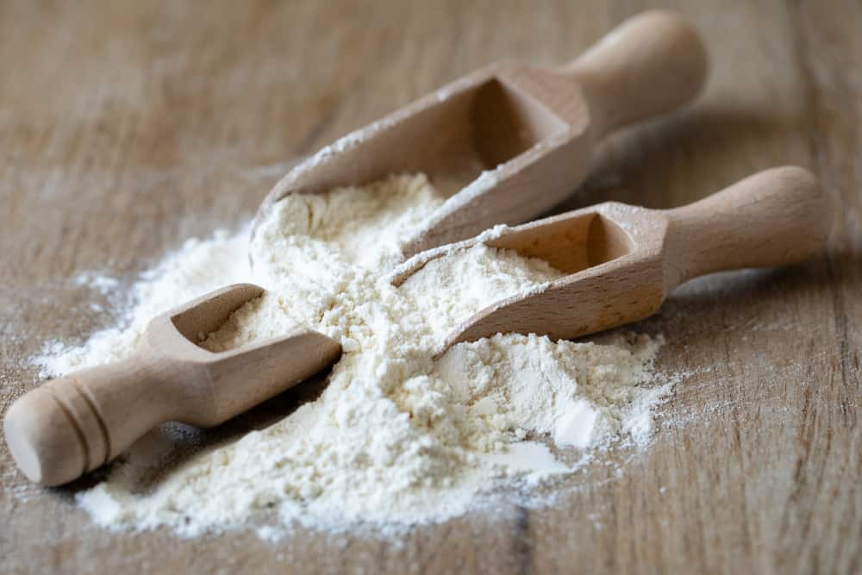
CONSIDERED THE GOLD STANDARD FOR MAKING PIZZA DOUGH, DOUBLE ZERO OR “TIPO 00” FLOUR IS A FINELY MILLED FLOUR WITH A TYPICAL PROTEIN CONTENT OF AROUND 11 OR 12%. THIS LEADS TO A CRUNCHY CRUST SYNONYMOUS WITH ITALIAN PIZZA.
MOST AMERICAN PIZZAS ARE MADE FROM ALL-PURPOSE FLOUR MADE FROM DURUM WHEAT AND WITH A PROTEIN CONTENT AS HIGH AS 14%.
AMERICAN PIZZA OFTEN HAS VEGETABLE OIL OR SHORTENING MIXED INTO THE DOUGH; THIS IS NOT AS COMMON IN ITALIAN RECIPES.

2. THE CHEESE
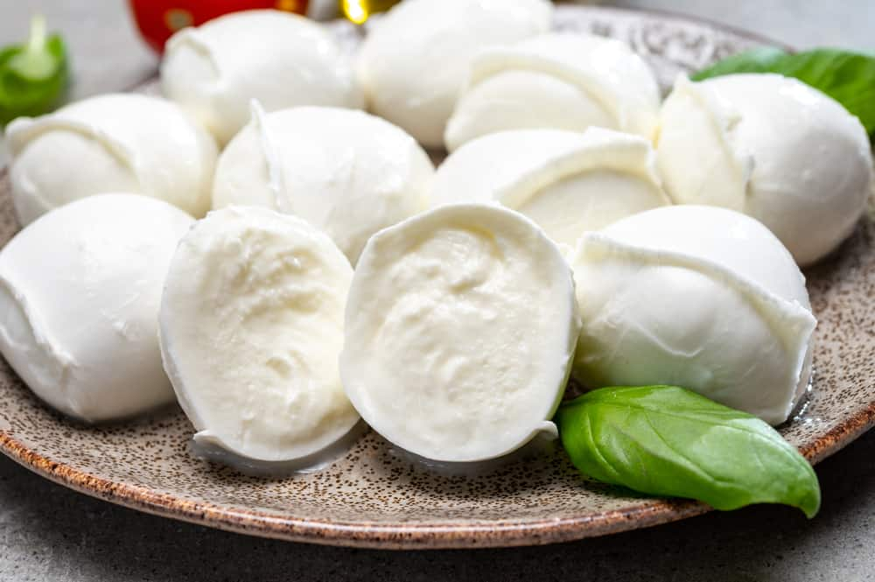
ITALIAN PIZZA IS MADE USING BUFFALO MOZZARELLA, WHICH IS FRESH AND MILD WITH A CREAMY CONSISTENCY. THESE CHEESE BALLS ARE USUALLY STORED AND SOLD IN GLASS JARS OR PLASTIC BAGS FILLED WITH WATER OR WHEY TO KEEP THEM MOIST.
THEY ARE NOT GRATED BUT APPLIED WHOLE OR SLICED, FAIRLY SPARINGLY. ONCE COOKED, THE TOMATO BASE SHOULD BE VISIBLE BETWEEN THE CHEESE DOLLOPS.
THE MOZZARELLA USED TO MAKE AMERICAN-STYLE PIZZA IS FIRMER AND MORE RUBBERY WITH A MILD, SALTY TASTE. THIS MASS-PRODUCED CHEESE VARIETY IS USUALLY GRATED BEFORE APPLYING, MELTS WELL, AND CAN BE STRINGY.
SOMETIMES, A MIXTURE OF CHEESES, INCLUDING MOZZARELLA AND CHEDDAR OR PROVOLONE, CAN BE APPLIED TO CREATE A RICHER TEXTURE AND TASTE.

3. THE TOMATO SAUCE
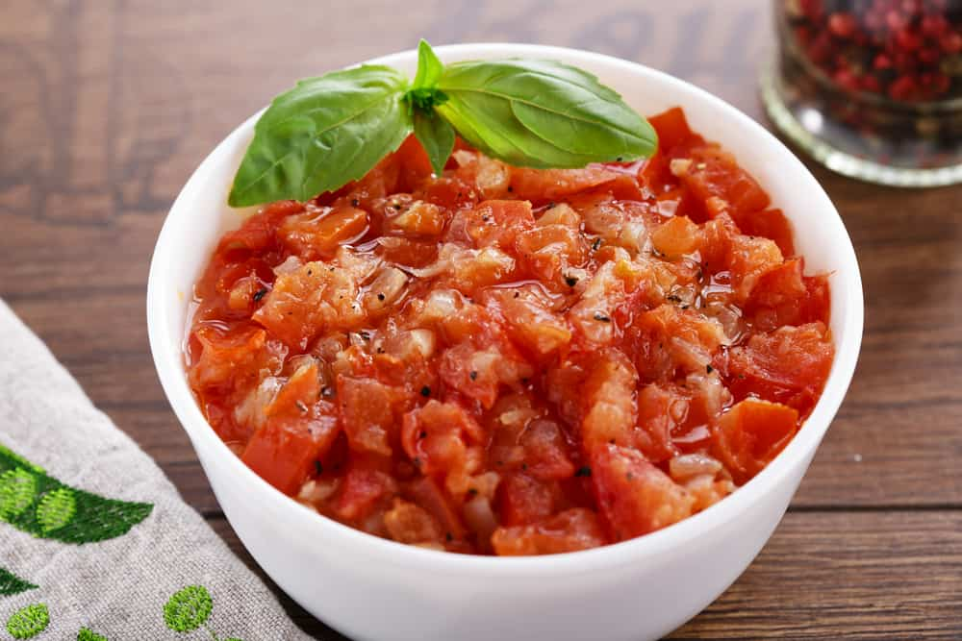
THE SAUCES USED ARE A KEY DIFFERENCE. IN THE U.S., A SLOW-COOKED TOMATO CONCASSE USING PUREED TOMATO PASTE IS USED. THEY OFTEN DIFFER BASED ON THE MANUFACTURER OR A RESTAURANT TO CREATE A SIGNATURE SAUCE.
IN ITALY, HOWEVER, THIS IS NOT USUALLY THE CASE. YOU ARE MORE LIKELY TO SEE A FRESHLY MADE SAUCE COMPRISING CRUSHED OR PUREED FRESH TOMATOES AND GARLIC, OREGANO HERB, AND OLIVE OIL. THIS HERBY SAUCE IS USED TO INFUSE THE DRY CRUST OF THE BASE.

4. THE MEAT TOPPINGS

Bottom of Form
IN THE U.S., CUSTOMERS ARE MORE LIKELY TO GET THEIR TOPPINGS, INCLUDING THE MEAT, JUST AS YOU WANT IT. THESE MEAT ADDITIONS CAN COME IN THE FORM OF ANY MANNER OF SAUSAGE, SALAMI, BACON, PEPPERONI, HAM, OR EVEN MINCEMEAT. A REAL MEAT LOVER’S PIZZA WILL EVEN INCLUDE A COMBINATION OF MEATS.
THE ITALIANS, ON THE OTHER HAND, FIND THIS APPROACH SACRILEGIOUS. MIXING MEATS IN ITALY IS CONSIDERED TABOO, AND YOU WON’T FIND A MEAT SALAD ON YOUR PIZZA. THEY WILL USUALLY USE ONLY SALAMI OR PEPPERONI AND APPLY SPARINGLY.

5. THE CRUST

DEPENDING ON WHERE YOU GO, YOU WILL FIND A VARIETY OF CRUSTS CATERING TO EVERY TASTE. EVERY LITTLE MOM-AND-POP VILLAGE PIZZERIA WILL HAVE ITS OWN VERSION AND LOUDLY DECLARE IT THE ONLY WAY TO MAKE A PROPER PIZZA.
USUALLY, THOUGH, A TRADITIONAL ITALIAN PIZZA HAS A WAFER-THIN BASE WITH A PUFFED-UP CRISPY RING EDGE.
THE CORRECT WAY TO EAT THE PIZZA SLICE IS TO CURL IT IN WITH YOUR HAND TO FORM A FOLDED-UP CALZONE-STYLE PIZZA.
AMERICAN PIZZAS USUALLY COME IN TWO BASIC STYLES, THE STANDARD THIN-BASED PIZZA AND THE DEEP-DISH PAN PIZZA, SO THICK SOMETIMES THAT IT’S LIKE EATING A LOAF OF BREAD. THIS IS AN ENTIRELY AMERICAN TAKE ON PIZZA CRUST.

6. VARIETY
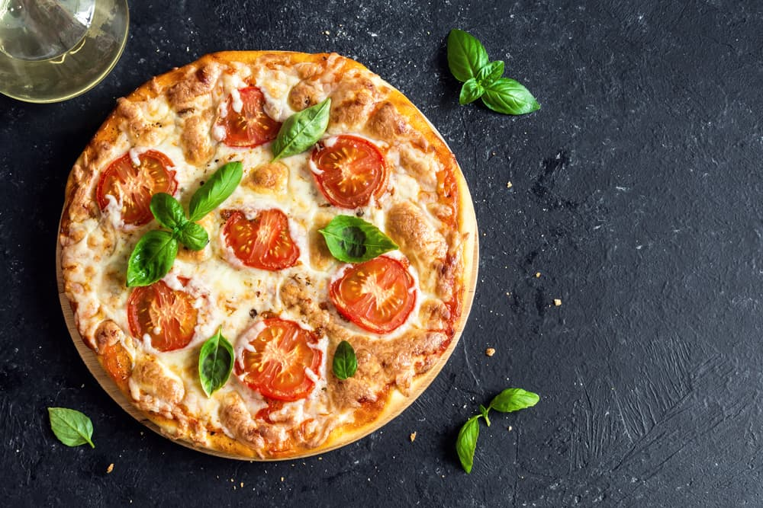
MANY A NEAPOLITAN PIZZAIOLO WILL TELL YOU THAT IN HIS “PROFESSIONAL” OPINION, THERE ARE ONLY THREE TYPES OF PIZZA THAT SHOULD BE SERVED, ALTHOUGH THIS CAN BE TAKEN WITH A SLIGHT PINCH OF SALT.
THE THREE BASIC TYPES OF NAPLES STYLE PIZZA ARE:
- MARGHERITA – TOMATO, MOZZARELLA, AND BASIL
- MARINARA – TOMATO, OREGANO, AND OLIVE OIL
- DOP MARGHERITA – TOMATO, BUFFALO MOZZARELLA, BASIL, AND OLIVE OIL
THE U.S. HAS TAKEN THE TRADITIONAL PIZZA AND RUN WITH IT WHEN IT COMES TO VARIATIONS. THERE ARE PERHAPS AS MANY VARIATIONS ON THE CHOICE OF TOPPINGS AS PIZZA JOINTS THAT SERVE THEM.
HOWEVER, A FEW POPULAR VARIANTS, SUCH AS THE HAWAIIAN, PEPPERONI, AND REGINA, ARE USUALLY FOUND IN CHAIN PIZZA RESTAURANTS AND TAKE-OUT DINERS.

ITALIAN PIZZA
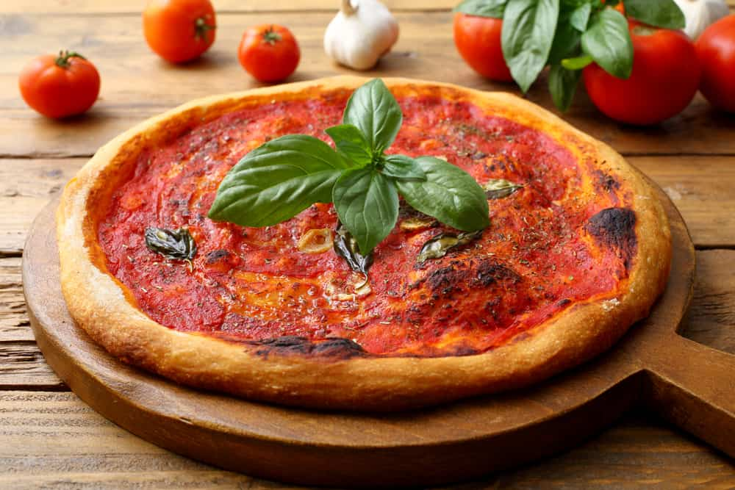
REGARDED AS THE ONLY “TRUE” PIZZA, THE ITALIAN GOVERNMENT HAS CLAIMED THE NEOPOLITAN PIZZA AS REQUIRING PROTECTION AND PROMOTION. IN 2004, THE MINISTRY OF AGRICULTURE RELEASED A SET OF GUIDELINES OUTLYING THE STEP-BY-STEP REQUIREMENTS FOR MAKING THE FAMOUS NEOPOLITAN.
AMONGST OTHERS, SOME OF THE RULES STIPULATE THE FOLLOWING:
THE BASE MUST BE ROUND AND NO MORE THAN 35CM IN DIAMETER, AND THE DOUGH KNEADED AND SHAPED BY HAND. THE DOUGH MUST RISE FOR AROUND SIX HOURS. THE PIZZA MUST BE COOKED IN A WOOD-FIRED OVEN. THE FINAL PRODUCT MUST BE ELASTIC AND SOFT, AND EASILY FOLDABLE.
ONLY THREE TYPES OF NEAPOLITAN PIZZA EXIST, THEY SAY. THE FIRST IS MARINARA WITH GARLIC AND OREGANO.
A MARGHERITA MUST BE MADE WITH BASIL, TOMATOES, AND MOZZARELLA CHEESE FROM THE SOUTHERN APENNINE MOUNTAINS.
FINALLY, THE “EXTRA MARGHERITA” VARIETY MUST INCLUDE BUFFALO MOZZARELLA FROM THE CAMPANIA REGION.
ACCORDING TO THE DRAFT BILL, PIZZAS THAT MAKE THE CUT ARE ALLOWED TO SPORT A PRESTIGIOUS STG OR GUARANTEED TRADITIONAL SPECIALITY LABEL.
“THE STG NEAPOLITAN APPROVED PIZZA IS CHARACTERIZED BY ITS RAISED, GOLDEN CRUST, SOFT TO THE TOUCH AND THE LIPS WITH THE RED OF THE TOMATO VISIBLE THROUGH THE WHITE SPOTS OF THE MOZZARELLA.”
IN 2009 THE PIZZA NAPOLETANA WAS, ACCORDING TO AN ARTICLE IN THE BRITISH DAILY “THE GUARDIAN,” AWARDED THIS SPECIAL STATUS BY THE EUROPEAN UNION. PIZZA PROFESSIONAL “POLICE” DO APPARENTLY MAKE SPOT CHECKS ON ALL STAGES OF THE PIZZA-MAKING PROCESS.
ALTHOUGH THE THREE BASIC VARIATIONS OF THE NEAPOLITAN PIZZA ARE THE STANDARD FARE FOUND IN ANY AUTHENTIC ITALIAN PIZZERIA, THERE IS SOME ROOM FOR AN ARTISTIC LICENSE WHEN CREATING A CULINARY MASTERPIECE. THEREFORE SOME OFFSHOOTS HAVE BEEN MAKING GAINS IN THE POPULARITY STAKES WITH ITALIANS AND FOREIGN VISITORS IN RECENT YEARS.

1. PIZZA VIENNAISE

SURPRISINGLY A NATIVE OF NAPLES, THIS KID’S FAVORITE IS A TRADITIONAL ITALIAN VARIETY DESPITE ITS GERMANIC-SOUNDING NAME. TOPPED WITH TOMATO SAUCE AND MOZZARELLA, IT ALSO INCLUDES VIENNA SAUSAGES SLICED INTO PIECES.
IT’S QUITE COMMONLY SERVED IN THE NORTHERN ITALIAN REGIONS BORDERING AUSTRIA AND IS SOMETIMES ACCOMPANIED BY FRIES. DEFINITELY NOT FOR CALORIE COUNTERS. ALSO KNOWN AS PIZZA WURSTEL AND PIZZA WITH HOTDOG.

2. PIZZA CARRETTIERA
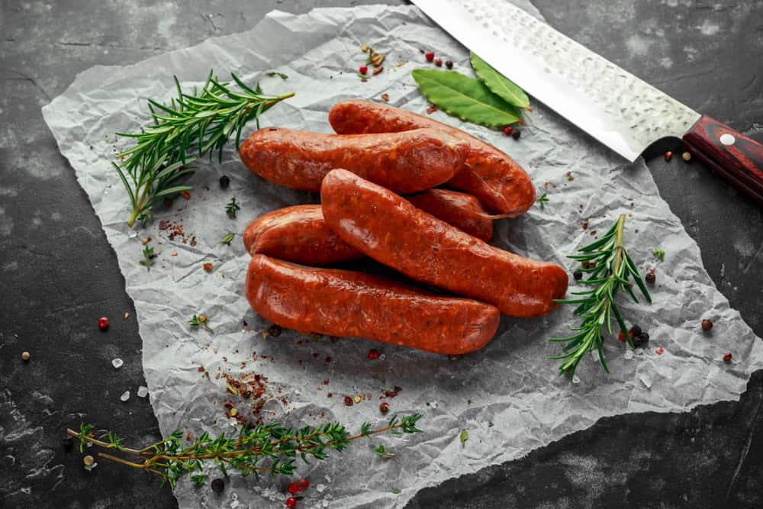
A MUCH LOVED VERY TYPICALLY ITALIAN VARIETY; THE CARRETTIERA IS MOST COMMONLY TOPPED WITH SALSICCIA (A TYPE OF PORK SAUSAGE), RAPINI (AN ITALIAN VEGETABLE RESEMBLING BROCCOLI), PEPPERONCINI OR HOT PEPPERS, AND SMOKED PROVOLONE INSTEAD OF MOZZARELLA CHEESE.
TO FINISH IT OFF, IT’S USUALLY DRIZZLED WITH OLIVE OIL AND FRESH BASIL LEAVES FOR GARNISHING.
ANOTHER VARIATION OF THE CARRETTIERA IS CALLED THE “RIPIENO,” A STUFFED VERSION, SIMILAR TO A CALZONE WITH THE MAIN INGREDIENTS SEALED BETWEEN TWO HALVES OF THE DOUGH AND BAKED IN THE OVEN, SOMETIMES WITHOUT THE TOMATO SAUCE BASE.

3. PIZZA MONTANARA
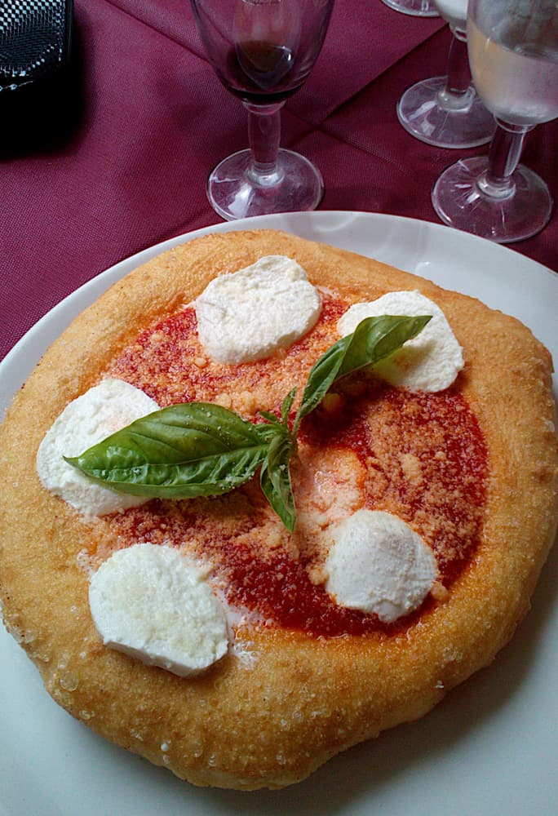
PIZZA MONTANARA (OR MOUNTAIN-STYLE) IS COMMON STREET FOOD IN MANY PARTS OF ITALY. THE MONTANARA CALLS FOR THE DOUGH TO BE TOSSED IN THE DEEP FRIER FOR A SHORT WHILE, THEN TOPPED WITH CHEESE, BASIL AND MOZZARELLA BEFORE BEING PLACED IN THE OVEN TO FINISH OFF WITH AN IMBUED TOASTED FLAVOR AND TO MAKE THE CRUST AIRY AND LIGHT AND ALSO CRUNCHY.
THE HISTORY OF THIS LEGENDARY TAKE ON PIZZA DATES BACK AGES AGO IN THE MOUNTAINS OF CAMPANIA SURROUNDING THE CITY OF NAPLES. THIS PIZZA IS OFTEN SERVED IN ITALIAN RESTAURANTS IN NEW YORK CITY.

4. PIZZA FRITTA
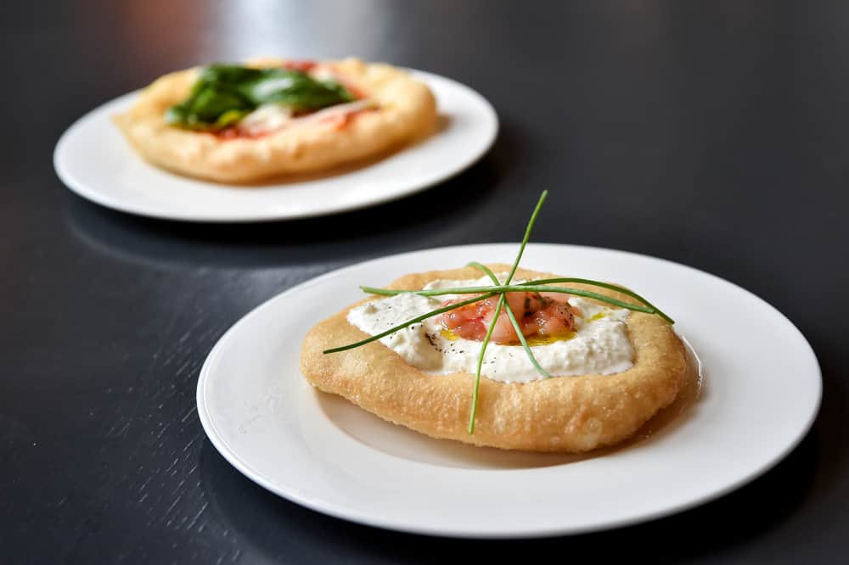
FRITTA OR NEAPOLITAN FRIED PIZZA WAS ONE OF THE OLDEST TYPES OF CLASSIC STREET PIZZA WHEN IT WAS MORE CONVENIENT AND FASTER COOKING WITH HOT OIL RATHER THAN TENDING TO A WOOD-FIRED OVEN.
IT’S BASICALLY MADE BY SEALING THE TOPPINGS BETWEEN TWO LAYERS OF DOUGH AND FRYING IT IN OIL UNTIL IT BECOMES CRISPY ON THE OUTSIDE AND CREAMY ON THE INSIDE, ALMOST LIKE A DOUGHNUT.
IT IS VERY POPULAR AMONGST LOCALS IN NAPLES AND HAS TO BE EATEN PIPING HOT FROM ITS PAPER WRAPPING.

5. PIZZA MARINARA
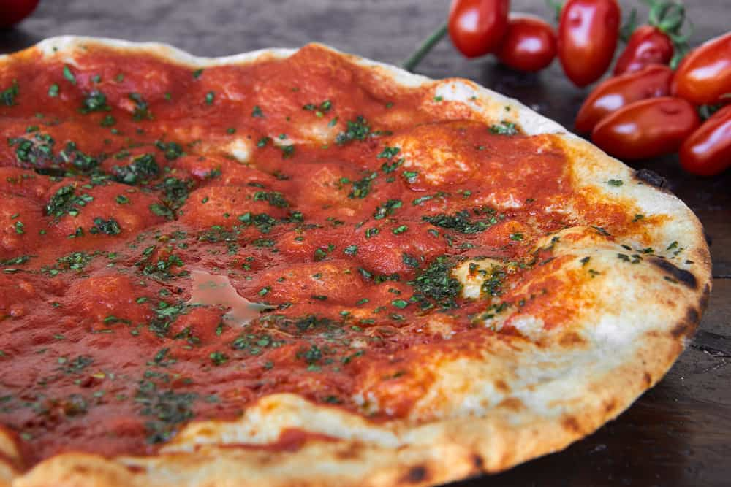
ONE OF THE CLASSIC ORIGINAL THREE NEAPOLITANS, DESPITE ITS NAME, IT IS NOT TOPPED WITH ANY SEAFOOD BUT RATHER GETS ITS NAME FROM THE FACT THAT IT WAS A STAPLE FOR THE NEAPOLITAN FISHERMEN RETURNING AFTER A DAY OUT FISHING IN THE EARLY 18TH CENTURY.
THERE ARE RUMORS THAT ANCHOVIES WERE SOMETIMES ADDED FOR THOSE WHO COULD AFFORD IT BUT THAT THE ANCHOVIES EVENTUALLY GAVE WAY TO GARLIC IN LATER YEARS.
ALLEGED TO BE THE OLDEST PIZZERIA IN THE WORLD, PIZZERIA PORT’ALBA IS CONSIDERED THE MARINARA’S BIRTHPLACE. IT IS ONE OF THE PROTECTED PIZZAS, WITH SPECIFIC GUIDELINES AND RULES GOVERNING ITS PRODUCTION.
THE MAIN INGREDIENTS INCLUDE TOMATOES, GARLIC, EXTRA VIRGIN OLIVE OIL, OREGANO, AND OPTIONAL FRESH BASIL LEAVES.

6. CALZONE PIZZA
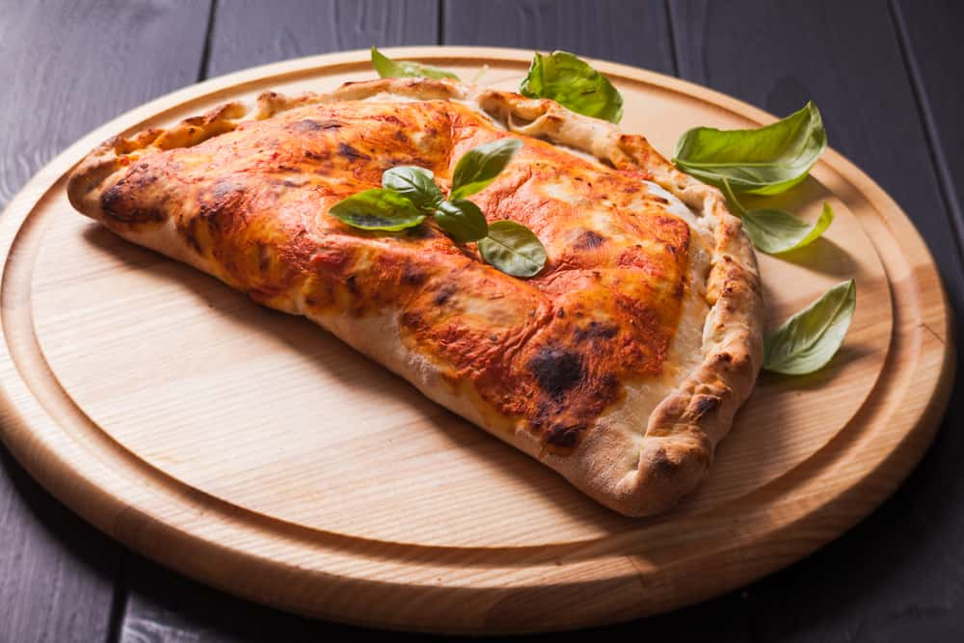
SIMILAR TO THE RIPIENI VERSION OF THE CARRETIERRA, THIS UNIQUE, HALF-MOON-SHAPED PIZZA IS MADE BY FOLDING A PIZZA IN HALF. ORIGINATING IN 18TH CENTURY NAPLES, CALZONE’S LITERAL ITALIAN TRANSLATION MEANS “PANT LEG,” REFERRING APPARENTLY TO THE FACT THAT CALZONE’S ORIGINAL INTENTION WAS TO BE CONSUMED WHILE STANDING OR ON THE GO.
THE INGREDIENT CHOICE IS QUITE VERSATILE, WITH HAM OR SALAMI AND CHEESES SUCH AS MOZZARELLA, PARMESAN, PECORINO, OR RICOTTA-STUFFED INSIDE. A VARIANT FROM APULIA, CALLED PANZEROTTI, INCLUDES SPECIAL LOCALLY GROWN TOMATOES.
TYPICALLY, CALZONES ARE FILLED WITH SALAMI OR HAM AND CHEESES SUCH AS MOZZARELLA, RICOTTA, PARMESAN, AND PECORINO. IN CONTRAST, FRIED CALZONES WITH MOZZARELLA AND TOMATOES ARE A SPECIALTY FROM THE ITALIAN REGION OF APULIA AND ARE KNOWN AS PANZEROTTI.
DEPENDING ON THE REGION, THERE ARE MANY VARIATIONS ON THE CALZONE, AND RECIPES EVEN DIFFER FROM FAMILY TO FAMILY. THE MOST NOTABLE VERSION IS PROBABLY FROM PUGLIA, OR BARI, PREPARED WITH ONIONS, PITTED OLIVES, AND ANCHOVIES, RESEMBLING MORE FOCACCIA THAN THE STANDARD CALZONE.

7. PIZZA MARGHERITA

ONE OF THE MOST POPULAR AND BEST-KNOWN PIZZAS GLOBALLY, THIS SIMPLE PIZZA HAS AN INTERESTING GENESIS.
ALTHOUGH PIZZAIOLO RAFFAELE ESPOSITO OF PIZZERIA BRANDI AND HIS WIFE OFTEN GET CREDITED WITH INVENTING THE ORIGINAL MARGHERITA, THE TRUTH IS THAT IT WAS INVENTED AROUND THE TURN OF THE 19TH CENTURY.
THE STORY GOES THAT IN 1889, ITALIAN QUEEN MARGHERITA OF SAVOY VISITED THE CITY OF NAPLES, WHERE SHE WAS SERVED A PIZZA IN THE TRI-COLORS OF THE ITALIAN FLAG: RED TOMATOES, WHITE MOZZARELLA, AND GREEN BASIL. YET MORE THEORIES TRACE THE ORIGINS BACK TO 1866 AND EARLIER.
IT IS ALSO ONE OF THE THREE ORIGINAL GREATS PROTECTED BY THE STG EUROPEAN UNION PROTECTION LABELS OF 2009.

AMERICAN PIZZA
THERE ARE NO SPECIFIC INDUSTRY GUIDELINES THAT REGULATE THE AMERICAN STYLE PIZZA AND HOW IT SHOULD BE MADE; RATHER, INDIVIDUAL TASTES AND PERSONAL PREFERENCES HAVE BEEN THE CORNERSTONES OF THE EVOLUTION OF AMERICAN PIZZA.
FROM THE LOCAL CORNER PIZZERIA OR ITALIAN RESTAURANT PIZZA JOINT TO THE FROZEN FOODS SECTION OF YOUR LOCAL SUPERMARKET OR DELI, PIZZA AND ITS VARIANTS ARE RATHER DIFFICULT TO DISCERN.
THERE ARE, HOWEVER, SOME REGIONAL FAVORITES THAT HAVE EVOLVED AND ARE SURE TO ENDURE FOR GENERATIONS TO COME.

1. NEW YORK-STYLE PIZZA

THIS PERENNIAL FAVORITE HAS TO BE ONE OF THE MOST WELL-KNOWN AND IS REMINISCENT OF THE OLD SOUTHERN ITALIAN PIZZA TYPES.
NEW YORK-STYLE PIZZA IS MOSTLY FOUND IN NEW YORK AND NEW JERSEY BUT IS PREVALENT THROUGHOUT THE NORTHEASTERN UNITED STATES.
MANY MAINSTREAM FRANCHISE PIZZERIAS SUCH AS PIZZA HUT WILL ADVERTISE THEIR BRAND OF THIS ICONIC FAVORITE BUT ARE NOT GENERALLY ACCEPTED AS AUTHENTIC.
THE HAND-TOSSED HIGH GLUTEN BASE IS TYPICALLY ROLLED OUT LARGE AND THIN, WITH THE RESULTANT CRUST BAKED CRISPY AND THICKER ALONG THE EDGES AND IS OFTEN SOLD AS SLICES TO GO.
THE SLICES ARE SO WIDE AND THIN THAT THEY CAN BE FOLDED IN HALF TO EAT. SIMPLE TOPPINGS SUCH AS TOMATO SAUCE AND MOZZARELLA CHEESE ARE TYPICAL: OREGANO, CHILI FLAKES, OR GARLIC.
VARIATIONS ON THE NEW YORK PIZZA CAN INCLUDE TOPPINGS SUCH AS SALAMI OR PEPPERONI OR BY USING BUFFALO MOZZARELLA INSTEAD OF THE USUAL DRY TYPE.
IT IS A COMMONLY HELD BELIEF THAT THE HIGH MINERAL CONTENT IN THE NEW YORK WATER SUPPLY CONTRIBUTES TO THE TEXTURE AND TASTE OF THE DOUGH MIXTURE USED.

2. CHICAGO-STYLE PIZZA

REVERED AS A CHICAGO NATIVE CREATION, THERE ARE CONTRASTING THEORIES ON THE ORIGINS OF THE CHICAGO-STYLE PIZZA OR DEEP-DISH PIZZA AS IT IS COLLOQUIALLY NAMED. WHAT IS NOT DISPUTED IS THAT IT GETS ITS DEEP-DISH DESIGNATION FROM THE WAY THAT IT IS PREPARED.
THE CHICAGO-STYLE DEEP-DISH PIZZA, RESEMBLING A PIE, IS EITHER THICK ALL THE WAY THROUGH, OR THE CRUST IS THINNER ON THE INSIDE IN MORE TRADITIONAL VARIANTS. THIS PIZZA IS BAKED IN A ROUND PIE OR CAKE PAN OR SKILLET THAT’S OILED BEFOREHAND TO LIMIT STICKING AND CREATE A FRIED EDGE TEXTURE.
THE DOUGH IS OFTEN A MIXTURE OF WHEAT FLOUR AND SEMOLINA OR CORNFLOUR AND CAN HAVE A YELLOWISH TONE, RESULTING FROM FOOD DYE ADDED TO THE MIXTURE.
THE DOUGH IS PRESSED UP AGAINST THE INSIDE OF THE PAN, ALLOWING A DEEP SPACE FOR A THICK LAYER OF TOPPINGS.
THE USUAL SLICED OR GRATED MOZZARELLA CHEESE IS SPRINKLED ONTO THE BASE, FOLLOWED BY PEPPERONI, SALAMI, SAUSAGE, OR HAM MEAT TOPPINGS. THIS CAN THEN BE COMPLEMENTED BY OTHER ADDITIONS SUCH AS MUSHROOMS, PEPPERS, AND ONIONS AND SPRINKLED WITH PARMESAN SHAVINGS FOR A RICHER FLAVOR.
IT IS THEN FINISHED OFF WITH A GENEROUS HELPING OF CANNED CRUSHED TOMATOES. THE TOPPINGS ARE APPLIED IN THE REVERSE ORDER OF CONVENTIONAL PIZZA STYLES.
THIS PIZZA IS QUITE DENSE AND MOIST ON THE INSIDE AND IS USUALLY NOT SLICED UNTIL IT’S READY TO BE CONSUMED, THUS PREVENTING THE CRUST FROM GETTING SOAKED BY THE SAUCES.

3. DETROIT-STYLE PIZZA

DETROIT-STYLE PIZZA IS ANOTHER REGIONAL DIVERSION FROM ITS ITALIAN ROOTS. THESE PIZZAS ARE SERVED IN A SQUARE OR RECTANGULAR SHAPE, SIMILAR TO THE “SFINCIONE” OR THICK SPONGE ONES FOUND IN SICILY.
A LOCAL FABLE CREDITS THE SHAPE TO DETROIT AUTO WORKERS USING CAR OIL DRIP TRAYS FROM THEIR FACTORIES AND AUTO WORKSHOPS TO BAKE THE PIZZAS IN. LIKE DEEP-DISH PIZZAS, THE DOUGH IS PUSHED AND PRESSED UP THE SIDES OF THE BAKING DISH, RESEMBLING AN APPLE PIE CRUST OR A FOCACCIA BREAD.
THE SAME PRINCIPLE AS DEEP-DISH PIZZA APPLIES WHEREBY A LAYER OF PEPPERONI OR OTHER MEAT TOPPING IS APPLIED DIRECTLY TO THE BASE, FOLLOWED BY A THICK LAYER OF EITHER MORE TRADITIONAL WISCONSIN BRICK CHEESE OR MOZZARELLA, OR A COMBINATION OF BOTH AND THEN TOPPED OFF WITH THE TOMATO SAUCE.
THE TOPPINGS ARE APPLIED TO THE EDGE AND, WHEN MELTED, ADD FATS AND OILS TO THE CRUST EDGE TO CREATE THAT EXTRAORDINARY CRISPY CRUST WITH A PILLOWY INSIDE.

4. CALIFORNIA PIZZA

A FAIRLY MODERN AND UNIQUE VARIANT ORIGINATING AT THE FAMOUS CHEZ PANISSE RESTAURANT IN THE ’80S, THE CALIFORNIA OR GOURMET PIZZA COMBINES A NEW YORK-STYLE AND ITALIAN THIN-CRUST WITH A RANGE OF UNUSUAL TOPPINGS SUCH AS BARBECUE SAUCE, GOAT CHEESE, PINEAPPLES, AND CHICKEN OR WITH A SEAFOOD MIXTURE OF SHRIMP AND SMOKED SALMON WITH ASPARAGUS.
RESIDENT CHEF AT THE CHEZ PANISSE, ED LADOU, EVEN EXPERIMENTED WITH INGREDIENTS SUCH AS RICOTTA, PATE, MUSTARD, AND OTHER INTERESTING COMBINATIONS.
THIS CULINARY ALCHEMY THAT ENDED UP WITH OVER 250 PIZZA RECIPES EVENTUALLY LED TO THE FORMATION OF THE MENU FOR THE CALIFORNIA PIZZA KITCHEN CHAIN RESTAURANT.
THERE ARE NO SPECIFIC TOPPINGS REQUIRED TO MAKE A CALIFORNIA PIZZA. ANYTHING GOES, AND YOU CAN REQUEST IT SERVED EITHER AS A THICK OR A THIN BASE.

5. GREEK-STYLE PIZZA

UNLIKE THE “GREEK PIZZA” ITEM OFTEN SERVED IN RESTAURANTS AS A BASIC GREEK SALAD SERVED ON A REGULAR PIZZA BASE, AN AUTHENTIC GREEK PIZZA WAS CREATED BY GREEK IMMIGRANTS TO THE U.S. WHO WERE INTRODUCED TO ITALIAN CUISINE.
A STYLE OF PIZZA THAT’S CHEWIER AND PUFFIER THAN THE STANDARD THIN-BASED FARE, THEY ARE BAKED IN SHALLOW OILED PANS, RESULTING IN A SLIGHTLY FRIED CRUSTY BOTTOM. NOT TO BE CONFUSED WITH THE DEEP-DISH CRUST, IT’S THINNER, AND THE DOUGH IS SOMETIMES VERY DENSE.
THE SAUCE IS QUITE SPICY WITH A HEAVY INFUSION OF OREGANO AND IS LAYERED ON THE CRUST QUITE THICKLY, AS IS THE CHEESE MIX, WHICH CAN INCLUDE MOZZARELLA, PROVOLONE, OR CHEDDAR.
ADDED TOPPINGS CAN INCLUDE FETA CHEESE, OLIVES, AND RED ONION.

6. ST LOUIS-STYLE PIZZA

ST LOUIS-STYLE PIZZA IS A MID-WESTERN U.S. FAVORITE POPULAR IN RESTAURANTS SUCH AS IMO’S PIZZA AND CAN BE FOUND IN THE FROZEN FOODS SECTION AT SOME SUPERMARKETS AND MANY LOCAL BARS AND TAVERNS.
THE CRUST IS MADE WITHOUT YEAST AND FORMS A THIN, CRISPY, CRACKER-LIKE CRUST THAT DOES NOT BEND WELL. THE TOPPINGS LAID ALL THE WAY TO THE EDGE INCLUDE A PROCESSED CHEESE MIXTURE CALLED “PROVEL,” WHICH INCLUDES SWISS, PROVOLONE, AND CHEDDAR.
THE SAUCE IS USUALLY DISTINCTLY SWEETER THAN TRADITIONAL VARIETIES, THOUGHT TO BE BROUGHT ON BY SICILIAN IMMIGRANTS TO ST LOUIS AND THEIR INFLUENCE ON ITALIAN COOKING.
THE PIZZA IS SERVED SLICED INTO SQUARES INSTEAD OF THE USUAL TRIANGULAR WEDGES, WITH THE REASON FOR THIS LARGELY UNKNOWN.

CONCLUSION
WHILE THE TRADITIONAL PIZZA HAS BEEN AROUND FOR AROUND 200 YEARS IN ITS MODERN FORM, NEW CREATIONS ARE CONSTANTLY BEING ADDED. WITH THE INCREASING DRIVE TO HEALTHIER EATING, VARIATIONS ON THE INGREDIENTS, INCLUDING VEGAN AND GLUTEN-FREE OPTIONS, ARE BECOMING THE NEW NORM.
ONE THING, HOWEVER, IS CERTAIN, NO MATTER HOW YOU LIKE YOUR PIZZA SERVED, IT IS SURELY HERE TO STAY FOR SOME TIME TO COME. BUON APPETITO!

20 TYPES OF BROCCOLI
WHO KNEW THERE WERE 20 DIFFERENT TYPES OF BROCCOLI? WELL, THERE IS AND WE LIST THEM ALL OUT WITH PICTURES AND DESCRIPTIONS. THIS IS YOUR ULTIMATE BROCCOLI GUIDE.
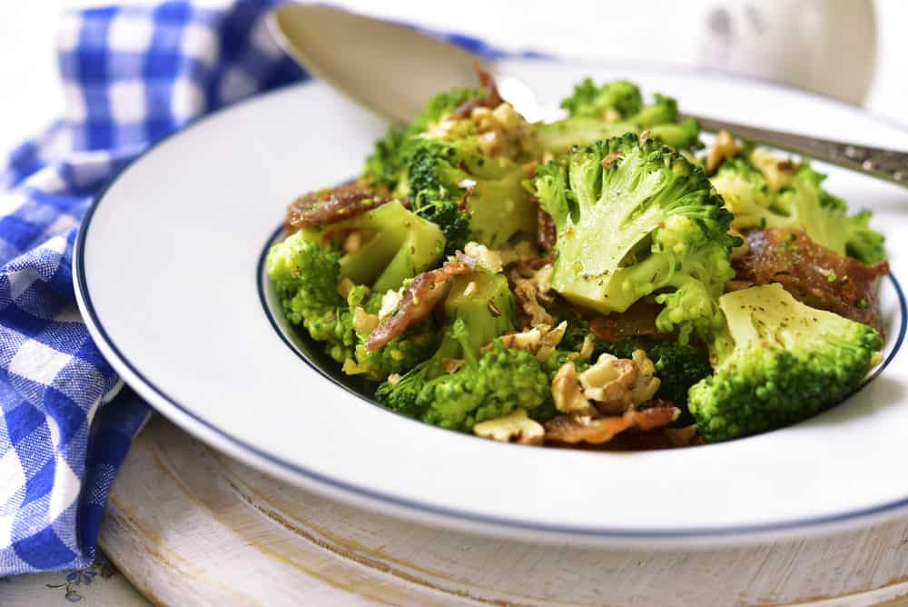
AS I GET OLDER, I APPRECIATE BROCCOLI MORE AND MORE. WHILE I STILL HAVE A HUGE SWEET TOOTH, I’VE COME TO ENJOY VEGETABLES MORE THAN I DID 20 YEARS AGO. BROCCOLI IS MY FAVORITE VEGETABLE. I LIKE COOKED AND RAW. I ALSO LIKE BROCCOLINI.
I SUSPECT OVER THE YEARS I’VE EATEN A VARIETY OF BROCCOLI TYPES, BUT WHAT I DIDN’T REALIZE IS THAT THERE ARE 20 TYPES OF BROCCOLI.
CABBAGE, ANYONE?
BROCCOLI IS A CRUCIFEROUS VEGETABLE AND PART OF THE CABBAGE FAMILY, WHICH INCLUDES VEGETABLES SUCH AS BRUSSEL SPROUTS AND KALE. ALTHOUGH THE TASTES ARE DIFFERENT, BROCCOLI AND THESE OTHER VEGETABLES ARE FROM THE SAME FAMILY.
NUMEROUS HEALTH BENEFITS
THERE ARE NUMEROUS BENEFITS TO EATING BROCCOLI, INCLUDING THE HIGH AMOUNTS OF VITAMINS INCLUDED. THIS INCLUDES VITAMINS C, K, AND A, FIBER, CALCIUM, IRON, AND EVEN ANTI-INFLAMMATORY PROPERTIES THAT MAKE EATING BROCCOLI A VERY SMART THING TO DO. BELOW I SET OUT ALL THE BROCCOLI OPTIONS PLUS A NIFTY BROCCOLI NUTRITION CHART.
RELATED: BROCCOLI ALTERNATIVES | VEGETABLES AND HERBS FOR SYMBIOTIC GARDENING | HOW TO INCREASE VEGETABLE GARDEN YIELD | BROCCOLI CHEDDAR RICE RECIPE | BROCCOLI CHEESE SOUP RECIPE

BROCCOLI NUTRITION FACTS CHART
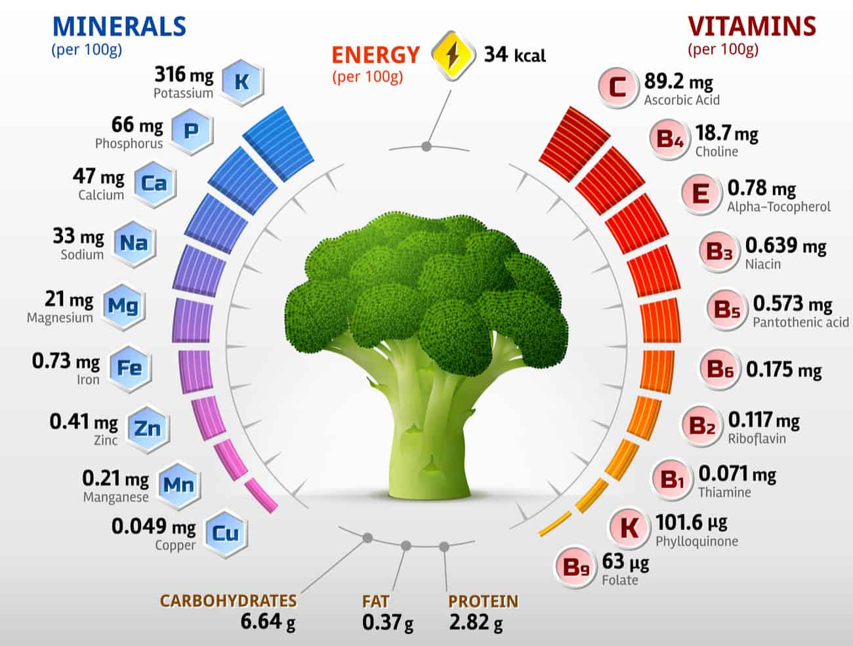
NOW LET’S JUMP INTO YOUR BROCCOLI OPTIONS.

EARLY-IN-THE-YEAR BROCCOLI TYPES

ARCADIA BROCCOLI
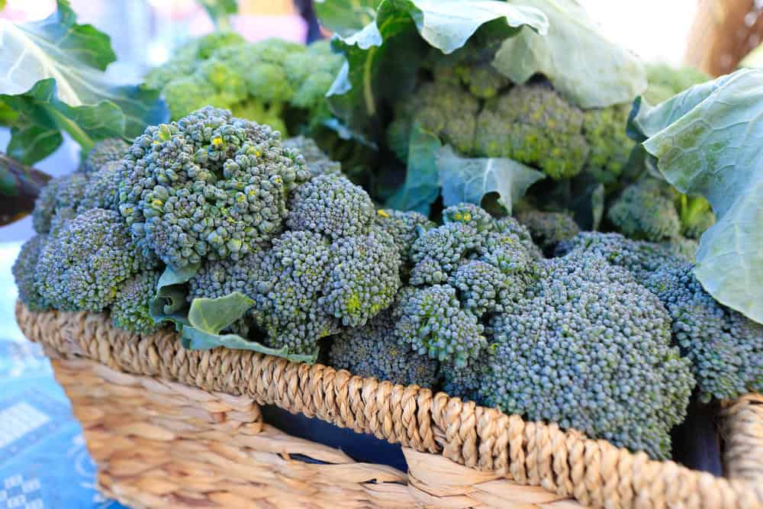
ARCADIA BROCCOLI MATURES IN AROUND TWO MONTHS AND CONSISTS OF UNIFORM HEADS THAT ARE SMALL AND PURPLISH GREEN IN COLOR. THEY ARE FIVE TO SIX INCHES ACROSS AND VERY TOLERANT OF THE COLD, WHICH MEANS FALL AND WINTER PRODUCTION IS HIGHLY RECOMMENDED. NOT ONLY IS IT RESISTANT TO COLD, BUT IT IS ALSO RESISTANT TO HEAD ROT AND DOWNY MILDEW, AND IT WON’T PRODUCE BROWN BEADS, EITHER.

CALABRESE BROCCOLI
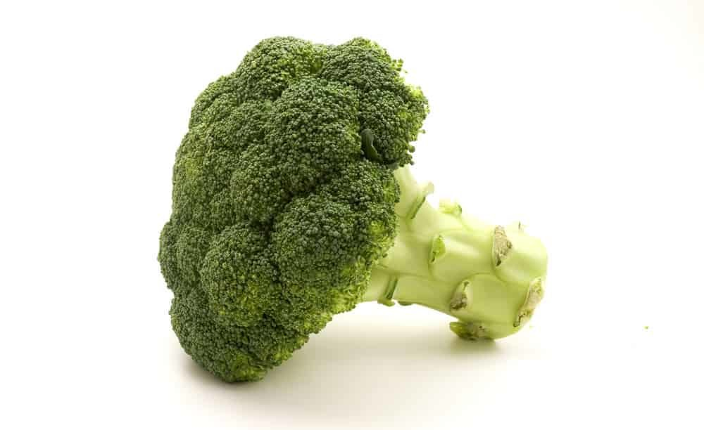
THE CALABRESE BROCCOLI MATURES IN AROUND 65 DAYS AND IS PERFECT WHEN PLANTED IN THE FALL. IN FACT, AS THE WEATHER GETS COOLER THE HEADS ACTUALLY GET SWEETER. THE BROCCOLI HAS DEEP-GREEN HEADS THAT ARE A MEDIUM SIZE, AND THERE ARE A LOT OF SIDE SHOOTS PRODUCED ONCE THE CENTRAL HEAD IS HARVESTED.

AMADEUS BROCCOLI
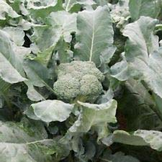
MATURING IN A LITTLE UNDER 60 DAYS, THE AMADEUS BROCCOLI IS ROUGHLY FOUR TO FIVE INCHES IN DIAMETER AND HAS SMALL BEADS AND TIGHT HEADS THAT ARE BLUE GREEN IN COLOR. IT HAS STRONG SIDE-SHOOT PRODUCTION ONCE YOU HARVEST THE MAIN HEAD, AND IT IS A VERY VIGOROUS AND MEDIUM-SIZED TYPE OF BROCCOLI.

BLUE WIND BROCCOLI
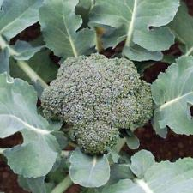
BLUE WIND BROCCOLI IS AN EARLY BLOOMER, USUALLY GETTING TO BE FULL-GROWN IN LESS THAN 60 DAYS, AND IT HAS TIGHT, LARGE HEADS AND BLUISH-GREEN LEAVES ON THE TOP OF THE PLANT. JUST LIKE KALE, BLUE WIND BROCCOLI IS EXCELLENT WHEN BRAISED OR STEAMED.

“DE CICCO” HEIRLOOM BROCCOLI
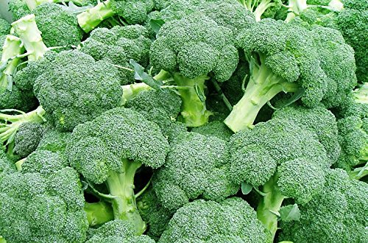
THIS TYPE OF BROCCOLI CAN BE READY IN LESS THAN 50 DAYS, AND IT IS USUALLY FAIRLY SMALL – AROUND THREE TO FOUR INCHES PER HEAD. IT IS A MULTI-CUT ITALIAN HEIRLOOM VARIETY AND WORKS ESPECIALLY WELL IN HOME GARDENS. THE BROCCOLI ALSO HAS TENDER SIDE-SHOOTS SPEARS IN LARGE NUMBERS, BUT IF YOU ARE INTERESTED IN MORE OF THEM YOU CAN HARVEST THE MAIN HEAD AT AROUND THREE INCHES.

GYPSY BROCCOLI
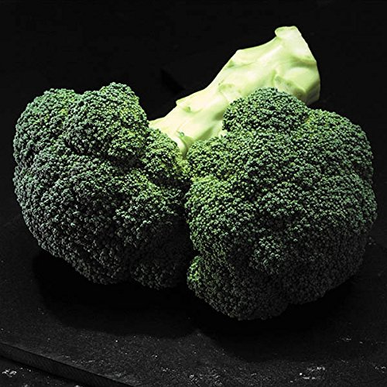
MATURING IN ROUGHLY 60 DAYS, THIS IS ONE OF THE EARLIEST BLOOMING BROCCOLI PLANTS. IT HAS A VERY GOOD ROOT SYSTEM AND THEREFORE, IT PRODUCES WELL EVEN IF THE SOIL IS LESS THAN PERFECT. GYPSY BROCCOLI HAS GREEN HEADS THAT ARE WELL DOMED AND BEADS THAT ARE MEDIUM TO SMALL IN SIZE. IT ALSO HAS GREAT HEAT TOLERANCE AND PRODUCES A LOT OF SIDE SHOOTS.

MID-SEASON BROCCOLI VARIETIES

BELSTAR BROCCOLI
THIS TYPE OF BROCCOLI HAS TIGHTLY PACKED HEADS THAT ARE A BEAUTIFUL SHADE OF BLUE GREEN. MATURING IN ROUGHLY 70 DAYS, THE BELSTAR BROCCOLI CAN TOLERATE BOTH COLD AND HEAT, SO YOU CAN PLANT IT EITHER IN THE SPRING OR THE FALL.

DIPLOMAT BROCCOLI
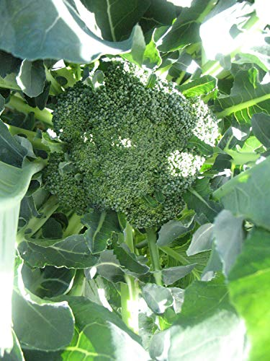
RESISTANT TO MANY TYPES OF MILDEW, THE DIPLOMAT BROCCOLI CONSISTS OF THICK, UNIFORM HEADS FROM FOUR TO SIX INCHES ACROSS, AND THEY ARE DARK GREEN IN COLOR. THEY DO ESPECIALLY WELL IN COLDER CLIMATES THAT ONLY GET MODERATELY WARM IN THE SUMMER MONTHS, AND THEY BLOOM IN A LITTLE OVER TWO MONTHS.

EXPRESS BROCCOLI
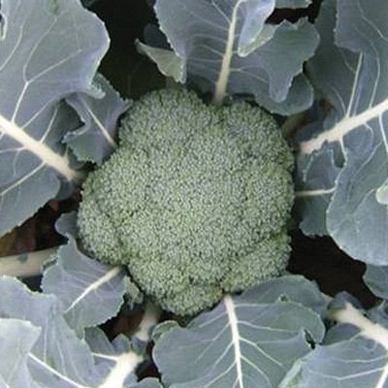
MATURING IN ROUGHLY 75 DAYS, THIS IS A GREAT MID-SEASON BROCCOLI THAT PRODUCES A LOT OF SIDE SHOOTS, AS WELL AS DEEP BLUE-GREEN HEADS, TIGHT BEADS, AND A SIZE OF APPROXIMATELY SIX TO SEVEN INCHES IN DIAMETER.

FIESTA BROCCOLI
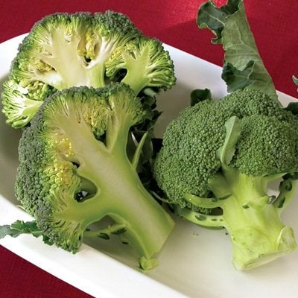
FIESTA BROCCOLI PRODUCES IN ROUGHLY 70 DAYS, AND THE BROCCOLI HEADS THEMSELVES ARE WELL DOMED AND THICK, WITH VERY THICK STEMS AS WELL. IT DOES BEST IF YOU PLANT IT IN THE LATE SUMMER MONTHS SO THAT IT CAN MATURE IN THE FALL AND WINTER. IT HAS LIMITED SIDE-SHOOT PRODUCTION AND HAS LIMITED HEAT TOLERANCE ONCE IT’S FULLY GROWN.

MARATHON BROCCOLI
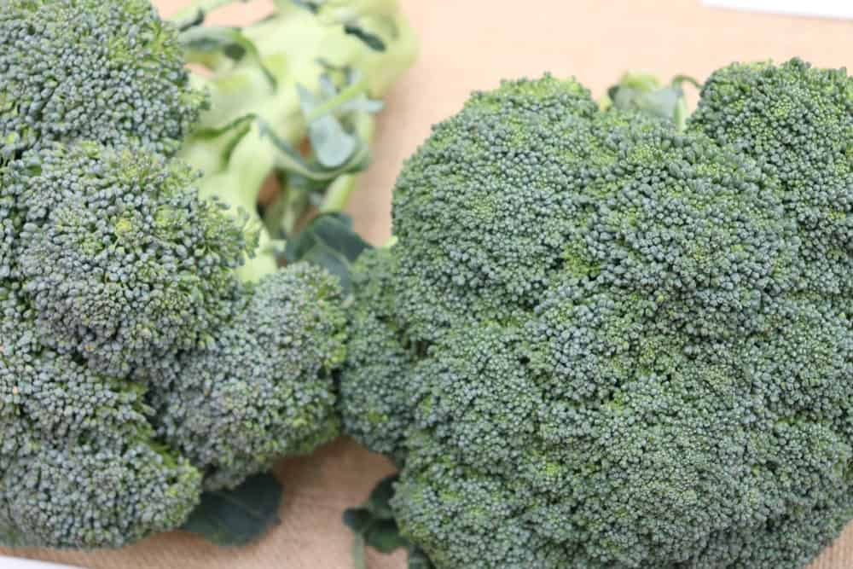
MARATHON BROCCOLI MATURES IN A LITTLE MORE THAN 60 DAYS, AND IF YOU LIVE IN THE PACIFIC NORTHWEST AND NORTHERN CALIFORNIA, IT WORKS BEST WHEN PRODUCED IN THE FALL AND WINTER SEASONS.

WALTHAM 29 BROCCOLI
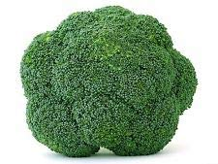

ALSO CALLED THE OPEN POLLINATED OR HEIRLOOM BROCCOLI, THIS TYPE PRODUCES MULTIPLE THICK, BLUE-GREEN HEADS THAT CAN BE FROM FOUR TO EIGHT INCHES IN DIAMETER. THIS IS FOLLOWED BY MULTIPLE SIDE SHOOTS OVER A SEASON THAT CAN LAST A LITTLE OVER 70 DAYS. THE WALTHAM 29 BROCCOLI IS SUITABLE FOR PRODUCTION IN EARLY SPRING AND LATE FALL, AND IT IS A VERY COLD-TOLERANT TYPE OF BROCCOLI.

CHINESE BROCCOLI (GAI-LON)

HAPPY RICH
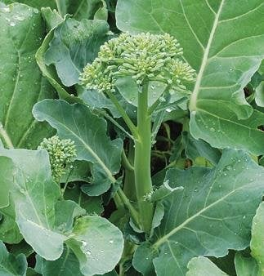
Bottom of Form
THE HAPPY RICH IS A VERY VIGOROUS PLANT THAT MATURES IN ROUGHLY 55 DAYS. IT HAS A LOT OF SIDE SHOOTS AND PRODUCES LARGE FLORETS THAT ACTUALLY LOOK LIKE MINIATURE HEADS OF BROCCOLI. IT IS A HYBRID PLANT AND PRODUCES A LARGE AMOUNT OF FOOD.

KAILAAN
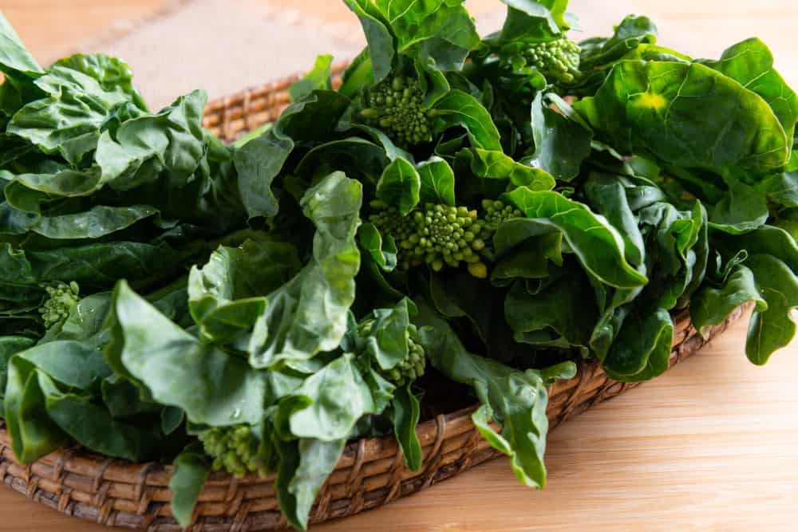
MATURING IN ROUGHLY TWO MONTHS, THIS TYPE OF BROCCOLI IS DEEP GREEN IN COLOR AND GROWS TO SIX TO EIGHT INCHES IN DIAMETER. IT ALSO HAS WHITE FLOWERS ON ITS STALKS, AND BECAUSE IT DOESN’T ALWAYS DO GREAT IN HOT WEATHER, IT IS BEST TO PLANT IT IN EARLY SPRING OR LATE SUMMER.

SUIHO
THIS IS ALSO A HYBRID PLANT THAT MATURES IN 44 DAYS AND TENDS TO BE MORE HEAT TOLERANT THAN THE NON-HYBRID VARIETIES.

SPECIALTY BROCCOLI

APOLLO
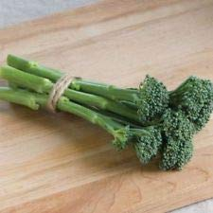
THIS TYPE OF BROCCOLI MATURES IN TWO TO THREE MONTHS, AND IT SPROUTS PROFUSELY. IF YOU HARVEST THE MAIN HEAD EARLY, YOU CAN ENJOY LOTS OF SIDE SHOOTS AFTERWARDS, AND THEY ARE TENDER AND LONG. YOU CAN USE THIS FOOD IN STIR-FRIES OR PREPARE IT LIKE YOU DO ASPARAGUS, AND THEY DO BEST WHEN PRODUCED IN THE SPRING OR FALL, ALTHOUGH IN HIGH TEMPERATURES THEY CAN TASTE A LITTLE ON THE BITTER SIDE.

BROCCOLINI
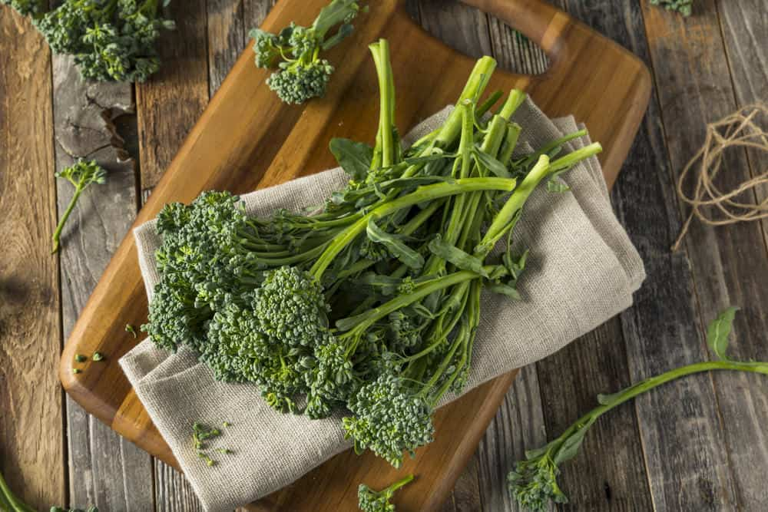
THESE ARE ESSENTIALLY BROCCOLI SIDE SHOOTS THAT CAN BE COOKED LIKE THE SPROUTING BROCCOLI VARIETY. OFTEN, BROCCOLI WILL PRODUCE A LARGE AMOUNT OF SIDE SHOOTS AFTER THE HEAD IS HARVESTED, AND DIFFERENT VARIETIES PRODUCE DIFFERENT AMOUNTS OF SIDE SHOOTS.

ROMANESCO BROCCOLI
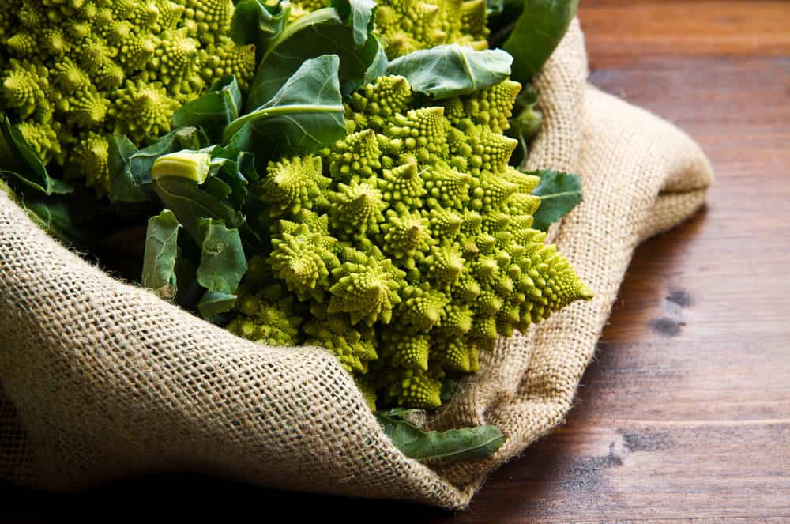
THIS IS AN ITALIAN HEIRLOOM THAT LOOKS VERY SIMILAR TO A CROSS BETWEEN A CAULIFLOWER AND A BROCCOLI PLANT. IT MATURES IN 75 DAYS, AND ITS GREENHEADS ARE SPIRALED AND QUITE ATTRACTIVE. IT ALSO HAS A VERY DELICATE FLAVOR. IT HAS BEEN GROWN IN ITALY SINCE THE 1500S AND HAS A SLIGHTLY CRUNCHY TASTE.

SANTEE BROCCOLI
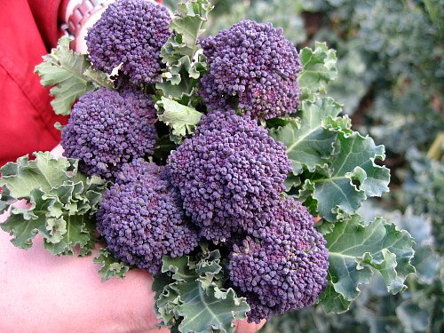
ALSO KNOWN AS THE PURPLE SPROUTING BROCCOLI, THIS TYPE OF BROCCOLI PRODUCES LOTS OF TENDER, PURPLE FLOWERS THAT HAVE GREEN STEMS. WHEN YOU COOK THE FLORETS THEY TURN GREEN, AND THERE IS A THREE- TO FIVE-WEEK EXTENDED HARVEST PERIOD. BEST WHEN GROWN IN COOL WEATHER, MAINLY BECAUSE THE SHOOTS TASTE VERY BITTER WHEN THE WEATHER IS HOT.

SPROUTING BROCCOLI
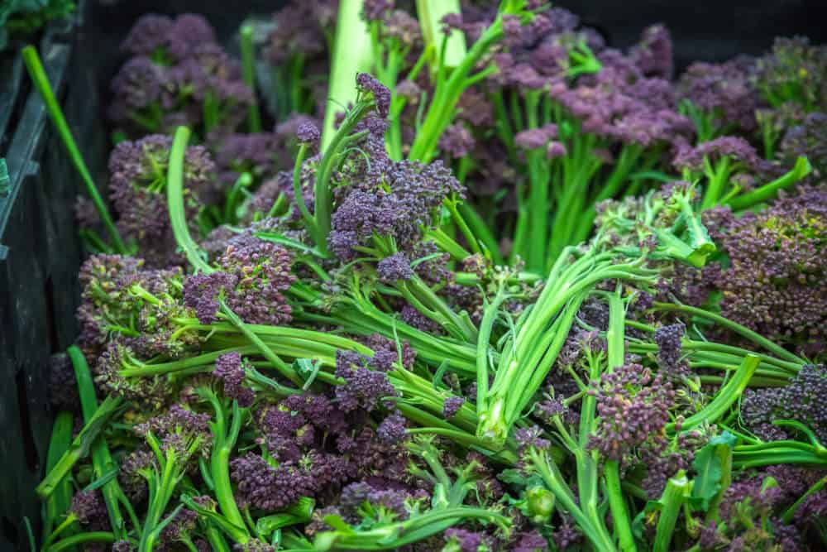
SPROUTING BROCCOLI CAME ABOUT BEFORE THE BROCCOLI AS WE KNOW IT TODAY. IT HAS LOTS OF LONG SIDE SHOOTS AND PRODUCES A LOT OF LARGE, ABUNDANT HEADS. MOST PEOPLE COOK THE SIDE SHOOTS LIKE ASPARAGUS, WHICH MEANS YOU CAN CHOP AND SAUTÉ THEM, OR EVEN GRILL THEM AFTER YOU BRUSH THEM WITH A LITTLE OLIVE OIL.

10 DIFFERENT TYPES OF GARLIC
GET TO KNOW ONE OF THE HEALTHIEST FOODS ON EARTH AS WELL AS ONE OF THE OLDEST FOOD FLAVORINGS BY EXPLORING THE DIFFERENT TYPES OF GARLIC AND THEIR DISTINCTIONS.
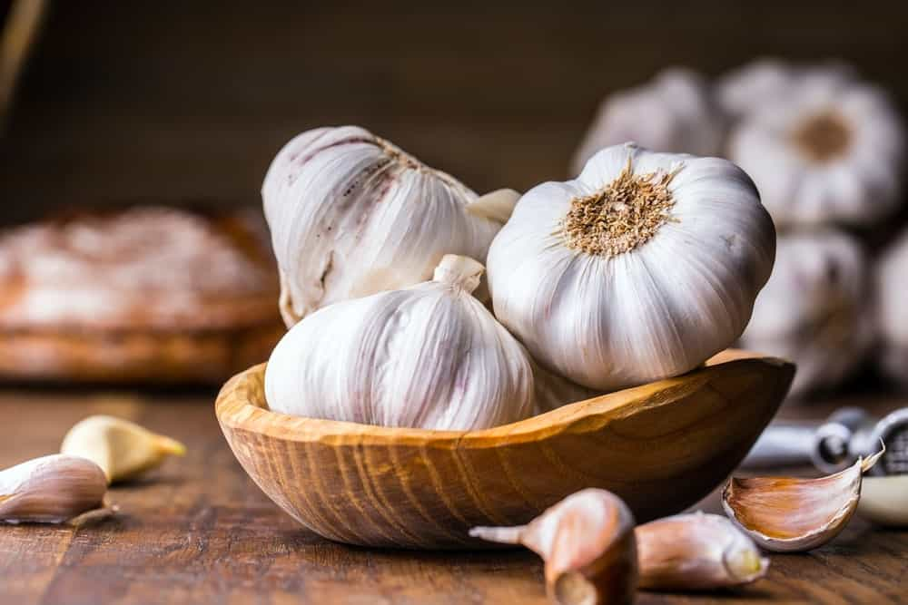
GARLIC IS A BULBOUS PLANT WITH MORE THAN 450 VARIETIES THAT BELONG TO THE LILIES FAMILY. IT ORIGINATED IN CENTRAL ASIA AND IS ONE OF THE FIRST HERBS CULTIVATED ABOUT 4,000 YEARS AGO. THE NEOLITHIC MEN WHO EXISTED OVER 7,000 YEARS AGO USED GARLIC AS A FOOD SEASONING.
IN THE 3RD MILLENNIUM B.C., THE ANCIENT EGYPTIANS INCORPORATED GARLIC AS PART OF THEIR DIET AS WELL AS A PART OF THEIR MEDICINE, RELIGIOUS RITUAL, AND A SOURCE OF STRENGTH FOR SLAVES.
RELATED: TYPES OF SHALLOTS | TYPES OF CHILI | WHAT GOES WITH POTATOES | TYPES OF PARSLEY | TYPES OF ONIONS

GARLIC NUTRITION FACTS CHART
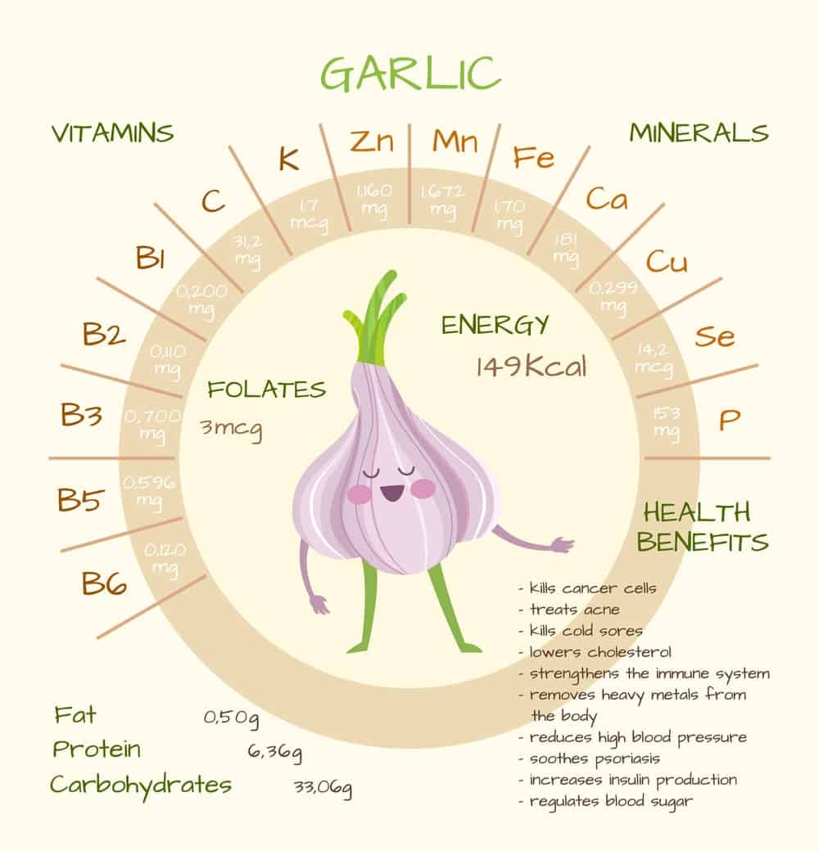
NOW LET’S JUMP INTO YOUR GARLIC OPTIONS.

1. ASIATIC GARLIC
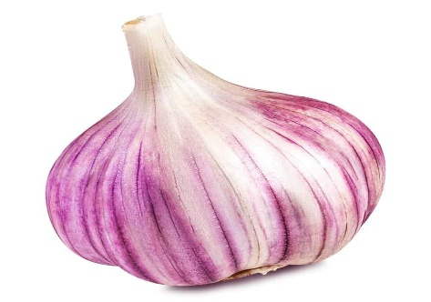
ASIATIC GARLIC IS AN EARLY-HARVESTED TYPE OF GARLIC AND HAS UP TO 12 CLOVES PER BULB. THEY USUALLY STORE FOR UP TO FIVE MONTHS ONLY, AND THEIR TASTE VARIES DEPENDING ON THE ACTUAL VARIETY. HOWEVER, ASIATIC GARLIC TENDS TO BE VERY STRONG AND HOT, PARTICULARLY IF YOU EAT IT RAW, AND VARIETIES INCLUDE THE RUSSIAN RED, ASIAN ROSE, KOREAN RED, AND THE ASIAN TEMPEST.

2. BLACK GARLIC
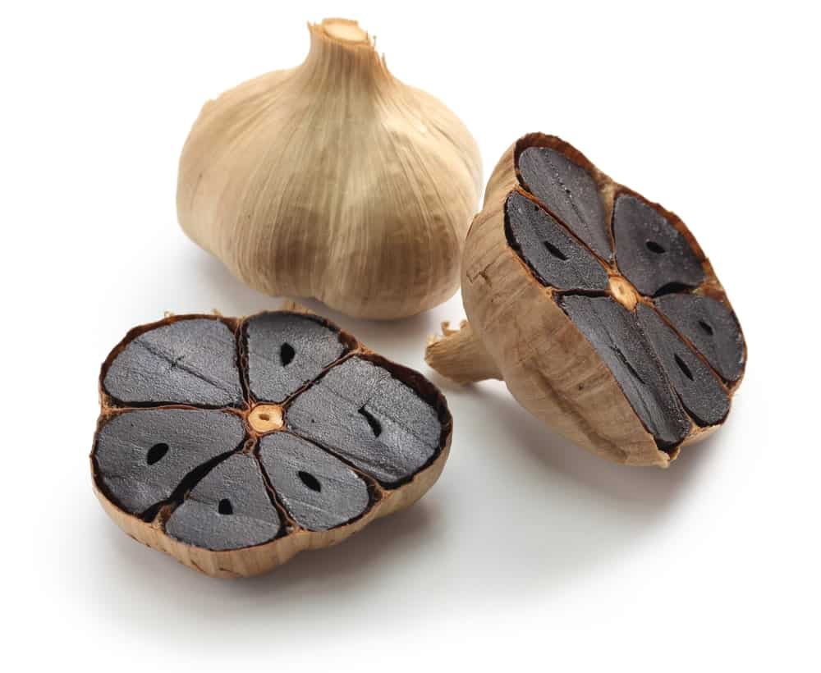
BLACK GARLIC CAN BE FOUND IN KOREAN GROCERY STORES, AND IT HAS A PLUM-LIKE TASTE WITH JUST A TOUCH OF VINEGAR. IT IS CHEWY, SUCH AS DRIED FRUIT, AND IF YOU KNOW SOMEONE THAT HATES REGULAR GARLIC, THIS IS THE TYPE OF GARLIC YOU SHOULD TRY. IN FACT, ITS TASTE IS QUITE UNIQUE AND RATHER DIFFICULT TO DESCRIBE, AND IT IS BLACK IN COLOR BECAUSE OF THE WAY IT IS MADE.
BLACK GARLIC IS A LITTLE SWEET, A LITTLE BITTER, AND TASTES ROUGH LIKE IT HAS SOME CARAMEL IN IT AS WELL. YOU CAN USE BLACK GARLIC IN SAUCES AND AS A GARNISH ON MEATS AND SALADS, ALTHOUGH SOME PEOPLE HAVE ALSO USED IT IN VARIOUS DESSERTS, AS WELL AS MAIN DISHES.
Bottom of Form

3. CREOLE GARLIC
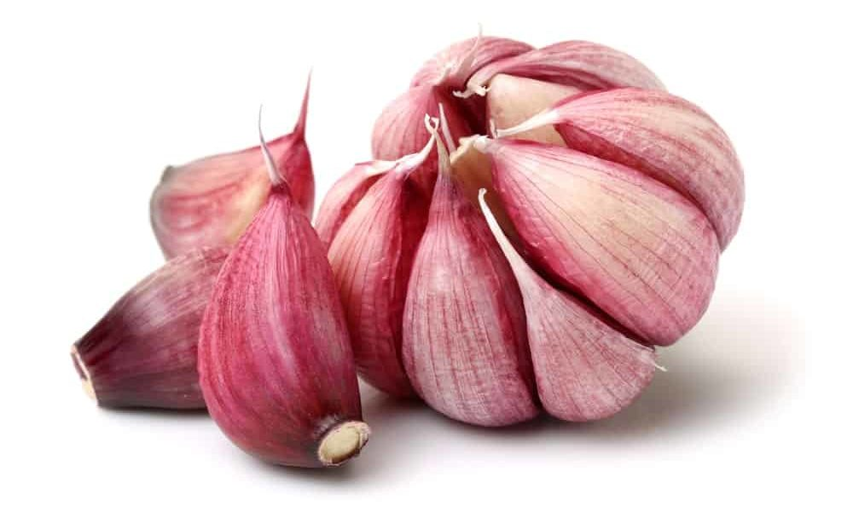
CREOLE GARLIC USUALLY GROWS UP TO 12 CLOVES AND CAN RANGE IN COLOR FROM A LIGHT PINK TO PURPLE COLOR. IN FACT, THE ENTIRE BULB CAN BE THAT COLOR, BUT CREOLE GARLIC IS VERY RARE COMPARED TO OTHER TYPES OF GARLIC. IT IS GROWN IN WARMER CLIMATES AND INCLUDES VARIETIES SUCH AS THE BURGUNDY, CREOLE RED, AND CUBAN PURPLE. DEPENDING ON WHERE YOU BUY THIS TYPE OF GARLIC, IT CAN BE A LITTLE ON THE SPICY SIDE, AND IF YOU PREFER A LITTLE LESS BITE, IT IS A GOOD IDEA TO SMELL IT BEFORE YOU BUY IT.

4. ELEPHANT (BUFFALO) GARLIC
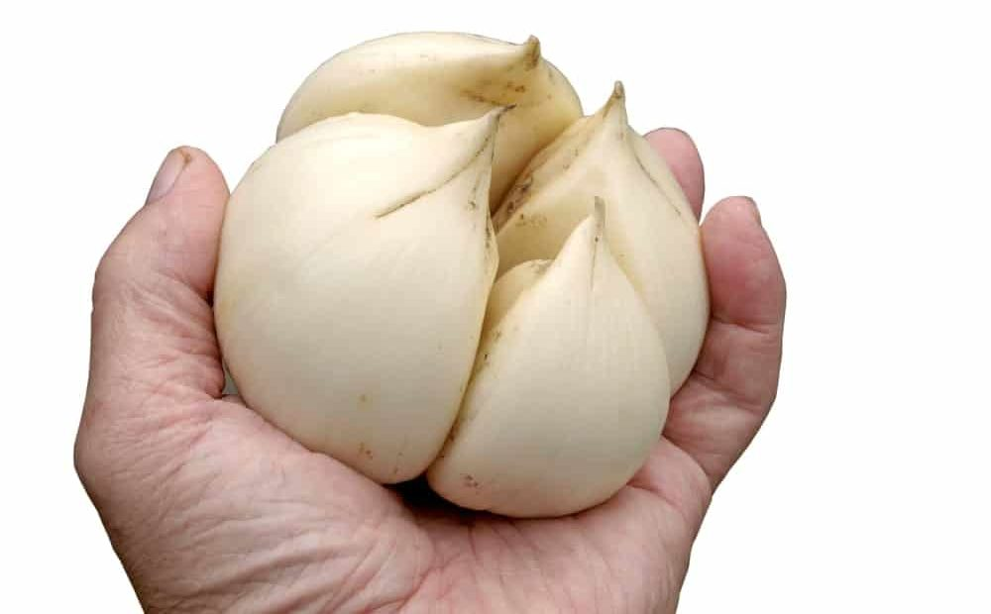
IT IS EASY TO IDENTIFY ELEPHANT GARLIC BECAUSE OF ITS HUGE SIZE. ALSO CALLED BUFFALO GARLIC, THIS TYPE OF GARLIC IS MILDER THAN MANY OTHER GARLIC VARIETIES, WITH A SLIGHTLY ONION-LIKE FLAVOR. GREAT FOR STIR-FRY DISHES AND VINAIGRETTES, ELEPHANT GARLIC IS ALSO SUPERB WHEN YOU ROAST IT. THEY ARE VERY EASY TO PEEL AND CAN BE USED IN PLACE OF JUST ABOUT ANY OTHER TYPE OF GARLIC, AND THEIR EXTRA-LARGE SIZE MAKES THEM VERY EASY TO WORK WITH.

5. HARDNECK GARLIC
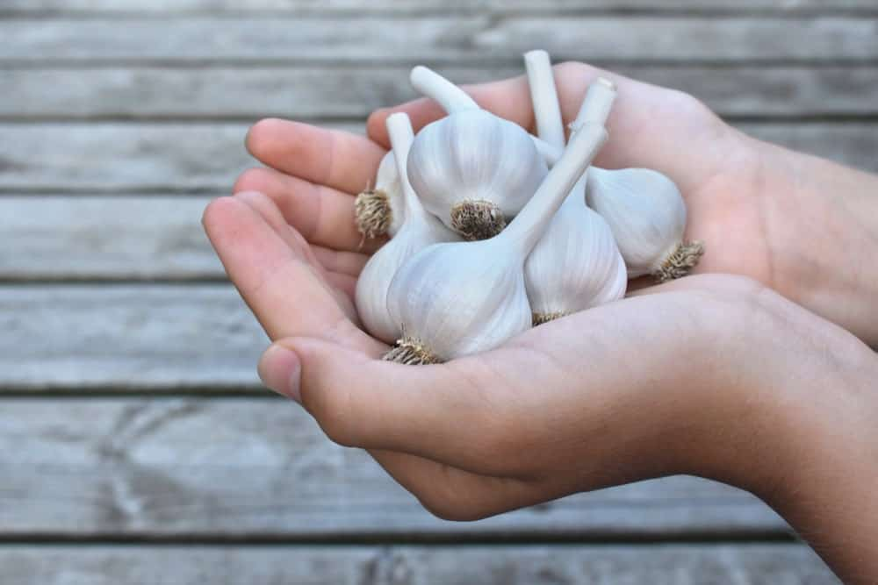
KNOWN FOR THEIR THIN SKINS AND VIOLET-ROSE HUE, THE HARD NECK GARLIC HAS A LOT OF FLAVORS AND USUALLY CONTAIN FOUR TO TWELVE CLOVES IN EACH BULB. THEY USUALLY HAVE STALKS THAT ARE LONG AND WHICH CURL AND LOOP, AND THEY HAVE DIFFERENT VARIETIES, INCLUDING PURPLE STRIPE, PORCELAIN, AND ROCAMBOLE. THEY ALSO TEND TO GROW BETTER IN AREAS THAT GET VERY COLD IN THE WINTERTIME, AND THEY GO GREAT WITH GAMEY MEATS SUCH AS VENISON OR DUCK, AS WELL AS OTHER DISHES.

6. PURPLE STRIPE GARLIC
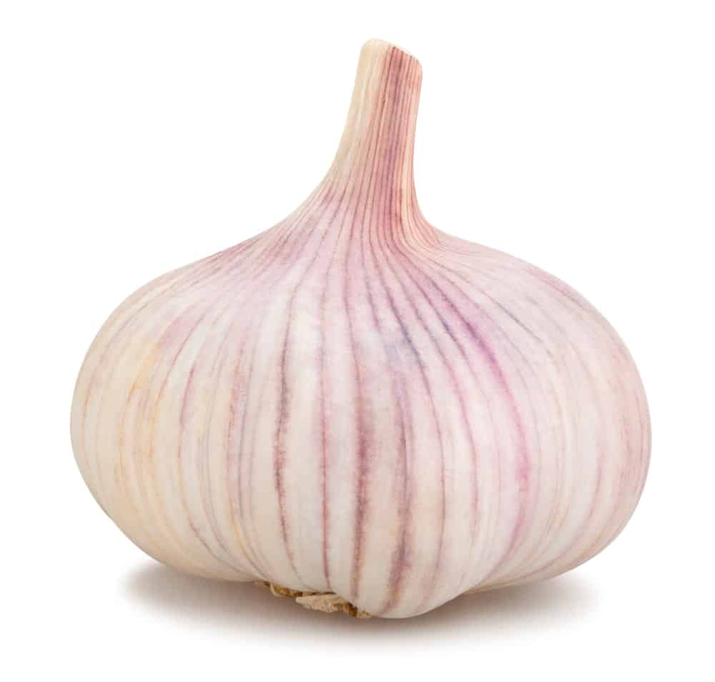
THIS IS A VERY POPULAR TYPE OF HARDNECK GARLIC THAT STORES FOR FOUR TO SIX MONTHS AND PRODUCES ROUGHLY 55 CLOVES PER POUND. THE CLOVES HAVE A SYMMETRICAL SHAPE AND THE CLOVES ARE SO CLEARLY DEFINED THAT YOU CAN SEE THEM WITHOUT BREAKING APART THE GARLIC.
THEY ARE NOT ONLY ATTRACTIVE, BUT VERY TASTY, AND THEY ARE EASY TO PEEL AND TASTE GREAT IN A VARIETY OF DISHES. THEY ARE PERFECT FOR ROASTING, AND THEIR VARIETIES INCLUDE THE KHABAR, LITHUANIAN PURPLE, BROWN ROSE, AND THE RUSSIAN RED. THEY COME IN THREE BASIC TYPES: GLAZED, STANDARD, AND MARBLED, WITH EACH OFFERING ITS OWN ADVANTAGES.

7. RAMPS

RAMPS USUALLY HAVE SEVERAL WIDE, SPADE-SHAPED LEAVES AND PALE-GREEN STEMS. THEIR LEAVES, IN FACT, ARE QUITE LONG, USUALLY UP TO 12 INCHES IN LENGTH, AND THEY HAVE A TASTE THAT IS BOTH SWEET AND PUNGENT.
CLOSELY RELATED TO THE WILD GARLIC, BUT LOOKING SIMILAR TO GREEN ONIONS, THEY MATURE IN THE SPRING, MAKING THAT THE PERFECT TIME TO PURCHASE THEM IN GROCERY STORES OR FARMERS’ MARKETS. THEY ARE SIMILAR TO SCAPES IN THAT THEY GO WITH JUST ABOUT ANY TYPE OF FOOD, AND YOU CAN COOK THEM JUST ABOUT ANY WAY YOU WANT TO.

8. SCAPES
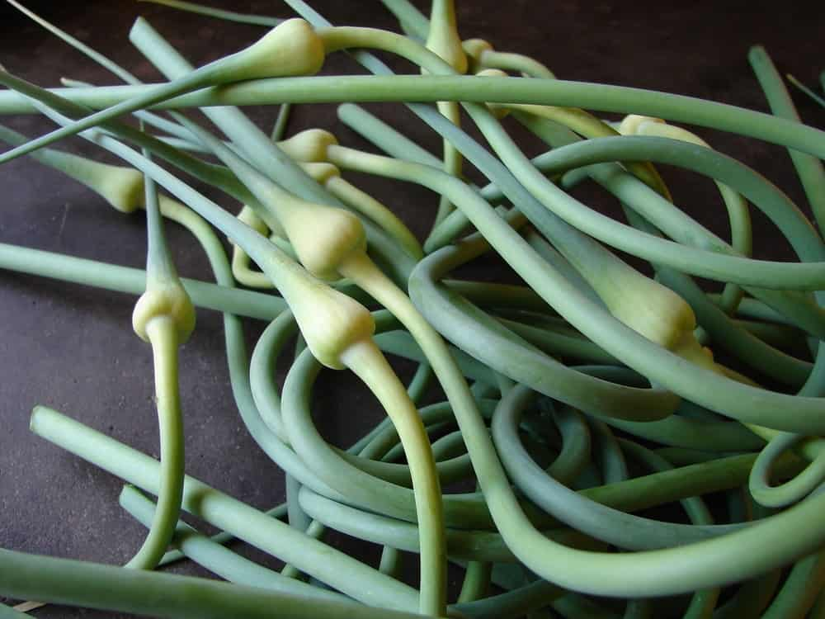
OFTEN CONFUSED WITH RAMPS, SCAPES AND RAMPS ARE ACTUALLY TWO VERY DIFFERENT VARIETIES OF GREENS. SCAPES GROW IN THE MIDDLE OF THE HARDNECK GARLIC BULB AND HAVE A SMALL WHITE BULB NEAR THE END. THEY HAVE A VERY FRESH, VEGETABLE-LIKE FLAVOR AND ARE ESPECIALLY TASTY WHEN SAUTÉED IN BUTTER OR OIL. SCAPES HAVE A CRISP, TENDER TEXTURE AND ARE PERFECT FOR SALADS AND FOR PLACING ON TOP OF PASTA. THEY ARE FOUND FREQUENTLY ON THE WEST COAST, AND THEIR BEST SEASON IS SPRINGTIME AND EARLY SUMMER.

9. SOFTNECK GARLIC
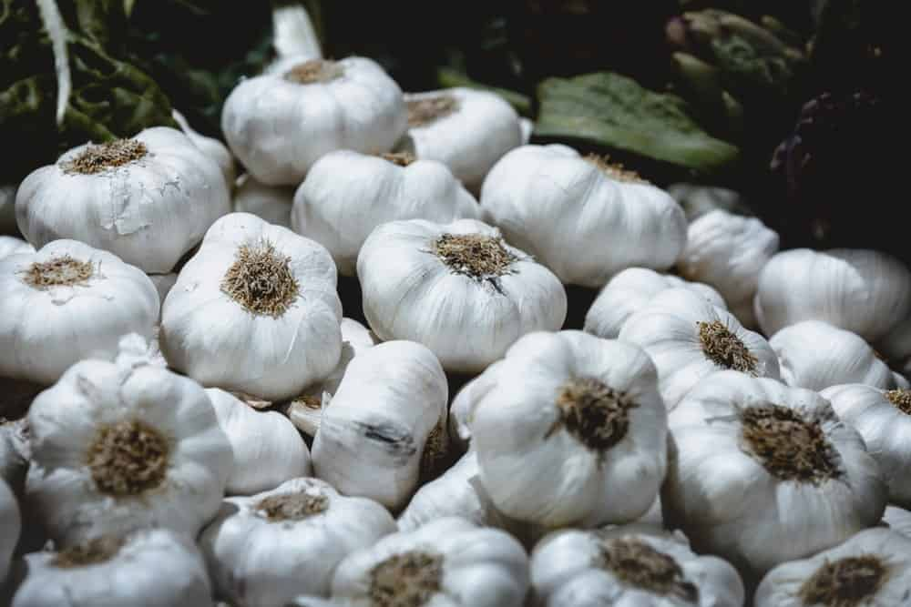
MOST OF THE GARLIC YOU FIND IN THE TYPICAL GROCERY STORE IS SOFTNECK GARLIC. THE NUMBER OF CLOVES IT CAN CONTAIN RANGES FROM EIGHT TO MORE THAN 30 BULBS, AND THIS IS THE PERFECT TYPE OF GARLIC IF YOU WANT TO EAT IT FRESH OR COOK WITH IT. ITS TASTE IS PLANT-LIKE AND ALMOST GRASSY IN NATURE, AND IT IS PERFECT FOR MAKING SALAD DRESSINGS OR WHEN YOU NEED TO LIGHTLY COOK OR SAUTÉ SOME GARLIC.
THE TWO MAIN VARIETIES OF SOFTNECK GARLIC INCLUDE THE SILVERSKIN, WHICH IS USUALLY SOLD BRAIDED; AND ARTICHOKE, WHICH IS FOUND FREQUENTLY IN SUPERMARKETS. IT IS ALSO CONTAINED IN MOST PROCESSED FOODS SUCH AS SEASONINGS AND GARLIC POWDER.

10. TURBAN GARLIC
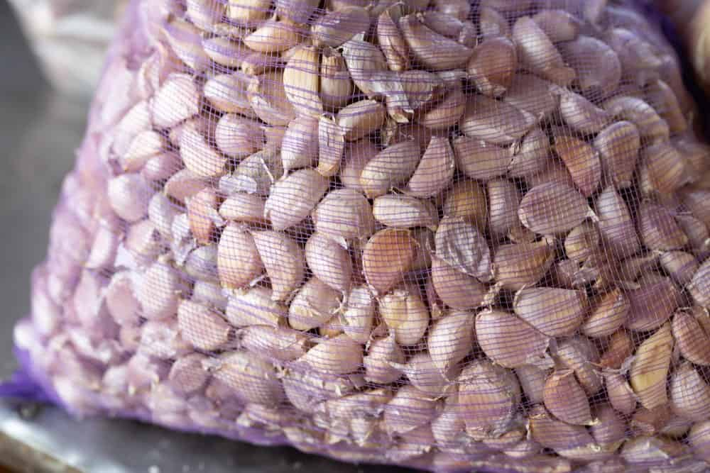
SIMILAR TO ASIATIC GARLIC, TURBAN GARLIC HAS ONLY A FEW CLOVES – USUALLY NO MORE THAN EIGHT PER BULB, AND VERY LARGE CLOVES AS WELL. THEY MATURE IN THE SPRING, BUT THEY DO NOT STORE FOR VERY LONG SO THEY NEED TO BE WATCHED CAREFULLY ONCE THEY’RE HARVESTED.
THEY DO WELL IN WARMER CLIMATES, AND THEIR VARIETIES INCLUDE THE CHINA DAWN AND THE RED JANICE. AS FAR AS THEIR TEXTURE AND TASTE, TURBAN GARLIC IS SOMEWHERE BETWEEN THE HARDNECK AND SOFTNECK VARIETIES, AND THEY DO NOT ALWAYS CONTAIN SCAPES OR FLOWERS.

6 DIFFERENT TYPES OF SHALLOTS
SHALLOTS ARE A VERSATILE AND ROBUST VEGETABLE THAT CAN BE INCLUDED IN MANY RECIPES DUE TO THEIR SOFTER AND MORE GENTLE ALTERNATIVE TO ONION. THIS FANTASTIC VEGETABLE COMES IN SEVERAL FLAVOR PROFILES, IS EASY TO GROW, AND CAN MAKE AN IDEAL REPLACEMENT WHEN ADDING GARLIC OR ONIONS TO YOUR RECIPE.
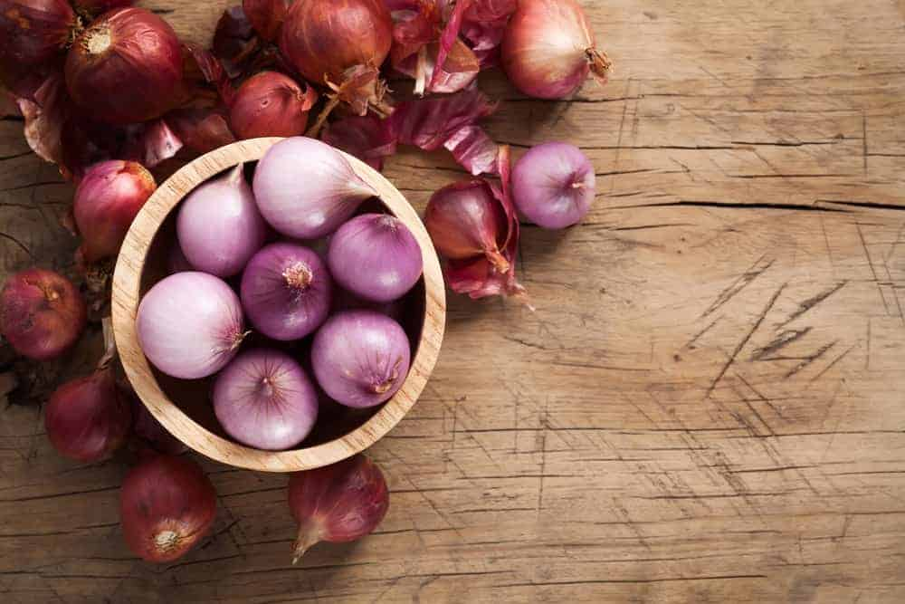
ADDING DIFFERENT VEGETABLES TO GIVE YOUR RECIPE THE RIGHT FLAVOR IS A GREAT WAY TO INTRODUCE ACIDITY AND BITTERNESS. OFTEN, PEOPLE WILL ADD GREEN ONION, YELLOW ONION, OR GARLIC TO THE RECIPE BUT OFTEN FORGET ABOUT THE WIDE VARIETY OF SHALLOT OPTIONS AVAILABLE TO MANY AVID COOKS. A SHALLOT IS A BEAUTIFUL VEGETABLE THAT COMES IN MANY COLOR VARIETIES AND FLAVOR PROFILES.
THIS EASY-TO-FIND AND VERSATILE VEGETABLE CAN SPICE UP JUST ABOUT ANY DISH AND GIVE YOUR MEAL A CERTAIN FLARE AND KICK UNOBTAINABLE WITH JUST A SIMPLE ONION OR GARLIC FLAVOR. BELOW, LET’S TAKE A CLOSER LOOK AT THE MANY TYPES OF SHALLOTS, THEIR TASTES, AND HOW THEY CAN BE INTRODUCED INTO YOUR RECIPES.
RELATED: HOW TO STORE SHALLOTS | TYPES OF ONIONS

WHAT IS A SHALLOT?
ALTHOUGH THIS LITTLE VEGETABLE CAN PACK QUITE A PUNCH, MANY PEOPLE ARE UNFAMILIAR WITH SHALLOT AND HOW IT CAN BE USED IN YOUR MEALS. A SHALLOT IS A COMPLETELY UNIQUE VEGETABLE SPECIES, ALTHOUGH IT IS MOST LIKELY RELATED TO AN ONION, GARLIC, LEEK, OR CHIVES. THIS VEGETABLE HAS BEEN IN EXISTENCE FOR CENTURIES BUT WAS PROBABLY FIRST INITIALLY CULTIVATED BY FARMERS AND TRAVELERS FROM SOUTHWEST ASIA WHO TRAVELED TO THE EASTERN MEDITERRANEAN OR INDIA.
THE PHYSICAL APPEARANCE OF A SHALLOT CAN VARY DEPENDING ON THE SPECIFIC TYPE OF SHALLOT. LIKE GARLIC, MOST SHALLOT VARIETIES WILL GROW IN A CLUSTER PROTECTED BY A THIN LAYER OF MATERIAL OR SKIN. THE INDIVIDUAL CLOVES OF SHALLOT CAN THEN BE STRIPPED OF THE SKIN AND USED IN MANY RECIPES. WHILE MOST SHALLOTS ARE BULB-SHAPED, OTHER SHALLOT VARIETIES CAN BE ELONGATED, SUCH AS THE BANANA SHALLOT, OR TEARDROP-SHAPED, SUCH AS THE AMBITION SHALLOT.
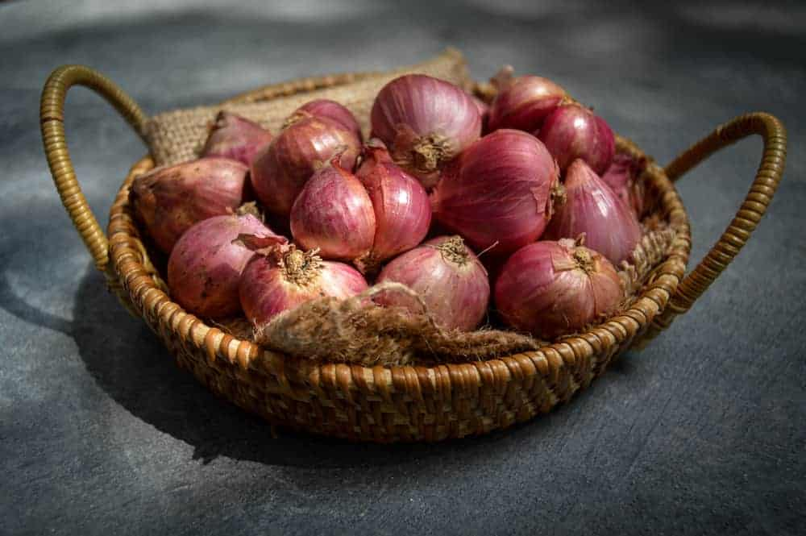
Bottom of Form
SHALLOTS ARE COMMONLY USED IN MANY TYPES OF CUISINE BUT ARE WIDELY FEATURED IN ASIAN DISHES. THIS VEGETABLE IS FREQUENTLY CUT AND COOKED OR PICKLED TO CREATE A COMPLETELY DIFFERENT FLAVOR PROFILE. THE SHALLOT OFFERS COOKS A SOFTER AND MORE MILD TASTE COMPARED TO AN ONION. IN MANY RECIPES, A SHALLOT CAN BE USED IN PLACE OF AN ONION TO SOFTEN THE FLAVOR.
OR, A CHEF CAN USE ONION IN PLACE OF SHALLOT TO CREATE A PUNCHIER, MORE ROBUST FLAVOR. SHALLOTS HAVE AN INCREDIBLY LONG SHELF LIFE AND CAN BE KEPT FOR SIX MONTHS OR LONGER IF THEY ARE STORED IN A COOL AND DRY PLACE.

TYPES OF SHALLOTS
LIKE MANY OTHER VEGETABLES, SHALLOTS COME IN A RANGE OF VARIETIES. THE SHALLOT’S APPEARANCE MAY CHANGE BETWEEN AVAILABLE VARIETIES, BUT THE FLAVOR PROFILE CAN ALSO BE INCREDIBLY DIFFERENT. BELOW, HERE ARE SOME OF THE MOST COMMON TYPES OF SHALLOTS CULTIVATED AND USED IN RECIPES AROUND THE WORLD.

PIKANT
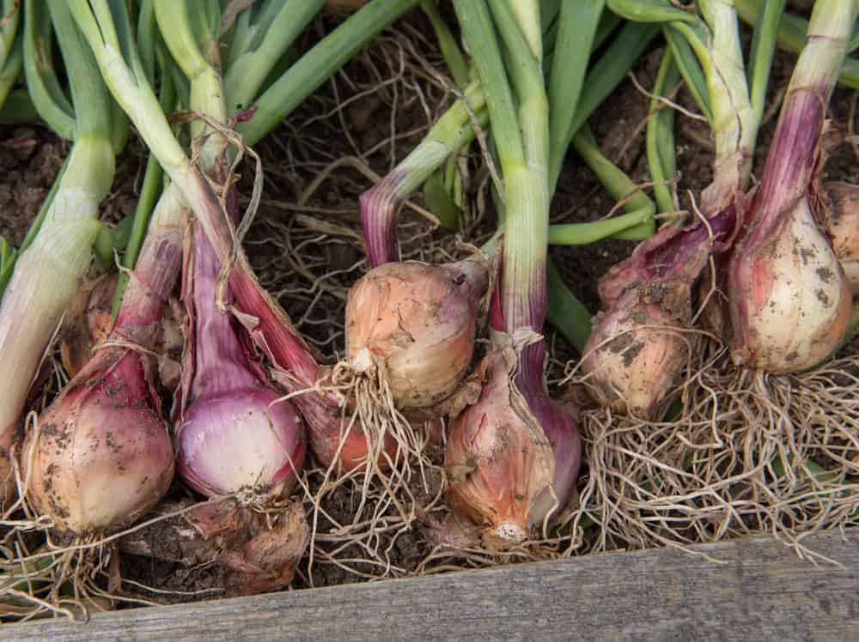
THIS FRENCH SHALLOT OPTION IS BROWN OR MAHOGANY COLOR ON THE OUTSIDE AND CAN BE PINK OR RED ON THE INSIDE. THE SHALLOT IS QUICK TO GROW AND REACHES MATURITY IN JUST 80 DAYS, MAKING IT ONE OF THE FASTEST-GROWING SHALLOT OPTIONS. THE PIKANT SHALLOT HAS A STRONG TASTE AND CAN BE STORED FOR AN EXTENDED PERIOD.

AMBITION
THE AMBITION SHALLOT IS A TEARDROP-SHAPED SHALLOT. THE INSIDE OF THIS SHALLOT RANGES FROM A RUSTY-BROWN COLOR TO A PINK SHALLOT COLOR. THIS OPTION IS A FRENCH SHALLOT VARIETY THAT MATURES IN ABOUT 100 DAYS AND CAN BE STORED EASILY FOR A LONG TIME. THIS OPTION IS A COMMONLY USED SHALLOT IN MANY RECIPES.

PRISMA
THE PRISMA SHALLOT OFTEN REFERRED TO AS THE RED SHALLOT, IS AN ENTIRELY RED SHALLOT BOTH INSIDE AND OUT. THIS SHALLOT HAS SMOOTH SKIN AND IS USUALLY READY FOR HARVESTING FROM THE PLANT AFTER ABOUT 100 DAYS. THIS SHALLOT HAS A VERY STRONG AND PUNGENT TASTE AND SMELL COMPARED TO OTHER SHALLOT VARIETY OPTIONS. THIS TYPE OF SHALLOT WILL MOST DIRECTLY REPLACE ONION IN A RECIPE DUE TO ITS STRONG TASTE.

YELLOW SHALLOT
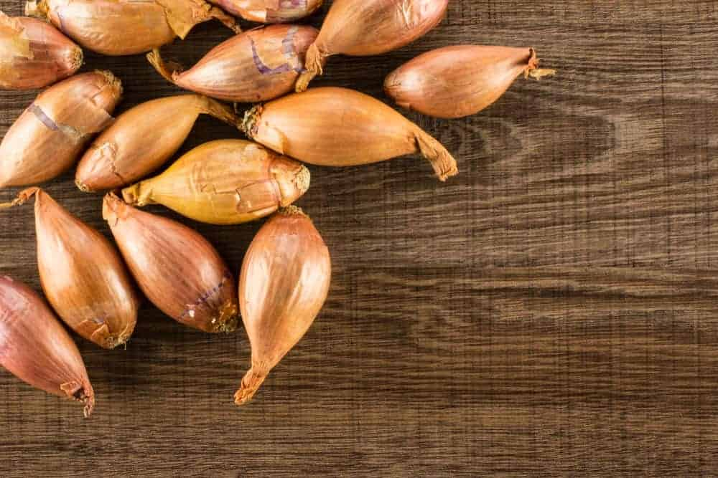
THE YELLOW SHALLOT, COMMONLY CALLED A GOLDEN SHALLOT, IS A SMALL TYPE OF ONION. THIS LITTLE VARIETY OF ALLIUM CEPA IS PRIZED FOR ITS MILDER AND SWEETER TASTE. THE YELLOW SHALLOT IS COMMONLY FEATURED IN MANY SOUPS AND STEWS, ADDING JUST A HINT OF ONION FLAVOR TO YOUR RECIPE. THIS TYPE OF SHALLOT IS ALSO WIDELY USED FOR PICKLING RECIPES.

FRENCH GRAY SHALLOT
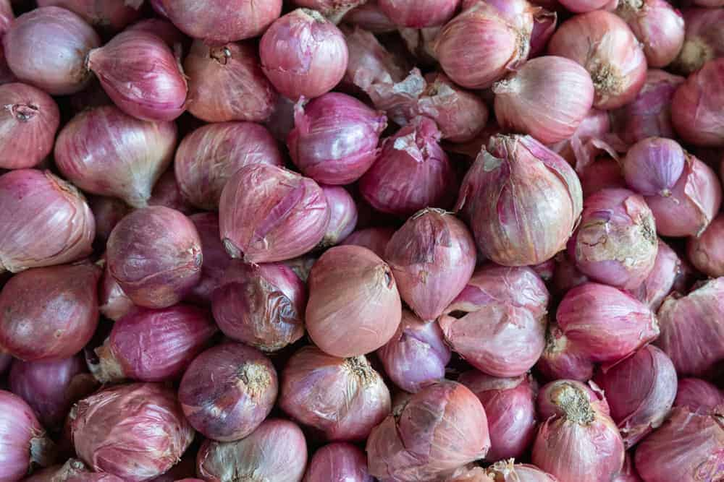
ALTHOUGH THE SCIENTIFIC NAME IS ALLIUM SCHANINII, THIS SHALLOT IS COMMONLY JUST REFERRED TO AS THE FRENCH GREY SHALLOT. THIS TYPE OF SHALLOT IS CONSIDERED THE TRUE SHALLOT AND CAN ALSO BE CALLED THE GRISELLE SHALLOT.
THE GRISELLE SHALLOT IS A FRENCH-STYLE SHALLOT THAT IS COMMONLY FOUND IN GARDEN CENTERS THE KITCHEN ALIKE. THIS VARIETY HAS A GRAY SHALLOT EXTERIOR, WITH AN ALMOST PURPLE INTERIOR. THIS SHALLOT VARIETY HAS AN ELONGATED SHAPE AND MATURES AFTER 200 DAYS. IT HAS AN EXTREMELY ROBUST FLAVOR AND CAN BE USED IN VARIOUS RECIPES BUT DOES NOT HAVE A PARTICULARLY LONG SHELF LIFE.

BANANA SHALLOT
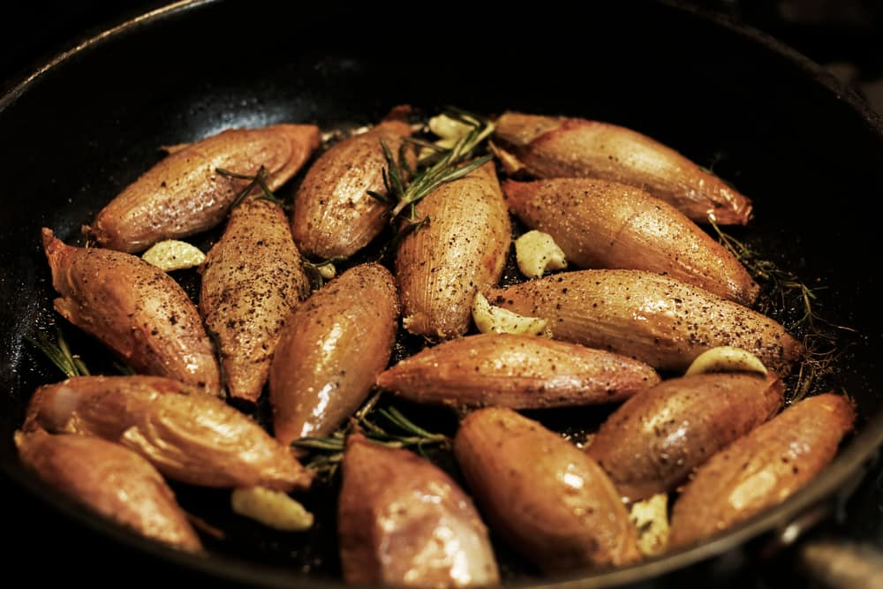
THE BANANA SHALLOT IS A HYBRID TYPE OF SHALLOT THAT MIXES AN ONION AND A SHALLOT. THIS VARIETY IS THE LARGEST SHALLOT AND IS COMMONLY USED IN MANY RECIPES. THIS SHALLOT HAS A BROWN OR RUST-COLORED EXTERIOR AND IS VERY EASY TO PEEL. COMPARED TO OTHER SHALLOTS OR ONIONS, THIS SHALLOT TASTES MORE SIMILAR TO A SOFTER OR SWEETER ONION AND GARLIC MIX.

FAQS
BECAUSE THIS VEGETABLE IS NOT COMMONLY USED IN EVERYDAY HOMES, IT MAKES SENSE TO HAVE SEVERAL QUESTIONS SURROUNDING ITS AVAILABILITY AND USE. BELOW, WE HAVE PUT TOGETHER A LIST OF SOME COMMONLY ASKED QUESTIONS ABOUT SHALLOTS. HOPEFULLY, WITH THE RIGHT INFORMATION AND GUIDANCE, YOU TOO CAN START USING THIS GREAT VEGETABLE TO SPICE UP YOUR MUNDANE RECIPES, GIVING YOUR COOKING SOME MORE FLAIR AND EXCITEMENT.

WHAT IS ANOTHER NAME FOR SHALLOTS?
SHALLOTS ARE THEIR OWN UNIQUE SPECIES OF PLANT AND VEGETABLE AND ARE ONLY CALLED SHALLOTS. THEIR SCIENTIFIC NAME IS ALLIUM CEPA, AND THIS OFTEN HELPS TO DEFINE SPECIFIC SHALLOT VARIETIES AND SPECIES FOR HORTICULTURISTS AND GARDENERS WHO WANT TO GROW THEIR OWN SPECIFIC SHALLOTS.
ALTHOUGH THE SHALLOT IS RELATED TO AND LOOKS VERY SIMILAR TO THE CHIVE, ONION, AND GARLIC PLANT, THE SHALLOT IS ITS OWN INDEPENDENT AND UNIQUE SPECIES. SOMETIMES, COOKS AND CHEFS WILL REFER TO THE SHALLOT BY USING THE SPECIFIC TYPE OF SHALLOT NAME, INCLUDING THE GRISELLE, BANANA SHALLOT, PINK SHALLOT, PIKANT, OR AMBITION SHALLOT.

WHAT IS THE FLAVOR OF SHALLOTS?
SHALLOTS HAVE A UNIQUELY DIFFERENT FLAVOR, BUT THE FLAVOR IS OFTEN COMPARED TO A MILD ONION. SHALLOTS WILL PROVIDE THE SAME BITE AND ACIDITY AS AN ONION BUT WITH A SOFTER SIDE. CERTAIN VARIETIES OF SHALLOTS CAN BE SWEETER, WHILE OTHERS ARE BOLDER.
IT IS POSSIBLE TO SUBSTITUTE A SHALLOT WITH ONIONS IN MANY RECIPES OR ONION WITH A SHALLOT TO CREATE A CUSTOMIZED VARIATION ON A STANDARD RECIPE. THIS VEGETABLE IS COMMONLY USED IN STEWS, SOUPS, OR PICKLING BECAUSE OF THE SOFTER SHALLOT FLAVOR.

WHAT DO SHALLOTS LOOK LIKE WHEN GROWING?
GROWING SHALLOTS IS EASY TO DO, AND MANY BEGINNER GARDENERS HAVE A GREAT DEAL OF SUCCESS WITH MANY SHALLOT VARIETIES. THIS VEGETABLE WILL GROW LARGELY UNDER THE SOIL. GARDENERS WILL JUST SEE THE VERY BRIGHT AND VIVID GREEN TOPS OF THE PLANTS SPROUTING ABOVE THE SURFACE. THESE PLANT STEMS ARE THICK AND GREEN AND OFTEN REACH SIX TO TEN INCHES IN HEIGHT.
UNDER THE SOIL, THOUGH, THE SHALLOT GROWS AS A BULB. THE ROOTS FOR THE SHALLOT PLANT THEN EXTEND PAST THE BOTTOM OF THE BULB. INSIDE THE SHALLOT BULB, SEVERAL INDIVIDUAL CLOVES CAN BE PEALED AND SEPARATED TO BE USED FOR COOKING.

WHAT PAIRS WELL WITH SHALLOTS?
SHALLOTS OFFER A SOFTER FLAVOR THAN AN ONION. FOR THIS REASON, THEY ARE COMMONLY USED AS A STAND-ALONE VEGETABLE IN STIR FRY DISHES, SAUCES, OR SALADS. A SHALLOT CAN BE LEFT RAW OR COOKED WITH OTHER VEGETABLES. SHALLOTS ARE ALSO COMMONLY PICKLED, OFFERING A SOFTER ALTERNATIVE TO USING PICKLED ONIONS.
SHALLOTS ARE OFTEN COMMONLY USED ALONGSIDE GARLIC BECAUSE OF THEIR SIMILAR FLAVOR PROFILE. SHALLOTS AND GARLIC PAIR WELL WITH ONE ANOTHER. COOK SHALLOTS AND GARLIC IN OLIVE OIL OR VINEGAR, AND INTRODUCE SOME FRESH HERBS LIKE THYME AND ROSEMARY TO REALLY BRING OUT THE FLAVORS.
SHALLOTS, FRESH HERBS, AND GARLIC ARE THE PERFECT WAY TO SEASON YOUR BEEF, CHICKEN, OR PORK. BECAUSE ONIONS AND SHALLOTS HAVE A VERY SIMILAR FLAVOR PROFILE, THEY CAN EASILY BE USED IN PLACE OF ONE ANOTHER TO CREATE A SLIGHTLY DIFFERENT FLAVOR FOR YOUR DISH.

ARE SCALLIONS AND SHALLOTS THE SAME?
ALTHOUGH SCALLIONS AND SHALLOTS ARE FROM THE SAME FAMILY AND ARE RELATED TO ONIONS, THEY ARE NOT THE SAME. A SCALLION, OR A GREEN ONION, IS THE PART OF THE PLANT FORMED BEFORE THE FULL ONION BULB HAS FORMED. MANY PARTS OF THE SCALLION OR GREEN ONION ARE EDIBLE, AND IT OFFERS AN ALTERNATIVE ONION-TYPE FLAVOR.
A SHALLOT IS A UNIQUE TYPE OF VEGETABLE RELATED TO THE ONION, GARLIC, AND CHIVES. THIS VEGETABLE GROWS AS A BULB IN THE GROWN AND FORMS AN INDIVIDUAL CLOVE THAT CAN BE PEELED AND COOKED.

WHAT ARE SHALLOTS BEST USED FOR?
SHALLOTS ARE BEST USED FOR COOKING AND CAN INTRODUCE A SIMILAR FLAVOR TO ONION BUT SOFTER. THIS COMMON ONION ALTERNATIVE IS A GREAT ADDITION TO ANY MEAL. CHOOSE TO FEATURE EACH SHALLOT AS THE MAIN COMPONENT IN A SALAD OR STIR-FRY, OR INTRODUCE THEM AS A WAY TO FLAVOR YOUR MEAL, COMBINING THEM WITH GARLIC AND FRESH HERBS. SHALLOTS CAN ALSO BE STORED FOR AN EXTENDED PERIOD OF TIME AND CAN BE KEPT FOR UPWARDS OF SIX MONTHS IN A COOL AND DRY LOCATION.

WHAT ARE SHALLOT BULBS?
SHALLOT BULBS REFER TO THE BOTTOM OF THE PLANT THAT LIVES UNDER THE SURFACE OF THE SOIL. WHEN GROWING SHALLOTS, GARDENERS WILL JUST SEE THE GREEN TOP PART OF THE PLANT THAT WILL GROW ABOVE THE SURFACE. UNDER THE SOIL, THE SHALLOT BULBS FORM, WITH ROOTS EXTENDING OFF THE BOTTOM.
WHEN HARVESTING SHALLOTS, GARDENERS WILL SIMPLY PULL AT THE PLANT’S EXPOSED GREEN TOPS, PULLING UP THE SHALLOT BULBS, INCLUDING THE ROOTS. THE SHALLOT BULBS CONTAIN INDIVIDUAL SHALLOT CLOVES, WHICH CAN BE PEELED AND SEPARATED FOR COOKING.
DEPENDING ON THE TYPE AND SPECIES OF SHALLOT YOU ARE GROWING, THE SHALLOT BULB MAY LOOK DIFFERENT. SOME SHALLOT BULBS ARE ROUND AND BULBOUS, WHILE OTHERS ARE ELONGATED AND SKINNY. THE SHALLOT BULB’S COLOR WILL ALSO VARY DRASTICALLY, RANGING FROM A GRAY OR WHITE COLOR TO DEEP RUST OR MAHOGANY COLOR.
OFTEN, CHEFS WILL SEEK OUT A SPECIFIC SHALLOT TYPE TO CREATE A FLAVOR PROFILE OR LOOK THAT COMPLIMENTS THE ENTIRE MEAL.

4 DIFFERENT TYPES OF PARSLEY (PLUS TIPS ON HOW TO GROW AND USE THEM)
PARSLEY IS AN OFTEN-OVERLOOKED HERB, BUT IT HAS PLENTY OF USES. IT'S A PRETTY SALAD GARNISH AND ENHANCES THE FLAVOR OF SOUPS, STEWS, SAUCES, AND MORE. PLUS, IT'S REMARKABLY EASY TO GROW. LEARN ABOUT THE MANY TYPES OF PARSLEY AS WELL AS HOW TO USE AND CULTIVATE IT.
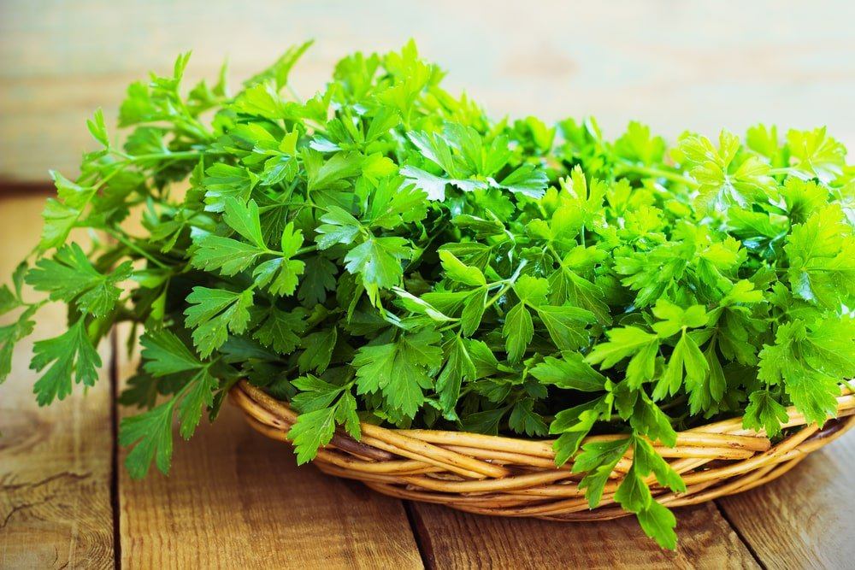
I NEVER REALIZED THERE WERE SO MANY DIFFERENT TYPES OF PARSLEY. AFTER ALL, WHEN RECIPES CALL FOR PARSLEY, THEY ALMOST NEVER SUGGEST THAT YOU USE A SPECIFIC KIND. BUT THEN I GOT INTO CULTIVATING HERBS AND USING ESSENTIAL OILS, AND I DISCOVERED THAT THERE ARE SEVERAL KINDS OF GREEN GARNISH. HERE’S A LOOK AT THE DIFFERENT PARSLEY VARIETIES, AS WELL AS SOME WAYS TO USE THEM IN SALADS AND OTHER DISHES FOR EXTRA FLAVOR.
RELATED: 13 PARSLEY SUBSTITUTES | PARSLEY VS. CILANTRO | HOW TO STORE PARSLEY

TYPES OF PARSLEY

CURLY PARSLEY
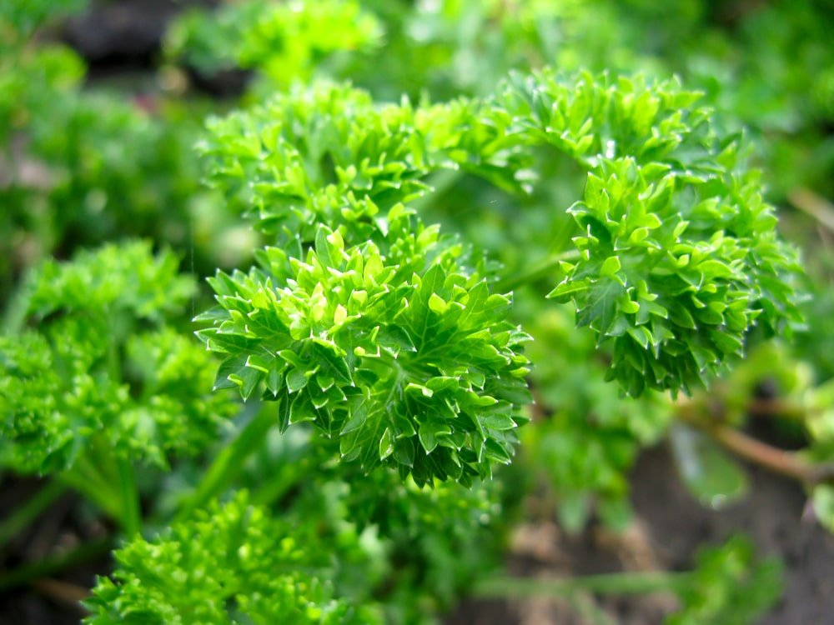
ALSO REFERRED TO AS PETROSELINUM CRISPUM VAR. CRISPUM, CURLY LEAF PARSLEY IS THE MOST COMMON TYPE OF PARSLEY. IT’S EASY TO GROW AND HIGHLY VERSATILE. ITS CURLED LEAF MAKES IT A POPULAR CHOICE FOR DECORATIVE PURPOSES. BUT CURLY-LEAVED PARSLEY ALSO HAS A PLEASANT TASTE, SO COOKS USE IT TO ENHANCE THE FLAVOR OF SOUPS AND OTHER CUISINES. THERE ARE DIFFERENT “SUB-VARIETIES” OF CURLY PARSLEY, SUCH AS EXTRA CURLED DWARF PARSLEY AND FOREST GREEN PARSLEY. ANOTHER TYPE IS COMPACT AND GROWS ESPECIALLY FAST.

JAPANESE PARSLEY
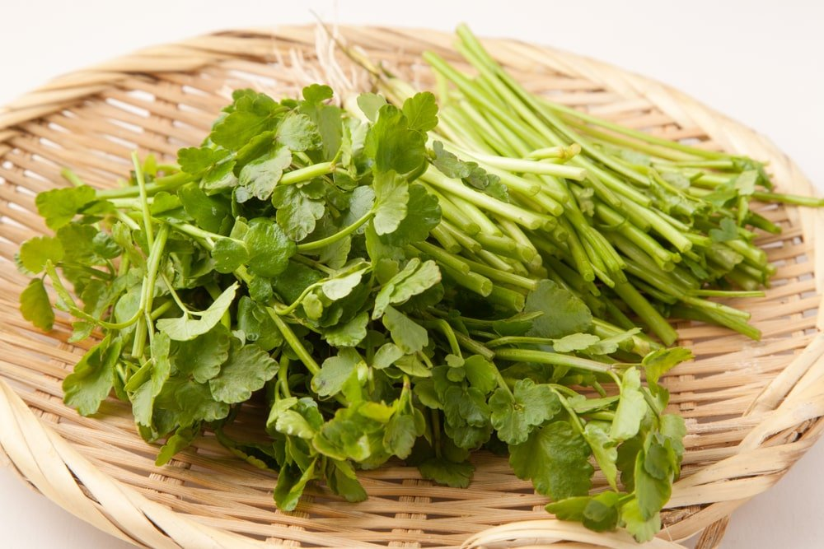
THIS EVERGREEN PERENNIAL HERB HAILS FROM CHINA AND JAPAN. IT HAS A SOMEWHAT BITTER TASTE, BUT SOME PEOPLE LIKE TO EAT IT ANYWAY, MUNCHING ON THE STURDY STEMS AS IF THEY WERE CELERY.

HAMBURG PARSLEY
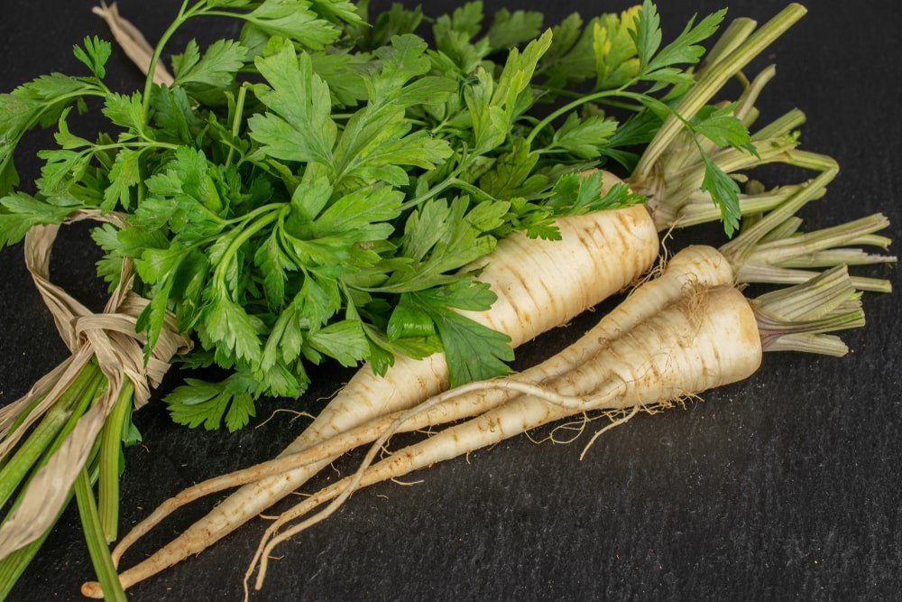
THIS TYPE (ALSO CALLED ROOT PARSLEY) IS FREQUENTLY ADDED TO SOUPS AND STEWS, WHERE IT IMPACTS BOTH THEIR TEXTURE AND FLAVOR. THE HAMBURG VARIETY IS LARGE PARSLEY WITH ROOTS SIMILAR TO THOSE OF PARSNIPS. ITS LEAVES ARE ORNAMENTAL AND LOOK SOMEWHAT LIKE FERNS.

FLAT LEAF PARSLEY
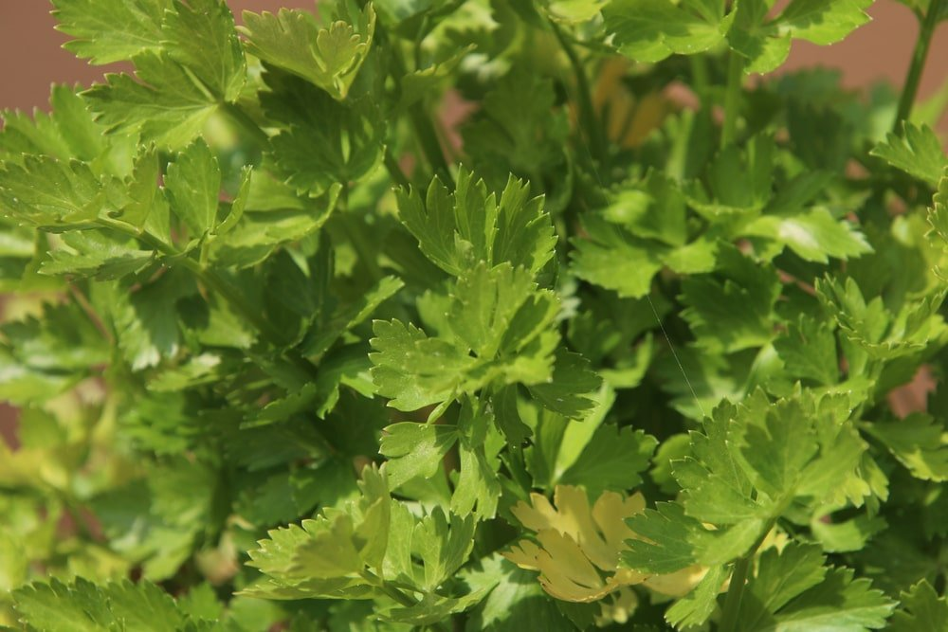
WHEN FULLY-GROWN, FLAT-LEAFED PARSLEY CAN REACH HEIGHTS OF 2-3 FEET, DEFINITELY MAKING IT ONE OF THE TALLER HERBS OF ITS KIND. IT’S A GREAT CHOICE IF YOU’RE LOOKING FOR HERBS TO PUT IN YOUR BUTTERFLY GARDEN. FLAT LEAF HAS A STRONGER FLAVOR THAN CURLY PARSLEY, SO IT’S A CULINARY STAPLE FOR CHEFS WHO LIKE TO GIVE THEIR CREATIONS A LITTLE EXTRA SPICE. WITHIN THIS BROAD PARSLEY CATEGORY ARE SEVERAL TYPES:
- TITAN PARSLEY. THIS IS A COMPACT HERB CHARACTERIZED BY SMALL, SERRATED LEAVES THAT ARE A DEEP GREEN.
- ITALIAN FLAT LEAF PARSLEY. THIS FLAT PARSLEY CLOSELY RESEMBLES CILANTRO AND TASTES LIKE PEPPER. IT HAS A MILDER FLAVOR THAN CURLY PARSLEY.
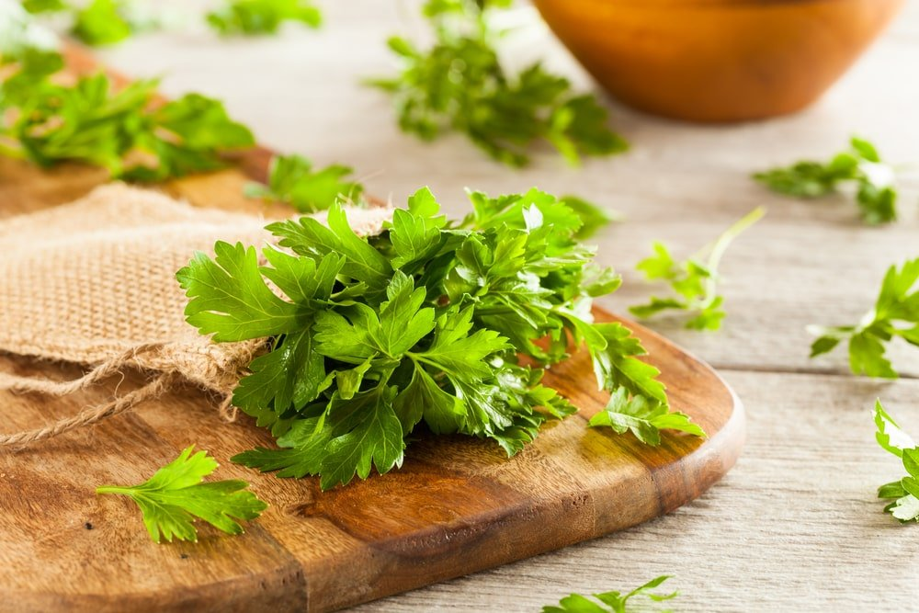
- GIANT OF ITALY. THIS PARSLEY VARIETY LIVES UP TO ITS NAME AND SETS ITSELF APART FROM OTHER KINDS OF PARSLEY. IT’S ESPECIALLY HARDY, AS IT STANDS UP WELL TO A WIDE RANGE OF GROWING CONDITIONS.

ORIGINS OF PARSLEY
THE PARSLEY PLANT ORIGINALLY HAILS FROM THE SOUTHERN MEDITERRANEAN AREA. IT WAS EVENTUALLY BROUGHT TO EUROPE AND IS NOW CULTIVATED WORLDWIDE.
IT WASN’T ALWAYS USED FOR COOKING. ANCIENT GREEKS THOUGHT OF IT AS A FUNERAL HERB AND DECORATED GRAVESTONES WITH IT. IN HEBREW CULTURE, PARSLEY REPRESENTED JUST THE OPPOSITE, AS IT WAS A SYMBOL OF REBIRTH AND SPRING. HENCE, IT WAS AN IMPORTANT PART OF PASSOVER CELEBRATIONS. IN ANCIENT ROME, PEOPLE USED IT AS A BREATH-FRESHENER TO MASK THE SMELL OF ALCOHOL. IT AIDED IN DIGESTION, LIKELY HELPING THE BODY METABOLIZE ALCOHOL FASTER.

TIPS FOR GROWING PARSLEY
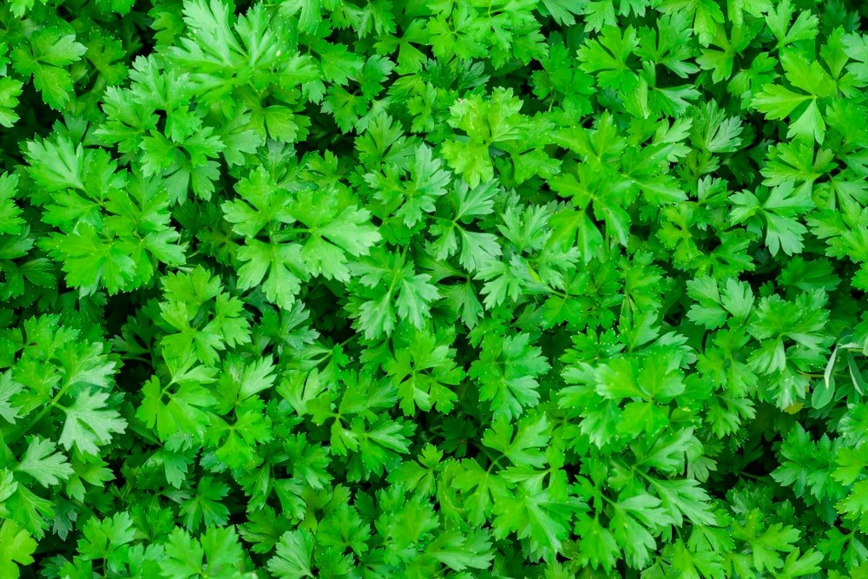
PARSLEY IS A FAVORITE AMONG HERB GARDENERS BECAUSE IT HAS SO MANY USES AND IS FAIRLY EASY TO GROW. HERE ARE SOME PARSLEY PLANTING TIPS TO HELP YOU YIELD THE BEST POSSIBLE HARVEST FROM YOUR GARDEN BED.

GETTING STARTED
- TEN TO TWELVE WEEKS BEFORE THE ANTICIPATED LAST SPRING FROST, PLANT PARSLEY SEEDS INDOORS (ONE SEED PER POT). FOR IMPROVED GERMINATION, SOAK THE SEEDS OVERNIGHT BEFORE PLACING THEM IN THE SOIL.
- GROWING PARSLEY CAN TAKE A WHILE, AT LEAST IN THE BEGINNING. IT CAN TAKE UP TO THREE WEEKS FOR SEEDS TO SPROUT. BUT SINCE THEY CAN HANDLE THE COLD, YOU CAN PLANT THEM OUTDOORS 3-4 WEEKS BEFORE THE LAST SPRING FROST TYPICALLY OCCURS.
- PARSLEY GROWS ESPECIALLY WELL IN SOIL THAT’S ABOUT 70°F.
- FOR BEST RESULTS, PLANT PARSLEY NEAR TOMATOES, CORN, AND ASPARAGUS.
- PARSLEY SEEDS DO WELL IN RICH, MOIST SOIL. PLACE SEEDS 6-8 INCHES APART. FOR THINNER PLANTS, LEAVE 8-10 INCHES OF SPACE BETWEEN THEM. TRY TO PLANT THEM IN A SPOT WHERE THEY WON’T SHARE THE SOIL WITH WEEDS. THIS WILL MAKE IT EASIER TO SEE THE FIRST SPROUTS.
- IF YOU WANT TO HELP THE SEEDLINGS ALONG, PUT THEM UNDER A FLUORESCENT LIGHT. THE LIGHT SHOULD REMAIN AT LEAST TWO INCHES ABOVE THE LEAVES.

CARING FOR GROWING PLANTS
- AS THEY GERMINATE, KEEP THE PLANTS WELL-WATERED.
- MAKE SURE YOU WATER THE HERBS EVENLY, ESPECIALLY WHEN SUMMER’S HEAT SETS IN.

HARVESTING AND STORING PARSLEY
- TO DETERMINE WHETHER YOUR PARSLEY IS READY TO BE PICKED, LOOK FOR THREE-SEGMENTED LEAF STEMS.
- WHEN YOU NEED SOME PARSLEY FOR SOUPS AND SALADS, CUT THE OUTER LEAVES AS NEEDED. (YOU DON’T HAVE TO HARVEST THEM ALL AT ONCE). DON’T CUT THE INNER PORTIONS OF THE PLANT, AS THEY’RE STILL MATURING.
- TO STORE FRESH PARSLEY, PLACE THE LEAF STALKS IN WATER AND REFRIGERATE THEM.
- TO MAKE DRIED PARSLEY, CUT IT AT THE BASE AND HANG IT SOMEWHERE THAT’S WARM, WELL-VENTILATED, AND SHADY. BE SURE IT’S COMPLETELY DRY. THEN, CRUMBLE IT AND STORE IT IN A SEALED CONTAINER.
- IF YOU WANT FRESH PARSLEY YEAR-ROUND, REPLANT SOME IN A POT AND KEEP IT ON A SUNNY WINDOWSILL.

WAYS TO USE PARSLEY
PARSLEY IS AN UNDERAPPRECIATED HERB, OFTEN OVERLOOKED IN FAVOR OF BOLDER FLAVORS LIKE SAGE AND BASIL. BUT IF YOU HAVE A BUNDLE OF PARSLEY ON HAND, THERE ARE A SURPRISING NUMBER OF FUN WAYS TO ENJOY IT. HERE ARE SOME CREATIVE WAYS TO GET THE MOST OUT OF THIS USEFUL HERB.

CHOPPED PARSLEY
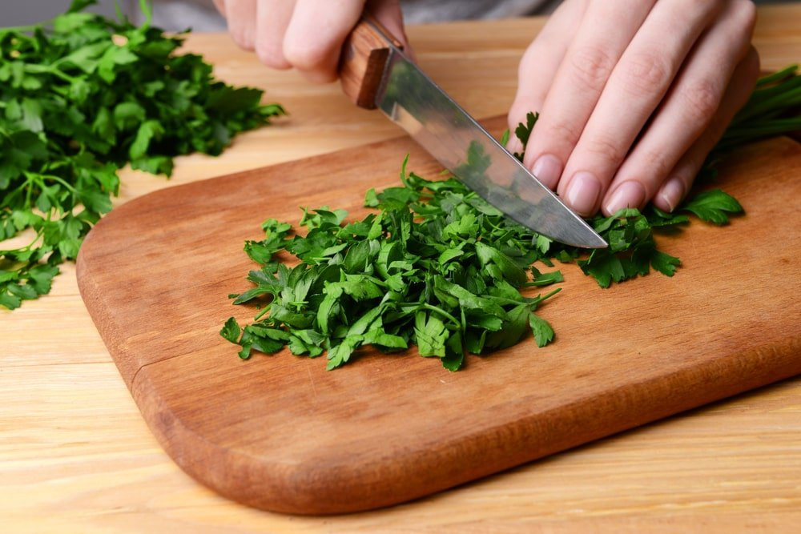
CHOPPED PARSLEY ENHANCES THE FLAVOR OF A VARIETY OF FOODS. SOME PEOPLE THINK IT TASTES GREAT ON EVERYTHING. THE KEY IS NOT TO CUT UP THE LEAVES TOO FINELY. LARGER PIECES OF GREENERY (ESPECIALLY THE CURLY VARIETY) ARE MORE PLEASING TO THE EYE AND TASTE BETTER TOO. TO GET STARTED, TRY TOSSING SOME OF THE FRESH HERBS OVER ROASTED POTATOES, GRILLED VEGGIES, COLD GREEN BEAN SALADS, AND MORE. YOU CAN EVEN SERVE IT ATOP GRAINS LIKE QUINOA AND COUSCOUS.

BOUQUET GARNI
THIS IS OFTEN ADDED TO SOUPS, STEWS, CASSEROLES, AND MORE. YOU WILL NEED:
- 1/4 CUP PARSLEY (FRESH OR DRIED)
- 2 TABLESPOONS DRIED THYME
- 1 TABLESPOON GROUND, DRIED BAY LEAF (OR 2 WHOLE DRIED BAY LEAVES)
- 2 TABLESPOONS DRIED ROSEMARY (OPTIONAL)
COMBINE THE INGREDIENTS IN A BOWL. THEN, PLACE THEM IN A DOUBLE-LAYERED CHEESECLOTH SQUARE. FORM A POUCH BY GATHERING THE SIDES TOGETHER. USE KITCHEN TWINE TO SECURE IT. LEAVE THE SECTION OF STRING LONG ENOUGH TO EASILY PULL THE BUNDLE FROM THE POT ONCE YOU’VE COOKED IT. EITHER USE IT RIGHT AWAY OR STORE IT IN AN AIRTIGHT CONTAINER IN A COOL, DRY PLACE FOR UP TO SIX MONTHS.

EASY PARSLEY SALAD
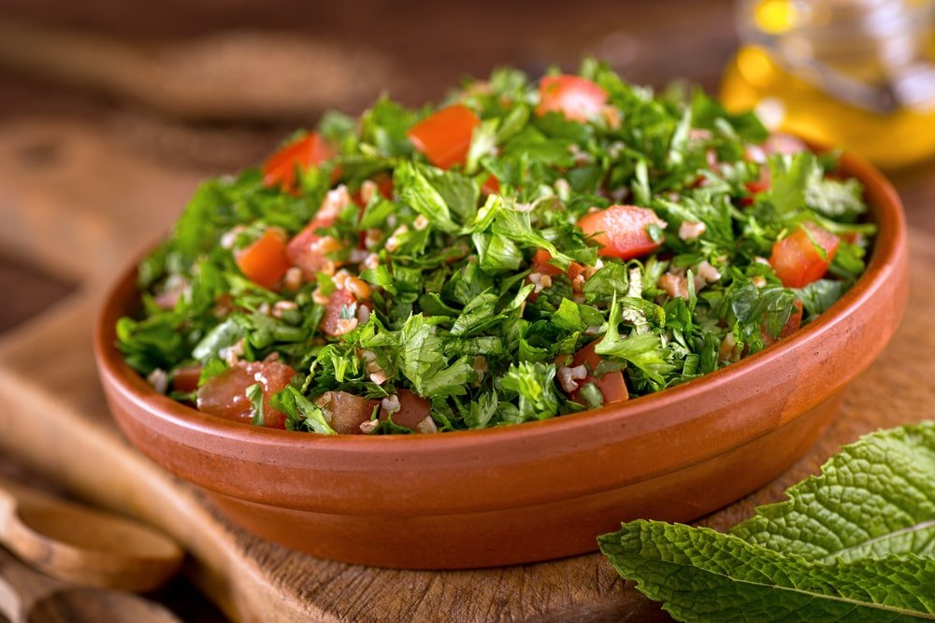
TOSS TOGETHER A FEW CUPS OF ITALIAN PARSLEY, A TEASPOON OF FRESH LEMON JUICE, 2 TABLESPOONS OF EXTRA-VIRGIN OLIVE OIL, AND A PINCH OF SALT. OR, INSTEAD OF SALT, USE UMEBOSHI VINEGAR FOR A MORE SOPHISTICATED DISH.

A DIFFERENT TAKE ON BASIC SALAD
FOR A VARIATION OF THE BASIC PARLEY SALAD, USE FLAT LEAF PARSLEY. ADD LEMON JUICE AND LEMON ZEST, HONEY AND SESAME SEEDS, AND WALNUT AND SESAME OIL. IT TASTES SO GOOD YOU’RE NOT LIKELY TO HAVE LEFTOVER, BUT IF YOU DO, YOU’LL BE HAPPY TO KNOW THAT THEY CAN LAST UP TO THREE WEEKS IN THE FRIDGE.

PARSLEY SUMAC SALAD
HERE’S WHAT YOU NEED FOR THIS PARSLEY-TOMATO SALAD:
- 2 TOMATOES, ROUGHLY DICED
- 1/4 CUP WHITE ONION, FINELY DICED
- 1/2 CUP PARSLEY LEAVES, ROUGHLY CHOPPED
TOSS THESE INGREDIENTS TOGETHER AND DRIZZLE OLIVE OIL OVER THEM. THEN ADD SUMAC, SALT, AND PEPPER TO TASTE.

CREAMY SALAD DRESSING
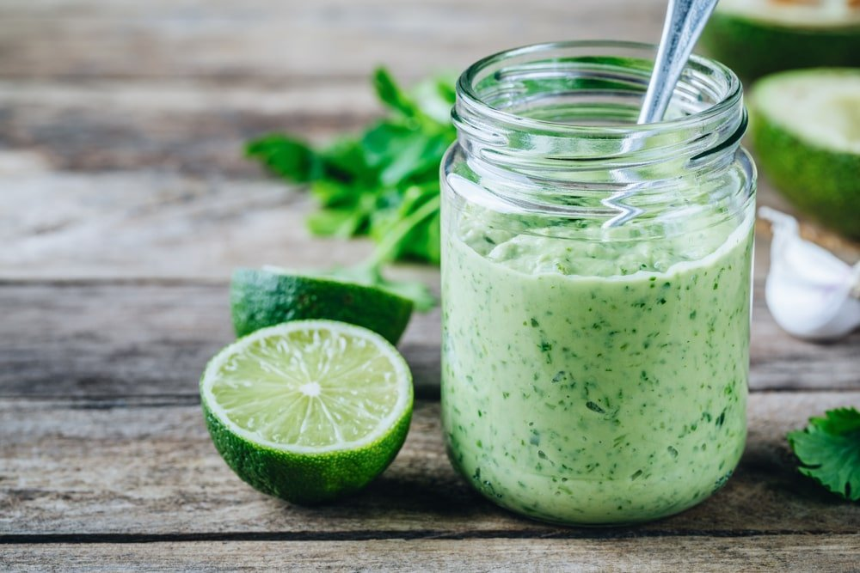
TO MAKE THE DRESSING, COMBINE THE FOLLOWING INGREDIENTS:
- 1/2 CUP PLAIN GREEK YOGURT (PREFERABLY THE KIND MADE WITH WHOLE MILK)
- 1/4 CUP EXTRA VIRGIN OLIVE OIL
- 1/4 CUP FRESH PARSLEY (YOU CAN ADD MORE IF YOU’RE A BIG FAN OF PARSLEY).
- KOSHER SALT (TO TASTE)
- A PINCH OF FRESH GROUND BLACK PEPPER
MIX THE INGREDIENTS BY HAND OR USE AN IMMERSION BLENDER. YOU CAN USE A REGULAR BLENDER OR FOOD PROCESS TOO, BUT AN IMMERSION BLENDER ALLOWS FOR THE EASIEST CLEANUP. NOT ONLY IS THIS A GREAT SALAD DRESSING, BUT IT’S A GREAT DIP FOR CHIPS AND VEGGIES, TOO.

PARSLEY VINAIGRETTE
THIS SALAD CONTAINS A FEW BASIC INGREDIENTS, SO YOU CAN ENJOY IT AS-IS OR ADD TO IT TO CUSTOMIZE IT. TO MAKE IT IN ITS SIMPLEST FORM, CHOP A CUP OR TWO OF CURLY OR ITALIAN PARSLEY AND MIX IT WITH MILD LETTUCE. (BUTTER LETTUCE IS A POPULAR CHOICE FOR THIS SALAD). THEN, DRIZZLE YOUR FAVORITE VINAIGRETTE OVER IT.

PARSLEY SMOOTHIE
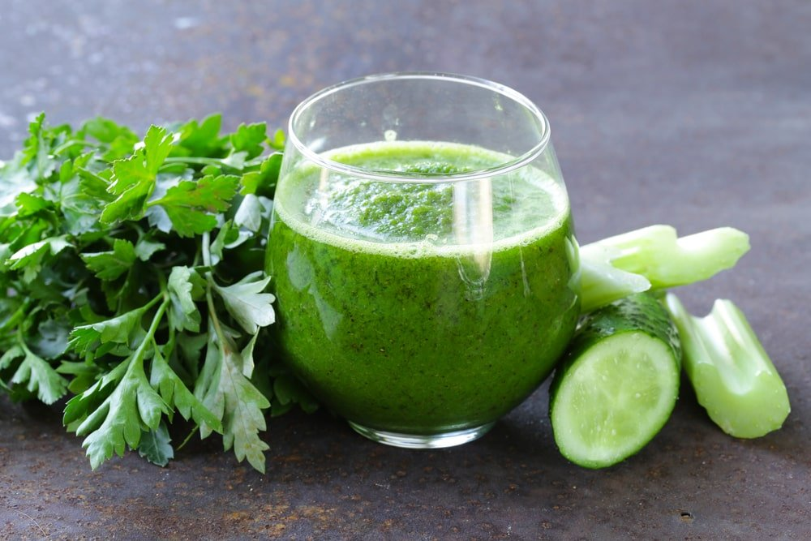
WE USUALLY EXPECT GREEN SMOOTHIES TO CONTAIN SPINACH OR KALE. BUT YOU CAN PUT PARSLEY IN THEM TOO, ALONG WITH MINT AND OTHER INGREDIENTS. IF YOU DON’T LIKE THROWING PARSLEY STEMS AWAY, YOU CAN INSTEAD STORE THEM IN A SEALED BAG IN THE FREEZER AND ADD A FEW TO EACH SMOOTHIE.

GARLIC PARSLEY BUTTER
IN CHIC RESTAURANTS, THIS STUFF GOES BY A MUCH FANCIER, FRENCH NAME, BEURRE MAITRE D’HOTEL. THE RECIPE, HOWEVER, ISN’T COMPLICATED. IT JUST REQUIRES:
- 1/2 CUP OF BUTTER
- 1 TABLESPOON OF LEMON JUICE
- 1-2 CLOVES OF GARLIC, FINELY MINCED
- 1/4 CUP PARSLEY, FINELY CHOPPED
CREAM THE INGREDIENTS TOGETHER, STARTING WITH THE BUTTER, THEN GRADUALLY ADDING IN THE OTHER COMPONENTS — IN ORDER. YOU CAN ADD A LITTLE LEMON ZEST, TOO. (IF GARLIC REALLY ISN’T YOUR THING, YOU CAN MAKE THIS SAUCE SANS THE PUNGENT SEASONING). THIS CONCOCTION IS A GREAT ADDITION TO SEAFOOD, VEGETABLES, AND GRILLED MEATS.

SIMPLE PARSLEY SAUCE
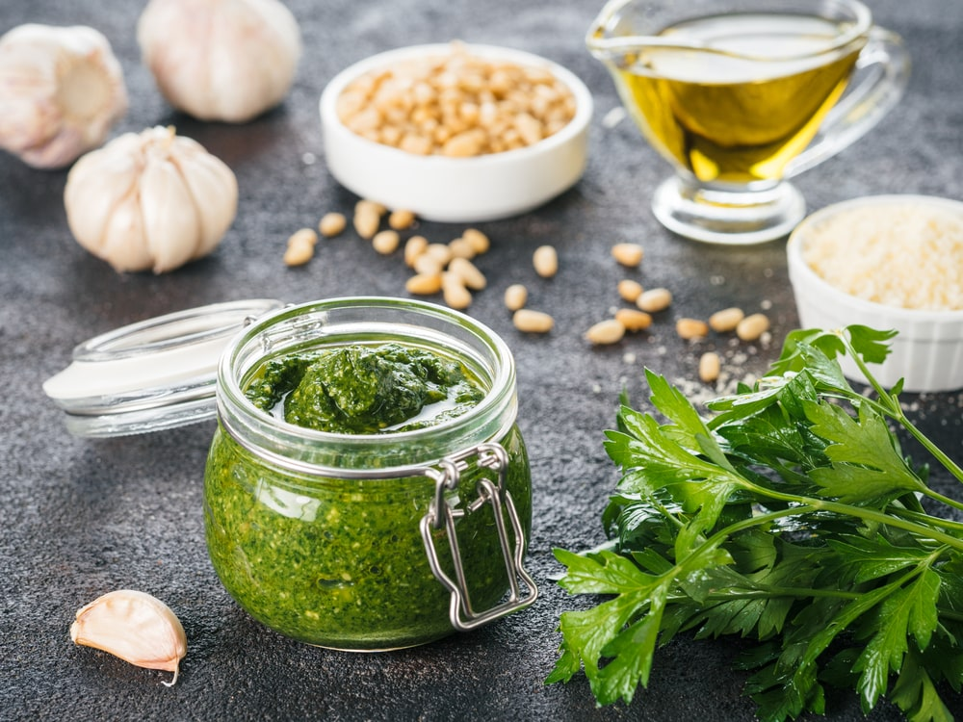
THIS IS A SOMEWHAT SIMPLER, TONED-DOWN VERSION OF THE FRENCH GARLIC SAUCE. TO MAKE IT, COMBINE:
- 1 CUP (ABOUT HALF A BUNCH) OF PARSLEY LEAVES
- 1 CLOVE GARLIC
- 1/2 TEASPOON OF KOSHER SALT
- 1/4 CUP EXTRA VIRGIN OLIVE OIL
BLEND THE INGREDIENTS THOROUGHLY.
WHAT’S COOL ABOUT THIS SAUCE IS THAT THERE ARE SEVERAL VARIATIONS OF IT. HERE’S WHAT ELSE YOU CAN DO WITH THIS RECIPE.
- GREMOLATA. ADD LEMON JUICE AND LEMON ZEST.
- PARSLEY PESTO. ADD PARMESAN AND TOASTED NUTS.
- EXTRA-ZESTY SAUCE. SUBSTITUTE SHALLOT FOR THE GARLIC AND THROW IN JUST A LITTLE ANCHOVY PASTE
WHAT’S GREAT ABOUT THESE VERSATILE SAUCES IS THAT THEY GO WITH A LOT OF DIFFERENT DISHES — GRILLED CHEESE SANDWICHES, VEGETABLES, STEAK, FISH, SOUPS, AND STEWS. PLUS, THE SAUCE HAS A FAIRLY LONG SHELF LIFE IN THE FRIDGE.

PARSLEY TEA
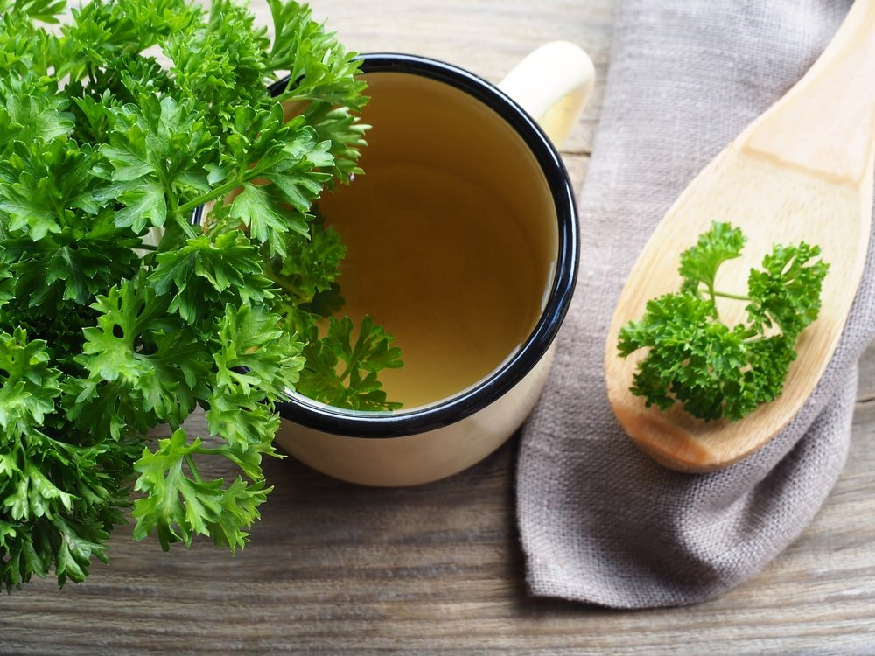

YOU CAN BREW FRESH LEAVES OR DRIED LEAVES AS TEA.

THERAPEUTIC USES FOR PARSLEY
IN ADDITION TO ENHANCING THE FLAVOR AND APPEARANCE OF DISHES, PARSLEY IS USED FOR ITS MEDICINAL AND THERAPEUTIC BENEFITS TOO. PARSLEY SEEDS, ROOTS, AND LEAVES ALL HAVE THERAPEUTIC QUALITIES. HERE ARE SOME PRACTICAL USES FOR THIS MULTI-PURPOSE HERB. IF YOU’RE THINKING ABOUT USING PARSLEY AS PART OF YOUR HEALTHY LIFESTYLE REGIMEN, CONSULT A QUALIFIED HEALTHCARE PROVIDER FIRST.
PARSLEY-INFUSED BATH. ADDING PARSLEY TO BATHWATER HAS TO CALM AS WELL AS CLEANSING PROPERTIES.
SOME PEOPLE USE PARSLEY TO MANAGE
- URINARY TRACT INFECTIONS (UTIS)
- HIGH BLOOD PRESSURE
- DIABETES
- GASTROINTESTINAL CONDITIONS
- CONSTIPATION
- ASTHMA
- COUGHS.

TOPICAL APPLICATIONS
PARSLEY CAN BE APPLIED DIRECTLY TO THE SKIN TO REDUCE FACIAL DARK PATCHES. PARSLEY CAN ALSO RELIEVE CRACKED, CHAPPED SKIN. IF YOU’RE DEALING WITH HAIR LOSS, PARSLEY MAY HELP STIMULATE NEW GROWTH. PARSLEY CAN ALSO HELP THE SKIN RECOVERY FROM BUG BITES AND BRUISES. SOME PATIENTS EVEN USE IT TO MANAGE TUMORS.

COSMETIC USES
MANUFACTURERS FREQUENTLY INCORPORATE PARSLEY SEED ESSENTIAL OIL TO ADD FRAGRANCE TO SOAPS, PERFUMES, AND COSMETICS.

HEALTH BENEFITS OF PARSLEY SEED ESSENTIAL OIL
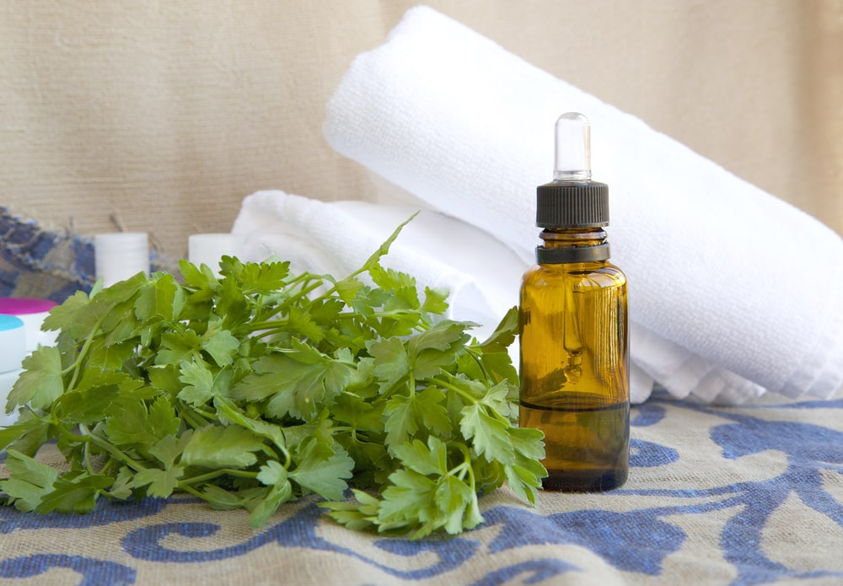
HERE ARE SOME OF THE HEALTH BENEFITS OF PARSLEY SEED ESSENTIAL OIL.
- ANTIMICROBIAL. SINCE IT INHIBITS MICROBE GROWTH, IT CAN LIMIT THE SPREAD OF INFECTIONS. IT MAY ALSO HELP PREVENT WOUNDS FROM BECOMING SEPTIC.
- GI SUPPORT. PARSLEY OIL CAN RELIEVE INTESTINAL COMPLAINTS SUCH AS NAUSEA, STOMACHACHES, VOMITING, INDIGESTION, AND GAS. IT ALSO BOOSTS DIGESTION AND IMPROVES APPETITE.
- ARTHRITIS RELIEF. THE OIL CAN IMPROVE CIRCULATION AND ALLEVIATE PAIN ASSOCIATED WITH ARTHRITIS AND GOUT.
- DIURETIC. PARSLEY SEED OIL CAN INCREASE URINE OUTPUT, HELPING TO REDUCE FLUID RETENTION IN THE BODY AND ELIMINATING CALCIUM DEPOSITS IN THE KIDNEYS AND URINARY TRACT.
- MENSTRUAL SUPPORT. BECAUSE IT PROMOTES ESTROGEN SECRETION, PARSLEY OIL CAN REDUCE MENSTRUAL ISSUES SUCH AS CRAMPS, NAUSEA, AND FATIGUE.
- CARDIOVASCULAR HELP. THE OIL CAN REDUCE HYPERTENSION WHILE BOOSTING CIRCULATION AND REMOVING TOXINS FROM THE BLOOD.

FAQS

HOW DO YOU STORE PARSLEY IN THE REFRIGERATOR?
YOU CAN REFRIGERATE FRESH PARSLEY FOR 3-5 DAYS. FIRST, RINSE THE PARSLEY IN A COLANDER, AND USE PAPER TOWELS TO DAB IT DRY. THEN, USE THE SAME TOWELS TO WRAP THE HERB LOOSELY. PLACE THE WHOLE BUNDLE IN A SEALABLE BAG, SEAL IT COMPLETELY, AND PLACE IT IN THE REFRIGERATOR. THIS METHOD WORKS WELL BECAUSE YOU DON’T HAVE TO DRY THE HERBS COMPLETELY, THUS RETAINING MOISTURE AND FRESHNESS.

HOW DO YOU PRESERVE PARSLEY IN THE FREEZER?
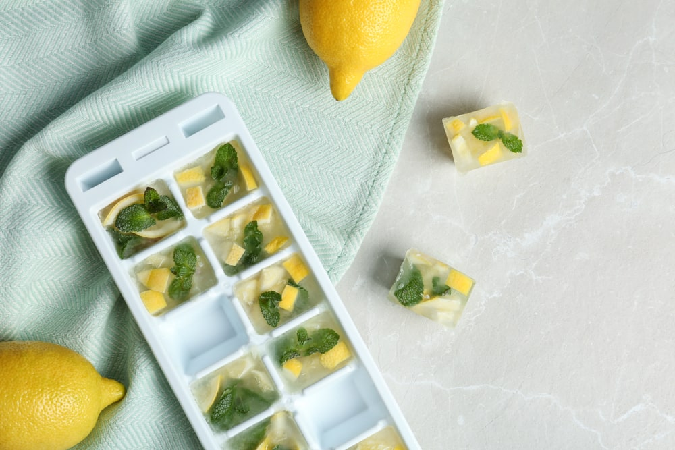
THERE ARE TWO WAYS TO STORE PARSLEY IN THE FREEZER. FREEZING IS RECOMMENDED IF YOU NEED TO STORE THE PARSLEY FOR MORE THAN 3-5 DAYS.
- BUNDLE THE HERB INTO A “PARSLEY CIGAR.” RINSE THE PARSLEY IN A COLANDER AND USE PAPER TOWELS TO DRY IT AS COMPLETELY AS POSSIBLE. PLACE WASHED AND DRIED PARSLEY TO THE BOTTOM OF THE BAG AND ROLL THE BAG UP LIKE A CIGAR, PUSHING ALL THE AIR OUT THROUGH THE TOP. BE SURE TO ROLL THE BAG TIGHTLY. GETTING THE AIR OUT OF IT PREVENTS FREEZER BURN, WHICH SHOWS UP AS WHITE CRYSTALS AND CAN REMOVE MUCH OF THE FLAVOR FROM YOUR FOOD. THEN, SEAL THE BAG AND FREEZE IT. USE KITCHEN SHEARS TO CHOP SECTIONS OF THE CIGAR AS NEEDED.
- MAKE PARSLEY ICE CUBES. RINSE THE PARSLEY IN A COLANDER. DAB IT DRY WITH SOME PAPER TOWELS. USE A KNIFE TO CHOP UP SMALL QUANTITIES. IF YOU HAVE A LOT, GO AHEAD AND THROW IT IN THE FOOD PROCESSOR. YOU CAN REDUCE IT TO THE CONSISTENCY OF A PASTE IF YOU WANT. IF YOU’RE USING THE BLENDER, ADD 2 TABLESPOONS OF OIL THAT HAVE A NEUTRAL TASTE. THE OIL MELTS FASTER THAN WATER AND PRESERVES THE HERB’S FLAVOR.
THERE ARE TWO WAYS TO MAKE PARSLEY CUBES OR BLOCKS.
- ICE CUBE TRAYS. SPOON FINELY CHOPPED PARSLEY INTO THE WELLS OF AN ICE CUBE TRAY. IF YOU HAVEN’T ALREADY ADDED OIL, NOW IS THE TIME TO DO IT. WHEN THE CUBES ARE COMPLETELY FROZEN, TRANSFER THEM TO A FREEZER-SAFE BAG.
- FREEZER BAGS. PLACE THE WHOLE BATCH IN A FREEZER BAG. IF YOU HAVEN’T ALREADY, ADD 2 TABLESPOONS OF OIL. THEN, CLOSE THE BAG ALMOST COMPLETELY. FLATTEN THE HERBS INTO AN EVEN LAYER AND PUSH ALL THE AIR OUT OF THE BAG BEFORE SEALING IT COMPLETELY.

WHAT CAN YOU DO WITH FROZEN PARSLEY?
THAWED PARSLEY WILL BE LESS SUPPLE THAN THE FRESH KIND. THEREFORE, IT DOESN’T MAKE THE BEST SALAD GARNISH. HOWEVER, YOU CAN STILL ADD IT TO SOUPS, STEWS, DRESSINGS, AND SAUCES.

HOW IS PARSLEY ESSENTIAL OIL OBTAINED?
THE ESSENTIAL OIL IS EXTRACTED FROM DRIED SEEDS THROUGH STEAM DISTILLATION. THIS PROCESS INVOLVES USING STEAM, TO SEPARATE MATERIALS THAT ARE TEMPERATURE-SENSITIVE (IN THIS CASE, VOLATILE OILS). STEAM IS ADDED TO DISTILLATION EQUIPMENT TO LOWER THE BOILING POINT OF THE MATERIALS SO THAT THEY CAN BE ISOLATED AT TEMPERATURES LOWER THAN THOSE AT WHICH THEY DECOMPOSE. THIS PRESERVES THE INTEGRITY OF THE OILS OR COMPOUNDS BEING SEPARATED.

26 DIFFERENT TYPES OF ONIONS
GET TO KNOW THE DIFFERENT TYPES OF ONIONS THAT CAN BE FOUND ALL OVER THE WORLD AND HOW THESE HIGHLY NUTRITIOUS PLANTS ARE USED FOR VARIOUS PURPOSES ASIDE FROM COOKING.
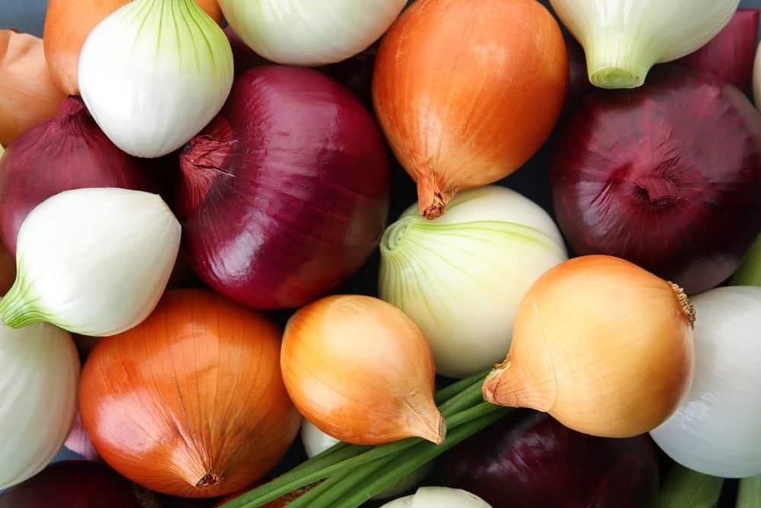
WHERE WOULD HUMANITY BE WITHOUT THE ONION? WE WOULD HAVE SHED FAR FEWER TEARS, WE WOULD HAVE NO APPROPRIATE ANALOGY DESCRIBING OUR PROTECTIVE PERSONALITIES, AND OUR SOUPS AND SAUCES WOULD BE FAR INFERIOR THAN THEY ARE NOW.
ONIONS ARE VEGETABLES THAT BELONG TO THE AMARYLLIDACEAE FAMILY AND THE GENUS ALLIUM. THEY ORIGINATED FROM CENTRAL ASIA AND WERE CULTIVATED 7,000 YEARS AGO AND HAVE BEEN CULTIVATED FOR FOOD HARVEST EVER SINCE. THEY ARE VERY CLOSE RELATIVES OF THE CHINESE ONION, LEEK, SCALLION, AND CHIVE.
THERE ARE HUNDREDS OF ONION SPECIES, AND DEPENDING ON THE ONION VARIETY, THEY WILL VARY IN OVERALL SHAPE, SIZE, COLOR, GROWING REGION, AND MOST IMPORTANTLY, FLAVOR!
DID YOU EVER WONDER WHAT IT IS THAT MAKES US CRY WHEN WE CUT OPEN AN ONION? WELL, ONION JUICE CONTAINS SULPHURIC ACID WHICH CAUSES OUR EYES TO CREATE MOISTURE BECAUSE OF THE STINGING SENSATION.
KEEP READING TO DISCOVER ALL THE DIFFERENT TYPES OF ONIONS! WE’LL ALSO GO OVER ALL OF THE BEAUTIFUL WAYS THAT ONIONS CAN BE USED; FROM GROWING ONIONS TO PUTTING THEM IN SALAD DRESSINGS OR FRENCH ONION SOUP. YOU CAN MAKE CARAMELIZED ONIONS, PICKLED ONION, AN ONION RING, AND THERE AIN’T NOTHING WRONG WITH A LOVELY RAW ONION!

COMMON ONION TYPES
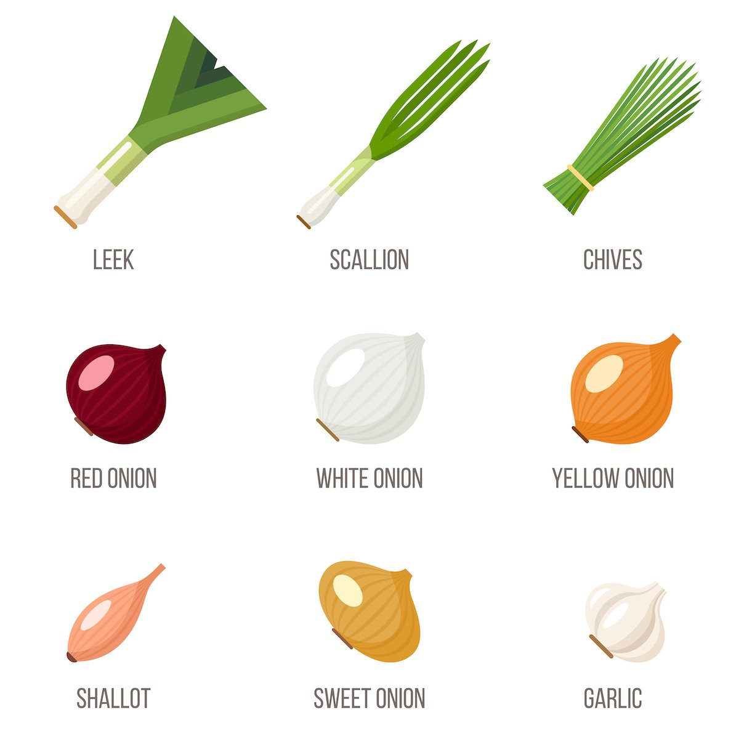

RELATED: TYPES OF GREEN ONIONS | TYPES OF SHALLOTS | WHAT GOES WITH CHILI | HERBS TO GROWN IN WATER ON YOUR WINDOWSILL | VEGETABLES AND HERBS FOR SYMBIOTIC FARMING

ONION NUTRITION CHART
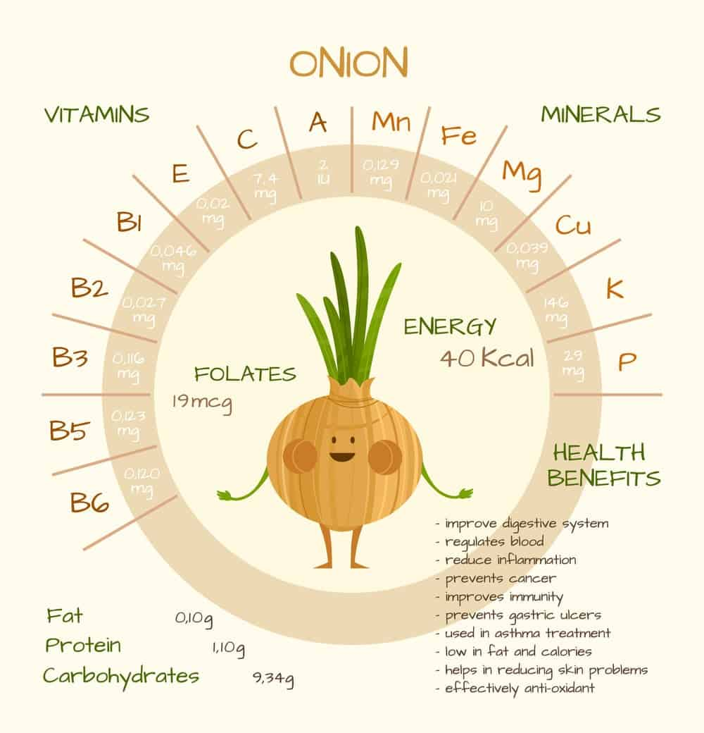
ONIONS ARE ONE OF THOSE SUPER VEGETABLES. NOT ONLY ARE THEY GOOD FOR YOU, BUT THEY PROVIDE SO MUCH ROBUST ONION FLAVOUR TO OUR FAVORITE DISHES. SOMETIMES THE MOST HEALTHY VEGETABLES CAN BE A LITTLE BIT ON THE BLAND SIDE (YA, I’M TALKING TO YOU, KALE) BUT THAT IS NOT THE CASE WITH ONIONS! WE LIKE SOMETHING A LITTLE BIT MORE OF A PUNGENT FLAVOUR AROUND HERE.

WHAT IS AN ONION?
THOUGH MOST OF US JUST CALL IT AN ONION, IT SHOULD MORE APPROPRIATELY BE CALLED A BULB ONION, BULBING ONION, OR COMMON ONION. THEY CAN BE GROWN AS A BIENNIAL (USUALLY LIVING 2 YEARS) OR A PERENNIAL PLANT, BUT WHEN CULTIVATED, THEY ARE MOSTLY TREATED AS AN ANNUAL PLANT AND HARVESTED AFTER THEIR VERY FIRST GROWING SEASON.
MUCH LIKE A ROOT VEGETABLE, WE ACTUALLY EAT THE BULB, OR TECHNICALLY THE ROOT SYSTEM OF THE ONION PLANT. AN ONION BULB IS AN UNDERGROUND STEM THAT IS SHORTENED AND COMPRESSED. THE BULB ITSELF IS COMPRISED OF SCALE-LIKE LEAVES (THIS IS THE PART WE EAT!)
THE LEAVES EMERGE VERY FLESHY AND JUICY, BUT AS HARVESTING SEASON APPROACHES, THE OUTER FOLIAGE DIES AND BECOME DRY AND BRITTLE. THIS ACTS AS A NATURAL PRESERVATION TOOL FOR THE ONION, AND WHY MOST ONIONS DON’T NEED TO BE REFRIGERATED!
ONCE AN ONION IS HARVESTED IT IS READY TO GO AS A STORAGE ONION THAT CAN BE USED AT ANY TIME, OR YOU CAN PROCESS YOUR ONIONS! TRY A PICKLED ONION RECIPE, A FERMENTED ONION RECIPE, OR EVEN TRY YOUR HAND AT DRY ONIONS FOR AN AWESOME GARNISH.

26 DIFFERENT ONION TYPES

1. BERMUDA ONION
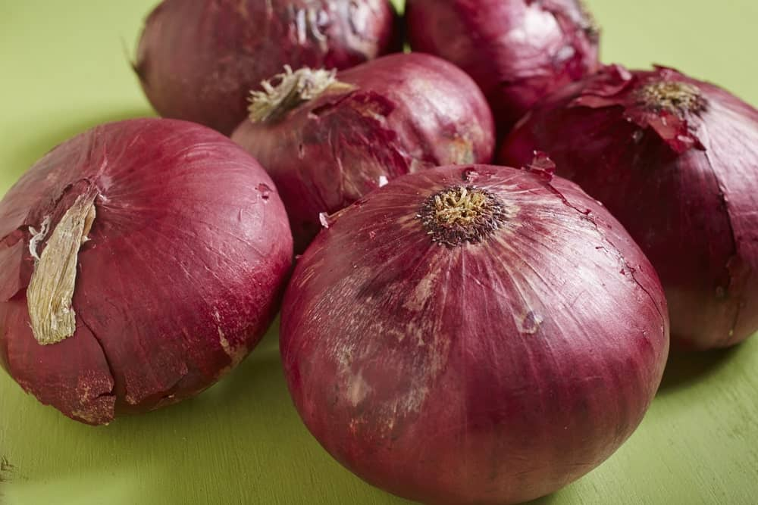BERMUDA ONIONS ARE GREAT FOR BOTH STUFFING AND BAKING, MAINLY BECAUSE OF THEIR LARGE SIZE. THEY HAVE A SLIGHTLY SWEET FLAVOR THAT WON’T OVERPOWER THE REST OF THE INGREDIENTS, AND THEY ARE A FAVORITE ON CERTAIN HOLIDAYS. IF YOU NEED A REPLACEMENT FOR EITHER SPANISH ONIONS OR SHALLOTS, THE BERMUDA ONION IS WHAT YOU SHOULD CHOOSE.
BERMUDA ONIONS ORIGINATED ON THE BERMUDA ISLANDS, BUT ARE ALSO POPULARLY GROWN ALL OVER THE UNITED STATES, ESPECIALLY IN TEXAS. THE BERMUDA ONION IS COMMONLY USED RAW IN SALADS AND SANDWICHES, BUT THEY ARE GREAT FOR COOKING AS WELL.
THEIR SWEET AND MILD FLAVOR MAKES THEM JUST AS VERSATILE AS THE COMMON YELLOW ONION. THEY COME IN A LARGE BULBOUS SHAPE AND WILL USUALLY BE EITHER WHITE, YELLOW, OR RED.

2. BOILING ONION
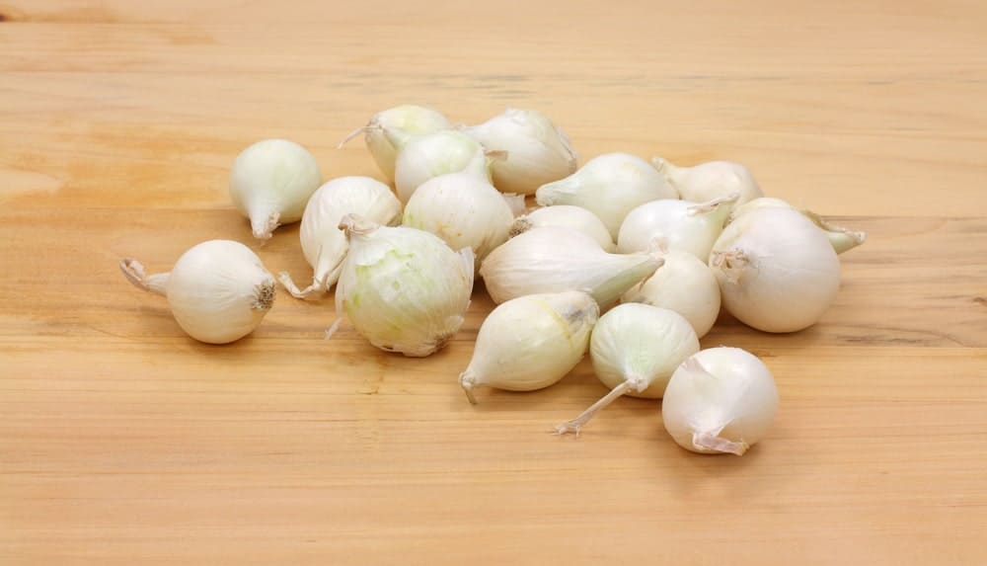
Bottom of Form
THE BOILING ONION IS VERY SIMILAR TO A PEARL ONION, THOUGH IT IS ABOUT TWICE AS LARGE. THEY ARE ABOUT AN INCH IN DIAMETER AND ROUND IN SHAPE. THEY ARE A GREAT DRY ONION THAT CAN BE KEPT FOR A LONG TIME IN A PANTRY.
BOILING ONIONS HAVE A VERY MILD FLAVOR, THOUGH NOT MILD ENOUGH TO BE USED RAW. THEY ARE COMMONLY USED AS WHOLE ONIONS TO BE ADDED TO SOUPS, STEWS, AND BRAISES.

3. CHIVE
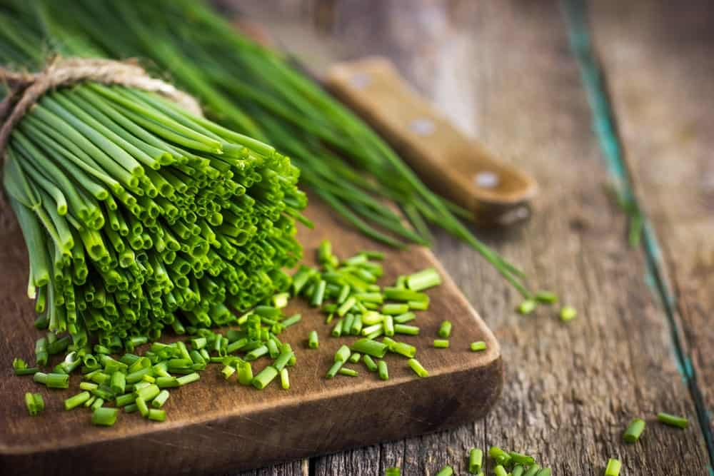
YES, CHIVES ARE A TYPE OF ONION, AND THEY ARE PERFECT FOR MAKING SALADS AND SOUPS WITH A LITTLE MORE KICK. IN FACT, THEY PROVIDE A SPICINESS TO ANY DISH YOU INCLUDE THEM IN, SO IF YOU WANT SOME EXTRA OOMPH FOR YOUR NEXT CASSEROLE OR MAIN DISH, CHIVES ARE THE PERFECT INGREDIENT. YOU CAN ALSO USE THEM IN EGGS AND CREAMED SOUPS FOR A LITTLE EXTRA FLAVOR.
CHIVES ARE MOST COMMONLY USED RAW. THEIR FRESH AND MILD SPICY FLAVOR IS BEST DEPICTED WHEN THEY ARE USED AS A GARNISH, AND WILL ALWAYS ENSURE A NECESSARY PUNCH OF FRESHNESS TO ANY DISH.

4. CIPOLLINI ONION
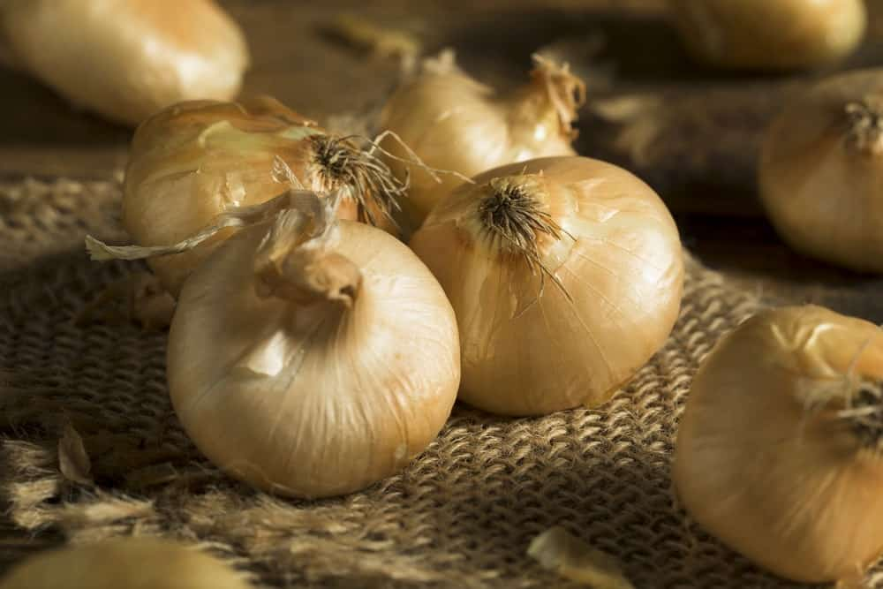
CIPOLLINI ONIONS ARE USUALLY A BEIGE OR BROWN COLOR, AND THEY HAVE A RICH, SWEET TASTE. IF YOU WANT THE PERFECT ONION TO CARAMELIZE OR ROAST, THE CIPOLLINI ONION IS THE ONE TO CHOOSE. THEY ALSO TASTE GREAT IN SALADS. ONE VARIETY OF CIPOLLINI ONION IS KNOWN AS THE BIANCO DI MAGGIO, WHICH IS WHITE IN COLOR AND HAS A SWEET TASTE.
CIPOLLINI ONIONS ARE ALSO AN EXCELLENT CHOICE FOR FRENCH ONION SOUP. USED WITH OTHER TYPES OF ONION, THE CIPOLLINI ADDS AN INCREDIBLY SWEET AND ROBUST DIMENSION TO THE SOUP.

5. COCKTAIL ONION
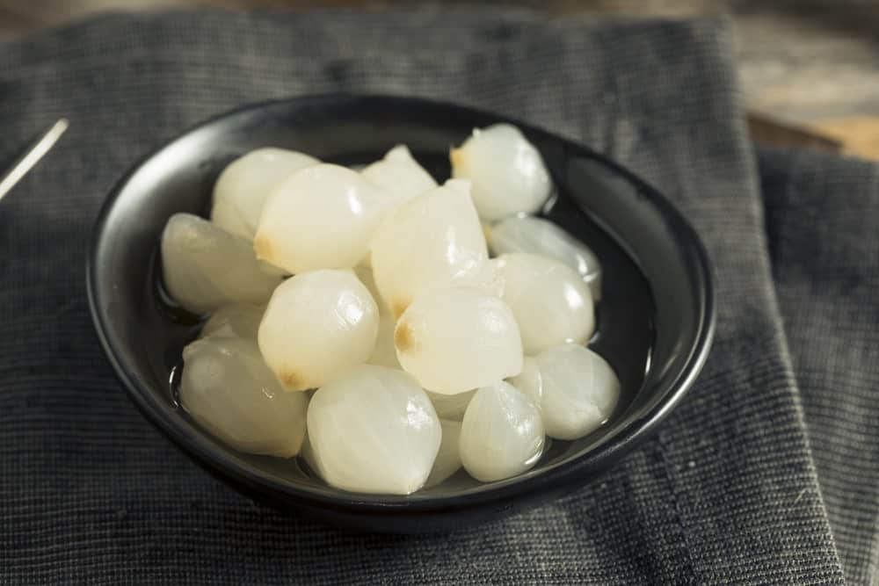
ALSO CALLED SILVER SKIN ONIONS, COCKTAIL ONIONS ARE SWEET AND VERY SMALL. IF YOU SEE PICKLED ONIONS IN A STORE, IT IS LIKELY GOING TO BE COCKTAIL ONION. THEY ARE OFTEN USED TO GARNISH COCKTAILS AND IN RECIPES FOR VARIOUS CHEESES AND BREAD.
THE COCKTAIL ONION IS ACTUALLY AN IMMATURE ONION OR A BABY ONION THAT IS HARVESTED BEFORE IT IS FULLY GROWN. THE OUTER LAYER ARE PEELED OFF BEFORE THE ONION IS PICKLED. THEY’VE GOT A SUPER PUNGENT FLAVOR!
THE CLASSIC VESPER MARTINI IS GARNISHED WITH A COCKTAIL ONION. TO BE HONEST, THEY ARE MORE OF AN OUTDATED GARNISH (WE ALL REMEMBER WHAT HAPPENED TO THE SUN DRIED TOMATO) AND THEY ARE NOT COMMONLY USED IN COOKING AS MUCH.

6. CREOLE ONION
SMALL AND RED, CREOLE ONIONS ARE VERY SPICY, AND THEY ARE PERFECT FOR ADDING A LITTLE KICK TO YOUR DISH. THEY ARE MOSTLY GROWN IN SOUTHERN CLIMATES AND HAVE BEEN USED IN CREOLE CUISINE FOR CENTURIES.
THEY ARE SHORT DAY ONIONS THAT ARE A FLATTENED BULB SHAPE WITH SPICY PURPLE FLESH. THEY ARE A SPECIAL HEIRLOOM VARIETY THAT HAS A VERY PUNGENT SMELL. THOUGH THEY HAVE AN INTENSE FLAVOR, THEY ARE MOST POPULARLY USED AS RAW GARNISHES FOR THAT EXTRA OOMPH!

7. EGYPTIAN ONION
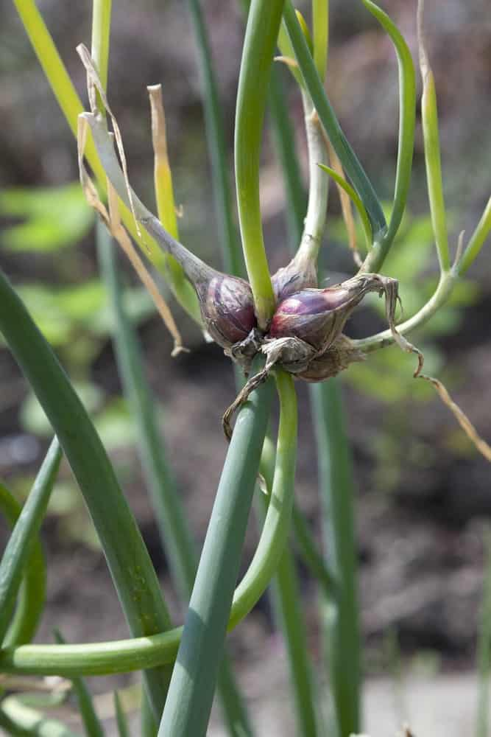
THE EGYPTIAN ONION IS ALSO KNOWN AS THE EGYPTIAN WALKING ONION. IT GETS THIS NAME BECAUSE IT’S ODD GROWING PATTERN. BASICALLY THE PLANT PRODUCES BULBLETS WHERE FLOWERS WOULD USUALLY GROW. ONCE THEY BULBLETS BECOME TOO HEAVY, THE STALKS TIP OVER AND THE BULBLETS PLANT THEMSELVES INTO THE GROUND. THIS CREATES AN INTERESTING “WALKING” GROWTH HABIT!
THESE EGYPTIAN ONION BULBLETS ARE EDIBLE AND ARE SAID TO TASTE VERY SIMILAR TO SHALLOTS, ONLY SLIGHTLY MORE INTENSE IN FLAVOR. THEY CAN BE EATEN BOTH RAW AND USED FOR VARIOUS COOKING RECIPES.

8. GREEN ONION
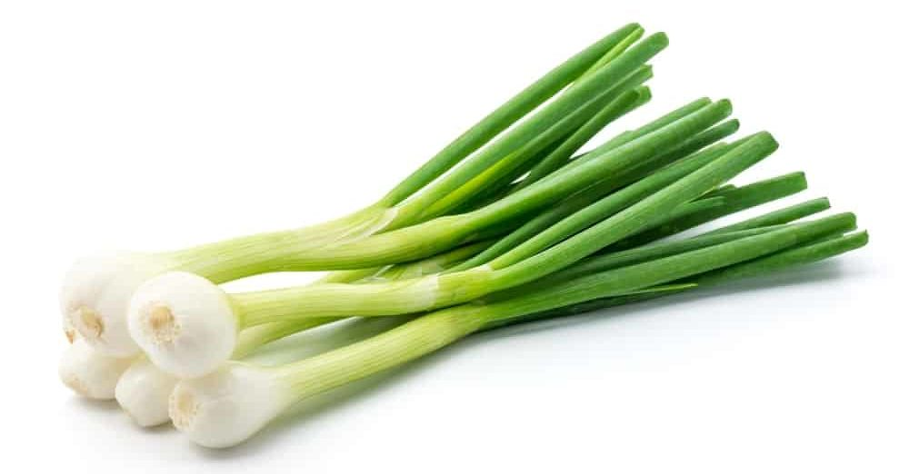
ALSO CALLED A SPRING ONION, GREEN ONIONS ARE GREAT IN DISHES SUCH AS SANDWICHES, STIR-FRY DISHES, AND VARIOUS TYPES OF DIPS. THEY HAVE A MILD, PEPPERY TASTE, AND THEY CAN EASILY BE EATEN RAW. IF YOU USE THEM IN A STIR-FRY DISH, YOU CAN USE BOTH THE WHITE AND THE GREEN PARTS, ALTHOUGH YOU MAY WANT TO USE ONLY ONE PART FOR OTHER RECIPES.
GREEN ONIONS ARE INTERESTING BECAUSE THEIR FLAVOR CHANGES THE CLOSER YOU GET TO THE BULB. THE VERY TIPS OF THE PLANT THAT ARE MOST DARK GREEN WILL HAVE A MORE MILD FLAVOR AND A MORE DRIED LEAF, AND THE LOWER DOWN YOU GO THE JUICIER AND MORE FLAVORFUL THE PLANT BECOMES.

9. LEEK
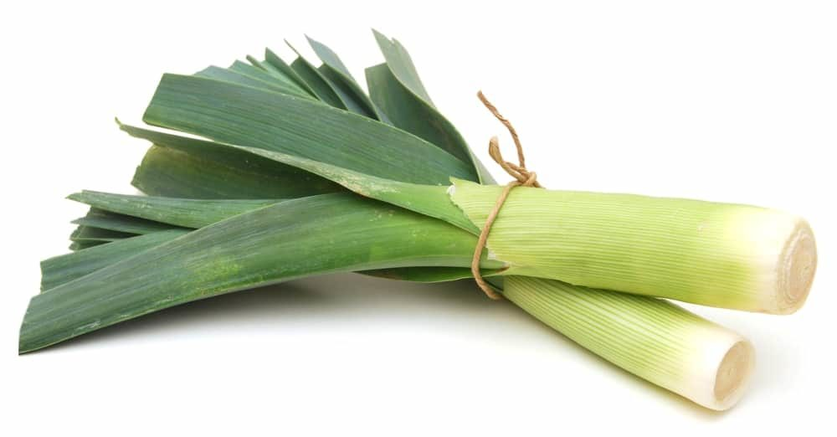
LEEKS ARE VERY VERSATILE ONIONS AND THEY GO GREAT WITH MEATS, SUCH AS BACON. IF YOU’RE COOKING SOMETHING SLOWLY FROM SCRATCH – INCLUDING STEWS AND SOUPS – THEY ARE THE PERFECT INGREDIENT TO ADD. IN FACT, YOU CAN FIND MANY SOUP RECIPES THAT INCLUDE LEEKS IF YOU SEARCH THE INTERNET.
LEEKS ARE AWESOME BECAUSE EVEN THOUGH THE TOPS OF THE LEAVES ARE EXACTLY EDIBLE, THEY CAN STILL BE STEEPED IN A SLOW COOKING BROTH, SO THAT NO PART OF THE PLANT HAS TO BE WASTED. THE BOTTOM HALF OF THE LEEKS ARE THE PARTS THAT CAN BE EATEN COOKED.

10. MAUI ONION
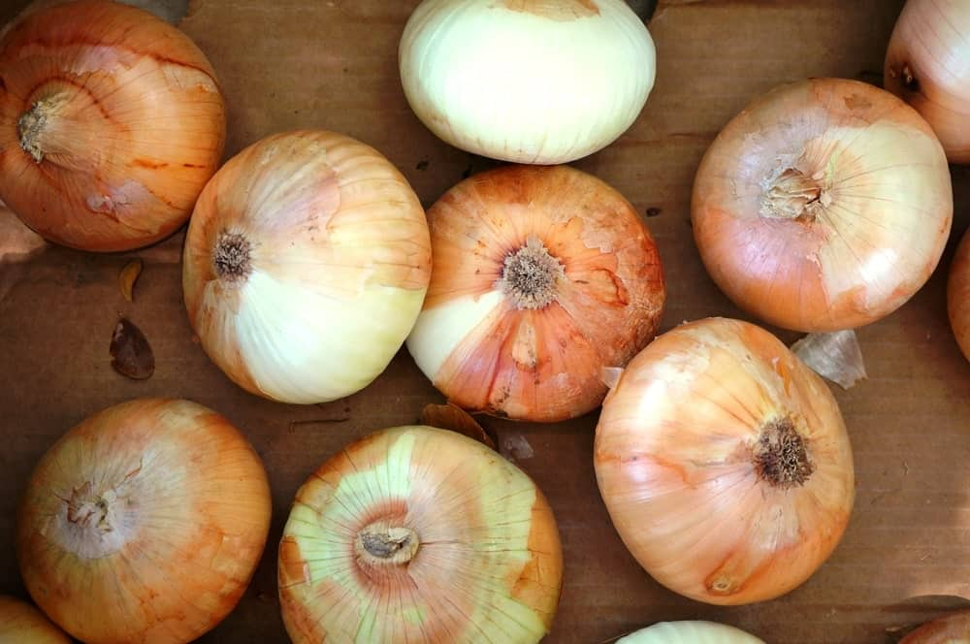
WITH A SWEET AND JUICY FLAVOR, MAUI ONIONS ARE GREAT WHEN MARINATED, GRILLED, OR CARAMELIZED. THE TASTE OF MAUI ONIONS REALLY COMES OUT WHEN YOU USE THEM IN SANDWICHES, ONION RINGS, AND VARIOUS SALADS.
THE MAUI ONION GROWS ONLY IN HAWAII AS IT REQUIRES VOLCANIC SOIL TO GROW. THESE ONIONS ARE EXTREMELY SWEET, AND LACK THE SULPHURIC ACID THAT OTHER ONIONS HAVE THAT CAUSE TEARS WHEN THEY ARE CUT. THEY ARE ALSO VERY JUICY DUE TO THEIR HIGH WATER CONTENT.
HAWAIIAN ISLANDERS WILL TRADITIONALLY EAT THE MAUI ONION RAW BECAUSE OF ITS WONDERFUL SWEETNESS, THOUGH WHEN COOKED THEY BECOME EVEN SWEETER.

11. MAYAN SWEET ONION
THE MAYAN SWEET ONION CAN BE FOUND IN THE UNITED STATES DURING THE FALL AND WINTER MONTHS, AND THEY ARE VERY JUICY AND MILD, ESPECIALLY WHEN EATEN FRESH. THEY BECOME INCREDIBLY SWEET WHEN THEY ARE COOKED, AND THEIR HIGH SUGAR CONTENT MAKES THEM THE PERFECT CANDIDATE FOR CARAMELIZED ONIONS.
THIS SWEET ONION VARIETY IS QUITE A BIT SWEETER AND LESS PUNGENT THAN OTHER ONIONS. THIS MAKES THEM MUCH EASIER TO CUT UP AS THEY HAVE A LOWER SULPHURIC ACID CONTENT.

12. PEARL ONION
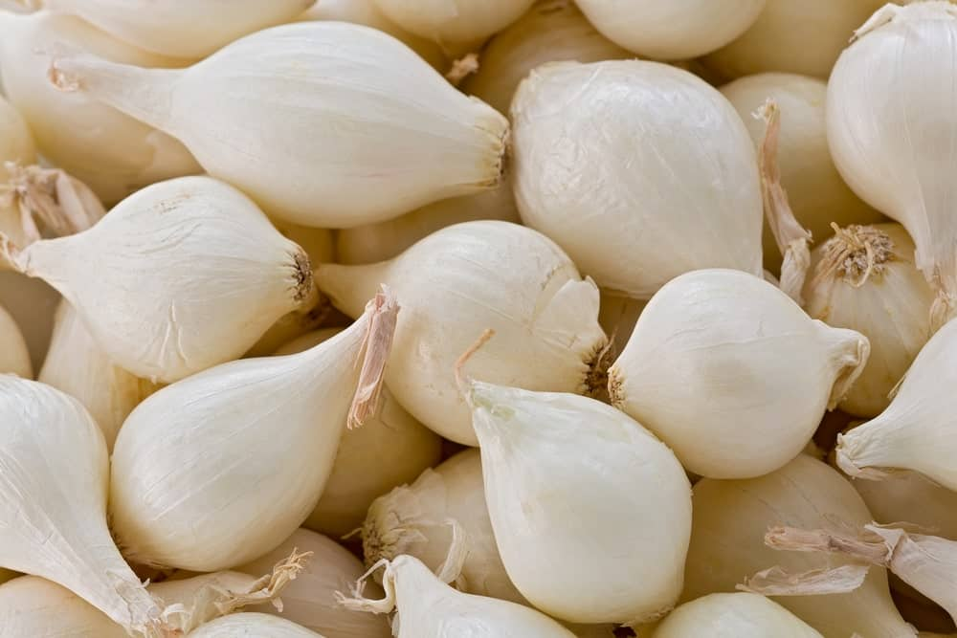
ALSO CALLED BUTTON OR BABY ONIONS, PEARL ONIONS ARE SMALL AND HAVE A MILD, SWEET TASTE. IN FACT, THEY ARE SO SMALL THAT THEY CAN BE USED WHOLE AFTER THEY’RE PEELED, AND THEY ARE PERFECT FOR PICKLING AND FOR MAKING YOUR GRAVY TASTE EVEN YUMMIER.
PEARL ONIONS HAVE VERY THIN SKIN AND CAN BE RATHER TEDIOUS TO PEEL, SO MAKE SURE TO LEAVE YOURSELF PLENTY OF EXTRA PREP TIME IF YOU CHOOSE A RECIPE THAT CONTAINS PEARL ONIONS!

13. PICKLING ONION
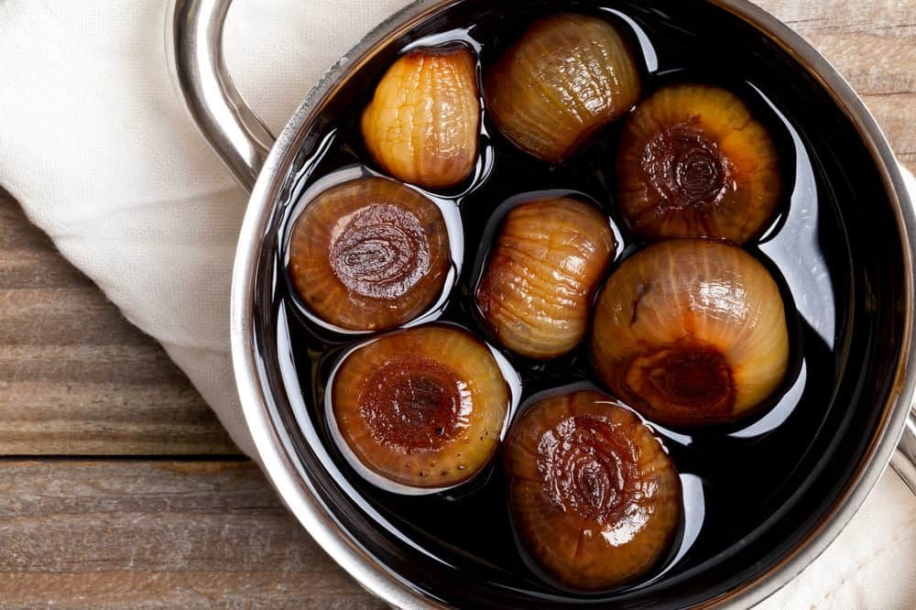
PICKLING ONIONS ARE VERY STRONG AND PUNGENT. THEY ARE GREAT FOR CASSEROLES AND IN FACT, THEY CAN BE USED AS A SUBSTITUTE FOR ALMOST ANY OTHER TYPE OF ONION. THEY ARE ALSO FREQUENTLY PICKLED, HENCE THEIR NAME.
KEEP IN MIND THAT AN ONION IS ALREADY INTENSE ENOUGH IN FLAVOR, AND PICKLING THEM MAKES THEM ALL THE MORE INTENSE. THIS ONION TYPE IS ONLY FOR THOSE WHO AREN’T AFRAID FOR A PUNCH IN THE FACE OF FLAVOUR.

14. RED ONION
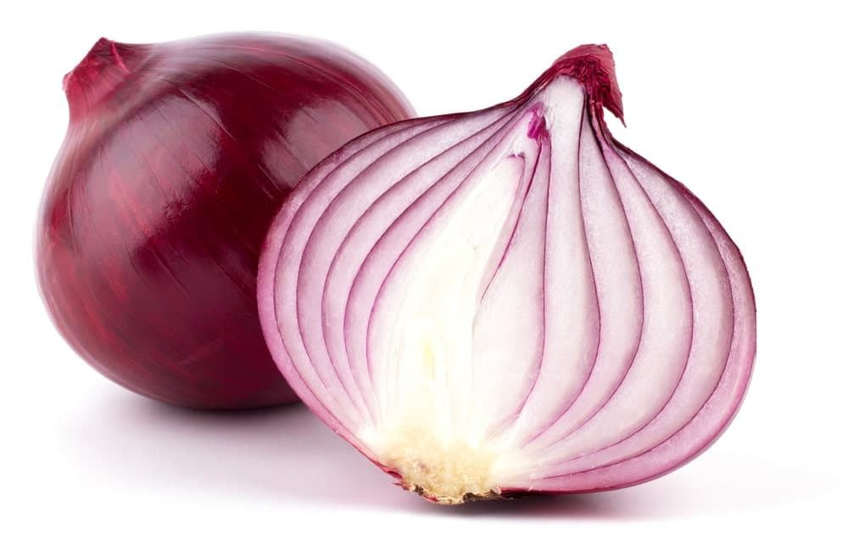
RED ONIONS HAVE A SWEET, BUT MILD FLAVOR AND THEY ARE PERFECT WHEN YOU’RE ROASTING MEATS AND WISH TO ADD A LITTLE MORE FLAVOR. THEY ARE GOOD WHEN ADDED TO SALADS AND SANDWICHES, AND YOU OFTEN SEE RED ONIONS ON ANTIPASTO TRAYS AS WELL.
SOME MAY THINK OF RED ONIONS AS BEING SPICY, BUT OTHERS FIND THEM HAVING THE PERFECT AMOUNT OF KICK. COMPLETELY DELICIOUS WHEN ROASTED, THEY ARE ALSO MILD ENOUGH IN FLAVOR TO BE EATEN RAW — THE PERFECT SALAD OR SANDWICH GARNISH.

15. RED WING ONION
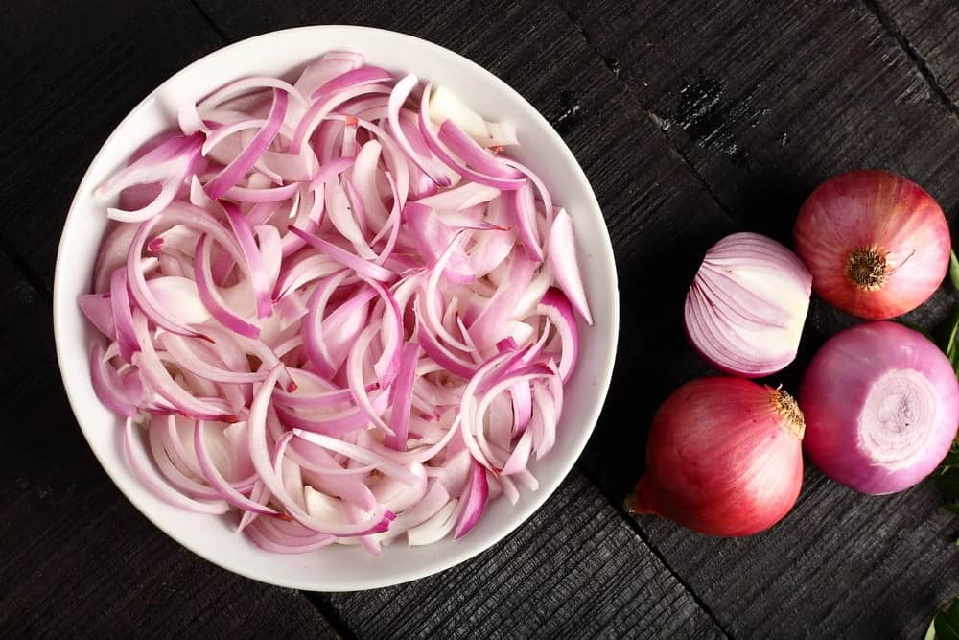
NATURALLY RED IN COLOR, HENCE THEIR NAME, RED WING ONIONS ARE VERY MILD AND, THEREFORE, THEY ARE GREAT FOR ADDING TO SANDWICHES AND SALADS. YOU CAN ALSO COOK THESE TYPES OF ONIONS, BUT THEY ARE USUALLY TASTIER EATEN RAW.
THESE ARE VERY SIMILAR TO THE CLASSIC RED ONION, THOUGH ARE SLIGHTLY LESS MILD IN TASTE. THEY ALSO USUALLY HAVE LESS DRY OUTER SKIN AND MORE FLESHY LEAVES.

16. SHALLOT
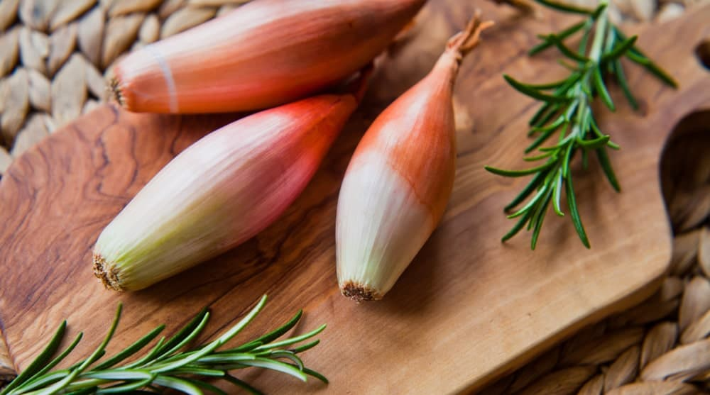
ALTHOUGH NOT A TRUE ONION, SHALLOTS ARE USUALLY CONSIDERED A TYPE OF ONION AND LOOK A LOT LIKE GREEN ONIONS OR LEEKS. THEY ARE USUALLY USED IN RECIPES FOR DIPS, SAUCES, AND DRESSINGS, AND THEY HAVE A VERY DELICATE, MILD FLAVOR. THERE IS ALSO A THAI SHALLOT, WHICH IS A LITTLE LESS PUNGENT THAN THE EUROPEAN VARIETIES AND THEY DO WELL IN SPICY PASTES.
SHALLOTS ARE VERY COMMONLY USED IN FRENCH CUISINE, AND TRULY CAN’T BE BEAT WHEN THEY ARE COOKED IN BUTTER. USING SHALLOTS AND CIPOLLINI ONIONS IN A FRENCH ONION SOUP WILL KNOCK THE SOCKS OFF OF YOUR DINNER GUESTS!

17. SPANISH ONION
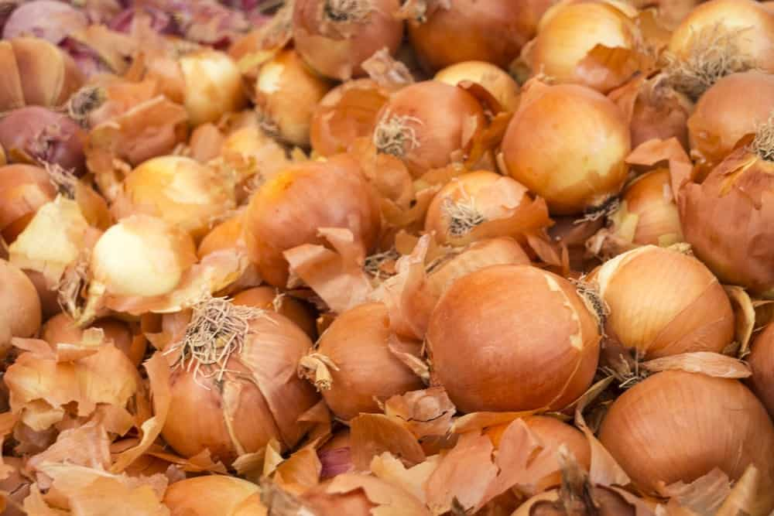
GREAT FOR STUFFING AND FOR MAKING THE PERFECT ONION RINGS, SPANISH ONIONS LOOK A LOT LIKE REGULAR YELLOW ONIONS AND HAVE A SWEET TASTE. THEY ALSO HAVE A LOWER WATER CONTENT THAN MANY OTHER TYPES OF ONIONS, AND THEY ARE PERFECT IN A VARIETY OF DISHES AS WELL.
THE SPANISH ONION IS ACTUALLY A TYPE OF YELLOW ONION. IN SOME SUPERMARKETS WHERE THEY DON’T HAVE A GREAT SELECTION OF ONION TYPE, THEY WILL MARKET THE SPANISH ONION AS A SIMPLY YELLOW ONION.
THE SPANISH ONION IS QUITE LARGE AND WILL RANGE FROM YELLOW TO RED. THEY ARE QUITE JUICY MILD IN FLAVOR AND HAVE MORE OF A SWEET TASTE. THESE DELECTABLE BULBS ARE MORE OFTEN USED AS RAW ONION BECAUSE OF THEIR DELICATE FLAVOR AND MAKE FOR A GREAT SALAD ONION OR SANDWICH ONION.

18. TEXAS SUPA-SWEET ONION
ALSO CALLED THE SUPERSWEET ONION, THESE ONIONS ACTUALLY HAVE A MILD, DELICATE TASTE. THEY ARE OFTEN USED FOR SANDWICHES, SALADS, AND EVEN CERTAIN TYPES OF SALSA.
IN TEXAS THEY SAY THAT THE TEXAS SUPER SWEET ONION IS SO SWEET THAT YOU COULD EAT IT LIKE AN APPLE! TALK ABOUT BAD BREATH FOR DAYS! THESE ONIONS ARE JUMBO SIZED AND CAN GROW TO BE ABOUT THE SIZE OF A BASEBALL. THEY HAVE VERY SWEET WHITE FLESH AND THINK YELLOW SKIN.

19. TORPEDO ONION
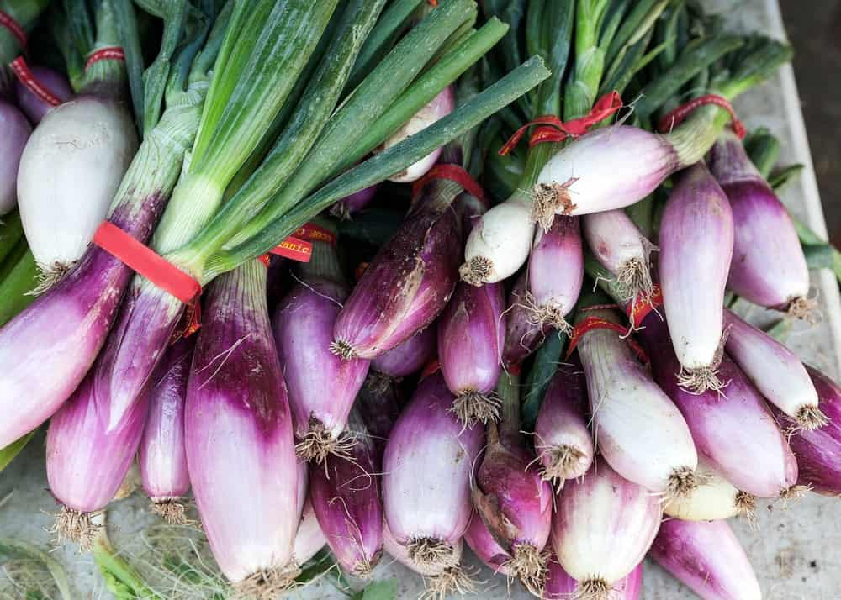
TORPEDO ONIONS HAVE A LOT OF SWEETNESS TO THEM, AND THEY ARE EXCELLENT WHEN EITHER PICKLED OR GRILLED UNTIL THEY’RE TENDER. THESE ARE A RED ITALIAN SPECIALTY ONION.
COMMONLY GROWING TO 8 INCHES IN LENGTH AND ONLY 3 INCHES AROUND, THEY HAVE PURPLE OR RED SKINS AND PALE RED FLESH. THEIR MILD SWEET FLAVOR ALLOWS THEM TO BE EATEN RAW THOUGH THEY ARE JUST AS PLEASANT COOKED.

20. TROPEA LUNGA ONION
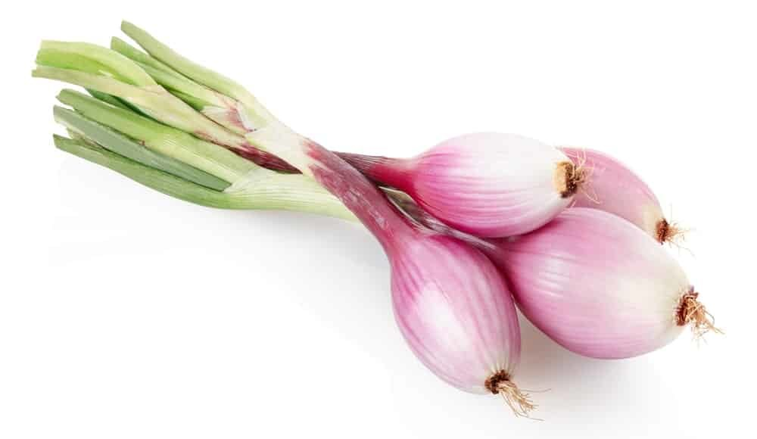
THESE ARE ONIONS COMMON AND POPULAR IN ITALY, AND THEY ARE WELL KNOWN FOR THEIR ZESTY TASTE. WHEN THEY ARE GRILLED, THEY ARE EVEN TASTIER, AND THEY BECOME MORE FRAGRANT AS WELL. THEY ARE AN HEIRLOOM VARIETY THAT ORIGINATED IN SOUTHERN ITALY.
THESE ELONGATED BULBS HAVE RED SKINS AND VERY CRISP PINK FLESH. THE MILD FLAVOR MAKES THEM PERFECT TO EAT RAW, THOUGH THEY ARE GREAT FOR PICKLING AND ROASTING AS WELL.

21. VIDALIA ONION
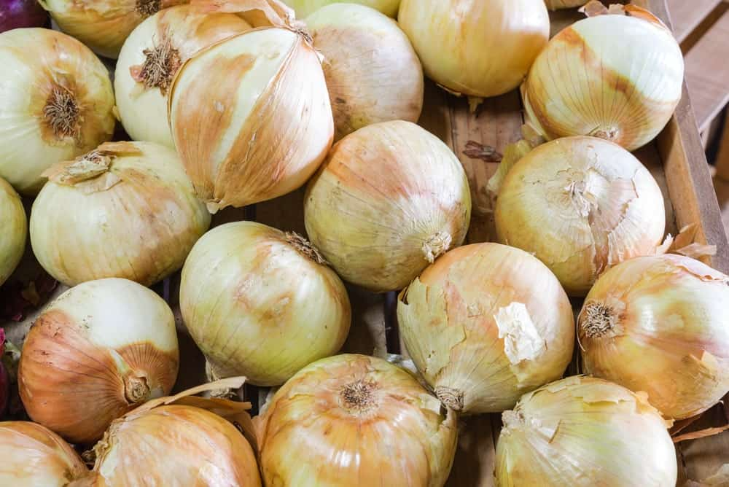
ESPECIALLY POPULAR IN THE SOUTH, VIDALIA ONIONS ARE EXTREMELY SWEET, MAKING THEM THE PERFECT ONION FOR EATING RAW. ADD THEM TO YOUR FAVORITE HAMBURGER OR OTHER SANDWICHES, AND ANY OTHER DISH YOU WISH TO HAVE A SWEET TASTE BECAUSE VIDALIA ONIONS WILL NEVER LET YOU DOWN IF A SWEET TASTE IS WHAT YOU WANT.
VIDALIA ONIONS ARE ONE OF THE MOST WELL KNOWN OF THE SWEET ONION FAMILY. WHEN YOU SEE THEM IN THE GROCERY STORE, MAKE SURE TO SNATCH THEM UP!

22. WALLA WALLA SWEET ONION
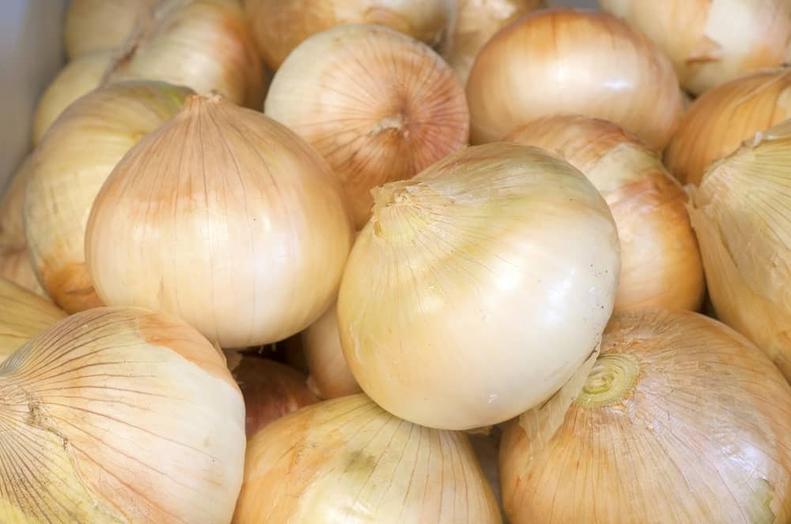
WALLA WALLA ONIONS HAVE A RATHER COMPLEX TASTE THAT IS MOSTLY SWEET IN NATURE. THEY ARE USUALLY EITHER EATEN RAW OR COOKED ONLY SLIGHTLY, AND YOU CAN FIND THEM IN RECIPES FOR QUICHE, PIZZA, PASTA, AND A VARIETY OF SALADS.
THE WALLA WALLA ONION IS TRULY HUGE. THEY ARE ALSO LOW IN SULPHURIC ACID, WHICH MEANS THAT THEY WILL BE LESS SPICY AND WON’T HURT AS MUCH WHEN YOU ARE CHOPPING THEM UP.

23. WELSH ONION
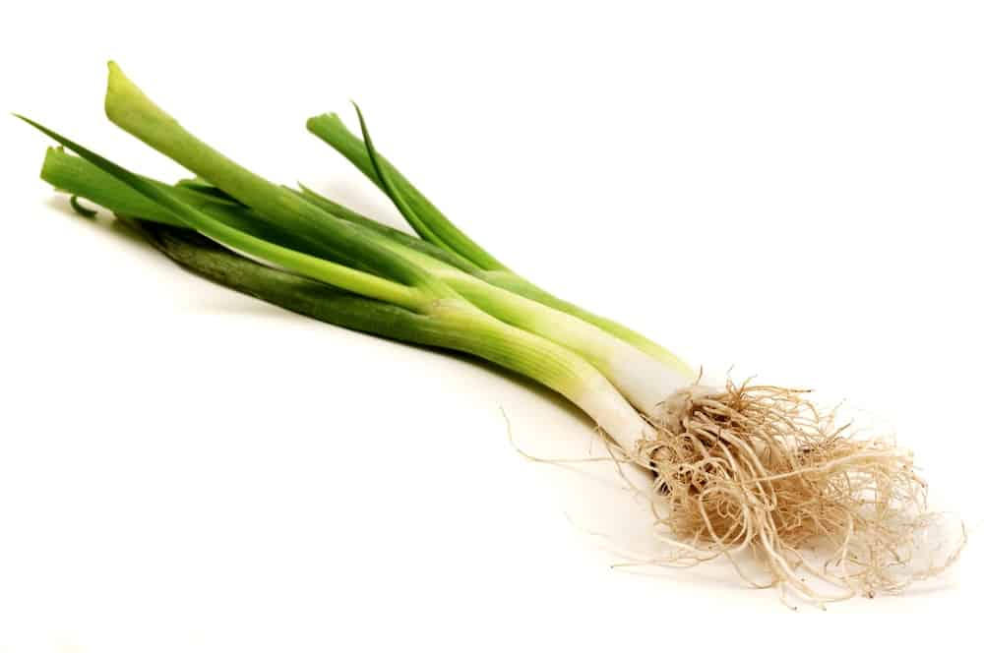
WITH A LOOK THAT IS SIMILAR TO GREEN ONIONS, THESE ONIONS ARE USED IN A LOT OF ASIAN DISHES AND IN FACT, HAVE NOTHING TO DO WITH WALES. WELSH ONIONS ARE NATIVE TO CHINA, AND THEY ARE SLIGHTLY BIGGER THAN GREEN ONIONS. THEY ARE ALSO PERFECT FOR A VARIETY OF STIR-FRY DISHES.
THEY ARE ALSO KNOWN UNDER THE NAMES OF BUNCHING ONION, LONG GREEN ONION, AND THEY ARE ACTUALLY A TYPE OF SCALLION RATHER THAN AN ONION. THEY DO NOT PRODUCE BULBS, BUT INSTEAD PRODUCE LONG AND HALLOW LEAVES AND SCAPES.

24. WHITE ONION
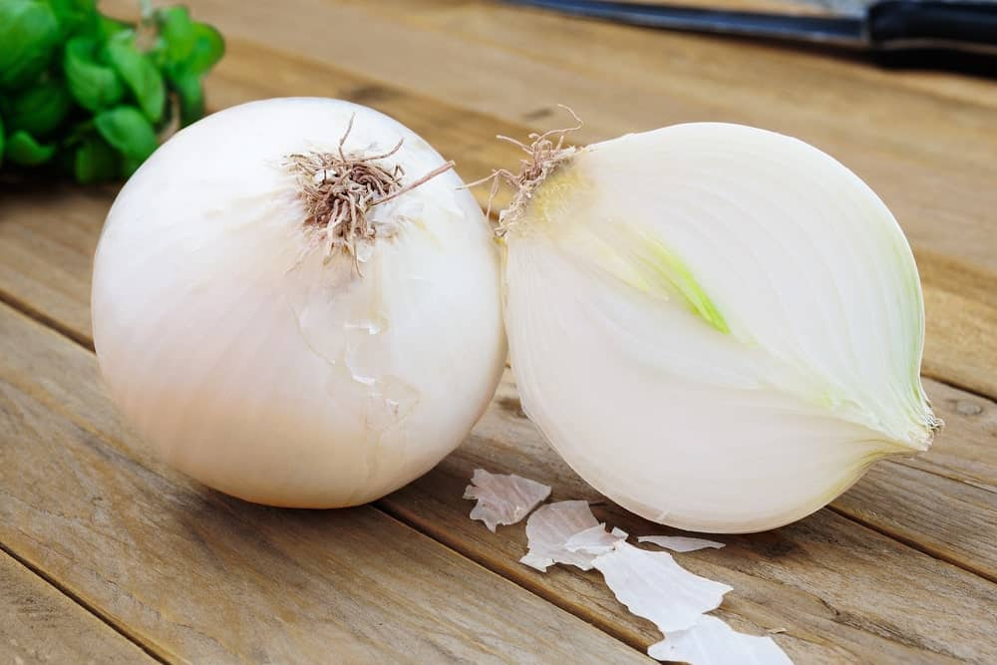
WHITE ONIONS HAVE A VERY PUNGENT, STRONG FLAVOR AND SHOULD ONLY BE USED WHEN A STRONG FLAVOR IS WHAT YOU WANT. THEY CAN BE USED IN A VARIETY OF DISHES FOR CERTAIN SALADS AND GENERAL COOKING PURPOSES, AND THEIR COLOR CAN BE WHITE OR SLIGHTLY BROWN.
WHITE ONIONS ARE PROBABLY ONE OF THE MORE INTENSE OF THE ONION FLAVORS, AND CAN EASILY BE IDENTIFIED BY THEIR WHITE SKINS AND WHITE FLESH. THEY TASTE FAR BETTER WHEN THEY ARE COOKED, BUT BE WARNED, THESE TEND TO STING THE MOST WHEN YOU ARE CHOPPING THEM UP!

25. YELLOW ONION
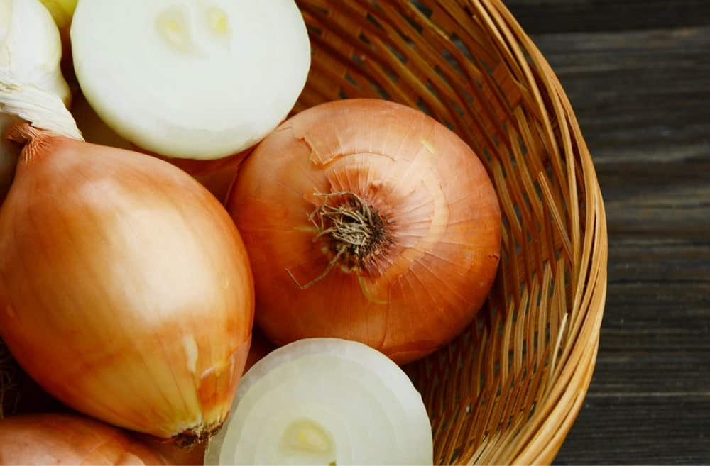
YELLOW ONIONS HAVE A PUNGENT TASTE, ALTHOUGH NOT NEARLY AS PUNGENT AS THE WHITE ONION. SOMETIMES CONFUSED WITH SPANISH ONIONS, YELLOW ONIONS ARE USED FOR NUMEROUS RECIPES, ESPECIALLY WHEN YOU’RE LOOKING FOR A KICK TO YOUR DISH.
YELLOW ONIONS ARE ONE OF THE MOST COMMON ONION TYPES THAT YOU’LL SEE IN THE GROCERY STORE. THEY ARE A STAPLE ITEM IN ANY PANTRY.

26. BROWN ONION
THE BROWN ONION IS ONE OF THE MOST POPULAR TYPES OF ONIONS THAT ARE USED FOR COOKING IN AUSTRALIA! THERE ARE MANY TYPES OF ONIONS THAT ARE MARKETED AS BROWN ONIONS, BUT THE REAL BROWN ONION HAS VERY CRISP, WHITE FLESH ENROBED BY VERY PAPERY BROWN SKIN.

THE FLAVOR OF A BROWN ONION IS A BIT TOO STRONG AND SPICY TO BE EATEN RAW, BUT THEY MAKE FOR THE PERFECT COOKING ONION. THEY ARE GREAT AS CARAMELIZED ONIONS, ONIONS FOR SOUPS, AND MAKE FOR GREAT DRIED ONIONS TOO.

BEST TYPE OF ONIONS FOR BURGERS, SALADS, ONION RINGS, AND MORE
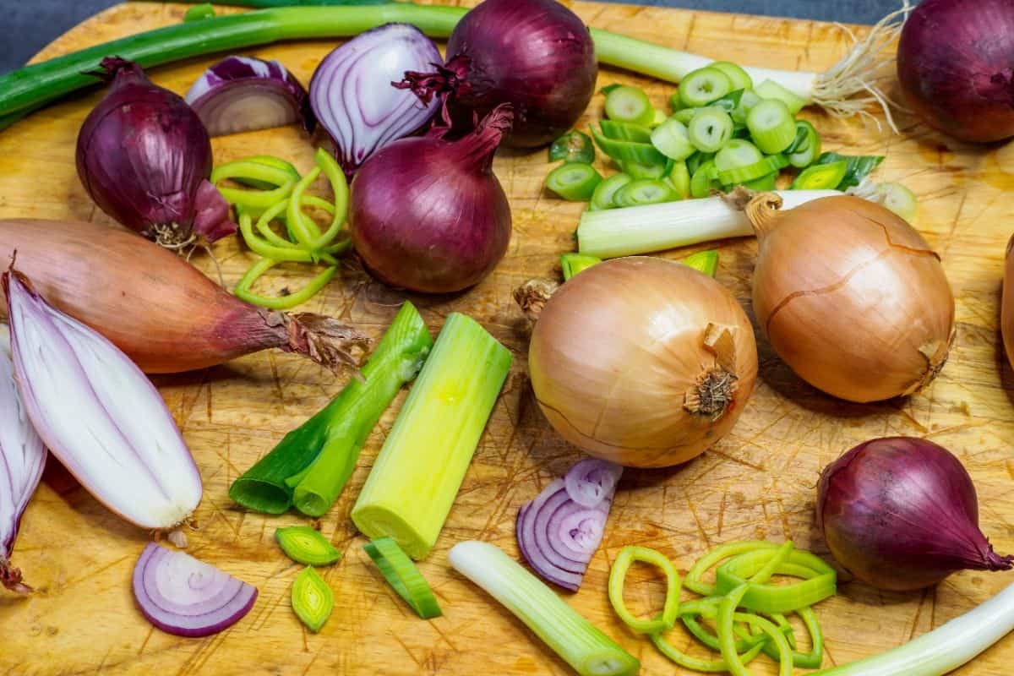

THAT SATISFYING CRUNCH WHEN YOU BITE INTO A BURGER WITH ONION ON IT MEANS A LOT TO DINERS. WHAT TYPE OF ONION PROVIDES THAT CRUNCH?
MOST RESTAURANTS BUY 50-POUND BAGS OF YELLOW OR WHITE ONIONS FROM THE GROCERY COMPANY BECAUSE BULK BUYING IS ULTIMATELY CHEAPER. THE EMPLOYEES SLICE AND DICE THEM AS THE RECIPES DICTATE. FOR BURGERS, YOU DON’T WANT THE TASTE OF THE ONION OVERPOWERING THE TRADEMARK TASTE OF THE BURGER. SOME RESTAURANTS USE RED ONIONS FOR JUST THAT PURPOSE.
FOR MY MONEY, EVEN IF IT MAKES ME CRY TO CUT THEM, YELLOW ONIONS GO BEST ON A BURGER. WHEN YOU COMBINE THE YELLOW ONION WITH THE OTHER VEGETABLES AND CONDIMENTS, THEY DON’T SO MUCH DISAPPEAR INTO THE OTHER FLAVORS AS ADDING A LITTLE KICK TO THEM.

IF YOU LOVE ONION RINGS, THERE’S ONLY ONE ONION YOU CAN USE

ONION RINGS TASTE LIKE NOTHING ELSE. THE BREADING VARIES BY THE COOK. ONE OF THE MOST POPULAR IS A BEER BATTER THAT’S USED ON FRIED FISH, FRIED CHICKEN, AND ONION RINGS. OTHER BATTERS INCLUDE THE ORIGINAL FLOUR AND EGG BATTER AND THE JAPANESE-TYPE TEMPURA BATTER. THE POINT OF THE BATTER IS NOT TO OVERPOWER THE TASTE OF THE ONION, BUT THE BATTER IS WHAT TASTES SO GOOD.
THE ONLY ONION YOU CAN USE IN ONION RINGS IS A SWEET ONION, WHICH INCLUDES VIDALIA, MAUI, AND WALLA WALLA SWEET ONIONS. IT ISN’T STRONG ENOUGH TO BLOCK OUT THE TASTE OF THE BATTER. THE CRUNCH AND THE SWEET FLAVOR ARE VERY SATISFYING.

JULIA CHILD USED YELLOW, ALTON BROWN USED SWEET, AND MARTHA STEWART USED YELLOW. IT’S ONIONS, AND WE’RE TALKING ABOUT FRENCH ONION SOUP
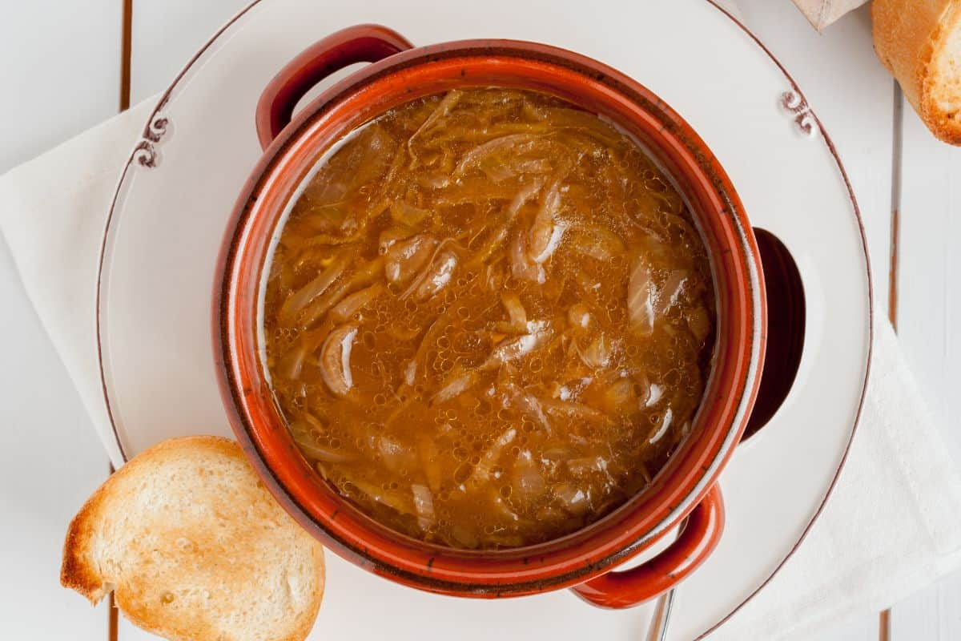
THE TYPE OF ONION USED IN FRENCH ONION SOUP IS INTEGRAL TO THE TASTE OF THE SOUP. FRENCH ONION SOUP IS DEEP AND RICH WITH A BEEFY KIND OF FLAVOR TO THE SOUP PART OF IT. THE CARAMELIZED ONIONS ADD A TOUCH TO THE SOUP THAT’S VERY IMPORTANT. IF THE ONION IS TOO STRONG, THE SOUP WILL TASTE AWFUL. IF YOU CAN’T TASTE THE ONION AT ALL, THEN WHAT’S THE POINT?
SWEET ONIONS LIKE VIDALIA SWEETS CARAMELIZE PRETTILY AND DON’T OVERPOWER THE SOUP. THEY HAVE THE HEAVIEST SUGAR CONTENT OF ALL THE TYPES OF ONIONS AND TASTE BEST IN RECIPES IN WHICH THE ONION NEEDS TO PLAY WELL WITH OTHERS.

WHY IN THE WORLD WOULD YOU PICKLE AN ONION? YOU’LL BE SURPRISED AT THE ANSWER
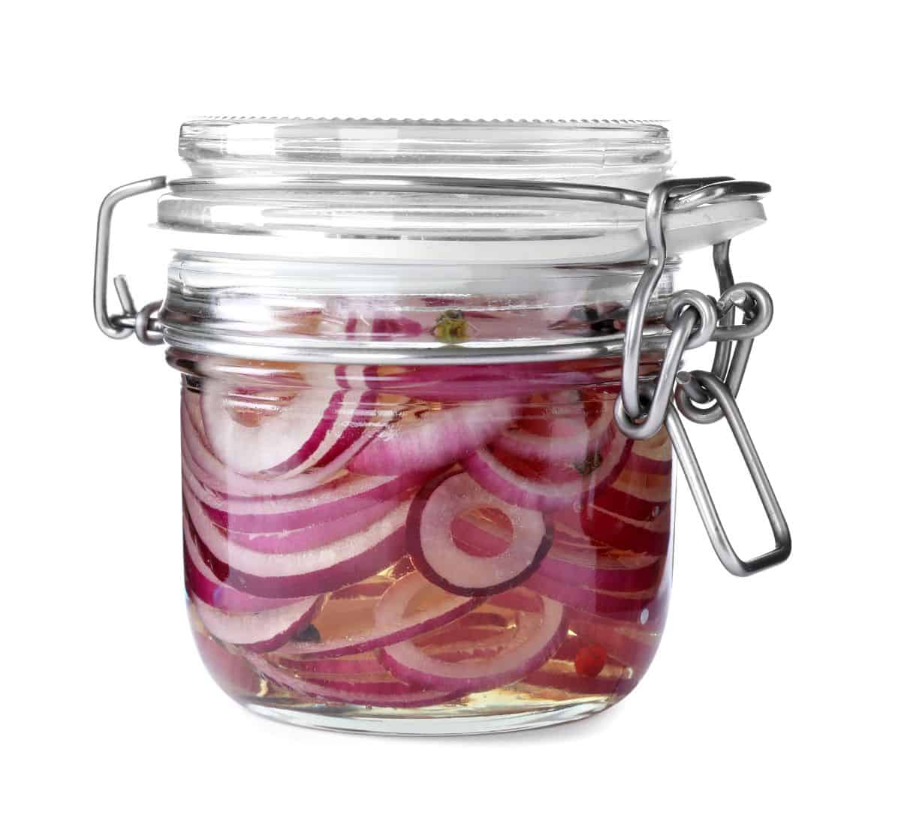

PICKLING FOOD HAS BEEN NECESSARY TO PRESERVE FOODS SINCE ANCIENT TIMES. WITH NO REFRIGERATORS OR FREEZERS, THE ANCIENTS HAD TO FIND A WAY TO KEEP THEIR FOODS FOR A LONG PERIOD OF TIME. PICKLING WORKED, BUT IT ALSO HAD HEALTH BENEFITS THE ANCIENTS DIDN’T KNOW ABOUT; THEY JUST ENJOYED BEING SCREAMINGLY HEALTHY.
THE ONION ITSELF, AND THE BEST ONE TO USE FOR PICKLING IS RED ONION, ALREADY OFFERS A BOATLOAD OF HEALTH BENEFITS. RED ONIONS OFFER MORE: ANTI-INFLAMMATORY PROPERTIES, ANTIOXIDANTS, IMMUNE SYSTEM BOOSTERS, HEART HEALTH PROTECTION, AND MUCH MORE. PICKLING ADDS PROBIOTICS TO THE FOOD, WHICH CONTRIBUTES GOOD BACTERIA TO GUT HEALTH. PICKLING ALSO DESTROYS THE SUGARS IN THE INTESTINE THAT CAUSE BLOATING AND GAS FOR THOSE WITH IRRITABLE BOWEL SYNDROME.

THERE ARE DOZENS OF WAYS TO INCORPORATE ONION IN YOUR SOUP AS WELL AS USING IT TO GARNISH YOUR CREATION
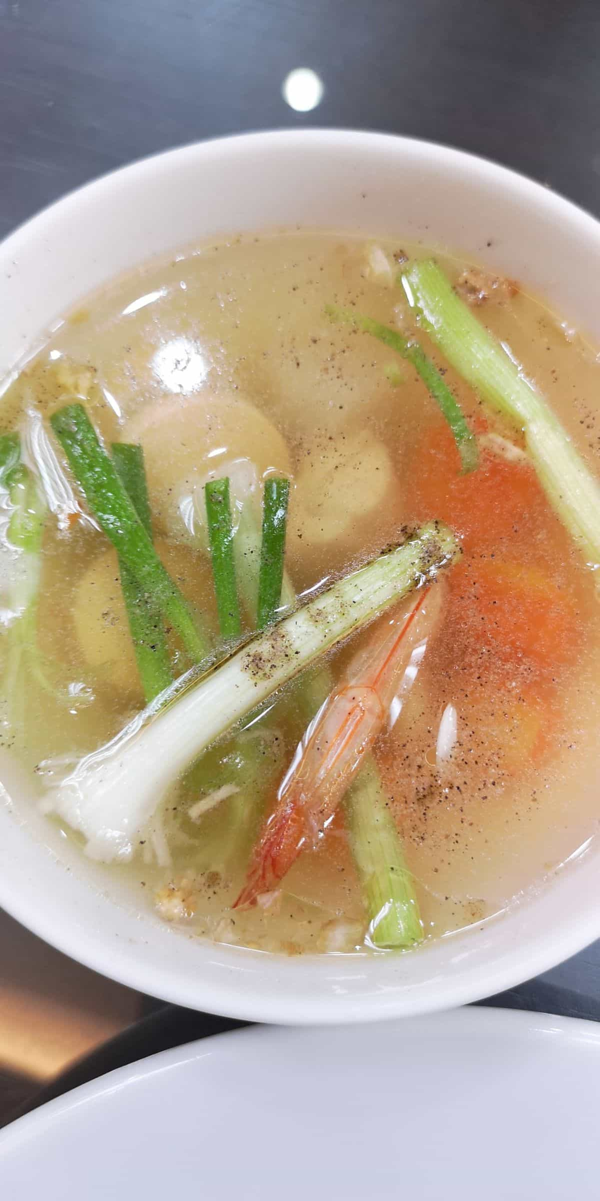
SOUPS ARE THE BEST WAY TO USE UP LEFTOVERS, FRESH VEGGIES ON THE WAY TO GOING BAD, AND WHATEVER MEATS OR CASSEROLES NO ONE WOULD EAT THE NIGHT BEFORE. EVERYONE LOVES SOUP. EVEN IF SOMEONE DISLIKES ONIONS, THEY’LL EAT THEM IN SOUP BECAUSE IT’S SO GOOD.
I, PERSONALLY, USE RED ONIONS FOR ALMOST ALL MY COOKING (I’VE CHOPPED ENOUGH YELLOW ONION IN PIZZA RESTAURANTS TO LAST A LIFETIME. RED ONIONS DON’T MAKE YOU CRY.) HOWEVER, YOU CAN PUT ANY ONION YOU HAVE ON HAND INTO SOUP, EVEN SWEET ONIONS. THE TEXTURES OF THE MEATS AND VEGETABLES MAKE THE BLENDING OF THE TASTES MORE PALATABLE. IN OTHER WORDS, THE ONION WILL BLEND IN. YOU CAN EVEN USE CHOPPED GREEN ONION ON TOP OF THE SOUP AS A GARNISH.

AH, SUMMER GRILLING BY THE POOL – BURGERS AND DOGS, CHICKEN AND STEAKS ON THE GRILL, AND DON’T FORGET THE ONIONS
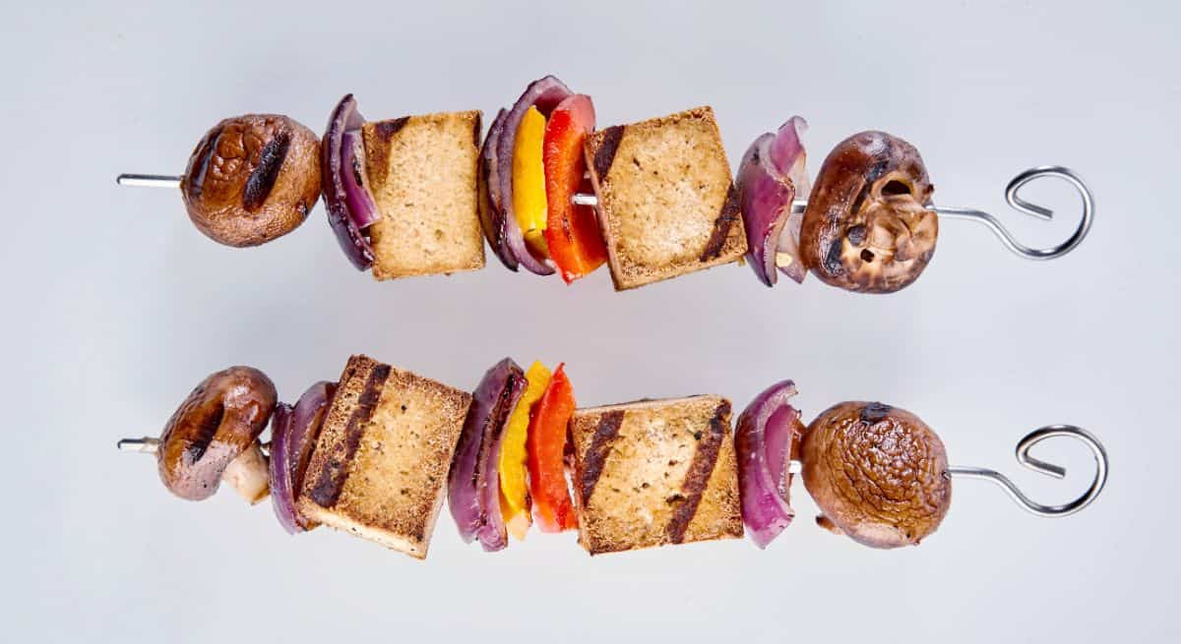
IT JUST ISN’T SUMMER WITHOUT THE MOUTH-WATERING AROMA OF SOMETHING COOKING ON THE GRILL. EVEN IF IT’S ONLY BURGERS AND DOGS, TOSSING SOME ONIONS, TOMATOES, AND MUSHROOMS ON THE GRILL BESIDE THEM MAKES YOU THE MOST POPULAR GUY IN THE NEIGHBORHOOD. IF YOU’VE GOT SOME PICKY EATERS, THOUGH, USING A CERTAIN TYPE OF ONION ON THE GRILL WILL HELP TREMENDOUSLY.
HERE IS WHERE WHITE ONIONS SHINE. EATING THEM RAW GIVES YOU A BIT OF A TANG, SO THEY’RE PERFECT ON SANDWICHES AND SALADS. WHEN YOU GRILL THEM, THOUGH, THEY CARAMELIZE NICELY. PILE THOSE TOMATOES, MUSHROOMS, CARAMELIZED WHITE ONIONS, AND CHEESE ON A BURGER FOR A LOVELY SWISS MUSHROOM BURGER OR ON SAUSAGES FOR THE BEST HOT DOG YOU EVER HAD.

MOST PEOPLE ARE MORE FAMILIAR WITH RAW ONIONS, BUT WHEN THEY DO EAT CARAMELIZED ONIONS, IT’S SPECIAL
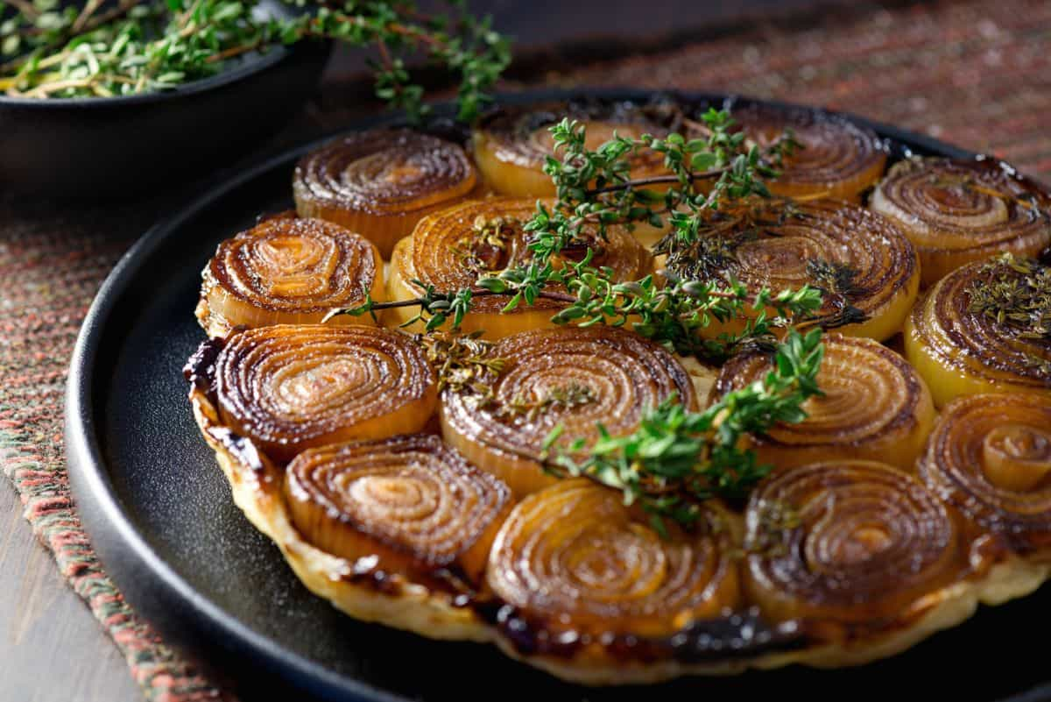
THEY’RE JUST LOVELY ATOP A JUICY, DRIPPING STEAK. YOU CAN’T HAVE A PHILLY CHEESESTEAK SANDWICH WITHOUT THEM. SOME TYPES OF PIZZA POP USING CARAMELIZED ONIONS (A MEGA-STEAK PIZZA JUST ISN’T THE SAME WITHOUT THEM.) THEY’RE A CHOICE OF TOPPINGS ON MANY SUB-SANDWICH OFFERINGS.
THE PERFECT ONION FOR CARAMELIZING IS IN THE ONION FAMILY BUT LOOKS NOTHING LIKE THE MOST RECOGNIZABLE ONIONS. LEEKS AND SHALLOTS LOOK MUCH LIKE GREEN ONIONS BEFORE FULL MATURITY. AT MATURITY, THEY BOTH LOOK A BIT PEAR-SHAPED. THEY ARE BOTH WHITE WITH A MILD FLAVOR, WHICH CARAMELIZES NICELY. IF YOU’RE NOT USED TO USING LEEKS AND SHALLOTS, THEN COMBINE THEM WITH THE ONION OF YOUR CHOICE (RED, WHITE, AND SWEET ONIONS CARAMELIZE WELL) UNTIL YOU GET USED TO THE FLAVORS.

WHAT’S YOUR FAVORITE SALAD? WOULD YOU BELIEVE THERE’S AN ONION FOR ALL OF THEM?
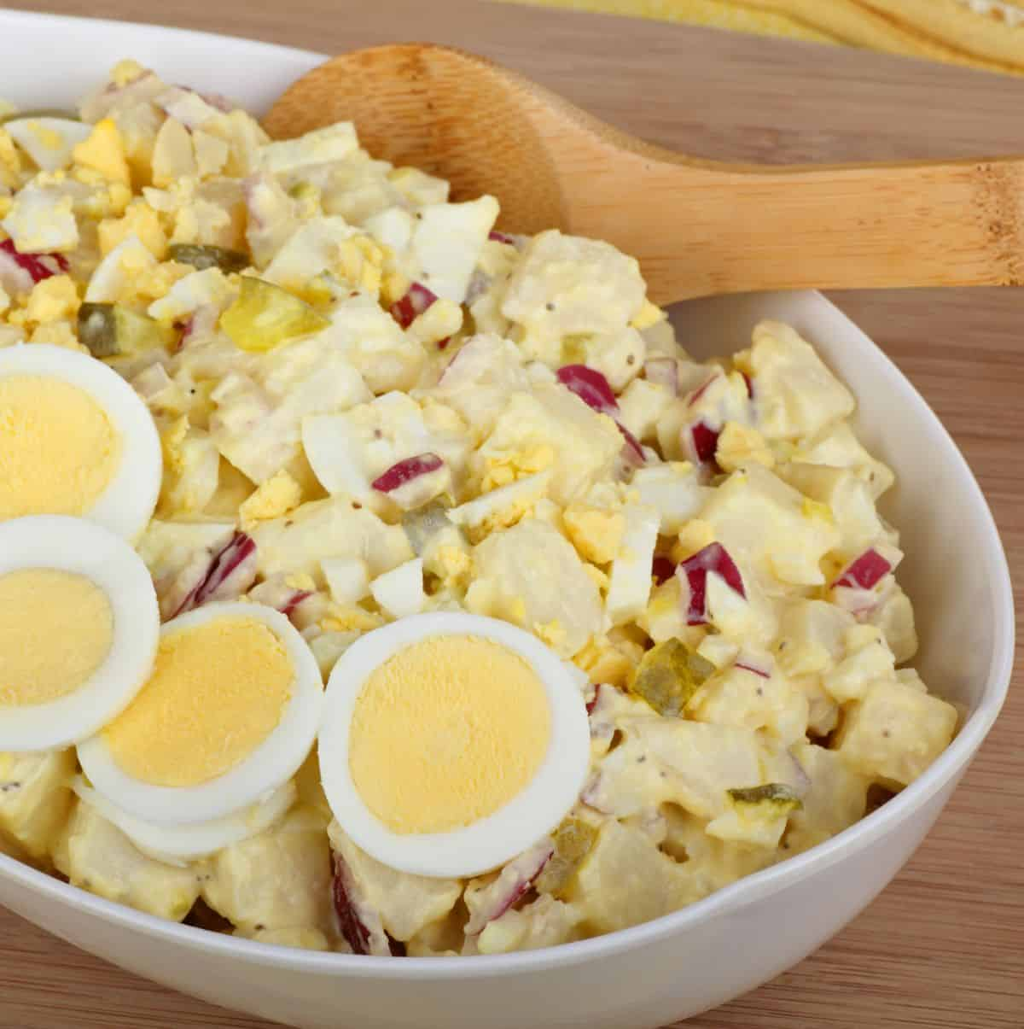
I USED A PICTURE OF POTATO SALAD WITH RED ONIONS, SO YOU WOULD SEE THAT GREEN SALADS AREN’T THE ONLY SALADS AVAILABLE. THERE’S COLE SLAW, TOMATO, ONION, AND CUCUMBER SALAD, BRUSSELS SPROUT SALAD, BROCCOLI SALAD, PASTA SALAD, ANTIPASTO SALAD, CARROT SALAD, WALDORF SALAD, FRUIT SALAD, AND I COULD GO ON WITH THIS LIST FOR A WEEK. YOU’D USE DIFFERENT TYPES OF ONIONS FOR DIFFERENT TYPES OF SALADS.
THE THING ABOUT SALAD IS THAT YOU WANT THE COLORS, TEXTURES, AND FLAVORS TO BLEND WELL WITHOUT ONE THING OVERPOWERING THE REST, AND THAT INCLUDES THE DRESSING.
THUS, YOU WANT TO USE SWEETER ONIONS FOR MOST SALADS, SUCH AS SHALLOTS, GREEN ONIONS, SWEET ONIONS LIKE VIDALIA, AND RED ONIONS. MY GO-TO ONION FOR SALADS IS VIDALIA SWEET ONIONS. IF I CAN’T GET ONE, I’LL USE RED OR GREEN ONIONS. THESE ARE MILD FLAVORS, AND RED AND GREEN ONIONS ADD A PRETTY COLOR TO ANY SALAD.

NOTHING SHOUTS FALL AND/OR WINTER LIKE A PIPING HOT BOWL OF CHILI
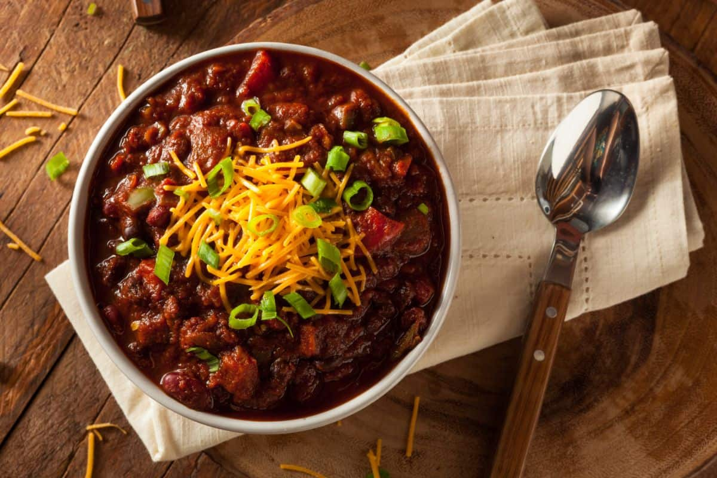
MY FAVORITE WAY TO MAKE HOMEMADE CHILI IS TO USE A CAN OF CRUSHED TOMATOES, WHITE OR NORTHERN BEANS (I DON’T LIKE KIDNEY BEANS,) COOKED GROUND BEEF, OR TINY BITS OF STEAK, CHOPPED ONION, AND TOMATO SAUCE. EVERYBODY’S DIFFERENT, SO I USE JUST ENOUGH CHILI POWDER TO GIVE IT A TINY BITE. TOSS SOME SHREDDED CHEESE ON TOP, AND A SPOONFUL OF SOUR CREAM, AND YOU’VE GOT A HEARTY DISH FOR A COLD WINTER’S NIGHT.
NOW, ABOUT THAT ONION. WHILE IT’S OKAY TO USE WHATEVER TYPE OF ONION IS IN THE FRIDGE OR ON THE SHELF, THE BEST ONION TO USE FOR CHILI IS A YELLOW ONION. THEY HAVE A BIT OF A BITE WHEN EATEN RAW, BUT WHEN THEY’RE ADDED TO SOUPS, STEWS, CHILI, SALSA, AND OTHER PREPARATIONS, THEY BLEND WELL WITHOUT OVERPOWERING THE DISH.

MEXICAN FOOD IS WONDERFUL IN ITS VARIETY, COLOR, AND TASTE. YET MEXICAN CUISINE USES ONE TYPE OF ONION SPECIFICALLY

I, PERSONALLY, HAVEN’T EVER HAD AN ENCHILADA; MY MEXICAN EXPERIENCES STRETCH TO TACOS. MEXICAN CUISINE JUST WASN’T PART OF MY UPBRINGING, SO I DON’T EVEN RECOGNIZE A LOT OF MEXICAN FOOD IN THE GROCERY STORE. HOWEVER, ENCHILADAS ARE THE QUINTESSENTIAL MEXICAN FOOD EXPERIENCE, AND THEY ONLY CONTAIN ONE TYPE OF ONION.
THE WHITE ONION IS USED IN MORE MEXICAN DISHES THAN ANY OTHER. ITS CRISP TEXTURE AND SHARP TASTE ENHANCE ANY DISH. CHOPPED FOR TACOS, SLICED LENGTH-WISE FOR FAJITAS, OR CARAMELIZED FOR ENCHILADAS, WHITE ONION ADDS A ZING TO ANY MEXICAN DISH.

BLESSINGS UPON THE HOUSE OF WHOMEVER DEVISED GUACAMOLE!

I USE GUACAMOLE IN MY TACOS AND MY NACHOS, AND HERE LATELY, I’VE BEGUN TO USE IT ON TOAST. AVOCADO IS ONE OF THOSE FOODS THAT TURN PLAIN OLD SALADS INTO SOMETHING SPECIAL. YOU CAN USE IT IN PLACE OF MAYO ON SANDWICHES. IT’S VERSATILE AND TASTES INCREDIBLE!
ADDING ONION TO YOUR GUAC POSES A CONUNDRUM: WHICH TYPE IS BEST? EACH TYPE OF ONION OFFERS ITS OWN ZING OR SWEETNESS. MOST MEXICAN DISHES USE WHITE ONIONS. YOU CAN, HOWEVER, USE GREEN ONIONS OR SHALLOTS IN PLACE OF WHITE ONIONS. IF YOU’VE NEVER USED THEM IN GUAC BEFORE, START SMALL AND WORK YOUR WAY UP TO SEE JUST HOW MUCH TO ADD TO ENHANCE THE FLAVOR OF THE DIP.

LOADING UP A HOT DOG FRESH OFF THE GRILL IS ALMOST MORE FUN THAN EATING IT!

FAMILY REUNIONS, BLOCK PARTIES, BIRTHDAY PARTIES, AND ANY OCCASION TO BREAK OUT THE GRILL IS THE PERFECT TIME TO LOAD UP A HOT DOG. THEY’RE THE KIND OF FOOD THAT’S ENHANCED BY ALMOST ANYTHING YOU CAN THINK OF: CHILI, SALSA, CHEESE, PICKLE RELISH, CHOPPED ONION, SAUERKRAUT, COLE SLAW, BACON BITS, AND THE LIST IS ENDLESS. AH, BUT WHAT KIND OF ONION GOES BEST ON A HOT DOG?
IF YOU’RE GOING TO PILE A LOT OF GOOD STUFF ON YOUR DOG, THEN USE RED OR YELLOW ONIONS FOR THE COLOR AND CRUNCH. IF YOU’RE A PURIST, THOUGH, AND PREFER YOUR DOG WITH A LITTLE MUSTARD AND ONION, THEN USE WHITE ONIONS. NEW YORK HOT DOGS ARE KNOWN FOR THEIR CRISP DICED WHITE ONIONS. THEY’RE REPORTEDLY CRISPER AND LAST LONGER THAN YELLOW ONIONS. SO THERE YOU HAVE IT!

COOKS WHO ROAST THEIR VEGETABLES LOVE ROASTING ONIONS ALONGSIDE THEM
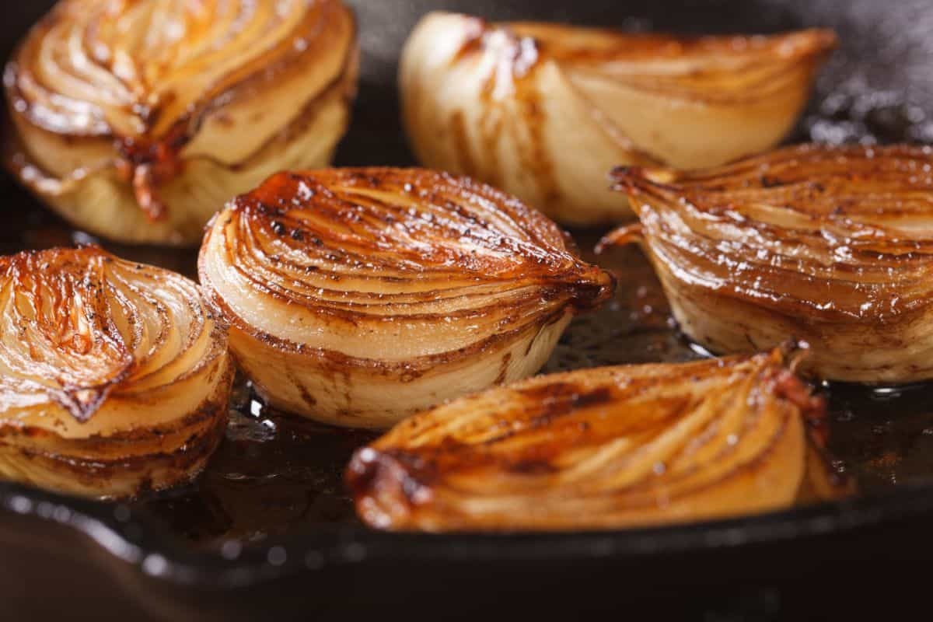
THEY’RE TASTY JUST BY THEMSELVES OR DRIZZLED WITH OLIVE OIL OR BALSAMIC, SERVED WITH OTHER ROASTED VEGETABLES, OR ROASTED ALONGSIDE MEATS. AS THEY COOK, THE TART TASTE OF THE ONION SUBSIDES INTO THE SWEET TASTE OF THE CARAMELIZED VEGETABLE. THIS MAKES YELLOW ONIONS THE BEST ONION FOR ROASTING. THE SWEETER VARIETIES OF ONION WOULD TURN MUSHY, AND THAT INCLUDES WHITE ONIONS, TOO.

