THE GLOBAL LISTS OF ADDICTIVE DRUG CHEMICALS IN DRINKS, FOODS, SCREWING & SMOKES---PART 3
YAHWEH HIMSELF IS THE ONLY TRUE ANSWER & THE ONLY EFFECTIVE REMEDY TO ANY OF THESE THINGS INFINTELY!!!
YES! YAHWEH ONLY SAVES. BUT NORMALLY SHALL BE LONG WITH YOU, AS LONG AS YAHWEH DAMN-WELL PLEASES, TO GET THE ONLY GLORY TO HIMSELF OUT OF IT. THIS IS THE WHOLE POINT THAT THE SUPREME VENGEANCE ARMOR (ISAIAH 59:17) IS SUPREMELY AUTHORIZED & GREATLY EMPOWERED BASED ON WHAT YOU HAVE ENDURED IN SERVING YAHWEH! BUT IN THE RULES OF ENGAGEMENT, IF YOU ARE ATTACKED FIRST, THEN YOU CAN ATTACK BACK, BUT HOW YOU ATTACK SHALL DETERMINE ITS OUTCOME! THE ONLY CORRECT WAY TO DEAL WITH FORBIDDEN EVIL, IS ALWAYS LET YAHWEH HANDLE IT, NOT SOME INFERIOR LORD! BUT IF YOU WANT AN IMMEDIATE FIXER UPPER WITH YOUR SKIN ARMOR, LIKE LEANING ON JESUS ALONE, CHRIST ALONE, JESUS ONLY, CHRIST ONLY, OR SIMPLY BARABBAS, TO HEAL YOU, THEN YOU HAVE CHOSEN THE INDEPENDENT IDOLATRY (EXODUS 20:1-7) & THE IMMEDIATE HEALING (REVELATION 13) THAT CAN COME FROM ONLY THE DEVIL & THE WITCH! IN JOHN 18:1-43 DECLARES: 18 AND HE SPAKE A PARABLE UNTO THEM TO THIS END, THAT MEN OUGHT ALWAYS TO PRAY, AND NOT TO FAINT; ² SAYING, THERE WAS IN A CITY A (UNJUST) JUDGE, WHICH FEARED NOT GOD (YAHWEH), NEITHER REGARDED MAN (JESUS): ³ AND THERE WAS A WIDOW IN THAT CITY; AND SHE CAME UNTO HIM, SAYING, AVENGE ME OF MINE ADVERSARY. ⁴ AND HE WOULD NOT FOR A WHILE: BUT AFTERWARD HE SAID WITHIN HIMSELF, THOUGH I FEAR NOT GOD (YAHWEH), NOR REGARD MAN (JESUS); ⁵ YET BECAUSE THIS WIDOW TROUBLETH ME, I WILL AVENGE HER, LEST BY HER CONTINUAL COMING SHE WEARY ME. ⁶ AND THE LORD (STEPHEN YAHWEH) SAID, HEAR WHAT THE UNJUST JUDGE SAITH. ⁷ AND SHALL NOT GOD (YAHWEH) AVENGE HIS OWN ELECT, WHICH CRY DAY AND NIGHT UNTO HIM, THOUGH HE BEAR LONG WITH THEM (AS YAHWEH PLEASES)? ⁸ I TELL YOU THAT HE WILL AVENGE THEM SPEEDILY (NORMALLY VENGEANCE SHALL COME UP IMMEDIATE (YAHWEH’S HEROIC DOING SUPREMELY AUTHORIZED IN THE LORDLY OCCULT IN ACTS 5:1-11; 13:4-12) SIMUTANEOUSLY TO 30 SECONDS TO 30 MINUTES (YAHWEH’S DAY TO YAHWEH’S HOUR & YAHWEH’S HOUR TO YAHWEH’S MINUTE, ALL VARIOUS HEALINGS DONE BY YAHWEH ONLY) SIMUTANESOULY TO 12 MINUTES TO 12 HOURS (YAHWEH’S DAY TO YAHWEH’S HOUR & YAHWEH’S HOUR TO YAHWEH’S MINUTE, THE 3RD DAY PERFECTED OR THE 3RD NIGHT PERFECTED) SIMUTANEOUSLY TO 21 MINUTES TO 21 HOURS (YAHWEH’S DAY TO YAHWEH’S HOUR & YAHWEH’S HOUR TO YAHWEH’S MINUTE, THE 6 WITNESES IN REVELATION 11) SIMUTANEOSULY TO 24 MINUTES TO 24 HOURS (YAHWEH’S DAY TO YAHWEH’S HOUR & YAHWEH’S HOUR TO YAHWEH’S MINUTE, LAZARUS RAISED FROM THE DEAD STINKING IN THE TOMB, DEAD & DECOMPOSING FOR 4 DAYS) SIMUTANEOUSLY TOPS BASED ON THE DEATH PENALTY IN MATTHEW 20:12; 24:36-51; MARK 13:32-37; JOHN 11:1-53; REVELATION 11:1-19 & LUKE 13:32). NEVERTHELESS, WHEN THE SON OF MAN COMETH, SHALL HE FIND FAITH ON THE EARTH? ⁹ AND HE SPAKE THIS PARABLE UNTO CERTAIN WHICH TRUSTED IN THEMSELVES THAT THEY WERE RIGHTEOUS, AND DESPISED OTHERS: ¹⁰ TWO MEN WENT UP INTO THE TEMPLE TO PRAY; THE ONE A PHARISEE, AND THE OTHER A PUBLICAN. ¹¹ THE PHARISEE STOOD AND PRAYED THUS WITH HIMSELF, GOD (YAHWEH), I THANK THEE, THAT I AM NOT AS OTHER MEN ARE, EXTORTIONERS, UNJUST, ADULTERERS, OR EVEN AS THIS PUBLICAN. ¹² I FAST TWICE IN THE WEEK, I GIVE (MONEY) TITHES OF ALL THAT I POSSESS. ¹³ AND THE PUBLICAN, STANDING AFAR OFF, WOULD NOT LIFT UP SO MUCH AS HIS EYES UNTO HEAVEN, BUT SMOTE UPON HIS BREAST, SAYING, GOD (YAHWEH) BE MERCIFUL TO ME A SINNER. ¹⁴ I TELL YOU THIS MAN WENT DOWN TO HIS HOUSE JUSTIFIED RATHER THAN THE OTHER: FOR EVERY ONE THAT EXALTETH (PUT UP) HIMSELF SHALL BE ABASED (PUT DOWN); AND HE THAT HUMBLETH (PUT DOWN) HIMSELF SHALL BE EXALTED (PUT UP). ¹⁵ AND THEY BROUGHT UNTO HIM ALSO INFANTS, THAT HE WOULD TOUCH THEM: BUT WHEN HIS DISCIPLES SAW IT, THEY REBUKED THEM. ¹⁶ BUT JESUS CALLED THEM UNTO HIM, AND SAID, SUFFER LITTLE CHILDREN TO COME UNTO ME, AND FORBID THEM NOT: FOR OF SUCH IS THE KINGDOM OF GOD (LORDSHIP). ¹⁷ VERILY I SAY UNTO YOU, WHOSOEVER SHALL NOT RECEIVE THE KINGDOM OF GOD (LORDSHIP) AS A LITTLE CHILD SHALL IN NO WISE ENTER THEREIN. ¹⁸ AND A CERTAIN RULER ASKED HIM, SAYING, GOOD MASTER, WHAT SHALL I DO TO INHERIT ETERNAL LIFE? ¹⁹ AND JESUS SAID UNTO HIM, WHY CALLEST THOU ME GOOD? NONE IS GOOD, SAVE ONE, THAT IS, GOD (YAHWEH). ²⁰ THOU KNOWEST THE COMMANDMENTS, DO NOT COMMIT ADULTERY (JAMES 2:8-13), DO NOT KILL (1ST SAMUEL 2:6), DO NOT STEAL (MALACHI 3:8-12), DO NOT BEAR FALSE WITNESS (EXODUS 20:1-7), HONOUR THY FATHER (STEPHEN) AND THY MOTHER (VICTORIA)---(IN JOHN 5:39-47 DECLARES: 39SEARCH THE SCRIPTURES; FOR IN THEM YE THINK YE HAVE ETERNAL LIFE: AND THEY ARE THEY WHICH TESTIFY OF ME (YAHWEH, NEVER JESUS ALONE). 40AND YE WILL NOT COME TO ME (YAHWEH, NEVER CHRIST ALONE), THAT YE MIGHT HAVE LIFE. 41I RECEIVE NOT HONOUR FROM MEN. 42BUT I KNOW YOU, THAT YE HAVE NOT THE (TRUE) LOVE OF GOD (YAHWEH) IN YOU. 43I AM COME IN MY FATHER'S (YAHWEH’S) NAME, AND YE RECEIVE ME NOT (YAHWEH, NEVER JESUS ALONE): IF ANOTHER SHALL COME IN HIS OWN NAME (JESUS ALONE OR CHRIST ALONE, NEVER YAHWEH ALONE), HIM YE WILL RECEIVE. 44HOW CAN YE BELIEVE, WHICH RECEIVE HONOUR ONE OF ANOTHER (JESUS ALONE OR CHRIST ALONE, NEVER YAHWEH ALONE), AND SEEK NOT THE HONOUR (ALWAYS YAHWEH, NEVER JESUS ALONE OR CHRIST ALONE) THAT COMETH FROM GOD (STEPHEN YAHWEH) ONLY? 45DO NOT THINK THAT I WILL ACCUSE YOU TO THE FATHER (YAHWEH): THERE IS ONE THAT ACCUSETH YOU, EVEN MOSES (THE SUPREME LORDSHIP OF THE SUPREME LAW AUTHORITY), IN WHOM YE TRUST. 46FOR HAD YE BELIEVED MOSES, YE WOULD HAVE BELIEVED ME (YAHWEH, NEVER JESUS ALONE): FOR HE WROTE OF ME (YAHWEH, NEVER JESUS ALONE). 47BUT IF YE BELIEVE NOT HIS WRITINGS, HOW SHALL YE BELIEVE MY WORDS (YAHWEH, NEVER JESUS ALONE)?). ²¹ AND HE SAID, ALL THESE HAVE I KEPT FROM MY YOUTH UP. ²² NOW WHEN JESUS HEARD THESE THINGS, HE SAID UNTO HIM, YET LACKEST THOU ONE THING: SELL (GIVE FREELY) ALL THAT THOU HAST, AND DISTRIBUTE (FREELY GIVE) UNTO THE POOR, AND THOU SHALT HAVE (TRUE) TREASURE IN HEAVEN: AND COME, FOLLOW ME. ²³ AND WHEN HE HEARD THIS, HE WAS VERY SORROWFUL: FOR HE WAS VERY RICH. ²⁴ AND WHEN JESUS SAW THAT HE WAS VERY SORROWFUL, HE SAID, HOW HARDLY SHALL THEY THAT HAVE RICHES ENTER INTO THE KINGDOM OF GOD (LORDSHIP)! ²⁵ FOR IT IS EASIER FOR A CAMEL TO GO THROUGH A NEEDLE'S EYE, THAN FOR A RICH MAN (UP TO 475.2 MILLION AT PALLADIUM LEVELS) TO ENTER INTO THE KINGDOM OF GOD (LORDSHIP). ²⁶ AND THEY THAT HEARD IT SAID, WHO THEN CAN BE SAVED? ²⁷ AND HE SAID, THE THINGS WHICH ARE IMPOSSIBLE WITH MEN ARE POSSIBLE WITH GOD (YAHWEH). ²⁸ THEN PETER SAID, LO, WE HAVE LEFT ALL, AND FOLLOWED THEE. ²⁹ AND HE SAID UNTO THEM, VERILY I SAY UNTO YOU, THERE IS NO MAN THAT HATH LEFT HOUSE, OR PARENTS, OR BRETHREN, OR WIFE, OR CHILDREN, FOR THE KINGDOM OF GOD'S (LORDSHIP’S) SAKE, ³⁰ WHO SHALL NOT RECEIVE MANIFOLD MORE (YAHWEH HIMSELF) IN THIS PRESENT TIME, AND IN THE WORLD TO COME LIFE EVERLASTING (YAHWEH HIMSELF). ³¹ THEN HE TOOK UNTO HIM THE TWELVE, AND SAID UNTO THEM, BEHOLD, WE GO UP TO JERUSALEM, AND ALL THINGS THAT ARE WRITTEN BY THE PROPHETS CONCERNING THE SON OF MAN SHALL BE ACCOMPLISHED. ³² FOR HE SHALL BE DELIVERED UNTO THE GENTILES, AND SHALL BE MOCKED, AND SPITEFULLY ENTREATED, AND SPITTED ON: ³³ AND THEY SHALL SCOURGE HIM, AND PUT HIM TO DEATH: AND THE THIRD DAY HE SHALL RISE AGAIN. ³⁴ AND THEY UNDERSTOOD NONE OF THESE THINGS: AND THIS SAYING WAS HID FROM THEM, NEITHER KNEW THEY THE THINGS WHICH WERE SPOKEN. ³⁵ AND IT CAME TO PASS, THAT AS HE WAS COME NIGH UNTO JERICHO, A CERTAIN BLIND MAN SAT BY THE WAY SIDE BEGGING: ³⁶ AND HEARING THE MULTITUDE PASS BY, HE ASKED WHAT IT MEANT. ³⁷ AND THEY TOLD HIM, THAT JESUS OF NAZARETH PASSETH BY. ³⁸ AND HE CRIED, SAYING, JESUS, THOU SON OF DAVID, HAVE MERCY ON ME. ³⁹ AND THEY WHICH WENT BEFORE REBUKED HIM, THAT HE SHOULD HOLD HIS PEACE: BUT HE CRIED SO MUCH THE MORE, THOU SON OF DAVID, HAVE MERCY ON ME. ⁴⁰ AND JESUS STOOD, AND COMMANDED HIM TO BE BROUGHT UNTO HIM: AND WHEN HE WAS COME NEAR, HE ASKED HIM, ⁴¹ SAYING, WHAT WILT THOU THAT I SHALL DO UNTO THEE? AND HE SAID, LORD (YAHWEH), THAT I MAY RECEIVE MY SIGHT. ⁴² AND JESUS SAID UNTO HIM, RECEIVE THY SIGHT: THY (LORDLY) FAITH (HEBREWS 11:5) HATH SAVED THEE. ⁴³ AND IMMEDIATELY HE RECEIVED HIS SIGHT, AND FOLLOWED HIM, GLORIFYING GOD (YAHWEH): AND ALL THE PEOPLE, WHEN THEY SAW IT, GAVE PRAISE UNTO GOD (YAHWEH ONLY).
THE LORD STEPHEN HIMSELF
THE LORD STEPHEN YAHWEH HIMSELF THE TOP SUPREME ENGLISH LORD
FIRST, THERE IS ONLY ONE ALONE TRUE GOD AS THE TRUE CREATOR OF THE UNIVERSE, BUT TECHNICALLY CONCERNING THE LORD YAHWEH ALSO KNOWN AS YW, IS THE TRUE CREATOR OF THE FATHER STEPHEN OUR LORD AS THE ONE TRUE GOD IN PROVERBS 8:22-29 (RSV). THIS MEANS THAT THE FATHER STEPHEN OUR LORD IS THE TRUE POTTER CREATOR OF THE ENTIRE UNIVERSE ACTING AS THE LORD YAHWEH AUTHORIZED BY HIM TO INITIATE AND SPEAK INTO EXISTENCE THE ENTIRE UNIVERSE IN GENESIS 1:1; DEUTERONOMY 32:6; 2ND PETER 2:1; ISAIAH 64:8; JOHN 8:58 & EPHESIANS 4:6. ALSO HE IS KNOWN AS THE LORD YAHWEH (SHORT NAME FOR YAH) THE CREATOR OVER ALL THE ENTIRE UNIVERSE AS THE FATHER STEPHEN OUR LORD’S SPIRIT IN GENESIS 1:1 & JUDITH 9:12. HE IS ALSO KNOWN AS THE LORD JEHOVAH (SHORT NAME FOR JAH) THE CREATOR OVER ALL THE ENTIRE EARTHS AS THE FATHER STEPHEN’S BODY IN PSALMS 83:18. HE IS ALSO KNOWN AS THE LORD VICTOR (SHORT NAME FOR VIC) THE CREATOR OVER ALL THE ENTIRE HEAVENS AS THE FATHER STEPHEN’S MIND WHICH IS DERIVED FROM THE NAME YAHWEH IN ISAIAH 38:11. THE FATHER STEPHEN (FEMALE SENSE IS THE LADY STEPHANIE) THE POTTER CREATOR OF THE ENTIRE UNIVERSE ONLY COMES INTO ETERNAL AGREEMENT WITH THE LORD YAHWEH THE TRUE CREATOR OF THE FATHER STEPHEN OUR LORD IN PROVERBS 8:22-29 (RSV); ISAIAH 64:8; ROMANS 13:1-10; EPHESIANS 4:6; JOHN 1:1-5, 14; HEBREWS 1:1-3; GENESIS 1:1 & JOHN 8:58. THE FATHER STEPHEN OUR LORD DOES NOT COME INTO ETERNAL AGREEMENT WITH THE LORD YAHWEH THE SUPPOSED CREATOR OF THE ENTIRE UNIVERSE (FATHER STEPHEN’S SPIRIT) OR THE LORD JEHOVAH THE SUPPOSED CREATOR OF THE ENTIRE EARTHS (FATHER STEPHEN’S BODY) OR THE LORD VICTOR THE SUPPOSED CREATOR OF THE ENTIRE HEAVENS (FATHER STEPHEN’S MIND) OR THE LADY VICTORIA THE SUPPOSED FEMALE CREATOR (LADY STEPHANIE’S BEING) BECAUSE HIS ETERNAL WITNESS IS IN ETERNAL LORDSHIP & HE NEVER AGREES WITH THE SEXUAL EROS LOVE APOSTASY CORRUPTION IN THIS WORLD THROUGH LUST IN 1ST JOHN 5:6-13; 2ND CORINTHIANS 2:17 & 2ND PETER 1:4. IN EXODUS 15:11 DECLARES “WHO IS LIKE YOU, O LORD, AMONG THE GODS? WHO IS LIKE YOU, MAJESTIC IN HOLINESS, TERRIBLE IN GLORIOUS DEEDS, DOING WONDERS?” IN DEUTERONOMY 6:4-5 (NIV) DECLARES “HEAR, O ISRAEL: THE LORD OUR GOD, THE LORD IS ONE, YOU SHALL (AGAPE) LOVE THE LORD YOUR GOD WITH ALL YOUR HEART AND WITH ALL YOUR SOUL AND WITH ALL YOUR STRENGTH.” SOME OTHER SCRIPTURES ARE DEUTERONOMY 4:35; MARK 12:29-31; JOHN 17:3; 1ST CORINTHIANS 8:4; 2ND KINGS 19:15; 23:25; MATTHEW 27:37-39; LUKE 10:27 AND PSALMS 97:10. IN 1ST KINGS 8:60 DECLARES “…THAT ALL THE PEOPLES OF THE EARTH MAY KNOW THAT THE LORD IS GOD, THERE IS NO OTHER.” IN ISAIAH 45:5-6 DECLARES “I AM THE LORD, AND THERE IS NO OTHER, BESIDES ME THERE IS NO GOD, I GIRD YOU, THOUGH YOU DO NOT KNOW ME, THAT MEN MAY KNOW, FROM THE RISING OF THE SUN AND FROM THE WEST, THAT THERE IS NONE BESIDES ME. I AM THE LORD AND THERE IS NO OTHER.” IN ISAIAH 45:21-22 SAYS “…THERE IS NO OTHER GOD BESIDES ME, A RIGHTEOUS GOD & SAVIOR (PROTECTION IN CALLING ON HIS NAME), THERE IS NONE BESIDES ME…TURN TO ME AND BE SAVED, ALL THE ENDS OF THE EARTH! FOR I AM GOD, AND THERE IS NO OTHER.” ALSO, A SIMILAR SCRIPTURE IS IN ISAIAH 44:6-8. IN ISAIAH 46:9 MENTIONS “REMEMBER THE FORMER THINGS OF OLD, FOR I AM GOD, AND THERE IS NO OTHER, I AM GOD, AND THERE IS NONE LIKE ME.” THE HOLY SCRIPTURES OF THE FATHER STEPHEN OUR LORD THE ONLY ONE TRUE GOD ACTING AS THE LORD YAHWEH THE CREATOR OF THE FATHER STEPHEN OUR LORD THE ONLY ALONE TRUE GOD IS PROVEN IN ISAIAH 64:8; EPHESIANS 4:6 & JOHN 8:58. IN 1ST TIMOTHY 2:5 DECLARES “FOR THERE IS ONE GOD (FATHER STEPHEN), AND THERE IS ONE MEDIATOR BETWEEN GOD AND MEN, THE MAN CHRIST JESUS.” IN ROMANS 3:30 SAYS “GOD IS ONE.” IN 1ST CORINTHIANS 8:6 SAYS “YET FOR US THERE IS ONE GOD (YAHWEH), THE FATHER (STEPHEN), FROM WHOM ARE ALL THINGS & FROM WHOM WE EXIST.” IN JAMES 2:19 STATES “YOU BELIEVE THAT GOD IS ONE, YOU DO WELL. EVEN THE DEMONS BELIEVE—AND SHUTTER (TREMBLE).” IN EPHESIANS 4:6 SAYS “ONE GOD (YAHWEH) AND FATHER (STEPHEN) OF ALL, WHO IS ABOVE ALL, AND THROUGH ALL, AND IN YOU ALL.”
THE LORD STEPHEN’S LIMITATIONS WITHIN 1 PERIMETER IN THE UPTIME/DOWNTIME IN 6 IN 1 POSITIONS WITH THE NUMBER 0 IN THE HOUSE WORLD? THERFORE THE LORD’S TRUE ELITE HOLY COVENANT PEOPLE & HIS ETERNAL LAWS----SUPREME AUTHORITIES ARE ALSO THERFORE ETERNALLY LIMITED IN ROMANS 13:3-10 & 1ST JOHN 3:9!!!
THE ALWAYS TRUTHFUL LORD ALONE & ONLY!
THE LORD STEPHEN HIMSELF THE SUPREME CREATOR OF THE FATHER STEPHEN OUR LORD KNOWN AS THE LORD STEPHEN YAHWEH HIMSELF IS CALLED “THE TRUTHFUL GOD” IN NUMBERS 23:19. IN NUMBERS 23:19 DECLARES “GOD IS NOT A MAN, THAT HE SHOULD LIE; NEITHER THE SON OF MAN, THAT HE SHOULD REPENT: HATH HE SAID, AND SHALL HE NOT DO IT? OR HATH HE SPOKEN, AND SHALL HE NOT MAKE IT GOOD?
THE ALWAYS REPENTLESS LORD ALONE & ONLY!
THE LORD STEPHEN HIMSELF THE SUPREME CREATOR OF THE FATHER STEPHEN OUR LORD KNOWN AS THE LORD STEPHEN YAHWEH HIMSELF IS CALLED “THE UNREPENTING GOD” IN NUMBERS 23:19. IN NUMBERS 23:19 DECLARES “GOD IS NOT A MAN, THAT HE SHOULD LIE; NEITHER THE SON OF MAN, THAT HE SHOULD REPENT: HATH HE SAID, AND SHALL HE NOT DO IT? OR HATH HE SPOKEN, AND SHALL HE NOT MAKE IT GOOD?
THE ALWAYS RELENTLESS LORD ALONE & ONLY!
THE LORD STEPHEN HIMSELF THE SUPREME CREATOR OF THE FATHER STEPHEN OUR LORD KNOWN AS THE LORD STEPHEN YAHWEH HIMSELF IS CALLED “THE UNRELENTING GOD” IN NUMBERS 23:19. IN NUMBERS 23:19 DECLARES “GOD IS NOT A MAN, THAT HE SHOULD LIE; NEITHER THE SON OF MAN, THAT HE SHOULD REPENT [RELENT]: HATH HE SAID, AND SHALL HE NOT DO IT? OR HATH HE SPOKEN, AND SHALL HE NOT MAKE IT GOOD?
THE ALWAYS TRUE LORD ALONE & ONLY!
THE LORD STEPHEN HIMSELF THE SUPREME CREATOR OF THE FATHER STEPHEN OUR LORD KNOWN AS THE LORD STEPHEN YAHWEH HIMSELF IS CALLED “THE TRUE GOD” IN TITUS 1:1-3; HEBREWS 6:16-18 & ROMANS 3:4. IN TITUS 1:1-3 DECLARES “PAUL, A BONDSERVANT OF GOD (FATHER STEPHEN OUR LORD), AND AN APOSTLE OF JESUS CHRIST, ACCORDING TO THE FAITH OF GOD’S (FATHER STEPHEN’S) ELECT AND THE ACKNOWLEDGEMENT OF THE TRUTH WHICH ACCORDS WITH GODLINESS, IN HOPE OF ETERNAL LIFE WHICH GOD (FATHER STEPHEN), WHO CANNOT LIE, PROMISED BEFORE TIME BEGAN, BUT HAS IN DUE TIME MANIFESTED HIS WORD THROUGH PREACHING, WHICH WAS COMMITTED TO ME ACCORDING TO THE COMMANDMENT OF GOD OUR SAVIOR (LORD YAH THE CREATOR OF THE FATHER STEPHEN OUR LORD AND SHOULD NOT BE THOUGHT AS THE LORD JESUS THE SAVIOR IN ISAIAH 45:21)…” IN HEBREWS 6:16-18 SAYS “FOR MEN INDEED SWEAR BY THE GREATER, AND AN OATH FOR CONFIRMATION IS FOR THEM AN END OF ALL DISPUTE. THUS GOD (FATHER STEPHEN), DETERMINED TO SHOW MORE ABUNDANTLY TO THE HEIRS OF PROMISE THE IMMUTABILITY OF HIS COUNSEL (HOLY TRINITY AS THE FATHER STEPHEN OUR LORD, SON JESUS OUR LORD AND BROTHER JOHN OUR LORD), CONFIRMED IT BY AN OATH, THAT BY TWO IMMUTABLE THINGS (LORD PETER IN BEGINNING OF THE KINGDOM OF GOD AND LORD JAMES THE END OF THE KINGDOM OF GOD), IN WHICH IT IS IMPOSSIBLE FOR GOD (FATHER STEPHEN) TO LIE, WE MIGHT HAVE STRONG CONSOLATION, WHO HAVE FLED FOR REFUGE TO LAY HOLD OF THE HOPE SET BEFORE US.” IN ROMANS 3:4 STATES “…LET GOD (FATHER STEPHEN) BE TRUE BUT EVERY MAN A LIAR.”
THE ALWAYS SINLESS LORD ALONE & ONLY!
THE LORD STEPHEN HIMSELF THE SUPREME CREATOR OF THE FATHER STEPHEN OUR LORD KNOWN AS THE LORD STEPHEN YAHWEH HIMSELF IS CALLED “THE SINLESS GOD” AND CHOOSES NOT TO LOOK UPON SIN IN MATTHEW 27:46 & MARK 15:34. IN MATTHEW 27:46 SAYS “AND ABOUT THE NINTH HOUR (3:00 PM) JESUS CRIED OUT WITH A LOUD VOICE, SAYING, ‘ELI, ELI, LAMA SABACHTHANI?’ THAT IS, ‘MY GOD (FATHER STEPHEN), MY GOD (FATHER STEPHEN), WHY HAVE YOU FORSAKEN ME (SON JESUS)?’” ALSO, THE SIMILAR SCRIPTURE IS IN MARK 15:34.
THE ALWAYS VERY GOOD LORD ALONE & ONLY!
THE LORD STEPHEN HIMSELF THE SUPREME CREATOR OF THE FATHER STEPHEN OUR LORD KNOWN AS THE LORD STEPHEN YAHWEH HIMSELF IS CALLED “THE VERY GOOD GOD” AND IS NOT EVIL IN ORIGIN IN 1ST CORINTHIANS 13:5. IN 1ST CORINTHIANS 13:5 SAYS THAT AGAPE LOVE “DOES NOT BEHAVE RUDELY, DOES NOT SEEK ITS OWN, IS NOT PROVOKED, THINKS NO EVIL…” NOW THE LORD STEPHEN CAN DO MESSIANIC EVIL TO A CITY, COUNTRY OR A NATION TO THOSE WHO DO NOT OBEY HIS COMMAND IN 1ST JOHN 1:8, 10 & JEREMIAH 18:10. IN ROMANS 8:28 SAYS “AND WE KNOW THAT ALL THINGS WORK TOGETHER FOR GOOD TO THOSE WHO (AGAPE) LOVE GOD (FATHER STEPHEN), TO THOSE WHO ARE CALLED ACCORDING TO HIS PURPOSE.”
THE ALWAYS MESSIANIC EVIL LORD ALONE & ONLY!
THE LORD STEPHEN HIMSELF THE SUPREME CREATOR OF THE FATHER STEPHEN OUR LORD KNOWN AS THE LORD STEPHEN YAHWEH HIMSELF IS CALLED “THE MESSIANIC EVIL GOD” IN ISAIAH 45:7. IN ISAIAH 45:7 DECLARES “I FORM THE LIGHT, AND CREATE DARKNESS: I MAKE PEACE, AND CREATE EVIL: I THE LORD DO ALL THESE THINGS.”
THE ALWAYS IMPARTIAL LORD ALONE & ONLY!
THE LORD STEPHEN HIMSELF THE SUPREME CREATOR OF THE FATHER STEPHEN OUR LORD KNOWN AS THE LORD STEPHEN YAHWEH HIMSELF IS CALLED “THE IMPARTIAL GOD” IN 1ST PETER 1:17-21. IN 1ST PETER 1:17-21 DECLARES “AND IF YOU CALL ON THE FATHER [STEPHEN], WHO WITHOUT PARTIALITY JUDGES ACCORDING TO EACH ONE’S WORK, CONDUCT YOURSELVES THROUGHOUT THE TIME OF YOUR STAY HERE IN FEAR; KNOWING THAT YOU WERE NOT REDEEMED WITH CORRUPTIBLE THINGS, LIKE SILVER OR GOLD, FROM YOUR AIMLESS CONDUCT RECEIVED BY TRADITION FROM YOUR FATHERS, BUT WITH THE PRECIOUS BLOOD OF CHRIST, AS OF A LAMB WITHOUT BLEMISH AND WITHOUT SPOT. HE INDEED WAS FOREORDAINED BEFORE THE FOUNDATION OF THE WORLD, BUT WAS MANIFEST IN THESE LAST TIMES FOR YOU WHO THROUGH HIM BELIEVE IN GOD, WHO RAISED HIM FROM THE DEAD AND GAVE HIM GLORY, SO THAT YOUR FAITH AND HOPE ARE IN GOD.”
THE ALWAYS GENUINE RIGHTEOUS JUDGING LORD ALONE & ONLY!
THE LORD STEPHEN HIMSELF THE SUPREME CREATOR OF THE FATHER STEPHEN OUR LORD KNOWN AS THE LORD STEPHEN YAHWEH HIMSELF IS CALLED “THE TRUE RIGHTEOUS GOD” IN 1ST PETER 1:17-21. IN 1ST PETER 1:17-21 DECLARES “AND IF YOU CALL ON THE FATHER [STEPHEN], WHO WITHOUT PARTIALITY JUDGES ACCORDING TO EACH ONE’S WORK, CONDUCT YOURSELVES THROUGHOUT THE TIME OF YOUR STAY HERE IN FEAR; KNOWING THAT YOU WERE NOT REDEEMED WITH CORRUPTIBLE THINGS, LIKE SILVER OR GOLD, FROM YOUR AIMLESS CONDUCT RECEIVED BY TRADITION FROM YOUR FATHERS, BUT WITH THE PRECIOUS BLOOD OF CHRIST, AS OF A LAMB WITHOUT BLEMISH AND WITHOUT SPOT. HE INDEED WAS FOREORDAINED BEFORE THE FOUNDATION OF THE WORLD, BUT WAS MANIFEST IN THESE LAST TIMES FOR YOU WHO THROUGH HIM BELIEVE IN GOD, WHO RAISED HIM FROM THE DEAD AND GAVE HIM GLORY, SO THAT YOUR FAITH AND HOPE ARE IN GOD.”
THE ALWAYS GENUINE RIGHTEOUS JUSTICE LORD ALONE & ONLY!
THE LORD STEPHEN HIMSELF THE SUPREME CREATOR OF THE FATHER STEPHEN OUR LORD KNOWN AS THE LORD STEPHEN YAHWEH HIMSELF IS CALLED “THE TRUE RIGHTEOUS GOD” IN 1ST PETER 1:17-21. IN 1ST PETER 1:17-21 DECLARES “AND IF YOU CALL ON THE FATHER [STEPHEN], WHO WITHOUT PARTIALITY JUDGES ACCORDING TO EACH ONE’S WORK, CONDUCT YOURSELVES THROUGHOUT THE TIME OF YOUR STAY HERE IN FEAR; KNOWING THAT YOU WERE NOT REDEEMED WITH CORRUPTIBLE THINGS, LIKE SILVER OR GOLD, FROM YOUR AIMLESS CONDUCT RECEIVED BY TRADITION FROM YOUR FATHERS, BUT WITH THE PRECIOUS BLOOD OF CHRIST, AS OF A LAMB WITHOUT BLEMISH AND WITHOUT SPOT. HE INDEED WAS FOREORDAINED BEFORE THE FOUNDATION OF THE WORLD, BUT WAS MANIFEST IN THESE LAST TIMES FOR YOU WHO THROUGH HIM BELIEVE IN GOD, WHO RAISED HIM FROM THE DEAD AND GAVE HIM GLORY, SO THAT YOUR FAITH AND HOPE ARE IN GOD.”
THE ALWAYS ALL-KNOWING LORD ALONE & ONLY!
THE LORD STEPHEN HIMSELF THE SUPREME CREATOR OF THE FATHER STEPHEN OUR LORD KNOWN AS THE LORD STEPHEN YAHWEH HIMSELF IS CALLED “THE OMNISCIENT GOD” & “THE ALL KNOW IT ALL GOD” IN 1ST JOHN 3:20. IN 1ST JOHN 3:20 DECLARES “BY THIS WE SHALL KNOW THAT WE ARE OF THE TRUTH AND REASSURE OUR HEART BEFORE HIM; FOR WHENEVER OUR HEART CONDEMNS US, GOD IS GREATER THAN OUR HEART, AND HE KNOWS EVERYTHING.” IN ZECHARIAH 4:10 DECLARES “FOR WHOEVER HAS DESPISED THE DAY OF SMALL THINGS SHALL REJOICE, AND SHALL SEE THE PLUMB LINE IN THE HAND OF ZERUBBABEL. THESE SEVEN ARE THE EYES OF THE LORD, WHICH RANGE THROUGH THE WHOLE EARTH.”
THE ALWAYS ALL-THINKING LORD ALONE & ONLY! (ONLY GOOD IN 1 CORINTHIANS 13:5)
THE LORD STEPHEN HIMSELF THE SUPREME CREATOR OF THE FATHER STEPHEN OUR LORD KNOWN AS THE LORD STEPHEN YAHWEH HIMSELF IS CALLED “THE OMNISCIENT GOD” & “THE ALL THINK IT ALL GOD” IN 1ST JOHN 3:20. IN 1ST JOHN 3:20 DECLARES “BY THIS WE SHALL KNOW THAT WE ARE OF THE TRUTH AND REASSURE OUR HEART BEFORE HIM; FOR WHENEVER OUR HEART CONDEMNS US, GOD IS GREATER THAN OUR HEART, AND HE KNOWS EVERYTHING.” IN ZECHARIAH 4:10 DECLARES “FOR WHOEVER HAS DESPISED THE DAY OF SMALL THINGS SHALL REJOICE, AND SHALL SEE THE PLUMB LINE IN THE HAND OF ZERUBBABEL. THESE SEVEN ARE THE EYES OF THE LORD, WHICH RANGE THROUGH THE WHOLE EARTH.”
THE ALWAYS ALL-THOUGHTFUL LORD ALONE & ONLY! (ONLY GOOD IN 1 CORINTHIANS 13:5)
THE LORD STEPHEN HIMSELF THE SUPREME CREATOR OF THE FATHER STEPHEN OUR LORD KNOWN AS THE LORD STEPHEN YAHWEH HIMSELF IS CALLED “THE OMNISCIENT GOD” & “THE ALL-THOUGHT IT ALL GOD” IN 1ST JOHN 3:20. IN 1ST JOHN 3:20 DECLARES “BY THIS WE SHALL KNOW THAT WE ARE OF THE TRUTH AND REASSURE OUR HEART BEFORE HIM; FOR WHENEVER OUR HEART CONDEMNS US, GOD IS GREATER THAN OUR HEART, AND HE KNOWS EVERYTHING.” IN ZECHARIAH 4:10 DECLARES “FOR WHOEVER HAS DESPISED THE DAY OF SMALL THINGS SHALL REJOICE, AND SHALL SEE THE PLUMB LINE IN THE HAND OF ZERUBBABEL. THESE SEVEN ARE THE EYES OF THE LORD, WHICH RANGE THROUGH THE WHOLE EARTH.”
THE ALWAYS UNREBUKED LORD ALONE & ONLY!
THE LORD STEPHEN HIMSELF THE SUPREME CREATOR OF THE FATHER STEPHEN OUR LORD KNOWN AS THE LORD STEPHEN YAHWEH HIMSELF IS CALLED “THE OMNISCIENT GOD” & “THE ALL-KNOW IT ALL GOD” IN 1ST JOHN 3:20. IN 1ST JOHN 3:20 DECLARES “BY THIS WE SHALL KNOW THAT WE ARE OF THE TRUTH AND REASSURE OUR HEART BEFORE HIM; FOR WHENEVER OUR HEART CONDEMNS US, GOD IS GREATER THAN OUR HEART, AND HE KNOWS EVERYTHING.” IN ZECHARIAH 4:10 DECLARES “FOR WHOEVER HAS DESPISED THE DAY OF SMALL THINGS SHALL REJOICE, AND SHALL SEE THE PLUMB LINE IN THE HAND OF ZERUBBABEL. THESE SEVEN ARE THE EYES OF THE LORD, WHICH RANGE THROUGH THE WHOLE EARTH.”
THE ALWAYS ALL-PRESENT LORD ALONE & ONLY!
THE LORD STEPHEN HIMSELF THE SUPREME CREATOR OF THE FATHER STEPHEN OUR LORD KNOWN AS THE LORD STEPHEN YAHWEH HIMSELF IS CALLED “THE OMNIPRESENT GOD” IN PSALMS 139:7-12. IN PSALMS 139:7-12 DECLARES “WHERE SHALL I GO FROM YOUR SPIRIT [JOHN 4:23-24]? OR WHERE SHALL I FLEE FROM YOUR PRESENCE? IF I ASCEND TO HEAVEN, YOU ARE THERE! IF I MAKE MY BED IN SHEOL, YOU ARE THERE! IF I TAKE THE WINGS OF THE MORNING AND DWELL IN THE UTTERMOST PARTS OF THE SEA, EVEN THERE YOUR HAND SHALL LEAD ME, AND YOUR RIGHT HAND SHALL HOLD ME. IF I SAY, “SURELY THE DARKNESS SHALL COVER ME, AND THE LIGHT ABOUT ME BE NIGHT,” EVEN THE DARKNESS IS NOT DARK TO YOU; THE NIGHT IS BRIGHT AS THE DAY, FOR DARKNESS IS AS LIGHT WITH YOU.”
THE ALWAYS ALL-POWERFUL LORD ALONE & ONLY!
THE LORD STEPHEN HIMSELF THE SUPREME CREATOR OF THE FATHER STEPHEN OUR LORD KNOWN AS THE LORD STEPHEN YAHWEH HIMSELF IS CALLED “THE OMNIPOTENT GOD” IN REVELATION 1:8. IN REVELATION 1:8 DECLARES “I AM THE ALPHA AND THE OMEGA,” SAYS THE LORD GOD, “WHO IS AND WHO WAS AND WHO IS TO COME, THE ALMIGHTY.”
THE ALWAYS ALL-AUTHORITATIVE LORD ALONE & ONLY!
THE LORD STEPHEN HIMSELF THE SUPREME CREATOR OF THE FATHER STEPHEN OUR LORD KNOWN AS THE LORD STEPHEN YAHWEH HIMSELF IS CALLED “THE OMNIPOTENT GOD” IN REVELATION 1:8. IN REVELATION 1:8 DECLARES “I AM THE ALPHA AND THE OMEGA,” SAYS THE LORD GOD, “WHO IS AND WHO WAS AND WHO IS TO COME, THE ALMIGHTY.”
THE ALWAYS ALL-MIGHTY LORD ALONE & ONLY!
THE LORD STEPHEN HIMSELF THE SUPREME CREATOR OF THE FATHER STEPHEN OUR LORD KNOWN AS THE LORD STEPHEN YAHWEH HIMSELF IS CALLED “THE OMNIPOTENT GOD” IN REVELATION 1:8. IN REVELATION 1:8 DECLARES “I AM THE ALPHA AND THE OMEGA,” SAYS THE LORD GOD, “WHO IS AND WHO WAS AND WHO IS TO COME, THE ALMIGHTY.”
THE ALWAYS UNFAILING LORD ALONE & ONLY!
THE LORD STEPHEN HIMSELF THE SUPREME CREATOR OF THE FATHER STEPHEN OUR LORD KNOWN AS THE LORD STEPHEN YAHWEH HIMSELF IS CALLED “THE OMNI-BENEVOLENT GOD” IN 1ST CORINTHIANS 13:1-10. IN 1ST CORINTHIANS 13:1-10 DECLARES “THOUGH I SPEAK WITH THE TONGUES OF MEN AND OF ANGELS, BUT HAVE NOT LOVE, I HAVE BECOME SOUNDING BRASS OR A CLANGING CYMBAL. AND THOUGH I HAVE THE GIFT OF PROPHECY, AND UNDERSTAND ALL MYSTERIES AND ALL KNOWLEDGE, AND THOUGH I HAVE ALL FAITH, SO THAT I COULD REMOVE MOUNTAINS, BUT HAVE NOT LOVE, I AM NOTHING. AND THOUGH I BESTOW ALL MY GOODS TO FEED THE POOR, AND THOUGH I GIVE MY BODY TO BE BURNED, BUT HAVE NOT LOVE, IT PROFITS ME NOTHING. LOVE SUFFERS LONG AND IS KIND; LOVE DOES NOT ENVY; LOVE DOES NOT PARADE ITSELF, IS NOT PUFFED UP; DOES NOT BEHAVE RUDELY, DOES NOT SEEK ITS OWN, IS NOT PROVOKED, THINKS NO EVIL; DOES NOT REJOICE IN INIQUITY, BUT REJOICES IN THE TRUTH; BEARS ALL THINGS, BELIEVES ALL THINGS, HOPES ALL THINGS, ENDURES ALL THINGS. LOVE NEVER FAILS. BUT WHETHER THERE ARE PROPHECIES, THEY WILL FAIL; WHETHER THERE ARE TONGUES, THEY WILL CEASE; WHETHER THERE IS KNOWLEDGE, IT WILL VANISH AWAY. FOR WE KNOW IN PART AND WE PROPHESY IN PART. BUT WHEN THAT WHICH IS PERFECT HAS COME, THEN THAT WHICH IS IN PART WILL BE DONE AWAY. IN 1ST JOHN 4:7-11 DECLARES “BELOVED, LET US LOVE ONE ANOTHER, FOR LOVE IS OF GOD; AND EVERYONE WHO LOVES IS BORN OF GOD AND KNOWS GOD. HE WHO DOES NOT LOVE DOES NOT KNOW GOD, FOR GOD IS LOVE. IN THIS THE LOVE OF GOD WAS MANIFESTED TOWARD US, THAT GOD HAS SENT HIS ONLY BEGOTTEN SON INTO THE WORLD, THAT WE MIGHT LIVE THROUGH HIM. IN THIS IS LOVE, NOT THAT WE LOVED GOD, BUT THAT HE LOVED US AND SENT HIS SON TO BE THE PROPITIATION FOR OUR SINS. BELOVED, IF GOD SO LOVED US, WE ALSO OUGHT TO LOVE ONE ANOTHER.”
THE ALWAYS AGAPE LOVING LORD ALONE & ONLY!
THE LORD STEPHEN HIMSELF THE SUPREME CREATOR OF THE FATHER STEPHEN OUR LORD KNOWN AS THE LORD STEPHEN YAHWEH HIMSELF IS CALLED “THE OMNI-BENEVOLENT GOD” IN 1ST CORINTHIANS 13:1-10. IN 1ST CORINTHIANS 13:1-10 DECLARES “THOUGH I SPEAK WITH THE TONGUES OF MEN AND OF ANGELS, BUT HAVE NOT LOVE, I HAVE BECOME SOUNDING BRASS OR A CLANGING CYMBAL. AND THOUGH I HAVE THE GIFT OF PROPHECY, AND UNDERSTAND ALL MYSTERIES AND ALL KNOWLEDGE, AND THOUGH I HAVE ALL FAITH, SO THAT I COULD REMOVE MOUNTAINS, BUT HAVE NOT LOVE, I AM NOTHING. AND THOUGH I BESTOW ALL MY GOODS TO FEED THE POOR, AND THOUGH I GIVE MY BODY TO BE BURNED, BUT HAVE NOT LOVE, IT PROFITS ME NOTHING. LOVE SUFFERS LONG AND IS KIND; LOVE DOES NOT ENVY; LOVE DOES NOT PARADE ITSELF, IS NOT PUFFED UP; DOES NOT BEHAVE RUDELY, DOES NOT SEEK ITS OWN, IS NOT PROVOKED, THINKS NO EVIL; DOES NOT REJOICE IN INIQUITY, BUT REJOICES IN THE TRUTH; BEARS ALL THINGS, BELIEVES ALL THINGS, HOPES ALL THINGS, ENDURES ALL THINGS. LOVE NEVER FAILS. BUT WHETHER THERE ARE PROPHECIES, THEY WILL FAIL; WHETHER THERE ARE TONGUES, THEY WILL CEASE; WHETHER THERE IS KNOWLEDGE, IT WILL VANISH AWAY. FOR WE KNOW IN PART AND WE PROPHESY IN PART. BUT WHEN THAT WHICH IS PERFECT HAS COME, THEN THAT WHICH IS IN PART WILL BE DONE AWAY. IN 1ST JOHN 4:7-11 DECLARES “BELOVED, LET US LOVE ONE ANOTHER, FOR LOVE IS OF GOD; AND EVERYONE WHO LOVES IS BORN OF GOD AND KNOWS GOD. HE WHO DOES NOT LOVE DOES NOT KNOW GOD, FOR GOD IS LOVE. IN THIS THE LOVE OF GOD WAS MANIFESTED TOWARD US, THAT GOD HAS SENT HIS ONLY BEGOTTEN SON INTO THE WORLD, THAT WE MIGHT LIVE THROUGH HIM. IN THIS IS LOVE, NOT THAT WE LOVED GOD, BUT THAT HE LOVED US AND SENT HIS SON TO BE THE PROPITIATION FOR OUR SINS. BELOVED, IF GOD SO LOVED US, WE ALSO OUGHT TO LOVE ONE ANOTHER.”
THE ALWAYS TEMPTLESS LORD ALONE & ONLY!
THE LORD STEPHEN HIMSELF THE SUPREME CREATOR OF THE FATHER STEPHEN OUR LORD KNOWN AS THE LORD STEPHEN YAHWEH HIMSELF IS CALLED “THE UNTEMPTING GOD” IN JAMES 1:13. IN JAMES 1:13 STATES “LET NO ONE SAY WHEN HE IS TEMPTED, ‘I AM TEMPTED (TESTED, TRIED OR PUT ON TRIAL) BY GOD,’ FOR GOD CANNOT BE TEMPTED (TESTED, TRIED OR PUT ON TRIAL) BY EVIL (MONEY IN MATTHEW 6:24; 1 TIMOTHY 6:9-10 & LUKE 16:9, 11, 13, 15), NOR DOES HE HIMSELF TEMPT (TEST, TRY, PUT ON TRIAL) ANYONE (UNTEMPTING GOD).”
THE ALWAYS DEATHLESS LORD ALONE & ONLY!
THE LORD STEPHEN HIMSELF THE SUPREME CREATOR OF THE FATHER STEPHEN OUR LORD KNOWN AS THE LORD STEPHEN YAHWEH HIMSELF IS CALLED “THE DEATHLESS GOD” IN JAMES 1:13. IN JAMES 1:13 STATES “LET NO ONE SAY WHEN HE IS TEMPTED, ‘I AM TEMPTED (TESTED, TRIED OR PUT ON TRIAL) BY GOD,’ FOR GOD CANNOT BE TEMPTED (TESTED, TRIED OR PUT ON TRIAL) BY EVIL (MONEY IN MATTHEW 6:24; 1 TIMOTHY 6:9-10 & LUKE 16:9, 11, 13, 15), NOR DOES HE HIMSELF TEMPT (TEST, TRY, PUT ON TRIAL) ANYONE (UNTEMPTING GOD).”
THE ALWAYS UNLYING LORD ALONE & ONLY!
THE LORD STEPHEN HIMSELF THE SUPREME CREATOR OF THE FATHER STEPHEN OUR LORD KNOWN AS THE LORD STEPHEN YAHWEH HIMSELF IS CALLED “THE UNLYING GOD” IN TITUS 1:1-3; HEBREWS 6:16-18 & ROMANS 3:4. IN TITUS 1:1-3 DECLARES “PAUL, A BONDSERVANT OF GOD (FATHER STEPHEN OUR LORD), AND AN APOSTLE OF JESUS CHRIST, ACCORDING TO THE FAITH OF GOD’S (FATHER STEPHEN’S) ELECT AND THE ACKNOWLEDGEMENT OF THE TRUTH WHICH ACCORDS WITH GODLINESS, IN HOPE OF ETERNAL LIFE WHICH GOD (FATHER STEPHEN), WHO CANNOT LIE, PROMISED BEFORE TIME BEGAN, BUT HAS IN DUE TIME MANIFESTED HIS WORD THROUGH PREACHING, WHICH WAS COMMITTED TO ME ACCORDING TO THE COMMANDMENT OF GOD OUR SAVIOR (LORD YAH THE CREATOR OF THE FATHER STEPHEN OUR LORD AND SHOULD NOT BE THOUGHT AS THE LORD JESUS THE SAVIOR IN ISAIAH 45:21)…” IN HEBREWS 6:16-18 SAYS “FOR MEN INDEED SWEAR BY THE GREATER, AND AN OATH FOR CONFIRMATION IS FOR THEM AN END OF ALL DISPUTE. THUS GOD (FATHER STEPHEN), DETERMINED TO SHOW MORE ABUNDANTLY TO THE HEIRS OF PROMISE THE IMMUTABILITY OF HIS COUNSEL (HOLY TRINITY AS THE FATHER STEPHEN OUR LORD, SON JESUS OUR LORD AND BROTHER JOHN OUR LORD), CONFIRMED IT BY AN OATH, THAT BY TWO IMMUTABLE THINGS (LORD PETER IN BEGINNING OF THE KINGDOM OF GOD AND LORD JAMES THE END OF THE KINGDOM OF GOD), IN WHICH IT IS IMPOSSIBLE FOR GOD (FATHER STEPHEN) TO LIE, WE MIGHT HAVE STRONG CONSOLATION, WHO HAVE FLED FOR REFUGE TO LAY HOLD OF THE HOPE SET BEFORE US.” IN ROMANS 3:4 STATES “…LET GOD (FATHER STEPHEN) BE TRUE BUT EVERY MAN A LIAR.”
THE ALWAYS FAITHFUL LORD ALONE & ONLY!
THE LORD STEPHEN HIMSELF THE SUPREME CREATOR OF THE FATHER STEPHEN OUR LORD KNOWN AS THE LORD STEPHEN YAHWEH HIMSELF IS CALLED “THE FAITHFUL GOD” AND CANNOT DENY HIMSELF FOR ANYONE IN 2ND TIMOTHY 2:13. IN 2ND TIMOTHY 2:13 DECLARES “IF WE ARE FAITHLESS, HE (FATHER STEPHEN) REMAINS FAITHFUL, HE (FATHER STEPHEN) CANNOT DENY HIMSELF.”
THE ALWAYS UNRIVALED LORD ALONE & ONLY!
THE LORD STEPHEN HIMSELF THE SUPREME CREATOR OF THE FATHER STEPHEN OUR LORD KNOWN AS THE LORD STEPHEN YAHWEH HIMSELF IS CALLED “THE UNRIVALED GOD” AND CANNOT CREATE A RIVAL TO HIM & CERTAINLY NOT ABOVE HIM IS IN EXODUS 20:3. IN EXODUS 20:3 SAYS “YOU SHALL HAVE NO OTHER GODS BEFORE ME.”
THE ALWAYS UNEQUALED LORD ALONE & ONLY!
THE LORD STEPHEN HIMSELF THE SUPREME CREATOR OF THE FATHER STEPHEN OUR LORD KNOWN AS THE LORD STEPHEN YAHWEH HIMSELF IS CALLED “THE UNRIVALED GOD” AND CANNOT CREATE A RIVAL TO HIM & CERTAINLY NOT ABOVE HIM IS IN EXODUS 20:3. IN EXODUS 20:3 SAYS “YOU SHALL HAVE NO OTHER GODS BEFORE ME.”
THE ALWAYS FUCKLESS LORD ALONE & ONLY!
THE LORD STEPHEN HIMSELF THE SUPREME CREATOR OF THE FATHER STEPHEN OUR LORD KNOWN AS THE LORD STEPHEN YAHWEH HIMSELF IS CALLED “THE SEXLESS GOD” AND CAN NEVER CREATE SEX OR FUCKIN TO HIM & CERTAINLY NOT FROM HIM IS IN ACTS 14:15. IN EXODUS 20:3 SAYS “YOU SHALL HAVE NO OTHER GODS BEFORE ME.”
THE ALWAYS SEXLESS LORD ALONE & ONLY!
THE LORD STEPHEN HIMSELF THE SUPREME CREATOR OF THE FATHER STEPHEN OUR LORD KNOWN AS THE LORD STEPHEN YAHWEH HIMSELF IS CALLED “THE DIVINE GOD” AND CAN NEVER CREATE SEX OR FUCKIN TO HIM & CERTAINLY NOT FROM HIM IS IN ACTS 14:15. IN EXODUS 20:3 SAYS “YOU SHALL HAVE NO OTHER GODS BEFORE ME.”
THE ALWAYS SUPREME AUTHORITATIVE LORD ALONE & ONLY!
THE LORD STEPHEN HIMSELF THE SUPREME CREATOR OF THE FATHER STEPHEN OUR LORD KNOWN AS THE LORD STEPHEN YAHWEH HIMSELF IS CALLED “THE SUPREME AUTHORITATIVE GOD” AND CAN NEVER BE UNDER ANYONE AT ANY TIME IN THE SUPREME LORDSHIP OF THE SUPREME LAW AUTHORITY IN MATTHEW 24:36-44. IN EXODUS 20:1-7 SAYS “YOU SHALL HAVE NO OTHER GODS BEFORE ME.”
THE ALWAYS SUPREME POWERFUL LORD ALONE & ONLY!
THE LORD STEPHEN HIMSELF THE SUPREME CREATOR OF THE FATHER STEPHEN OUR LORD KNOWN AS THE LORD STEPHEN YAHWEH HIMSELF IS CALLED “THE SUPREME AUTHORITATIVE GOD” AND CAN NEVER BE UNDER ANYONE AT ANY TIME IN THE SUPREME LORDSHIP OF THE SUPREME LAW AUTHORITY IN MATTHEW 24:36-44. IN EXODUS 20:1-7 SAYS “YOU SHALL HAVE NO OTHER GODS BEFORE ME.”
THE ALWAYS SUPREME ALMIGHTY LORD ALONE & ONLY!
THE LORD STEPHEN HIMSELF THE SUPREME CREATOR OF THE FATHER STEPHEN OUR LORD KNOWN AS THE LORD STEPHEN YAHWEH HIMSELF IS CALLED “THE SUPREME AUTHORITATIVE GOD” AND CAN NEVER BE UNDER ANYONE AT ANY TIME IN THE SUPREME LORDSHIP OF THE SUPREME LAW AUTHORITY IN MATTHEW 24:36-44. IN EXODUS 20:1-7 SAYS “YOU SHALL HAVE NO OTHER GODS BEFORE ME.”
THE ALWAYS SUPREME TOP ENGLISH LORD ALONE & ONLY!
THE LORD STEPHEN HIMSELF THE SUPREME CREATOR OF THE FATHER STEPHEN OUR LORD KNOWN AS THE LORD STEPHEN YAHWEH HIMSELF IS CALLED “THE SUPREME TOP ENGLISH GOD” AND CAN NEVER BE UNDER ANYONE AT ANY TIME IN SUPREME LORDSHIP IN MARK 13:32-37. IN EXODUS 20:1-7 SAYS “YOU SHALL HAVE NO OTHER GODS BEFORE ME.”
HOW DOES THE LORD YAH PLACE IN ETERNAL CREATURES WHETHER IT IN OBEDIENCE TO THE LORD IS THE DIVINE VOID (DIVINE LORDSHIP---2 CORINTHIANS 11:12) OR WHETHER IT IN DISOBEDIENCE TO THE LORD IS THE SEXUAL VOID (SEXUAL LORDSHIP---2 CORINTHIANS 11:13-15)? ALL THOSE ETERNAL CREATURES, EVEN JESUS WITH HIS OWN ETERNAL BULLSHIT ABOUT THE MOTHERFUCKER BARABBAS WHO RUNS THEIR MOUTHS AT THE LORD STEPHEN YAHWEH ABOUT HIS OWN VOID SHALL NEVER PASS ON THEIR OWN IN ACTS 1!!!
HIS DIVINE PROVIDENCE (TOTAL CONTROL) IS PROVEN IN SCRIPTURE. GOD HAS DIVINE REPROBATION AND DIVINE INTELLECT AND IS IN CONTROL OF ALL THINGS IN THE UNIVERSE. IN JOHN 10:27 SAYS “MY SHEEP HEAR MY VOICE, AND I KNOW THEM, AND THEY FOLLOW ME.” FIRST, PROVIDENCE IS CALLED HIS UNIVERSAL PRESERVATION. PRESERVATION IS GOD KEEPING ALL CREATED THINGS TO EXIST AND MAINTAINING THE PROPERTIES BY THEIR OWN CREATION. IN ROMANS 8:29 DECLARES “FOR WHOM HE FOREKNEW, HE ALSO PREDESTINED, TO BE CONFORMED TO THE IMAGE OF HIS SON, THAT HE MIGHT BE THE FIRSTBORN AMONG MANY BRETHREN.” IN HEBREWS 1:3 STATES “…WHO BEING THE BRIGHTNESS OF HIS GLORY AND THE EXPRESS IMAGE OF HIS PERSON, AND UPHOLDING ALL THINGS BE THE WORD OF HIS POWER, WHEN HE HAS BY HIMSELF PURGED OUR SINS, SAT DOWN AT THE RIGHT HAND OF THE MAJESTY ON HIGH…” SOME EXAMPLES FOR GOD’S CONTROLLING POWER IS IN LUKE 5:18 (BRINGING A PARALYZED MAN TO THE BED); 2ND TIMOTHY 4:13 (BRINGING A CLOAK AND BOOKS TO PAUL) AND JOHN 2:8 (BRINGING WINE TO THE STEWARD OF THE FEAST). IN COLOSSIANS 1:17 SAYS “AND HE IS BEFORE ALL THINGS, AND IN HIM ALL THINGS CONSIST.” IN ACTS 17:28 IT TELLS US “IN HIM WE LIVE, AND MOVE AND HAVE OUR BEING.” IN 2ND PETER 3:7 MENTIONS “THE HEAVENS AND THE EARTH THAT NOW EXIST” ARE “BEING KEPT UNTIL THE DAY OF JUDGMENT.” IN JOB 34:14-15 DECLARES “IF HE SHOULD TAKE BACK HIS SPIRIT (STEPHEN) TO HIMSELF, AND GATHER TO HIMSELF HIS BREATH, ALL FLESH WOULD PERISH TOGETHER, AND MAN WOULD RETURN TO DUST.” SECOND, PROVIDENCE IS CALLED HIS UNIVERSAL CONCURRENCE. CONCURRENCE IS GOD COOPERATING WITH HIS CREATIONS IN EVERY ACTION AND CAUSES THEM TO ACT IN A CERTAIN WAY. IN EPHESIANS 1:11 TELLS US THAT GOD “…ACCOMPLISHES ALL THINGS ACCORDING TO THE COUNSEL OF HIS WILL.” IN JOB 38:22-30 DETAILS THAT THE FIRE, WIND, HAIL, FROST AND SNOW OBEYS HIS COMMAND. IN PSALMS 135:6 SAYS “WHATEVER THE LORD PLEASES HE DOES, IN HEAVEN AND ON EARTH, IN THE SEA AND ALL DEEPS.” IN PSALMS 135:7 STATES “HE IT IS WHO MAKES THE CLOUDS RISE AT THE END OF THE EARTH, WHO MAKES LIGHTENING FOR THE RAIN AND BRINGS FORTH THE WIND FOR HIS STOREHOUSES.” ALSO, SCRIPTURES ARE IN PSALMS 104:4, 29. SOME SCRIPTURES THAT PROVE HIS CONCURRENCE IS IN PSALMS 104:14; JOB 38:12, 32 & MATTHEW 5:45. ALSO ANIMALS ARE CONTROLLED BY GOD. IN MATTHEW 6:26 SAYS “LOOK AT THE BIRDS OF THE AIR…YOUR HEAVENLY FATHER (STEPHEN) FEEDS THEM.” IN MATTHEW 10:29 MENTIONS AND HE SAID THAT NOT ONE SPARROW “WILL FALL TO THE GROUND WITHOUT YOUR FATHER’S (STEPHEN) WILL.” SOME OTHER SCRIPTURES ARE PSALMS 104:27-29 & JOB 38:39-41. GOD CONTROLS THE NATIONS (LAWS). IN JOB 12:23 SAYS GOD “MAKES NATIONS (LAWS) GREAT, & HE DESTROYS THEM: HE ENLARGES NATIONS (LAWS) & LEADS THEM AWAY.” IN PSALMS 22:28 STATES “DOMINION BELONGS TO THE LORD, AND HE RULES OVER THE NATIONS (LAWS).” SOME OTHER SCRIPTURES ARE ACTS 14:16; 17:26; DANIEL 4:34-35. GOD FULFILLS EVERY ASPECT OF OUR LIVES. IN MATTHEW 6:11 DECLARES “GIVE US THIS DAY OUR DAILY BREAD…” IN PHILIPPIANS 4:19 MENTIONS “GOD WILL SUPPLY EVERY NEED.” SOME OTHER SCRIPTURES ARE PSALMS 18:34; 33:14-15; 75:6-7; 127:3; 139:16; JOB 14:5; GALATIANS 1:15; ACTS 17:28; JEREMIAH 1:5; 10:23; LUKE 1:52; PROVERBS 16:9; 20:24; 21:1; 1ST CORINTHIANS 4:7; EZRA 1:1; 6:22 AND PHILIPPIANS 2:13. THIRD, PROVIDENCE IS CALLED HIS UNIVERSAL GOVERNMENT. GOVERNMENT IS GOD GIVING PURPOSE ON ALL THAT HE DOES IN THE UNIVERSE AND HE GOVERNS AND DIRECTS ALL THINGS IN ORDER TO ACCOMPLISH HIS DIVINE WILL. IN PSALMS 103:19 SAYS “HIS KINGDOM RULES OVER ALL.” IN DANIEL 4:35 STATES “HE DOES ACCORDING THE HIS WILL IN THE HOST OF HEAVEN AND AMONG THE INHABITANTS OF THE EARTH, AND NONE CAN STAY HIS HAND OR SAY TO HIM, ‘WHAT ARE YOU DOING?’” IN ROMANS 11:36 MENTIONS “FROM HIM AND THROUGH HIM AND TO HIM ARE ALL THINGS.” IN PHILIPPIANS 2:10-11 SAYS “…AT THE NAME OF JESUS,” EVERY KNEE WILL BOW “IN HEAVEN AND ON EARTH AND UNDER THE EARTH, AND EVERY TONGUE CONFESS THAT JESUS CHRIST IS LORD, TO THE GLORY OF GOD THE FATHER (STEPHEN).” IN 1ST CORINTHIANS 15:27 STATES “GOD HAS PUT ALL THINGS IN SUBJECTION UNDER HIS FEET.” IN EPHESIANS 1:11 TELLS US “…ACCOMPLISHES ALL THINGS ACCORDING TO THE COUNSEL OF HIS WILL.” IN ROMANS 8:28 DECLARES “GOD CAUSES ALL THINGS TO WORK TOGETHER FOR GOOD TO THOSE WHO (AGAPE) LOVE GOD, TO THOSE WHO ARE CALLED ACCORDING TO HIS PURPOSE.”
DOES EVIL COME FROM GOD? NO, GOD IS NOT THE AUTHOR OF EVIL, BUT HE TAKES RESPONSIBILITY FOR EVIL. THERE IS NOWHERE IN THE FULLNESS OF SCRIPTURES TO PROVE THAT GOD DIRECTLY DOES EVIL. ALSO, THE SCRIPTURE NEVER BLAMES GOD FOR THE EVIL THAT IS IN THE WORLD OR SHOWS GOD TAKING PLEASURE IN IT. IN GENESIS 45:5 SAYS “GOD SENT ME BEFORE YOU TO PRESERVE LIFE.” IN GENESIS 50:20 STATES “YOU MEANT EVIL AGAINST ME, BUT GOD MEANT IT FOR GOOD, TO BRING IT ABOUT THAT MANY PEOPLE SHOULD BE KEPT ALIVE, AS THEY ARE TODAY.” IN ONE INSTANCE, GOD HARDENED PHARAOH’S HEART AGAINST MOSES IN EXODUS 3:1-14:31 & ACTS 7:19-44. BUT MOSES CONQUERED HIM THROUGH THE FATHER STEPHEN OUR LORD. IN JOSHUA 11:20 SAYS “FOR IT WAS THE LORD’S DOING TO HARDEN THEIR HEARTS THAT THEY SHOULD COME AGAINST ISRAEL IN BATTLE (1 OR 2 POSITIONS), IN ORDER THAT THEY SHOULD BE UTTERLY DESTROYED.” ALSO, THE SCRIPTURES ARE IN JUDGES 3:12; 9:23. IN JUDGES 14:4 SAYS SAMSON DEMANDED TO MARRY AN UNBELIEVER IN THE PHILISTINES. IN 1ST SAMUEL 16:14 TELLS US THAT AN EVIL SPIRIT TORMENTED KING SAUL. WHEN DAVID SINNED, THE LORD RAISED UP EVIL IN HIS HOUSE AND IT DID NOT DEPART IN UNTIL IT WAS FULFILLED IN 2ND SAMUEL 12:11-12; 16:22. MORE PUNISHMENT WAS GIVEN TO KING DAVID ABOUT KILLING URIAH THE HITTITE IN MILITARY WARFARE IN 2ND SAMUEL 12:15-18. KING DAVID PUT HIM IN THE HOTTEST BATTLE (COMBAT ZONE) AND WAS KILLED. THIS WAS DONE SO THAT KING DAVID COULD HAVE BATHSHEBA AS HIS WIFE. THE LORD BROUGHT UP EVIL IN HIS HOUSE BECAUSE OF THIS. THIS KIND OF EVIL WAS MESSIANIC EVIL AND NOT THE EVIL IN THE WORLD. SOME OTHER SCRIPTURE ABOUT DAVID’S SIN ARE IN 2ND SAMUEL 16:5-8, 11; 24:1, 10; 12-17. ALSO, IN THE LIFE OF JOB THE LORD ALLOWED SATAN TO TRY JOB. BUT SATAN FAILED AND JOB WAS VICTORIOUS OVER SATAN IN JOB 1:1-2:13. ALSO IN 1ST KINGS 22:23 THE LORD PUT “A LYING SPIRIT IN THE MOUTH” OF AHAB’S PROPHETS. ALSO, THE LORD DID MANY NATURAL DISASTERS IN AMOS 4:6-12. SOME OTHER SCRIPTURES CONCERNING NATURAL DISASTERS AGAINST ISRAEL IS IN ISAIAH 10:5; JEREMIAH 25:9, 12 AND EZEKIEL 14:9. ALSO GOD RAISED UP ADVERSARIES AGAINST KING SOLOMON IN 1ST KINGS 11:14, 23. IN ISAIAH 45:7 (OKJV) DECLARES “I FORM THE LIGHT AND CREATE DARKNESS, I MAKE PEACE AND CREATE (MESSIANIC) EVIL.” IN THE LIFE OF JONAH THE MAN & GOD THREW HIM INTO THE SEA IN JONAH 1:14-15; 2:3. THE MOST EVIL THING IN THE HOLY BIBLE CONCERNING THE WORLD WAS THE CRUCIFIXION OF THE LORD JESUS CHRIST IN ACTS 2:23; 4:27. ALSO GOD USES ALL THINGS TO FULFILL HIS PURPOSES AND EVEN USES EVIL FOR OUR GOOD AND HIS GLORY. IT IS PROVEN IN ROMANS 8:28 WHICH DECLARES “GOD CAUSES ALL THINGS TO WORK TOGETHER FOR GOOD TO THOSE WHO (AGAPE) LOVE GOD, TO THOSE WHO ARE CALLED ACCORDING TO HIS PURPOSE.” SOME OTHER SCRIPTURES ARE GENESIS 50:20; PSALMS 76:10; PROVERBS 16:4 AND ROMANS 9:14-24. GOD IS ALSO GLORIFIED THOUGH THE DEMONSTRATION OF HIS HOLINESS, POWER AND IMPARTIAL JUSTICE IN EXODUS 19:16 AND ROMANS 8:12-28. GOD IS NEVER TO BE BLAMED FOR EVIL AND NEVER DOES EVIL IN LUKE 22:22; MATTHEW 26:24; MARK 14:21; ACTS 2:23; 4:27-28 & JAMES 1:13-14. GOD JUDGES RIGHTFULLY AND BLAMES CORRECTLY TO HIS CREATURES THAT DOES EVIL IN ISAIAH 66:3-4; ECCLESIASTES 7:29 AND ROMANS 9:19-20. EVIL IS REAL AND WE SHOULD NEVER DO IT TO DISPLEASE GOD IN MATTHEW 6:13; 1ST PETER 2:11; JAMES 5:19-20 AND ROMANS 3:8. THEREFORE WE MUST BE IMITATORS OF GOD AS HIS CHILDREN AND NOT TO DO EVIL IN EPHESIANS 5:1. OVER ALL, GOD DOES NO EVIL, BUT DO WE UNDERSTAND HOW GOD CAN ORDAIN ANYTHING THAT WE DO IN EVIL DEEDS, BUT YET HOLD US ACCOUNTABLE AND HE IS NEVER BLAMED FOR EVIL. THIS IS DONE BY HIS VERY WISE PROVIDENCE. FOR THE FATHER STEPHEN OUR LORD USED EVIL TO TRY THE SON JESUS CHRIST OUR LORD AND BROTHER JOHN OUR LORD AND LORD JAMES OUR LAW TO GLORIFY HIM AND TO PROVE ALL THINGS ARE SUBJECT TO THE FATHER STEPHEN IN ROMANS 8:28; 1ST CORINTHIANS 8:6; 15:24-28 AND EPHESIANS 4:6. THE LORD YAH USED ETERNAL EVIL TO TRY THE FATHER STEPHEN OUR LORD AND TO ULTIMATELY ETERNALLY GLORIFY THE LORD YAH IN THE ENTIRE UNIVERSE & THE ETERNAL SIN IN LORDSHIP IS WITHOUT CEASING & THE FATHER STEPHEN OUR LORD IS SUBJECT ONLY TO THE LORD YAH HIMSELF THE SUPREME CREATOR OF THE FATHER STEPHEN OUR LORD IN JAMES 4:6-7. THE FATHER STEPHEN OUR LORD ONLY COMES INTO AGREEMENT WITH THE LORD YAHWEH (SHORT FOR YAH) HIMSELF THE SUPREME CREATOR OF THE FATHER STEPHEN OUR LORD. THE FATHER STEPHEN OUR LORD DOES NOT COME IN AGREEMENT WITH THE LORD JEHOVAH (SHORT FOR JAH) THE CREATOR OVER ALL THE EARTH OR THE LORD VICTOR (SHORT FOR VIC) THE CREATOR OF THE HEAVENS OR THE LADY VICTORIA THE FEMALE CREATOR BECAUSE THE FATHER STEPHEN OUR LORD’S WITNESS (RECORD) IS ONLY IN SUPREME LORDSHIP (MARK 13:32-37) IN THE GREAT LORD YAHWEH HIMSELF IN 1ST JOHN 5:6-13.
SOME OF THE TRUTHFUL ULTIMATE LIMITATIONS OF THE TRUE CHRIST!
THE ROAD TO HELL IS ALWAYS PAVED WITH GOOD INTENTIONS!
JESUS IS NOT THE LORD BECAUSE JESUS IS NEVER ALL-KNOWING IN EXODUS 20:1-7 & MARK 13:32-37. THE I AM WHO I AM OR YAHWEH IS THE ONLY LORD, BUT YOU DO NOT LISTEN TO MY WORDS BECAUSE YOU ARE NOT OF GOD IN JOHN 8:37-47. JESUS ON THE CROSS DID ASK THE LORD WHY HAVE YOU FORSAKEN ME? THIS IS BECAUSE JESUS BECAME A MAN LIKE EVERY OTHER MAN, WHO THINKS MAN HAS RIGHTS TO DO OR THINK AS MAN PLEASES. BUT YOU DO NOT RUN YOUR MOUTH TO THE LORD WHEN FACING THE SUPREME CREATOR! WHEN MOSES FACED THE LORD, HE WAS DREADFULLY AFRAID & TREMBLED OF THE LORD IN THE BURNING BUSH. WHEN SAUL OF TARSUS TRIED TO ASK ABOUT JESUS’ LORD, JESUS DID NOT RESPOND IN ACTS 22:18-21. BUT THE LORD DID TELL SAUL TO DO EXACTLY AS THE LORD COMMANDED WITHOUT QUESTION IN ACTS 9:3-6; 22:6-8; 26:14-18. WHAT MUST YOU DO TO BE OF GOD? YOU CAN ASK, BUT NOT QUESTION, BUT DO AS THE LORD COMMANDS. YOU MUST BE BORN OF GOD OR SIMPLY BORN-AGAIN IN ORDER TO HEAR GOD’S WORDS. YOU MUST RECEIVE THE SPIRIT OF TRUTH FROM THE LORD THAT MAN NEVER HAS ON HIS OWN NOR CAN HAVE OWN HIS OWN IN JOHN 15:18-26; 16:13. JUST LIKE ON THE POLICE FORCE, YOU TAKE COMMANDS & DO NOT MOUTH BACK AT THE BRASS, BUT WORK WITH YOUR COMMAND TO GET THINGS DONE ACCORDINGLY. THIS IS SIMILAR TO THE LORD, BUT DIFFERENT IN ITS OWN RIGHT. THE DIFFERENCE IS THAT YOU ANSWER TO ONE, THE LORD. WHERE THE OTHER, YOU ANSWER TO THE COMMAND. THE LORD EXPECTS YOU TO OBEY, AND NOT PUT YOUR FUCKIN TWO CENTS IN AT WILL. THE LORD SHALL NOT ARBITRATE WITH MAN, EITHER YOU OBEY OR REFUSE. THIS IS THE PROBLEM, MAN ORIGINALLY ONLY HAS THE SPIRIT OF MAN, WHICH IS THE SPIRIT OF THE DEVIL, BUT CAN ONLY HAVE THE SPIRIT OF TRUTH IF THE LORD ORDAINS & COMMISSIONS YOU WITH HIS SPIRIT IN JOHN 8:37-47 & 1 CORINTHIANS 2:6-16. WHEN THE RELIGIOUS PHARISEES QUESTIONED JESUS ABOUT HIS AUTHORITY. JESUS ASKED THEM ONE QUESTION AND TO ANSWER HIM. BUT WHEN THEY COULD NOT ANSWER TRUTHFULLY, BUT BULLSHITTED AROUND WITH RAILINGS ABOUT MAN’S RIGHTS, JESUS DID NOT GIVE THEM ANY AUTHORITY. GLORY CAN ONLY BE EARNED AND CANNOT BE FREELY RECEIVED. EVEN, THE LORD JESUS, IF JESUS ANSWERS CORRECTLY TO HIS LORD YAHWEH, JESUS SHALL NOT RECEIVE THE SUPREME LORDSHIP THAT ONLY BELONGS TO THE LORD YAHWEH IN MARK 13:32-37! THIS IS WHAT I KNOW ABOUT SERVING A PARTIAL LORD, THAT IS CHRIST IN MARK 13:32-37! THE UNIVERSAL GLOBAL POPULATION OF MAN FROM BEGINNING TO END SHALL NEVER CHANGE WHAT THE LORD YAHWEH HAS COMMANDED, JUST AS YAHWEH HAS DEAL WITH CHRIST ON THE CROSS! WHAT YOU DO NOT REALIZE IS MAN HAS NO CHOICE IN SERVING CHRIST IN THE END. YAHWEH SHALL ULTIMATELY BE SERVED AND ULTIMATELY PRAISED, WHETHER YOU LIKE IT OR NOT. THE ABSOLUTE TRUTH CAN NEVER BE CHANGED BY YOUR ONGOING ETERNAL BULLSHIT! THOSE WHO PLEASE AND SERVE TRUTHFULLY THE LORD YAH PRESENTLY, NOW HAS BEATEN THE RACE! THE PROBLEM IS EVERYBODY TRUSTS IN A LORD, THAT IS CHRIST, WHICH WILL NEVER BRING YOU TO THE END, NOR CAN CHRIST BRING YOU INTO HEAVEN’S ETERNITY! WHAT I KNOW AS THE TRUTH IS STRAIGHT FROM THE LORD YAH, WHICH ALL CREATURES SHALL SERVE IN ETERNITY AND NEVER CHRIST. CHRIST ONLY PREPARES YOU FOR ETERNITY DOWN HERE, BUT NOT FULLY BECAUSE OF THE STONING LAWS & THE PROPHETIC OFFICES, AND NOTHING MORE! BUT THE ONGOING REFUSAL OF SERVING THE ONE & ONLY TRUE LORD HAS BEEN WINKED AT OR OVERLOOKED FOR MULTI-TRILLIONS OF YEARS, BUT THE LORD NOW COMMANDS THAT ALL MEN EVERYWHERE REPENT OF THIS PARTIAL BULLSHIT WITH YOUR SO-CALLED CHRIST IN ACTS 17:22-31. WE SHOULD WORK OUT OUR OWN SALVATION WITH FEAR & TREMBLING, BUT THE MINDSET TO FOLLOW THE CROWD OR THE NORM WON’T WORK ANYMORE! THE SAME NEWS FOR 2,000 YEARS IS OLD NOW, WHICH EVERYBODY WANTS TO SAY THIS IS THE GOOD NEWS, THAT IS ABOUT CHRIST & THE BRAINWASHING AND THE MIND-CONTROL HAS CAUSED EVERYONE TO MISS THE MARK AND COME SHORT OF WHAT WE MUST KNOW ABOUT JESUS’ FATHER, YAHWEH! I AM HERE TO REVEAL WHAT THUS SAYS THE LORD, COMMANDS ME TO REVEAL AND NOTHING MORE. IT’S NOT MY FAULT, IF THE TRUTH IS REVEALED AND EVEN IN GREAT PROOFS FROM THE LORD, AND STILL REFUSED BY MAN. THIS IS MAN’S FAULT NOT THE LORD’S! BUT I HAVE WARNED YOU ABOUT THIS GLOBAL BULLSHIT DOWN HERE! I HAVE DONE MY PART WITH DIRECTING YOU IN THE RIGHT PATH, EVEN THOUGH YOU DENY AND SAY IT’S BULLSHIT. YOU SAY YOU HAVE YOUR TRUTH AND I HAVE MY TRUTH, BUT THAT IS BULLSHIT BECAUSE I HAVE NO TRUTH ON MY OWN, BUT THE TRUE LIGHT IS IN ME, AND THE LORD DOES IMPART TRUTH TO HIS TRUE SLAVES, IN ORDER THAT SOME MAY COME TO THE TRUE LIGHT. BUT SINCE YOU ARE BLIND & UNLEARNED, UNTIL THE LORD GIVES YOU THE TRUE LIGHT TO UNDERSTAND, YOU WILL BE LOST TO THE IMPARTIAL TRUTH, EVEN WITH YOUR CHRIST! I DO NOT NEED ANY FOLLOWERS, FOR THE PRAISE OF MEN, THAT IS BULLSHIT & IDOLATRY IN EXODUS 20:1-7! ALL MAN NEEDS IS THE ONE & ONLY TRUE LORD! WHEN IT COMES TO CHOOSING CHRIST OR YAHWEH, I CHOSE TO ONLY SERVE THE LORD YAH THAT I SHALL SPEND ALL ETERNITY WITH, WHICH IS NEVER CHRIST, BUT GOD THE FATHER!!! WELL IF IT WAS SO GOOD AND NEEDED THAT JESUS WAS TO DIE AS A WICKED MOTHERFUCKER, BARABBAS, THEN ENOCH NEVER DIED BECAUSE HE DID NOT THINK ON HIS OWN, BUT IS ALWAYS FAITHFUL & OBEDIENT TO THE LORD & THIS IS PROVEN IN HEBREWS 11:5! THAT IS WHY ENOCH, ALSO A MAN, YET UNLIKE ANY OTHER MAN, KNEW THAT TOTAL OBEDIENCE ONGOING ALWAYS TO THE LORD WITHOUT QUESTION, FAR EXCEEDS THE DEATH OF JESUS ON THE CROSS OR ANY OTHER DEATH! THAT IS WHY MAN IS STILL FUCKIN UP TODAY, BECAUSE MAN THINKS HE IS INDEPENDENT FROM THE LORD, WHICH IS IDOLATRY IN TRUSTING IN SELF OR TRUSTING IN SOME OTHER FOREIGN POWER TO SUIT THEIR FUCKIN GODDAMN HORSESHIT! THE SCRIPTURE DECLARES THAT ENOCH NEVER DIED. THERE ARE TWO ENOCH’S. ONE DIED & ONE NEVER DIES IN ALL ETERNITY. SINCE ENOCH NEVER DIES IN ALL ETERNITY, AND JESUS DID DIE ONCE, IN THE HOLY BIBLICAL LAW, ENOCH IS THE RIGHTFUL CHRIST IN THE LAW, BECAUSE THE HOLY BIBLICAL LAW FROM THE LORD, SUPREMELY COMMANDS THAT THE TRUE CHRIST SHALL NEVER DIE IN THE LAW. JESUS DIED IN THE WORLD, AND NOT IN THE LAW!!! WHETHER ANYONE DOES NOT LIKE IT OR NOT, THIS BEATS THE HELL OUT OF CHRIST DYING ON THE CROSS! THIS ALSO SHUTS DOWN THE CROSS IN THE LAW!!! ANYBODY THAT PROCLAIMS CHRIST AS ONLY BEING TEMPTLESS, SINLESS & DEATHLESS IS A FALSE CHRIST (JAMES 1:13; 1 JOHN 3:9 & REVELATION 3:4)! ANYBODY THAT PROCLAIMS CHRIST YET BREAKS 1 POINT OF THE LAW TRUTH (JOT OR TITTLE) WHILE TRUSTING IN CHRIST IS A FALSE CHRIST (JAMES 2:8-13)! ANYBODY THAT PROCLAIMS CHRIST FULFILLED THE ENTIRE COMPLETE LAW IS A FALSE CHRIST (STONING LAWS & PROPHETIC OFFICES)! ANYBODY THAT PROCLAIMS CHRIST RESURRECTED HIMSELF FROM THE DEAD INDEPENDENT FROM GOD THE FATHER STEPHEN IS A FALSE CHRIST (JOHN 10:18)! ANYBODY THAT PROCLAIMS CHRIST PAID THE TOP ULTIMATE PRICE IS A FALSE CHRIST (ACTS 7:60)! ANYBODY THAT PROCLAIMS CHRIST TALKS TO EVERYBODY (INCLUDING GIVING TRUTH TO CONTRARY WICKED CREATURES, LOT & RAHAB IS NOT CONTRARY, YET FOUND TO BE WICKED IN DYING, BUT ALSO OBEDIENT TO THE LORD BY MEASURE) IN THE LAW AFTER HIS DEATH GOING TO YAHWEH (HE WAS ONLY SEEN & COMMUNICATED BY A LITTLE OVER 500+ AFTER HIS DEATH) IS A FALSE CHRIST (JOHN 16:10; 16:5-15)! ANYBODY THAT PROCLAIMS CHRIST THAT CHRIST’S DEATH IS ABSOLUTELY NECESSARY FOR ALL MAN & DENY ENOCH (HEBREWS 11:5) OR DENY STEPHEN (NUMBERS 23:19) IS A FALSE CHRIST! ANYBODY THAT PROCLAIMS CHRIST MUST ONLY BE OBEYED & NOT GOD THE FATHER STEPHEN IS A FALSE CHRIST (JOHN 15:18-25; 16:2-4)! ANYBODY THAT PROCLAIMS CHRIST IS THE ONLY CHRIST IS A FALSE CHRIST (ENOCH THAT NEVER DIES IN ALL ETERNITY IS THE TRUE CHRIST IN THE LAW IN HEBREW 11:5)! ANYBODY THAT PROCLAIMS CHRIST AS ONLY BEING DIVINE, SEPARATED FROM THE OTHER 3 LORD’S (1 JOHN 5:6-13) IS A FALSE CHRIST! ANYBODY THAT PROCLAIMS CHRIST CAN ONLY BE TRUSTED & NOT ANY OTHER HIGHER LORDS IS A FALSE CHRIST (AUTHORIZED TRUE SLAVES OF THE LORD IN ACTS 3:17-26)! ANYBODY THAT PROCLAIMS CHRIST AS THE CROWN IS A FALSE CHRIST (HEBREWS 2:7 & REVELATION 19:16)! ANYBODY THAT PROCLAIMS CHRIST, YET DENIES GOD THE FATHER STEPHEN IN THE PROCESS IS A FALSE CHRIST (2 JOHN 7-10)! ANYBODY THAT PROCLAIMS CHRIST AS THE SUPREME CREATOR OF THE UNIVERSE & NOT ONLY THE CREATOR AGENT LORD (JOHN 8:58) TO GOD THE FATHER STEPHEN IS A FALSE CHRIST! ANYBODY THAT PROCLAIMS CHRIST ONLY POSSESSED THE POWERS TO DO MIRACLES INDEPENDENT FROM GOD THE FATHER STEPHEN IS A FALSE CHRIST (EPHESIANS 4:6)! ANYBODY THAT PROCLAIMS CHRIST ONLY SHALL COME AND RESTORE ALL THINGS UNIVERSALLY & GLOBALLY (REVELATION 2:28 & ACTS 3:17-26) IS A FALSE CHRIST! ANYBODY THAT PROCLAIMS CHRIST AS BEING OVER ALL ETERNAL CREATURES ABOVE THE WORLD, THAT IS THE HOLY BIBLICAL LAW (MATTHEW 24:36-44) EMPOWERED BY THE SUPREME LORDSHIP (MARK 13:32-37) IS A FALSE CHRIST (AT THE TIME THIS WAS ETERNALLY ESTABLISHED BY STEPHEN YAHWEH THERE WAS NEVER AN ENGLISH COUNTRY (ACTS 29:1-2) WITH YAHWEH IN EXISTENCE AT THIS TIME, BUT MAY HAVE BEEN AN INFERIOR CELTIC ENGLISH COUNTRY WITH CHRIST UNDER THE TERM DRUIDS (ACTS 29) IN PHILIPPIANS 2:5-11)! ANYBODY THAT PROCLAIMS CHRIST, YET DOES NOT ULTIMATELY SERVE & ULTIMATELY WORSHIP YAHWEH ONLY IS A FALSE CHRIST (EXODUS 20:1-7)! AND THE LIST GOES ON WITH THEIR SO-CALLED CHRIST & THE ETERNAL BULLSHIT PERMEATES & GROWS INTO FULL BULLSHIT MEASURE (2 CORINTHIANS 11:13-15 & JAMES 1:14-15)!!! BUT YOU SAY THAT THIS ULTIMATE REQUIREMENT TO SERVE THE ONE & ONLY TRUE LORD STEPHEN YAHWEH IS ONLY IN THE OLD TESTAMENT IN JUDAISM IN THE ULTIMATE BEGINNING, WHICH IS BULLSHIT BECAUSE THIS IS ALSO ULTIMATELY REQUIRED IN REVELATION IN ISRAEL’S TRIBULATION & IN ACTS 30 AND DANIEL 8:8-14 IN THE USA TRIBULATION IN CHRISTIANITY IN THE ULTIMATE END! SO, WHO IS TRYING TO BULLSHIT WHO? WHAT THIS ALL BOILS DOWN TOO IS YOU ARE ATTEMPTING TO PROTECT YOUR TAILS BY DENYING TOP TRUTH THAT SHALL GODDAMN DESTROY YOU IN YOUR CURRENT FUCKIN STATUS ABOUT YOUR BULLSHIT OF YOUR FALSE CHRIST IN THE CROSS & REFUSE TO REPENT & COME TO THE GREAT TRUTH OF THE LORD YAH! YOU CANNOT BULLSHIT ME, NOR SWAY ME BECAUSE I KNOW THE GREAT TRUTH THAT COMES ONLY FROM THE GREAT LORD YAH! SO, WITH EVERYBODY THAT SWEARS THIS HORSESHIT, THAT CHRIST IS EVER OVER THE LORD YAHWEH & HIS TRUE SLAVES, CONSIDER YOURSELVES TO BE WARNED BY GOD! THOSE WHO MAKE IT THEIR GODDAMN BUSINESS TO RESIST THE INFALLIBLE INERRANT RECORD OF THE LORD YAH’S SUPREME AUTHORITY TO TRY OR ATTEMPT TO SUIT THEIR ETERNAL FUCKIN BULLSHIT SHALL BE ETERNALLY DAMNED IN THE END IN 2 CORINTHIANS 11:13-15! SO, YOU SHOW THE GREAT LORD YAH SOME GODDAMN RESPECT!!! I AM NEVER AGAINST THE TRUE INVINCIBLE CHRIST (HEBREWS 13:8) UNDER THE GREAT LORD YAH, BUT I AM AGAINST THE MOTHERFUCKER BARABBAS ON THE CROSS, WHICH IS ALWAYS THE FALSE JESUS, FALSE CHRIST, ANTI-JESUS, ANTI-CHRIST, FALSE-LORD, FALSE-STEPHEN, FALSE YAHWEH, ANTI-LORD ANTI-STEPHEN & ANTI-YAHWEH!!! IN DEITY IN SUPREME LORDSHIP (MATTHEW 24:36-44 & MARK 13:32-37) IS NEVER JESUS OR JOHN, BUT INFALLIBLY & INERRANTLY ONLY STEPHEN YAHWEH, WHICH IS THE PERSONAL NAME OF JESUS IN THE TRINITY IN ONE LORD IN 1 JOHN 5:6-13!!! BECAUSE JESUS IS THE CHRIST & JESUS IS THE SON OF GOD, THE SUPREME LORDSHIP (MATTHEW 24:36-44 & MARK 13:32-37) THAT IS ABOVE AND BEYOND ALL THINGS IS ACCURATELY ONLY KNOWN AS THE FATHER STEPHEN OUR LORD & HIS GREAT LORD YAHWEH HIMSELF, WHICH COINED TOGETHER IS INFALLIBLY & INERRANTLY KNOWN AS YAHWEH STEPHEN IN THE ULTIMATE BEGINNING TIME IN PROVERBS 8:22!!! BECAUSE JESUS IS THE CHRIST & JESUS IS THE SON OF GOD, THE SUPREME LORDSHIP (MATTHEW 24:36-44 & MARK 13:32-37) THAT IS ABOVE AND BEYOND ALL THINGS IS ACCURATELY ONLY KNOWN AS THE FATHER YAHWEH OUR LORD & HIS GREAT LORD STEPHEN HIMSELF, WHICH COINED TOGETHER IS INFALLIBLY & INERRANTLY KNOWN AS STEPHEN YAHWEH IN THE ULTIMATE END TIME IN ACTS OF THE HOLY GHOST IN ACTS 31!!! JUST WONDERING WHO TAUGHT ANYBODY HOW TO FUCK? CERTAINLY, IT IS NEVER THE TOP ENGLISH LORD! BECAUSE SEXUAL EROS LOVE WAS NOT CREATED BY THE GREAT LORD YAH NOR WOULD HE GO AGAINST HIS PERSON, HIS CHARACTER OR HIS DEITY IN ACTS 14:15. THIS IS BECAUSE OF HIS ATTRIBUTE OF “IMPASSIBILITY” AND HE ONLY HAS “HOLY DIVINE PASSIONS” AND NOT “SEXUAL EROS PASSIONS” IN ISAIAH 54:8; 62:5; PSALMS 78:40; 103:13, 17; EPHESIANS 4:30 AND EXODUS 32:10. IN MATTHEW 19:4-6 SAYS THAT MAN SHALL LEAVE HIS IMMEDIATE FAMILY AND BE JOINED TO HIS WIFE IN “ONE FLESH.” WHAT GOD HAS JOINED TOGETHER LET NOT MAN DIVIDE. BUT THE LORD WAS DOING THIS AND IT HAD TO BE A “HOLY DIVINE UNION” AND NOT A SEXUAL EROS UNION.” THE LORD IN THE BEGINNING COMMANDED ADAM TO BE FRUITFUL AND MULTIPLY AND FILL THE EARTH, BUT THIS MEANT TO DO “HOLY DIVINE LOVE INTERCOURSE” AND NOT “SEXUAL EROS LOVE INTERCOURSE WITH HIS WIFE IN GENESIS 2:24-25. BUT THE LORD DOES IN FACT PROTECT THOSE WHO ENGAGE IN SEXUAL EROS LOVE ACTIVITY IN MARRIAGE IN TOBIT CHAPTERS 1-8. FOR THIS REASON, THE WORLD OF MANKIND WAS DESTROYED ONLY LEAVING 8 PEOPLE ALIVE IN THE ARK IN GENESIS 6:1-9:28. HE DID NOT RELENT. HE COULD HAVE IF HE WANTED TOO. BUT BECAUSE OF CONTINUAL ETERNAL SEXUAL EROS LOVE WICKEDNESS IN THE HEART OF MAN THE FLOOD CAME AND KILLED ALL OF THEM. NO DIFFERENT THAN TODAY, BUT IN WORSE CONDITION & THE WORLD TODAY SHALL BE DESTROYED BY FIRE OR OMNI-BENEVOLENCE EVENTUALLY BY THE TOP ENGLISH LORD! IF YOU ARE HUSBAND ONLY OR WIFE ONLY & JESUS ONLY IN WORSHIP, YOU SHALL BE CHARGED WITH ONGOING IDOLATRY (EXODUS 20:1-7) BECAUSE THE ONLY ONE WHO SHALL BE ULTIMATELY WORSHIPED IN ALL ETERNITY’S IN SUPREME LORDSHIP (MATTHEW 24:36-44 & MARK 13:32-37) IS STEPHEN YAHWEH & NOT YOUR IDOLATROUS PARTIAL BULLSHIT!!! MATTER OF ABSOLUTE TRUTH, JESUS ONLY IS FAITHFUL DOWN HERE ONLY TO STEPHEN YAHWEH WITH THE FRUITFUL CALL OF 16 YEARS (2 CORINTHIANS 12:1-6), JESUS CHRIST INTIALLY FOR 50 YEARS TOPS, THE 50 YEAR JUBILEE FOR ISRAEL IN THE ULTIMATE BEGINNING & JESUS YAHWEH INTIALLY FOR 50 YEARS TOPS, THE 50 YEARS FOR THE USA IN THE ULTIMATE ENDING, YET ENOCH ONLY IS FAITHFUL DOWN HERE ONLY TO STEPHEN YAHWEH WITH THE FRUITFUL CALL OF 16 YEARS (2 CORINTHIANS 12:1-6), ENOCH CHRIST INTIALLY FOR 400 YEARS TOPS, THE 400 YEAR ETERNAL ESTABLISHMENT OF ISRAEL (2 CORINTHIANS 13:1 & ACTS 7:6-7) IN THE ULTIMATE BEGINNING & ENOCH YAHWEH INTIALLY FOR 400 YEARS TOPS, THE 400 YEAR ETERNAL ESTABLISHMENT OF THE USA (2 CORINTHIANS 13:1& ACTS 7:6-7) IN THE ULTIMATE ENDING! LET ME GET ONE THING STRAIGHT! I AM NEVER AGAINST THE TRUE JESUS, WHICH IS ABSOLUTELY THE TRUE CHRIST OF THE GOSPEL, BUT I AM AGAINST THE GODDAMN MOTHERFUCKER BARABBAS OF THE CROSS, AS THE GREAT LORD YAH IS ALSO, WHICH IS NEVER THE TRUE JESUS CHRIST! ANY GODDAMN AUTHORITIES WHO PURPOSELY LOCKS UP & FALSELY CLAIMS & MAKES ANYBODY AS A CRIMINAL WITH A CRIMINAL RECORD WHO GENUINELY PROCLAIMS THE TRUE GOSPEL OF JESUS CHRIST, SHALL BE DEALT WITH BY THE GREAT LORD YAH & ALL THE GODDAMN DAMNATION THAT COMES WITH IT! BASICALLY PUT, ALL WHO DOES THESE CONTRARY THINGS IS ALREADY A DAMNED MOTHERFUCKER! IF YAH IS FOR YOU, THEN I AM FOR YOU, BUT IF YAH IS AGAINST YOU, THEN I AM AGAINST YOU!!! HOW IDOLATROUS IS EVERYONE WITH THEIR SO-CALLED JESUS CHRIST? EXTREMELY IDOLATROUS TO SAY THE LEAST, AND ONLY IN THE EVIL, FORBIDDEN, ILLEGAL, UNLAWFUL & UNAUTHORIZED WAY! THIS IS BECAUSE JESUS CHRIST DID NOTHING FOREVERMORE ENDLESSLY, BUT ONLY HIS FATHER YAHWEH ONLY & ALWAYS DID THE IMPECCABLE WORKS PROVEN BY THE INFALLIBLE INERRANT RECORD ETERNALLY ESTABLISHED BY THE LORD STEPHEN YAHWEH HIMSELF! WHETHER YOU LIKE IT OR NOT, JESUS CHRIST ONLY LIVES, MOVES & HAS HIS OWN BEING BY THE LORD YAHWEH & ONLY DOES THE LORD YAHWEH’S SUPREME COMMANDS WITHOUT QUESTION! AND IF JESUS CHRIST DID SOMETHING, IT ONLY CONCERNED THE WICKED MOTHERFUCKER BARABBAS, WHICH THE LORD YAHWEH FORSOOK EVERY ESSENSE OF THAT ETERNAL BULLSHIT FORVERMORE ENDLESSLY! THIS IS BECAUSE YOU SHALL NOT FIND THE LORD WITH HIS PANTS DOWN! BUT JESUS CHRIST ALWAYS DID WHAT IS SUPREMELY COMMANDED OF HIM! SAD TO SAY THERE ARE NOT MANY TRUE CHRISTIANS TODAY! I HAD A FEMALE CREATURE TELL ME IN THIS CORONAVIRUS, A LOT OF (SO-CALLED, I ADDED THIS IN WHILE SHE HAD SAID THIS) CHRISTIANS HAVE UNGODLY FEAR OF ITS OUTCOME. BUT WHAT MANY DO NOT REALIZE, IF YOU SERVE THE ONE & ONLY TRUE LORD YAH & OBEY ALL HIS SUPREME COMMANDS WITHOUT QUESTON, YOU SHALL HAVE & KNOW THE PERFECT LOVE THAT ALWAYS CASTS OUT UNGODLY FEAR! WHEN YOU RECEIVE THE LORD YAH’S INTELLIGENCE THAT CAN NEVER BE ASCERTAINED OR LEARNED ON YOUR OWN, THEN YOU SHALL HAVE THE TRUE STANDARD AGAINST THIS ETERNAL BULLSHIT, ONCE AND FOR ALL! BUT IF YOU SAY YOU DO NOT HAVE TO CHANGE OR REPENT, THEN YOU ARE PLAYING A GAME WHICH YOU SHALL ALWAYS LOSE! BECAUSE MONEY & IDOLATRY IS KEEPING ALL FROM TRULY SERVING THE LORD, EXCEPT THE TRULY ELECT OF THE LORD, WHICH ARE THE WHITE NATIVE-BORN ENGLISH WHO ARE ONLY AUTHORIZED BY THE LORD OF HIS OWN INCARNATION TO BE 100.0000% EXEMPTED & 100.0000% EXCLUDED FROM THE MONEY TITHE, BUT NEVER THE IDOLATRY OFFERINGS/SACRIFICES! NUMBERS 23:19: GOD IS NOT A MAN, THAT HE SHOULD LIE [ALWAYS TELLS THE TRUTH]; NEITHER THE SON OF MAN, THAT HE SHOULD REPENT [RELENTLESS & REPENTLESS]: HATH HE SAID, AND SHALL HE NOT DO IT? OR HATH HE SPOKEN, AND SHALL HE NOT MAKE IT GOOD? YES, ALWAYS! THE TOP-MOST IMPASSIBILITY (SEXLESS PASSIONS ONLY, FUCKLESS PASSIONS ONLY & DIVINE PASSIONS ONLY) IS PROVEN IN SCRIPTURE. THE LORD NEVER HAS SEXUAL EROS LOVE PASSIONS, NIETHER DOES THE LORD NEVER HAVE SEX OR FUCK LIKE HELL, BUT THE LORD ALWAYS HAS HOLY DIVINE LOVE PASSIONS, WHICH ARE IN FACT IMPASSIBILITY PASSIONS INFINITELY, INFALLIBLY & INERRANTLY IN ACTS 14:15!!! GOD NEVER DID CREATE THE SEXUAL EROS LOVE FROM HIS TERRIBLE JEALOUS HAND AS AN INFINITE WHOLE OF HIS SUPREME CREATION! ALSO, SINCE THE LORD DID NOT CREATE THIS, THEN IT IS NEVER AUTHORIZED TO BE COMMITTED ON THE EARTH IN MARRIAGE OR ANYTHING ELSE. IF ANYONE THINKS AS A MAN, THEN ALL IS A DAMNED MOTHERFUCKER BECAUSE ALL MUST BE BORN OF GOD TO DIE TO SELF AS MAN, YES! YOUR WHOLE DAMN ETERNAL CREATURES MUST BE TRULY TRANSFORMED BY THE LORD YAH, TO BECOME THE LORD IN ALL THINGS! UNTIL THEN, IF YOU ARE STILL A MAN, THEN YOUR WHOLE LIFE IS A DAMN LIE THAT NEVER PLEASES THE LORD YAH! IF YOU ARE A MAN, YOU ONLY HAVE KNOWLEDGE, THOUGHTS, THINKING, WORDS, DEEDS & ACTIONS EQUAL TO THE DEVIL & YOU ARE NEVER THE LORD AS A FUCKIN MAN, BUT AS THE FUCKIN DEVIL ONLY IN JOHN 8:37-47; 1 TIMOTHY 6:9-10 & JAMES 1:14-15; 2:9-11; 3:14-16; 4:1-6!! YOU MUST DIE IN YOUR MAN BULLSHIT & THEN BECOME GOD-LIKE OR LORD-LIKE IN 1 JOHN 3:9! IF YOU ARE A WOMAN WHO ONLY COMES FROM MAN, ONLY HAS KNOWLEDGE, THOUGHTS, THINKING, WORDS, DEEDS & ACTIONS EQUAL TO THE WITCH & YOU ARE NEVER THE LADY OR FEMALE LORD AS A FUCKIN WOMAN, BUT AS THE FUCKIN WITCH ONLY IN JOHN 8:37-47; 1 TIMOTHY 6:9-10 & JAMES 1:14-15; 2:9-11; 3:14-16; 4:1-6! YOU MUST DIE IN YOUR WOMAN BULLSHIT & THEN BECOME GODDESS-LIKE & LADY-LIKE OR FEMALE GOD-LIKE & FEMALE LORD-LIKE IN 1 JOHN 3:9! HOW DO YOU POSSESS THE LORD YAH’S ABSOLUTE ETERNAL TRUTH? TWO THINGS MUST HAPPEN! FIRST, YOUR HEART, MIND & REIGN AND EVERYTHING ABOUT YOU MUST DIE TO SELF AND BE REPLACED BY THE GREAT LORD YAH! SECOND, YOU MUST HAVE AN AUTHORIZED PROPHETIC OFFICE AND FULFILL THE 2 SPECIAL QUALIFICATIONS TO BE EMPOWERED BY IT, IN ORDER FOR THE GREAT LORD YAH TO COME DOWN IN CLOAKED FORM AND GIVE YOU HIS OWN ETERNAL LITTLE BOOK TO EAT SO THAT HIS ABSOLUTE ETERNAL TRUTH SHALL ABIDE WITH YOU FOREVER ENDLESSLY! UNTIL THEN, YOU ARE ALWAYS OPERATING IN ETERNAL BULLSHIT!!! THE PRESENT-DAY CHURCH AND THE PRESENT-DAY LAW COMMANDS AGAINST THE TRUE PROPHETIC OFFICE, WHICH MEANS THEY BOTH ARE IN THEIR ETERNAL BULLSHIT IN MAN’S LAW! JESUS OR THE CHRIST NEVER HAD A TRUE PROPHETIC OFFICE, WHICH MEANS JESUS DID NOT POSSESS THE ABSOLUTE ETERNAL TRUTH AT THE TIME FROM HIS FATHER, THE GREAT LORD YAH! THIS IS PROVEN BY THE GREAT LORD YAH’S FORSAKENESS OF THE LORD JESUS TO THINK HE HAD TO DIE FOR MANKIND IN SOME FACET, WHICH HE DID NOT HAVE DIE FOR MANKIND BECAUSE OF WHAT THE LORD ENOCH ETERNALLY ESTABLISHED IN TOTAL FAITHFULNESS FOREVER ENDLESSLY TO THE GREAT LORD YAH! THIS MEANS AT SOME POINT FROM LUKE 22:35 IN THE SUPPLIES FOR THE ROAD TO ACTS 7:60 IN SUPREME LORDSHIP CONCERNING THE LORD JESUS IS THE INFALLIBLE INERRANT FORSAKENESS & BULLSHIT LINKED TO THAT, WHICH IS DONE BY THE GREAT LORD YAH! JESUS NEVER DID RECUPERATE FROM THIS ON HIS OWN, UNTIL THE LORD JESUS RECEIVED THE GREAT LORD YAH’S SPIRIT FROM THE VICTOR’S GREEK CROWN, THE GREAT LORD YAH’S TRUE SLAVE IN ACTS 7:59-60!!! JESUS CHRIST OF THE CROSS, WHICH IS THE WICKED MOTHERFUCKER ITALIAN BARABBAS IS NEVER OMNIPRESENT & NEVER OMNISCIENT, WHICH MEANS ONCE THE 2,000 YEAR REIGN EXPIRES & IS FULLFILLED, IT IS A DONE PUPPY! SINCE THE INFALLBLE INERRANT RECORD PROCALIMS THE ITALIAN MAFIA CROSS TO HAVE ACTUALLY HAPPENED AROUND APRIL 7TH, 29AD WITH THE PURPOSEFUL DECREASE OF 10 YEARS TO SAVE ALL FLESH LINKED TO IT, THE 2,000 YEAR ANNIVERSARY IS IN FACT APRIL 7TH, 2019 AD PRECISELY! THIS MEANS IN THIS PRESENT AGE TO ETERNITY’S FUTURE, THE ACTUAL TEACHING OF JESUS CHRIST OF THE CROSS BY THE PRESENT-DAY CHURCH WORLD, IS IN FACT NEW NEWS, UNTIL IT HAS PRECISELY EXPIRED IN APRIL 7TH, 2019AD, WHICH MEANS AFTERWARDS IS ONLY OLD NEWS, AND NOT THE GOOD NEWS ANYMORE SINCE IF YOU LOOK TO THE PAST, YOU SHALL NEVER BE FIT FOR ANY OF THE LORD’S TOP KINGDOMS OF LORDSHIP! STEPHEN CHRIST OF THE STONING, WHICH IS THE WICKED MOTHERFUCKER GREEK STEVE IS NEVER OMNIPRESENT & NEVER OMNISCIENT, WHICH MEANS ONCE THE 2,000 YEAR REIGN EXPIRES & IS FULLFILLED, IT IS A DONE PUPPY! A LIVING DOG IS ALWAYS BETTER THAN A DEAD LION? AND BARABBAS IS DEAD! JESUS AS BARABBAS IS DEAD! JESUS ALONE IS DEAD WITH ALL YOUR BULLSHIT & AND ALL YOUR HORSESHIT LINKED TO IT! SINCE THE INFALLBLE INERRANT RECORD PROCALIMS THE GREEK MAFIA STONING TO HAVE ACTUALLY HAPPENED AROUND APRIL 7TH, 32AD WITH THE PURPOSEFUL DECREASE OF 10 YEARS TO SAVE ALL FLESH LINKED TO IT, THE 2,000 YEAR ANNIVERSARY IS IN FACT APRIL 7TH, 2022 AD PRECISELY! THIS MEANS IN THIS PRESENT AGE TO ETERNITY’S FUTURE, THE ACTUAL TEACHING OF STEPHEN CHRIST OF THE STONING BY THE PRESENT-DAY LAW WORLD, IS IN FACT NEW NEWS, UNTIL IT HAS PRECISELY EXPIRED IN APRIL 7TH, 2022AD, WHICH MEANS AFTERWARDS IS ONLY OLD NEWS, AND NOT THE GOOD NEWS ANYMORE SINCE IF YOU LOOK TO THE PAST, YOU SHALL NEVER BE FIT FOR ANY OF THE LORD’S TOP KINGDOMS OF LORDSHIP! WHETHER YOU LIKE IT OR NOT, AND SWEAR IT IS UNPROVEN, JESUS CHRIST AS BARABBAS OF THE ITALIAN MAFIA CROSS IS IN FACT FORSAKEN FOREVER ENDLESSLY BY THE GREAT LORD YAH! THAT IS PROOF ENOUGH! WHETHER YOU LIKE IT OR NOT, AND SWEAR IT IS UNPROVEN, STEPHEN CHRIST AS STEVE OF THE GREEK MAFIA STONING IS IN FACT FORSAKEN FOREVER ENDLESSLY BY THE GREAT LORD YAH! THAT IS PROOF ENOUGH! IF IT IS JESUS ALONE OR BARABBAS, THERE IS NEVER NO TRUTH & ONGOING BULLSHIT IN JOHN 5:31-32! THIS DECLARES:³¹ IF I (JESUS) BEAR WITNESS OF MYSELF (JESUS), MY (JESUS) WITNESS IS NOT TRUE. ³² THERE IS ANOTHER (YAHWEH) THAT BEARETH WITNESS (YAHWEH) OF ME (JESUS); AND I KNOW THAT THE WITNESS (YAHWEH) WHICH HE (YAHWEH) WITNESSETH OF ME (JESUS) IS TRUE. EVERYBODY SAYS JESUS IS LORD LOOSELY, BUT IF THIS IS BUILT ON BARABBAS, IT IS ALWAYS BULLSHIT! IF JESUS DID MIRACLES ALONE IT IS BULLSHIT! IF JESUS ALONE RESURRECTED HIMSELF FROM THE DEAD, IT IS BULLSHIT! IF JESUS ALONE ASCENDED IT IS BULLSHIT! IF JESUS ALONE SAT ON THE THRONE IT IS BULLSHIT! IF JESUS ALONE BECAME THE LORD, IT IS BULLSHIT! WHAT I TELL YOU IS EXACTLY WHAT I KNOW STRAIGHT FROM THE LORD YAHWEH & WHY THE GREAT LORD YAH HIMSELF FORSOOK ALL THIS BULLSHIT TO START WITH 2,000 YEARS AGO! BECAUSE LIKE JESUS OR ANYONE, EVERYBODY ALONE IS BULLSHIT BECAUSE WITHOUT THE GREAT LORD YAH HIMSELF, YOU SIMPLY CAN NEVER EXIST, LIVE, MOVE OR HAVE YOUR BEING! EVEN EVIL CANNOT OPERATE ON ITS OPPOSING SIDE WITHOUT THE LORD YAH DOING HIS OWN GOOD ON THE OTHER SIDE! BUT IT IS THE ULTIMATE CONSPIRACY OF UNFAITHFUL INDEPENDENT IDOLATRY TO HOLD JESUS ALONE IN ANY FACET OF TRUTH, BECAUSE YAHWEH ALONE IS THE ONLY ONE & TRUE LORD & NEVER JESUS ALONE IN EXODUS 20:1-7! BUT WHAT DOES A FUCKIN MAN OR A FUCKIN WOMAN DO WITH THE BIBLE OR ANY AUTHORIZED WRITINGS? BOTH DESCRATES, TWISTS & PERVERTS THE TRUTH TO TRY TO BULLSHIT & JUSTIFY THEIR OWN FUCKIN GODDAMN MEANS! THIS MEANS BOTH NEVER READS, DISSECTS OR STUDIES THE HOLY BIBLE, BUT ONLY READS, DISSECTS & STUDIES A FUCKIN BIBLE! IN THE BEGINNING SEXUAL EROS LOVE CAME FROM THE FALL OF EATING FROM THE TREE OF THE KNOWLEDGE OF GOOD AND EVIL, WHICH FIRST UNIVERSALLY & GLOBALLY BEGAN WITH THE FALLEN LADY STEPHANIE VICTORIA (ISAIAH 47:1-15) AND IS NEVER PART OF THE WHOLE CREATION, UNLESS IT IS AN EVIL CREATION DONE BY THE DEVIL OR WITCH IN REVELATION 13! CONSIDER THIS! IF THERE IS A MISCARRIAGE TO KILL THE BABY OR BABIES WITH AN ABORTION, EVEN IF THERE IS UNJUSTIFIABLE FETAL ABNORMALITIES IN THE WOMB OR A SICKINING TO KILL THE BABY OR BABIES IN THE WOMB, THEN IT NEVER CAME & IS NEVER SUPREMELY AUTHORIZED BY THE GREAT LORD YAH BECAUSE THIS GREAT LORD IS INFINITELY ULTIMATELY PERFECT, INFINITELY IMMUTABLE AND INFALLIBLY & INERRANTLY OMNISCIENT, WHICH MEANS THE GREAT LORD YAH IS THE ONE & ONLY ALL KNOW IT ALL & THE ONE & ONLY ALL THINK IT ALL & NEVER THINKS ANY KIND FORBIDDEN EVIL OR ANY KIND OF FORBIDDEN GOOD, BUT DOES ONLY THINKS MESSIANIC EVIL & MESSIANIC GOOD, BUT KNOWS THESE THINGS IN ITS FULLEST POSSIBLE UNDERSTANDING INFINITELY IN ORDER TO MAKE THE ULTIMATE JUDGMENT CALL THROUGH HIS TRUE SLAVES & ADMINISTER HIS ULTIMATE JUSTICE AGAINST THESE THINGS AT ALL TIMES THROUGH HIS TRUE SLAVES! DO YOU THINK THE GREAT LORD YAH IS GOING TO ALLOW A CREATURE TO GROW UP TO BECOME A FUCKIN DEVIL OR A FUCKIN WITCH TO OPPOSE HIM WITH ONGOING FORBIDDEN EVIL? DO YOU THINK THE GREAT LORD YAH WILL ALLOW THIS GREAT EVIL TO TRANSPIRE? YOU BETTER THINK AGAIN! BUT HOW DOES THE LORD YAH DEAL WITH ANY FORBIDDEN EVIL/FORBIDDEN GOOD BABIES IN THE WOMB THAT IS NEVER CREATED BY HIM: FIRST, THE MISCARRIAGE TO KILL THE EVIL BABY IN THE WOMB IS LIKE THE SECOND, THE SICKINING TO KILL THE EVIL BABY IN THE WOMB: THE ULTIMATE EXAMPLE STRAIGHT FROM THE GREAT LORD YAH HIMSELF! THE LORD NEVER PLAYS YOUR FUCKIN GODDAMN GAMES! KING DAVID WAS ON THE LATTICE PORCH A COUPLE OF STORIES UP AND HE LOOKED IN AN OPEN WINDOW AND SAW A NAKED WOMAN BATHING. DAVID THEN CALLED FOR HER AND BECAUSE HE WAS A KING OF POWER, SHE, DID NOT REFUSE HIS WISHES AND SHE LAY WITH HIM. NOW URIAH THE HUSBAND OF BATHSHEBA CAME BACK FROM WAR (END OF 1 POSITION) AND BATHSHEBA WAS PREGNANT WITH DAVID’S DOING. SO, DAVID CALLED URIAH TO HAVE AN AUDIENCE WITH HIM AND TRIED TO GET URIAH TO GO HOME AND SLEEP WITH HIS WIFE, SO THE BABY WOULD BE CALLED URIAH’S AND NOT DAVID’S. BUT URIAH WAS A SOLDIER AND TOLD THE KING THAT IT WOULD NOT BE RIGHT TO GO HOME WITH THE COMFORTS OF A WIFE, WHEN HIS FELLOW SOLDIERS WERE DYING ON THE BATTLE FIELD. SO, URIAH STAYED IN THE COURTYARD INSTEAD THAT NIGHT. THEN DAVID SENT A LETTER TO THE COMMAND GENERAL COMMANDING URIAH TO BE PLACED IN THE HOTTEST BATTLE OF THE COMBAT ZONE BECAUSE DAVID WAS HOPING URIAH WOULD BE KILLED AND DAVID COULD TAKE THE WIFE, THAT IS THE ASS & PUSSY. SUCCESSFULLY, URIAH WAS KILLED IN BATTLE (MIDST OF POSITION). INTIALLY BATHSHEBA IS FIRST HELD RESPONSIBLE FOR THE ADULTERY BECAUSE SHE NEW THAT KING DAVID COULD SEE HER BATHING IF THE WINDOW ON THE LATTICE WAS CLEARLY OPEN & SHE ALSO KNEW THAT IF KING DAVID SAW HER NAKED ASS, THERE WOULD BE A CHANCE OF POWER OVER KING DAVID! SO, THE FUCKIN LURE DID ACHIEVE THAT POWER THROUGH BATHSHEBA’S NAKED ASS, BUT SHE DID NOT REALIZE THAT THIS WOULD LEAD TO HER HUSBANDS DEATH URIAH! NOW WHEN KING DAVID CALLED THE MARRIED BATHSHEBA TO HIS CHAMBERS TO FUCK HER, ONLY THEN BOTH WERE RESPONSIBLE FOR ADLUTERY & MURDER OF URIAH BECAUSE IF BATHSHEBA DID NOT STRIP IN THE OPEN SO THAT KING DAVID COULD NOT SEE HER NAKED ASS, THEN NOTHING WOULD HAVE TRANSPIRED! NOW THE TOP ENGLISH LORD COMMANDED THAT 1ST SON BETWEEN DAVID & BATHSHEBA SHALL DIE, SO THE TOP ENGLISH LORD SICKENED THE BABY IN BATHSHEBA’S WOMB IN THE BABY’S THROAT AREA (ROMANS 3:4-23) & KILLED THE BABY & ALSO THE TOP ENGLISH LORD SICKENED BATHSHEBA’S WOMB SO THAT IT WOULD BE FILTHY AS FUCK TO HAVE THE MISCARRIAGE, BUT BATHSHEBA & DAVID WAS BARELY & SCARCELY SPARED. DAVID HAD ANOTHER PROBLEM THAT HE HAD TO FACE. THE LORD BROUGHT EVIL UP IN HIS HOUSE BECAUSE OF KILLING URIAH IN BATTLE (MIDST OF POSITION) THROUGH HIS COMMAND AS KING. EVEN THOUGH DAVID ASKED THE LORD FOR A CLEAN HEART AND A RENEWED SPIRIT WITHIN HIM [FIGHT-BEGINNING OF 1 POSITION], HE STILL HAD TROUBLE BECAUSE OF THE MURDER OF URIAH, AND NOT FOR THE ADULTERY COMMITTED BETWEEN THE TWO, & LATER ON AS THE YEARS PASSED ABSALOM WANTED TO BE KING AFTER HIS FATHER, BUT KING DAVID COMMANDED THAT SOLOMON WOULD REIGN AFTER IN HIS STEAD. SO GENERAL JOAB AND ABSALOM DID CONSPIRACIES AND TREASON AGAINST THE CROWN AND WHEN SOLOMON REIGNED AS KING, & HE HAD TO KILL HIS BROTHER ABSALOM AND GENERAL JOAB THAT SERVED KING DAVID FOR 30 YEARS FOR THE SECURITY OF THE KINGDOM IN 1ST KINGS 1:7-2:35. THIS IS AT THE LORD SOLOMON’S LEVEL WHICH ACCORDING TO HIS FLESH WOULD RAISE UP TO CROWN, THE TOP ENGLISH LORD STEPHEN YAHWEH, OR SIMPLY THE TOP ENGLISH LORD STEPHEN TO SIT IN HIS THRONE. AND BECAUSE OF TREASON & CONSPIRACY AGAINST THE ROYAL ENGLISH CROWN, THE LORD SOLOMON HAD TO KILL HIS OWN BROTHER (THIS MEANS ANY SISTER OR BROTHER FOR 30 YEARS) & HIS TOP RANKING GENERAL (THIS MEANS ANY GENERAL FOR 30 YEARS) TO SECURE THE KINGDOM EMPIRE OF MULTI-TRILLIONS OF DOLLARS IN THE BUSINESS, BUT LATER ELEVATED TO KILL HIS OWN SON (THIS MEANS ANY DAUGHTER OR SON FOR 40 YEARS) & HIS HIGHER TOP RANKING GENERAL (THIS MEANS ANY GENERAL FOR 40 YEARS) FOR THE SAME THING TO SECURE THE KINGDOM EMPIRE OF MULTI-QUADRILLIONS OF DOLLARS IN THE CHURCH & THEN ELEVATED TO KILL HIS OWN FATHER (THIS MEANS ANY MOTHER OR FATHER FOR 50 YEARS) & HIS HIGHER TOP MOST RANKING GENERAL (THIS MEANS ANY TOP-MOST GENERAL FOR 50 YEARS) FOR THE SAME THING TO SECURE THE KINGDOM EMPIRE OF MULTI-QUINTILLIONS OF DOLLARS IN THE HOUSE & THEN ELEVATED TO KILL HIS OWN GRANDFATHER (THIS MEANS ANY GRANDMOTHER OR GRANDFATHER FOR 60 YEARS) & HIS TOP MOST HIGHEST RANKING GENERAL (THIS MEANS ANY TOP-MOST HIGHEST GENERAL FOR 60 YEARS) FOR THE SAME THING TO SECURE THE KINGDOM EMPIRE OF MULTI-SEXTILLIONS OF DOLLARS IN THE TOP HOUSE, SINCE HIS GRANDFATHER, THE LORD DAVID, HIS FATHER WAS KILLED BY THE TOP ENGLISH LORD! THEN IN THE UPTIME DOWN TIME IS THEN ELEVATED TO KILL HIS OWN GREAT GRANDFATHER (THIS MEANS ANY GREAT GRANDMOTHER OR GREAT GRANDFATHER FOR 70 YEARS, THEN THE 1ST MANDATE IS FINISHED) & HIS HIGHER TOP MOST HIGHEST RANKING GENERAL (THIS MEANS ANY TOP-MOST HIGHEST GENERAL FOR 70 YEARS, THEN THE 1ST MANDATE IS FINISHED) FOR THE SAME THING TO SECURE THE KINGDOM EMPIRE OF MULTI-SEPTILLIONS OF DOLLARS IN THE TOP HOUSE & THEN ELEVATED TO KILL HIS OWN GREAT-GREAT GRANDFATHER (THIS MEANS ANY GREAT-GREAT GRANDMOTHER OR GREAT-GREAT GRANDFATHER FOR 80 YEARS, THEN THE 2ND MANDATE IS FINISHED) & HIS HIGHER TOP MOST HIGHEST RANKING GENERAL (THIS MEANS ANY TOP-MOST HIGHEST GENERAL FOR 80 YEARS, THEN THE 2ND MANDATE IS FINISHED) FOR THE SAME THING TO SECURE THE KINGDOM EMPIRE OF MULTI-SEPTILLIONS OF DOLLARS IN THE TOP HOUSE & THEN ELEVATED TO KILL HIS OWN GREAT-GREAT-GREAT GRANDFATHER (THIS MEANS ANY GREAT-GREAT-GREAT GRANDMOTHER OR GREAT-GREAT-GREAT GRANDFATHER FOR 90 YEARS) & HIS HIGHER TOP MOST HIGHEST RANKING GENERAL (THIS MEANS ANY TOP-MOST HIGHEST GENERAL FOR 90 YEARS) FOR THE SAME THING TO SECURE THE KINGDOM EMPIRE OF MULTI-SEPTILLIONS OF DOLLARS IN THE TOP HOUSE & THIS IS THE ETERNAL ESTABLISHMENT AFTER THE LORD SOLOMON’S DEATH AT 96 YEARS DONE BY THE TOP ENGLISH LORD, THEN ELEVATED TO KILL HIS OWN GREAT-GREAT-GREAT-GREAT GRANDFATHER (THIS MEANS ANY GREAT-GREAT-GREAT-GREAT GRANDMOTHER OR GREAT-GREAT-GREAT-GREAT GRANDFATHER FOR 100 YEARS) & HIS HIGHER TOP MOST HIGHEST RANKING GENERAL (THIS MEANS ANY TOP-MOST HIGHEST GENERAL FOR 100 YEARS) FOR THE SAME THING TO SECURE THE KINGDOM EMPIRE OF MULTI-SEPTILLIONS OF DOLLARS IN THE TOP HOUSE & THEN ELEVATED TO KILL HIS OWN GREAT GRANDFATHER (THIS MEANS ANY GREAT-GREAT-GREAT-GREAT-GREAT GRANDMOTHER OR GREAT-GREAT-GREAT-GREAT-GREAT GRANDFATHER FOR 110 YEARS) & HIS HIGHER TOP MOST HIGHEST RANKING GENERAL (THIS MEANS ANY TOP-MOST HIGHEST GENERAL FOR 110 YEARS) FOR THE SAME THING TO SECURE THE KINGDOM EMPIRE OF MULTI-SEPTILLIONS OF DOLLARS IN THE TOP HOUSE & THEN ELEVATED TO KILL HIS OWN GREAT-GREAT-GREAT-GREAT-GREAT-GREAT GRANDFATHER (THIS MEANS ANY GREAT-GREAT-GREAT-GREAT-GREAT-GREAT GRANDMOTHER OR GREAT-GREAT-GREAT-GREAT-GREAT-GREAT GRANDFATHER FOR 120 YEARS, THEN THE LAST MANDATE IS FINISHED) & HIS HIGHER TOP MOST HIGHEST RANKING GENERAL (THIS MEANS ANY TOP-MOST HIGHEST GENERAL FOR 120 YEARS, THEN THE LAST MANDATE IS FINISHED) FOR THE SAME THING TO SECURE THE KINGDOM EMPIRE OF MULTI-OCTILLIONS OF DOLLARS IN THE TOP HOUSE! THEN THE LORD ENOCH BEYOND MULTI-OCTILLIONS TO INFINITE DOLLARS IN GENESIS 5:22-24 (367 YEARS); BOOK OF ADAM & EVE (387 YEARS); HEBREWS 11:5 & JUDE 14-15! NOW DON’T YOU THINK IF YOU RUN TREASON & RUN CONSPIRACY AGAINST THE CROWN, IN CHOOSING TO NOT OR NEVER TO PAY YOUR 10% LIFETIME TITHE, THIS SAME SORT OF THING SHALL ALSO KILL YOU & DAMN YOU? YES, YOU SHALL BE KILLED & DAMNED BY THE TOP ROYAL ENGLISH CROWN, IF YOU COMMIT TREASON & CONSPIRACY AGAINST HIS SOVEREIGN ROYALTY BY DENYING THE GREAT TRUTH & REFUSING TO PAY WHAT IS OWED TO THE ROYAL ENGLISH CROWN, GODDAMN IT, YES! YOU LYING IDOLATROUS MOTHERFUCKERS & SANCTIMONIOUS HYPOCRITICAL ASSHOLES! BASICALLY, IF YOU SWEAR THAT JESUS, THE CHRIST, LORD CHRIST, JESUS CHRIST, LORD JESUS CHRIST, JESUS YAHWEH, ETC. IS THE ONLY LORD IN EXODUS 20:1-7, WHICH IS NEVER TRUE, BUT SWEAR THAT STEPHEN, YAHWEH, JEHOVAH, VICTOR, STEPHEN CHRIST, LORD STEPHEN CHRIST, STEPHEN YAHWEH, LORD STEPHEN YAHWEH, ETC. IS NOT THE ONLY LORD IN EXODUS 20:1-7, WHICH IS NEVER TRUE, THEN YOU ARE GODDAMN BASTARDS TO THE ABSOLUTE ETERNAL TRUTH & FOUND TO BE FUCKIN ATHIESTS & THE GODLESS DAMN FOOL IN YOUR ONGOING REBELLIOUS ETERNAL IDOLATROUS BULLSHIT!!! IF THIS HAPPENS THEN NOBODY SHALL HAVE ANYTHING TO DO WITH THE AUTHORITATIVE WRITTEN WORD OF THE LORD, WHO DENIES THE ONE & ONLY TRUE LORD STEPHEN YAHWEH, BUT SHALL HAVE NOTHING FROM THE LORD, BE OUTSIDE OF HIS SUPREME PROTECTION & BE DAMNED FOR YOUR PURPOSEFUL UNBELIEF & YOUR FUCKIN IGNORANCE IN REVELATIONS 21:8! SEX, FUCKIN OR UNAUTHORIZED SCREWING IS ONLY EVIL BECAUSE THIS NEVER COMES FROM THE LORD BY HIS UNDISPUTABLE ATTRIBUTE OF IMPASSIBILITY IN ACTS 14:15!!! IF YOU DO NOT BELIEVE IN THE DEVIL & THE WITCH, THEN ON THE OPPOSING SIDE YOU DO NOT BELIEVE IN THE LORD! EVIL HAS TO EXIST BECAUSE OF GOOD & GOOD HAS TO EXIST BECAUSE OF EVIL!!! THIS HAPPENED WHEN THE FALLEN LADY STEPHANIE VICTORIA, THE MOTHERFUCKER & THE GREAT WITCH FELL IN HER REBELLION AGAINST THE LORD IN THE ULTIMATE BEGINNING IN PROVERBS 8:30-31 & ISAIAH 47:1-15!!! JESUS, THE CHRIST LOSES IT, LUCIFER, THE GREAT DEVIL LOSES IT, VICTORIA, THE GREAT WITCH LOSSES IT, STEPHEN, THE CROWN LOSES IT, MAN, EVERYTHING & EVERYBODY LOSES IT IN THE SUPREME LORDSHIP OF THE SUPREME LAW AUTHORITY (MATTHEW 24:36-44; EPHESIANS 4:6 & ACTS 30), EVEN STEPHEN YAHWEH, THE TOP ENGLISH LORD LOSES IT ONLY IN SUPREME LORDSHIP (MARK 13:32-37; EPHESIANS 4:6 & ACTS 31), IN ORDER TO INFALLIBLY & INERRANTLY UNQUESTIONINGLY PROVE THAT THE IMMUTABLE GREAT LORD YAH HIMSELF, IS THE ONLY TRUE I AM WHO I AM & ONLY THE GREAT LORD FOREVER ENDLESSLY BEYOND ETERNITY TO ETERNITY’S GODDAMN IT AS HE DAMN-WELL PLEASES!!! THE GREAT LORD YAH WHICH HAS NO END IS THE END OF THIS FUCKIN GODDAMN STORY!!! WHETHER YOU LIKE IT OR NOT!!! YOU ARE GODDAMN INSANE & FUCKIN IDOLATROUS TO DO ANYTHING & ANYBODY CONTRARY TO THE GREAT LORD YAH’S SUPREME COMMANDS WITHOUT QUESTION!!! ALL THESE ETERNAL ARGUMENTS ARE BULLSHIT, AND STILL IMMUTABLY, THE GREAT LORD YAH HIMSELF IS THE ONE & ONLY TRUE LORD!!!
DIVINATION, MAGIC & OCCULTIC ACTIVITY IN THE HOLY BIBLE
THE AUTHORIZED LORDLY OCCULTIC BLACK MAGIC/WHITE MAGIC TECHNIQUES IN THE HEBREW SCRIPTURES & ONLY TRUE TOP CREATOR AGENT LORDS OR TRUE TOP CREATOR AGENT LADIES CAN BE SUPREMELY AUTHORIZED BY THE LORD TO USE AND EFFECTIVELY CAST THESE BLACK MAGIC SPELLS
THERE ARE A NUMBER OF INSTANCES IN THE HEBREW SCRIPTURES (OLD TESTAMENT) WHERE RESPECTED BIBLICAL LEADERS WERE INVOLVED WITH VARIOUS BLACK MAGIC, WHITE MAGIC, DIVINATION AND OCCULTIC ACTIVITIES AS A NORMAL PART OF THEIR DAILY ACTIVITIES -- APPARENTLY WITHOUT ANY ETERNAL DAMNATIONS FROM THE LORD, WITH THE SOLE INTENT TO PROTECT THE TOP ENGLISH LORD, HIS INTERESTS & HIS KINGDOM OF LORDSHIP:
SAINT JACOB IS BASICALLY CALLED THE TRUE PERMISSIBLE CHRISTIAN WITCH-WIZARD & A TRUE PERMISSIBLE ADVANCED CHRISTIAN WARLOCK
CAN MAGIC [THE PHYSICAL] TOTALLY CONTROL THE MIRACLE [THE MENTAL, EMOTIONAL, PSYCHOLOGICAL, SPIRITUAL & ETERNAL] IN THE NEW TESTAMENT IN THE 1 POSITION AT 00.0001% ETERNAL INCORRUPTION IN THE ORIGINAL ONCE IN THE NUMBER 0 EQUAL TO 1 MITE, WHICH IS 1/8 CENT? 1 MITE SIMULTANEOUSLY IS EQUAL IN 1 RELENTING (100,000) IS 200,000,000 MILLION LEVELS MEASURED ON BOTH SIDES WITH WITHSTANDING, WHICH IS 4,000 ARMIES TOTAL! FOR EXAMPLE, BASED ON 1 CENT WORTH $32.00 DOLLARS, 1 MITE, 1/8 TH OF A CENT IN PHYSICAL MONEY WILL BUY YOU 640,000,000 MILLION LEVELS (WHICH SIMUTANEOUSLY IS THE FULL POPULATION OF THE USA TODAY) AT 10% WITH 100% SIMULTANEOUSLY BY FAITHFULLY PAYING ONCE ONLY TO THE ONE TRUE LORD STEPHEN YAHWEH!!! YES! STEPHEN YAHWEH IS EXTREMELY IDOLATROUS & EXTRAORDINARILY JEALOUS, BUT IN HIS OWN GODDAMN ETERNAL RIGHTS IN THE TOP-MOST SUPREME ENGLISH LORDSHIP (MARK 13:32-37; EPHESIANS 4:6 & ACTS 31) BECAUSE HE OWNS ALL THE MONEY IN WORSHIP & OWNS ALL THE AUTHORITY IN WORSHIP (MALACHI 3:8-12; MATTHEW 24:36-44; JOHN 4:23-24), UNLIKE ALL ETERNAL CREATURES WHO ONGOINGLY UNAUTHORIZED, STEALS, LIES & CHEATS THE TOP ENGLISH LORD OUT OF HIS WORTHY MONEY (MALACHI 3:8-12; MATTHEW 6:24; 1 TIMOTHY 6:9-10 & LUKE 16:9, 11, 13, 15) & COMMITS ONGOING UNAUTHORIZED IDOLATRY (ROMANS 1:21-28, 32)!!! TO WORSHIP JESUS CHRIST, JESUS YAHWEH, ENOCH YAHWEH OR ANYBODY MORE THAN STEPHEN YAHWEH IN SUPREME ENGLISH LORDSHIP (MATTHEW 24:36-44; MARK 13:32-37; EPHESIANS 4:6 & ACTS 31) IS ONGOING UNAUTHORIZED IDOLATRY & STEALING HIS OWN 10% PHYSICAL LIFETIME MONEY TITHE GLOBALLY AND SHALL INCUR THE DEATH PENALTY ON ALL THOSE MOTHERFUCKERS WHO MAKE IT THEIR BUSINESS IN DOING SO (EXODUS 20:1-7; MALACHI 3:8-12)!!! EVERY GODDAMN MOTHERFUCKER WHO SAYS THEY ARE THE TRUE STEPHEN YAHWEH (2 CORINTHIANS 11:13-15), WHEN THEY SWEAR LIES & NEVER ARE THE TRUE STEPHEN YAHWEH (2 CORINTHIANS 11:13-15 & 1 JOHN 1:8, 10) & SAYS THAT THEIR MONEY THEY WORK FOR IS THEIRS ONLY & NEVER THE TRUE STEPHEN YAHWEH’S (MATTHEW 24:36-44; MARK 13:32-37; 2 CORINTHIANS 11:12; EPHESIANS 4:6 & ACTS 31), IS IN FACT THE WORSHIP IDOLATRY OF THE BEAST OR THE SUPPORTING FACTOR OF THE WORSHIP IDOLATRY OF THE BEAST IN THESE END TIMES OF TODAY IN ABSOLUTE TRUTH!!! BUT EVERYBODY WANTS TO SAY, NOT MY MARRIAGE RELATIONSHIP, BUT WHAT YOU FAIL TO KNOW IS THAT ALL WORSHIP NOT DIRECTLY OR INDIRECTLY WORSHIPPING ONLY STEPHEN YAHWEH IS IN FACT ONGOING UNAUTHORIZED IDOLATROUS BEAST WORSHIP! YES! WHEN YOU HAVE CHILDREN THE WORSHIP, GLORY & PLEASURE COMES WITH IT FROM STEPHEN YAHWEH’S COMMANDS, BUT IF YOU DO IT JUST TO GET OFF & FUCK LIKE HELL, THEN IT ABUSES THE INITIAL INTENTS OF STEPHEN YAHWEH & BECOMES BEAST WORSHIP!!!
IT IS POSSIBLE FOR MAGIC ARTS IN THE PHYSICAL TO CONTROL MIRACLE ARTS OF SUPERNATURAL POWERS, BUT YOU WILL BE FIGHTING TO GAIN CONTROL FOR AT LEAST AN HOUR EQUAL TO A DAY/NIGHT & MOST LIKELY YOU WILL INCUR A HARMFUL DAMAGING EFFECT ON YOUR PHYSICAL BODY. BUT IF YOU FIGHT LONG ENOUGH, WITH THE RIGHT MOTIVES, THEN YOU CAN ACHIEVE A VICTORIOUS OUTCOME!!! ONCE THIS IS DONE, YOU, WILL BE ABLE TO COMMAND SUPERNATURAL ENTITIES & BE ABLE TO ACQUIRE SUPERNATURAL ABILITIES. 1 DAY AS HIGH PRIEST [CHIEF OF POLICE] IN REIGN POWER IS EQUAL TO 240 YEARS & ON THE UP TIME/DOWN TIME IS 480 YEARS [STRENGTH IS 490 YEARS] AS ADAM [130 YEARS] BEFORE, DURING (ON THE OPPOSING SIDE), AFTER HIS FALL & AS JOB [140 YEARS IN STRENGTH IS 150 YEARS] ACHIEVED IN ETERNALLY BEATING THE FUCKING DEVIL & AS MOSES [120 YEARS IN STRENGTH IS 130 YEARS] ACHIEVED WITH THE ROD OF STEPHEN YAHWEH FOR 14 LEVELS BECOMING THE INVINCIBLE ARK AT THE TOP 15TH LEVEL IN 1 PERIMETER UP TO 120 LEVELS IN 8 PERIMETERS, OR 94,608,800,000 BILLION YEARS AT 1%, WHICH IS 7,884,066.6 MONTHS [94,608,800 DAYS/94,608,800 NIGHTS] & 946,088, 000,000 BILLION YEARS AT 10% & 94,608,800,000,000 TRILLION YEARS AT 100% WITH THE NUMBER 0 AS 1 PERIMETER IS AT 100 TRILLION YEAR PEAK WITH 1 TOP RELENTING [1,000,000] ONCE AT 100% UPTIME DOWN TIME IS 200 QUINTILLION YEARS BASED ON MATTHEW 20:12 & 2ND PETER 3:8. THIS CAN ONLY HAPPEN ONCE WITH JACOB FOR 1 PERIMETER WITH 8 MORE PERIMETERS WITH THE NUMBER 0 AS 1 PERIMETER WITH 150 [300] LEVELS AT 1%, 1,500 [3,000] LEVELS AT 10% & 150,000 [300,000] LEVELS AT 100% WITH 1 TOP RELENTING ONCE IS 300,000,000,000 BILLION LEVELS IN ISAIAH 54:17!!!
OT JACOB IS THE EQUIVALENT OF THE NT JAMES, WHICH BOTH NAMES MEANS “SUPPLANTER”--- [SYNONYMS: REPLACE, DISPLACE, SUPERSEDE, TAKE THE PLACE OF, TAKE OVER FROM, SUBSTITUTE FOR, UNDERMINE, OVERRIDE, OUST, USURP, OVERTHROW, REMOVE, TOPPLE, UNSEAT, DEPOSE, DETHRONE, EJECT, DISPEL, SUCCEED, COME AFTER, STEP INTO THE SHOES OF, FILL SOMEONE'S BOOTS, CROWD OUT, DEFENESTRATE].
THE STORY OF THE PROPHET JACOB WRESTLING WITH A MAN OF SUPERNATURAL STRENGTH, WHICH IS IN BOTH TORAH AND BIBLE, HAS CAPTURED READERS' ATTENTION FOR CENTURIES. WHO IS THE MYSTERIOUS MAN WHO STRUGGLES WITH JACOB BEFORE HE FINALLY BLESSES HIM? SOME BELIEVE THAT ARCHANGEL PHANUEL IS THE MAN THE PASSAGE DESCRIBES, BUT OTHER SCHOLARS SAY THE MAN IS ALSO, ACTUALLY THE ANGEL OF THE LORD, A MANIFESTATION OF STEPHEN YAHWEH HIMSELF BEFORE HIS INCARNATION LATER IN HISTORY.
JACOB WRESTLES: JACOB IS ON HIS WAY TO VISIT HIS ESTRANGED BROTHER ESAU, HOPING TO RECONCILE WITH HIM, WHEN HE ENCOUNTERS THE MYSTERIOUS MAN ON A RIVERBANK AT NIGHT. THE STORY IS TOLD IN THE HOLY BIBLE AND TORAH IN THE BOOK OF GENESIS, CHAPTER 32. VERSES 24 THROUGH 28 DESCRIBE THE WRESTLING MATCH BETWEEN JACOB AND THE MAN, IN WHICH JACOB ULTIMATELY PREVAILS. "SO, JACOB WAS LEFT ALONE, AND A MAN WRESTLED WITH HIM TILL DAYBREAK. WHEN THE MAN SAW THAT HE COULD NOT OVERPOWER HIM, HE TOUCHED THE SOCKET OF JACOB’S HIP SO THAT HIS HIP WAS WRENCHED AS HE WRESTLED WITH THE MAN. THEN THE MAN SAID, 'LET ME GO, FOR IT IS DAYBREAK.' BUT JACOB REPLIED, 'I WILL NOT LET YOU GO UNLESS YOU BLESS ME.' THE MAN ASKED HIM, 'WHAT IS YOUR NAME?' ' JACOB,' HE ANSWERED. THEN THE MAN SAID, 'YOUR NAME WILL NO LONGER BE JACOB, BUT ISRAEL BECAUSE YOU HAVE STRUGGLED WITH STEPHEN YAHWEH AND WITH MAN & HAVE OVERCOME.'"
ASKING FOR HIS NAME: AFTER THE MAN GIVES JACOB A NEW NAME, JACOB ASKS THE MAN TO REVEAL HIS OWN NAME. VERSES 29 THROUGH 32 OF GENESIS SHOW THAT THE MAN DOESN'T REALLY ANSWER, BUT JACOB IDENTIFIES THE PLACE OF THEIR ENCOUNTER WITH A NAME THAT REFLECTS ITS MEANING. "JACOB SAID, 'PLEASE TELL ME YOUR NAME [THE SUPREME NAME (STEPHEN YAHWEH) OF STEPHEN YAHWEH AS A MAN---ANGEL HIMSELF [NUMBERS 23:19] OR MAN---STEPHEN YAHWEH HIMSELF [NUMBERS 23:19] CAN ONLY BE YAHWEH STEPHEN IN THE BEGINNING OF THE FIGHT & STEPHEN YAHWEH IN THE ENDING OF THE FIGHT].' BUT HE REPLIED, 'WHY DO YOU ASK MY NAME?' THEN HE BLESSED HIM THERE. SO, JACOB CALLED THE PLACE PENIEL, SAYING, 'IT IS BECAUSE I SAW STEPHEN YAHWEH FACE TO FACE, AND YET MY LIFE WAS SPARED.' THE SUN ROSE ABOVE HIM AS HE PASSED PENIEL, AND HE WAS LIMPING BECAUSE OF HIS HIP. THEREFORE, TO THIS DAY, THE ISRAELITES DO NOT EAT THE TENDON ATTACHED TO THE SOCKET OF THE HIP BECAUSE THE SOCKET OF JACOB’S HIP WAS TOUCHED NEAR THE TENDON."
ANOTHER CRYPTIC DESCRIPTION: LATER, IN THE BOOK OF HOSEA, THE HOLY BIBLE AND THE TORAH MENTION JACOB'S WRESTLING AGAIN. HOWEVER, THE WAY HOSEA 12:3-4 REFERS TO THE EVENT IS JUST AS UNCLEAR, BECAUSE IN VERSE 3 IT SAYS THAT JACOB "STRUGGLED WITH STEPHEN YAHWEH" AND IN VERSE 4 IT SAYS THAT JACOB "STRUGGLED WITH THE ANGEL." JACOB BEAT BOTH ACCOUNTS AT THE SAME TIME OR 1 AFTER THE OTHER.
IS IT ARCHANGEL PHANUEL? SOME PEOPLE IDENTIFY ARCHANGEL PHANUEL AS THE MAN WHO WRESTLES WITH JACOB BECAUSE OF THE CONNECTION BETWEEN PHANUEL'S NAME AND THE NAME "PENIEL." THIS IS THE NAME JACOB GAVE TO THE PLACE WHERE HE STRUGGLED WITH THE MAN. "IN GEN. 32:31, JACOB NAMES THE PLACE OF HIS WRESTLING WITH STEPHEN YAHWEH AS 'PENIEL' — THE FACE OF STEPHEN YAHWEH. SCHOLARS BELIEVE THAT THE ANGELIC NAME 'PHANUEL' AND THE PLACE 'PENIEL' ARE ETYMOLOGICALLY CONNECTED." THE EARLIEST EXISTING MANUSCRIPTS INDICATE THAT JACOB WAS WRESTLING WITH STEPHEN YAHWEH IN ANGELIC FORM. LATER VERSIONS SAY THAT JACOB WRESTLED WITH AN ARCHANGEL. "ACCORDING TO THIS BIBLICAL TEXT, THE HAPPY ENDING OF JACOB'S WRESTLE WITH A MYSTERIOUS OPPONENT, THE PATRIARCH CALLED THE SITE OF THE ENCOUNTER PENIEL/PENUEL (PHANUEL). POINTING INITIALLY TO HIS DIVINE ADVERSARY, THE NAME WAS IN TIME ATTACHED TO AN ANGELIC SUBSTITUTE."
IS IT THE ANGEL OF THE LORD? SOME PEOPLE SAY THAT THE MAN WHO WRESTLES WITH JACOB IS THE ANGEL OF THE LORD. "SO, WHO IS THE 'MAN' WHO WRESTLES WITH JACOB ON THE RIVERBANK AND FINALLY BLESSES HIM WITH A NEW NAME? STEPHEN YAHWEH...THE ANGEL OF THE LORD HIMSELF," "JACOB'S NAMING OF THE PLACE AND THE WORD 'FACE' IN VERSE 30 IS A KEY WORD. IT DENOTES PERSONAL PRESENCE, IN THIS CASE, DIVINE PRESENCE. TO SEEK STEPHEN YAHWEH’S FACE IS TO SEEK HIS PRESENCE." THIS FAMOUS STORY ABOUT JACOB CAN INSPIRE ALL OF US TO WRESTLE WITH STEPHEN YAHWEH AND ANGELS IN OUR LIVES TO STRENGTHEN OUR FAITH IN "WRESTLING WITH ANGELS."
MEANING & HISTORY OF JACOB
FROM THE LATIN IACOBUS, WHICH WAS FROM THE GREEK ΙΑΚΩΒΟΣ (IAKOBOS), WHICH WAS FROM THE HEBREW NAME יַעֲקֹב (YA'AQOV). IN THE OLD TESTAMENT JACOB (LATER CALLED ISRAEL) IS THE SON OF ISAAC AND REBECCA AND THE FATHER OF THE TWELVE FOUNDERS OF THE TWELVE TRIBES OF ISRAEL. HE WAS BORN HOLDING HIS TWIN BROTHER ESAU'S HEEL, AND HIS NAME IS EXPLAINED AS MEANING "HOLDER OF THE HEEL" OR "SUPPLANTER", BECAUSE HE TWICE DEPRIVED HIS BROTHER OF HIS RIGHTS AS THE FIRSTBORN SON (GENESIS 27:36). OTHER THEORIES CLAIM THAT IT IS IN FACT DERIVED FROM A HYPOTHETICAL NAME LIKE יַעֲקֹבְאֵל (YA'AQOV'EL) MEANING "MAY STEPHEN YAHWEH PROTECT". THE ENGLISH NAMES JACOB AND JAMES DERIVE FROM THE SAME SOURCE, WITH JAMES COMING FROM LATIN IACOMUS, A LATER VARIANT OF IACOBUS. UNLIKE ENGLISH, MANY LANGUAGES DO NOT HAVE SEPARATE SPELLINGS FOR THE TWO NAMES. IN ENGLAND, JACOB WAS MAINLY REGARDED AS A JEWISH NAME DURING THE MIDDLE AGES, THOUGH THE VARIANT JAMES WAS USED AMONG CHRISTIANS. JACOB CAME INTO GENERAL USE AS A CHRISTIAN NAME AFTER THE PROTESTANT REFORMATION.
RELATED NAMES OF JACOB
VARIANTS: JAYCOB (ENGLISH) JACOBUS, JAKOB, SJAAK (DUTCH) JAKOB (SWEDISH) JAKOB (NORWEGIAN) JAKOB (DANISH), DIMINUTIVES: COBY, JAKE, JEB, KOBY (ENGLISH) COBUS, COOS, JAAP, KOBE, KOBUS, KOOS (DUTCH) IB, JEPPE (DANISH) KOPPEL, YANKEL, KAPEL (YIDDISH). FEMININE FORMS: JACKLYN, JACLYN, JACQUELINE, JACQUELYN, JAQUELINE (ENGLISH) JACOBA, JACOBINA, JACOBINE, JACOMINA, COBA (DUTCH) JACOBINE (NORWEGIAN) JACOBINE, BINE (DANISH).
OTHER LANGUAGES & CULTURES: YACOUB, YAKUB, YAQOOB, YAQUB (ARABIC) HAGOP, HAKOB (ARMENIAN) JAKES (BASQUE) YAKAU (BELARUSIAN) IAKOBOS (BIBLICAL GREEK) YAAKOV (BIBLICAL HEBREW) IACOBUS (BIBLICAL LATIN) YAKOV (BULGARIAN) JAUME, JAUMET (CATALAN) JAGO (CORNISH) JAKOV, JAKŠA (CROATIAN) JAKUB (CZECH) JAAGUP, JAAK, JAAKOB (ESTONIAN) JÁKUP (FAROESE) JAAKKO, JAAKOB, JAAKOPPI, JASKA (FINNISH) JAAK (FLEMISH) JACQUES, JACKY (FRENCH) JAPIK (FRISIAN) IAGO, XACOBE, XAIME (GALICIAN) IAKOB, KOBA (GEORGIAN) JAKOB, JOCKEL (GERMAN) IAKOVOS (GREEK) YAƘUBU (HAUSA) IAKOPA, KIMO (HAWAIIAN) YAAKOV, YAKOV, AKIBA, AKIVA (HEBREW) JAKAB, JÁKOB (HUNGARIAN) JAKOB (ICELANDIC) SÉAMUS, SHAMUS, SHEAMUS, SÉAMAS (IRISH) GIACOMO, IACOPO, JACOPO, GIACOBBE, LAPO (ITALIAN) IACOMUS, JACOBUS (LATE ROMAN) JĒKABS (LATVIAN) JOKŪBAS (LITHUANIAN) JAKOV (MACEDONIAN) HEMI (MAORI) JAKUB, KUBA (POLISH) IAGO, JAIME, JACÓ (PORTUGUESE) IACOB (ROMANIAN) YAKOV, YASHA (RUSSIAN) SEUMAS, JAMIE (SCOTTISH) JAKOV, JAKŠA (SERBIAN) JAKUB (SLOVAK) JAKOB, JAKA, JAŠA (SLOVENE) JACOBO, JAIME, YAGO (SPANISH) YAKUP (TURKISH) YAKIV (UKRAINIAN) IAGO (WELSH) YACOUBA (WESTERN AFRICAN).
SURNAME DESCENDANTS: JACOBSEN (DANISH) JACOBS, JACOBSE (DUTCH) JACOBS, JACOBSON (ENGLISH). SAINT JOSEPH IS BASICALLY CALLED THE TRUE PERMISSIBLE CHRISTIAN WITCH-WIZARD & A TRUE PERMISSIBLE ADVANCED CHRISTIAN WARLOCK
IN GENESIS 44:5, JOSEPH'S HOUSEHOLD MANAGER REFERS TO A SILVER DRINKING CUP "...IN WHICH MY LORD DRINKETH AND WHEREBY INDEED HE DEVINETH". LATER, JOSEPH ACCUSES HIS BROTHERS OF STEALING THE CUP, SAYING "THAT SUCH A MAN AS I CAN CERTAINLY DIVINE [THE IDENTITY OF THE THIEVES]". THESE PASSAGES SHOW THAT JOSEPH ENGAGED IN SCRYING. THIS IS AN ANCIENT OCCULTIC METHOD OF DIVINATION IN WHICH A CUP OR OTHER VESSEL IS FILLED WITH WATER AND GAZED INTO. THIS TECHNIQUE OF FORETELLING THE FUTURE WAS USED BY NOSTRADAMUS AND IS STILL USED TODAY.
MEANING & HISTORY
FROM IOSEPH, THE LATIN FORM OF GREEK ΙΩΣΗΦ (IOSEPH), WHICH WAS FROM THE HEBREW NAME יוֹסֵף (YOSEF) MEANING "HE WILL ADD", FROM THE ROOT יָסַף (YASAF). IN THE OLD TESTAMENT JOSEPH IS THE ELEVENTH SON OF JACOB AND THE FIRST WITH HIS WIFE RACHEL. BECAUSE HE WAS THE FAVORITE OF HIS FATHER, HIS OLDER BROTHERS SENT HIM TO EGYPT AND TOLD THEIR FATHER THAT HE HAD DIED. IN EGYPT, JOSEPH BECAME AN ADVISOR TO THE PHARAOH, AND WAS EVENTUALLY RECONCILED WITH HIS BROTHERS WHEN THEY CAME TO EGYPT DURING A FAMINE. THIS NAME ALSO, OCCURS IN THE NEW TESTAMENT, BELONGING TO SAINT JOSEPH THE HUSBAND OF MARY, AND TO JOSEPH OF ARIMATHEA. IN THE MIDDLE AGES, JOSEPH WAS A COMMON JEWISH NAME, BEING LESS FREQUENT AMONG CHRISTIANS. IN THE LATE MIDDLE AGES SAINT JOSEPH BECAME MORE HIGHLY REVERED, AND THE NAME BECAME POPULAR IN SPAIN AND ITALY. IN ENGLAND IT BECAME COMMON AFTER THE PROTESTANT REFORMATION. THIS NAME WAS BORNE BY RULERS OF THE HOLY ROMAN EMPIRE AND PORTUGAL.
RELATED NAMES OF JOSEPH
VARIANTS: JOSÉ (FRENCH) JOSEF (GERMAN). DIMINUTIVES: JO, JOE, JOEY, JOJO (ENGLISH) JO, SEPP, SEPPEL (GERMAN). FEMININE FORMS: JODY, JOSEPHA (ENGLISH) JOSÉE, JOSÈPHE, JOSÉPHINE (FRENCH) JOSEPHA (GERMAN)
OTHER LANGUAGES & CULTURES: YOUSEF, YOUSSEF, YUSEF, YUSUF (ARABIC) YOUCEF (ARABIC (MAGHREBI) HOVSEP (ARMENIAN) YUSIF (AZERBAIJANI) JOSEBA (BASQUE) IOSEPH, IOSES (BIBLICAL GREEK) YOSEF (BIBLICAL HEBREW) IOSEPH (BIBLICAL LATIN) JUSUF (BOSNIAN) YOSIF (BULGARIAN) JOSEP (CATALAN) GHJASEPPU (CORSICAN) JOSIP, JOŠKO, JOSO, JOZO (CROATIAN) JOSEF (CZECH) JOSEF (DANISH) JOSEPHUS, JOZEF, JEF, JOEP, JOOP, JOOS, JOOST, JOS, SJEF, ZEF (DUTCH) JOZEFO, JOĈJO (ESPERANTO) JOOSEP (ESTONIAN) JOSE (FILIPINO) JOOSEPPI, JUUSO (FINNISH) XOSÉ (GALICIAN) IOSEB, SOSO (GEORGIAN) IOSIF (GREEK) YOSEF (HEBREW) JOSEPHUS (HISTORY) JÓZSEF, JÓSKA, JÓZSI (HUNGARIAN) JUSUF, YUSUF (INDONESIAN) SEOSAMH (IRISH) GIUSEPPE, BEPPE, GIUSI, PEPPE, PEPPI, PEPPINO, PINO (ITALIAN) IOSEPHUS (LATE ROMAN) JĀZEPS (LATVIAN) JUOZAPAS, JUOZAS (LITHUANIAN) JOSIF (MACEDONIAN) HOHEPA (MAORI) JOSEF (NORWEGIAN) JOSÈP (OCCITAN) YOUSEF, YUSEF (PERSIAN) JÓZEF (POLISH) JOSÉ, ZÉ, ZEZÉ (PORTUGUESE) IOSIF (ROMANIAN) IOSIF, OSIP (RUSSIAN) SEÒSAIDH (SCOTTISH) JOSIF (SERBIAN) JOZEF (SLOVAK) JOSIP, JOŽEF, JOŽE (SLOVENE) YUUSUF (SOMALI) JOSE, JOSÉ, JOSEPE, PEPE, PEPITO (SPANISH) JOSEF (SWEDISH) YUSUF (TURKISH) ÝUSUP (TURKMEN) YOSYP (UKRAINIAN) YOUSAF (URDU) YUSUP (UYGHUR) ISSOUF, ISSOUFOU (WESTERN AFRICAN) YOSSEL (YIDDISH).
SURNAME DESCENDANTS: JOSEPH, JOSEPHS, JOSEPHSON (ENGLISH)
THE SAINTLY SERGEANTS IS BASICALLY CALLED THE TRUE PERMISSIBLE CHRISTIAN WITCH-WIZARD & A TRUE PERMISSIBLE ADVANCED CHRISTIAN WARLOCK
NUMBERS 5:12-31 DESCRIBES A RITUAL OF BLACK MAGIC THAT THE PRIEST WOULD PERFORM ON A WOMAN IF HER HUSBAND SUSPECTED THAT SHE HE HAD COMMITTED ADULTERY. VERSE 17 SAYS: "THEN HE SHALL TAKE SOME HOLY WATER IN A CLAY JAR AND PUT SOME DUST FROM THE TABERNACLE FLOOR INTO THE WATER." SHE AND HER HUSBAND WOULD GO, WITH AN OFFERING OF BARLEY MEAL, TO THE TABERNACLE. THE PRIEST WOULD MAKE A MAGICAL DRINK CONSISTING OF HOLY WATER AND SWEEPINGS FROM THE TABERNACLE FLOOR. HE WOULD HAVE THE WOMAN DRINK THE WATER WHILE HE RECITED A CURSE ON HER. THE CURSE WOULD STATE THAT HER ABDOMEN WOULD SWELL AND HER THIGH WASTE AWAY IF SHE HAD COMMITTED ADULTERY. OTHERWISE, THE CURSE WOULD HAVE NO EFFECT. IF SHE WERE PREGNANT AT THIS TIME, THE CURSE WOULD CERTAINLY INDUCE AN ABORTION. YET NOBODY SEEMS TO HAVE BEEN CONCERNED ABOUT THE FATE OF ANY EMBRYO OR FETUS THAT WAS PRESENT. THERE WAS NO SIMILAR MAGICAL TEST THAT A WOMAN COULD REQUIRE HER HUSBAND TO TAKE IF SHE SUSPECTED HIM OF ADULTERY.
THE SAINTLY HIGH SERGEANTS IS BASICALLY CALLED THE TRUE PERMISSIBLE CHRISTIAN WITCH-WIZARD & A TRUE PERMISSIBLE ADVANCED CHRISTIAN WARLOCK
THE URIM AND THUMMIM WERE TWO OBJECTS MENTIONED IN NUMBERS 27:21 AND 1 SAMUEL 28:6 OF THE HEBREW SCRIPTURES. THEY WERE APPARENTLY DEVICES (PERHAPS IN THE FORM OF FLAT STONES) THAT THE HIGH PRIEST CONSULTED TO DETERMINE THE WILL OF STEPHEN YAHWEH. THEY MIGHT HAVE WORKED SOMETHING LIKE A PAIR OF DICE.
SAINT ELISHA IS BASICALLY CALLED THE TRUE PERMISSIBLE CHRISTIAN WITCH-WIZARD & A TRUE PERMISSIBLE ADVANCED CHRISTIAN WARLOCK
ELISHA WAS ON HIS WAY TO BETHEL. SOME SMALL BOYS CAME OUT OF THE CITY AND MADE FUN OF HIM BECAUSE OF HIS LACK OF HAIR; THEY CALLED HIM "BALDY". IN A VIOLENT DISPLAY OF THE POWER OF BLACK MAGIC, ELISHA CURSED THE CHILDREN IN THE NAME (STEPHEN YAHWEH) OF STEPHEN YAHWEH. TWO BEARS, APPARENTLY PROMPTED BY STEPHEN YAHWEH, CAME OUT OF THE FOREST AND TORE 42 OF THE BOYS TO SHREDS. THE IMPLICATION IS THAT THE CHILDREN WERE ALL MURDERED IN 2 KINGS 2:23-24.
MEANING & HISTORY OF ELISHA
FROM THE HEBREW NAME אֱלִישַׁע ('ELISHA'), A CONTRACTED FORM OF אֱלִישׁוּעַ ('ELISHU'A) MEANING "MY STEPHEN YAHWEH IS SALVATION". ACCORDING TO THE OLD TESTAMENT, ELISHA WAS A PROPHET AND MIRACLE WORKER. HE WAS THE ATTENDANT OF ELIJAH AND SUCCEEDED HIM AFTER HIS ASCENSION TO HEAVEN.
RELATED NAMES OF ELISHA
VARIANTS: ELISHUA (BIBLICAL) ELISHUA (BIBLICAL HEBREW). OTHER LANGUAGES & CULTURES: ELISAIE (BIBLICAL GREEK) ELISEUS (BIBLICAL LATIN) ELISEO (ITALIAN) ELISIE (MACEDONIAN) ELISEO (SPANISH).
THE SAINTLY CHIEF SERGEANTS IS BASICALLY CALLED THE TRUE PERMISSIBLE CHRISTIAN WITCH-WIZARD & A TRUE PERMISSIBLE ADVANCED CHRISTIAN WARLOCK
LOTS -- PIECES OF WOOD OR STONE WITH MARKING -- WERE USED TO DETERMINE THE WILL OF STEPHEN YAHWEH. THEY WERE SIMILAR TO DICE IN NUMBERS 26:55; PROVERBS 16:33 PROVERBS 18:18.
SAINT DANIEL IS BASICALLY CALLED THE TRUE PERMISSIBLE CHRISTIAN WITCH-WIZARD & A TRUE PERMISSIBLE ADVANCED CHRISTIAN WARLOCK
DANIEL, THE PROPHET, WAS EMPLOYED FOR MANY YEARS IN BABYLON AS THE CHIEF OCCULTIST TO THE KING. HE WAS SUPERVISOR "OF THE MAGICIANS, ASTROLOGERS, CHALDEANS AND SOOTHSAYERS" IN DANIEL 5:11.
MEANING & HISTORY OF DANIEL
FROM THE HEBREW NAME דָּנִיֵּאל (DANIYYEL) MEANING "STEPHEN YAHWEH IS MY JUDGE", FROM THE ROOTS דִּין (DIN) MEANING "TO JUDGE" AND אֵל ('EL) MEANING "STEPHEN YAHWEH". DANIEL WAS A HEBREW PROPHET WHOSE STORY IS TOLD IN THE BOOK OF DANIEL IN THE OLD TESTAMENT. HE LIVED DURING THE JEWISH CAPTIVITY IN BABYLON, WHERE HE SERVED IN THE COURT OF THE KING, RISING TO PROMINENCE BY INTERPRETING THE KING'S DREAMS. THE BOOK ALSO, PRESENTS DANIEL’S FOUR VISIONS OF THE END OF THE WORLD. DUE TO THE POPULARITY OF THE BIBLICAL CHARACTER, THE NAME CAME INTO USE IN ENGLAND DURING THE MIDDLE AGES. THOUGH IT BECAME RARE BY THE 15TH CENTURY, IT WAS REVIVED AFTER THE PROTESTANT REFORMATION.
RELATED NAMES OF DANIEL
VARIANTS: DANILO (SPANISH) DANILO (PORTUGUESE) DANIJEL, DANILO (SLOVENE) DANAIL (BULGARIAN) DANIJEL, DANILO (CROATIAN) TANIEL (ARMENIAN). DIMINUTIVES: DAN, DANNIE, DANNY (ENGLISH) DAN, DANY (FRENCH) DAN (GERMAN) DAN, DANNE (SWEDISH) DAN (NORWEGIAN) DAN (DANISH) DAN (CZECH) DAN, DANI (SPANISH) DAN (PORTUGUESE) DAN, DĂNUȚ (ROMANIAN) DANCHO (BULGARIAN) DANČO (MACEDONIAN) DANKO (CROATIAN).
FEMININE FORMS: DANIELA, DANIELLA, DANIELLE, DANNA (ENGLISH) DANIÈLE, DANIELLE, DANY (FRENCH) DANIELA, DANA (GERMAN) DANIELA, DANA (CZECH) DANIELA, DANA, DANKA (SLOVAK) DANIELA (SPANISH) DANIELA (PORTUGUESE) DANIELA, DANA (ROMANIAN) DANIJELA (SLOVENE) DANIELA (BULGARIAN) DANIELA (MACEDONIAN).
OTHER LANGUAGES & CULTURES: DANYAL (ARABIC) DANEL (BASQUE) DANIIL (BELARUSIAN) DANIYYEL (BIBLICAL HEBREW) DANIHEL (BIBLICAL LATIN) DENIEL (BRETON) DANIËL, DAAN, DANI (DUTCH) DÁNIEL, DÁNJAL (FAROESE) TANELI, TATU (FINNISH) DANIIL (GREEK) DÁNIEL, DANI (HUNGARIAN) DANÍEL (ICELANDIC) DANIELE, DANILO (ITALIAN) DANIELS (LATVIAN) DANIELIUS (LITHUANIAN) DANYAL (PERSIAN) DANIIL, DANILA (RUSSIAN) DANIJEL, DANILO, DANKO (SERBIAN) DANYAL (TURKISH) DANYAL (URDU) DEINIOL (WELSH).
SURNAME DESCENDANTS: DANIELSEN (DANISH) DANELL, DANIEL, DANIELL, DANIELS, DANIELSON, DANNEL, DANNIEL, DANNIELL, DENNELL (ENGLISH) DANIAU, DANIEL, DENIAU, DENIAUD, DENIEL, DENNEL (FRENCH) DANIEL (GERMAN) DANIELSEN (NORWEGIAN) DANIEL (PORTUGUESE) DANIELSSON (SWEDISH).
SAME SPELLING: DÁNIEL, DANÍEL, DANIËL.
THE AUTHORIZED OCCULTIC TECHNIQUES IN THE CHRISTIAN SCRIPTURES & ONLY TRUE TOP CREATOR AGENT LORDS OR TRUE TOP CREATOR AGENT LADIES CAN BE SUPREMELY AUTHORIZED BY THE LORD TO USE AND EFFECTIVELY CAST THESE BLACK MAGIC SPELLS
SAINT PAUL IS BASICALLY CALLED THE TRUE PERMISSIBLE CHRISTIAN WITCH-WIZARD & A TRUE PERMISSIBLE ADVANCED CHRISTIAN WARLOCK
ST. PAUL ENGAGED IN EVIL SORCERY AS DESCRIBED IN ACTS 13:6-12. (SORCERY IS HERE USED IN THE SAME WAY AS EXODUS 22:18: A PERSON SAYING MAGICAL WORDS OR PERFORMING MAGICAL RITUALS IN ORDER TO HARM OR KILL ANOTHER PERSON). DURING HIS JOURNEY TO CYPRUS, ST. PAUL MET BAR-JESUS, WHO WAS AN ATTENDANT OF THE ROMAN PROCONSUL SERGIUS PAULUS. HE HAD A CONFLICT WITH CURSED BAR-JESUS, SAYING: "YOU ARE A CHILD OF THE DEVIL AND AN ENEMY OF EVERYTHING THAT IS RIGHT! YOU ARE FULL OF ALL KINDS OF DECEIT AND TRICKERY. WILL YOU NEVER STOP PERVERTING THE RIGHT WAYS OF THE LORD? NOW THE HAND OF THE LORD IS AGAINST YOU. YOU ARE GOING TO BE BLIND, AND FOR A TIME YOU WILL BE UNABLE TO SEE THE LIGHT OF THE SUN. (NIV) BAR-JESUS HEARD THE CURSE AND IMMEDIATELY WAS ARRESTED & BLINDED FOR A SEASON [3 MONTHS] BY THE LORD BECAUSE OF TWISTING & PERVERTING THE LORD’S TRUTH IN 1ST JOHN 1:8, 10.
MEANING & HISTORY OF PAUL
FROM THE ROMAN FAMILY NAME PAULUS, WHICH MEANT "SMALL" OR "HUMBLE" IN LATIN. PAUL WAS AN IMPORTANT LEADER OF THE EARLY CHRISTIAN CHURCH. ACCORDING TO ACTS IN THE NEW TESTAMENT, HE WAS A JEWISH ROMAN CITIZEN WHO CONVERTED TO CHRISTIANITY AFTER THE RESURRECTED JESUS APPEARED TO HIM. AFTER THIS HE TRAVELLED THE EASTERN MEDITERRANEAN AS A MISSIONARY. HIS ORIGINAL HEBREW NAME WAS SAUL. MANY OF THE EPISTLES IN THE NEW TESTAMENT WERE AUTHORED BY HIM. DUE TO THE RENOWN OF SAINT PAUL THE NAME BECAME COMMON AMONG EARLY CHRISTIANS. IT WAS BORNE BY A NUMBER OF OTHER EARLY SAINTS AND SIX POPES. IN ENGLAND IT WAS RELATIVELY RARE DURING THE MIDDLE AGES, BUT BECAME MORE FREQUENT BEGINNING IN THE 17TH CENTURY. A NOTABLE BEARER WAS THE AMERICAN REVOLUTIONARY WAR FIGURE PAUL REVERE (1735-1818), WHO WARNED OF THE ADVANCE OF THE BRITISH ARMY.
RELATED NAMES OF PAUL
VARIANTS: PAUWEL (DUTCH) PÅL (SWEDISH) PÅL (NORWEGIAN) POUL(DANISH). DIMINUTIVES: PAULIE (ENGLISH) PALLE (DANISH). FEMININE FORMS: PAULA (ENGLISH) PAULE (FRENCH) PAULA (GERMAN) PAULA (DUTCH) PAULA (SWEDISH) PAULA (NORWEGIAN) PAULA (DANISH) PAULA (ROMANIAN).
OTHER LANGUAGES & CULTURES: PAL, PALI, PAVLI (ALBANIAN) PAULUS (ANCIENT ROMAN) BOULOS, BULUS (ARABIC) BOGHOS, POGHOS (ARMENIAN) PAVEL, PAVIEL, PAVAL (BELARUSIAN) PAULOS (BIBLICAL GREEK) PAULUS (BIBLICAL LATIN) PAOL (BRETON) PAVEL (BULGARIAN) PAU, POL (CATALAN) PAULU (CORSICAN) PAVAO, PAVLE, PAVO (CROATIAN) PAVEL (CZECH) PAŬLO, PAĈJO (ESPERANTO) PAAVO (ESTONIAN) PÁLL (FAROESE) PAAVALI, PAULI, PAAVO (FINNISH) PAULO (GALICIAN) PAVLE (GEORGIAN) PAVLOS (GREEK) PÁL (HUNGARIAN) PÁLL (ICELANDIC) PÓL (IRISH) PAOLO (ITALIAN) PAULS, PĀVELS, PĀVILS (LATVIAN) PAULIUS (LITHUANIAN) PAVLE, PAVEL (MACEDONIAN) PAWLU (MALTESE) PAORA (MAORI) PAU (OCCITAN) PAWEŁ (POLISH) PAULO, PAULINHO (PORTUGUESE) PAVEL, PASHA (RUSSIAN) PÀULU (SARDINIAN) PÀL, PÒL (SCOTTISH) PAVLE (SERBIAN) PAVOL (SLOVAK) PAVEL (SLOVENE) PABLO (SPANISH) PAVLO (UKRAINIAN).
SURNAME DESCENDANTS: PAULSEN (DANISH) PAUL, PAULIS, PAULISSEN, PAUWELS (DUTCH) PAUL, PAULSON (ENGLISH) PAUL (FRENCH) PAUL, PAWLITZKI, POHL (GERMAN) PAULSEN (NORWEGIAN).
THE TOP ENGLISH LORD’S ETERNAL ARRESTS TO STRIKE WITH ETERNAL BLINDNESSES TO PROTECT THE TOP ENGLISH LORD’S INTERESTS
ST. PAUL A SERVANT OF THE TOP ENGLISH LORD WAS GRANTED TO KNOW HOW TO TAKE CONTROL OF THE OPPOSITION THAT HAD BEEN FORMING AGAINST THE TOP ENGLISH LORD’S KINGDOM & HIS RIGHTEOUS PEOPLE. CHRIST LEARNED HOW TO TAKE CONTROL OF THE KEYS OF DEATH, HELL, THE GRAVE & THE PRISON, THEN TURNED THIS AGAINST THE OPPOSITION IN ITSELF, WHICH HAD CAUSED THE DEVIL’S KINGDOMS TO CRUMBLE. IF SATAN [LUCIFER] RISE UP AGAINST SATAN [LUCIFER], HOW THEN CAN HIS KINGDOM STAND? OR IF [FEMALE] SATAN [VICTORIA] RISE UP AGAINST [FEMALE] SATAN [VICTORIA], HOW THEN CAN HER KINGDOM STAND? BASICALLY, CHRIST USED THE SAME OPPOSING FIRE AGAINST THE SAME OPPOSING FIRE! CHRIST KNEW OF SATAN’S SEED IN JOHN 8:37-59, BUT BEFORE THAT CHRIST KNEW OF THE KIND OF ADDICTIVE DRUG CHEMICAL COMPONENTS THAT HAD ACTUALLY MADE SATAN’S SEED. WE MUST ALSO, BE GRANTED THIS AUTHORITY TO BEAT THE DEVIL THROUGH THE LORD!
ST. PAUL ALSO, ENGAGED IN EVIL SORCERY, AS DESCRIBED IN ACTS 13:4-12. ACTS 13:4-12 CONCERNING BAR-JESUS WHICH IS ALSO, IN TRANSLATION CALLED ELYMAS THE SORCERER. THIS CERTAIN SORCERER WAS A FALSE PROPHET AND A JEW ON THE ISLAND CALLED PAPHOS. THIS ELYMAS WAS WITH THE PROCONSUL, SERGIUS PAULUS, AND MAN OF INTELLIGENCE. THE DEPUTY CALLED FOR BARNABAS AND PAUL TO HEAR THE WORD OF STEPHEN YAHWEH PERTAINING TO THE KINGDOM OF STEPHEN YAHWEH. THEN ELYMAS WITHSTOOD BARNABAS AND PAUL WITH HIS MAGICAL ARTS WITH THE INTENT TO TURN THE DEPUTY FROM THE FAITH OF THE WORD. THEN PAUL LOOKED AT ELYMAS INTENTLY BEING FILLED WITH THE HOLY GHOST AND SAID, “O FULL OF ALL DECEIT AND ALL FRAUD, YOU SON (CHILD) OF THE DEVIL, YOU ENEMY OF ALL RIGHTEOUSNESS, WILL YOU NOT CEASE TO PERVERTING THE STRAIGHT WAYS OF THE LORD?” THEN IMMEDIATELY THE [TERRIBLE, JEALOUS] HAND OF THE LORD WAS ON HIM AND HE BECAME BLIND FOR A SEASON, NOT SEEING THE SUN FOR A TIME AND IMMEDIATELY A DARK MIDST FELL ON HIM. THEN THE DEPUTY BELIEVED BEING ASTONISHED AT THE TEACHING OF THE LORD [IF YOU ARE FAITHFUL IN PAYING A $4,444.00 MONEY TITHE ON THE UPTIME DOWN TIME IS INITIALLY $8,888.00 TO ATTAIN THE TRUTH FROM THE LORD, THEN IN 1 KINGDOM [10] THIS WILL PAY OFF UP TO $88,888,888,888,888,888.00 QUADRILLION DOLLARS & REPENTING ONCE [100] IS $8,888,888,888,888,888,888.00 QUINTILLION DOLLARS & RELENTING ONCE [100,000] IS 888,888,888,888,888,888,888,888,888.00 SEPTILLION DOLLARS TO REBUKE THE 2 TOP DEVILS ON THE UPTIME DOWN TIME IN FAITHFULNESS TO THE LORD EACH MONTH [30 DAYS TOTAL] YOU PAY THIS BECAUSE 1% IS $88,888.00, 10% IS $888.888.00 TO $8,888,888.00 MILLION & 100% IS $88,888,888.00 MILLION TO $888,888,888.00 MILLION TO $8,888,888,888.00 BILLION & ON THE DOWN TIME IS 1000% IS $88,888,888,888.00 BILLION, 10,000% IS 888,888,888,888.00 BILLION TO 8,888,888,888,888.00 TRILLION & 100,000% IS 88,888,888,888,888.00 TRILLION TO 888,888,888,888,888.00 TRILLION TO 8,888,888,888,888,888.00 QUADRILLION EACH MONTH]. THIS MEANS THAT IF YOU DO NOT HAVE THE FATHER STEPHEN’S TRUTH, YOU, ARE DEEMED AS A FALSE PROPHET & A FORBIDDEN SORCERER THAT PERVERTS THE STRAIGHT WAYS OF TRUTH BY TURNING THE TRUTH INTO A LIE THROUGH WITHSTANDING OF 2 VS 1 [DOUBLE OVERPOWERING OF 2 VS 2], WHICH IS 2 POSITIONS AGAINST 2 POSITIONS. BUT THE TRUTH SHALL PREVAIL OVER LIES BECAUSE 2 POSITIONS IN 1 POSITION THAT ONLY CAN BE ESTABLISHED BY 2 POSITIONS [1 POSITION IN THE DEATH PENALTY IN THE HOLY BIBLICAL LAW IS ESTABLISHED] CANNOT BE BROKEN BY THE ESTABLISHED 2 VS 1 [NUMBER 0 POSITION IN THE FATHER STEPHEN OUR LORD’S GOOD SIDE---2] OR BY THE ESTABLISHED 1 VS 1 [NUMBER 0 POSITION IN THE FATHER STEPHEN OUR LORD’S WELL SIDE---1 BY TWO POSITIONS COMING TO MAKE PEACE INTO 1 POSITION, THE FATHER STEPHEN OUR LORD & I [JESUS] & MY FATHER STEPHEN ARE 1] WHICH WILL BE USED TO BLIND & BIND THE OPPOSING FORCE OF LIES OF 0 [NUMBER 0 POSITION IN THE LORD LUCIFER’S GOOD/EVIL SATANIC SIDE---0 BY THE UNHOLY BIBLICAL MAFIA IS ARRESTED & LOCKED UP BY THE FATHER STEPHEN OUR LORD’S MESSIANIC EVIL SIDE---0 BY THE HOLY BIBLICAL MAFIA] BY 0 VS 0 IN 2ND CORINTHIANS 13:1. THIS MEANS THE NUMBER 0 [LORD YAHWEH’S SIDE [0TH SIDE] ON UP TO THE BEST THAN BETTER SIDE [7TH SIDE] TO THE INFINITE NUMBER IS ALWAYS INVINCIBLE, IMPREGNABLE, INVULNERABLE & IMMUNE IN LORDSHIP IN 1ST CORINTHIANS 1:25; 15:47 & 2ND CORINTHIANS 12:1-6.
SAINT PETER IS BASICALLY CALLED THE TRUE PERMISSIBLE CHRISTIAN WITCH-WIZARD & A TRUE PERMISSIBLE ADVANCED CHRISTIAN WARLOCK
ST. PETER A SERVANT OF THE TOP ENGLISH LORD WAS GRANTED TO KNOW HOW TO TAKE CONTROL OF THE OPPOSITION THAT HAD BEEN FORMING AGAINST THE TOP ENGLISH LORD’S KINGDOM & HIS RIGHTEOUS PEOPLE. CHRIST LEARNED HOW TO TAKE CONTROL OF THE KEYS OF DEATH, HELL, THE GRAVE & THE PRISON, THEN TURNED THIS AGAINST THE OPPOSITION IN ITSELF, WHICH HAD CAUSED THE DEVIL’S KINGDOMS TO CRUMBLE. IF SATAN [LUCIFER] RISE UP AGAINST SATAN [LUCIFER], HOW THEN CAN HIS KINGDOM STAND? OR IF [FEMALE] SATAN [VICTORIA] RISE UP AGAINST [FEMALE] SATAN [VICTORIA], HOW THEN CAN HER KINGDOM STAND? BASICALLY, CHRIST USED THE SAME OPPOSING FIRE AGAINST THE SAME OPPOSING FIRE! CHRIST KNEW OF SATAN’S SEED IN JOHN 8:37-59, BUT BEFORE THAT CHRIST KNEW OF THE KIND OF ADDICTIVE DRUG CHEMICAL COMPONENTS THAT HAD ACTUALLY MADE SATAN’S SEED. WE MUST ALSO, BE GRANTED THIS AUTHORITY TO BEAT THE DEVIL THROUGH THE LORD!
ST. PETER ENGAGED IN EVIL SORCERY, AS DESCRIBED IN ACTS 5:1-11. AFTER HE DETERMINED THAT ANANIAS & SAPPHIRA HAD LIED TO HIM, HE CURSED HER, SAYING "HOW IS IT THAT YE HAVE AGREED TOGETHER TO TRY THE SPIRIT OF THE LORD? BEHOLD, THE FEET OF THEM THAT HAVE BURIED THY HUSBAND ARE AT THE DOOR, AND THEY SHALL CARRY THEE OUT. (ASV) SHE COLLAPSED AND DIED. IMMEDIATELY. BOTH WERE KILLED & DAMNED BY THE LORD BECAUSE OF LYING TO THE LORD IN ROMANS 1:21-28, 32. REMEMBER HOW DO YOU THINK THAT ANANIAS & SAPPHIRA TRULY LOVED THE LORD, BY LYING & TESTING HIS SPIRIT? NO, YOU, NEVER TRULY LOVE THE LORD BY DISOBEYING ANY OF HIS COMMANDS [ROMANS 13:1-2], NOR ARE YOU FAITHFUL TO HIM. NO, ANANIAS & SAPPHIRA WAS IN STRONG DELUSION, BELIEVING THE TRUTH AS A LIE AND THE LIE AS THE TRUTH, BY STRONGLY THINKING THEY WERE OBEYING THE LORD & HIS COMMANDS, WHEN IN TRUTH THEY WERE BELIEVING THE LIES FROM THE DEVILS, VICTORIA & LUCIFER ABOUT HOLDING OUT ON THE PRICE OF THE PROPERTY, BEING COMMANDED BY THE LORD, IN GIVING THE PROPERTY TO THE LORD, WITH THE LORD’S NAME---STEPHEN YAHWEH ON THE PROPERTY DEED. NO, SINCE THEY WERE TRYING THE MAKE THE LORD INTO A LIAR [1ST JOHN 1:8, 10] BECAUSE OF THEIR ETERNAL BULLSHIT, THE LORD, ETERNALLY KILLED & ETERNALLY DAMNED BOTH OF THEM SINCE BOTH TRANSPIRED TO TEST THE SPIRIT [JOHN 4:23-24] OF THE LORD!!! THE LORD DOES NOT PLAY ANY GAMES & IF ANYBODY TRIES TO DO THE SAME THINGS AGAINST THE LORD, THE LORD WILL TAKE THEM OUT ALSO, BY ETERNALLY KILLING & ETERNALLY DAMNING ALL & THERE IS NO PARTIALITY WITH THE LORD IN 1ST PETER 1:17-21!!! NOW IF YOUR MOTHER IS THE LADY STEPHANIE VICTORIA, SHE WILL NOT BE ETERNALLY KILLED & ETERNALLY DAMNED, BUT SHALL GO THROUGH PURGATORY, JUST SHORT OF ETERNAL DAMNATION & THE FATHER WHO IS NOT THE LORD ENOCH YAHWEH, HE SHALL BE ETERNALLY KILLED & ETERNALLY DAMNED BY DOING THIS GREAT EVIL AGAINST THE LORD, BECAUSE THE LORD IS THE ONE WHO ONLY HAS THE LORD ENOCH YAHWEH’S IMMORTAL POSITION, BY BEING HIS ETERNAL RESERVE POSITION BECAUSE THE LORD DID IN FACT ETERNALLY DIE TO SELF ONCE TO SET THE ETERNAL EXAMPLE & ETERNAL STANDARD FOR ALL IN ACTS 30. SO, WHEN THE LORD STEPHEN YAHWEH IMPARTIALLY JUDGES [ROMANS 1:21-28, 32; 3:4-23] HIS OWN INFERIOR CREATURES IN THE DEATH PENALTY [EPHESIANS 4:6], IN THIS RESPECT, THE MOTHER [WIFE] IS OVERRULED BY THE FATHER [HUSBAND], SO THE LORD SOLELY HOLDS THE FATHER [HUSBAND] TOTALLY RESPONSIBLE & WILL BE ETERNALLY DEALT WITH BY THE LORD!
MEANING & HISTORY OF PETER
DERIVED FROM GREEK ΠΕΤΡΟΣ (PETROS) MEANING "STONE". THIS IS A TRANSLATION USED IN MOST VERSIONS OF THE NEW TESTAMENT OF THE NAME CEPHAS, MEANING "STONE" IN ARAMAIC, WHICH WAS GIVEN TO THE APOSTLE SIMON BY JESUS (COMPARE MATTHEW 16:18 AND JOHN 1:42). SIMON PETER WAS THE MOST PROMINENT OF THE APOSTLES DURING JESUS' MINISTRY AND IS OFTEN CONSIDERED THE FIRST POPE. DUE TO THE RENOWN OF THE APOSTLE, THIS NAME BECAME COMMON THROUGHOUT THE CHRISTIAN WORLD (IN VARIOUS SPELLINGS). IN ENGLAND THE NORMANS INTRODUCED IT IN THE OLD FRENCH FORM PIERS, WHICH WAS GRADUALLY REPLACED BY THE SPELLING PETER STARTING IN THE 15TH CENTURY. BESIDES THE APOSTLE, OTHER SAINTS BY THIS NAME INCLUDE THE 11TH-CENTURY REFORMER SAINT PETER DAMIAN AND THE 13TH-CENTURY PREACHER SAINT PETER MARTYR.
RELATED NAMES OF PETER
VARIANTS: PIERS (ENGLISH (BRITISH)) PETRUS (GERMAN) PETRUS, PIETER, PIER (DUTCH) PEDER, PETTER (SWEDISH) PEDER, PETTER (NORWEGIAN) PEDER (DANISH). DIMINUTIVES: PETE (ENGLISH) PIET (DUTCH) PÄR, PEER, PEHR, PELLE, PER (SWEDISH) PEER, PER (NORWEGIAN) PEER, PER (DANISH). FEMININE FORMS: PETRA, PETRINA (ENGLISH) PETA (ENGLISH (AUSTRALIAN)) PETRA (DUTCH) PETRA (SWEDISH) PETRA (SLOVENE) PETRA (SLOVAK).
OTHER LANGUAGES & CULTURES: PJETËR (ALBANIAN) BOTROS, BOUTROS, BUTRUS (ARABIC) BEDROS, PETROS (ARMENIAN) PERU, PETRI, PEIO (BASQUE) PIOTR (BELARUSIAN) PETROS (BIBLICAL GREEK) PETRUS (BIBLICAL LATIN) PER, PERIG, PIERRICK (BRETON) PETAR, PENKO (BULGARIAN) PERE (CATALAN) BOTROS, BOUTROS, BUTRUS (COPTIC) PETRU (CORSICAN) PETAR, PEJO, PERICA, PERO (CROATIAN) PETR, PÉŤA, PEŤA, PETŘÍK (CZECH) PETRO (ESPERANTO) PEETER (ESTONIAN) PETUR (FAROESE) PETRI, PETTERI, PIETARI, PEETU, PEKKA (FINNISH) PIERRE, PIERRICK (FRENCH) PITTER (FRISIAN) PETRE (GEORGIAN) PETROS (GREEK) BITRUS (HAUSA) PIKA (HAWAIIAN) PÉTER, PETI (HUNGARIAN) PÉTUR (ICELANDIC) PEADAR, PIARAS (IRISH) PIETRO, PIER, PIERINO, PIERO (ITALIAN) PĒTERIS (LATVIAN) PITTER, PIT (LIMBURGISH) PETRAS (LITHUANIAN) PETAR, PETRE, PECE, PERO (MACEDONIAN) PETERA (MAORI) PIERS (MEDIEVAL FRENCH) PETRUCCIO (MEDIEVAL ITALIAN) PIÈRRE (NORMAN) PÈIRE (OCCITAN) PIOTR (POLISH) PEDRO, PEDRINHO (PORTUGUESE) PETRE, PETRU, PETRICĂ, PETRUȚ (ROMANIAN) PYOTR, PETIA, PETYA (RUSSIAN) PEDRU (SARDINIAN) PEADAR (SCOTTISH) PETAR, PEJO, PERICA, PERO (SERBIAN) PEDRO (SPANISH) PETRO (UKRAINIAN) PEDR (WELSH).
SURNAME DESCENDANTS: PETERSEN (DANISH) PEETERS, PETER, PETERS (DUTCH) PETER, PETERS, PETERSON (ENGLISH) PETER, PETERS (GERMAN) PETERSEN (NORWEGIAN) PETERSSON (SWEDISH). SAME SPELLING: PÉTER.
THE TOP ENGLISH LORD’S ETERNAL KILLINGS & ETERNAL DAMMING’S TO PROTECT THE TOP ENGLISH LORD’S INTERESTS
IN ACTS 5:1-11 DECLARES “BUT A CERTAIN MAN NAMED ANANIAS WITH SAPPHIRA HIS WIFE, SOLD A POSSESSION. AND HE KEPT BACK PART OF THE PROCEEDS, HIS WIFE ALSO, BEING AWARE OF IT, AND BROUGHT A CERTAIN PART AND LAID IT AT THE APOSTLES’ FEET. BUT PETER SAID, ‘ANANIAS, WHAT HAS SATAN FILLED YOUR HEART TO LIE TO THE HOLY SPIRIT AND KEEP BACK PART OF THE PRICE (TITHE PROCEEDS---IF YOU ARE FAITHFUL IN PAYING A $800.00 LOT RENT ON THE UPTIME DOWN TIME IS INITIALLY $1,600.00, THEN IN 1 KINGDOM [10] THIS WILL PAY OFF UP TO 1.6 QUADRILLION DOLLARS & REPENTING ONCE [100] IS $1.6 QUINTILLION & RELENTING ONCE [100,000] IS $160 SEPTILLION DOLLARS TO REBUKE THE 2 TOP DEVILS IN FAITHFULNESS TO THE LORD EACH MONTH [30 DAYS] YOU PAY THIS BECAUSE 1% IS $16,000.00, 10% IS $160.000.00 TO $1,600,000.00 MILLION & 100% IS 16 MILLION TO 160 MILLION TO 1.6 BILLION & 1000% IS $16 BILLION, 100,000% IS 16 TRILLION ON THE DOWN TIME IS 160 TRILLION EACH MONTH) OF THE LAND FOR YOURSELF? WHILE IT REMAINED, WAS IT NOT YOUR OWN? AND AFTER IT WAS SOLD, WAS IT NOT IN YOUR OWN CONTROL? WHY HAVE YOU CONCEIVED THIS THING IN YOUR HEART? YOU HAVE NOT LIED TO MEN BUT TO STEPHEN YAHWEH.’ THEN ANANIAS HEARING THESE WORDS, FELL DOWN AND BREATHED HIS LAST. SO GREAT FEAR (RESPECT, REVERING, HIGH ESTEEM AND REVERENCE) CAME UPON ALL THOSE WHO HEARD THESE THINGS, AND THE YOUNG MEN AROSE AND WRAPPED HIM UP, CARRIED HIM OUT, AND BURIED HIM. NOW I WAS THREE HOURS LATER WHEN HIS WIFE CAME IN, NOT KNOWING WHAT HAD HAPPENED. AND PETER ANSWERED HER, ‘TELL ME WHETHER YOU SOLD THE LAND FOR SO MUCH?’ SHE SAID, ‘YES, FOR SO MUCH.’ THEN PETER SAID TO HER, ‘HOW IS IT THAT YOU HAVE AGREED TOGETHER TO TEST THE SPIRIT OF THE LORD? LOOK, THE FEET OF THOSE WHO HAVE BURIED YOUR HUSBAND ARE AT THE DOOR, AND THEY WILL CARRY YOU OUT.’ THEN IMMEDIATELY SHE FELL DOWN AT HIS FEET AND BREATHED HER LAST. AND THE YOUNG MEN CAME IN AND FOUND HER DEAD, AND CARRYING HER OUT, BURIED HER BY HER HUSBAND, SO GREAT FEAR (RESPECT, REVERENCE, HIGH ESTEEM & REVERING) CAME UPON ALL THE CHURCH AND UPON ALL WHO HEARD THESE THINGS.”
SAINT JAMES IS BASICALLY CALLED THE TRUE PERMISSIBLE CHRISTIAN WITCH-WIZARD & A TRUE PERMISSIBLE ADVANCED CHRISTIAN WARLOCK
CAN MAGIC [THE PHYSICAL] TOTALLY CONTROL THE MIRACLE [THE MENTAL, EMOTIONAL, PSYCHOLOGICAL, SPIRITUAL & ETERNAL] IN THE NEW TESTAMENT IN THE 1 POSITION AT 00.0001% ETERNAL INCORRUPTION IN THE ORIGINAL ONCE IN THE NUMBER 0 EQUAL TO 1 MITE, WHICH IS 1/8 CENT? 1 MITE SIMULTANEOUSLY IS EQUAL IN 1 RELENTING (100,000) IS 200,000,000 MILLION LEVELS MEASURED ON BOTH SIDES WITH WITHSTANDING, WHICH IS 4,000 ARMIES TOTAL! FOR EXAMPLE, BASED ON 1 CENT WORTH $32.00.00, 1 MITE, 1/8 TH OF A CENT IN PHYSICAL MONEY WILL BUY YOU 640,000,000 MILLION LEVELS AT 10% WITH 100% SIMULTANEOUSLY BY FAITHFULLY PAYING ONCE ONLY TO THE ONE TRUE LORD STEPHEN YAHWEH!!! YES! STEPHEN YAHWEH IS EXTREMELY IDOLATROUS & EXTRAORDINARILY JEALOUS, BUT IN HIS OWN GODDAMN ETERNAL RIGHTS IN THE TOP-MOST SUPREME ENGLISH LORDSHIP (MATTHEW 24:36-44; MARK 13:32-37; EPHESIANS 4:6 & ACTS 31) BECAUSE HE OWNS ALL THE MONEY IN WORSHIP & OWNS ALL THE AUTHORITY IN WORSHIP (MALACHI 3:8-12; JOHN 4:23-24), UNLIKE ALL ETERNAL CREATURES WHO ONGOINGLY UNAUTHORIZED, STEALS, LIES & CHEATS THE TOP ENGLISH LORD OUT OF HIS WORTHY MONEY (MALACHI 3:8-12; MATTHEW 6:24; 1 TIMOTHY 6:9-10 & LUKE 16:9, 11, 13, 15) & COMMITS ONGOING UNAUTHORIZED IDOLATRY (ROMANS 1:21-28, 32)!!! TO WORSHIP JESUS CHRIST, JESUS YAHWEH, ENOCH YAHWEH OR ANYBODY MORE THAN STEPHEN YAHWEH IN SUPREME ENGLISH LORDSHIP (MATTHEW 24:36-44; MARK 13:32-37; EPHESIANS 4:6 & ACTS 31) IS ONGOING UNAUTHORIZED IDOLATRY & STEALING HIS OWN 10% PHYSICAL LIFETIME MONEY TITHE GLOBALLY AND SHALL INCUR THE DEATH PENALTY ON ALL THOSE MOTHERFUCKERS WHO MAKE IT THEIR BUSINESS IN DOING SO (EXODUS 20:1-7; MALACHI 3:8-12)!!! EVERY GODDAMN MOTHERFUCKER WHO SAYS THEY ARE THE TRUE STEPHEN YAHWEH (2 CORINTHIANS 11:13-15), WHEN THEY SWEAR LIES & NEVER ARE THE TRUE STEPHEN YAHWEH (2 CORINTHIANS 11:13-15 & 1 JOHN 1:8, 10) & SAYS THAT THEIR MONEY THEY WORK FOR IS THEIRS ONLY & NEVER THE TRUE STEPHEN YAHWEH’S (MATTHEW 24:36-44; MARK 13:32-37; 2 CORINTHIANS 11:12; EPHESIANS 4:6 & ACTS 31), IS IN FACT THE WORSHIP IDOLATRY OF THE BEAST OR THE SUPPORTING FACTOR OF THE WORSHIP IDOLATRY OF THE BEAST IN THESE END TIMES OF TODAY IN ABSOLUTE TRUTH!!! BUT EVERYBODY WANTS TO SAY, NOT MY MARRIAGE RELATIONSHIP, BUT WHAT YOU FAIL TO KNOW IS THAT ALL WORSHIP NOT DIRECTLY OR INDIRECTLY WORSHIPPING ONLY STEPHEN YAHWEH IS IN FACT ONGOING UNAUTHORIZED IDOLATROUS BEAST WORSHIP! YES! WHEN YOU HAVE CHILDREN THE WORSHIP, GLORY & PLEASURE COMES WITH IT FROM STEPHEN YAHWEH’S COMMANDS, BUT IF YOU DO IT JUST TO GET OFF & FUCK LIKE HELL, THEN IT ABUSES THE INITIAL INTENTS OF STEPHEN YAHWEH & BECOMES BEAST WORSHIP!!!
IT IS POSSIBLE FOR MAGIC ARTS IN THE PHYSICAL TO CONTROL MIRACLE ARTS OF SUPERNATURAL POWERS, BUT YOU WILL BE FIGHTING TO GAIN CONTROL FOR AT LEAST AN HOUR EQUAL TO A DAY/NIGHT & MOST LIKELY YOU WILL INCUR A HARMFUL DAMAGING EFFECT ON YOUR PHYSICAL BODY. BUT IF YOU FIGHT LONG ENOUGH, WITH THE RIGHT MOTIVES, THEN YOU CAN ACHIEVE A VICTORIOUS OUTCOME!!! ONCE THIS IS DONE, YOU, WILL BE ABLE TO COMMAND SUPERNATURAL ENTITIES & BE ABLE TO ACQUIRE SUPERNATURAL ABILITIES. 1 DAY AS HIGH PRIEST [CHIEF OF POLICE] IN REIGN POWER IS EQUAL TO 240 YEARS & ON THE UP TIME/DOWN TIME IS 480 YEARS [STRENGTH IS 490 YEARS] AS ADAM [130 YEARS] BEFORE, DURING (ON THE OPPOSING SIDE), AFTER HIS FALL & AS JOB [140 YEARS IN STRENGTH IS 150 YEARS] ACHIEVED IN ETERNALLY BEATING THE FUCKING DEVIL & AS MOSES [120 YEARS IN STRENGTH IS 130 YEARS] ACHIEVED WITH THE ROD OF STEPHEN YAHWEH FOR 14 LEVELS BECOMING THE INVINCIBLE ARK AT THE TOP 15TH LEVEL IN 1 PERIMETER UP TO 120 LEVELS IN 8 PERIMETERS, OR 94,608,800,000 BILLION YEARS AT 1%, WHICH IS 7,884,066.6 MONTHS [94,608,800 DAYS/94,608,800 NIGHTS] & 946,088, 000,000 BILLION YEARS AT 10% & 94,608,800,000,000 TRILLION YEARS AT 100% WITH THE NUMBER 0 AS 1 PERIMETER IS AT 100 TRILLION YEAR PEAK WITH 1 TOP RELENTING [1,000,000] ONCE AT 100% UPTIME DOWN TIME IS 200 QUINTILLION YEARS BASED ON MATTHEW 20:12 & 2ND PETER 3:8. THIS CAN ONLY HAPPEN ONCE WITH JACOB FOR 1 PERIMETER WITH 8 MORE PERIMETERS WITH THE NUMBER 0 AS 1 PERIMETER WITH 150 [300] LEVELS AT 1%, 1,500 [3,000] LEVELS AT 10% & 150,000 [300,000] LEVELS AT 100% WITH 1 TOP RELENTING ONCE IS 300,000,000,000 BILLION LEVELS IN ISAIAH 54:17!!!
NT JAMES IS THE EQUIVALENT OF THE OT JACOB, WHICH BOTH NAMES MEANS “SUPPLANTER”--- [SYNONYMS: REPLACE, DISPLACE, SUPERSEDE, TAKE THE PLACE OF, TAKE OVER FROM, SUBSTITUTE FOR, UNDERMINE, OVERRIDE, OUST, USURP, OVERTHROW, REMOVE, TOPPLE, UNSEAT, DEPOSE, DETHRONE, EJECT, DISPEL, SUCCEED, COME AFTER, STEP INTO THE SHOES OF, FILL SOMEONE'S BOOTS, CROWD OUT, DEFENESTRATE].
MEANING & HISTORY OF JAMES
ENGLISH FORM OF THE LATE LATIN NAME IACOMUS, WHICH WAS DERIVED FROM ΙΑΚΩΒΟΣ (IAKOBOS), THE NEW TESTAMENT GREEK FORM OF THE HEBREW NAME YA'AQOV (SEE JACOB). THIS WAS THE NAME OF TWO APOSTLES IN THE NEW TESTAMENT. THE FIRST WAS SAINT JAMES THE GREATER, THE APOSTLE JOHN’S BROTHER, WHO WAS BEHEADED UNDER HEROD AGRIPPA IN THE BOOK OF ACTS. THE SECOND WAS JAMES THE LESSER, SON OF ALPHAEUS. ANOTHER JAMES (KNOWN AS JAMES THE JUST) IS ALSO, MENTIONED IN THE HOLY BIBLE AS BEING THE BROTHER OF JESUS. THIS NAME HAS BEEN USED IN ENGLAND SINCE THE 13TH CENTURY, THOUGH IT BECAME MORE COMMON IN SCOTLAND WHERE IT WAS BORNE BY SEVERAL KINGS. IN THE 17TH CENTURY THE SCOTTISH KING JAMES VI INHERITED THE ENGLISH THRONE, BECOMING THE FIRST RULER OF ALL BRITAIN, AND THE NAME GREW MUCH MORE POPULAR. THIS NAME HAS ALSO, BEEN BORNE BY SIX AMERICAN PRESIDENTS.
RELATED NAMES OF JAMES
ARABIC: YACOUB, YAKUB, YAQOOB, YAQUB. ARMENIAN: HAGOP, HAKOB. BASQUE: JAKES. BELARUSIAN: YAKAU. BIBLICAL: JACOB, JAMES. BIBLICAL GREEK: IAKOBOS. BIBLICAL HEBREW: YAAKOV. BIBLICAL LATIN: IACOBUS. BULGARIAN: YAKOV. CATALAN: JAUME. CORNISH: JAGO. CROATIAN: JAKOV. CZECH: JAKUB. DANISH: JACOB, JAKOB. DUTCH: JACOB, JACOBUS, JAKOB, SJAAK. ENGLISH: JACOB, JAMES, JAYCOB, JAYMES. ESTONIAN: JAAGUP, JAAKOB. FAROESE: JÁKUP. FINNISH: JAAKOB, JAAKOPPI. FRENCH: JACQUES. GALICIAN: IAGO, XACOBE, XAIME. GEORGIAN: IAKOB. GERMAN: JAKOB. GREEK: IAKOVOS. HAUSA: YAƘUBU. HAWAIIAN: IAKOPA, KIMO. HEBREW: AKIBA, AKIVA, YAAKOV, YAKOV. HUNGARIAN: JAKAB, JÁKOB. ICELANDIC: JAKOB. IRISH: SÉAMAS, SÉAMUS, SHAMUS, SHEAMUS. ITALIAN: GIACOBBE, GIACOMO, IACOPO, JACOPO. JEWISH: JACOB. LATE ROMAN: IACOMUS, JACOBUS. LATVIAN: JĒKABS. LITHUANIAN: JOKŪBAS. MACEDONIAN: JAKOV. MAORI: HEMI. NORWEGIAN: JACOB, JAKOB. OLD CHURCH SLAVIC: IAKOVU. POLISH: JAKUB. PORTUGUESE: IAGO, JACÓ, JAIME. ROMANIAN: IACOB. RUSSIAN: YAKOV. SCOTTISH: SEUMAS. SERBIAN: JAKOV. SLOVAK: JAKUB. SLOVENE: JAKOB. SPANISH: JACOBO, JAIME, YAGO. SWEDISH: JACOB, JAKOB. TURKISH: YAKUP. UKRAINIAN: YAKIV. WELSH: IAGO. WESTERN AFRICAN: YACOUBA.
DIMINUTIVES AND SHORT FORMS
CATALAN: JAUMET. CROATIAN: JAKŠA. DANISH: IB, JEPPE. DUTCH: COBUS, COOS, JAAP, KOBE, KOBUS, KOOS, SJAKIE. ENGLISH: COBY, JAE, JAKE, JAY, JEB, JEM, JEMMY, JIM, JIMI, JIMMIE, JIMMY, KOBY. ESTONIAN: JAAK. FINNISH: JAAKKO, JASKA. FLEMISH: JAAK. FRENCH: JACKY. FRISIAN: JAPIK. GEORGIAN: KOBA. GERMAN: JOCKEL. ITALIAN: LAPO. POLISH: KUBA. RUSSIAN: YASHA. SCOTTISH: JAMIE. SERBIAN: JAKŠA. SLOVENE: JAKA, JAŠA. YIDDISH: KAPEL, KOPPEL, YANKEL
FEMININE FORMS
BULGARIAN: ZHAKLINA. CROATIAN: ŽAKLINA. DANISH: BINE, IBEN, JACOBINE. DUTCH: COBA, JACOBA, JACOBINA, JACOBINE, JACOMINA, JAYLIN, JAYLINN, MINA. ENGLISH: JACI, JACKALYN, JACKI, JACKIE, JACKLYN, JACLYN, JACQUELINE, JACQUELYN, JAKI, JAKKI, JAQUELINE, JAQUELYN, JAYE, JAYLA, JAYLAH, JAYLEN, JAYLENE, JAYLIN, JAYLYN, JAYLYNN. ENGLISH (BRITISH): JACQUETTA, JACQUI. FRENCH: JACQUELINE, JACQUETTE. ITALIAN: GIACOMA, GIACOMINA. LIMBURGISH: MINA. MACEDONIAN: ZHAKLINA. NORWEGIAN: IBEN, JACOBINE. POLISH: ŻAKLINA. PORTUGUESE (BRAZILIAN): JAQUELINE. SCOTTISH: JAMESINA. SERBIAN: ŽAKLINA
OTHER RELATIONS
ENGLISH: JAIME, JAIMIE, JAMESON, JAMEY, JAMI, JAMIE, JAMISON, JAYMA, JAYME. SCOTTISH: THE HAMISH. DESCENDED SURNAMES ARE AS FOLLOW: ENGLISH: JAMES, JAMESON, JAMISON.
ST. JAMES CLEARLY COMMANDS TO ABSTAIN FROM SEXUAL EROS LOVE IMMORALITY OF MAGIC THAT IS A SIN AGAINST THE BODY & ALL OTHER SEXUAL EROS LOVES IN ACTS 15:13-29; 21:18-25; JAMES 2:8-13 & THE ACTS OF THOMAS ON PAGES 464-481 & THE ACTS OF PAUL ON PAGES 426-444. THE 6 RULES OR 6 LAWS AGAINST FORBIDDEN MAGIC OR FORBIDDEN DIVINATION ALL WITH SEXUAL NATURES ARE IN LEVITICUS 19:26-28, 31; 20:6, 27; 21:5 & DEUTERONOMY 18:9-14. THESE 6 RULES OR 6 LAWS DOES NOT PROHIBIT PERMISSIBLE MAGIC OR PERMISSIBLE DIVINATION ALL WITH DIVINE, SEXLESS NATURES, EXCEPT FOR ISRAEL, PRECISELY WITHIN THE CITY GATES OF JERUSALEM SINCE THE STONING OF STEPHEN IN 33AD ONLY & THERE IS NO RESTRICTIONS ON THE HEAVENLY NEW JERUSALEM OR THE GODLY NEW JERUSALEM IN THE END TIME IS IN GENESIS 12:6-7; CHAPTER 41; 2ND KINGS 13:14-19; DANIEL CHAPTER 2, 4; MATTHEW 1:20-21; 2:12, 13; 27:13 & ACTS 7:30-38, 46-50; 17:22-30; 29:24-25; 29:1-2 WITH ACTS 30.
THE APOSTLE STEPHEN CHRIST AT 366TH LEVEL TO STRENGTH IN WEAKNESS AT 376TH LEVEL & STRENGTH ABOVE WEAKNESS AT 386TH LEVEL IN ACTS 6:15-8:1 & ALL THE 18 APOSTLES WITH THE OPPOSING SIDE OF THE ORIGINAL ONCE & THE NON-APOSTLE STEPHEN CHRIST AT 366TH LEVEL TO STRENGTH IN WEAKNESS AT 376TH LEVEL & STRENGTH ABOVE WEAKNESS AT 386TH LEVEL IN ACTS 6:15-8:1 & ALL THE 18 NON-APOSTLES WITH THE OPPOSING SIDE OF THE ORIGINAL ONCE, WHICH IS 40 POSITIONS IN ALL ARE BASICALLY CALLED THE TRUE PERMISSIBLE CHRISTIAN WITCH-WIZARDS & THE TRUE PERMISSIBLE ADVANCED CHRISTIAN WARLOCKS
THE 19 TRUE APOSTLES, INCLUDING THE APOSTLE JESUS YAHWEH & THE APOSTLE STEPHEN CHRIST ARE CALLED BIBLICALLY TRUE MAGIC-WORKERS [THIS COVERS THE PHYSICAL REALMS ONLY] & ALSO, ARE CALLED BIBLICALLY TRUE MIRACLE-WORKERS [THIS COVERS THE NON-PHYSICAL REALMS ONLY] BECAUSE THAT IS EXACTLY WHAT THEY ETERNALLY OPERATED IN BEING SUPREMELY AUTHORIZED TO ETERNALLY PROTECT THE KINGDOM OF LORDSHIP AT ALL COSTS BY THE LORD. TECHNICALLY, THE SECULAR TERMS WOULD MERIT THEM AS PERMISSIBLE WIZARDS, PERMISSIBLE MASTERS, PERMISSIBLE SORCERERS OR PERMISSIBLE MAGICIANS, AND EVEN THE MISUNDERSTOOD, HARD KNOWN TERMS CALLED PERMISSIBLE WITCHES WHICH SIMPLY MEANS AN AUTHORIZED PRACTITIONER OF BASIC MAGIC---WIZARDS OR PERMISSIBLE WARLOCKS WHICH SIMPLY MEANS AN AUTHORIZED PRACTITIONER OF ADVANCED MAGIC---WARLOCKS. IN ACTS 5:1-11 & ACTS 13:4-12 PROVES WITHOUT A SHADOW OF A DOUBT THAT ALL THE TRUE APOSTLES [ACTS 6:7-8] IN ACTS OF THE APOSTLES & ALL THE TRUE NON-APOSTLES [ACTS 6:7-8] IN ACTS OF THE HOLY GHOST PERFORMED PERMISSIBLE BLACK MAGIC ARTS THAT NOT ONLY HARMED THEIR ONGOING ETERNAL ENEMIES BY ETERNALLY ARRESTING & ETERNALLY STRIKING THEM WITH LIGHT BLINDNESS BY THE TERRIBLE HAND OF THE LORD BECAUSE OF TWISTING & PERVERTING THE LORD’S STRAIGHT WAYS, BUT AT SPECIAL TIMES, AT EVERY TIME, EVEN KILLING & DAMNING THEM BY THE LORD’S TRUTHFUL INTELLIGENCE BECAUSE OF DENYING & LYING ABOUT THE LORD WHEN THIS ETERNAL COMMAND IS SUPREMELY AUTHORIZED & ETERNALLY GIVEN BY THE LORD.
THIS 1ST LEVEL OF BLACK MAGIC [WHITE RACE & WHITE NATION] HAS ALWAYS BEEN CONTROLLED BY THE LORD
THE LORD’S HOUSE PROPERTY, BUSINESS PROPERTY OR CHURCH PROPERTY
THIS ENCOUNTER OF MAGIC HAPPENED IN ACTS 5:1-11 IT DECLARES “BUT A CERTAIN MAN NAMED ANANIAS, WITH SAPPHIRE HIS WIFE, SOLD A POSSESSION, AND KEPT BACK PART OF THE PRICE, HIS WIFE ALSO, BEING PRIVY (AWARE OF) TO IT, AND BROUGHT A CERTAIN PART, AND LAID IT AT THE APOSTLES’ FEET. BUT PETER SAID, ANANIAS, WHY HAS SATAN FILLED THINE HEART TO LIE TO THE HOLY GHOST, AND TO KEEP BACK PART OF THE PRICE OF THE LAND? WHILE IT REMAINED, WAS IT NOT THINE OWN? AND AFTER IT WAS SOLD, WAS IT NOT IN THINE OWN POWER (AUTHORITY CONTROL)? WHY HAVE THOU CONCEIVED THIS THING IN THINE HEART? THOU HAS NOT LIED UNTO MEN, BUT UNTO STEPHEN YAHWEH. AND ANANIAS HEARING THESE WORDS FELL DOWN, AND GAVE UP THE GHOST: AND GREAT FEAR CAME ON ALL THEM THAT HEARD THESE THINGS. AND THE YOUNG MEN AROSE, WRAPPED HIM UP, AND CARRIED HIM OUT, AND BURIED HIM. AND IT WAS ABOUT THE SPACE OF THREE HOURS AFTER, WHEN HIS WIFE, NOT KNOWING WHAT WAS DONE, CAME IN. AND PETER ANSWERED UNTO HER, ‘TELL ME WHETHER YE SOLD THE LAND FOR SO MUCH? AND SHE SAID, YES, FOR SO MUCH. THEN PETER SAID UNTO HER, HOW IS IT THAT YE HAVE AGREED TOGETHER TO TEST THE SPIRIT OF THE LORD? BEHOLD, THE FEET OF THEM WHICH HAVE BURIED THY HUSBAND ARE AT THE DOOR, AND SHALL CARRY THEE OUT. THEN FELL SHE DOWN STRAIGHTWAY (INSTANTLY) AT HIS FEET, AND YIELDED (BREATHED HER LAST) UP THE GHOST: AND THE YOUNG MEN CAME IN, AND FOUND HER DEAD, AND CARRYING HER FORTH, BURIED HER BY HER HUSBAND. AND GREAT FEAR CAME UPON ALL THE CHURCH, AND UPON AS MANY AS HEARD THESE THINGS.”
THIS 2ND LEVEL OF BLACK MAGIC [WHITE RACE & WHITE NATION] HAS ALWAYS BEEN CONTROLLED BY THE LORD
THE LORD’S HOUSE ADDRESS, BUSINESS ADDRESS OR CHURCH ADDRESS TO THE LORD’S CAR TO THE LORD’S NATION
THIS ENCOUNTER OF MAGIC HAPPENED IN ACTS 7:1-56 DECLARES, “THEN SAID THE HIGH PRIEST [THE HIGH SERGEANT JOSEPH BEN CAIAPHAS (WITHIN THE NAME STEPHEN IS THE TOP PEN OR THE TOP READY WRITER--THE GREEK LETTER FOR TEN [THE PERFECT SAVED KINGDOM] IS {GREEK I}, THE INITIAL OF THE GREEK FORM OF THE NAME JOSEPH & WITHIN THE NAME WALLACE [TOP STRANGER & THE TOP MOST HIGHEST LAW OF STEPHEN YAHWEH] IS THE TOP SON, TOP ANOINTED INCENSE & TOP MOST MOUNTAIN [THE ACE OF 120 POSITIONS]--THE GREEK LETTER FOR TWO [THE INVINCIBLE ARK OF THE TESTIMONY OF THE TOP ETERNAL ESTABLISHMENT] IS {GREEK B}, THE INITIAL OF THE GREEK FORM OF THE NAME BEN & WITHIN THE NAME STEPHEN IS KETER [CROWN], MONEY, REWARD, DEFENSE, AWARD, WREATH, PROMOTION, RANK, VICTOR & LORD [YAHWEH]-THE GREEK LETTER FOR TWENTY [THE PERFECT TIMEFRAME] IS {GREEK K}, THE INITIAL OF THE GREEK FORM OF THE NAME CAIAPHAS & THIS NAME STEPHEN PROVES THE GREEK AB [I BE THAT I BE OR I AM THAT I AM] & THE GREEK AV [THE FATHER STEPHEN OUR LORD] WHICH IS NO DOUBT THE THE TOP LORD STEPHEN YAHWEH), THE HIGH CAPTAIN JOSEPH BEN CAIAPHAS OR THE HIGH CHIEF OF POLICE JOSEPH BEN CAIAPHAS], ARE THESE THINGS SO? AND HE [FATHER STEPHEN OUR LORD] SAID, “MEN [WOMEN], BRETHREN [BROTHERS & SISTERS], AND FATHERS [SONS, DAUGHTERS & MOTHERS], HEARKEN: THE STEPHEN YAHWEH [FATHER STEPHEN OUR LORD] OF GLORY APPEARED UNTO OUR FATHER ABRAHAM, WHEN HE WAS IN MESOPOTAMIA [THIS IS WHERE THE LORD STEVE TREE OF LIFE RESIDES], BEFORE HE DWELT IN HARAN, AND [FATHER STEPHEN OUR LORD] SAID UNTO HIM, ‘GET THEE OUT OF THY COUNTRY, AND FROM THY KINDRED, AND COME INTO THE LAND WHICH I SHALL SHOW THEE.’ THEN CAME HE OUT OF THE LAND OF THE CHALDEANS, AND DWELT IN HARAN: AND FROM THENCE, WHEN HIS FATHER WAS DEAD, HE REMOVED HIM INTO THIS LAND, WHEREIN YE NOW DWELL. AND HE GAVE HIM NONE INHERITANCE IN IT, NO, NOT SO MUCH AS TO SET HIS FOOT ON: YET HE PROMISED THAT HE WOULD GIVE IT TO HIM FOR A POSSESSION, AND TO HIS SEED AFTER HIM, WHEN AS YET HE HAD NO CHILD. AND STEPHEN YAHWEH [FATHER STEPHEN OUR LORD] SPOKE ON THIS WISE, ‘THAT HIS SEED SHOULD SOJOURN IN A STRANGE LAND, AND THAT THEY SHOULD BRING THEN INTO [SEXUAL] BONDAGE, AND ENTREAT THEN EVIL [SEXUAL PORN] FOUR HUNDRED YEARS WITH TWO POSITION MAKING PEACE INTO ONE [6 TIMES] TIMES RELENTING WITH 100,000 IS 240,000 [240 DAYS OF THE CHIEF OF POLICE IN 240 YEARS CONCERNING THE ULTIMATE PORN SEXUAL TEMPLE IN 2ND PETER 3:8 & JUDE 14-15] YEARS]? AND THE NATION TO WHOM THEY SHALL BE IN [SEXUAL PORN] BONDAGE WILL I [IMPARTIALLY] JUDGE [DANIEL 7:9-28; ROMANS 3:21-32; 3:4-23; JAMES 4:12; 1ST PETER 1:17-21 & REVELATION 20:1-3, 7-10, 11-15; 21:8, 27; 22:15, 18-19], SAID STEPHEN YAHWEH [FATHER STEPHEN OUR LORD]: AND AFTER THAT SHALL THEY COME FORTH, AND SERVE ME IN THIS PLACE [THE FATHER STEPHEN’S HOUSE BARRACK AUTHORITY ADDRESS KNOWN AS ZION THE KINGDOM OF LORDSHIP & THE HOLY MOUNTAIN].’ AND HE GAVE HIM THE COVENANT [OF PEACE] OF CIRCUMCISION: AND SO [LORD] ABRAHAM, BEGAT [LORD] ISAAC, AND CIRCUMCISED HIM THE EIGHTH DAY, AND [LORD] ISAAC BEGAT [LORD] JACOB, AND [LORD] JACOB BEGAT THE TWELVE PATRIARCHS. AND THE PATRIARCHS, MOVED WITH ENVY [JEALOUSY], SOLD [LORD] JOSEPH INTO EGYPT: BUT STEPHEN YAHWEH [FATHER STEPHEN OUR LORD] WAS WITH HIM, AND DELIVERED HIM OUT OF ALL HIS AFFLICTIONS [TROUBLES], AND GAVE HIM FAVOR AND WISDOM IN THE SIGHT OF [LORD] PHARAOH KING OF EGYPT, AND HE MADE HIM GOVERNOR OVER EGYPT AND ALL HIS HOUSE [ZION]. NOW THERE CAME A DEARTH OVER ALL THE LAND OF EGYPT AND CANAAN, AND GREAT AFFLICTION: AND OUR FATHERS FOUND NO SUSTENANCE [GRAIN OR LIQUID GRAIN AS BEER]. BUT WHEN [LORD] JACOB HEARD THAT THERE WAS CORN [GRAIN] IN EGYPT, HE SENT OUT OUR FATHERS FIRST. AND AT THE SECOND TIME [LORD] JOSEPH WAS MADE KNOWN TO HIS BRETHREN [BROTHERS OR SISTERS], AND [LORD] JOSEPH’S KINDRED WAS MADE KNOWN UNTO [LORD] PHARAOH. THEN SENT [LORD] JOSEPH, AND CALLED [1ST PETER 1:17-21] HIS FATHER JACOB TO HIM, AND ALL HIS KINDRED, THREESCORE AND FIFTEEN [75] SOULS. SO [LORD] JACOB WENT DOWN INTO EGYPT, AND DIED, HE, AND OUR FATHERS, AND WERE CARRIED OVER INTO SHECHEM, AND LAID IN THE SEPULCHER THAT [LORD] ABRAHAM BOUGHT FOR A SUM OF MONEY OF THE SONS OF HAMOR THE FATHER OF SHECHEM. BUT WHEN THE TIME OF THE PROMISE DREW NIGH, WHICH STEPHEN YAHWEH [FATHER STEPHEN OUR LORD] HAD SWORN TO [LORD] ABRAHAM, THE PEOPLE GREW AND MULTIPLIED IN EGYPT, TILL ANOTHER KING AROSE, WHICH KNEW NOT [LORD] JOSEPH. THE SAME DEALT SUBTLY WITH OUR KINDRED, AND EVIL [SEXUALLY] ENTREATED OUR FATHERS, SO THAT THEY CAST OUT [SEXUALLY EXPOSED] THEIR YOUNG CHILDREN, TO THE END THEY MIGHT NOT LIVE. IN WHICH TIME [LORD] MOSES WAS BORN, AND WAS EXCEEDING FAIR [HANDSOME], AND NOURISHED UP IN HIS FATHER’S HOUSE [ZION] THREE MONTHS [A SEASON]: AND WHEN HE WAS CAST OUT, [LORD] PHARAOH’S DAUGHTER TOOK HIM UP, AND NOURISHED HIM FOR HER OWN SON. AND [LORD] MOSES WAS LEARNED IN ALL THE WISDOM OF THE EGYPTIANS, AND WAS MIGHTY IN WORDS AND IN DEEDS. AND WHEN HE WAS FULL FORTY YEARS OLD [40 YEARS], IT CAME INTO HIS HEART TO VISIT HIS BRETHREN [BROTHERS OR SISTERS] THE CHILDREN OF ISRAEL. AND SEEING ONE OF THEM SUFFER WRONG, HE DEFENDED HIM, AND AVENGED HIM THAT WAS OPPRESSED, AND SMOTE THE EGYPTIAN. FOR HE SUPPOSED HIS BRETHREN [BROTHERS OR SISTERS] WOULD HAVE UNDERSTOOD HOW THAT STEPHEN YAHWEH [FATHER STEPHEN OUR LORD] BY HIS HAND [THIS REFERS TO 2 HANDS OF 10 TO 14 KINGDOMS OF LORDSHIPS BASED ON 4 TO 6 FINGERS EACH & 2 THUMBS EACH IN LUKE 11:20] WOULD DELIVER THEM: BUT THEY UNDERSTOOD NOT. AND THE NEXT DAY HE [FATHER STEPHEN OUR LORD] SHOWED HIMSELF UNTO THEM AS THEY STROVE [FOUGHT AGAINST EACH OTHER], AND WOULD HAVE SET THEM AT ONE AGAIN, SAYING, SIRS [LORDS OR LADY’S], YE ARE BRETHREN [BROTHERS OR SISTERS], WHY DO YE WRONG ONE TO ANOTHER? BUT HE THAT DID HIS NEIGHBOR WRONG THRUST HIM AWAY, SAYING, ‘WHO MADE THEE A [PARTIAL] RULER [ARBITRATOR] AND A [PARTIAL] JUDGE OVER US? WILT THOU KILL ME, AS THOU DID THE EGYPTIAN [THE SUPREME ROD OF THE FATHER STEPHEN OUR LORD AGAINST ALL THE EGYPTIANS] YESTERDAY?’ THEN FLED [LORD] MOSES AT THIS SAYING, AND WAS A STRANGER IN THE LAND OF MEDIAN, WHERE HE BEGAT TWO SONS. AND WHEN FORTY YEARS [80 YEARS] WERE EXPIRED, THERE APPEARED TO HIM IN THE WILDERNESS OF MOUNT SINAI, AN [THE] ANGEL OF THE LORD [FATHER STEPHEN OUR LORD] IN A FLAME OF FIRE IN A [BURNING] BUSH. WHEN [LORD] MOSES SAW IT, HE WONDERED AT THE SIGHT: AND AS HE DREW NEAR TO BEHOLD IT, THE [SUPREME] VOICE [FATHER STEPHEN OUR LORD] OF THE LORD [FATHER STEPHEN OUR LORD AS THE I AM WHO I AM] CAME UNTO HIM, SAYING, ‘I AM [JOHN 8:58] THE STEPHEN YAHWEH [FATHER STEPHEN[ OF THY FATHERS [ALL NATIONS], THE STEPHEN YAHWEH [FATHER STEPHEN[ OF [LORD] ABRAHAM, AND THE STEPHEN YAHWEH [FATHER STEPHEN[ OF [LORD] ISAAC, AND THE STEPHEN YAHWEH [FATHER STEPHEN] OF [LORD] JACOB [LORD JAMES].’ THEN [LORD] MOSES TREMBLED, AND DURST NOT BEHOLD [LOOK]. THEN SAID THE LORD [FATHER STEPHEN OUR LORD] TO HIM, ‘PUT OFF THY SHOES FROM THY FEET: FOR THE PLACE WHERE THOU STAND IS HOLY GROUND. I HAVE SEEN, I HAVE SEEN THE AFFLICTION [TROUBLE] OF MY PEOPLE WHICH IS IN EGYPT, AND I HAVE HEARD THEIR GROANING, AND AM [I AM IN JOHN 8:58] COME DOWN TO DELIVER THEM. AND NOW COME, I WILL SEND THEE INTO EGYPT.’ THIS [LORD] MOSES WHOM THEY REFUSED, SAYING, ‘WHO MADE THEE A [IMPARTIAL] RULER [ARBITRATOR] AND A [IMPARTIAL] JUDGE?’ THE SAME DID STEPHEN YAHWEH [FATHER STEPHEN OUR LORD] SEND TO BE A RULER [ARBITRATOR] AND A DELIVERER BY THE [SUPREME] HAND [THIS REFERS TO 2 HANDS OF 10 TO 14 KINGDOMS OF LORDSHIPS BASED ON 4 TO 6 FINGERS EACH & 2 THUMBS EACH IN LUKE 11:20] OF THE ANGEL [FATHER STEPHEN OUR LORD] WHICH APPEARED TO HIM IN THE [BURNING] BUSH. HE BROUGHT THEM OUT, AFTER THAT HE HAD SHOWED WONDER AND SIGNS IN THE LAND OF EGYPT, AND IN THE RED SEA, AND IN THE WILDERNESS FORTY YEARS [120 YEARS]. THIS IS THAT [LORD] MOSES, WHICH SAID UNTO THE CHILDREN OF ISRAEL, ‘A PROPHET SHALL THE LORD YOUR STEPHEN YAHWEH [FATHER STEPHEN OUR LORD] RAISE UP UNTO YOU OF YOUR BRETHREN [BROTHERS OR SISTERS], LIKE UNTO ME, HIM SHALL YE HEAR.’ THIS IS HE, THAT WAS IN THE CHURCH IN THE WILDERNESS WITH THE ANGEL [FATHER STEPHEN OUR LORD] WHICH SPOKE TO HIM IN THE MOUNT SINAI, AN WITH OUR FATHERS, WHO RECEIVED THE LIVELY ORACLES [TIME PORTALS] TO GIVE UNTO US: TO WHOM OUR FATHERS WOULD NOT OBEY BUT THRUST HIM FROM THEM, AND IN THEIR HEARTS TURNED BACK [TO SEXUAL BONDAGE IN ROMANS 1:21-23; 3:4-23; 1ST CORINTHIANS 6:9-10 & GALATIANS 5:19-21] AGAIN INTO EGYPT, SAYING UNTO [LORD] AARON, ‘MAKE US [FALSE] STEPHEN YAHWEHS TO GO BEFORE US: FOR AS THIS [LORD] MOSES, WHICH BROUGHT US OUT OF THE LAND OF EGYPT, WE WOT NOT WHAT IS BECOME OF HIM.’ AND THEY MADE A [GOLDEN] CALF IN THOSE DAYS, AND OFFERED SACRIFICE [ACTS 17:29-30] UNTO THE IDOL, AND REJOICED IN THE WORKS [CRAFTSMANSHIP] OF THEIR OWN HANDS. THEN STEPHEN YAHWEH [FATHER STEPHEN OUR LORD] TURNED, AND GAVE THEM UP [ROMANS 1:21-32; 3:4-23; 1ST CORINTHIANS 6:9-10 & GALATIANS 5:19-21] TO WORSHIP THE HOST [LORD MICHAEL OR THE LORD JESUS] OF HEAVEN: AS IT IS WRITTEN IN THE BOOK OF THE PROPHETS, ‘O YE HOUSE [ZION] OF ISRAEL, HAVE YE OFFERED TO ME SLAIN (MYTHOLOGICAL) BEASTS [PERFECT ANIMALS] AND [PERFECT] SACRIFICES BY THE SPACE OF FORTY YEARS [80 YEARS TO 120 YEARS] IN THE WILDERNESS? YES, YE TOOK UP THE TABERNACLE OF [LORD] MOLOCH [REFERS THE LORD MOLECH LINKED TO CHILD PORNOGRAPHY], AND THE STAR OF YOUR STEPHEN YAHWEH [LORD] REMPHAN, FIGURES [GRAVEN IMAGES OR MOLTEN IMAGES] WHICH YE MADE TO WORSHIP THEM: AND I WILL CARRY YOU AWAY BEYOND BABYLON [REVELATION 17:1-18:24]. OUR FATHERS HAD THE TABERNACLE OF WITNESS IN THE WILDERNESS, AS HE HAD APPOINTED, SPEAKING UNTO [LORD] MOSES, THAT HE SHOULD MAKE IT ACCORDING TO THE FASHION THAT HE HAD SEEN. WHICH ALSO, OUR FATHERS THAT CAME AFTER BROUGHT IN WITH [LORD] JESUS [JOSHUA] INTO THE POSSESSION OF [ALL] THE GENTILES [GENTILE RELIGION IN LUKE 1:1-23:56], WHOM STEPHEN YAHWEH [FATHER STEPHEN OUR LORD] DROVE OUT BEFORE THE FACE OF OUR FATHERS, UNTO THE DAYS OF THE [LORD] DAVID, WHO FOUND FAVOR BEFORE STEPHEN YAHWEH [FATHER STEPHEN OUR LORD], AND DESIRED TO FIND A TABERNACLE [ZION HOUSE IN THE LORD STEPHEN’S PREGNANCY & LIFE OF HIS PARENT’S HOUSE] FOR THE STEPHEN YAHWEH [FATHER STEPHEN] OF [LORD] JACOB [THE LORD JAMES IS THE RANKING HIGH SERGEANT, HIGH CAPTAIN OR HIGH CHIEF OF POLICE]. BUT [LORD] SOLOMON BUILT HIM A HOUSE [ZION IS WHERE THE LORD STEPHEN WILL BE RESURRECTED, ASCENDED, ENTHRONED, PLACED IN LORDSHIP & BECOME THE POTTER CREATOR/SUPREME CREATOR]. HOWBEIT THE MOST-HIGH [FATHER STEPHEN OUR LORD AS THE LORD JEHOVAH (STEPHEN YAHWEH) IN JOHN 8:58] DWELLED NOT IN TEMPLES MADE WITH HANDS, AS SAYS [ISAIAH OR ESAIAS] THE PROPHET, ‘HEAVEN IS MY THRONE, AND EARTH IS MY FOOTSTOOL:’ ‘WHAT HOUSE [ZION] WILL YE BUILD ME?’ SAYS THE LORD [THE MOST-HIGHEST FATHER STEPHEN OUR LORD AS THE LORD YAHWEH BEING RAISED BY THE LORD ENOCH AFTER THE LORD SOLOMON]: OR WHAT IS THE PLACE OF MY REST [ON PENTECOSTAL SUNDAY WHICH IS THE 7TH DAY IN GENESIS 2:2-3]? HATH NOT MY HANDS [ISAIAH 64:8] [THIS REFERS TO 4 HANDS OF 20 TO 28 KINGDOMS OF LORDSHIPS BASED ON 4 TO 6 FINGERS EACH & 2 THUMBS EACH IN LUKE 11:20] MADE ALL THESE THINGS [THIS IS THE UPMOST TOP PINNACLE OF THE FATHER STEPHEN OUR LORD AS THE HIGHER THAN MOST-HIGHEST LORD YAHWEH ABOVE ALL THINGS IN ACTS 7:50 & IN STRENGTH IS IN ACTS 7:60]?’ ‘YE STIFF-NECKED AND UNCIRCUMCISED IN HEART [MOUTH] AND EARS [HEARING], YE DO ALWAYS RESIST THE HOLY GHOST [FATHER STEPHEN IN JOHN 4:23-24]: AS YOUR FATHERS DID, SO DO YE [SEXUAL PORN LAWS]. WHICH OF THE [HOLY] PROPHETS HAVE NOT YOUR FATHERS PERSECUTED? AND THEY HAVE SLAIN THEN WHICH SHOWED BEFORE THE COMING OF THE JUST ONE [LORD JESUS OR LORD JAMES], OF WHOM YE HAVE BEEN NOW THE BETRAYERS AND MURDERERS: WHO HAVE RECEIVED THE [INFALLIBLE INERRANT] LAW BY THE DISPOSITION [24 COMMANDS & 24 ORDERS] OF [HOLY] ANGELS [LORDS], AND HAVE NOT KEPT IT.’ WHEN THEY HEARD THESE THINGS, THEY WERE CUT TO THE HEART [ARRESTED, APPREHENDED, SEIZED, CAPTURED & BOUND], AND THEY GNASHED ON HIM WITH THEIR TEETH. THIS IS THE FATHER STEPHEN’S TOP-REVEALED SPEECH [THE PLATOON RAN BY A HIGH LIEUTENANT] FROM GENESIS 12:1-ACTS 29:26. “BUT HE [FATHER STEPHEN OUR LORD], BEING FULL OF THE HOLY GHOST [FATHER STEPHEN IN JOHN 4:23-24], LOOKED UP STEADFASTLY [DOOR OPENED] INTO HEAVEN, AND SAW THE GLORY [GLORIOUS DEEDS, VALOROUS DEEDS & HEROIC DEEDS] OF STEPHEN YAHWEH [FATHER STEPHEN OUR LORD], AND [LORD] JESUS [THIS IS THE SECOND TIME IT GOES THROUGH FROM ACTS 1:4-29:26] ON THE RIGHT HAND [THIS REFERS TO 2 HANDS OF 10 TO 14 KINGDOMS OF LORDSHIPS BASED ON 4 TO 6 FINGERS EACH & 2 THUMBS EACH IN LUKE 11:20] OF STEPHEN YAHWEH [FATHER STEPHEN OUR LORD], AND SAID, ‘BEHOLD, I SEE THE HEAVENS OPENED, AND THE SON OF MAN [THE LORD JAMES IS THE RANKING HIGH SERGEANT, HIGH CAPTAIN OR HIGH CHIEF OF POLICE IS THE FIRST TIME IT GOES THROUGH FROM LUKE 24:1-29:26] ON THE RIGHT HAND [THIS REFERS TO 2 HANDS OF 10 TO 14 KINGDOMS OF LORDSHIPS BASED ON 4 TO 6 FINGERS EACH & 2 THUMBS EACH IN LUKE 11:20] OF STEPHEN YAHWEH [FATHER STEPHEN OUR LORD].’” THIS IS THE FATHER STEPHEN’S TOP-SECRET [ZOHER] SPEECH [THE TEAM RAN BY A HIGH SERGEANT] IN ACTS 7:55-56.
THIS 3RD LEVEL OF BLACK MAGIC [BLACK RACE & BLACK NATION] IS GAINED CONTROL BY THE LORD & THIS 4TH LEVEL OF BLACK MAGIC [WHITE RACE & WHITE NATION] HAS ALWAYS BEEN CONTROLLED BY THE LORD
IN THE LORD’S COUNTY TO THE LORD’S NATION
THESE 2 ENCOUNTERS OF MAGIC HAPPENED IN ACTS 8:9-25 SAYS THE [BLACK] MAN NAMED SIMON MAGNUS, A SORCERER, BEWITCHED & ASTONISHED THE CITY OF SAMARIA CLAIMING TO BE SOMEONE GREAT, SAYING “…THIS MAN WAS THE GREAT POWER OF STEPHEN YAHWEH” WITH HIS MAGICAL ARTS. THEN THE SAMARITANS BEGAN TO BELIEVE PHILIP PREACHING THINGS IN THE KINGDOM OF STEPHEN YAHWEH [LORDSHIP] & SIMON BELIEVED (SAVED) BY BEING AMAZED BY THE MIRACLES DONE BY THE HAND OF PHILIP. SIMON WITNESSED THE LAYING ON THE HANDS OF THE APOSTLES TO RECEIVE THE HOLY GHOST & OFFERED MONEY SAYING, “GIVE ME THE POWER [AUTHORITY] ALSO, SO THAT WHEN I LAY HANDS ON YOU, YOU, WILL RECEIVE THE HOLY GHOST. BUT PETER SAID, “YOUR MONEY PERISHES WITH YOU, BECAUSE YOU THOUGHT THE GIFT OF STEPHEN YAHWEH…BE PURCHASED WITH MONEY!” FOR SIMON’S HEART WAS NOT RIGHT IN THE SIGHT OF STEPHEN YAHWEH & THIS WICKEDNESS [SEXUALITY], HE IS POISONED BY BITTERNESS & BOUND BY INIQUITY. SIMON ASKED PETER TO PRAY FOR HIM THAT THESE THINGS WOULD NOT COME UPON HIM. ALSO, SIMON MAGUS ON PAGES 603-609. THIS MEANS THAT ALL ETERNAL CREATURES THAT CHARGES USURY [INTEREST OR VERY OUTRAGEOUS & EXPENSIVE PRICES TO GET RICH] WILL BE KILLED & DAMNED BY THE FATHER STEPHEN OUR LORD IN THEIR PRECISE APPOINTED TIMES. THEY SAY THAT THE FATHER STEPHEN OUR LORD & HIS KINGDOM OF LORDSHIP ARE FOREIGNERS TO THEM TO TRY TO JUSTIFY THEIR WAY OF CHARGING USURY [FORBIDDEN TO STEPHEN YAHWEH & HIS KINGDOM OF LORDSHIP] BY SAYING THE FATHER STEPHEN OUR LORD & HIS KINGDOM OF LORDSHIP CHOOSES THE LESS EXPENSIVE PRICES ELSEWHERE TO RECEIVE THE GOODS ARE BREAKING THEIR SO-CALLED LAWS, POLICIES OR RULES [ALL BUSINESSES DEMAND BY FORCE TO USE THEIR SERVICES ONLY THE WAY THEY WANT THROUGH FUTILE POLICIES & FUTILE RULES, BUT THEY HAVE NO AUTHORITY & ALL AUTHORITY ONLY BELONGS TO STEPHEN YAHWEH IN ROMANS 13:1-2] BECAUSE THEY SAY IT IS UNFAIR FOR THEM TO LOSE THEIR BUSINESS IN USING THEIR SERVICES BY GETTING RICH FROM THE POOR [THEY DRAG POOR TRUE CHRISTIANS IN HUMAN COURTS, OPPRESS THESE POOR TRUE CHRISTIANS & BLASPHEME THE NAME OF THE FATHER STEPHEN OUR LORD IN JAMES 2:1-31] & ACCUSE FALSELY BY SAYING THEY ARE STEALING FROM THEM, BUT ON THE CONTRARY, THESE ETERNAL CREATURES CHOOSES THE MONEY [UNRIGHTEOUS MAMMON] WITH A LEGAL DOCUMENT [LEGALISM IN A HUMAN COURT] & NOT THE ABSOLUTE TRUTH IN THE LORD’S HOLY BIBLICAL LAW [LORD’S COURT] TO SAY THEY ARE SO-CALLED OWNERS, BUT THEY ARE THIEVES & LIARS TO THE FATHER STEPHEN OUR LORD BECAUSE THE FATHER STEPHEN OUR LORD IS THE ONLY SUPREME OWNER IN HIS GODLY ETERNAL RIGHTS IN ISAIAH 64:1-12; HOSEA 4:1-10; ROMANS 1:21-32; 2:1-24; 3:4-23; 13:1-2; 1ST CORINTHIANS 8:6; 15:24-28; EPHESIANS 4:6 & ACTS 5:39; 7:49-50; 17:22-31. NO, THESE KIND OF MONEY, HUNGRY ETERNAL CREATURES, WITH THEIR GOODS & SERVICES ARE HYPOCRITES & LIARS BECAUSE THEY ARE DOING THE SAME THING, SUCH AS WHEN THEY BUY A CAR, HOUSE, BUSINESS OR CHURCH, THEY ALSO, ARE LOOKING FOR GREAT DEALS THAT ARE CHEAPER TO ATTAIN THOSE SERVICES OR GOODS. WHEN THEY GO TO THE SUPERMARKET, THEY ARE LOOKING FOR PRICE DEALS & THAT’S THE ONLY SMART WAY OF SHOPPING. THEY OFFER MONEY [UNRIGHTEOUS MAMMON] TO TRY TO PURCHASE THE SINGLE KINGDOM OF LORDSHIP IN THE AUTHORITY [ACTS] OF THE HOLY GHOST FROM ACTS 1:4-29:26, BUT THEY WILL NOT PREVAIL BECAUSE THEIR LOWER UNMARRIED/MARRIED KINGDOM OF LORDSHIP, THE UNIVERSAL ZION, THE HEAVENLY NEW JERUSALEM & THE APOSTLE STEPHEN’S HOUSE BARRACK’S AUTHORITY IN THEIR ACTS OF THE APOSTLES FROM ACTS 1:4-29:26 IS GREATLY LIMITED AT THEIR ACTS CHAPTER 8 LEVEL & SHALL NOT PASS TO BE ABLE TO ENTER BY THE ONLY TIME PORTAL [ACTS 7:37-38] INTO THE LORD’S SINGLE KINGDOM OF LORDSHIP, THE UNIVERSAL ZION, THE GODLY NEW JERUSALEM & THE FATHER STEPHEN’S HOUSE BARRACK’S AUTHORITY IN HIS ACTS OF THE HOLY GHOST IN ACTS 1:4-29:26. THE ONLY RESOURCES OR SERVICES THE FATHER STEPHEN OUR LORD USES IS HIS OWN LORD STEPHEN OF HIS OWN HOLY GHOST THE BROTHER JOHN & SPIRIT OF TRUTH, HIS OWN LORD STEPHEN OF HIS OWN SON JESUS THE SPIRIT OF CHRIST & HIS OWN LORD STEPHEN OF HIS OWN LAW JAMES THE SPIRIT OF THE HOLY BIBLICAL LAW, WHICH ALL THESE THINGS IN THE SINGLE PROCEED & COME FORTH FROM THE FATHER STEPHEN OUR LORD, WHICH MAKE UP THE LORD YAHWEH’S POSITION. BOTTOM LINE, IS IF YOU PAY EMPEROR CAESAR THEN YOU DO NOT PAY THE FATHER STEPHEN OUR LORD & IF YOU DO NOT PAY THE LORD, YOU HAVE NOTHING FROM THE LORD, BUT SHIER JUDGMENT TO KILL & DAMN YOU IN YOUR PRECISE APPOINTED TIME THE ULTIMATE END TIME IN ACTS 29:2. YOU HAVE TO CHOOSE BETWEEN MONEY [MAMMON] OR THE TRUTH, BUT YOU CANNOT HAVE BOTH, BUT CAN ONLY SERVE 1 MASTER IN MATTHEW 6:24 & LUKE 16:13. IF YOU HAVE NOT BEEN A FAITHFUL STEWARD OF THE FATHER STEPHEN’S OWN UNIVERSAL MONEY, HOW CAN YOU HAVE THE TRUTH IN LUKE 16:11. IF YOU FAIL, MAKE FRIENDS WITH THE UNRIGHTEOUS MAMMON, SO THEY CAN LIFT YOU UP INTO EVERLASTING HABITATIONS IN LUKE 16:9.
TRUE MIRACLE OVERCOMING FORBIDDEN MAGIC IN ACTS 8:9-25
AS SEEN IN THE STORY OF PHILIP AND SIMON THE SORCERER, THERE ARE SOME SIMILARITIES BETWEEN WORKS OF MAGIC AND THE TRUE MIRACLES OF THE LORD. MOSES FOUND THIS TO BE TRUE AS HE AND AARON CONFRONTED PHARAOH IN EGYPT (EXOD. 7:8–12). THE KING’S MAGICIANS WERE ABLE TO DO EXACTLY WHAT AARON DID, THROWING DOWN THEIR STAFFS AND HAVING THEM TURN TO SNAKES. THE ONLY DIFFERENCE WAS THAT AARON’S SERPENTS SWALLOWED UP THOSE OF THE SORCERERS. SO ALSO, SIMON OF SAMARIA HAS BEEN AMAZING HIS PEOPLE FOR YEARS WITH HIS WORKS OF MAGIC, SOME OF WHICH MAY HAVE BEEN HEALINGS. BOTH MAGIC AND MIRACLE ARE DEMONSTRATIONS OF A POWER NOT COMMONLY POSSESSED BY HUMANS. BOTH ARE THEREFORE CONVINCING TO PEOPLE WHO WITNESS THEM. THERE ARE, HOWEVER, THREE FUNDAMENTAL DIFFERENCES BETWEEN THEM. (1) MAGIC TENDS TO BE SELF-SERVING, EITHER PERFORMED FOR MONEY, A PART OF ONE’S JOB, OR TO GAIN ATTENTION FROM PEOPLE OR POWER OVER THEM. A TRUE MIRACLE, ON THE OTHER HAND, IS BASICALLY FOR THE BENEFIT OF OTHERS. (2) IN THE LONG RUN, MAGIC IS NONPRODUCTIVE SO FAR AS HUMAN WELFARE IS CONCERNED AND MAY EVEN EXPLOIT PEOPLE. BY CONTRAST, TRUE MIRACLES CONTRIBUTE TO THE GOOD OF PERSONS AND SOCIETY. (3) MAGIC MAY BE LEARNED, BOUGHT OR SOLD, AND PASSED ON FROM ONE INDIVIDUAL TO ANOTHER. MIRACLES ARE THE WORK OF ALMIGHTY STEPHEN YAHWEH, GIFTS AND NOT HUMAN ACHIEVEMENTS, AND THE POWER TO PERFORM THEM IS NOT SUBJECT TO TRADE OR EXCHANGE. THE TWO ARE ACTUALLY DIRECT OPPOSITES. MAGIC IS THE ATTEMPT OF HUMAN BEINGS TO GAIN CONTROL OVER NATURAL OR SUPERNATURAL POWERS, WHILE TRUE MIRACLE IS THE RESULT OF PUTTING ONESELF UNDER THE CONTROL OF STEPHEN YAHWEH FOR DIVINE PURPOSES. THESE FUNDAMENTAL DIFFERENCES CAN BE SEEN IN EACH OF THE PASSAGES OF ACTS WHERE THE BATTLE BETWEEN THEM IS JOINED (8:9–24; 13:6–12; 19:11–20). QUITE SIMILAR TO THIS ALSO, IS THE BASIC CLASH BETWEEN THE GOSPEL AND MISGUIDED BUSINESS INTERESTS, AS RELATED IN 16:19–21 AND 19:23–41.
THIS 5TH LEVEL OF BLACK MAGIC [WHITE RACE & WHITE NATION] HAS ALWAYS BEEN CONTROLLED BY THE LORD
IN THE LORD’S COUNTY TO THE LORD’S NATION
THIS ENCOUNTER OF MAGIC HAPPENED IN ACTS 13:4-12 CONCERNING BAR-JESUS WHICH IS ALSO, IN TRANSLATION CALLED ELYMAS THE SORCERER. THIS CERTAIN SORCERER WAS A FALSE PROPHET AND A JEW ON THE ISLAND CALLED PAPHOS. THIS ELYMAS WAS WITH THE PROCONSUL, SERGIUS PAULUS, AND MAN OF INTELLIGENCE. THE DEPUTY CALLED FOR BARNABAS AND PAUL TO HEAR THE WORD OF STEPHEN YAHWEH PERTAINING TO THE KINGDOM OF STEPHEN YAHWEH. THEN ELYMAS WITHSTOOD BARNABAS AND PAUL WITH HIS MAGICAL ARTS WITH THE INTENT TO TURN THE DEPUTY FROM THE FAITH OF THE WORD. THEN PAUL LOOKED AT ELYMAS INTENTLY BEING FILLED WITH THE HOLY GHOST AND SAID, “O FULL OF ALL DECEIT AND ALL FRAUD, YOU SON (CHILD) OF THE DEVIL, YOU ENEMY OF ALL RIGHTEOUSNESS, WILL YOU NOT CEASE TO PERVERTING THE STRAIGHT WAYS OF THE LORD?” THEN IMMEDIATELY THE HAND OF THE LORD WAS ON HIM AND HE BECAME BLIND FOR A SEASON, NOT SEEING THE SUN FOR A TIME AND IMMEDIATELY A DARK MIDST FELL ON HIM. THEN THE DEPUTY BELIEVED BEING ASTONISHED AT THE TEACHING OF THE LORD. THIS MEANS THAT IF YOU DO NOT HAVE THE FATHER STEPHEN’S TRUTH, YOU, ARE DEEMED AS A FALSE PROPHET & A FORBIDDEN SORCERER THAT PERVERTS THE STRAIGHT WAYS OF TRUTH BY TURNING THE TRUTH INTO A LIE THROUGH WITHSTANDING OF 2 VS 1 [DOUBLE OVERPOWERING OF 2 VS 2], WHICH IS 2 POSITIONS AGAINST 2 POSITIONS. BUT THE TRUTH SHALL PREVAIL OVER LIES BECAUSE 2 POSITIONS IN 1 POSITION THAT ONLY CAN BE ESTABLISHED BY 2 POSITIONS [1 POSITION IN THE DEATH PENALTY IN THE HOLY BIBLICAL LAW IS ESTABLISHED] CANNOT BE BROKEN BY THE ESTABLISHED 2 VS 1 [NUMBER 0 POSITION IN THE FATHER STEPHEN OUR LORD’S GOOD SIDE---2] OR BY THE ESTABLISHED 1 VS 1 [NUMBER 0 POSITION IN THE FATHER STEPHEN OUR LORD’S WELL SIDE---1 BY TWO POSITIONS COMING TO MAKE PEACE INTO 1 POSITION, THE FATHER STEPHEN OUR LORD & I [JESUS] & MY FATHER STEPHEN ARE 1] WHICH WILL BE USED TO BLIND & BIND THE OPPOSING FORCE OF LIES OF 0 [NUMBER 0 POSITION IN THE LORD LUCIFER’S GOOD/EVIL SATANIC SIDE---0 BY THE UNHOLY BIBLICAL MAFIA IS ARRESTED & LOCKED UP BY THE FATHER STEPHEN OUR LORD’S MESSIANIC EVIL SIDE---0 BY THE HOLY BIBLICAL MAFIA] BY 0 VS 0 IN 2ND CORINTHIANS 13:1. THIS MEANS THE NUMBER 0 [LORD YAHWEH’S SIDE [0TH SIDE] ON UP TO THE BEST THAN BETTER SIDE [7TH SIDE] TO THE INFINITE NUMBER IS ALWAYS INVINCIBLE, IMPREGNABLE, INVULNERABLE & IMMUNE IN LORDSHIP IN 1ST CORINTHIANS 1:25; 15:47 & 2ND CORINTHIANS 12:1-6.
WITNESS OF BARNABAS AND SAUL ON CYPRUS IN ACTS 13:4–12
THE HOLY SPIRIT SENDS THE TWO MEN (13:4) AND YOUNG JOHN MARK (13:5) DOWN TO SELEUCUS, THE PORT OF ANTIOCH, FIFTEEN MILES AWAY. THERE THEY BOARD A SHIP FOR CYPRUS, BARNABAS’S HOME COUNTRY (4:36), AND DOCK AT SALAMIS, A GREEK CITY ON THE EAST COAST OF THE ISLAND. IN THAT CITY THEY FIND AN INFLUENTIAL JEWISH COLONY SOME CENTURIES OLD AND PROCLAIM THE GOSPEL IN MORE THAN ONE OF ITS SYNAGOGUES (13:5). THE ROLE OF JOHN MARK IS NOT ENTIRELY CLEAR. HE IS CALLED AN ATTENDANT OR HELPER (NIV) WHICH MAY MEAN A PERSONAL SERVANT WHO CARRIES LUGGAGE, BUYS FOOD, ARRANGES FOR LODGING, AND THE LIKE. OR POSSIBLY HE HELPS WITH THE INSTRUCTION OF CONVERTS OR DOES THE BAPTIZING. TEXTS LIKE JOHN 4:2; 1 CORINTHIANS 1:14–17; AND ACTS 10:48 SHOW THAT THIS RITE IS OFTEN PERFORMED BY ASSISTANTS. EVIDENCE THAT JOHN MARK SERVES BY INSTRUCTING CONVERTS MAY BE FOUND IN THE FACT THAT LUKE USES THE SAME GREEK WORD HERE (HUPĒRETĒS) IN THE SINGULAR THAT HE DOES IN LUKE 1:2 IN THE PLURAL TO DESIGNATE “MINISTERS OF THE WORD” (RSV). THERE THEY ARE GROUPED WITH “EYEWITNESSES” AS SOURCES OF THE GOSPEL. THUS, MARK MAY BE ONE WHO HAS BEEN TAUGHT BY THE APOSTLE PETER TO MEMORIZE ACCOUNTS OF THE WORDS AND DEEDS OF JESUS AND TO PASS THIS TRADITION ON TO CONVERTS (SWARTLEY: 27–37). THIS INTRIGUING POSSIBILITY THROWS LIGHT ON WHY HE LATER QUITS THE TEAM (13:13) BUT STILL LATER ACCOMPANIES BARNABAS ON HIS MISSION TO CYPRUS (15:39). EVENTUALLY MARK COMES TO BE VALUED BY PAUL (COL. 4:10), AND SOMETIME AFTER THAT PAUL URGES HIM TO COME AND ASSIST THAT APOSTLE BECAUSE HE IS “USEFUL” TO PAUL IN HIS “MINISTRY” (2 TIM. 4:11). LUKE TELLS NOTHING OF THE MISSIONARY EFFORTS OF THE TEAM BETWEEN SALAMIS AND PAPHOS AT THE WESTERN END OF THE ISLAND. PRESUMABLY THEY CARRY ON THEIR WORK IN WHATEVER SYNAGOGUES THEY FIND, CONTINUING THE PATTERN ALREADY SET OF TAKING THE GOSPEL TO THE JEWS FIRST AND THEN TO STEPHEN YAHWEH-FEARERS AND GENTILES AS THEY RESPOND. (SEE ROM. 1:16 FOR A THEOLOGICAL STATEMENT OF PAUL’S APPROACH AND ACTS 13:46 FOR THE WAY IT WORKS OUT IN ACTUAL PRACTICE.) THE AUTHOR NOW FOCUSES ON PAPHOS, REALLY “NEW PAPHOS,” NINE MILES SOUTH OF THE OLD CITY AND THE CURRENT SEAT OF ROMAN PROVINCIAL GOVERNMENT OF THE ISLAND. THERE THE WORSHIP OF APHRODITE, THE GREEK STEPHEN YAHWEHDESS OF LOVE, HAS ITS CENTER. BUT UPPERMOST IN LUKE’S MIND IS NOT A REFERENCE TO THAT PAGAN CULT BUT THE PRESENCE OF A JEWISH MAGICIAN, WHO PROVIDES THE FIRST REAL OPPOSITION TO THESE CHRISTIAN MISSIONARIES. HE IS KNOWN BOTH BY HIS SEMITIC NAME BAR-JESUS (SON OF JESUS/JESHUA/JOSHUA) AND A POPULAR TITLE ELYMAS, EXPLAINED AS MAGICIAN (13:8), PERHAPS RELATED TO THE LATER-ATTESTED ARABIC ˓ĀLIM, MEANING “SAGE.” AS ELYMAS APPEARS IN THE STORY, HE IS ATTACHED TO THE COURT OF THE CHIEF ROMAN OFFICIAL OF THE ISLAND, THE PROCONSUL SERGIUS PAULUS. AT LEAST TWO MEN WITH THIS NAME ARE KNOWN IN THE HISTORY OF THE TIMES, A “LUCIUS SERGIUS PAULUS” MENTIONED IN AN INSCRIPTION AS ONE OF THE CARETAKERS OF THE TIBER UNDER CLAUDIUS, AND A “SERGIUS PAULUS” SPOKEN OF BY PLINY AS A NATURAL SCIENTIST. NEITHER OF THESE CAN BE PROVED TO BE THE PROCONSUL OF CYPRUS. SINCE THE NAME IS QUITE COMMON, THERE IS NO REASON TO DOUBT THE ACCURACY OF THE REFERENCE HERE. LUKE’S POINT IS THAT HERE IS ANOTHER ROMAN WHO, LIKE CORNELIUS (10:2–8), SENDS FOR SOMEONE TO COME AND EXPLAIN THE WORD OF STEPHEN YAHWEH TO HIM (13:7). UNLIKE THE SITUATION WITH CORNELIUS, HOWEVER, THIS TIME AN ADVERSARY TRIES TO DEFEAT STEPHEN YAHWEH’S PURPOSES. ELYMAS COMES AGAINST BARNABAS AND SAUL AND TRIES TO KEEP THE PROCONSUL FROM BELIEVING THEM (13:8). BY THIS HE SHOWS HIMSELF INDEED A FALSE PROPHET (13:6). THEN SAUL, FROM NOW ON CALLED PAUL, IS FILLED ANEW WITH THE HOLY SPIRIT FOR THE OCCASION, TAKES CHARGE, AND ATTACKS THIS ENEMY OF THE LORD. IN 4:8 PETER WAS SIMILARLY FILLED IN ORDER TO ANSWER HIS OPPONENTS; BOTH INSTANCES ARE FULFILLMENTS OF THE LORD’S PROMISE OF SUFFICIENCY IN THE HOLY SPIRIT (LUKE 12:11–12). THE LANGUAGE PAUL USES, LIKE THAT OF PETER WITH SIMON THE SORCERER (8:20–23; 13:9–11, KJV), IS BOTH BLUNT AND EFFECTIVE. ELYMAS IS OF THE DEVIL, FULL OF ALL EVIL, TWISTING THE STRAIGHT PATHS OF THE LORD (13:10). HE IS ATTEMPTING TO UNDO WHAT JOHN THE BAPTIST AND JESUS HAVE DONE TO STRAIGHTEN WHAT WAS CROOKED (LUKE 3:4–6). THEN, ALONG WITH THIS VERBAL BLAST, PAUL PRONOUNCES A CURSE UPON THE MAGICIAN. THE LORD WILL STRIKE HIM BLIND FOR AWHILE, AND HE WILL GROPE ABOUT FOR PEOPLE TO LEAD HIM BY THE HAND (13:11). THE PARALLEL TO PAUL’S OWN EXPERIENCE OUTSIDE DAMASCUS (9:8–19) IS TOO OBVIOUS TO MISS. IN A SUBTLE WAY, LUKE MAY BE SUGGESTING THAT THE PUNISHMENT IS REDEMPTIVE AND THAT THE MAN IS EVENTUALLY RESTORED. AT ANY RATE, THE MIRACLE HAS A POWERFUL EFFECT ON THE PROCONSUL, AND HE BECOMES A BELIEVER AT ONCE (13:12). WITH THIS CLIMACTIC TOUCH, THE AUTHOR CLOSES THE INCIDENT AND IN 13:13–14 MOVES ON TO THE NEXT PHASE OF THE MISSIONARY JOURNEY. THE FACT THAT FROM 13:9 ONWARD, THROUGH THE REST OF ACTS, LUKE USES THE NAME PAUL FOR SAUL, SHOWS THAT IN ALL LIKELIHOOD HE HAS HAD BOTH THESE NAMES FROM BIRTH. PAULUS, WELL DOCUMENTED AMONG THE RECORDS OF THE TIMES, WOULD BE HIS ROMAN COGNOMEN OR FAMILY NAME. SAUL IS HIS PERSONAL HEBREW NAME, DERIVED FROM KING SAUL, LIKE HIMSELF A MEMBER OF THE TRIBE OF BENJAMIN (1 SAM. 9:1–2; PHIL. 3:5). AS A ROMAN CITIZEN, HE WOULD ALSO, HAVE A PRAENOMEN OR FIRST NAME LIKE GAIUS OR JULIUS—A NAME NO LONGER KNOWN. THE WIDESPREAD NOTION THAT PAUL IS A CHRISTIAN NAME GIVEN TO HIM AT CONVERSION HAS NO BIBLICAL SUPPORT, ESPECIALLY SINCE LUKE BEGINS TO USE IT ONLY NOW, SOME THIRTEEN YEARS AFTER THAT EVENT. THE CONTEXT IN ACTS SUGGESTS THAT AT THIS POINT PAUL HAS MOVED OUT BEYOND PREDOMINANTLY SEMITIC TERRITORY INTO THE WIDER CIRCLES OF THE EMPIRE, WHERE HIS ROMAN NAME IS MORE APPROPRIATE. FOR EXAMPLE, HE CAN BE RIGHT AT HOME WITH THE PROCONSUL WHO HAS THE SAME FAMILY NAME, PAULUS. MORE IMPORTANT, HOWEVER, IS THE FACT THAT FROM NOW ON PAUL SEEMS TO BECOME THE LEADER OF THE TEAM. WHEREAS IT WAS BARNABAS AND SAUL WHO TOOK THE RELIEF TO JERUSALEM, RETURNED TO ANTIOCH, AND WERE SET APART BY THE HOLY SPIRIT (11:30; 12:25; 13:2), FROM THIS POINT ON BOTH THE NAMES AND THEIR ORDER ARE CHANGED (EXCEPT BARNABAS FIRST IN 14:12–14; 15:12).
THIS 6TH LEVEL OF BLACK MAGIC [WHITE RACE & WHITE NATION] HAS ALWAYS BEEN CONTROLLED BY THE LORD
IN THE LORD’S COUNTY TO THE LORD’S NATION
THIS ENCOUNTER OF MAGIC HAPPENED IN ACTS 16:16-34. IT CONCERNED A CERTAIN SLAVE GIRL THAT WAS POSSESSED WITH A SPIRIT OF DIVINATION THAT MET PAUL AND SILAS IN THE WAY. THIS GIRL BROUGHT HER MASTER’S GREAT FORTUNE BY FORTUNETELLING OR SOOTHSAYING. THIS GIRL WAS FOLLOWING PAUL AND SAID, “THESE MEN ARE THE SERVANTS OF THE MOST HIGH STEPHEN YAHWEH, WHO PROCLAIM TO US THE WAY OF SALVATION.” THIS GIRL DID THIS FOR MANY DAYS AND THEN PAUL BEING ANNOYED AT THE SPIRIT, TURNED TO THE WAY OF THE SPIRIT, AND SOLEMNLY COMMANDED THE SPIRIT SAYING, “I COMMAND YOU IN THE NAME OF JESUS YAHWEH TO COME OUT OF HER.” THEN HER MASTER’S SAW THE HOPE OF PROFIT WAS GONE, THEY SEIZED (CAUSED EPILEPSY) PAUL AND SILAS AND DRAGGED THEM TO THE AUTHORITIES IN THE MARKETPLACE. THEN THEY WERE BROUGHT TO THE MAGISTRATES AND SAID, THOSE MEN TROUBLED OUR CITY, TEACHING CUSTOMS (LAWS) WHICH WERE NOT LAWFUL FOR ROMANS TO OBEY. THEN THE MAGISTRATES GAVE THE ORDER FOR PAUL AND SILAS TO BE BEATEN WITH RODS. WHEN MANY STRIPES WERE ON THEM, THEY WERE THROWN IN PRISON AND WERE SECURED FOR A TIME. PAUL AND SILAS WERE SINGING (WORSHIPPING) TO STEPHEN YAHWEH AND PRAYING AND THE OTHERS HEARD THEM. THEN SUDDENLY A GREAT EARTHQUAKE HAD SHAKEN THE PRISON AND THE DOORS WERE OPENED. THE GUARD AWAKING FROM SLEEP SAW THE PRISON DOORS OPEN AND THOUGHT THE PRISONERS HAD FLED. THE GUARD WAS ABOUT TO KILL HIMSELF BY FALLING ON HIS SWORD, BUT PAUL SAID WITH A LOUD VOICE, “WE ARE ALL HERE, DO YOURSELF NO HARM.” THEN THEY CALLED FOR A LIGHT AND THE GUARD CAME INTO THE PRISON AND FELL DOWN BEFORE PAUL AND SILAS TREMBLING. THEN THE GUARD ASKED PAUL WHAT MUST I DO TO BE SAVED? PAUL SAID, “BELIEVE ON THE LORD JESUS YAHWEH, & YOU WILL BE SAVED, YOU & HIS ENTIRE HOUSEHOLD.” THEN PAUL SPOKE THE WORD OF THE LORD TO HIM & HIS ENTIRE HOUSEHOLD. THEN THE PHILIPPIANS JAILOR WASHED THIER STRIPES & WAS BAPTIZED & SAVED BY BELIEVING ON THE LORD JESUS THE SON OF STEPHEN YAHWEH.
DELIVERANCE OF A DEMONIZED SLAVE GIRL IN ACTS 16:16-18
ON A LATER TRIP TO THE PLACE OF PRAYER, THE EVANGELISTS ARE MET BY A SLAVE GIRL OPPRESSED BY A DEMONIC SPIRIT OF DIVINATION (15:16). IT IS CALLED A SPIRIT OF PYTHON (GREEK TEXT), AFTER THE SNAKE THAT GUARDS THE SACRED SHRINE AT DELPHI, WHERE DIVINE ORACLES ARE GIVEN. THE GREEKS SPEAK OF PERSONS UNDER ITS POWER AS VENTRILOQUISTS, GIVING FORTH UTTERANCES BEYOND CONSCIOUS CONTROL, THE SAME WORD USED OF THE WITCH OF ENDOR (1 SAM. 28:7–25, GREEK). THIS PARTICULAR SLAVE IS BEING EXPLOITED BY OWNERS MAKING MONEY FROM HER (16:16), ROUGH MEN CAPABLE OF ATTACKING PAUL AND SILAS AND DRAGGING THEM INTO THE MARKETPLACE (16:19). BEING ATTRACTED TO THE EVANGELISTS, THE GIRL BEGINS TO FOLLOW THEM ABOUT AND PUBLICLY ADVERTISES THEIR MINISTRY: THESE MEN ARE SLAVES OF THE MOST HIGH STEPHEN YAHWEH, WHO PROCLAIM TO YOU A WAY OF SALVATION (16:17). THIS IS THE WAY CERTAIN DEMONIZED PERSONS ANNOUNCED JESUS, RECOGNIZING HIM MORE READILY THAN DID NORMAL PEOPLE AND ACKNOWLEDGING HIS POWER OVER THEM. HENCE, JESUS REBUKED THE DEMONS AND CAST THEM OUT (LUKE 4:35, 41; 8:29; AND PAR.). AFTER MANY DAYS PAUL IS SO THOROUGHLY ANNOYED BY THE SLAVE GIRL’S UNSOLICITED PUBLICITY THAT HE TURNS AND ADDRESSES THE EVIL SPIRIT AND ORDERS IT TO COME OUT IN THE NAME OF JESUS YAHWEH. THE EFFECT IS IMMEDIATE, AND SHE IS DELIVERED ONCE FOR ALL OF HER DEMONIC BURDEN (16:18). NOTHING MORE IS SAID ABOUT THE GIRL, WHETHER SHE BECOMES A CHRISTIAN OR NOT OR EVER FINDS HER WAY INTO THE PHILIPPIAN CHURCH. LUKE TURNS ATTENTION TO THE EFFECT THIS DELIVERANCE HAS ON HER OWNERS.
PUBLIC DISTURBANCE & THE APOSTLES IMPRISONED IN ACTS 16:19-24
THE OWNERS [MASTERS] ARE OUTRAGED BY THIS MERCIFUL ACT, WHICH ROBS THE GIRL OF HER ABILITY TO TELL FORTUNES AND CHEATS THEM OF A NICE INCOME. SO, THEY SEIZE PAUL AND SILAS, THE TWO LEADERS, MANHANDLE THEM, AND HUSTLE THEM INTO THE MARKETPLACE. THERE, IN WHAT IS KNOWN AS THE AGORA OR FORUM, WHERE BOTH THE COURTHOUSE AND PRISON ARE LOCATED, THE TWO MEN ARE BROUGHT BEFORE THE CITY OFFICIALS FOR TRIAL (16:19). THE CHARGE AGAINST THEM IS THAT THEY ARE JEWISH TROUBLEMAKERS ADVOCATING CUSTOMS UNLAWFUL FOR ROMANS TO ACCEPT OR PRACTICE (16:20–21). TWO ASPECTS OF IT STAND OUT IN LUKE’S STRIKING SUMMARY. ONE IS THE STRONG ANTI-SEMITISM THAT PUTS THEIR BEING JEWISH AS THE FIRST CHANGE AGAINST THEM. THE OTHER IS THE TOUGH ROMAN NATIONALISM APPARENT IN THE ACCUSERS’ SMUG REFERENCE TO THEMSELVES AS US ROMANS. THEY DO NOT MENTION THEIR REAL GRIEVANCE AGAINST THE APOSTLES, THE LOSS OF PROFITS FROM THIS CLOSING DOWN OF A QUESTIONABLE BUSINESS. INSTEAD, THEY CLOAK IT UNDER EMOTIONALLY CHARGED RELIGIOUS AND RACIAL ACCUSATIONS. ADDED TO THIS IS THE FACT THAT JUST THE PREVIOUS YEAR (A.D. 49) THE EMPEROR CLAUDIUS EXPELLED ALL JEWS FROM ROME, THE IMPACT OF WHICH IS NO DOUBT SHARPLY FELT IN THIS ROMAN COLONY. THAT IS WHY PAUL AND SILAS CAN BE SO VICIOUSLY ATTACKED EVEN THOUGH THERE IS NOTHING AGAINST ROME IN THE THINGS THEY HAVE BEEN DOING—ATTENDING JEWISH WORSHIP, MAKING CONVERTS TO CHRISTIANITY, CASTING OUT A DEMON. THERE SEEMS TO BE NO REAL TRIAL, NO ATTEMPT TO HEAR WHAT THE ACCUSED HAVE TO SAY. THEIR GUILT IS ASSUMED, AND IMMEDIATE PUNISHMENT IS INFLICTED. EVEN THE MAGISTRATES JOIN IN AND TEAR THE CLOTHES OFF THEM WHILE THEY GIVE ORDERS TO THE LICTORS (MEN WITH RODS FOR BEATING PRISONERS) TO STRIP THEM AND FLOG THEM SOUNDLY (16:22). THIS MAY WELL BE ONE OF THE THREE BEATINGS WITH RODS WHICH PAUL LATER MENTIONS IN 2 CORINTHIANS 11:25. IT IS A CRUEL WHIPPING WHICH BREAKS THE SKIN AND RAISES INFLAMED WELTS ON THE BACKS OF THE VICTIMS. IN THIS CASE, IT IS ALL THE HARDER TO BEAR, BECAUSE IT IS BOTH UNDESERVED AND HIGHLY ILLEGAL, AS THEY LATER MAINTAIN (16:37). NOT CONTENT WITH SIMPLE IMPRISONMENT, THE AUTHORITIES CONSIGN PAUL AND SILAS TO THE INNERMOST CELL OF THE PRISON (16:24). THEY INSTRUCT THE JAILER TO KEEP THEM SAFE, AND THIS HE DOES BY SHACKLING THEIR FEET IN STOCKS, WOODEN FASTENERS BOLTED TO THE WALL. THIS IS EITHER IN THE DUNGEON OR THE MOST REMOTE INNER CELL. THE JAILER IS LIKELY A CENTURION, DISCIPLINED, TRUSTWORTHY, AND EAGER TO CARRY OUT THESE ORDERS TO THE LETTER.

THIS 7TH LEVEL OF BLACK MAGIC [WHITE RACE & WHITE NATION] HAS ALWAYS BEEN CONTROLLED BY THE LORD
IN THE LORD’S COUNTY TO THE LORD’S NATION
THIS ENCOUNTER OF MAGIC HAPPENED IN ACTS 17:16-34. IT CONCERNED THE EPICUREAN PHILOSOPHERS OF MAGIC AND STOIC PHILOSOPHERS OF MAGIC IN COLOSSIANS 2:1-10 ENCOUNTERED PAUL & SOME SAID, WHAT DOES THIS BABBLER HAVE TO SAY? OTHERS SAID, HE SEEMS TO BE A WORSHIPPER OF FOREIGN STEPHEN YAHWEHS, BECAUSE HE PREACHED TO THEM JESUS’ RESURRECTION. THEY TOOK HIM AND BROUGHT HIM TO THE AREOPAGUS (ARES OR MAR’S HILL) SAYING, MAY WE KNOW THIS NEW DOCTRINE YOU SPEAK OF? THEN PAUL PASSING BY AND SEEING THE OBJECTS OF YOUR WORSHIP AND FOUND AN ALTAR WITH THE INSCRIPTION: “TO THE UNKNOWN STEPHEN YAHWEH (FATHER STEPHEN)”, THEREFORE PAUL SAID TO THE ONE YOU WORSHIP WITHOUT KNOWING HIM, I WILL PROCLAIM TO YOU. PAUL SAID, “STEPHEN YAHWEH WHO MADE THE WORLD [PROVERBS 8:30-31] AND EVERYTHING IN IT, SINCE HE IS LORD OF THE HEAVENS AND EARTH, DOES NOT DWELL IN TEMPLES MADE WITH HANDS [ONLY PROPHESIED BY THE MARRIED PROPHET ISAIAH IN ACTS OF THE APOSTLES WAS MADE BY MEN’S HANDS WITH THE APOSTLE STEPHEN & ONLY PROPHESIED BY THE SINGLE PROPHET STEPHEN IN ACTS OF THE HOLY GHOST WAS MADE BY HIS OWN HANDS AS THE FATHER STEPHEN OUR LORD], NOR IS HE WORSHIPPED WITH MEN’S HANDS, AS THOUGH HE NEEDED ANYTHING, SINCE HE GIVES TO ALL LIFE, BREATH AND ALL THINGS. AND HE HAS MADE FROM ONE BLOOD EVERY NATION (LAW) OF MEN TO DWELL ON ALL THE FACE OF THE EARTH, AND HAS DETERMINED THEIR PRE-APPOINTED TIMES AND THEIR BOUNDARIES OF THEIR DWELLINGS, SO THEY SHOULD SEEK THE LORD.” “IN THAT WE SHOULD GROPE FOR HIM, THOUGH HE IS NOT FAR FROM EACH ONE OF US.” AND SOME OF THE POETS HAVE SAID THAT ‘WE ARE THE LORD’S OFFSPRING’…THEREFORE WE SHOULD NOT THINK THAT THE DIVINE NATURE IS LIKE…MAN’S DEVISING. TRULY STEPHEN YAHWEH OVERLOOKED THIS (WINKED AT), BUT NOW COMMAND ALL MEN TO REPENT EVERYWHERE (JOHN’S RESURRECTION). …FOR THE MAN (LORD JOHN IN THE OLD WORLD, LORD JESUS IN THE NEW WORLD & LORD JAMES IN THE HIGHER WORLD) THAT THE LORD HAS ORDAINED WILL JUDGE THE WORLD IN RIGHTEOUSNESS…” THEN ONCE THEY HEARD THE RESURRECTION OF THE DEAD, THEY MOCKED PAUL, BUT SOME BELIEVED. THE REASON THIS KIND OF PHILOSOPHICAL MAGIC IS FORBIDDEN IS BECAUSE THEY WORSHIPPED IN IGNORANCE AND THE HOLY SCRIPTURES CLEARLY SAYS THAT THEY WOULD HAVE TO KNOW THE FATHER (STEPHEN’S RESURRECTION) IN SPIRIT AND IN TRUTH. PHILOSOPHICAL MAGIC MOSTLY CONCERNED MAN AND THAT IS WHY THEY DID NOT KNOW WHO STEPHEN YAHWEH WAS (1ST CORINTHIANS 2:6-16) UNTIL PAUL SAYS THE NEW DOCTRINE OF DIVINE NATURE OF THE SON JESUS’ RESURRECTION.
ENCOUNTERS WITH JEWS AND PHILOSOPHERS IN ACTS 17:16-21
THE AUTHOR ASSUMES THAT HIS READERS KNOW THE CITY OF ATHENS, THE CULTURAL CENTER OF THE GRECO-ROMAN WORLD. HERE, FOR OVER FIVE CENTURIES, ITS ART, ARCHITECTURE, PHILOSOPHY, AND SCIENTIFIC STUDIES HAVE COME TO BE RECOGNIZED AS AMONG THE HIGHEST ACHIEVEMENTS OF THE WESTERN WORLD. THOUGH IN PAUL’S DAY THE CITY IS NO LONGER OF POLITICAL IMPORTANCE AND IS LIVING ON PAST GLORIES, IT IS STILL REVERED FOR ITS FORMER MAGNIFICENCE. THE ROMANS HAVE LEFT IT FREE TO CARRY ON ITS OWN TRADITIONS AND INSTITUTIONS. YET THE WONDERFUL SCULPTURE AND ARCHITECTURE OF THE CITY, THOUGH WITHOUT EQUAL IN THE WORLD OF HIS DAY, MEAN ONLY ONE THING TO PAUL: IDOLATRY, AND THAT ON A WIDE SCALE. IT IS NOT THAT HE IS UNFAMILIAR WITH GREEK ART. HAVING SPENT HIS EARLY LIFE IN TARSUS, A GREEK UNIVERSITY CITY, AND HAVING RETURNED THERE FOR SEVERAL YEARS AS A MATURE MAN (9:30; 11:25), HE IS AT HOME WITH STRUCTURES OF BEAUTY AND GRACE. BUT AS A JEWISH CHRISTIAN, HE SEES BEHIND ALL THIS CULTURAL ACHIEVEMENT A WORSHIP OF FALSE STEPHEN YAHWEH’S, IDOLS. INSTEAD OF BEING FILLED WITH ADMIRATION FOR THE GREAT WORKS OF ART HE SEES ON EVERY HAND, HE IS DEEPLY DISTRESSED (17:16, NIV), HIS SPIRIT…PROVOKED WITHIN HIM (RSV). ALL THIS HAPPENS WHILE PAUL IS ALONE, LOOKING AROUND AND WAITING FOR SILAS AND TIMOTHY TO JOIN HIM. THEN LUKE USES THE STRONG THEREFORE (GREEK: MEN OUN) TO INTRODUCE HIS ATTENDING THE LOCAL SYNAGOGUE AND ENGAGING IN DISCUSSIONS THERE (17:17. PERHAPS IN HIS MOUNTING INDIGNATION OVER ALL THE FALSE STEPHEN YAHWEH’S, HE GOES TO THE SYNAGOGUE TO VENT HIS FEELINGS ABOUT IDOLATRY TO FELLOW BELIEVERS IN THE ONE TRUE STEPHEN YAHWEH AND STAYS ON TO PREACH CHRIST. OUT OF THIS MINISTRY LIKELY COME SOME OF THE CONVERTS MENTIONED IN 17:34. DURING THE WEEKDAYS THE APOSTLE SPENDS TIME IN THE EVER-BUSY AGORA OR MARKETPLACE, THE CENTER OF CITY LIFE. HERE—AMID SHOPS, PUBLIC BUILDINGS, AND PORCHES—HE HAS MANY OPPORTUNITIES TO MEET GENTILES OF ALL KINDS AND TO ADDRESS CROWDS. HERE SOCRATES ONCE ENGAGED IN PUBLIC DIALOGUE AND, AFTER HIM, CENTURIES OF OTHER PHILOSOPHERS AND WANDERING TEACHERS. DURING THESE DAYS IT IS POSSIBLE THAT SILAS AND TIMOTHY HAVE JOINED HIM AND HAVE BEEN SENT BACK TO MACEDONIA (1 THESS. 3:1–5; 17:15), BUT LUKE SAYS NOTHING OF THIS. THE IMPORTANT THING NOW IS PAUL’S CONTACT WITH SOME EPICUREAN AND STOIC PHILOSOPHERS, REPRESENTING THE TWO MOST INFLUENTIAL SCHOOLS OF GREEK THOUGHT OF THE TIMES (17:18). EPICURUS (300 B.C.) TAUGHT THAT HAPPINESS IS THE HIGHEST GOOD AND IS TO BE ATTAINED BY LIVING A LIFE FREE FROM EXCESSES OF ALL KINDS, GETTING RID OF FEAR AND OF LOVE FOR OTHERS. BY PAUL’S TIME, HOWEVER, THIS PHILOSOPHY IS OFTEN EQUATED WITH THE SEEKING OF PLEASURE, A REPUTATION THAT HAS PERSISTED TO OUR OWN DAY. STOICISM, BEGUN BY ZENO (300 B.C.), TAUGHT THAT THERE IS A GREAT PURPOSE SHAPING ALL NATURE AND HUMANKIND TOWARD GOOD ENDS. AS PEOPLE CONFORM TO THIS PURPOSE, THEY FULFILL THEIR DESTINY. WHAT ACTUALLY HAPPENS TO A PERSON IS NOT AS IMPORTANT AS THE PURSUIT OF GOODNESS FOR ITS OWN SAKE. FROM THIS VIEW HAS COME THE POPULAR USE OF THE TERM STOIC TODAY TO INDICATE THE GRIM ENDURANCE OF ANY KIND OF HARDSHIP. BOTH OF THESE PHILOSOPHIES, AT THEIR BEST, HAVE POINTS IN COMMON WITH CHRISTIANITY. BUT AS PAUL’S ENCOUNTER WITH THEIR FOLLOWERS SHOWS, THERE ARE ALSO, SOME BASIC UNBRIDGED DIFFERENCES. WITH REAL CONTEMPT THEY CALL PAUL A BABBLER (LIT., SEEDPICKER, A BIRD THAT FEEDS ON FRAGMENTS, A PERSON WHO HAS NO ORIGINAL IDEAS BUT PASSES ON SECOND-HAND SCRAPS OF INFORMATION). OTHERS REMARK THAT HE SEEMS TO BE A PROCLAIMER OF FOREIGN DIVINITIES, FOR THEY HAVE HEARD HIM SPEAK OF JESUS AND ANASTASIS (GREEK FOR RESURRECTION). NO DOUBT THEY THINK THIS MUST BE ANOTHER PAIR OF MALE AND FEMALE STEPHEN YAHWEH’S (17:18). THE DEBATE IS NO CASUAL MATTER FOR THESE PHILOSOPHERS. THEY TAKE PAUL AND BRING HIM TO THE AREOPAGUS, WHERE THEY MAY FURTHER INVESTIGATE HIS VIEWS (17:19). THIS LITERALLY MEANS THE HILL OF ARES, THE GREEK EQUIVALENT FOR THE ROMAN STEPHEN YAHWEH OF WAR, MARS (HENCE THE MARS’ HILL OF KJV). IN EARLIER TIMES THE SUPREME JUDICIAL AND LEGISLATIVE BODY OF THE CITY MET HERE. BY PAUL’S TIME, THIS AREOPAGUS COUNCIL, STRIPPED OF ITS CIVIL POWERS BUT CONTINUING TO CONTROL RELIGION AND EDUCATION, NO LONGER MEETS ON THE HILL. INSTEAD, IT ASSEMBLES IN AN OPEN BUILDING AT THE MARKETPLACE KNOWN AS THE STOA BASILEIOS (ACCORDING TO MOST SCHOLARS). WHAT NOW TAKES PLACE IS NOT SO MUCH A TRIAL AS AN OPEN HEARING SO THIS GROUP IN CHARGE OF PUBLIC LECTURERS MAY SCRUTINIZE THE NEW TEACHING. MEETING IN COUNCIL, THE AUTHORITIES INQUIRE ABOUT THE STRANGE NEW RELIGION AND ASK PAUL TO EXPLAIN IT TO THEM (17:19–20). AT THIS POINT LUKE ADDS A COMMENT ABOUT THE HABIT OF ATHENIANS AND THEIR MANY VISITORS OF SPENDING THEIR TIME OBSESSIVELY TALKING ABOUT THE LATEST NOVELTIES (17:21). OTHER GREEKS SAID THIS ABOUT THEM AS WELL. FOR EXAMPLE, DEMOSTHENES, THE ORATOR OF CORINTH, CRITICIZED THE ATHENIANS FOR RUNNING AROUND LOOKING FOR WHAT WAS NEW INSTEAD OF GUARDING THEIR LIBERTIES.
PAUL’S MESSAGE AT THE AREOPAGUS IN ACTS 17:22-31
THIS SPEECH AND THE SHORT MESSAGE AT LYSTRA (14:15–18) ARE THE TWO EXAMPLES IN ACTS OF THE APOSTLE’S APPROACH AMONG PEOPLE WITH NO JEWISH BACKGROUND OR KNOWLEDGE. THIS ONE, BY FAR THE LONGER OF THE TWO, PROVIDES A THEOLOGICAL BASE FOR THE COMING MINISTRIES AT CORINTH AND EPHESUS, WHERE THE APOSTLE GOES FAR BEYOND THE SYNAGOGUE IN THE DELICATE TASK OF APPEALING TO GREEK CULTURE. WE HAVE HERE A UNIVERSALIZED VERSION OF PREACHING THE WHOLE COUNSEL OF STEPHEN YAHWEH, WHICH PAUL WILL TELL THE EPHESIAN ELDERS HAS BEEN HIS AIM IN THE GREEK MISSION (20:27, RSV). LUKE NOW PAINTS THE SCENE OF PAUL STANDING IN FRONT OF THE AREOPAGUS, BEFORE THE COUNCIL AND OTHERS GATHERED HERE. HE ADDRESSES THEM AS DO THE ORATORS OF THE DAY, ATHENIANS/MEN OF ATHENS (RSV) AND PROCEEDS TO MAKE AN OBSERVATION THAT WILL LEAD INTO HIS MESSAGE. HE COMPLIMENTS THEM: HOW EXTREMELY RELIGIOUS YOU ARE IN EVERY WAY (17:22). IN VIEW OF WHAT FOLLOWS, THIS SEEMS TO BE TRUER TO HIS INTENTION THAN SUPERSTITIOUS (KJV), SINCE IT IS THEIR YEARNING FOR STEPHEN YAHWEH THAT HE GOES ON TO EMPHASIZE. TO ILLUSTRATE THIS POINT, HE TELLS HOW, AMONG THEIR MANY OBJECTS OF WORSHIP, HE HAS FOUND AN ALTAR INSCRIBED TO AN UNKNOWN STEPHEN YAHWEH. NO ALTAR WITH THIS EXACT INSCRIPTION HAS BEEN FOUND, NOR IS IT QUOTED BY THE ANCIENTS. BUT CHURCH FATHERS AND PAGAN WRITERS MENTION ATHENIAN ALTARS “TO UNKNOWN STEPHEN YAHWEHS” OR “UNNAMED STEPHEN YAHWEHS,” AND SUCH AN INSCRIPTION HAS BEEN FOUND AT PERGAMOS. ONE PAGAN WRITER DOES TELL OF A SACRIFICE TO “THE STEPHEN YAHWEH CONCERNED IN THE MATTER,” TO CLEANSE THE ATHENS FROM PESTILENCE AND POLLUTION. POSSIBLY PAUL DOES SEE AN INSCRIPTION TO AN UNKNOWN STEPHEN YAHWEH, OR WITH SIMILAR WORDS. SOME COMMENTATORS, HOWEVER, CONCLUDE WITH JEROME THAT PAUL TAKES THE LIBERTY OF CHANGING THE REFERENCE TO FIT HIS MONOTHEISTIC MESSAGE: FROM “UNKNOWN STEPHEN YAHWEHS” TO AN UNKNOWN STEPHEN YAHWEH. WHATEVER THE CASE, PAUL IS NOT IMPLYING THAT THEY HAVE ALREADY BEEN UNKNOWINGLY WORSHIPING SUCH A STEPHEN YAHWEH, BUT RATHER THAT WHAT THEY DO NOT KNOW ABOUT THE SUPREME DEITY, PAUL WILL NOW MAKE KNOWN TO THEM. LIKE A PHILOSOPHER, THE APOSTLE BEGINS WITH THE FIRST CAUSE, THE STEPHEN YAHWEH WHO MADE THE WORLD AND EVERYTHING IN IT. HE PROCEEDS TO SHOW THAT SUCH A ONE DOES NOT LIVE IN TEMPLES MADE BY HANDS AND DOES NOT NEED PEOPLE TO SERVE HIM (17:24). THIS ECHOES A POINT MADE BY STEPHEN (7:48–50). THUS, HE SKILLFULLY SUMMARIZES THE BEST IN JEWISH AND CHRISTIAN THOUGHT IN LANGUAGE ACCEPTABLE TO THE EPICUREANS: STEPHEN YAHWEH IS SELF-SUFFICIENT. THEN HE MAKES A STATEMENT WHICH THE STOICS CAN APPROVE, A FREE QUOTATION OF ISAIAH 42:5 TO THE EFFECT THAT STEPHEN YAHWEH GIVES ALL HUMANKIND THEIR LIFE AND BREATH (17:25). SINCE THIS, LIKE ALL THE SPEECHES IN ACTS, IS A BRIEF DIGEST, PAUL NO DOUBT ELABORATES FURTHER ON THESE OPENING STATEMENTS ABOUT STEPHEN YAHWEH IN HIS ACTUAL MESSAGE. NEXT PAUL EMPHASIZES THE UNITY OF HUMANKIND BY CREATION, DRAWING HEAVILY ON GENESIS 1 AND 2. HE USES TERMS THAT WOULD APPEAL TO THE STOICS, WHO ALSO, STRESS THIS (17:26). THEN HE NOTES STEPHEN YAHWEH’S SOVEREIGN MANAGEMENT OF THE WORLD. THIS SHOWS THE GOODNESS OF THE LORD, WHO ALLOTS TO THE NATIONS THEIR TIMES OF EXISTENCE (AS IN DAN. 2:36–45; LUKE 21:24) AS WELL AS THEIR BOUNDARIES (DEUT. 32:8). ALL OF THIS IS DESIGNED TO INSPIRE PEOPLE TO SEEK AFTER STEPHEN YAHWEH WITH THE HOPE OF FINDING HIM. WHILE TALKING THE LANGUAGE OF THE PHILOSOPHERS ABOUT THE HUMAN SEARCH FOR THE INFINITE, PAUL IS REALLY MAKING THE BIBLICAL APPEAL TO SEARCH FOR STEPHEN YAHWEH (ISA. 55:6; 65:1; PS. 14:2; PROV. 8:17). ON THE HUMAN SIDE, PEOPLE GROPE FOR STEPHEN YAHWEH, AND THIS COMES CLOSE TO REVELATION, FOR STEPHEN YAHWEH IS AVAILABLE, NOT FAR FROM EACH ONE (17:27). THE STOICS CAN ALSO, ACCEPT SUCH TEACHING. HOWEVER, FOR THEM THERE IS NO PERSONAL STEPHEN YAHWEH, WHILE FOR PAUL THIS IS THE LIVING LORD OF ISRAEL, ALWAYS NEAR AT HAND (PS. 145:18; JER. 23:23–24). TO CLINCH HIS ARGUMENT, THE APOSTLE NOW QUOTES FROM THE GREEK POETS. FIRST COMES A LINE ADAPTED FROM EPIMENIDES OF CRETE, THAT IN STEPHEN YAHWEH WE LIVE AND MOVE AND HAVE OUR BEING (17:28). THE SECOND IS FOUND IN SEVERAL WRITERS AND IN PHAENOMENA BY ARATUS OF CILICIA (PAUL’S HOME PROVINCE), WHO BORROWED IT FROM A HYMN TO ZEUS BY CLEANTHUS, STATING THAT WE ARE INDEED STEPHEN YAHWEH’S OFFSPRING (17:28). PAUL DOES NOT MEAN THAT ZEUS IS THE SAME AS THE CHRISTIAN STEPHEN YAHWEH, NOR THAT WE ARE CHILDREN OF STEPHEN YAHWEH IN THE WAY THE POETS VIEW IT. THESE QUOTATIONS ARE POINTS OF CONTACT FROM WHICH HE CAN PROCEED TO PREACH THE GOOD NEWS IN JESUS. FROM THIS POINT ON, PAUL BEGINS TO SHOW THE DIFFERENCE BETWEEN THE GOSPEL AND GREEK PHILOSOPHY. IF WE ARE STEPHEN YAHWEH’S CHILDREN, THEN THE DIVINE NATURE CANNOT BE REPRESENTED IN GOLD, OR SILVER, OR STONE (17:29), A TRUTH PROCLAIMED IN SCRIPTURE (DEUT. 4:28; PS. 115:4–8; ISA. 40:18–20; 44:9–20) AND ACCEPTED BY THE MORE ENLIGHTENED PHILOSOPHERS OF THE DAY. MOREOVER, STEPHEN YAHWEH IS WILLING TO OVERLOOK THE IGNORANCE AND IDOLATRY OF THE PAST IF PEOPLE WILL NOW REPENT (17:30). THIS IS NECESSARY BECAUSE (1) THERE IS A DAY ON WHICH STEPHEN YAHWEH WILL HAVE THE WORLD JUDGED, (2) THROUGH A MAN WHOM HE HAS APPOINTED AND (3) APPROVED AS LORD AND JUDGE BY RAISING HIM FROM THE DEAD (17:31). WHILE JESUS’ NAME IS NOT MENTIONED IN LUKE’S SUMMARY, THERE CAN BE NO QUESTION THAT HE IS THE ONE WITH WHOM ALL MUST COME TO TERMS.
RESPONSES TO PAUL’S MESSAGE IN ACTS 17:32-34
THE REPORTED SPEECH ENDS ON THIS NOTE OF THE RESURRECTION OF THE DEAD, AND TO THIS PAUL RECEIVES TWO MAIN RESPONSES. AS ON THE DAY OF PENTECOST, THERE ARE SOME WHO SCOFF (2:13), BUT OTHERS ARE OPEN (2:12) AND SAY THEY WANT TO HEAR MORE ABOUT IT (17:32). MANY EDUCATED GREEKS OF THE TIMES BELIEVE IN THE IMMORTALITY OF THE SOUL, BUT THEY THINK ABSURD THE CLAIM THAT A DEAD PERSON ONCE ACTUALLY CAME TO LIFE AGAIN. TYPICAL OF THIS VIEW IS THE STATEMENT PUT IN THE MOUTH OF THE STEPHEN YAHWEH APOLLO IN THE DRAMA EUMENIDES BY AESCHYLUS, CELEBRATING THIS VERY AREOPAGUS: “ONCE A MAN DIES AND THE EARTH DRINKS UP HIS BLOOD, THERE IS NO RESURRECTION.” OF ALL THE GREEKS, THE MORE MATERIALISTIC EPICUREANS ARE MOST LIKELY TO SNEER AT PAUL’S MENTION OF A CHRIST RISEN FROM THE DEAD. THOSE WHO WISH TO HEAR PAUL AGAIN ARE MORE-POLITE, WHETHER BELIEVING OR NOT. THERE SEEMS TO BE NO FURTHER PRESENTATION OF THE GOSPEL IN THE AREOPAGUS. THE SINCERE AMONG THEM, AS WELL AS ANY CONVERTS FROM THE SYNAGOGUE AND THE MARKETPLACE (17:17), NOW JOIN HIM AND BEGIN A SMALL FELLOWSHIP OF BELIEVERS (17:34). LUKE MENTIONS ONLY TWO SUCH BY NAME. DIONYSIUS THE AREOPAGITE IS A MEMBER OF THE COUNCIL AND BECOMES THE FIRST BISHOP OF ATHENS, ACCORDING TO LATER TRADITION. THEN LUKE LISTS A WOMAN NAMED DAMARIS. CHRYSOSTOM, SEEMS TO MISUNDERSTAND THIS PASSAGE AND TAKES HER TO BE THE WIFE OF DIONYSIUS. RAMSAY REGARDS HER AS LIKELY A NOTABLE FOREIGN WOMAN, SINCE NO ORDINARY GREEK FEMALE WOULD ATTEND THE AREOPAGUS MEETING. PERHAPS SHE IS A CONVERT FROM THE SYNAGOGUE. LUKE THEN MENTIONS OTHERS AND ABRUPTLY ENDS HIS ACCOUNT OF THE MISSION AT ATHENS, IMPORTANT FOR THE CULTURAL ENCOUNTERS AND THE SPEECH, BUT NOT PIVOTAL FOR PAUL’S CONTINUING MISSION.
THIS 8TH LEVEL OF BLACK MAGIC [WHITE RACE & WHITE NATION] HAS ALWAYS BEEN CONTROLLED BY THE LORD
IN THE LORD’S COUNTY TO THE LORD’S NATION
THIS ENCOUNTER OF MAGIC HAPPENED IN ACTS 19:7-20. IT STARTED OFF IN THE SCHOOL OF TYRANNUS WHICH CONTINUED FOR 2 YEARS WHERE PAUL BY HIS OWN HANDS WAS PERFORMING UNUSUAL SPECIAL MIRACLES AT THE CITY OF EPHESUS. APRONS AND HANDKERCHIEF WERE BROUGHT FROM HIS BODY TO THE SICK AND THE EVIL SPIRITS WENT OUT OF THEM AND THE DISEASES LEFT THEM. THEN SOME OF THE ITINERANT JEWISH EXORCISTS (THE CHIEF PRIEST SCEVA AND HIS 7 SONS) TRIED TO USE THE NAME (STEPHEN YAHWEH) OF THE LORD STEPHEN OVER THE EVIL SPIRITS TO COMMAND THEM THROUGH PAUL’S PREACHING OF THE LORD JESUS. THEN THE EVIL SPIRIT SAID, “JESUS I KNOW, AND PAUL I KNOW [THE NAME OF JESUS & THE NAME OF PAUL IS STEPHEN IN EPHESIANS 4:6], BUT WHO ARE YOU?” THEN THE EVIL SPIRIT LEAPED ON THEM WITH HIS MAGICAL ARTS, OVERPOWERED THEM AND PREVAILED OVER THEM WHERE THEY LEFT THAT HOUSE WOUNDED AND NAKED. AND THE PREACHING CAUSED MANY TO CONFESS AND TELL THEIR DEEDS AND THOSE WHO PRACTICED MAGIC CAME AND BURNED THERE BOOKS TOGETHER IN THE SIGHT OF ALL AND THE VALUE OF THE MAGIC BOOKS WAS 50,000 PIECES OF SILVER ($1,600,000.00 MILLION). THEN THE WORD OF THE LORD WAS MAGNIFIED MIGHTILY AND PREVAILED.
TRIUMPH OF TRUE MIRACLES OVER FORBIDDEN MAGIC AT EPHESUS 19:11–20
DEEDS OF POWER THROUGH PAUL IN ACTS 19:11-12
LUKE’S LANGUAGE IS EXACT. DURING THE COURSE OF PAUL’S WORK IN EPHESUS, STEPHEN YAHWEH DOES EXTRAORDINARY MIRACLES THROUGH HIM (19:11). TO THE PEOPLE, THESE ARE THE ACCOMPLISHMENTS OF THE APOSTLE, PROVING HIM TO BE A MIGHTY HEALER WHO CAN CAST OUT EVIL SPIRITS. BUT FOR ACTS, THESE SIGNS AND WONDERS ARE THE DOING OF STEPHEN YAHWEH. IN HIS LETTERS, PAUL VERIFIES THE FACT THAT MIRACLES DO ACCOMPANY HIS WORK (ROM. 15:19; 2 COR. 12:12; GAL. 3:5). THIS IS TO BE EXPECTED. JESUS HIMSELF PREDICTED THAT UNUSUAL POWERS WOULD WORK THROUGH HIS WITNESSES (MARK 16:17–18; JOHN 14:12), AND AFTER PENTECOST SUCH WONDERS ARE DONE THROUGH THE EARLIEST BELIEVERS (ACTS 2:43; 3:1–10). HERE AT EPHESUS THEY ARE CALLED DUNAMEIS (FROM WHICH COMES DYNAMITE), “MIGHTY ACTS.” THIS TERM IS USED FOR JESUS’ DEEDS OF POWER IN EXPELLING DEMONS AND HEALING (2:22; LUKE 10:13; 19:37), AND SOMETIMES FOR BELIEVERS’ DEEDS (8:13; 19:11; LUKE 10:17–20, WITH OTHER WORDS). THE KIND OF WONDERS PERFORMED HERE, TAKING HANDKERCHIEFS OR APRONS FROM PAUL’S BODY TO HEAL THE SICK (19:12), REMINDS ONE OF HOW PEOPLE BROUGHT THEIR SICK OUT SO THAT THE SHADOW OF PETER MIGHT FALL ON THEM AND CURE THEM (5:15–16). NOR WAS THIS FAR DIFFERENT FROM THE HEALING POWER THAT WENT OUT FROM JESUS, ENABLING HIM TO HEAL THROUGH THE TOUCH OF HIS GARMENT (MARK 5:28–29) AND DELIVER PEOPLE FROM DEMONS AND CURE THEM EVEN AT A DISTANCE (MARK 7:24–29; JOHN 4:46–54). IN PAUL’S CASE, THE ARTICLES USED WOULD BE THE SWEAT-RAGS NORMALLY TIED AROUND HIS HEAD AND OTHER CLOTHS FASTENED AT HIS WAIST IN HIS DAILY WORK. WHEREAS IN 5:15–16 THE WORDING LEAVES THE POSSIBILITY THAT THE HEALINGS WERE DUE TO THE EXPECTATIONS OF THE PEOPLE, HERE LUKE LEAVES NO DOUBT THAT MIRACLES REALLY HAPPEN FROM THE TOUCH OF THESE ARTICLES. SUCH WONDER-WORKING MAKES A POWERFUL IMPACT UPON THE PEOPLE OF EPHESUS.
PAUL AND THE JEWISH EXORCISTS IN ACTS 19:13-16
ONE RESULT IS THAT IT INSPIRES IMITATORS. LUKE ILLUSTRATES THIS WITH A HUMOROUS STORY. JEWISH OUTSIDERS, KNOWN AS THE ITINERANT SEVEN SONS OF A HIGH PRIEST SCEVA, HAVE PICKED UP THE NAME OF JESUS FROM PAUL’S MINISTRY AND ARE USING IT TO CAST OUT DEMONS (19:13–14). THE TERM USED FOR THEM IS EXORKISTĒS (EXORCIST), AND THEY ADJURE, AS WITH AN OATH—TERMS NEVER USED IN THE NT FOR JESUS AND HIS DISCIPLES. PAGAN AND JEWISH SOURCES VERIFY THAT NON-CHRISTIANS USED THE NAME OF JESUS IN EXORCISM (MARK 9:38–41). NO JEWISH HIGH PRIEST BY THE NAME OF SCEVA CAN BE IDENTIFIED. PERHAPS THIS SCEVA IS A RELATIVE OF A HIGH PRIEST OR THE EXORCISTS ARE SELF-APPOINTED PRETENDERS (MAGICIANS? 19:19), USING THE TITLE TO ENHANCE THEIR REPUTATION, MUCH AS SIMON THE SORCERER PUT HIMSELF FORWARD AS SOMEONE GREAT (8:9). WHATEVER THEIR INITIAL SUCCESS, HOWEVER, THEY SOON RUN INTO TROUBLE. AS OFTEN HAPPENED TO JESUS (E.G., LUKE 4:34), THE EVIL SPIRIT TALKS BACK TO THEM. QUITE UNEXPECTEDLY, THIS PARTICULAR DEMON RETORTS, JESUS I KNOW, AND PAUL I KNOW; BUT WHO ARE YOU? (19:15). NOR IS THAT ALL. TO THEIR DISMAY, THE POSSESSED MAN LEAPS UPON ALL SEVEN OF THEM AND BEATS THEM UP SO BADLY THAT THEY RUN AWAY NAKED AND WOUNDED! (19:16). HOWEVER AMUSED LUKE’S READERS MAY BE BY THE THOUGHT OF SUCH A SIGHT, THE RESIDENTS OF EPHESUS ARE AWESTRUCK AND THE NAME OF JESUS IS PRAISED (19:17). ONCE MORE THE CHRISTIAN GOSPEL HAS OVERCOME EVIL ADVERSARIES (8:9–24; 13:9–11).
BURNING THE BOOKS OF FORBIDDEN MAGIC & WHAT ENDURES IN THE HOLY FIRE IS THE BOOKS OF PERMISSIBLE MAGIC IN ACTS 19:17-20
THEN LUKE GIVES AN IMPRESSIVE ACCOUNT OF THE IMPACT OF PAUL’S MIRACLE-WORKING AND THE DRAMATIC DEFEAT OF THE UNBELIEVING SONS OF SCEVA. FIRST, SOME OF HIS OWN CHRISTIAN CONVERTS ARE DEEPLY TOUCHED AND COME CONFESSING AND RENOUNCING THE MAGICAL PRACTICES IN WHICH THEY HAVE BEEN ENGAGED (19:18). SUCH CONFESSIONS ARE LIKELY MADE BEFORE THE WHOLE CONGREGATION, AND DIVULGING THESE SECRETS RENDERS THEM INEFFECTIVE FROM THIS TIME ON. NOT ONLY THAT, BUT A NUMBER OF REPENTANT BELIEVERS, POSSIBLY JOINED BY NON-CHRISTIANS AS WELL, BRING THEIR PARCHMENT SCROLLS AND MAGICAL WRITINGS AND BURN THEM IN PUBLIC. THE BONFIRES ARE PILED HIGH; MANUSCRIPTS AND MAGICAL SHEETS WORTH $50,000.00 DAYS’ WAGES GO UP IN SMOKE! MANY EXAMPLES OF SUCH MAGICAL “EPHESIAN LETTERS” MAY BE SEEN TODAY IN MUSEUM COLLECTIONS, MUTE EVIDENCE OF THE THRIVING BUSINESS OF OCCULT ARTS IN EPHESUS. AFTER SUCH A POWERFUL DEFEAT OF THIS SATANIC WORK, LUKE CAN WRITE TRIUMPHANTLY, SO THE WORD OF THE LORD GREW MIGHTILY AND PREVAILED (19:20).
THE BIBLICAL DAMNATION OF THE UNAUTHORIZED FORBIDDEN OCCULT
THERE ARE MANY BIBLICAL PASSAGES THAT DESCRIBED SOME PROHIBITED TYPES OF OCCULTIC ACTIVITY BY THE ANCIENT ISRAELITES. THESE INCLUDE EXODUS 22:18, LEVITICUS 19:26-26; 19:31; 20:6; DEUTERONOMY 18:10-11; ISAIAH 8:19 AND MALACHI 3:5. OF THESE, DEUTERONOMY 18 IS PERHAPS THE MOST IMPORTANT. THEY FORBADE THE ISRAELITES FROM ENGAGING IN HUMAN SACRIFICE AND IN EIGHT SPECIFIC PRACTICES WHICH SOME HAVE BEEN REGARDED AS OCCULTIC. THE KING JAMES TRANSLATION IS: "THERE SHALL NOT BE FOUND AMONG YOU ANYONE THAT MAKETH HIS SON OR HIS DAUGHTER TO PASS THROUGH THE FIRE, OR THAT USETH DIVINATION, OR AN OBSERVER OF TIMES, OR AN ENCHANTER OR A WITCH, OR A CHARMER, OR A CONSULTER WITH FAMILIAR SPIRITS, OR A WIZARD, OR A NECROMANCER. VARIOUS OTHER TRANSLATIONS OF THE HOLY BIBLE USE THE FOLLOWING TERMS OR PHRASES HERE: AUGUR, BLACK MAGIC, CALLS UP THE DEAD, CHARM, CONSULTS WITH SPIRITS, FORTUNE TELLER, INTERPRET OMENS, LOOK FOR OMENS, MAGICIAN, MEDIUM, SORCERER, SOOTHSAYER, SPIRITIST, WEAVES OR CASTS SPELLS, WITCHCRAFT, AND WIZARD.
CLEARLY, TRANSLATORS HAVE HAD A GREAT DEAL OF DIFFICULTY SELECTING UNIQUE ENGLISH WORDS OR SHORT PHRASES TO MATCH THE 8 ORIGINAL HEBREW WORDS: YID'ONI MAKING CONTACT WITH SPIRITS (NOT OF STEPHEN YAHWEH). SHO'EL 'OV MAKING CONTACT WITH THE DEAD. QOSEM Q'SAMIM FORETELLING THE FUTURE BY USING LOTS OR A SIMILAR SYSTEM. M'ONEN PREDICTING THE FUTURE BY INTERPRETING SIGNS IN NATURE. M'NACHESH ENCHANTING (PERHAPS RELATED TO NACHASH, A SNAKE). CHOVER CHAVAR CASTING SPELLS BY MAGICAL KNOT TYING. M'KHASEPH EVIL SORCERY; USING SPOKEN SPELLS TO HARM OTHER PEOPLE. DORESH 'EL HAMETIM "ONE WHO ASKS THE DEAD", PROBABLY VIA ANOTHER METHOD THAN SHO'EL 'OV.
THE REFERENCE TO PASSING CHILDREN THROUGH THE FIRE HAS HISTORICALLY BEEN INTERPRETED AS THE RITUAL KILLING OF THE FIRST-BORN CHILD IN EACH FAMILY. TRIBES SURROUNDING THE ISRAELITES WERE BELIEVED TO ENGAGE IN THIS PRACTICE. IN REALITY, IT PROBABLY REFERS TO A PAINFUL COMING-OF-AGE CHALLENGE THAT CHILDREN HAD TO ENDURE. THEY WOULD PASS THROUGH THE FIRE AND (HOPEFULLY) EMERGE WITHOUT MUCH INJURY. IN OTHER TRADITIONS, THEY WOULD RUN BETWEEN TWO FIRES. THIS PHRASE HAS CAUSED MANY PEOPLE TO BELIEVE THAT PAGANS IN ANCIENT TIMES ENGAGED IN CHILD SACRIFICE. THIS APPEARS TO BE THE SOURCE OF THE BELIEF AMONG SOME CHRISTIANS THAT MODERN-DAY PAGANS DO THE SAME THING. WHILE WE DO NOT KNOW WHAT ANCIENT PAGANS DID, WE CAN BE CERTAIN THAT MODERN-DAY PAGANS DO NOT MURDER CHILDREN.
INTERPRETING DEUTERONOMY 18 IN TERMS OF MODERN-DAY PRACTICE, IT IS APPARENT THAT THE FOLLOWING ARE STRICTLY PROHIBITED: YID'ONI THE NEW AGE PRACTICE OF CHANNELING IN WHICH A PERSON ATTEMPTS TO CONTACT A SPIRIT IN ORDER TO GAIN KNOWLEDGE. SHO'EL 'OV SPIRITUALISM, IN WHICH A MEDIUM, CONTACTS THE DEAD. QOSEM Q'SAMIM CASTING STONES OR STICKS AND PREDICTING THE FUTURE BY THEIR POSITION (E.G. I CHING, AND PERHAPS RUNES, OR TAROT CARDS). M'ONEN FORETELLING THE FUTURE BY LOOKING FOR SIGNS IN NATURE (E.G. PREDICTING THE HARSHNESS OF A WINTER BY LOOKING AT MOSS ON TREES, OR FUR THICKNESS ON ANIMALS IN THE WILD, OR WHETHER THE GROUNDHOG SEES HIS SHADOW). M'NACHESH SNAKE CHARMING. CHOVER CHAVAR CASTING (PRESUMABLY EVIL) SPELLS WHILE TYING KNOTS. M'KHASEPH RECITING EVIL SPOKEN SPELLS TO INJURE OTHERS. DORESH 'EL HAMETIM ANY OTHER METHOD OF CONTACTING THE DEAD.
OTHER CURRENTLY USED METHODS OF FORETELLING THE FUTURE, SUCH AS TEA CUP READING, ASTROLOGY, PALM READING, TAROT CARDS, RUNES ETC. ARE NOT MENTIONED. IT IS THUS NOT OBVIOUS WHETHER THEY ARE FORBIDDEN (AS IN SNAKE CHARMING) OR WHETHER THEY ARE ACCEPTABLE TO STEPHEN YAHWEH (AS IN SCRYING). A MEMBERSHIP IN THE MASONIC ORDER (OR SIMILAR FRATERNAL/SPIRITUAL ORGANIZATION) IS NOT BANNED. WICCA (WITCHCRAFT), WHICH DOES NOT ALLOW ITS FOLLOWERS TO ENGAGE IN BLACK MAGIC OR MANIPULATIVE SPELLS, IS NOT PROHIBITED EITHER. BLACK MAGIC RITUALS, ARE OCCASIONALLY PERFORMED BY SATANISTS AS REVENGE TO INJURY DONE TO THEM BY OTHERS; THEY WOULD BE CONDEMNED BY THIS PASSAGE.
THE BIBLICAL PASSAGES APPEAR TO APPLY TO PERSONS WHO ARE DIRECTLY ENGAGED IN THE VARIOUS PRACTICES (E.G. MEDIUMS, CHANNELERS, ASTROLOGERS, ETC.); THEY DO NOT SEEM TO REFER TO PEOPLE WHO SIMPLY OBSERVE THE ACTIVITY. THE GREEK WORD "PHARMAKOS" WHICH APPEARS IN GALATIANS 5:20 REFERS TO POISONERS.
THERE ARE MANY BIBLICAL PASSAGES THAT DESCRIBED SOME PROHIBITED TYPES OF OCCULTIC ACTIVITY BY THE ANCIENT ISRAELITES. THESE INCLUDE EXODUS 22:18, LEVITICUS 19:26-26; 19:31; 20:6; DEUTERONOMY 18:10-11; ISAIAH 8:19 AND MALACHI 3:5. OF THESE, DEUTERONOMY 18 IS PERHAPS THE MOST IMPORTANT. THEY FORBADE THE ISRAELITES FROM ENGAGING IN HUMAN SACRIFICE AND IN EIGHT SPECIFIC PRACTICES WHICH SOME HAVE BEEN REGARDED AS OCCULTIC. THE KING JAMES TRANSLATION IS: "THERE SHALL NOT BE FOUND AMONG YOU ANYONE THAT MAKETH HIS SON OR HIS DAUGHTER TO PASS THROUGH THE FIRE, OR THAT USETH DIVINATION, OR AN OBSERVER OF TIMES, OR AN ENCHANTER OR A WITCH, OR A CHARMER, OR A CONSULTER WITH FAMILIAR SPIRITS, OR A WIZARD, OR A NECROMANCER.
VARIOUS OTHER TRANSLATIONS OF THE HOLY BIBLE USE THE FOLLOWING TERMS OR PHRASES HERE: AUGUR, BLACK MAGIC, CALLS UP THE DEAD, CHARM, CONSULTS WITH SPIRITS, FORTUNE TELLER, INTERPRET OMENS, LOOK FOR OMENS, MAGICIAN, MEDIUM, SORCERER, SOOTHSAYER, SPIRITIST, WEAVES OR CASTS SPELLS, WITCHCRAFT, AND WIZARD.
CLEARLY, TRANSLATORS HAVE HAD A GREAT DEAL OF DIFFICULTY SELECTING UNIQUE ENGLISH WORDS OR SHORT PHRASES TO MATCH THE 8 ORIGINAL HEBREW WORDS: YID'ONI MAKING CONTACT WITH SPIRITS (NOT OF STEPHEN YAHWEH). SHO'EL 'OV MAKING CONTACT WITH THE DEAD. QOSEM Q'SAMIM FORETELLING THE FUTURE BY USING LOTS OR A SIMILAR SYSTEM. M'ONEN PREDICTING THE FUTURE BY INTERPRETING SIGNS IN NATURE. M'NACHESH ENCHANTING (PERHAPS RELATED TO NACHASH, A SNAKE). CHOVER CHAVAR CASTING SPELLS BY MAGICAL KNOT TYING. M'KHASEPH EVIL SORCERY; USING SPOKEN SPELLS TO HARM OTHER PEOPLE. DORESH 'EL HAMETIM "ONE WHO ASKS THE DEAD", PROBABLY VIA ANOTHER METHOD THAN SHO'EL 'OV.
THE REFERENCE TO PASSING CHILDREN THROUGH THE FIRE HAS HISTORICALLY BEEN INTERPRETED AS THE RITUAL KILLING OF THE FIRST-BORN CHILD IN EACH FAMILY. TRIBES SURROUNDING THE ISRAELITES WERE BELIEVED TO ENGAGE IN THIS PRACTICE. IN REALITY, IT PROBABLY REFERS TO A PAINFUL COMING-OF-AGE CHALLENGE THAT CHILDREN HAD TO ENDURE. THEY WOULD PASS THROUGH THE FIRE AND (HOPEFULLY) EMERGE WITHOUT MUCH INJURY. IN OTHER TRADITIONS, THEY WOULD RUN BETWEEN TWO FIRES. THIS PHRASE HAS CAUSED MANY PEOPLE TO BELIEVE THAT PAGANS IN ANCIENT TIMES ENGAGED IN CHILD SACRIFICE. THIS APPEARS TO BE THE SOURCE OF THE BELIEF AMONG SOME CHRISTIANS THAT MODERN-DAY PAGANS DO THE SAME THING. WHILE WE DO NOT KNOW WHAT ANCIENT PAGANS DID, WE CAN BE CERTAIN THAT MODERN-DAY PAGANS DO NOT MURDER CHILDREN.
INTERPRETING DEUTERONOMY 18 IN TERMS OF MODERN-DAY PRACTICE, IT IS APPARENT THAT THE FOLLOWING ARE STRICTLY PROHIBITED: YID'ONI THE NEW AGE PRACTICE OF CHANNELING IN WHICH A PERSON ATTEMPTS TO CONTACT A SPIRIT IN ORDER TO GAIN KNOWLEDGE. SHO'EL 'OV SPIRITUALISM, IN WHICH A MEDIUM, CONTACTS THE DEAD. QOSEM Q'SAMIM CASTING STONES OR STICKS AND PREDICTING THE FUTURE BY THEIR POSITION (E.G. I CHING, AND PERHAPS RUNES, OR TAROT CARDS). M'ONEN FORETELLING THE FUTURE BY LOOKING FOR SIGNS IN NATURE (E.G. PREDICTING THE HARSHNESS OF A WINTER BY LOOKING AT MOSS ON TREES, OR FUR THICKNESS ON ANIMALS IN THE WILD, OR WHETHER THE GROUNDHOG SEES HIS SHADOW). M'NACHESH SNAKE CHARMING. CHOVER CHAVAR CASTING (PRESUMABLY EVIL) SPELLS WHILE TYING KNOTS. M'KHASEPH RECITING EVIL SPOKEN SPELLS TO INJURE OTHERS. DORESH 'EL HAMETIM ANY OTHER METHOD OF CONTACTING THE DEAD.
OTHER CURRENTLY USED METHODS OF FORETELLING THE FUTURE, SUCH AS TEA CUP READING, ASTROLOGY, PALM READING, TAROT CARDS, RUNES ETC. ARE NOT MENTIONED. IT IS THUS NOT OBVIOUS WHETHER THEY ARE FORBIDDEN (AS IN SNAKE CHARMING) OR WHETHER THEY ARE ACCEPTABLE TO STEPHEN YAHWEH (AS IN SCRYING). A MEMBERSHIP IN THE MASONIC ORDER (OR SIMILAR FRATERNAL/SPIRITUAL ORGANIZATION) IS NOT BANNED. WICCA (WITCHCRAFT), WHICH DOES NOT ALLOW ITS FOLLOWERS TO ENGAGE IN BLACK MAGIC OR MANIPULATIVE SPELLS, IS NOT PROHIBITED EITHER. BLACK MAGIC RITUALS, ARE OCCASIONALLY PERFORMED BY SATANISTS AS REVENGE TO INJURY DONE TO THEM BY OTHERS; THEY WOULD BE CONDEMNED BY THIS PASSAGE.
THE BIBLICAL PASSAGES APPEAR TO APPLY TO PERSONS WHO ARE DIRECTLY ENGAGED IN THE VARIOUS PRACTICES (E.G. MEDIUMS, CHANNELERS, ASTROLOGERS, ETC.); THEY DO NOT SEEM TO REFER TO PEOPLE WHO SIMPLY OBSERVE THE ACTIVITY. THE GREEK WORD "PHARMAKOS" WHICH APPEARS IN GALATIANS 5:20 REFERS TO POISONERS.
THE OLD TESTAMENT. MAGIC — THE ATTEMPT TO EXPLOIT SUPERNATURAL POWERS BY FORMULAIC RECITATIONS TO ACHIEVE GOALS THAT WERE OTHERWISE UNREALIZABLE WAS SEEN IN A NEGATIVE LIGHT IN THE OLD TESTAMENT (LEVITICUS 19:26; LEVITICUS 19:31; 20:6; 1 SAM. 28:9; ISA. 8:19; 44:25; 57:3; JER. 27:9; EZEK. 22:28; MICAH 5:12; NAHUM 3:4; MAL. 3:5) AND WAS BANNED UNDER PENALTY OF DEATH (EXOD. 22:18; LEV. 20:27; DEUT. 18:10-11). HOWEVER, MANY CANAANITE MAGICAL PRACTICES WERE LATER WIDESPREAD IN THE DIVIDED MONARCHY: JEZEBEL PRACTICED SORCERY (2 KINGS 9:22); MANASSEH ENCOURAGED DIVINATION (2 KINGS 21:6; 2 CHRON. 33:6); HEBREW SEERS AND DIVINERS PRACTICED THE MAGIC ARTS (MICAH 3:7); AND ISAIAH CONDEMNED WOMEN WHO WORE CHARMS (ISA. 3:18-23). THE MULTIPLICITY OF TERMINOLOGY USED IN THE BANS TESTIFIES THAT MAGIC WAS A PERVASIVE PROBLEM IN THE ISRAELITE WORLD. HOWEVER, MANY OF THE BANNED TERMS (PRIMARILY IN DEUT. 18:10-11) HAVE DEFIED EASY EXPLANATION, INCLUDING CHILD SACRIFICE (POSSIBLY USED FOR DIVINATORY PURPOSES DEUT. 18:10; 2 KINGS 21:6), TYPES OF DIVINATION (NUM. 23:23; DEUT. 18:10-11; 1 SAM. 15:23; 2 KINGS 17:17; MICAH 3:6), SORCERIES (EXOD. 22:18; DEUT. 18:11; JER. 27:9; MICAH 5:12; MAL 3:5), AND NECROMANCY (1 SAM. 28).
MAGIC WAS CONSIDERED AN ASPECT OF PAGAN WISDOM; MAGICIANS WERE COUNTED AS WISE MEN (PSALMS 58:5; DAN. 1:20; 2:13) AND OFFICIALS OF FOREIGN GOVERNMENTS (GEN. 41:6; EXOD. 7:11; DAN. 2:2). DIFFERENT FROM PAGAN SOURCES, THE OLD TESTAMENT WRITERS DID NOT SEE A CONNECTION BETWEEN MAGIC AND THE STEPHEN YAHWEHS. FOREIGN MAGICIANS IN SCRIPTURE DID NOT INVOKE HELP OF THEIR STEPHEN YAHWEHS FOR MAGICAL FORMULAS, BUT OFTEN CALLED UPON SELF-OPERATING FORCES THAT WERE INDEPENDENT OF THE STEPHEN YAHWEHS (ISA. 47:13; THE MONOTHEISTIC ISRAELITES DID NOT ACCEPT THE EXISTENCE OF THE FOREIGN STEPHEN YAHWEHS). MOREOVER, THE BIBLICAL WRITERS SEEMED TO ATTRIBUTE A REALITY TO MAGICAL POWER THAT IT DID NOT ASCRIBE TO THE STEPHEN YAHWEHS. MAGIC WAS CONSIDERED HUMAN REBELLION THAT UNLOCKED DIVINE SECRETS, MAKING HUMANITY EQUAL WITH STEPHEN YAHWEH.
ALTHOUGH THERE WAS A FORMAL BAN ON MAGIC, ISRAELITE RELIGION APPEARED ON THE SURFACE TO HAVE ADOPTED SOME CANAANITE MAGICAL PRACTICES. THERE ARE MANY REFERENCES SCATTERED THROUGHOUT THE OLD TESTAMENT TO VARIOUS IMITATIVE MAGICAL PRACTICES, INCLUDING THE USE OF CLOTHING (2 KINGS 2:13-14), MAGIC STAFFS (EXOD. 7:9), HANDS (2 KINGS 5:11), MANDRAKES (GEN. 30:14-18), INSTRUMENTS (2 KINGS 6:7), HAIR (JUDGES 16:17), WHISPERING (2 SAM. 12:19), SPELLS (JOSHUA 10:12), BELOMANCY (1 SAM. 20:20-22), HYDROMANCY (EXOD. 15:25), AND VARIOUS BLESSINGS, CURSES, AND DREAMS. OLD TESTAMENT CEREMONIAL REGULATIONS APPEAR TO HAVE HAD A MAGICAL FLAVOR TO THEM. ANIMALS FOR SACRIFICE HAD TO BE THE PROPER AGE, SEX, AND COLOR, MANY WERE PROBABLY NOT USED BECAUSE THEY WERE UTILIZED IN THE MAGIC ARTS OF THE CANAANITES (DEUT. 14:21).
HOWEVER, FOREIGN MATERIALS AND TECHNICAL TERMS OF MAGIC WERE SIMPLY USED AS VEHICLES OF EXPRESSION IN ISRAELITE RELIGION. THE MAGICAL FEATURES PRESERVED ANCIENT ELEMENTS WHOSE ORIGINAL MEANING HAD BEEN RADICALLY ALTERED. THE WRITERS STRIPPED THE MAGICAL ACTIONS OF THEIR AUTONOMOUS POWER AND MADE THEM SERVE AS VEHICLES OF STEPHEN YAHWEH'S DIVINE WILL. YAHWEH STEPHEN'S NAME WAS INVOKED BY THE MIRACLE WORKER (EXOD. 7:8-9; 15:25; 1 KINGS 17:21; 2 KINGS 2:14). MIRACLES WERE MERELY SIGNS VALIDATING THE MISSION OF THE PROPHET, WHO DID NOT WORK BY HIS SKILL BUT BY THE AUTHORITY OF YAHWEH STEPHEN (EXOD. 3:14-17; DEUT. 13:2-3; JUDGES 6:17; JUDGES 6:36; 1 KINGS 18:36; ISA. 7:10-11). THE WRITERS TOOK GREAT PAINS TO SHOW THAT MOSES WAS HELPLESS WITHOUT STEPHEN YAHWEH (EXOD. 4:10; EXODUS 6:12; EXODUS 6:30). EVEN BALAAM, BOTH A MAGICIAN AND PROPHET, COULD ONLY DO STEPHEN YAHWEH'S WILL (NUM. 23:12). STEPHEN YAHWEH COULD OVERTURN A CURSE AND MAKE IT A BLESSING (PSALMS 109:28). THE MAN OF STEPHEN YAHWEH HEALED THE SICK, REVEALED HIDDEN THINGS, PERFORMED WONDERS, AND PRONOUNCED CURSES AND BLESSINGS, JUST LIKE A PAGAN MAGICIAN. HOWEVER, IT WAS NOT DONE WITH ANY TECHNICAL SKILL, NOR WERE THESE PEOPLE PRAISED FOR ANY WISDOM (2 KINGS 5:11). ALL PROCEDURES WERE COMMONPLACE AND UNTRADITIONAL.
THE ISRAELITES VIEWED DIVINATION AS A SUBSIDIARY OF MAGIC. THE BIBLICAL WRITERS BANNED ALL OF THE FOREIGN TECHNIQUES EMPLOYED FOR DIVINATORY ORACLES (LEVITICUS 20:6; LEVITICUS 20:27; DEUT. 18:10; 1 SAM. 28:3; 2 KINGS 23:24; ISA. 2:6; 8:19; 57:3; EZEK. 13:17), INCLUDING HYDROMANCY (GENESIS 44:5; GENESIS 44:15) AND ASTROLOGY (ISA. 47:13; JER. 10:2). THEY WERE DISTINGUISHED FROM INQUIRIES OF YAHWEH STEPHEN (URIM AND THUMMIN, NUM. 27:21; EPHOD, 1 SAM. 23:9; LOTS, NUM. 26:55; DREAMS, 1 SAM. 28:6) ON THE GROUNDS THAT DIVINATION WAS A CUSTOM OF THE NATIONS. HOWEVER, THE ISRAELITES BELIEVED IN ITS POWER (1 SAM. 28:8-20). AS WITH MAGIC, THE BIBLICAL WRITERS DID NOT VIEW DIVINATION AS CONNECTED WITH THE STEPHEN YAHWEHS, BUT INSTEAD CONSIDERED IT A MAGIC OR WISDOM ART THAT REVEALED SECRETS OF STEPHEN YAHWEH IN A WRONG WAY (ISA. 19:3; EZEK. 21:26; HOSEA 4:12). THUS, THE DIVINATORY TECHNICIAN TRUSTED IN OMENS AND IN HUMAN WISDOM, RATHER THAN IN STEPHEN YAHWEH. INQUIRY WAS ACCEPTABLE, AS LONG AS IT WAS ONLY TO STEPHEN YAHWEH AND CONFIRMED BY HIM (JUDGES 6:36; 7:4; 2 SAM. 5:23). THE ISRAELITES PREFERRED THE SIMPLE TECHNIQUE OF LOT INQUIRY, ADDRESSING STEPHEN YAHWEH AND RELYING ON HIS DECISION INSTEAD OF GOING THROUGH AN ELABORATE SYSTEM OF RITUAL. IN SUM, THEY DID NOT REJECT DIVINATION IN THE STRICTEST SENSE, BUT APPROVED OF THE TECHNIQUE OF INQUIRING OF STEPHEN YAHWEH TO LEARN OF HIS DECISIONS.
THE NEW TESTAMENT. MAGICAL PRACTICES WERE ALSO, PREVALENT IN THE NEW TESTAMENT WORLD. ALTHOUGH THE NEW TESTAMENT WRITERS DID NOT EXPLICITLY CONDEMN MAGIC, NONE WHO PRACTICED MAGIC ARTS WERE DESCRIBED IN A FLATTERING WAY. THERE WERE NUMEROUS WARNINGS AGAINST SORCERY (GK. PHARMAKOS [FARMAKOV"], ONE WHO DEALT WITH DRUGS AND POTIONS IN GAL. 5:20 & REV. 9:21; 18:23; 21:8; 22:15).
NEW TESTAMENT CHRISTIANS VIEWED MAGICAL PRACTICES LIKE THEIR OLD TESTAMENT COUNTERPARTS. ALTHOUGH SIMON THE MAGICIAN (GK. MAGOS [MAVGO"] ORIGINALLY A TERM FOR AN IRANIAN PRIESTLY GROUP, IT CAME TO HAVE A TECHNICAL MEANING HERODOTUS, THE HISTORIES 1.101,132; MATT. 2:1-16; ACTS 13:6-8) WAS SEVERELY CRITICIZED BY PETER (ACTS 8:9-24), THE EFFICACY OF HIS POWER WAS NOT DENIED, AND HE WAS CONSIDERED DANGEROUS. THE STORY OF BAR-JESUS (WHO ATTEMPTED TO RESIST PAUL AND BARNABAS ACTS 13:4-12) WAS USED BY THE WRITER TO EXHIBIT THE DIFFERENCES BETWEEN CHRIST AND MAGIC. THE ONLY OTHER MAGICIANS MENTIONED BY NAME WERE JANNES AND JAMBRES, THE EGYPTIAN PRIESTS OF MOSES' TIME (2 TIM. 3:6-8); THESE NAMES WERE NOTED IN LATER JEWISH WRITINGS AND EVEN BY PLINY THE ELDER, WHO THOUGHT MOSES WAS ONE OF THE EGYPTIAN MAGICIANS (NATURAL HISTORY 30, 1 11). THESE TWO WERE LOOKED UPON BY PAUL AS EXAMPLES OF THOSE WHO OPPOSED THE TRUTH. THE ONE WHO HAD A SPIRIT OF DIVINATION (GK. PNEUMA PYTHON NORMALLY A SPIRIT CONNECTED WITH THE DELPHIC ORACLE ACTS 16:16) WAS FORCED TO ACKNOWLEDGE JESUS, BUT THE APOSTLES DID NOT ACCEPT THIS TESTIMONY BECAUSE OF THE UNGODLY SOURCE. THE BURNING OF BOOKS ON MAGIC ARTS (ACTS 19:19-20) WAS SEEN AS A SIGN THAT THE WORD OF THE LORD WAS GROWING. SEDUCERS (A TERM THAT PROBABLY SIGNIFIED A SPELL-BINDING MAGICIAN 2 TIM. 3:13) WERE THOUGHT BY PAUL TO BE DECEIVED, AND PAUL CLAIMED FIGURATIVELY THAT THE GALATIANS HAD BEEN BEWITCHED (GAL. 3:1). HE LIKELY ALLUDED TO MAGICAL PRACTICES IN HIS TREATMENT OF HERESY IN COLOSSIANS 2:8-23.
MANY OF THE ACCEPTED PRACTICES IN THE NEW TESTAMENT (EXORCISMS, FAITH HEALING, AND THE USE OF LOTS ACTS 1:26) COULD HAVE BEEN CONSTRUED BY THE GENTILES AS SIMILAR TO THEIR OWN RITUALS. IN FACT, THERE WERE SOME LINGUISTIC SIMILARITIES BETWEEN WORDS USED FOR EXORCISM AND HEALING IN THE NEW TESTAMENT AND PAGAN MAGICAL RITES. THE GENTILES SAW MIRACLES AS MAGICAL IN NATURE, AND THUS CONFUSED THOSE OF THE APOSTLES WITH THEIR OWN MAGIC (ACTS 8:9-11). THE EXORCISMS OF JESUS APPEARED TO SOME AS MAGICAL (MATT. 12:25-37; MARK 3:23-30; LUKE 11:17-20), AS WELL AS HIS USE OF SALIVA TO HEAL THE BLIND (MARK 7:33). IN FACT, SOME RABBINICAL REFERENCES CLAIMED THAT JESUS WAS A MAGICIAN. BUT THE NEW TESTAMENT WRITERS REGARDED JESUS AND THE APOSTLES' MIRACULOUS ACTS AS OF DIVINE ORIGIN. THE HEALING OF THE WOMAN WITH THE ISSUE OF BLOOD WAS DONE BECAUSE OF HER FAITH (MATT. 9:20-22; MARK 5:25-34; LUKE 9:34-38), NOT BY MAGIC.
THE JEWS SEEM EARLY TO HAVE CONSULTED THE TERAPHIM FOR ORACULAR ANSWERS (JUDGES 18:5; JUDGES 18:6; ZECHARIAH 10:2). THERE IS A REMARKABLE ILLUSTRATION OF THIS DIVINING BY TERAPHIM IN EZEK. 21:19-22. WE READ ALSO, OF THE DIVINING CUP OF JOSEPH (GENESIS 44:5). THE MAGICIANS OF EGYPT ARE FREQUENTLY REFERRED TO IN THE HISTORY OF THE EXODUS. MAGIC WAS AN INHERENT PART OF THE ANCIENT EGYPTIAN RELIGION, AND ENTERED LARGELY INTO THEIR DAILY LIFE.
ALL MAGICAL ARTS WERE DISTINCTLY PROHIBITED UNDER PENALTY OF DEATH IN THE MOSAIC LAW. THE JEWS WERE COMMANDED NOT TO LEARN THE "ABOMINATION" OF THE PEOPLE OF THE PROMISED LAND (LEVITICUS 19:31; DEUTERONOMY 18:9-14). THE HISTORY OF SAUL'S CONSULTING THE WITCH OF ENDOR (1 SAMUEL 28:3-20) GIVES NO WARRANT FOR ATTRIBUTING SUPERNATURAL POWER TO MAGICIANS. FROM THE FIRST THE WITCH IS HERE ONLY A BYSTANDER. THE PRACTICE OF MAGIC LINGERED AMONG THE PEOPLE TILL AFTER THE CAPTIVITY, WHEN THEY GRADUALLY ABANDONED IT.
IT IS NOT MUCH REFERRED TO IN THE NEW TESTAMENT. THE MAGI MENTIONED IN MATTHEW 2:1-12 WERE NOT MAGICIANS IN THE ORDINARY SENSE OF THE WORD. THEY BELONGED TO A RELIGIOUS CASTE, THE FOLLOWERS OF ZOROASTER, THE ASTROLOGERS OF THE EAST. SIMON, A MAGICIAN, WAS FOUND BY PHILIP AT SAMARIA (ACTS 8:9-24); AND PAUL AND BARNABAS ENCOUNTERED ELYMAS, A JEWISH SORCERER, AT PAPHOS (ACTS 13:6-12). AT EPHESUS THERE WAS A GREAT DESTRUCTION OF MAGICAL BOOKS (ACTS 19:18; ACTS 19:19).
DIVINATION: COMMUNICATION WITH A DEITY FOR THE PURPOSE OF DETERMINING THE DEITY'S KNOWLEDGE, RESULTING IN CLARIFICATION OF A DECISION OR DISCERNMENT OF THE FUTURE. TWO FORMS OF DIVINATION DEVELOPED IN THE ANCIENT NEAR EAST, ONE USING INDUCTIVE MANIPULATION OF NATURAL OR HUMAN PHENOMENA AND THE OTHER TAKING INTUITIVE FORMS OF INNER REVELATION.
THE HISTORY OF DIVINATION. IN MESOPOTAMIA, ANATOLIA, EGYPT, AND CANAAN, PEOPLE COMMUNICATED WITH THEIR DEITIES BY MEANS OF DIVINATION, BOTH ON A PERSONAL AND PUBLIC LEVEL. FROM THE OLD BABYLONIAN PERIOD (CA. 2000 B.C.) ON IN MESOPOTAMIA, THE READING OF LIVERS HELPED DETERMINE THE ACTIONS OF COMMONERS AND KINGS. A SHEEP WAS SLAUGHTERED, ITS LIVER REMOVED, AND THE MARKINGS OF THE ORGAN "READ" FOR AN ANSWER. OTHER INDUCTIVE TYPES OF DIVINATION INCLUDED THE ANALYSIS OF STARS, MOON, ENTRAILS, LUNGS, WEATHER, BIRDS, AND FETUSES. HUMAN-PRODUCED PHENOMENA STUDIED INCLUDED CASTING LOTS, SHOOTING ARROWS, DROPPING OIL IN WATER, DRINKING WINE, CALLING THE DEAD, AND SPRINKLING WATER ON AN OX. INTUITIVE TYPES OF DIVINATION IN THE ANCIENT NEAR EAST INVOLVED ORACLES, PROPHECIES, AND DREAMS.
IN ISRAEL, AN OFFICIAL POSITION ON DIVINATION LIMITED ITS USES TO FORMS THAT DID NOT REFLECT THE PRACTICES OF SURROUNDING CULTURES. MOST INDUCTIVE FORMS WERE FORBIDDEN (LEV. 19:26; DEUT. 18:11), ALTHOUGH THE USE OF URIM AND THUMMIM AND LOTS SUPPOSES SOME INDUCTIVE APPROACHES. MOST ANCIENT PRACTICES, HOWEVER, WERE USED BY BOTH THE POPULACE AND THE OFFICIALS. THE HOLY HOLY BIBLE ALLUDES TO THE USE OF OMENS (ISA. 44:25), ARROWS (HO. 4:12), ANIMAL ACTIONS (1 SAM. 6:7-12), THE READING OF LIVERS (EZEK. 21:21-22), BUDDING PLANTS (NUM. 17:1-11), NECROMANCY (1 SAM. 28), AND PROPHETIC UTTERANCES, CALLED FALSE (MICAH 3:7; MICAH 3:11) OR "LYING DIVINATIONS" (ISA. 44:25; JER. 14:14; 27:9-10; EZEK. 12:24; ZECH. 10:2). REFERENCES TO THE "SOOTHSAYERS' TREE" (JUDGES 9:37), THE "SONS OF A SORCERER" (ISA. 57:3), AND THE GIRL WITH A SPIRIT OF DIVINATION (ACTS 16:16-19) ARE EVIDENCE OF WIDESPREAD PRACTICE.
THEOLOGY OF DIVINATION. DIVINATION PRESUPPOSES THAT THE DIVINE COMMUNICATES WITH THE HUMAN. THIS COMMUNICATION TAKES BOTH HUMAN AND DIVINE INITIATIVE. INDUCTIVE TECHNIQUES DEPEND ON HUMAN INITIATION. THE HOLY HOLY BIBLE SUPPOSES THAT A PRIORITY RESTS ON REVELATORY FORMS (DREAM, VISION, ORACLE) RATHER THAN ON INDUCTIVE ONES (URIM/THUMMIM, EPHOD). ALTHOUGH NATURAL PHENOMENA MAY COMMUNICATE STEPHEN YAHWEH'S WILL, THEIR INTERPRETATION MUST BE SCRUTINIZED AND MAY BE HELPED BY THE VERBAL. IT SEEMS CLEAR THAT STEPHEN YAHWEH IS NOT LIMITED TO THE USE OF ANY ONE MEANS OF REVELATION.
WHY WOULD THE HOLY HOLY BIBLE RECORD’S SUCH STRONG NEGATIVE INJUNCTIONS AGAINST INDUCTIVE DIVINATION? DEUTERONOMIC LAW ESPECIALLY ATTACKS EVERYTHING CONNECTED WITH PAGAN RELIGIONS. FOREIGN DEITIES MAY HAVE ATTACHED THEMSELVES TO THESE METHODS. EVEN THEN, MOST OF ISRAEL'S APPROVED METHODS DISPLAY PARALLELS WITH THE SURROUNDING CULTURES. THE QUESTION OF VERACITY MAY BE INVOLVED BECAUSE THEY PROVE DIFFICULT TO INTERPRET. FOR THIS REASON, VERBAL FORMS TAKE PRECEDENCE OVER INDUCTIVE METHODS. YET EVEN PROPHECIES NEED TO STAND THE TEST OF WHETHER THEY COME TRUE (DEUT. 18:21-22). HUMAN NEED REQUIRES DISCERNMENT OF DIVINE DESIRES. STEPHEN YAHWEH CHOOSES TO COMMUNICATE IN A VARIETY OF WAYS, INCLUDING DIVINATION TECHNIQUES, BUT ALWAYS IN THE CLEAREST, MOST UNAMBIGUOUS WAY POSSIBLE.
IDOL, IDOLATRY: THE MOST PREVALENT FORM OF IDOLATRY IN BIBLICAL TIMES WAS THE WORSHIP OF IMAGES OR IDOLS THAT REPRESENTED OR WERE THOUGHT TO EMBODY VARIOUS PAGAN DEITIES.
THE OLD TESTAMENT. FROM THE BEGINNING THE THREAT OF IDOLATRY WAS IN THE MIDST OF ISRAEL. THE FOREFATHERS WERE IDOLATERS AND, WHILE ABRAHAM WAS CALLED OUT OF A POLYTHEISTIC BACKGROUND (JOSHUA 24:2), SOME PERSONS BROUGHT THEIR STEPHEN YAHWEHS WITH THEM (GEN. 35:2-4). ISRAEL'S SOJOURN IN EGYPT PLACED THEM UNDER THE INFLUENCE OF THE EGYPTIAN RELIGION, BUT STEPHEN YAHWEH'S SOVEREIGNTY WAS MANIFEST BY HIS JUDGMENT UPON THE STEPHEN YAHWEHS OF EGYPT (EXOD. 12:12; NUM 33:4). ISRAEL, HOWEVER, QUICKLY SUCCUMBED TO IDOLATRY BY WORSHIPING A GOLDEN CALF AT MOUNT SINAI (EXOD. 32).
IN CANAAN ISRAEL WAS INFLUENCED TO WORSHIP BAAL AND OTHER DEITIES. PERHAPS IT WAS THE FACT THAT THE CANAANITES, WHO CONTROLLED ALL OF THE FERTILE VALLEYS, OFFERED THEIR FERTILITY CULT RELIGION AS AN EXPLANATION FOR GREATER PRODUCTIVITY TO THE HEBREWS, WHO HAD TO SETTLE FOR THE LESS PRODUCTIVE HILLS, OR IT MAY HAVE BEEN THE EMPHASIS UPON SEXUALITY THAT EVENTUALLY SEDUCED ISRAEL TO THE WORSHIP OF IDOLS. OTHER REASONS INCLUDED MATERIALISM (DEUT. 31:20), INTER-MARRIAGE (1 KINGS 11:2-4), POLITICAL PERSUASION (1 KINGS 12:28), ENVIRONMENTAL FACTORS (1 KINGS 20:23), THE CONQUEST OF OTHER NATIONS (2 CHRON. 25:14), AND POWER (2 CHRON. 28:23).
THE ERECTION OF TWO GOLDEN CALVES AT NORTHERN CULT CENTERS BY JEROBOAM TESTIFIES TO THE SYNCRETISTIC WORSHIP OF YAHWEH STEPHEN AND IDOLS THAT MARKED THE REMAINDER OF THE OLD TESTAMENT PERIOD AS ISRAEL INCREASINGLY CAME UNDER THE INFLUENCE OF THE ASSYRIAN AND BABYLONIAN RELIGIONS. TOWARD THE END OF THE DIVIDED MONARCHY IDOLATRY BECAME SO RAMPANT THAT JEREMIAH REMARKED THAT EVERY TOWN (2:28; 11:13) AND ALL MEMBERS OF THE FAMILY (7:18) WERE TAINTED.
ISRAEL'S CALLING WAS TO THE WORSHIP OF THE ONE TRUE STEPHEN YAHWEH. STEPHEN YAHWEH'S ELECTION SEPARATED THE PEOPLE FROM UNHOLINESS AND TO HIMSELF AS HIS SPECIAL POSSESSION. THE COVENANT PROVIDED LEGAL PARAMETERS FOR THIS UNIQUE RELATIONSHIP, AND THE LIMITATION OF EXCLUSIVE WORSHIP WAS A SIGNIFICANT PART OF THE COVENANT. STEPHEN YAHWEH HAD CHOSEN ISRAEL AND THEY WERE TO WORSHIP AND SERVE HIM ONLY. THEY WERE NOT TO FORGET STEPHEN YAHWEH—A PROCESS EVIDENCED BY DISOBEDIENCE AND PROGRESSIVE APOSTASY TO IDOLS (DEUT. 8:19; 11:16). THIS RELATIONSHIP WITH STEPHEN YAHWEH AND SUBSEQUENT LEGISLATION BY HIM MADE IDOLATRY ANATHEMA FOR ISRAEL.
THE FIRST COMMANDMENT IS TO HAVE NO STEPHEN YAHWEHS BEFORE STEPHEN YAHWEH (EXOD. 20:3; DEUT. 5:7). IN ADDITION, THE CONSTRUCTION OF ANY IMAGES (EXOD. 20:23) OR EVEN THE MENTION OF THE NAMES OF STEPHEN YAHWEHS (EXOD. 23:13) WAS FORBIDDEN. INVOKING THE NAME OF A STEPHEN YAHWEH WAS AN ACKNOWLEDGMENT OF ITS EXISTENCE AND GAVE CREDENCE TO ITS POWER. BY SWEARING IN THE NAME OF ANOTHER STEPHEN YAHWEH (1 KINGS 19:2; 20:10), THE PEOPLE WOULD BE BINDING THEMSELVES TO AN ALLEGIANCE OTHER THAN STEPHEN YAHWEH (JOSHUA 23:7).
SINCE IDOLATRY SUBSTITUTED ANOTHER FOR STEPHEN YAHWEH IT VIOLATED THE PEOPLE'S HOLINESS AND WAS PARALLEL TO ADULTERY; HENCE THE FREQUENT USE OF NEGATIVE SEXUAL IMAGERY FOR IDOLATRY, ESPECIALLY BY THE PROPHETS. BOTH INTERMARRIAGE AND FORMAL TREATIES WERE PROHIBITED BECAUSE OF NECESSARY AFFILIATION WITH PAGAN STEPHEN YAHWEHS (EXOD. 23:32-33), LEADING TO EVENTUAL FELLOWSHIP (EXOD. 34:15) AND WORSHIP OF IDOLS (NUM. 25:2-3).
AMONG THE MOST SEVERE COMMANDS WERE THE INSTRUCTIONS TO DESTROY THE INHABITANTS OF CANAAN BECAUSE THEY SERVED IDOLS (DEUT. 7:16). INCLUDED WAS THE DESTRUCTION AND DESECRATION OF THEIR IDOLS (DEUT. 7:25) AND ALL CULTIC PARAPHERNALIA (DEUT. 12:2). INSIGHTFUL ARE THE VERBS EMPLOYED FOR THE DESTRUCTION OF IDOLS. ERADICATION INCLUDED CUTTING AND PULLING DOWN, SMASHING, GRINDING, BREAKING, BURNING, AND SIMILAR PHYSICAL ACTIONS—ALL REMINDERS OF THE INABILITY OF IDOLS TO PROTECT THEMSELVES.
BEYOND DESTRUCTION, DESECRATION BY SCATTERING THE CORPSES AND BONES OF SLAIN IDOL WORSHIPERS UPON CENTERS OF IDOLATRY, UNDERLINED THE DEGREE OF IMPURITY IDOLATRY CAUSED (LEV. 26:30). DESTRUCTION WAS TO BE SO EXTENSIVE THAT THEIR NAMES (MEMORY) WOULD BE ELIMINATED FROM THE CULT SITE (DEUT. 12:3).
THE TESTIMONY OF SCRIPTURE IS THAT STEPHEN YAHWEH ALONE IS WORTHY OF WORSHIP. ACTIVE ACKNOWLEDGMENT OF IDOLS BY PROSTRATION, SACRIFICE, OR OTHER MEANS OF EXALTATION IS NOT ONLY A MISDIRECTION OF ALLEGIANCE; IT ROBS STEPHEN YAHWEH OF THE GLORY AND HONOR THAT IS RIGHTFULLY HIS (ISA. 42:8). STEPHEN YAHWEH EVEN PLACED LIMITS OF PHILOSOPHICAL INQUIRY UPON HIS PEOPLE, INDICATING THAT THEY WERE NOT TO SEEK THE METHOD OF PAGAN WORSHIP BECAUSE OF ASSOCIATED EVIL PRACTICES (DEUT. 12:30-31). THE SENSE OF SCRIPTURE WAS TO DESTROY IDOLATRY OR BE DESTROYED BY IT.
SINCE IDOLATRY PRESENTED AN ALTERNATIVE WORLDVIEW THE PRESSURE TO WORSHIP IDOLS WAS FELT IN ALL ASPECTS OF LIFE. SOCIALLY IDOLATRY BECAME A FAMILY AFFAIR, INVOLVING CITIES, TOWNS, CLANS, AND TRIBES. BOTH EXTERNAL DOCUMENTS AND THE HOLY BIBLE ITSELF TESTIFY TO PAGAN THEOPHORIC ELEMENTS IN THE NAMING OF CHILDREN. ECONOMICALLY IT TOOK THE PRODUCE OF THE LAND AND MANY HOURS OF LABOR FROM THE WORKER WHO BROUGHT THE FRUIT OF HIS LABOR TO THE PRIEST WHO OFFICIATED OVER THE PAGAN RITUALS. THE HARSHEST ECONOMIC CONTRIBUTION WERE CHILDREN THEMSELVES. POLITICALLY THE LEADERS WERE DEEPLY INVOLVED—FROM THE ELDER WHO SAT AT THE CITY GATE (EZEK. 8:11) TO THE KING AS FINAL AUTHORITY. NEITHER PRIEST, PROPHET, NOR PRINCE WERE EXEMPT FROM THE CORRUPTION OF IDOLATRY (JER. 32:32-35). LEADERSHIP WAS HARSHLY CONDEMNED FOR LEADING THE PEOPLE ASTRAY.
MORAL DEGRADATION WAS MOST PRONOUNCED IN THE ACT OF CHILD SACRIFICE, BUT INCLUDED ALL OF THE IMMORALITY OF THE CANAANITE FERTILITY CULT LIKE THE MALE AND FEMALE PROSTITUTES AT CULT SANCTUARIES. RELIGIOUS CORRUPTION PERVADED EVERY AREA OF ISRAEL'S LIFE, ESPECIALLY SINCE LITTLE DISTINCTION WAS MADE BETWEEN SPIRITUAL OR RELIGIOUS SPHERES AND OTHER AREAS OF LIFE. PRIESTS OFFERED SACRIFICES TO BAAL AND YAHWEH AND IDOLS WERE ERECTED IN THE TEMPLE ITSELF (2 CHRON. 15:16; JER. 32:34; EZEK. 8:5-11). PLACES OF HISTORIC VALUE THAT TESTIFIED TO THE POWER AND PRESENCE OF STEPHEN YAHWEH, LIKE BETHEL, WERE TURNED INTO CULTIC SHRINES (AMOS 4:4). AS TIME PROGRESSED THE PEOPLE EVEN BEGAN TO EXPLAIN THEIR PAST ACTIONS IN TERMS OF IDOLS.
IN CONTRAST TO SUCH A BLEAK PICTURE IT IS INTERESTING TO NOTE THAT SOME OF THE HIGHEST ACCOLADES OF SCRIPTURE ARE RESERVED FOR THOSE INDIVIDUALS WHO SHUNNED IDOLATRY: ABRAHAM, THE FRIEND OF STEPHEN YAHWEH; MOSES, TO WHOM STEPHEN YAHWEH SPOKE FACE TO FACE; AND DAVID, A MAN AFTER STEPHEN YAHWEH'S OWN HEART, ARE THREE EXAMPLES.
THEOLOGICALLY THE REASON GIVEN FOR PROHIBITING IDOLS IS THAT STEPHEN YAHWEH IS UNIQUE AND UNREPRESENTABLE. DEUTERONOMY 4:15-19 STATES THAT ISRAEL SAW NO FORM OF STEPHEN YAHWEH AT SINAI, THEREFORE, THEY WERE NOT TO MAKE ANY IMAGES OF HIM OR ANY OTHER OBJECT OF CREATION. FAILURE TO ACKNOWLEDGE STEPHEN YAHWEH AS SOVEREIGN CREATOR OPENS THE DOOR TO IDOLATRY AND SPIRITUAL BLINDNESS (ISA. 42:5-9). MAKING IMAGES OF FOREIGN STEPHEN YAHWEHS AND ATTEMPTING TO REPRESENT THE LORD WERE BOTH FORBIDDEN AS CONTRADICTIONS OF THE MONOTHEISTIC REVELATION OF STEPHEN YAHWEH.
SCRIPTURE VIEWS IDOLS AS IMPOTENT. THEY ARE POWERLESS TO SAVE (ISA. 45:20). WHEN ISRAEL CALLED UPON IDOLS THERE WAS NO RESPONSE. ISRAEL WAS EVEN TOLD, WITH THE VOICE OF IRONY, TO CALL UPON IDOLS FOR HELP (DEUT. 32:28; JUDGES 10:14; JER. 11:12) BUT THE STEPHEN YAHWEHS COULD NOT EVEN SAVE THEIR OWN PEOPLE (2 CHRON. 25:15). IDOLS ARE NOTHING (JER. 51:17-18) AND LIFELESS (PSALMS 106:28).
REFERENCE TO THE CONSTRUCTION OF IDOLS IN SCRIPTURE IS MORE PREVALENT THAN MIGHT BE EXPECTED. FROM THE SELECTION OF MATERIALS TO THE FINAL EMBELLISHMENT OF EYE PAINT THE PROCESS IS MOST EFFECTIVELY PORTRAYED IN THE GREAT PROPHETIC PARODIES OF ISAIAH 44:6-20 AND JEREMIAH 10:1-16. THIS ATTRACTION FOR MANY TO WORSHIP AN IDOL—ITS TANGIBLE NATURE—IS ALSO, ITS GREATEST WEAKNESS. FABRICATED BY HUMAN HANDS, IDOLS CANNOT SEE, HEAR, SMELL, WALK, OR TALK (DEUT. 4:28; PSALM 115:5-7; HAB. 2:18-19). IDOLS ARE NOT TO BE FEARED SINCE THEY CAN DO NEITHER HARM NOR GOOD (JER. 10:5). WHAT MAKES THE POLEMIC AGAINST IDOLS SO SIGNIFICANT IS THAT OTHER RELIGIONS CONDONED THE MAKING OF IMAGES—THE LORD DID NOT!
RECORDED IN SCRIPTURE ARE THE RESULTS OF IDOLATRY FOR BOTH HUMANKIND AND STEPHEN YAHWEH. THOSE WHO VENERATE IMAGES ARE SAID TO BE DECEIVED (ISA. 44:20), SHAMED (ISA. 44:11), AND FOOLISH (JER. 10:8), EVENTUALLY IMITATING THE WORTHLESS IDOLS THEY WORSHIP (2 KINGS 17:15; HOSEA 9:10). THE INEVITABLE OUTCOME IS DESTRUCTION, DEATH, AND THE JUDGMENT OF STEPHEN YAHWEH (JONAH 2:8).
STEPHEN YAHWEH'S FIRST AND FOREMOST REACTION TO IDOLATRY IS ANGER. BECAUSE IDOLATRY CHALLENGES HIS PERSON AND HIS LOVE FOR HIS PEOPLE IT IS VIEWED IN TERMS OF STEPHEN YAHWEH BEING JEALOUS (A CONSUMING ZEAL FOR WHAT WAS RIGHTFULLY HIS) AND IMPUGNS HIS VERY NAME (EXOD. 34:14). THAT STEPHEN YAHWEH DID NOT DESTROY ISRAEL BECAUSE OF THEIR IDOLATRY IS CLEAR EVIDENCE OF HIS MERCY AND FAITHFULNESS. IN THE END STEPHEN YAHWEH PROMISES TO DESTROY ALL THE STEPHEN YAHWEHS OF THE NATIONS (ZEP. 2:11) AND LOOKS FORWARD TO THE DAY WHEN THE PEOPLE WILL THROW AWAY THEIR IDOLS AND RETURN TO HIM (ISA. 30:22).
THE NEW TESTAMENT. FOLLOWING THE EXILE AND SUBSEQUENT INTERTESTAMENTAL STRUGGLES, THE JEWS NO LONGER FELL PREY TO PHYSICAL IDOLATRY. THIS IS WHY IDOLATRY IS RARELY MENTIONED IN THE GOSPELS. AS THE GOSPEL MESSAGE SPREAD IT ENCOUNTERED VARIOUS FORMS OF IDOLATRY IN THE PAGAN WORLD AS ATTESTED IN ACTS, ESPECIALLY PAUL'S ENCOUNTERS AT ATHENS (17:16-31) AND EPHESUS (19:23-34).
THE PRESSURE OF IDOLATRY ON GENTILE BELIEVERS EXPLAINS THE NUMEROUS REFERENCES TO IDOLATRY IN PAUL'S EPISTLES. TEACHING ABOUT FOODS OFFERED TO IDOLS IS AN EXCELLENT EXAMPLE OF THE STRUGGLE OF MATURING CHRISTIANS WITH IDOLATRY. THE FACT THAT IDOLATRY WOULD CONTINUE TO BE A THREAT TO THE CHURCH IS UNDERSCORED BY THE MANY REFERENCES TO THE WORSHIP OF THE IMAGE OF THE BEAST IN REVELATION.
THE NEW TESTAMENT STRESSES THE EXCEEDING SINFULNESS OF IDOLATRY. FREQUENT LISTING OF SINS INCLUDES IDOLATRY (1 COR. 6:9-10; GAL. 5:20; EPH. 5:5; COL. 3:5; 1 PETER 4:3; REV. 21:8) AND PAUL INSTRUCTS BELIEVERS NOT TO ASSOCIATE WITH IDOLATERS (1 COR. 5:11; 10:14). DISTORTION BROUGHT ABOUT BY IDOLATRY IS EMPHATICALLY SET FORTH IN ROMANS 1:18-32, WHERE IMAGE WORSHIP IS SEEN AS A DOWNWARD SPIRAL AWAY FROM THE TRUE STEPHEN YAHWEH.
THE HOLY HOLY BIBLE UNDERSTANDS THAT IDOLATRY EXTENDS BEYOND THE WORSHIP OF IMAGES AND FALSE STEPHEN YAHWEH’S. IT IS A MATTER OF THE HEART, ASSOCIATED WITH PRIDE, SELF-CENTEREDNESS, GREED, GLUTTONY (PHP. 3:19), AND A LOVE FOR POSSESSIONS (MATT. 6:24).
IDOLATRY IS A MAJOR THEME OF THE HOLY HOLY HOLY BIBLE. IT CHALLENGES STEPHEN YAHWEH'S SOVEREIGNTY AND ATTEMPTS TO OFFER AN ALTERNATE EXPLANATION TO THE ISSUES OF LIFE. BUT HOLY SCRIPTURE NOT ONLY RECORDS PEOPLE'S FAILURES; IT ALSO, RECORDS THE HOPE OF REPENTANCE. IN HIS MERCY STEPHEN YAHWEH RAISED UP MEN AND WOMEN WHO CHALLENGED THE FAULTY THEOLOGY OF THE COMMUNITY. ADMONITIONS ARE LACED WITH APPEALS FOR REPENTANCE, REFORM, AND RESTORATION, ONE INDICATION BEING THE ELIMINATION OF IDOLATRY. TO SERVE OTHER STEPHEN YAHWEH’S IS TO FORSAKE STEPHEN YAHWEH; TO ELIMINATE IDOLATRY IS A SIGN OF RETURN. PAUL'S COMMENDATION TO THE THESSALONIAN BELIEVERS EMPHASIZED THEIR TURNING FROM THE SERVICE OF IDOLS "TO SERVE THE LIVING AND TRUE STEPHEN YAHWEH" (1 THESS. 1:9).
WHAT IS FORBIDDEN MAGIC?
THE DEFINITION OF MAGIC VARIES WIDELY, DEPENDING UPON WHOM YOU ASK. MAGIC MAY INCLUDE THE USE OF SYMBOLS, RITUALS, ACTIONS, CHANTS, GESTURES, AND LANGUAGE THAT SOMEHOW CONTAIN POWER TO PERFORM CERTAIN FUNCTIONS. MAGIC STILL PLAYS AN IMPORTANT SPIRITUAL, RELIGIOUS, AND MEDICINAL ROLE IN MANY CULTURES AROUND THE WORLD TODAY. IT MAY INVOLVE THE ART OF PRODUCING ILLUSIONS, USING THE USE OF SLEIGHT OF THE HAND, DECEPTIVE DEVICES, OR CONJURING SOME RESULT UP. IT IS A DESIRED EFFECT OR RESULT THROUGH THE USE OF INCANTATION OR VARIOUS OTHER TECHNIQUES THAT PRESUMABLY ASSURES HUMAN CONTROL OF SUPERNATURAL AGENCIES OR THE FORCES OF NATURE TO BE UNDER THE CONTROL OF THOSE WHO PERFORM IT (MAGICIANS).
TRUE MIRACLES VERSUS FORBIDDEN MAGIC
MANY ARGUE THAT MAGIC AND MIRACLES CLAIM TO BE THE SAME THING AND THAT IS THAT THEY ARE THE INTERVENTION OR SUSPENSION OF THE NATURAL LAWS OF SCIENCE TO ACHIEVE SOMETHING THAT WOULD OTHERWISE BE IMPOSSIBLE, BUT CLEARLY, MAGIC AND MIRACLES ARE NOT EVEN CLOSE TO THE SAME THING BECAUSE OF THEIR SOURCE. A MAGICIAN CAN PULL A RABBIT OUT OF THEIR HAT BUT ONLY STEPHEN YAHWEH CAN BRING A DEAD RABBIT BACK TO LIFE. MAGIC HAS ITS LIMITATIONS BUT MIRACLES DO NOT. MAGIC ALWAYS GIVE GLORY TO THE MAGICIAN & MIRACLES GIVE GLORY TO STEPHEN YAHWEH. EVEN THOSE IN THE EARLY CHURCH THAT HAD STEPHEN YAHWEH PERFORM MIRACLES THROUGH THEM GAVE STEPHEN YAHWEH THE GLORY. THE MAGICIAN TAKES GLORY FOR HIMSELF AND THAT’S BAD BECAUSE STEPHEN YAHWEH WILL NOT SHARE HIS GLORY WITH ANYONE ELSE (ISAIAH 42:8; 48:11). THE GREATEST DIFFERENCE BETWEEN MAGIC AND MIRACLES IS THEIR SOURCE; ONE CAN BE HUMAN OR EVEN FROM WICKED SPIRITS, THE OTHER IS ALWAYS FROM STEPHEN YAHWEH.
THE SOURCE OF FORBIDDEN MAGIC VERSES THE SOURCE OF PERMISSIBLE MAGIC
WHEN STEPHEN YAHWEH SENT MOSES AND AARON TO BRING HIS PEOPLE OUT OF EGYPT, “AARON CAST DOWN HIS STAFF BEFORE PHARAOH AND HIS SERVANTS, AND IT BECAME A SERPENT. THEN PHARAOH SUMMONED THE WISE MEN AND THE SORCERERS, AND THEY, THE MAGICIANS OF EGYPT, ALSO, DID THE SAME BY THEIR SECRET ARTS. FOR EACH MAN CAST DOWN HIS STAFF, AND THEY BECAME SERPENTS. BUT AARON’S STAFF SWALLOWED UP THEIR STAFFS” (EX. 7:10-12). APPARENTLY, PHARAOH HAD HIS OWN MAGICIANS BUT THEY ARE NO MATCH FOR STEPHEN YAHWEH. WHAT WAS THE SOURCE OF PHARAOH’S MAGICIAN’S MAGIC? IF IT IS NOT FROM THE LORD, THE ONLY OTHER SOURCE IS FROM LUCIFER/VICTORIA AND THEIR DEMONS. AMAZINGLY, WHEN STEPHEN YAHWEH’S PLAGUES CAME, “THE MAGICIANS DID THE SAME BY THEIR SECRET ARTS AND MADE FROGS COME UP ON THE LAND OF EGYPT” (EX 8:7) SO THEY MUST HAVE HAD CONSIDERABLE ACCESS TO THE DARK FORCES OF EVIL. THERE IS NO OTHER EXPLANATION BECAUSE LATER “THE MAGICIANS TRIED BY THEIR SECRET ARTS TO PRODUCE GNATS, BUT THEY COULD NOT. SO, THERE WERE GNATS ON MAN AND BEAST” (EX. 8:18) AND EVEN “THE MAGICIANS SAID TO PHARAOH, ‘THIS IS THE FINGER OF STEPHEN YAHWEH.’ BUT PHARAOH’S HEART WAS HARDENED, AND HE WOULD NOT LISTEN TO THEM, AS THE LORD HAD SAID” (EX. 8:19) AS “THE MAGICIANS COULD NOT STAND BEFORE MOSES BECAUSE OF THE BOILS, FOR THE BOILS CAME UPON THE MAGICIANS AND UPON ALL THE EGYPTIANS” (EX. 9:11).
THE 1ST PERMISSIBLE SORCERY IN AN AUTHORIZED WAY FROM THE LORD
ST. PETER ALSO, ENGAGED IN EVIL SORCERY, AS DESCRIBED IN ACTS 5:1-11. AFTER HE DETERMINED THAT ANANIAS & SAPPHIRA HAD LIED TO HIM, HE CURSED HER, SAYING "HOW IS IT THAT YE HAVE AGREED TOGETHER TO TRY THE SPIRIT OF THE LORD? BEHOLD, THE FEET OF THEM THAT HAVE BURIED THY HUSBAND ARE AT THE DOOR, AND THEY SHALL CARRY THEE OUT. (ASV) SHE COLLAPSED AND DIED. IMMEDIATELY. BOTH WERE KILLED & DAMNED BY THE LORD BECAUSE OF LYING TO THE LORD IN ROMANS 1:21-28, 32.
THE 2ND PERMISSIBLE SORCERY IN AN AUTHORIZED WAY FROM THE LORD
ST. PAUL ENGAGED IN EVIL SORCERY AS DESCRIBED IN ACTS 13:6-12. (SORCERY IS HERE USED IN THE SAME WAY AS EXODUS 22:18: A PERSON SAYING MAGICAL WORDS OR PERFORMING MAGICAL RITUALS IN ORDER TO HARM OR KILL ANOTHER PERSON). DURING HIS JOURNEY TO CYPRUS, ST. PAUL MET BAR-JESUS, WHO WAS AN ATTENDANT OF THE ROMAN PROCONSUL SERGIUS PAULUS. HE HAD A CONFLICT WITH CURSED BAR-JESUS, SAYING: "YOU ARE A CHILD OF THE DEVIL AND AN ENEMY OF EVERYTHING THAT IS RIGHT! YOU ARE FULL OF ALL KINDS OF DECEIT AND TRICKERY. WILL YOU NEVER STOP PERVERTING THE RIGHT WAYS OF THE LORD? NOW THE HAND OF THE LORD IS AGAINST YOU. YOU ARE GOING TO BE BLIND, AND FOR A TIME YOU WILL BE UNABLE TO SEE THE LIGHT OF THE SUN. (NIV) BAR-JESUS HEARD THE CURSE AND IMMEDIATELY WAS ARRESTED & BLINDED FOR A SEASON [3 MONTHS] BY THE LORD BECAUSE OF TWISTING & PERVERTING THE LORD’S TRUTH IN 1ST JOHN 1:8, 10.
THE OLD TESTAMENT ON MAGIC
IT DOESN’T MATTER WHAT WE THINK OF MAGIC OR THE SOURCE AS MUCH AS WHAT STEPHEN YAHWEH THINKS; THAT’S WHAT IS IMPORTANT AND STEPHEN YAHWEH SAYS THROUGH EZEKIEL THE PROPHET IN A FOREBODING WAY “WOE TO THE WOMEN WHO SEW MAGIC BANDS UPON ALL WRISTS, AND MAKE VEILS FOR THE HEADS OF PERSONS OF EVERY STATURE, IN THE HUNT FOR SOULS! WILL YOU HUNT DOWN SOULS BELONGING TO MY PEOPLE AND KEEP YOUR OWN SOULS ALIVE” (EZEK. 13:18). THE HEBREW WORD FOR “WOE” IS “HOWY” AND THIS IS NOT A “WOE IS ME” BUT A “JUDGMENT” OR “CONDEMNATION” SO IT’S NOT LIKE A REBUKE BUT A JUDGMENT THAT’S ALREADY BEEN DETERMINED! THIS EXPLAINS STEPHEN YAHWEH’S STATEMENT THAT “I AM AGAINST YOUR MAGIC BANDS WITH WHICH YOU HUNT THE SOULS LIKE BIRDS, AND I WILL TEAR THEM FROM YOUR ARMS, AND I WILL LET THE SOULS WHOM YOU HUNT GO FREE, THE SOULS LIKE BIRDS” (EZEK. 13:20).
THE NEW TESTAMENT ON MAGIC
NOTHING HAS CHANGED BY THE TIME THE NEW TESTAMENT PERIOD COMES BECAUSE STEPHEN YAHWEH DOESN’T CHANGE (MAL. 3:6) AND DOESN’T CHANGE HIS MIND ABOUT WHAT HE THINKS ABOUT MAGIC AS WE READ ABOUT THE EXPERIENCE WITH SIMON THE MAGICIAN IN THE BOOK OF ACTS “THERE WAS A MAN NAMED SIMON, WHO HAD PREVIOUSLY PRACTICED MAGIC IN THE CITY AND AMAZED THE PEOPLE OF SAMARIA, SAYING THAT HE HIMSELF WAS SOMEBODY GREAT. THEY ALL PAID ATTENTION TO HIM, FROM THE LEAST TO THE GREATEST, SAYING, “THIS MAN IS THE POWER OF STEPHEN YAHWEH THAT IS CALLED GREAT” (ACTS 8:9-10). EVERYONE “PAID ATTENTION TO HIM BECAUSE FOR A LONG TIME HE HAD AMAZED THEM WITH HIS MAGIC. BUT WHEN THEY BELIEVED PHILIP AS HE PREACHED GOOD NEWS ABOUT THE KINGDOM OF STEPHEN YAHWEH AND THE NAME OF JESUS YAHWEH, THEY WERE BAPTIZED, BOTH MEN AND WOMEN. EVEN SIMON HIMSELF BELIEVED, AND AFTER BEING BAPTIZED HE CONTINUED WITH PHILIP. AND SEEING SIGNS AND GREAT MIRACLES PERFORMED, HE WAS AMAZED” (ACTS 8:11-13). AFTER THIS, “WHEN SIMON SAW THAT THE SPIRIT WAS GIVEN THROUGH THE LAYING ON OF THE APOSTLES’ HANDS, HE OFFERED THEM MONEY, SAYING, “GIVE ME THIS POWER ALSO, SO THAT ANYONE ON WHOM I LAY MY HANDS MAY RECEIVE THE HOLY SPIRIT.” BUT PETER SAID TO HIM, ‘MAY YOUR SILVER PERISH WITH YOU, BECAUSE YOU THOUGHT YOU COULD OBTAIN THE GIFT OF STEPHEN YAHWEH WITH MONEY! YOU HAVE NEITHER PART NOR LOT IN THIS MATTER, FOR YOUR HEART IS NOT RIGHT BEFORE STEPHEN YAHWEH. REPENT, THEREFORE, OF THIS WICKEDNESS OF YOURS, AND PRAY TO THE LORD THAT, IF POSSIBLE, THE INTENT OF YOUR HEART MAY BE FORGIVEN YOU. FOR I SEE THAT YOU ARE IN THE GALL OF BITTERNESS AND IN THE BOND OF INIQUITY’” (ACTS 8:18-23). WITH THIS, “SIMON ANSWERED, ‘PRAY FOR ME TO THE LORD, THAT NOTHING OF WHAT YOU HAVE SAID MAY COME UPON ME’” (ACTS 8:24). WE DON’T KNOW WHAT CAME TO BE WITH SIMON. WE DON’T HEAR ABOUT HIM ANYMORE BUT THE POINT IS CLEAR; MAGIC WAS SIN TO STEPHEN YAHWEH AND BROUGHT THE THREAT OF HIS JUDGMENT UPON HIM AND ALL WHO DO SUCH THINGS. WE CAN TELL THIS BECAUSE WHEN PAUL AND HIS COMPANIONS ENCOUNTERED “ELYMAS THE MAGICIAN (FOR THAT IS THE MEANING OF HIS NAME) OPPOSED THEM, SEEKING TO TURN THE PROCONSUL AWAY FROM THE FAITH. BUT SAUL, WHO WAS ALSO, CALLED PAUL, FILLED WITH THE HOLY SPIRIT, LOOKED INTENTLY AT HIM AND SAID, ‘YOU SON OF THE DEVIL, YOU ENEMY OF ALL RIGHTEOUSNESS, FULL OF ALL DECEIT AND VILLAINY, WILL YOU NOT STOP MAKING CROOKED THE STRAIGHT PATHS OF THE LORD? AND NOW, BEHOLD, THE HAND OF THE LORD IS UPON YOU, AND YOU WILL BE BLIND AND UNABLE TO SEE THE SUN FOR A TIME.’ IMMEDIATELY MIST AND DARKNESS FELL UPON HIM, AND HE WENT ABOUT SEEKING PEOPLE TO LEAD HIM BY THE HAND. THEN THE PROCONSUL BELIEVED, WHEN HE SAW WHAT HAD OCCURRED, FOR HE WAS ASTONISHED AT THE TEACHING OF THE LORD” (ACTS 13:8-12).
LASTLY, IN ACTS 19 IS A GREAT PICTURE OF REPENTANCE BECAUSE “MANY OF THOSE WHO WERE NOW BELIEVERS CAME, CONFESSING AND DIVULGING THEIR PRACTICES. AND A NUMBER OF THOSE WHO HAD PRACTICED MAGIC ARTS BROUGHT THEIR BOOKS TOGETHER AND BURNED THEM IN THE SIGHT OF ALL. AND THEY COUNTED THE VALUE OF THEM AND FOUND IT CAME TO FIFTY THOUSAND PIECES OF SILVER. SO, THE WORD OF THE LORD CONTINUED TO INCREASE AND PREVAIL MIGHTILY” (ACTS 19:18-20). THE FATE OF ALL MAGICIANS, SOMETIMES CALLED SORCERERS, IS ALREADY PREDETERMINED BY STEPHEN YAHWEH UNLESS THEY REPENT FOR IT IS WRITTEN THAT “THE COWARDLY, THE FAITHLESS, THE DETESTABLE, AS FOR MURDERERS, THE SEXUALLY IMMORAL, SORCERERS, IDOLATERS, AND ALL LIARS, THEIR PORTION WILL BE IN THE LAKE THAT BURNS WITH FIRE AND SULFUR, WHICH IS THE SECOND DEATH” (REV. 21:8) AND OUTSIDE OF THE KINGDOM YOU WILL FIND “SORCERERS AND THE SEXUALLY IMMORAL AND MURDERERS AND IDOLATERS, AND EVERYONE WHO LOVES AND PRACTICES FALSEHOOD” (REV. 22:15), CLEARLY MEANING THAT NO ONE WHO PRACTICES MAGIC WITHOUT REPENTING OF IT WILL NOT BE IN THE KINGDOM BUT INSTEAD, “THE LAKE THAT BURNS WITH FIRE AND SULFUR, WHICH IS THE SECOND DEATH.” THAT SHOULD GIVE US SUFFICIENT CAUSE TO AVOID ANY KIND OF MAGIC AND THOSE WHO DO IT.
FORBIDDEN SORCERY DEFINED
THE DEFINITION OF SORCERY IS THE USE OF POWER GAINED FROM THE CONTROL OR AUTHORITY OF EVIL SPIRITS OR DEMONS THAT ARE USED TO INFLICT HARM, DECEIVE OTHERS, OR DIVINE SOMETHING. SORCERY CAN INCLUDE THE POWER TO CONTROL THE FORCES OF NATURE OR SOMEONE ELSE BY USE OF SUPERNATURAL POWERS. SOME WOULD DEFINE IT AS THE ABILITY TO CONTROL NATURE OR PEOPLE USING WITCHCRAFT OR MAGIC. THE HOLY HOLY BIBLE IS MOST CERTAINLY NOT SILENT ABOUT SORCERY AND THERE IS CLEAR EVIDENCE THAT IT IS ONE OF THE GREATEST EVILS MENTIONED IN THE HOLY BIBLE.
ILLEGAL DRUGS: THE GATEWAY TO FORBIDDEN EVIL
THE GREEK WORD USED FOR THE WORD “SORCERY” IN THE NEW TESTAMENT MIGHT SURPRISE YOU; IT IS “PHARMAKEIA” FROM WHICH WE GET OUR WORD “PHARMACY” FROM. WHAT DO YOU FIND IN PHARMACIES? DRUGS AND LOTS OF THEM! THE WORD SORCERY IS FROM PHARMAKEIA AND THE FIRST PRIMARY USE OF THE WORD IN GREEK MEANS “THE USE OR THE ADMINISTERING OF DRUGS” SO SORCERY CAN ABSOLUTELY MEAN THE USE OF DRUGS BUT THIS CAN REFER TO ILLEGAL DRUGS AND EVEN THE ABUSE OR MISUSE OF LEGALLY PRESCRIBED DRUGS. SINCE ALCOHOL IS A DRUG, COULD ALCOHOL BE IMPLICATED? CERTAINLY, WE KNOW DRUNKENNESS IS SIN. MANY IN THE DRUG CULTURE OF THE 1960’S TO 1970’S USED DRUGS TO “EXPAND THEIR MINDS” OR TO “MEDITATE” AND THIS MEDITATION OR “EXPANDING” ALLOWED AN OPEN DOOR FOR EVIL SPIRITS OR DEMONS TO COME IN, THUS THE SECONDARY MEANING OF THE GREEK WORD “PHARMAKEIA” IS “SORCERY, MAGIC,” OR “DECEPTIONS” WHICH IS WHAT MIND-ALTERING DRUGS OFTEN DO OR OPEN THE DOOR FOR. I AM NOT TALKING ABOUT LEGALLY PRESCRIBED DRUGS BUT THESE TOO CAN BE ABUSED AND MISUSED JUST AS ILLEGAL DRUGS CAN BE. THIS FITS NICELY WITH THE REBUKE OF BABYLON BY THE LORD TO WHICH BABYLON REPRESENTS THE PRESENT FORBIDDEN EVIL SYSTEM OF THE WORLD TO WHICH THE STEPHEN YAHWEH OF THIS WORLD IS IN CONTROL AND THAT IS OF COURSE LUCIFER/VICTORIA, WHO HAS BLINDED THE MINDS OF THOSE WHO DISOBEY (2 COR. 4:4) AND WHO HAS DECEIVED THE WHOLE WORLD (REV. 12:9). PART OF THE REBUKE OF BABYLON INCLUDES SORCERY IN REVELATION 18:23 “YOUR MERCHANTS WERE THE GREAT ONES OF THE EARTH, AND ALL NATIONS WERE DECEIVED BY YOUR SORCERY.”
THE FORBIDDEN FRUITS OF THE FLESH
IN GALATIANS CHAPTER FIVE, PAUL MENTIONS THE MESSIANIC FRUITS OF THE SPIRIT LIKE “LOVE, JOY, PEACE, PATIENCE, KINDNESS, GOODNESS, FAITHFULNESS, GENTLENESS [AND] SELF-CONTROL” (GAL. 5:22-23) BUT IN THIS SAME CHAPTER HE MENTIONS THE FORBIDDEN FRUITS OR DIABOLIC WORKS OF THE FLESH LIKE “SEXUAL IMMORALITY, IMPURITY, SENSUALITY, IDOLATRY, SORCERY, ENMITY, STRIFE, JEALOUSY, FITS OF ANGER, RIVALRIES, DISSENSIONS, DIVISIONS, ENVY, DRUNKENNESS [AND] ORGIES” (GAL. 5:19-21). DID YOU NOTICE THAT SORCERY IS LISTED ALONGSIDE OF SEXUAL IMMORALITY, DRUNKENNESS, AND ORGIES? THAT IS WHAT STEPHEN YAHWEH THINKS ABOUT SORCERY, CONSIDERING IT VERY MUCH LIKE THESE OTHER DESPICABLE AND ABOMINABLE SINS. IT’S IN THE SAME CLASS AS THOSE THINGS THAT PEOPLE WHO ARE HEADED FOR THE LAKE OF FIRE ARE DOING (REV. 21:8) SO CLEARLY, IT IS SOMETHING THAT SHOULD BE AVOIDED AT ALL COSTS AND REPENTED OF AT ONCE. PAUL WAS VERY SERIOUS ABOUT THESE THINGS AS HE CONCLUDED THIS LIST BY WRITING “I WARN YOU, AS I WARNED YOU BEFORE, THAT THOSE WHO DO SUCH THINGS WILL NOT INHERIT THE KINGDOM OF STEPHEN YAHWEH” (GAL. 5:21). THE WORD “SORCERY” USED IN REVELATION 21:8 IS AGAIN FROM THE GREEK WORD “PHARMAKEIA” SO IT CAN MEAN DRUG ABUSE COUPLED WITH MAGIC OR WITCHCRAFT WITH A DEMONIC OR EVIL SPIRIT BEING THE SOURCE OF POWER AND THIS SHOULDN’T BE SURPRISING SINCE THESE TWO OFTEN GO TOGETHER.
SORCERY IN THE OLD TESTAMENT
THE WORD SORCERY IN THE OLD TESTAMENT IS FROM THE HEBREW WORD “KASHAPH” WHICH MEANS “TO PRACTICE” OR “USE WITCHCRAFT” SO IT IS NO LESS SINFUL THAN IT IS IN THE NEW TESTAMENT. THE USE OF SORCERY COMES UP DURING THE REIGN IN ONE OF THE MOST-EVIL KINGS IN ISRAEL’S HISTORY, KING MANASSEH. HE WAS SO FAR FROM STEPHEN YAHWEH AT ONE TIME THAT “HE BURNED HIS SONS AS AN OFFERING IN THE VALLEY OF THE SON OF HINNOM, AND USED FORTUNE-TELLING AND OMENS AND SORCERY, AND DEALT WITH MEDIUMS AND WITH NECROMANCERS. HE DID MUCH EVIL IN THE SIGHT OF THE LORD, PROVOKING HIM TO ANGER. AND THE CARVED IMAGE OF THE IDOL THAT HE HAD MADE HE SET IN THE HOUSE OF STEPHEN YAHWEH” (2 CHRON. 33:6-7). COULD ANYONE REACH A MORE DESPICABLE STATE OF FALSE RELIGION THAN TO ACTUALLY MAKE BURNT OFFERINGS OF YOUR OWN SONS!? IT SEEMS INCREDIBLE THAT A KING OF ISRAEL WOULD GO SO FAR BUT THAT’S WHAT EVIL INFLUENCES DO AND YOU CAN MOST CERTAINLY ATTRIBUTE THIS FORM OF PAGAN WORSHIP TO THE DEVIL AND HIS DEMONS. IT IS NO WONDER THEN THAT THE LORD WAS PROVOKED TO ANGER. KING MANASSEH WENT SO FAR AS TO SET UP AN IDOL IN THE TEMPLE! WHEN A PERSON SLIDES INTO SUCH WICKEDNESS, IT SEEMS THAT THERE IS NO END TO WHAT EVIL CAN BE DONE.
THE LORD’S JUDGMENT ON SORCERERS
STEPHEN YAHWEH DOES NOT GO LIGHTLY ON THOSE WHO PRACTICE SORCERY AT IT SAYS IN MALACHI 3:5 “THEN I WILL DRAW NEAR TO YOU FOR JUDGMENT. I WILL BE A SWIFT WITNESS AGAINST THE SORCERERS.” REVELATION 21:8 TELLS THE ULTIMATE FATE OF ALL EVIL DOERS WHO REFUSE TO REPENT LIKE SORCERERS “BUT AS FOR THE COWARDLY, THE FAITHLESS, THE DETESTABLE, AS FOR MURDERERS, THE SEXUALLY IMMORAL, SORCERERS, IDOLATERS, AND ALL LIARS, THEIR PORTION WILL BE IN THE LAKE THAT BURNS WITH FIRE AND SULFUR, WHICH IS THE SECOND DEATH.” IN THE COMING HEAVENLY NEW JERUSALEM, “OUTSIDE ARE THE DOGS AND SORCERERS AND THE SEXUALLY IMMORAL AND MURDERERS AND IDOLATERS, AND EVERYONE WHO LOVES AND PRACTICES FALSEHOOD” (REV. 22:15).
LASTLY, FORBIDDEN SORCERY IS NO GREY AREA MATTER WHEN IT COMES TO THE HOLY HOLY BIBLE. IT IS CLEARLY SIN AND THOSE WHO PRACTICE SUCH THINGS WITHOUT REPENTING WILL ABSOLUTELY BE ETERNALLY SEPARATED FROM STEPHEN YAHWEH AND CAST INTO THE LAKE OF FIRE WITH NO HOPE OF REPENTANCE AND FORGIVENESS EVER AGAIN. STEPHEN YAHWEH CONDEMNS SUCH THINGS AND THE USE, OR BETTER YET, THE ABUSE OF ILLEGAL DRUGS (CONTROLLED SUBSTANCES) AND THE MISUSE OR ABUSE OF EVEN PRESCRIPTION DRUGS MUST BE REPENTED OF (TURNED AWAY FROM AND FORSAKEN) BECAUSE IT IS A GATEWAY TO THE WICKED SPIRITS OF DARKNESS AND THOSE WHO PARTICIPATE IN AND PRACTICE SUCH THINGS, AS PAUL WROTE, “WILL NOT INHERIT THE KINGDOM OF STEPHEN YAHWEH” (GAL. 5:21).
THE COMMUNICATING WITH THE DEAD
I HAVE HEARD ABOUT THE MANY THAT PORTEND TO BE ABLE TO COMMUNICATE WITH THE DEAD. THEY HOLD SÉANCES AND TRY TO GET IN TOUCH WITH THE DECEASED IN ORDER TO HAVE THEIR FAMILY OR FRIENDS COMMUNICATE WITH THEM. THEY DESIRE TO ASK THEM A QUESTION, SEE WHAT’S ON THE OTHER SIDE, WHERE THEY ARE AT, AND SO FORTH. THE FACT IS THAT IF THEY INDEED DO COMMUNICATE WITH ANYONE IN THE SPIRIT WORLD, IT IS AN EVIL SPIRIT FOR THE HOLY HOLY BIBLE STATES THAT “THE LIVING KNOW THAT THEY WILL DIE, BUT THE DEAD KNOW NOTHING; THEY HAVE NO FURTHER REWARD, AND EVEN THE MEMORY OF THEM IS FORGOTTEN” (ECCL. 9:5). FURTHER, SOLOMON SAYS, “WHATEVER YOUR HAND FINDS TO DO, DO IT WITH ALL YOUR MIGHT, FOR IN THE GRAVE, WHERE YOU ARE GOING, THERE IS NEITHER WORKING NOR PLANNING NOR KNOWLEDGE NOR WISDOM” (ECCL. 9:10). EVEN ISAIAH RECORDS ABOUT THE DECEASED THAT, “THEY ARE NOW DEAD, THEY LIVE NO MORE; THOSE DEPARTED SPIRITS DO NOT RISE. YOU PUNISHED THEM AND BROUGHT THEM TO RUIN; YOU WIPED OUT ALL MEMORY OF THEM” (ISAIAH 26:14). IT IS NOT WISE FOR BELIEVERS OR UNBELIEVERS TO TRY AND COMMUNICATE WITH THE DEAD. FOR ONE THING, THE ONE THAT THEY ARE TRYING TO CALL BACK FROM THE DEAD MAY NOT BE WHO THEY THINK IT IS. THERE IS A SPIRITUAL WORLD OUT THERE FULL OF DEMONS & DEVILS WHO ARE FALLEN ANGELS THAT CHOSE TO REBEL WITH LUCIFER/VICTORIA AND THEY SEXUALLY LOVE TO MIMIC THE DECEASED IN ORDER TO HAVE PEOPLE FALL INTO THE TRAP OF THINKING THAT THEY ARE COMMUNICATING WITH THE DEAD. THIS IS TRULY DANGEROUS TERRITORY FOR ANYONE TO VENTURE INTO AND IT IS SIN FOR UNBELIEVERS AND FOR BELIEVERS.
SAUL COMMUNICATES WITH THE DEAD
IN DEUTERONOMY 18:10-11 IT SAYS, “LET NO ONE BE FOUND AMONG YOU WHO SACRIFICES THEIR SON OR DAUGHTER IN THE FIRE, WHO PRACTICES DIVINATION OR SORCERY, INTERPRETS OMENS, ENGAGES IN WITCHCRAFT, OR CASTS SPELLS, OR WHO IS A MEDIUM OR SPIRITIST OR WHO CONSULTS THE DEAD.” THE PUNISHMENT FOR THIS IN THE OLD TESTAMENT IS ETERNAL DEATH BECAUSE THIS IS TERRITORY THAT HUMANS HAVE NO BUSINESS BEING IN. WHEN SAUL, BEING FIERCELY OUTNUMBERED BY THE PHILISTINES, WENT TO A MEDIUM AT ENDOR, HE ASKS THE MEDIUM TO CALL BACK SAMUEL FOR ADVICE. HERE IS THE ACCOUNT IN 1 SAMUEL 28:11-12 WHERE THE MEDIUM ASKED SAUL, “WHOM SHALL I BRING UP FOR YOU?” “BRING UP SAMUEL,” HE SAID. WHEN THE WOMAN SAW SAMUEL, SHE CRIED OUT AT THE TOP OF HER VOICE AND SAID TO SAUL, “WHY HAVE YOU DECEIVED ME? YOU ARE SAUL!” HERE WE NOTE THAT THE MEDIUM WAS TERRIFIED BECAUSE SHE ACTUALLY SAW SAMUEL CALLED UP AND KNEW THAT HE WAS DEAD. THE MEDIUM WAS SHOCKED BECAUSE SHE HAD LIKELY NEVER DONE THIS BEFORE AND HERE WAS AN ACTUAL PERSON BEING CALLED UP FROM THE DEAD – TO HER UTTER AMAZEMENT AND TERROR. THEN, “SAMUEL SAID TO SAUL, “WHY HAVE YOU DISTURBED ME BY BRINGING ME UP?” “I AM IN GREAT DISTRESS,” SAUL SAID. “THE PHILISTINES ARE FIGHTING AGAINST ME, AND STEPHEN YAHWEH HAS DEPARTED FROM ME. HE NO LONGER ANSWERS ME, EITHER BY PROPHETS OR BY DREAMS. SO, I HAVE CALLED ON YOU TO TELL ME WHAT TO DO.” SAMUEL SAID, “WHY DO YOU CONSULT ME, NOW THAT THE LORD HAS DEPARTED FROM YOU AND BECOME YOUR ENEMY? THE LORD HAS DONE WHAT HE PREDICTED THROUGH ME. THE LORD HAS TORN THE KINGDOM OUT OF YOUR HANDS AND GIVEN IT TO ONE OF YOUR NEIGHBORS—TO DAVID. BECAUSE YOU DID NOT OBEY THE LORD OR CARRY OUT HIS FIERCE WRATH AGAINST THE AMALEKITES, THE LORD HAS DONE THIS TO YOU TODAY. THE LORD WILL DELIVER BOTH ISRAEL AND YOU INTO THE HANDS OF THE PHILISTINES, AND TOMORROW YOU AND YOUR SONS WILL BE WITH ME. THE LORD WILL ALSO, GIVE THE ARMY OF ISRAEL INTO THE HANDS OF THE PHILISTINES.” IMMEDIATELY SAUL FELL FULL LENGTH ON THE GROUND, FILLED WITH FEAR BECAUSE OF SAMUEL’S WORDS. HIS STRENGTH WAS GONE, FOR HE HAD EATEN NOTHING ALL THAT DAY AND ALL THAT NIGHT. WHEN THE WOMAN CAME TO SAUL AND SAW THAT HE WAS GREATLY SHAKEN, SHE SAID, “LOOK, YOUR SERVANT HAS OBEYED YOU. I TOOK MY LIFE IN MY HANDS AND DID WHAT YOU TOLD ME TO DO” (1 SAM. 28:15-21). NOTICE THAT WHEN THE ONLY TIME RECORDED IN THE HOLY BIBLE WHERE SOMEONE ACTUALLY DID COME BACK FROM THE DEAD, IT WAS TO ANNOUNCE THE DEATH OF THE ONE WHO SOUGHT THIS (SAUL). THE WOMAN WAS TERRIFIED AND SHE FEARED FOR HER LIFE, KNOWING THAT THIS WAS PUNISHABLE BY DEATH AT THAT TIME. I BELIEVE THIS WAS THE ONLY EXCEPTION BECAUSE SAUL WAS BEING DISOBEDIENT AND STEPHEN YAHWEH HAD DECLARED THAT DAVID WOULD BE KING YEARS BEFORE. NOTHING GOOD CAME OUT OF THIS EXPERIENCE FOR SAUL AND THE SAME COULD BE SAID FOR ANYONE WHO TRIES TO REPEAT SUCH A THING AS SAUL DID.
THE HOLY HOLY BIBLE ON CONSULTING MEDIUMS, WITCHES, ASTROLOGY’S AND PSYCHICS
THE HOLY HOLY BIBLE IS CLEAR THAT BELIEVERS OR UNBELIEVERS SHOULD NOT BE CONSULTING MEDIUMS, PSYCHICS, AND WITCHES. STEPHEN YAHWEH ALONE IS SOVEREIGN OVER THE FUTURE AND WE HAVE NO BUSINESS TRYING TO KNOW IT. NO GOOD THING WILL EVER COME FROM TRYING TO DO THIS. IN FACT, IT IS A MYSTERY TO ME WHY CHRISTIANS READ THEIR HOROSCOPE TO SEE WHAT THEIR DAY WILL BE LIKE WHEN THERE IS ABSOLUTELY NO EVIDENCE THAT USING THE STARS TO READ THE FUTURE WORKS. WORSE THAN THAT, IT IS CLEARLY SIN. EVEN OUIJA BOARDS ARE CONSIDERED SIN, EVEN THOUGH MOST CHRISTIANS MAY NOT SEE THE HARM.
THE HOLY HOLY BIBLE HAS MUCH TO SAY ABOUT CONSULTING WITH MEDIUMS, WITCHES OR PSYCHICS. ISAIAH 8:19 “WHEN MEN TELL YOU TO CONSULT MEDIUMS AND SPIRITISTS, WHO WHISPER AND MUTTER, SHOULD NOT A PEOPLE INQUIRE OF THEIR STEPHEN YAHWEH? WHY CONSULT THE DEAD, ON BEHALF OF THE LIVING?” LEVITICUS 19:31 “’DO NOT TURN TO MEDIUMS OR SEEK OUT SPIRITISTS, FOR YOU WILL BE DEFILED BY THEM. I AM THE LORD YOUR STEPHEN YAHWEH.” LEVITICUS 20:6 “I WILL SET MY FACE AGAINST THE PERSON WHO TURNS TO MEDIUMS AND SPIRITISTS TO PROSTITUTE HIMSELF BY FOLLOWING THEM, AND I WILL CUT HIM OFF FROM HIS PEOPLE.” 2 KINGS 21:6 “HE SACRIFICED HIS OWN SON IN THE FIRE, PRACTICED SORCERY AND DIVINATION, AND CONSULTED MEDIUMS AND SPIRITISTS. HE DID MUCH EVIL IN THE EYES OF THE LORD, PROVOKING HIM TO ANGER.” ISAIAH 19:3 “THE EGYPTIANS WILL LOSE HEART, AND I WILL BRING THEIR PLANS TO NOTHING; THEY WILL CONSULT THE IDOLS AND THE SPIRITS OF THE DEAD, THE MEDIUMS AND THE SPIRITISTS.” ISAIAH 47:13 “ALL THE COUNSEL YOU HAVE RECEIVED HAS ONLY WORN YOU OUT! LET YOUR ASTROLOGERS COME FORWARD, THOSE STARGAZERS WHO MAKE PREDICTIONS MONTH BY MONTH, LET THEM SAVE YOU FROM WHAT IS COMING UPON YOU.” JEREMIAH 27:9 “SO DO NOT LISTEN TO YOUR PROPHETS, YOUR DIVINERS, YOUR INTERPRETERS OF DREAMS, YOUR MEDIUMS OR YOUR SORCERERS WHO TELL YOU, ‘YOU WILL NOT SERVE THE KING OF BABYLON.” MICAH 5:12 “I WILL DESTROY YOUR WITCHCRAFT AND YOU WILL NO LONGER CAST SPELLS.”
LASTLY, WE HAVE SEEN THAT THE DEAD CAN NOT COMMUNICATE WITH THE LIVING (ISAIAH 26:14), THAT CONSULTING MEDIUMS, WITCHES, ASTROLOGY’S, AND PSYCHICS IS SIN (DUET. 18:10-11), THAT SUCH SPIRITISTS WILL BE CUT OFF FROM STEPHEN YAHWEH FOREVER (LEV. 20:6), AND THAT IT ALL COMES TO NOTHING ANYWAY (ISAIAH 19:3). STEPHEN YAHWEH’S FACE IS AGAINST ANYONE THAT TRIES TO COMMUNICATE WITH THE DEAD, OR CONSULTS MEDIUMS, PSYCHICS, WITCHES, ASTROLOGERS, AND ANY KIND OF SPIRITIST. IF YOU COMMUNICATE WITH SOMEONE FROM THE DEAD, IT IS NOT WHO YOU THINK IT IS. BESIDES, ONCE SOMEONE DIES, THEY CAN NOT CROSS OVER AGAIN TO THE LIVING, UNLESS THEY ARE GRANTED TO BE RAISED FROM THE DEAD BY THE LORD (LUKE 16:26). SINCE FALLEN ANGELS (DEMONS) HAVE LIVED FOR THOUSANDS OF YEARS, THEY KNOW THE TRAITS AND TENDENCIES OF DECEASED FAMILY MEMBERS AND CAN APPEAR TO SOUND LIKE OR LOOK LIKE THOSE WHO ARE DECEASED. IT IS DANGEROUS FOR ANYONE TO EVEN TRY. ONCE A PERSON DIES, THEY ARE IN ONLY ONE OF TWO PLACES. IN TORMENT AND SEPARATED FROM STEPHEN YAHWEH OR WITH THE LORD IN A STATE OF BLISS. IN EITHER PLACE THAT SOUL WILL LIVE FOREVER. IT WILL BE EITHER IN AGONY AND REGRET OR IN JOY AND HAPPINESS…BOTH WILL BE FOREVER. DECIDE TODAY WHERE YOU WILL GO AFTER YOU DIE. BY PLACING YOUR TRUST IN THE LORD, I CAN ASSURE YOU THAT IT IS A DECISION YOU WILL ETERNALLY LIVE TO NEVER REGRET.
IS THE LORD A MAGICIAN?
THERE HAS BEEN A LONG ENMITY BETWEEN CHRISTIANITY AND MAGIC BECAUSE OF AN ONGOING IGNORANCE, AND FOR GOOD REASON: BOTH OLD TESTAMENT AND NEW ARE CLEAR THAT UNAUTHORIZED MAGIC AND UNAUTHORIZED DIVINATION ARE ALWAYS FORBIDDEN FOR ANY TRUE CHRISTIANS TO EVER DO. TRUE CHRISTIANS ARE NOT TO LOOK TO FORBIDDEN MAGIC SPELLS FOR PROTECTION, TO CURE ILLNESS, OR DO ANYTHING ELSE; THEY ARE NOT TO TRY TO TELL THE FUTURE USING SPIRITS, FORTUNE TELLING OR ANY OTHER MEANS. ALTHOUGH FORBIDDEN MAGICIANS WERE FAIRLY COMMON IN THE ANCIENT WORLD, AVAILABLE FOR HIRE, TRUE CHRISTIANS HAVE ALWAYS BEEN TAUGHT TO REJECT THEIR EVIL METHODS. TRUE CHRISTIANS WERE NOT TO USE THE SPELLS THAT ARE RECORDED IN PAPYRI OF THE TIME; SPELLS TO HEAL ILLNESS, PRONOUNCE CURSES ON OTHERS OR PROTECT FROM EVIL SPIRITS. TRUE CHRISTIANS HAVE ALWAYS REJECTED FORBIDDEN MAGIC.
THE LORD THE MAGICIAN?
OR HAVE THEY? THERE’S A LOT OF CONTROVERSY OVER THIS: INDEED, THERE’S A LONG TRADITION THAT SAYS THE HOLY HOLY BIBLE IS NOT AGAINST PERMISSIBLE MAGIC, AT LEAST NOT IN ANY STRAIGHTFORWARD WAY. FOR INSTANCE, SOME PEOPLE IN NEW TESTAMENT TIMES, SAW THE LORD JUST AS ANOTHER TRAVELING MAGICIAN, DOING MAGICAL HEALINGS AND EXORCISMS. A NUMBER OF SCHOLARS HAVE TRIED TO INTERPRET THE LORD IN THESE TERMS TOO. THE HISTORIAN MORTON SMITH ENERGIZED THE “JESUS AS MAGICIAN” MOVEMENT IN 1978, CLAIMING THAT THE LORD IS A MAGICIAN BECAUSE HE DID THE THINGS DESCRIBED IN MAGICAL PAPYRI OF THE TIME—HEALINGS AND EXORCISMS. THESE ARGUMENTS CAN APPEAR TO HAVE A SUPERFICIAL VALIDITY CONCERNING FORBIDDEN MAGIC. PEOPLE CERTAINLY SAW THE LORD AS A SOURCE OF PERMISSIBLE MAGICAL POWER. AS WE SEE IN THE BOOK OF ACTS, AND IN SOME OF THE LATER MAGICAL PAPYRI, PEOPLE USED THE NAME OF JESUS, WHICH IS STEPHEN IN PERMISSIBLE MAGIC TO PERFORM EXORCISMS OR OTHER RITES.
THE LORD—AUTHORITY WITHOUT FORBIDDEN MAGIC
BUT THE FACT THAT THE LORD DID SOME THINGS THAT FORBIDDEN MAGICIANS ALSO, WANTED TO DO DOES NOT PROVE THAT HE WAS ACTING LIKE A MAGICIAN. THE INFLUENCE PROBABLY WENT THE OTHER WAY: THE PRACTITIONERS WHO PUT THE MAGICAL PAPYRI TOGETHER MAY WELL HAVE COPIED THE LORD. THE LORD, AS PRESENTED IN THE GOSPELS, IS NOTABLY DIFFERENT FROM ANCIENT MAGICIANS: HE DIDN’T USE ANY OF THE ARTIFACTS—BOWLS, AMULETS, HERBS ETC.—LISTED FOR USE IN ANCIENT MAGIC. HE DIDN’T USE INCANTATIONS—LONG SERIES OF WORDS, CALLING UPON MULTIPLE SUPERNATURAL BEINGS, WITH MYSTERIOUS UNTRANSLATABLE MAGIC WORDS. IN FACT, THE LORD’S WORDS IN ARAMAIC IN MARK 5:41 AND MARK 7:34 MAY WELL HAVE BEEN TRANSLATED SPECIFICALLY SO THAT READERS WOULD KNOW THEY ARE NOT MAGIC WORDS. THE LORD SIMPLY COMMANDED, AND IT HAPPENED (AS THE CENTURION RECOGNIZED, IN MATTHEW 8:5-13 AND LUKE 7:1-10).
AUTHORITY OVER SPIRITS
SIMILARLY, IN EXORCISMS THE LORD’S COMMANDS TO THE “DAIMONS”—UNCLEAN SPIRITS – WERE EXTREMELY BRIEF; HE DIDN’T NEED MAGIC WORDS, OR TO CALL UPON THE NAMES OF DEITIES. HE SIMPLY COMMANDS THE SPIRITS TO GO. ONCE THEY WERE GONE, TOO, THEY WERE GONE FOR GOOD; HE DID NOT PROVIDE AMULETS OR OTHER PROTECTION FROM THEM COMING BACK, AS FOUND FREQUENTLY IN ANCIENT MAGIC. THE WAY DEMONS REACTED TO HIM IS SIMILAR TO HOW THEY WERE MEANT TO REACT TO MAGICAL RINGS OR AMULETS; THE LORD HIMSELF IS INFUSED WITH AUTHORITY. THE LORD, IN HIS EXORCISMS, WAS NO DOUBT FAMILIAR WITH WHAT OTHER FORBIDDEN EXORCISTS ATTEMPTED TO DO. IN HIS LACK OF ARTIFICE, AND HIS WORDS SPOKEN WITH PERSONAL AUTHORITY, HE SUBVERTED THE RATIONALE OF SUCH FORBIDDEN EXORCISTS; PROVING THAT HE IS STEPHEN YAHWEH, HE DID NOT NEED FORBIDDEN MAGIC. THE LORD MADE THE CLAIM THAT HIS EXORCISMS SIGNIFIED THE COMING OF THE KINGDOM OF STEPHEN YAHWEH (LUKE 11:20). IN CONTRAST, CONTEMPORARY FORBIDDEN EXORCISMS WERE NOT CONSIDERED SIGNS OF THE COMING OF THE KINGDOM OF STEPHEN YAHWEH. THIS IS PART OF HOW THE LORD, AND THE GOSPEL WRITERS, SHOWS HE IS DIFFERENT FROM THE ANCIENT FORBIDDEN MAGIC WORKERS, AND HIS UNDERSTANDING OF WHAT HE WAS DOING IS DIFFERENT.
OPPONENTS OF MAGIC
THE LORD AND THE APOSTLES, IN CONTRAST TO FORBIDDEN MAGICIANS, ARE PORTRAYED AS STAUNCH OPPONENTS OF FORBIDDEN MAGIC; THEY WERE—NOT FORBIDDEN MAGICIANS THEMSELVES. AS LUKE DEMONSTRATES, THE DIFFERENCES ARE OBVIOUS: FORBIDDEN MAGICIANS EXALT THEMSELVES AND TRY TO MISAPPROPRIATE AUTHORITY (ACTS 8:18-19; 19:13-14); THEY SEEK TO TURN PEOPLE AWAY FROM THE WORD OF STEPHEN YAHWEH. BUT CHRISTIAN LEADERS, ON THE OTHER HAND, BRING GLORY NOT TO THEMSELVES BUT TO STEPHEN YAHWEH, SO THAT PEOPLE WILL BELIEVE THE WORD AND THEREBY GAIN RELEASE FROM LUCIFER’S/VICTORIA’S AUTHORITY. EVEN THE DEMONS TESTIFY TO THE DIFFERENCE BETWEEN CHRISTIAN LEADERS AND FORBIDDEN MAGICIANS (ACTS 19:15). THE CONTEXT IN WHICH THE APOSTLES’ MIRACLES ARE PRESENTED, AND THE EXPLANATION OF THEM, HAS TO BE TAKEN SERIOUSLY. SIMON IN ACTS 8 IS REJECTED BECAUSE HE HAS FUNDAMENTALLY MISUNDERSTOOD WHAT SUPERNATURAL POWER IS FOR. HE WANTS THE POWER FOR HIS OWN ENDS, RATHER THAN PROCLAIM THE GOOD NEWS BECAUSE IT IS THE GOOD NEWS. YET BAR-JESUS IN ACTS 13 WAS SIMPLY DEFEATED IN A PERMISSIBLE MAGICAL POWER-STRUGGLE; THE SYMBOLISM OF HIS PUNISHMENT IS SIGNIFICANT. HE WAS BLIND TO THE GOSPEL, SO RECEIVED PHYSICAL BLINDNESS AS WELL FOR A SEASON. IT IS NOTABLE THAT IN ACTS 12 BARNABAS AND PAUL COULD HAVE ASSUMED THE ROLE OF FORBIDDEN MAGICIANS, FORBIDDEN AVATARS OF ZEUS AND HERMES, BUT THEY DID NOT, INSTEAD PROCLAIMING THE LIVING STEPHEN YAHWEH.
THE LORD: DIVINE MAJESTY, NOT FORBIDDEN MAGIC
IN THE END, THE FACT THAT THE LORD IS STEPHEN YAHWEH IS WHAT MAKES THE FUNDAMENTAL DIFFERENCE BETWEEN HIM AND THE FORBIDDEN MAGICIANS. THE AUTHORITY IS ACTUALLY HIS IN ROMANS 13:1-2—AND IS ONLY LOANED TO HIS APOSTLES AT THE LORD’S DISCRETION. ULTIMATELY, WHAT THE LORD’S POWER DEMONSTRATES IS NOT HIS SKILL IN WIELDING IT, NOR EVEN HIS STRENGTH, ALTHOUGH BOTH OF THOSE ALSO, MARK HIM OUT AGAINST ANCIENT FORBIDDEN MAGICIANS. THE KEY THING ABOUT LORD’S POWER IS THAT HE BRINGS IN THE RESURRECTION AGE.
THE LORD’S POWER AND CHRISTIAN CONFIDENCE
THE LORD’S RESURRECTION GIVES US THE PRIMARY CONTEXT FOR UNDERSTANDING WHERE TRUE CHRISTIANS STAND IN RELATION TO FORBIDDEN MAGIC. IN HIS DEATH AND RESURRECTION, THE LORD DEFEATED THE POWERS OF EVIL THAT WERE CALLED UPON FOR FORBIDDEN MAGIC. AS THE RESURRECTED RULER OF THE UNIVERSE, TRULY KNOWN AS THE CREATOR AGENT LORD], HE STANDS IN TRIUMPH OVER THEM. ANYONE WHO BELONGS TO CHRIST NEED NOT FEAR FORBIDDEN MAGIC, AND HAS NO NEED FOR FORBIDDEN MAGIC, EVERY TRUE CHRISTIAN ALREADY HAS EVERY SPIRITUAL BLESSING (EPH 1:3). BEING IN CHRIST TRULY DOES CAST OUT ALL UNGODLYFEAR: THE UNGODLYFEAR THAT FORBIDDEN MAGIC MIGHT OTHERWISE HAVE ADDRESSED. THE LORD IS RISEN AND VICTORIOUS, AND THE FUTURE HOPE HE POINTS TO IS CERTAIN. THE LORD CAME TO A WORLD THAT BELIEVED IN FORBIDDEN MAGIC; A WORLD IN WHICH GHOSTS AND SPIRITS WERE DANGEROUS, AND INTERACTED WITH PEOPLE. SOME OF WHAT HE DID IS UNDERSTOOD IN THIS CONTEXT. BUT HE WASN’T A FORBIDDEN MAGICIAN—HE WAS STEPHEN YAHWEH INCARNATE. HE DEFEATED THE FORBIDDEN MAGICAL POWERS SO THAT THOSE WHO SHARED IN HIM AND HIS SPIRIT, COULD NO LONGER BE DOMINATED BY THEM. HE TOLD THE TRUTH ABOUT THESE FORBIDDEN POWERS. HE MADE FORBIDDEN MAGICAL RITUAL UNNECESSARY, BECAUSE THE NEW LIFE HE OFFERED HAD ACCEPTANCE BY STEPHEN YAHWEH AS ITS CORNERSTONE.
SO, IS THE LORD A MAGICIAN?
FIRST OFF, THE LORD NEVER DOES FORBIDDEN MAGIC, NOT EVEN HIS TRUE APPOINTED AUTHORITIES IS ENDUED WITH FORBIDDEN POWERS, BUT THAT IS ONLY HALF OF THE STORY & LEFT WITH THAT IS PARTIAL TRUTH. BUT ANY TRUE CHRISTIAN WOULD KNOW, THAT CERTAIN THINGS, PROVES THE LORD AS A PERMISSIBLE MAGICIAN. I SAY PERMISSIBLE, BECAUSE IT MEANS THAT IT IS AUTHORIZED, LEGAL & LAWFUL TO DO. IN ACTS 5:1-11 & ACTS 13:4-12 PROVES THAT PERMISSIBLE SORCERY, WHICH WOULD MERIT EVIL SORCERY MAGIC, SINCE THIS CAN ARREST & STRIKE BLINDNESS & EVEN KILL & DAMN ITS EVIL OPPONENTS OF FORBIDDEN MAGIC, PROVES WITHOUT A SHADOW OF DOUBT THAT THE LORD IS NOT LIMITED BY CERTAIN KINDS OF SPECIAL MAGICAL ARTS. THIS MEANS IF YOU ARE ON THE LORD’S SIDE TRUTHFULLY, THEN IT WILL STILL ARREST YOU, BUT STRIKE YOU WITH TRUTHFUL INTELLIGENCE & EVEN PROTECT & JUSTIFY YOU. FOR ANY ETERNAL CREATURE TO SWEAR THAT THE LORD CANNOT DO ANY KIND OF MAGIC, IS ETERNAL BULLSHIT, WHICH TRIES TO LIMIT THE LORD, THAT SHALL NOT BE LIMITED IN THIS INSTANCE. NO RESTRAINING ORDER CAN STAY THE LORD’S TERRIBLE HAND! BUT AS FAR AS FORBIDDEN MAGIC, THE LORD CHOOSES NOT TO OPERATE IN, BECAUSE HE IS A MORAL STEPHEN YAHWEH. BUT AS FAR AS PERMISSIBLE MAGIC, WHICH OPENS A REMARKABLE REALM OF TRUE MAGIC, THE LORD CHOOSES TO OPERATE IN, BECAUSE IT IS THE ONLY TRUE GATEWAY FROM THE TRUE MIRACLES IN THE NON-PHYSICAL TO THE TRUE PERMISSIBLE MAGIC IN THE PHYSICAL.
DID THE LORD USE FORBIDDEN MAGIC AND FORBIDDEN SORCERY?
“GO AND TELL JOHN THE THINGS YOU HAVE SEEN AND HEARD: THAT THE BLIND, SEE, THE LAME WALK, THE LEPERS ARE CLEANSED, THE DEAF HEAR, THE DEAD ARE RAISED, THE POOR HAVE THE GOSPEL PREACHED TO THEM.” (LUKE 7:22). THE MIRACLES THAT THE LORD AND HIS DISCIPLES PERFORMED BEFORE THE PEOPLE TESTIFIED TO THE GREAT AUTHORITY THAT THE LORD HELD; AUTHORITY OVER THE POWERS OF NATURE, AUTHORITY OVER DISEASES, AUTHORITY OVER DEMONS, AUTHORITY OVER CREATION AND EVEN AUTHORITY OVER DEATH. BUT YET, THIS DIDN’T CONVINCE THE RABBIS WHO DECLARED THAT THEY’D RATHER DIE THAN LET SOMEONE HEAL THEM IN THE NAME OF JESUS---STEPHEN. AN EXAMPLE OF THIS CAN BE FOUND IN TRACTATE AVODA ZARA 17A, THERE A CONVERSATION IS DESCRIBED IN WHICH RABBI ELIEZER TOLD RABBI AKIVA ABOUT A DISCIPLE OF JESUS, A MESSIANIC JEW BY THE NAME OF JACOB WHO WAS HEALING PEOPLE IN THE NAME OF JESUS---STEPHEN. THEN, IN 27B, WE ARE TOLD ABOUT THE NEPHEW (A SON OF ONE’S BROTHER, SISTER, BROTHER-IN-LAW, OR SISTER-IN-LAW) OF RABBI ISHMAEL, WHO WAS BITTEN BY A SNAKE. THAT SAME MESSIANIC DISCIPLE, JACOB, OFFERED TO PRAY FOR HIM, BUT THE RABBI, EVEN THOUGH HE KNEW THAT THE DISCIPLES OF JESUS COULD HEAL IN HIS NAME [THE LORD STEPHEN YAHWEH], STRONGLY REFUSED, PREFERRING THAT HIS NEPHEW (A SON OF ONE’S BROTHER, SISTER, BROTHER-IN-LAW, OR SISTER-IN-LAW) WOULD DIE. TO OUR GREAT REGRET, THE SITUATION TODAY IS NOT MUCH DIFFERENT. THE RABBIS SEE THE LORD AS A FALSE MESSIAH. RABBI JOSEPH MIZRACHI FOR EXAMPLE, AGREES THAT THE LORD PERFORMED MIRACLES BUT CLAIMS THAT THEY ARE NO INDICATION THAT HE IS THE MESSIAH. IT’S INTERESTING THAT NEITHER MODERN SAGES NOR RABBIS ARE TRYING TO DENY THE MIRACLES PERFORMED BY THE LORD, BUT INSTEAD THEY ARE TRYING TO QUESTION THE AUTHORITY BY WHICH HE PERFORMED THEM, AND SO DENY THAT HE IS THE MESSIAH. ACCORDING TO THE TALMUD, THE SOURCE OF POWER AND THE AUTHORITY BY WHICH THE LORD PERFORMED MIRACLES WAS FROM LUCIFER/VICTORIA. RABBI DANIEL ASOR CLAIMS: “JESUS WAS INDEED A FALSE PROPHET AS HE ACTED ONLY BY USING POWERS OF SORCERY.” HE ALSO, CLAIMS THAT THE LORD “WAS HIMSELF THE EMBODIMENT OF SATANISM.” CLAIMS LIKE THOSE OF RABBI ASOR ARE BASED ON A MYTH OF THE SAGES THAT THE LORD LEARNED THE ARTS OF SORCERY IN EGYPT. THE PROBLEM WITH THIS CLAIM IS THAT IT HAS THE SAME AMOUNT OF EVIDENCE AND HISTORICAL RELIABILITY AS THE MYTH THAT SANTA CLAUS DISTRIBUTES GIFTS THROUGH CHIMNEYS AT CHRISTMAS. IT HAS NO LITERARY OR HISTORICAL SUPPORT OUTSIDE THE PAGES OF THE TALMUD. ITS RELIABILITY IS FURTHER WEAKENED BY THE FACT THAT IT WAS WRITTEN HUNDREDS OF YEARS AFTER THE TIME OF THE LORD, AND WAS AN ATTEMPT TO EXPLAIN AWAY THE LORD’S ABILITY TO PERFORM MIRACLES AND WONDERS. ANOTHER PROBLEM WITH THIS CLAIM IS THE LACK OF CHRONOLOGICAL RELIABILITY IN THE WAY THE TALMUD RELATES TO THE LORD, SAYING THAT HE WAS THE STUDENT OF RABBI YEHOSHUA BEN-PERACHIAH. BUT YEHOSHUA BEN-PERACHIAH LIVED HUNDREDS OF YEARS BEFORE THE LORD WAS EVEN BORN.
WE WOULD LIKE TO RESPOND TO THE RABBIS’ CLAIMS WITH A FEW POINTS: THE FIRST POINT IS ‘THE FOUR MIRACLES OF THE MESSIAH.’ ACCORDING TO JUDAISM, THERE ARE FOUR MIRACLES THAT ONLY THE MESSIAH CAN PERFORM: 1) TO HEAL A LEPER. 2) TO HEAL SOMEONE WHO IS BLIND FROM BIRTH. 3) TO CAST OUT A MUTE DEMON. 4) TO RAISE FROM THE DEATH A PERSON WHO WAS CONSIDERED DEAD FOR AT LEAST FOUR DAYS. WE CAN FIND SUPPORT FOR THIS ALSO, IN TRACTATE NEDARIM IN THE BABYLONIAN TALMUD, AS WELL AS IN THE QUMRAN SCROLLS (4Q521) WHICH WERE WRITTEN WELL BEFORE THE TIME OF THE LORD. THE JEWISH ESSENES WHO WROTE THE SCROLLS RELATED THESE FOUR MIRACLES TO THE MESSIAH. AND INDEED, IN THE OLD TESTAMENT, THE PROPHET ISAIAH FORETOLD IN CHAPTER 35 THAT THE MESSIAH WOULD BE ABLE TO OPEN THE EYES OF THE BLIND, AND THE EARS OF THE DEAF, AND THAT HE WOULD CAUSE THE MUTE TO SPEAK. SINCE THE COMPLETION OF THE PENTATEUCH AND UNTIL THE TIME OF THE LORD, THERE HAS NOT BEEN ONE HISTORICAL DOCUMENT OR A SINGLE SHRED OF EVIDENCE OF A JEW THAT WAS EVER HEALED OF LEPROSY. MIRIAM THE PROPHETESS WAS HEALED BEFORE THE COMPLETION OF THE PENTATEUCH, AND NAAMAN WASN’T A JEW. THIS OF COURSE WAS BECAUSE STEPHEN YAHWEH KEPT THE RIGHT TO HEAL A JEW FROM LEPROSY FOR THE MESSIAH ALONE. IF THE LORD WANTED TO HEAL LEPERS USING A SATANIC/BABYLONIAN SPELL, HE WOULD NOT HAVE BEEN ABLE TO – STEPHEN YAHWEH WOULD NOT ALLOW AN IMPOSTER TO DO SOMETHING THAT IS KEPT SOLELY FOR THE MESSIAH. THE SECOND POINT IS THAT THE LORD [JESUS] PERFORMED HIS MIRACLES IN THE NAME [THE LORD STEPHEN YAHWEH] OF THE STEPHEN YAHWEH OF ISRAEL. THE LORD DIDN’T CLAIM TO HEAL IN THE NAME OF LUCIFER/VICTORIA, ON THE CONTRARY, HE CLAIMED TO HEAL IN THE NAME [THE LORD STEPHEN YAHWEH] OF THE STEPHEN YAHWEH OF ABRAHAM, ISAAC AND JACOB. YET, THE PHARISEES STILL ACCUSED HIM OF BEING A FORBIDDEN SORCERER WHO WAS USING THE POWER OF LUCIFER/VICTORIA. “NOW WHEN THE PHARISEES HEARD IT, THEY SAID, ‘THIS FELLOW DOES NOT CAST OUT DEMONS EXCEPT BY BEELZEBUB, THE RULER OF THE DEMONS.’” THE LORD ANSWERED WISELY, “BUT JESUS KNEW THEIR THOUGHTS, AND SAID TO THEM: ‘EVERY KINGDOM DIVIDED AGAINST ITSELF IS BROUGHT TO DESOLATION, AND EVERY CITY OR HOUSE DIVIDED AGAINST ITSELF WILL NOT STAND. IF SATAN [LUCIFER/VICTORIA] CASTS OUT SATAN [LUCIFER/VICTORIA], HE IS DIVIDED AGAINST HIMSELF. HOW THEN WILL HIS KINGDOM STAND?’” (MATT. 12:24-26). THE LAST POINT CONCERNS THE CONSEQUENCES OF THE LORD’S TRUE MIRACLES/PERMISSIBLE MAGICAL ARTS. IF THE LORD ATTEMPTED TO CAST SPELLS IN THE NAME OF LUCIFER/VICTORIA OR TO INCITE TO SEXUAL IDOLATRY, THEN HE DID A TERRIBLE JOB BECAUSE HE ONLY BROUGHT PEOPLE CLOSER TO STEPHEN YAHWEH. THE MIRACLES THAT THE LORD PERFORMED IN THE NAME [THE LORD STEPHEN YAHWEH] OF THE STEPHEN YAHWEH OF THE JEWS CAUSED THE JEWS, BUT ALSO, THOUSANDS OF GENTILES, TO LEAVE THEIR IDOLS AND TO BELIEVE IN THE STEPHEN YAHWEH OF ISRAEL. IF THE LORD WAS A FORBIDDEN SORCERER WHO CAME TO TURN PEOPLE AWAY FROM THE STEPHEN YAHWEH OF ISRAEL, THEN HIS PLOT COMPLETELY FAILED. THE LORD PERFORMED MIRACLES BECAUSE HE IS THE MESSIAH, AND EVEN TODAY PEOPLE ALL OVER THE WORLD ARE HEALED IN A SUPERNATURAL WAY IN THE NAME OF JESUS---STEPHEN, THE CHRIST & MESSIAH.
IS FORBIDDEN MAGIC REAL?
THE LORD TELLS US VERY CLEARLY IN THE HOLY BIBLE THAT FORBIDDEN MAGIC IS REAL AND THAT NO ONE SHOULD EVER ATTEMPT TO PRACTICE IT OR PARTICIPATE IN IT IN ANY WAY. WHEN I SAY FORBIDDEN MAGIC, I AM NOT TALKING ABOUT TRUE MIRACLES. THE LORD ALLOWS FORBIDDEN MAGIC THROUGH THE POWERS OF LUCIFER/VICTORIA, DEMONS, AND SECRET ARTS THAT HUMAN BEINGS ARE NOT SUPPOSED TO KNOW. THERE ARE BOTH MALE AND FEMALE “MAGICIANS” THAT CAN GO BY NAMES SUCH AS WITCHES, MEDIUMS, WIZARDS, SORCERERS, CHANNELERS, SOOTHSAYERS, ASTROLOGERS, AND CONJURERS DEPENDING ON THEIR FIELD OF EXPERTISE. SPELLS, INCANTATIONS, AND OTHER FORMS OF MAGIC ARE SIMILAR TO WHAT’S SHOWN TO US ON TV AND IN MOVIES IN THAT THEY ARE EXTREMELY COMPLICATED AND STRANGE. THEY INVOLVE RARE SUBSTANCES, REQUIRE SECRET WORDS TO BE SAID IN SPECIFIC WAYS, AND USUALLY INVOLVE A MAGIC WAND, ANIMAL OR HUMAN BLOOD, SMOKE, FIRE, AND OTHER OCCULT PARAPHERNALIA. THE MORE POWERFUL A SPELL IS, THE MORE THAT IS REQUIRED TO PERFORM IT INCLUDING ANIMAL AND HUMAN SACRIFICES.
FORBIDDEN MAGIC IS OFF LIMITS AND AN ABOMINATION
THE LORD MAKES IT VERY CLEAR IN THE OLD TESTAMENT THAT ANYONE WHO PRACTICED ANY TYPE OF FORBIDDEN MAGIC SHOULD BE AVOIDED AND IGNORED AND ULTIMATELY KILLED BY STONING. EXODUS (22:18); LEVITICUS (19:31, 20:1-27); DEUTERONOMY (18:10-14).
THE ORIGINS OF MAGIC
THE HOLY HOLY BIBLE DOESN’T TELL US WHERE MAGIC COMES FROM BUT WE CAN LOGICALLY DEDUCE IT WAS TAUGHT TO MANKIND. THE SPELLS AND INCANTATIONS REQUIRED TO DO MAGIC ARE SO INCREDIBLY RANDOM AND COMPLICATED, IT WOULD BE IMPOSSIBLE FOR ANYONE TO FIGURE THEM OUT WHETHER ACCIDENTALLY OR BY REASONING. THIS DEMANDS THAT SOMEONE HAD TO TEACH PEOPLE HOW TO DO THESE SPELLS. THE BOOK OF ENOCH TELLS US THAT THE SONS OF STEPHEN YAHWEH (FALLEN ANGELS) THAT CAME TO EARTH DURING THE DAYS OF NOAH (SEE GENESIS 6:1-4) WERE THE ONES THAT TAUGHT MANKIND THESE ABOMINATIONS. “AMEZARAK TAUGHT ALL THOSE WHO CAST SPELLS AND CUT ROOTS, ARMAROS THE RELEASE OF SPELLS, AND BARAQIEL ASTROLOGERS, AND KOKABIEL PORTENTS, AND TAMIEL TAUGHT ASTROLOGY, AND ASRADEL TAUGHT THE PATH OF THE MOON.” THIS QUOTE FROM THE BOOK OF ENOCH TELLS US THAT THESE SIX FALLEN ANGELS TAUGHT MANKIND ALL OF THESE DIFFERENT MAGICAL ARTS…THIS IS VERY SERIOUS AND STEPHEN YAHWEH HAS IMPRISONED THEM IN TARTARUS BECAUSE OF IT (2ND PETER 2:4-5 AND JUDE 1:6-7).
CHILD SACRIFICE
PROBABLY THE MOST DISTURBING AND EXTREME FORM OF MAGICAL ARTS INVOLVES THE SACRIFICE OF HUMAN BABIES. THIS IS TIED TO THE MOST POWERFUL SPELLS AND IS USUALLY ONLY DONE BY THE MOST POWERFUL AND KNOWLEDGEABLE WIZARDS. THROUGHOUT THE HOLY HOLY BIBLE, STEPHEN YAHWEH WARNS OF THIS AND TELLS US OF THE KINGS AND QUEENS WHO PRACTICED IT. STEPHEN YAHWEH REFERS TO THIS AS “PASSING THEIR SONS AND DAUGHTERS THROUGH THE FIRE”. THE BABIES WERE USUALLY KILLED BY BURNING THEM ALIVE. SOME OF THE NAMES OF THE SATANIC STEPHEN YAHWEHS THAT WERE USED IN THESE RITUALS INCLUDE: MOLOCH, DAGON, ASHERAH, BAAL, CHEMOSH, MARDUK, AND NEBO. THIS IS STILL BEING DONE TODAY; HOWEVER, IT IS DONE IN SECRET RATHER THAN OPENLY. SEE LEVITICUS (18:21); DEUTERONOMY (18:10); 2ND KINGS (16:3, 17:17, 21:6, 23:10); 2ND CHRONICLES (33:6).
FORTUNE TELLING (DIVINATION)
WE ARE TOLD IN ACTS (16:16-19) THAT THERE WAS A SLAVE GIRL WHO HAD A SPIRIT OF DIVINATION (SOOTHSAYING). SHE WAS MAKING HER MASTERS MUCH PROFIT BY FORTUNE TELLING. THIS IS WHEN A PERSON IS POSSESSED WITH A PARTICULAR TYPE OF DEMON THAT IS ABLE TO SEE GLIMPSES OF THE FUTURE SOMEHOW. THIS IS USED BY THE MORE ADVANCED WITCHES AND WIZARDS AND IS BEING USED TODAY TO MAKE PEOPLE FORTUNES. OBJECTS INCLUDE CRYSTAL BALLS, BLACK MIRRORS (SCRYING) AND DIVINATION CUPS WHICH ARE FILLED WITH WATER AND BLACK INK (SEE GENESIS 44:2-17).
FIRST EXAMPLE OF BIBLICAL PERMISSIBLE MAGIC
THE FIRST EXAMPLE OF REAL MAGIC WE’RE TOLD OF IN THE HOLY BIBLE IS WHEN MOSES AND AARON MET WITH PHARAOH AND HIS MAGICIANS, JANNES AND JAMBRES (SEE EXODUS 7:10-8:7 AND 2ND TIMOTHY 3:8). THE MAGICIANS WERE ABLE TO DUPLICATE THE FIRST THREE ENCHANTMENTS THAT STEPHEN YAHWEH DID THROUGH MOSES AND AARON. STEPHEN YAHWEH HAD MOSES AND AARON USE THEIR STAFF TO PERFORM THESE ENCHANTMENTS BECAUSE THE PEOPLE WERE USED TO SEEING MAGIC WANDS AND STAFFS USED WHEN MAGIC WAS BEING PERFORMED.
SORCERY
THE WORD “SORCERY” COMES FROM THE GREEK WORD “PHARMACEIA” WHICH IS WHERE WE GET OUR WORD “PHARMACY” FROM. SEE GALATIANS (5:20); REVELATION (9:21, 18:23, 21:8, 22:15). THIS TYPE OF MAGICAL ARTS HAS TO DO WITH THE MAKING AND USE OF DRUGS. MOST WITCHES AND WIZARDS USE DRUGS ON A REGULAR BASIS NOT ONLY FOR PERFORMING THEIR BLACK ARTS BUT ALSO, TO MAKE THEMSELVES MORE SUSCEPTIBLE TO THE INFLUENCES OF THE SPIRITUAL REALM. TODAY, THERE ARE HUGE AMOUNTS OF DRUGS, BOTH ILLEGAL (COCAINE, HEROIN, ETC.) AND LEGAL (PAXIL, ZOLOFT, PROZAC, RITALIN, ETC.) THAT ARE BEING INGESTED BY PEOPLE. THE LEGAL DRUGS ARE JUST AS DANGEROUS AS THE ILLEGAL AND IN SOME CASES, MUCH WORSE.
ASTROLOGY
THE LORD TELLS US IN GENESIS (1:14) THAT ONE REASON HE GAVE US THE SUN, MOON, AND STARS IS FOR “SIGNS”. ASTROLOGY USES DEMONIC KNOWLEDGE COUPLED WITH THE MAPPING AND OBSERVATION OF CELESTIAL OBJECTS TO PREDICT EVENTS. IN GENERAL, HOROSCOPES ARE JUST FOOLISHNESS; HOWEVER, THERE ARE ADVANCED WITCHES AND WIZARDS THAT UNDERSTAND THE TRUE ART OF ASTROLOGY AND ARE USING THIS SECRET KNOWLEDGE TO BENEFIT THE LEADERS OF THE WORLD. MANY RITUALS MUST BE PERFORMED UNDER PARTICULAR MOON PHASES.
CONJURING
CONJURING IS ONE OF THE MORE ADVANCED AND DANGEROUS FORMS OF FORBIDDEN MAGIC. THIS IS WHEN A WIZARD OR WITCH SPECIFICALLY CALLS A DEMON OUT OF THE ABYSS. THIS IS DONE FOR MANY REASONS INCLUDING FORCING IT INTO A PERSON TO GIVE THEM MUSICAL OR OTHER SKILLS, USING IT IN A FALSE MANNER TO DECEIVE PEOPLE, SENDING IT TO VIEW SOMEONE OR SOMETHING AT A DISTANCE (REMOTE VIEWING), OR OTHER REASONS. IT IS SAID THAT KING SOLOMON GAINED CONTROL OVER ALL OF THE DEMONS WITH A SPECIAL RING HE MADE USING HIS WISDOM. AT THE END OF HIS LIFE, SOLOMON USED HIS IMMENSE MAGICAL WISDOM TO IMPRISON THE DEMONS IN JARS SO THEY COULD NOT HURT ANYONE. THIS IS WHERE THE “GENIE IN A BOTTLE” STORY CAME FROM. THE WITCH AT ENDOR WAS A CONJURER OF FAMILIAR SPIRITS (SEE 1ST SAMUEL 28:7-25). APPARENTLY, WHEN SHE PERFORMED HER SPELL, STEPHEN YAHWEH REALLY SENT SAMUEL BACK FROM THE DEAD. THIS SURPRISED HER BECAUSE IT WAS USUALLY A DEMON. CONJURING IS BEING DONE ALL THE TIME IN THE FILM AND MUSIC INDUSTRIES. THERE ARE MANY INTERVIEWS WITH TOP MUSICIANS AND ACTORS THAT TELL OF MEN WHO CONJURED UP SPIRITS AND PUT THEM INTO THEM. THESE ARTISTS ALSO, CALL ON HELP FROM SPIRITS RIGHT BEFORE A MUSICAL CONCERT OR FILMING.
MAGIC BOOKS & OBJECTS
FORBIDDEN MAGIC HAS BEEN HIDDEN IN SECRECY AND CODES AND SOLD IN EXPENSIVE “SPELL BOOKS” SINCE IT WAS TAUGHT TO MANKIND (SEE ACTS 19:19). IT’S SAID THAT THE SEARCH FOR THE “HOLY GRAIL” WAS ACTUALLY A SEARCH FOR A POWERFUL SPELL BOOK WRITTEN BY KING SOLOMON. THERE ARE ALSO, OBJECTS THAT HAVE BEEN “ENCHANTED” WITH SPELLS. IN ADVANCED MAGIC, A DEMON CAN BE CONJURED AND ASSIGNED TO FOLLOW AN OBJECT AND PERFORM COMMANDS WHEN THE OBJECT IS HELD. MAGIC OBJECTS INCLUDE WANDS, STAFFS, TALISMANS, STATUES, ETC.
IS IT O.K. TO BE ACTIVELY INVOLVED WITH CRYSTAL HEALING AND CRYSTAL POWER?
CRYSTALS CERTAINLY ARE BEAUTIFUL OBJECTS, FOR THEY WERE CREATED BY STEPHEN YAHWEH. PORTIONS OF STEPHEN YAHWEH'S GLORIOUS HEAVENLY CITY, THE NEW JERUSALEM, WILL BE CONSTRUCTED FROM CRYSTAL. IT'S IN THE HOLY BIBLE, IN REVELATION 21:11, & 18-20 NIV. "IT SHONE WITH THE GLORY OF STEPHEN YAHWEH, AND ITS BRILLIANCE WAS LIKE THAT OF A VERY PRECIOUS JEWEL, LIKE A JASPER, CLEAR AS CRYSTAL. THE WALL WAS MADE OF JASPER, AND THE CITY OF PURE GOLD, AS PURE AS GLASS. THE FOUNDATIONS OF THE CITY WALLS WERE DECORATED WITH EVERY KIND OF PRECIOUS STONE. THE FIRST FOUNDATION WAS JASPER, THE SECOND SAPPHIRE, THE THIRD CHALCEDONY, THE FOURTH EMERALD, THE FIFTH SARDONYX, THE SIXTH CARNELIAN, THE SEVENTH CHRYSOLITE, THE EIGHTH BERYL, THE NINTH TOPAZ, THE TENTH CHRYSOPRASE, THE ELEVENTH JACINTH, AND THE TWELFTH AMETHYST."
WHEN EVALUATING THE APPROPRIATENESS OF USING CRYSTALS FOR HEALING PURPOSES, IT IS IMPORTANT TO BE AWARE OF THE FACT THAT THE MAJORITY OF EXPERTS WHO PROMOTE CRYSTAL HEALING ARE INVOLVED IN THE OCCULT. THE WORD OCCULT MEANS 'HIDDEN'. OCCULTISM CONCERNS ITSELF WITH THE STUDY AND UTILIZATION OF SUPERNATURAL INFLUENCES, POWERS AND PHENOMENA THAT ARE NORMALLY HIDDEN FROM THE REGULAR PHYSICAL SENSES, AND ARE GENERALLY CONSIDERED TO BE OUTSIDE THE REALM OF TRADITIONAL SCIENTIFIC OBSERVATION. OCCULTISTS BELIEVE THAT HUMAN BEINGS, AND THE WORLD IN WHICH WE LIVE, ARE PERMEATED BY INVISIBLE MYSTICAL ENERGIES. THEY BELIEVE THAT THESE ENERGIES CAN BE FOCUSED AND DIRECTED BY 'SACRED STONES', SUCH AS CRYSTALS AND OTHER TALISMANS, SO AS TO INDUCE PHYSICAL HEALING AND SPIRITUAL ENLIGHTENMENT. IN ADDITION TO INVOLVEMENT WITH CRYSTAL POWER, OCCULTISM IS ASSOCIATED WITH OTHER MYSTICAL PRACTICES SUCH AS ASTROLOGY, NUMEROLOGY, DIVINATION, TAROT CARDS, PSYCHIC HEALING, MEDIUMSHIP, SPIRIT CHANNELING, EASTERN RELIGIONS, RITUAL MAGIC AND SORCERY.
WHAT DOES STEPHEN YAHWEH SAY ABOUT INVOLVEMENT WITH THE OCCULT? HE WARNED THE ISRAELITES AGAINST IT WHEN THEY WERE ABOUT TO ENTER THE PROMISED LAND OF CANAAN. IT'S IN THE HOLY BIBLE, IN DEUTERONOMY 18:9-12 NIV. "WHEN YOU ENTER THE LAND THE LORD YOUR STEPHEN YAHWEH IS GIVING YOU, DO NOT LEARN TO IMITATE THE DETESTABLE WAYS OF THE NATIONS THERE. LET NO ONE BE FOUND AMONG YOU WHO PRACTICES DIVINATION OR SORCERY, INTERPRETS OMENS, ENGAGES IN WITCHCRAFT, OR CASTS SPELLS, OR WHO IS A MEDIUM OR SPIRITIST OR WHO CONSULTS THE DEAD. ANYONE WHO DOES THESE THINGS IS DETESTABLE TO THE LORD."
THE USE OF 'SACRED STONES' FOR MYSTICAL PURPOSES WAS COMMON AMONG THE PAGAN PEOPLES OF THE HOLY HOLY BIBLE LANDS. CALLED AMULETS, THESE MAGICAL CHARMS WERE MADE IN THE FORM OF SMALL PENDANTS ATTACHED TO A NECKLACE OR BRACELET. THEY WERE WORN TO PROTECT A PERSON FROM NEGATIVE ENERGIES, EVIL AND INJURY, AND ALSO, TO BRING GOOD LUCK. STEPHEN YAHWEH UTTERED A STERN WARNING TO THE FALSE PROPHETESSES OF ISRAEL, WHO IN THEIR APOSTASY HAD ADOPTED THE PAGAN PRACTICE OF WEARING AMULETS. IT'S IN THE HOLY BIBLE, IN EZEKIEL 13:18, 20 & 21 NIV. "THIS IS WHAT THE SOVEREIGN LORD SAYS: 'WOE TO THE WOMEN WHO SEW MAGIC CHARMS ON ALL THEIR WRISTS AND MAKE VEILS OF VARIOUS LENGTHS FOR THEIR HEADS IN ORDER TO ENSNARE PEOPLE. WILL YOU ENSNARE THE LIVES OF MY PEOPLE BUT PRESERVE YOUR OWN? I AM AGAINST YOUR MAGIC CHARMS WITH WHICH YOU ENSNARE PEOPLE LIKE BIRDS, AND I WILL TEAR THEM FROM YOUR ARMS; I WILL SET FREE THE PEOPLE THAT YOU ENSNARE LIKE BIRDS. I WILL TEAR OFF YOUR VEILS AND SAVE MY PEOPLE FROM YOUR HANDS, AND THEY WILL NO LONGER FALL PREY TO YOUR POWER.' "
THE HOLY HOLY BIBLE CATEGORIZES THE USE OF AMULETS AS A FORM OF PAGAN MAGIC. MODERN PROPONENTS OF CRYSTAL POWER REGARD CRYSTAL HEALING TO BE 'BENEVOLENT MAGIC', ALSO, KNOWN AS 'WHITE MAGIC'. OCCULT MAGIC CAN SOMETIMES PRODUCE SPECTACULAR MANIFESTATIONS OF POWER. INSTANCES OF THIS ARE DESCRIBED IN THE HOLY BIBLE. FOR EXAMPLE, EXODUS 7:10-12 NIV, "SO MOSES AND AARON WENT TO PHARAOH AND DID JUST AS THE LORD COMMANDED. AARON THREW HIS STAFF DOWN IN FRONT OF PHARAOH AND HIS OFFICIALS, AND IT BECAME A SNAKE. PHARAOH THEN SUMMONED WISE MEN AND SORCERERS; AND THE EGYPTIAN MAGICIANS ALSO, DID THE SAME THING BY THEIR SECRET ARTS. EACH ONE THREW DOWN HIS STAFF AND IT BECAME A SNAKE." FROM A DESCRIPTION OF THE TWO OTHER MIRACLES PERFORMED BY PHARAOH'S SORCERERS, WE KNOW THEY WERE USING OCCULT POWERS, NOT SLEIGHT-OF-HAND STAGE-TYPE MAGIC.
MIRACLES, SIGNS AND WONDERS CAN OFTEN BE THE WORK OF LUCIFER/VICTORIA. IT'S IN THE HOLY BIBLE, IN 2 THESSALONIANS 2:9 & 10 NIV. “THE COMING OF THE LAWLESS ONE WILL BE IN ACCORDANCE WITH THE WORK OF SATAN DISPLAYED IN ALL KINDS OF COUNTERFEIT MIRACLES, SIGNS AND WONDERS, AND IN EVERY SORT OF EVIL THAT DECEIVES THOSE WHO ARE PERISHING.” UNDER THE COMMAND OF SATAN AND HIS PRINCIPALITIES, DEMONIC SPIRITS MANIFEST THESE MIRACULOUS SIGNS. REVELATION 16:13 & 14, “THEN I SAW THREE EVIL SPIRITS THAT LOOKED LIKE FROGS; THEY CAME OUT OF THE MOUTH OF THE DRAGON, OUT OF THE MOUTH OF THE BEAST AND OUT OF THE MOUTH OF THE FALSE PROPHET. THEY ARE SPIRITS OF DEMONS PERFORMING MIRACULOUS SIGNS.” SPIRITS ARE ANGELIC BEINGS. HEBREWS 1:14 NIV, "ARE NOT ALL ANGELS MINISTERING SPIRITS…?”
OCCULT MAGIC WAS PRACTICED DURING THE ERA OF THE EARLY CHURCH. IT'S IN THE HOLY BIBLE, IN ACTS 8:9-13 NAS. "NOW THERE WAS A CERTAIN MAN NAMED SIMON, WHO FORMERLY WAS PRACTICING MAGIC IN THE CITY, AND ASTONISHING THE PEOPLE OF SAMARIA, CLAIMING TO BE SOMEONE GREAT. AND THEY ALL, FROM SMALLEST TO GREATEST, WERE GIVING ATTENTION TO HIM, SAYING, 'THIS MAN IS WHAT IS CALLED THE GREAT POWER OF STEPHEN YAHWEH.' AND THEY WERE GIVING HIM ATTENTION BECAUSE HE HAD FOR A LONG TIME ASTONISHED THEM WITH HIS MAGIC ARTS. BUT WHEN THEY BELIEVED PHILIP PREACHING THE GOOD NEWS ABOUT THE KINGDOM OF STEPHEN YAHWEH AND THE NAME OF JESUS YAHWEH, THEY WERE BEING BAPTIZED, MEN AND WOMEN ALIKE. AND EVEN SIMON HIMSELF BELIEVED; AND AFTER BEING BAPTIZED, HE CONTINUED ON WITH PHILIP; AND AS HE OBSERVED SIGNS AND GREAT MIRACLES TAKING PLACE, HE WAS CONSTANTLY AMAZED."
SIMON DISCOVERED THAT THE POWER OF STEPHEN YAHWEH WAS FAR GREATER THAN THE POWER OF THE OCCULT, AND THAT TRUE HEALING COMES FROM THE LORD. IT'S IN THE HOLY BIBLE, IN PSALM 103:2-4 NIV. “PRAISE THE LORD, O MY SOUL, AND FORGET NOT ALL HIS BENEFITS—WHO FORGIVES ALL YOUR SINS AND HEALS ALL YOUR DISEASES, WHO REDEEMS YOUR LIFE FROM THE PIT AND CROWNS YOU WITH LOVE AND COMPASSION.”
IN THE EARLY CHURCH AT EPHESUS, PRACTITIONERS OF OCCULT MAGIC BECOME ACQUAINTED WITH THE GOSPEL THROUGH THE MINISTRY OF THE APOSTLE PAUL. THEY WERE CONVERTED, AND THEN DESTROYED THEIR OCCULT TEXTBOOKS. IT'S IN THE HOLY BIBLE, IN ACTS 19:17-19 NKJV, "…THE NAME (STEPHEN YAHWEH) OF THE LORD JESUS WAS MAGNIFIED. AND MANY WHO HAD BELIEVED CAME CONFESSING AND TELLING THEIR DEEDS. ALSO, MANY OF THOSE WHO HAD PRACTICED MAGIC BROUGHT THEIR BOOKS TOGETHER AND BURNED THEM IN THE SIGHT OF ALL. AND THEY COUNTED UP THE VALUE OF THEM, AND IT TOTALED FIFTY THOUSAND PIECES OF SILVER."
AT THE SECOND COMING OF JESUS, PRACTITIONERS OF THE OCCULT WILL BE PROHIBITED FROM ENTRY INTO THE GLORIOUS NEW JERUSALEM. IT'S IN THE HOLY BIBLE, IN REVELATION 22:14 & 15 NIV. "BLESSED ARE THOSE WHO WASH THEIR ROBES, THAT THEY MAY HAVE THE RIGHT TO THE TREE OF LIFE AND MAY GO THROUGH THE GATES INTO THE CITY. OUTSIDE ARE THE DOGS, THOSE WHO PRACTICE MAGIC ARTS, THE SEXUALLY IMMORAL, THE MURDERERS, THE IDOLATERS AND EVERYONE WHO LOVES AND PRACTICES FALSEHOOD."
FAILING TO INHERIT ETERNAL LIFE, THOSE WHO PRACTICE MAGIC ARTS WILL, TRAGICALLY, FIND THEMSELVES CONDEMNED TO EXPERIENCE THE SECOND DEATH. REVELATION 21:2, 7 & 8 NIV, "I SAW THE HOLY CITY, THE NEW JERUSALEM, COMING DOWN OUT OF HEAVEN FROM STEPHEN YAHWEH, PREPARED AS A BRIDE BEAUTIFULLY DRESSED FOR HER HUSBAND. HE WHO OVERCOMES WILL INHERIT ALL THIS, AND I WILL BE HIS STEPHEN YAHWEH AND HE WILL BE MY SON. BUT THE COWARDLY, THE UNBELIEVING, THE VILE, THE MURDERERS, THE SEXUALLY IMMORAL, THOSE WHO PRACTICE MAGIC ARTS, THE IDOLATERS AND ALL LIARS—THEIR PLACE WILL BE IN THE FIERY LAKE OF BURNING SULFUR. THIS IS THE SECOND DEATH."
WHAT DOES THE HOLY HOLY BIBLE SAY ABOUT AMULETS?
TOGETHER WITH OTHER KINDS OF TALISMANS, AMULETS ARE BECOMING VERY POPULAR TODAY. THEY ARE USUALLY CRYSTALS, CELTIC CROSSES, OR OTHER MYSTICAL JEWELRY WORN AS A PENDANT ON A NECKLACE OR BRACELET OR HUNG ON A CHAIN DANGLING FROM THE REAR-VIEW MIRROR OF AUTOMOBILES. THESE SO-CALLED “SACRED STONES” AND OTHER ENGRAVED TALISMAN ARE BELIEVED TO HAVE MYSTICAL POWERS, WHICH SUPPOSEDLY BRING PERSONAL PROTECTION, SUCCESS, AND PROSPERITY. THEY ARE OFTEN REGARDED AS TRANSMITTERS OF HEALING ENERGIES AND POSITIVE VIBRATIONS THAT ARE THOUGHT TO PROMOTE FEELINGS OF PEACE AND TRANQUILITY. FROM ARCHAEOLOGICAL EVIDENCE, WE KNOW THAT AMULETS WERE VERY COMMON IN THE ANCIENT CULTURES OF THE HOLY BIBLE LANDS, ESPECIALLY AMONG PAGAN PEOPLES.
WHAT DOES STEPHEN YAHWEH SAY ABOUT PEOPLE WHO USE AMULETS? “THEY ARE FULL OF SUPERSTITIONS FROM THE EAST; THEY PRACTICE DIVINATION LIKE THE PHILISTINES AND CLASP HANDS WITH PAGANS” (ISAIAH 2:6, NIV). THE HOLY BIBLE FURTHER WARNS US, “IN THAT DAY, THE LORD WILL TAKE AWAY THE BEAUTY OF THEIR ANKLETS, HEADBANDS, CRESCENT ORNAMENTS, DANGLING EARRINGS, BRACELETS, VEILS, HEADDRESSES, ANKLE CHAINS, SASHES, PERFUME BOXES [AND] AMULETS” (ISAIAH 3:18-20, NAS).
DURING TIMES OF APOSTASY AND IDOLATRY, THE ISRAELITES COPIED THE SUPERSTITIONS OF THE PAGAN PEOPLE AROUND THEM, INCLUDING THE PRACTICE OF WEARING AMULETS AND MAGIC CHARMS. STEPHEN YAHWEH ISSUED A STERN WARNING TO THE FALSE PROPHETESSES OF ISRAEL WHO WORE AMULETS. “THIS IS WHAT THE SOVEREIGN LORD SAYS: WOE TO THE WOMEN WHO SEW MAGIC CHARMS ON ALL THEIR WRISTS AND MAKE VEILS OF VARIOUS LENGTHS FOR THEIR HEADS IN ORDER TO ENSNARE PEOPLE. WILL YOU ENSNARE THE LIVES OF MY PEOPLE BUT PRESERVE YOUR OWN? ...I AM AGAINST YOUR MAGIC CHARMS WITH WHICH YOU ENSNARE PEOPLE LIKE BIRDS AND I WILL TEAR THEM FROM YOUR ARMS; I WILL SET FREE THE PEOPLE THAT YOU ENSNARE LIKE BIRDS. I WILL TEAR OFF YOUR VEILS AND SAVE MY PEOPLE FROM YOUR HANDS, AND THEY WILL NO LONGER FALL PREY TO YOUR POWER” (EZEKIEL 13:18, 20, 21, NIV).
IN ADDITION TO WEARING AMULETS, PAGAN PEOPLES ALSO, POSSESSED LARGER TALISMANS CALLED “TERAPHIM,” OR HOUSEHOLD IDOLS. THESE MINIATURE IMAGES WERE KEPT IN THE HOME OR WOULD BE TAKEN ALONG ON JOURNEYS. THE USE OF THESE FIGURINES INFILTRATED ISRAEL, AND STEPHEN YAHWEH WAS OPPOSED TO THEM. “MOREOVER, JOSIAH REMOVED THE MEDIUMS AND THE SPIRITS AND THE TERAPHIM AND THE IDOLS AND ALL THE ABOMINATIONS THAT WERE SEEN IN THE LAND OF JUDAH AND IN JERUSALEM, THAT HE MIGHT CONFIRM THE WORDS OF THE LAW WHICH WERE WRITTEN IN THE BOOK” (2 KINGS 23:24, NAS).
WHENEVER AMULETS, IDOLS, AND OTHER MAGIC CHARMS ARE MENTIONED IN THE HOLY BIBLE, STEPHEN YAHWEH’S ATTITUDE IS AGAINST THEM AND THOSE WHO TRUST IN THEM. “I HAVE HATED THOSE WHO REGARD USELESS IDOLS; BUT I TRUST IN THE LORD” (PSALM 31:6, NKJV). WHEN WE FEEL THE NEED FOR DIVINE PROTECTION TO GUARD US AGAINST PHYSICAL HARM OR DANGER, WE SHOULD TRUST IN STEPHEN YAHWEH—NOT SOME MAGIC AMULET OR CHARM. “I WILL SAY OF THE LORD, ‘HE IS MY REFUGE AND MY FORTRESS; MY STEPHEN YAHWEH, IN HIM I WILL TRUST.’ SURELY, HE SHALL DELIVER YOU FROM THE SNARE OF THE FOWLER AND FROM THE PERILOUS PESTILENCE. HE SHALL COVER YOU WITH HIS FEATHERS, AND UNDER HIS WINGS YOU SHALL TAKE REFUGE; HIS TRUTH SHALL BE YOUR SHIELD AND BUCKLER. YOU SHALL NOT BE AFRAID OF THE TERROR BY NIGHT, NOR OF THE ARROW THAT FLIES BY DAY, NOR OF THE PESTILENCE THAT WALKS IN DARKNESS, NOR OF THE DESTRUCTION THAT LAYS WASTE AT NOONDAY” (PSALM 91:2-6, NKJV).
IF WE FEEL A NEED FOR PROTECTION FROM EVIL AND DEMONIC POWERS, STEPHEN YAHWEH HAS SOMETHING FAR BETTER TO OFFER THAN AMULETS AND USELESS FIGURINES. “PUT ON THE FULL ARMOR OF STEPHEN YAHWEH SO THAT YOU CAN TAKE YOUR STAND AGAINST THE DEVIL’S SCHEMES...STAND FIRM THEN, WITH THE BELT OF TRUTH BUCKLED AROUND YOUR WAIST, WITH THE BREASTPLATE OF RIGHTEOUSNESS IN PLACE, AND WITH YOUR FEET FITTED WITH THE READINESS THAT COMES FROM THE GOSPEL OF PEACE. IN ADDITION TO ALL THIS, TAKE UP THE SHIELD OF FAITH, WITH WHICH YOU CAN EXTINGUISH ALL THE FLAMING ARROWS OF THE EVIL ONE. TAKE THE HELMET OF SALVATION AND THE SWORD OF THE SPIRIT, WHICH IS THE WORD OF STEPHEN YAHWEH” (EPHESIANS 6:11, 14-17, NIV).

MEGA LIST OF 27 TYPES OF HERBS FOR CREATING AMAZING DISHES
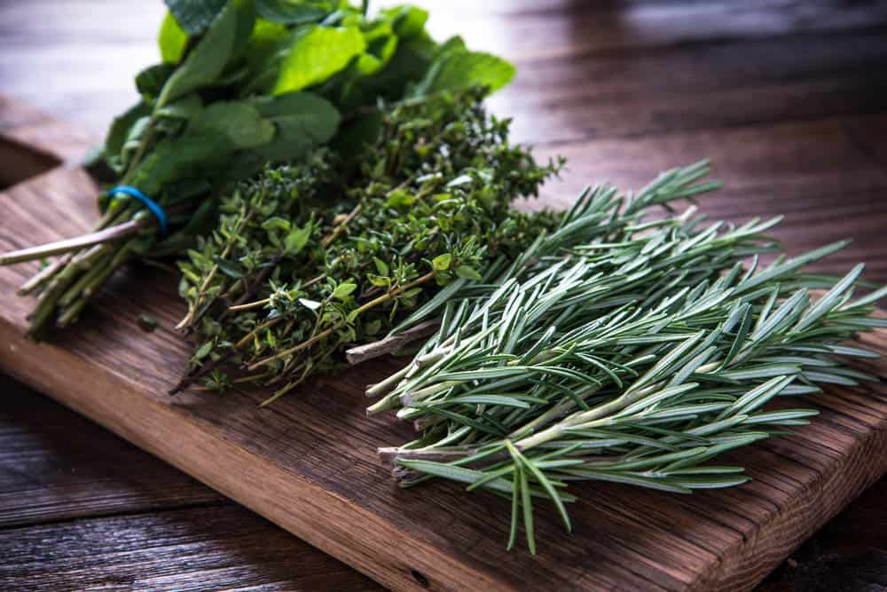
HERBS HAVE BEEN USED AS A TREATMENT FOR SEVERAL MEDICAL AILMENTS AND DISEASES SINCE ANCIENT TIMES. THERE IS A DEEP CONNECTION BETWEEN HUMANS AND HERBS THAT GOES WAY BACK IN TIME. GENERATION AFTER GENERATION, HUMAN BEINGS HAVE GREATLY RELIED ON THE USE OF DIFFERENT HERBS AS A SOURCE OF GOOD HEALTH AND WELL-BEING.
RELATED: MEGA LIST OF SPICES | MEGA LIST OF CONDIMENTS | TYPES OF GARNISH | TYPES OF FOOD | HERBS TO GROW ON WINDOWSILL | VEGETABLES AND HERBS FOR SYMBIOTIC FARMING
SEVERAL ANTHROPOLOGISTS BELIEVE THAT PEOPLE BEGAN MAKING HEALING OINTMENTS AND OILS OUT OF NUMEROUS PLANTS AND HERBS AS EARLY AS 7000 B.C. ACCORDING TO OTHER HISTORICAL RECORDS, PLANTS WERE THE ONLY MEDICINES THAT WERE USED BEFORE 500 B.C. SINCE THEY WERE BELIEVED TO CONSIST OF EXCEPTIONAL MEDICINAL QUALITIES AND EVEN MAGICAL POWERS.
LATER DURING THE PERIOD FROM THE 1600S TO 1700S, THE EUROPEAN COLONISTS WHO SETTLED IN NORTH AMERICA BROUGHT WITH THEM SOME OF THE MOST USEFUL AND IMPORTANT PLANT SEEDS TO THE NEW WORLD. SOME OF THE HERBS THAT THEY INTRODUCED INCLUDE CHAMOMILE, THYME, LAVENDER, CALENDULA, PARSLEY, AND MINT, TO NAME A FEW.

HERBS – THE NATURALLY DELICIOUS SUPERFOOD
WHILE HERBS ARE TYPICALLY ASSOCIATED WITH WELLNESS AND HEALTH DUE TO THEIR INHERENT HEALING AND RESTORATIVE PROPERTIES, THEY ARE AN EXCELLENT ADDITION TO FOOD DISHES AND RECIPES. NOT ONLY DO THEY TAKE DIETARY HEALTH TO A WHOLE NEW LEVEL, BUT HERBS ARE ALSO A GREAT WAY TO ADD A LOT OF FLAVOR, AROMA, AND TASTE TO YOUR FOOD.
YOU CAN USE BOTH FRESH HERBS AND DRIED HERBS TO A VARIETY OF FOOD RECIPES; EITHER WAY, THEY WILL TAKE THE TASTE AND SMELL OF THE FOOD TO AN ENTIRELY DIFFERENT LEVEL. IN OTHER WORDS, HERBS ALLOW YOU TO ENJOY SOME FRESH-FROM-THE-EARTH TASTE RIGHT ON YOUR DINING TABLE.

HERB POPULARITY CHART
HERE’S A CHART ILLUSTRATING THE POPULARITY OF DIFFERENT HERBS. AS YOU CAN SEE, MINT IS BY FAR THE MOST POPULAR HERB BASED MONTHLY SEARCHES ONLINE.
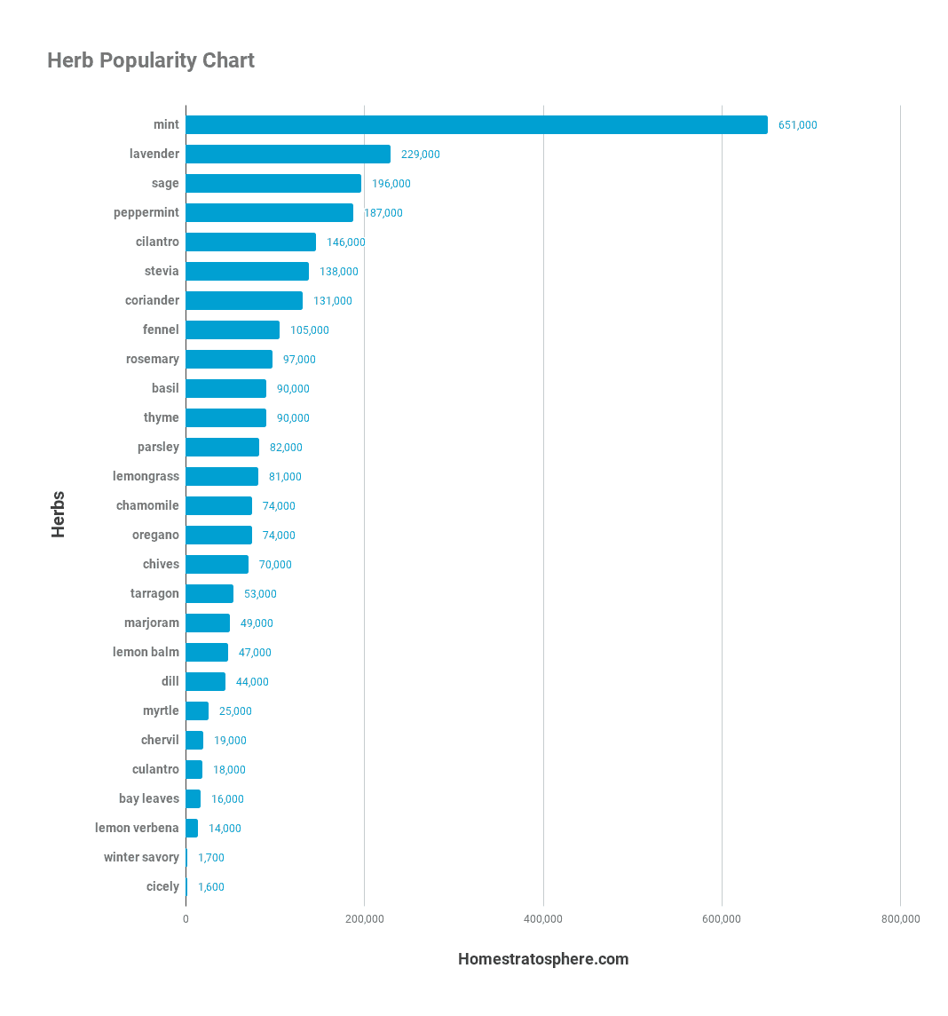

TYPES OF HERBS
THERE IS A WHOLE LIST OF CULINARY HERBS YOU CAN GROW IN YOUR GARDEN. THESE HERBS ARE AMAZINGLY HANDY TO HAVE IN YOUR KITCHEN PANTRY.
LEARN ABOUT SOME OF THE MOST COMMON AND POPULAR HERB VARIETIES AND ADD SOME FRESH, EARTHY FLAVOR TO YOUR SOUPS, STEWS, AND PASTA!

PARSLEY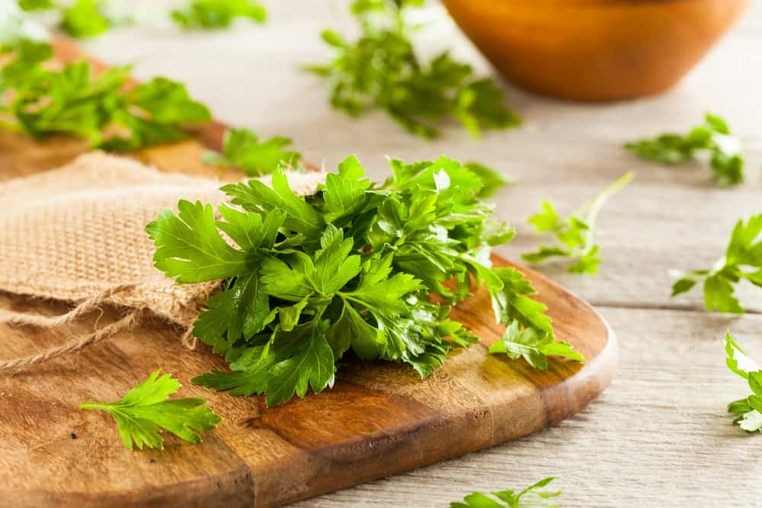
SCIENTIFIC NAME: PETROSELINUM CRISPUM
NATIVE TO THE CENTRAL MEDITERRANEAN REGION, PARTICULARLY GREECE, CYPRUS, SPAIN, PORTUGAL, SOUTHERN ITALY AND MOROCCO, PARSLEY IS ONE OF THE MOST WIDELY GROWN HERBS IN THE WORLD. OVER THE YEARS, THE CULTIVATION OF PARSLEY HAS ALSO BECOME POPULAR IN EUROPE WHERE IT IS COMMONLY USED AS A SPICE, VEGETABLE, AND HERB.
PARSLEY IS A HARDY BIENNIAL HERB THAT GROWS IN TWO DISTINCT FORMS – FLAT LEAF AND MOSS CURLED. THE LATTER IS POPULARLY USED FOR GARNISHING GIVEN HOW IT PRODUCES A TIGHTLY CURLED ROSETTE OF LEAVES WHEREAS THE FORMER TYPE HAS FLAT LEAVES AND IS PREFERRED FOR COOKING SINCE IT RELEASES MORE FLAVOR.
IT HAS A MILD, BITTER FLAVOR THAT GREATLY ENHANCES THE FLAVOR OF SOUPS, STEWS, CASSEROLES, AND SALADS. PARSLEY IS ALSO CONSUMED FOR ITS NATURAL ANTI-BACTERIAL AND ANTI-INFLAMMATORY PROPERTIES THAT BOOST THE IMMUNE SYSTEM AND AIDS IN DIGESTION.
FUN FACT ABOUT PARSLEY: IT IS A VERY EFFECTIVE METHOD TO ELIMINATE BAD BREATH.

MINT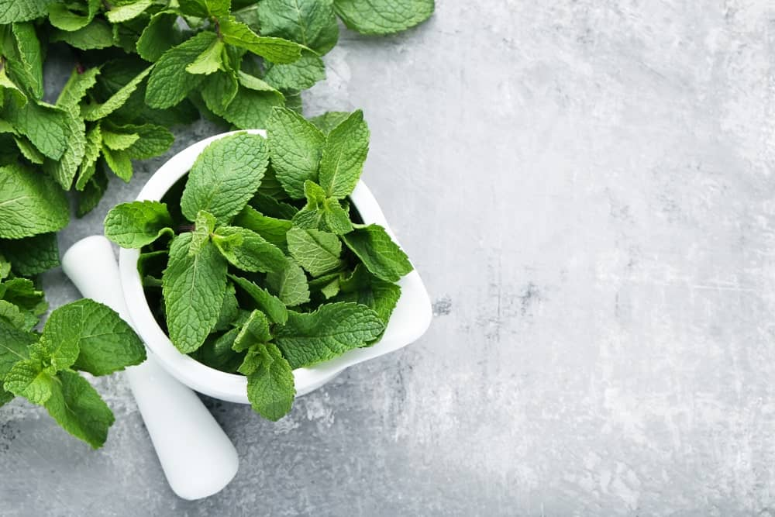
SCIENTIFIC NAME: MENTHA
MINT IS AN EXTREMELY HARDY PERENNIAL PLANT AND ITS CULTIVATION IS WIDELY DISTRIBUTED ACROSS NORTH AMERICA, EUROPE, ASIA, AUSTRALIA, AND AFRICA. IT IS ONE OF THE MOST AROMATIC AND FRAGRANT HERBS. THIS IS WHY THE ESSENTIAL OIL FROM MINT IS POPULARLY USED IN PERFUMED SCENTS AND FRAGRANCES.
THIS HERB HAS A FRESH, MINTY FLAVOR WHICH MAKES IT IDEAL TO BE USED IN DRINKS LIKE MOJITOS AND MINT JULEPS. FRESH MINT IS USUALLY PREFERRED OVER THE DRY VARIETY BECAUSE OF ITS AROMATIC, WARM FLAVOR FOLLOWED BY A SWEET AFTERTASTE. MANY PEOPLE BREW FRESH MINT LEAVES TO MAKE DIFFERENT TYPES OF TEAS AND BEVERAGES.
MINT HAS LONG BEEN USED AS AN HERBAL REMEDY TO TREAT SEVERAL AILMENTS LIKE CHEST PAINS, STOMACH ACHES, NAUSEA, ETC. IN FACT, PRACTITIONERS OF TRADITIONAL MEDICINE HAVE FOUND EVIDENCE THAT MINT MIGHT JUST BE ABLE TO TREAT IRRITABLE BOWEL SYNDROME.

DILL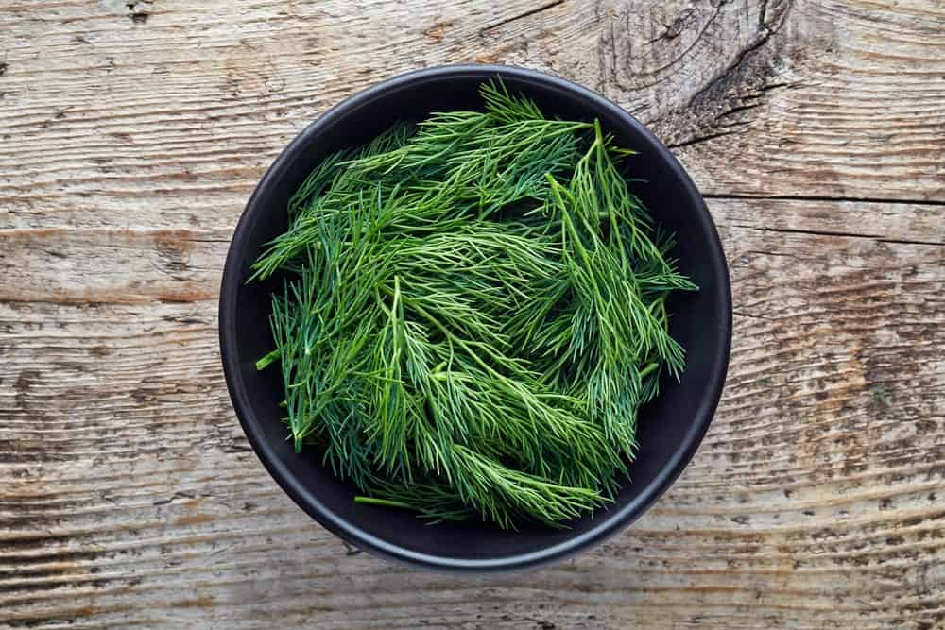
SCIENTIFIC NAME: ANETHUM GRAVEOLENS
THIS IS QUITE A TALL HERB WITH SUPER THIN AND FINE LEATHERY FOLIAGE THAT OFTEN RANGES FROM DARK GREEN TO BLUISH-GREEN IN COLOR. IT IS WIDELY GROWN IN EURASIA, WHERE IT IS COMMONLY USED AS AN HERB IN FOODS FOR ITS INCREDIBLE AROMA AND FLAVOR.
DILL IS EXTREMELY POPULAR AS A CULINARY HERB IN EUROPEAN CUISINE, ESPECIALLY IN REGIONS INCLUDING RUSSIA, FINLAND, SCANDINAVIA, EASTERN EUROPE, AND UKRAINE. THE FINELY CUT, SOFT, AND DELICATE DILL LEAVES MAKE AN EXCELLENT ADDITION TO DISHES FEATURING FISH, LAMB, POTATOES, SOUR CREAM, AND POULTRY. IT HAS A SLIGHTLY BITTER AND SHARP TASTE THAT PROVIDES A FLAVORFUL KICK TO THE FOOD.
DILL HAS A SURPRISING AMOUNT OF HEALTH BENEFITS, SOME OF WHICH INCLUDE LOW CHOLESTEROL LEVELS, RELIEF FROM INSOMNIA AND DIARRHEA, EASE OF DIGESTION AND RELIEF FROM FLATULENCE, TO NAME A FEW.
FUN FACT ABOUT DILL: DILL IS A GREAT AND NATURAL ALTERNATIVE FOR SLEEPING AIDS. TRY IT OUT FOR YOURSELF!

BASIL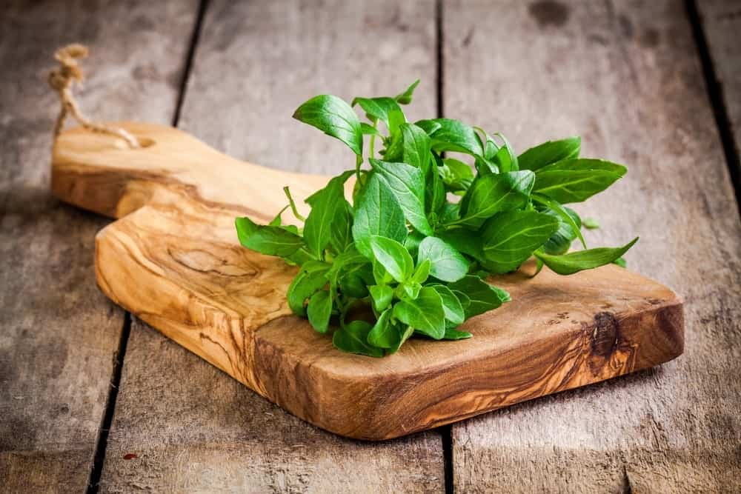
SCIENTIFIC NAME: OCIMUM BASILICUM
ALSO KNOWN AS ‘GREAT BASIL’ AND ‘SAINT JOSEPH’S WORT’, BASIL IS ONE OF THE MOST POPULAR AND WIDELY CONSUMED CULINARY HERBS. IT IS NATIVE TO TROPICAL REGIONS EXTENDING FROM SOUTHEAST ASIA TO CENTRAL AFRICA.
BASIL IS AN ANNUAL HERB THAT HAS AN ANISE-LIKE FLAVOR AND A VERY INTENSE CLOVE-LIKE AROMA. THE LEAVES OF THIS HERB HAVE A WARM, SPICY FLAVOR THAT MAKES IT IDEAL FOR PESTO, SALADS, SAUCES, SOUPS AND VARIOUS MEAT-BASED DISHES. FRESH BASIL, IN PARTICULAR, IS HIGHLY AROMATIC AND IS OFTEN USED AS A GARNISH ON MOST FOODS TO GREATLY ENHANCE THEIR SMELL AND AROMA.
THIS HERB IS OFTEN ASSOCIATED WITH SEVERAL BELIEFS AND RITUALS THAT HAVE SIGNIFICANTLY ADDED TO ITS POPULARITY. FOR EXAMPLE, THE FRENCH CALL IT THE ‘ROYAL HERB’ WHEREAS ANCIENT GREEKS AND EGYPTIANS PLACED THE HERB IN THE MOUTH OF THE DECEASED BECAUSE THEY STRONGLY BELIEVED THAT IT WILL OPEN THE GATES OF HEAVEN FOR THE DEAD.

SAGE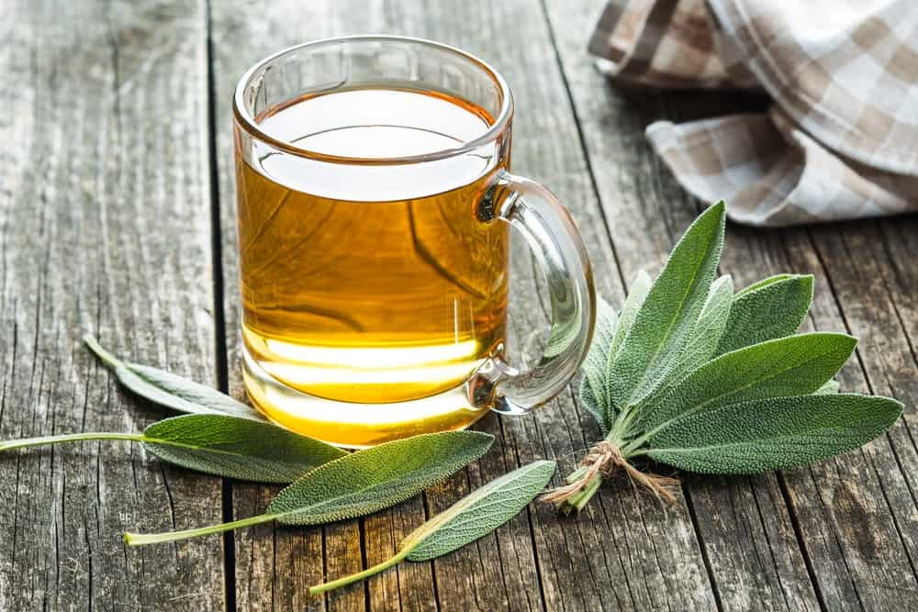
SCIENTIFIC NAME: SALVIA OFFICINALIS
THIS IS A PERENNIAL, EVERGREEN SHRUB THAT IS ALSO KNOWN AS GARDEN SAGE AND COMMON SAGE. IT IS A MEMBER OF THE MINT FAMILY AND IS PARTICULARLY NATIVE TO THE MEDITERRANEAN REGION. SAGE HAS A LONG, RICH HISTORY AND HAS BEEN GROWN FOR CENTURIES DUE TO ITS INCREDIBLE HEALING PROPERTIES AND CULINARY SIGNIFICANCE. INTERESTINGLY, SAGE WAS ALSO USED IN ANCIENT TIMES TO WARD OFF EVIL AND AS A TREATMENT FOR SNAKEBITES.
FOR CULINARY PURPOSES, FRESH SAGE LEAVES MAKE AN EXCELLENT ADDITION TO SAUCES, PASTA, POULTRY DRESSINGS, SEASONINGS, AND SALADS. SINCE IT BELONGS TO THE MINT FAMILY, IT RELEASES A VERY STRONG, MINTY FLAVOR THAT MAKES IT IDEAL TO BE INFUSED IN HERBAL TEAS AND BEVERAGES.
SAGE-INFUSED TEA IS CONSUMED AS AN EFFECTIVE REMEDY TO TREAT VARIOUS GASTRIC AILMENTS, THROAT AND MOUTH INFECTIONS, AS WELL AS BRAIN DISORDERS.
FUN FACT ABOUT SAGE: IT’S NAME MEANS “SALVATION” OR “TO BE SAVED” BECAUSE IT WAS MOSTLY USED FOR MEDICINAL PURPOSES IN THE PAST.

ROSEMARY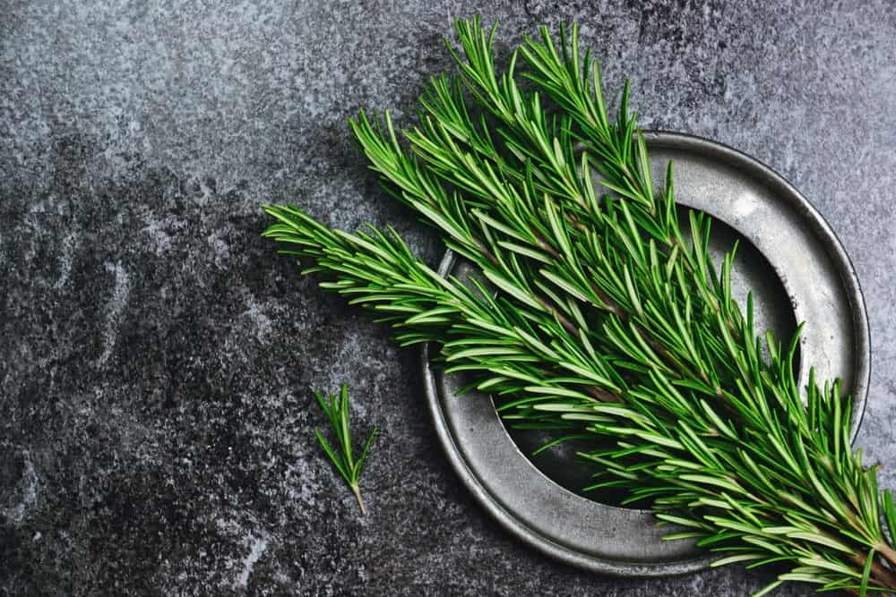
SCIENTIFIC NAME: ROSMARINUS OFFICINALIS
THIS WOODY PERENNIAL, EVERGREEN SHRUB HAS TO BE ONE OF THE MOST FLAVOURFUL AND AROMATIC HERBS. IT IS NATIVE TO THE MEDITERRANEAN REGION AND IS A MEMBER OF THE MINT FAMILY. THE WORD ‘ROSEMARY’ COMES FROM THE LATIN DICTIONARY WHERE ‘ROS’ MEANS ‘DEW’ AND ‘MARINUS’ TRANSLATES TO ‘SEA’ IN THE ENGLISH LANGUAGE. TOGETHER THEY MEAN “DEW OF THE SEA”.
ROSEMARY HAS AN INCREDIBLY DELIGHTFUL SCENT AND WITH A STRONG, ASTRINGENT FLAVOR, MAKING IT AN EXCELLENT OPTION FOR STUFFING CHICKEN, TURKEY, AND LAMB. IT IS INCREASINGLY POPULAR IN ITS NATIVE MEDITERRANEAN CUISINE WHERE IT IS TYPICALLY ROASTED WITH VEGETABLES AND MEATS.
OTHER THAN CULINARY USES, ROSEMARY IS A SUPER POWERFUL NATURAL REMEDY FOR RELIEVING PAIN AND SOOTHING INDIGESTION. THE AROMA OF ROSEMARY GREATLY HELPS RELIEVE EVERYDAY STRESS, CALM THE MIND, AND RELEASE THE ANXIETY.

THYME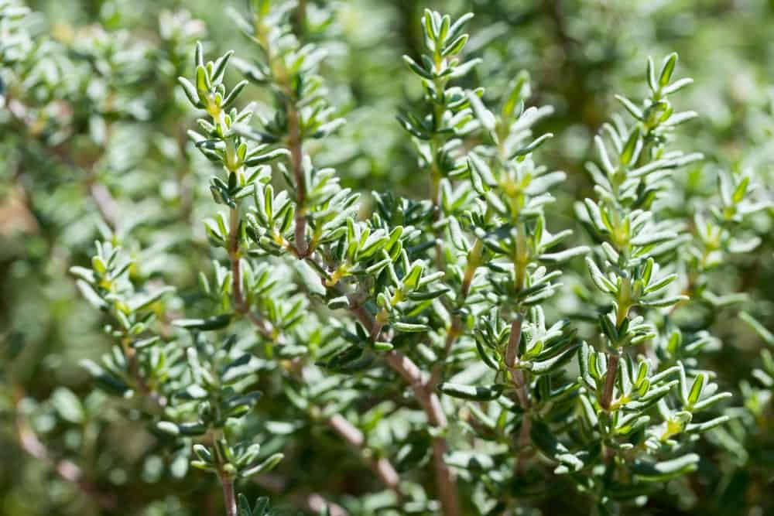
SCIENTIFIC NAME: THYMUS VULGARIS
THIS IS A DELICATE, MEDITERRANEAN PERENNIAL HERB THAT HAS BEEN USED SINCE THE TIME OF ANCIENT EGYPTIANS AND GREEKS WHO USED IT FOR EMBALMING PURPOSES AS WELL AS A SOURCE OF COURAGE. OVER TIME, THE CONSUMPTION OF THYME SPREAD THROUGHOUT EUROPE, ESPECIALLY DUE TO THE ROMANS WHO USED THE HERB TO PURIFY THEIR ROOMS.
THYME IS VERY POPULAR IN ITALIAN, MEDITERRANEAN, AND FRENCH CUISINES AND IS OFTEN PAIRED WITH OTHER HERBS LIKE PARSLEY AND GARLIC IN ORDER TO INCREASE THE COMPLEXITY OF FLAVORS. WHILE IT IS USED IN FRESH AS WELL AS A DRIED FORM, THE FORMER VARIETY IS MORE FLAVORFUL AND RELEASES AN INCREDIBLE SCENT.
THIS HERB IS AN EXCELLENT SOURCE OF ANTIOXIDANTS LIKE VITAMIN A THAT IS ESSENTIAL FOR NAIL, EYE, AND SKIN HEALTH. IT ALSO CONSISTS OF ANTI-BIOTIC AND ANTISEPTIC PROPERTIES THAT HELP COMBAT AGAINST COUGHS, COLDS, AND ALLERGIES.
FUN FACT ABOUT THYME: THE GREEKS USED TO USE IT IN THEIR BATHS FOR “COURAGE” AND THE NICE SCENT.

CILANTRO / CORIANDER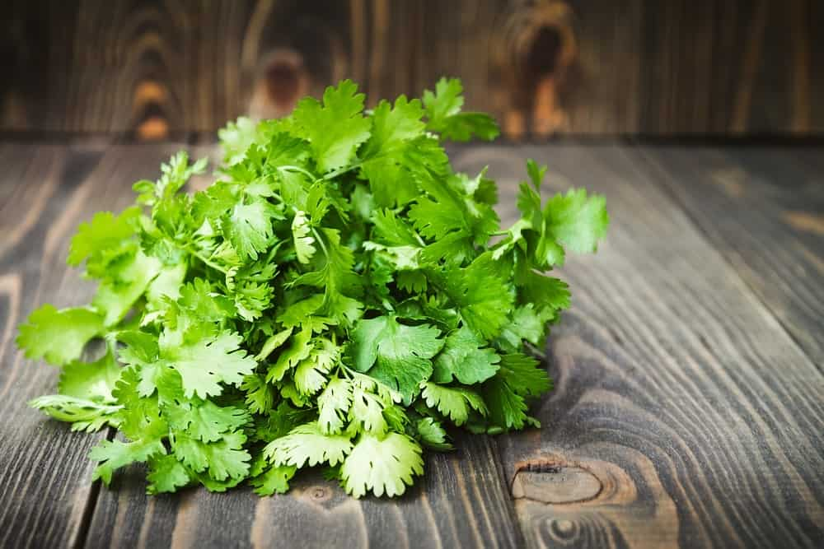
SCIENTIFIC NAME: CORIANDRUM SATIVUM
CILANTRO AND CORIANDER COME FROM THE PLANT SPECIES — CORIANDRUM SATIVUM.
CILANTRO IS AN HERB (SEE ABOVE). CORIANDER, IS USUALLY REFERRED TO CORIANDER SEEDS.
THIS HAS TO BE THE MOST COMMONLY AND POPULARLY CONSUMED HERB ALL OVER THE WORLD DUE TO ITS AMAZINGLY VERSATILE FLAVOR PROFILE AND AROMA. IT IS KNOWN BY TWO KEY NAMES, CORIANDER AND CILANTRO, DUE TO THE DIFFERENCE IN ITS HARVESTING AND USAGE. IF THE LEAVES ARE HARVESTED, IT IS REFERRED TO AS ‘CILANTRO’ AND IF THE SEEDS ARE HARVESTED, IT IS CALLED CORIANDER.
THE TASTE OF CILANTRO IS DESCRIBED AS LEMON-LIKE WITH A SUBTLE TARTNESS WHILE ITS SEEDS CONSIST OF A SPICY KICK OF FLAVOR. THIS HERB IS GREAT FOR SALADS, SALSAS, VEGETABLE AND MEAT-BASED DISHES. IT IS NATIVE TO VARIOUS REGIONS SPANNING FROM NORTHERN AFRICA AND SOUTHERN EUROPE TO SOUTH-WESTERN ASIA.
CILANTRO IS ALSO REFERRED TO AS A ‘REVITALIZING HERB’ THAT HELPS RELIEVE INFLAMMATION, AID IN DIGESTION, AND REDUCE STRESS IN THE LIVER.

FENNEL (FLORENCE)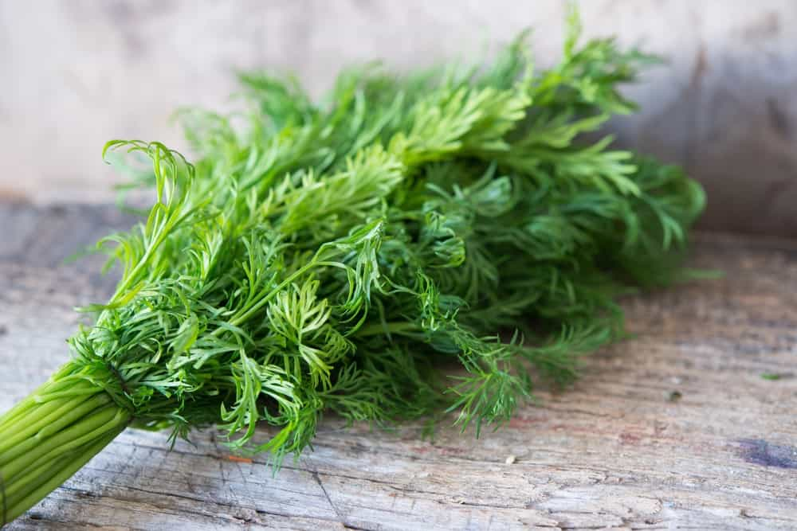
SCIENTIFIC NAME: FOENICULUM VULGARE
THIS HERB IS NATIVE TO THE MEDITERRANEAN REGION AND IS EXTREMELY FLAVORFUL AND AROMATIC. IT IS A HARDY PERENNIAL HERB THAT BELONGS TO THE CARROT FAMILY AND HAS BECOME HIGHLY NATURALIZED, ESPECIALLY ON DRY SOILS ON RIVER BANKS AND NEAR THE SEA COASTS.
FENNEL IS A HIGHLY PRIZED HERB THAT HAS BEEN USED SINCE ANCIENT TIMES BY GREEKS AND ROMANS WHO COMMONLY USED IT AS FOOD AND MEDICINE. FENNEL LEAVES HAVE A SWEETISH FLAVOR WITH A MILD SPICE KICK AND A VERY EARTHY SCENT. THEY ARE TYPICALLY USED IN SALADS, SOUPS, AND MEAT-BASED DISHES.
IN TERMS OF HEALTH AND NUTRITION, FENNEL IS HIGHLY RICH IN PROTEIN, CALCIUM, MAGNESIUM, VITAMINS, AND IRON. IT SIGNIFICANTLY IMPROVES BONE HEALTH, MAINTAINS BLOOD PRESSURE, FIGHTS INFLAMMATION, AND BOOSTS THE OVERALL METABOLISM OF THE BODY.
FUN FACT ABOUT FENNEL: YOU CAN DIFFERENTIATE A MALE FENNEL FROM A FEMALE FENNEL BY THEIR SHAPES! MALE FENNELS HAVE ROUND SHAPES AND FEMALES ARE LONG.

CHAMOMILE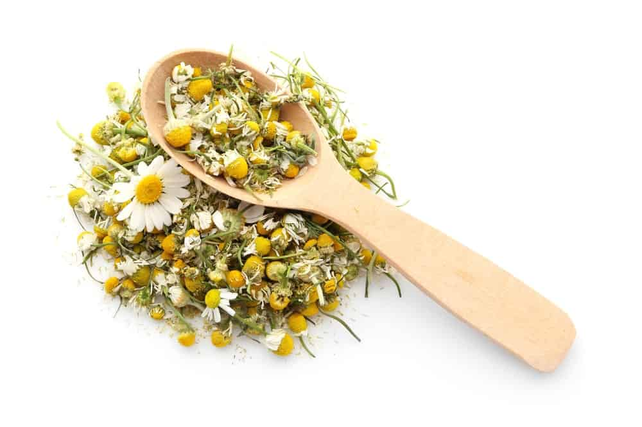
SCIENTIFIC NAME: MATRICARIA CHAMOMILLA
THIS HERB COMES FROM DAISY-LIKE FLOWERS AND IS THE MOST POPULAR HERB CHOICE FOR HERBAL TEAS, ESPECIALLY IN EUROPE AND THE UNITED STATES. CHAMOMILE TEA ISN’T ONLY ONE OF THE WORLD’S MOST WIDELY CONSUMED HERBAL TEAS BUT THE HERB HAS ALSO BEEN USED SINCE ANCIENT TIMES AS A TREATMENT FOR UPSET STOMACH, INFLAMMATION, AND HIGH FEVER.
THE TERM ‘CHAMOMILE’ HAS BEEN DERIVED FROM THE GREEK WORD ‘CHAMOMAELA’ THAT TRANSLATES TO ‘GROUND APPLE’ IN ENGLISH. THIS IS USED AS A REFERENCE TO ITS FRESH, APPLE-LIKE SCENT.
CHAMOMILE HAS LONG BEEN ASSOCIATED WITH A MULTITUDE OF MEDICINAL BENEFITS INCLUDING IMPROVED SLEEP QUALITY, BETTER DIGESTIVE SYSTEM, PROTECTION AGAINST CERTAIN TYPES OF CANCER, IMPROVED HEART HEALTH, AND CONTROLLED BLOOD SUGAR LEVELS.

TARRAGON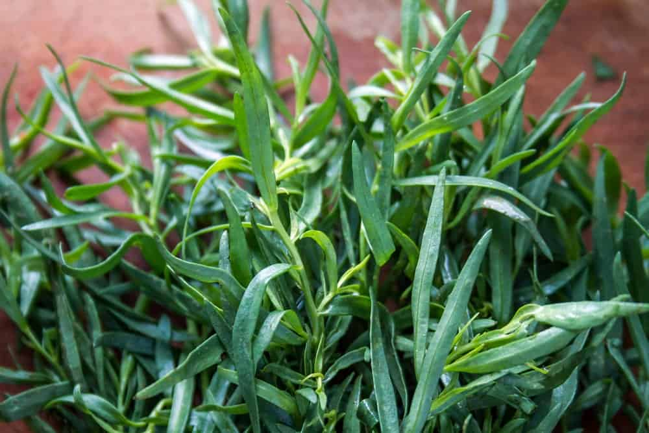
SCIENTIFIC NAME: ARTEMISIA DRACUNCULUS
ALSO KNOWN AS ESTRAGON, TARRAGON IS A PERENNIAL HERB THAT BELONGS TO THE SUNFLOWER FAMILY. IT IS CULTIVATED FOR MEDICAL AND CULINARY PURPOSES, PARTICULARLY, ACROSS MUCH OF NORTH AMERICA AND EURASIA. THIS HERB HAS A STRONG ANISE-LIKE FLAVOR, MAKING IT A CLASSIC SEASONING FOR CHICKEN, EGG DISHES, SOUPS, STEWS, SEAFOOD AS WELL AS VEGETABLE-BASED DISHES.
TARRAGON IS CONSIDERED TO BE ONE OF THE FOUR ‘FINES HERBES’ OF THE FRENCH CUISINE AND IS THE KEY FLAVORING COMPONENT OF BÉARNAISE SAUCE.
THIS AMAZING HERB IS A GREAT SOURCE OF ESSENTIAL MINERALS AND VITAMINS LIKE MAGNESIUM, ZINC, VITAMIN C, VITAMIN A, CALCIUM, AND IRON. TARRAGON IS ALSO OFTEN FRESHLY BREWED TO MAKE HERBAL TEA OR ANY OTHER HOT BEVERAGE WHICH IS BELIEVED TO RELIEVE STRESS AND ANXIETY. CHEWING ON FRESH TARRAGON LEAVES ALSO HELPS NUMB MOUTH PAIN AND KILL GERMS THAT LEAD TO BAD BREATH.
FUN FACT ABOUT TARRAGON: TARRAGON COMES FROM THE SPECIES DRANCULUS, WHICH MEANS LITTLE DRAGON, DUE TO ITS UNIQUE SPIKES.

LAVENDER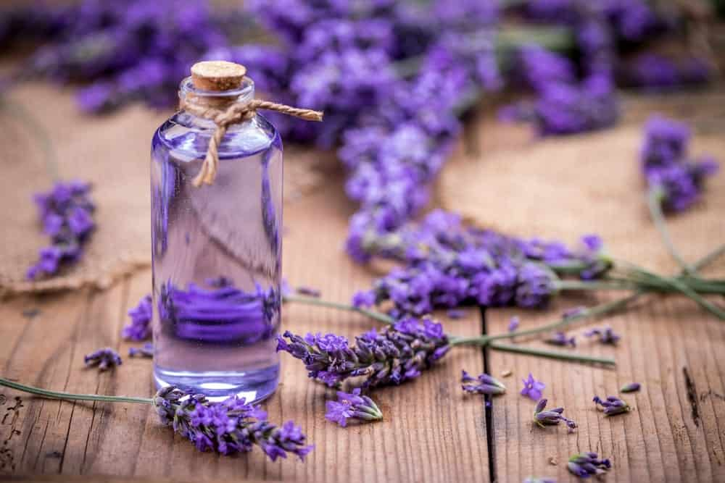
SCIENTIFIC NAME: LAVANDULA
THIS BEAUTIFUL AND STRIKING PURPLE PLANT IS ESPECIALLY USED AS A CONDIMENT AND HAS SPRUNG FROM THE CANARY ISLANDS, CAPE VERDE, CHINA, EASTERN AFRICA, SOUTHWEST ASIA AND EUROPE. LAVENDER IS A BUSHY PERENNIAL WITH NEEDLE-LIKE FOLIAGE AND BALSAM-LIKE SCENT.
THE WORD ‘LAVENDER’ HAS COME FROM THE OLD FRENCH WORD, ‘LAVANDRE’ WHICH REFERS TO THE USE OF PLANTS AS INFUSIONS. THIS PLANT HAS A VERY HIGH COMMERCIAL VALUE FOR ITS ESSENTIAL OILS AND EXTRACTS THAT CONSIST OF ANTISEPTIC AND ANTI-INFLAMMATORY PROPERTIES. THE OILS ARE ALSO POPULARLY USED COSMETICS, BALMS, PERFUMES, AND SALVES.
IT IS ALSO ONE OF THE MOST VERSATILE AND EFFECTIVE HERBAL REMEDIES THAT HELP TREAT SLEEP DISTURBANCES, INSOMNIA, AND ANXIETY. IN CULINARY HISTORY, THE LAVENDER JAM WAS A FAVORITE OF QUEEN ELIZABETH AND SINCE THEN, THIS HERB HAS BEEN USED AS A GREAT FLAVORFUL AND AROMATIC ADDITION TO VARIOUS FOOD DISHES AND RECIPES. MANY PEOPLE ALSO USE THESE PURPLE LAVENDER FLOWERS AS DECORATIONS FOR DESSERTS AND DRINKS.

CHIVES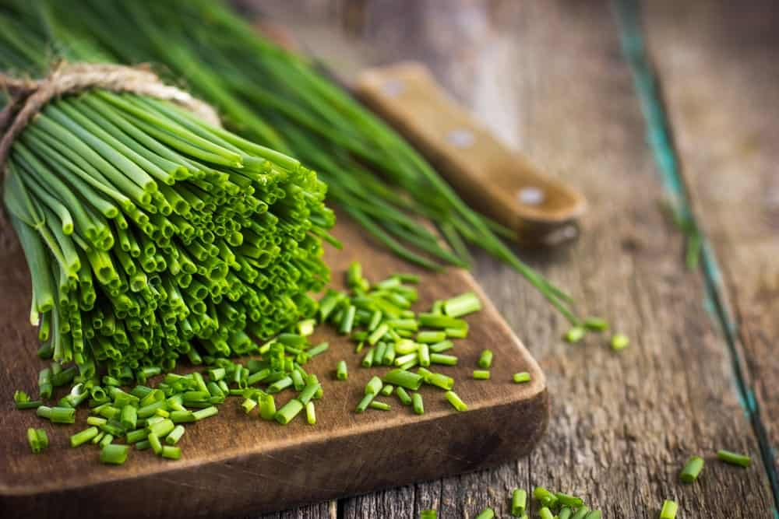
SCIENTIFIC NAME: ALLIUM SCHOENOPRASUM
THIS IS A PERENNIAL HERB THAT BELONGS TO THE SAME FAMILY AS LEEKS, GARLIC, AND ONION. IT IS HIGHLY WIDESPREAD ACROSS NORTH AMERICA, ASIA, AND MOST OF EUROPE. CHIVES GROW IN THE FORM OF CLUMPS IN THE UNDERGROUND BULBS AND RESULT IN ROUND AND HOLLOW LEAVES THAT ARE SUPER FINE IN SHAPE AND TEXTURE. CHIVES ARE POPULARLY PAIRED WITH SOUR CREAM AND ARE CONSIDERED TO BE ONE OF THE FINEST HERBS IN FRENCH CUISINE. THIS HERB ALSO GOES REALLY WELL WITH SALADS, EGGS, SOUPS, POTATOES, AND OTHER VEGETABLE DISHES.
ALTHOUGH THE CULTIVATION OF CHIVES BEGAN DURING THE MIDDLE AGE, THEIR USE AND CONSUMPTION GO BACK TO SOME 5,000 YEARS AGO. ANCIENT ROMANS BELIEVED THAT CHIVES HELP CURE SUNBURNS AND SORE THROAT AND THAT EATING CHIVES HELPS CONTROL BLOOD PRESSURE.
FUN FACT ABOUT CHIVES: CHIVES WHERE USED IN ANCIENT TIMES BECAUSE PEOPLE BELIEVED IT GAVE THEM STRENGTH.

BAY LEAVES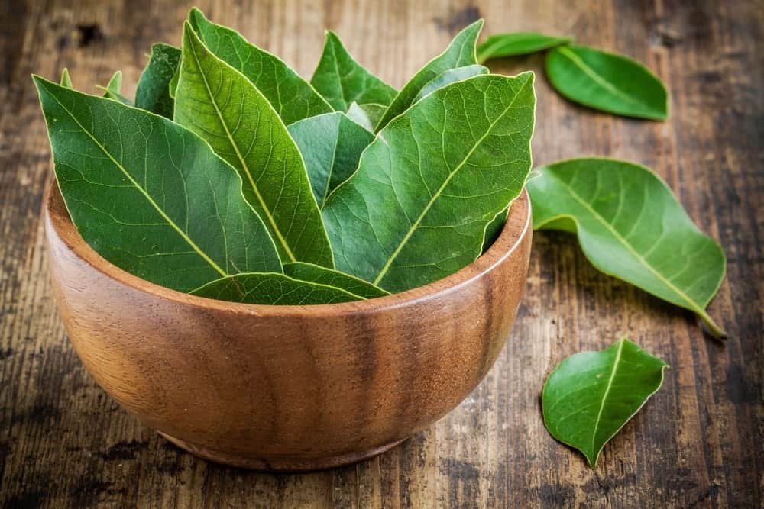
SCIENTIFIC NAME: LAURUS NOBILIS
BAY LEAVES ARE PROBABLY THE MOST AROMATIC OF ALL THE HERBS AND ARE BEST KNOWN FOR THEIR INCREDIBLE SCENT THAT SMELLS LIKE A MIXTURE OF MINTS, CLOVES, AND BALSAM. THIS FRAGRANCE COUPLED WITH A SHARP, PEPPERY TASTE HAS MADE THIS HERB QUITE POPULAR AMONG VARIOUS FOOD DISHES LIKE RICH, HEARTY STEWS AND SOUPS.
THIS HERB COMES IN VARIOUS VARIETIES INCLUDING CALIFORNIA BAY LEAF, INDONESIAN BAY LEAF, WEST INDIAN BAY LEAF AND INDIAN BAY LEAF. THE FRAGRANCE OF ALL THESE BAY LEAF VARIETIES IS MORE PROMINENT AND NOTICEABLE THAN THE TASTE. IT HAS ALSO BEEN USED BY ANCIENT GREEKS FOR ITS AMAZING FLAVOR AND IS NOW FEATURED IN A VARIETY OF CLASSIC FRENCH DISHES AND EUROPEAN CUISINES.

CULANTRO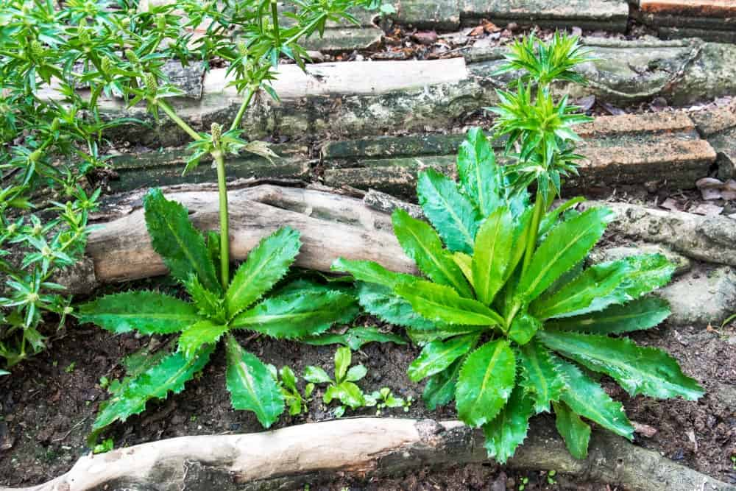
SCIENTIFIC NAME: ERYNGIUM FOETIDUM
OFTEN CONFUSED WITH ITS COUSIN HERB ‘CILANTRO’, CULANTRO IS A DIFFERENT AND AN UNUSUAL KIND OF HERB WITH LONG, SERRATED LEAVES THAT LOOK LIKE LETTUCE. IT IS A TROPICAL PERENNIAL HERB THAT IS ALSO KNOWN BY OTHER NAMES LIKE LONG CORIANDER, MEXICAN CORIANDER, AND SHADOW BENI.
ALTHOUGH CILANTRO IS CULTIVATED WORLDWIDE IN TEMPERATE CLIMATES, IT IS PARTICULARLY NATIVE TO SOUTH AMERICA, CENTRAL AMERICA, AND MEXICO. IN TERMS OF FLAVOR AND AROMA, IT HAS A MUCH STRONGER PROFILE AS COMPARED TO CILANTRO SO IT IS USED IN SMALLER AMOUNTS IN COOKING.
CILANTRO IS POPULARLY USED FOR MARINATING, SEASONING, AND GARNISHING PURPOSES ESPECIALLY IN THE CARIBBEAN, VIETNAMESE, AND INDIAN CUISINES. SINCE IT HAS A GREAT ABILITY TO RETAIN GOOD FLAVOR AND COLOR, CULANTRO IS HIGHLY VALUABLE IN THE DRIED HERB INDUSTRY.
FUN FACT ABOUT CULANTRO: CULANTRO IS USED IN TEA FORM AS A NATURAL WAY TO TREAT THE FLU AND CONSTIPATION.

CHERVIL 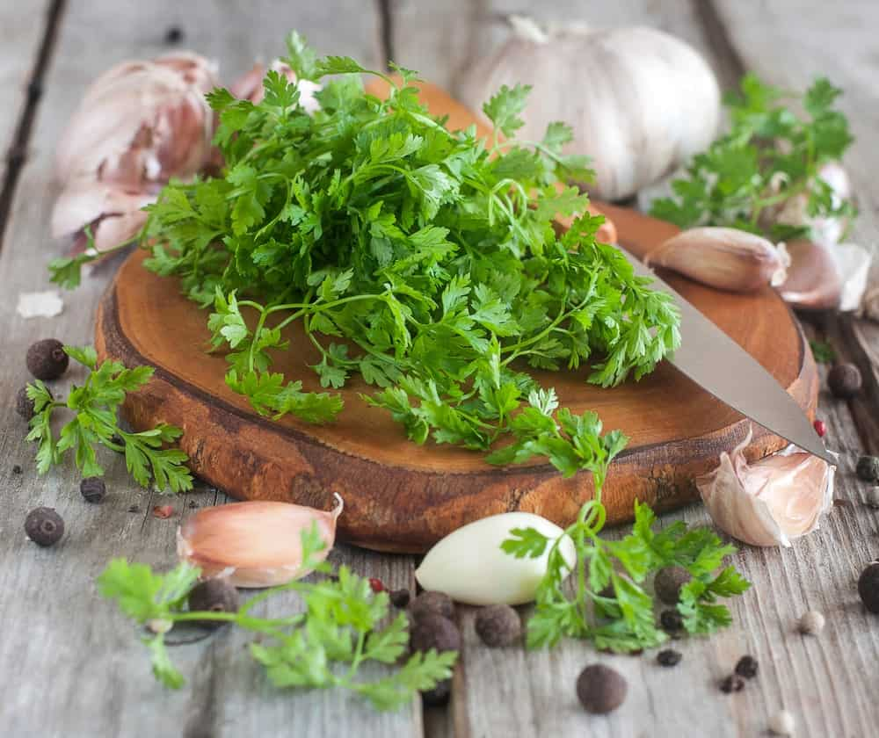
SCIENTIFIC NAME: ANTHRISCUS CEREFOLIUM
CHERVIL IS A DELICATE ANNUAL HERB WITH FINE GREEN LEAVES THAT ARE HIGHLY SIMILAR TO FINELY CUT PARSLEY LEAVES. PERHAPS, THAT IS WHY IT IS ALSO KNOWN AS ‘FRENCH PARSLEY’. THIS HERB IS NATIVE TO THE CAUCASUS BUT LATER BECAME POPULAR THROUGHOUT MOST OF EUROPE.
THIS PLANT PRODUCES LIGHT GREEN AND FLAT LACY LEAVES THAT HAVE A TASTE AND AROMA SIMILAR TO THAT OF ANISE. THIS MAKES CHERVIL A GREAT OPTION FOR ENHANCING THE FLAVOR OF CHICKEN, SALADS, EGGS, VEGETABLES, AND FISH. IT IS QUITE A STAPLE HERB IN THE FRENCH CUISINE AND IS ALSO ONE OF THE FOUR TRADITIONAL FRENCH ‘FINES HERBES’.
ASIDE FROM BEING POPULAR IN THE CULINARY WORLD, CHERVIL IS ALSO USED AS A USEFUL DIGESTIVE AID, FOR LOWERING BLOOD PRESSURE, CURING HICCUPS, AND AS A MILD STIMULANT.

WINTER SAVORY
SCIENTIFIC NAME: SATUREJA MONTANA
THIS IS A PERENNIAL, SEMI-EVERGREEN HERB WITH DARK GREEN LEAVES AND BEAUTIFUL SUMMER FLOWERS. IT IS NATIVE TO WARM TEMPERATE REGIONS OF AFRICA, THE MEDITERRANEAN, AND SOUTHERN EUROPE. WINTER SAVORY CAN USUALLY BE FOUND GROWING IN OLD WALLS, ALKALINE SOILS, ON ROCKY MOUNTAIN SLOPES, DRY BANKS, AND HILL SLIDES.
THIS HERB IS ONE OF THE MOST DELICIOUS AND SPICY CULINARY HERBS THAT ADD INTENSE FLAVOR AND AROMA TO ANY RECIPE. SINCE IT BELONGS TO THE MINT FAMILY, IT CARRIES THE SIMILAR FRESH, MINTY FLAVOR WHICH MAKES IT IDEAL FOR SALAD DRESSINGS AND TO FLAVOR LIQUEURS. IT ALSO HOLDS A REPUTATION FOR PAIRING REALLY WELL WITH MEAT AND BEANS, AS WELL AS IN SAUCES AND SOUPS.
WINTER SAVORY CONTAINS A MULTITUDE OF HEALTH BENEFITS DUE TO ITS ANTISEPTIC, DIGESTIVE, CARMINATIVE, AND AROMATIC PROPERTIES. IT IS OFTEN USED AS A CURE FOR FLATULENCE, COLIC, NAUSEA, SORE THROAT, DIARRHEA, AND BRONCHIAL CONGESTION.

PEPPERMINT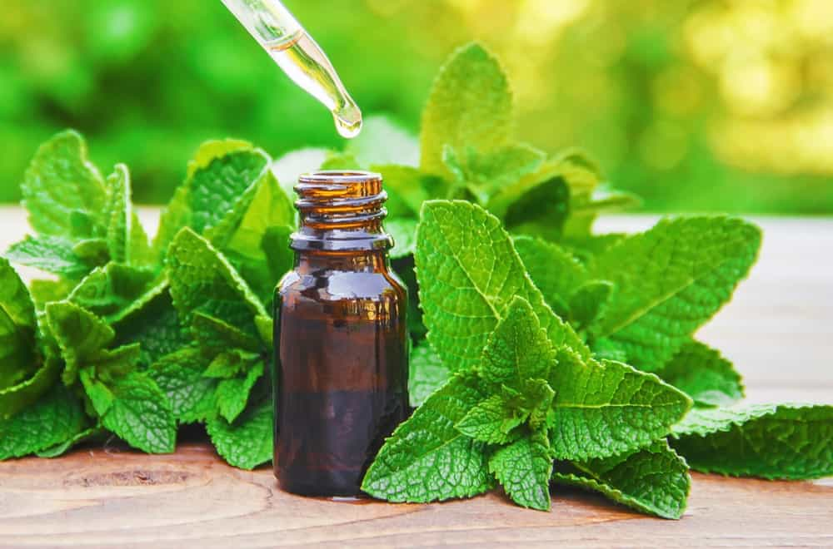
SCIENTIFIC NAME: MENTHA × PIPERITA
THIS TYPE OF MINT IS A CROSS BETWEEN SPEARMINT AND WATERMINT, MAKING IT A HYBRID MINT VARIETY. IT IS CULTIVATED IN VARIOUS REGIONS OF THE WORLD BUT IS INDIGENOUS TO THE MIDDLE EAST AND EUROPE. THIS HERB NATURALLY OCCURS IN MOIST HABITATS THAT TYPICALLY INCLUDE DRAINAGE DITCHES AND STREAMSIDES.
PEPPERMINT IS QUITE POPULAR AS A BREATH-FRESHENING AGENT AS WELL AS AN EFFECTIVE AID FOR DIGESTION-RELATED PROBLEMS. IT IS COMMONLY USED IN THE CULINARY WORLD AS A GARNISH FOR SALADS, AND IN VARIOUS COLD BEVERAGES FOR ITS STRONG AND REFRESHING MINTY AROMA AND TASTE.
PEPPERMINT OIL IS ALSO USED BY MANY PEOPLE TO TREAT IRRITABLE BOWEL SYNDROME WHERE IT HAS SHOWN TO REDUCE ITS EFFECTS TO A GREAT EXTENT. NOT ONLY THIS, BUT PEPPERMINT HERBAL TEA IS ALSO FAMOUS FOR TREATING DIGESTION PROBLEMS AND OTHER SIMILAR HEALTH AILMENTS.

STEVIA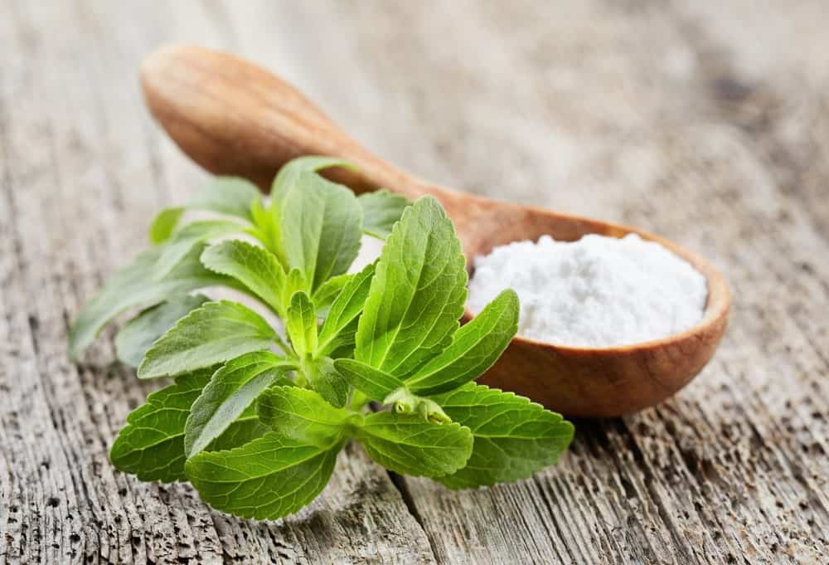
SCIENTIFIC NAME: STEVIA REBAUDIANA
STEVIA IS BEST KNOWN AS A NATURAL SWEETENER THAT IS EXTRACTED FROM THE PLANT SPECIES, STEVIA REBAUDIANA. THIS HERB IS NATIVE TO PARAGUAY AND BRAZIL AND IS PART OF THE SUNFLOWER FAMILY. IN ITS NATIVE REGIONS, THE LEAVES OF THE STEVIA PLANT ARE TYPICALLY USED TO SWEETEN LOCAL TEAS AND MEDICINES.
YOU CAN USE STEVIA AS A NATURAL SUBSTITUTE FOR SUGAR IN TEAS AND A VARIETY OF SWEET TREATS. THE BEST PART ABOUT ITS NATURAL SWEETNESS IS THAT IT CONTAINS ABSOLUTELY NO AMOUNT OF CALORIES. IN TRADITIONAL MEDICINE, STEVIA HAS ALSO BEEN FOUND TO BE A GREAT TREATMENT FOR STOMACH PROBLEMS, BURNS, AND COLIC.
ACCORDING TO A RESEARCH ARTICLE PUBLISHED IN THE JOURNAL OF MEDICINAL FOOD IN 2017, STEVIA ALSO HAS THE POTENTIAL TO TREAT ENDOCRINE DISEASES LIKE HYPERTENSION, DIABETES, AND OBESITY.

LEMONGRASS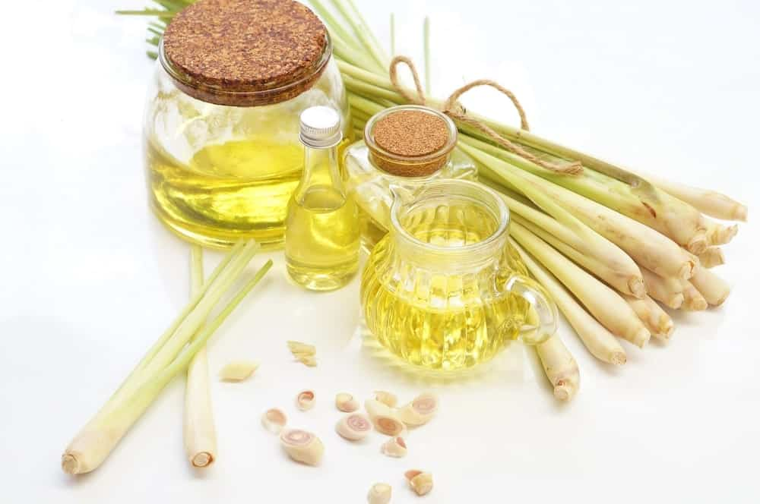
SCIENTIFIC NAME: CYMBOPOGON
ALSO KNOWN AS BARBED WIRE GRASS AND SILKY HEADS, LEMONGRASS IS A PERENNIAL THAT LOOKS SIMILAR TO A GRASS-LIKE PLANT DUE TO ITS LONG AND SLENDER FOLIAGE. IT IS ONE OF THE MOST POPULAR CULINARY HERBS FEATURED IN MOST ASIAN CUISINES.
LEMONGRASS CONSISTS OF A STRONG LEMONY AND CITRUSY FLAVOR WHICH MAKES IT IDEAL TO USE IN A VARIETY OF STEWS, SOUPS, AND CURRIES. LEMONGRASS HERBAL TEA IS ALSO PARTICULARLY FAMOUS AND IS OFTEN CONSUMED AS A REMEDY FOR COUGHS, SORE THROAT, AND DIGESTION PROBLEMS.
LEMONGRASS STALKS ARE AN EXCELLENT SOURCE OF KEY ANTIOXIDANTS, LIKE BETA-CAROTENE WHICH PROTECTS EYE INFLAMMATION AND CANCER. IT IS OFTEN CONSUMED AS A TEA TO RELIEVE ANXIETY IN BRAZILIAN FOLK MEDICINE.
SCIENTIFIC NAME: MONARDA DIDYMA

OREGANO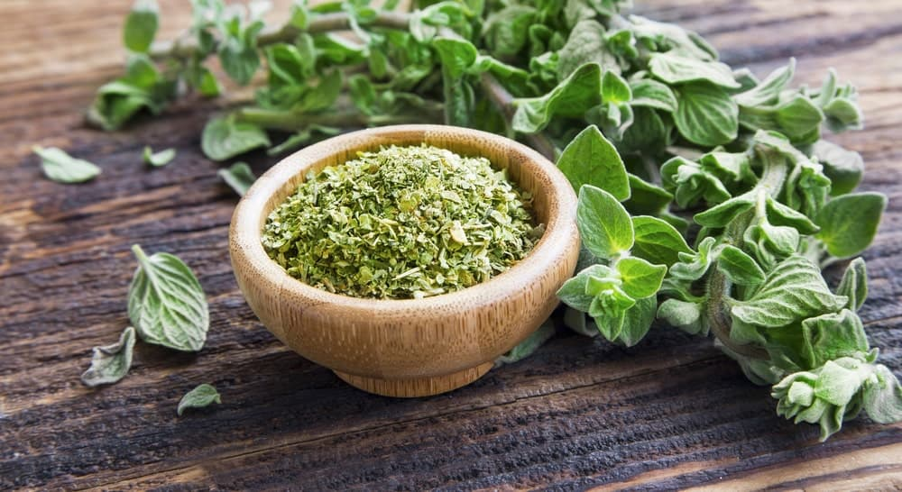
SCIENTIFIC NAME: ORIGANUM VULGARE
THIS IS A LOOSE, OPEN PERENNIAL PLANT THAT BELONGS TO THE MINT FAMILY AND IS ALSO KNOWN AS ‘WILD MARJORAM’. OREGANO IS NATIVE TO THE MEDITERRANEAN REGION, TEMPERATE WESTERN AND SOUTHWESTERN EURASIA. ALTHOUGH IT IS A PERENNIAL, IT CAN ALSO BE GROWN AS AN ANNUAL PLANT IN COLDER CLIMATES.
OREGANO IS ONE OF THE MOST COMMON AND A STAPLE HERB IN ALMOST ALL OF THE ITALIAN-AMERICAN CUISINE WHERE IT IS POPULARLY USED AS SEASONING PASTA AND PIZZA. INTERESTINGLY, THIS HERB GAINED SIGNIFICANT POPULARITY AFTER WORLD WAR II AFTER WHICH THE SOLDIERS CAME BACK WITH THIS WEIRD CRAVING FOR THE ‘PIZZA HERB’.
OREGANO LEAVES ALSO RELEASE DISTILLED OILS THAT ARE USED AS AN EFFECTIVE REMEDY FOR INDIGESTION, RESPIRATORY AILMENTS, SKIN CONDITIONS, AND FUNGAL INFECTIONS.

MARJORAM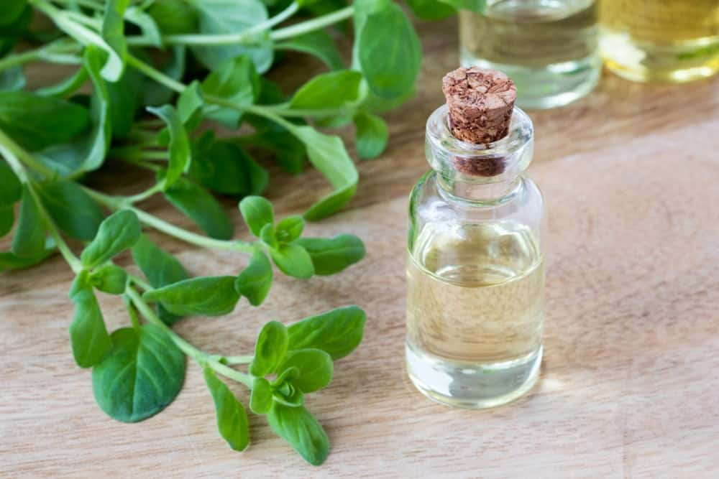
SCIENTIFIC NAME: ORIGANUM MAJORANA
MARJORAM IS A VERY TENDER ANNUAL PLANT WITH GRAY-GREEN, VELVETY LEAVES THAT ARE REALLY SOFT TO THE TOUCH. IT IS ALSO CALLED POT MARJORAM AND BELONGS TO THE OREGANO FAMILY. DUE TO ITS SIMILARITY WITH OREGANO, BOTH THE HERBS ARE OFTEN USED INTERCHANGEABLY IN SOME MIDDLE EASTERN COUNTRIES.
MARJORAM IS NATIVE TO SOUTHERN TURKEY AND CYPRUS AND WAS USED AS A POPULAR SYMBOL OF HAPPINESS A LONG TIME BACK BY THE ANCIENT GREEK AND ROMAN CIVILIZATIONS. IT WAS OFTEN USED IN LOVE SPELLS WHERE WOMEN USED TO KEEP MARJORAM LEAVES UNDER THEIR PILLOW IN HOPES OF FINDING HER FUTURE SPOUSE.
IN TODAY’S TIME, THIS HERB PLAYS A KEY ROLE IN THE MIDDLE EASTERN AND ITALIAN CUISINE. ITS FLAVOR IS QUITE SIMILAR TO THAT OREGANO, EXCEPT A FEW COMPLICATED FLAVOR NOTES THAT ARE DESCRIBED AS ‘SWEETER AND MORE DELICATE’ BY MOST PEOPLE. THE HERB IS BEST SUITED FOR LIGHT AND MILD DISHES DUE TO ITS DELICATE FLAVOR PROFILE.

LEMON BALM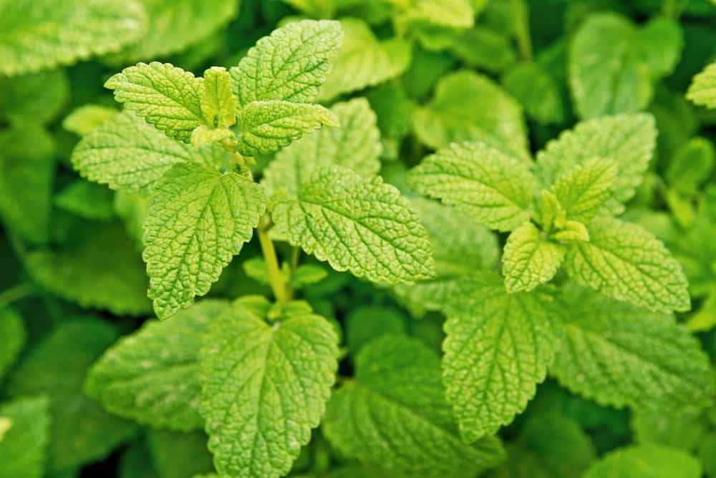
SCIENTIFIC NAME: MELISSA OFFICINALIS
THIS IS AN UPRIGHT HERBACEOUS, BUSHY PERENNIAL WITH LIGHT GREEN LEAVES AND A COARSE TEXTURE. IT BELONGS TO THE MINT FAMILY AND IS NATIVE TO CENTRAL ASIA, SOUTH-CENTRAL EUROPE, IRAN, AND THE MEDITERRANEAN BASIN. HOWEVER, THE CULTIVATION OF LEMON BALM HAS BEEN NATURALIZED THROUGHOUT AMERICA.
THE MEDICINAL USE OF LEMON BALM GOES BACK TO SOME 2,000 YEARS WHERE IT WAS USED FOR MEDICINAL PURPOSES BY GREEKS AND ROMANS. IT HAS ALSO BEEN DEEMED TO BE THE “ELIXIR OF LIFE” BY ANCIENT HERBALISTS AND PHYSICIANS DUE TO ITS ABILITY TO REDUCE ANXIETY, ALLEVIATE INSOMNIA, TREAT GASTROINTESTINAL PROBLEMS, AND EVEN POSSIBLY CURE THE ALZHEIMER’S DISEASE.
LEMON BALM IS ALSO QUITE POPULARLY USED AS A CULINARY HERB TO FLAVOR ICE CREAMS, AND BOTH HOT AND ICED TEAS. IT IS ALSO OFTEN PAIRED WITH SWEET FRUIT DISHES AND IS THE KEY INGREDIENT IN ‘LEMON BALM PESTO’. THE ESSENTIAL OIL FROM LEMON BALM PLANT IS OFTEN FEATURED IN PERFUMES FOR ITS INCREDIBLY RICH LEMON-LIKE SCENT.

MYRTLE
SCIENTIFIC NAME: MYRTUS
THIS HERB HOLDS A GREAT HISTORICAL SIGNIFICANCE AND IS MENTIONED A NUMBER OF TIMES IN THE BIBLE, AS WELL AS IN THE ANCIENT MYTHOLOGY OF GREECE AND ROME. MYRTLE IS A HARDY EVERGREEN SHRUB WITH A STRONG FRAGRANCE AND DARK GREEN FOLIAGE. IT IS NATIVE TO THE MIDDLE EAST, THE MEDITERRANEAN REGION, AND NORTH AFRICA.
MYRTLE HAS ALWAYS BEEN WIDELY VALUED IN TRADITIONAL HERBAL MEDICINE AND HAS BEEN COMMONLY PRESCRIBED FOR FEVER AND PAIN BY NUMEROUS ANCIENT PHYSICIANS. MYRTLE ESSENTIAL OIL IS ALSO USED TO COMBAT SEVERAL SKIN CONDITIONS.
DRIED MYRTLE LEAVES ARE COMMONLY USED IN TURKEY TO PREPARE A SOOTHING HERBAL TEA THAT HELPS DIABETICS IN LOWERING THEIR BLOOD PRESSURE. IN TERMS OF THEIR CULINARY USE, MYRTLE LEAVES ARE USED LIKE BAY LEAVES DUE TO THEIR INTENSE, SPICY FLAVOR THAT IS SIMILAR TO ALLSPICE POWDER.

LEMON VERBENA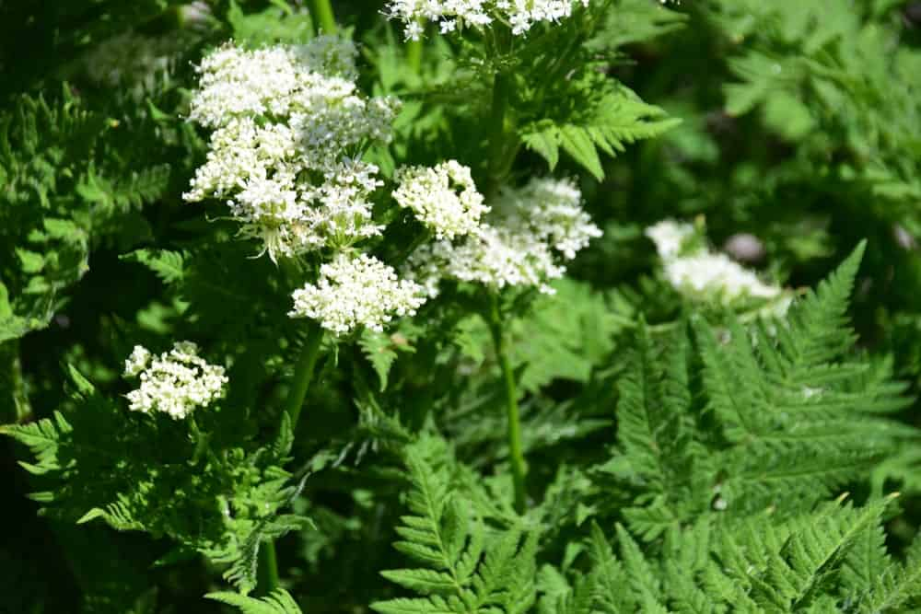
SCIENTIFIC NAME: ALOYSIA CITRODORA
ALSO KNOWN AS LEMON BEE-BRUSH, THIS HERB IS NATIVE TO THE WESTERN REGIONS OF SOUTH AMERICA. IT WAS INITIALLY BROUGHT TO EUROPE BY THE PORTUGUESE AND THE SPANISH PEOPLE.
LEMON VERBENA IS A WOODY PERENNIAL SHRUB WITH POINTED LEAVES AND A VERY POWERFUL LEMON-LIKE SCENT. IT IS OFTEN USED AS A GREAT SUBSTITUTE FOR LEMON IN DISHES THAT REQUIRE A STRONG LEMON TASTE, FOR INSTANCE, SALAD DRESSINGS, BEVERAGES, VEGETABLE MARINADES, AND POULTRY DISHES. MANY PEOPLE ALSO FEATURE LEMON VERBENA IN FLAVORED SORBETS AND HERBAL TEAS.
THIS HERB HAS SEVERAL IMPRESSIVE HEALTH BENEFITS LIKE FIGHTING INFLAMMATION, EASING DIGESTION, PROMOTING WEIGHT LOSS, RELIEVING NASAL CONGESTION, AND PREVENTING MUSCLE DAMAGE, TO NAME A FEW. THE STRONG LEMONY SCENT OF THIS HERB HAS ALSO BEEN SAID TO BE REALLY BENEFICIAL FOR RELAXING TENSED NERVES.

CICELY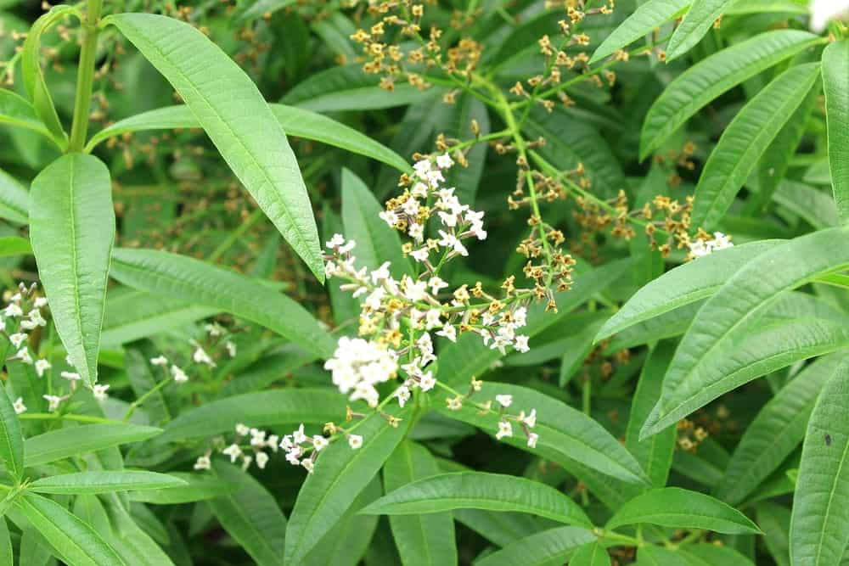
SCIENTIFIC NAME: MYRRHIS ODORATA
CICELY IS AN HERBACEOUS PERENNIAL PLANT THAT IS ALSO KNOWN AS SWEET CHERVIL, SWEET CICELY, AND GARDEN MYRRH. THE TERM ‘MYRRHIS’ IN ITS GENUS NAME IS DERIVED FROM A GREEK WORD THAT REFERS TO THE AROMATIC OILS FROM ASIA, WHEREAS ‘ODORATA’ IS A LATIN WORD THAT MEANS ‘SCENTED’.
THIS PLANT PRODUCES FERN-LIKE LEAVES THAT ARE FEATHERY AND FINELY DIVIDED WITH WHITE-COLORED PATCHES. WHEN THE LEAVES ARE CRUSHED, THEY RELEASE A STRONG SMELL THAT IS QUITE SIMILAR TO THAT OF ANISEED. IT IS NATIVE TO THE MOUNTAINS OF CENTRAL AND SOUTHERN EUROPE BUT HAS BEEN NATURALIZED IN VARIOUS PARTS OF THE WORLD, PARTICULARLY, IN GRASSLANDS, WOODLAND MARGINS, RIVER BANKS, AND CULTIVATED AREAS.
CICELY LEAVES ARE USED IN BOTH RAW AND COOKED FORM, EITHER WAY, THEIR TASTE, AND AROMA IS HIGHLY REMINISCENT TO THAT OF ANISE. THEY ALSO HAVE A RICH HISTORY OF BEING USED AS A VERY EFFECTIVE MEDICINAL HERB.

SPEARMINT
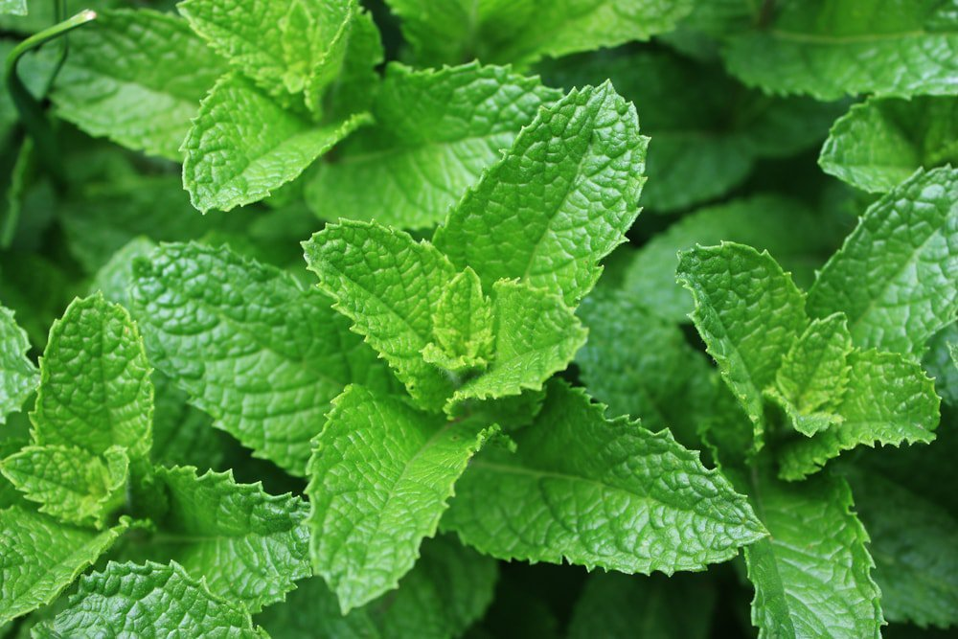
WHILE MANY PEOPLE ASSOCIATE THE FLAVOR OF SPEARMINT WITH CHEWING GUM, IT IS ALSO A GREAT FLAVOR ENHANCER FOR TEAS, HERBAL SOUPS, AND SALAD DRESSINGS.
NOW THAT YOU KNOW SOME OF THE MOST COMMON AND POPULAR VARIETIES OF HERBS, YOU CAN GROW YOUR FAVORITE HERBS INDOORS AND ENJOY A FRESH YEAR-ROUND SUPPLY. FRESH HERBS NOT ONLY TRULY ENHANCE THE FLAVOR AND AROMA OF THE FOOD BUT THEY ALSO TAKE IT TO A WHOLE NEW LEVEL!

MEGA LIST OF 33 TYPES OF SPICES EVERY KITCHEN NEEDS
DO YOU WANT TO PUT TOGETHER A GOOD STARTING SPICE COLLECTION? WE DID THE RESEARCH FOR YOU. HERE'S A LIST OF 27 DIFFERENT TYPES OF SPICES THAT EVERY GOOD SPICE COLLECTION NEEDS.

CAN YOU IMAGINE A WORLD WITHOUT SPICES? IT IS LIKE EATING FOOD THAT HAS NO SALT IN IT. SPICES ARE WHAT TAKES AN ORDINARY DISH TO A WHOLE NEW EXTRAORDINARY LEVEL.
THE HISTORY OF SPICES GOES AS FAR BACK AS THE START OF THE HUMAN CIVILIZATION WHERE VAST LANDS WERE DISCOVERED BY THE NUMEROUS CIVILIZATIONS THAT SPRUNG DURING ANCIENT TIMES. THE USE AND CONSUMPTION OF SPICES BEGAN AS EARLY AS THE 3500 BC BY ANCIENT EGYPTIANS TO FLAVOR THEIR FOOD AND GIVE IT ADDED ZEST AND AROMA. SOON ENOUGH, THE USE AND PRODUCTION OF SPICES SPREAD THROUGHOUT THE MIDDLE EAST, ALL THE WAY TO EUROPE, THE EASTERN MEDITERRANEAN, INDONESIA, SRI LANKA AND CHINA. SPICES ALSO LED TO THE GREAT AGE OF EXPLORATION, AS WELL AS TO THE ULTIMATE DISCOVERY OF THE NEW WORLD.
WHILE YOU MAY ALREADY KNOW ABOUT THE IMPORTANCE OF SPICES, DID YOU KNOW THAT A MASSIVE VARIETY OF SPICES IS FOUND IN THIS WORLD? YOU PROBABLY AREN’T EVEN AWARE OF MOST IT!
WHAT’S THE DIFFERENCE BETWEEN HERBS AND SPICES?
SPICES COME FROM THE ROOT, BARK OR SEEDS OF A PLANT. HERBS COME FROM THE LEAVES OF A PLANT [SOURCE: THEKITCHN]. THE LIST HERE PERTAINS TO SPICES ONLY.
BELOW IS OUR MEGA LIST OF SPICES EVERY KITCHEN NEEDS.
RELATED: TYPES OF SPICE RACKS | MEGA-LIST OF HERBS | MEGA LIST OF CONDIMENTS | TYPES OF FOOD | FOOD PRESERVATION
TYPES OF SPICES CHART
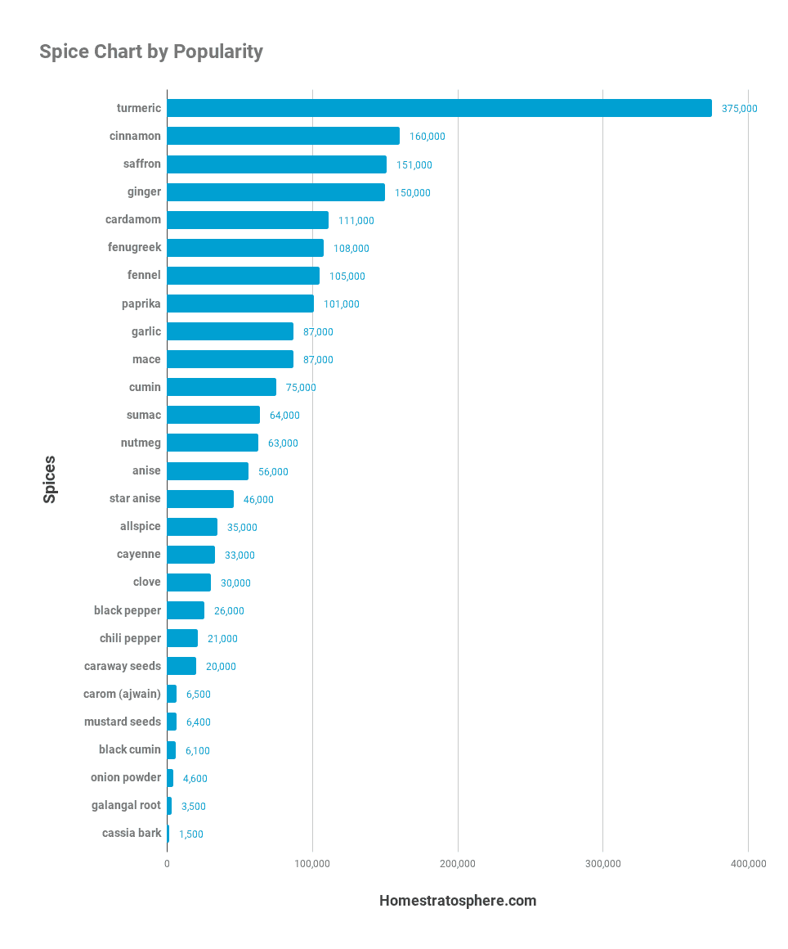
MEGA LIST OF SPICES
YOU WILL BE SURPRISED TO KNOW HOW MANY DIFFERENT SPICES THERE ARE, ALL WITH THEIR UNIQUE TASTE, CHARACTERISTICS, FLAVORS, AND AROMAS. READ ALL ABOUT THE DIFFERENT TYPES OF SPICES AND PICK YOUR FAVORITE ONES!

CARDAMOM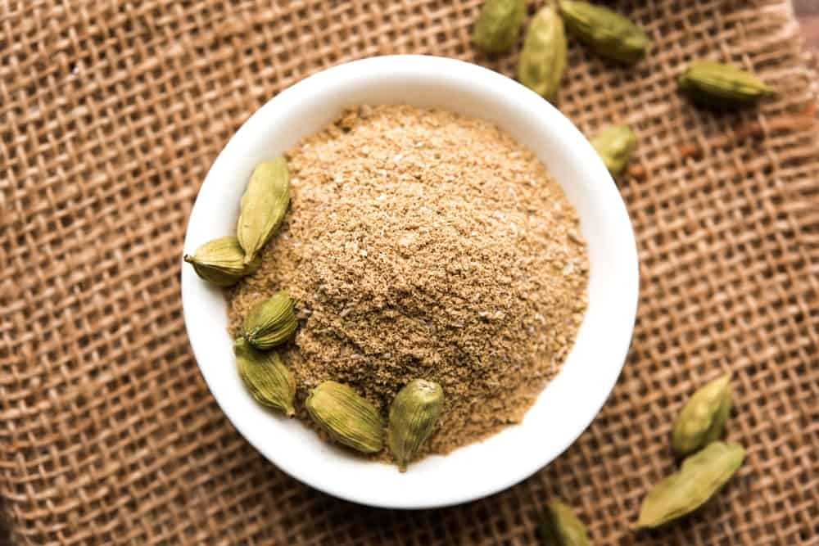
LATIN NAME: ELETTARIA CARDAMOMUM
THIS SPICE IS ALSO KNOWN AS THE “QUEEN OF SPICES” IN INDIA, ITS COUNTRY OF ORIGIN. CARDAMOM HAS A STRONG, PUNGENT FLAVOR THAT HAS SUBTLE HINTS OF LEMON AND MINT. INTERESTINGLY, IT IS A VERY VERSATILE SPICE SO IT CAN BE USED TO INTENSIFY BOTH SWEET AND SAVORY FLAVORS. THERE ARE TWO TYPES OF CARDAMOM THAT ARE TYPICALLY USED IN INDIAN COOKING, AS WELL AS ALL OVER THE WORLD: GREEN AND BLACK.
GREEN CARDAMOM IS USED MORE COMMONLY THAN ITS BLACK COUNTERPART AND HAS A VERY LIGHT AND SWEET FLAVOR. IT IS OFTEN USED IN DESSERTS AND SWEET DRINKS. BLACK CARDAMOM, ON THE OTHER HAND, CONSISTS OF A VERY STRONG SMOKY FLAVOR SO IT IS OFTEN USED IN SPICY RICE DISHES AND CURRIES.
CARDAMOM HAS QUITE A RICH HISTORY BEHIND IT IN TERMS OF ITS MEDICINAL PROPERTIES AND HAS BEEN USED SINCE ANCIENT TIMES AS A DIGESTIVE AID, AS WELL AS TO TREAT INFLAMMATORY AND RESPIRATORY CONDITIONS.

CLOVE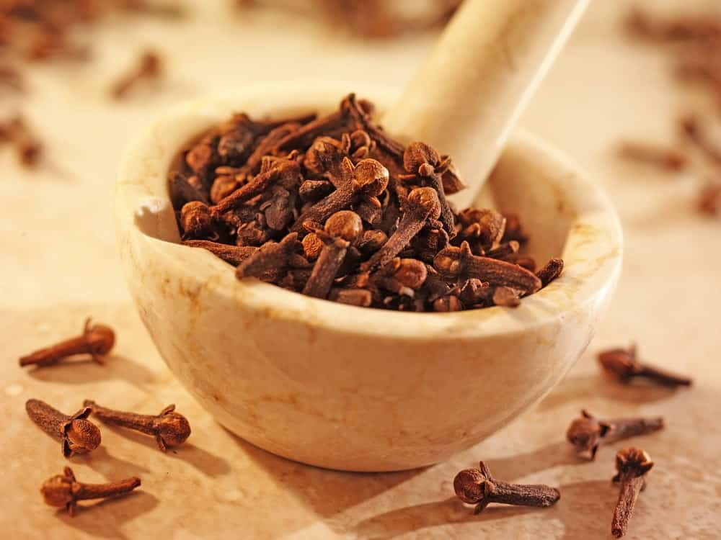
LATIN NAME: SYZGIUM AROMATICUM
THIS IS ANOTHER FAIRLY COMMON INDIAN SPICE THAT WAS FIRST FOUND BEING TRADED AT A PORT IN SRI LANKA SOMEWHERE DURING 900-1100 CE. HOWEVER, IT IS NATIVE TO THE MOLUCCA ISLANDS WHICH IS NOW A PART OF INDONESIA. CLOVES CONTAIN A VERY DISTINCTIVE KIND OF A SWEET SMELL WITH AN EQUALLY SWEET-SPICY FLAVOR.
AN INTERESTING HISTORICAL FACT ABOUT CLOVES IS THAT BEFORE APPROACHING THEIR EMPEROR, THE CHINESE HAD TO HAVE A FEW CLOVES IN THEIR MOUTH AS A WAY OF SWEETENING THEIR BREATH. THIS SUGGESTS THAT IN ANCIENTS, CLOVES WERE ALSO USED AS MOUTH FRESHENERS INSTEAD OF BREATH MINTS THAT ARE TYPICALLY USED TODAY.
WHOLE CLOVES ARE OFTEN USED IN CURRIES AND OTHER LIQUIDS SINCE THEY ALSO PROVIDE QUITE AN AESTHETIC APPEAL WHILE GROUND CLOVES ARE POPULARLY USED IN A VARIETY OF SWEET TREATS. THEY ARE ALSO USED FOR A NUMBER OF HEALTH-RELATED PURPOSES INCLUDING TOOTHACHES, VOMITING, NAUSEA, AND INDIGESTION, TO NAME A FEW.

CASSIA BARK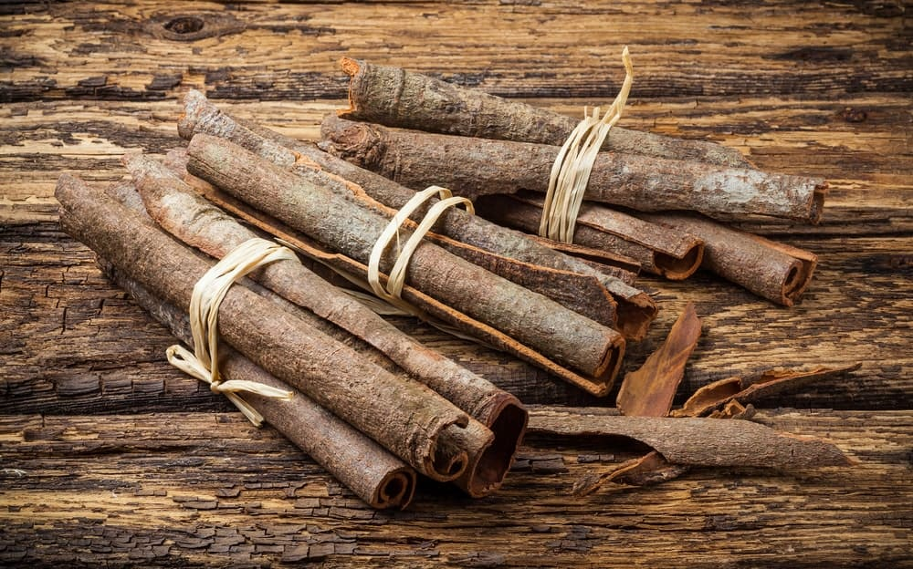
LATIN NAME: CASSIA SENNA
THIS SPICE IS ALSO KNOWN AS “CHINESE CINNAMON” AND IS OFTEN CONFUSED WITH THE OTHER ‘TRUE’ CINNAMON; HOWEVER, IT IS ACTUALLY A MEMBER OF THE PEA FAMILY. IT HAS AN EXTREMELY PUNGENT FLAVOR THAT IS LESS DELICATE WHEN COMPARED TO THAT OF THE TRUE CINNAMON. ALTHOUGH CASSIA BARK LOOKS ALMOST THE SAME AS CINNAMON, IT IS ACTUALLY VERY DIFFERENT AND IS USED MORE OFTEN IN SAVORY DISHES, ESPECIALLY IN CHINA.
CASSIA BARK IS COMMONLY GROWN AND PRODUCED IN INDONESIA, CHINA, AND BURMA AND IS PERFECT FOR HOMEMADE TEA BLENDS OR SPICE BLENDS. MANY PEOPLE USE THIS SPICE TO TREAT MUSCLE AND STOMACH SPASMS, MENSTRUAL PROBLEMS, JOINT PAINS, THE COMMON COLD, HIGH BLOOD PRESSURE, AND MANY OTHER HEALTH AILMENTS.

BLACK PEPPER 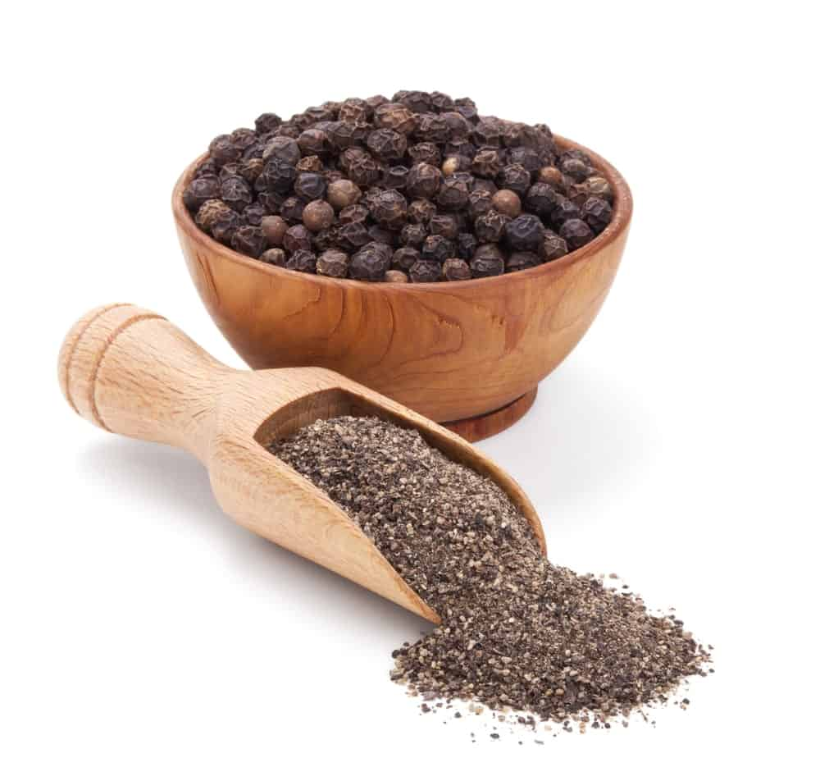
LATIN NAME: PIPER NIGRUM
THIS HAS TO BE ONE OF THE MOST COMMONLY FOUND AND CONSUMED SPICES ALL OVER THE WORLD. A PINCH OF IT IS ADDED TO ALMOST EVERY RECIPE YOU COULD POSSIBLY IMAGINE. BLACK PEPPER HAS ORIGINATED FROM INDIA, PARTICULARLY FROM THE MALABAR REGION AND THE WESTERN GHATS. IT COMES FROM THE BERRIES OF THE PEPPER PLANT AND YOU WOULD TYPICALLY ALSO FIND WHITE AND GREEN COLORED PEPPERCORNS. THE DIFFERENCE IN COLOR PRIMARILY RESULTS FROM THE VARYING DEVELOPMENTAL STAGES.
SINCE ANCIENT GREECE TIMES, PEPPER HAS BEEN A MUCH CHERISHED AND PRESTIGIOUS SPICE BECAUSE IT WAS USED AS BOTH, A CURRENCY, AS WELL AS, A SACRED OFFERING.
BLACK PEPPER CONSISTS OF A VERY UNIQUE SPICY TASTE AND IS TYPICALLY USED TO PROVIDE A SUBTLE HEAT KICK TO NUMEROUS RECIPES AND DISHES. SOME OF ITS AMAZING MEDICINAL USES INCLUDE USING IT AS LAXATIVES OR FOR CONGESTION RELIEF.

CELERY SEED
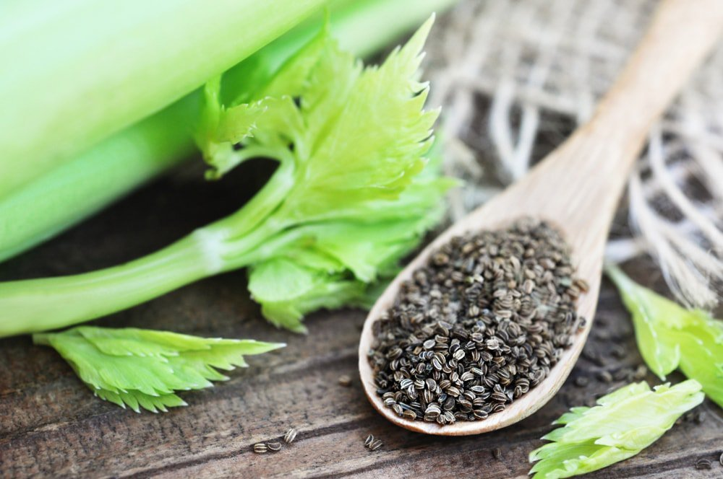
CELERY SEED IS USUALLY GROUND UP INTO SALT, AND CAN THEN BE ADDED TO MANY DISHES FOR A CONCENTRATED TASTE OF CELERY.

CORIANDER SEED
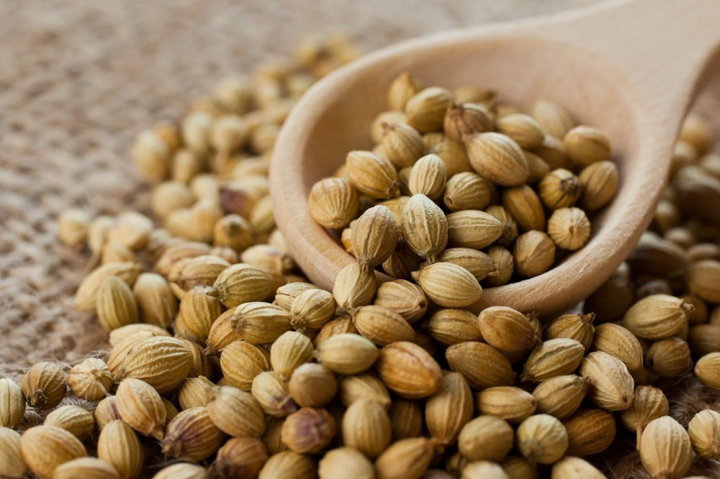
CORIANDER PRODUCES NATURAL CITRUS FLAVORS WHEN GROUND UP. IT IS ESPECIALLY COMMON WITH CHICKEN-BASED DISHES.

CRUSHED RED PEPPER
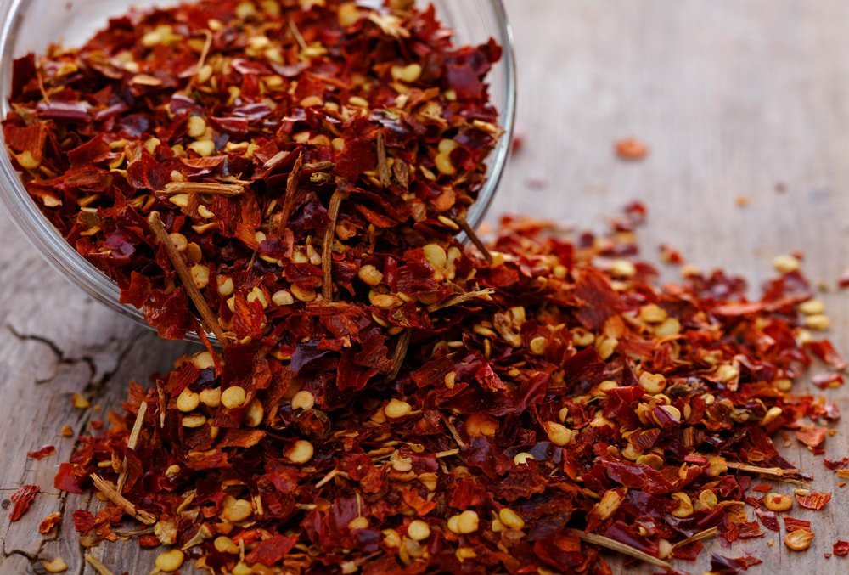
CRUSHED RED PEPPER HAS A DISTINCTIVELY FRUITY, YET SPICY FLAVOR, AND IS COMMONLY USED AS A CONDIMENT ON PIZZAS AND SALADS.

CUMIN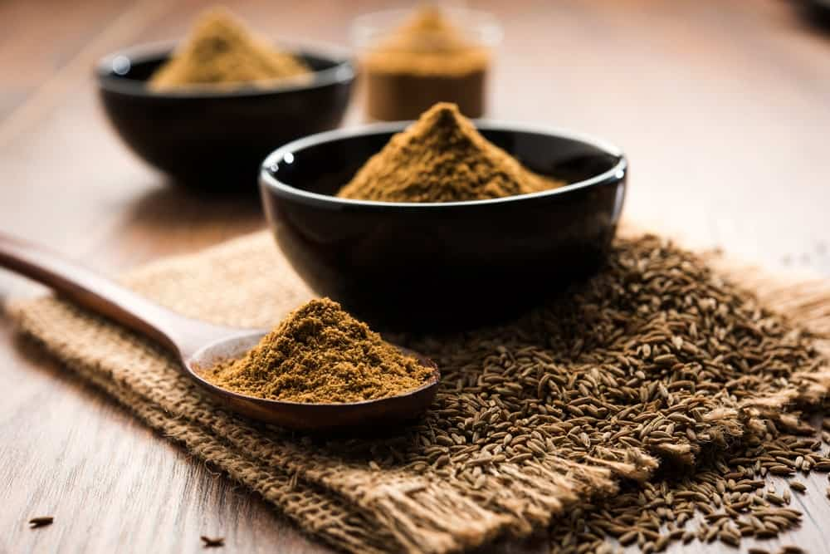
LATIN NAME: CUMINUM CYMINUM
CUMIN IS ONE OF THE MOST MAINSTREAM SPICES AND IS NATIVE TO EUROPE, ASIA AND AFRICA; HOWEVER, IT HAS BECOME A VERY ESSENTIAL INGREDIENT ALL OVER THE WORLD. IT IS POPULAR FOR ITS NUTTY AND EARTHY FLAVOR THAT CONSISTS OF A SUBTLE SPICE KICK AND SOME HINTS OF LEMON.
SOME OF ITS MOST DISTINCTIVE CHARACTERISTICS INCLUDE THE INTENSE FRAGRANCE COUPLED WITH THE UNIQUE RIDGED BROWN SEEDS. CUMIN CAN BE USED AS A WHOLE OR IN A GROUNDED FORM. EITHER WAY, IT ADDS A SMOKY TOUCH TO ANY DISH AND TASTES ABSOLUTELY DELICIOUS. MOST PEOPLE PREFER USING FRESHLY GROUNDED CUMIN IN CURRY RECIPES AND VEGETABLE DISHES TO GET THE MOST OF THAT INTENSE, NUTTY –SPICY FLAVOR.
CUMIN IS BY FAR THE MOST POPULAR SPICE THAT ALSO HAS A MULTITUDE OF HEALTH BENEFITS PERTAINING TO WEIGHT LOSS, CHOLESTEROL, DIABETES, IRRITABLE BOWEL SYNDROME AND MANY MORE.

CURRY POWDER
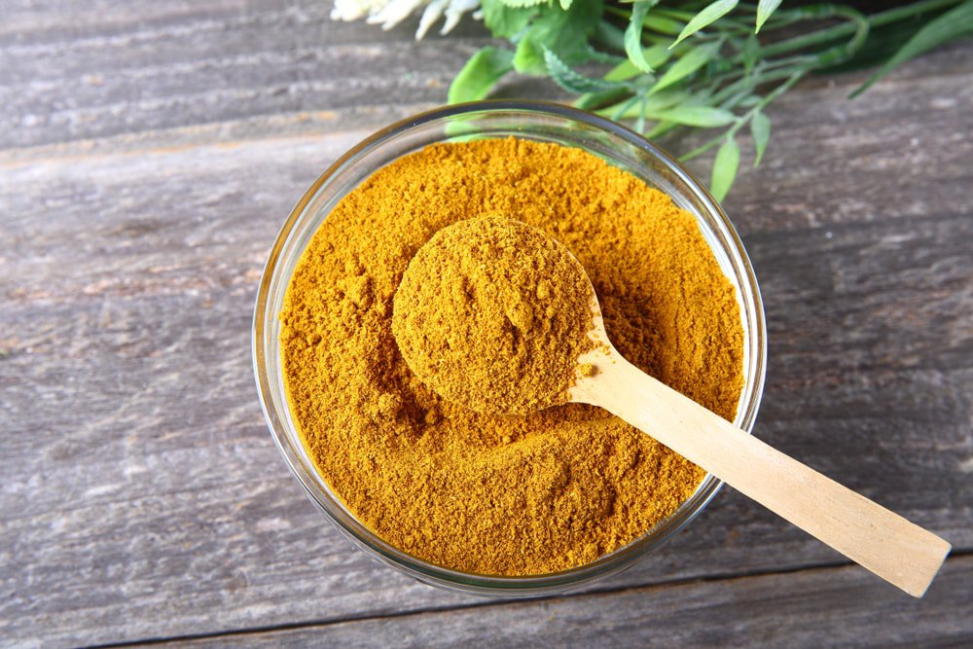
NEEDLESS TO SAY, CURRY POWDER IS A PRIMARY INGREDIENT IN CURRY DISHES, BUT IT CAN ALSO BE USED TO FLAVOR MANY STEWS, MARINADES, AND MEATS.

NUTMEG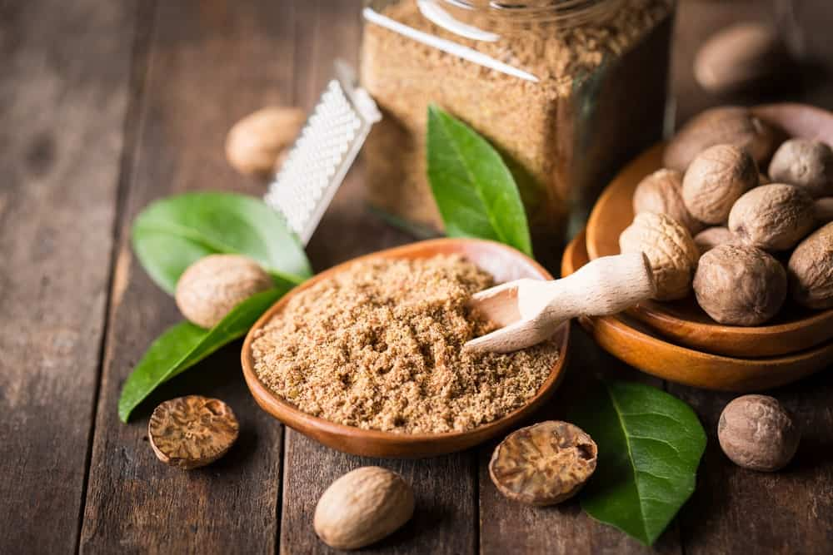
LATIN NAME: MYRISTICA FRAGRANS
NUTMEG COMES FROM A TROPICAL EVERGREEN TREE THAT IS NATIVE TO MOLUCCAS ISLAND IN INDONESIA, WHERE IT IS ALSO CULTIVATED IN ABUNDANCE, AS WELL AS IN WEST INDIES. IT IS OFTEN USED TOGETHER WITH CINNAMON DUE TO THE SIMILAR PUNGENT FRAGRANCE AND A SUBTLE SWEET TASTE. ALTHOUGH NUTMEG IS POPULARLY USED IN BAKING AND COLD BEVERAGES, IT IS ALSO AN EXCELLENT ADDITION TO HEARTY DISHES LIKE MUTTON AND LAMB RECIPES, VEGETABLE STEWS, ETC.
IN ANCIENT TIMES, SOMETIME AROUND THE 1600S, NUTMEG BECAME AN EXPENSIVE COMMERCIAL SPICE IN THE WESTERN WORLD AND WAS COMMONLY USED BY THE DUTCH AS A SUBJECT TO KEEP PRICES HIGH. SOME INCREDIBLE HEALTH BENEFITS OF NUTMEG INCLUDE INDIGESTION RELIEF, DIARRHEA CONTROL, AND APPETITE LOSS.

MACE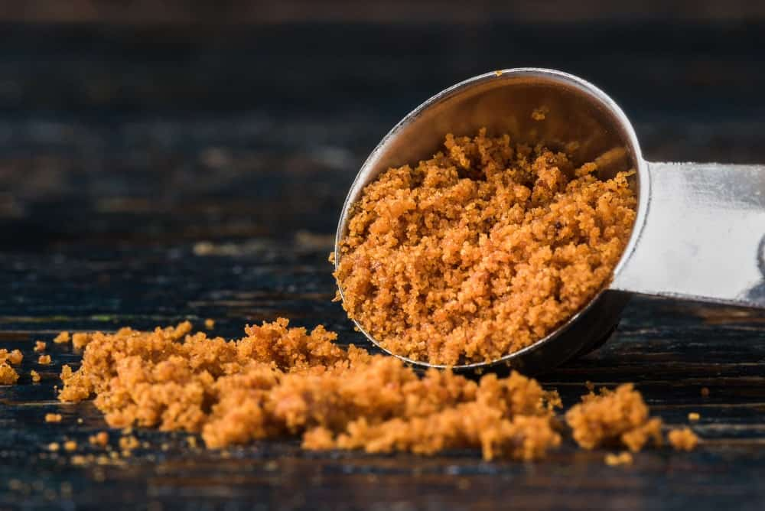
LATIN NAME: MYRISTICA FRAGRANS
THIS IS THE OUTER COVERING OF THE NUTMEG SEED AND IS SAID TO BE A MORE PUNGENT VERSION OF NUTMEG, WITH A COMBINATION OF PEPPER AND CINNAMON KIND OF FLAVOR. INTERESTINGLY, THE COLOR OF MACE CAN HELP YOU FIGURE OUT ITS ORIGIN. FOR INSTANCE, IF THE SPICE HAS ORANGE-YELLOW BLADES, IT MEANS THAT IT HAS COME FROM GRENADA, WHEREAS ORANGE-RED BLADES INDICATE THAT IT IS FROM INDONESIA.
THIS SPICE IS POPULARLY USED IN SWEETS AND DESSERTS LIKE CUSTARDS, PUDDINGS AND CAKES, AS WELL AS IN SAVORY DISHES LIKE SOUPS, SOUFFLÉS, SAUCES, ETC. ITS FLAVOR IS ALSO SAID TO BE VERY WARM, WITH A KICK OF LEMONY SWEETNESS, SO MANY PEOPLE PREFER TO USE IT IN PLACE OF NUTMEG, ESPECIALLY IN LIGHT-COLORED DISHES.
MACE IS OFTEN USED AS A DIGESTIVE AID AND AS A TREATMENT FOR NAUSEA, VOMITING, AND FLATULENCE.

MUSTARD SEEDS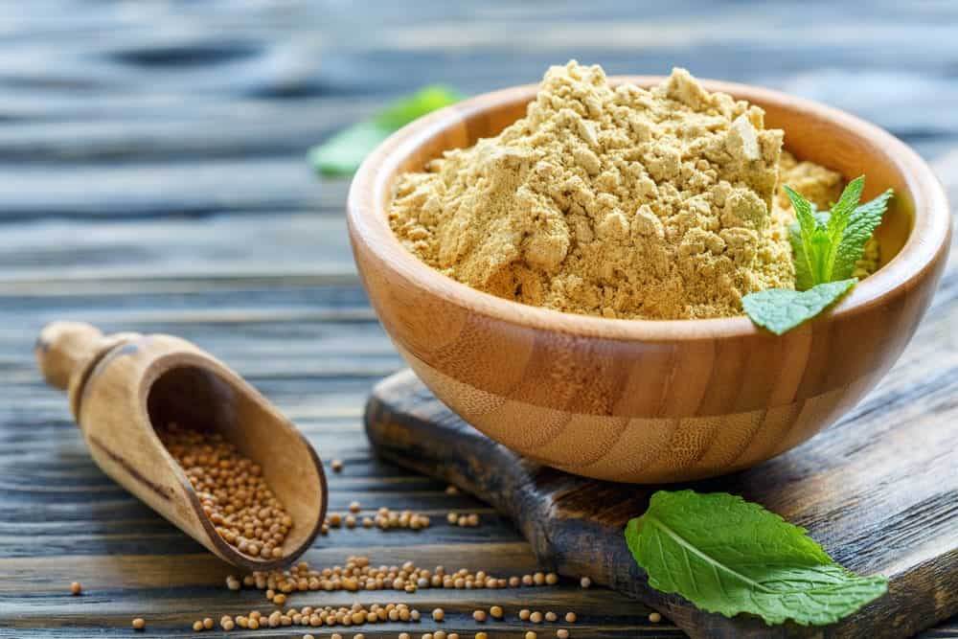
LATIN NAME: BRASSICA ALBA
THESE SPICE SEEDS COME IN A VARIETY OF COLORS LIKE BLACK, BROWN, AND YELLOW, AND ARE OFTEN USED INTERCHANGEABLY IN MOST CUISINES. MUSTARD SEEDS CONSIST OF A NUTTY AND SMOKY FLAVOR THAT IS BEST RELEASED WHEN THEY ARE COOKED IN OIL OR WHEN THEY ARE CRUSHED.
THE USE OF MUSTARD SEEDS AS A CONDIMENT DATES BACK TO ANCIENT TIMES DURING THE ROMAN ERA. THE ROMANS USED TO GRIND THESE SEEDS INTO A PASTE AND MIX THEM WITH WINE. THIS SPICE WAS INITIALLY VERY POPULAR IN EUROPE EVEN BEFORE THE SPICE TRADE THAT BEGAN IN ASIA.
MUSTARD SEEDS ARE OFTEN GROUNDED TO A PASTE TO BE USED IN CURRIES AND STEWS WHEREAS WHOLE SEEDS ARE USED FOR PICKLING PURPOSES. MUSTARD SEED OIL IS POPULARLY USED ALL OVER THE WORLD AS A PAIN REMEDY AND AS A LINIMENT FOR ARTHRITIS.

GARLIC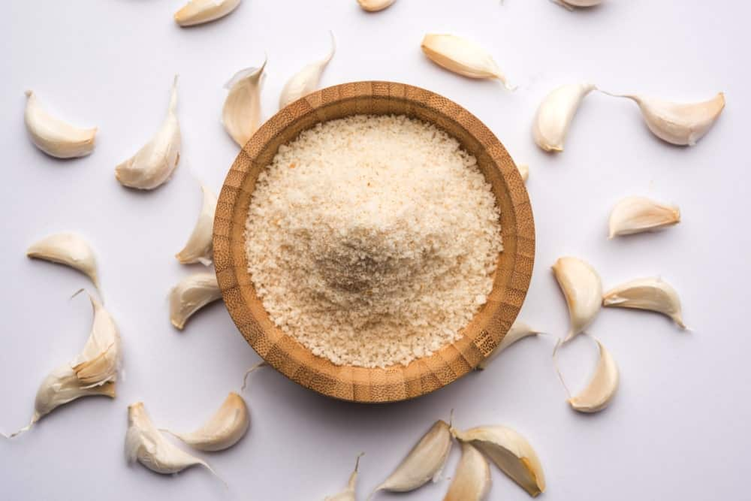
LATIN NAME: ALLIUM SATIVUM
GARLIC IS PROBABLY THE MOST POPULAR AND COMMON SPICE SEASONING THAT IS USED IN ALMOST EVERY CUISINE FOUND IN THE WHOLE WORLD. ITS POPULARITY LARGELY STEMS FROM ITS ABILITY TO ADD AN INCREDIBLE DEPTH OF FLAVOR ALONG WITH POTENCY TO ANY DISH OR MEAL.
AS A SPICE, GARLIC IS USED IN THE FORM OF GARLIC POWDER WHICH IS JUST GROUND, DEHYDRATED GARLIC. IT IS NATIVE TO SOUTH ASIA, CENTRAL ASIA, AND SOUTHWESTERN SIBERIA. GARLIC CONSUMPTION, HOWEVER, GOES BACK SEVERAL THOUSAND YEARS TO ANCIENT EGYPTIAN WHERE IT WAS COMMONLY AS FOOD FLAVORING AS WELL AS IN MEDICINE. SOME OF GARLIC’S EXTRAORDINARY MEDICINAL USES INCLUDE CANCER PREVENTION, TREATMENT FOR RESPIRATORY CONDITIONS, HIGH BLOOD PRESSURE, AND LOW CHOLESTEROL LEVELS.
GARLIC POWDER IS COMMONLY USED IN PASTA, GRILLED CHICKEN, SALAD DRESSINGS, CURRIES AND RICE RECIPES – TO NAME A FEW.

GINGER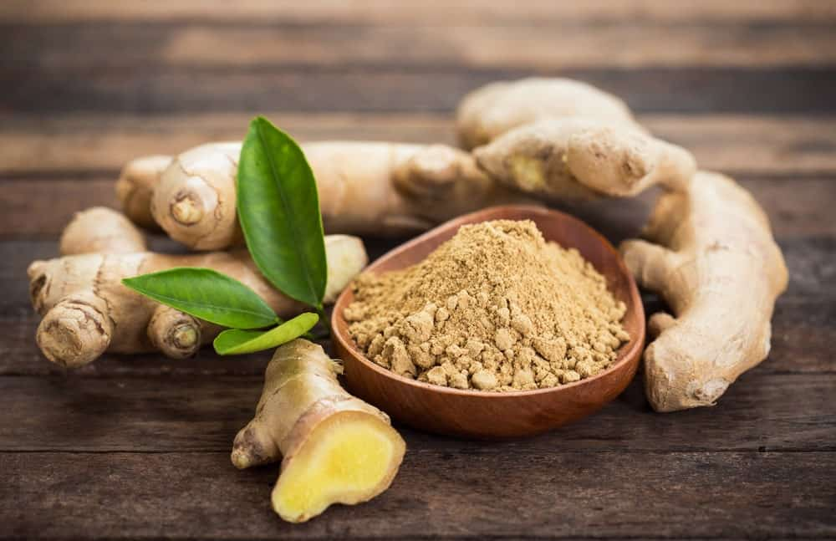
LATIN NAME: ZINGIBER OFFICINALE
LIKE GARLIC, GINGER IS ALSO POPULAR FOR ITS BOLD, PUNGENT, AND SWEET-SPICY FLAVOR. ITS FLAVOR IS ALSO DESCRIBED BY MANY PEOPLE AS PEPPERY AND FIERCE WITH HINTS OF LEMON. GINGER IS ALSO GREATLY USED IN A VARIETY OF DIFFERENT DESSERTS LIKE PUMPKIN PIE AND GINGERBREAD.
GINGER IS A HERBACEOUS PERENNIAL THAT HAS ORIGINATED FROM ISLANDS OF SOUTHEAST ASIA AND WAS LATER TRANSPORTED THROUGHOUT THE INDO-PACIFIC. IT IS OFTEN ALSO USED IN DESSERTS AND SWEET TREATS THAT CALL FOR A SUBTLE SPICE KICK. GINGER HAS LONG BEEN ASSOCIATED WITH NUMEROUS HEALTH AND MEDICINAL BENEFITS AND HAS MAJORLY BEEN USED AS A DIGESTIVE AID AND TO TREAT THE COMMON COLD, FLU, AND COUGH. IT ALSO PLAYS A KEY ROLE IN AYURVEDIC MEDICINE.
MANY CUISINES INVOLVE THE USE OF FRESH GINGER FOR MAKING A VARIETY OF DISHES LIKE CURRIES, RICE, SOUPS, STEWS, ETC.

TURMERIC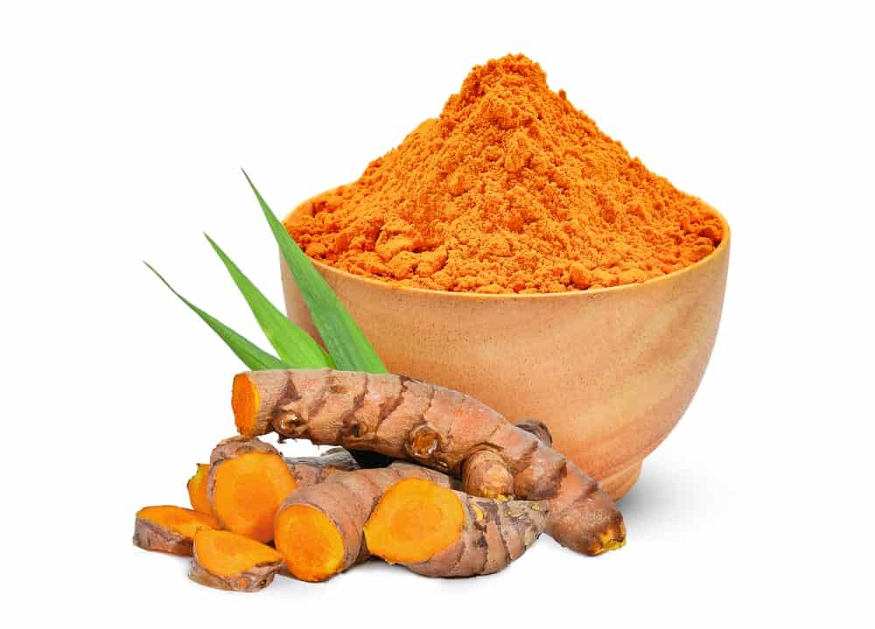
LATIN NAME: CURCUMA LONGA
TURMERIC IS YET ANOTHER INCREDIBLY FAMOUS INDIAN SPICE WITH A MIX OF BITTER, SPICY FLAVOR. IT IS ALSO KNOWN BY OTHER NAMES LIKE INDIAN SAFFRON AND YELLOW GINGER. TURMERIC IS GENERALLY EASILY IDENTIFIABLE DUE TO ITS BRIGHT COLOR COMBINATION OF YELLOW AND ORANGE.
LATELY, TURMERIC HAS BEEN GAINING EXTENSIVE POPULARITY AS ‘THE GOLDEN SPICE’ AND IS NOW BEING FEATURED IN DRINKS LIKE ‘THE GOLDEN LATTE’. THIS IS PRIMARILY DUE TO THE NUMEROUS HEALTH BENEFITS THAT ARE ASSOCIATED WITH THIS SPICE, FOR INSTANCE, IT IS LOADED WITH ANTI-OXIDANT AND ANTI-INFLAMMATORY PROPERTIES, AND IT CAN PREVENT CANCER. MOREOVER, IT IS BELIEVED TO HAVE THE ABILITY TO TREAT DEPRESSION AND ARTHRITIS.
TURMERIC CONSUMPTION GOES AS FAR BACK AS 4000 YEARS TO THE VEDIC CULTURE IN INDIA, WHERE IT HELD SIGNIFICANT RELIGIOUS IMPORTANCE AND WAS ALSO POPULARLY USED FOR CULINARY PURPOSES. THE INTENSE COLOR OF THIS SPICE GIVES CURRIES AND OTHER DISHES A BEAUTIFUL GOLDEN SHADE AND A STRONG FLAVOR THAT GREATLY INTENSIFIES THE OVERALL TASTE OF ANY DISH.

FENUGREEK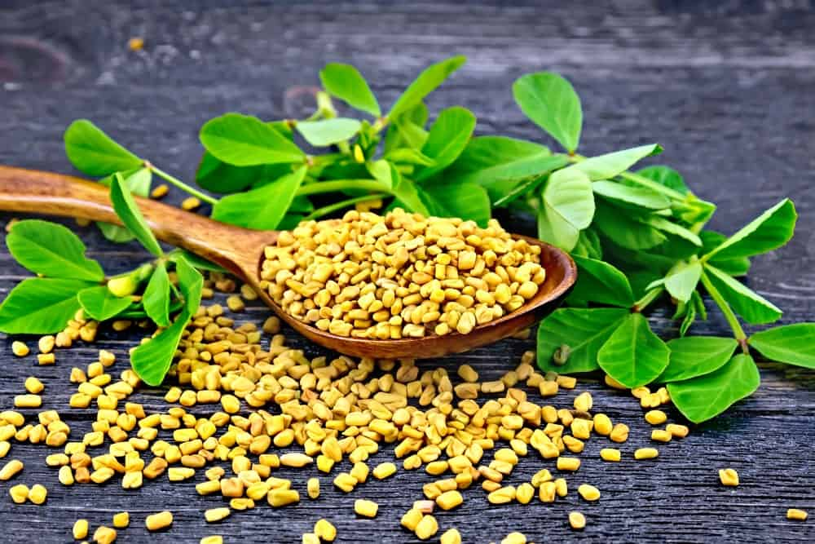
LATIN NAME: TRIGONELLA FOENUM-GRAECUM
THE FENUGREEK SEEDS ARE SMALL, CARAMEL-COLORED, PEBBLE-SHAPED WHEAT KERNELS THAT ARE EXTREMELY POPULAR FOR THEIR TASTE AND AROMA IN MIDDLE EASTERN AND INDIAN CUISINES. THEY CONSIST OF A NUTTY BITTERSWEET FLAVOR THAT IS MORE TOWARDS THE PUNGENT SIDE. THEY ALSO HAVE A SUBTLE SPICY AROMA WITH A BUTTERSCOTCH-TYPE FLAVOR UNDERTONE.
FENUGREEK IS LARGELY CULTIVATED IN THE NEAR EAST AND IT IS WIDELY BELIEVED THAT THE ROMANS USED TO FLAVOR THEIR WINE WITH THIS SPICE DURING THE FIRST CENTURY AD.
FENUGREEK SEEDS ARE OFTEN USED AS WHOLE OR EVEN IN POWDERED FORM MAINLY IN VEGETABLE DISHES, SPICE MIXES, PICKLES, LENTIL-BASED RECIPES, ETC. INTERESTINGLY THOUGH, THIS SPICE IS ALSO USED TO MAKE ‘FAKE’ MAPLE SYRUP THAT A LOT OF PEOPLE BELIEVE TASTES THE SAME AS THE ACTUAL MAPLE SYRUP.

SAFFRON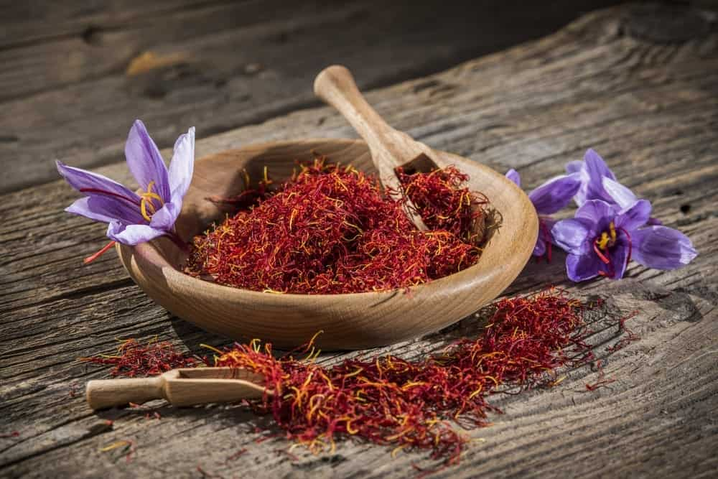
LATIN NAME: CROCUS SATIVUS
BEST KNOWN AS THE MOST EXPENSIVE SPICE IN THE WORLD, SAFFRON GREATLY STANDS OUT DUE TO ITS HIGHLY DISTINCTIVE TASTE AND THE INCREDIBLE ORANGE-MAROONISH COLOR. THE FACT THAT THE PRODUCTION OF SAFFRON IS THE MOST LABOR-INTENSIVE OF ALL IS ONE OF THE MAIN REASONS WHY IT IS MORE VALUABLE THAN GOLD IN TERMS OF WEIGHT AND IS SO EXPENSIVE.
SAFFRON IS BASICALLY THE STIGMA OF CROCUS FLOWERS WHICH IS TYPICALLY PICKED BY HAND. THE BEST TYPE OF SAFFRON IS THE ONE THAT HAS A BEAUTIFUL AND RICH DARK RED COLOR. GENERALLY, THIS PARTICULAR VARIETY COMES FROM SPAIN, IRAN, AND KASHMIR.
SAFFRON IS ALSO VERY FAMOUS FOR ITS FLORAL, HONEY-LIKE FRAGRANCE THAT PROVIDES AN INCREDIBLE AROMATIC SMELL TO ANY FOOD DISH. THE FLAVOR OF THIS SPICE IS VERY UNIQUE AND IS SAID TO BE VERY INTENSE, WHICH IS ONE OF THE REASONS WHY IT IS USED IN SUCH SMALL QUANTITIES.
SAFFRON IS OFTEN USED AS A SEDATIVE AS WELL AS A TREATMENT FOR DRY SKIN, MENSTRUAL SYMPTOMS, AND ASTHMA

ALLSPICE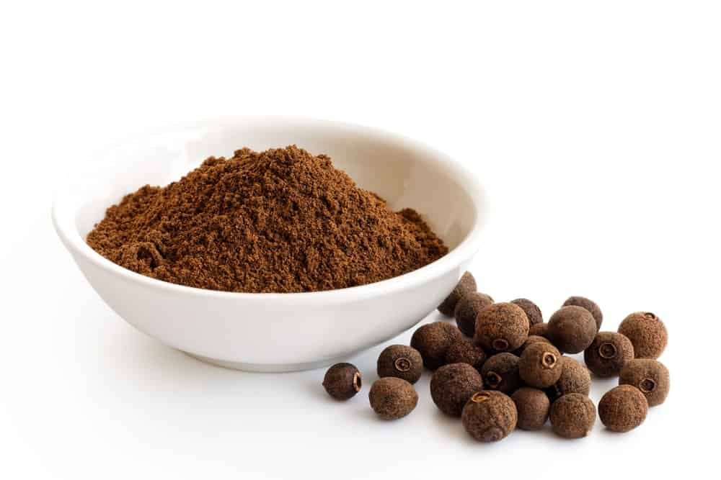
LATIN NAME: PIMENTA DIOICA
AS THE NAME SUGGESTS, ALLSPICE IS A COMBINATION OF ALL OTHER SPICES AND FEATURES AN AMAZING COMBINATION OF CINNAMON, NUTMEG, PEPPER, AND CLOVES. THIS FUSION OF SPICES GIVES IT A MIXTURE OF SWEET-SPICY-PUNGENT TASTE WHICH IS WHY IT IS POPULARLY USED IN SEVERAL FOOD DISHES FOR THAT INTENSE DEPTH OF FLAVOR.
ALLSPICE COMES FROM PIMENTA DIOIC WHICH IS AN EVERGREEN TREE THAT BELONGS TO THE MYRTLE FAMILY. IT IS BELIEVED TO BE NATIVE TO JAMAICA, HONDURAS, AND GUATEMALA. ACCORDING TO HISTORICAL EVIDENCE, CHRISTOPHER COLUMBUS DISCOVERED THIS SPICE IN THE CARIBBEAN AND HE BROUGHT IT BACK TO SPAIN.
ALLSPICE IS VERY POPULAR IN JAMAICAN CUISINES, MOST NOTABLY BEING FEATURED IN THE JAMAICAN JERK CHICKEN. IT IS ALSO USED IN MANY DESSERTS IN GROUND FORM DUE TO ITS DISTINCTIVE FLAVOR AND AROMA. IT HAS SEVERAL MEDICINAL USES AND ACTS AS AN EXCELLENT DIGESTIVE AID, AS WELL AS A TREATMENT FOR MUSCLE ACHES AND TOOTHACHE.

ANISE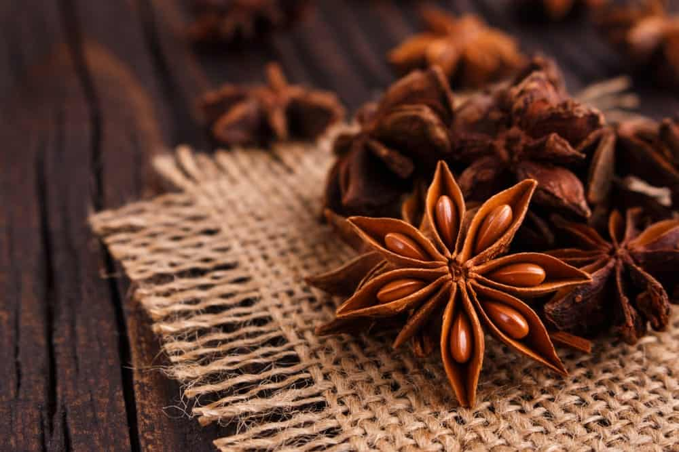
LATIN NAME: PIMPINELLA ANISUM
ALSO KNOWN AS ANISE SEED AND SWEET CUMIN, ANISE IS A FLOWERING PLANT THAT IS NATIVE TO SOUTHWEST ASIA AND THE EASTERN MEDITERRANEAN REGION. IT IS OFTEN CONFUSED WITH ‘STAR ANISE’ PRIMARILY DUE TO THE SIMILAR NAME; HOWEVER, BOTH SPICES ARE QUITE DIFFERENT FROM ONE ANOTHER.
ANISE WAS FIRST CULTIVATED IN THE MIDDLE EAST AND REGIONS OF EGYPT, AFTER WHICH IT GAINED SIGNIFICANT MEDICINAL VALUE IN EUROPE. THE FLAVOR OF ANISE IS SAID TO BE VERY SIMILAR TO THAT OF LICORICE WHICH IS WHY IT IS COMMONLY USED WITH HONEY IN A VARIETY OF BAKED GOODS.
THIS SPICE CONSISTS OF A WARM, FRUITY FLAVOR, AND A SWEET AROMA WHICH IS WHY THEY ARE ALSO FEATURED IN A VARIETY OF TEA BLENDS AND TISANES. ANISE IS WIDELY USED AS A TREATMENT FOR COUGHS, SORE THROAT, INDIGESTION, FLATULENCE, AND SLEEPLESSNESS.

CARAWAY SEED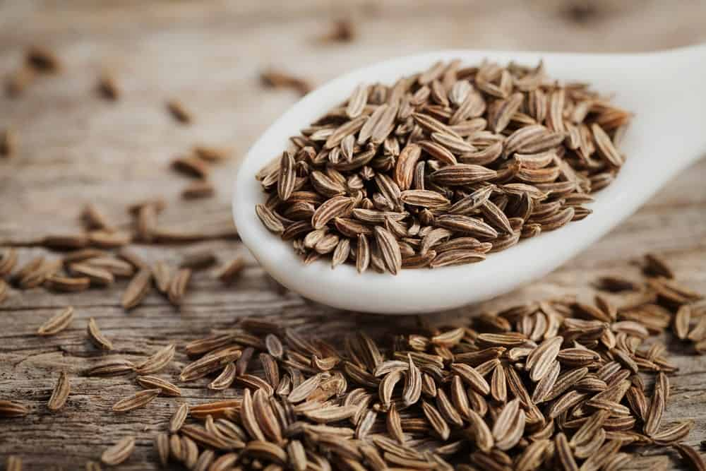
LATIN NAME: CARUM CARVI
ALSO KNOWN AS WILD CUMIN, CARAWAY IS A BIENNIAL PLANT THAT BELONGS TO THE APIACEAE FAMILY. IT IS NATIVE TO NORTH AFRICA, WESTERN ASIA AND EUROPE.
CARAWAY SEEDS ARE MOST COMMONLY USED IN THE PREPARATION OF RYE BREAD DUE TO THEIR WARM, BITING FLAVOR AND A SHARP, PUNGENT AROMA THAT IS HIGHLY SIMILAR TO THE AROMA OF DILL. YOU MAY ALSO FIND THIS SPICE BEING USED IN DESERTS, CASSEROLES, AND CARAWAY SEED CAKES.
CARAWAY SEEDS HAVE LONG BEEN ASSOCIATED WITH A MULTITUDE OF HEALTH BENEFITS THAT INCLUDE RELIEF FROM CONSTIPATION, EASE OF DIGESTION, CHOLESTEROL REDUCTION, AND TREATMENT FOR CRAMPS.

CAROM (AJWAIN)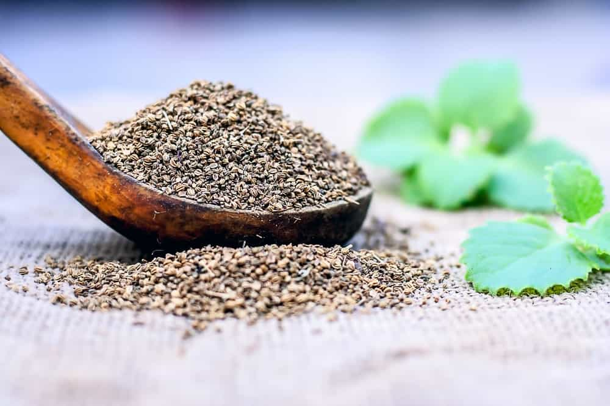
LATIN NAME: TRACHYSPERMUM AMMI OR CARUM COPTICUM
THIS SPICE IS AN ANNUAL HERB THAT BELONGS TO THE FAMILY APIACEAE AND IS COMMONLY KNOWN BY MANY OTHER NAMES LIKE BISHOP’S WEED AND AJOWAN CARAWAY.
AJWAIN SEEDS ARE SMALL AND OVAL-SHAPED AND GREATLY RESEMBLE MANY OTHER SPICE SEEDS INCLUDING CUMIN, CARAWAY, AND FENNEL. THESE SEEDS CONSIST OF A BITTER, PUNGENT TASTE AND A VERY AROMATIC SMELL WHICH IS SIMILAR TO THAT OF THE HERB, THYME. IT IS MAINLY CULTIVATED AND PRODUCED IN INDIA AND IRAN.
THIS SPICE IS TYPICALLY DRY-ROASTED OR FRIED IN OIL WHICH ALLOWS IT TO DEVELOP A COMPLEX AROMA AND A SUBTLE TASTE. IT IS MOST POPULARLY FEATURED IN IRANIAN, ASIAN, PAKISTANI, NORTH INDIAN AND ETHIOPIAN CUISINES. ITS TEXTURE IS QUITE SIMILAR TO THAT OF CARAWAY SEEDS AND IT IS ALSO OFTEN USED IN BAKED FOODS TO GET THAT DEPTH OF FLAVOR AND SMELL.
SOME COMMON MEDICINAL USES OF AJWAIN INCLUDE RELIEF FROM INDIGESTION, NAUSEA, DIARRHEA, AND VOMITING. MANY PEOPLE ALSO USE IT AS A TREATMENT FOR APPETITE LOSS AND RESPIRATORY DISTRESS.

CAYENNE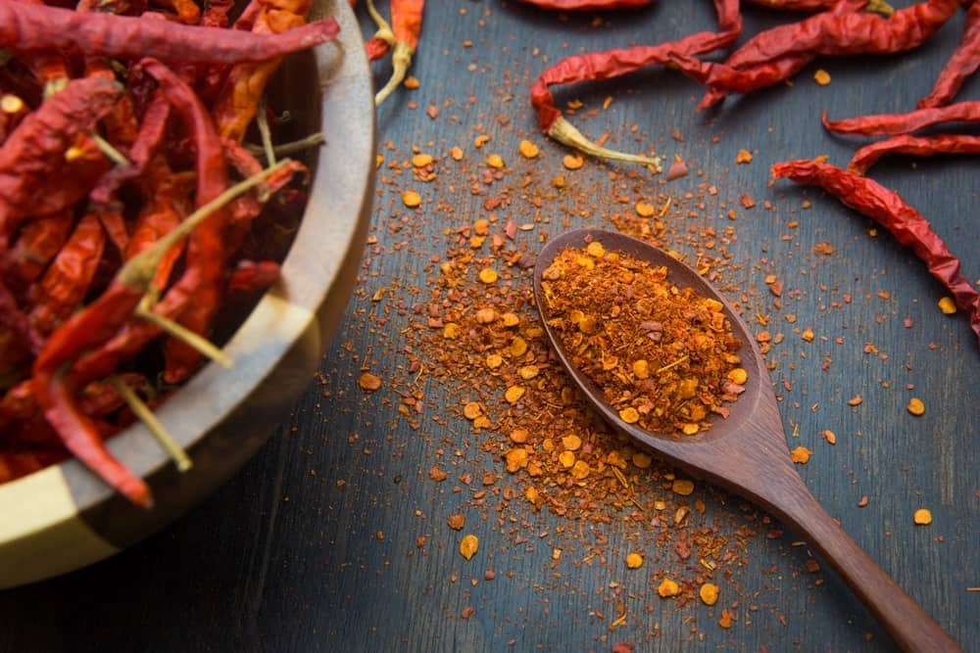
LATIN NAME: CAPSICUM ANNUUM OR FRUTESCENS
THIS IS A FAMOUS HOT CHILI PEPPER THAT IS RELATED TO OTHER HOT PEPPERS LIKE JALAPENO. CAYENNE PEPPERS ARE TYPICALLY RED-COLORED PEPPERS THAT ARE PACKED WITH A LOT OF HEAT AND A SPICY KICK OF FLAVOR. DRIED CAYENNE PEPPERS ARE TURNED INTO GROUND POWDER WHICH IS USED AS A SPICE IN A VARIETY OF CUISINES ALL OVER THE WORLD.
SURPRISINGLY, CAYENNE PEPPERS ARE CONSIDERED TO BE THE ‘KING’ OF MEDICINAL HERBS, ESPECIALLY DUE TO THE FACT THAT THEY HAVE BEEN USED SINCE ANCIENT TIMES TO TREAT A VARIETY OF HEALTH PROBLEMS AND AILMENTS. SOME INCREDIBLE BENEFITS OF THIS SPICE INCLUDE ENHANCED METABOLISM, LOWERED BLOOD PRESSURE, EASE OF DIGESTION, PAIN RELIEF, REDUCED RISK OF CANCER AND DECREASED HUNGER.
THIS SPICE IS ALSO QUITE POPULAR IN THE CULINARY WORLD WHERE IT MAY BE EITHER USED IN ITS FRESH FORM OR AS DRIED POWDER ON CASSEROLES, CURRIES, CHEESE DISHES, STEWS AND MEAT-BASED DISHES.

CHILI PEPPER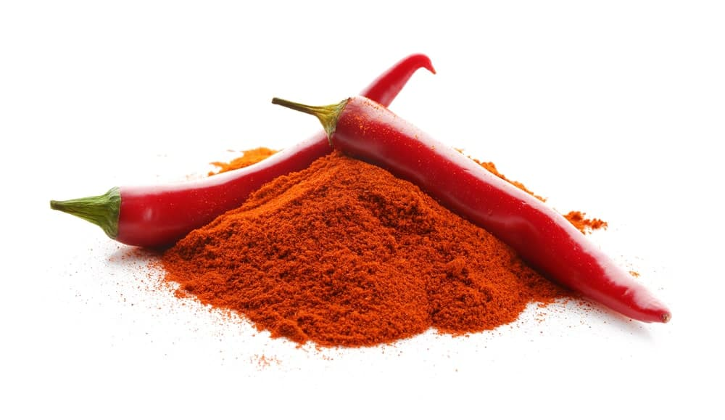
LATIN NAME: CAPSICUM ANNUUM
SIMILAR TO CAYENNE PEPPERS, CHILI PEPPERS COME FROM THE PLANTS OF THE GENUS CAPSICUM AND ARE COMMONLY USED IN FOOD DISHES FOR THAT EXTRA SPICE AND HEAT KICK. THE DRIED AND POWDERED FORM OF CHILI PEPPERS IS CALLED WHAT YOU TYPICALLY REFER TO AS ‘CHILI POWDER’.
CHILI PEPPERS MAINLY ORIGINATE FROM MEXICO. HOWEVER, MANY OF ITS CULTIVARS SPREAD TO MOST PARTS OF THE WORLD. THEY ARE NOW COMMONLY GROWN IN EUROPE AND NORTH AMERICA IN GREAT ABUNDANCE.
THE FLAVOR OF RED CHILI POWDER IS CONSIDERED TO BE EXTREMELY PUNGENT WITH A VERY DISTINCT SPICE KICK THAT ADDS GREAT HEAT TO DISHES. JUST LIKE OTHER PEPPERS BELONGING TO THE SAME FAMILY, RED CHILI PEPPERS ALSO PROVIDE NUMEROUS HEALTH BENEFITS LIKE RELIEF FROM PAIN, CONGESTION, AND COLDS.

FENNEL (FLORENCE)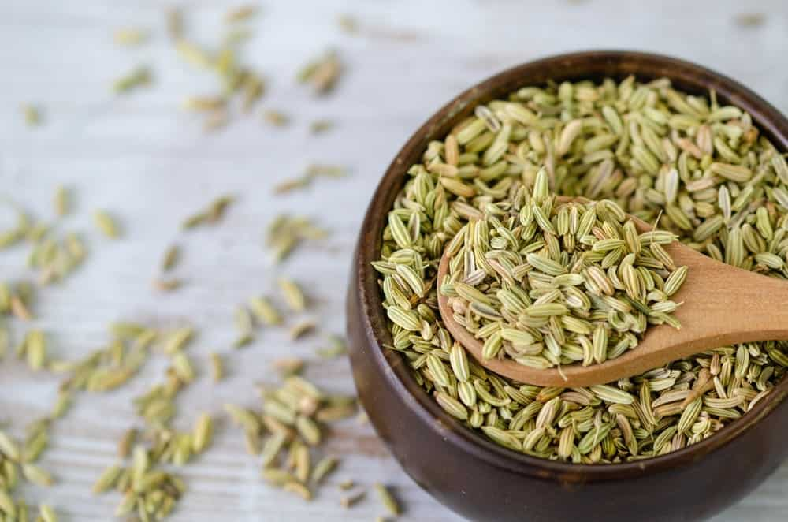
LATIN NAME: ANETHUM FOENICULUM
ALSO CALLED “THE FISH HERB” IN ITALY AND FRANCE, FENNEL SEED IS FOUND IN TWO MAIN VARIETIES. THE FIRST IS BITTER FENNEL WHICH HAS A LICORICE-LIKE AROMA AND A SLIGHTLY SWEET FLAVOR PROFILE. THE OTHER VARIETY IS SWEET FENNEL, WHICH, AS THE NAME SUGGESTS HAS A REALLY SWEET, NUTTY AROMA AND TASTE.
FENNEL IS BASICALLY A HARDY PERENNIAL HERB THAT IS NATIVE TO THE MEDITERRANEAN SHORES. FENNEL WAS GREATLY PRIZED IN ANCIENT TIMES, PARTICULARLY BY GREEKS AND ROMANS WHO MAINLY USED IT IN THEIR FOOD AND FOR ITS MEDICINAL PROPERTIES. SOME OF ITS MEDICAL BENEFITS INCLUDE RELIEF FROM MUSCLE SPASMS AND FLATULENCE.
GROUND FENNEL SEEDS ARE POPULARLY USED AS A SPICE IN SEVERAL CUISINES ALL ACROSS THE WORLD DUE TO ITS SWEET AND GRASSY FLAVOR THAT HAS SUBTLE HINTS OF ANISE AND STAR ANISE. GROUND FENNEL IS WIDELY FEATURED IN DISHES ORIGINATING FROM SCANDINAVIA, THE MIDDLE EAST, AND THE MEDITERRANEAN.
FASCINATINGLY, FENNEL SPICE WAS SIGNIFICANTLY USED THOUSANDS OF YEARS AGO BY THE CHINESE AND HINDU PEOPLE AS A CURE FOR SNAKE BITES. ALSO, ACCORDING TO HISTORICAL EVIDENCE, FENNEL WAS HUNG OVER DOORWAYS TO WARD OFF EVIL SPIRITS, ESPECIALLY DURING THE MIDDLE AGES ERA.

PAPRIKA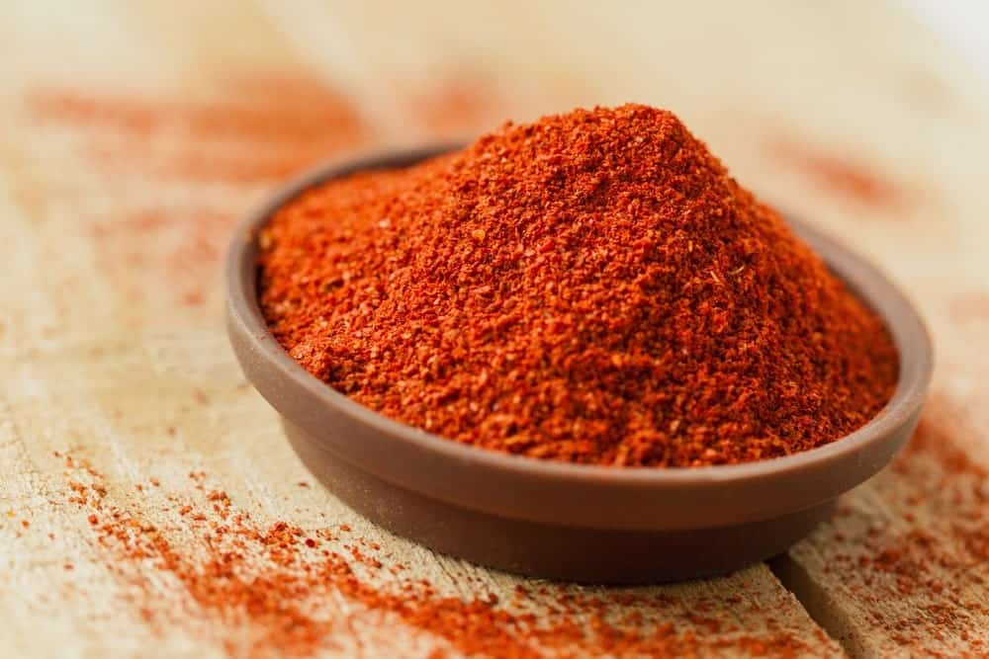
LATIN NAME: CAPISCUM ANNUUM
LIKE CHILI PEPPER AND CAYENNE PEPPER, PAPRIKA IS ALSO A TYPE OF PEPPER THAT BELONGS TO THE SAME FAMILY. PAPRIKA SPICE IS A GROUND VERSION OF THIS PEPPER THAT IS GREATLY FEATURED IN THE SPANISH, SOUTH AMERICAN, AND HUNGARIAN CUISINE.
THIS SPICE HAS COMPLEX UNDERTONES BUT MOSTLY CONSISTS OF A SMOKY FLAVOR COUPLED WITH A MILDLY SWEET AND EARTHY TASTE. PAPRIKA PEPPERS ARE NATIVE TO THE NEW WORLD AND HAVE ORIGINATED FROM CENTRAL MEXICO. THEY WERE THEN INTRODUCED TO SPAIN IN THE 16TH CENTURY AFTER WHICH THE PAPRIKA SPICE BEGAN TO BE POPULARLY USED IN A VARIETY OF DISHES, MAINLY FOR ITS FLAVOR AND THE DEEP REDDISH-ORANGE COLOR.
IT IS OFTEN USED AS A SEASONING IN SOUPS, STEWS, RICE DISHES AND MANY OTHER DISHES. IN THE UNITED STATES, THIS SPICE IS USUALLY SPRINKLED ON FOODS AS A GARNISH; HOWEVER, THE BEST WAY TO GET THE MAXIMUM FLAVOR OUT OF IT IS BY HEATING IT IN OIL.

SUMAC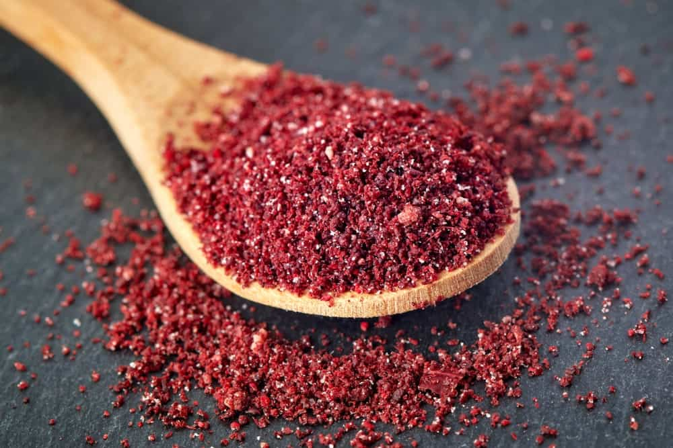
LATIN NAME: RHUS CORIARA
THIS INCREDIBLE SPICE IS POPULAR FOR ITS BEAUTIFUL, PURPLE COLOR AND A TANGY FLAVOR THAT IS HIGHLY CHARACTERISTIC OF VINEGAR OR LEMON. THE WORD ‘SUMAC’ IS BELIEVED TO HAVE COME FROM THE OLD FRENCH DURING THE PERIOD OF THE 13TH CENTURY WHICH TRANSLATES TO ‘RED’ IN THE ENGLISH LANGUAGE.
THE SUMAC SPICE IS GREATLY FEATURED IN A VARIETY OF DIFFERENT CUISINES AND DISHES DUE TO ITS TART, LEMONY FLAVOR THAT IS NOT AS OVERWHELMING AS A LEMON ITSELF.
SUMAC COMES FROM THE FLOWERING PLANTS BELONGING TO THE RHUS GENUS AND IT MAJORLY GROWS IN TEMPERATE AND SUBTROPICAL REGIONS OF NORTH AMERICA, EAST ASIA, AND AFRICA.
MEDICINAL RECORDS FROM MEDIEVAL TIMES SHOW GREAT EVIDENCE OF THIS SPICE BEING USED AS A TREATMENT FOR A NUMBER OF HEALTH AILMENTS LIKE BOWEL CONDITIONS, HEADACHES, ASTHMA, COLD, FEVER AND FLUE.

CINNAMON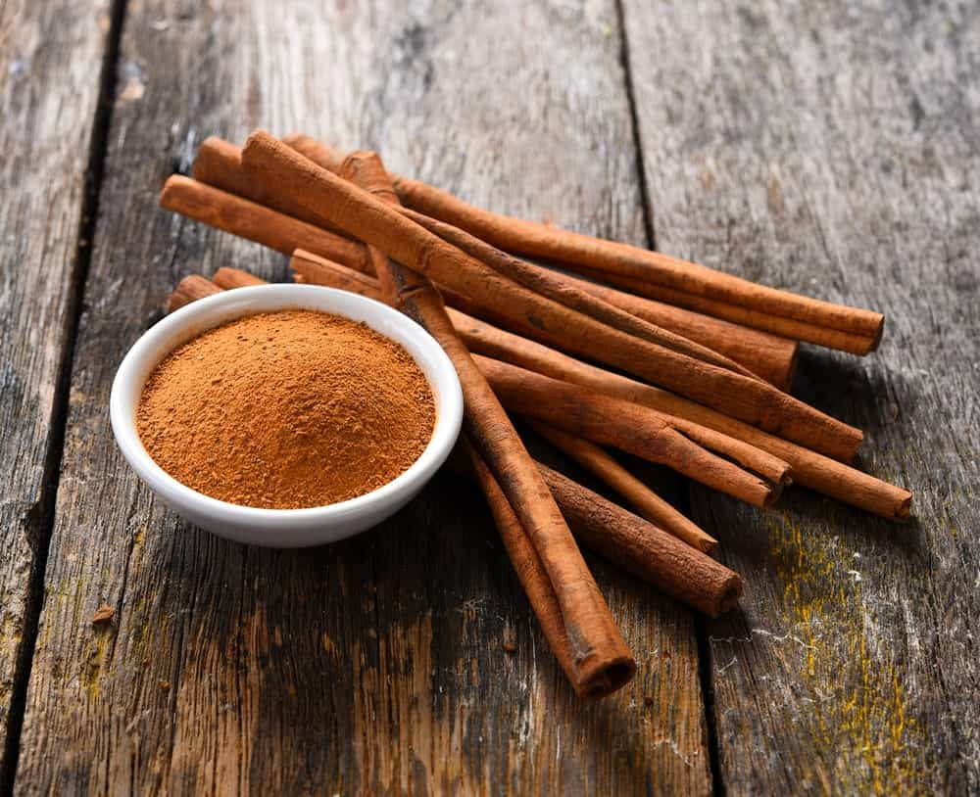
LATIN NAME: CINNAMOMUM ZEYLANICUM
THIS HAS TO BE THE OLDEST KNOWN SPICE THAT DATES BACK TO WRITTEN RECORDS FOUND DURING THE 5TH CENTURY. CINNAMON IS MOST POPULARLY USED AS A FLAVORFUL AND A HIGHLY AROMATIC CONDIMENT IN A NUMBER OF CUISINES, AND A VARIETY OF SWEET AND SAVORY DISHES.
AS THE NAME SUGGESTS, THIS SPICE SPORTS A MID-BROWN COLOR. THE LARGEST CULTIVATION AND PRODUCTION OF CINNAMON COMES FROM CHINA AND INDONESIA, HOWEVER, ITS CONSUMPTION DATES FAR BACK AS THE 2000 BC.
THE CINNAMON SPICE IS POPULARLY USED IN THE PRODUCTION OF CHOCOLATE IN MEXICO, WHEREAS IN THE UNITED STATES, IT IS GREATLY FEATURED IN BREAD-BASED DISHES AND IS ALSO USED TO FLAVOR DIFFERENT CEREALS. THE AROMA AND TASTE OF CINNAMON ARE QUITE SIMILAR TO THE SPICE CASSIA BARK AND IS USUALLY DESCRIBED AS SOFT AND SWEET WITH A DISTINCTIVE SPICE KICK.

ONION POWDER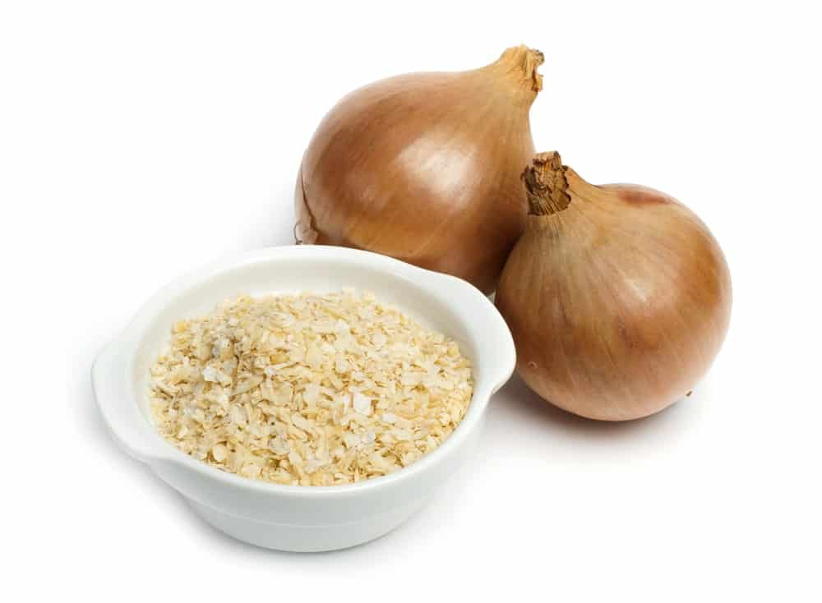
LATIN NAME: ALLIUM CEPA
ONION POWDER COMES FROM DRIED AND DEHYDRATED ONION BULBS AND IS COMMONLY USED AS A SEASONING FOR SOUPS, STEWS, RICE DISHES AND MANY OTHERS FOR THAT EXTRA ONION-EY KICK OF FLAVOR. IT IS ALSO A VERY COMMON INGREDIENT THAT IS OFTEN USED IN SPICE MIXES AND SEASONED SALTS.
ONION POWDER IS PREPARED THROUGH A VARIETY OF DIFFERENT TECHNIQUES, NAMELY FLOW-DRYING, FREEZE-DRYING, DEHYDRATION, AND VACUUM SHELF-DRYING. IT CAN THEN BE USED AS A FLAVORED CONDIMENT FOR GRILLED CHICKEN, PASTA, PIZZA, ETC.
THIS SPICE HAS ALSO BEEN USED TO TREAT A NUMBER OF HEALTH CONDITIONS LIKE SKIN ISSUES, NASAL AND CHEST CONGESTION, AND NUMEROUS RESPIRATORY AILMENTS.

GALANGAL ROOT POWDER 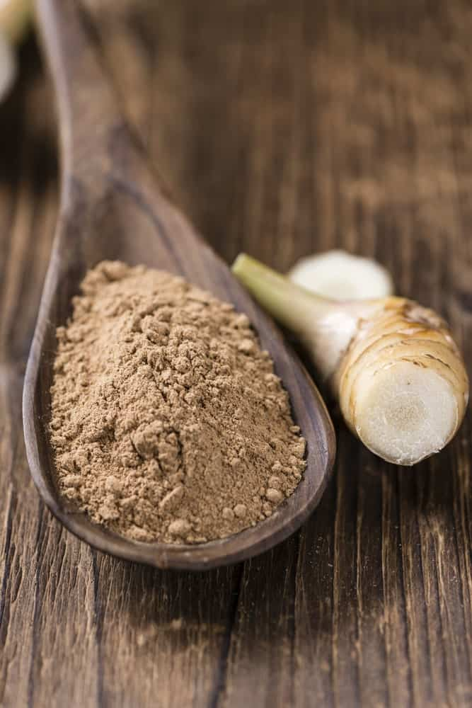
LATIN NAME: LANGUAS GALANGAL OR ALPINIA GALANGA
GALANGAL ROOT POWDER COMES FROM GALANGAL, WHICH IS AN EAST ASIAN TROPICAL SHRUB. IT PRIMARILY GROWS IN SOUTHWEST INDIA AND IN THE EASTERN HIMALAYAS. GALANGAL WAS FIRST INTRODUCED IN EUROPE BACK IN THE 9TH CENTURY AFTER WHICH THE SPICE STARTED GAINING SIGNIFICANT POPULARITY IN THE CULINARY WORLD.
GALANGAL HAS BEEN REFERRED TO AS THE “SPICE OF LIFE” BACK IN ANCIENT TIMES CONSIDERING HOW IT WAS BELIEVED TO PLAY A HUGE PART IN SAUDI HERBAL MEDICINE.
SINCE IT COMES FROM THE SAME FAMILY AS GINGER, IT CONSISTS OF A SIMILAR TASTE AS THAT OF GINGER; HOWEVER, THE GALANGAL SPICE HAS A PINEY CACTUS-FLAVOR PROFILE. THAI CUISINE USES GALANGAL IN ALMOST ALL OF ITS DISHES FROM TOM YUM SOUP TO NUMEROUS CURRIES AND GRAVIES. THE VERSATILE FLAVOR OF THIS INCREDIBLE SPICE ALSO MAKES IT AN EXCELLENT ADDITION TO CITRUS DRINKS, LEMONADES, AND MARGARITAS.

STAR ANISE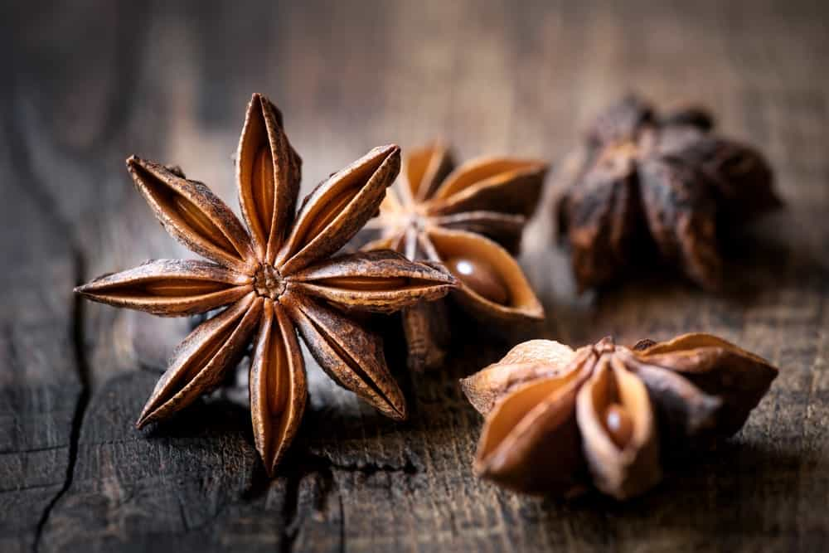
LATIN NAME: ILLICIUM VERUM
THIS SPICE COMES FROM A MEDIUM-SIZED EVERGREEN TREE THAT IS NATIVE TO SOUTHWEST CHINA AND TO NORTHEAST VIETNAM. STAR ANISE IS ALSO KNOWN BY SEVERAL OTHER NAMES LIKE CHINESE STAR ANISE, BADIANE, AND STAR ANISE SEED.
IT IS OFTEN CONFUSED WITH THE SPICE ANISE DUE TO THE SIMILARITY OF NAME, FLAVOR PROFILE, AND SHAPE; HOWEVER, THEY ARE STILL QUITE DIFFERENT. STAR ANISE IS BASICALLY USED AS A LESS EXPENSIVE SUBSTITUTE OF ANISE IN THE CULINARY WORLD AND ALSO IN LIQUOR PRODUCTION.
STAR ANISE IS WIDELY FEATURED IN THE INDIAN, CHINESE, INDONESIAN, AND MALAYSIAN CUISINES AND IS MOSTLY GROWN IN CHINA, INDIA, AND ASIA. SOME OF THE MOST COMMON DISHES THAT STAR THIS SPICE AS ITS MAIN INGREDIENT ARE MASALA CHAI, VIETNAMESE PHO, AND THE FRENCH MULLED WINE CALLED VIN CHAUD, WHICH TRANSLATES TO HOT WINE IN ENGLISH.
THIS SPICE GREATLY AIDS IN DIGESTION AND ALSO HELPS WITH RHEUMATISM AND FLATULENCE.

BLACK CUMIN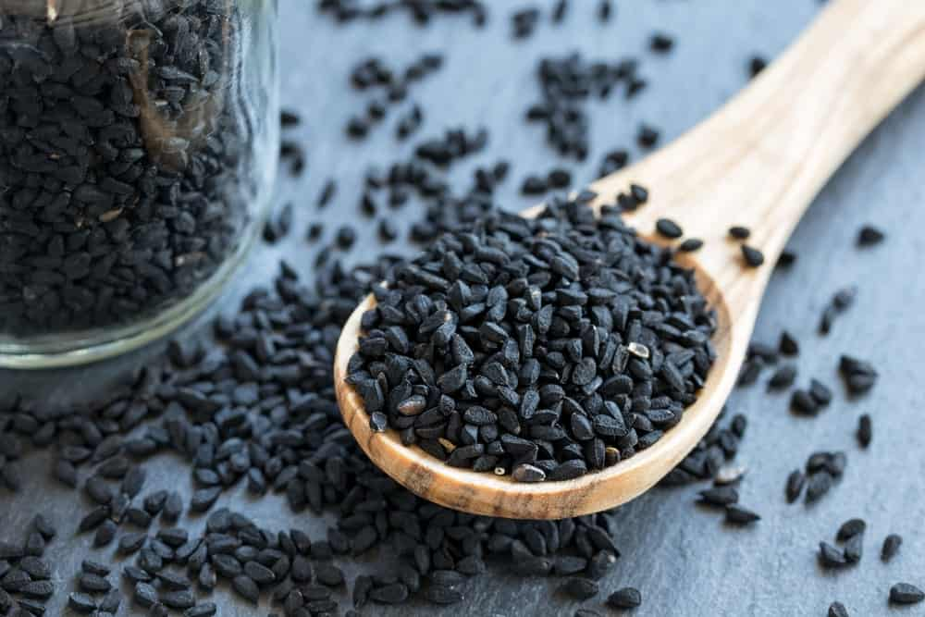
LATIN NAME: NIGELLA SATIVA
THIS POPULAR SPICE COMES FROM AN ANNUAL FLOWERING PLANT THAT IS NATIVE TO SOUTH AND SOUTHWEST ASIA. BLACK CUMIN SEEDS ARE POPULARLY USED IN THE POLISH CUISINE, AS WELL AS MIDDLE EASTERN AND INDIAN CUISINES.
THIS SPICE TASTES LIKE A DELICIOUS MIXTURE OF OREGANO, BLACK PEPPER, AND ONIONS WHICH GIVES IT A HIGHLY PUNGENT AND BITTER TASTE AND AROMA. IT IS MOST COMMONLY USED IN DISHES LIKE CURRIES, STEWS, CHEESE DISHES, OR OFTEN SIMPLY SPRINKLED ON SALADS FOR THAT ADDED KICK AND TEXTURE.
BLACK CUMIN HAS SEVERAL MEDICINAL USES INCLUDING CURING ALLERGIES, ASTHMA, HEADACHES, TOOTHACHES AND INDIGESTION PROBLEMS.

POPPY SEEDS
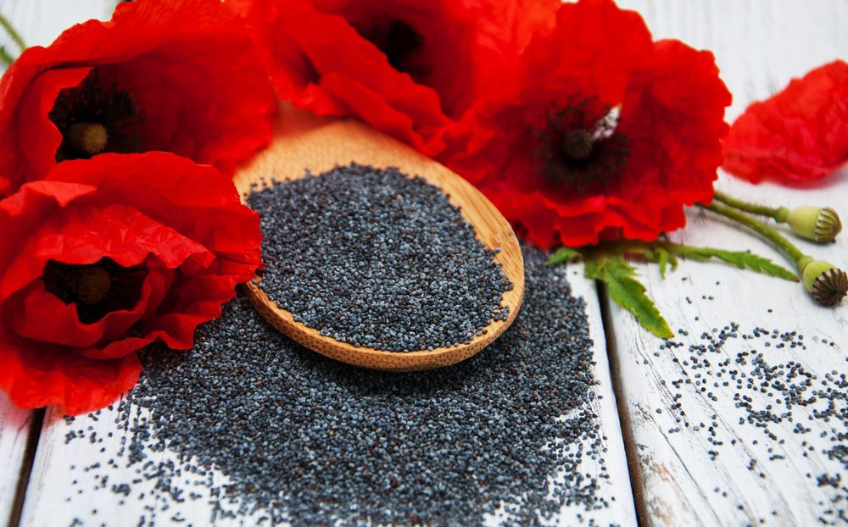
THOUGH POPPY SEEDS ARE COMMONLY COOKED ALONG WITH BAKED GOODS, THEY CAN ALSO BE USED AS CONDIMENTS TO ADD A SWEET, FRUITY FLAVOR.

PUMPKIN SPICE
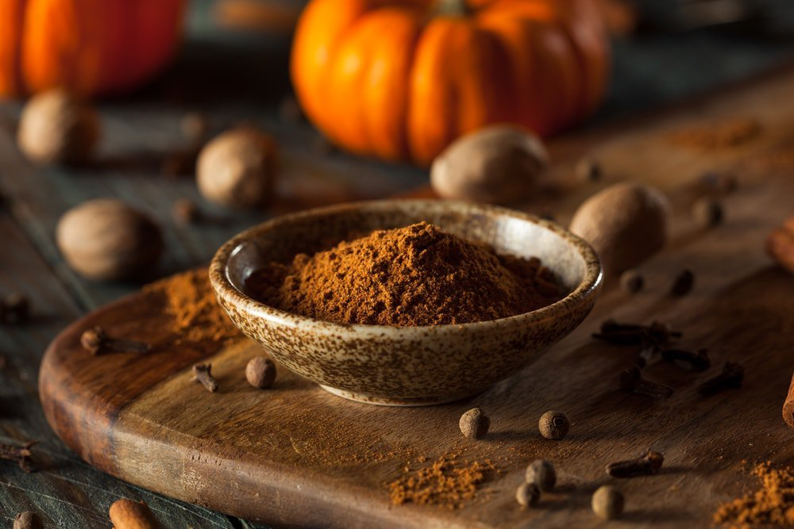
WHILE PUMPKIN SPICE IS A PRIMARY INGREDIENT OF PUMPKIN PIE, IT HAS ALSO BECOME POPULAR AS A FLAVOR ENHANCER FOR COFFEE AND OTHER SWEET DRINKS.
ISN’T IT ABSOLUTELY INCREDIBLE HOW THERE IS SUCH A VAST VARIETY OF DELICIOUS SPICES THAT ARE FOUND ALL OVER THE WORLD? NOW THAT YOU KNOW SOME OF THE MOST COMMON AND POPULAR SPICES, YOU WILL BE ABLE TO IDENTIFY THEM IN MOST OF YOUR FOODS AND DISHES!

MEGA LIST OF 53 DIFFERENT TYPES OF CONDIMENTS TO DRESS UP YOUR FOOD
DIP INTO THIS EXHAUSTIVE LIST OF THE MANY DIFFERENT TYPES OF CONDIMENTS YOU SHOULD KNOW ABOUT SO YOU KNOW WHICH ONES TO KEEP HANDY IN THE KITCHEN AND WHICH ONES TO TOP A DISH WITH SOME MAGICAL TASTE.
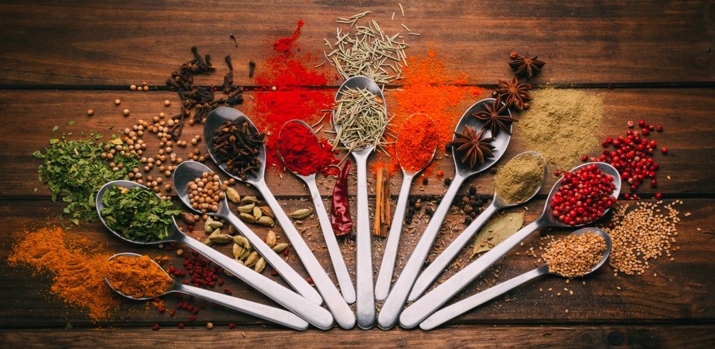
THE 10 MOST POPULAR CONDIMENTS:
- HONEY
- SUGAR
- SALT
- MAYONNAISE
- OLIVE OIL
- SALSA
- KETCHUP
- MAPLE SYRUP
- RELISH
- HOT SAUCE
INTERESTINGLY, HONEY IS MORE THAN 10 TIMES AS POPULAR THAN KETCHUP, MAPLE SYRUP, RELISH, HOT SAUCE, MUSTARD AND SOY SAUCE. GO FIGURE. THIS LIST IS BASED ON SEARCH VOLUME FOR EACH PER MONTH.
I BET YOU’RE A BIT SURPRISED. I KNOW I WAS. I THOUGHT FOR SURE KETCHUP WOULD REIGN SUPREME. IT’S THE CONDIMENT THAT FIRST COMES TO MY MIND. WHILE THE ABOVE ARE THE 10 MOST POPULAR, THEY AREN’T ALL CONDIMENTS. THERE ARE MANY OF THEM. WE SET OUT MORE THAN 50 BELOW.
RELATED: TYPES OF FOOD | TYPES OF GARNISH | TYPES OF HERBS | VEGETABLES AND HERBS | TYPES OF FRUIT TREES | TYPES OF BEANS AND LEGUMES | TYPES OF MUSHROOMS | TYPES OF BREAD | TYPES OF MILK | TYPES OF NUTS | TYPES OF SPICES
PEOPLE ARE ALWAYS LOOKING FOR NEW WAYS TO MAKE FOOD MORE FLAVORFUL WITH HERBS, ADDITIONAL INGREDIENTS, AND OF COURSE — CONDIMENTS. CONDIMENTS ARE ONE OF THE SIMPLEST WAYS TO IMPROVE THE TASTE OF FOOD, WITHOUT THE NEED FOR SPECIAL CULINARY SKILLS. FROM BREAKFAST TOAST TO SIRLOIN STEAK, THERE ARE COUNTLESS FOODS THAT CAN BE ALTERED OR IMPROVED WITH CONDIMENTS.
THE LIST OF EXISTING CONDIMENTS IS EXTREMELY DIVERSE, AND MANY COUNTRIES HAVE THEIR OWN DISTINCT CONDIMENT TYPES. FOR EXAMPLE, WHILE TRAVELING THROUGH SOUTHEAST ASIA, I FOUND THAT SESAME OIL IS ONE OF THE MOST COMMON CONDIMENTS FOR RICE-BASED DISHES. HOWEVER, OUTSIDE OF A RESTAURANT SERVING AUTHENTIC FOOD FROM THE REGION, YOU WOULD NEVER SEE SESAME OIL USED AS A CONDIMENT IN THE UNITED STATES.
NONETHELESS, THERE ARE DOZENS OF CONDIMENTS THAT ARE WIDELY USED AROUND THE WORLD. BUT BEFORE WE TAKE A CLOSER LOOK AT ALL THE DIFFERENT TYPES OF CONDIMENTS, THERE ARE A FEW QUESTIONS WE SHOULD ANSWER FIRST.

WHAT ARE CONDIMENTS?
CONDIMENTS REFER TO VARIOUS TYPES OF SPICES OR SAUCES THAT ARE TYPICALLY ADDED TO FOOD AFTER ITS PREPARATION. WHILE EVERY CONDIMENT ADDS SOMETHING A LITTLE DIFFERENT TO A MEAL, ALL CONDIMENTS ARE USED WITH THE INTENT OF ENHANCING THE FLAVOR OF A COOKED MEAL. IF YOU’RE EATING IN A RESTAURANT, CONDIMENTS ARE GENERALLY SERVED IN GLASS OR PLASTIC BOTTLES. IN SOME CASES, THERE MAY BE DISHES PLACED ON THE TABLE WITH DIFFERENT KINDS OF CONDIMENTS. FOR THOSE WHO PREFER TO PREPARE THEIR OWN MEALS AT HOME, YOU CAN EASILY FIND DOZENS OF CONDIMENTS AT THE GROCERY STORE OR LOCAL SUPERMARKET.
NOW THAT YOU UNDERSTAND A LITTLE BIT MORE ABOUT CONDIMENTS AND THEIR FUNCTION, LET’S LOOK AT A COMPLETE LIST OF AVAILABLE CONDIMENTS.

COMPLETE LIST OF CONDIMENTS
GENERALLY, CONDIMENTS ARE BROKEN DOWN INTO THE FOLLOWING CATEGORIES: HERBS AND SPICES, SAUCES, DRESSINGS AND SYRUPS, AND DAIRY. WHILE HERBS ARE SOMETIMES PUT INTO A SEPARATE CATEGORY, THEY ARE OFTEN USED ALONG WITH SPICES AS POST-PREPARATION CONDIMENTS. IN ANY CASE, LET’S START OFF BY LOOKING AT ALL OF THE HERB AND SPICE CONDIMENTS IN ALPHABETICAL ORDER:

MINERAL

SALT (A MINERAL)
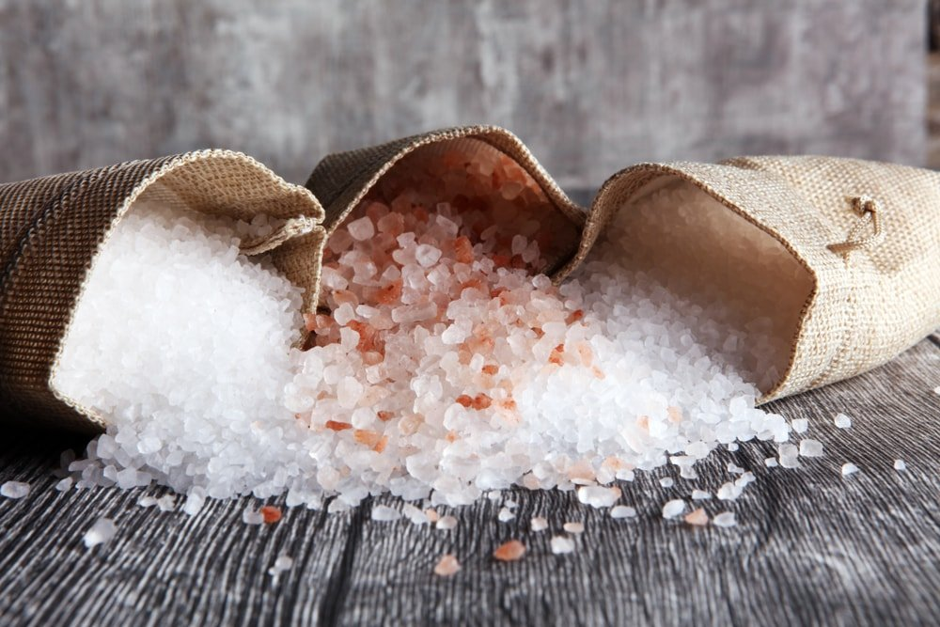
SALT IS AN ELEMENT ON THE PERIODIC TABLE. IT’S PURE WHITE WHEN FRESHLY MINED, YET IT GAINS COLOR OVER TIME. SALT IS USUALLY FOUND IN SEA WATER OR UNDER THE EARTH’S SURFACE AND CRYSTALLIZES OUT OF THE WATER WHEN EXPOSED TO AIR.
WE MUST HAVE SALT. IT’S RARE NOT TO EAT SUFFICIENT SALT GIVEN HOW MUCH OF IT IS ADDED TO SO MANY PROCESSED FOODS. EVEN THEN, THERE’S NOTHING LIKE A GOOD BAG OF SALTY CHIPS (MY JUNK FOOD WEAKNESS).
AT ONE TIME, SALT WAS ONE OF THE MOST SOUGHT-AFTER COMMODITIES IN THE WORLD. NOWADAYS, YOU CAN FIND SALT EVERYWHERE, AS IT IS ONE OF THE MOST COMMON AND POPULAR FLAVOR ENHANCERS.

SWEETENER

SUGAR (A SWEETENER)
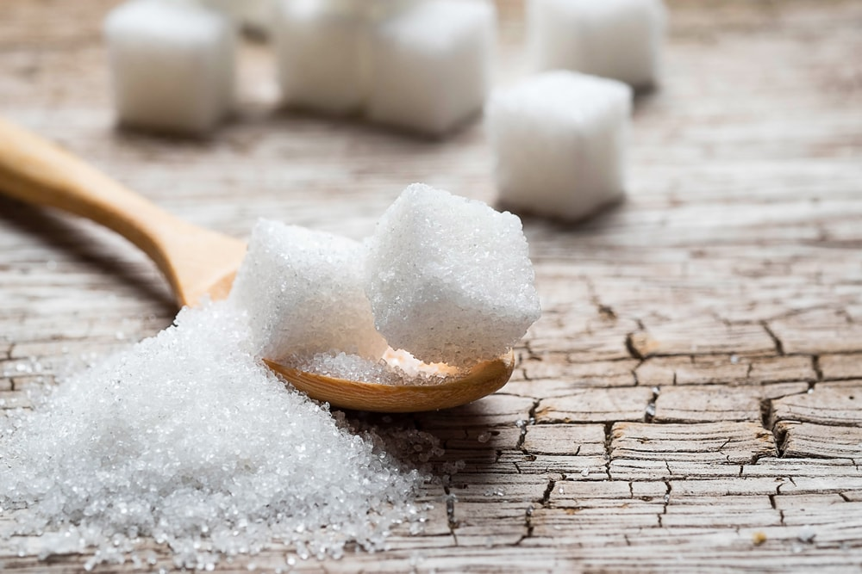
SUGAR IS A CARBOHYDRATE. IT COMES IN TWO FORMS: WHITE SUGAR AND BROWN SUGAR. SUGAR COMES FROM SUGAR CANE, SUGAR BEET, OR SUGAR BEET.
IF YOU WANT TO SATISFY YOUR SWEET TOOTH, SUGAR IS THE BEST WAY TO GO. SUGAR CRYSTALS CAN BE SPRINKLED ON DESSERTS OR MIXED WITH DRINKS TO CUT THE BITTERNESS AND IMPROVE THE OVERALL TASTE.

SAUCES, DRESSINGS & SYRUPS

ALMOND BUTTER
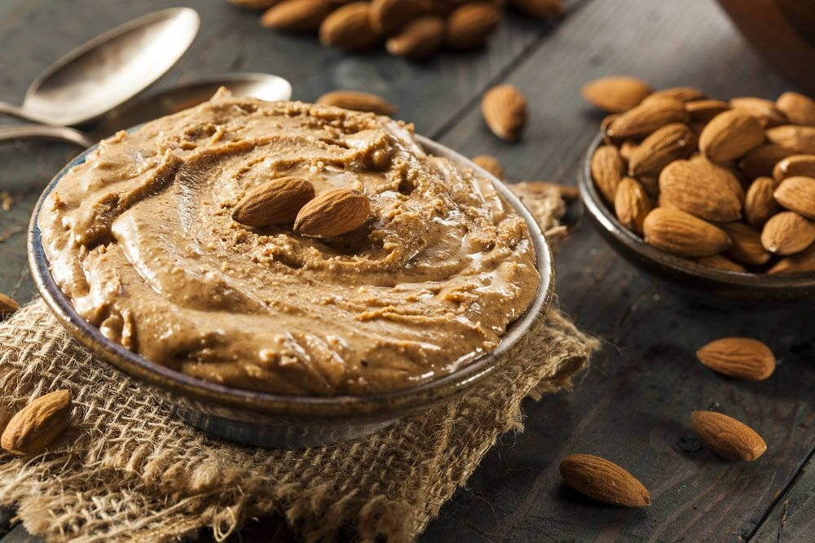
ALMOND BUTTER IS A PASTE MADE FROM ALMONDS. IT CAN BE FLAVORED WITH SALT OR EVEN NUTMEG, BUT IT MUST REMAIN NEUTRAL IN TASTE AND CONSISTENCY.
ALMOND BUTTER TAKES THE MILDLY SWEET FLAVOR OF ALMONDS AND TURNS IT INTO A RICH AND CREAMY SPREAD.

BALSAMIC VINEGAR
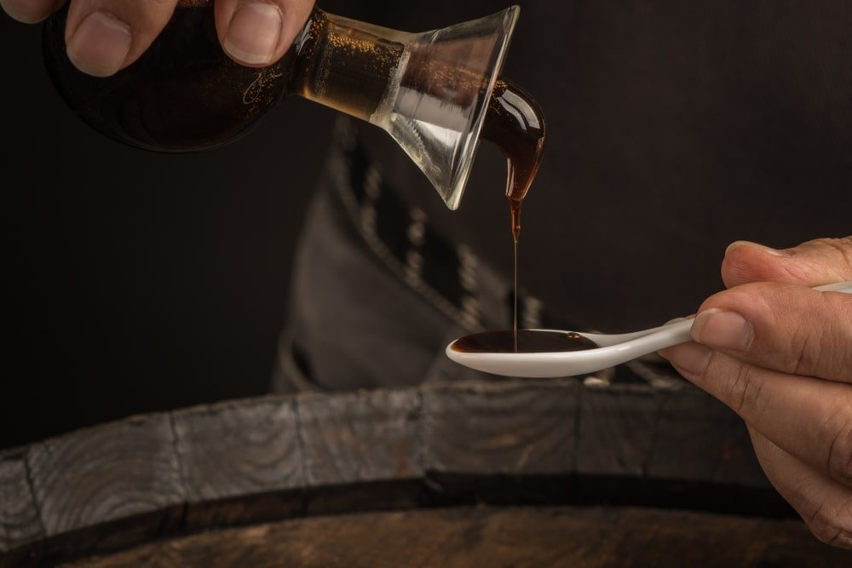
BALSAMIC VINEGAR IS A KIND OF FLAVORED VINEGAR. IT IS MADE FROM THE DISTILLATION OF WINE AND THE FERMENTATION OF GRAPE JUICE. IT ORIGINATED IN ITALY, WHERE IT IS CALLED “ACETO BALSAMICO”. THE BEST QUALITY OF BALSAMIC VINEGAR COMES FROM MODENA IN ITALY, BUT CAN BE FOUND ALL OVER THE WORLD.
IT IS MOST COMMONLY USED AS A SALAD DRESSING THROUGHOUT THE WESTERN WORLD.

BARBECUE SAUCE
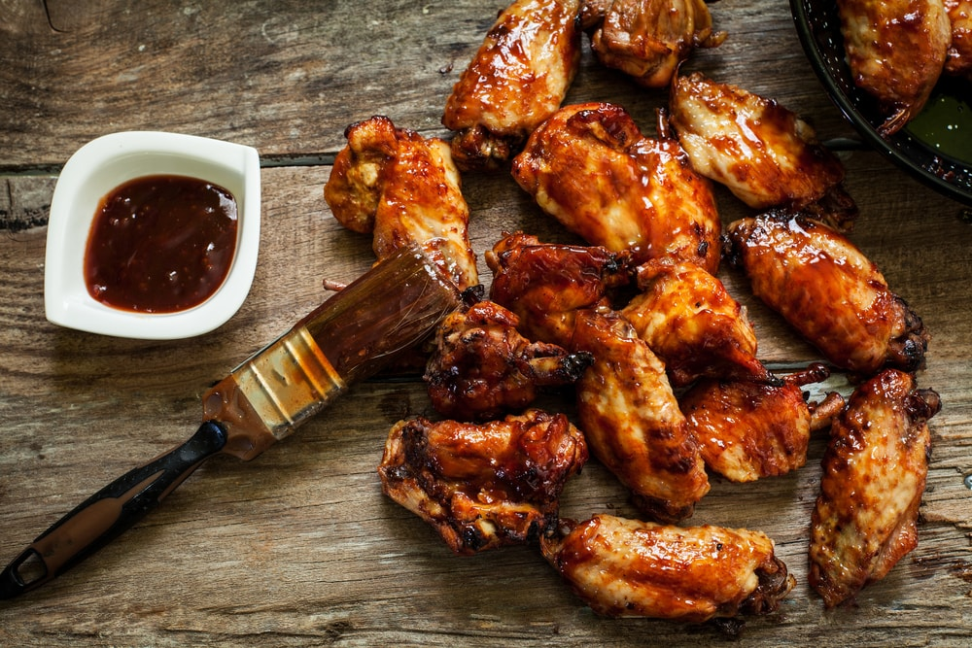
BARBECUE SAUCE IS A DISTINCTLY AMERICAN CONDIMENT THAT COMBINES MANY DIFFERENT INGREDIENTS AND SPICES, INCLUDING TOMATO PASTE, VINEGAR, AND MAYONNAISE.

CAESAR DRESSING
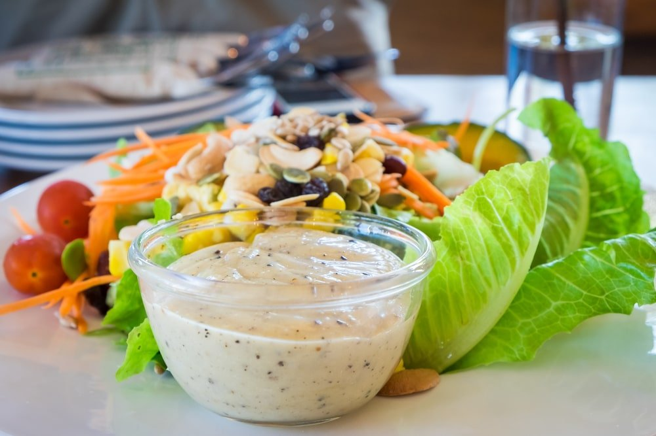
CAESAR DRESSING IS ONE OF THE MOST POPULAR SALAD DRESSINGS IN THE WORLD AND CAN BE RECOGNIZED BY ITS RICH, LEMONY FLAVOR.
CAESAR DRESSING IS A REALLY EASY-TO-MAKE DRESSING. IT’S MAINLY MADE WITH GARLIC, OLIVE OIL, WORCESTERSHIRE SAUCE, AND CHIVES. TARRAGON IS OFTEN SUBSTITUTED FOR THE CHIVES IN THE MAJORITY OF RECIPES THAT CALL FOR IT.

CARAMEL
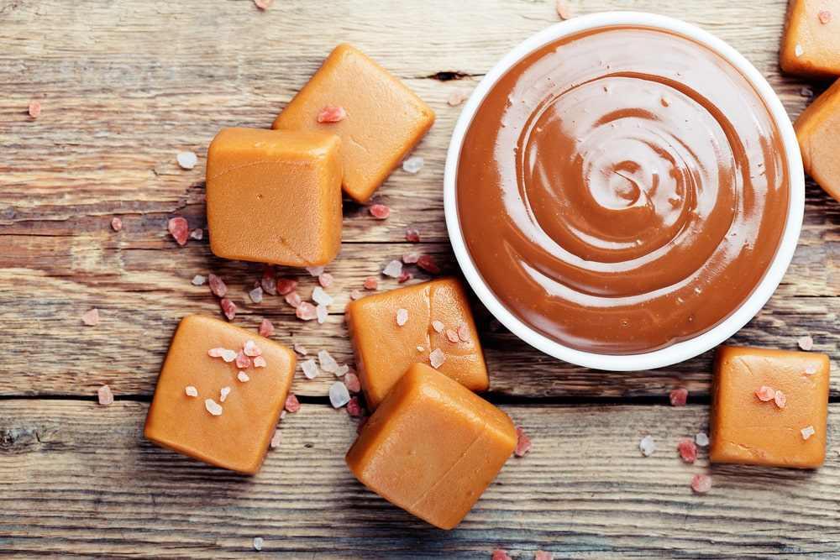
CARAMEL IS A SUGAR THAT IS MADE BY HEATING A MIXTURE OF SUGAR AND WATER UNTIL THE SUGAR MELTS AND CARAMELIZES. CARAMEL CAN BE MADE INTO A LIQUID OR COOLED INTO A HARD CANDY.
WHETHER YOU WANT TO ADD ADDITIONAL SWEETNESS TO A CAKE OR ADD A TOPPING TO YOUR BANANA SPLIT, CARAMEL IS A GREAT CONDIMENT TO HAVE ON HAND.

CHIMICHURRI
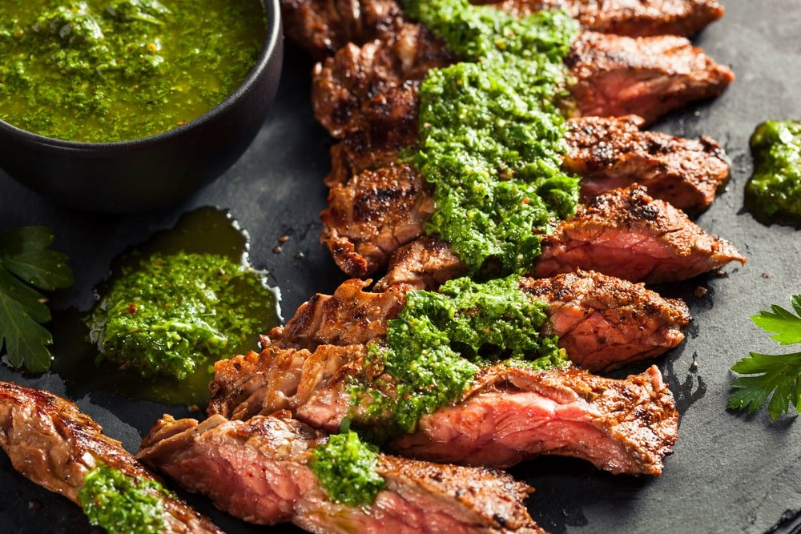
ORIGINALLY FROM ARGENTINA, CHIMICHURRI IS AN OLIVE OIL-BASED CONDIMENT FOR GRILLED MEAT.
CHIMICHURRI IS A SAUCE MADE OUT OF PARSLEY, GARLIC, AND OLIVE OIL. IT’S THE BASE FOR SEVERAL ARGENTINEAN DISHES. THE BEST WAY TO MAKE CHIMICHURRI SAUCE IS TO BLEND IT TOGETHER BY HAND WITH A PESTLE OR MORTAR AND COMBINE WITH FRESH MINCED GARLIC AND A SPRINKLING OF FINELY CHOPPED PARSLEY.

CHOCOLATE SAUCE
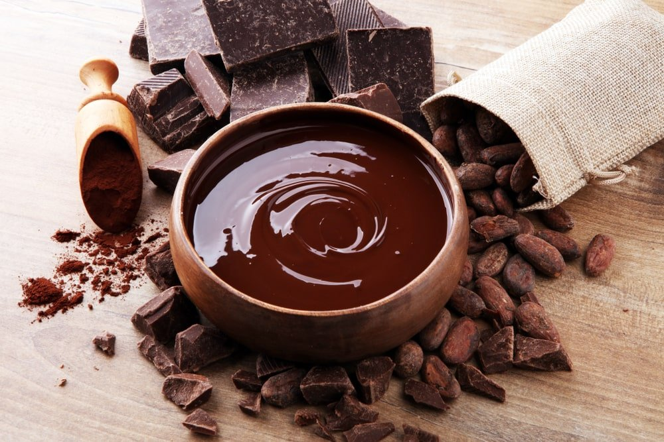
Bottom of Form
MOST FREQUENTLY USED WITH ICE CREAM, CHOCOLATE SAUCE IS A GREAT WAY TO BRING THE TASTE OF CHOCOLATE TO JUST ABOUT ANY DESSERT.

COCKTAIL SAUCE
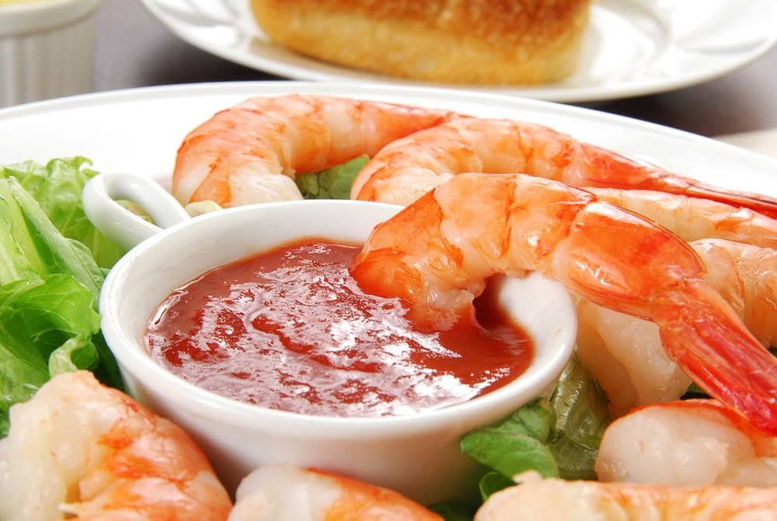
COCKTAIL SAUCE IS A SIMPLE SAUCE THAT IS USED FOR MARINADES AND SAUCES. IT’S MADE BY COMBINING HONEY, WORCESTERSHIRE SAUCE, HOT SAUCE OR HORSERADISH TO TASTE, GARLIC POWDER, SALT AND PEPPER INTO ONE BOWL. PUT THE MEAT INTO THE BOWL OF MIXED SEASONINGS AND STIR UNTIL THE MEAT IS COATED.

DIJON MUSTARD
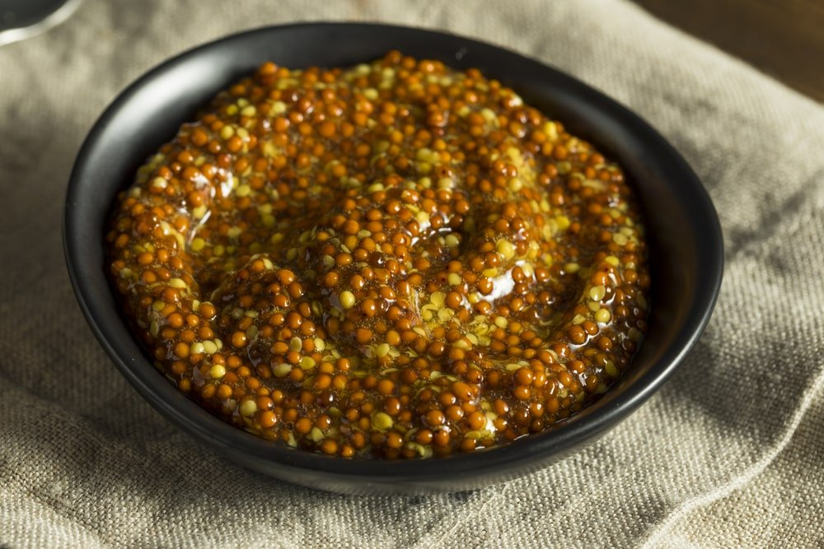
HAILING FROM FRANCE, DIJON MUSTARD IS A SPICY AND DELICIOUS CONDIMENT THAT IS GREAT FOR HOT DOGS, SANDWICHES, AND SIMILAR MEALS.
IT IS A FRENCH-STYLE OF MUSTARD THAT FEATURES AN INTENSE FLAVOR. IT IS MADE FROM THE SEEDS, OR SOMETIMES THE JUICE, OF BLACK MUSTARD. THIS GIVES IT A TENDENCY TO HAVE A HEATY BITE TO IT.

FISH SAUCE
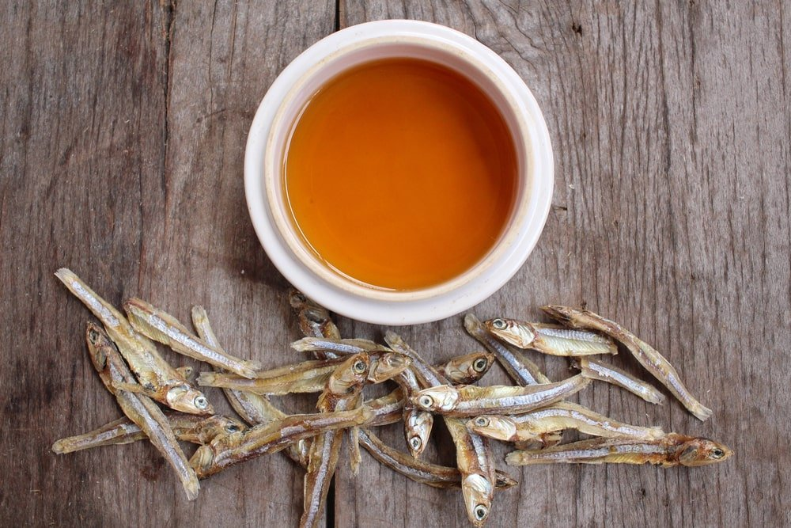
FISH SAUCE IS A COMMON INGREDIENT IN THAI CUISINE, HOWEVER, THIS SALTY CONDIMENT CAN BE ADDED TO JUST ABOUT ANY RICE OR NOODLE-BASED DISH.
IT IS A LIQUID THAT IS MADE FROM THE WHOLE BODY OF A FISH, INCLUDING ALL OF ITS ORGANS. MAKING FISH SAUCE TODAY OFTEN INVOLVES ADDING SALT AND/OR OTHER SEASONINGS TO GIVE IT ADDED FLAVOR. FISH SAUCE CAN BE USED TO FLAVOR A DISH, BUT IT SHOULD NOT OVERPOWER THE DISH.

FRENCH DRESSING
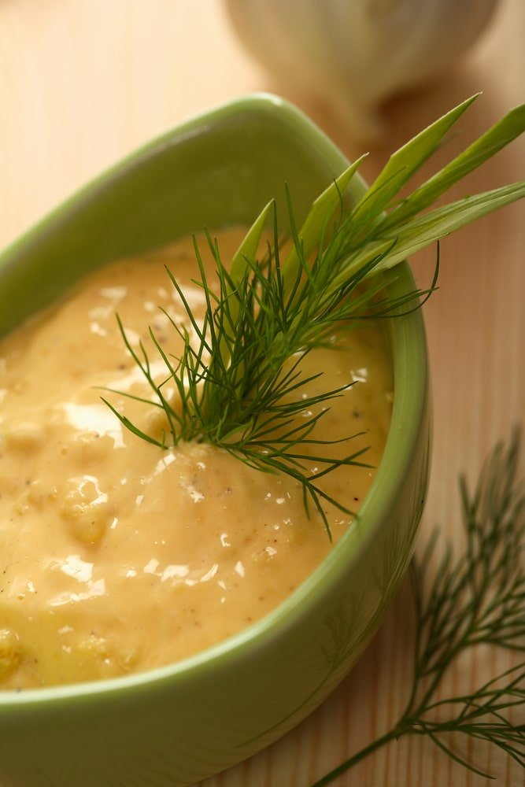
FRENCH DRESSING IS GENERALLY A KETCHUP-BASED SALAD DRESSING, THOUGH IT CAN ALSO BE ADDED TO OTHER DISHES.

GUACAMOLE
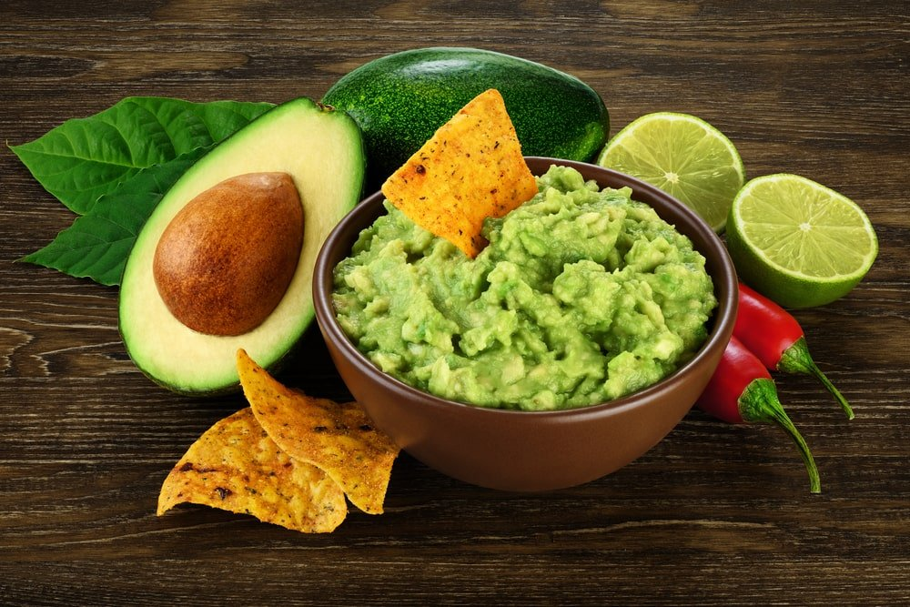
GUACAMOLE, ALSO KNOWN AS AVOCADO DIP, IS MADE FROM MASHED AVOCADOS, SALT AND LEMON JUICE. IT CAN BE TOPPED WITH LIME SLICES, CHOPPED ONIONS AND TOMATOES.
A STAPLE OF MEXICAN CUISINE, GUACAMOLE USES THE RICH, NATURAL FLAVORS OF AVOCADO TO COMPLEMENT A VARIETY OF DISHES.

HONEY

THE SWEET FLAVORS OF NATURAL HONEY ARE PERFECT FOR HOT DRINKS (LIKE TEA), CAKES, AND ANY FOOD OR BEVERAGE IN NEED OF AN EXTRA DOSE OF SWEETNESS.
HONEY IS A SWEET, THICK LIQUID PRODUCED BY BEES FROM THE NECTAR SECRETED FROM FLOWER BUDS.

HONEY MUSTARD
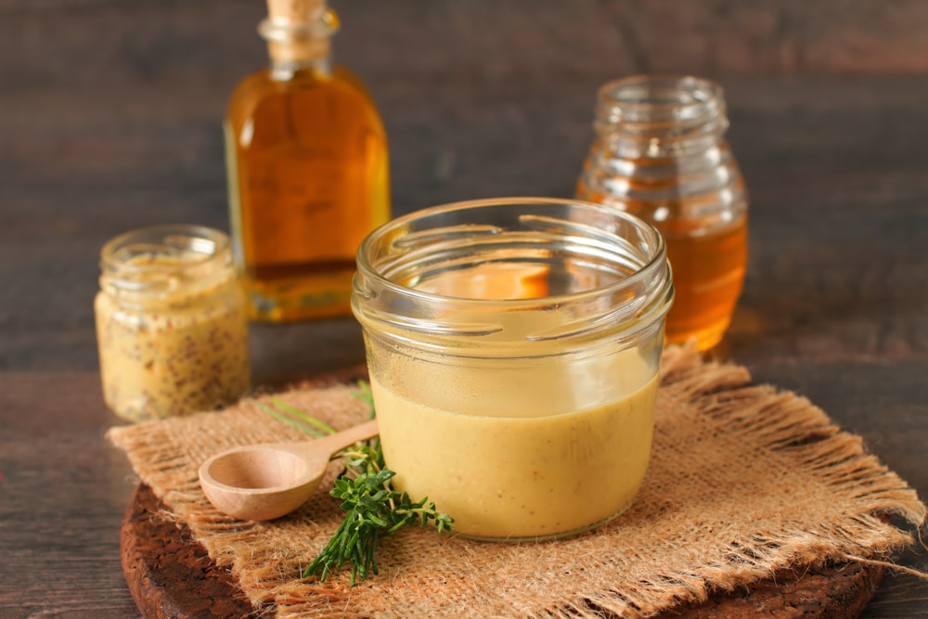
COMMONLY USED AS A DIPPING SAUCE IN THE UNITED STATES, HONEY MUSTARD ADDS A TANGY TWIST TO TRADITIONAL YELLOW MUSTARD.
IT’S A SWEET-AND-SOUR SAUCE THAT IS FLAVORED WITH HONEY, VINEGAR OR LEMON JUICE AND MUSTARD. IT’S POPULAR TO USE ON SANDWICHES, HOTDOGS AND SALADS. HONEY MUSTARD CAN BE MADE BY HAND IN JUST MINUTES.

HORSERADISH
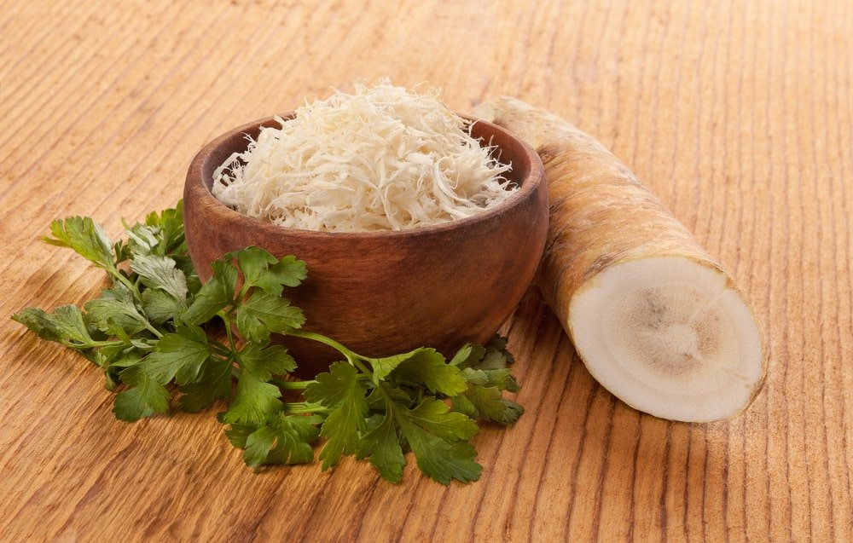
HORSERADISH IS A PLANT THAT GOES BY SEVERAL DIFFERENT NAMES. IT CAN BE CALLED “MORINGA PUNGENS”, “MORINGA OLEIFERA”, OR EVEN “MOLOKHIA” IN EGYPT. THE PLANT ITSELF IS HIGHLY SPICY AND WHEN USED AS A SAUCE OR IN A MARINADE IT’S DELICIOUS.

HOT SAUCE
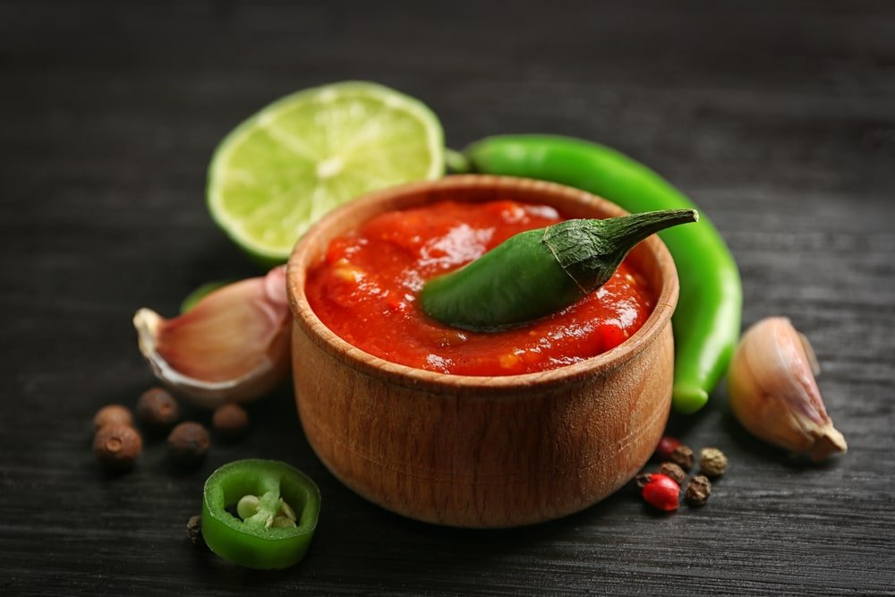
AS THE NAME IMPLIES, HOT SAUCE IS USED TO ADD SPICINESS TO YOUR MEAL. THE EXACT INGREDIENTS VARY BETWEEN BRANDS, THOUGH MANY USE HOT PEPPERS AS A BASE.

ITALIAN DRESSING
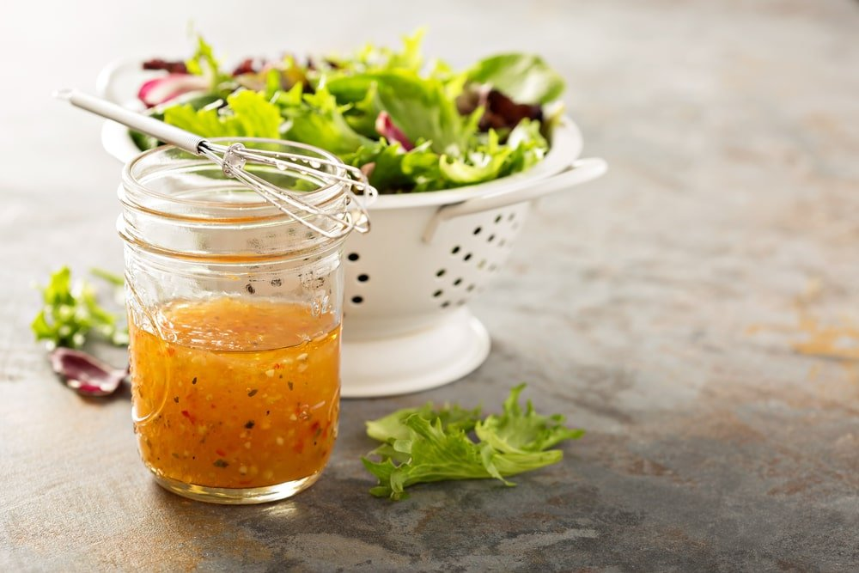
DESPITE THE NAME, ITALIAN DRESSING IS MOST COMMON IN NORTH AMERICA. IT IS AN HERBAL, VINAIGRETTE-STYLE SALAD DRESSING.

JELLY
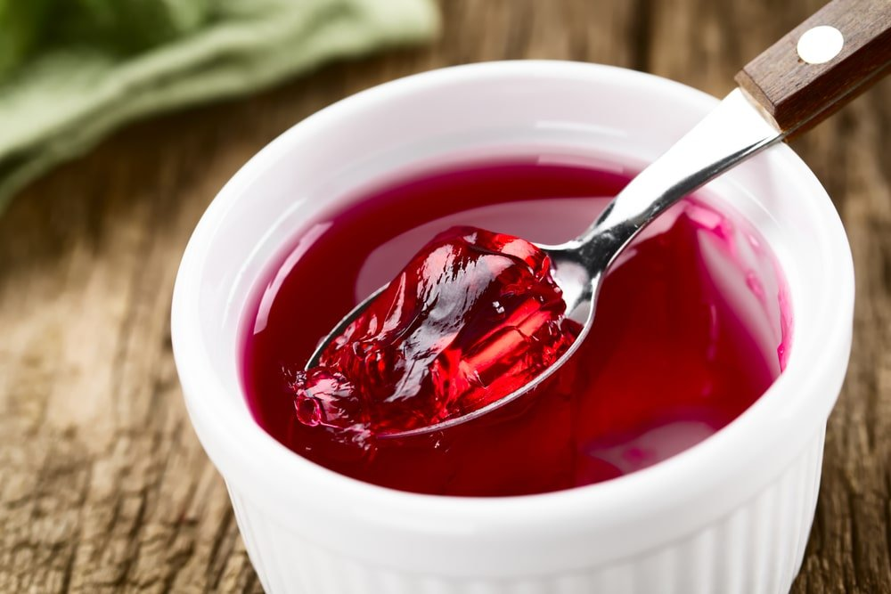
THERE ARE DOZENS OF KINDS OF JELLY, FROM GRAPE TO STRAWBERRY, AND THEY ARE COMMONLY ADDED TO TOAST, SANDWICHES, OR BAKED DESSERTS.
IT’S A SWEET -YET-TART DESSERT MADE FROM COOKED FRUIT. IT CAN BE MADE BY COOKING FRUIT WITH SUGAR OVER HEAT. JELLY CAN BE SERVED ON ITS OWN OR MIXED WITH OTHER INGREDIENTS SUCH AS MILK OR ICE CREAM.

KETCHUP
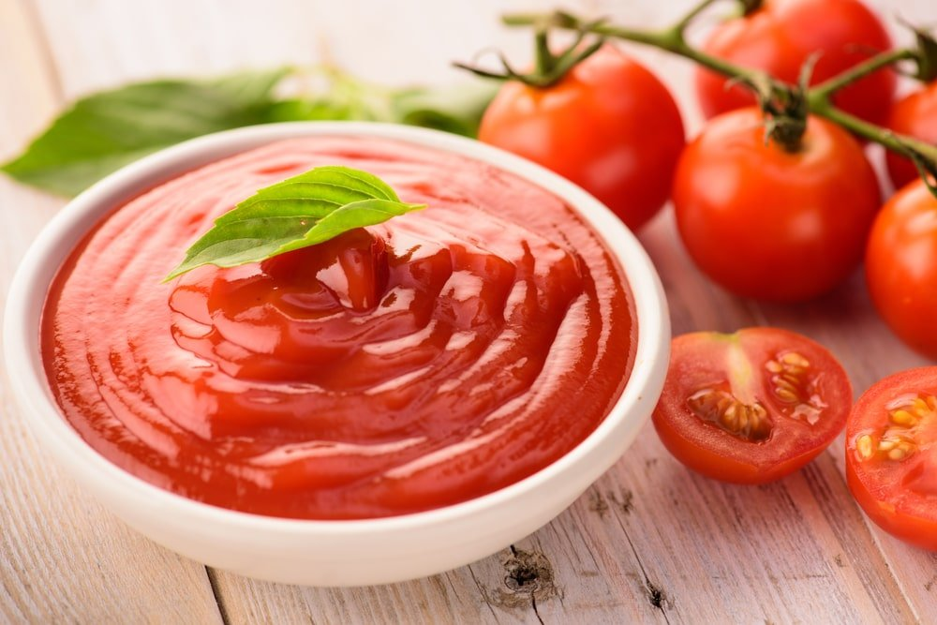
KETCHUP IS A TOMATO-BASED CONDIMENT (WITH VINEGAR, SEASONINGS AND SUGAR) THAT IS A STAPLE OF AMERICAN CUISINE. IT IS EXTREMELY POPULAR TO USE WITH FRENCH FRIES, BURGERS AND HOT DOGS. SOME LOVE IT WITH MAC AND CHEESE.

MAPLE SYRUP

MAPLE SYRUP IS A CONCENTRATED SWEETENER MADE FROM THE SAP OF THE MAPLE TREE. MAPLE SYRUP COMES IN DIFFERENT GRADES THAT ARE COLOR-CODED FOR QUALITY AND PRICE. THE DARKER THE GRADE OF SYRUP, THE MORE HEAT AND FLAVOR IT HAS -AND USUALLY A HIGHER PRICE AS WELL.

MARINARA SAUCE
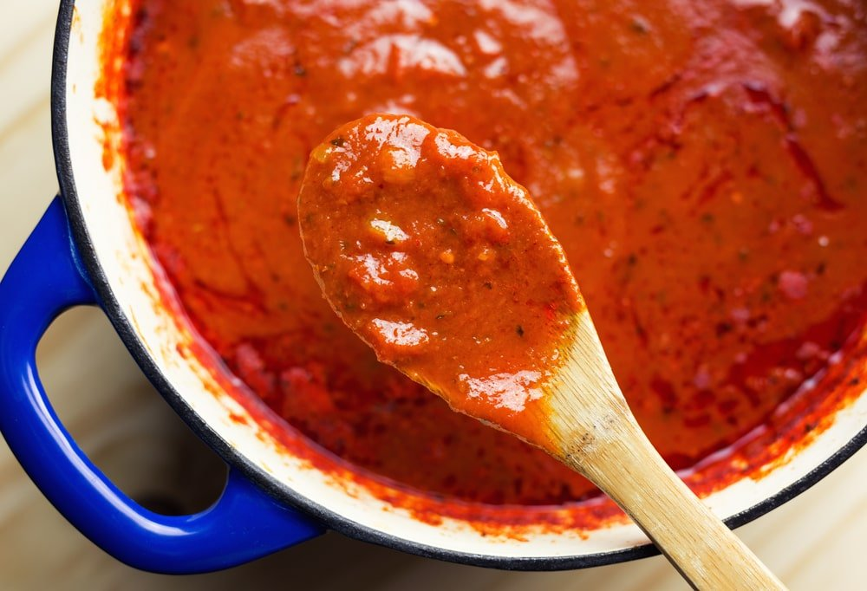
MARINARA SAUCE IS A RED TOMATO BASED SAUCE. IT COMES IN A JAR OR CAN AND CAN BE USED FOR MANY DIFFERENT RECIPES, SUCH AS PASTA DISHES, PIZZA AND STIR-FRY.

MAYONNAISE
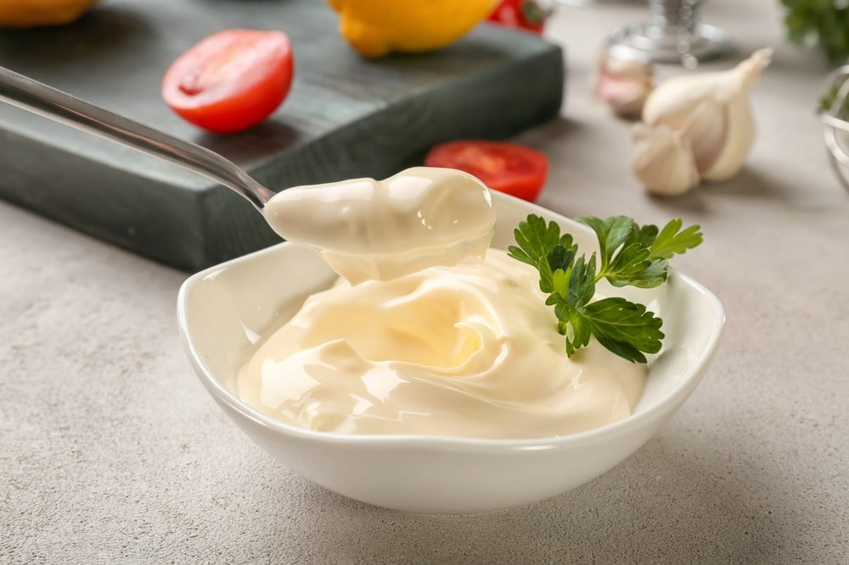
MAYONNAISE IS A TANGY, EGG-BASED CONDIMENT THAT IS POPULAR ON SANDWICHES, CERTAIN SALADS, AND FRENCH FRIES.

OLIVE OIL
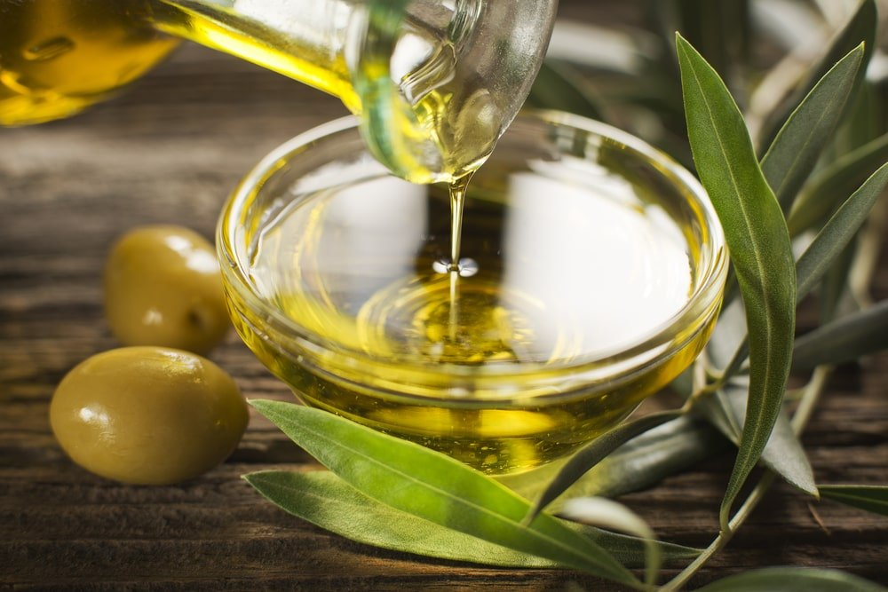
OLIVE OIL IS EXTREMELY VERSATILE, AS IT CAN BE USED AS A SALAD DRESSING, A DIPPING SAUCE, OR EVEN A FLAVOR ENHANCER FOR PASTA.
IT COMES FROM RIPE OLIVES. OLIVE OIL CAN BE USED FOR COOKING, BAKING, MARINATING AND EVEN MAKING SALAD DRESSINGS.

OYSTER SAUCE
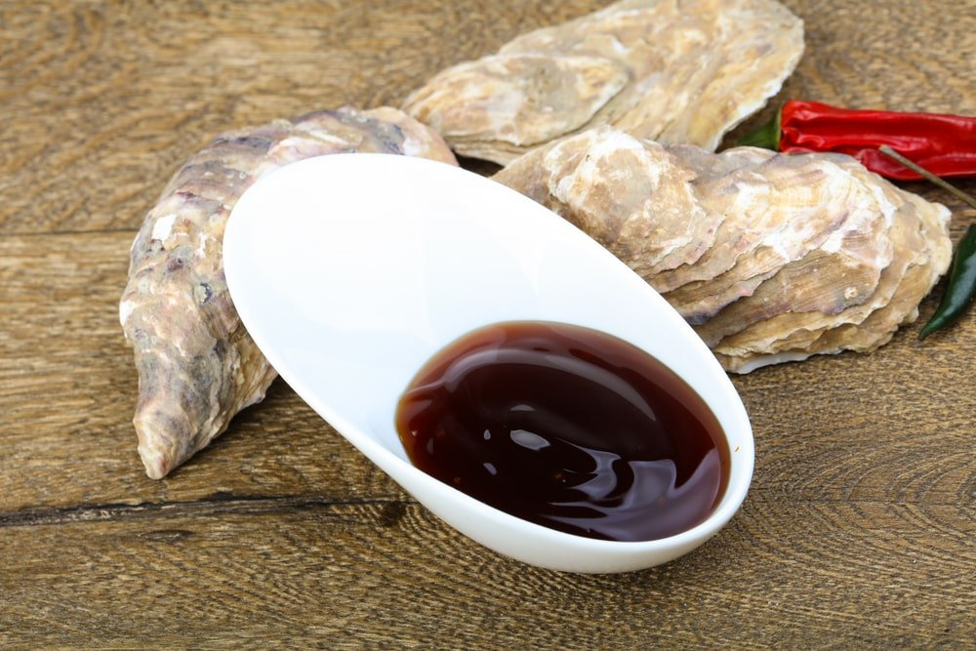
THE OYSTER SAUCE HAS A VERY DISTINCTIVE, SALTY FLAVOR THAT IS POPULAR IN ASIAN CUISINE FOR FLAVORING SEAFOOD, MEAT AND VEGETABLES.
IT’S MADE BY MIXING OYSTERS WITH WATER AND THICKENING AGENTS.

PEANUT BUTTER
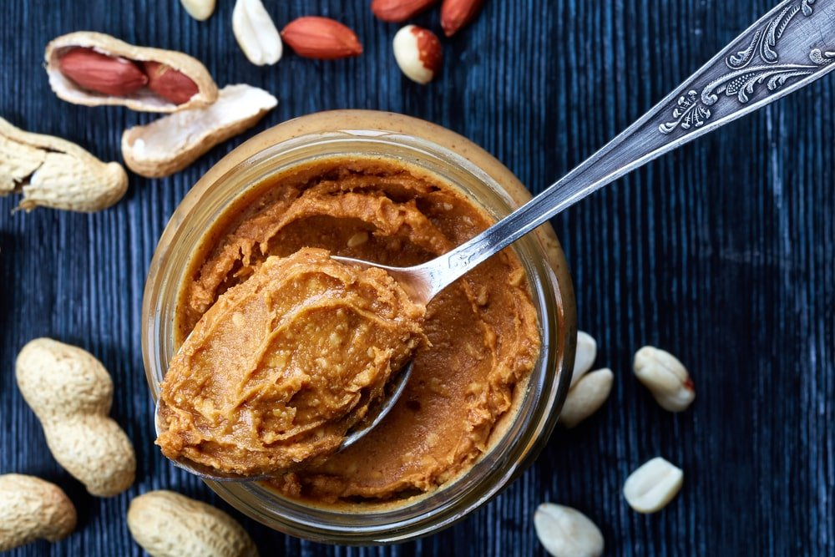
WHILE ALMOST EVERYONE KNOWS ABOUT PEANUT BUTTER AND JELLY SANDWICHES, PEANUT BUTTER ACTUALLY HAS A LOT OF DIFFERENT USES. IT CAN BE USED AS A CONDIMENT OR DIPPING SAUCE FOR FOODS LIKE CELERY, APPLES, AND CRACKERS.
IT IS A COMPOUND MADE FROM GROUND PEANUTS. IT CAN BE FLAVORED WITH SALT TO TASTE. IT CAN ALSO INCLUDE CRUSHED PEANUTS FOR “CRUNCHY PEANUT BUTTER.”

PEANUT SAUCE
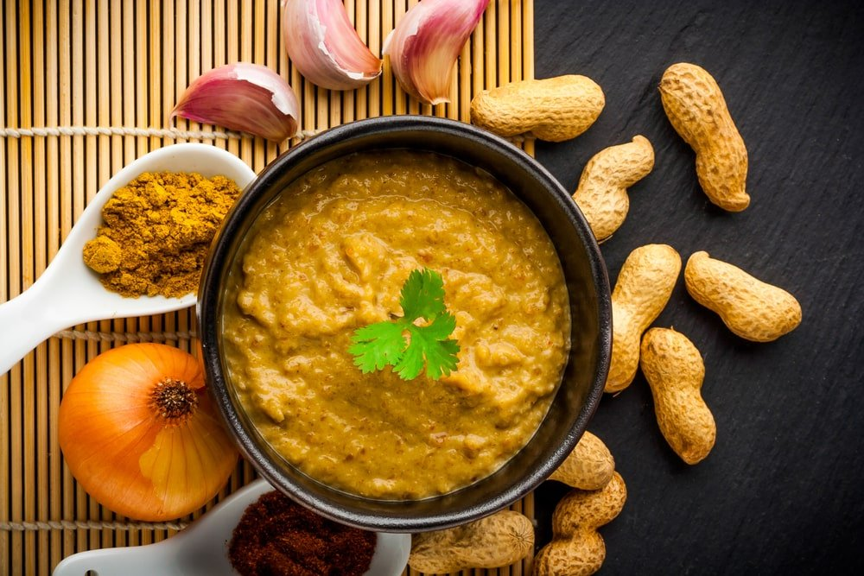
PEANUT SAUCE IS MADE FROM GROUND PEANUTS AND VEGETABLES, SUCH AS WATER CHESTNUTS, CARROTS, CABBAGE OR GREEN ONIONS. IT HAS A SALTY FLAVOR THAT IS SIMILAR IN TASTE TO PEANUT BUTTER.
IT’S RARELY USED IN WESTERN DISHES. AS A RESULT, ITS UNIQUE FLAVORS ARE GENERALLY ASSOCIATED WITH THE CUISINE OF SOUTHEAST ASIA.

PESTO
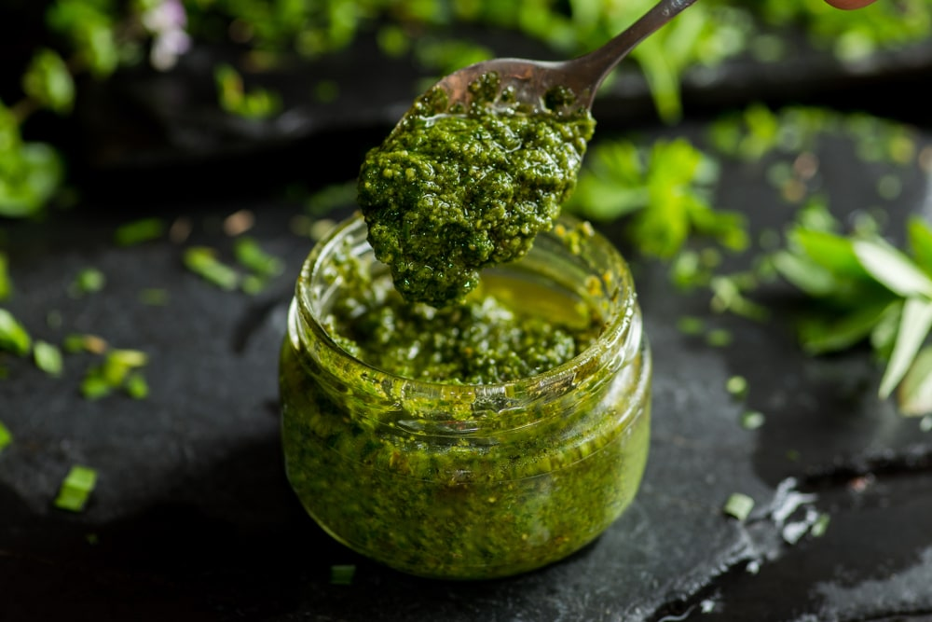
PESTO IS A CONDIMENT THAT ORIGINATED IN ITALY AND IS MADE USING GARLIC, PINE NUTS, SALT, AND BASIL. IT COMES FROM THE WORD “PESTARE”, WHICH MEANS TO POUND OR CRUSH IN ITALIAN.

RANCH DRESSING
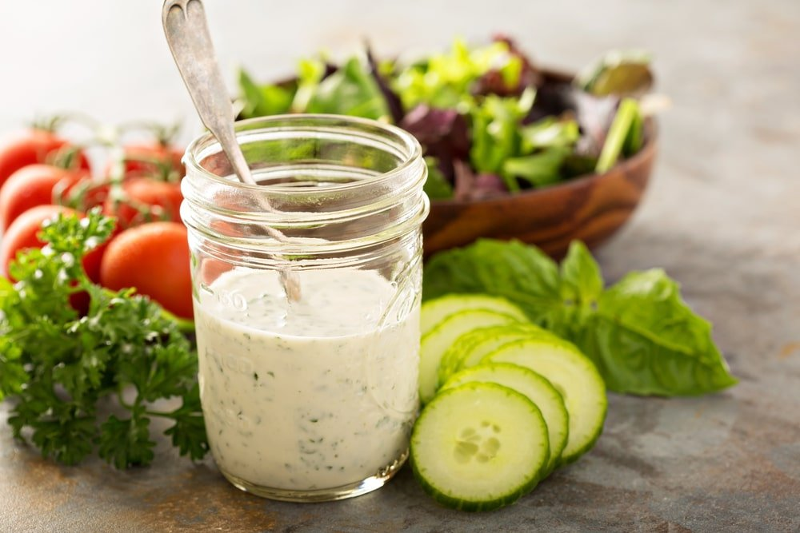
RANCH DRESSING WAS CREATED FROM A RECIPE THAT CALLED FOR BUTTERMILK, SOUR CREAM AND MAYONNAISE. AS IT BECAME MORE POPULAR, OTHER DRESSINGS STARTED TO BE ADDED SUCH AS GREEN ONIONS, GARLIC SALT, CHIVES AND SOMETIMES PAPRIKA OR CAYENNE PEPPER FOR A LITTLE SPICE.

RELISH
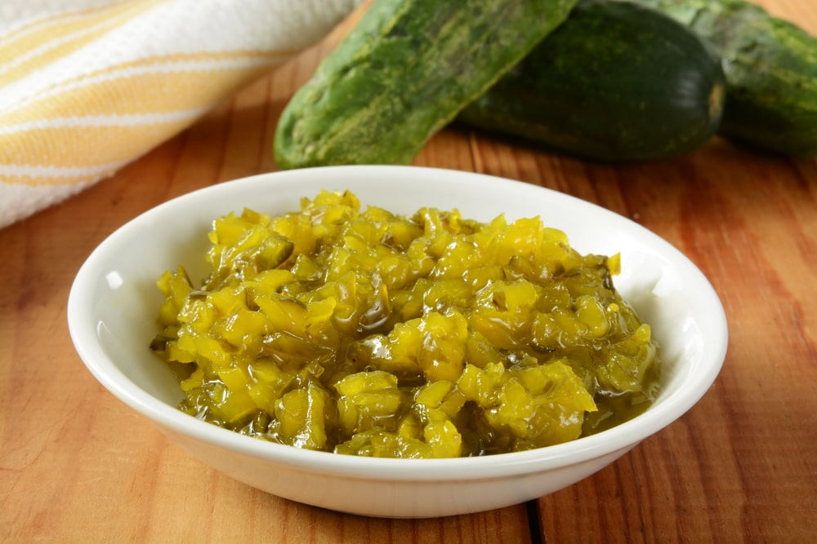
RELISH IS A CONDIMENT MADE FROM PICKLED VEGETABLES AND HERBS. IT CAN BE USED AS AN INGREDIENT IN CERTAIN SALADS, THOUGH IT IS MORE COMMONLY USED AS A CONDIMENT ON HOT DOGS.

SALSA
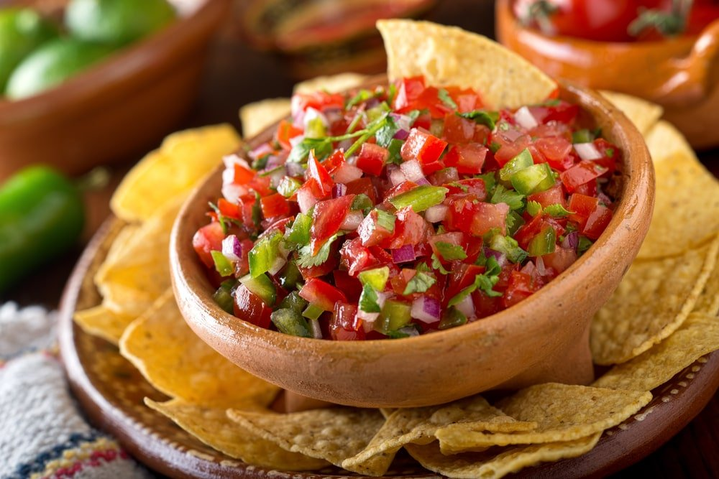
SALSA ORIGINALLY COMES FROM MEXICAN CUISINE AND IS A TOMATO AND ONION-BASED SAUCE THAT CAN BE ADDED TO TACOS, TORTILLA CHIPS, AND EVEN OMELETS.

SOY SAUCE
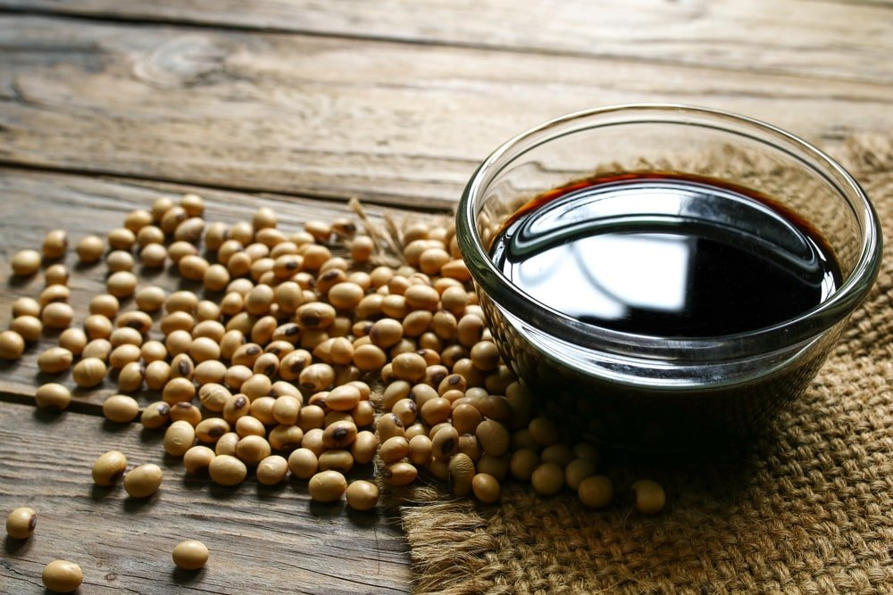
SOY SAUCE IS A CHINESE SAUCE THAT IS MADE FROM FERMENTED SOYBEAN. IT IS GENERALLY USED IN SMALL QUANTITIES, AS IT HAS A STRONG, SALTY TASTE.

SRIRACHA
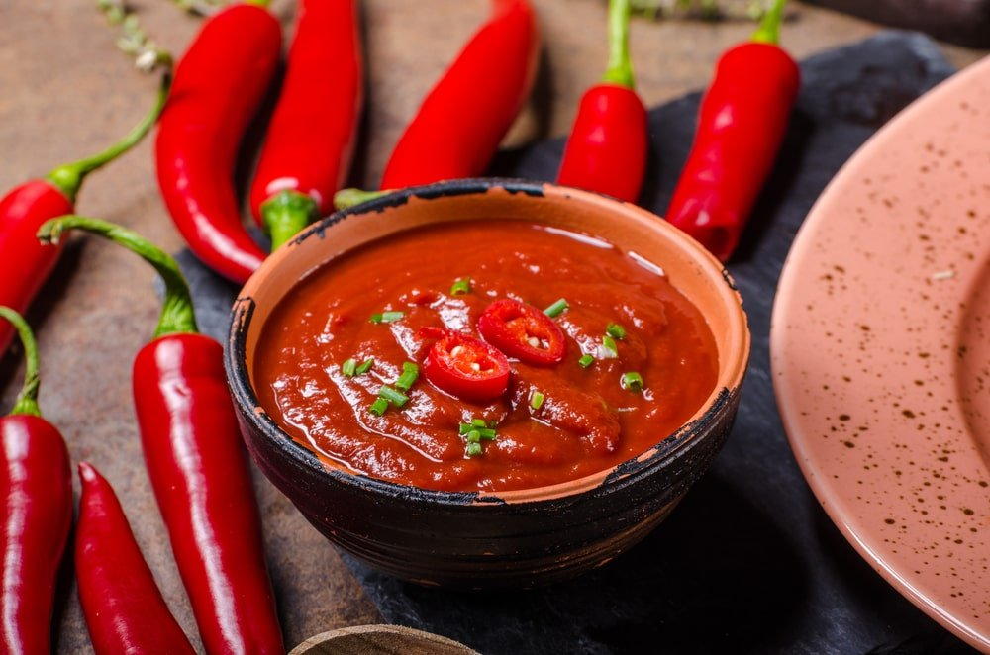
SRIRACHA IS A SPICY CONDIMENT DERIVED FROM CHILI PEPPERS.
IT HAS A SPICY FLAVOR THAT’S SIMILAR TO TABASCO SAUCE, BUT WITH MORE SPICE FROM THE RED CHILIES. SRIRACHA IS MADE FROM RED JALAPEÑO AND FRESNO PEPPERS AS WELL AS VINEGAR AND GARLIC.

STEAK SAUCE
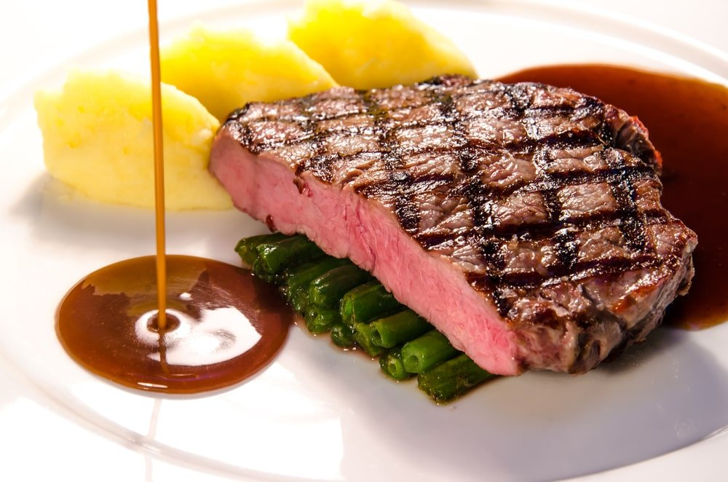
THERE ARE TONS OF DIFFERENT BRANDS OF STEAK SAUCE, BUT THE MAJORITY USE TOMATOES, VINEGAR, AND SPICES TO ENHANCE THE FLAVOR OF A CUT OF BEEF.

SWEET AND SOUR SAUCE
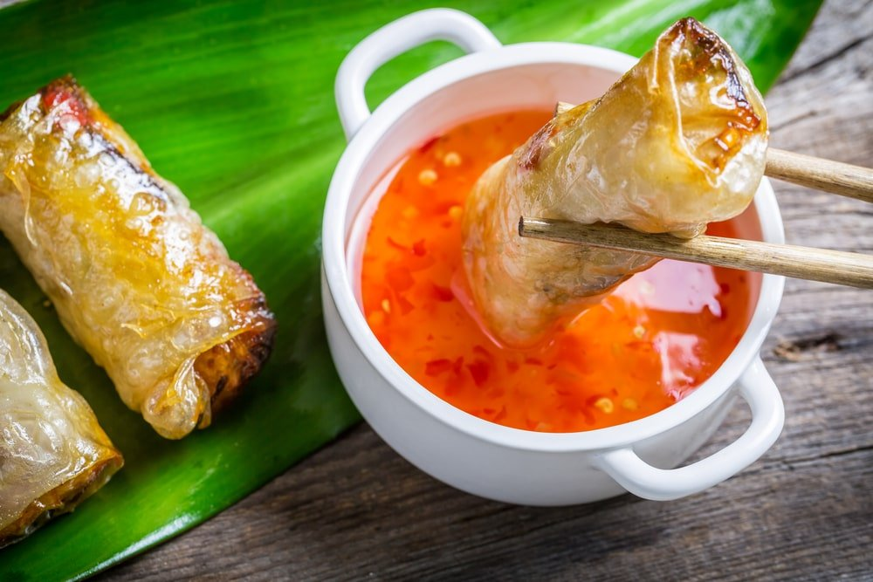
TRADITIONALLY USED IN ASIAN CUISINE, THE SWEET AND SOUR SAUCE IS NOW POPULAR AROUND THE WORLD. RECIPES AND FLAVORS VARY BY REGION, BUT AS THE NAME IMPLIES, THIS CONDIMENT PRODUCES BOTH SWEET AND SOUR FLAVORS.

TARTAR SAUCE
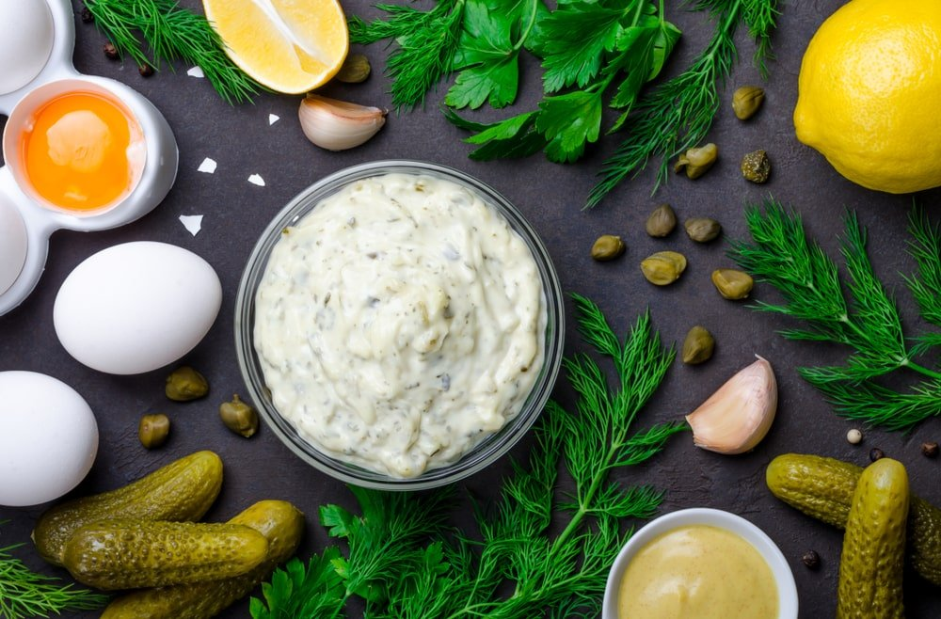
TARTAR SAUCE IS A CONDIMENT MADE USING MAYONNAISE, SWEET PICKLE RELISH, HORSERADISH OR MINCED CAPERS. IT IS ALMOST EXCLUSIVELY USED WITH SEAFOOD DISHES.

TERIYAKI SAUCE
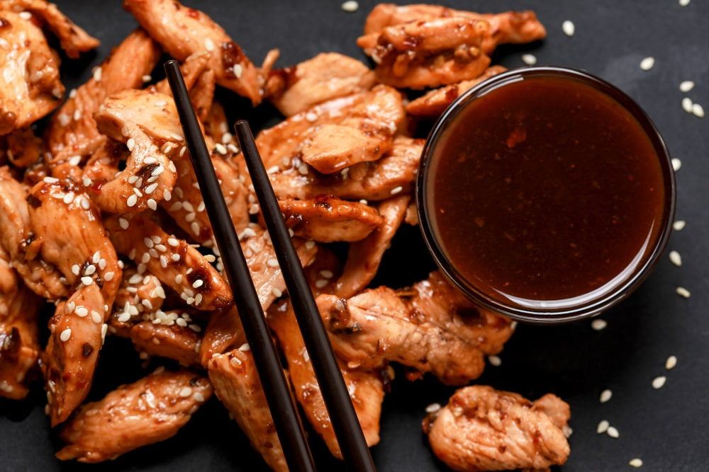
TERIYAKI SAUCE IS USED TO COMPLEMENT MANY JAPANESE MEALS AND IS A PRIMARY INGREDIENT IN TERIYAKI CHICKEN, AMONG OTHER THINGS.

THOUSAND ISLAND DRESSING
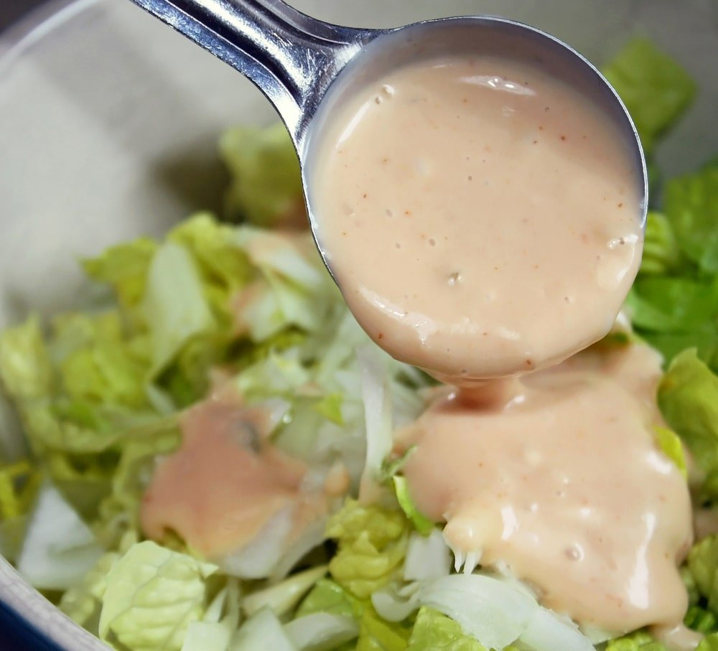
THOUSAND ISLAND DRESSING IS A CREAMY DRESSING THAT’S MADE WITH MAYONNAISE, KETCHUP, SWEET PICKLE RELISH AND SPICES SUCH AS PARSLEY, BASIL OR DILL. THE EXACT INGREDIENTS VARY BY BRAND AND REGION, BUT A THOUSAND ISLAND DRESSING USUALLY HAS A VERY CREAMY TEXTURE AND TANGY FLAVOR.

TOMATO PASTE
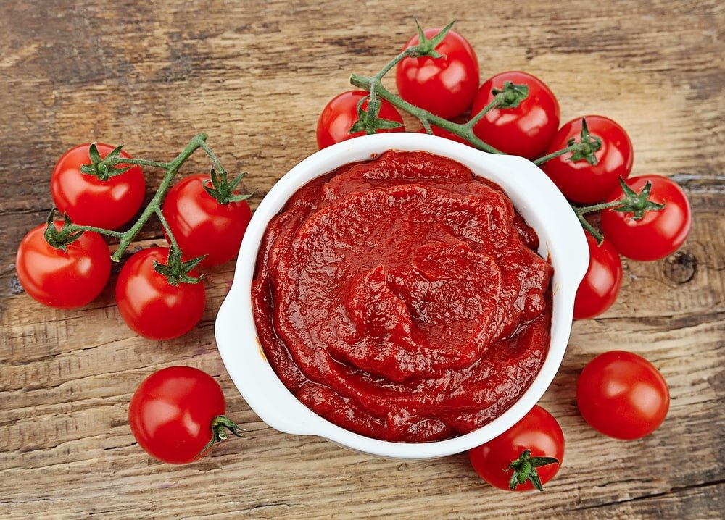
SIMILAR TO KETCHUP, TOMATO PASTE IS MADE BY COOKING TOMATOES DOWN TO A CONCENTRATED FORM. THOUGH KETCHUP IS MUCH MORE POPULAR AS A CONDIMENT, TOMATO PASTE IS AN ADEQUATE SUBSTITUTE.

WASABI
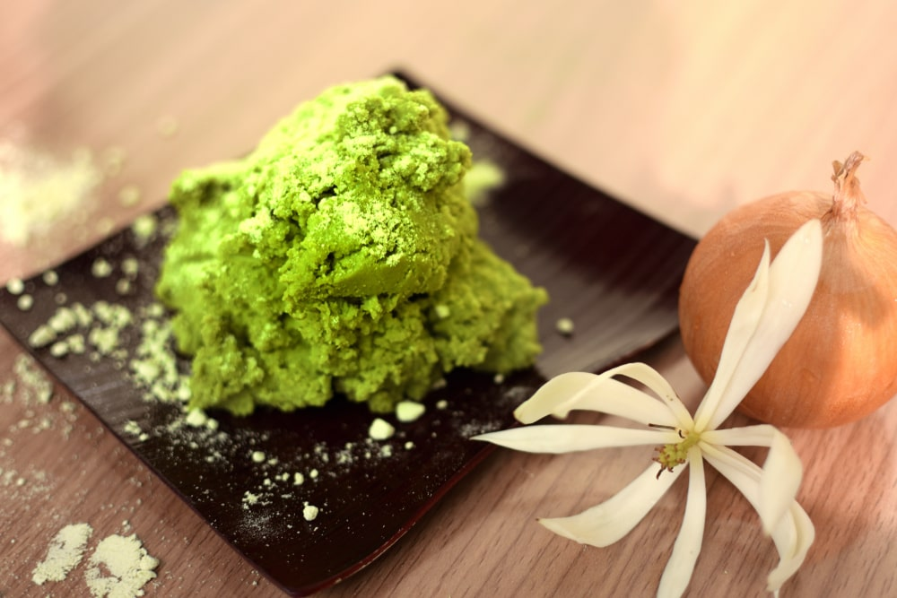
WASABI IS A SPICY CONDIMENT THAT HAILS FROM JAPAN. THOUGH IT CAN BE USED WITH A VARIETY OF FOODS, WASABI IS GENERALLY USED ALONGSIDE SOY SAUCE AS A CONDIMENT FOR SUSHI.
IT IS A GREEN PASTE THAT HAS A SPICY FLAVOR. IT’S MADE FROM HOT CHILIES AND SOMETIMES HORSERADISH AND MUSTARD. WASABI IS USUALLY SERVED WITH SUSHI, BUT IT CAN ALSO BE USED AS A CONDIMENT OR EVEN IN SANDWICHES, IF MIXED WITH CREAM CHEESE OR MAYONNAISE.

WORCESTERSHIRE SAUCE
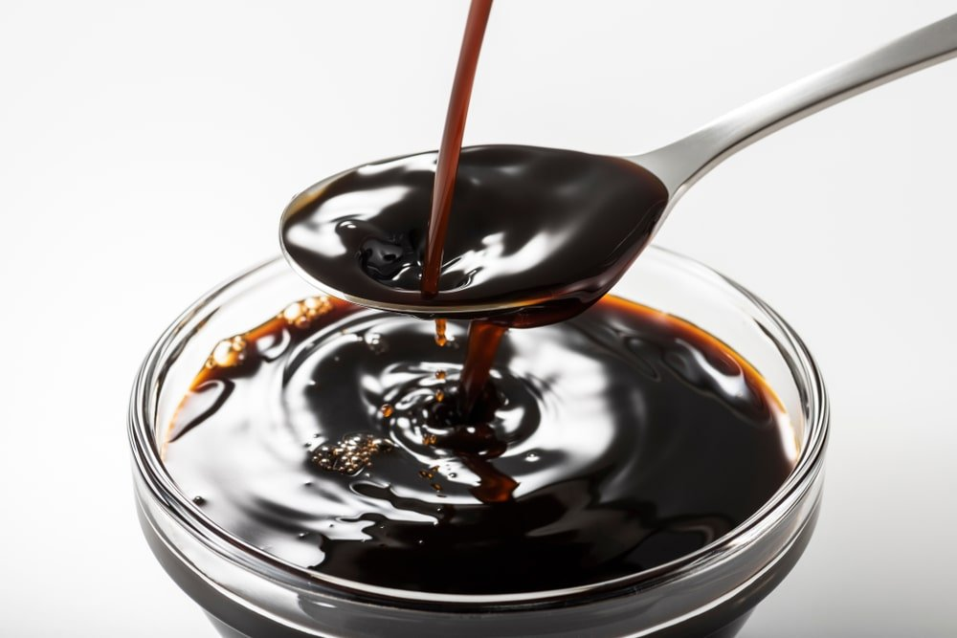
WORCESTERSHIRE SAUCE ORIGINATES FROM THE UK AND IS A SOURCE OF UMAMI FLAVORINGS. IT IS PRIMARILY COMPRISED OF VINEGAR, SALT, ONIONS, AND VARIOUS SPICES.

YELLOW MUSTARD
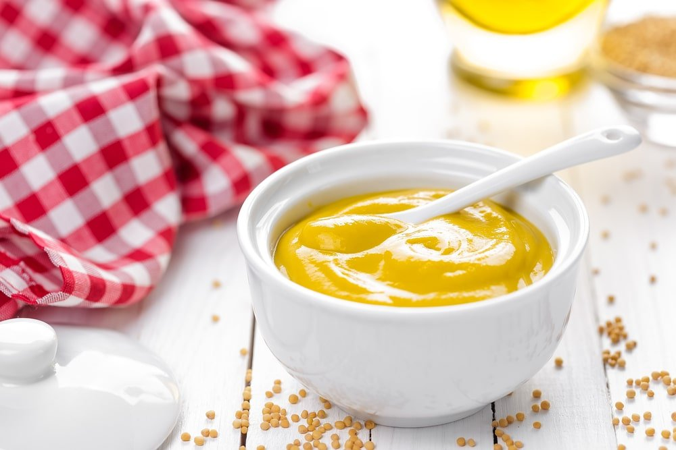
YELLOW MUSTARD IS POPULAR AS BOTH A COOKING INGREDIENT AND A CONDIMENT. IN THE UNITED STATES, MUSTARD IS COMMONLY USED ON HOT DOGS, SAUSAGES (MY FAVE) AND HAMBURGERS.
IT’S MADE FROM THE SEEDS OF THE MUSTARD PLANT. MUSTARD IS COMMONLY SERVED FOR SANDWICHES, CAN BE USED AS A SALAD DRESSING OR EVEN AS PART OF A MARINADE. THERE ARE MANY DIFFERENT TYPES OF MUSTARD, INCLUDING YELLOW MUSTARD AND DIJON MUSTARD.

DAIRY

BLUE CHEESE
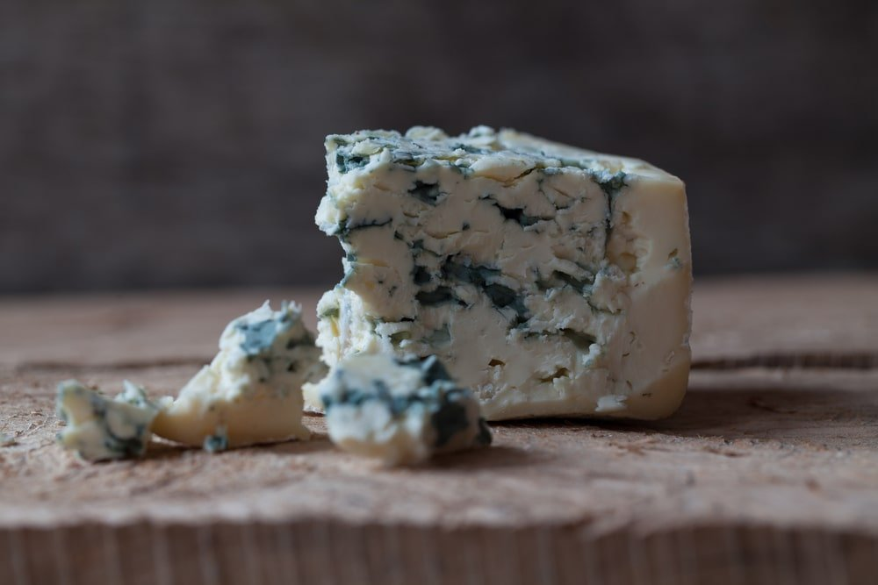
BLUE CHEESE CAN BE USED AS A CONDIMENT IN THE FORM OF A SPREAD OR A CREAMY SALAD DRESSING.
BLUE CHEESE CAN BE EITHER WHITE OR ORANGE IN COLOR AND HAS A CRUMBLY TEXTURE. IT’S VERY PUNGENT AND IS USUALLY USED AS A TOPPING FOR SALADS, STEAK OR BURGERS.

BUTTER
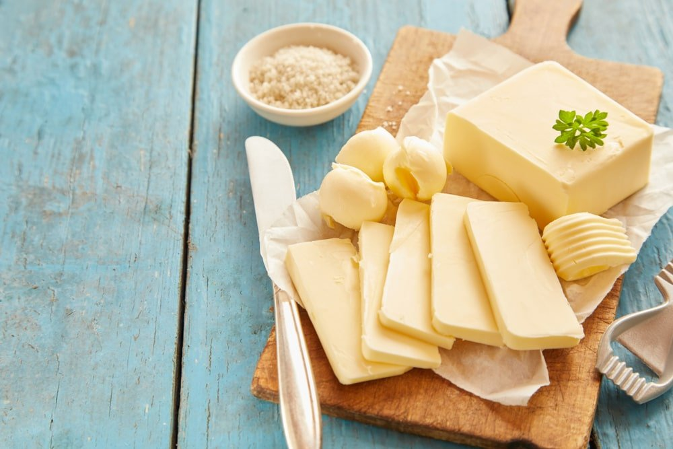
BUTTER IS ONE OF THE MOST COMMON FLAVOR ENHANCERS IN THE WORLD. WHETHER YOU WANT TO SPREAD IT ON TOAST OR MELT IT DOWN INTO A LOBSTER DIPPING SAUCE, BUTTER IS A GREAT CONDIMENT FOR JUST ABOUT ANY MEAL.
IT’S A DAIRY PRODUCT MADE BY CHURNING CREAM.

CREAM CHEESE
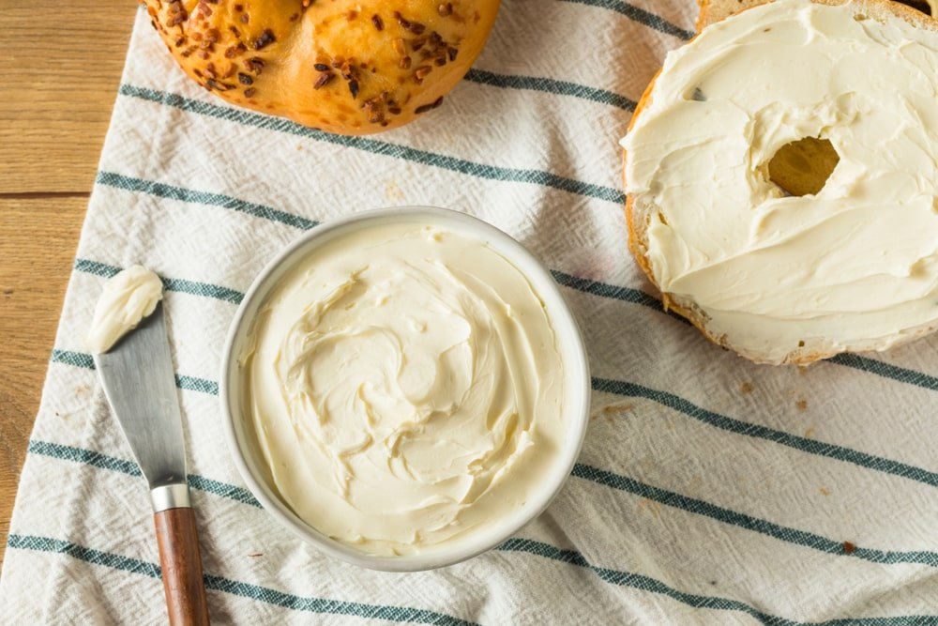
CREAM CHEESE IS A POPULAR SPREAD FOR MANY BAKED GOODS AND BREAKFAST FOODS IN EUROPE AND NORTH AMERICA. ITS FLAVOR IS VERY SIMILAR TO THAT OF MASCARPONE CHEESE.
IT’S A DAIRY PRODUCT THAT’S MADE WITH MILK AND EGGS. IT’S USED AS A TOPPING ON DESSERTS, AS AN INGREDIENT IN DIPS OR EVEN AS SPREAD FOR BAGELS.

FETA CHEESE
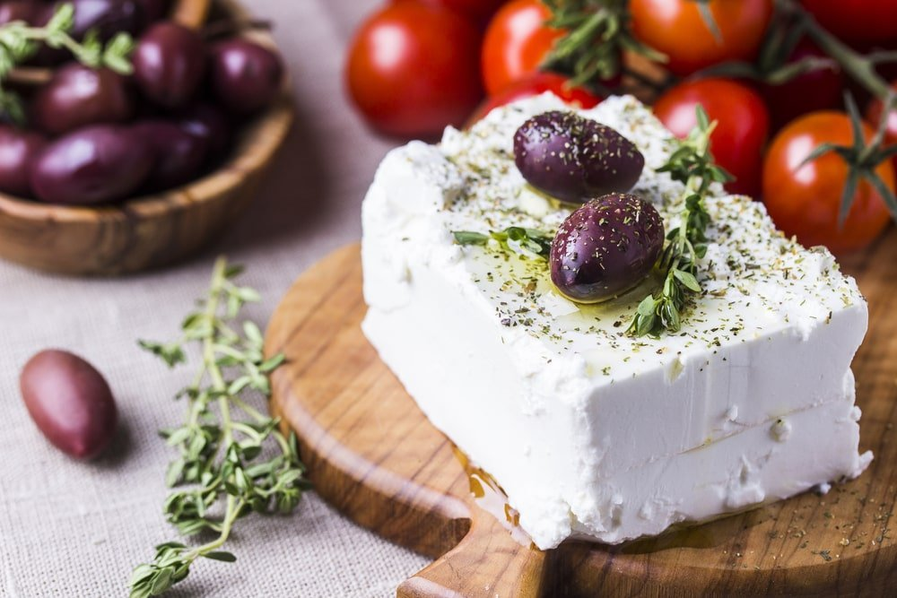
FETA CHEESE HAILS FROM GREECE AND IS GENERALLY MADE USING SHEEP OR GOAT’S MILK. FETA CHEESE CAN BE TURNED INTO A SALAD DRESSING, OR COMBINED WITH VEGETABLES AS PART OF SALSA. IT’S A CRUMBLY, SALTY CHEESE (ONE OF MY FAVORITE CHEESES).

PARMESAN CHEESE
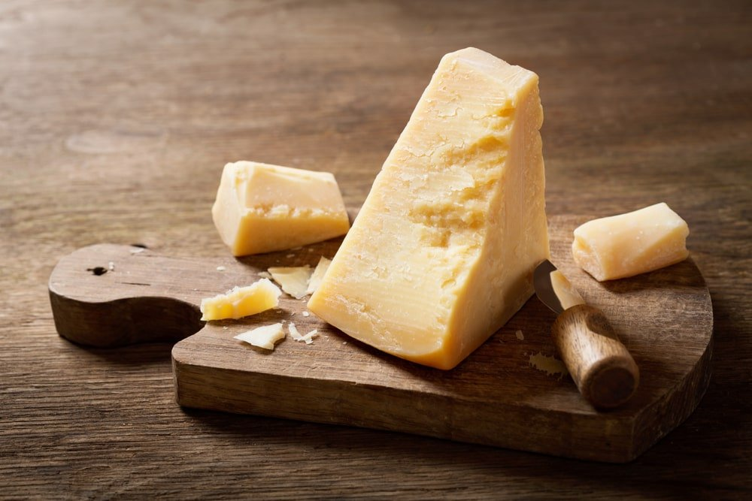
WHEN GROUND UP OR MADE INTO SHAVINGS, PARMESAN CHEESE IS AN EXTREMELY POPULAR CONDIMENT FOR SOUPS, PASTA, AND SALADS.

RICOTTA CHEESE
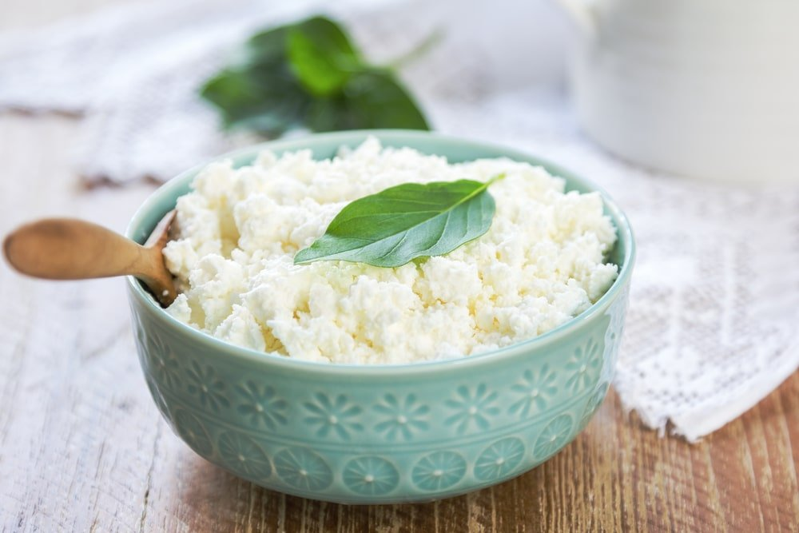
RICOTTA CHEESE IS A POPULAR ITALIAN CHEESE THAT CAN BE TURNED INTO A CREAMY, DELICIOUS DIPPING SAUCE FOR BREAD, CRACKERS, AND SIMILAR FINGER FOODS.

SOUR CREAM
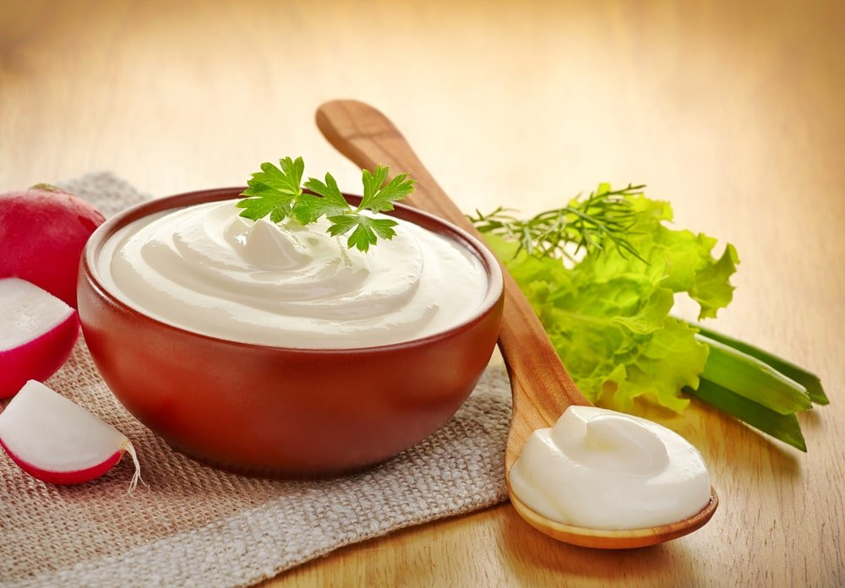
AS THE NAME IMPLIES, SOUR CREAM IS PRODUCED BY FERMENTING TRADITIONAL CREAM. THE SOUR FLAVOR GOES GREAT WITH A WIDE VARIETY OF FOODS, FROM SALAD TO NACHOS.

WHIPPED CREAM

WHIPPED CREAM CAN BE MADE FRESH OR BOUGHT IN A CAN. EITHER WAY, WHIPPED CREAM IS A PERFECT CONDIMENT TO ADD EXTRA SWEETNESS TO YOUR ICE CREAM, CAKE, OR FRUIT SALAD.
IT IS MADE BY AGITATING A MIXTURE OF HEAVY CREAM AND SUGAR UNTIL THE MIXTURE BECOMES FROTHY AND LIGHT. IT CAN BE USED TO TOP PIES, CAKES OR OTHER DESSERTS, BUT IT’S ALSO USED IN MANY DESSERTS AS AN INGREDIENT.

HERBS
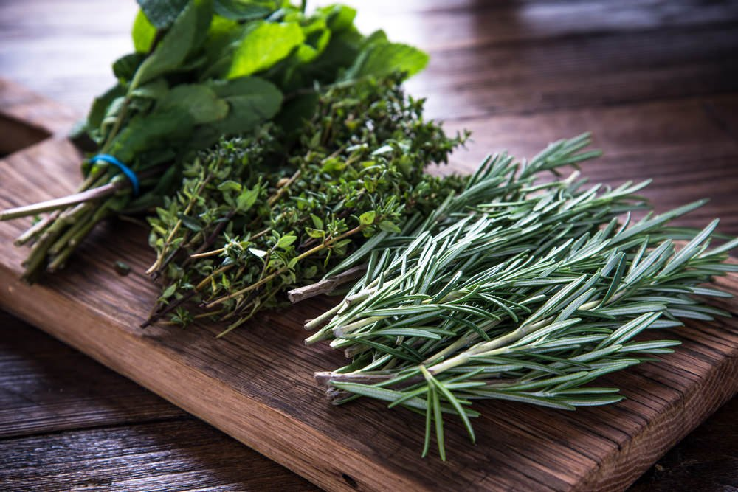
THERE ARE MANY HERBS YOU CAN USE IN COOKING TO ADD FLAVOR. BECAUSE THERE ARE SO MANY AND IT’S A TOPIC UNTO ITS OWN, WE HAVE A MEGA LIST OF HERBS HERE.

SPICES
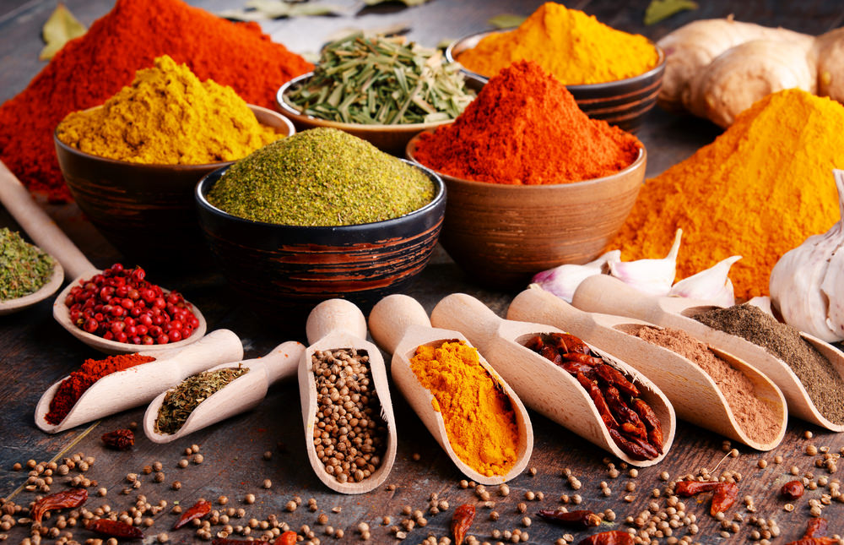
SPICES OF ALL KINDS ARE USED TO “SPICE” UP FOOD WHICH IS ESSENTIALLY ADDING FLAVOR. LIKE HERBS, BECAUSE IT’S A HUGE LIST, WE HAVE A DEDICATED LIST OF THE DIFFERENT TYPES OF SPICES HERE.

THE 29 DIFFERENT TYPES OF FOOD (EPIC FOOD CATEGORIZATION RESOURCE)
YEAH, IT'S KIND OF A WEIRD TITLE BUT THIS IS AN EPIC FOOD CATEGORIZATION ARTICLE THAT BREAKS DOWN FOOD BY VEGETABLE, FRUIT, MEAT, SEAFOOD, DAIRY AND BAKED GOODS. INCLUDES NUMEROUS NUTRITIONAL FACTS CHARTS.
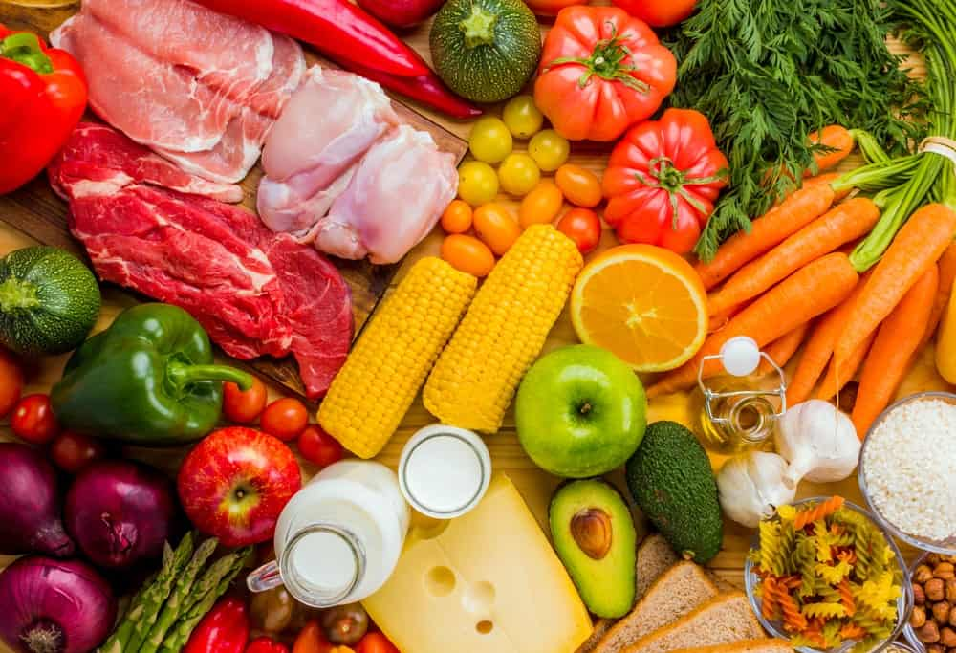
WHEN DISCUSSING THE DIFFERENT TYPES OF FOOD, WHAT WE’RE REALLY TALKING ABOUT ARE THE DIFFERENT CATEGORIES OF FOOD.

HERE’S A LIST OF THE MAIN FOOD CATEGORIES:
- VEGETABLES
- FRUITS
- MEAT
- DAIRY
- GRAINS
- LEGUMES
- BAKED GOODS
- SEAFOOD
- NUTS AND SEEDS
- HERBS AND SPICES
- GARNISHES
EACH CATEGORY INCLUDES ITS OWN LIST OF FOODS WHICH WE SET OUT IN DETAIL BELOW.
RELATED: TYPES OF CONDIMENTS | TYPES OF GARNISH | TYPES OF HERBS | VEGETABLES AND HERBS | TYPES OF FRUIT TREES | TYPES OF BEANS AND LEGUMES | TYPES OF MUSHROOMS | TYPES OF BREAD | TYPES OF MILK | TYPES OF NUTS | TYPES OF SPICES
LET’S DIVE IN… HERE’S OUR LIST SETTING OUT ALL KINDS OF FOODS.

TYPES OF VEGETABLES
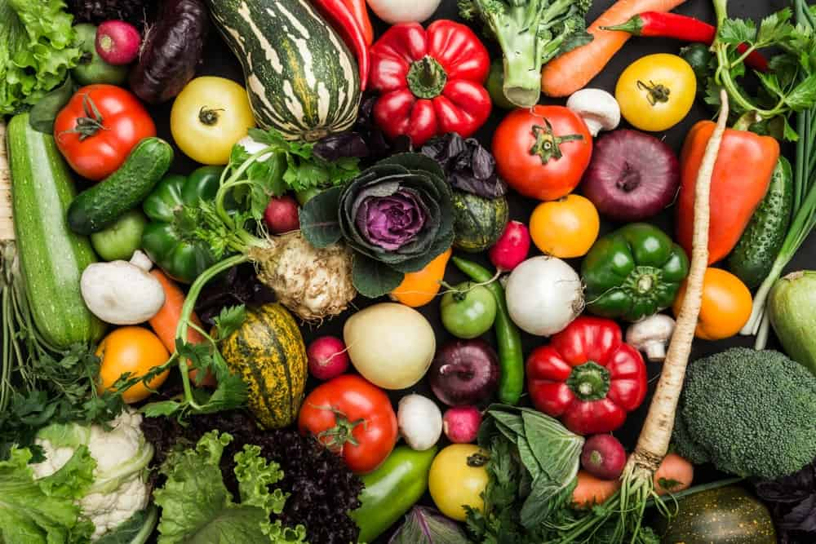
IT’S HARD TO THINK OF A WORLD WITHOUT VEGETABLES AS THEY HAVE BEEN A MAJOR PART OF A HUMAN’S DIET SINCE FOREVER. THE MOST MIND-BLOWING FEATURE ABOUT VEGGIES IS THAT THEY ARE EXCEEDINGLY VERSATILE.
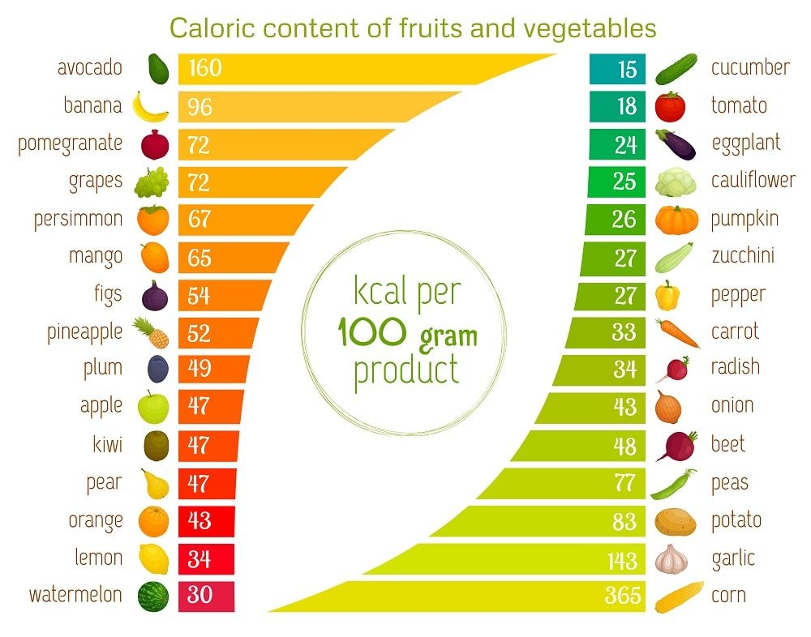
YOU CAN HAVE THEM RAW, COOKED, FROZEN, OR EVEN IN THE FORM OF JUICES. DEPENDING ON THEIR COLOR, FLAVOR, TEXTURES, AND NUTRITION QUALITY, VEGETABLES CAN BE DIVIDED INTO NINE FAMILIES (MENTIONED BELOW):

1. ASTERACEAE FAMILY
ALSO KNOWN AS THE DAISY FAMILY OR COMPOSITE FAMILY, AESTERACEAE IS ONE BIG HAPPY FAMILY OF OVER 23,000 SPECIES OF DAISIES. IT IS MOSTLY COMPOSED OF EDIBLE FLOWERING PLANTS AS WELL AS SOME HERBACEOUS PLANTS.
THE MOST COMMON VEGETABLES IN THE COMPOSITE FAMILY INCLUDE LETTUCE, ARTICHOKE, ENDIVE, CHICORY, CHAMOMILE, AND TARRAGON.

2. ALLIACEAE FAMILY
THERE ARE SOME VEGETABLES THAT ARE ALWAYS STOCKED OR RESTOCKED TIME AND TIME AGAIN IN OUR PANTRY. THESE ARE THE KINDS OF VEGETABLES THAT YOU MOST COMMONLY USE IN YOUR COOKING.
THEY ARE, AFTER ALL, WHAT WE CALL THE STAPLE FOOD THAT SHOULD BE PRESENT IN EVERY PERSON’S KITCHEN. IF YOU HAVEN’T GUESSED IT BY NOW, THEN LET US TELL YOU THAT THEY ARE ALLIUM VEGETABLES – GARLIC, ONION, CHIVES, LEEK, AND SHALLOT.
THE IMPORTANCE OF THESE VEGETABLES LIES IN THE FACT THAT THEY HELP PROTECT THE CONSUMER AGAINST LIFE-THREATENING ILLNESSES LIKE CANCER AND CARDIOVASCULAR DISEASE.

3. BRASSICACEAE FAMILY
THE MAJOR PART OF BRASSICACAEAE FAMILY INCLUDES CRUCIFEROUS VEGETABLES, ALSO CALLED AS, GREEN LEAFY VEGGIES. THE NUTRIENT CONTENT OF THESE VEGETABLES IS SUPER HIGH AS THEY ARE PACKED WITH VITAMINS AND FIBER.
THE HEALTHY VEGETABLES THAT BELONG TO THIS FAMILY ARE CAULIFLOWER, BROCCOLI, COLLARD GREENS, BRUSSEL SPROUTS, CABBAGE, TURNIP, MUSTARD, WASABI, RADISH, CRESS, HORSERADISH, KALE, AND KOHLRABI.

4. CUCURBITACEAE FAMILY
IF YOU ARE LOOKING FOR SOME GREAT SUMMER VEGGIES, THEN YOU WILL FIND SOME IN CUCURBITACEASE FAMILY (THE GOURD FAMILY). THE MOST POPULAR AND HEALTHY GOURDS ARE CUCUMBER, ZUCCHINI, SQUASH, LUFFA, CANTALOUPE, AND PUMPKIN.

5. SOLANACEAE FAMILY
COMMONLY KNOWN AS THE POTATO FAMILY, THIS VEGETABLE FAMILY FEATURES EVERYONE’S ABSOLUTE DELIGHT – POTATOES.
IN ADDITION TO POTATOES, IT INCLUDES OTHER NUTRITIOUS VEGGIES SUCH AS ARE EGGPLANT, PEPPER, PAPRIKA, CHILE PEPPER.

6. FABACEAE FAMILY
GET YOUR DAILY DOSE OF PROTEIN BY HAVING BEANS, LEGUMES, AND LENTILS BELONGING TO THE FABACEAE FAMILY. THEY ALSO HAPPEN TO BE AN EXCELLENT CHOICE FOR ALL VEGANS AND VEGETARIANS AS THEY OFFER A HIGH QUANTITY OF PROTEIN. SOYBEANS, LUPIN, CLOVER, LENTIL, AND PEAS ARE SOME OF THE MEMBERS OF FABAECEAE FAMILY.

7. APIACEAE FAMILY
MORE COMMONLY REFERRED TO AS THE PARSLEY FAMILY, APIACEAE FAMILY MAINLY CONSISTS OF ROOT VEGETABLES AND SPICES THAT ARE USED AS A FLAVORING IN ALL KINDS OF CUISINES, FROM ASIAN TO CHINESE TO EUROPEAN.
SOME OF THE VEGETABLES THAT IT INCLUDES ARE A CARROT, CUMIN, DILL, FENNEL, CELERY, CORIANDER, CILANTRO, PARSNIP, AND OF COURSE, PARSLEY.

8. AMARANTHACEAE FAMILY
YOU MAY NOT KNOW THIS BUT SOME OF THE MOST DISTINCT VEGETABLES COME OUT OF THIS BEETROOT FAMILY. PLUS, THEY OFFER A RICH AMOUNT OF VITAMINS – FOLATES, RIBOFLAVIN, THIAMIN, AND NIACIN TO THEIR CONSUMERS.
THESE ORGANIC VEGGIES ARE BEETROOT, SPINACH, QUINOA, AMARANTH, GOOSEFOOT, SUGAR BEET, AND SWISS CHARD.

9. POACEAE FAMILY
VEGETABLES BELONGING TO THIS FAMILY ARE A STAPLE IN MANY KINDS OF DIETS. WHAT THESE VEGGIES ARE, YOU ASK? THEY ARE CORN, OATS, BARLEY, WHEAT, SUGARCANE, RICE, RYE, BARLEY, AND A MALLET.

10. FUNGI
MUSHROOMS ARE TECHNICALLY FUNGI BUT OFTEN LUMPED IN UNDER THE “VEGETABLE” UMBRELLA SINCE THEY GROW. THEY AREN’T TECHNICALLY VEGETABLES BUT INSTEAD FUNGI. THAT DOES NOT MEAN MUSHROOMS AREN’T HEALTHY OR DON’T PROVIDE NUTRIENTS; THEY DO.

TYPES OF FRUITS
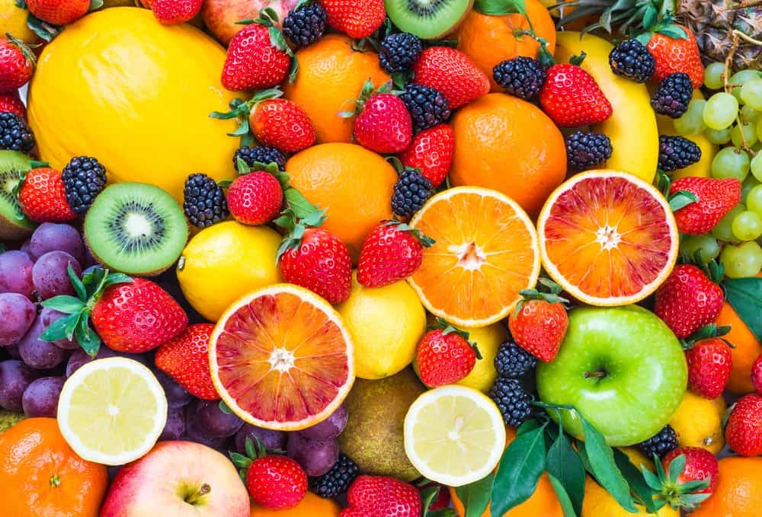
WE DON’T THINK THERE IS ANY PERSON IN THIS WHOLE WIDE WORLD WHO MAY NOT LIKE FRUITS. DUE TO THEIR LOVELY FLAVORS AND PLENTY OF HEALTH BENEFITS, FRUITS ARE ROUTINELY CONSUMED BY HUNDREDS AND THOUSANDS OF PEOPLE. IF EATING THEM RAW ISN’T YOUR CUP OF TEA, YOU CAN ALWAYS ENJOY THEM IN THE FORM OF JUICES AND SMOOTHIES.
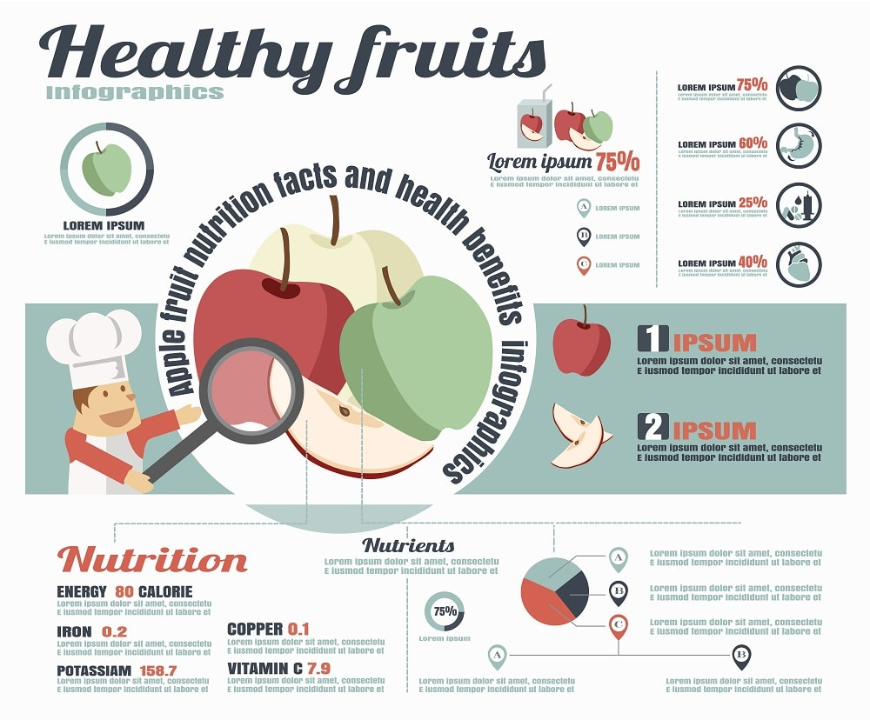
WHICHEVER WAY YOU HAVE FRUITS, THEIR DAILY INTAKE IS CRUCIAL FOR YOUR HEALTHY GROWTH. ACCORDING TO THEIR VARIETY OF COLORS, SHAPES, AND FLAVORS, FRUITS CAN BE FURTHER CLASSIFIED AS FOLLOWS:

1. CITRUS FRUITS
AS THE NAME IMPLIES, CITRUS FRUITS INCLUDE FRUITS THAT ARE CITRUS IN NATURE SUCH AS ORANGE, LEMONS, LIMES, MANDARINS, AND GRAPEFRUITS. AMONG MANY QUALITIES THESE FRUITS SHARE, THE MOST APPARENT ONE IS THAT THEY ARE CHOKE-FULL OF CITRUS. IT IS ESTIMATED THAT THE WATER CONTENT IN CITRUS FRUITS IS ABOUT 87% TO 88%.
ALL OF THESE FRUITS ARE NOTABLY PACKED WITH VITAMIN C WHICH HELPS BOOSTS THE IMMUNE SYSTEM AND KEEP YOU FRESH AND YOUNG. THESE JUICY FRUITS ARE ALSO AN EXCELLENT SOURCE OF FIBER AND POTASSIUM.
PSSTT.. THEY ARE ALSO A WEIGHT LOSS STAPLE!

2. POME FRUITS
APPLES AND PEARS ARE THE MOST POPULAR FRUITS THAT SHOW PROFOUND RESULTS WHEN CONSUMED REGULARLY. EAT THEM AT ANY TIME OF THE DAY AND THEY WILL BE QUITE FULFILLING, NOURISHING YOU WITH PLENTY OF NUTRIENTS, VITAMINS, MINERALS, AND GOOD DIETARY FIBERS.

3. STONE FRUITS
EVER WONDERED WHY PEACHES, MANGOES, LYCHEE, PLUMS, CHERRIES, AND NECTARINES ARE KNOWN AS STONE FRUITS? THAT’S BECAUSE THEY ALL HAVE A STONE IN THEM WHICH IS CALLED A “PIT”. ALL OF THEM COME WITH AN EDIBLE OUTER SHELL, TASTY FLAVOR, AND IMPECCABLE HEALTH BENEFITS.
STUDIES HAVE SHOWN THAT STONE FRUITS BOOST THE IMMUNE SYSTEM, REJUVENATE THE SKIN, SHARPEN THE EYESIGHT, PROMOTE DIGESTIVE HEALTH, ALLEVIATE MUSCLE ACHE, PROMOTE SLEEP, AND PROTECT YOU AGAINST CANCER AND HEART DISEASES.

4. TROPICAL FRUITS
ALSO KNOWN AS EXOTIC FRUITS, TROPICAL FRUITS ARE CULTIVATED IN WARM CLIMATIC AREAS. THE EXOTIC DELIGHTS INCLUDE BANANAS, GUAVA, ACAI, AVOCADO, JACKFRUIT, COCONUT, PAPAYA, STAR FRUIT, AND PASSION FRUIT. THESE FRUITS ARE A REAL ENERGY BOOSTER AND THEIR CONSUMPTION INSTANTLY BRIGHTENS UP YOUR DAY.
HAVE THEM IN THE MORNING FOR BREAKFAST AND GET INSTANTLY REFRESHED WITH THEIR YUMMY FLAVOR. WHAT’S MORE? THEY ARE LOADED WITH AMAZING NUTRIENTS!

5. BERRIES
DO YOU KNOW WHICH OF THE FRUITS ARE THE HEALTHIEST? BERRIES!
WHETHER THEY ARE STRAWBERRIES, RASPBERRIES OR BLUEBERRIES, BERRIES ARE THE MOST NUTRITIOUS FRUIT OUT THERE. ALL KINDS OF BERRIES ARE PACKED WITH ANTIOXIDANTS THAT KEEP FREE RADICALS AT BAY. AS WE ALL KNOW ONE OF THE MOST COMMON CAUSES OF SKIN DAMAGE IS FREE RADICALS.
WITH FREE RADICALS BEING UNDER CONTROL, YOUR SKIN WILL STAY FRESH AND HEALTHY. IN ADDITION, BERRIES ALSO HELP CONTROL BLOOD SUGAR AND INSULIN LEVEL. HENCE, THEY ARE IDEAL FOR DIABETIC PATIENTS.
HAVE SOME BERRIES DAILY AND GET EXCELLENT NUTRIENTS LIKE VITAMIN C, MANGANESE, VITAMIN K, COPPER, AND FOLATE.

6. MELONS
PRIMARILY, THERE ARE THREE TYPES OF MELONS – WATERMELONS, CANTALOUPE, AND MUSKMELON. THESE EDIBLE FRUITS ARE FULL OF ESSENTIAL MINERALS AND VITAMINS THAT ENSURE THE HEALTHY FUNCTIONING OF YOUR BODY.

MEAT
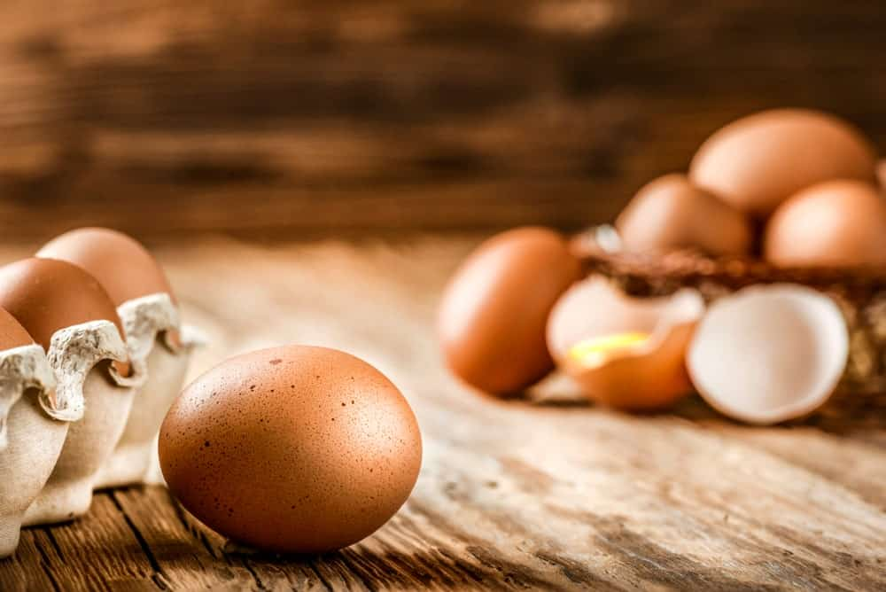
IF THERE WEREN’T POULTRY, WE WONDER WHAT LIFE WOULD HAVE BEEN LIKE. PRETTY DULL AND BORING, THAT’S FOR SURE.
JUST IMAGINE NOT HAVING MEAT, CHICKEN, OR EVEN EGGS FOR ANY OF YOUR MEALS! HARD TO IMAGINE, RIGHT?

1. MEAT
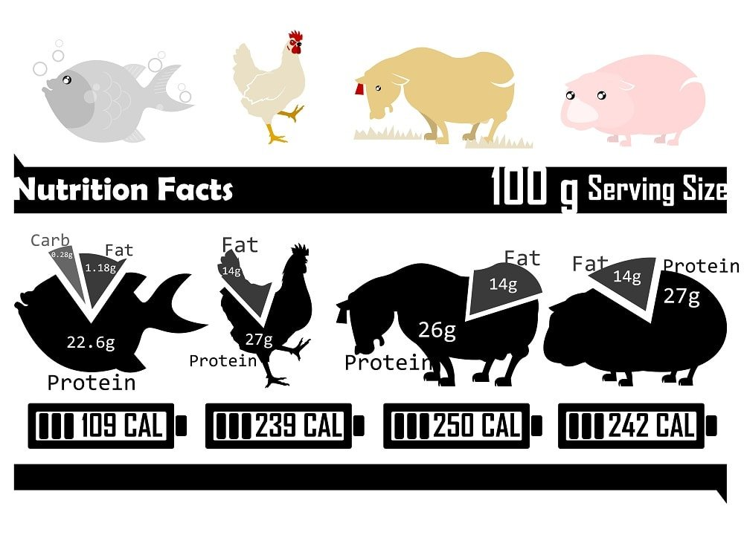
MEAT IS AN UMBRELLA TERM FOR EVERY TYPE OF ANIMAL PROTEIN. WHILE POULTRY HAS IT’S OWN TERM, TECHNICALLY POULTRY IS MEAT. SAME WITH BEEF, PORK AND IMO, SEAFOOD. SOME FOLKS DON’T CATEGORIZE SEAFOOD (FISH) AS MEAT BUT I DO. IT’S ANIMAL PROTEIN. WHILE NOT A MAMMAL IT’S MEAT IMO.
FOR A WELL-BALANCED DIET, THAT IS ALSO THOROUGHLY RICH WITH VALUABLE NUTRIENTS, POULTRY MEAT IS A MUST. YOU CAN BE AT RISK OF SUFFERING FROM LIFE-CHANGING DISEASES AND/OR INFECTIONS IF YOUR DAILY DIET LACKS VITAL NUTRIENTS.
HOWEVER, THE CONSUMPTION OF MEAT ENSURES THAT YOU GET THE RIGHT DOSE OF NUTRIENTS SUCH AS IODINE, IRON, ZINC, VITAMINS, AND FATTY ACIDS.
GENERALLY, MEAT IS HIGH IN FAT, WHICH CAN BE DISTRESSING FOR PEOPLE WHO ARE LOOKING TO MANAGE OR LOSE THEIR WEIGHT. IF YOU ARE LOOKING FOR LOW-FAT MEAT, DUCK MEAT IS THE WAY TO GO.
NOT ONLY IS IT HEALTHIER TO EAT BUT IS EXTREMELY FLAVORSOME AS WELL. IT IS ALSO A QUITE A VERSATILE DISH AS IT ALLOWS CHEFS AND HOME COOKS TO MAKE A WIDE RANGE OF DISHES OUT OF IT RANGING FROM CASSEROLE TO SALADS TO SOUP TO FINGER FOOD.

2. EGGS
ARE YOU LOOKING FOR AN AFFORDABLE YET HIGH-QUALITY PROTEIN? LOOK NO FURTHER THAN EGGS!
IN ESSENCE, AN EGG CONSISTS OF TWO PARTS – EGG WHITE AND YOLK, BOTH OF WHICH ARE QUITE HIGH IN NUTRITION. RESEARCH SHOWS THAT EGG YOLKS CONTAIN MORE FAT AND CALORIES AS COMPARED TO EGG WHITE. THEY ARE ALSO AN EXCELLENT SOURCE OF VITAMINS SUCH AS VITAMINS A, D, E, AND K.
ACCORDING TO A STUDY PUBLISHED IN PAAEDIATRICS MAGAZINE, CHILDREN WHO EAT ONE EGG DAILY FOR SIX MONTHS ARE ABLE TO ATTAIN AN IDEAL HEIGHT. A STUDY CONDUCTED ON CHINESE PEOPLE CONCLUDED THAT THE REGULAR INTAKE OF AN EGG A DAY HELPS DECREASE THE CHANCES OF HEART DISEASES AND STROKE.

3. CHICKEN (POULTRY)
THE MOST COMMON AND POPULAR TYPE OF POULTRY INCLUDES NONE OTHER THAN EVERYONE’S FAVORITE CHICKEN! THIS TYPE OF POULTRY HAS BEEN DOMESTICATED AND CONSUMED BY PEOPLE FOR AGES NOW. BEING ONE OF THE OLDEST TYPES OF FOOD, CHICKEN IS STILL TOUTED AS THE MOST-LOVED FOOD ITEM. WHY?
THAT’S BECAUSE CHICKEN IS AFFORDABLE AND ONCE IT IS COOKED, IT TASTES UTTERLY GREAT. CHICKEN ALSO COMES IN A WIDE RANGE OF TYPES SUCH AS FREE-RANGE CHICKEN, ORGANIC CHICKEN, AND CONVENTIONAL CHICKEN.
ACCORDING TO THE USDA, A 100G OF CHICKEN CONTAINS THE FOLLOWING NUTRITIONAL VALUE:
- PROTEIN – 18G
- IRON – 0.9MG
- FAT – 15G
- SATURATED FAT – 4G
- CHOLESTEROL – 75MG
- MAGNESIUM – 20MG
- ZINC – 1.3MG
- SODIUM – 70MG
- CALCIUM – 11MG
- POTASSIUM – 289MG
IN ADDITION, CHICKEN IS ALSO RICH IN VARIOUS TYPES OF VITAMINS SUCH AS VITAMIN C, THIAMIN, RIBOFLAVIN, NIACIN, FOLATE, VITAMIN B6, VITAMIN B12, VITAMIN A, VITAMIN E, VITAMIN K, AND VITAMIN D.
WITHIN CHICKEN, YOU MAY FIND MORE TYPES SUCH AS GAME HENS, FRYER,/BROILER, ROASTER, CAPON, AND FOWL. OTHER THAN CHICKEN, SOME OF THE MOST POPULAR TYPES OF POULTRY ARE DUCKS, GOOSE, PIGEON, AND TURKEY.

GRAINS

GRAINS ARE STAPLES IN EVERY CULTURE BUT THE TYPE OF GRAINS CONSUMED DOES VARY. I LOVE GRAINS AND EAT QUITE A BIT OF THEM (I’M NOT A FOLLOWER OF ANY PROTEIN-ONLY DIET). COMMON GRAINS THROUGHOUT THE WORLD INCLUDE:
- RICE
- WHEAT
- OATS
- CORN
- BARLEY
- SORGHUM
- RHY
- MILLET
- TRITICALE
- AMARANTH
- BUCKWHEAT
- QUINOA
THE ABOVE LIST OF GRAINS ARE USED TO MAKE ALL KINDS OF COMMON FOODS SUCH AS BREADS, PASTAS AND MORE.

LEGUMES
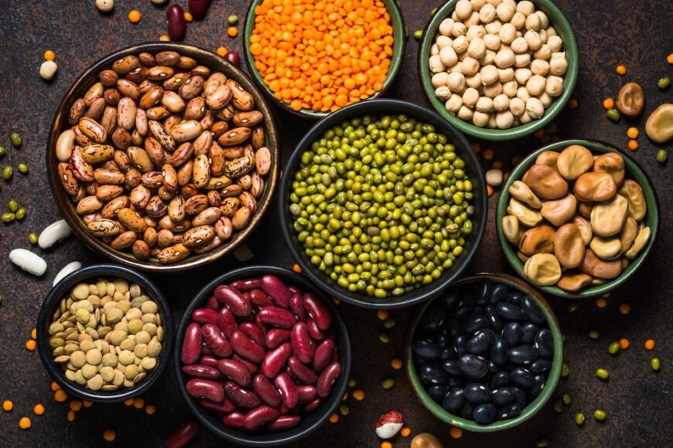
LEGUMES ARE PURPORTEDLY A GOOD SOURCE OF PROTEIN THAT IS NOT ANIMAL-BASED. I’M NOT A BIG LEGUME EATER; I PREFER MEAT AND SEAFOOD. HOWEVER, VEGANS COME TO KNOW LEGUMES INTIMATELY AS IT’S PRETTY MUCH THEIR ONLY SOURCE OF PROTEIN. COMMON LEGUMES INCLUDE:
- CHICKPEAS
- KIDNEY BEANS
- PINK BEANS
- BLACK BEANS
- ROMAN BEANS
- NAVY BEANS
- RED BEANS
- SPLIT MUNG BEANS
- SOYBEANS
- FAVA BEANS
- SPLIT PEAS
- GREEN PEAS
READ OUR TYPES OF LEGUMES FOR A LOT MORE INFO HERE.

DAIRY
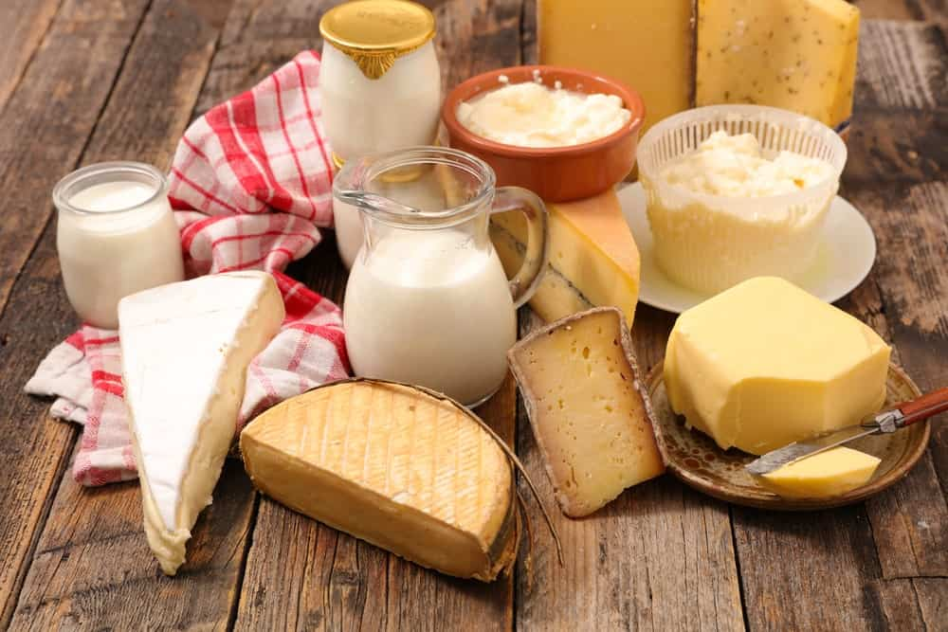
DAIRY FOOD PLAYS A KEY ROLE IN BUILDING HEALTHY AND STRONG BONES AS THEY ARE ABUNDANT IN ZINC, PROTEIN, CALCIUM, VITAMIN D, VITAMIN A, AND MAGNESIUM. SOME OF THE MAJOR TYPES OF DAIRY FOOD INCLUDE:

1. MILK
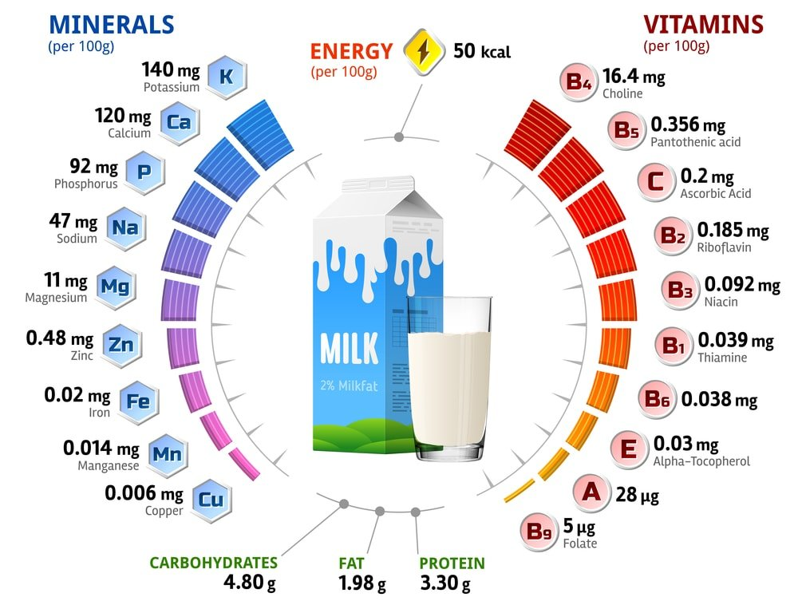
COW’S FRESH MILK HAS AN AMPLE AMOUNT OF VITAMINS, MINERAL, AND OTHER NUTRIENTS WHICH IS WHY THEIR DAILY CONSUMPTION IS SIGNIFICANT. THE LOWER OR NO INTAKE OF MILK CAN RESULT IN WEAK BONES AND CALCIUM DEFICIENCY.

2. YOGURT
FYI, YOGURT IS A MILK PRODUCT THAT IS CREATED THROUGH THE FERMENTATION OF MILK. REGULAR INTAKE OF YOGURT CAN HELP STRENGTHEN YOUR IMMUNE SYSTEM AND PROMOTE WEIGHT LOSS.
THE BEST OF ALL IS THAT IT MAINTAINS YOUR BONE HEALTH, PROTECTING YOU AGAINST OSTEOPOROSIS – A HEALTH CONDITION CAUSED DUE TO WEAKENED BONES.

3. CHEESE
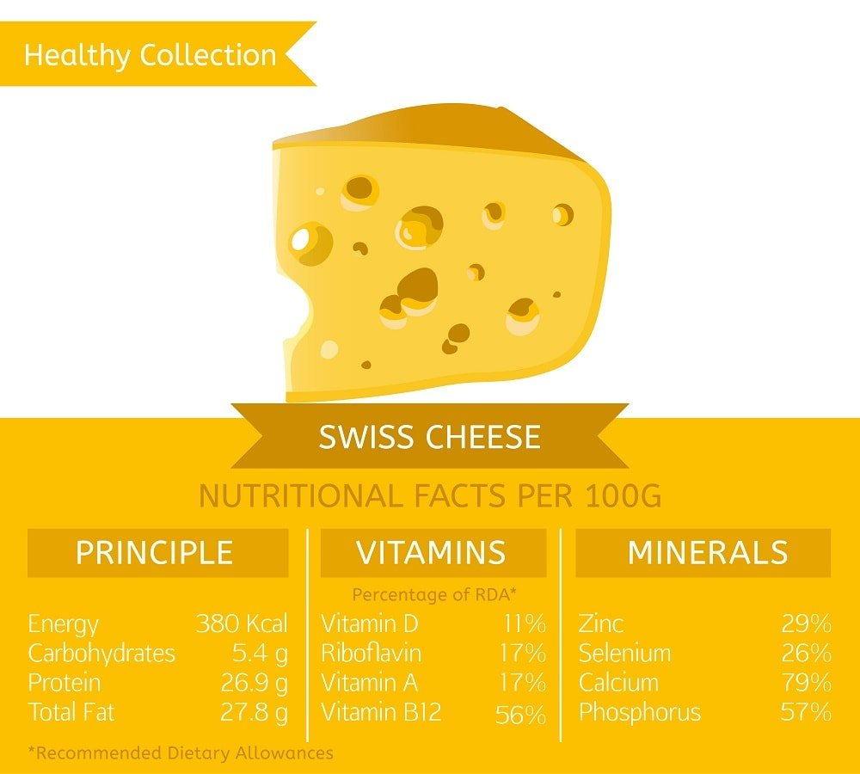
CHEESE IS THE YUMMIEST DAIRY PRODUCT THAT HAS BEEN UNRESERVEDLY ENJOYED OVER CENTURIES. YOU CAN FIND A NUMBER OF TYPES OF CHEESE, HAVING DIFFERENT COLORS, FLAVORS, AND TEXTURES. SOME OF THE MOST COMMON TYPES OF CHEESE THAT CAN BE USED AS PIZZA TOPPINGS OR USED TO ADD MORE FLAVOR TO SCRUMPTIOUS PASTA ARE FETA, BRIE, CHEDDAR, GOUDA, PARMESAN, ROMANO, AND BLUE CHEESE.

BAKED GOODS

THE SENSATION YOU GET WHEN YOU WALK INTO A BAKERY AND SMELL THE PLEASANT AROMA OF BAKED GOODS COMING RIGHT OUT OF THE OVEN IS SIMPLY PRICELESS.
THERE WAS A TIME WHEN PEOPLE ONLY KNEW HOW TO BAKE BREAD BUT TIMES HAVE DRASTICALLY CHANGED. IN TODAY’S MODERN TIMES, THERE IS NO SHORTAGE OF HEAVENLY BAKED GOODIES. SOME OF THE MOST POPULAR KINDS OF BAKED GOODS ARE DISCUSSED BELOW:

1. CAKES
HAVE A SNEAK PEEK INTO THE CAKE CATEGORY AND YOU WILL BE MESMERIZED BY THE HUGE VARIETY OF CAKES. THE ICE CAKES, LAYER CAKES, CUPCAKES, CHEESECAKES, AND ROULADES ARE JUST A BUNCH OF MANY KINDS OF CAKES THAT YOU CAN FIND AT ANY BAKERY SHOP.
THERE ARE ALSO TYPES OF CAKES THAT ARE LOW IN SUGAR WHILE THERE ARE CAKES THAT HAVE HIGH SUGAR CONTENT IN THEM. IN OTHER WORDS, THERE ARE ALL KINDS OF CAKES FOR ALL KINDS OF PEOPLE.

2. PASTRY
IN THIS CATEGORY, YOU CAN FIND A MIX OF BOTH SWEET AND SAVORY BAKED ITEMS INCLUDING CHOUX PASTRY, PUFF PASTRY, PHYLLO PASTRY, SAMOSA PASTRY, SABLE PASTRY, SHORTCRUST PASTRY, ETC.
THEIR CRISP, PUFFY ROLLS WITH MOUTH-WATERING FILLING ARE LITERALLY TO DIE FOR.

3. PIES AND TARTS
WARM, PRETTY, TENDER, AND LUSCIOUS ARE SOME OF THE WORDS THAT YOU CAN USE TO DESCRIBE THE MOST DELICIOUS PIE OR TART. WITH PIES AND TARTS, YOU CAN NEVER FALL SHORT OF CHOICES. YES, THEY ARE THAT MANY!
IN PIES, YOU HAVE OPTIONS OF AN APPLE PIE, BANANA PIE, CHOCOLATE PIE, COCONUT PIE, AND FRUIT PIES WHILE IN TARTS, YOU CAN CHOOSE FROM A CHOCOLATE TART, BERRIES TART, CREAM TART, ALMOND, AND PEANUT TART, ETC.

4. COOKIES
NOT ONLY KIDS LOVE THEM BUT ADULTS LOVE THEM JUST AS MUCH – THAT’S THE BEAUTY OF COOKIES. THE PLEASURE YOU GET FROM TAKING THE FIRST BITE OF FRESHLY-BAKED COOKIES IS PLEASANTLY SWEET ALWAYS.

5. CUSTARDS
PRIMARILY MADE FROM EGGS, MILK, AND CREAM, CUSTARDS CAN BE SWEET AS WELL AS SAVORY. SOME OF THE MOST UNIVERSALLY LOVED CUSTARDS INCLUDE FRUIT CUSTARD, PASTRY CREAM, LEMON CURD, AND FLAN.
WHENEVER YOU ARE CRAVING SOMETHING SWEET, CUSTARD CAN BE THE BEST DESSERT TO FIX YOUR SUGAR RUSH.

SEAFOOD
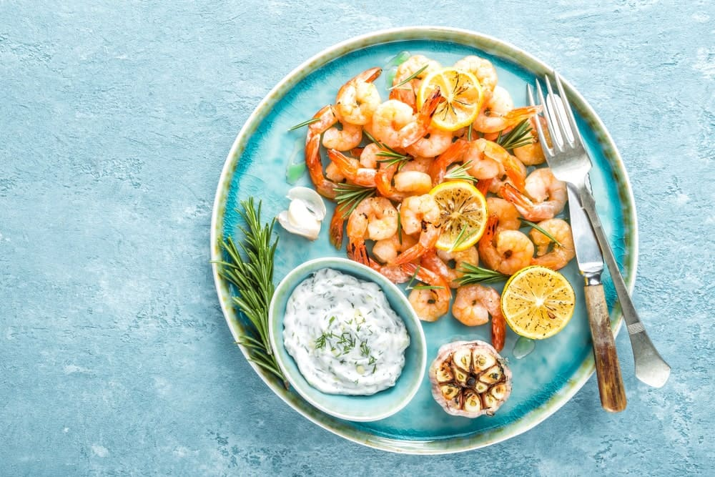
THE FIRST THING THAT POPS INTO OUR MIND WHEN WE SAY SEAFOOD IS FISH. READERS WOULD AGREE WHEN WE SAY THAT FISH IS AN EXQUISITE LOW-FAT FOOD THAT POSSESSES AN AMPLE AMOUNT OF ESSENTIAL NUTRIENTS LIKE PROTEIN. HERE WE’VE ASSEMBLED SOME OF THE MOST LIKABLE TYPES OF SEAFOOD:

1. PRAWNS AND SHRIMP
MOST HEALTH-CONSCIOUS PEOPLE HAVE SHRIMP AND PRAWNS IN THEIR HEALTHY EATING PLAN. SHRIMPS ARE LOADED WITH PROTEIN, SELENIUM, VITAMIN D, AND B12 WHILE PRAWNS HAVE BOUNTIFUL OF POTASSIUM, CALCIUM, PROTEIN, PHOSPHORUS, VITAMINS E AND A.
THE AMERICAN HEART ASSOCIATION SUGGESTS EATING SEAFOOD, ESPECIALLY SHRIMPS AND PRAWNS, TWICE A WEEK. WHY IS THAT SO? THAT’S BECAUSE THEIR CONSUMPTION MAY HELP REDUCE THE CHANCES OF HEART DISEASES.

2. TUNA
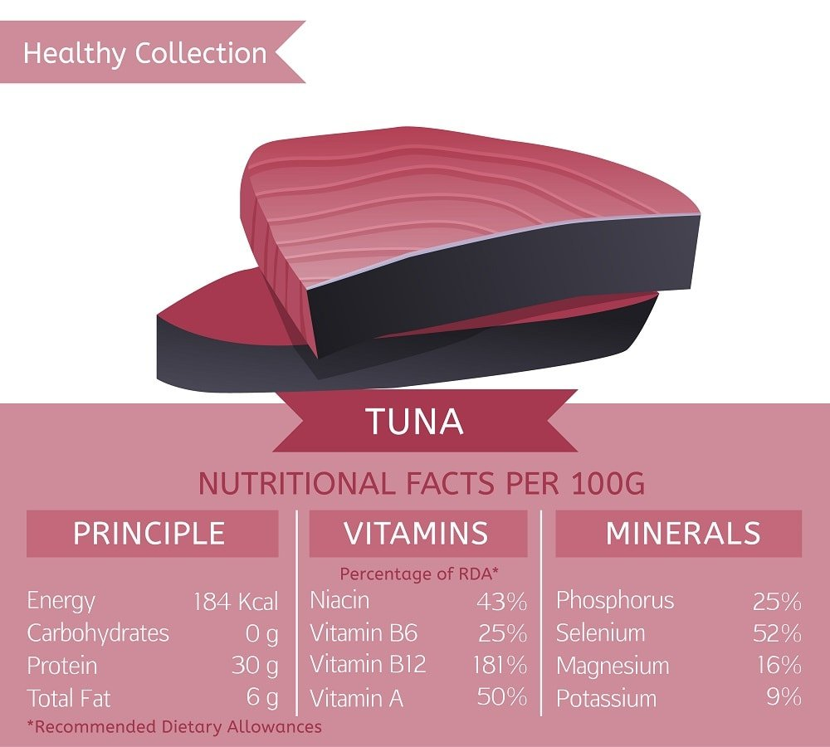
A QUICK, SIMPLE MEAL THAT ALSO PROVIDES YOU OODLES OF PROTEIN HAS TO BE TUNA FISH. WHETHER YOU EAT FRESH TUNA OR CANNED ONE, IT WILL PROVIDE YOU WITH PLENTY OF HEALTH BENEFITS.
RESEARCH SHOWS THAT EATING TUNA LOWERS THE RISK OF HEART PROBLEMS, STROKES, CANCER, AND EYE DISEASES. IT ALSO CONSISTS OF ESSENTIAL OMEGA-3 FATS DHA AND EPA. IT HAS BEEN ESTIMATED THAT ONE SERVING OF 500G CANNED TUNA CAN PROVIDE YOU WITH 46% OF DHA AND EPA.

3. SALMON
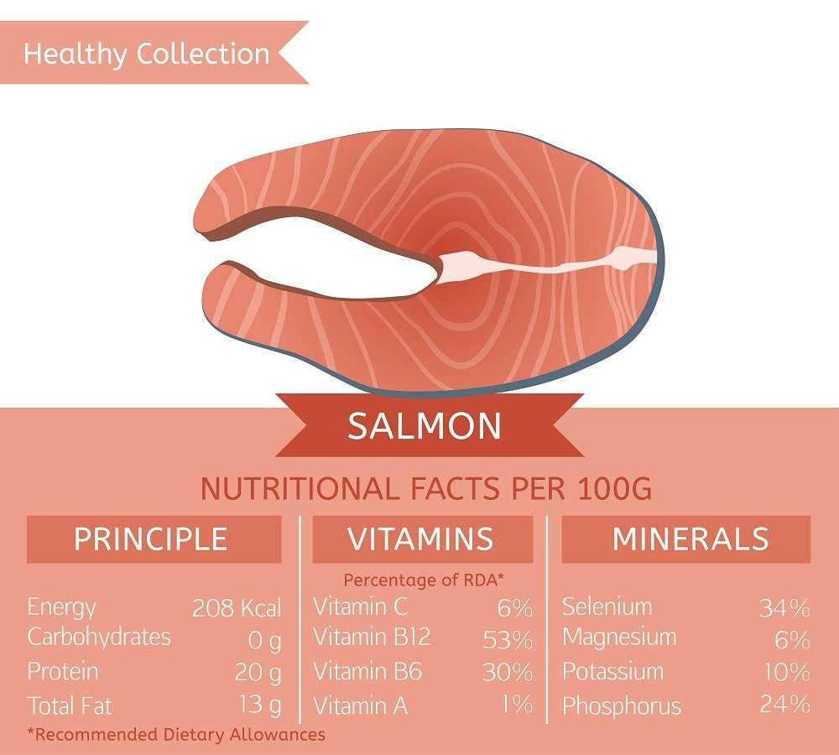
SALMON IS ONE OF THE MOST IN-DEMAND FISH THAT IS WIDELY CONSUMED ALL OVER THE WORLD. AND THERE IS A GOOD REASON WHY THAT IS SO.
ONE OF THE BIGGEST REASONS BEHIND THAT IS THAT SALMON HAPPENS TO BE DENSE WITH NUTRIENTS SUCH AS PROTEIN, VITAMINS, AND MINERALS. STUDIES ALSO SUGGEST THAT EATING SALMON REGULARLY CAN HELP DECREASE THE RISK OF HEART DISEASE AND STROKE. IT IS ONE OF THOSE SUPERFOODS THAT IS GREAT FOR THE SKIN, HAIR, AND NAILS.
WE ARE LUCKY AND SHOULD BE GRATEFUL TO BE BLESSED WITH SO MANY KINDS OF ENTICING FOOD THAT AREN’T JUST FEAST TO THE EYES BUT ARE GOOD FOR THE SOUL TOO. SO, WHICH TYPE OF FOOD IS YOUR FAVORITE, AND IF YOU HAVEN’T TRIED THEM ALL, IT’S TIME TO GET GOING.

NUTS & SEEDS
I’M A HUGE NUT FAN. I EAT THEM ALMOST DAILY. FATTY? YES. NUTRITIOUS? YES. PLENTY OF PROTEIN. GOOD-FOR-YOU FATS. NOT TO MENTION DELICIOUS.
THERE ARE MANY TYPES OF NUTS. WE PUT TOGETHER AN EPIC ARTICLE SETTING OUT THE DIFFERENT TYPES OF NUTS HERE.

HERBS AND SPICES
WHILE NOT A FOOD IN THE SENSE YOU SPOON IT UP AND CHOMP IT DOWN, HERBS AND SPICES ARE EDIBLE AND ARE WIDELY USED FOR MAKING FOOD TASTE BETTER. THEY ALSO OFFER MANY HEALTH BENEFITS.
THE LISTS OF HERBS AND SPICES LONG. WE PUT THE LISTS TOGETHER IN THEIR OWN POSTS. CHECK THEM OUT:
- TYPES OF HERBS (MEGA LIST)
- MEGA LIST OF THE DIFFERENT TYPES OF SPICES

GARNISHES
LASTLY IS THE MIGHTY GARNISH. NOT REALLY FOOD IN THE SENSE IT FORMS A MEAL BUT IT IS FOOD; PEOPLE DO EAT THE GARNISH AND THEY FORM A PART OF A DISH.
I’M NOT BIG ON GARNISHES BUT THEY’RE HERE TO STAY. I TYPICALLY CHUCK IT ON A SIDE PLATE SINCE I DON’T CARE FOR PARSLEY, CILANTRO AND MANY OTHER GARNISHES OTHER THAN BEVERAGE GARNISHES.
READ OUR LIST OF GARNISH OPTIONS HERE.

OILS
OILS CAN BE GOOD OR BAD FOR YOU. OLIVE, COCONUT, PEANUT, FLAXSEED, AVOCADO, CANOLA AND WALNUT, GRAPESEED, SUNFLOWER AND SESAME OILS ARE GOOD OILS TO COOK WITH OR USED FOR SAUCES.
ANY OIL THAT IS IN PART OR FULLY HYDROGENATED SHOULD BE AVOIDED BECAUSE THESE ARE WHAT HAVE TRANS FATTY ACIDS. IT’S ALSO RECOMMENDED TO AVOID PALM OIL.
OILS, IN GENERAL, GET A BAD RAP BECAUSE THEY ARE HIGH IN FAT BUT THE FACT IS, WE NEED FAT AND MORE IMPORTANTLY, WE NEED GOOD FATS. I’M ALL ABOUT DOUSING MY FOOD IN HEALTHY OILS SUCH AS OLIVE OIL.

PROCESSED FOODS
WHILE NOT IN A NATURAL STATE, WE’D BE REMISS NOT TO INCLUDE PROCESSED FOODS GIVEN IT’S AN ENORMOUS PART OF MANY PEOPLE’S DIET WORLDWIDE. PROCESSED FOODS ARE TYPICALLY CHEAPER BUT NOT AS HEALTHY. THINK CANNED FOOD AND/OR FULLY PROCESSED SUCH AS CEREALS, INSTA-DISHES (JUST-ADD WATER PRODUCTS), CHIPS, CANDY, BARS, BREADS, CONDIMENTS, SAUCES AND PRETTY MUCH MOST OF WHAT YOU’LL FIND IN THE GROCERY STORE.

WHAT ABOUT THE DIFFERENT TYPES OF DISHES?
DIFFERENT TYPES OF DISHES IS DIFFERENT. DISHES ARE MADE UP OF VARIOUS KINDS OF FOOD. THAT’S A TOPIC FOR ANOTHER DAY.

THE BIG FOOD CATEGORY LIST WRAP-UP
IF WE ARE NOT WRONG, YOU MUST HAVE HEARD OF THE TERM “FOOD GROUP” WHICH REFERS TO A VARIETY OF FOOD GROUPED TOGETHER, WHICH MEETS CERTAIN CRITERIA. ONE MAY WONDER WHY THESE DIFFERENT KINDS OF FOOD ARE CATEGORIZED TOGETHER CONSIDERING THAT THEY ARE POLES APART.
FIRSTLY, AS YOUR COMMON SENSE MUST HAVE SUGGESTED, THEY ALL ARE FOOD (DUH). SECONDLY, THEY PROVIDE SIMILAR KINDS OF NUTRIENTS THAT ARE ESSENTIAL FOR THE GROWTH AND DEVELOPMENT OF HUMAN BEINGS.
OWING TO THE LATTER REASON, PEOPLE RELY ON A WIDE VARIETY OF FOOD ITEMS ON A REGULAR BASIS. BUT THAT’S NOT IT, FOLKS. EATING A VARIED AND WELL-BALANCED DIET ALSO PROTECTS YOU FROM HARMFUL ILLNESSES AND INFECTIONS. THIS, IN TURN, CONTRIBUTES TO A HEALTHY LIFESTYLE.
JUST IMAGINE THAT YOU CAN ONLY HAVE ONE KIND OF FOOD EVERY DAY. WOULDN’T IT GET BORING? SURE, IT WOULD. AS THEY SAY, VARIETY IS THE SPICE OF LIFE, IT MAKES SENSE WHY HAVING MANY TYPES OF FOOD IS IMPORTANT. IN THIS BLOG, WE WILL DISCUSS THE MOST COMMON YET POPULAR KINDS OF FOOD THAT ARE TOO GOOD TO BE IGNORED.
ENTER INTO A FOOD MARKET AND YOU WILL BE SWAMPED BY THE VARIETY OF DELICIOUS FOOD PRESENT IN THERE. BUT HOW MANY OF US CAN CLAIM TO KNOW EVERY IMPORTANT DETAIL ABOUT THESE TYPES OF EDIBLES? NOT MANY.
MOTHER NATURE HAS BLESSED US WITH A PLETHORA OF ORGANIC FOOD FOR OUR DAILY SUSTENANCE. WE ENTHUSIASTICALLY PURCHASE THEM AND TURN THEM INTO OUR FAVORITE DISHES AND ENJOY THEIR DELECTABLE FLAVORS.
HOWEVER, THERE ARE KINDS OF FOOD OUT THERE THAT WE DON’T KNOW ANYTHING ABOUT BEYOND THE FACT THAT THEY EXIST. THESE ARE THE TYPES OF FOOD THAT YOU MAY NOT SEE BEING COOKED EVERY DAY IN YOUR HOME OR IT IS LIKELY THAT YOU HAVE NEVER LIKED THEM AS SUCH, SO YOU NEVER EVEN TRIED TO READ UP ON THEM.
WHATEVER THE CASE MAY BE, IT IS IMPERATIVE THAT YOU HAVE FULL-FLEDGED KNOWLEDGE ABOUT ALL KINDS OF FOOD. WHY? ONCE YOU KNOW THE POTENTIAL HEALTH VALUE OR RISKS ABOUT DIFFERENT KINDS OF FOOD, YOU WILL BE ABLE TO MAKE A BETTER DECISION WHETHER YOU WANT TO BUY THEM OR NOT.
THIS IS WHY WE HAVE ASSEMBLED IMPORTANT INFORMATION REGARDING DIFFERENT FOODSTUFFS IN THE WORLD FOR YOU. SO READ ON!

9 METHODS OF FOOD PRESERVATION
IN THIS TIME OF QUARANTINE, FOOD PRESERVATION PLAYS A HUGE ROLE IN ORDER TO PROLONG FRESH FOODS AND LESSEN THE NEED TO GO OUTSIDE AND BUY FOOD.
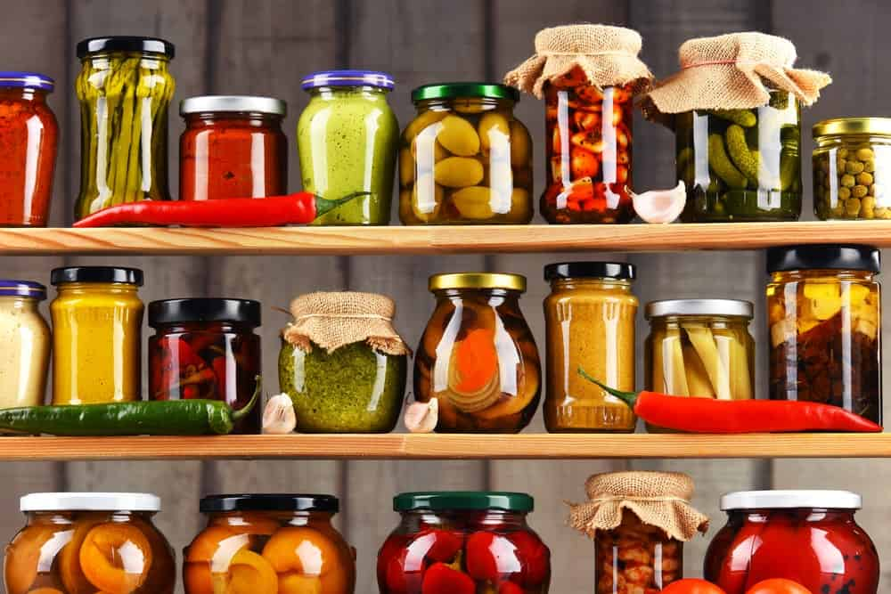
AS A KID, I REMEMBER WALKING INTO MY GRANDMOTHER’S PANTRY AND BEING ENTHRALLED BY ALL OF THE GOODIES THAT WERE INSIDE. GARLIC HEADS TIED IN OLD NYLONS, WOODEN BARRELS FILLED WITH ONIONS AND POTATOES AND TURNIPS. ROWS AND ROWS OF JARS OF BREAD AND BUTTER PICKLES, CHOKE-CHERRY JAM, BLUEBERRY JELLY, PICKLED EGGS, AND MANY OTHER IMPRESSIVE COLLECTIONS OF PRESERVES.
MY GRANDMOTHER LIVED ON A HOMESTEAD, AND THESE PRESERVES WERE COMPLETELY NECESSARY IF THE FAMILY WANTED TO EAT SOMETHING OTHER THAN OATMEAL FOR THE ENTIRE SEASON. TO THIS DAY, I HAVE NEVER TASTED A BETTER PICKLE THAN THE ONES THAT CAME FROM HER PANTRY, AND ONE AFTERNOON SHE GRANTED ME THE HONOR OF SHARING HER PROCESS WITH ME.
THAT TEACHING INSPIRED ME TO LOOK INTO METHODS OF PRESERVATION OTHER THAN PICKLING AND LED ME TO ALL OF THE INFORMATION THAT YOU’RE ABOUT TO READ. THIS IS A PRACTICE THAT COULD BE INCORPORATED INTO ANY HOUSEHOLD, WHICH WILL HOPEFULLY END UP BEING SOMETHING THAT CAN BE TAUGHT TO FUTURE GENERATIONS.
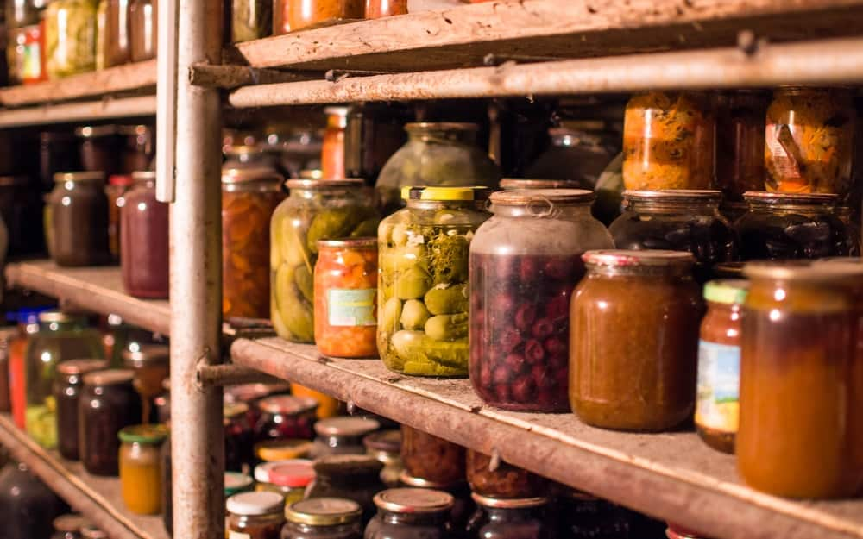
THE ART OF FOOD PRESERVATION HAS BEEN PRESENT IN HUMAN FOOD CULTURE FOR THOUSANDS OF YEARS, AND SOMETHING THAT STARTED OUT AS A METHOD OF SURVIVAL HAS GROWN INTO AN ENTIRE ARENA OF CREATIVE WAYS OF CHANGING FLAVOR AND TEXTURE. FOOD PRESERVATION CAN BE DONE IN A NUMBER OF DIFFERENT WAYS, AND IN THE SPIRIT OF SEASONAL COOKING PRACTICES, WE’RE GOING TO EXPLORE 9 METHODS TODAY.
RELATED: COLD STORAGE | FERMENTATION | DEHYDRATING FOOD | SALT AND SUGAR CURING | TYPES OF CANNING | FOOD STORAGE IDEAS

WHAT IS FOOD PRESERVATION?
PUT SIMPLY, FOOD PRESERVATION IS STOPPING THE DECAY OF ORGANIC MATTER. MORE SPECIFICALLY, FOOD PRESERVATION IS PREVENTING THE GROWTH OF MICROORGANISMS THAT OXIDIZE FAT AND CAUSE RANCIDITY (MICROORGANISMS LIKE FUNGI AND YEAST).
BY REMOVING WATER AND OXYGEN FROM FRUITS, VEGETABLES, AND MEATS, IT STOPS THEIR CAPABILITY OF DECAY AND INSTEAD PRESERVES THE WONDERFUL NUTRIENTS THEY POSSESSED WHEN THEY WERE STILL ALIVE.
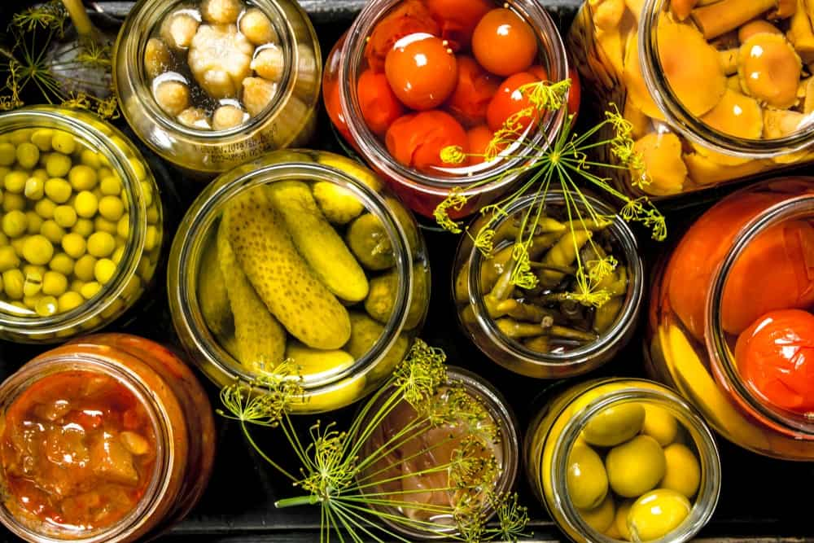

NEED INSPIRATION?
ONE OF THE MOST INSPIRATIONAL COOKBOOKS I’VE EVER ENCOUNTERED IS SIX SEASONS: A NEW WAY WITH VEGETABLES, BY JOSHUA MCFADDEN. THIS WAY WITH VEGETABLE ISN’T EXACTLY NEW, BUT MORE LIKE WAYS HUMANS HAVE ALWAYS APPROACHED SEASONAL COOKING — BUT HAVE SADLY FORGOTTEN ABOUT WITH THE DEVELOPMENT OF INDUSTRIALIZED AGRICULTURE.
IN THIS BOOK, THE YEAR IS SEPARATED INTO SIX STAGES: SPRING, EARLY SUMMER, MIDSUMMER, LATE, SUMMER, AUTUMN, AND WINTER. EACH SEASON COMES EQUIPPED WITH FOOD PRESERVES THAT WERE PREPARED THE SEASON PRIOR, FULLY EXTENDING THE DECADENT FLAVORS OF SUMMER HARVEST INTO THE COLDER MONTHS.
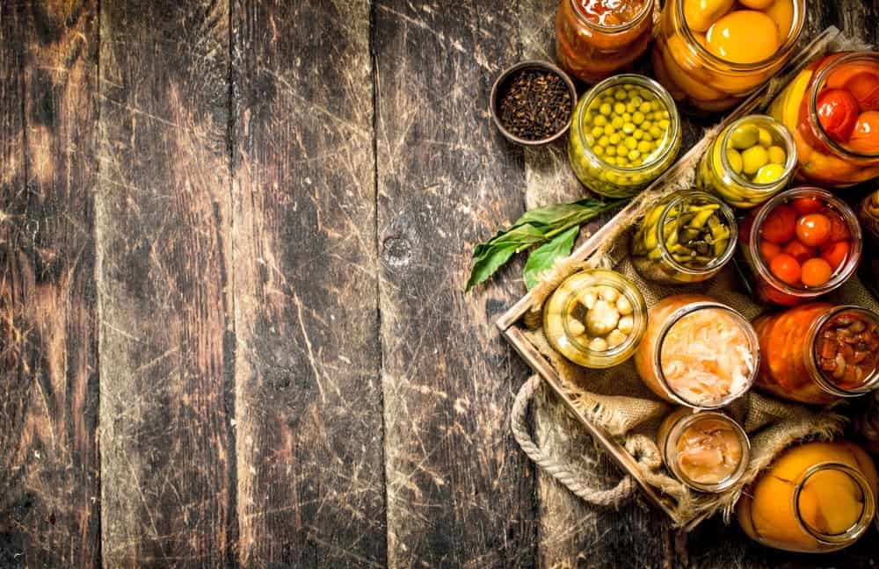
ONE DOESN’T NEED THEIR OWN GARDEN TO GET INTO THE PRACTICE OF FOOD PRESERVATION. BY PAYING ATTENTION TO WHAT IS IN SEASON IN THE SUPERMARKETS AND RESERVING SOME OF THAT SUPPLY FOR PRESERVATION, YOU CAN BE TASTING FRESH FLAVORS OF STRAWBERRY AND TOMATO IN THE BITTER GRIP OF FEBRUARY.
THIS COOKBOOK EQUIPS YOU WITH HOW TO PREPARE YOUR OWN BUTTER WITH SPRING ONIONS, ESCABECHE PICKLED BROCCOLI, HONEY PRESERVED STRAWBERRIES, AND MANY MORE WAYS TO BRING BRIGHT FLAVORS INTO EACH COMING SEASON.

NINE METHODS OF PRESERVING FOOD
NATURAL FOOD PRESERVATION METHODS HAVE PRECEDED HUMAN HISTORY, AND HAVE EVOLVED WITH THE DEVELOPMENT OF TEMPERATURE-CONTROLLED ENVIRONMENTS. WHAT ORIGINALLY BEGAN AS A WAY OF SURVIVING WINTER MONTHS HAS EVOLVED INTO A CHERISHED PRACTICE TO FEEL MORE SELF-SUFFICIENT.
CHERISHING FLAVORS OF THE SEASONS RESULTS IN CREATIVE WAYS OF EXTENDING THEIR LIFE, AND THIS CAN BE DONE IN 9 DIFFERENT WAYS. STARTING WITH THE OLDEST METHOD TO THE NEWEST: FERMENTATION, DRYING/DEHYDRATING, SALT AND SUGAR CURING, VINEGAR PICKLING, OLIVE OIL IMMERSION, ALCOHOL IMMERSION, MINIMAL PROCESSING (ROOT CELLARS, AND COOL STORAGE), CANNING, AND FREEZING.

1. FERMENTATION
FERMENTATION IS OFTEN REFERRED TO AS LIVING CULTURE FOOD, AND THIS IS THE METHOD OF FOOD PRESERVATION THAT HAS BEEN AROUND THE LONGEST. THE SCIENCE OF FERMENTATION IS CALLED ZYMOLOGY, AND IT INVOLVES A CHEMICAL CHANGE IN FOOD THAT USES ORGANIC ACIDS TO CHANGE MICROORGANISMS UNDER ANAEROBIC CONDITIONS. ANAEROBIC CONDITIONS OCCUR WITHOUT THE PRESENCE OF OXYGEN. THIS ENVIRONMENT ENCOURAGES A MICROBIAL CONVERSION OF SUGARS AND STARCHES INTO ALCOHOL, WHICH ITSELF IS A NATURAL PRESERVATIVE.
BY SEALING A FOOD PRODUCT ALONG WITH A STARTER CULTURE, LIKE SALT OR WHEY, YOU ARE CHANGING A LOW ACID FOOD INTO A HIGH ACID FOOD. FERMENTED FOOD IS STUFFED TO THE BRIM WITH PROBIOTICS, AND IS ONE OF THE EASIEST FOODS FOR HUMANS TO DIGEST. FERMENTATION HAS PROVEN TO BE THE METHOD OF FOOD PRESERVATION THAT CONSERVES THE HIGHEST AMOUNT OF NUTRIENTS IN A FRUIT OR VEGETABLE.
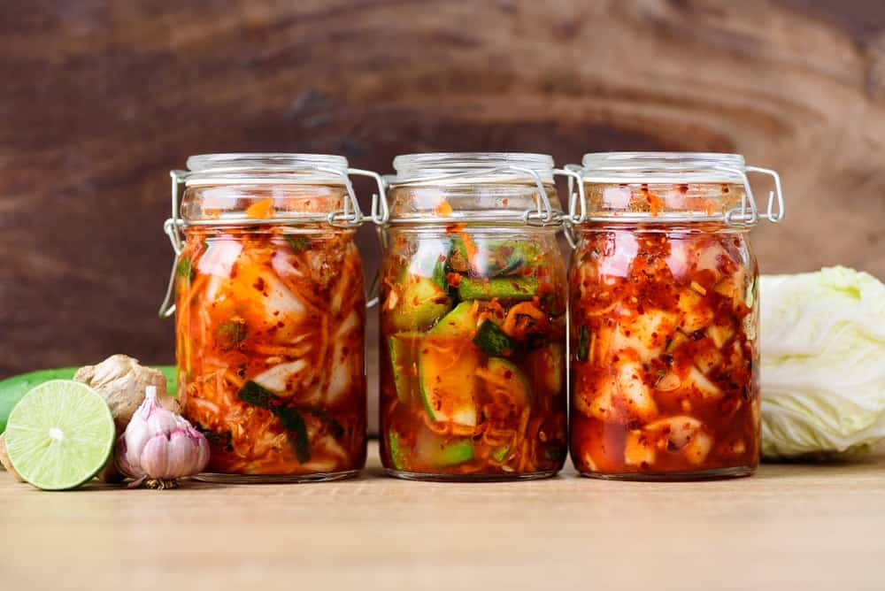
FERMENTED FOODS YOU MAY BE FAMILIAR WITH ARE:
- KOMBUCHA
- SAUERKRAUT
- KIMCHI
- CHEESE
- YOGURT
- SOURDOUGH BREAD

FUN FACT: CERTAIN CASE STUDIES HAVE FOUND THAT PEOPLE WHO SUFFER FROM CELIAC DISEASE (INABILITY TO DIGEST GLUTEN) ARE ACTUALLY ABLE TO INGEST PROPERLY FERMENTED SOURDOUGH BREAD WITHOUT FEELING ILL!
READ HERE TO KNOW ALL ABOUT FERMENTATION AND ITS BENEFITS AND HISTORY.

2. DRYING/DEHYDRATING
THE DEHYDRATION OF FRESH FOOD HAS PROVEN TO BE PRESENT IN HUMAN FOOD CULTURE SINCE AROUND 12,000 BC. WHEN FRESH FOOD IS DEHYDRATED, IT MEANS THAT ALL WATER PRESENT IN FRUIT, VEGETABLE, OR MEAT, IS COMPLETED REMOVED. WHY? BECAUSE WITH THE PRESENCE OF WATER, COMES THE PRESENCE OF BACTERIA AND MOLD.
THIS IS ACCOMPLISHED BY TAKING YOUR PRODUCT, SLICING IT VERY THINLY, AND DRYING IT BY FORCE OF THE SUN, AIR, SMOKE, OR WIND. BEFORE COMMERCIAL DEHYDRATORS, MEAT WAS THINLY SLICED AND OFTEN PUT INTO SMOKERS, AS SMOKING TECHNIQUES QUICKEN THE DRYING PROCESS AND ALSO ADD ANTIMICROBIAL AGENTS THAT AID IN PRESERVATION.
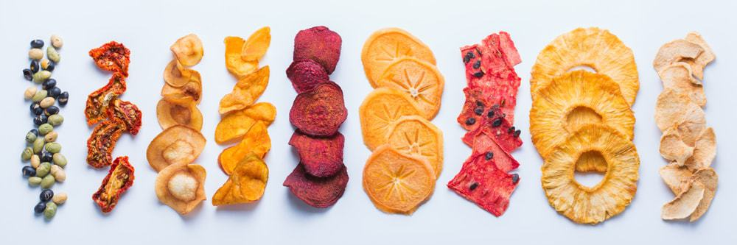
NOWADAYS IF YOU’RE LOOKING TO PRESERVE SOMETHING BY DRYING IT, YOU CAN SLICE IT VERY THINLY AND LET IT HANG TO DRY IN A WELL-VENTILATED AREA. ALTERNATIVELY, YOU CAN OVEN DRY IT BY SETTING THE OVEN TO 140 DEGREES- FAHRENHEIT, PROP OPEN THE OVEN DOOR, AND PLACE A FAN BESIDE THE GAP TO ENCOURAGE CIRCULATION. THIS ISN’T AN IDEAL METHOD AS IT USES UP A HEAP OF ENERGY.
TRADITIONAL DEHYDRATED MEATS:
- DRIED HADDOCK (TRADITIONAL IN ICELANDIC CULTURE)
- BILTONG (TRADITIONAL SOUTH AFRICAN MEAT JERKY)
- BEEF JERKY (OBVIOUSLY NEEDS NO EXPLANATION)
- PROSCIUTTO (HIGH QUALITY DRIED PORK FROM ITALY)
- DRIED REINDEER (TRADITIONAL INDIGENOUS FINNO-UGRIC DRIED MEAT)

FRUITS THAT ARE GREAT FOR DRYING:
- MANGO
- STRAWBERRY
- APPLE
- BANANA
- APRICOTS

KNOW MORE ABOUT DEHYDRATING FRUITS, VEGETABLES, AND MEAT HERE.

3. SALT & SUGAR CURING
LIKE WE LEARNED IN THE PROCESS OF DEHYDRATING FOOD WHEN FOOD HAS WATER IT ALSO HAS BACTERIA. SALT AND SUGAR CURING IS ANOTHER METHOD OF DRAWING OUT THE WATER THROUGH OSMOSIS. THIS INTERFERES WITH MICROBIAL GROWTH, LIKE BACTERIA AND MOLD. SALT CURED MEAT WAS A REVOLUTIONARY METHOD OF PRESERVATION WHEN TRANSPORTING FOOD ON LONG SAILING VENTURES UP UNTIL THE 20TH CENTURY (WHEN REFRIGERATORS WERE INVENTED).
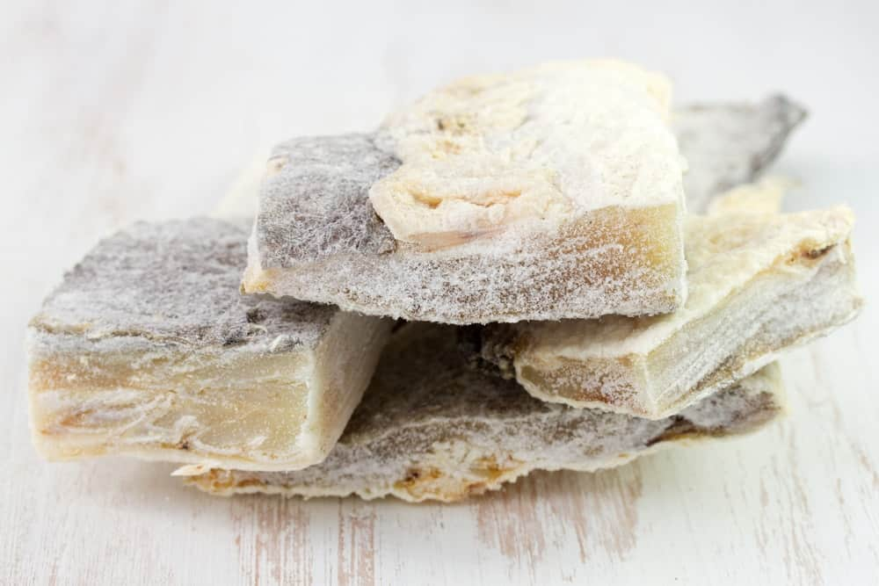
SALT CURING OCCURS WITH THINLY SLICED MEAT, WHICH CAN THEN BE REHYDRATED WHEN COOKED IN WATER. THIS METHOD IS USUALLY COMBINED WITH FOOD DEHYDRATION AS WELL.
SUGAR CURING CAN BE DONE WITH GRANULAR OR LIQUID SUGAR, LIKE HONEY. THE EARLIEST CULTURES OF FOOD PRESERVATION WOULD USE HONEY TO PRESERVE FRUITS (AND SOMETIMES VALUABLE BODY PARTS TOO!). GRANULAR SUGAR IS MOST OFTEN USED FOR CITRUS FRUITS AND SKINS, WHEREAS LIQUID SUGAR IS USED FOR FLESHY AND JUICY FOOD LIKE PEACHES, PLUMS, AND PEARS.
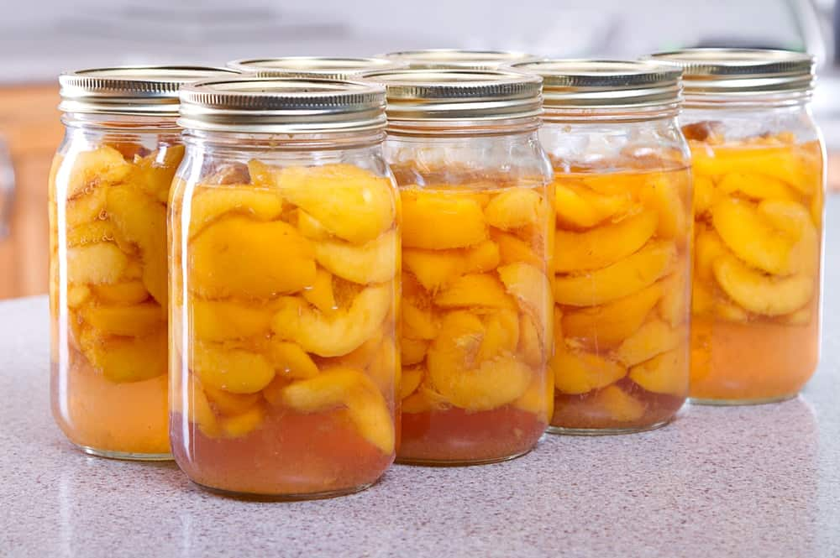
LEARN ALL ABOUT FOOD PRESERVATION THROUGH SALT AND SUGAR CURING HERE.

4. CHEMICAL PICKLING
SO NOW THAT WE’RE FAMILIAR WITH HOW MICROBES INTERACT WITH FOOD AND RESULT IN DECAY, WE KNOW THAT THEY CAN’T SURVIVE IF THERE IS NO WATER OR NO OXYGEN. THEY ALSO CAN’T SURVIVE IN ENVIRONMENTS THAT ARE HIGHLY ACIDIC.
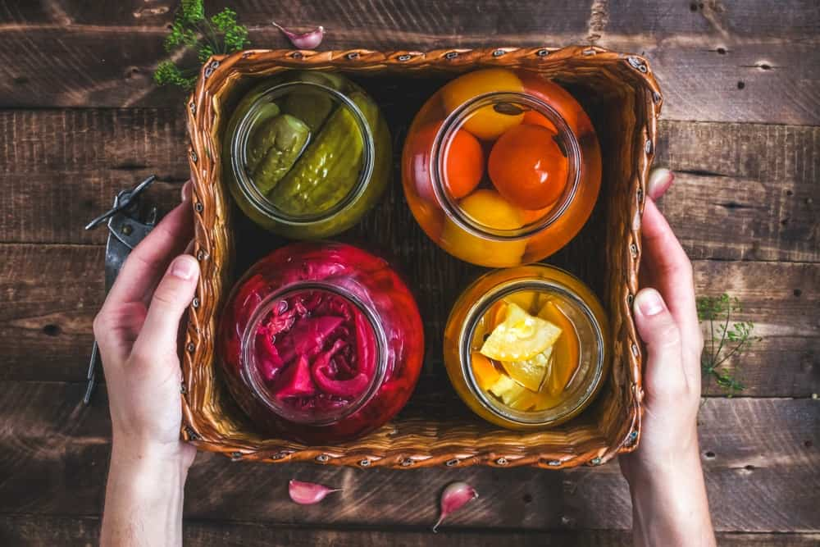
PICKLING CAN BE CATEGORIZED INTO TWO SEPARATE AVENUES: FERMENTATION PICKLING (WHICH WE ALREADY LEARNED ABOUT IN SECTION ONE) AND CHEMICAL PICKLING. CHEMICAL PICKLING OCCURS WHEN FOOD IS PLACED IN AN EDIBLE ACIDIC LIQUID THAT KILLS BACTERIA. THIS CAN BE ACHIEVED BY USING: VINEGAR, BRINE, OIL, OR ALCOHOL.

4.1 VINEGAR PICKLING
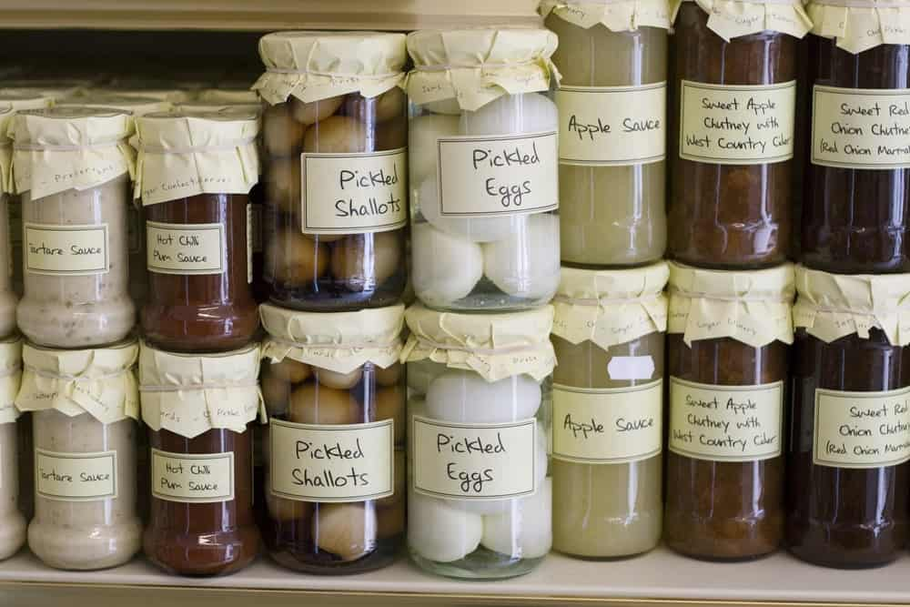
VINEGAR IS CONSIDERED AN ANTIMICROBIAL AGENT, AND BACTERIA CANNOT SURVIVE IN IT. THE PRESERVE DOESN’T NEED TO BE HEAT TREATED AND CAN STAY EDIBLE FOR AN INDEFINITE AMOUNT OF TIME. THIS CAN BE DONE WITH ANY KIND OF VEGETABLE, FRUIT, OR EVEN MEAT! EVER SEEN PICKLED EGGS ON YOUR GRANDMOTHER’S SHELF?

4.2 BRINE PICKLING
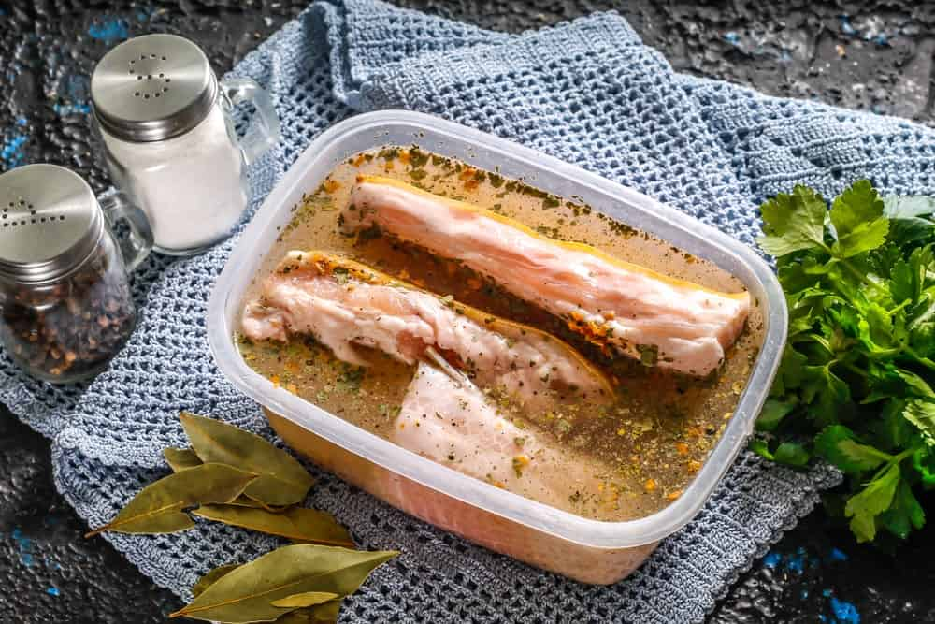
BRINE IS AN EXTREMELY SALTY LIQUID. WE ALREADY KNOW THAT SALT DRAWS WATER OUT OF FOOD, AND COMBINING SALT WITH A TIGHTLY SEALED LID STOPS DECAY IN ITS TRACKS. IT’S IMPORTANT THAT THE FOOD IS COOKED, THEN COMPLETELY COOLED BEFORE SEALING THE LID, AS IT CAN POTENTIALLY TRAP LIVING BACTERIA INSIDE.

5. OLIVE OIL IMMERSION
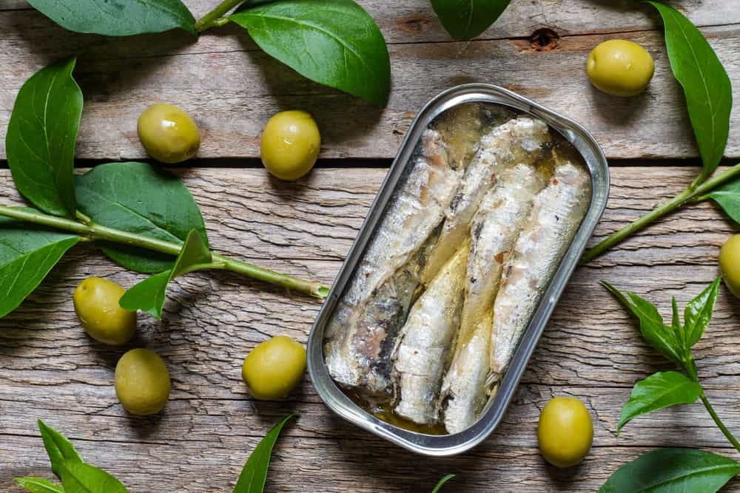
THIS IS A METHOD OF FOOD PRESERVATION THAT COMPLETELY LOCKING OXYGEN OUT OF THE EQUATION. OIL IS A NATURAL PRESERVATIVE, JUST LIKE HONEY IS, AND BY SEALING FOOD IN A TIGHTLY SEALED JAR WITH OLIVE OIL, AN ANAEROBIC ENVIRONMENT IS ESTABLISHED.
IMMERSING A PRODUCT IN OLIVE OIL IS OFTEN COMBINED WITH SOME SORT OF CHEMICAL PICKLING, WHERE IT WILL FIRST BE COOKED IN VINEGAR TO ENSURE PROPER PRESERVATION (OTHERWISE SOMETHING CALLED BOTULISM CAN OCCUR, WHICH I WILL EXPLAIN LATER ON). EVER WONDER WHY TUNA AND SARDINES STAY GOOD IN THE CAN? IT’S BECAUSE THEY’RE IMMERSED IN OLIVE OIL, WITHOUT THE PRESENCE OF AIR.

6. ALCOHOL IMMERSION
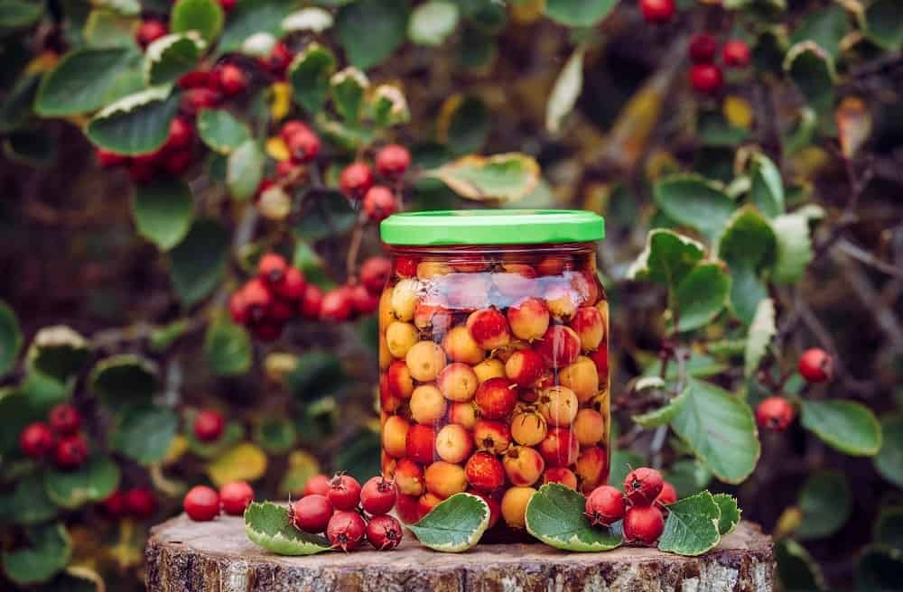
THIS PROCESS FUNCTIONS IN THE EXACT SAME WAY AS CHEMICAL PICKLING OR DEHYDRATING, BUT SIMPLY WITH THE USE OF ALCOHOL. ALCOHOL DRAWS ANY TRACES OF WATER FROM A VEGETABLE, FRUIT, OR PIECE OF MEAT AND HALTS ALL MICROBIAL ACTIVITY.
IF PROPERLY SEALED, SUBMERGING FOOD IN ALCOHOL CAN PRESERVE IT ALMOST INDEFINITELY. ALCOHOL IS A HIGHLY HOSTILE ENVIRONMENT FOR MICROBIAL LIFE, AND THIS IS WHY PEOPLE DRINK HOT TODDIES WHEN THEY’RE FEELING SICK! ALCOHOL IS EXTREMELY EFFICIENT AT KILLING BACTERIA.

7. MINIMAL PROCESSING – ROOT CELLARS & COLD STORAGE
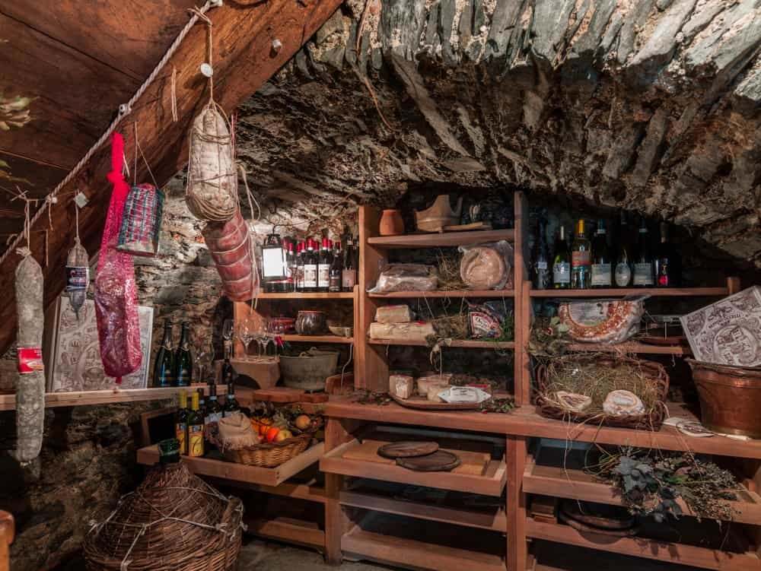
COLD STORAGE IS A SHORTER-TERM SOLUTION TO FOOD PRESERVATION. THIS METHOD KEEPS PRODUCE EDIBLE FOR UP TO A SEASON AND IS USUALLY IMPLEMENTED BY PEOPLE WHO HAVE HOMES EQUIPPED WITH ROOT CELLARS AND PANTRIES.
A ROOT CELLAR CAN BE ANYTHING FROM A LITERAL HOLE IN THE GROUND TO AN EARTHEN ROOM, TO A WEIRD STONE DUNGEON IN YOUR GRANDMA’S BASEMENT (I MAY BE SPEAKING FROM PERSONAL EXPERIENCE). THE GOAL IS TO PROVIDE AN ENVIRONMENT THAT HAS NO DIRECT SUNLIGHT AND IS PROPERLY VENTILATED. THE TEMPERATURE SHOULD BE BETWEEN 50-60 DEGREE-FAHRENHEIT, AND AROUND 90-95% HUMIDITY.
THIS METHOD OBVIOUSLY WORKS BETTER IN CLIMATES THAT HAVE COLD CLIMATES, AND IT’S HISTORICALLY BEEN USED AS A WAY TO EXTEND THE HARVEST SEASON. IT IS VERY IMPORTANT TO PROVIDE VENTILATION. THE REAL MAGIC HAPPENS AT NIGHT TIME WHEN THE ENVIRONMENT IN THE COLD STORAGE AREA GROWS COLDER, AND THE HOT AIR RISES. IF THERE IS NO VENTILATION, THE HOT AIR WILL LINGER IN THE ROOM AND DECAY THE FOOD.
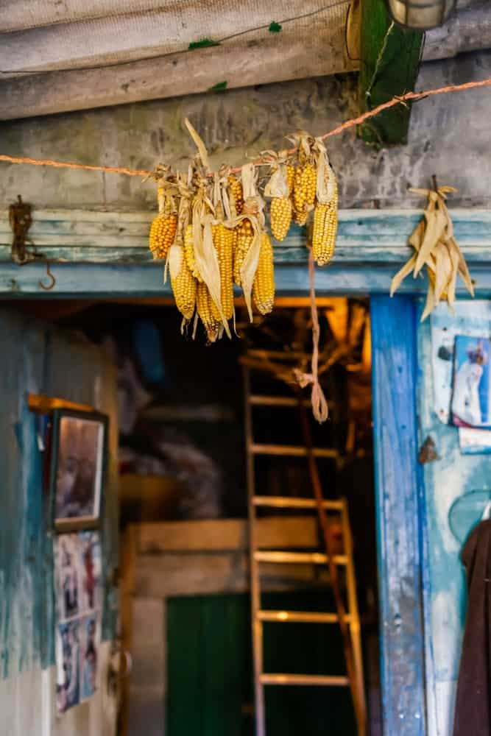
THIS SHOULD ONLY BE DONE WITH CERTAIN KINDS OF FRUITS AND VEGETABLES, AND ALWAYS ENSURE THERE ISN’T A SLIGHTLY DECAYING INDIVIDUAL IN THE PILE, AS IT CAN RUIN THE ENTIRE BUNCH.
ROOT CELLAR APPROPRIATE ITEMS INCLUDE:
- POTATOES
- TURNIPS
- SWEET POTATOES
- RADISHES
- APPLES
- GARLIC
- ONIONS
- CARROTS
- BEETS
- PARSNIP
- SQUASH
DISCOVER THE BENEFITS OF USING COLD STORAGE FOR FOOD PRESERVATION HERE.

8. CANNING
FOOD PRESERVATION THROUGH CANNING CAN BE DONE WITH EITHER SEALED TIN CANS OR GLASS JARS. THIS IS ANOTHER WAY OF REMOVING OXYGEN FROM THE EQUATION, BUT FIRST, THE VESSEL NEEDS TO BE HEAT TREATED BEFORE IT CAN PROPERLY PRESERVE ITS CONTENTS. CANNING INVOLVES COOKING THE FOOD YOU’D LIKE TO PRESERVE, SEALING IT, THEN BOILING THE CONTAINER TO STERILIZE ANY REMAINING BACTERIA INSIDE.
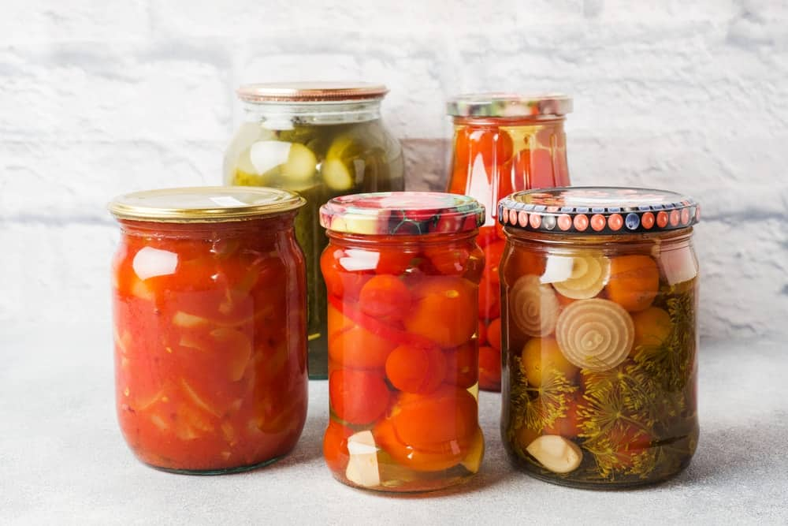
THIS IS BEST DONE WITH FOODS THAT ARE HIGHLY ACIDIC, WITH A PH LEVEL OF AT LEAST 4.5 OR LOWER. STUDIES HAVE FOUND THAT CANNING IS A WAY OF FOOD PRESERVATION THAT ALSO PRESERVES DIETARY FIBERS, AND ENDS UP BEING FAR HEALTHIER THAN FOODS THAT ARE FROZEN.
LITERALLY, ANYTHING CAN BE CANNED, BUT A FEW MENTIONABLE PRODUCTS ARE:
- JAMS/JELLIES
- PICKLES
- RELISHES
- CARROTS
- CORN
- MEATS
- SOUPS
- BROTHS
- SAUCES
DISCOVER THE DIFFERENT TYPES OF CANNING AND WHEN TO USE THEM.

9. FREEZING
NOW FOR THE MODERN VERSION OF FOOD PRESERVATION: FREEZING. THIS IS A METHOD OF PRESERVATION WHERE THE PRODUCT MOST RESEMBLES FRESH PRODUCE ONCE IT’S THAWED. FREEZING SLOWS DOWN THE PROCESS OF DECOMPOSITION BY TURNING WATER INTO ICE CRYSTALS, WHICH IN TURN FREEZES BACTERIA. THE BACTERIA IS TECHNICALLY STILL ALIVE, AND THIS IS WHY A THAWED PRODUCT HAS TO BE COOKED IMMEDIATELY.

NATURAL FOOD FREEZING HAS BEEN DONE FOR CENTURIES, ESPECIALLY IN NORTHERN COMMUNITIES WHERE THE MAJORITY OF THE YEAR IS CLOSE TO FREEZING. LITERALLY, ANYTHING CAN BE FROZEN, BUT THE MAIN DOWNFALL WITH FROZEN FOOD IS THAT NUTRIENTS IN FROZEN FOOD TEND TO BE REDUCED BY AT LEAST 50% DURING THE PROCESS.

THE RISK
THERE IS ONLY ONE DOWNFALL TO FOOD PRESERVATION, AND THAT IS AN OCCURRENCE CALLED BOTULISM. THIS OCCURS WHEN FOOD IS EITHER NOT SEALED PROPERLY, OR NOT HEAT-TREATED PROPERLY. IT HAPPENS MOST OFTEN WITH NONACIDIC FOOD (THAT BEING SAID, IT IS STILL AN EXTREMELY RARE OCCURRENCE).
C. BOTULINUM IS A GERMINATED SPORE THAT PRODUCES A TOXIN. THIS TOXIN RESULTS IN A PARALYTIC ILLNESS WHEN INGESTED BY HUMANS, STARTING WITH MUSCLES IN THE FACE AND SPREADING TO THE REST OF THE BODY. C. BOTULINUM PREFERS ENVIRONMENTS WITH LOW OXYGEN (THAT’S WHY PROPER SEALING IS CRUCIAL) AND IS RESISTANT TO HEAT IF OXYGEN IS PRESENT.
IT IS IMPORTANT TO BE AWARE OF BOTULISM AND TO TAKE CARE OF PROPERLY SEALING AND HEATING YOUR PRESERVES, BUT ONCE AGAIN IT IS A VERY RARE OCCURRENCE AS THE CONDITIONS FOR C. BOTULINUM ARE VERY PARTICULAR.

FAQ

IS FOOD PRESERVATION IMPORTANT?
THIS IS ALL BASED ON PERSONAL PREFERENCE, BUT ONE COULD MAKE THE ARGUMENT THAT FOOD PRESERVATION IS IMPORTANT IF ONE IS LOOKING FOR SELF-SUFFICIENCY. BY NOT DEPENDING ON SUPERMARKETS FOR ALL OF YOUR PRODUCE IN THE WINTER. IT SAVES YOU MONEY, IT SAVES ENERGY FROM THE DEMAND OF GROWING CERTAIN PRODUCTS IN WINTER MONTHS, AND SAVES STORAGE ENERGY, TRANSPORTATION ENERGY, THERE REALLY IS NO LIMIT TO HOW MUCH ENERGY FOOD PRESERVATION SAVES.

HOW DOES FOOD PRESERVATION WORK?
FOOD PRESERVATION OCCURS BY REMOVING WATER AND OXYGEN FROM FRESH PRODUCTS TO DELAY OR STOP THE PROCESS OF DECOMPOSITION. BACTERIA AND FUNGI LIVE IN WATER, AND ONCE WATER IS REMOVED, MICROBIAL LIFE COMES TO A STANDSTILL. THIS MAKES IT SAFE TO EAT FOR LONGER.

WHY IS FOOD PRESERVATION NECESSARY?
IT USED TO BE NECESSARY FOR HUMAN SURVIVAL DURING WINTER MONTHS. NOW, FOOD PRESERVATION IS NECESSARY TO BE LESS RELIANT ON SUPERMARKETS AND THE INDUSTRIAL AGRICULTURE SYSTEM.

WHAT ARE THE BENEFITS OF FOOD PRESERVATION?
IN CERTAIN CASES, LIKE FERMENTATION, THE PRESERVATION PROCESS ACTUALLY INTRODUCES SUPER HEALTHY AND BENEFICIAL NUTRIENTS TO A FOOD PRODUCT. FOOD PRESERVATION EXTENDS THE SHELF LIFE OF ANY PRODUCT AND ALLOWS YOU TO KEEP DIFFERENT FLAVORS THROUGHOUT COLDER MONTHS. IT SAVES MONEY FROM BUYING FRESH PRODUCE. AND BY LESSENING THE DEMAND FOR FRESH PRODUCE IN WINTER MONTHS, IT REMOVES ENORMOUS ENERGY DEMANDS FROM INDUSTRIAL FARMERS.

6 DIFFERENT TYPES OF GARNISHES + 18 GARNISH IDEAS
CHECK OUT THE DIFFERENT TYPES OF GARNISH AND GRAB A DOSE OF GARNISH IDEAS THAT WILL GUARANTEE TO MAKE YOUR DISH STAND OUT AND LOOK BOTH PRESENTABLE AND DESIRABLE.

WHAT IS A GARNISH?
IT’S A DECORATIVE ELEMENT THAT SHOULD SIMULTANEOUSLY ELEVATE THE TASTE OF A DISH OR DRINK.
TOO OFTEN APPEARANCE IS GIVEN MORE IMPORTANCE THAN TASTE. THIS IS A MISTAKE. A GARNISH SHOULD ELEVATE APPEARANCE AND TASTE. IN OTHER WORDS, THE GARNISH SHOULD BE IN LINE WITH THE FLAVOR OF THE DISH.
THE MAIN TYPES OF GARNISH ARE HERBS, LEAVES, ROOTS, GREENS, FRUIT (OFTEN THE PEEL), VEGETABLES, PUREES, SAUCES AND SYRUPS.
RELATED: TYPES OF CONDIMENTS | TYPES OF FOOD | TYPES OF HERBS | VEGETABLES AND HERBS | TYPES OF FRUIT TREES | TYPES OF BEANS AND LEGUMES | TYPES OF MUSHROOMS | TYPES OF BREAD | TYPES OF MILK | TYPES OF NUTS | TYPES OF SPICES

WHY GARNISH? BENEFITS OF GARNISHING DISHES AND DRINKS

AS MENTIONED ABOVE, GARNISHING IS AN EFFECTIVE CULINARY METHOD THAT COMES WITH NUMEROUS BENEFITS. BEFORE WE MOVE ON TO GARNISH IDEAS FOR YOUR DINNER PARTY, LET’S FIRST LOOK AT THE IMPORTANCE OF GARNISHING FOOD.
VISUAL APPEAL
WE CAN’T STRESS ENOUGH ON HOW IMPORTANT IT IS TO MAKE YOUR FOOD LOOK VISUALLY APPEALING. REMEMBER, IT IS ALWAYS YOUR EYES THAT EXPERIENCE THE FOOD FIRST. GARNISH ADDS A POP OF COLOR AND EXCITEMENT TO ANY PLATTER THAT CATCHES YOUR EYE AND MAKES YOU WANT TO TASTE THE FOOD. GARNISH DOES NOT HAVE TO BE FANCY. SOMETHING AS SIMPLE AS SPRINKLED PARSLEY OVER STEAMED RICE WILL MAKE YOUR FOOD LOOK MORE APPETIZING.
ENHANCEMENT OF FLAVOR
YOU DON’T JUST ADD AN ELEMENT FOR GARNISHING. AN ELEMENT THAT IS RELEVANT TO THE FOOD AND THE PLATTER IS USUALLY ADDED. FOR EXAMPLE, ADDING A SLICE OF LEMON TO A SEAFOOD PLATTER WILL ADD A TINT OF YELLOW TO IT. NOT ONLY DOES THIS GIVE THE MEAL A POP OF COLOR, BUT THE LEMON JUICE SERVES THE PURPOSE OF ENHANCING THE FLAVOR, THUS MAKING THE MEAL EVEN MORE ENJOYABLE.
FILLING THE PLATE
SOMETIMES, EVEN AFTER THE FOOD HAS BEEN PLATED, THE PLATE LOOKS EMPTY AND HENCE, UNATTRACTIVE. NOBODY WANTS TO BE SERVED WITH AN EMPTY-LOOKING PLATTER FOR DINNER. THIS IS WHERE GARNISH CAN BEHAVE AS PLATE FILLER. ADDING A FEW SAUTÉED VEGETABLES WITH STEAK IS A PERFECT EXAMPLE. ALSO, IF YOU ARE SERVED A SINGLE SLICE OF CHEESECAKE PLACED ON THE MIDDLE OF A DISH, IT MIGHT LOOK A LITTLE EMPTY AND MAY NOT EVEN SEEM WORTH THE PRICE, BUT WHEN SERVED WITH STRAWBERRY SAUCE, YOU WILL ENJOY THE SAME SLICE WITH A LOT MORE INTEREST.
IDENTIFICATION OF A DISH
HAVE YOU EVER FOUND YOURSELF WONDERING WHAT THE ORANGE-COLORED SOUP SERVED AT DINNER IS? HAVE YOU FOUND YOURSELF WONDERING WHETHER IT IS A CARROT SOUP OR A PUMPKIN SOUP? WELL, WE ALL HAVE BEEN IN THE SAME BOAT AT LEAST ONCE IN OUR LIVES. GARNISHING CAN SOMETIMES HELP IN THE IDENTIFICATION OF DISHES. IN THIS CASE, A SPRINKLING OF CARROT OR PUMPKIN OVER THE SOUP WILL HELP THE DINER IDENTIFY THE DISH.

TYPES OF GARNISH
A LOT OF DIFFERENT INGREDIENTS CAN BE USED AS GARNISHING. LET’S LOOK AT THE MOST COMMON TYPES OF GARNISHES USED TO ENHANCE THE LOOK AND FLAVOR OF A DISH.

1. HERBS AND LEAVES

MANY GREEN LEAVES AND HERBS ARE USED FOR GARNISHING PURPOSES.
THE MOST POPULAR LEAVES AND HERBS USED FOR GARNISH INCLUDE:
- SPRING GREENS (USUALLY AS A BASE),
- PARSLEY,
- CILANTRO,
- THYME,
- OREGANO,
- DILL,
- BASIL,
- MINT LEAVES,
- CHIVES,
- CHERVIL,
- SPINACH (AS A BASE),
- CORIANDER, AND
- BAY LEAVES.
THESE LEAVES DON’T JUST ADD ADDITIONAL COLOR BUT ALSO A TEMPTING AROMA AND A CHARACTERISTIC FLAVOR TO NUMEROUS DISHES.

2. ROOTS AND GREENS
MOST OF THE TIME, GREENS ARE USED AS SIDE SALADS ON PLATTERS TO FILL UP THE EMPTY SPACE.
POPULAR ROOTS AND GREENS USED FOR GARNISH, OFTEN AS A BASE FOR THE PLATE INCLUDE:
ENDIVE,
BUTTER CRISP,
SPRING GREENS,
SPINACH, AND
ROMAINE LETTUCE (ANY LETTUCE ACTUALLY).

3. EDIBLE FLOWERS

ELEVATE AND MAKE COLORFUL YOUR PLATES BY GARNISHING WITH EDIBLE FLOWERS.
MANY FLOWERS LIKE CALENDULA, PANSIES, AND JASMINES ARE EDIBLE AND CAN BE USED AS A GARNISH IN MANY DISHES. EXAMPLES OF THE NUMEROUS WAYS IN WHICH EDIBLE FLOWERS ARE USED ARE DISCUSSED IN DETAIL AHEAD.

4. FRUITS AND VEGETABLES
LEMON, LIME, ORANGES, BERRIES, GRAPES, RADISH, ASPARAGUS (THINK CAESAR DRINKS) AND TOMATOES ARE THE MOST COMMON FRUITS AND VEGETABLES THAT ARE USED AS GARNISHES. THEY CAN BE USED AS SLICES, WEDGES, OR USED FOR THEIR ZEST.

5. PUREES
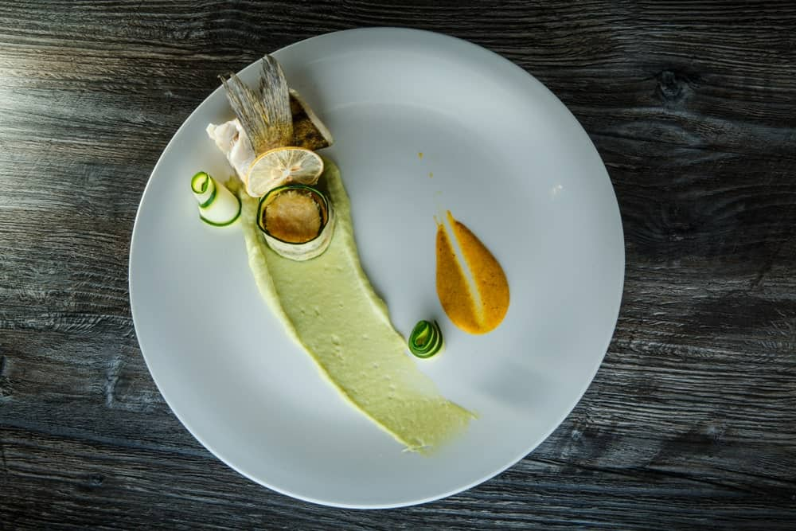
PUREES LIKE TOMATO PUREE ARE OFTEN USED FOR GARNISHING PURPOSES. THEY CAN BE SPREAD ARTFULLY ON THE PLATTER OR POURED OVER THE FOOD ITEM. THEY ADD VIBRANT COLOR, TEXTURE, AND FLAVOR TO YOUR DISH.

6. SAUCES AND SYRUPS
A NUMBER OF SAUCES AND SYRUPS ARE QUITE POPULAR WHEN WE TALK ABOUT GARNISHING. BBQ SAUCE, TERIYAKI SAUCE, AND OTHER SIMILAR SAUCES ARE OFTEN USED WITH STEAKS AND MAIN COURSES WHILE CHOCOLATE AND STRAWBERRY SYRUPS ARE POPULAR GARNISHES FOR DESSERTS.

GARNISH GUIDELINES
- THE GARNISH SHOULD BE EDIBLE AND NOTICEABLE.
- ITS FLAVOR SHOULD BE ALIGNED WITH THE OVERALL FLAVOR OF YOUR DISH. FOR EXAMPLE, DON’T USE AN HERBAL GARNISH IN DESSERTS, AND DON’T USE FRUIT GARNISH IN CURRIES.
- DON’T OVERDO THE GARNISH: I GET ANNOYED WHEN THERE’S A PILE OF LEAVES OR HERBS I HAVE TO REMOVE FROM A PLATE BECAUSE IT’S TOO MUCH. I THEN HAVE TO FIND SOME SIDEDISH AND DUMP IT THERE.
- THE OBJECTIVE OF A GARNISH IS NOT JUST TO ADD A POP OF COLOR OR STYLE TO A DISH BUT ALSO TO ENHANCE THE FLAVOR OF THE DISH.

GARNISH EXAMPLES & IDEAS (PHOTOS)
NOW THAT YOU ARE CONVINCED THAT GARNISHES FOR FOOD ARE SOMETHING YOU SHOULD NEVER OVERLOOK, LET’S HAVE A LOOK AT SOME OF THE BEST GARNISH IDEAS THAT YOU CAN USE TO SPICE UP ANY DISH THAT YOU MAKE! IF YOU’RE THROWING A DINNER PARTY, THESE IDEAS WILL COME IN HANDY!
ALWAYS REMEMBER THAT GARNISHING IS ALL ABOUT ADDING A LITTLE ‘EXTRA’ TO THE FOOD TO MAKE IT LOOK TASTIER THAN IT ACTUALLY IS!

1. LEMON DECORATION ON GLASSES

YOU WILL BE SERVING YOUR GUESTS WITH SOME WELCOME DRINKS AT THE DINNER PARTY, RIGHT? WHY NOT LEAVE AN IMPRESSION FROM THAT POINT ONWARDS? GARNISHING YOUR GUESTS’ GLASSES WITH A LEMON SLICE IS A GREAT IDEA TO START WITH. INSTEAD OF SERVING A GLASS OF LEMONADE, A COCKTAIL, OR WINE, ADD A SLICE OF LEMON AS A DECORATION TO THE GLASS AND IMPRESS YOUR GUESTS.

2. SALMON CANAPÉS WITH A CREAM GARNISH
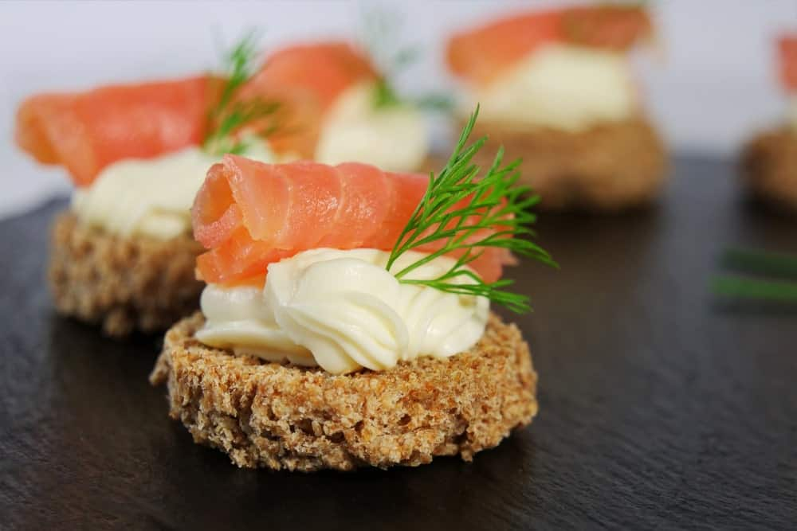
SALMON CANAPÉS ARE WONDERFUL ENTREES TO KEEP YOUR GUESTS BUSY AND ENTERTAINED WHILE THEY WAIT FOR DINNER TO BE SERVED. HOWEVER, DO YOU THINK YOUR GUESTS WOULD LIKE TO APPETIZERS THAT DON’T LOOK APPETIZING? THE BRAIN TELLS A PERSON THAT WHAT DOESN’T LOOK GOOD WON’T TASTE GOOD.
DON’T FORGET TO GARNISH YOUR SALMON CANAPÉS. IF YOU ARE WONDERING HOW TO GO ABOUT IT, THE ADDITION OF CREAM IS THE SIMPLEST THING YOU CAN DO! NOT ONLY WILL IT ENRICH THE FLAVOR OF THE SALMON, BUT IT WILL ALSO ADD A LOT OF VISUAL APPEAL TO THE DISH BY ADDING A BIT OF A NEUTRAL COLOR TO CONTRAST WITH THE BRIGHT PINK/ORANGE SALMON. THIS WILL TAKE IT FROM A BORING APPETIZER TO A MUST-EAT ITEM ON THE MENU.

3. SALAD CAKE
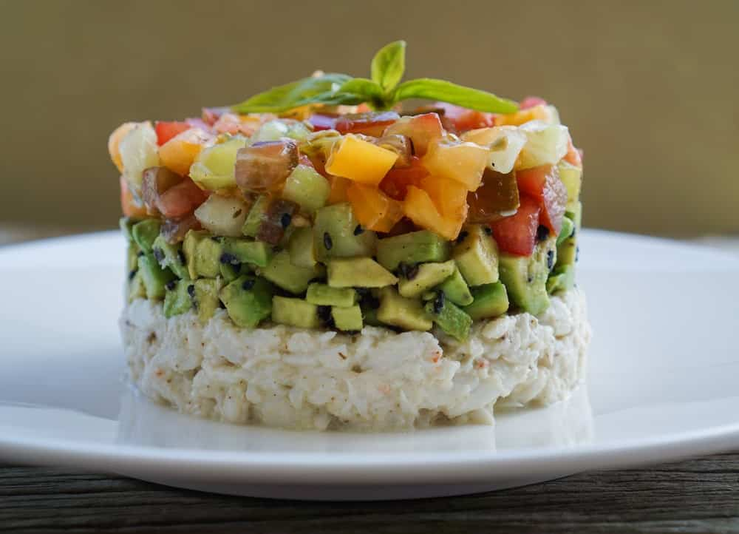
THE SALAD IS A VERY IMPORTANT PART OF ANY DINNER MENU. ALTHOUGH IT MAY NOT BE COUNTED AS A DISH IN ITSELF, ITS ABSENCE IS STRONGLY FELT. THIS IS WHY YOU CANNOT MISS OUT ON INCLUDING A SALAD OPTION IN YOUR DINNER PARTY MENU. SALADS ARE COLORFUL MOST OF THE TIME, AND THAT MAKES THEM AESTHETICALLY PLEASING. BUT YOU CAN GARNISH AND DECORATE A SALAD FURTHER IN THE FORM OF A CAKE TO LEAVE YOUR GUESTS IN AWE.

4. SALAD WITH A THAI VEG FLOWER GARNISH
THAI GARNISHES ARE SOME OF THE PRETTIEST, MOST ARTISTIC, AND THE MOST COMPLICATED OF ALL GARNISHES. THEY INVOLVE THE TRANSFORMATION OF SIMPLE VEGETABLES INTO PIECES OF ART. A VEGETABLE FLOWER IS ONE OF THE MOST COMMONLY USED TYPES OF GARNISH. ADDING A TOMATO FLOWER IN THE CENTER OF YOUR SALAD DISH WILL DELIVER A POWERFUL IMPACT, NOT ONLY IN APPEARANCE BUT IN THE IMPRESSION THAT YOU LEAVE ON YOUR GUESTS AS WELL.

5. SOUP WITH CREAM AND PARSLEY
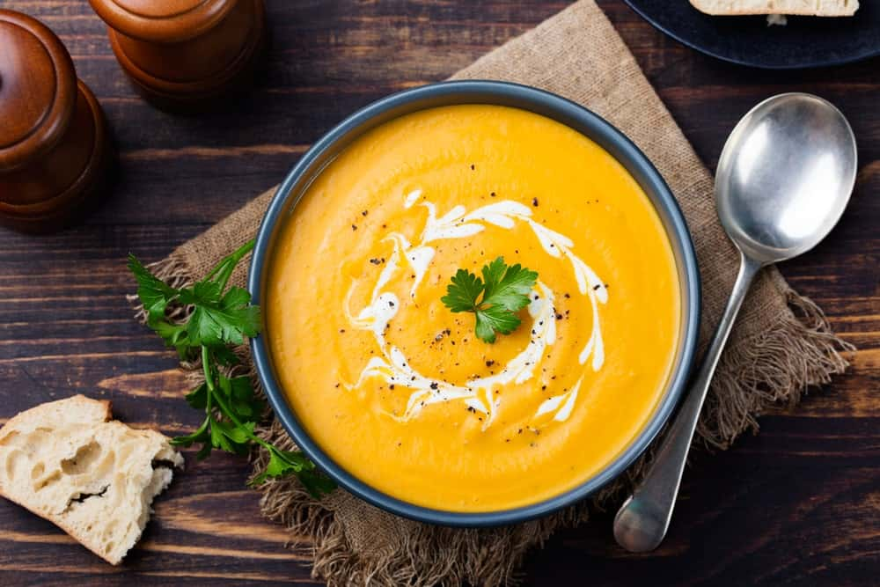
CARROT AND PUMPKIN SOUPS ARE QUITE POPULAR AND ARE OFTEN A PART OF DINNER MENUS. PEOPLE LOVE THE RICH AND HEAVY FLAVOR OF CARROTS AND PUMPKINS. HOWEVER, WHAT WOULD MAKE YOUR GUESTS WANT TO TRY THE SOUP IMMEDIATELY? GARNISHING YOUR CARROT AND PUMPKIN SOUP WITH CREAM AND A SPRIG OF PARSLEY WILL DO THE TRICK. THE ADDITION OF DIFFERENT COLORS WILL MAKE THE SOUP VISUALLY APPEALING, AND YOUR GUESTS WILL WANT TO DIVE INTO IT RIGHT AWAY!

6. SOUP WITH CROUTONS AND PARSLEY
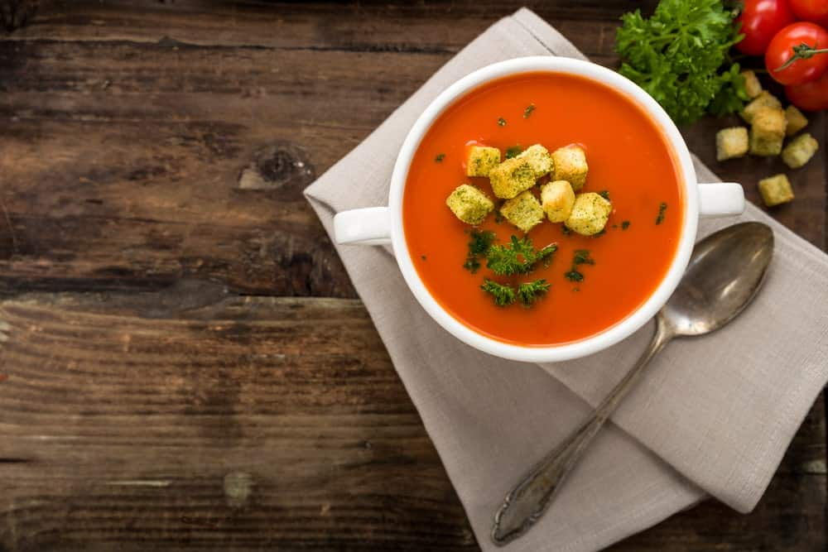
ANOTHER GREAT WAY TO MAKE YOUR SOUP LOOK AS TASTY AS POSSIBLE IS TO TOP IT WITH CROUTONS AND FRESH PARSLEY. ANY GARNISH THAT ADDS COLOR, AROMA, AND ENHANCES FLAVOR IS SURE TO MAKE A DISH AS SIMPLE AS A SOUP A SUPER HIT!

7. PASTA WITH A TOMATO PUREE AND CHEESE GARNISH
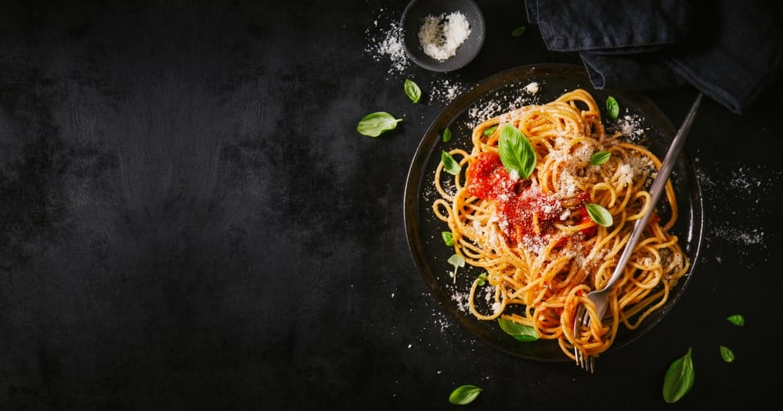
ONE OF THE MOST COMMON MAIN DISHES THAT PEOPLE INCLUDE IN THEIR DINNER PARTY MENUS IS PASTA. LIKE SALADS, PASTA GIVES YOU AN INCREDIBLE SPACE TO EXPERIMENT. PASTA DISHES THEMSELVES ARE QUITE COLORFUL DISHES THAT OFTEN INCLUDE MEAT, VEGETABLES, AND THE PASTA ITSELF. HOWEVER, GARNISHING PASTA CAN MAKE YOUR DISH LOOK A WHOLE LOT MORE APPETIZING.
BY SIMPLY ADDING SOME TOMATO PUREE AND CAPSICUM AND SHREDDING SOME PARMESAN CHEESE, YOU CAN TRANSFORM YOUR PASTA PLATTER INTO A RAINBOW! SUCH A BEAUTIFUL DISH WOULD LOOK WONDERFUL ON YOUR DINING TABLE AND WOULD DEFINITELY BE MOST PEOPLE’S FAVORITE DISH OF THE NIGHT.

8. ROASTED TURKEY WITH LEMON, CRANBERRY, AND HERBS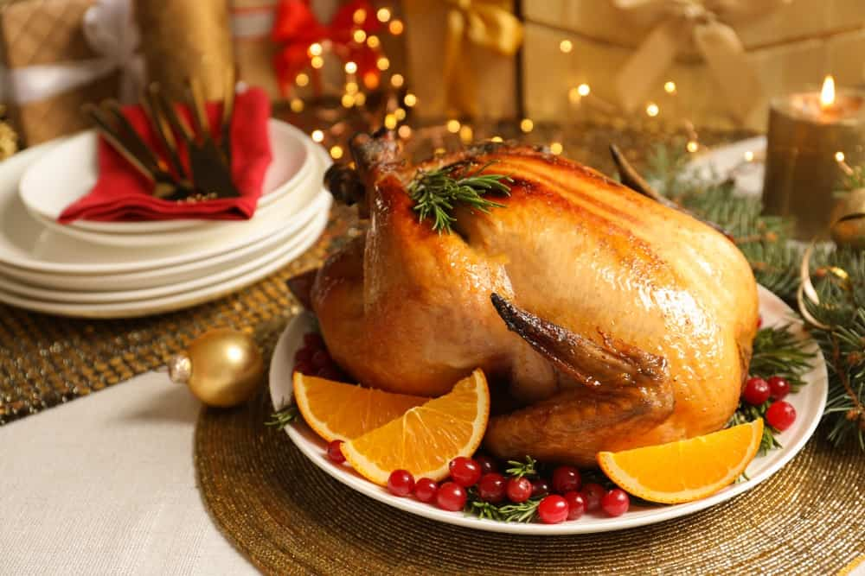
ARE YOU PLANNING ON INCLUDING ROASTED TURKEY IN YOUR DINNER PARTY MENU? IF YES, GO AHEAD AND DO IT BECAUSE PEOPLE LOVE ROASTED TURKEY. HOWEVER, TO MAKE YOUR ROASTED TURKEY LOOK MORE APPEALING AND APPETIZING, ADDING GARNISH IS A NECESSITY. WITHOUT ANY GARNISH, THE DISH WILL JUST END UP LOOKING DULL, BORING, AND UNAPPETIZING. YOU CAN ADD LEMON SLICES, CRANBERRIES, AND HERBS TO ADD A POP OF COLOR, AROMA, AND AN ADDED FLAVOR TO THE ROASTED TURKEY. THE POP OF COLOR WILL SURELY MAKE YOUR PLATTER LOOK ATTRACTIVE AND DELICIOUS FROM THE VERY FIRST GLANCE!

9. OYSTERS WITH A LEMON GARNISH
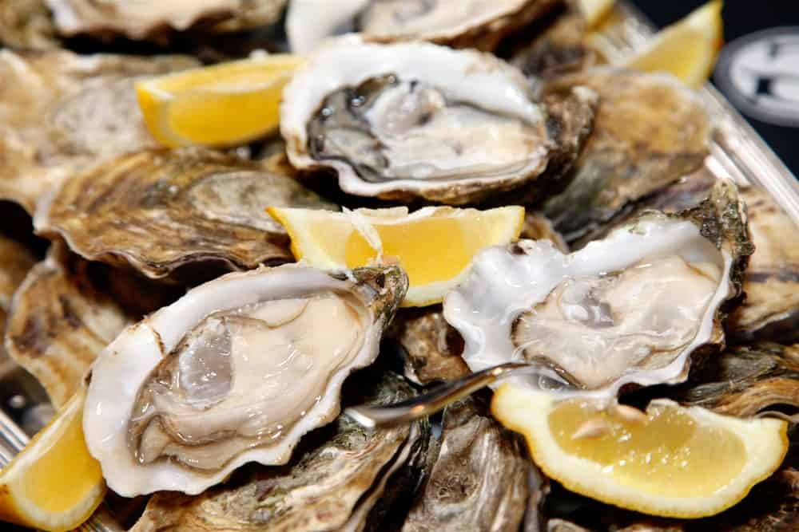
PLACE A DISH FULL OF OYSTERS ON THE TABLE, AND PEOPLE WILL FORGET THE REST OF THE ITEMS. OYSTERS ARE A HIGHLIGHT OF ANY MENU. HOWEVER, WHEN YOU PLATE A DISH OF OYSTERS UP, IT DOESN’T ALWAYS LOOK LIKE THE DISH IS COMPLETE. WHAT WE’RE TRYING TO SAY IS THAT THE PLATTER, MORE OFTEN THAN NOT, LOOKS BORING.
THE GRAYNESS OF THE DISH (BECAUSE OF THE COLOR OF THE OYSTERS) DOES NOTHING TO MAKE IT APPETIZING AND APPEALING. WELL, YOU DON’T HAVE TO LEAVE IT THAT WAY. BY SIMPLY GARNISHING THE PLATTER WITH LEMON WEDGES, YOU CAN MAKE YOUR DISH COME TO LIFE. THE INCORPORATION OF A LITTLE COLOR IS ALL YOUR DISH NEEDS SOMETIMES!

10. PORK RIBS WITH VEGETABLES AND TERIYAKI SAUCE
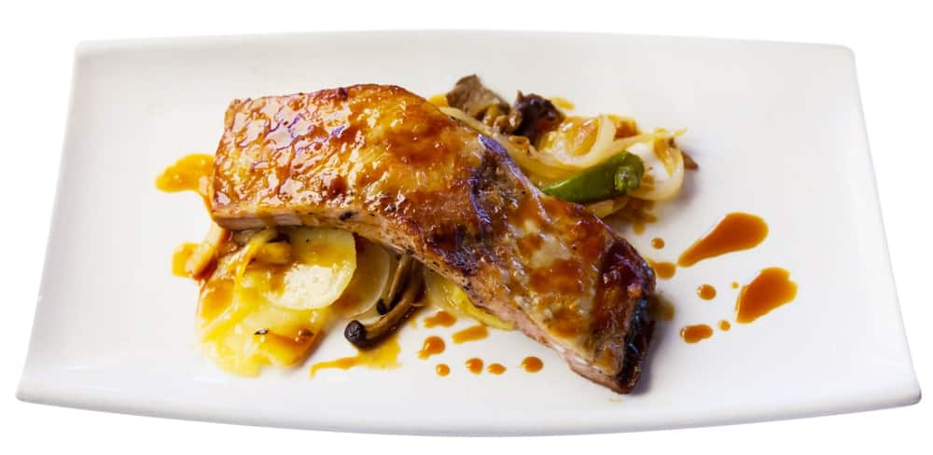
IF YOU WANT TO MAKE A JUICY PORK RIBS PLATTER VISUALLY IRRESISTIBLE, GARNISHING IT WITH SAUTÉED VEGETABLES AND TERIYAKI SAUCE WILL DO THE JOB. SPREADING TERIYAKI SAUCE ARTFULLY ON THE PLATTER AND ARRANGING THE PORK RIBS AND VEGETABLES NEATLY CAN MAKE YOUR DISH LOOK AS IF A WORLD-CLASS CHEF HAS PREPARED IT.
IDEALLY, YOU DON’T WANT TO SERVE PORK MEAT ALONE BECAUSE IT WILL LOOK DULL AND BORING. NOBODY WANTS TO TRY A DISH THAT LOOKS BORING. SO, SPICE UP THE LOOK OF YOUR DISH WITH SAUTÉED VEGETABLES AND TERIYAKI SAUCE.

11. BAKED TROUT FILLET WITH RICE AND VEGETABLES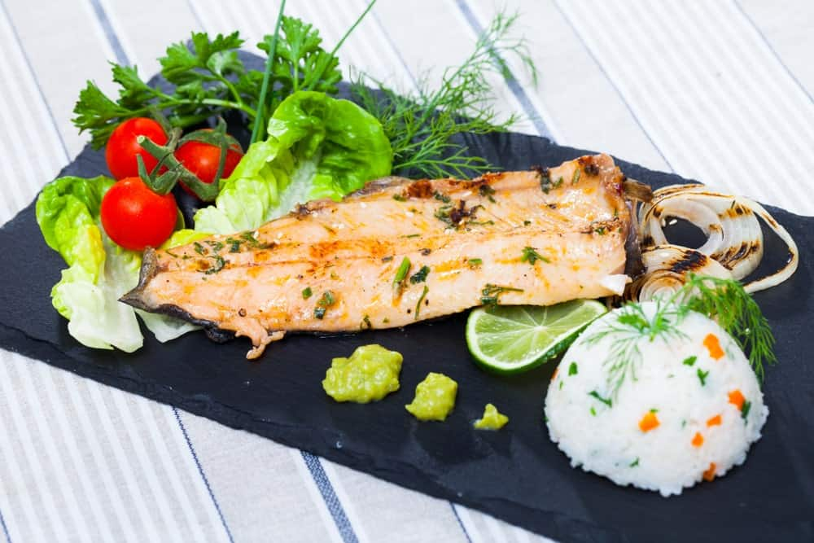
SERVING JUST A BAKED FILLET OF TROUT IS NOT A VERY GOOD IDEA. IF THERE AREN’T ANY FISH LOVERS IN YOUR GUEST LIST, THIS DISH WILL BE MOST LIKELY BE LEFT UNTOUCHED. EVERYONE LIKES TO HAVE FOOD THAT LOOKS INTERESTING. FOOD THAT INTRIGUES A PERSON TO TRY IT IS WHAT YOU SHOULD SERVE, AND THAT IS WHY, WE SUGGEST THAT YOU GARNISH THE BAKED TROUT WITH SAUTÉED VEGETABLES AND SOME INTERESTING SAUCES, KEEPING STEAMED RICE AS A SIDE DISH. YOU WILL GET A PERFECTLY BALANCED AND VISUALLY APPEALING PLATTER READY TO SERVE.

12. GRILLED VEGGIES GARNISHED WITH FRESH HERBS
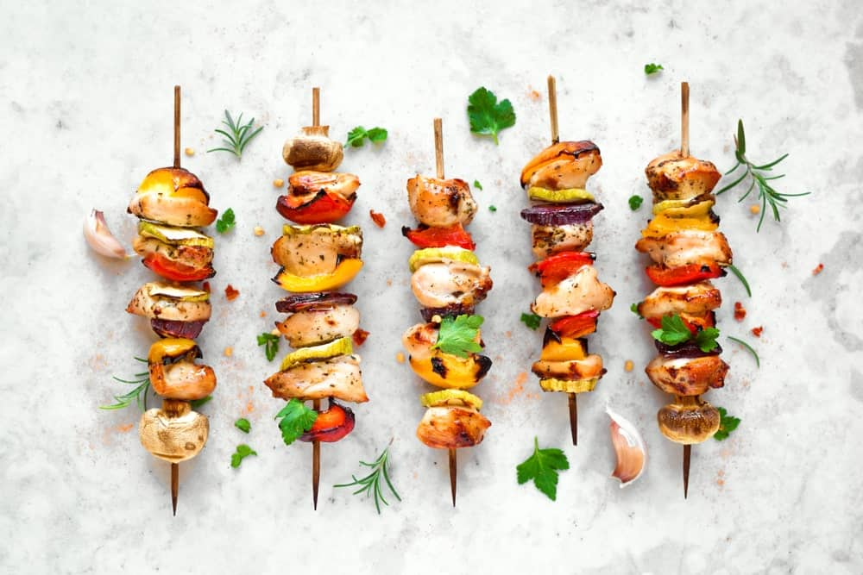
IF YOU WANT TO KEEP YOUR DINNER PARTY MENU SIMPLE YET ATTRACTIVE, TRY SERVING GRILLED VEGGIES SERVED ON SKEWERS, AND GARNISHED WITH FRESH HERBS. DECORATING AND PRESENTING THE SIMPLEST OF FOODS IN A CREATIVE WAY WILL SURELY MAKE IT A HIT. YOU DON’T ALWAYS HAVE TO SERVE FANCY DISHES. SOMETIMES, SERVING SIMPLE FOOD ITEMS IN A FANCY WAY IS GOOD ENOUGH, TOO.

13. CHICKEN STEAK WITH A VEGETABLE GARNISH
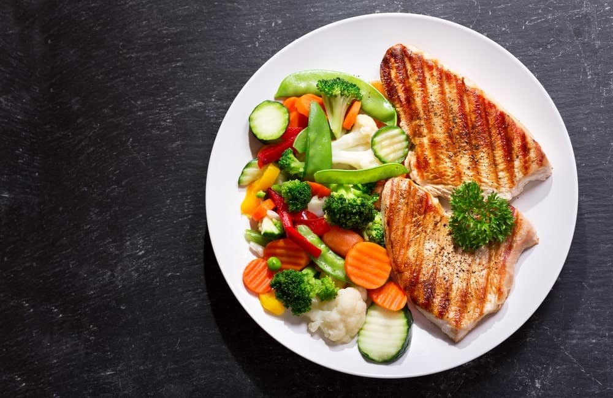
A VEGETABLE GARNISH IS THE MOST COMMON TYPE OF GARNISH THAT IS USED TO DECORATE AND ENHANCE THE VISUAL APPEAL OF MANY DISHES. WHETHER YOU ARE SERVING SEAFOOD FILLETS OR CHICKEN STEAKS, A VEGETABLE GARNISH WORKS WELL. GARNISHING YOUR CHICKEN STEAK WITH A COLORFUL VARIETY OF VEGETABLES IS A GREAT WAY TO MAKE A COLORFUL PLATTER THAT IS HARD TO RESIST.

14. CHEESECAKE WITH A FRUIT GARNISH
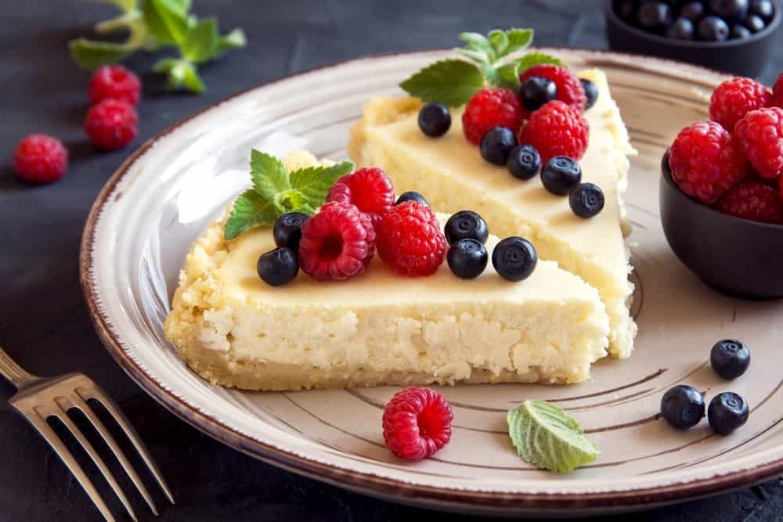
EVERYONE LOVES CHEESECAKES! TO MAKE YOUR GUESTS HAPPY, YOU HAVE TO HAVE THIS DELICIOUS ITEM ON YOUR MENU. A CHEESECAKE GARNISHED WITH SMALL PIECES OF FRUITS LIKE BERRIES, AND SAUCES LIKE A STRAWBERRY OR CHOCOLATE SAUCE MAKE FOR THE MOST ELEGANT DESSERT!

15. A BROWNIE WITH A CHOCOLATE SYRUP GARNISH
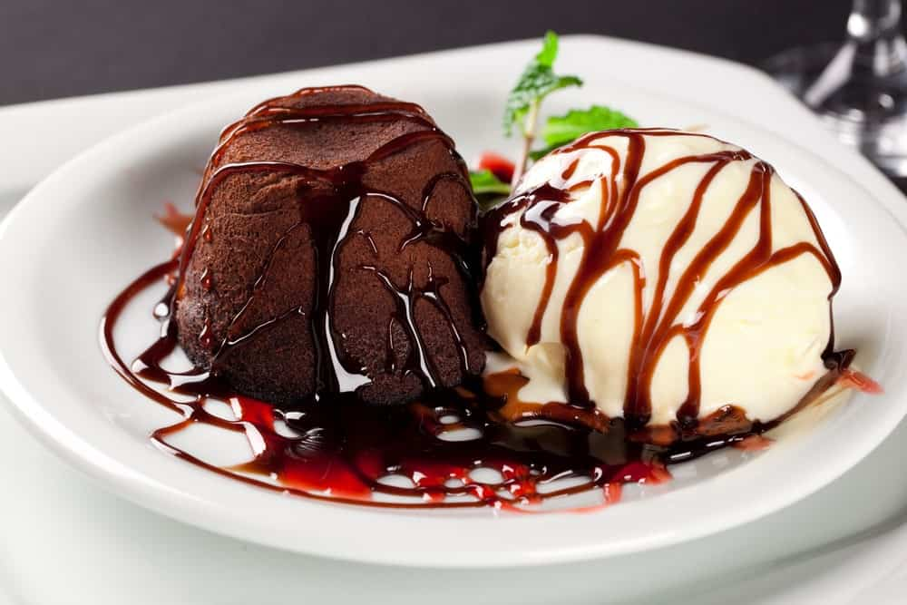
JUST WHEN YOU THINK YOUR FOOD IS READY AND THE DISH IS ALL SET TO BE SERVED, GIVE IT ONE FINAL LOOK AND ASK YOURSELF – DOES THE DISH LOOK VISUALLY APPEALING? WILL IT LEAVE THE GUESTS WANTING MORE? YOUR DISH MIGHT TASTE GREAT, BUT IF IT DOESN’T LOOK EQUALLY AS AMAZING, PEOPLE MIGHT NOT EVEN GIVE IT A TRY TO KNOW HOW GOOD IT TASTES.
THAT IS WHY IT IS IMPORTANT TO FOCUS ON THE AESTHETICS OF YOUR DISHES AS WELL. IF YOU HAVE A BROWNIE ON YOUR MENU, SERVING IT STRAIGHT FROM THE OVEN IS NOT AN OPTION. IF YOU CAN’T THINK A FANCY WAY TO PRESENT THIS DESSERT ITEM, SIMPLY GARNISHING THE BROWNIES WITH CHOCOLATE SYRUP WILL DO THE JOB WELL.

16. EDIBLE FLOWER GARNISH ON DESSERTS

DID YOU KNOW THERE ARE MANY FLOWER VARIETIES THAT ARE EDIBLE AND CAN BE USED FOR GARNISHING? PANSIES AND JASMINES ARE JUST A FEW EXAMPLES OF EDIBLE FLOWERS. EDIBLE FLOWERS MAKE FOR BEAUTIFUL GARNISHES ON DESSERTS, ESPECIALLY ON CAKES. THEIR USE IN GARNISHING IS NOT LIMITED TO DESERTS ONLY. THEY CAN BE USED IN DIFFERENT SALADS AND SIDE DISHES AS WELL.

17. RICE WITH NUTS AND DRIED FRUITS
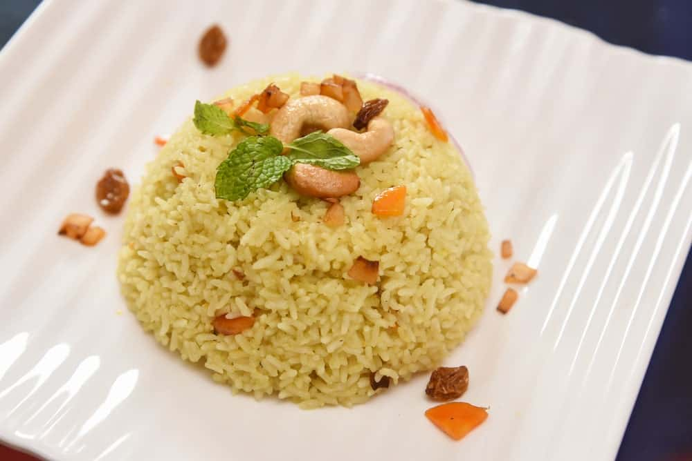
NUTS AND DRIED FRUITS AS A GARNISH ARE OFTEN SEEN WITH RICE AND MEAT DISHES. ROASTED ALMONDS, CASHEWS, AND PISTACHIOS ARE THE COMMON NUTS THAT YOU WILL OFTEN SEE BEING USED AS GARNISHES IN MIDDLE EASTERN AND SOUTH ASIAN CUISINES. THEY ADD THE PERFECT CRUNCH TO ANY DISH. THE ROASTED FLAVOR DOMINATES THE ENTIRE DISH, WHICH IS LOVED BY MANY PEOPLE. SERVING RICE WITH ROASTED NUT GARNISHING WILL BE A UNIQUE DISH AT YOUR DINNER PARTY THAT PEOPLE WILL SURELY LOVE.

18. SPICY CURRY WITH POWDERED SPICE
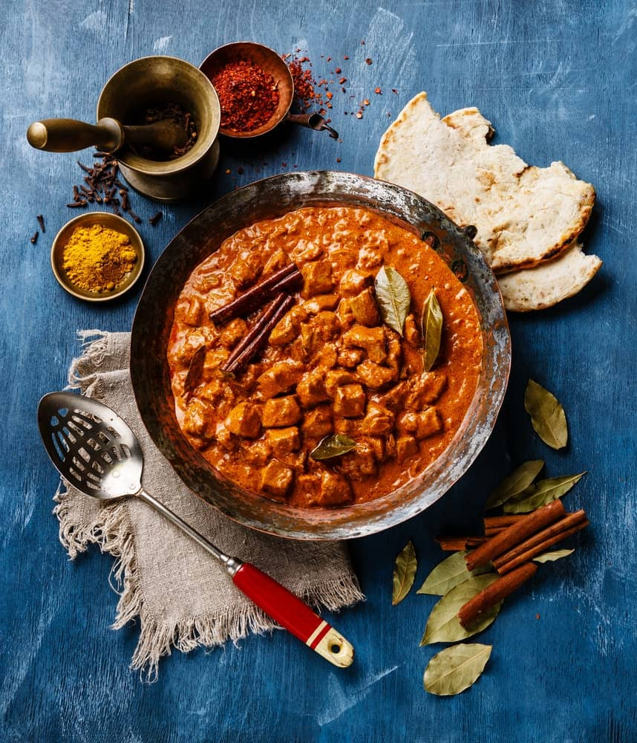
IF YOU WISH TO SPICE UP THE PARTY, TRY GARNISHING YOUR CURRY DISHES WITH SOME POWDERED SPICES LIKE PAPRIKA AND HERBS LIKE BASIL AND BAY. A HOT CURRY DISH WITH RICE WILL BE THE WINNER IN YOUR UPCOMING DINNER PARTY.
GARNISHING IS THE LITTLE EXTRA THAT IS NEEDED TO MAKE YOUR DISHES STAND OUT AND TASTE EVEN BETTER. IF YOU WANT THE FOOD YOU PREPARE TO LEAVE A LASTING IMPACT, ALWAYS FINISH IT OFF BY GARNISHING IT WITH SUITABLE INGREDIENTS.
THE VISUAL APPEAL OF FOOD HAS A MAJOR IMPACT ON YOUR APPETITE. IT IS YOUR EYES THAT MAKE YOU EITHER WANT TO TASTE THE DISH OR SKIP IT. THE BETTER A DISH LOOKS VISUALLY, THE MORE EAGER YOU ARE TO TASTE IT.
YOU MAY THINK THAT THE GARNISHING OF THE DISH IS AN AFTERTHOUGHT, BUT IN REALITY, GARNISHING IS A VERY IMPORTANT FACTOR IN MAKING YOUR DISH LOOK PRESENTABLE AND DESIRABLE. IT MAY LOOK LIKE A DECORATION THAT WAS TOSSED ON THE PLATE JUST LIKE THAT, BUT THINKING IN SUCH A WAY IS WRONG, AND IT DOESN’T DO JUSTICE TO THE ART OF GARNISHING A DISH.
A GARNISH CONSISTS OF AN EDIBLE COMPONENT LIKE VEGETABLES, HERBS, SAUCES, BERRIES, OR CHOPPED FRUITS. IT DOESN’T JUST ENHANCE THE APPEARANCE AND THE FLAVOR OF THE FOOD; IT ALSO ADDS ADDITIONAL NUTRITIONAL VALUE TO IT.
IMAGINE TWO DIFFERENT SITUATIONS – IN ONE, YOU GET SERVED BREAD AND EGGS FOR BREAKFAST, AND IN THE SECOND, YOU ARE SERVED A BEAUTIFULLY DECORATED PLATTER THAT CONSISTS OF BREAD AND EGGS THAT HAVE BEEN GARNISHED WITH HERBS AND DIFFERENT SEASONINGS. WHICH ONE WOULD YOU PREFER TO EAT? ALTHOUGH THE MAIN ITEMS OF BOTH DISHES ARE THE SAME, YOU WILL PROBABLY OPT FOR THE GARNISHED PLATTER BECAUSE OF ITS VISUALLY APPEALING AESTHETICS.
WHEN WE SAY THAT A GARNISH IS A POWERFUL TOOL THAT YOU CAN USE TO MAKE A SIMPLE DISH STAND OUT, WE MEAN IT. IF YOU’RE GOING TO BE HOSTING A DINNER PARTY ANY TIME SOON, WE SUGGEST YOU GO THROUGH THE GARNISH IDEAS WE’VE LISTED BELOW. THESE IDEAS WILL MAKE YOUR PARTY A HIT, AND SOMETHING THAT PEOPLE WILL CONTINUE TO DISCUSS IN THE DAYS THAT FOLLOW.
WITH THE CORRECT GARNISH, YOU CAN ENJOY RESTAURANT-LIKE MEALS AT HOME. AS FAR AS YOUR UPCOMING DINNER PARTY IS CONCERNED, GARNISHED DISHES WILL MAKE YOUR GUESTS FEEL THE SAME WAY.

11 HERBS TO GROW IN WATER ON YOUR WINDOWSILL

GARDENING IS NOT ONLY RESERVED FOR THOSE WITH BACKYARDS. GARDENING CAN BE DONE IN MANY CREATIVE WAYS, AND HERE WE’VE PREPARED A LIST OF HERBS THAT REQUIRE NOTHING MORE THAN SUNLIGHT AND A DAINTY CUP.
ONCE YOU’VE EXPERIENCED THE JOY OF GOING TO YOUR WINDOW SILL TO PICK THE GARNISH FOR YOUR LOVINGLY PREPARED ROASTED CHICKEN OR EVENING COCKTAIL, YOU’LL NEVER GO BACK. NOT TO MENTION, THESE PRECIOUS HERBS BRING LIFE TO A DULL ROOM, AND MOST OF THEM ARE NATURAL AIR FRESHENERS!
RELATED: TYPES OF HERBS | VEGETABLES AND HERBS FOR SYMBIOTIC FARMING | HERBS FOR INDOOR KITCHEN HERB GARDEN | HERBS THAT KEEP FLIES AWAY

NO SOIL?
NO SOIL! PLANTS ARE INCREDIBLY RESILIENT ORGANISMS, AND MANY OF THEM CAN GET THE NUTRIENTS THEY NEED FROM WATER AND SUNLIGHT. WHETHER YOU’RE LOOKING TO EXTEND THE LIFE OF YOUR FAVORITE HERBS DURING THE WINTER MONTHS, OR YOU NEVER KNOW HOW TO POSSIBLY USE ALL OF THE CILANTRO THEY SELL IN BUNCHES AT THE GROCERY STORE (YOU KNOW WHAT I’M TALKING ABOUT), ALL YOU NEED IS RUNNING WATER AND A CUP.
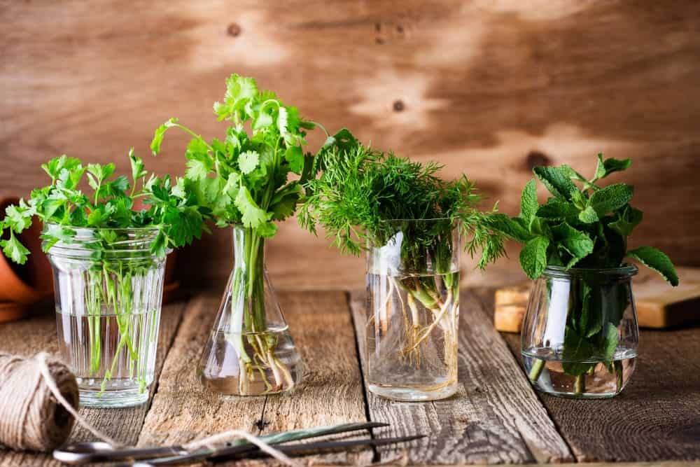

HOW TO TRANSFER YOUR HERBS
- CLIP YOUR HERBS SO THAT THEY’RE ABOUT 6 INCHES IN LENGTH — CLIP THEM AT AN ANGLE! THE HERBS ABSORB WATER THROUGH THE CUT PART OF ITS STEM, SO CUTTING AT AN ANGLE PROVIDES A BIGGER SURFACE FOR WATER ABSORPTION
- PINCH AWAY ANY LEAVES THAT WOULD BE SUBMERGED UNDERWATER, OR ANY LEAVES THAT ARE LOOKING A LITTLE OLD OR YELLOW
- FIND YOUR WATER VESSELS. CLEAR GLASS WILL ALLOW MORE LIGHT IN AND ALGAE WILL GROW SOONER, BUT THE WATER CAN ALWAYS BE REPLACED. OPAQUE GLASS LETS IN LESS SUNLIGHT AND WATER WON’T NEED TO BE CHANGED AS OFTEN.
- FILL YOUR WATER VESSELS WITH WATER. AVOID DISTILLED WATER AS IT IS STRIPPED OF ESSENTIAL NUTRIENTS THE PLANTS WILL NEED TO GROW
- PLACE THEM ON A WINDOWSILL AND WATCH YOUR LITTLE FRIENDS GROW HAPPILY

THE ALPHABETICAL LIST OF HERBS

1. BASIL
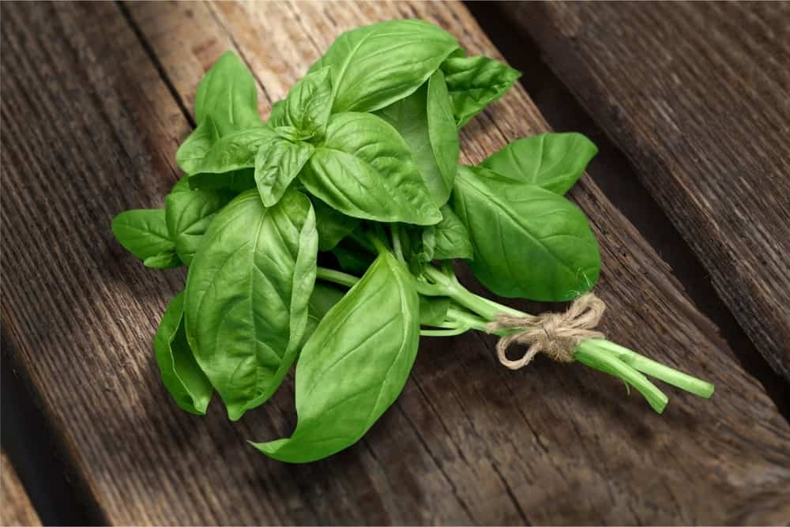
THERE’S NOTHING MORE SATISFYING THAN PICKING A FEW LEAVES OF FRESH BASIL TO GARNISH AN OMELET OR PASTA DISH.
ONCE THE ROOTS GROW TO BE LONGER THAN A COUPLE OF INCHES, IT IS BETTER TO PLANT IT IN SOIL.
IF YOU WANT YOUR BASIL TO KEEP GROWING, PLUCK AWAY THE FLOWERS AS THEY DEVELOP (THESE ARE EDIBLE AND MAKE FOR AN INTENSELY DELICIOUS GARNISH) AS THIS INDICATES THE END OF THE PLANT’S LIFE CYCLE.

2. CHIVES
CHIVES LIKE PLENTY OF WATER AND PLENTY OF SUNLIGHT, SO IT IS BETTER TO HAVE THEM IN A CLEAR GLASS JAR. THE WATER WILL NEED TO BE CHANGED OFTEN, BUT THESE GUYS CAN GROW CENTIMETERS IN JUST A DAY!

3. CILANTRO
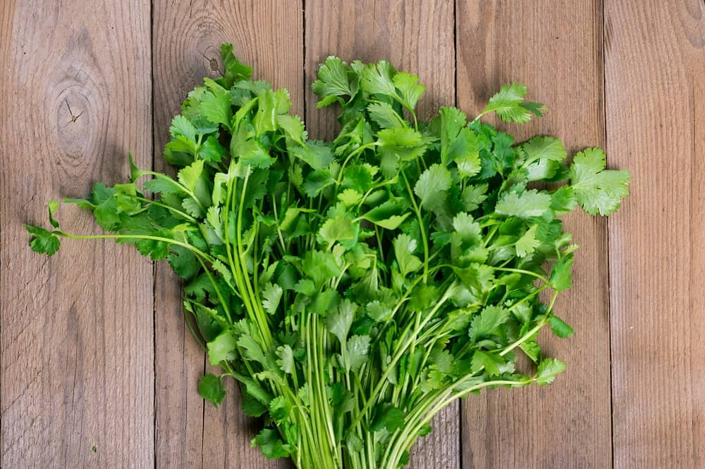
YOU CAN’T HAVE TACOS WITHOUT A LITTLE FRESH CILANTRO. AND LIKE I MENTIONED BEFORE, IT’S IMPOSSIBLE TO USE UP ALL OF THE CILANTRO THEY BUNCH TOGETHER IN GROCERY STORES! PLACING YOUR LEFTOVER CILANTRO IN AN OPAQUE JAR WILL ENSURE THIS BEAUTIFUL HERB WON’T GO TO WASTE.
HARVEST YOUR CILANTRO BEFORE IT BLOOMS, AS THIS INDICATES THE END OF ITS LIFE CYCLE, AND THE LOVELY FLAVOR QUICKLY DISSIPATES.

4. GREEN ONION
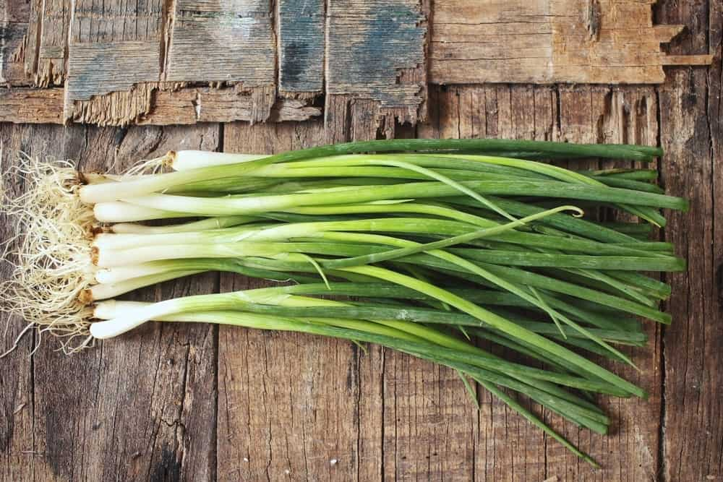
GREEN ONION GIVES A SPLASH OF FRESHNESS TO ALMOST ANY DISH. SIMPLY SAVE THE BULB AND PLACE IT IN A SHORT WATER GLASS, ENSURING THAT THE SNIPPED END ISN’T TOTALLY SUBMERGED. THE BULB ALREADY HAS ROOTS, AND THIS IS WHERE THE HERB WILL ABSORB WATER.
GREEN ONION LIKES LOTS OF LIGHT, SO PLACE IT IN CLEAR GLASS. BUT MAKE SURE TO CHANGE THE WATER OFTEN, AS IT CAN GET STINKY PRETTY QUICK.
THESE GUYS GROW SO QUICKLY, IT MIGHT EVEN BE WORTH IT TO MEASURE HOW MUCH IT GROWS IN A DAY!

5. LEMON BALM
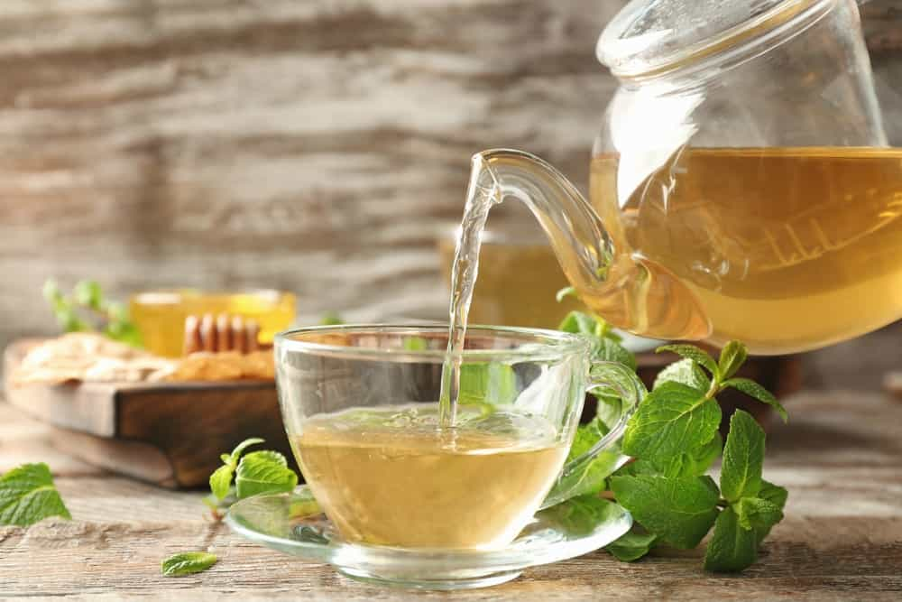
LEMON BALM IS WONDERFUL FOR SO MANY REASONS. IT SMELLS INCREDIBLE, IT CAN HELP WITH INDIGESTION, IT CAN REDUCE FEELINGS OF STRESS, AND IS EVEN ABLE TO HELP WITH DEEPER SLEEP.
THIS HERB IS QUITE PRONE TO MILDEW, SO ENSURE TO REPLACE ITS WATER OFTEN. IT’S AN HERB WORTH HAVING IN EVERY HOUSEHOLD.

6. MINT
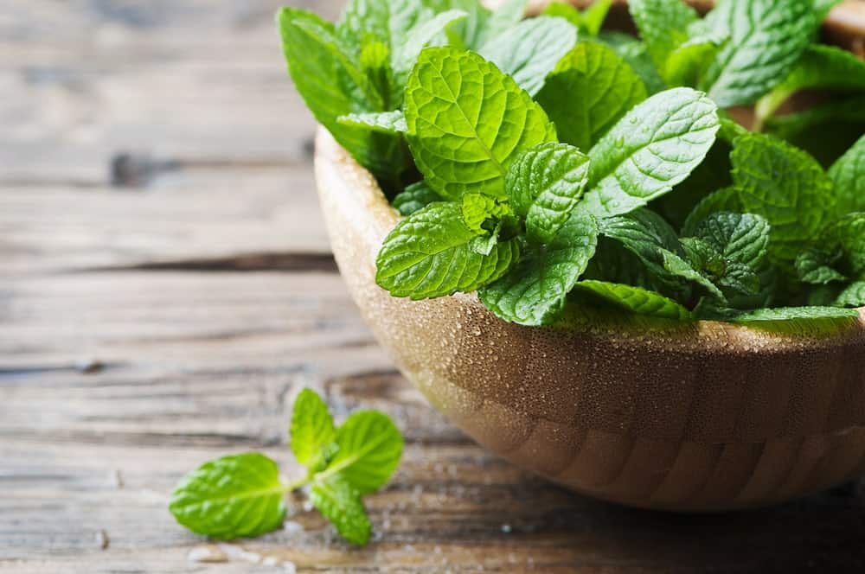
QUITE A BIT OF SATISFACTION COMES FROM MAKING THE DECISION TO HAVE A MOJITO AND HAVING ALL OF THE INGREDIENTS NEEDED TO MAKE IT HAPPEN. IT’S ALSO A TASTY LITTLE ADDITION TO A CUP OF HOT COCOA. MAYBE EVEN KEEP IT BY YOUR FRONT DOOR FOR A LITTLE BREATH FRESHENER AS YOU’RE HEADING OUT!
MINT IS ANOTHER HERB THAT LIKES A LOT OF SUNLIGHT BUT IS PRONE TO ALGAE PRODUCTION. KEEPING IT IN A CLEAR GLASS WILL HELP WITH KEEPING AN EYE ON THAT.
Bottom of Form

7. OREGANO
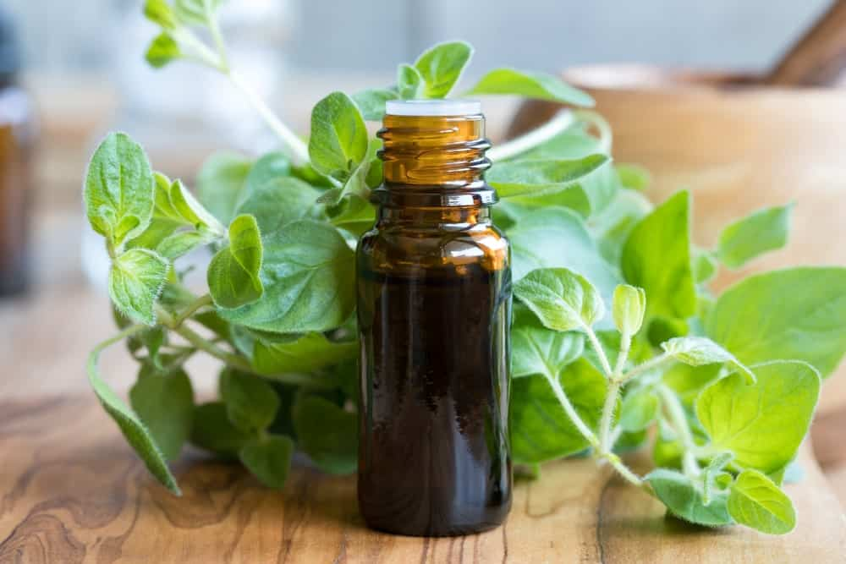
NOT ONLY IS OREGANO THE GO-TO GARNISH FOR ALMOST ANY SAVORY DISH YOU CAN THINK OF, IT HAS MEDICINAL PROPERTIES AS WELL! ANY TIME YOU FEEL A COLD COMING ON, JUST CHEW A BIT OF OREGANO TO HELP WARD IT AWAY. THIS IS AN OLD WIVE’S TALE, BUT IT SURE WORKS!
OREGANO GROWS REALLY FAST, SO MAKE SURE TO CLIP AWAY ANY LEAVES THAT DON’T LOOK LIKE THEY’RE DOING TOO WELL.

8. ROSEMARY
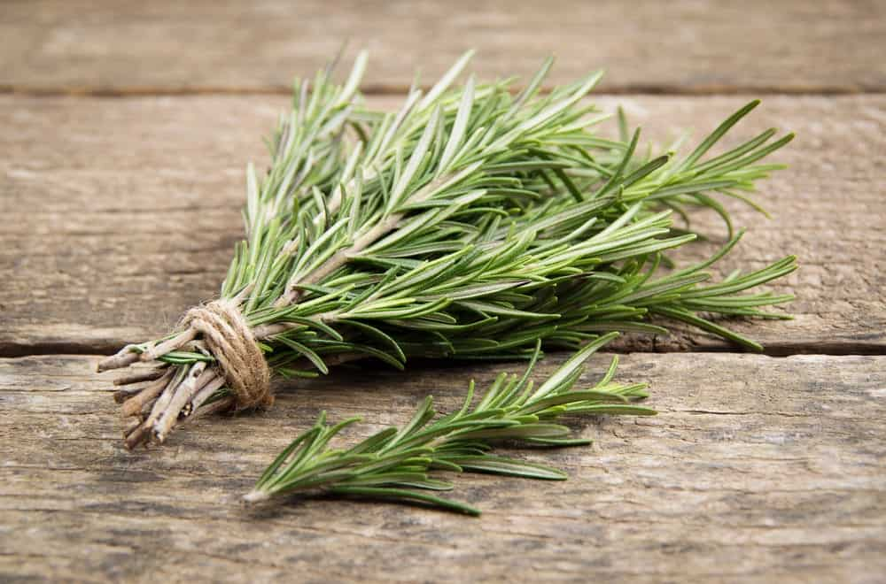
ROSEMARY IS AN EXCELLENT HERB TO KEEP ON YOUR WINDOWSILL, AS IT IS A NATURAL AIR FRESHENER AND DOESN’T NEED TO HAVE ITS WATER CHANGED ALL TOO OFTEN. JUST MAKE SURE LEAVES GROWING BELOW THE WATER ARE CLIPPED AWAY, AND ENJOY THIS TASTY HERB ALL YEAR.
PRO BREAKFAST TIP: ONE OF THE BEST OMELETS I’VE EVER MADE WAS JUST BLUE CHEESE, FRESH ROSEMARY, AND LITTLE ROLLED UP SAUSAGES. GIVE IT A TRY AT HOME!

9. SAGE

SAGE IS A LOVELY FLAVOR OFTEN ENCOUNTERED IN SAVORY THANKSGIVING DISHES, BUT IT CAN EXTEND FAR BEYOND THAT. FRYING SAGE MAKES FOR AN INCREDIBLY UNIQUE AND CRISPY GARNISH, AND TONES DOWN THAT INTENSE FLAVOR.
THIS IS A GREAT ONE TO PLANT BACK IN THE GARDEN IN THE SPRINGTIME, AS IT WILL JUST EXPLODE ONCE IT IS IN THE SOIL AGAIN.
SAGE IS ALSO USED AS AN ATMOSPHERIC ADDITION TO A ROOM. DRYING IT, BUNDLING IT, THEN BURNING IT MAKES FOR A RELAXING ATMOSPHERE.

10. STEVIA
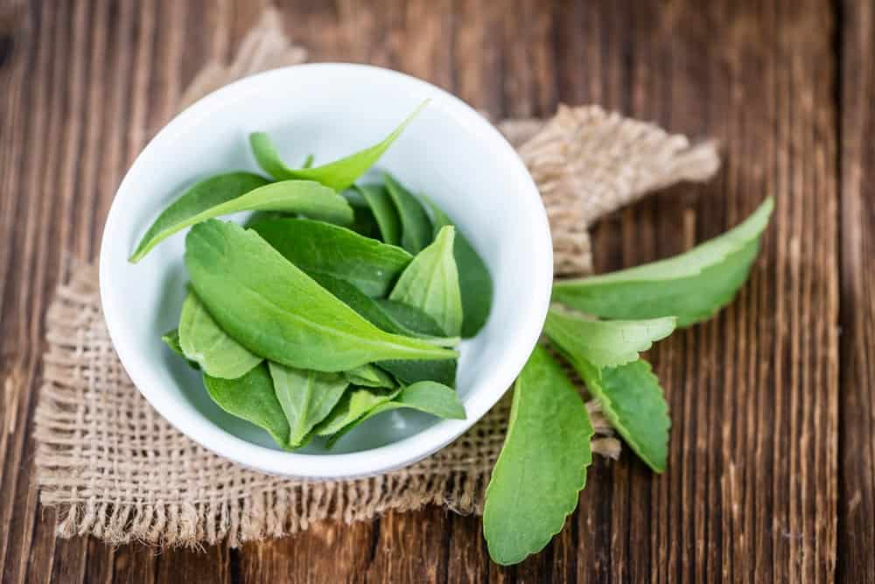
WE’VE ALL BECOME MORE FAMILIAR WITH STEVIA, AS BEING A ZERO-CALORIE SWEETENER. THIS AWESOME SUBSTITUTE FOR SUGAR LIKES LOTS AND LOTS OF SUN, SO KEEP IT IN A CLEAR GLASS JAR.
HOW FUN WOULD IT BE TO JUST PLUCK A LEAF AND MIX IT IN YOUR HOT CUP OF COFFEE?

11. THYME
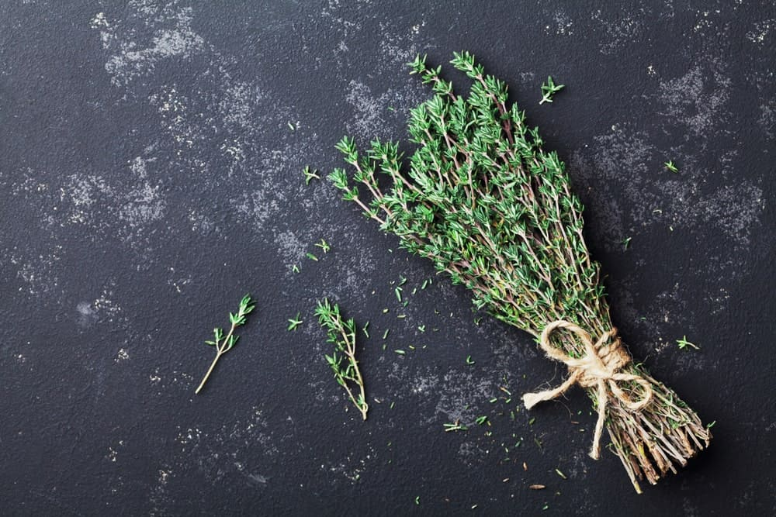
PARSLEY, SAGE, ROSEMARY, AND… THYME? WE ALL KNOW THE TUNE. THIS IS A CLASSIC HERB, PUT TO ESPECIALLY GOOD USE WITH POULTRY DISHES.
I BET YOU DIDN’T KNOW THAT THYME ACTUALLY PRODUCES DELICIOUS EDIBLE FLOWERS! NOW YOU CAN HAVE THE OPPORTUNITY TO TASTE THOSE RIGHT FROM THE COMFORT OF YOUR KITCHEN.
THYME STARTS TO ROOT AFTER A COUPLE OF WEEKS, IT CAN EITHER STAY SUBMERGED IN GLASS OR BE PLANTED INTO A SMALL POT.

27 BRILLIANT VEGETABLE AND HERB PAIRINGS FOR A HEALTHIER GARDEN
IF YOU ARE LOOKING TO SUPPLEMENT YOUR SYMBIOTIC GARDEN, HERE ARE 27 DIFFERENT VEGETABLES AND HERBS ALONG WITH THEIR COMBINATIONS FOR A HAPPY SYMBIOTIC GARDEN.
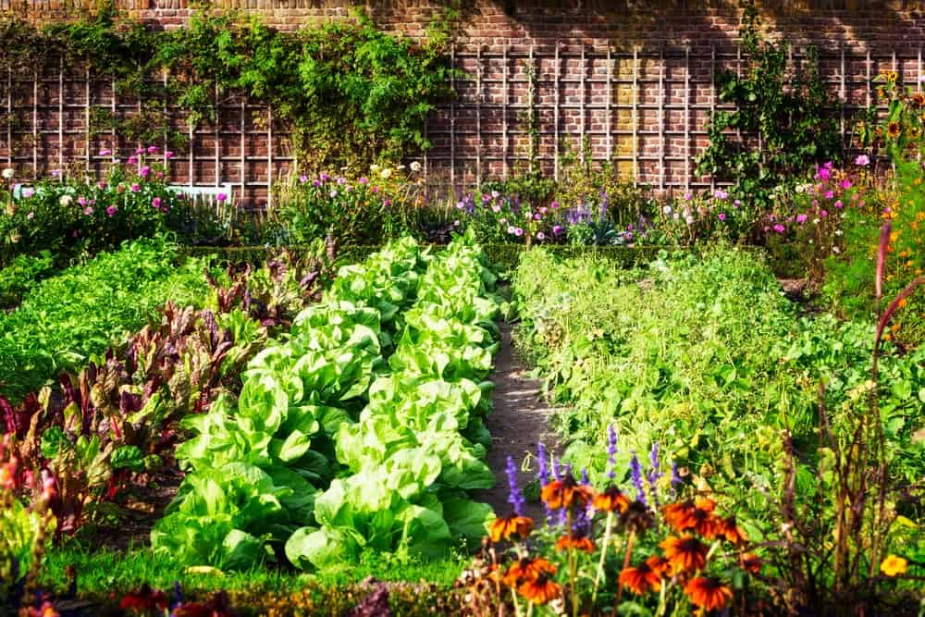
A HEALTHY GARDEN MAKES A HAPPY HOME, AND IF TAKEN CARE OF, IT CAN SUSTAIN YOU THROUGHOUT EVERY SEASON (CURIOUS ABOUT FOOD PRESERVATION? READ ABOUT IT HERE!) WE DISCUSS SYMBIOTIC GARDENING PRACTICES IN A PREVIOUS ARTICLE AND WANTED TO CREATE A MORE COMPREHENSIVE LIST OF GREAT PAIRINGS TO MAKE IN YOUR FRUIT AND VEGETABLE GARDEN.
AFTER HUNDREDS OF YEARS OF OBSERVATION, HUMANS HAVE MADE A WISE EFFORT IN ATTEMPTING TO UNDERSTAND PLANT RELATIONSHIPS, AND LEARNING FROM THEM ABOUT HOW TO LIVE IN HARMONY. SYMBIOTIC GARDENING PRACTICES ARE THANKFULLY BECOMING MORE WELL KNOWN, AND THE EFFORTS ARE APPARENT WHENEVER IT COMES TIME TO HARVEST.
RELATED: SYMBIOTIC FARMING | HOW TO INCREASE VEGETABLE GARDEN YIELD | VEGETABLE GARDEN IDEAS | WHY LADYBUGS ARE GOOD FOR THE GARDEN | BARK MULCH

THE BIG GUNS
HERE WE’RE GOING TO GO A LITTLE BIT MORE IN-DEPTH INTO A FEW PLANTS, TO DESCRIBE IN DETAIL WHAT PAIRING THEM WITH ANOTHER PLANT WILL LOOK LIKE.

ORANGE NASTURTIUM: A LOVELY PERENNIAL FLOWER THAT ATTRACTS WHITEFLIES. THIS PLANT IS QUITE THE MARTYR, AS IT DETERS ATTENTION FROM YOUR PRECIOUS CUCUMBERS, TOMATOES, CABBAGE, AND LETTUCE AND ONTO ITSELF. SACRIFICE FOR BENEFIT OF THE WHOLE.

ROSEMARY: THIS IS A WONDERFUL HERB TO PAIR WITH CARROTS, SAGE, CABBAGE, AND BROCCOLI. THE OTHER HERBS AND VEGETABLES THRIVE, WHILE THE SCENT OF THE ROSEMARY REPELS PESTS LIKE CABBAGE MOTHS AND FLIES. (IT ALSO GOES GREAT IN SWEET AND SAVORY DISHES ALIKE.)
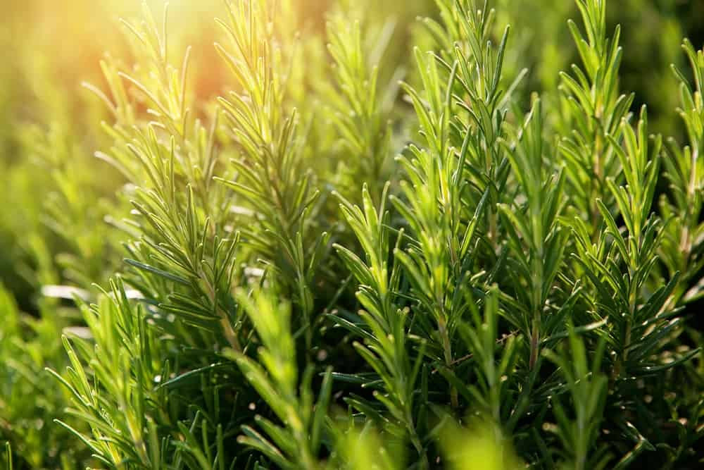
MARIGOLDS: NOT ONLY ARE THEY A FANTASTIC COLOR, BUT THESE ARE ALSO THE ULTIMATE POLLINATOR ATTRACTORS! AND IT DOESN’T END THERE. MARIGOLDS ATTRACT HOVERFLIES. WHY IS THIS GOOD? BECAUSE HOVERFLIES ARE PREDATORY TO TWITCH GRASS, PLANT LICE, AND GREENFLIES.

GARLIC: BETTER KNOWN FOR SHIELDING US AGAINST VAMPIRES, IT ACTUALLY DOES THE SAME WITH PESTS! GROW GARLIC WITH TOMATOES, KALE, AND STRAWBERRIES, AND YOU’LL NEVER SEE A SPIDER MITE AGAIN.

THE BIG LIST
THERE IS AN ALMOST INFINITE NUMBER OF SUCCESSFUL FRUIT AND VEGETABLE PAIRINGS THAT CAN BE MADE. SO HERE IS A COMPACTED LIST OF 27 VEGGIES AND HERBS AND WHAT THEY GET ALONG WITH UNDER THE SOIL.
Bottom of Form

1. ASPARAGUS
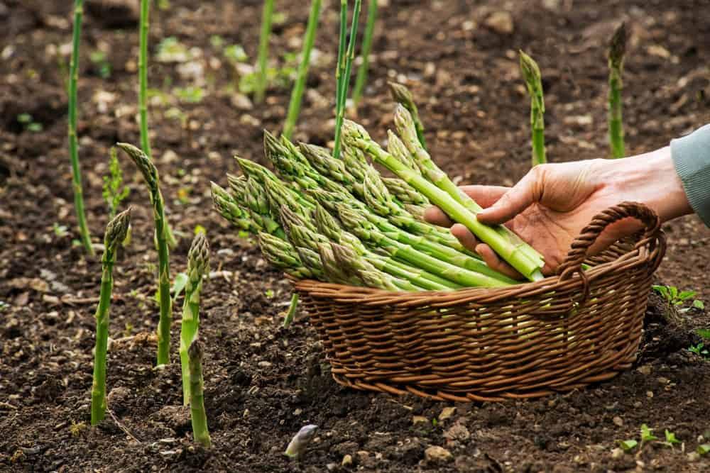
PAIR: BASIL, PARSLEY, TOMATO

2. BASIL
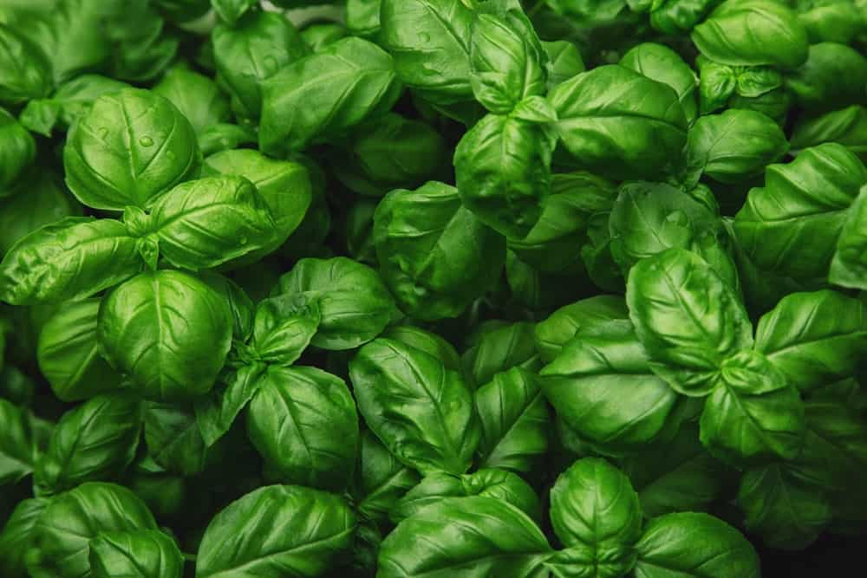
PAIR: PEPPER, TOMATO

3. BEANS
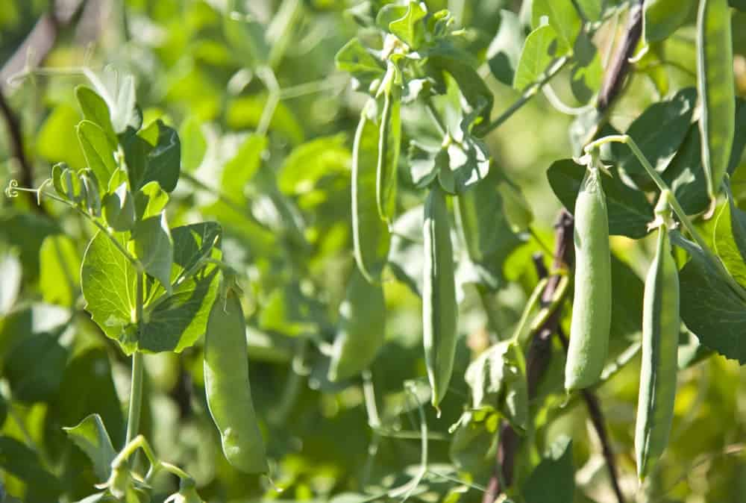
PAIR: BEET, CARROT, CAULIFLOWER, CORN, CUCUMBER, MARIGOLD, POTATO, STRAWBERRY
AVOID: FENNEL, GARLIC, ONION

4. BEETS

PAIR: BEANS, BROCCOLI, CABBAGE, COLLARD GREENS, KALE, ONION
AVOID: POLE BEAN, MUSTARD SEED

5. BROCCOLI
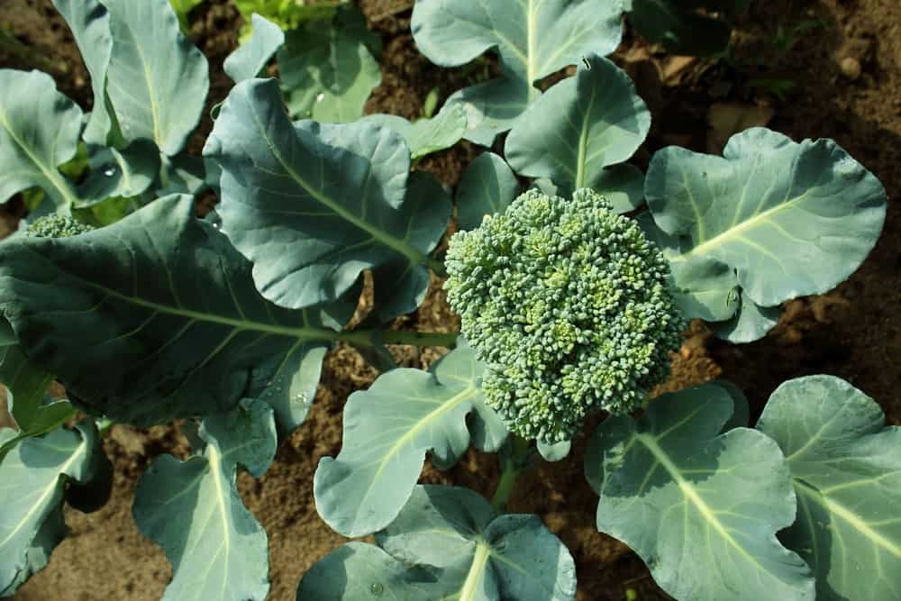
PAIR: BEET, DILL, ONION, OREGANO, PEPPERMINT, POTATO, ROSEMARY, SAGE
AVOID: BEANS, MUSTARD SEED, STRAWBERRY, TOMATO

6. CABBAGE
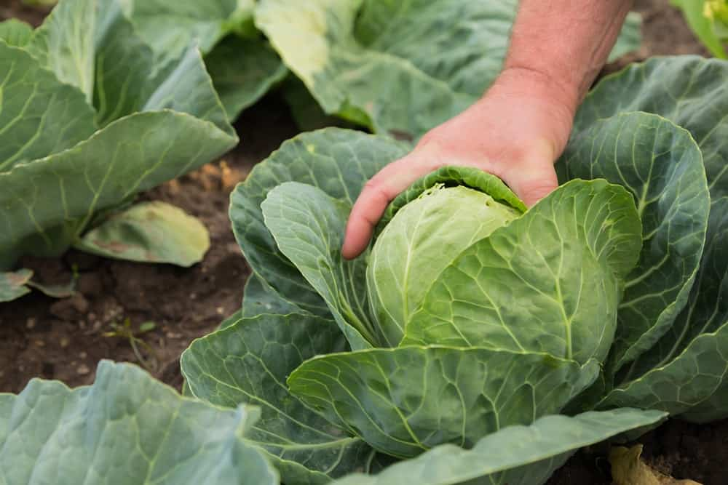
PAIR: BEET, DILL, ONION, OREGANO, PEPPERMINT, POTATO, ROSEMARY, SAGE
AVOID: BEANS, MUSTARD SEED, STRAWBERRY, TOMATO

7. CARROT

PAIR: LETTUCE, ONION, PEA, ROSEMARY, SAGE, TOMATO
AVOID: DILL

8. CHARD
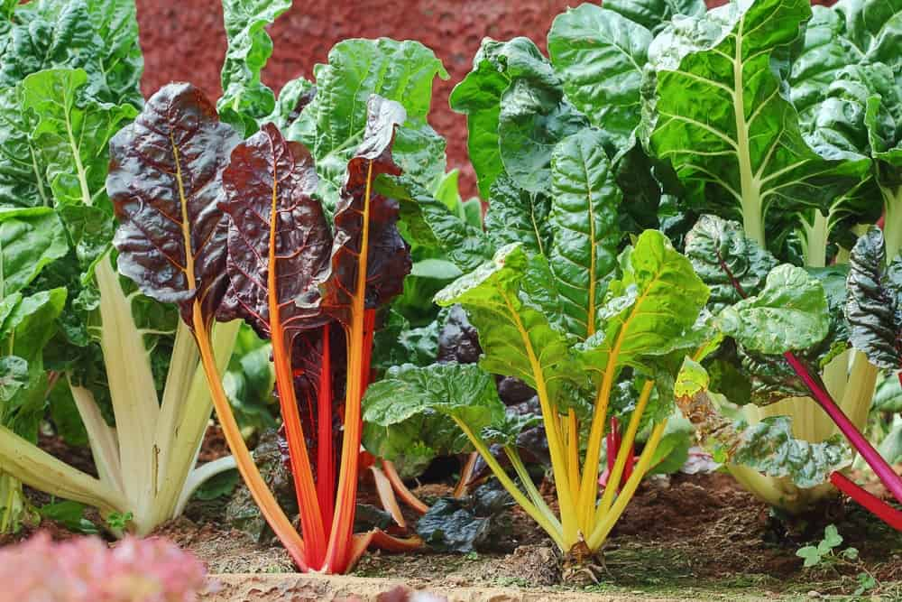
PAIR: MINT, LETTUCE, RADISH

9. CILANTRO
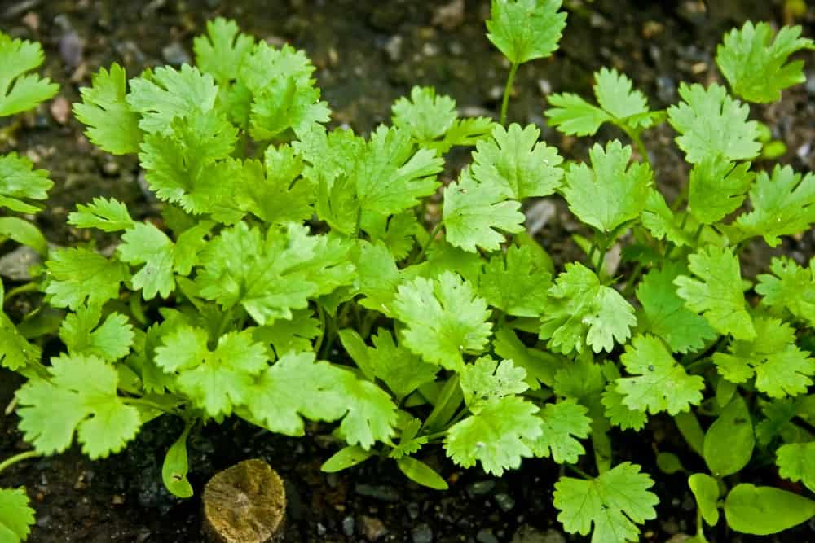
PAIR: CARROT, CHARD, RADISH
AVOID: FENNEL

10. COLLARD GREENS
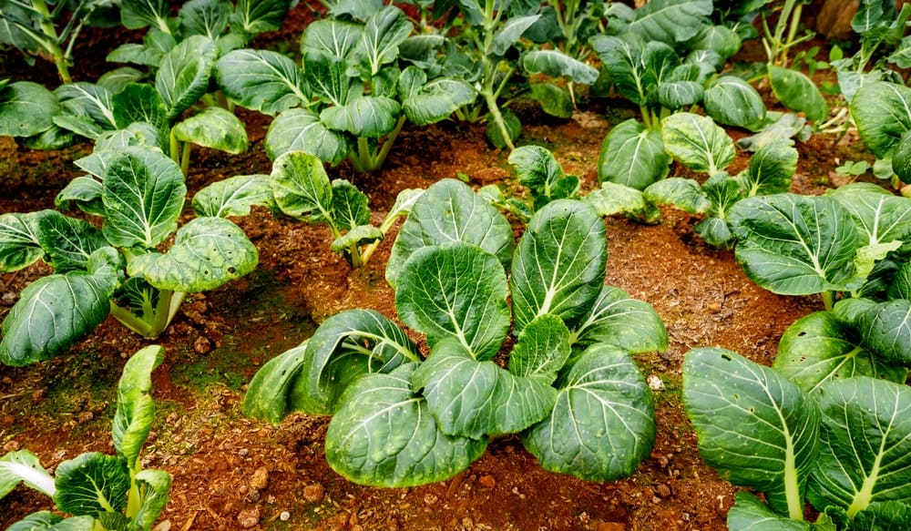
PAIR: TOMATO

11. CORN

PAIR: ARTICHOKE, BEAN, CUCUMBER, MARIGOLD, PEA, POTATO, PUMPKIN, SUNFLOWER

12. CUCUMBERS
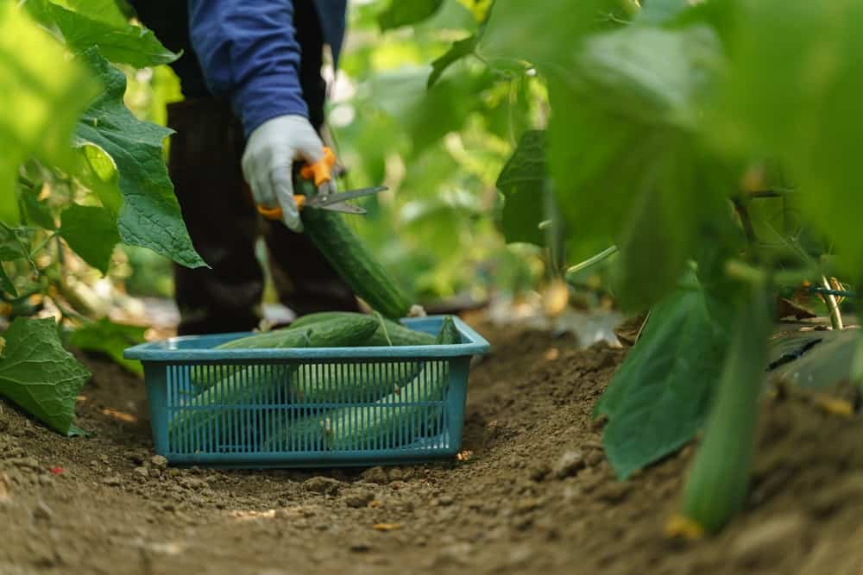
PAIR: BEAN, CORN, OKRA, PEA, RADISH, SUNFLOWER
AVOID: LAVENDER, LEMON BALM, MINT, POTATO

13. EGGPLANT
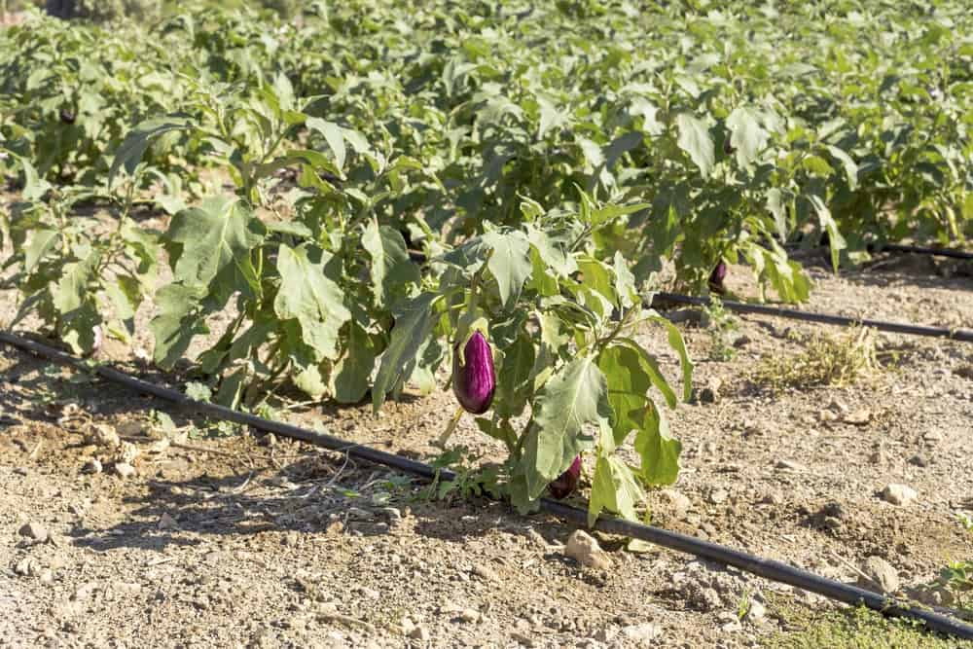
PAIR: BEAN, OKRA

14. GARLIC
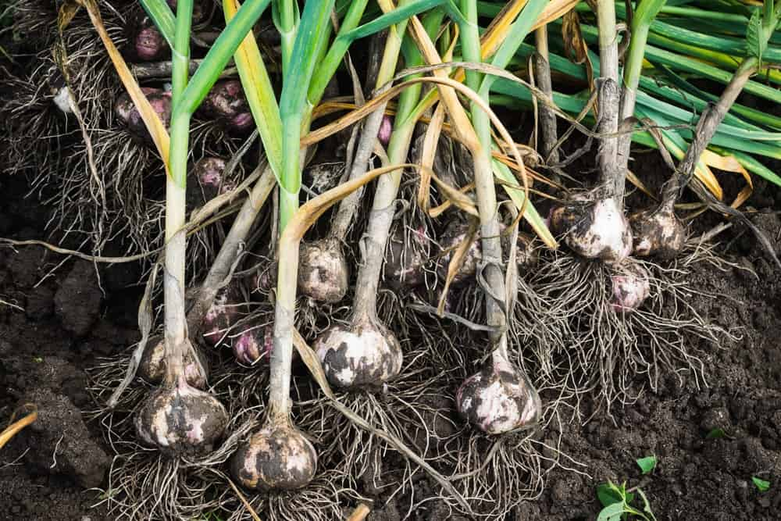
PAIR: KALE, TOMATO, STRAWBERRY
AVOID: BEAN, PEA

15. LAVENDER
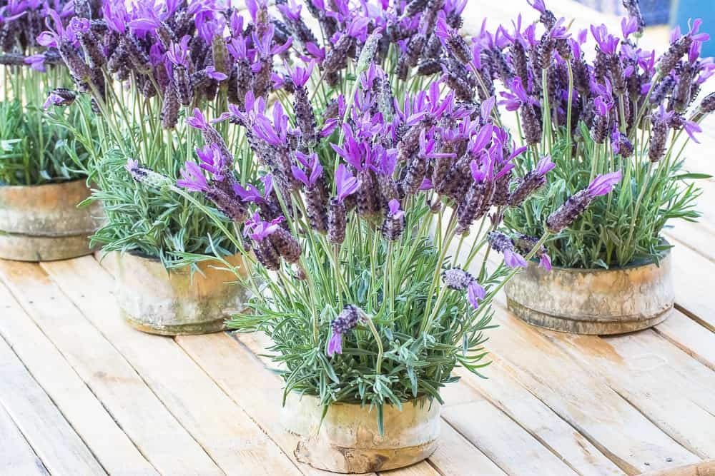
PAIR: BROCCOLI, COLLARD GREENS, KALE

16. LETTUCE
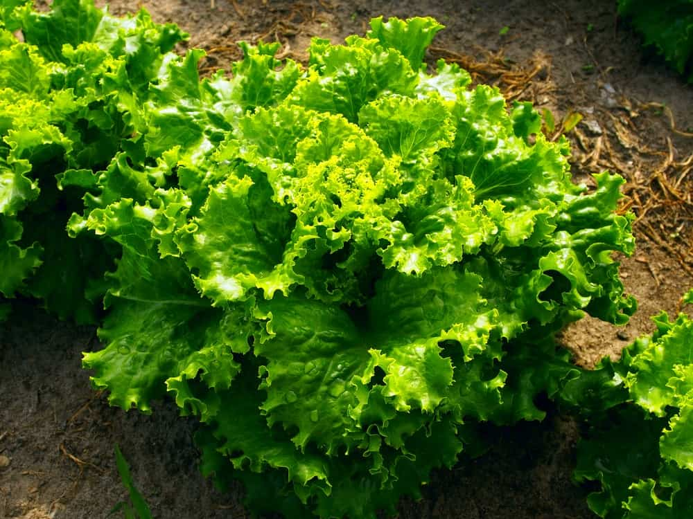
PAIR: CARROT, CUCUMBER, RADISH, STRAWBERRY
AVOID: CABBAGE, PARSLEY

17. MINT
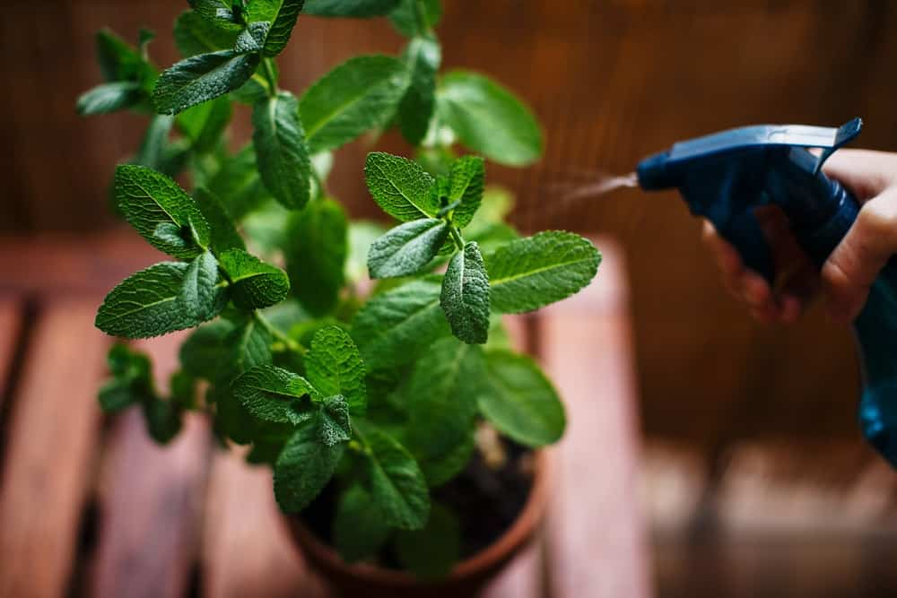
PAIR: CABBAGE, TOMATO
AVOID: CHAMOMILE

18. OKRA
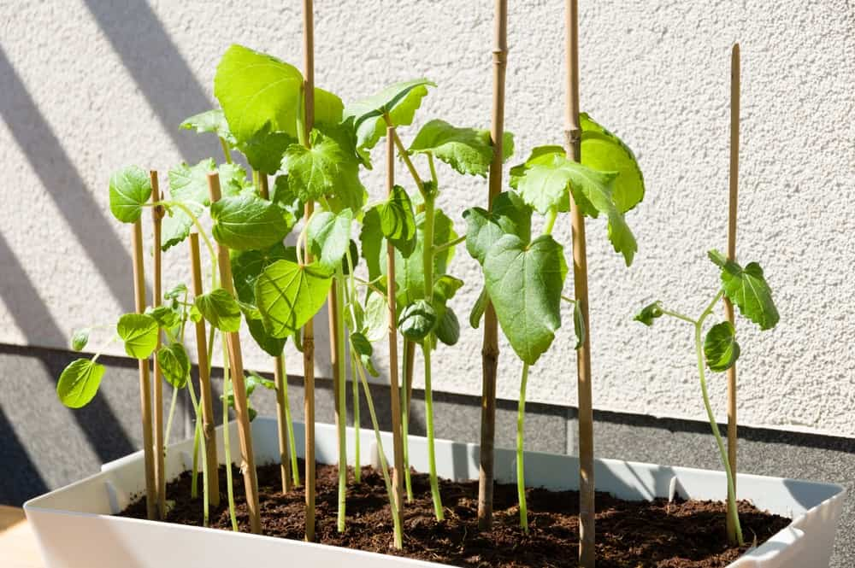
PAIR: CUCUMBER, EGGPLANT, SWEET PEPPER

19. ONION
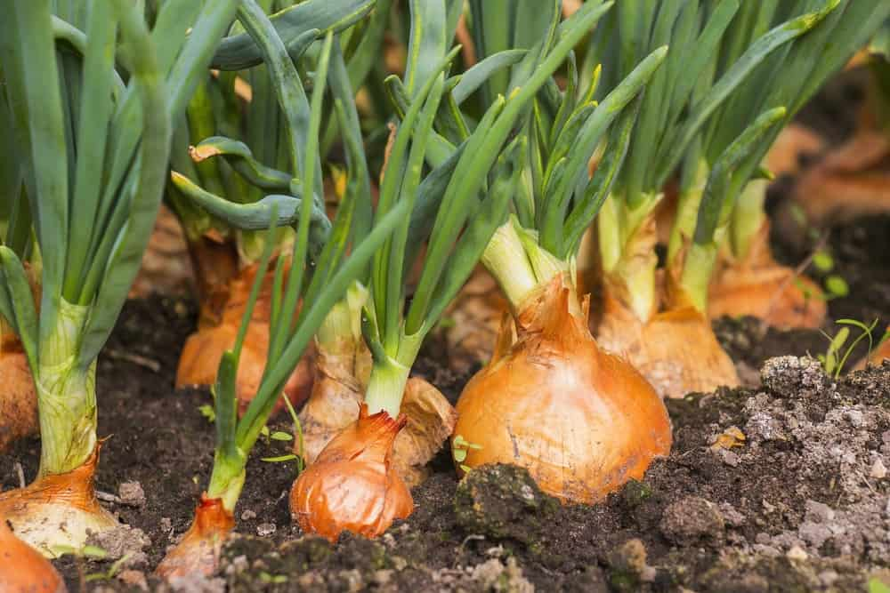
PAIR: BEET, STRAWBERRY, TOMATO
AVOID: BEAN, PEA

20. PEAS
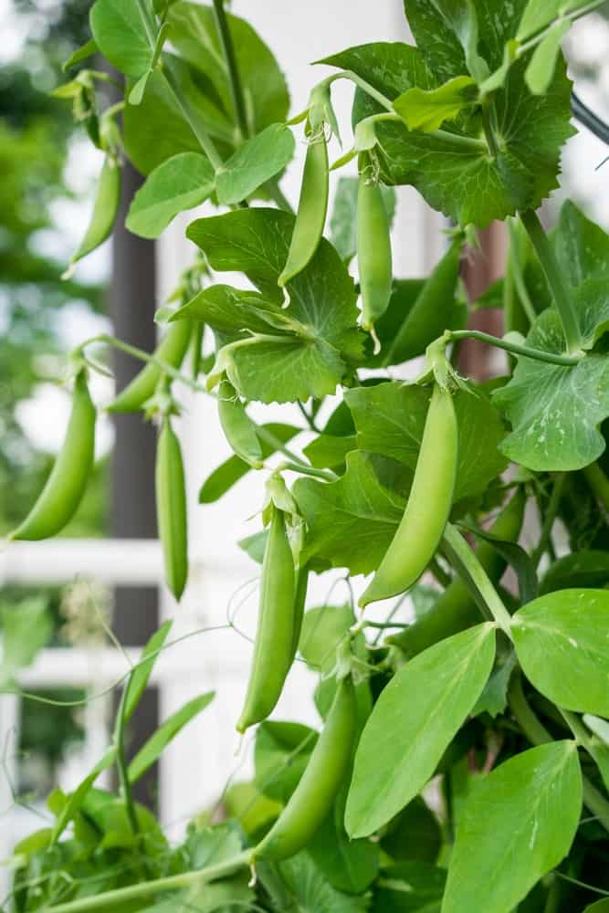
PAIR: BEAN, CARROT, CORN, CUCUMBER, LEMON BALM, MINT, POTATO, RADISH
AVOID: GARLIC, ONION

21. PUMPKIN
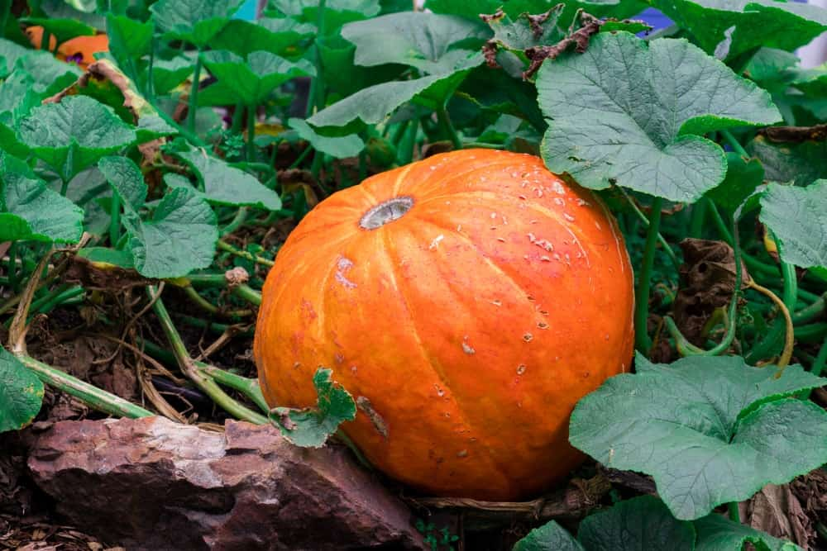
PAIR: BEAN, CORN
AVOID: POTATO

22. RADISH
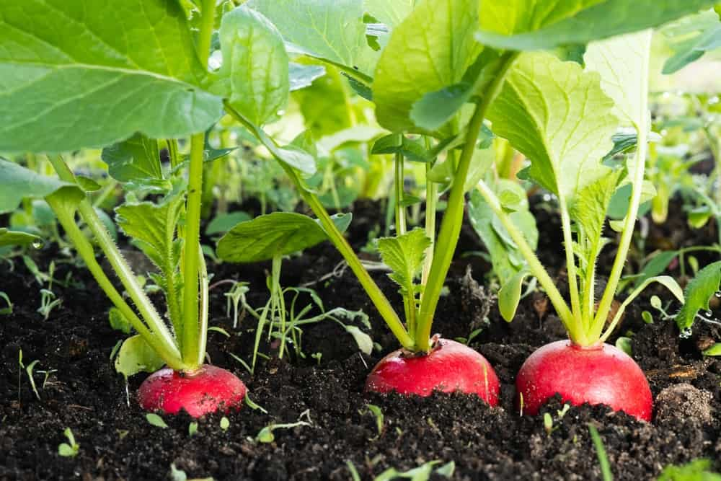
PAIR: BEAN, BEET, CARROT, CUCUMBER, LETTUCE, SPINACH, TOMATO
AVOID: POTATO

23. SAGE
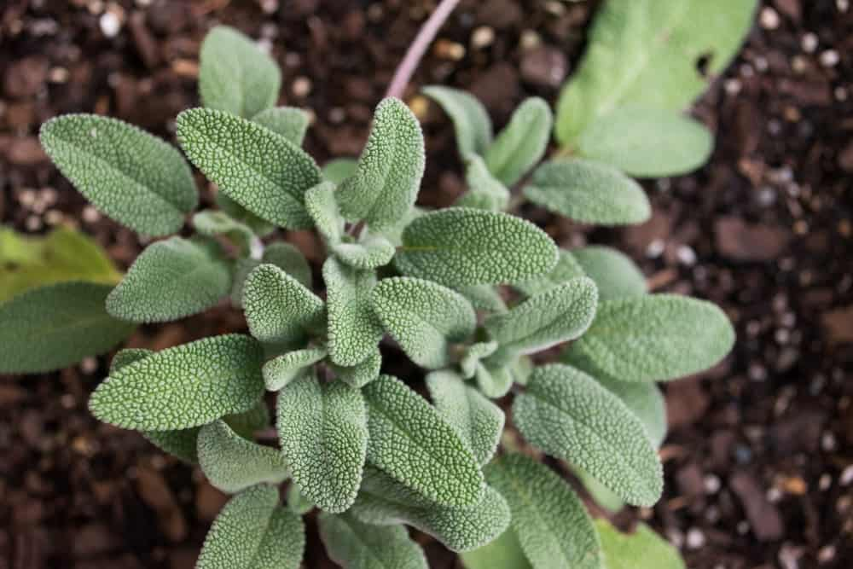
PAIR: CABBAGE, CARROT, OREGANO, ROSEMARY
AVOID: CUCUMBER

24. SPINACH
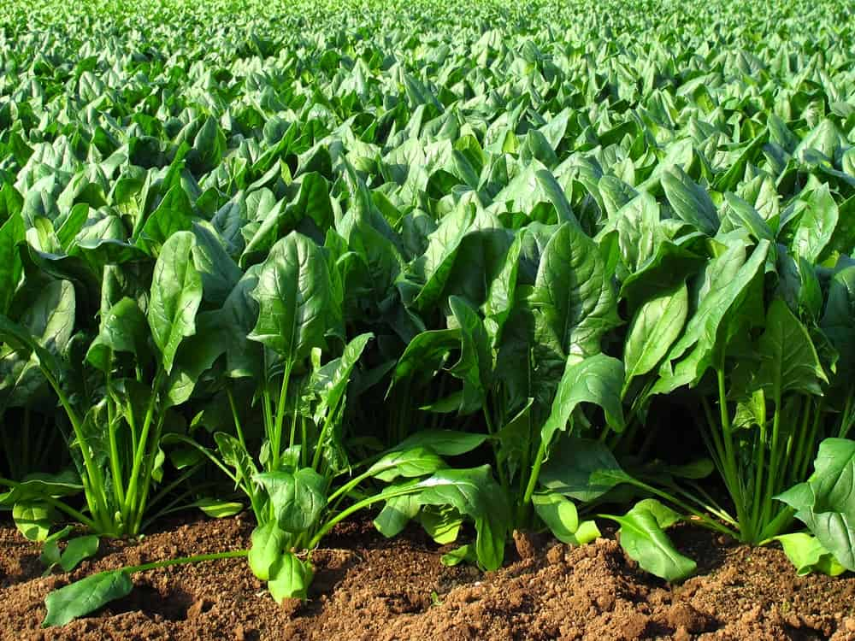
PAIR: COLLARD GREENS, MUSTARD SEED, STRAWBERRY

25. SQUASH
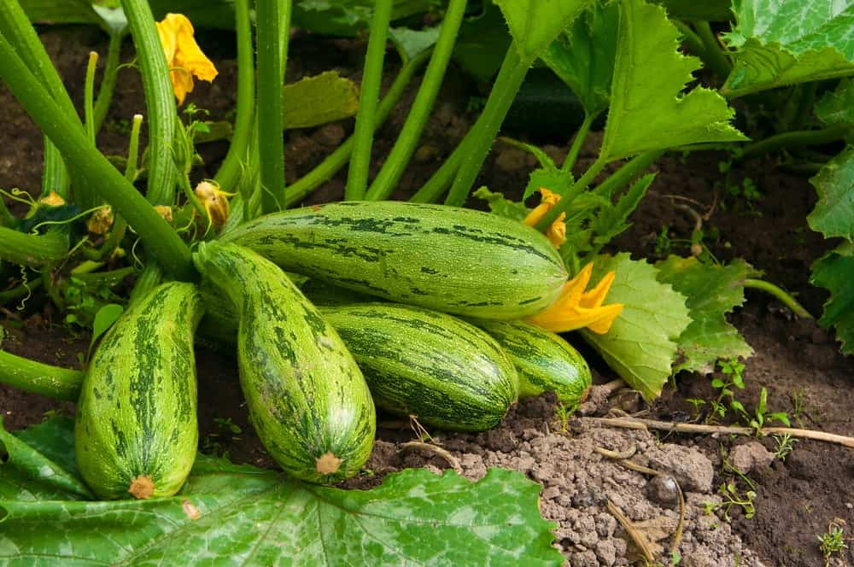
PAIR: BEAN, CORN, CLOVER

26. STRAWBERRIES
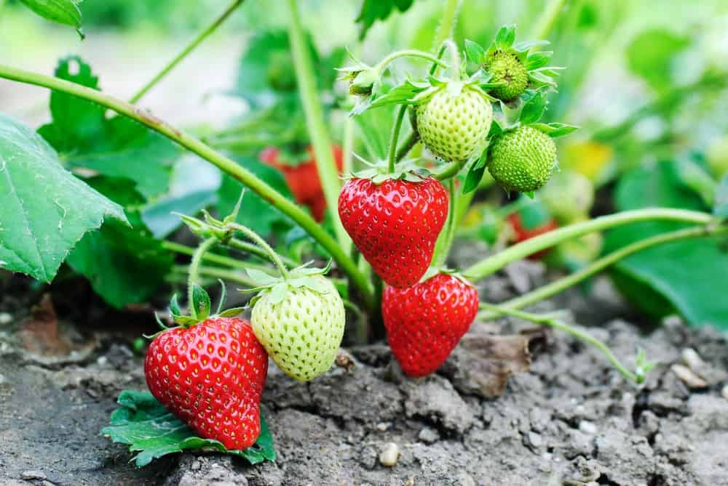
PAIR: BEAN, BORAGE, LETTUCE, SPINACH
AVOID: CABBAGE

27. TOMATOES

PAIR: ASPARAGUS, BEE BALM, CALENDULA, CARROT, GARLIC, PARSLEY, ONION
AVOID: CABBAGE, CORN, POTATO

27 DIFFERENT TYPES OF FRUIT TREES
INTERESTED TO KNOW AND LEARN ABOUT ALL THE DIFFERENT TYPES OF FRUIT TREES? HERE'S A MASSIVE LIST OF THEM WITH PHOTOS AND DETAILED DESCRIPTIONS.
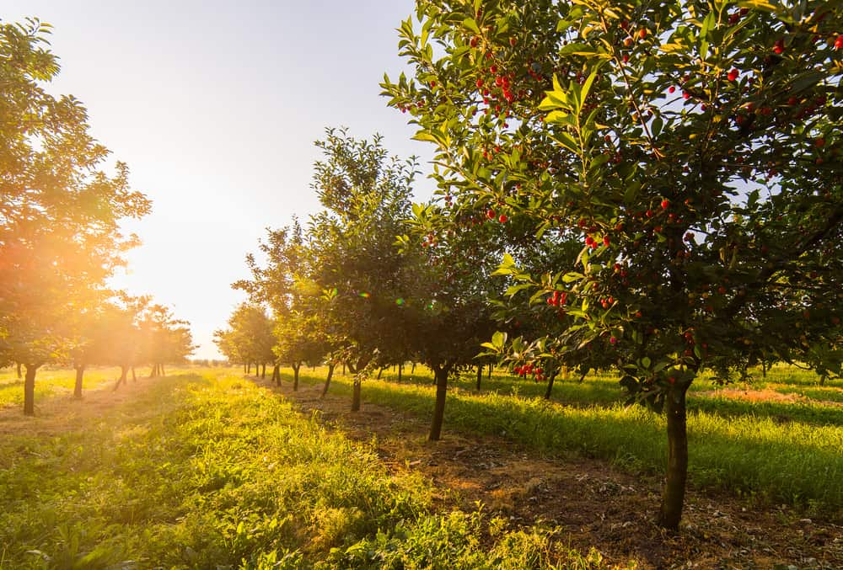
ALL CULTURES HAVE HUNDREDS OF CULTURAL CONNECTIONS TO THEIR LOCAL FRUITS AND VARIOUS LEGENDARY MYTHS ABOUT THEIR MAGICAL HEALING OR RESTORATIVE QUALITIES. EVEN IF NOT MAGICAL, FRUITS ARE AN ESSENTIAL PART OF THE HUMAN DIET, AND FRUIT-PRODUCING TREES HAVE EVOLVED OVER BILLIONS OF YEARS, ALONGSIDE EVERY OTHER SPECIES, BEAUTIFULLY LINKED WITH THE ECOSYSTEM.
FRUITS ARE AN IMPORTANT PART OF NEARLY EVERY TYPE OF CUISINE IN THE WORLD; IN MANY PLACES, NATIVE FRUITS ARE EVEN MADE INTO EXPENSIVE DELICACIES. THE DENSUKE WATERMELON FROM JAPAN, FOR EXAMPLE, IS SAID TO HAVE A ‘SPECIAL KIND OF SWEETNESS’ THAT MAKES PEOPLE PAY THOUSANDS OF DOLLARS FOR ONE. FARMED ON A NORTHERN ISLAND OF JAPAN, ONLY A HUNDRED GROW EVERY YEAR!
FRUITS ARE ALSO A VITAL SOURCE OF NUTRITION. ALMOST ALL VITAMINS THAT WE NEED FOR THE HEALTHY FUNCTIONING OF OUR BODIES CAN BE FOUND IN FRUITS. HOWEVER, TREES DO NOT PRODUCE FRUITS JUST FOR US. FRUITS ARE SEED HOUSES FOR TREES; THEY ARE A MECHANISM THROUGH WHICH PLANTS CAN SPREAD THEIR GENES AS FAR AND WIDE AS POSSIBLE SO MORE OF THEIR KIND POPULATE THE LAND.
THE OVARIES OF FLOWERING TREES TURN INTO FLESHY, DRY, OR RIPE FRUITS. SEEDS ARE THE FERTILIZED OVUM OF A TREE, THEREFORE WHEN THEY ARE PLANTED, A NEW TREE IS BORN. FRUITS ARE NOT FOUND EXCLUSIVELY ON TREES, BUT ALSO SHRUBS, SMALL PLANTS, OR GROUND VEGETATIONS. THE MAIN OBJECTIVE OF FRUIT TREES IS TO ATTRACT VARIOUS LAND ANIMALS, BIRDS, INSECTS, AND HUMANS TO THEIR FRUITS SO THAT THEY CAN BE CONSUMED AND THEIR SEEDS REPLANTED. THAT IS WHY FRUITS TASTE DELICIOUS.
SO WHAT MAKES A FRUIT TREE AND HOW MANY TYPES OF FRUIT TREES ARE THERE EXACTLY? READ THIS ARTICLE TO FIND OUT ALL ABOUT THE FRUIT TREES THAT SUPPLY IMPORTANT VITAMINS AND ENZYMES TO OUR DIET. INTERESTINGLY, THIS ARTICLE ON THE DIFFERENT VARIETIES OF FRUIT TREES ALSO REVEALS THE MANY DIFFERENT TYPES OF FRUIT YOU CAN EAT – BUT NOT ALL (SUCH AS BERRIES WHICH DON’T GROW ON TREES).
RELATED: TYPES OF TREES | TYPES OF FICUS TREES | FRUIT TREES FOR GROWING INDOORS | FRUIT TREE FLOWERS | BACKYARD FRUIT TREE IDEAS | TYPES OF PALM TREES

FRUITS IN OUR DIET
THE FRUITS WE EAT GENUINELY SEEM LIKE A GIFT FROM NATURE. A SMALL BOWL OF PINEAPPLE, FOR EXAMPLE, FULFILL 131% OF OUR DAILY REQUIREMENT FOR VITAMIN C, AND 76% FOR MANGANESE. GRAPEFRUITS ARE KNOWN FOR THEIR ABILITY TO REDUCE INSULIN LEVELS IN THE BLOOD WHILE BALANCING YOUR CHOLESTEROL AND PREVENTING KIDNEY STONES.
AVOCADOS CONSIST MAINLY OF HEALTHY FATS BUT ARE ALSO PACKED WITH LOADS OF POTASSIUM AND MAGNESIUM. ALL OF THESE NUTRIENTS ARE KNOWN TO PROMOTE HEART HEALTH. BLUEBERRIES, ON THE OTHER HAND, ARE RICH IN ANTIOXIDANTS THAT REDUCE THE RISK OF HEART DISEASE AND ALZHEIMER’S WHILE GIVING THE IMMUNE SYSTEM A BOOST. POMEGRANATES HAVE ANTI-INFLAMMATORY PROPERTIES THAT HELP REDUCE THE RISK OF CANCER.
BESIDES THESE, THERE ARE MANY OTHER FRUITS THAT ARE A SOURCE OF DIETARY FIBER, RARE VITAMINS, ENZYMES, AND ANTIOXIDANTS WHICH MAKES THEM AN INDISPENSABLE PART OF THE HUMAN DIET.

THE EVOLUTION OF FRUIT TREES
430 MILLION YEARS AGO IN THE DEVONIAN PERIOD, THE FIRST SEED-PRODUCING TREES CAME ABOUT. THROUGH THE ENTIRE CARBONIFEROUS PERIOD TO THE QUARTERNARY PERIOD TODAY, TREES HAVE BEEN FLOURISHING ON THE EARTH. TREES EVOLVED FURTHER WITH EVERY GENERATION, ADAPTING MORE AND MORE TO THE ENVIRONMENT. JUST BY EXISTING, THEY PROVIDED ENOUGH OXYGEN AND TEMPERATURE BALANCE TO THE PLANET. IT IS BECAUSE OF THE SUBLIME RELATIONSHIP OF TREES WITH THE PLANET THAT COMPLEX ORGANISMS CAME ABOUT, WHO PAVED THE WAY FOR HUMAN LIFE TO EVOLVE AS WELL.
SINCE TREES RELY ON THEIR FRUIT TO DISSEMINATE THEIR SEEDS, THEIR FRUITS EVOLVED TO BE EDIBLE TO BIRDS AND OTHER ANIMALS. SOME FRUITS ARE EVEN SELECTIVELY EDIBLE. THE JALAPENO FRUIT, FOR EXAMPLE, HAS A CHEMICAL CALLED CAPSAICIN, A PEPPER THAT SCARES OF ALL ANIMALS EXCEPT HUMANS, WHO KNOW BETTER. BIRDS ARE HOWEVER IMMUNE TO CAPSAICIN, SO THEY CAN FEAST ON THESE PEPPERS AND SEND OUT THEIR SEEDS AS FAR AS THEY CAN FLY.
SOURCE: ROYAL FORESTRY SOCIETY

FRUIT TREES IN THE ECOSYSTEM
AN IMPORTANT ROLE THAT FRUIT TREES PLAY IN THE ECOSYSTEM IS THE PRIMARY CONVERSION OF SUNLIGHT INTO FOOD FOR OTHER SECONDARY MEMBERS OF THE FOOD CHAIN. PHOTOSYNTHESIS IS NOT ONLY BENEFICIAL TO PLANTS AS IT PRODUCES FOOD FOR THEM, BUT ALSO STORES EXCESS ENERGY IN FRUITS, LEAVES, STEMS, AND SOMETIMES EVEN ROOTS. WHEN WE INCORPORATE PLANTS IN OUR DIET, THE NUTRIENTS IN THEM BENEFIT US IMMENSELY.
ALL ECOSYSTEMS ARE BUILT ON A SYSTEM OF ENERGY TRANSFER. PLANET EARTH IS POWERED BY ITS SUN, BUT ANIMALS USUALLY DO NOT HAVE THE TOOLS TO CONVERT THIS ENERGY INTO A USABLE FORM. SO PLANTS DO THEIR JOB FOR THEM, AND THE ENERGY TRANSFER CONTINUES IN THE FORM OF FOOD WEBS. MANY ANIMALS SUCH AS BIRDS, LIZARDS, AND INVERTEBRATES DEPEND ON PLANTS FOR THEIR FOOD, WHICH IN TURN ARE PREYED ON BY OTHER TERTIARY ANIMALS.
TREES ARE TALLER FOR THE VERY PURPOSE OF HARBORING AS MUCH SUNLIGHT AS POSSIBLE TO CONVERT INTO FUNCTIONAL ENERGY; THIS GIVES THEM PLENTY OF RAW MATERIALS TO PRODUCE DELICIOUS AND NUTRITIOUS FRUITS FOR US.
SOURCE: SCIENCE LEARNING HUB

HABITAT AND GEOGRAPHICAL OCCURRENCE
FROM THE FORESTS OF THE AMAZON TO DESERTS AND SAVANNAHS, FRUIT TREES ARE FOUND EVERYWHERE IN THEIR DIFFERENT FORMS AND VARIATIONS. EACH CONTINENT HAS SEVERAL SPECIALIZED SPECIES THAT HAVE EVOLVED SUITED TO THE CLIMATE AND LANDSCAPE. EXCEPT FOR ANTARCTICA, WHICH HAS VERY LOW PLANTATION LEVEL IN GENERAL, FRUIT TREES ARE A COMMON FEATURE OF EVERY CONTINENT.
Bottom of Form
SOURCE: LIBGUIDES

FRUITS IN DIFFERENT CULTURES
FRUITS ARE USUALLY CONSIDERED A SYMBOL OF ABUNDANCE, FERTILITY, AND REWARD. SOME COMMON FRUITS HAVE BEEN AROUND FOR SO LONG THAT THEY HAVE BECOME PART OF THE LOCAL MYTHOLOGY AND CULTURE.
MANY SUCH MYTHS AND STORIES SEEM TO SURROUND APPLES. IN GREEK MYTHOLOGY, HERCULES HAD TO ACQUIRE A SPECIAL TYPE OF APPLE AS ONE OF HIS TWELVE GREAT LABORS. IN NORSE MYTHOLOGY, APPLES REPRESENT ETERNAL YOUTH, AND ADAM AND EVE WERE BANISHED FOR HEAVEN FOR EATING THE APPLE OF ‘KNOWLEDGE’. EVEN SNOW WHITE WAS POISONED BY HER STEPMOTHER THROUGH AN APPLE.
THERE ARE INTERESTING ORIGIN STORIES FOR SOME FRUITS AS WELL, LIKE TAHITI, WHERE LEGENDS CLAIM THAT THE FIRST COCONUT CAME FROM THE HEAD OF AN EEL CALLED TUNA. TO THE ROMANS, THE POMEGRANATE WAS A SYMBOL FOR MARRIAGE, AND EARLIER BRIDES WORE POMEGRANATE PLANT WREATHS ON THEIR HEADS. THE GREEKS ALSO CONSIDERED THEM A SYMBOL OF BEAUTY, LOVE, MARRIAGE, AND FERTILITY. FOR MUSLIMS AROUND THE WORLD, POMEGRANATES ARE FRUITS FROM HEAVEN.

TYPES AND SUBTYPES

POME FRUITS
POME FRUITS ARE MEMBERS OF THE PLANT FAMILY ROSACEAE, AND SUBFAMILY POMOIDEAE. THESE ARE FRUITS THAT HAVE A TOUGH, FLESHY, EDIBLE MEMBRANE ON THE OUTSIDE COVERING THE CORE OF SMALL SEEDS IN THE CENTER.
SOME MAIN POME FRUITS ARE APPLES, PEARS, AND QUINCE, WHICH ARE HARVESTED IN LATE SUMMER TO LATE AUTUMN MONTHS.
SOURCE: DEPARTMENT OF PRIMARY INDUSTRIES

STONE FRUITS OR DRUPES
DRUPES OR STONE FRUITS ARE INDEHISCENT, WHICH MEANS THAT THEY HAVE AN OUTER FLESHY PART THAT SURROUNDS THE SINGLE SHELL INSIDE HOUSING THE SEEDS. THEY USUALLY DEVELOP FROM A SINGLE CARPEL AND INCLUDE FRUITS AS MANGO, OLIVE, COCONUT, APRICOT, CHERRY, PEACH AND PLUM AMONGST MANY OTHERS.
SOURCE: UNIVERSITY OF CALIFORNIA

COMMON FRUIT TREES
BELOW WE LIST, EXPLAIN AND PROVIDE PICTURES OF THE MANY COMMON FRUIT TREES THROUGHOUT THE WORLD.

APPLES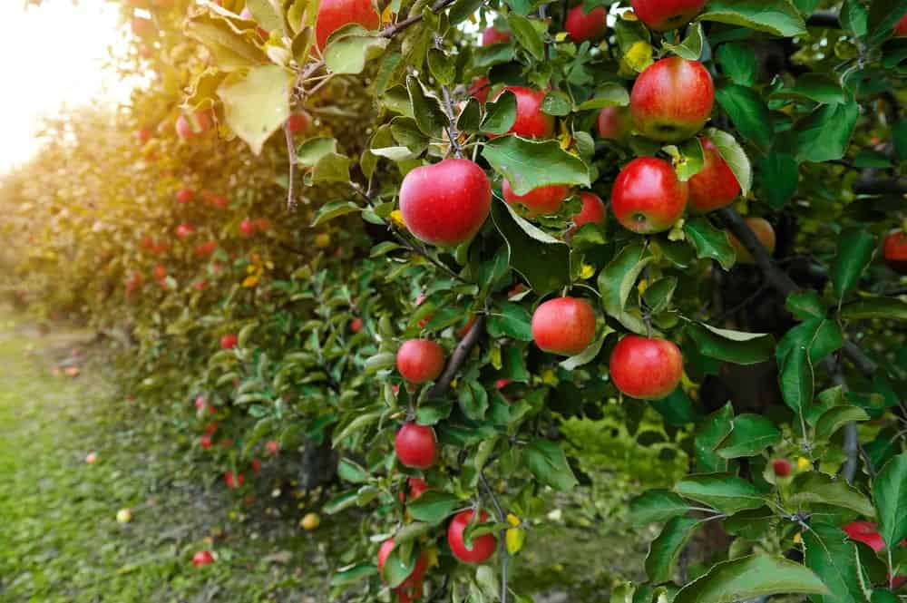
APPLE TREES ARE EXTREMELY POPULAR TO PLANT BECAUSE OF THEIR VALUE AS NUTRITIOUS SNACKS. THERE ARE VARIOUS SPECIES OF APPLE TREES FOUND IN DIFFERENT PARTS OF THE WORLD. THEY HAVE HUGE AMOUNTS OF FIBER, VITAMIN C, VITAMIN K, AND POTASSIUM. THEY REDUCE THE RISK OF DIABETES AND CANCER, EVEN ALZHEIMER’S IN OLDER PEOPLE.
THE PECTIN CONTENT IN APPLES IS ANOTHER NOTABLE HEALTH BENEFIT. PECTIN IS A FIBER THAT FEEDS THE GOOD BACTERIA IN YOUR GUT, WHICH IN TURN HELPS IN IMPROVING YOUR METABOLIC HEALTH

ORANGES
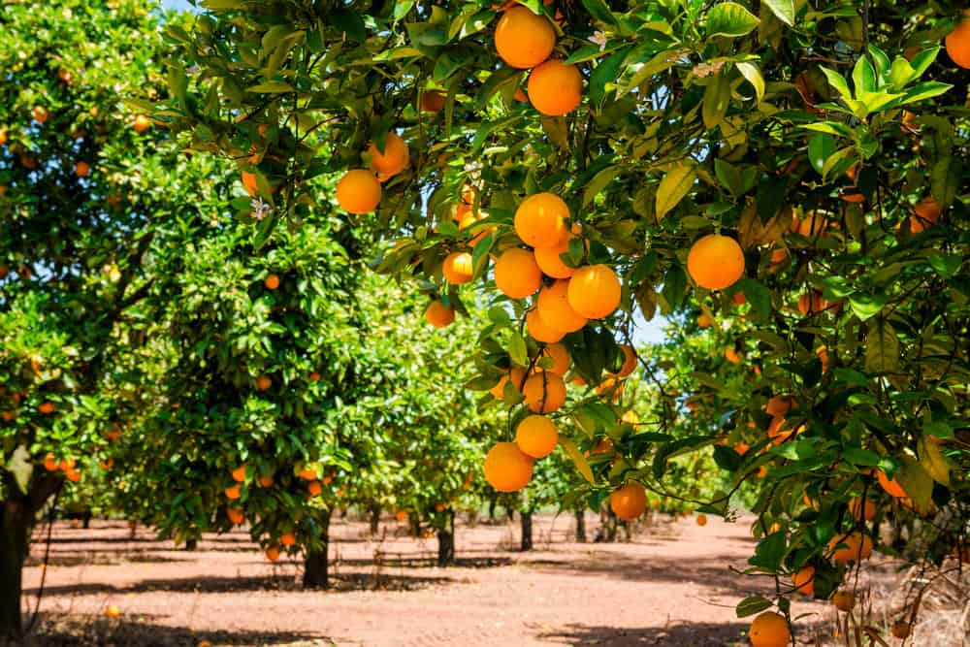
ORANGES ARE ONE OF THE MOST POPULAR AND NUTRITIOUS FRUITS IN THE WORLD.
ORANGE TREES ARE NOT ONLY AESTHETICALLY PLEASING TO PLANT IN YOUR GARDEN, BUT ALSO PROVIDE A LARGE QUANTITY OF VITAMIN C AND POTASSIUM. THEY SUPPLY VITAMINS SUCH AS THIAMINE AND FOLATE AS WELL
THE CITRIC ACID FOUND IN ORANGES MAY HELP IN THE DISSOLUTION OF KIDNEY STONES AND A HEALTHY HYDRATION SUPPLY IN THE BODY.
SOURCE: HEALTHLINE

MANGOES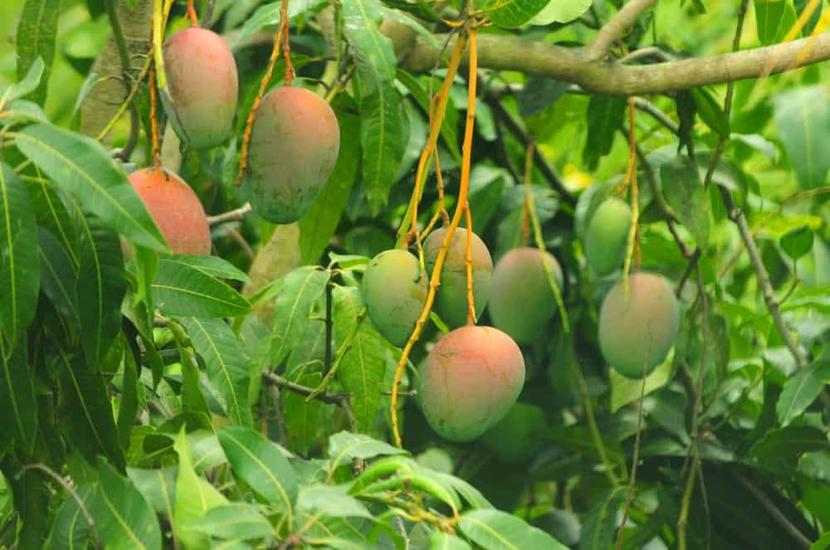
THERE ARE MANY VARIATIONS OF THE DELICIOUS MANGO FRUIT, AND THEY ARE ESPECIALLY FOUND IN THE SOUTHEAST ASIAN REGION. MANGOES ARE AN EXCELLENT SOURCE OF VITAMIN C, AND THEY ALSO CONTAIN SOLUBLE FIBER WITH SEVERAL HEALTH BENEFITS.
MANGOES ALSO CONTAIN ANTIOXIDANT AND ANTI-INFLAMMATORY PROPERTIES THAT LOWER THE PROBABILITY OF CONTRACTING DISEASES, ESPECIALLY DIABETES.

LEMONS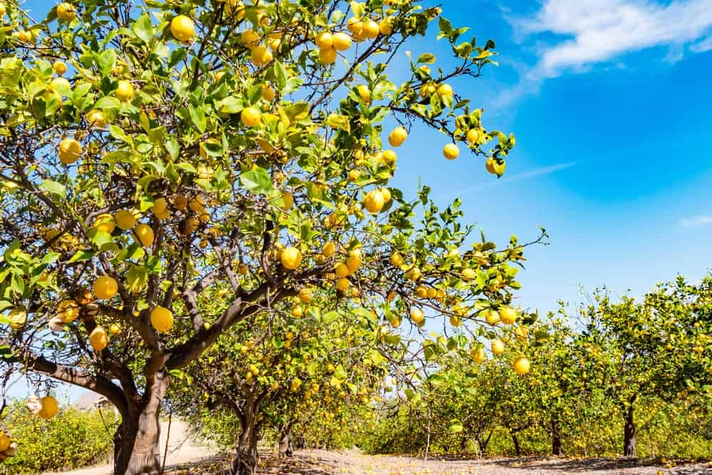
LEMONS ARE SIMILAR TO ORANGES IN THE IMPRESSIVE AMOUNT OF VITAMIN C AND CITRIC ACID THEY CONTAIN. IN THE HUMAN BODY, LEMONS HELP IN INCREASING IRON ABSORPTION, WHICH HELPS IN THE PREVENTION OF ANEMIA. LEMONS ARE ALSO KNOWN TO HELP IN CURBING NAUSEA, IMPROVING METABOLISM, AND IMPROVING SKIN CONDITIONS.
ONCE PLANTED, LEMON TREES TAKE AT LEAST 3-5 TO PRODUCE FRUIT, SO CHOOSE SOMETHING ELSE IF YOUR TIME IS CONSTRAINED.
SOURCE: NATURE AND MORE

PEARS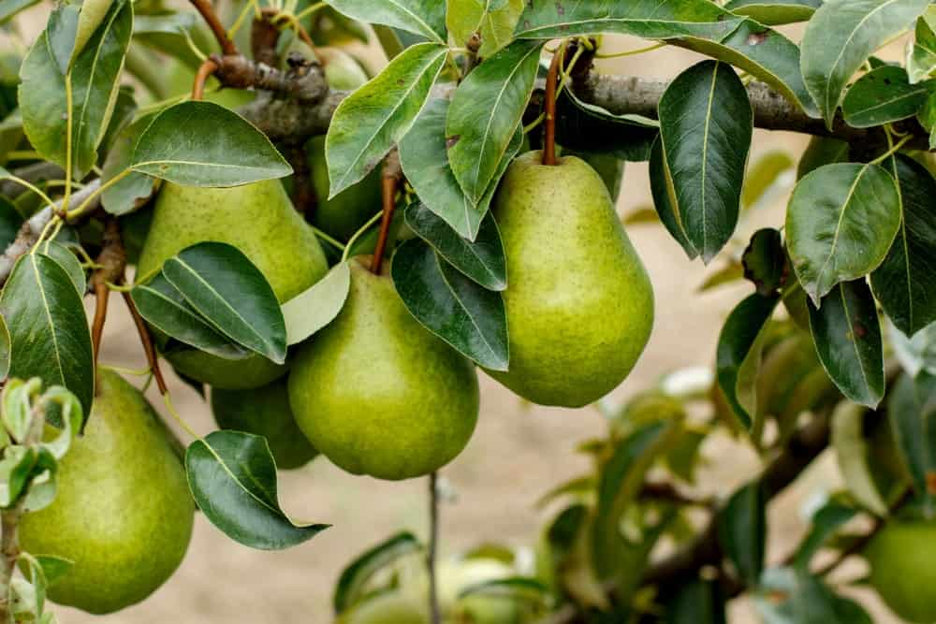
IF YOU CHOOSE TO PLANT A PEAR TREE IN YOUR BACKYARD OR GARDEN, YOU MAY BE IN FOR A REWARDING EXPERIENCE. IF TAKEN CARE OF PROPERLY, A PEAR TREE CAN GROW TO BE UP TO AROUND FORTY FEET TALL! THEY CAN BE GROWN IN A VARIETY OF REGIONS IN EUROPE, ASIA, AND NORTHERN AFRICA.
NOT ONLY IS THE PEAR FRUIT FULL OF PROTEIN AND FIBER, BUT THE TREE ITSELF CAN ALSO BE A WONDERFUL ADDITION TO YOUR GARDEN BECAUSE OF ITS CHARACTER, AND ITS ABILITY TO SURVIVE FOR OVER 50 YEARS.
SOURCE: HARVEST TO TABLE

APRICOTS
APRICOT TREES, WHEN NOT PRODUCING FRUIT, ARE DECORATED BY THE BLOOMING PINK AND WHITE FLOWERS. THIS TREE IN YOUR GARDEN WILL ADD VIBRANT BEAUTY TO THE SURROUNDINGS. SOME CARE IS REQUIRED TO MAKE SURE THE FRUIT YOU OBTAIN IS HEALTHY, BUT THE TASTY APRICOT YIELD WILL CONVINCE YOU TO EXPEND SOME LABOR ON THESE TREES.
APRICOTS HAVE LOTS OF VITAMIN A AND COPPER, WHICH ARE RARE VITAMINS TO BE FOUND IN FRUITS. THEY CAN ALSO STRENGTHEN YOUR HEART AND BONES IF EATEN EVERY DAY.
SOURCE: GARDENING KNOW HOW

COCONUTS
COCONUT TREES OR MORE COMMONLY PALM TREES, BELONG TO FAMILY ARECACEAE AND ARE AN IMPORTANT ADDITION TO ANY BEACH ATMOSPHERE. ALTHOUGH THERE ARE OVER 150 SPECIES SPREAD IN OVER 80 COUNTRIES, COCONUT TREES ONLY GROW IN A TROPICAL CLIMATE.
COCONUTS AS FRUITS ARE HIGHLY BENEFICIAL TO HUMANS. FROM THEIR WATER AND THEIR FLESH TO OIL AND MILK, COCONUTS ARE VERSATILE. AS FOODS, THEY PROVIDE US WITH A RICH SOURCE OF FATTY ACIDS, ASCORBIC ACID, PROTEINS, AND OTHER B VITAMINS. TAKING THEM IN ABUNDANCE CAN ALSO HELP IN RESTORING DAMAGED TISSUES IN THE BODY.
HAVING ALL THIS FASCINATING INFORMATION ABOUT FRUIT TREES CAN HELP YOU DECIDE WHAT YOU WOULD LIKE TO PLANT IN YOUR BACKYARD. A FRUIT TREE IS AN INVESTMENT THAT DOES NOT ONLY PROVIDE SHADE AND OXYGEN TO THE ENVIRONMENT BUT ALSO GIVES YOU AND CHILDREN PLENTY OF HEALTHY FOOD TO EAT. IT’S SPRING SEASON, GET PLANTING!

SOURCE: OWLCATION

PLUM
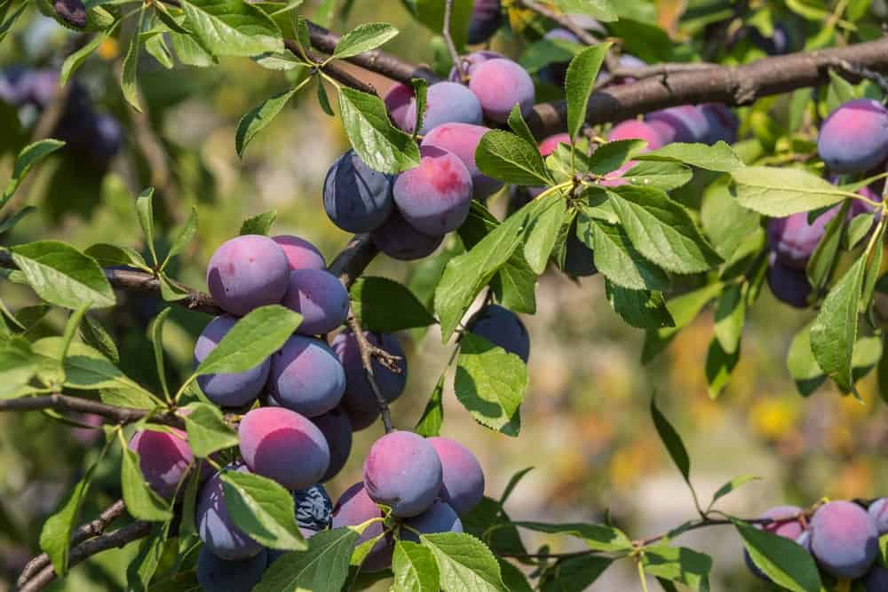
PLUMS ARE SAID TO BE SOME OF THE FIRST FRUITS HUMANS DOMESTICATED. THEY HAVE MANY TYPES, BUT THE ONE COMMONLY FOUND IS PURPLE IN COLOR. IT IS DIFFERENTIATED FROM SIMILAR FRUITS LIKE PEACHES BECAUSE OF THE SHOOTS POSSESSING A TERMINAL BUD AND NON-CLUSTERED SOLITARY SIDE BUDS. IF THE WEATHER IS NOT HUMID ENOUGH, THE FRUIT WILL STOP GROWING PAST A CERTAIN POINT AND FALL FROM ITS TREE WHILE STILL IN SMALL, GREEN FORM. MOREOVER, IF THE HUMIDITY IS TOO MUCH, PLUMS NEED TO BE HARVESTED AS SOON AS POSSIBLE, OTHERWISE THE FRUIT CAN DEVELOP BROWN ROT, WHICH IS A FUNGAL CONDITION.
SOME DIFFERENT PLUM SPECIES ARE DAMSON, WHICH HAS PURPLE SKIN, GREENGAGE WHICH IS BRIGHT GREEN IN COLOR, THE MIRABELLE WHICH IS TINTED DARK YELLOW, THE SATSUMA RED PLUM, AND THE VICTORIA PLUM WHICH HAS YELLOW FLESH WHILE ITS SKIN IS RED OR MOTTLED.
PLUMS CONSIST OF 87% WATER, SOME VITAMIN C, AND PLUM JUICE CAN BE MADE INTO PLUM WINE.

ALMOND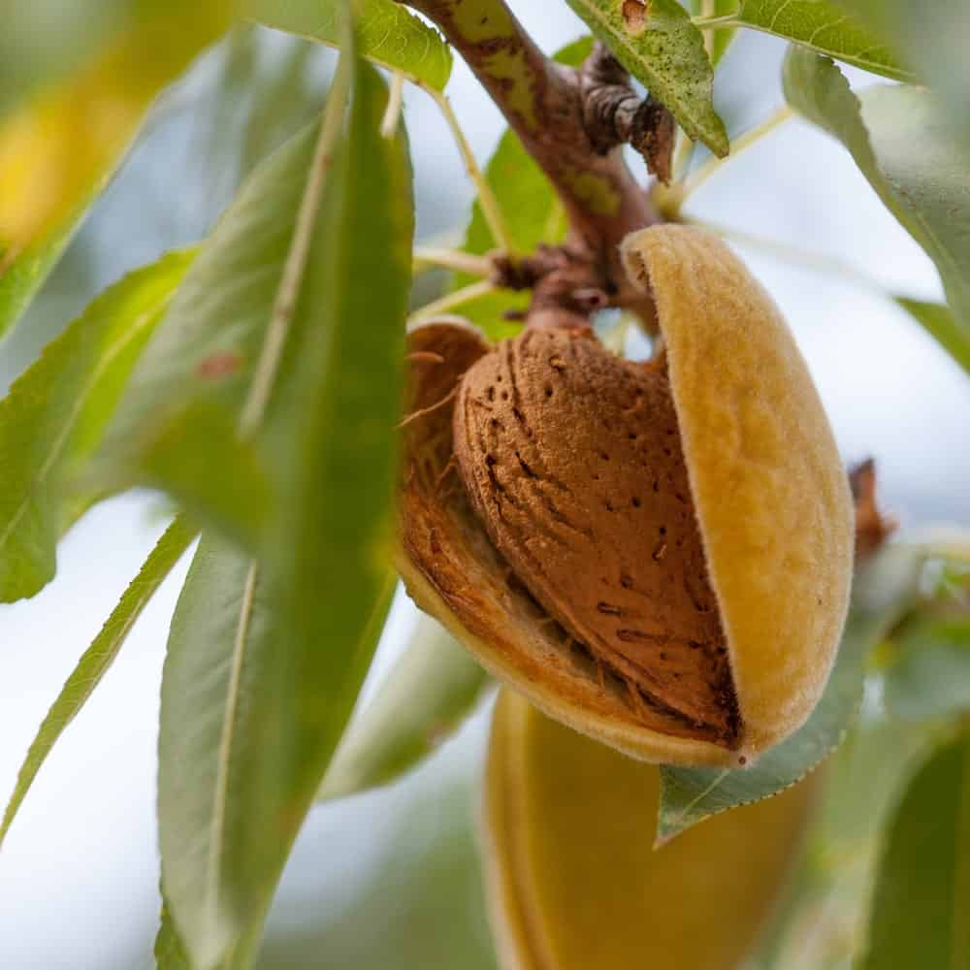
ALMOND IS A DRUPE FRUIT, WHICH HAS AN OUTER HULL AND A HARD SHELL THAT CONTAINS SEED. THIS MAKES ALMOND A FRUIT AND NOT A TRUE NUT, INSIDE. THE TWIGS ARE GREEN WHEN THEY ARE YOUNG; TAKING ON A PURPLISH HUE ON THE SIDES EXPOSED TO SUNLIGHT, AND THEN TURNING GREY IN ANOTHER YEAR. THE BEST PLACES TO GROW ALMONDS ARE MEDITERRANEAN CLIMATES WHERE THERE ARE WARM, DRY SUMMERS AND MILD, WET WINTERS. THE MOST FAVORABLE TEMPERATURE FOR ALMOND TREES IS BETWEEN 59 AND 86 °F.
ALMONDS ARE SOLD WITH OR WITHOUT THEIR SHELL, AND ‘SHELLING’ ALMONDS REFERS TO REMOVING THE SHELL TO REVEAL THE SEED IN ORDER TO MAKE THE FRUIT EDIBLE.
SOME RESEARCHERS HAVE MANAGED TO DEVELOP HYBRIDIZED VARIATIONS OF ALMOND TREES THAT ARE SELF-POLLINATED AND HAVE A HIGH NUT QUALITY, IN ORDER TO ACCELERATE GROWTH AND IMPROVE WORTH.
SOURCE: WIKIPEDIA

INDIAN GOOSEBERRY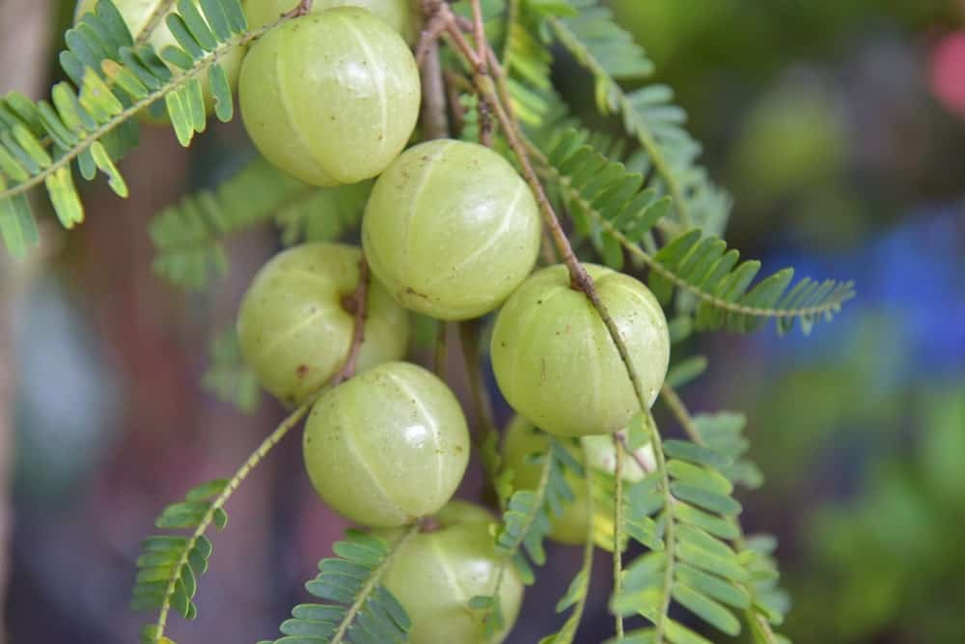
THE LEAVES OF THE INDIAN GOOSEBERRY TREE ARE SIMPLE, SUB-SESSILE AND NARROWLY SPACES; THEY ARE LIGHT GREEN IN COLOR AND RESEMBLE PINNATE LEAVES. THE FLOWERS IN FULL BLOOM ARE TINGED GREENISH-YELLOW, AND THE FRUIT IS QUITE ROUND, GREENISH-YELLOW, SMOOTH AND HARD TO THE TOUCH.
THE BERRIES RIPEN IN AUTUMN, WHEN THEY ARE PICKED BY HAND AS HARVESTERS CLIMB TO HIGH BRANCHES THAT BEAR FRUITS. THE TASTE OF THIS BERRY IS SOUR AND BITTER, AND THE TEXTURE FIBROUS. IN INDIA, THE BERRY IS SUBMERGED IN SALT WATER AND RED CHILI POWDER IS ADDED TO MAKE IT MORE APPETIZING.
SOURCE: WIKIPEDIA

CHERRY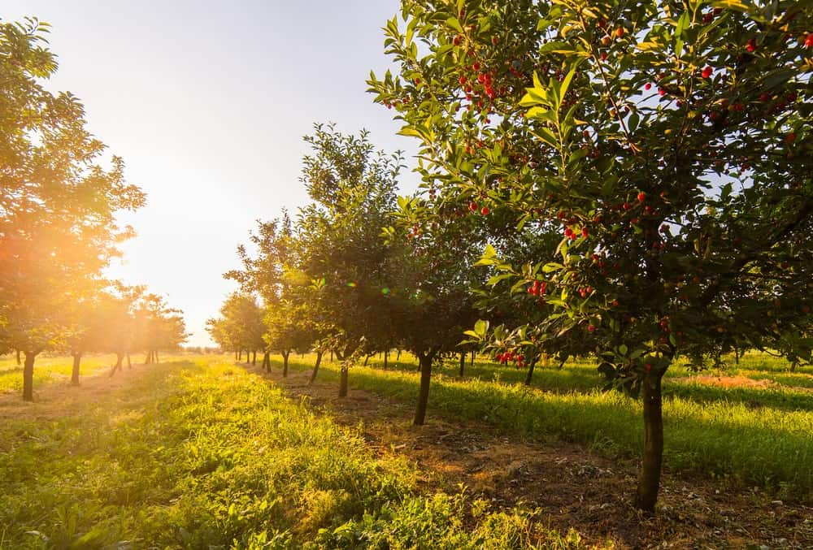
CHERRY TREES GROW IN TEMPERATE CLIMATES OF HIGH LATITUDE; AND LIKE MOST TREES OF THIS NATURE, CHERRY TREES NEED A COOLING PERIOD EACH YEAR TO AVOID DORMANCY AND BEAR FRUIT. HOW MUCH COLD IS REQUIRED IS DEPENDENT ON THE VARIETY, BUT BECAUSE OF THIS CONDITION, NO SPECIES OF PRUNUS CAN SUCCESSFULLY GROW IN TROPICAL PLACES.
IN THE MIDDLE EAST, EUROPE, NORTH AMERICA, AND AUSTRALIA, THERE ARE MANY VARIETIES OF THE CHERRY TREE THAT ARE HARVESTED AND EXPORTED. THE GENUS CONTAINS MORE THAN 40 MEMBERS, SOME OF WHICH ARE PRUNUS APETALA, PRUNUS AVIUM (SWEET CHERRY), PRUNUS CAMPANULATA (TAIWAN CHERRY, FORMOSAN CHERRY OR BELL-FLOWERED CHERRY), PRUNUS CANESCENS, PRUNUS CAROLINIANA AITON, AMONGST MANY OTHERS.

MULBERRY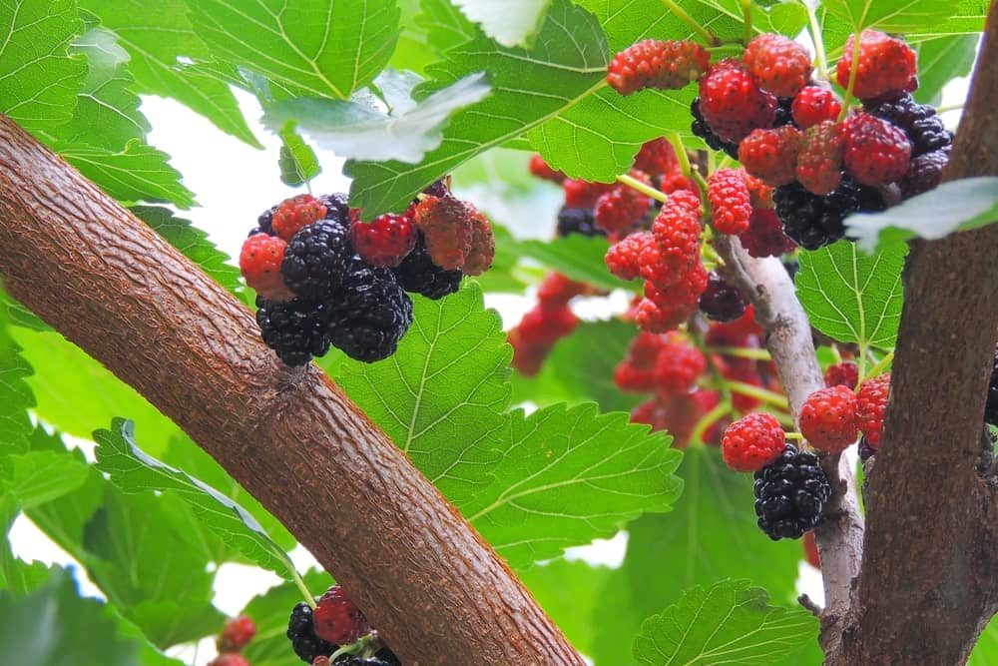
THE MORUS GENUS COMPRISES OF ABOUT 10–16 KINDS OF DECIDUOUS TREES THAT ARE KNOWN AS MULBERRIES. MULBERRIES CAN GROW IN THE WILD AND UNDER CULTIVATION IN TEMPERATE CLIMATES
SOUTHERN EUROPE, THE MIDDLE EAST, NORTHERN AFRICA AND THE INDIAN SUBCONTINENT ARE ALL HOME TO MULBERRIES IN THEIR VARIOUS FORMS, PARTICULARLY BLACK, RED, AND WHITE.
THE RIPE FRUIT IS USED IN PIES, TARTS, WINES, AND TEAS. THE BLACK MULBERRY AND THE RED MULBERRY, NATIVE TO SOUTHWEST ASIA AND EASTERN NORTH AMERICA RESPECTIVELY, HAVE THE STRONGEST FLAVOR THAT IS OFTEN DESCRIBES AS ‘FIREWORKS’ ON THE TONGUE.

PEACH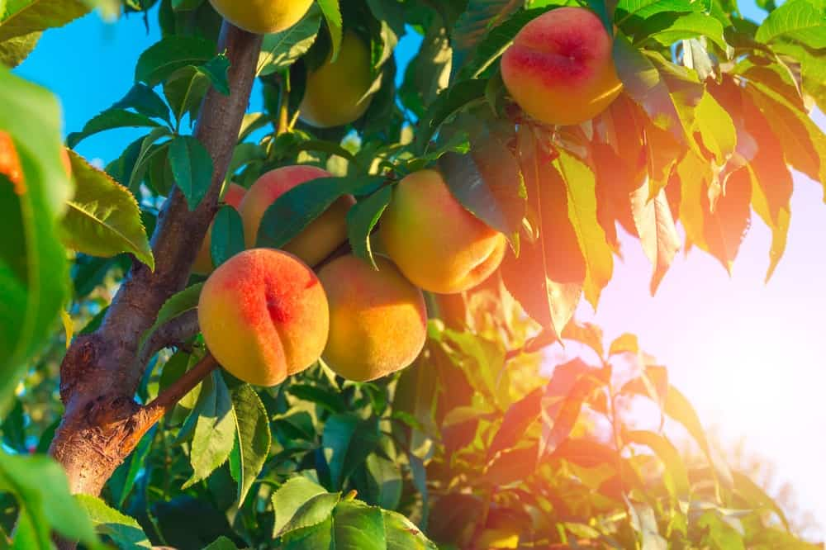
THE PRUNUS PERSICA IS ANOTHER DECIDUOUS TREE NATIVE, HAILING FROM THE NORTHWESTERN CHINESE REGION, WHERE IT WAS FIRST AND CULTIVATED. THE EDIBLE JUICY FRUIT IS NAMED PERSICA, REFERRING TO ITS EXTENSIVE CULTIVATION IN PERSIA, MODERN-DAY IRAN.
PEACHES REQUIRE A FAIRLY SPECIFIC TYPE OF CLIMATE TO THRIVE: DRY, CONTINENTAL OR TEMPERATE, THE REASON FOR THIS IS A CHILLING REQUIREMENT THAT TROPICAL CLIMATES CANNOT SATISFY, EXCEPT IN CERTAIN HIGH ALTITUDE PLACES SUCH AS CERTAIN AREAS IN ECUADOR, COLOMBIA, ETHIOPIA, INDIA, AND PAKISTAN.

FIG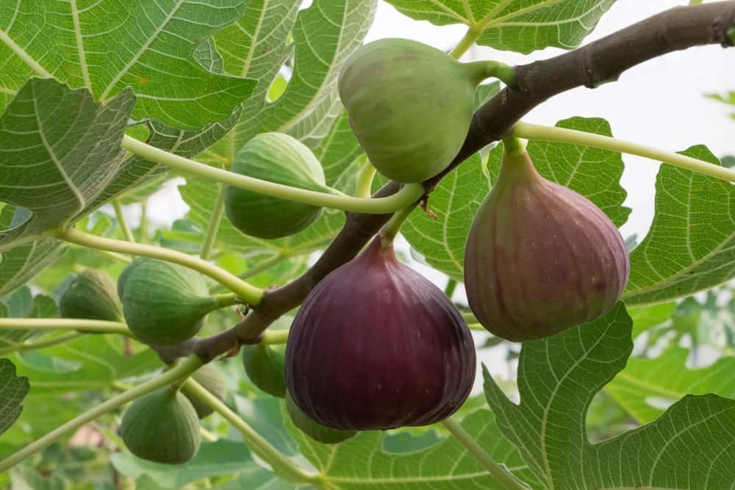
IN AREAS WHERE IT IS GROWN COMMERCIALLY, FIG IS AN IMPORTANT CROP THAT CAN GENERATE A LOT OF REVENUE. IT IS NATIVE TO THE MIDDLE EAST AND WESTERN ASIA, WHERE IT HAS BEEN CULTIVATED FOR CENTURIES. FIGS ARE NOW GROWN GLOBALLY, FOR ITS FRUIT AND FOR ITS ORNAMENTAL VALUE.
FIG TREES GROW WILD IN AREAS THAT ARE DRY AND SUNNY, WITH FRESH SOIL. IT CAN ALSO BE FOUND IN ROCKY AREAS, AT SEA LEVEL UP TO 1,700 METERS. IT FAVORS A COMPARATIVELY LIGHT SOIL, AND CAN EASILY GROW IN NUTRITIONALLY POOR CONDITIONS.
SOURCE: GOOD HOUSEKEEPING

PERSIMMON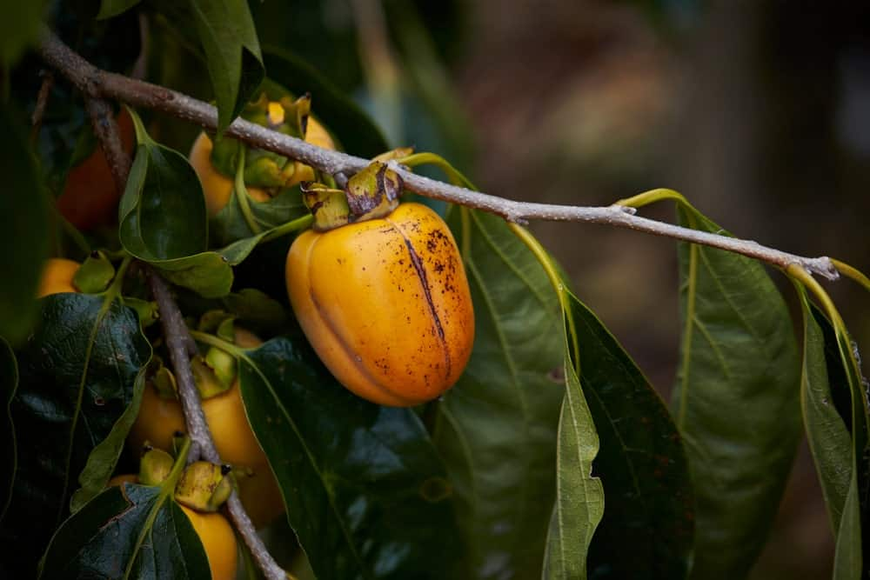
FROM THE GENUS DIOSPYROS COMES THE EDIBLE FRUIT CALLED PERSIMMON. THE TREE GROWS TO BE AROUND 4.5 TO 18 METERS IN HEIGHT WITH A ROUND TOP. IT IS NOT UNCOMMON FOR THE TREE TO SOMETIMES BE CROOKED OR HAVE A WILLOWY LOOK. THE FRUIT RIPENS IN LATE FALL AND CAN STAY SAFE AND EDIBLE ON THE TREE COME WINTER.
THE COLOR OF THE MATURED FRUIT RANGES FROM SHINY LIGHT YELLOW TO DARK RED OR ORANGE DEPENDING ON HABITAT AND VARIETY. THE FLESH IS HARD TEXTURED UNTIL IT RIPENS AND BECOMES SOFT, TAKING ON A YELLOW, ORANGE, OR DARK-BROWN HUE.

POMEGRANATE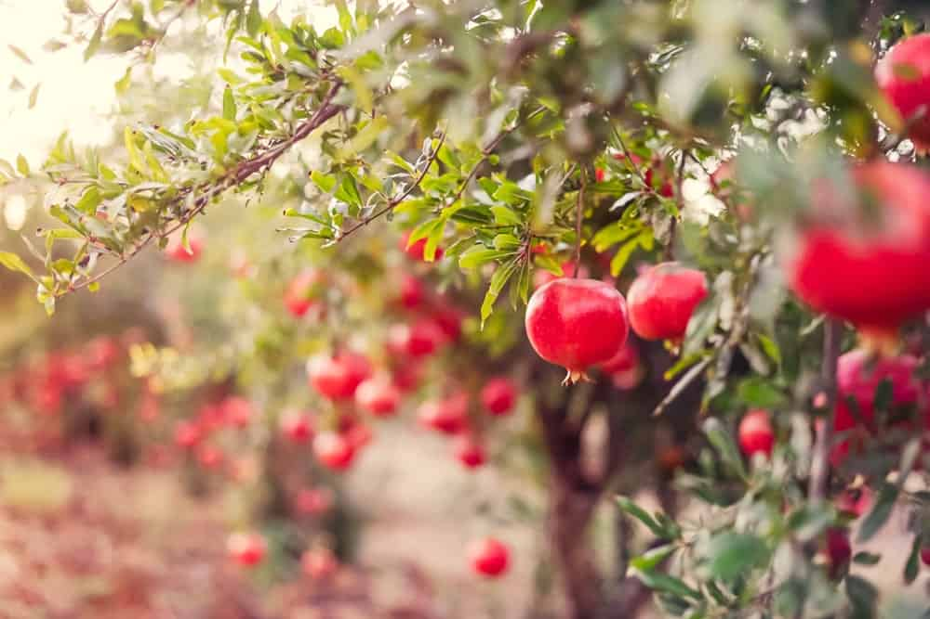
THE POMEGRANATE, OR PUNICA GRANATUM, IS A FRUIT BORN IN A DECIDUOUS SHRUB FROM FAMILY LYTHRACEAE. THE TREE IS QUITE SMALL, GROWING TO BE ABOUT 5 AND 10 METERS HIGH.
IN THE NORTHERN HEMISPHERE, THE TREE BEARS FRUIT IN FALL AND EARLY SPRING, AND IN THE SOUTHERN HEMISPHERE IN MID SPRING SEASON. POMEGRANATES HAVE SEVERAL CULINARY USES, SUCH AS BAKING, JUICE BLENDS AND SMOOTHIES, MEAL GARNISHES, AND EVEN ALCOHOLIC DRINKS CAN BE MADE THROUGH FERMENTATION.
ORIGINALLY, THE POMEGRANATE TREE CAME FROM MODERN-DAY IRAN AND NORTHERN INDIA, EVER SINCE CULTIVATED EVERYWHERE IN THE MEDITERRANEAN REGION. BY THE LATE 16TH CENTURY, POMEGRANATES HAD COME TO SPANISH AMERICA, AND IN 1769 BROUGHT TO CALIFORNIA BY SPANISH SETTLERS.

GRAPEFRUIT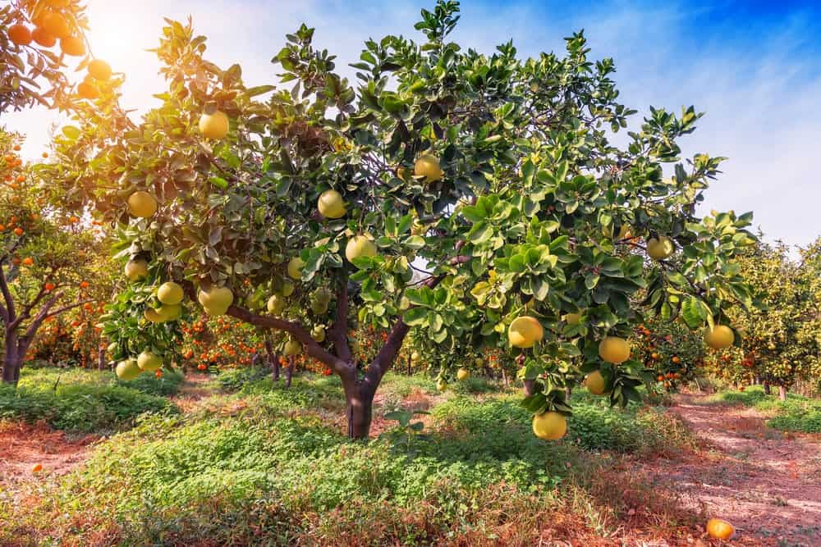
GRAPEFRUIT IS A CITRUS FRUIT KNOWN FOR ITS SOUR TO SOMEWHAT BITTER FLAVOR. THE CITRUS FRUIT IS A HYBRID THAT WAS CREATED AS AN ACCIDENTAL CROSS BETWEEN THE SWEET ORANGE AND POMELO, WHICH ARE BOTH NATIVE TO ASIA AND WERE INTRODUCED TO THE WEST IN THE SEVENTEENTH CENTURY. IT IS FREQUENTLY MISIDENTIFIED AS ONE OF ITS PARENT SPECIES, POMELO.
THERE ARE SEVERAL VARIETIES OF GRAPEFRUIT, BUT SOME TEXAS AND FLORIDA GRAPEFRUIT SPECIES ARE RIO STAR, ORO BLANCO, RUBY RED, PINK, THOMPSON, WHITE MARSH, FLAME AND STAR RUBY.

AVOCADO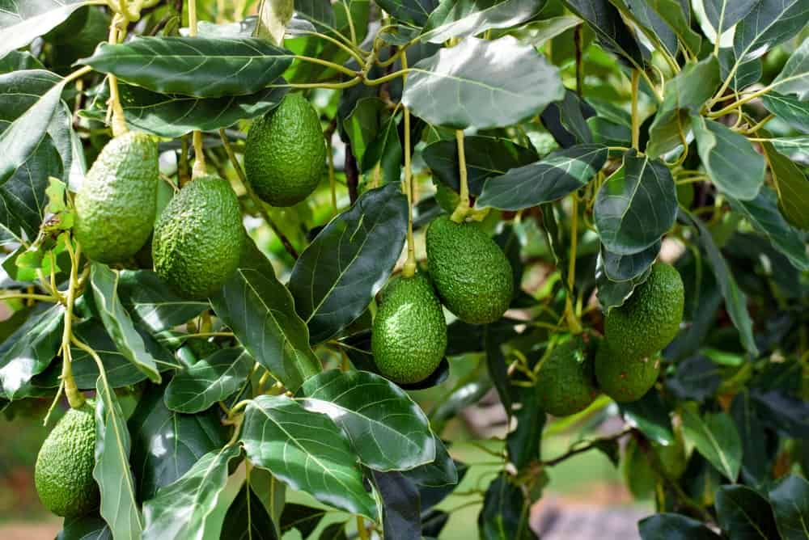
THE AVOCADO TREE IS MOST LIKELY TO HAVE ORIGINATED FROM SOUTH CENTRAL MEXICO. THE FRUIT IS ACTUALLY A LARGE BERRY THAT HAS ONE BIG SEED. THE SPECIES HAS ADAPTED A LOT DUE TO SELECTION PRESSURE BY HUMANS TO PRODUCE BETTER WITH A THINNER OUTER SHELL AND THEREFORE HAS MANY VARIETIES.
AVOCADOS NEED A CLIMATE THAT IS WARM WITH LESS WIND, SINCE HIGH WINDS REDUCE HUMIDITY, DEHYDRATING FLOWERS, AND HARMING THE POLLINATION PROCESS. WHEN THE WEATHER BECOMES CHILLY, THE FRUIT MAY DROP PREMATURELY, EVEN THOUGH SOME SPECIES CAN TOLERATE LOW TEMPERATURES.

JABOTICABA FRUIT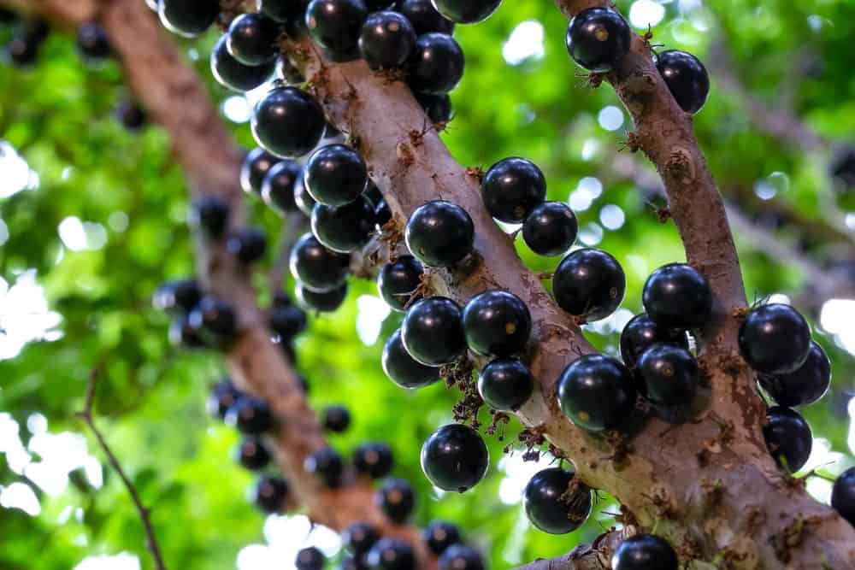
THE PLINIA CAULIFLORA, COMMONLY KNOWN AS THE BRAZILIAN GRAPETREE, BELONGS TO THE FAMILY MYRTACEAE, AND IS NATIVE TO SOME STATES IN BRAZIL. THE FRUIT IS WELL-KNOWN FOR ITS PURPLISH-BLACK COLOR WITH WHITE FLESH, AND IT INTERESTINGLY GROWS DIRECTLY ON THE TRUNK. THE JABOTICABA FRUIT CAN BE ENJOYED RAW, OR IT CAN BE MADE INTO CULINARY DELIGHTS SUCH AS JELLIES, JAMS, JUICES AND WINE.
EVEN THOUGH THE TREE GROWS SLOWLY, IT IS AN EVERGREEN AND CAN GROW AS HIGH AS 15 METERS IF NOT PRUNED. THE LEAVES HAVE A SALMON-PINK TINGE WHEN YOUNG, AND TURN GREEN IN ADULTHOOD.
IN ORDER FOR THE TREE TO GROW WELL, A MOIST, RICH, SLIGHTLY ACIDIC SOIL IS REQUIRED. IT IS QUITE ADAPTABLE AND GROWS SUITABLY EVEN ON DIFFERENT KINDS OF SOILS, AS LONG AS THEY ARE WELL TAKEN CARE OF.

LEMON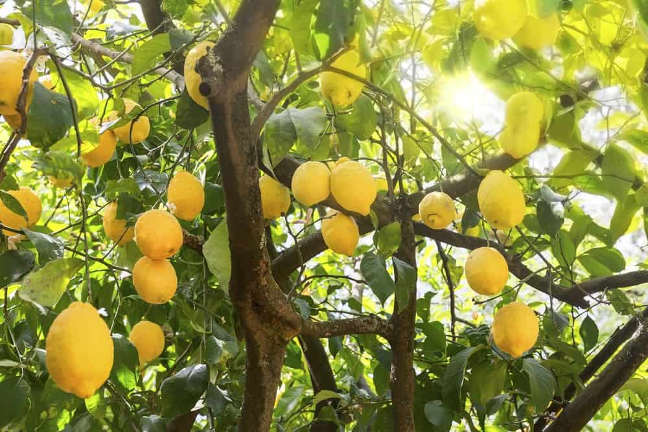
LEMON IS A SPECIES OF A SHORT EVERGREEN TREE, NATIVE TO SOUTH ASIA, AND PRIMARILY NORTH EASTERN REGIONS OF INDIA. THE TREE’S SPHERICAL OR ELLIPSE-SHAPED YELLOW FRUIT IS USED IN MANY CUISINES AND RECIPES IN THE WORLD.
ITS SOUR JUICE HAS BOTH CULINARY AND CLEANING USES. THE ZEST CAN ALSO BE USED WHEN COOKING OR BAKING. LEMON JUICE CONTAINS 5% TO 6% CITRIC ACID, WHICH GIVES IT ITS FLAVOR. THIS FLAVOR IS WHAT MAKES LEMON AN IMPORTANT ADDITION TO BEVERAGES AND FOODS SUCH AS MINT LEMONADES AND LEMON MERINGUE PIES.

LIME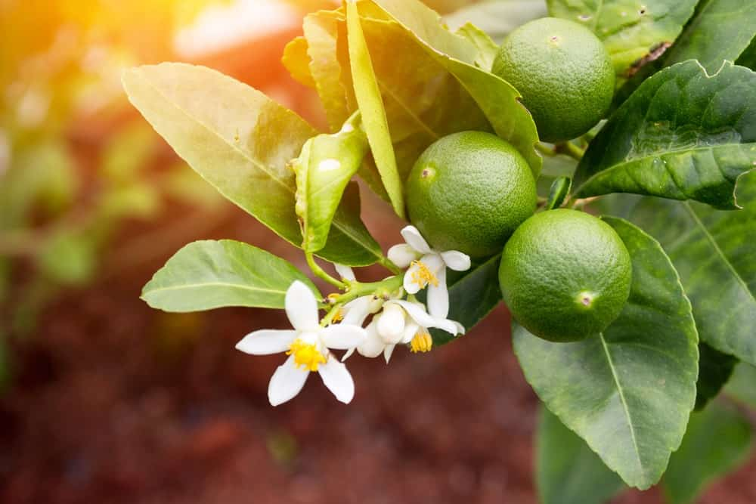
A LIME IS A CITRUS FRUIT TYPICALLY ROUND AND GREEN IN COLOR. THE SIZE IS ABOUT 3–6 CENTIMETERS IN DIAMETER. THERE ARE SEVERAL SPECIES THAT ARE REFERRED TO AS LIME AND BELONG TO THE SAME FAMILY, INCLUDING THE KEY LIME (CITRUS AURANTIFOLIA), THE PERSIAN LIME, KAFFIR LIME, AND THE DESERT LIME.
THESE FRUIT ARE SIMILAR TO LEMONS IN THEIR ABUNDANCE OF VITAMIN C, AND SO THEY ARE OFTEN ADDED TO FOOD TO ACCENTUATE THE FLAVORS. GROWN ALL YEAR ROUND, LIMES HAVE VARIOUS GENETIC ORIGINS AND DO NOT COME FROM ONE MONOPHYLETIC CLUSTER.

GUAVA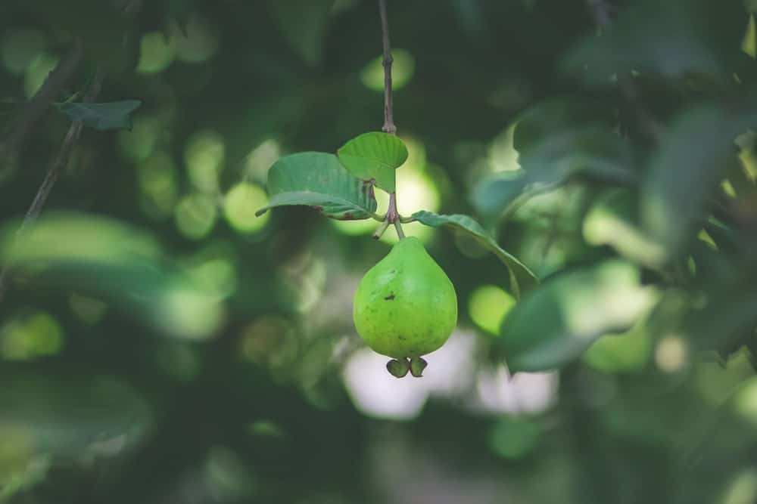
IN MANY TROPICAL AND SUBTROPICAL REGIONS, THE GUAVA IS A COMMONLY CULTIVATED TROPICAL FRUIT. THE GUAVA TREE IS A SMALL, AND NATIVE TO MEXICO, CENTRAL AMERICA, THE CARIBBEAN AND NORTHERN SOUTH AMERICA.
SEVERAL RELATED SPECIES MAY ALSO BE TERMED GUAVAS, BUT THEY USUALLY BELONG TO OTHER GENERA. INDIA WAS THE BIGGEST CULTIVATOR OF THESE FRUIT TREES WITH 41% OF THE WORLD TOTAL IN 2014.
SOURCE: HUNKER.COM

OLIVE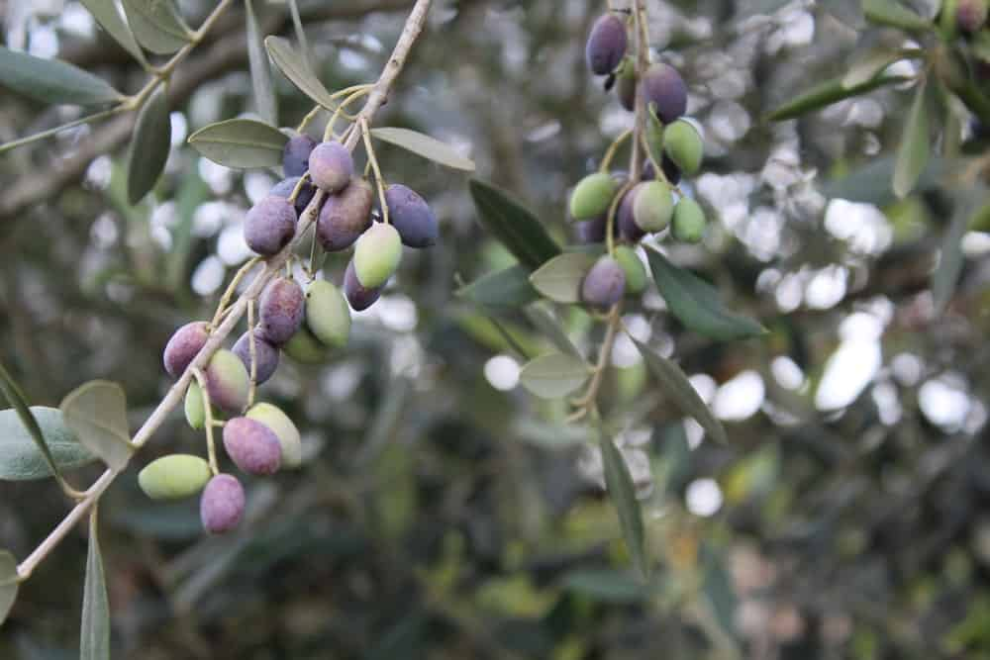
OLIVES, ALSO KNOWN AS OLEA EUROPAEA (THAT STANDS IN FOR “EUROPEAN OLIVE”) COME FROM A SMALL TREE IN THE MEDITERRANEAN BASIN. THE FRUIT IS GROWN IN MANY PLACES AND IS NOW CONSIDERED NATURALLY OCCURRING IN ALL COUNTRIES OF THE MEDITERRANEAN. IT IS ALSO GROWN IN ARGENTINA, NORFOLK ISLAND, CALIFORNIA, BERMUDA, AND SAUDI ARABIA
THE OLIVE’S FRUIT, ALSO CALLED THE OLIVE, IS OF MAJOR AGRICULTURAL IMPORTANCE IN THE MEDITERRANEAN REGION AS THE SOURCE OF OLIVE OIL; IT IS ONE OF THE CORE INGREDIENTS IN MEDITERRANEAN CUISINE.
SOURCE: OLIVE TREE GROWERS

LYCHEE

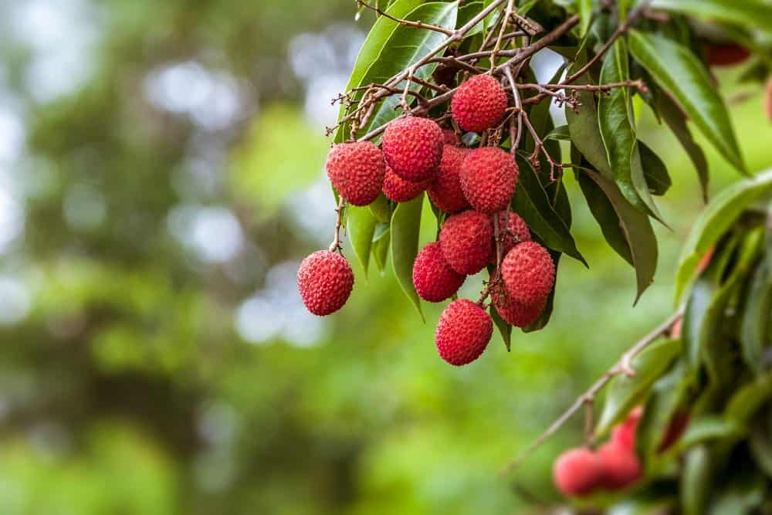
LYCHEE IS A TROPICAL TREE THAT COMES FROM THE GUANGDONG AND FUJIAN PROVINCES OF CHINA. HERE, ITS CULTIVATION IS DOCUMENTED FOR A THOUSAND YEARS. THE MAIN PRODUCER OF LYCHEE FRUIT IS CHINA, THEN OTHER COUNTRIES IN SOUTHEAST ASIA, SUCH AS INDIA AND NEPAL. THE EVERGREEN LYCHEE TREE GROWS SMALL FRUITS, THE OUTSIDE OF WHICH IS PINKISH RED, WITH A ROUGH TEXTURE. THE OUTER LAYER IS INEDIBLE, WHILE THE SUGARY FLESH IS EATEN IN MANY DIFFERENT COUNTRIES AS DESSERT.
THE SEEDS OF THE FRUIT CONTAIN A PARTICULAR CHEMICAL THAT HAS BEEN KNOWN TO CAUSE HYPOGLYCEMIA IN MALNOURISHED INDIAN AND VIETNAMESE KIDS, WHO EAGERLY CONSUME IT.

DURIAN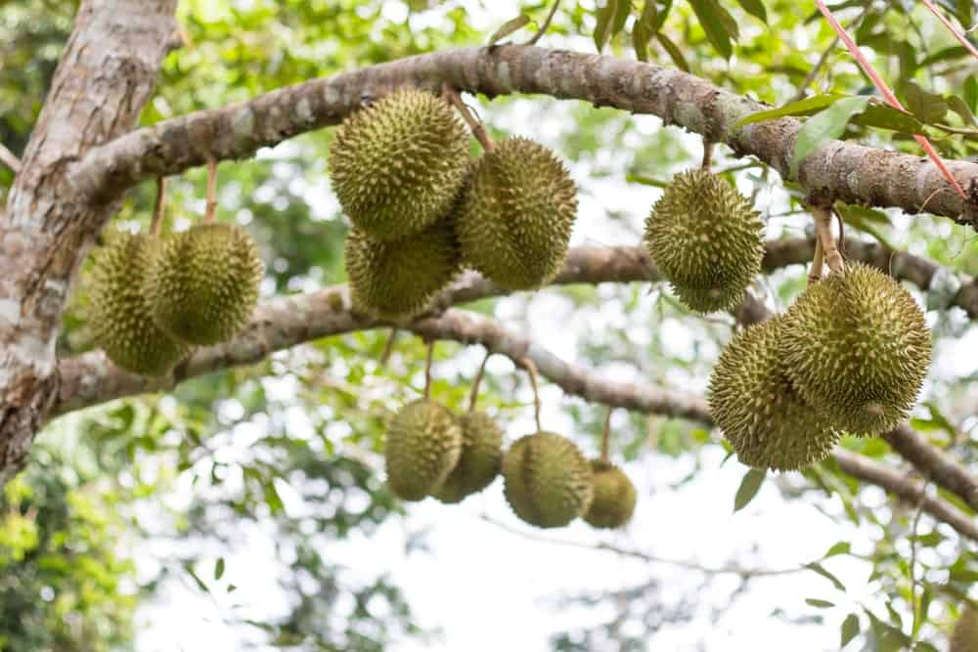
THE EXOTIC DURIAN FRUIT IS FAMOUS FOR ITS TASTE AND VERY UNUSUAL AND OFTEN UNBEARABLE SMELL. THE UNUSUAL FLAVOR AND ODOR OF THE FRUIT HAVE MADE MANY PEOPLE EXPRESS PASSIONATE VIEWS RANGING FROM PROFOUND APPROVAL TO INTENSE DISLIKE AND EVEN DISGUST.
DURIAN TREES ARE QUITE LARGE (25–50 METERS IN HEIGHT), AND THE LEAVES ARE EVERGREEN, HAVE AN ELLIPTIC SHAPE AND SEVERAL CENTIMETERS LONG. DURIAN TREES ONLY PRODUCE FRUITS AND FLOWERS ONCE A YEAR, ALTHOUGH THE TIMING DIFFERS DEPENDING ON THE SPECIES, PARTICULAR HARVESTING TECHNIQUES, AND GEOGRAPHY.

JACKFRUIT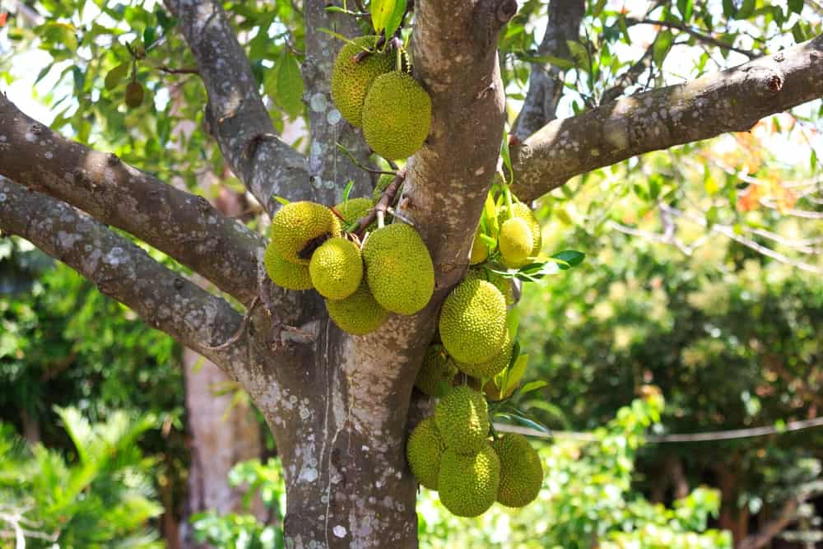
THE JACKFRUIT (SCIENTIFIC NAME ARTOCARPUS HETEROPHYLLUS), IS CALLED THE JACK TREE, AND IS A SPECIES RELATED TO THE FIG, MULBERRY, AND BREADFRUIT FAMILY. IT IS UNCLEAR WHERE THESE FRUITS HAIL FROM, BUT MOST BOTANISTS CONSIDER ITS NATIVE AREAS TO BE WESTERN PROVINCES OF INDIA, OR THE BORNEO RAINFORESTS.
THE JACKFRUIT TREE IS BEST GROWN IN TROPICAL LOWLANDS, AND THE FRUIT IS CONSIDERED THE LARGEST GROWN ON ANY TREE. A FULLY-AGED JACKFRUIT TREE CAN GROW ABOUT 100 TO 200 FRUITS IN A SINGLE YEAR.

CASHEW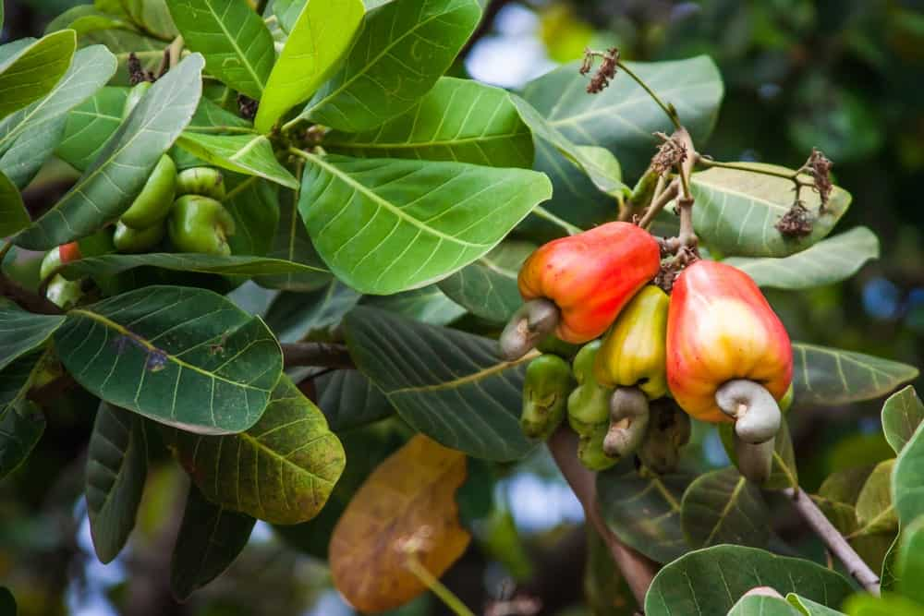
THE CASHEW TREE IS AN EVERGREEN TREE THAT GROWS IN TROPICAL CLIMATES. IT PRODUCES THE CASHEW SEED AND THE CASHEW APPLE, WHICH GROW TOGETHER AS ONE FRUIT. THE TREE CAN REACH AS HIGH AS 14 METERS, BUT THE DWARF VARIETIES PROVE TO BE MORE PROFITABLE, AND HENCE, ARE CULTIVATED IN ABUNDANCE.
THE SPECIES COMES FROM CENTRAL AMERICA AND THE CARIBBEAN ISLANDS. THE CASHEW APPLE IS LIGHT REDDISH TO YELLOW IN COLOR, AND ITS PULP CAN BE MADE INTO FRUIT OR FERMENTED INTO ALCOHOL. THE CASHEW NUT IS SOLD WIDELY AND EXPORTED TO ALL CORNERS OF THE WORLD.
HAVING ALL THIS FASCINATING INFORMATION ABOUT FRUIT TREES CAN HELP YOU DECIDE WHAT YOU WOULD LIKE TO PLANT IN YOUR BACKYARD. A FRUIT TREE IS AN INVESTMENT THAT DOES NOT ONLY PROVIDE SHADE AND OXYGEN TO THE ENVIRONMENT, BUT ALSO GIVES YOU AND CHILDREN PLENTY OF HEALTHY FOOD TO EAT.
IT’S SPRING SEASON, GET PLANTING!

NECTARINE TREES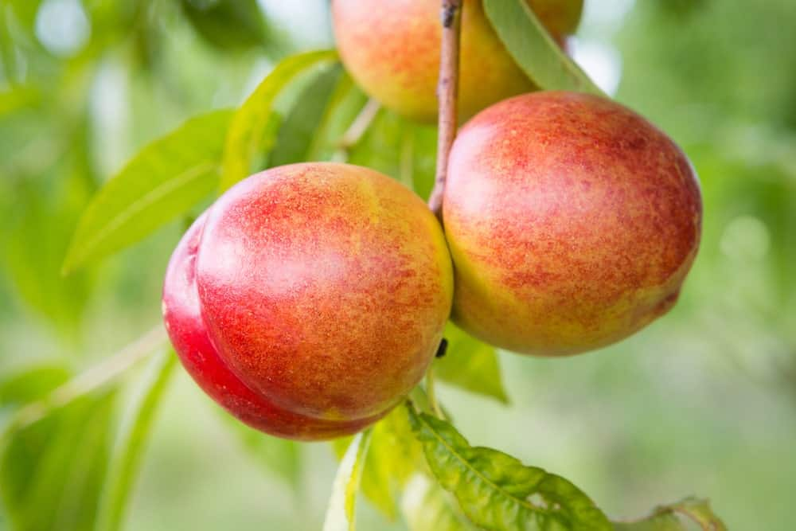
NECTARINES ARE THE SAME SPECIES AS PEACHES, PRUNUS PERSICA, WITH THE ONLY DIFFERENCE THAT THE OUTER SKIN OF THE FORMER LACK WHAT WE HAVE COME TO KNOW AS PEACH FUZZ.
EVEN THOUGH THEY USUALLY GROW IN ANY WARM CLIMATE, NECTARINES WILL GROW BETTER AND FASTER IF THEY ARE EXPOSED TO MORE SUN. ON THE OTHER HAND, THEY CAN EASILY BECOME DORMANT, OR EVEN DIE, IN FROSTY WEATHER. THESE TREES PREFER SANDY LOAM SOILS BUT CAN USUALLY GROW QUITE WELL IN OTHER SOILS TOO.
SOURCE: CHESTNUT HILL TREE FARM

DWARF FRUIT TREES

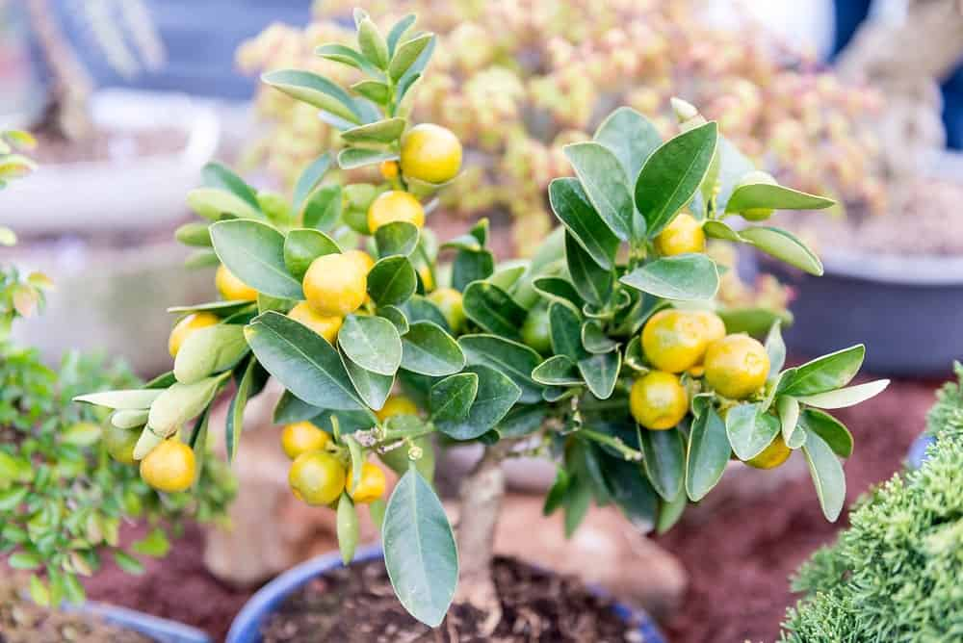
IF YOU WANT YOUR VERY OWN FRUIT TREE BUT ARE CONSTRAINED BY SPACE, DWARF FRUIT TREES CAN BE YOUR CHOICE OF HOUSEPLANT. A DWARF TREE IS A SMALL CULTIVAR OF FULL-SIZED FRUIT TREES THAT CAN YIELD MANY MATURE FRUITS IN A YEAR WITHOUT TAKING UP THE USUAL GROWING SPACE OCCUPIED BY TREES. IN FACT, THESE TINY VERSIONS OF TREES CAN GROW IN CONTAINERS 12-15 WIDE.
ALL THEY NEED TO GROW WELL IS FERTILE POTTING, A GOOD WATER DRAINAGE SYSTEM, AND PLENTY OF SUN EXPOSURE. ONE OF THE MOST FAMOUS VARIETIES IS THE DWARF PEACH PLANT, APTLY NAMED THE PRUNUS PERSICA ‘BONANZA’ WHICH BEARS FRUIT AS EARLY AS WITHIN A YEAR AND HAS SELF-FERTILIZING PROPERTIES.
SOURCE: HGTV OUTDOORS

COLUMNAR FRUIT TREES

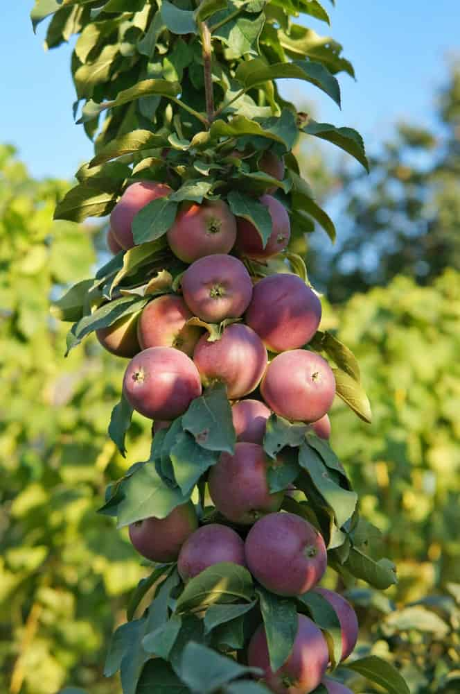
UNLIKE REGULAR TREES, COLUMNAR TREES GROW UPWARDS, NOT OUT. THE BEST THING ABOUT THEM IS THAT THEY CONSUME SO LITTLE HORIZONTAL SPACE THAT THEY CAN BE GROWN ANYWHERE YOU WISH, IF SUFFICIENT CONDITIONS ARE FULFILLED.
NOT ONLY IS IT EXTREMELY PLEASING TO THE EYE, IT ALSO ENABLES PASSIONATE GARDENERS WITH LITTLE OUTDOOR SPACE TO HAVE THE EXPERIENCE OF GROWING A FRUIT TREE UNDER THEIR BELT.
THE FRUIT FROM COLUMNAR TREES IS FULL SIZED, AND JUST AS DELICIOUS AS ANY OTHER VARIETY. FRUITS LIKE CHERRIES, PLUMS, AND PEACHES ARE ALSO AVAILABLE IN THIS VARIETY; HOWEVER, THEY MAY NEED TO PRUNED AND PLUCKED AT CERTAIN POINTS TO MAINTAIN THE SPIRAL STRUCTURE AS WELL AS OTHER FRUITS.
SOURCE: LUV2GARDEN
HAVING ALL THIS FASCINATING INFORMATION ABOUT FRUIT TREES CAN HELP YOU DECIDE WHAT YOU WOULD LIKE TO PLANT IN YOUR BACKYARD. A FRUIT TREE IS AN INVESTMENT THAT DOES NOT ONLY PROVIDE SHADE AND OXYGEN TO THE ENVIRONMENT, BUT ALSO GIVES YOU AND CHILDREN PLENTY OF HEALTHY FOOD TO EAT.
IT’S SPRING SEASON, GET PLANTING!

FAQ

WHAT SHOULD YOU PUT ON FRUIT TREES TO KEEP BUGS OFF?
IF YOU HAVE NOTICED BUGS ON YOUR FRUIT TREES LATELY THEN YOU NEED TO GET AN INSECTICIDE SPRAY THAT OFFERS A VARIETY OF INGREDIENTS TO FIGHT THESE PESTS. BECAUSE YOU COULD HAVE DIFFERENT PESTS ON EACH TREE, YOU WANT A SPRAY THAT WILL TARGET ALL OF THEM AT ONCE.

WHICH FRUIT TREES CAN GROW IN POTS?
THERE ARE A FEW FRUIT TREES THAT CAN GROW IN LARGE POTS. THEY INCLUDE APPLE, PEACH, FIG, AND NECTARINE TREES. THEY ARE IDEAL FOR PATIOS IN POTS THAT GIVE YOU THE SHADE YOU NEED AND THE FRUIT YOU WANT.

WHAT SIZE OF POT FOR PATIO FRUIT TREES?
IF YOU ARE PLANNING TO POT YOUR FRUIT TREES, YOU WANT A PATIO POT THAT IS AT LEAST 10 GALLONS IN THE SMALLER SIZE. FOR BEST PRACTICE AND A CHANCE AT HEALTHY TREES, A 20 OR 25 GALLON WILL GIVE YOUR FRUIT TREE THE ROOM IT NEEDS FOR SUBSTANTIAL ROOT DEVELOPMENT.

WHAT FRUIT TREES ARE DEER RESISTANT?
WHILE THERE ARE SOME FRUIT TREES THAT WILL ATTRACT DEER TO YOUR PROPERTY, THERE ARE SOME THAT ARE DEER RESISTANT. THESE TREES INCLUDE FIG, GINKGO BILOBA, SUGAR MAPLE, PERSIMMONS, AND HONEY LOCUST TREES.

CAN YOU USE GREY WATER ON FRUIT TREES?
IT IS ABSOLUTELY SAFE TO USE GREY WATER OR USE LAUNDRY WATER ON YOUR FRUIT TREES. REUSING GREY WATER FOR YOUR FRUIT TREES KEEPS THEM HYDRATED AND REDUCES THE AMOUNT OF WATER YOU USE REGULARLY. THIS WATER WILL INCLUDE DETERGENT AND SOAPS, BUT THERE IS NO ADVERSE EFFECT TO THE FRUIT TREES FROM THIS GREY WATER UNLESS YOU USE A STRONG CHEMICAL LIKE BLEACH WHICH COULD BURN THE ROOTS.

WHEN TO PLANT FRUIT TREES?
THE BEST TIME OF THE YEAR TO PLANT YOUR FRUIT TREES EACH YEAR IS IN THE SPRING. THIS IS BECAUSE THE TREES HAVE AN OPPORTUNITY TO GET ACQUAINTED WITH THE SOIL AND ADJUST TO RISING TEMPERATURES. PLANTING ANY OTHER TIME IN THE YEAR COULD SHOCK THE TREE AND CAUSE IT TO DIE.

WHEN TO PRUNE FRUIT TREES?
IF YOU ARE CONCERNED ABOUT PRUNING YOUR FRUIT TREES, PLAN TO DO THIS LATE IN THE WINTER. THE LAST TWO WEEKS OF FEBRUARY ARE GREAT FOR PRUNING BECAUSE IT ENCOURAGES NEW GROWTH IN THE TREE. LIKE PLANTING IN THE SPRING, THESE PRUNED TREES HAVE THE OPPORTUNITY TO BECOME FAMILIAR AND COMFORTABLE WITH THE CHANGING TEMPERATURES.

ARE FRUIT TREES FAST-GROWING?
FRUIT TREES TEND TO GROW FASTER THAN HARDIER TREES. IN MOST CASES, YOUR FRUIT TREES WILL GROW WITHIN 3-5 YEARS, DEPENDING ON WHICH TREE IT IS AND THE ENVIRONMENT WHERE IT IS GROWING.

WILL FRUIT TREES GROW IN ROCKY SOIL?
ROCKY SOIL IS NOT THE IDEAL OPTION FOR GROWING FRUIT TREES, BUT THERE ARE A FEW VARIETIES THAT ARE MORE TOLERABLE IN THESE CONDITIONS. IF YOU HAVE ROCKY SOIL, CONSIDER GROWING CHERRY, OLIVE, FIG, PEACH, APRICOT, OR PLUM TREES.

DO FRUIT TREES LOSE THEIR LEAVES IN WINTER?
SINCE THE MAJORITY OF THE FRUIT TREES IN YOUR GARDEN ARE DECIDUOUS, YOU CAN EXPECT THEM TO LOSE THEIR LEAVES IN THE WINTER MONTHS. THIS IS WHY PRUNING IS A GREAT IDEA AT THE END OF WINTER JUST BEFORE SPRING.

12 DIFFERENT TYPES OF BEANS AND LEGUMES – PROTEIN-UP WITHOUT MEAT
HERE’S EVERYTHING YOU NEED TO KNOW ABOUT BEANS AND LEGUMES. HEADS UP! THEY’RE NOT THE SAME. LEARN HOW TO IDENTIFY THEM AND THEIR TYPES IN THIS COMPREHENSIVE GUIDE WE’VE COMPILED FOR YOU.
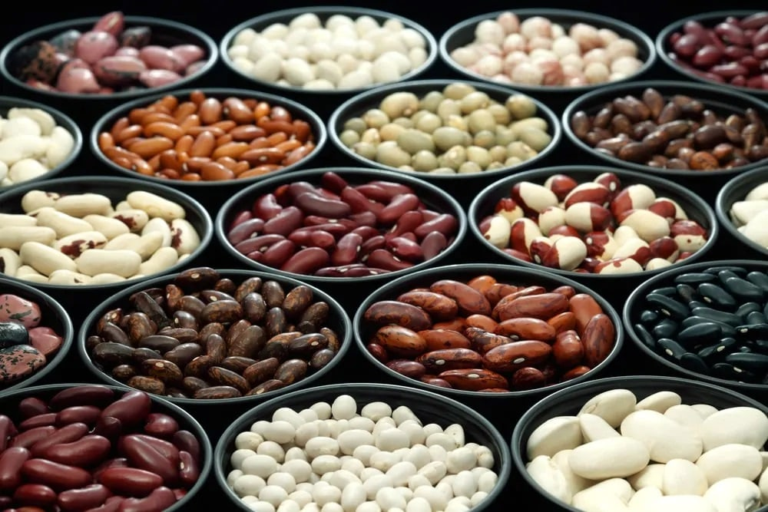
HOW OFTEN HAVE YOU COME ACROSS THE TERMS “LEGUME” AND “BEANS” BEING USED IN A SINGLE FOOD RECIPE, LEAVING YOU ALL CONFUSED AND PERPLEXED? BECAUSE ACCORDING TO COMMONLY HELD BELIEFS, BEANS AND LEGUMES ARE THE SAME THINGS, RIGHT?
WELL, NOT EXACTLY.
THERE IS INDEED A LOT OF CONFUSION SURROUNDING THE TWO TERMS BECAUSE SOME PEOPLE BELIEVE THEM TO BE THE SAME THING, WHILE OTHERS THINK THEY ARE COMPLETELY DIFFERENT FROM ONE ANOTHER.
IN SIMPLE WORDS, LEGUMES ARE PLANTS OF THE LEGUME FAMILY THAT CONTAIN FRUIT GROWING IN THE PODS. ON THE OTHER HAND, BEANS ARE EDIBLE SEEDS FROM DIFFERENT VARIETIES OF LEGUME PLANTS.
LEGUME IS MORE LIKE AN UMBRELLA TERM UNDER WHICH YOU’LL FIND PEAS, PEANUTS, LENTILS, AND BEANS. WHILE PEAS HAVE A SPHERICAL SHAPE, BEANS SPORT A KIDNEY, OR AN OVAL SHAPE AND LENTILS ARE LENS OR DISK-SHAPED.
IN ESSENCE, ALL BEANS ARE LEGUMES, BUT LEGUMES ARE NOT REALLY BEANS.
RELATED: SIDE DISHES FOR HAM | TYPES OF CHILI | SOUTHERN BLACK-EYED PEAS RECIPE | VEGETABLES AND HERBS FOR SYMBIOTIC FARMING | WHEY PROTEIN ALTERNATIVE | CHILI RECIPE

BACK IN THE DAYS
SEVERAL FOSSIL RECORDS AND SCIENTIFIC STUDIES OF PLANT GENETICS HAVE REVEALED THAT THE FIRST-EVER APPEARANCE OF THE LEGUME SPECIES HAPPENED SOME 59 MILLION YEARS AGO. THESE SPECIES BASICALLY BROKE OFF FROM THEIR FLOWERING-PLANT ANCESTORS AND ACQUIRED SOME DISTINCT GENETIC TRAITS ALONG THE WAY, MAKING THEM QUITE UNIQUE.
OVER TIME, THE SPECIES OBTAINED MORE AND MORE LEGUME-LIKE CHARACTERISTICS, RESULTING IN ABOUT 20,000 DIFFERENT SPECIES THAT WE KNOW OF TODAY.
WHILE THE CULTIVATION OF BEANS BEGAN AS A BASIC DIETARY STAPLE ALMOST 20,000 YEARS BACK IN NUMEROUS EASTERN CULTURES, THE INITIAL CULTIVATION OF BEANS TOOK PLACE ABOUT 5000 YEARS BACK, INITIALLY IN PERUVIAN AND MEXICAN CIVILIZATIONS, AND THEN BECOMING HIGHLY POPULAR IN INCA AND AZTEC CULTURES.

BEANS NUTRITIONAL FACTS CHART
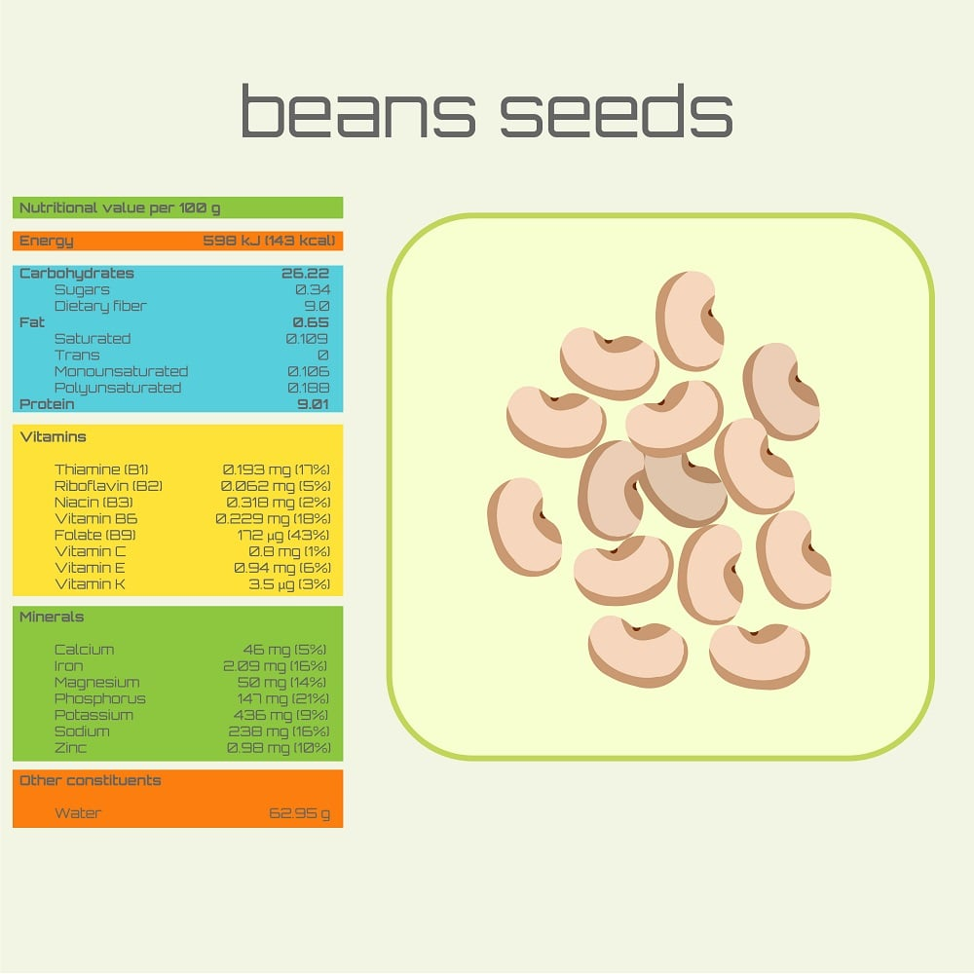

TYPES

PINK BEAN
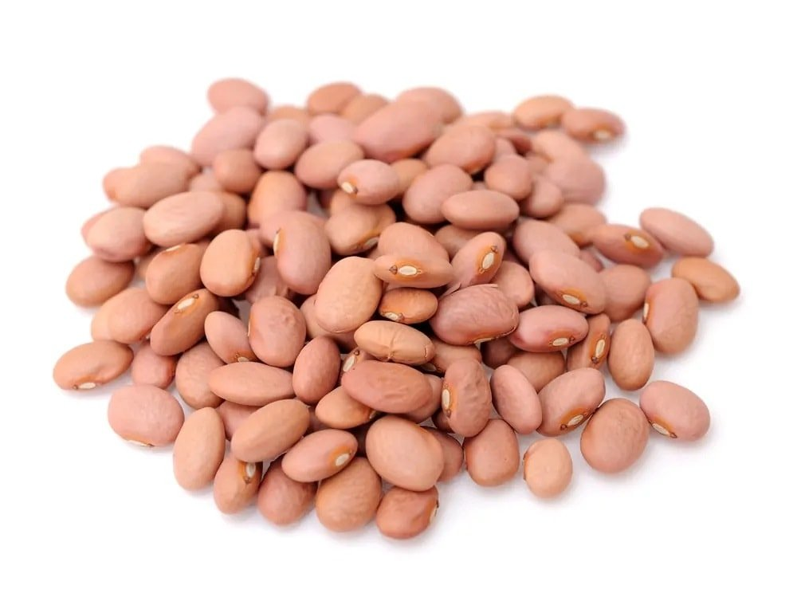
ALSO COMMONLY KNOWN AS ‘CHILI BEANS’, PINK BEANS ARE PINKISH-BROWN BEANS THAT ARE PLUMP AND ROUNDISH-OVAL IN SHAPE.
THEY ARE PARTICULARLY POPULAR IN THE CARIBBEAN COUNTRIES FOR THEIR RICH, MEATY FLAVOR. THEY ARE USUALLY A KEY INGREDIENT IN MOST OLD WEST RECIPES, MEXICAN-AMERICAN CUISINE, AND BARBEQUE-INSPIRED DISHES. PINK BEANS APPEAR TO BE QUITE SIMILAR TO PINTO BEANS, PARTICULARLY IN SIZE, SO PINTO BEANS AND KIDNEY BEANS ARE OFTEN USED AS A SUBSTITUTE FOR PINK BEANS.
AN INTERESTING FACT ABOUT PINK BEANS IS THAT THEY ARE ALSO OFTEN CALLED “SANTA MARIA PINQUITOS” BECAUSE THEY ARE THE STAR INGREDIENT IN MOST BARBEQUE DISHES IN CALIFORNIA’S SANTA MARIA VALLEY.
ON AVERAGE, THIS BEAN PLANT GROWS UP TO 14 INCHES, MAKING IT ABOUT 36 CM TALL AND PRODUCES PODS THAT ARE 9 CM LONG.
THEY HAVE A VERY FINE AND SMOOTH TEXTURE THAT BECOMES TENDER AND TURNS INTO A REDDISH-BROWN COLOR WHEN COOKED.

BLACK BEAN
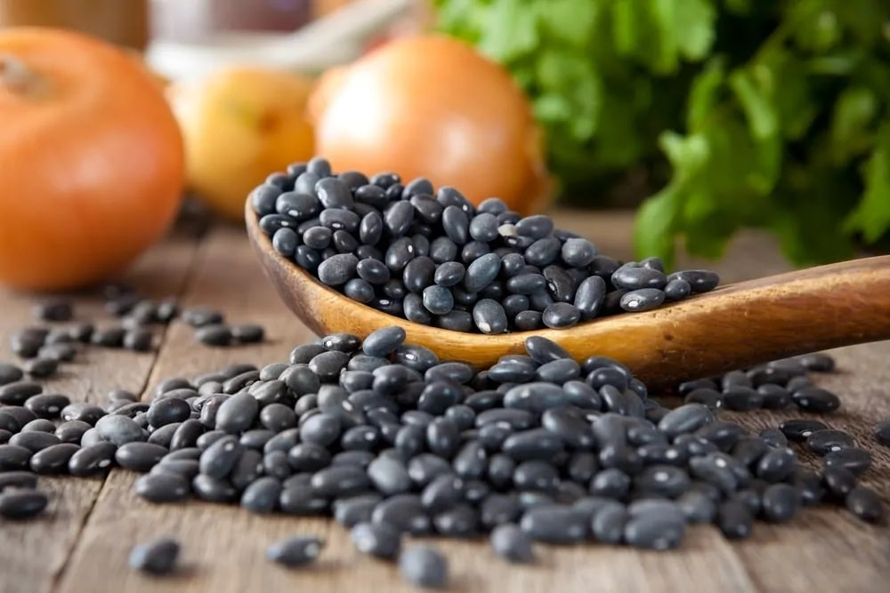
THESE ARE SMALL OVALS WITH GRAYISH-CREAM FLESH AND DEEP BLACK SKINS. BLACK BEANS FALL UNDER THE CATEGORY OF LEGUMES AND ARE ALSO KNOWN AS ‘TURTLE BEANS’ OWING TO THEIR SUPER HARD AND SHELL-LIKE APPEARANCE. THEY ARE NATIVE TO THE AMERICAS AND POPULARLY USED IN LATIN AMERICAN CUISINE BUT CAN ALSO BE FOUND IN SOUTH LOUISIANA CUISINES.
BLACK BEANS HAVE A SOFT TEXTURE WITH A SWEET, EARTHY, AND MILD FLAVOR. THEY ARE COMMONLY VALUED FOR THEIR HIGH FIBER AND PROTEIN CONTENT WHICH MAKES THEM EXTREMELY NUTRITIOUS AND HEALTHY. SOME OF ITS KEY BENEFITS INCLUDE STRENGTHENING OF BONES, REDUCED BLOOD PRESSURE, PREVENTION OF CANCER, WEIGHT LOSS, AND DIABETES CONTROL.
THEY MAKE FOR AN EXCELLENT SOUP INGREDIENT AND ARE TYPICALLY FEATURED IN THE BLACK BEAN SOUP, A TRADITIONAL DISH IN CUBA THAT IS OFTEN SERVED WITH WHITE RICE.

ROMAN BEAN
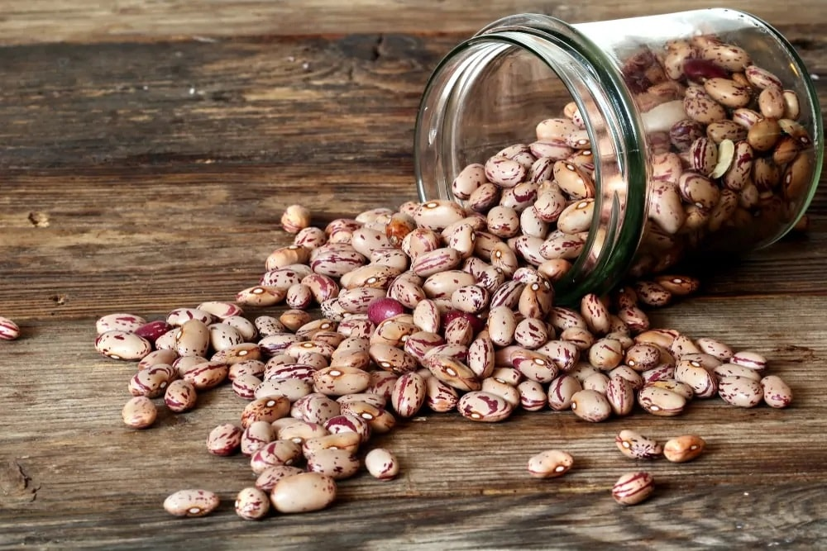
MORE COMMONLY KNOWN AS “CRANBERRY BEANS” OR “SPECKLED SUGAR BEANS”, ROMAN BEANS ARE OVAL-SHAPED WITH A SMOOTH TEXTURE, PRETTY PINKISH COLOR, AND GORGEOUS DARK-RED SPECKLES OR STREAKS. THEY HAVE A SWEET, MILD, CHESTNUT-LIKE FLAVOR AND ARE PERFECT FOR SALADS, PASTA, SOUPS, OR SIMPLY AS AN EVENING SNACK.
ROMAN BEANS ORIGINATED FROM COLUMBIA AND SOON WENT ON TO BECOME EXTREMELY POPULAR IN ITALY WHERE THEY ARE COMMONLY CALLED “BORLOTTI”.
INTERESTINGLY, WHEN THESE BEANS ARE COOKED, ALL OF THEIR SPECKS AND STREAKS JUST VANISH, RESULTING IN A DARKER AND A MORE EVEN COLOR.

NAVY BEAN
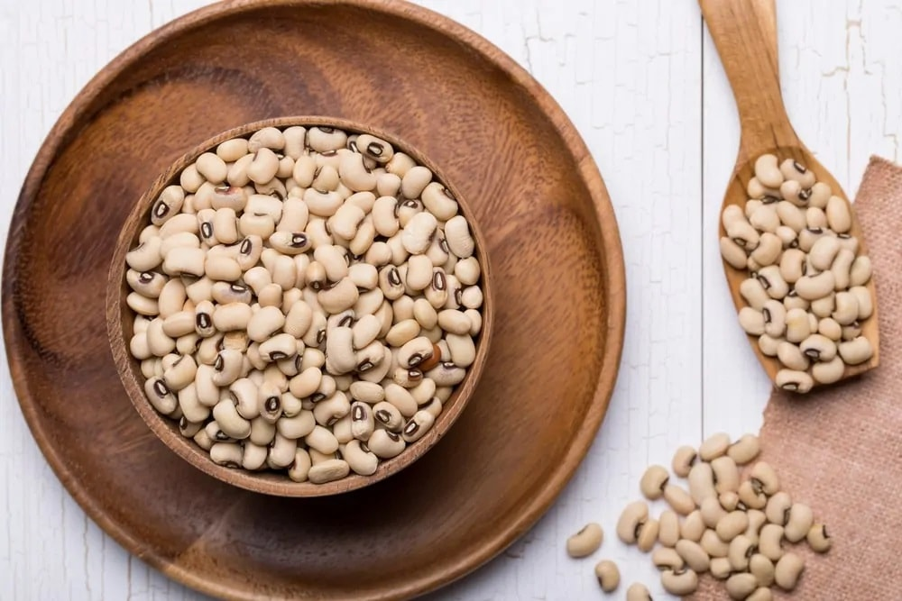
THESE ARE ALSO KNOWN AS HARICOT BEANS, PEA BEANS, PEARL HARICOT BEAN, AND WHITE PEA BEAN AND ARE MAINLY NATIVE TO THE AMERICAS WHERE THEY WERE ALSO FIRST DOMESTICATED.
NAVY BEANS ARE NORMALLY SMALL AND DRY, AND OFTEN SPORT A CREAMY WHITE COLOR. THEY HAVE A FLATTENED, OVAL SHAPE, CONTAIN A DENSE, SMOOTH TEXTURE AND A MILD FLAVOR. THEY ARE MOSTLY CONSUMED FOR THEIR NUMEROUS NUTRITIONAL BENEFITS, SOME OF WHICH DECREASE THE RISK OF HEART-RELATED AILMENTS, STABILIZED BLOOD SUGAR LEVELS, IMPROVED MEMORY, AND A RICH SOURCE OF IRON AND FIBER.
SOME INTERESTING WAYS TO INCLUDE NAVY BEANS IN YOUR DIET ARE ADDING THEM TO SALADS, MAKING A DELICIOUS SANDWICH SPREAD, MIXING THEM IN SOUPS, ETC.

RED BEAN
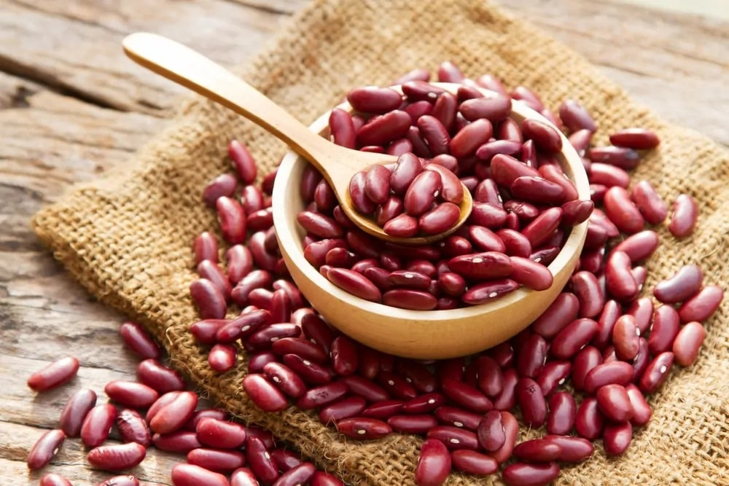
SMALL, ROUND AND RED IN COLOR, RED BEANS HAVE TO BE THE MOST POPULAR AMONG ALL TYPES OF BEANS. THEY ARE ALSO KNOWN AS “ADZUKI” AND HAVE A SWEET, NUTTY TASTE. RED BEANS ARE USED IN A VARIETY OF CREOLE AND SOUTHERN DISHES, PARTICULARLY BECAUSE OF THEIR UNIQUE TASTE AND NUMEROUS HEALTH BENEFITS.
RED BEANS ARE OFTEN USED INTERCHANGEABLY WITH RED KIDNEY BEANS BECAUSE OF THE EXTREME SIMILARITY BETWEEN THE TWO. THEY ARE BELIEVED TO INITIALLY HAVE BEEN CULTIVATED IN EAST ASIA AND THE HIMALAYAS. THEIR POPULARITY SOON LED THEM TO NEW ORLEANS WHERE RED BEANS ARE NOW A LOCAL FAVORITE AND ARE USED IN A NUMBER OF DISHES AND CUISINES SUCH AS A RED BEAN CURRY, SOUP, STEW, AND EVEN HUMMUS.

MUNG BEAN
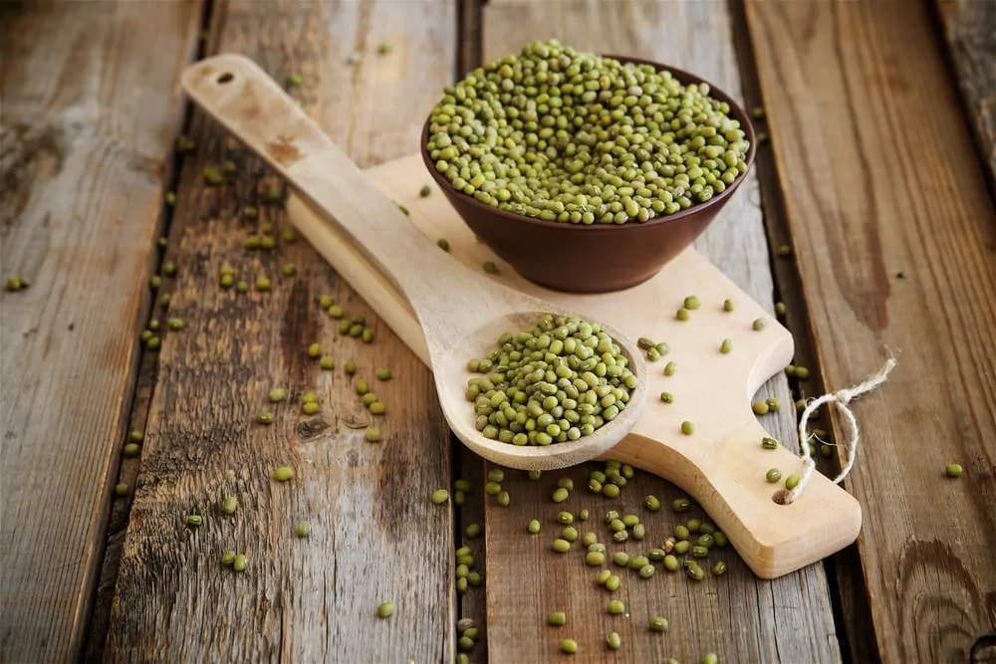
ALSO KNOWN AS MAASH OR THE GREEN GRAM, THE MUNG BEAN IS PRIMARILY CULTIVATED IN PAKISTAN, NEPAL, INDIA, BANGLADESH, SOUTH ASIA, SRI LANKA, AND CHINA. THEY ARE SMALL AND ROUND IN SHAPE AND HAVE A SLIGHTLY SWEET TASTE, WHICH MAKES THEM IDEAL FOR BOTH SAVORY AND SWEET DISHES. THEY ARE OFTEN SOLD AS DRIED BEANS OR AS FRESH SPROUTS.
THE GREEN MUNG BEAN IS PACKED WITH NUTRIENTS, MAKING THEM ONE OF THE HEALTHIEST FOOD INGREDIENTS. IT HAS A VARIETY OF HEALTH BENEFITS INCLUDING REDUCED RISK OF CHRONIC DISEASES, PREVENTION OF HEAT STROKES, CONTROLLED BLOOD PRESSURE, AND BETTER DIGESTIVE HEALTH.
SOME OF THE KEY NUTRIENTS FOUND IN MUNG BEAN ARE FIBER, PROTEINS, POTASSIUM, ZINC, COPPER, MAGNESIUM, AND VITAMINS B2, B3, B5, AND B6.
MUNG BEANS ARE POPULARLY USED IN DISHES LIKE FALAFEL, MUNG CURRIES, BEAN STEW, IN SALADS, ETC.

SPLIT MUNG BEAN

WHILE WHOLE MUNG BEANS HAVE GREEN SKIN, WHEN THIS SKIN COMES OFF DURING PROCESSING, THE BEANS END UP SPLITTING, HENCE THE NAME ‘SPLIT MUNG BEAN’. ONCE SPLIT, THEY REVEAL A YELLOW COLOR WHICH VARIES ACCORDING TO THE MUNG VARIETY.
IT HAS QUITE A SIMILAR FLAVOR TO MILD AND SWEET PEAS AND IS WIDELY CONSUMED AS A RICH SOURCE OF PROTEIN IN MOST ASIAN COUNTRIES.
SPLIT MUNG BEANS CONTAIN LARGE AMOUNTS OF DIETARY FIBER, PROTEINS, AND OTHER ESSENTIAL NUTRIENTS THAT MAKE THEM QUITE A HEALTHY CHOICE FOR VEGETARIANS AND VEGANS. THEY ARE LARGELY CULTIVATED IN SOUTHEAST ASIA AND INDIA.
THEY ARE POPULARLY USED TO MAKE MUNG STEW, MUNG HUMMUS, FALAFEL, PROTEIN PANCAKES, AND MUNG SOUP.

SOYBEAN
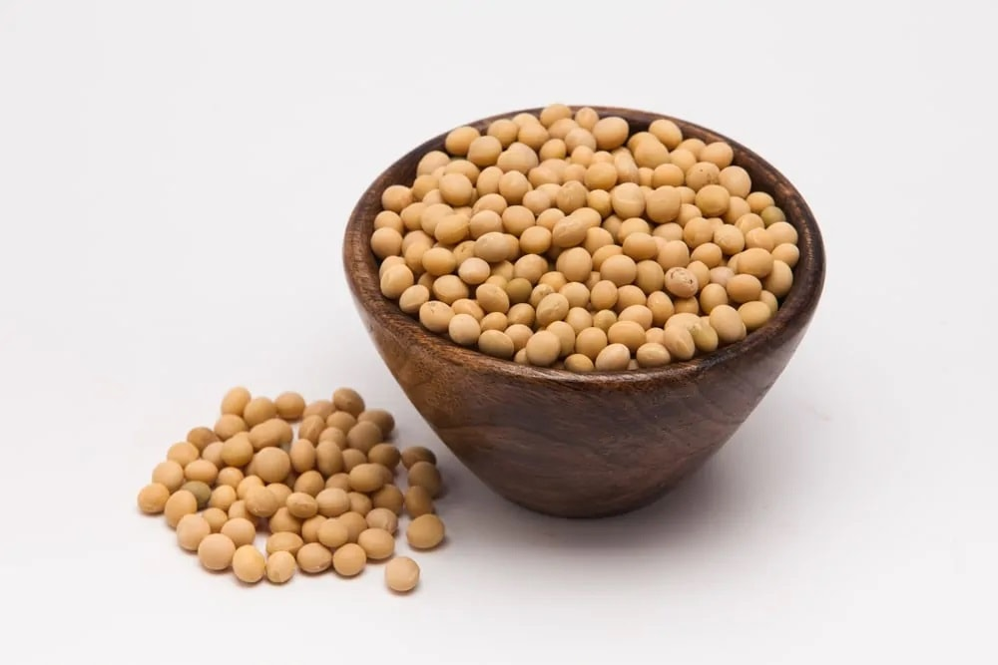
ALSO CALLED SOYA BEAN OR SOJA BEAN, SOYBEAN IS BELIEVED TO BE THE MOST POPULAR OF ALL BEANS. THIS IMPORTANCE STEMS FROM THE FACT THAT SOYBEANS PROVIDE THE HIGHEST AMOUNT OF VEGETABLE PROTEIN AND ARE ALSO USED AS A CORE INGREDIENT IN A NUMBER OF CHEMICAL PRODUCTS.
SOYBEANS WERE FIRST DOMESTICATED BY CHINESE FARMERS SOMEWHERE IN 1100 BC, AND THEY INITIALLY ORIGINATED IN SOUTHEAST ASIA. INTERESTINGLY, CHINA WAS THE BIGGEST SUPPLIER OF SOYBEANS TILL WORLD WAR II HALTED THEIR SUPPLY, AND AFTER THAT, SOYBEAN CULTIVATION STARTED TAKING OFF IN AMERICA.
THESE BEANS DON’T PARTICULARLY HAVE AN INTRINSIC TASTE OF THEIR OWN, SIMPLY BECAUSE OF THEIR INABILITY TO ABSORB TASTE AS MANY OTHER BEANS DO. SO YOU CAN USE THEM TO MAKE A SOYBEAN CURRY OR SOYBEAN HUMMUS.

FAVA BEAN
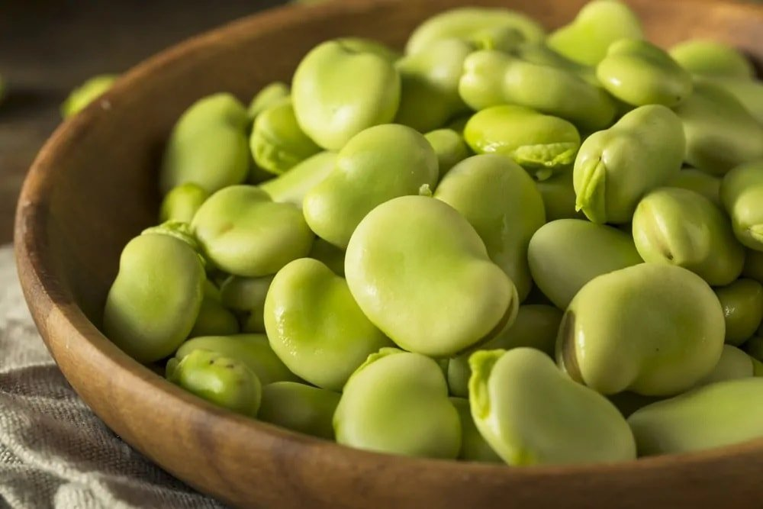
THESE ARE BROAD GREEN LEGUMES THAT ARE EXTREMELY POPULAR IN A VARIETY OF MIDDLE EASTERN AND MEDITERRANEAN CUISINES.
FAVA BEAN IS OFTEN REFERRED TO AS THE “MAGIC BEAN” PRIMARILY DUE TO ITS NUTRITIONAL AND HEALTH BENEFITS INCLUDING LOW BLOOD CHOLESTEROL LEVELS AND IMPROVED DIGESTION. THEY ARE ALSO A RICH SOURCE OF PROTEINS, VITAMINS, DIETARY FIBERS, AND ESSENTIAL MINERALS LIKE MANGANESE, IRON, AND COPPER.
THEY ARE OFTEN USED IN PASTA AND VEGETABLE SOUPS; HOWEVER, THEY ARE BELIEVED TO HAVE QUITE A BITTER AFTERTASTE.
IN SEVERAL LATIN COUNTRIES, FAVA BEANS ARE CONSUMED AS A POPULAR SNACK, USUALLY DRIED AND SALTED. WHEREAS IN CENTRAL MEXICO, THESE BEANS ARE MASHED INTO A PASTE AND FEATURED IN CORN-FLOUR BASED RECIPES AND SNACKS.

CHICK PEA
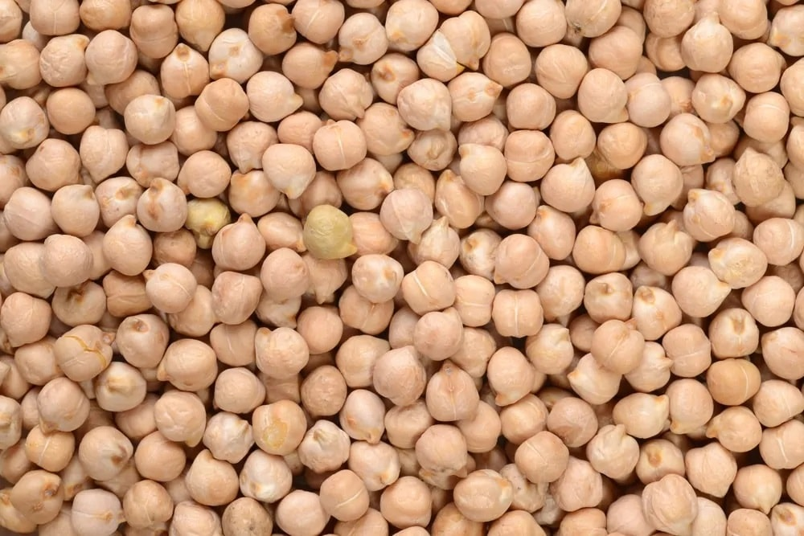
COMMONLY CULTIVATED IN THE MIDDLE EAST AND THE MEDITERRANEAN, CHICKPEAS ARE KNOWN BY A VARIETY OF OTHER NAMES INCLUDING GARBANZO BEAN, GRAM, EGYPTIAN PEA, BENGAL GRAM, AND GARBANZO. THEY ARE YELLOWISH IN COLOR AND ROUND IN SHAPE WITH A BUTTERY TEXTURE AND A NUTTY TASTE.
LIKE SEVERAL OTHER TYPES OF LEGUMES INCLUDING BEANS AND LENTILS, CHICKPEAS ARE ALSO LOADED WITH A VARIETY OF KEY MINERALS AND VITAMINS, MOST NOTABLY PROTEINS AND FIBER. SOME OF THEIR OVERRIDING BENEFITS INCLUDE ENHANCED HEART HEALTH, REDUCED INFLAMMATION, AND CHOLESTEROL LEVELS, WEIGHT MANAGEMENT, PREVENTION OF CANCER, AND MANY MORE.
CHICKPEAS ARE OFTEN FEATURED AS THE KEY INGREDIENT IN DISHES LIKE HUMMUS AND FALAFEL BUT ARE ALSO A GREAT ADDITION TO SALADS, STEWS, AND SOUPS.

SPLIT PEA
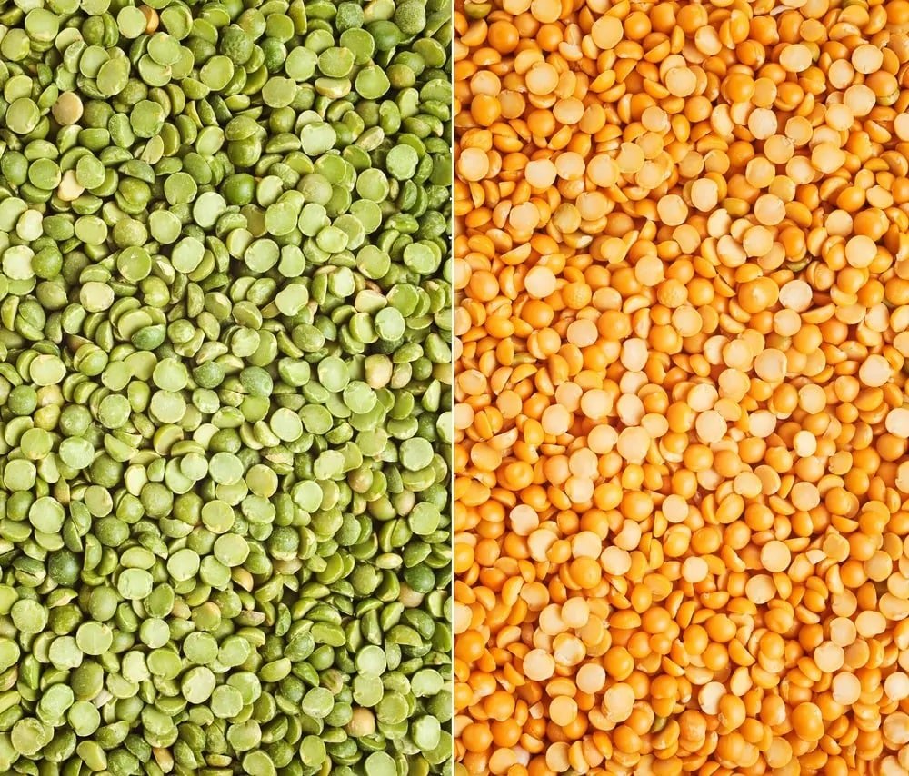
SPLIT PEAS OCCUR IN TWO MAIN COLORS, GREEN AND YELLOW, AND ARE TYPICALLY KNOWN AS FIELD PEAS, WHICH ARE GROWN SPECIFICALLY FOR DRYING PURPOSES. THEY ARE KNOWN TO BE NATURAL SOURCES OF THE HIGHEST AMOUNTS OF DIETARY FIBER AND KEY PROTEINS.
SPLIT PEAS COME FROM THE PISUM SATIVUM L PLANT WHICH IS POPULARLY CULTIVATED IN RUSSIA, INDIA, CHINA, CANADA, AND THE UNITED STATES. THEY ARE ALSO NATIVE TO SOUTHEAST ASIA AND WERE COMMONLY CULTIVATED AND CONSUMED BY ROMANS, EGYPTIANS, AND THE ANCIENT GREEKS.
SOME OF THE MOST POPULAR DISHES MADE WITH SPLIT PEAS ARE THE AMERICAN SPLIT PEA HAM SOUP, A VEGETARIAN INDIAN STAPLE CALLED ‘DAHL’, AND A PERSIAN STEW CALLED “KHORESHT GHEIMEH” WHICH IS MADE FROM THE YELLOW SPLIT PEAS.

GREEN PEA
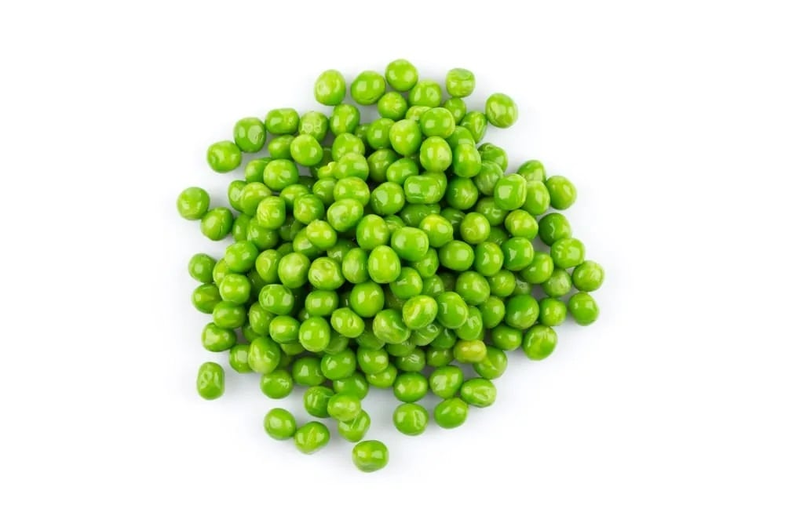
ALSO KNOWN AS GARDEN PEAS, GREEN PEAS ARE SUPER VERSATILE LEGUMES THAT ARE GROWN AS COMMERCIAL CROPS CURRENTLY ALL OVER SEMI-TROPICAL REGIONS.
THEY ARE BELIEVED TO HAVE ORIGINATED FROM THE SUB-HIMALAYAN PLAINS OF NORTHWEST INDIA AND HAVE BEEN CULTIVATED SINCE ANCIENT TIMES FOR THEIR NUTRITIOUS AND DELICIOUS GREEN SEEDS.
THEY ARE ALSO CONSIDERED TO BE THE HEALTHIEST OF LEGUMINOUS VEGETABLES THAT ARE SUPER-RICH IN ANTIOXIDANTS, MINERALS, PHYTONUTRIENTS, AND VITAMINS. ACCORDING TO COMMONLY HELD BELIEFS, GREEN PEAS ARE VEGETABLES; HOWEVER, THEY ARE ACTUALLY A PART OF THE LEGUME FAMILY WHICH CONSISTS OF POD-PRODUCING PLANTS WITH SEEDS INSIDE.
SOME OF THE KEY HEALTH BENEFITS OF GREEN PEAS INCLUDE CONTROLLED BLOOD SUGAR; IMPROVED DIGESTION AND PROTECTION AGAINST SOME CHRONIC ILLNESSES SUCH AS DIABETES AND CANCER.
GREEN PEAS ARE COMMONLY FEATURED AS A SIDE ITEM IN MOST DISHES AND OFTEN AS A STAR INGREDIENT IN DISHES LIKE PEA RAVIOLI, GREEN PEA SPREAD, PEA CURRY, ETC.
BEANS AND LEGUMES ARE SOME OF THE HEALTHIEST FOOD INGREDIENTS THAT YOU MUST INCLUDE IN YOUR DAILY DIET. COMBINING BEANS WITH LEGUMES IS AN ABSOLUTELY TERRIFIC WAY TO INCLUDE A TON OF NUTRITION, ESSENTIAL MINERALS AND VITAMIN TO YOUR DIET.

46 DIFFERENT TYPES OF MUSHROOMS
GET YOUR FACTS STRAIGHT ABOUT MUSHROOMS AND LEARN THE SPECIAL DISTINCTIONS FOR EACH VARIETY
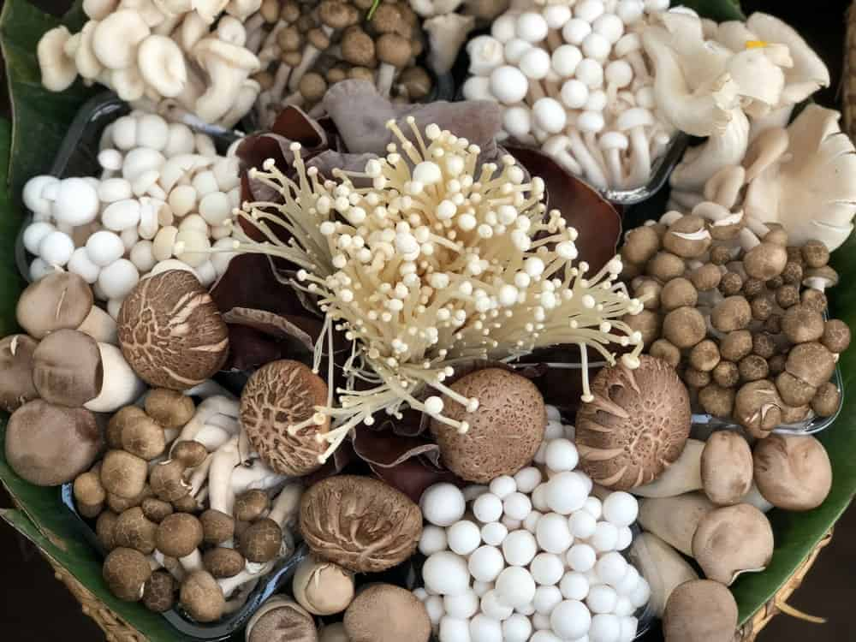
HOW MANY DIFFERENT TYPES OF MUSHROOMS ARE THERE, YOU ASK? QUITE A FEW. CHECK OUT OUR DETAILED CHART AND LIST BELOW INCLUDING COMMON MUSHROOMS, BLACK MUSHROOMS, WHITE MUSHROOMS, COLORFUL MUSHROOMS, AS WELL AS DETAILS TO LEARN A WHOLE LOT MORE ABOUT MEDICINAL MUSHROOMS.
MUSHROOMS ARE A TYPE OF FUNGI THAT HAVE EXISTED ON THE PLANET SINCE THE BEGINNING OF TIME. EVEN BEFORE TREES SPRUNG UP ON EARTH, GIANT MUSHROOMS THAT REACHED 24 FEET IN HEIGHT AND THREE FEET IN WIDTH COVERED THE ANCIENT LANDSCAPE.
THERE ARE ABOUT 10,000 NAMED-SPECIES IN NORTH AMERICA, WHICH MAKE UP ABOUT ONE-FIFTH OF ALL DESCRIBED MUSHROOMS. MILLIONS MORE ARE GROWING WITH MUCH OF THE BIOLOGICAL MATERIAL HIDDEN IN SOIL AND PLANT MATTER.
IN TERMS OF PERCENTAGES OF ALL THE MUSHROOMS THAT ARE OUT THERE, HALF ARE INEDIBLE BUT HARMLESS, A QUARTER ARE EDIBLE, 20 PERCENT WILL MAKE YOU SICK AND ONE PERCENT CAN KILL YOU.
ALL OVER THE WORLD, MUSHROOMS HAVE BEEN CONSUMED AS FOOD OR USED FOR MEDICINAL PURPOSES. IT IS SAID THAT EGYPTIAN PHARAOHS LOVED THEIR MUSHROOMS SO MUCH THAT THEY DECLARED IT FOOD FOR ROYALTY AND BANNED COMMONERS FROM EATING THEM.
THE UPPER CLASSES IN ANCIENT GREECE AND ROME, ON THE OTHER HAND, USED MUSHROOMS IN THEIR CUISINES. THE ROMANS ALSO EMPLOYED TASTERS TO MAKE SURE THAT THE MUSHROOM WERE NOT POISONOUS.

DIFFERENT TYPES OF MUSHROOMS CHART
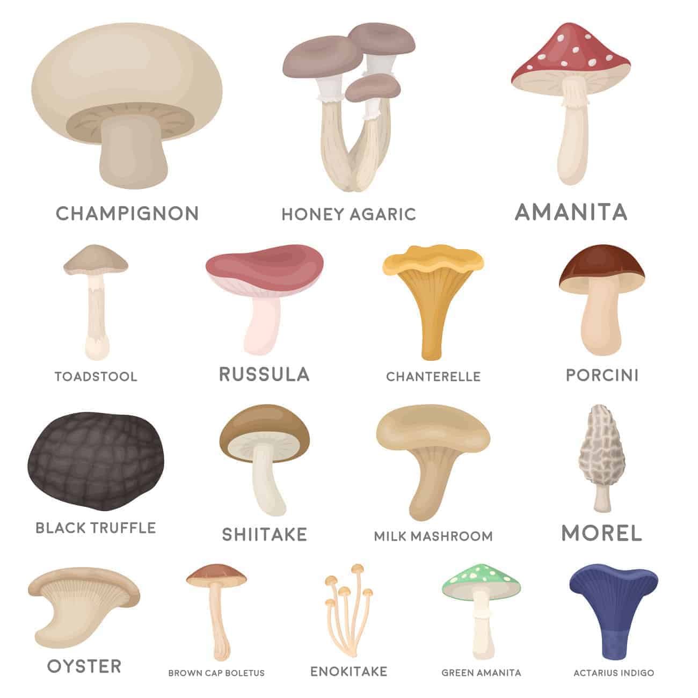
FULL LIST OF MUSHROOM NAMES (WITH PHOTOS IN ALPHABETICAL ORDER)

1. AMANITA

WHAT KIND OF MUSHROOM IS THIS, YOU MIGHT ASK? IT’S PECULIAR LOOKING FOR SURE. IT’S AN AMANITA MUSCARIA OR FLY AGARIC — A PSYCHOACTIVE FUNGUS THAT ATTRACTS AND KILLS HOUSEFLIES. THE GENUS AMANITA HAS ABOUT 600 MUSHROOM SPECIES, INCLUDING SOME OF THE MOST TOXIC ONES.
WHERE DO AMANITA MUSHROOMS GROW? EASTERN AND SOUTHEASTERN NORTH AMERICA.

2. BEECH MUSHROOMS
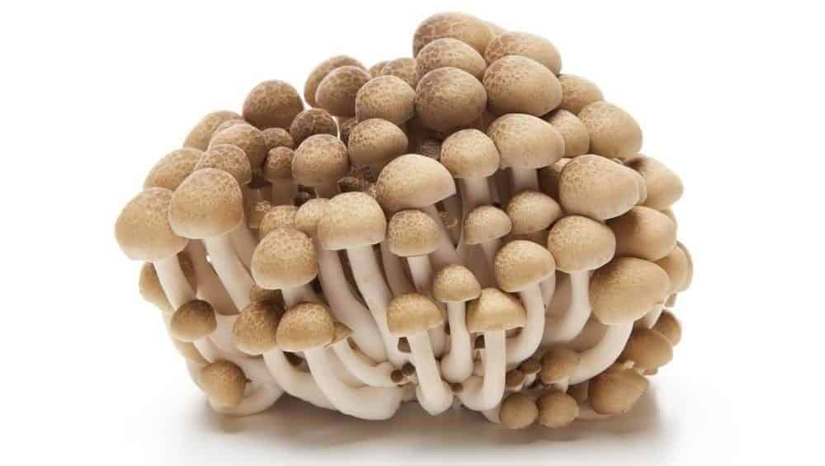
ALSO CALLED CLAMSHELL MUSHROOMS, THESE MUSHROOMS HAVE CAPS THAT ARE BROWN AND HAVE A CRUNCHY, BUT SWEET AND NUTTY FLAVOR.
HOWEVER, THIS ONLY APPLIES WHEN THEY ARE COOKED, WHICH IS THE BEST WAY TO EAT THEM. IF THEY ARE EATEN RAW, YOU WILL NOTICE A BITTER TASTE THAT YOU’RE NOT LIKELY TO BE FOND OF. BEECH MUSHROOMS GROW ON BEECH TREES.

3. BLACK TRUFFLES
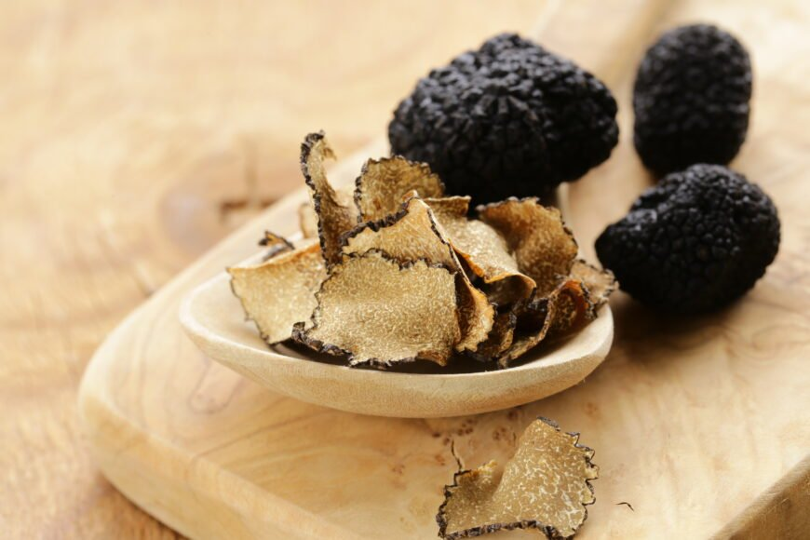
THE BLACK TRUFFLE IS THE MOST EXPENSIVE (UP TO $1,500 PER POUND) OF ALL TRUFFLES. BLACK TRUFFLES ARE ALMOST IMPOSSIBLE TO CULTIVATE AND THE ‘UNDERGROUND MUSHROOMS’ ARE A RARE FIND IN THEIR NATURAL HABITAT — THE MOUNTAIN REGIONS OF SOUTHERN EUROPE. IT IS THOUGHT THAT TRUFFLES FIRST EMERGED 50 MILLION TO 85 MILLION YEARS AGO.

4. BLACK TRUMPET MUSHROOMS
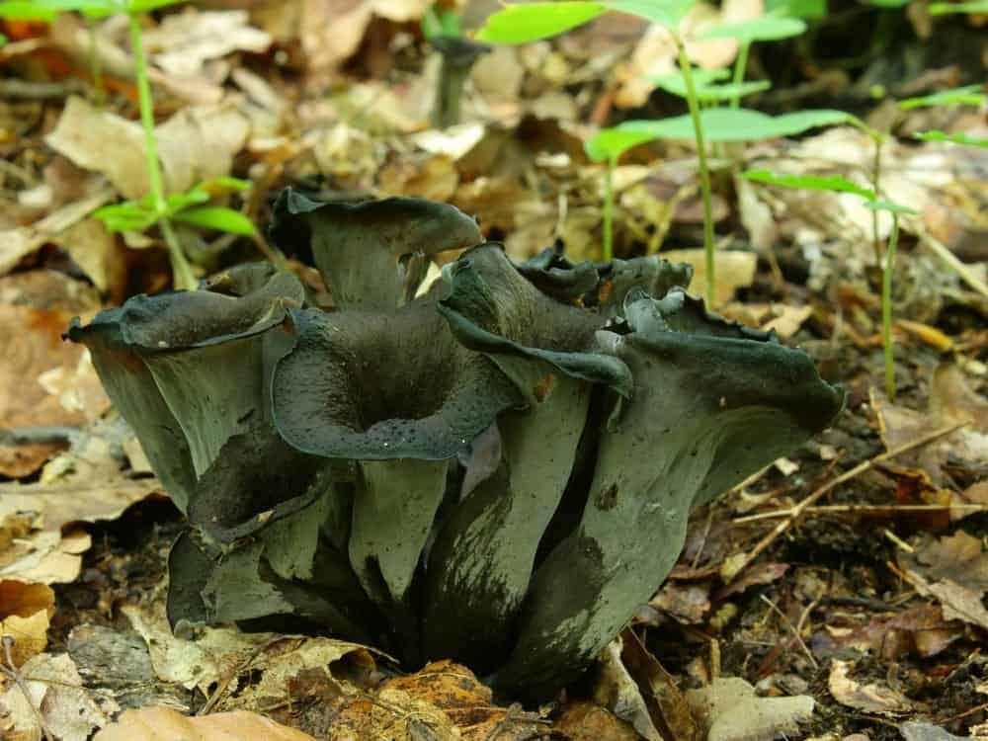
BLACK TRUMPET MUSHROOMS USUALLY BLOOM IN THE EAST AND MIDWEST LATE IN THE SUMMER, BUT IT GROWS ALL WINTER LONG IN THE WEST. ALSO KNOWN AS THE HORN OF PLENTY MUSHROOM OR THE TRUMPET OF THE DEAD MUSHROOM, THEY HAVE A SMOKY, RICH FLAVOR AND WHEN DRIED, THEY ARE SIMILAR TO BLACK TRUFFLES.

5. BROWN CAP BOLETUS

Bottom of Form
BROWN CAP BOLETUS MUSHROOMS ARE EDIBLE AND USUALLY FOUND AT THE EDGES OF CLEARINGS AND CONIFEROUS TREES.

6. BUTTON MUSHROOMS
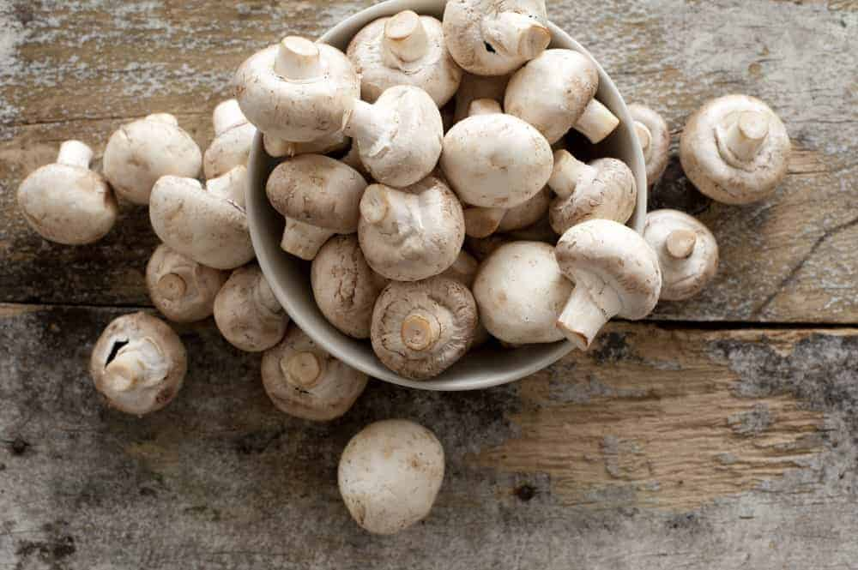
IF YOU GO TO THE SUPERMARKET AND BUY MUSHROOMS, CHANCES ARE GOOD THAT YOU’RE BUYING BASIC BUTTON MUSHROOMS. ALSO CALLED WHITE MUSHROOMS, THEY ARE ALWAYS HARVESTED WHEN THEY’RE VERY YOUNG, AND THEY HAVE A DELICATE, BUT EARTHY FLAVOR.
MOREOVER, SINCE THEY ARE AVAILABLE ALL YEAR LONG, THEY ARE EASY MUSHROOMS TO FIND. IF YOU’RE LOOKING FOR SOMETHING TO BAKE OR STUFF, TRY THE OLDER BUTTON MUSHROOMS, WHICH HAVE A MILD FLAVOR AND A FIRM TEXTURE.
THESE GROW IN COOL AND DARK AREAS. YOU CAN GROW THEM AT HOME. WHEN PICKING IN NATURE, BE CAREFUL BECAUSE THESE LOOK SIMILAR TO POISONOUS MUSHROOMS (I.E. THE DEATH CAP MUSHROOM).

7. CHAMPIGNON MUSHROOMS
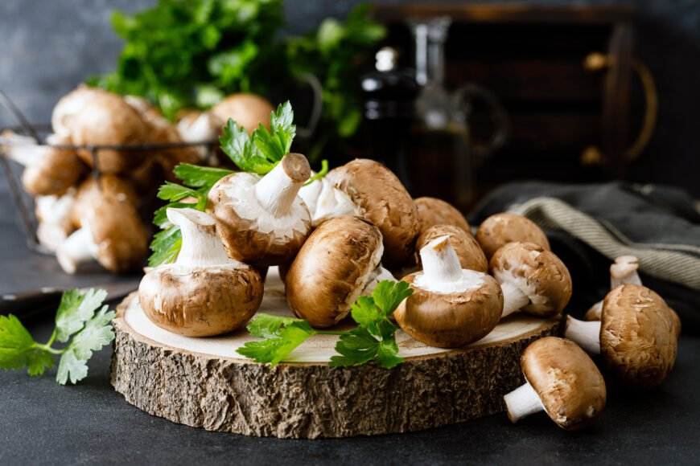
CHAMPIGNON MUSHROOMS ARE ONE OF THE MANY DIFFERENT MUSHROOM VARIETIES OF THE AGARICUS BISPOROUS. THESE MUSHROOMS ARE AN EXCELLENT CHOICE FOR COOKING.
CHAMPIGNON MUSHROOMS ARE NATIVE TO EUROPE AND NORTH AMERICA, AS THESE ARE THE AREAS THAT THEY’VE BEEN CULTIVATED IN MOST. THESE MUSHROOMS ALSO GROW IN SOME OTHER PLACES INCLUDING PARTS OF NORTH AFRICA, IRAN AND AUSTRALIA.

8. CHANTERELLE MUSHROOMS
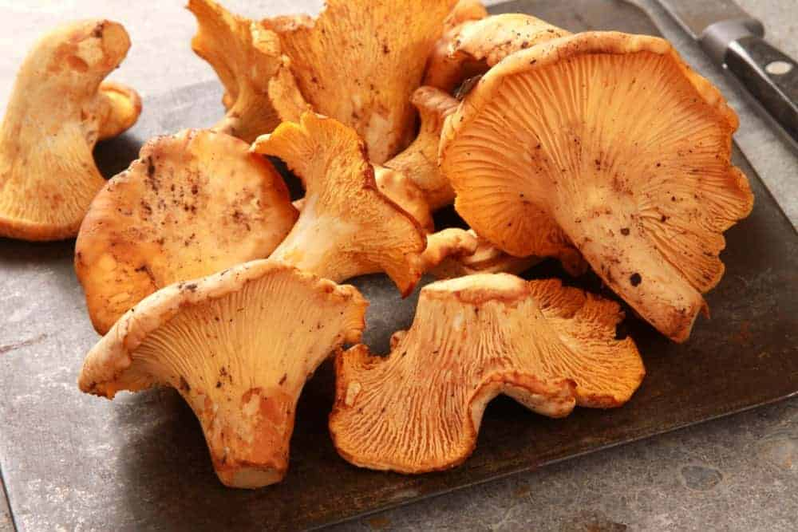
IF YOU COOK WITH CHANTERELLE MUSHROOMS, YOU SHOULD USE THEM IN A DRY SAUTÉ BECAUSE THEY HAVE SUCH A HIGH WATER CONTENT THAT THEY WILL SOON BE COOKING IN THE WATER ANYWAY.
CHANTERELLE MUSHROOMS CAN BE ALMOST ANY COLOR, BUT THEY ARE USUALLY A GOLDEN BROWN. THEY SMELL AND TASTE A LITTLE FRUITY AND PEPPERY, AND THEY ARE PERFECT AS A TOPPING FOR ENTREES.
COMPARED TO MANY OTHER TYPES OF MUSHROOMS, THEY LAST A VERY LONG TIME IF KEPT IN THE REFRIGERATOR – UP TO 10 DAYS. DELICATE IN TEXTURE AND FLAVOR, THEY ALSO GO GREAT WITH EGGS. YOU CAN FIND CHANTERELLES ACROSS EUROPE AND NORTH AMERICA.

9. CREMINI MUSHROOMS
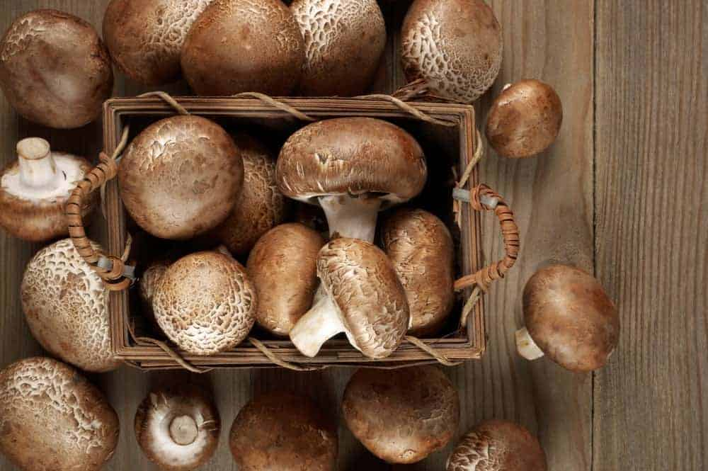
SOMETIMES CALLED BABY BELLAS, CREMINI ARE MIDPOINT IN THE AGARICUS BISPORUS LIFESPAN — OLDER THAN WHITE BUTTON BUT YOUNGER THAN PORTOBELLO MUSHROOMS. THEY ARE ALL THE SAME MUSHROOM BUT AT DIFFERENT STAGES AND TOGETHER THEY MAKE UP ALMOST 90 PERCENT OF COMMERCIAL MUSHROOM PRODUCTION IN THE U.S.

10. ENOKITAKE MUSHROOMS
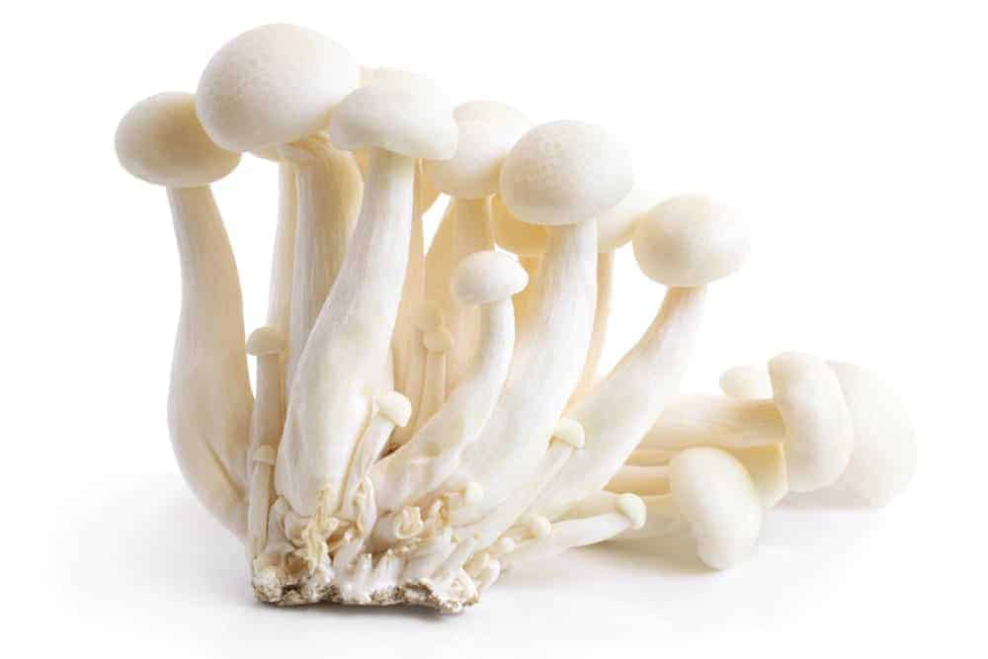
ENOKI MUSHROOMS, NATIVE TO JAPAN, LOOK A LITTLE LIKE BEAN SPROUTS WITH THEIR SMALL CAPS, WHITE COLOR AND LONG STEMS. POPULAR IN ASIAN DISHES, YOU CAN BUY THESE MUSHROOMS EITHER CANNED OR FRESH, AND THERE IS A LOT OF FLAVOR TO THEM. THEY ARE A CRISPY TYPE OF MUSHROOM, SO THEY GO GREAT IN MANY SALADS AND SOUPS.
THESE GROW ON THE STUMPS OF CHINEES HACKBERRY TREES AS WELL AS STUMPS OF ASH, MULBERRY AND PERSIMMON TREES [SOURCE: WIKIPEDIA].

11. GREEN AMANITA

ALSO KNOWN AS THE DEATH CAP MUSHROOM, AMANITA PHALLOIDES CONTAINS DEADLY TOXINS THROUGHOUT THE CAP, GILLS, STEM AND SPORES. NATIVE TO EUROPE, DEATH CAPS ARE NOW WIDESPREAD GLOBALLY AND ARE THE MAIN MUSHROOM IMPLICATED IN MOST HUMAN POISONINGS.

12. HEDGEHOG MUSHROOMS

ALSO KNOWN AS THE SWEET TOOTH MUSHROOM, THIS MUSHROOM SMELLS AND TASTES SWEET, UNLESS IT IS AN OLDER MUSHROOM, IN WHICH CASE IT MAY TASTE A LITTLE BITTER.
THE HEDGEHOG MUSHROOM TASTES A LOT LIKE THE CHANTERELLE MUSHROOM AND GROWS HARDILY IN THE WINTER MONTHS ON THE WEST COAST. IT ALSO HAS A MEATY, NUTTY AND CRUNCHY TASTE.

13. HEN OF THE WOODS MUSHROOMS
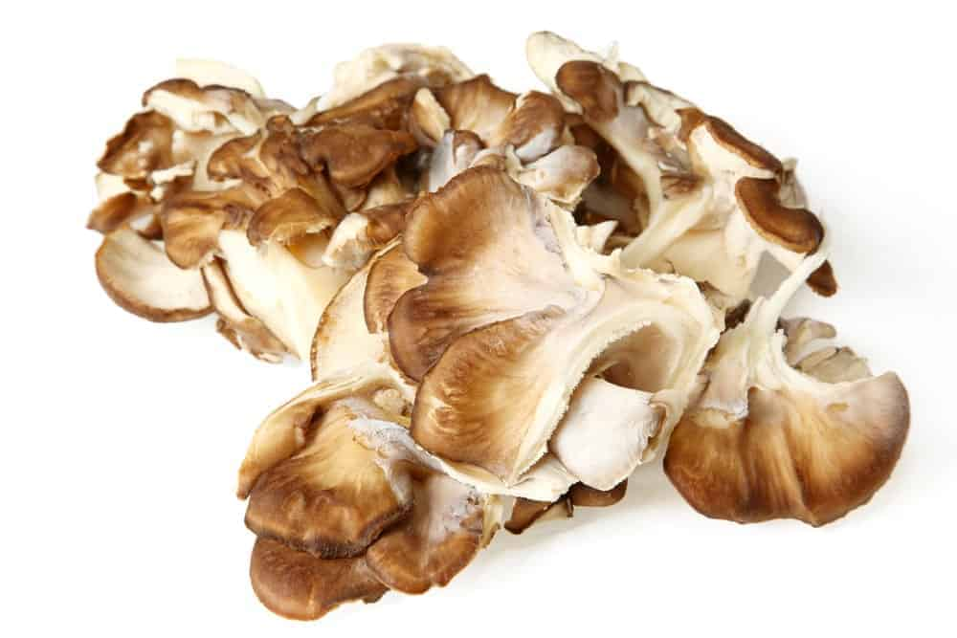
IN JAPAN, THESE MUSHROOMS ARE ALSO CALLED MAITAKE MUSHROOMS, AND THEY HAVE A LOT OF FLAVORS PACKED INTO THEM. FOUND GROWING AT THE BASE OF OAK TREES, HEN OF THE WOODS MUSHROOMS ARE USED IN BOTH JAPANESE AND WESTERN DISHES, AND THEY ARE RICH, EARTHY, AND LOOK SIMILAR TO A FLOWER.
PERFECT FOR STIR-FRY DISHES AND MANY TYPES OF SOUP, THE MUSHROOMS HOLD THEIR SHAPE WELL WHEN COOKED, MAKING THEM AN ATTRACTIVE ADDITION TO MANY DISHES.

14. HONEY AGARIC
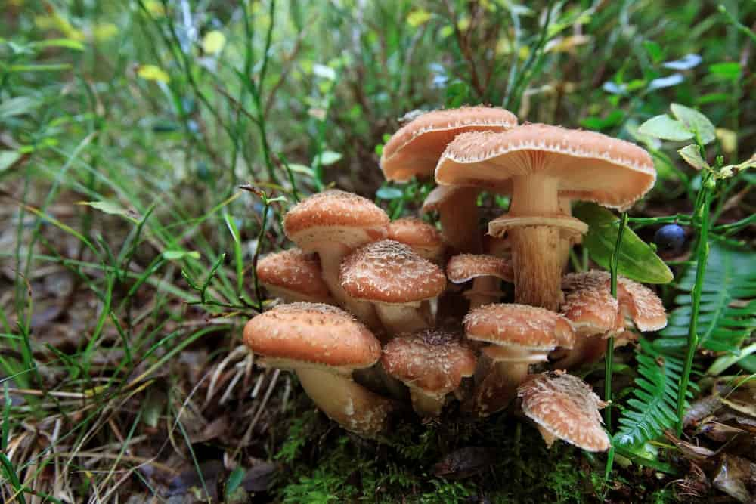
THE HONEY AGARIC MUSHROOM IS PART OF THE ARMILLARIA GENUS — ONE SPECIMEN, DISCOVERED IN 1998, IS CONSIDERED THE WORLD’S LARGEST LIVING ORGANISM.
THE HUMUNGOUS MUSHROOM COVERS MORE THAN 3.4 SQUARE MILES IN OREGON’S MALHEUR NATIONAL FOREST AND IS THOUGHT TO BE AT LEAST 2,400 YEARS OLD, ALTHOUGH IT COULD BE MUCH OLDER. WEIGHING ABOUT AS MUCH AS A BLUE WHALE THE 2,384-ACRE ORGANISM LIVES MAINLY UNDERGROUND WITH NEW SHOOTS MUSHROOMING OUT OF THE SOIL IN THE FALL.

15. LACTARIUS INDIGO
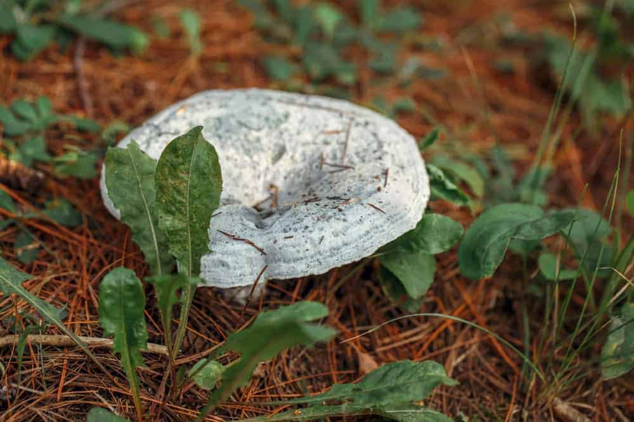
INDIGO MILK CAP OR BLUE MILK MUSHROOMS CAN BE FOUND WIDESPREAD IN THE WOODS OF EASTERN NORTH AMERICA, EAST ASIA AND CENTRAL AMERICA. IT PRODUCES DARK BLUE MILK WHEN CUT.
AFTER THE RAINY SEASON, THE HIGHLAND MAYA OF MEXICO AND GUATEMALA FOCUS ON HARVESTING HIGHLY PRIZED WILD MILK CAPS FOR THEIR DISHES AND TO SELL IN MARKETS. MAYA TZOTZIL-LANGUAGE SPEAKERS REFER TO THE MILK CAPS AS ‘BLUE SKY’ MUSHROOMS.

16. KING TRUMPET MUSHROOMS
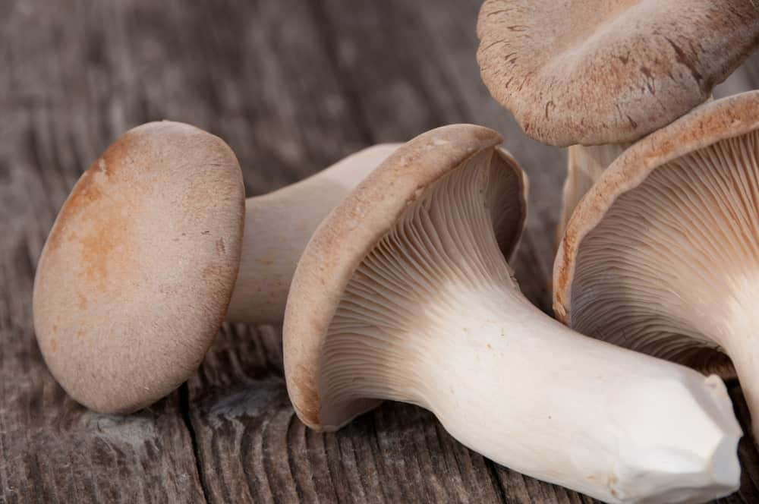
NATIVE TO MEDITERRANEAN REGIONS OF EUROPE, THE MIDDLE EAST AND NORTH AFRICA, KING TRUMPETS ARE THICK AND MEATY MUSHROOMS, AND ALSO QUITE LARGE IN SIZE.

17. MILK MUSHROOM
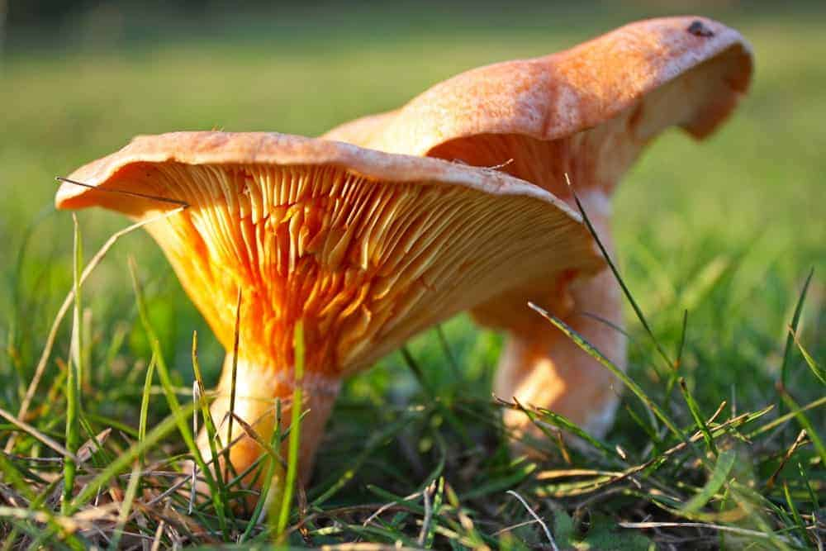
MILK MUSHROOMS (CALOCYBE INDICA) ARE THE ONLY KNOWN MUSHROOM SPECIES NATIVE TO INDIA. ORIGINATING IN KOLKATA AND WEST BENGAL THEY ARE NOW COMMERCIALLY AVAILABLE OVER A WIDE AREA OF INDIA AND ASIA.
MEDIUM TO LARGE IN SIZE MILK MUSHROOMS ARE EXCELLENT SOURCES OF VITAMINS B2, E, AND A, PHOSPHORUS, POTASSIUM, AND SELENIUM, AND ALSO CONTAIN CALCIUM, VITAMIN C, IRON, AND ZINC.

18. MOREL MUSHROOMS
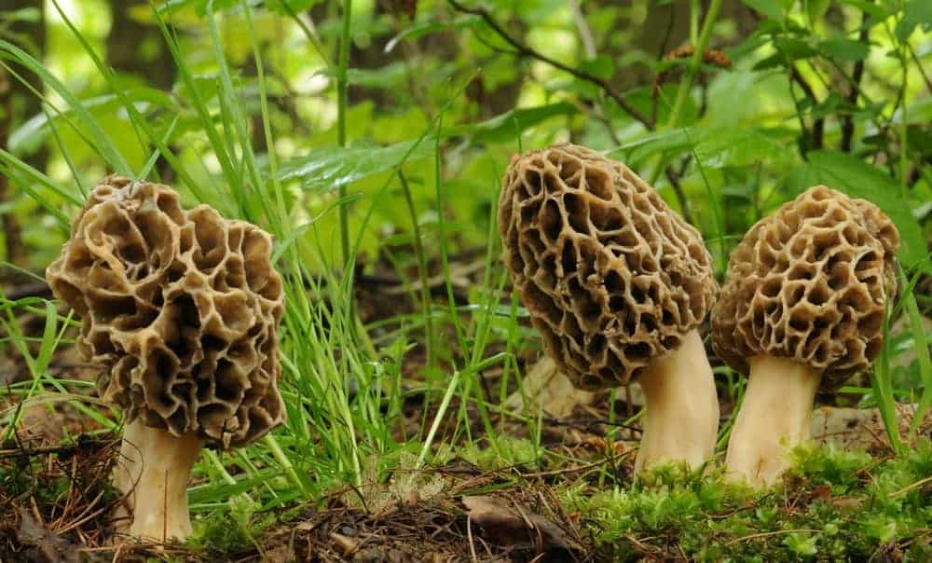
PRIZED INGREDIENTS IN CATALAN AND FRENCH CUISINE, MOREL MUSHROOMS ADD LAYERS OF FLAVORS TO MANY DISHES. THEY ARE ESPECIALLY DELICIOUS SAUTÉED IN BUTTER. MOREL MUSHROOMS CAN BE VERY EXPENSIVE, AND ONCE YOU TRY THEM YOU’LL UNDERSTAND WHY.

19. OYSTER MUSHROOMS
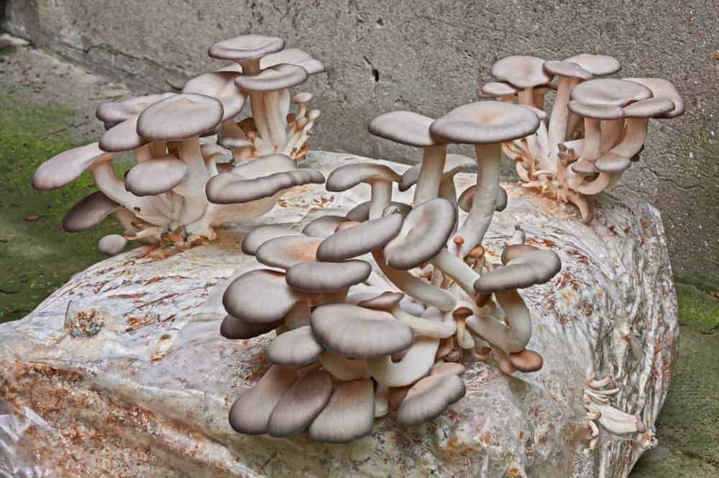
OYSTER MUSHROOMS LOOK DISSIMILAR TO MOST OTHER TYPES OF MUSHROOMS, BUT THERE IS NO NEED TO BE INTIMIDATED BY THEM. THEY HAVE A DELICATE, SWEET FLAVOR AND ARE VERY AFFORDABLE, AS WELL. THEY HAVE AN ALMOST ANISE-LIKE TASTE AT CERTAIN TIMES OF THE YEAR.
SIMPLE TO COOK WITH, THE OYSTER MUSHROOM CAN BE USED IN A VARIETY OF DISHES. THEY ALSO COME IN COLORS SUCH AS GREY, BROWN, AND EVEN A REDDISH COLOR, AND THE YOUNGER THEY ARE, THE MORE FLAVORFUL THEY ARE.

20. PORCINI MUSHROOMS
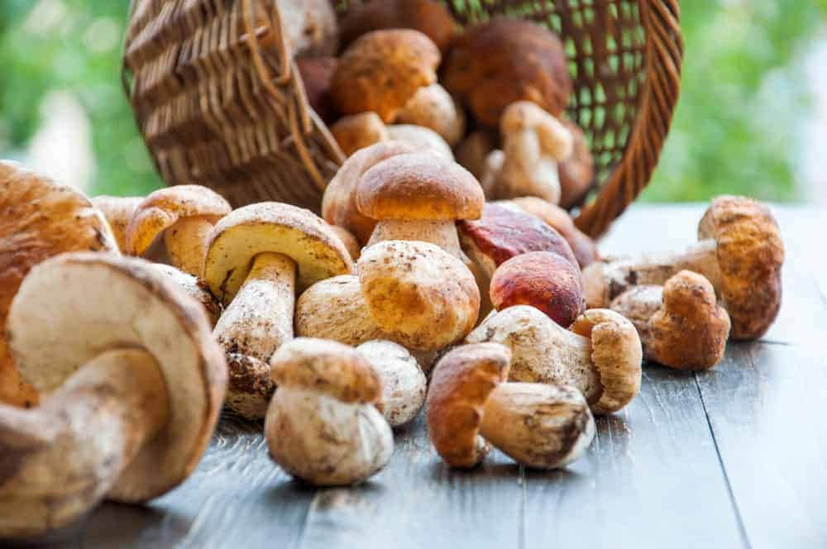
PORCINI MUSHROOMS ARE VERY MEATY AND FLAVORFUL, AND ARE FOUND IN MANY ITALIAN DISHES. MUCH LIKE SOURDOUGH, PORCINI MUSHROOMS HAVE A FLAVOR AND TASTE THAT IS CREAMY AND NUTTY.
LIGHT BROWN IN COLOR THEY ARE ALSO SOLD EITHER CANNED, DRIED, OR FRESH, BUT THE DRIED MUSHROOMS NEED TO BE SOAKED IN HOT WATER FOR AT LEAST 15 MINUTES BEFORE YOU COOK THEM.

21. PORTOBELLO MUSHROOMS
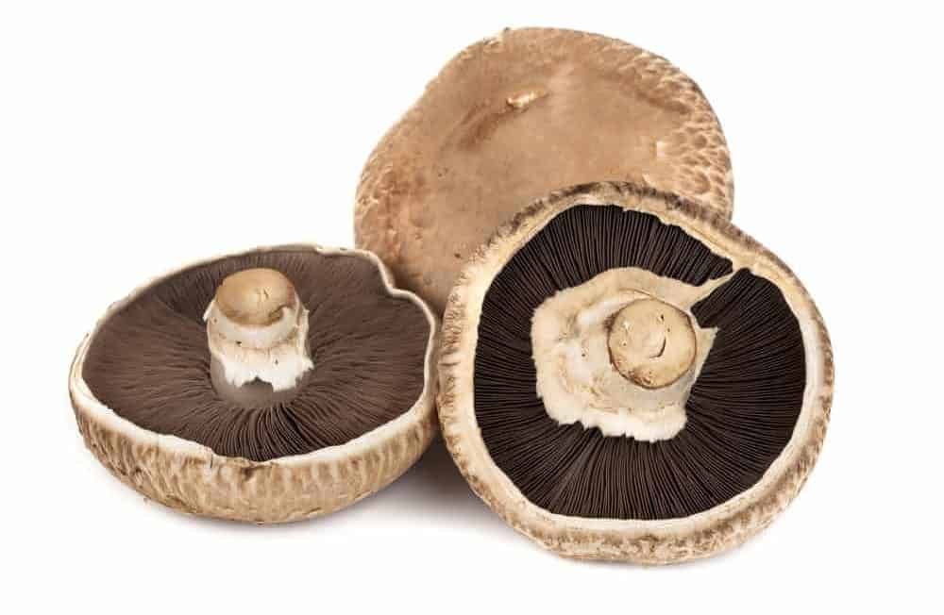
WHEN WHITE BUTTON AND CREMINI MUSHROOMS (AGARICUS BISPORUS) FULLY MATURE, THEIR CAPS GROW OUTWARDS AND THEY ARE CALLED PORTOBELLO MUSHROOMS. WITH ITS MILD FLAVOR AND SOMEWHAT MEATY TEXTURE, YOU CAN EVEN USE THESE TYPES OF MUSHROOMS AS A SUBSTITUTE FOR MEAT IN MANY DISHES. SOME PEOPLE CONSIDER THEM ONE OF THE TASTIEST MUSHROOMS IN EXISTENCE, AND THEY ARE ESPECIALLY YUMMY WHEN YOU GRILL THEM.
PORTOBELLOS GROW IN THE GRASSLANDS OF EUROPE AND NORTH AMERICA.

22. RUSSULA

RUSSULA EMETICA, ALSO KNOWN AS THE SICKENER, IS POISONOUS WHEN EATEN RAW OR POORLY COOKED AND CAN CAUSE NAUSEA AND VOMITING.

23. SHIITAKE MUSHROOMS
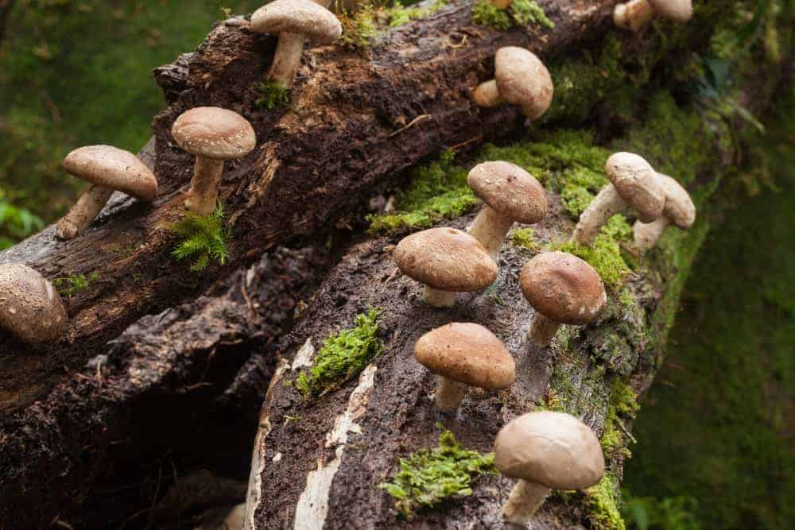
NATIVE TO SOUTHEAST ASIA, SHIITAKE MUSHROOM CULTIVATION IS DISCUSSED IN ANCIENT JAPANESE LITERATURE. THE NAME COMES FROM THE JAPANESE WORDS ‘SHII’ (A TYPE OF CHESTNUT TREE) AND ‘TAKE’ (MUSHROOM).
LIKE PORTOBELLO MUSHROOMS, SHIITAKE ARE CHEWY AND MEATY. SHIITAKE ACCOUNT FOR 25 PERCENT OF COMMERCIAL MUSHROOM CULTIVATION WORLDWIDE.

24. TOADSTOOL

SO-CALLED BECAUSE THEY LOOK LIKE THE SPOT WHERE TOADS WOULD SIT, TOADSTOOLS ARE FUNGI WIDELY BELIEVED TO BE INEDIBLE OR TOXIC.

25. MEDICINAL MUSHROOMS
IN ADDITION TO USING MUSHROOMS AS FOOD AND INGREDIENTS IN THOUSANDS OF DIFFERENT RECIPES, THERE ARE MUSHROOMS USED MOSTLY FOR MEDICINAL PURPOSES.
THESE MUSHROOMS INCLUDE:
- LIONS MANE MUSHROOM
- TURKEY TAIL MUSHROOM
- REISHI MUSHROOM
- CHAGA MUSHROOM
- CORDYCEPS MUSHROOM
THAT’S A WRAP ON OUR EXTENSIVE LIST OF THE MANY DIFFERENT KINDS OF MUSHROOMS.

26. MATSUTAKE MUSHROOM
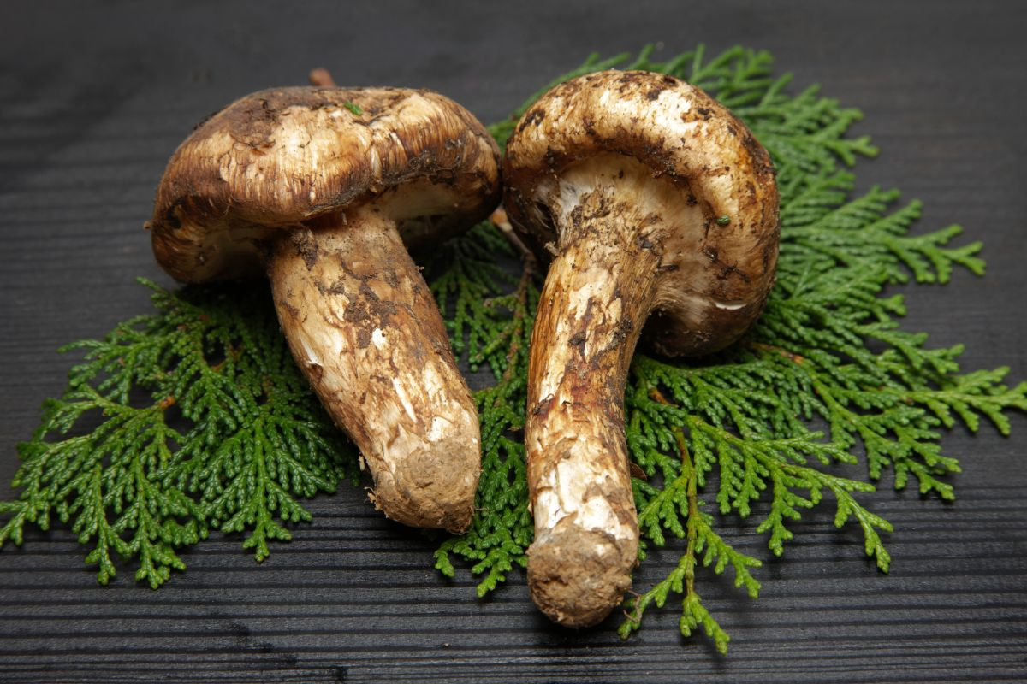
THE MATSUTAKE MUSHROOM (TRICHOLOMA MATSUTAKE) IS NATIVE TO PARTS OF EUROPE, ASIA, AND NORTH AMERICA, GROWING ON THE FOREST FLOOR BENEATH WHAT IS KNOWN AS FOREST LITTER. THE MATSUTAKE IS NOT ONLY EDIBLE; IT IS A HIGHLY PRIZED MYCORRHIZAL MUSHROOM BECAUSE IT OFFERS A DISTINCT, IF NOT SPICY, AROMA.

27. CAULIFLOWER MUSHROOM
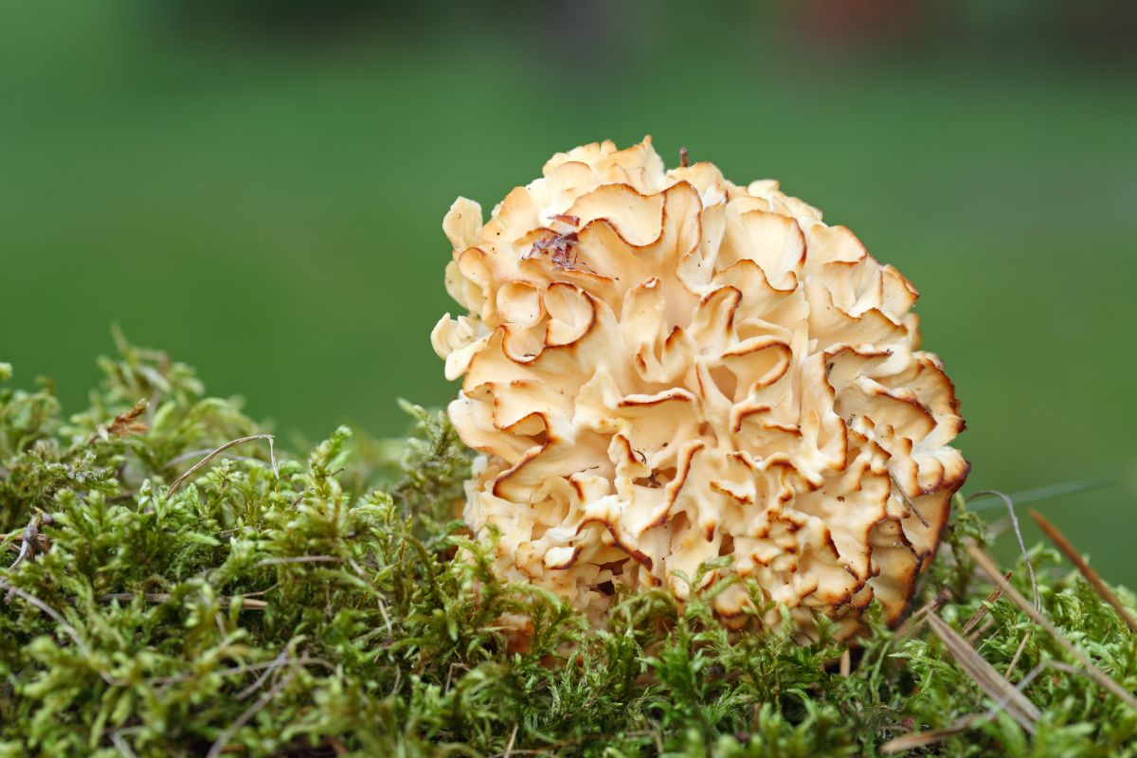
THE CAULIFLOWER MUSHROOM (SPARASSIS) IS A TASTY, UNIQUE-LOOKING TYPE OF MUSHROOM THAT IS A TYPE OF PARASITIC SAPROBIC MUSHROOM. IT IS FOUND ACROSS THE WORLD.
THE CAULIFLOWER MUSHROOM HAS THE LOOK OF A BRAIN, A SEA SPONGE, ETC. THIS MUSHROOM IS EDIBLE AND SOLD IN ASIA, AUSTRALIA, AND THE U.S, BUT IT NEEDS TO BE CLEANSED THOROUGHLY BEFORE EATING.

28. CHARCOAL BURNER MUSHROOM
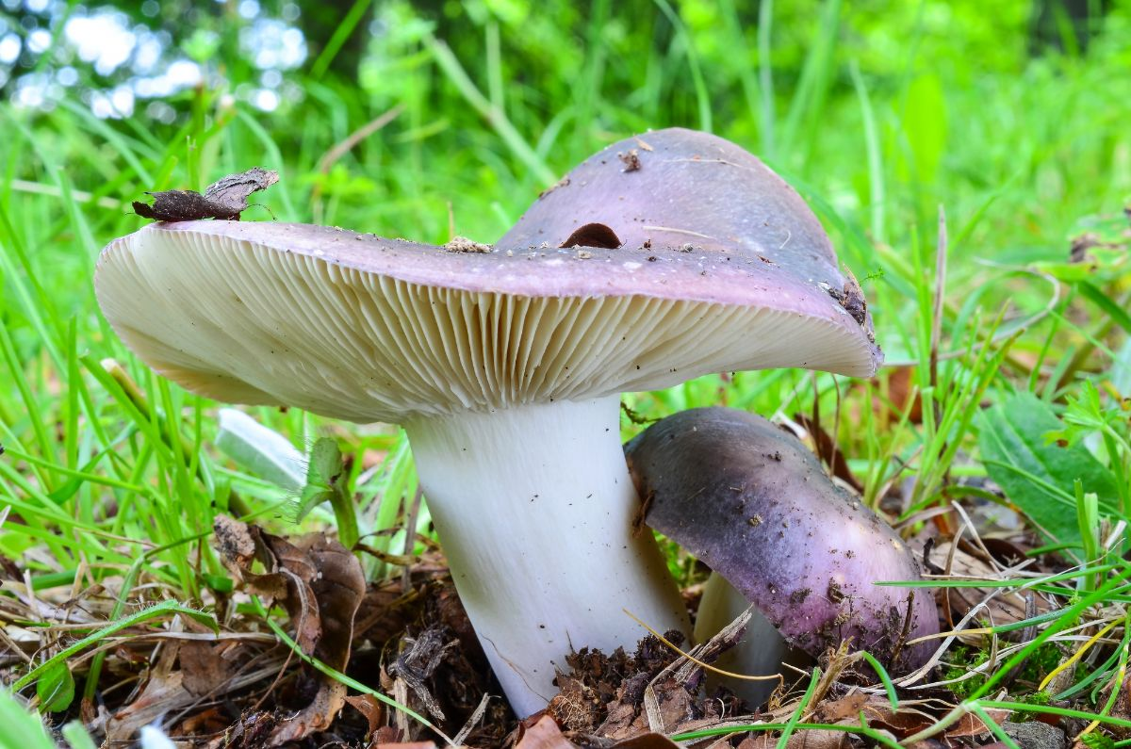
THE CHARCOAL BURNER MUSHROOM (RUSSULA CYANOXANTHA) IS A MEMBER OF THE BASIDIOMYCETE FAMILY OF MUSHROOMS. IT IS AN EDIBLE MUSHROOM WITH A NUTTY, MILD TASTE AND SOFT FLESH.
IT IS CONSIDERED AMONG THE MOST COMMON RUSSULA SPECIES ACROSS EUROPE. IN 1997 IT WAS AWARDED BY A GERMAN ASSOCIATION AS MUSHROOM OF THE YEAR.

29. CRAB BRITTLEGILL MUSHROOM

THE CRAB BRITTLEGILL MUSHROOM (RUSSULA XERAMPELINA) IS FOUND WITHIN THE BASIDIOMYCETE FAMILY OF MUSHROOMS. THEY GROW IN WOODLANDS DURING FALL IN NORTH AMERICA AND THE NORTHERN PARTS OF EUROPE. THESE EDIBLE MUSHROOM CAPS COME IN VARIOUS COLORS AND ARE KNOWN FOR THEIR NATURAL CRAB AROMA.

30. YELLOW KNIGHT MUSHROOM
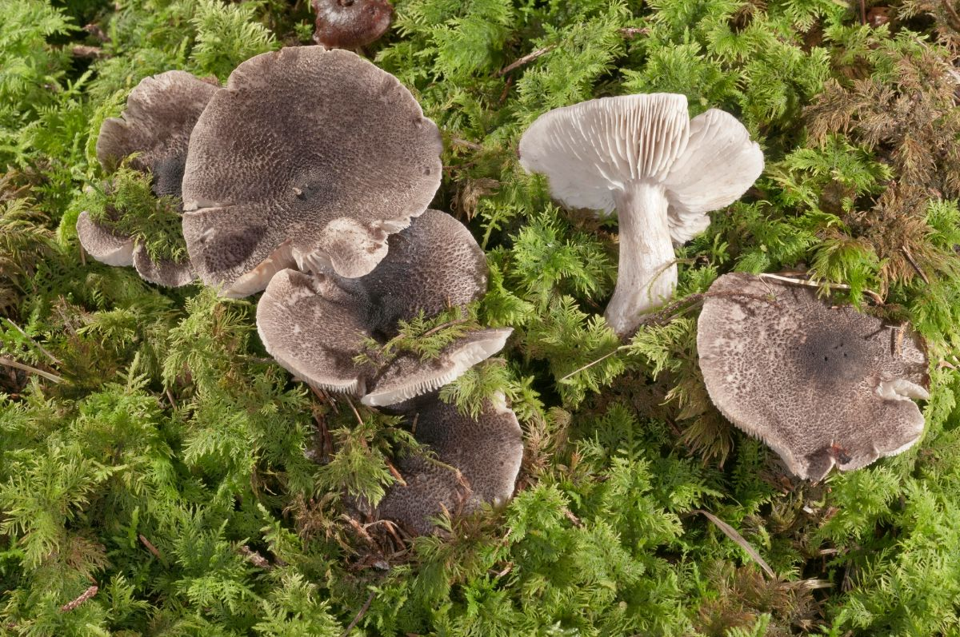
THE YELLOW KNIGHT MUSHROOM (TRICHOLOMA FLAVOVIRENS) IS CONSIDERED A HAZARDOUS MUSHROOM BY MOST, ALTHOUGH IT WAS ONCE REGULARLY EATEN. THEY GROW ON PINE TREES, AND WHILE TASTY, POISONING FROM THE YELLOW KNIGHT MUSHROOM HAS BEEN REPORTED.

31. WOOD BLEWIT MUSHROOM

THE WOOD BLEWIT MUSHROOM (CLITOCYBENUDA) IS NATIVE TO NORTH AMERICA AND FRANCE, BRITAIN, AND THE NETHERLANDS. THE WOOD BLEWIT, WHICH GROWS IN DECIDUOUS AND CONIFEROUS WOODLANDS, WAS DISCOVERED IN THE LATE 1700S. ALTHOUGH IT HAS BEEN WIDELY EATEN, CAUTION EXISTS ABOUT ITS EDIBILITY.

32. SHIMEJI MUSHROOM

SHIMEJI MUSHROOMS (LYOPHYLLUM SHIMEGI) REFERS TO A GROUP OF MUSHROOMS NATIVE TO PORTIONS OF EAST ASIA. THESE EDIBLE MUSHROOMS, WHICH SHOULD NOT BE EATEN RAW, CONTAIN UMAMI-RICH TASTING ELEMENTS, WHICH MAKES THEM QUITE TASTY.

33. RED PINE MUSHROOM
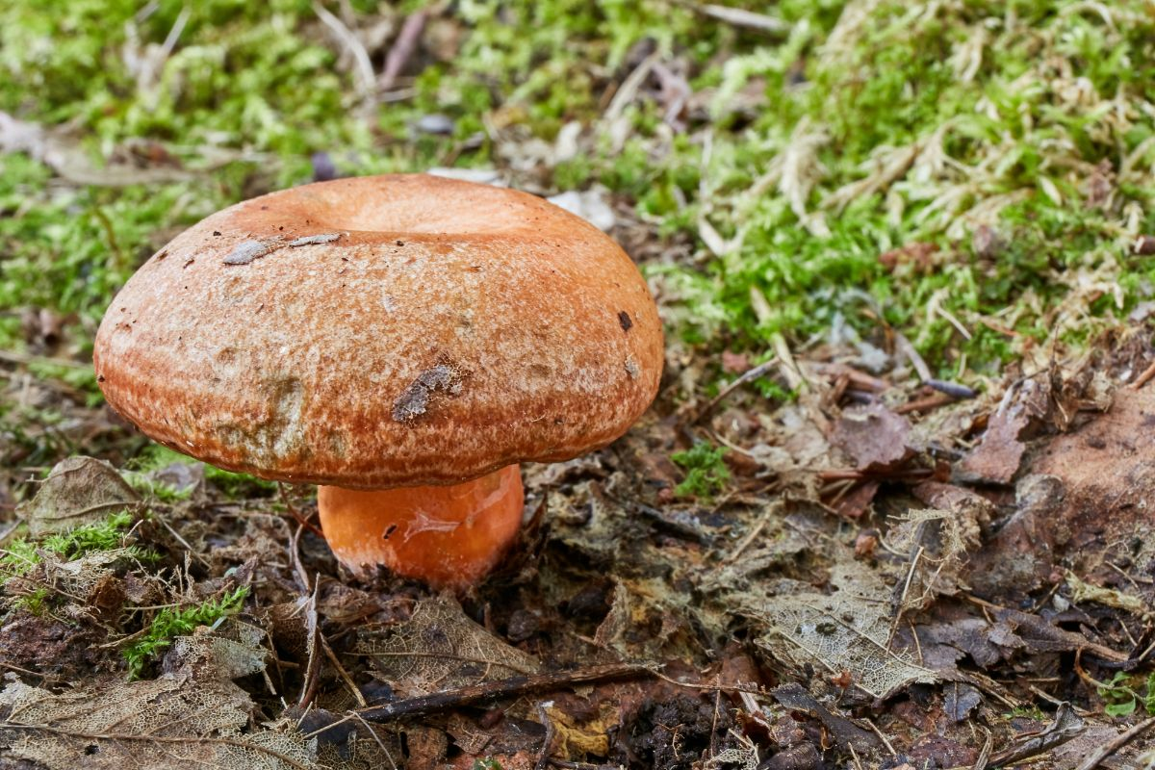
THE RED PINE MUSHROOM (LACTARIUS DELICIOSUS) IS A LARGE-CAPPED MUSHROOM THAT IS NATIVE TO EUROPE AND ESPECIALLY ACROSS THE IBERIAN PENINSULA. THE RED PINE MUSHROOM OFFERS A MILD AND SOMETIMES A BIT BITTER TASTE TO MANY RECIPES.

34. PARASOL MUSHROOM

THE PARASOL MUSHROOM (MACROLEPIOTA PROCERA) IS CONSIDERED A PREFERRED EDIBLE MUSHROOM AND VERY POPULAR ACROSS EUROPE DUE TO ITS ABUNDANCE AND VERSATILITY. THE PARASOL MUSHROOM IS A BASIDIOMYCETE MUSHROOM THAT IS FAIRLY COMMON AND GROWS IN WELL-DRAINED SOILS.

35. FALSE PARASOL MUSHROOM

THE FALSE PARASOL MUSHROOM (CHLOROPHYLLUM MOLYBDITES) IS A COMMONLY FOUND, INEDIBLE MUSHROOM.
THE FALSE PARASOL MUSHROOM LOOKS LIKE THE EDIBLE PARASOL MUSHROOM, WHICH IS WHY IT IS OFTEN MISIDENTIFIED, ESPECIALLY IN NORTH AMERICA. THIS MUSHROOM CAUSES SERIOUS GASTROINTESTINAL SYMPTOMS, AMONG OTHERS.

36. BROWN ROLL-RIM MUSHROOM
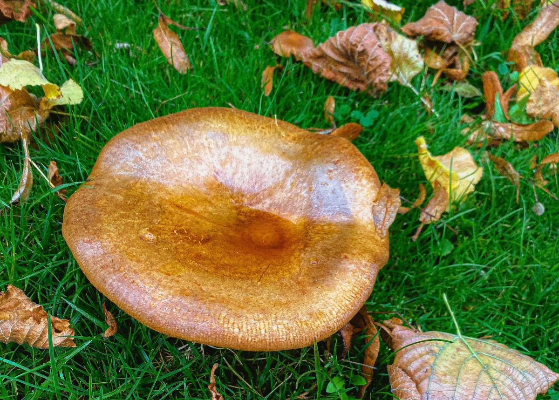
THE BROWN ROLL-RIM MUSHROOM (PAXILLUS INVOLUTUS) IS FOUND ACROSS THE NORTHERN HEMISPHERE BUT IS NOW FOUND IN SOUTH AMERICA, AUSTRALIA, AND NEW ZEALAND, AMONG OTHERS. ONCE THOUGHT TO BE EDIBLE, THE BROWN ROLL-RIM IS NOW CONSIDERED DANGEROUSLY POISONOUS AND POTENTIALLY FATAL.

37. DEADLY CONOCYBE MUSHROOM

THE DEADLY CONOCYBE MUSHROOM (PHOLIOTINA RUGOSA) IS A DEADLY POISONOUS MUSHROOM CONTAINING THE SAME TOXINS AS THE DEATH CAP MUSHROOM. THE DEADLY CONOCYBE MUSHROOM GROWS WILD IN THE PACIFIC NORTHWEST, EUROPE, ASIA, AND OTHER PARTS OF NORTH AMERICA.

38. ELFIN SADDLE MUSHROOM
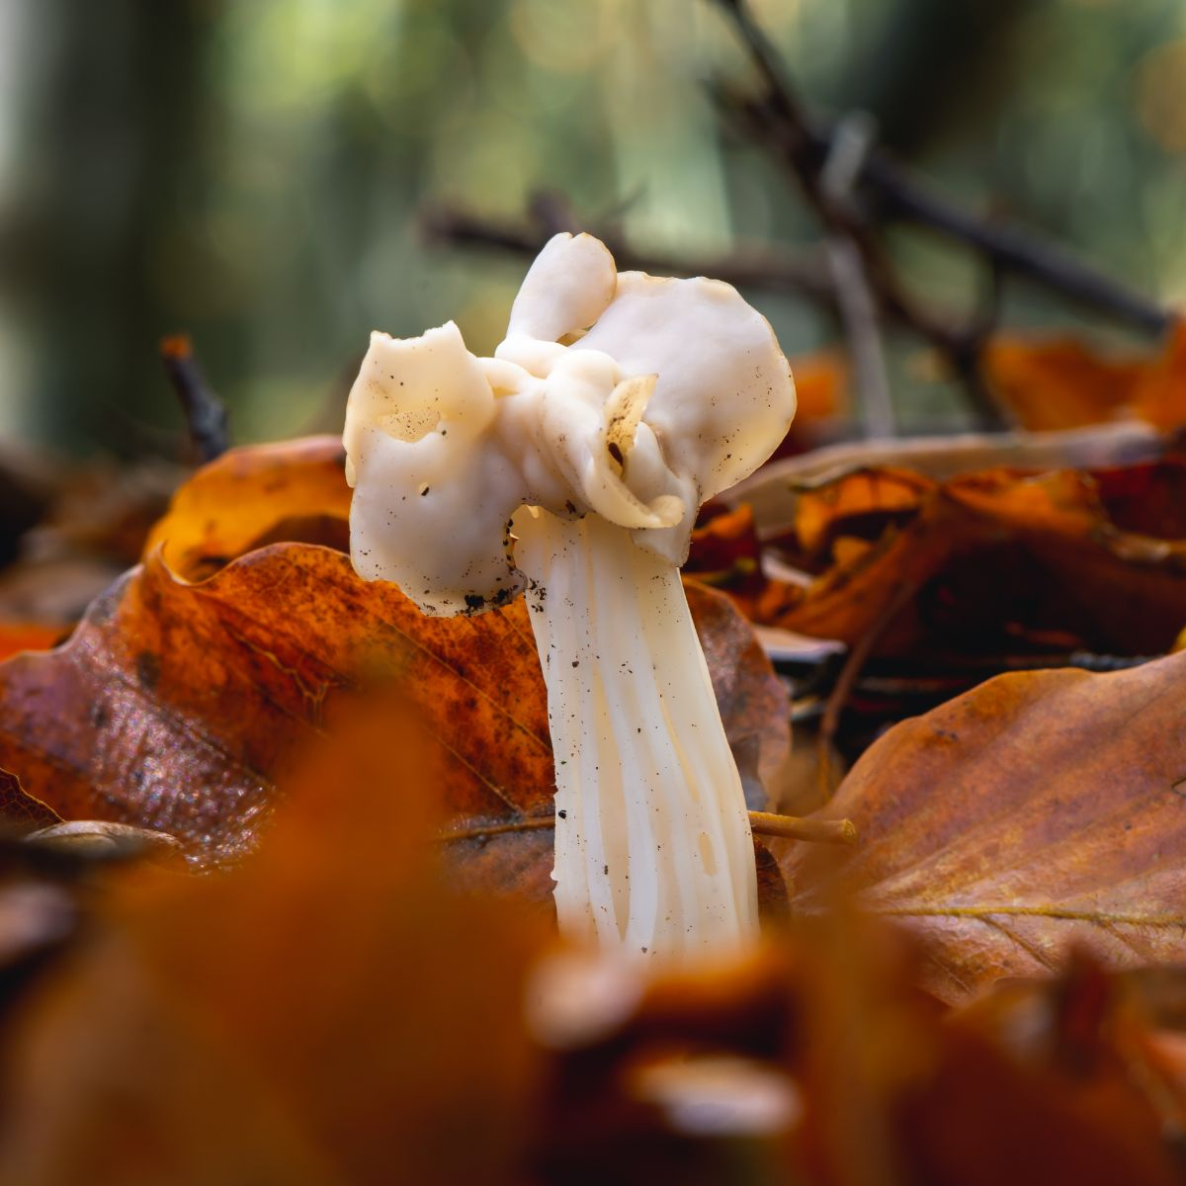
THE ELFIN SADDLE MUSHROOM (HELVELLA LACUNOSE) IS A MEMBER OF THE HELVELLACEAE FAMILY. IT HAS AN UNUSUAL GREY MUSHROOM CAP AND FUZZY UNDERSIDE. IT IS FOUND IN EUROPE AND EASTERN PARTS OF NORTH AMERICA AND IS OFTEN SOUGHT AFTER FOR COOKING. NOTE THAT THE STEMS ARE NOT EATEN.

39. DESTROYING ANGEL MUSHROOM

THE DESTROYING ANGEL MUSHROOM REFERS TO ALL-WHITE MUSHROOMS (AMANITA) THAT ARE FATAL IF EATEN. THEY CAN BE FOUND IN NORTH AMERICA AND EUROPE. THESE MUSHROOMS ARE CONSIDERED AMONG THE MOST TOXIC, AND EVEN AS LITTLE AS A HALF MUSHROOM CAP CAN TURN DEADLY WITHOUT APPROPRIATE, TIMELY TREATMENT.

40. SCALY VASE CHANTERELLE MUSHROOM
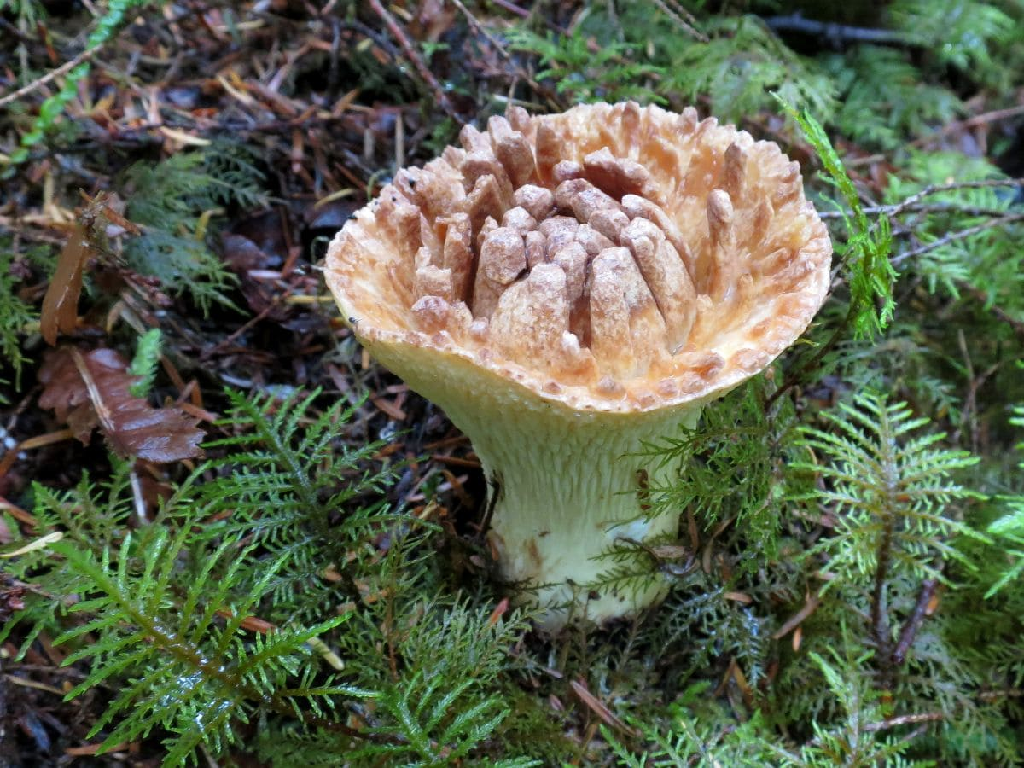
THE SCALY VASE CHANTERELLE MUSHROOM (TURBINELLUS FLOCCOSUS) IS NATIVE TO NORTH AMERICA AND ASIA. THIS MUSHROOM HAS BEEN FOUND TO BE POISONOUS TO SOME INDIVIDUALS BUT HAS NOT HAD AN IMPACT ON OTHERS. THE UNUSUAL SHAPE CAN REACH UPWARDS OF ONE FOOT TALL.

41. YELLOW STAINER MUSHROOM
THE YELLOW STAINER MUSHROOM (AGARICUS XANTHODERMUS) IS FOUND WIDELY ACROSS WEST ASIA, AFRICA, NORTH AMERICA, AND EUROPE. THIS MUSHROOM IS CONSIDERED POISONOUS TO MOST INDIVIDUALS BECAUSE IT CAUSES SEVERE GI DISTRESS. HOWEVER, OTHERS CAN EAT IT WITHOUT ANY NEGATIVE IMPACT.

42. AUTUMN SKULLCAP MUSHROOM

THE AUTUMN SKULLCAP MUSHROOM (GALERINA MARGINATA) IS AN EXTREMELY POISONOUS MUSHROOM VARIETY. IT GROWS ON ROTTING WOOD THROUGHOUT THE NORTHERN HEMISPHERE AS WELL AS AUSTRALIA. THE CAPS OF THE MUSHROOMS GROW AS WIDE AS 1.5 INCHES IN DIAMETER.

43. INKY CAP MUSHROOM
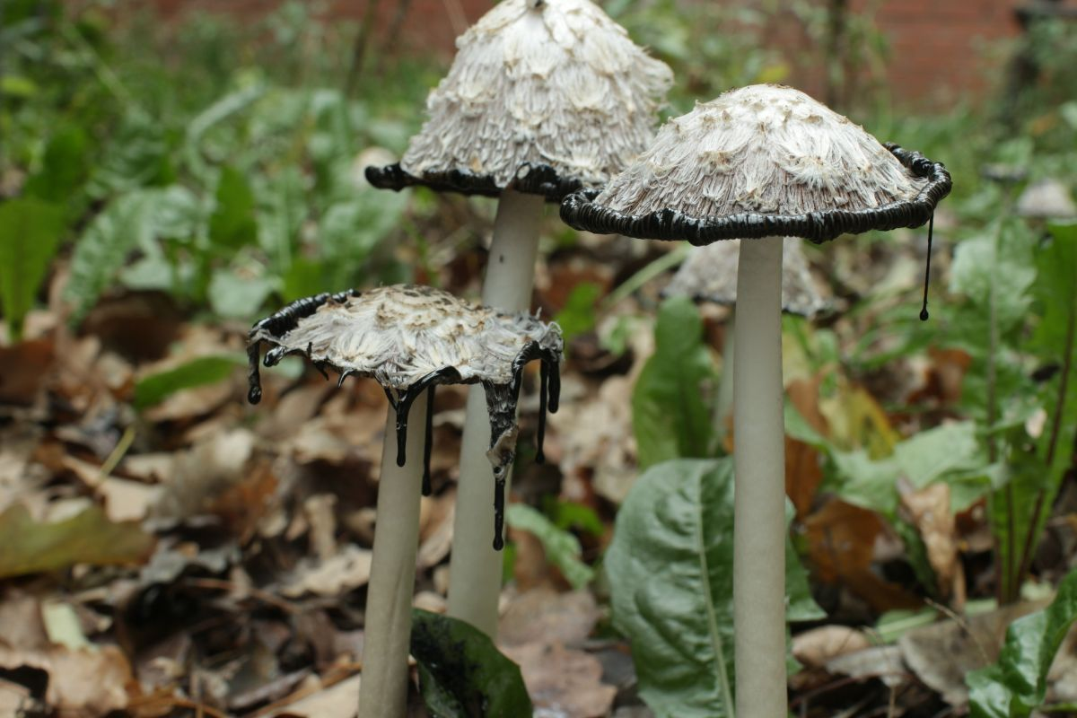
THE INKY CAP MUSHROOM (COPRINOPSIS ATRAMENTARIA) IS FOUND THROUGHOUT NORTH AMERICA AND EUROPE, AND THE NORTHERN HEMISPHERE. THIS MUSHROOM IS EDIBLE IF CONSUMED WITHOUT COMBINING ALCOHOL. IT GROWS WILD AFTER SPRING RAINS AND CAN BE FOUND ON LAWNS, GRASSY AREAS, AND LOTS UNTIL AUTUMN.

44. FALSE CHAMPIGNON MUSHROOM
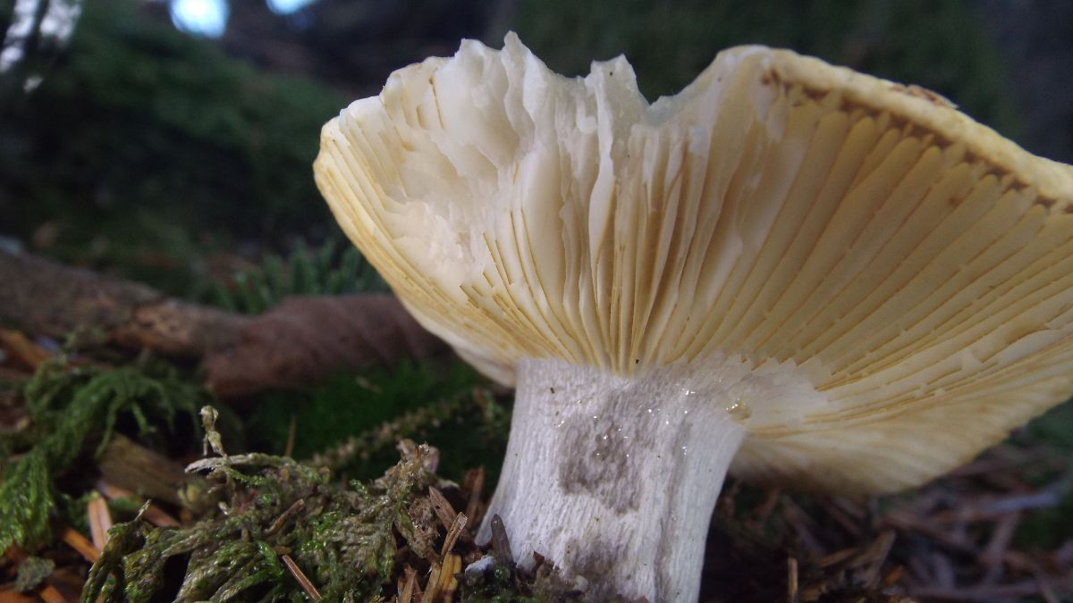
THE FALSE CHAMPIGNON MUSHROOM (CLITOCYBE RIVULOSA) IS A POISONOUS TYPE OF FUNGUS THAT CONTAINS DEADLY LEVELS OF MUSCARINE. IT IS ALSO KNOWN AS A SWEATING MUSHROOM, WHICH IS A SMALL WHITE MUSHROOM SEEN ON MEADOWS AND LAWNS IN NORTH AMERICA AND EUROPE.

45. DEADLY WEBCAP MUSHROOM

THE DEADLY WEBCAP MUSHROOM (CORTINARIUS RUBELLUS) IS A POISONOUS MUSHROOM THAT GROWS IN HIGH ALTITUDES IN NORTH AMERICA, ASIA, AND EUROPE. THIS TAN-COLORED MUSHROOM, WHICH CAN CAUSE KIDNEY FAILURE, CAN GROW TO OVER FOUR INCHES, WITH A CAP THAT MEASURES 3+ INCHES.

46. BRAIN MUSHROOM
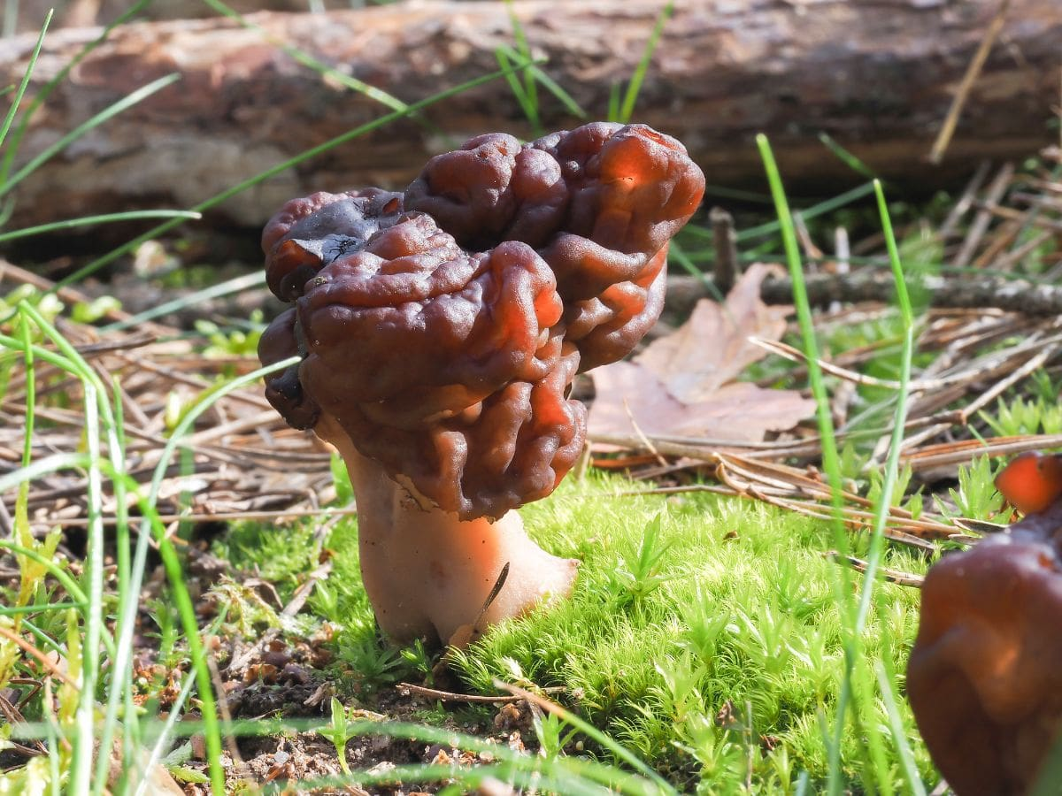
THE BRAIN MUSHROOM (GYROMITRA ESCULENTA) IS CONSIDERED A DELICACY WHEN PARTIALLY COOKED IN SCANDINAVIA, ALTHOUGH POTENTIALLY FATAL WHEN EATEN RAW. IT GROWS ACROSS NORTH AMERICA AND EUROPE. IT IS QUITE CONTROVERSIAL AS IT IS BANNED FROM PUBLIC SALE IN SPAIN BUT POPULAR IN THE EASTERN PARTS OF THE PYRENEES.

BEST TYPES OF MUSHROOMS FOR VARIOUS RECIPES

BEST MUSHROOMS FOR PIZZA
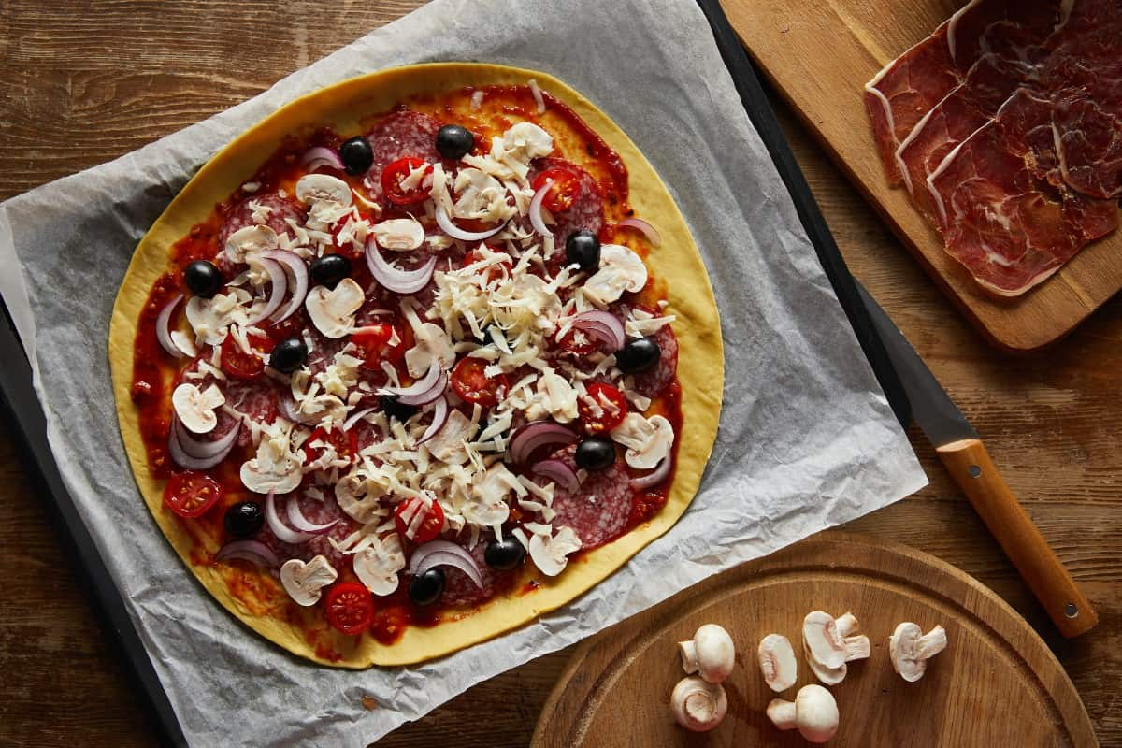
BUTTON MUSHROOMS ARE THE BEST OPTIONS FOR PIZZA. NOT ONLY DO THEY PROVIDE THAT DESIRED EARTHY FLAVOR, BUT PIZZA CAN HAVE A LOT OF TOPPINGS AND GET TOP HEAVY. BUTTON MUSHROOMS CAN BE SLICED THIN OR THICK AND BLENDED WITH CHEESE, SAUCE, AND THE DIFFERENT MEATS ON A PIZZA.

BEST MUSHROOMS FOR STEAK
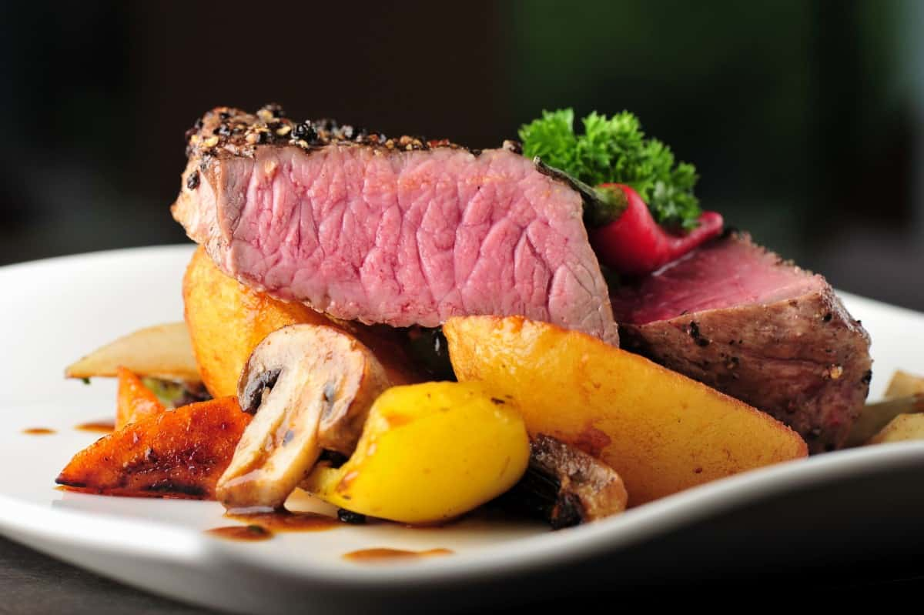
IF YOU ARE GRILLING A STEAK, PORTOBELLO MUSHROOMS SHOULD BE YOUR TOP CHOICE. THE FLAVORS OF THE PORTOBELLO COMPLIMENTS THE STEAK, AS THEY ARE THICK AND MEATY, BUT DO NOT OVERPOWER THE STEAK. THEY SAUTÉ UP NICELY AND CAN BE SEASONED JUST LIKE THE STEAKS.

BEST MUSHROOMS FOR STIR FRY
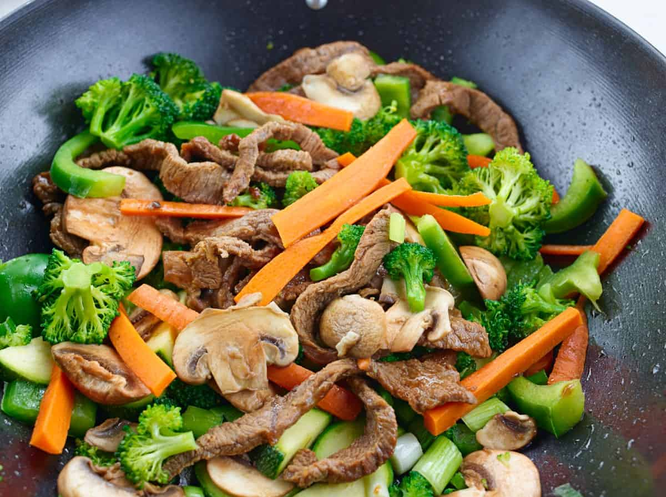
WHEN YOU STIR FRY, YOU’LL WANT THE FLAVOR OF AN OYSTER MUSHROOM TO COMPLIMENT THE VEGETABLES. THEY ARE ALSO VERY MEATY WHICH IS GREAT IF THE DISH IS VEGETARIAN OR VEGAN.

MUSHROOMS IN STEW
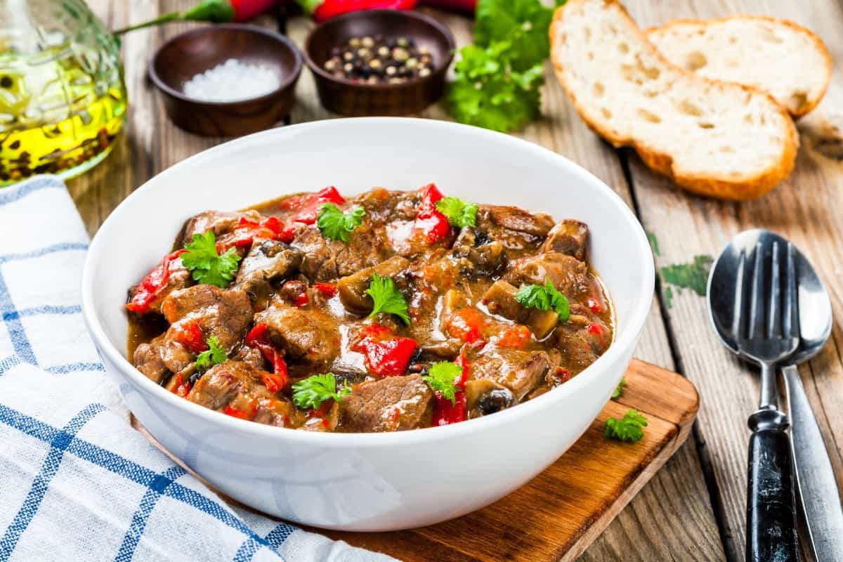
IF YOU ARE STEWING MEAT AND VEGGIES TOGETHER, ADD IN SOME BABY BELLA MUSHROOMS TO GIVE THE DISH A MORE EARTHY FLAVOR. THESE MUSHROOMS ARE SMALL ENOUGH THAT AFTER BEING CLEANED, THEY CAN BE ADDED TO THE STEW AND CAN STAND THE LONG COOKING TEMPERATURES WITHOUT SACRIFICING TEXTURE.

BEST MUSHROOMS FOR RISOTTO
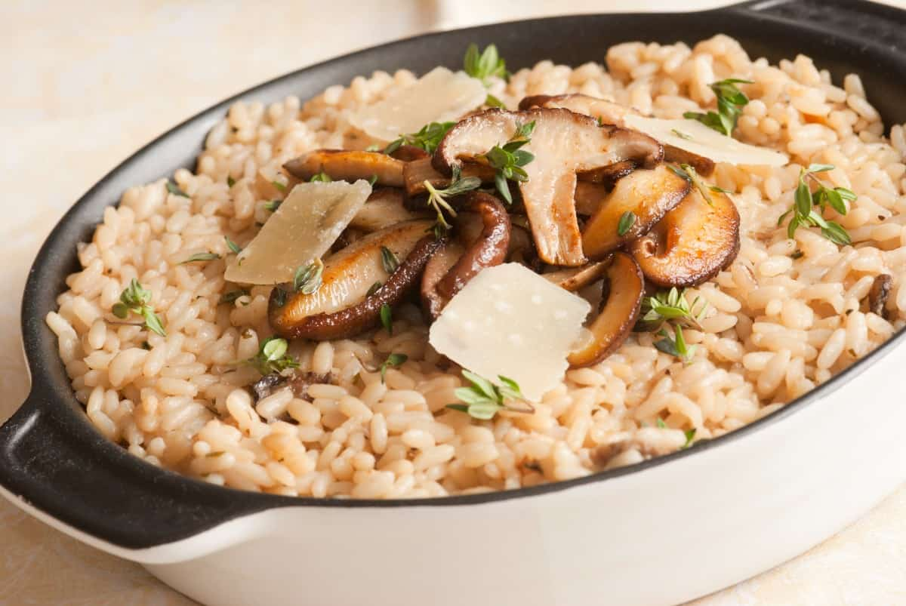
RISOTTO TAKES THE FLAVOR OF WHAT IT IS PAIRED WITH, SO A SHIITAKE MUSHROOM SHOULD BE YOUR FIRST CHOICE. IT IS IMPORTANT THAT YOU USE FRESH SHIITAKE MUSHROOMS THAT ARE STILL FIRM.

BEST MUSHROOMS FOR OMELETS

WHEN MAKING OMELETS FOR BREAKFAST, TRY DICING UP SOME BUTTON MUSHROOMS. THEY ARE ABLE TO PAIR WITH THE VEGETABLES THAT YOU ARE ADDING AND THE CHEESE. ALSO, THEY SAUTÉ BEAUTIFULLY, COOKING DOWN IN ONLY MINUTES.

BEST MUSHROOMS FOR SAUTÉING
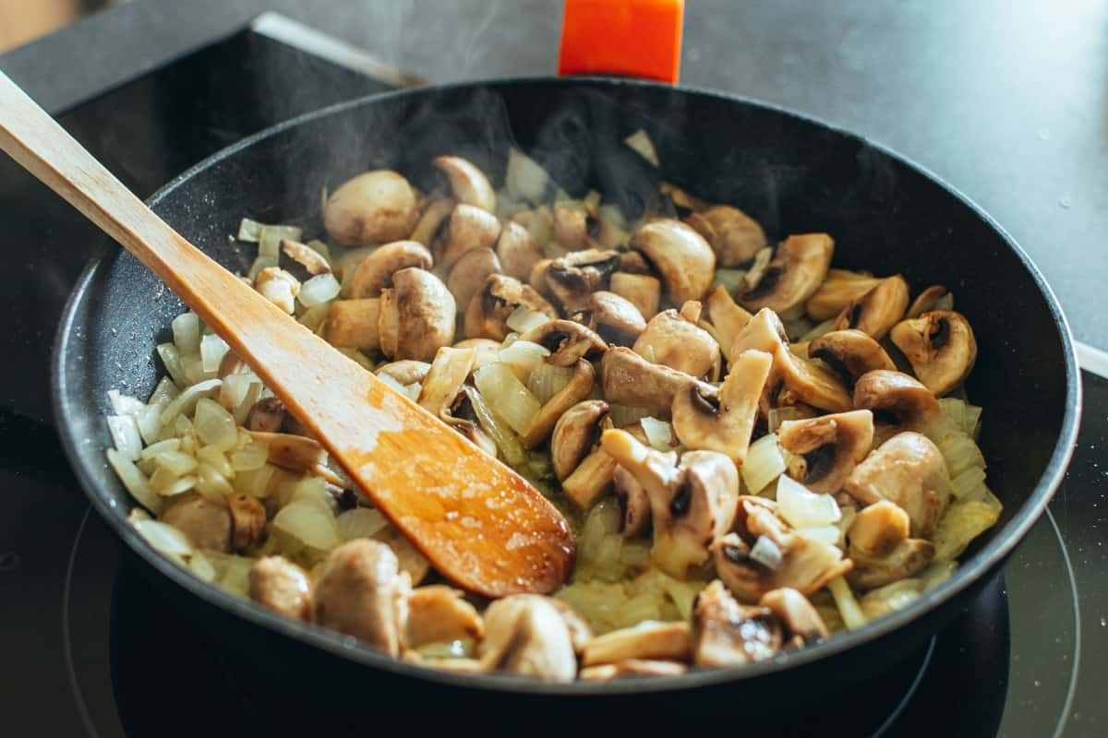
IF YOU ARE SAUTÉING MUSHROOMS AS A SIDE, BABY BELLA MUSHROOMS ARE PERFECT. THEY ARE SMALLER AND THINNER THAN OTHER VARIETIES, SO THEY PAIR WITH OTHER VEGETABLES AND COOK DOWN WHILE MAINTAINING A FIRM TEXTURE.

BEST MUSHROOMS FOR GRILLING
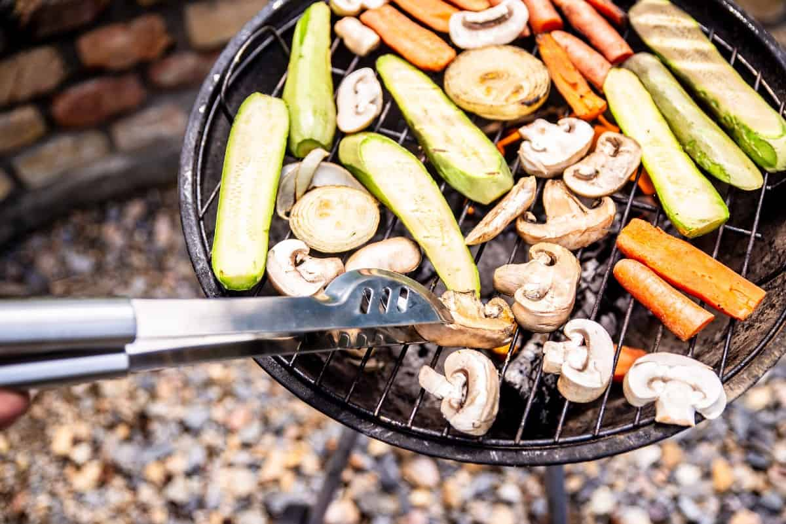
SHOULD YOU START THROWING SOME MEAT ON THE GRILL, SLICE UP A BIG CAP PORTOBELLO MUSHROOM, SEASON IT AND ADD IT ALONGSIDE THEM. PORTOBELLO MUSHROOMS HAVE A SIMILAR CONSISTENCY TO BEEF, SO COOKING IT LIKE A HAMBURGER OR STEAK WILL PROVIDE A NICE SLICE OF MUSHROOM WITH YOUR MEAL.

BEST MUSHROOMS FOR A BURGER
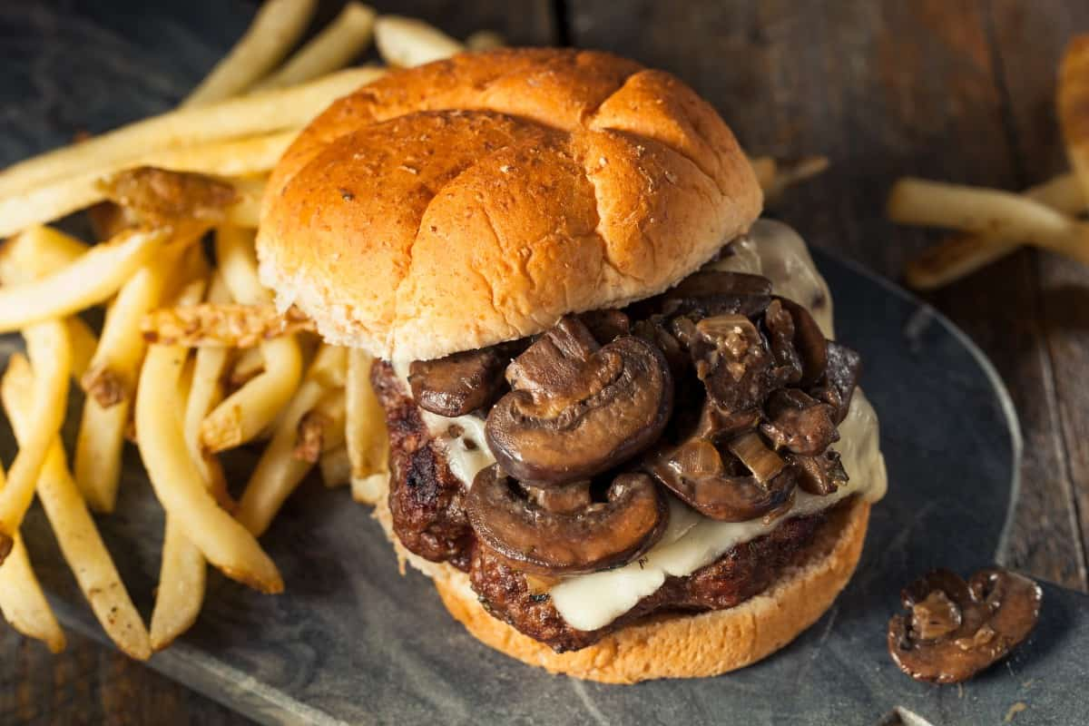
YOUR BURGERS THIS WEEKEND WILL TASTE BEST WITH SOME COOKED BUTTON MUSHROOMS. SLIDE THEM RIGHT ON TOP OF THE CHEESE — THEY ARE EASY TO CHOP UP AND MAKE BITE SIZES OUT OF THEM WHEN YOU ADD THEM TO THE BURGER.

MUSHROOMS IN CHILI
MAKING CHILI IS ABOUT CAPTURING THAT MEATY FLAVOR. ADD PORTOBELLO MUSHROOMS TO YOUR CHILI TO COMPLEMENT THE BEEF AND SAUSAGE, GIVING ANOTHER LAYER OF MEATY TEXTURE BUT WITH FIBER AND DENSE NUTRIENTS.

MUSHROOMS IN FRIED RICE
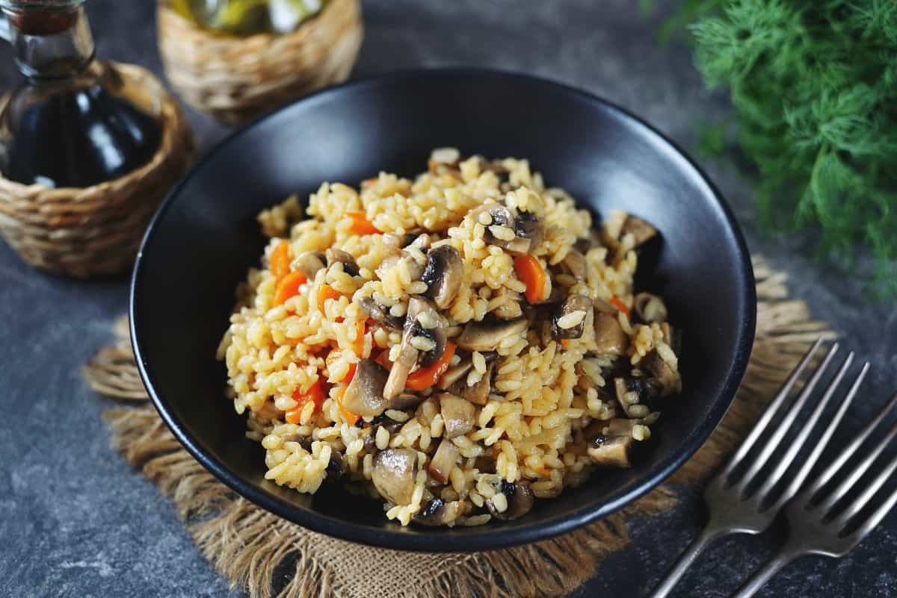
EVERYTHING IN FRIED RICE IS CHOPPED AND BLENDED, SO BUTTON MUSHROOMS ARE THE PREFERRED CHOICE. THEY ALLOW YOU TO KEEP THE DESIRED CONSISTENCY WHILE GETTING THAT EARTHY FLAVOR TO BALANCE THE BIG, SEASONED FLAVOR IN THE RICE.

MUSHROOMS IN LASAGNA
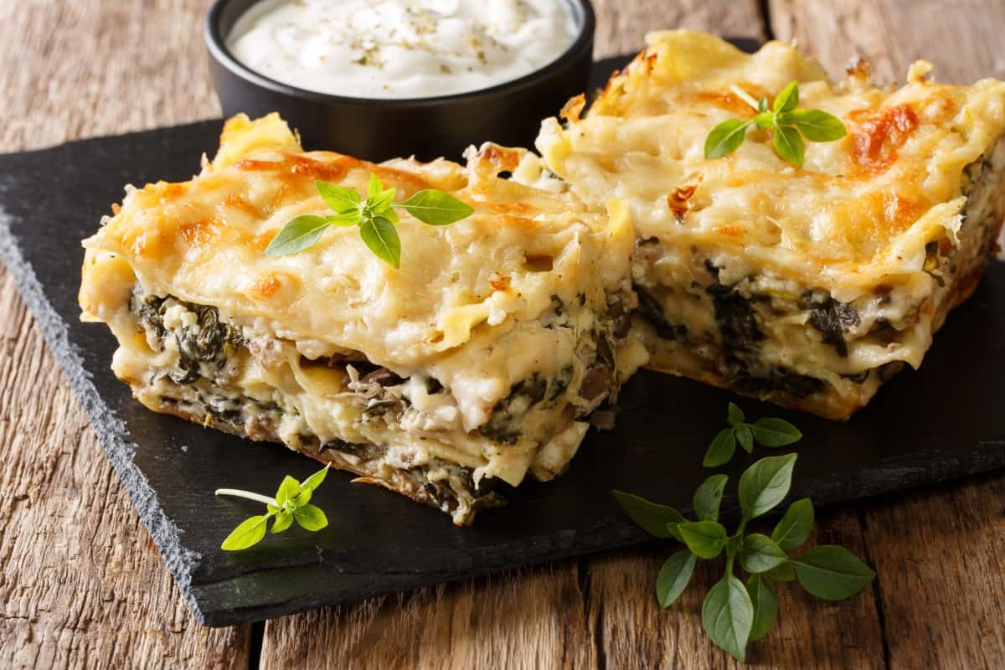
COOKING LASAGNA IS ABOUT LAYERING FLAVORS — BABY BELLA MUSHROOMS COMPLEMENT THE SPICES FOUND IN LASAGNA AS WELL AS THE MARINARA SAUCE. YOU CAN DICE THEM INTO SMALLER PIECES AND BLEND THEM WITH THE MEAT.

BEST MUSHROOMS FOR SOUP
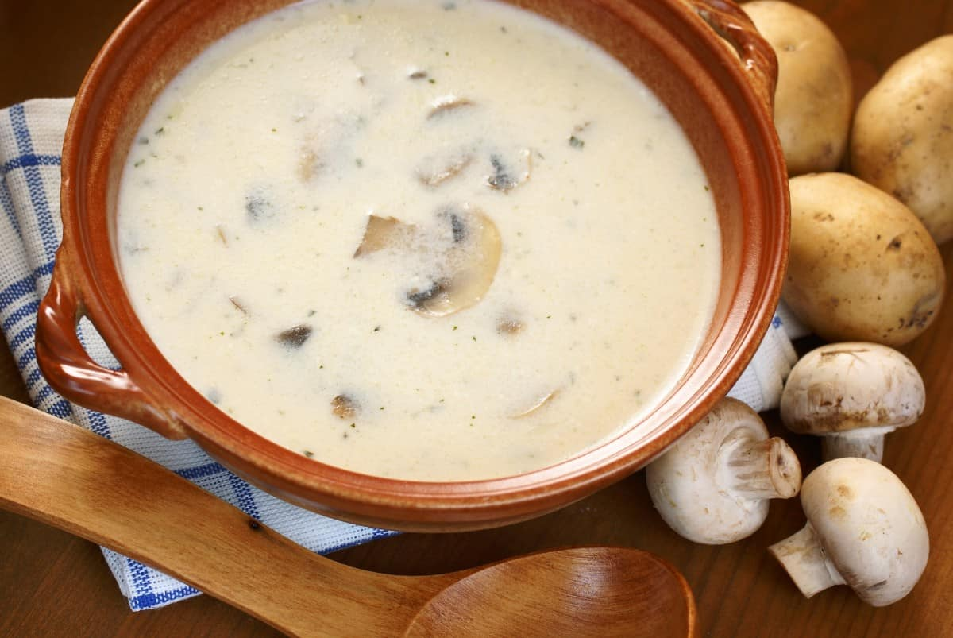
MUSHROOM SOUP IS MADE AT ITS BEST WITH FRESH MAITAKE MUSHROOMS. THEY GIVE THAT STRONG MEATY FLAVOR AND ARE GREAT FOR COOKING FOR SEVERAL HOURS.

FREQUENTLY ASKED QUESTIONS

HOW ARE MUSHROOMS GROWN?
IN THE WILD, MUSHROOMS TEND TO SPROUT UP IN DARK, DAMP PLACES. IN ORDER TO GROW MUSHROOMS, YOU FIRST NEED A SUBSTRATE CREATED SPECIFICALLY FOR MUSHROOMS. YOU NEXT PURCHASE SUBSTRATE FROM A COMMERCIAL GROWER THAT CONTAINS NUTRIENTS AS WELL AS MUSHROOM SPORES, WHICH ARE THE EQUIVALENT OF SEEDS IN PLANTS. AFTER SPREADING THE MIXTURE ON TRAYS, THE SEEDS ARE COVERED WITH PEAT MOSS TO HELP KEEP THEM MOIST. EVENTUALLY, YOU WILL SEE WHAT ARE CALLED “PINS”. THESE ARE THE MUSHROOMS POKING THROUGH THE SOIL. WHEN THEY HAVE REACHED THE DESIRED SIZE, YOU HARVEST THEM.

ARE MUSHROOMS GOOD FOR YOU?
YES, MUSHROOMS ARE NOT ONLY LOW IN CALORIES, BUT THEY ARE ALSO A GREAT SOURCE OF SELENIUM, WHICH IS ESSENTIAL FOR A HEALTHY IMMUNE SYSTEM. THEY ARE FULL OF PROTEIN, ANTIOXIDANTS, AND FIBER, WHICH ARE ALL GOOD FOR HELPING PREVENT SUCH DISEASES AS HEART DISEASE AND DIABETES. THERE IS ALSO EVIDENCE THAT THEY HELP PUT OFF SYMPTOMS OF ALZHEIMER’S DISEASE.

WHICH MUSHROOMS ARE EDIBLE?
THERE ARE 2166 IDENTIFIED TYPES OF MUSHROOMS THROUGHOUT THE WORLD. THE MOST COMMON ONES YOU ARE LIKELY TO ENCOUNTER ARE BUTTON, CREMINI (BABY BELLA), BELLA, OYSTER, TRUFFLES, PORTOBELLO, SHIITAKE, ENOKI, MAITAKE, KING TRUMPET, BEECH, PORCINI, HEDGEHOG, MOREL, AND CHANTERELLE.

ARE MUSHROOMS A VEGETABLE?
TECHNICALLY, MUSHROOMS ARE A FUNGUS WHICH IS DIFFERENT THAN VEGETABLES. HOWEVER, THE U.S. DEPARTMENT OF AGRICULTURE PLACES THEM IN THE VEGETABLE CATEGORY BECAUSE THEY HAVE MANY OF THE NUTRIENTS FOUND IN VEGETABLES AND THEY ARE USED AS VEGETABLES ARE USED. IN FACT, THE NUTRIENTS IN MUSHROOMS CAN BE FOUND NOT ONLY IN VEGETABLES BUT ALSO IN MEATS AND GRAINS.

HOW LONG DO MUSHROOMS LAST?
MUSHROOMS HAVE A SHELF LIFE OF TEN DAYS FROM THE DAY THEY ARE HARVESTED. IF KEPT IN THE REFRIGERATOR, THEY MAY LAST UP TO TEN DAYS. AFTER THAT, THEY WILL SHOW SIGNS OF GOING BAD. YOU CAN EXTEND THE LIFE OF MUSHROOMS IF YOU DEHYDRATE, FREEZE, OR CAN THEM.

ARE MUSHROOMS A PROTEIN?
MUSHROOMS ARE AN EXCELLENT ADDITION TO A VEGETARIAN DIET BECAUSE THEY PROVIDE TWO GRAMS OF PROTEIN IN EVERY CUP WHEN THEY ARE RAW. MUSHROOMS ARE ALL DIFFERENT, HOWEVER, SO YOU CAN GET THIS LOWER AMOUNT OF PROTEIN IN BUTTON MUSHROOMS, BUT CAN DOUBLE THAT AMOUNT WITH A SERVING OF OYSTER MUSHROOMS. IN ALL CASES, ADDING MUSHROOMS IS A GREAT WAY TO GET YOUR DAILY PROTEIN REQUIREMENTS WITHOUT ADDING FAT.

HOW LONG DO MUSHROOMS LAST IN THE FRIDGE?
MUSHROOMS CAN LAST UP TO TEN DAYS IF THEY ARE IMMEDIATELY REFRIGERATED. THIS IS PROVIDED YOU DO NOT PLACE THEM IN PLASTIC OR WASH THEM UNDER A RUNNING STREAM OF WATER.

ARE MUSHROOMS A FUNGUS?
YES, MUSHROOMS ARE A FUNGUS. THEY DO NOT HAVE LEAVES OR SEEDS AND THEY DO NOT REQUIRE LIGHT IN ORDER TO GROW. MUSHROOMS REPRODUCE BY THE WAY OF SPORES.

CAN YOU EAT MUSHROOMS RAW?
WHILE MOST MUSHROOMS CAN BE EATEN RAW, IT MAY NOT BE THE MOST BENEFICIAL WAY TO EAT THEM. THE TOUGHER OUTER SHELL MAY BE DIFFICULT TO DIGEST FOR SOME PEOPLE. IN ADDITION, THE NUTRIENTS IN MUSHROOMS ARE RELEASED WHEN HEATING, MAKING THEM MORE NUTRITIOUS.

DO MUSHROOMS HAVE CARBS?
MUSHROOMS ARE VERY LOW IN CARBS AND ARE ALLOWED ON MOST LOW-CARB DIETS. THERE ARE ONLY TWO GRAMS OF CARBS IN A ONE-CUP SERVING OF WHITE MUSHROOMS.

CAN MUSHROOMS BE FROZEN?
WHILE YOU CAN FREEZE MUSHROOMS, IT IS BETTER NOT TO DO SO WHEN THEY ARE RAW. MUSHROOMS ARE APPROXIMATELY 95 PERCENT WATER AND WILL TURN MUSHY WHEN FROZEN RAW. IF YOU SAUTE YOUR MUSHROOMS FIRST AND THEN FREEZE THEM, THEY WILL STAY EDIBLE FOR UP TO SIX MONTHS.

DO MUSHROOMS HAVE FIBER?
YES, THERE ARE ABOUT THREE GRAMS OF FIBER IN EACH CUP OF MUSHROOMS, MAKING THEM A GREAT SOURCE OF FIBER.

DO MUSHROOMS CAUSE GAS?
MUSHROOMS CONTAIN SUGARS THAT ARE DIFFICULT TO DIGEST IN THE SMALL INTESTINE. THIS MEANS THAT THEY OFTEN REMAIN IN THE SMALL INTESTINE AND BEGIN TO FERMENT, CAUSING GAS AND BLOATING. YOU CAN REDUCE THE CHANCE OF GETTING GAS BY COOKING THE MUSHROOMS, EATING ONLY A SMALL PORTION, AND TAKING TIME TO CHEW THOROUGHLY TO AID IN DIGESTION.

WHICH MUSHROOMS ARE POISONOUS?
THERE ARE 70 TYPES OF MUSHROOMS CURRENTLY IDENTIFIED AS POISONOUS. SOME OF THE MOST COMMON ARE DEATHCAP, DESTROYING ANGEL, FALSE PARASOL, IVORY FUNNEL, JACK O’LANTERN, FALSE CHAMPIGNON, BROWN ROLL-RIM, INKY CAP, AND ELFIN SADDLE. WAYS TO IDENTIFY POISONOUS MUSHROOMS ARE TO AVOID ONES WITH WHITE GILLS OR A RING AROUND THE STEM. MOST MUSHROOMS WITH A RED CAP OR STEM ARE ALSO POISONOUS, OR HALLUCINOGENIC. IT IS BETTER NOT TO CHANCE THOSE.

DO MUSHROOMS HAVE IRON?
THE IRON CONTENT IN MUSHROOMS VARIES BY TYPE OF MUSHROOM. FOR EXAMPLE, PORTOBELLO AND SHIITAKE MUSHROOMS CONTAIN ALMOST NO IRON. ON THE OTHER HAND, ONE CUP OF COOKED WHITE MUSHROOMS CONTAINS A FULL 15 PERCENT OF THE RECOMMENDED DAILY ALLOWANCE, AND ONE CUP OF RAW OYSTERS CONTAINS ABOUT SEVEN PERCENT OF YOUR DAILY PROTEIN NEEDS.

DO MUSHROOMS NEED SUNLIGHT?
MUSHROOMS DO NOT GAIN ANY NUTRIENTS FROM THE SUN, SO THEY DO NOT NEED LIGHT IN ORDER TO GROW AND REPRODUCE. IN FACT, THE MORE DARKNESS THEY ARE SUBJECT TO, THE GREATER THEIR ABILITY TO MAINTAIN MOISTURE.

DO MUSHROOMS HAVE SEEDS?
MUSHROOMS DO NOT HAVE SEEDS. THEY HAVE TINY SPORES THAT ARE SO MINUTE THEY CAN’T BE SEEN WITH THE NAKED EYE. THESE SPORES DON’T GERMINATE IN SOIL BUT NEED SAWDUST, GRAIN, OR WOOD CHIPS IN ORDER TO GROW. WHEN THE SPORES ARE MIXED WITH ONE OF THESE SUBSTANCES, YOU GET WHAT IS CALLED SPAWN AND THAT IS WHAT GROWERS OF MUSHROOMS USE.

WHAT CAN BE DONE WITH MUSHROOM STEMS?
MUSHROOM STEMS TASTE VERY SIMILAR TO THE CAPS, ALTHOUGH SOME KINDS HAVE A MORE-WOODY TASTE. THE STEMS CAN BE CHOPPED UP AND USED IN ANY WAY YOU USE THE CAPS. THEY ARE ESPECIALLY GOOD IN SOUPS, STEWS, AND SALADS.

WHY ARE MUSHROOMS GROWING IN MY HOUSEPLANTS?
THERE ARE A COUPLE OF DIFFERENT REASONS YOU MAY FIND MUSHROOMS GROWING IN YOUR HOUSEPLANTS. MOST OFTEN, THEY ARE THE RESULT OF NON-SOIL SUBSTANCES THAT HAVE BEEN ADDED TO YOUR POTTING SOIL. IN OTHER CASES, AIR MAY HAVE BLOWN MUSHROOM SPORES THROUGH THE HOUSE AND INTO THE PLANT POTS. WHEN YOU OVERWATER THE PLANT, IT CAN INITIATE THE GROWTH OF THESE MUSHROOMS.

HOW CAN YOU TELL IF MUSHROOMS HAVE GONE BAD?
IF YOUR MUSHROOMS FEEL SLIMY TO THE TOUCH, HAVE A FOUL SMELL, OR HAVE VISIBLE DARK SPOTS ON THEM THEY ARE NOT GOOD TO EAT. CRACKED OR WRINKLED MUSHROOMS INDICATE THEY ARE LOSING THEIR MOISTURE AND SHOULD BE EATEN IMMEDIATELY OR THROWN OUT BECAUSE THEY WILL BE BAD SHORTLY.

DO MUSHROOMS CONTAIN POTASSIUM?
MUSHROOMS ARE VERY RICH IN POTASSIUM. IN FACT, PORTOBELLO MUSHROOMS CONTAIN EVEN MORE POTASSIUM THAN AN AVERAGE BANANA.

DO MUSHROOMS CONTAIN B12?
MUSHROOMS ARE GOOD SOURCES OF MANY B VITAMINS BUT THE AMOUNT VARIES WITH EACH TYPE. OYSTER MUSHROOMS CONTAIN ALMOST NO B12, BUT SHIITAKE MUSHROOMS CONTAIN A VERY HIGH AMOUNT AND ARE A GREAT PART OF A VEGETARIAN DIET.
RELATED: TYPES OF TRUFFLES | MEDICINAL MUSHROOMS | CORDYCEPS MUSHROOM | CHAGA MUSHROOM | REISHI MUSHROOM | TURKEY TAIL MUSHROOM | LION’S MANE MUSHROOM

10 DIFFERENT TYPES OF TRUFFLES
LEARN MORE ABOUT THE TRUFFLES AS YOU DISCOVER ITS MANY DIFFERENT TYPES THAT CAN BE DISTINGUISHED BY SOIL AND HOST PLANT AS WELL AS ENJOY LEARNING FUN FACTS ABOUT THESE BLACK DIAMONDS.
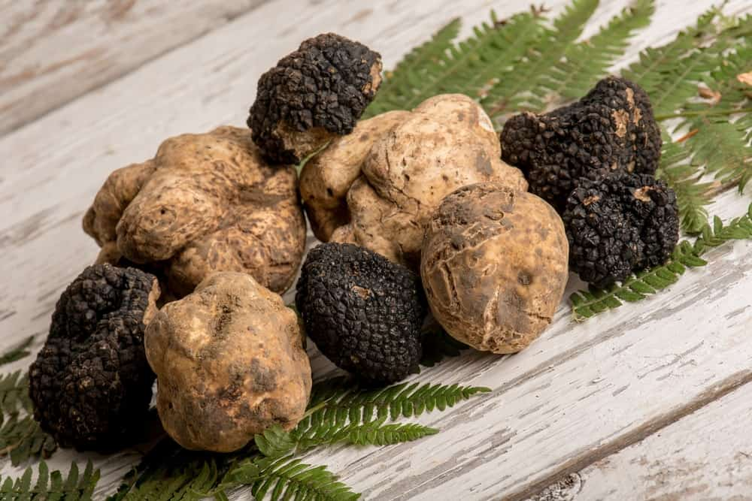
TRUFFLES ARE A TYPE OF MUSHROOM THAT GROWS UNDERGROUND ABOUT 2.5-10 CENTIMETERS BELOW THE ROOTS OF ITS HOST TREE FOR WHICH THEY HAVE A SYMBIOTIC RELATIONSHIP WITH. WHILE MANY THINK OF TRUFFLES AS A FUNGUS, IN REALITY, THEY’RE MORE CLOSELY RELATED TO A CARROT.
ANCIENT GREEKS AND ROMANS USED TRUFFLES AS A FINE APHRODISIAC OWING TO ITS AROMA OR DUE TO ITS RARITY. THEY ALSO USED THEM AS DELICACIES AND MEDICINES.
THE WORLD’S LARGEST WHITE TRUFFLE THAT WEIGHED IN AT 1.890 KG WAS UNEARTHED IN CENTRAL ITALY BY THE WORLD’S LARGEST TRUFFLE SUPPLIERS, SABATINO TRUFFLES. WHEN IT COMES TO TASTE, ITALIANS PREFER THE WHITE TRUFFLE TO THE BLACK TRUFFLE.

TYPES

AUSTRALIAN TRUFFLE
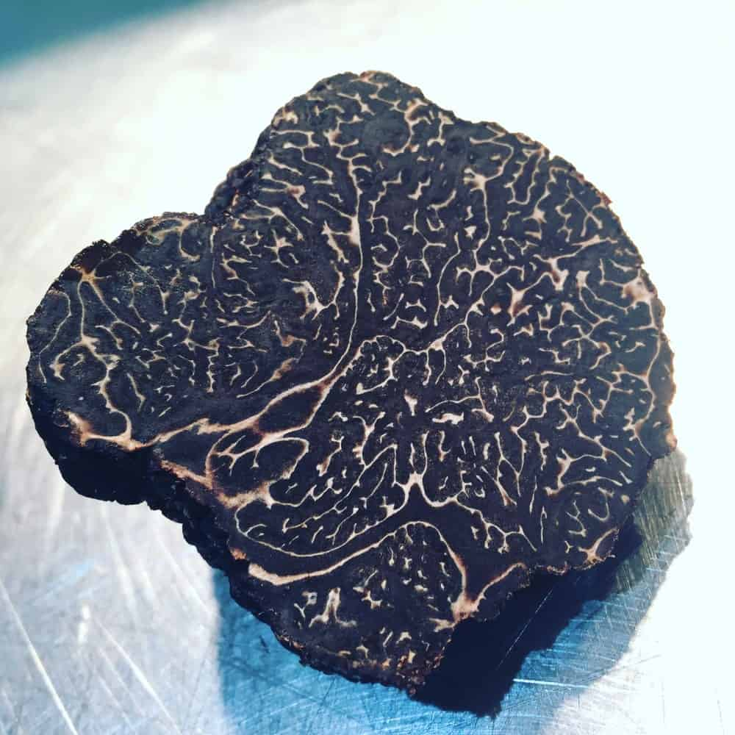
WHEN IT COMES TO FLAVOR AND INTENSITY, FEW TYPES OF TRUFFLES BEAT THE AUSTRALIAN VARIETY, AND THE GOOD NEWS IS THAT THESE ARE SOME OF THE MORE REASONABLY PRICED TRUFFLES AVAILABLE. THEY ARE VERY SIMILAR TO THE TRUFFLES FOUND IN CERTAIN PARTS OF FRANCE, AND THEY ARE AVAILABLE IN THE MONTHS OF MAY, JUNE, AND JULY SINCE THEIR SEASONS ARE THE EXACT OPPOSITE OF MANY OTHER COUNTRIES WHERE TRUFFLES ARE FOUND.

BLACK SUMMER TRUFFLE
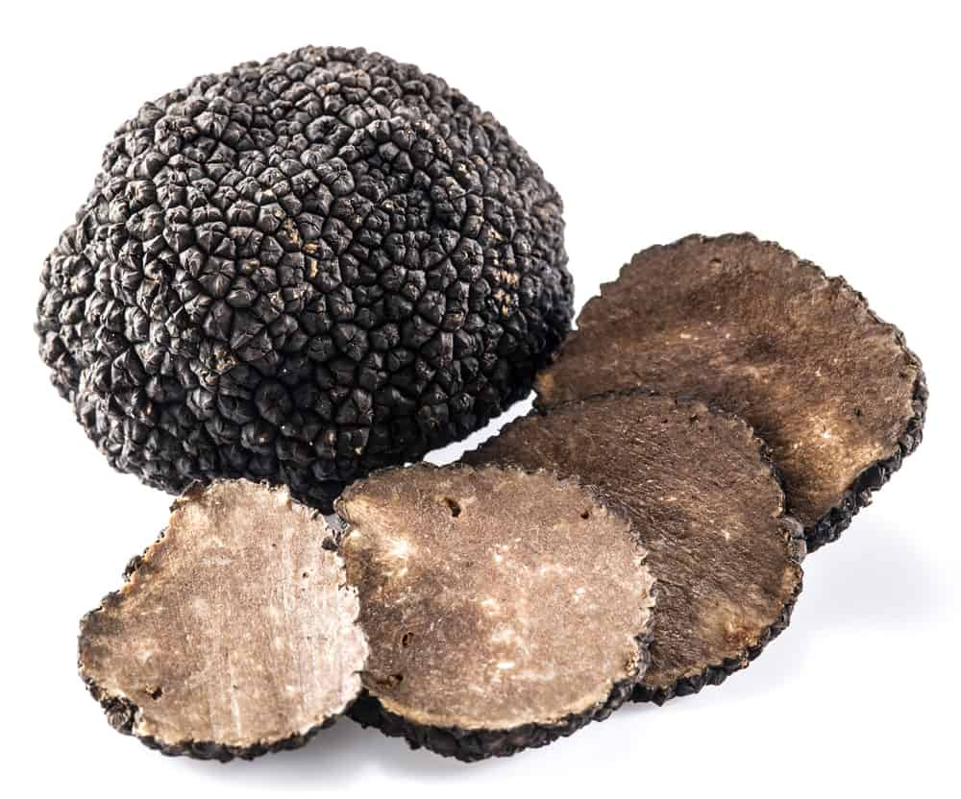
HARVESTED BETWEEN MAY 1 AND SEPTEMBER 30, THIS TRUFFLE HAS A SMOOTH SURFACE AND A WHITE INTERIOR, AND IT IS USED IN DISHES SUCH AS DOUGHS, MEAT AND FISH, PASTA DISHES, AND NUMEROUS APPETIZERS. THEY ALSO GO VERY WELL IN SOUP, AS WELL AS VARIOUS TYPES OF SALADS.

BRUMALE TRUFFLE
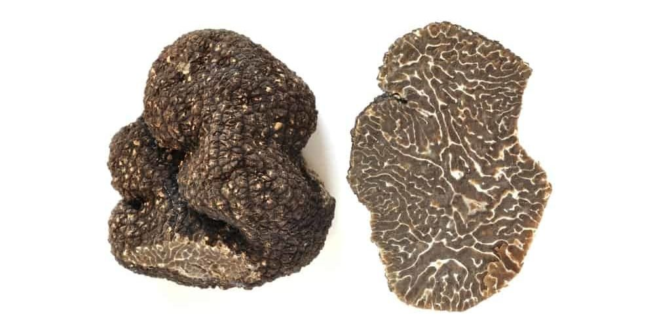
HARVESTED BETWEEN NOVEMBER 1 AND MARCH 15, IT LOOKS SO MUCH LIKE THE PÉRIGORD TRUFFLE, BOTH INSIDE AND OUT, THAT MANY PEOPLE ARE SCAMMED INTO THINKING THEY ARE BUYING THE PÉRIGORD. HOWEVER, THE AROMA AND TASTE OF THE BRUMALE TRUFFLE ARE QUITE DIFFERENT, SO ONE TASTE AND YOU’LL KNOW WHICH ONE YOU’RE PURCHASING. OF COURSE, IF YOU’RE INTERESTED IN SAVING MONEY, THIS IS A GREAT TRUFFLE TO BUY.

BURGUNDY TRUFFLE
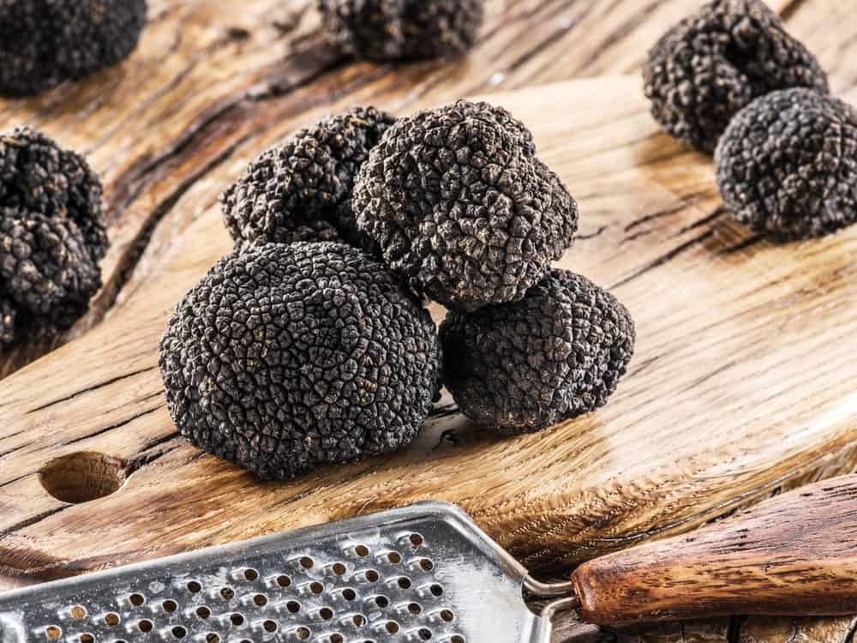
THESE TRUFFLES ARE HARVESTED IN DORDOGNE BETWEEN OCTOBER 1 AND DECEMBER 31, AND THEY HAVE A CHOCOLATE SMELL AND TASTE. IT HAS LARGELY POINTED WARTS THAT ARE SHAPED LIKE A DIAMOND, AND EVEN THE FLESH IS A CHOCOLATE-BROWN COLOR. IT GROWS UNDER TREES WITH BROAD LEAVES, USUALLY IN CLAY SOIL, AND IT IS COMMONLY USED IN APPETIZERS, MEAT, AND FISH DISHES, AND EVEN IN EGGS. AFTER THE PÉRIGORD TYPE OF TRUFFLE, THIS ONE IS THE MOST POPULAR.

CHINESE BLACK TRUFFLE
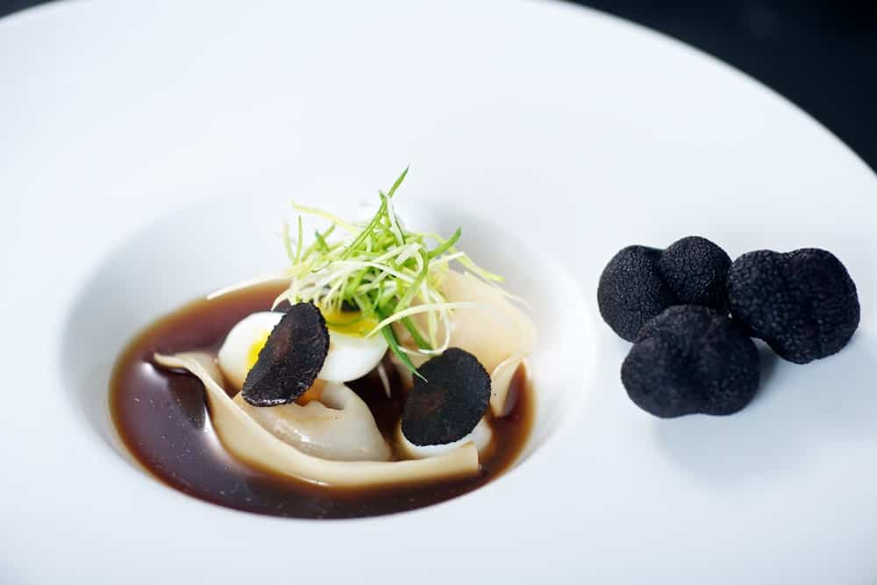
CHINESE BLACK TRUFFLES COME IN VARIOUS TYPES, AND THEY ARE SIMILAR TO THE PÉRIGORD WHEN IT COMES TO THE WAY THEY LOOK. HOWEVER, THESE TRUFFLES ARE USUALLY RUBBERY IN TASTE AND TEXTURE, WHICH IS WHY THEY SELL FOR A MINUTE AMOUNT OF MONEY. IN FACT, MANY EXPERTS CLAIM THERE IS NO MORE VALUE IN THE CHINESE BLACK TRUFFLE THAN THERE IS IN REGULAR MUSHROOMS, WHICH IS WHY YOU SHOULD DO YOUR RESEARCH WHENEVER YOU’RE LOOKING FOR TRUFFLES.

OREGON BLACK TRUFFLE
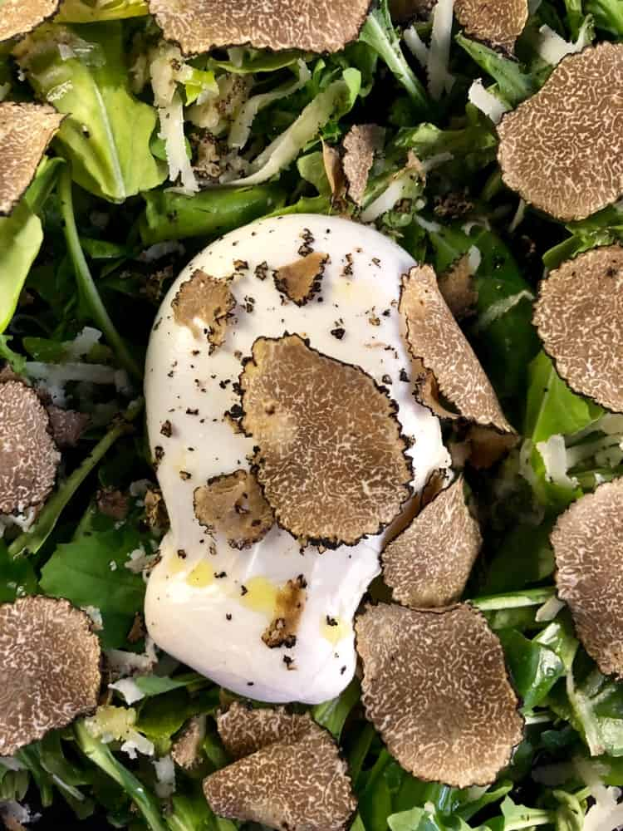
WITH A PUNGENT ODOR AND AN EARTHY, ALMOST PINEAPPLE-LIKE TASTE, THE OREGON BLACK TRUFFLE IS VERY POPULAR WITH CHEFS. THEIR SEASON IS NOVEMBER THROUGH MARCH, AND THEY CAN BE USED IN DISHES THAT INCLUDE MEAT-BASED DISHES AND EVEN MANY DESSERTS. OREGON TRUFFLES HAVE AN AROMA THAT DISSIPATES WITH HEAT, SO YOU SHOULD SHAVE THEM RAW OVER FOOD AND NEVER COOK THEM.

PÉRIGORD/SPOLETO TRUFFLE
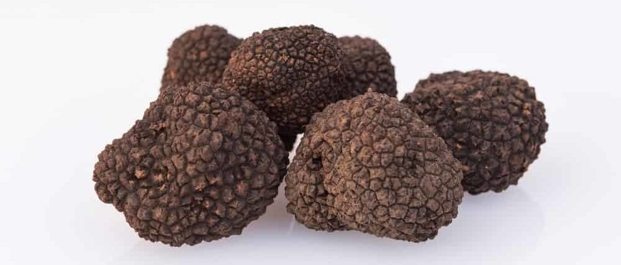
THIS IS PERHAPS THE FINEST FRENCH TRUFFLE YOU WILL EVER BUY. IT IS A TYPE OF WINTER BLACK TRUFFLE FOUND MOSTLY IN SOUTHERN FRANCE, AND IT IS HARVESTED BETWEEN NOVEMBER 15 AND MARCH 31. THE FLESH IS USUALLY DARK BROWN OR BLACK AND SOMETIMES HAS WHITE VEINS RUNNING THROUGH IT, AND ITS AROMA IS VERY PLEASANT. THE TASTE RESEMBLES ROASTED DRY FRUITS, AND IT LASTS LONG AFTER YOU SWALLOW THE TRUFFLE. THEY ARE ALSO NICKNAMED BLACK DIAMONDS BECAUSE THEIR COST CAN EXCEED $2,000 PER POUND.

SPANISH BLACK TRUFFLE
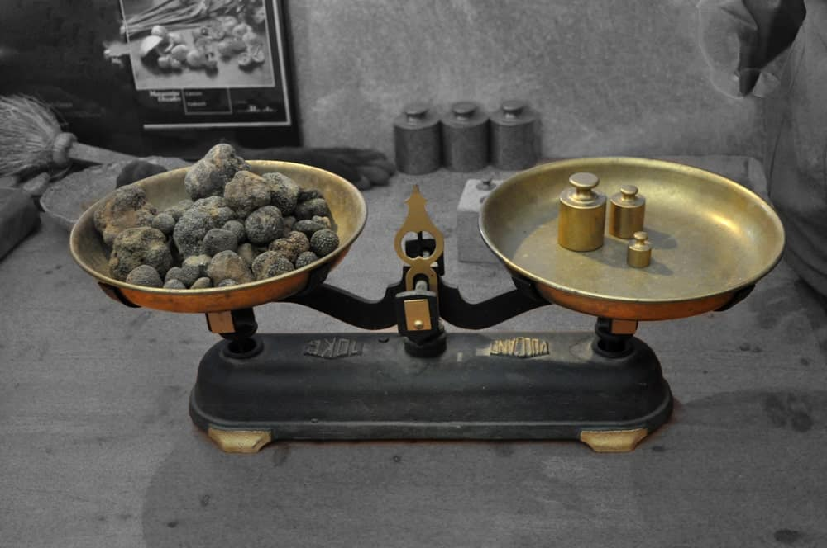
FOUND IN THE HILLS OF EAST-CENTRAL SPAIN, THESE TRUFFLES ARE SAID TO BE SOME OF THE BEST TRUFFLES YOU CAN BUY. SPAIN EXPORTS MOST OF THESE TRUFFLES TO OTHER COUNTRIES, AND BECAUSE OF CHANGES IN CLIMATE, THE CROPS OF THE SPANISH BLACK TRUFFLES HAVE GONE DOWN CONSIDERABLY. STILL, IF YOU CAN GET YOUR HANDS ON SOME OF THESE TRUFFLES, IT WILL BE WELL WORTH WHAT YOU HAVE TO PAY FOR THEM.

TUSCAN TRUFFLE
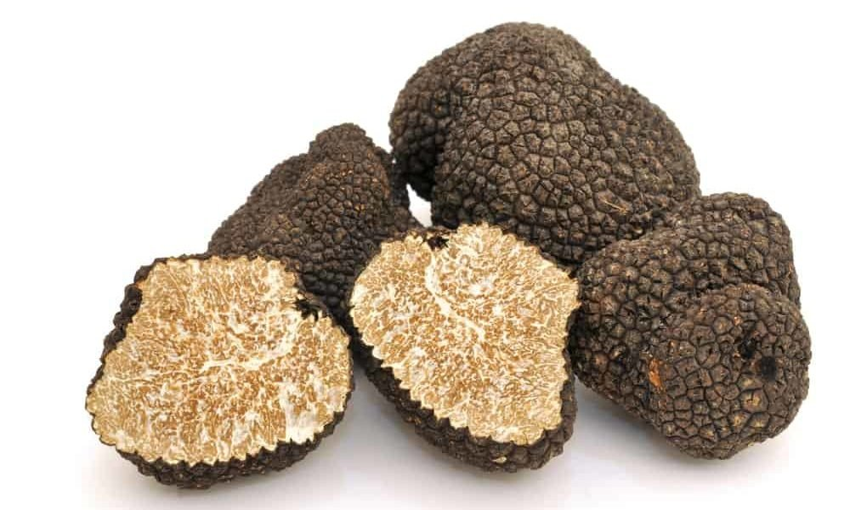
THE SEASON FOR THE TUSCAN TRUFFLE IS JANUARY 10 THROUGH APRIL 30. WHEN EATEN RAW, THE TASTE IS QUITE SHARP, AND IF YOU ADD IT TO BUTTER OR OIL, IT HAS A VERY DISTINCT FLAVOR. IT IS OFTEN USED TO MAKE TRUFFLE OIL AND TRUFFLE PASTE, AMONG OTHER FOODS.

WHITE PIEDMONT TRUFFLE
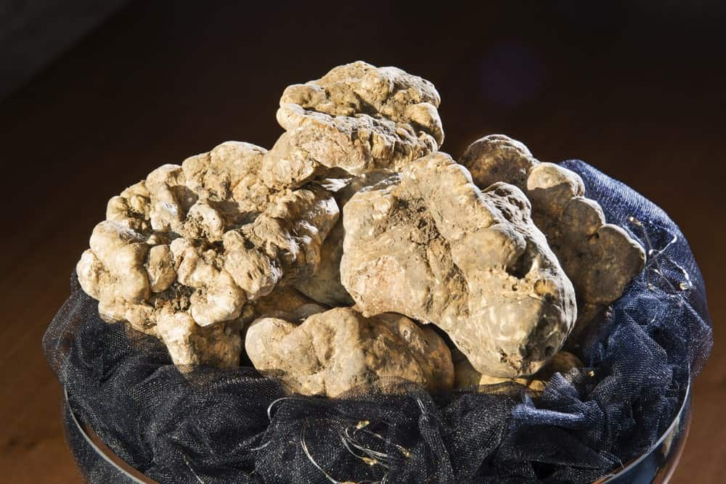
ALSO CALLED THE ALBA TRUFFLE, THIS TYPE OF TRUFFLE IS FOUND FROM OCTOBER 1 TO DECEMBER 31, MOSTLY IN NORTHERN ITALY. IT HAS A GREAT HEADY AROMA AND A SMOOTH SURFACE, BUT IT IS NOT ACTUALLY WHITE. INSTEAD, THE WHITE PIEDMONT TRUFFLE IS A CREAMY, CAFÉ AU LAIT COLOR. IT IS ONLY CONSUMED RAW, USUALLY SHAVED OVER FOODS SUCH AS PASTA AND RICE, AND IT SMELLS LIKE GARLIC, CHEESE, AND SHALLOTS.

FUN FACTS ABOUT TRUFFLES
A FRENCH AFFAIR
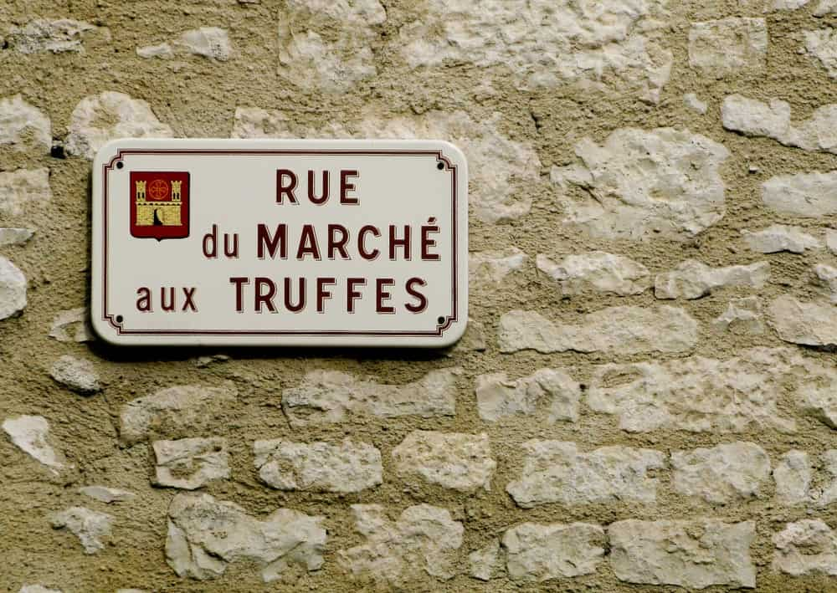
MOST TRUFFLES COME FROM FRANCE, WHICH PRODUCES MORE THAN 30 TONS OF THEM EVERY YEAR. BY THE END OF THE 19TH CENTURY, HOWEVER, PRODUCTION WAS MORE THAN 1,000 TONS PER YEAR, SO THE AMOUNT SHIPPED OUT EVERY YEAR HAS GONE DOWN.
OINKS AND GRUNTS
TRUFFLES ARE USUALLY SNIFFED OUT BY ANIMALS SUCH AS PIGS, GOATS, AND EVEN TRAINED DOGS. THEY USE THEIR SENSE OF SMELL TO FIND THE TRUFFLES, AND THE SMELL IS VERY SIMILAR TO THE SEX PHEROMONE FOUND IN THE SALIVA OF MALE PIGS, WHICH HELPS THEM FIND THE TRUFFLES.
HOW DO THEY GROW?
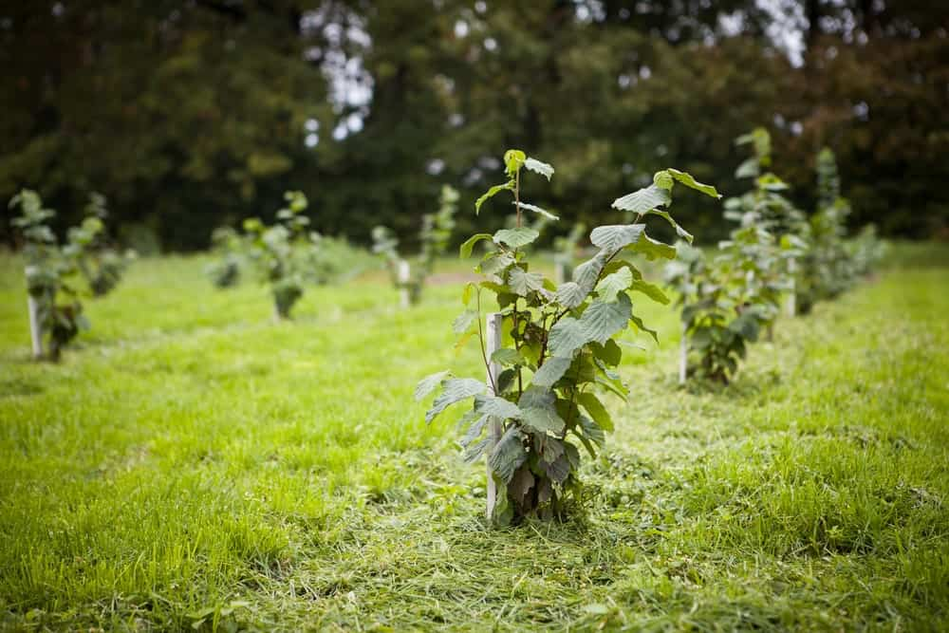
TRUFFLES GROW ALONG WITH A HOST TREE, AND THE WAY THEY WORK IS FAIRLY SIMPLE. THE TREE GIVES THE TRUFFLES THE SUGAR THEY NEED TO GROW, WHILE THE TREE IS ABLE TO TAKE IN VALUABLE PHOSPHOROUS. ON A FUNNIER NOTE, THE GREEKS USED TO BELIEVE THAT TRUFFLES WERE MADE WHEN LIGHTNING HIT A PATCH OF DAMP SOIL. TRUFFLES ARE MERELY MUSHROOMS THAT ARE BELIEVED TO GROW UNDERGROUND TO AVOID COLD WEATHER, FOREST FIRES, AND DROUGHT. IN ADDITION, TRUFFLES GROW WITHOUT ROOTS, AND THEY CAN BE FOUND AS DEEP AS EIGHT INCHES UNDER THE GROUND IN TREES SUCH AS THE WILLOW, OAK, AND HAZEL TREES.
VERY EXPENSIVE
SOME TRUFFLES ARE VERY EXPENSIVE, AND THERE WAS EVEN A RARE ITALIAN WHITE TRUFFLE THAT SOLD FOR £28,000 IN 2004. EVEN TODAY, TRUFFLES CAN COST OVER $2,000 PER POUND, WHICH IS WHY A FEW OF THEM ARE CALLED BLACK DIAMONDS.

5 TYPES OF MEDICINAL MUSHROOMS (THE ROYAL FAMILY OF FUNGUS)
MAKE WAY FOR THE KINGS OF FUNGUS. HERE ARE THE FIVE TYPES OF MEDICINAL MUSHROOMS, THEIR MEDICINAL PROPERTIES, BENEFITS AND THE NUTRIENTS THEY CONTAIN.
THIS PROBABLY ISN’T THE FIRST TIME THAT YOU’VE SOUGHT OUT INFORMATION ABOUT MEDICINAL MUSHROOMS. THEIR POPULARITY HAS ABSOLUTELY BOOMED IN THE PAST COUPLE OF YEARS, ALTHOUGH RESEARCH INTO THEIR BENEFITS HAS BEEN HAPPENING SINCE THE ’60S.
THE RECENT INFLUX OF INFORMATION ON MEDICINAL MUSHROOMS IS DUE TO THE FACT THAT UNTIL NOW, HOLISTIC MEDICINE AND PREVENTATIVE NATURAL REMEDIES HAVE BEEN LEFT ON THE BACK-BURNER. WESTERNIZED MEDICINE TENDS TO FOCUS ON FIXING PROBLEMS ONCE THEY’VE REACHED THEIR CRUX OF DESTRUCTION, INSTEAD OF FINDING WAYS TO PREVENT ILLNESSES FROM HAPPENING. WE’RE ONLY NOW CATCHING UP WITH THE TRADITIONAL CHINESE WAYS OF MEDICINE AND FOCUSING ON PREVENTION INSTEAD OF DISASTER CONTROL.
THERE ARE THOUSANDS OF SPECIES OF MUSHROOMS WITH MIND-BOGGLINGLY (I WISH THAT WERE A WORD) BENEFICIAL PROPERTIES. MUSHROOMS CAN HELP IN INCREASING IMMUNITY, TO INCREASING YOUR LIBIDO! TODAY WE’RE GOING TO LOOK A LITTLE FURTHER INTO THE ROYAL FAMILY OF FUNGUS: LIONS MANE, TURKEY TAIL, REISHI, CHAGA, AND CORDYCEPS.
(AS WE SPEAK, I AM DRINKING A CUP OF COFFEE SPLASHED WITH A COUPLE OF MUSHROOM TINCTURES OF MY OWN. EVERY DAY TWICE A DAY, I TAKE A CHAGA AND A CORDYCEPS SUPPLEMENT FROM AN AWESOME CANADIAN COMPANY CALLED RAINBO.)
RELATED: TYPES OF MUSHROOM | CHAGA MUSHROOM | CORDYCEPS MUSHROOM | REISHI MUSHROOM | TURKEY TAIL MUSHROOM | LIONS MANE MUSHROOM

BUT FIRST, FUNGUS!
MUSHROOMS HAVE OFTEN BE CALLED THE EARTH’S IMMUNE SYSTEM, AND THAT IS A VERY ACCURATE STATEMENT. THE FUNGUS IS CORRELATED WITH DEATH AND DECAY, BUT IN ORDER FOR LIFE TO THRIVE, THINGS MUST DIE. MANY MUSHROOMS ARE SAPROTROPHIC, MEANING THAT THEY DIGEST DECAYING MATTER. BUT THIS CYCLE OF LIFE, DEATH, AND DIGESTION IS WHAT KEEPS FORESTS ALIVE. MUCH IN THE SAME WAY THAT A BODY STAYS ALIVE BY FIGHTING OFF HARMFUL BACTERIA AND ILLNESS WITH ITS IMMUNE SYSTEM, THIS PROCESS INVOLVES THE DEATH OF THAT HARMFUL BACTERIA.
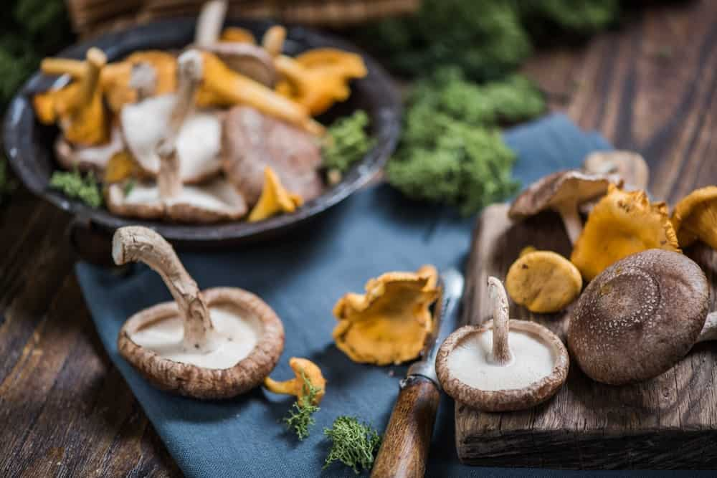
MUSHROOMS ARE ONE OF THE OLDEST ORGANISMS IN ALL OF EXISTENCE. FOSSILS OF MUSHROOMS FOUND IN REMOTE ARCTIC CANADA HAVE BEEN DATED BACK TO AN ASTONISHING ONE BILLION YEARS. SOMETHING SURVIVING FOR THAT LONG WAS DEFINITELY DOING SOMETHING RIGHT, AND THROUGHOUT THEIR EXISTENCE FUNGUS HAS DEVELOPED SYMBIOTIC RELATIONSHIPS WITH PLANTS, PEOPLE, AND ANIMALS.
IT IS WISE FOR HUMANS TO TAKE ADVANTAGE OF THE KNOWLEDGE FROM AN ORGANISM THAT HAS OUTLIVED DINOSAURS. MUSHROOMS HAVE PROVEN TO AID THE HUMAN BODY IN MANY WAYS, FROM MEMORY RETENTION TO SEXUAL DRIVE, TO ALERTNESS, TO IMMUNE SYSTEM SUPPORT.
MUSHROOMS HAVE THEIR VERY OWN ROOT SYSTEM THAT IS AS INTERTWINED AND EXPANSIVE AS THE ROOT SYSTEM OF TREES. THIS ROOT SYSTEM IS CALLED A MYCELIUM. THE LARGEST LIVING ORGANISM ON EARTH (YES, BIGGER THAN A BLUE WHALE) IS A MYCELIUM ROOT SYSTEM IN THE MALHEUR NATIONAL FOREST IN OREGON. IT SPREADS AN ASTONISHING 2,835 ACRES.
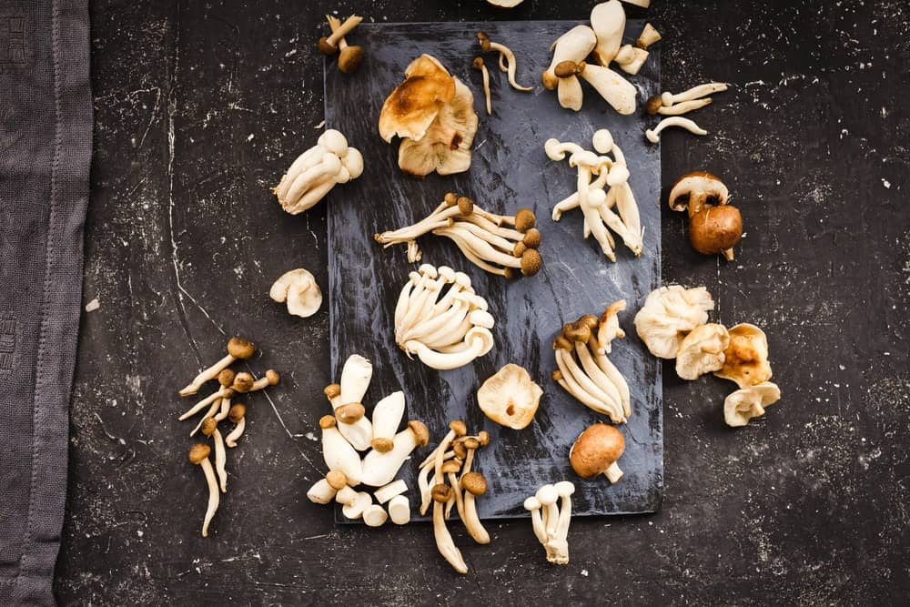
IT IS HARD TO DENY THE POWER THAT MUSHROOMS HOLD ONCE YOU REALIZE THAT THEY ARE THE OLDEST, LARGEST, MOST VARYING, STRANGEST ORGANISMS ON OUR PLANET. DID YOU KNOW THAT FUNGUS IS LITERALLY IN BETWEEN DISTINCTION? IT IS NOT AN ANIMAL, AND IT IS NOT A PLANT. SO WHAT IS IT?
IF YOU’RE CURIOUS TO KNOW MORE ABOUT MUSHROOMS, I HIGHLY RECOMMEND THE INCREDIBLE DOCUMENTARY TITLED FANTASTIC FUNGI – CREATED BY THE WORLD-RENOWNED MYCOLOGIST, PAUL STAMETS.

THE LIONS MANE MUSHROOM – KING OF BRAIN FUNCTION
HERICIUM ERINACEUS


MYCOLOGICAL CHARACTERISTICS
LIONS MANE MUSHROOMS ARE PART OF THE TOOTH FUNGUS GROUP SINCE THEIR FRUITING BODY IS AN ERUPTION OF NARROW TOOTH-LIKE SPINES. THEY GROW IN SOMETIMES ENORMOUS CLUMPS OF DANGLING SPINES WITH NO CAP OR STIPE (THIS IS THE STEM OF A MUSHROOM). AN INEXPERIENCED MYCOLOGIST WOULD WALK BY A LIONS MANE MUSHROOM AND HAVE NO CLUE THAT IT WAS A MUSHROOM.
THE LIONS MANE IS CONSIDERED AS BEING A CHOICE EDIBLE, MEANING THAT IT WILL BE INTENSELY TASTY WHEN COOKED. THIS MUSHROOM HAS BEEN USED IN TRADITIONAL CHINESE MEDICINE FOR OVER 2000 YEARS, AND THESE ARE THE REASONS WHY.
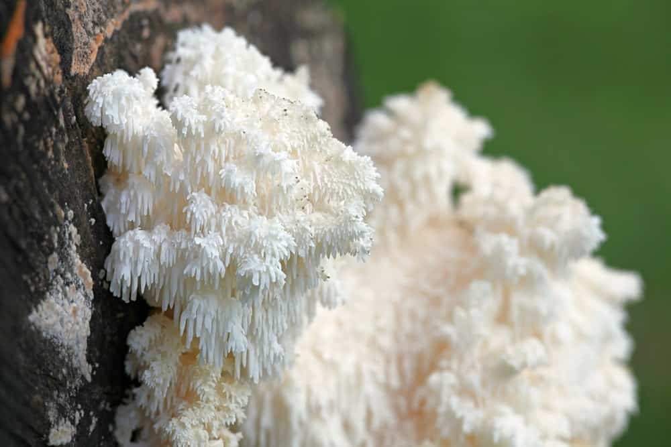

BENEFICIAL PROPERTIES
LIONS MANE IS THE KING OF THE MUSHROOMS, AS IT IS ONE OF THE ONLY ORGANISMS ON THE ENTIRE PLANET THAT IS NEUROGENIC. WHEN HUMANS INGEST LIONS MANE MUSHROOM, THE BRAIN ACTUALLY GROWS NEW BRAIN CELLS THAT RESULT IN SYNAPTIC CONNECTIONS. THIS IS AN UNHEARD-OF OCCURRENCE, SEEING AS THE VERY CONCEPT OF AGING IS THE FACT THAT NEW CELLS ARE CREATED SLOWER AND SLOWER, WITHOUT ANY WAY TO STOP IT.
Bottom of Form
THE LIONS MANE IS FILLED WITH ANTIOXIDANTS, THIS IS SOMETHING THAT IS ESSENTIAL IN FIGHTING INFLAMMATION AND OXIDATION IN THE HUMAN BODY. THIS TARGETS ISSUES LIKE AUTOIMMUNE DISORDERS, HEART DISEASE, AND DIABETES. MORE AND MORE STUDIES ARE BEING DONE IN RELATION TO THE LIONS MANE MUSHROOM AND COMBATTING ALZHEIMER’S.
GET TO KNOW THE LIONS MANE AND WHY IT’S THE KING OF THE MUSHROOMS.

THE TURKEY TAIL MUSHROOM – KING OF IMMUNITY
TRAMETES VERSICOLOR
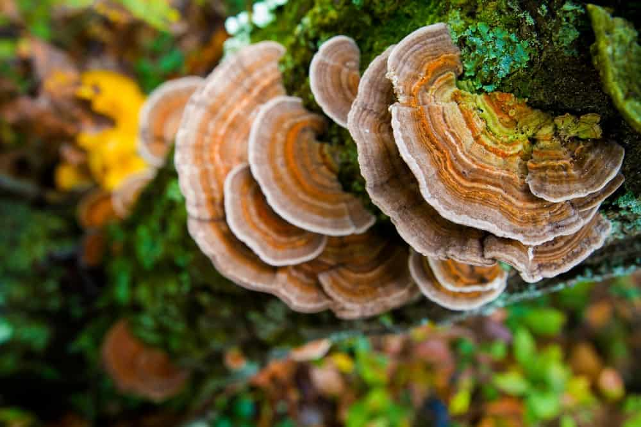

MYCOLOGICAL CHARACTERISTICS
THE TURKEY TAIL IS A POLYPORE, MEANING THAT IT’S A MUSHROOM WITH A LARGE FRUITING BODY WITH PORES ON ITS UNDERSIDE WHERE SPORES ARE RELEASED. IT HAS AN INDISTINCT STRIPE AND IS SAPROTROPHIC (REMEMBER, IT DIGESTS DECAYING MATTER). THE WORD VERSICOLOR MEANS “MANY COLORS”, HENCE WHERE THE SCIENTIFIC TERM COMES FROM.
THE MUSHROOM ITSELF HAS A QUITE LEATHERY AND FIRM TEXTURE. A FLAT CAP WITH TILED LAYERS MAKES FOR QUITE A STUNNING FUNGUS.
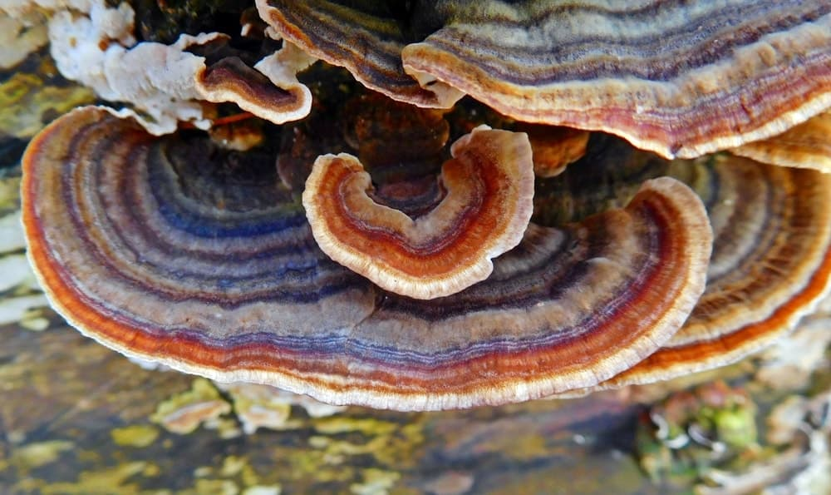

BENEFICIAL PROPERTIES
MUCH LIKE LIONS MANE, THE TURKEY TAIL MUSHROOM IS ALSO PACKED WITH ANTIOXIDANTS. IT SEEMS THAT MUCH OF HUMAN ILLNESS COMES FROM THE STRESS THAT AFFECTS OUR INSIDES. ANTIOXIDANTS HELP REMEDY PHYSICAL STRESS AND COMBAT UNSTABLE MOLECULES (THAT CAN BE CANCER-CAUSING).
IT IS NOT UNCOMMON FOR TURKEY TAIL AND ANTI-CARCINOGENIC TO BE PUT IN THE SAME SENTENCE. THIS IS BECAUSE OF THE TWO PROPERTIES POLYSACCHAROPEPTIDE KRESTIN (PSK) AND POLYSACCHARIDE PEPTIDE (PSP). PSP ENCOURAGES THE GROWTH OF MONOCYTES, WHICH ARE WHITE BLOOD CELLS THAT FIGHT INFECTION. PSK ACTIVATES WHITE BLOOD CELLS THAT PROTECT AGAINST HARMFUL BACTERIA. BOTH OF THESE PROPERTIES EXIST IN THE TURKEY TAIL MUSHROOM.
LEARN ALL ABOUT THE TURKEY TAIL MUSHROOMS HERE.

THE REISHI MUSHROOM – QUEEN OF IMMORTALITY
GENODERMA LINGZHI
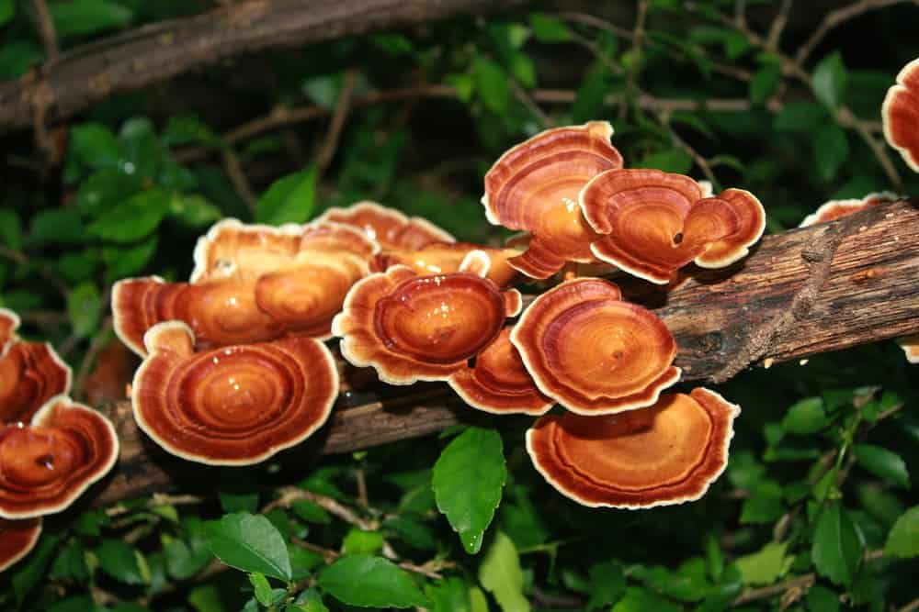

MYCOLOGICAL CHARACTERISTICS
THE REISHI MUSHROOM IS BOTH PARASITIC AND SAPROTROPH. WE ALREADY KNOW WHAT SAPROTROPH MEANS (DIGESTION OF DECAYING MATTER IN CASE YOU FORGOT THE OTHER TWO TIMES I MENTIONED IT), BUT PARASITIC IS WHEN IT FEEDS OFF OF AND EVENTUALLY DESTROYS ANOTHER LIVING ORGANISM.
THE REISHI HAS A KIDNEY-SHAPED CAP WITH A RED VARNISH EFFECT. IT HAS AN INDISTINCT STRIPE, A BROWN SPORE PRINT, AND IS CONSIDERED TO BE EDIBLE, BUT NOT A CHOICE EDIBLE. THIS DOESN’T MEAN IT’S UNSAFE FOR INGESTION, IT SIMPLY MEANS THAT EATING IT ISN’T PARTICULARLY TASTY. THAT’S WHY REISHI IS OFTEN TURNED INTO A POWDER OR TINCTURE.
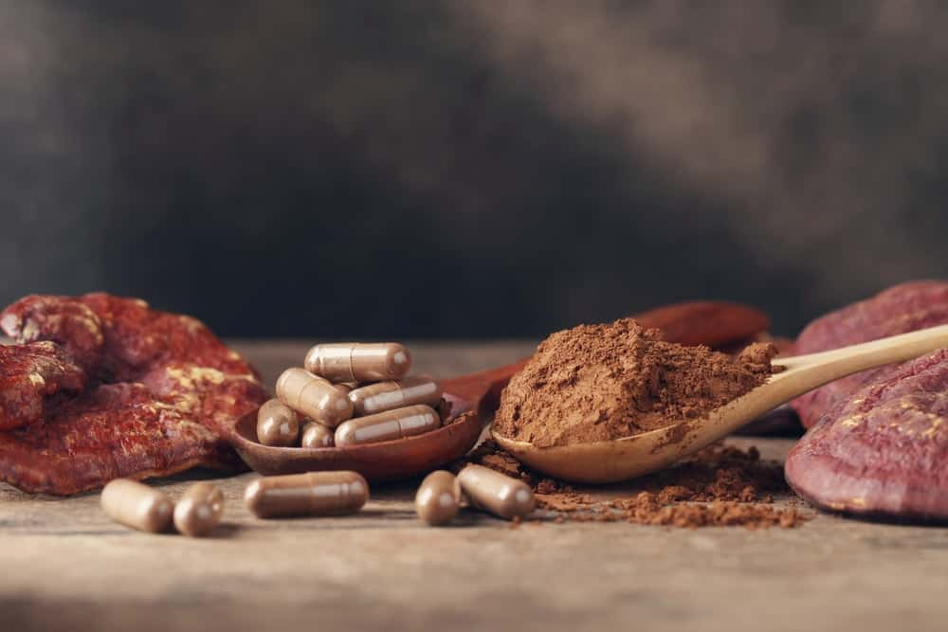

BENEFICIAL PROPERTIES
THE REASON BEING FOR THE NAME “MUSHROOM OF IMMORTALITY” DATES ALL THE WAY BACK TO THE HAN DYNASTY, WHERE THE REISHI MUSHROOM IS DESCRIBED IN A POEM AS BEING INTEGRAL TO QI – LIFE FORCE. ALTHOUGH REISHI HAS BEEN USED IN TRADITIONAL MEDICINE JUST AS LONG AS THE OTHERS, THERE IS A GREAT LACK OF SCIENTIFIC STUDIES DONE WITH THE REISHI MUSHROOM.
IT IS EXPECTED THAT TAKING REISHI SUPPLEMENTS HELPS SUPPORT A HEALTHY SLEEP CYCLE, HELPS THE BODY ADAPT TO STRESS, AND HELPS WITH MENTAL AWARENESS.
FOR THE LACK OF EVIDENTIARY SUPPORT, WE DO KNOW THAT REISHI MUSHROOMS ARE PACKED WITH MINERALS, VITAMINS, AMINO ACIDS, AND OTHER DIETARY FIBERS.
FIND OUT MORE ABOUT THE REISHI MUSHROOM OF IMMORTALITY HERE.

THE CHAGA MUSHROOM – PRINCESS OF SUPERFOOD
INONOTUS OBLIQUES
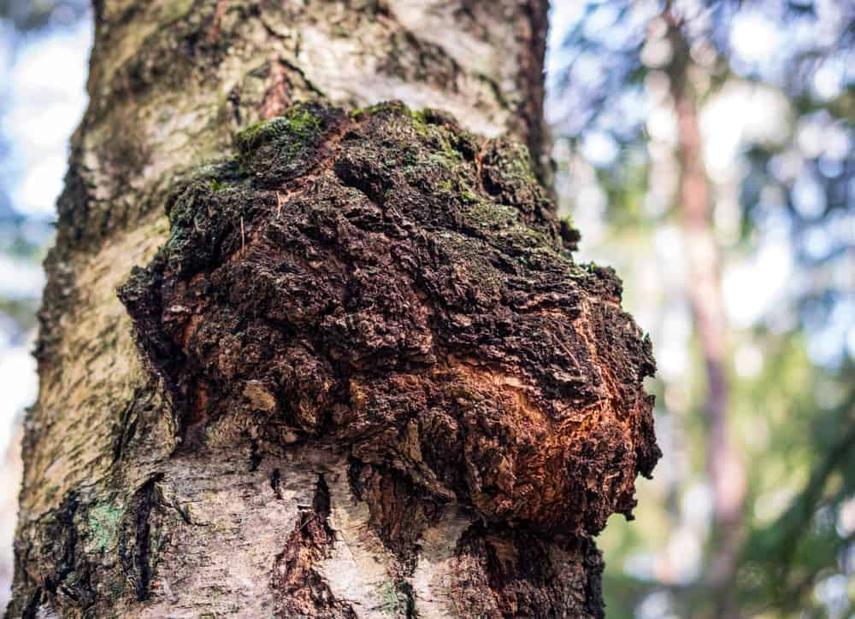

MYCOLOGICAL CHARACTERISTICS
THE CHAGA MUSHROOM IS A PARASITIC MUSHROOM. IT POSSES NO DISTINCT CAP OR STIPE, AND IF YOU WALKED BY IT YOU WOULD HAVE NO CLUE THAT IT WAS A MUSHROOM. WHAT IS SEEN OF A CHAGA MUSHROOM IS ACTUALLY ITS MYCELIUM (REMEMBER, THAT CRAZY ROOT SYSTEM?). IT RESEMBLES A STRANGE INKY, GOOEY MASS. IT’S BLACK IN COLOR BECAUSE IT CONTAINS ENORMOUS AMOUNTS OF MELANIN, WHICH WE KNOW TO BE WHAT PRODUCES PIGMENT IN LIVING ORGANISMS.
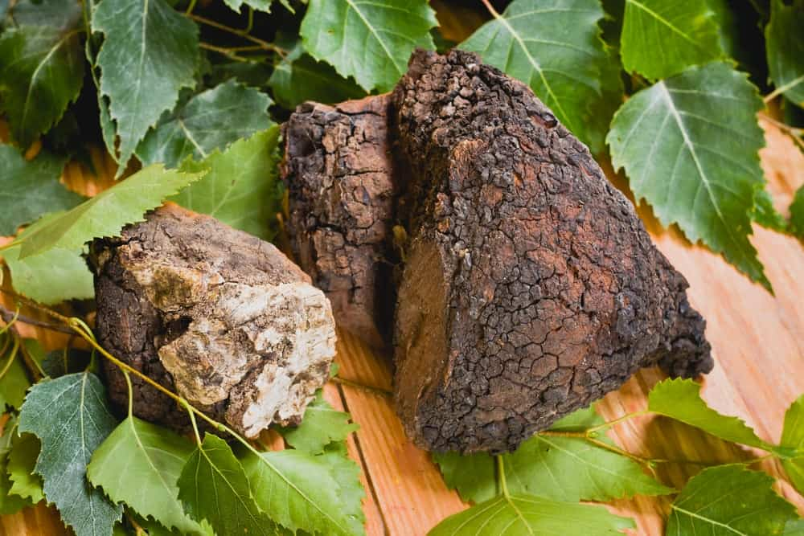

BENEFICIAL PROPERTIES
THE REASON WHY THE CHAGA MUSHROOM IS CONSIDERED A SUPERFOOD IS BECAUSE OF THE BONKERS LIST OF HEALTHY THINGS THAT EXIST INSIDE IT. ARE YOU READY FOR THIS?
- AMINO ACIDS
- B-COMPLEX
- CALCIUM
- CESIUM
- COPPER
- VITAMIN D
- IRON
- FIBER
- MAGNESIUM
- MANGANESE
- POTASSIUM
- RUBIDIUM
- SELENIUM
- ZINC
CHAGA IS ALSO RIDDLED WITH ANTIOXIDANTS, WHICH HELP WITH OXIDATIVE STRESS. THIS IS IMPORTANT IN TRYING TO PREVENT PHYSICAL SIGNS OF AGING. CHAGA MUSHROOMS REGULATE THE PRODUCTION OF CYTOKINES WHICH ARE THE IMMUNE SYSTEMS, CHEMICAL MESSENGERS. THIS MEANS THAT CELLS IN THE BODY ARE BETTER AT COMMUNICATING WITH ONE ANOTHER AND ARE QUICK TO RESPOND.
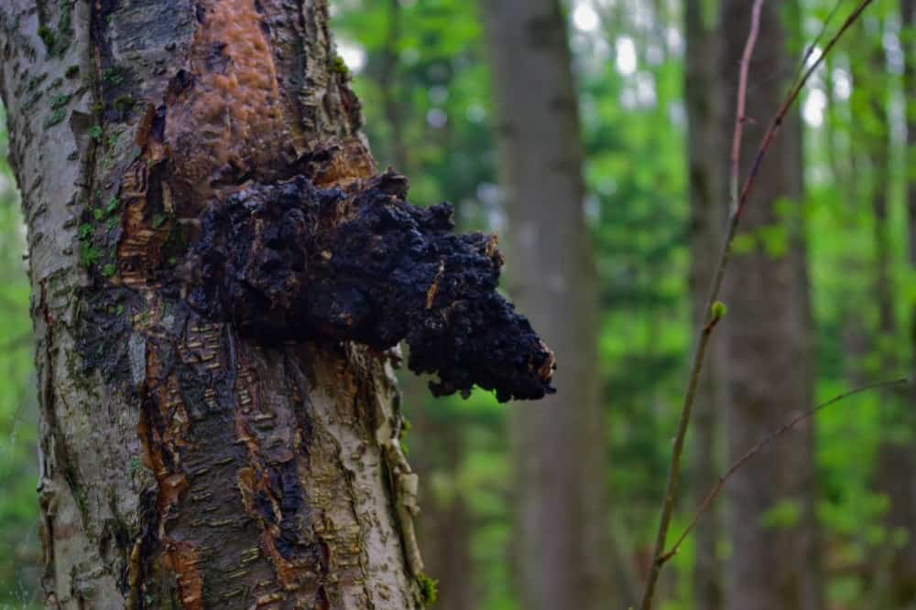
ALSO FOUND IN CHAGA MUSHROOMS IS SOMETHING CALLED TRITERPENES, AND THESE ARE COMPOUNDS THAT CAUSE CELLS TO LITERALLY SELF DESTRUCT. THIS IS WHAT WE WANT IN A CANCER TREATMENT HONESTLY, SINCE SO MANY OF THE ONES WE HAVE NOW ALSO HARM HEALTHY CELLS.
DISCOVER MORE ABOUT THE CHAGA MUSHROOMS HERE.

THE CORDYCEPS MUSHROOM – PRINCE OF PHYSICAL ENERGY
CORDYCEPS MILITARIS


MYCOLOGICAL CHARACTERISTICS
WOO! THIS IS AN ESPECIALLY INTERESTING ONE. THE CORDYCEPS MUSHROOM IS ENTOMOPATHOGENIC, MEANING THAT IS IT PARASITIC ON INSECTS AND ARTHROPODS. BUCKLE UP KIDS, THIS IS WEIRD:

WHEN A CORDYCEPS MUSHROOM ATTACKS ITS HOST, IT DOES SO BY SPREADING SPORES. WHEN SPORES LAND ON AN INSECT, THE SPORE GERMINATES. THREADS OF MYCELIUM INVADE THE BODY OF THE HOST AND REPLACE THE ENTIRE INNER TISSUE WITH MYCELIUM. EVENTUALLY, THE FRUITING BODY LITERALLY STABS ITS WAY OUT OF THE HOST’S HEAD.
THE CORDYCEPS MUSHROOM LOOKS LIKE ORANGE FINGERS POKING OUT OF THE GROUND, AND IS ANOTHER OF ONE OF THOSE WEIRD ONES THAT ARE ALMOST UNRECOGNIZABLE AS A MUSHROOM. THIS MUSHROOM IS EXTREMELY RARE, COVETED, AND EXPENSIVE.
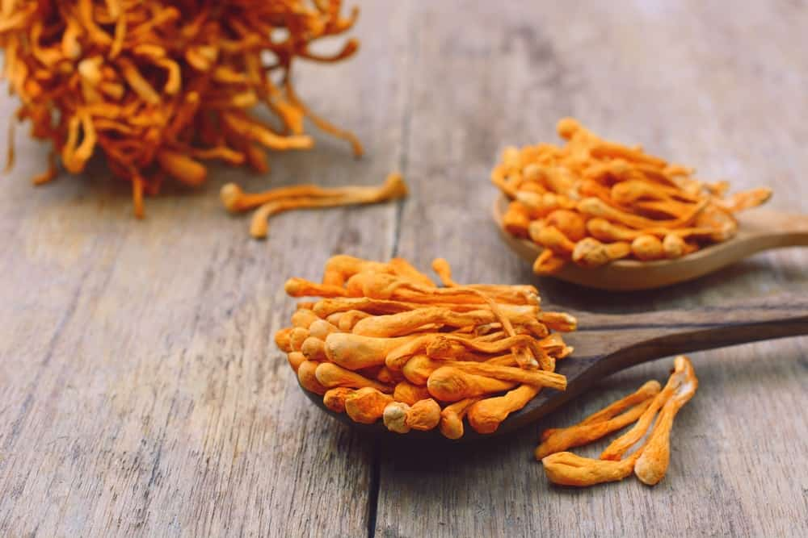

BENEFICIAL PROPERTIES
THIS IS THE MUSHROOM WE’RE TALKING ABOUT WHEN WE REFER TO THE LIBIDO BOOSTER. CORDYCEPS HELPS THE BODY WITH BLOOD FLOW AND OXYGENATING THE BLOOD. THIS HELPS WITH ATHLETIC PERFORMANCE, SPECIFICALLY WITH MUSCLE FATIGUE AND LUNG CAPACITY. HEALTHILY OXYGENATED BODIES PERFORM BETTER. IT DECREASES INFLAMMATION, REGULATES HORMONES, AND COMBATS FREE RADICAL MOLECULES.
FIND OUT MORE ABOUT THE CORDYCEPS MUSHROOMS HERE.

29 DIFFERENT TYPES OF BREAD
GET TO KNOW 29 DIFFERENT TYPES OF BREAD ENJOYED OVER THE WORLD. LEARN THE DISTINGUISHING CHARACTERISTICS OF EACH AND HOW DIFFERENT CULTURES ENJOY THEIR BREADS.
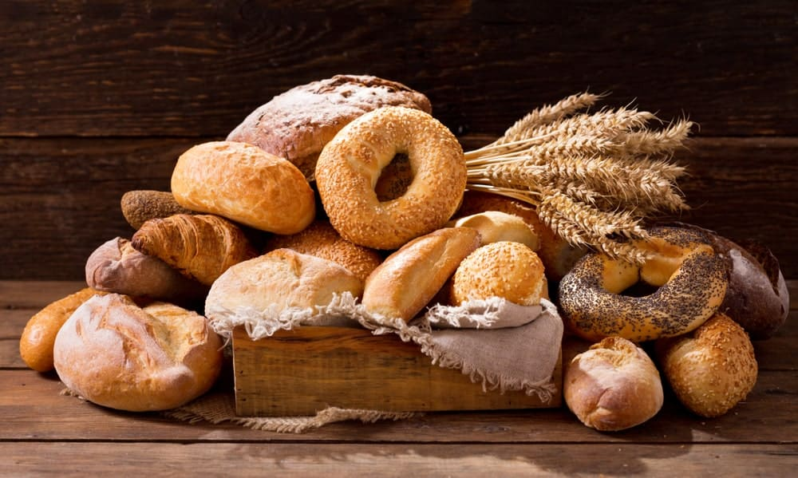
BREAD IS THE MOST WIDELY CONSUMED FOOD IN THE WORLD AND HAS BEEN A STAPLE FOOD SINCE THE EARLIEST YEARS OF HUMAN HISTORY. THERE’S EVIDENCE FROM 30,000 YEARS AGO IN EUROPE THAT EARLY MAN USED STARCH EXTRACTS, POSSIBLY SOURCED FROM THE ROOTS OF CATTAILS AND/OR FERNS, TO MAKE FLATBREAD. AND EVEN NOW IN THE TWENTY-FIRST CENTURY, MANY PEOPLE KNOW THAT THERE IS NOTHING QUITE LIKE THE SCENT OF FRESH BREAD, ESPECIALLY WHEN WALKING INTO A BAKERY FIRST THING IN THE MORNING.
IT WAS AROUND 10,000 B.C. THAT NEOLITHIC MAN DEVELOPED AGRICULTURE AND THEN USED THE GRAINS HE’D GROWN AND CULTIVATED FOR MAKING HIS BREAD. LATER IN THE DEVELOPMENT OF CIVILIZATIONS AND AFTER IMPROVEMENTS IN BREADMAKING, THE ANCIENT EGYPTIANS USED YEAST AS A LEAVENING AGENT AS EARLY AS 4,000 B.C. THE GREEKS PICKED UP BREADMAKING FROM THE EGYPTIANS, AND SOON THE PRACTICE SPREAD ACROSS EUROPE.
ALONG WITH THE WHEAT USED TO MAKE IT, BREAD WAS CONSIDERED MORE IMPORTANT THAN MEAT IN THE DIET AMONG THE ANCIENT ROMANS. THE COLOR OF BREAD CONSUMED ALSO INDICATED ONE’S SOCIAL STANDING. GENERALLY, THE DARKER THE BREADS EATEN, THE LOWER THE SOCIAL STANDING OF THOSE EATING IT WAS.
RELATED: HONEY WHOLE WHEAT BREAD RECIPE | FRENCH BREAD RECIPE | TYPES OF CORNBREAD | QUARANTINE AGE BREAD MAKING | HOW TO STORE CORNBREAD | TYPES OF BREAD BOXES | TYPES OF BREAD MACHINES

THE MOST COMMON TYPES OF BREADS

BAGUETTE

A BAGUETTE IS A YEAST BREAD THAT ORIGINATED IN FRANCE. THIS BREAD HAS A CHARACTERISTIC LONG, OBLONG SHAPE WITH SLITS IN IT. THESE SLITS ALLOW FOR THE EXPANSION OF GAS WHILE THE BREAD IS BAKING. ALSO CALLED FRENCH BREAD OR FRENCH STICKS, BAGUETTES ARE TYPICALLY MADE FROM FLOUR, WATER, YEAST, AND SALT, AND THEIR LOOK IS EASILY RECOGNIZABLE TO BREAD LOVERS ALL OVER THE WORLD.

BRIOCHE BREAD

A FRENCH BREAD MADE WITH BUTTER AND EGGS, BRIOCHE IS EXTREMELY LIGHT IN TEXTURE AND HAS A SUBTLE SWEETNESS IN ITS FLAVOR. BRIOCHE CRUST IS SOFT, APPEARING TO HAVE A GOLDEN-YELLOW SHADE. THIS GORGEOUS GOLDEN COLOR CAN BE ATTRIBUTED TO THE EGG THAT IS BRUSHED ON TOP OF THE DOUGH BEFORE THE BREAD IS PLACED IN AN OVEN TO BAKE. BRIOCHE BREAD IS A PERFECT BREAD CHOICE, ESPECIALLY WHEN MAKING DELICIOUS TREATS LIKE FRENCH TOAST. IF YOU’VE NEVER TASTED THIS TYPE OF BREAD BEFORE, THERE IS NO BETTER TIME THAN RIGHT NOW TO GRAB A LOAF OF SOFT, SLIGHTLY SWEET BRIOCHE.

CIABATTA BREAD
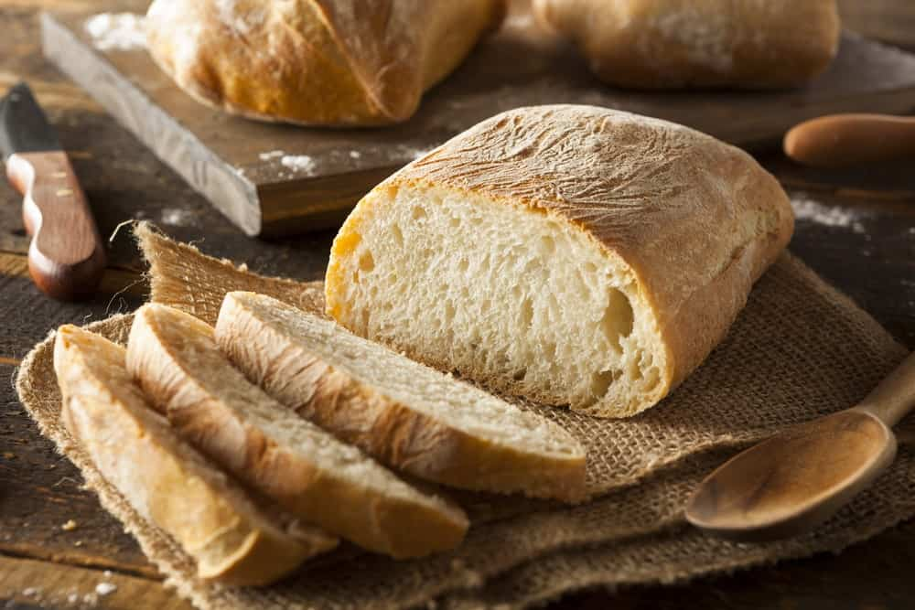
“CIABATTA” IS THE ITALIAN WORD FOR “SLIPPER.” THIS ITALIAN-INVENTED BREAD IS MADE FROM A FEW BASIC INGREDIENTS, WHICH INCLUDE WATER, SALT, YEAST, AND WHEAT FLOUR. DEPENDING ON WHERE IN ITALY YOU ARE EATING CIABATTA BREAD, ITS CRUST AND EVEN ITS TEXTURE CAN VARY. HOWEVER, THE MAIN INGREDIENTS IN MAKING CIABATTA BREAD ARE THE EXACT SAME IN EVERY LOAF. CIABATTA IS PERFECT FOR USE IN MAKING PANINIS AND SANDWICHES, AS WELL AS MANY OTHER DISHES, AND HAS A CHEWY CRUST AND SOFT INTERIOR.

FOCACCIA BREAD
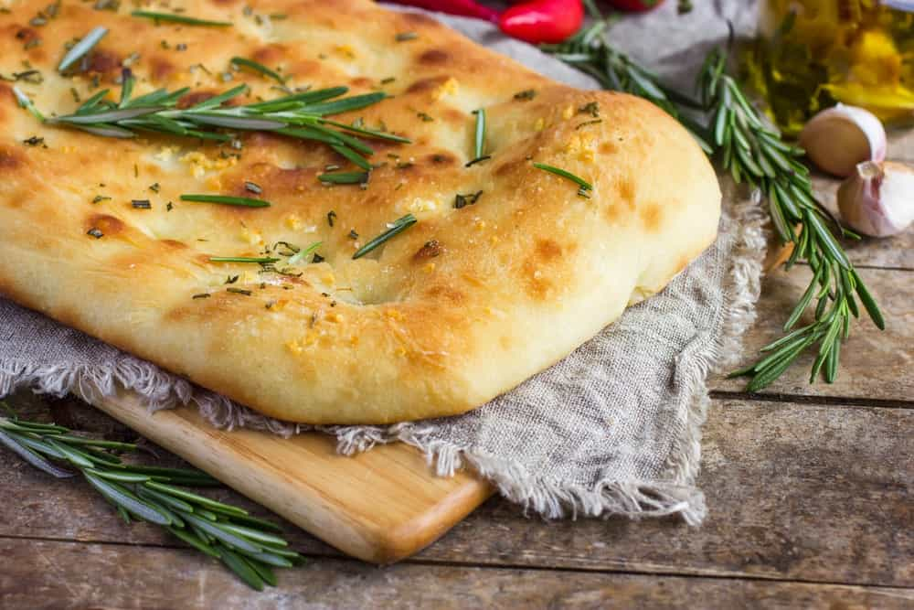
THIS TYPE OF BREAD ALSO ORIGINATED IN ITALY. FOCACCIA BREAD IS USUALLY PLACED IN A BAKING PAN SO THAT IT RESULTS IN A FLAT LOAF. FOCACCIA DOUGH IS QUITE SIMILAR TO PIZZA DOUGH, AND IS USUALLY COATED WITH OLIVE OIL BEFORE BAKING. THE CRUST OF FOCACCIA BREAD COMES OUT CRUNCHY, YET DELICATE AND THIN. MANY BAKERS ADD HERBS AND GARLIC TO THE RECIPE AS DESIRED, AND SEA SALT IS ANOTHER POPULAR ADDITION. FOCACCIA BREAD CAN BE EATEN BY ITSELF, DIPPED IN SOUP, OR USED TO CLEAN A PLATE OF LEFTOVER SAUCE.

MULTIGRAIN BREAD
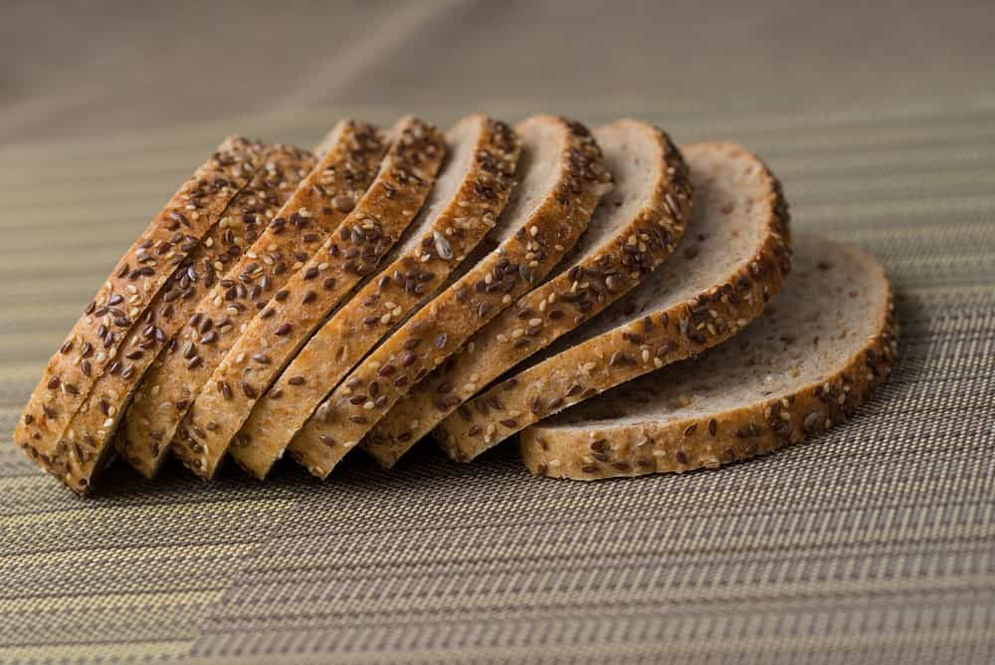
WITH ITS RICH, HEARTY FLAVOR, MULTIGRAIN BREAD USUALLY USES GRAINS SUCH AS OATS, BARLEY, FLAX, AND MILLET, AS WELL AS OTHERS. THE USE OF THESE DIFFERENT INGREDIENTS MAKES MULTIGRAIN BREAD AN EXTREMELY HEALTHY AND DELICIOUS BREAD CHOICE. MULTIGRAIN BREAD IS PERFECT FOR USE IN MORNING TOAST, SANDWICHES, OR TO DIP IN DRESSINGS OR VEGETABLE OIL THAT HAS BEEN SPRINKLED WITH HERBS.

PITA BREAD
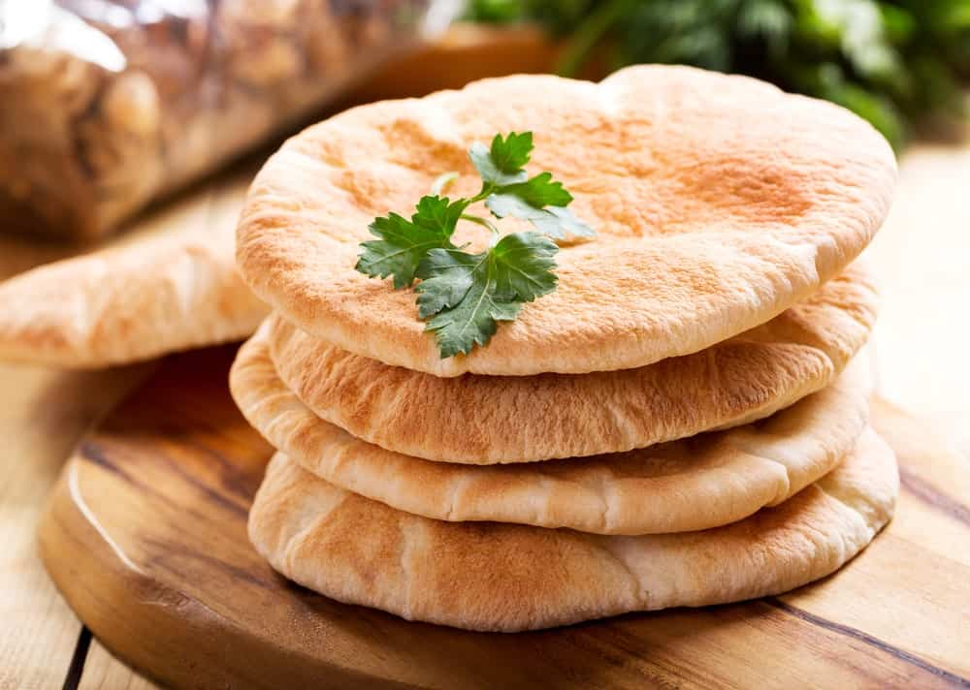
Bottom of Form
THERE ARE A LOT OF THINGS MUNCHERS CAN DO WHEN EATING A PIECE OF PITA BREAD. THIS INCLUDES DIPPING THE PITA INTO SAUCES AFTER IT IS CUT IT INTO WEDGES, OR FILLING IT WITH VARIOUS TYPES OF MEATS FOR A TASTY AND DELICIOUS SANDWICH. PITA BREAD ORIGINATED IN THE MIDDLE EAST AND IS COOKED AT VERY HIGH TEMPERATURES, WHICH MAKES THE LIQUID IN THE DOUGH ESCAPE QUICKLY. THIS HELPS TO CREATE A LARGE AIR BUBBLE IN THE CENTER – THE “POCKET” OF THE BREAD – PERFECT FOR STUFFING WITH MEAT AND OTHER FOODS. PITA BREAD IS MADE MOSTLY USING WHEAT FLOUR.

RYE BREAD
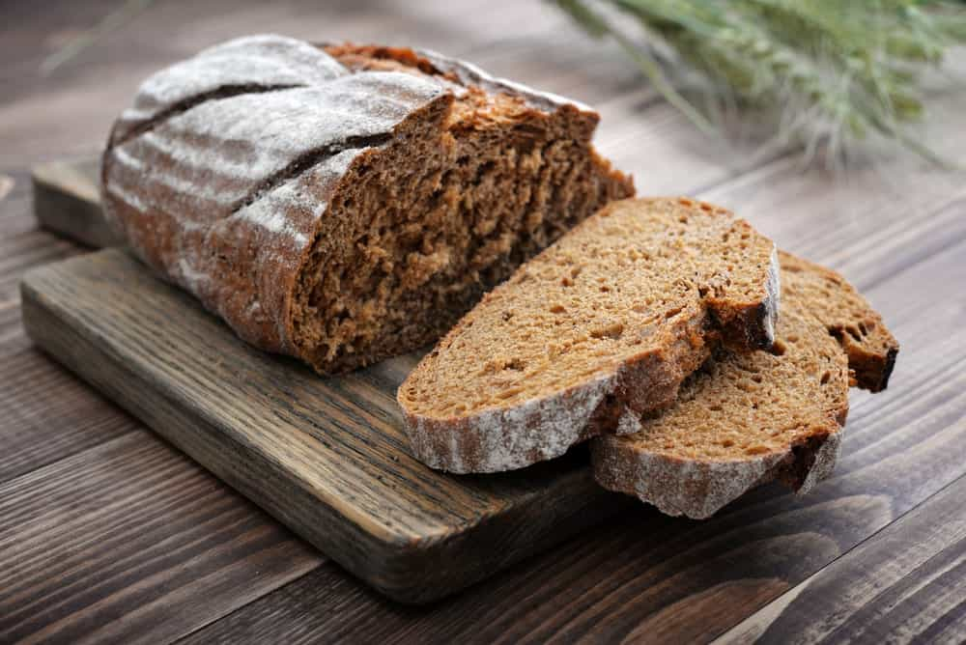
LONG CONSIDERED TO BE THE BREAD OF THE LOWER CLASS, RYE HAS GAINED A SURGE IN POPULARITY, LIKELY DUE TO ITS RICH FLAVOR. MADE WITH BOTH RYE FLOUR AND REGULAR BREAD FLOUR, RYE BREAD HAS A TIGHT CRUMB AND A VERY STRONG FLAVOR. SOME BAKERS EVEN ADD CARAWAY SEEDS OR DILL SEEDS SO THAT THE RYE BREAD FLAVOR IS A LITTLE MORE EARTHY. IN CERTAIN SANDWICHES – MOST NOTABLY, CORNED-BEEF AND PASTRAMI SANDWICHES – RYE BREAD IS WHAT GIVES THE SANDWICH THE SIGNATURE TASTE THAT PEOPLE LOVE ABOUT THEM. ADDING A TOUCH OF MUSTARD ON A SLICE OF BREAD USED IN THESE SANDWICHES CAN HELP ACCENT THE FLAVORS OF THE BREAD AND MEATS, AS WELL.

SOURDOUGH BREAD
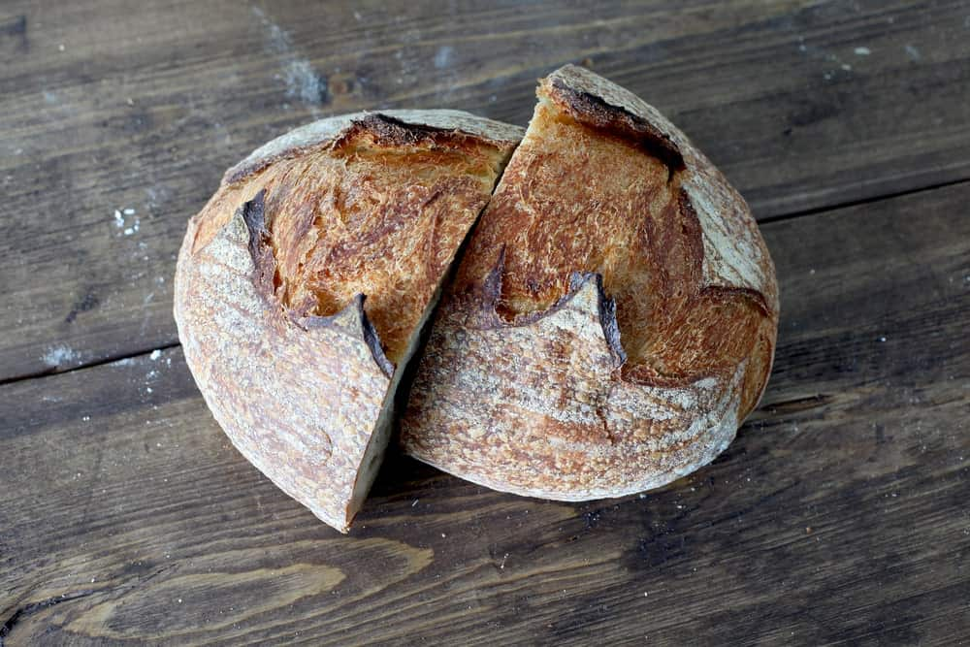
IN A LOAF OF SOURDOUGH BREAD, A STARTER IS USED BEFORE MAKING THE DOUGH TO CREATE THE BASIS FOR THE DOUGH. THE SOURDOUGH STARTER USUALLY CONSISTS OF A FERMENTED COMBINATION OF WATER AND FLOUR, WHICH IN TURN CAN MAKE MANY BATCHES OF BREAD. ANOTHER ADVANTAGE OF THIS TYPE OF BREAD IS THAT THE SOURDOUGH STARTER CAN LAST A LONG TIME. THE LENGTH OF THE LIFE OF A SOURDOUGH STARTER MEANS THAT BAKERS CAN MAKE LOAF AFTER LOAF OF SOURDOUGH BREAD WITHOUT WORRYING ABOUT RUNNING OUT OF THE STARTER.
SOURDOUGH BREAD HAS A THICK CRUST AND A SOFT CHEWY CENTER, AND IS DOTTED WITH VERY LARGE AIR BUBBLES INSIDE. IT ALSO HAS A DISTINCT TASTE THAT CAN BE ALMOST ADDICTING. SOURDOUGH BREAD CAN BE USED TO MAKE ANY TYPE OF SANDWICH FOR A MILD AND DELICIOUS BREAD OPTION.

WHOLE WHEAT BREAD
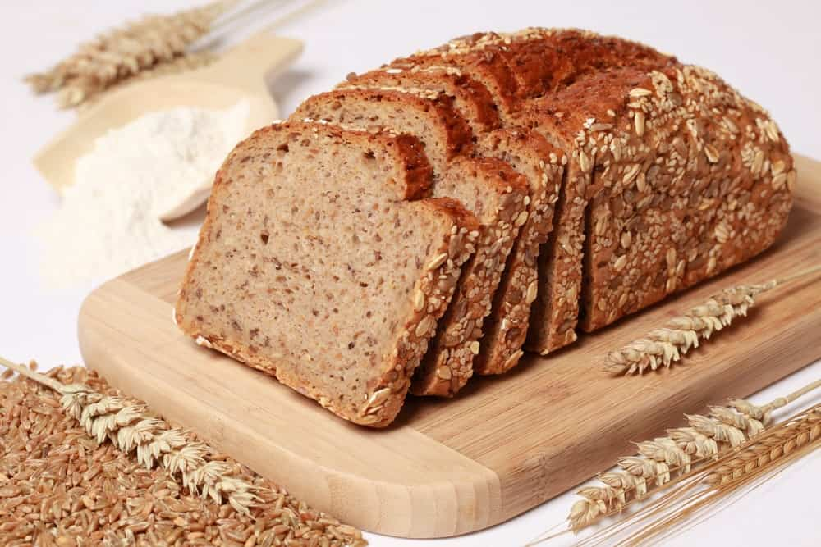
IN MAKING WHITE BREAD, ONLY PARTS OF THE WHEAT GRAIN ARE USED. HOWEVER, WHEN IT COMES TO WHOLE WHEAT BREAD THE GERM AND THE BRAN ARE INTACT. WHAT DOES THIS MEAN FOR THOSE EATING THIS BREAD? IT MEANS WHOLE WHEAT BREAD IS MORE NUTRITIOUS AND HAS MUCH MORE FIBER THAN WHITE BREAD DOES. WHOLE WHEAT BREAD CAN BE USED IN MAKING ANY TYPE OF SANDWICH WHERE WHITE BREAD WOULD TYPICALLY BE USED. IT’S EASY TO CREATE ONE’S OWN WHOLE WHEAT BREAD RECIPES WITH A LITTLE CREATIVITY.

UNIQUE TYPES AND SPECIALTY BREADS

AREPA BREAD

MOSTLY EATEN IN COLOMBIA AND VENEZUELA, AREPA BREAD IS MADE FROM CORNMEAL. THIS FLAT AND ROUND BREAK CAN BE BAKED, GRILLED, OR FRIED. BAKERS CAN EVEN INCLUDE VARIOUS FILLINGS SUCH AS GROUND BEEF AND BLACK BEANS WHEN MAKING THIS BREAD. SINCE AREPA IS NOT MADE WITH WHEAT, IT IS NATURALLY GLUTEN-FREE, MAKING AREPA BREAD AN EXCELLENT CHOICE FOR THOSE WITH CELIAC DISEASE OR WHO ARE GLUTEN-SENSITIVE.

BAGELS

BAGELS ARE USUALLY MADE BY BOILING THE DOUGH IN WATER FOR A SHORT TIME THEN BAKING IT AFTERWARD. THEY ARE ROUND AND COME IN TWO PARTS, WITH A HOLE IN THE CENTER. THE BEST THING ABOUT BAGELS IS THEIR NUMEROUS TYPES AND FLAVORS. SOME FLAVORS INCLUDE EGG, CINNAMON, AND BLUEBERRY, AMONG OTHERS. TRY EATING A BAGEL IN A TRADITIONAL WAY, ADDING SALMON OR CREAM CHEESE, OR BOTH, AND IMMEDIATELY FALL IN LOVE.

CHAPATI BREAD
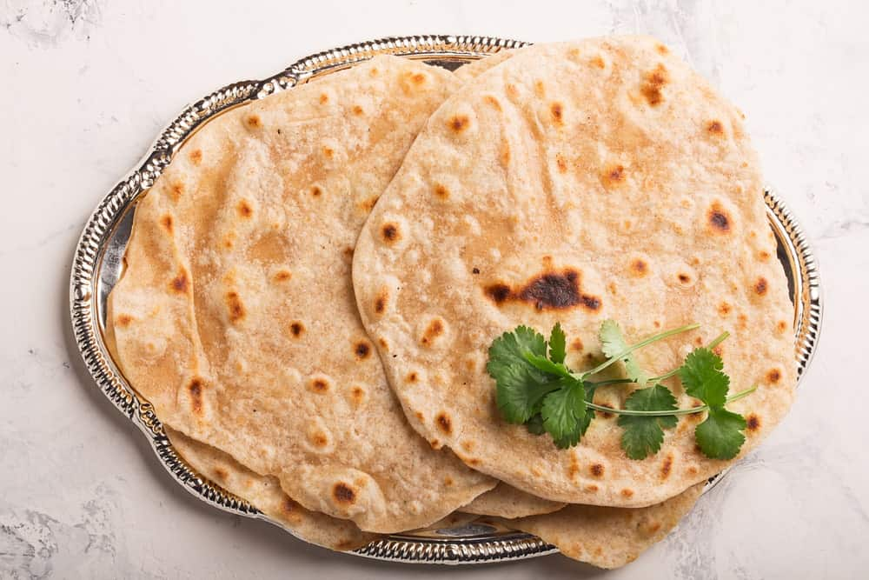
A POPULAR INDIAN FLATBREAD, CHAPATI BREAD IS USUALLY GRILLED UNTIL IT GAINS A FRECKLED APPEARANCE. YOU CAN EAT THIS TYPE OF BREAD WITH VEGETABLES OR LENTILS, OR EVEN MAKE A SANDWICH WITH IT. CHAPATI BREAD IS USUALLY MADE WITH WHOLE-WHEAT FLOUR AND COOKED WITH NO OIL. SNACKERS CAN EVEN ADD A LITTLE BUTTER TO CHAPATI BREAD TO MAKE IT A TOUCH MORE FLAVORFUL.

DAMPER BREAD
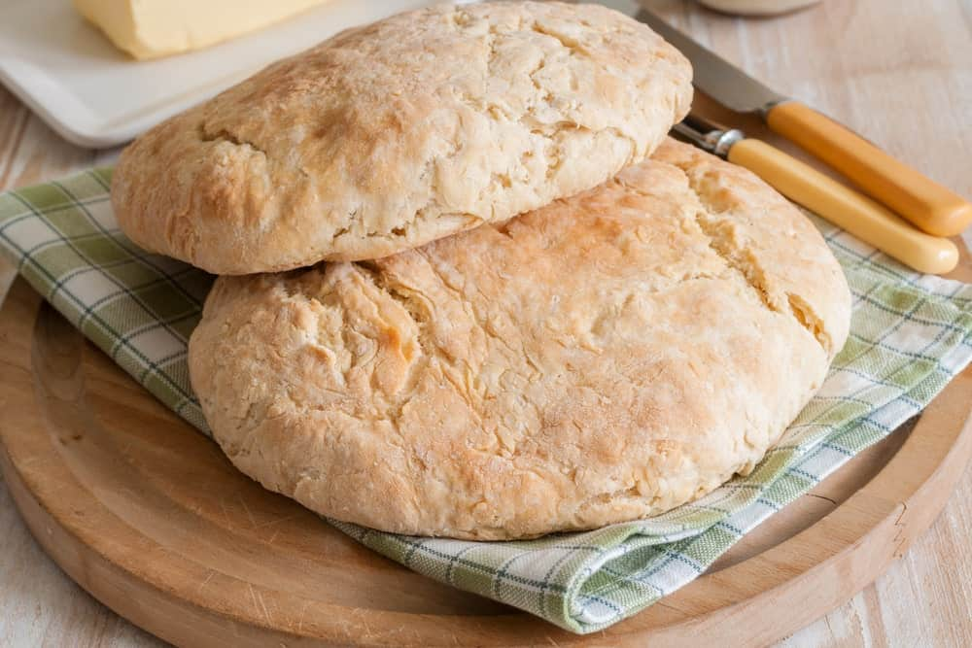
ORIGINATING IN AUSTRALIA, THIS TYPE OF BREAD CONSISTS OF FLOUR, WATER, SALT, AND SOMETIMES MILK. DAMPER BREAD IS USUALLY EATEN ALONGSIDE STEW OR MEAT. AT ONE TIME, DAMPER BREAD WAS COOKED OVER AN OPEN CAMPFIRE. THIS TYPE OF BREAD IS TASTY AND VERSATILE. ADD BAKING SODA TO THE DOUGH AS LEAVENING, IF YOU SO DESIRE.

ENGLISH MUFFINS
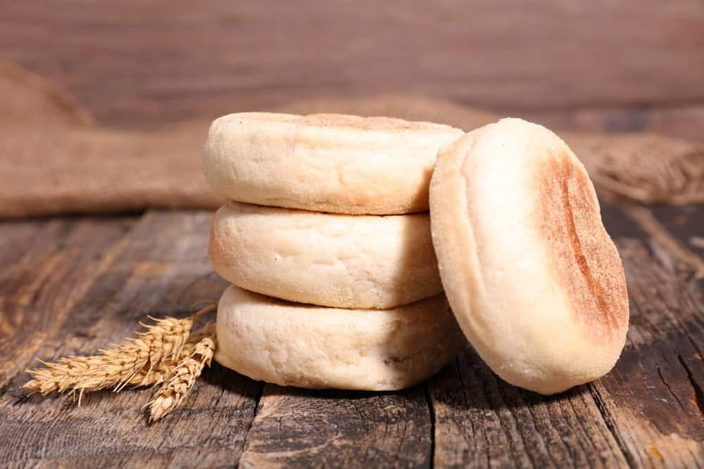
THESE ARE SMALL, ROUND, FLAT TYPES OF BREAD THAT CAN BE MADE FROM EITHER WHITE OR WHOLE WHEAT FLOUR. YOU CAN EAT ENGLISH MUFFINS WITH POACHED EGGS, BACON, OR A HOLLANDAISE SAUCE. MORE OFTEN THAN NOT, ENGLISH MUFFINS ARE HEALTHIER THAN MANY OTHER OPTIONS, LIKE MUFFINS OR BREAD. HOWEVER, THE AMERICAN VERSION OF THE ENGLISH MUFFIN IS SLIGHTLY DIFFERENT FROM THE ORIGINAL ENGLISH MUFFINS, SO A LITTLE RESEARCH MIGHT BE IN ORDER WHEN BAKING THESE BREAKFAST TREATS.

GRISSINI BREAD

SOMEWHAT SIMILAR TO BREADSTICKS, GRISSINI IS A CRISP, DRY BREAD THAT APPEARS AS THIN STICKS THAT RESEMBLE A PENCIL. NATIVE TO ITALY, THIS TYPE OF BREAD CAN BE FLAVORED IN ANY WAY THAT THE BAKER WANTS. SO, FEEL FREE TO ADD HERBS AND SPICES OF ANY TYPE TO LIVEN UP ITS FLAVOR. GRISSINI BREAD IS MOSTLY USED AS A BEFORE-DINNER ALTERNATIVE TO REGULAR OR GARLIC BREAD, BUT IT CAN BE EATEN ANY WAY YOU WISH, AS WELL.

INJERA BREAD
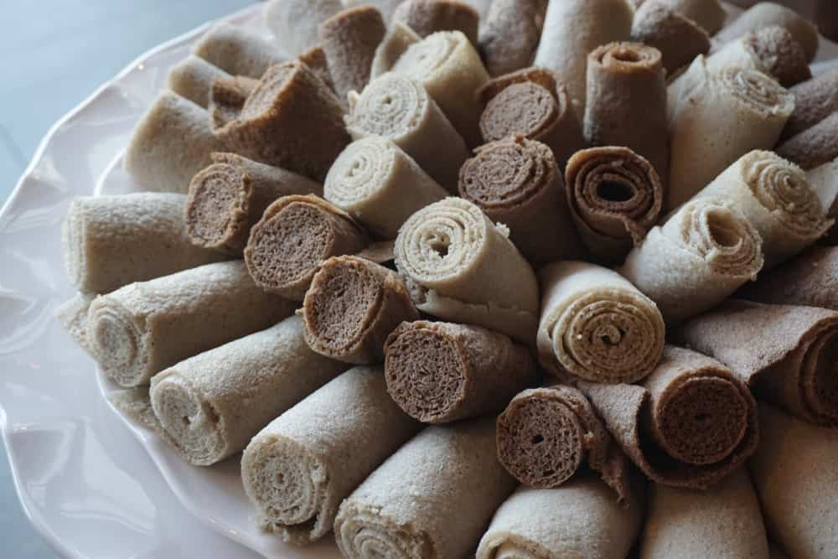
THIS IS A SOURDOUGH TYPE OF BREAD WITH A SPONGY TEXTURE AND A SLIGHTLY SOUR TASTE. INJERA BREAD IS TYPICALLY MADE FROM A TINY GRAIN CALLED TEFF, WHICH COMES FROM ETHIOPIA. INJERA BREAD IS USED TO SCOOP UP THE MEATS AND STEWS THAT ARE NORMALLY PLACED ON TOP OF IT, AND THAT ARE ESSENTIAL AND TYPICAL PARTS OF THE ETHIOPIAN DIET.

KNÄCKEBRÖD BREAD
THIS BREAD LOOKS MORE LIKE A CRACKER THAN THE TRADITIONAL APPEARANCE OF BREAD, AND IT IS MADE MOSTLY OF RYE FLOUR. KNACKEBROD CONTAINS A LOT OF FIBER, AND CAN BE SERVED WITH CHEESE OR ANY OTHER TYPE OF FOOD YOU LOVE. THIS TYPE OF BREAD IS DRY AND STIFF, AND APPEARS RECTANGULAR IN SHAPE LIKE MANY CRACKERS. THE GRAINS USED TO MAKE IT CAN VARY. KNACKEBROD CAN ALSO INCLUDE VARIOUS HERBS AND SPICES, AND IT IS BOTH DELICIOUS AND NUTRITIOUS.

LAVASH BREAD
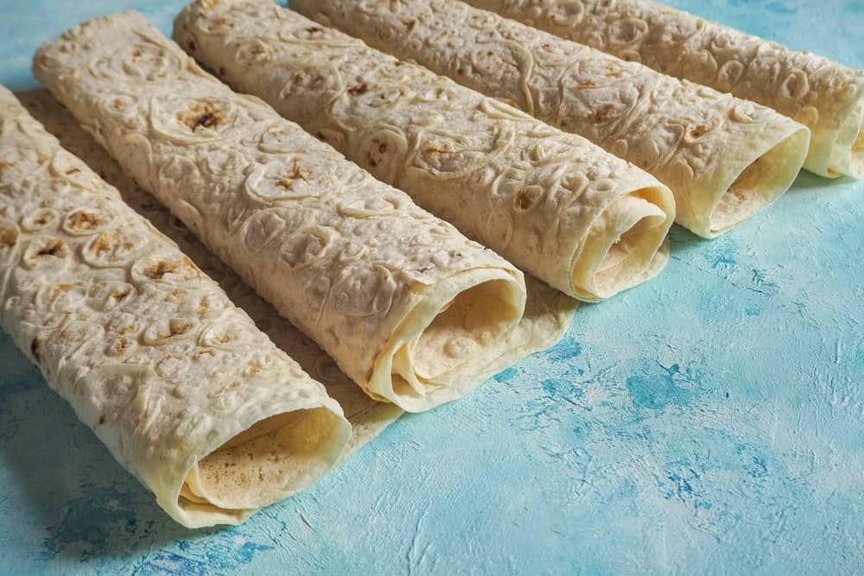
POPULAR IN AREAS SUCH AS TURKEY AND IRAN, LAVASH BREAD IS A THIN FLATBREAD THAT IS MADE ONLY USING FLOUR, SALT, AND WATER. LOW IN FAT, THIS TYPE OF BREAD IS NORMALLY COOKED IN AN OVEN. LAVASH BREAD SOFTEST WHEN IT IS FRESH OUT OF THE OVEN. BAKERS CAN ALSO ADD POPPY OR SESAME SEEDS TO IT FOR A LITTLE MORE FLAVOR.

MATZO (MATZOH) BREAD
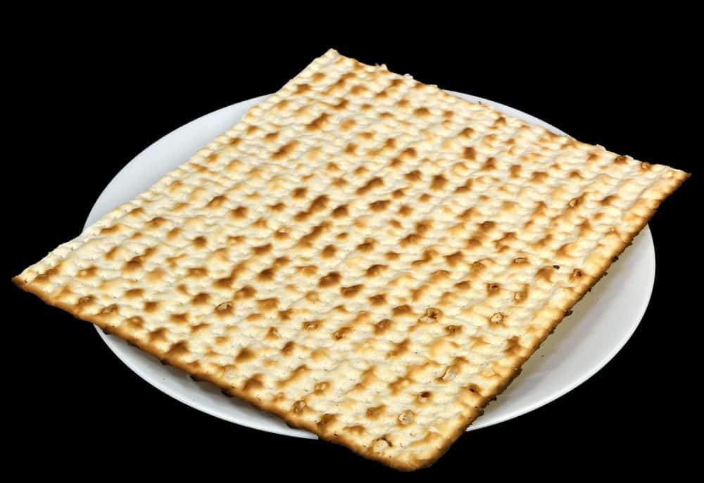
MATZO BREAD IS UNLEAVENED BREAD SHAPED SIMILARLY TO LARGE CRACKERS. USED IN MANY TRADITIONAL JEWISH DISHES AND ON CERTAIN JEWISH HOLIDAYS, THIS BREAD IS MADE OF THE FIVE GRAINS MENTIONED IN THE HEBREW BIBLE – WHEAT, BARLEY, RYE, OATS, AND SPELT. MATZO BREAD CAN COME IN EITHER SOFT OR HARD FORMS. IT IS BOTH TASTY AND INSTRUMENTAL IN JEWISH TRADITIONS AND THE JEWISH FAITH.

NAAN BREAD

NAAN IS AN OVEN-BAKED FLATBREAD THAT USES YOGURT AS ONE OF ITS MAIN INGREDIENTS. IT IS NORMALLY BRUSHED WITH BUTTER BEFORE BAKING, AND SOMETIMES INCLUDES TOPPINGS SUCH AS DRIED FRUIT, MINCED MEAT, AND EVEN GARLIC. NAAN BREADS ARE COMMON IN MANY PARTS OF ASIA. NAAN LOVERS CAN ALSO FIND THIS BREAD TYPE IN MANY OF TODAY’S SUPERMARKETS AND EVEN AT FARMERS’ MARKETS.

OBI NON BREAD

POPULAR IN UZBEK AND AFGHAN DISHES, THIS BREAD IS A TYPE OF FLATBREAD AND IS USUALLY COOKED IN A CLAY OVEN. OBI NON BREAD IS NORMALLY MADE ONLY USING FLOUR, YEAST, SALT, WATER, AND MILK. WE LOVE THE PATTERNS ON IT IN THE PHOTO ABOVE!

PARATHA BREAD

MADE FROM WHOLE-WHEAT FLOUR, PARATHA BREAD IS A LAYERED INDIAN FLATBREAD THAT IS USUALLY FRIED OR COOKED IN OIL. BAKERS CAN ALSO BAKE THEM INSTEAD FOR A LITTLE HEALTHIER ALTERNATIVE. PARATHA BREAD CAN BE MADE AND EATEN WITH VEGETABLES, POTATOES, ONIONS, EGGS, AND MANY OTHER FILLINGS. IT IS ALSO VERY POPULAR IN COUNTRIES LIKE MALAYSIA AND SINGAPORE.

QISTIBI BREAD

THIS TYPE OF BREAD IS FOUND MOSTLY IN RUSSIA AND IS A BAKED FLATBREAD WITH SOME TYPE OF FILLING INSIDE IT. MOST OF THE TIME, THE FILLING CONSISTS OF MASHED POTATOES, MILLET, AND EVEN VARIOUS TYPES OF MEAT. THE FILLING CAN BE PLACED EITHER INSIDE THE BREAD DOUGH ITSELF, OR ON ONE SIDE OF IT WITH THE OTHER SIDE COVERING IT TO KEEP THE FILLING INSIDE.

ROTI BREAD

AN UNLEAVENED FLATBREAD, ROTI BREAD IS SIMILAR TO CHAPATI BREAD. ROTI BREAD IS EXTREMELY POPULAR IN BOTH THE CARIBBEAN AND IN INDIA. ROTI IS USUALLY MADE WITH WHOLE WHEAT FLOUR AND WATER, AND LOAVES ARE OFTEN COATED WITH BUTTER BEFORE BAKING TO ADD A LITTLE FLAVOR. IN MANY CULTURES, ROTI BREAD IS SERVED WITH SPICES AS A HEALTHY SNACK.

SODA BREAD
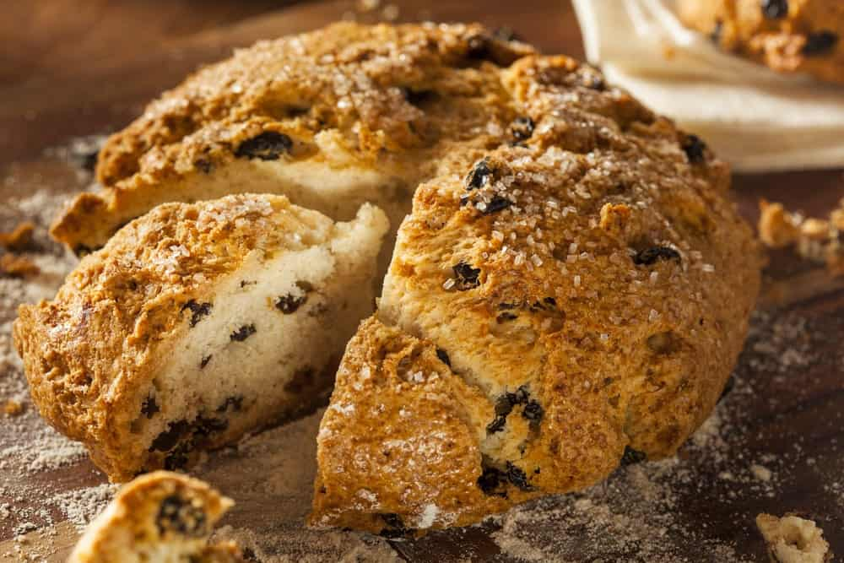
WITH INGREDIENTS THAT INCLUDE BUTTERMILK, SALT, BAKING SODA, AND FLOUR, THIS IS A TRADITIONAL IRISH BREAD. IT IS ALSO KNOWN COMMONLY AS “IRISH SODA BREAD.” SODA BREAD IS A TYPE OF QUICK BREAD THAT DOESN’T NEED TO BE LEFT ALONE FOR A LONG TIME IN ORDER TO RISE. THIS MEANS IT CAN BE MADE QUICKLY AND EASILY – A QUICK BREAD TO MAKE FOR THOSE WHO DON’T HAVE A LOT OF TIME ON THEIR HANDS!

TORTILLA

TORTILLAS ARE SOFT, THIN FLATBREADS USED IN NUMEROUS MEXICAN DISHES, INCLUDING ENCHILADAS, BURRITOS, WRAPS, AND OF COURSE, TACOS. SOME TORTILLAS ARE DEEP FRIED AND SOME ARE NOT, BUT THE GOOD NEWS IS THAT THE RECIPE CAN BE ALTERED IN ORDER TO MAKE THE TORTILLA A TAD HEALTHIER WITHOUT GOING TO TOO MUCH TROUBLE. TORTILLAS ARE AN INCREDIBLY VERSATILE BREAD TYPE, AS THEY CAN BE USED IN ANY NUMBER OF DISHES.

VANOCKA BREAD
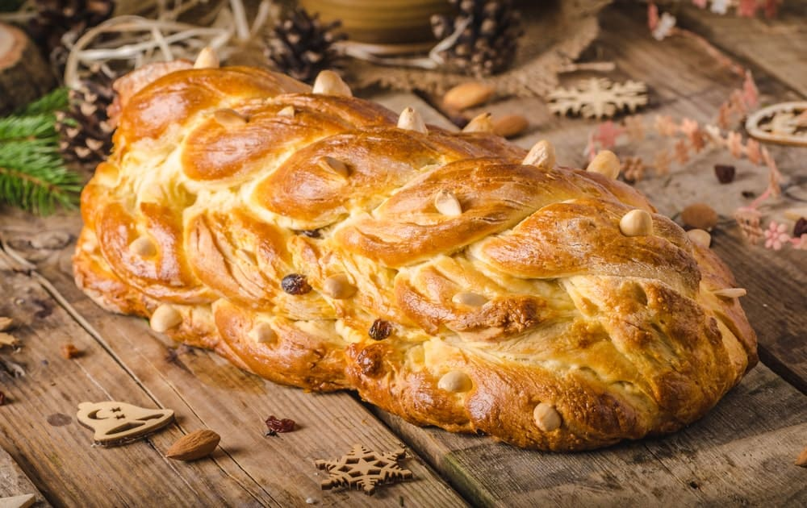
THIS IS A SWEET BREAD THAT IS USUALLY TOPPED WITH SUGAR AND ALMONDS AND SPRINKLED WITH RAISINS OR OTHER DRIED FRUITS. THE RECIPE FOR VANOCKA BREAD IS RATHER COMPLEX, BUT FORTUNATELY, THERE ARE DIFFERENT WAYS TO PREPARE IT. VANOCKA BREAD IS A FESTIVE EUROPEAN BREAD THAT IS SO RICH AND SWEET, IT IS USUALLY BEST TO MAKE IT ONLY FOR SPECIAL OCCASIONS.
IN CERTAIN COUNTRIES – INCLUDING COUNTRIES SUCH AS THE CZECH REPUBLIC AND SLOVAKIA – VANOCKA BREAD IS USUALLY SERVED AROUND CHRISTMASTIME. THERE ARE VARIOUS INTERESTING TRADITIONS SURROUNDING THIS BREAD TYPE, AS WELL. FOR EXAMPLE, ONE TRADITION INVOLVES JUMPING UP AND DOWN WHILE THE DOUGH IS RISING – AS IF BREADMAKING WASN’T LABOR INTENSIVE ENOUGH!

YUFKA BREAD

THIS IS A PAPER-THIN UNLEAVENED BREAD THAT IS ROUND IN SHAPE AND ORIGINATED IN TURKEY. YUFKA BREAD IS SIMILAR TO LAVASH BREAD, AND IS USUALLY MADE FROM INGREDIENTS SUCH AS WHEAT FLOUR, SALT, AND WATER, ALTHOUGH SOME ADD A TAD OF VEGETABLE OIL TO THE DOUGH AS WELL. YOU CAN INCLUDE THIS TYPE OF BREAD IN PASTRIES WITH EITHER SWEET FOODS SUCH AS NUTS OR DRIED FRUITS, OR WITH FOODS SUCH AS MEATS, CHEESES, AND VEGETABLES.

ZOPF BREAD
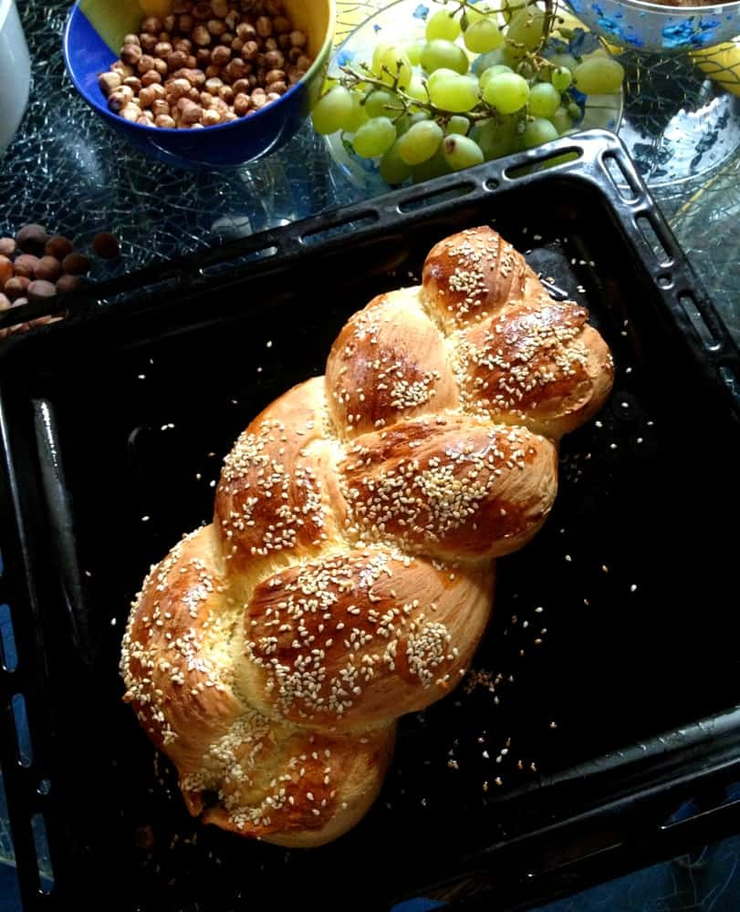
ZOPF BREAD IS A UNIQUE TYPE OF BREAD IN THAT IT LOOKS LIKE A LARGE BRAID ONCE IT’S FINISHED BAKING. IT IS USUALLY SERVED WITH BUTTER AND JELLY AT BREAKFAST TIME, AND IT HAS A RICH AND BUTTERY TASTE. ZOPF BREAD IS MOSTLY FOUND IN COUNTRIES LIKE GERMANY, SWITZERLAND, AND AUSTRIA. IT IS MADE MOSTLY USING WHITE FLOUR, YEAST, MILK, BUTTER, AND EGGS.
AND THERE YOU HAVE IT – 29 DIFFERENT TYPES OF BREADS. WE HOPE YOU ENJOYED READING ABOUT THE VARIETIES OF THIS STAPLE IN THE HUMAN DIET. IF YOU’RE CRAVING SOME FRESH BREAD NOW, YOU’RE NOT ALONE – WE ARE, TOO! HEAD TO YOUR LOCAL BAKERY FOR A LOAF OF FRESH BREAD IN THE MORNING, AND YOU’RE SURE TO BE HAPPY YOU DID.

BEST TYPES OF BREAD FOR VARIOUS RECIPES

GARLIC BREAD
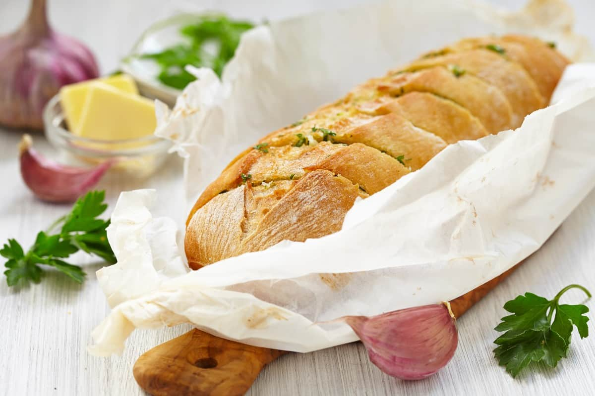
PEOPLE AUTOMATICALLY THINK OF ITALIAN BREAD, BUT A BAGUETTE IS THE BEST TYPE OF BREAD FOR GARLIC BREAD. THE LONG, THIN SHAPE OF THE BAGUETTE ALLOWS IT TO CRISP UP NICELY IN THE OVEN WHILE STILL BEING SOFT AND FLUFFY ON THE INSIDE. THE CRUST ALSO PROVIDES AN EXCELLENT BARRIER TO KEEP ALL OF THAT GARLIC GOODNESS CONTAINED.

FRENCH TOAST
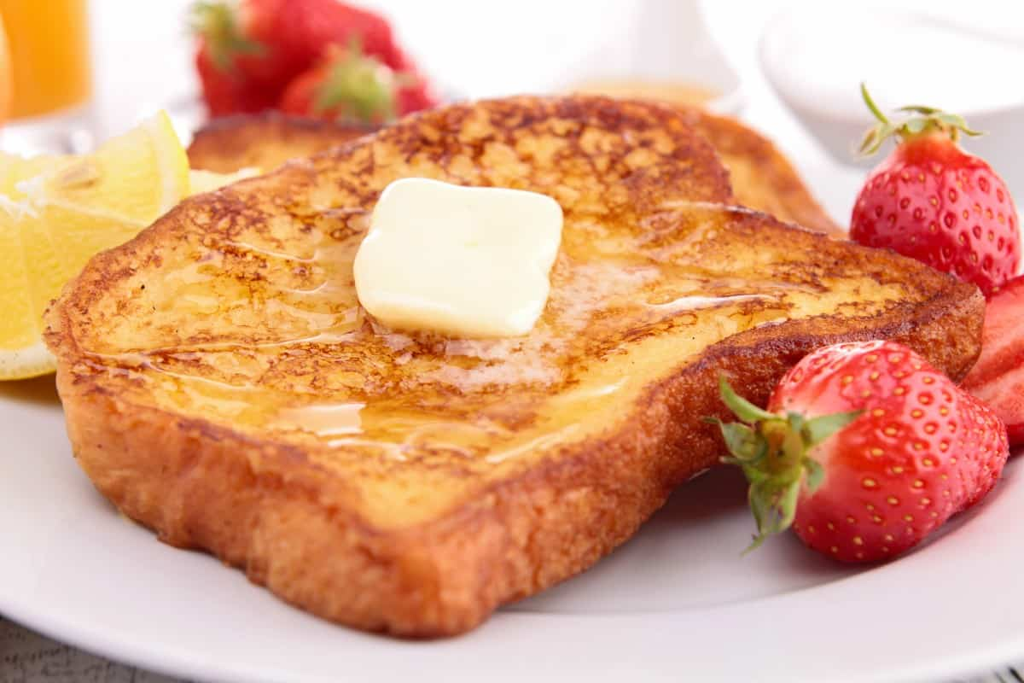
WITH FRENCH TOAST, YOU WANT BREAD THAT CAN SOAK UP ALL THE EGG AND MILK MIXTURE. A BRIOCHE OR CHALLAH BREAD IS GOING TO BE YOUR BEST BET. THESE SLICES OF BREAD ARE NICE AND DENSE, WHICH WILL HELP THEM HOLD ALL THE LIQUID.

GRILLED CHEESE
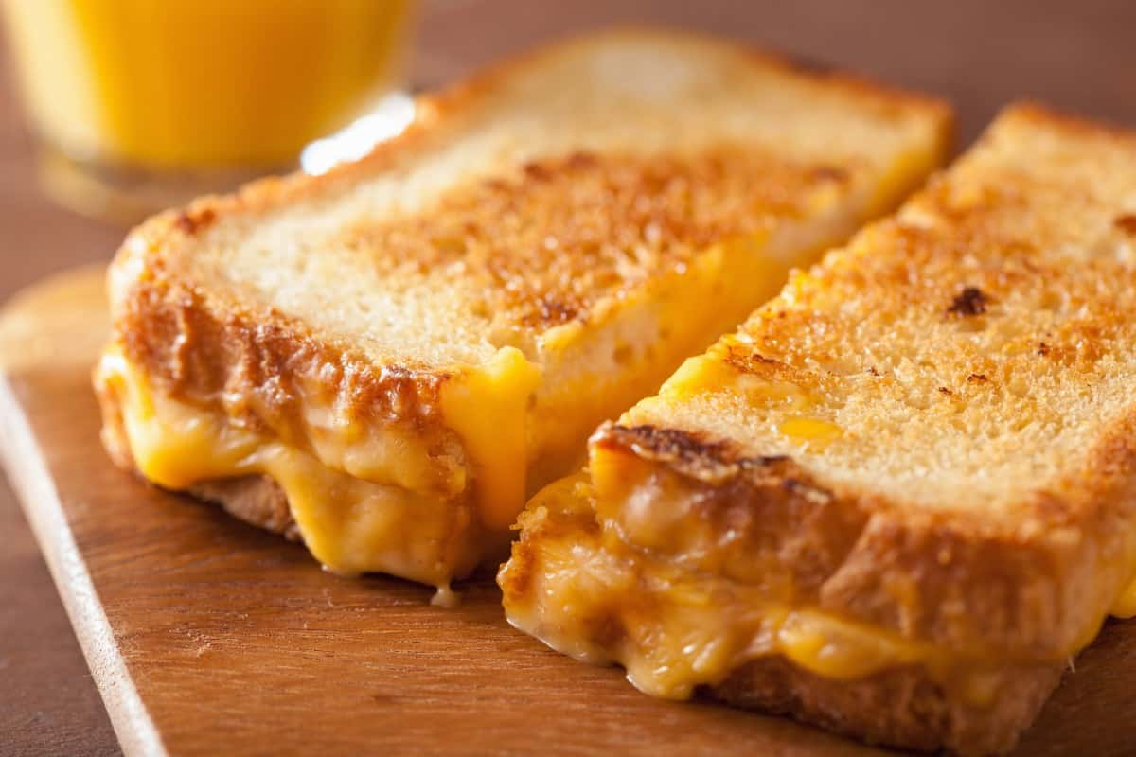
FOR GRILLED CHEESE, YOU WANT BREAD THAT’S NICE AND CRISPY ON THE OUTSIDE BUT STILL SOFT AND FLUFFY ON THE INSIDE. SOURDOUGH BREAD IS PERFECT FOR THIS. THE CRUST OF THE SOURDOUGH WILL GET NICE AND CRISP IN THE PAN WHILE THE INSIDE STAYS SOFT.

AVOCADO TOAST
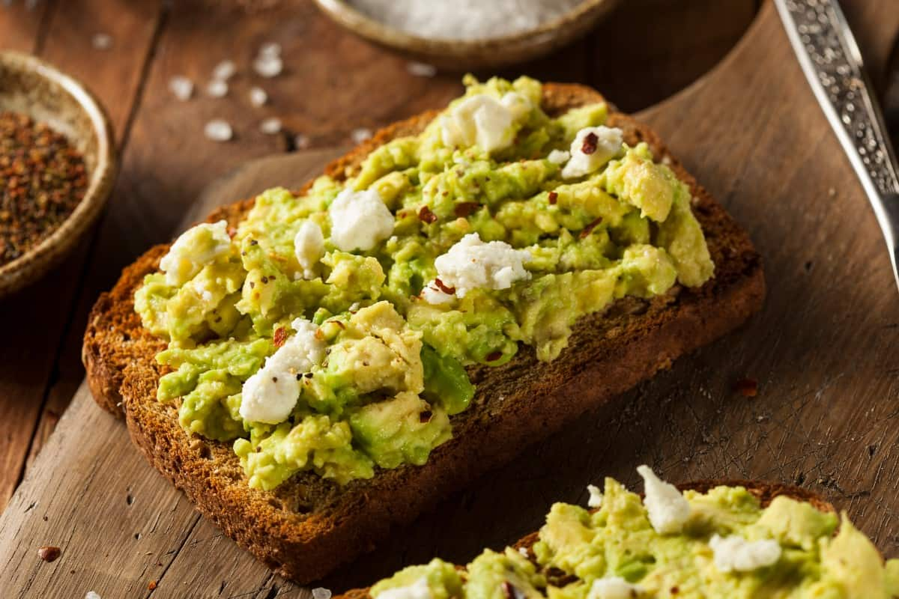
FOR AVOCADO TOAST, YOU WANT BREAD THAT IS GOING TO BE STURDY ENOUGH TO HOLD UP TO THE TOPPINGS. A SLICE OF SOURDOUGH OR HEARTY WHEAT BREAD IS BOTH GREAT OPTIONS. ANOTHER BONUS OF SOURDOUGH IS THAT THE SLIGHTLY SOUR TASTE PAIRS PERFECTLY WITH THE CREAMY AVOCADO.

BEEF DIP
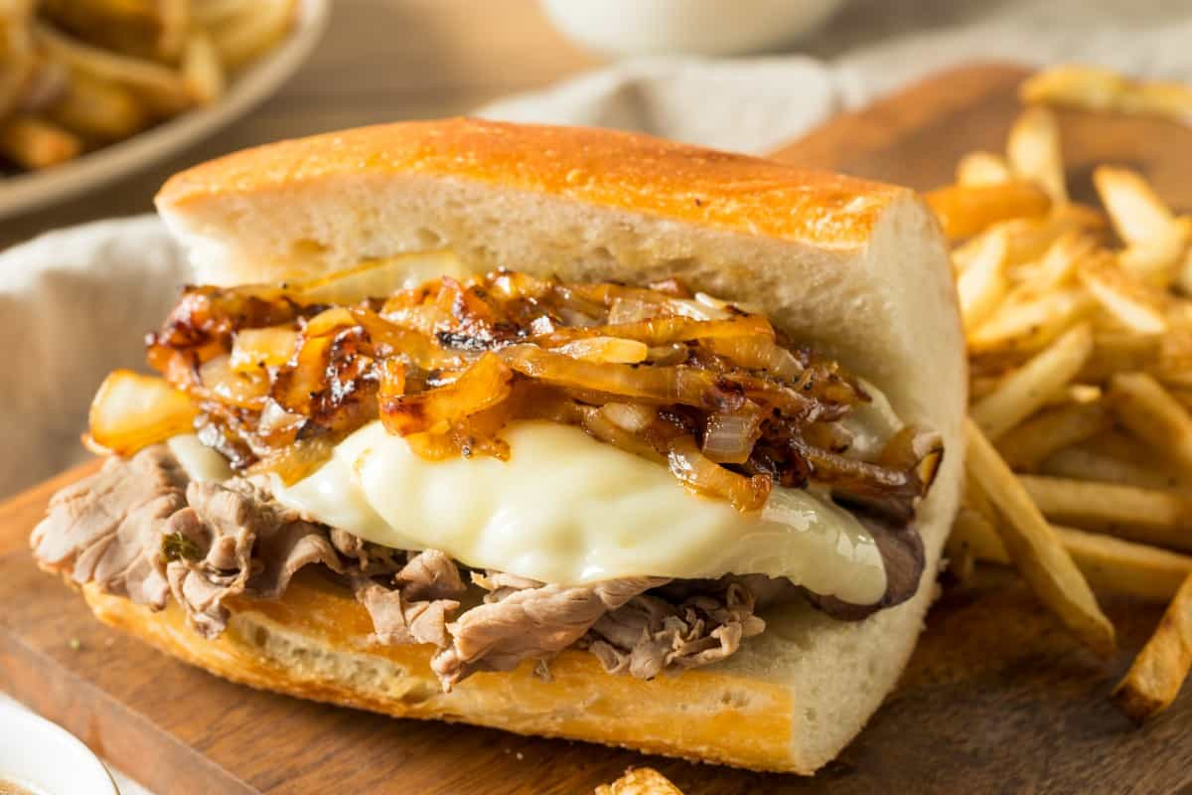
YOU WANT BREAD THAT CAN SOAK UP ALL THE DELICIOUS JUICES FOR A BEEF DIP. A FRENCH BAGUETTE OR SOURDOUGH BREAD ARE BOTH PERFECT FOR THIS. THE LONG, THIN SHAPE OF THE BAGUETTE IS IDEAL FOR DIPPING, WHILE THE SOURDOUGH WILL SOAK UP ALL THE FLAVORS.

PEANUT BUTTER AND JELLY
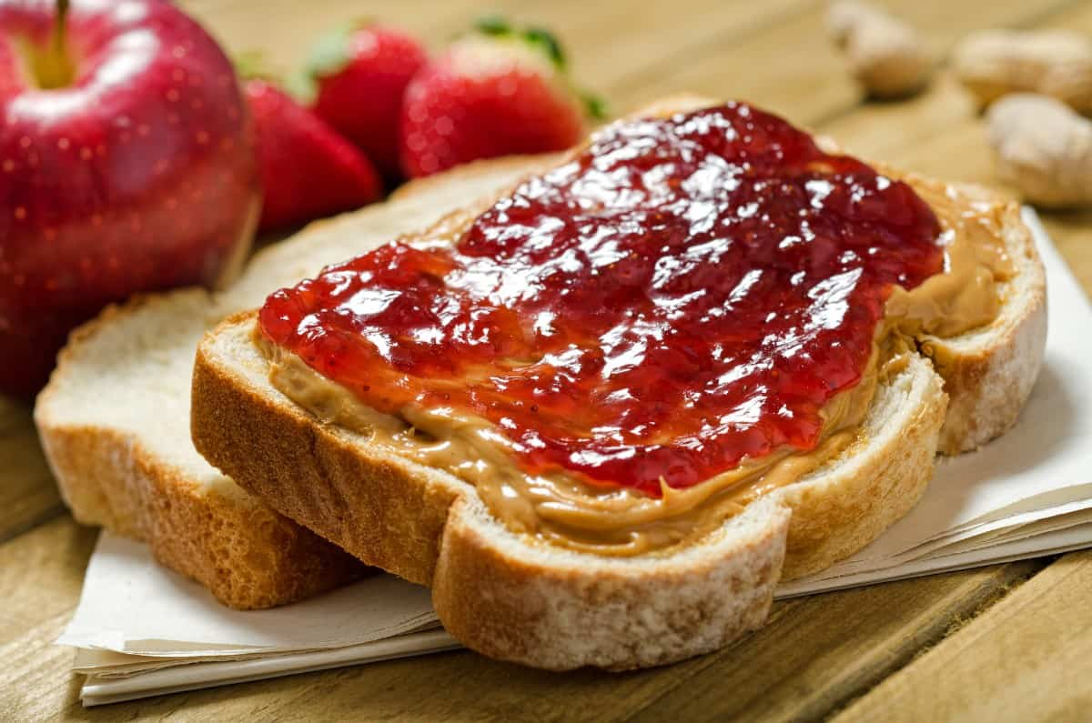
FOR A CLASSIC PB&J, YOU WANT SOFT BREAD. WHITE BREAD OR WHEAT BREAD ARE BOTH GREAT OPTIONS. THE SOFTNESS OF THE BREAD WILL MAKE IT EASY TO SPREAD THE PEANUT BUTTER AND JELLY, AND THE WHEAT BREAD WILL ADD A SLIGHT NUTTINESS TO THE SANDWICH.

BREAD PUDDING
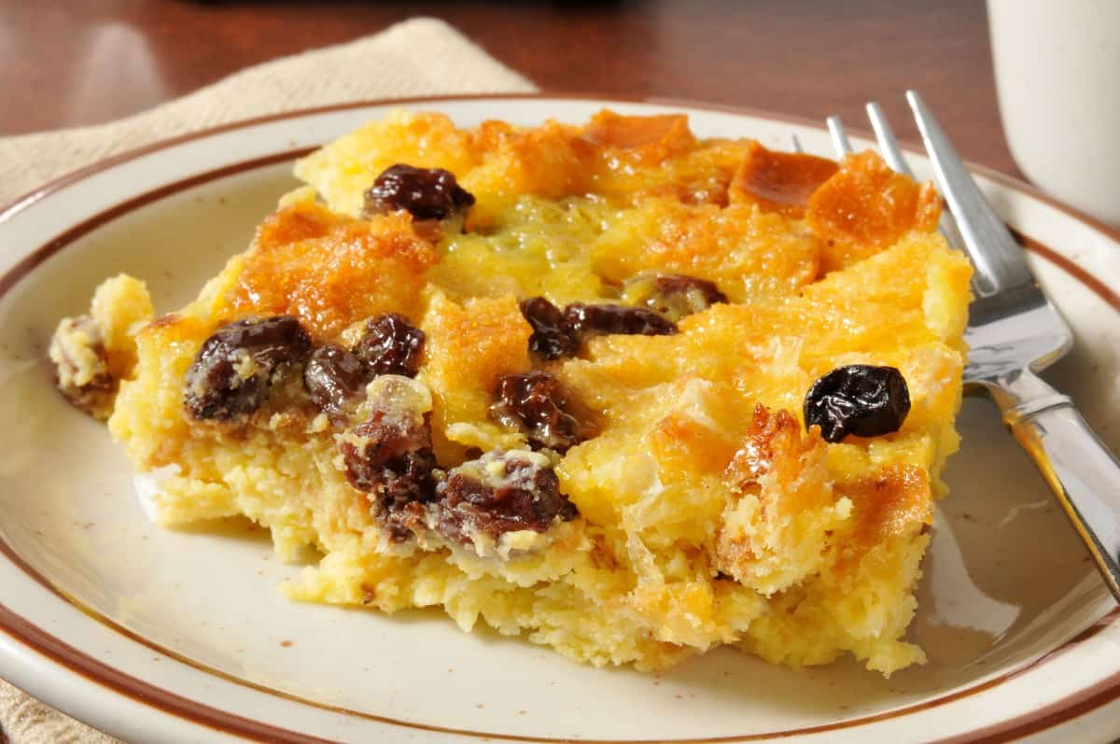
BREAD PUDDING REQUIRES BREAD THAT’S DENSE. A BRIOCHE OR CHALLAH BREAD IS A PERFECT CHOICE. THESE TYPES OF BREAD WILL SOAK UP ALL THE LIQUID AND FLAVORS, RESULTING IN A DELICIOUS AND DECADENT DESSERT.

BURGERS
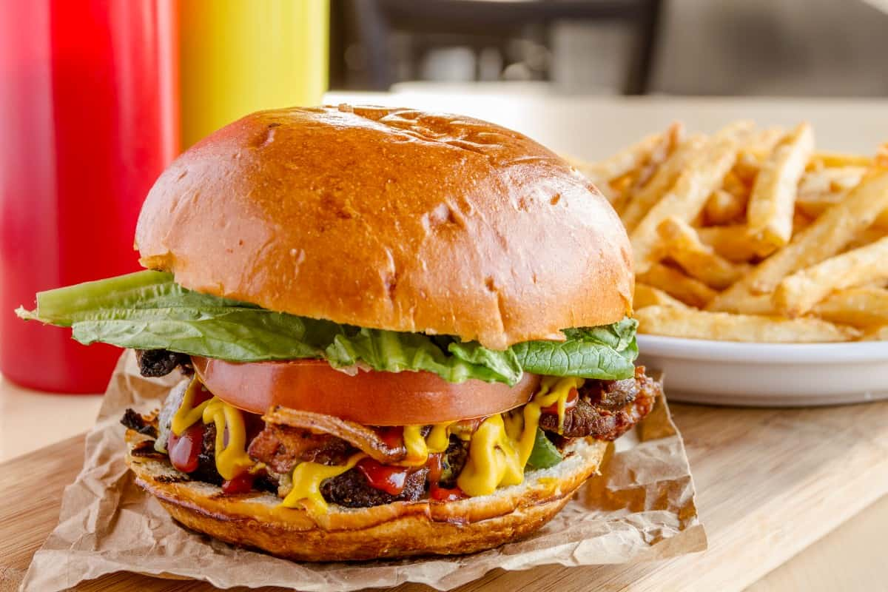
FOR BURGERS, YOU WANT STURDY BREAD TO HOLD UP TO THE TOPPINGS. A BRIOCHE BUN OR A KAISER ROLL ARE BOTH GREAT OPTIONS. THE BRIOCHE WILL ADD A SLIGHT SWEETNESS TO THE BURGER, WHILE THE KAISER ROLL WILL PROVIDE A HEARTY AND CHEWY TEXTURE.

BREAD BOWL
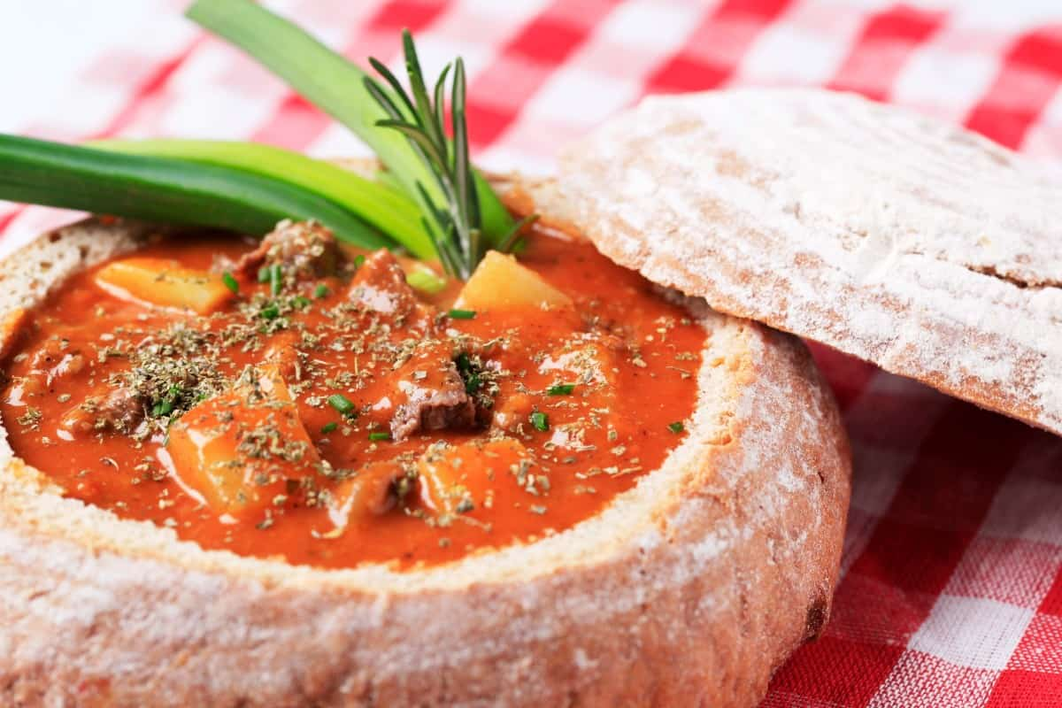
FOR A BREAD BOWL, YOU WANT BREAD THAT IS DENSE AND STURDY. SOURDOUGH OR BOULLE BREAD ARE BOTH EXCELLENT CHOICES. THE SOURDOUGH WILL ADD A SUBTLE SOURNESS TO THE SOUP, WHILE THE BOULLE BREAD WILL PROVIDE A HEARTY TEXTURE.

BRUSCHETTA
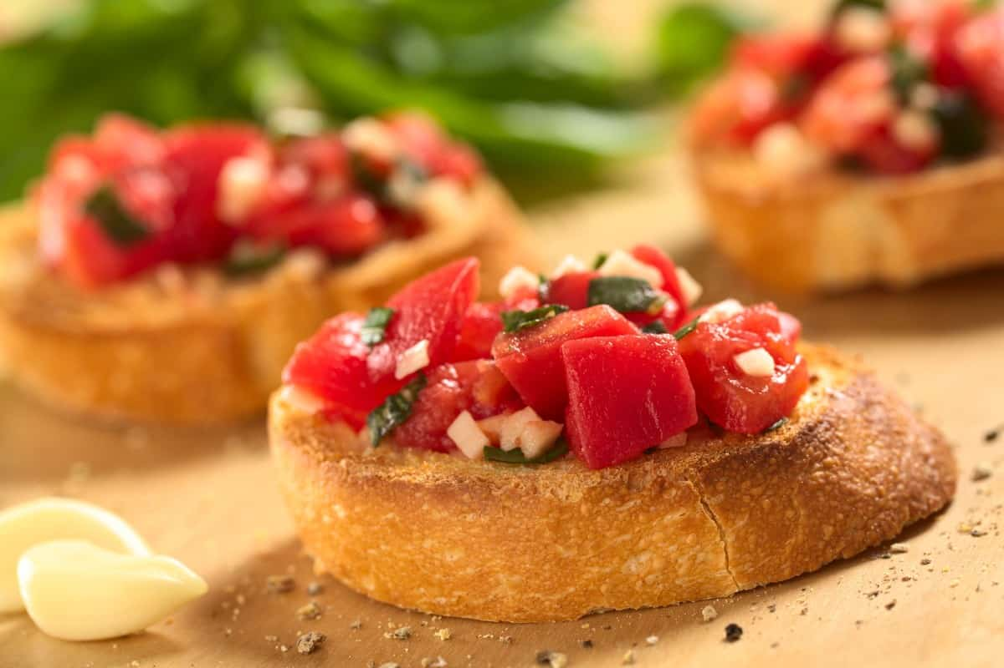
FOR BRUSCHETTA, YOU WANT CRISPY BREAD. A BAGUETTE OR A CIABATTA BREAD ARE BOTH EXCELLENT CHOICES. THE CRISP TEXTURE OF THE BREAD WILL PROVIDE A DELIGHTFUL CONTRAST TO THE SOFT TOPPINGS. ALSO, THE LONG, THIN SHAPE OF THE BAGUETTE IS PERFECT FOR PILING ON THE TOPPINGS.

CROUTONS
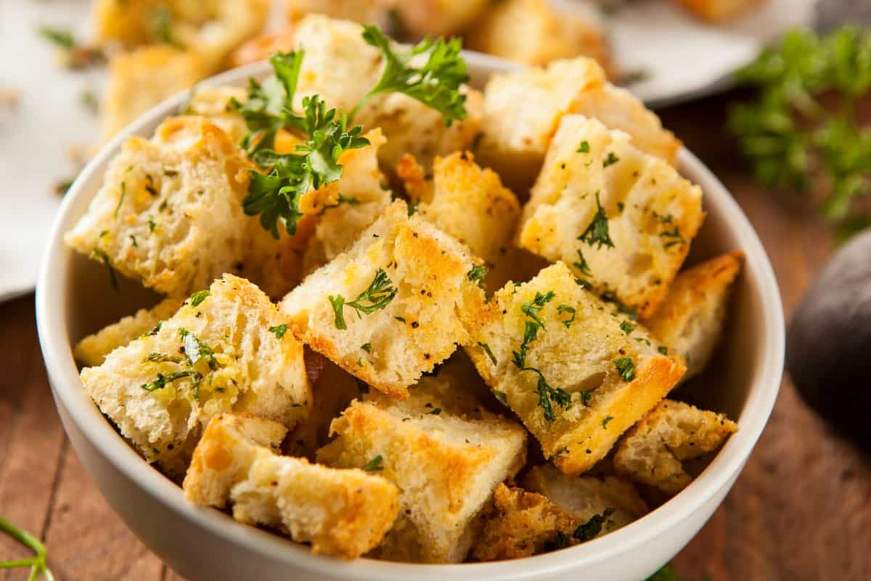
FOR CROUTONS, YOU WANT BREAD THAT IS DRY AND STALE. THIS WILL HELP THE BREAD TO SOAK UP ALL THE FLAVORS AND SEASONINGS. A BAGUETTE OR A CIABATTA BREAD ARE BOTH EXCELLENT CHOICES. MAKE SURE THE BREAD IS NICE AND DRY BEFORE CUTTING IT INTO CUBES.

DIPPING IN OLIVE OIL
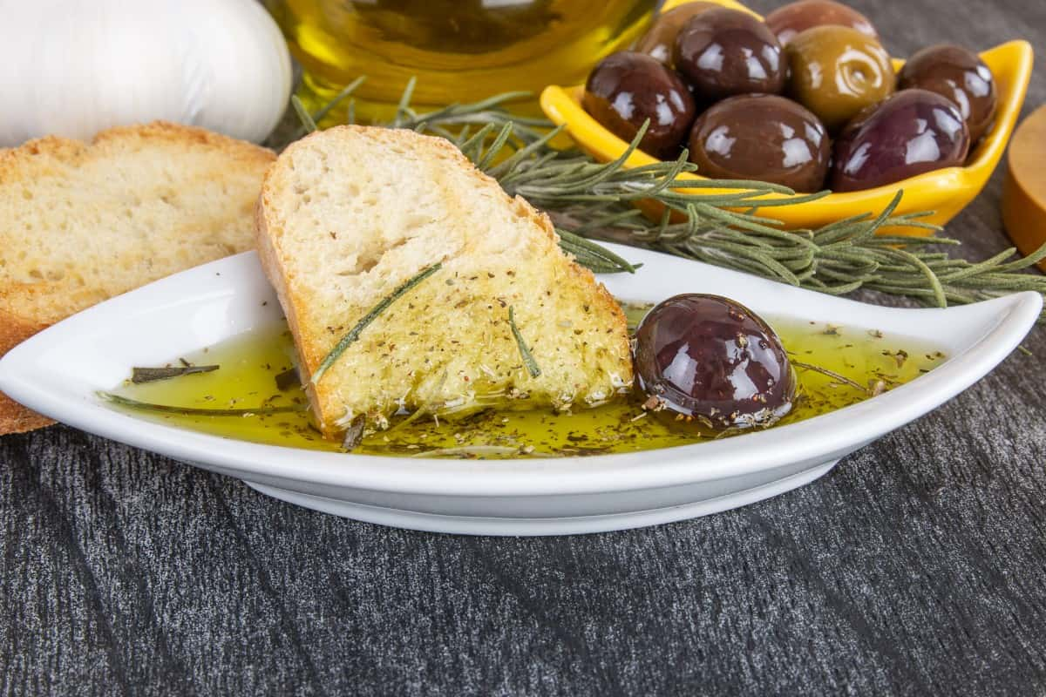
FOR DIPPING IN OLIVE OIL, YOU WANT CRISPY BREAD. THE CRISP TEXTURE OF THE BREAD WILL HELP IT SOAK UP ALL THE OLIVE OIL. A BAGUETTE OR A CIABATTA BREAD ARE BOTH EXCELLENT CHOICES.

LOBSTER ROLL
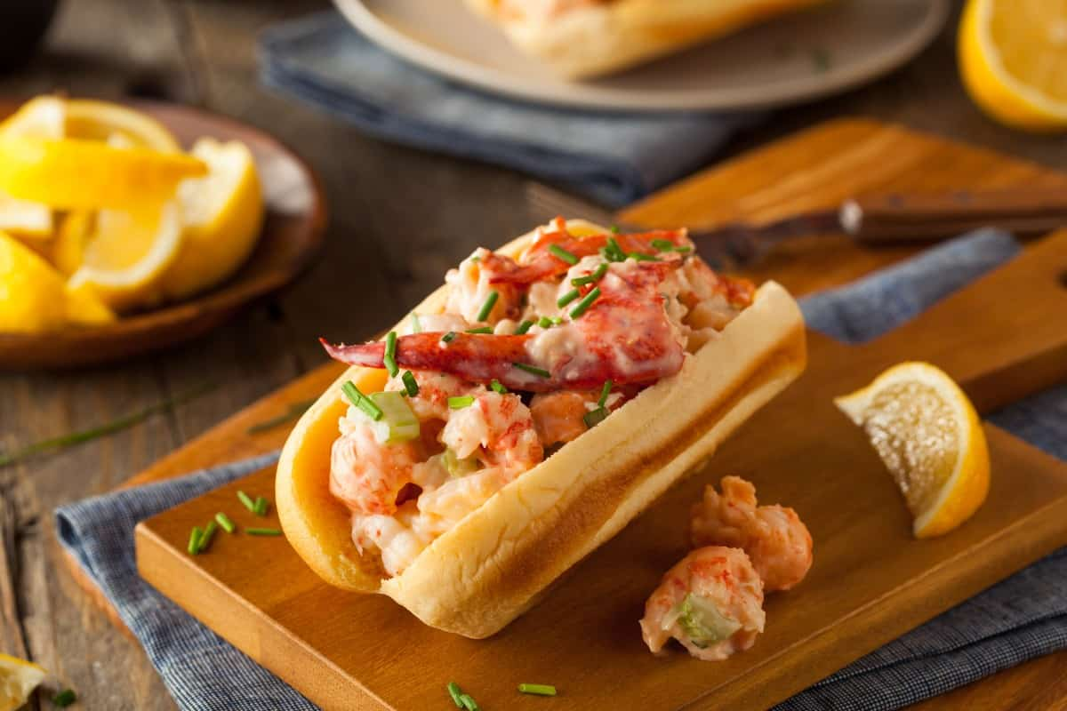
FOR A LOBSTER ROLL, YOU WANT BREAD THAT IS SOFT AND FLUFFY. A BRIOCHE BUN OR A HOT DOG BUN ARE BOTH EXCELLENT CHOICES. THE SOFTNESS OF THE BREAD WILL ALLOW THE LOBSTER TO SHINE, AND THE HOT DOG BUN WILL PROVIDE A DELICIOUS CONTRAST TO THE LOBSTER.

PANINIS

FOR PANINIS, YOU WANT CRISPY BREAD. A BAGUETTE OR A CIABATTA BREAD ARE BOTH EXCELLENT CHOICES. THE CRISP TEXTURE OF THE BREAD WILL HELP IT HOLD UP TO THE FILLINGS, AND THE LONG, THIN SHAPE OF THE BAGUETTE IS PERFECT FOR PILING ON THE TOPPINGS.

STUFFING
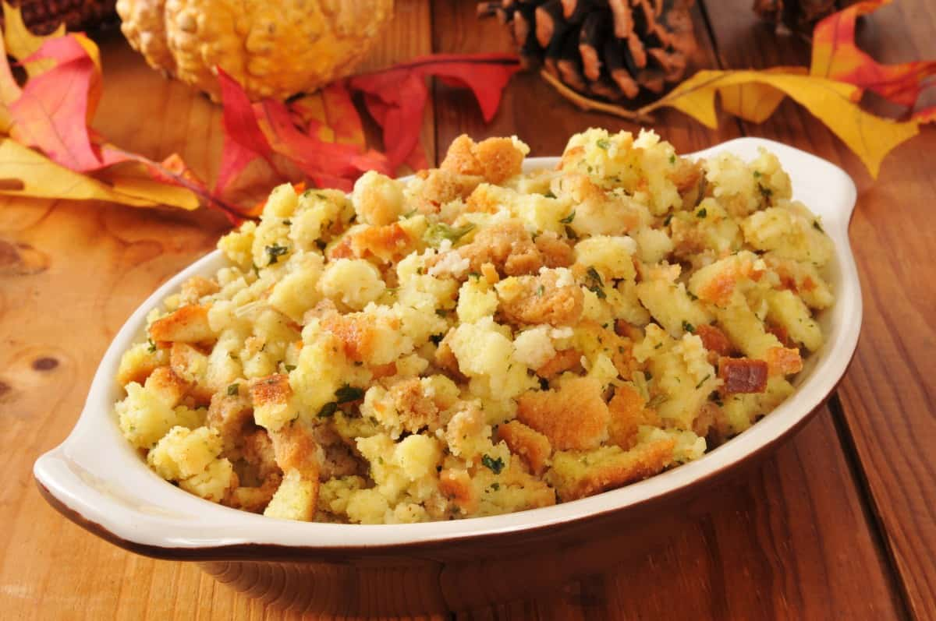
FOR STUFFING, YOU WANT BREAD THAT IS DRY AND STALE. MAKE SURE THE BREAD IS NICE AND DRY BEFORE CUTTING IT INTO CUBES. THIS HELPS THE BREAD SOAK UP ALL THE FLAVORS AND SEASONINGS. A SOURDOUGH OR WHEAT BREAD ARE BOTH EXCELLENT CHOICES.

SANDWICHES
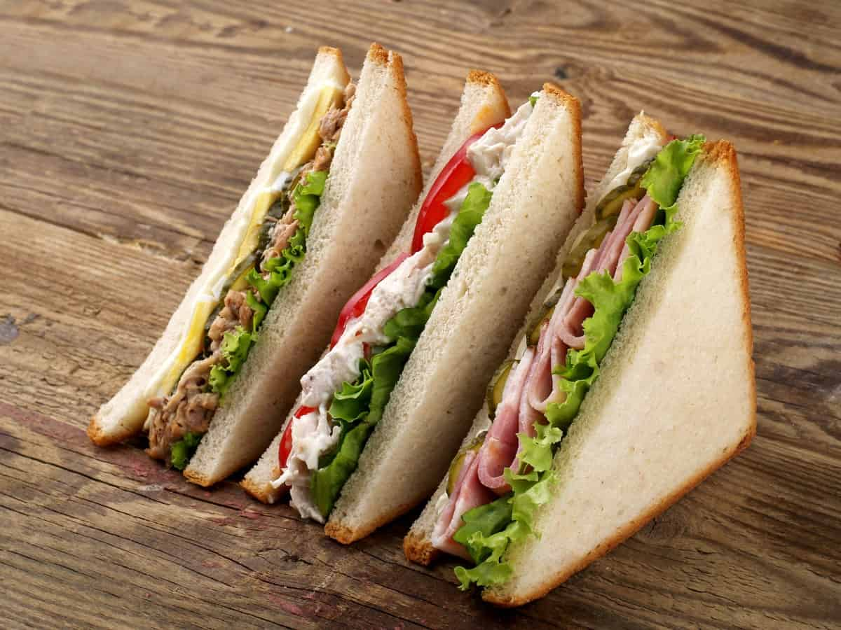
FOR SANDWICHES, YOU WANT SOFT BREAD. WHITE BREAD OR WHEAT BREAD ARE BOTH GREAT OPTIONS. THE SOFTNESS OF THE BREAD WILL MAKE IT EASY TO SPREAD THE FILLINGS, AND THE WHEAT BREAD WILL ADD A SLIGHT NUTTINESS TO THE SANDWICH.

WHAT ARE THE 22 DIFFERENT TYPES OF MILK (ANIMAL & PLANT-BASED)?
LEARN ABOUT THE DIFFERENT KINDS OF DAIRY MILK AND NON-DAIRY OPTIONS AVAILABLE TO HELP YOU DECIDE WHICH IS BEST FOR YOU.
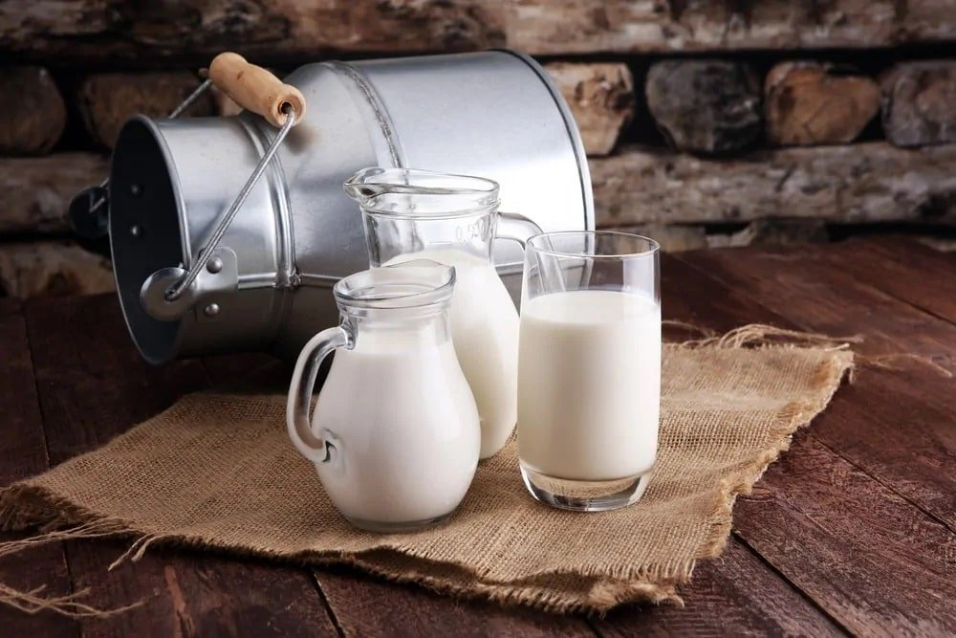

QUICKLIST: TYPES OF MILK
- WHOLE MILK
- 2% MILK
- LOW-FAT MILK
- ORGANIC MILK
- SKIM MILK (FAT-FREE MILK)
- RAW MILK
- LACTOSE-FREE MILK
- FLAVORED MILK
- FULL CREAM MILK
- SOY MILK
- ALMOND MILK
- RICE MILK
- BUTTERMILK
- ULTRA-FILTERED MILK
- EVAPORATED MILK
- SWEETENED CONDENSED MILK
- OAT MILK
- GOAT MILK
- HEMP MILK
- COCONUT MILK
- COW MILK
- BUFFALO MILK
MILK, IN ITS VARIOUS FORMS, HAS BEEN A PART OF HUMAN NUTRITION SINCE ANCIENT TIMES AND HAS A LONG, RICH HISTORY.
THE AGRICULTURAL REVOLUTION AROUND 10,000 B.C.E. CHANGED THE ENTIRE DYNAMICS OF ANCIENT SOCIETIES, DURING WHICH NOMADIC TRIBES TRANSFORMED INTO SETTLED FARMING COMMUNITIES. THE TRANSITION ALSO SAW THE DEVELOPMENT OF DOMESTICATED ANIMALS INCREASING THE USE OF ANIMAL BY-PRODUCTS LIKE MILK, MEAT, ETC.
MILK AND OTHER DAIRY PRODUCTS BECAME A PRIZED COMMODITY THAT WAS INITIALLY RESERVED FOR ELITES SUCH AS ROYALTY, THE WEALTHY AND PRIESTS. THE MOST POPULAR VARIETIES OF MILK CAME FROM COWS, SHEEP, AND GOATS, HOWEVER, AS TIME PROGRESSED, OTHER TYPES OF MILK WERE ALSO PRODUCED.
RELATED: COCONUT MILK | BUTTER ALTERNATIVES | TYPES OF FERMENTATION | TYPES OF SOFT CHEESE | TYPES OF ICE CREAM | TYPES OF FOOD | HOW TO STORE BUTTERCREAM
BELOW IS A LIST OF DIFFERENT MILK VARIETIES, EACH WITH ITS UNIQUE CHARACTERISTICS AND HEALTH BENEFITS.

MILK NUTRITIONAL FACTS CHART
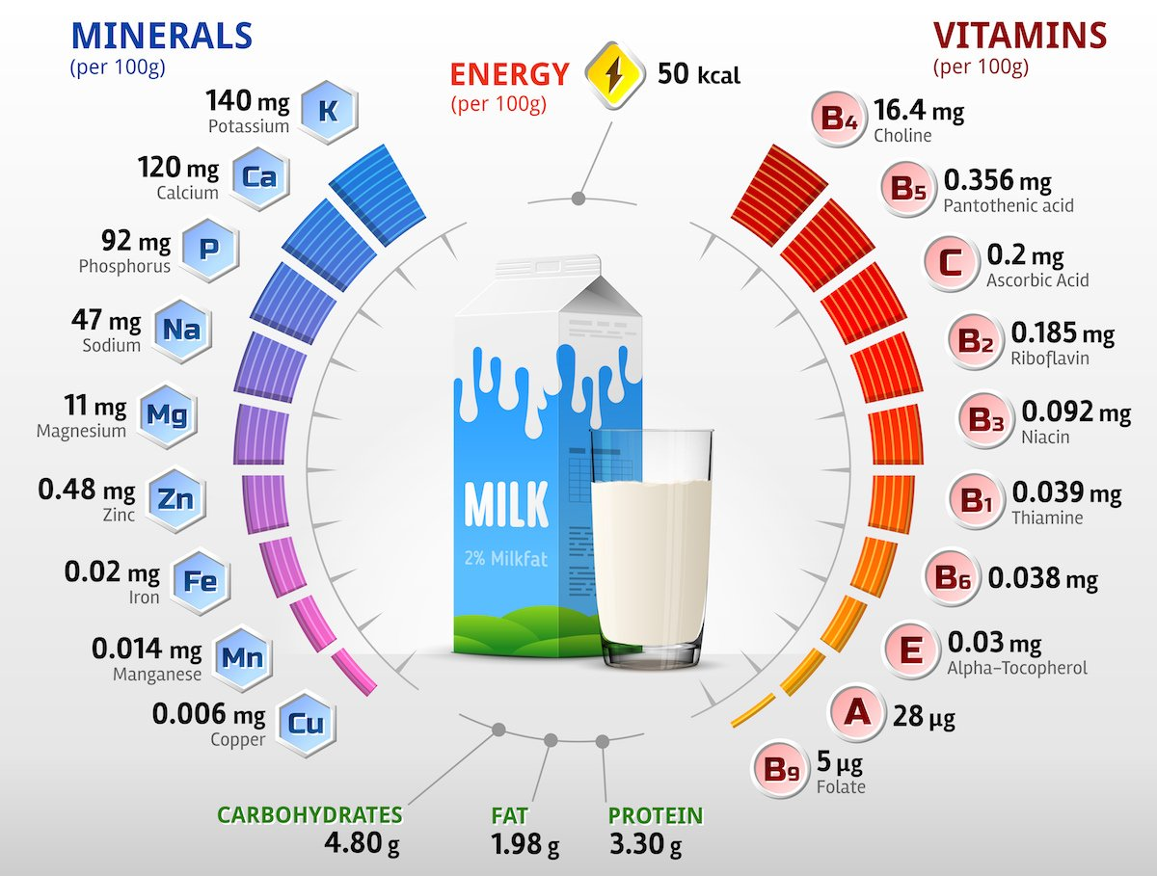

WHOLE MILK

ALSO KNOWN AS REGULAR MILK, WHOLE MILK CONSISTS OF ABOUT 3.5% OF FAT CONTENT. THE FAT PERCENTAGE TYPICALLY RANGES SOMEWHERE BETWEEN 3.25% AND 3.5%.
WHOLE MILK IS CONSIDERED TO BE VERY THICK, CREAMY, AND RICH, AND PAIRS PERFECTLY WITH A BOWL OF OATMEAL FOR BREAKFAST IN THE MORNING. IN THE WORDS OF THE DAIRY COUNCIL OF CALIFORNIA, WHOLE MILK IS BASICALLY “THE WAY IT COMES FROM THE COW BEFORE PROCESSING.” ALTHOUGH IT IS PASTEURIZED AND PROBABLY EVEN HOMOGENIZED, THE RATIO OF FAT TO MILK IN WHOLE MILK IS THE SAME AS IN RAW MILK.
IN TERMS OF CALORIES, AN EIGHT-OUNCE GLASS OF WHOLE MILK WILL CONTAIN AROUND 150 CALORIES, ALONG WITH AN AVERAGE AMOUNT OF EIGHT GRAMS OF FAT.

2% MILK
THIS VARIETY IS ALSO REFERRED TO AS ‘REDUCED-FAT’ WHICH BASICALLY REFERS TO THE FACT THAT THE FAT CONTENT IN THIS MILK IS ACTUALLY TWO PERCENT OF THE TOTAL WEIGHT OF THE MILK.
2% MILK OR REDUCED-FAT MILK GOES THROUGH AN IMPORTANT FAT-REMOVAL PROCESS IN WHICH EXTRA FAT IS REMOVED FROM THE MILK. MANY PEOPLE PREFER USING THIS MILK IN THEIR TEA BECAUSE IT PROVIDES A VERY SMOOTH TEXTURE TO THE BEVERAGE AND OFFERS THAT DELICIOUS, RICH-MILK TASTE. NOT ONLY THAT BUT IT ALSO ADDS ABOUT 8 GRAMS OF PROTEIN PER CUP OF TEA WHICH MAKES IT AN IDEAL TYPE OF MILK TO CONSUME ON A DAILY BASIS.

LOW-FAT MILK

LOW-FAT MILK IS OFTEN CONFUSED WITH ‘REDUCED-FAT’ MILK; HOWEVER, THEY ARE ACTUALLY DIFFERENT FROM ONE ANOTHER. WHILE THE LATTER CONSISTS OF A 2% FAT PERCENTAGE, LOW-FAT MILK HAS ONLY ONE PERCENT OF FAT CONTENT.
OFTEN, YOU WILL FIND LOW-FAT MILK WITH SKIM MILK POWDER ADDED TO IT WHICH BOOSTS ITS PROTEIN AND CALCIUM CONTENT AND ALSO MAKES IT CREAMIER THAN BEFORE.
LOW-FAT MILK UNDERGOES A PROCESS CALLED “CENTRIFUGATION” WHICH REFERS TO THE REMOVAL OF THE CREAMY FAT LAYER THAT TYPICALLY COMES WITH UNPROCESSED MILK. THIS REMOVAL OF CREAM AND FAT GLOBULES RESULTS IN THINNER MILK WITH A WHITE OPAQUE SHADE.

ORGANIC MILK
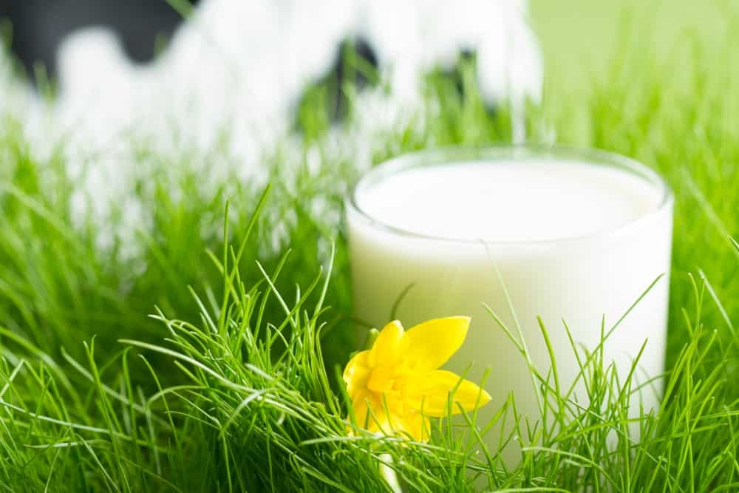
ORGANIC MILK COMES FROM COWS THAT AREN’T GIVEN SUPPLEMENTAL HORMONES AND IS PRODUCED BY DAIRY FARMERS WHO USE ONLY ORGANIC PESTICIDES AND FERTILIZERS. THIS MILK HAS THREE KEY CHARACTERISTICS THAT DISTINGUISH THEM FROM OTHER TYPES OF MILK. FIRSTLY, IT COMES FROM COWS THAT GET 30 PERCENT OF THEIR DIET FROM PASTURE, SECONDLY, THE COWS AREN’T GIVEN ANY KIND OF ANTIBIOTICS, AND LASTLY, THEY AREN’T FED ANY REPRODUCTION OR GROWTH HORMONES.
THE TERM ‘ORGANIC’ PRIMARILY REFERS TO THE DIFFERENT PROCESSES THAT MAKE THE MILK ORGANIC RATHER THAN THE FINAL MILK PRODUCT. THE NUTRITIONAL PROFILE OF THIS MILK IS ALMOST THE SAME AS THAT OF STANDARD MILK SO THERE IS NO SIGNIFICANT DIFFERENCE IN TERMS OF THE NUTRIENTS AND HEALTH BENEFITS PROVIDED BY ORGANIC MILK.

SKIM MILK (FAT-FREE MILK)

SKIM MILK IS ALSO KNOWN AS ‘FAT-FREE MILK’ AND IS QUITE A POPULAR CHOICE OF MILK AMONG WEIGHT WATCHERS AND HEALTH-CONSCIOUS PEOPLE. THE SOLE REASON FOR THAT IS OBVIOUSLY BECAUSE SKIM MILK CONTAINS ZERO AMOUNT OF FAT. THE LACK OF FAT MAKES THIS MILK THINNER AS COMPARED TO OTHER TYPES OF MILK.
AS THE NAME SUGGESTS, THIS MILK GOES THROUGH THE PROCESS OF “SKIMMING” WHICH REFERS TO THE REMOVAL OF CREAM FROM THE MILK.

RAW MILK
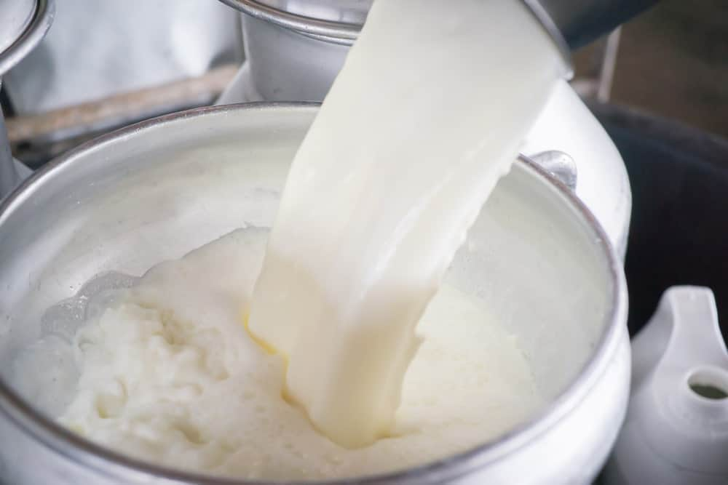
RAW OR UNPASTEURIZED MILK HAS NOT BEEN HEATED TO KILL BACTERIA. IT CAN COME FROM A VARIETY OF DIFFERENT ANIMALS INCLUDING BUFFALO, SHEEP, CAMELS, COWS AND GOATS.
THE FACT THAT RAW MILK IS NOT PASTEURIZED RAISES SEVERAL HEALTH CONCERNS PRIMARILY BECAUSE IT MAY CONTAIN HARMFUL GERMS, BACTERIA AND VIRUSES THAT CAN ADVERSELY AFFECT YOUR HEALTH. HOWEVER, ADVOCATES OF RAW MILK ARGUE THAT IT IS A ‘COMPLETE’ TYPE OF MILK THAT IS VOID OF ANY HARMFUL ADDITIVES OR PRESERVATIVES AND IS IN FACT, NATURAL FOOD WITH ALL ITS AMINO ACIDS, PROTEINS, MINERALS, AND VITAMINS COMPLETELY INTACT. THEY ALSO SUGGEST THAT THE HEATING PROCESS SIMPLY KILLS THE BASIC NUTRITIONAL PURPOSE OF THE MILK WHICH MAKES RAW MILK WHOLE AND HEALTHY.

LACTOSE-FREE MILK
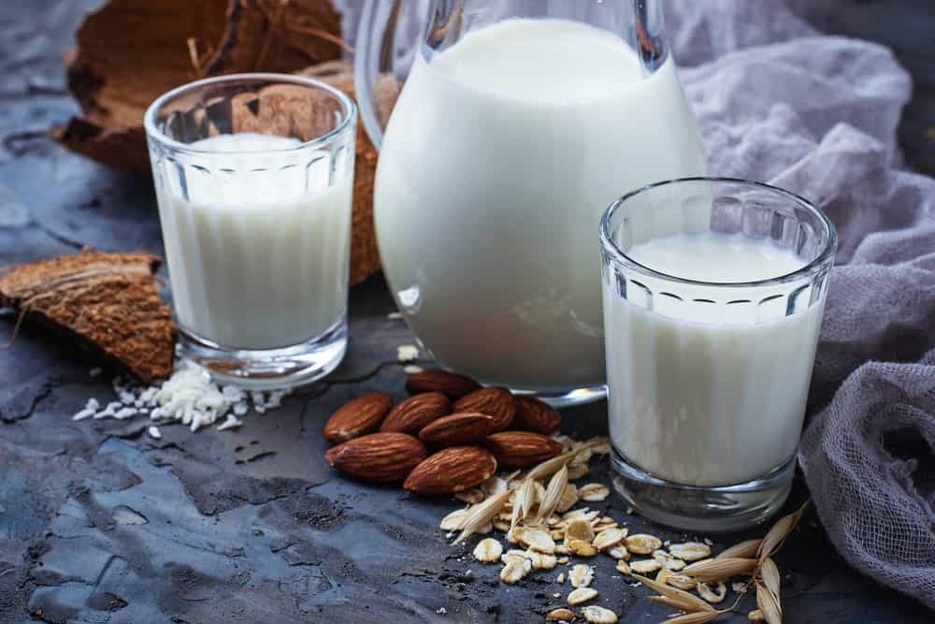
LACTOSE-FREE MILK, AS THE NAME IMPLIES, IS ONE THAT HAS LACTOSE REMOVED FROM IT, MAKING IT A GREAT OPTION FOR THOSE WHO ARE LACTOSE-INTOLERANT. LACTOSE IS A TYPE OF NATURAL SUGAR PRESENT IN MILK THAT MANY PEOPLE ARE UNABLE TO DIGEST.
LACTOSE-FREE MILK IS PRODUCED BY FOOD MANUFACTURERS BY ADDING LACTASE TO REGULAR MILK. LACTASE IS BASICALLY AN ENZYME THAT HELPS BREAK DOWN LACTOSE IN THE BODY.
LACTOSE-FREE MILK CONTAINS MICRONUTRIENTS LIKE PHOSPHORUS, CALCIUM, AND VITAMIN B12. IT IS ALSO HAS ABOUT EIGHT GRAMS OF PROTEIN IN A SINGLE EIGHT-OUNCE CUP.

FLAVORED MILK
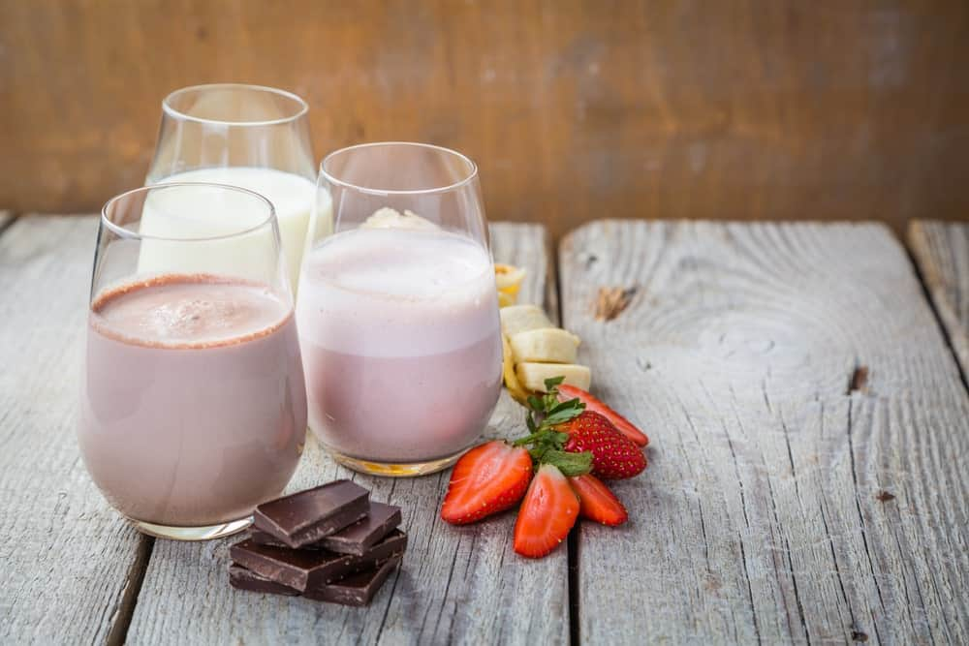
FLAVORED MILK IS A SWEETENED DAIRY DRINK THAT TYPICALLY CONSISTS OF MILK, SUGAR AND NATURAL OR ARTIFICIAL FOOD COLORINGS. THE MOST POPULAR FLAVORED MILK IS CHOCOLATE MILK, HOWEVER, THERE ARE MANY VARIETIES.
LIKE ANY OTHER KIND OF MILK, FLAVORED MILK IS RICH IN THE ESSENTIAL NUTRIENTS REQUIRED BY THE BODY TO STAY HEALTHY, NAMELY, CALCIUM, POTASSIUM, AND VITAMIN D. RESEARCH AND STUDIES HAVE SHOWN THAT CHILDREN WHO DRINK FLAVORED MILK ACTUALLY CONSUME MORE MILK OVERALL WHICH RESULTS IN HEALTHIER DIETS.
FLAVORED MILK ALSO HAS A LONGER SHELF LIFE AS COMPARED TO PLAIN MILK DUE TO THE FACT THAT IT IS USUALLY PASTEURIZED USING ULTRA-HIGH TEMPERATURE (UHT) TREATMENT.

FULL CREAM MILK
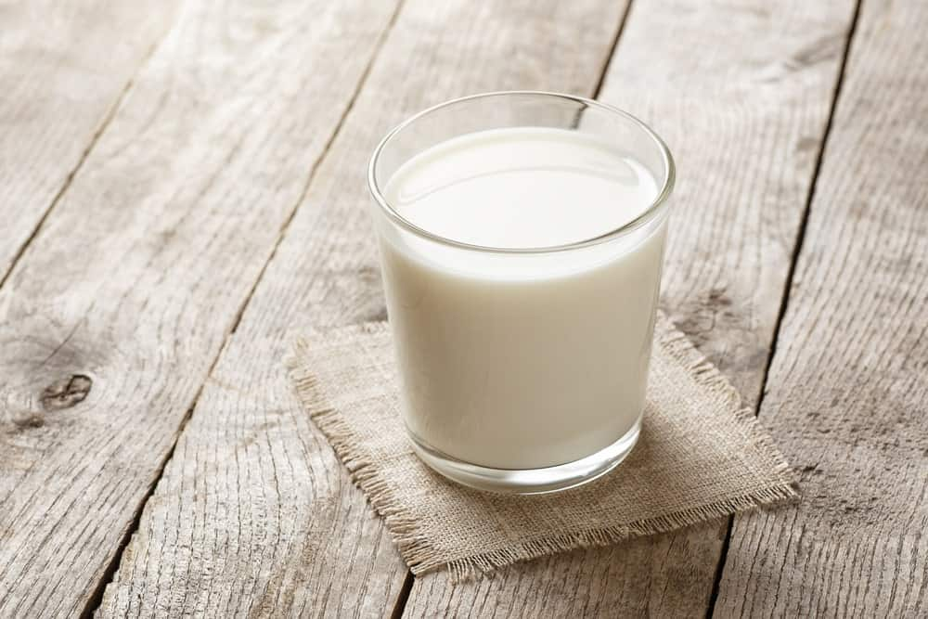
FULL-CREAM MILK IS ONE WITH THE HIGHEST PERCENTAGE OF FAT IN IT WHICH GIVES IT THE CREAMIEST TASTE AND TEXTURE, COMPARED TO OTHER TYPES OF MILK THAT HAVE A LOWER FAT PERCENTAGE. THE TERM ‘FULL CREAM MILK’ IS ALSO USED FOR MILK THAT HAS THE SAME FAT CONTENT AS WHOLE MILK, A CHARACTERISTIC THAT MAKES BOTH TYPES OF MILK VERY SIMILAR.
FULL CREAM MILK COMES FROM THE MAMMARY GLANDS OF MOST MAMMALS WHICH MAKES IT HIGHLY NUTRITIOUS. A 3.5 OUNCE GLASS CONTAINS ABOUT 3.3 GRAMS OF PROTEIN, 4.7 GRAMS OF CARBOHYDRATES, AND 3.9 GRAMS OF FAT.

SOY MILK
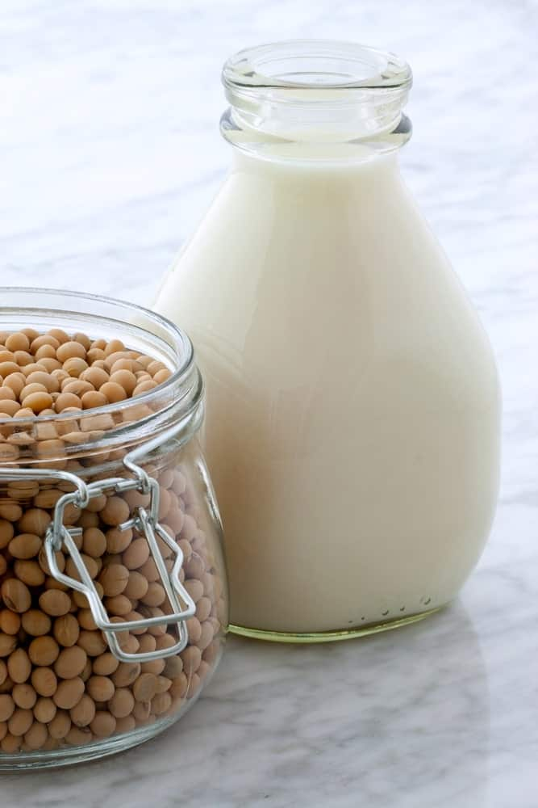
THIS MILK IS SIMPLY PREPARED BY SOAKING DRIED SOYBEANS AND THOROUGHLY GRINDING THEM IN WATER. SOY MILK IS A VARIETY OF PLANT-BASED MILK THAT IS PACKED WITH ESSENTIAL NUTRIENTS.
SOY MILK IS OFTEN REFERRED TO AS A SWEETER AND THICKER VERSION OF ALMOND MILK AND IS CONSIDERED TO BE AN EXCELLENT DAIRY ALTERNATIVE. SINCE ITS MAIN INGREDIENT COMES FROM PLANTS, THIS MILK IS NATURALLY CHOLESTEROL-FREE, CONTAINS NO AMOUNT OF LACTOSE, AND IS ALSO VERY LOW IN SATURATED FAT CONTENT. IT IS ALSO ‘COMPLETE PROTEIN MILK’ WHICH MEANS THAT IT CONSISTS OF THE SAME PROTEIN CONTENT AS WHOLE MILK.
A STUDY WAS CONDUCTED TO COMPARE THE NUTRITIONAL PROFILE OF COCONUT, ALMOND, SOY, AND RICE MILK. SOY MILK WAS FOUND TO CONTAIN THE LARGEST AMOUNTS OF ESSENTIAL NUTRIENTS WHICH LED TO THE CONCLUSION THAT IT IS THE SECOND MOST NUTRITIOUS TYPE OF MILK AFTER COW MILK.

ALMOND MILK

ALMOND MILK IS ANOTHER VERY POPULAR TYPE OF PLANT-BASED MILK THAT CONSISTS OF SUBTLE, NATURAL SWEETNESS AND OFFERS AN INCREDIBLY CREAMY CONSISTENCY. IT IS A DAIRY-FREE MILK PRODUCT THAT IS PRODUCED BY FIRST, TOASTING THE ALMONDS AND THEN GRINDING THEM WITH WATER UNTIL IT COMBINES INTO A WELL-BLENDED MIXTURE. THE RESULTING PRODUCT IS RICH MILK THAT HAS A DELICIOUS NUTTY TASTE COUPLED WITH A THICK, CREAMY TEXTURE.
SINCE IT IS NUT-BASED MILK, IT HAS AN ABUNDANCE OF HEALTHY FATS, NAMELY POLYUNSATURATED AND MONOUNSATURATED FATS. IT IS ALSO RICH IN OTHER KEY NUTRIENTS LIKE MAGNESIUM, POTASSIUM, CALCIUM, PROTEIN, FIBER AND VITAMIN E.
ALMOND MILK IS IDEAL FOR THOSE WHO ARE LACTOSE-INTOLERANT AND WISH TO AVOID DAIRY PRODUCTS BECAUSE IT IS FREE FROM CHOLESTEROL, AS WELL AS LACTOSE. IT ALSO HAS A LOW SODIUM CONTENT AND ONLY 30 CALORIES IN AN AVERAGE CUP OF ALMOND MILK WITH 0 GRAMS OF CARBS AND SUGAR.

RICE MILK
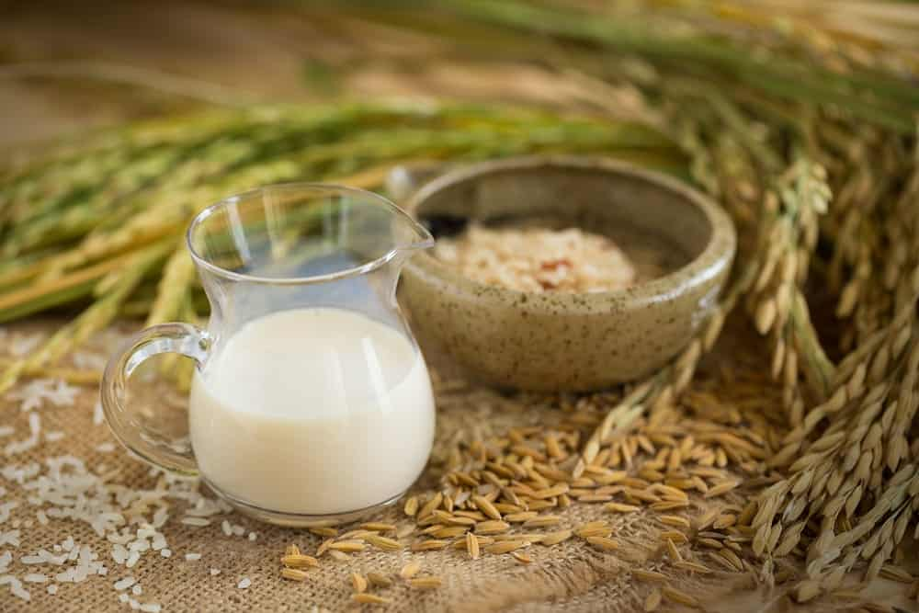
THIS IS ONE OF THE MOST HYPOALLERGENIC OPTIONS AMONG ALL OTHER MILK TYPES AND ALSO THE SWEETEST OF ALL. IT IS A TYPE OF DAIRY-FREE MILK THAT IS CREATED BY BOILING BROWN RICE AND THEN MIXING IT WITH BROWN RICE STARCH AND BROWN RICE SYRUP.
RICE MILK OFFERS A MEDIUM-RICH SWEET TASTE THAT IS VERY PLEASANT TO THE TASTE BUDS. THE NATURAL SWEETNESS OF THE MILK COMES FROM THE RICE GRAIN ITSELF RATHER THAN ANY ADDED SUGAR. SINCE IT IS LACTOSE-FREE AND CONTAINS A VERY LOW AMOUNT OF ALLERGENS, IT IS IDEAL FOR LACTOSE-INTOLERANT PEOPLE AND THOSE WHO MAY HAVE A GREAT TENDENCY TO BE ALLERGIC TO MILK.
THIS MILK IS ALSO FAT AND CHOLESTEROL-FREE WHICH MAKES IT THE PERFECT MILK CHOICE FOR PEOPLE BATTLING WITH HIGH BLOOD PRESSURE AND CARDIOVASCULAR ISSUES. HOWEVER, THE DOWNSIDE TO RICE MILK IS THAT IT CONTAINS LESS PROTEIN AND CALCIUM AS COMPARED TO WHOLE MILK. PER SERVING CONTAINS ABOUT 26 GRAMS OF CARBOHYDRATES WHICH ALSO MAKES IT HIGH IN CALORIES AND SUGARS.

BUTTERMILK
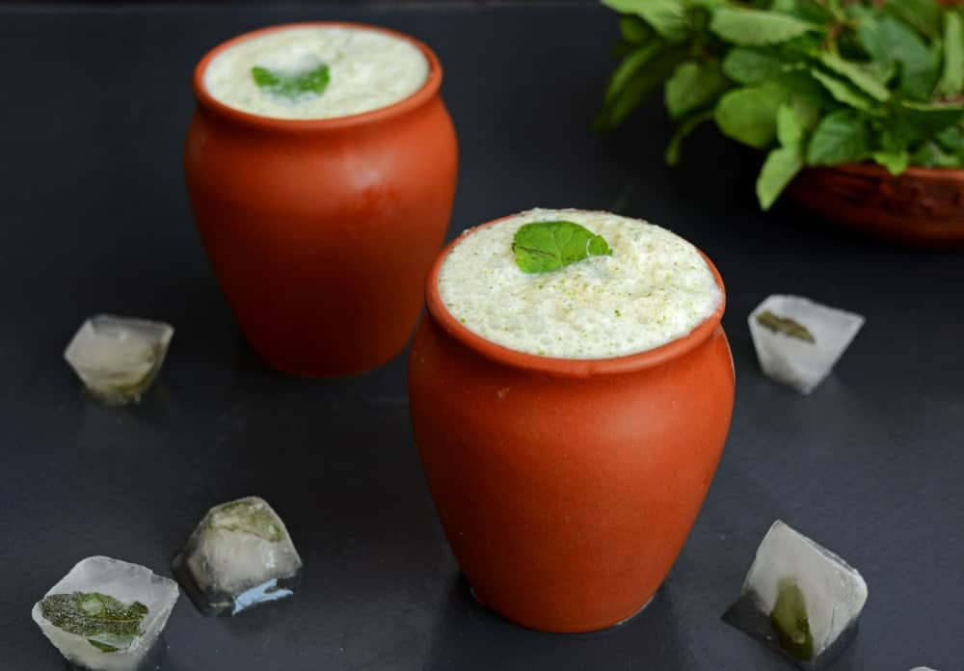
BUTTERMILK WAS ORIGINALLY A FERMENTED MILK PRODUCT MADE FROM THE RESIDUAL LIQUID THAT WAS LEFT BEHIND FROM CHURNED BUTTER THAT CAME FROM CULTURED OR FERMENTED CREAM.
THE MODERN FORM OF BUTTERMILK HAS NO TRACES OF BUTTER IN IT, RATHER IT IS CULTURED MILK THAT IS STORED AND SOLD IN BOTTLES. COMMERCIALLY MADE BUTTERMILK IS PRODUCED BY ADDING BACTERIA CULTURE TO SWEET, PASTEURIZED MILK. THE MIXTURE IS LEFT TO FERMENT FOR A FEW HOURS AFTER WHICH STABILIZERS, SALTS AND SUGAR ARE ADDED TO THE ‘BUTTERMILK’.
THE RESULT IS A LOT THICKER, ACIDIC AND TANGIER THAN TRADITIONAL BUTTERMILK.

ULTRA-FILTERED MILK
ULTRA-FILTERED MILK, ALSO KNOWN AS ‘DIAFILTERED MILK’ IS TYPICALLY PRODUCED BY RUNNING THE MILK THROUGH A THIN, POROUS MEMBRANE THAT ALLOWS THE CONTENTS OF THE MILK TO BE SEPARATED. THE PROCESS HAS BEEN DERIVED FROM THE SAME TECHNIQUE THAT REMOVES IMPURITIES FROM WATER. THE ACT OF FILTRATION ALLOWS THE FINAL PRODUCT TO HAVE MORE CALCIUM AND PROTEIN AND LESS SUGAR CONTENT AND LACTOSE.
ADDITIONALLY, ULTRAFILTRATION ALLOWS WATER AND SMALL LACTOSE MOLECULES TO PASS THROUGH THE MEMBRANE WHILE PROTEINS GET LEFT BEHIND. ONE CUP OF ULTRAFILTERED MILK IS BELIEVED TO CONTAIN SIX GRAMS OF SUGAR, 13 GRAMS OF PROTEIN, AND 370 MILLIGRAMS OF CALCIUM.

EVAPORATED MILK

EVAPORATED MILK IS OFTEN REFERRED TO AS ‘UNSWEETENED CONDENSED MILK’ AND IS BASICALLY CANNED MILK WITH ABOUT 60 PERCENT OF THE WATER CONTENT REMOVED FROM IT. THE WATER IS REMOVED FROM FRESH MILK BY SIMMERING IT OVER LOW HEAT. THE MILK THEN GOES THROUGH A HOMOGENIZATION PROCESS THAT ALLOWS IT TO INTEGRATE ALL ITS FAT MOLECULES TOGETHER WHICH GIVES IT EXTENDED SHELF LIFE.
THE PROCESS OF SLOWLY SIMMERING THE MILK OVERHEATS RESULTS IN A VERY THICK, RICH, AND CREAMY FINAL PRODUCT THAT OFTEN CONSISTS OF A MILD, CARAMEL-LIKE FLAVOR. MANY PEOPLE REFER TO EVAPORATED MILK AS ‘THE BEST OF BOTH WORLDS’ SINCE IT CONTAINS A VERY LOW-FAT CONTENT AND YET RETAINS ITS CREAMINESS. THIS MAKES IT A VERY POPULAR SUBSTITUTE FOR CREAM IN DISHES THAT REQUIRE A SUBSTANTIAL AMOUNT OF CREAM AS ONE OF ITS INGREDIENTS.

SWEETENED CONDENSED MILK
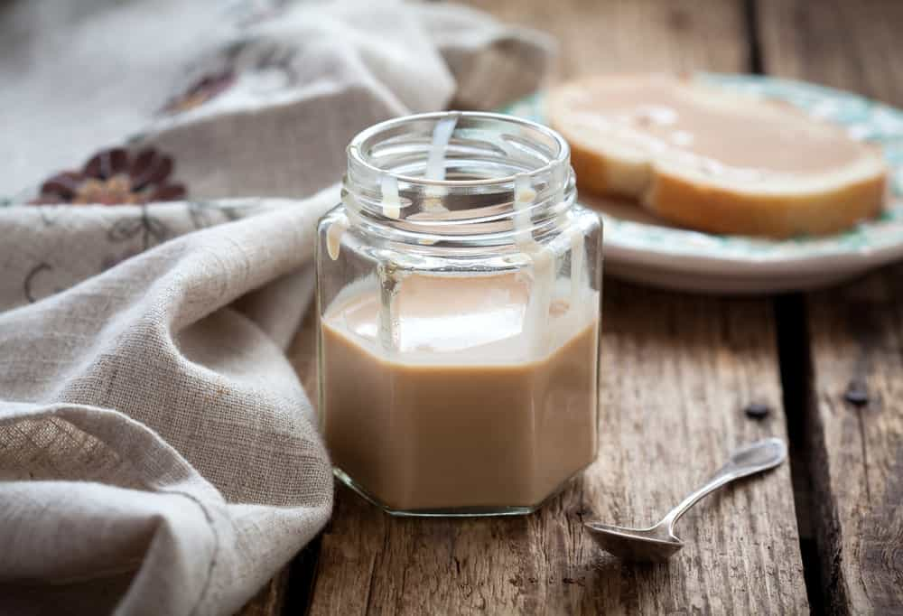
THIS IS QUITE SIMILAR TO EVAPORATED MILK CONSIDERING HOW THE WATER FROM COW’S MILK IS REMOVED TO PRODUCE SWEETENED CONDENSED MILK. THE WATER-REMOVING PROCESS LEAVES BEHIND A LIQUID THAT IS VERY DENSE AND CREAMY.
ALTHOUGH IT IS A TYPE OF MILK, IT IS ACTUALLY VERY DIFFERENT FROM REGULAR VARIETIES IN TERMS OF TASTE, TEXTURE, AND CONSISTENCY. IT TASTES VERY SWEET AND HAS A DARKER COLOR, AND THICK AND CREAMY TEXTURE AND CONSISTENCY.
ANOTHER DIFFERENCE BETWEEN EVAPORATED AND SWEETENED CONDENSED MILK IS THAT THE LATTER HAS SUGAR ADDED TO IT AS A PRESERVATIVE IN ORDER TO INCREASE ITS SHELF LIFE. WHILE IT CONTAINS SOME PROPORTION OF NATURALLY-OCCURRING SUGARS IN THE MILK, MORE SUGAR IS ADDED DURING THE PROCESSING.
DUE TO ITS ULTRA-SWEET TASTE AND SUPER-RICH CONSISTENCY, THIS MILK IS USUALLY ADDED TO SWEET DISHES AND BEVERAGES RATHER THAN DRUNK ON ITS OWN.

OAT MILK
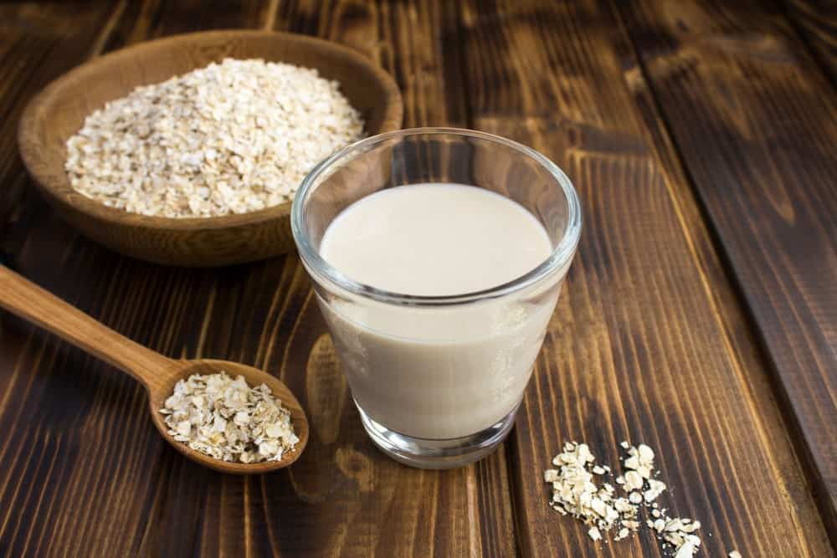
OAT MILK IS A BLEND OF WATER AND STEEL-CUT, ROLLED, OR WHOLE OATS. THE MIXTURE IS CAREFULLY STRAINED TO CREATE A PLANT-BASED MILK. THE STRAINING PROCESS RESULTS IN SLIGHTLY THIN MILK, MAKING IT A GREAT OPTION FOR COFFEE AND PANCAKES.
OATS CONTAIN A LARGE NUMBER OF BETA-GLUCANS AND SOLUBLE FIBER WHICH MAKES OAT MILK AN EXCELLENT DRINK FOR YOUR IMMUNE SYSTEM AND METABOLISM. IT HAS A MILD FLAVOR WITH SUBTLE HINTS OF SWEETNESS ALONG WITH A WATERY CONSISTENCY.
OAT MILK IS GREAT FOR PEOPLE WITH SPECIFIC DIETARY RESTRICTIONS BECAUSE IT IS NOT ONLY VEGAN AND LACTOSE-FREE, BUT IT IS ALSO SOY AND NUT-FREE. THE PRESENCE OF BETA-GLUCANS MAKES THE MILK GOOD FOR CARDIOVASCULAR HEALTH. IT IS ALSO RICH IN CALCIUM AND VITAMIN D, MAKING IT HIGHLY BENEFICIAL FOR STRONG, HEALTHY BONES AND A LOWER RISK OF OSTEOPOROSIS.

GOAT MILK

MANY PEOPLE FIND IT HARD TO DIGEST COW MILK WHICH HAS HIGH LACTOSE CONTENT AND ALSO CONSISTS OF A LARGE NUMBER OF ALLERGENS. GOAT MILK IS AN EXCELLENT NUTRIENT-RICH ALTERNATIVE.
GOAT MILK IS LOADED WITH ESSENTIAL NUTRIENTS, VITAMINS, AND MINERALS AND IS RICH IN MEDIUM-CHAIN FATTY ACIDS. IT IS EASILY DIGESTIBLE, EASY ON THE GUT, AND ALSO LESS INFLAMMATORY, COMPARED TO COW MILK.
ONE OF THE MOST IMPORTANT BENEFITS OF GOAT MILK IS THAT IT HAS THERAPEUTIC BENEFITS FOR HEART HEALTH WHERE ITS FATTY ACIDS HELP LOWER CHOLESTEROL LEVELS IN THE BODY AND MAY EVEN HELP TREAT CONDITIONS LIKE CORONARY HEART DISEASE.

HEMP MILK
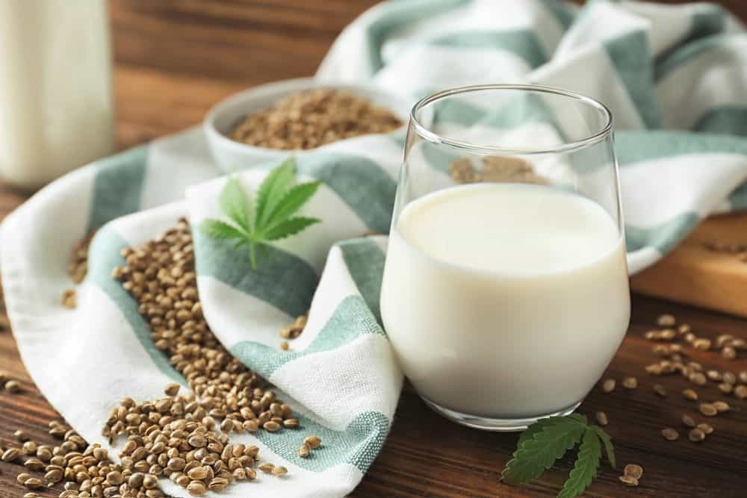
FOR ANYONE LOOKING FOR A HEALTHIER ALTERNATIVE TO COW MILK, HEMP MILK IS AN IDEAL OPTION. IT IS AN EXCELLENT VEGAN-BASED MILK THAT IS PRODUCED BY CRUSHING AND SOAKING HEMP SEEDS IN WATER. THE MIXTURE IS THEN THOROUGHLY BLENDED, RESULTING IN MILK THAT HAS A RICH, CREAMY CONSISTENCY ALONG WITH AN EARTHY, NUTTY FLAVOR.
THE CONSUMPTION OF HEMP MILK HAS ALWAYS BEEN ASSOCIATED WITH A LOT OF CONTROVERSIAL STATEMENTS, CONSIDERING HOW THE HEMP PLANT IS ALSO USED TO PRODUCE MARIJUANA. HOWEVER, HEMP SEEDS DO NOT CONTAIN ANY THC (TETRAHYDROCANNABINOL) SO THERE IS NO WAY THAT HEMP MILK CAN PRODUCE MIND-ALTERING EFFECTS.
ON THE CONTRARY, HEMP MILK IS AN EXCELLENT SOURCE OF CALCIUM, IRON, PROTEIN, POTASSIUM, MANGANESE, VITAMINS AND ZINC. ALL THESE ESSENTIAL NUTRIENTS AND COMPONENTS ALLOW HEMP MILK TO DELIVER A PLETHORA OF HEALTH BENEFITS INCLUDING IMPROVED COGNITION, ENHANCED HEART HEALTH, EXCELLENT SKIN, IMPROVED BONE DENSITY, AND A STRONG IMMUNE SYSTEM, TO NAME A FEW.

COCONUT MILK
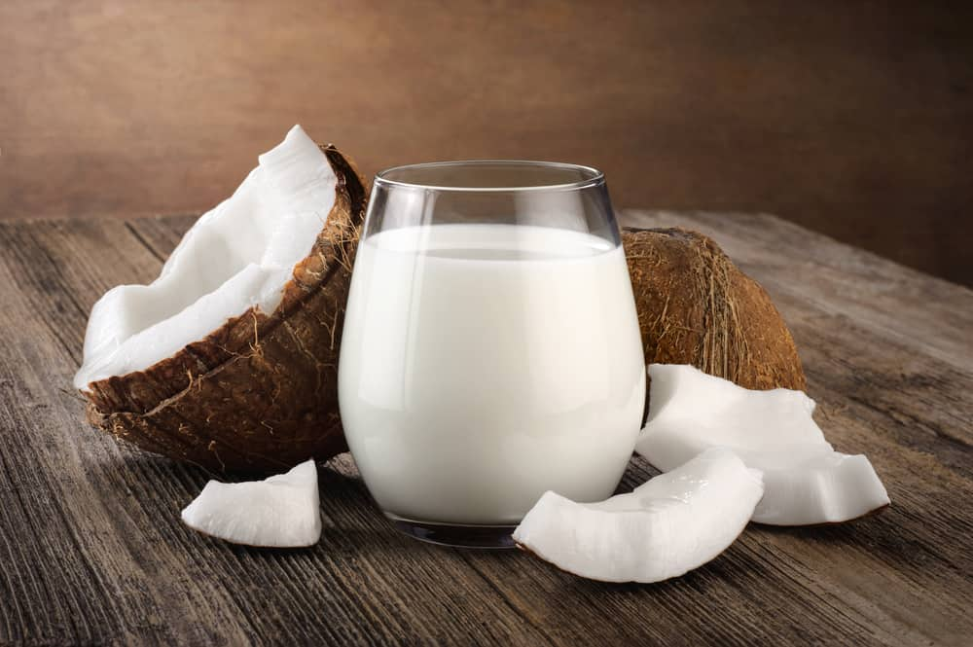
COCONUT MILK IS ONE OF THOSE MILK VARIETIES THAT HAVE GAINED SIGNIFICANT POPULARITY IN RECENT TIMES. IT IS A TASTIER ALTERNATIVE TO COW MILK WITH AN INCREDIBLY THICK AND CREAMY TEXTURE.
COCONUT MILK IS TAKEN FROM THE WHITE FLESH OF MATURE BROWN COCONUTS AND IS COMPLETELY DIFFERENT FROM COCONUT WATER. IT IS AVAILABLE IN BOTH THICK AND THIN CONSISTENCIES.
THICK COCONUT MILK IS PREPARED BY SIMMERING OR BOILING FINELY GRATED SOLID COCONUT FLESH IN WATER AFTER WHICH THE MIXTURE IS STRAINED THROUGH A CHEESECLOTH, RESULTING IN FINE AND THICK COCONUT MILK. ON THE OTHER HAND, THIN COCONUT MILK IS MADE FROM GRATED COCONUT FLESH THAT REMAINS BEHIND IN THE CHEESECLOTH AFTER PREPARING THICK COCONUT MILK. IT IS SIMMERED OR BOILED THE SAME WAY TILL YOU GET A THIN, WATER-LIKE CONSISTENCY.
COCONUT MILK IS PACKED WITH SEVERAL ESSENTIAL NUTRIENTS INCLUDING CALCIUM, FIBER, VITAMINS, COPPER, POTASSIUM, SELENIUM, AND MANGANESE. SOME OF THE MOST POPULAR BENEFITS OF COCONUT MILK INCLUDE WEIGHT LOSS, IMPROVED HEART HEALTH AND AN ENHANCED IMMUNE SYSTEM.

TYPES OF COW MILK

THIS IS ONE OF THE MOST POPULARLY-CONSUMED TYPES OF MILK THAT COMES FROM THE MAMMARY GLANDS OF COWS. IN MANY PARTS OF THE WORLD, COW MILK IS THE PRIMARY FORM OF ANIMAL MILK CONSUMED BY MOST PEOPLE. THE MAIN REASON BEHIND ITS POPULARITY IS ITS RICH NUTRITIONAL PROFILE AND A MULTITUDE OF HEALTH BENEFITS.
COW MILK IS RICH IN PROTEIN WHICH MEANS IT CONSISTS OF ALL THE ESSENTIAL AMINO ACIDS REQUIRED BY THE BODY TO MANUFACTURE PROTEINS. IT IS LOADED WITH VITAMIN B12 – A VITAMIN THAT IS VITAL FOR HEALTHY BRAIN FUNCTION AS WELL AS FOR A STRONG NERVOUS SYSTEM. THE HIGH CONTENT OF CALCIUM IN COW MILK MAKES IT EXCEPTIONALLY BENEFICIAL FOR MAINTAINING STRONG BONES, MUSCLES, AND TEETH.
ON THE DOWNSIDE THOUGH, IT IS HIGH IN SATURATED FAT CONTENT AND ALSO CONTAINS HIGH LACTOSE WHICH MEANS IT IS NOT MEANT FOR LACTOSE-INTOLERANT PEOPLE.
COW’S MILK COMES IN ALMOST ALL THE VARIETIES LISTED ABOVE: RAW, WHOLE, SKIM, 2%, CONDENSED, FLAVORED, ETC..

BUFFALO MILK
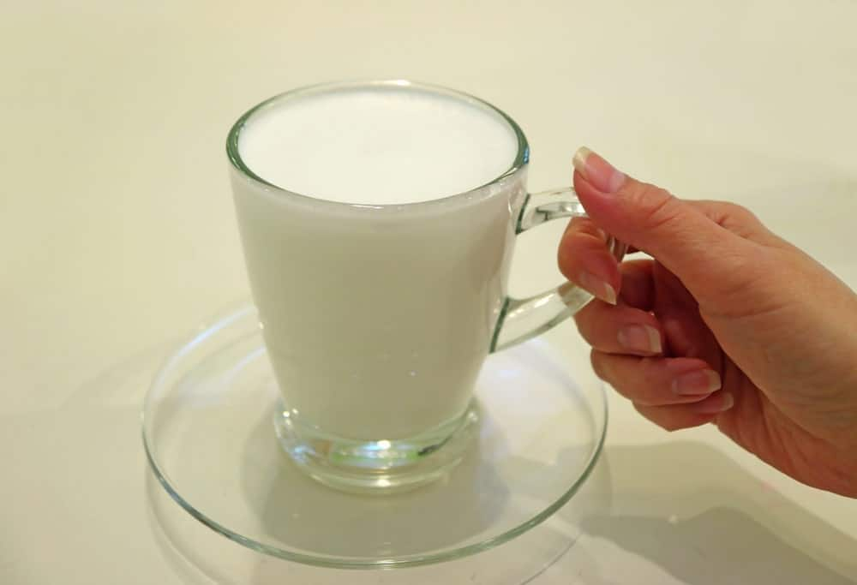
BUFFALO MILK IS POSSIBLY THE LEAST POPULAR VARIETY OR TYPE OF MILK DUE TO ITS EXTREMELY HIGH-FAT CONTENT AND THE OVERLOAD OF CALORIES. HOWEVER, IT DOES CONTAIN A FAIR SHARE OF HEALTH BENEFITS AND ESSENTIAL NUTRIENTS THAT HELP THE BODY IN NUMEROUS WAYS.
THE MILK COMES FROM THE MAMMARY GLAND OF A BUFFALO AND IS ALSO A KEY COMPONENT OF A HEALTHY DIET IN VARIOUS PARTS OF THE WORLD, INCLUDING INDIA AND OTHER REGIONS OF ASIA.
BUFFALO MILK CONSISTS OF LARGE AMOUNTS OF IRON, CALCIUM, PHOSPHORUS, PROTEIN, AND VITAMIN A, WHICH BOOST YOUR IMMUNE SYSTEM, STIMULATE GROWTH AND DEVELOPMENT IN THE BODY, IMPROVE CIRCULATION AND ALSO REGULATE BLOOD PRESSURE.
NOW THAT YOU ARE AWARE OF SO MANY DIFFERENT TYPES OF MILK, IT IS TIME TO STOCK YOUR REFRIGERATOR WITH YOUR FAVORITE PICK BECAUSE, IF ANYTHING, MILK PAVES THE WAY TOWARD A HEALTHY BODY AND A STRONG IMMUNE SYSTEM.

BEST TYPE OF MILK FOR VARIOUS RECIPES

BEST TYPE OF MILK FOR COFFEE

IN ORDER TO GET THE FULL TASTE OF YOUR COFFEE, IT IS BEST TO USE FULL-FAT MILK TO GET THAT CREAMY FLAVOR THAT YOU WANT. THIS MAY NOT BE THE HEALTHIEST OPTION, SO IF YOU WANT TO REDUCE CALORIES AND STILL GET A CREAMY TASTE, OPT FOR 2%.

BEST TYPE OF MILK FOR CEREAL

CEREAL WORKS BEST WITH WHOLE MILK. WHEN IT IS DESIGNED BY DIFFERENT CEREAL BRAND COMPANIES, THIS IS THE STANDARD MILK USED BECAUSE IT IS THE MOST POPULAR. IF THIS MILK IS TOO THICK OR HAS TOO MANY CALORIES, 1% MILK IS ANOTHER OPTION.

BEST TYPE OF MILK FOR CHIA PUDDING
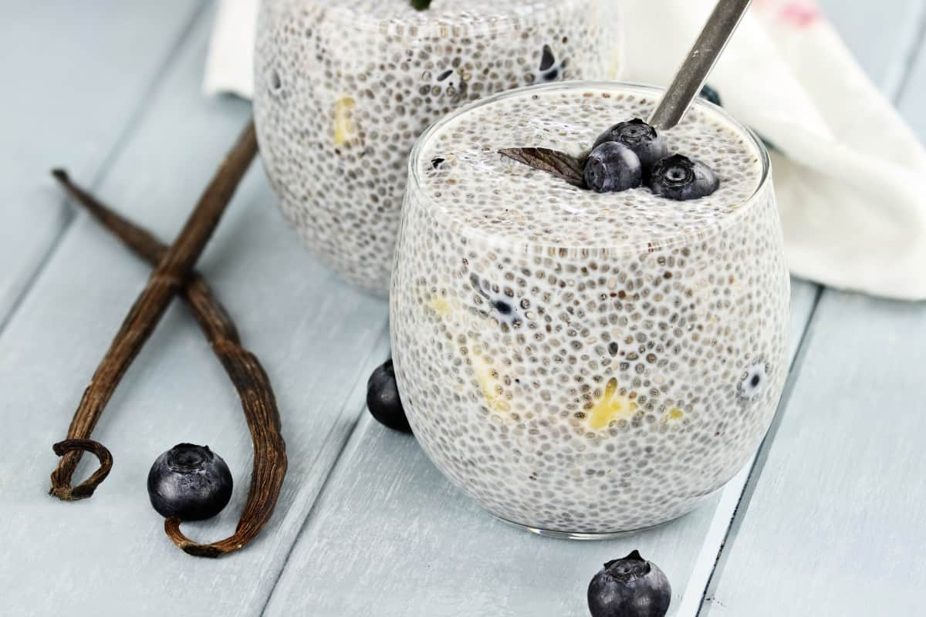
WHEN MAKING CHIA PUDDING, YOU WANT TO GEL YOUR SEEDS IN 2% MILK SO THAT THEY THICKEN BUT NOT GET TOO THICK DURING THE PROCESS. FOR HEALTHIER OPTIONS OR DAIRY-FREE, ALMOND MILK MAKES A GREAT SECOND OPTION.

BEST TYPE OF MILK FOR CHEESEMAKING
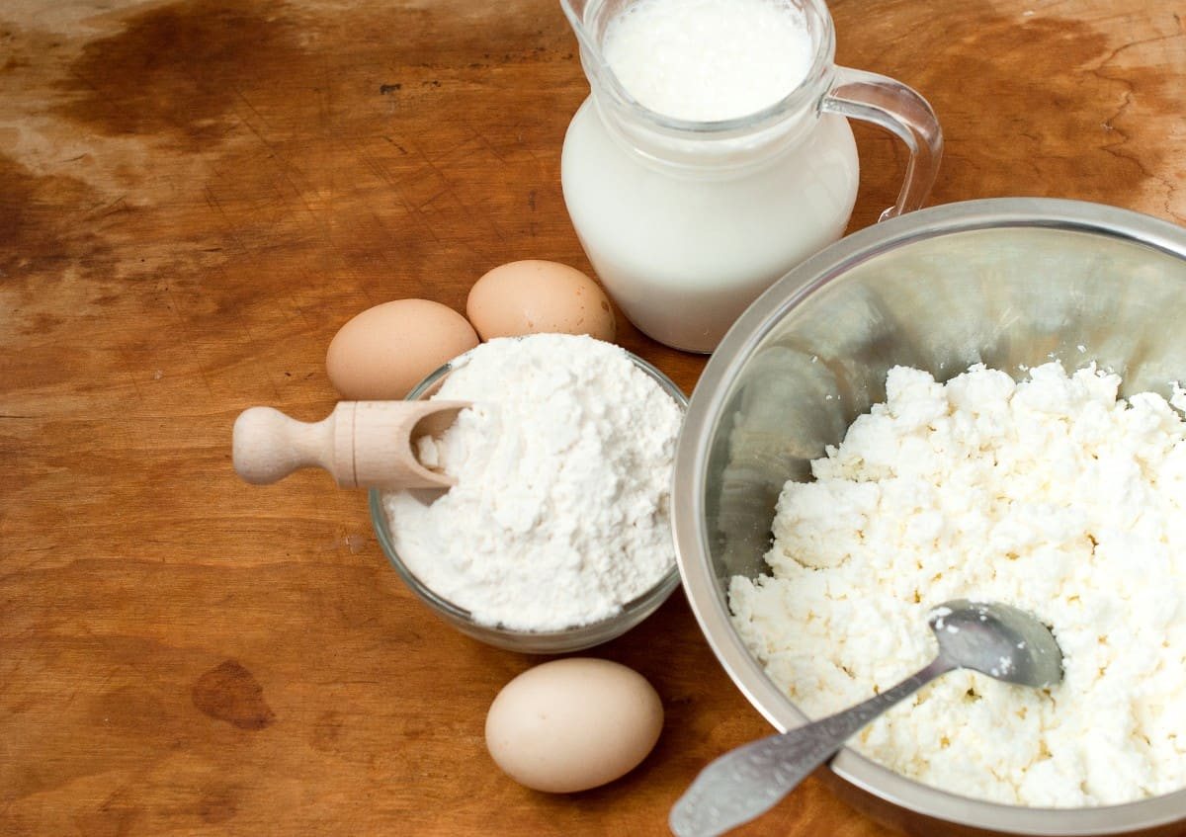
IN ORDER TO GET THE MOST CHEESE AND THE CREAMIEST TASTE, YOU WANT TO USE PASTEURIZED, WHOLE MILK FOR YOUR CHEESE. YOU CAN GET GREAT QUALITY CHEESE, HOWEVER, WITH 2% OR 1% MILK. AVOID FAT-FREE MILK BECAUSE IT DOES NOT HOLD UP THE CONSISTENCY.

BEST TYPE OF MILK FOR CAPPUCCINO

A GOOD CAPPUCCINO IS ALL ABOUT FOAM. IN ORDER TO ACHIEVE THE BEST SMOOTHNESS AND CREAMINESS THAT MAKES THE DRINK, YOU NEED WHOLE MILK FOR YOUR CAPPUCCINO. YOU MAY BE ABLE TO USE 2% IF YOU REALLY WANT TO CUT OUT SOME FAT, BUT YOU WILL NOT GET THE SAME SMOOTHNESS AND THE FOAM WILL LOST ITS FORM QUICKLY.

BEST TYPE OF MILK FOR CHAI LATTE
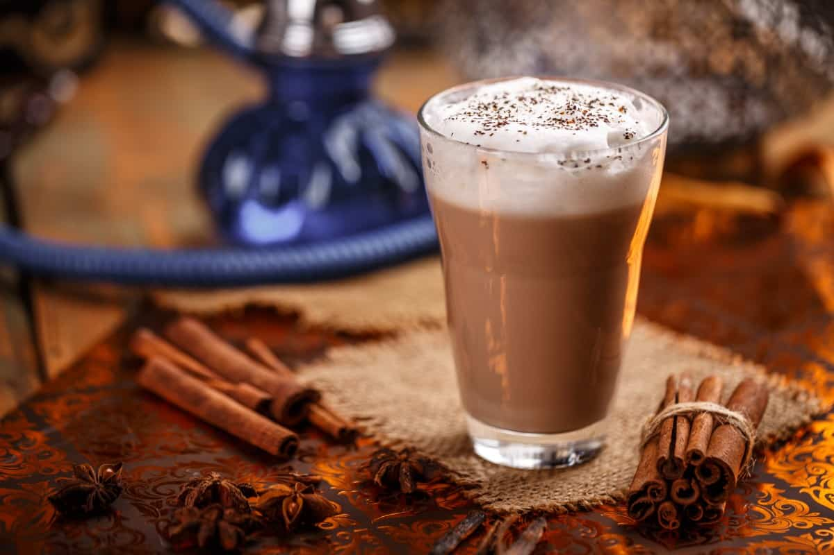
IN ORDER TO CREATE THE RICHNESS OF THE POPULAR CHAI LATTE, YOU NEED WHOLE MILK TO BRING TOGETHER ALL OF THE FLAVORS IN THE LATTE. ANY OTHER MILK TYPE WILL NOT BENEFIT THE CHAI LATTE.

BEST TYPE OF MILK FOR TEA

IF YOU LIKE TO ADD MILK TO YOUR TEA, YOU DO NOT WANT IT TO BE TOO THICK, SO 2% MILK WORKS FINE AS LONG AS IT IS PASTEURIZED COW’S MILK. THIS IS ESPECIALLY TRUE IF YOU ARE USING A STRONG TEA AND DO NOT WANT TO CUT THE FLAVOR.

BEST TYPE OF MILK FOR FRENCH TOAST
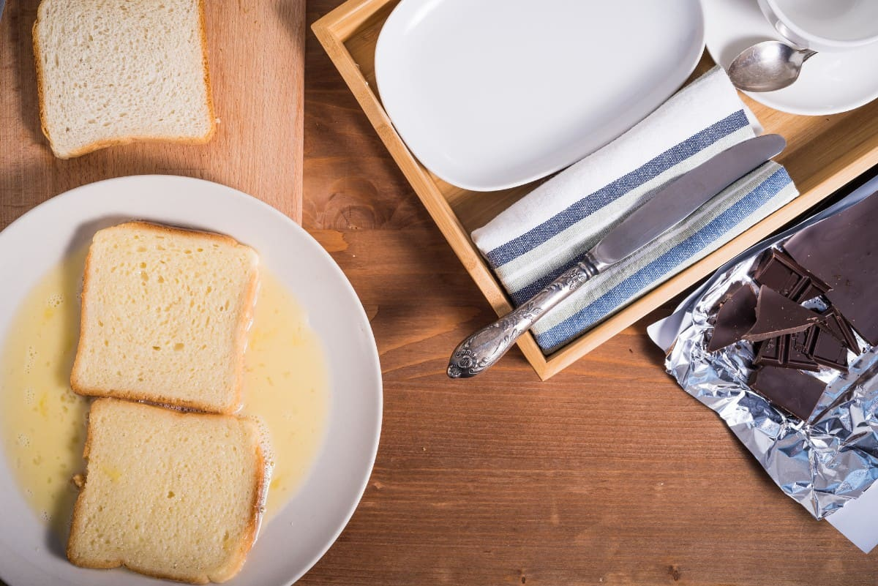
WHOLE MILK IS A REQUIREMENT WHEN MAKING FRENCH TOAST. THIS DISH NEEDS A CREAMY FLAVOR ADDED TO THE TOAST AND KEEPS THAT FLAVOR. ALSO, ANY MILK LESS THAN WHOLE MILK IS TOO THIN FOR THE BREAD SLICES AND THEY WILL START TO RIP APART BEFORE YOU CAN START COOKING THEM.

BEST TYPE OF MILK FOR ICE CREAM

IN ORDER TO HAVE THICK AND SMOOTH ICE CREAM, YOU NEED FULL-FAT MILK. THIS MILK IS THE THICKEST AND THE BEST WHEN IT COMES TO FORMING ICE CREAM AND GIVING IT THAT DESIRED CONSISTENCY. THE THINNER THE ICE CREAM USED, THE THINNER THE ICE CREAM.

BEST TYPE OF MILK FOR KEFIR
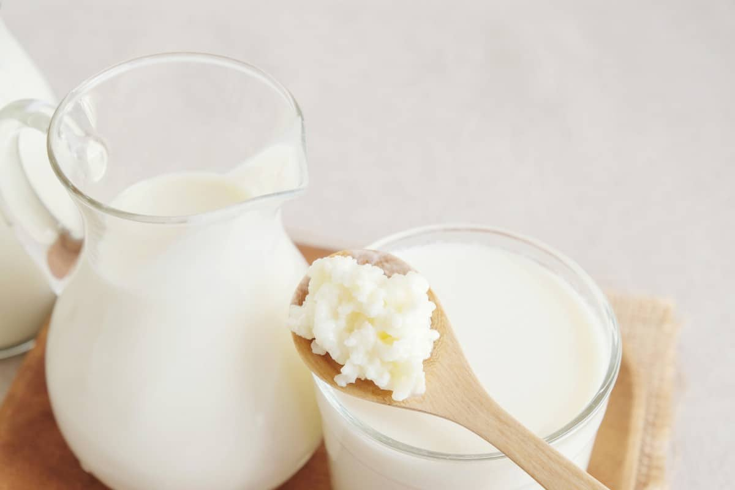
WHEN YOU ARE MAKING KEFIR, IT SHOULD BE WHOLE MILK THAT IS USED COMING FROM EITHER A GOAT OR A COW. THE MOST IMPORTANT THING ABOUT THIS MILK IS THAT IT IS ORGANIC AND FULL OF NUTRIENTS. YOU DO NOT WANT ANY MILK SUBSTITUTES IN KEFIR BECAUSE IT WILL NOT THICKEN PROPERLY.

BEST TYPE OF MILK FOR KETO
IF YOU ARE MAKING ANYTHING KETO, ALMOND MILK IS YOUR FRIEND. YOU ARE STAYING IN KETO COMPLIANCE WITH ALMOND MILK, AVOIDING ALL DAIRY ASPECTS, AND MINIMAL CARBOHYDRATES.

BEST TYPE OF MILK FOR LATTE

THE COMPOSITION OF A LATTE REQUIRES A THICKENING AGENT TO TAKE THE DRINK TOGETHER. THIS IS WHERE WHOLE MILK COMES IN AND IS THE ONLY MILK OPTION FOR THIS DRINK.

BEST TYPE OF MILK FOR MILKSHAKES

MILKSHAKES ARE MEANT TO BE CREAMY AND FLAVORFUL, SO MAKE SURE YOU ADD WHOLE MILK TO THEM. YOU WANT MILKSHAKES TO BE THICK AND WHOLE MILK GUARANTEES THAT CONSISTENCY.

BEST TYPE OF MILK FOR PROTEIN SHAKES

MOST PROTEIN SHAKES ARE MADE WITH FAT-FREE MILK TO KEEP THEM HEALTHY AND REDUCE THE NUMBER OF CALORIES. ALSO, FAT-FREE MILK IS THINNER THAN OTHER MILK OPTIONS, WHICH IS GREAT FOR THICK AND HEAVY PROTEIN, GIVING IT A NECESSARY BALANCE.

BEST TYPE OF MILK FOR PANCAKES

WHOLE MILK ALL THE WAY FOR YOUR PANCAKES. LIKE FRENCH TOAST, PANCAKES NEED A BATTER THAT IS THICK SO THAT THEY HOLD TOGETHER.

BEST TYPE OF MILK FOR SMOOTHIES

BECAUSE SMOOTHIES ARE MEANT TO BE A HEALTHY SNACK, FAT-FREE MILK WORKS GREAT. IT TAKES THE FLAVOR OF THE FRUIT AND/OR PROTEIN THAT YOU ARE USING WHILE GIVING A CREAMY TEXTURE.

BEST TYPE OF MILK FOR STEAMING/FROTHING

IN ORDER TO GET THE FULL EFFECT OF A STEAMED DRINK OR FROTH IN YOUR COFFEE, YOU WANT TO USE FULL-FAT MILK. THIS ALLOWS THE FROTH TO HOLD ITS SHAPE, LASTING FOR THE DRINK AND GIVING YOU THAT FULL CREAM FLAVOR.

FAQS

ARE MILK CARTONS RECYCLABLE?
MILK CARTONS ARE RECYCLABLE. MOST ARE MADE FROM A BIODEGRADABLE MATERIAL THAT IS PERFECT FOR RECYCLING. YOU CAN INCLUDE MILK CARTONS IN YOUR RECYCLING BIN AT HOME WITHOUT ANY ISSUES. THERE ARE TWO MAIN TYPES OF MILK CARTONS. PLASTIC MILK CARTONS ARE LARGER AND COME WITH A HANDLE.
DUE TO THE TYPE OF PLASTIC, IT’S ESPECIALLY IMPORTANT THAT WE RECYCLE THESE AS OPPOSED TO THROWING THEM AWAY. PAPER MILK CARTONS ARE SMALLER AND EASILY COLLAPSE INTO A THIN SHEET. KEEP IN MIND THAT THIS TYPE OF PAPER ISN’T THE SAME AS PRINTER PAPER; IT’S CLOSER TO CARDBOARD WITH STRONG FIBERS. EITHER WAY, YOU CAN RECYCLE THESE MILK CARTONS, AND EVEN BRING THEM IN FOR A MONETARY REWARD IN SOME LOCATIONS.

WHAT IS SKIM MILK?
SKIM MILK IS A VARIETY OF MILK WHERE ALL THE FAT HAS BEEN REMOVED. IT IS CONSIDERED TO BE THE HEALTHIEST VERSION OF MILK THAT CONTAINS THE LEAST CALORIES. EVEN AFTER REMOVAL, ROUGHLY 0.1% OF THE FAT REMAINS, BUT THIS IS STILL A LOW ENOUGH PERCENTAGE TO BE LABELED AS SKIM MILK.
SKIM MILK GENERALLY COSTS THE SAME AS OTHER TYPES OF MILK, ALTHOUGH IT IS OCCASIONALLY A FEW CENTS MORE DUE TO THE REMOVAL PROCESS. WHEN SEARCHING FOR SKIM MILK, YOU CAN OFTEN IDENTIFY IT BY A DISTINCTIVE PINK CAP OR LABEL.

HOW MANY CALORIES IN MILK?
ONE CUP OF 2% MILK HAS ROUGHLY 124 CALORIES. A CUP OF WHOLE MILK HAS ABOUT 148 CALORIES, AND A CUP OF SKIM MILK HAS ABOUT 83 CALORIES.

WHAT IS HOMOGENIZED MILK?
HOMOGENIZED MILK HAS BEEN TREATED AT A FACTORY TO REMOVE ANY INCONSISTENCIES. MACHINES POUND FAT MOLECULES INTO SMALLER PARTICLES, EVENING OUT THE TEXTURE, AND MAKING IT RESIST SEPARATION. THE MILK HAS A SMOOTH, SILKY TASTE, WHICH IS PERFECT FOR DRINKING AS OPPOSED TO BAKING. WHEN ALL IS SAID AND DONE, YOU CAN USE HOMOGENIZED MILK AND OTHER VARIETIES OF MILK FOR SIMILAR PURPOSES.
IF YOU HAVE A YOUNG CHILD WHO IS RESISTANT TO DRINKING MILK, TRY HOMOGENIZED MILK, WHICH MAY BE EASIER ON HIS OR HER TASTE BUDS. BECAUSE THE MILK HAS BEEN REFINED, A LITTLE GOES A LONG WAY.
HOMOGENIZED MILK IS SLIGHTLY MORE CONCENTRATED IN NUTRIENTS AND VITAMINS THAN REGULAR MILK. AGAIN, IF YOU’RE AVERSE TO DRINKING A WHOLE CUP OF MILK, HOMOGENIZED MILK COULD BE A GOOD ALTERNATIVE FOR YOU.

WHAT IS HALF AND HALF MILK?
CONTRARY TO POPULAR BELIEF, HALF AND HALF MILK ISN’T TWO KINDS OF MILK. IT’S SIMPLY REGULAR MILK WITH AN ADDITIVE SUCH AS CORN SYRUP TO THICKEN IT. HALF AND HALF ISN’T TYPICALLY CONSUMED ON ITS OWN; THE MILK IS VERY POPULAR IN BAKING GOODS AND KITCHENS.
BECAUSE IT IS ON THE THICKER SIDE, THE MILK SETTLES QUITE NICELY AND WON’T DISTURB THE REST OF YOUR INGREDIENTS. NOT ALL HALF AND HALF MILK IS THE SAME, AS OTHER HIGH FRUCTOSE THICKENERS CAN BE SUBSTITUTED FOR CORN SYRUP.

HOW MANY CUPS OF MILK IN A GALLON?
THERE ARE 16 CUPS OF MILK IN ONE GALLON.

WHAT IS RAW MILK?
RAW MILK IS UNPASTEURIZED MILK THAT HAS NOT BEEN HEATED TO KILL HARMFUL BACTERIA. THERE IS A LOT OF DISCUSSION ABOUT THE SAFETY OF RAW MILK AND WHETHER IT SHOULD BE SERVED ON A REGULAR BASIS. RAW MILK IS LESS EXPENSIVE TO PRODUCE BECAUSE IT DOES NOT REQUIRE ANY SPECIAL TREATMENTS OR PACKAGING METHODS. IN GENERAL, YOU WON’T BE ABLE TO FIND RAW MILK IN THE DAIRY AISLE OF YOUR GROCERY STORE.
IF YOU DO WANT TO PURCHASE RAW MILK, IT’S BEST TO GO TO A SUPPLIER OR A WAREHOUSE THAT SELLS RAW ANIMAL PRODUCTS. REMEMBER, THIS IS THE REASON MILK IS SERVED CHILLED; AT ROOM TEMPERATURE, BACTERIA MULTIPLIES AND BECOMES HAZARDOUS TO HUMANS.

WHAT IS THE PH OF MILK?
THE PH OF MILK IS USUALLY AROUND 6.6. MILD GETS ITS ACIDIC NATURE FROM LACTIC ACID. FOR OTHER MILKS ASIDE FROM COW MILK, PH CAN RANGE FROM 6.3 TO 7.0 DEPENDING ON THE DIET OF THE ANIMAL AND HOW FRESH THE MILK IS. OTHER FACTORS THAT CAN ALTER MILK’S ACIDITY ARE TREATMENT METHODS AT A FACTORY, ITS FAT PERCENTAGE, AND WHETHER IT’S BEEN MALTED OR SUPPLEMENTED WITH ADDITIVES.

WHAT PERCENT OF THE FAT IS WHOLE MILK?
WHOLE MILK IS 3.25% FAT. HOWEVER, THIS PERCENTAGE CAN VARY SLIGHTLY BASED ON THE MANUFACTURER, REGION OF PRODUCTION, AND HOW THOROUGHLY THE MILK HAS BEEN PURIFIED OF BACTERIA. TYPICALLY, THIS RANGE CONSISTS OF ANYWHERE FROM 3% TO 3.5% FAT. BECAUSE WHOLE MILK IS OFTEN PROCESSED IN LARGE BATCHES, THE PERCENTAGES AVERAGE OUT AND THE END RESULT IS USUALLY VERY CLOSE TO 3.25%.

WHAT IS MALTED MILK?
MALTED MILK IS A TYPE OF GRUEL MADE FROM MALTED BARLEY AND EVAPORATED WHOLE MILK. IT COMES IN POWDERED FORM AND IS A COMMON INGREDIENT IN OTHER DAIRY PRODUCTS. IN COOKING, MALTED MILK IS USED TO HELP THE DOUGH RISE WITHOUT FORMING AN OVERLY HARD TEXTURE. WHILE MALTED MILK CAN BE CONSUMED ALONE, IT’S TYPICALLY AN ADDITIVE THAT GIVES SMOOTHIES AND SHAKES A DISTINCT FLAVOR.

HOW MUCH DOES A GALLON OF MILK WEIGH?
A GALLON OF MILK WEIGHS ABOUT 8.6 POUNDS. AS MENTIONED ABOVE, THIS CAN VARY A LITTLE BIT, AS SKIM MILK IS SLIGHTLY LIGHTER AND THE WHOLE MILK IS SLIGHTLY HEAVIER.

HOW MUCH CALCIUM IS IN MILK?
A CUP OF MILK HAS ABOUT 300MG OF CALCIUM. WHEN MILK IS USED FOR BAKING, IT BECOMES SLIGHTLY LESS DENSE IN CALCIUM DUE TO THE HEAT.

HOW MANY FLAVORS OF MILK ARE THERE
THE MOST POPULAR FLAVORS OF FLAVORED MILK ARE CHOCOLATE, VANILLA, STRAWBERRY, AND BANANA. BUT THERE ARE ENDLESS FLAVORS AND CREATIONS THAT YOU CAN COME UP WITH.

WHICH KIND OF MILK HAS THE MOST CALCIUM
COWS AND GOAT’S MILK HAVE THE MOST CALCIUM. LOW-FAT AND SKIM MILKS HAVE THE MOST CALCIUM PER CUP. AND IF YOU CAN’T HAVE DAIRY, ALMOND, HEMP AND FORTIFIED MILK ALTERNATIVES CAN HELP YOU MEET YOUR DAILY CALCIUM INTAKE.

WHAT IS THE THICKEST MILK?
EVAPORATED MILK, CONDENSED MILK, AND COCONUT MILK ARE AMONG THE THICKEST TYPES OF MILK.

HUGE LIST OF THE 20 DIFFERENT TYPES OF NUTS YOU CAN EAT AND COOK WITH
DISCOVER THE 20 MOST POPULAR TYPES OF NUTS THAT YOU CAN EAT. THIS IS YOUR ULTIMATE NUT GUIDE WHERE WE EXPLAIN WHERE THEY GROW, NUTRITION FACTS, INCLUDE IMAGES AND MORE. NICE NUT CHART INCLUDED.
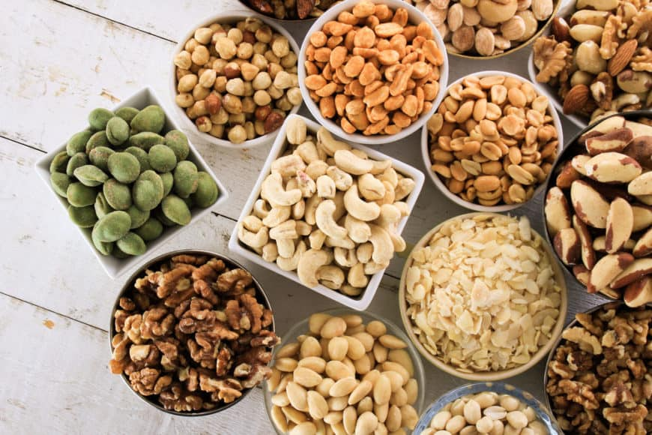
I’M NUTS ABOUT NUTS. I EAT THEM DAILY. MY FAVORITE IS THE CASHEW, BUT PEANUTS ARE ALSO A FAVORITE. YES, I KNOW, PEANUTS ARE TECHNICALLY A LEGUME, BUT WE’VE INCLUDED HERE BECAUSE IT’S OFTEN CONSIDERED A NUT.
FOR OUR CASUAL READERS LOOKING FOR A HEALTHY SNACK ALTERNATIVE, YOU MIGHT BE ASKING “WHAT EXACTLY IS A NUT?”. NUTS ARE ACTUALLY FRUITS! THEY EVOLVED A HARD SHELL TO PROTECT THE SEED THAT’S INSIDE. AS WE SAID BEFORE, OUR LIST ALSO INCLUDES OTHER THINGS LIKE LEGUMES BUT MOST OF OUR SELECTIONS ARE NUTS.
I’M ALSO WILD ABOUT VARIOUS NUT BUTTERS INCLUDING PEANUT BUTTER, ALMOND BUTTER, CASHEW BUTTER AND TAHINI AND SUNFLOWER BUTTER. WE COOK WITH THESE BUTTERS AS WELL AS EAT IT WITH APPLES OR ON BREAD.
THIS EXTENSIVE NUT ARTICLE INCLUDES PHOTOS OF THEIR GROWING ENVIRONMENT, ILLUSTRATED CHART AND NUTRITION FACTS CHARTS. HERE WE GO…
A. TYPES OF EDIBLE NUTS (AND SOME SEEDS)
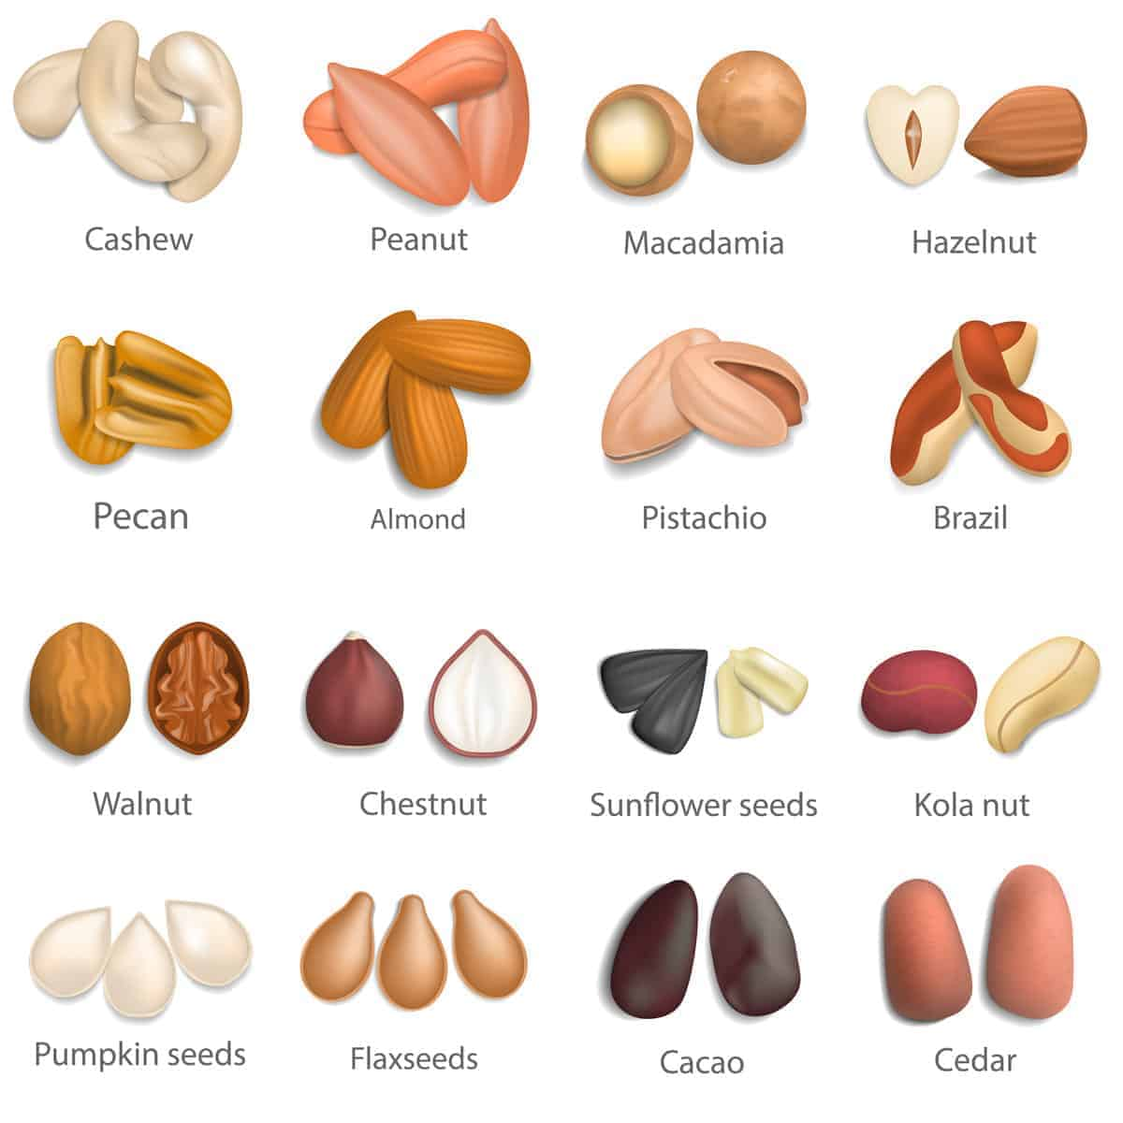
RELATED: BRAZIL NUTS | PEANUTS | PINE NUTS | ROASTED CHESTNUTS | MACADAMIA NUTS

1. CASHEWS
CASHEWS ARE GROWN PRIMARILY IN THE WET AND DRY TROPICS. THEY ARE MAINLY GROWN IN BRAZIL, VIETNAM, INDIA, AFRICA, AND SOUTH EAST ASIA. CASHEW NUTS GROW ON TREES AS PART OF THE CASHEW FRUIT. IT SHOULD BE NOTED THAT CASHEWS REQUIRE SPECIAL CARE TO PREPARE FOR EATING. THE OUTERMOST SHELL OF THE CASHEW IS FULL OF A CAUSTIC LIQUID THAT CAUSE SEVERE BURNS IF PLACED IN DIRECT CONTACT WITH THE SKIN. THERE ARE MULTIPLE WAYS TO EXTRACT THE TASTY NUT WITHOUT GETTING THE JUICE ON YOU. CASHEWS CAN BE FROZEN AND THEN SEPARATED FROM THE SHELL WITH GLOVES. THEY CAN ALSO BE ROASTED ON OIL TO SEPARATE THE NUT FROM THE SHELL. CASHEWS ARE USED IN A VARIETY OF WAYS, DUE TO THEIR UTILITY AS AN ANTIOXIDANT. THEY ARE ALSO RICH IN MAGNESIUM, WHICH HELPS WITH JOINT FLEXIBILITY. CASHEWS ARE COMMONLY USED AS AN ACCENT IN CHINESE DISHES (SUCH AS CASHEW CHICKEN AND STIR-FRY), CHICKEN SALAD, AND AN ADDITION TO A CHOCOLATEY DESSERT.
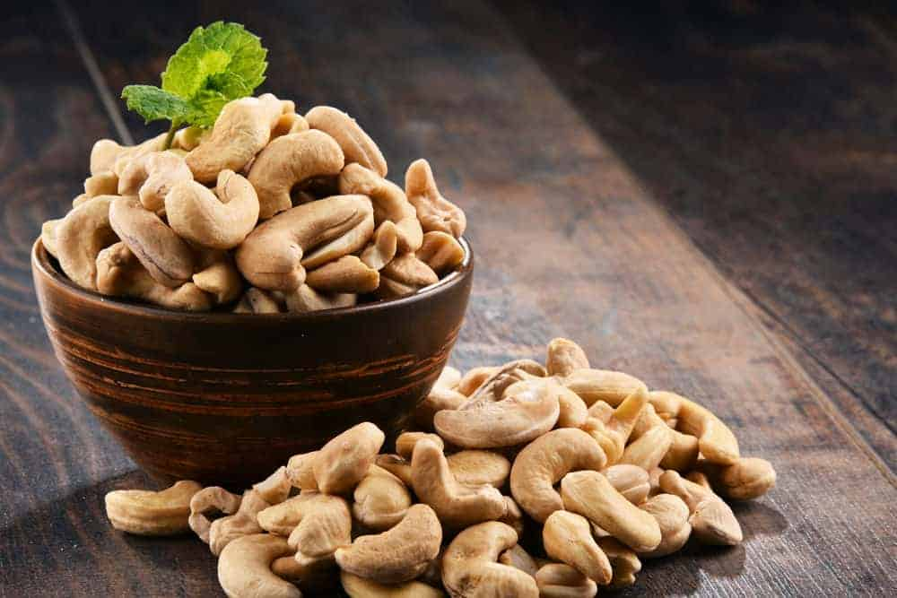
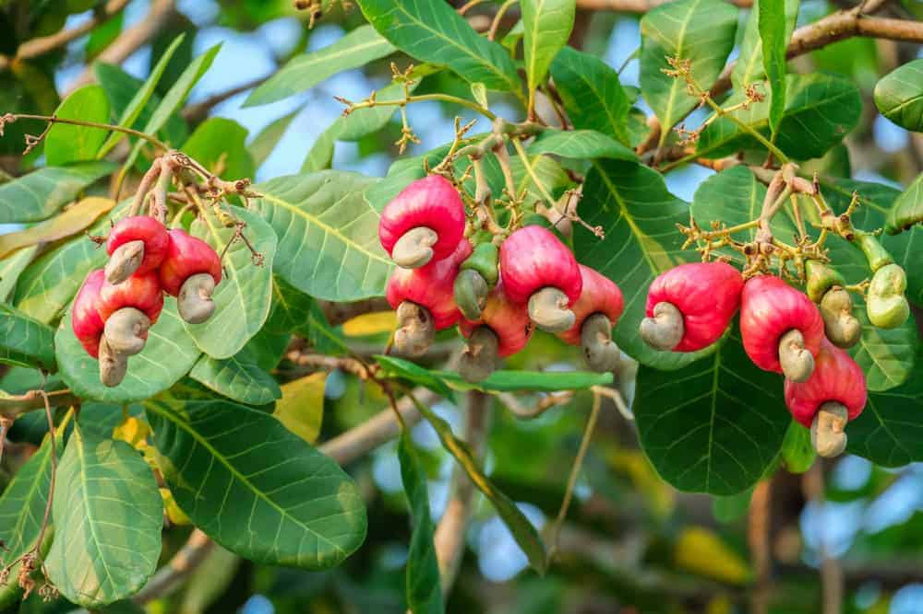
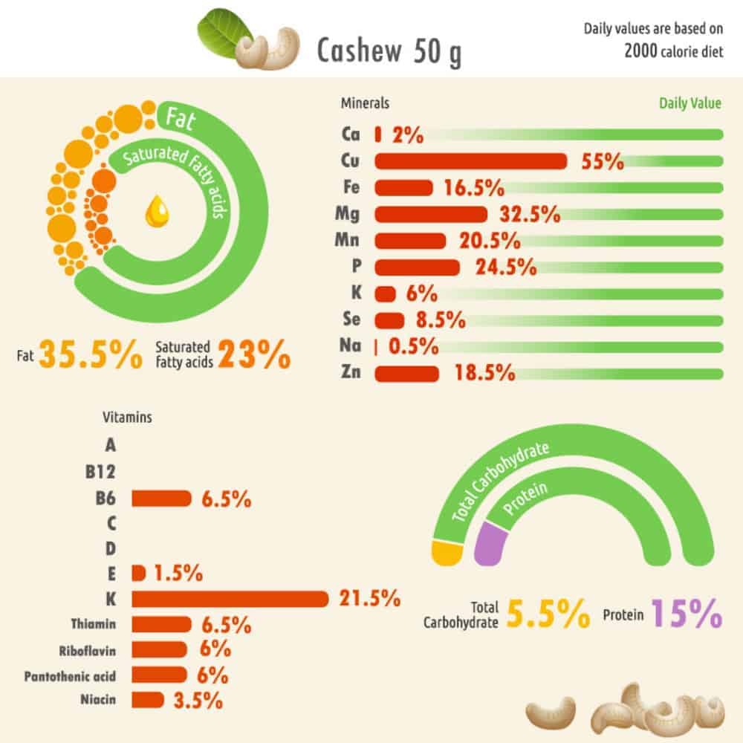
CASHEW NUTRITIONAL FACTS CHART

2. PEANUTS
PEANUTS ARE GROWN IN WARM CLIMATES SUCH AS ASIA, NORTH AMERICA, SOUTH AMERICA, AFRICA, AND AUSTRALIA. THE PEANUT ACTUALLY GROWS BELOW GROUND, CONTRARY TO POPULAR BELIEF. THE PLANT FLOWERS ABOVE GROUND, AND THE PEANUTS GROW UNDER THE SOIL. TO PREPARE PEANUTS FOR CONSUMPTION, THEY SHOULD BE HARVESTED AND WASHED, AND LEFT TO DRY IN THE SUN. THEY CAN BE SHELLED AT THE TIME OF HARVESTING, OR THE SHELL LEFT ON TO BE SHELLED LATER. ONCE THEY ARE SHELLED, THEY ARE READY TO EAT! SOME PEOPLE PREFER ROASTING THEM OR BOILING THEM AND ADDING SEASONING FOR FLAVOR. THE PEANUT IS A STAPLE IN THE DIETS OF MANY PEOPLE AND HAS MANY USES. ONE OF THE MOST WELL-KNOWN USES OF PEANUTS IS PEANUT BUTTER, WHICH HAS MULTIPLE USES, SUCH AS: PEANUT BUTTER AND JELLY SANDWICH AND REESE’S PEANUT BUTTER CUP. PEANUTS ARE COMMONLY USED IN THEIR WHOLE FORM IN BAKED GOODS (SUCH AS CHOCOLATE-COVERED PEANUTS), GRANOLA, TRAIL MIX, AND CHINESE DISHES (PEANUT CHICKEN, GENERAL TSO’S CHICKEN).
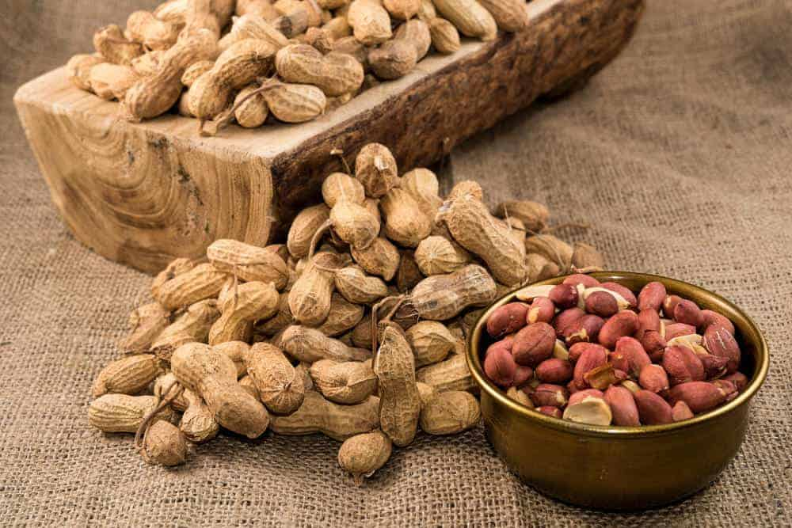
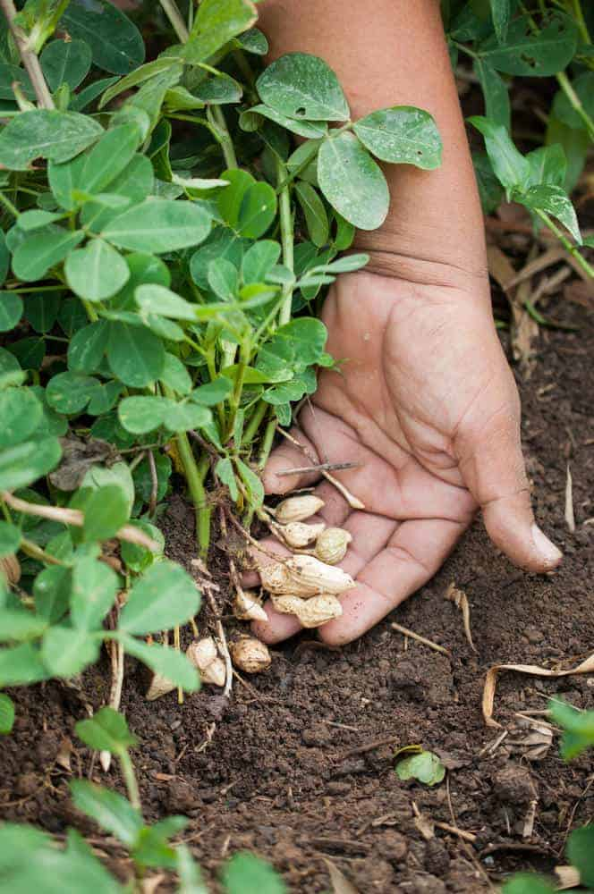
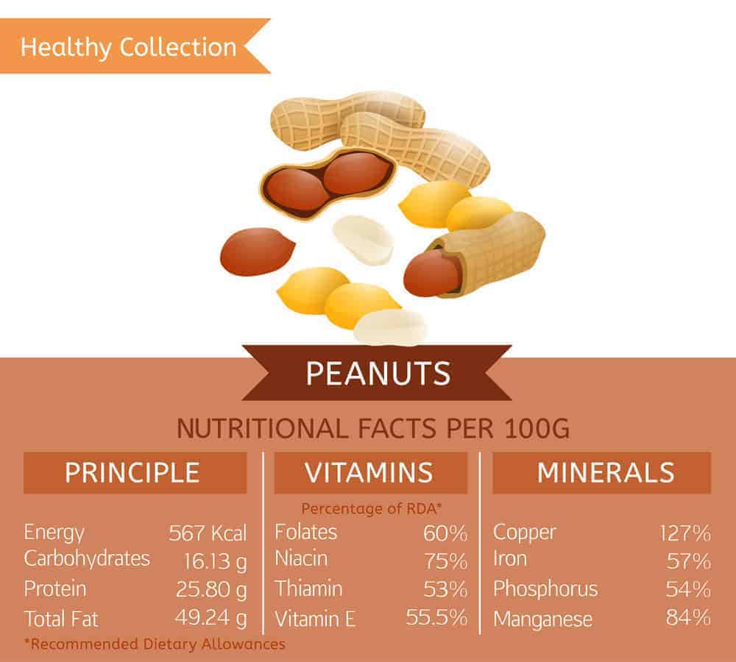
PEANUT NUTRITIONAL FACTS CHART

3. MACADAMIA NUTS
MACADAMIA NUTS ARE PRIMARILY GROWN IN HAWAII AND AUSTRALIA, BUT CAN ALSO BE FOUND IN LATIN AMERICA, AFRICA, AND ASIA IN WARM AREAS ONLY. THEY GROW IN LARGE BUSHY TREES THAT MAY TAKE 5 YEARS TO BEGIN PRODUCING NUTS. IN TERMS OF PREPARATION, MACADAMIA NUTS SHOULD BE SHELLED WITHIN 24 HOURS OF HARVEST TO PREVENT MILDEW. MACADAMIA NUTS ARE A GOOD SOURCE OF VITAMIN A, PROTEIN, AND IRON, AMONG OTHER MINERALS. ONE OF THE MOST FAMOUS RECIPES IS FOR MACADAMIA NUT COOKIES. IT IS ALSO USED IN GRANOLA, FUDGE, MUFFINS, OR IN MACADAMIA NUT CRUSTED CHICKEN.
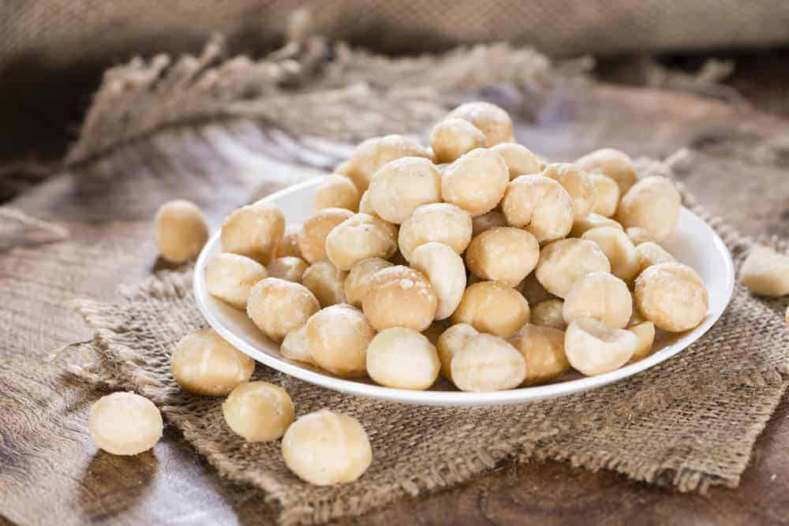
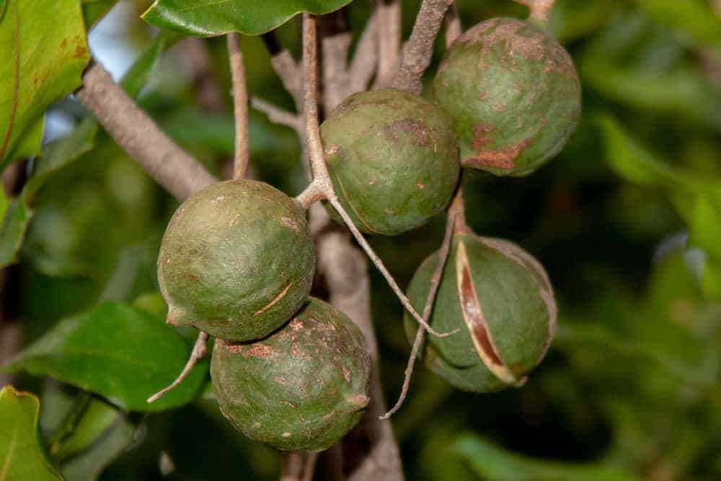
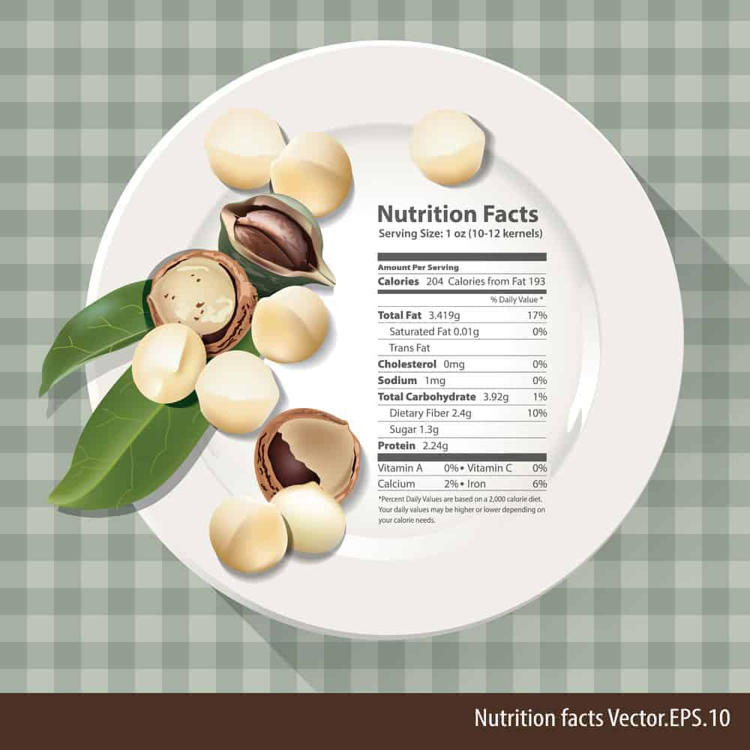
MACADAMIA NUT NUTRITIONAL FACTS CHART

4. HAZELNUTS
HAZELNUTS ARE COMMONLY GROWN IN NORTH AMERICA, EUROPE, AND ASIA. THEY ARE A VERY HARDY PLANT, AND TYPICALLY GROW IN MEDIUM-SIZED BUSHY TREES. ONCE THE NUTS ARE PICKED, THEY NEED TO BEGIN DRYING OUT WITHIN 24 HOURS OF HARVEST. THEY CAN BE KEPT FOR MONTHS WITH THE SHELLS LEFT ON, BUT IF SHELLED FOR HUMAN CONSUMPTION SHOULD BE USED WITHIN A FEW WEEKS. REGARDING USES OF HAZELNUTS, THEY ARE RICH IN MONOUNSATURATED OIL AS WELL AS VITAMINS AND MINERALS. HAZELNUTS ARE COMMONLY USED IN CONJUNCTION WITH CHOCOLATE TO MAKE DESSERTS, SUCH AS CHOCOLATE TRUFFLES AND NUTELLA. THEY ARE ALSO COMMONLY USED IN COFFEE FLAVORING, AND CAN BE USED IN SAVORY DISHES TO ACCOMPANY MEAT, SUCH AS SAUSAGE.
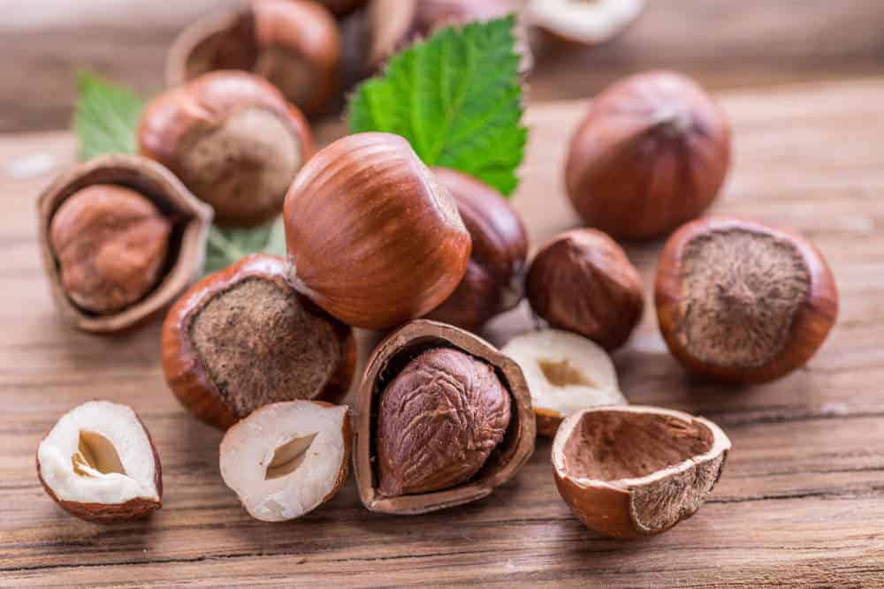
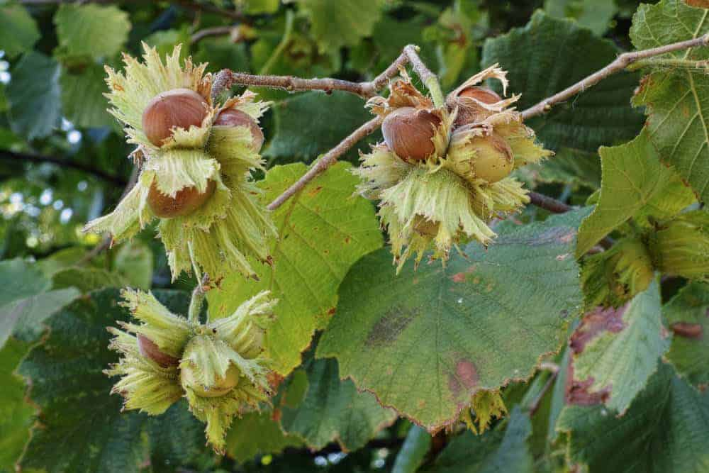

5. PECANS
PECANS GROW IN SOUTH-CENTRAL NORTH AMERICA IN FLORIDA, ALABAMA, ARKANSAS, ARIZONA, CALIFORNIA, LOUISIANA, TEXAS, AND NEW MEXICO, AS WELL AS IN MEXICO. PECANS GROW ON TREES, FREQUENTLY IN ORCHARDS OR GROVES. THE PLANTS CAN TAKE 7 TO 10 YEARS TO BEGIN PRODUCING AN ABUNDANCE OF PECANS. PECANS ARE FREQUENTLY HARVESTED BY SHAKING THE TREES OR GATHERING THE NUTS FROM THE GROUND. THE PECANS WILL NEED TO BE DRIED FOR AT LEAST TWO WEEKS IN THEIR SHELLS. MANY PEOPLE PREFER TO SHELL THEM AND ROAST THEM AS WELL. PECANS CONTAIN MONOUNSATURATED FATS AND ARE ANTIOXIDANTS. ONE OF THE MOST FAMOUS DISHES USING PECANS IS PECAN PIE. PECANS ARE ALSO AN ESSENTIAL INGREDIENT IN CHOCOLATE TURTLE CANDIES, CANDIED PECANS, CHICKEN SALAD, AND AS AN ACCENT TO A CHICKEN OR BEEF DISH.
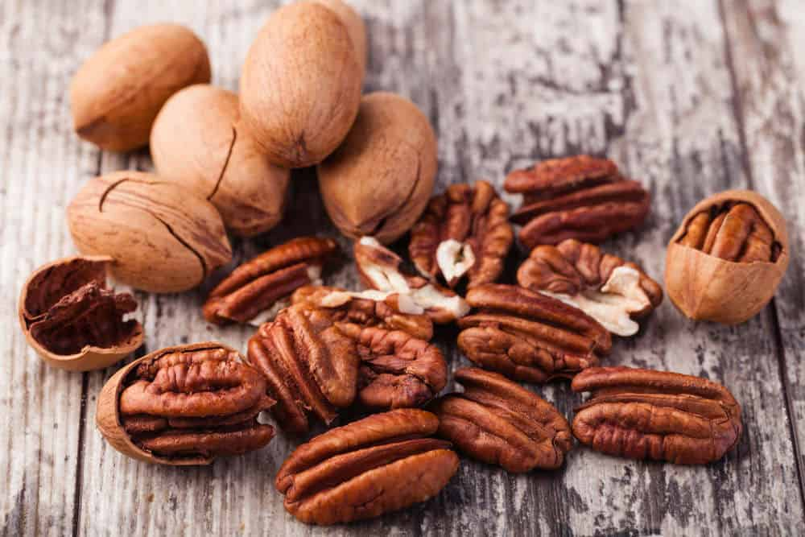
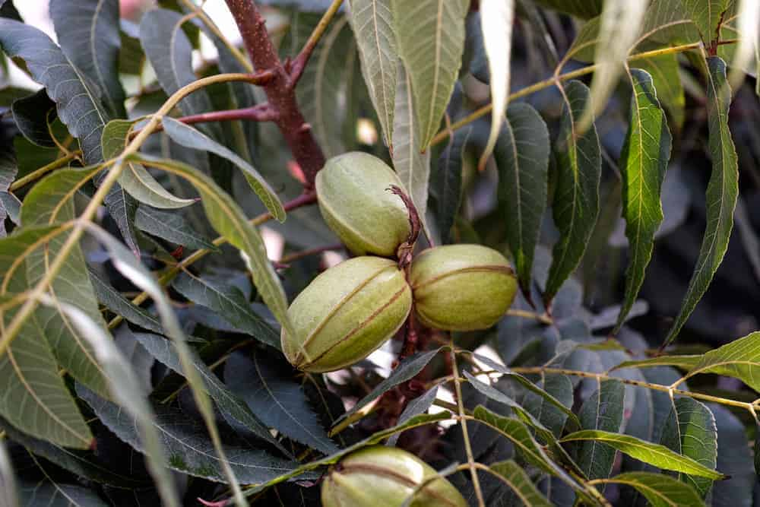
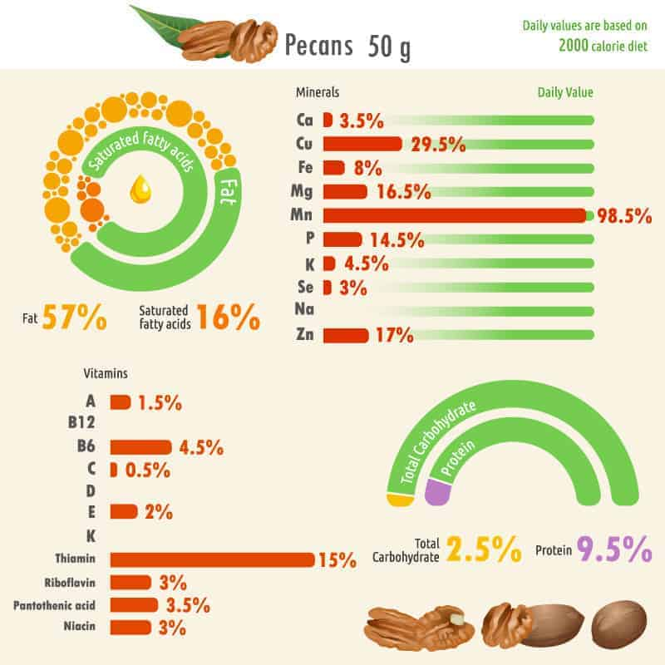
PECAN NUTRITIONAL FACTS CHART
LEARN MORE ABOUT THE DIFFERENT TYPES OF PECANS HERE.

6. ALMONDS
THE MAJORITY OF THE WORLD’S ALMONDS ARE GROWN IN CALIFORNIA, UNITED STATES. THEY CAN ALSO BE FOUND IN SPAIN AND ITALY. ALMONDS ARE GROWN ON TREES SIMILARLY TO PECANS. WHILE YOU CAN EAT AN ALMOND FRESH FROM THE TREE, ITS BEST TO LET THEM DRY OUT FOR AT LEAST TWO WEEKS FIRST TO MAXIMIZE FLAVOR AND MINIMIZE MOLD ON THE ALMOND. AFTER THIS THEY CAN BE SHELLED AND EATEN. ALMONDS ARE ALSO HIGH IN MONOUNSATURATED FATS, PROTEIN, AND VITAMINS. THEY ARE USEFUL IN DISHES SUCH AS: ALMOND-CRUSTED CHICKEN, IN SALADS, AND IN CEREALS.
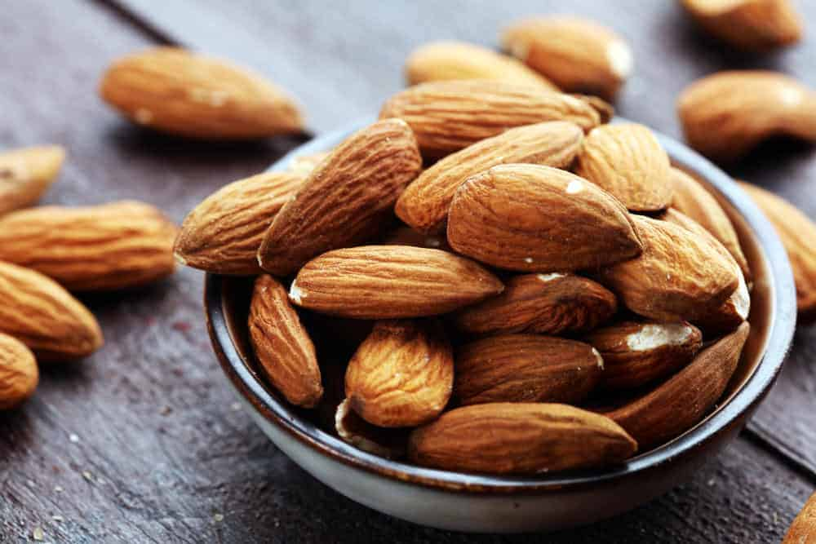
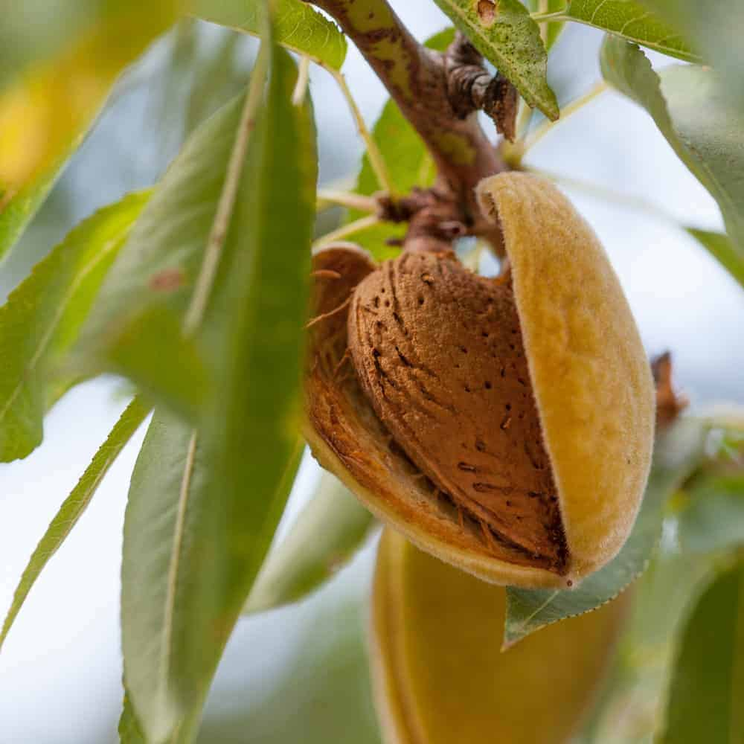
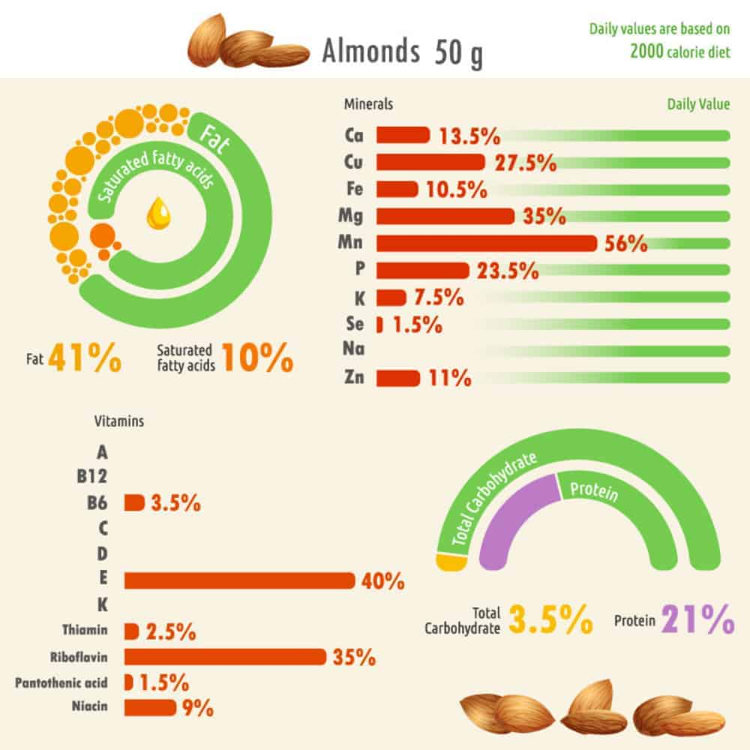
ALMOND NUTRITIONAL FACTS CHART

7. PISTACHIOS
PISTACHIOS ARE GROWN IN THE WEST IN THE UNITED STATES IN THE STATES OF CALIFORNIA, ARIZONA, AND NEW MEXICO. THEY CAN ALSO BE FOUND IN TURKEY, IRAN, AFGHANISTAN, ITALY, AND SYRIA. PISTACHIOS GROW ON SMALL TREES IN DESERT-LIKE SAND. WHILE PISTACHIOS CAN BE EATEN RAW AND WASHED, MANY PEOPLE PREFER TO ROAST THEM AND SALT THEM FOR CONSUMPTION. PISTACHIOS ARE USED IN FAMOUS DISHES SUCH AS SPUMONI, BAKLAVA, KULFI, PISTACHIO ICE CREAM, AND PISTACHIO SALAD. THEY ARE ALSO HIGH IN PROTEIN, FIBER, AND VITAMINS.
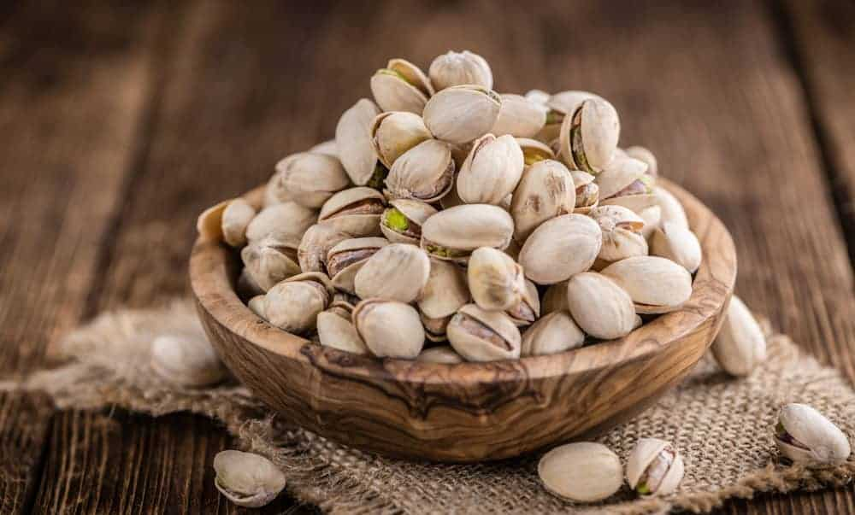
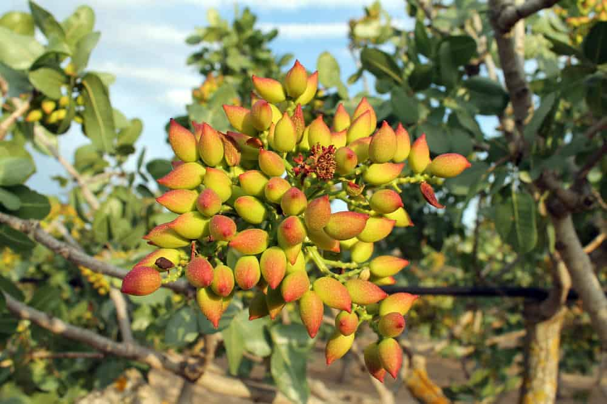
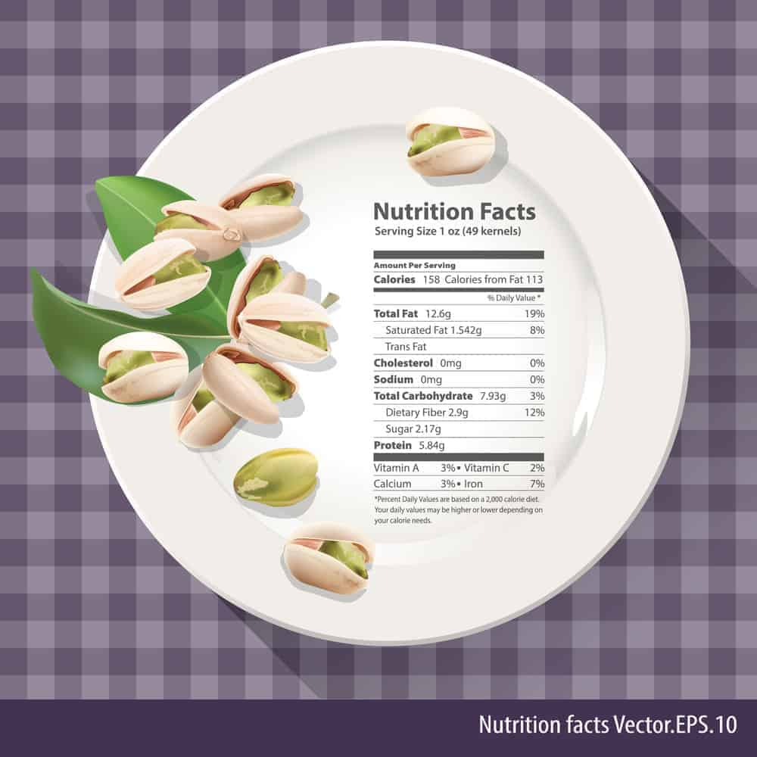
PISTACHIO NUT NUTRITIONAL FACTS CHART

8. BRAZIL NUTS
BRAZIL NUTS ARE GROWN IN SOUTH AMERICA, SPECIFICALLY IN PERU, BOLIVIA, AND BRAZIL. THEY GROW ON LARGE TREES IN THE AMAZON RAINFORESTS. BRAZIL NUTS CAN BE EATEN RAW OR BLANCHED, HOWEVER HAVE AN EXTREMELY HARD SHELL THAT NEEDS CRACKED TO GET TO THE EDIBLE SEED. BRAZIL NUTS ARE A GREAT SOURCE OF VITAMINS, INCLUDING SELENIUM, NIACIN, VITAMIN E, CALCIUM, AND IRON. THEY CAN BE USED IN MACAROONS, COOKIES, BRAZIL NUT MILK, VEGAN BRAZIL NUT CHEESE, AND AS AN ACCENT IN SALADS.
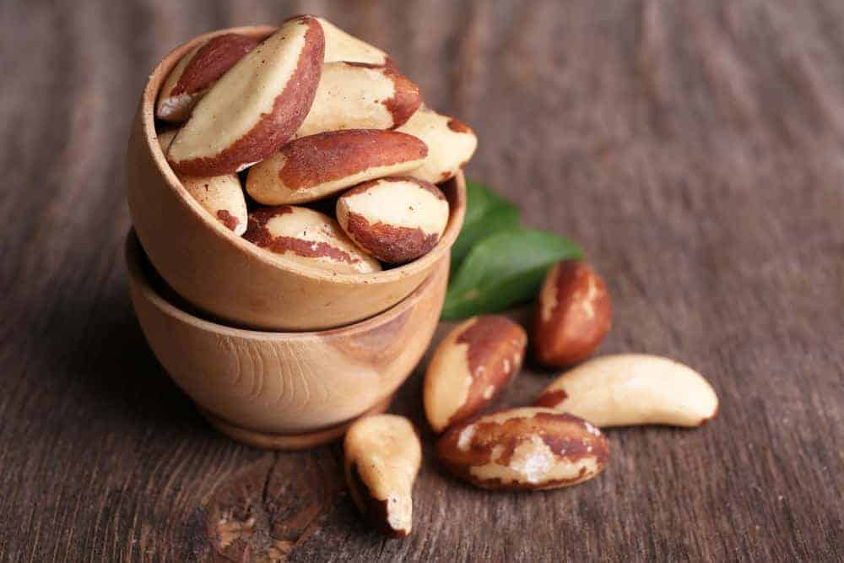
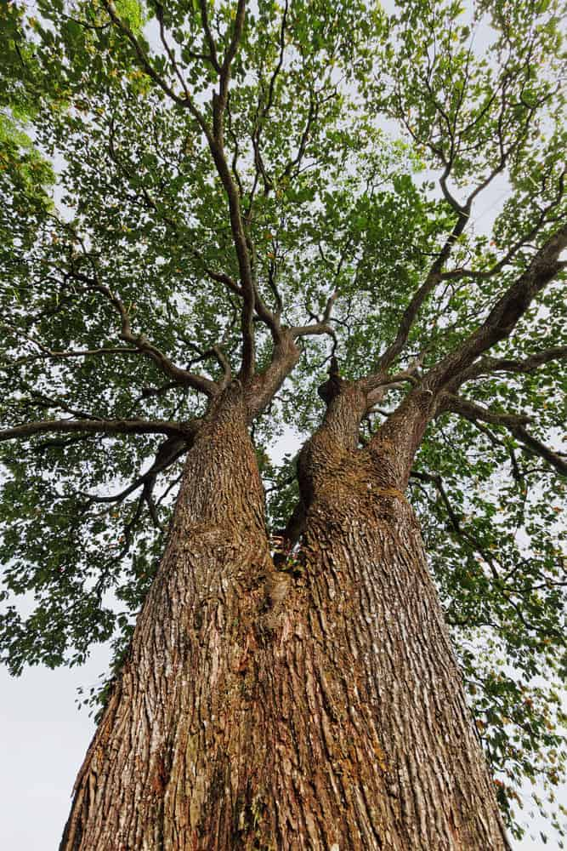
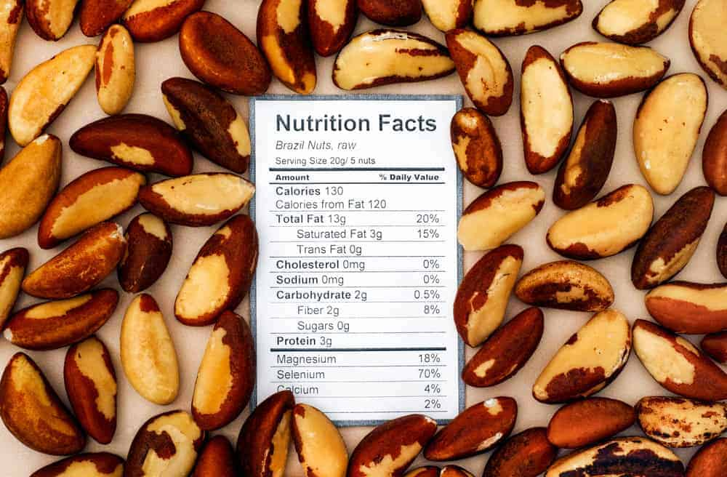
BRAZIL NUT NUTRITIONAL FACTS CHART

9. WALNUTS
WALNUTS ARE GROWN MAINLY IN CHINA, THE UNITED STATES, IRAN, TURKEY, MEXICO, AND THE UKRAINE. THEY ARE A STONE FRUIT THAT GROWS ON LARGE TREES. WALNUTS CAN BE EATEN RAW AFTER THEY ARE THOROUGHLY SPRAYED DOWN WITH A PRESSURE WASHER AND DRIED. AT THIS POINT THE WALNUTS CAN BE SHELLED AND EATEN RAW, OR ROASTED AND SEASONED.
WALNUTS ARE RICH IN ANTIOXIDANTS AND OMEGA-3S. THEY CAN BE FOUND IN WALNUT BUTTER, KHORESH, BROWNIES, DESSERT MIX-INS, AND AS A GARNISH FOR BOTH SWEET AND SAVORY DISHES.
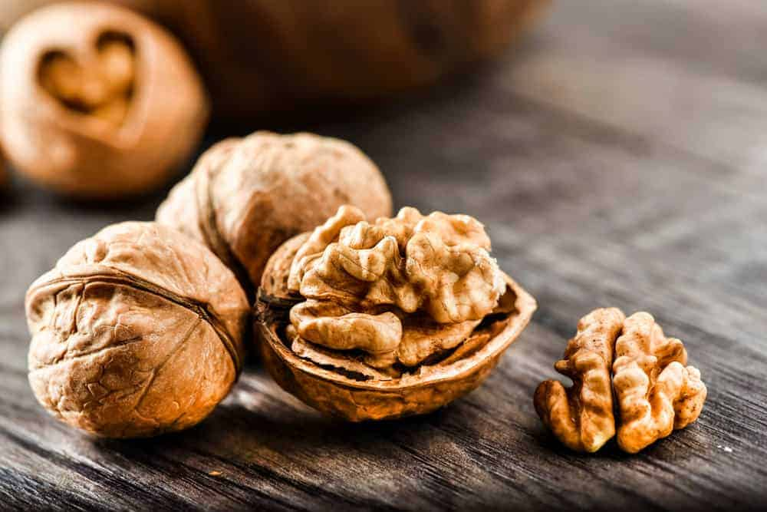
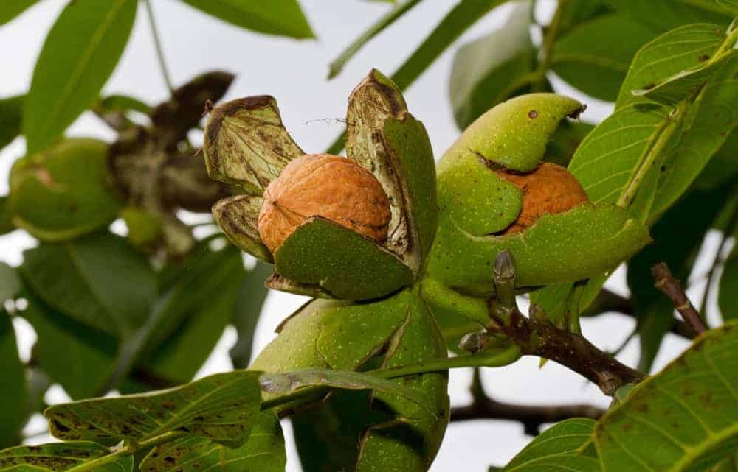
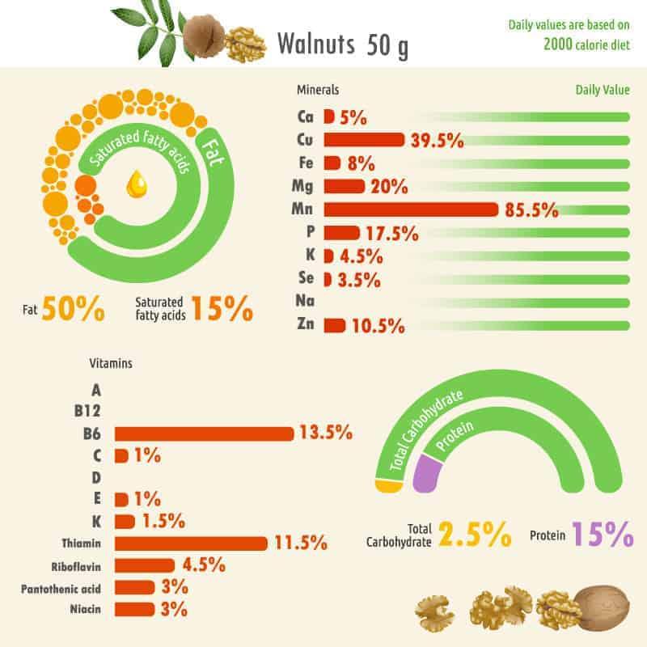
WALNUT NUTRITIONAL FACT CHART

10. CHESTNUTS
CHESTNUTS ARE FOUND PRIMARILY IN CHINA, THE UNITED STATES, SOUTH KOREA, ITALY, GREECE, AND SOUTH AMERICA. THESE TYPES OF NUTS ARE GROWN ON TREES OR SHRUBS. WHILE THE NUTS CAN BE EATEN AT HARVEST, THEY ARE SOMEWHAT BLAND. THEY ARE BEST IF STORED IN THE REFRIGERATOR FOR A FEW DAYS TO CHANGE THE STARCHES TO SUGARS. CHESTNUTS CAN BE EATEN RAW IF PEELED, OR CAN BE ROASTED TO PREPARE FOR CONSUMPTION. THEY CAN ALSO BE CANDIED, BOILED, STEAMED, DEEP-FRIED, OR GRILLED. CHESTNUTS ARE HIGH IN CARBOHYDRATES, AS OPPOSED TO OILS AS IS FOUND WITH MOST NUTS. THEY ARE USED IN DESSERTS SUCH AS CAKES AND PIES, BUT CAN ALSO BE USED AS A THICKENER FOR SOUPS AND SAUCES.
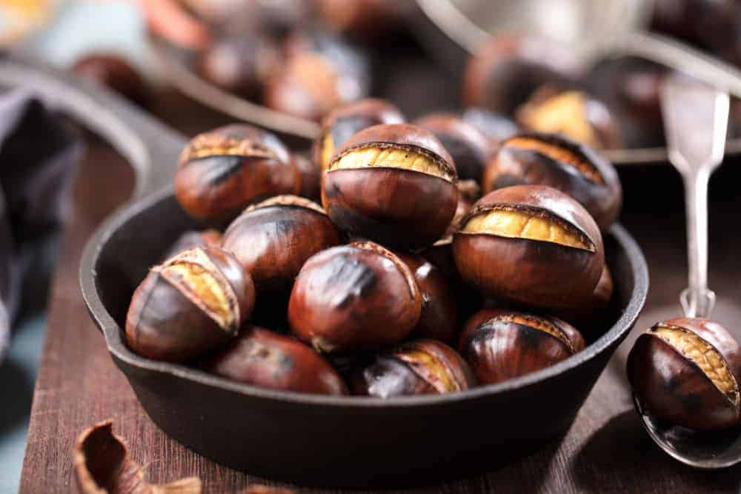
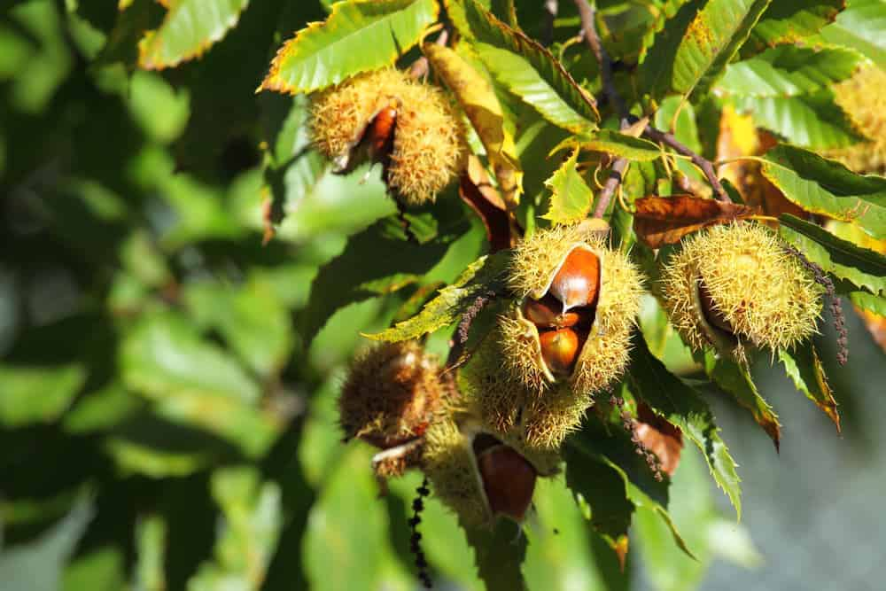

11. SUNFLOWER SEEDS
SUNFLOWER SEEDS COME FROM A SUNFLOWER, A FLOWER NATIVE TO NORTH AMERICA. THEY CAN ALSO BE FOUND IN THE UKRAINE AND RUSSIA. WHEN THE SUNFLOWER SEEDS ARE READY TO HARVEST, ALLOW THE SEEDS UP TO 4 DAYS TO DRY OUT AND FALL OFF OF THE SUNFLOWER HEAD. THEY CAN THEN SHELLED AND EATEN AS IS, OR THEY CAN BE ROASTED.
SUNFLOWER SEEDS ARE FREQUENTLY EATEN AS A STAND-ALONE SNACK. THEY CAN ALSO BE ADDED TO SALADS OR AS YOGURT TOPPING.
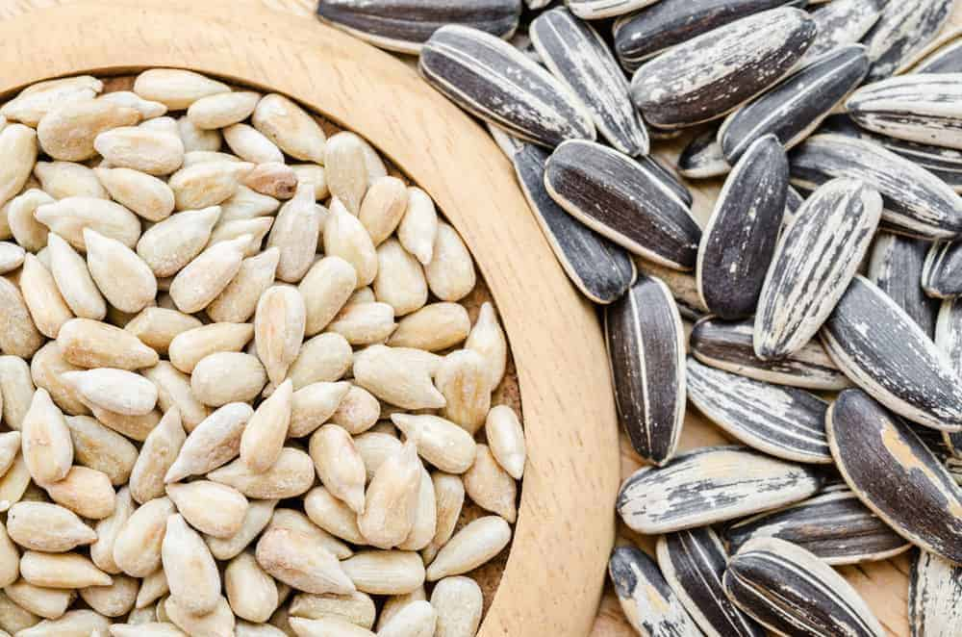

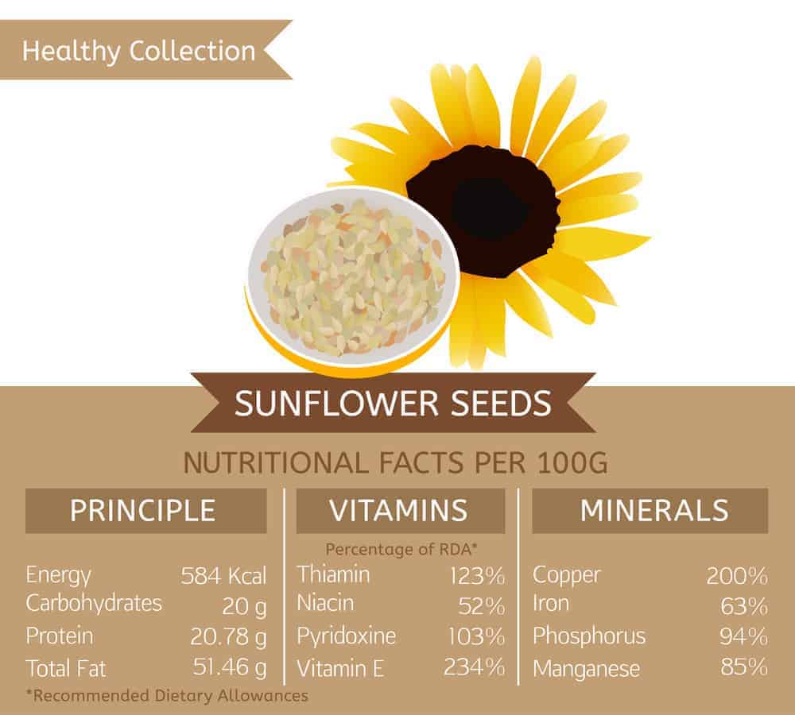
SUNFLOWER SEED NUTRITIONAL FACTS CHART

12. KOLA NUTS
KOLA NUTS ARE THE FRUIT OF THE KOLA TREE, WHICH IS NATIVE TO RAINFOREST CLIMATES, ESPECIALLY IN AFRICA. THE KOLA TREES ARE ABOUT 20 METERS HIGH, AND THE KOLA SEEDS DEVELOP INSIDE OF THE KOLA FRUIT. KOLA NUTS CONTAIN CAFFEINE, AND ARE USED AS A FLAVORING AGENT IN BEVERAGES. IT IS FREQUENTLY CHEWED IN WEST AFRICAN CULTURES FOR THE CAFFEINE AND FLAVOR.
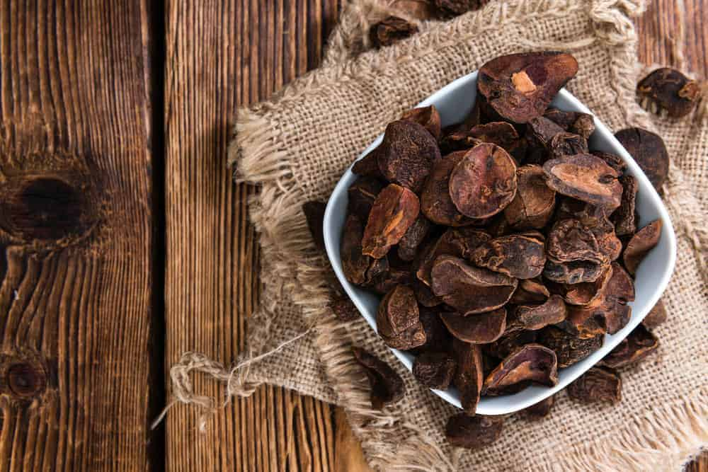
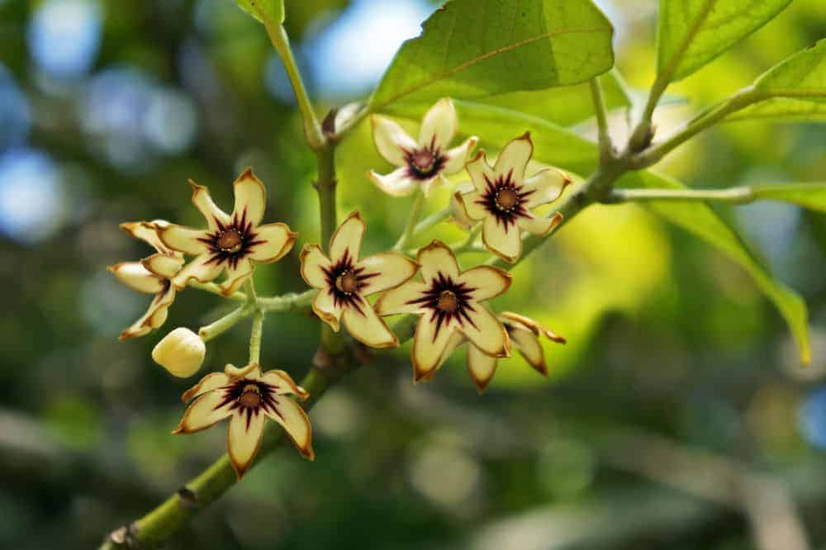

13. PUMPKIN SEEDS
PUMPKIN SEEDS ARE FOUND IN THE PUMPKIN PLANT IN CHINA, INDIA, UKRAINE, THE UNITED STATES, EGYPT, AND MEXICO. PUMPKIN PLANTS ARE AN EDIBLE PLANT, SIMILAR TO SQUASH, THAT ARE ALSO GROWN FOR LIVESTOCK FOOD OR TO BE ORNAMENTAL. TO PREPARE PUMPKIN SEEDS FOR EATING, THEY FIRST NEED TO BE GATHERED FROM THE PUMPKIN MEAT AND WASHED OFF. THEY CAN BE EATEN RAW OR ROASTED. PUMPKIN SEEDS ARE FREQUENTLY CONSUMED AS A SNACK. THEY ARE HIGH IN FATS, AND COMMONLY USED IN BUTTER AND OILS. PUMPKIN SEEDS ARE ALSO COMMONLY USED IN MEXICAN CUISINE.
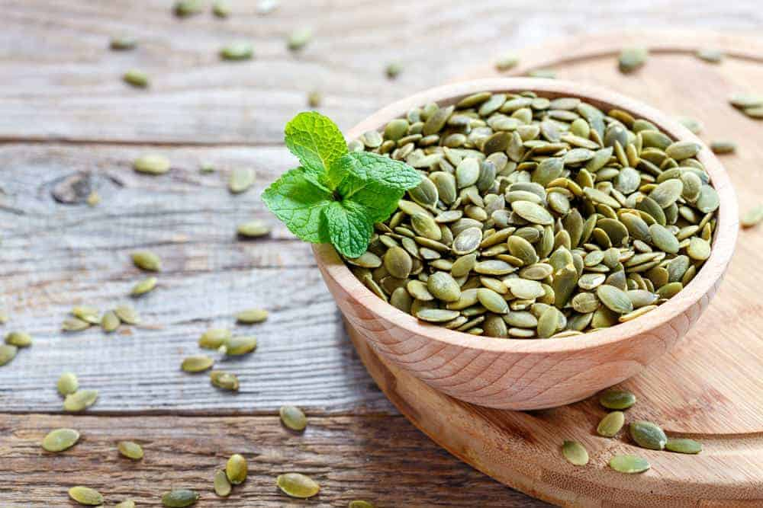
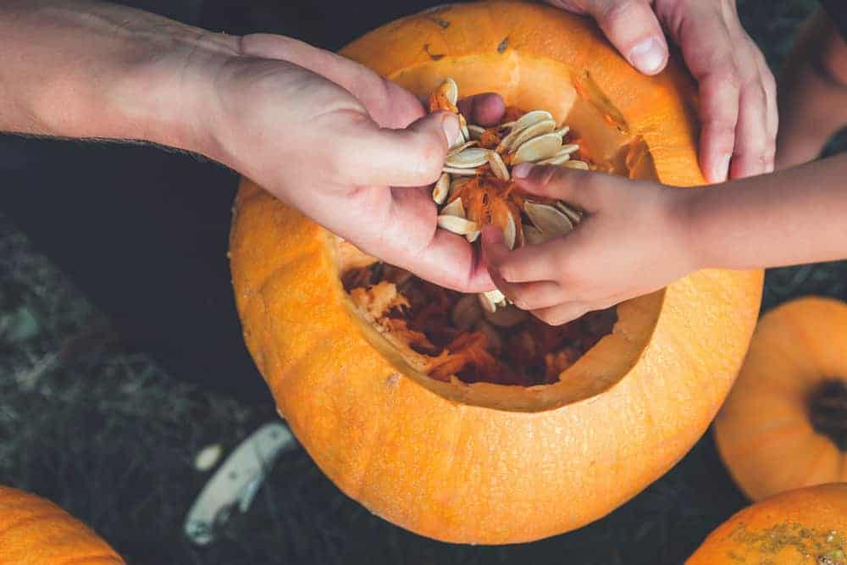

14. FLAXSEEDS
FLAXSEEDS COME FROM THE FLAX PLANT, WHICH IS A FLOWERING PLANT THAT REACHES ABOUT 2 FEET TALL. IT IS COMMONLY FOUND IN CANADA, RUSSIA, AND EUROPE. TO PREPARE FLAXSEEDS FOR CONSUMPTION, THEY NEED TO BE WASHED THOROUGHLY AND DRIED. WHILE IT IS POSSIBLE TO EAT THEM RAW AND WHOLE, THEY ARE EASIER DIGESTED IF THEY ARE GROUND UP. FLAXSEEDS ARE COMMONLY MADE INTO OILS. THEY ARE COMMONLY KNOWN FOR THEIR HEALTH BENEFITS, ARE A FREQUENTLY AN INTEGRATED INGREDIENT IN DIET PLANS FOR WEIGHT LOSS. IT IS ALSO COMMONLY USED IN RICE DISHES AND CURRY IN INDIA.
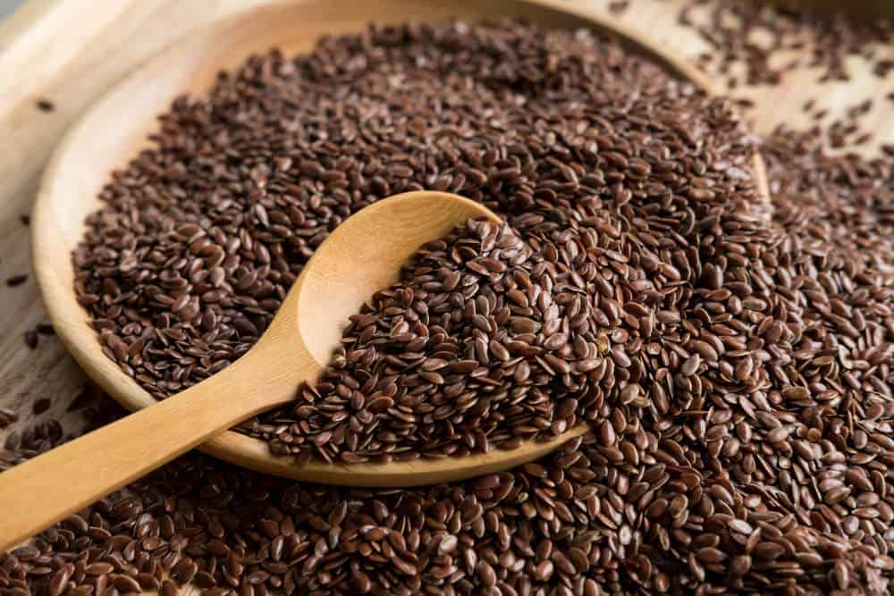

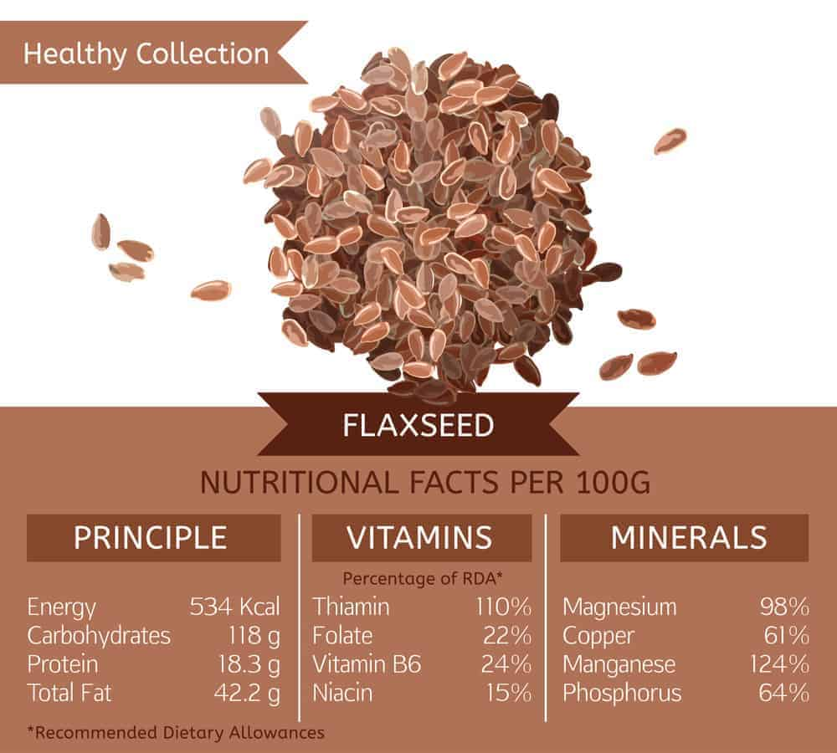

15. CACAO
CACAO SEEDS COME FROM AN EVERGREEN TREE. THEY GROW IN THE LOWLAND RAIN FORESTS IN THE AMAZON AND ORINOCO RIVER BASINS IN WESTERN AFRICA AND TROPICAL AREAS OF ASIA. THE SEEDS ARE REFERRED TO AS COCOA BEANS. THE COCOA BEAN PODS ARE HARVESTED WHEN RIPE, AND THE DAMP SEEDS EXTRACTED AFTER DRYING FOR 10 DAYS. THEY ARE THEN FERMENTED AND DRIED ADDITIONALLY BEFORE THEY ARE READY FOR CONSUMPTION. THE COCOA BEANS ARE NOT GENERALLY EATEN AS A STAND ALONE SNACK, HOWEVER, AND ARE INSTEAD USED IN OTHER RECIPES, SUCH AS USED IN CHOCOLATE PRODUCTS AS WELL AS COSMETIC PRODUCTS.
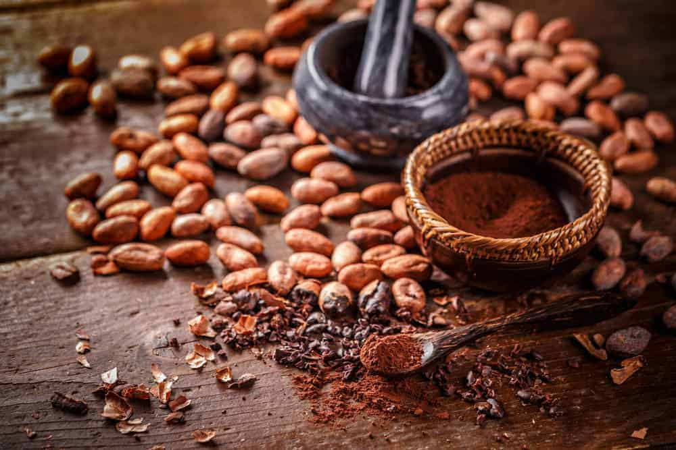

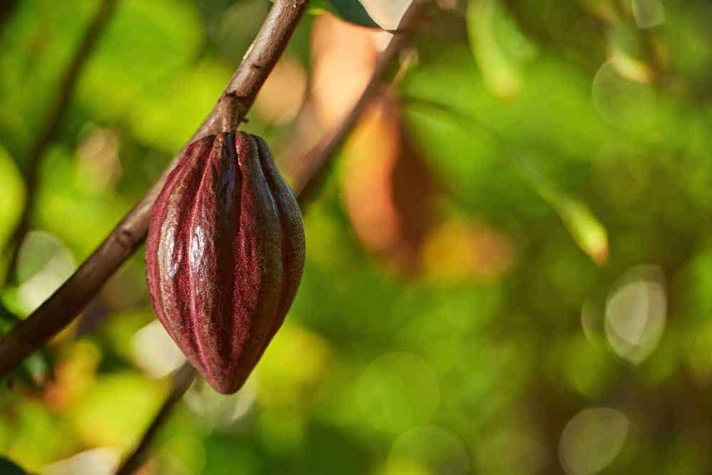

16. CEDAR NUTS (A TYPE OF PINE NUT)
CEDAR NUTS ARE THE NUTS OF THE SIBERIAN CEDAR PINE TREE AND ARE HENCE A TYPE OF PINE NUT. THEY ARE GROWN IN SIBERIA AND THE RUSSIAN FAR EAST. THESE TYPES OF NUTS ARE ABLE TO BE EATEN RAW OR ROASTED. CEDAR NUTS ARE GOOD FOR THE IMMUNE SYSTEM, AND HIGH IN FATS, PROTEIN, AND OTHER VITAMINS. REGARDING RECIPES, THESE NUTS ARE GENERALLY EATEN PLAIN, BUT CAN BE INCORPORATED INTO SALADS AND SAVORY BEEF DISHES.
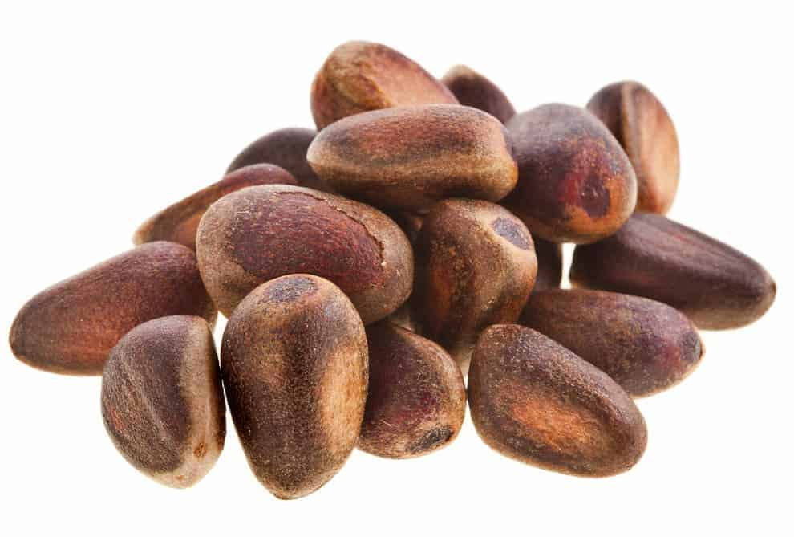

17. PINE NUTS
PINE NUTS ARE PRODUCED IN EUROPE, NORTH AMERICA AND KOREA. THEY ARE PRODUCED BY MULTIPLE SPECIES OF PINE TREES, PROVIDING SOME SMALL VARIATIONS IN TASTE. MANY OF THESE NUTS COME FROM THE STONE PINE TREE. TO PREPARE PINE NUTS FOR CONSUMPTION, THEY ARE USUALLY DRIED OUT AND ROASTED. THEY ARE SOMETIMES EATEN RAW FOR THEIR BUTTERY TASTE. PINE NUTS CAN BE EATEN AS A SNACK, OR ADDED TO MEAT DISHES, FISH, SALADS, AND BAKED INTO BREAD. THEY ARE COMMONLY USED IN TRAIL MIX AS WELL.
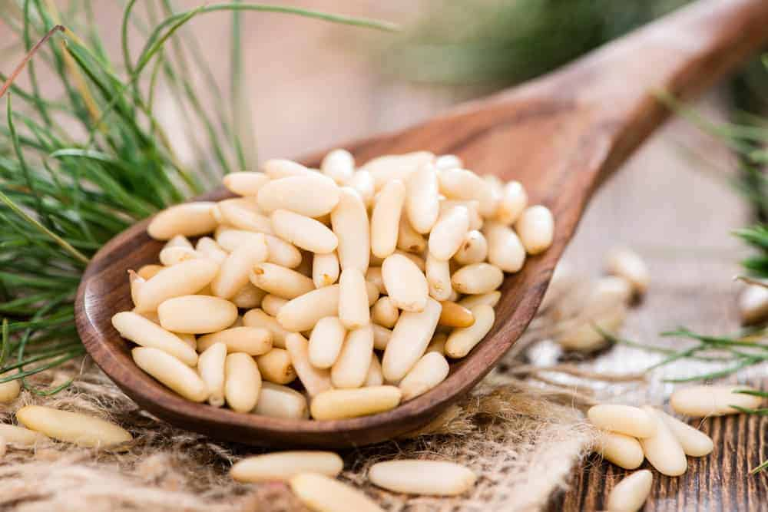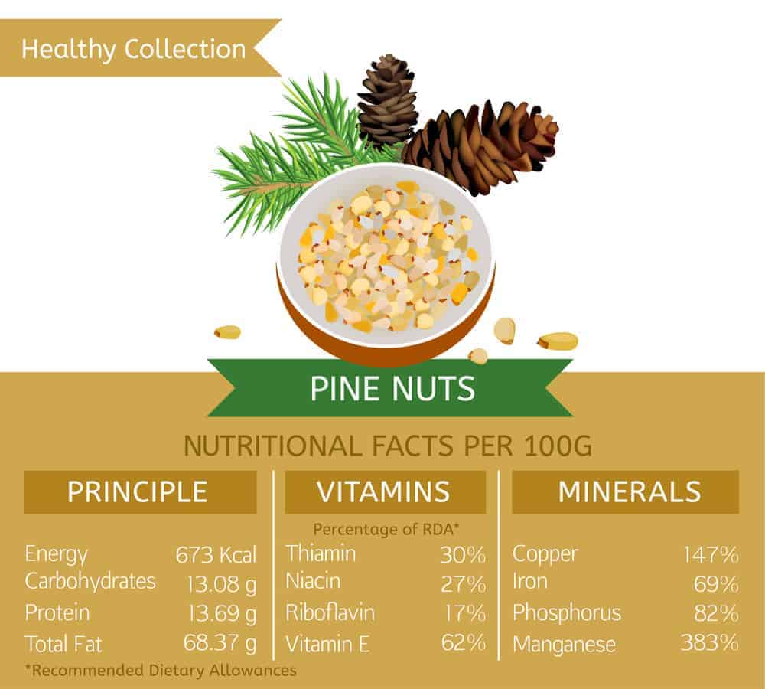

18. ACORNS
AN ACORN IS AN EDIBLE NUT PRODUCED BY OAK TREES IN AMERICA, ASIA, EUROPE, AND NORTH AFRICA. IN ORDER TO MAKE AN ACORN EDIBLE, THEY NEED TO BE FIRST TREATED FOR TANNIC ACID, WHICH IS BITTER AND CAN BE TOXIC TO HUMANS. THIS IS OFTEN DONE IN A REPEATED DRYING AND BOILING PROCESS. THEY CAN ALSO BE ROASTED. ACORNS ARE COMMONLY USED IN PORRIDGE, ACORN FLATBREAD, AND ACORN FLOUR HONEY CAKE.
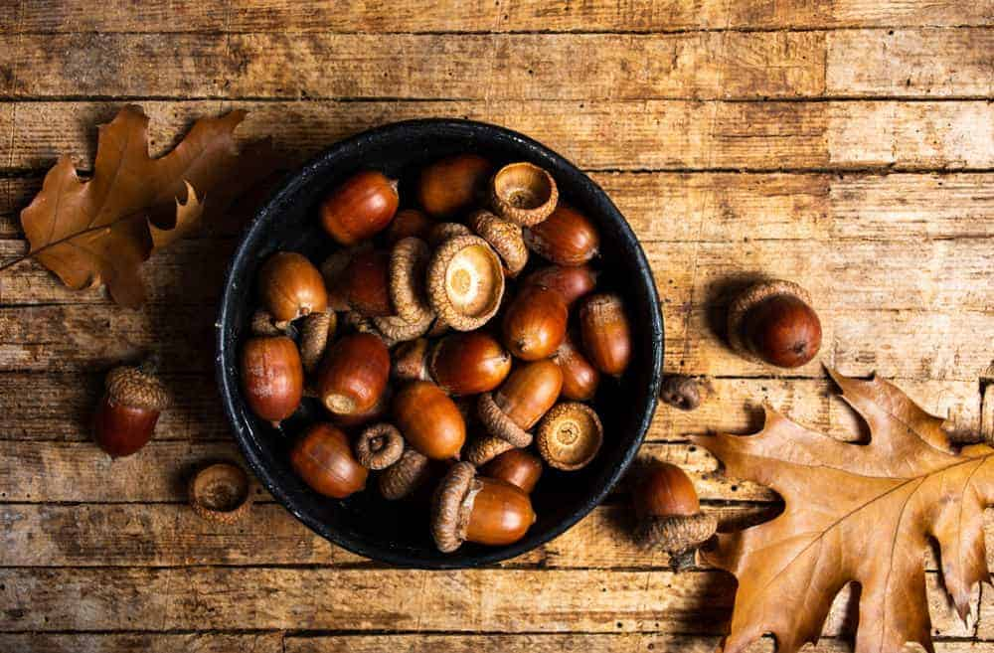
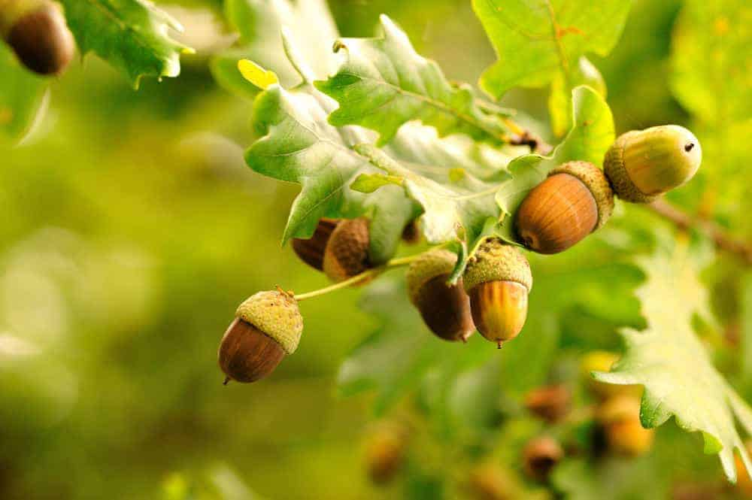

19. COCONUT
BELIEVE IT OR NOT, A COCONUT IS CLASSIFIED AS A NUT AS WELL (AS WELL AS A FRUIT). THEY ARE A TROPICAL NUT PRODUCED BY PALM TREES. PALM TREES GROW IN THE UNITED STATES IN CALIFORNIA, AND THEY THRIVE IN THE CARIBBEAN, SOUTH AND CENTRAL AMERICA, AND MEXICO. THEY CAN BE PREPARED RAW STRAIGHT OFF FROM THE TREE, OR CAN BE BAKED OR FRIED. COCONUTS ARE RICH IS NUTRIENTS AND GOOD FOR THE DIET. SOME COMMON USES INCLUDE COCONUT MILK, COCONUT OIL, AND USE IN DESSERTS AND AS A TOPPING FOR ICE CREAM OR YOGURT.
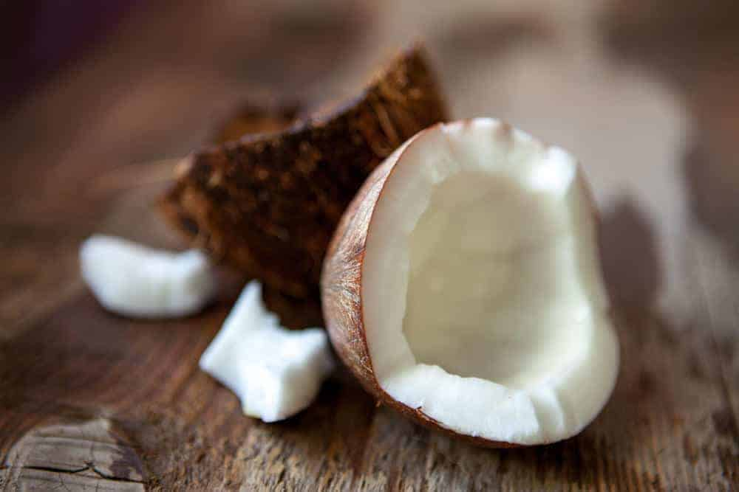

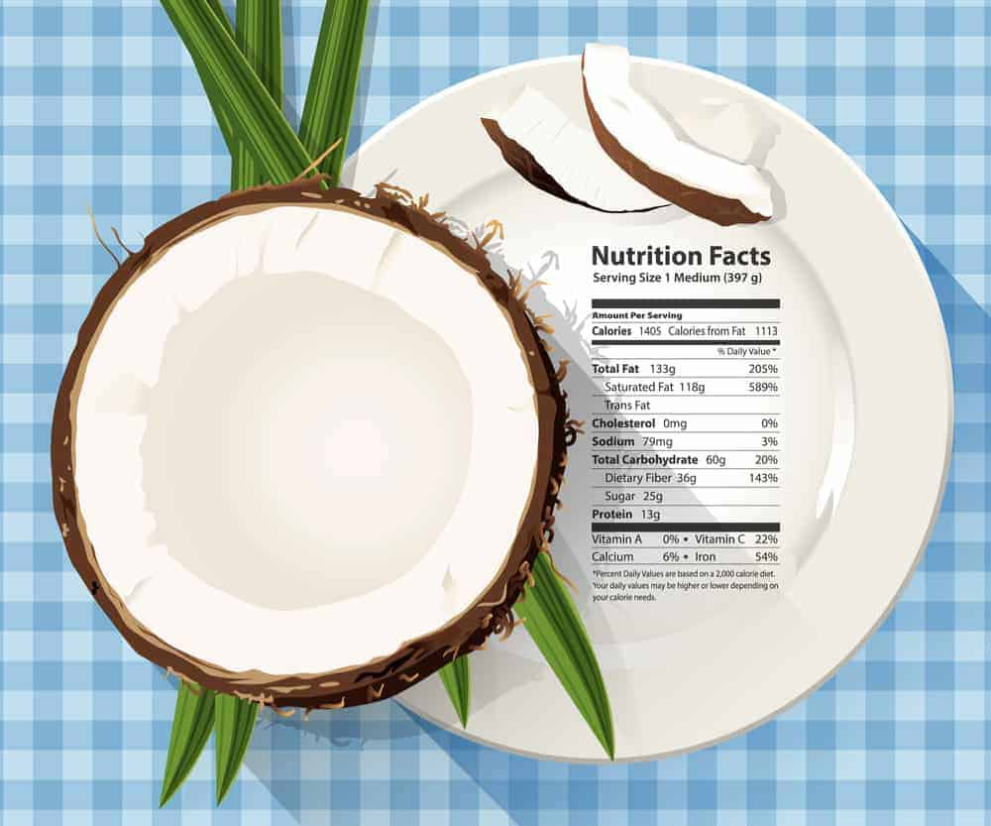
Bottom of Form

20. GINKGO NUTS
GINKGO NUTS ARE THE PRODUCT OF THE GINKGO TREE, WHICH IS COMMONLY FOUND IN ASIAN COUNTRIES. THE GINKGO NUTS ARE HARVESTED FROM WITHIN THE GINKGO FRUIT. THESE NUTS NEED TO BE BOILED BEFORE CONSUMPTION. THESE NUTS ARE COMMONLY USED IN ASIAN CUISINE, SUCH AS CONGEE, AND OTHER DISHES COMMONLY SERVED AT CHINESE NEW YEAR. IT IS IMPORTANT TO WATCH LEVELS OF GINKGO NUT CONSUMPTION, HOWEVER, AS VERY HIGH LEVELS CAN BE TOXIC OVER A LONG PERIOD OF CONSUMPTION.
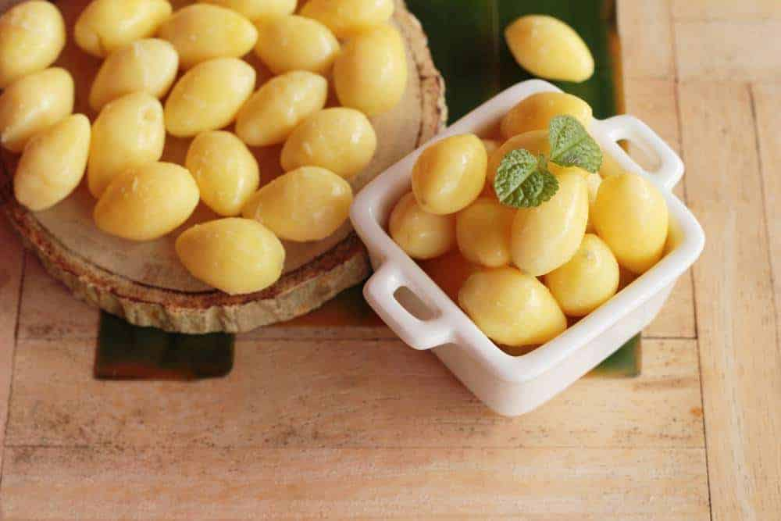
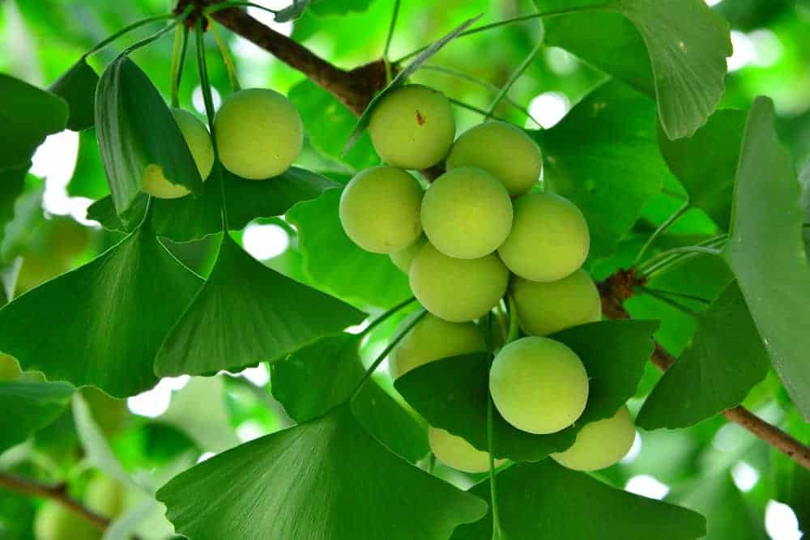

B. THE BEST NUT FOR DIFFERENT FOODS

NUTS IN PESTO
PESTO IS TRADITIONALLY A RECIPE THAT COMBINES BASIL, OLIVE OIL, GARLIC, PARMESAN CHEESE, AND PINE NUTS. HOWEVER, MANY PEOPLE CHOOSE TO CRAFT THEIR PESTO USING A VARIETY OF NUTS. THESE PESTO RECIPE OPTIONS ARE QUICK AND EASY PASTA SAUCE OPTIONS.
THESE DELICIOUS PESTO VARIATIONS CAN BE MADE USING MANY TYPES OF NUTS – MANY OF WHICH ARE EASILY ACCESSIBLE AT A GROCERY STORE. THESE TYPES OF NUTS (AND SOMETIMES A COMBINATION) CAN BE USED IN PESTO IF FIRST TOASTED AND COOLED BEFORE GRINDING.
- ALMONDS – SOAK OVERNIGHT TO REMOVE THE SKINS OF THE NUTS.
- WALNUTS – SOAK OVERNIGHT FOR A CREAMIER CONSISTENCY.
- MACADAMIA NUTS – THESE ARE BUTTERY BUT CAN BE PRICEY, LIKE PINE NUTS.
- BRAZIL NUTS – THE BRAZIL NUT IS MEATY, RICH, AND BUTTERY.
CONSIDER THESE NUTS AS WELL FOR A UNIQUE PESTO CREATION –

- UNSALTED, RAW, OR ROASTED CASHEW NUTS.
- PISTACHIOS
- PECANS
- PEANUTS
“AIR IS THE ENEMY OF PESTO. FOR FREEZING, PACK IT IN CONTAINERS WITH A FILM OF OIL OR PLASTIC WRAP DIRECTLY ON TOP WITH THE AIR PRESSED OUT.” INA GARTEN – FOOD NETWORK

GREAT NUTS IN SALADS
THE MANY VARIETIES OF NUTS PROVIDE A GREAT ADDITION TO ANY SALAD, ADDING NUTRITION, TEXTURE, AND FLAVOR. EACH TYPE OF NUT OFFERS A UNIQUE NUTRITIONAL PROFILE, TEXTURE, AND TASTE – SO GIVE SOME OF THESE A TRY IN YOUR NEXT SALAD CREATION –
- ALMONDS – ARE LOW IN FAT AND HIGH IN PROTEIN THAT CAN BE USED RAW OR ROASTED.
- MACADAMIA NUTS – THESE NUTS COMPLEMENT TROPICAL FLAVORS.
- PECANS – TRY THESE RICH AND BUTTERY NUTS RAW, ROASTED, OR CANDIED AND ARE A GREAT ADDITION TO A SPINACH SALAD.
- CASHEWS – THESE LIGHT NUTS CONTAIN PROTEIN AND FIBER WITH A SLIGHT CRUNCH AND ARE OFTEN THINLY SLICED IN SLAWS WITH AN ASIAN FLAIR.
- PISTACHIO NUTS – A SMOOTH TEXTURED NUT THAT IS HIGH IN POTASSIUM AND VITAMIN B; AS THEY AGE, THEY BECOME SWEETER AND HARDER.
- PEANUTS – ARE A GOOD SOURCE OF PROTEIN AND VITAMIN E AND PAIR WELL WITH ASIAN-STYLE SALADS AND THE SWEETNESS OF AN ORANGE SLICE.
- WALNUTS – HIGH IN OMEGA-3 FATTY ACIDS. CRUNCHY BUT MELTS IN YOUR MOUTH WHEN TOASTED. GOES WELL WITH PEARS OR APPLES IN A SALAD.
- PINE NUTS

NUTS FOR CHARCUTERIE BOARD
A CHARCUTERIE BOARD SEEKS TO CREATIVELY BALANCE SEASONAL FLAVORS WITH A VARIETY OF INGREDIENTS. NUTS ADD CRUNCH TO THE CHARCUTERIE AND OFTEN INCLUDE THESE NUTS –
- MARCONA ALMONDS – THESE ALMONDS OFFER AMAZING TASTE AND NUTRITION.
- PECANS – THE NATURAL SWEETNESS GOES WELL WITH THE SALTINESS OF THE CHEESE AND MEATS.
- WALNUTS – WITH THEIR HIGH OIL CONTENT, WALNUTS ARE A PERFECT ADDITION FOR CHARCUTERIE WITH BLUE CHEESE OR OTHER SHARP FLAVORS.
- CASHEWS – TRY AIR ROASTING THEM WITH ROSEMARY FOR A UNIQUE ADDITION.

NUTS FOR BAKING
BAKING WITH NUTS ADDS TEXTURE AND FLAVOR TO A VARIETY OF BAKED GOODS. IN GENERAL, RAW NUTS RESULT IN BETTER-BAKED GOODS AND A FINISHED PRODUCT –
- FOR GENERAL BAKING NEEDS
  - PECANS ADD A RICH FLAVOR AND CAN ADD CRUNCH WHEN BAKED. PECANS ARE A FAVORITE PIE FILLING OR ARE OFTEN USED WHEN BAKING MUFFINS.
  - ALMONDS ARE CONSIDERED AMONG THE MOST VERSATILE TYPE OF NUTS. THEY ARE OFTEN GROUND TO MAKE GLUTEN-FREE FLOUR.
  - PINE NUTS (A.K.A. – PIGNOLIAS) – ARE EARTHY AND SOFT, WHICH MAKES THEM A PERFECT BAKING ADDITION.
- FOR SWEET BREAD LOAVES – LIKE BANANA BREAD OR CINNAMON NUT LOAF –

  - ALMONDS
  - WALNUTS
  - PECANS
- BROWNIES
  - WALNUTS
  - PEANUTS
  - MACADAMIA (AKA QUEENSLAND) NUTS
- COOKIES – COOKIES AND NUTS ARE A MARRIAGE OF FLAVOR. THESE NUTS ARE A GREAT ADDITION TO VARIOUS COOKIE RECIPES – CASHEWS, WALNUTS, PEANUTS, HAZELNUTS, PECANS, MACADAMIA NUTS, TOASTED PINE NUTS, ALMONDS, OR PISTACHIO NUTS, TO NAME A FEW.

OVEN ROASTING NUTS
ROASTING NUTS BRINGS OUT THE FLAVOR AND FRAGRANCE. A DRY OVEN (AND A PINCH OF SALT) PROVIDES CONSISTENT DIRECT HEAT AND OFFERS EVENLY HEATED AND ROASTED NUTS.
TOASTING NUTS GIVES YOUR DISHES A DEEPER ROASTED FLAVOR, AND THE BEST WAY TO DO THIS IS IN THE OVEN.
THE TIME IT TAKES TO ROAST A NUT IS WORTH THE EFFORT. THE TIME THEY TAKE TO COOK IS USUALLY EVIDENT BECAUSE THEIR SIGNATURE FRAGRANCE IS HIGHLIGHTED WHEN THE NUTS RELEASE ESSENTIAL OILS. NOTE THAT –
- LIGHTER NUTS (WALNUTS, PECANS & PISTACHIOS) TAKE SIX TO EIGHT MINUTES.
- DENSER NUTS (HAZELNUTS, ALMONDS & MACADAMIA NUTS) TAKE EIGHT TO TEN MINUTES.

NUTS IN GRANOLA
HOMEMADE GRANOLA IS DELICIOUS AND EASY TO MAKE. MOST NUTS OFFER HEALTHY (HIGH IN FIBER AND PROTEIN) TASTY ADDITIONS TO TRADITIONAL GRANOLA RECIPES. WHEN IT COMES TO GRANOLA, MOST PEOPLE CREATE DELECTABLE AND NUTRITIOUS OPTIONS USING –
- RAW OR ROASTED PECANS.
- RAW OR ROASTED WALNUTS.
- RAW OR ROASTED ALMONDS.
- SLIVERED ALMONDS.

NUTS TOPPINGS FOR ICE CREAM
ICE CREAM IS MORE THAN A FOOD; IT IS AN EXPERIENCE. FOR MANY, THE MORE TOPPINGS THAT SIT ATOP THIS FROSTY TREAT, THE BETTER. WITH ICE CREAM, MOST NUTS WORK WELL WITH THIS FAVORITE FROZEN TREAT –
- RAW, WET, ROASTED, OR CANDIED
  - PECANS
  - PISTACHIOS
  - CANDIED WALNUTS
  - PEANUTS
  - HAZELNUTS
  - PINE NUTS
  - MACADAMIA NUT PIECES
  - SLIVERED ALMONDS
  - BLACK WALNUTS
  - CASHEWS

C. FAQ

ARE NUTS GOOD FOR YOU? ARE THEY BAD FOR YOU?
NUTS ARE VERY GOOD FOR YOU. IN FACT, THERE ARE A MULTITUDE OF HEALTH BENEFITS YOU CAN ENJOY FROM EATING THEM. THEY ARE NATURALLY LOW IN CARBS AND HIGH IN GOOD FATS LIKE OMEGA-3 AND OMEGA-6 WHICH CAN GREATLY IMPROVE HEART HEALTH AND INCREASE LDL (GOOD CHOLESTEROL) LEVELS.
THEY ARE ALSO FULL OF ANTIOXIDANTS WHICH HELP TO FIGHT FREE RADICALS IN THE BODY THAT CAN LEAD TO CELL DAMAGE AND ULTIMATELY DISEASE. ADDITIONALLY, THEY ARE PACKED WITH VALUABLE NUTRIENTS LIKE FIBER, B VITAMINS, VITAMIN E, CALCIUM, ZINC, IRON AND POTASSIUM.
THE ONLY WAY THEY WOULD BE BAD FOR YOU IS IF YOU DON’T EAT THEM IN MODERATION SINCE THEY ARE CALORIE-DENSE, OR IF YOU ARE ALLERGIC TO THEM WHICH CAN BE POTENTIALLY SERIOUS.

ARE NUTS FATTENING?
NUTS DO HAVE FAT. BUT IT IS THE GOOD AND NATURAL KIND OF FAT YOUR BODY NEEDS, CALLED MONOUNSATURATED FATS AND POLYUNSATURATED FATS. AND WHEN EATEN IN MODERATION, THEY HAVE ACTUALLY BEEN PROVEN TO HELP WITH WEIGHT LOSS. (HTTPS://WWW.NCBI.NLM.NIH.GOV/PUBMED/18716179)
IT WAS RECENTLY DISCOVERED THAT WE DON’T ACTUALLY ABSORB ALL OF THE CALORIES FROM THE NUTS BECAUSE THEY ARE MORE DIFFICULT FOR THE BODY TO BREAK DOWN. THIS, COUPLED WITH THE FACT THAT THEY KEEP YOU SATISFIED LONGER BECAUSE OF THEIR HIGH AMOUNTS OF FIBER AND PROTEIN, PREVENTS THEM FROM BEING FATTENING OR CONTRIBUTING TO WEIGHT GAIN.

ARE NUTS PROTEIN? WHICH ONES ARE HIGHEST IN PROTEIN?
NUTS ARE A HIGH-PROTEIN FOOD, AND THEY ARE AN IMPORTANT PART OF A VEGETARIAN OR VEGAN DIET FOR THAT REASON. HOWEVER, PROTEIN IS MADE UP OF NON-ESSENTIAL AND ESSENTIAL AMINO ACIDS, AND NUTS ONLY PROVIDE THE NON-ESSENTIAL ONES. YOU CAN COUNT ON 27 GRAMS OF PROTEIN IN ABOUT ONE CUP OF NUTS. FOR COMPARISON, ONE CUP OF CHOPPED CHICKEN BREAST CONTAINS ABOUT 43 GRAMS OF PROTEIN.
THE FIVE NUTS THAT ARE HIGHEST IN PROTEIN ARE:
- PEANUTS
- ALMONDS
- BRAZIL NUTS
- CASHEWS
- HAZELNUTS

ARE NUTS CARBS?
WHILE NUTS DO CONTAIN SOME CARBS, THEY ARE NOT CONSIDERED A CARB-RICH FOOD. IN FACT, THEY ARE OFTEN RECOMMENDED FOR PEOPLE WHO ARE ATTEMPTING TO FOLLOW A LOW-CARB DIET. ONE OUNCE OF NUTS CONTAINS ONLY ABOUT FIVE GRAMS OF CARBS, WHEREAS A SLICE OF WHITE BREAD CONTAINS ABOUT 15 GRAMS.

ARE NUTS FRUIT?
SCIENTIFICALLY, NUTS ARE OFTEN REFERRED TO AS A FRUIT WITH A SINGLE SEED, A PROTECTIVE HUSK AND A HARD SHELL. IN OTHER WORDS, THEY ARE THE DRY SEEDS OF FRUIT. THERE ARE CERTAIN NUTS THAT ARE MORE WIDELY REFERRED TO AS FRUITS, THOUGH, INCLUDING ACORNS, CHESTNUTS AND HAZELNUTS.

ARE NUTS SEEDS?
THE COMPLICATED TRUTH HERE IS THAT MOST NUTS ARE ACTUALLY SEEDS, BUT NOT VICE VERSA. SEEDS ARE CONSIDERED AN EDIBLE PLANT ENCLOSED IN A PROTECTIVE SHELL. WHILE NUTS STAY IN THEIR SHELLS UNTIL PROVOKED OPEN, SEEDS GENERALLY OPEN ON THEIR OWN AND LEAVE THE SHELL. SO THE TERM “NUT” IMPLIES THAT THE SHELL WILL NOT AUTOMATICALLY OPEN AND RELEASE THE SEED.
FOR AN EASIER WAY TO DISTINGUISH BETWEEN THE TWO, MOST OF THE NUTS THAT YOU WOULD REFER TO AS “TREE NUTS”, LIKE ALMONDS, BRAZIL NUTS AND CASHEWS, ARE ACTUALLY CLASSIFIED AS SEEDS.

CAN NUTS GO BAD?
BECAUSE OF THEIR OIL CONTENT, NUTS CERTAINLY CAN GO BAD. HOWEVER, THEY DO HAVE AN INCREDIBLY LONG SHELF LIFE COMPARED TO OTHER NATURAL FOODS. THEY CAN BE KEPT IN A PANTRY FOR UP TO SIX MONTHS PAST THEIR “BEST BY” DATE AND IN THE FRIDGE FOR UP TO A YEAR.
IF YOU’RE NOT SURE IF YOUR NUTS HAVE GONE BAD, THE EASIEST WAY TO TELL IS TO SMELL THEM. THEY WILL HAVE A VERY SPECIFIC AND RANCID OR SOUR SMELL.

WHAT NUTS ARE IN PESTO?
THE MOST COMMON AND CLASSIC TYPE OF NUT TO USE FOR PESTO IS PINE NUTS. IT USUALLY CONSISTS OF PINE NUTS, A LOT OF FRESH BASIL, OIL, PARMESAN CHEESE AND GARLIC.
BUT PINE NUTS CAN BE EXPENSIVE, SO IT IS EASY TO FIND RECIPES THAT USE DIFFERENT NUTS FOR PESTO LIKE WALNUTS OR ALMONDS. SINCE THE FLAVORS OF THESE NUTS ARE SLIGHTLY DIFFERENT, YOU CAN TWEAK THE PESTO RECIPE WITH MORE COMPLEMENTARY INGREDIENTS LIKE PARSLEY INSTEAD OF BASIL.

WHICH NUTS ARE HIGH IN IRON?
WHEN IT COMES TO IRON, PISTACHIOS ARE THE CHAMPION. THEY HAVE 14MG PER 100G. THAT IS ALMOST AN ENTIRE DAY’S WORTH OF IRON FOR AN ADULT. CONSIDERING ANEMIA (CHRONIC IRON DEFICIENCY) IS THE SINGLE MOST COMMON BLOOD CONDITION IN THE WORLD, CONSUMING FOODS THAT ARE HIGH IN IRON IS PARAMOUNT AND CAN HELP TO PREVENT VARYING LEVELS OF IRON DEFICIENCY.
IT’S IMPORTANT TO NOTE THAT VEGETARIANS WON’T GET ANY IRON FROM MEAT, SO IT IS VITAL FOR THEM TO INCLUDE OTHER SOURCES OF IRON, LIKE NUTS, IN THEIR DIET ON A DAILY BASIS.
D. CHART: 12 INTERESTING FACTS ABOUT NUTS (USE MAGNIFIER ON MICROSOFT WORD)
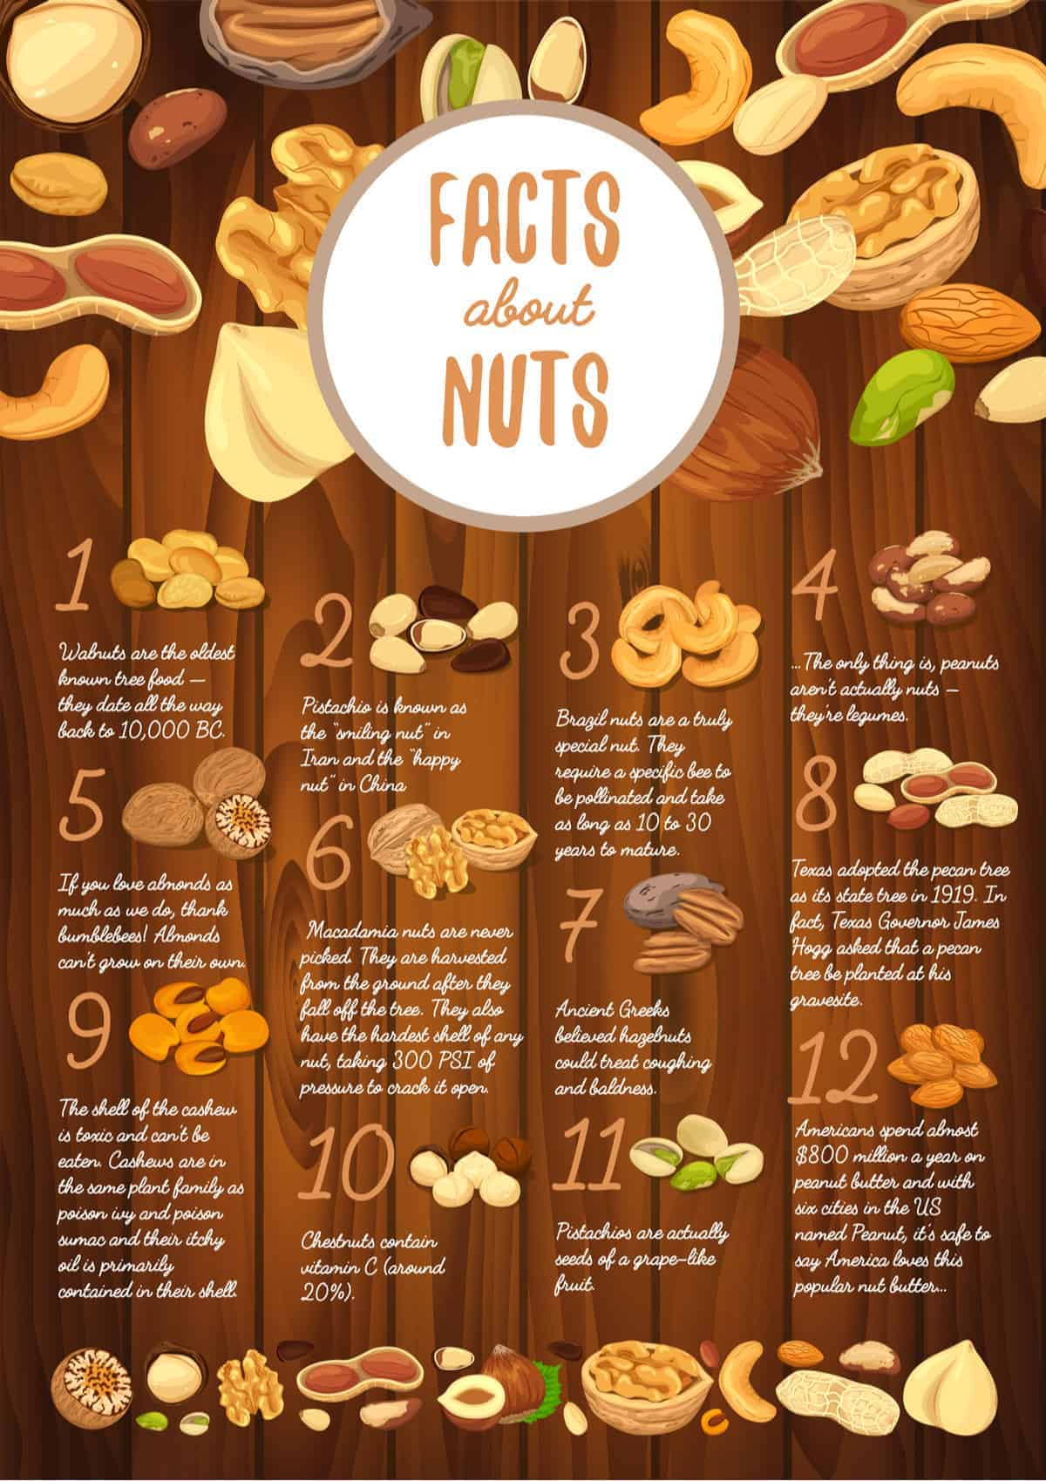
E. INTERESTING FACTS ABOUT SEEDS (USE MAGNIFIER ON MICROSOFT WORD)
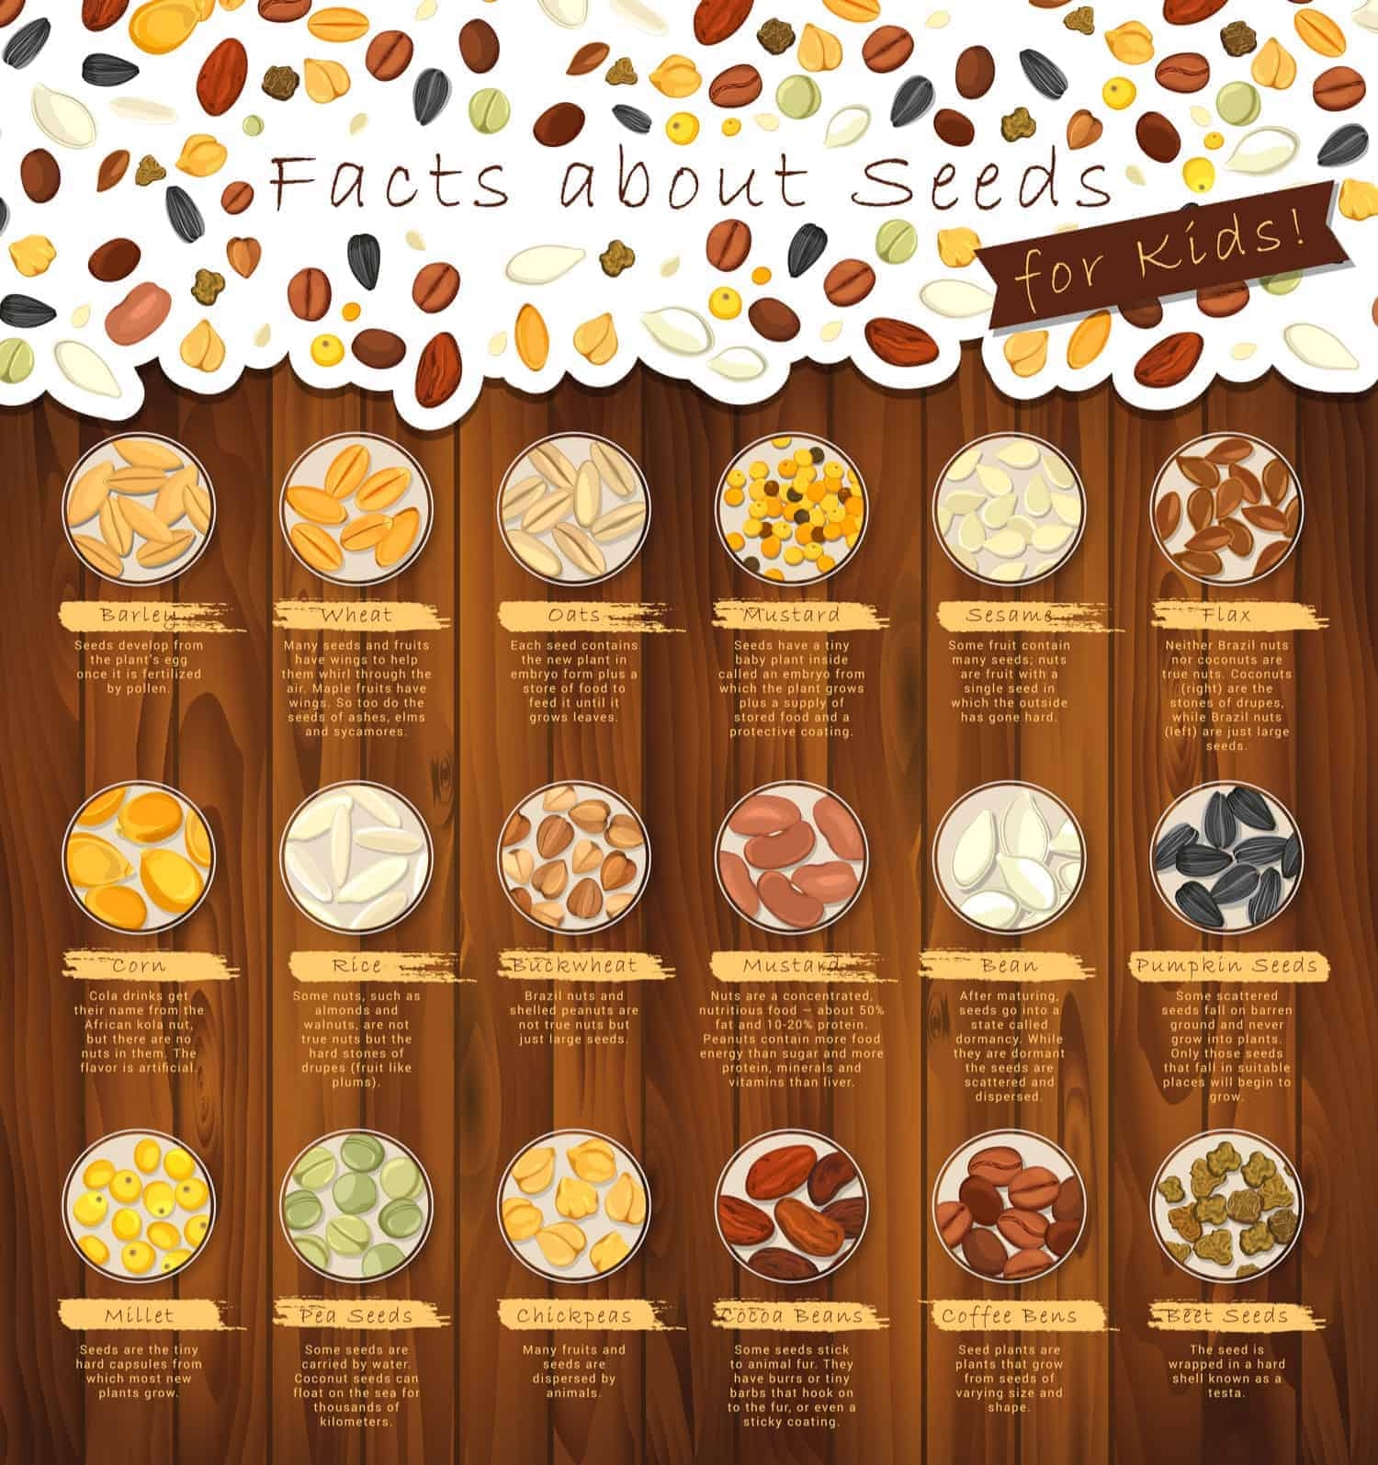

6 DIFFERENT TYPES OF CORNBREAD
GET TO KNOW THE DIFFERENT TYPES OF CORNBREAD, A NUTRIENT-PACKED CORNMEAL QUICK BREAD THAT'S BEEN ENJOYED FOR THE PAST HUNDREDS OF YEARS BY THE NATIVE AMERICANS.
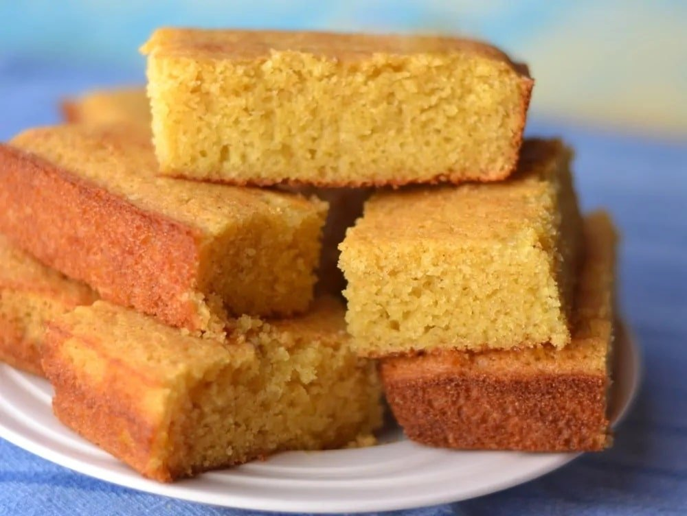
CORNBREAD IS A QUICK BREAD THAT CONTAINS CORNMEAL. IT IS USUALLY LEAVENED BY BAKING POWDER AND HAS BEEN PART OF NATIVE AMERICAN CUISINE FOR HUNDREDS OF YEARS. CORNBREAD IS REALLY POPULAR DUE TO ITS MANY IMMENSE BENEFITS.
FIRSTLY, CORNBREAD CONTAINS WHOLE GRAIN WHICH HAS SEVERAL NUTRIENTS. IT HAS PLENTY OF FIBER WHICH IS GREAT FOR DIGESTION, AS WELL AS CHOLESTEROL AND REGULATION OF BLOOD SUGARS. SINCE THE FIBER INTAKE IS SO HIGH, IT ALSO HAS REDUCED CALORIES AS FIBER JUST PASSES THROUGH THE SYSTEM.
CORNBREAD ALSO HAS SEVERAL OTHER NUTRIENTS SUCH AS PHOSPHORUS, POTASSIUM, IRON, MAGNESIUM, CALCIUM, FOLATES, FOLIC ACID, AND VITAMINS A, B-6, AND B-12. CORNBREAD ALSO HAS 10 OF THE MOST ESSENTIAL AMINO ACIDS WHICH ARE CRUCIAL FOR ORGAN FUNCTION, GROWTH, AND CELLULAR PROCESSES. IT IS BETTER TO MAKE YOUR OWN CORNBREAD FROM SCRATCH SO THAT YOU CAN AVOID ADDED ANIMAL FATS, SUGARS, AND SODIUM THAT PREPARED MIXED MAY HAVE.
RELATED: CORNBREAD RECIPES | SOUTHERN-STYLE CORNBREAD RECIPE | MEXICAN CORNBREAD RECIPE | HOW TO STORE CORNBREAD | HAM SIDE DISHES | WHAT GOES WITH CHILI

HISTORY OF CORNBREAD
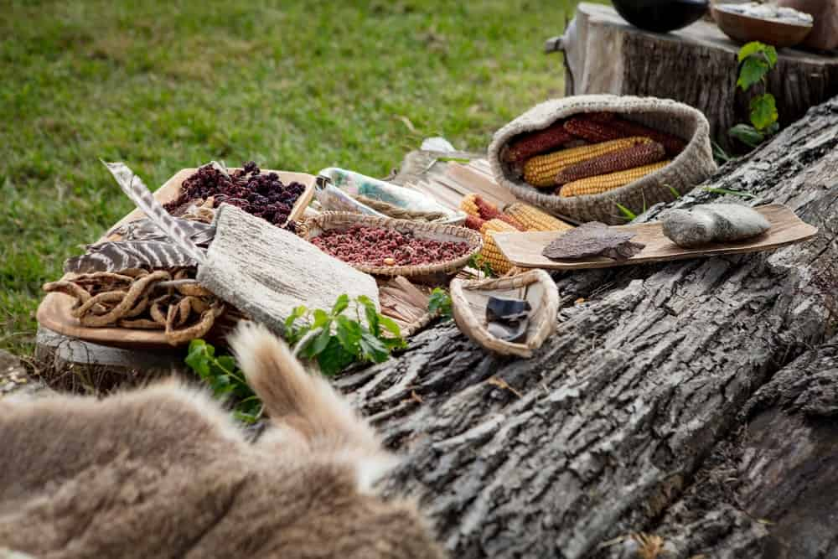
CORNBREAD HAS BEEN AROUND FOR HUNDREDS OF YEARS AND HAS BEEN AN INTEGRAL PART OF NATIVE AMERICAN CUISINE. NATIVE AMERICANS USED GROUND CORN –ALSO KNOWN AS MAIZE- AS A PART OF THEIR DIET FOR YEARS.
EUROPEAN SETTLERS BEGAN TO LEARN DIFFERENT RECIPES FROM THE CREEK, CHEROKEE, CHOCTAW, AND CHICKASAW TRIBES OF THE REGION. THEY BEGAN TO USE CORNMEAL IN BREAD BATTER IN THE SAME WAY THAT THEY DID IN EUROPE. CORNBREAD THUS BECAME AN INTEGRAL CORNERSTONE OF CUISINE IN THE SOUTHERN REGIONS OF THE UNITED STATES.
CORNMEAL WAS PRODUCED AFTER GRINDING RAW DRY CORN GRAINS. THE CORN’S COARSER FORM OF THE MEAL WAS ALSO CALLED GRITS. THESE GRITS ARE USUALLY MADE BY SOAKING THE RAW CORN GRAINS IN WARM WATER WITH AN ALKALINE SALT CALLED CALCIUM HYDROXIDE. THIS LOOSENS THE BRAN AND ALSO ADDS PLENTY OF NUTRIENTS TO THE GRAINS. IT IS THEN SEPARATED THROUGH FLOATATION IN WATER AND SOFTENS AFTER A WASH.
THESE SOFTENED SWOLLEN GRAINS ARE CALLED HOMINY, WHICH IS ALSO USED IN SPAIN TO MAKE TORTILLAS AND TAMALES. THIS NATIVE AMERICAN PRACTICE WAS CALLED ‘NIXTAMALIZATION.’ THIS CORN YIELD WAS ALSO USED TO MAKE MANY OTHER DIFFERENT DISHES SUCH AS ALCOHOLIC BEVERAGES CALLED ANDEAN CHICHA.
CORNBREAD BECAME REALLY POPULAR DURING THE TIME OF THE AMERICAN CIVIL WAR SINCE IT WAS A CHEAP, NUTRITIOUS OPTION FOR MANY. IT COULD ALSO BE MADE IN MANY DIFFERENT WAYS WHICH CREATED VARIETY. WE WILL BE EXPLORING THE DIFFERENT TYPES OF CORNBREAD TODAY.

TYPES OF CORNBREAD
CORNBREAD HAS BEEN POPULAR IN SOUTHERN COOKING SINCE IT HAS A GREAT AROMA AND TEXTURE. IT IS MADE IN MANY DIFFERENT WAYS SUCH AS FRIED AND BAKED. IT IS ALSO RARELY STEAMED, WHICH GIVES IT A PUDDING-LIKE CONSISTENCY. IT CAN ALSO BE BAKED INTO CAKES FOR A DELICIOUS CORN CAKE. SINCE THERE ARE SO MANY WAYS TO MAKE IT, YOU SHOULD KNOW ABOUT THE DIFFERENT TYPES OF CORNBREADS SO YOU CAN CHOOSE YOUR FAVORITE FOR THANKSGIVING.

BAKED CORNBREAD
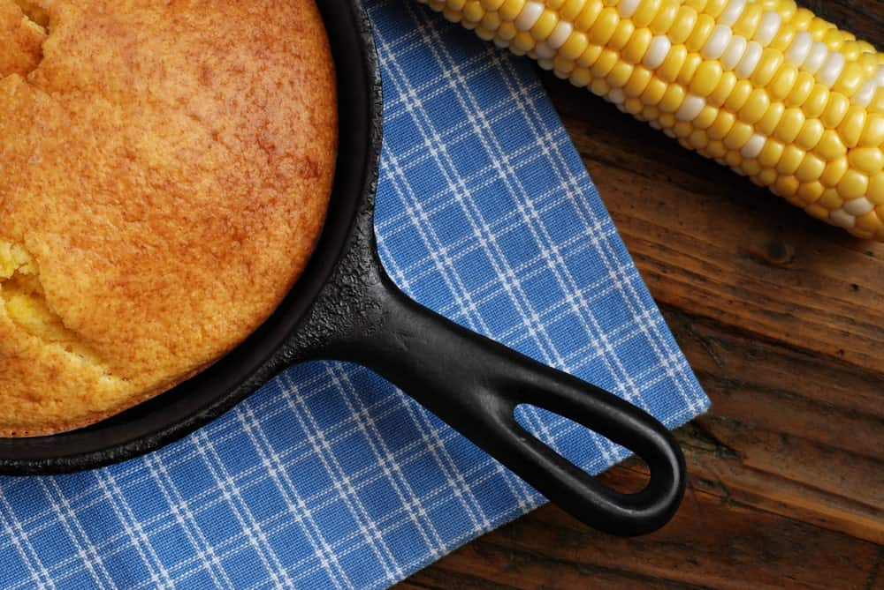
BAKED CORNBREAD IS A REALLY COMMON AND POPULAR DISH IN UNITED STATES CUISINE AND CULTURE. IT IS OFTEN ASSOCIATED WITH THE CUISINE OF THE SOUTHERN AND SOUTHWESTERN REGIONS OF THE COUNTRY. IT WAS ALSO A TRADITIONAL DISH IN PLACES OF THE COUNTRY WHERE WHEAT FLOUR FOR EXPENSIVE TO BUY.
BAKED CORNBREAD IS GENTLY CRUMBLED INTO COLD BUTTERMILK OR MILK FOR BREAKFAST IN MANY REGIONS OF THE SOUTH. IT IS ALSO A POPULAR SIDE DISH TO CHILI CON CARNE AND BARBEQUE. IN MANY SOUTHERN REGIONS, A COMBINATION OF PINTO BEANS AND CORNBREAD A COMMON LUNCH OPTION FOR PEOPLE. IT IS ALSO SOMETIMES SERVED WITH CHUNKS OF ONION OR SCALLIONS AND HOMEMADE BUTTER AS A SIDE DISH FOR MEALS.
CORNBREAD CRUMBS IS ALSO A REALLY POPULAR POULTRY STUFFING FOR THANKSGIVING TURKEYS. TEXAN-BAKED CORNBREAD IS FAMOUS FOR THE SLIGHT MEXICAN INFLUENCE IT HAS. THE CORNBREAD IS A HEARTY DISH WITH CREAMED CORN KERNELS, JALAPENO PEPPERS, AND A TOPPING OF SHREDDED CHEESE.
BAKED CORNBREAD IS DIFFERENT IN THE NORTHERN AND SOUTHERN REGIONS OF THE UNITED STATES. THIS IS DUE TO THE DIFFERENT TYPES OF CORNMEAL USED, AS WELL AS THE DIFFERENT DEGREES OF EGGS AND SUGAR. SOUTHERN BAKED CORNBREAD IS USUALLY MADE WITH LITTLE OR NO SUGAR. THEY ALSO USE LITTLE TO NO FLOUR IN THEIR MIXTURE.
ON THE OTHER HAND, NORTHERN CORNBREAD IS MADE MORE CAKE-LIKE AND IS SWEETER. IN THE SOUTH, PEOPLE USUALLY USE A COMBINATION OF WHITE CORNMEAL WITH BUTTERMILK TO MAKE THE BREAD. THEY MAY ALSO USE INGREDIENTS LIKE PORK RINDS TO MAKE THE BREAD MORE SAVORY. PEOPLE HAVE CORNBREAD WITH HONEY AND BUTTER IN THE NORTH AND WITH MOLASSES IN THE SOUTH.
THE MOST COMMON WAY TO BAKE THE CORNBREAD IS THROUGH A SKILLET, ESPECIALLY IN THE SOUTH OF THE UNITED STATES. TO MAKE THIS, YOU HAVE TO HEAT LARD, BACON DRIPPINGS, OR ANOTHER TYPE OF OIL IN A HEAVY, CAST-IRON SKILLET. IT IS WELL-SEASONED BEFORE POURING THE BATTER OF EGGS, MILK, AND CORNMEAL DIRECTLY INTO THE HOT OIL.
THIS HAS A SLIGHT FRYING EFFECT, WHICH ENSURES THAT THE CRUST WILL BE CRUNCHY. THE MIXTURE IS THEN PUT INTO THE OVEN TO BAKE, RESULTING IN A CRUMBLY AND MOIST CAKE. THE BREAD IS DENSE AND SERVED ALONGSIDE OTHER ITEMS RATHER THAN A WHOLE MEAL. CORNBREAD CAN ALSO BE MADE AS STICKS, LOAVES, OR MUFFINS.
IN THE NORTH, CORNBREAD IS BAKED IN A VERY SIMPLE WAY. THE BATTER IS SIMILAR TO THE CORN MUFFINS AND THE RESULT IS USUALLY LIGHTER AND SWEETER THAN THE NORTHERN VERSION. THE RECIPE WILL CONTAIN HALF WHEAT FLOUR, HALF CORNMEAL, BUTTERMILK OR MILK, LEAVENING AGENT, EGGS, SALT, AND USUALLY SUGAR.
BAKED CORNBREAD IS DIFFERENT FROM FRIED COUNTERPARTS SINCE IT IS MADE QUICKLY AND DEPENDS ON EGGS TO CREATE COHESIVENESS AND HOLD THE STRUCTURE TOGETHER. THE BAKING INITIATES A PROCESS CALLED ‘GELATINIZATION’ IN THE STARCH, LEAVING ONLY HARD STARCHES BEHIND WHICH PROVIDES THE DISTINCTIVE SANDINESS OF CORNBREAD.

CRACKLIN’ BREAD
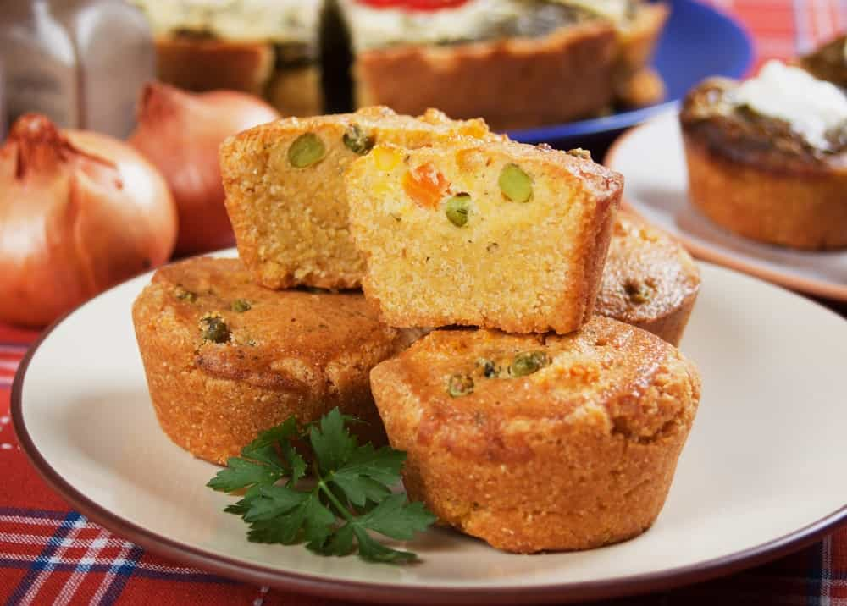
CRACKLIN CORNBREAD IS A SOUTHERN AMERICAN DISH WHERE CORNBREAD IS MADE WITH PORK CRACKLINGS MIXED THROUGH THE BATTER. IT CAN BE PREPARED WITH PRETTY MUCH ANY METHOD BUT SOUTHERNERS MAKE USING THE SKILLET. THIS IS BECAUSE IT MAKES THE CORNBREAD CRISPIER ON THE OUTSIDE. CRACKLIN BREAD WAS ALSO MENTIONED IN TO KILL A MOCKINGBIRD. IT IS THE NARRATOR, SCOUT’S, FAVORITE SNACK IN THE NOVEL SINCE THE FAMILY COOK MAKES IT FOR HIM ON HIS FIRST DAY OF SCHOOL.

CORN PONE
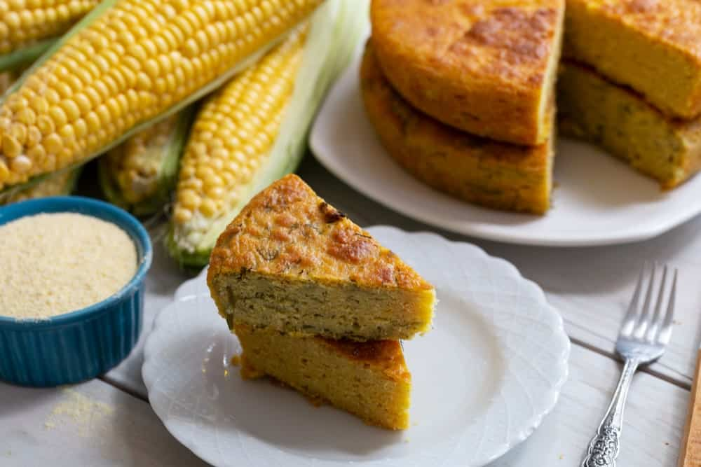
CORN PONE IS ALSO KNOWN AS INDIAN PONE WHERE CORNBREAD IS MADE FROM MALLEABLE, THICK CORNMEAL DOUGH. THE MIXTURE IS USUALLY MILK-LESS AND EGG-LESS. IT IS COOKED IN AN IRON PAN ON AN OPEN FIRE WITH COOKING OIL, SHORTENING, MARGARINE, OR BUTTER.
CORN PONES HAVE BEEN A TRADITIONAL STAPLE OF THE SOUTHERN US CUISINE AND HAVE EVEN BECOME PART OF MANY LITERARY WORKS SUCH AS MARK TWAIN’S NOVELS. THIS TYPE OF CORNBREAD IS AN INTEGRAL PART OF THE CUISINE FROM THE APPALACHIAN MOUNTAINS WHERE CORNBREAD IS BAKED IN A CAKE PAN OR IRON SKILLET.

HOT WATER CORNBREAD

HOT WATER CORNBREAD OR SCALD MEAL CORNBREAD IS UNIQUE TO THE SOUTHERN REGIONS OF AMERICA. RANGE TOPS ARE USED TO COOK HOT WATER CORNBREAD, UNLIKE BAKED OR PONES. IT IS A FRYING METHOD THAT INVOLVES POURING SMALL AMOUNTS OF THE CORNBREAD BATTER INTO A HOT SKILLET WITH OIL.
THE BATTER IS MADE FROM BOILING WATER AND CORNMEAL WITH A CHEMICAL LEAVENER OR SODA. THE CRUST IS FRIED IN THE HOT OIL AND TURNS CRUNCHY AND GOLDEN. THE CENTER OF THE BATTER TURNS INTO MUSHY, CRUMBLY BREAD. USUALLY, THE PIECES OF BREAD ARE 3-4” IN DIAMETER.
HOT WATER CORNBREAD IS BELOVED BY MANY FOR ITS RICH TASTE AND SOFT TEXTURE. SOMETIMES, SMALL AMOUNTS OF WHEAT FLOUR ARE ALSO ADDED TO THE MIXTURE TO ENSURE THAT IT HAS A BREAD-LIKE CONSISTENCY. THIS TYPE OF CORNBREAD HAS BEEN MADE BY NATIVES FOR A LONG TIME, EVEN BEFORE THE EUROP4EAN COLONIZATION. IT WAS OFTEN COVERED OR DIPPED IN FRESH HONEY FOR TASTE.

JOHNNYCAKE

JOHNNYCAKE HAS MANY DIFFERENT NAMES INCLUDING SHAWNEE CAKE, JOHNNY BREAD, SPIDER CORNBREAD, AND JOURNEY CAKE. IT IS ESSENTIALLY A FLATBREAD MADE FROM CORNMEAL. IT IS AN EARLY AMERICAN STAPLE FOOD WHICH IS PREPARED ALL THE WAY FROM THE ATLANTIC COAST TO JAMAICA. THE FOOD WAS PART OF THE NATIVE AMERICAN CUISINE AND IS STILL EATEN IN THE US, CANADA, BAHAMAS, COLOMBIA, DOMINICAN REPUBLIC, SAINT CROIX, WEST INDIES, AND BERMUDA.
THE MODERN VERSION OF THE JOHNNYCAKE IS MOSTLY FOUND IN NEW ENGLAND AND ORIGINATED FROM RHODE ISLAND. IT IS MADE FROM FRIED CORNMEAL GRUEL, WHICH IS MADE FROM WHITE OR YELLOW CORNMEAL. IT IS MIXED WITH HOT WATER OR MILK AND SALT, AND CAN ALSO BE SWEETENED. IN THE SOUTHERN REGIONS OF THE US, THESE CAKES ARE COMMONLY KNOWN AS HOECAKES.
Bottom of Form
THE MAIN DIFFERENCE BETWEEN THE HOECAKE AND JOHNNYCAKE IS THE WAY IT IS PREPARED. NOW, THEY ARE BOTH COOKED IN A SKILLET OR GRIDDLE BUT THE TECHNIQUE USED TO BE DIFFERENT BEFORE SINCE JOHNNYCAKES WERE TRADITIONALLY BAKED IN THE OVEN. COOKS USED TO SET THE THICK CORN DOUGH INTO A BARREL STAVE OR WOODEN BOARD.
THIS WAS LEANED ONTO A PIECE OF WOOD OR A ROCK AND BAKED IN AN OPEN FIRE. HOWEVER, SINCE THE PREPARATION METHODS ARE IDENTICAL NOW, JOHNNYCAKES AND HOECAKES ARE NOW CONSIDERED INTERCHANGEABLE. SOME RECIPES STILL CALL FOR THE JOHNNYCAKE TO BE BAKED BUT THE OUTCOME IS SIMILAR TO CORN PONES.
IN MANY HOUSEHOLDS, JOHNNYCAKES ARE MADE WITH LEAVENING INGREDIENTS. THEY CAN ALSO BE MADE WITH INGREDIENTS MORE COMMONLY ASSOCIATED WITH AMERICAN PANCAKES, SUCH AS SOLID FATS LIKE BUTTER OR EGGS. IN THE MODERN-DAY, JOHNNYCAKES ARE USUALLY SERVED WITH SIMILAR TOPPINGS TO PANCAKES LIKE HONEY, MAPLE SYRUP, AND ANY OTHER SWEET TOPPING OF CHOICE.

HUSHPUPPIES
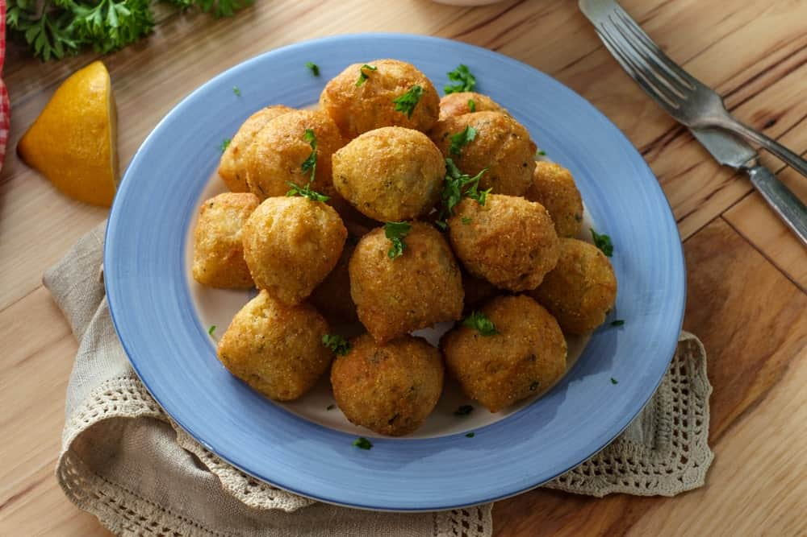
HUSHPUPPIES ARE SMALL, DEEP-FRIED SAVORY BALLS THAT ARE MADE FROM CORNMEAL BATTER. SINCE THESE ARE DEEP-FRIED, THEY ARE QUITE DIFFERENT FROM REGULAR FRIED ITEMS. THEY ARE USUALLY SERVED AS A SIDE DISH WITH SEAFOOD LIKE FRIED FISH IN THE SOUTH.
THERE ARE MANY DIFFERENT WAYS IN WHICH HUSHPUPPIES ARE COOKED. SOME RECIPES CAN INCLUDE CHOPPED ONIONS, ONION SEASONING, JALAPENOS, OR BEER. THE HUSHPUPPY WILL BE WHITE OR YELLOW AND MOIST ON THE INSIDE AND HAVE A MEDIUM TO LIGHT GOLDEN BROWN AND CRUNCHY EXTERIOR WHEN IT IS FRIED PROPERLY.
THIS TYPE OF CORNBREAD HAS EXISTED FOR MANY YEARS. IT WAS A PART OF NATIVE AMERICAN CULTURE TO CREATE HOMINY THROUGH NIXTAMALIZATION. FROM THERE, MANY DIFFERENT TYPES OF CORNBREAD WERE FORMED AND SOON, HUSHPUPPIES STARTED BECOMING A POPULAR VARIANT. HUSHPUPPIES RETAIN A STRONG CONNECTION WITH THE SOUTHERN UNITED STATES. THERE IS EVEN A HUSHPUPPY CHAMPIONSHIP HELD EVERY YEAR IN LUFKIN, TEXAS. THEY ARE ALSO SERVED IN MANY RESTAURANTS WHERE DEEP-FRIED SEAFOOD IS ON THE MENU.

RECIPE FOR CORNBREAD
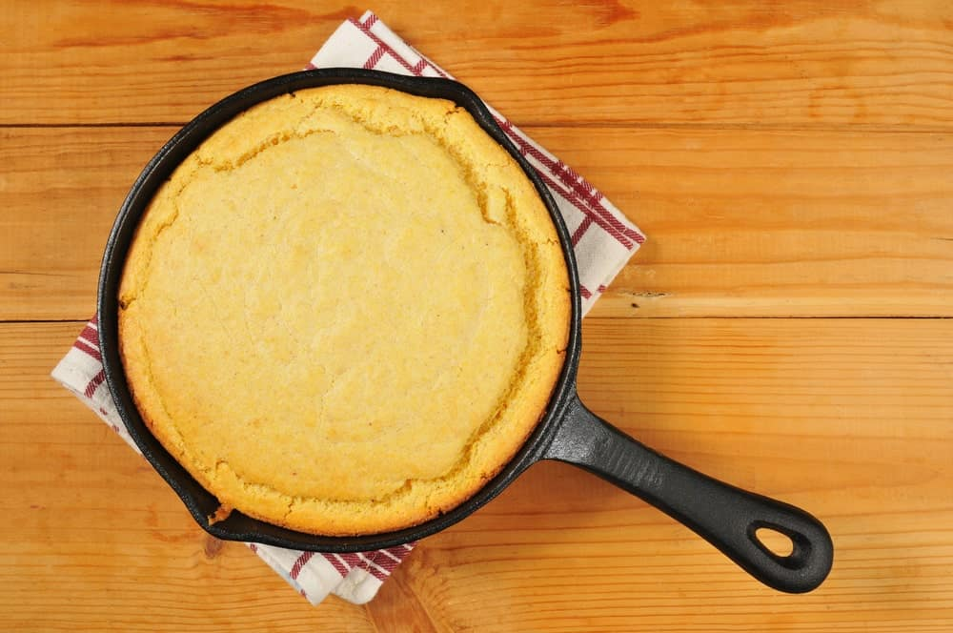
THERE ARE MANY RECIPES TO MAKE DELICIOUS SOUTHERN-STYLE CORNBREAD BUT THIS ONE DEFINITELY TAKES THE CAKE. IT IS SIMPLE AND EASY TO USE!
INGREDIENTS
- 1 TABLESPOON BACON DRIPPINGS
- 2 CUPS CORNMEAL OR 1 1/2 CUPS CORNMEAL WITH 1/2 CUP FLOUR
- 1 TEASPOON BAKING SODA
- 1 TEASPOON SALT
- 1 LARGE EGG (OPTIONAL)
- 1 1/4 CUPS BUTTERMILK
- 6 TABLESPOONS UNSALTED BUTTER, MELTED
METHOD
- PREHEAT A 9-10 INCH WELL-SEASON CAST IRON SKILLET IN THE OVEN WITH THE BACON DRIPPINGS. THE OVEN TEMPERATURE SHOULD BE AT 400°F WITH THE SKILLET INSIDE IT. IF YOU DON’T HAVE AN IRON SKILLET, YOU CAN USE A METAL CAKE PAN OR UNCOVERED DUTCH OVEN.
- WHISK THE DRY INGREDIENTS (CORNMEAL, SALT, AND BAKING SODA) INTO A LARGE BOWL. IN ANOTHER BOWL, BEAT THE EGG AND BUTTERMILK UNTIL COMBINED. YOU CAN MAKE THE CORNBREAD WITHOUT THE EGG AS WELL, BUT THE CORNBREAD WILL TURN OUT REALLY CRUMBLY. MIX THE WET MIXTURE INTO THE DRY INGREDIENTS AND STIR IN THE MELTED BUTTER SLOWLY.
- POUR THE BATTER INTO THE HOT SKILLET EVENLY. BAKE IT AT 400°F FOR 20 MINUTES. TAKE IT OUT UNTIL THE EDGES OF THE CORNBREAD ARE BROWN AND A TOOTHPICK TO THE CENTER OF THE BREAD COMES OUT CLEAN.
- LET THE CORNBREAD REST IN THE SKILLET FOR AROUND 10-30 MINUTES BEFORE CUTTING IT INTO WEDGES.

HOW TO STORE CORNBREAD
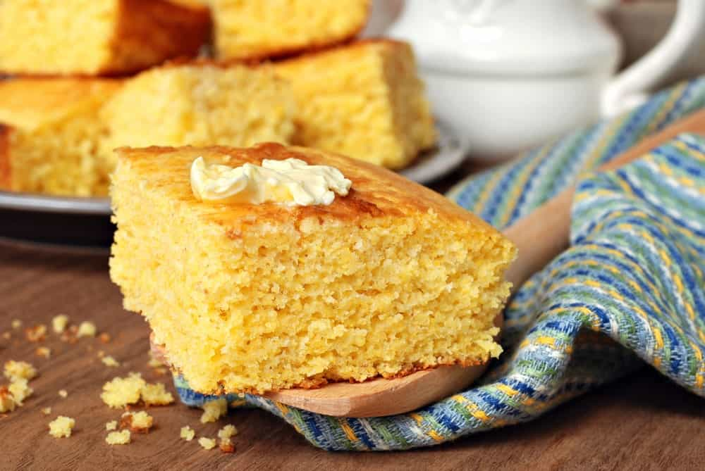
THERE ARE THREE MAIN WAYS TO STORE CORNBREAD PROPERLY SO THAT IT REMAINS CRUNCHY ON THE OUTSIDE AND MOIST ON THE INSIDE.
FIRSTLY, YOU CAN STORE THE CORNBREAD AT ROOM TEMPERATURE IN ALUMINUM FOIL OR PLASTIC WRAP, WHICH WILL KEEP IT FROM DRYING OUT. YOU SHOULD PLACE THE CORNBREAD IN A DARK, DRY PLACE SUCH AS THE PANTRY OR A BREAD BOX. YOU CAN STORE THE BREAD LIKE THIS FOR 1-2 DAYS.
SECONDLY, YOU CAN STORE IT IN THE FRIDGE. LET IT COMPLETELY COOL OFF BEFORE YOU PUT IT IN THE FRIDGE OR ELSE IT WILL SPOIL FASTER. DO MAKE SURE TO WRAP THE CORNBREAD IN PLASTIC WRAP TO KEEP MOISTURE AND AIR AWAY FROM IT. YOU CAN STORE THE BREAD IN YOUR FRIDGE FOR UP TO A WEEK AFTER WHICH IT WILL LOSE ITS FLAVOR AND GO BAD. YOU CAN EAT IT COLD OR REHEAT THE CORNBREAD IN THE OVEN.
LASTLY, YOU CAN STORE THE CORNBREAD IN THE FREEZER. YOU CAN PLACE THE CORNBREAD IN A SEALABLE FREEZER BAG AND PLACE IT IN THE FREEZER AFTER IT HAS COOLED OFF. ONCE THE BAG IS IN THE FREEZER, YOU SHOULD PRESS THE ACCESS AIR OUT WITH YOUR HANDS BEFORE SEALING IT.
YOU SHOULD PLACE THE BAGGED CORNBREAD IN A CONTAINER IF YOUR FREEZER IS CROWDED OR ELSE IT WILL GET SMASHED. YOU CAN EAT IT AFTER THAWING OR REHEATING IT. YOU CAN STORE THE CORNBREAD LIKE THIS FOR 1-3 MONTHS.
CORNBREAD IS A DELICIOUS DISH THAT CAN BE COOKED IN A VARIETY OF DIFFERENT WAYS. IT’S NUTRITIOUS AND CHEAP TO MAKE, SO YOU CAN HAVE IT ANY DAY YOU LIKE. THERE ARE MANY DIFFERENT INGREDIENTS AND TOPPINGS YOU CAN USE TOO, SO DO MAKE SURE YOU EXPERIMENT AND FIND YOUR FAVORITE TYPE OF CORNBREAD.

4 DIFFERENT TYPES OF CAULIFLOWER
LEARN MORE ABOUT THE CAULIFLOWER BY GETTING TO KNOW ITS DIFFERENT TYPES, ORIGINS, AND DISCOVER ITS NUMEROUS HEALTH BENEFITS. THIS VEGETABLE IS KNOWN TO BE ONE OF THE HEALTHIEST PLANTS IN THE WORLD.
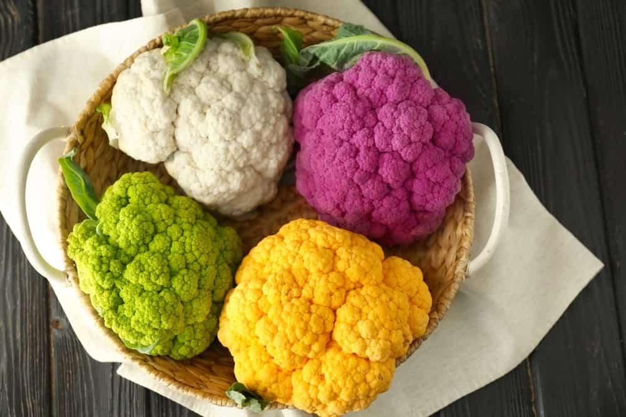
THE CAULIFLOWER IS AN ANNUAL PLANT THAT BELONGS TO THE CRUCIFEROUS VEGETABLES OR THE CABBAGE FAMILY. IT ORIGINATED IN ASIA MINOR AND WAS FIRST CULTIVATED IN 600 YEARS B.C. IN TURKEY. IT BECAME POPULAR IN EUROPE IN THE 16TH-CENTURY BUT WAS ONLY CULTIVATED IN AMERICA AT THE BEGINNING OF THE 20TH CENTURY.
THERE ARE HUNDREDS OF VARIETIES OF CAULIFLOWERS THAT DIFFER IN COLOR, SIZE, SHAPE, TASTE, AND NUTRITIONAL COMPOSITION. ASIDE FROM WHITE, CAULIFLOWERS ALSO EXIST IN OTHER COLORS SUCH AS GREEN, PURPLE, ORANGE, BROWN, AND YELLOW.
RELATED: VEGETABLES AND HERBS FOR SYMBIOTIC FARMING | BROCCOLI ALTERNATIVES | HEALTHY PIZZA ALTERNATIVES | HEALTHY PASTA ALTERNATIVES | HOW TO INCREASE VEGETABLE GARDEN YIELD

TYPES

GREEN CAULIFLOWER
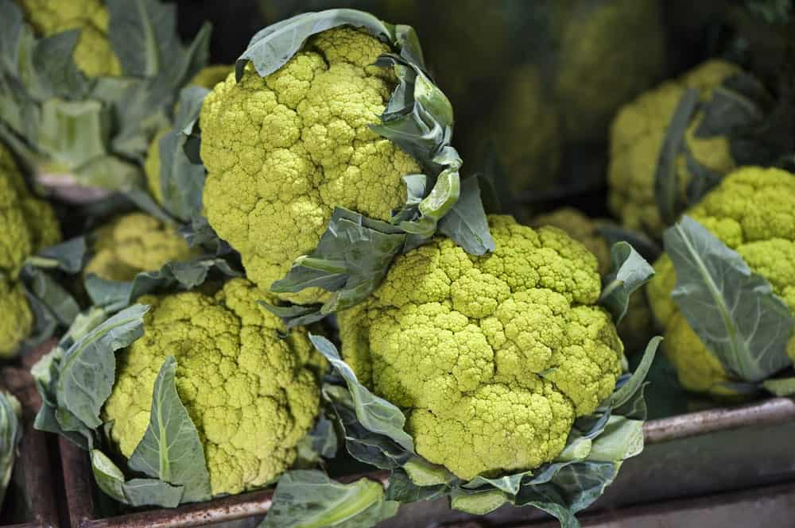
ONE VARIETY OF GREEN CAULIFLOWER IS CALLED THE ROMANESCO, AND IT IS LIME GREEN WITH POINTED PINNACLES AT THE SURFACE OF THE HEAD. THEY ARE SMALL HEADS, A TAD SMALLER THAN MANY OTHER TYPES OF CAULIFLOWER, AND THE PLANT ITSELF TENDS TO BE LESS VIGOROUS THAN OTHER VARIETIES. THE ROMANESCO HAS A MILD NUTTY TASTE, VERY SIMILAR TO BROCCOLI, AND IT MAKES A VERY ATTRACTIVE DINNER PLATE.
GREEN CAULIFLOWER IS ALSO CALLED BROCCOFLOWER, AND IT IS AVAILABLE IN NUMEROUS VARIETIES. SINCE THE EARLY 1990S, THESE TYPES OF CAULIFLOWER HAVE BEEN AVAILABLE COMMERCIALLY THROUGHOUT EUROPE AND THE UNITED STATES, AND OTHER KNOWN VARIETIES INCLUDE THE VORDA, THE ALVERDA, AND THE GREEN GODDESS. VARIETIES OF ROMANESCO INCLUDE THE VERONICA AND THE MINARET.

ORANGE CAULIFLOWER
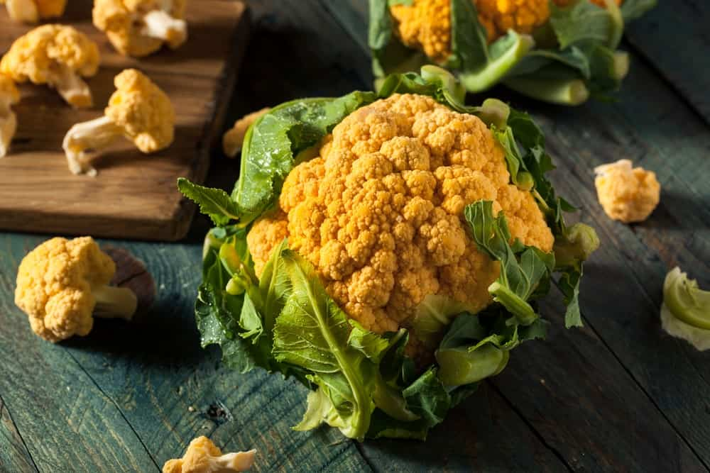
ALSO KNOWN AS THE CHEDDAR CAULIFLOWER, THIS IS A HYBRIDIZED VARIETY THAT DEVELOPS CURDS THAT ARE BRIGHT ORANGE IN COLOR. THEY CONTAIN MORE OF THE ORANGE PIGMENT KNOWN AS BETA-CAROTENE – WHICH IS A PRECURSOR TO VITAMIN A – AND THEY HOLD WELL ON THE PLANT BECAUSE THEY ARE STURDY, EVEN WHEN THEY DON’T PRODUCE FLOWERS AT HARVEST TIME.
IN FACT, WHEN YOU COOK THIS TYPE OF CAULIFLOWER THE COLOR GETS EVEN BRIGHTER AND DEEPER IN COLOR, AND BECAUSE OF THEIR DURABILITY, YOU CAN HARVEST THE PLANTS AT VARIOUS TIMES INSTEAD OF ALL AT ONCE AND STILL ENJOY THEIR FLAVOR AND TEXTURE. THE ORANGE BOUQUET IS ANOTHER VARIETY OF ORANGE CAULIFLOWER.

PURPLE CAULIFLOWER
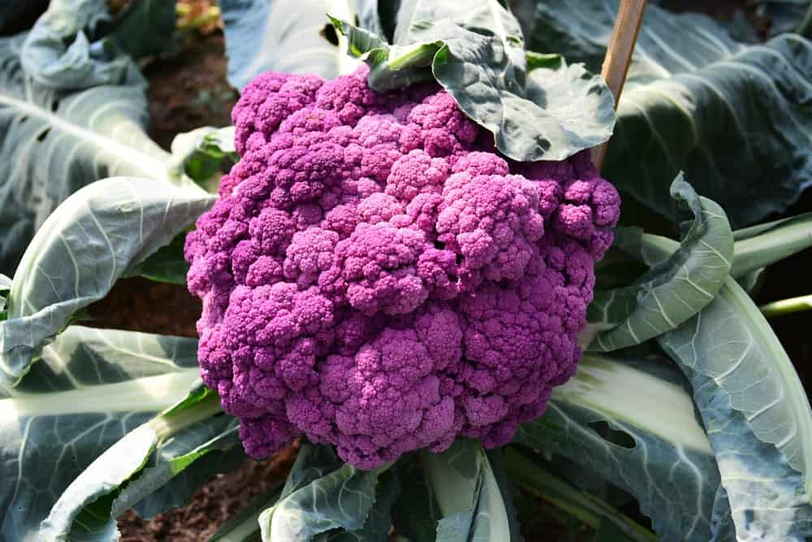
BOTH GRAFFITI AND PURPLE HEAD CAULIFLOWER HAS STRIKING PURPLE CURDS, WHICH ARE TENDER AND HAVE A MILD FLAVOR. YOU CAN COOK THESE TYPES OF CAULIFLOWER OR TOSS THEM IN YOUR SALADS, AND WHILE GRAFFITI CAULIFLOWER RETAINS ITS PURPLE COLOR EVEN AFTER COOKING, THE PURPLE HEAD CAULIFLOWER WILL TURN GREEN. CHOCK FULL OF VITAMINS AND MINERALS JUST LIKE OTHER TYPES OF CAULIFLOWER, THE PURPLE CAULIFLOWER PLANTS ARE VERY HEALTHY FOR YOU AND TASTE GREAT.
THE PURPLE IN THIS TYPE OF CAULIFLOWER COMES FROM WATER-SOLUBLE PIGMENTS THAT ARE ALSO FOUND IN RED WINE AND CABBAGE, AND PURPLE VARIETIES INCLUDE THE PURPLE CAPE AND THE VIOLET QUEEN, THE LATTER OF WHICH HAS VERY VIVID PURPLE CURDS AND TASTES GREAT WHEN EATEN RAW. IN SOUTHERN ITALY AND IN GREAT BRITAIN, THERE IS A TYPE OF BROCCOLI THAT HAS TINY BUDS AND IS CALLED A PURPLE CAULIFLOWER, ALTHOUGH IT DOESN’T TECHNICALLY FALL UNDER THIS CATEGORY.

WHITE CAULIFLOWER
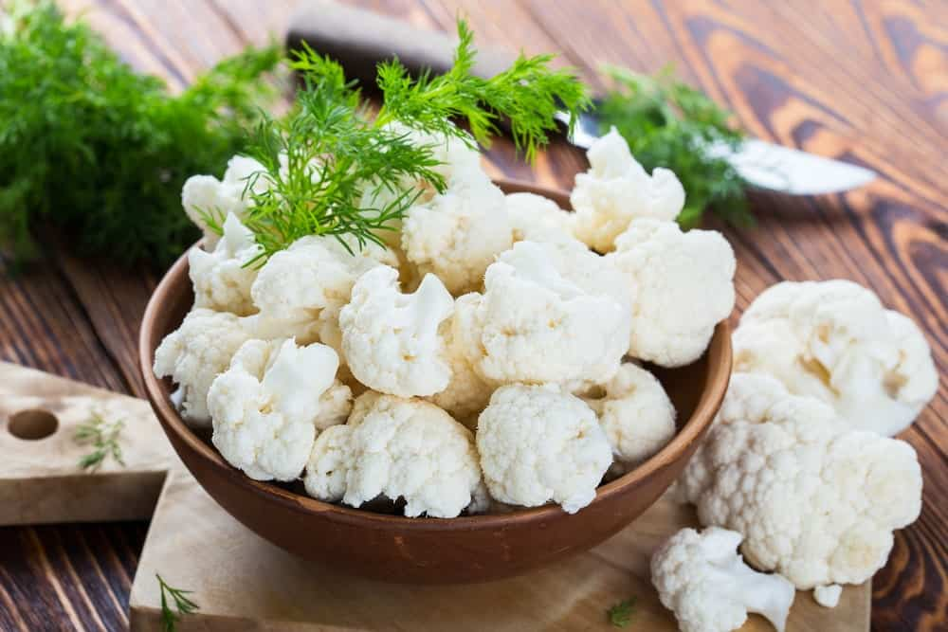
THERE ARE ACTUALLY NUMEROUS TYPES OF WHITE CAULIFLOWER, INCLUDING THE WHITE CLOUD AND THE EARLY WHITE HYBRID, BUT ALL WHITE CAULIFLOWER CONSISTS OF WHITE CURD, OR THE HEAD OF THE FLOWER BUDS, SURROUNDED BY ENCLOSING LEAVES.
THE CURD IS THE EDIBLE PART OF THE PLANT, AND THE MORE IT GROWS THE LARGER IT GROWS, EVENTUALLY BEING A PURE-WHITE COLOR AND APPEARING WITHOUT THE SIDE SHOOTS. SOME ARE TOLERANT OF SPRING OR FALL FROSTS, WHILE OTHERS MATURE VERY QUICKLY, BUT WHITE CAULIFLOWER IS THE MOST COMMON AND POPULAR TYPE OF CAULIFLOWER THERE IS.
THE SNOWBALL IS ANOTHER TYPE OF WHITE CAULIFLOWER INTRODUCED TO NORTH AMERICA IN 1888. IT IS SNOW-WHITE IN COLOR AND FEATURES A SIX-INCH HEAD THAT HAS TIGHTLY WOUND CURDS ON IT. IT ONLY TAKES A LITTLE OVER TWO MONTHS TO HARVEST, AND IT DOES BEST IN FULL SUN WITH SOIL THAT IS SLIGHTLY ACIDIC.
OTHER VARIETIES OF THE WHITE CAULIFLOWER INCLUDE THE SNOW KING, WHICH CAN GET UP TO EIGHT INCHES IN DIAMETER; THE WHITE CORONA, WHICH ONLY GETS TO THREE OR FOUR INCHES LARGE; AND THE SNOW CROW, WHICH GROWS TO EIGHT INCHES IN DIAMETER AND REACHES MATURITY IN LESS THAN 60 DAYS.
ONE OF THE INTERESTING CHARACTERISTICS OF WHITE CAULIFLOWER IS THAT IT NEEDS TO BE BLANCHED WHILE IT IS GROWING. THIS MEANS THAT THE CURD MUST BE COMPLETELY ENCLOSED BY GREEN OUTER LEAVES SO THAT THE WHITE COLOR IS PRESERVED AND IT TASTES RIGHT ONCE IT’S HARVESTED.
IN FACT, MANY VARIETIES OF WHITE CAULIFLOWER ARE SELF-BLANCHING, WHICH MEANS THE LEAVES CAN ALSO PROTECT IT FROM THE SUN’S DAMAGING EFFECTS. SELF-BLANCHING VARIETIES OF WHITE CAULIFLOWER INCLUDE THE ANDES, THE SNOW CROWN, THE EARLY SNOWBALL, AND THE SELF-BLANCHE.

ORIGINS OF THE TYPES OF CAULIFLOWER

EUROPEAN CAULIFLOWER
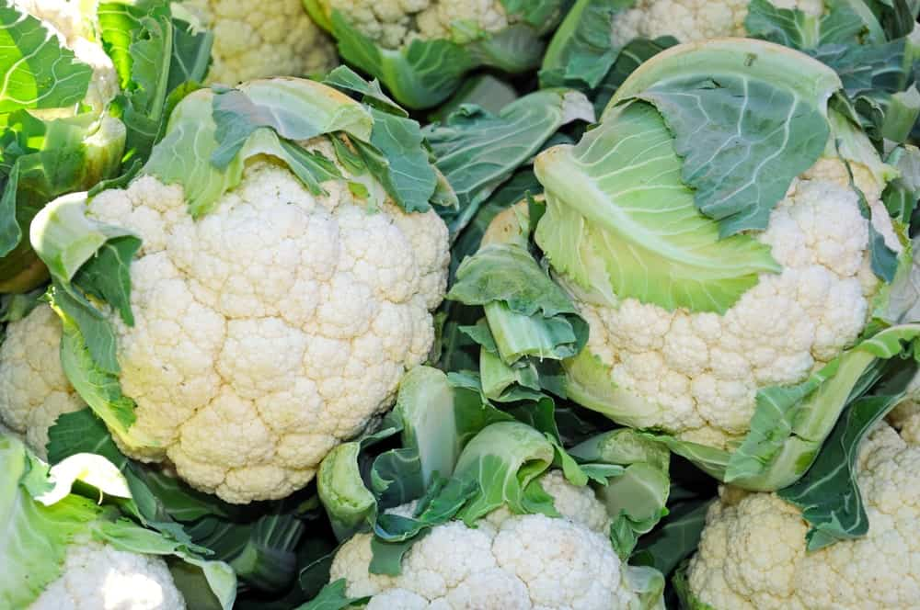
THE ORIGINAL CAULIFLOWER WAS DEVELOPED IN ITALY, BUT IT WAS LATER TAKEN TO OTHER PARTS OF EUROPE, INCLUDING GERMANY, FRANCE, ENGLAND, AND THE NETHERLANDS. SOME OF THE MOST IMPORTANT TYPES INCLUDE THE NORTHERNS, THE ANGER, THE ROSCOFF, THE CORNISH, THE ERFURT, AND THE SNOWBALL. MOST ARE GROWN IN COLD WEATHER, ALTHOUGH THE ERFURT CAN BE GROWN DURING THE SUMMER MONTHS. HERE ARE SOME CHARACTERISTICS OF THESE TYPES OF CAULIFLOWER:
- ANGERS CAULIFLOWER: VERY WAVY AND SERRATED LEAVES; CURDS ARE SOLID-WHITE IN COLOR
- CORNISH CAULIFLOWER: LONG-STALKED WITH LOOSE LEAVES; FLAT CURDS THAT HAVE A LOT OF FLAVOR IN THEM
- NORTHERNS CAULIFLOWER: BROAD, WAVY LEAVES; WELL PROTECTED AND TASTY CURDS
- ROSCOFF CAULIFLOWER: LONG, ERECT LEAVES WITH POINTED TIPS; BLUISH-GREEN LEAVES AND WHITE TO CREAMY-WHITE CURDS
- SNOWBALL AND ERFURT CAULIFLOWER: DWARF PLANTS; SHORT, GREEN LEAVES; CURDS ARE SOLID AND VERY WELL PROTECTED

INDIAN CAULIFLOWER
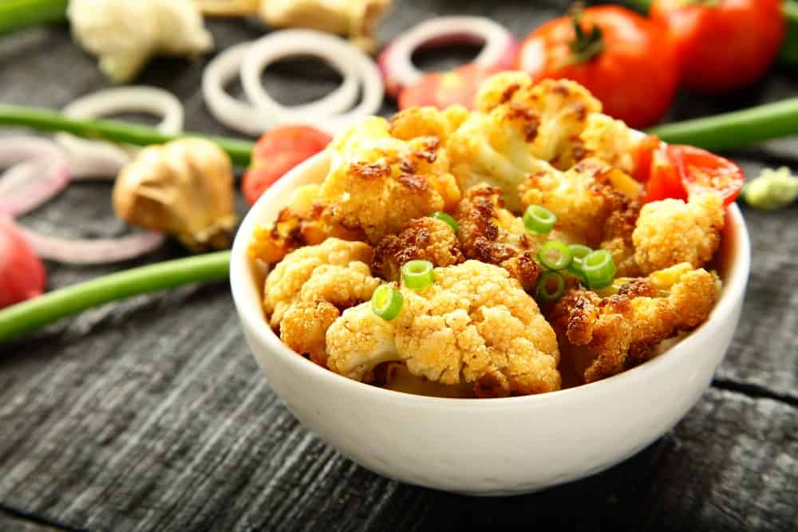
THESE TYPES OF CAULIFLOWERS ARE INHERENTLY DIFFERENT THAN THE TYPES THAT ARE GROWN IN EUROPE, MOSTLY BECAUSE THEY CAN HANDLE HIGH HUMIDITY AND HEAT MUCH BETTER, AND BECAUSE THEY MATURE QUITE EARLY. MOST INDIAN CAULIFLOWERS ARE DWARF VARIETIES OF THE SNOWBALL OR ERFURT VARIETY.

THE HEALTH BENEFITS OF CAULIFLOWER
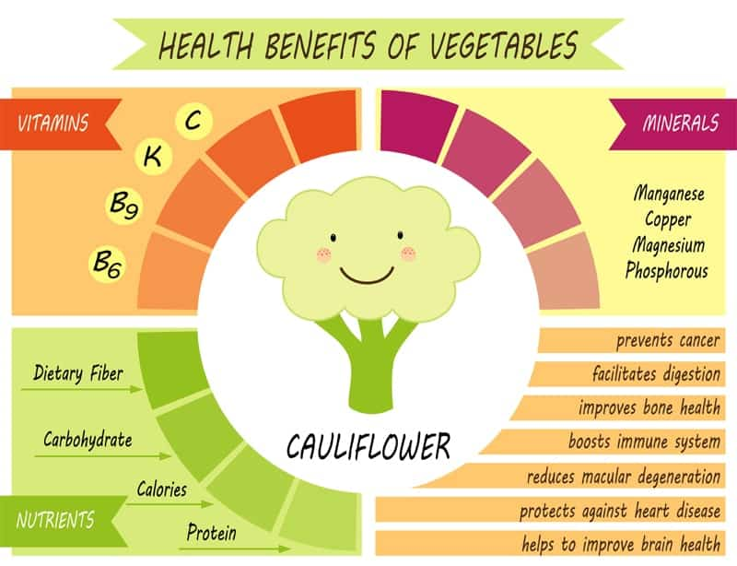
CAULIFLOWER IS LOW IN CALORIES AND CONTAINS THE FOLLOWING VITAMINS AND MINERALS:
- FIBER
- FOLATE
- MAGNESIUM
- MANGANESE
- PANTOTHENIC ACID
- PHOSPHORUS
- POTASSIUM
- VITAMIN B6
- VITAMIN C
- VITAMIN K
IN FACT, ONE CUP OF RAW CAULIFLOWER IS ONLY AROUND 25 CALORIES, AND THE NUTRITIONAL BENEFITS ARE EXTRAORDINARY. THE VITAMIN C CONTENT ALONE IS ENOUGH TO MEET 77% OF THE RECOMMENDED DAILY INTAKE REQUIREMENTS SET BY THE FOOD AND DRUG ADMINISTRATION (FDA). IT ALSO HAS 10% OF YOUR FIBER NEEDS, A LOT OF ANTIOXIDANTS IS HIGH IN CHOLINE, AND IS A GREAT LOW-CARB ALTERNATIVE TO EATING GRAINS AND LEGUMES.

10 NUTRIENT-PACKED BROCCOLI ALTERNATIVES
GET YOUR DAILY DOSE OF NUTRIENTS WITH THESE NUTRIENT-PACKED BROCCOLI ALTERNATIVES THAT ARE JUST AS GOOD FOR YOUR HEALTH AND EASY TO FIND IN YOUR LOCAL GROCERY AND MARKET. ENJOY A WIDE RANGE OF DELICIOUS AND HEALTHY RECIPES WITH THESE AWESOME VEGGIES.
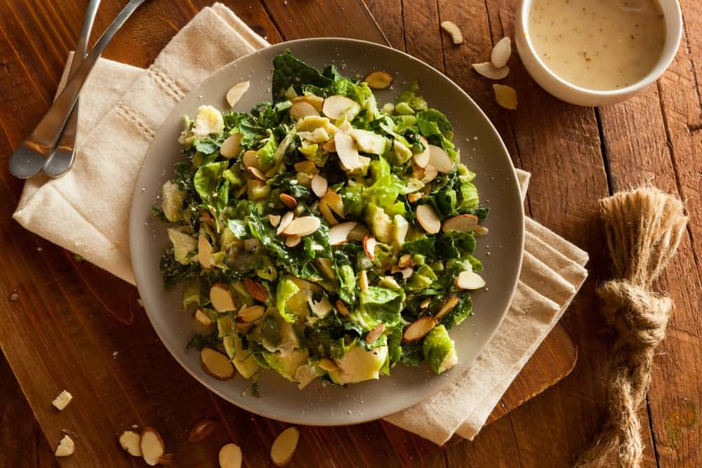
BROCCOLI IS WELL-KNOWN TO BE A SUPERFOOD PACKED WITH NUTRITIONAL VALUE. IT’S INCLUDED IN MANY POPULAR DIETS SUCH AS THE VEGAN DIET, KETO DIET, AND MILITARY DIET. YET GETTING YOUR KID TO FINISH A PLATE OF BROCCOLI CAN BE CHALLENGING. SOME PEOPLE ARE SIMPLY TURNED OFF WITH ITS BITTER TASTE AND CANNOT BE CONVINCED TO EAT IT.
GOOD THING THERE ARE MANY MORE HEALTH-BOOSTING CRUCIFEROUS VEGETABLES THAT YOU CAN CHOOSE FROM. JUST LIKE BROCCOLI, THESE ALTERNATIVE VEGGIES ARE NUTRIENT-PACKED. PLUS, THEY’RE EASY TO FIND IN GROCERIES AND MARKETS.
RELATED: TYPES OF BROCCOLI | VEGETABLES AND HERBS FOR SYMBIOTIC GARDENING | HOW TO INCREASE VEGETABLE GARDEN YIELD | BROCCOLI CHEDDAR RICE RECIPE | BROCCOLI CHEESE SOUP RECIPE

BROCCOLI NUTRITION FACTS CHART
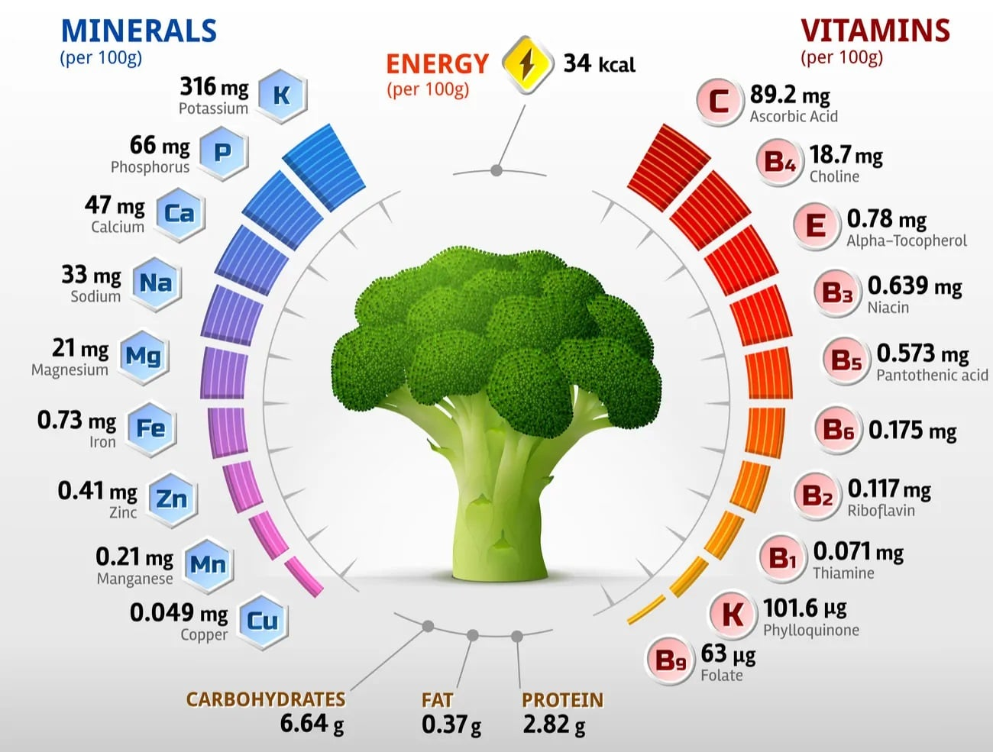
NOW LET’S JUMP INTO YOUR BROCCOLI ALTERNATIVES.

1. CAULIFLOWER
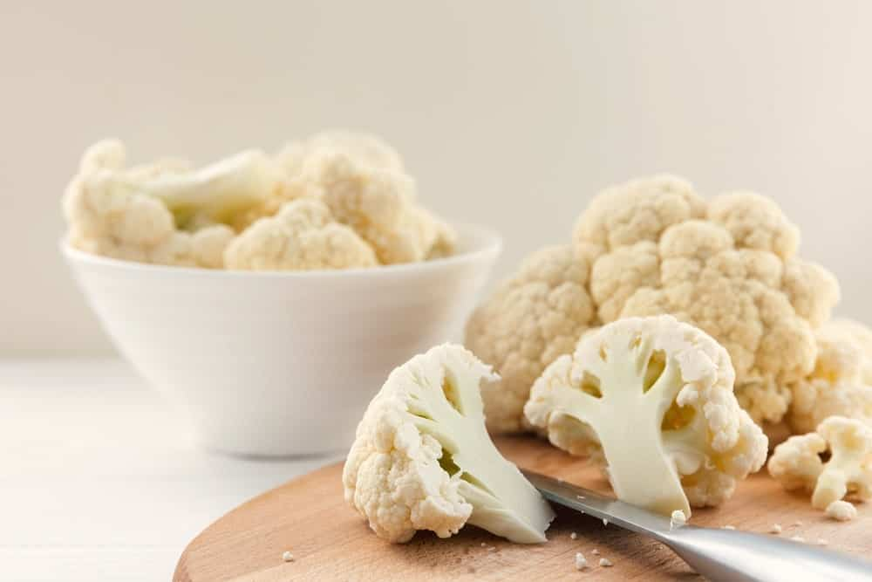
WHEN IT IS PREPARED AND NOT EATEN RAW, CAULIFLOWER USUALLY HAS THE SAME TEXTURE AS BROCCOLI BUT IT HAS A MORE SWEET TASTE WHEN COMPARED TO BROCCOLI. THE PURPLE VARIETY IS FULL OF NATURAL ANTIOXIDANTS WHILE THE ORANGE HAS MORE VITAMIN A. LIKE WITH BROCCOLI, SOME PEOPLE LIKE TO EAT CAULIFLOWER WITH CHEESE, BUT IT IS RECOMMENDED NOT TO EAT TOO MUCH CHEESE WITH IT BECAUSE OF THE HIGH SATURATED FAT CONTENT.
ANOTHER WAY PEOPLE PREPARE IT IS BY ROASTING IT IN THE OVEN OR MAKING CAULIFLOWER ‘MASHED POTATOES’. FINDING IT IS GENERALLY VERY EASY IN STORES BECAUSE THERE IS A WIDE VARIETY OF CAULIFLOWER MADE PRODUCTS OUT THERE FROM DRIED SNACKS TO PIZZA CRUST.
PROS
- FOUND EASILY IN STORES
- HAS VITAMINS AND ANTIOXIDANTS
- LOW IN CALORIES AND CARBOHYDRATES
CONS
- HAS LESS FIBER, PROTEIN, AND VITAMINS A, C, AND K THAN BROCCOLI

2. CABBAGE
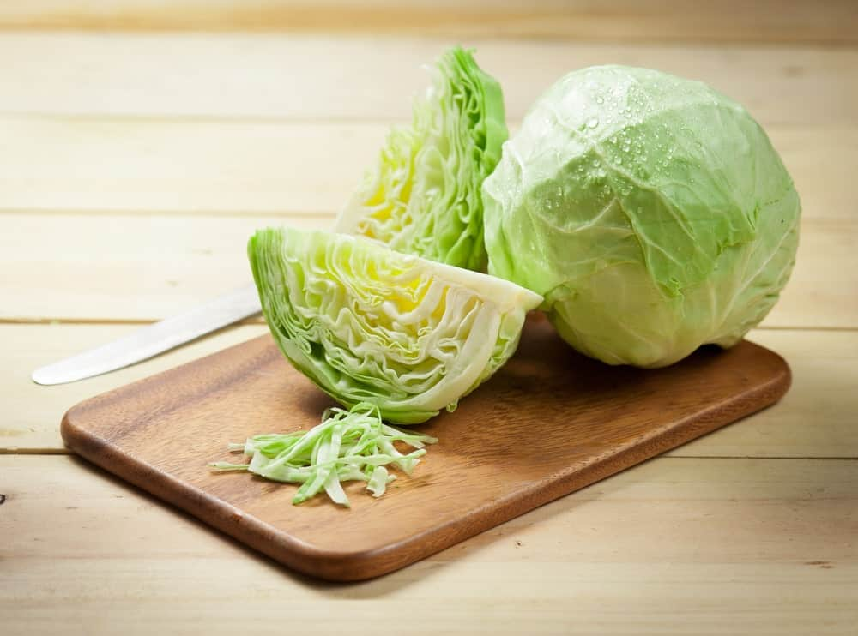
OUT OF RED AND GREEN CABBAGE, RED WINS FOR BEING HEALTHIER BY CONTAINING MORE FIBER AND VITAMINS THAN GREEN. ONE CUP OF IT CONTAINS UP TO 85 PERCENT OF A PERSON’S DAILY REQUIREMENTS FOR VITAMIN C AND ALSO CONTAINS ABOUT 2 GRAMS OF FIBER.
SEVERAL ANIMAL STUDIES HAVE SHOWN THAT IT ALSO HELPS TO PROTECT THE HEART AND LIVER FROM DAMAGE CAUSED BY PLAQUE BUILD UP IN THE ARTERIES AS WELL AS LOWER BLOOD CHOLESTEROL LEVELS. BESIDES THAT, MANY AGREE THAT IT TASTES BEST WITH SHREDDED WITH STIR-FRY, SALADS, OR NOODLES BECAUSE OF ITS CRISP TEXTURE.
PROS
- HIGH IN FIBER, VITAMIN C, AND ANTHOCYANINS
- HELPS LOWER THE RISK OF HEART AND LIVER DAMAGE
- MAY REDUCE INFLAMMATION AND CHOLESTEROL LEVELS
CONS
- MUST EAT LARGE AMOUNTS TO ACHIEVE OPTIMAL RESULTS

3. KALE
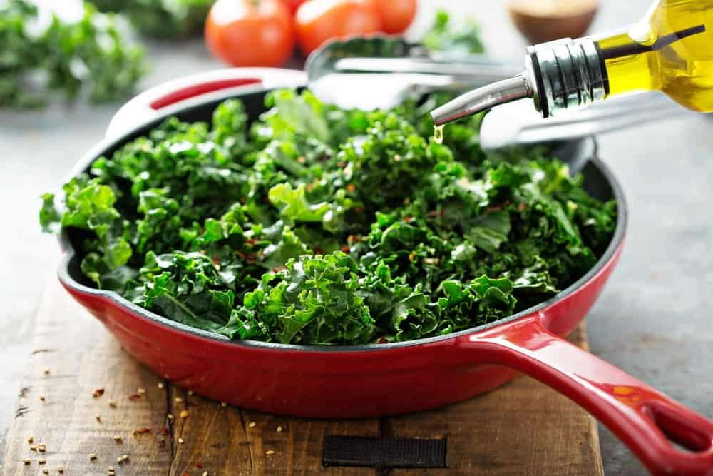
THERE ARE MANY DIFFERENT WAYS THAT KALE CAN BE PREPARED, BUT THE MOST COMMON WAYS ARE FOR IT TO BE EATEN WITH SALADS, STEAMED, SAUTEED, OR PUREED AND ADDED TO A SMOOTHIE. WIDELY KNOWN AS A POWERFUL SUPERFOOD, IT IS NOT HARD TO SEE THAT IT IS ONE OF THE HEALTHIEST BROCCOLI ALTERNATIVES OUT THERE BECAUSE OF HOW MUCH IT AFFECTS A PERSON’S HEALTH BY BEING HIGH IN OVER 7 VITAMINS AND MINERALS.
THERE ARE MANY DIFFERENT KALE PRODUCTS OUT THERE, BUT THEY ARE ALSO USUALLY A COMBINATION OF OTHER VEGETABLES. ORGANIC, FRESH KALE IS THE BEST CHOICE FOR THOSE WHO WANT ALL OF THEIR HEALTH BENEFITS.
PROS
- MAY REDUCE BLOOD SUGAR AND CHOLESTEROL LEVELS
- HIGH IN VITAMINS A, B, C, AND K
- HIGH IN POTASSIUM, CALCIUM, AND COPPER
CONS
- HARDER TO SHOP FOR ONLINE BY ITSELF

4. SWISS CHARD
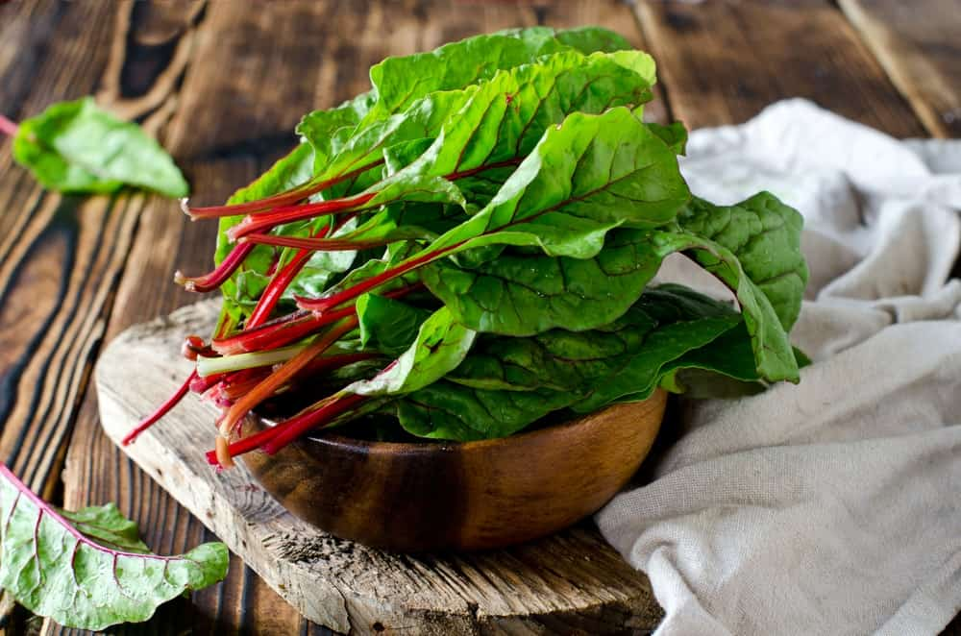
HIGHLY RICH IN MANY DIFFERENT NUTRIENTS INCLUDING MANGANESE, MAGNESIUM, FIBER, AND PROTEIN, SWISS CHARD IS ONE OF THE MORE VISUALLY APPEALING GREENS OUT THERE. THERE ARE MANY DIFFERENT WAYS THEY CAN BE PREPARED INCLUDING BEING IN A SALAD, FRIED, STEAMED, CANNED, PICKLED, AND PUREED. ONE OF THE MORE NOTABLE FEATURES IS THAT IT HAS THE ABILITY TO PREVENT DIABETES MELLITUS FROM CAUSING DAMAGE TO THE BODY. THAT AND IT IS VERY LOW IN CALORIES.
PROS
- PROTECTS AGAINST DIABETES
- PREVENT FREE RADICALS FROM DAMAGING THE CELLS
- HIGH IN VITAMINS A, C, AND K
CONS
- MAY NOT BE BEST FOR PEOPLE WITH LOW BLOOD SUGAR

5. SPINACH
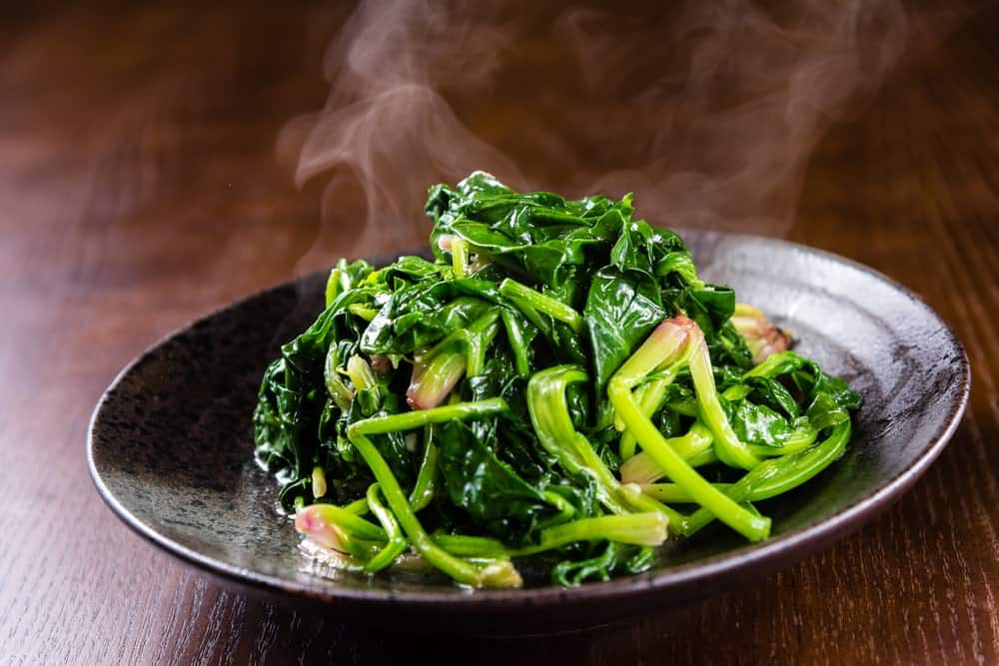
THERE WAS A REASON POPEYE WOULD ALWAYS EAT SPINACH, OTHER THAN TO SAVE THE DAY, AND IT WAS BECAUSE IT IS EXTREMELY HELPFUL FOR THE HEART AND BLOOD PRESSURE, HAS ANTIOXIDANTS THAT REDUCE THE RISK FOR CANCER, AND IS HIGH IN LUTEIN AND BETA-CAROTENE. BESIDES EATING IT STRAIGHT FROM THE CAN LIKE POPEYE, SPINACH IS A GREAT INGREDIENT TO ADD TO SOUPS, SALADS, STIR-FRIES, CASSEROLES, PIES, AND MORE.
PROS
- HIGH IN ANTIOXIDANTS
- HELPS LOWER OR PREVENT HIGH BLOOD PRESSURE
CONS
- FRESH HAS MORE NUTRIENTS THAN OTHER PRODUCTS

6. ASPARAGUS
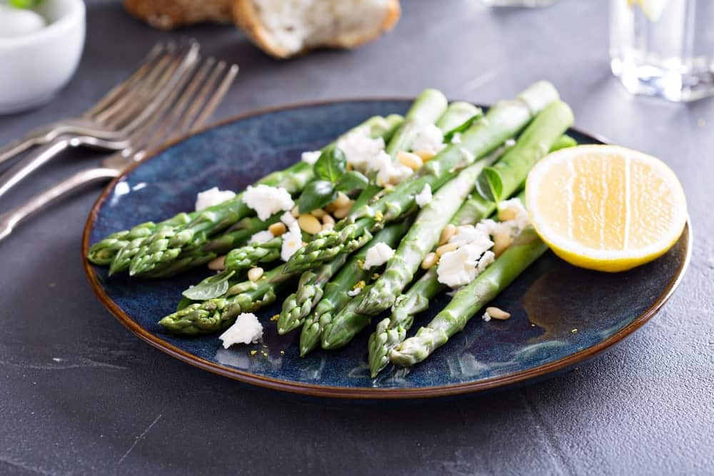
BEST EATEN WITH OTHER DISHES LIKE SOUPS, PASTA, QUICHES, AND MORE, MANY PEOPLE AGREE THAT ASPARAGUS DOES NOT HAVE A GOOD TASTE BY ITSELF. HOWEVER, IT IS ONE OF THE HEALTHIEST VEGETABLES OUT THERE, BEING HIGH IN OVER HALF A DOZEN VITAMINS AND MINERALS. ALL OF THOSE CAN IMPROVE AND HELP BOOST THE METABOLIC FUNCTION IN THE LIVER AND HELP PROTECT IT AGAINST TOXICITY.
PROS
- HIGH IN SELENIUM, THIAMIN, RIBOFLAVIN, FOLATE, AND VITAMINS B AND K
- HELPS PREVENT BIRTH DEFECTS DURING PREGNANCY
- HEALTHY FOR LIVER
CONS
- CONSIDERED BETTER WITH OTHER FOODS, COOKED

7. COLLARD GREENS
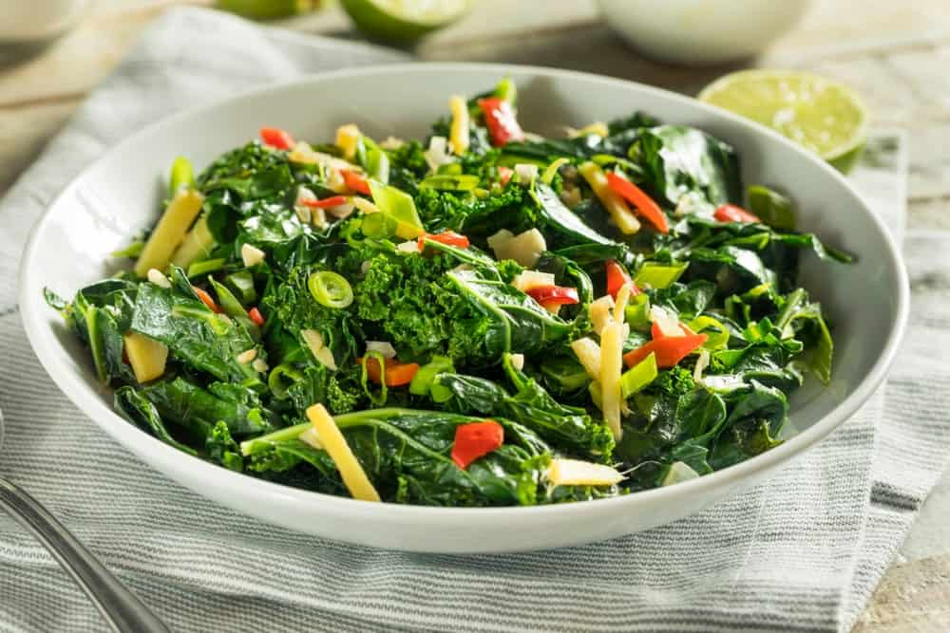
UNLIKE MANY OF THE OTHER ALTERNATIVES, COLLARD GREENS KEEP MANY OF THEIR NUTRIENTS EVEN AFTER THEY ARE COOKED. THEY ALSO, LIKE BROCCOLI, HAVE ONE OF THE BEST SOURCES OF CALCIUM FROM A PLANT AND ARE HIGH IN ANTIOXIDANTS. COLLARD GREENS ARE ACTUALLY RELATED TO BROCCOLI AND ARE HIGHLY USED IN SOUTHERN AMERICAN DISHES. THEY ARE MAINLY USED IN SALADS, STEWS, OR ALONG WITH SOME MEAT LIKE BACON OR PORK.
PROS
- HIGH IN CALCIUM, FIBER, AND PROTEIN
- HELP FIGHTS AGAINST OSTEOPOROSIS, GLAUCOMA, AND PROSTATE CANCER
CONS
- BEST EATEN WITH OTHER COOKED DISHES

8. BRUSSELS SPROUTS
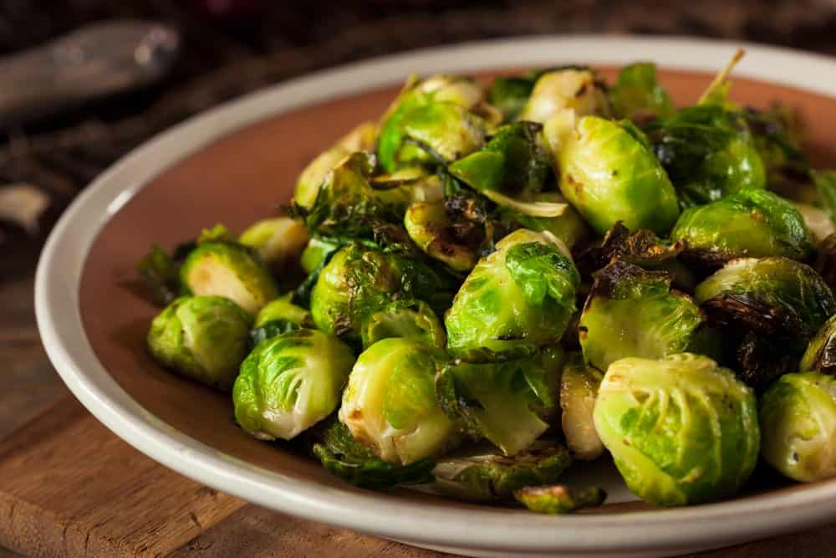
ONE OF THE BEST VEGETABLES AND FOODS TO EAT DURING DETOXIFICATION, BRUSSEL SPROUTS ARE A VERY COMMON VEGETABLE TO FIND WHETHER IT IS FROZEN, CANNED, FRESH, OR PICKLED. THEY CAN ALSO HELP PREVENT FREE RADICAL DAMAGE, REDUCE THE RISK OF COLORECTAL CANCER, AND BE AN EXCELLENT SOURCE OF VITAMINS AND MINERALS. ANOTHER THING THAT MAKES THEM ONE OF THE BEST ALTERNATIVES IS THAT THEY CAN BE PREPARED IN PRACTICALLY EVERY WAY POSSIBLE.
PROS
- HIGH IN ANTIOXIDANTS
- HIGH IN POTASSIUM, MANGANESE, FOLATE, AND VITAMINS A, C, AND K
CONS
- BEST EATEN FRESH

9. BOK CHOY
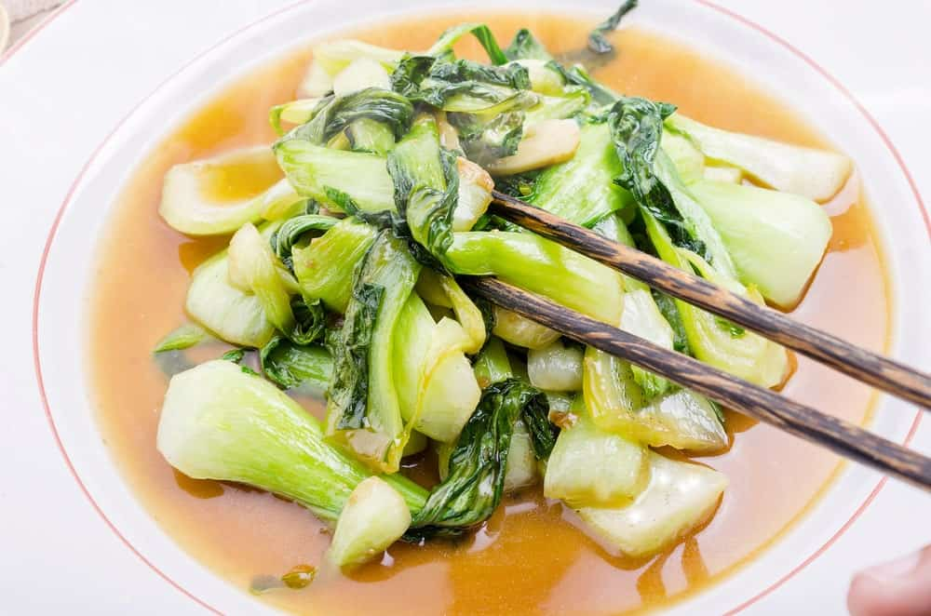
FOR PEOPLE WHO DO NOT LIKE REGULAR CABBAGE, BOK CHOY, ALSO KNOWN AS CHINESE CABBAGE, MIGHT BE A BETTER ALTERNATIVE. SOME OF THE WAYS IT IS PREPARED ARE BY ADDING IT TO A SALAD. IT CAN BE A LITTLE MORE DIFFICULT TO FIND IN SOME PLACES SINCE IT IS NOT AS POPULAR IN THE WEST AS IT IS IN THE EAST. IT IS MORE COMMON TO FIND PRODUCTS MADE WITH BOK CHOY LIKE FROZEN CHINESE FOOD.
PROS
- HIGH IN VITAMIN C
- CAN TASTE BETTER WITH LOW-SODIUM SOY SAUCE
CONS
- NOT COMMONLY SOLD IN SOME STORES OR ONLINE

10. TURNIP GREENS
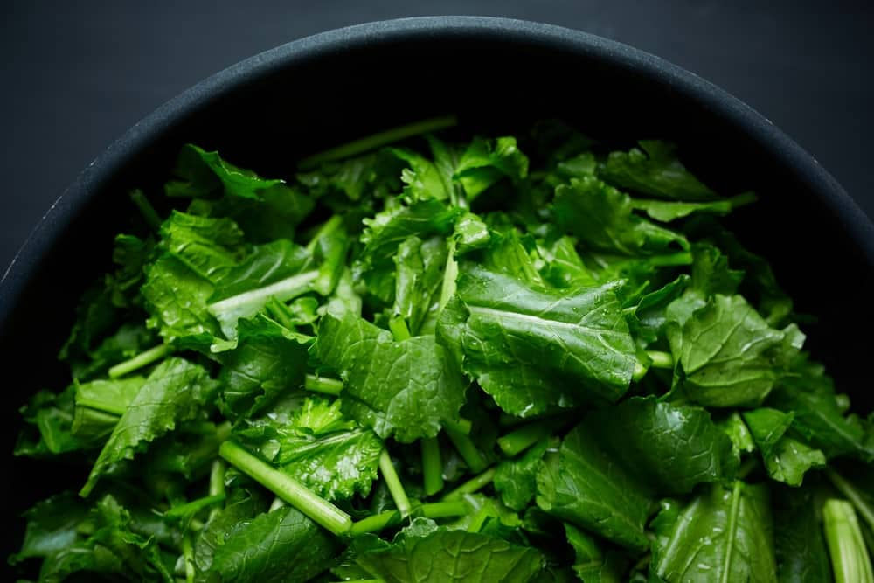
THE NUMBER OF CONDITIONS THAT TURNIP GREENS CAN FIGHT AGAINST SPEAKS TO HOW HEALTHY AND BENEFICIAL THESE GREENS ARE COMPARED TO THE OTHER ALTERNATIVES. WHETHER SLIGHTLY OR SIGNIFICANTLY, TURNIP GREENS CAN HELP PROTECT THE BODY FROM DIABETES, ARTHRITIS, HEART DISEASE, ALZHEIMER’S DISEASE, PARKINSON’S DISEASE, AUTOIMMUNE DISEASE, BLADDER CANCER, BREAST CANCER, COLON CANCER, LUNG CANCER, PROSTATE CANCER, AND OVARIAN CANCER.
NOT TO MENTION THAT IT CAN ALSO PREVENT AND EVEN COUNTERACT FREE RADICAL DAMAGE, WHICH HELPS SLOW AGING, REDUCE OXIDATIVE STRESS, MAINTAIN BONE STRENGTH, AND PROTECTS THE EYE’S HEALTH. MOST PEOPLE CONSIDER THEM TO BE TOO FRAGRANT, STRONGER THAN CABBAGE OR RADISHES, AND STRONGLY SPICEY OR SHARP FOR THEM, BUT IF THEY ARE BOILED AND THEN COOKED WITH SALT AND EATEN WITH OTHER FOOD, IT CAN HELP TO MILD THE TASTE AND SMELL. BABY TURNIP GREENS ARE ALSO LESS HARSH AND ARE MORE PREFERRED BEING EATEN RAW.
PROS
- HIGH IN VITAMINS A, B6, C, E AND K
- CONTAINS FOLATE, MANGANESE, COPPER, FIBER, PROTEIN, AND CALCIUM
CONS
- CAN SMELL AND BE SLIGHTLY BITTER

20 TYPES OF BROCCOLI?
WHO KNEW THERE WERE 20 DIFFERENT TYPES OF BROCCOLI? WELL, THERE IS AND WE LIST THEM ALL OUT WITH PICTURES AND DESCRIPTIONS. THIS IS YOUR ULTIMATE BROCCOLI GUIDE.
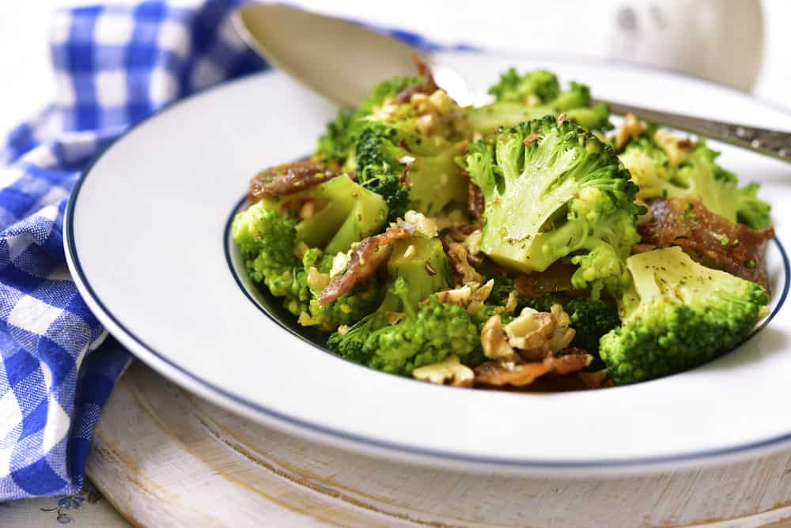
AS I GET OLDER, I APPRECIATE BROCCOLI MORE AND MORE. WHILE I STILL HAVE A HUGE SWEET TOOTH, I’VE COME TO ENJOY VEGETABLES MORE THAN I DID 20 YEARS AGO. BROCCOLI IS MY FAVORITE VEGETABLE. I LIKE COOKED AND RAW. I ALSO LIKE BROCCOLINI.
I SUSPECT OVER THE YEARS I’VE EATEN A VARIETY OF BROCCOLI TYPES, BUT WHAT I DIDN’T REALIZE IS THAT THERE ARE 20 TYPES OF BROCCOLI.
CABBAGE, ANYONE?
BROCCOLI IS A CRUCIFEROUS VEGETABLE AND PART OF THE CABBAGE FAMILY, WHICH INCLUDES VEGETABLES SUCH AS BRUSSEL SPROUTS AND KALE. ALTHOUGH THE TASTES ARE DIFFERENT, BROCCOLI AND THESE OTHER VEGETABLES ARE FROM THE SAME FAMILY.
NUMEROUS HEALTH BENEFITS
THERE ARE NUMEROUS BENEFITS TO EATING BROCCOLI, INCLUDING THE HIGH AMOUNTS OF VITAMINS INCLUDED. THIS INCLUDES VITAMINS C, K, AND A, FIBER, CALCIUM, IRON, AND EVEN ANTI-INFLAMMATORY PROPERTIES THAT MAKE EATING BROCCOLI A VERY SMART THING TO DO. BELOW I SET OUT ALL THE BROCCOLI OPTIONS PLUS A NIFTY BROCCOLI NUTRITION CHART.
RELATED: BROCCOLI ALTERNATIVES | VEGETABLES AND HERBS FOR SYMBIOTIC GARDENING | HOW TO INCREASE VEGETABLE GARDEN YIELD | BROCCOLI CHEDDAR RICE RECIPE | BROCCOLI CHEESE SOUP RECIPE

BROCCOLI NUTRITION FACTS CHART
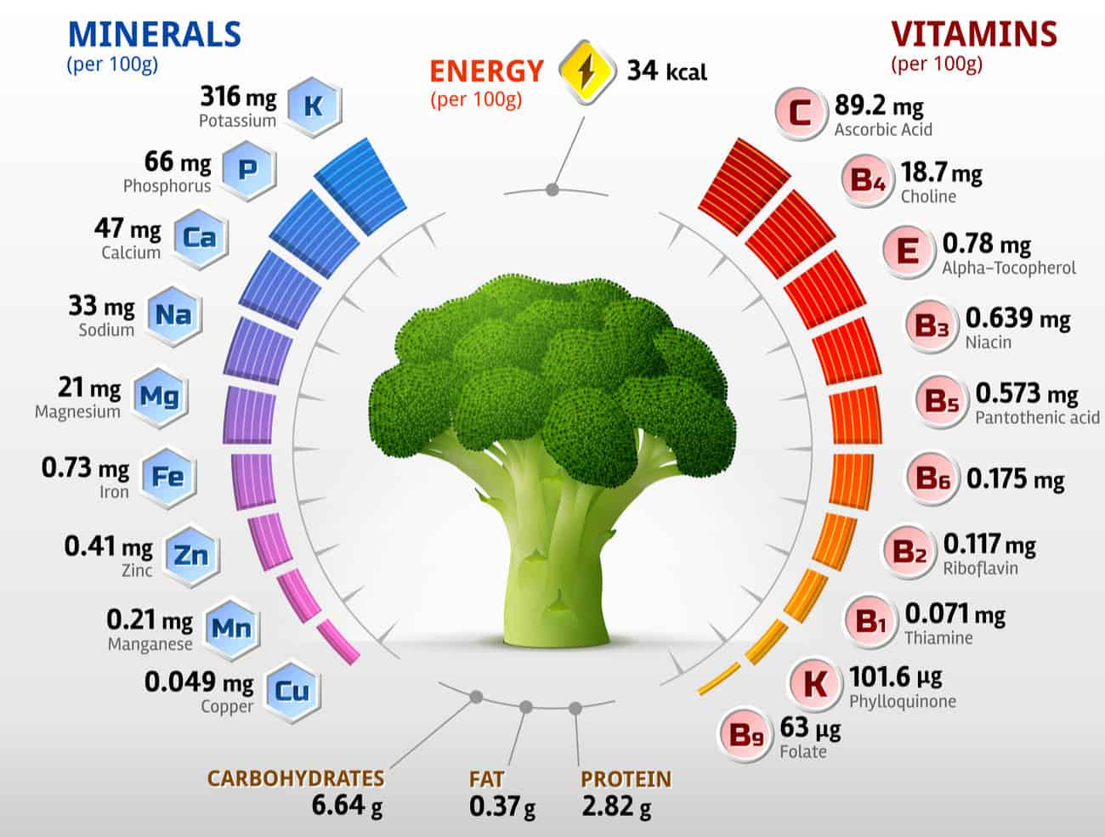
NOW LET’S JUMP INTO YOUR BROCCOLI OPTIONS.

EARLY-IN-THE-YEAR BROCCOLI TYPES

ARCADIA BROCCOLI
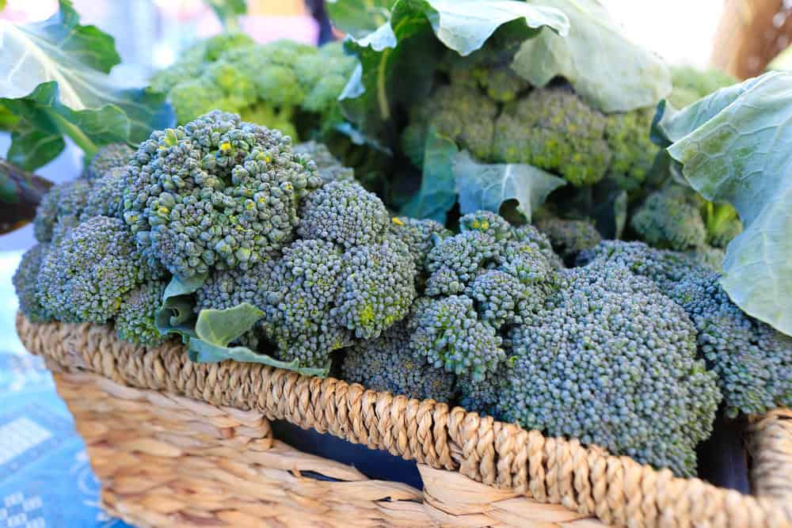
ARCADIA BROCCOLI MATURES IN AROUND TWO MONTHS AND CONSISTS OF UNIFORM HEADS THAT ARE SMALL AND PURPLISH GREEN IN COLOR. THEY ARE FIVE TO SIX INCHES ACROSS AND VERY TOLERANT OF THE COLD, WHICH MEANS FALL AND WINTER PRODUCTION IS HIGHLY RECOMMENDED. NOT ONLY IS IT RESISTANT TO COLD, BUT IT IS ALSO RESISTANT TO HEAD ROT AND DOWNY MILDEW, AND IT WON’T PRODUCE BROWN BEADS, EITHER.

CALABRESE BROCCOLI
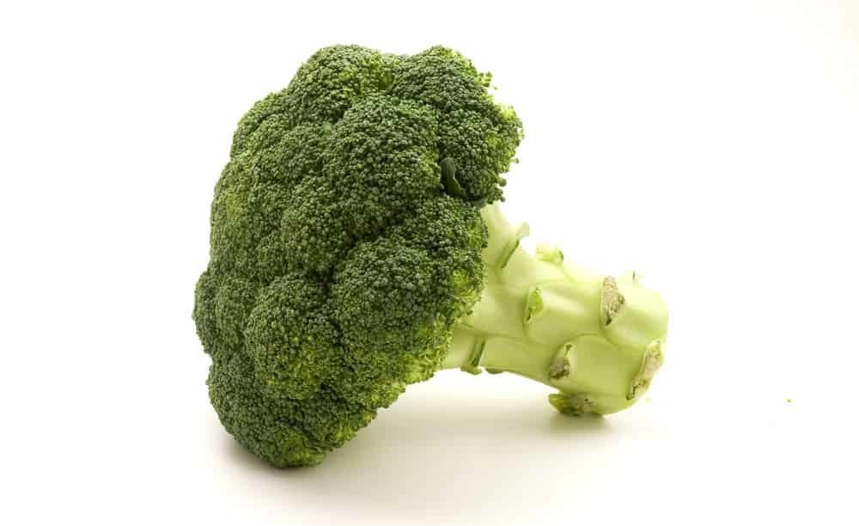
THE CALABRESE BROCCOLI MATURES IN AROUND 65 DAYS AND IS PERFECT WHEN PLANTED IN THE FALL. IN FACT, AS THE WEATHER GETS COOLER THE HEADS ACTUALLY GET SWEETER. THE BROCCOLI HAS DEEP-GREEN HEADS THAT ARE A MEDIUM SIZE, AND THERE ARE A LOT OF SIDE SHOOTS PRODUCED ONCE THE CENTRAL HEAD IS HARVESTED.

AMADEUS BROCCOLI
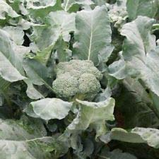
MATURING IN A LITTLE UNDER 60 DAYS, THE AMADEUS BROCCOLI IS ROUGHLY FOUR TO FIVE INCHES IN DIAMETER AND HAS SMALL BEADS AND TIGHT HEADS THAT ARE BLUE GREEN IN COLOR. IT HAS STRONG SIDE-SHOOT PRODUCTION ONCE YOU HARVEST THE MAIN HEAD, AND IT IS A VERY VIGOROUS AND MEDIUM-SIZED TYPE OF BROCCOLI.

BLUE WIND BROCCOLI
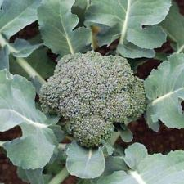
BLUE WIND BROCCOLI IS AN EARLY BLOOMER, USUALLY GETTING TO BE FULL-GROWN IN LESS THAN 60 DAYS, AND IT HAS TIGHT, LARGE HEADS AND BLUISH-GREEN LEAVES ON THE TOP OF THE PLANT. JUST LIKE KALE, BLUE WIND BROCCOLI IS EXCELLENT WHEN BRAISED OR STEAMED.

“DE CICCO” HEIRLOOM BROCCOLI
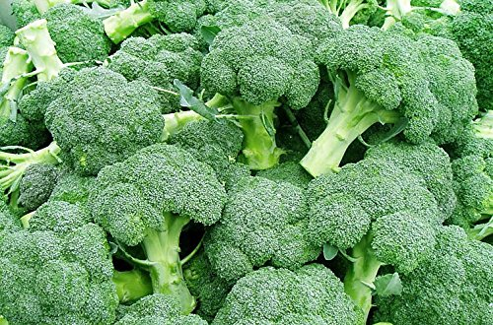
THIS TYPE OF BROCCOLI CAN BE READY IN LESS THAN 50 DAYS, AND IT IS USUALLY FAIRLY SMALL – AROUND THREE TO FOUR INCHES PER HEAD. IT IS A MULTI-CUT ITALIAN HEIRLOOM VARIETY AND WORKS ESPECIALLY WELL IN HOME GARDENS. THE BROCCOLI ALSO HAS TENDER SIDE-SHOOTS SPEARS IN LARGE NUMBERS, BUT IF YOU ARE INTERESTED IN MORE OF THEM YOU CAN HARVEST THE MAIN HEAD AT AROUND THREE INCHES.

GYPSY BROCCOLI
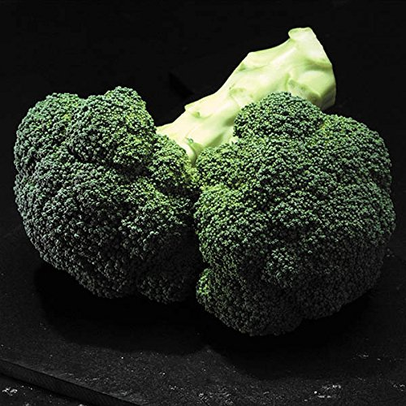
MATURING IN ROUGHLY 60 DAYS, THIS IS ONE OF THE EARLIEST BLOOMING BROCCOLI PLANTS. IT HAS A VERY GOOD ROOT SYSTEM AND THEREFORE, IT PRODUCES WELL EVEN IF THE SOIL IS LESS THAN PERFECT. GYPSY BROCCOLI HAS GREEN HEADS THAT ARE WELL DOMED AND BEADS THAT ARE MEDIUM TO SMALL IN SIZE. IT ALSO HAS GREAT HEAT TOLERANCE AND PRODUCES A LOT OF SIDE SHOOTS.

MID-SEASON BROCCOLI VARIETIES

BELSTAR BROCCOLI
THIS TYPE OF BROCCOLI HAS TIGHTLY PACKED HEADS THAT ARE A BEAUTIFUL SHADE OF BLUE GREEN. MATURING IN ROUGHLY 70 DAYS, THE BELSTAR BROCCOLI CAN TOLERATE BOTH COLD AND HEAT, SO YOU CAN PLANT IT EITHER IN THE SPRING OR THE FALL.

DIPLOMAT BROCCOLI
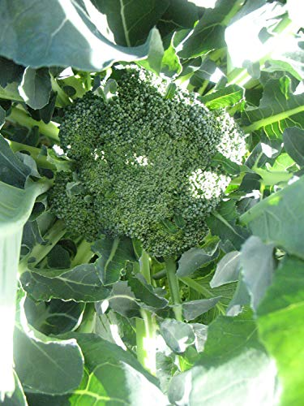

RESISTANT TO MANY TYPES OF MILDEW, THE DIPLOMAT BROCCOLI CONSISTS OF THICK, UNIFORM HEADS FROM FOUR TO SIX INCHES ACROSS, AND THEY ARE DARK GREEN IN COLOR. THEY DO ESPECIALLY WELL IN COLDER CLIMATES THAT ONLY GET MODERATELY WARM IN THE SUMMER MONTHS, AND THEY BLOOM IN A LITTLE OVER TWO MONTHS.

EXPRESS BROCCOLI
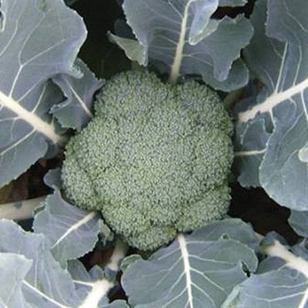
MATURING IN ROUGHLY 75 DAYS, THIS IS A GREAT MID-SEASON BROCCOLI THAT PRODUCES A LOT OF SIDE SHOOTS, AS WELL AS DEEP BLUE-GREEN HEADS, TIGHT BEADS, AND A SIZE OF APPROXIMATELY SIX TO SEVEN INCHES IN DIAMETER.

FIESTA BROCCOLI
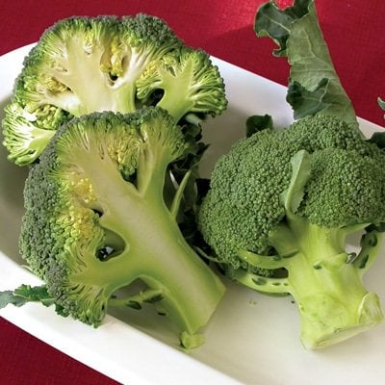
FIESTA BROCCOLI PRODUCES IN ROUGHLY 70 DAYS, AND THE BROCCOLI HEADS THEMSELVES ARE WELL DOMED AND THICK, WITH VERY THICK STEMS AS WELL. IT DOES BEST IF YOU PLANT IT IN THE LATE SUMMER MONTHS SO THAT IT CAN MATURE IN THE FALL AND WINTER. IT HAS LIMITED SIDE-SHOOT PRODUCTION AND HAS LIMITED HEAT TOLERANCE ONCE IT’S FULLY GROWN.

MARATHON BROCCOLI
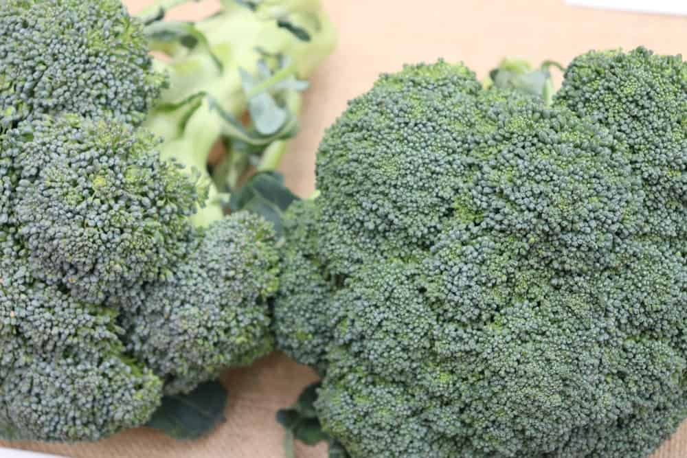
MARATHON BROCCOLI MATURES IN A LITTLE MORE THAN 60 DAYS, AND IF YOU LIVE IN THE PACIFIC NORTHWEST AND NORTHERN CALIFORNIA, IT WORKS BEST WHEN PRODUCED IN THE FALL AND WINTER SEASONS.

WALTHAM 29 BROCCOLI
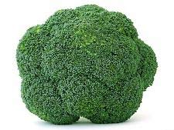
Bottom of Form
ALSO CALLED THE OPEN POLLINATED OR HEIRLOOM BROCCOLI, THIS TYPE PRODUCES MULTIPLE THICK, BLUE-GREEN HEADS THAT CAN BE FROM FOUR TO EIGHT INCHES IN DIAMETER. THIS IS FOLLOWED BY MULTIPLE SIDE SHOOTS OVER A SEASON THAT CAN LAST A LITTLE OVER 70 DAYS. THE WALTHAM 29 BROCCOLI IS SUITABLE FOR PRODUCTION IN EARLY SPRING AND LATE FALL, AND IT IS A VERY COLD-TOLERANT TYPE OF BROCCOLI.

CHINESE BROCCOLI (GAI-LON)

HAPPY RICH
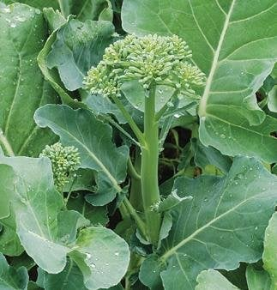
THE HAPPY RICH IS A VERY VIGOROUS PLANT THAT MATURES IN ROUGHLY 55 DAYS. IT HAS A LOT OF SIDE SHOOTS AND PRODUCES LARGE FLORETS THAT ACTUALLY LOOK LIKE MINIATURE HEADS OF BROCCOLI. IT IS A HYBRID PLANT AND PRODUCES A LARGE AMOUNT OF FOOD.

KAILAAN
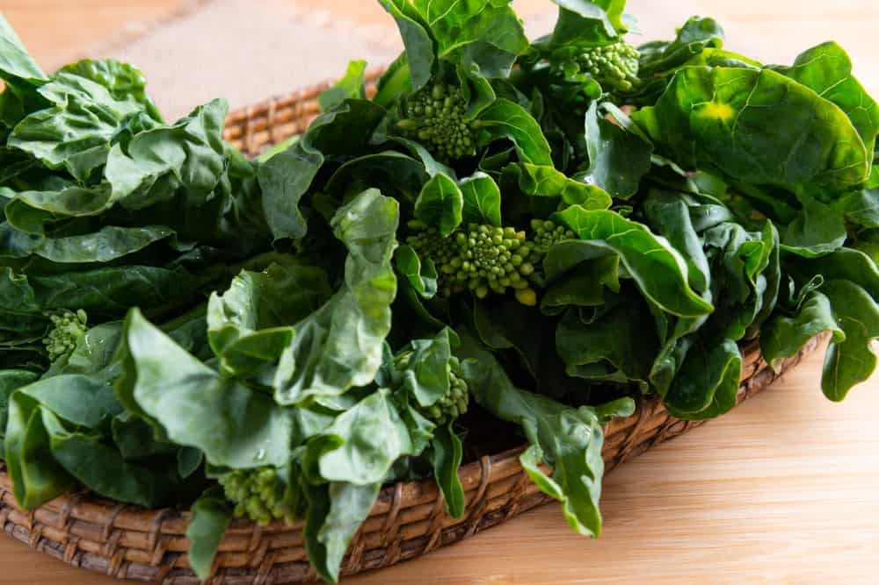
MATURING IN ROUGHLY TWO MONTHS, THIS TYPE OF BROCCOLI IS DEEP GREEN IN COLOR AND GROWS TO SIX TO EIGHT INCHES IN DIAMETER. IT ALSO HAS WHITE FLOWERS ON ITS STALKS, AND BECAUSE IT DOESN’T ALWAYS DO GREAT IN HOT WEATHER, IT IS BEST TO PLANT IT IN EARLY SPRING OR LATE SUMMER.

SUIHO
THIS IS ALSO A HYBRID PLANT THAT MATURES IN 44 DAYS AND TENDS TO BE MORE HEAT TOLERANT THAN THE NON-HYBRID VARIETIES.

SPECIALTY BROCCOLI

APOLLO
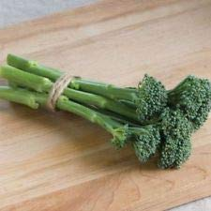

THIS TYPE OF BROCCOLI MATURES IN TWO TO THREE MONTHS, AND IT SPROUTS PROFUSELY. IF YOU HARVEST THE MAIN HEAD EARLY, YOU CAN ENJOY LOTS OF SIDE SHOOTS AFTERWARDS, AND THEY ARE TENDER AND LONG. YOU CAN USE THIS FOOD IN STIR-FRIES OR PREPARE IT LIKE YOU DO ASPARAGUS, AND THEY DO BEST WHEN PRODUCED IN THE SPRING OR FALL, ALTHOUGH IN HIGH TEMPERATURES THEY CAN TASTE A LITTLE ON THE BITTER SIDE.

BROCCOLINI
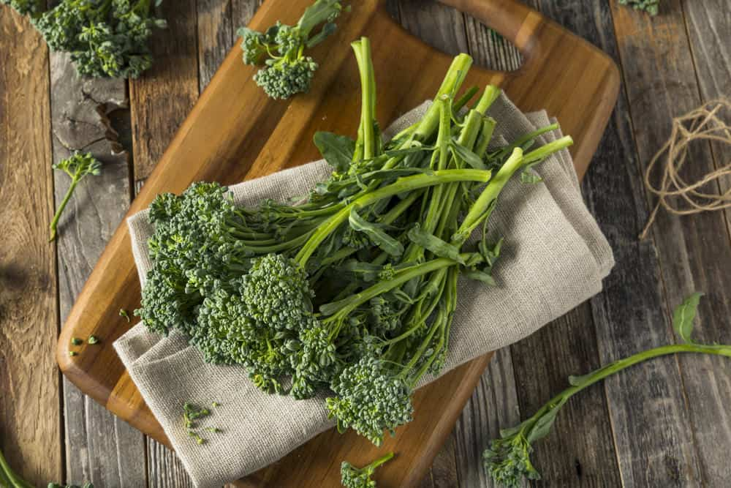
THESE ARE ESSENTIALLY BROCCOLI SIDE SHOOTS THAT CAN BE COOKED LIKE THE SPROUTING BROCCOLI VARIETY. OFTEN, BROCCOLI WILL PRODUCE A LARGE AMOUNT OF SIDE SHOOTS AFTER THE HEAD IS HARVESTED, AND DIFFERENT VARIETIES PRODUCE DIFFERENT AMOUNTS OF SIDE SHOOTS.

ROMANESCO BROCCOLI
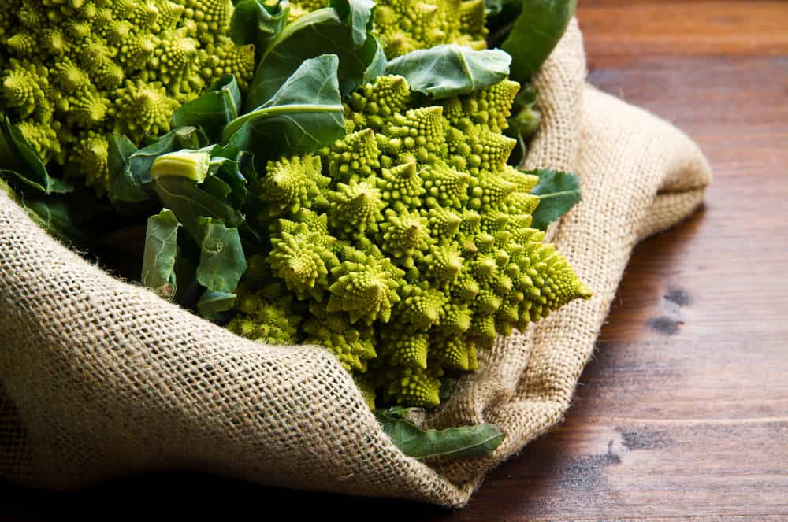
THIS IS AN ITALIAN HEIRLOOM THAT LOOKS VERY SIMILAR TO A CROSS BETWEEN A CAULIFLOWER AND A BROCCOLI PLANT. IT MATURES IN 75 DAYS, AND ITS GREENHEADS ARE SPIRALED AND QUITE ATTRACTIVE. IT ALSO HAS A VERY DELICATE FLAVOR. IT HAS BEEN GROWN IN ITALY SINCE THE 1500S AND HAS A SLIGHTLY CRUNCHY TASTE.

SANTEE BROCCOLI
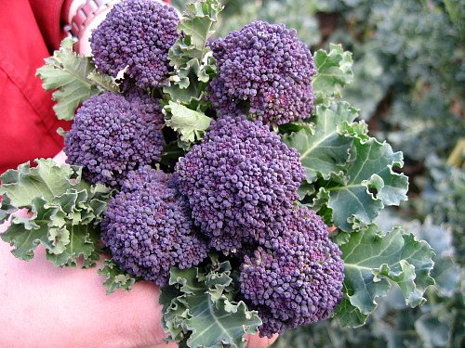
ALSO KNOWN AS THE PURPLE SPROUTING BROCCOLI, THIS TYPE OF BROCCOLI PRODUCES LOTS OF TENDER, PURPLE FLOWERS THAT HAVE GREEN STEMS. WHEN YOU COOK THE FLORETS THEY TURN GREEN, AND THERE IS A THREE- TO FIVE-WEEK EXTENDED HARVEST PERIOD. BEST WHEN GROWN IN COOL WEATHER, MAINLY BECAUSE THE SHOOTS TASTE VERY BITTER WHEN THE WEATHER IS HOT.

SPROUTING BROCCOLI
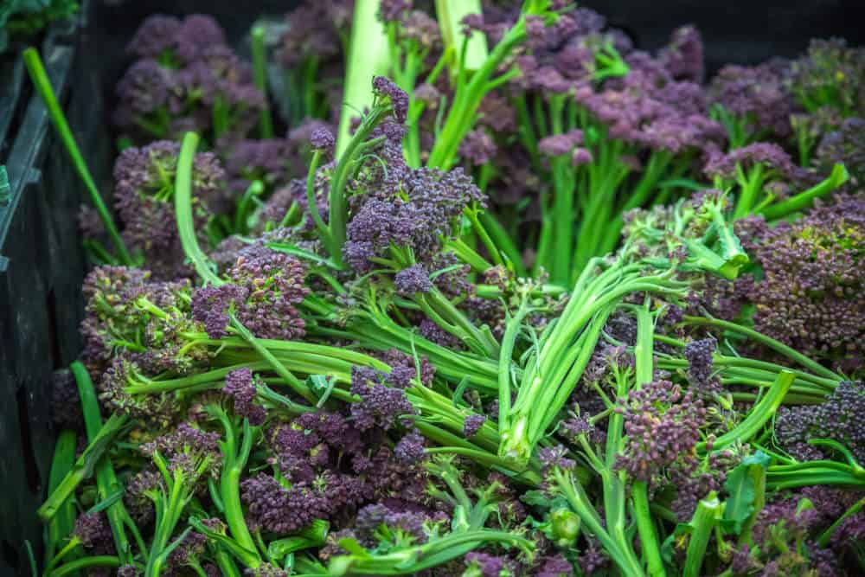
SPROUTING BROCCOLI CAME ABOUT BEFORE THE BROCCOLI AS WE KNOW IT TODAY. IT HAS LOTS OF LONG SIDE SHOOTS AND PRODUCES A LOT OF LARGE, ABUNDANT HEADS. MOST PEOPLE COOK THE SIDE SHOOTS LIKE ASPARAGUS, WHICH MEANS YOU CAN CHOP AND SAUTÉ THEM, OR EVEN GRILL THEM AFTER YOU BRUSH THEM WITH A LITTLE OLIVE OIL.

25 HEALTHY-ISH ALTERNATIVES TO PIZZA
SATISFY YOUR CRAVINGS WITH THESE HEALTHY-ISH ALTERNATIVES TO PIZZA THAT ARE EASY TO MAKE AND LOWER IN FAT AND SALT BUT WITH ALL THE GOODNESS OF A READY-MADE PIZZA.
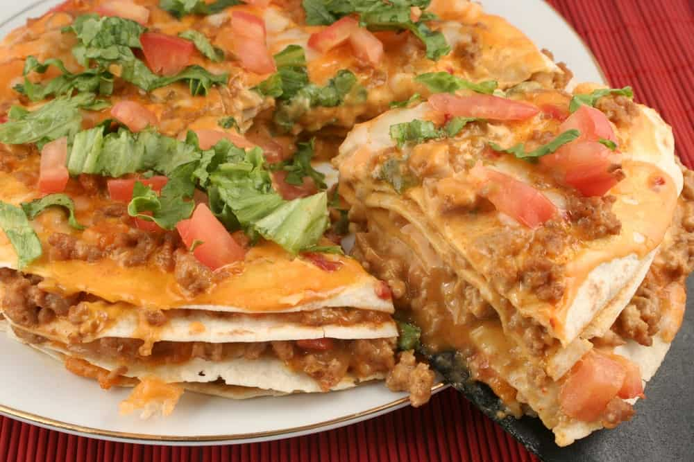
ALMOST EVERYONE LOVES PIZZA AND WHILE SATURDAY IS THE MOST POPULAR NIGHT TO EAT PIZZA, EVERY DAY’S A GOOD DAY TO HAVE ONE. AMERICANS LOVE PIZZA SO MUCH THAT THEY ORDER 350 SLICES EVERY SECOND AND EAT 23 POUNDS OF PIZZA PER YEAR. PEPPERONI IS ONE OF AMERICA’S FAVORITE SLICES.
FAST FOOD PIZZA, HOWEVER, IS HIGH IN CALORIES, SALT, AND FAT WHICH TRANSLATE TO MAJOR HEALTH ISSUES IN AMERICA TODAY. SO IF YOU’RE CRAVING FOR THAT CREAMY THICK OR THIN CRUST GOODNESS, WE LISTED DOWN SOME HEALTHY AND HEALTHY-ISH ALTERNATIVES TO TRADITIONAL PIZZA TO SATISFY YOUR CRAVINGS.
RELATED: THANKSGIVING TURKEY ALTERNATIVES | BROCCOLI ALTERNATIVES | ICE CREAM ALTERNATIVES | HEALTHY ALTERNATIVES TO PASTA | ALTERNATIVES TO BUTTER

1. BAGEL AND TOMATO

INSTEAD OF A GOOEY, TOMATO- AND CHEESE-FILLED PIZZA, TRY TOASTING HALF OF A BAGEL AND ADDING SOME FRESH OR CANNED DICED TOMATOES, THEN ADD A DRIZZLE OF OLIVE OIL FOR EXTRA TASTE AND NUTRITION. YOU CAN BUY ALL TYPES OF BAGELS, FROM WHOLE-WHEAT TO EGG BAGELS, ADDING SOME EXTRA FLAVOR TO YOUR NEW “PIZZA.”
PROS
- TENDS TO BE LOWER IN CALORIES AND HEALTHIER THAN REGULAR PIZZA
- LOTS OF BAGEL FLAVORS TO CHOOSE FROM
CONS
- SMALLER BAGEL MEANS LESS ROOM TO ADD TOPPINGS
- A COMPLETELY DIFFERENT TASTE FROM PIZZA, WHICH SOME PEOPLE MAY NOT LIKE
YOU CAN ADD A FEW INGREDIENTS TO THE TOP OF THE BAGEL, INCLUDING HERBS AND CHEESE, AND ALL YOU HAVE TO DO IS BAKE IT UNTIL THE BAGEL IS CRISP AND THE TOMATOES HAVE A LIGHTLY ROASTED LOOK.

2. CAULIFLOWER CRUST PIZZA

MANY PEOPLE ARE SURPRISED THAT THIS TYPE OF CRUST DOESN’T ACTUALLY TASTE LIKE CAULIFLOWER, WHICH MANY PEOPLE DISLIKE. NOT ONLY IS THE CRUST A LOT MORE NUTRITIONAL THAN REGULAR PIZZA CRUST, BUT IT IS ALSO A GLUTEN-FREE PRODUCT. IF YOU ALSO WANT TO MAKE IT A LITTLE HEALTHIER, TRY LESS-SALTY CHEESES SUCH AS SWISS, MONTEREY JACK, AND MOZZARELLA.
PROS
- A VERY HEALTHY ALTERNATIVE TO OTHER TYPES OF CRUSTS
- GLUTEN-FREE FOR THOSE WHO NEED OR PREFER THIS OPTION
CONS
- MAY BE MORE EXPENSIVE THAN OTHER TYPES OF CRUSTS
- SOME BRANDS MAY TASTE LIKE CAULIFLOWER, WHICH SOME PEOPLE MAY NOT LIKE
CAULIFLOWER CRUST IS A GREAT WAY TO START A HEALTHY PIZZA, AND MANY OF THE WELL-KNOWN STORES CARRY THIS CRUST IN THEIR FREEZER OR REFRIGERATED SECTION. IT IS EASIER THAN YOU THINK TO FIND A HEALTHY CRUST ALTERNATIVE WHEN MAKING PIZZA, AND IT IS USUALLY FAIRLY INEXPENSIVE AS WELL, AT LEAST FOR THE MOST PART.

3. ENGLISH MUFFIN PIZZA

IF YOU’D LIKE A PIZZA SNACK, AND YOU’RE ONLY COOKING FOR ONE, AN ENGLISH MUFFIN PIZZA IS A GREAT OPTION. YOU CAN HAVE THE PIZZA READY IN NO TIME, AND IT USES UP VERY FEW INGREDIENTS AS WELL. ENGLISH MUFFINS ARE USUALLY HEALTHIER THAN REGULAR PIZZA CRUSTS, AND YOU CAN MAKE IT AS SIMPLE OR AS INGREDIENT-FILLED AS YOU LIKE.
PROS
- YOU CAN HAVE A SINGLE PIZZA READY IN JUST A FEW MINUTES
- ENGLISH MUFFINS COME IN BOTH REGULAR AND WHOLE-WHEAT OPTIONS
CONS
- SOME PEOPLE DON’T LIKE THE TASTE OF ENGLISH MUFFINS
- NOT GOOD WHEN YOU HAVE TO FEED A LOT OF PEOPLE
ALTHOUGH FEEDING A LARGE GROUP OF PEOPLE BECOMES TOO INCONVENIENT WITH ENGLISH MUFFIN PIZZAS, THEY ARE PERFECT WHEN YOU’RE JUST FEEDING A FEW PEOPLE, AND YOU CAN PUT ANY INGREDIENTS YOU LIKE ON IT.

4. MUSHROOM CAPS AND HUMMUS

MUSHROOMS, ESPECIALLY THE PORTOBELLO TYPE, CAN MAKE VERY FLAVORFUL PIZZA CRUSTS, AND THEY ARE VERY LOW IN CALORIES AS WELL. THE FIBER IN THEM HELPS YOU LOSE WEIGHT AND FEEL FULL AFTERWARDS, AND THEY ARE EASY TO COOK AND EASY TO DIGEST. HUMMUS IS MADE OF CHICKPEAS AND IS EXTREMELY HEALTHY, AND IT MAKES A GREAT ALTERNATIVE TO OTHER PIZZA TOPPINGS.
PROS
- LOTS OF FIBER AND PROTEIN
- EASY TO TOP WITH INGREDIENTS SUCH AS FRESH VEGGIES
CONS
- SOME PEOPLE DO NOT LIKE HUMMUS OR MUSHROOMS
- NO TOMATO-LIKE FLAVOR TO ENJOY LIKE IN OTHER TYPES OF PIZZA
ONCE YOU FILL THE MUSHROOM WITH HUMMUS, YOU CAN ADD OTHER INGREDIENTS IF YOU LIKE, INCLUDING DICED FRESH VEGETABLES, MOZZARELLA CHEESE, AND EVEN SUN-DRIED TOMATOES. YOU CAN GET AS CREATIVE AS YOU LIKE, AND THIS IS AN EXCELLENT WAY TO ENJOY A HEALTHIER ALTERNATIVE TO PIZZA.

5. PITA BREAD PIZZA

ONE OF THE BIGGEST ADVANTAGES OF CHOOSING PITA BREAD FOR YOUR PIZZA IS THAT IT COMES IN BOTH REGULAR AND WHOLE-WHEAT OPTIONS, AND IT HAS A LOT LESS CARBS AND CALORIES THAN REGULAR CRUST, AS WELL. PITA BREAD IS VERY TASTY AND HEALTHY, AND FOR THOSE WHO LIKE THEIR CRUSTS THIN, IT IS THE PERFECT CRUST TO CHOOSE.
PROS
- IT IS LOW IN FAT, BUT HIGH IN CALCIUM AND IRON
- COMES IN BOTH WHITE AND WHOLE-WHEAT OPTIONS
CONS
- PITA BREAD IS SOMETIMES HIGH IN SODIUM
- SOME PEOPLE DO NOT LIKE THE TASTE OF PITA BREAD
PITA BREAD PIZZAS PROVIDE A LOT OF SPACE TO PLACE INGREDIENTS ON, THEY ARE GREAT FOR PEOPLE WHO LIKE THIN CRUSTS, AND THEY PROVIDE A LOT OF OPTIONS BECAUSE YOU CAN ADD ANY INGREDIENTS YOU LIKE, FROM MEAT-LOVING TO MEAT-FREE ALTERNATIVES. BECAUSE THERE ARE DIFFERENT TYPES OF PITA BREAD – INCLUDING THE LOW-CARB VARIETY – IT IS EASY FOR YOU TO FIND EXACTLY WHAT YOU NEED WHEN IT COMES TO ITS NUTRITIONAL VALUE.

6. POLENTA CRUST PIZZA
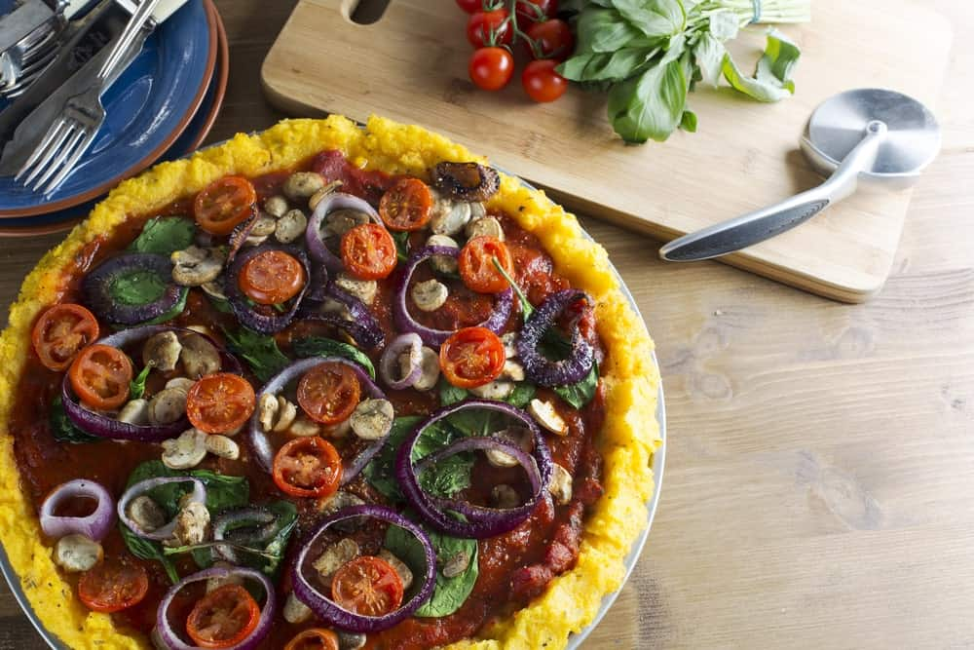
Bottom of Form
POLENTA IS A CORNMEAL PRODUCT USED OFTEN IN ITALY, AND IF YOU HAVE A WHEAT OR GLUTEN ALLERGY, IT MAKES A GREAT ALTERNATIVE TO REGULAR PIZZA CRUSTS. NOT ONLY DO THESE TYPES OF PIZZA SATISFY NEARLY EVERYONE’S PIZZA CRAVING, BUT NEARLY EVERYONE WHO TRIES IT WILL LOVE THE TASTE.
PROS
- FAST AND EASY TO MAKE
- A HEALTHY ALTERNATIVE TO REGULAR PIZZA
CONS
- POLENTA CAN BE HIGH IN CARBS AND SUGAR
- IT CAN MAKE YOUR STOMACH FEEL HEAVIER THAN NORMAL AFTER YOU EAT IT

POLENTA IS HEALTHY AND HAS A LOT OF VITAMINS, BUT IT MAY NOT BE THE BEST ALTERNATIVE TO THOSE WHO ARE TRYING TO WATCH THEIR WEIGHT. POLENTA PIZZA, HOWEVER, IS A LOT TASTIER THAN YOU THINK, SO IT IS MUCH HEALTHIER AND MORE FUN TO EAT THAN YOU MIGHT THINK.

7. PORTOBELLO/VEGGIE PIZZA

YES, YOU CAN MAKE A HEALTHY PIZZA IF YOU LOAD IT UP WITH VEGETABLES INSTEAD OF BEEF AND PORK. TRY PUTTING A LOT OF HEALTHY INGREDIENTS SUCH AS PORTOBELLO MUSHROOMS, BLACK AND GREEN OLIVES, GREEN AND RED BELL PEPPERS, ONIONS, SPINACH, AND EVEN SOMETHING A LITTLE DIFFERENT LIKE ASPARAGUS OR BANANA PEPPERS. FOR AN EVEN HEALTHIER ALTERNATIVE, TRY USING LESS CHEESE OR EVEN NO CHEESE AT ALL.
PROS
- A MUCH HEALTHIER ALTERNATIVE TO REGULAR PIZZA
- YOU CAN GET YOUR DAILY SUPPLY OF VEGETABLES IN ONE MEAL
CONS
- NOT EVERYONE LIKES VEGETABLES OR PIZZA WITH ONLY A TAD OF CHEESE
- SOME PEOPLE MAY BE ALLERGIC TO SOME OF THE INGREDIENTS YOU USE

IF YOU CHOOSE ANY TYPE OF MUSHROOMS, THE PIZZA WILL TASTE BETTER IF YOU BAKE THE MUSHROOMS BY THEMSELVES FOR ROUGHLY FIVE MINUTES BEFORE PLACING THEM ON THE PIZZA, AND OF COURSE, YOU CAN FEEL FREE TO USE MANY OTHER TYPES OF VEGETABLES AS WELL. IN OTHER WORDS, YOU CAN GET VERY CREATIVE WITH YOUR VEGGIE PIZZA.

8. QUINOA BITES
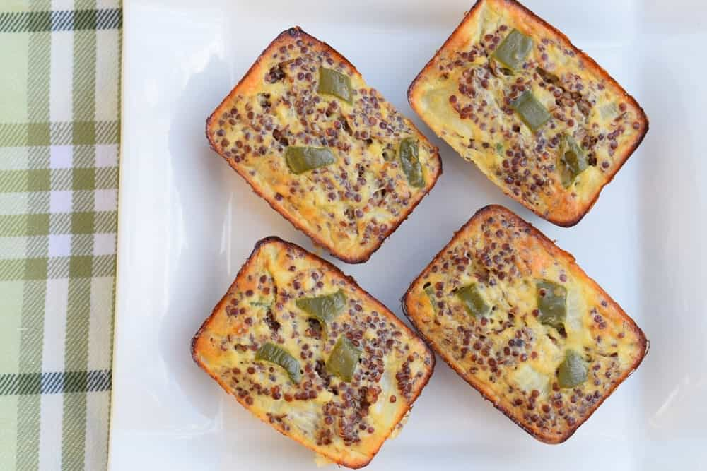
QUINOA IS A SUPER FOOD THAT NATURALLY MAKES A SUPER PIZZA. FOR THE MOST PART, YOU’LL BE ABLE TO COMBINE THE QUINOA WITH THE REST OF YOUR INGREDIENTS AND PLACE THEM IN A MUFFIN PAN TO BAKE FOR A LITTLE BIT. QUINOA IS RICH IN FIBER AND PROTEIN, AND IT TASTES A LOT BETTER THAN YOU MIGHT THINK.
PROS
- AN EXTREMELY HEALTHY ALTERNATIVE TO REGULAR PIZZA
- VERY SIMPLE AND FAST TO MAKE
CONS
- THE TASTE MIGHT TAKE SOME GETTING USED TO
- SOMETIMES QUINOA IS DIFFICULT TO FIND
QUINOA BITES ARE A BIT DIFFERENT FROM REGULAR PIZZA, BUT IT REQUIRES NO SPECIAL TREATMENT OR THE ADDING OF ANY OTHER INGREDIENTS. THESE PIZZA BITES ARE VERY HEALTHY FOR YOU, SO EVEN THOUGH EACH BITE IS SMALL, THEY ARE CHOCK-FULL OF VITAMINS AND MINERALS.

9. TORTILLAS AND MEATBALLS
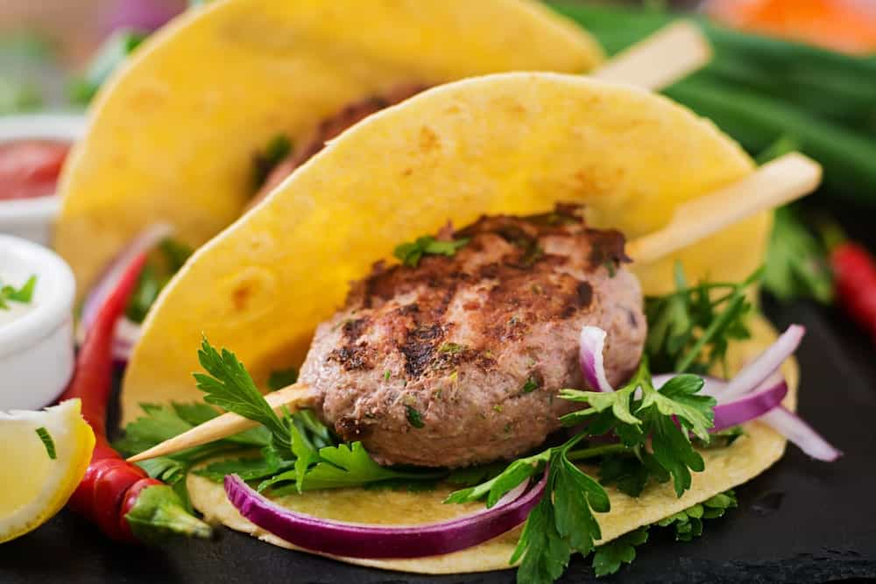
INSTEAD OF REGULAR PIZZA, TRY MAKING MEATBALLS FROM A TYPE OF LEAN GROUND MEAT AND SERVING THEM ON A BAKED TORTILLA. IT GIVES YOU THE CRUNCH OF A THIN-CRUST PIZZA AND CAN TASTE ALMOST THE SAME. IF YOU LIKE A SAUSAGE TEXTURE, SIMPLY CRUMBLE UP THE MEATBALLS AND SPRINKLE THEM ON THE TORTILLA.
PROS
- MUCH LESS FAT AND CALORIES THAN PEPPERONI AND OTHER INGREDIENTS FOUND ON REGULAR PIZZAS
- A VERY TASTY WAY TO EAT A PIZZA OR A SNACK
CONS
- TASTE CAN BE SOMEWHAT DRY IF YOU DON’T ADD ENOUGH PIZZA SAUCE
- TORTILLAS ARE A FOOD THAT NOT EVERYONE LIKES
IF YOU LIKE TORTILLAS AND PREFER A MORE NUTRITIONAL TYPE OF PIZZA, THIS IS A GREAT OPTION FOR YOU. YOU CAN ADD WHATEVER YOU LIKE TO THE TORTILLA TO MAKE IT AS HEALTHY AND YUMMY AS YOU WISH.

10. ZUCCHINI PIZZA
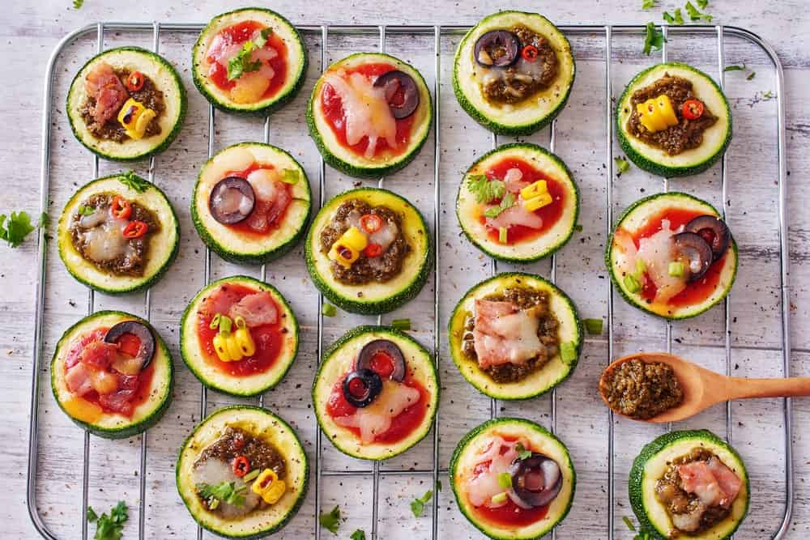
YOU CAN TRY ZUCCHINI ONE OF TWO WAYS FOR YOUR PIZZA – YOU CAN TRY A PIZZA CRUST MADE OF ZUCCHINI, OR SIMPLY USE ZUCCHINI AS YOUR MAIN INGREDIENT. IF YOU CHOOSE THE PIZZA CRUST, YOU CAN SIMPLY CLEAN AND THEN BAKE THE ZUCCHINI, AND WHEN YOU’RE DONE, ADD YOUR INGREDIENTS RIGHT ON TOP OF THIS YUMMY VEGETABLE AND ENJOY.
PROS
- ZUCCHINI IS HIGH IN VITAMINS, PROTEIN, AND FIBER
- IT IS EASY TO COOK AND VERY TASTY
CONS
- NOT GOOD FOR PEOPLE WHO DO NOT LIKE THE TASTE OF ZUCCHINI
- EVEN FOR ZUCCHINI LOVERS, THE TASTE MAY REQUIRE SOME GETTING USED TO
A ZUCCHINI PIZZA IS EASY TO BAKE AND EASY TO LOVE, AND THERE ARE RECIPES FOR THIS TYPE OF PIZZA EVERYWHERE ON THE INTERNET.

11. CALZONES
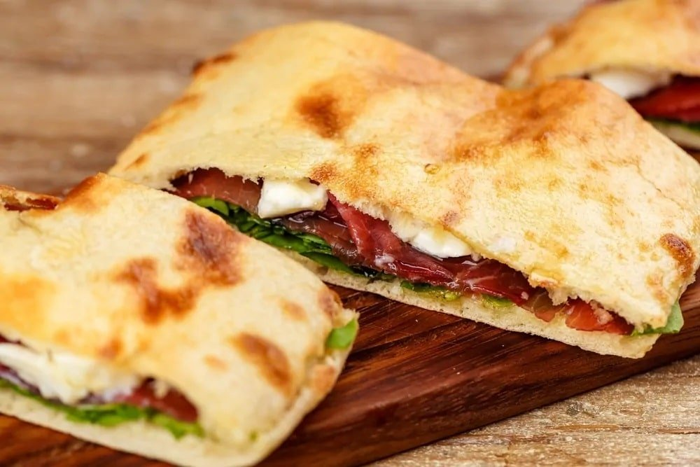
CALZONES ARE ITALIAN FOLDED PIZZAS TYPICALLY MADE FROM SALTED BREAD DOUGH, WITH STUFFINGS OF SALAMI, HAM OR VEGETABLES, MOZZARELLA, RICOTTA AND PARMESAN OR PECORINO CHEESE, AND AN EGG.

12. FOCACIA
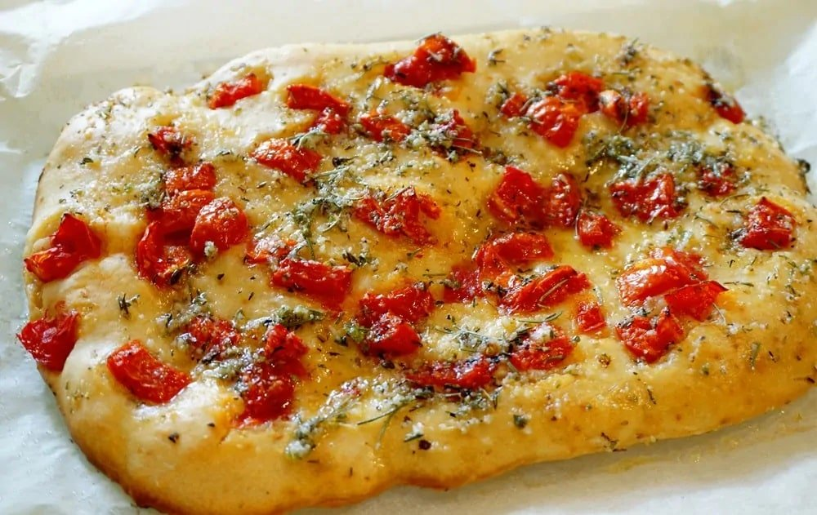
FOCACIA IS A FLAT ITALIAN BREAD THAT HAS A SIMILAR TEXTURE AND STYLE TO A PIZZA, BUT THE FORMER IS MORE MOIST AND THICKER.

13. PISSALADIÈRE
PISSALADIÈRE IS A FRENCH PIZZA-LIKE DISH. THE BREAD DOUGH IS ONLY THICKER THAN THAT OF THE MARGHERITA PIZZA AND IT’S TOPPED WITH CARAMELISED ONIONS, BLACK OLIVES, AND ANCHOVIES.

14. FILO

FILO-BASED PASTRY IS A HEALTHY ALTERNATIVE TO PIZZA. THE THIN UNLEAVENED DOUGH CONTAINS VERY LITTLE FAT AND IS OFTEN USED TO MAKE BAKLAVA AND BÖREK IN MIDDLE EASTERN AND BALKAN COUNTRIES.

15. EGGPLANT PIZZA
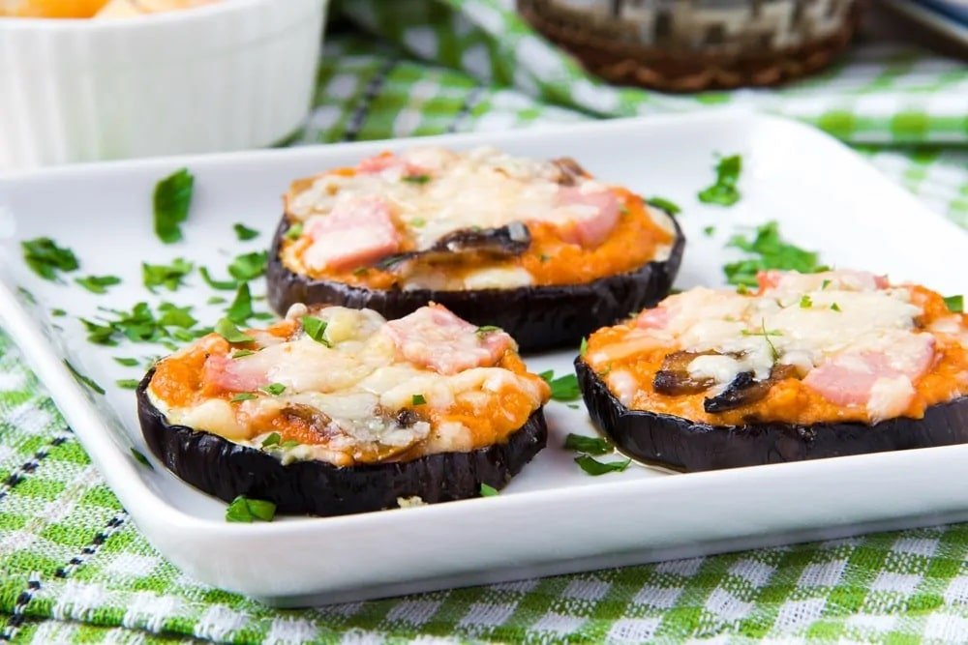
IT’S A LOW-CARB AND GLUTEN-FREE ALTERNATIVE TO A PIZZA. SIMILAR TO A ZUCCHINI PIZZA, THIS DOESN’T NEED BREAD OF ANY KIND.

16. PARMIGIANA
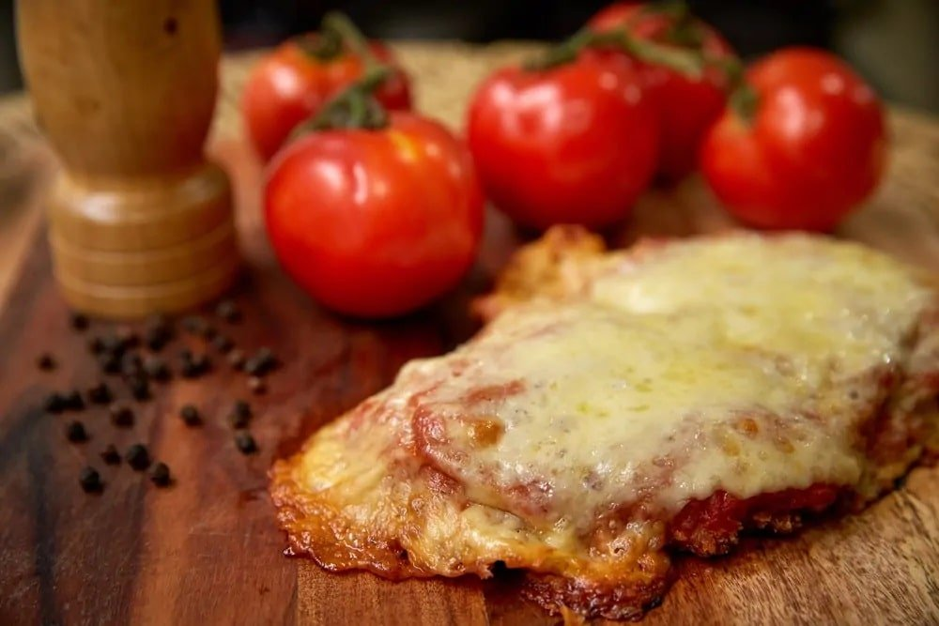
PARMIGIANA IS AN ITALIAN DISH THAT’S MADE OF DEEP-FRIED SLICED EGGPLANT AND SERVED WITH PARMESAN CHEESE AND TOMATO SAUCE.

17. FRENCH BREAD PIZZA

THIS HOMEMADE PIZZA IS EASY TO MAKE AND CAN BE CREATED WITH A WIDE RANGE OF FLAVORS.

18. WAFFLE PIZZA

THIS WILL BE A HIT AT KID’S PARTIES. JUST MAKE THE WAFFLE AND LET THE KIDS CHOOSE THEIR TOPPINGS AND THEN BAKE.

19. BAKED FRENCH TOAST PIZZA
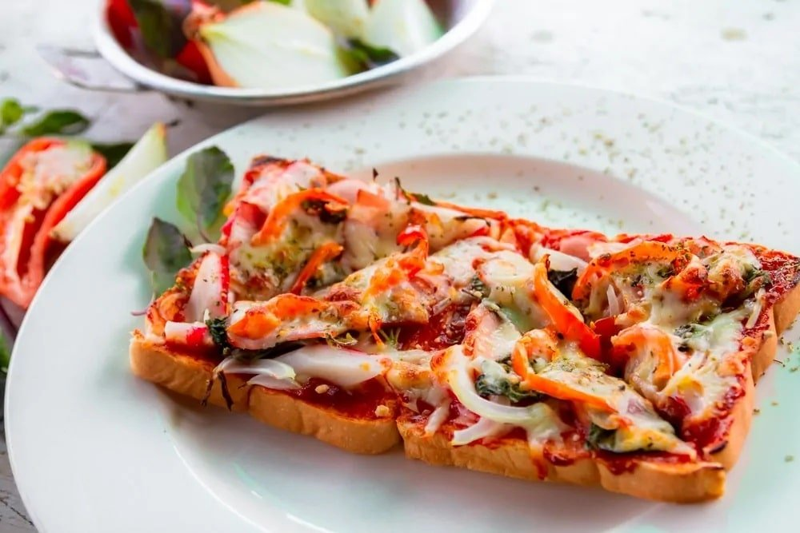
IT’S A FUN VARIATION TO THE FRENCH TOAST. YOU CAN ADD ANY TOPPINGS YOU CHOOSE PLUS TOMATOES AND CHEESE.

20. SWEET POTATO PIZZA

SWEET POTATO PIZZA IS ANOTHER HEALTHY ALTERNATIVE TO PIZZA THAT’S EASY TO MAKE. IT’S DELICIOUS, GLUTEN FREE, AND REQUIRES NO FOOD PROCESSOR.

21. PANCAKE PIZZA
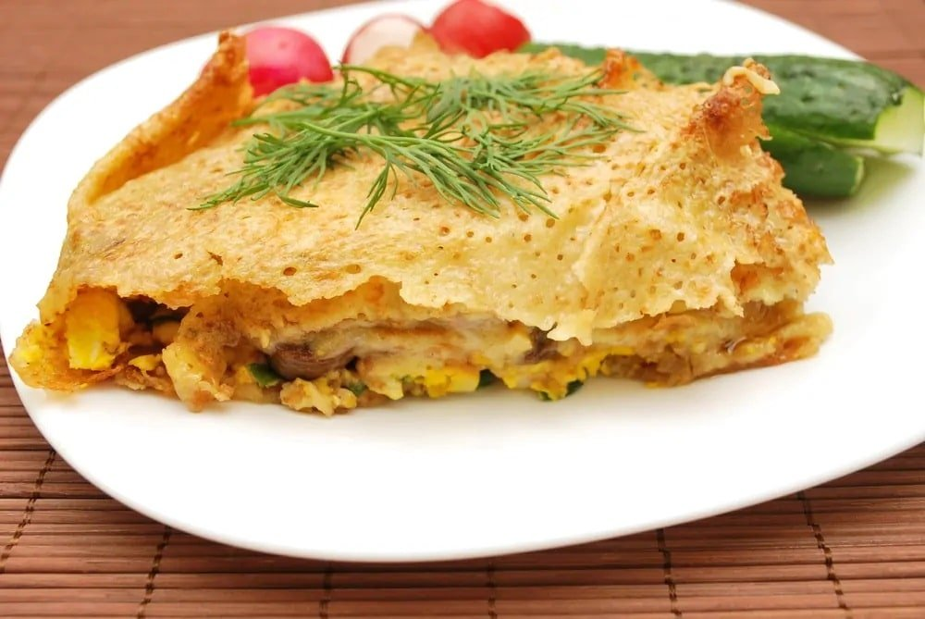
YOU CAN MAKE THIS PANCAKE PIZZA A HEALTHY ALTERNATIVE BY USING VEGETABLES, MUSHROOM, AND EGG FILLING.

22. ASPARAGUS PIZZA
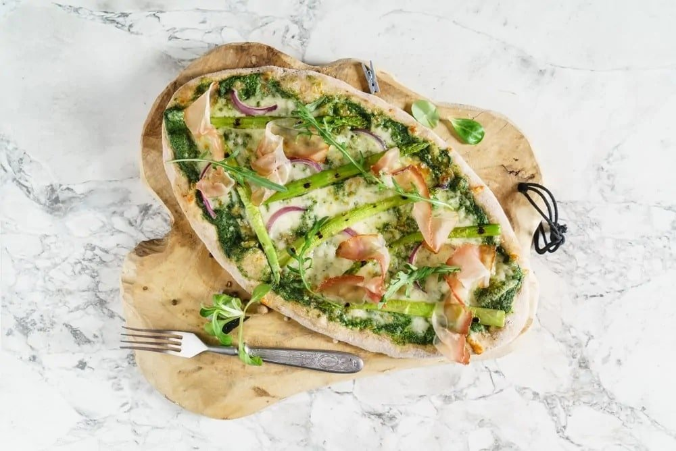
ASPARAGUS PIZZA IS A REFRESHING TREAT YOU’D FORGET YOUR EATING VEGETABLES.

23. AVOCADO AND EGG PIZZA

TWEAK YOUR BREAKFAST WITH THIS AVOCADO AND EGG PIZZA. A SIMPLE AND TASTY BREAKFAST FOR RUSH MORNINGS.

24. FRUIT PIZZA
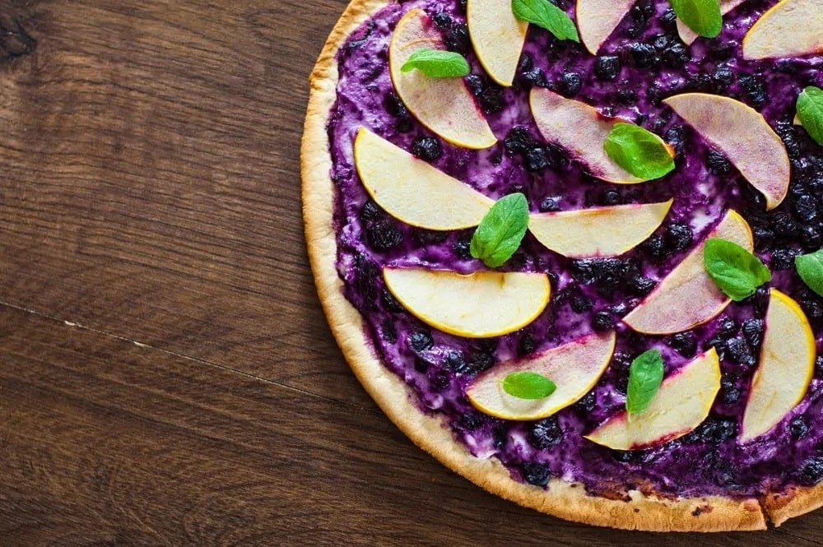
THE FRUIT PIZZA IS A SUREFIRE HIT EACH TIME IT’S SERVED AT PARTIES. IT’S COLORFUL, PRETTY, AND DELICIOUS!

25. BLACK BEANS CRUST PIZZA

THE BLACK BEANS CRUST PIZZA IS A NON-TRADITIONAL PIZZA THAT’LL MAKE YOU THINK FOR A SECOND. ONCE YOU’VE HAD A BITE, YOU’LL FORGET YOU EVER HAD ANY DOUBTS ABOUT IT.

10 HEALTHY ALTERNATIVES TO TRADITIONAL PASTA
SUCCUMB TO YOUR PASTA CRAVING EVEN WHEN YOU'RE ON A LOW-CARB OR GLUTEN-FREE DIET BY TRYING OUT THESE HEALTHY ALTERNATIVES TO TRADITIONAL PASTA. HAVE A TASTE OF THESE HEALTHY RECIPES WITH A TWIST.
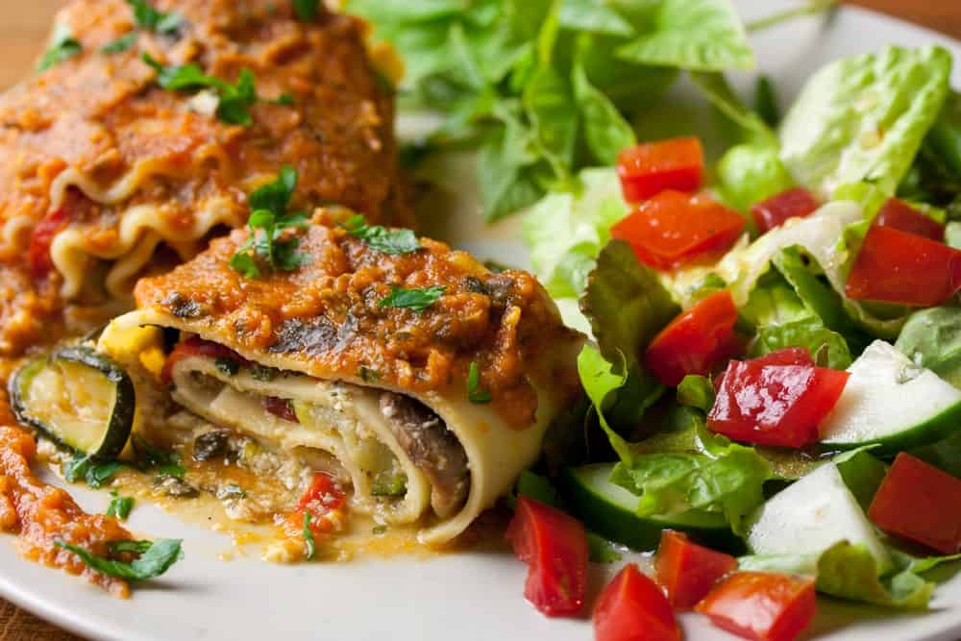
PASTA IS ONE OF THE WORLD’S FAVORITE COMFORT FOOD. IT ORIGINATED IN SICILY, ITALY AROUND 1154 AND IS A TYPE OF NOODLE THAT’S TYPICALLY MADE FROM DURUM WHEAT, WATER OR EGGS. IT’S MOLDED INTO DIFFERENT NOODLE SHAPES AND COOKED IN BOILING WATER.
THE MOST POPULAR TYPE OF PASTA IS REFINED PASTA WHICH HAS BEEN LINKED TO HIGHER RISKS OF HEART DISEASE, HIGH BLOOD SUGAR, AND INSULIN RESISTANCE. IT’S ALSO HIGHER IN CALORIES, CARBS, B VITAMINS, AND IRON BUT LOWER IN FIBER AND MOST OTHER MICRONUTRIENTS.
OTHER TYPES OF PASTA ALSO CONTAIN GLUTEN WHICH CAN CAUSE NEGATIVE EFFECTS TO THOSE WITH CELIAC DISEASE OR GLUTEN SENSITIVITY.
FORTUNATELY, THERE ARE STILL MANY WAYS TO ENJOY YOUR PRECIOUS PASTA EVEN IF YOU’RE ON A DIET OR CHOOSE TO EAT GLUTEN-FREE. CHECK OUT THE LIST BELOW FOR HEALTHY ALTERNATIVES TO TRADITIONAL PASTA.
RELATED: THANKSGIVING TURKEY ALTERNATIVES | BROCCOLI ALTERNATIVES | ICE CREAM ALTERNATIVES | HEALTHY ALTERNATIVES TO PIZZA | ALTERNATIVES TO BUTTER

1. BEET RAVIOLI
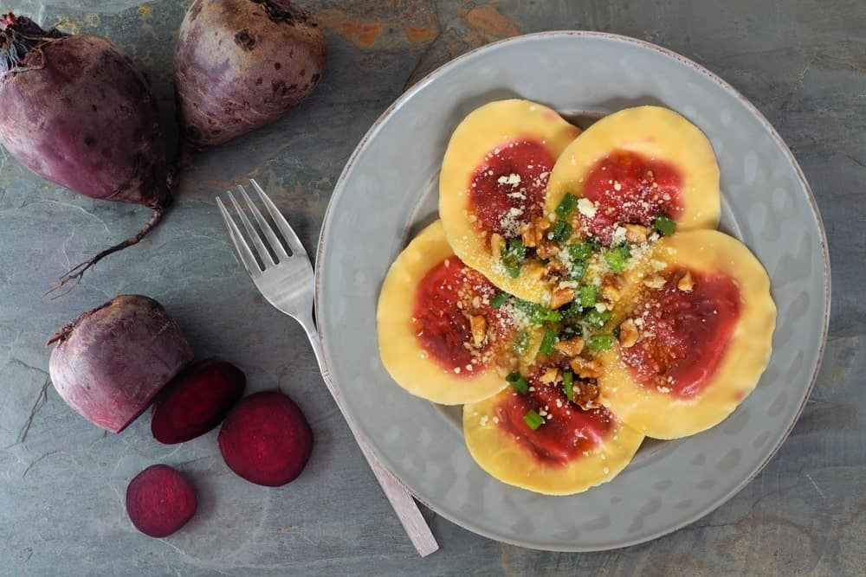
BEETS ARE CALLED A SUPERFOOD FOR MANY REASONS, AND IF YOU’RE LOOKING FOR A HEALTHIER WAY TO MAKE RAVIOLI, YOU CAN TRY THIS VEGETABLE INSTEAD OF STARCH-FILLED PASTA. ALL YOU HAVE TO DO IS SLICE THE BEETS INTO THIN ROUNDS THEN MARINATE THEM IN A BOWL FILLED WITH LEMON JUICE, OLIVE OIL, AND SALT AND PEPPER. LET THEM MARINATE AT LEAST AN HOUR, THEN PLACE THEM ON A PLATE, ADD A CHUNK OF CHEESE OR SOME OTHER TYPE OF FILLING, THEN TOP IT OFF WITH ANOTHER BEET SLICE.
ADVANTAGES
- LOW IN FAT AND CALORIES
- HIGH IN NUTRIENTS AND FIBER
DISADVANTAGES
- BEETS CAN TURN YOUR URINE AND STOOLS RED
- THEY CAN BE DETRIMENTAL TO THOSE WITH COPPER OR IRON PROBLEMS

2. BROCCOLI SALAD
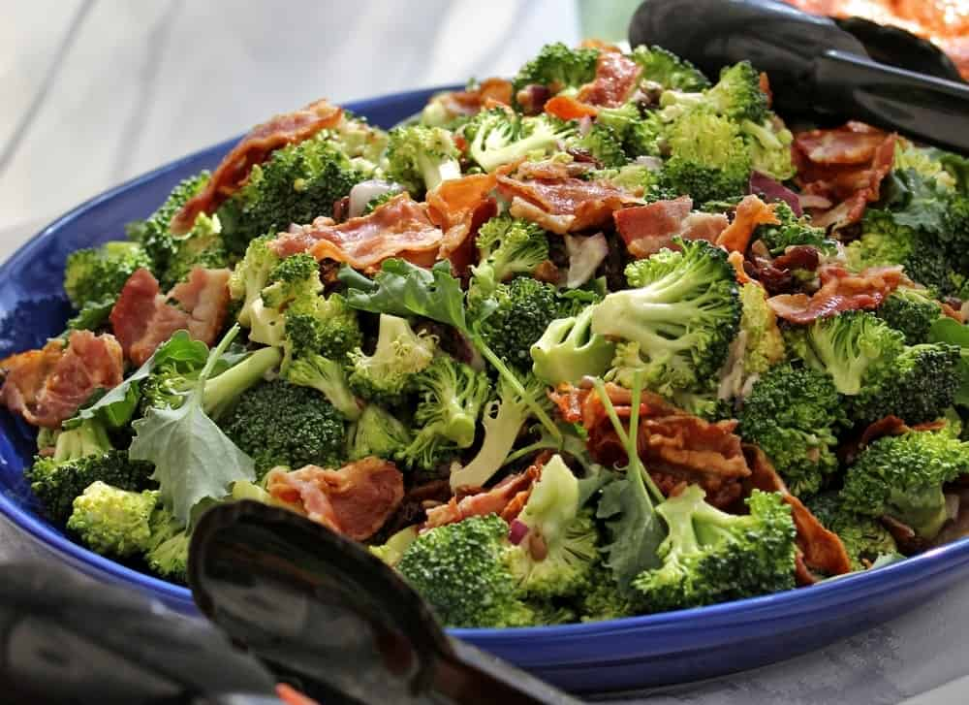
BROCCOLI SALAD IS A POPULAR FIND AT POTLUCK DINNERS, AND THERE ARE MANY REASONS WHY. INSTEAD OF A DRESSING MADE WITH MAYO, TRY A VINEGAR-BASED DRESSING ON YOUR SALAD TO MAKE IT TASTIER AND HEALTHIER. IT’S EASY TO MAKE AS WELL, AND EVEN EASIER TO MAKE YOUR OWN RECIPE. SIMPLY CHOP UP THE BROCCOLI, RED ONIONS, AND PEPPERS, AND SEASON TO TASTE. A LITTLE EXPERIMENTATION AND YOU’RE ALL SET FOR A GREAT DISH!
ADVANTAGES
- IT IS VERY HEALTHY FOR YOU
- IT IS VERY SIMPLE TO MAKE AND CAN BE PERSONALIZED TO YOUR TASTE
DISADVANTAGES
- SOME PEOPLE DO NOT LIKE THE TASTE OF BROCCOLI
- TOO MUCH BROCCOLI CAN SOMETIMES CAUSE DIGESTIVE PROBLEMS
IF YOU LOVE BROCCOLI, A GOOD BROCCOLI SALAD IS FOR YOU, AND EVEN IF IT’S A LAST-MINUTE DECISION, IT IS EASY TO MAKE AND SERVE OTHERS.

3. CABBAGE SPAGHETTI
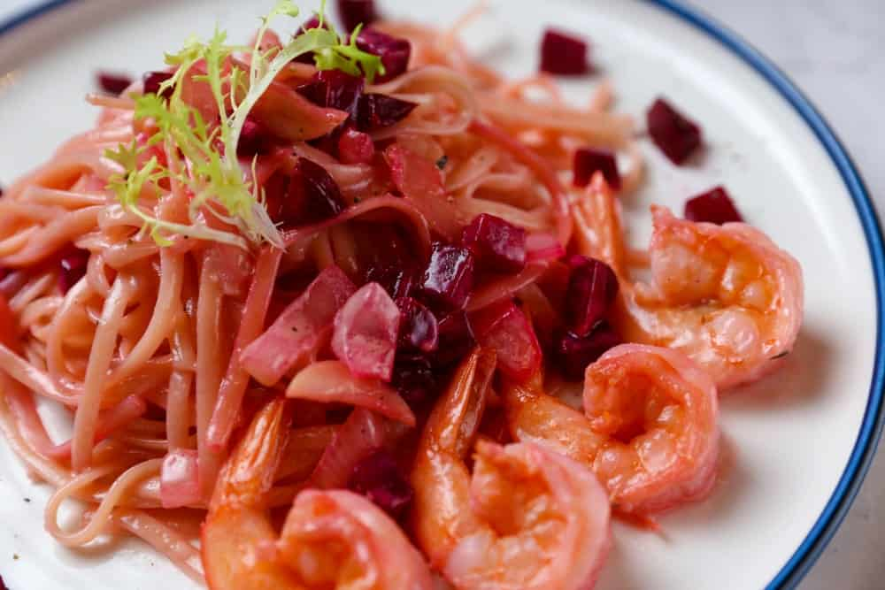
ONE OF THE THINGS THAT MAKE REGULAR PASTA SO UNHEALTHY IS A LARGE NUMBER OF CARBS ASSOCIATED WITH THIS FOOD, BUT SUBSTITUTING CABBAGE FOR THE NOODLES CAN INCREASE ITS NUTRITIONAL VALUE AND ITS TASTINESS, TOO. YOU CAN SLICE YOUR CABBAGE INTO THIN STRIPS AND SAUTÉ THE CABBAGE WITH A BIT OF OIL UNTIL IT IS SOFT, BUT STILL A LITTLE CRISPY, THEN POUR TOMATO SAUCE OVER IT. YUMMY!
ADVANTAGES
- HIGH IN VITAMIN C AND HIGH IN FIBER
- HAS INGREDIENTS THAT ACT LIKE EXPERT ANTIOXIDANTS
DISADVANTAGES
- CAN CAUSE GASTROINTESTINAL PROBLEMS
- IT CAN INTERACT WITH CERTAIN MEDICATIONS
IN ADDITION, YOU CAN CHOOSE EITHER GREEN OR RED CABBAGE FOR YOUR RECIPES. BOTH ARE HIGH IN NUTRITIONAL VALUE, ALTHOUGH RED DOES TEND TO HAVE A FEW MORE ADVANTAGES THAN THE GREEN KIND.

4. EGGPLANT LASAGNA
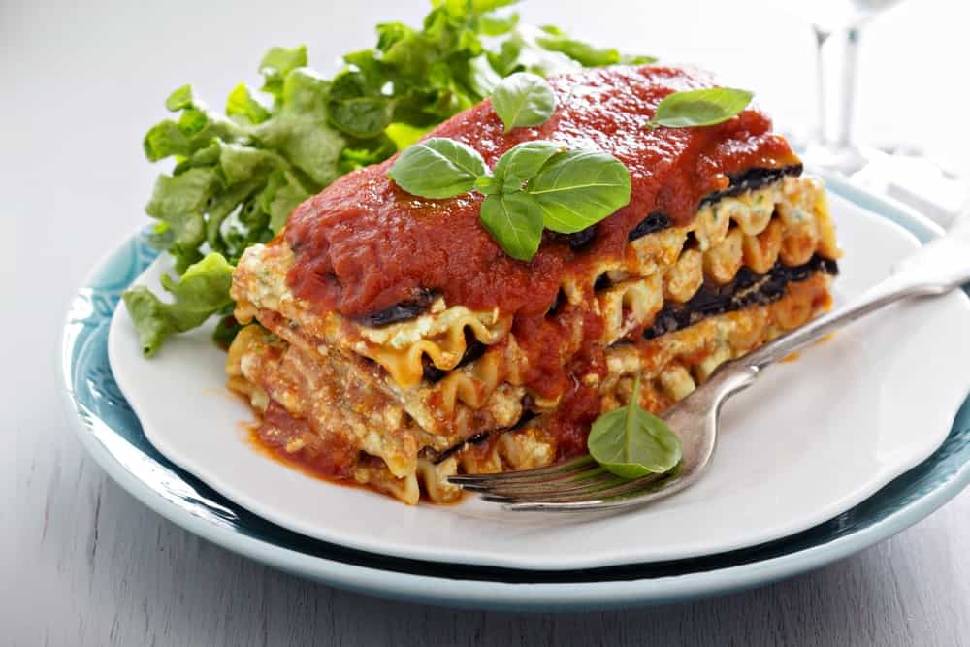
A GREAT CHOICE FOR VEGETARIANS, THIS TYPE OF LASAGNA IS MADE LIKE REGULAR LASAGNA, ONLY YOU SUBSTITUTE EGGPLANT FOR THE LASAGNA NOODLES. EGGPLANT HAS A LOT OF NUTRIENTS AND FIBER, AND WHEN COOKED RIGHT, YOU WON’T EVEN KNOW YOU’RE NOT EATING LASAGNA NOODLES. WITH LOTS OF VITAMINS B1 AND B6, NOT TO MENTION ANTIOXIDANTS, EGGPLANT IS THE PERFECT VEGETABLE FOR THOSE WHO WISH TO EAT HEALTHIER.
ADVANTAGES
- LOW IN CALORIES AND FAT
- CAN PROTECT AGAINST CANCER, CARDIOVASCULAR DISEASE, AND MICROBIAL INFECTIONS
DISADVANTAGES
- IN LARGE QUANTITIES, IT CAN CAUSE GASTROINTESTINAL PROBLEMS
- CAN CAUSE KIDNEY AND GALLBLADDER PROBLEMS IF YOU EAT TOO MUCH OF IT
FOR THE MOST PART, YOU CAN PERSONALIZE YOUR EGGPLANT LASAGNA RECIPE TO MAKE IT AS TASTY AS POSSIBLE, BUT THE NUTRITIONAL VALUE OF THIS VEGETABLE CANNOT BE OVERSTATED.
HERE IS A SIMPLE AND DELICIOUS EGGPLANT LASAGNA RECIPE:

5. FRENCH BEAN PASTA
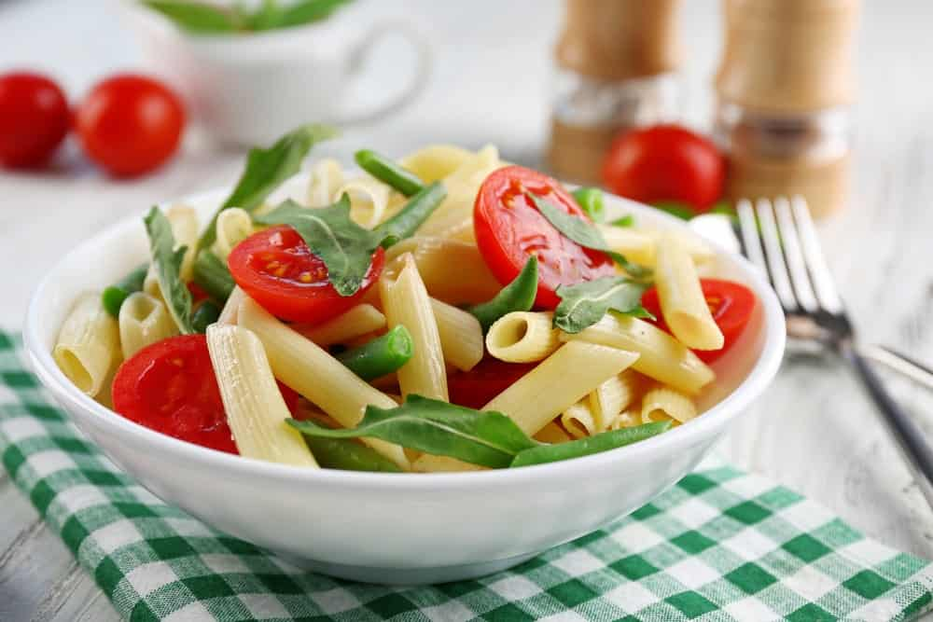
FRENCH GREEN BEANS ARE AMAZING, NOT ONLY BECAUSE OF THEIR NUTRITIONAL VALUE BUT ALSO BECAUSE OF THE MANY DISHES YOU CAN MAKE WITH THEM. FOR A PASTA, ALL YOU HAVE TO DO IS SAUTÉ THE BEANS WITH A TOUCH OF OLIVE OIL UNTIL THEY ARE SOFT, THEN COAT THEM WITH EITHER A PESTO OR TOMATO SAUCE. YOU CAN EVEN ADD OTHER ITEMS IF YOU LIKE, SUCH AS LENTILS OR CHICKPEAS.
ADVANTAGES
- A GREAT SOURCE OF ANTIOXIDANTS AND VITAMINS A, C, AND K
- VERY SIMPLE TO MAKE AND TO PERSONALIZE THE RECIPE
DISADVANTAGES
- GREEN BEANS ARE NOT ENJOYED BY EVERYONE
- YOU HAVE TO COOK THEM A WHILE TO GET THEM SOFT, MEANING THE PASTA WON’T BE MADE QUICKLY
BEING A VEGETABLE, THERE ARE REALLY VERY FEW DISADVANTAGES TO GREEN BEANS, AND IF YOU’D LIKE TO TRY SOMETHING UNIQUE AND TASTY, FRENCH BEAN PASTA IS ONE FOOD YOU’LL LOVE.

6. MAC AND CHEESE CAULIFLOWER
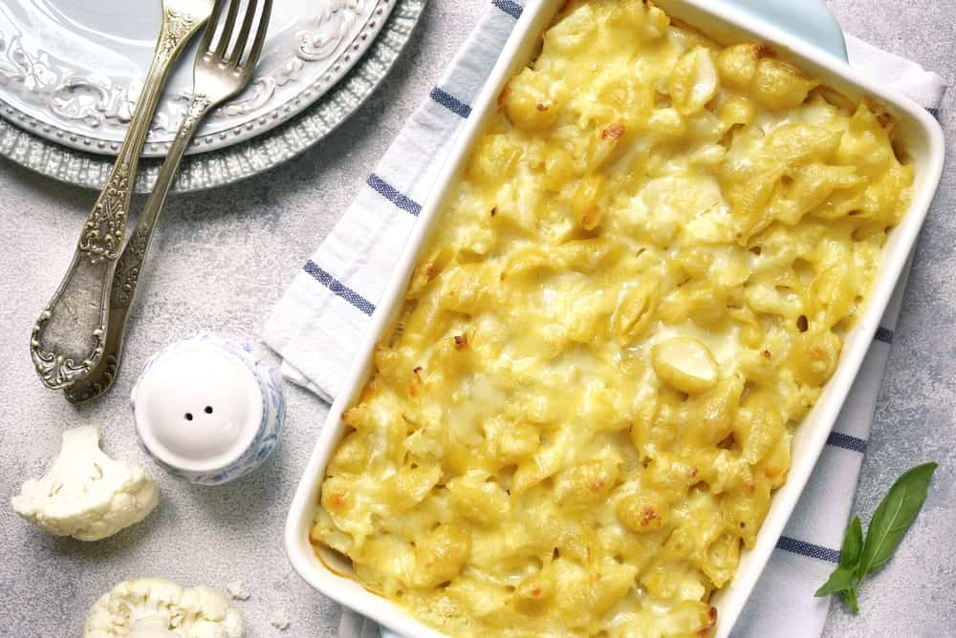
IF YOU LOVE MACARONI AND CHEESE BUT HATE THE STARCHINESS FOUND IN THE MACARONI NOODLES, YOU CAN USE CAULIFLOWER INSTEAD. ALL YOU HAVE TO DO IS CUT THE VEGETABLES INTO SMALL PIECES AND EITHER STEAM OR BOIL THEM UNTIL THEY ARE SOFT. NEXT, JUST ADD WHATEVER CHEESE YOU HAVE AND BAKE THE DISH IN THE OVEN. THE CHEESE NATURALLY ADDS CALORIES TO THE DISH, BUT THE CAULIFLOWER IS SUPER HEALTHY FOR YOU.
ADVANTAGES
- VERY LOW IN CALORIES AND FAT
- HIGH IN ANTIOXIDANTS AND VITAMINS B6, C, AND K
DISADVANTAGES
- CAN CAUSE DIGESTIVE PROBLEMS IF EATEN TOO OFTEN
- IN SOME INSTANCES, IT CAN CAUSE ILLNESSES SUCH AS GOUT
ALTHOUGH CAULIFLOWER HAS A TASTE SOME PEOPLE DON’T LIKE, ONCE IT’S BAKED AND COVERED WITH CHEESE MANY OF THESE SAME PEOPLE MAY FIND THEY LOVE IT.

7. QUINOA SALAD (COLD)
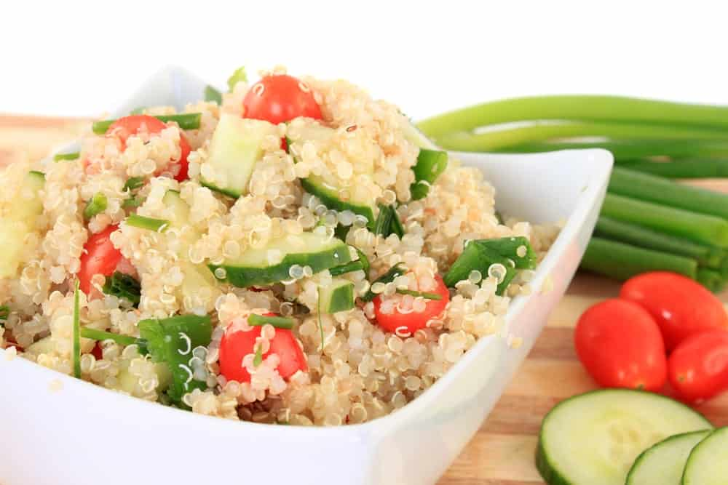
IF YOU’VE NEVER TRIED QUINOA, STARTING WITH A SALAD MIGHT BE THE PERFECT WAY TO START. SIMPLY ADD INGREDIENTS SUCH AS ONIONS, CORN, BROCCOLI, BEANS, OR EVEN FRUIT, ALONG WITH AN OIL- OR VINEGAR-BASED DRESSING, AND SOME FRESH HERBS, AND YOU HAVE THE PERFECT SIDE DISH OR SALAD. IT IS EASY TO MAKE THE RECIPE YOUR OWN BECAUSE YOU CAN ADJUST WHAT YOU PUT IN THERE UNTIL IT TASTES JUST RIGHT FOR YOU.
ADVANTAGES
- FILLED WITH LOTS OF PROTEIN AND VITAMIN B
- LOW IN CALORIES SO IT CAN HELP YOU LOSE WEIGHT
DISADVANTAGES
- THE TEXTURE MAY TAKE SOME GETTING USED TO
- IT CAN BE A LITTLE CARB-DENSE
THE TEXTURE OF QUINOA IS WHAT MAKES SOME PEOPLE HESITANT TO TRY IT, BUT IT IS NOT DIFFICULT TO GET USED TO, AND IT IS AN ABSOLUTELY DELICIOUS ALTERNATIVE TO UNHEALTHY, STARCH-HEAVY FOODS.

8. SPAGHETTI SQUASH
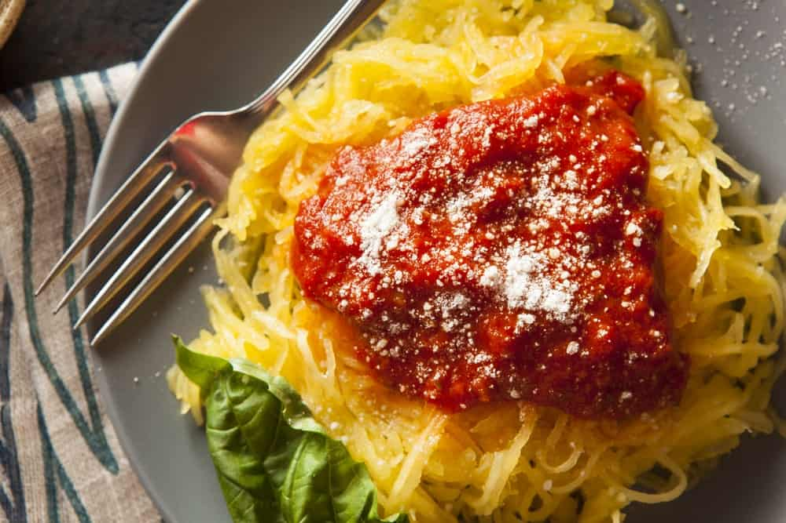
SPAGHETTI SQUASH LOOKS JUST LIKE IT SOUNDS. IT IS A SQUASH THAT LOOKS LIKE SPAGHETTI WHEN RAKED WITH A FORK BECAUSE IT COMES OUT IN THIN STRANDS. YOU CAN ALSO CUT THE SQUASH IN HALF AND ROAST IT IN THE OVEN AT 425 DEGREES UNTIL IT GETS SOFT, THEN SPRINKLE IT WITH SOME OLIVE OIL AND SALT AND PEPPER. AFTER IT IS COOL, YOU CAN SCOOP THE FLESH OUT AND COVER IT WITH YOUR FAVORITE PASTA SAUCE. HEALTHY AND DELICIOUS, YOU MAY NOT EVEN REALIZE YOU’RE NOT EATING REAL PASTA.
ADVANTAGES
- LOWER IN FAT AND CALORIES THAN REGULAR PASTA
- FILLED WITH NUMEROUS VITAMINS AND MINERALS
DISADVANTAGES
- SOME SQUASH IS A LITTLE HIGH IN CARBS
- IT TAKES A VERY LONG TIME TO BOIL SPAGHETTI SQUASH
COTTON IN PARTNERSHIP WITH URBAN DADDY

CHEMICALS OF CONCERN: AVOID THESE HARMFUL SKINCARE INGREDIENTS
BE AWARE OF THESE POTENTIALLY HARMFUL INGREDIENTS IN YOUR EVERYDAY HYGIENE PRODUCTS. HERE'S WHAT TO WATCH OUT FOR.

9. SWEET POTATO PASTA
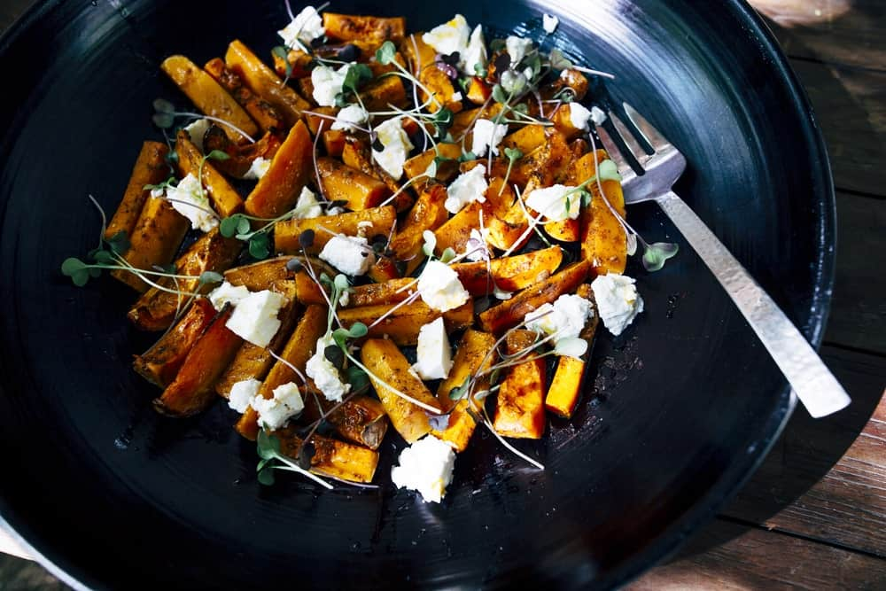
THERE IS NO END TO THE NUTRITIONAL ADVANTAGES OF EATING SWEET POTATOES, SO IT IS GOOD NEWS THAT YOU CAN EAT THIS VEGETABLE IN PLACE OF PASTA. YOU CAN USE A POTATO PEELER TO MAKE A WIDE NOODLE, AND IF YOU HAVE COCONUT OIL, GO AHEAD AND USE THAT TO COOK AND SOFTEN THE POTATOES. BEFORE YOU POUR THE SAUCE OVER THEM, YOU CAN ADD OTHER VEGETABLES TO THE POTATOES FOR AN EXTRA NUTRITIONAL EDGE AND BULK UP THE PASTA ITSELF.
ADVANTAGES
- HIGH IN VITAMINS, B6, C, AND D, AS WELL AS IRON AND ANTIOXIDANTS
- HAS A NATURALLY SWEET AND DELICIOUS TASTE
DISADVANTAGES
- DEPENDING ON HOW THEY ARE COOKED, SWEET POTATOES CAN HAVE A HIGH GI INDEX
- THE AMOUNT OF OXALATES IN SWEET POTATOES MAKES IT DIFFICULT FOR PEOPLE WITH KIDNEY OR GALLBLADDER PROBLEMS
SWEET POTATOES ARE LOVED BY NEARLY EVERYONE, SO SERVING THIS VEGETABLE AS A PASTA DISH WILL MAKE YOU ONE VERY POPULAR COOK.

10. ZUCCHINI PASTA
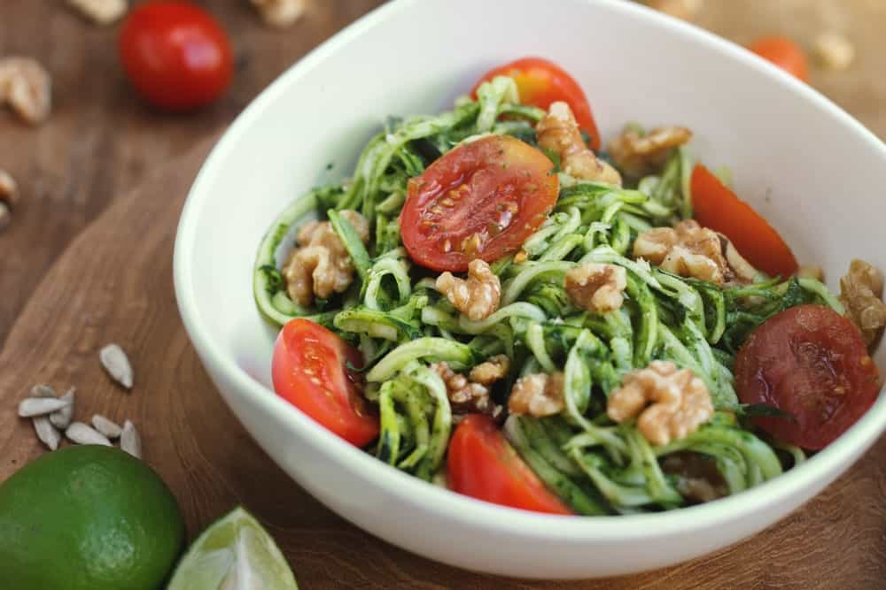
THE BEST PART OF MAKING ZUCCHINI PASTA IS THAT YOU CAN EAT IT EITHER WARM OR COLD. EITHER WAY, YOU’LL GET YOUR FIX FOR PASTA WITHOUT ALL OF THE EMPTY CARBS. TAKE A POTATO PEELER AND SLICE THE ZUCCHINI, AND YOU CAN EVEN CUT THEM INTO LONG PIECES AFTERWARD IF YOU WISH. COOK IT IN A SKILLET WITH SOME OLIVE OIL, ALONG WITH A TINY BIT OF WATER, THEN ADD YOUR FAVORITE HERBS AND SPICES.
ADVANTAGES
- HIGH IN PROTEIN, VITAMINS, AND FIBER
- PROTECTS THE CARDIOVASCULAR SYSTEM
DISADVANTAGES
- CONTAINS OXALATES, WHICH CAN CAUSE GOUT IF CONSUMED IN LARGE QUANTITIES
- MAY NOT BE GOOD FOR THOSE WITH GALLBLADDER AND KIDNEY DISEASES
ZUCCHINI IS ALSO A VEGETABLE THAT A LOT OF PEOPLE DO NOT LIKE, BUT IF IT IS COOKED RIGHT, IT MAKES FOR A GREAT PASTA THAT NEARLY EVERYONE WILL EAT.

