MAGIC CARDS PART 58
171 DRAGON’S MAZE MAGIC DECK CARDS
ADVENT OF THE WURM (4)
INSTANT
CREATE A 5/5 GREEN WURM CREATURE TOKEN WITH TRAMPLE.

ÆTHERLING (AETHERLING) (6)
CREATURE — SHAPESHIFTER (4/5)
: EXILE AETHERLING. RETURN IT TO THE BATTLEFIELD UNDER ITS OWNER'S CONTROL AT THE BEGINNING OF THE NEXT END STEP.
: AETHERLING CAN'T BE BLOCKED THIS TURN.
: AETHERLING GETS +1/-1 UNTIL END OF TURN.
: AETHERLING GETS -1/+1 UNTIL END OF TURN.

ALIVE // WELL (ALIVE) (4)
SORCERY
CREATE A 3/3 GREEN CENTAUR CREATURE TOKEN.
FUSE (YOU MAY CAST ONE OR BOTH HALVES OF THIS CARD FROM YOUR HAND.)

ARMED // DANGEROUS (ARMED) (2)
SORCERY
TARGET CREATURE GETS +1/+1 AND GAINS DOUBLE STRIKE UNTIL END OF TURN.
FUSE (YOU MAY CAST ONE OR BOTH HALVES OF THIS CARD FROM YOUR HAND.)

ARMORED WOLF-RIDER (5)
CREATURE — ELF KNIGHT (4/6)

ASCENDED LAWMAGE (4)
CREATURE — VEDALKEN WIZARD (3/2)
FLYING
HEXPROOF (THIS CREATURE CAN'T BE THE TARGET OF SPELLS OR ABILITIES YOUR OPPONENTS CONTROL.)

FAR // AWAY (AWAY) (3)
INSTANT
TARGET PLAYER SACRIFICES A CREATURE.
FUSE (YOU MAY CAST ONE OR BOTH HALVES OF THIS CARD FROM YOUR HAND.)

AWE FOR THE GUILDS (3)
SORCERY
MONOCOLORED CREATURES CAN'T BLOCK THIS TURN.

AZORIUS CLUESTONE (3)
ARTIFACT
: ADD OR .
, , SACRIFICE AZORIUS CLUESTONE: DRAW A CARD.

AZORIUS GUILDGATE (0)
LAND — GATE
AZORIUS GUILDGATE ENTERS THE BATTLEFIELD TAPPED.
: ADD OR .

BANE ALLEY BLACKGUARD (2)
CREATURE — HUMAN ROGUE (1/3)

BATTERING KRASIS (3)
CREATURE — SHARK BEAST (2/1)
TRAMPLE
EVOLVE (WHENEVER A CREATURE ENTERS THE BATTLEFIELD UNDER YOUR CONTROL, IF THAT CREATURE HAS GREATER POWER OR TOUGHNESS THAN THIS CREATURE, PUT A +1/+1 COUNTER ON THIS CREATURE.)

BECK // CALL (BECK) (2)
SORCERY
WHENEVER A CREATURE ENTERS THE BATTLEFIELD THIS TURN, YOU MAY DRAW A CARD.
FUSE (YOU MAY CAST ONE OR BOTH HALVES OF THIS CARD FROM YOUR HAND.)

BEETLEFORM MAGE (3)
CREATURE — HUMAN INSECT WIZARD (2/2)
: BEETLEFORM MAGE GETS +2/+2 AND GAINS FLYING UNTIL END OF TURN. ACTIVATE ONLY ONCE EACH TURN.

BLAST OF GENIUS (6)
SORCERY
CHOOSE ANY TARGET. DRAW THREE CARDS, THEN DISCARD A CARD. BLAST OF GENIUS DEALS DAMAGE EQUAL TO THE DISCARDED CARD'S MANA VALUE TO THAT PERMANENT OR PLAYER.

BLAZE COMMANDO (5)
CREATURE — MINOTAUR SOLDIER (5/3)
WHENEVER AN INSTANT OR SORCERY SPELL YOU CONTROL DEALS DAMAGE, CREATE TWO 1/1 RED AND WHITE SOLDIER CREATURE TOKENS WITH HASTE.

FLESH // BLOOD (BLOOD) (2)
SORCERY
TARGET CREATURE YOU CONTROL DEALS DAMAGE EQUAL TO ITS POWER TO ANY TARGET.
FUSE (YOU MAY CAST ONE OR BOTH HALVES OF THIS CARD FROM YOUR HAND.)

BLOOD BARON OF VIZKOPA (5)
CREATURE — VAMPIRE (4/4)
LIFELINK, PROTECTION FROM WHITE AND FROM BLACK
AS LONG AS YOU HAVE 30 OR MORE LIFE AND AN OPPONENT HAS 10 OR LESS LIFE, BLOOD BARON OF VIZKOPA GETS +6/+6 AND HAS FLYING.

BLOOD SCRIVENER (2)
CREATURE — ZOMBIE WIZARD (2/1)
IF YOU WOULD DRAW A CARD WHILE YOU HAVE NO CARDS IN HAND, INSTEAD YOU DRAW TWO CARDS AND YOU LOSE 1 LIFE.

BOROS BATTLESHAPER (7)
CREATURE — MINOTAUR SOLDIER (5/5)
AT THE BEGINNING OF EACH COMBAT, UP TO ONE TARGET CREATURE ATTACKS OR BLOCKS THIS COMBAT IF ABLE AND UP TO ONE TARGET CREATURE CAN'T ATTACK OR BLOCK THIS COMBAT.

BOROS CLUESTONE (3)
ARTIFACT
: ADD OR .
, , SACRIFICE BOROS CLUESTONE: DRAW A CARD.

BOROS GUILDGATE (0)
LAND — GATE
BOROS GUILDGATE ENTERS THE BATTLEFIELD TAPPED.
: ADD OR .

BOROS MASTIFF (2)
CREATURE — DOG (2/2)
BATTALION — WHENEVER BOROS MASTIFF AND AT LEAST TWO OTHER CREATURES ATTACK, BOROS MASTIFF GAINS LIFELINK UNTIL END OF TURN. (DAMAGE DEALT BY A CREATURE WITH LIFELINK ALSO CAUSES ITS CONTROLLER TO GAIN THAT MUCH LIFE.)

BREAKING // ENTERING (BREAKING) (2)
SORCERY
TARGET PLAYER MILLS EIGHT CARDS.
FUSE (YOU MAY CAST ONE OR BOTH HALVES OF THIS CARD FROM YOUR HAND.)

BRED FOR THE HUNT (3)
ENCHANTMENT
WHENEVER A CREATURE YOU CONTROL WITH A +1/+1 COUNTER ON IT DEALS COMBAT DAMAGE TO A PLAYER, YOU MAY DRAW A CARD.

BRONZEBEAK MOA (4)
CREATURE — BIRD (2/2)
WHENEVER ANOTHER CREATURE ENTERS THE BATTLEFIELD UNDER YOUR CONTROL, BRONZEBEAK MOA GETS +3/+3 UNTIL END OF TURN.

TURN // BURN (BURN) (2)
INSTANT
BURN DEALS 2 DAMAGE TO ANY TARGET.
FUSE (YOU MAY CAST ONE OR BOTH HALVES OF THIS CARD FROM YOUR HAND.)

BECK // CALL (CALL) (6)
SORCERY
CREATE FOUR 1/1 WHITE BIRD CREATURE TOKENS WITH FLYING.
FUSE (YOU MAY CAST ONE OR BOTH HALVES OF THIS CARD FROM YOUR HAND.)

CARNAGE GLADIATOR (4)
CREATURE — SKELETON WARRIOR (4/2)
WHENEVER A CREATURE BLOCKS, THAT CREATURE'S CONTROLLER LOSES 1 LIFE.
: REGENERATE CARNAGE GLADIATOR.

CATCH // RELEASE (CATCH) (3)
SORCERY
GAIN CONTROL OF TARGET PERMANENT UNTIL END OF TURN. UNTAP IT. IT GAINS HASTE UNTIL END OF TURN.
FUSE (YOU MAY CAST ONE OR BOTH HALVES OF THIS CARD FROM YOUR HAND.)

CLEAR A PATH (1)
SORCERY
DESTROY TARGET CREATURE WITH DEFENDER.

COUNCIL OF THE ABSOLUTE (4)
CREATURE — HUMAN ADVISOR (2/4)
AS COUNCIL OF THE ABSOLUTE ENTERS THE BATTLEFIELD, CHOOSE A NONCREATURE, NONLAND CARD NAME.
YOUR OPPONENTS CAN'T CAST SPELLS WITH THE CHOSEN NAME.
SPELLS WITH THE CHOSEN NAME YOU CAST COST LESS TO CAST.

CRYPT INCURSION (3)
INSTANT
EXILE ALL CREATURE CARDS FROM TARGET PLAYER'S GRAVEYARD. YOU GAIN 3 LIFE FOR EACH CARD EXILED THIS WAY.

ARMED // DANGEROUS (DANGEROUS) (4)
SORCERY
ALL CREATURES ABLE TO BLOCK TARGET CREATURE THIS TURN DO SO.
FUSE (YOU MAY CAST ONE OR BOTH HALVES OF THIS CARD FROM YOUR HAND.)

DEADBRIDGE CHANT (6)
ENCHANTMENT
WHEN DEADBRIDGE CHANT ENTERS THE BATTLEFIELD, MILL TEN CARDS.
AT THE BEGINNING OF YOUR UPKEEP, CHOOSE A CARD AT RANDOM IN YOUR GRAVEYARD. IF IT'S A CREATURE CARD, PUT IT ONTO THE BATTLEFIELD. OTHERWISE, PUT IT INTO YOUR HAND.

DEBT TO THE DEATHLESS (4)
SORCERY
EACH OPPONENT LOSES TWO TIMES X LIFE. YOU GAIN LIFE EQUAL TO THE LIFE LOST THIS WAY.

DEPUTY OF ACQUITTALS (2)
CREATURE — HUMAN WIZARD (2/2)
FLASH (YOU MAY CAST THIS SPELL ANY TIME YOU COULD CAST AN INSTANT.)
WHEN DEPUTY OF ACQUITTALS ENTERS THE BATTLEFIELD, YOU MAY RETURN ANOTHER TARGET CREATURE YOU CONTROL TO ITS OWNER'S HAND.

DIMIR CLUESTONE (3)
ARTIFACT
: ADD OR .
, , SACRIFICE DIMIR CLUESTONE: DRAW A CARD.

DIMIR GUILDGATE (0)
LAND — GATE
DIMIR GUILDGATE ENTERS THE BATTLEFIELD TAPPED.
: ADD OR .

DOWN // DIRTY (DIRTY) (3)
SORCERY
RETURN TARGET CARD FROM YOUR GRAVEYARD TO YOUR HAND.
FUSE (YOU MAY CAST ONE OR BOTH HALVES OF THIS CARD FROM YOUR HAND.)

DOWN // DIRTY (DOWN) (4)
SORCERY
TARGET PLAYER DISCARDS TWO CARDS.
FUSE (YOU MAY CAST ONE OR BOTH HALVES OF THIS CARD FROM YOUR HAND.)

DRAGONSHIFT (3)
INSTANT
UNTIL END OF TURN, TARGET CREATURE YOU CONTROL BECOMES A BLUE AND RED DRAGON WITH BASE POWER AND TOUGHNESS 4/4, LOSES ALL ABILITIES, AND GAINS FLYING.
OVERLOAD (YOU MAY CAST THIS SPELL FOR ITS OVERLOAD COST. IF YOU DO, CHANGE "TARGET" IN ITS TEXT TO "EACH.")

DROWN IN FILTH (2)
SORCERY
CHOOSE TARGET CREATURE. MILL FOUR CARDS, THEN THAT CREATURE GETS -1/-1 UNTIL END OF TURN FOR EACH LAND CARD IN YOUR GRAVEYARD.

EMMARA TANDRIS (7)
LEGENDARY CREATURE — ELF SHAMAN (5/7)
PREVENT ALL DAMAGE THAT WOULD BE DEALT TO CREATURE TOKENS YOU CONTROL.

BREAKING // ENTERING (ENTERING) (6)
SORCERY
PUT A CREATURE CARD FROM A GRAVEYARD ONTO THE BATTLEFIELD UNDER YOUR CONTROL. IT GAINS HASTE UNTIL END OF TURN.
FUSE (YOU MAY CAST ONE OR BOTH HALVES OF THIS CARD FROM YOUR HAND.)

EXAVA, RAKDOS BLOOD WITCH (4)
LEGENDARY CREATURE — HUMAN CLERIC (3/3)
FIRST STRIKE, HASTE
UNLEASH (YOU MAY HAVE THIS CREATURE ENTER THE BATTLEFIELD WITH A +1/+1 COUNTER ON IT. IT CAN'T BLOCK AS LONG AS IT HAS A +1/+1 COUNTER ON IT.)
EACH OTHER CREATURE YOU CONTROL WITH A +1/+1 COUNTER ON IT HAS HASTE.

FAR // AWAY (FAR) (2)
INSTANT
RETURN TARGET CREATURE TO ITS OWNER'S HAND.
FUSE (YOU MAY CAST ONE OR BOTH HALVES OF THIS CARD FROM YOUR HAND.)

FATAL FUMES (4)
INSTANT
TARGET CREATURE GETS -4/-2 UNTIL END OF TURN.

FERAL ANIMIST (3)
CREATURE — GOBLIN SHAMAN (2/1)
: FERAL ANIMIST GETS +X/+0 UNTIL END OF TURN, WHERE X IS ITS POWER.

FLESH // BLOOD (FLESH) (5)
SORCERY
EXILE TARGET CREATURE CARD FROM A GRAVEYARD. PUT X +1/+1 COUNTERS ON TARGET CREATURE, WHERE X IS THE POWER OF THE CARD YOU EXILED.
FUSE (YOU MAY CAST ONE OR BOTH HALVES OF THIS CARD FROM YOUR HAND.)

FLUXCHARGER (4)
CREATURE — WEIRD (1/5)
FLYING
WHENEVER YOU CAST AN INSTANT OR SORCERY SPELL, YOU MAY SWITCH FLUXCHARGER'S POWER AND TOUGHNESS UNTIL END OF TURN.

GAZE OF GRANITE (3)
SORCERY
DESTROY EACH NONLAND PERMANENT WITH MANA VALUE X OR LESS.

GIVE // TAKE (GIVE) (3)
SORCERY
PUT THREE +1/+1 COUNTERS ON TARGET CREATURE.
FUSE (YOU MAY CAST ONE OR BOTH HALVES OF THIS CARD FROM YOUR HAND.)

GLEAM OF BATTLE (6)
ENCHANTMENT
WHENEVER A CREATURE YOU CONTROL ATTACKS, PUT A +1/+1 COUNTER ON IT.

GOBLIN TEST PILOT (3)
CREATURE — GOBLIN PILOT WIZARD (0/2)
FLYING
: GOBLIN TEST PILOT DEALS 2 DAMAGE TO ANY TARGET CHOSEN AT RANDOM.

GOLGARI CLUESTONE (3)
ARTIFACT
: ADD OR .
, , SACRIFICE GOLGARI CLUESTONE: DRAW A CARD.

GOLGARI GUILDGATE (0)
LAND — GATE
GOLGARI GUILDGATE ENTERS THE BATTLEFIELD TAPPED.
: ADD OR .

GRUUL CLUESTONE (3)
ARTIFACT
: ADD OR .
, , SACRIFICE GRUUL CLUESTONE: DRAW A CARD.

GRUUL GUILDGATE (0)
LAND — GATE
GRUUL GUILDGATE ENTERS THE BATTLEFIELD TAPPED.
: ADD OR .

GRUUL WAR CHANT (4)
ENCHANTMENT
ATTACKING CREATURES YOU CONTROL GET +1/+0 AND HAVE MENACE.

HAAZDA SNARE SQUAD (3)
CREATURE — HUMAN SOLDIER (1/4)
WHENEVER HAAZDA SNARE SQUAD ATTACKS, YOU MAY PAY . IF YOU DO, TAP TARGET CREATURE AN OPPONENT CONTROLS.

HAUNTER OF NIGHTVEIL (5)
CREATURE — SPIRIT (3/4)
CREATURES YOUR OPPONENTS CONTROL GET -1/-0.

HIDDEN STRINGS (2)
SORCERY
YOU MAY TAP OR UNTAP TARGET PERMANENT, THEN YOU MAY TAP OR UNTAP ANOTHER TARGET PERMANENT.
CIPHER (THEN YOU MAY EXILE THIS SPELL CARD ENCODED ON A CREATURE YOU CONTROL. WHENEVER THAT CREATURE DEALS COMBAT DAMAGE TO A PLAYER, ITS CONTROLLER MAY CAST A COPY OF THE ENCODED CARD WITHOUT PAYING ITS MANA COST.)

HIRED TORTURER (3)
CREATURE — HUMAN ROGUE (2/3)
DEFENDER
, : TARGET OPPONENT LOSES 2 LIFE, THEN REVEALS A CARD AT RANDOM FROM THEIR HAND.

IZZET CLUESTONE (3)
ARTIFACT
: ADD OR .
, , SACRIFICE IZZET CLUESTONE: DRAW A CARD.

IZZET GUILDGATE (0)
LAND — GATE
IZZET GUILDGATE ENTERS THE BATTLEFIELD TAPPED.
: ADD OR .

JELENN SPHINX (5)
CREATURE — SPHINX (1/5)
FLYING, VIGILANCE
WHENEVER JELENN SPHINX ATTACKS, OTHER ATTACKING CREATURES GET +1/+1 UNTIL END OF TURN.

KOROZDA GORGON (5)
CREATURE — GORGON (2/5)
DEATHTOUCH
, REMOVE A +1/+1 COUNTER FROM A CREATURE YOU CONTROL: TARGET CREATURE GETS -1/-1 UNTIL END OF TURN.

KRASIS INCUBATION (4)
ENCHANTMENT — AURA
ENCHANT CREATURE
ENCHANTED CREATURE CAN'T ATTACK OR BLOCK, AND ITS ACTIVATED ABILITIES CAN'T BE ACTIVATED.
, RETURN KRASIS INCUBATION TO ITS OWNER'S HAND: PUT TWO +1/+1 COUNTERS ON ENCHANTED CREATURE.

KRAUL WARRIOR (2)
CREATURE — INSECT WARRIOR (2/2)
: KRAUL WARRIOR GETS +3/+3 UNTIL END OF TURN.

LAVINIA OF THE TENTH (5)
LEGENDARY CREATURE — HUMAN SOLDIER (4/4)
PROTECTION FROM RED
WHEN LAVINIA OF THE TENTH ENTERS THE BATTLEFIELD, DETAIN EACH NONLAND PERMANENT YOUR OPPONENTS CONTROL WITH MANA VALUE 4 OR LESS. (UNTIL YOUR NEXT TURN, THOSE PERMANENTS CAN'T ATTACK OR BLOCK AND THEIR ACTIVATED ABILITIES CAN'T BE ACTIVATED.)

LEGION'S INITIATIVE (2)
ENCHANTMENT
RED CREATURES YOU CONTROL GET +1/+0.
WHITE CREATURES YOU CONTROL GET +0/+1.
, EXILE LEGION'S INITIATIVE: EXILE ALL CREATURES YOU CONTROL. AT THE BEGINNING OF THE NEXT COMBAT, RETURN THOSE CARDS TO THE BATTLEFIELD UNDER THEIR OWNER'S CONTROL AND THOSE CREATURES GAIN HASTE UNTIL END OF TURN.

PROFIT // LOSS (LOSS) (3)
INSTANT
CREATURES YOUR OPPONENTS CONTROL GET -1/-1 UNTIL END OF TURN.
FUSE (YOU MAY CAST ONE OR BOTH HALVES OF THIS CARD FROM YOUR HAND.)

LYEV DECREE (2)
SORCERY
DETAIN UP TO TWO TARGET CREATURES YOUR OPPONENTS CONTROL. (UNTIL YOUR NEXT TURN, THOSE CREATURES CAN'T ATTACK OR BLOCK AND THEIR ACTIVATED ABILITIES CAN'T BE ACTIVATED.)

MASTER OF CRUELTIES (5)
CREATURE — DEMON (1/4)
FIRST STRIKE, DEATHTOUCH
MASTER OF CRUELTIES CAN ONLY ATTACK ALONE.
WHENEVER MASTER OF CRUELTIES ATTACKS A PLAYER AND ISN'T BLOCKED, THAT PLAYER'S LIFE TOTAL BECOMES 1. MASTER OF CRUELTIES ASSIGNS NO COMBAT DAMAGE THIS COMBAT.

MAW OF THE OBZEDAT (5)
CREATURE — THRULL (3/3)
SACRIFICE A CREATURE: CREATURES YOU CONTROL GET +1/+1 UNTIL END OF TURN.

MAZE ABOMINATION (6)
CREATURE — ELEMENTAL (4/5)
DEATHTOUCH (ANY AMOUNT OF DAMAGE THIS DEALS TO A CREATURE IS ENOUGH TO DESTROY IT.)
MULTICOLORED CREATURES YOU CONTROL HAVE DEATHTOUCH.

MAZE BEHEMOTH (6)
CREATURE — ELEMENTAL (5/4)
TRAMPLE
MULTICOLORED CREATURES YOU CONTROL HAVE TRAMPLE.

MAZE GLIDER (6)
CREATURE — ELEMENTAL (3/5)
FLYING
MULTICOLORED CREATURES YOU CONTROL HAVE FLYING.

MAZE RUSHER (6)
CREATURE — ELEMENTAL (6/3)
HASTE
MULTICOLORED CREATURES YOU CONTROL HAVE HASTE.

MAZE SENTINEL (6)
CREATURE — ELEMENTAL (3/6)
VIGILANCE
MULTICOLORED CREATURES YOU CONTROL HAVE VIGILANCE.

MAZE'S END (0)
LAND
MAZE'S END ENTERS THE BATTLEFIELD TAPPED.
: ADD .
, , RETURN MAZE'S END TO ITS OWNER'S HAND: SEARCH YOUR LIBRARY FOR A GATE CARD, PUT IT ONTO THE BATTLEFIELD, THEN SHUFFLE. IF YOU CONTROL TEN OR MORE GATES WITH DIFFERENT NAMES, YOU WIN THE GAME.

MELEK, IZZET PARAGON (6)
LEGENDARY CREATURE — WEIRD WIZARD (2/4)
PLAY WITH THE TOP CARD OF YOUR LIBRARY REVEALED.
YOU MAY CAST INSTANT AND SORCERY SPELLS FROM THE TOP OF YOUR LIBRARY.
WHENEVER YOU CAST AN INSTANT OR SORCERY SPELL FROM YOUR LIBRARY, COPY IT. YOU MAY CHOOSE NEW TARGETS FOR THE COPY.

MENDING TOUCH (1)
INSTANT
REGENERATE TARGET CREATURE.

MINDSTATIC (4)
INSTANT
COUNTER TARGET SPELL UNLESS ITS CONTROLLER PAYS .

MIRKO VOSK, MIND DRINKER (5)
LEGENDARY CREATURE — VAMPIRE (2/4)
FLYING
WHENEVER MIRKO VOSK, MIND DRINKER DEALS COMBAT DAMAGE TO A PLAYER, THAT PLAYER REVEALS CARDS FROM THE TOP OF THEIR LIBRARY UNTIL THEY REVEAL FOUR LAND CARDS, THEN PUTS THOSE CARDS INTO THEIR GRAVEYARD.

MORGUE BURST (6)
SORCERY
RETURN TARGET CREATURE CARD FROM YOUR GRAVEYARD TO YOUR HAND. MORGUE BURST DEALS DAMAGE TO ANY TARGET EQUAL TO THE POWER OF THE CARD RETURNED THIS WAY.

MURMURING PHANTASM (2)
CREATURE — SPIRIT (0/5)
DEFENDER

MUTANT'S PREY (1)
INSTANT
TARGET CREATURE YOU CONTROL WITH A +1/+1 COUNTER ON IT FIGHTS TARGET CREATURE AN OPPONENT CONTROLS. (EACH DEALS DAMAGE EQUAL TO ITS POWER TO THE OTHER.)

NIVIX CYCLOPS (3)
CREATURE — CYCLOPS (1/4)
DEFENDER
WHENEVER YOU CAST AN INSTANT OR SORCERY SPELL, NIVIX CYCLOPS GETS +3/+0 UNTIL END OF TURN AND CAN ATTACK THIS TURN AS THOUGH IT DIDN'T HAVE DEFENDER.

NOTION THIEF (4)
CREATURE — HUMAN ROGUE (3/1)
FLASH
IF AN OPPONENT WOULD DRAW A CARD EXCEPT THE FIRST ONE THEY DRAW IN EACH OF THEIR DRAW STEPS, INSTEAD THAT PLAYER SKIPS THAT DRAW AND YOU DRAW A CARD.

OBZEDAT'S AID (5)
SORCERY
RETURN TARGET PERMANENT CARD FROM YOUR GRAVEYARD TO THE BATTLEFIELD.

OPAL LAKE GATEKEEPERS (4)
CREATURE — VEDALKEN SOLDIER (2/4)
WHEN OPAL LAKE GATEKEEPERS ENTERS THE BATTLEFIELD, IF YOU CONTROL TWO OR MORE GATES, YOU MAY DRAW A CARD.

ORZHOV CLUESTONE (3)
ARTIFACT
: ADD OR .
, , SACRIFICE ORZHOV CLUESTONE: DRAW A CARD.

ORZHOV GUILDGATE (0)
LAND — GATE
ORZHOV GUILDGATE ENTERS THE BATTLEFIELD TAPPED.
: ADD OR .

PHYTOBURST (2)
SORCERY
TARGET CREATURE GETS +5/+5 UNTIL END OF TURN.

PILFERED PLANS (3)
SORCERY
TARGET PLAYER MILLS TWO CARDS. DRAW TWO CARDS.

PLASM CAPTURE (4)
INSTANT
COUNTER TARGET SPELL. AT THE BEGINNING OF YOUR NEXT PRECOMBAT MAIN PHASE, ADD X MANA IN ANY COMBINATION OF COLORS, WHERE X IS THAT SPELL'S MANA VALUE.

PONTIFF OF BLIGHT (6)
CREATURE — ZOMBIE CLERIC (2/7)
EXTORT (WHENEVER YOU CAST A SPELL, YOU MAY PAY . IF YOU DO, EACH OPPONENT LOSES 1 LIFE AND YOU GAIN THAT MUCH LIFE.)
OTHER CREATURES YOU CONTROL HAVE EXTORT. (IF A CREATURE HAS MULTIPLE INSTANCES OF EXTORT, EACH TRIGGERS SEPARATELY.)

POSSIBILITY STORM (5)
ENCHANTMENT
WHENEVER A PLAYER CASTS A SPELL FROM THEIR HAND, THAT PLAYER EXILES IT, THEN EXILES CARDS FROM THE TOP OF THEIR LIBRARY UNTIL THEY EXILE A CARD THAT SHARES A CARD TYPE WITH IT. THAT PLAYER MAY CAST THAT CARD WITHOUT PAYING ITS MANA COST. THEN THEY PUT ALL CARDS EXILED WITH POSSIBILITY STORM ON THE BOTTOM OF THEIR LIBRARY IN A RANDOM ORDER.
PROFIT // LOSS (PROFIT) (2)
INSTANT
CREATURES YOU CONTROL GET +1/+1 UNTIL END OF TURN.
FUSE (YOU MAY CAST ONE OR BOTH HALVES OF THIS CARD FROM YOUR HAND.)

PROGENITOR MIMIC (6)
CREATURE — SHAPESHIFTER (0/0)
YOU MAY HAVE PROGENITOR MIMIC ENTER THE BATTLEFIELD AS A COPY OF ANY CREATURE ON THE BATTLEFIELD, EXCEPT IT HAS "AT THE BEGINNING OF YOUR UPKEEP, IF THIS CREATURE ISN'T A TOKEN, CREATE A TOKEN THAT'S A COPY OF THIS CREATURE."

PROTECT // SERVE (PROTECT) (3)
INSTANT
TARGET CREATURE GETS +2/+4 UNTIL END OF TURN.
FUSE (YOU MAY CAST ONE OR BOTH HALVES OF THIS CARD FROM YOUR HAND.)

PUNISH THE ENEMY (5)
INSTANT
PUNISH THE ENEMY DEALS 3 DAMAGE TO TARGET PLAYER OR PLANESWALKER AND 3 DAMAGE TO TARGET CREATURE.

PUTREFY (3)
INSTANT
DESTROY TARGET ARTIFACT OR CREATURE. IT CAN'T BE REGENERATED.

PYREWILD SHAMAN (3)
CREATURE — GOBLIN SHAMAN (3/1)
BLOODRUSH — , DISCARD PYREWILD SHAMAN: TARGET ATTACKING CREATURE GETS +3/+1 UNTIL END OF TURN.
WHENEVER ONE OR MORE CREATURES YOU CONTROL DEAL COMBAT DAMAGE TO A PLAYER, IF PYREWILD SHAMAN IS IN YOUR GRAVEYARD, YOU MAY PAY . IF YOU DO, RETURN PYREWILD SHAMAN TO YOUR HAND.

RAKDOS CLUESTONE (3)
ARTIFACT
: ADD OR .
, , SACRIFICE RAKDOS CLUESTONE: DRAW A CARD.

RAKDOS DRAKE (3)
CREATURE — DRAKE (1/2)
FLYING
UNLEASH (YOU MAY HAVE THIS CREATURE ENTER THE BATTLEFIELD WITH A +1/+1 COUNTER ON IT. IT CAN'T BLOCK AS LONG AS IT HAS A +1/+1 COUNTER ON IT.)

RAKDOS GUILDGATE (0)
LAND — GATE
RAKDOS GUILDGATE ENTERS THE BATTLEFIELD TAPPED.
: ADD OR .

RAL ZAREK (4)
LEGENDARY PLANESWALKER — RAL (4)
+1: TAP TARGET PERMANENT, THEN UNTAP ANOTHER TARGET PERMANENT.
−2: RAL ZAREK DEALS 3 DAMAGE TO ANY TARGET.
−7: FLIP FIVE COINS. TAKE AN EXTRA TURN AFTER THIS ONE FOR EACH COIN THAT COMES UP HEADS.

READY // WILLING (READY) (3)
INSTANT
CREATURES YOU CONTROL GAIN INDESTRUCTIBLE UNTIL END OF TURN. UNTAP EACH CREATURE YOU CONTROL.
FUSE (YOU MAY CAST ONE OR BOTH HALVES OF THIS CARD FROM YOUR HAND.)

REAP INTELLECT (4)
SORCERY
TARGET OPPONENT REVEALS THEIR HAND. YOU CHOOSE UP TO X NONLAND CARDS FROM IT AND EXILE THEM. FOR EACH CARD EXILED THIS WAY, SEARCH THAT PLAYER'S GRAVEYARD, HAND, AND LIBRARY FOR ANY NUMBER OF CARDS WITH THE SAME NAME AS THAT CARD AND EXILE THEM. THEN THAT PLAYER SHUFFLES.

CATCH // RELEASE (RELEASE) (6)
SORCERY
EACH PLAYER SACRIFICES AN ARTIFACT, A CREATURE, AN ENCHANTMENT, A LAND, AND A PLANESWALKER.
FUSE (YOU MAY CAST ONE OR BOTH HALVES OF THIS CARD FROM YOUR HAND.)

RENDER SILENT (3)
INSTANT
COUNTER TARGET SPELL. ITS CONTROLLER CAN'T CAST SPELLS THIS TURN.

RENEGADE KRASIS (3)
CREATURE — BEAST MUTANT (3/2)
EVOLVE (WHENEVER A CREATURE ENTERS THE BATTLEFIELD UNDER YOUR CONTROL, IF THAT CREATURE HAS GREATER POWER OR TOUGHNESS THAN THIS CREATURE, PUT A +1/+1 COUNTER ON THIS CREATURE.)
WHENEVER RENEGADE KRASIS EVOLVES, PUT A +1/+1 COUNTER ON EACH OTHER CREATURE YOU CONTROL WITH A +1/+1 COUNTER ON IT.

RENOUNCE THE GUILDS (2)
INSTANT
EACH PLAYER SACRIFICES A MULTICOLORED PERMANENT.

RESTORE THE PEACE (3)
INSTANT
RETURN EACH CREATURE THAT DEALT DAMAGE THIS TURN TO ITS OWNER'S HAND.

RIOT CONTROL (3)
INSTANT
YOU GAIN 1 LIFE FOR EACH CREATURE YOUR OPPONENTS CONTROL. PREVENT ALL DAMAGE THAT WOULD BE DEALT TO YOU THIS TURN.

RIOT PIKER (2)
CREATURE — GOBLIN BERSERKER (2/1)
FIRST STRIKE
RIOT PIKER ATTACKS EACH COMBAT IF ABLE.

ROT FARM SKELETON (4)
CREATURE — PLANT SKELETON (4/1)
ROT FARM SKELETON CAN'T BLOCK.
, MILL FOUR CARDS: RETURN ROT FARM SKELETON FROM YOUR GRAVEYARD TO THE BATTLEFIELD. ACTIVATE ONLY AS A SORCERY.

RUBBLEBELT MAAKA (4)
CREATURE — CAT (3/3)
BLOODRUSH — , DISCARD RUBBLEBELT MAAKA: TARGET ATTACKING CREATURE GETS +3/+3 UNTIL END OF TURN.

RUNNER'S BANE (2)
ENCHANTMENT — AURA
ENCHANT CREATURE WITH POWER 3 OR LESS
WHEN RUNNER'S BANE ENTERS THE BATTLEFIELD, TAP ENCHANTED CREATURE.
ENCHANTED CREATURE DOESN'T UNTAP DURING ITS CONTROLLER'S UNTAP STEP.

RURIC THAR, THE UNBOWED (6)
LEGENDARY CREATURE — OGRE WARRIOR (6/6)
VIGILANCE, REACH
RURIC THAR, THE UNBOWED ATTACKS EACH COMBAT IF ABLE.
WHENEVER A PLAYER CASTS A NONCREATURE SPELL, RURIC THAR DEALS 6 DAMAGE TO THAT PLAYER.

SARULI GATEKEEPERS (4)
CREATURE — ELF WARRIOR (2/4)
WHEN SARULI GATEKEEPERS ENTERS THE BATTLEFIELD, IF YOU CONTROL TWO OR MORE GATES, YOU GAIN 7 LIFE.

SAVAGEBORN HYDRA (2)
CREATURE — HYDRA (0/0)
DOUBLE STRIKE
SAVAGEBORN HYDRA ENTERS THE BATTLEFIELD WITH X +1/+1 COUNTERS ON IT.
: PUT A +1/+1 COUNTER ON SAVAGEBORN HYDRA. ACTIVATE ONLY AS A SORCERY.

SCAB-CLAN GIANT (6)
CREATURE — GIANT WARRIOR (4/5)
WHEN SCAB-CLAN GIANT ENTERS THE BATTLEFIELD, IT FIGHTS TARGET CREATURE AN OPPONENT CONTROLS CHOSEN AT RANDOM.

SCION OF VITU-GHAZI (5)
CREATURE — ELEMENTAL (4/4)
WHEN SCION OF VITU-GHAZI ENTERS THE BATTLEFIELD, IF YOU CAST IT FROM YOUR HAND, CREATE A 1/1 WHITE BIRD CREATURE TOKEN WITH FLYING, THEN POPULATE. (CREATE A TOKEN THAT'S A COPY OF A CREATURE TOKEN YOU CONTROL.)

SELESNYA CLUESTONE (3)
ARTIFACT
: ADD OR .
, , SACRIFICE SELESNYA CLUESTONE: DRAW A CARD.

SELESNYA GUILDGATE (0)
LAND — GATE
SELESNYA GUILDGATE ENTERS THE BATTLEFIELD TAPPED.
: ADD OR .

PROTECT // SERVE (SERVE) (2)
INSTANT
TARGET CREATURE GETS -6/-0 UNTIL END OF TURN.
FUSE (YOU MAY CAST ONE OR BOTH HALVES OF THIS CARD FROM YOUR HAND.)

SHOWSTOPPER (3)
INSTANT
UNTIL END OF TURN, CREATURES YOU CONTROL GAIN "WHEN THIS CREATURE DIES, IT DEALS 2 DAMAGE TO TARGET CREATURE AN OPPONENT CONTROLS."

SIMIC CLUESTONE (3)
ARTIFACT
: ADD OR .
, , SACRIFICE SIMIC CLUESTONE: DRAW A CARD.

SIMIC GUILDGATE (0)
LAND — GATE
SIMIC GUILDGATE ENTERS THE BATTLEFIELD TAPPED.
: ADD OR .

SIN COLLECTOR (3)
CREATURE — HUMAN CLERIC (2/1)
WHEN SIN COLLECTOR ENTERS THE BATTLEFIELD, TARGET OPPONENT REVEALS THEIR HAND. YOU CHOOSE AN INSTANT OR SORCERY CARD FROM IT AND EXILE THAT CARD.

SINISTER POSSESSION (1)
ENCHANTMENT — AURA
ENCHANT CREATURE
WHENEVER ENCHANTED CREATURE ATTACKS OR BLOCKS, ITS CONTROLLER LOSES 2 LIFE.

SIRE OF INSANITY (6)
CREATURE — DEMON (6/4)
AT THE BEGINNING OF EACH END STEP, EACH PLAYER DISCARDS THEIR HAND.

SKYLASHER (2)
CREATURE — INSECT (2/2)
FLASH
THIS SPELL CAN'T BE COUNTERED.
REACH, PROTECTION FROM BLUE

SMELT-WARD GATEKEEPERS (4)
CREATURE — HUMAN WARRIOR (2/4)
WHEN SMELT-WARD GATEKEEPERS ENTERS THE BATTLEFIELD, IF YOU CONTROL TWO OR MORE GATES, GAIN CONTROL OF TARGET CREATURE AN OPPONENT CONTROLS UNTIL END OF TURN. UNTAP THAT CREATURE. IT GAINS HASTE UNTIL END OF TURN.

SPECIES GORGER (5)
CREATURE — FROG BEAST (6/6)
AT THE BEGINNING OF YOUR UPKEEP, RETURN A CREATURE YOU CONTROL TO ITS OWNER'S HAND.

SPIKE JESTER (2)
CREATURE — GOBLIN WARRIOR (3/1)
HASTE

STEEPLE ROC (5)
CREATURE — BIRD (3/1)
FLYING, FIRST STRIKE

SUNSPIRE GATEKEEPERS (4)
CREATURE — HUMAN SOLDIER (2/4)
WHEN SUNSPIRE GATEKEEPERS ENTERS THE BATTLEFIELD, IF YOU CONTROL TWO OR MORE GATES, CREATE A 2/2 WHITE KNIGHT CREATURE TOKEN WITH VIGILANCE.

TAJIC, BLADE OF THE LEGION (4)
LEGENDARY CREATURE — HUMAN SOLDIER (2/2)
INDESTRUCTIBLE
BATTALION — WHENEVER TAJIC, BLADE OF THE LEGION AND AT LEAST TWO OTHER CREATURES ATTACK, TAJIC GETS +5/+5 UNTIL END OF TURN.

GIVE // TAKE (TAKE) (3)
SORCERY
REMOVE ALL +1/+1 COUNTERS FROM TARGET CREATURE YOU CONTROL. DRAW THAT MANY CARDS.
FUSE (YOU MAY CAST ONE OR BOTH HALVES OF THIS CARD FROM YOUR HAND.)

WEAR // TEAR (TEAR) (1)
INSTANT
DESTROY TARGET ENCHANTMENT.
FUSE (YOU MAY CAST ONE OR BOTH HALVES OF THIS CARD FROM YOUR HAND.)

TEYSA, ENVOY OF GHOSTS (7)
LEGENDARY CREATURE — HUMAN ADVISOR (4/4)
VIGILANCE, PROTECTION FROM CREATURES
WHENEVER A CREATURE DEALS COMBAT DAMAGE TO YOU, DESTROY THAT CREATURE. CREATE A 1/1 WHITE AND BLACK SPIRIT CREATURE TOKEN WITH FLYING.

THRASHING MOSSDOG (4)
CREATURE — PLANT DOG (3/3)
REACH (THIS CREATURE CAN BLOCK CREATURES WITH FLYING.)
SCAVENGE (, EXILE THIS CARD FROM YOUR GRAVEYARD: PUT A NUMBER OF +1/+1 COUNTERS EQUAL TO THIS CARD'S POWER ON TARGET CREATURE. SCAVENGE ONLY AS A SORCERY.)

TITHE DRINKER (2)
CREATURE — VAMPIRE (2/1)
LIFELINK (DAMAGE DEALT BY THIS CREATURE ALSO CAUSES YOU TO GAIN THAT MUCH LIFE.)
EXTORT (WHENEVER YOU CAST A SPELL, YOU MAY PAY . IF YOU DO, EACH OPPONENT LOSES 1 LIFE AND YOU GAIN THAT MUCH LIFE.)

TOIL // TROUBLE (TOIL) (3)
SORCERY
TARGET PLAYER DRAWS TWO CARDS AND LOSES 2 LIFE.
FUSE (YOU MAY CAST ONE OR BOTH HALVES OF THIS CARD FROM YOUR HAND.)

TRAIT DOCTORING (1)
SORCERY
CHANGE THE TEXT OF TARGET PERMANENT BY REPLACING ALL INSTANCES OF ONE COLOR WORD WITH ANOTHER OR ONE BASIC LAND TYPE WITH ANOTHER UNTIL END OF TURN.
CIPHER (THEN YOU MAY EXILE THIS SPELL CARD ENCODED ON A CREATURE YOU CONTROL. WHENEVER THAT CREATURE DEALS COMBAT DAMAGE TO A PLAYER, ITS CONTROLLER MAY CAST A COPY OF THE ENCODED CARD WITHOUT PAYING ITS MANA COST.)

TROSTANI'S SUMMONER (7)
CREATURE — ELF SHAMAN (1/1)
WHEN TROSTANI'S SUMMONER ENTERS THE BATTLEFIELD, CREATE A 2/2 WHITE KNIGHT CREATURE TOKEN WITH VIGILANCE, A 3/3 GREEN CENTAUR CREATURE TOKEN, AND A 4/4 GREEN RHINO CREATURE TOKEN WITH TRAMPLE.

TOIL // TROUBLE (TROUBLE) (3)
SORCERY
TROUBLE DEALS DAMAGE TO TARGET PLAYER EQUAL TO THE NUMBER OF CARDS IN THAT PLAYER'S HAND.
FUSE (YOU MAY CAST ONE OR BOTH HALVES OF THIS CARD FROM YOUR HAND.)

TURN // BURN (TURN) (3)
INSTANT
UNTIL END OF TURN, TARGET CREATURE LOSES ALL ABILITIES AND BECOMES A RED WEIRD WITH BASE POWER AND TOUGHNESS 0/1.
FUSE (YOU MAY CAST ONE OR BOTH HALVES OF THIS CARD FROM YOUR HAND.)

UBUL SAR GATEKEEPERS (4)
CREATURE — ZOMBIE SOLDIER (2/4)
WHEN UBUL SAR GATEKEEPERS ENTERS THE BATTLEFIELD, IF YOU CONTROL TWO OR MORE GATES, TARGET CREATURE AN OPPONENT CONTROLS GETS -2/-2 UNTIL END OF TURN.

UNCOVERED CLUES (3)
SORCERY
LOOK AT THE TOP FOUR CARDS OF YOUR LIBRARY. YOU MAY REVEAL UP TO TWO INSTANT AND/OR SORCERY CARDS FROM AMONG THEM AND PUT THE REVEALED CARDS INTO YOUR HAND. PUT THE REST ON THE BOTTOM OF YOUR LIBRARY IN ANY ORDER.

UNFLINCHING COURAGE (3)
ENCHANTMENT — AURA
ENCHANT CREATURE
ENCHANTED CREATURE GETS +2/+2 AND HAS TRAMPLE AND LIFELINK. (DAMAGE DEALT BY A CREATURE WITH LIFELINK ALSO CAUSES ITS CONTROLLER TO GAIN THAT MUCH LIFE.)

VAROLZ, THE SCAR-STRIPED (3)
LEGENDARY CREATURE — TROLL WARRIOR (2/2)
EACH CREATURE CARD IN YOUR GRAVEYARD HAS SCAVENGE. THE SCAVENGE COST IS EQUAL TO ITS MANA COST. (EXILE A CREATURE CARD FROM YOUR GRAVEYARD AND PAY ITS MANA COST: PUT A NUMBER OF +1/+1 COUNTERS EQUAL TO THAT CARD'S POWER ON TARGET CREATURE. SCAVENGE ONLY AS A SORCERY.)
SACRIFICE ANOTHER CREATURE: REGENERATE VAROLZ, THE SCAR-STRIPED.

VIASHINO FIRSTBLADE (3)
CREATURE — VIASHINO SOLDIER (2/2)
HASTE
WHEN VIASHINO FIRSTBLADE ENTERS THE BATTLEFIELD, IT GETS +2/+2 UNTIL END OF TURN.

VOICE OF RESURGENCE (2)
CREATURE — ELEMENTAL (2/2)
WHENEVER AN OPPONENT CASTS A SPELL DURING YOUR TURN OR WHEN VOICE OF RESURGENCE DIES, CREATE A GREEN AND WHITE ELEMENTAL CREATURE TOKEN WITH "THIS CREATURE'S POWER AND TOUGHNESS ARE EACH EQUAL TO THE NUMBER OF CREATURES YOU CONTROL."

VOREL OF THE HULL CLADE (3)
LEGENDARY CREATURE — HUMAN MERFOLK (1/4)
, : DOUBLE THE NUMBER OF EACH KIND OF COUNTER ON TARGET ARTIFACT, CREATURE, OR LAND.

WAKE THE REFLECTIONS (1)
SORCERY
POPULATE. (CREATE A TOKEN THAT'S A COPY OF A CREATURE TOKEN YOU CONTROL.)

WARLEADER'S HELIX (4)
INSTANT
WARLEADER'S HELIX DEALS 4 DAMAGE TO ANY TARGET AND YOU GAIN 4 LIFE.

WARPED PHYSIQUE (2)
INSTANT
TARGET CREATURE GETS +X/-X UNTIL END OF TURN, WHERE X IS THE NUMBER OF CARDS IN YOUR HAND.

WEAPON SURGE (1)
INSTANT
TARGET CREATURE YOU CONTROL GETS +1/+0 AND GAINS FIRST STRIKE UNTIL END OF TURN.
OVERLOAD (YOU MAY CAST THIS SPELL FOR ITS OVERLOAD COST. IF YOU DO, CHANGE "TARGET" IN ITS TEXT TO "EACH.")

WEAR // TEAR (WEAR) (2)
INSTANT
DESTROY TARGET ARTIFACT.
FUSE (YOU MAY CAST ONE OR BOTH HALVES OF THIS CARD FROM YOUR HAND.)

ALIVE // WELL (WELL) (1)
SORCERY
YOU GAIN 2 LIFE FOR EACH CREATURE YOU CONTROL.
FUSE (YOU MAY CAST ONE OR BOTH HALVES OF THIS CARD FROM YOUR HAND.)

READY // WILLING (WILLING) (3)
INSTANT
CREATURES YOU CONTROL GAIN DEATHTOUCH AND LIFELINK UNTIL END OF TURN.
FUSE (YOU MAY CAST ONE OR BOTH HALVES OF THIS CARD FROM YOUR HAND.)

WIND DRAKE (3)
CREATURE — DRAKE (2/2)
FLYING

WOODLOT CRAWLER (2)
CREATURE — INSECT (2/1)
FORESTWALK (THIS CREATURE CAN'T BE BLOCKED AS LONG AS DEFENDING PLAYER CONTROLS A FOREST.)
PROTECTION FROM GREEN

ZHUR-TAA ANCIENT (5)
CREATURE — BEAST (7/5)
WHENEVER A PLAYER TAPS A LAND FOR MANA, THAT PLAYER ADDS ONE MANA OF ANY TYPE THAT LAND PRODUCED.

ZHUR-TAA DRUID (2)
CREATURE — HUMAN DRUID (1/1)
: ADD .
WHENEVER YOU TAP ZHUR-TAA DRUID FOR MANA, IT DEALS 1 DAMAGE TO EACH OPPONENT.

254 DRAGONS OF TARKIR MAGIC DECK CARDS
ACID-SPEWER DRAGON (6)
CREATURE — DRAGON (3/3)
FLYING, DEATHTOUCH
MEGAMORPH <I>(YOU MAY CAST THIS CARD FACE DOWN AS A 2/2 CREATURE FOR . TURN IT FACE UP ANY TIME FOR ITS MEGAMORPH COST AND PUT A +1/+1 COUNTER ON IT.)</I>
WHEN ACID-SPEWER DRAGON IS TURNED FACE UP, PUT A +1/+1 COUNTER ON EACH OTHER DRAGON CREATURE YOU CONTROL.

AERIE BOWMASTERS (4)
CREATURE — DOG ARCHER (3/4)
REACH <I>(THIS CREATURE CAN BLOCK CREATURES WITH FLYING.)</I>
MEGAMORPH <I>(YOU MAY CAST THIS CARD FACE DOWN AS A 2/2 CREATURE FOR . TURN IT FACE UP ANY TIME FOR ITS MEGAMORPH COST AND PUT A +1/+1 COUNTER ON IT.)</I>

AINOK ARTILLERIST (3)
CREATURE — DOG ARCHER (4/1)
AINOK ARTILLERIST HAS REACH AS LONG AS IT HAS A +1/+1 COUNTER ON IT. <I>(IT CAN BLOCK CREATURES WITH FLYING.)</I>

AINOK SURVIVALIST (2)
CREATURE — DOG SHAMAN (2/1)
MEGAMORPH <I>(YOU MAY CAST THIS CARD FACE DOWN AS A 2/2 CREATURE FOR . TURN IT FACE UP ANY TIME FOR ITS MEGAMORPH COST AND PUT A +1/+1 COUNTER ON IT.)</I>
WHEN AINOK SURVIVALIST IS TURNED FACE UP, DESTROY TARGET ARTIFACT OR ENCHANTMENT AN OPPONENT CONTROLS.

AMBUSCADE SHAMAN (3)
CREATURE — ORC SHAMAN (2/2)
WHENEVER AMBUSCADE SHAMAN OR ANOTHER CREATURE ENTERS THE BATTLEFIELD UNDER YOUR CONTROL, THAT CREATURE GETS +2/+2 UNTIL END OF TURN.
DASH <I>(YOU MAY CAST THIS SPELL FOR ITS DASH COST. IF YOU DO, IT GAINS HASTE, AND IT'S RETURNED FROM THE BATTLEFIELD TO ITS OWNER'S HAND AT THE BEGINNING OF THE NEXT END STEP.)</I>

ANAFENZA, KIN-TREE SPIRIT (2)
LEGENDARY CREATURE — SPIRIT SOLDIER (2/2)
WHENEVER ANOTHER NONTOKEN CREATURE ENTERS THE BATTLEFIELD UNDER YOUR CONTROL, BOLSTER 1. <I>(CHOOSE A CREATURE WITH THE LEAST TOUGHNESS AMONG CREATURES YOU CONTROL AND PUT A +1/+1 COUNTER ON IT.)</I>

ANCESTRAL STATUE (4)
ARTIFACT CREATURE — GOLEM (3/4)
WHEN ANCESTRAL STATUE ENTERS THE BATTLEFIELD, RETURN A NONLAND PERMANENT YOU CONTROL TO ITS OWNER'S HAND.

ANCIENT CARP (5)
CREATURE — FISH (2/5)

ANTICIPATE (2)
INSTANT
LOOK AT THE TOP THREE CARDS OF YOUR LIBRARY. PUT ONE OF THEM INTO YOUR HAND AND THE REST ON THE BOTTOM OF YOUR LIBRARY IN ANY ORDER.

ARASHIN FOREMOST (3)
CREATURE — HUMAN WARRIOR (2/2)
DOUBLE STRIKE
WHENEVER ARASHIN FOREMOST ENTERS THE BATTLEFIELD OR ATTACKS, ANOTHER TARGET WARRIOR CREATURE YOU CONTROL GAINS DOUBLE STRIKE UNTIL END OF TURN.

ARASHIN SOVEREIGN (7)
CREATURE — DRAGON (6/6)
FLYING
WHEN ARASHIN SOVEREIGN DIES, YOU MAY PUT IT ON THE TOP OR BOTTOM OF ITS OWNER'S LIBRARY.

ARTFUL MANEUVER (2)
INSTANT
TARGET CREATURE GETS +2/+2 UNTIL END OF TURN.
REBOUND <I>(IF YOU CAST THIS SPELL FROM YOUR HAND, EXILE IT AS IT RESOLVES. AT THE BEGINNING OF YOUR NEXT UPKEEP, YOU MAY CAST THIS CARD FROM EXILE WITHOUT PAYING ITS MANA COST.)</I>

ASSAULT FORMATION (2)
ENCHANTMENT
EACH CREATURE YOU CONTROL ASSIGNS COMBAT DAMAGE EQUAL TO ITS TOUGHNESS RATHER THAN ITS POWER.
: TARGET CREATURE WITH DEFENDER CAN ATTACK THIS TURN AS THOUGH IT DIDN'T HAVE DEFENDER.
: CREATURES YOU CONTROL GET +0/+1 UNTIL END OF TURN.

ATARKA BEASTBREAKER (2)
CREATURE — HUMAN WARRIOR (2/2)
<I>FORMIDABLE</I> — : ATARKA BEASTBREAKER GETS +4/+4 UNTIL END OF TURN. ACTIVATE ONLY IF CREATURES YOU CONTROL HAVE TOTAL POWER 8 OR GREATER.

ATARKA EFREET (4)
CREATURE — EFREET SHAMAN (5/1)
MEGAMORPH <I>(YOU MAY CAST THIS CARD FACE DOWN AS A 2/2 CREATURE FOR . TURN IT FACE UP ANY TIME FOR ITS MEGAMORPH COST AND PUT A +1/+1 COUNTER ON IT.)</I>
WHEN ATARKA EFREET IS TURNED FACE UP, IT DEALS 1 DAMAGE TO ANY TARGET.

ATARKA MONUMENT (3)
ARTIFACT
: ADD OR .
: ATARKA MONUMENT BECOMES A 4/4 RED AND GREEN DRAGON ARTIFACT CREATURE WITH FLYING UNTIL END OF TURN.

ATARKA PUMMELER (5)
CREATURE — OGRE WARRIOR (4/5)
<I>FORMIDABLE</I> — : CREATURES YOU CONTROL GAIN MENACE UNTIL END OF TURN. ACTIVATE ONLY IF CREATURES YOU CONTROL HAVE TOTAL POWER 8 OR GREATER. <I>(THEY CAN'T BE BLOCKED EXCEPT BY TWO OR MORE CREATURES.)</I>

ATARKA'S COMMAND (2)
INSTANT
CHOOSE TWO —
• YOUR OPPONENTS CAN'T GAIN LIFE THIS TURN.
• ATARKA'S COMMAND DEALS 3 DAMAGE TO EACH OPPONENT.
• YOU MAY PUT A LAND CARD FROM YOUR HAND ONTO THE BATTLEFIELD.
• CREATURES YOU CONTROL GET +1/+1 AND GAIN REACH UNTIL END OF TURN.

AVATAR OF THE RESOLUTE (2)
CREATURE — AVATAR (3/2)
REACH, TRAMPLE
AVATAR OF THE RESOLUTE ENTERS THE BATTLEFIELD WITH A +1/+1 COUNTER ON IT FOR EACH OTHER CREATURE YOU CONTROL WITH A +1/+1 COUNTER ON IT.

AVEN SUNSTRIKER (3)
CREATURE — BIRD WARRIOR (1/1)
FLYING
DOUBLE STRIKE <I>(THIS CREATURE DEALS BOTH FIRST-STRIKE AND REGULAR COMBAT DAMAGE.)</I>
MEGAMORPH <I>(YOU MAY CAST THIS CARD FACE DOWN AS A 2/2 CREATURE FOR . TURN IT FACE UP ANY TIME FOR ITS MEGAMORPH COST AND PUT A +1/+1 COUNTER ON IT.)</I>

AVEN TACTICIAN (5)
CREATURE — BIRD SOLDIER (2/3)
FLYING
WHEN AVEN TACTICIAN ENTERS THE BATTLEFIELD, BOLSTER 1. <I>(CHOOSE A CREATURE WITH THE LEAST TOUGHNESS AMONG CREATURES YOU CONTROL AND PUT A +1/+1 COUNTER ON IT.)</I>

BATTLE MASTERY (3)
ENCHANTMENT — AURA
ENCHANT CREATURE
ENCHANTED CREATURE HAS DOUBLE STRIKE. <I>(IT DEALS BOTH FIRST-STRIKE AND REGULAR COMBAT DAMAGE.)</I>

BELLTOLL DRAGON (6)
CREATURE — DRAGON (3/3)
FLYING, HEXPROOF
MEGAMORPH <I>(YOU MAY CAST THIS CARD FACE DOWN AS A 2/2 CREATURE FOR . TURN IT FACE UP ANY TIME FOR ITS MEGAMORPH COST AND PUT A +1/+1 COUNTER ON IT.)</I>
WHEN BELLTOLL DRAGON IS TURNED FACE UP, PUT A +1/+1 COUNTER ON EACH OTHER DRAGON CREATURE YOU CONTROL.

BERSERKERS' ONSLAUGHT (5)
ENCHANTMENT
ATTACKING CREATURES YOU CONTROL HAVE DOUBLE STRIKE.

BLESSED REINCARNATION (4)
INSTANT
EXILE TARGET CREATURE AN OPPONENT CONTROLS. THAT PLAYER REVEALS CARDS FROM THE TOP OF THEIR LIBRARY UNTIL A CREATURE CARD IS REVEALED. THE PLAYER PUTS THAT CARD ONTO THE BATTLEFIELD, THEN SHUFFLES THE REST INTO THEIR LIBRARY.
REBOUND <I>(IF YOU CAST THIS SPELL FROM YOUR HAND, EXILE IT AS IT RESOLVES. AT THE BEGINNING OF YOUR NEXT UPKEEP, YOU MAY CAST THIS CARD FROM EXILE WITHOUT PAYING ITS MANA COST.)</I>

BLOOD-CHIN FANATIC (3)
CREATURE — ORC WARRIOR (3/3)
, SACRIFICE ANOTHER WARRIOR CREATURE: TARGET PLAYER LOSES X LIFE AND YOU GAIN X LIFE, WHERE X IS THE SACRIFICED CREATURE'S POWER.

BLOOD-CHIN RAGER (2)
CREATURE — HUMAN WARRIOR (2/2)
WHENEVER BLOOD-CHIN RAGER ATTACKS, WARRIOR CREATURES YOU CONTROL GAIN MENACE UNTIL END OF TURN. <I>(THEY CAN'T BE BLOCKED EXCEPT BY TWO OR MORE CREATURES.)</I>

BOLTWING MARAUDER (5)
CREATURE — DRAGON (5/4)
FLYING
WHENEVER ANOTHER CREATURE ENTERS THE BATTLEFIELD UNDER YOUR CONTROL, TARGET CREATURE GETS +2/+0 UNTIL END OF TURN.

BUTCHER'S GLEE (3)
INSTANT
TARGET CREATURE GETS +3/+0 AND GAINS LIFELINK UNTIL END OF TURN. REGENERATE IT. <I>(DAMAGE DEALT BY A CREATURE WITH LIFELINK ALSO CAUSES ITS CONTROLLER TO GAIN THAT MUCH LIFE.)</I>

CENTER SOUL (2)
INSTANT
TARGET CREATURE YOU CONTROL GAINS PROTECTION FROM THE COLOR OF YOUR CHOICE UNTIL END OF TURN.
REBOUND <I>(IF YOU CAST THIS SPELL FROM YOUR HAND, EXILE IT AS IT RESOLVES. AT THE BEGINNING OF YOUR NEXT UPKEEP, YOU MAY CAST THIS CARD FROM EXILE WITHOUT PAYING ITS MANA COST.)</I>

CHAMPION OF ARASHIN (4)
CREATURE — DOG WARRIOR (3/2)
LIFELINK <I>(DAMAGE DEALT BY THIS CREATURE ALSO CAUSES YOU TO GAIN THAT MUCH LIFE.)</I>

CIRCLE OF ELDERS (4)
CREATURE — HUMAN SHAMAN (2/4)
VIGILANCE
<I>FORMIDABLE</I> — : ADD . ACTIVATE ONLY IF CREATURES YOU CONTROL HAVE TOTAL POWER 8 OR GREATER.

CLONE LEGION (9)
SORCERY
FOR EACH CREATURE TARGET PLAYER CONTROLS, CREATE A TOKEN THAT'S A COPY OF THAT CREATURE.

COAT WITH VENOM (1)
INSTANT
TARGET CREATURE GETS +1/+2 AND GAINS DEATHTOUCH UNTIL END OF TURN. <I>(ANY AMOUNT OF DAMAGE IT DEALS TO A CREATURE IS ENOUGH TO DESTROY IT.)</I>

COLLECTED COMPANY (4)
INSTANT
LOOK AT THE TOP SIX CARDS OF YOUR LIBRARY. PUT UP TO TWO CREATURE CARDS WITH MANA VALUE 3 OR LESS FROM AMONG THEM ONTO THE BATTLEFIELD. PUT THE REST ON THE BOTTOM OF YOUR LIBRARY IN ANY ORDER.

COLOSSODON YEARLING (3)
CREATURE — BEAST (2/4)

COMMUNE WITH LAVA (2)
INSTANT
EXILE THE TOP X CARDS OF YOUR LIBRARY. UNTIL THE END OF YOUR NEXT TURN, YOU MAY PLAY THOSE CARDS.

CONIFER STRIDER (4)
CREATURE — ELEMENTAL (5/1)
HEXPROOF <I>(THIS CREATURE CAN'T BE THE TARGET OF SPELLS OR ABILITIES YOUR OPPONENTS CONTROL.)</I>

CONTRADICT (5)
INSTANT
COUNTER TARGET SPELL.
DRAW A CARD.

CORPSEWEFT (3)
ENCHANTMENT
, EXILE ONE OR MORE CREATURE CARDS FROM YOUR GRAVEYARD: CREATE A TAPPED X/X BLACK ZOMBIE HORROR CREATURE TOKEN, WHERE X IS TWICE THE NUMBER OF CARDS EXILED THIS WAY.

CRATER ELEMENTAL (3)
CREATURE — ELEMENTAL (0/6)
, , SACRIFICE CRATER ELEMENTAL: IT DEALS 4 DAMAGE TO TARGET CREATURE.
<I>FORMIDABLE</I> — : CRATER ELEMENTAL HAS BASE POWER 8 UNTIL END OF TURN. ACTIVATE ONLY IF CREATURES YOU CONTROL HAVE TOTAL POWER 8 OR GREATER.

CUNNING BREEZEDANCER (6)
CREATURE — DRAGON (4/4)
FLYING
WHENEVER YOU CAST A NONCREATURE SPELL, CUNNING BREEZEDANCER GETS +2/+2 UNTIL END OF TURN.

CUSTODIAN OF THE TROVE (3)
ARTIFACT CREATURE — GOLEM (2/5)
DEFENDER
CUSTODIAN OF THE TROVE ENTERS THE BATTLEFIELD TAPPED.

DAMNABLE PACT (2)
SORCERY
TARGET PLAYER DRAWS X CARDS AND LOSES X LIFE.

DANCE OF THE SKYWISE (2)
INSTANT
UNTIL END OF TURN, TARGET CREATURE YOU CONTROL BECOMES A BLUE DRAGON ILLUSION WITH BASE POWER AND TOUGHNESS 4/4, LOSES ALL ABILITIES, AND GAINS FLYING.

DEADLY WANDERINGS (5)
ENCHANTMENT
AS LONG AS YOU CONTROL EXACTLY ONE CREATURE, THAT CREATURE GETS +2/+0 AND HAS DEATHTOUCH AND LIFELINK.

DEATH WIND (1)
INSTANT
TARGET CREATURE GETS -X/-X UNTIL END OF TURN.

DEATHBRINGER REGENT (7)
CREATURE — DRAGON (5/6)
FLYING
WHEN DEATHBRINGER REGENT ENTERS THE BATTLEFIELD, IF YOU CAST IT FROM YOUR HAND AND THERE ARE FIVE OR MORE OTHER CREATURES ON THE BATTLEFIELD, DESTROY ALL OTHER CREATURES.

DEATHMIST RAPTOR (3)
CREATURE — DINOSAUR BEAST (3/3)
DEATHTOUCH
WHENEVER A PERMANENT YOU CONTROL IS TURNED FACE UP, YOU MAY RETURN DEATHMIST RAPTOR FROM YOUR GRAVEYARD TO THE BATTLEFIELD FACE UP OR FACE DOWN.
MEGAMORPH <I>(YOU MAY CAST THIS CARD FACE DOWN AS A 2/2 CREATURE FOR . TURN IT FACE UP ANY TIME FOR ITS MEGAMORPH COST AND PUT A +1/+1 COUNTER ON IT.)</I>

DEFEAT (2)
SORCERY
DESTROY TARGET CREATURE WITH POWER 2 OR LESS.

DEN PROTECTOR (2)
CREATURE — HUMAN WARRIOR (2/1)
CREATURES WITH POWER LESS THAN DEN PROTECTOR'S POWER CAN'T BLOCK IT.
MEGAMORPH <I>(YOU MAY CAST THIS CARD FACE DOWN AS A 2/2 CREATURE FOR . TURN IT FACE UP ANY TIME FOR ITS MEGAMORPH COST AND PUT A +1/+1 COUNTER ON IT.)</I>
WHEN DEN PROTECTOR IS TURNED FACE UP, RETURN TARGET CARD FROM YOUR GRAVEYARD TO YOUR HAND.

DESCENT OF THE DRAGONS (6)
SORCERY
DESTROY ANY NUMBER OF TARGET CREATURES. FOR EACH CREATURE DESTROYED THIS WAY, ITS CONTROLLER CREATES A 4/4 RED DRAGON CREATURE TOKEN WITH FLYING.

DIRGUR NEMESIS (6)
CREATURE — SERPENT (6/5)
DEFENDER
MEGAMORPH <I>(YOU MAY CAST THIS CARD FACE DOWN AS A 2/2 CREATURE FOR . TURN IT FACE UP ANY TIME FOR ITS MEGAMORPH COST AND PUT A +1/+1 COUNTER ON IT.)</I>

DISPLAY OF DOMINANCE (2)
INSTANT
CHOOSE ONE —
• DESTROY TARGET BLUE OR BLACK NONCREATURE PERMANENT.
• PERMANENTS YOU CONTROL CAN'T BE THE TARGETS OF BLUE OR BLACK SPELLS YOUR OPPONENTS CONTROL THIS TURN.

DRACONIC ROAR (2)
INSTANT
AS AN ADDITIONAL COST TO CAST THIS SPELL, YOU MAY REVEAL A DRAGON CARD FROM YOUR HAND.
DRACONIC ROAR DEALS 3 DAMAGE TO TARGET CREATURE. IF YOU REVEALED A DRAGON CARD OR CONTROLLED A DRAGON AS YOU CAST THIS SPELL, DRACONIC ROAR DEALS 3 DAMAGE TO THAT CREATURE'S CONTROLLER.

DRAGON FODDER (2)
SORCERY
CREATE TWO 1/1 RED GOBLIN CREATURE TOKENS.

DRAGON HUNTER (1)
CREATURE — HUMAN WARRIOR (2/1)
PROTECTION FROM DRAGONS
DRAGON HUNTER CAN BLOCK DRAGONS AS THOUGH IT HAD REACH.

DRAGON TEMPEST (2)
ENCHANTMENT
WHENEVER A CREATURE WITH FLYING ENTERS THE BATTLEFIELD UNDER YOUR CONTROL, IT GAINS HASTE UNTIL END OF TURN.
WHENEVER A DRAGON ENTERS THE BATTLEFIELD UNDER YOUR CONTROL, IT DEALS X DAMAGE TO ANY TARGET, WHERE X IS THE NUMBER OF DRAGONS YOU CONTROL.

DRAGON WHISPERER (2)
CREATURE — HUMAN SHAMAN (2/2)
: DRAGON WHISPERER GAINS FLYING UNTIL END OF TURN.
: DRAGON WHISPERER GETS +1/+0 UNTIL END OF TURN.
<I>FORMIDABLE</I> — : CREATE A 4/4 RED DRAGON CREATURE TOKEN WITH FLYING. ACTIVATE ONLY IF CREATURES YOU CONTROL HAVE TOTAL POWER 8 OR GREATER.

DRAGONLOFT IDOL (4)
ARTIFACT CREATURE — GARGOYLE (3/3)
AS LONG AS YOU CONTROL A DRAGON, DRAGONLOFT IDOL GETS +1/+1 AND HAS FLYING AND TRAMPLE.

DRAGONLORD ATARKA (7)
LEGENDARY CREATURE — ELDER DRAGON (8/8)
FLYING, TRAMPLE
WHEN DRAGONLORD ATARKA ENTERS THE BATTLEFIELD, IT DEALS 5 DAMAGE DIVIDED AS YOU CHOOSE AMONG ANY NUMBER OF TARGET CREATURES AND/OR PLANESWALKERS YOUR OPPONENTS CONTROL.

DRAGONLORD DROMOKA (6)
LEGENDARY CREATURE — ELDER DRAGON (5/7)
THIS SPELL CAN'T BE COUNTERED.
FLYING, LIFELINK
YOUR OPPONENTS CAN'T CAST SPELLS DURING YOUR TURN.

DRAGONLORD KOLAGHAN (6)
LEGENDARY CREATURE — ELDER DRAGON (6/5)
FLYING, HASTE
OTHER CREATURES YOU CONTROL HAVE HASTE.
WHENEVER AN OPPONENT CASTS A CREATURE OR PLANESWALKER SPELL WITH THE SAME NAME AS A CARD IN THEIR GRAVEYARD, THAT PLAYER LOSES 10 LIFE.

DRAGONLORD OJUTAI (5)
LEGENDARY CREATURE — ELDER DRAGON (5/4)
FLYING
DRAGONLORD OJUTAI HAS HEXPROOF AS LONG AS IT'S UNTAPPED.
WHENEVER DRAGONLORD OJUTAI DEALS COMBAT DAMAGE TO A PLAYER, LOOK AT THE TOP THREE CARDS OF YOUR LIBRARY. PUT ONE OF THEM INTO YOUR HAND AND THE REST ON THE BOTTOM OF YOUR LIBRARY IN ANY ORDER.

DRAGONLORD SILUMGAR (6)
LEGENDARY CREATURE — ELDER DRAGON (3/5)
FLYING, DEATHTOUCH
WHEN DRAGONLORD SILUMGAR ENTERS THE BATTLEFIELD, GAIN CONTROL OF TARGET CREATURE OR PLANESWALKER FOR AS LONG AS YOU CONTROL DRAGONLORD SILUMGAR.

DRAGONLORD'S PREROGATIVE (6)
INSTANT
AS AN ADDITIONAL COST TO CAST THIS SPELL, YOU MAY REVEAL A DRAGON CARD FROM YOUR HAND.
IF YOU REVEALED A DRAGON CARD OR CONTROLLED A DRAGON AS YOU CAST THIS SPELL, THIS SPELL CAN'T BE COUNTERED.
DRAW FOUR CARDS.

DRAGONLORD'S SERVANT (2)
CREATURE — GOBLIN SHAMAN (1/3)
DRAGON SPELLS YOU CAST COST LESS TO CAST.

DRAGON'S EYE SENTRY (1)
CREATURE — HUMAN MONK (1/3)
DEFENDER, FIRST STRIKE

DRAGON-SCARRED BEAR (3)
CREATURE — BEAR (3/2)
<I>FORMIDABLE</I> — : REGENERATE DRAGON-SCARRED BEAR. ACTIVATE ONLY IF CREATURES YOU CONTROL HAVE TOTAL POWER 8 OR GREATER.

DROMOKA CAPTAIN (3)
CREATURE — HUMAN SOLDIER (1/1)
FIRST STRIKE
WHENEVER DROMOKA CAPTAIN ATTACKS, BOLSTER 1. <I>(CHOOSE A CREATURE WITH THE LEAST TOUGHNESS AMONG CREATURES YOU CONTROL AND PUT A +1/+1 COUNTER ON IT.)</I>

DROMOKA DUNECASTER (1)
CREATURE — HUMAN WIZARD (0/2)
, : TAP TARGET CREATURE WITHOUT FLYING.

DROMOKA MONUMENT (3)
ARTIFACT
: ADD OR .
: DROMOKA MONUMENT BECOMES A 4/4 GREEN AND WHITE DRAGON ARTIFACT CREATURE WITH FLYING UNTIL END OF TURN.

DROMOKA WARRIOR (2)
CREATURE — HUMAN WARRIOR (3/1)

DROMOKA'S COMMAND (2)
INSTANT
CHOOSE TWO —
• PREVENT ALL DAMAGE TARGET INSTANT OR SORCERY SPELL WOULD DEAL THIS TURN.
• TARGET PLAYER SACRIFICES AN ENCHANTMENT.
• PUT A +1/+1 COUNTER ON TARGET CREATURE.
• TARGET CREATURE YOU CONTROL FIGHTS TARGET CREATURE YOU DON'T CONTROL.

DROMOKA'S GIFT (5)
INSTANT
BOLSTER 4. <I>(CHOOSE A CREATURE WITH THE LEAST TOUGHNESS AMONG CREATURES YOU CONTROL AND PUT FOUR +1/+1 COUNTERS ON IT.)</I>

DURESS (1)
SORCERY
TARGET OPPONENT REVEALS THEIR HAND. YOU CHOOSE A NONCREATURE, NONLAND CARD FROM IT. THAT PLAYER DISCARDS THAT CARD.

DUTIFUL ATTENDANT (3)
CREATURE — HUMAN WARRIOR (1/2)
WHEN DUTIFUL ATTENDANT DIES, RETURN ANOTHER TARGET CREATURE CARD FROM YOUR GRAVEYARD TO YOUR HAND.

ECHOES OF THE KIN TREE (2)
ENCHANTMENT
: BOLSTER 1. <I>(CHOOSE A CREATURE WITH THE LEAST TOUGHNESS AMONG CREATURES YOU CONTROL AND PUT A +1/+1 COUNTER ON IT.)</I>

ELUSIVE SPELLFIST (2)
CREATURE — HUMAN MONK (1/3)
WHENEVER YOU CAST A NONCREATURE SPELL, ELUSIVE SPELLFIST GETS +1/+0 UNTIL END OF TURN AND CAN'T BE BLOCKED THIS TURN.

ENCASE IN ICE (2)
ENCHANTMENT — AURA
FLASH <I>(YOU MAY CAST THIS SPELL ANY TIME YOU COULD CAST AN INSTANT.)</I>
ENCHANT RED OR GREEN CREATURE
WHEN ENCASE IN ICE ENTERS THE BATTLEFIELD, TAP ENCHANTED CREATURE.
ENCHANTED CREATURE DOESN'T UNTAP DURING ITS CONTROLLER'S UNTAP STEP.

ENDURING SCALELORD (6)
CREATURE — DRAGON (4/4)
FLYING
WHENEVER ONE OR MORE +1/+1 COUNTERS ARE PUT ON ANOTHER CREATURE YOU CONTROL, YOU MAY PUT A +1/+1 COUNTER ON ENDURING SCALELORD.

ENDURING VICTORY (5)
INSTANT
DESTROY TARGET ATTACKING OR BLOCKING CREATURE. BOLSTER 1. <I>(CHOOSE A CREATURE WITH THE LEAST TOUGHNESS AMONG CREATURES YOU CONTROL AND PUT A +1/+1 COUNTER ON IT.)</I>

EPIC CONFRONTATION (2)
SORCERY
TARGET CREATURE YOU CONTROL GETS +1/+2 UNTIL END OF TURN. IT FIGHTS TARGET CREATURE YOU DON'T CONTROL. <I>(EACH DEALS DAMAGE EQUAL TO ITS POWER TO THE OTHER.)</I>

EVOLVING WILDS (0)
LAND
, SACRIFICE EVOLVING WILDS: SEARCH YOUR LIBRARY FOR A BASIC LAND CARD, PUT IT ONTO THE BATTLEFIELD TAPPED, THEN SHUFFLE.

EXPLOSIVE VEGETATION (4)
SORCERY
SEARCH YOUR LIBRARY FOR UP TO TWO BASIC LAND CARDS, PUT THEM ONTO THE BATTLEFIELD TAPPED, THEN SHUFFLE.

FATE FORGOTTEN (3)
INSTANT
EXILE TARGET ARTIFACT OR ENCHANTMENT.

FLATTEN (4)
INSTANT
TARGET CREATURE GETS -4/-4 UNTIL END OF TURN.

FOE-RAZER REGENT (7)
CREATURE — DRAGON (4/5)
FLYING
WHEN FOE-RAZER REGENT ENTERS THE BATTLEFIELD, YOU MAY HAVE IT FIGHT TARGET CREATURE YOU DON'T CONTROL.
WHENEVER A CREATURE YOU CONTROL FIGHTS, PUT TWO +1/+1 COUNTERS ON IT AT THE BEGINNING OF THE NEXT END STEP.

FOREST (0)
BASIC LAND — FOREST

FOUL RENEWAL (4)
INSTANT
RETURN TARGET CREATURE CARD FROM YOUR GRAVEYARD TO YOUR HAND. TARGET CREATURE GETS -X/-X UNTIL END OF TURN, WHERE X IS THE TOUGHNESS OF THE CARD RETURNED THIS WAY.

FOUL-TONGUE INVOCATION (3)
INSTANT
AS AN ADDITIONAL COST TO CAST THIS SPELL, YOU MAY REVEAL A DRAGON CARD FROM YOUR HAND.
TARGET PLAYER SACRIFICES A CREATURE. IF YOU REVEALED A DRAGON CARD OR CONTROLLED A DRAGON AS YOU CAST THIS SPELL, YOU GAIN 4 LIFE.

FOUL-TONGUE SHRIEK (1)
INSTANT
TARGET OPPONENT LOSES 1 LIFE FOR EACH ATTACKING CREATURE YOU CONTROL. YOU GAIN THAT MUCH LIFE.

GATE SMASHER (3)
ARTIFACT — EQUIPMENT
GATE SMASHER CAN BE ATTACHED ONLY TO A CREATURE WITH TOUGHNESS 4 OR GREATER.
EQUIPPED CREATURE GETS +3/+0 AND HAS TRAMPLE.
EQUIP

GLADE WATCHER (2)
CREATURE — ELEMENTAL (3/3)
DEFENDER
<I>FORMIDABLE</I> — : GLADE WATCHER CAN ATTACK THIS TURN AS THOUGH IT DIDN'T HAVE DEFENDER. ACTIVATE ONLY IF CREATURES YOU CONTROL HAVE TOTAL POWER 8 OR GREATER.

GLARING AEGIS (1)
ENCHANTMENT — AURA
ENCHANT CREATURE
WHEN GLARING AEGIS ENTERS THE BATTLEFIELD, TAP TARGET CREATURE AN OPPONENT CONTROLS.
ENCHANTED CREATURE GETS +1/+3.

GLEAM OF AUTHORITY (2)
ENCHANTMENT — AURA
ENCHANT CREATURE
ENCHANTED CREATURE GETS +1/+1 FOR EACH +1/+1 COUNTER ON OTHER CREATURES YOU CONTROL.
ENCHANTED CREATURE HAS VIGILANCE AND ", : BOLSTER 1." <I>(TO BOLSTER 1, CHOOSE A CREATURE WITH THE LEAST TOUGHNESS AMONG CREATURES YOU CONTROL AND PUT A +1/+1 COUNTER ON IT.)</I>

GLINT (2)
INSTANT
TARGET CREATURE YOU CONTROL GETS +0/+3 AND GAINS HEXPROOF UNTIL END OF TURN. <I>(IT CAN'T BE THE TARGET OF SPELLS OR ABILITIES YOUR OPPONENTS CONTROL.)</I>

GRACEBLADE ARTISAN (3)
CREATURE — HUMAN MONK (2/3)
GRACEBLADE ARTISAN GETS +2/+2 FOR EACH AURA ATTACHED TO IT.

GRAVEPURGE (3)
INSTANT
PUT ANY NUMBER OF TARGET CREATURE CARDS FROM YOUR GRAVEYARD ON TOP OF YOUR LIBRARY.
DRAW A CARD.

GREAT TEACHER'S DECREE (4)
SORCERY
CREATURES YOU CONTROL GET +2/+1 UNTIL END OF TURN.
REBOUND <I>(IF YOU CAST THIS SPELL FROM YOUR HAND, EXILE IT AS IT RESOLVES. AT THE BEGINNING OF YOUR NEXT UPKEEP, YOU MAY CAST THIS CARD FROM EXILE WITHOUT PAYING ITS MANA COST.)</I>

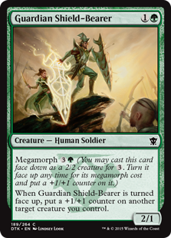 | GUARDIAN SHIELD-BEARER (2)  CREATURE — HUMAN SOLDIER (2/1)  MEGAMORPH <I>(YOU MAY CAST THIS CARD FACE DOWN AS A 2/2 CREATURE FOR . TURN IT FACE UP ANY TIME FOR ITS MEGAMORPH COST AND PUT A +1/+1 COUNTER ON IT.)</I>  WHEN GUARDIAN SHIELD-BEARER IS TURNED FACE UP, PUT A +1/+1 COUNTER ON ANOTHER TARGET CREATURE YOU CONTROL.

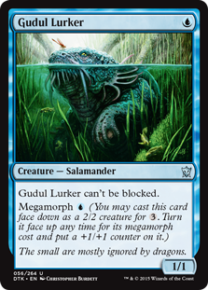 | GUDUL LURKER (1)  CREATURE — SALAMANDER (1/1)  GUDUL LURKER CAN'T BE BLOCKED.  MEGAMORPH <I>(YOU MAY CAST THIS CARD FACE DOWN AS A 2/2 CREATURE FOR . TURN IT FACE UP ANY TIME FOR ITS MEGAMORPH COST AND PUT A +1/+1 COUNTER ON IT.)</I>

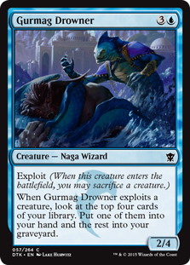 | GURMAG DROWNER (4)  CREATURE — NAGA WIZARD (2/4)  EXPLOIT <I>(WHEN THIS CREATURE ENTERS THE BATTLEFIELD, YOU MAY SACRIFICE A CREATURE.)</I>  WHEN GURMAG DROWNER EXPLOITS A CREATURE, LOOK AT THE TOP FOUR CARDS OF YOUR LIBRARY. PUT ONE OF THEM INTO YOUR HAND AND THE REST INTO YOUR GRAVEYARD.

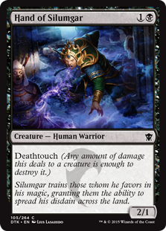 | HAND OF SILUMGAR (2)  CREATURE — HUMAN WARRIOR (2/1)  DEATHTOUCH <I>(ANY AMOUNT OF DAMAGE THIS DEALS TO A CREATURE IS ENOUGH TO DESTROY IT.)</I>

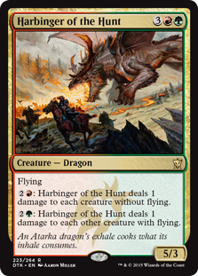 | HARBINGER OF THE HUNT (5)  CREATURE — DRAGON (5/3)  FLYING  : HARBINGER OF THE HUNT DEALS 1 DAMAGE TO EACH CREATURE WITHOUT FLYING.  : HARBINGER OF THE HUNT DEALS 1 DAMAGE TO EACH OTHER CREATURE WITH FLYING.

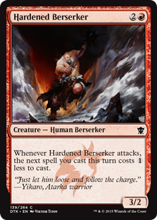 | HARDENED BERSERKER (3)  CREATURE — HUMAN BERSERKER (3/2)  WHENEVER HARDENED BERSERKER ATTACKS, THE NEXT SPELL YOU CAST THIS TURN COSTS LESS TO CAST.

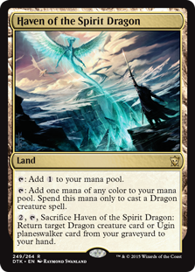 | HAVEN OF THE SPIRIT DRAGON (0)  LAND  : ADD .  : ADD ONE MANA OF ANY COLOR. SPEND THIS MANA ONLY TO CAST A DRAGON CREATURE SPELL.  , , SACRIFICE HAVEN OF THE SPIRIT DRAGON: RETURN TARGET DRAGON CREATURE CARD OR UGIN PLANESWALKER CARD FROM YOUR GRAVEYARD TO YOUR HAND.

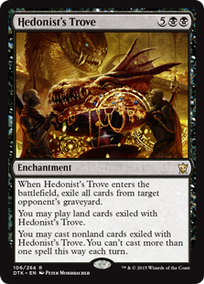 | HEDONIST'S TROVE (7)  ENCHANTMENT  WHEN HEDONIST'S TROVE ENTERS THE BATTLEFIELD, EXILE TARGET OPPONENT'S GRAVEYARD.  YOU MAY PLAY LANDS FROM AMONG CARDS EXILED WITH HEDONIST'S TROVE.  YOU MAY CAST SPELLS FROM AMONG CARDS EXILED WITH HEDONIST'S TROVE. YOU CAN'T CAST MORE THAN ONE SPELL THIS WAY EACH TURN.

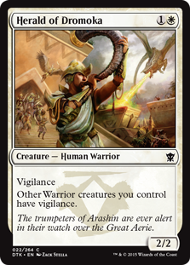 | HERALD OF DROMOKA (2)  CREATURE — HUMAN WARRIOR (2/2)  VIGILANCE  OTHER WARRIOR CREATURES YOU CONTROL HAVE VIGILANCE.

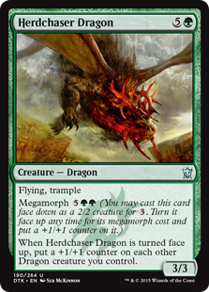 | HERDCHASER DRAGON (6)  CREATURE — DRAGON (3/3)  FLYING, TRAMPLE  MEGAMORPH <I>(YOU MAY CAST THIS CARD FACE DOWN AS A 2/2 CREATURE FOR . TURN IT FACE UP ANY TIME FOR ITS MEGAMORPH COST AND PUT A +1/+1 COUNTER ON IT.)</I>  WHEN HERDCHASER DRAGON IS TURNED FACE UP, PUT A +1/+1 COUNTER ON EACH OTHER DRAGON CREATURE YOU CONTROL.

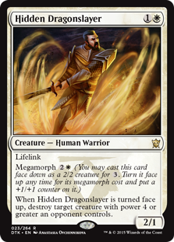 | HIDDEN DRAGONSLAYER (2)  CREATURE — HUMAN WARRIOR (2/1)  LIFELINK  MEGAMORPH <I>(YOU MAY CAST THIS CARD FACE DOWN AS A 2/2 CREATURE FOR . TURN IT FACE UP ANY TIME FOR ITS MEGAMORPH COST AND PUT A +1/+1 COUNTER ON IT.)</I>  WHEN HIDDEN DRAGONSLAYER IS TURNED FACE UP, DESTROY TARGET CREATURE WITH POWER 4 OR GREATER AN OPPONENT CONTROLS.

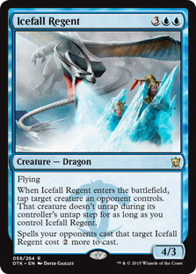 | ICEFALL REGENT (5)  CREATURE — DRAGON (4/3)  FLYING  WHEN ICEFALL REGENT ENTERS THE BATTLEFIELD, TAP TARGET CREATURE AN OPPONENT CONTROLS. THAT CREATURE DOESN'T UNTAP DURING ITS CONTROLLER'S UNTAP STEP FOR AS LONG AS YOU CONTROL ICEFALL REGENT.  SPELLS YOUR OPPONENTS CAST THAT TARGET ICEFALL REGENT COST MORE TO CAST.

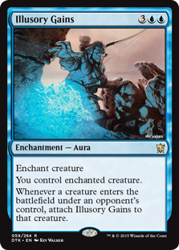 | ILLUSORY GAINS (5)  ENCHANTMENT — AURA  ENCHANT CREATURE  YOU CONTROL ENCHANTED CREATURE.  WHENEVER A CREATURE ENTERS THE BATTLEFIELD UNDER AN OPPONENT'S CONTROL, ATTACH ILLUSORY GAINS TO THAT CREATURE.

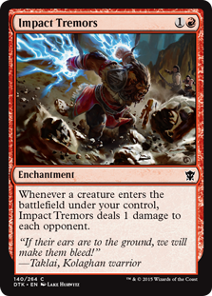 | IMPACT TREMORS (2)  ENCHANTMENT  WHENEVER A CREATURE ENTERS THE BATTLEFIELD UNDER YOUR CONTROL, IMPACT TREMORS DEALS 1 DAMAGE TO EACH OPPONENT.

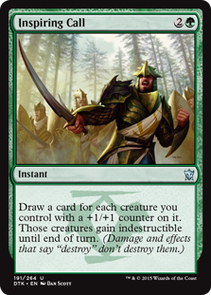 | INSPIRING CALL (3)  INSTANT  DRAW A CARD FOR EACH CREATURE YOU CONTROL WITH A +1/+1 COUNTER ON IT. THOSE CREATURES GAIN INDESTRUCTIBLE UNTIL END OF TURN.

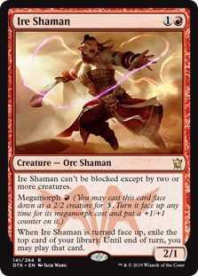 | IRE SHAMAN (2)  CREATURE — ORC SHAMAN (2/1)  MENACE <I>(THIS CREATURE CAN'T BE BLOCKED EXCEPT BY TWO OR MORE CREATURES.)</I>  MEGAMORPH <I>(YOU MAY CAST THIS CARD FACE DOWN AS A 2/2 CREATURE FOR . TURN IT FACE UP ANY TIME FOR ITS MEGAMORPH COST AND PUT A +1/+1 COUNTER ON IT.)</I>  WHEN IRE SHAMAN IS TURNED FACE UP, EXILE THE TOP CARD OF YOUR LIBRARY. UNTIL END OF TURN, YOU MAY PLAY THAT CARD.

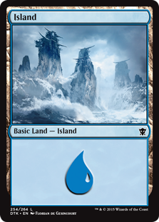 | ISLAND (0)  BASIC LAND — ISLAND

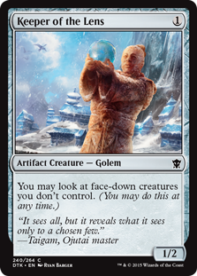 | KEEPER OF THE LENS (1)  ARTIFACT CREATURE — GOLEM (1/2)  YOU MAY LOOK AT FACE-DOWN CREATURES YOU DON'T CONTROL ANY TIME.

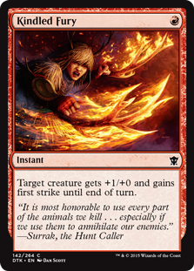 | KINDLED FURY (1)  INSTANT  TARGET CREATURE GETS +1/+0 AND GAINS FIRST STRIKE UNTIL END OF TURN.

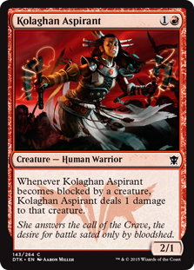 | KOLAGHAN ASPIRANT (2)  CREATURE — HUMAN WARRIOR (2/1)  WHENEVER KOLAGHAN ASPIRANT BECOMES BLOCKED BY A CREATURE, KOLAGHAN ASPIRANT DEALS 1 DAMAGE TO THAT CREATURE.

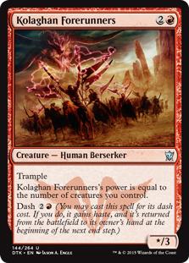 | KOLAGHAN FORERUNNERS (3)  CREATURE — HUMAN BERSERKER (*/3)  TRAMPLE  KOLAGHAN FORERUNNERS'S POWER IS EQUAL TO THE NUMBER OF CREATURES YOU CONTROL.  DASH <I>(YOU MAY CAST THIS SPELL FOR ITS DASH COST. IF YOU DO, IT GAINS HASTE, AND IT'S RETURNED FROM THE BATTLEFIELD TO ITS OWNER'S HAND AT THE BEGINNING OF THE NEXT END STEP.)</I>

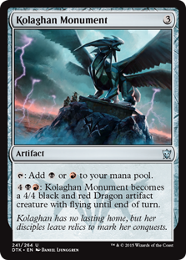 | KOLAGHAN MONUMENT (3)  ARTIFACT  : ADD OR .  : KOLAGHAN MONUMENT BECOMES A 4/4 BLACK AND RED DRAGON ARTIFACT CREATURE WITH FLYING UNTIL END OF TURN.

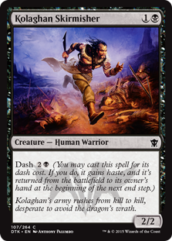 | KOLAGHAN SKIRMISHER (2)  CREATURE — HUMAN WARRIOR (2/2)  DASH <I>(YOU MAY CAST THIS SPELL FOR ITS DASH COST. IF YOU DO, IT GAINS HASTE, AND IT'S RETURNED FROM THE BATTLEFIELD TO ITS OWNER'S HAND AT THE BEGINNING OF THE NEXT END STEP.)</I>

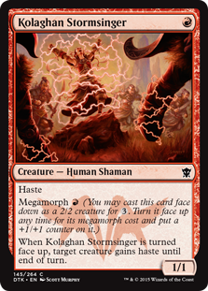 | KOLAGHAN STORMSINGER (1)  CREATURE — HUMAN SHAMAN (1/1)  HASTE  MEGAMORPH <I>(YOU MAY CAST THIS CARD FACE DOWN AS A 2/2 CREATURE FOR . TURN IT FACE UP ANY TIME FOR ITS MEGAMORPH COST AND PUT A +1/+1 COUNTER ON IT.)</I>  WHEN KOLAGHAN STORMSINGER IS TURNED FACE UP, TARGET CREATURE GAINS HASTE UNTIL END OF TURN.

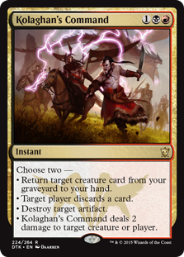 | KOLAGHAN'S COMMAND (3)  INSTANT  CHOOSE TWO —  • RETURN TARGET CREATURE CARD FROM YOUR GRAVEYARD TO YOUR HAND.  • TARGET PLAYER DISCARDS A CARD.  • DESTROY TARGET ARTIFACT.  • KOLAGHAN'S COMMAND DEALS 2 DAMAGE TO ANY TARGET.

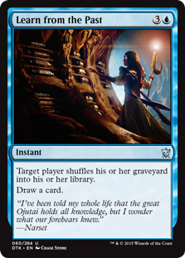 | LEARN FROM THE PAST (4)  INSTANT  TARGET PLAYER SHUFFLES THEIR GRAVEYARD INTO THEIR LIBRARY.  DRAW A CARD.

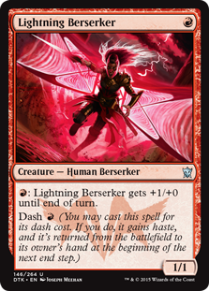 | LIGHTNING BERSERKER (1)  CREATURE — HUMAN BERSERKER (1/1)  : LIGHTNING BERSERKER GETS +1/+0 UNTIL END OF TURN.  DASH <I>(YOU MAY CAST THIS SPELL FOR ITS DASH COST. IF YOU DO, IT GAINS HASTE, AND IT'S RETURNED FROM THE BATTLEFIELD TO ITS OWNER'S HAND AT THE BEGINNING OF THE NEXT END STEP.)</I>

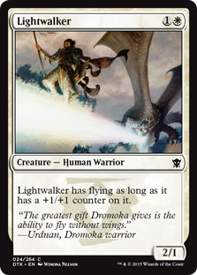 | LIGHTWALKER (2)  CREATURE — HUMAN WARRIOR (2/1)  LIGHTWALKER HAS FLYING AS LONG AS IT HAS A +1/+1 COUNTER ON IT.

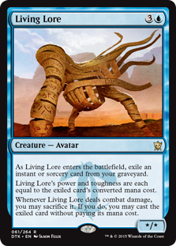 | LIVING LORE (4)  CREATURE — AVATAR (*/*)  AS LIVING LORE ENTERS THE BATTLEFIELD, EXILE AN INSTANT OR SORCERY CARD FROM YOUR GRAVEYARD.  LIVING LORE'S POWER AND TOUGHNESS ARE EACH EQUAL TO THE EXILED CARD'S MANA VALUE.  WHENEVER LIVING LORE DEALS COMBAT DAMAGE, YOU MAY SACRIFICE IT. IF YOU DO, YOU MAY CAST THE EXILED CARD WITHOUT PAYING ITS MANA COST.

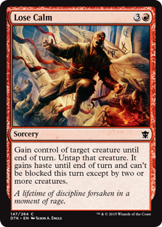 | LOSE CALM (4)  SORCERY  GAIN CONTROL OF TARGET CREATURE UNTIL END OF TURN. UNTAP THAT CREATURE. IT GAINS HASTE AND MENACE UNTIL END OF TURN. <I>(A CREATURE WITH MENACE CAN'T BE BLOCKED EXCEPT BY TWO OR MORE CREATURES.)</I>

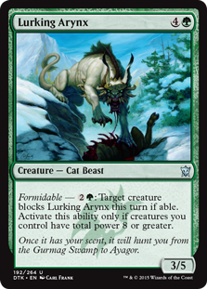 | LURKING ARYNX (5)  CREATURE — CAT BEAST (3/5)  <I>FORMIDABLE</I> — : TARGET CREATURE BLOCKS LURKING ARYNX THIS TURN IF ABLE. ACTIVATE ONLY IF CREATURES YOU CONTROL HAVE TOTAL POWER 8 OR GREATER.

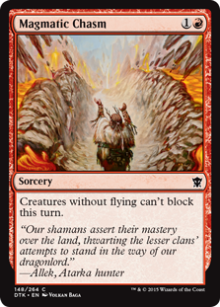 | MAGMATIC CHASM (2)  SORCERY  CREATURES WITHOUT FLYING CAN'T BLOCK THIS TURN.

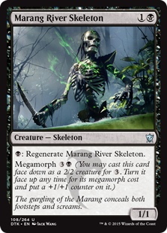 | MARANG RIVER SKELETON (2)  CREATURE — SKELETON (1/1)  : REGENERATE MARANG RIVER SKELETON.  MEGAMORPH <I>(YOU MAY CAST THIS CARD FACE DOWN AS A 2/2 CREATURE FOR . TURN IT FACE UP ANY TIME FOR ITS MEGAMORPH COST AND PUT A +1/+1 COUNTER ON IT.)</I>

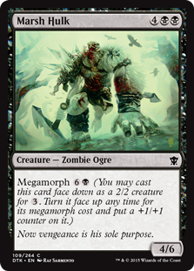 | MARSH HULK (6)  CREATURE — ZOMBIE OGRE (4/6)  MEGAMORPH <I>(YOU MAY CAST THIS CARD FACE DOWN AS A 2/2 CREATURE FOR . TURN IT FACE UP ANY TIME FOR ITS MEGAMORPH COST AND PUT A +1/+1 COUNTER ON IT.)</I>

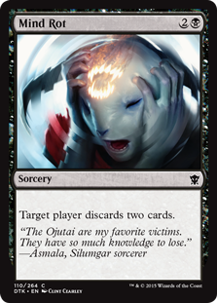 | MIND ROT (3)  SORCERY  TARGET PLAYER DISCARDS TWO CARDS.

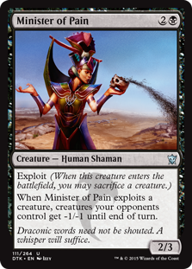 | MINISTER OF PAIN (3)  CREATURE — HUMAN SHAMAN (2/3)  EXPLOIT <I>(WHEN THIS CREATURE ENTERS THE BATTLEFIELD, YOU MAY SACRIFICE A CREATURE.)</I>  WHEN MINISTER OF PAIN EXPLOITS A CREATURE, CREATURES YOUR OPPONENTS CONTROL GET -1/-1 UNTIL END OF TURN.

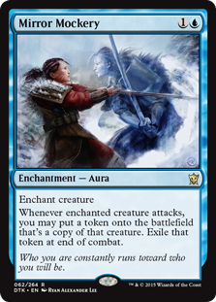 | MIRROR MOCKERY (2)  ENCHANTMENT — AURA  ENCHANT CREATURE  WHENEVER ENCHANTED CREATURE ATTACKS, YOU MAY CREATE A TOKEN THAT'S A COPY OF THAT CREATURE. EXILE THAT TOKEN AT END OF COMBAT.

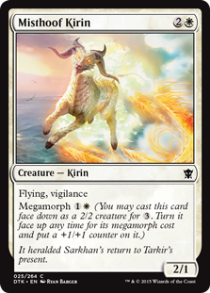 | MISTHOOF KIRIN (3)  CREATURE — KIRIN (2/1)  FLYING, VIGILANCE  MEGAMORPH <I>(YOU MAY CAST THIS CARD FACE DOWN AS A 2/2 CREATURE FOR . TURN IT FACE UP ANY TIME FOR ITS MEGAMORPH COST AND PUT A +1/+1 COUNTER ON IT.)</I>

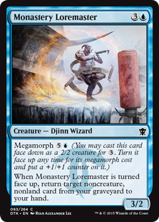 | MONASTERY LOREMASTER (4)  CREATURE — DJINN WIZARD (3/2)  MEGAMORPH <I>(YOU MAY CAST THIS CARD FACE DOWN AS A 2/2 CREATURE FOR . TURN IT FACE UP ANY TIME FOR ITS MEGAMORPH COST AND PUT A +1/+1 COUNTER ON IT.)</I>  WHEN MONASTERY LOREMASTER IS TURNED FACE UP, RETURN TARGET NONCREATURE, NONLAND CARD FROM YOUR GRAVEYARD TO YOUR HAND.

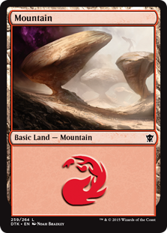 | MOUNTAIN (0)  BASIC LAND — MOUNTAIN

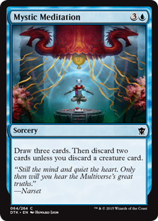 | MYSTIC MEDITATION (4)  SORCERY  DRAW THREE CARDS. THEN DISCARD TWO CARDS UNLESS YOU DISCARD A CREATURE CARD.

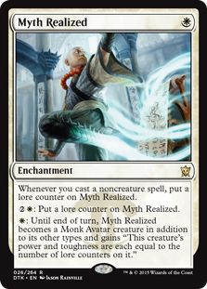 | MYTH REALIZED (1)  ENCHANTMENT  WHENEVER YOU CAST A NONCREATURE SPELL, PUT A LORE COUNTER ON MYTH REALIZED.  : PUT A LORE COUNTER ON MYTH REALIZED.  : UNTIL END OF TURN, MYTH REALIZED BECOMES A MONK AVATAR CREATURE IN ADDITION TO ITS OTHER TYPES AND GAINS "THIS CREATURE'S POWER AND TOUGHNESS ARE EACH EQUAL TO THE NUMBER OF LORE COUNTERS ON IT."

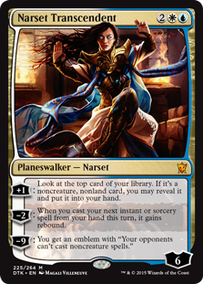 | NARSET TRANSCENDENT (4)  LEGENDARY PLANESWALKER — NARSET (6)  +1: LOOK AT THE TOP CARD OF YOUR LIBRARY. IF IT'S A NONCREATURE, NONLAND CARD, YOU MAY REVEAL IT AND PUT IT INTO YOUR HAND.  −2: WHEN YOU CAST YOUR NEXT INSTANT OR SORCERY SPELL FROM YOUR HAND THIS TURN, IT GAINS REBOUND. <I>(EXILE THE SPELL AS IT RESOLVES. AT THE BEGINNING OF YOUR NEXT UPKEEP, YOU MAY CAST THAT CARD FROM EXILE WITHOUT PAYING ITS MANA COST.)</I>  −9: YOU GET AN EMBLEM WITH "YOUR OPPONENTS CAN'T CAST NONCREATURE SPELLS."

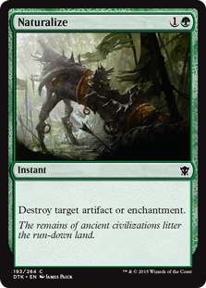 | NATURALIZE (2)  INSTANT  DESTROY TARGET ARTIFACT OR ENCHANTMENT.

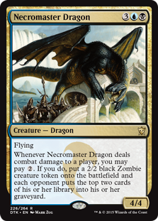 | NECROMASTER DRAGON (5)  CREATURE — DRAGON (4/4)  FLYING  WHENEVER NECROMASTER DRAGON DEALS COMBAT DAMAGE TO A PLAYER, YOU MAY PAY . IF YOU DO, CREATE A 2/2 BLACK ZOMBIE CREATURE TOKEN AND EACH OPPONENT MILLS TWO CARDS.

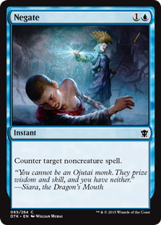 | NEGATE (2)  INSTANT  COUNTER TARGET NONCREATURE SPELL.

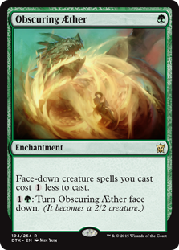 | OBSCURING ÆTHER (OBSCURING AETHER) (1)  ENCHANTMENT  FACE-DOWN CREATURE SPELLS YOU CAST COST LESS TO CAST.  : TURN OBSCURING AETHER FACE DOWN. <I>(IT BECOMES A 2/2 CREATURE.)</I>

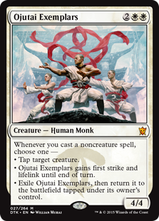 | OJUTAI EXEMPLARS (4)  CREATURE — HUMAN MONK (4/4)  WHENEVER YOU CAST A NONCREATURE SPELL, CHOOSE ONE —  • TAP TARGET CREATURE.  • OJUTAI EXEMPLARS GAINS FIRST STRIKE AND LIFELINK UNTIL END OF TURN.  • EXILE OJUTAI EXEMPLARS, THEN RETURN IT TO THE BATTLEFIELD TAPPED UNDER ITS OWNER'S CONTROL.

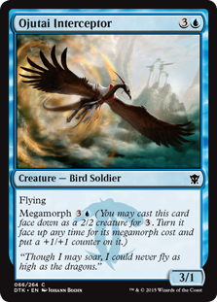 | OJUTAI INTERCEPTOR (4)  CREATURE — BIRD SOLDIER (3/1)  FLYING  MEGAMORPH <I>(YOU MAY CAST THIS CARD FACE DOWN AS A 2/2 CREATURE FOR . TURN IT FACE UP ANY TIME FOR ITS MEGAMORPH COST AND PUT A +1/+1 COUNTER ON IT.)</I>

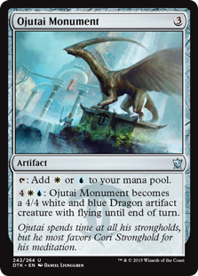 | OJUTAI MONUMENT (3)  ARTIFACT  : ADD OR .  : OJUTAI MONUMENT BECOMES A 4/4 WHITE AND BLUE DRAGON ARTIFACT CREATURE WITH FLYING UNTIL END OF TURN.

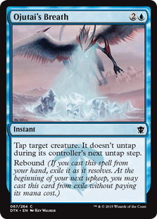 | OJUTAI'S BREATH (3)  INSTANT  TAP TARGET CREATURE. IT DOESN'T UNTAP DURING ITS CONTROLLER'S NEXT UNTAP STEP.  REBOUND <I>(IF YOU CAST THIS SPELL FROM YOUR HAND, EXILE IT AS IT RESOLVES. AT THE BEGINNING OF YOUR NEXT UPKEEP, YOU MAY CAST THIS CARD FROM EXILE WITHOUT PAYING ITS MANA COST.)</I>

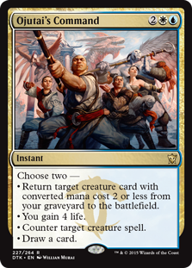 | OJUTAI'S COMMAND (4)  INSTANT  CHOOSE TWO —  • RETURN TARGET CREATURE CARD WITH MANA VALUE 2 OR LESS FROM YOUR GRAVEYARD TO THE BATTLEFIELD.  • YOU GAIN 4 LIFE.  • COUNTER TARGET CREATURE SPELL.  • DRAW A CARD.

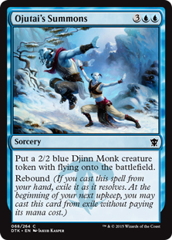 | OJUTAI'S SUMMONS (5)  SORCERY  CREATE A 2/2 BLUE DJINN MONK CREATURE TOKEN WITH FLYING.  REBOUND <I>(IF YOU CAST THIS SPELL FROM YOUR HAND, EXILE IT AS IT RESOLVES. AT THE BEGINNING OF YOUR NEXT UPKEEP, YOU MAY CAST THIS CARD FROM EXILE WITHOUT PAYING ITS MANA COST.)</I>

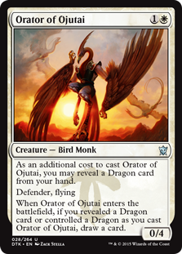 | ORATOR OF OJUTAI (2)  CREATURE — BIRD MONK (0/4)  AS AN ADDITIONAL COST TO CAST THIS SPELL, YOU MAY REVEAL A DRAGON CARD FROM YOUR HAND.  DEFENDER, FLYING  WHEN ORATOR OF OJUTAI ENTERS THE BATTLEFIELD, IF YOU REVEALED A DRAGON CARD OR CONTROLLED A DRAGON AS YOU CAST THIS SPELL, DRAW A CARD.

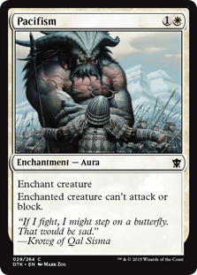 | PACIFISM (2)  ENCHANTMENT — AURA  ENCHANT CREATURE  ENCHANTED CREATURE CAN'T ATTACK OR BLOCK.

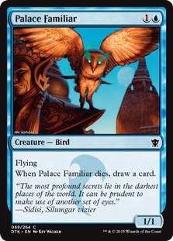 | PALACE FAMILIAR (2)  CREATURE — BIRD (1/1)  FLYING  WHEN PALACE FAMILIAR DIES, DRAW A CARD.

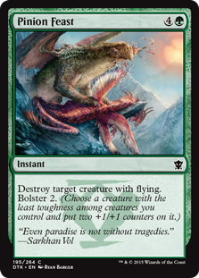 | PINION FEAST (5)  INSTANT  DESTROY TARGET CREATURE WITH FLYING. BOLSTER 2. <I>(CHOOSE A CREATURE WITH THE LEAST TOUGHNESS AMONG CREATURES YOU CONTROL AND PUT TWO +1/+1 COUNTERS ON IT.)</I>

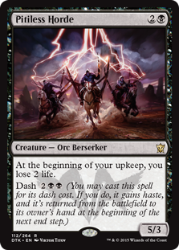 | PITILESS HORDE (3)  CREATURE — ORC BERSERKER (5/3)  AT THE BEGINNING OF YOUR UPKEEP, YOU LOSE 2 LIFE.  DASH <I>(YOU MAY CAST THIS SPELL FOR ITS DASH COST. IF YOU DO, IT GAINS HASTE, AND IT'S RETURNED FROM THE BATTLEFIELD TO ITS OWNER'S HAND AT THE BEGINNING OF THE NEXT END STEP.)</I>

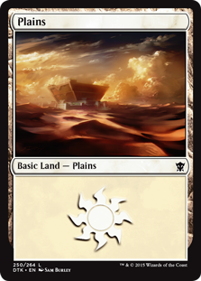 | PLAINS (0)  BASIC LAND — PLAINS

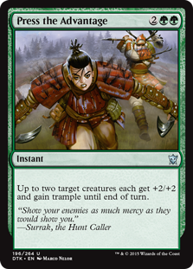 | PRESS THE ADVANTAGE (4)  INSTANT  UP TO TWO TARGET CREATURES EACH GET +2/+2 AND GAIN TRAMPLE UNTIL END OF TURN.

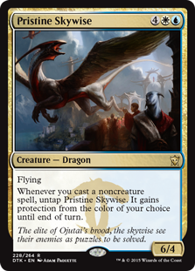 | PRISTINE SKYWISE (6)  CREATURE — DRAGON (6/4)  FLYING  WHENEVER YOU CAST A NONCREATURE SPELL, UNTAP PRISTINE SKYWISE. IT GAINS PROTECTION FROM THE COLOR OF YOUR CHOICE UNTIL END OF TURN.

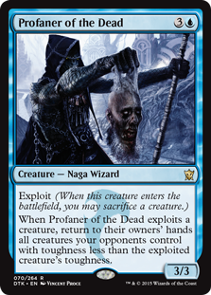 | PROFANER OF THE DEAD (4)  CREATURE — NAGA WIZARD (3/3)  EXPLOIT <I>(WHEN THIS CREATURE ENTERS THE BATTLEFIELD, YOU MAY SACRIFICE A CREATURE.)</I>  WHEN PROFANER OF THE DEAD EXPLOITS A CREATURE, RETURN TO THEIR OWNERS' HANDS ALL CREATURES YOUR OPPONENTS CONTROL WITH TOUGHNESS LESS THAN THE EXPLOITED CREATURE'S TOUGHNESS.

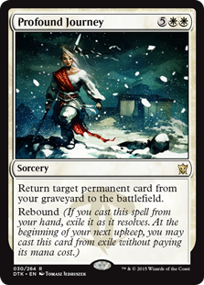 | PROFOUND JOURNEY (7)  SORCERY  RETURN TARGET PERMANENT CARD FROM YOUR GRAVEYARD TO THE BATTLEFIELD.  REBOUND <I>(IF YOU CAST THIS SPELL FROM YOUR HAND, EXILE IT AS IT RESOLVES. AT THE BEGINNING OF YOUR NEXT UPKEEP, YOU MAY CAST THIS CARD FROM EXILE WITHOUT PAYING ITS MANA COST.)</I>

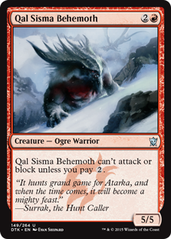 | QAL SISMA BEHEMOTH (3)  CREATURE — OGRE WARRIOR (5/5)  QAL SISMA BEHEMOTH CAN'T ATTACK OR BLOCK UNLESS YOU PAY .

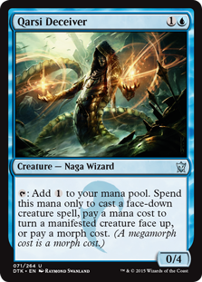 | QARSI DECEIVER (2)  CREATURE — NAGA WIZARD (0/4)  : ADD . SPEND THIS MANA ONLY TO CAST A FACE-DOWN CREATURE SPELL, PAY A MANA COST TO TURN A MANIFESTED CREATURE FACE UP, OR PAY A MORPH COST. <I>(A MEGAMORPH COST IS A MORPH COST.)</I>

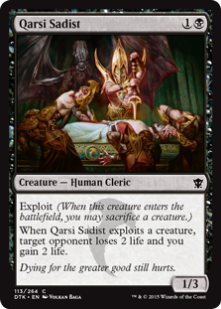 | QARSI SADIST (2)  CREATURE — HUMAN CLERIC (1/3)  EXPLOIT <I>(WHEN THIS CREATURE ENTERS THE BATTLEFIELD, YOU MAY SACRIFICE A CREATURE.)</I>  WHEN QARSI SADIST EXPLOITS A CREATURE, TARGET OPPONENT LOSES 2 LIFE AND YOU GAIN 2 LIFE.

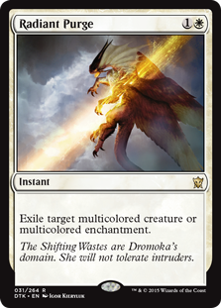 | RADIANT PURGE (2)  INSTANT  EXILE TARGET MULTICOLORED CREATURE OR MULTICOLORED ENCHANTMENT.

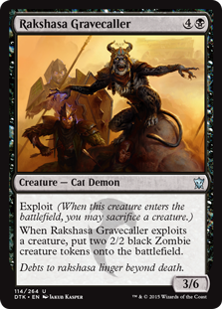 | RAKSHASA GRAVECALLER (5)  CREATURE — CAT DEMON (3/6)  EXPLOIT <I>(WHEN THIS CREATURE ENTERS THE BATTLEFIELD, YOU MAY SACRIFICE A CREATURE.)</I>  WHEN RAKSHASA GRAVECALLER EXPLOITS A CREATURE, CREATE TWO 2/2 BLACK ZOMBIE CREATURE TOKENS.

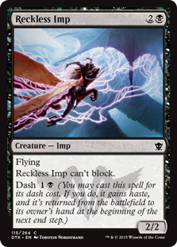 | RECKLESS IMP (3)  CREATURE — IMP (2/2)  FLYING  RECKLESS IMP CAN'T BLOCK.  DASH <I>(YOU MAY CAST THIS SPELL FOR ITS DASH COST. IF YOU DO, IT GAINS HASTE, AND IT'S RETURNED FROM THE BATTLEFIELD TO ITS OWNER'S HAND AT THE BEGINNING OF THE NEXT END STEP.)</I>

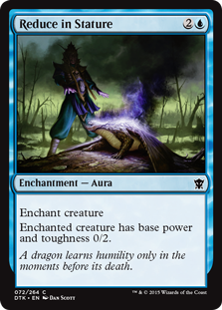 | REDUCE IN STATURE (3)  ENCHANTMENT — AURA  ENCHANT CREATURE  ENCHANTED CREATURE HAS BASE POWER AND TOUGHNESS 0/2.

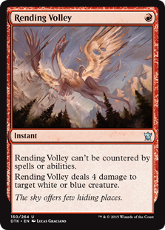 | RENDING VOLLEY (1)  INSTANT  THIS SPELL CAN'T BE COUNTERED.  RENDING VOLLEY DEALS 4 DAMAGE TO TARGET WHITE OR BLUE CREATURE.

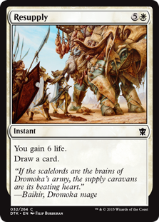 | RESUPPLY (6)  INSTANT  YOU GAIN 6 LIFE.  DRAW A CARD.

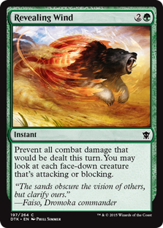 | REVEALING WIND (3)  INSTANT  PREVENT ALL COMBAT DAMAGE THAT WOULD BE DEALT THIS TURN. YOU MAY LOOK AT EACH FACE-DOWN CREATURE THAT'S ATTACKING OR BLOCKING.

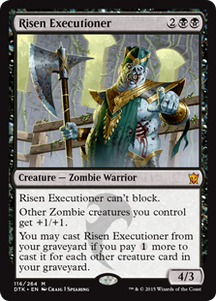 | RISEN EXECUTIONER (4)  CREATURE — ZOMBIE WARRIOR (4/3)  RISEN EXECUTIONER CAN'T BLOCK.  OTHER ZOMBIE CREATURES YOU CONTROL GET +1/+1.  YOU MAY CAST RISEN EXECUTIONER FROM YOUR GRAVEYARD IF YOU PAY MORE TO CAST IT FOR EACH OTHER CREATURE CARD IN YOUR GRAVEYARD.

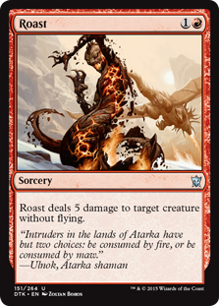 | ROAST (2)  SORCERY  ROAST DEALS 5 DAMAGE TO TARGET CREATURE WITHOUT FLYING.

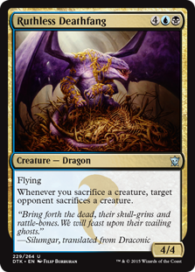 | RUTHLESS DEATHFANG (6)  CREATURE — DRAGON (4/4)  FLYING  WHENEVER YOU SACRIFICE A CREATURE, TARGET OPPONENT SACRIFICES A CREATURE.

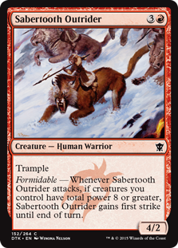 | SABERTOOTH OUTRIDER (4)  CREATURE — HUMAN WARRIOR (4/2)  TRAMPLE  <I>FORMIDABLE</I> — WHENEVER SABERTOOTH OUTRIDER ATTACKS, IF CREATURES YOU CONTROL HAVE TOTAL POWER 8 OR GREATER, SABERTOOTH OUTRIDER GAINS FIRST STRIKE UNTIL END OF TURN.

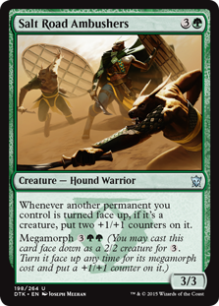 | SALT ROAD AMBUSHERS (4)  CREATURE — DOG WARRIOR (3/3)  WHENEVER ANOTHER PERMANENT YOU CONTROL IS TURNED FACE UP, IF IT'S A CREATURE, PUT TWO +1/+1 COUNTERS ON IT.  MEGAMORPH <I>(YOU MAY CAST THIS CARD FACE DOWN AS A 2/2 CREATURE FOR . TURN IT FACE UP ANY TIME FOR ITS MEGAMORPH COST AND PUT A +1/+1 COUNTER ON IT.)</I>

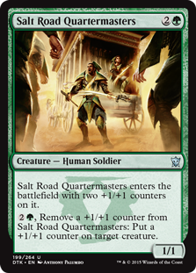 | SALT ROAD QUARTERMASTERS (3)  CREATURE — HUMAN SOLDIER (1/1)  SALT ROAD QUARTERMASTERS ENTERS THE BATTLEFIELD WITH TWO +1/+1 COUNTERS ON IT.  , REMOVE A +1/+1 COUNTER FROM SALT ROAD QUARTERMASTERS: PUT A +1/+1 COUNTER ON TARGET CREATURE.

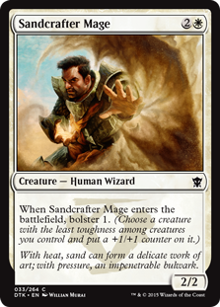 | SANDCRAFTER MAGE (3)  CREATURE — HUMAN WIZARD (2/2)  WHEN SANDCRAFTER MAGE ENTERS THE BATTLEFIELD, BOLSTER 1. <I>(CHOOSE A CREATURE WITH THE LEAST TOUGHNESS AMONG CREATURES YOU CONTROL AND PUT A +1/+1 COUNTER ON IT.)</I>

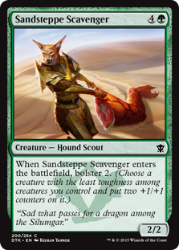 | SANDSTEPPE SCAVENGER (5)  CREATURE — DOG SCOUT (2/2)  WHEN SANDSTEPPE SCAVENGER ENTERS THE BATTLEFIELD, BOLSTER 2. <I>(CHOOSE A CREATURE WITH THE LEAST TOUGHNESS AMONG CREATURES YOU CONTROL AND PUT TWO +1/+1 COUNTERS ON IT.)</I>

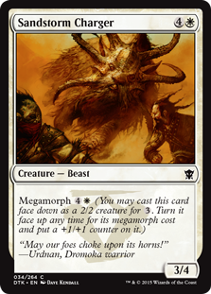 | SANDSTORM CHARGER (5)  CREATURE — BEAST (3/4)  MEGAMORPH <I>(YOU MAY CAST THIS CARD FACE DOWN AS A 2/2 CREATURE FOR . TURN IT FACE UP ANY TIME FOR ITS MEGAMORPH COST AND PUT A +1/+1 COUNTER ON IT.)</I>

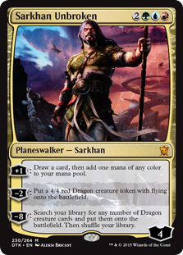 | SARKHAN UNBROKEN (5)  LEGENDARY PLANESWALKER — SARKHAN (4)  +1: DRAW A CARD, THEN ADD ONE MANA OF ANY COLOR.  −2: CREATE A 4/4 RED DRAGON CREATURE TOKEN WITH FLYING.  −8: SEARCH YOUR LIBRARY FOR ANY NUMBER OF DRAGON CREATURE CARDS, PUT THEM ONTO THE BATTLEFIELD, THEN SHUFFLE.

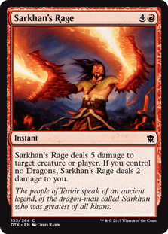 | SARKHAN'S RAGE (5)  INSTANT  SARKHAN'S RAGE DEALS 5 DAMAGE TO ANY TARGET. IF YOU CONTROL NO DRAGONS, SARKHAN'S RAGE DEALS 2 DAMAGE TO YOU.

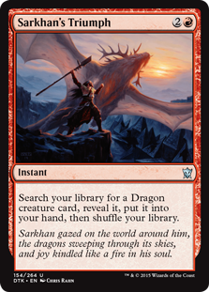 | SARKHAN'S TRIUMPH (3)  INSTANT  SEARCH YOUR LIBRARY FOR A DRAGON CREATURE CARD, REVEAL IT, PUT IT INTO YOUR HAND, THEN SHUFFLE.

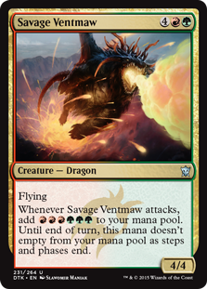 | SAVAGE VENTMAW (6)  CREATURE — DRAGON (4/4)  FLYING  WHENEVER SAVAGE VENTMAW ATTACKS, ADD . UNTIL END OF TURN, YOU DON'T LOSE THIS MANA AS STEPS AND PHASES END.

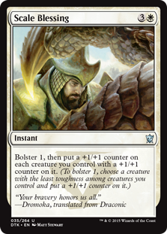 | SCALE BLESSING (4)  INSTANT  BOLSTER 1, THEN PUT A +1/+1 COUNTER ON EACH CREATURE YOU CONTROL WITH A +1/+1 COUNTER ON IT. <I>(TO BOLSTER 1, CHOOSE A CREATURE WITH THE LEAST TOUGHNESS AMONG CREATURES YOU CONTROL AND PUT A +1/+1 COUNTER ON IT.)</I>

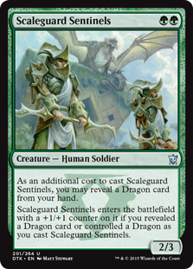 | SCALEGUARD SENTINELS (2)  CREATURE — HUMAN SOLDIER (2/3)  AS AN ADDITIONAL COST TO CAST THIS SPELL, YOU MAY REVEAL A DRAGON CARD FROM YOUR HAND.  SCALEGUARD SENTINELS ENTERS THE BATTLEFIELD WITH A +1/+1 COUNTER ON IT IF YOU REVEALED A DRAGON CARD OR CONTROLLED A DRAGON AS YOU CAST THIS SPELL.

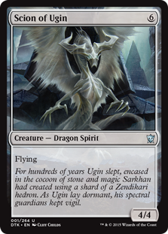 | SCION OF UGIN (6)  CREATURE — DRAGON SPIRIT (4/4)  FLYING

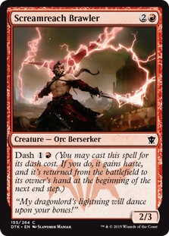 | SCREAMREACH BRAWLER (3)  CREATURE — ORC BERSERKER (2/3)  DASH <I>(YOU MAY CAST THIS SPELL FOR ITS DASH COST. IF YOU DO, IT GAINS HASTE, AND IT'S RETURNED FROM THE BATTLEFIELD TO ITS OWNER'S HAND AT THE BEGINNING OF THE NEXT END STEP.)</I>

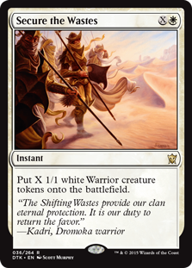 | SECURE THE WASTES (1)  INSTANT  CREATE X 1/1 WHITE WARRIOR CREATURE TOKENS.

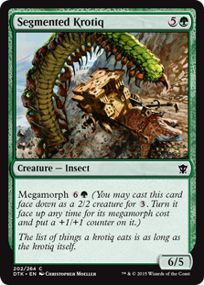 | SEGMENTED KROTIQ (6)  CREATURE — INSECT (6/5)  MEGAMORPH <I>(YOU MAY CAST THIS CARD FACE DOWN AS A 2/2 CREATURE FOR . TURN IT FACE UP ANY TIME FOR ITS MEGAMORPH COST AND PUT A +1/+1 COUNTER ON IT.)</I>

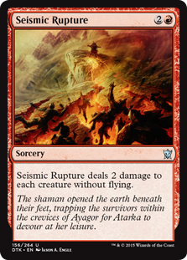 | SEISMIC RUPTURE (3)  SORCERY  SEISMIC RUPTURE DEALS 2 DAMAGE TO EACH CREATURE WITHOUT FLYING.

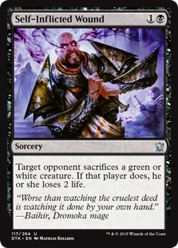 | SELF-INFLICTED WOUND (2)  SORCERY  TARGET OPPONENT SACRIFICES A GREEN OR WHITE CREATURE. IF THAT PLAYER DOES, THEY LOSE 2 LIFE.

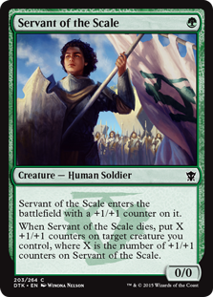 | SERVANT OF THE SCALE (1)  CREATURE — HUMAN SOLDIER (0/0)  SERVANT OF THE SCALE ENTERS THE BATTLEFIELD WITH A +1/+1 COUNTER ON IT.  WHEN SERVANT OF THE SCALE DIES, PUT X +1/+1 COUNTERS ON TARGET CREATURE YOU CONTROL, WHERE X IS THE NUMBER OF +1/+1 COUNTERS ON SERVANT OF THE SCALE.

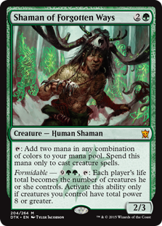 | SHAMAN OF FORGOTTEN WAYS (3)  CREATURE — HUMAN SHAMAN (2/3)  : ADD TWO MANA IN ANY COMBINATION OF COLORS. SPEND THIS MANA ONLY TO CAST CREATURE SPELLS.  <I>FORMIDABLE</I> — , : EACH PLAYER'S LIFE TOTAL BECOMES THE NUMBER OF CREATURES THEY CONTROL. ACTIVATE ONLY IF CREATURES YOU CONTROL HAVE TOTAL POWER 8 OR GREATER.

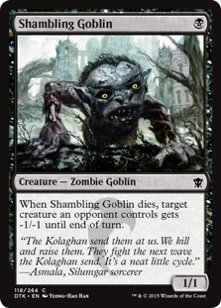 | SHAMBLING GOBLIN (1)  CREATURE — ZOMBIE GOBLIN (1/1)  WHEN SHAMBLING GOBLIN DIES, TARGET CREATURE AN OPPONENT CONTROLS GETS -1/-1 UNTIL END OF TURN.

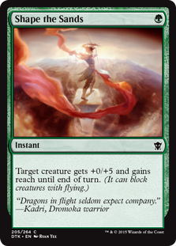 | SHAPE THE SANDS (1)  INSTANT  TARGET CREATURE GETS +0/+5 AND GAINS REACH UNTIL END OF TURN. <I>(IT CAN BLOCK CREATURES WITH FLYING.)</I>

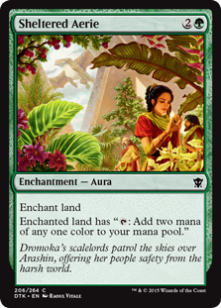 | SHELTERED AERIE (3)  ENCHANTMENT — AURA  ENCHANT LAND  ENCHANTED LAND HAS ": ADD TWO MANA OF ANY ONE COLOR."

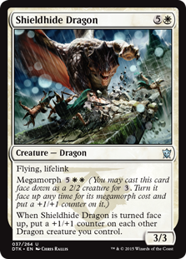 |  | SHIELDHIDE DRAGON (6)  CREATURE — DRAGON (3/3)  FLYING, LIFELINK  MEGAMORPH <I>(YOU MAY CAST THIS CARD FACE DOWN AS A 2/2 CREATURE FOR . TURN IT FACE UP ANY TIME FOR ITS MEGAMORPH COST AND PUT A +1/+1 COUNTER ON IT.)</I>  WHEN SHIELDHIDE DRAGON IS TURNED FACE UP, PUT A +1/+1 COUNTER ON EACH OTHER DRAGON CREATURE YOU CONTROL.
 | 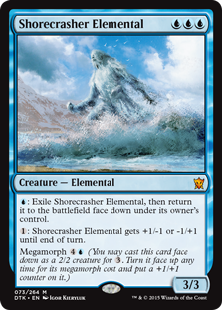 | SHORECRASHER ELEMENTAL (3)  CREATURE — ELEMENTAL (3/3)  : EXILE SHORECRASHER ELEMENTAL, THEN RETURN IT TO THE BATTLEFIELD FACE DOWN UNDER ITS OWNER'S CONTROL.  : SHORECRASHER ELEMENTAL GETS +1/-1 OR -1/+1 UNTIL END OF TURN.  MEGAMORPH <I>(YOU MAY CAST THIS CARD FACE DOWN AS A 2/2 CREATURE FOR . TURN IT FACE UP ANY TIME FOR ITS MEGAMORPH COST AND PUT A +1/+1 COUNTER ON IT.)</I>

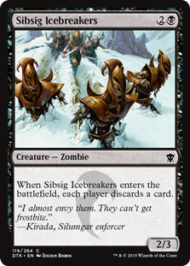 | SIBSIG ICEBREAKERS (3)  CREATURE — ZOMBIE (2/3)  WHEN SIBSIG ICEBREAKERS ENTERS THE BATTLEFIELD, EACH PLAYER DISCARDS A CARD.

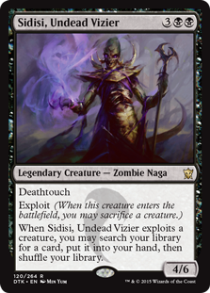 | SIDISI, UNDEAD VIZIER (5)  LEGENDARY CREATURE — ZOMBIE NAGA (4/6)  DEATHTOUCH  EXPLOIT <I>(WHEN THIS CREATURE ENTERS THE BATTLEFIELD, YOU MAY SACRIFICE A CREATURE.)</I>  WHEN SIDISI, UNDEAD VIZIER EXPLOITS A CREATURE, YOU MAY SEARCH YOUR LIBRARY FOR A CARD, PUT IT INTO YOUR HAND, THEN SHUFFLE.

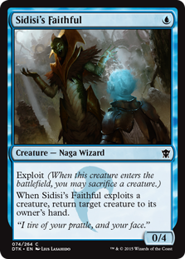 | SIDISI'S FAITHFUL (1)  CREATURE — NAGA WIZARD (0/4)  EXPLOIT <I>(WHEN THIS CREATURE ENTERS THE BATTLEFIELD, YOU MAY SACRIFICE A CREATURE.)</I>  WHEN SIDISI'S FAITHFUL EXPLOITS A CREATURE, RETURN TARGET CREATURE TO ITS OWNER'S HAND.

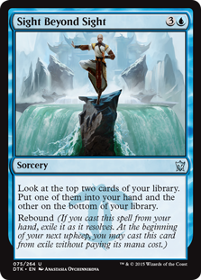 | SIGHT BEYOND SIGHT (4)  SORCERY  LOOK AT THE TOP TWO CARDS OF YOUR LIBRARY. PUT ONE OF THEM INTO YOUR HAND AND THE OTHER ON THE BOTTOM OF YOUR LIBRARY.  REBOUND <I>(IF YOU CAST THIS SPELL FROM YOUR HAND, EXILE IT AS IT RESOLVES. AT THE BEGINNING OF YOUR NEXT UPKEEP, YOU MAY CAST THIS CARD FROM EXILE WITHOUT PAYING ITS MANA COST.)</I>

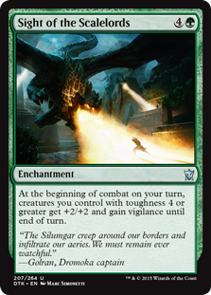 | SIGHT OF THE SCALELORDS (5)  ENCHANTMENT  AT THE BEGINNING OF COMBAT ON YOUR TURN, CREATURES YOU CONTROL WITH TOUGHNESS 4 OR GREATER GET +2/+2 AND GAIN VIGILANCE UNTIL END OF TURN.

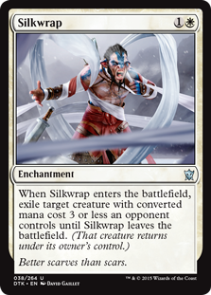 | SILKWRAP (2)  ENCHANTMENT  WHEN SILKWRAP ENTERS THE BATTLEFIELD, EXILE TARGET CREATURE WITH MANA VALUE 3 OR LESS AN OPPONENT CONTROLS UNTIL SILKWRAP LEAVES THE BATTLEFIELD. <I>(THAT CREATURE RETURNS UNDER ITS OWNER'S CONTROL.)</I>

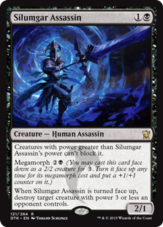 | SILUMGAR ASSASSIN (2)  CREATURE — HUMAN ASSASSIN (2/1)  CREATURES WITH POWER GREATER THAN SILUMGAR ASSASSIN'S POWER CAN'T BLOCK IT.  MEGAMORPH <I>(YOU MAY CAST THIS CARD FACE DOWN AS A 2/2 CREATURE FOR . TURN IT FACE UP ANY TIME FOR ITS MEGAMORPH COST AND PUT A +1/+1 COUNTER ON IT.)</I>  WHEN SILUMGAR ASSASSIN IS TURNED FACE UP, DESTROY TARGET CREATURE WITH POWER 3 OR LESS AN OPPONENT CONTROLS.

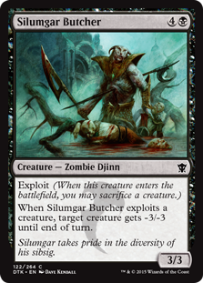 | SILUMGAR BUTCHER (5)  CREATURE — ZOMBIE DJINN (3/3)  EXPLOIT <I>(WHEN THIS CREATURE ENTERS THE BATTLEFIELD, YOU MAY SACRIFICE A CREATURE.)</I>  WHEN SILUMGAR BUTCHER EXPLOITS A CREATURE, TARGET CREATURE GETS -3/-3 UNTIL END OF TURN.

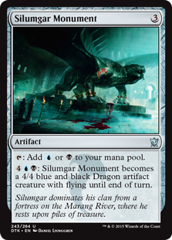 | SILUMGAR MONUMENT (3)  ARTIFACT  : ADD OR .  : SILUMGAR MONUMENT BECOMES A 4/4 BLUE AND BLACK DRAGON ARTIFACT CREATURE WITH FLYING UNTIL END OF TURN.

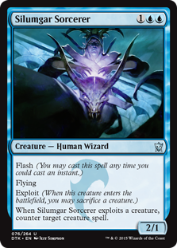 | SILUMGAR SORCERER (3)  CREATURE — HUMAN WIZARD (2/1)  FLASH <I>(YOU MAY CAST THIS SPELL ANY TIME YOU COULD CAST AN INSTANT.)</I>  FLYING  EXPLOIT <I>(WHEN THIS CREATURE ENTERS THE BATTLEFIELD, YOU MAY SACRIFICE A CREATURE.)</I>  WHEN SILUMGAR SORCERER EXPLOITS A CREATURE, COUNTER TARGET CREATURE SPELL.

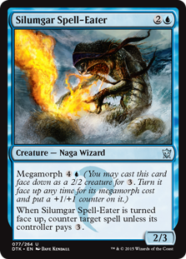 | SILUMGAR SPELL-EATER (3)  CREATURE — NAGA WIZARD (2/3)  MEGAMORPH <I>(YOU MAY CAST THIS CARD FACE DOWN AS A 2/2 CREATURE FOR . TURN IT FACE UP ANY TIME FOR ITS MEGAMORPH COST AND PUT A +1/+1 COUNTER ON IT.)</I>  WHEN SILUMGAR SPELL-EATER IS TURNED FACE UP, COUNTER TARGET SPELL UNLESS ITS CONTROLLER PAYS .

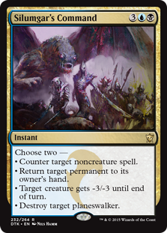 | SILUMGAR'S COMMAND (5)  INSTANT  CHOOSE TWO —  • COUNTER TARGET NONCREATURE SPELL.  • RETURN TARGET PERMANENT TO ITS OWNER'S HAND.  • TARGET CREATURE GETS -3/-3 UNTIL END OF TURN.  • DESTROY TARGET PLANESWALKER.

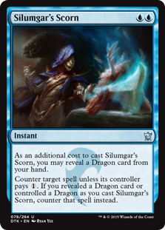 | SILUMGAR'S SCORN (2)  INSTANT  AS AN ADDITIONAL COST TO CAST THIS SPELL, YOU MAY REVEAL A DRAGON CARD FROM YOUR HAND.  COUNTER TARGET SPELL UNLESS ITS CONTROLLER PAYS . IF YOU REVEALED A DRAGON CARD OR CONTROLLED A DRAGON AS YOU CAST THIS SPELL, COUNTER THAT SPELL INSTEAD.

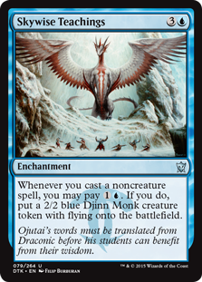 | SKYWISE TEACHINGS (4)  ENCHANTMENT  WHENEVER YOU CAST A NONCREATURE SPELL, YOU MAY PAY . IF YOU DO, CREATE A 2/2 BLUE DJINN MONK CREATURE TOKEN WITH FLYING.

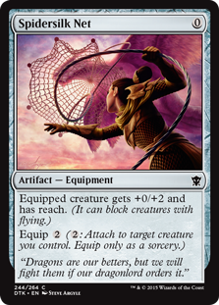 | SPIDERSILK NET (0)  ARTIFACT — EQUIPMENT  EQUIPPED CREATURE GETS +0/+2 AND HAS REACH. <I>(IT CAN BLOCK CREATURES WITH FLYING.)</I>  EQUIP <I>(: ATTACH TO TARGET CREATURE YOU CONTROL. EQUIP ONLY AS A SORCERY.)</I>

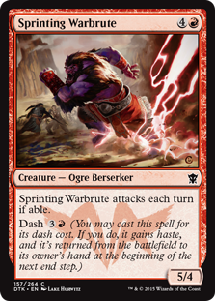 | SPRINTING WARBRUTE (5)  CREATURE — OGRE BERSERKER (5/4)  SPRINTING WARBRUTE ATTACKS EACH COMBAT IF ABLE.  DASH <I>(YOU MAY CAST THIS SPELL FOR ITS DASH COST. IF YOU DO, IT GAINS HASTE, AND IT'S RETURNED FROM THE BATTLEFIELD TO ITS OWNER'S HAND AT THE BEGINNING OF THE NEXT END STEP.)</I>

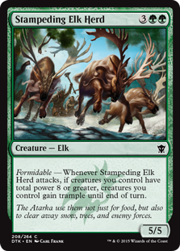 | STAMPEDING ELK HERD (5)  CREATURE — ELK (5/5)  <I>FORMIDABLE</I> — WHENEVER STAMPEDING ELK HERD ATTACKS, IF CREATURES YOU CONTROL HAVE TOTAL POWER 8 OR GREATER, CREATURES YOU CONTROL GAIN TRAMPLE UNTIL END OF TURN.

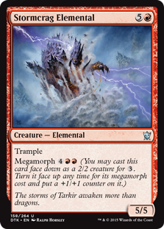 | STORMCRAG ELEMENTAL (6)  CREATURE — ELEMENTAL (5/5)  TRAMPLE  MEGAMORPH <I>(YOU MAY CAST THIS CARD FACE DOWN AS A 2/2 CREATURE FOR . TURN IT FACE UP ANY TIME FOR ITS MEGAMORPH COST AND PUT A +1/+1 COUNTER ON IT.)</I>

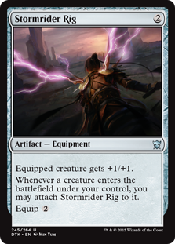 | STORMRIDER RIG (2)  ARTIFACT — EQUIPMENT  EQUIPPED CREATURE GETS +1/+1.  WHENEVER A CREATURE ENTERS THE BATTLEFIELD UNDER YOUR CONTROL, YOU MAY ATTACH STORMRIDER RIG TO IT.  EQUIP

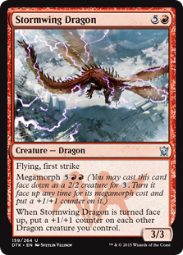 | STORMWING DRAGON (6)  CREATURE — DRAGON (3/3)  FLYING, FIRST STRIKE  MEGAMORPH <I>(YOU MAY CAST THIS CARD FACE DOWN AS A 2/2 CREATURE FOR . TURN IT FACE UP ANY TIME FOR ITS MEGAMORPH COST AND PUT A +1/+1 COUNTER ON IT.)</I>  WHEN STORMWING DRAGON IS TURNED FACE UP, PUT A +1/+1 COUNTER ON EACH OTHER DRAGON CREATURE YOU CONTROL.

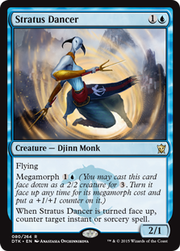 | STRATUS DANCER (2)  CREATURE — DJINN MONK (2/1)  FLYING  MEGAMORPH <I>(YOU MAY CAST THIS CARD FACE DOWN AS A 2/2 CREATURE FOR . TURN IT FACE UP ANY TIME FOR ITS MEGAMORPH COST AND PUT A +1/+1 COUNTER ON IT.)</I>  WHEN STRATUS DANCER IS TURNED FACE UP, COUNTER TARGET INSTANT OR SORCERY SPELL.

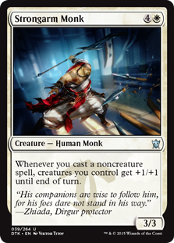 | STRONGARM MONK (5)  CREATURE — HUMAN MONK (3/3)  WHENEVER YOU CAST A NONCREATURE SPELL, CREATURES YOU CONTROL GET +1/+1 UNTIL END OF TURN.

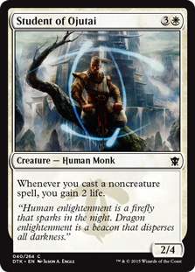 | STUDENT OF OJUTAI (4)  CREATURE — HUMAN MONK (2/4)  WHENEVER YOU CAST A NONCREATURE SPELL, YOU GAIN 2 LIFE.

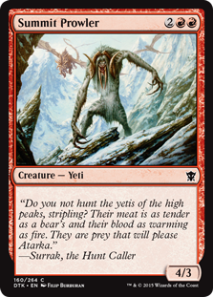 | SUMMIT PROWLER (4)  CREATURE — YETI (4/3)

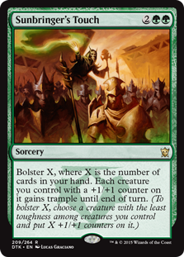 | SUNBRINGER'S TOUCH (4)  SORCERY  BOLSTER X, WHERE X IS THE NUMBER OF CARDS IN YOUR HAND. EACH CREATURE YOU CONTROL WITH A +1/+1 COUNTER ON IT GAINS TRAMPLE UNTIL END OF TURN. <I>(TO BOLSTER X, CHOOSE A CREATURE WITH THE LEAST TOUGHNESS AMONG CREATURES YOU CONTROL AND PUT X +1/+1 COUNTERS ON IT.)</I>

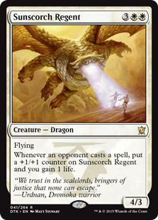 | SUNSCORCH REGENT (5)  CREATURE — DRAGON (4/3)  FLYING  WHENEVER AN OPPONENT CASTS A SPELL, PUT A +1/+1 COUNTER ON SUNSCORCH REGENT AND YOU GAIN 1 LIFE.

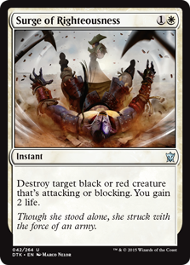 | SURGE OF RIGHTEOUSNESS (2)  INSTANT  DESTROY TARGET BLACK OR RED CREATURE THAT'S ATTACKING OR BLOCKING. YOU GAIN 2 LIFE.

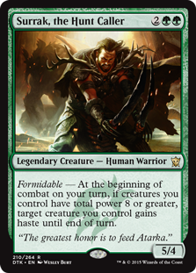 | SURRAK, THE HUNT CALLER (4)  LEGENDARY CREATURE — HUMAN WARRIOR (5/4)  <I>FORMIDABLE</I> — AT THE BEGINNING OF COMBAT ON YOUR TURN, IF CREATURES YOU CONTROL HAVE TOTAL POWER 8 OR GREATER, TARGET CREATURE YOU CONTROL GAINS HASTE UNTIL END OF TURN.

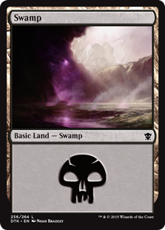 | SWAMP (0)  BASIC LAND — SWAMP

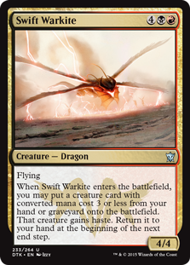 | SWIFT WARKITE (6)  CREATURE — DRAGON (4/4)  FLYING  WHEN SWIFT WARKITE ENTERS THE BATTLEFIELD, YOU MAY PUT A CREATURE CARD WITH MANA VALUE 3 OR LESS FROM YOUR HAND OR GRAVEYARD ONTO THE BATTLEFIELD. THAT CREATURE GAINS HASTE. RETURN IT TO YOUR HAND AT THE BEGINNING OF THE NEXT END STEP.

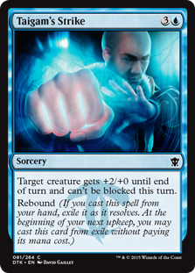 | TAIGAM'S STRIKE (4)  SORCERY  TARGET CREATURE GETS +2/+0 UNTIL END OF TURN AND CAN'T BE BLOCKED THIS TURN.  REBOUND <I>(IF YOU CAST THIS SPELL FROM YOUR HAND, EXILE IT AS IT RESOLVES. AT THE BEGINNING OF YOUR NEXT UPKEEP, YOU MAY CAST THIS CARD FROM EXILE WITHOUT PAYING ITS MANA COST.)</I>

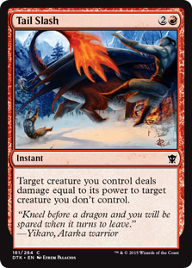 | TAIL SLASH (3)  INSTANT  TARGET CREATURE YOU CONTROL DEALS DAMAGE EQUAL TO ITS POWER TO TARGET CREATURE YOU DON'T CONTROL.

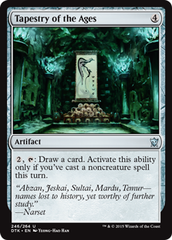 | TAPESTRY OF THE AGES (4)  ARTIFACT  , : DRAW A CARD. ACTIVATE ONLY IF YOU'VE CAST A NONCREATURE SPELL THIS TURN.

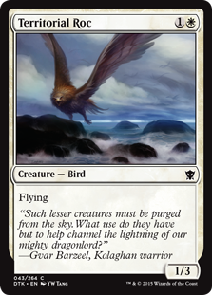 | TERRITORIAL ROC (2)  CREATURE — BIRD (1/3)  FLYING

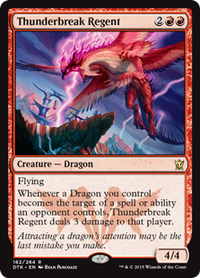 | THUNDERBREAK REGENT (4)  CREATURE — DRAGON (4/4)  FLYING  WHENEVER A DRAGON YOU CONTROL BECOMES THE TARGET OF A SPELL OR ABILITY AN OPPONENT CONTROLS, THUNDERBREAK REGENT DEALS 3 DAMAGE TO THAT PLAYER.

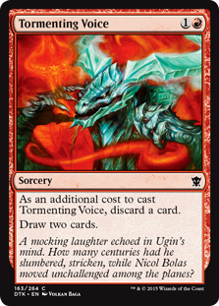 | TORMENTING VOICE (2)  SORCERY  AS AN ADDITIONAL COST TO CAST THIS SPELL, DISCARD A CARD.  DRAW TWO CARDS.

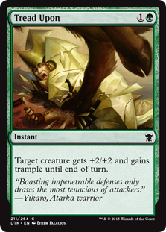 | TREAD UPON (2)  INSTANT  TARGET CREATURE GETS +2/+2 AND GAINS TRAMPLE UNTIL END OF TURN.

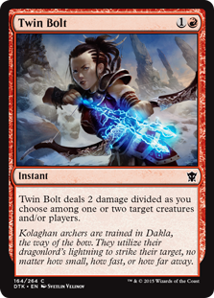 | TWIN BOLT (2)  INSTANT  TWIN BOLT DEALS 2 DAMAGE DIVIDED AS YOU CHOOSE AMONG ONE OR TWO TARGETS.

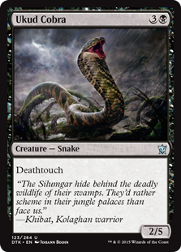 | UKUD COBRA (4)  CREATURE — SNAKE (2/5)  DEATHTOUCH

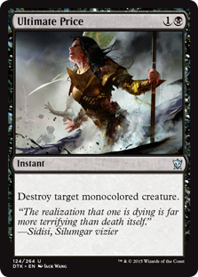 | ULTIMATE PRICE (2)  INSTANT  DESTROY TARGET MONOCOLORED CREATURE.

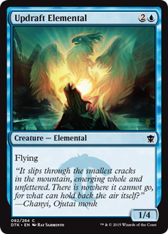 | UPDRAFT ELEMENTAL (3)  CREATURE — ELEMENTAL (1/4)  FLYING

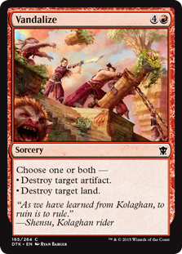 | VANDALIZE (5)  SORCERY  CHOOSE ONE OR BOTH —  • DESTROY TARGET ARTIFACT.  • DESTROY TARGET LAND.

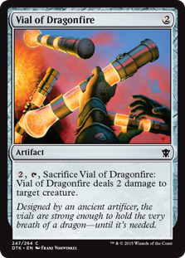 | VIAL OF DRAGONFIRE (2)  ARTIFACT  , , SACRIFICE VIAL OF DRAGONFIRE: IT DEALS 2 DAMAGE TO TARGET CREATURE.

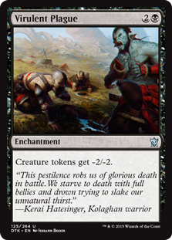 | VIRULENT PLAGUE (3)  ENCHANTMENT  CREATURE TOKENS GET -2/-2.

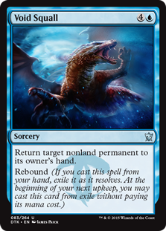 | VOID SQUALL (5)  SORCERY  RETURN TARGET NONLAND PERMANENT TO ITS OWNER'S HAND.  REBOUND <I>(IF YOU CAST THIS SPELL FROM YOUR HAND, EXILE IT AS IT RESOLVES. AT THE BEGINNING OF YOUR NEXT UPKEEP, YOU MAY CAST THIS CARD FROM EXILE WITHOUT PAYING ITS MANA COST.)</I>

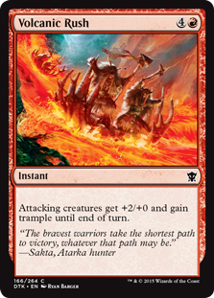 | VOLCANIC RUSH (5)  INSTANT  ATTACKING CREATURES GET +2/+0 AND GAIN TRAMPLE UNTIL END OF TURN.

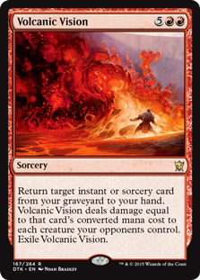 | VOLCANIC VISION (7)  SORCERY  RETURN TARGET INSTANT OR SORCERY CARD FROM YOUR GRAVEYARD TO YOUR HAND. VOLCANIC VISION DEALS DAMAGE EQUAL TO THAT CARD'S MANA VALUE TO EACH CREATURE YOUR OPPONENTS CONTROL. EXILE VOLCANIC VISION.

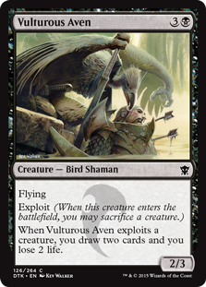 | VULTUROUS AVEN (4)  CREATURE — BIRD SHAMAN (2/3)  FLYING  EXPLOIT <I>(WHEN THIS CREATURE ENTERS THE BATTLEFIELD, YOU MAY SACRIFICE A CREATURE.)</I>  WHEN VULTUROUS AVEN EXPLOITS A CREATURE, YOU DRAW TWO CARDS AND YOU LOSE 2 LIFE.

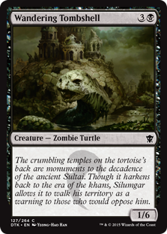 | WANDERING TOMBSHELL (4)  CREATURE — ZOMBIE TURTLE (1/6)

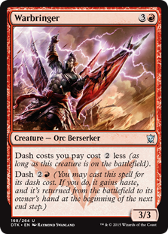 | WARBRINGER (4)  CREATURE — ORC BERSERKER (3/3)  DASH COSTS YOU PAY COST LESS <I>(AS LONG AS THIS CREATURE IS ON THE BATTLEFIELD)</I>.  DASH <I>(YOU MAY CAST THIS SPELL FOR ITS DASH COST. IF YOU DO, IT GAINS HASTE, AND IT'S RETURNED FROM THE BATTLEFIELD TO ITS OWNER'S HAND AT THE BEGINNING OF THE NEXT END STEP.)</I>

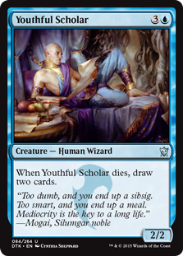 | YOUTHFUL SCHOLAR (4)  CREATURE — HUMAN WIZARD (2/2)  WHEN YOUTHFUL SCHOLAR DIES, DRAW TWO CARDS.

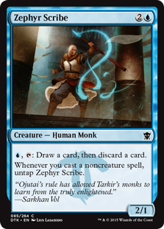 | ZEPHYR SCRIBE (3)  CREATURE — HUMAN MONK (2/1)  , : DRAW A CARD, THEN DISCARD A CARD.  WHENEVER YOU CAST A NONCREATURE SPELL, UNTAP ZEPHYR SCRIBE.

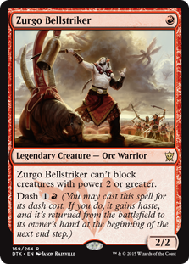 | ZURGO BELLSTRIKER (1)  LEGENDARY CREATURE — ORC WARRIOR (2/2)  ZURGO BELLSTRIKER CAN'T BLOCK CREATURES WITH POWER 2 OR GREATER.  DASH <I>(YOU MAY CAST THIS SPELL FOR ITS DASH COST. IF YOU DO, IT GAINS HASTE, AND IT'S RETURNED FROM THE BATTLEFIELD TO ITS OWNER'S HAND AT THE BEGINNING OF THE NEXT END STEP.)</I>

