*Wheel of Life*

Where are you at?

To live a fulfilled life, all parts are working together. What does this mean? Generally, there are 8 segments of life that we operate in.

So, before you start making significant changes in your life, lets first see where you see your life to be. Without awareness of which parts in your life you feel is not fantastic, you may be making changes in ways that may not be a wise investment of your resources

To help develop clarity, it is essential to ask questions that prompt and poke you to get super clear as to what is potentially going on, and what it is you would really like to have.

As challenging as it can be, it is invaluable to be honest with yourself. The first step to any change is awareness, so to become aware and open to the first thoughts that come to mind when you ask questions. Be truthful to yourself, with as little judgment or self-criticism as possible, remember, your life experiences have brought you to this point, and you have learnt some very useful lessons along the way, even if it is a lesson of not doing something again.

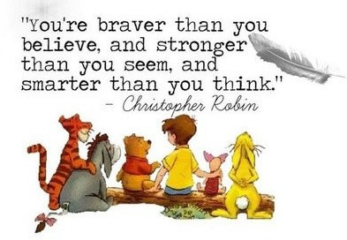Yes, some have been painful, embarrassing, confronting, but from the mouth of Christopher Robin (a favorite of mine)

The Wheel of Life tool helps you to gain clarity where you feel you fit in your world, in the moment. There is no right or wrong, and it can change over time. This is a snap shot in the now, to become aware of how you see you are operating in the various parts of your life.

Ideally, this exercise is completed when you have time to sit and reflect, though for some the insight will come to you while doing even the most mundane of things like washing up, vacuuming, doing your exercises etc where in your body is involved in an auto-pilot activity and your mind can explore.

If you wish, you can do it after a short meditation, setting the intent to explore your current life state. Take some time out without distractions, schedule some time along so you can ponder uninterrupted.

Set the scene, gentle music, be in a space that inspires you to be the best you can be. For some, this can be the first challenge, so consider a park, beach, garden, bath, lounge (without the TV on), favorite cafe, or restaurant. Really give yourself permission to be with yourself. If you can, plan for a day or so away, this really opens up the imagination and is a reward to you for looking after yourself.

To complete this exercise, work through these steps

1. Create the right frame of mind, with the intent to find your center. When reach your center, you are fully present. You’re not in the future or thinking about the past. It is a feeling of calmness, spacious and alert. In your center, you aren’t inflated or deflate. You avoid extremes in either direction.
2. To establish your center, place both your feet firmly on the ground. Then, place your full attention on the bottom of your feet for about 20 seconds. Notice any sensations. Breathe slowly, steadily, and quietly. Focusing on your feet draws excessive energy from your head, down into your body. It’s the fastest way I know to quiet the mind.

As you can see, it covers the main aspects of one’s experiences, from work, relationships, health, and relaxation.

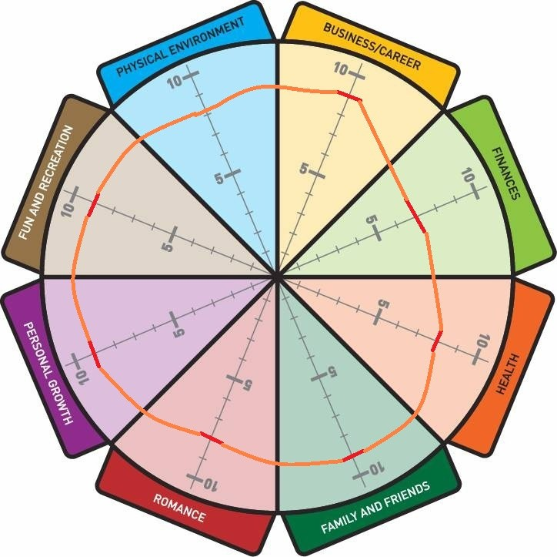This is a wheel example. As you can see, this person feels each segment of their life is fairly even through the segments, but each also has room for improvement. With conscious effort, clearing out their blocks and continue the reflective and clearing process and it is very possible to be a 10 all round. Look around, there are people who are happy, healthy and content with their life and choices, and this doesn't mean they are mega wealthy in money, though they may be; it is their perception of their quality of life.

Back to you. Now that you have identified a few potential gaps in some areas of your life between where you currently see yourself, just ask which sectors are important enough to seriously look at and change. Remember, there is no right or wrong answers here, as if you ask yourself the same question tomorrow, or next week, you might give yourself a different answer based on what is happening at the time.

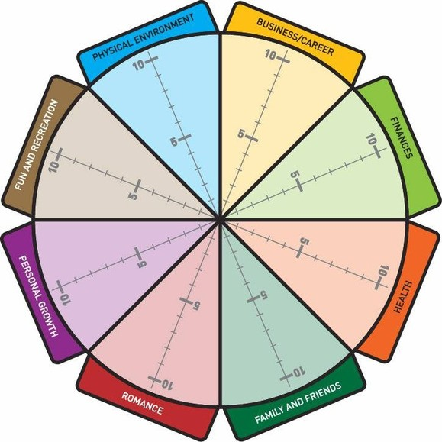

1. Mark on the scale between 1­10 for each sector; 10 being absolutely spot on wonderful, and 1 being totally blah.

2. Link the marks you made on the scale in each sector by drawing a line going around the wheel.

Awareness is the first step.

This time on the wheel, mark out where you would like ach of the segments to be. Let your imagination run, be a kid with this stage, and be honest with yourself. It will give you things to consider, explore and work through, not goals as such, but some really meaty topics to play with.

Awareness is the first step, but having the end in mind is the second.

Exploratory questions:

* What aspects in each of the segments that ‘aren’t quite right’, or ‘not working for you’?
* What about them isn’t working?
* Time, people, location, vibe, expectations, energy etc.?
* What would you like to change?
  + If you had the magic wand, what would you wish for?
  + Who would be involved?
  + What things would you be doing, feeling?
  + What actions, roles, duties, projects etc. would you be working on?
  + Are you at home, a different location or city?
* What were your dreams as a child, teenager, young adult? What are you secretly harboring or wish you would have done?
* If you couldn’t fail, and your dreams could become a reality, what would your reality look like for you?
* What would your life feel like with these changes? What feelings do you want to feel?
* What would you hear, see and smell after the changes were made?
* What would be happening in your life and around you when you reached your ideal world?

Let the ideas be on the page. There is no right or wrong, only ideas that are hiding out. Give them a chance to come back to life for a bit, and have a voice.

When a negative, questioning or “no” voice is heard in your head thank the thought, and ask what it’s real message.

Who is saying it isn’t possible? You, your parents, others from your past, culture, social norms etc. then write this down too, on a separate page. These ‘voices’ a jewel along the way that when cashed in give you what you want in life, just like gems found in the mud when panning can make you a fortune when cashed in.

Allow your mind to drift, with curiosity. Curiosity creates a lot more jewels than reserved judgement. You have the invitation to play with this, and see what comes to the surface. You don’t need to do any or all of the ideas, the process starts the awareness phase towards creating curiosity and healing.