St. Thomas Altar Society
Constitution and By-Laws
Revised February 21, 2022

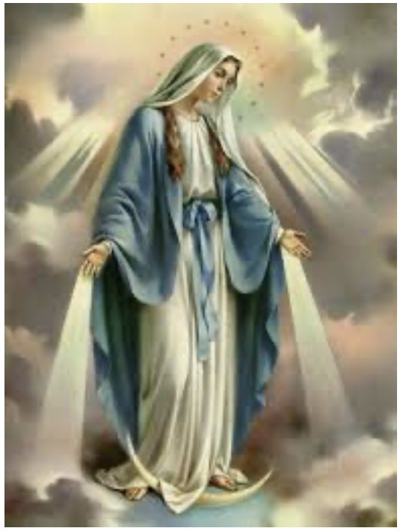

CONSTITUTION
ARTICLE I – NAME
The name of this organization shall be St. Thomas Altar Society functioning under the direction of the Pastor, the board of elected officers and the members under the patronage of Our Blessed Mother.
ARTICLE II – MISSION
The mission of this organization shall be:
Section 1. To unite all women of St. Thomas Parish in the works of the Catholic Church, taking responsibility for care of the Altar and assisting the Pastor in spiritual and material undertakings for the welfare of the Parish.
Section 2. To take care of the needs of the Altar and sacristy, including vestments, linens, and flowers; purchasing items needed for liturgy including hosts, wine, vestments and Altar linens.
Section 3. The Altar Society is to hold meetings to share information, assist in material undertakings of the Parish, to promote spiritual growth and Christian charity, to establish fellowship and strengthen friendship with one another.
ARTICLE III—STRUCTURE
Section 1. The membership of St. Thomas Altar Society is open to every Catholic woman aged 18 and older in the Parish. Attendance at meetings nor dues is necessary for membership. Young ladies of the Parish aged 15-17 are honorary members, and although not voting members, they are encouraged to participate in Altar Society objectives under the supervision of their mother or guardian.
Section 2. The Officers responsible for conduction and continuation of the Altar Society shall be composed of the Parish Pastor, President, Vice President, Recording Secretary and Treasurer.
ARTICLE IV – OFFICERS AND THEIR ELECTIONS
The elected officers and the elections of officers for this organization shall be:
Section 1. The officers of this organization shall be President, Vice President, Recording Secretary, and Treasurer.
- A nominating chairperson/committee shall be appointed by the President in April. A slate of officers shall be presented at the May meeting.
- All officers shall be elected from the active membership at the May meeting. If there is more than one candidate for an office, election to that office will be done by secret ballot. If there is only one candidate for an office, election may be done by acclamation.
- The newly elected officers shall be installed at the September meeting and take Office at that time.
- Officers shall be elected for a term of two years. No officer shall succeed herself to the same office for more than two consecutive years.
Section 2. The Executive Board shall consist of elected officers and the Pastor.

ARTICLE V – AMENDMENTS
Section 1. The Constitution may be amended at a general meeting by two-thirds vote of the members present.

BY-LAWS

ARTICLE I – DUTIES OF OFFICERS
The duties of the Officers of this organization shall be:
Section 1. The Pastor of the Parish shall be the Spiritual Moderator of the Altar Society.
Section 2. The President shall preside at all meeting of the organization, appoint all committees and perform such duties as are incumbent upon this office. The President will serve on the Parish Pastoral Council for her term of office. In the event she cannot serve on the Parish Pastoral Council, she may appoint another officer to serve in that position.
The President is an ex-officio member of all committees except the nominating committee.
Section 3. The Vice President shall assist the President and preside in her absence. The Vice President or appointee Officer shall serve on the Scholarship Committee.
Section 4. The Recording Secretary shall keep minutes of all meetings and discharge such duties as are incumbent upon the office. Electronic version of minutes to be placed onto Parish website, with assistance of IT Specialist, following approval from Pastor and President.
Section 5. The Treasurer shall collect all contributions, dispense checks as necessary and keep an accurate account of the money. The Treasurer will provide a detailed monthly financial report to the President and other officers on a monthly basis. The Treasurer will propose and maintain annual budget following approval of Executive Board.
Section 6. The elected officials shall have the general management of all the affairs of the Altar Society including control of financial responsibilities. The Executive Board shall authorize expenditures that pertain directly to the responsibilities and functions of the Altar Society under $100. However, when expedient, expenditures up to $100 may be approved by the President alone. Any financial transactions exceeding $100 shall be approved by the Executive Board and by the general membership, with exception of budgeted items. Proposed annual budget shall be presented at the September meeting by the Treasurer in alignment with prior years and any unforeseen adjustments.
ARTICLE II – ALTAR SOCIETY IT VOLUNTEER SPECIALIST
Section 1. The Executive Board shall select and appoint a non-officer to work directly with the Board and Parish Office on various information technology matters.

ARTICLE III – COMMITTEES
Section 1. Altar Care/Altar Flowers
Section 2. Coffee & Donuts
Section 3. Rummage Sale
Section 4. Bazaar
Section 5. Funeral Luncheons
Section 6. St. Thomas Feast/Festival
Section 7. Membership
Section 8. Sunshine
Section 9. Quilting
Section 11. Gift Counter
Section 12. Cookie Sales

ARTICLE IV – MEETINGS
Section 1. All meetings are held the second Monday of each month, September through May. A separate meeting of the board of officers or committee chairpersons may be held at the discretion of the President.

Section 2. Meeting Agenda:
- Call to order by President
- Opening Prayer and Pastor’s Comments
- Reading of minutes by Recording Secretary
- Treasurer’s report
- Reports of Committees
- Old Business
- New Business
- Closing Prayer

ARTICLE V – NOMINATIONS AND ELECTIONS
Section 1. The President shall appoint a nominating Chairperson/committee.
- The nominating committee shall select at least one candidate for each office.
- Nominations may also be made from the floor with the consent of the person being nominated.

Section 2. (a) All officers shall be elected at the May meeting and be installed at the September meeting and assume office at that time.
(b) Vacancies occurring during the year shall be filled by the board of officers, except in the case of the Presidency. A presidential vacancy shall be filled by the Vice President.

ARTICLE VI – AMENDMENTS
Section 1. These By-Laws may be amended at a general meeting by two-thirds vote of the members present.

ARTICLE VII – PARLIAMENTARY AUTHORITY
Section 1. Roberts Rules of Order shall be the Parliamentary authority for this organization.

The above Constitution and By-Laws were reviewed at the General Meeting on February 21, 2022

Executive Board’s signatures:

Pastor: | Date:
President: | Date:
Vice President: | Date:
Recording Secretary: | Date:
Treasurer: | Date:

