


SparkITude Rule Book and definitions

Game 1: The object of this game is to build a story and map out of the center of the spiral through the strengths and virtues, honoring the Golden Rule:
- Select your first card and hold on to it until your turn.
- Locate the card's definition in your rule book and share your thoughts.
- Select two from the questions on the back of the card you would like to share answers to. These will be your starting points of reference.
- Each person takes a turn sharing about the card they choose. Limit 5 min per share.
- The group comes to a unanimous decision as to which card to place in the center. This will be the card we dive into with the shadow a little. This can also be done by a roll of the dice.
- The group explores the shadow of the chosen card and each person takes a turn adding a card to build a map out of the center of the spiral, resolving the shadows that arise, through the use of the strengths and virtues.
- Utilize the #SoulSpark ToolKit to identify, evaluate, adapt and overcome any blocks or challenges that arise when sharing answers on your cards.
- It is OK to have two cards in the center if that is what the group would like to do.
- Each player goes back to the deck to choose their next card.
- When you are taking your turn, you may move one card on the board aside from the card you are using. This enables the map to transform as the story unfolds.
- Use the Phoenix elemental cards as transformation cards when shadows appear.
- When you have built a map out of the center, you are ready to explore and connect with others in a more meaningful and healthy way. Add some information about yourself in the SoulSpark Game located in the next frame and build your network of allies.

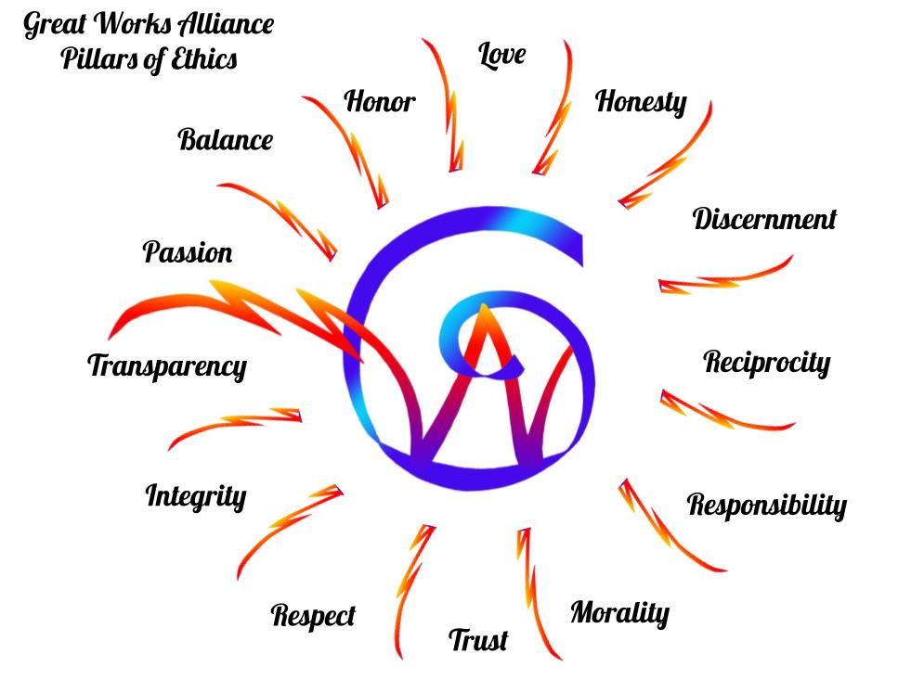

Pillars of Ethics ~ Honoring the Golden Rule
Our pillars of principle ethical standards and collaboration are Love, Honesty, Trust, Honor, Integrity, Discernment, Morality, Respect, Responsibility, Reciprocity, Passion, and Transparency.
To read more about these pillars, visit this page.

Phoenix Elemental Cards

The following Phoenix Elementals are provided as bridging cards and should be used sparingly. The Mission I'm Possible Superpowers are listed on the page linked below.
While you may have different ways to express your superpowers of positive growth, values, and strengths, you will be delighted to learn of the superpowers of the Phoenix Elementals.

Phoenix air ~ constantly in motion, typically logical, thinking through every decision thoroughly, often finding clever solutions to difficult problems. Air tuning, telekinesis, flexible, flight, gliding and levitation, weather tuning.
Phoenix earth ~ stable, reliable, and balanced yet constantly working and moving, practical and logical and firm in convictions, set achievable goals that are attained through hard work. Crystal tuning, earth tuning and grounding, geokinetic flight, empathic, gardener, magnetic tuning.

Phoenix fire ~ confidence, leadership, teamwork, provides heat and light, comes from within, can be forceful, natural intensity that compels others to take notice, natural-born leader, gut instinct and become fully committed. Fire tuning, energy transforming, sparker, bright, charismatic, focused, decisive, daring.
Phoenix Metal ~ leadership, mindfulness, clear convictions, clarity, set clear boundaries. Metal tuning, harmonic tuning, highly conductive, sense of quality and value, flexible, guiding internal reflection, the power to let go, refined purification.

Phoenix Spirit ~ appreciation of beauty, transform, transcendence; aether/ether, celestial energy that fills all spaces, does not follow any particular rule of energy, it IS the rule. Spirit tuning, energy transforming, transmutation, alchemical processes, divine intervention, the eternal nature, energy in motion, creates an binds all elements, quantum dream weaving.

Phoenix Water ~ constantly flowing, can be emotional, purifying, compassionate and caring and can relate easily to others. Water tuning, harmony, empathic, agile swimmer, breathing under water, blood/ body purifying.

Phoenix Wild ~ adaptive, humor, innovation; able to take on any of the elemental roles and overcome any obstacle. It is up to you to decide how to use it. Wild crafting, wild tuning, able to take on any of the elemental roles and overcome any obstacle. It is up to you to decide how to use it.

Phoenix Wood ~ resilience, perseverance, creativity, and imagination. Also highly motivated and driven to push past the status quo, able to overcome difficult circumstances and find unique solutions to the challenges they face. Wood also reflects the Pioneer archetype. Wood tuning, vital, active, and flexible; also related to upward movement and growth, diplomatic, having clear perspective, balanced opinions.

Positive Psychology ~ Virtues in Action

Definitions:

adaptive: able to easily adjust to changing circumstances.

altruism: the unselfish concern for the well-being of other people and involves engaging in selfless acts such as donating items, volunteering, protecting those who can’t protect themselves, helping strangers standing on the highway, donating blood, volunteering for the needy ones and donating food/necessities to the disadvantaged.

appreciation of beauty: noticing and appreciating beauty, excellence, and/or skilled performance in various domains of life.

balance: a state of equilibrium; having different parts or elements properly or effectively arranged, proportioned, regulated, considered, etc.

bravery: not shrinking from threat, challenge, difficulty, or pain; speaking up for what is right even if there is opposition; acting on convictions even if unpopular.

citizenship: the quality of an individual's response to membership in a community.

compassion: To suffer together; the feeling that arises when you are confronted with another's suffering and feel motivated to relieve that suffering.

confidence: a belief in oneself, and others; the conviction that one has the ability to meet life's challenges and to succeed—and the willingness to act accordingly.

communicate: able to express ideas effectively

courage: to act from the heart, the exercise of will to accomplish goals, venture, persevere, and withstand danger and withstand danger, fear, or difficulty in the face of opposition, external or internal.

creativity: thinking of novel and productive ways to conceptualize and do things; includes artistic achievement but is not limited to it.

curiosity: taking an interest in ongoing experience for its own sake; finding subjects and topics fascinating; exploring and discovering.

discernment: the act or process of keen insight and good judgment of people, things, or situations clearly and intelligently.

empathy: the ability to recognize, understand, and share the thoughts and feelings of another person, animal, or fictional character.

fairness: treating all people the same according to notions of fairness and justice; not letting personal feelings bias decisions about others; giving everyone a fair chance.

forgiveness: forgiving those who have done wrong; accepting the short-comings of others; giving people a second chance; not being vengeful.

generosity – willingness to give of yourself without expectation gracefulness: moving in a smooth and attractive way, having a smooth and pleasing shape or style, acting polite or kind.

gratitude: being aware of and thankful for the good things that happen; taking time to express thanks.

honesty: speaking the truth but more broadly presenting oneself in a genuine way and acting in a sincere way; being without pretense; taking responsibility for one's feelings and actions.

honor: having or showing honesty and good moral character, fair and proper, not deserving blame or criticism.

hope: expecting the best in the future and working to achieve it; believing that a good future is something that can be brought about.

humanity: the interpersonal strengths that involve tending and befriending others.

humility: letting one's accomplishments speak for themselves; not regarding oneself as more special than one is.

humor: liking to laugh and tease; bringing smiles to other people; seeing the light side; making (not necessarily telling) jokes.

innovation: being or producing something like nothing done or experienced or created before, a new idea, method, or device.

integrity – a firm adherence to a code of ethics, values or morals

judgment: the process of forming an opinion or evaluation by discerning and comparing.

justice: the quality of being just, impartial, or fair; civic strengths that underlie healthy community life, the establishment or determination of rights according to the rules of natural law or equity.
innovation: being or producing something like nothing done or experienced or created before, a new idea, method, or device.

kindness: doing favors and good deeds for others; helping them; taking care of them.

knowledgeable: containing information gathered from learning and education, having clarity of facts and truths.

leadership: encouraging a group of which one is a member to get things done, and at the same time maintaining good relations within the group; organizing group activities and seeing that they happen.

love: valuing close relations with others, in particular those in which sharing and caring are reciprocated; being close to people. The three types of love are Agape, Eros and Philia.

love of learning: mastering new skills, topics, and bodies of knowledge, whether on one's own or formally; related to the strength of curiosity but goes beyond it to describe the tendency to add systematically to what one knows.

mercy: compassionate treatment of those in distress; shown especially to an offender or to one subject to one's authority.

mindfulness: the quality or state of being conscious or aware of someone or something.

moral: sanctioned by or operative on one's conscience or ethical judgment; expressing or teaching a conception of right behavior: of or relating to principles of right and wrong behavior.

nurture: to provide care and nourishment; to further the development of a healthy life and environment.

patience: exhibiting steadfast qualities despite opposition, difficulty, or adversity; bearing pains or trials calmly or without complaint.

perseverance: finishing what one starts; persisting in a course of action in spite of obstacles; “getting it out the door”; taking pleasure in completing tasks.

perspective: the capacity to view things in their true relations or relative importance; having ways of looking at the world that make sense to oneself and to other people.

prudence: being careful about one's choices; not taking undue risks; not saying or doing things that might later be regretted.

respect: to consider worthy of high regard; to refrain from interfering with.

responsible: able to answer for one's conduct and obligations;
liable to be called on to answer.

self-control: regulating what one feels and does; being disciplined; controlling one's appetites and emotions.

sense of meaning: conscious awareness or rationality of self and purpose in life.

social intelligence: being aware of the motives and feelings of other people and oneself; knowing what to do to fit into different social situations; knowing what makes other people tick.

spirituality: having coherent beliefs about the higher purpose and meaning of the universe; knowing where one fits within the larger scheme.

teamwork: working well as a member of a group or team; being loyal to the group; doing one's share.

temperance: moderation in action, thought, or feeling; habitual moderation in the indulgence of the appetites or passions.

transcendence: to rise above a previous understanding; strengths that forge connections to the larger universe and provide meaning.

trustworthy: being worthy of confidence; someone who is honest who can be entrusted with secrets or with anything else important.

vitality: lively and animated character; capacity to live and develop physical or mental vigor; power of enduring.

wisdom: gathered knowledge from day-to-day experiences, the practical ability to make consistently good decisions in life, and is a state of being wise.

zest: great enthusiasm and exuberance; the quality or state of being stimulating to the mind or senses.

Other Character Strengths not yet designed in the games.
Assertiveness - being self-assured and confident without being aggressive to defend a right point of view or a relevant statement. It can be learned and a mode of communication.
Authentic - being sincere, real, trustworthy, or genuine.
Dependable – able to be consistently relied upon
Flexibility – the ability to change or be changed easily according to the situation. The ability to bend and be flexible without breaking easily.
Inspirational – ability to inspire hope and encouragement
Loyalty – the quality or state of remaining unswerving in allegiance and faithfulness

Optimistic – hoping or believing that everything will turn out for the best, good things will happen

Purposeful – having a clear idea of action, showing that you know what you want to do

Resilient – able to be happy, successful, and positive after a difficult or bad experience. determined to succeed despite past failures.

Self-awareness – the ability to perceive and understand the things that make you who you are as an individual, including your personality, actions, values, beliefs, emotions and thoughts.

Game 2 ~ Next Level Quest

Leveling up: Become your own mirror and begin in the shadow hexagons from the outside looking in.

1) Choose your first card of reflection and take a deep dive into some of the opposites. Follow the same rules as before, but stick to the shadow as you spiral inward.

2) Seek the cards to fulfill a transformation of the first card's shadows.

3) Identify the shadow of those cards and repeat as you move closer to the center of the board.

Transformation

4) Move the cards from the shadow to the light using the surrounding cards and begin spiraling out.


5) On the journey back out, explore how to lift each card into the light, using the cards next to each other from the inward spiral. Move the cards out accordingly. They may shift position as you bring them into the light again.

