Name: Date: 2/23/2017
Calculus 2 Chapter 7 Test

1)
$$\int{\left(x-1\right)Sin πx dx}$$
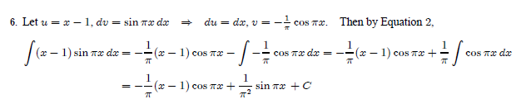

2)
$$\int{\frac{z}{{10}^{z}}}dz$$

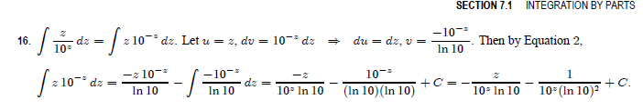

3)
$$\int_{0}^{2π}{t^{2}\sin{2t}}dt$$
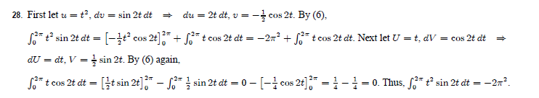

4)
$$\int_{0}^{π/2}{\sin^{7}θ\cos^{5}θ}dθ$$
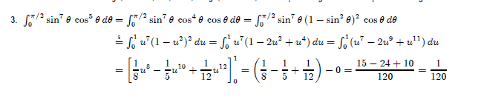

5)
$$\int_{0}^{π/2}{\cos^{2}θ}dθ$$
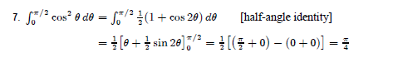
6)
$$\int{\tan^{4}x}\sec^{6}x dx$$
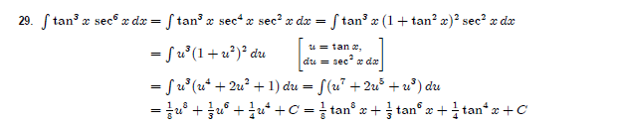

7)
$$\int_{0}^{3}{\frac{x}{\sqrt{36-x^{2}}}dx}$$
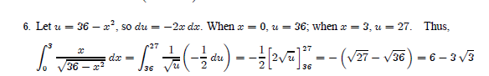

8)
$$\int{\frac{dt}{t^{2}\sqrt{t^{2}-16}}}$$
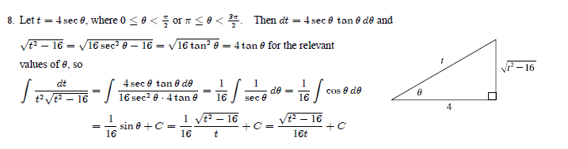

9)
$$\int_{0}^{1}{\frac{2}{2x^{2}+3x+1}dx}$$
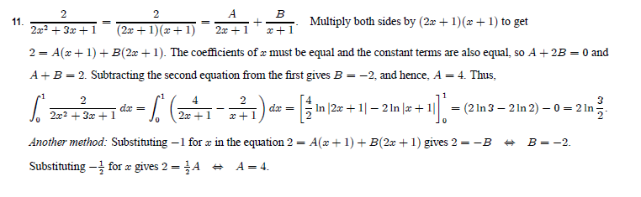

10)
$$\int{\frac{x^{4}+{4x}^{3}-x^{2}-16x-12}{x^{3}+{3x}^{2}-4x-12}}dx$$

$$\int{x+1 dx}$$

