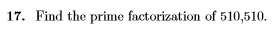

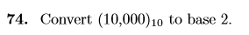

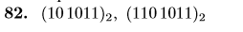

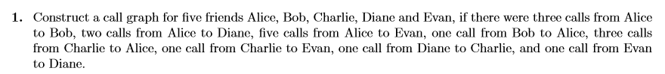

Draw the following graphs and give an adjacency matrix
7. K_{4,5}
