PUBLIC NOTICE TO RE-ADOPT AN EXPIRED TENTATIVE TRACT MAP AND
ADDENDUM TO AN ADOPTED CEQA - MITIGATED NEGATIVE DECLERATION
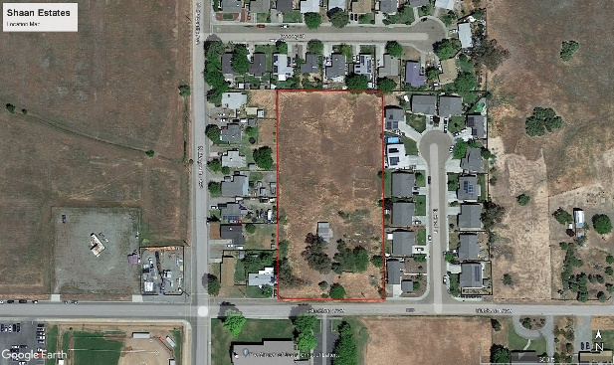
The City of Corning must inform you of a development project for the property shown on the map below.

WHAT IS BEING PLANNED:
Hirday Singh has re-submitted a Previously approved Tentative Tract Map that proposes to create 14 parcels in an R-1: Single Family Residential Zoning District. The subject property is located on the North side of Blackburn Ave. and about 140 feet east of Marguerite Avenue. Assessor’s Parcel No. 75-310-42; approximately 2.74 acres.

WHY THIS NOTICE:
The City of Corning adopted a mitigated negative declaration and approved Tentative Tract Map in September of 2007. Due to the map expiring over the last 17 years and the State of California changing CEQA requirements, the Lead Agency, City of Corning is required to do a CEQA addendum to address the possible environmental potentials created by the project.

The City wants you to be aware that the project is available for review at City Hall, 794 Third Street in Corning. You are invited to attend a Public Hearing to be conducted by the Planning Commission in the City Council Chambers in City Hall at 6:30 p.m. on Tuesday, March 19, 2024. Please note if this project is challenged in court, you may be limited to raising only those issues that were raised at the Public hearing or in writing delivered to the Planning Commission at or prior to the Public Hearing.

WHAT CAN YOU DO:
Please call or come into City Hall if you have any questions or want to review the project information. You are welcome to attend the Public Hearing to ask questions or to make a public comment. Your written comments may be given to the Planning Commission at the Hearing. If mailed, comments must be received by the City Clerk prior to the meeting. We are sorry, but City staff cannot forward your verbal comments or questions to the City Planning Commission. Verbal comments or questions must come from your attendance during the Public Hearing.

FOR MORE INFORMATION REGARDING THIS PROJECT PLEASE CONTACT:
Christina Meeds, Planner II
794 Third Street
Corning, CA 96021
530-824-7036

