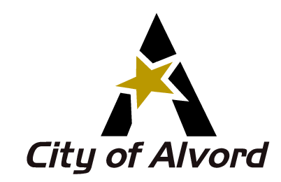
AGENDA
ECONOMIC DEVELOPMENT CORPORATION
February 8, 2023
6:00 p.m.

Notice is hereby given of a meeting of the Alvord Economic Development Corporation to be held on WEDNESDAY, FEBRUARY 8, 2023 at 6:00 p.m. in the Council Chambers of City Hall, 215 West Elm Street, Alvord, Texas, for the purpose of considering the following agenda items. All agenda items are subject to action. The City of Alvord EDC reserves the right to meet in closed session on any agenda item should the need arise and if applicable pursuant to authorization of Title 5, Chapter 551 of the Texas Government Code.

I. CALL MEETING TO ORDER AND ANNOUNCE A QUORUM IS PRESENT

II. INVOCATION

III. CITIZENS TO BE HEARD – during this part of the meeting, citizens are allowed (3) minutes to make comments on topics that do not appear on this agenda. The EDC cannot discuss, deliberate or take action on any item not scheduled on the agenda.

IV. ITEMS FOR CONSIDERATION
(Citizens have the right to speak on scheduled agenda items when that agenda item is being considered by the EDC)
a. Approving minutes from previous meeting
b. Treasurer’s Report
c. Outstanding items
d. EDC open position applications
1. Aaron Moore
e. Façade program applications
f. Elm Creek Park
1. Discuss and take action on park utility bills
2. Park sub-committee
g. City Council items
h. Community garden budget
i. American Ramp

V. NEW ITEMS FOR CONSIDERATION
a. Country Living Tour
b. Christmas tree follow-up

VI. TABLED ITEMS
a. Discuss forming a subcommittee for bylaw review, workshop with attorney to develop process for EDC contacting and assisting new and existing businesses
b. Discuss forming a subcommittee for grant writing
c. Downtown Beautification
d. Discuss directional signs
e. Vice-President
f. AEA budget for 2023
g. Dog park
h. Library/Community Center/Multiuse Facility

VII. FUTURE AGENDA ITEMS AND SET NEXT MEETING DATE

VIII. ADJOURN

I, the undersigned authority, do hereby certify that the above notice of the meeting of the City of Alvord Economic Development Board is a true and correct copy of the notice and that I posted a true and correct copy of the notice on the bulletin board at City Hall of the City of Alvord, Texas, a place convenient and readily accessible to the general public at all times and the notice was posted February 3, 2023 at 5:00 p.m. and remained posted continuously for at least 72 hours preceding the scheduled time of the meeting.

_________________________________________
Pamela Gregg, TRMC, City Secretary
In compliance with the Americans with Disabilities Act, the City of Alvord will provide for reasonable accommodations for persons attending EDC meetings. To better serve you, requests should be received 48 hours prior to the meetings. Please contact City Hall at 940-427-5916.

