

Planning and Zoning Department

PO Box 431

Belmont, NC 28012

(704) 901-2610

**NOTICE OF PUBLIC MEETING**

The Planning & Zoning Board will hear a proposed Major Development Plan request to develop a new industrial project with access from Hickory Grove Rd on three parcels totaling 44.4 acres. You are receiving this notification because you are the owner of the property located adjacent to the site or are located within the required notification area and are invited to attend the public meeting.

|  |  |
| --- | --- |
| Case MDP2022.04 Oaks Commerce Center | |
| Meeting  Information | Thursday, October 20, 2022, at 6:30 PM  CityWorks Community Room, 1401 E. Catawba St., Belmont, NC 28012 |
| Subject Property  Location | 630 Hickory Grove Rd, Gastonia NC 28056  PID #306477, 183195, 183196- located across from the Linn St and Hickory Grove Rd intersection |
| Existing Zoning | Business Campus District (BC-D) – No change |
| Proposed Development | A request to develop a +/- 470,000 SF industrial warehouse building on three parcels utilizing Business Campus District zoning. The total site area is 44.4 acres, which includes a new public right-of-way. |
| Property Owner | DMG ROAD WORKS LLC | 14600 SW 136 ST, MIAMI, FL 33186 |
| Applicant & Points of Contact | CROW HOLDINGS | 4064 Colony Road, Suite 405, Charlotte, NC 28211   * Chris Urquhart, Developer, Crow Holdings   Email: [curquhart@chindustrial.com](mailto:curquhart@chindustrial.com) Phone: 704-236-2440   * Lin Leslie, Engineer, Orsborn Engineering   Email: [lleslie@orsborn-eng.com](mailto:lleslie@orsborn-eng.com) Phone: 704-749-1432 |
| Project Planner | Tiffany Faro, AICP  [tfaro@cityofbelmont.org](mailto:tfaro@cityofbelmont.org%20) or 704-829-4010 |
| Web Information | <https://www.cityofbelmont.org/oaks-commerce> |

**What is a Major Development Plan?**

A major development plan is a development that requires a subdivision of land into eight (8) or more lots; individual building(s) exceeding 30,000 square feet in gross floor area; or, the subdivision of land into four (4) or more non-residential lots. The process creates the opportunity for the applicant, Planning Board, City Council, and the adjacent community to interact through conversation about the future development.

The documentation on the proposed project is available for viewing from 8:00 am until 5:00 pm, Monday – Friday at the Belmont Planning Department located at 1401 E. Catawba. The proposed site plan associated with this project is provided on the backside of this notice.

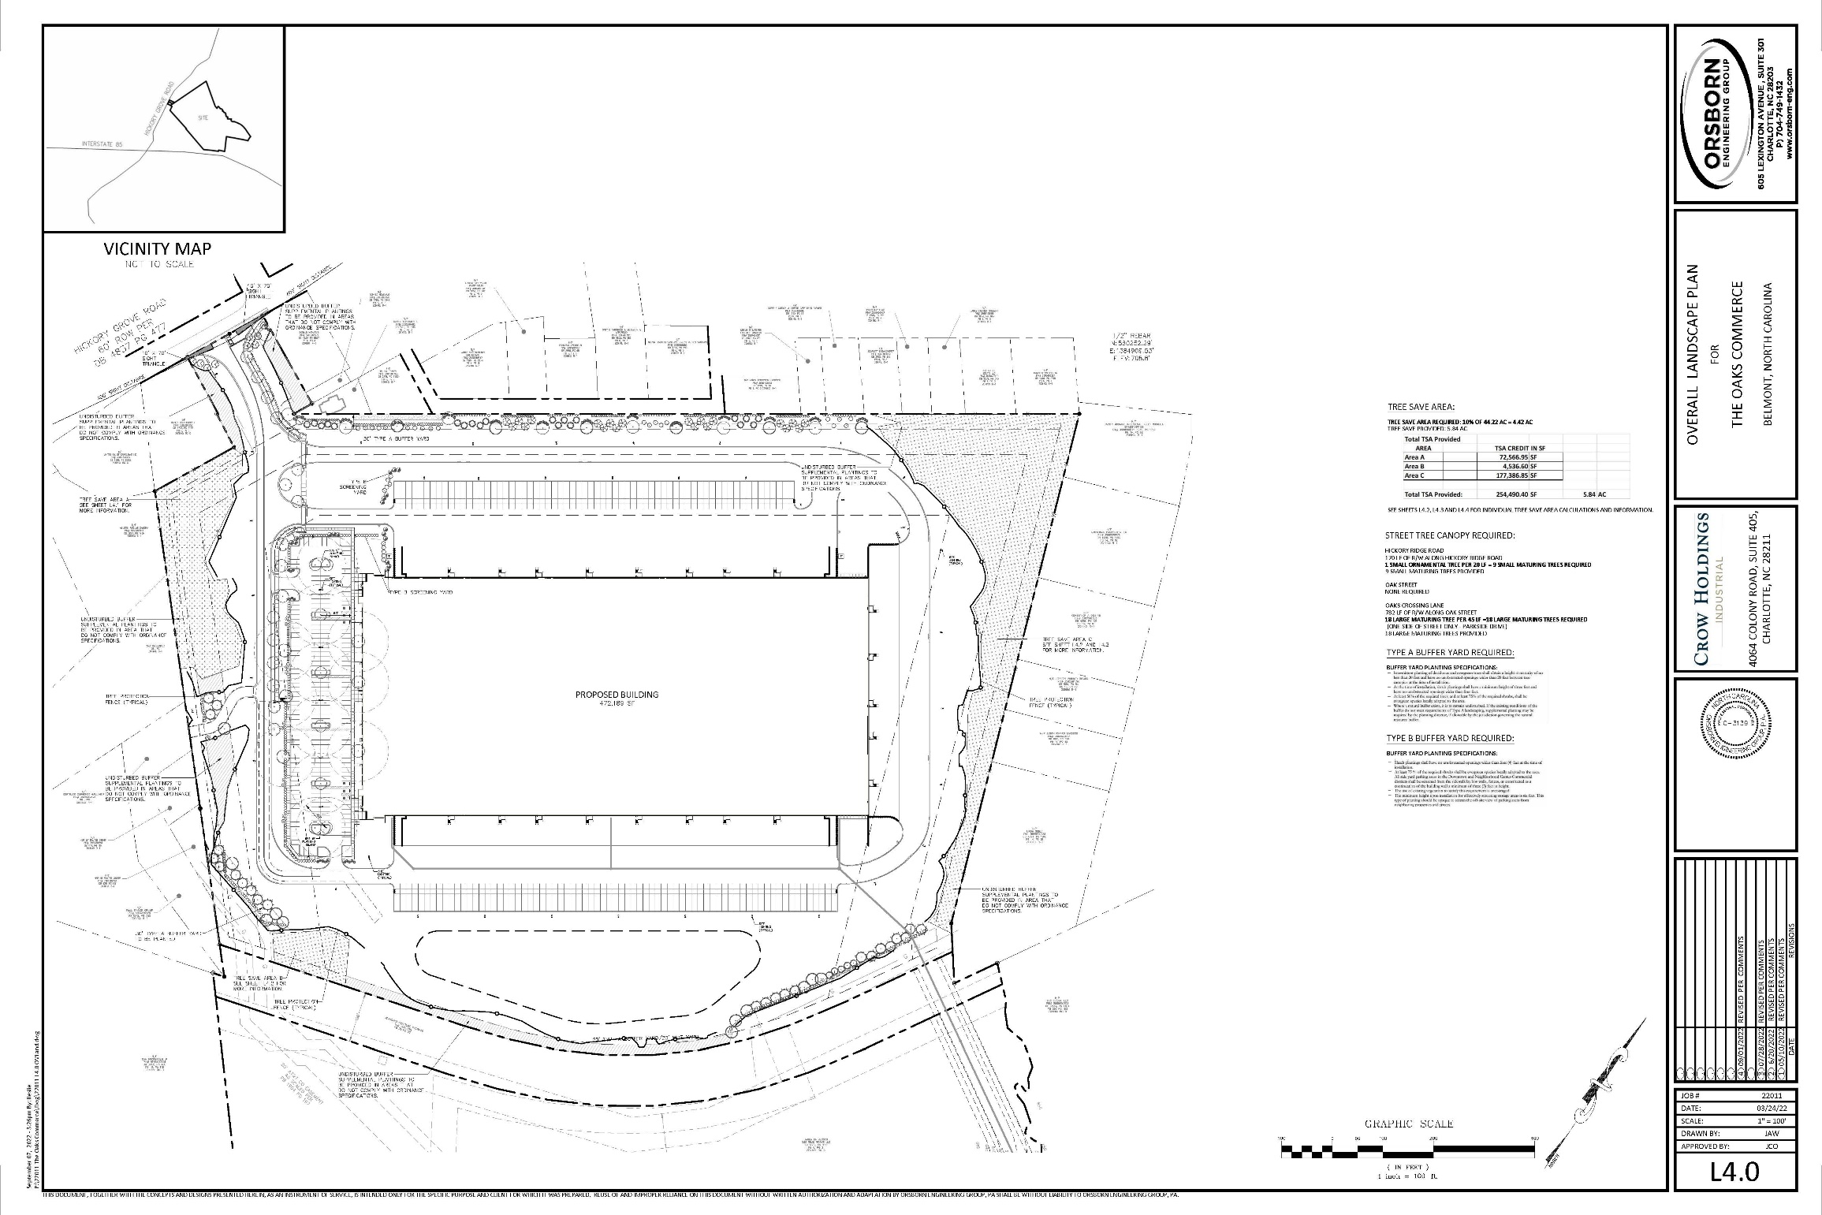

**LINN ST**

**HICKORY GROVE RD.**

**KIRKLEY ST.**

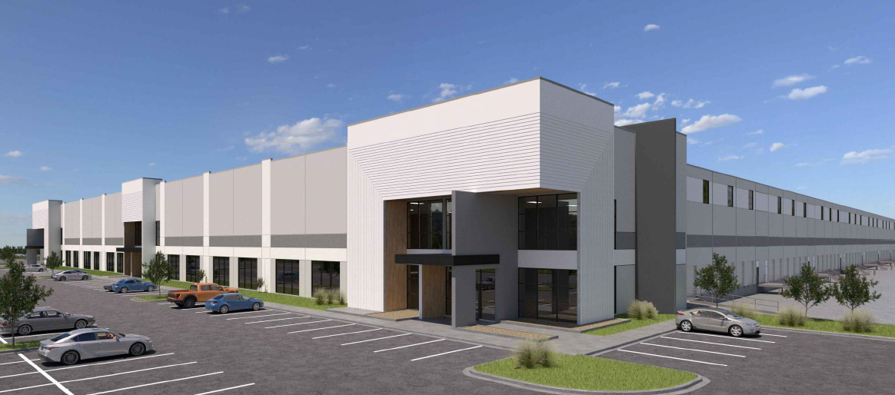

**OAK ST.**