August 5, 2022

TO: All Food Facilities in the Town of Colma

COLMA’S NEW REQUIRMENTS: SINGLE-USE PLASTIC FOODWARE NO LONGER ALLOWED & REQUIRES TRANSITION TO COMPOSTABLE FOODWARE

Dear Restaurant/ Food Facility Owner or Manager,

Colma’s new ordinance affects all food facilities in Colma and doesn’t allow single-use plastic foodware and only allows compostable foodware. Additional requirements are highlighted below. Free resources and assistance are available to businesses to help with these requirements. Enforcement of these requirements starts October 1, 2022.

ORDINANCE REQUIREMENTS & WHAT YOU NEED TO DO

- Don’t Purchase or Provide Single-use Plastic Foodware like forks, knives, straws, containers, etc. Instead, Purchase and Provide Compostable Foodware. USE THE COMPOSTABLE FOODWARE GUIDE: https://www.smcsustainability.org/food-ware/facilities/ to find compostable foodware that complies with the requirements.

- Only Distribute Straws, Forks, Spoons, Knives, Condiments, etc. Upon Request by Customer

- Only use dispensers that dispense items like straws, forks, spoons One at a Time

- Don’t use “compostable” plastics like bioplastics, they’re not compostable and are not allowed

FREE RESOURCES FOR YOUR BUSINESS

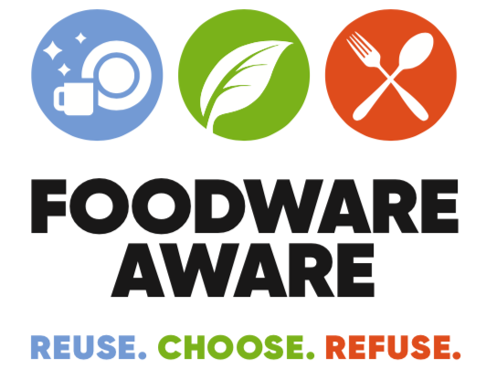
Colma is partnering with the Foodware Aware Program Team (County’s Office of Sustainability, Environmental Innovations, ReThink Disposable) to help make this transition easier. Free resources are:

- COMPOSTABLE FOODWARE GUIDE: https://www.smcsustainability.org/food-ware/facilities/

- FREE ASSISTANCE FOR BUSINESSES: Email foodware@smcgov.org or call 888-442-2666

- FREE MATERIALS TO HELP EDUCATE/TRAIN STAFF AND CUSTOMERS about these changes

- $300 Available for Businesses to Help Buy Reusables: Available on a first-come, first-served basis!
WHAT YOU CAN DO NOW TO PREPARE FOR REQUIREMENTS
- Use up your existing stock of single-use disposable foodware-BUT don’t purchase any new single-use plastic. Begin to purchase COMPOSTABLE FOODWARE using the COMPOSTABLE FOODWARE GUIDE https://www.smcsustainability.org/food-ware/facilities/
- Come to our Foodware Aware Mini Expo at Foster City’s Community Center on August 16th 9 AM and 2 PM. Free Event to learn about the new requirements, resources, test out compliant foodware, free refreshments, connect with foodware vendors! RSVP: foodware.eventbrite.com
- Join us at weekly virtual sessions to answer your questions, starts in September
RSVP: www.bit.ly/foodfac
- Tell your staff about the new requirements!
- Tell your staff to put compostable foodware in your organics collection bin (contact Republic Services If you need an organics recycling bin (Republic Services/Sarah Prescott: 415-279-8348)
- Contact us with any questions, we can help you and your staff make this transition!

QUESTIONS?

Foodware Aware Program Team: Email: foodware@smcgov.org
Foodware Aware Program Hotline: 888-442-2666
Foodware Website: https://www.smcsustainability.org/food-ware
Town of Colma Website: https://www.colma.ca.gov/foodware-requirements/

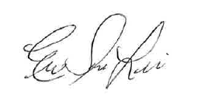
Sincerely,

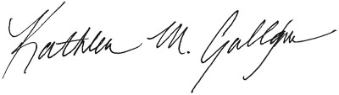

Kathleen Gallagher Eun-Soo Lim
Sustainability Programs Manager Senior Sustainability Specialist
Town of Colma County of San Mateo
1198 El Camino Real County Government Center
Colma, CA 94014 455 County Center, 4th Floor
Redwood City, CA 94063

