CITY OF CORNING
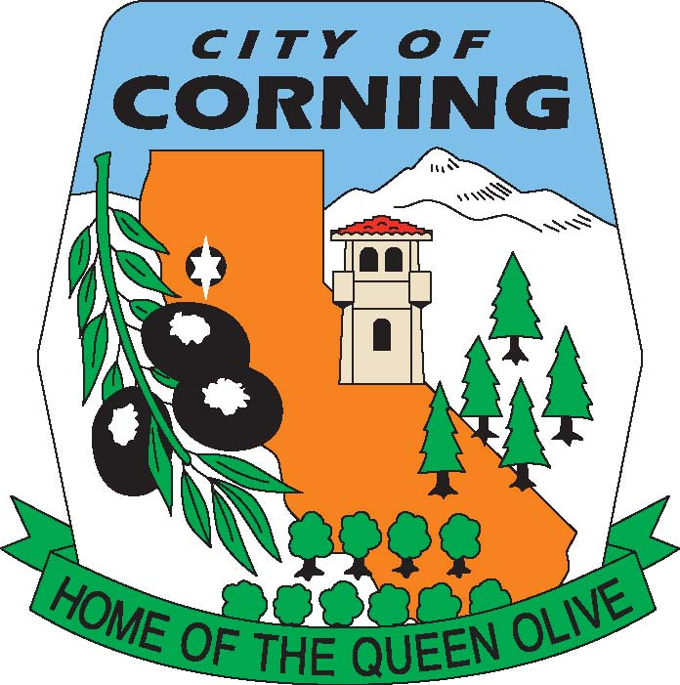

NOTICE OF CANCELLATION
OF THE
TUESDAY, JULY 2, 2024
RECREATION COMMISSION MEETING

DUE TO
LACK OF AGENDA

The Corning Library Commission serves as an advisory body to the Corning City Council and the Tehama County Library Director on Public Library issues including recommendations for building improvements, improvements to the literary, music and film collection and planning for future library service to the Community of Corning. The Commission provides a public forum for the proposal and discussion of public library services that benefit the Community. Ideally the Commission would encourage community volunteers to work together in the planning for current and future library facility and program needs.

POSTED: THURSDAY, JUNE 27, 2024

MEMO
City of Corning

794 Third Street, Corning, CA 96021

(530) 824-7033 Fax (530) 824-2489
TO: RECREATION COMMISSIONERS

FROM: CHRISSY MEEDS, PLANNER II/RECREATION COORDINATOR

BRANT MESKER, CITY MANAGER

DATE: JUNE 25, 2024

SUBJECT: RECREATION CENTER AND CITY PLAZA UPDATE

Dear Recreation Commissioners:

We continue to work with COAR, our design group for the City Plaza and Recreation Center. Currently the timeline is as follows:

- Second Plan Check to the City on July 2nd;
- July 16th a tentative Ad Hoc Committee meeting; and
- July 23rd to City Council for final approval of the design and construction plans with Bid package.

If you have further questions or concerns, please contact me at cmeeds@corning.org or by phone at 530/824-7036.

Thank you,

Chrissy Meeds
Planner II/Recreation Coordinator
City of Corning

