CITY OF CORNING
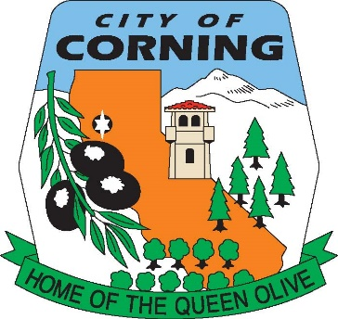

NOTICE OF CANCELLATION
OF THE
MONDAY, JULY 1, 2024
AIRPORT COMMISSION MEETING
DUE TO
LACK OF AGENDA

The Corning Airport Commission serves as an advisory body to the Corning City Council on Municipal Airport and Aviation issues including: Use, Master Planning, Land Acquisition and Development, Beautification, and Improvement and Maintenance of the Corning Municipal Airport. The Commission provides a public forum for the proposal and discussion of Airport services and amenities that benefit the Community. Ideally the Commission would encourage Pilots, Airport Businesses, Airport Land Leaseholders, Hangar Owners and Tenants to work together in the planning for current and future facility and Airport needs.

POSTED: TUESDAY, JUNE 25, 2024

THE CITY OF CORNING IS AN EQUAL OPPORTUNITY PROVIDER AND EMPLOYER

