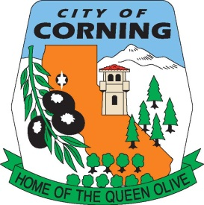
City of Corning Solar Checklist

Eligibility Checklist for Expedited
Solar Photovoltaic Permitting for
One- and Two-Family Dwellings

GENERAL REQUIREMENTS:
- System size is 10 kW AC CEC rating or less. □ Y □ N
- The solar array is roof-mounted on one- or two-family dwelling or accessory structure. □ Y □ N
- The solar panel/module arrays will not exceed the maximum legal building height. □ Y □ N
- Solar system is utility interactive and without battery storage. □ Y □ N

ELECTRICAL REQUIREMENTS:
No more than four photovoltaic module strings are connected to each Maximum PowerPoint
Tracking (MPPT) input where source circuit fusing is included in the inverter □ Y □ N
- No more than two strings per MPPT input where source circuit fusing is not included. □ Y □ N
- Fuses (if needed) are rated to the series fuse rating of the PV Module. □ Y □ N
- No more than one non-inverter integrated DC combiner is utilized per inverter. □ Y □ N
- For central inverter systems: No more than two inverters are utilized. □ Y □ N
- The PV system is interconnected to a single-phase AC service panel of nominal 120/220
Vac with a bus bar rating of 225 A or less. □ Y □ N
- The PV system is connected to the load side of the utility distribution equipment. □ Y □ N

STRUCTURAL REQUIREMENTS:
- A completed Structural Criteria and supporting documentation is attached (if required). □ Y □ N

FIRE SAFETY REQUIREMENTS:
- Clear access pathways provided. □ Y □ N
- Fire classification solar system is provided. □ Y □ N
- All required markings and labels are provided. □ Y □ N
- A diagram of the roof layout of all panels, modules, clear access pathways and approximate locations of electrical disconnecting means and roof access points is completed and attached. □ Y □ N

Notes:
- These criteria are intended for expedited solar permitting process.
- If any items are checked NO, revise design to fit within Eligibility Checklist, otherwise permit application may go through standard process.

