CITY OF CORNING
PLANNING COMMISSION AGENDA

CITY COUNCIL CHAMBERS

794 THIRD STREET
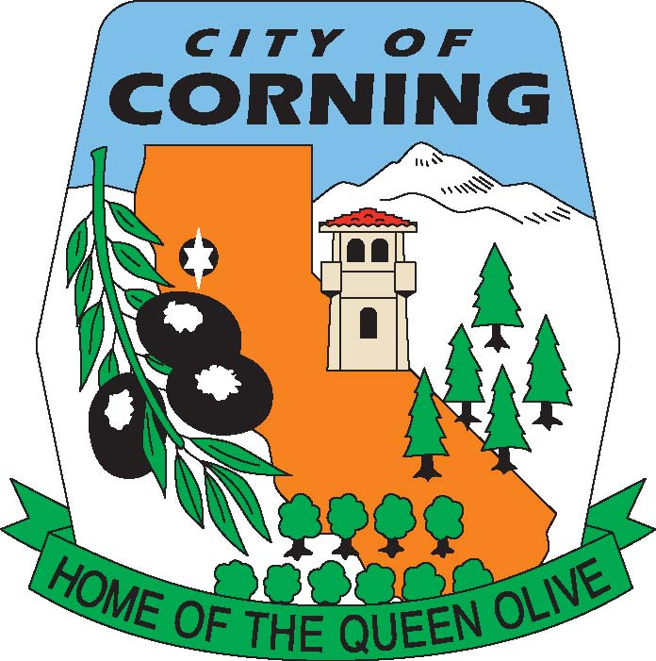

TUESDAY, JUNE 15, 2021

PLANNING COMMISSION MEETING

HAS BEEN CANCELLED
DUE TO
LACK OF AGENDA

POSTED WEDNESDAY, JUNE 9, 2021

THE CITY OF CORNING IS AN EQUAL OPPORTUNITY PROVIDER AND EMPLOYER

