CITY OF CORNING
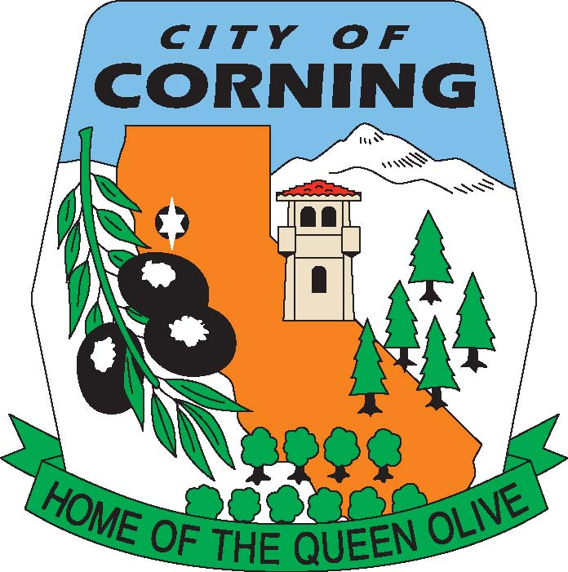

NOTICE OF CANCELLATION
OF THE
TUESDAY, OCTOBER 5, 2021
RECREATION COMMISSION MEETING
DUE TO LACK OF AGENDA

The Corning Recreation Commission serves as an advisory body to the Corning City Council on Public Parks and Recreation issues including park use, master planning, acquisition and development, beautification, improvement, and maintenance of City Parks. The Commission provides a public forum for the proposal and discussion of public recreation services that benefit the Community. Ideally the Commission would encourage community volunteers and youth/adult volunteer sports groups to work together in the planning for current and future facility and program needs.

POSTED: TUESDAY, SEPTEMBER 28, 2021
MEMO
City of Corning

794 Third Street, Corning, CA 96021

(530) 824-7033 Fax (530) 824-2489
TO: RECREATION COMMISSIONERS

FROM: CHRISTINA MEEDS

DATE: SEPTEMBER 28, 2021

SUBJECT: RECREATION UPDATE

Dear Recreation Commissioners:

The scheduled quarterly meeting for October 5th will be cancelled as we have no discretionary items to discuss.

Staff would like to provide the Commission with an update on the Promise Neighborhood Recreation Grant; it appears that the City will receive funding through calendar year 2022 for our Recreation Program. As the details are worked out, we will keep you updated.

The State should be announcing awards for the Prop. 68, Round 4 Grants anytime. We will keep you posted on that as information is received.

Thank you,

Christina Meeds
Planner 1/Recreation Coordinator
City of Corning

