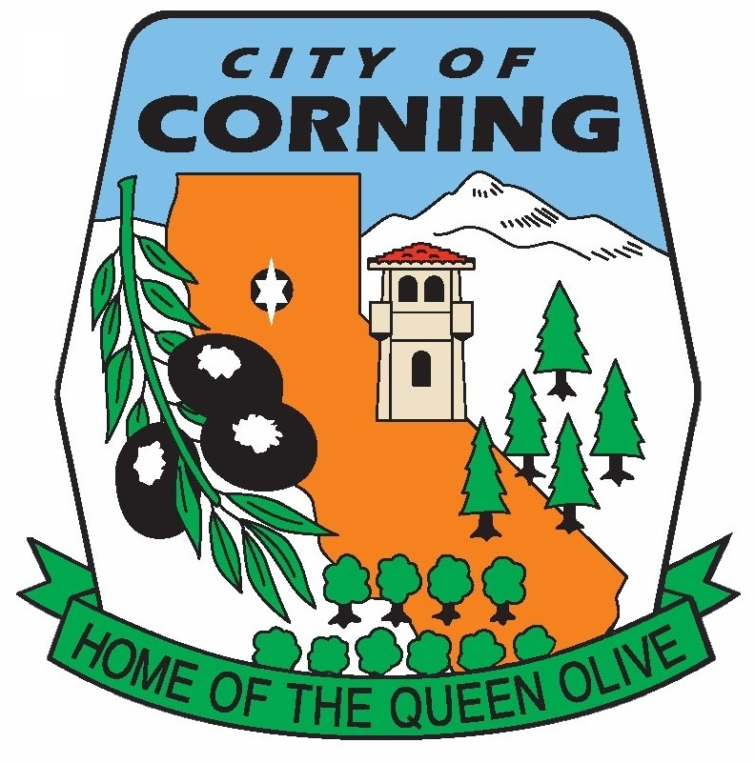

City of Corning
Recreation Department
794 THIRD STREET CORNING, CA 96021
Phone: (530) 824-7036
Email: cmeeds@corning.org

SPORTS FIELD RESERVATION REQUEST

TODAY’S DATE: ____________ NAME OF USER GROUP: ___________________

CONTACT PERSON: ___________________________ PHONE: ________________

MAILING ADDRESS: ____________________________________________________
Street City Zip

DATE REQUESTED: ___________ TIME REQUESTED: from _______ to_______

TYPE OF ACTIVITY: ____________________________________________________

BALL FIELD LIGHTING REQUIRED?: Yes No from ________ to _________

# OF PEOPLE IN USER GROUP: ___________________________________________

LEAGUES – FOR CONTINUOUS USE, COMPLETE INFORMATION BELOW

DATES REQUESTED: from ________ to ________

DAYS REQUESTED: S S M T W TH F

TIME REQUESTED:
Sunday: ______________________________

Monday: ______________________________

Tuesday: ______________________________

Wednesday: ______________________________

Thursday: ______________________________

Friday: ______________________________

Saturday: ______________________________

** SEE REVERSE SIDE**
RESERVATION FEES
$75 Clean up deposit
$25 Key deposit – Cash Only
$100 Refundable

$8 Daily Light Fee
$75 Daily Use Fee
$83 Non-Refundable

$16 Weekend Light Fee
$150 Weekend Use Fee
$166 Non-Refundable

GENERAL INFORMATION
- Sports Leagues can only use park facilities during approved scheduled dates and times.
- The Maintenance Department may close field in the event of rain, maintenance liabilities, or unexpected events. Representatives will be notified.
- Keys not returned by approved due date will result in a loss of deposit and additional fees to change the locks.
- Director must pre-approved items to be stored on site.
- League representatives are responsible for enforcing General Rules and Regulations.
- If requested, ball field lighting cannot extend beyond 10pm.
- Players, coaches, board members, and spectators are to vacate the park after scheduled times.
- Refundable fees will be returned the first business day following the event provided there is no damage.

GENERAL RULES AND REGULATIONS – PLEASE NO
- Littering
- Glass Containers
- Unleashed pets/animals
- Parking in red zones
- Climbing trees, slopes, backstops, or soccer/football goals
- Driving vehicles onto grass, fields, sidewalks
- Loud music

________________________________ __________________________________
SIGNATURE OF CONTACT PERSON TITLE IF APPLICABLE

