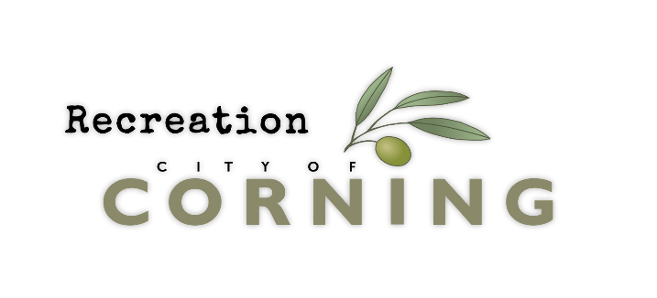

VOLUNTEER APPLICATION
Volunteer Position Applied For:

PERSONAL INFORMATION
Last Name: First Name:
Address City State
Cell Phone Home Phone
E-mail Address Gender M F
Are you over 18? Yes ☐ No ☐
Emergency Contact Name and Number
COACHING INFO
By applying to be a volunteer coach, you are agreeing to the Corning Recreation’s philosophy.
The goal is for our youth to learn and grow in positive surroundings. Volunteers should be aware of the influence they have on players. What makes a great volunteer coach, someone who displays good sportsmanship, and involvement, Promotes respect, sportsmanship, and citizenship. Volunteers are expected to help athletes by teaching them the fundamentals of the sport.

What sport do you want to coach?

What position are you applying for? ☐ Head Coach ☐ Assistant

Please describe your coaching experience:

*Volunteer Applicants will need to complete a criminal history check through the State of California Department of Justice Live Scan Service. Individuals with certain criminal convictions pursuant to Public Resources Code 5164 and drug crime violations with California Uniform Controlled Substances Act in Division 10 of the Health and Safety Code of any one (1) felony or three (3) or more misdemeanor convictions within 10 years of the date of application cannot provide volunteer services. My signature on this application indicates my understanding of this requirement.
VOLUNTEER AGREEMENT, WAIVER AND RELEASE: In consideration for being permitted by Corning Recreation to volunteer for a sport, program, or recreational activity, I for myself, personal representative, assigns, heirs, and next of kin, herby waive, release and discharge any and all claims for damages for personal injury, death or property damage which I may have, or which may hereafter accrue to me, as a result of participation in said RECREATIONAL ACTIVITY. I certify and represent that I am in good health and physically able to participate in said RECREATIONAL ACTIVITY. I fully understand the RECREATIONAL ACTIVITY involves risks and I fully accept all such rights and responsibilities for losses, costs and damages I incur as a result of my VOLUNTARY participation in the RECREATIONAL ACTIVITY. This release is intended to release and discharge in advance Corning Recreation (it’s directors, officers, employees, volunteers, and agents) from any and all liability arising out of or connected in any way with my VOLUNTARY participation in said RECREATIONAL ACTIVITY. It is understood that this RECREATIONAL ACTIVITY involves an element of risk of accidents INHERENT TO THE RECREATIONAL ACTIVITY and knowing those risks I herby VOLUNTARILY assume those risks. It is further agreed that this Agreement, Waiver, and Release is to be binding on my heirs and assigns. I agree to indemnify and to hold the above persons or entities free and harmless from any loss, liability, damage, cost or expense which they may incur as the result of my death or injury or property damage that I may sustain while participating in said RECREATIONAL ACTIVITY. I agree that if any portion of this Agreement, Waiver, and Release is held to be invalid, the balance shall remain in full force and effect.
PHOTOGRAPHY/VIDEO/INTERVIEW/SOCIAL MEDIA RELEASE:
I hereby authorize Corning Recreation to publish photographs and/or videos and/ or written or quoted statements taken of/from me and/or of my minor child/ward, and my/our names and information provided in an interview, in connection with the publicizing/promotion of Corning Recreation, its services, including, but not limited to, newsletters, flyers, publications, websites, social media, public service announcements, news releases, and feature articles. I agree that such reproduction may be edited as desired and used in whole or in part for any and all print, audio-visual, multimedia, online, and/or exhibition purposes in any manner or media, in perpetuity, throughout the world. I understand that I have no rights to any benefits derived therefrom. I release Corning Recreation from any expectation of confidentially for myself and/or my minor child/ward. I understand that there is to be no remuneration for the use or reproduction of said photographs/video/interview information. I further agree that I and/or my minor child/ward have no rights of ownership whatsoever.
I HAVE CAREFULLY READ THIS ENTIRE DOCUMENT AND FULLY UNDERSTAND ITS CONTENTS. I AM AWARE THAT THIS IS A RELEASE OF LIABILITY, CONTRACT, AND RELEASE BETWEEN MYSELF AND CORNING RECREATIONAND I SIGN IT OF MY FREE WILL ON BEHALF OF MYSELF AND/OR MY MINOR CHILD/WARD.
Signature of Volunteer

Date

City of Corning Recreation Department [ 794 Third St, Corning Ca 96021
530-824-7036 [ cmeeds@corning.org

