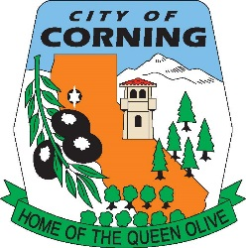
City of Corning
794 Third St. Corning, CA 96021 (530) 824-7020

PERMIT FOR HOME OCCUPATION BUSINESSES

Corning Municipal Code 17.06.270 defines a “Home Occupation” as:
Any use customarily carried on within a dwelling by the inhabitants thereof, which use is incidental to the residential use of the dwelling, and which use.

______A. Is confined within the dwelling and occupies not more than twenty-five percent of the floor space thereof.
______B. Involves no sales of merchandise other than that produced on the premises, or directly related to and incidental to the services offered.
______C. Is carried on by the members of the family occupying the dwelling with no other person employed.
______D. Produces no evidence of its existence beyond the premises such as smoke, odors, vibrations, noise, etc., except one sign not to exceed two square feet of area and pertaining directly to the particular home occupation.
______E. Produces no excess traffic.
______F. Must apply for a permit for home occupancy use (to be approved by the planning department, with a fee set by council)

I hereby agree to meet all the above stated conditions. If approved, and at any time thereafter, I fail to meet the above-mentioned criteria, my home occupation business license will be revoked.

Signature Date

BUILDING 824-7027 * PLANNING 824-7036 * CITY MANAGER 824-7034 * CITY CLERK 824-7033 * FINANCE 824-7020 * PUBLIC WORKS 824-7025 * POLICE DEPARTMENT 824-7000 * FIRE DEPARTMENT 824-7044 *
“THE CITY OF CORNING IS AN AFFIRMATIVE ACTION-EQUAL OPPORTUNITY EMPLOYER”

