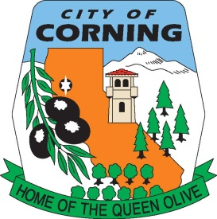
CORNING CITY COUNCIL
CLOSED SESSION AGENDA

FRIDAY, APRIL 22, 2022
CITY COUNCIL CHAMBERS
794 THIRD STREET

The City of Corning welcomes you to our meetings, which are regularly scheduled for the second and fourth Tuesdays of each month. Your participation and interest are encouraged and appreciated.

In compliance with the Americans with Disabilities Act, the City of Corning will make available to members of the public any special assistance necessary to participate in this meeting. The public should contact the City Clerk’s office (530/824-7033) to make such a request. Notification at least 72 hours prior to the meeting will enable the City to make reasonable arrangements to ensure accessibility to this meeting.

This is an Equal Opportunity Program. Discrimination is prohibited by Federal Law. Complaints of discrimination may be filed with the Secretary of Agriculture, Washington, D.C. 20250.

- CALL TO ORDER: 5:00 p.m.

- ROLL CALL: Council: Dave Demo
Karen Burnett
Shelly Hargens
Jose “Chuy” Valerio
Mayor: Robert Snow

The Brown Act requires that the Council provide the opportunity for persons in the audience to briefly address the Council on the subject(s) scheduled for tonight’s closed session. Is there anyone wanting to comment on the subject(s) the Council will be discussing in closed session? If so, please come to the podium, identify yourself and give us your comments.

- PUBLIC COMMENTS:

- REGULAR AGENDA:

- CONFERENCE WITH REAL PROPERTY NEGOTIATOR PURSUANT TO GOVERNMENT CODE SECTION 54956.8:
Property: 071-131-001 (Sixth and Yolo St.)
Agency Negotiation: Kristina Miller
Under Negotiation: Price and Terms

- ADJOURN TO REGULARLY SCHEDULED CITY COUNCIL MEETING AND REPORT ON CLOSED SESSION:

POSTED: WEDNESDAY, APRIL 20, 2022

